A REPORT ON
PROPOSED NATIONAL YOUTH SERVICE CORPS (NYSC) ORIENTATION CAMP

FOR
EKITI STATE GOVERNMENT

BY

IDRIS ABDULHAKEEM OPEYEMI
MATRIC NO: - HND/22/ARC/FT/088

SUBMITTED TO

THE DEPARTMENT OF ARCHITECTURAL TECHNOLOGY, INSTITUTE OF ENVIRONMENTAL STUDIES, KWARA STATE POLYTECHNIC, ILORIN KWARA STATE.

IN PARTIAL FULFILLMENT OF THE REQUIREMENT FOR THE AWARD OF HIGHER NATIONAL DIPLOMAL (HND) IN THE ARCHITECTURAL TECHNOLOGY

JULY, 2025.

DECLARATION
I, IDRIS ABDULHAKEEM OPEYEMI Of Matric No- HND/22/ARC/FT/088, hereby

declear that this project has been carried out solely by me under the supervisor of ARC. FAMILUA .O.S. of Department of Architecture, Kwara State Polytechnic, Ilorin.

CERTIFICATION
This project report on the proposed project of NYSC Orientation Camp, for Ekiti State Government, by IDRIS ABDULHAKEEM OPEYEMI Of Matric No- HND/22/ARC/FT/088, has been duly read and certified as meeting the requirement for the award of Higher National Diploma (HND) in Architectural Technology of the Kwara State Polytechnic, Ilorin.


ARC. FAMILUA O.S. …………………………
Project Supervisor Date



ARC. OLAREWAJU F.A. …………………………
Project Coordinator Date


ARC. J.M. TOMORI …………………………
Head of Department Date

EXTERNAL EXAMINER ………………………… Date

DEDICATION
This research project work is dedicated to the Almighty GOD the source of knowledge and to my able parent Mr. Mrs. IDRIS, who teaches and guides me in my academic pursuit.

ACKNOWLEDGMENT
All praise and adoration and glorification to Almighty (S.W.T) the creator of the universe that gave me the privilege to take part in this program. First and foremost.
I am grateful to my able Hardworking and untiring project supervisor ARC FAMILUA O.S and I must appreciate all lecturers of the department of architectural technology, ARC TOMORI the (H..O.D) ARC.CHUCKWUMA NMOM, ARC.OLAREWAJU F.A, ARC. ABDULAZEEZ
B.Y.F, God bless you all for your encouragement, expert advice and continuous kind assistant and supervision that made the completion of this study successful.
My sincere gratitude goes to my lovely parents Mr. And mrs. Rasheed who brought me to this world , may you eat the fruit of your labour.
However, my gratitude also goes to all my helpers, Brothers, Sisters, and my friends for their encouragement and financial support.
My Special thanks goes to my Architecture friends and my entire class member to numerous to mention for their co-operation, advice and moral supports, my love beyond is cannot be measure, for their support, love, encouragement and care. May our love abide forever (Amen).
…….Jazakumllahi Khair

 | TABLE OF CONTENT
Contents |  | Page No
Title Page |  | i
Declaration |  | ii
Certification |  | iii
Dedication |  | iv
Acknowledgement |  | v-vi
Table of Content |  | vii - ix
List of Tables |  | x
List of Figures |  | xi
List of Plates |  | xii-xiii
Abstract |  | xiv

CHAPTER ONE:
  - General Introduction 1
  - Introduction 1
  - Definition of Terms 1
  - Background of Study/Historical 1
    - Background of NYSC 1-2
    - National Anthem NYSC 3
  - Justification 3
  - Aim 3
  - Objectives 3-4
  - Scope 4-5

  - Limitation of the Study 5
  - Contribution of the body of Knowledge 5

  - Research Methodology 6
  - Conclusion 6-7

CHAPTER TWO
  - Literature Review 8-9
  - Conclusion 9-10
  - Research Methodology 10
  - Case Studies 10
    - Case Study One 10-18

    - Case Study Two 19-28

    - Case Study Three 28-36

  - Finding and Discussion/Statistical Backup 36

  - General Deduction 37

CHAPTER THREE

  - Site and Environmental Analysis 38

  - Historical Development of Ekiti State 38

  - Site Location and Description 39

  - Site Selection Criteria 39

  - Site Analysis and Inventory 39-41

  - Geographical/Climatic Data 41-43

CHAPTER FOUR

  - Design Criteria 44

  - Design Scope/Brief Analysis 44
    - Scope Analysis 44-45
    - Brief Analysis 45-46
  - Space Allocation/Schedule of Accommodation 47-48
  - Functional Relationship 49
  - Conceptual Development (Site and Building) 49-52
CHAPTER FIVE
  - Appraisal of Proposed Scheme 53
  - Construction Method 53-54
  - Materials and Standard Forms 54-56
  - Essential Services 56-58
  - Conclusion and Recommendation 58
REFERENCES 59-60
APPENDIX

LIST OF TABLES

TABLE 1: | HISTORICAL WEATHER DATA OF ADO EKITI | 42
TABLE 2: | ADMINISTRATION BLOCK | 47
TABLE 3: | HOSTEL | 48
TABLE 4: | STAFF QUARTERS | 48

LIST OF FIGURES
FIGURE 2.1: Location Plan of case study one of NYSC Orientation camp, Yikpata, Kwara State. 11
FIGURE 2.2: Administration Floor Plan of case study one of NYSC Orientation camp, Yikpata, Kwara State. 12
FIGURE 2.3: Hostel Floor Plan of case study one of NYSC Orientation camp, Yikpata, Kwara State. 13
FIGURE 2.4: Toilet and Bath Floor Plan of case study one of NYSC Orientation camp, Yikpata, Kwara State. 14
FIGURE 2.5: Location Plan of case study two of NYSC Orientation camp, Ede, Osun State.20 FIGURE 2.6: Hall Floor Plan of case study two of NYSC Orientation camp, Ede, Osun State.21 FIGURE 2.7: Hostel Floor Plan of case study two of NYSC Orientation camp, Ede, Osun
State. 22
FIGURE 2.8: Male Hostel Floor Plan of case study two of NYSC Orientation camp, Ede, Osun State. 23
FIGURE 2.9: Location Plan of case study three of NYSC Orientation camp, Ise, Ekiti State.29
FIGURE 2.10: Male Hostel Floor Plan of case study three of NYSC Orientation camp, Ise, Ekiti State. 30
FIGURE 2.11: Female Hostel, Administration Office and clinic Floor Plan of case study three of NYSC Orientation camp, Ise, Ekiti State. 31

LIST OF PLATES
PLATE 1: Picture showing the Signpost of NYSC Orientation camp, Yikpata, Kwara State.15 PLATE 2: Picture showing the Administration block of NYSC Orientation camp, Yikpata,
Kwara State. 16
PLATE 3: Picture showing the side view of the hostel at NYSC Orientation camp, Yikpata, Kwara State. 16
PLATE 4: Picture showing the back view of the hostel at NYSC Orientation camp, Yikpata, Kwara State. 17
PLATE 5: Picture showing the inside view of the hostel at NYSC Orientation camp, Yikpata, Kwara State. 17
PLATE 6: Picture showing assort course at NYSC Orientation camp, Yikpata, Kwara State.18 PLATE 7: Picture showing Pavilion at NYSC Orientation camp, Yikpata, Kwara State. 18 PLATE 8: Picture showing the Signpost of NYSC Orientation camp Ede, Osun State. 24
PLATE 9: Picture showing the Administration block of NYSC Orientation camp Ede, Osun State. 25
PLATE 10: Picture showing the front view of the hostel at NYSC Orientation camp Ede, Osun State. 25
PLATE 11: Picture showing the side view of the hostel at NYSC Orientation camp Ede, Osun State.
PLATE 12: Picture showing the inside view of the hostel at NYSC Orientation camp Ede, Osun State. 26
PLATE 13: Picture showing the front view (Male Hostel) of the hostel at NYSC Orientation camp Ede, Osun State. 27

PLATE 14: Picture showing assort course at NYSC Orientation camp Ede, Osun State. 27 PLATE 15: Picture showing assort course at NYSC Orientation camp Ede, Osun State. 28 PLATE 16: Picture showing the Signpost of NYSC Orientation camp Ise, Ekiti State 32
PLATE 17: Picture showing the front view of the Male hostel at NYSC Orientation camp Ise, Ekiti State. 33
PLATE 18: Picture showing the back view of the Male hostel at NYSC Orientation camp Ise, Ekiti State. 33
PLATE 19: Picture showing the inside view of the hostel at NYSC Orientation camp Ise, Ekiti State. 34
PLATE 20: Picture showing the front view of the Female hostel attached with Administration Offices, Clinic and OBS at NYSC Orientation camp, Ise, Ekiti State. 34
PLATE 21: Picture showing the back view of the Female hostel attached with Administration Offices, Clinic and OBS at NYSC Orientation camp, Ise, Ekiti State. 35
PLATE 22: Picture showing assort course at NYSC Orientation camp Ise, Ekiti State. 35
PLATE 23: Picture showing assort course at NYSC Orientation camp Ise, Ekiti State. 36
PLATE 24: Climate graph Ado Ekiti 41

ABSTRACT
The main focus of this project work is to combine with a reasonable scope, a comprehensive study of the principle guiding the design and planning of a well functional and aesthetically balanced structure for all graduate both from Universities and Polytechnics, all over the Nation, which will be camping for their 3 weeks National Youth Service Corps (NYSC), taking reference from case studies and journals. Having a good design for a Orientation Camp is nothing but to create and achieve a working environment that is well ventilated, lightened coupled with good landscaping as well as functional and convenient building units that would result to an effective relationship and a good activities atmosphere, so that the best can be achieved in terms of Quality.

CHAPTER ONE

GENERAL INTRODUCTION

INTRODUCTION
The National Youth Service Corps was established decree 24 of May 1993. However, the founding decree has been replaced with decree 51 of 16th June, 1993. It is also important that scheme was established to promote the idea of national unity and sense of common testimony Nigeria and eliminate mutual suspicion and mistrust that has not been eliminated since the civil war. It’s an organization sated up by the Nigeria government to involve the countries graduates in the development of approximately (3) weeks spent in the camp away from family and friends.
During the staying of 3week of camping actives and training are being carried out morning exercise, sport, parade and man “o” war training, etc. there are NYSC officials, military and paramilitary men on camp to affiliate and train during the period. Corps members will undergo different kind of activates and training on camp to enable them to face challenges during the services and after the year.

DEFINITION OF TERMS

NYSC: National Youth Services Corp

Orientation: Information of training that are given before you start a new job or activities. Camp: A place where people converge for holiday or other common activities, its usually characterized by tents in other temporary structural or shelters.

BACKGROUND OF STUDY/HISTORICAL

BACKGROUND OF NYSC

The NYSC was established by decree 24 of May 1973. However the founding decree has been replaced with decree 51 of 16th June, 1993. It is also important that scheme was established

to promote the idea of national unity and sense of common testimony Nigeria and eliminated mutual suspicion and mistrust that has not been eliminated since the civil war.
The NYSC scheme was created in order to reconstruct and rebuild the antecedent in our national history gave impeder to the establishment of the national youth services corps by decree 24 of May 1973. This stated that the NYSC is being established with the view to attain the proper encouragement and development of communities among Nigeria youth and the promotion of the national unity.
As a developing country, Nigeria is further plagued by the problem attendant upon a condition of under development namely: poverty, mess illiteracy, acute shortage of high man skilled manpower{coupled with most uneven distribution of the skilled people that are available} wearily inadequate socio economic infrastructural facilities, housing, water, and sewage, facilities road, health care services and effective communities system raced with these almost intractable problems which were rather compounded by the burden of reconstruction after the civil war, the government and the people of Nigeria set for the country fresh goals and objective aimed at establishing Nigeria as:
      - A united, strong and self reliant nation

      - A great and dynamic economy

      - A land of bright and job opportunities for all citizens.

It is culture in Nigeria, that once a student graduate from the university or polytechnic, with a degree or high national diplomat (HND) he/she is posted to have a state in Nigeria to serve the nation.

NATIONAL ANTHEM NYSC
Youth obey the clarion call, let us lift our nation high under the sun and in the rain with dedication and selflessness, Nigeria ours we serve.
The above is the National anthem of NYSC every youth corps member in Nigeria and for 30 years it has sounded sort and true. The NYSC scheme has 3 stages, 3 weeks of orientation camping, the community development services (done once a week) and the place of primary assignment, (a place corps member are posted to after the orientation camp and is to serve for one year).

JUSTIFICATION

In view of the fact that that Ekiti state NYSC orientation camp located at Ise-Orun/Emure Local Government Area, Ekiti state, was not initial plan for NYSC Orientation camp, the structure was abandon Secondary School, which there is the need for the organization to have their own structure.
Hence, I have decided to embark on the design of a befitting NYSC camp to be remain on the same site, which is been the permanent site for the state NYSC Orientation Camp situated at Ise-Orun/Emure Local Government Area, Ekiti State.

AIM

- To design a well comfortable and functional building/area for corps members and officials during their 3 weeks stay on the camp.

OBJECTIVES

- To design a building that will accommodate the workers, office and convenience.

- To provide a well defined space/area for games, parade grounds, obstacles, gadgets ground e.t.c

- To design a well oriented and comfortable building.
- The design shall be based on simple enclosure shall be well ventilated provided with natural and mechanical building.

SCOPE
The scope of this project is limited to the provision of

ADMINISTRATION
  - State coordination
  - Camp director office
  - Camp commandant office

  - Head of man “o” war office

  - Accountant office

  - Store keeper office

  - Registration office

  - Dining

  - Toilet

  - Staff office

  - Conference hall

  - Information technology office

  - Camp manager

  - OBS

  - Store

- HOSTEL

  - Laundry area

  - Toilet
- DISPENSARY

  - Pharmacy
  - Consultation
  - Mini wardroom
  - Toilet
  - Waiting room
- Church
- Mosque
- Pavilion

- Kitchen/dining

- Store

- Hall

- Security post

LIMITATION OF THE STUDY

- LIMITED ACCESIBILITY

In most of the case studies I did. I was restricted from getting into some units in the existing building and even restricted in some places and this limited my design scope.

LIMITED INFORMATION

In most place visited for my case study, less information was been give to me by the camp directors, which means I have to limit my design to information collected.

CONTRIBUTION OF THE BODY OF KNOWLEDGE
This help to know the different kind of materials to be used and where it should be applied and it also helps to give more ideas on NYSC Orientation camp.

RESEARCH METHODOLOGY
In the research for this project various research method were adopted. Methodology adopted includes:-
Case studies of some existing N.Y.S.C orientation camp in other state. Oral interview
Literature review

CASE STUDIES

This is a process of field sampling in which the research studies of some existing prototype of the proposed project for a first hand information was carried out.

ORAL INTERVIEW

Oral interview approach serves as a major source of information of this project. It is adopted to seek opinion of available officers in the NYSC staff were considered as major users who provided very useful information in deciding the concept and scope of the project.

LITERATURE REVIEW

Under the literature review approach textbook written articles relevant journal magazines on existing NYSC camp.

CONCLUSION

The research made during case study on existing NYSC camp gives an insight into the organizational flow chart i.e high rank post in any NYSC camp design and arrangement of building in the camp. In fact without case study research on every building design as an

architectural student the research will be inconclusive. Graduate as those that much are expected for the development of the nation. And as a result of that, the Nigeria youth does not see it as any misdeed to misbehave or to be irresponsible today we have lamentation from the NYSC orientation camp this research work examine the concept of the circulation and planning design of a permanent orientation camp as a means.

CHAPTER TWO
  - LITERATURE REVIEW

The national youth service corps (NYSC) scheme was established by then head of state, General Yakub Gowon of Nigeria on 22nd may, 1973. By the year after the degree enabling its establishment was promulgated, a large and diverse segment of the Nigeria population as well as notable people around the world, commended it establishment and eulogized its operations and achievement, especially its momentous role in promoting national unity, integration and rapid economic development of Nigeria. The Nigeria former head of state General Yakub Gowon, who promulgated the NYSC degree in 1973, recalled that the scheme which some ill motivated people tried to write off at inception, has since grown to such a level of national importance and acceptance to the extent that no one can today speaks of national unity, or rural development, without mentioning the NYSC. Also speaking during a public lecture organized in Abuja on June 4th, 1998, to mark the silver jubilee of the scheme, the first chairman of the NYSC, Professor Adebajo Adedeji, likened the rapid development of the programme to the biblical grain of the mustard seed planted in 1973, that has become a huge in 1998, from his quote, in spite of all the odds, the NYSC scheme has not only remained intact, but has also prospered and expanded considerably, almost expressing identical sentiments during the same occasion, an ex-corps member, Dr. Lanre Bamidele, of the department of theatre and Art, University of Ibadan, observed that the scheme has become a household name in Nigeria today. In his words: There is no aspect of the Nigeria social, cultural and Economic life, that the NYSC has not been touched, or has not been contributing meaningfully. It has become a household name in educational sector that one can say that, if it is for the sector alone, the NYSC shall continue to be relevant as long as the resources could maintain it. Another ex-corps member, Dr. Godwill Ogbogodo of the

University of Benin, see the NYSC as one of the best programmes that have being introduced to this country. In the same vein the sixth Director General, Hafiz Momoh, in his preface to NYSC: 20 year of national service, observed that the scheme has impacted positively on various aspects of our national life.
According to him, “The NYSC has come to acclaimed as one of the most effective and successful instrument in our continuing efforts at achieving a humane and egalitarian society based on mutual understanding, trust, tolerance and a common vision of our national destiny”. In her formal statement on 15th January, 1996, the minister of Youth and Sport in Gambia, Mrs. Aminah Faal-Sanko, said “Members of Gambian study the team that visited America, Europe, the middle East and a number of Africa countries in search of model youth service scheme for the Gambia, were anonymous in their report, that the NYSC of Nigeria is the best organized youth service programme in the world”.
According to Brig. General Yufus Bomoi, in accordance with the decree 51 of June 1993, only successfully graduated candidates in the various certificate/diploma or degree examinations are qualify to be called for service in the NYSC scheme. Only such candidate are qualify to collect their call up letters from the student affairs officers to their respective institutions. All prospective corps members are issued with call-up letters on graduation from their respective institution. The letter inform them of their orientation venues and the date they should register for National Youth Service Corps (NYSC) Orientation camps.

CONCLUSION
In the course of this research, I was able to find out that, out of 36 states including the federal capital (Abuja) of the country, 28 states have permanent orientation camp, while 9 states are using temporary site.

Therefore, for convenience on the part of the government staff and NYSC participant either directly or indirectly, the need for an NYSC orientation cannot be over emphasized.

RESEARCH METHODOLOGY

There are three forms of research which include:-

- Literature review

- Internet research

- Case study

CASE STUDIES

As a way of finding solutions to any design problems this is also based on deducing solution from existing N.Y.S.C orientation camp at other states.
The sole aim of the procedure is to subject each of these case studies to critical analysis in term of the following:
- Functionality
- Flexibility of the design built up area
- Merits and demerits of the qualities of building and the built environment.

CASE STUDY ONE
Kwara state NYSC orientation camp. Yikpata, Kwara state.

INTRODUCTION

The Kwara state NYSC orientation camp is located at Yikpata, Edu local government usually allocate. Secondary school to N.Y.S.C for their orientation but since the establishment of the citizenship and leadership training centre, Yikpata youth camp in 1979 the Kwara state government allocated it to be used temporally.

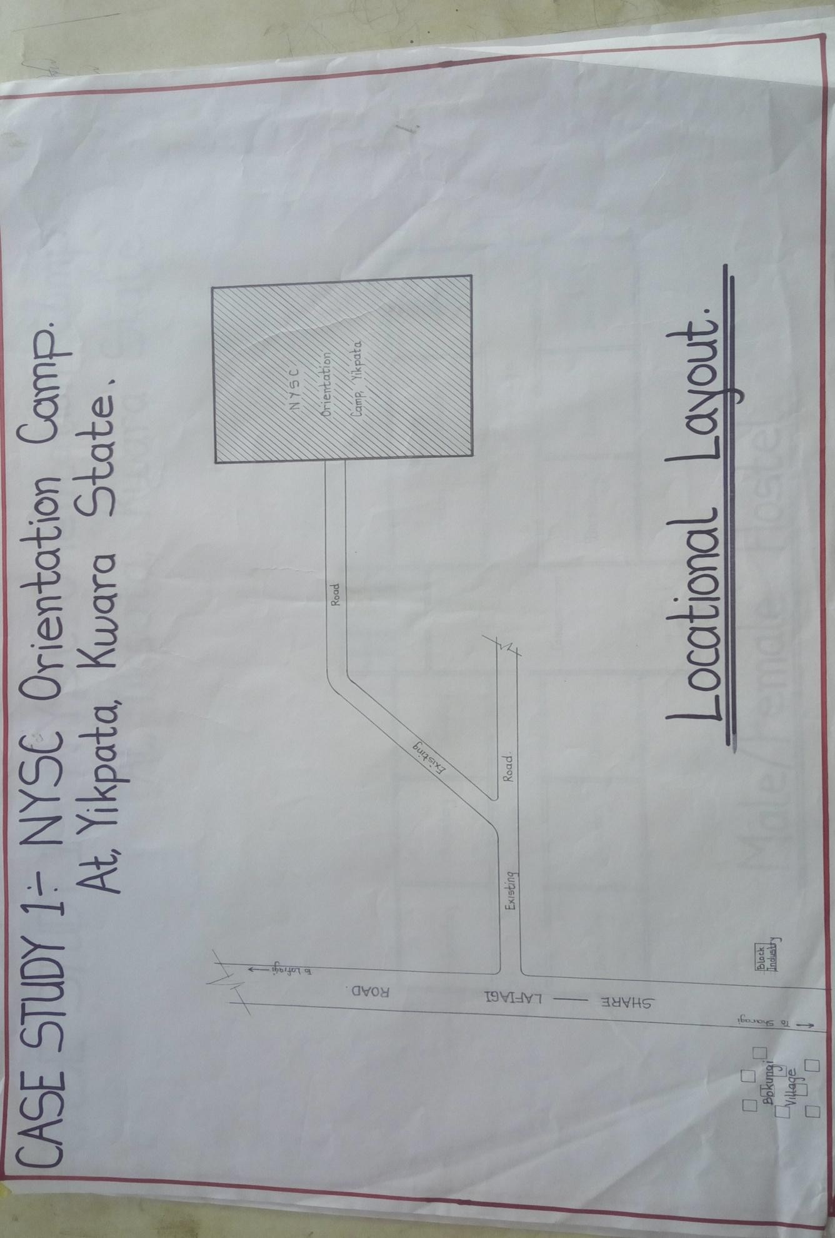 FIGU

RE 2.1: Location Plan of case study one of NYSC Orientation camp, Yikpata, Kwara State.

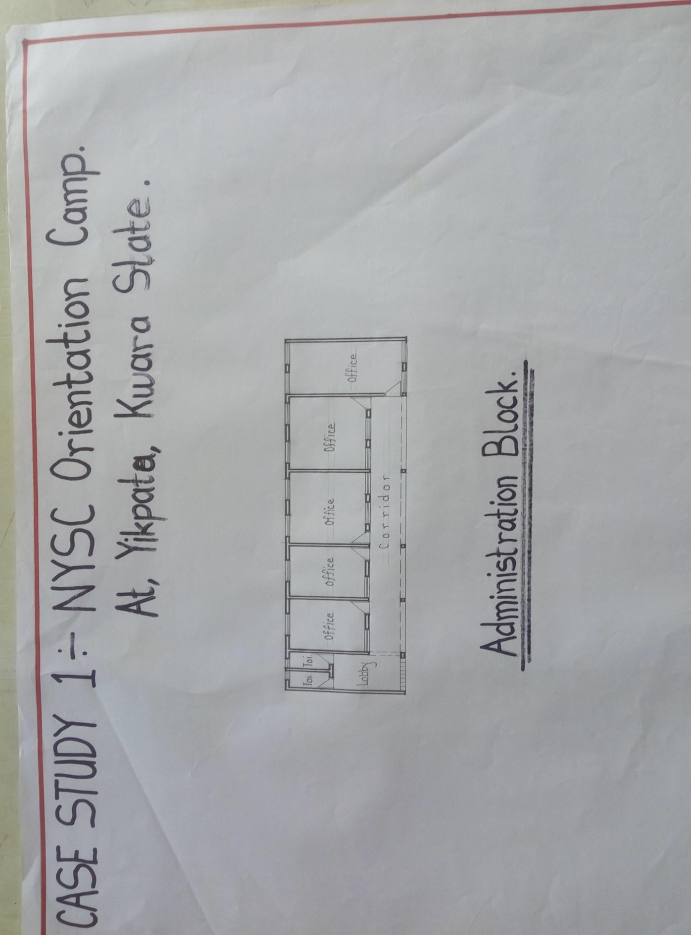
FIGURE 2.2: Administration Floor Plan of case study one of NYSC Orientation camp, Yikpata, Kwara State.

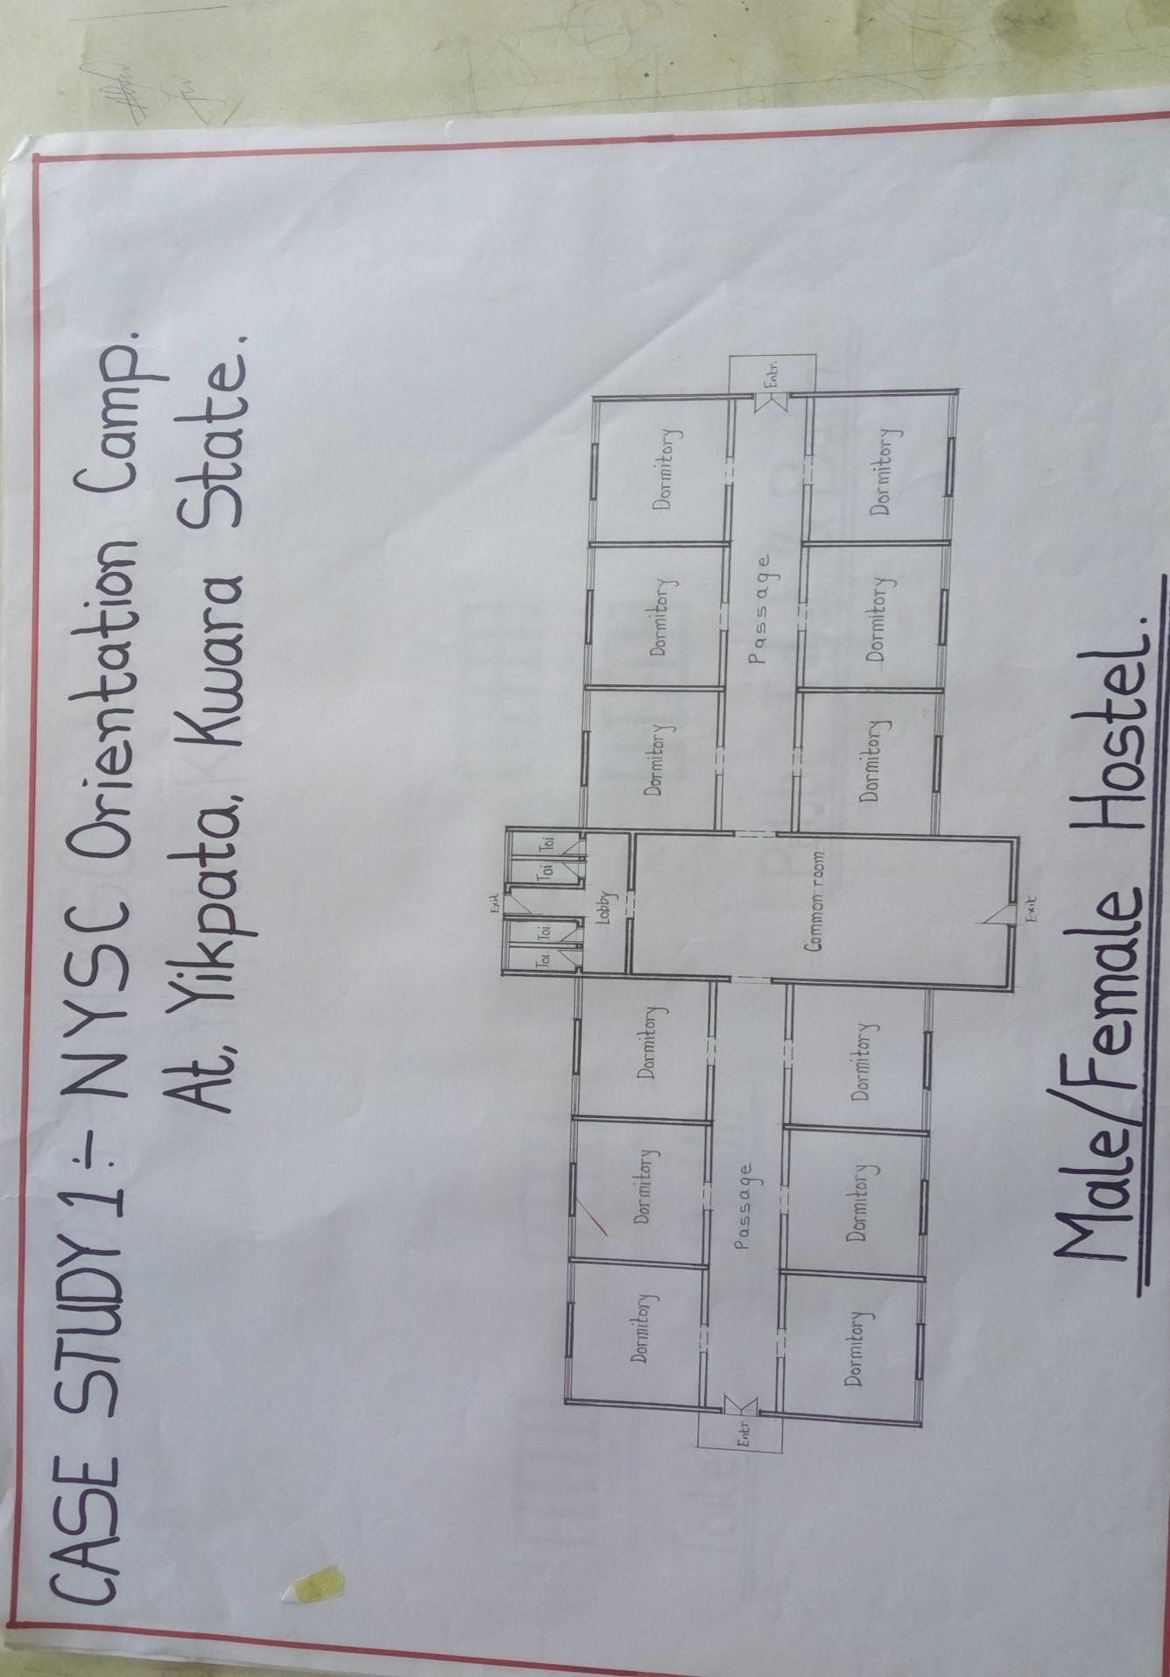
FIGURE 2.3: Hostel Floor Plan of case study one of NYSC Orientation camp, Yikpata, Kwara State.

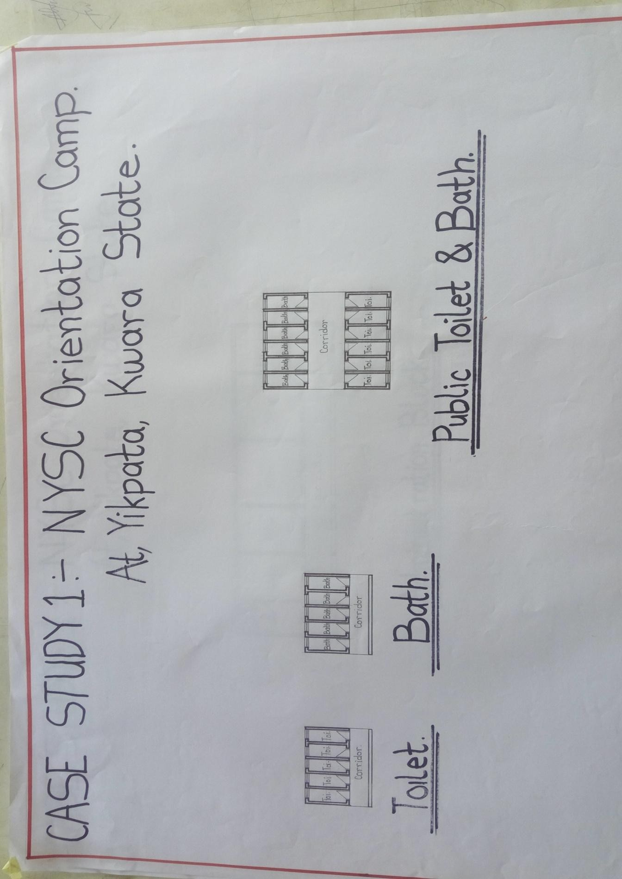

FIGURE 2.4: Toilet and Bath Floor Plan of case study one of NYSC Orientation camp, Yikpata, Kwara State.

MERIT
- It is well oriented

- Easily accessible

DEMERIT
- Inadequate toilet
- No landscape
- Not well functional
- No aesthetic view.
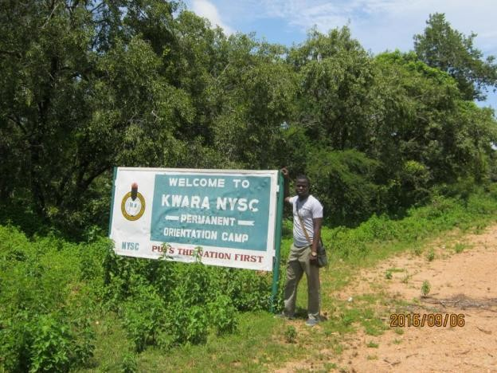
PLATE 1: Picture showing the Signpost of NYSC Orientation camp, Yikpata, Kwara State.

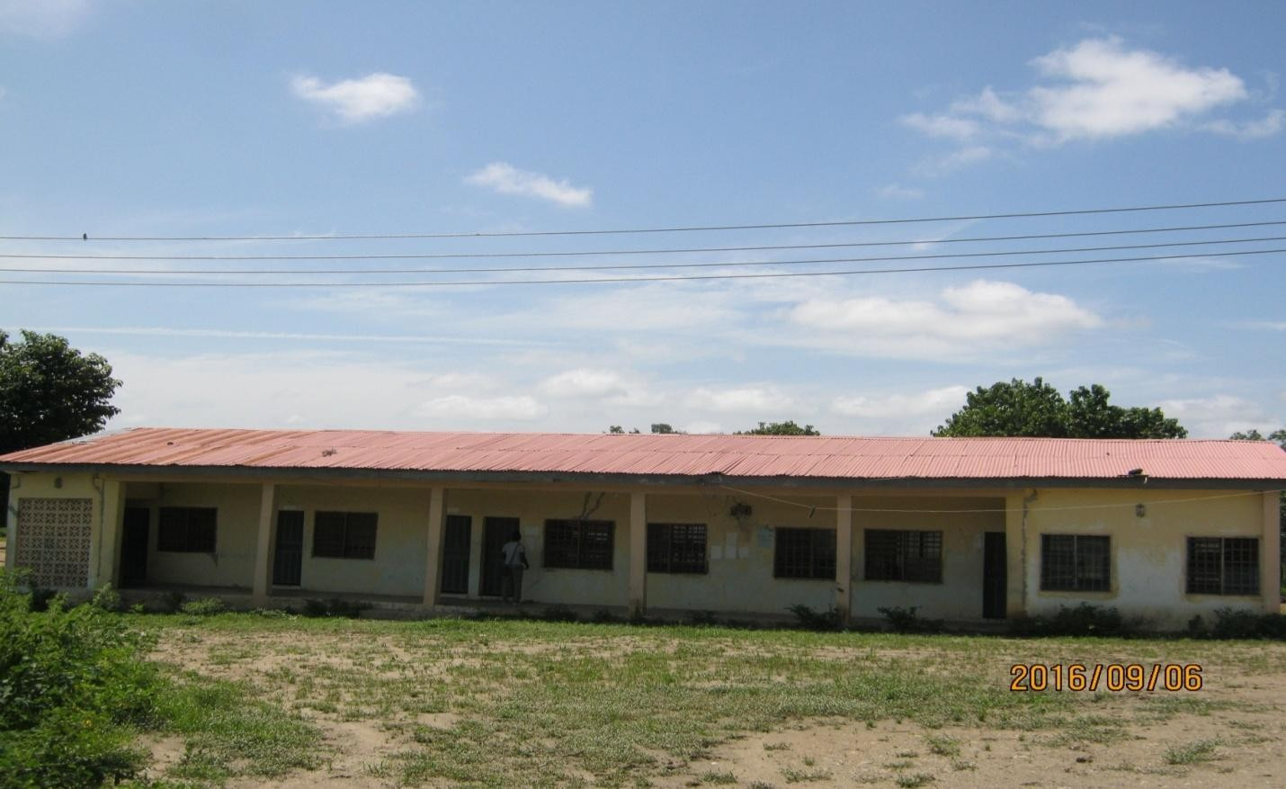
PLATE 2: Picture showing the Administration block of NYSC Orientation camp, Yikpata, Kwara State.

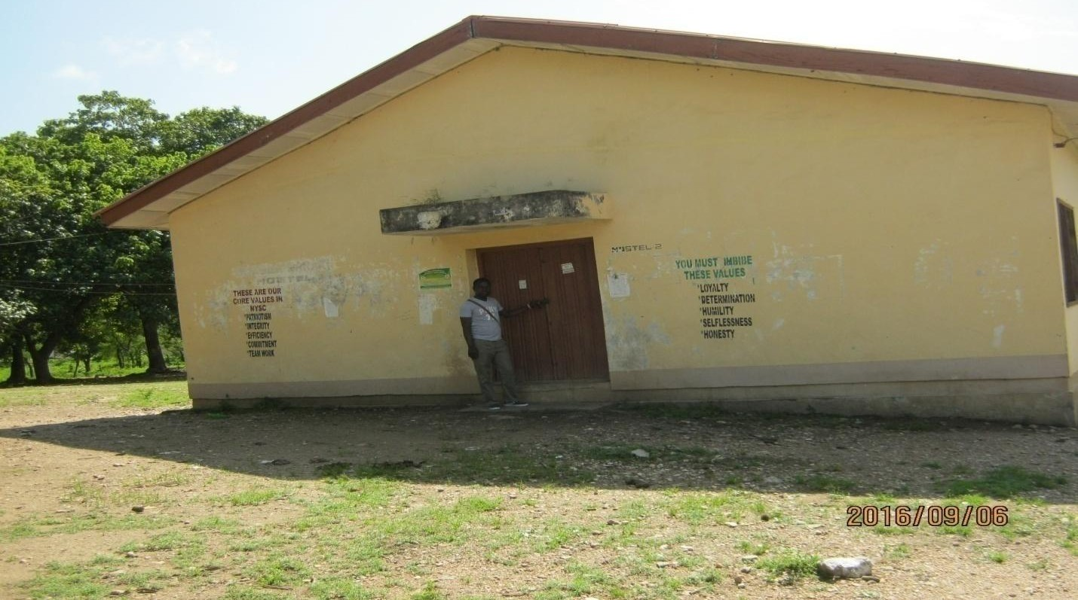
PLATE 3: Picture showing the side view of the hostel at NYSC Orientation camp, Yikpata, Kwara State.

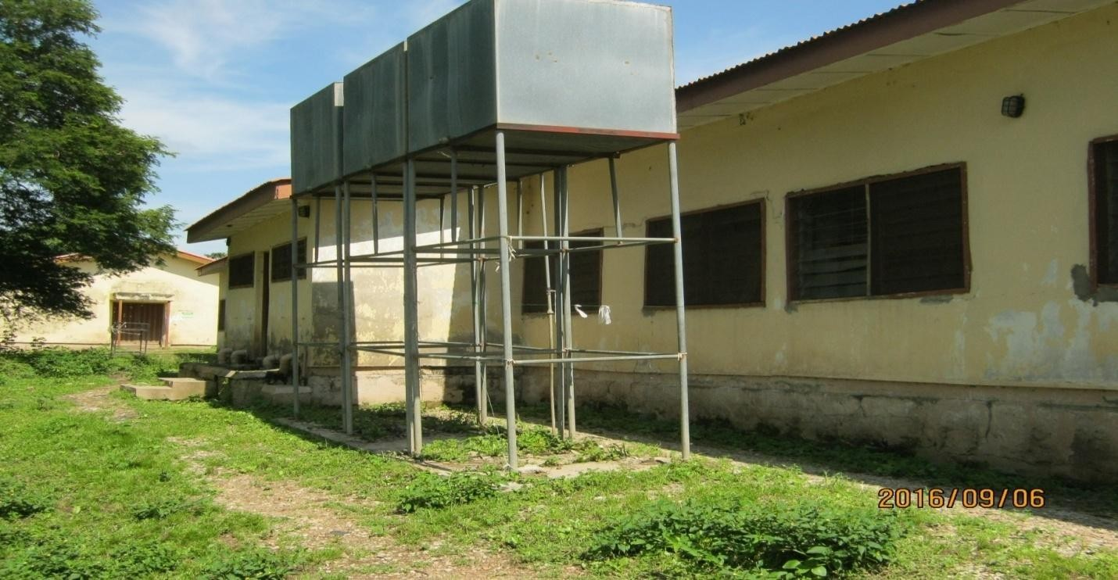
PLATE 4: Picture showing the back view of the hostel at NYSC Orientation camp, Yikpata, Kwara State.

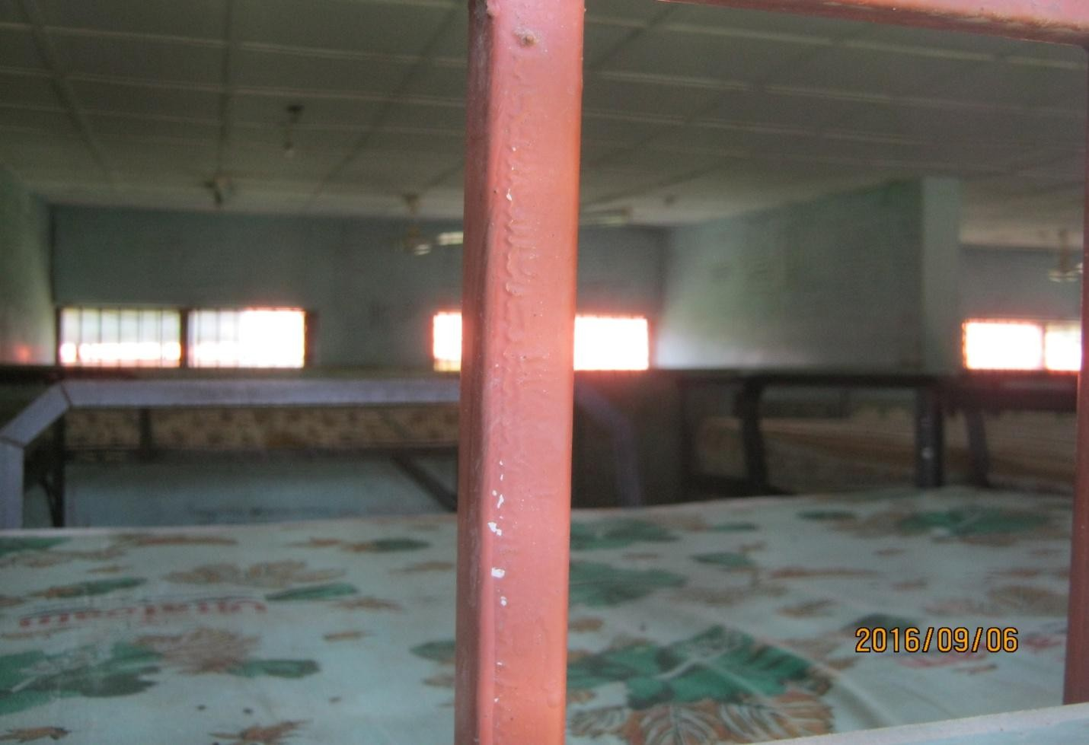
PLATE 5: Picture showing the inside view of the hostel at NYSC Orientation camp, Yikpata, Kwara State.

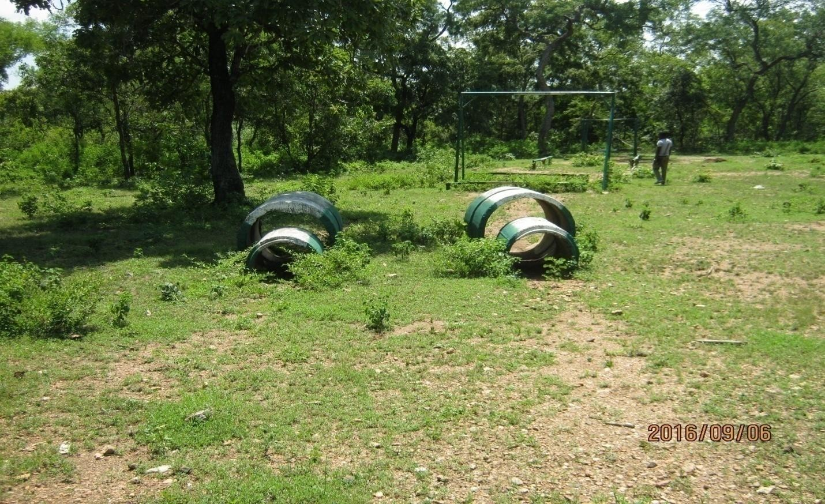
PLATE 6: Picture showing assort course at NYSC Orientation camp, Yikpata, Kwara State.

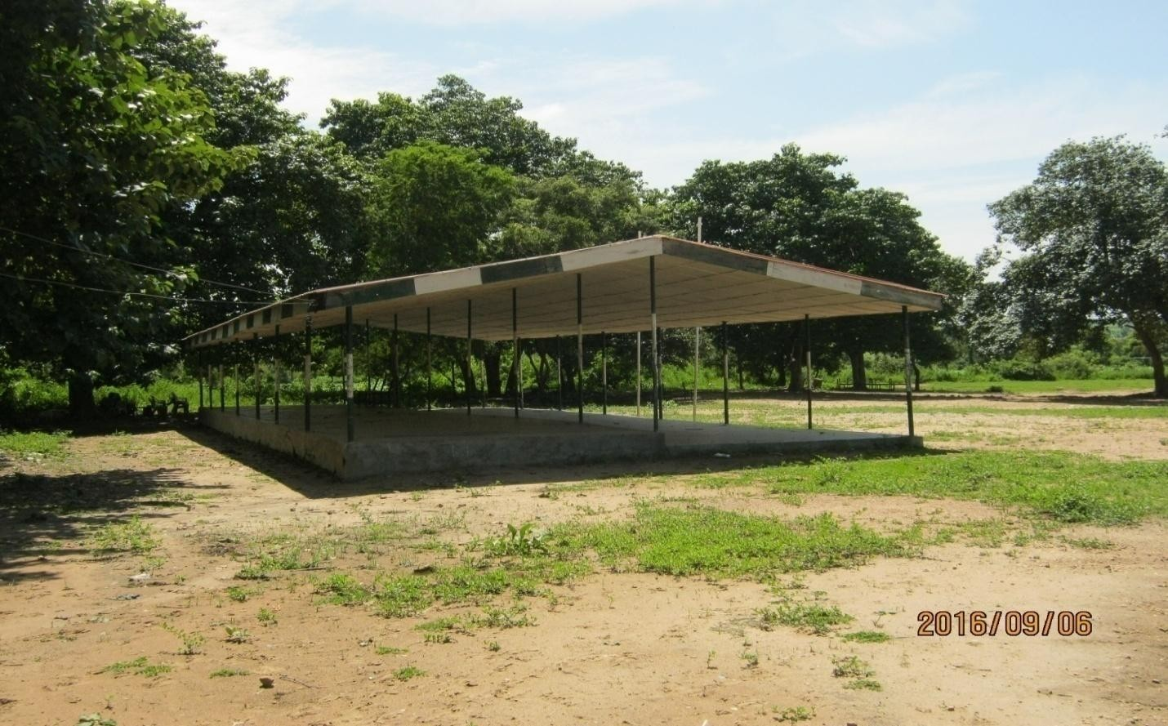
PLATE 7: Picture showing Pavilion at NYSC Orientation camp, Yikpata, Kwara State.

CASE STUDY TWO

Osun State NYSC Orientation Camp Ede, Osun State

INTRODUCTION
The osun state NYSC orientation camp is located at Aisu College Hospital Road, Ede North Local Government Area Osun State and consist of the following units.
- Administrative block

- Hostel

- Kitchen and block

- Hall

- Quarters.

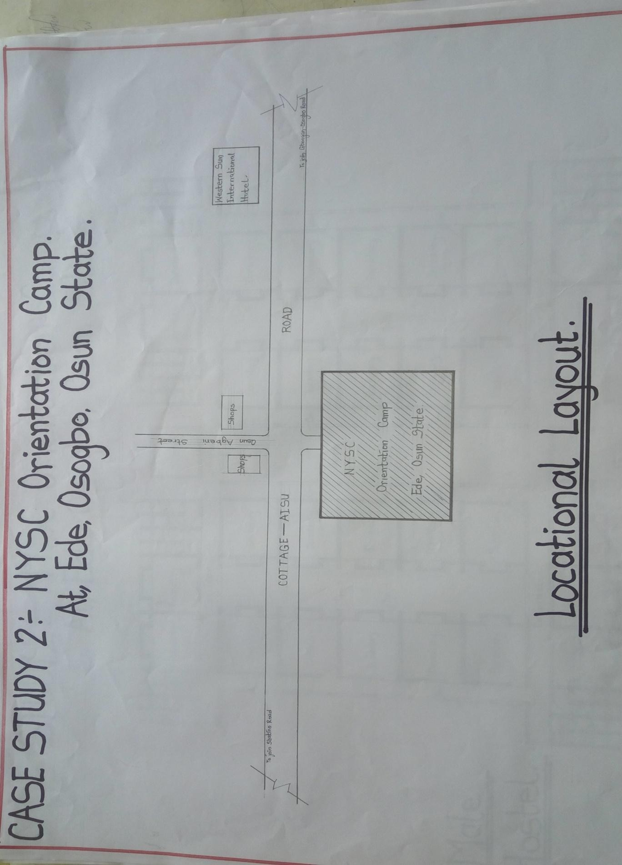
FIGURE 2.5: Location Plan of case study two of NYSC Orientation camp, Ede, Osun State.

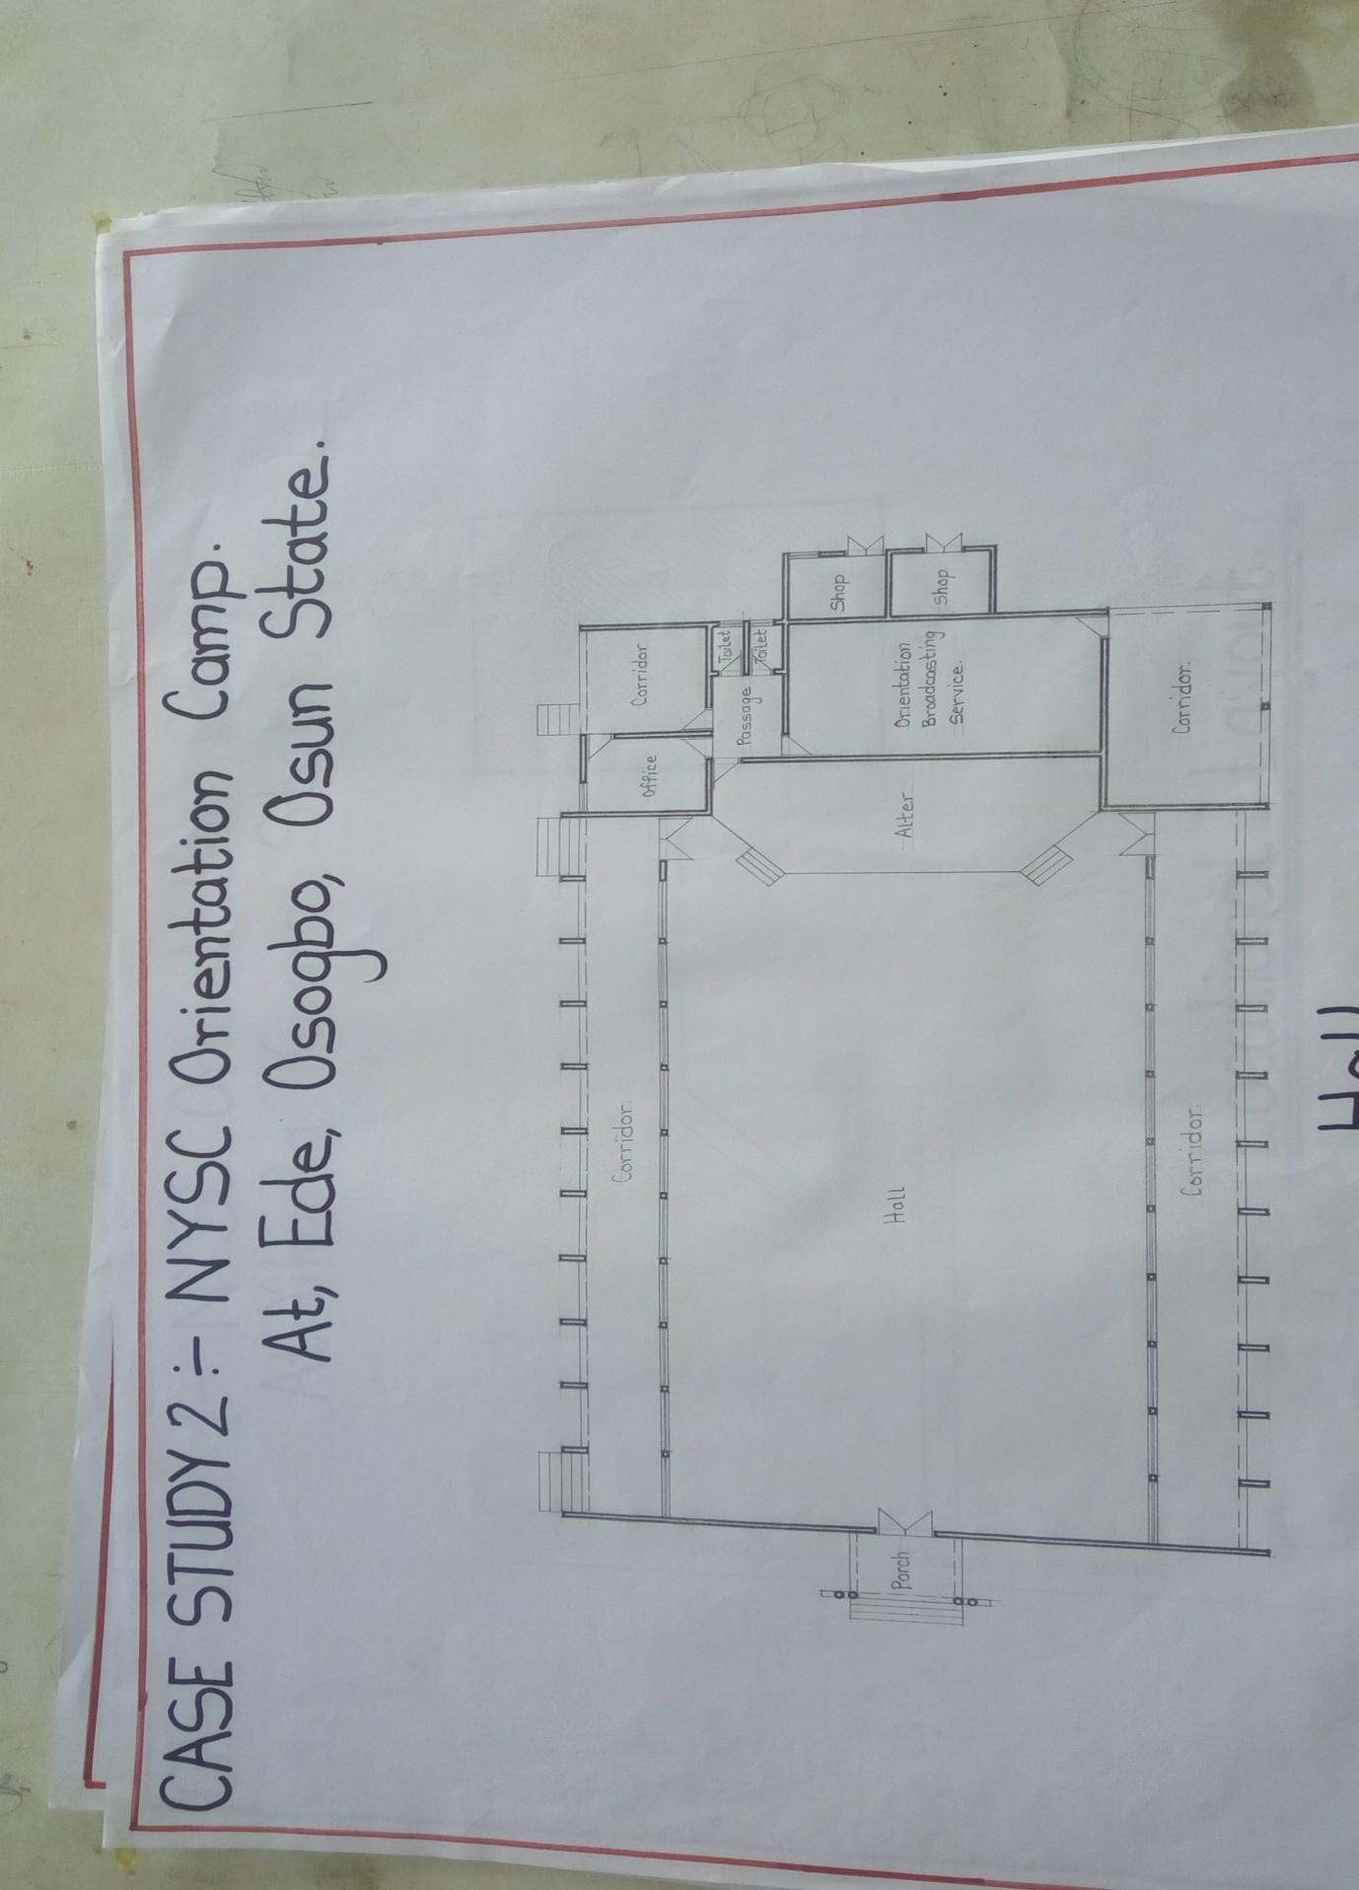
FIGURE 2.6: Hall Floor Plan of case study two of NYSC Orientation camp, Ede, Osun State.

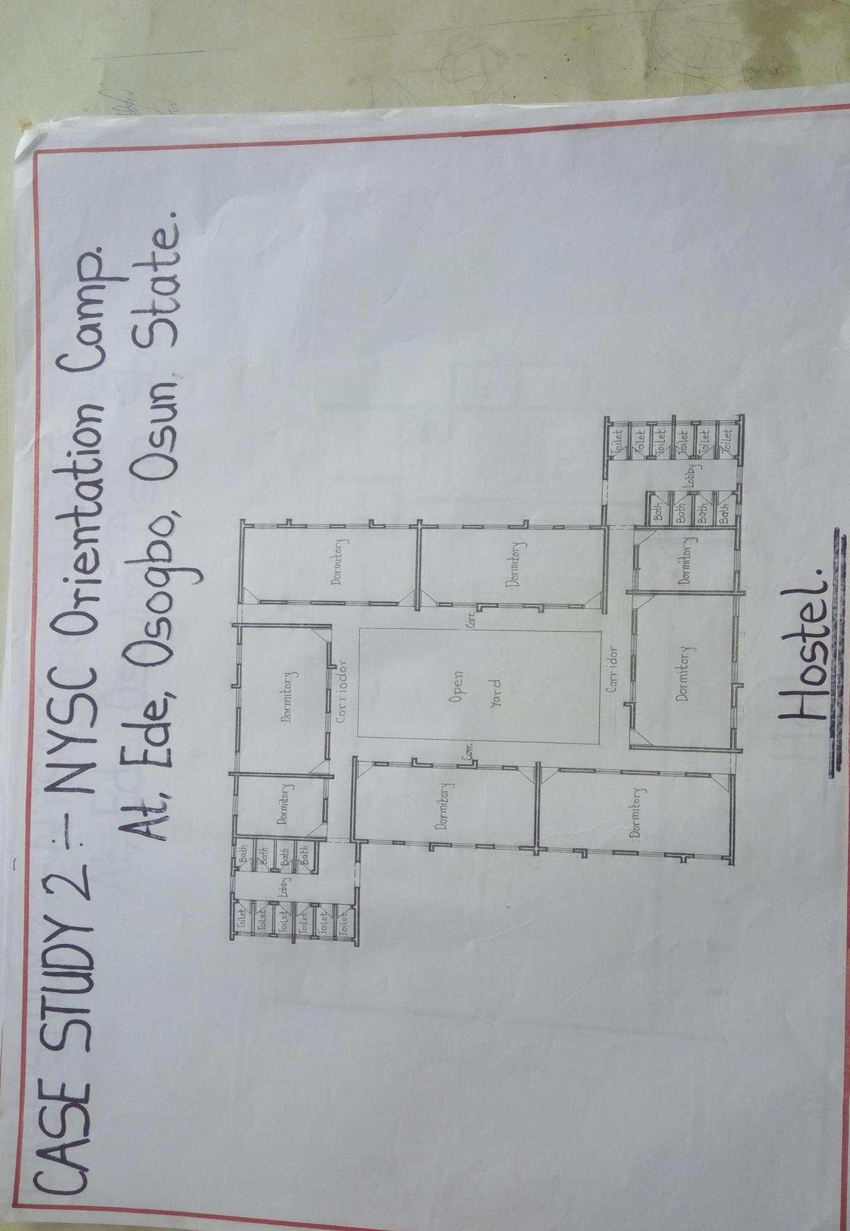
FIGURE 2.7: Hostel Floor Plan of case study two of NYSC Orientation camp, Ede, Osun State.

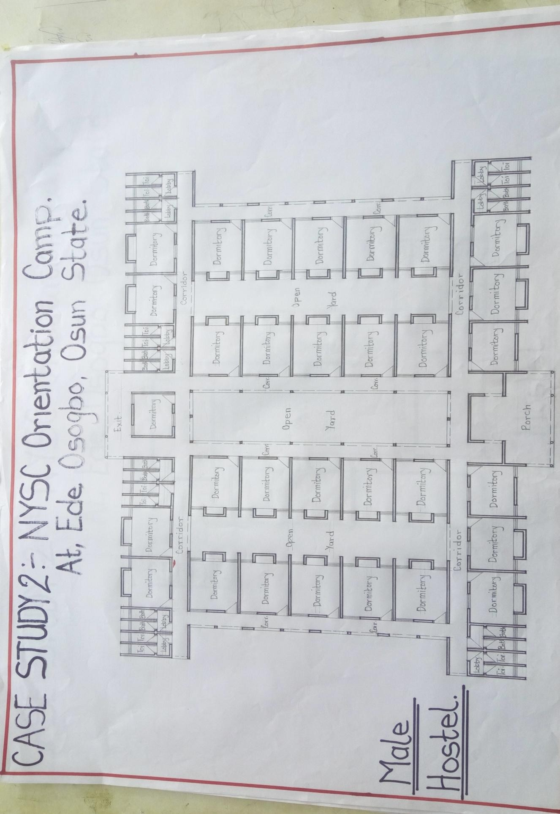
FIGURE 2.8: Male Hostel Floor Plan of case study two of NYSC Orientation camp, Ede, Osun State.

APPRASIAL MERITS
- It is easily accessible and centrally located

- Well oriented

- Adequately ventilated

- Provision for future development

DEMERIT

- Inadequate offices for the staffs.

- No provision for parking spaces.

- Not properly landscaped.

PLATE 8: Picture showing the Signpost of NYSC Orientation camp Ede, Osun State.

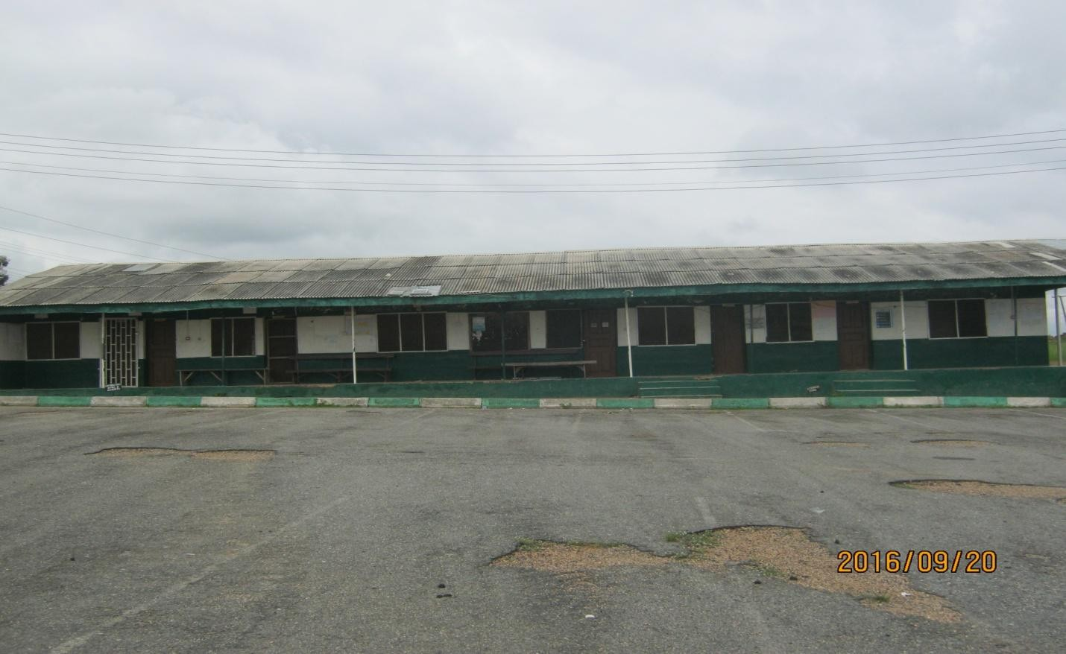
PLATE 9: Picture showing the Administration block of NYSC Orientation camp Ede, Osun State.

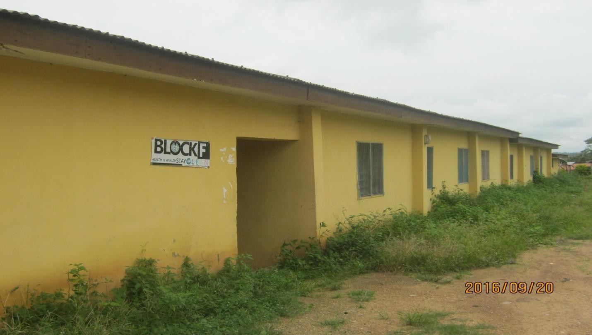
PLATE 10: Picture showing the front view of the hostel at NYSC Orientation camp Ede, Osun State.

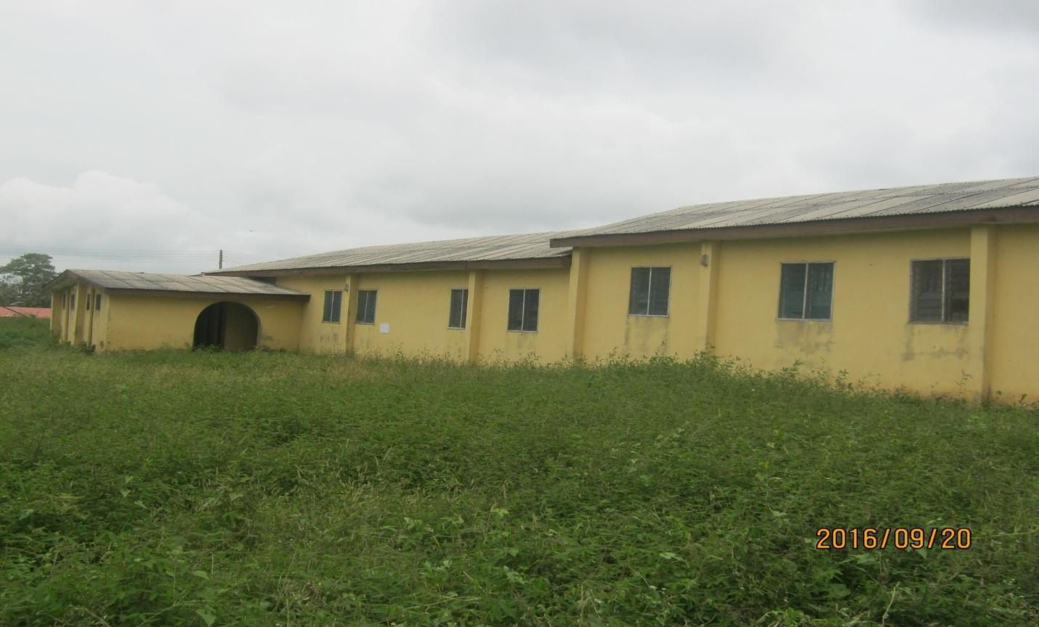
PLATE 11: Picture showing the side view of the hostel at NYSC Orientation camp Ede, Osun State.

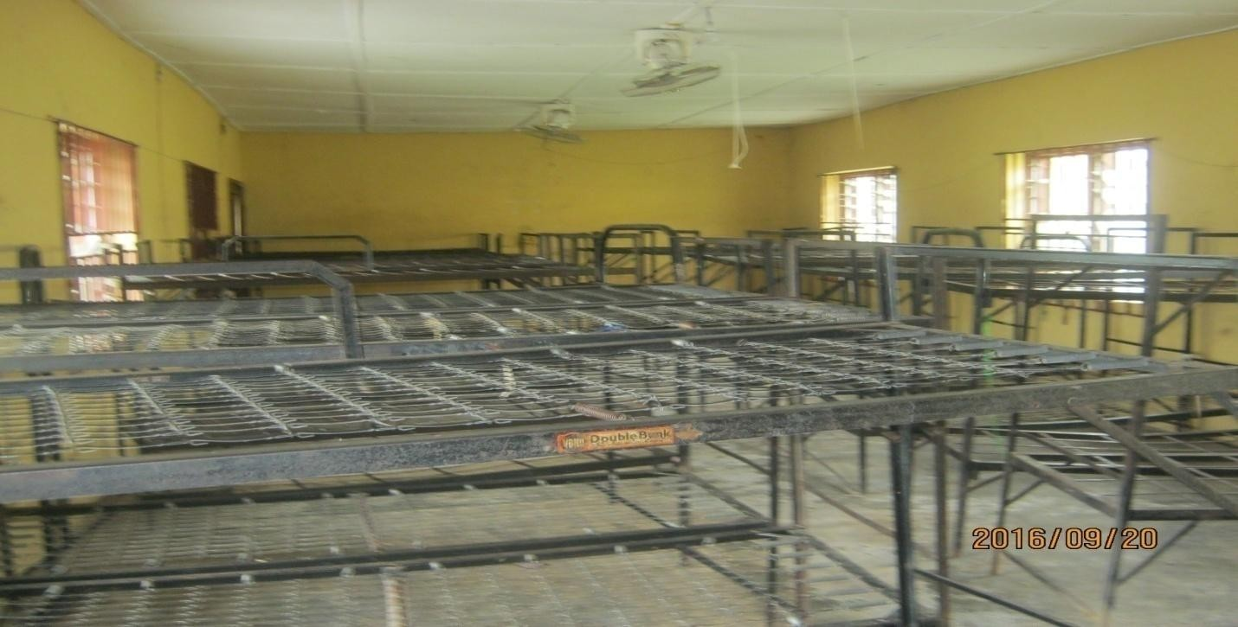
PLATE 12: Picture showing the inside view of the hostel at NYSC Orientation camp Ede, Osun State.

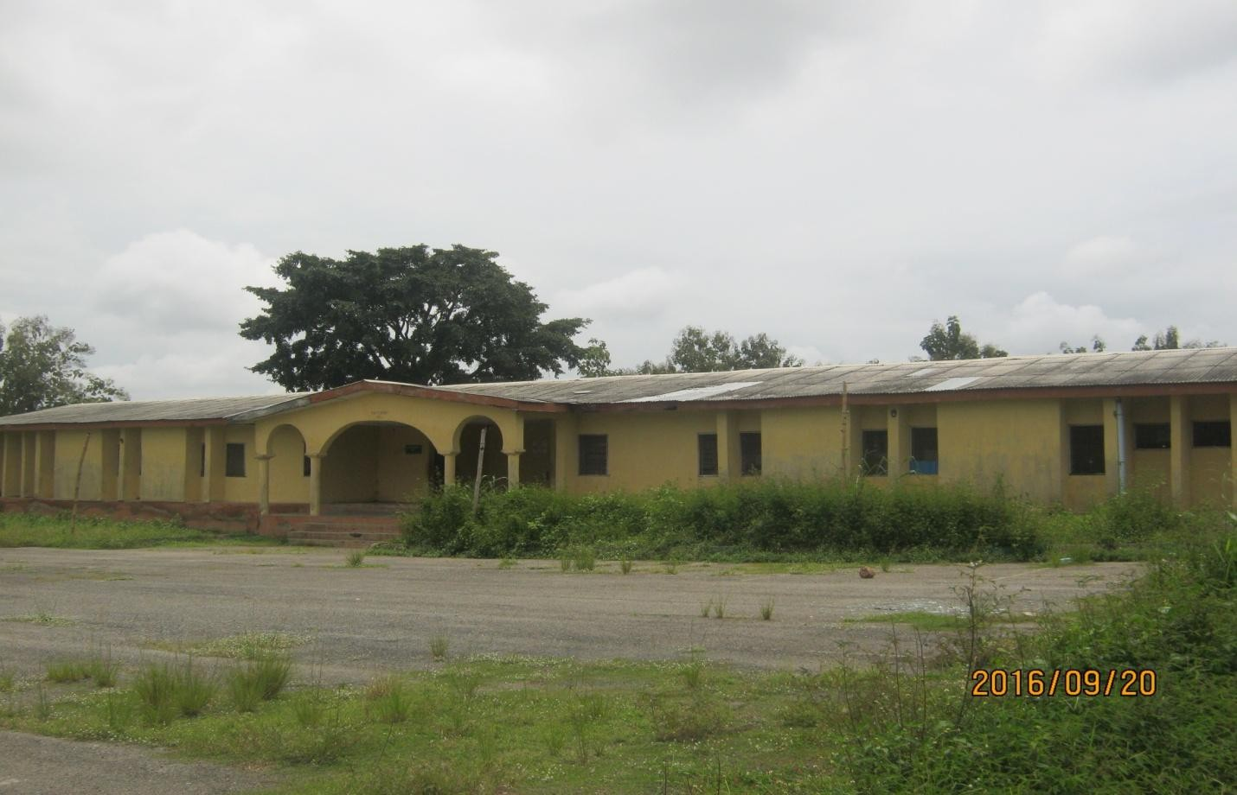
PLATE 13: Picture showing the front view (Male Hostel) of the hostel at NYSC Orientation camp Ede, Osun State.

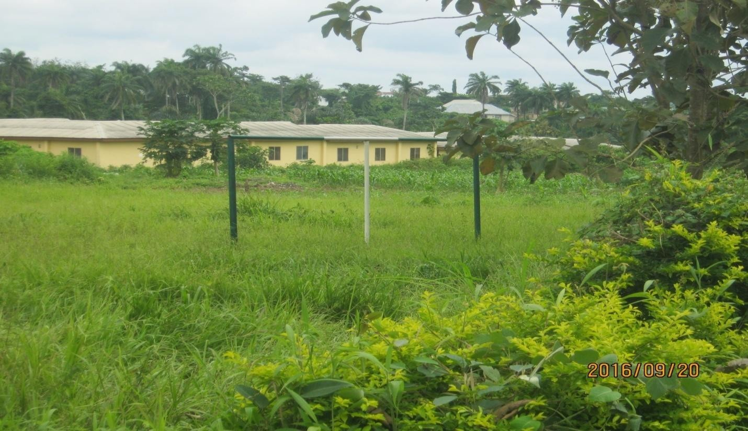
PLATE 14: Picture showing assort course at NYSC Orientation camp Ede, Osun State.


PLATE 15: Picture showing assort course at NYSC Orientation camp Ede, Osun State.

CASE STUDY THREE

Ekiti State Nysc Orientation Camp. Ise Ekiti State

INTRODUCTION
N.Y.S.C orientation camp is local at ise-orun/Emure local government area Ekiti State and consists of the following units.
- Auditorium

- Hostel (male and female)

- Administrative block.

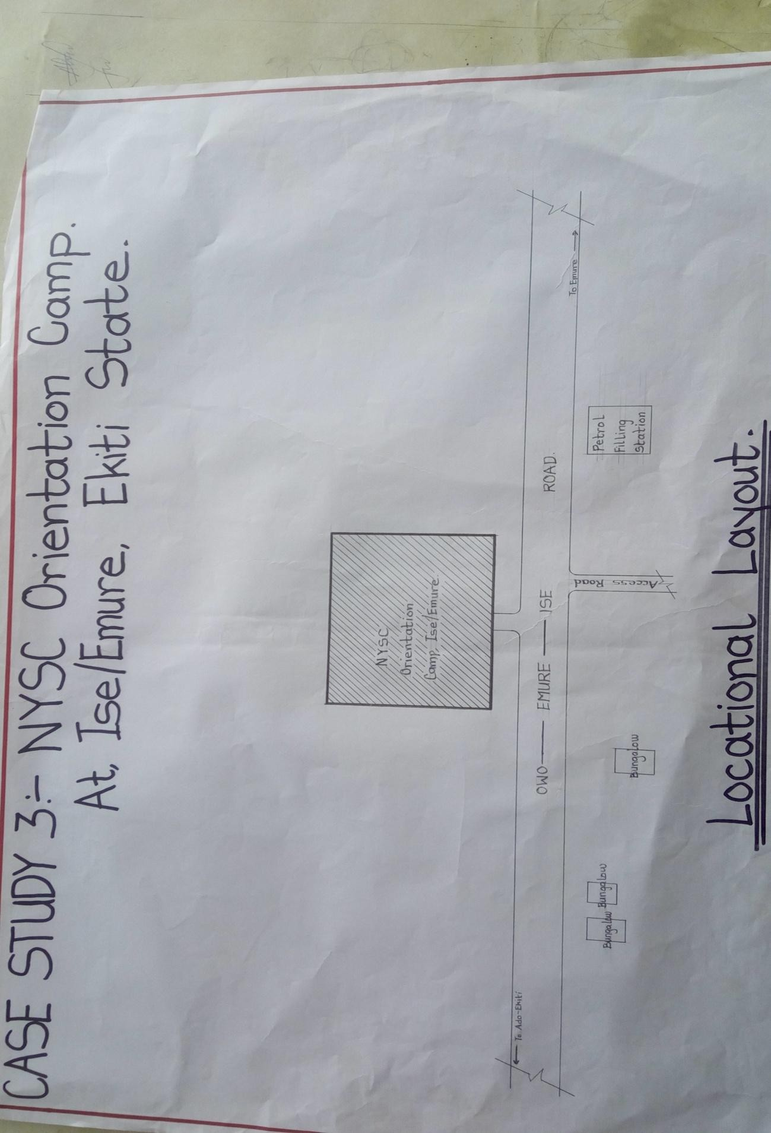

FIGURE 2.9: Location Plan of case study three of NYSC Orientation camp, Ise, Ekiti State.

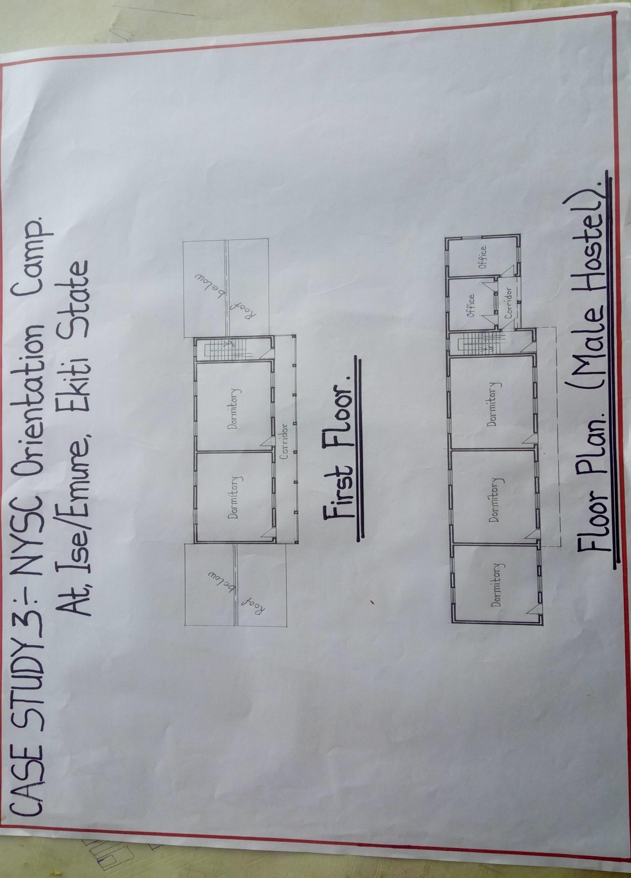

FIGURE 2.10: Male Hostel Floor Plan of case study three of NYSC Orientation camp, Ise, Ekiti State.

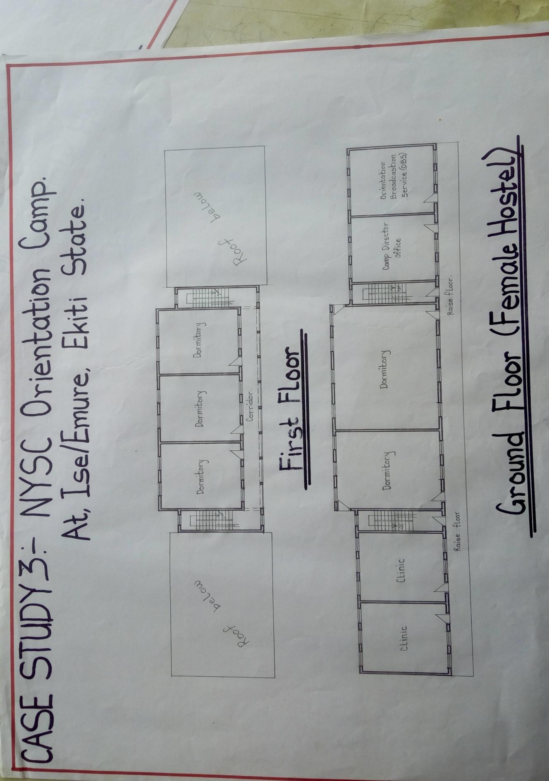
FIGURE 2.11: Female Hostel, Administration Office and clinic Floor Plan of case study three of NYSC
Orientation camp, Ise, Ekiti State.

APPRAISAL MERITS
- It is easily accessible and located

- Adequately ventilated

DEMERITS

- No provision for parking spaces

- Not propriety landscaped

- The auditorium is so small

- Inadequate quarters for the staffs

- Inadequate offices for the staffs.

PLATE 16: Picture showing the Signpost of NYSC Orientation camp Ise, Ekiti State

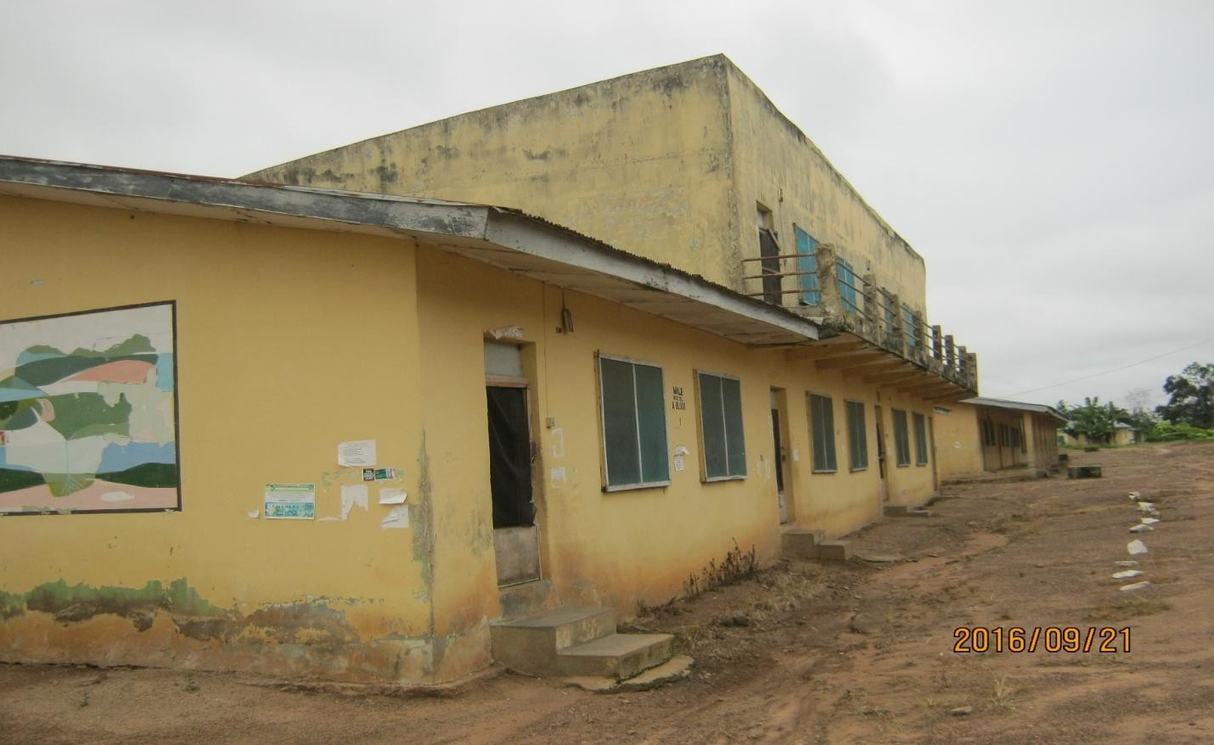
PLATE 17: Picture showing the front view of the Male hostel at NYSC Orientation camp Ise, Ekiti State.

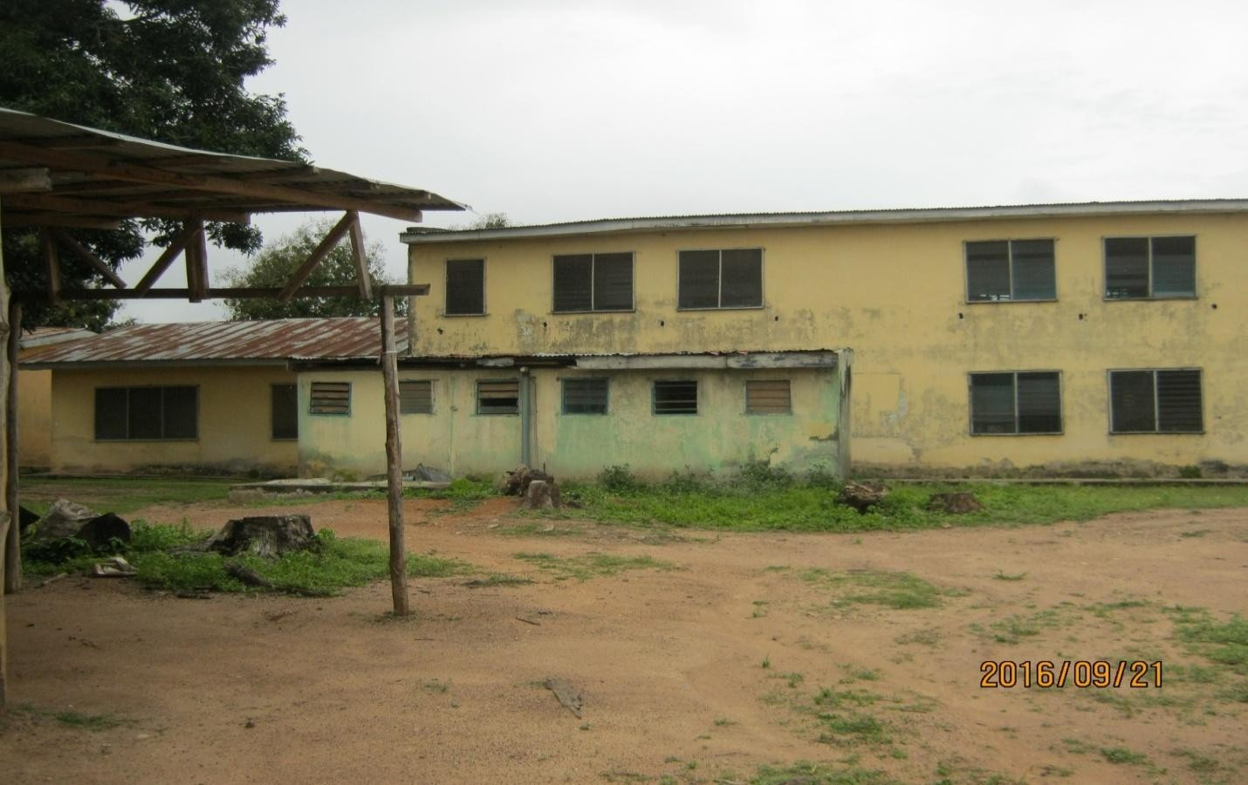
PLATE 18: Picture showing the back view of the Male hostel at NYSC Orientation camp Ise, Ekiti State.

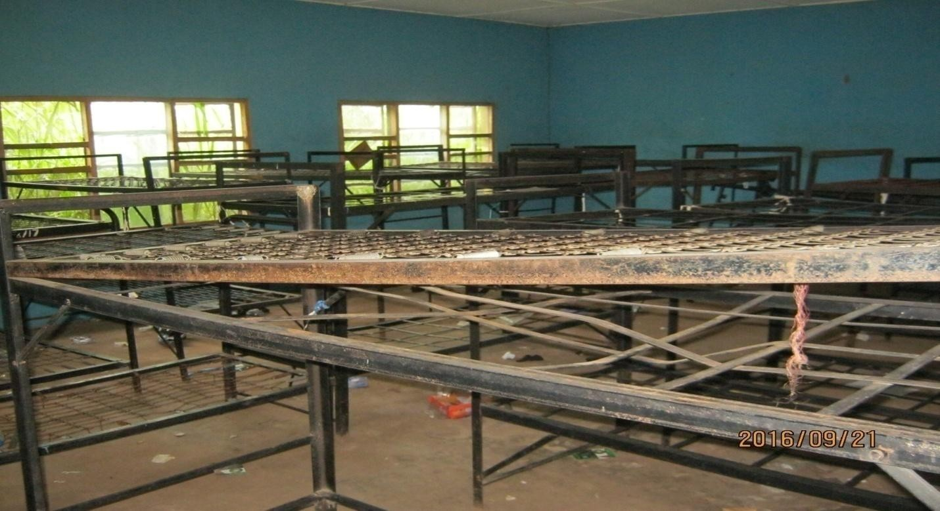
PLATE 19: Picture showing the inside view of the hostel at NYSC Orientation camp Ise, Ekiti State.

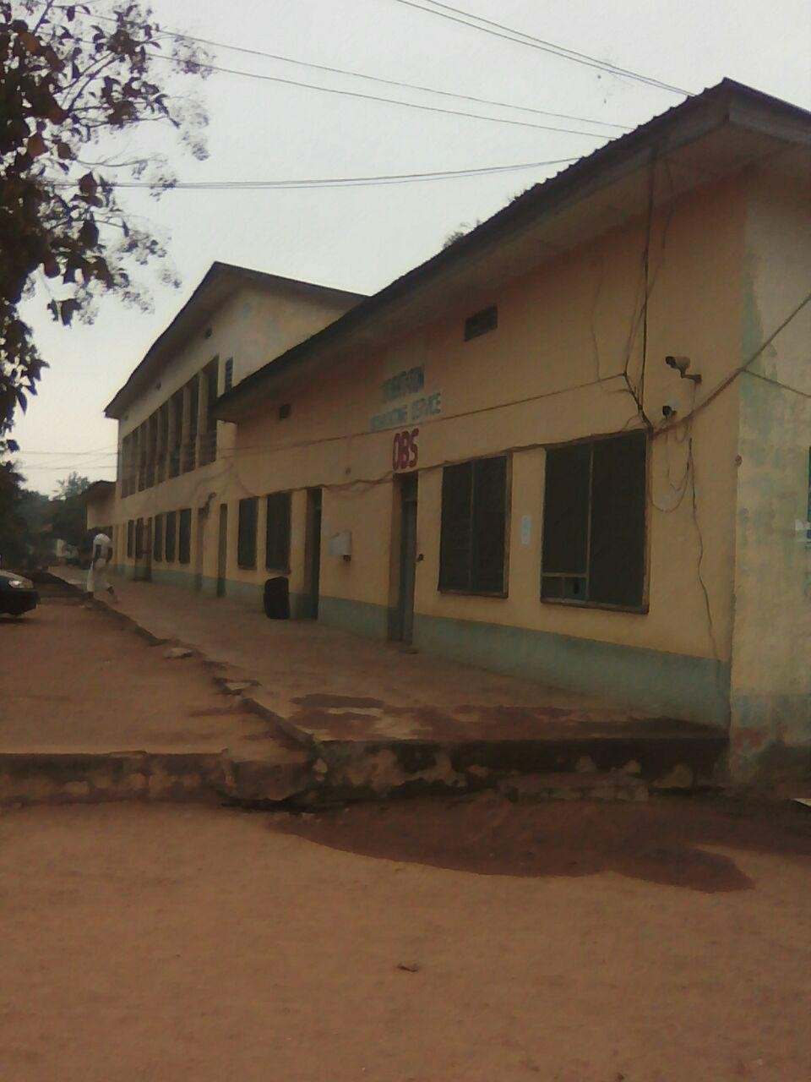
PLATE 20: Picture showing the front view of the Female hostel attached with Administration Offices, Clinic and OBS at NYSC Orientation camp, Ise, Ekiti State.

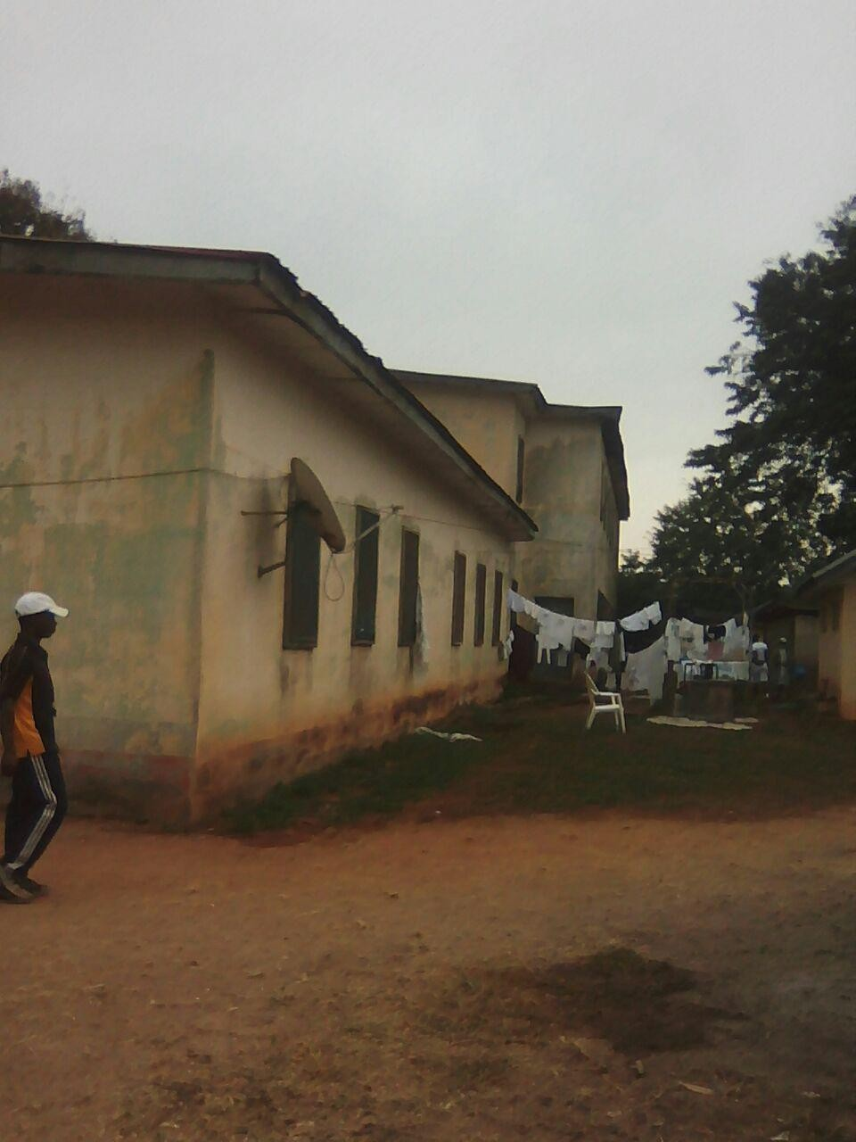
PLATE 21: Picture showing the back view of the Female hostel attached with Administration Offices, Clinic and OBS at NYSC Orientation camp, Ise, Ekiti State.

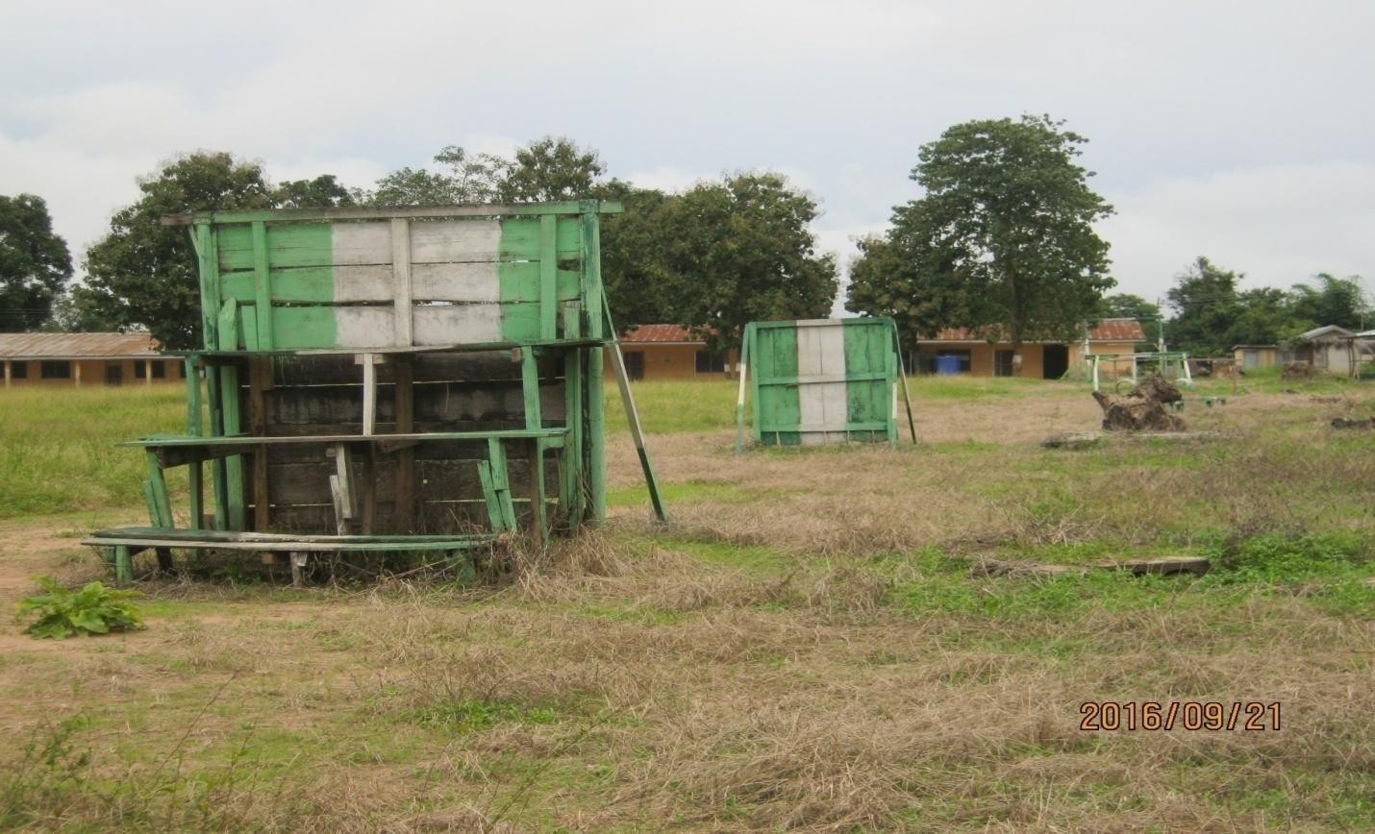
PLATE 22: Picture showing assort course at NYSC Orientation camp Ise, Ekiti State.

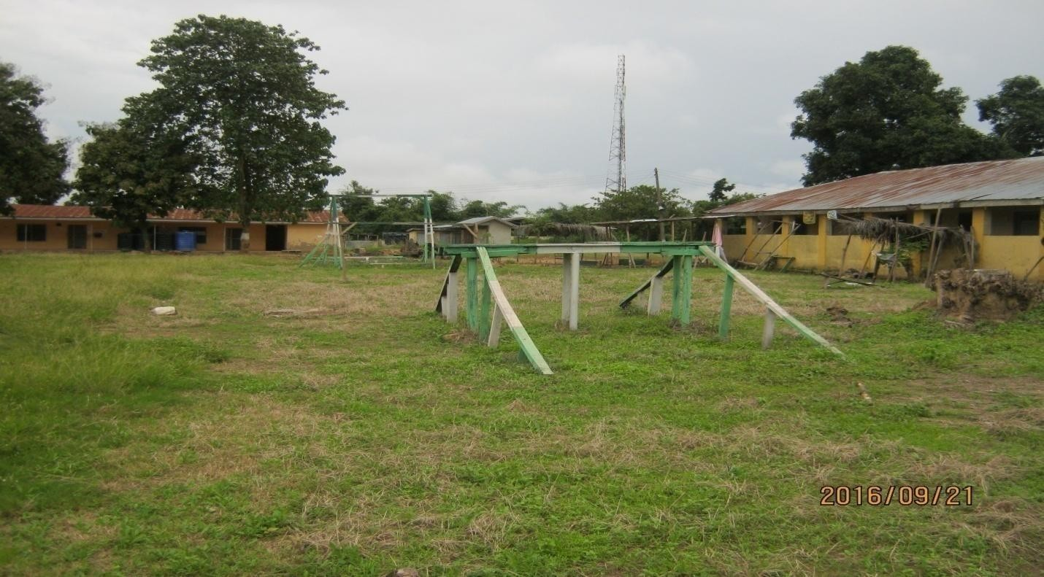
PLATE 23: Picture showing assort course at NYSC Orientation camp Ise, Ekiti State.

FINDING AND DISCUSSION/STATISTICAL BACKUP

Due to the lack of planning ahead most of the hostels in N.Y.S.C camp is not planed/ constructed purposely for the Orientation camping and are not enough for corps members, like 7- 10 years ago, corps member in a batch are not up to 1500 but now they are more than 2500. The late batch 2015 for Ekiti state was 2300 corps member and orientation camp was built for not more than 1500 corps member per batch and even through there were only two batch in a year. Not only that the corps member which is increasing but also the NYSC officials military paramilitary men, cooker, Other workers and even the seller at the mammy market. The buildings that are being built are not enough for corps member even the space are suppose to be set.

GENERAL DEDUCTION
From the case studies I carried out. It has been deduced that N.Y.S.C orientation camp should be properly oriented and the functional units should be spacious enough to avoid congestion
For a well befitting effective and functional orientation camp the entire demerit above shall be properly considered and attended to.

CHAPTER THREE
  - SITE AND ENVIRONMENTAL ANALYSIS

  - HISTORICAL DEVELOPMENT OF EKITI STATE
Ekiti is a state in south-west of Nigeria, which was declared a state on October 1st, 1996, on the government dictatorship of General Sanni Abacha, Ekiti State is situated entirely within the tropics. It is located between longitudes 40°51′ and 50°451′ East of the Greenwich meridian and latitudes 70°151′ and 80°51′ north of the Equator. It lies south of Kwara and Kogi State, East of Osun State and bounded by Ondo State in the East and in the south, with a total land Area of 5887.890sq km. Ekiti State has 16 Local Government Councils. By 1991 Census, the population of Ekiti State was 1,647,822 while the estimated population upon its creation on October 1st, 1996 was put at 1,750,000 with the capital located at Ado-Ekiti. The 2006 population census by the National Population Commission put the population of Ekiti State at 2,384,212 people.
Ekiti state was one of the many Yoruba state in Nigeria of today, Ekiti as a state and district of Yoruba race and had progeny in Oduduwa, the father and progenitor of Yoruba race.
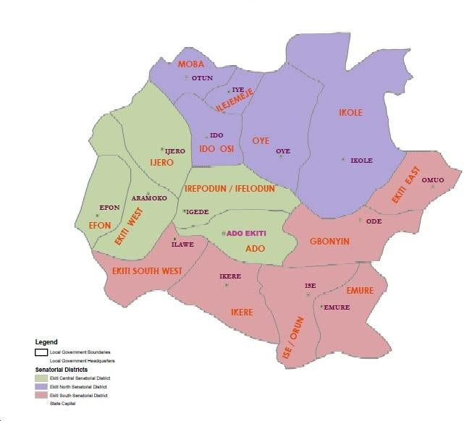

Map of Ekiti State

  - SITE LOCATION AND DESCRIPTION
The site is location along Ise/Emure road, link to Ilawe metropolis. It is about the site is a virgin land. It is located along the main access road Afelele therefore is easily accessible.

SITE SELECTION CRITERIA
    - Proximity to the major necessary infrastructure such as-
      - Major road
      - Electricity
      - Pipe borne water
    - Accessibility - The site is accessible from other part of the town, whereby any visitor/ corp member can easily locate the camp, which also fall along the major road to Emure Town.
- Good soil texture- the soil type is litarite which can easily be built on with less cost. The site appears to have a good soil bearing capacity that will ensure smooth erection process.

SITE ANALYSIS AND INVENTORY

The site is directly linked to the major road linking Ise/Emure to Ado-Ekiti, there are few scattering tress and the site is fairly sloppy, which has no rocks/rock out crops above the natural ground level.
The site is perfectly located, hence proximity to necessary infrastructure such as electricity, pipe borne water and availability of access road across the site.
The top soil is literite with layer of humus soil. This type of soil is capable to contain heavy structures. The site is is in the guinea savannah region with scattered high growing trees, shrubs and locust trees.

As been discussed above, there is road network that connects the site to the other part of the state, Electricity supply is also available near the site due to a nearby village, with electricity power cable run pass the main road of the site.
Also, there is possibility of water supply to the site, immediately as the project commence

e.g. borehole, overhead water tanks. Etc

Noise pollution is less as the project is sited/zoned to a less busy area of the state. However, the noise coming is mainly from passing by vehicles and natural noise pollution from the site vegetation.

GENERAL CLIMATE

The climate is equatorial notably with dry and wet season with relative heights humidity, the dry season lasts from November to March while the wet season start from April and ends in October. Average daily temperature ranges between 25oc (77.OF) and 35OC (95.O7F) almost throughout the year.

WIND

There are prevailing winds namely: The wind bearing south-west monsoon wind: This blow across the Atlantic Ocean between the month of May and October which is referred to as the wet season.
The dusty north-east trade wind: This blows through the Sahara desert during the month of November to April with very or no rainfall. The period is called the dry season and it brings along harmattan during its driest period.

HUMIDITY AND DURATION OF SUNSHINE
The relative humidity is as high as 70% during the dry season especially in the afternoon; it can toll as low as 15%-25% at a higher elevation and in the valley respectively. The mean

daily sunshine is a maximum of 9.06 hours in December while in August; it falls to a minimum of 3.96 hours. The extreme mean maximum of 191mm occurs in March. The yearly evaporation is 12629mm.
Based on the dates, excessive solar penetration within the building is prevented either by the use of shading devices or the orientation of the building such that the opening will not be directed to the part of the sun.

GEOGRAPHICAL/CLIMATIC DATA
The state is mainly an upland zone rising over 200m above the sea level. The site is roughly enclosed by latitude 700c 40’ north and longitude 50c 15’ east, the climate is equatorial, notably with dry and wet season with relative light humidity. The dry season lasts from November to February while the wet season starts from March and ends in October. Average daily temperature ranges between 250c (77.00F) and 350C (95.00F).
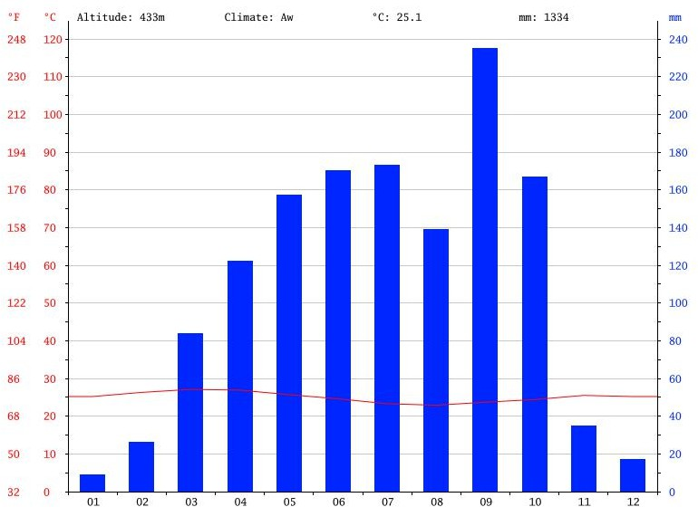
PLATE 24: Climate graph Ado Ekiti

TRADE AND HUMIDITY
The relative humidity is as high as 70% during the raining season, however during the dry season especially in the afternoon it can fall as low as 15% - 25% at a higher elevation and in the valley respectively. The mean daily sunshine is a maximum of 9.06hour in December while it falls to a minimum of 3.096hour in August. The extreme now mean minimum of evaporation of 92mm occurs in April and the maximum of 191mm occurs in March. The average evaporation per year is 129mm.

TABLE 1: HISTORICAL WEATHER DATA OF ADO EKITI
 | January | February | March | April | May | June | July | August | September | October | November | December
Avg. Temperature (°C) | 25.2 | 26.3 | 27.1 | 26.9 | 25.7 | 24.6 | 23.3 | 22.9 | 23.7 | 24.4 | 25.5 | 25.2
Min. Temperature (°C) | 19 | 19.9 | 21.5 | 21.8 | 20.8 | 20.5 | 19.7 | 19.4 | 19.9 | 19.9 | 19.9 | 18.6
Max. Temperature (°C) | 31.4 | 32.7 | 32.8 | 32.1 | 30.7 | 28.8 | 27 | 26.5 | 27.6 | 28.9 | 31.1 | 31.8
Avg. Temperature (°F) | 77.4 | 79.3 | 80.8 | 80.4 | 78.3 | 76.3 | 73.9 | 73.2 | 74.7 | 75.9 | 77.9 | 77.4
Min. Temperature (°F) | 66.2 | 67.8 | 70.7 | 71.2 | 69.4 | 68.9 | 67.5 | 66.9 | 67.8 | 67.8 | 67.8 | 65.5
Max. Temperature (°F) | 88.5 | 90.9 | 91.0 | 89.8 | 87.3 | 83.8 | 80.6 | 79.7 | 81.7 | 84.0 | 88.0 | 89.2
Precipitation  / Rainfall (mm) | 9 | 26 | 84 | 122 | 157 | 170 | 173 | 139 | 235 | 167 | 35 | 17

Based on these dates, excessive solar penetration within the building shall be prevented either by the use of shading devices or orientation such that the opening will not be directed to the part of the sun.
Agriculture is the main occupation of people in Ekiti state. The climate in the state favors cultivation of crops like Maize, Cassava, Yam, Cocoa, Palm produce etc

Ekiti is also known for trading and commerce. They engage in the sales of farm produce and goods like provision, clothing and cooking utensils.
The manufacturing industry comprises of large and small industries using simple and complex machineries, the large scale industries comprises of maize factory, bond chemical industries, foam industries and many more which serve as a means of employment for large number of people. The small scale industries are saw mill, structural metal firm, hand craft and several bakeries.

CHAPTER FOUR
  - DESIGN CRITERIA

This type of design call for some basic fundamental knowledge of functionality of space and high aesthetics value of forms.
NYSC orientation camp as earlier define, call for different zoning and planning or arrangement that will make the objectives of this project to be attain.
Some of the considerations are:

- Organizing a well flow chart among the units

- Provision of enough infrastructures

- Providing a well aesthetic building.

DESIGN SCOPE/BRIEF ANALYSIS

The existing NYSC orientation camp at Ise-Orun/Emure is formally a secondary school structures, ever since the inception of National Youth Service Corps. The school is not ideal and convenient for the orientation programme, therefore urgent attention is need.
Due to numbers of function performed at the camp, the school building is insufficient for the functions and activities need to be perform at the orientation camp. This project is therefore aiming to propose a new NYSC orientation camp to solve these problems.

SCOPE ANALYSIS

The project design is to incorporate the following units:

      - Administrative Block

      - Hostel

      - Staff Quarters

      - Military Quarters

      - Auditorium
      - Clinic

      - Parade/Camp Ground
      - Kit Store
      - Orientation Broadcasting Service (OBS)
      - Mosque
      - Chapel
      - Mammy Market
      - Kitchen/Dining
      - Sport Arena

      - Quarter Guard

Nevertheless, from the above listed scope, I restricted my design to three structure of the listed scopes, which are:
- Administrative Block

- Hostel

- Staff Quarters

BRIEF ANALYSIS

- ADMINISTRATION BLOCK

  - State Coordinator office

  - Secretary to State Coordinator

  - Camp Director office

  - Secretary to Camp Director office

  - Accountant office

  - Store keeper office
  - Sport director office

  - Registration office
  - Conference room
  - Convenience
  - Store

HOSTEL
  - Dormitory
  - Common room
  - Convenience

  - Laundry Yard

STAFF QUARTERS

  - Sitting room

  - Bedroom

  - Kitchenette

  - Convenience

  - SPACE ALLOCATION/SCHEDULE OF ACCOMMODATION TABLE 2: ADMINISTRATION BLOCK
^{S}/N | Units | No | Dimension  L x b (m) | Area (m²)
1 | State coordinator office | 1 | 3.6 x 3.6 | 12.96
2 | Secretary to State coordinator | 1 | 3.6 x 3.6 | 12.96
3 | Camp director office | 1 | 3.6 x 3.6 | 12.96
4 | Secretary to Camp director office | 1 | 3.6 x 3.6 | 12.96
5 | Accountant office | 1 | 3.6 x 3.6 | 12.96
6 | Store keeper office | 1 | 3.0 x 3.6 | 10.8
7 | Sport director office | 1 | 3.0 x 3.6 | 10.8
8 | Registration office | 3 | 3.0 x 3.6 | 10.8
9 | Store | 1 | 2.4 x 3.6 | 8.64
10 | Conference | 1 | 4.5 x 6.0 | 27.0
11 | Convenience | 6 | 1.0 x 1.8 | 1.8

TABLE 3: HOSTEL
^{S}/N | Units | No | Dimension  L x b (m) | Area (m²)
1 | Common room | 2 | 14.4 x 15. 6 | 224.64
2 | Dormitory | 20 | 15.0 x 17.2 | 108.0
3 | Convenience | 40 | 1.0 x 1.8 | 1.8
4 | Laundry yard | 1 | 14.1 x 12.0 | 169.20

TABLE 4: STAFF QUARTERS
^{S}/N | Units | No | Dimension  L x b (m) | Area (m²)
1 | Sitting room | 5 | 4.2 x 3.6 | 15.12
2 | Bedroom | 5 | 3.6 x 3.6 | 12.96
3 | Convenience | 40 | 1.8 x 2.1 | 3.78
4 | Kitchenette | 1 | 1.8 x 2.7 | 4.86

FUNCTIONAL RELATIONSHIP
The concept for the site is based on uniformity and functionality of structures. The proposed buildings consist of the Hostel(Male and Female) at the northern end of the site, the administrative at the southern part of the site and staff quarter at the western part of the site. To both eastern and northern parts of the site are the other buildings.

CONCEPTUAL DEVELOPMENT (SITE AND BUILDING)
- DESIGN PARAMETER

The general planning of the orientation camp requires certain consideration which an architect and a planner are suppose to understand. It is the duty of the planner to know the object to which all activities are directed to and the means of accomplishing them through the uses of structures.
It should be noted that, areas of building and facilities for administration welfares of the corps members should be well located, fit the environment and accommodate the various diversify interest. There are three basic parameters used to evaluate the purpose of design and these are:
  - Planning consideration

  - Environmental consideration

  - Design consideration

PLANNING CONSIDERATION

The basic consideration lies in site planning. This involves the evaluation of needs of social group of people within the identifiable geographical setting.
The principles of site planning are aimed at:

  - flexibility and growth of structures

  - adequate zoning of the site

ENVIRONMENTAL CONSIDRATION

The environmental consideration is quite important and this affects man and structures alike, in a built up environment, basically there are far prominent environmental factors to be considered in the design and these are:
- Wind control
- Thermal comfort.

WIND CONTROL

The improvement of human comfort in the building can be achieved by introducing adequate openings and control of air movements in the building.
Usage of trees for external landscaping also provides cool air into the building. Introduction of court yard to the building eventually improves the comfort in the building by air. There are times the use of external barriers such to reduce noise from the external traffics.

THERMAL COMFORT

Thermal comfort can be achieved through careful design and choice of building both day and night. Also the principle of time help to ensure an adequate thermal comfort i.e utilizing heavy construction techniques to allow accumulation of heat during the day which is release at night. Good thermal comfort can also be achieved by using natural and manmade element such as fountain or pool to reduce air movement.
The orientation of building plays a significant role in the thermal comfort in which the best orientation is assumed for the building. Openings should be toward north-south elevation.
The use of shading devices helps in building against the sun rays.

DESIGN CONSIDRATION
The consideration for camp involves a thorough understanding of the organization and the analysis of spaces for a functional usage of the centre
- SPACE ANALYSIS: Space analysis of spaces to be provided and it is quite important deducing the space of area or hectares of land. Thus this analysis influences the design.
The purpose of the space analysis is to determine the physical characteristics, the quality and condition that can satisfy the client. The ultimate is the translation of the criteria to physical dimension.
- PRODUCT: The product comprises of physical elements which comprise of space needed. This includes types and number of different spaces, area requirement usual acoustic and comfort criteria requirement and furnishing need to make space usable and space relationship.

LANDSCAPING

Landscaping is to improve the general appearance of a building with its surroundings and increases its value of the design.
Landscaping can also be used for thermal control such as to reduce for wind effects, to provide shading against direct sun rays and assist ground drainage. Landscape elements include soft and hard element. Manmade sculptures, garden, lawns, sit out, etc.
For this project attempts are made to use landscape elements, which enhance the general aesthetic values of the environment.

OTHER ELEMENT FOR ENVIRONMENTAL IMPROVEMENT AND PROTECTION
- FINS AS SHADING DEVICES

Vertical fins to the walls are used in asymmetrical orders to prevent heat transmission into interior of the building.

OTHER SHADING DEVICES
Trees and ornamental plants, these are shading devices used to protect heat from the sun on the building, which eventually improves human comfort in a building. Trees are therefore used as shading device, which also aids cool air into the building if properly located.

RAIN PROTECTION

Since rain can be sudden, heavy and wind borne in the part of the country, pitched roof are used, the roofs are suspended over roof gutters.

CHAPTER FIVE

APPRAISAL OF PROPOSED SCHEME

The design appraisal of project is basically concentrate on the basic concept of orientation camp, architecture which is to provide a simple and imaginative center is design on functional orientation camp, well circulated orientation structural rigidity, etc. in order to perform its functions as expected.

CONSTRUCTION METHOD

The method of construction involve in the erection of the building structure is in accordance with the architectural detail required in executing the buildings and the process of construction that is critical to structural component as affected by the site conditions and types of materials to be used.
After the preparation of the overall site plan many design detail is developed to show the specific methods of construction. These details as an integral part of the design process and serve two important purposes. Firstly, they stipulate the aesthetic and structural element of the plan and second, they provide the basis for costing project.
This section offers a wide range of representative details of the various aspect of site development and assumed that the details will act as guild to assist site designer. This solves their particular problems. The section is not intended to present aesthetic or design solution alone but also indicate how similar technological difficulties are handled. It is clear that the method of construction of any structure such as a housing estate is determined from the functional requirement of the facilities provided and its exposure to weather and climate condition for any used, the following factors are considered.
    - Climatic conditions of the site

    - Condition of the sub-soil present on the site
    - Fire protection requirement

    - Appearance of materials
    - Durability and easy maintenance
    - Economy
    - Availability of materials
    - Aesthetics
    - Construction technique
    - Cost of materials
The various building components taken into consideration are:

i. SUB-STRUCTURE:

This is the part of the building below the natural ground level. The foundation footing are reinforce for stability of the building to enable it to withstand the load (live, super-imposed and wind load). The foundation of the building shall be determined by the structural engineer according to the bearing capacity of the soil.
i. SUPER-STRUCTURE:

This is the building part that is above the natural ground level. The entire structure is designed with reinforced concert columns, beams and hollow sand screed block

MATERIALS AND STANDARD FORMS

The following materials are applied in the construction of the structure such as:

- FLOORS

The ground floor will be of solid concrete slab of 150mm with asphalt coating as damp proof course laid on well compacted hardware. The upper floors are reinforced concrete suspended floors of 150mm thick.
Floor finishes are to be specified for each unit depending on the function it is meant to serve, floor finishes are ceramic floor tiles and terrazzo floor tiles because they are durable, easy to maintain and do not wear easily.
- DOORS
The size and types of doors used depend on its location but generally the size ranges from 750mm, 900mm, 1200mm and 1800mm. The type of materials specified for the construction is in the door schedule which should be strictly followed.
- WINDOWS

A window in a building is designed primarily to allow natural light, natural air, the building and used to allow free flow of carbon dioxide out of the building as well as to allow for outside view. The choice of window to be used is specified in the window schedules.
- ROOFS

Roof members of all building will be made up of timber and long span of aluminium roofing sheet. This is for the easy maintenance of self-support and longer life span
- CEILING

The kind of ceiling system specified for the building in the housing estate is the asbestos ceiling sheet. The functional requirement of this ceiling is considered under the following:
- Durability

- Easy to maintain

- Heat resistance
- Cost

ESSENTIAL SERVICES
Services are essential for comfort ability security and safety to create a conducive atmosphere for the users of the housing estate to achieve this, the following services must be provided.
- ELECTRICITY

The main source of electricity is from the national electric power authority and this should be connected to the site from the power line in front of the site way.
- VENTILATION

Ventilation needed in the intention part of building varies from place to place. Natural ventilation is considered best in building construction and is attained with the use of natural air. Natural air reaches interior part of the building through windows and some other openings. Artificial ventilation is attained with the use of fans and some other atmospheric cooling machines
- LIGHTENING

Natural lightening is the best and most effective source of light for the building though artificial sources will be used where necessary
- PLUMBING SERVICES

All water supplies and other distribution to all the required areas would be through 50mm diameter galvanized steel pipe while sewage will be PVP service pipe, which ranges from 50mm, 100mm and 150mm diameter. All the baths and shower will be provided with shower tray, towel trays, washing hand basin and tissue roll holders.

The entire toilet WHB will be with a mirror over it.
Septic tanks and soak away pit shall be placed and in suitable location for easy maintenance.
- ACOUSTICS
The major noise comes from the major road and this could be reduced considerably by maintaining a reasonable setback from the major road and the proper landscaping which include planting of trees and grass to serve as noise and sound absorbent
- WASTE DISPOSAL

Waste disposal should be provided where unwanted materials such as dirty should be dump in order to make the environment clean.
- FIRE PROTECTION

Structural protection is achieved by using fire resisting elements and limiting the use of combustible materials and finishes. Fire detectors and fire fighting equipment should be provided.
- SECURITY SERVICES

The entry and exit to the site has been restricted to one entrance. This is to monitor the movement of vehicles in and out of the site. The entrance will be maintained with the security men checking incoming and outgoing vehicles. The entire site will be light up with security light and street light within the site. It is necessary to fence the housing estate to ensure adequate security, a strong fence is provided in addition to the police post in order to keep off intruders of all types.
- EXTERNAL WORKS

These are works carried out outside and around the building. It is otherwise known as Landscaping.
These are elements used to provide aesthetics and general human comfort in and around the building.
There are two types of landscaping:

  - Soft Landscaping

  - Hard Landscaping

- SOFT LANDSCAPING: This is done by planting trees, shrubs and flowers around the building to serve as barrier to the thermal discomfort and beautify the structures
- HARD LANDSCAPING: This is done by paving the whole of the open ground and such paving area include the parking lots, the walk ways, roads etc.

CONCLUSION AND RECOMMENDATION

The major consideration in this design of the proposed NYSC orientation camp are centered to provide adequate functional spaces that will meet the modern and comfortable orientation environment, which will reflect with a well architectural planned and designed structures, that will enhance the aesthetic value of the environment.
With this attempt a great percentage of the above requirements have been met. Future user of this proposed orientation camp may find this proposal useful as adequate orientation accommodation.

REFERENCES

Anita Lawrence (1989): Acoustics and built environment Elsevier science publisher ltd.

Barry R. (1982): The Construction of Building Third Edition, A John Wiley and Sons, Ltd, Publication

Burridge, R. and Ormandy D. (1993): Unhealthy Housing Research, Remedies and Reforms, First Edition.

Effions- Williams J. (2010):McGraw Hill Encyclopedia of Science and Techbonolg

Harri. C.M. (1975): Dictionary of Architecture and Construction. Pub MC graw Hill.

Book Company

Lyneh, K. and Hak, G. (1984): Site Planning. Pub Mip Press Cambridge Massachusetts and London, England.

Mcmullan R. (1983): Environmental Science In Building Macmillan.Pub First Edition.

Neufert E (1980): Architects Data. (third national English edition), Granada publishing limited.

Great britain

Ramsey and Sleeper (2000): Architectural Graphics Standards. Tenth Edition. John Willey and Sons Inc.

Rogers E.K (1982): The Modern House: Its Design and Decoration. Harper and Row Pub.

Salvato.A.J(1982): Environmental Engineering and Sanitation. Third Edition. John Willey and Sons Inc.

APPENDIX

