PROBLEMS ASSOCIATED WITH THE MANAGEMENT OF PRIVATE RESIDENTIAL ESTATE.
(A CASE STUDY OF ALHAJI OSENI OLANREWAJU ESTATE)

PRESENTED BY

ROQEEB AJIBOLA OLAMIDE
ND/23/ETM/PT/0066

A RESEARCH PROJECT SUBMITTED TO THE DEPARTMENT OF ESTATE MANAGEMETN, INSTITUTE OF ENVIRONMETAL STUDIES, (IES) KWARA STATE POLYTECHNIC, ILORIN.

IN PARTIAL FULFUILMENT OF THE REQUIREMEBNT FOR THE AWARD OF NATIONAL DIPOLMA (ND) IN ESTATE MANAGEMENT,

JUNE, 2025.

CERTIFICATION
This is to certify that this project work was carried out by ROQEEB AJIBOLA OLAMIDE of matriculation Number ND/23/ETM/PT/0066 in the Department of estate management is accepted having conform with the requirement for the award of National Diploma (ND) programme in estate management.
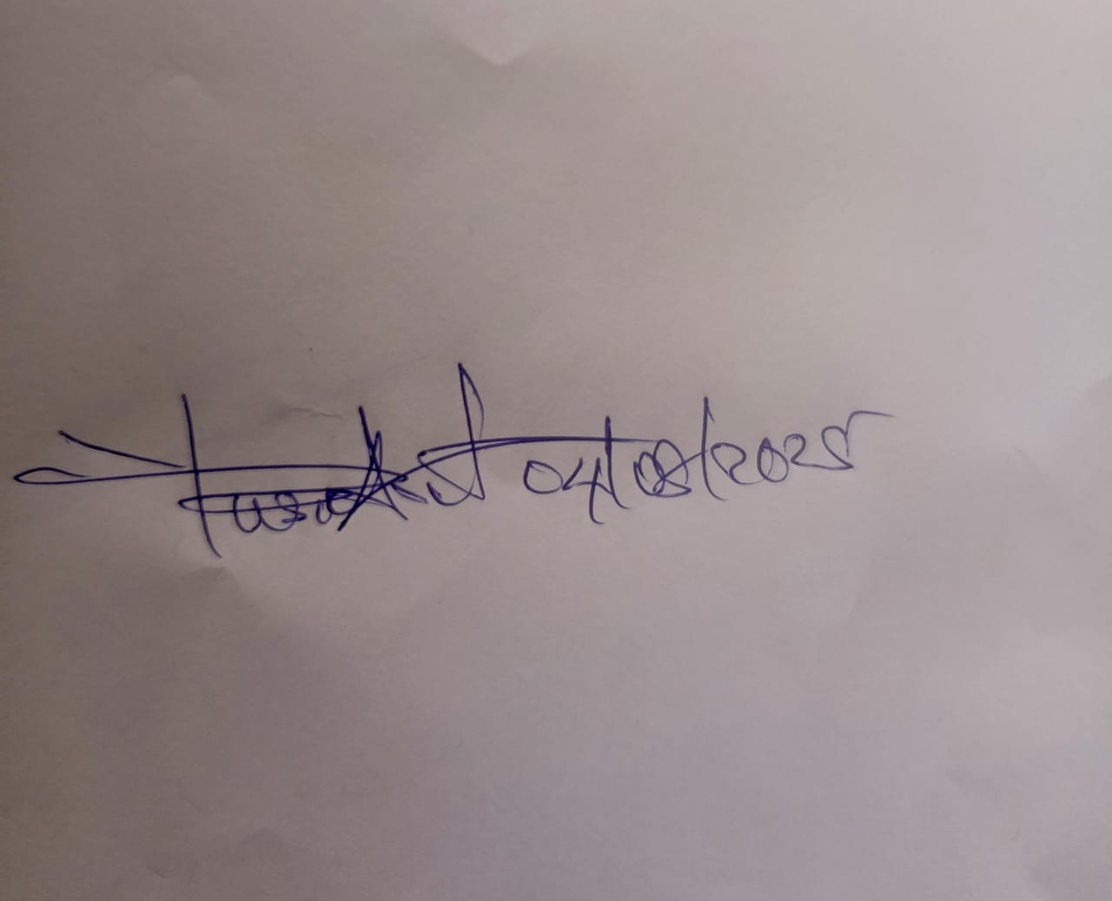

________________________________________ ______________
ESV. ABDULKAREEM RASHIDAT ARIKE DATE
Head of Department



11/08/2025
___________________________________ _______________
MR. ABDULAZEEZ ABDULMUMEEN DATE
Part-Time Coordinator

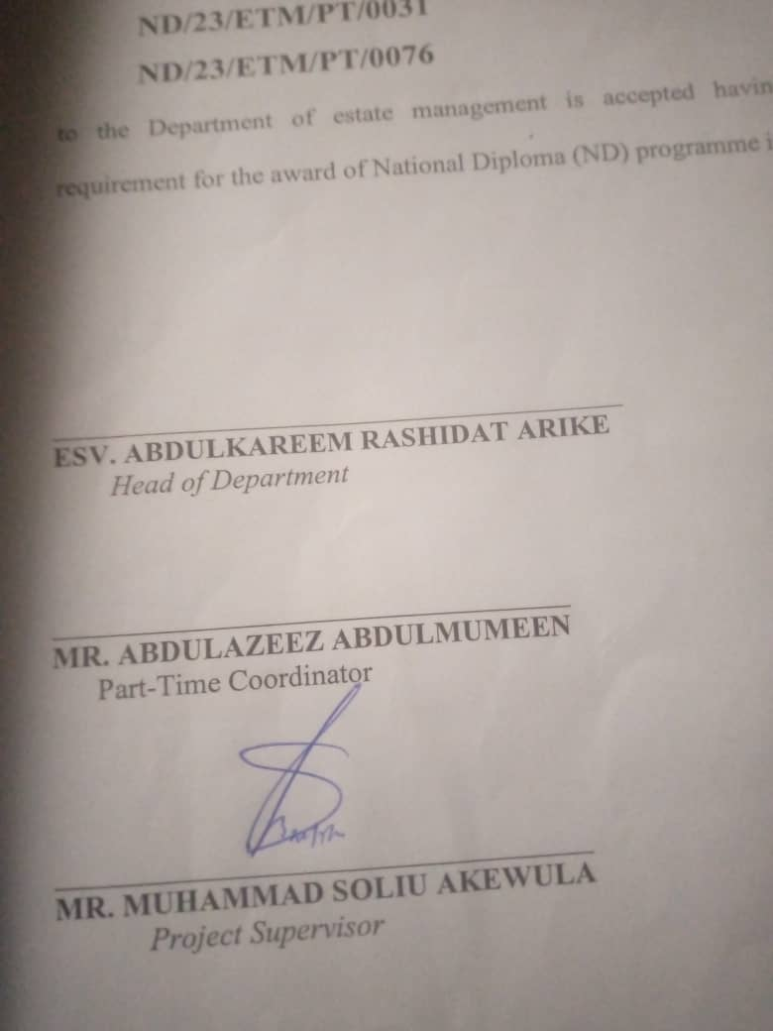

21/07/2025
___________________________________ ______________
MR. MUHAMMAD SOLIU AKEWULA DATE
Project Supervisor

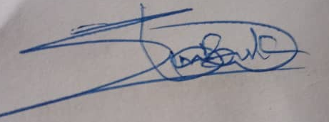

11/08/2025
_______________________________ _______________
ESV LAWAL SIMIAT B. DATE
Project Coordinator



11/08/2025
____________________________ _______________
ESV. ABDUL SULE AYINLA DATE
(ANIVS/RSV)
External Examiner

DEDICATION
This research is dedicated to Almighty God, the owner of Universe for His special grace on us, right from Birth to this Moment and also to our Lovely and Caring Parents.

ACKNOWLEDGEMENT
All praise, Glory and Honour to Almighty God, The Author and the Finisher of our Faiths, The one who Remains in Existence after everything seized to exist. We thank Him for His grace and Strength giving to us for the successful completion of this Project.
Our sincere appreciation goes to our wonderful loving and caring parents, friends and families for their moral, financial and spiritual supports from our childhood till date, may they live long to eat the fruit of their labour.
Furthermore, our profound gratitude goes to our project supervisor in person of MR. MUHAMMAD SOLIU AKEWULA for his fatherly advice and guidance before, during and after this project work. May God continue to bless you and be with you and your family all days. We also tender our sincere appreciation to our (Coordinator) in person of MR. ABDULAZEEZ ABDULMUMEEN and other lecturers in our department, God’s mercy will always be with you all (Amen).
My special appreciation goes to my beloved parent Mr and Mrs. ROQEEB. I pray that you live long to reap the fruit of your labour (Amen).
Finally, we return all praise and honor to Almighty God for preserving our life to witness the end of this programme.
May your name be praise in our life forever (Amen).

TABLE OF CONTENT
Title page i
Certification ii
Dedication iii
Acknowledgement iv
Table of content v
Synopsis vi
CHAPTER ONE
1.0 Introduction 1
1.1 Statement of problem 2
1.2 Aim and objective of the study 2
1.3 Significant of the study 3
1.4 Scope of the study 3
1.5 Limitation of the study 4
1.6 The study area 4
1.7 Definition of term 4
CHAPTER TWO: LITERATURE REVIEW/CONCEPT/THEORETICAL FRAME WORK
2.1 General principle of management 6
2.2 Management functions 6
2.3 Concept of property management 7
2.4 Property maintenance 7
2.5 Functions of property manager 9
2.6 Concept of private resident estate 9
CHAPTER THREE: RESEARCH METHODOLOGY
3.1 Research design 11
3.2 Data types and source 11
3.3 Instrumentation for data collection 12
3.4 Sample frame, sample size and sampling procedure 12
3.5 Method of data collection 14
3.6 Method of data analysis 14
CHAPTER FOUR: DATA PRESENTATION AND ANALYSIS
4.1 Facilities and services in the study area 18
4.2 Management procedure employed in the management of the study area. 18
4.3 Analysis of response in the facilities and services 20
4.4 Condition of the building and services 20
CHAPTER FIVE: SUMMARY OF FINDING, RECOMMENDATION AND CONCLUSION
5.1 Summary of findings 22
5.2 Recommendation 22
5.3 Conclusion 25
5.4 References 28
5.5 Appendix i-iii 33

SYNOPSIS
Developers and property ensure now realizes the close relationship between property management and effectively managed property and the income flow form which property, termites too are becoming increasingly aware of their ringlets and liabilities within the legal framework of their tenancy, a situation which now makes property management practices more technical and broad in operation.
This research work is therefore carried out to examine a critical analyzes of the management procedure, associated with private residential estate.
It also identifies the management problems and recommends possible solutions to the problem.
Both Primary and secondary sources of data collection will be adopted in the research work to get necessary information about the research problem.

CHAPTER ONE
- INTRODUCTION
Until recently, property management as an area of real estate practice was considered as simple of rent collection and attendance to minor repair works in building. Landlords or their appointed surveyor in most cases, were involved in this regard.
However, the national economy coupled with the resultant effect of increasing cost of building material and souring cost of capital caused a shift of attention to corporate management in landed properties, the risk involved in real estate development has inevitably increased. Consequently, additions to existing stock of properties have reduced strongly. In conforming to the attributes of capital appreciation, rents and value on properties rise with multiple years rent now being demanded.
For new lettings, the market forces if supply and demand are easily reflected in rents and other considerations. However, requires professional experience to negotiate comparative terms with “sitting tenants”, besides, vacant possession is not easily obtained as it involves intricate legal procedure.
For these and other related reasons property owners and developers are beginning to appreciate the important roles estate surveyor could pay ion realizing their investment objectives of profit maximization while extending the economic life of their properties.
  - STATEMENT OF PROBLEM
Inadequate management of most private residential estate has load most of them being in a state o obsolescence. This inadequate property management is largely due to non discount attitude among Nigerians towards maintenance culture. The owners of most private residential estate have the full responsibility I entrusting their properties into the hands of efficient property manager in other to enjoy profitable returns which will allow the occupant a peaceful stay in the property. But in most cases, it is affected by the interview of those who need to be trained.
Alhaji Oseni Olanrewaju estate which is private residential estate use for developing place have been facing little management problem in view of the state of the economy.
The problems which are connected with private residential estate management include nature of electricity, water supply, effect of inflation on rent, service charge administration and maintenance culture.
  - AIM AND OBJECTIVES OF THE STUDY
The aim of this dissertation is to examine the problem associated with management and maintenance of private residential property estate with or view to identify the management problems and prefer solution.
The following objectives are to;
- Identify the various types of residential properties with the estate;
- Examine the state and condition of the study area
- Identify the problems of private residential in study area
  - SIGNIFICANT OF THE STUDY
The significant of the study is to examine the management and maintenance procedure of a private residential estate. It also provides an essential body of knowledge that will encourage further research on the topic. It also serves as a valuable material to the general public to stop the non-chalet attribute towards management and maintenance of landed properties. Also the study maintenance of existing physical facilities is part of the overall process of national development.
  - SCOPE OF THE STUDY
The purpose of this research findings, shall be based on private residential estate notably Alhaji Oseni Olanrewaju estate.
  - LIMITATION OF STUDY
Limitations of study are those problems that limit the scope of coverage and quality of the output such as:
- Financial constraint
- Unwilling attitude of the tenants to reveal vital information concerning the estate.
- Scarcities of relevant textbooks on the topic really limit my literature review on the concept of management.
- Time is another factor fact served as constraint in this course of the research work.
  - THE STUDY AREA
Ilorin is the capital of Kwara State, Nigeria; Ilorin was founded by a hunter called Ojo-Isekuse who migrated from Gambia. His descendant live up till today in a village called Gambia in Likponrin. He was later followed by Emila (elci). According to local history, the name Ilorin was derived from an important stone used for shaping Kaives and cutlass. The stone can be found today outside a compound called “Ile Bamidele” (Idi-Ape).
Emila (ela) who was followed by a Kanisi man called Solaegu and settled at Okesuna at the out sketch of Ilorin town was later joined by Olufade a low rarer, who migrated to Ilorin fromIresa in the Western state. Then came Afonja from old Oyo (Oyo Ile) these were followed by Alfa Alimi (Shehu ALimi) Sarkin Gambari, Surkin Gobis and a shehu Alimi called Abdulsalam who became the first emir of Ilorin later succeeded by his brother Mallam Shittu.
Ilorin was an area of 4, 164 square miles and a population of over 30, 000.
People: The inhabitants of Ilorin are Yoruba, Nupe, Fulani, Gobie and Huasa
Economic activities: These includes farming, petty trading, cloth weaving, (Aso Oke) and plot making, others includes carpentry, tailoring, bricklayer mechanic etc.
Industrial establishment: The industries in Ilorin include global soap and detergent, coca-cola, 7up bottling company, informational tobacco company, Kamwill Nigeria Limited, Shelter setter limited etc. Ilorin is an essential cattle route of the South of the country. Ilorin is a large sprawling nature town.
Trade and commerce: It is a nodal centre of trade because of its geographical position. The North to South railway line and the truck and trunk a road linking the Southern states pass through Ilorin. Dry seasonal and other feeder roads, connecting Ilorin with the other towns in Kwara State are properly maintained, Ilorin is an essential cattle route to the South of the country.
Festivals: Because the greater numbers of people are Muslim, the important festivals are those associated with Islamic religion. These include id-elfitri (lesser helvan), id-el-abir (bigger beirams), Maolud Nabiyy (the birth of the noble prophet Muhammad).
Communication: Ilorin is well served with modern communication facilities and postal facilities.
Institutions: Ilorin town has many primary and post primary institutions owned by the government and by individuals. And four (4) higher institutions namely, University of Ilorin, Kwara State Polytechnic, Kwara State University (KWASU) and Kwara state college of education. All in Ilorin.
CONSTRUCTION DETAILS
The property consists of 21 numbers of 4 and 3 bed room bungalows of the same prototype.
Floor: The floor is concrete have core floor finished with sound screed.
Wall: It is of hallow rendered and painted both inside and outside with emulsion paint.
Door: The door sued is of flush doors, metal glaze door and the window are of louvers type. There is a burglary for security and mosquito net.
Roof: The roof is made of aluminum roofing sheet nail to timber tresses with asbestos.
Service: Electricity is connected to the premises with a transformer serving the whole estate and water form water corporation and there is a well to serve as supplement.
Dimension: The length of the estate is 250 meters and depth 160 meters, fenced and with hollow blocks and render.
Age: The age of building is thirty two (45) years old i.e. from December 1980 to 2025.
Accessibility: There is a tarred road from the main road to the estate but less been eroded.
Waste disposal: This is done by an individual i.e. some tenant make use of receptacle provided by the state government outside the estate and some tenant burn their refuse within the estate.
Types of foundation: Strip foundation is adopted for the construction of whole block.

  - DEFINITION OF TERMS
Premium: This is a lamp sum of money paid by the tenant (lesser) is the landlord (lessor) in consideration for a reduced rent.
Outgoing: This is the term used in describe the annual incurred by the landlord or tenant in order to keep the property in state so as to command its open market value. It can also be defined as the total amount of money spent annually by lessor in order to make it property habitable.
Estate: Can be defined as the landlord property, residential or industrial district planned as a unit.
Private: Can be defined as the property that belongs to an individual.
Real property: This can be defined as the right ogf use of physical land or building and the total of all tangible benefit o ownership.
Lease: This may be described as a contract giving the exclusive right of possession and use of landed property (IES) for a fixed or determinable period of time to an individual, organization or group of people.
Maintenance: This is defined as work embarked upon in order to restore a building and all facilities therein, in a currently acceptable standard.
Service charge: is a compulsory deposit made by all categories of occupiers of a property in multiple occupations, in addition to rent for the discharged of those obligations which would be taken by each of such occupiers.
Rent: it can be described as the periodic payment made by the tenant to the landlord for the use of property.
Management: Can be defined as the act or skill of directing human activities and physical resources towards the aim of achieving pre-determine or desire goals.
Landed Property: This can be defined as the immoveable properties but can be seen, touched and acquired e.g. building of different types if pattern example are bungalow, mansion, duplex, semi detach, bungalow etc.

CHAPTER TWO
2.0 LITERATURE REVIEW/CONCEPTUAL/THEORETICAL
FRAMEWORK
2.1 GENERAL PRINCIPLE OF MANAGEMENT
Management can be defined as the selection of goals and planning, procurement, organization, co-ordination and control of the necessary resources for their achievement. It can also be interpreted to mean a group of individuals in an organization hat provide leadership and direction in the areas of planning, organizing staffing supervising and controlling if business activities Olayonwa, (2000).
Bello and Olajide (2003) as quoted in Okunola A.S etal, (2012), in a simple form, defines management as the science3 of organization and operation or at practical level, the act of dissecting and conducting affirms.
According to Oxford Dictionary, Managements are people engaged in managing a business.
Druker, (1965) sees management as a discipline dated to the early 19th century when investigation were made into the ways of rationalizing production techniques plant layout and the flow of operation.
As the industrial revolution progressed studies in management were focused on the problems relating to staff moral and country with the rise of the United State, France and Germany reviewed researchers are made in order to boost the export market then. It was difficult for this development and eventually a body of principles slowly emerged in organization operation decision making process, which of course now constitute in that we know as management.
2.2 MANAGEMENT FUNCTIONS
A longer definition of management would be concerned with how the tasks will be accomplished. The first task involves setting objectives planning and setting up a formal organization. The second tasks consist of motivation and control (including measurement) and the development of the people.
According to Okunola A. S, (2012) stated the list of management functions planning, organizing staffing, directing control, forecasting communication, coordinating, motivation, innovation.
- Planning: This is the process of setting organizational goals and objectives analyze problems and make decision. In other words, it is the process of formulating policy. Some writers, knowledge say that setting objectives is the function of the director (leadership) the role of the manager in setting objectives and formulating policy is very clear. He presents objectives and policy options to policy to the leadership of the organization for decision making.
- Organization: Is the process of determining what activities are necessary to achieve policy objectives. Managers classified the work, divide it and assign it to group and individuals.
- Staffing: This involves the process by which managers select, train, promote, and retire existing members of staff that are subordinates in an organization.
- Direction: The act of dincting in some management literature is required to as supervising. Olayonwa, (2007) confirms this to be process of providing employees with adequate supervision, guidance and counseling in a manner that allows for the achievement of company and individuals objectives.
- Control: This involves the continuous monitoring of the work of the organization to make sure that approved policies are being pursued.
- Forecasting: This is made by the analysis and interpretation of obtained fact and, partly by hunches and guesses, in which there is often an element of sub-conscious analysis.
- Communication: This is the process whereby ideas are transmitted to other for the purpose of producing a desired result.
- Coordinating: This refers to ht e process of relating activities and responsibilities into an appropriate structure.
- Motivation: This is a way of meeting the psychological and social needs of the employee so as to achieve the set up organizational objectives. Good working environment, remuneration, welfare packages etc are means of motivating the employees.
- Innovation: This is a process of replacing one way of doing tings with another new ideas, new equipment, and new system methods that will boost productivity of the subject organization.
2.3 CONCEPT OF PROPERTY MANAGEMENT
The early origin of the landed property management profession can be terraced to the factors and people who were responsible for the supervision and running of large estate.
Oluwi, (1994) defines property management as the upkeep of land and building, the provision and maintenance of capital works, full and proper use of restoring them for the good of the state and all those who may derive profit pleasure or enjoyment form them.
Property management like any other business enterprises is concerned with correct motivation of staff and fairness of tenants by consulting information and encouraging them so that sense of partners hip and joint endeavors, Nwakwo, (1995) Lawal, (1997).
Thorn Croft, (1965) property management is the direction and supervision of an interest in landed property with the aim of securing optimum returm. The return may be in terms if social benefit, prestige, political power, status or some other goals.
Also, Odudu (1987) defines property management as essentially concerned with decision to develop, maintain, improves or replace building in their setting in order to satisfy or provide physical framework form satisfying human needs.
Macey and Baker, (1973) defined property management as the application of skills in caring for the property, its surroundings and amenities and tenant and among tenant themselves so that the property as well as the individual premises would be able to give its fullest value both to the landlord and the tenant.
Lawal, (1997) identifies the five (5) major objectives of property management as:
- To return the value of investment.
- To ensure the maximum return on investment
- To ensure the economy of land use.
- To ensure that the property fulfill the purpose of the users, their needs and requirements.
- To ensure that the utility of the property is preserved.
The property management must always consider economic performance of the estate before taking ant decision in action. The essence of property management can only be justified by economic result of benefit that is produces. Property management is a function that is crucial in enabling the interest or in real estate to achieve expected objectives of the ownership or manager management of property is need to reflect in the following ways.
- To prolong the life of the property.
- To ensure the safety of residents
- To secure the interest therein
Effective managements start with a clear understanding of property aims and objectives. Property management shaves the same principles in organization and administration with any other aspect of management as it entails organization of men and their expert knowledge to maintain building in an acceptance condition Ajagbe (1993).
2.3.1 PRINCIPLES OF PROPERTY MANAGEMENT
The principles of property management cannot be presented as a simple set of rules, partly there has been too little research and methodical analysis of experiences to formulate moiré than elementary generalization and partly because ant attempt act such as statement of necessity. Nevertheless such principles exist, some of them are various and not exclusive to property management the need to keep the physical, functional and economic efficiency of premises under surveillance in order to adopt and improve wherever necessary, but are note readily apparent and only merge from careful programmes of observation and study. However, the practice of management will never be reduced to a mechanical process of applying the correct principal, judgment, practical experience but these are more effective if they operate within a framework of reliable criteria. Indeed, the advantages in understanding the principles of property management is that they can to some extent fill the gaps in experience and provide the basis for tacking new and untried problems.
Therefore, the major principles of real property management include:
- Extending the productive life i.e. mechanizing space to secure maximum income reducing operating and maintenance cost.
- Variation and combination of receiving income and securing a capital gain i.e. maximizing the productive level of property.
- Reducing the financial burden.
- Adapting the property to environment and market charges i.e. through change in management policy investing additional capital in re-modeling to cope with change. Olayonwa, (2000).
2.3.2 PROBLEMS OF PROPERTY MANAGEMENT
Ajagbe, (1993) viewed our perspective problem of property management which re:
- Problems of the property owner themselves.
- Problems relating to property attribute
- Problems of the tenants of managed properties
- More importantly, problems that are linked with the activities of the fake agents popularly known as quacks.
- Problems of the property owners
Property owners known as client may create problems for the property manager and there by frustrate the achievement of the objectives of property management. Infact, the success of the property manager depends on the corporation of his client. Problem may arise where the client always insist on having his way and preferences contrary to the professional judgment of the property manager.
- Problems relating to property attributes
This include where the property manager finds it extremely difficult to get spare part of replace broken down components of a manager property or where several series in the property have broken down due to incessant power failure.
- Problems of the tenants of managed properties
This may also constitute stumbling blocks for the manager most especially in case of chronic rent difficulties more so where there is no effective dept recovery or action delinquent tenant eviction machinery.
- Problems that are linked with the activities f he fake agents.
Apart from the above problems the serious concern is the incursion of the fake agents into the noble profession is estate management. Their increasing activities have been traced to the buoyancy and profitability of real estate marketing business n the last few years while the fake agents themselves are the main cuprites of this problem, the property owners themselves who utilize the service if these quacks cannot be exonerated.
The ignorant property owner is no longer valid or relevant taking to consideration the enlighten campaign and propaganda of he Nigeria Institute of Estate Surveyor and valuer.
2.3.3 Factor affecting the use of management of an estate
- Physical identity
- Economic condition
- Legal status
- Managerial aspect
- Physical identity: The physical features of an estate or property have great effect on the management of a property. The size and the environment in which the property is situated have obvious bearing on it mode of management. Again the types of building and finishes have effect on the management. Management of a private residential estate differ form that of commercial building coming (1994).
- Economic condition: Economic condition is one of the aims of holding a property. Hence, economic features of a property govern the course of management, important of economic aspects if a property can be determined by the use of which it is paid, the extent to which it is develop, the income and financial investment towards physical obsolescence Lawal (2000).
- Legal status: Coming (1994) in his book said the types if rights which is subsisting in a properties has the effect in control and management of a property.
The bears of this management depend upon the privileges and obligation contained in the property, which should be employed to obtain optimum returns form the property Lawal, (2000).
- Management aspect: The success of any organization depends upon the sustainability of the organizations appropriateness of the various unit of management supervision and the smoothness of command from the high level of the lower of the controlling hierarchy. The degree of the effective and efficient managements determines the degree of success f the organization. Hence, failure of any organization will bounce back to the management department coming, (1994).
2.4 PROPERTY MAINTENANCE
Effective property management cannot be achieved except by placing priority n maintenance of a property.
Odudu, (1987) Sees property maintenance as work undertaken in order to service and surrounds to a currently accepted standard and to sustain the utility ad value of the facility.
The keywords, which are “kept” “restore and improve”, can be interpreted to main preventive maintenance, corrective maintenance and emergency maintenance.
- Preventive maintenance: This is the maintenance carryout to predetermine plan to as reduce the rate of failure.
- Corrective maintenance: Is the maintenance carried out after a failure has occurred and is intended to restore on item to a stage in which is can perform its required function.
- Emergency maintenance: This is necessary to avoid serious consequence e.g. replacement of faculty doors.
2.4.1 IMPORTANCE OF MAINTENANCE IN AN ESTATE
- To maintain an acceptable equality standard particularly to existing standard fabrics and facilities which have below existing state and demand e.g. conversion of pit toilet to water closet.
- To prevent building form obsolescence
- To Prolong the life span of a building
- To attract higher rental income.
2.4.4 MAINTENANCE ROLES IN PROPERTY MANAGEMENT
Maintenance is in identified by Allsop (1979) are as following
- Functional role
- Authentic role
- Financial role
- Functional role: This is to retain the usefulness of the property with the acceptable standard of a reasonable user. Researcher user could include all those that have legal authority to be in the premises and would include tenants.
- Aesthetic role: It ensures that the appearances of the property are acceptable. The acceptable in this way could be referred to the followings.
- Acceptability to the person paying for the work
- Acceptability to the person receiving the benefit
- Acceptability to the enforcing aspect such as town planning authority
- Acceptability to the entire public or part of the public.
- Financial role: Financial role of maintenance in an estate is that of ensuring that property in a state whereby its value to the owner does not diminish and ensure that such values are achieved. A badly maintained property not only reduce it won vale but also has a bad and negative effect on the value of he neighborhood properties.
2.5 FUNCTION OF PROPERTY MANAGER
Kuje, (2000) identifies the functions of property manager as followings.
- Estate agency: The valuer is his role as an estate agent negotiates on behalf of his or her client for the purchase sale or lease of property he offers advice on the market or rentals value of property. A typical example can be seen where a landlord is willing to dispose a block of flats, he will decide whether to lease out each flats to tenants or he may be interested in the outright sale of the building. In order to achieve this, he may therefore employ the service of a valuer who will market the property, find it suitable lessee and negotiate the terms of the sales or lease. Valuer may also assist the client in purchasing or leasing property for the client use.
- Property management: The valuer plays an important role in the management and maintenance of property. In the case of leased properties after playing the role of estate agent valuer may be further needed by the client to monitor the physical condition of the property. Under this function, the valuer duties include:
- Routine management: This involves a serves of stepped taken to successful run an estate, usually this is too tedious for the landlord to do on his own, and hence he shifts the job to the valuer.
- Rent collection: This may be done at different intervals e.g. monthly as in the case of tenant buildings, quarterly, and half-yearly, yearly etc payment can be done by cheque cash.
- Tenant complaint: A tenant may lodge or complaint against the landlord or he ma complain about a co-tenant. The valuer is then required to act on the landlord’s behalf. In the case of a tenant versus the landlord, it may necessary for the estate surveyor to try ad settle any misunderstandings as amicably and as quick as possible. However, in the case of a tenant versus another tenants, the valuer is not expected to intervene except in a case where the landlord’s interest is affected
- Periodic inspection: Valuer normally carried out this important exercise in order to keep him a breast of the current situation of a property by carrying out this inspection he will be able to determine the extent of disrepair and necessary action to be carried out.
- Estate development finance: Valuer may act as a project manager as co-ordinate in the development of property. He constitutes part of the development team and his duties entail the following activities.
- Feasibility study and viability study
- Project supervision
- Securing development finance
- Property rating: Valuer may work in the public sector e.g. local government property rates are taxes which are levied by the local government (i.e. rating authorities) on various owners or occupiers of hereditament for the provision and maintenance of public services.
- Valuation: This can be described as the process of determining het worth of a property, on the other hand, it can also be described as the basic and attribute discipline of the valuer because he ability to place monetary value on an interest in land and property underlines all the other professional pursuits of agency, management development and investment. Valuer’s social expertise is to asses the capital or fair market value of any property act a certain time.
Value ay embark on valuation for the following purpose.
- Letting a property
- For insurance purpose
- For taxation purpose
- For probate
- For balance sheet
- For mortgage purpose etc.
- Advising the client on the rent: Rent can be defined as a periodic payment made by the tenant to the landlord for the use of property. To the tenant it is often seen as that wasteful payment, he reluctantly makes to is shylock landlord for the use of his return house. To the landlord it could represent his only means of livelihood a return for wise spending in year gone by, or return an investment and therefore the higher the better. Nwankwo, (1995).
2.7 CONCEPTS OF PRIVATE RESIDENTIAL ESTATE
Residential estates as defined by the law of recovery of residential premises and rent control edict of Kwara State are as follow:
- Building approved by the authority for residential use
- Building used as residential as at the date of the edict
- Building used as residential either approved by authority or not.
Residential property can be define as the property which is gone for single family home, multi family apartments, town houses, condominium and or co-ops. On the other hand, it can also be defines as class of dwelling accommodation which is otherwise known as housing. It could be rural, sub-urban or urban housing.
Residential property comprises of different types which are duplex mansion, terrace, house, detached Bungalow, flat, rooming, apartment, bed single welling residential building multi-dwelling residential building Lawal, (197).
- Duplex: A middle/high income self contained single store accommodation unit in a two family party wall building.
- Mansion: From the word “mansion” means largely. Therefore can be described as a mighty or large building built separately on piece of land without any building attached to it.
- Detached bungalow: A high income self contained single story accommodation nit on its won ground.
- Flats: A low/middle income self-contained accommodation units on one floor in a block or other units.
- Rooming apartment: A low income accommodation unit sharing facilities with more than one household. Traditionally referred to as tenant building.
- Bed sitting apartment: A middle income self-contained accommodation unit on two or more floors in a block or other units.
- Manonette: A middle income self-contained accommodation unit on two or more floors in a block or other units.
- Single dwelling residential building: These are free standing (detached) individual houses and bungalows. Also included with the rising price of development land in urban area are semi-detached. Federal officer of statistics in 1985, SDR building constituted 1.5% of the dwelling occupied by urban household in Kwara state.
- Multi-dwelling residential building: These are mansomettes, flats and rooming tenant building. According to the federal office of statistics flat constituted 51% of the dwelling occupied by urban household in Kwara state while single rooms constituted 93.5%
CHAPTER THREE
  - RESEARCH METHODOLOGY
  - RESEARCH DESIGN
In carryout a research of this kind, it is important t adopt a particular method in giving a reliable and successful work. In this regard, the chapter specifically highlights the method adopted in the research work.
This research methodology described the procedure followed in vesting the aims and objectives of the research.
In this regards, the research took are sampling techniques necessitating the administration of questionnaire, oral interview and visual observation
  - DATA TYPES OF SOURCES
The sources of data collection for this research work include:
- Primary data/source: The primary sources of data collection for this research work were obtained through direct observation, personal interview and the use of questionnaire.
- Secondary data/source: The secondary data for this research were obtained through a review of related literature such as text books, journals and the use of internet.
  - INSTRUMENTATION FOR THE DATA COLLECTION
The instruments used for this study consisted of
- Questionnaire
- Visual or physical observation
- Oral interview

  - SAMPLE FRAME, SAMPLE SIZE AND SAMPLING PROCEDURE
The sample frame comprises of all tenant living within the estate and surveyor managing the estate at offers garages, Ilorin Kwara State for the sample size, a total number of 12 questionnaires were served to respondent living within the estate. The researcher adopted a simple random technique while administering the questionnaire.
  - METHOD OF DATA COLLECTION
In carrying out investigation of data collection many methods were used for information and those sources include primary and secondary source.
- Primary source: These sources were collected through interview, questionnaire and physical observation.
- Interview: This is used a supplement to the questionnaire, it is used to further investigated and follow up answer given by the respondents, it is concerned with individual client and which they are experiencing in the estates and the aims is to have direct discussion with the tenants and surveyor in charge of the management of the estate.
- Questionnaires: This refers to the printed questions designed by the researcher in relation to the research question aims at finding solution to the problems of the study, it also enable the respondents t supply all necessary information require in respect of the questionnaire. The questionnaire is of two types (1) questionnaire to the tenants living in the estate in which the question includes the name, address, location, types of the property, age of the property, rent paid etc and (2) questionnaire been forwarded to the surveyor in charge of the management of the estate which include the name, address, problems encountered, amount of rent paid by the occupier of the estate etc.
- Physical observation: This involves physical inspection of the estate in order to observe possible obsolescence that may appear on fittings, fixtures, installations and other facilities within the estate, it is mostly useful and applicable in scientific research of the project work.
- Secondary source: This source involved obtaining information from the existing academic work of various authors on the project such as past project, textbooks, seminars and journals to compliment primary data.
Information gathered from secondary source is very helpful in the literature review.
  - METHOD OF DATA ANALYSIS
The information gathered for this dissertation were presented and analyzed through frequency distribution represented by way of tables and percentage as shown in chapter four.
CHAPTER FOUR
DATA PRESENTATION, ANALYSIS AND INTERPRETATION
4.1 Introduction
This chapter presents the data collected from respondents within Alhaji Oseni Olanrewaju Estate regarding the challenges associated with the management and maintenance of the estate. The results are analyzed in line with the research objectives, and the responses are interpreted to provide insight into the current state of the estate.
4.2 Questionnaire Distribution and Return Rate
A total of fifty (50) questionnaires were distributed to residents, caretakers, and other stakeholders of Alhaji Oseni Olanrewaju Estate. Out of these, forty-five (45) were correctly filled and returned, representing a 90% response rate. This high return rate indicates a strong interest and concern among residents regarding the state of their living environment.
Table 4.1: Showing questionnaire administered and Retrieved
Respondent | Questionnaire Administered | Number Retrieved | % of Number Retrieved | % not Retrieved | Total
Resident | 50 | 45 | 90% | 10% | 100%

From the above table it show that 90% of the questionnaire distributed was retrieved which is a good and valuable figure to work with

4.3 Demographic Characteristics of Respondents
4.3.1 Age Distribution
The age distribution showed that most respondents were between the ages of 31-50 years (55.6%), indicating active working-class individuals who are likely homeowners or heads of households. This demographic is crucial as they are the most directly affected by maintenance issues.
Occupation | Frequency | Percentage
Civil servant | 20 | 40%
Business owners | 15 | 33.3%
Others | 10 | 26.7%
Total | 45 | 100%

4.3.2 Occupation of Respondents
Most respondents were civil servants (40%) and business owners (33.3%). This implies a middle-income community with expectations for a moderately maintained residential environment.
4.3.3 Duration of year spent
Years | Frequency | Percentage
1-5 | 20 | 40%
5 - above | 25 | 60%

4.4 Common Maintenance Problems in the Estate
The respondents identified several issues affecting the physical infrastructure of the estate. The most recurring problems were poor drainage systems (66.7%) and bad road networks (55.6%). Others included irregular waste disposal (44.4%), faulty electrical infrastructure (40%), and insecurity (22.2%).
Item | Percentage
Drainage | 66.7%
Bad road | 55.6%
Other irregular waste disposal | 44.4%
Electrical infrastructure | 40%
Insecurity | 22.2%

Interpretation
The data suggest that infrastructure decay is a major concern for residents. Poor drainage and road networks not only inconvenience residents but also pose health and safety risks, especially during the rainy season. The presence of waste and inaderate lighting further reflects poor estate management.
4.5 Management Challenges in the Estate
Residents were asked to identify the challenges facing the effective management of the estate. A majority (77.8%) attributed the failure to inadequate funding, while 62.2% mentioned lack of cooperation from residents. Other issues included absence of a functional estate management team (48.9%) and poor leadership or miscommunication (33.3%).
Interpretation:
The estate is evidently lacking a proper administrative and financial structure. Funding is a critical component of maintenance, and its absence leads to delays or neglect in addressing pressing needs. In addition, uncooperative behavior from residents and the absence of a unified voice further hampers coordinated efforts.
4.6 Residents' Knowledge and Participation
4.6.1 Awareness of Maintenance Structures
Only 35% of the respondents indicated awareness of a formal estate maintenance or structure. The remaining 65% had no knowledge of any such arrangement.

4.7 Residents' Level of Satisfaction
When asked to rate their level of satisfaction with the current management, 53.3% of the respondents reported being dissatisfied, and 22.2% were very dissatisfied. Only 6.7% said they were very satisfied.
Interpretation:
This indicates a generally poor perception of the current management structure. A high level of dissatisfaction is a strong indicator of failure in meeting basic maintenance standards and fulfilling residents' expectations.
4.8 Suggestions for Improvement
Respondents recommended several strategies to improve the estate's condition. These include:
Establishment of a strong and accountable residents' association
Employment of professional facility managers
Strict enforcement of monthly maintenance dues
Collaboration with the local government for infrastructural support
Interpretation:
Residents are open to improvement and are willing to support structured management initiatives. However, any such intervention must be inclusive, transparent, and participatory to gain trust and effectiveness.
4.9 Summary of Findings
The estate suffers from critical infrastructure issues such as poor drainage and roads.
There is no effective estate management system in place.
Majority of residents are unaware of formal maintenance policies.
Funding, leadership gaps, and resident apathy are major challenges.
There is widespread dissatisfaction with current management practices.
There is, however, willingness among residents to support improved efforts if well coordinated.

CHAPTER FIVE
  - SUMMARY OF FINDINGS, RECOMMENDATIONS AND CONCLUSION
  - SUMMARY OF THE FINDINGS
Management of a property is challenging but the problems are not insurmountable depending on the experiences of the property manager and measure of power given to him by the property owner to take decision action.
Problems idenfication without solution has done nothing to the problem and therefore remain unless treated.
From the management of the estate, it has shown that the estate depend on proper handling of service charge in order to maintain the facilities but here is no proper maintenance of the facilities.
It was discovered that there is no adequate management of the estate in terms of repair because most of the repair work in the building are carried out by the tenant.
There is no commitment by the staff employed, it was reviewed that the security men dot not come to work regularly and proved difficult to control by the supervisor and this lead to improper security within the estate.
  - RECOMMENDATIONS
In this part of the dissertation, the following recommendation will be made to cater for the problems and likely related problems in the nearest future.
- In administrating service charge, all tenants must be able to comply with the amount charge and the inspection and maintenance of the facilities provided by the landlord must be thoroughly done. Good tenants should not suffer induely for deficient service as was experience on generator provided at Alhaji Oseni Olanrewaju housing estate.
- Based on the research carried out, I will recommend that the estate surveyor in charge of the estate should always endeavor to restrict the tenants form carryout repairs which are not really necessary in the estate even if there is a need for such repairs, the estate manager should ensure that inspiration is carried out before and after such work is carried out or done.
- Management of the estate should mark provision to employ a completed and sincere man within the estate.
- Where any unit of management property is available for letting, proper selection of tenant is important past records of prospective tenants should be collected properly from tenant (s) and landlord of the property and this will reduce common case of improper use of neglect of the property by the tenant.
- Facility in the building such as generator, it is a mechanical equipment which can only function well and live long through regular serving of its component should not wait until it breakdown and out of use before calling the intention of competent lands to repair it.
  - CONCLUSION
Property management as and crest of estate surveying and valuation profession demand the gunnies commitment and special skills of surveyor. Success of a property management demands largely on the style of operation of the management firm.
The management of Alhaji Oseni Olanrewaju estate has to be considered as a major priority because the study his established that most property owner are not maintaining their property so therefore, the estate surveyor needs to improve and develop a management policy to effectively perform their expected function.
Finally, the recommendation given, if property considered and implementation will improve the state of the estate.

REFERENCES
Badiru I. A (2003): Principle of Practice of estate management. Ibadan Tumid Printronix
Kuye Olusegun (2002): Property valuation principles and practice in Nigerian (NIQS Journal presentation)
Lawal M. I (1997): Principles of practice of housing management Lagos ELCO Book Publisher.
Lawal M.I (2000) estate development practice in Nigeria. Lagos; ELCO book publisher.
Ajagbe Yaha (1993): Estate management student companion, Ibadan, Commander Printing Press
Jack Coming (1994): Rental Management, London: Estate Gazette Limited
Olayiwola G. O (2000): Property management principle and practices, Iwo DPC Debo Publishing Company
Allsop (1997): Management in the profession, London Business Book
Nwankwo (1995): Property management practice in Nigerian Lagos Pelvin Limitation
Odudu W. O (1987): Problems of property management and Maintenance paper delivered at the 17th annual conference of Nigeria Institute of estate surveyor and valuer
Oluwi. J. B (1994): Introduction to estate management, Ibadan: Oward Printing Press
Thorn Croft Michaels (1978): Principles of Estate Management, London; Estate Gazette Limited
Ivor Seely (1991): Building Maintenance London; second Edition Macmillan Press
Baker C. (1993): The practice of Management, London; Estate Gazette Limited
Macey J. F (19976): the Principle of management, LONDON estate gazette Limited.
Stapleton T. (1978) Estate management practice, London estate gazette Limited.
INTERNET
David. N. Bewnyston and yeo Chang Youn (2000): www urban containment policies and the protection of national areas, the case of soul’s greenbelt.

APPENDIX I
ODUDU AND COMPANY TENANCT AGRMMENT
THISA TENANCY AGREEMENT IS MADE THIS ------------- OF ------------------------- BETWEENOF ------------------------------ (here, in after refereed to as the landlord which express representative and assigns) of the other part.

And ----------------------- Of ---------------(here in after referred to as the “tenant” which expression shall where the context so admit include its successors in title and assigns) of the second part.
Now this agreement witnessed as follows:
- In consideration of the next rent hereafter reserved and convenient and conditions on the part o the tenant to be paid, performed and observed, the landlord hereby demises unto the tenant ---------------- (hereafter referred to as “the demised premises”) for a term of ---------------------------- commencing form the --------------------- day--------------------- of --------------- to --------------day ---------------------------------------- paying and yielding yearly rent of N------------------------ only) per annum net of tax payable on advance, the sum of N--------------------- representing payment of rent for the term hereby granted having been paid for in advance by the tenant before the execution of this agreement (the receipt where the land lord hereby acknowledges).
- The tenant hereby covenants’ with the landlord as follows
- To pay the rent in the mister aforesaid.
- To bear, pay and discharge all tenement and water levied on the demised premises.
- To pay for electricity consumed on the demised premises during the term hereby granted.
- To keep the interior of the demised premises in good and tenantable repair and condition reasonable wear and hair excepted and to reprint the interior of the demised premises at the determination of this tenancy.
- To keep the fixture fitting, with the demised premises in good and service enable condition reasonable wear and tear excepted and in the event of any item. Becoming damaged beyond repair or cost of replace same with a similar item
- To permit the landlord, his agents and all persons authorized by hi at all reasonable times after reasonable notice to examine the state and condition of demised premises and to carry out structural repair or works for which the landlord may be liable by virtue of the covenants’ on his part hereafter expressing and of the purpose to enter upon the demised premises or any part there of.
- Not to make or permit to be made only structural alteration or addition to the demised premises or nay part thereof without the previous written consent of the landlord or his agent.
- Not to assign, sublet or otherwise part with the possession of the demised premises or any part thereof without the previous written consent of the landlord such consent however, not to be unreasonably withheld in the case of the tenant observing all his lease obligations.
- At the expiration or sooner determination of the term hereby granted to yield up peaceably and surrender to the landlord the demised premises including the said fittings and fixture (but not the tenant’s fitting) in such state of repair, condition order and presentation as shall be in accordance with this agreement.
- To evacuate and discharges the soak way pit as when necessary in collaboration with the other tenants on the premises.
THE LANDLORD HEREBY COVENANTS WITH THE TENANT AS FOLLOWS:
- That the tenant observing and performing his covenants under this agreement shall peaceably hold and enjoy the demised premises during the term hereby granted without any interception by the landlord or any other person righty clamming in trust for him.
- To keep the demised premises structural sound, wind and water tight and exterior therefore in a reasonable state of decorative repair.
- To pay the rent and observe the covenant on his part continued in the head lease or instrument under epic he derived his title.
- Provided always and it is hereby agreed as follows:
- That if the tenancy shall at any time fail or neglect to perform ant condition herein on their part contained, then the landlord may any time thereafter within the confine of the law apply to re-enter the demised premises or any part thereafter in the name of the whole and henceforth a hold and enjoy the same as if this lease had been granted but without prejudice to why or action or remedy on the part of the landlord or tenant in respect of any antecedent branch of covenants.
- That in the event of the demised premises or any part thereof act any time during the term hereby granted being damaged or destroyed buy tornado, earthquake to any cause other than the act of default of the tenants or visitor are servant either wholly or partly so as to be unfit for habitation then the rent herein before reserved or a fair proportion thereof according to the nature and extent of damage sustained shall be refined in respect of the period during which the demised premises or any part hall remain unfit for habitation or use.
- If any parties shall desire to determine the lease before the expiration of the term hereby created then it shall give to the other party three months notice in writing before the cause anniversary.
- If his tenancy determines by defluxion of time and the tenants hold over it shall be sufficient to determine the holding over by giving to the tenants thirsty (30) days native to quit to be served on the tenant any time after sold effusion of time.
IN WRITING THEREOF BOTH PARTIES HAVE EXECUTED PRESENS AS AET OUT HERE UNDER THE DAY AND YEAR PRIST ABOVE WRITTEN
SIGNED AND DELIVERED BY THE WTIHIN NAMED LANDLORD:
IN THE PRESENCE OF
NAME: __________________________________
ADDRESS: ______________________________
OCCUPATION: __________________________
Signature: _____________________________
Signed, sealed and delivered by the writing names landlord:
In the presence of: ________________________________
Name: ____________________________________________
Address: ___________________________________________
Occupation: _______________________________________
Signature: _________________________________________
APPENDIX II
THE DEPARTMENT OF ESTATE MANAGEMENT, INSTITUTE OF ENVIRONMENTAL STUDIES KWARA STATE POLYTECHNIC, ILORIN

TOPIC: AN EXAMINATION OF PROBLEMS ASSOCIATED WITH THE MANAGEMENT OF PRIVATE RESIDENTIAL ESTATE.
(A CASE STUDY OF ALHAJI OSENI OLANREWAJU ESTATE ILORIN KWARA STATE)
Dear Respondents,
This questionnaire is designed to collect relevant field information (detain) as listed on the above academic project dissertation. Information supplied will be purely for academic purpose. You are implored to answer the questions with all sincerity.
Yours faithfully,

QUESTIONNAIRE FOR THE ESTATE SURVEYOR
- Name: ___________________________________________
- Address: _________________________________________
- State the categories of properties managed by your firm: ______________________
- For how long have you been managing the properties? ________________________
- How many bedrooms are in the property? ___________________________________
- Mention the problems encountered in the course of managing the estate: _________
- _______________________________________________
- _______________________________________________
- _______________________________________________
- How do you solve the problem? ______________________
_____________________________________________________
- Apart from rent collection, what other management function are you involves in?__________________________________________________________________
- Who is responsible for the maintenance/repair of the property? ____________________________________________________________________
- Is here any insurance for the occupier of the property? (a) yes (b) No
- If yes, what types of insurance? ___________________________________________
- Do the tenants pay service changes? _______________________________________
- If yes, how often do they pay their service charges?___________________________
- How much is the service charge? _________________________________________
- How do the occupiers of the estate pay their rent? ____________________________
- Monthly ( ) (b) annually ( ) (c) in advance ( ) (d) in areas ( )
- How much are they paying? _____________________________________________
APPENDIX III
THE DEPARTMENT OF ESTATE MANAGEMENT, INSTITUTE OF ENVIRONMENTAL STUDIES KWARA STATE POLYTECHNIC, ILORIN

TOPIC: AN EXAMINATION OF PROBLEMS ASSOCIATED WITH THE MANAGEMENT OF PRIVATE RESIDENTIAL ESTATE.
(A CASE STUDY OF ALHAJI OSENI OLANREWAJU ESTATE ILORIN KWARA STATE)
Dear Respondents,
This questionnaire is designed to collect relevant field information (detain) as listed on the above academic project dissertation. Information supplied will be purely for academic purpose. You are implored to answer the questions with all sincerity.
Yours faithfully,
Sample Questionnaire for the Study
SECTION A: Demographic Information
1. Age:
2. Occupation:
3. How long have you been living in the estate?
Less than 1 year
1-5 years
Over 5 years
SECTION B: Maintenance and Management Issues
4. What are the major maintenance problems in your area?
(Tick all that apply)
Poor drainage
Bad roads
Electricity failure
Water supply
Waste disposal
Security
5. How frequently are these issues addressed?
Regularly
Occasionally
Rarely
Never
6. Who do you think is responsible for estate maintenance?
Government
Estate Association
Individual landlords
7. Are you aware of any formal estate management plan or structure?
Yes
No
SECTION C: Opinions and Suggestions
8. Are you satisfied with the current estate management?
Very satisfied
Satisfied
Dissatisfied
Very dissatisfied
9. What are the challenges facing estate management?
(Tick all that apply)
Lack of funds
Poor leadership
Residents' non-cooperation
Lack of qualified professionals
10. What suggestions do you have to improve estate maintenance?

