A PROJECT PROPOSE
ON
AMPHITHEATER

ALOBA MUHAMMAD BASHIR

HND/21/ARC/FT/130

SUBMITTED TO THE DEPARTMENT OF ARCHITECTURAL TECHNOLOGY, INSTITUTE OF ENVIRONMENTAL STUDIES, KWARA STATE POLYTECHNIC, ILORIN, KWARA STATE.

IN PARTIAL FULFILLMENT OF THE REQUIREMENTS FOR THE AWARD OF THE HIGHER NATIONAL DIPLOMA (HND) IN ARCHITECTURAL TECHNOLOGY

SUPERVISOR: ARC. ABDULAZEEZ B. Y. F

JULY,2025
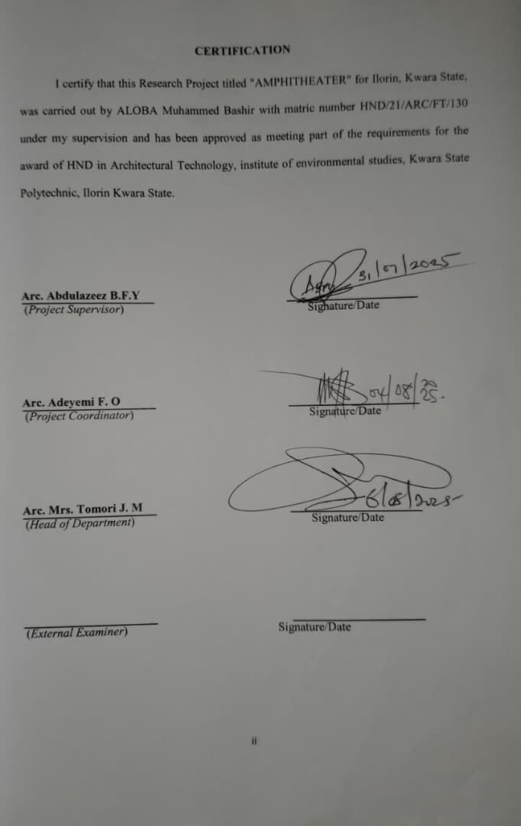

DEDICATION

This research project work is dedicated to Almighty God the source of knowledge and to who teaches and guides me throughout the academic pursuit.

ACKNOWLEDGEMENT
I return all the glory, honour, praises and adoration to the master of the universe that has given me the privilege of seeing the end of this program. To Him (God) alone be the glory. My immediate gratitude goes to the Department of Architecture Technology the entire staff and also to my mentor and supervisor Arc. Abdulazeez B. Y. F who has been supportive throughout this project, may God continue to bless and reward you and family abundantly. My sincere gratitude goes to my parents, Alhaji Musa Aloba and Alhaja Fatimah Aloba, who brought me to this world, and for the role they play in my life right from birth till this present time. I pray Almighty Allah grant them the grace of good health and eat the fruit of their labour.
However, my gratitude also goes for all my beloved siblings (Ibrahim Nariam and Fatimah) and those that have supported me through the words of encouragement, Enor Abdulganiyu Alope, Arc. Abdulazeez B.Y.F.
I can’t forget the helps from my friends, course mates and colleagues, may God bless you all (Amen).

ABSTRACT

This thesis explores the Amphitheater crucial role in advancing architectural education, research, and practice. It examines the comprehensive undergraduate and doctoral academic programs, highlighting their integration of design theory, technical proficiency, and practical experience. Emphasizing critical thinking, creativity, and interdisciplinary collaboration, the curriculum prepares students to address challenges in the contemporary built environment.
Additionally, the thesis highlights the Amphitheater to community engagement and global outreach. By partnering with industry, government, and non-profit organizations, the Amphitheater ensures its educational and research efforts have a tangible impact on real- world architectural and urban challenges. International exchange programs, study abroad opportunities and public lectures further enrich the learning experience, fostering a global perspective among students and faculty.

TABLE OF CONTENT

Title Page i

Certification ii

Dedication iii

Acknowledge iv

Abstract v

Table of Content vi

CHAPTER ONE 1
  - Introduction 1
  - Background of Study 2
  - Definition of Skill 3
  - Aim and Objective of the Project 4
  - Statement of Design Problem 4
  - Justification of the Study 5
  - Scope of Study 6
  - Limitation and Constraint 7
  - Research Methodology 8
CHAPTER TWO 9
  - Literature Review 9
  - Challenges in Conversation 10
  - Modern Amphitheatres 11
  - Case Study One 12
  - Case Study Two 14
  - Case Study Three 16
  - Case Study Four 18
  - Online Case Study 20
CHAPTER THREE 21
  - Introduction of Study Area 21
  - Site Location and Description 21
  - Site Analysis and Inventory 23
  - Geographical/Climatic Data 23
CHAPTER FOUR 25
  - Design Consideration/Design Criteria 25
  - Design Brief 25
  - Design Scope 27
  - Spatial Allocation 28
CHAPTER FIVE 32
  - Project Appraisal Scheme 32
  - Construction Method and Materials 33
  - Essential Services 35
  - Plumbing Services 36
  - Fire Precaution 36
  - Building Requirements 37
  - Conclusion 38
  - Recommendation 39
References 40

CHAPTER ONE

INTRODUCTION:

Amphitheater is an open-air venue used for entertainment, performances and sports. The term derives from the ancient Greek (amphitheatron) from (amphi), meaning" on both sides" or "around" and (theatron) meaning "place of view".
Ancient Greek threatres were typically built on hillsides and semi-circular in design. The first amphitheater may have been built at Pompeii around TOBC. Ancient Roman amphitheater were oval or circular in plan, with seating tiers that surrounded the central performances area, like a modern open-air stadium. In contrast, both ancient Greek and ancient Romans threatres were built in a semi-circle, with tiered seating rising on one side of the performance area.
Modern English parlance uses "amphitheater" for any structure with sloping seating, including theatres- style stages with spectator seating on only one side, theatres in the round, and stadia. They can be indoor and outdoor. Contemporary amphitheater often include standing structure, called band shells, sometimes curved or bowl- =shaped, both behind the stage and behind the audience, creating an area which echoes or sports. Theamplifies sounds, making the amphitheater ideal for musical or theatrical performances.

HISTORICAL BACKGROUND.

The historical background of amphitheater dates back to ancient Greece and Rome, where they played a significant role in the cultural, social and political lives of the people.
*ANCIENT GREECE (5TH-4TH CENTURIES BCE)

- Early beginning: The earliest known predecessors of amphitheater were the Greek theatres, which were built into hillside to provide natural seating.
- Theatron and orchestra: Greek theatres consisted of a theatron (seating area) and orchestra (performance area).
- Influence on Roman architecture: Greek theatre design influenced the development of Roman amphitheaters.
* ANCIENT ROME (1ST CENTURY BCE - 5TH CENTURY CE)

- Development of amphitheater: The Roman developed the amphitheater design, creating larger, more complex structure.
- Gladiatorial contests and games: Amphitheater were used for gladiatorial contests, animal hunts, public games (munera)
- Imperial patronage: Roman emperor often sponsored the construction of Amphitheater as a symbol of their power and wealth.
* DECLINE AND LEGACY (5TH-18TH CENTURIES CE)

- Decline of the normal empire: As the Roman empire declined, many Amphitheater fell into disrepair or were abandoned.
- Medural and renoussance periods: During the middle ages, Amphitheater were often used as queries for building materials or were converted into fortifications.
- Rediscovery and restoration: during the renaissance, there was a renewed interest in classical architecture, leading to the restoration and study of ancient amphitheaters.
*Modern Era (19th-20th century CE)

  - New classical and modernist influences: the 19th and 20th centuries saw the construction of new amphitheaters influenced by neoclassical and modernist architectural styles.
  - Outdoor concert and performance venues: modern amphitheaters are often used as outdoor concert and performances venues, hosting a wide range of events.

DEFINITION

    - An amphitheater is an open-air circular or oval building with a central space surrounded by tiers of seats for spectators, for the presentation of dramatic of sporting events. As those used in ancient Rome for gladiatorical contests, games, performances, exhibition, e.t.c. an arena, stadium, or auditorium.
*It can be defined simply as an Open-air space or venue used for entertainment, performances and sports.

AIMS AND OBJECTIVES OF PROJECT

    - AIMS

      - To provide a versatile venue that offers a flexible space for various events, performances and activities.
To foster community engagement by hosting events and performances, amphitheaters, aim to bring people together, promoting social interaction and community bonding.
      - To showcase artistic and cultural expressions that provides a platform for artists, performers and creativities.
*Objectives

- Optimized acoustics: to ensure that sound travels clearly and evenly from the performance area to all parts of the audience seating.
*Use natural or designed amplification techniques, such as curved walls or tiered seating, for effective sound distribution.
- Interrogation with the environment:

*To harmonize the structure with its naturalor urban surroundings.

*Many classical ampitheatres are semi-subterranean or built into hill-sides to reduce environmental impact.
- Structural stability and durability

  - To ensure the amphitheater can withstand heavy loads and it continuous use.

  - Use of strong lasting materials such as stone, concrete or reinforced steel.

STATEMENT OF DESIGN PROBLEM

Key challenges:

- Acoustics and sound quality: ensure clear and even sound distribution throughout the venue.
- Visibility and sightlines: provides unobstructed views of the performances area for all spectators.
- Weather protection: design a roof or canopy system that protects spectators from the elements while maintaining an open-air feel.

- Accessibility and safety: ensure easy access for all spectators, while maintaining a secure and safe environment.
- Flexibility and adaptability: design a venue that can accommodate a wide range of events and performances.

JUSTIFICATION FOR THE PROJECT

    - Social justification

- Community Engagement: provides a shared public space for the community events, fostering social connections.
- Cultural Enrichment: an amphitheater attracts tourists, stimulates local businesses, create jobs and contributing to the local economy
* Economic Justification

- Revenue generation: ticket sales, sponsorships and concession create revenue streams for the venue and local businesses.
- Increase property value: it enhances the surroundings areas attractiveness, increasing property values and attract new investments.
- Job creation: it generates employment oppurtunities in construction, maintenance and event management.
* Cultural Justification

- Presentation of heritage: it reflects the local cultural heritage by preserving historical and architectural significance.

- Promotion of Arts: it supports local artists, promotes cultural diversity and enriches the community’s cultural landscape.
- Community identity: becomes a symbol of community identity, reflecting the values, traditions and aspirations.

SCOPE OF STUDY

The scope of study for an amphitheater;

- Study the design elements, such as seating capacity, stage design.

- Examine the materials used, construction techniques, and structural integrity.

- Accessibility evaluation, emergency evaluation routes and safety measures.

- Investigate the types of events hosted, event schedules and logistics.

- Analyze ticketing systems, revenue streams and financial management.

- Examine the role of the amphitheater in the community events, social gatherings and cultural celebrations.
- Study the audio-visual systems including social sound and lighting design, installation and operation.
- Investigate the digital infrastructure including infrastructure including networking, wifi, and digital signal.
- Examine the software used for ticketing, event management and customer relationship management.

LIMITATION AND CONTRAST

The limitation and contrast of an amphitheater are;

- Weather dependence: outdoor Amphitheater are weather-dependent, which can impact event scheduling and attendance
- Limited seating capacity: Amphitheater typically have a freedseating capacity, which can limit the number of attendees.
- Acoustic challenges: can present acoustic challenges, such as echo and sound reflection.
- Technical infrastructure: Amphitheaters may require significant technical infrastructure including sound and light systems.
- Logistical challenges: amphitheaters can present logistical challenges, such as parking, accessibility and crowd control.
- Security concerns: Amphitheater may require additional security measures, such as crowd monitoring and emergency response plan.
- Environmental impact: it can have significant environmental impact, such as energy consumption and waste generation.
- High maintenance costs: it can be expensive to maintain, especially if they are outdoor venues.
- Depending on funding: may rely on funding from government, agencies, grants, or private donors.

- Limited revenue streams: amphitheaters may have limited revenue streams, such as ticket sales and sponsorship.

RESEARCH METHODOLOGY

- Case study: conduct and in-depth analysis of a specific amphitheater exploring its design, operations and impact.
- Literature review: analyse existing research, articles and books on amphitheater, architecture and event management.
- Interview and surveys: conduct interview with venue manager and staff, event organizers and promoters, performers and artists, audience members and visitors, local community members and stakeholders.
- Document analysis: review documents related to the amphitheater such as: review documents related to the amphitheater such as; architectural plans and designs,event schedules and programming, financial reports and budget documents.

CHAPTER TWO

LITERATURE REVIEW

The amphitheater, a distinctive architectural form associated primarily with Ancient Rome has been a subject of extensive scholarly investigation across multiple disciplines including archaology, architecture, and cultural studies. These structures were not only feats of engineering but also served as focal points of Roman public life, embosying social, political and cultural ideologies.
    - Architectural significance: Amphitheater exemplify Roman ingenuity in concrete construction and urban planning. The coliseum, Rome’s most iconic amphitheater, demonstrates advanced engineering through its use of barrel and grown vaults, as discusses by ward-perkins (1981). The efficient crowd circulation system and the vela rum (awning system) reflect a sophisticated understanding of spatial management and user experience.
    - Cultural and social functions: beyond entertainment, amphitheater were political tools, Kyle (1998) asserts that spectacles reinforced imperial authority and social hierarchy by physically manifesting the power of the state. Seating arrangement mirrored social stratifications with the elite occupying the lower tiers and marginalized groups relegated to the upper sections.
    - Preservation and modern reuse: contemporary scholarship has also addressed the conservation of amphitheaters and their adaptation for modern use. Studies by claridge (2010) examine how restored amphitheaters serves as cultural heritage sites, tourist attractions, and performances venues, raising debates over authenticity, commercialization and preservation ethnics.

CHALLENGES IN CONSERVATION

The conversation of ancient amphitheater presents numerous challenges that span structural, environmental, cultural and ethnical dimensions. These monumental significance, face a complex interplay of threats that complicate preservation efforts.
- Structural degradation and material deterioration: many Roman amphitheater in El Dejon, suffer from structural instability due to centuries of weathering, seismic activity, and the decay of original materials. The degradation of stone and concrete is often accelerated by pollution, water infiltration, and biological growth (e.g. Mosses, Lichens) leading to loss of integrity in load-bearing elements.
- Tourism and overcrowding: while tourism generates revenue for conservation, it also contributes to physical wear, littering and vibrations that can destabilize fragile structures. Managing visitors access without compromising the site’s integrity requires careful planning, including regulated foot traffic, the use of reused walkways, and digital engagement tool.
- Limited funding and political instability: in many regions, especially in parts of North Africa and the middle East, financial constraints and political instability hinder consistent conservation work limited access to advanced conservation technology and expertise further complicates sustainable preservation.
- Environmental and climate factors: climate change has introduced new challenges, including increased rainfall, temperature fluctuations, and rising humidity levels, which exacerbate the weathering of exposed surfaces. As noted by sabbion et al (2010), salt crystallization and freeze-thaw cycles are especially damaging to ancient masonry, and wastal amphitheater are further threatened by marine erosion and rising sea levels.

MODERN AMPHITHEATER

The modern amphitheater represents a reinterpretation of the classical Roman amphitheater, adapted to suit contemporary needs in performance, public gathering and urban design.
- Architectural Evolution and Design Principles.

Modern amphitheaters borrow the basic structural form an-open, elliptical or circular space with tiered seating but are often open-air venues designed with acoustics, visibility and accessisbility in mind. Modern amphitheater design prioritizes audience experience, incorporating ergonomic seating, stage versatility, and sound optimization.
- Technological integration

Advanced acoustic engineering and lighting technology have transformed the amphitheater into a high-performance venue. Structures like the Hollywood Bowl (USA) and expiates modern reconstructions shoe how technology can enhance both the aesthetic and functional aspects of open-air performance spaces. Sound systems, retractable roofing, and multimedia integration are common function and features.
- Global examples and adaptation

From the Sydney Myer Music Bowl on Melbourne to the Dalhalla amphitheater in Sweden (a repurposed limestone quality) modern amphitheaters reflect local culture, climate, and topography. This diversity marks a departure from the uniformity of Roman models, showing how the amphitheater has become a
globally adaptable form.

CASE STUDY (ONE)

Project: Amphitheater

Historical Background: the amphitheater at Ladoke Akintola University of Technology (LAUTECH), Ogbomosho, serves as a central venue for significant academic and ceremonial events, including convocation ceremonies and founder’s day celebrations. While specific historical details about the amphitheater’s construction are not readily available in public records, it’s prominence in university events underscores it’s importance within the campus infrastructure. The amphitheater’s role in hosting key events, such as the award of degrees during convocation ceremonies, highlights its functions as a gathering place for the university community.
Description: the structure encompasses three entrance, two exist, stores offices, the tiers are supported with columns and beams.
Locations: Ladoke Akintola University of Technology Ogbomosho, Oyo state.

Merit
- It is well landscaped.
- Enough exit is provided incase of emergency.
- The external wall finishes are aesthetically pleasing.
- It is a well defined.

Demerit

- Insufficient parking space.

- Absence of major portion such as rehearsal room, mini hall.

- No security.

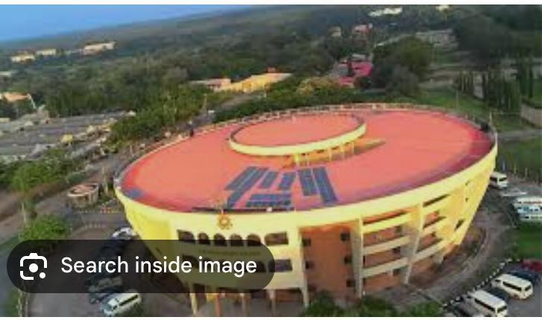

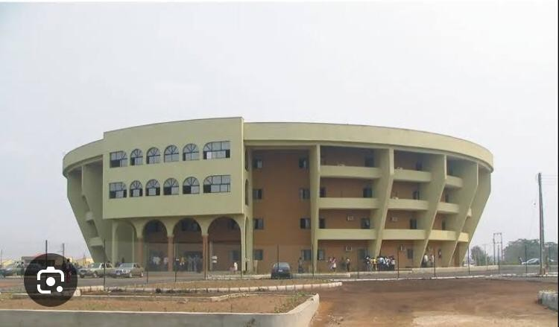

CASE STUDY (TWO)

Project Name: Amphitheater

Location: Behind Oduduwa Hall, Obafemi Awolowo University (OAU) Ile-ife. Capacity: 5000
Description: the structure is built and finished with materials.it has a entrance, it has two lecture theater underneath the tiers, the structure (amphitheater) is attached to the back of Oduduwa Hall.
Historical Background: the amphitheater of Oduduwa Hall stand as a testament to oni’s dedication to blending cultural heritage with architectural incorporation, serving as a central hub for intellectual and cultural activities within the university community.

Merit

- It has enough circulation

- There is enough outlet

- High accommodation.

Demerit

- Pre-service of ray of sun and rain because of the open roof

- Insufficient parking space

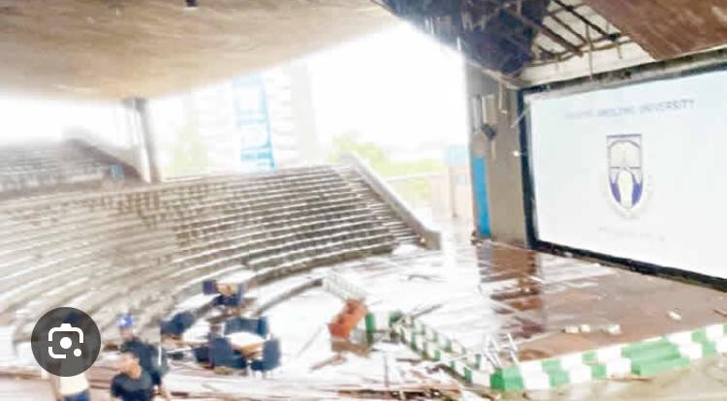

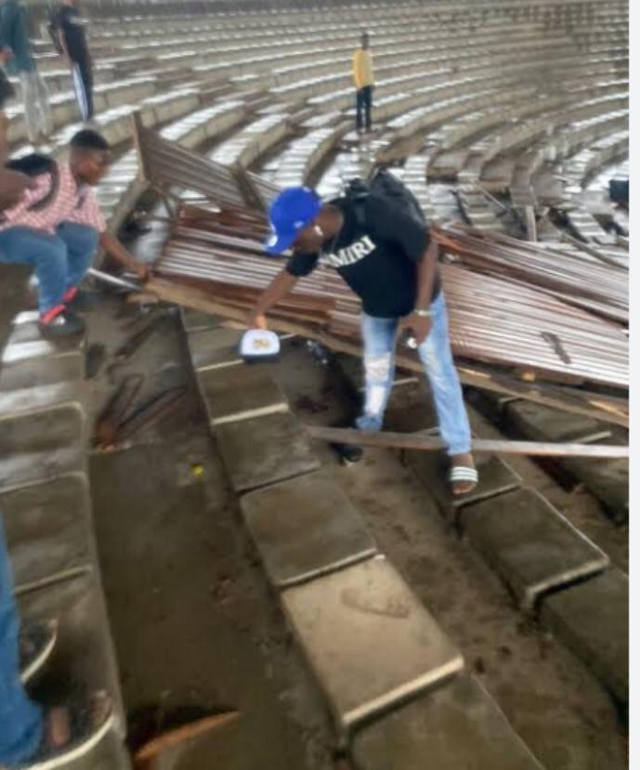

CASE STUDY (THREE)

Project Name: Unilag Amphitheater

Location: At Yaba Oworonshodi, Lagos State. Capacity: 5000
Description: Unilag Amphitheater is one of the best place to chill on campus when you are in university of Lagos. It’s has a sitting arrangement like that of a stadium but not covered.

Merit

- It is located in the university of Lagos.

- The architectural structure make it look like the coliseum

- Great environment.

- Unilag amphitheater very spacious for gatherings

- A restaurant is located at the back of the theater.

Demerit

- It doesn’t have a covering.

- Lack of maintenance

- Poor landscaping

- Insufficient parking space.

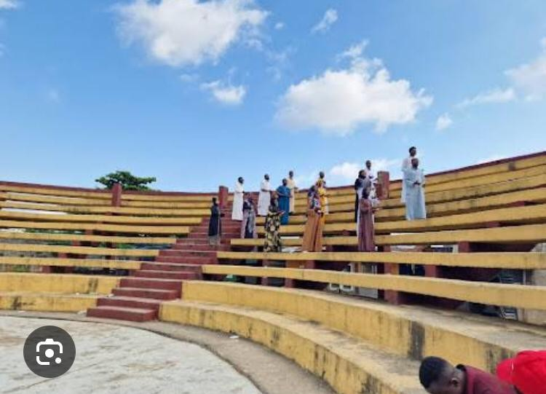

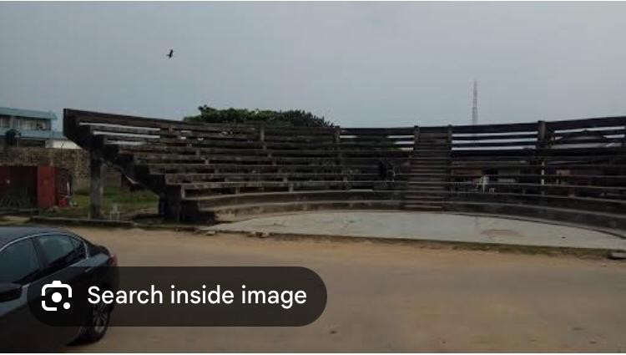

CASE STUDY (FOUR)

Project Name: Babcock Amphitheater

Location: At ilushan Ram; University of Ogun state. Capacity: 5000
Description: A modern take on western treasure constructed in 1907, the Babcock theater is a bold, colourful landmark in what was once a venue for stage show and boxing matches, the Babcock is now a venue available to tent for live performance, film, wedding, parties.

Merit

- Big spacious with nice atmosphere.

- This is a good auditorium for several events;tech, music, outdoor cinema.

- Are well arranged and ventilated.

- It is well landscaped

Demerit

- Insufficient parking space.

- Absence of rehearsal room, changing room.

- Some place need maintenance.

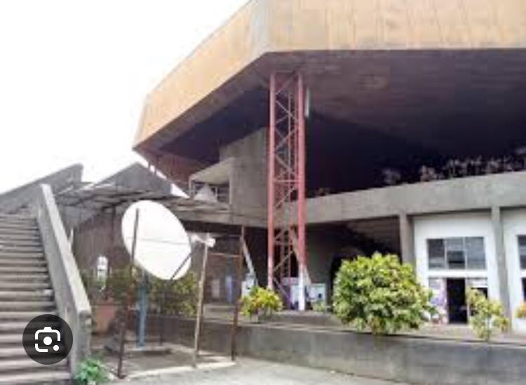

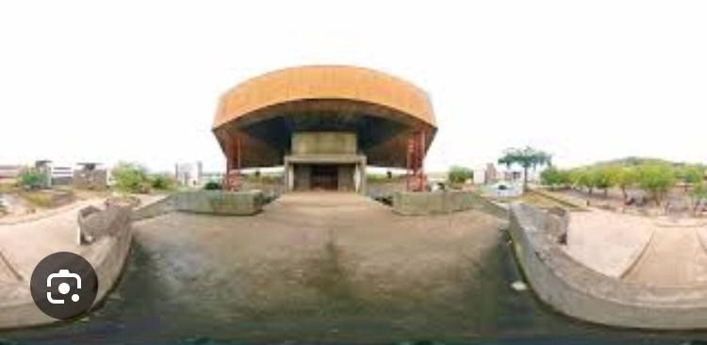

CASE STUDY (FIVE)

(Online case study one)

Project name: Glen Helen Amphitheater Location: United state
Capacity: 65000

Description: it is out door entertainment venue hosting love music acts and local festivals.

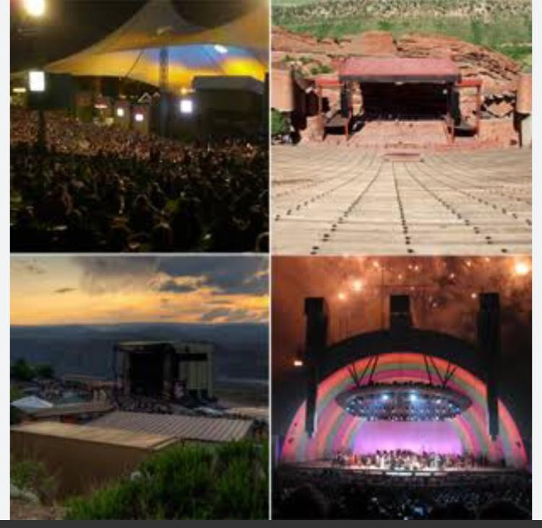

CHAPTER THREE

1 INTRODUCTION OF STUDY AREA

The study was conducted at Geri-Alimi located in the Ilorin west local government area. This area is notably recognized for the Geri-Alimi Diamond Underpass, a significant infrastructure project aimed at alleviating traffic congestion in the city.

Historical and Cultural Significance

The name “Geri-Alami” translates to “Ilorin’s place” and is named after sheikh Alimi, a Fulani Islamic scholar who settled in Ilorin and played a pivotal role in its history.

Socio-economic Activities

Geri-Alimi is a bustlow hub within Ilorin, featuring a mine of residential, commercial, and institutional establishments. The area experiences significant vehicular and pedestrian traffic, contributingto its vibrant economy.

Environmental Aspects

Environmental studiesin Ilorin have include Geri-Alimi as a sampling location, particularly in research focusing on soil properties and fungal diversity. Soil samples from Ger-Alimihave been Analysed for physic chemical properties and microbial content, contributing to the understanding of the areas environmental conditions.

SITE LOCATION AND DESCRIPTION

The site is located at Geri-Alimi, In Ilorin West L.G.A, Kwara state, Nigeria.
*Coordinate and attitude Latitude and longitude

-Latitude: approximately 8.4629⁰N

-Longitude: approximately 4.5209⁰N

*Elevation

- Approximately 320m above sea level

* Geographic setting of Ilorin

-Latitude=8.4964⁰N

-longitude=4.5480⁰E

-Elevation=ranges from 220m to 350m above sea level.

-Geopolitical zone= North Central Nigeria (Middle belt).

*Regional context

- North=bordered by nigerstate.

-South=connects with Osun and Ekiti states.

-West=shares boundary with oyo states.

-East=bordered by kogi states.

*Topography

-Generally undulating terrain, with gentle slopes.

-Some isolated high lands and hills around areas like sobi-hill

- Low-lying cover valleys around the area of Asa River, which cuts through the city.

SITE ANALYSIS AND INVENTORY

The proposed site for the amphitheater at Geri-Alimi, Ilorin, is well-situated allow a major transportation corridor with good accessibility and visibility. The natural topography includes a gentle slope suitable for tiered seating. The area is historically significant, culturally vibrant, and already a gathering point for locals, making it ideals for an amphitheater. However, considerations such as seasonal flooding ang traffic congestion must be addressed in the design phase.

GEOGRAPHICAL CLIMATE DATA

Climatic Data:

Ilorin has a tropical savanna climate. It has an annual rainfall which can range between

990.3 and 1,318 millimeters (39 and 52 in). The city has maximum temperatures vary between 33 and 37⁰C or 91.4 and 98.6⁰F , with the third month of the year, march, being the hottest.
Geographical data of Ilorin:

Country: Nigeria State: Kwara State
Geographical Coordinates: Latitude=8.4966⁰N

Longitude=4.5421⁰E

* Elevation: Ilorin lies at an average elevation of 294 to 320 meters (approximately 965 to 1050 feet above sea level).

- Topography: its generally flat to gently undulating, with occasional low hills, the land is well-suited for agriculture, urban development, and infrastructure and projects like amphitheaters due to the gentle slopes.
- Soil: the dominant soil types are laterite and sandy loam.

CHAPTER FOUR

  - DESIGN CONSIDERATION AND CRITERIA

The amphitheater design at Geri-Alimi will leverage the sites natural slopes. Face north to minimize sun glare, and featured seatings for 3000 people. The stage will incorporate acoustic walls and shaded structures to ensure comfort. Adequate drainage, accessibility features, and solar-powered lighting will be integrated for functionality and sustainability.
Following the emergency exists to ensure safety, and must be protected for environmental conditions (rain, sun, wind). The stage and performance area should be intensively adequate for performance and easy entertainment.

DESIGN BRIEF

- Project title: Geri-Alimi community Amphitheater, Ilorin, Kwara State.

- Project overview: the proposed amphitheater will be a multi-purpose open-air performance and gathering space serving the Ilorin community. It is envisioned to support cultural performances, concerts, public, speeches, educational activities, religious events.
- Objectives:

  - To provide a dedicated outdoor venue for arts, culture and community.

  - To celebrate the historical and cultural heritage of Geri-Alimi.

  - To integrate sustainable and climate-responsive design.

  - To ensure accessibility, safety and comfort for all users.

- Site Description

- Location: Geri-Alimi, Ilorin West LGA, Kwara state, Nigeria.

- Topography: Gently sloping terrain, suitable for tiered seating.

- Climate: tropical savannah with distinct wet and dry seasons.

- Accesibility: well connected by major roads.

- Design requirements

- Seating: with the maximum of 3000 people, tiered arrangement using natural slope, with durable weather-resistant materials.
- Stage area: not covered, with backage access and so many facilities.

- Safety and lighting

- Emergency exists and fire safety.

- LED lights for evening events.

- Security and provisions for surveillance.

- Support facilities

- Toilets (include accessible units)

- Small concession stand.

- Ticketing booth

- Equipment/ storage room

- Rehearsal room.

- Offices.

- Sustainability Goals

- Solar-powered lighting

- Native planting for erosion control.

- Budget and Timeline

- Budget: to be determined (based on funding and scope)

- Timeline: Estimated 6-9 months from design to completion.

- Stakeholders

  - Kwara State Government

  - Local Community Leaders

  - Artists and cultural organizations

  - Environmental consultants

  - Constructions and landscape firms.

DESIGN SCOPE

    - Seating areas.

    - Stage

    - Ticketing/ booth

    - Equipment Room

    - Rehearsal Room

    - Offices

    - Toilets

    - Changing room

    - Box room lighting room

    - Workshop

    - Storage

    - Laundry room

SPATIAL ALLOCATION

S/N | Components | Recommended | Purpose
1. | Seating Area | 2,500-3,000 | Tiered concrete/metal seating for 3,000 audience.
2. | Stage | 20-30 m | Large stage for major shows or events.
3. | Office | 3600 x 3600 | For managements, or for and officicial meet and use.
4. | Workshop room | 6000 x 4000 | For educational purpose and classes.
5. | Rehearsal room | 4600 x 5000 | A room for artists or show performer to rehearse before coming to stage.
6. | Electrical room | 4600 x 8000 | A room for controlling the power system of the whole amphitheater.
7. | Concession Area | 2000 x 6000 | Designated space where attendees can order food.
8. | Dressing Room | 6000 x 5000 | A space for performers to change outfit to costume
9. | Box room | 6000 x 4000 | A designed room for gift, or collectibles
10. | Toilet(male&female) | 1200 x 1200 | A small place for attendees, performers, artists, staffs to use for urinal or rest room.

Room-by-room-space calculation

Space | Size | Area | Comment
Seating area | 20m x 14m | 280 m² | Approx. 300 seats
Stage | 14m x 4m | 56 m² | Raised platform
Control room | 4m x 3m | 12 m² | Rear of Hall
Conference room | 6m x 5m | 30 m² | Left wing
Mezzanine | 6m x 4m | 24 m² | Multi Purpose
Hot office | 4m x 4m | 16 m²
B office | 4m x 4m | 16 m²
Staff office | 4m x 4m | 16 m²
Admin office | 4m x 4m | 16 m²
Guest changing room | 3m x 4m | 12 m²
Choir changing room | 3m x 4m | 12 m²
Laundry | 4m x 3m | 12 m²
Store | 3m x 3m | 9 m²
Male Toilet {left} | 3m x 3m | 6 m²

Female Toilet {left} | 3m x 2m | 6 m²
Male Toilet {Right} | 3m x 2m | 6 m²
Female Toilet {Right} | 3m x 2m | 6 m²
Entrance Lobby | 8m x 4m | 32 m² | Reception Area
Circulation | Estimated | 100 m² | Hallways, movement path

Total Estimated Area: 667 m²

    - Space Function Analysis

Function | Spaces | Total Area | Notes
Public Audience | Seating, Entrance, Toilets | 336 m² | Main | use | Area
Performance | Control Room, Mezzanine | 92 m² | Event Operations
Admin/Staff | Offices, Conferences | 94 m² | Control & support
Support services | Changing, Laundry, store | 45 m² | backstage support
Circulation | Hallways, Access Path | 100 m² | Connectivity

AMPHITHEATER SPACE SCHEDULE AND ANALYSIS
      - SPACE SCHEDULE TABLE

Space | Area | Remarks
Seating Area | 280 m² | Approx. 300 seats [0.9 m^{2/} person]
Stage | 56 m² | Raised platform with side Access
Control Room | 12 m² | Rear of Auditorium
Conference Room | 30 m² | Located in left wing
Mezzanine | 24 m² | Multipurpose use
Offices (x4) | 64 m² | B office, HOD, Staff, Admin
Changing room | 24 m² | Choir and Guest Room
Toilets | 24 m² | Male & Female, Both wings
Laundry | 12 m² | Support/utility
Store | 9 m² | Adjacent to laundry
Circulation | 100 m² | Hallways and path
Entrance Foyer | 32 m² | Reception/Entry Area

      - SPACE FUNCTION ANALYSIS
The floor plan is efficiently organized into three main functional zones:
- Audience/public: seating Area, Entrance Foyer, and Toilets.
- Performance/presentation: Stage, control room
- Support/Admin: offices, conference room, Mezzanine, Laundry store, Changing rooms. Each functional zone is accessible via dedicated circulation paths, with an estimated 100m² allocated to movement and flow.
The seating Area accommodates approximately 300 guests with adequate comfort [0.9 m^{2/} person].
Toilet placements ensures coverage for both male and female guests on both wings.

The layout supports both performance and administrative operations with effective space distribution.
      - TOTAL AREA ESTIMATE

Total Functional Area=576 m^{2/} Estimated circulation space= 100 m²
Overall Estimated Total= 670 m²

This estimation assumes a 1-meter grid scale based on the provided floor plan image.

RECOMMENDATIONS:

- Ensure accessibility [Ramp/stair access to stage]

- Re access toilet quantity if audience exceeds 300 regularly.

- Allocate flexible use of mezzanine and conference spaces.

CHAPTER FIVE

5.0 PROJECT APPRAISAL SCHEME

APPRAISAL REPORT: PROPOSED AMPHITHEATRE SCHEME AT GERI ALIMI, ILORIN.

Introduction

The report provides a comprehensive appraisal of the proposed amphitheatre scheme planned for Geri Alimi in Ilorin west LGA, Kwara State. The purpose is to evaluate the project strength, weakness, opportunities and threat. (SWOT), guiding informed decision making for design refinement and implementation.

Project Overview;

The project amphitheatre is designed to accommodate approximately 3000 spectators, serving as multi- functional outdoor venue for cultural, educational and civic activities.

Appraisal

  - Strength.

- Strategic site location: utilization of the site's natural slope.

- Capacity and flexibility: large capacity suitable for divers event types.

- Climate responsiveness: inclusion of shading elements and landscaping.

- Accessibility: compliance with universal design principles.

  - Weakness

- High initial investment: Large scale infrastructure may require significant capital.

- Infrastructure limitations: existing roads network and parking facilities.

- Weather vulnerability: outdoor design subject to disruption from sudden rains.

- Maintenance demand: long term upkeep may challenge local capacity without proper management plans.
  - Opportunities

- Community development: it enhance social cohesion.

- Economic growth: stimulate local economy.

- Environmental leadership: demonstrate sustainable public space development.

- 3.4 Threats

- Funding constraint: budget shortfall may delay project scope.

- Environmental risks: potential flooding or erosion are inadequate.

- Security challenges: large crowds necessitate safety and security frameworks.

- Stakeholder engagement: requires ongoing communication to maintain support.

CONSTRUCTION METHOD AND MATERIAL

- Earthworks and site preparation

  - Method: Grading and terracing to follow natural slope: Excavation for foundations.

  - Materials: Excavated soil can be reused, stone pitching on slope.

- Foundation

  - Method: Reinforced concrete strip or pad foundation depend on soil condition.

  - Materials: cement, granite, sharp sand, reinforcement bars, stone masonry.

- Seating construction

  - Method: earth-beamed seating and concrete bleachers.

  - Materials: concrete, local stone or bricks, timber or recycled plastic.

- Stage Platform

  - Method: raised concrete slab, or steel-framed desk

  - Materials: concrete slab, non-ship tiles or wooden decking for surface.

- Roofing/shading (optional)

  - Method: tensile fabric canopy or steel-frame shade structures.

  - Material: PVC-Coated polyester, Galvanized steel

- Finishes

  - Method: minimalist and weather-resistant finishes, anti-ship surfaces.

  - Materials: local stones, clay brick, plaster, mural paint, smooth screed

- Drainage

  - Method: perimeter planting, tree cover and swales

  - Materials: Native plants, permeable paving, shrubs.

- Ancillary structures

  - Method: prefabricated units for toilet, or masonry

  - Materials: sand Crete blocks, ceramic tiles

- Sustainable Elements (optional but ideal)

  - Solar panels

  - Rain water harvesting tanks from roof run-off

  - Use of recycled or low-carbon materials.

ESSENTIAL SERVICES

- Electrical services

  - Lighting

- Stage lighting (Adjustable/focus light)

- Audience and general area lighting

- Pathway and emergency lighting

  - Power supply

- Main Electrical grid connection

- Backup generator for sound/lights

- Solar panel

  - Sockets & wiring

- Outlets at stage and control booth

- Underground or protected wiring ducts

- Sound & Audio-visual services

  - Sound System:

- PA system with speakers distributed evenly

- control booth with mixing console and amplifiers

  - Microphones:

- Wireless, lapel and stage mics.

  - Video Equipment (optional)

- Projector or LED screens.

- CCTV for monitoring.

PLUMBING SERVICES

    - Water supply

- Connection to local water mains or boreholes.

- Overhead tanks or underground reservoir.

    - Sanitation

- Male, Female and accessible toilets

- Wash basins with soap dispensers.

    - Drainage

- Surface water drainage (sloped floors, channels, stone gutters)

- Soak aways or storm water pits

- Roof Drainage if stage is covered.

FIRE PRECAUTIONS

- Fire safety planning

  - Must be developed and approved by the local fire service.

  - Clearly marked fire exit routes and signage.

- Fire-Fighting equipment

  - Fire extinguishers

  - Fire buckets

  - Fire blankets and hose reels

- Fire Detection and Alarm Systems

  - Smoke detectors.

  - Manual fire alarms.

- Access for Emergency services

  - Unobstructed routes.

  - Fire hydrants or water storage points near entry roads

- Emergency Lighting and Signage

  - Clearly visible “EXIT” signs at all exit points.

  - Glow-in-the-dark signs for night time or power failure scenario

BUILDING REQUIREMENTS\

- Site requirements

  - Minimum area of 2-3 acres for 3,000 capacity, including seating, stage, services and facilities.
  - Accessibility: proximity to major roads and pedestrian pathways.

- Structural Requirements

  - Seating structure:

- Reinforced concrete or steel-framed seating tiers.

  - Stage platform:

- Strong base and optional covering structure.

- Environmental Requirements

- Damage

- Ventilation

- Noise control

- Safety Requirements

- Fire safety

- Structural Stability

- Crowd management

- Legal & Regulatory Requirement

  - Building Approval: must comply with Kwara state urban and regional planning authority
- Zoning compliance

  - Environmental Impact Assessment (EIA): may be required due to scale and location

- Fire service approval

- Building services Requirements.

  - Power supply: connection of grid with back up solar or generator

  - Water supply: Borehole or main water connections, overhead tank for toilets.

  - Toilets: Male, Female, accessible: 1 per 100-150 people of minimum.

*Waste Disposal: waste bins and structured disposal collected plan.

5.7 CONCLUSION

The proposed amphitheater at Geri-Alimi, Ilorin, represents a visionary approach to cultural infrastructure, blending functionality, sustainability and community engagement. With a capacity of 3,000 seats, the design responds effectively to the local topography, climate, and socio-cultural needs of the region. Comprehensive considerations – including s site analysis, environmental factors, building services, fire safety and accessibility ensure that the project will be safe, efficient and inclusive.
By integrating local materials, natural ventilations and environmentally conscious features, the amphitheaters will not only serve as a dynamic public space for performances and gatherings but also as a model for sustainable development in kwara state.

RECOMMENDATION

- Adopt a phased Development Approach: Begin with essential structures (seating, stage and basic services), then expand based on funding and usage demands.
- Engage local Stakeholders Early: Collaborate with community leaders, cultural groups and government agencies to ensure support.
- Use local and sustainable materials: incorporate locally sourced stone compressed earth blocks (CEB), and solar technology to reduce costs.
- Ensure accessibility and safety standards: implement universal design principles fire safety systems, and proper drainage to guarantee safety.
- Plan for long-term maintenance: establish a management body or partner with the local council to oversee security, cleanliness, and ongoing repairs.
- Create a programming strategy: develop a calendar of cultural, educational, and commercial events to ensure year-round use and financial sustainability.
- Conduct Final Environmental and structural reviews: carry out necessary assessments (EIA) before full implementations to meet regulatory requirements.

REFERENCES

Berardi, U. (2013). "Clarifying the new interpretations of the concept of sustainable building." Sustainable Cities and Society, 8, 72-78.
Bosworth, F. (2016). "Designing the Learning Spaces." Journal of Architecture and Urban Planning.
Cheryan, S., Ziegler, S. A., Plaut, V. C., & Meltzoff, A. N. (2014). "Designing Classrooms to Maximize Student Achievement." Psychological Science, 25(6), 1037-1051.
Ching, F. D. K. (2014). "Building Construction Illustrated." John Wiley & Sons.

Dudek, M. (2000). "Architecture of Schools: The New Learning Environments." Architectural Press.
Frampton, K. (1992). "Modern Architecture: A Critical History." Thames & Hudson.

Hartig, T., Mang, M., & Evans, G. W. (2014). "Restorative Effects of Natural Environment Experiences." Environment and Behavior, 23(1), 3-26.
Kostof, S. (1995). "A History of Architecture: Settings and Rituals." Oxford University Press.

Nair, P., & Fielding, R. (2005). "The Language of School Design: Design Patterns for 21st Century Schools." DesignShare.
OECD (2017). "The OECD Handbook for Innovative Learning Environments." OECD Publishing.
Wang, S., Yan, C., & Xiao, F. (2013). "HVAC system optimization Research and development needs." Renewable and Sustainable Energy Reviews, 16(1), 68-74.
Wargocki, P., Wyon, D. P., Sundell, J., Clausen, G., & Fanger, P. O. (2002). "The effects of outdoor air supply rate in an office on perceived air quality, SBS symptoms and productivity." Indoor Air, 10(4), 222-236.
Yin, R.K. (2004). Complementary methods for research in education. Washington, DC: American research association press.
Neufert, E., & Neufert, P. (2019). Architects' Data (5th ed.). Wiley-Blackwell.
APPENDIX
