A PROJECT REPORT
ON
PROPOSED MULTI-UNIT LECTURE THEATRE
FOR
KWARA STATE COLLEGE OF EDUCATION

By
ABDULRAHMAN ABDULLAHI
HND/22/ARC/FT/0080

SUBMITTED TO THE DEPARTMENT OF ARCHITECTURAL TECHNOLOGY INSTITUTE OF ENVIRONMENTAL STUDIES, (I.E.S) KWARA STATE POLYTECHNIC ILORIN, KWARA STATE.

IN PARTIAL FULFILLMENT OF THE REQUIREMENTS FOR THE AWARD OF HIGHER NATIONAL DIPLOMA (HND) IN ARCHITECTURAL TECHNOLOGY

JULY, 2025

DECLARATION
I declare that this project project/dissertation is a product of my personal research work. It has not been presented for the award of any degree in any polytechnic. The ideas, observations, comments, suggestions herein represent my own convictions, except quotations, which have been acknowledged in accordance with conventional academic traditions.

NAME: ABDULRAHMAN ABDULLAHI
MATRIC NO: HND/22/ARC/FT/0080

________________ ________________
Signature Date

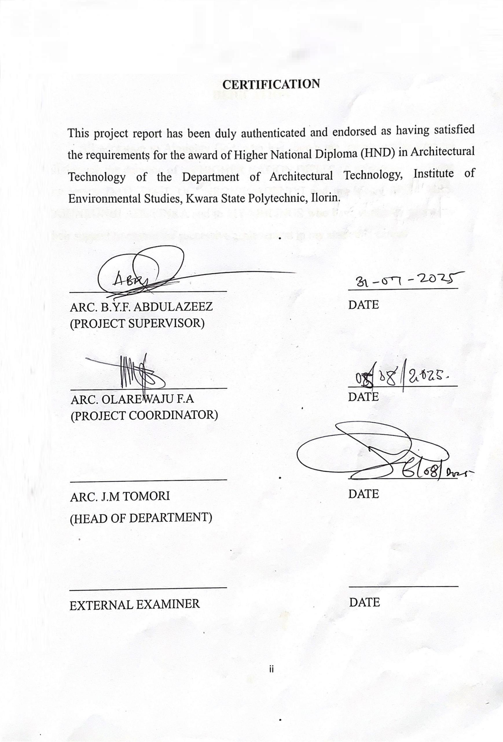

DEDICATION
This report is dedicated to Almighty Allah, the Creator of the universe, the source of all creation, and the sustainer of mankind. I am deeply grateful for His infinite mercy, unwavering guidance, and divine strength that have seen me through every stage of this project and throughout my academic journey.

ACKNOWLEDGEMENT
All praise and adoration and glorification to Almighty (S.W.T) the creator of the universe that gave me the privilege to take part in this program. First and foremost, I am grateful to my able Hardworking and untiring project supervisor ARC. ABDULAZEEZ B.Y.F, ARC. OLAREWAJU, F. A. and the HOD of Department ARC. (MRS.) J.M. TOMORI and the member staff of the Architecture Department, Kwara State Polytechnic, Ilorin for their encouragement, expert advice and continuous kind assistant and supervision that made the completion of this study successful. My gratitude goes to my able, amiable and knowledgeable guidance MR ABDULLAHI for his inexplicable finance, moral, parent prayers support from birth till date, I say a very big thanks you sir & ma. I pray almighty Allah grant your life long to reap the fruit of your labor in good health and wealth who support morally, financially and spiritually at all time towards my success in this program.
However, I would like to express my gratitude to all my entire families and friends for all forms the benefit receives from them.

Table of Contents
DECLARATION ii
CERTIFICATION iii
DEDICATION iv
ACKNOWLEDGEMENT v
ABSTRACT viii
CHAPTER ONE 1
1.0 INTRODUCTION 1
1.1 HISTORICAL BACKGROUND 1
1.2 DEFINITION 3
1.3 AIM AND OBJECTIVES 3
1.4 JUSTIFICATION 4
1.5 RESEARCH METHODOLOGY 4
1.6 LIMIT AND CONSTRAINTS 5
CHAPTER TWO 7
2.0 LITERATURE REVIEW 7
2.1 OUTLINE OF CASE STUDIES 7
2.2 CASE STUDY ONE (1) 7
2.3 CASE STUDY TWO 10
2.4 CASE STUDY THREE 13
3.5 ONLINE CASE STUDY ONE 16
CHAPTER THREE 19
3.0 INTRODUCTION OF STUDY AREA / SITE SELECTION 19
3.1 Introduction of Study Area 19
3.2 SITE LOCATION / DESCRIPTION 22
3.3 CLIMATIC DATA ANALYSIS 23
CHAPTER FOUR 33
4.0 DESIGN CRITERIA 33
4.1 SITE ZONING, CONCEPT & PLANNING 33
4.2 ANALYSIS (Client/User Request) 33
4.3 CONCEPT DERIVATION 33
4.4 DESIGN SCOPE 33
4.5 FUNCTIONAL RELATIONSHIP 33
4.6 SPACE ANALYSIS & CALCULATION 34
4.7 CONCEPT DEVELOPMENT 34
CHAPTER FIVE 35
5.0 APPRAISAL OF PROPOSED DESIGN SCHEME 35
5.1 CONSTRUCTION METHODOLOGY AND MATERIALS 35
5.2 MATERIAL USED 36
5.3 GENERAL DESIGN CONSIDERATION 36
5.6 RECOMMENDATION 37
5.7 CONCLUSION 38
REFERENCES 39

ABSTRACT
This project explores the architectural design and planning of a Multi-Unit Lecture Theatre for the Kwara State College of Education, Ilorin, as a strategic response to the institution’s growing student population and infrastructural demands. The proposed theatre is conceived as a modular, technologically advanced facility that supports diverse pedagogical methods, ranging from traditional lectures to interactive and hybrid learning. The design features interconnected lecture units with tiered seating, high-quality acoustics, flexible partitions, ergonomic furniture, and integrated audiovisual systems to ensure visibility, audibility, and comfort for up to 1,200 students. Through comprehensive case studies, site analysis, and climatic adaptation, the project emphasizes environmental sustainability and user-centered functionality. Passive cooling, natural lighting, rainwater harvesting, and energy-efficient materials are incorporated to address the tropical savannah climate of Ilorin. Accessibility for persons with disabilities, compliance with national building codes, and modern spatial zoning also guided the design. The research methodology employed includes literature review, case study analysis, oral interviews, and digital sourcing. Ultimately, the multi-unit lecture theatre aims to serve as a landmark facility that enhances educational delivery, fosters academic collaboration, and reinforces Kwara State College of Education’s commitment to excellence in teacher education and community engagement.

CHAPTER ONE

1.0 INTRODUCTION
The proposed multi-unit lecture theatre for the University of Education, Ubrin, is conceived as a transformative vehicle, staging the art faculty designed to elevate the academic and professional experience within the institution. This innovative space is engineered to accommodate a wide spectrum of educational activities from small scale tutorials and workshops to large-scale lectures and conferences, through its highly adaptable modular configuration. Featuring movable partitions which the theatre can be seamlessly divided into smaller, self-contained units for concurrent session or unified into a single expansive venue for university-wide events, maximizing space efficiency and versatility, the facility will incorporate tiered, flexible seating arrangements to ensure unobstructed visibility and comfort for all attendees regardless of the event size or format. Equipped with cutting-edge audiovisual technology, including high-resolution interactive screens, advanced sound systems, and adjustable lighting, the theatre will deliver exceptional audio clarity and visual engagement tailored to each configuration. Additionally, the design prioritizes accessibility, sustainability, and user comfort with ergonomic seating, ample natural lighting, and energy-efficient systems, creating an inspiring environment that fosters learning, collaboration, and innovation. This Multi-unit lecture theatre will serve as a cornerstone for academic excellence at the University of Education, Ubrin, empowering students, faculty, and visitors to engage in dynamic and impactful educational experiences.

1.1 HISTORICAL BACKGROUND
Historical Context of Lecture Theatre
Early Beginnings: Ancient and Medieval periods
The origin of lecture theatre can be traced to ancient civilizations, where communal spaces were used for oration and teaching. In ancient Greece (circa 5th century BCE), open-air amphitheatres, such as those in Athens, facilitated philosophical debates by figures like Socrates and Plato. These spaces prioritized good acoustic and visibility, with tiered seating arranged in a semi-circle to ensure audibility and engagement.
In medieval Europe (9th-15th centuries), the rise of Universities like the University of Bologna (1088) and the University of Paris (1150) introduced formalized lecture halls. These early lecture spaces were often simple rooms within Monasteries or cathedrals, with wooden benches and minimal furnishings. The focus was on oral delivery by a single lecturer, with students taking notes by hand. The design was utilitarian, reflecting the limited technological and architectural resources of the time.
Renaissance and Early Modern period (15th-18th centuries)
The Renaissance brought a renewed emphasis on education and science, influencing lecture theatre design. The University of Padua’s anatomical theatres (1594) is a notable example designed specifically for Medical demonstration; its circular, tiered structure allowed students to observe dissections closely, marking a shift toward specialized academic spaces. By the 18th and 19th centuries, lecture theatres began incorporating more sophisticated designs: the Enlightenment era, on reason and empirical study led to clearer, purpose-built halls in institutions like Oxford and Cambridge. These theatres often featured raked seating, improved lighting, and basic acoustic enhancements, such as Vaulted ceilings, to amplify the lecturer’s voice.
For focusing the attention of large groups on a single point such as a lecturer or experimental apparatus
Evolution in the 19th Century: The standard style lecture theatre
By the 19th century lecture theaters began to diversify in design and purpose as Universities expanded and formalized higher education. The Harvard-style lecture theatre developed at Harvard Law School in the late 19th century marked a significant shift. Unlike the steeply tiered anatomy theatre, these had a shallower rake and arranged seating in a U-shape fostering interaction between lecturers and students. This design promoted a more dialogic teaching style, reflecting changes in pedagogical teaching style approaches that emphasized discussion over passive observation. Upholstered seating and the introduction of desks also became standard, enhancing comfort and functionality for note-taking.

1.2 DEFINITION
A multi-unit lecture theatre is a flexible modular educational space comprising two or more interconnected lecture or learning room equipped with advanced technology and designed to facilitate collaborative learning versatility and efficiency in teaching and learning.

1.3 AIM AND OBJECTIVES
1.3.1 Aim
- To design a functional flexible and technologically advanced multi-unit lecture theatre that enhance the learning experience collaboration and support various teaching methods.
1.3.2 Objective
- To Provide a Comfortable learning Space.
- To optimize Space utilization and efficiency.
- To ensure accessibility for Students with disabilities.
- To optimize natural light and ventilation.
- To accommodate large Student Cohorts efficiently with tiered Seating and advanced audio-visual systems ensuring clear visibility and audibility for all attendees.
- To integrate cutting-edge technologies such as lecture capture and video Conferencing to support both in-person and virtual learning.
- To offer flexible configurations that cater to various Pedagogical approaches, including interactive group work and Performative features.
- To host significant events like graduations, guest lectures, and Conferences, reinforcing the theater's role as a Symbol of academic excellence.
- To maintain an inclusive and comfortable environment with modern amenities like ergonomic Seating, climate Control, and accessibility features. Our multi-unit lecture theater is designed to adapt to the evolving needs of education while preserving the tradition of collective learning.

1.4 JUSTIFICATION
The Kwara State College of Education aim to provide high quality education to students equipping them with the knowledge and skills to thrive this goal the college require Modern flexible and advanced learning Spaces.
This proposal justifies the Construction of a Multi-Unit lecture theatre at the college to Enhance teaching and learning and
The proposed multi-unit lecture theatre aligns with Kwara State college of Education strategic goals on enhancing academic excellence
The Kwara State College of Education is a vital Institute for training educators in the region but with increasing student enrollment our Current lecture facilities are inadequate often overcrowded and lacking Modern amenities. A multi-unit lecture theater comprising interconnected halls with tiered seating and advanced audio-visual Systems will efficiently accommodate large groups of Students ensuring optimal visibility and audibility for effective learning.
This facility will Supports diverse Pedagogical approaches essential for teacher education from traditional lectures to Interactive Workshops and hybrid learning enable by flexible seating arrangements and technologies like lecture capture and video Conferencing Such versatility aligns with modern educational Standards and equip Students with the skills needed for 21st-century classrooms Beyond academics the theater will host key Events Such as Conferences Professional development Seminars and Community Outreach Programs reinforcing the Colleges role as a regional Educational leader.

1.5 RESEARCH METHODOLOGY
To ensure an informed and contextually responsive design for the proposed Multi-Unit Lecture Theatre, the following research methods were employed:
- Literature Review: A comprehensive review of academic publications, architectural journals, and textbooks focusing on educational facility design, spatial planning, acoustics, ventilation, and user comfort. This provided theoretical insights and guided design decisions in alignment with best practices in institutional architecture.
- Oral Interviews: Structured discussions with lecturers, students, and university facility managers to gather firsthand information on current challenges in lecture theatre usage. These interviews helped identify functional requirements, seating preferences, lighting needs, and accessibility concerns.
- Case Studies: Critical examination of existing lecture theatres within and outside the region to analyze space efficiency, circulation patterns, technological integration, and overall user experience. Lessons drawn from these examples informed practical and adaptable design solutions.
- Online Research (Net Browsing): Utilization of digital platforms, architectural databases, and educational infrastructure websites to study current trends in academic architecture, including smart classroom technology and sustainable material use.
- Photography and Site Documentation: Visual data was collected through photographs of existing lecture facilities and the proposed site. These images aided in understanding spatial relationships, user density, and natural lighting conditions, which were considered in the design process.
This multi-dimensional research approach ensures that the final design proposal for the Multi-Unit Lecture Theatre is functionally efficient, user-centered, and adaptable to both current and future academic needs.

1.6 LIMITATION AND CONSTRAINTS
  - Potential Limits and Constraints for a Multi-Unit Lecture theatre:
  - Site constraints:
  - Limited site area, irregular Site shape, or proximity to adjacent building or Infrastructure.
  - Budgetary Constraints:
  - Limited Construction budget, operational budget or maintenance budget.
  - Acoustic Constraints:
  - Need for optimal Sound quality, minimal echo, and effective Sound Isolation between adjacent lecture Units.
  - Accessibility Constraints:
  - Compliance with Accessibility Standard, provision of accessible access for students with disabilities.
  - Technological Constraints:
  - Integration of advanced technologies such as audio-visual Systems, interactive whiteboards, and wireless Connectivity.
  - Sustainable Constraints:
  - Need for energy-efficient design, Minimized environmental Impact, and Incorporation of Sustainable materials.
  - Code and Regulator Constraints:
  - Compliance with local building Codes, zoning regulations, and fire Safety Standards

CHAPTER TWO

2.0 LITERATURE REVIEW
Clare (2006) notes that 20th-century Universities expanded large Halls to accommodate growing student populations, a challenge mirrored by Kwara State College of Education’s Current theaters Freeman et al (2019) highlight that Multi-unit lecture Systems with shared Infrastructure like lobbies and technical Single halls making them Ideal for resource-limited setting like the literature Supports a multi-unit lecture theater with Interconnected halls to Serve 600+ students, addressing overcrowding and enabling diverse teaching methods.
Technologies like lecture capture and video Conferencing will meet local demand for hybrid learning, as Seen in Similar Nigerian Institutions. Sustainable and Inclusive design will ensure affordability and accessibility, Positioning the theater as a model for educational Infrastructure in Kwara State.
This literature review, completed in May 2025, provides a Strong evidence base for a multi-unit lecture theater that will enhance teaching, learning and Community engagement at Kwara State College of Education, Ilorin.

2.1 OUTLINE OF CASE STUDIES

2.2 CASE STUDY ONE (1)
NAME: LAUTECH MKO Lecture Hall:
LOCATION: University Road No.1 ogbomoso Oyo State
HISTORICAL BACKGROUND
LAUTECH was established on April 23, 1990 as the Oyo State University of Technology (OSUTECH) with the signing of the enabling law by the Government of Oyo State Col. Adedukarim Adisa.
In 1991, the name was changed to Ladoke Akintola University of Technology in honor of a prominent ogbomoso politician and statesman Chief Samuel Ladoke Akintola.
The MKO lecture hall was built and Commissioned during the tenure of Governor Lam Adesina of Oyo State for the late Chief Moshood Kashimawo Olawale Abiola, a prominent Nigerian businessman and philanthropist.
DESCRIPTION
Locations: Situated at LAUTECH’s Main Campus in ogbomoso North Local Government, Oyo State near the University’s administrative hub and Opposite the LAUTECH convocation ground.
Capacity: the hall accommodates approximately 450 Students, making it one of largest lecture theatre on Campus.
Primary use: at primary Serves Students in the faculty of pure and applied Science (PHS), though it also used by Students in 200- and 300-levels Courses across various faculties for lectures and Occasionally for events.
Merit and De-Merit
Merit:
- is designed with accessibility features for students with disability
- It Well lighting and Well-Ventilated Structure
- Large and well Spacious Interior View
Demerit:
- No admin block attached to the Structure
- Fixed Seating Arrangement which limit Flexibility

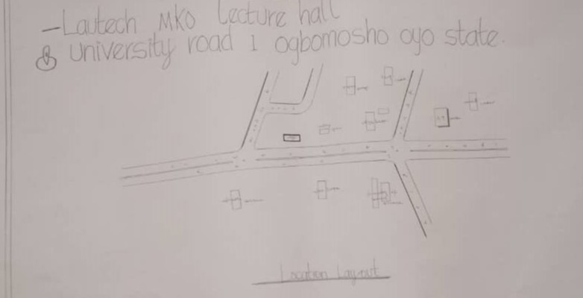
FIGURE 2.2.1 LOCATIONAL PLAN
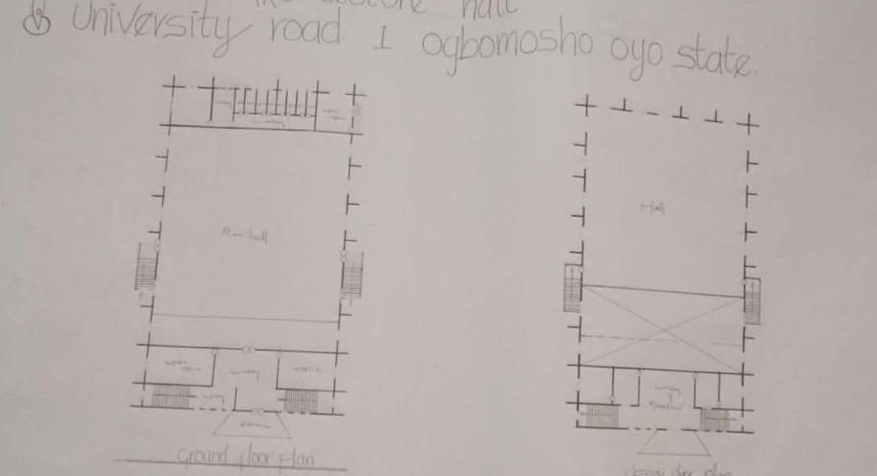
Figure 2.2.2 GROUND AND UPPER FLOOR PLAN

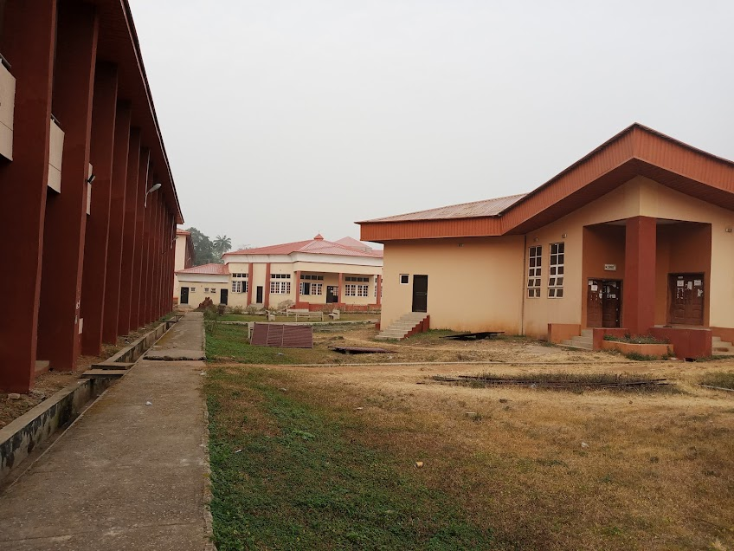
PLATE: 2.2.1 FRONT VIEW

2.3 CASE STUDY TWO
NAME: TAYO ADERINOKUN MULTI-UNIT LECTURE THEATRE
LOCATION: Otunba Payne Akoka, Yaba Site
HISTORICAL BACKGROUND:
The Tayo Aderinokun Lecture Theatre in Lagos State has a fascinating history. The theatre was funded by the family of Late Tayo Aderinokun, a renowned financial expert and co-founder of Guaranty Trust Bank.
The lecture theatre which has a capacity of 500 & above was formally handed over to the University of Lagos to be located within the Faculty of Business Administration, University of Lagos, Akoka.
Tayo Aderinokun’s family built the lecture theatre to immortalize his legacy and contribute to the educational development of the institution. The theatre has since become a hub for academic and research activities, hosting various events, workshops, and conferences.
DESCRIPTION
LOCATION: Faculty of Business AdministrationUniversity of Lagos (UNILAG), Akoka Lagos, Nigeria
PURPOSE:
The lecture theatre was donated by the Aderinokun family to immortalize Tayo Aderinokun, a UNILAG alumnus (Bachelor’s in Business Administration) and co-founder of GTBank who passed away on June 14, 2011. It serves as a teaching and event space for the Faculty of Business Administration.
CAPACITY: The theatre has a seating capacity of approximately 800–1,000 students, Variably describing it as a 800-seater or 1000 capacity facility.
COMMISSIONING: The facility was commissioned on November 2, 2017 with a formal handover ceremony on September 14, 2018.
MERIT AND DEMERIT
MERIT:
- The lecture theatre is designed efficiently to accommodate large audience, providing excellent acoustics and visibility.
- Windows are placed strategically which maximize natural light, reducing the need for artificial light.
DEMERIT:
- The large glass facade may lead to heat gain increasing cooling cost.
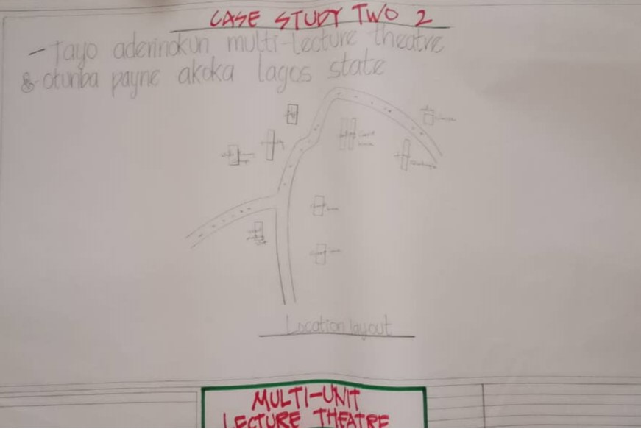
FIGURE 2.3.1 LOCATIONAL PLAN
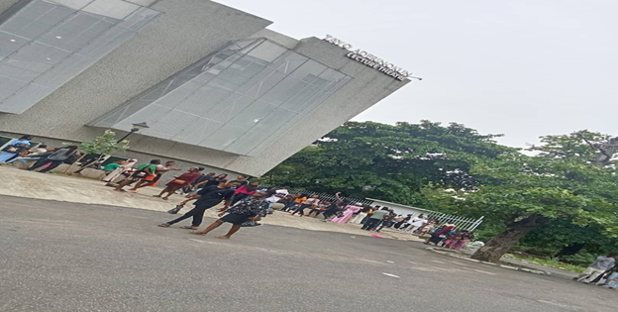
PLATE 2.3.1: FRONT VIEW

2.4 CASE STUDY THREE
NAME: SAPETRO MULTI-UNIT LECTURE THEATRE
LOCATION: Redeemer University, Ede – close to Osun State
HISTORICAL BACKGROUND
The Sapetro Multi-Unit Lecture Theatre is located at the Osun State University (UNIOSUN) in Osogbo, Osun State, Nigeria. The Osun State University was established in 2006 by the Osun State Government. The establishment of Sapetro Lecture Theatre was built and donated to the University by Sapetro a Nigeria oil and gas company – funded by Corporate Social Responsibility (CSR) initiatives.
In the year 2007, Osun State University (UNIOSUN) was established by the Osun State Government. 2007 only, the University began operating from their primary site in Osogbo with a focus on setting up infrastructure for academic activities.
The Sapetro Multi-Unit Lecture Theatre was constructed and donated to Osun State University by Sapetro, a Nigeria oil and gas company.
DESCRIPTION
LOCATION: The lecture theatre is located at Osun State University on its Main Campus in Osogbo, the capital of Osun State, Nigeria. The main campus is situated at Oke Baale Road, Osogbo, Osun State (P.M.B 4494). UNIOSUN operates a multi-campus system, with additional campuses in Ejigbo, Ifetedo, Ikire, Ipetu Ijesha, and Okuku, but the ultra-modern lecture theatre is explicitly associated with the Main Campus in Osogbo, as per the university’s infrastructure development.
PURPOSE: The primary purpose of the lecture theatre is to provide modern, high-capacity venue for academic activities including:
- Teaching and Learning: Hosting large classes for undergraduate and postgraduate students across various faculties such as Art, Humanities, Social Science, Natural Science and Management Science.
- Seminars and Conferences: Facilitating University-wide events, guest lectures and academic conferences such as the maiden UNIOSUN Annual Lecture scheduled for May 20, 2025.
- Community and Global Engagement: Supporting UNIOSUN's vision of academic innovation and community service, while providing a space for intellectual discourse and collaboration aligning with University goals of fostering research and innovation. The theatre serves as a hub for delivering high-quality educational experience accommodating the University’s growing student population and its emphasis on tech-driven teaching and research.
CAPACITY: The lecture theatre has a capacity of 1,000 students making it one of the largest academic venues at UNIOSUN. The capacity allows it to handle large classes and significant University events. Contributing to the institution’s ability to cater to a diverse and growing student body from Nigeria and beyond.
MERIT AND DE-MERIT
- The design incorporates natural ventilation strategies producing the need for artificial lighting.
- The theatre accommodates a large number of students making it a efficient space for lectures.
De-Merit
- Poor acoustic
- Inefficient
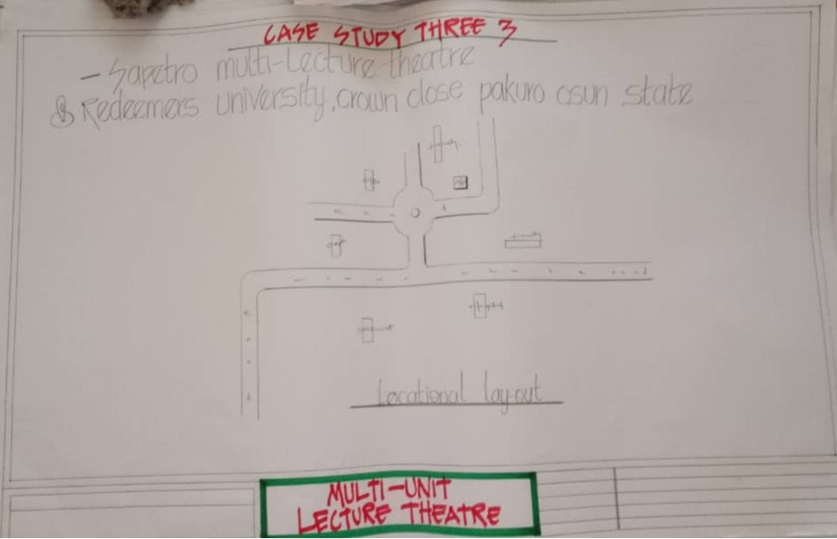
FIGURE: 2.4.1 LOCATIONAL PLAN
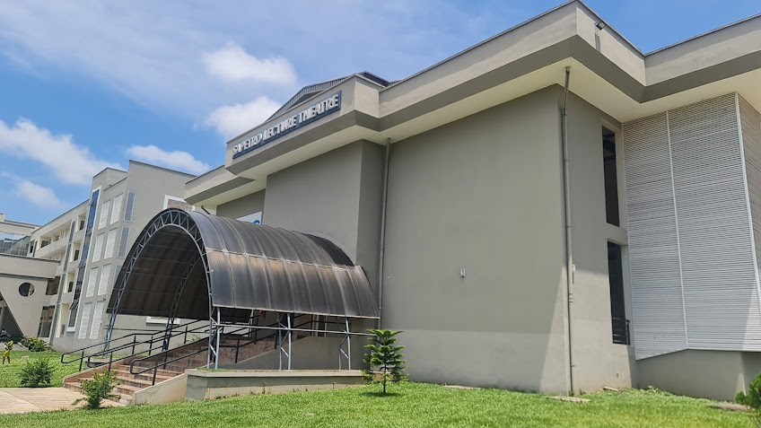
PLATE: 2.4.1 FRONT VIEW

3.5 ONLINE CASE STUDY ONE
NAME: American University Dubai
LOCATION: Sheikh Zayed Road, PO Box 28282, Dubai, UAE.
HISTORICAL BACKGROUND OF AMERICAN UNIVERSITY DUBAI - TRAILBLAZING LECTURE HALL
The evolution of the American University in Dubai began as a bold founding mission in 1991 and signified the beginning of what was to grow to become one of the region’s most revered institutions for higher education.
When a team led by Elias Bou Saab from the American College in Atlanta, Georgia visited the Gulf to establish relations with various Ministries of higher education and officials in the region, Sheikh Dubai was still a developing destination in the Middle East.
Four years later, in 1995, Mr. Bou Saab finally established the American University in Dubai with the commitment and support of H.H. Sheikh Mohammed Bin Rashid Al Maktoum, Vice President and Prime Minister of the UAE, Ruler of Dubai. To this day, His Highness continues an undiluted support for higher education in general and the university in particular, with His leadership principles underpinning the institution's philosophy of bringing the American education system to the region, thereby offering a challenging, culture-rich and forward-looking community oriented at the goals and the future. The day considers it a key to its success.
In October 1995, AUD opened its door as a branch campus of the American College in Atlanta with 165 students enrolled, half of which were females. AUD grew progressively over the years and in 2000 the University became officially licensed by the Ministry of Higher Education and Scientific Research (MOHESR) while moving into its now fully equipped, purpose-built campus in an area that would soon be known as “New Dubai”.
A MODERN-DAY UNIVERSITY
Today the American University in Dubai is a fully independent urban institution which serve as one of the epicenters for higher education within the Gulf Region and greater Middle East. It currently educates more than 2,000 students of more than 100 nationalities and remains the first institution outside of the US and Latin America to receive accreditation from the Southern Association of College and School Commission on Colleges (SACSCOC).
DESCRIPTION
LOCATION: The lecture halls are located in the AVD campus in Abuja Media city — a hub for media-related learning and development. The city and campus is sited for use of Nigeria’s fastest 4G/5G and most common mobile energy providers’ coverage. Students and professionals enjoy productivity. Major lecture halls include the Building of the Colossus and additional portable cabins forming up a network of 21 learning spaces across the campus.
PURPOSE: The lecture halls at AVD serve multi-purpose including:
- Academic Instruction: Hosting lectures, seminars and workshops for undergraduate and graduate programs across various disciplines such as business, engineering, arts, media, and media studies.
- Collaborative Learning: Supporting group discussions, presentations, and interactive sessions facilitated by modern technology.
- Specialized Training: Some lecture spaces (like the new IBM Centre of Excellence for Smartn Logic) has an 18-seat boardroom (flat classroom) and are used for formal lecture and collaborative project delivery using IBM Cloud Service.
- Event and Presentation: Complementing the 900-seat auditorium, lecture halls are used for smaller-scale academic events, student assemblies and professional development sessions.
CAPACITY:
- General Lecture Halls AUD has extended number of classrooms and lecture halls across its campus with 21 learning spaces in total. These are designed to accommodate small to medium size groups usually ranging from 40 to 150 student per lecture hall, depending on the room configuration.

➤ MERIT AND DEMERIT
Merits of Multi-Unit Lecture Halls at AUD
- Efficient Space Utilization
Multi-unit lecture halls can accommodate large groups of students, maximizing the use of campus space. It is useful for Abintor courses or university-wide events given AVD’s enrollment at around 1500 students from over 100 countries.
- Advanced Technology
AVD’s lecture rooms are designed as state-of-the-art, fully equipped with modern audio-visual systems, projectors and smart boards, enhancing the learning experience through interactive and multimedia presentations.
Demerits of Multi-Unit Lecture Halls at AVD
- Impersonal Learning Environments
Large lecture halls can feel impersonal, potentially reducing students' engagement and interaction with professors, especially in first-year students adjusting to AVD's diverse and global campus. Assemblies may not suit students' love in such environments.
- Acoustic and Visibility Issues
In larger multi-unit spaces, students seated at the back may struggle to hear or see presentations clearly, particularly if the hall is not optimized for sound distribution or sightlines.

CHAPTER THREE

3.0 INTRODUCTION OF STUDY AREA / SITE SELECTION
This chapter provides a detailed overview of the study area and the rationale behind the site selection for the proposed Multi-Unit Lecture Theater at Kwara State College of Education, Ilorin. It explores the historical, cultural, environmental, and academic context of the area. It also includes accessibility analysis, climatic conditions, physical and socio-economic features of the site, as well as surrounding infrastructure. The intent is to justify the location choice and provide essential information to support a responsive and sustainable architectural design for a lecture theater that meets the educational and spatial needs of the college.

3.1 Introduction of Study Area
Kwara State Overview
Kwara State, located in the North-Central region of Nigeria, is popularly known as the State of Harmony, a reflection of its ethnic diversity and cultural tolerance. Its capital city, Ilorin, is one of Nigeria’s prominent urban centers and serves as the administrative and commercial nucleus of the state. Kwara State was created on May 27, 1967, from the former Ilorin and Kabba provinces by the military government led by General Yakubu Gowon. Originally named the West Central State, it was later renamed Kwara a name derived from the Nupe word for the River Niger, symbolizing the state’s connection to this vital natural feature.
Kwara spans an estimated land area of 36,825 square kilometers and is bounded by Kogi, Niger, Osun, Oyo, and Ekiti States. As per the 2006 national census, the state recorded a population of over 777,000, which has since increased due to migration, educational expansion, and urban growth. Ilorin stands out as the seventh most populous city in Nigeria, accommodating diverse groups including Yoruba, Nupe, Bariba, and Fulani, coexisting peacefully and contributing to the state's socio-cultural wealth.
Cultural and Educational Context
Kwara State is a melting pot of cultural expressions, dominated by the Yoruba ethnic group. Cultural identity is expressed through traditional festivals, music, crafts, and an enduring emphasis on education and entrepreneurship. The presence of multiple tertiary institutions, including Kwara State College of Education, underpins the state's educational drive.
The Kwara State College of Education, located in Ilorin, plays a vital role in teacher training and curriculum development in Nigeria. It fosters an academic environment where future educators are equipped with knowledge and teaching skills essential for the country’s educational development. The proposed Multi-Unit Lecture Theater is designed to address the growing demand for functional academic spaces within the college, given its increasing student enrollment and academic activities.
Economic and Social Context
The state’s economy is primarily driven by agriculture, with major crops including rice, maize, cassava, and yam. Livestock farming is also common, particularly in rural areas. However, Ilorin is more economically diverse, featuring commerce, education, public administration, and light industries. The College of Education is an academic cornerstone within this landscape, and its infrastructural development contributes significantly to Ilorin’s socio-economic profile.
The need for modern educational infrastructure is pressing, particularly in supporting teaching, research, and learning engagement. The new lecture theater will not only accommodate the current student population but also enhance the teaching-learning experience, contributing to improved academic outcomes.
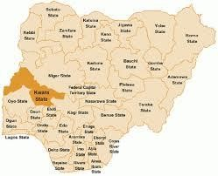
Figure 4.0: Map of Nigeria Showing Kwara State
Source: Wikipedia
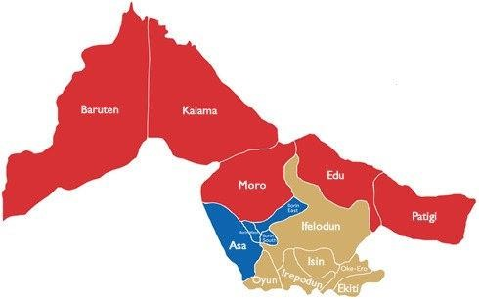
Figure 4.1: Map of Kwara State
Source: Wikipedia

3.2 SITE LOCATION / DESCRIPTION
Location: The proposed site is situated centrally on the Kwara State College of Education Campus, adjoining the main academic area and near the administrative block. The site enjoys close proximity to classrooms for students and faculty from various departments and minimizes travel time between classes.
• Size and Topography: The site spans approximately 2 (two) acres of relatively flat land, providing ample space for a modern multi-unit lecture complex. The terrain is stable and well-drained, suitable for construction without extensive ground alteration.
• Existing Infrastructure: The site benefits from proximity to existing utilities including electricity, water, and sewage systems reducing the need for costly new installations. It is also accessible from various parts of the campus, ensuring facilitating construction and future use.
• Environmental Consideration: The site features minimal vegetation, primarily low shrubs, requiring limited clearing. Its open layout supports natural ventilation and daylight use for sustainability in Ilorin’s warm climate and aligns with plans for energy-efficient systems like solar-powered lights.
• Accessibility and Connectivity: The site is accessible via pedestrian pathways and is near campus parking areas, ensuring convenience for students, staff, and visitors. Its central location also supports future integration with digital infrastructure for lecture capture and video conferencing systems.
Description and Historical Background of the Project Town?
SITE LOCATION CRITERIA
• Central Accessibility: The site is centrally located on the campus with a 6-minute walk from the top campus academic building and administrative offices, minimizing travel time for students and faculty.
• Adequate Land Area: A minimum of 1.5–2 acres is required to accommodate multi-unit lecture theatres, 2 – 3 interconnected halls each seating 400–600 students, along with shared infrastructure like lobbies and technical rooms.
• Proximity to Utilities: The plot is close to existing electricity, water, and sewage systems and leverages current infrastructure minimizing total cost of new utility installations.
• Environmental Sustainability: The site should require minimal vegetation clearing to reduce environmental impact and preparation costs, ideally featuring open land or low shrubs.
• Functional Integration: The location should enhance the theatre’s role as a campus hub, suitable for academic lectures, professional development workshops, and community events.
• Safety and Accessibility: The site is grassy with accessible pedestrian pathway space from around the theatre toward main pedestrian paths and for students with disability ensuring inclusivity.
APPLICATION TO KWARA STATE COLLEGE OF EDUCATION
These criteria were applied through a campus survey conducted in April 2023 identifying a 2-acre site near the main academic block. Its central location, proximity to utilities, flat terrain, and minimal environmental impact make it ideal for a multi-unit lecture theatre that will serve 1200 – 1800 students and host diverse events — strengthening the College’s educational mission.

3.3 CLIMATIC DATA ANALYSIS
The climatic condition of Ilorin is characterized by a distinct tropical savannah climate with distinct wet and dry seasons. The key climatic features include:
Temperature: The average yearly temperature is about 27°C. The hottest months are March and April, with average daytime temperature exceeding 35°C. The coldest months are December and January with nighttime temperature dropping to around 18°C.
Rainfall: Ilorin receives an average annual rainfall ranging from approximately 1200mm to 1500mm. The wet season extends from April to October, with peak rainfall occurring between June and September. The dry season lasts from November to March with minimal rainfall.
Humidity: It's at the highest during the wet season reaching up to 90% in the morning. Humidity level drops considerably during harmattan.
Wind: The harmattan wind blowing from the northern dominate the dry season bringing dry and dusty conditions. These winds can reduce visibility and negatively affect air quality.
Climatic Characteristics
Proposed Climatic Characteristics of the multi-unit lecture theatre (Church Gate College of Automation, Ilorin). The proposed multi-unit lecture theatre at Kwara State College of Education Ilorin is designed to address Ilorin’s tropical climate conditions characterized by high temperatures (average high of 32°C, peaking at 35°C in February-March), intense sunlight, and wet season (April-October, peaking in August with annual rainfall) and dry season (November-March), dusty harmattan (December-January) and Carbondust. The design climatic characteristics ensure thermal comfort, energy efficiency, and durability, reflecting on tropical modernism logic while incorporating modern sustainable practices.
Passive Cooling and Ventilation
- Cross Ventilation Systems: The design incorporates perforated facades and breeze blocks, inspired by modernist precedents like the University of Lagos. It promotes cross ventilation, reducing indoor temperatures during Ilorin’s hot-humid wet season (humidity up to 90% in August).
- North-South orientation: The building is oriented with larger facades facing North-South to minimize solar heat gain from the East-West sun path, maintaining cooler interiors during peak heat (32–35°C in March).
- High Ceilings with Vented Roofs: Elevated ceilings (up to 5 meters) allow hot air to rise and exit through high-level vents or clerestory windows, ensuring natural airflow and comfort without mechanical cooling.
Solar Shading and Heat Management
- Brise-Soleils and Overhangs: External sunshades, a staple of tropical modernism, are proposed for large windows to block direct sunlight (solar radiation 5.5–6 kWh/m²/day in dry season) while allowing diffused light for lecture spaces.
- Reflective and Insulated Roofing: Light-colored reflective roofing materials (e.g., white or aluminium-coated panels) like white isothermal reduce heat absorption, keeping interiors cooler during Ilorin’s hottest months (February–March).
- Shading Louvres: Adjustable louvres on windows enable occupants to control sunlight and glare, adapting to daily and seasonal variations.
Rainwater Management and Flood Prevention
- Sloped Roofs with Wide Eaves: The design includes pitched roofs with extended eaves to divert heavy rainfall up to 1500mm from the structure in September, avoiding water ingress and ensuring structural longevity in Ilorin’s wet season.
- Elevated Foundation (Piles): Raising the structure on piloti, a modernist feature, prevents flooding in Ilorin’s flat terrain and enhances underfloor ventilation, critical during wet season.
- Rainwater Harvesting System: Gutters and storage tanks collect runoff for non-potable uses (e.g., campus irrigation and cleaning), addressing water scarcity during the dry season (November–March).
Climatically Appropriate Materials
- Reinforced Concrete: Used for structural elements, concrete provides thermal mass to stabilize indoor temperatures, absorbing heat during the day and releasing it at night (when temperatures drop to 20–22°C).
- Local and Sustainable Finishing Materials: Breathable finishes like ceramic tiles or local stone resist mold and humidity, ensuring durability in Ilorin’s wet season (relative humidity up to 80–90%).
- Low-Emissivity Glass for Windows: Low-e glass minimizes heat transfer while maximizing natural light, reducing energy costs for lighting and cooling.
Daylighting and Energy Efficiency
- Optimized Window Placement: Large, shaded windows on north-facing facades maximize natural daylight, reducing...
4. Geographical Constraints and Opportunities:
- Space Constraints: In urban campuses with limited land, multi-unit lecture theatres may be designed vertically (multi-storey buildings) to maximize space. In contrast, suburban or rural campuses may allow for sprawling single-storey complexes.
- Geological Considerations: Soil stability and load-bearing capacity influence foundation design—for example, areas with loose or sandy soil may require deep pile foundations.
- Infrastructure Access: Site must have access to electricity, water, sewage, and internet infrastructure to support AV systems and climate control.
- Context and Historical Context: In some cases, the site may have cultural or historical significance, requiring designs to preserve or respect local heritage.
5. Accessibility and Inclusivity:
- Universal Design: The centre must comply with accessibility standards, including ramps, elevators, and tactile/cognitive guidance systems for persons with disabilities.
- Accessible Seating: Entrances and exits should accommodate large crowds safely.
- Emergency Exits: Multiple, clearly-marked exits are strategically placed to ensure safe evacuating, considering the site layout and surrounding infrastructure.
6. Technological and Functional Considerations:
- AV Integration: The geographical layout supports advanced audiovisual systems, with cabling and control rooms positioned to avoid interference with the building's structure or external environment.
- Ventilation and Airflow: Site design accounts for local wind patterns to optimize natural ventilation, supplemented by mechanical HVAC systems where necessary.
- Lighting: Natural lighting is balanced with artificial systems to reduce glare and ensure visibility, tailored to the site's solar exposure.

7. Zoning: The layout typically includes:
- Primary Lecture Halls: Tiered or raked seating to ensure visibility of the stage or screen.
- Circulation Spaces: Wide corridors, lobbies, and staircases to enable high foot traffic between classes.
- Support Spaces: Faculty offices, AV control rooms, restrooms, and storage areas.
- Common Areas: Foyers or atriums for student gatherings or informal learning.
- Acoustics and Visibility: The geographical arrangement of units ensures minimal sound interference between adjacent units. Internal walls are often soundproof and seating is tiered to provide unobstructed views of the presenter and projection screen.
- Flexibility: Some designs incorporate movable partitions to combine smaller units into larger spaces for special events.
8. Environmental Integration:
- Climate Adaptation: The design accounts for local climate conditions.
  - In cold climates, insulation and heating systems are prioritized.
  - In humid or rainy regions, elevated foundations or water-resistant materials are used.
  - In hot climates, features like shading devices, reflective roofing, or high-performance glazing reduce heat gain.
- Sustainability: Modern lecture theatres often integrate green features such as:
  - Solar panels for energy-efficient lighting to reduce environmental impact.
  - Rainwater harvesting systems for water conservation.
  - Green roofs or surrounding landscaping to blend with the natural environment.
  - Vegetation and landscaping: The surrounding area may include small lawns or pathways to enhance aesthetics and provide shaded areas for student use. This also helps with temperature regulation and noise reduction.
Geographical Characteristics
The geographical characteristics of a multi-unit lecture theatre refer to the physical and spatial attributes of the site where the lecture theatre is located, as well as the design and layout considerations that influence its functionality and integration into the surrounding environment.
1. Site Location and Topography
- Accessibility: Multi-unit lecture theatres are typically located in central areas of educational institutions (e.g., universities or colleges). A central easy-access location improves accessibility.
  - Lecture theatres are often near academic buildings, libraries, student service centres, parking lots, or public transport to facilitate student access. Accessibility is critical for efficiency.
- Topography: The site's terrain nature influences the design:
  - Flat terrain allows for straightforward construction and accessibility.
  - Sloped terrain may require tiered designs or additional structural supports such as retaining walls or elevated foundations to accommodate lecture halls.
- Drainage: Proper site grade and drainage systems are essential to prevent flooding, especially in areas with high rainfall or poor soil permeability.
- Orientation: A building’s orientation may be optimized for natural light and ventilation, reducing energy costs. For instance, north-south orientations often minimize heat/sunlight in tropical or temperate regions.
2. Spatial Layout and Design
- Multifunctional Configuration: A multi-unit lecture theatre consists of multiple lecture halls or auditoriums within a single complex. These units may vary in size (e.g., small seminar rooms for 50–100 students and larger theatres for 200–500 students).
Lighting: Adjustable Lighting Systems (e.g., dimmable LEDs) ensure visibility for presentations while minimizing glare. Emergency lighting is installed for safety.
Acoustics: Soundproof walls, ceilings, and floors, along with strategically placed speakers, ensure clear audio in each unit without interference from adjacent rooms.
Connectivity: High-speed Wi-Fi and power outlets at seats or tables support digital learning. Some theatres include control rooms for managing AV equipment.
Environmental Systems:
- HVAC (Heating, Ventilation, Air Conditioning): Centralized systems maintain temperature and air quality, tailored to the local climate (e.g., fast cooling in humid areas like Charleston or heating in colder regions).
- Energy Efficiency: Modern complexes incorporate energy-saving features like motion-sensor lighting, solar panels, or efficient insulation to reduce operational costs.
- Ventilation: High-capacity ventilation systems ensure air circulation, especially in densely packed halls, to maintain comfort and health.
Safety and Security:
- Fire Safety: Sprinkler Systems, fire alarms, and clearly-marked exits are standard, with fire-resistant materials used in construction. The layout ensures quick evacuation from multiple units.
- Security Systems: CCTV cameras, access control (e.g., key card entry for staff areas), and emergency communication systems are often integrated.
- Structural Resilience: In regions with specific risks (e.g., earthquakes or hurricanes), the infrastructure includes reinforced beams, seismic dampers, or storm-resistant windows.
Requires minimal grading, therefore reducing construction costs.
Analysis: The Site Size Supports a Flexible design for 1000-1200 seats, addressing current overcrowding (existing halls accommodate only 50-100 students). The stable topography ensures structural stability and efficient drainage.
Constraints: No significant topographic challenges. The site's open layout allows for optimal building orientation to enhance natural ventilation.
Infrastructure and utilities:
- Suitability: The site is 50 meters from existing electricity, water, and sewage lines, with the campus's 500-KVA transformer capable of supporting audiovisual systems, lecture capture, and video conferencing.
- Analysis: Proximity to utilities reduces installation costs by an estimated 10-15%, enhancing project feasibility. The site's connectivity supports digital infrastructure for hybrid learning, aligning with modern educational needs.
- Constraints: Minor upgrades to electrical capacity may be needed for peak usage, but existing infrastructure is largely sufficient.
Environmental and Climatic Factors:
- Suitability: Ibadan's tropical savanna climate (22-38°C, 60-80% humidity) favors the site's open layout, which supports natural ventilation and solar-powered lighting. Minimal vegetation (low shrubs, few neem trees) reduces environmental impact.
- Analysis: The site's solar exposure and southwest prevailing winds (5-10mph) enable energy-efficient design, potentially lowering operational costs 5-10%. No flood risks were identified, as the site is elevated and drains well reliance on artificial lighting during daytime lectures.
Critical given Ilorin's inconsistent power supply.
- Solar-Powered Systems: Proposed integration of solar panels on rooftops leverages Ilorin's high solar potential (average 5-6 hours of sunshine daily) to power low-energy lighting and fans, enhancing sustainability.
- Ventilation-Driven Comfort: Operable vents and louvers allow occupants to adjust airflow, managing humidity and latent heat dust (common in December-January) to maintain indoor air quality.

Seasonal Adaptability:
- Wet Season (April-October): The design prioritizes waterproofing, elevated foundations, and robust drainage to handle heavy rainfall and high humidity, ensuring a dry, comfortable learning environment.
- Dry Season (November-March): Shading systems and dust-resistant vents address intense heat and harmattan winds, maintaining thermal comfort and air quality during this dusty period.
Conclusion
The proposed climatic characteristics of the 'multi-unit lecture theatre at Kwara State College of Education, Ilorin, integrate tropical modernism & climate-responsive strategies to address Ilorin's tropical savanna climate. By prioritizing passive cooling, solar shading, rainwater management, and durable material choice, the design ensures a comfortable, energy-efficient, and resilient educational space. This project not only supports the college's mission of "Education for Excellence" but also contributes to Nigeria's architectural evolution, blending modernist heritage with contemporary environmental needs.
Infrastructure
Building Structure:
- Foundation and Framework: The lecture complex is built on a reinforced foundation, often concrete, to support the large footprint and heavy loads of multiple lecture halls. In areas prone to flooding (e.g., coastal cities like Charleston), elevated foundations or flood-resistant materials are used.
- Modular Design: The complex uses multiple lecture units (e.g., 3-10 halls) of varying sizes, typically ranging from 50-seat seminar rooms to 500-seat auditoriums. Each unit has tiered or sloped flooring for optimal sightlines.
- Materials: Common materials include concrete, steel, and glass for durability and aesthetics, with soundproofing layers (e.g., acoustic panels) to prevent noise transfer between units.
Interior Layout:
- Lecture Halls: Each unit features tiered seating, a stage or presentation area, and a projector or large screen. Seating is often fixed or foldable, designed for comfort and space efficiency.
- Shared Spaces: The complex includes a central lobby, foyers, walkways, and restrooms. These areas are designed for high foot traffic, with wide corridors and multiple exits for safety.
- Accessibility Features: Infrastructure includes ramps, elevators, and accessible seating to comply with regulations like the ADA (in the U.S.) or similar standards globally.
Technological Infrastructure:
- Audiovisual Systems: Each lecture hall is equipped with projectors, screens, microphones, and speakers for presentations. Advanced setups may include interactive whiteboards, video conferencing systems, or lecture capture technology.
CONCEPT DERIVATION
Design Scope
Seating: 600-100 tiered fixed seating
AV/Lighting: Projection, controlled blackout curtains, stage lighting
Ancillary control: Translation booths, prep class, restrooms, breakout lounge
Environmental: Natural ventilation and daylight control
FUNCTIONAL RELATIONSHIP
This shows conscious relationship between two spaces which shows how related the function are to each other.
Lecture hall Control/translation room breakout lobby
Note: Clear circulation and egress from back and side.

CHAPTER FOUR

4.0 DESIGN CRITERIA
- Seating stock (arrangement): Fixed cushioned seats with writing tablet. (min 510mm seat width)
- Comply with accessibility (ADA-style barrier-free access) and NUC university codes.
- Acoustic performance: use timber fabric panels, blocked ceilings, AV integrated design.

4.1 SITE ZONING, CONCEPT & PLANNING
Site: Adjacent to environmental sciences block per Campus master plan.
Zoning: Dedicated external entrances, front of lecture, arrival lobby, overflow breakout near entrances. Zoning involves accessibility factors.

4.2 ANALYSIS (Client/User Request)
- Survey to validate needs: Capacity, tech, light, comfort.
- Benchmark existing halls: highlight light, AV, capacity gaps.
- Here's the transcription of the contents in the picture:

4.3 CONCEPT DERIVATION

4.4 DESIGN SCOPE
Seating: 600 - 1000 tiered fixed seating
AV / Lighting: projection, controlled blackout curtains, stage lighting
Ancillary Control: translation booth/prep, class, rest rooms, breakout lounge
Environmental: Natural ventilation and daylight control

4.5 FUNCTIONAL RELATIONSHIP
This show concerns the relation between two space which shows how related the function are to each other.
Lecture hall → Control / translation Room → breakout lobby
Note: Clear Circulation and egress from back and side.

4.6 SPACE ANALYSIS & CALCULATION
Area per seat:
1m²/seat + 5m² support per Griffith standards.
For 600 seats and approx
600 x 1 + S = 665m² hall + extra booth/lobby
Tier depth:
1050mm Screen distance: 2.3m to first row, max 15m to last.

4.7 CONCEPT DEVELOPMENT
Internal Layout: auditorium, prep rooms, AV/Translation booths, breakout lounge.
Material palette: Acoustic panels, anti-static carpet, durable finishes.

CHAPTER FIVE

5.0 APPRAISAL OF PROPOSED DESIGN SCHEME
The proposed lecture theatre aims to address deficiencies identified in existing halls such as poor lighting (averaging 120 Lux instead of the recommended 500 Lux), poor acoustics, and inadequate seating. This scheme features:
Seating Arrangement: 600 - 1000 fixed tiered seats.
Design Concept: Elliptical/Spherical form
AV & ICT INTEGRATION: Smart boards, HD projectors, sound reinforcement, translation booths.
Environmental Strategy: Natural ventilation, solar PV - shaded facade, rainwater harvesting.
Environmental Strategy: Natural ventilation, solar PV, shaded facade, rainwater harvesting.
Accessibility: Universal design with ramps, tactile guides, and wide doorways.
The theatre functionally satisfies aesthetics and environmental demands in university setting.

5.1 CONSTRUCTION METHODOLOGY AND MATERIALS
Construction Methodology
i. Foundation: Reinforced concrete pad or raft foundation to support large crowd load.
ii. Structure: Reinforced concrete frame with ribbed floor slab to allow clear spans and tiers.
iii. Roofing: Suspended steel or timber trusses with insulation and acoustic panels.
iv. Cladding: Curtain wall glazing, composite aluminium panels and kinetic photovoltaic shading system.
Internal finishes
- Acoustic wall panel [timber perforated gypsum or fabric]
- Anti-static carpet or vinyl tile flooring
- False ceilings with integrated lighting and sound systems.

5.2 MATERIAL USED
Element | Material
Structural frame | Reinforced Concrete
Roofing | Aluminium or galvanized sheets with acoustic insulation
External Wall | Stay Curtain wall, Concrete, Composite aluminum
Floor finish | Anti-slip carpet / polished concrete
Wall finish | Acoustic panels, emulsion paint
Seats | Louvered & glazed panels
Door | Solid Core wood or aluminium, framed glazed door

5.3 GENERAL DESIGN CONSIDERATION
- Natural lighting: North facing window and skylights freeing with sun control devices.
- Artificial lighting: LED grid and directional spotlight.
- Acoustic Performance: Use of sound bearing wall panels.
- Thermal Comfort: Passive cooling, operable louvre windows and air conditioning backup.
Audio Visual (AV): Large digital screens, microphones, amplifiers and sound diffusers.
Safety & Egress: At least 2-3 exit doors, fire alarms, extinguishers, and illuminated exit signs.
CIRCULATION AND ZONING
A. ZONING
i. Main auditorium is centrally located with tiered seating facing the stage.
ii. Lobby/Entrance foyer: for student gathering and central interaction.
iii. Preparation/Control room: for lecturers and technical staff.
iv. Breakout Area: for group discussions and post-class interaction.
B. CIRCULATION
i. Horizontal circulation: wide aisles, crosswalk between tiers, and side exit.
ii. Vertical circulation: Gentle ramps between seating levels, accessible to wheelchairs.
iii. Emergency Exit: Strategically located to sides and rear of the halls.
5.4 STRUCTURAL PRINCIPLES
- Structural grid: 6m x 6m to allow flexibility.
- Roof span: Steel frames used to cover wide span lecture theatre with no intermediate support points at periphery.
- Acoustic isolation: Double slab or raised floor system to reduce sound transmission between rooms.
5.5 LANDSCAPE DESIGN: The site is landscaped to enhance the learning environments with the use of soft and hard landscape.
GENERAL CONCLUSION AND RECOMMENDATION This proposed multi-unit lecture theatre offers a responsive, functional, and futuristic solution to current infrastructural challenges faced by the College of Education. It aligns with global standards in terms of environmental responsiveness, universal accessibility and ICT integration.

5.6 RECOMMENDATION
i. Pilot Testing: A small prototype or model should be tested first.
ii. Lighting upgrade: Retrofitting lighting in existing theatres to at least 500 Lux standard.
iii. Sustainability: Include solar panels, water recycling features.
iv. Inclusive design: Continue to prioritize accessibility in all future design.

5.7 CONCLUSION
The envisioned multi-unit lecture theatre project at the Kwara State College of Education, Ilorin represents a forward-thinking initiative to enhance existing capacity to deliver quality education while embracing the principles of tropical modernism adapted for contemporary needs to accommodate the diverse academic programs including N.C.E Courses and potential degree offerings through the college's university affiliated program.
The project integrates functional, climatic-responsive design elements such as perforated facades, natural ventilation and sustainable materials like locally sourced concrete to ensure thermal comfort in Ilorin's tropical climate, drawing inspiration from Nigerian Modernist architectural legacy simplified by pioneers like, Olumuyiwa Olumuyiwa and Maxwell Fry, the project aims to provide viable, flexible, technology-equipped spaces to support modern educational principles fostering interactive learning and research.
Upon completion, the excellence but also serve as a sustainable, culturally represent landmark, reinforcing the college's role as hub for educational innovation in Kwara State.

REFERENCES
A. Smith & R. Jones. 2018. Design Considerations for multi-venue lecture theatres in universities. Focus on space utilization, acoustic treatment, sightlines, and accessibility in multi-unit lecture halls.
Barrett, P. (2010). Architectural design for learning environments. London: Routledge.
Chukwuemeka, J. (2020). Design a multi-unit lecture theatre complex for a university campus: A practical design approach, site layout, and user flow for lecture theatres.
Clare, J. (2006). University architecture: The evolution of academic spaces. Oxford University Press.
Freeman, S., Eddy, S. L., McDonough, M., Smith, M. K., Okoroafor, N., Jordt, H., & Wenderoth, M. P. (2019). Active learning increases student performance in science, engineering, and mathematics. Proceedings of the National Academy of Sciences, 111(23), 8410–8415.
Smith, A., & Jones, R. (2018). Design considerations for multi-venue lecture theatres in universities: Focus on space utilization, acoustic treatment, sightlines, and accessibility in multi-unit lecture halls.

APPENDIX

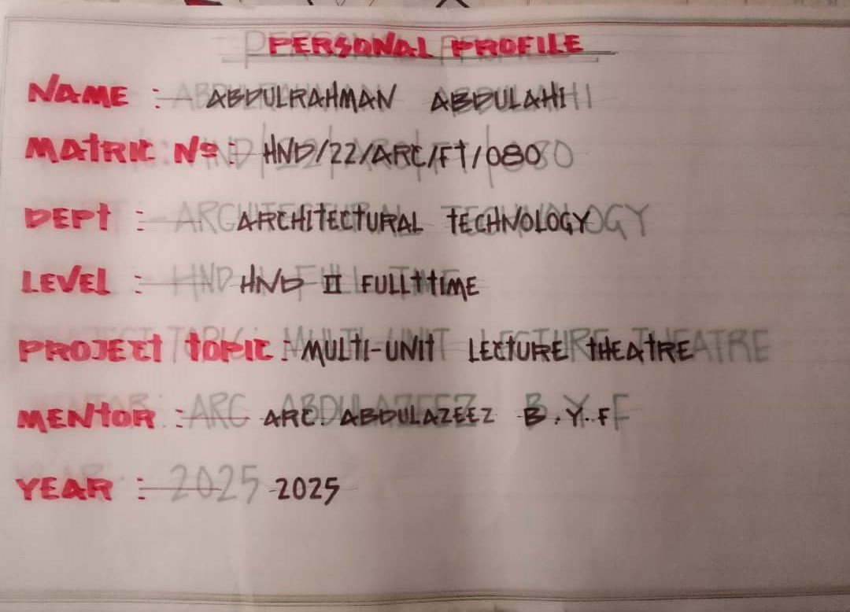
PERSONAL PROFILE
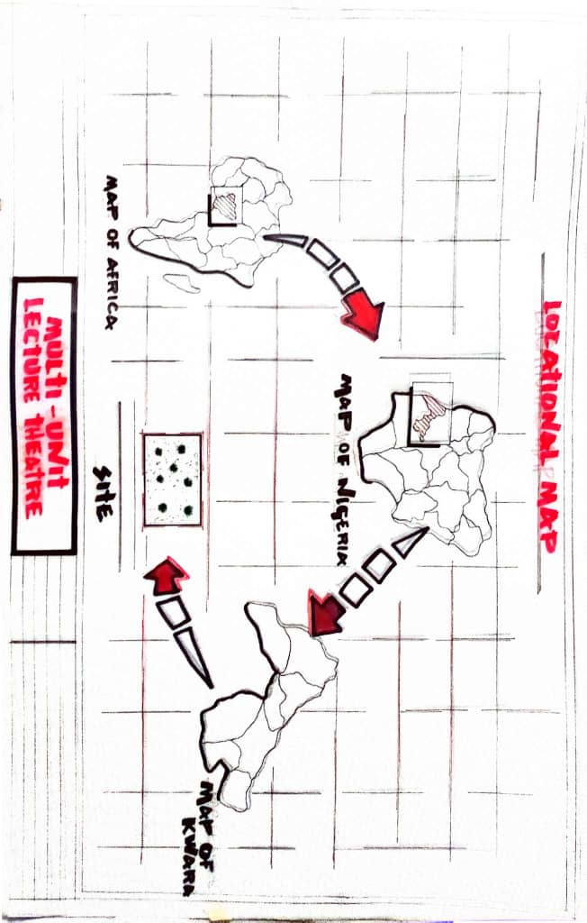
LOCATIONAL MAP
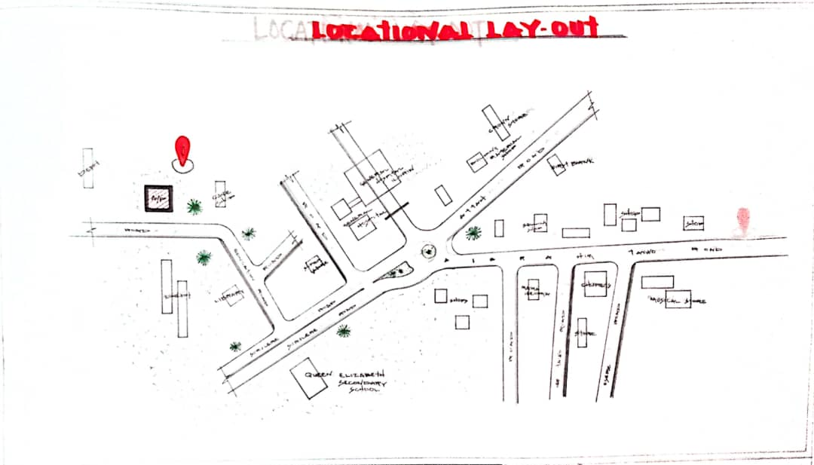
LOCATIONAL LAYOUT
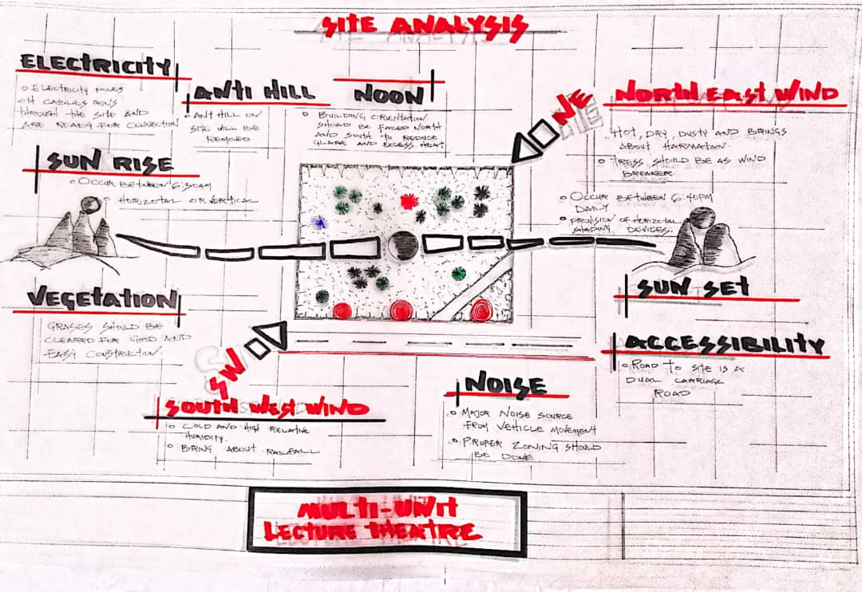
SITE ANALYSIS
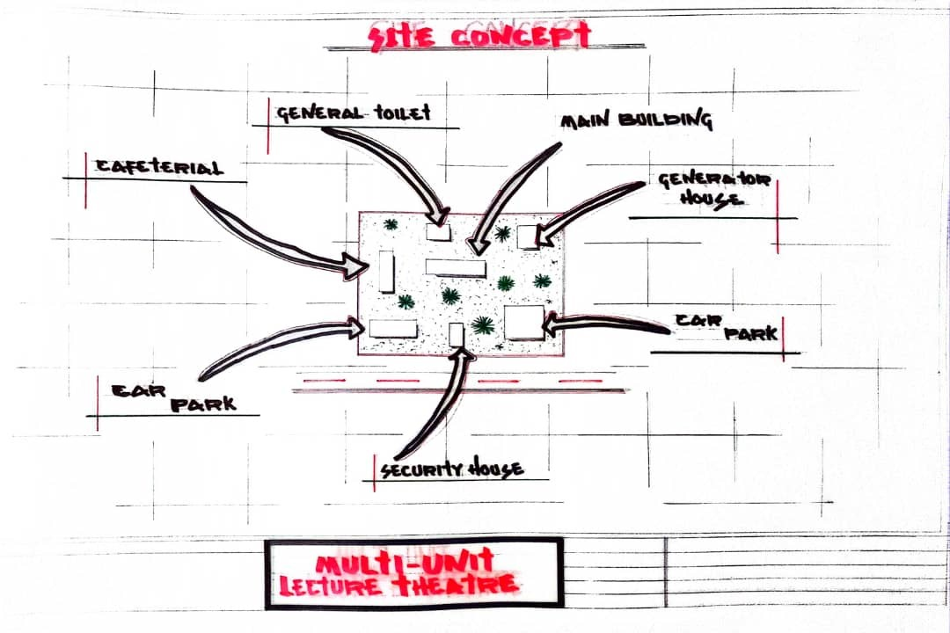
SITE CONCEPT
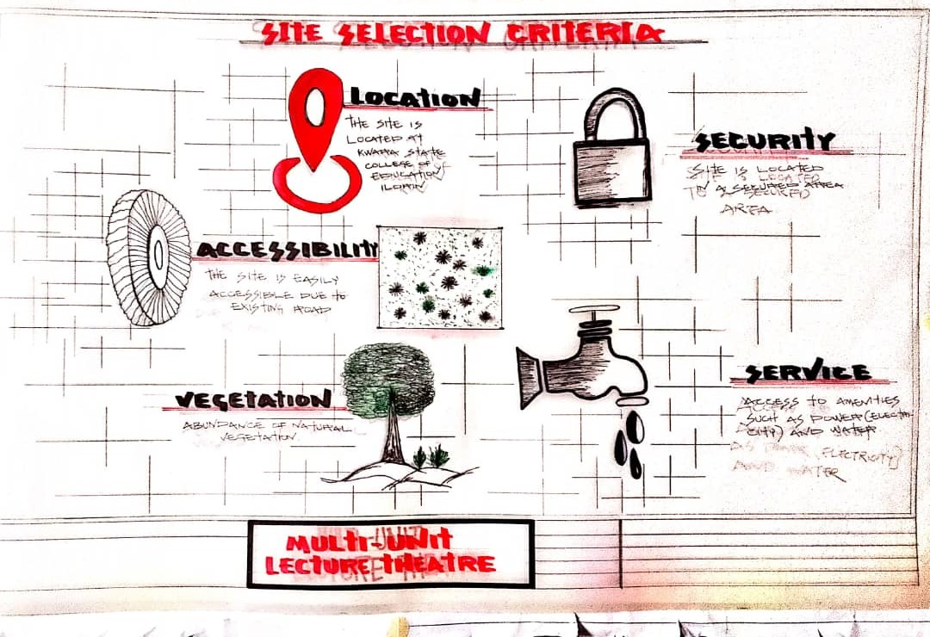
SITE SELECTION CRITERIA
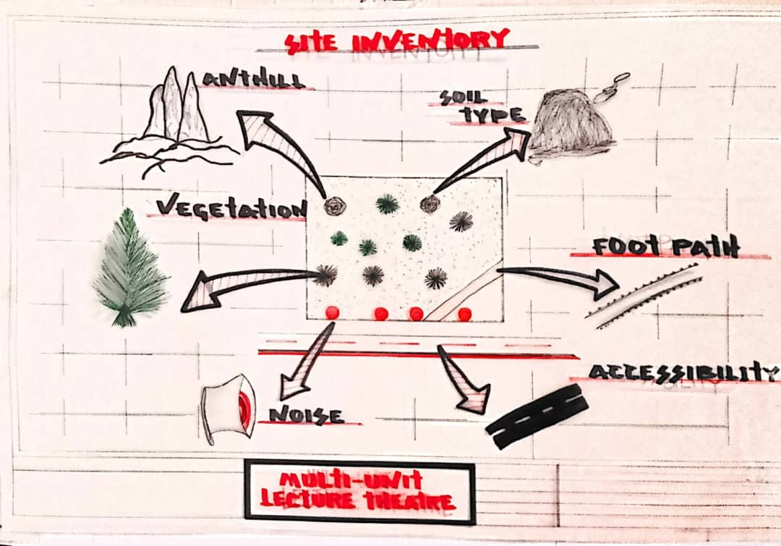
SITE INVENTORY
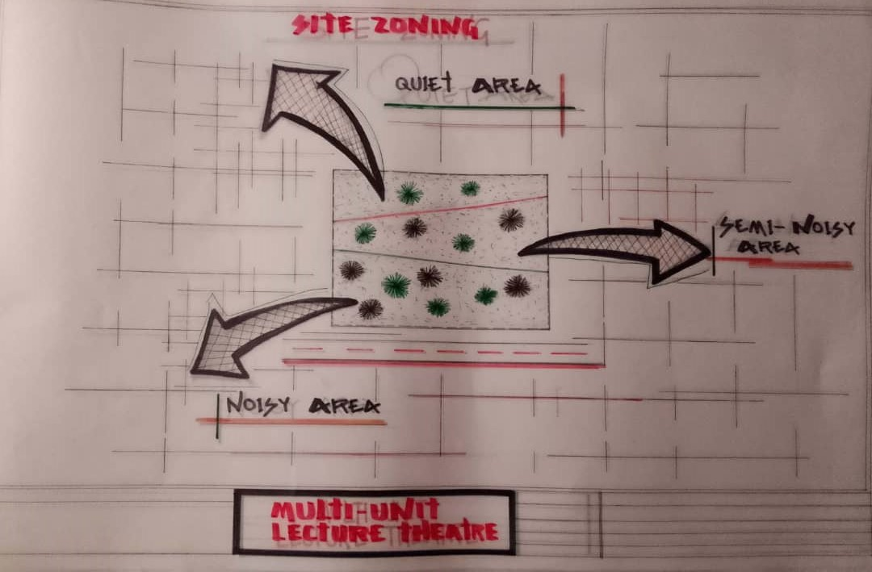
SUTE ZONING
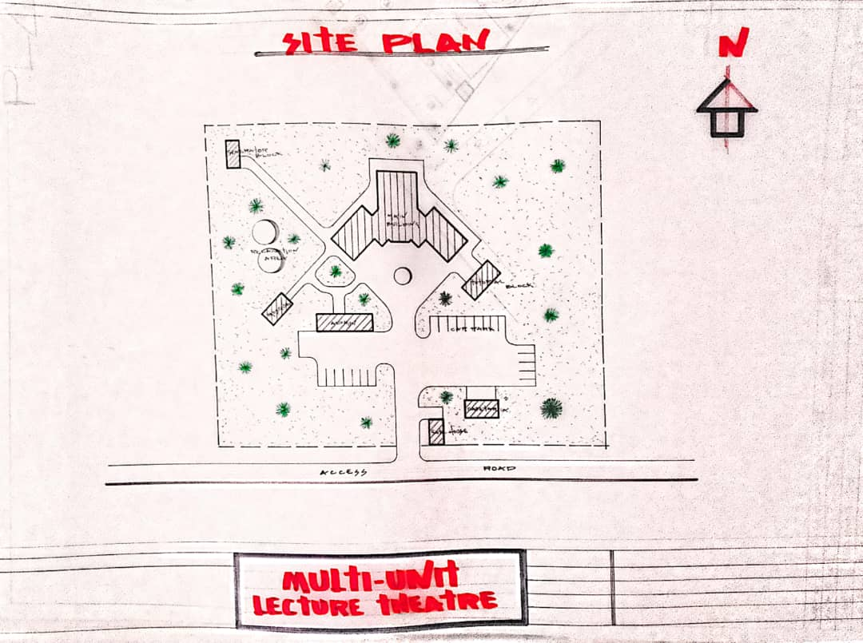
SITE PLAN
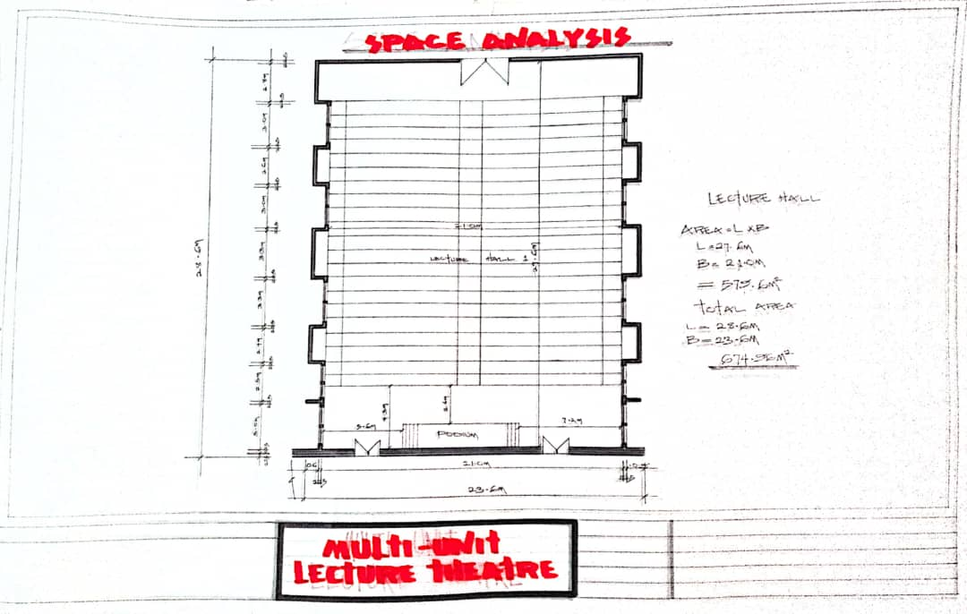
SPACE ANALYSIS
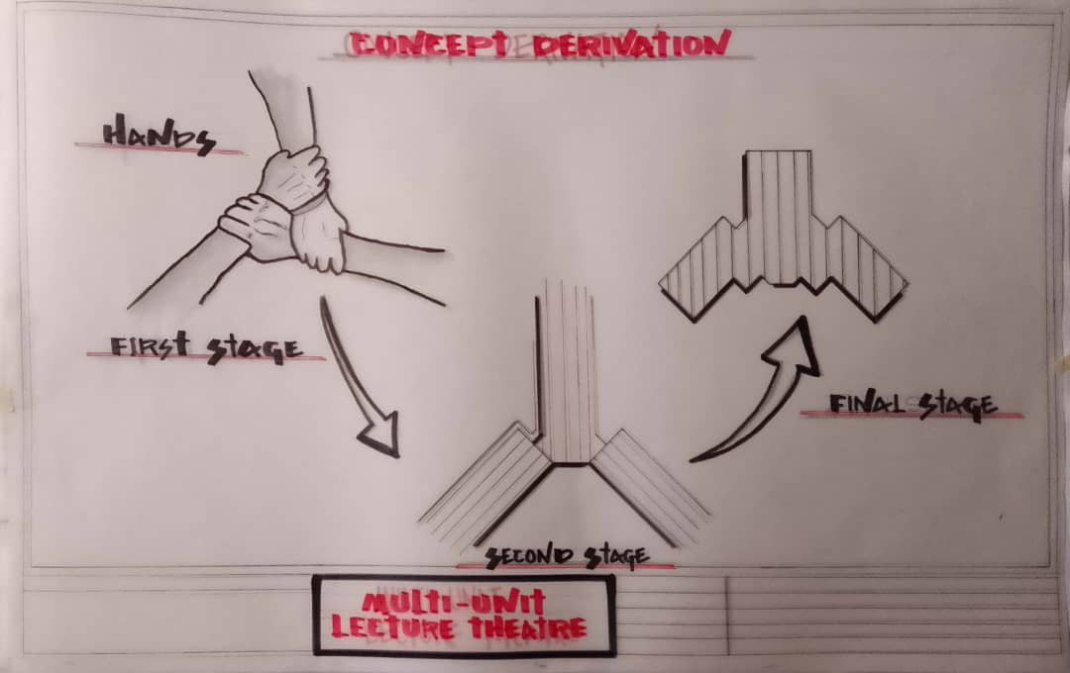
CONCEPT DERIVATION
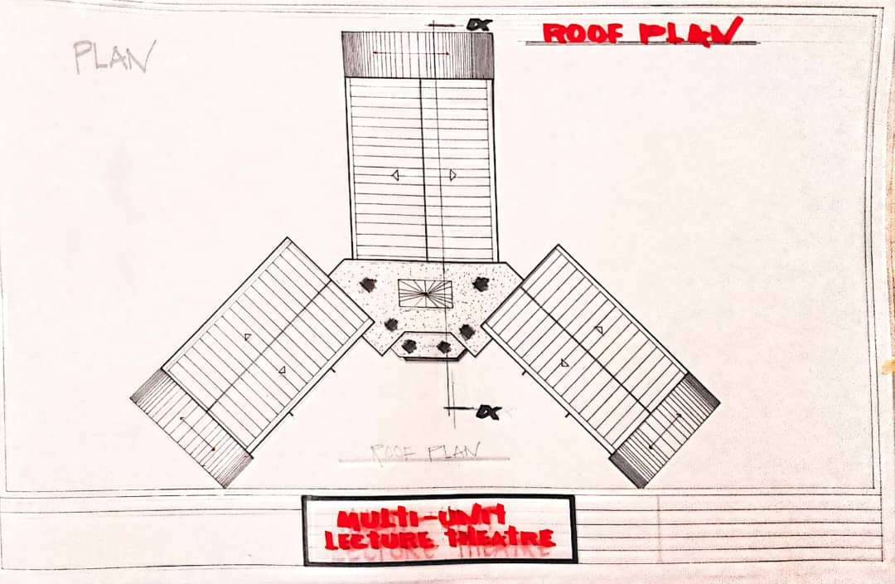
ROOF PLAN
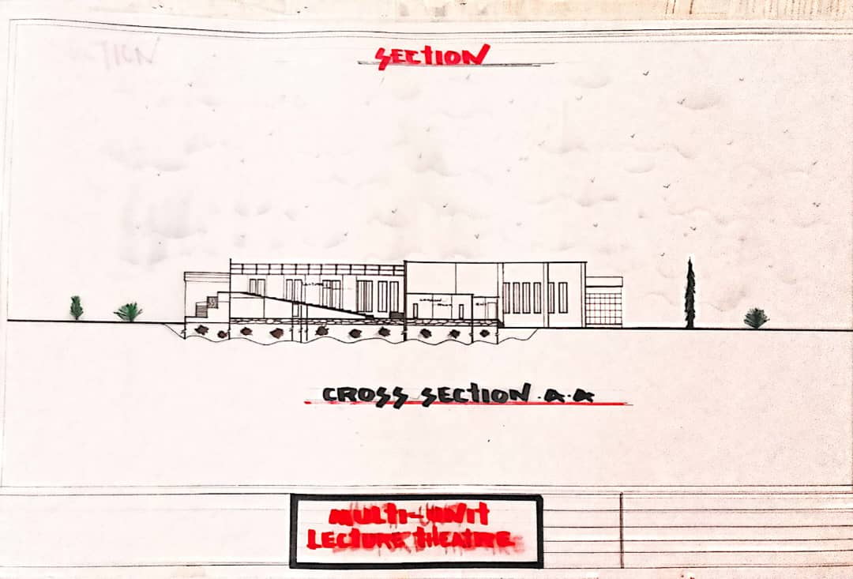
SECTION
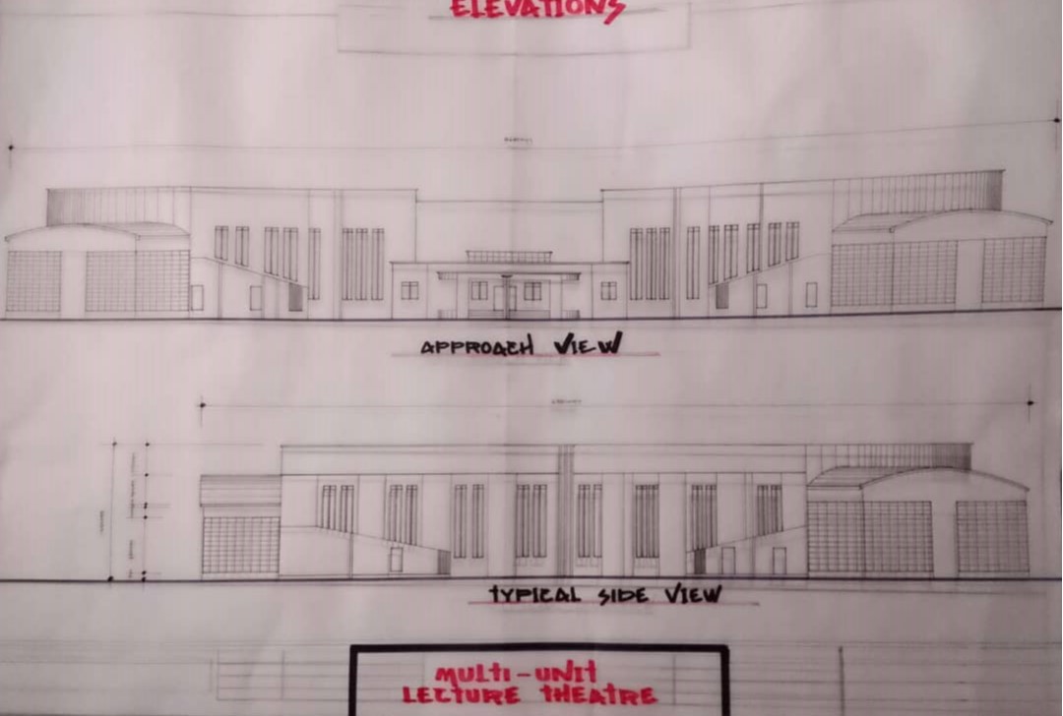
ELEVATION
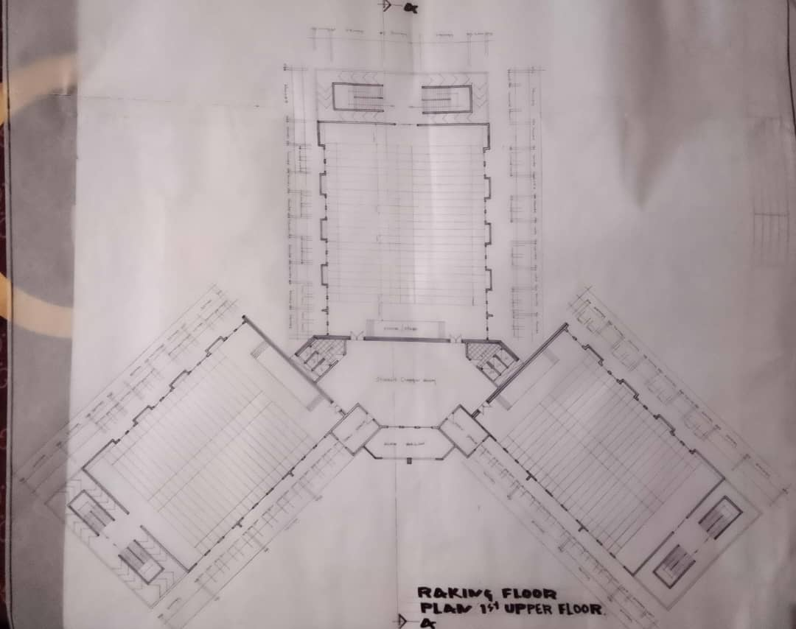
FIRST UPPER PLAN
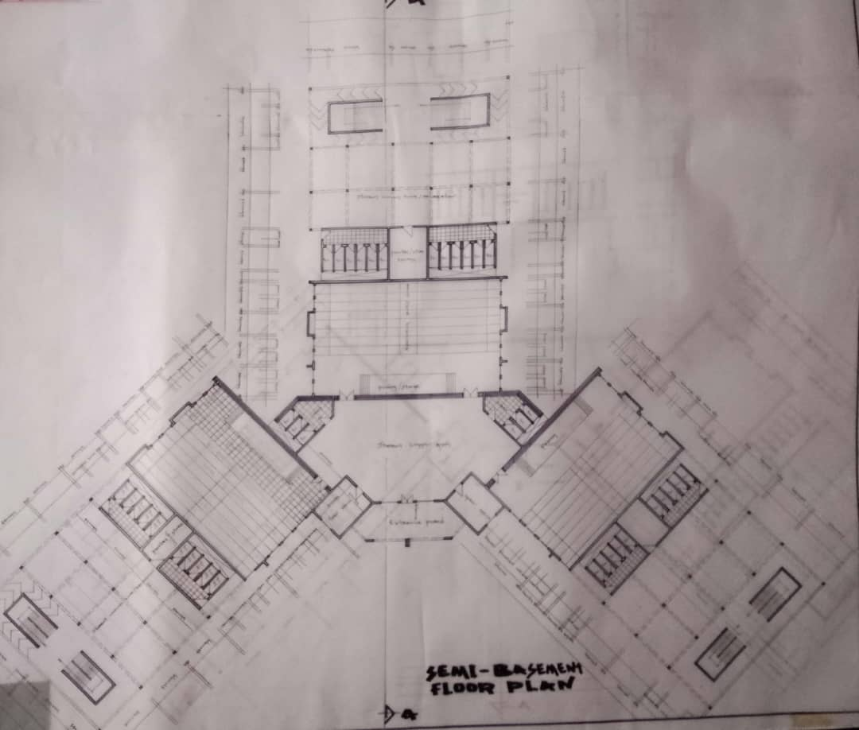
SEMI BASEMENT PLAN

