PROJECT REPORT
ON
PROPOSED OFFICE COMPLEX

BY
ABDULLAHI OLOLADE ABDULKADIR
HND/23/ARC/FT/0016

BEING A PROJECT RESEARCH SUBMITTED TO THE DEPARTMENT OF ARCHITECTURAL TECHNOLOGY
INSTITUTION OF ENVIRONMENTAL STUDIES (IES)
KWARA STATE POLYTECHNIC ILORIN

IN PARTIAL FULFILMENT OF THE REQUIREMENT FOR THE AWARD OF HIGHER NATIONAL DIPLOMA (HND) IN ARCHITECTURAL TECHNOLOGY

2025

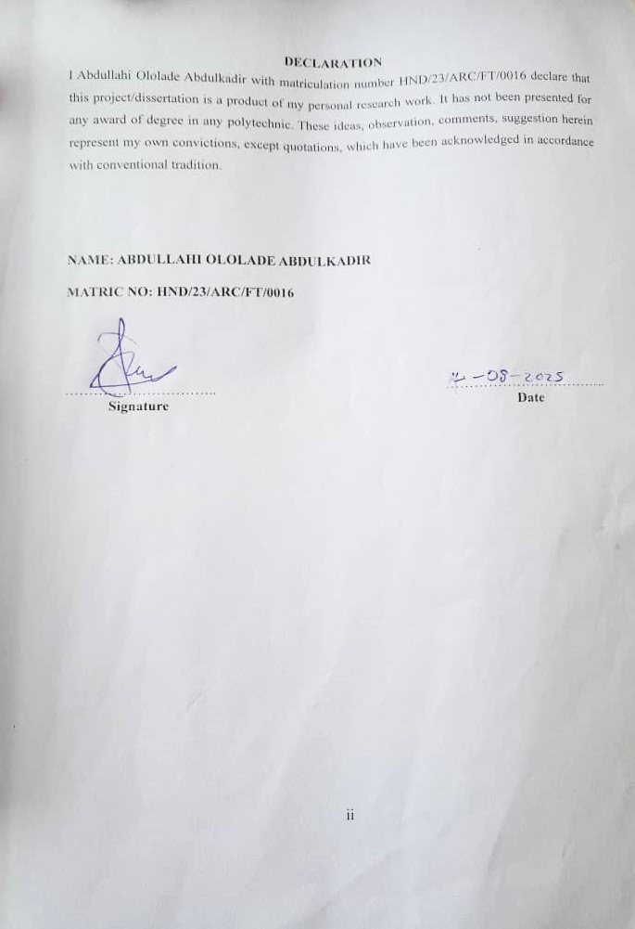

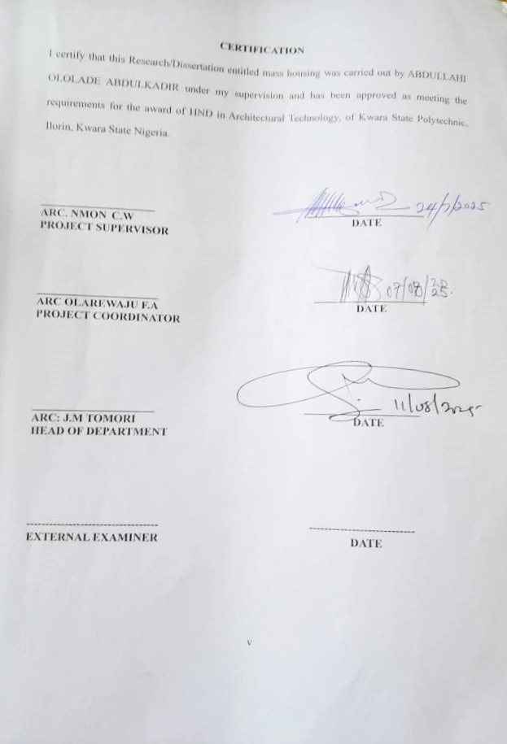

DEDICATION
This project report is dedicated to the Almighty Allah (S.W.T.), and my parents mrs and mrs Abdulkadir

ACKNOWLEDGEMENT
All praise and adoration and glorification to Almighty (S.W.T) the creator of the universe that gave me the privilege to take part in this program.
First and foremost, I am grateful to my able Hardworking and untiring project supervisor ARC. NOMN. C.W and the member staff of the Architecture Department, Kwara State Polytechnic, Ilorin for their encouragement, expert advice and continuous kind assistant and supervision that made the completion of this study successful.

Table of Contents
DEDICATION iii
ACKNOWLEDGEMENT iv
ABSTRACT x
CHAPTER ONE 1
1.0 Introduction 1
1.1 Historical Background 1
1.2 Definition 3
1.3 Aim and Objectives 3
1.3.2 Objectives 3
1.4 Scope 3
1.5 Statement of the Problem 4
1.6 Research Methodology 4
1.7 Limits of Constraints 5
1.8 Justification 5
CHAPTER TWO 7
2.0 Literature Review and Case Studies 7
2.1 Review of Relevant Literature 7
2.2 Importance 7
2.3 Selected Case Studies 8
2.3.1 Case Study One: OPIC Building, Ogun State 8
2.3.2 Case Study Two: Alafiya Complex, Ilorin 10
2.3.3 Case Study Three: Abdulsalam Ayemojuba & Associates Building, Ibadan 12
2.3.4 Online Case Study one: Marina Bay Financial Centre, Singapore 15
2.3.5 Case Study Two: Manchester International Office Centre 17
CHAPTER THREE 20
3.0 SITE AND ENVIRONMENTAL ANALYSIS 20
3.1 INTRODUCTION OF THE STUDY SITE/AREA 20
3.2 SITE LOCATION / DESCRIPTION 20
3.3 SITE SELECTION / LOCATION CRITERIA 21
3.4 Site Analysis (Inventory) 21
3.5 Climatic Data (Geographical Consideration) 22
CHAPTER FOUR 24
4.0 Design Criteria 24
4.1 Site Planning 24
4.2 Brief Analysis 24
4.3 Analysis of the Spaces 24
4.4 Space Allocation 24
4.5 Functional Relationship 25
4.6 Conceptual Development 25
CHAPTER FIVE 26
APPRAISAL OF PROPOSED SCHEME 26
5.0 GENERAL DESIGN CONSIDERATION 26
5.1 DESIGN AND CONSTRUCTION 26
5.2 GENERAL DESIGN CONSIDERATION 26
5.3 Construction Method and Materials 27
5.3.1 Construction Methods 27
5.3.2 Materials 27
5.4 Landscape Design 27
5.5 Landscape Elements Used in the Design 27
5.6 General Conclusion and Recommendations 28

LIST OF FIGURES
FIGURE 1 LOCATIONAL PLAN OF OPIC BUILDING 9
FIGURE 2: LOCATIONAL PLAN OF ALAFIYA COMPLEX 11
FIGURE 3: LOCATIONAL PLAN 13
FIGURE 4: LOCATIONAL MAP 15
FIGURE 5: LOCATION MAP 18
FIGURE 6: SITE LOCATION PLAN 22

LIST OF PLATES
PLATE 1: EXTERIOR VIEW OF OPIC BUILDING 9
PLATE 2SIDE VIEW OF OPIC BUILDING 10
PLATE 3: EXTERIOR VIEW OF ALAFIYA COMPLEX 11
PLATE 4: SIDE VIEW OF ALAFIYA COMPLEX 12
PLATE 5: ELEVATION 14
PLATE 6: INTERIOR VIEW 14
PLATE 7: AERIAL VIEW OF MARINA BAY 16
PLATE 8: INTERIOR VIEW OF OFFICE LOBBY 16
PLATE 9: ENTRANCE VIEW 19
PLATE 10: ELEVATION 19

ABSTRACT
This project report presents the design and development proposal for the Saliu Mustapha Office Complex, strategically located along Sawmill Road in Ilorin South Local Government Area, Kwara State. The office complex is conceived as a modern, multi-functional commercial facility aimed at meeting the increasing demand for professional workspaces in the region. The design integrates contemporary architectural principles with sustainable building practices while reflecting the rich cultural heritage of Ilorin, particularly its Nupe and Islamic influences. The project emphasizes flexibility, efficiency, and user comfort, providing diverse spaces such as private offices, conference rooms, shared workstations, retail areas, and support amenities. It also incorporates passive ventilation, natural lighting, and basic smart technologies to enhance energy efficiency and operational sustainability. Special attention is given to site planning, circulation, accessibility, and environmental impact. By bridging the gap between traditional identity and modern functionality, the proposed Saliu Mustapha Office Complex is positioned to become a landmark that fosters economic activity, supports entrepreneurship, and contributes to the overall urban development of Ilori

CHAPTER ONE

1.0 Introduction
An office complex is a dedicated architectural facility designed to house various administrative, professional, and commercial functions under one roof or across interconnected structures. It serves as a vital hub for business activities, fostering collaboration, innovation, and economic productivity. Unlike single-use office buildings, office complexes often provide flexible spaces that accommodate a variety of tenants, including corporate organizations, government agencies, startups, and professional service providers. These complexes are usually equipped with shared facilities such as meeting rooms, cafeterias, elevators, security posts, and ample parking spaces to ensure functionality and convenience for occupants and visitors alike.
In the context of modern urban development, office complexes play a pivotal role in shaping the commercial landscape of cities. They contribute to employment generation, attract investors, promote urban renewal, and enhance the image of the city as a growing business destination.
The proposed Saliu Mustapha Office Complex, situated along Sawmill Road in Ilorin South Local Government Area of Kwara State, is conceived to meet the rising demand for high-quality, culturally relevant, and technologically advanced office infrastructure in Ilorin. The city, known for its Islamic traditions and Nupe cultural heritage, has experienced significant commercial growth over the last decade. However, the availability of functional, modern, and aesthetically appealing office spaces remains limited.
This proposed development seeks to fill this infrastructural gap by integrating sustainable design principles, smart building technology, and architectural elements inspired by local cultural motifs. It will not only serve as a commercial hub but also as a landmark reflecting the identity, ambition, and evolving needs of Ilorin’s socio-economic environment. The project aims to enhance operational efficiency for occupants, stimulate local economic activity, and contribute to the overall urban development of Ilorin.

1.1 Historical Background
The concept of office spaces dates back to ancient civilizations where administrative and clerical functions were conducted in informal or semi-structured environments. In ancient Rome, public administration and judicial activities took place in basilicas and domus (large homes of the elite). During the Middle Ages, administrative work was primarily handled in monasteries, castles, and royal courts, which acted as the seat of power and record-keeping.
The Industrial Revolution of the 18th and 19th centuries marked a turning point in the development of purpose-built office buildings. The rise of factories and international trade necessitated centralized spaces for administration, finance, and coordination. In cities like London and New York, tall office buildings were constructed, introducing architectural features like elevators, open-plan layouts, and steel-frame structures, all aimed at maximizing efficiency.
In Nigeria, office architecture began to evolve significantly during the colonial era, especially in the late 19th and early 20th centuries. The British colonial administration introduced Western-style administrative buildings for the running of government affairs. Cities such as Lagos, Ibadan, and Enugu saw the construction of colonial secretariats, government houses, and merchant offices. These buildings were often designed in neoclassical or tropical colonial styles with wide verandahs and high ceilings to suit the local climate.
Following Nigeria’s independence in 1960, rapid urbanization and economic expansion led to a greater need for formal office spaces. The public and private sectors expanded, leading to the development of iconic complexes like the Federal Secretariat in Lagos and Abuja, and numerous state secretariats and business plazas across major cities.
In Ilorin, the capital of Kwara State and a historic city with a unique blend of Yoruba, Fulani, and Nupe influences, the evolution of office architecture reflects its administrative importance and cultural heritage. Traditional leadership structures, Islamic scholarship, and regional trade networks necessitated organized record-keeping and administrative centers even before colonial rule. In the post-colonial era, buildings like the Alafiya Office Complex, Olorunsogo Plaza, and the Kwara State Government Secretariat became central to the city’s business and governmental operations.
Despite this growth, the demand for contemporary, environmentally responsive, and culturally grounded office infrastructure continues to rise. The Saliu Mustapha Office Complex represents a step forward in meeting this demand. The complex is envisioned not only as a functional space but also as a culturally significant structure that aligns with Ilorin’s identity and its future aspirations as a regional economic center.

1.2 Definition
An office complex is a building or group of buildings designed to house multiple offices for administrative, professional, and commercial activities. It includes shared amenities like meeting rooms, cafeterias, and parking areas, fostering collaboration and efficiency. The Saliu Mustapha Office Complex will provide flexible workspaces, advanced technological infrastructure, and culturally resonant design to serve diverse tenants in Ilorin.

1.3 Aim and Objectives
1.3.1 Aim
To design a modern, functional, and sustainable office complex at Sawmill Road, Ilorin, that fosters productivity, collaboration, and business growth while reflecting the cultural identity of Ilorin South.

1.3.2 Objectives
- To create efficient and organized workspaces that support diverse administrative and commercial operations.
- To ensure flexibility in design to accommodate future expansion and evolving business needs.
- To prioritize user comfort through ergonomic design, natural lighting, ventilation, and accessibility features.
- To integrate sustainable practices and modern technology for energy efficiency and smart operations.
- To incorporate Nupe and Islamic cultural motifs and local materials to create a contextually relevant and aesthetically pleasing environment.

1.4 Scope
The project scope includes:
- Site Analysis: Evaluating accessibility, topography, climate, and regulatory requirements.
- Space Planning: Designing functional spaces such as offices, meeting rooms, reception areas, and support facilities.
- Zoning and Circulation: Ensuring efficient layout and privacy through strategic zoning.
- Design and Services: Incorporating architectural aesthetics, HVAC, lighting, plumbing, and IT infrastructure.
- Sustainability and Compliance: Adhering to environmental standards, building codes, and accessibility guidelines.

1.5 Statement of the Problem
Many office complexes in Nigeria suffer from inefficient space utilization, outdated infrastructure, and lack of flexibility for modern work patterns like hybrid models. In Ilorin, the shortage of modern office spaces limits commercial growth and administrative efficiency. Key challenges include:
- Limited Space: Insufficient areas for diverse functions like collaborative workspaces and support facilities.
- Outdated Technology: Lack of smart systems and high-speed internet hinders productivity.
- Accessibility Issues: Inadequate provisions for people with disabilities.
- Environmental Comfort: Poor lighting, ventilation, and noise control affect user well-being.
- Cultural Disconnect: Existing facilities often fail to reflect Ilorin’s Nupe and Islamic heritage.
The proposed Saliu Mustapha Office Complex aims to address these issues by providing a flexible, technology-driven, accessible, and culturally resonant workspace.

1.6 Research Methodology
The design process will employ the following methods:
- Literature Review: Analysis of architectural texts and journals on office design, sustainability, and technology integration.
- Case Studies: Examination of local and international office complexes (e.g., OPIC Building, Alafiya Complex) to identify best practices.
- Site Analysis: Field visits to assess topography, climate, and infrastructure at Sawmill Road, Ilorin.
- User Interviews: Consultations with potential tenants, employees, and local stakeholders to understand needs.
- Online Research: Review of digital resources on smart building technologies and sustainable design.

1.7 Limits of Constraints
The project faces the following constraints:
- Site Limitations: Size, shape, and proximity to existing structures may restrict design options.
- Budget Constraints: Limited funding may affect material choices and technological installations.
- Regulatory Restrictions: Compliance with Ilorin South’s zoning laws and building codes.
- Time Constraints: Tight project timelines may limit the depth of analysis.
- Environmental Factors: Ilorin’s tropical climate requires careful consideration of ventilation and heat management.

1.8 Justification
The proposed office complex is a strategic response to the growing need for modern, functional, and culturally relevant workspaces in Ilorin. As the city continues to expand commercially, the availability of well-designed office environments becomes essential to attract investment and stimulate economic development. By offering high-quality spaces that prioritize user comfort, accessibility, and operational efficiency, the project aims to boost employee productivity and overall workplace satisfaction.
Incorporating sustainable building practices, the design reduces environmental impact and aligns with global standards for green architecture, making it both future-oriented and environmentally responsible. Moreover, the project draws inspiration from the Nupe and Islamic heritage that defines Ilorin’s cultural landscape, reinforcing a sense of identity and community pride. Strategically located near key institutions such as Ahman Pategi University, the complex will further contribute to regional development by serving as a hub for professional, academic, and governmental activities within the city.

CHAPTER TWO

2.0 Literature Review and Case Studies
This chapter synthesizes scholarly works, architectural theories, and case studies to inform the design of the Saliu Mustapha Office Complex. It explores the evolution, importance, and best practices of office design, focusing on functionality, sustainability, and cultural integration.

2.1 Review of Relevant Literature
Office complexes have evolved from simple administrative spaces to multifaceted hubs supporting diverse work patterns. Ching (2015) notes that early offices in ancient Rome were integrated into basilicas for record-keeping. The Industrial Revolution introduced standalone office buildings, with the 20th century bringing innovations like open-plan layouts and glass facades, as seen in Lever House (1952). Modern office complexes prioritize flexibility, technology, and sustainability to accommodate remote work and environmental concerns, as highlighted by UN-Habitat (2014).
Pallasmaa (2005) emphasizes sensory engagement in architecture, advocating for office designs that inspire productivity through natural light and ergonomic layouts. Watson and Totten (2011) underscore the role of smart technologies, such as automated HVAC and IT infrastructure, in enhancing efficiency. Long (2014) highlights acoustics as critical for privacy and focus, recommending soundproofing and zoning strategies. These principles inform the design of a user-centric, technologically advanced office complex in Ilorin.

2.2 Importance
Office complexes are vital for:
- Productivity: Providing organized workspaces that enhance efficiency and collaboration.
- Economic Development: Attracting businesses and creating jobs in Ilorin.
- Employee Well-Being: Offering comfortable environments that improve health and performance.
- Community Engagement: Serving as a hub for professional and social interactions.
Sustainability: Reducing environmental impact through energy-efficient and green design.

2.3 Selected Case Studies

2.3.1 Case Study One: OPIC Building, Ogun State
Location: OPIC Circle, Oke-Ilewo, Abeokuta, Ogun State
Historical Background: The Ogun State Property and Investment Corporation (OPIC) Building serves as the headquarters for OPIC, managing industrial and residential estates like the OPIC Agbara/Igbesa Estate. Built to support administrative and commercial functions, it reflects Ogun State’s push for urban development.
Merits:
- Central location with easy access to major roads.
- Modern facade using glass and aluminum for aesthetic appeal.
- Functional layout with administrative offices and meeting rooms.
Demerits:
- Limited green spaces for employee recreation.
- High maintenance costs for glass facade.
- Inadequate parking for peak usage.

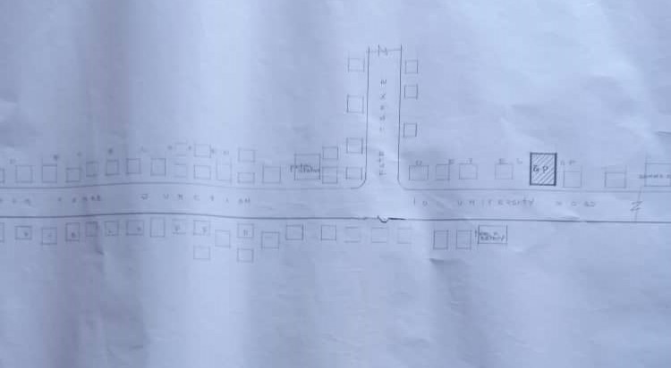
FIGURE 1 LOCATIONAL PLAN OF OPIC BUILDING
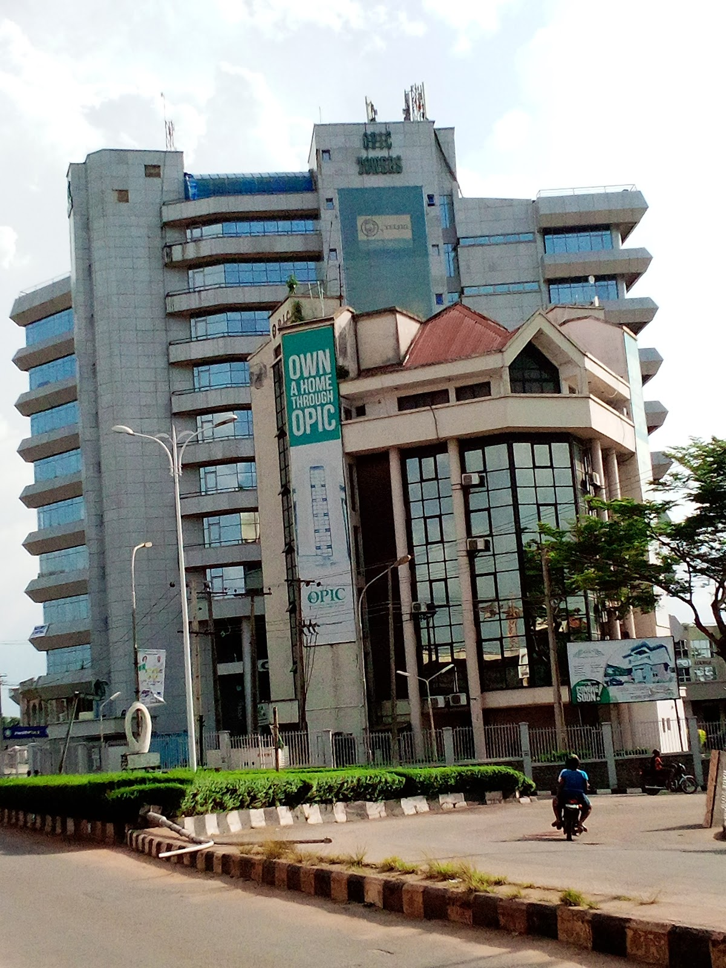
PLATE 1: EXTERIOR VIEW OF OPIC BUILDING

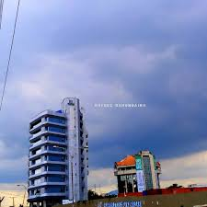
PLATE 2SIDE VIEW OF OPIC BUILDING

2.3.2 Case Study Two: Alafiya Complex, Ilorin
Location: Along Opo Malu Isale Ilorin, Kwara State
Historical Background: The Alafiya Complex is a multi-tenant office and commercial facility in Ilorin, designed to support local businesses and administrative functions. It serves as a hub for professional services in the region.
Merits:
- Strategic location in Ilorin’s commercial district, enhancing accessibility.
- Mixed-use design with office and retail spaces.
- Use of local materials like cement blocks for cost-effectiveness.
Demerits:
- Outdated infrastructure, lacking smart technology.
- Limited accessibility features for people with disabilities.
- Insufficient natural ventilation, leading to reliance on mechanical systems.
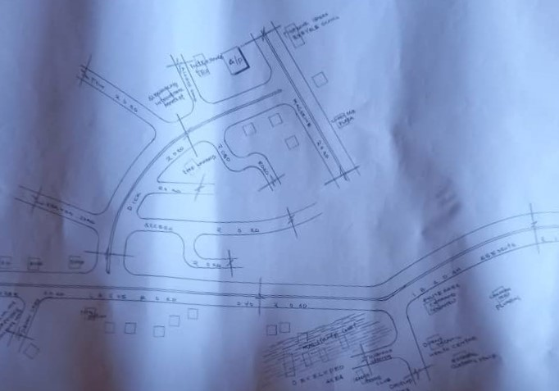
FIGURE 2: LOCATIONAL PLAN OF ALAFIYA COMPLEX

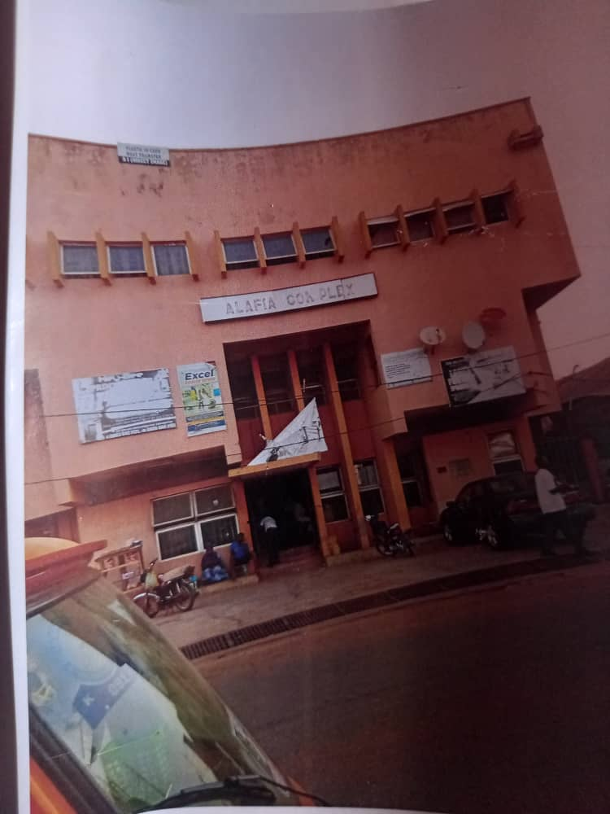
PLATE 3: EXTERIOR VIEW OF ALAFIYA COMPLEX
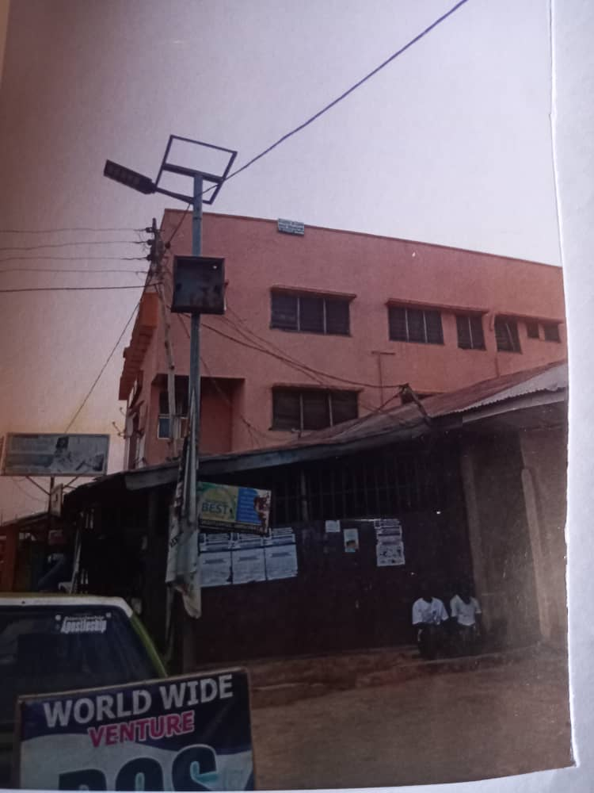
PLATE 4: SIDE VIEW OF ALAFIYA COMPLEX

2.3.3 Case Study Three: Abdulsalam Ayemojuba & Associates Building, Ibadan
Location: ANCE Building, Sabo-Onireke Road, Jericho, Ibadan, Oyo State. Located within the CGV International Limited Complex.
Historical Background
Abdulsalam Ayemojuba & Associates is a reputable firm of estate surveyors and valuers, headquartered in Ibadan. The firm occupies a section of the ANCE Building, a modern commercial facility located in Jericho—one of Ibadan’s most prestigious and professional districts. This area hosts a concentration of real estate consultants, legal chambers, and corporate offices, making it an ideal location for a property-based professional practice. The firm’s presence in this building reflects its standing in the real estate industry and its proximity to both government and private sector clients in Ibadan and beyond.
Merits:
- Located in Jericho, a well-planned, high-value district known for its peaceful environment and business-friendly infrastructure.
- Housed within a professionally managed multi-tenant commercial complex (CGV International Ltd.), offering access to shared amenities and security.
- Proximity to major roads and high-income residential areas improves accessibility for clients.
- The office space is designed for professionalism and includes private offices, reception, and meeting areas.
Demerits:
- Being part of a shared commercial complex, the firm may have limited control over building-wide infrastructure upgrades or branding visibility.
- Parking space is shared and can become limited during peak office hours.
- The architectural design of the building is modern but generic, lacking localized cultural aesthetics or identity.
- No notable use of sustainable or energy-efficient building materials or systems.
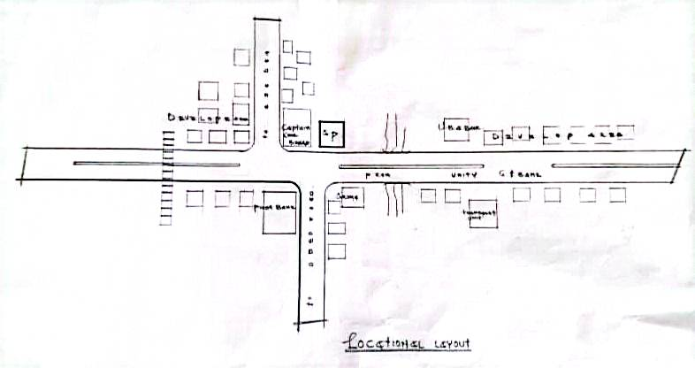
FIGURE 3: LOCATIONAL PLAN

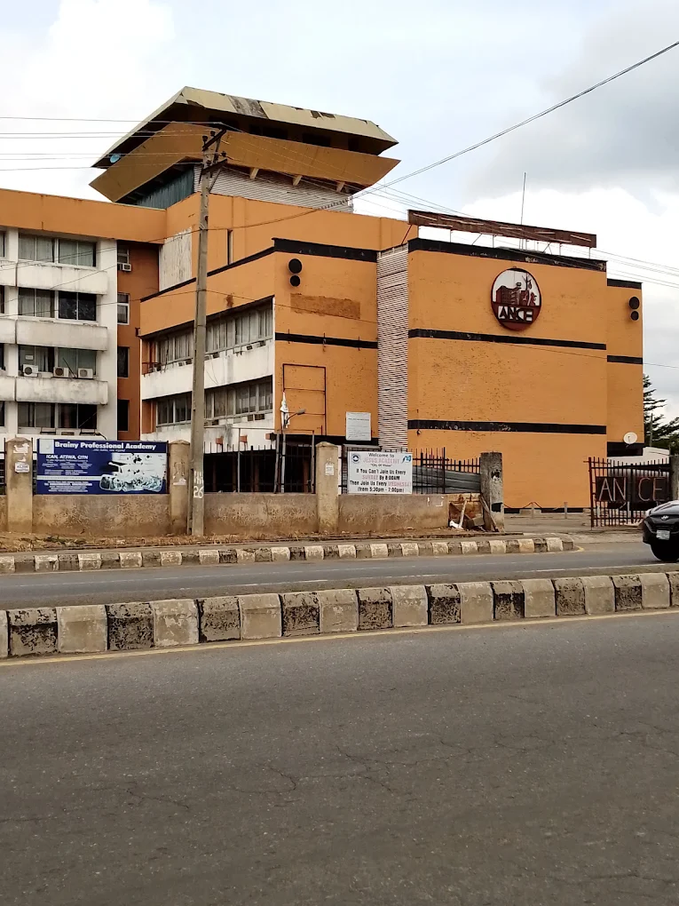
PLATE 5: ELEVATION
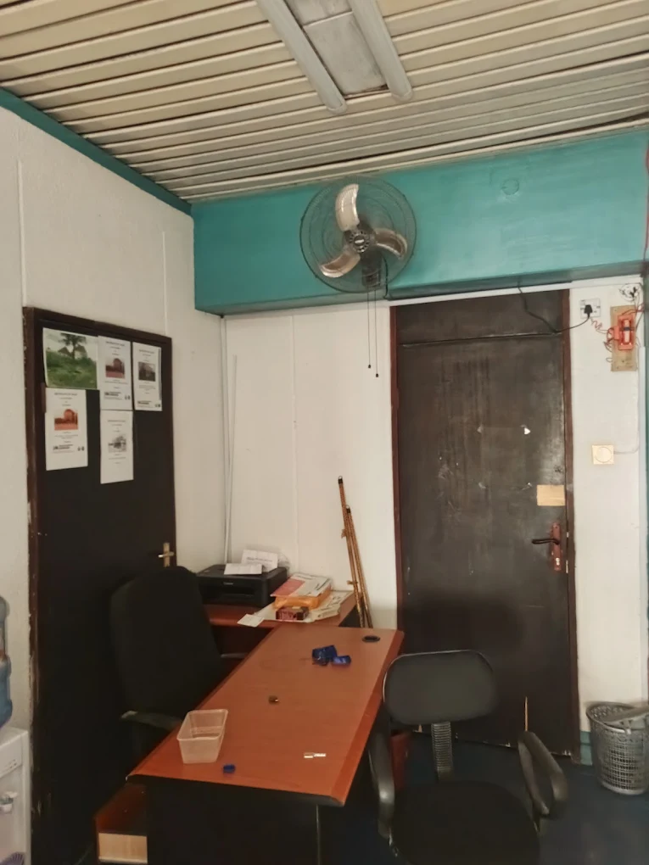
PLATE 6: INTERIOR VIEW

2.3.4 Online Case Study one: Marina Bay Financial Centre, Singapore
Location: Marina Bay, Singapore
Historical Background: Completed in 2013, this mixed-use complex integrates offices, retail, and residential spaces, designed to support Singapore’s financial sector.
Merits:
- Seamless urban integration with public transport access.
- Sustainable features like rainwater harvesting and energy-efficient lighting.
- Flexible layouts for diverse tenants.
Demerits:
- High development costs due to advanced technology.
- Large scale may feel impersonal for smaller businesses.
- Maintenance of green systems requires expertise.
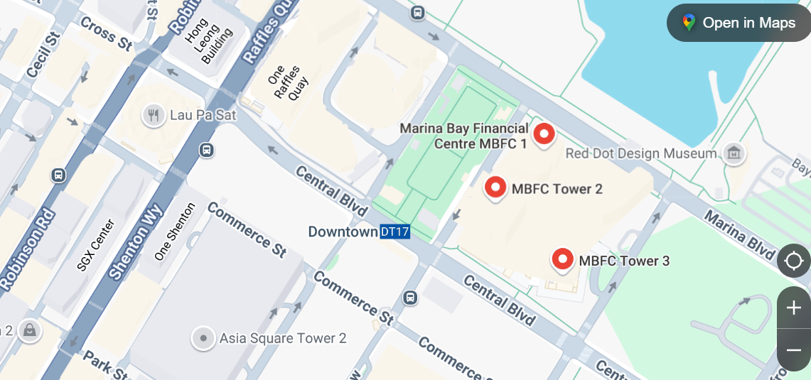
FIGURE 4: LOCATIONAL MAP
Source: google map
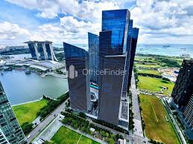
PLATE 7: AERIAL VIEW OF MARINA BAY
SOURCE: OFFICEFINDER.COM

PLATE 8: INTERIOR VIEW OF OFFICE LOBBY
source: google.com

2.3.5 Case Study Two: Manchester International Office Centre
Location:
Styal Road, Manchester M22 5WB, United Kingdom. Located near Manchester Airport.
Historical Background:
The Manchester International Office Centre (MIOC) is a landmark commercial building originally developed to support the expansion of Manchester Airport and surrounding businesses. Originally constructed in the 1950s as an aviation training centre, the structure was later converted into a premium multi-tenant office facility. Today, it is home to a variety of local, national, and international companies, offering flexible workspaces in a modernized, professionally managed environment. MIOC has played a significant role in attracting business activity to the southern corridor of Manchester and reflects a successful example of adaptive reuse in commercial real estate.
Architectural Features:
The building combines elements of mid-century modernist architecture with contemporary refurbishments. It features a steel frame construction, large glazed facades for natural lighting, suspended ceilings, open floor plans, and smart office layouts. Interior updates have included high-speed internet cabling, energy-efficient lighting, and contemporary reception and lounge areas.
Merits:
- Strategic Location: Close proximity to Manchester Airport and motorway links (M56), making it highly accessible for international and regional businesses.
- Flexibility: Offers serviced offices, open-plan spaces, and meeting rooms with lease flexibility for various tenant sizes.
- Modern Amenities: Includes breakout areas, café/lounge, elevators, 24-hour access, security surveillance, and on-site management.
- Sustainability Upgrades: The facility incorporates energy-saving measures, waste management systems, and improved HVAC systems.

Demerits:
- Being an older structure, certain parts of the building still require occasional maintenance and retrofitting.
- High competition with newer business parks and tech-focused office hubs in Greater Manchester may affect tenant retention.
- Shared amenities and services can become strained during peak usage times due to high tenant density.
- Despite upgrades, the external appearance remains modest compared to newly constructed high-rise office buildings in the city centre.
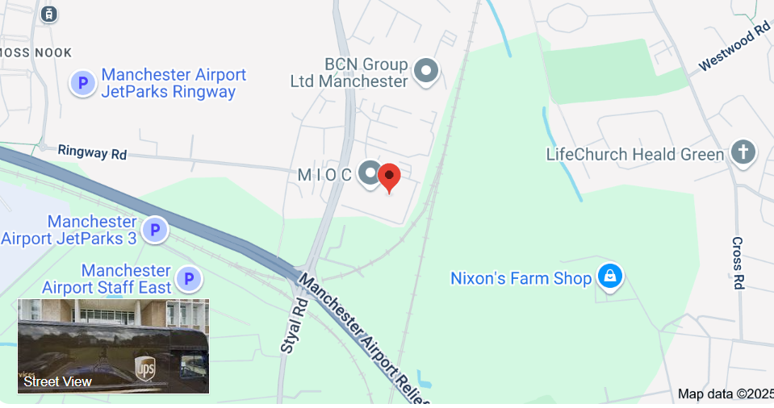
FIGURE 5: LOCATION MAP
Source: google map

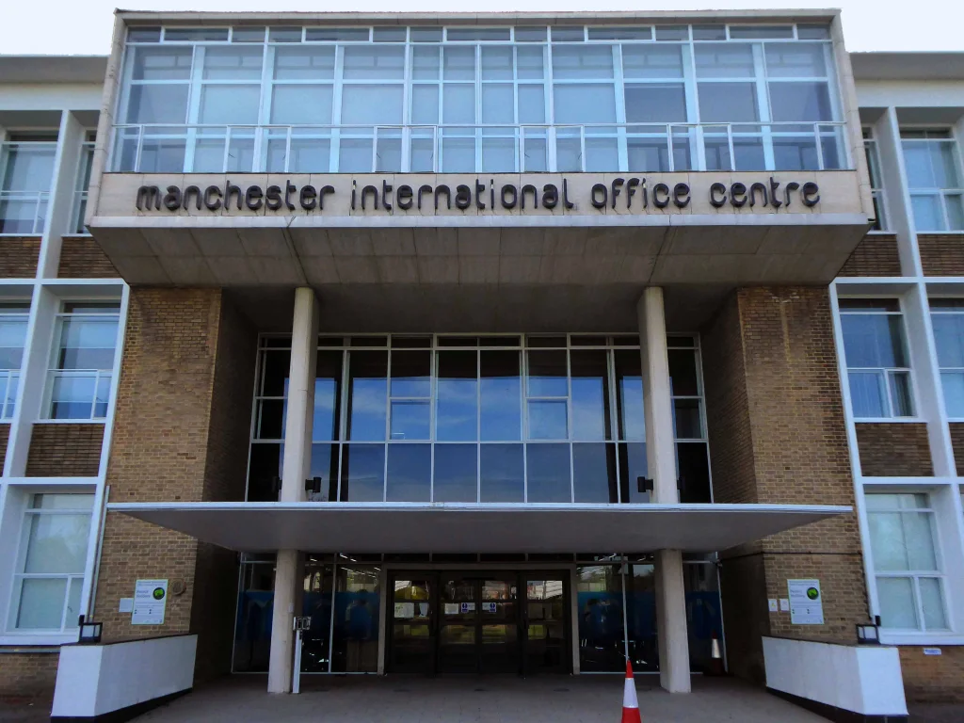
PLATE 9: ENTRANCE VIEW
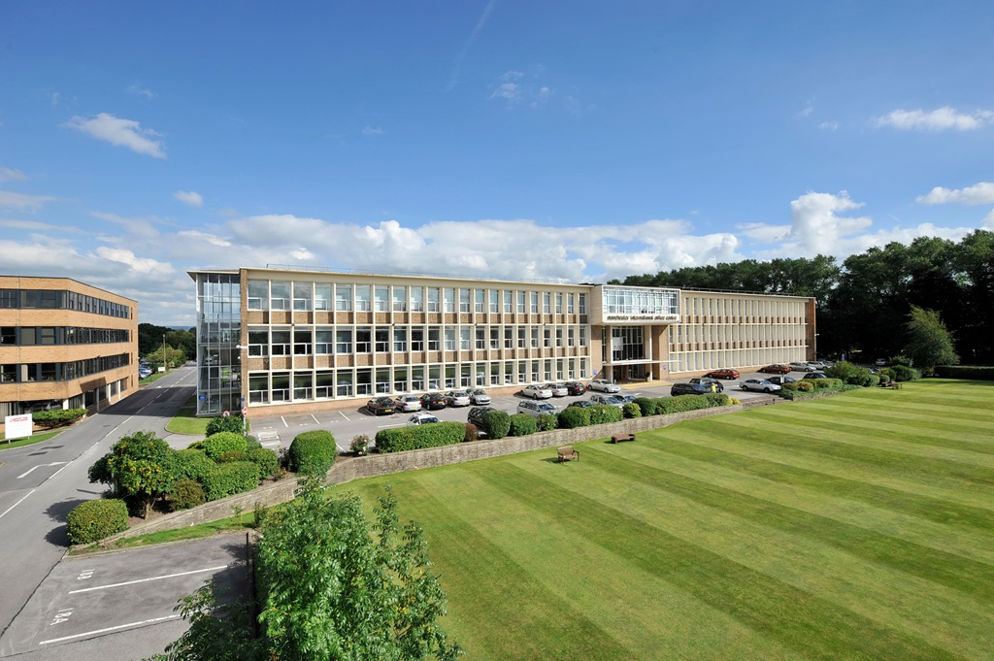
PLATE 10: ELEVATION

CHAPTER THREE

3.0 SITE AND ENVIRONMENTAL ANALYSIS
This chapters evaluates the proposed site at Sawmill Road Ilorin, to ensure its suitability for the office complex, considering accessibility, topography, climate and infrastructure

3.1 INTRODUCTION OF THE STUDY SITE/AREA
The Saliu Mustapha Office Complex is located along Sawmill Road, Ilorin, Kwara State, Nigeria. Ilorin, the capital city of Kwara State, is a vibrant metropolitan area known for its rich cultural heritage and growing commercial significance. The site is situated within the Ilorin West Local Government Area, a bustling region that serves as the administrative headquarters of the state. Historically, Ilorin has evolved from a traditional trading hub under the influence of the Oyo Empire and later the Sokoto Caliphate into a modern urban center, with significant development spurred by its strategic location and infrastructure improvements in the 20th and 21st centuries.
The transformation of Ilorin, particularly along key routes like Sawmill Road, has been driven by its proximity to major markets such as Ipata and Oja-Oba, as well as its connectivity via rail and highway networks linking it to Lagos and other parts of Nigeria. The area around Sawmill Road is characterized by a mix of commercial activities, including sawmills, small-scale industries, and residential zones, making it a dynamic economic corridor. The presence of political and administrative figures, such as Senator Saliu Mustapha, has further catalyzed development, with initiatives aimed at enhancing infrastructure and community welfare.
However, rapid urbanization has introduced challenges, including traffic congestion, inadequate infrastructure, and environmental concerns such as waste management. Despite these issues, the area remains a vital part of Ilorin’s economic and social fabric, with ongoing efforts to improve accessibility and services.

3.2 SITE LOCATION / DESCRIPTION
The site selected for the Saliu Mustapha Office Complex is located along Sawmill Road, Ilorin West Local Government Area, Kwara State. This location benefits from its proximity to the Ipata market and major transportation routes, enhancing its accessibility and visibility.

3.3 SITE SELECTION / LOCATION CRITERIA
The selection of the site is based on a coordination of criteria that influence its development, considering factors affecting site suitability. These include:
- Ventilation and solar control: Ensuring adequate airflow and natural lighting to create a comfortable working environment.
- Thermal control: Mitigating heat gain to maintain an optimal indoor climate.
- Comfort of occupants: Prioritizing ergonomic design and safety features.
- Utility of service: Proximity to essential services such as water, electricity, and road networks.

3.4 Site Analysis (Inventory)
- Topography: Flat with lateritic soil, suitable for standard foundations.
- Surroundings: Adjacent to commercial buildings, markets, and residential areas.
- Noise Levels: Moderate due to nearby road traffic, requiring acoustic mitigation.
- Utilities: Existing water, electricity, and internet; sewage systems require enhancement.
- Zoning: Designated for commercial use, compliant with Ilorin South regulations.
FIGURE 6: SITE LOCATION PLAN

3.5 Climatic Data (Geographical Consideration)
Ilorin experiences a tropical wet and dry climate:
- Average Annual Temperature: ~26°C
- Annual Rainfall: ~1200 mm
- Driest Months: December–February (~10 mm rainfall)
- Wettest Months: June–September (~200 mm/month)
- Temperature Range: 23°C (August) to 34°C (March)
- Design Implications: Natural ventilation, shading devices, and rainwater harvesting to address heat and rainfall.
Table 3.5.1: Climatic Data for Ilorin
Month | Rainfall (mm) | Avg. Temperature (°C)
January | 10 | 26
September | 200 | 24

CHAPTER FOUR

4.0 Design Criteria
The office complex design prioritizes functionality, flexibility, comfort, sustainability, and cultural relevance, ensuring a productive and inspiring workspace.

4.1 Site Planning
Site planning involves arranging buildings, parking, access routes, and landscaping to optimize space, circulation, and environmental integration. The layout ensures clear pathways, natural lighting, and alignment with Ilorin’s tropical climate.

4.2 Brief Analysis
The site’s flat topography and access to utilities support efficient construction. Its location in Ilorin’s commercial hub enhances suitability. Environmental factors like sun path and wind direction inform the orientation for natural ventilation and daylighting.

4.3 Analysis of the Spaces
Spaces are analyzed based on functional needs, circulation flow, and zoning:
- Workspaces: Private offices and open-plan areas for individual and collaborative work.
- Support Areas: Reception, meeting rooms, and server rooms for operational efficiency.
- Amenities: Cafeteria, lounge, and restrooms for user comfort.
- Circulation: Clear pathways to connect zones without disrupting workflows.

4.4 Space Allocation
Table 4.4.1: Space Allocation
Space | Area (m²) | Capacity / Description
Reception | 50 | Welcoming area with information desk
Private Offices | 150 | 10 offices for 1–2 occupants each
Open-Plan Workspace | 200 | 20 workstations for collaborative work
Meeting Rooms | 80 | 2 rooms, each seating 10–12
Cafeteria | 60 | 30 seats for dining and breaks
Server Room | 30 | IT infrastructure and data storage
Restrooms | 40 | Male, female, and accessible facilities
Lounge Area | 50 | Informal seating for 15–20 users
Parking Area | 200 | Space for 20 vehicles

4.5 Functional Relationship
- Reception: Located near the entrance, connecting to public areas and offices.
- Offices: Zoned for privacy, accessible from common areas.
- Meeting Rooms: Centrally placed for shared access.
- Support Spaces: Server room and storage near workspaces for efficiency.
- Amenities: Cafeteria and lounge accessible from all zones.
- Circulation: Pathways ensure seamless movement without disrupting work areas.

4.6 Conceptual Development
The design concept blends modern functionality with Nupe and Islamic cultural elements, using geometric patterns and local materials like lateritic bricks. The layout emphasizes open spaces, natural light, and modular furniture for flexibility, creating a vibrant and productive workspace that reflects Ilorin’s heritage.

CHAPTER FIVE

APPRAISAL OF PROPOSED SCHEME

5.0 GENERAL DESIGN CONSIDERATION
The design and construction of the Saliu Mustapha Office Complex along Sawmill Road, Ilorin, Kwara State, are guided by two basic factors that should be taken into consideration: the need for aesthetic merit and functionality of a design of building.
The above-listed factors were thoroughly taken to satisfy the highly demanded functional arrangement of the proposed project and also to create aesthetically and proportionally balanced design.
Furthermore, zoning of area with related functions circulation pattern, security and safety were highly considered in this project design. The design was carefully zoned into major and minor zones, semi-noisy and quiet areas.

5.1 DESIGN AND CONSTRUCTION
The office couple is highly decorated with plastered and painted walls, colored marble cladding and some mosaic and opus sectile floors, supplied by water stem, with water channeled via trenches into a main sewer, the building would have provided hot and cold air condition in the office spaces and other area. The astern was massive and water would have been pumped up to the tank before a network of water pipes drains and sewers would have ensured a constant flow of clean water. The degree of workmanship seen within the remain during the original excavation was compared with that seen at roman building, and the kind of sophisticated and strategic planning involved in the construction of both mall and the office complex is also comparable.

5.2 GENERAL DESIGN CONSIDERATION
To achieve a functional design, the following factors are essentially needed to give the structure a considerable aesthetic value; some of these things are:-
- Functionality: Efficient zoning for workflows and collaboration.
- Accessibility: Ramps, elevators, and tactile guides for inclusivity.
- Comfort: Natural lighting, ventilation, and ergonomic furniture.
- Flexibility: Modular layouts for future adaptability.
- Sustainability: Energy-efficient systems and low-impact materials.
- Aesthetics: Nupe and Islamic-inspired motifs and modern facades for visual appeal.

5.3 Construction Method and Materials

5.3.1 Construction Methods
The complex will use a reinforced concrete frame for durability, with precast components for efficiency. Modular construction techniques allow for future expansion.

5.3.2 Materials
- Concrete and Steel: Structural framework for strength and stability.
- Glass and Aluminum: Windows and curtain walls for natural light and modern aesthetics.
- Cement Blocks: Exterior and interior walls for cost-effectiveness and durability.
- Gypsum Board: Interior partitions for flexibility and soundproofing.
- Laminated Wood: Flooring in offices and lounges for warmth and comfort.
- Low-VOC Paint and Cladding: Finishes for sustainability and aesthetics.
- Insulation Materials: High-performance insulation for energy efficiency.

5.4 Landscape Design
The landscape design includes green spaces, walkways, and seating areas to enhance aesthetics and employee well-being. Sustainable features like permeable surfaces and native plants reduce environmental impact.

5.5 Landscape Elements Used in the Design
- Lawns and Trees: Native species for shade and beauty.
- Walkways: Paved paths for accessibility and circulation.
- Seating Areas: Benches for relaxation and social interaction.
- Water Features: Small fountains for aesthetic appeal.
- Lighting: Solar-powered lights for safety and ambiance.
- Permeable Surfaces: For rainwater management and sustainability.

5.6 General Conclusion and Recommendations
Conclusion
The proposed Saliu Mustapha Office Complex at Sawmill Road, Ilorin, is designed to be a functional, sustainable, and culturally resonant workspace that supports economic growth and employee well-being. By integrating modern technology, flexible layouts, and Nupe-inspired aesthetics, it addresses Ilorin’s need for a modern commercial hub.
Recommendations
- Sustainability: Prioritize passive design, solar panels, and rainwater harvesting.
- Accessibility: Ensure ramps, elevators, and accessible facilities for all users.
- Technology: Invest in high-speed internet and smart building systems.
- Cultural Integration: Incorporate Nupe and Islamic motifs and local materials.
- Flexibility: Use modular designs for future adaptability.
- Community Engagement: Include spaces for networking and local events to foster interaction.

REFERENCES
Ching, F. D. K. (2015). Architecture: Form, Space, and Order. John Wiley & Sons.
Heschong Mahone Group (2003). Daylighting in Schools: An Investigation into the Relationship Between Daylighting and Human Performance.
Long, M. (2014). Architectural Acoustics. Elsevier Academic Press.
Obateru, O. I. (2003). The Yoruba City in History: Urbanism and Environment in West Africa. Ibadan University Press.
Pallasmaa, J. (2005). The Eyes of the Skin: Architecture and the Senses. Wiley.
UN-Habitat (2014). Urban Planning for City Leaders. United Nations Human Settlements Programme.
Watson, J., & Totten, M. (2011). Designing for Acoustics in Performance Spaces. Acoustical Society of America Journal.
OPIC Group. (n.d.). OPIC: Expanding the Frontiers of Ogun State. Retrieved from opicgroup.com

