A PROJECT REPORT

ON

PROPOSED SKILL ACQUISITION CENTRE

FOR

ASA LOCAL GOVERNMENT AT OKO OLOWO AREA, ILORIN, KWARA STATE

BY

OMIDIJI YUSUF BABATUNDE

HND/23/ARC/FT/0077

SUBMITTED TO THE DEPARTMENT OF ARCHITECTURAL TECHNOLOGY INSTITUTE OF ENVIRONMENTAL STUDIES (IES) KWARA STATE POLYTECHNIC ILORIN.

IN PARTIAL FULFILMENT FOR THE REQUIREMENT OF THE AWARD OF HIGHER NATIONAL DIPLOMA (HND) IN ARCHITECTURAL TECHNOLOGY

July 2025
DECLARATION
This is work carried out by me , OMIDIJI YUSUF BABATUNDE with matric number HND/23/ARC/FT/0077 for the award of Higher National Diploma (HND) in the department of architectural technology under the supervision of Arc. Olarewaju F.A. The ideas,observations,comments except quotations which has been acknowledged in accordance with conventional academic traditions.

Signature Date

DEDICATION
This project is dedicated to almighty God for His Divine mercies and protection
bestowed upon me from the beginning of my life up to this present moment, all glory, praise, honor and adoration are for him forever.
To my caring and lovely family for their moral, financial and spiritual support given to me throughout my staying in campus may almighty God continue to bless them.

CERTIFICATION

I certify that the research has been approved as meeting the requirement for the award of Higher National Diploma (HND) in Architectural Technology Department of Kwara State Polytechnic, Ilorin, kwara State.

ARC. Olarewaju F.A ________________
(Project supervisor) SIGNATURE/DATE

ARC. Olarewaju F.A _________________
(Project coordinator) SIGNATURE/DATE

ARC. J.M Tomori
(Head of Department) SIGNATURE/DATE

__________________ _ ____________
EXTERNAL SUPERVISOR SIGNATURE/DATE

ACKNOWLEDGEMENT
All praise and adoration to almighty Allah (SW) that gave me a privileged to take part in this program.
I am grateful to my able hardworking and untiring project supervisor ARC ADEYEMI F.O,and the head of department ARC. TOMORI J.M, and all other academic and Non academic staff members of the department of architecture for their encouragement and advise and constant kind supervision
My sincere appreciation goes to my dearest, lovely and caring parents Mr. OMIDIJI A.O for the parental, financial and moral support for making my dream a reality.
My utmost greetings go to my friends and my neighbors in person of ABDULAZEEZ OPEYEMI and OMIDIJI MISTURA
Finally, I see this privilege as a milestone in my career development and I will definitely strive to utilize the gained skills and knowledge in the best way to achieve desired future objective.
I would also like to express my gratitude to my family and friends for all terms of support received.
May almighty Allah continue to reward you.

TABLE OF CONTENTS
Title Page
Declaration……………………………………………………….…………………. ii
Certification …………………………………………………………….…………...iii
Dedication …………………………………………………………………………...iv
Acknowledgment ………………………………………………………….…………v
Table of content ……………………………………………………………………..vi
List of plates……………………………………………………………………...…vii
List of Tables………………………………………………………….……………viii
List of Figures ……………………………………………………………………....ix
List of Appendix…………………………………………………………………..…x
Abstract ……………………………………………………………………………. xi

CHAPTER ONE:
1.0 General Introduction …………………...…………..………………….…….1
  - Historical background of the project……………………………….…..……2
1.2 Definition……………………………….…………………….……………2
1.3 Statement of design problem ………………………………………………..3
1.4 Aim and Objectives of the study…………………………………………….4
1.5 Project justification ……………………………………………………….…5
1.6 Clients background…………………………………………………….…….5
1.7 Scope of the study …………………………………………………….....6
1.8 Limitation of design…………………………………………………………9
1.9 Research Methodology ………………………………………………….…10

CHAPTER TWO:
2.0 Review of relevant Literature………………………………………………..11

CHAPTER THREE
3.0 Case studies……………………………………………………..…………...14
3.2 Case study one……………………………………………………………….15
3.3 Case study two…………………………………………………………….…18
3.4 Case study three……………………………………………………………...22
3.5 Case study four……………………………………………………………….26
3.6 Case study five (online case study) …………………………………..……...29
3.7 Deduction from Case study …………………………………..……………...29

CHAPTER FOUR
4.0 Project location…………………………………………….……….………...31
4.1 Historical background of selected location state………………………….….31
4.2 Historical background of Selected location LGA……………………………32
4.3 Physical feature of the location …………………………………………...…33
4.4 Population ……………………………………………...…………………….33
4.5 Social service …………………………….…………………….….…………33
4.6 General climatic condition………………………………………….…….….34
4.7 Site analysis ………………………………………………….………………35
4.7.1 Site selection/justification ………………….………………………………..35

CHAPTER FIVE
5.0 Design report…………………………………………………………………42
5.1 Design brief ……………………………………..…………………………...42
5.2 Design analysis …………………………..……………………………42
5.3 Design appraisal ……………………………..………………………………45
5.4 Design characteristics …………………………..…………………………...45
5.5 Building structure ………………………………..………………………….47
5.6 Service …………………………….………………………………………...48
5.7 General requirement ……………..………………………………………….48
5.7.1 Lighting ………………………………….………………………………….48
5.7.2 Orientation ………………………………………………………………….49
5.7.3 Rain protection devices ………………….………………………………….50
5.7.4 Noise control device ………………………………………………………...50
5.8 Material and finishes ………………………..………………………………51

CHAPTER SIX
6.0 Summary and conclusion …………………………..………………….……54
6.1 Summary ……………………………………………………………….…...54
6.2 Conclusion ……………………………………………………………….…54
References ………………………………………………………………………..…56
Appendix

LIST OF TABLES
1. Spatial allocation/schedule of accommodation

LIST OF FIGURES
Figure 3.1: Showing Location Plan And Floor Plan of Case Study One……………14
Figure 3.2: Showing Location Plan And Floor Plan Of Case Study Two……..……17
Figure 3.3: Showing Floor Plan Of Case Study Three……………………..………..20

LIST OF PLATES
Plate 3.1: Approach And Side View Of Case Study One………………….………..15
Plate 3.2: Approach View Of Case Study Two…………………………….…….…17
Plate 3.4: Approach View Of Case Study Three……………………………………20
Plate 3.5: Approach And Side View Of Case Study Four………………….……….21
ABSTRACT
The need for sustainable economic development and youth empowerment has led to increased attention on skill acquisition centers as viable platforms for capacity building. This project proposal presents the design and development of a Skill Acquisition Centre aimed at providing vocational training and entrepreneurial skills to individuals, particularly youths and women, to reduce unemployment and promote self-reliance. The centre is envisioned as a multipurpose facility that accommodates various trades including tailoring, carpentry, ICT, catering, welding, and hairdressing, among others.The design integrates functional spaces such as workshops, classrooms, administrative offices, exhibition areas, and recreational zones, ensuring a conducive environment for both learning and innovation. Consideration is given to accessibility, energy efficiency, safety, and sustainability in the design and construction methodology. The project addresses both the architectural and socioeconomic aspects of vocational education, aiming to contribute meaningfully to community development and national productivity. This proposal outlines the key objectives, design strategies, and expected impact of the Skill Acquisition Centre within its host community.This project proposal focuses on the design and development of a Skill Acquisition Centre aimed at addressing the growing need for vocational education and self-reliance among youths and unemployed individuals. As the formal job market becomes increasingly saturated, skill acquisition offers a sustainable pathway to economic empowerment, poverty reduction, and national development. The centre is envisioned to provide practical training in various disciplines including tailoring, ICT, carpentry, catering, welding, and hairdressing. The proposed design incorporates functional spaces such as training workshops, classrooms, administrative offices, multipurpose halls, and recreational areas. Emphasis is placed on accessibility, flexibility, energy efficiency, and user comfort. Data was gathered through site analysis, literature review, and case studies to ensure that the design responds effectively to the functional and socio-economic needs of the target population. The ultimate goal of this project is to create an inclusive, purpose-driven learning environment that promotes entrepreneurship and equips individuals with relevant, marketable skills for lifelong productivity.

CHAPTER ONE
1.0 INTRODUCTION
Skill acquisition is a critical component of national development, primarily national development,particularly in emerging economy where unemployment and under employment are prudent.
A well designed skill acquisition center provides a enabling environment where individual;especially youth, can gain practical knowledge and technical skill necessary for self reliance and entrepreneurship. This project explores the architectural and functional design of such a centre to meet the need of the modern vocational training.
The proposed design considers spatial efficiency,accessibility,cultural atmosphere and sustainability to create a conducive learning atmosphere that aligns with national education and development goals.

1.2 DEFINITION
Definition of Skill acqusition:
Skill acquisition involve empowering individual with practical and entrepreneurial skills to provide and improve employment opportunities and to provide and reduce poverty
Definition of Skill acquisition centre:
Skill acquisition centre is a place where learning and teaching individual with practical and entrepreneurial skills to provide and improve employment opportunit
Skill acquisition centre focused on vocational training and job creation have a relatively recent history,with many established in the late 2000’s and early 2010 in Nigeria.many of the centers were established as part of government programs aimed at averting poverty alleviation and youth empowerment
In addition to government initiative,private organization and NGO have also established skill acquisition centers often focusing on specific vocational skills like tailoring,carpentry e.t.c

1.3 HISTORICAL BACKGROUND
The concept of skill acquisition centres traces its roots to the broader evolution of vocational and technical education, which began gaining prominence globally during the Industrial Revolution in the 18th and 19th centuries. As industrialization created new job roles and demanded a technically competent workforce, governments and private institutions started investing in vocational training facilities to equip individuals with job-specific skills.
In Africa, and particularly in Nigeria, the institutionalization of skill acquisition began during the colonial era, when trade schools and craft centres were established primarily to train artisans and technicians needed to support colonial infrastructure and services. The earliest forms of skill training were informal and based on apprenticeship systems—where young people learned trades under the mentor-ship of skilled artisans. This traditional system remains in practice in various parts of Nigeria, especially in trades like tailoring, carpentry, metal works, and automobile repairs.
The post-independence era (after 1960) marked a significant shift in Nigeria's approach to skill development. In an effort to combat rising unemployment and improve productivity, several policies and institutions were established. Key among them was the introduction of Technical Colleges, Polytechnics, and vocational training centers across states. The National Directorate of Employment (NDE) was created in 1986, following the economic downturn of the 1980s, with the mandate to design and implement job creation programs. One of its core programs was the establishment of Skills Acquisition Centre nationwide.
By the early 2000s, the Nigerian government, in partnership with non-governmental organizations (NGOs), religious institutions, and private sector players, expanded the scope and number of skill acquisition centers. These centers began to offer a wide range of training in areas such as Information and Communication Technology (ICT), fashion design, catering, agriculture, welding, electrical installation, and renewable energy technologies. Emphasis was placed not only on technical skill acquisition but also on entrepreneurial development, aiming to produce job creators rather than job seekers.
Additionally, global movements such as the United Nations Sustainable Development Goals (SDGs), particularly Goal 4 (Quality Education) and Goal 8 (Decent Work and Economic Growth), reinforced the importance of skills training as a strategy for sustainable economic development. These have influenced donor agencies, governments, and communities to continue investing in modern, inclusive, and well-equipped skill acquisition centres.
In recent years, state governments and educational institutions in Nigeria have partnered to build skill acquisition centres as part of university and polytechnic campuses, including the establishment of ICT hubs, fashion academies, and fabrication workshops. Notable examples include the Agege Skill Acquisition Centre in Lagos State, the Kwara State Skill Acquisition Hub, and several centres sponsored by corporate social responsibility (CSR) programs.

1.4 STATEMENT OF PROBLEM
The growing need to empower individual,especially youth and unemployed population with practical,marketable skills to improve employ-ability development
However, existing facilities are often inadequate in-terms of accessibility,functionality,which brought the need to design a inclusive,sustainable centre for hands on learning of various vocational and technical skills.
1.5 AIM AND OBJECTIVES
This project aim to design a sustainable,self efficient and a vocational skill acquisition centre.
1.5.2 OBJECTIVES
- To provide a conducive environment in training workshops
- To integrate sustainable principle
- To ensure universal accessibility and inclusiveness in the facility layout

1.6 JUSTIFICATION
Due to the growing need to empower individual,especially youth and unemployed population with practical,marketable skills to improve employ-ability development ; existing facilities are often inadequate in-terms of accessibility,functionality,which brought the need to design a inclusive,sustainable centre for hands on learning of various vocational and technical skills.

1.6 CLIENT BACKGROUND
My client is the chairman of Ilorin East Local Government. He discovered the high level of youthful delinquency and high rate of unemployment ;the government decided to provide skill acquisition centre for people who are in Ilorin East Local government Area, kwara state.

1.8 SCOPE OF THE STUDY
The skill acquisition centre will ensure the provision of a space that is sustainable and with vocational learning environment and the provision of other units e.g (workshops,laboratories,offices,common rooms,gate house ,storage units ) among others.

1.9 LIMITATION OF THE STUDY
In the course of this project,access to some units is denied,renovation of some case study units cause lack of accuracy

1.10 RESEARCH METHODOLOGY
1. INTERNET BROWSING
2. CASE STUDIES
3. LITERATURE REVIEW
4. ORAL INTERVIEWS

INTERNET BROWSING: also known as web browsing or surfing the web is the process of using a web browser to navigate and view websites on the internet. It involves using a software application to view web pages,follow links and access various online resources and it is used to search for and retrieve information from various websites,making it a primary tool for online research and knowledge gathering.

CASE STUDIES: Case study is a research methodology typically seen in social and life science . Case study is an intensive, systematic investigation of a single individual,group,community or some other unit in which the researcher examines in-depth data relating to service of a church auditorium

CHAPTER TWO
2.0 LITERATURE REVIEW ON SKILL ACQUISITION CENTRES
Skill acquisition centers play a vital role in the socio-economic development of individuals and communities, especially in developing countries. They are designed to provide practical, vocational, and entrepreneurial training that empowers individuals with the skills necessary for self-employment, job creation, and economic independence.
According to Okorie (2001), skill acquisition is the process of gaining practical knowledge and abilities in a particular trade or profession. He emphasizes that effective skill acquisition enhances productivity and helps reduce unemployment and poverty, especially among youth.
UNESCO (2015) supports the development of Technical and Vocational Education and Training (TVET) centres, highlighting their importance in equipping learners with employable skills. These centres are seen as a bridge between the education system and the labour market, providing training in fields such as tailoring, carpentry, ICT, agriculture, and mechanics.
In the Nigerian context, Adebayo and Ogunyemi (2014) stress that skill acquisition centres have been instrumental in addressing youth unemployment by equipping young people with market-relevant skills. However, they point out challenges such as inadequate funding, lack of qualified trainers, and outdated equipment that hinder the effectiveness of many centres.
Akinyemi and Abati (2012) note that government-driven initiatives like the National Directorate of Employment (NDE) and NYSC Skill Acquisition and Entrepreneurship Development (SAED) have made strides in skill development. However, they call for more integration with private sector support to improve quality and sustainability.
Skill acquisition centres play a critical role in empowering individuals with the practical knowledge and technical competencies needed to become self-reliant, productive, and economically active members of society. In the face of persistent youth unemployment and underemployment, especially in developing nations like Nigeria, these centres provide alternative education and training avenues aimed at fostering entrepreneurship and vocational growth. This literature review evaluates the historical evolution, objectives, structure, relevance, challenges, and global practices related to skill acquisition centres.
Conceptual Framework Skill acquisition refers to the process by which individuals learn or improve on a particular skill for the purpose of gaining employment, self-sufficiency, or entrepreneurship. Skill acquisition centres are institutions or facilities that provide structured training in diverse vocational fields such as tailoring, carpentry, ICT, catering, agriculture, welding, fashion design, automobile repair, and hairdressing. According to Ogbuanya (2010), skill acquisition training is a vital tool for combating poverty and fostering national development through hands-on experiences.
Historical Development The roots of skill acquisition centres in Nigeria can be traced back to traditional apprenticeship systems, which were informal but effective in passing vocational skills from one generation to another. The colonial and post-colonial governments introduced formal vocational education through trade centres and technical colleges. The establishment of the National Directorate of Employment (NDE) in 1986 was a major turning point, promoting structured skill development initiatives across the country. Over the decades, several initiatives, such as the YouWin Program, N-Power, and state-owned centres like the Lagos State Skill Acquisition Centre, have contributed to advancing this sector.
Objectives and Importance The primary objective of skill acquisition centres is to reduce unemployment by providing individuals with employable and entrepreneurial skills. As stated by Adebayo (2013), skill acquisition enhances an individual’s capacity for wealth creation, self-reliance, and job creation. Additionally, these centres support the development of Micro, Small, and Medium Enterprises (MSMEs), reduce dependency on white-collar jobs, and promote inclusive growth. They also serve as mechanisms for addressing socio-economic inequalities by targeting marginalized and disadvantaged populations, including women, youth, and persons with disabilities.
Methodologies and Training Structures Skill acquisition centres use diverse training methodologies, including classroom instruction, hands-on practice, apprenticeships, mentorships, and ICT-based learning. Most centres operate modular courses, ranging from a few weeks to several months. According to Okoro (2006), effective training combines theoretical knowledge with practical exposure, often culminating in certification and startup support such as toolkits or business mentoring. Some centres also incorporate entrepreneurship training, bookkeeping, and marketing strategies to ensure business sustainability.
Global and Regional Trends Globally, countries like Germany, Japan, and South Korea have excelled in integrating vocational training into national development strategies. The German Dual Vocational Training System, which combines school-based learning with industry placement, is a widely studied model. In Africa, countries such as Ghana, Kenya, and South Africa have prioritized Technical and Vocational Education and Training (TVET) as a key tool for youth empowerment. Nigeria’s efforts in this direction have seen the emergence of public-private partnerships and donor-supported projects, including initiatives by UNDP and the World Bank.
CHALLENGES FACING SKILL ACQUISITION CENTRES
Despite their importance, skill acquisition centres face several challenges, including inadequate funding, poor infrastructure, lack of qualified instructors, outdated training equipment, and low societal perception of vocational education. Additionally, the mismatch between training and market demands has rendered some trainees unemployable. According to UNESCO (2015), aligning training with labour market needs and industry standards is crucial for enhancing outcomes. Policy inconsistencies and insufficient post-training support also hinder the long-term success of graduates.
Strategies for Improvement Experts advocate for curriculum reform, industry linkages, continuous instructor training, and the use of modern technologies in skill acquisition centres. Akinyemi (2012) suggests that centres should adopt competency-based training and accreditation systems to ensure quality and standardization. Furthermore, leveraging digital platforms and mobile learning can extend access, especially in rural areas. Government incentives, grants, and soft loans are also critical to helping trained individuals transition into successful entrepreneurs.
The review highlights the pivotal role of skill acquisition centres in driving economic empowerment, reducing unemployment, and promoting sustainable development. While the challenges are significant, strategic investment, policy consistency, and public-private collaboration can significantly enhance the effectiveness of these centres. As Nigeria continues to confront youth unemployment, skill acquisition remains a key pillar of national development.
Additionally, Oduwaiye (2015) explains that many skill acquisition centres function not just as training facilities but as community development tools. They help reduce crime, promote entrepreneurship, and boost local economies when adequately supported with infrastructure and policy backing.
Recent studies by Ibrahim and Olanrewaju (2020) advocate for digital literacy inclusion in skill acquisition, arguing that ICT skills are now foundational in most industries. They propose a hybrid training model that blends hands-on learning with online platforms to expand access and effectiveness.
In summary, the literature highlights that while skill acquisition centres are crucial for economic empowerment, their success depends on factors such as funding, modern equipment, trained personnel, curriculum relevance, and community engagement. For skill acquisition centres to fulfill their potential, strategic investment and policy reforms are essential.The growing challenge of youth unemployment and poverty in developing countries has necessitated the establishment of alternative forms of education and empowerment beyond traditional academic learning. One of the most prominent responses to this challenge is the creation of Skill Acquisition Centres, which are institutions designed to equip individuals with practical and vocational skills for self-employment and job readiness.
- THEORETICAL BACKGROUND
The concept of skill acquisition is grounded in Human Capital Theory, which emphasizes the importance of investing in people to improve productivity and economic growth (Becker, 1964). According to this theory, individuals can increase their value in the labor market by acquiring education, training, and skills. Skill acquisition centres therefore serve as platforms for human capital development, helping individuals develop competencies that lead to economic empowerment and self-sufficiency.
- EMPIRICAL STUDIES AND GLOBAL PERSPECTIVE
Globally, vocational and technical education has been recognized as a driver of inclusive economic development.
The United Nations Educational, Scientific and Cultural Organization (UNESCO) underscores the importance of Technical and Vocational Education and Training (TVET) as a tool for achieving Sustainable Development Goal 4 (quality education) and Goal 8 (decent work and economic growth).
Studies by Adams (2007) and King & Palmer (2010) highlight that vocational training institutions in Asia and Latin America significantly reduced unemployment and improved entrepreneurship among marginalized populations. These findings support the notion that skill acquisition centres are vital in preparing individuals for both formal and informal employment sectors.
- SKILL ACQUISITION IN THE NIGERIAN CONTEXT
In Nigeria, skill acquisition has been widely recognized as a key strategy for addressing youth unemployment, reducing crime, and fostering socio-economic development.
According to Okon and Ibrahim (2015), Nigeria’s formal education system produces graduates with theoretical knowledge but limited practical skills, creating a mismatch between education outcomes and labor market needs.
To bridge this gap, various government agencies such as the National Directorate of Employment (NDE) and Small and Medium Enterprises Development Agency of Nigeria (SMEDAN) have established skill acquisition centres across the country.
The Lagos State Ministry of Women Affairs and Poverty Alleviation (WAPA) has also played a leading role in providing free vocational training for women and youth through community-based skill acquisition centres in places such as Agege, Ikorodu, and Badagry.
Evaluations of these centres indicate a positive impact on employment creation and small-scale business growth (Ogunleye, 2018).
- CHALLENGES IN SKILL ACQUISITION PROGRAMMES
Despite their importance, literature also points out several challenges facing skill acquisition centres. These include inadequate funding, obsolete training equipment, insufficient qualified instructors, poor policy implementation, and social stigma associated with vocational education. Adebayo (2013) notes that for these centres to be effective, there must be consistent government support, private sector collaboration, and integration with national education and industrial policies.
- GAPS IN THE LITERATURE
While many studies confirm the relevance of skill acquisition centres, few focus on community-based models, sustainability strategies, or the integration of digital skills in rural areas.
Moreover, little attention has been paid to the design, location planning, and infrastructure requirements of such centres, which are vital for effective service delivery. This project proposal aims to fill these gaps by presenting a well-structured, sustainable, and inclusive model for a modern Skill Acquisition Centre.
Literature reviewed affirms that skill acquisition centres are essential instruments for human capital development, economic empowerment, and poverty alleviation.
They address the skills mismatch in the labor market and provide viable alternatives to formal education. For such centres to succeed, strategic planning, adequate infrastructure, community engagement, and a clear linkage to market opportunities must be ensured.
This proposal builds on these findings to suggest a comprehensive and adaptable framework for a new skill acquisition centre tailored to meet contemporary economic and social challenges.

CHAPTER THREE
3.1 CASE STUDY
A case study is a process or record of research in which detailed consideration is given to the development of a particular person, group or situation over a period of time
3.1.1 CASESTUDY AND LOCATIONS
- AGEGE SKILL ACQUSITION CENTRE
- OSUN STATE POLYTECHNIC SKILL ACQUISITION CENTRE
- FEDERAL POLYTECHNIC EDE SKILL ACQUISITION CENTRE

3.2: CASESTUDY 1:AGEGE SKILL ACQUSITION CENTRE
The Agege Skill Acquisition Centre is a vocational and empowerment-focused institution located in Agege, Lagos State, Nigeria. Established as part of Lagos State Government’s strategic efforts to reduce unemployment, poverty, and youth restiveness, the centre plays a vital role in equipping individuals—especially young people, women, and artisans—with practical skills that promote self-reliance and economic sustainability.
Agege, a densely populated area with a vibrant and diverse population, has long faced challenges such as youth unemployment, underemployment, and a lack of formal education opportunities for many of its residents. Recognizing these challenges, the Lagos State Government, through the Ministry of Women Affairs and Poverty Alleviation (WAPA) and related agencies, initiated the Agege Skill Acquisition Centre to serve as a hub for empowerment, development, and community transformation.
The centre offers hands-on training in various vocational and entrepreneurial fields including but not limited to: tailoring and fashion design, hairdressing and cosmetology, catering and hotel management, bead making, barbing, shoe making, ICT training, aluminum fabrication, and soap production. These skills are carefully selected to meet local demand, promote self-employment, and align with the broader goals of youth development and economic diversification in Lagos State.
Beyond vocational training, the Agege Skill Acquisition Centre also provides entrepreneurial education, life skills, and mentor-ship opportunities. Graduates of the centre often receive certificates of completion, start-up kits, or referrals for micro-credit schemes and small business grants, thereby enabling them to immediately begin their journey towards financial independence and productivity.
The centre has recorded numerous success stories of individuals who, after undergoing training, were able to establish small businesses, gain employment, or support their families. These outcomes contribute significantly to reducing crime, improving household incomes, and fostering a sense of purpose and dignity among residents.
Importantly, the Agege Skill Acquisition Centre reflects the government’s commitment to inclusive development. By providing accessible and often tuition-free training, it removes barriers that typically prevent underprivileged groups from acquiring valuable skills. It also encourages community involvement, public-private partnerships, and a focus on sustainable development goals (SDGs), especially those relating to quality education, gender equality, and decent work.
In summary, the Agege Skill Acquisition Centre stands as a model for community-driven development and empowerment. It not only offers practical solutions to pressing economic challenges but also serves as a beacon of hope and transformation for residents of Agege and surrounding areas.
MERITS
- There are adequate parking spaces
- The building is structurally balanced
- Its easily accessible for all users

DEMERITS
- Inadequate offices for the staff
- There is not enough covieneces for the both staff and the student
- Its not well landscapped

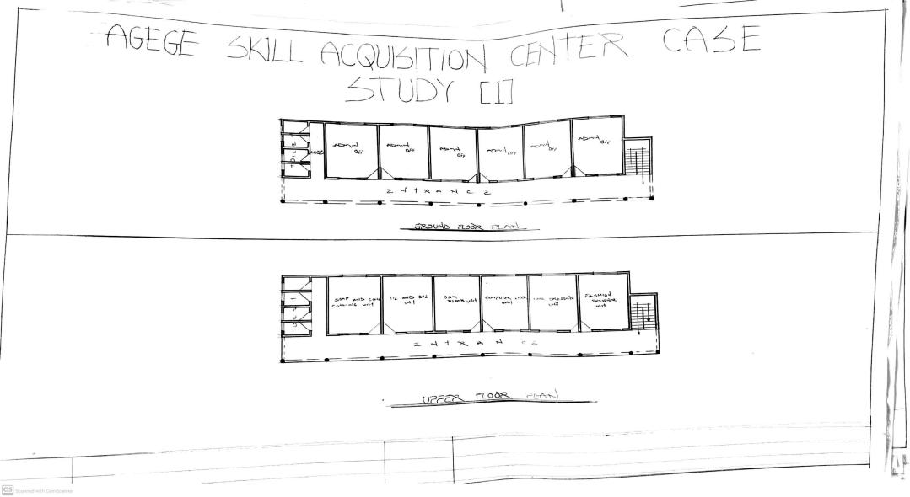

3.2: CASESTUDY 2:AGEGE SKILL ACQUSITION CENTRE
APPROCH PLAN FOR CASE STUDY
LOCATION PLAN FOR CASE STUDY

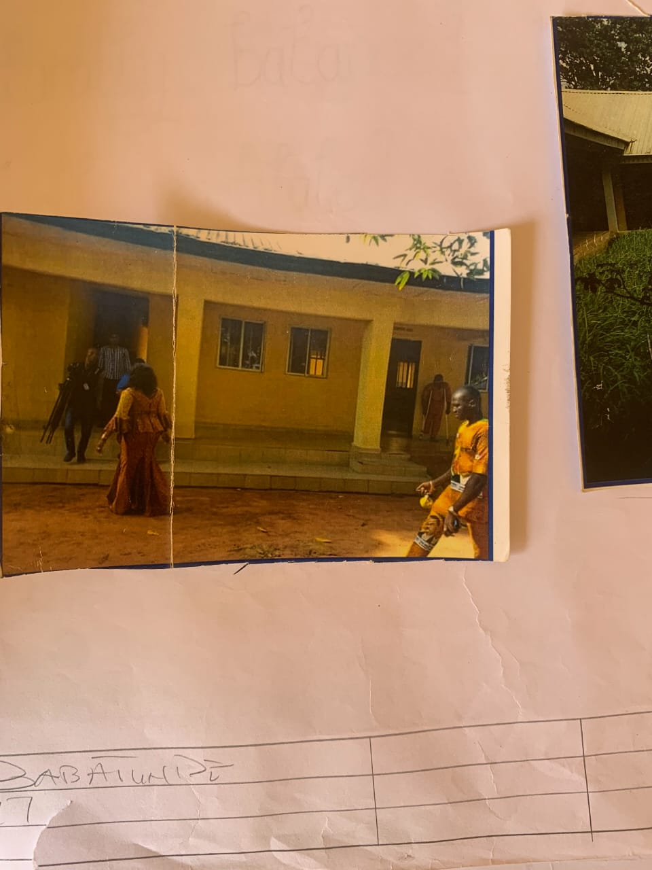
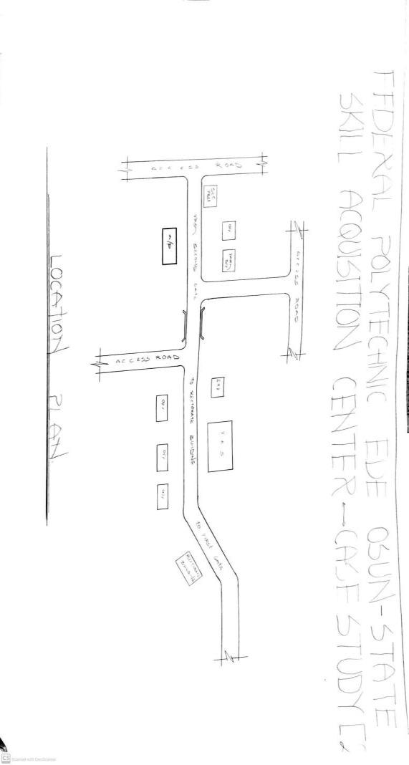
FLOOR PLAN FOR CASE STUDY
Ede Skill Acquisition Centre reflects the government’s commitment to inclusive development. By providing accessible and often tuition-free training, it removes barriers that typically prevent underprivileged groups from acquiring valuable skills. It also encourages community involvement, public-private partnerships, and a focus on sustainable development goals (SDGs), especially those relating to quality education, gender equality, and decent work.
In summary, the Agege Skill Acquisition Centre stands as a model for community-driven development and empowerment. It not only offers practical solutions to pressing economic challenges but also serves as a beacon of hope and transformation for residents of Agege and surrounding areas.

3.3. CASE STUDY THREE
FLOOR PLAN FOR CASE STUDY
LOCATIONAL PLAN FOR CASE STUDY
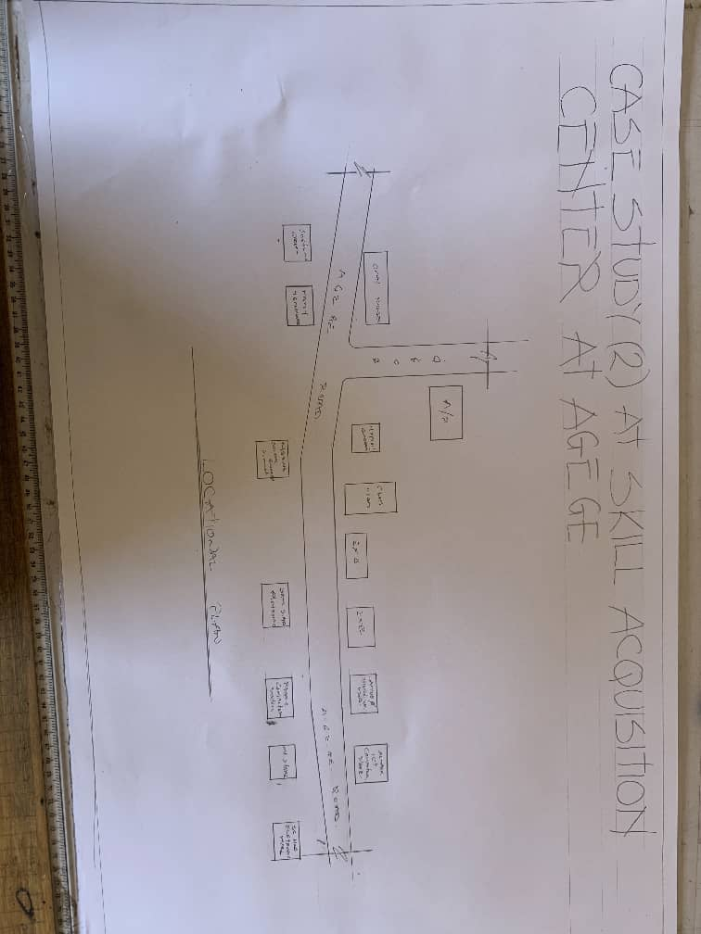
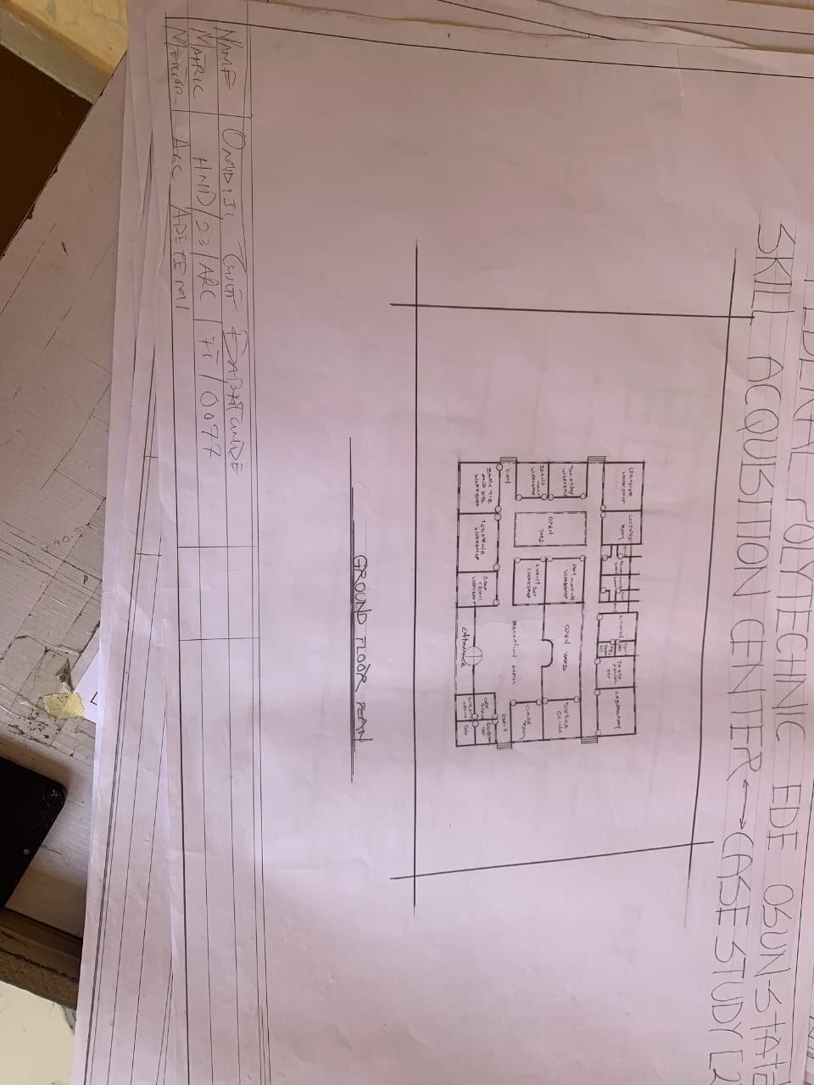
LOCATION PLAN FOR CASE STUDY
W.A.P.A SKILL ACQUISITION AND VOCATIONAL CENTER LOCATED AT EGBEDA, LAGOS STATE.
BRIEF INTRODUCTION
WAPA means Women Affairs and Poverty Alleviation. The Ministry was established in 1999. Prior to its becoming fully ledged Ministry, it had passed through various stages of evolvement. The Ministry comprises of different and various types of departments, units and agencies. Under the section of poverty alleviation and Skill Acquisition Development Unit(SADU) felt the idea of creating a Vocational training scheme which has literally birthed the WAPA skill acquisition center in Egbeda, Lagos state. They commenced academic activities with just 30 students admitted into the school and has gradually increased into numerous amount of students. The following are some of the courses offered in the school:
- Aluminum studies
- Computer studies
- Fashion Designing
- Catering
- Hair Making/Dressing
- Welding
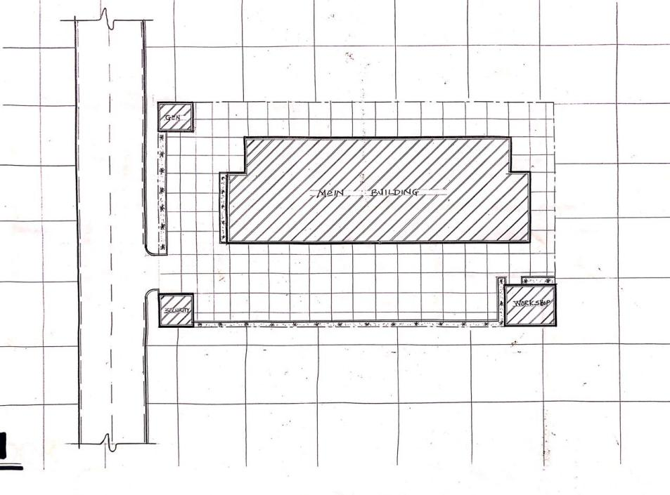
FIG 3.1:- SITE PLAN
SOURCE:- Researcher Field Work, 2024
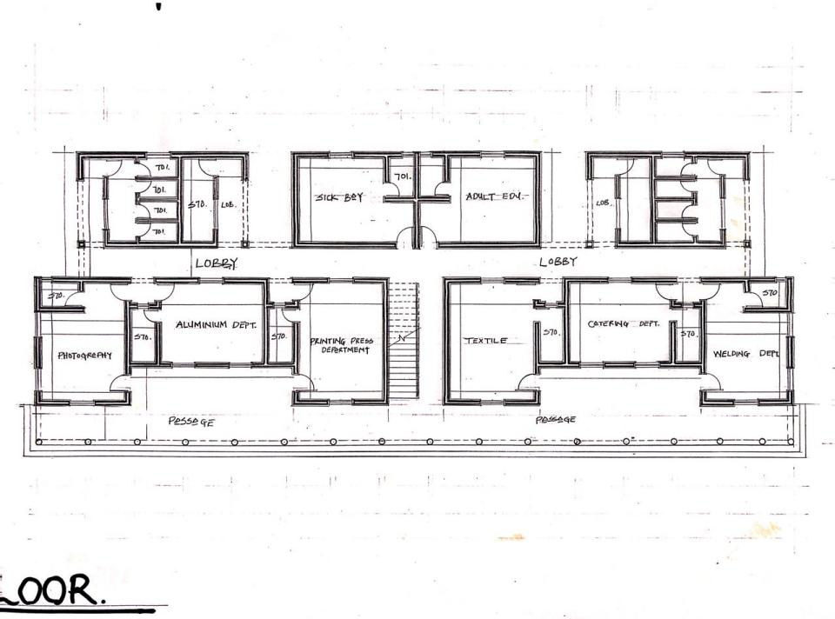
FIG 3.2:- GROUND FLOOR PLAN
SOURCE:- Researcher Field Work, 2024
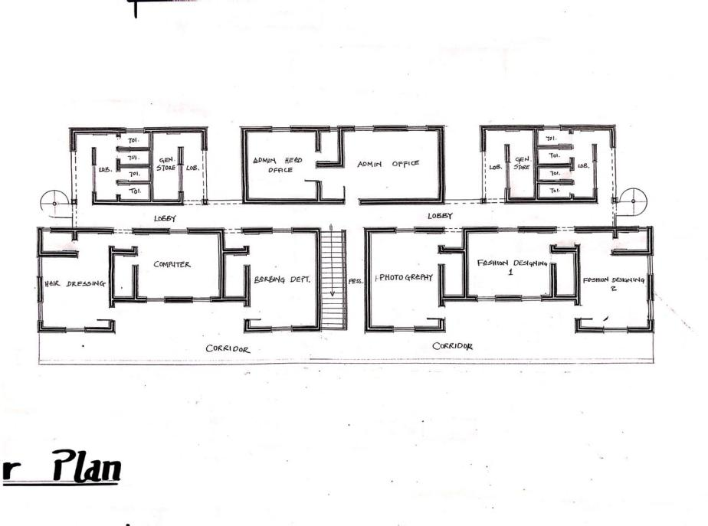
FIG 3.3:- FIRST FLOOR PLAN
SOURCE:- Researcher Field Work, 2024

PLATE 3.1:- SIDE VIEW
SOURCE:- Researcher Field Work, 2024

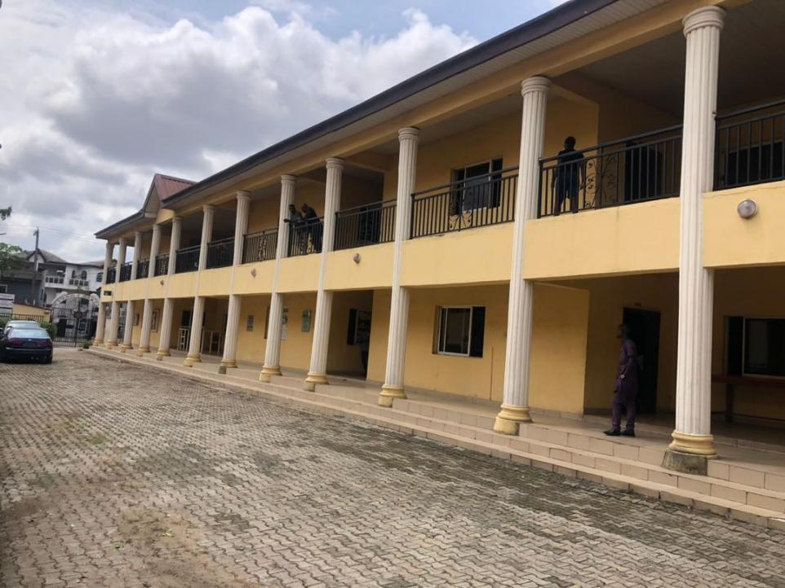
PLATE 3.2:- SIDE VIEW
SOURCE:- Researcher Field Work, 2024

3.1.1 MERITS
- The facility is easily accessed
- Properly built for its purpose
- Its units are well ventilated

3.1.2 DEMERITS
- It was built in a noisy environment
- Poor drainage system
- Site scopes is not well segmented

CHAPTER FOUR
4.0 STUDY AREA/PROJECT SITE

Oko Olowo is a prominent and rapidly developing area located along the outskirts of Ilorin, the capital city of Kwara State, Nigeria. Positioned along the Ilorin-Jebba expressway, it serves as a gateway between Ilorin and northern parts of the state and country. The area is known for its strategic location, which has contributed significantly to its growth in terms of residential, commercial, and infrastructural development.
Oko Olowo falls under the jurisdiction of Ilorin West Local Government Area and has grown from a semi-rural settlement into a bustling community with modern housing estates, markets, educational institutions, and religious centres. Its accessibility, coupled with affordable land and housing, has made it attractive for real estate developers, civil servants, traders, and artisans.
Due to its continuous expansion and the increasing population influx, Oko Olowo has become a focus area for government and private sector interventions in terms of road infrastructure, public utilities, and social amenities. The community remains a vital hub for both economic activities and residential development within the Ilorin metropolis.

4.1 HISTORY OF KWARA STATE
Kwara State is one of the 36 states in the Federal Republic of Nigeria. It is located in the North-Central geopolitical zone, also referred to as the Middle Belt region, and shares boundaries with Kogi State to the east, Ekiti and Osun States to the south, Oyo State to the southwest, and Niger State to the north. To the west, it shares an international boundary with the Republic of Benin, making it a strategically positioned state for trade and cultural exchange.
The state was created on May 27, 1967, from the former Northern Region of Nigeria. Its capital city is Ilorin, a historic town known for its rich Islamic heritage, cultural diversity, and educational institutions.
The state comprises 16 Local Government Areas, including Ilorin West, Ilorin East, Offa, Omu-Aran, Patigi, Kaiama, and Baruten, among others.
Kwara State is ethnically and culturally diverse, with major ethnic groups including the Yoruba, Nupe, Baruba, and Fulani.
This diversity is reflected in the state's traditions, festivals, languages, and social practices. The people of Kwara are known for their peaceful coexistence, religious tolerance, and hospitality.
Economically, Kwara is largely agrarian, with farming being the dominant occupation in rural areas. Major crops grown in the state include maize, yam, cassava, rice, guinea corn, and sugarcane.
In recent years, the state government has focused on agricultural development, youth empowerment, and small-scale enterprise support, particularly through initiatives like "Kwara State Agricultural Modernization Master Plan" and Kwara NG-CARES. Kwara is also home to emerging industrial and commercial sectors, supported by a growing network of infrastructure and investment incentives.
The state is an educational hub in the region, hosting institutions such as the University of Ilorin, Kwara State University (KWASU), Kwara State Polytechnic, and various colleges of education and vocational centres.
These institutions contribute to human capital development and serve as research and training grounds for youths across Nigeria.In terms of tourism, Kwara offers attractions such as the Owu Falls, Esie Museum, Imoleboja Rock Shelter, and the annual Durbar Festival in Ilorin. These sites reflect the state's natural beauty and historical significance.
Kwara State remains committed to development, inclusivity, and innovation. With its youthful population, abundant natural resources, and policy-driven leadership, the state continues to position itself as a forward-looking entity focused on sustainable growth and prosperity

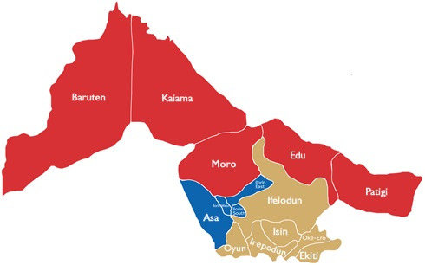

FIG 1:KWARA STATE MAP

3.8 SITE SELECTION CRITERIA
The site is located along existing female hostels within the school Location
- Ease of access
- Availability of enough land
- Security
- Nature of Site and Vegetation
- Location:
The site is located along existing female hostels within the school.
- Ease of Access:
The site can be accessed easily as there is an existing road that leads to I
- Availability of Enough land:
To adequately provide for the various facilities required in the building and on the site, the area of land required for the project must be adequate. Therefore, the site was selected because it is wide enough to accommodate the proposed design.
- Security:
The site is located within the school thereby is covered by the school security ensuring safety of the students. But also, additional security would be provided on the site.
- Nature of Site and Vegetation:
The topography of the site is fairly levelled and the slightly unlevelled part can be adequately levelled. The sub soil is mainly red lateritic soil, with barches of sandy soil. The site also contains few trees and shrubs, which can help enhance the landscape of the site, and also act as wind-breakers and dust filters during the harmattan.
4.3 SITE CHARACTERISTICS
4.3.1 Soil Type
The sub soil is mainly red lateritic soil, with barches of sandy soil. It is a high load bearing capacity soil.
4.3.2 Vegetation
The vegetation on the site consists of few trees of different species and shrubs. Some trees and shrubs will be retained to enhance the landscape of the site, and also act as wind-breakers and dust filters during the harmattan.
4.3.3 Topography
The topography of the site is fairly levelled and the slightly unlevelled part can be adequately levelled.
4.3.4 Drainage
There is no existing drainage on the site, so drainage would be constructed.
4.3.5 Accessibility
The site is accessible by an existing road along the adjoining buildings which leads to the site.

4.4 SITE ANALYSIS.
A site analysis involving a study of the site is carried out, it takes into consideration natural and man-made components present in and around the site, as well as climatic conditions of Lagos state. The plate below shows a schematic summary of the analysis of the proposed site.
4.5 GEOGRAPHICAL/CLIMATIC DATA
Lagos is one of the cold regions in Nigeria with an average daily high temperature of only 31 degrees centigrade. High humidity and hot temperatures make the weather at times pleasant but also tropical humid. It is warm to hot all year round and invites to bathe at average water temperatures of 27 degrees. Due to the lesser rain the best time for traveling is from November to March. Most precipitation decrease from June to October.
- Hours of sunshine per day

Figure 4.3 Hours of Sunshine per day
Source; Worlddata.info
The number of hours of sunshine refers to the time when the sun is actually visible. That is, without any obstruction of visibility by clouds, fog or mountains. With 7 hours per day, February is the sunniest month in the state of Lagos. In August the sun shines the shortest.

- Rainy days per month

Figure 4.4 Rainy days per month
Source; Worlddata.info
A rainy day is a day on which at least an amount of 0.1 mm precipitation (=0.1 liter) per square meter falls. This can be rain, snow, hail or even dew. So it does not have to rain the whole day. With 18 rainy days, June offers the most number of rainy days, and in December the least.
- Precipitation in mm/day

Figure 4.5 Precipitation in mm/day
Source; Worlddata.info
The amount of precipitation is measured in millimeters per square meter. Thus, at two mm/day, two litres of water fall on one square meter within 24 hours. With only 0.4 mm, the least rain falls in December. June, on the other hand, has the most rain.

- Water temperature

Figure 4.6 Water temperature
Source; Worlddata.info
Water temperature depends not only on solar radiation within the same region, but also on ocean currents. For example, depending on the season, cold or warm water masses are moved from other areas. The warmest temperatures in Lagos are in March, when the water is 28 °C.
- Relative humidityin %

Figure 4.7 Water temperature
Source; Worlddata.info
Warm air can absorb more moisture than cold air. The relative humidity indicates how much moisture of the physically possible is actually contained in the air. At high humidity, the person feels uncomfortable and perceives this as oppressive. In general, a relative humidity of 40-60% gives as pleasant. With humidity averaging 87%, June is the most uncomfortable. In March, on the other hand, it is easier to endure.
4.5 ANALYSES OF THE IMMEDIATE ENVIRONMENTAL CONDITIONS OF THE SITE

Site Features and Infrastructure
The site features electrical lines which proposes that open power supply is promptly accessible inside the site.
Perfectly drained soil; soils water moves through easily to allow good soil aeration and at the same time sufficient amount is retained for plant growth.
Other features are water supply and an access road.
- Noise Sources
There are no much noises on the site but the few noises that can be heard comes from the adjacent structures which are the existing female hostels.
- Rainfall:
Minimum rainfalls are recorded in December, while June offers the most amount of rainfall.
- Vegetation and Topography:
The vegetation on the site consists of few trees of different species and few shrubs. The site is relatively gentle sloping and has a high load bearing capacity soil.
- Prevailing Wind Direction & Sun-Path Angles
The two predominant winds blowing across this area are the South West Trade wind and the North East Trade wind. The former, which blows across the Atlantic Ocean, is characteristically cold and results in the wet season. Being a cold wind, it is capable of holding much moisture contents across the ocean, and hence an increase in relative humidity of the area affected. However, the North East Trade wind, which blows across the Sahara Desert, is dusty and dry wind. Consequently, the two predominant seasons experienced in this area are characteristically marked by the two wind types. The summer (the season between spring autumn when the sun is hot and there are many flowers) is experienced between April and September, when the south west Trade wind is more predominant, while the winter season is shortly marked between November and March, when the north east trade wind is more predominant. This later season {winter} is however characterized by cool and hazy mornings, couple with dusty afternoons, because of the dust particles it brings forth from the desert. To reduce the effects of wind driven, trees were planted.
- Sunrise and sunset:
The sun rises from the east in the early hours of the morning at about 6:30am - 7:00 am and sets in the west at about 6:45 pm in the evening daily.
- Accessibility:
The site is accessible by an existing road along the adjoining buildings which leads to the site.
- Man-made features

- Electricity: Electricity is supply to the site through overhead cables along the site boundary.
- Footpath: There are no existing footpaths on the site, few would be channeled.
- Noises: Caused by adjacent structures
4.6 PROPOSED DESIGN
The proposed design is the design of a female hostel with emphasis on fire safety to ensure the safety of the students and occupants.
- ​Design Considerations:
The following are the factors considered when designing the building;
- Passive and Active Fire safety: Fire safety measures would be considered in designing the building to increase safety in the building,
- Aesthetics: In any architectural design, aesthetics is most common factor to consider which shall be achieved by the use of attractive and lively finishing materials.
- Functionality: In any architectural design, functionality plays major role, design must be functional to meet the taste and convenience of the occupants.
- Ventilation: This includes the orientation of the building, sizes and locations of fenestration, vegetation.
- Circulation and Zoning: Appropriate and well-articulated pattern of circulation in a building alleviates confusion and at the same time tailor the movement of students to their respective destination.
- Landscaping: The form of landscaping in the building is aimed at satisfying user requirements, having aesthetic value and improving environmental comfort. Hence, landscaping will be considered in the design
- Security: The provision of security in the hostel involves the protection of the students, the building and its contents.
4.7 DESIGN CONCEPT
The design approach was based on functionalism, which is an architectural principle that says that building should be designed based solely on purpose and function of the building.
4.8 PROJECT GOAL
The proposed design is the design of a female hostel with emphasis on fire safety to ensure the safety of the students and occupants.
The hostel is to provide the students with accommodation facilities and other functional spaces and facilities. These facilities include:
- Reception
- Cloak room
- Workshops
- Fire safety Equipment rooms
- Relaxation area
- Car parking spaces
- Offices
- Conferances
- Covienences

4.9 APPRAISAL OF PROPOSED SCHEMES.
An appraisal of a proposed scheme for institutional hostels involves evaluating the plan's feasibility, effectiveness, and potential impact. appraisal framework is based on the following:
- Location and Accessibility
- Proximity to academic buildings and facilities
- Safety and security features
CHAPTER FIVE
5.0 DESIGN AFFRAISAL OF PROPOSED SCHEME
In any project design, there are two basic factors that should be taken into consideration. These factors are Functionality and aesthetics of the design, although to some designers, aesthetic and functionality of any buildings are incompatible but in the case if this project, both aesthetic and functionality of the design been taken care of to satisfy the highly demanded functional requirements and to create aesthetically balanced design.

5.1 CONSTRUCTION METHODOLOGY AND MATERIALS
The method of construction involved in the erection of the building structure is in accordance with the architectural detail required in executing the buildings and the process of construction that is critical to structural component as affected by the site conditions and types of materials to be used.
After the preparation of the overall site plan, many designs are developed to show the specific methods of construction. These details as an integral part of the design process and serve two important purposes. Firstly, they stipulate the aesthetic as structural element of the plan and they provide the basis for costing project.
CONSTRUCTION GRIDS: Consider the size of buildings products and materials
available in the market, this reduce unnecessary wastage to fit the design space.
SERVICES GRID: They exist to alleviate the problem of disturbing service point
throughout the building. This point includes power points and telephone outlets.
PLANNING GRID: They guide the location work group and their work places.in
addition they impose the overall order and maintain individual and group space standards.
i. BUILDING ORIENTATION
Orientation of the building will be chosen according to the form of the site and at the same
time give credence to traffic
This traffic is categorized into
i) Vehicular
ii) pedestrian
Pedestrian movement will be given adequate consideration and proper acessibilityii. LANDSCAPE: Landscape is necessary to improve the aesthetics of the environment
barrier against solar radiation and absorption of noise from the environment, hence use of
trees, shrubs and grasses will dominate in the design than concrete surface of landscape.
iii. CONSTRUCTION MATERIAL: The construction materials that will be used for
project will be limited to Nigeria labor market having in mind that the labor market is
made up of indigenous workers.
Therefore, the building materials and techniques be locally available in Nigeria.
v. FOUNDATIONS: Simple concrete strips/pads/pile foundations shall be used
vi. FLOOR FINNISHES: Hard wearing and resistant flooring materials shall be used for
the design for easy maintenance and durability. Ceramic floor tiles and the administrative
block and terrazzo floor Finnish shall be used for all public space and custody blocks.

vii. WALL AND INTERNAL PARTITIONS: The external wall shall be of sand-Crete
hallow block material while some internal partition may be of concrete which will be
treated against fires accident
viii. ROOF MATERIAL: The roof material shall be of aluminum long span.
ix. DOORS AND WINDOW: In this design, the door of the major entrance into the site
will be steel made gate, while other doors and window will be four panel door and
casement metal window.
5.2 DESIGN CHARACTERISTIC (Landscape)
The ideas of planning good surroundings evolve from the primary function. It gives a
good aesthetic view of the structure. It enhance the psychological feelings of the public
making use of the area, it makes the entire environment healthy, a clean and well planned
site is a healthy environment in view of these the following had been adopted in planning
LANDSCAPE
It has been known to us that throughout the world people use mainly two types of
landscape namely:
* Soft Landscape
* Hard Landscape
SOFT LANDSCAPE ELEMENTS
a) Tree (Vegetation): Tree also has been strategically planned to be plant at turning point
addition to the existing one by the road and closer to some structures to perform the fun of
a shading device.
b) Grasses/Lawn: Bahamas grasses have been suggested as type of soft landscape in
some area liable to be influenced negatively by erosion, it gives a good aesthetically view or
look on the ground surface which makes it look more appealing to the eye
HARD LANDSCAPING ELEMENTS
a) Asphalt: Used for drive ways and parking lots, it is economical and durable both for
staffs and visitors
b) Interlocking paving: Used for walk ways and outdoor paving to blend with the natural
texture of the environment
c) Concrete Krebs: Used to separate tater surface from the lawn covered areas
5.3 BUILDING STRUCTURE
The administrative block is a story building with court yards supported by beams and column at appropriate intervals. Most modern buildings are usually constructed by introducing grids into the design, this make for easy and accurate consideration of frame structures used in buildings
There are two types of grids systems
1) Modular grid
2) Structured grid
For this project, structured grid system was employed in filled sand Crete block where
used all retaining wall of the building. The roofing system is used for building is well
seasoned timber roofing and metal roof trustees
5.4 SERVICES
These include
i. ELECTRICAL SERVICE: The electrical service will be high quality and cables in
concealed and conduit wiring system will be used, there is a power house to generate constant electricity supply in case of power failure as we all know how electricity sector is not actually stable.
ii. SEWAGE DISPOSAL: For effective drainage of both surface and soil waste
appropriate size of pipes are used. All pipes used are run into duct system with leaf net provided on drain pipe to prevent blockage from soil waste
iii. Drainage
iv. Waste disposal e.t.c.

REFERENCE
Oyesiku, K. (1998). Modern urban and regional planning law and administration in Nigeria. Ibadan: Kraft Books.
Ogunbiade, M. E., & Uduak, I. (2017). Planning sustainable housing estates in Nigeria. Journal of Urban and Regional Planning, 9(1), 23–38.
Akinmoladun, O. I., & Oluwoye, J. (2007). An assessment of why the problems of housing shortages persist in developing countries. Pacific Journal of Science and Technology, 8(2), 253–260.

APPENDICES
APPENDIX 3: SITE ANALYSIS
APPENDIX 2:LOCATION PLAN
APPENDIX 1:LOCATION MAP
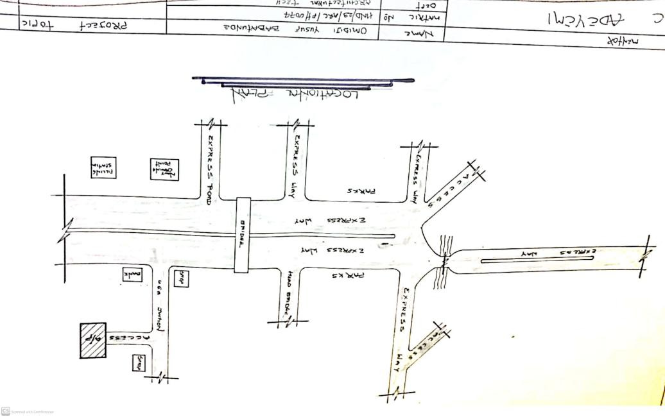
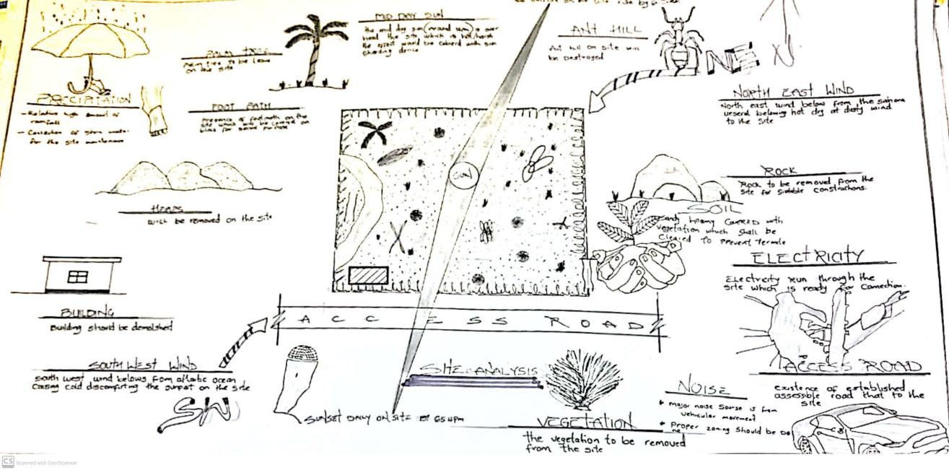
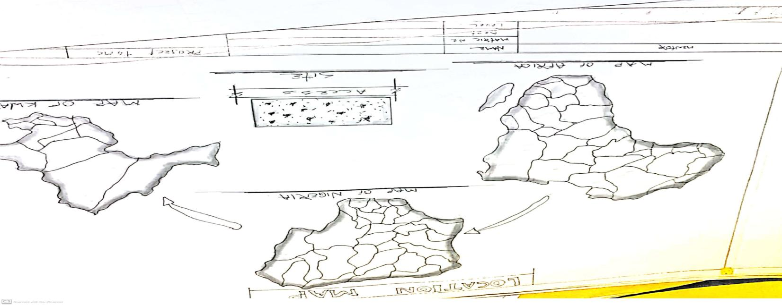

APPENDIX 6: SPACE CALCULATION
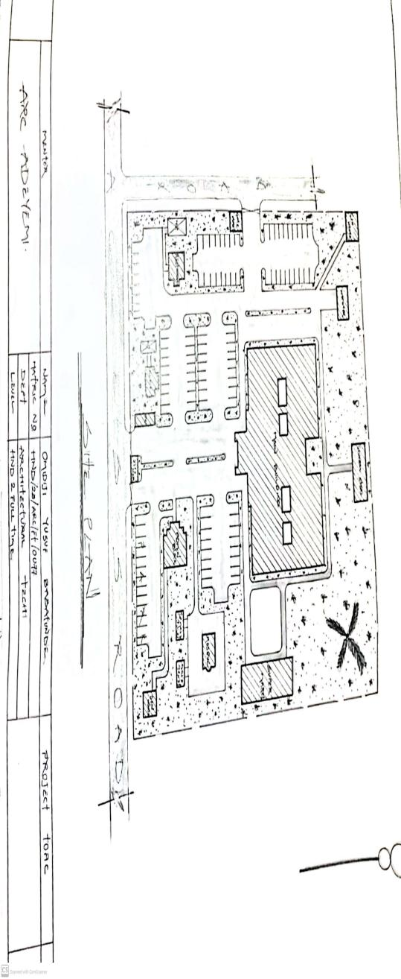
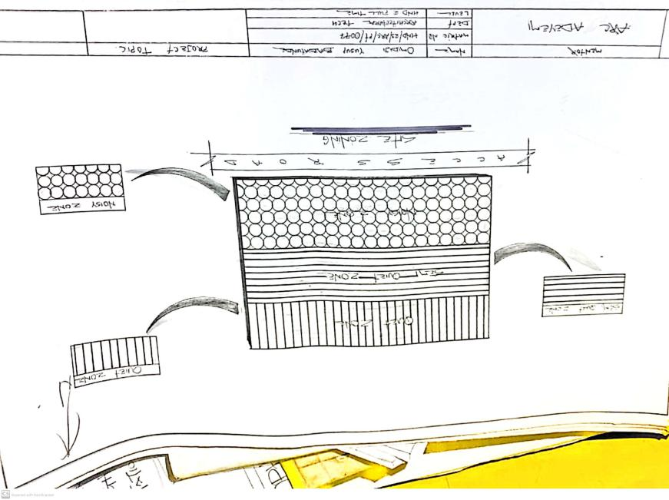
APPENDIX 5:SITE ZONING
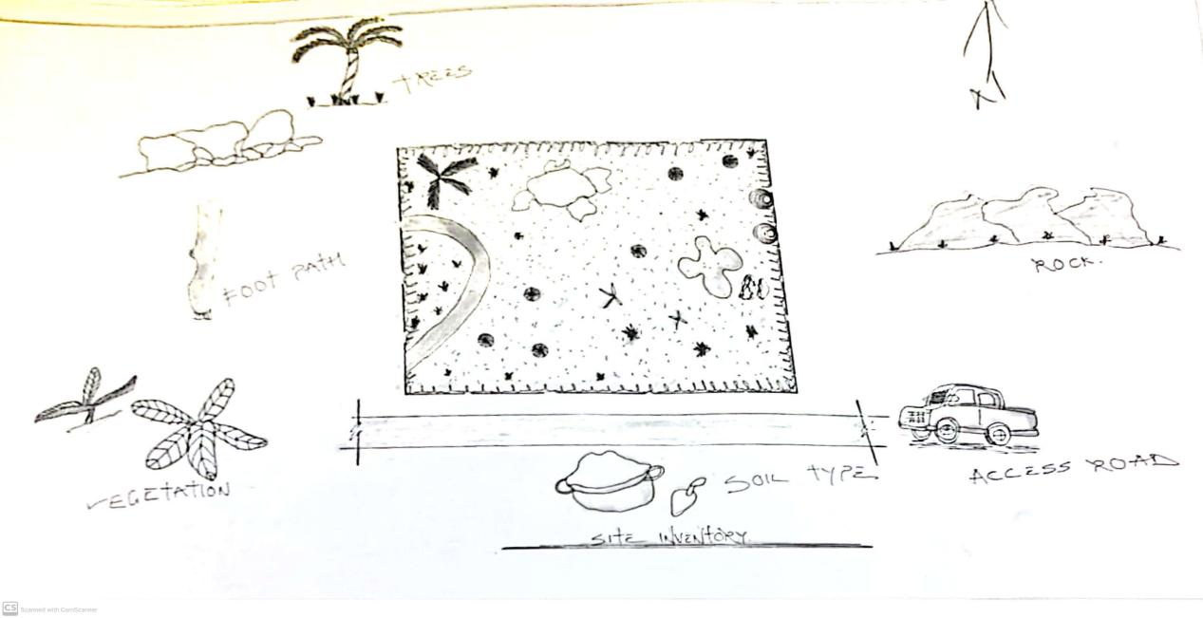
APPENDIX 4:SITE INVENTORY
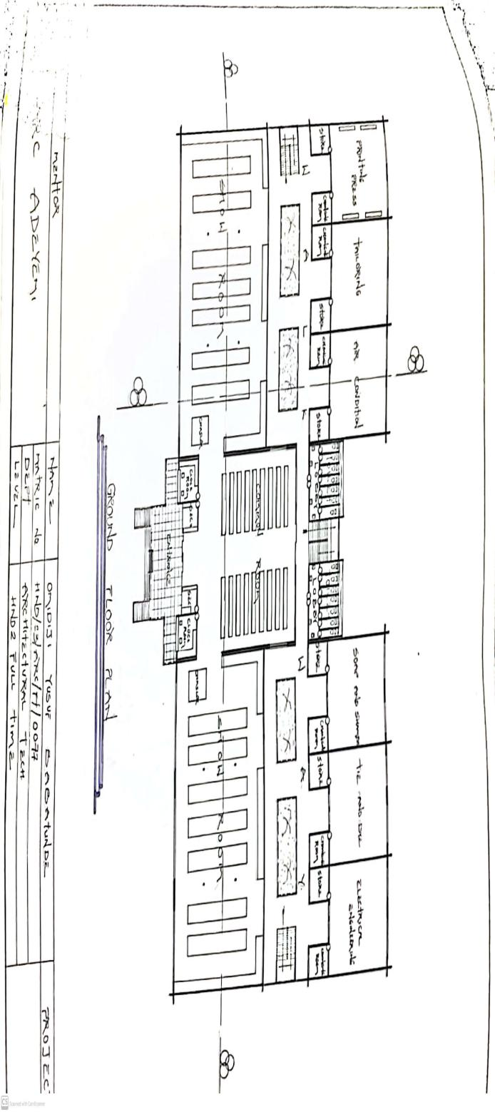

APPENDIX 9:SECTION
APPENDIX 8:ROOF PLAN
APPENDIX 7:FLOOR PLAN

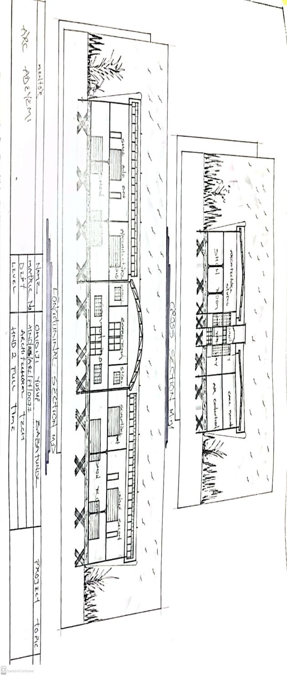
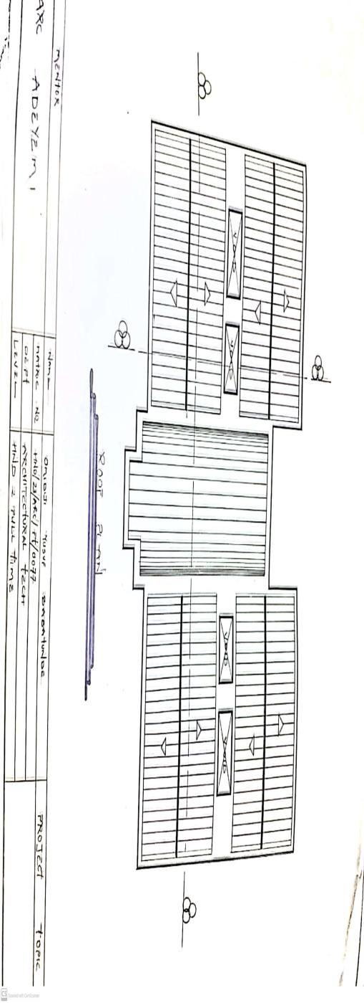
APPENDIX 10:ELEVATION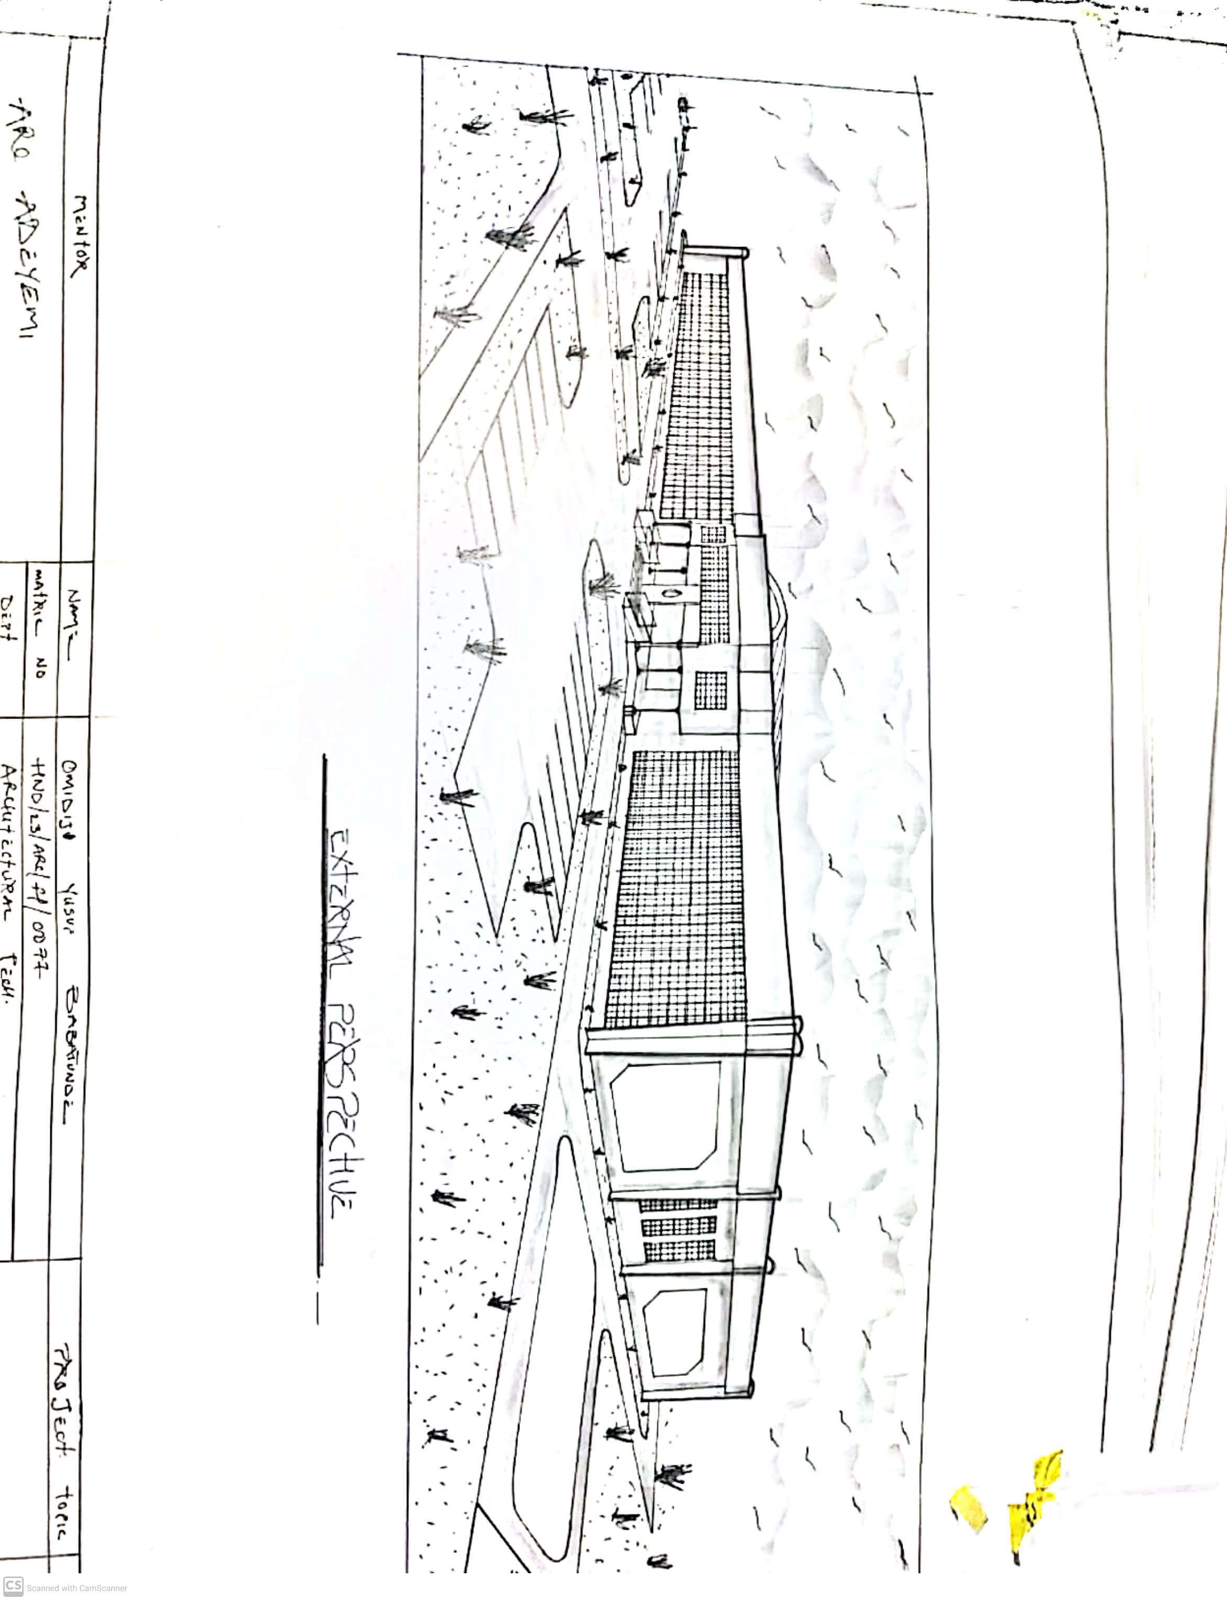
APPENDIX 11: ELEVATION
