A PROJECT REPORT
ON
PROPOSED FACULTY OF ARCHITECTURE
FOR
LANDMARK UNIVERSITY

LOCATED AT
KM 4 IPETU, OMU-ARAN ROAD, PMB 1001, IPETU ROAD OMU-ARAN, KWARA STATE.

BY

OYELEYE EMMANUEL OLUWAGBENGA
HND/22/ARC/FT/012

SUBMITTED TO
THE DEPARTMENT OF ARCHITECTURAL TECHNOLOGY, INSTITUTE OF ENVIRONMENTAL STUDIES, KWARA STATE POLYTECHNIC, ILORIN, KWARA STATE.

IN PARTIAL FULFILLMENT OF THE REQUIREMENTS FOR THE AWARD OF THE HIGHER NATIONAL DIPLOMA (HND) IN ARCHITECTURAL TECHNOLOGY
SUPERVISOR: ARC. OLAREWAJU F. A.

JULY, 2025.
DECLARATION

I declare that this project/dissertation of my research works. It has not been presented for the award of any HND in any polytechnic. The ideas, observations, comments, and suggestions herein represent my conviction, except for quotations, which have been acknowledged by conventional academic traditions under the supervision of Arc. Olarewaju Felix Adeyemi in the Department of Architectural Technology, institute of environmental studies, Kwara State polytechnic, Ilorin.

Emmanuel Oluwagbenga Oyeleye Signature and Date

CERTIFICATION
I certify that this Research Project titled "Faculty of Architecture" for Landmark University, Omu-Aran, Kwara State, was carried out by OYELEYE Emmanuel Oluwagbenga with matric number HND/22/ARC/FT/012 under my supervisor, Arc. Olarewaju F.A. and has been approved as meeting part of the requirements for the award of HND in Architectural Technology, institute of environmental studies, Kwara State Polytechnic, Ilorin Kwara State.

Arc. Olarewaju F.A.
(Project Supervisor) Signature/Date


Arc. Olarewaju F.A.
(Project Coordinator) Signature/Date


Arc. Mrs. Tomori J.M.
(Head of Department) Signature/Date

(External Examiner) Signature/Date

DEDICATION
This research project work is dedicated to Almighty God the source of knowledge and to who teaches and guides me throughout the academic pursuit.

ACKNOWLEDGEMENT
I return all the glory, honour, praise, and adoration to the master of the universe that has given me the privilege of seeing the end of this program. To Him alone be the glory. My immediate gratitude goes to the Department of Architectural Technology the entire staff and also to my supervisor Arc. Olarewaju F. A. who has been supportive throughout this project, may God continue to reward you and your family. My sincere gratitude goes to my parent, Mr. Oyeleye J.A. and Mrs. Oyeleye R. O., who brought me to this world, and for the role they play in my life right from birth till this present moment. I pray Almighty God grant them the grace to eat what they have laboured for.
However, my gratitude also goes to all my beloved siblings (Sanjo, Mayowa, Abigail, Bolu) and my helpers The Oludipes, The Ogundipes, The Olaitans, The Shoruns, Barr. Timi O., Arc. Seyi O., Arc. Tosin O., for their encouragement and financial support.
I can't forget the help of my friends, course mates and colleague, which includes; The entire Light Executives, Christ Apostolic Church Students’ Fellowship of Kwara State Polytechnic at large and my loved ones, may almighty God bless you all.

ABSTRACT
This thesis explores the Faculty of Architecture's crucial role in advancing architectural education, research, and practice. It examines the comprehensive undergraduate and doctoral academic programs, highlighting their integration of design theory, technical proficiency, and practical experience. Emphasizing critical thinking, creativity, and interdisciplinary collaboration, the curriculum prepares students to address challenges in the contemporary built environment. A significant focus is on the Faculty's state-of-the-art facilities, including modern design studios, specialized research laboratories, an extensive library, and dynamic exhibition spaces. These resources enable students and faculty to innovate and excel in architectural research. The thesis also underscores the Faculty's commitment to sustainable design, urban resilience, and digital technologies through detailed case studies and research initiatives. Additionally, the thesis highlights the Faculty's dedication to community engagement and global outreach. By partnering with industry, government, and non-profit organizations, the Faculty ensures its educational and research efforts have a tangible impact on real-world architectural and urban challenges. International exchange programs, study abroad opportunities and public lectures further enrich the learning experience, fostering a global perspective among students and faculty. Utilizing historical analysis, qualitative research, and empirical data, this thesis provides a comprehensive understanding of the Faculty of Architecture's contributions to the field. It explores how the Faculty's core values; innovation, sustainability, and inclusivity, shape its approach to education and practice. Ultimately, the thesis asserts that the Faculty of Architecture is a centre of academic and professional excellence and a catalyst for positive change in the built environment, nurturing future architects to lead with vision, creativity, and social responsibility.

TABLE OF CONTENT
Title page....................................................................................................................................i Declaration................................................................................................................................ii Certification.............................................................................................................................iii Dedication.................................................................................................................................iv Acknowledgement.....................................................................................................................v Abstract....................................................................................................................................vi
Table of contents.....................................................................................................................vii
List of Table...............................................................................................................................x
List of Figures..........................................................................................................................xi
List of Plate.............................................................................................................................xii Appendices.............................................................................................................................xiii

CHAPTER 1:
1.1 Introduction..........................................................................................................................1
1.2 Historical Background........................................................................................................1
1.3 Definition of Project Topic...................................................................................................3
1.4 Aim and Ojectives................................................................................................................3
1.6 Justification..........................................................................................................................3
1.7 Scope of the project...........................................................................................................4
1.8 Limitation of the Study........................................................................................................4
1.9 Research Methodology........................................................................................................5

CHAPTER 2:
2.0 Review of the Relevant Literature.......................................................................................9
2.1 Evolution of the Building Typology.....................................................................................9
2.2 Important Issues and Problems Peculiar to this Typology...................................................9
2.3 Functions and Relationships Between Spaces.....................................................................9
2.4 Technological and Environmental Approaches..............................................................10
2.5 Sub-Topic of the Thesis.................................................................................................10

CHAPTER 3:
3.1 Case Study one (Department of Architecture, University of Ilorin)...............................12
3.2 Case Study two (Department of Architecture, OAU, Ile-Ife).........................................14
3.3 Case Study three (Department of Architecture, LAUTECH, Ogbomosho)...................16
3.4 Case Studies Deductions................................................................................................18

CHAPTER 4:
4.1 Fact about Omu-Aran, Kwara State...............................................................................19
4.2 Site Location/Description..............................................................................................19
4.3 Site Location Criteria.....................................................................................................20
4.4 Site Selection Criteria....................................................................................................22
4.5 Geographical/ Climatic data..........................................................................................22
4.6 Function Of The Proposal..............................................................................................23
4.7 Feasibility Study of the Site...........................................................................................25
4.8 Site Analysis and Inventory............................................................................................25
4.9 Proximity to the User.....................................................................................................26

CHAPTER 5:
5.1 Design Criteria...............................................................................................................27
5.2 Brief Analysis (Client/User requirement)......................................................................27
5.3 Analysis of Scope...........................................................................................................27
5.4 Department Under the Faculty and their Courses..............................................................32
5.5 Spaces to be Provided (General & Department-Specific)..................................................35
5.6 Design Approach Realization.............................................................................................37
5.7 Construction Method & Materials......................................................................................39
5.8 General Design Consideration...........................................................................................39
5.9 Landscape Design..............................................................................................................41
5.9.1 Maintenance....................................................................................................................42
General Conclusion and Recommendation..............................................................................39
REFERENCES.........................................................................................................................44
APPENDICES..........................................................................................................................46

LIST OF TABLES
Table 5.3: Spatial Allocation...................................................................................................28

LIST OF FIGURES
Fig: 4.2: Location Map..........................................................................................................17
Fig: 4.4: Site Selection Criteria.............................................................................................18
Fig 4.5: Climatic Data...........................................................................................................19
Fig 4.8: Site Analysis............................................................................................................22

LIST OF PLATES
Plate: 3.1 Approach View...........................................................................................................9
Plate: 3.2 Approach View of Case Study Two.........................................................................10
Plate: 3.3 Perspective View of Case Study Three....................................................................10
Plate: 3.4 Approach View of the Department...........................................................................11
Plate: 3.5 General Office-HOD-Audio Visual..........................................................................12
Plate: 3.6 Approach View.........................................................................................................13
Plate: 3.7 Rear view..................................................................................................................14

CHAPTER ONE
1.1 Introduction
The Faculty of Architecture represents an epicenter of innovation, creativity, and scholarly excellence within the architectural domain. This institution is dedicated to advancing the built environment through a holistic blend of rigorous academic programs, cutting-edge research, and extensive community engagement. As a pillar of architectural education and practice, the Faculty stands out for its unwavering commitment to fostering the next generation of architects who are equipped to meet the complex challenges of the 21st century.
The Faculty of Architecture has evolved into a leading institution recognized globally for its contributions to the architectural field, initially established to address the growing demand for skilled architects, the Faculty has continuously adapted its curriculum and research focus to align with the changing dynamics of the profession. This evolution reflects a deep understanding of the interplay between architectural heritage and contemporary innovations, ensuring that students are grounded in both historical knowledge and future-oriented practices.
The vision of the Faculty of Architecture is to be at the forefront of architectural education and practice, leading through innovation, sustainability, and inclusivity. Its mission is to cultivate a diverse and inclusive community of learners and practitioners committed to designing environments that are aesthetically pleasing, functionally effective, and environmentally responsible. By promoting a holistic approach to architectural education, the Faculty prepares graduates who are adept at addressing the multifaceted challenges of modern society.
1.2 Historical Background
The Faculty of Architecture is an integral part of many universities around the world, dedicated to the study and practice of architecture and related disciplines. Its historical development reflects the evolution of architectural education and practice over time. Here's a detailed background:
Ancient Roots Ancient Civilizations: The roots of architectural education can be traced back to ancient civilizations such as Egypt, Mesopotamia, Greece, and Rome. In these cultures, knowledge about architecture was often passed down through apprenticeships and informal mentoring rather than structured academic programs. (De Chiara, Crosbie, & Callender, (2001)
Medieval Period: During the medieval period, architectural knowledge continued to be transmitted through guilds and workshops. The construction of cathedrals and other monumental structures required specialized knowledge, which was acquired through hands-on experience rather than formal education.
Renaissance and Enlightenment
Renaissance (14th-17th Century): The Renaissance marked a significant shift in architectural education, emphasizing classical principles and humanist ideals. Figures like Leon Battista Alberti and Andrea Palladio wrote influential treatises that began to formalize architectural knowledge. (Alberti, (1988)
Enlightenment (17th-18th Century): The Enlightenment period further advanced the formal study of architecture. The focus on reason and scientific inquiry led to the development of architectural theory and education based on empirical methods and classical principles. (Kruft, (1994)
19th Century Formation of Architectural Schools: The 19th century saw the establishment of formal architectural schools. One of the earliest examples is the École des Beaux-Arts in Paris, founded in 1648, which became a model for architectural education worldwide. The Beaux-Arts approach emphasized a rigorous academic training combined with practical design skills. (Palladio, (1997)
Architectural Movements: This period also saw the rise of various architectural movements, including Neoclassicism, Romanticism, and the early stages of Modernism. These movements influenced architectural education and practice, incorporating new styles and technologies.
20th Century Modernism and Functionalism: The early 20th century was characterized by the rise of Modernism, which emphasized functionality and simplicity. Prominent architects like Le Corbusier, Frank Lloyd Wright, and Ludwig Mies van der Rohe influenced architectural education with their innovative approaches. (Mallgrave, (2005)
Expansion of Architecture Programs: As the profession evolved, architectural education expanded globally. Many universities established dedicated faculties or departments of architecture, offering undergraduate and graduate programs. These programs often included a combination of design, theory, history, and technical courses.
Interdisciplinary Approaches: By the mid-20th century, architectural education began incorporating interdisciplinary approaches, including urban planning, environmental design, and digital technology. This reflected a broader understanding of architecture's role in society.
21st Century Technology and Sustainability: The 21st century has seen a significant focus on technology and sustainability in architectural education. The integration of digital tools, sustainable design principles, and innovative construction methods are now central to many architecture programs. (Olgyay, V. (2015).
Globalization and Diversity: Architectural faculties worldwide have embraced a more global perspective, reflecting diverse architectural practices and cultural contexts. This includes a greater emphasis on international collaboration and cross-cultural understanding. Watts, A. (2016).
Changing Educational Models: Many architecture programs have adopted new educational models, including online learning, interdisciplinary studios, and collaborative projects with industry and community partners. These changes aim to better prepare students for the evolving demands of the profession. (Dober, R. P. (2000).

1.3 Definition of Project Topic
The Faculty of Architecture is an academic division within a university or educational institution dedicated to the study of architecture. It typically offers programs and courses that cover various aspects of architectural design, theory, and practice. Students in this faculty learn about building design, urban planning, sustainability, structural systems, and the history of architecture, among other topics. The goal of the faculty is to prepare students to become skilled architects who can design functional, aesthetic, and sustainable structures and spaces.
1.4 Aim and Objectives
Aim
The aim of designing this faculty of architecture is to create a dynamic, functional and collaborative space that fosters creativity, innovation, and interdisciplinary learning, equipped with state-of-the-art facilities to prepare students for contemporary challenges in the field of architecture.
Objectives
- To create a functional and aesthetically pleasing design to support effective teaching and collaborative activities.
- To emphasis architectural flexibility for adapting to a evolving educational practises and technological changes.
- To integrate sustainable features to promote environmentally conscious construction and operation.
- To enhance aesthetic appeal in creativity and creat an enriching learning atmosphere.
1.6 Justification Landmark University currently lacks an architecture program. Introducing a faculty of architecture will fill this gap and provide students with the opportunity to pursue a professional career in architecture, thereby expanding the academic offerings of the university.
1.7 Scope of the Project
- Lecture Hall
- Eatery
- The Faculty
- Recreational areas
- Gate House
- Generator House
- Parking Lots.

Design Brief
- Recreational Areas
- Exhibition Area
- Lecture Hall
- Eating Area
- Studio
- Doctor's Office
- Lecturer's Office
- CAD Lab
- Workshop
- Gallery
- Game Arcade
- Secretariat
- Locker
- HOD's Office
- Sub-Dean's Office
- Dean's Office
- Exam Office
- Staff Lounge
- Seminar Room
- Printing Room
- Research Room
- Archi Shop
- Modelling Room
- Photography Room
- Toilets
1.8 Limitation of the Study
This study was geographically constrained to Omu-Aran and its immediate surroundings, potentially limiting the applicability of findings to other regions with different socio-economic and cultural conditions. Additionally, the sample size of participants, including potential students, faculty members, and industry stakeholders, was relatively small due to time and resource constraints, which may not fully capture the diverse range of opinions and needs.
Financial and temporal limitations also impacted the study. Budgetary constraints restricted the ability to conduct extensive fieldwork, detailed architectural feasibility studies, and cost-benefit analyses, leading to reliance on secondary data and assumptions. The relatively short timeframe for conducting the research may have affected the depth of analysis and breadth of stakeholder engagement.
Further constraints include limited access to comprehensive data on the current demand for architectural education in Nigeria and specific statistics related to Landmark University's prospective student base. The study also assumes stability in higher education policies and regulatory frameworks, which could change and affect feasibility. Rapid technological advancements in architecture and education methods were not fully accounted for, necessitating ongoing curriculum and infrastructure updates.

1.9 Research Methodology:
To ensure a well-informed and contextually relevant design approach for the proposed Faculty of Architecture, a combination of research methods was employed. These methods provided both qualitative and quantitative insights that directly influenced the conceptualization and development of the final design proposal.

1. Case Studies
This research adopts an experimental case study approach, focusing on selected existing architectural faculties and academic structures both within and outside the country. These case studies were meticulously analysed in terms of their spatial organization, circulation systems, structural systems, climatic response, material usage, and overall functionality. From these analyses, critical deductions were made, highlighting strengths and weaknesses in existing designs. These findings significantly shaped the framework for a more responsive, efficient, and contextually appropriate architectural solution for the proposed project.

2. Literature Review
A comprehensive literature review was undertaken to gather theoretical, practical, and regulatory information relevant to the design and planning of an academic faculty—specifically, a Faculty of Architecture. Various standard architectural textbooks and reference materials were consulted, including but not limited to:
Architect’s Data by Ernst Neufert – A foundational reference for space planning, standard measurements, and architectural design elements.
Time-Saver Standards for Building Types edited by Joseph De Chiara, Michael J. Crosbie, and John Hancock Callender – Offers typological case studies and detailed design criteria for educational facilities.
Building Construction Illustrated by Francis D.K. Ching – Provides graphic representations and explanations of construction systems and building elements.
Fundamentals of Building Construction: Materials and Methods by Edward Allen and Joseph Iano – Covers the science of construction and material behaviour.
Metric Handbook: Planning and Design Data edited by Pamela Buxton – A comprehensive guide to planning data for a wide range of building types.
Building Performance Simulation for Design and Operation by Jan L.M. Hensen and Roberto Lamberts – Useful for understanding performance-based design approaches.
Design with Climate: Bioclimatic Approach to Architectural Regionalism by Victor Olgyay – Informed decisions related to climate-responsive architecture.
Modern Construction Handbook by Andrew Watts – Offered insight into modern detailing and materials used in institutional buildings.
Campus Design: Planning & Architecture for the Twenty-First Century by Richard P. Dober – Focused specifically on campus and academic facility design strategies.

3. Oral Interviews
To obtain first-hand, experiential knowledge, structured oral interviews were conducted with academic and non-academic staff of an existing Department of Architecture. These participants included lecturers, administrative personnel, and technical staff. The purpose was to understand the daily operational needs, spatial challenges, and opportunities within their current facilities. The feedback obtained from these interviews was instrumental in guiding the design process, particularly in areas such as studio arrangements, faculty-student interaction zones, and workshop/laboratory configurations.

4. Online Research and Internet Browsing
Internet research played a vital role in broadening the scope of this study. Various academic databases, architectural journals, digital archives, and institutional websites were consulted to gather information on contemporary architectural faculty designs and trends from different parts of the world. This method allowed access to cutting-edge innovations, comparative analysis, and visual documentation of similar projects. It also enabled the researcher to explore global best practices that informed the design concept and functional program of the proposed faculty.

CHAPTER TWO
2.0 LITERATURE REVIEW
2.1 Evolution of the Building Typology
The evolution of architecture faculty buildings, specifically at the University of Manitoba, provides a comprehensive understanding of how these spaces have adapted over time to meet educational and technological needs.
Early Interpretations: The architecture faculty like many others, initially focused on providing basic educational spaces. These early buildings emphasized functionality over form, prioritizing classrooms and studios (Frampton, (1992; Kostof, (1995).
Modern architecture buildings incorporate advanced technology and sustainable practices. The John A. Russell Building, home to the Faculty of Architecture at the University of Manitoba, exemplifies this with its integration of digital fabrication labs, environmentally conscious design, and spaces that encourage collaborative learning and innovation (University of Manitoba, 2020).
2.2 Important Issues and Problems Peculiar to this Typology
Discussing the important issues and problems unique to architecture faculty buildings, including the different variants and their classification bases, is crucial.
Variants and Classification: Architecture faculty buildings can be categorized into various types based on their primary functions, such as design studios, fabrication labs, and research centers. Each variant has specific design and operational requirements (Gropius, 1955; Neufert, (2012).
Functional Relationships: The relationship between different spaces in an architecture building is essential for fostering a conducive learning environment. At the University of Manitoba, the design studios are strategically located near fabrication labs and lecture halls to facilitate easy movement and interaction among students and faculty (Ching, (2014).
2.3 Functions and Relationships Between Spaces
Identifying common functions and spatial relationships in architecture faculty buildings helps to understand their unique solutions to specific problems.
Common Functions: Functions such as design studios, lecture halls, and research labs are central to architecture buildings. These spaces must accommodate various activities, ensuring smooth workflow and accessibility (Ching, (2014).
Unique Solutions: Innovative designs address specific challenges in building incorporates flexible studio spaces that can be reconfigured for different projects and group sizes, and uses natural lighting to enhance the learning environment (University of Manitoba, (2020).
2.4 Technological and Environmental Approaches
Technological and environmental considerations are significant in designing architecture faculty buildings.
Technological Advances: Modern architecture buildings integrate advanced technologies for improved efficiency and user experience. The University of Manitoba's architecture building features state-of-the-art digital fabrication facilities and smart building technologies to enhance educational outcomes (Wang et al., (2013).
Environmental Approaches: Sustainable design practices, such as using eco-friendly materials and incorporating renewable energy sources, are increasingly important. The building incorporates passive solar design and green roofs to reduce its environmental impact (Berardi, (2013).
2.5 Sub-Topic of the Thesis
- Educational Benefits and Practical Experiences
Embedding sustainability principles into the curriculum equips architecture students with essential skills and knowledge for creating environmentally responsible designs. Hands-on projects and collaborations, allow students to apply sustainable design principles in real-world scenarios, enhancing their practical skills (University of Manitoba, (2020).
- Environmental Impact and Energy Efficiency
Sustainable design of faculty buildings demonstrates best practices and influences the broader campus environment. High-performance building envelopes, energy-efficient HVAC systems, and renewable energy sources reduce energy consumption and operational costs, lowering the carbon footprint (Berardi, 2013; Wang et al., (2013).
Resource Conservation: Utilizing water-saving fixtures, sustainable materials, and waste reduction strategies minimizes environmental impact, setting a standard for future architectural projects (Kibert, (2016).
- Well-being and Natural Lighting
Sustainable buildings create healthier indoor environments, benefiting students and staff. Enhanced ventilation and non-toxic materials improve indoor air quality, reducing health issues and promoting well-being (Wargocki et al., (2002). Design strategies that maximize natural light, such as optimal orientation and window placement, enhance mood, productivity, and learning outcomes (Cheryan et al., (2014).
- Leadership and Innovation
Integrating sustainability principles positions architecture faculties as leaders in the field and fosters innovation. Sustainability Leadership: Faculties often collaborate with industry partners and government agencies to advance sustainable practices, influencing industry standards and inspiring other institutions (McDonough & Braungart, (2002).
Innovative Practices: Sustainable design promotes innovation in materials, construction techniques, and building systems, with faculty buildings serving as testbeds for new technologies (Hagan, (2001).

CHAPTER THREE
3.1 Case Study one (Department of Architecture, University of Ilorin)
Description Located along University Senate Building, University Road, Tanke, Ilorin Kwara State. The Department is situated meters away from the studio. The department encompasses the Dean's Office, the Sub-Dean's Office, the Head of Department's Office, various offices, Presentation room and Library.
Merit
- The Use of Shading Device
- Proper Ventilation
- Easily Accessible
Demerit
- Poor Building Zoning
- Exceedingly long lobby.
- Poor ventilation system.
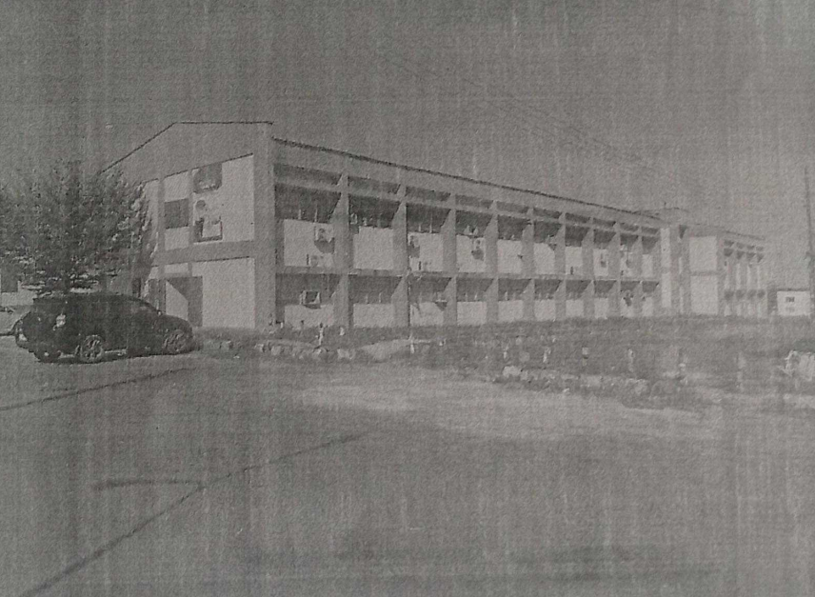

Plate 3.1: Approach View
Source: Author's field work (2024)

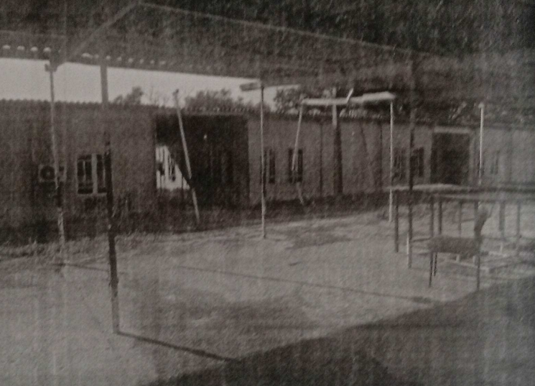

Plate 3.2: Rear View of the Studio
Source: Author's field work (2024)

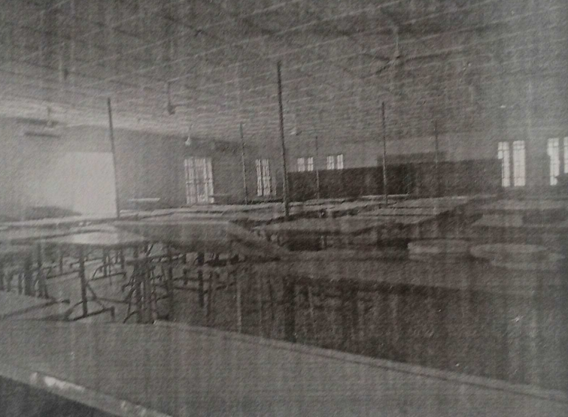

Plate 3.3: Interior View of 300L Studio
Source: Author's field work (2024)

3.2 Case Study Two (Department of Architecture, OAU, Ile-Ife)
Description
A former Cafeteria converted into architecture department, Located at the Faculty of Environmental Design and Management, Obafemi Awolowo University, Ile-Ife, Osun State. The Department have CAD Lab, MSc studio, Undergraduate Studios, Lecturer's Offices, Prof Offices, HOD's Office, Staff Common Room, Gallery, Archi Mart, a Secretariat, Resource Room, Locker, Exhibition Hall and Lounge.
Merit
- Adaptability for future needs.
- Optimal Ventilation and Planning.
- State-of-art infrastructure.
Demerit
- Lack of Sustainable Practice.
- Limited Car Park.
- Limited Accessibility.
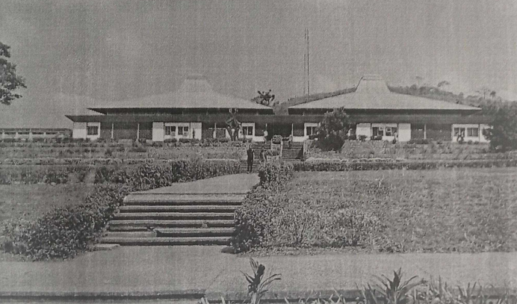

Plate 3.4: Approach View of the Department
Source: Author's field work (2024)

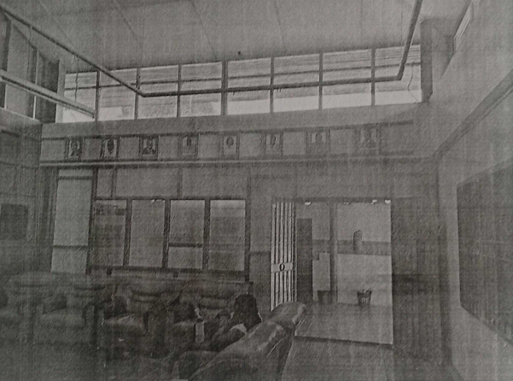

Plate 3.5: General Office-HOD-Audio Visual
Source: Author's field work (2024)

3.4 Case Studies
Deductions
The case studies highlight several recurring architectural challenges, including poor ventilation, lack of sustainable design practices, inefficient layouts, limited parking space, and inadequate building zoning. Poor ventilation affects indoor air quality and occupant comfort, which can be addressed by implementing cross-ventilation with strategic window placement, using energy-efficient HVAC systems with air purifiers, and incorporating indoor

3.3 Case Study Three (Department of Architecture, LAUTECH, Ogbomosho)
Description
Situate along, University Rd 4, Ogbomosho. The department comprises of the old and new buildings jointly used together. The Department have the HOD Office, other Offices, model room, Presentation room and Library, Studio, Lecture hall

Merit
- Collaborative Spaces
- Good Ventilation and Lighting
- Good Landscape

Demerit
- Poor Sustainable Practice.
- Poor Layout.
- Few parking lots.

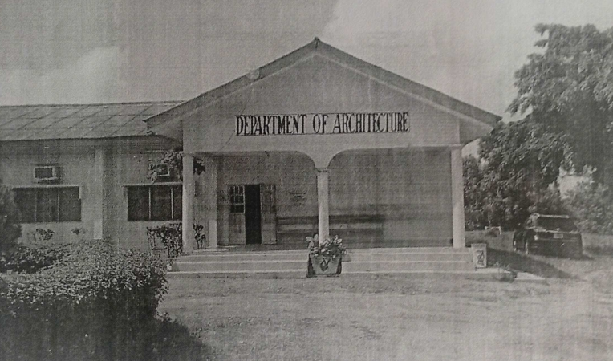

Plate 3.6: Approach View
Source: Author's field work (2024)

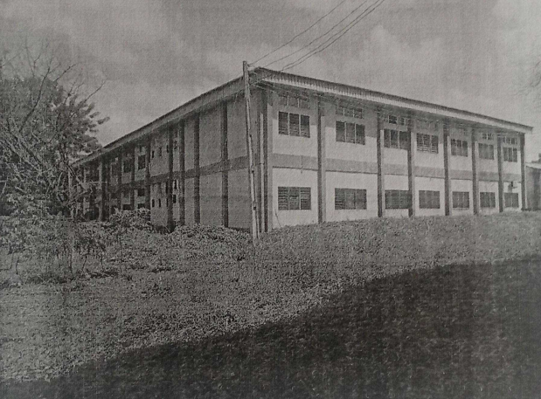

Plate 3.7: Rear view
Source: Author's field work (2024)

3.4 Case Studies Deductions
The case studies highlight several recurring architectural challenges, including poor ventilation, lack of sustainable design practices, inefficient layouts, limited parking space, and inadequate building zoning. Poor ventilation affects indoor air quality and occupant comfort, which can be addressed by implementing cross-ventilation with strategic window placement, using energy-efficient HVAC systems with air purifiers, and incorporating indoor plants and green walls. The absence of sustainable features like green roofs and solar panels increases energy consumption. Proposed improvements include installing green roofs to reduce the heat island effect and provide insulation, harnessing solar energy through solar panels, and using materials with high thermal efficiency and low environmental impact.
Inefficient building layouts lead to underutilized spaces and occupant discomfort, which can be mitigated by optimizing space for functional flow and efficiency, designing adaptable spaces for changing needs, and ensuring layouts support ergonomic comfort and accessibility. Limited parking space causes inconvenience and traffic congestion. Efficient parking management systems can maximize space use, multi-use spaces can serve multiple purposes, and facilities encouraging biking, public transit, and carpooling can alleviate parking issues.
Inadequate zoning results in functional conflicts and inefficiency. Improvements include clearly zoning areas based on their functions, designing logical circulation paths for easy movement, and using buffer zones like courtyards and gardens to separate incompatible functions. By addressing these issues with thoughtful design and sustainable practices, buildings can become more efficient, comfortable, and environmentally friendly, enhancing user experience and contributing to long-term sustainability.

CHAPTER FOUR
4.1 Fact about Omu-Aran, Kwara State
Omu-Aran, located in the southern part of Kwara State, Nigeria, is the headquarters of the Irepodun Local Government Area. It holds historical significance as the ancestral home of the Igbomina people, a subgroup of the Yoruba ethnic group. The town is known for its rich cultural heritage and traditional practices, which are celebrated through various cultural festivals that attract visitors from different parts of Nigeria.
The town's economy is primarily based on agriculture, with yam, cassava, maize, and vegetables being the main crops produced. Additionally, Omu-Aran has small-scale industries and trading activities that contribute to the local economy. The presence of Landmark University, a private Christian university renowned for its focus on agriculture, science, and technology, has further spurred educational and economic development in the area.
Omu-Aran has an estimated population of around 148,610 as of the 2021 census. The town continues to grow and develop, maintaining its cultural heritage while embracing modern advancements, thereby playing a significant role in the socio-economic landscape of Kwara State.
4.2 Site Location/Description
Landmark University is located in Omu-Aran, a town in the southern part of Kwara State, Nigeria. The university campus spans a vast area, providing ample space for various academic and administrative buildings, recreational facilities, and green spaces. The serene and well-planned environment of the campus supports the university's goal of delivering quality education in a tranquil setting.
The Proposed Faculty of Architecture for Landmark University will be strategically situated within the university's expansive campus in Omu-Aran, Kwara State. This location is integral to the university's mission of fostering an environment conducive to learning, innovation, and sustainable development.

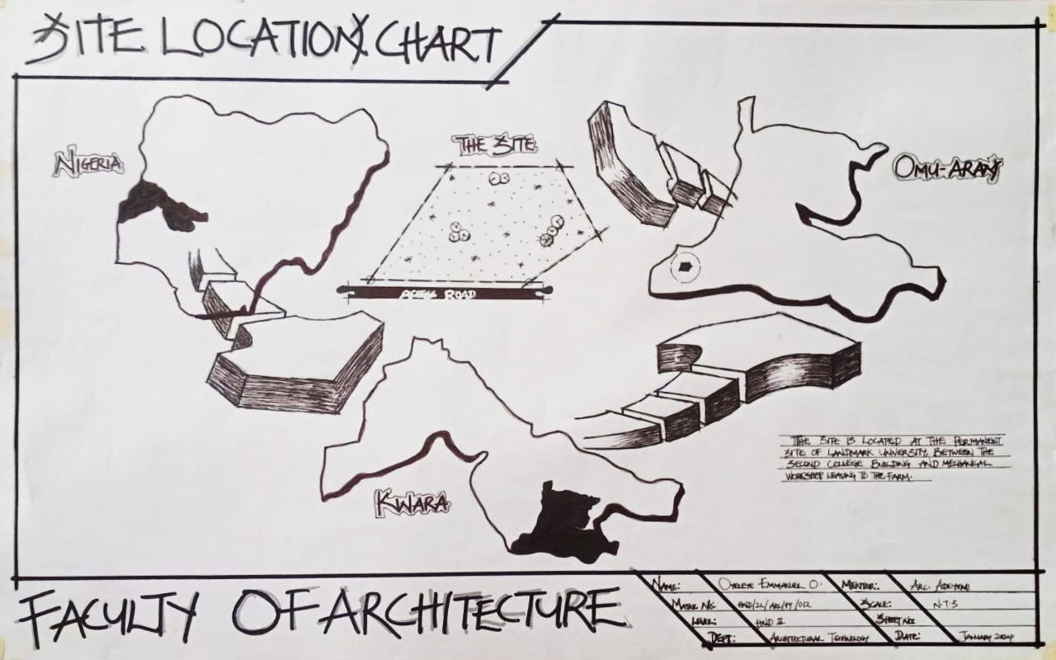

Fig. 4.2: Location Map

4.3 Site Location
Criteria Site location is the consideration of certain factors which influence the development of the site and spatial activities conversely, a site selection criteria is based on screening factors affecting site selection include comfort, thermal control, ventilation and solar control etc. and the activities taking place on the site due to the nature of the project the site selection should meet the requirement for the proposed design.
Furthermore, the land available for development should adequately reasonable to accommodate such functions. However, the proposed site for the construction of the proposed design Faculty of Architecture has enough land and existing facilities that will facilitate the proficient functioning.
4.4 Site Selection Criteria
- Proximity: the site is located at the extreme end of the town. Which is still relatively okay.
- Accessibility: the site is not easily accessible by anybody, since it is located inside Landmark University and they are the patent owner.
- Neighbourhood: the site is bounded by College building and workshop at the eastern side, the main road at the southern side, the proposed access road.
- Topography: the site has a gentle slope towards the eastern side of the site which can be used for drainage controlling.
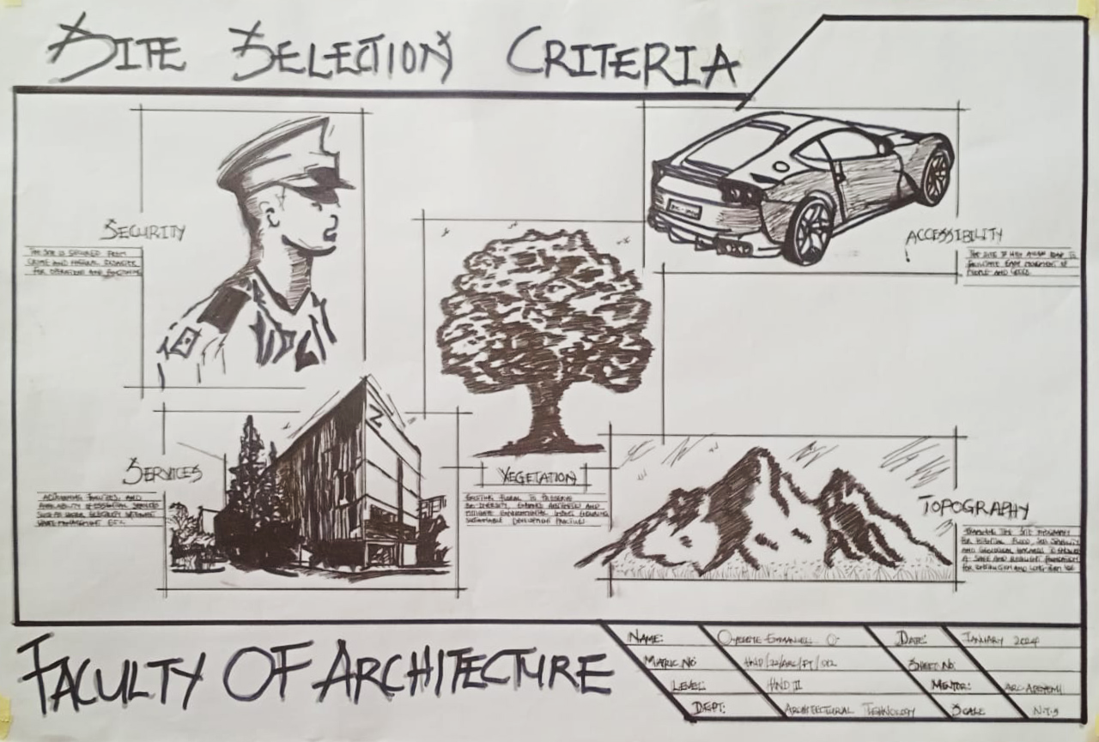

Fig. 4.4: Site Selection Criteria

4.5 Geographical/ Climatic data
Omu Aran has a tropical wet and dry or savanna climate and is located at an elevation of 536.14 meters (1758.99 feet) above sea level (Classification: Aw). The district's average
annual temperature is 0.26% higher than Nigeria's averages at 29.72°C (85.5°F). Omu Aran generally has 149.31 wet days per year (40.91% of the time) and average annual precipitation of roughly 102.08 millimeters (4.02 inches).
From January 23 to April 11, the hot season, with an average daily high temperature exceeding 89°F, lasts for 2.6 months. In Omu-Aran, March is the hottest month of the year, with an average high of 91°F and low of 71°F.
From June 21 to October 14, the chilly season, which has an average daily high temperature below 82°F, lasts for 3.8 months. With an average low of 68°F and high of 80°F, August is the coldest month of the year in Omu-Aran.
Omu-Aran has a tropical savanna climate. It is warm every month with both a wet and dry season. The average annual temperature for Omu-Aran is 60° degrees and there is about 336 inch of rain in a year. It is dry for 120 days a year with an average humidity of 71% and an UV-index of 6.
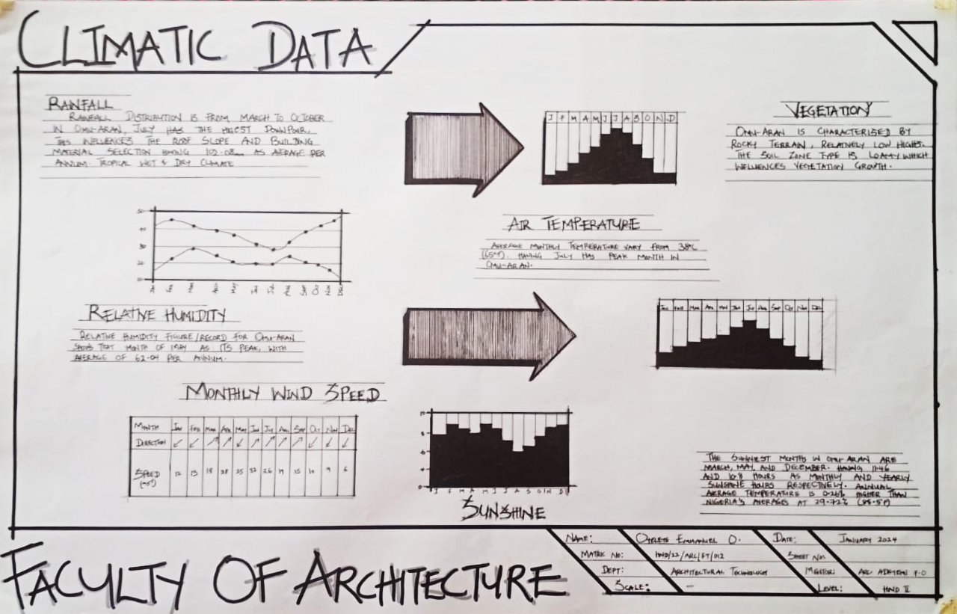

Fig. 4.5: Climatic Data

4.6 Function of the Proposal
The objective of this proposal is to address the current absence of an architecture program at Landmark University. The establishment of such a program is anticipated to significantly enhance the academic offerings of the university and foster substantial development within the broader community. By introducing an architecture program, Landmark University will not only broaden its educational horizons but also contribute to the socio-economic and cultural advancement of Omu-Aran and its environs.

4.7 Feasibility Study of the Site
- Site Location and Accessibility
Landmark University Location: Omu-Aran, Kwara State, Nigeria.
Proximity to Infrastructure: The university is located near major roads such as the Omu-Aran - Ilorin highway. This provides good connectivity to nearby cities and states.
Traffic Analysis: The area has moderate traffic, primarily consisting of university traffic, local residents, and visitors.
Zoning Regulations: Being an educational institution, the site is already zoned appropriately. Future expansions should comply with local zoning laws.
- Environmental Impact
Soil and Geotechnical Analysis: The region generally has suitable soil for construction.
Environmental Restrictions: Kwara State has environmental regulations that must be followed, such as those regarding waste management and water usage.
Ecological Impact: Minimal impact on local flora and fauna expected due to existing development. This Project would incorporate green spaces and sustainable practices.
- Market Analysis
Demographics: The student population primarily consists of young adults from various regions, including international students. The local population is diverse, with a mix of students, staff, and residents.
Demand Assessment: High demand for quality education, accommodation, and associated services. Potential for growth in student numbers and academic programs.
Competitive Analysis: Competitors include other universities in Nigeria, both public and private. Landmark University's unique selling points include its focus on agrarian studies and innovative educational practices.

- Legal and Regulatory Compliance
Permitting Requirements: Construction permits, environmental impact assessments, and approvals from the National Universities Commission (NUC) for new programs or expansions.
Land Use Restrictions: Adherence to land use plans and any specific restrictions set by local authorities.
4.8 Site Analysis and Inventory
This is done on the purpose for which the site is to serve certain steps are considers to obtain vital information of the site, this information is then analysed after site survey in details for design purposed it also involves carrying out a preliminary survey of the site. a. Soil condition: the types of soil are loamy and hence aids goods vegetation of trees, shrubs and grasses. b. Geology: this soil has a poor and bearing capacity and hence raft foundation will be used for the structure to be erected on the site. c. Vegetable cover: the site is covered with shrubs, palm tree and ground cover most of it would be retained for landscaping.
The sunrise and sunset will be considered for effective ventilation and solar radiation control for total comfort of occupant.
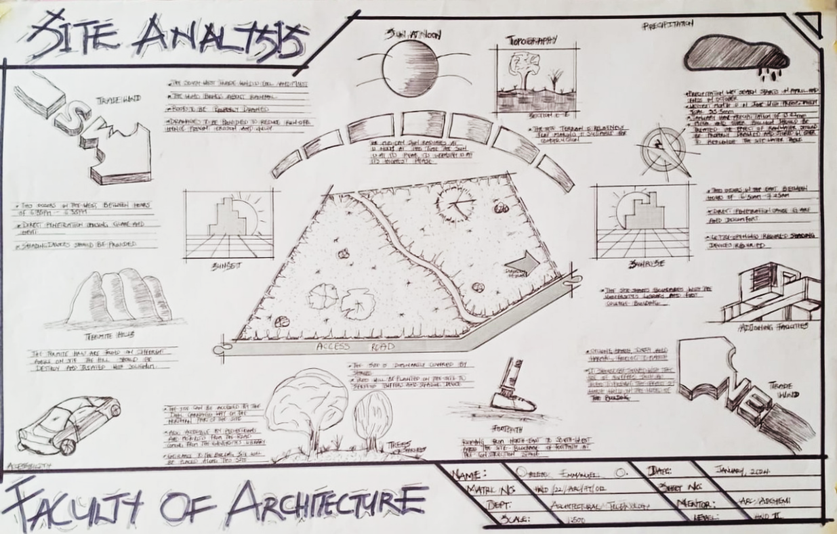
Noise generated from the vehicular movement is controlled through proper planning, good landscape and the location of various structures to aid comfort.

Fig. 4.8: Site Analysis
4.9 Proximity to the User
The site is chosen because it belongs to Landmark University. The site is relatively larger enough for the proposed project and the road on the site major road passes through the university, it is not far to the users.

CHAPTER FIVE
5.1 Design Criteria
In this type of project, some things need to be considered in order to bring comfort to users.
- Space Planning
Studios: Ample studio spaces for different year groups, equipped with drafting tables, computer workstations, and storage for materials and models.
Classrooms: Flexible classrooms that can accommodate various teaching methods, including lectures, seminars, and workshops.
Workshops: Facilities for hands-on work with materials, including woodworking, metalworking, and digital fabrication (3D printing, laser cutting).
Labs: Computer labs with the latest architectural software and high-performance hardware.
Exhibition Spaces: Areas for students to display their work, including both temporary and permanent exhibition spaces.
- Technology Integration
Digital Infrastructure: High-speed internet, robust network infrastructure, and advanced audiovisual systems in classrooms and lecture halls.
Software: Access to industry-standard design and visualization software such as AutoCAD, Revit, Rhino, SketchUp, and Adobe Creative Suite.
Virtual Reality (VR) and Augmented Reality (AR): Facilities for immersive visualization and virtual walk-throughs of designs.
- Sustainability
Green Building Standards: Designing to meet LEED or other sustainability certifications, incorporating energy-efficient systems, natural lighting, and sustainable materials.
Environmental Controls: Advanced HVAC systems to ensure comfort and air quality in all spaces.
- Flexibility and Adaptability
Modular Spaces: Design studios and classrooms that can be reconfigured as needed to accommodate different group sizes and teaching styles.
Future-Proofing: Infrastructure that can support future technological advancements and changes in architectural education.
- Collaboration and Community Common Areas: Informal gathering spaces for students and faculty to interact, collaborate, and exchange ideas. Meeting Rooms: Small and large meeting rooms for group projects, faculty meetings, and guest lectures. Cafeteria and Lounge: Social spaces for relaxation and informal meetings.
- Accessibility and Inclusivity Universal Design: Ensuring all areas are accessible to individuals with disabilities, including ramps, elevators, and appropriate restroom facilities. Inclusive Spaces: Creating spaces that are welcoming and supportive for a diverse student body, including prayer rooms, gender-neutral restrooms, and lactation rooms.
- Aesthetics and Inspiration Architectural Quality: Designing the building itself as a teaching tool, showcasing innovative design, materials, and construction techniques. Inspiring Environment: Creating a visually stimulating environment that fosters creativity and reflects the principles of good architecture.
- Location and Connectivity Campus Integration: Ensuring the faculty building is well-connected to other campus facilities, such as libraries, administrative offices, and recreational areas. Public Transport: Easy access to public transportation and parking facilities.
- Safety and Security Safety Standards: Compliance with all relevant safety standards and building codes. Security Systems: Robust security measures, including surveillance cameras, access control systems, and emergency response plans.

Material Selection
The materials selected for different parts of the roof will be measured against criteria based on required design life, technical aspects and aesthetics.

a. Roof Coverings: The requirements for a satisfactory roof covering include the need
for the material to be lightweight, tough, water-tight, incombustible, aesthetically
acceptable, cost-effective and durable. Opaque coverings such as steel or aluminium
sheets are commonly used and are cheap and easy to fix. In some instances, where the
roof structure is also the covering, lightweight concrete is used but it will become
weathered and stained if not treated or finished. Translucent coverings are often rigid
plastics, such as PVC or acrylic, which are waterproof, strong and can withstand large
deformations without damage. Plastic fabrics can also be used as a non-rigid,
transparent roof coverings. The main problem faced with the roof covering is the
collection of rain or snow in ponds on the roof which can overload the covering
material and lead to failure.
b. Concrete: Concrete is a very versatile building material and is commonly-used for
stadiums as it is cheap, fire-proof and can be cast in any shape. This makes it the only
material capable of creating the seating profiles for a stadium, but is rarely used for
the roof's as it is heavy and unattractive once weathered.
c. Steel: Steel offers a slender and graceful solution for roofs as it is lighter and more
aesthetically pleasing than concrete, so is the obvious choice for roof structures.
Design Life/Maintenance
The design life of different elements of the roof will vary from around 50 years for the
load bearing structure to perhaps only a year for some of the finishes, depending on the type
and quality. The elements, such as the roof covering and cladding, must be designed for easy
replacement and an in depth maintenance strategy will need to be considered during the
design stage.

5.2 Brief Analysis (Client/User requirement)
• Entrance
• Exhibition Area
• Stair hall
• Shop
• General Store
• Lecture Hall
• Eating Area
• Servery
• Recreational Area
• Staff Sit Out
• Staff Lounge
• Professor's Office
• Doctor's Office
• Lecturer's Office
• HOD's Office
• Printing Room
• Research Room
• Seminar Room
• Archi Shop
• Modelling Room
• Workshop
• CAD Lab
• Studio
• Post Graduate Unit
•Lecture Room
•Game Arcade
•Secretariat
•Locker
•Toilet

5. 3 Analysis of Scope
The Design Scope
The outlines of the scope accommodate the following structures and facilities.
•Parking Lots
•Lecture Theatre
•Recreational Area
•Gate House
•Generator House
•Eatery
S/N | UNIT | LENGTH | BREADTH | AREA(m²) | NO REQ
1 | Research Room | 5.60 | 4.50 | 25.20 | 5
2 | Staff Lounge | 13.60 | 4.60 | 62.56 | 5
3 | Doctor's Office | 3.00 | 2.00 | 6.00 | 20
4 | Lecturer's Office | 4.30 | 2.0 | 8.60 | 15
5 | Exam Office | 3.50 | 2.10 | 7.35 | 1
6 | Dean's Office | 3.60 | 3.50 | 12.60 | 1
7 | Sub-Dean's Office | 3.60 | 2.30 | 8.28 | 1
8 | HOD's Office | 4.5 | 3.1 | 13.95 | 5
9 | Printing Room | 6.5 | 4.2 | 27.30 | 5
10 | Photography Room | 6.2 | 4.2 | 26.04 | 5
11 | Modelling Room | 7.10 | 6.10 | 43.31 | 5
12 | CAD Lab | 13.00 | 4.30 | 55.90 | 5
13 | Workshop | 13.00 | 4.30 | 55.90 | 5
14 | Lecture Room | 10.40 | 7.10 | 73.84 | 10
15 | Arshi Shop | 6.10 | 4.40 | 76.84 | 5
16 | Studio 1 & 2 | 6.60 | 5.50 | 36.30 | 5
17 | Studio 3 & 4 | 7.50 | 5.50 | 41.25 | 5
18 | Post Graduate Unit | 10.40 | 3.70 | 38.48 | 10
19 | Seminar Room | 6.60 | 4.30 | 28.38 | 5
20 | Professor's Office | 3.10 | 3.10 | 9.61 | 5
21 | Exhibition Area | 12.2 | 7.5 | 91.5 | 1
22 | Staff Sit Out | 8.20 | 5.90 | 48.38 | 5
23 | General Store | 6.10 | 2.50 | 15.25 | 1
24 | Eating Area | 11.20 | 5.20 | 58.24 | 1
25 | Stair Hall | 4.90 | 4.30 | 21.07 | 1

Table 5.3: Spatial Allocation

5.4 Department Under the Faculty and their Courses
1. Landscape Architecture
Landscape Architecture focuses on the planning, design, and management of outdoor spaces such as parks, gardens, campuses, waterfronts, and urban plazas. It blends art and science to create functional, sustainable, and aesthetically pleasing environments while addressing ecological concerns and human well-being.
2. Environmental Design
Environmental Design integrates architecture, urban planning, and sustainability principles to create spaces that are energy-efficient, climate-responsive, and environmentally responsible. This course emphasizes the relationship between the built environment and natural systems, aiming to reduce environmental impact and enhance quality of life.
3.Interior Design
Interior Design deals with the creative and technical solutions applied within a building to achieve a functional and visually appealing interior environment. It involves space planning, furniture design, lighting, colour schemes, materials, and finishes, all tailored to enhance user experience and well-being.

4. Building Science and Technology
This course explores the technical aspects of building design and construction. It covers structural systems, construction materials, building services (like HVAC and plumbing), and performance evaluation. Students learn how buildings work, how to make them durable and efficient, and how technology can enhance the building process.
5. Industrial Design
Industrial Design focuses on designing everyday products, systems, and devices with functionality, user comfort, and aesthetics in mind. It combines creativity with engineering principles to develop innovative solutions in product design, from furniture and electronics to tools and packaging, often through prototyping and user testing.

DEPARTMENT-SPECIFIC COURSES
  - Landscape Architecture
- Site Planning & Landscape Design
- Landscape Ecology
- Urban Green Infrastructure
- Environmental Impact Assessment
- History of Landscape Architecture
- Landscape Construction & Detailing
- Planting Design
- Parks & Recreation Planning
- GIS & Remote Sensing for Landscape Architects

- Environmental Design
- Principles of Environmental Design
- Climate Responsive Design
- Sustainable Architecture
- Building Energy Systems
- Environmental Psychology
- Passive Solar Design
- Water and Waste Systems
- Environmental Laws and Policies
- Urban Environmental Management

3. Interior Design

- Interior Spatial Planning
- Furniture Design
- Color and Lighting Theory
- Building Materials & Finishes
- Ergonomics & Human Factors
- Interior Construction & Detailing
- Historic Interiors
- Retail, Hospitality & Residential Design
- Computer-Aided Interior Design

- Building Science and Technology
- Building Construction Technology
- Structural Systems in Architecture
  - Building Materials & Assemblies
- Construction Management
  - Building Services (HVAC, Electrical, Plumbing)
  - Smart Buildings & Automation
- Building Acoustics
- Fire Safety and Egress Systems
- Building Performance Analysis

- Industrial Design
- Product Design & Development
- Materials and Processes
- 3D Modeling and Prototyping
- Design for Manufacturing
- Ergonomic Product Design
- Design Thinking and Innovation
- Consumer Behavior & Market Research
- Packaging Design
- Sustainable Product Design

  - Spaces to be Provided (General & Department-Specific)
- Administrative Block
- Dean’s Office
- Faculty Officer’s Office
- Departmental Offices
- Staff/Faculty Lounge
- General Conference Room
- Records/Archives Room
- ICT/Admin Server Room
- Lecture Theatres & Classrooms
- Large lecture halls (100–200 capacity)
- Medium-size classrooms (30–50 students)
- Seminar rooms
- Studios
- Design Studios (for all departments)
- Model-making Workshop
- Computer/3D Lab
- Drafting Studio
- Interior Mock-up Studio
- Library
- Architecture & Design Resource Section
- Digital Access Lab
- Materials Archive (swatches, samples, physical references)
- Workshops & Labs
- Material Testing Lab
- CAD & BIM Lab
- Wood & Metal Workshop
- Lighting Lab (for Interior Design)
- Student Amenities
- Common Rooms
- Lockers
- Canteen/Cafeteria
- Outdoor Learning Courtyards
- Exhibition Gallery (student works)
- Exhibition & Critique Spaces
- Jury Rooms
- Gallery Spaces
- Multi-use Open Studio for exhibitions/installations
- Research & Innovation Centre
- Building Performance Lab
- Sustainable Design Research Lab
- Environmental Monitoring Lab

5.6 Design Approach/Realization
Conceptual Framework
The design of the Faculty of Architecture at Landmark University aims to create an inspiring and sustainable environment that fosters creativity, collaboration, and innovation. The conceptual framework integrates the principles of sustainable architecture, local cultural aesthetics, and cutting-edge educational facilities to provide a holistic learning experience. The design is inspired by the need to blend modern architectural practices with the cultural and environmental context of Omu-Aran, Kwara State.
Site Analysis and Selection
A comprehensive site analysis was conducted to identify the optimal location within Landmark University’s campus. Key considerations included proximity to existing academic facilities, accessibility, topography, and environmental impact. The selected site offers ample space for future expansion and is strategically located to facilitate easy access for students, faculty, and visitors.
Sustainable Design Principles
The design incorporates sustainable practices to minimize environmental impact and promote energy efficiency. Key features include:
Passive Design Strategies: Utilization of natural ventilation, daylighting, and solar shading to reduce reliance on artificial heating, cooling, and lighting.
Green Building Materials: Selection of locally sourced, eco-friendly materials to reduce carbon footprint and support the local economy.
Water Management Systems: Implementation of rainwater harvesting, greywater recycling, and efficient irrigation systems to conserve water resources.
Renewable Energy: Integration of solar panels and other renewable energy sources to achieve energy self-sufficiency.
Functional Zoning and Spatial Organization
The faculty is designed with distinct zones to cater to the diverse needs of architecture students and faculty. Key zones include:
Academic Zone: Comprising lecture halls, studios, and classrooms equipped with modern teaching aids and flexible furniture to support various learning activities.
Administrative Zone: Housing offices for faculty members, administrative staff, and support services, designed to foster a collaborative working environment.
Research and Innovation Zone: Featuring advanced laboratories, a digital fabrication lab, and research spaces to encourage experimentation and innovation in architectural practices.
Community and Interaction Spaces: Including a lounge, Games arcade, and exhibition spaces to promote interaction and collaboration among students, faculty, and industry professionals.

Technological Integration
The design integrates state-of-the-art technology to enhance learning and research. Key technological features include:
Smart Classrooms: Equipped with interactive whiteboards, digital projectors, and video conferencing facilities to support remote and hybrid learning.
Building Information Modeling (BIM) Lab: Providing students with access to advanced software and tools for designing, modeling, and simulating architectural projects.
Virtual Reality (VR) and Augmented Reality (AR) Studios: Allowing students to visualize and interact with their designs in immersive environments.
Cultural and Aesthetic Considerations
The architectural design reflects the rich cultural heritage of Omu-Aran and Nigeria. Key aesthetic elements include:
Incorporation of Traditional Motifs: Using local architectural motifs and patterns in the façade design and interior spaces to celebrate cultural identity.
Landscape Design: Featuring indigenous plants and landscaping elements that harmonize with the local environment and create a serene campus atmosphere.
Art Installations: Showcasing works by local artists and students to enrich the cultural experience and inspire creativity.
Implementation Plan
The implementation plan outlines the phased construction approach to ensure timely and cost-effective realization of the project. Key phases include:
Phase 1: Site preparation and foundational work, including infrastructure development and basic utilities installation.
Phase 2: Construction of core academic and administrative buildings, ensuring operational readiness for initial student intake.
Phase 3: Development of research and innovation facilities, followed by community and interaction spaces.
Phase 4: Final landscaping, finishing touches, and commissioning of renewable energy systems.
5.7 Construction Method and Materials
For the Proposed Faculty of Architecture, the choice of construction methods and materials plays a crucial role in ensuring functionality, durability, and sustainability. Modern construction methods such as modular building and prefabrication can significantly reduce construction time and costs while maintaining high quality. Modular construction involves prefabricating building components in a factory setting before assembling them on-site, which can streamline the construction process and minimize disruptions. Additionally, sustainable construction practices, including the use of energy-efficient systems, green roofs, and rainwater harvesting, can enhance the building’s environmental performance and operational efficiency.
The selection of materials should prioritize durability, aesthetic appeal, and sustainability. High-quality, low-maintenance materials such as reinforced concrete, steel, and advanced composites are commonly used in educational facilities for their structural integrity and longevity. Incorporating sustainable materials like recycled steel, bamboo, and low-VOC (volatile organic compound) paints can contribute to the building’s eco-friendly credentials. Moreover, the design should consider natural light optimization and effective thermal insulation to create a comfortable and energy-efficient learning environment. By integrating these construction methods and materials, the Faculty of Architecture will not only serve its educational purpose but also exemplify best practices in modern architectural design.
5.8 General Design Consideration
To achieve a functional design, the following factors are essentially needed to give the structure a considerable aesthetic value; some of these things are;
Services
These include;
Electrical Services: The electrical services will be of high quality and cables in concealed and conduit wiring system will be used. There is a power house to generate constant electricity supply in case of power failure as well all know how electricity sector is not actually stable.
Sewage Disposal: For effective drainage of both surface and soil waste, appropriate sizes of pipes are used. All pipes used are run into duct system with leaf net provided on drainpipe to prevent blockage from soil waste.
Drainage
Waste Disposal etc.
Also, incinerator will be used to burn waste on site. The element that controls the effect of solar radiation such as roof wall, sun breaker, greenies and other material are used.
Ventilation
Ventilation constitutes a primary factor in determining human comfort. They have direct effect on human body through the physiological effect on air purity and motion and indirect effect through their influence on the temperature humidity of the indoor air and surfaces. To achieve optimum ventilation condition proper orientation of building is ensured and windows are of adequate sizes and good positioning within sub division of internal spaces. Also the use of mechanical means of ventilation for example; air conditioner and heat extractor will be applied.
Lighting
Lighting inside a building must fulfill two functions; to illuminate interior and its content, and to illuminate the activities within the building appropriately so that visual mechanism can function at high level of efficiency. All windows are of adequate size and height within and outside the structure. Also the use atrium is employed to throw light into the passages in order to compliment the artificial light sources in the building.
Acoustics
Acoustics design controls intrusive noise by the choice of materials, dimension and shapes of the building. High level of noise can cause Damage to the ear and so careful selection of doors, windows seals and no mongering will play and effective role in providing acoustic for the building. Also suspended ceiling and parapet wall will be extensively used on the roof.
Fire Protection
Modern building require not only means of escape, access for fire brigade and structure protection but also first aid equipment like hydrant plant, fire extinguisher to combat any fire outbreak before the intervention of fire brigade.
In the proposed designed there will be provision for fire alarms and detectors. Also, fire extinguisher such as hose reels, sprinklers and drenches are provided at strategic position for easy access.
External Work
For external works, the following specifications are applicable:
i. The floor surface to be of interlocking materials and asphalt to allow effective drainage.
ii. The drainage to be conveyed away through suitable sealed gully fitted with strong grating. It should be drained into existing gutter.
iii. The floors to withstanding expected impact and high load bearing capacity.
iv. Surrounding walls to be rendered and painted.
v. The enclosure to be secured against unauthorized entry.
vi. Tarred and grasses surface should be separated with Kerbs.
vii. Soak away pits must be avoided with the nature of the soil generally both.
viii. Foul and soil waste must be properly drained.

5.9 Landscape Design
Landscape design is the determination of the character of different landscaping element and their arrangement on the site to enhance the building works. Landscape design may be in two types, Aesthetic design, and economic design. Both types are considered in the landscape design of the leisure Centre.
Landscape Element used in the Design
In choosing an appropriate landscape element the following are considered:
i. Easy cleaning
ii. Resistance to wear
iii. Durability
iv. Acoustic properties
The following landscaping elements are employed:
a. Asphalt: used for drive ways and parking lots. It is economical and durable both for pedestrian and vehicular traffics.
b. Interlocking paving: Used for walkways and doors paving to blend with the natural texture of the environment.
c. Trees: Used as shading device and also to reduce solar rays in both paving and structures and also reduce radiated and improve comfort. It is also used to beautify the environment.
d. Shrubs and hedges: used to set-off the various building within the centres. Also used as fence to direct movement within the site.
e. Grasses and lawn materials: used as land cover to reduce the reflective effect of the ground and also to control erosion and landslide in case of flooding. It is also used to reduce the intensity of sole radiation. It absorbs up to 45% of solar rays and disperses the rest to the environment thereby creating comfort for the occupant of the building.
f. Decorative flowers: Different species of flowers are used to enhance the aesthetic appearance of the site.
g. Concrete Kerbs: used to separate tarred surfaces from the lawn covered areas.
h. Other elements used include fountains, man-made hills and waterfall, flower ponds etc. to create visual interest and beautify the environment in a harmoniously blended aesthetical grandeur.
Generally, there is a successful blend of both hard and soft landscape elements to create a fascinating feature and alluring scenes of the proposed leisure.

5.9.1 Maintenance
Maintenance cannot be isolated from the initial planning and design of any architectural edified most especially a project of this caliber which involves leisure and entertainment. Timely maintenance of the structure and facilities to put them in proper working condition to enhance workability and habitability of both structure and facilities for maximum satisfaction of visiting leisure and intending guest must be ensured.
Maintenance work in real technology is defined as work undertaken to keep or restore every facility of a building or site to an acceptable standard. The work may be carried out with for thought, control and records i.e. planned maintenance or out on an emergency basis when the need arises.
Due to the lack of the maintenance culture in this part of the globe, adequate provisions are made for security, sanitation and maintenance department to cater for the facilities and endure high level of hygiene.
The maintenance of building and facilities will be dully attended to with regular servicing or equipment and other facilities.
The external works consists of so many factors that are of greater significance and these factors are as follows:
i. Parking Space (VIPs, Players and General)
ii. Access Road
Parking Space
This has to be technically considered by investigating the existing parking spaces in some Faculties, this has given me a detailed experience and I have been able to deduce to some facts that has assisted me in my own planning principle. Effective parking space must be sectioned in order to have a proper security survey and manage space to the maximum level.
Access Road
This has been professionally achieved by creating or designing a ring road that has been properly linked by the minor road for easy accessibility, and also easy movement and transportation has been achieved effectively.
Landscape
It has been known to us that throughout the world people use mainly two types of landscape namely: Soft and Hard Landscape
Soft Landscape Elements
a. Tree (Vegetation): Trees also have been strategically planned to be plant at turning point by the road and closer to some structures to perform the function of a shading device.
b. Grasses/Lawn: Bahamas grasses have suggested as types of soft landscape in some areas liable to be influenced negatively by erosion. It gives a good aesthetical view or look on the ground surface which makes it look more appealing to eye.
c. Flower Box: These are grown along walkways and roads for proper demarcations where necessary.
Hard Landscape Element
a. Asphalt: used for drive ways and parking lots. It is economical and durable both for pedestrian and vehicular traffics.
b. Interlocking paving: used for walkways and outdoor paving to blend with the natural texture of the environment.
c. Concrete Kerbs: Used to separate tarred surfaces from the lawn covered areas.
General Conclusion & Recommendation
The establishment of a Faculty of Architecture at Landmark University in Omu-Aran, Kwara State, is a strategic initiative aligned with the university’s mission to provide comprehensive education and address the growing demand for professional architects in Nigeria. This initiative will enhance the university’s academic portfolio, attract a diverse student body, and contribute to the development of skilled professionals capable of driving innovation in the built environment. The feasibility study and stakeholder consultations indicate strong support for the project, highlighting its potential for positive academic, social, and economic impacts.
To ensure the success of this project, it is recommended to design a comprehensive curriculum that aligns with global standards, recruit experienced faculty, and develop state-of-the-art facilities. Establishing partnerships with architectural firms and professional organizations will provide students with practical training opportunities. Additionally, seeking accreditation from relevant bodies and implementing a robust quality assurance system will ensure the program meets high academic and professional standards.
Financial planning is crucial for the project’s sustainability, including budget allocation for infrastructure, faculty salaries, and scholarships. Exploring funding opportunities from government agencies, private sector partnerships, and international donors will support the faculty’s growth. Promoting community-based projects, public lectures, and exhibitions will enhance community engagement and raise awareness about the importance of architecture. By following these recommendations, Landmark University can establish a reputable and impactful faculty of architecture that significantly contributes to the architectural profession and the broader community.

REFERENCES
Alberti, L. B. (1988). On the art of building in ten books (J. Rykwert, N. Leach, & R. Tavernor, Trans.). MIT Press. (Original work published 1452)
Frampton, K. (1992). "Modern Architecture: A Critical History." Thames & Hudson.
Kruft, H.-W. (1994). A history of architectural theory: From Vitruvius to the present. Princeton Architectural Press.
Kostof, S. (1995). "A History of Architecture: Settings and Rituals." Oxford University Press.
Nair, P., & Fielding, R. (2005). "The Language of School Design: Design Patterns for 21st Century Schools." DesignShare.
Palladio, A. (1997). The four books on architecture (R. Tavernor & R. Schofield, Trans.). MIT Press. (Original work published 1570)
Dudek, M. (2000). "Architecture of Schools: The New Learning Environments." Architectural Press.
Dober, R. P. (2000). Campus design: Planning & architecture for the twenty-first century. Wiley.
De Chiara, J., Crosbie, M. J., & Callender, J. H. (2001). Time-saver standards for building types (4th ed.). McGraw-Hill.
Yin, R.K. (2004). Complementary methods for research in education. Washington, DC: American research association press.
Mallgrave, H. F. (2005). Modern architectural theory: A historical survey, 1673–1968. Cambridge University Press.
Hensen, J. L. M., & Lamberts, R. (2011). Building performance simulation for design and operation. Routledge.
Neufert, E. (2012). Architect’s data (4th ed.). Wiley-Blackwell.
Berardi, U. (2013). "Clarifying the new interpretations of the concept of sustainable building." Sustainable Cities and Society, 8, 72-78.
Wang, S., Yan, C., & Xiao, F. (2013). "HVAC system optimization—Research and development needs." Renewable and Sustainable Energy Reviews, 16(1), 68-74.
Wargocki, P., Wyon, D. P., Sundell, J., Clusen, G., & Ranger, P. O. (2002). "The effects of outdoor air supply rate in an office on perceived air quality, SBS symptoms and productivity." Indoor Air, 10(4), 222-236.
Cheryan, S., Ziegler, S. A., Plaut, V. C., & Meltzoff, A. N. (2014). "Designing Classrooms to Maximize Student Achievement." Psychological Science. 25(6), 1037-1051.
Ching, F. D. K. (2014). "Building Construction Illustrated." John Wiley & Sons.
Ching, F. D. K. (2014). Building construction illustrated (5th ed.). Wiley.
Olgyay, V. (2015). Design with climate: Bioclimatic approach to architectural regionalism. Princeton University Press. (Original work published 1963)
Buxton, P. (Ed.). (2015). Metric handbook: Planning and design data (6th ed.). Routledge.
Watts, A. (2016). Modern construction handbook (4th ed.). Birkhäuser
Bosworth, F. (2016). "Designing the Learning Spaces." Journal of Architecture and Urban Planning.
Neufert, E., & Neufert, P. (2019). Architects' Data (5th ed.). Wiley-Blackwell.
Allen, E., & Iano, J. (2019). Fundamentals of building construction: Materials and methods (7th ed.). Wiley.

APPENDICES
