A PROJECT REPORT
ON
PROPOSED HOUSING ESTATE
FOR
NON-ACADEMIC STAFF UNION OF POLYTECHNIC(N.A.S.U.P),
KWARA STATE POLYTECHNIC CHAPTER
AT
AT-TAQWA QUARTERS,KA’RA MARKET,OKE-OSE AREA
BY
YUSUF ABDULKABIR OLAREWAJU
HND/23/ARC/FT/0037
SUBMITTED TO
THE DEPARTMENT OF ARCHITECTURE,INSTITUITE OF ENVIRONMENTAL STUDIES,KWARA STATE POLYTECHNIC,ILORIN,KWARA STATE

IN PARTIAL FUFILMENT OF THE REQUIREMENTS FOR THE AWARD OF THE HIGHER NATIONAL DIPLOMA (HND) IN ARCHITECTURAL TECHNOLOGY KWARA STATE POLYTECHNIC, ILORIN, KWARA STATE.

JULY, 2025

DEDICATION
I dedicated to Almighty Allah who made the this project research a success ,all I could say is alhamdulilaih!. I also dedicated this to my parent, Mr.and Mrs. Yusuf yekeen for their support and prayers. May almighty Allah continue to reward you abundantly.

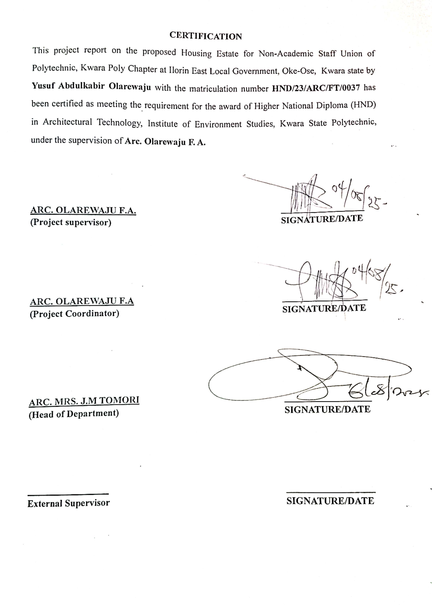
ACKNOWLEDGEMENT
All praise and adoration to almighty Allah (SW) that gave me a privileged to take part in this program.
I am grateful to my able hardworking and untiring project supervisor ARC ADEYEMI F.O, the H.O.D in person of ARC. J.M TOMORI and all other academic and Non academic staff members of the department of architecture for their encouragement and advise and constant kind supervision
My sincere appreciation goes to my dearest, lovely and caring parents Mr. YEKEEN for the parental, financial and moral support for making my dream a reality.
My utmost greetings go to my friends and my neighbors in person of ABDULAZEEZ OPEYEMI and OMIDIJI TOHEEB
Finally, I see this privilege as a milestone in my career development and I will definitely strive to utilize the gained skills and knowledge in the best way to achieve desired future objective.
I would also like to express my gratitude to my family and friends for all terms of support received.
May almighty Allah continue to reward you all
Table of contents
Title page
Declaration……………………………………………………………………ii
Certification……………………………………………………………..……iii
Acknowledgement………………………………………………………….iv
Dedication………………………………………………………………………V
Table of contents…………………………………...……………………….vi
List of tables………………………………………….………………………Vii
List of figures………………………………………………………………..viii
List of plates………………………………………………………………… Ix
Abstract………………………………………………………………………….x

Chapter one
1.0 Introduction……………………………………………………………1
1.1 Definition……………….…………………………………… …..……... 2
1.2 Historical background………………………………………….…3
1.3 Statement of design problem…………………………………….4
1.4 Aim and objectives……………………………………………………5
1.5 Justification………………………………………………………….…6
1.6 Client’s background………………………………………………...6
1.7 Scope of the project………………………………………….……...8
1.8 Limitation of study…………………………………………………..7
1.9 Research methodology…………………………………………….7

Chapter two
2.0 Literature review ...………………………………………………….8
2.1 Review of relevant literature on building types……….8
2.2 Review of literature on housing affordability……………9

Chapter three
3.1 Case study…………………………………………………………...… .12
3.2 Case study 1: Cosgrove smart estate, ilorin…………… .12
3.3 Case study 2:Godab estate,life camp,abuja …………. .….19
3.4 Case study 3: Paradise estate,lifecamp,abuja ………... ….25
3.5 Case study 4: Envo smart estate,ilorin……………… ….….33
Chapter four
4.0 Study area/project site…………………………………………….40
4.1 History of kwara state…………………………………………….40
4.2 Location of site……………………………………………………….41
4.3 Site inventory and analysis …………………………………….43
4.4 Geographic/climatic data………………………………………. ..45
4.5 Analysis of the immediate environmental conditions of
The site……………………………………………………………………………48
4.6 Project analysis/design criteria………………………………49
4.6.1 Design criteria………………………………………………………...49
4.7 Brief analysis of project………………………………………….50
4.8 Functional analysis/spacial criteria………………………..51
4.9 Appraisal of schemes………………………………………………..54
4.10 Equipment and operational and performance requirement………………………………………………………….…………54
4.12 Spatial allocations schedule of accommodation……….54
4.13 Conceptual development………………………………………….55

Chapter five
5.0 Approach to the design/design realization……………. 56
5.1 Technological and environmental criteria…..…. ……. 56
5.1.1 Construction method………………………………………………56
5.2 Services required…………………………………………………....58
5.2.1 Environmental condition to be achieved…...……………. 60
5.2.2 performance standards…………………………………………. 60
5.2.3 legal issues and planning regulations…………………… 60
5.2.4 Behavioural patterns and considerations ……………….61
5.3 Conclusion and recommendations……………………………61
5.4 References………………………………………………………………63
5.5 Appendices……………………………………………………………… 65

LIST OF TABLES
Table Title Page
1. Space Allocation for One Bedroom Semi-detached block of flat …….…… 52

2. Space allocation for Two bedroom bungalow …………………………….. 52

3. Space allocation for 3 bedroom bungalow .…. ………………….………… 53

LIST OF PLATES
Plate 1: casestudy 1 cosgroove housing estate
Plate 2: casestudy 2 godab housing estate
Plate 3: casestudy 3 paradise housing estate
LIST OF FIGURES
Figure3.1: Locational Plan of Case Study One at Cosgrove Smart Estate, Abuja…….14
Figure3.2: Site Plan of Case Study One at Cosgrove Smart Estate, Abuja …….……. 15

Figure3.3:Floor Plan of Case Study One at Cosgrove Smart Estate…………….…….16

Figure3.4:Floor Plan of Case Study One at Cosgrove Smart Estate, Abuja…….…….17

Figure 3.5: Location Plan of Case Study Two at Godab Estate,Life Camp,Abuja .…..21

Figure3.6: Layout Plan of Case Study Two at Godab Estate,Life Camp,Abuja ……..22

Figure3.7: Floor Plan of Case Study Two at Godab Estate,Life Camp,Abuja ……….23

Figure3.8: Location Plan of Case Study Three at Paradise Estate,Lifecamp,Abuja ..…27

Figure3.9: Layout Plan of Case Study Three at Paradise Estate,Lifecamp,Abuja ……28

Figure3.10:Floor Plan of Case Study Three at Paradise Estate,Lifecamp,Abuja ….…29

Figure3.11:Site Plan of Case Study Three at Paradise Estate,Lifecamp,Abuja ……...30

ABSTRACT
This project proposal presents the development of a modern housing estate designed to address the growing demand for affordable, functional, and sustainable residential accommodation. The proposed estate will feature a mix of housing units, including detached and semi-detached houses, bungalows, and apartment blocks, tailored to meet the diverse needs of low, middle, and high-income earners.
Its Located in a strategically chosen area with proximity to essential amenities such as schools, healthcare facilities, and transportation networks, the housing estate aims to foster a safe, inclusive, and livable community. The design emphasizes efficient land use, aesthetic appeal, and environmentally friendly practices such as green spaces, proper drainage systems, and renewable energy integration.
The project adopts a phased development approach to ensure cost-effectiveness and smooth implementation. It includes provisions for road networks, water supply, electricity, security, and recreational facilities. This proposal outlines the project's objectives, scope, site analysis, concept development, planning standards, sustainability measures, and financial estimates. Upon completion, the housing estate will contribute significantly to urban development and improved living standards.
This study explores the development, structure, and socioeconomic impact of housing estates as a form of planned residential community. Housing estates typically consist of groups of homes constructed as a unified project, offering standardized infrastructure and amenities.
While housing estates can improve living standards through modern infrastructure and planned layouts, they also raise concerns related to social segregation, environmental impact, and long-term sustainability.
Through case studies and spatial analysis, this paper highlights the critical balance between design efficiency, social inclusive, and environmental responsibility in contemporary housing estate development.
In-conclusion, this proposal ultimately envisions a model residential community that reflects the aspirations of N.A.S.U.P members—providing more than shelter, but dignity, and ownership.

CHAPTER ONE
1.0 INTRODUCTION
A housing estate is a residential planned community that comprises a group of houses or apartment buildings constructed within a defined area.
These estates often designed to provide residents with a safe,organized environment,complete with infrastructure amenities and services that support modern lifestyle.
The development of housing estate plays a crucial role in urban planning and population management,especially in rapid-growing cities.They help meet the increasing demand for housing by offering diverse option ranging from affordable units to luxury homes.
Housing estate can vary in size and design, and may include shared amenities such as parks,playground,shopping centre and recreational facilities
This project explores the concept of planning,design and socioeconomic importance of housing estate. Housing estate examines how these communities are developed,the benefits they offers to residents and impact on urban.
The concept of the housing estate has emerged as a significant solution to the growing challenges of urbanization, housing shortage, and unplanned settlements, especially in rapidly developing regions.
A housing estate provides a well-organized framework for the delivery of residential units in a manner that is both functional and aesthetically pleasing. It promotes orderly physical development by offering housing units within a defined geographic area, accompanied by essential services such as access roads, drainage, electricity, water, and waste management.
Modern housing estates go beyond basic shelter to offer comfort, security, and a sense of community. They are often designed with gated entry points, recreational areas, and designated zones for public, semi-public, and private uses. This structured approach ensures effective land utilization while enhancing quality of life for residents.
The development of housing estates is a key strategy in government policies aimed at addressing homelessness, slum eradication, and youth empowerment through real estate investment and job creation. At the same time, private developers view housing estates as profitable ventures that cater to the increasing demand for residential accommodation in urban and per-urban areas.
In conclusion, a housing estate represents an intentional and integrated approach to housing provision, contributing to urban development, environmental control, and socioeconomic stability.

1.1 DEFINITION
Housing estate:
Housing estate can be defined to be a planned residential area consisting of homes built with shared amenities.These estates are designed to cater for specific income groups or demographic groups;which offers a range of benefits compared to unplanned residential development.
Detailed definition:
Housing :
Can be defined to be a planned community with structures or building where people reside which includes apartment,condos and other residential accommodation.
Estate:
Is refers to as a piece of land or property often including building (residential,commercial) built with shared amenities.
A housing estate is a systematically arranged layout of residential buildings with consistent design themes, materials, and infrastructure. The layout often follows zoning regulations and urban design principles for aesthetics, accessibility, and functionality.
A housing estate is a planned residential development comprising a group of houses built together as a single project, often by a public authority, private developer, or as a public-private partnership.
Housing estates typically include a uniform architectural style and are designed with shared infrastructure such as roads, water supp
drainage systems, electricity, and sometimes social amenities like schools, playgrounds, security services, and commercial areas.
Housing estates may consist of various housing types such as detached houses, semi-detached houses, terraced houses, bungalows, and apartment blocks, tailored to accommodate different income groups and household sizes.
They can be classified as public estates (government-funded), private estates (developed by private investors), or mixed-use developments (including both residential and commercial components).
From a planning perspective, a housing estate aims to create a structured, livable, and organized environment that promotes healthy living, safety, accessibility, and social cohesion.
The layout usually adheres to urban design standards, including zoning regulations, land use efficiency, and environmental sustainability.

1.2 HISTORICAL BACKGROUND
1.2.1 EARLY CONCEPTS (PRE-INDUSTRIAL ERA)
In ancient civilizations (e.g., Rome, Egypt), housing clusters existed but weren’t called “housing estates.”Early forms of grouped housing included insulae (apartment-style buildings) in ancient Rome for urban dwellers.
1.2.2 INDUSTRIAL REVOLUTION (18TH–19TH CENTURY)
Massive urban migration led to overcrowded, unsanitary living conditions.Philanthropists and industrialists began building planned worker housing near factories.Examples: Saltaire and Port Sunlight in England.
1.2.3 EARLY 20TH CENTURY: GARDEN CITY MOVEMENT
It Initiated by Ebenezer Howard in the UK (1898), advocating self contained communities with green belts.it Led to developments like Letchworth Garden City (1903) and Welwyn Garden City (1920).This movement greatly influenced suburban estate planning.
1.2.4 POST-WAR PUBLIC HOUSING (MID-20TH CENTURY)
After WWII, many governments launched mass housing projects to replace destroyed or substandard homes.These were usually:High-density apartment blocks,Uniform in design,Managed by public authorities (e.g., UK’s council estates, France’s HLMs)

1.2.5 LATE 20TH CENTURY: SUBURBAN ESTATES AND PRIVATIZATION
Focus shifted to home ownership, leading to the rise of suburban housing estates with detached/semi-detached homes.Public housing began to decline or be privatized (e.g., Right to Buy in the UK).Estates were now often developed by private firms, emphasizing affordability and car accessibility.
1.2.6 21ST CENTURY TRENDS
Modern housing estates emphasize:Sustainability (green spaces, energy-efficient buildings),Mixed-use planning (residential + commercial),Security and amenities (gated communities, parks, schools),Redevelopment of older estates has become common to address urban decay.

1.3 STATEMENT OF PROBLEM
Generally speaking, housing estate is the first and foremost needs in every human life and essential for land development and urbanization.
Due to high cost of transportation and high cost of standard of living in the metropolis of Ilorin east, oke-ose; there is need to design a standard affordable housing without hindering the technological advancement and social amenities provision in the design of the proposed housing estate.
1.4 AIM AND OBJECTIVES
1.4.1 AIM
The main aim of this project/design is to functional/safe and smart design of housing estate
1.4.2 OBJECTIVE
To achieve the aim, the following objectives are set out;
- To inculcate smart design principle and responsive device to the design
- To design home that modify harsh climatic element and converting them to useful energy.
- Effective site planning that would enhance ease in traffic flows and other activities within the state.
- Provision of necessary amenities, services and facilities that will ensure a safe and secure living within the state.
1.5 JUSTIFICATION
Due to high cost of transportation for the staff of the association of non academic staff union of polytechnic (N.A.S.U.P.) Kwara state,this calls for the need to design a standard housing estate to bring comfortability and economic benefit for the occupants.

1.6 CLIENT BACKGROUND
My client is the staff of the association of non academic staff union of polytechnic (N.A.S.U.P.) kwara state polytechnic chapter they discovered the difficulty of getting decent accommodation and high cost of transportation for the staffs to afford and stay with this project, the union decided to provide accommodation for staff who are in high, Low and middle income earner to have their own dream houses in oke ose area Ilorin East Local government Area, kwara state which is near to their workplace.

1.7 RESEARCH METHODOLOGY
1. INTERNET BROWSING.
2. CASE STUDIES.
3. LITERATURE REVIEW.
4. ORAL INTERVIEWS.
INTERNET BROWSING: also known as web browsing or surfing the web is the process of using a web browser to navigate and view websites on the internet. It involves using a software application to view web pages,follow links and access various online resources and it is used to search for and retrieve information from various websites,making it a primary tool for online research and knowledge gathering.
CASE STUDIES: Case study is a research methodology typically seen in social and life science . Case study is an intensive, systematic investigation of a single individual,group,community or some other unit in which the researcher examines in-depth data relating to housing and housing estate

1.8 SCOPE OF THE PROJECT
The scope of this project will encompass the use of design techniques or strategies to design or plan mass housing. The scope of the project include:
- RESIDENTIAL: One Bedroom Semi-Detach bungalow, two Bedroom bungalow and three Bedroom bungalow
- SERVICES: Mini-mart, Event center, Clinic/health care center, Fire station and Police post/security post and departmental store.
- RECREATION: Children play ground, Garden/sit out and Sport area.
- RELIGIOUS: Mosque and Church.
- INSTITUTIONAL: Nursery and primary school.
- MAINTENANCE: Waste disposal and Central sewage system.
- ACCESSIBILITY: vehicular and pedestrian access
1.9 LIMITATION OF STUDY
Limitation to the research is very many but some of them were overcome in the course of study. The scope of the study is limited to the following cadre of income earners which are; the low income earners, the medium income earners and the high income earners.
The following to an extent limited the study:
- Refusal of access into the buildings for proper investigations and accurate findings.
- Dynamic changes:renovation is being done during the course of study,leading to inaccurate info
1.10 DEDUCTIONS
In all the case studies carried out,all housing estate visited for case study didn’t duly incorporate pedestrian accessibility and also central sewage system.
CHAPTER TWO
    - LITERATURE REVIEW
  - REVIEW OF RELEVANT LITERATURE ON BUILDING TYPES
Housing is one of the most critical components of urban development and human well-being. According to the United Nations Human Settlements Programme (UN-Habitat, 2020), access to adequate housing is a fundamental human right and an essential factor in ensuring the sustainability of urban environments.
The development of housing estates has emerged as a strategic approach to meet growing urban population demands, particularly in developing countries where housing deficits are prevalent.
Scholars such as Agbola (1998) and Oyesiku (2002) have argued that well-planned housing estates contribute significantly to urban planning goals by promoting spatial organization, reducing slum development, and enhancing socio-economic integration.
Housing estates are often characterized by uniformity in building design, infrastructure provision, and the integration of essential services like roads, water supply, drainage, power, security, and recreational spaces. These features contribute to the livability and aesthetic quality of urban environments.
In Nigeria, several studies (e.g., Ibem & Aduwo, 2013) have evaluated housing estate projects initiated by government and private developers, pointing out the challenges of affordability, infrastructure gaps, land tenure issues, and poor maintenance.
Despite these challenges, housing estates have remained one of the most viable solutions to tackle urban housing shortages. The Federal Government’s National Housing Policy (2012) emphasizes the promotion of public-private partnerships to facilitate mass housing delivery and ensure affordable and decent shelter for all citizens.
Moreover, research by Akinmoladun and Oluwoye (2007) highlights the importance of sustainability in estate development. Green design practices, proper waste management, and energy-efficient systems are increasingly integrated into modern housing estates to promote environmental responsibility.
Housing projects now consider climate-responsive architecture and urban resilience, aligning with the global agenda for sustainable cities (SDG 11).
From a planning and design perspective, housing estate proposals must follow urban zoning laws, space standards, and building regulations. As noted by Olujimi (2009), the success of a housing estate depends on its ability to respond to the needs of its target population while integrating flexibility, accessibility, and community infrastructure.
Literature affirms that housing estates serve as a strategic solution to urban housing crises. For project proposals to be effective, they must be rooted in sustainability principles, guided by planning standards, and informed by both demographic needs and environmental considerations.
Housing is universally recognized as one of the most basic human needs and a key indicator of an individual’s standard of living.
According to the United Nations Human Settlements Programme (UN-Habitat, 2020), adequate housing is essential for human dignity, safety, and socio-economic development. In this regard, housing estate developments have emerged as one of the most structured and efficient ways to address the increasing demand for urban shelter, particularly in rapidly growing cities.
The development of housing estates is supported by several theoretical frameworks. One of the most relevant is the Modern Urban Planning Theory, which emphasizes orderly, planned environments with access to infrastructure, social amenities, and efficient land use. In addition, the Basic Needs Theory (Streeten et al., 1981) suggests that shelter is a fundamental component of human development, alongside food, education, and healthcare. Housing estates, therefore, are not just about physical structures but are key to achieving social stability and economic productivity.
Global and Regional Perspectives
Globally, housing estate development has been utilized in both developed and developing countries to meet growing urbanization demanpds. Countries like Singapore and South Korea have demonstrated how government-led housing estate programmes can drastically reduce slums and improve quality of life (World Bank, 2016). In sub-Saharan Africa, however, the growth of informal settlements continues to challenge sustainable urban development. The African Development Bank (AfDB, 2019) reports that over 60% of urban dwellers in African cities live in substandard or unplanned settlements, largely due to housing shortages, poor policy implementation, and rapid population growth.
The Nigerian Context
In Nigeria, the housing deficit is estimated at over 20 million units (Federal Mortgage Bank of Nigeria, 2022). This has created an urgent need for innovative and scalable housing solutions. Housing estate projects have gained prominence as a response to this crisis, offering structured and affordable housing for various income groups. Government and private sector initiatives, such as the National Housing Programme (NHP) and Family Homes Fund, have played roles in this regard.
The variety of building types varies in a mass housing depending on the household value and the neighborhood value of the community of the site. The neighborhood value tells us of the environment in which the design is to be situated which is ‘Ilorin east local Government, kwara state’ the people who lives here are majorly the Low income earners which gives permission for the design of One bedroom semi-detached block of flat respectively. The household value tells of the number of people resident in a family or in a house at large. The middle income earners attract also the Two bedroom semi-detached block of flat while the high income earners attracts the three bedroom semi-detached block of flat due to increase in their own income.
The problems of housing in Nigeria are enormous and complex, exhibiting marked regional differences. Furthermore, the challenges faced by the rapid rate of uncontrolled and unplanned urban growth are immersed. Millions of people live in sub-standard and sub-human environment characterized by slum, squalor and grossly inadequate social amenities.The problem of housing in our urban center is not only restricted to quality of housing stock, but also to the quality of affordable housing units, infrastructure and the environment. The result is manifested in growing overcrowding in homes, neighborhood, communities and increase pressure on infrastructural facilities such as road, drainage, water power supply e.t.c and rapidly deteriorating environment. The scenario is slightly different in the rural areas where the problem is primarily, not just that of inadequate quality of housing units but also that of inadequate and poor infrastructural facilities such as roads, drainage water, power supply and basic social amenities (schools, health care facilities e.t.c).
Another important characteristics of both the urban and rural schemes is the to social amenities, and foster planned urban growth. Additionally, estates contribute to economic development by stimulating the construction industry and generating employment.
Challenges in Housing Estate Development
Despite these benefits, housing estate development in Nigeria faces challenges such as land acquisition disputes, high construction costs, inadequate infrastructure, poor maintenance culture, and bureaucratic delays in title documentation. Egbu et al. (2008) argue that lack of access to affordable housing finance and weak urban planning regulations hinder the effectiveness of housing estate projects. Moreover, many estates lack inclusivity, often catering to middle- or high-income earners while neglecting low-income populations.
Gaps in the Literature
Although much research has focused on housing deficits and affordability, less attention has been paid to the design quality, environmental sustainability, and long-term livability of housing estates, particularly in peri-urban and semi-rural locations.
Furthermore, there is a need for more studies on community participation in housing estate planning and how estates can be integrated with broader urban transport and economic networks.The literature confirms that housing estates are a practical and scalable solution to the housing crisis in Nigeria and other developing countries.
However, their success depends on strategic planning, community inclusion, sustainable design, and policy support. This project proposal seeks to build upon these insights by proposing a well-designed, affordable, and environmentally friendly housing estate that meets the growing demand for decent shelter while contributing to organized urban development.
Housing remains a fundamental human necessity and an essential component of sustainable urban development. In recent decades, rapid urbanization, population growth, and rural-urban migration have intensified the demand for residential accommodation in many developing nations, including Nigeria.
To address this challenge, the concept of housing estates has become increasingly relevant. Housing estates, as planned residential developments, are designed to provide structured, functional, and affordable shelter while contributing to improved living standards and urban orderliness.
The United Nations (UN-Habitat, 2021) asserts that access to decent, adequate, and affordable housing is a basic right. However, the persistent housing deficit, particularly in urban centers, has made this right elusive for many. In Nigeria, the estimated housing deficit exceeds 20 million units (Federal Ministry of Works and Housing, 2023), highlighting the urgent need for sustainable housing solutions. Housing estates—whether public, private, or through public-private partnerships—are viewed as effective instruments to tackle this shortfall.
Aluko (2011) points out that housing estates are advantageous because they provide integrated services and infrastructure such as road networks, water supply, electricity, drainage, and waste disposal, which are often lacking in informal settlements. Estates also offer a better framework for urban planning and management, as they can be regulated more easily in terms of layout, building codes, and environmental standards.
In urban planning literature, the compact city model supports the idea of developing organized, higher-density housing estates to reduce urban sprawl and preserve open land.
Housing estates encourage efficient land use and enable the clustering of essential services such as schools, markets, and healthcare centers within accessible proximity.
Agboola (2005) highlights that properly planned housing estates can also improve social integration and safety, as they often provide communal spaces and security systems.Despite the promise housing estates hold, numerous challenges have been documented.
These include land tenure issues, poor infrastructure, weak institutional frameworks, and lack of affordability for low-income earners. Studies by Onibokun (1990) and Olotuah (2010) show that while many housing estates exist, they often cater to middle and high-income groups, leaving the majority of urban dwellers—who are low-income earners—underserved.
Additionally, maintenance culture and enforcement of development control in estates are often weak, leading to rapid deterioration and informal modifications by residents.
Recent innovations in housing delivery advocate for sustainable and affordable designs, such as the use of local building materials, green architecture, and modular housing systems.
Inconclusion, These concepts aim to reduce costs while enhancing energy efficiency and livability, particularly for urban poor populations. Moreover, modern housing estate models increasingly emphasize inclusive planning, where community participation is key in ensuring relevance and acceptance.

CHAPTER THREE
3.1 CASE STUDY
A case study is a process or record of research in which detailed consideration is given to the development of a particular person, group or situation over a period of time
3.2 LIST OF CASESTUDIES
- Cosgrove Smart Estate, Abuja (Wuye)
- Godab housing estate,Life camp,Abuja.
- Paradise housing estate,Life camp,Abuja.
3.2.1: CASESTUDY 1: Cosgrove Smart Estate, Abuja (Wuye)
Cosgrove Smart Estate in Wuye, Abuja represents a pioneering "future-ready" residential development by Cosgrove Investment Limited. It is acclaimed as the first fully automated, high-tech housing estate in the Federal Capital Territory
- LOCATION & LAYOUT
Situated in Wuye, Phase 1 of the estate spans approximately 4.32 hectares and includes 160 premium units—a mix of 5-bedroom detached villas (Oak), 4-bedroom terraces (Acacia), 3-bedroom apartments (Maple), and luxury 4-bedroom penthouses. It is Positioned in a serene yet accessible neighborhood, it benefits from proximity to Wuse, Utako, Wuse II diplomatic corridors, and the airport .Cosgrove combines eco-friendly design and modern infrastructure, such as smart street lighting, well-managed water systems, recreational spaces like pools and playgrounds, and Full automation extends to energy management, entertainment systems, and comprehensive estate solutions through Cosgrove Technology, its automation subsidiary .

MERITS
- As it is said to be asmart estate,smart devices are provided and adequately functioning.
- Modern contemporary architecture are aesthetically appealing.
- Amenities are provides aids and improves the occupant’s standard of living

DEMERITS

- Repetitive or uniform design causing lack of visual details
- Accessibility for the physically challenged were no inculcated
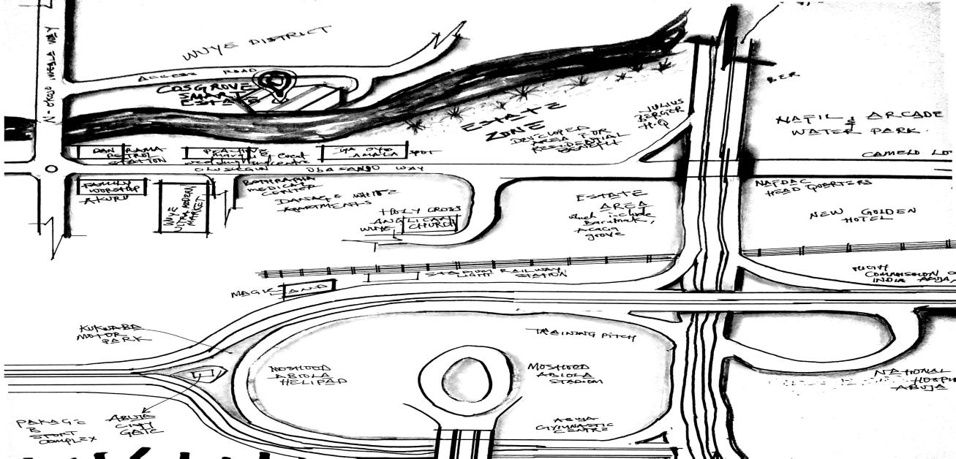
Plate1.1: Site Location of Case Study One at Cosgrove Smart Estate, Abuja (Wuye)

Plate1.2: Site plan of Case Study One at Cosgrove Smart Estate, Abuja (Wuye)
State

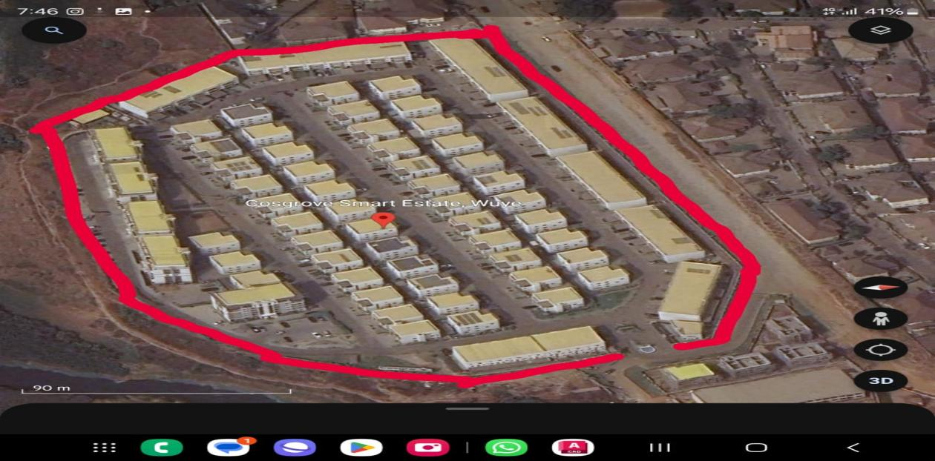
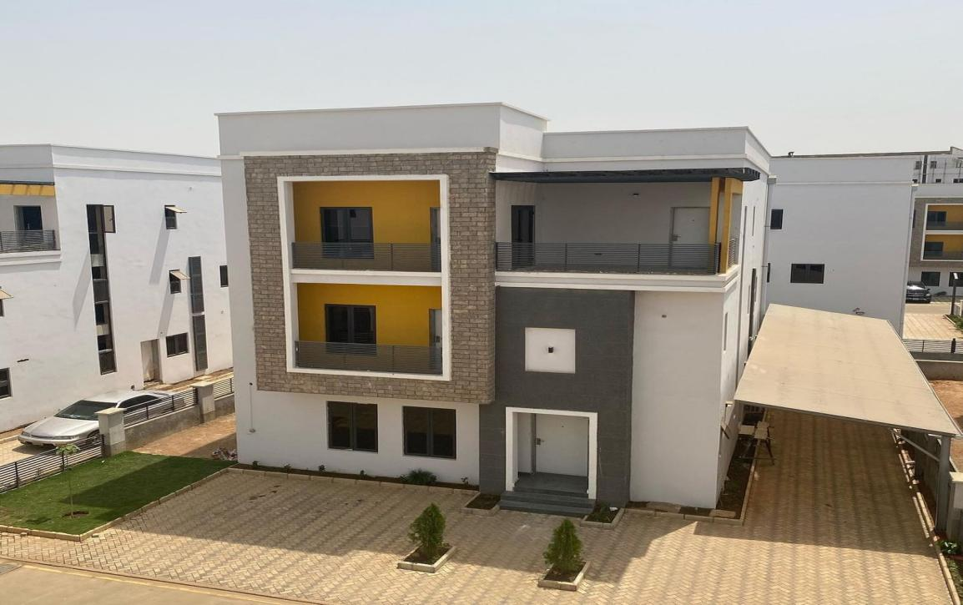
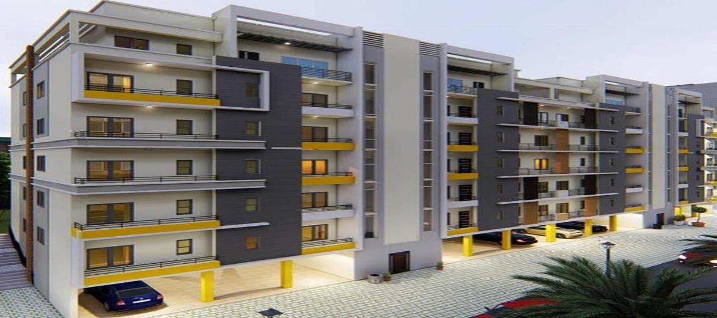

Plate1.3:perspective of Case Study One at Cosgrove Smart Estate, Abuja )
State

Plate1.4:perspective of Case Study One at Cosgrove Smart Estate, Abuja )
State

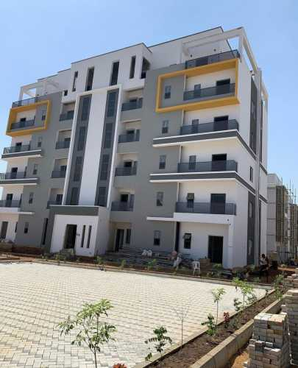

Plate1.5:perspective of Case Study One at Cosgrove Smart Estate, Abuja )
State

Dfzg
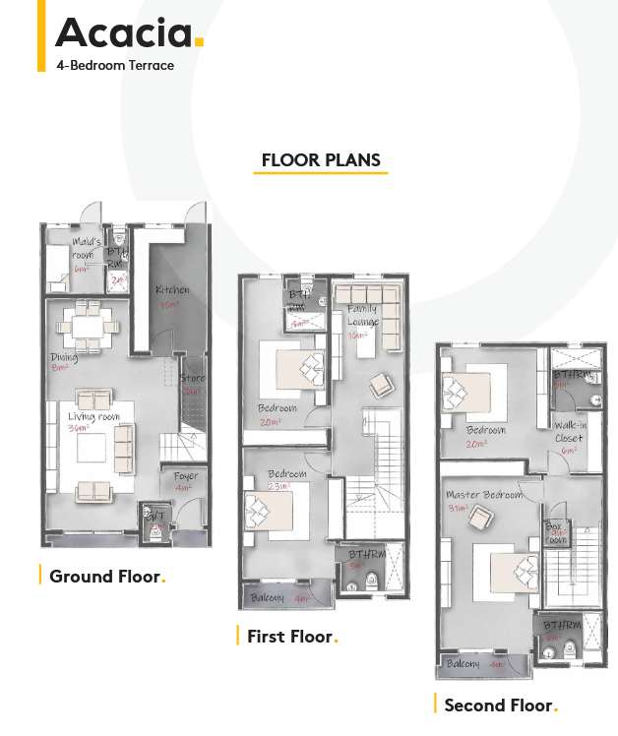

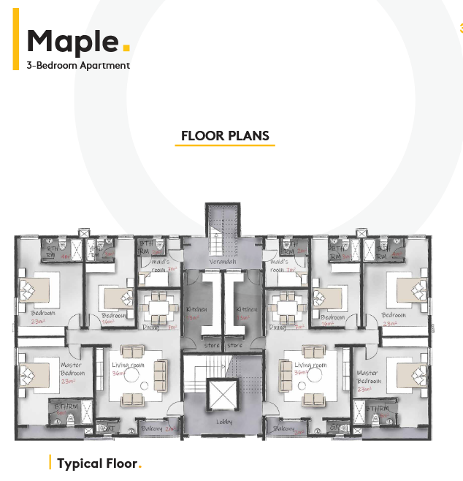

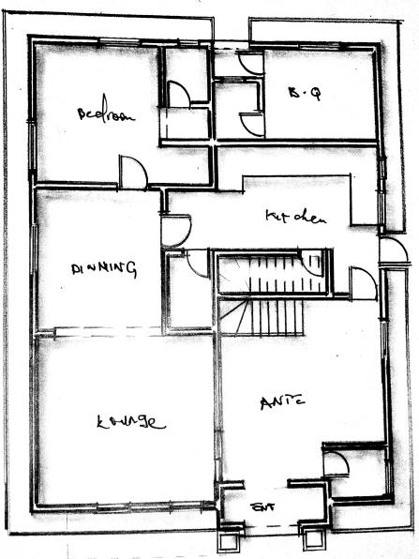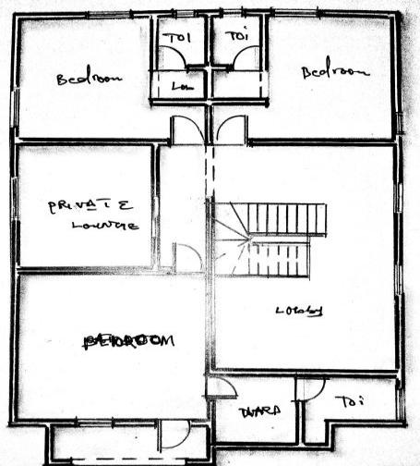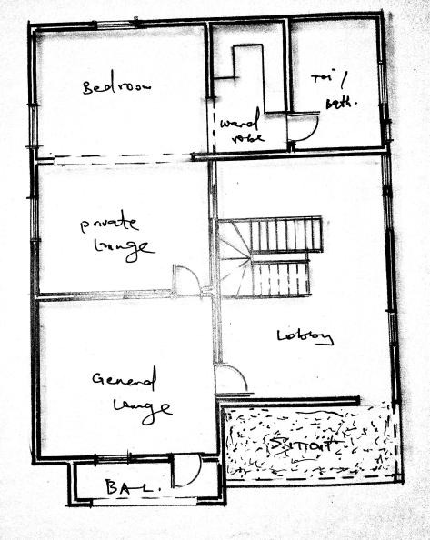

Fig 1.1 :floorplan of Case Study one at cosgrove Abuja 4 Bedroom Duplex
State

3.3: CASESTUDY 2: Godab housing estate,Life camp,Abuja.
Godab Estate is a high-end, gated housing community located in the Lifecamp/Kafe axis of Abuja. Known for its serene, secure, and family-friendly environment, it appeals to professionals, government officials, and expats seeking premium residential living
- Location & Accessibility
Sited within Lifecamp, adjacent to Gwarinpa, Kado, and Jabi, with easy highway access via Ring Road 2 and Obafemi Awolowo .Within a 10–15 minute drive to Abuja’s Central Business District and major amenities.
- Community & Housing
Encompasses over 400 units, including 4- and 5-bedroom standalone, semi-detached, and terraced duplexes—all complete with boys’ quarters and fitted kitchens.Homes are well-finished, structurally sound, and surrounded by lush, well-paved roads
- Amenities & Infrastructure
Features include: tarred roads, street lighting, quality water infrastructure, 24/7 electricity, and electric fencing Around Abuja .
Recreational amenities such as a swimming pool, children’s playground, and gym/community park are available .
Strict access control with guarded gates, CCTV, and strong private security—residents highlight clean, well-managed spaces and tranquility
These sentiments underscore its reputation as a well-maintained, peaceful, and highly organized community. Godab Estate is a premium gated community in Abuja offering:
- Spacious modern duplexes with BQ
- Reliable utilities (power, water, roads)
- Desirable amenities (pool, gym, playground)
- Excellent security and serene setting
- Strategic location with easy access to the city

MERITS
- As it is said to be a smart estate,smart devices are provided and adequately functioning.
- Modern contemporary architecture are aesthetically appealing.
- Amenities are provides aids and improves the occupant’s standard of living

DEMERITS
- Monotonous design causing lack of security and privacy
- Accessibility for the challanged or disabled were not considered

Fig 1.2: Site Location of Case Study two at Godab Estate, Abuja (Wuye)

Plate 2.1: Site plan of Case Study two at Godab Estate, Abuja (Wuye)
State

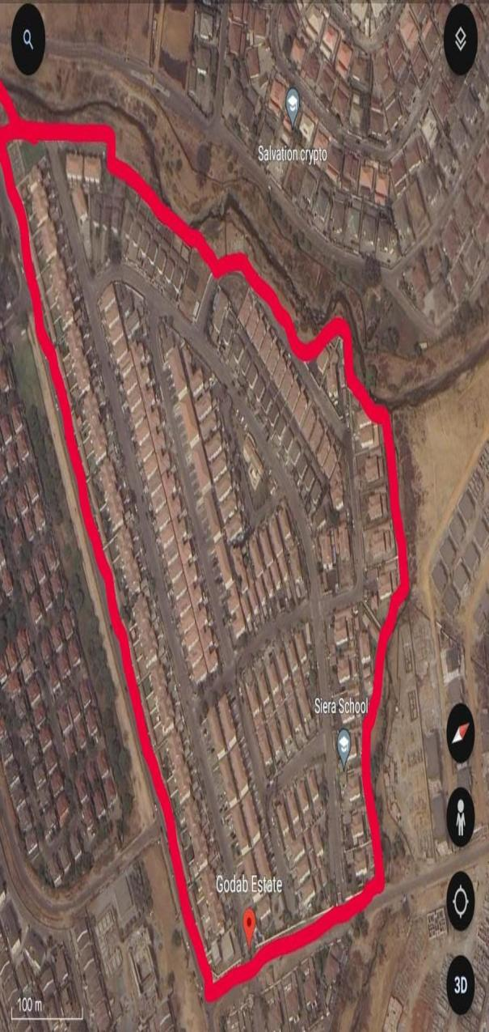
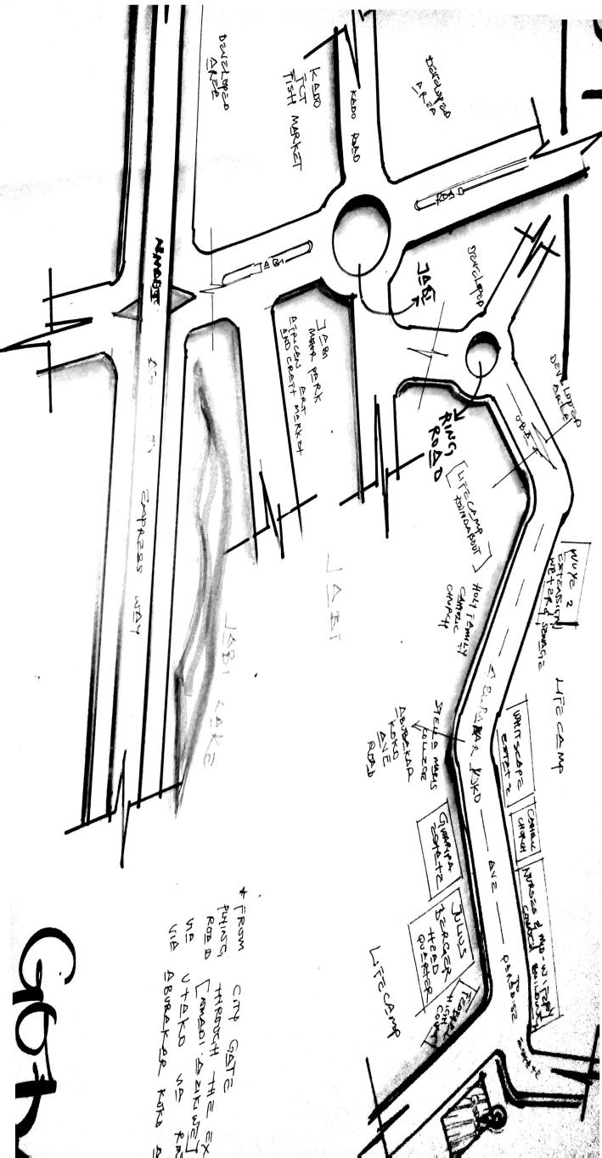
Plate2.4:perspective of Case Study two at Godab Estate, Abuja )
State

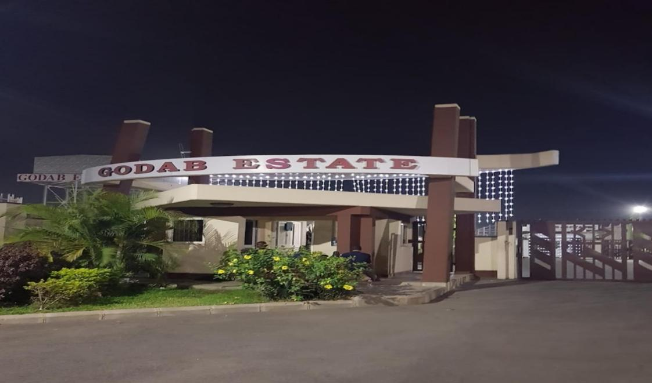
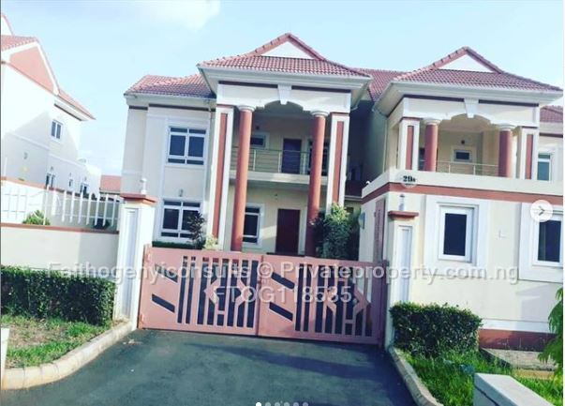
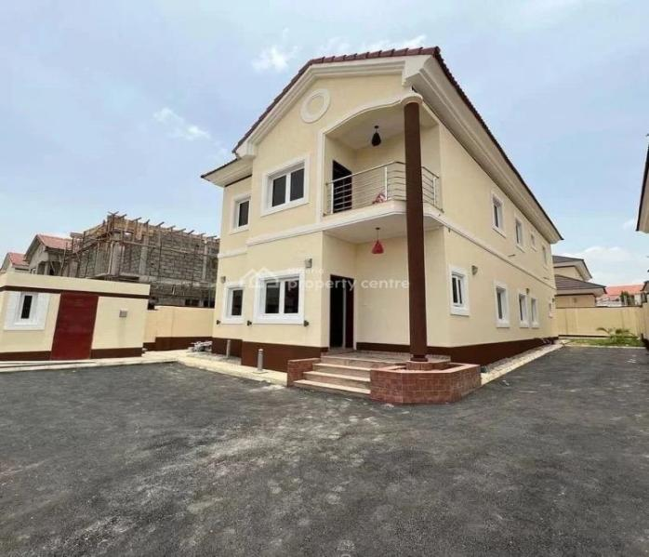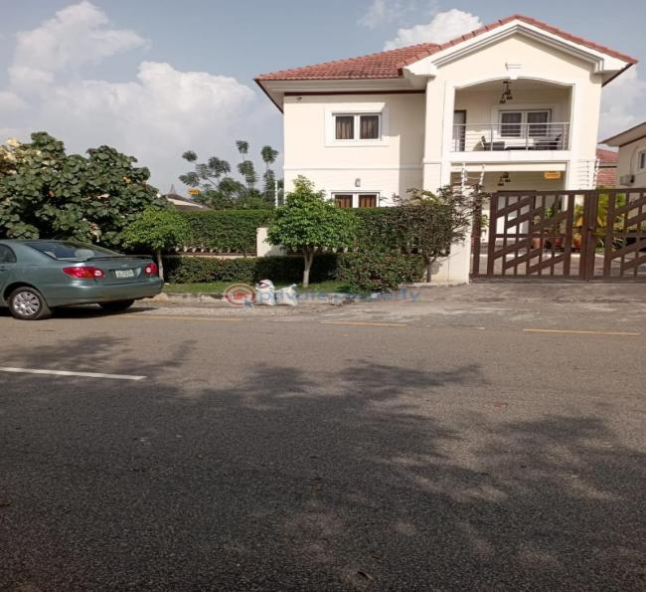

Plate2.2:perspective of Case Study two at Godab Estate, Abuja )
State

Plate2.3:perspective of Case Study two at Godab Estate, Abuja )
State

Dfzg
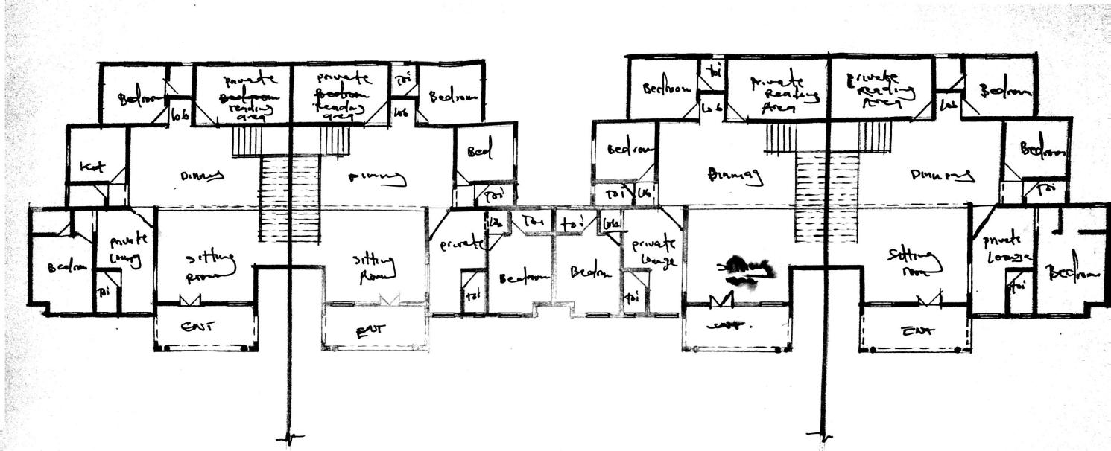

Fig 2.2:floorplan of Case Study two at Godab estate,Abuja Semi Detached Duplex )
State

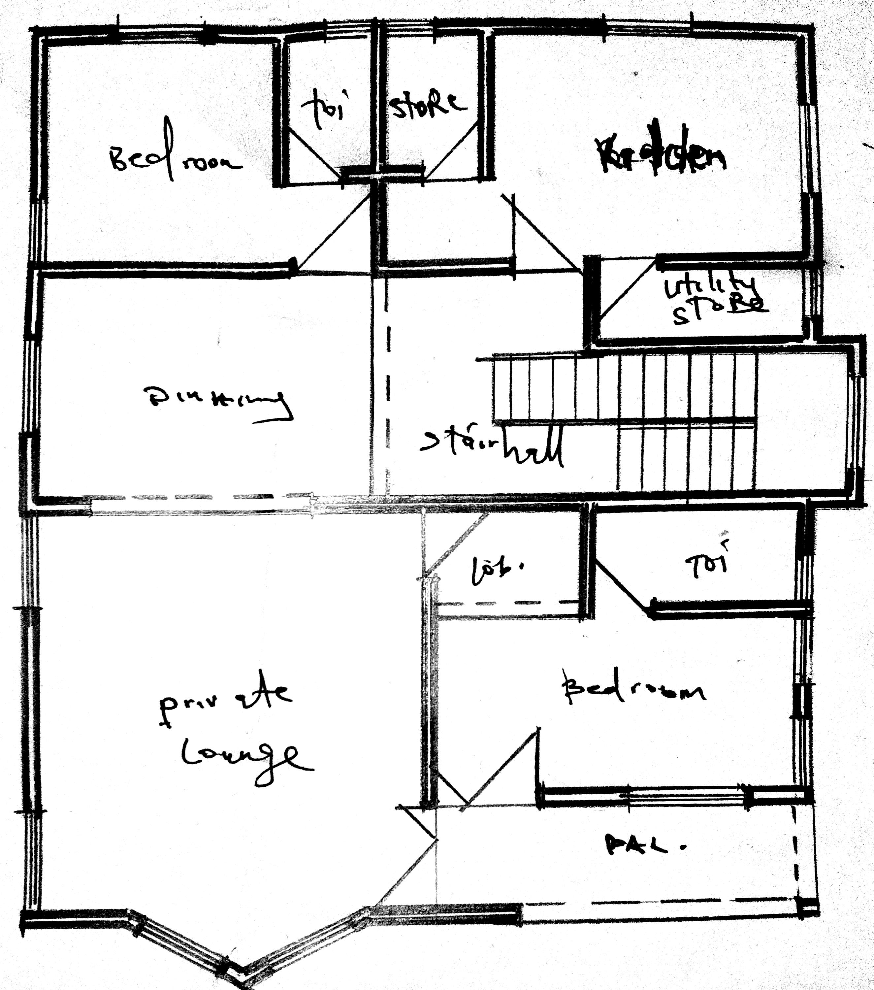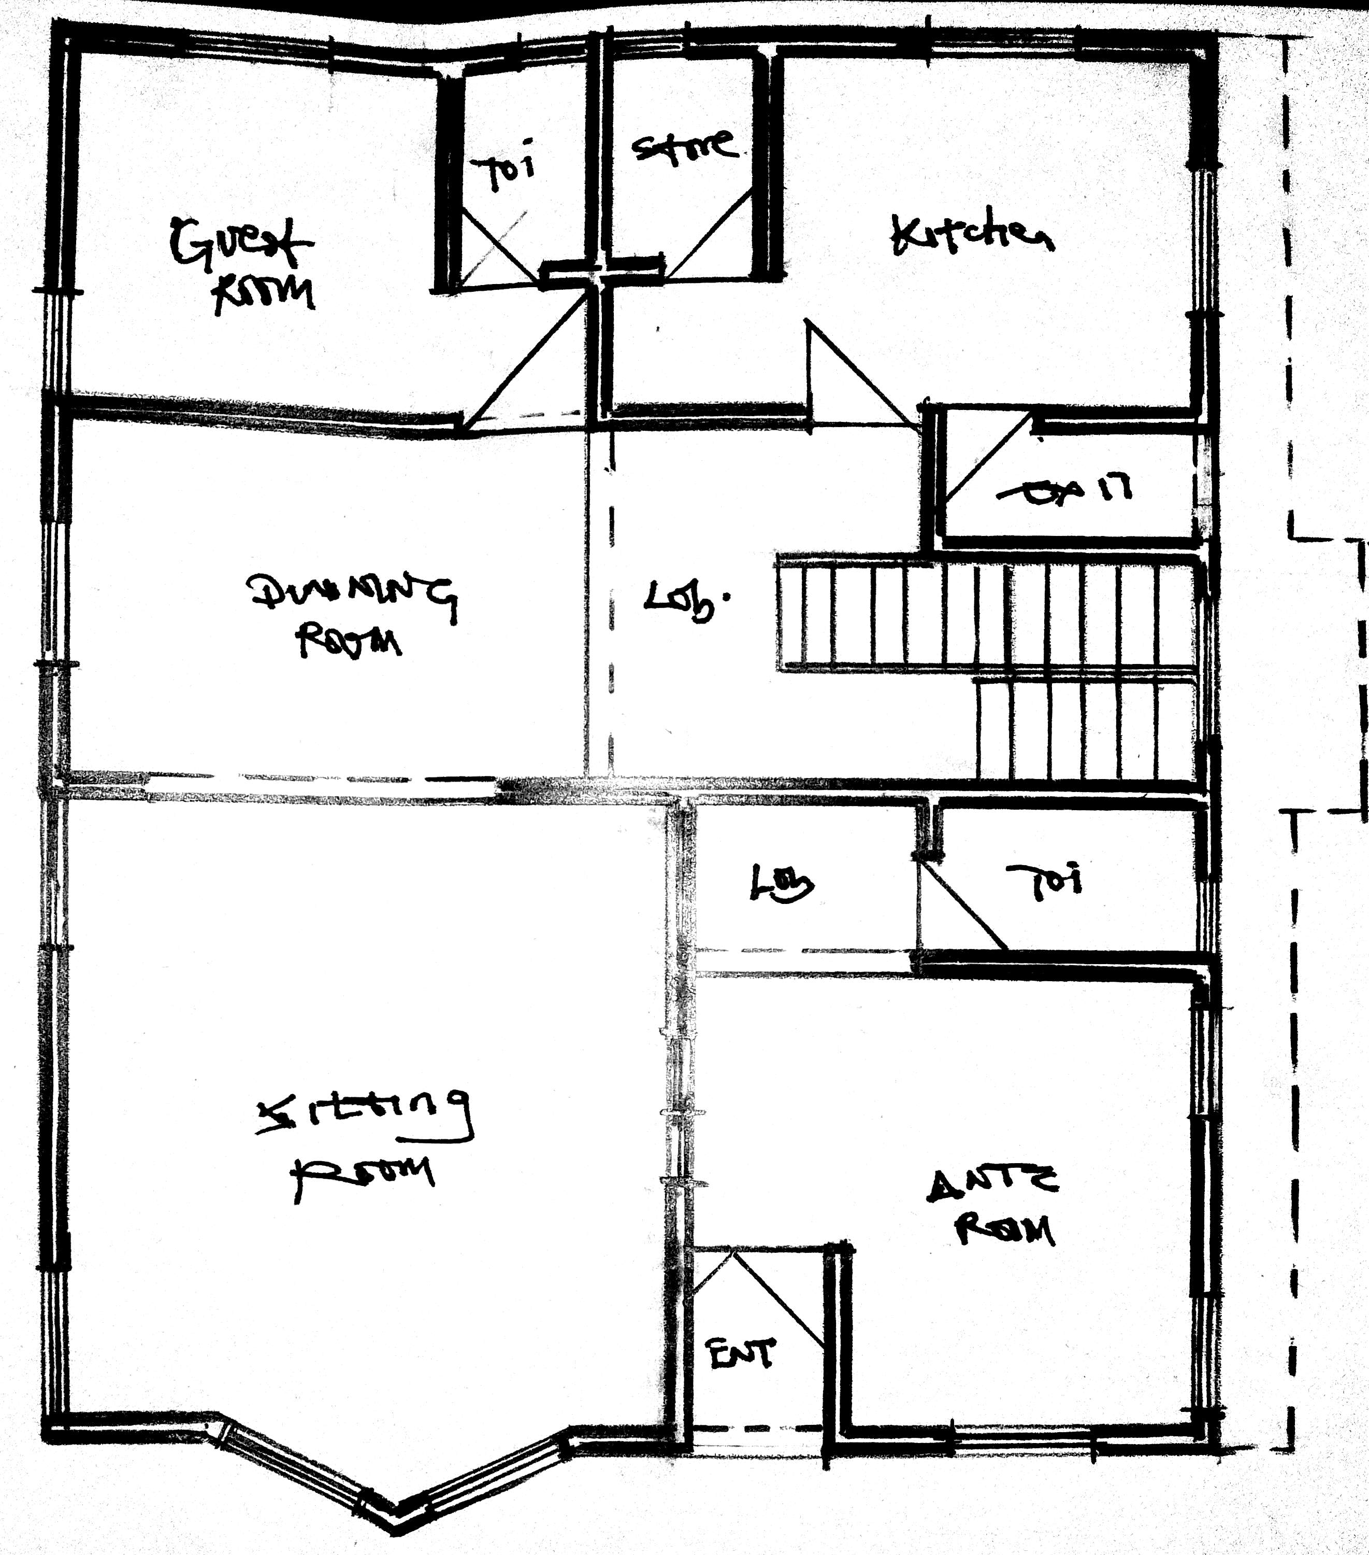

Xerys
Fig 2.3 :floorplan of Case Study two at Godab estate, Abuja )
State

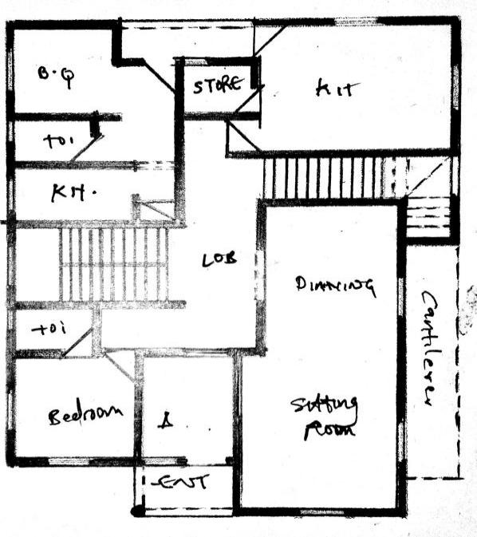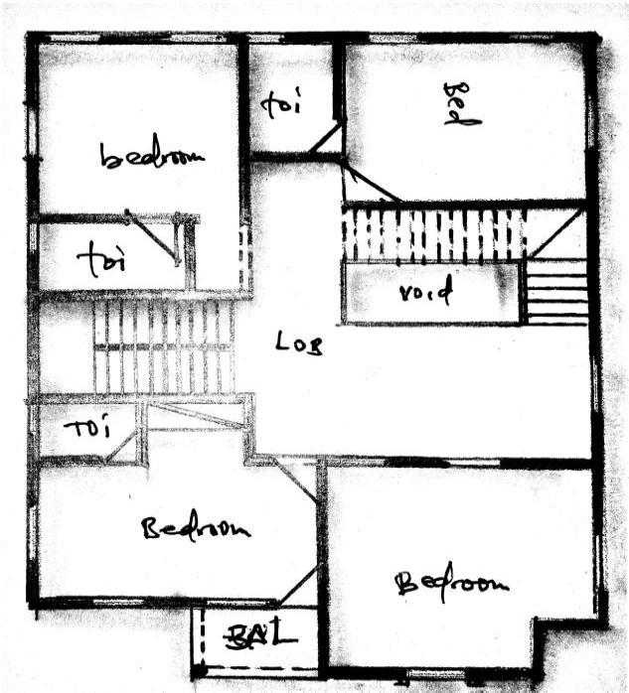

3.4: CASESTUDY 3:Paradise Estate – Life Camp, Abuja
Fig 2.4 :floorplan of Case Study two at Godab estate, Abuja )
State

Paradise Estate, situated in the Life Camp district of Abuja, is a serene, gated residential community designed for middle- to upper-middle-income families. Developed by Lekki Gardens (The Paradise Estate Abuja), this estate blends modern living standards with a peaceful suburban atmosphere
- Location & Accessibility
Nestled in Lifecamp, just off the magistrate court and near Stella Maris School. It enjoys quick access to major roads like Obafemi Awolowo Way and Ring Road 2, ensuring an easy commute to the CBD, Gwarinpa, Kado, and Jabi .The estate is approximately a 10–15 minute drive from the city center .
- Residential Typology & Finishing
Offers a range of residential options: 2- to 3-bedroom apartments, terraced duplexes, semi-detached and fully detached duplexes, typically sold as shell units, allowing residents to personalize interiors Shell units provide a blank canvas for custom finishes, attracting buyers who prefer personalized design .
- Amenities & Environment
Planned with well-laid roads, landscaped green areas, children’s playgrounds, a cycling trail, and clubhouse facilities
security infrastructure includes gated access, CCTV, solid perimeter fencing, and 24/7 guard presence
Community feedback consistently praises its security, serenity, organization, and suitability for families
- Summary
Paradise Estate in Life Camp, Abuja offers:
- A gated, secure, and family-oriented environment
- Shell-unit homes for personalization, including terraced, semi-detached, detached, and apartments
- Modern infrastructure: playgrounds, roads, club facilities, and reliable utilities
- Convenient location near key urban hubs and thoroughfares
- Appealing price point, especially for discerning middle- to upper-middle-income buyers
Overall, it’s an attractive choice for residents wanting a blend of affordability, customization, and quality of life within Abuja’s expanding southern corridor.

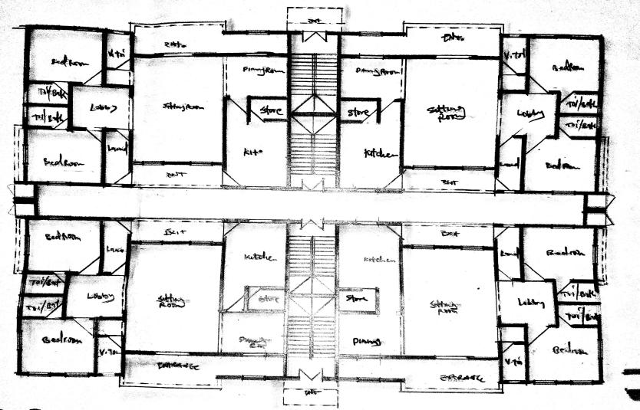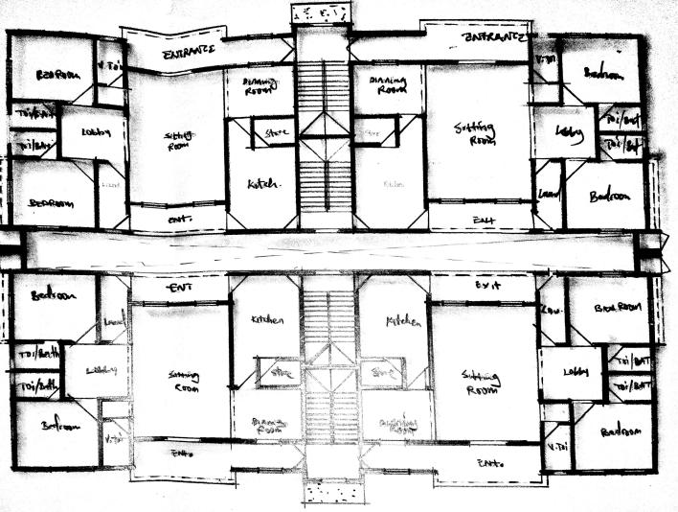
Fig 3.3:floorplan of Case Study three at paradise estate, Abuja )

Fig 3.2 :floorplan of Case Study three at paradise estate, Abuja )

Fig 3.1:floorplan of Case Study three at paradise estate, Abuja )

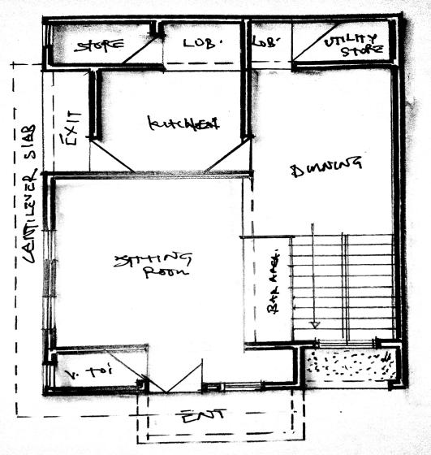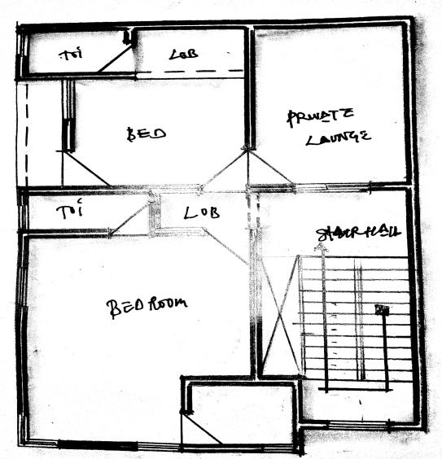
plate3.3:approach view of Case Study One at paradise estate, Abuja )
State

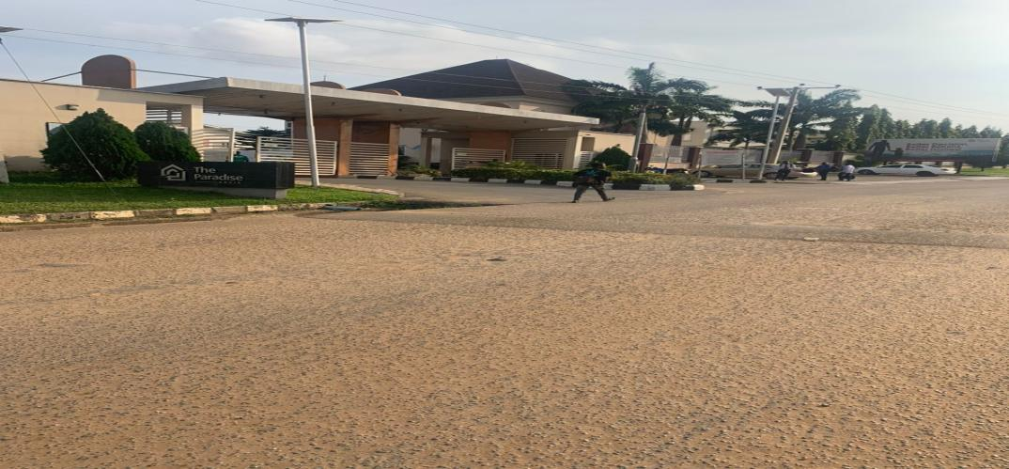
plate3.2:approach view of Case Study One at paradise estate, Abuja )
State

plate3.1:perspective viewof Case Study One at paradise estate, Abuja )
State

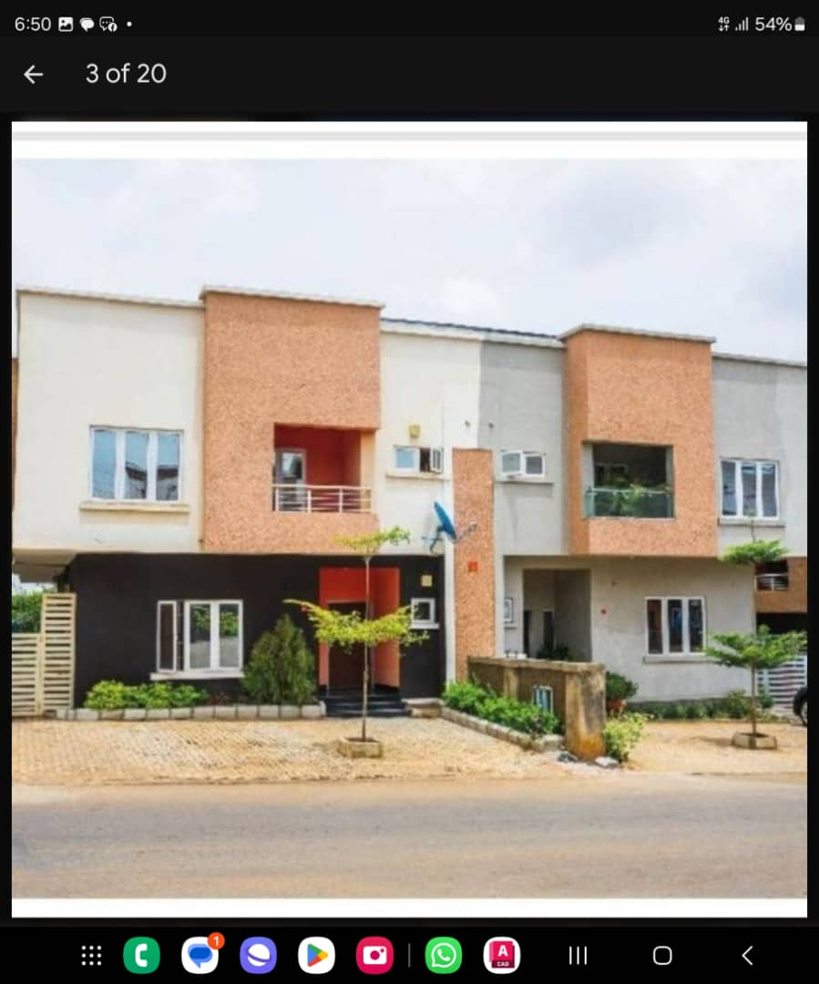
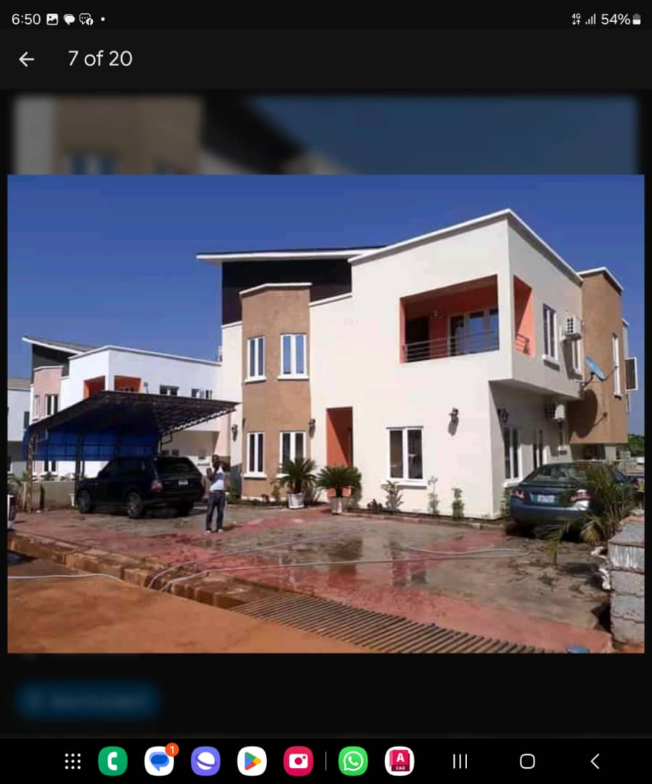
CHAPTER FOUR
4.0 STUDY AREA/PROJECT SITE
4.1 HISTORY OF KWARA STATE
Kwara State, located in the North-Central geopolitical zone of Nigeria, stands as a culturally rich and historically significant region in the nation’s development. Created on May 27, 1967, from the former Northern Region, the state serves as a geographical and cultural bridge between the northern and southern parts of Nigeria. It derives its name from the local term for the River Niger — "Kwara" — which flows through its landscape. The state is known for its diverse ethnic composition, including Yoruba, Fulani, Nupe, Baruba, and other minority groups, and for its reputation in education, agriculture, commerce, and peaceful coexistence.
Ilorin, the capital of Kwara State, is one of Nigeria’s prominent Islamic centers and is the seat of the Ilorin Emirate. Within this capital lies Ilorin East Local Government Area (LGA), with its administrative headquarters at Oke-Oyi. Ilorin East plays a vital role in the state’s socio-political and economic affairs, combining a growing urban landscape with traditional rural life. The area is known for its agricultural potential, expanding real estate, and growing infrastructure, making it a key zone in Kwara’s continuous development.
This work presents a historical, cultural, and developmental overview of Kwara State and Ilorin East, highlighting their significance in Nigeria’s past and present, while projecting their potential for future growth..
Kwara state is a state located in the North central region of Nigeria and it was created on May 27,1967, by General Yakubu Gowon, along with 11 other state. It was originally named the west central state but was later renamed kwara, which is a local name for River Niger.
The region was conquered by the Fulani in the 19th century and was part of the greater Fulani empire until it was defeated by the forces of sir George Goldie’s Royal Niger company in 1897. It was then incorporated into the protectorate of Nigeria in 1914.
Kwara state is bordered by Benin to the west and by the Nigerian state of Niger to the North, kogi to the east, and Ekiti, Osun and oyo to the South. The state mostly consists of wooded savanna, but there are also forested regions in the south.
As of 2006, the population of kwara state was around 2.3million, making it the 30th most populous state in Nigeria.

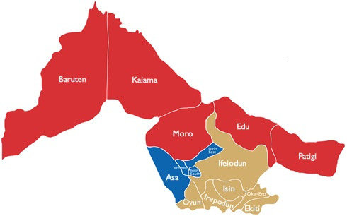
Source:google/researchgate.com
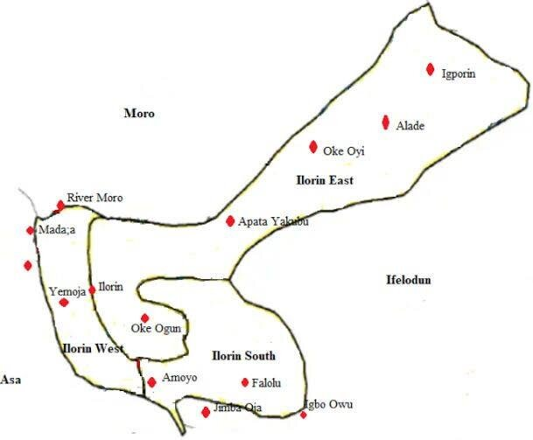
Figure 4.1: Locational map of Kwara State

4.2 SITE LOCATION DESCRIPTION

4.2.1 PROPOSED HOUSING ESTATE SITE AT OKE OSE, ILORIN, KWARA STATE
The proposed site for the N.A.S.U.P Housing Estate is a large expanse of land measuring approximately 500 standard plots, strategically located in the Oke Ose area of Ilorin East Local Government Area, Kwara State, Nigeria. Oke Ose is a growing peri-urban community situated along the Ilorin–Oke Oyi–Share development corridor, an area known for its peaceful environment, expanding population, and increasing infrastructural investments.
The site enjoys direct access via a motorable road network, with existing link routes connecting it to major parts of Ilorin metropolis, including the University of Ilorin Teaching Hospital axis and the Ilorin International Airport. This accessibility makes the location ideal for mid- to large-scale residential development and future urban integration.
The land is relatively flat and well-drained, making it suitable for phased estate construction with minimal topographic challenges. Additionally, the area is gradually experiencing urban sprawl, supported by the presence of public utilities, educational institutions, religious centers, and ongoing private developments.
Its proximity to existing amenities and transport infrastructure positions it as a viable site for the development of a modern, affordable, and sustainable housing estate targeted at meeting the residential needs of members of the Non-Academic Staff Union of Polytechnics (N.A.S.U.P).
This location presents a unique opportunity to provide quality housing within a serene and well-connected environment, while also contributing to the larger goal of reducing housing deficits among staff in the Nigerian education sector.

4.3 SITE ANALYSIS
Site Analysis is a thorugh examination and evaluation of site’s conditions, characteristics and context. It involves gathering and analyzing data to understand the site. The goals of the site analysis are to identify site constraints and opportunities, inform design and development decisions, ensure environmental sustainability, respect cultural and historical heritage and enhance the site’s potential.
4.4 GEOGRAPHICAL / CLIMATIC DATA
4.4.1 CLIMATIC DATA
In Ilorin, the wet season is oppressive and overcast, the dry season is humid and partly cloudy and it is hot year round. Over the course of the year, the temperature typically varies from 64⁰F to 95⁰F and is rarely below 57⁰F or above 100⁰F .
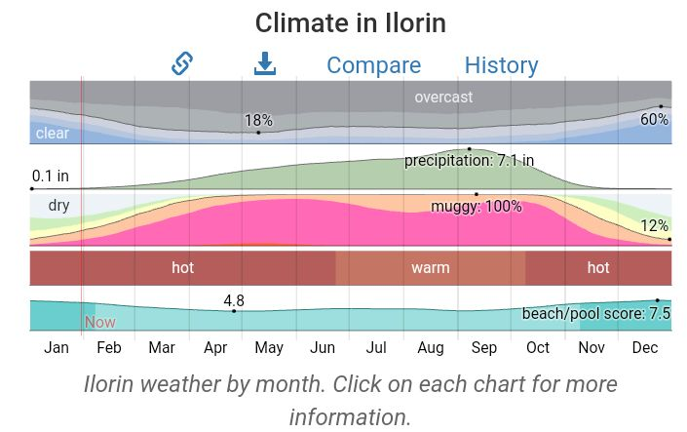Figure 4.4: Graph of Climate in Ilorin

4.4.2 RAINFALL
Kwara typically receives about 101.45millimeters (3.99 inches) of precipitation and has 148.38 rainy days (40.65% of the time) annually.
Ilorin experiences two climatic season i.e rainy and dry season. The rainy season is between march and november with a brief break in august and the annual rainfall varies from 1200mm 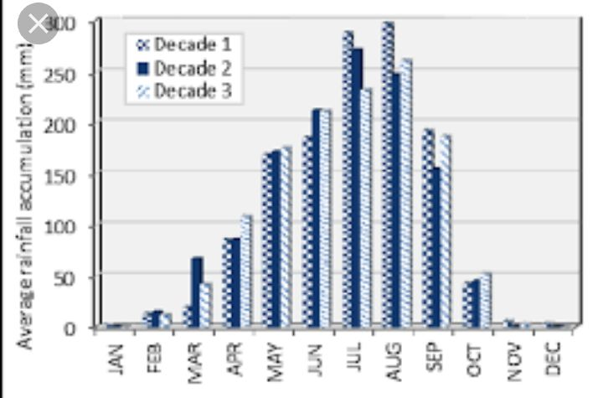
Figure 4.5: Graph of Rainfall in Ilorin
4.4.3 WIND
Both tropical continental and tropical maritime air masses affect ilorin. The city experiences thunderstorm, during the beginning and ending of the raining season. The prevailing wind direction is southwest trade wind, which is rain bearing since it takes origin from the sea in the raining season period and from north.
4.4.4 TEMPERATURE
Ilorin is within the climatic zone known as the equatorial zone which has a climatic type of low wet equatorial. The two major influences on Ilorin climate are the two major wind currents. The south west trade wind is warm and moisture laden and the north east trade wind is cold and dry. The two winds current bring about the two different seasons called the rainy and dry season. The raining season is between April and October while the dry season is between November and March. It is accompanied by cold dust and harmattan.
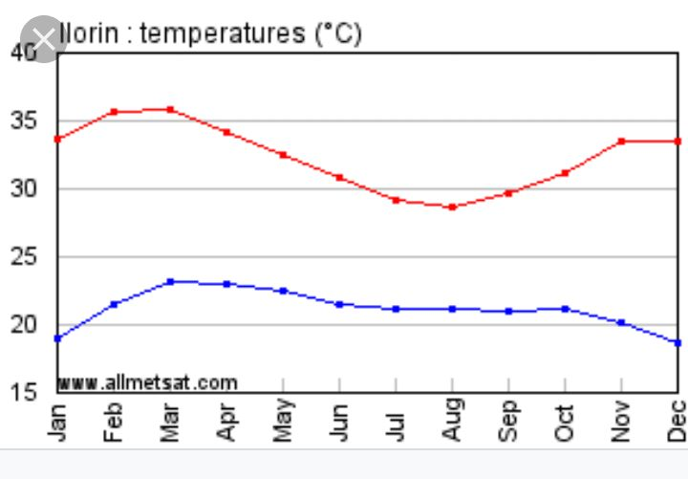
Figure 4.6: Graph of temperature in Ilorin

4.4.5 HUMIDITY
Kwara under certain factors experiences high relative humidity with high rainfall during the month june, july, august, and September.
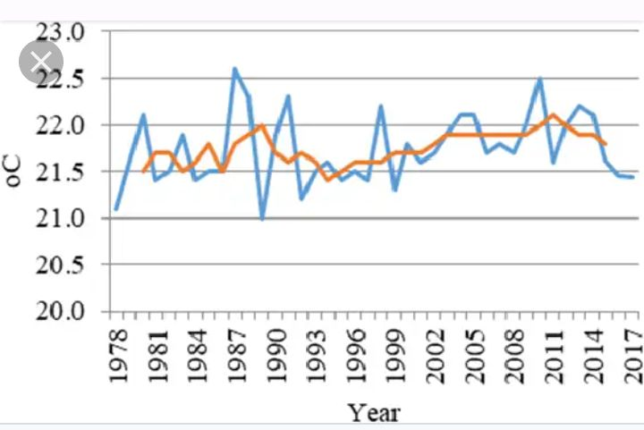
Figure 4.7: Graph of humidity in Kwara state
4.5 ANALYSIS OF THE IMMEDIATE ENVIRONMENTAL CONDITIONS OF THE SITE
4.5.1 VEGETATION
The site is covered with grass, trees and shrubs are to removed.
4.5.2 SOIL CONDITION
The site has a rite soil with good sub-surface condition for construction and landscaping, it gives satisfactory geological and soil condition with no rock.

4.5.3 TOPOGRAPHY
It has a gentle slope towards the road at 30mm. It does not undulate. The typography of the proposed development site is relatively low that the topsoil and sub-soil firm and build-able. The site is therefore free from any natural of physical constraints and rock outcrops.
4.5.4 WIND DIRECTION
The site is planned in order to give it a defined shape and also to reflect the activities taking place. the location of building and facilities within the site follow these major principles.
- The priority of individual structure within the term zoning (noisy, semi-noisy and quiet zone)
- Parking space located within and around the various units of convenience.
- The police post is located within the entrance of the estate for security purpose.
- The supporting units such as church, mini mart, school, fire station, event center, clinic and market are centralized for easy access for the occupant.
4.5.5 ORIENTATION
The orientation of the building must be designed in such a way that the large side face the north-east and south-west with adequate openings.

4.6 PROJECT ANALYSIS / DESIGN CRITERIA
4.6.1 DESIGN CRITERIA
- DESIGN GENERAL REQUIREMENT
- DESIGN BRIEF
After research and planning the next step in the series of the project program is design it, to achieve functional and where established design there must be a brief to work on. The brief depends generally on the scope of individual design; the brief of this project is therefore based on the various individual designs that take place in the housing estate .To have enough brief for the purpose correctional Center were carried on the existing housing estate. The study also gives me the opportunity to know the nature of the
Occupant lives and their lifestyle and also relationship between staff and inmates. The housing estate has different building type which are: the 1 bedroom semi-detached,2 bedroom,3 bedroom,educational centre,recreational centre,health centre e.t.c.
- DESIGN ANALYSIS
This is the process of itemizing unit within the component of the entire design with a view to establish a solid understanding and appropriate functional flow. The unit of the design is as follows
4.7 BRIEF ANALYSIS OF PROJECT
As a result of the deductions made from the studies conducted on the project adequate attention shall be given to the seven area/units that make this project. All these end up on mass housing.
THE UNITS/AREAS ARE AS FOLLOWS:
- Residential
- Services
- Recreation
- Maintenance
- Religion
- Institution
- Road network
RESIDENTIAL AREA: this area plays most important area in the housing, it’s the center of focus because it is the place where the occupant will spend most of their time as shelter and this is group into: One bedroom semi-detach block of flat, two bedroom semi-detach block of flat and three bedroom semi-detach block of flat.
The one bedroom semi-detach block of flat is for low income earners and the two bedroom semi-detach block of flat is for the middle income while the three bedroom semi-detach block of flat is for the high income earners.
SERVICES: these units play much important role in the residential area because without services in the housing, the lives of the occupant will not be complete and also services are part of the social amenities and facilities that will improve physical, biological and social of the occupant in the mass housing. the following are services provided in the servicing area; mini-mart, Gate house, Police post, Clinic/health care, Fire station and Event center and market.
RECREATION: recreation area is also an important area in the mass housing and the units include: Garden / sit-outs, Sport area and Children playground.
MAINTENANCE: is a very important section in the mass housing for comfortability of the occupant. This unit includes; Waste disposal and Central sewage system.
RELIGION: Some people find of difficult to worship God due to far distance if worship centers, then, in the proposal housing there is provision of worship center for Muslim and Christian worshippers such as: Mosque and Church.
INSTITUTION: The children of the occupant and the people living around the housing estate can make use of the school present within the housing. The unit includes: Nursery and primary school.
ROAD NETWORK: For proper movement of traffic flow to case activities within the housing estate. The unites provided are follow: Trucks, Bus, Cars.

4.8 FUNCTIONAL ANALYSIS
There is various types of means that is employed in the functional analysis but the most suitable will be used for the project based on the relationship between two unit and activities done there
- Low income earner
S/N | UNITS | L x B | AREA
1 | ENTRANCE | 3.0m x 1.2m | 3.6m
2 | PARLOUR | 3.0m x 3.6m | 10.8m
3 | BEDROOM | 3.0m x 3.6m | 10.8m
4 | KITCHEN | 2.4m x 1.5m | 3.6m
5 | VISITOR’STOILET | 0.9m x 1.2m | 1.08m
6 | WC & SHW | 1.875m x 1.5m | 2.8125m
Table 4.1: Space allocation for one bedroom semi-detach block of flat
- Middle income earner
S/N | UNITS | L x B | AREA
1 | ENTRANCE | 3.925m x 1.2m | 4.71m
2 | VISITOR’STOILET | 0.9m x 1.5m | 1.35m
3 | MAIN LOUNGE | 5.05m x 4.725m | 23.86125m
4 | DINING | 2.425m x 3.6m | 8.73m
5 | KITCHEN | 3.925m x 3.6m | 9.99m
6 | STORE | 0.9m x 2.4m | 2.16m
7 | BEDROOM | 3.6m x 3.75m | 13.5m
8 | BEDROOM | 3.3m x 3.9m | 12.87m
9 | WC & SHW | 2.175m x 1.2m | 2.61m
10 | WC & SHW | 2.175m x 1.2m | 2.61m
11 | EXIT | 2.425m x 1.2m | 2.91m
12 | LOBBY | 3.9m x 0.9m | 3.51m
Table 4.2: Space allocation for two bedroom semi-detach block of flat
- High income earner
12 | WC & SHW | 1.275m x 2.1m | 2.6775m
13 | EXIT | 2.65m x 1.2m | 3.18m
14 | LOBBY | 5.4m x 1..05m | 5.67m

4.9 APPRAISAL OF PROPOSED SCHEMES
In a project design, there are three basic factors to be considered and they are Stability i.e the strength, capability of the structure, both in exterior and interior of the structure. Functionality i.e the proper chaining of the units block, to meet the purpose of the structure to the users and the Aesthetics of the design i.e the consideration beauty of the structure in both views, environment and the finished. In this design, these three factors are put in place to meet the functional demand and to create a proportionally balanced design.
4.9 EQUIPMENT AND OPERATIONAL AND PERFORMANCE REQUIREMENT
Here attempt is made to group the various units according to the activities taking place in them. Their activities have been grouped into seven zone units but zoning base on the activities taking place in the housing has to go this way.
- Housing area/residential area ( private area): This area is known to be private area on site
- Public area: This area is where the auxiliary facilities is located and this area include Mini-mart, police post, fire station, clinic/healthcare, church, mosque, event center, nursery and primary school, relaxation area and market.
4.11 SPATIAL ALLOCATION/ SCHEDULE OF ACCOMMODATION
It is the allocation of space required in the building design in order to make the most appropriate use of spaces available.
4.13 CONCEPT DEVELOPMENT
Firstly the process of analyzing the design into necessary unit required for the design is based on the data collection through research methodologies.and also the grouping of the various units together according to their relationship with one and other is also based on the data and information gathered.
The housing estate project is envissioned as a modern residential community inspired by contemporary architectural design,tailored to meet the needs of todays dweller.

CHAPTER FIVE
5.0 APPROACH TO THE DESIGN/DESIGN REALIZATION
In approaching this design, many factors, strategies and research work were taken into consideration. Some of the factors include functionality, durability, and cost of materials.
Their search work that were carried out are the study of the area, the neighborhood value. Statistics and population of the community, the household value, the occupations and social lives of the occupant of the area.
These factors and deductions were highly considered in the development of this project to achieve a functional and aesthetically balanced design.
5.1 TECHNOLOGICAL AND ENVIRONMENTAL CRITERIA
5.1.1 CONSTRUCTION METHOD
The method of construction involved in the erection of the building structure is in accordance with the architectural detail required in executing the buildings and the process of construction that is critical to structural component as affected by the site conditions and types of materials to be used.
After the preparation of the overall site plan, many designs are developed to show the specific methods of construction. These details as an integral part of the design process and serve two important purposes. Firstly, they stipulate the aesthetic as structural element of the plan and they provide the basis for costing project.
The section is not intended to present aesthetic or design solution alone but also indicate how similar technological difficulties are handled, it is clear that the method of construction of any structure such mass housing is determined from the functional requirement of the facilities provided and its exposure to weather and climatic condition for any use, the following factors are considered; Climatic conditions of the site, Condition of the sub-soil present on the site, Fire protection requirement, Appearance of materials, Durability and easy maintenance, Economy, Availability of materials, Aesthetic, Construction technique and Cost of materials. The various building components taken into consideration are:
- SUB-STUCTURE: This is the part of the building below the natural ground level. The foundation footing is reinforced for stability of the building to enable it to withstand the load (live, superimposed and wind load). The foundation of the building shall be determined by the structural engineer according to the bearing capacity of the soil.
- SUPER-STRUCTURE: This is the building part that is above the natural ground level. The entire structure is designed with reinforced concert columns, beans and hollow sand screed block.
5.1.2 MATERIALS AND STANDARD FORMS
The following materials are applied in the construction of the structure such as:
- FLOORS: The ground floor will be of solid concrete slab of 150mm with asphalt coating as damp proof course laid on well compacted hardware. The upper floors are reinforced concrete suspended floors of 150mm thick.
Floor finishes are to be specified for each unit depending on the function it is meant to serve. Floor finishes are to be specified for each tiles and terrazzo floor tiles because they are durable, easy to maintain and do not wear easily.
- DOORS: The size and types of doors used depend on its location but generally the size ranges from 1200mm, 900mm and 750mm and the type of materials specified for the construction is in the door schedule which should be strictly followed.
- WINDOWS: A window in a building is designed primarily to allow natural light, natural air, the building issued to allow free flow of carbon dioxide out of the building as well as to allow for outside view.
- ROOFS: Roof members of all building will be made up of timber and long span of aluminum roofing sheet. This is for the easy maintenance of self-support and longer life span.
- CEILING: The kind of ceiling system specified for the building in the housing estate is the asbestos ceiling sheet. The functional requirement of this ceiling is considered under the following: Durability, Easy to maintain, Heat resistance and Cost
5.2 SERVICES REQUIRED
Services are essential for comfort ability security and safety to create a conducive atmosphere for the user of the housing estate to achieve this, the following services must be provided.
1. ELECTRICITY: The main source of electricity is from the national electric power authority and this should be connected to the site from the power in front of the site way.
2. VENTILATION: Ventilation needed in the intention part of building varies from place to place. Natural ventilation is considered best in building construction and is attained with the use pf natural air. Natural air reaches interior part of the building through windows and some other openings. Artificial ventilation is attained with the use of fans and some other atmospheric cooling machines.
3. LIGHTNING: Natural lightning is the best and most effective source of light for the building though artificial sources will be used where necessary.
4. PLUMBING SERVICES: All water supplies and other distribution to all the required areas would be through 50mmdiameter galvanized steel pipe while sewage will be PVP service pipe, which ranges from 50mm, 100mm and 150mm diameter. All the baths and shower will be provided with shower tray, towel trays, washing hand basin and tissue roll holders. The entire toilet WHB will be with a mirror over it. Septic tanks and soak away pit shall be placed and in suitable location for easy maintenance.
5. ACOUSTICS: The major noise comes from the major road and this could be reduced considerably by maintaining a reasonable setback from the major road and the proper landscaping which include planting of trees and grass to serve as noise and sound absorbent.
6. WASTE DISPOSAL: Waste disposal should be provided where unwanted material such as dirty should be dump in order to make the environment clean.
7. FIRE PROTECTION: Structural protection is achieved by using fire resistance elements and limiting the use of combustible materials and finishes. Fire detectors and firefighting equipment should be provided.
8. SECURITY SERVICES: The entry and exit to the site have been restricted to one entrance. This is to monitor the movement of vehicles in and out of the site. The entrance will be maintained with the security men checking incoming and outgoing vehicles. The entire site will be light up with security light and street light within the site. It is necessary to fence the mass housing to ensure adequate security, a strong fence is provided in addition to police post in order to keep off intruders of all types.
9. EXTERNAL WORK: These are work carried out outside and around the building. It is otherwise known as Landscaping. These are elements used to provide aesthetics and general human comfort in and around the building.There are two types of landscaping: Soft Landscaping and Hard Landscaping
i. SOFT LANDSCAPING: This is done by planting trees, shrubs and lowers around the building to serve as barrier to the thermal discomfort and beautify the structures.
ii. HARD LANDSCAPING: This is done by paving the whole of the open ground and such paving area include the parking lots, the walk ways, roadster.
5.2.1 ENVIRONMENTAL CONDITIONS TO BE ACHIEVED
There is plantation of trees to regulate the temperature. The orientation of the building structure to achieve maximum comfort thereby controlling the radiation.

5.2.2 PERFORMANCE STANDARDS
The performance standard of the building construction is to be highly luxurious because of the targeted users and the occupants of the town which have a high taste of social lives.
5.2.3 LEGAL ISSUES AND PLANNING REGULATIONS
The proposed building must pass through various process in order to be approved of the planning regulations of the local government authorities and the board of chiefs because of its being public building. The process for approval in the local planning authority is to provide the following which are: The C of O of the Land, The Survey Plan, The original land purchase documents, The Structural Drawings, The Architectural Drawings and The Mechanical and Electrical Drawings.
5.2.4 BEHAVIOURAL PATTERNS AND CONSIDERATIONS
The condition in designing the housing estate is for comfort ability and affordability of the proposed tenant and user of the estate, providing adequate recreational facilities and securities.
5.3 CONCLUSION AND RECOMMENDATIONS
5.3.1 CONCLUSION
This project has examined the contextual and organizational challenges in public housing provision in Ilorin east local government, kwara state.
Research shows that since independence in 1960, government in Nigeria have demonstrated commitment to addressing the housing problems in several ways but due to funding, political and organizational challenges, public housing agencies have provided insufficient number of poor quality and unaffordable.

5.3.2 RECOMMENDATIONS
- Adopt Comprehensive Urban Planning Principles
- Implement a well-structured master plan incorporating zoning, access roads, drainage, green spaces, and essential infrastructure.
- Use GIS and modern survey techniques to assess site suitability and mitigate environmental risks.Promote Use of Durable and Affordable Building Materials
- Encourage local, sustainable materials like stabilized earth blocks, interlocking bricks, or treated timber.
- Enforce material quality standards through testing and certification.
- Enforce Building Codes and Standards
- Collaborate with urban development authorities to ensure all buildings meet national and international building codes (e.g., NIA/NIBS standards).
- Conduct periodic inspections during construction to prevent structural defects.Incorporate Sustainable Infrastructure and Services
- Provide reliable water supply, sanitation systems, waste management, and electricity from the beginning.
- Explore renewable energy options like solar streetlights and solar rooftops to reduce reliance on erratic public supply.
- Ensure Proper Layout and Density Management.
- Avoid overcrowding by using population projections and planning unit layouts based on per capital land requirements.
- Allocate open spaces, recreational zones, and buffer areas to promote healthy living.
- Establish Housing Maintenance Systems.
- Create a resident housing association or facility management system for maintenance of common facilities (e.g., sewage systems, roads, lighting).
- Implement a maintenance fee scheme to ensure long-term upkeep

REFERENCES
Olayiwola, L. M., Adeleye, O. A., & Ogunshakin, L. (2005). Public housing delivery in Nigeria: Problems and challenges. Paper presented at the World Congress on Housing: Transforming Housing Environments through Design, Pretoria, South Africa.
Mabogunje, A. L. (2002). Perspectives on urban land and urban management policies in Sub-Saharan Africa. Ibadan: IFRA.
Ogunbiade, M. E., & Uduak, I. (2017). Planning sustainable housing estates in Nigeria. Journal of Urban and Regional Planning, 9(1), 23–38.
Oyesiku, K. (1998). Modern urban and regional planning law and administration in Nigeria. Ibadan: Kraft Books.
Akinmoladun, O. I., & Oluwoye, J. (2007). An assessment of why the problems of housing shortages persist in developing countries. Pacific Journal of Science and Technology, 8(2), 253–260.

APPENDICES
APPENDIX 1: SITE ANALYSIS
APPENDIX 2 :SITE INVENTORY
APPENDIX 3: SITE SELSCTION CRITERIA
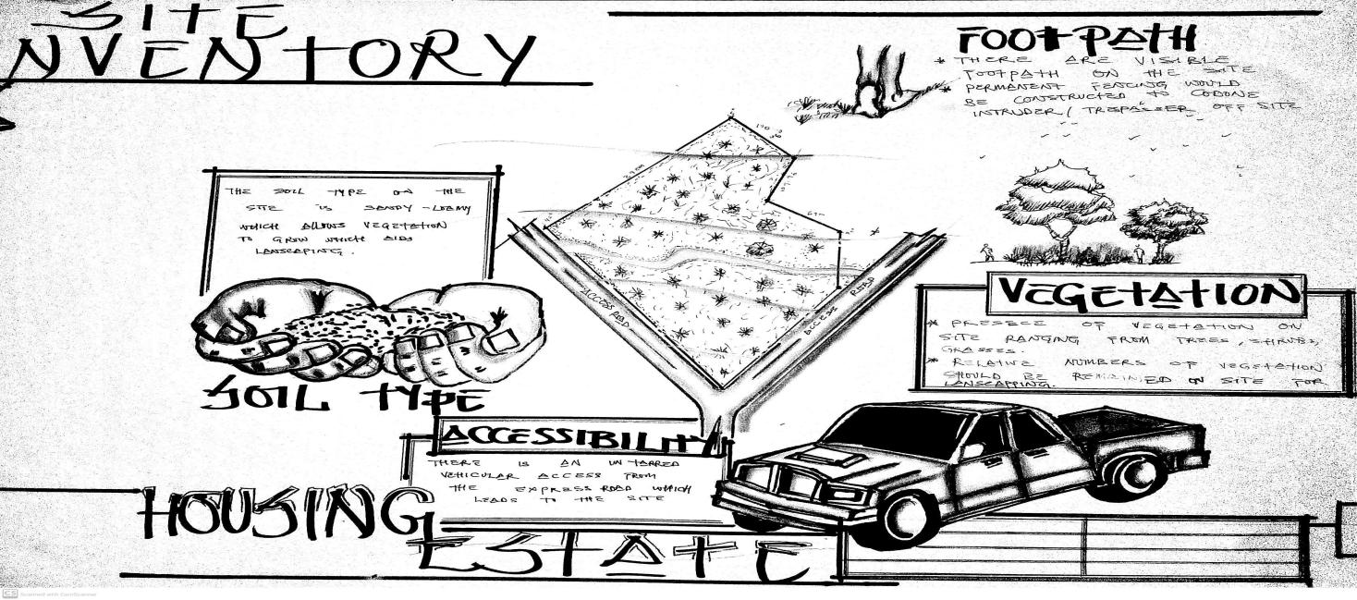
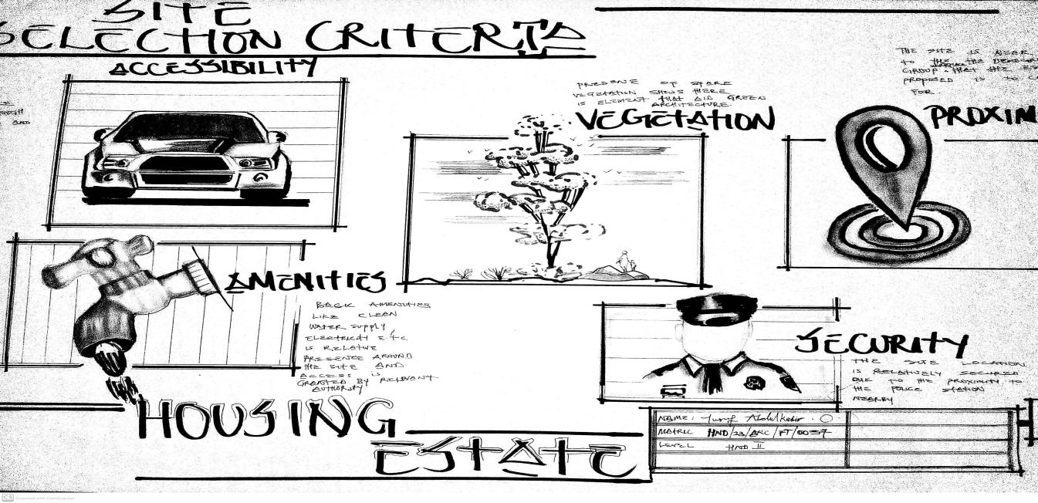
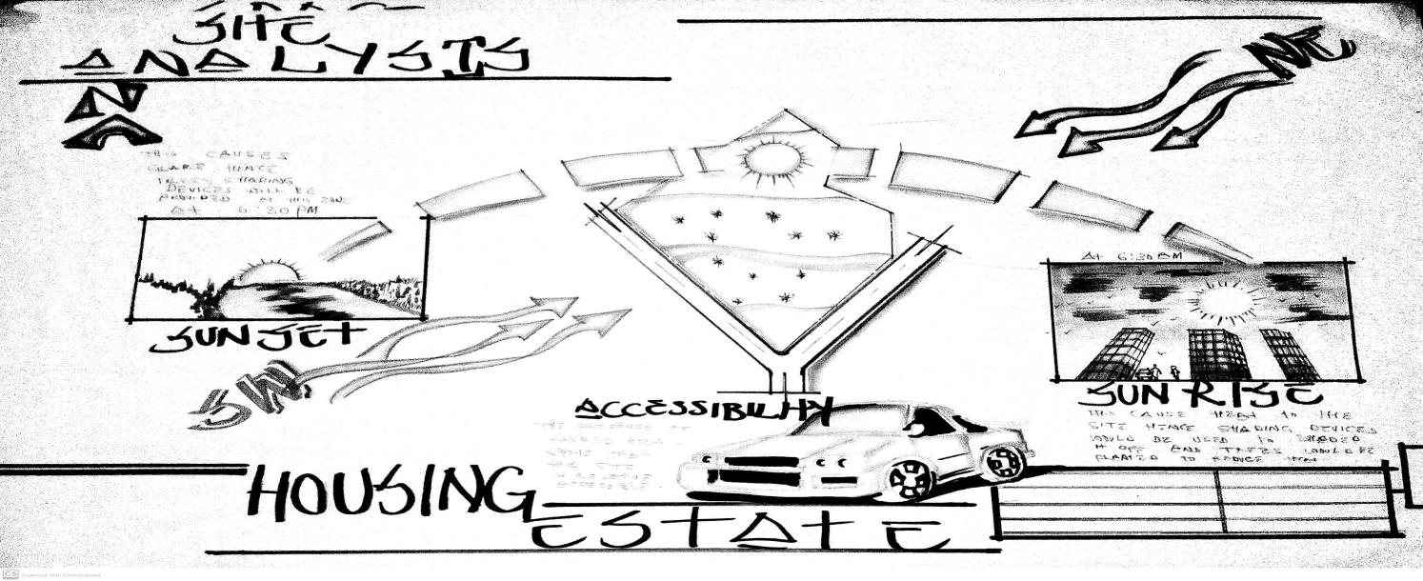

APPENDIX 6: SPACE CALCULATION
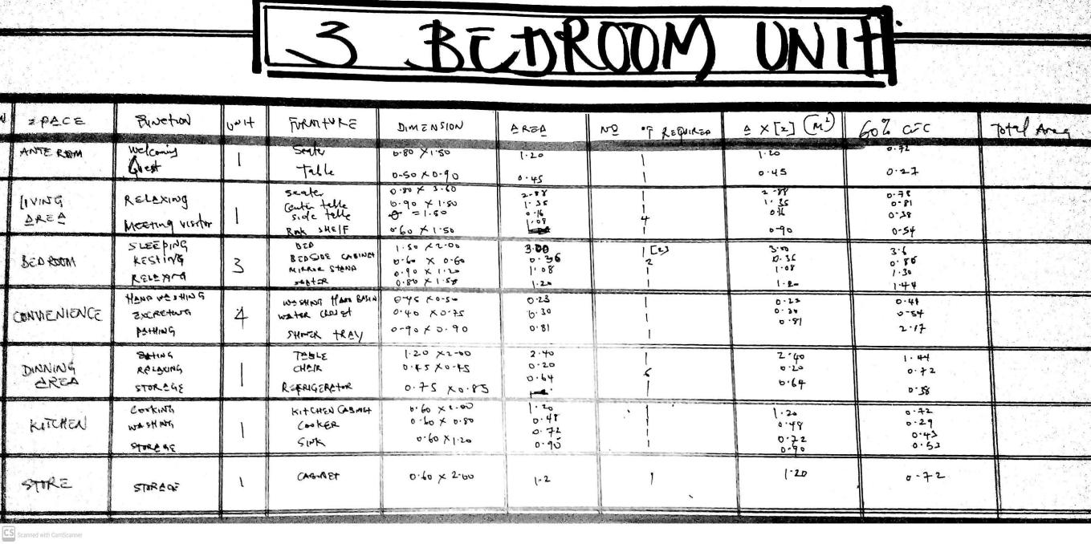
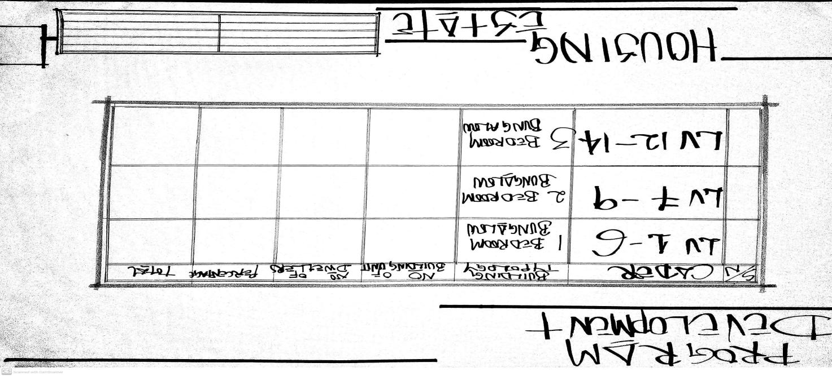
APPENDIX 5: PROGRAM DEVELOPMENT
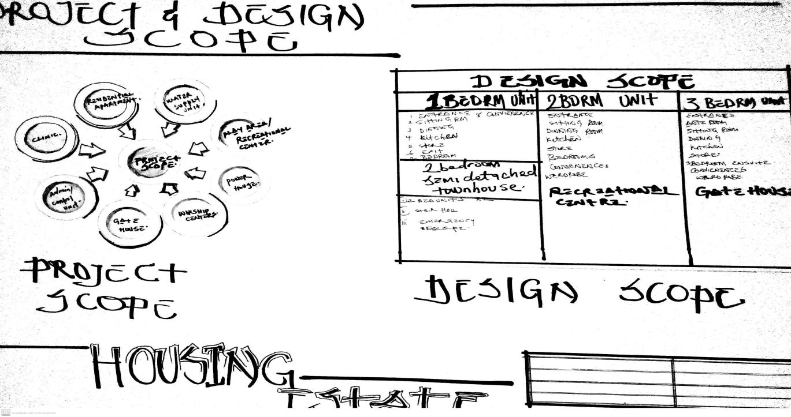
APPENDIX 4: PROJECT SCOPE AND DESIGN SCOPE
APPENDIX 8: CONCEPT DIAGRAM
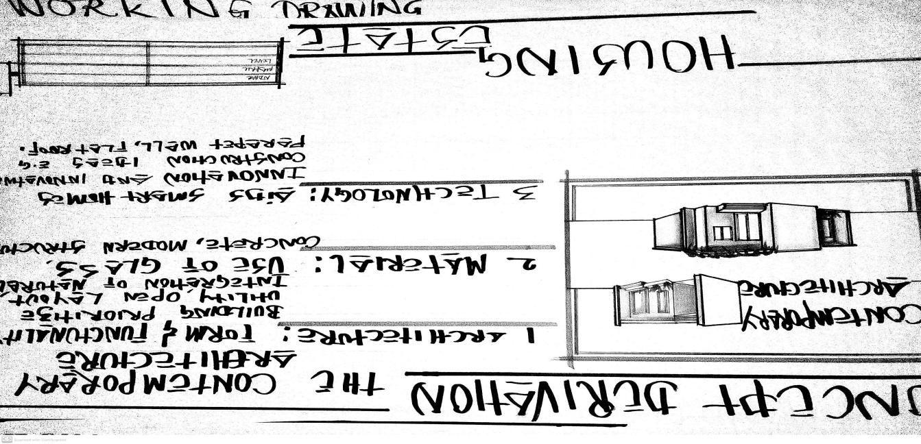
APPENDIX 7: BUBBLE DIAGRAM
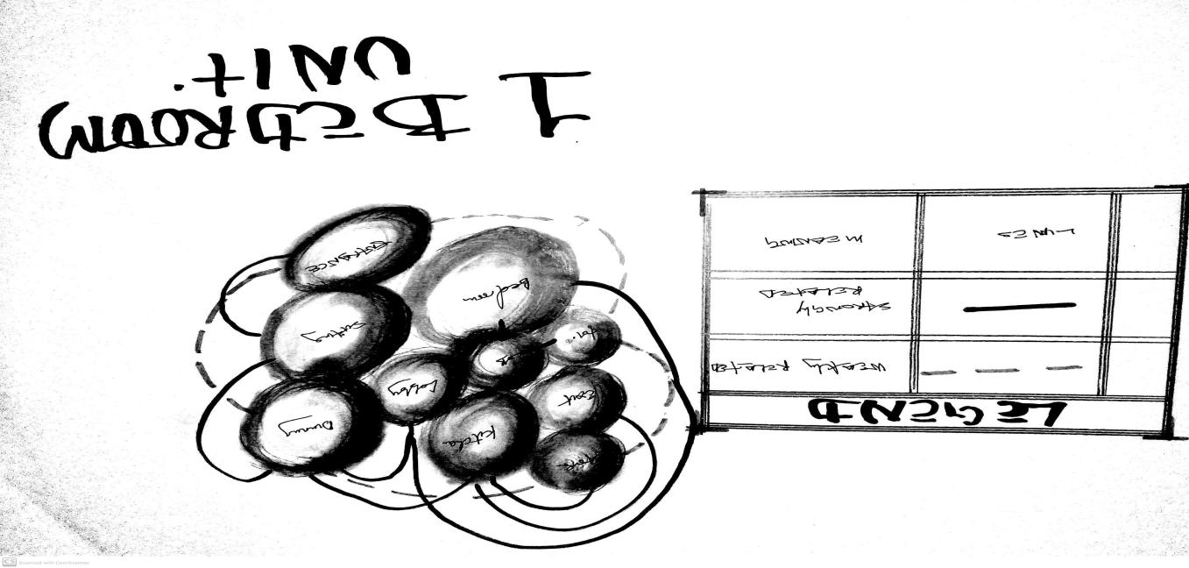
APPENDIX 6: BUBBLE DIAGRAM


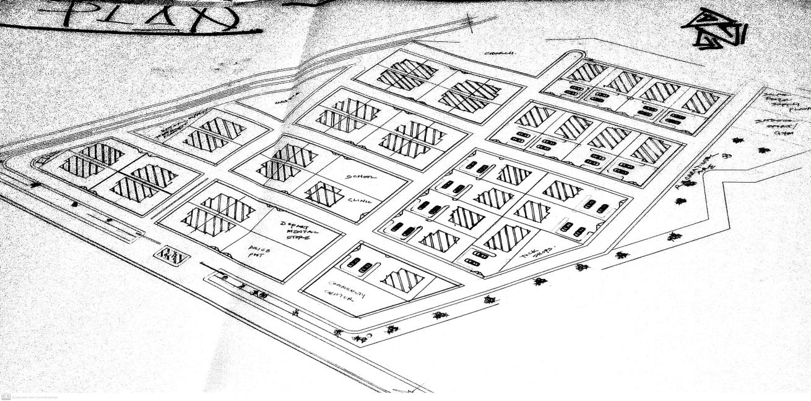

F
APPENDIX 11: ROOF PLAN ONE BEDROOM SEMI DETACHED

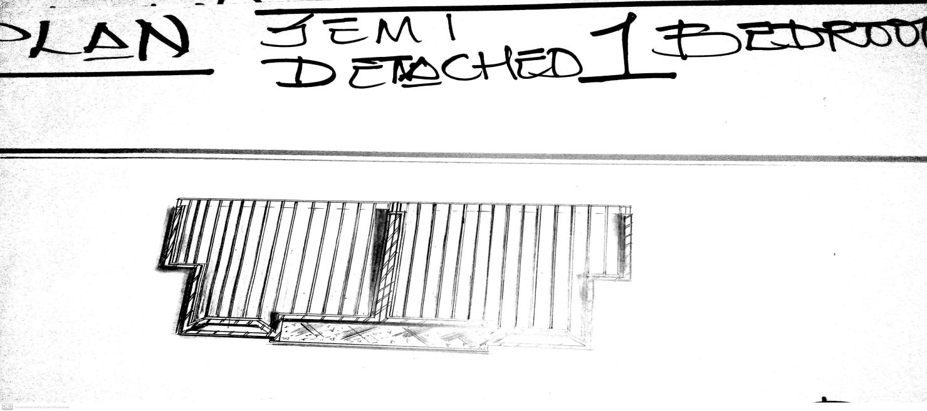
APPENDIX 10: FLOOR PLAN ONE BEDROOM SEMI DETACHED
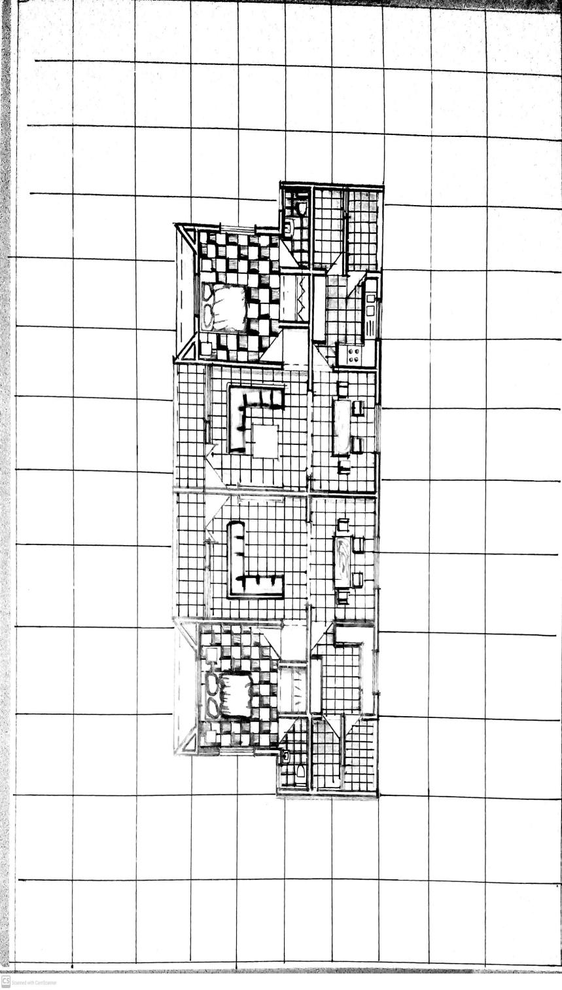
APPENDIX 9: SITE PLAN

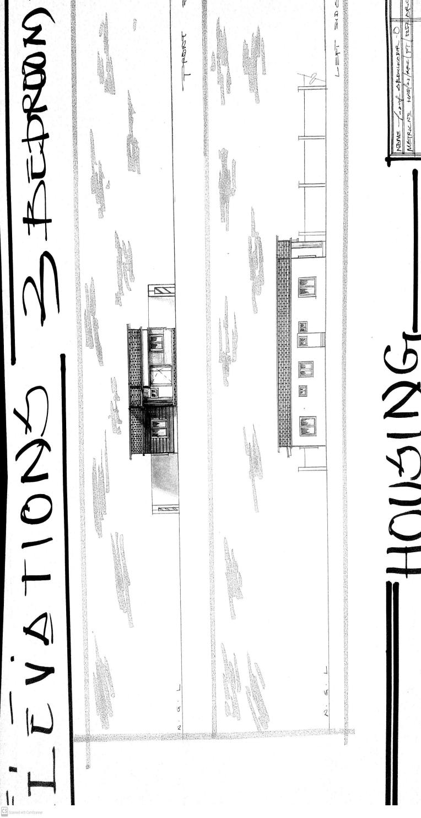
APPENDIX 14: ELEVATION FOR THREE BED ROOM BUNGALOW

APPENDIX 13: ELEVATION FOR TWO BED ROOM BUNGALOW

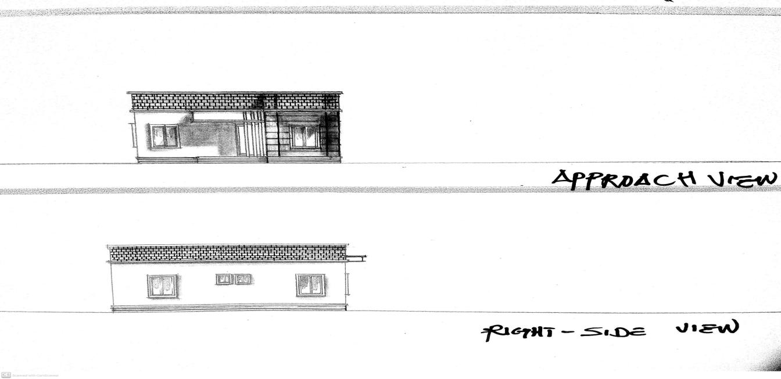
APPENDIX 12:ELEVATION FOR SEMI DETACHED 1 BED ROOM BUNGALOW
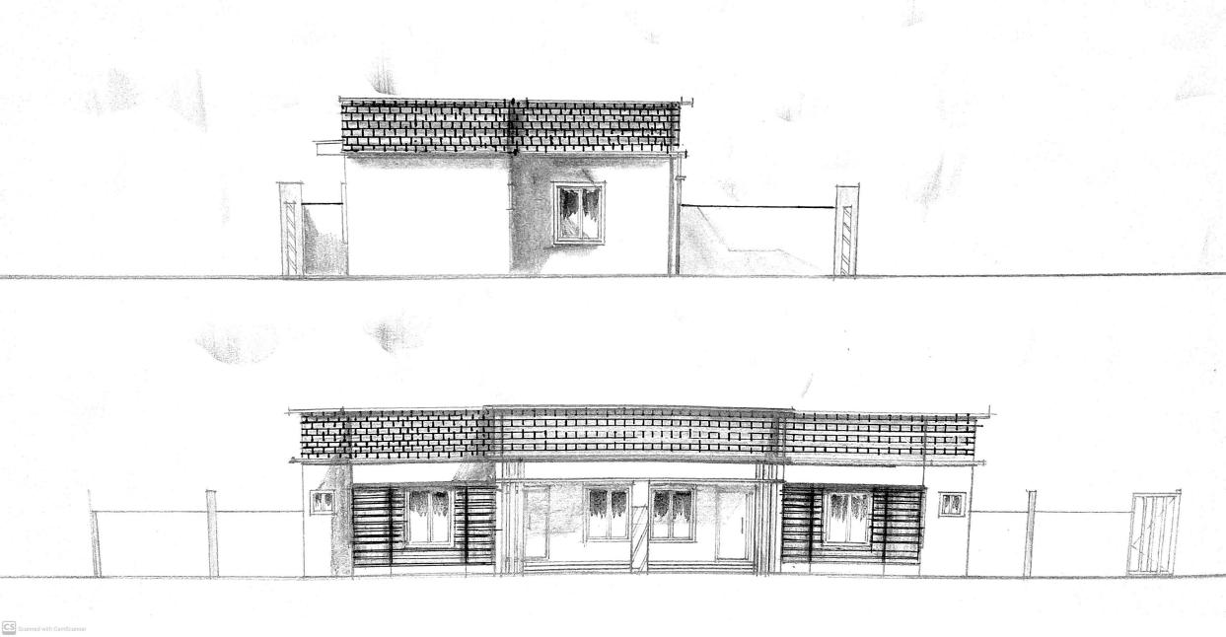
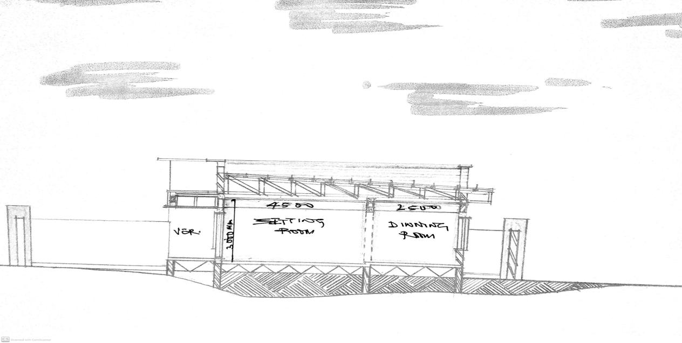
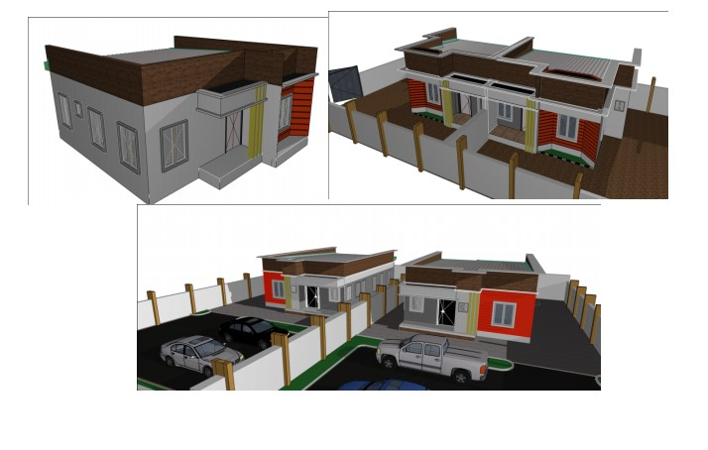
APPENDIX 15: SECTION FOR 1 BEDROM SEMI DETACHED BUNGALOW
APPENDIX 16: PERSPECTIVES

