A PROPOSED PROJECT REPORT
ON
CONDOMINIUM
FOR
ILORIN SOUTH LOCAL GOVERNMENT, GRA, ILORIN, KWARA STATE.
BY
AFIABOH BENEDICT
HND/23/ARC/FT/0058
SUBMITTED TO:

THE DEPARTMENT OF ARCHITECTURAL TECHNOLOGY
INSTITUTE OF ENVIRONMENTAL STUDIES (I.E.S)
KWARA STATE POLYTECHNIC, ILORIN.

IN PARTIAL FULFILLMENT OF THE REQUIREMENTS FOR THE AWARD OF HIGHER NATIONAL DIPLOMA (HND) IN ARCHITECTURAL TECHNOLOGY

JULY, 2025.

DECLARATION
I, Afiaboh Benedict, with matriculation number HND/23/ARC/FT/0058, hereby declare that this research project was carried out by me as part of the requirements for the award of Higher National Diploma (HND) in the Department of Architectural Technology, Kwara Stare Polytechnic, Ilorin, under the supervision of ARC. ADEYEMI F.O
I affirm that this work is original and has not been submitted, either in whole or in part, for the award of any other degree or diploma in this or any other institution.
All sources of information and data used in this research have been duly acknowledged.

________________________ ______________________
SIGNATURE DATE

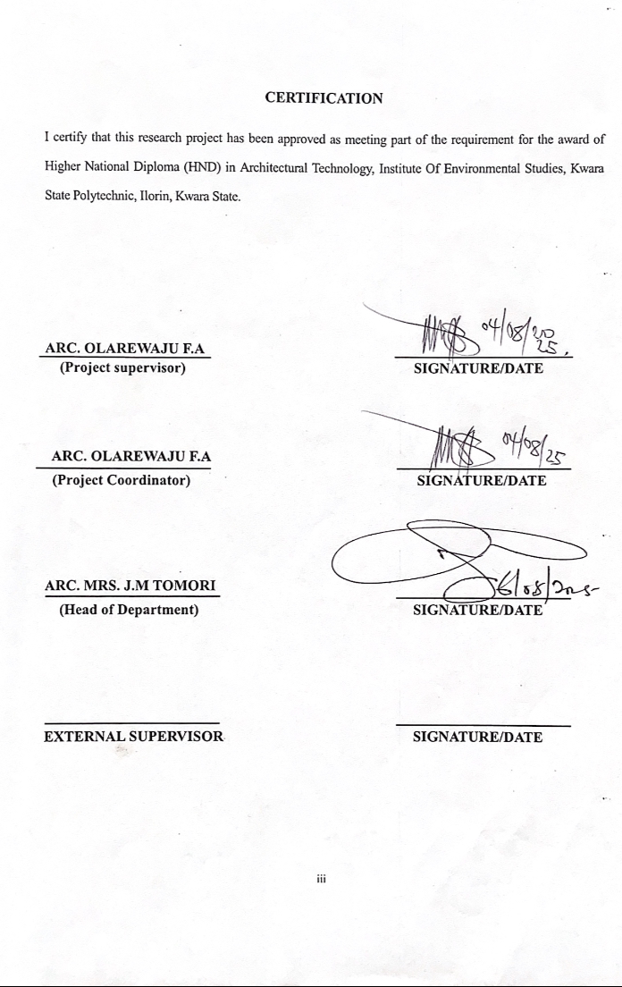

DEDICATION
I hereby dedicate this project research to God Almighty, whose grace and guidance have brought me to this stage. And to my beloved elder brother, Raymond Afiaboh, for his unwavering love, prayers, and support throughout my academic journey.

ACKNOWLEDGEMENT
First and foremost, I give all glory and thanks to God Almighty for the strength, wisdom, and grace to successfully complete this project.
I would like to express my sincere appreciation to my project supervisor, Architect Adeyemi F.O, for his guidance, constructive criticism, and consistent support throughout the course of this research.
My heartfelt gratitude goes to the entire academic and non-academic staffs of the Department of Architecture, whose teachings, encouragement, and academic support laid the foundation for this work. Your dedication and commitment to students success are deeply appreciated.
I also thank my parents and family for their endless love, prayers, and moral support. Your belief in me kept me going even during the most challenging times.
To my friends and colleagues, thank you for your collaboration, insightful discussions, and for sharing this journey with me.
Lastly, I acknowledge everyone who contributed in one way or another to the success of this project. Your support did not go unnoticed.

ABSTRACT

This project explores the design of a contemporary condominium building that integrates functionality, sustainability, and cultural relevance within an urban context. The increasing demand for high-density residential housing in growing cities like Ilorin has led to the proliferation of generic apartment blocks that often lack identity and connection to their environment.
This design seeks to address this issue by creating a condominium that not only meets modern living standards but also reflects the cultural and climatic characteristics of its region. The research examines spatial planning, material selection, and facade treatment as tools for achieving environmental efficiency and cultural expression.
Case studies of successful condominium developments were analyzed, and interviews with architects and potential residents were conducted to understand user preferences and local design values.
The resulting design proposal features modular apartment units, shared green spaces, efficient ventilation strategies, and natural facade elements. The project concludes that incorporating cultural identity and sustainable design principles in condominiums enhances both the living experience and the architectural character of urban housing.

TABLE OF CONTENT
Title Page
Declaration……………………………………………………………….……. ii
Certification ……………………………………………………………….…...iii
Dedication ……………………………………………………………………...iv
Acknowledgment ………………………………………………………………v
Table of content ………………………………………………………………...vi
List of plates…………………………………………………………………....vii
List of Tables………………………………………………………….……..…viii
Abstract ……………………………………………………………………….. ix
CHAPTER ONE:
1.0 General Introduction …………………………………………………..………………….1
1.1 Definition………………………………………………………………….………………2
1.2 Historical background of the project …………………………………….………………..2
1.3 Statement of design problem …………………………………………………………..….3
1.4 Aim and Objectives of the study…………………………………………………….…….4
1.5 Project justification …………………………………………………………….…………5
1.6 Clients background…………………………………………………………………….…..5
1.7 Scope of the study ………………………………………………………………………...6
1.8 Limitation of design………………………………………………………………….……9
1.9 Research Methodology ……………………………………………………………….….10
CHAPTER TWO:
2.0 Review of relevant Literature…………………………………………………. ….……...11
CHAPTER THREE
3.0 Case studies…………………………………………………………………………….….14
3.1 Selected case studies ……………………………………………………………………...14
3.2 Case study one……………………………………………………………...……………..15
3.3 Case study two…………………………………………………………….………………18
3.4 Case study three…………………………………………………………………………...22
3.5 Case study four………………………………………………………………………….…26
3.6 Case study five (online case study) ……………………………………………...………..29
3.7 Deduction from Case study ……………………………………………………...………..29
CHAPTER FOUR
4.0 Project location……………………………………………………………………….…....31
4.1 Historical background of selected location state …………………………………….....….31
4.2 Historical background of Selected location LGA………………………………………….32
4.3 Physical feature of the location ……………………………………………………………33
4.4 Population …………………………………………………………………………..…….33
4.5 Social service ……………………………………………………………………..………33
4.5.1 Road ……………………………………………………………………….……………...33
4.5.2 Health service ……………………………………………………………….…….………33
4.5.3 Water and electricity ……………………………………………………………………...34
4.6 General climatic condition ……………………………………………………….……….34
4.7 Site analysis …………………………………………………………………………….…35
4.7.1 Site selection/justification …………………………………….…………………………..35
CHAPTER FIVE
5.0 Design report………………………………………………………………………………42
5.1 Design brief ……………………………………………………………………………..42
5.2 Design analysis …………………………………………………………………………42
5.3 Design appraisal …………………………………………………………………………45
5.4 Design characteristics ……………………………………………………………………..45
5.5 Building structure ………………………………………………………………………….47
5.6 Service ………………………………………………………………………………….....48
5.7 General requirement ……………………………………………………………………….48
5.7.1 Lighting ………………………………………………………………………….………...48
5.7.2 Orientation …………………………………………………………………………..…….49
5.7.3 Rain protection devices ……………………………………………………………..…….50
5.7.4 Noise control device ……………………………………………………………….……...50
5.8 Material and finishes ………………………………………………………………………51
5.9 Summary and conclusion …………………………………………………………….……54
6..0 Summary …………………………………………………………………………………..54
6.1 Conclusion …………………………………………………………………………………54
References ………………………………………………………………………………………56
Appendix

LIST OF PLATES
Location plan….……………………………………………………………………….38
Site inventory…………………………………………………………………………..38
Site analysis………………………………………………………………………….…39
Functional relationship…………………………………………………………………43
Space calculation.………………………………………………..……………………..44
Site plan ………………………………………………………………………………..58
Floor plan administrative building …………………………………………………59-60
Roof plan ………………………………………………………………………………60
Elevations……………………………………………………………………………….61
Floor plan workshop building I…………………………………………………………62
Roof plan ……………………………………………………….………..……………..63
Section ………………………………………………………………………………64-65
Elevations ………………………………..……………………………………….…65-66
LIST OF FIGURES
Fig. 4.0: Map of Africa showing Nigeria………………………………………..……..42
Fig 4.1: Map of Nigeria showing Lagos ………………………………………………46
Fig 4.2: Map of Lagos State……………………………………………………...…….51
Fig 4.3: Site Location map…..…………………………………………………………56
Fig 4.4: Site Analysis of the Proposed site……..………………………………………65
Fig 4.4: Climatic Graph of Lagos State……..…….……………………………………65
Fig 4.4: Flow Chart and Bubble diagram………………………………………………65

CHAPTER ONE
1.0 GENERAL INTRODUCTION
A Condominium, commonly referred to as “Condo”, is a type of residential property that consists of individually owned units within a large complex or building combined with shared ownership of common areas and amenities. Popular in urban areas, Condominiums are managed by Home Owner Association (HOA) that oversees maintenance. Condominiums cater to diverse demographics, including young professionals, small families, retired retirees and investors. They are designed to provide a comfortable, secure and affordable living environment, often located in proximity to workplaces, schools, business districts and entertainment hubs.
In the dynamic evolution of urban development and modern residential architecture, the Condominium building stands as a prominent symbol of both efficiency and luxury in housing solutions. As cities become more densely populated and land value rises, the need for innovative, space-saving and community-oriented housing has grown significantly.
From a development perspective, Condominium buildings represent a strategic use of vertical space, often built in prime urban location close to business districts, transportation hubs, schools and recreational facilities. This strategic siting increases their attractiveness for residents who value accessibility and convenience. Moreover, the architectural and structural design of Condominium buildings often emphasizes modern aesthetics, energy efficiency, sustainability and smart technology integration, reflecting the changing tastes and environmental consciousness of today’s urban dwellers.
In summary, the Condominium building is more than a mere structure; it is a lifestyle model that responds to contemporary urban challenges while promoting efficiency, community and modern living standards. Its continued popularity and adaptability makes it a key feature in the future of residential development in cities across the globe.

1.1 DEFINITION OF CONDOMINIUM
A condominium is a residential building or complex composed of individual units, with shared ownership of common areas and amenities such as hallways, lobbies, stairwells and recreational spaces.
Architecturally, it is designed to optimize space, often through vertical construction in urban settings while integrating modern aesthetics and functionality. (Golland & Blake, 2004)
1.2 HISTORICAL BACKGROUND OF THE PROJECT
The term “Condominium” originated from the Latin words “Con” (Together) and “Dominium” (Ownership). The first legal framework for condominiums was established in Pueto Rico in 1958 with the passage of horizontal property act. This model quickly spread to the United States, where the Federal Housing Administration (FHA) supported it in the 1960s to address housing shortages and promote home ownership.
The concept of shared property ownership, which forms the foundation of the modern condominium model, has existed in various forms throughout history. Although the term “condominium” is relatively recent in legal and architectural usage, the principles underlying communal ownership and individual dwelling rights have roots that can be traced back to ancient civilizations.
One of the earliest examples of multi-unit residential living can be found in ancient Rome, where insulae (Latin for “islands”) served as apartment-style housing for urban residents, particularly the working class. These structures often rose several stories high and featured stacked individual living units, with shared facilities like water sources and latrines. While not condominiums in the modern legal sense, insulae reflected the early need for efficient urban housing within shared structures.
Similarly, in ancient Egypt, Greece, and parts of Asia, there were instances of communal land use and cooperative dwellings, although formal property rights over individual units were not established in the way they are today. The idea of cohabiting structures with delineated personal spaces has existed in various traditional societies, often under communal or feudal ownership models.
1.3 STATEMENT OF DESIGN PROBLEM
Many condominiums face challenges related to overcrowding, inadequate maintenance, poor space utilization, and a lack of cohesive community planning, leading to a decline in residents’ quality of life and property value over time. In urban areas, condominiums have become a common housing solution due to limited land space and growing populations. However, many of these buildings suffer from poor architectural planning, inadequate communal amenities, and unsustainable management structures. As a result, residents often face issues such as noise pollution, limited parking, inefficient waste disposal systems, and deteriorating facilities.
The root cause of these issues often lies in the lack of an integrated design and management approach during the planning and post-construction phases. This includes insufficient stakeholder engagement, poor regulatory enforcement, and an absence of long-term sustainability and community integration strategies. An ideal condominium should offer residents a harmonious living experience through efficient space planning, adequate amenities, effective facility management, and sustainable design. It should support a sense of community while maintaining safety, privacy, and comfort.
I’m proposing to implement a holistic design and management framework that integrates sustainable architecture, community centered planning and smart facility management systems.

1.4 AIM AND OBJECTIVES
To design an efficient, functional and aesthetically pleasing condominium.
OBJECTIVES
- To design functional layouts that meets diverse needs in a condominium.
- To design an energy efficient condominium that is eco-friendly.
- To design a visual appealing structure that enhances the surrounding environment.
1.5 PROJECT JUSTIFICATION
The design of a condominium building in the city of ilorin is a strategic response to urban growth, land management and the increasing demand of affordable housing. With limited land available in key areas such as Tanke, Fatè and GRA, vertical development through condominiums ensures efficient land use and supports compact city planning.
As part of Kwara State’s smart city initiative, condominiums provide an opportunity to integrate smart infrastructure—such as solar power, smart meters, and centralized waste systems—promoting sustainability and modern living. In addition, condominiums simplify urban management by concentrating housing units, allowing for more effective service delivery, infrastructure maintenance, and planning. This makes them a practical and forward-thinking solution for Ilorin’s future development.
1.6 CLIENT’S BACKGROUND, PHILOSOPHY, OPERATIONAL STRUCTURE AND GOAL OF THE PROPOSAL
Ilorin South is one of the sixteen (16) Local Government Areas in Kwara State, Nigeria. Strategically located in the heart of the Kwara State capital, it is home to a rapidly growing population and key public institutions. With neighborhoods such as Fate, Pipeline, and the Agba Dam axis, Ilorin South serves as a vital hub of residential, commercial, and administrative activity. The LGA covers a mix of urban and peri-urban communities, making it a prime location for structured housing development.
Despite its centrality and population growth, Ilorin South LGA is in urgent need of well-planned residential infrastructure to meet the rising demand for quality, affordable housing. A modern condominium estate will not only address the area’s housing shortage but also redefine the architectural character of the community. It will serve as a focal point for social stability, economic activity, and modern urban living.
1.7 SCOPE OF THE STUDY
Numerous residential, recreational and communal activities take place within a condominium building. The scope of this project is limited to a thorough study on the adequate provision of functional residential units and supporting facilities that make up a standard modern condominium. The design will emphasize space efficiency, comfort, privacy and social interaction, catering to a diverse range of occupants such is individuals, couples and large families.
The development will reflect a contemporary urban lifestyle with considerations of sustainability smart technology integration and community living. Facilities provided within the condominium will cater for daily living, relaxation, wellness and basic services to the quality of life of the residents.

- The facilities to be provided in the condominium development will include;
- Residential Apartments
- Reception
- Lounge
- Gymnasium
- Swimming pools
- Outdoor kid’s playground
- A tennis court
- Rooftop Terrace
- Business Centers
- Retail spaces
- Shopping mall
- Clinic
- Management and security offices
- Laundry rooms
- Utility
- Waste disposal and recycling area
- Car parking areas
- Water storage and supply system
- Access control and security area
- Elevators and emergency stairwells

1.8 LIMITATION TO DESIGN
While conducting research for the design and planning of the building several challenges were encountered, these factors affected the depth, scope and efficiency of my research.

- Limited Access to Information: Access to detailed architectural floor plans, construction documents and past occupancy evaluation of the existing condominiums were restricted due to privacy policies proprietary restrictions.
- Technical Knowledge Limited: Some stake holders, particularly residents and users lacked the technical knowledge to articulate architectural or design related issues in detail. This posed a challenge in interpreting their feedback accurately.
- Environmental and Physical Barriers: Site visits were occasionally hindered by environmental factors such as poor weather conditions and accessibility issues especially in high density urban areas like Lagos. Physical barriers such as restricted entry to certain condominium premises also limited on-site observation and interaction with residents.
1.9 RESEARCH METHODOLOGY
Various avenues were explored as regard the method of research in order to arrive at a functional and appealing design concept. The following research methods were employed.
Literature review: reference to tolerance for ideas of various writer were consulted in order to attain useful and important past thesis work on similar project.
Oral interview: practicing architects, engineers, allied professional as well as students of various schools were interviewed and better deduction from their information sources also influence the end design.
Personal observation: personal initiations coupled with inquisitive measure, interviewed and visitation was made in order to actually visualize the daily activities that take place within the required motive.
Case study: This involves the thorough synthesis and analysis of similar existing structure building based on the data collected and better seduction was made for realization of the design best.

CHAPTER TWO
2.0 REVIEW OF RELEVANT LITERATURE
2.0.1 Review of literature on building type (Condominium)
Condominiums, also known as strata titles or shared-ownership housing units, represent a vital component of contemporary residential development globally and have gained prominence in Nigeria’s urban landscape. As urban populations rise and available land becomes scarcer, especially in metropolitan regions like Lagos, Abuja, and Port Harcourt, condominiums have emerged as a viable solution to high-density housing demands.

However, the architectural design of modern condominiums in Nigeria often follows standardized, functional templates driven by economic considerations, construction efficiency, and developer profitability. These designs typically adopt international or Western-style aesthetics with limited regard for the cultural context of their users. Research by Olotuah (2016) and Lawanson (2005) points out that most residential developments in Nigeria fail to incorporate indigenous architectural expressions, leading to physical environments that feel alien to the occupants and disconnected from their cultural roots.

Several scholars have advocated for a shift towards culturally responsive design approaches in the residential sector. The incorporation of traditional elements—such as courtyard typologies, compound-like layouts, and symbolic ornamentation—can significantly contribute to a stronger sense of place and community. In this regard, the theory of “critical regionalism” (Frampton, 1983) offers a framework for mediating between universal architectural modernism and specific cultural contexts. By responding to both local climate and cultural traditions, designers can create condominium environments that reflect the socio-cultural realities of Nigerian society.

Unfortunately, most existing literature focuses on cultural identity in individual housing or traditional compounds, with minimal application to multi-unit housing such as condominiums. This gap calls for more targeted research on how to translate principles of vernacular architecture into medium- and high-density condominium developments, particularly in rapidly urbanizing African contexts.
2.0.2 Variants and classification of condominium types
Condominiums are not monolithic in form or function; they exist in various typologies and classifications based on structural height, user demographics, spatial configuration, and ownership model. Structurally, condominiums may be categorized into low-rise (typically 1–3 stories), mid-rise (4–7 stories), and high-rise (8 stories and above). Each category addresses different market needs and urban conditions. For instance, high-rise condominiums are becoming common in densely populated urban cores like Victoria Island and Lekki in Lagos, where land values are exorbitantly high. Mid-rise and low-rise developments, conversely, are prevalent in peri-urban areas and secondary cities such as Ibadan and Enugu, where land availability is relatively more generous.

From a functional perspective, condominiums can be classified into residential-only and mixed-use developments. Mixed-use condominiums often integrate commercial units—such as shops, cafés, or co-working spaces—at the lower levels, enhancing accessibility and livability. Gated condominium communities, characterized by controlled access and shared amenities, have also become popular in Nigeria due to concerns about safety, security, and social exclusivity.

Another emerging variant in Nigeria is the co-housing model, where residents share communal facilities such as kitchens, dining areas, gardens, and recreational spaces while maintaining private apartments. This model aligns with the communal lifestyle traditionally observed in many Nigerian cultures, suggesting a possible convergence between modern and indigenous housing principles.

Ownership patterns also vary. While most Nigerian condominiums operate under a freehold or leasehold system, some developers are introducing fractional ownership and cooperative schemes to improve affordability. These evolving typologies demonstrate how the condominium model is being adapted to meet Nigeria’s complex housing needs. However, classification remains informal and inconsistent, highlighting the need for regulatory clarity and standardized typologies to guide future development.
2.0.3 Functions and Spatial Relationship
Condominium housing typically balances private and communal spatial elements, and the functional relationship between these spaces plays a vital role in determining the quality of life for residents. Private units usually consist of living spaces—bedrooms, living/dining areas, kitchens, and bathrooms—while communal areas range from corridors, staircases, and elevators to recreational and service facilities such as gyms, pools, lobbies, and parking garages.

The effectiveness of a condominium’s spatial layout depends on the efficiency of circulation systems, zoning of public and private areas, and accessibility. Vertical circulation, particularly in high-rise structures, must be strategically placed to minimize walking distances and reduce crowding. Core systems that house elevators, stairwells, and utility shafts are often centrally located for maximum coverage.

Zoning is another critical element in condominium design. Public areas like lobbies and lounges are typically situated on the ground floor for accessibility, while residential units are located above, arranged to ensure privacy and minimize noise transmission. Service areas (such as garbage chutes, mechanical rooms, and utility closets) are positioned for ease of maintenance and proximity to vertical shafts.

Innovations in spatial planning have emerged in response to challenges posed by high-density living. For instance, rooftop gardens, internal courtyards, and balconies provide much-needed green space and access to natural light and ventilation. Shared amenities, such as laundry rooms, community halls, and playgrounds, also contribute to a sense of community. When well-designed, these shared spaces enhance social interaction and foster a communal identity—an essential aspect in multi-unit dwellings.

However, in many Nigerian condominiums, poor spatial planning, overcrowding, and neglect of communal spaces have led to dissatisfaction among residents. Literature advocates for a more holistic design approach that incorporates user feedback, local climate considerations, and cultural preferences into the spatial layout.
2.0.4 Technological and Environmental Approaches
Contemporary condominium design has been significantly shaped by advances in construction technology and growing environmental concerns. In Nigeria, where climate extremes, power instability, and material scarcity present unique challenges, developers must balance modern technology with practical, sustainable solutions.

Technologically, the construction of condominiums often relies on reinforced concrete frames, steel reinforcements, and precast systems that speed up delivery while reducing costs. Mechanical and electrical systems—such as elevators, air-conditioning, firefighting installations, and plumbing networks—are integrated into building cores for efficiency. In high-rise structures, the use of Building Management Systems (BMS) is becoming more common, allowing for automated control of lighting, ventilation, and security.

However, technological implementation faces serious limitations in Nigeria due to inadequate infrastructure, erratic power supply, and poor maintenance culture. As a result, passive design strategies are essential. These include orientation for natural ventilation, strategic window placement for daylighting, and use of shading devices such as louvers and deep overhangs.
Environmental sustainability is a growing concern in condominium development. Literature recommends the use of green roofs, rainwater harvesting systems, and solar power to reduce dependence on public utilities. Locally sourced materials like laterite blocks, adobe, bamboo, and recycled timber offer ecological and economic advantages. These materials not only reduce carbon footprints but also support local economies and enhance cultural relevance.
Innovative developers in cities like Lagos are beginning to integrate off-grid solar systems, inverter backup power, and borehole-based water supply into their projects. Despite these efforts, regulatory and financial barriers often limit widespread adoption. There is a need for government incentives and professional training to encourage the use of environmentally responsible technologies in residential construction.
2.1 Review of Literature on the Sub-Topic: Cultural Identity in Condominium Design
2.1.1 Understanding the Sub-Topic
Cultural identity in architecture refers to the expression of a community’s values, beliefs, and heritage through built form. In Nigeria—a country with over 250 ethnic groups—architecture has historically served as a medium for storytelling, social organization, and environmental adaptation. Traditional housing types, such as the Yoruba compound, the Tiv roundhouse, and the Hausa walled family compound, reflect deep social meanings and are intricately tied to indigenous knowledge systems.
In contrast, modern condominium developments often exhibit generic designs devoid of cultural symbolism. This disconnect can lead to social alienation, reduced community cohesion, and a diminished sense of place. Scholars such as Rapoport (1969) and Frampton (1983) argue that architecture should be rooted in the socio-cultural and environmental context of its users. The theory of “vernacular modernism” suggests that modern design can coexist with traditional elements, forming a hybrid architectural language that is both progressive and grounded.

The literature on Nigerian vernacular architecture offers rich insights into spatial logic, material culture, and communal living patterns that could inform contemporary condominium design. For instance, the use of courtyards as social hubs, compound housing layouts that promote extended family living, and symbolic decorative elements like carved doors and patterned facades are all culturally significant features that could be reinterpreted in multi-unit housing.
2.1.2 Issues, Problems, and Relevance
The marginalization of cultural identity in modern housing presents several challenges. Without deliberate efforts to reflect cultural values, residential buildings risk becoming sterile environments that fail to foster emotional connection or communal belonging. In the Nigerian context, many condominiums are designed by foreign architects or follow templates developed for other climates and cultures, resulting in homes that are climatically inappropriate and socially unresponsive.

Key problems include:
• Lack of communal spaces that mirror traditional gathering areas.
• Absence of decorative motifs or architectural symbolism rooted in local tradition.
• Inadequate climate responsiveness, such as poor ventilation or excessive heat gain due to Western-style glazing.
• Social fragmentation, as the design neglects opportunities for interaction and collective identity.

Cultural integration can help address these issues. Several Nigerian architects and scholars are exploring ways to blend modern functional requirements with cultural aesthetics. For example, Arayela (2012) proposes using indigenous materials in contemporary housing to promote sustainability and identity. Similarly, Nnamdi Elleh emphasizes the importance of cultural narratives in shaping urban form.

The relevance of this sub-topic lies in its potential to foster identity, social cohesion, and emotional well-being. As Nigerian cities become increasingly diverse and dense, creating housing that respects and celebrates cultural heritage becomes not just desirable, but necessary. Culturally sensitive condominiums can contribute to national pride, enhance architectural diversity, and provide residents with a deeper sense of ownership and belonging.
CONCLUSION
The literature reviewed highlights the complex interplay between functional efficiency, technological innovation, environmental responsibility, and cultural expression in condominium design. While Nigerian developments have made strides in addressing urban housing demand, the neglect of cultural identity remains a critical gap. Bridging this divide requires a multidisciplinary approach that draws from architectural theory, vernacular knowledge, and contemporary needs. As the country continues to urbanize, rethinking condominium design through a cultural lens could redefine the future of residential architecture in Nigeria.
CHAPTER THREE
3.0 CASE STUDIES
  - KINGSWAY TOWER ALFRED REWANE WAY (FORMERLY KINGSWAY ROAD), IKOYI, LAGOS, NIGERIA.
  - DAKKADA TOWER 74 WELLINGTON BASSEY WAY, UYO, AKWA IBOM STATE, NIGERIA.
  - 4. BOURDILLON TOWER, 4 BOURDILLON ROAD, IKOYI, LAGOS, NIGERIA.

  - CENTRAL PARK TOWER NO.225 WEST 57TH STREET, MIDTOWN MANHATTAN, NEE YORK, USA.
  - THE BURJ KHALIFA TOWER NO.1 SHEIKH MOHAMMED BIN RASHID BOULEVARD, DOWNTOWN DUBAI, DUBAI, UNITED ARAB EMIRATES.
3.1. CASE STUDY ONE
KINGSWAY TOWER ALFRED REWANE WAY (FORMERLY KINGSWAY ROAD), IKOYI, LAGOS, NIGERIA.
BRIEF INTRODUCTION
Kingsway Tower is a prominent 15-storey Office and Miss use development located on Alfred Rewane Lagos. Completed in 2020, The building was designed by SAOTA (Stefon Antoni olmoeshdahl truen architects) and developed by Sky View Tower Limited. The structure includes 13.317 square meters of office space, ground floor retail areas. It also boast of 337 parking bays, catering for both tenants and visitors. Notably the building employs sustainable design strategies such as shading screens, planters and natural ventilation, addressing Lagos’ tropical climate and infrastructural challenges.
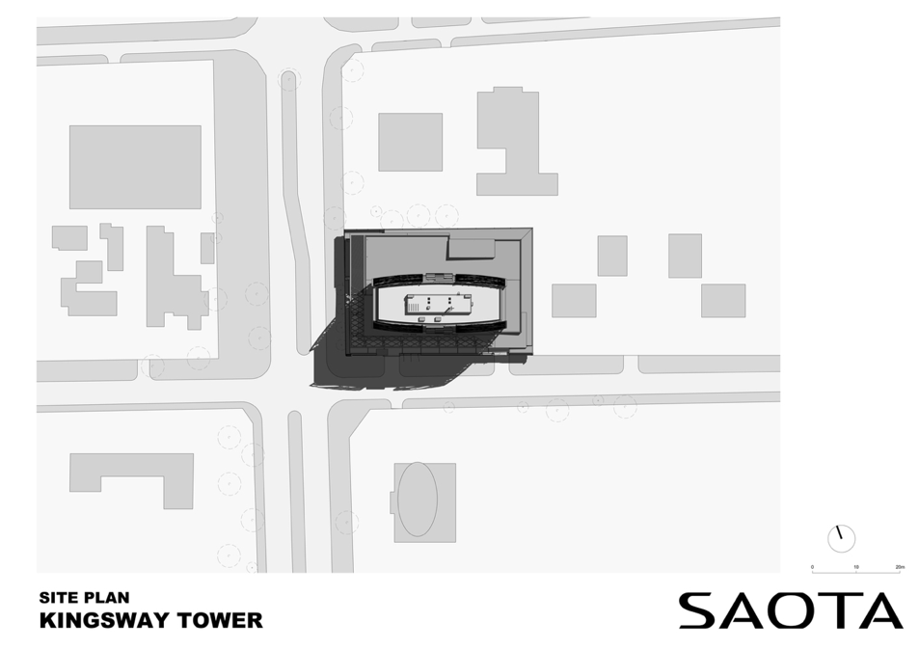
FIG 3.1:- SITE PLAN

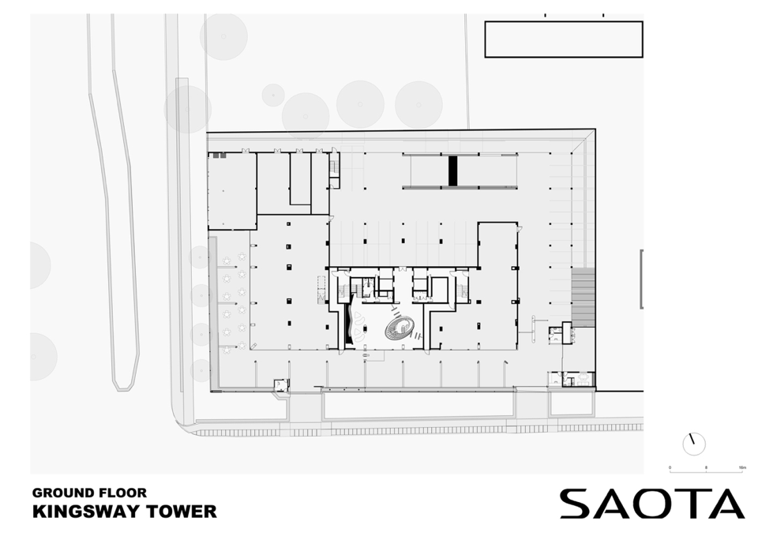
FIG 3.2:- GROUND FLOOR PLAN

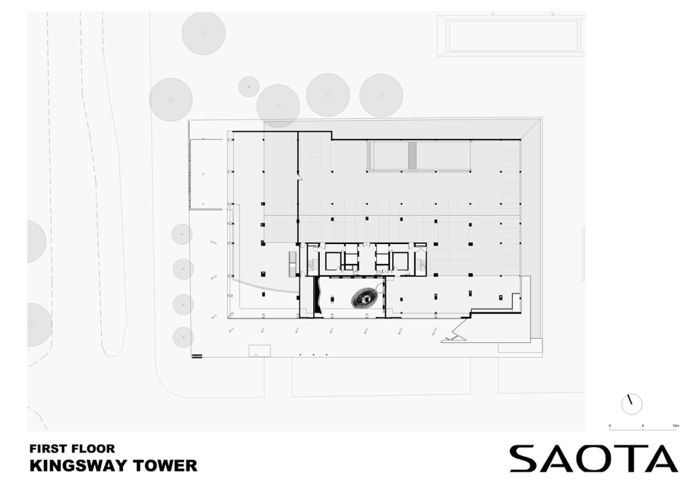
FIG3.3:- FIRST FLOOR PLAN
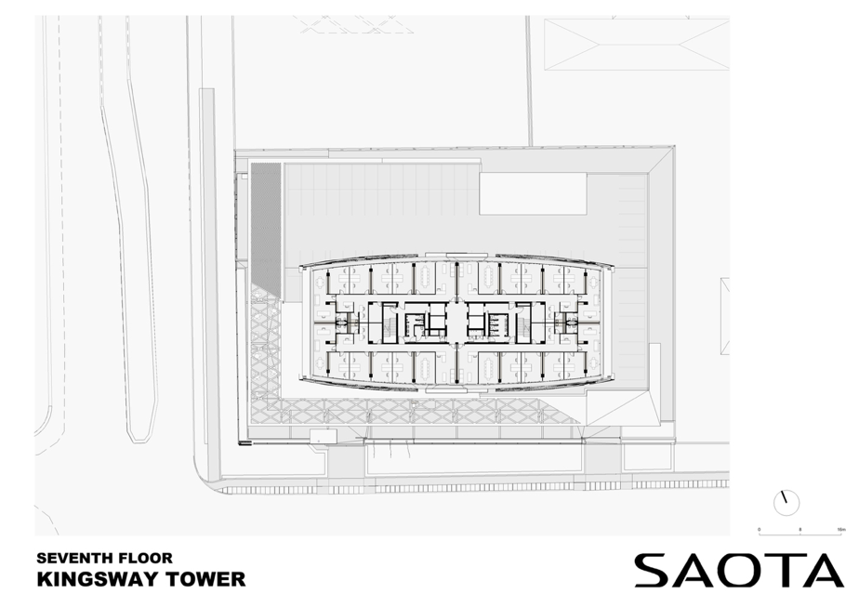
FIG 3.4:- SEVENTH FLOOR PLAN
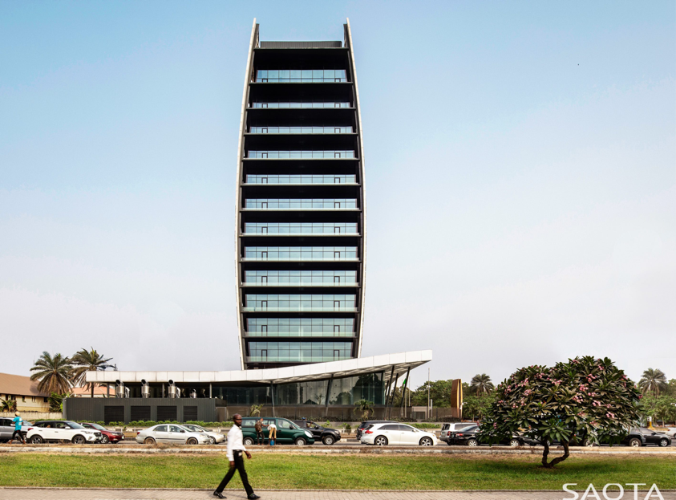
PLATE 3.1:- SIDE VIEW

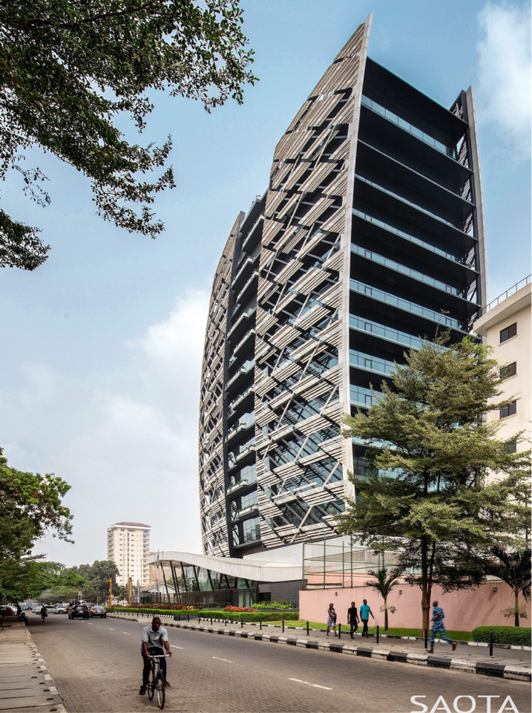
PLATE 3.2:- FRONT VIEW

3.1.1 MERITS
- The building features an aesthetically striking facade inspired by local climate and cultural elements
- The design emphasizes more on openess and connectivity, this challenge the typical “closed” architecture in Nigerian.
- The design incorporates passive energy solution like shading devices that reduces the need for air conditioning.

3.1.2 DEMERITS
- The need for maintenance will be high and requires high cost due to the advanced shading devices and ventilation.
- The heavy use of glass increases solar heat absorption leading to high cooling demands.
- The reflective surface causes visual discomfort for occupants and passersby.

3.2 CASE STUDY TWO
DAKKADA TOWER 74 WELLINGTON BASSEY WAY, UYO, AKWA IBOM STATE, NIGERIA.
BRIEF INTRODUCTION

The Dakkada tower in Uyo, Akwa Ibom stands as an architectural and economic symbol for the region. Completed in December 2020, the 20 storey skyscraper is the tallest building in the south-south region of Nigerian at 108.8 meters high. The project managed by VKS construction limited , began in 2017 and features state-of-the-art facilities, including office spaces designed for international organizations alongside ground-floor spaces for banks and restaurants.

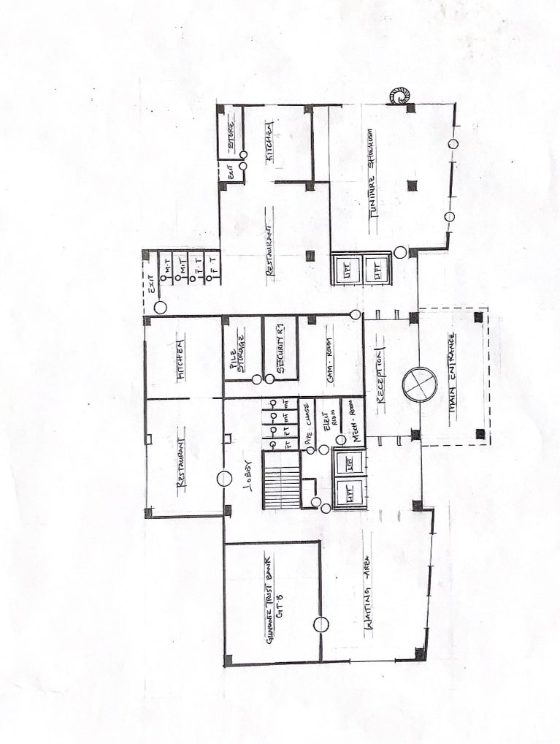
FIG 3.5:- FLOOR PLAN

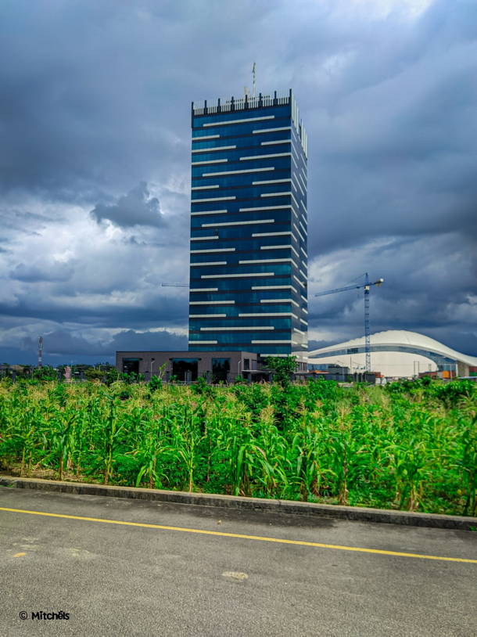
PLATE 3.3:- FRONT VIEW
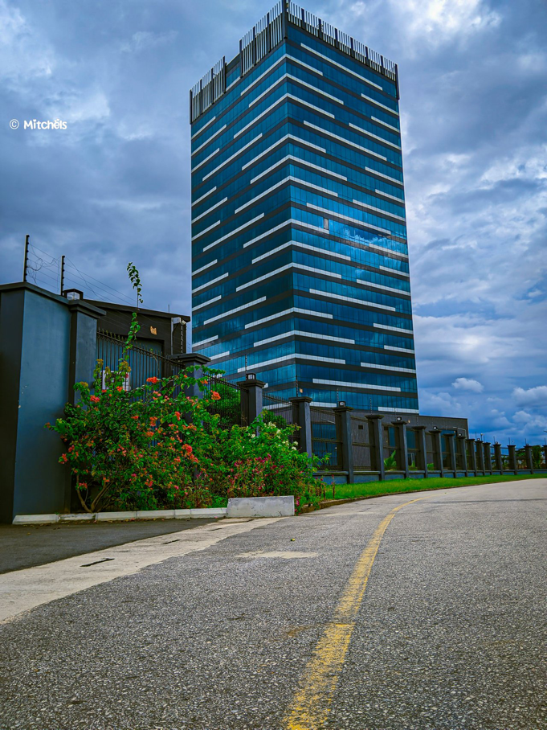
PLATE 3.4:- SIDE VIEW
3.2.1 MERITS
- The stands as a landmark of modern architecture
- The building enhances the skyline of the area
- The building is equipped with reinforced concrete and steel to handle the region’s climate conditions such as high wind,
3.2.2 DEMERITS
- The extensive glass facade leads to significant solar heat gain
- The ultra-modern architectural style lacks cultural elements that reflects the Akwa Ibom heritage.
- The building requires a stable electricity supply due to it’s advanced system

3.3 CASE STUDY THREE
4 BOURDILLON TOWER, 4 BOURDILLON ROAD, IKOYI, LAGOS, NIGERIA.

BRIEF INTRODUCTION
4- Bourdillon is a luxury residential high rise building know for it’s sophistication and architectural prominence. Completed in 2020, the building was developed by KAZEN PROPERTIES and EL-ALAN CONSTRUCTION GROUP, both known for their contribution to upscale real estate sector. The twin-tower structure stands 103 meters tall with 25 floors, making it one of the tallest residential buildings on Nigeria.

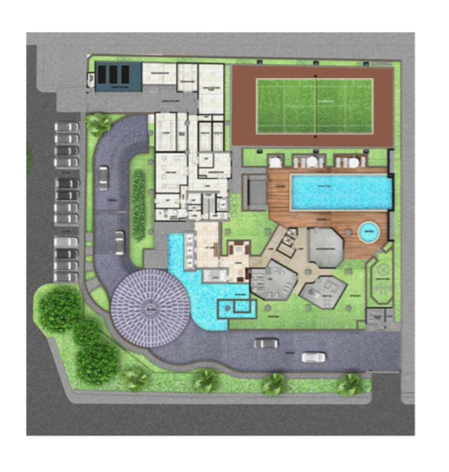
FIG 3.6:- SITE PLAN
SOURCE:- Researcher Field work 2024

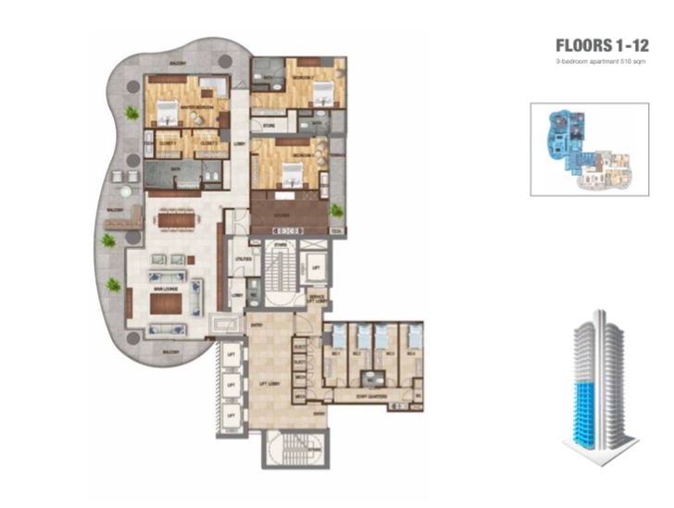

FIG 3.7:- FLOOR PLAN
SOURCE:- Researcher Field Work, 2024

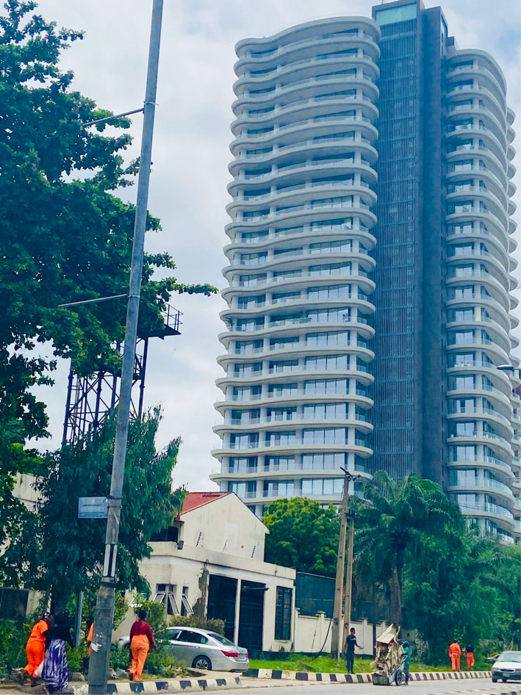
PLATE 3.6:- FRONT VIEW

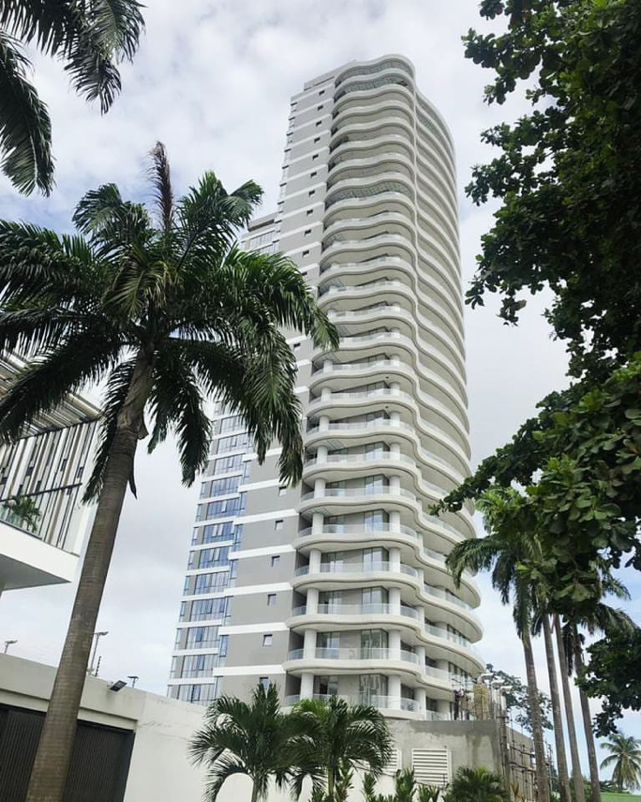
PLATE 3.7:- SIDE VIEW

3.3.1 MERITS
- The apartments in the building are exceptionally large with sizes from 51sqm to 1135sqm.
- The building provides a breathtaking view in the vicinity
- The L-shaped layout allows for natural daylight and cross ventilation
3.3.2 DEMERITs
- There are limited green spaces around the building
- The extensive use of glass can cause discomfort the occupants and surrounding areas due to excessive glare.
- The luxury-oriented design prioritize aesthetics over optimal space utilization.

3.4 CASE STUDY FOUR [ONLINE CASE STUDY)
CENTRAL PARK TOWER NO.225 WEST 57TH STREET, MIDTOWN MANHATTAN, NEE YORK, USA.
BRIEF INTRODUCTION
Central park tower is a modern architectural marvel and rhe world’s tallest residential building at 1550 feet (472 meters). Designed by ADRIAN SMITH & GORDON GILL ARCHITECTURE, it embodies sleek minimalism with reflective glass facade and stepped terraces to maximize views of central park. Built between 2014 and 2019, the structure features advanced engineering, including a composite and tuned mass damper of stability.

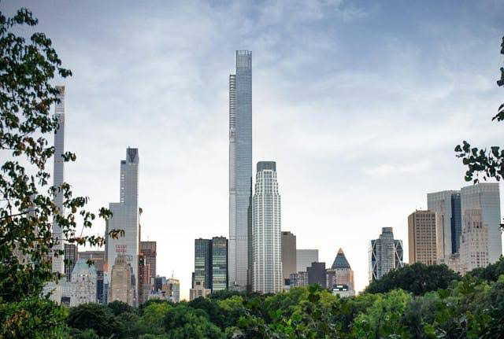
PLATE 3.10:- METAL WORKSHOP
SOURCE:- Researcher Field Work, 2024

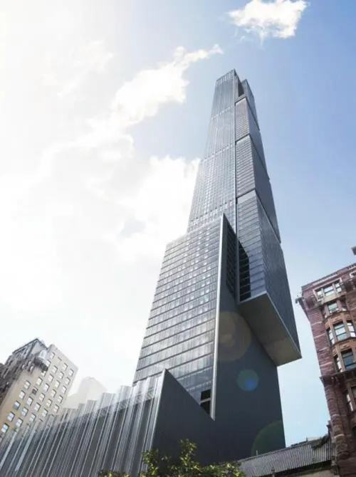
PLATE 3.11:- FRONT VIEW
SOURCE:- Researcher Field Work, 2024

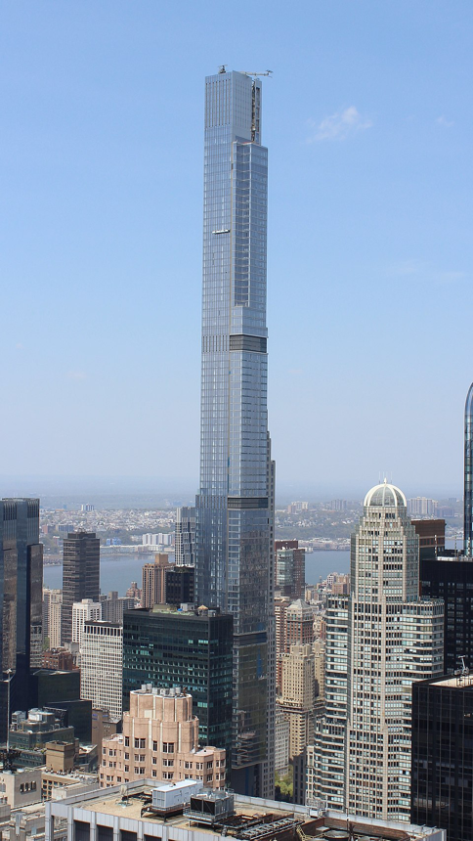
PLATE 3.12:- ARIAL VIEW

3.4.1 MERITS
- Super-Slender Design – Innovative engineering allows extreme height on a small footprint.
- Prime Location – Offers unmatched views of Central Park and Manhattan skyline.
- Luxury Integration –High-end design with exclusive amenities (e.g., Nordstrom flagship, private club)
3.4.2 DEMERIT
1. Wind Sway Issues – Slender form makes it more susceptible to motion discomfort.
2. Access Inequality – Separate entrances for luxury residents vs. retail/public areas.
3. Context Disruption – Overwhelms surrounding skyline and casts long shadows on Central Park.
3.5 CASE STUDY FIVE [ONLINE CASE STUDY 2]
.THE BURJ KHALIFA TOWER NO.1 SHEIKH MOHAMMED BIN RASHID BOULEVARD, DOWNTOWN DUBAI, DUBAI, UNITED ARAB EMIRATES.
BRIEF INTRODUCTION:
The Burj Khalifa, located in dubai, UAE was designed by Adrian Smith and built by EMAAR PROPERTIES, it’s construction began in 2004 and was completed in 2010. The tower features a Y-shaped design inspired by the hymenocallis flower and incorporates islamic architectural elements. It uses advanced engineering, including buttressed core system and fast elevators to address challenges like wind resistance. Originally named Burj Dubai, it was renamed Burj Khalifa to honor the UAE president,
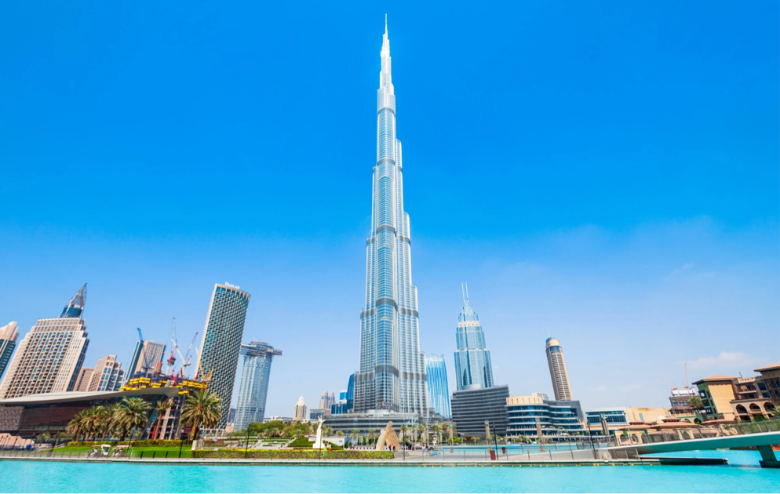
PLATE 3.15:- FRONT VIEW
SOURCE:- GOOGLE

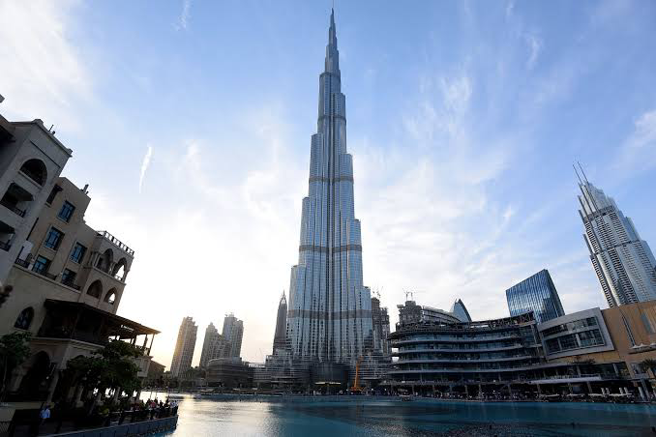
PLATE 3.16:- BACK VIEW
SOURCE:- GOOGLE
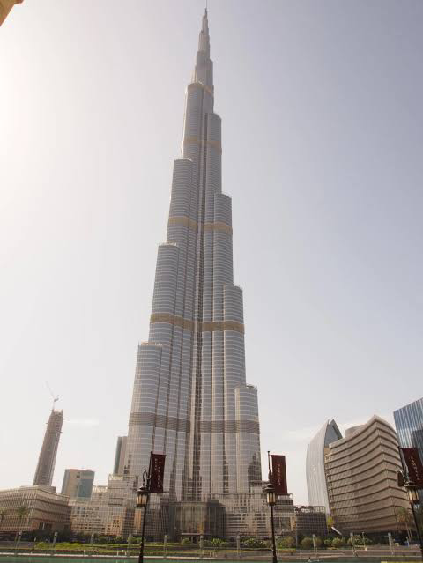
PLATE 3.17:- SIDE VIEW
SOURCE:- GOOGLE

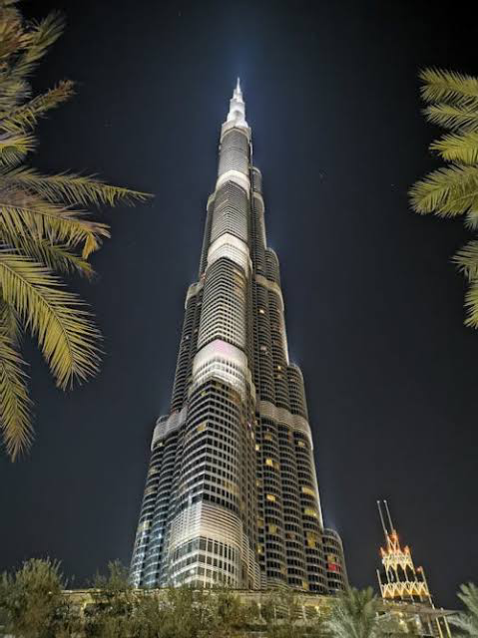
PLATE 3.18:- EXTERNAL VIEW
SOURCE:- GOOGLE
3.5.1 MERITS
1. Innovative Design – Buttressed core structure ensures stability at extreme heights.
2. Iconic Aesthetic – Inspired by Islamic architecture; globally recognizable.
3. Mixed-Use Efficiency – Combines hotel, residential, office, and observation spaces.

3.5.2 DEMERIT
1. Low Space Efficiency – Upper floors have limited usable space.
2. Design for Spectacle – Height prioritized over practicality.
3. Wind Load Complexity – Requires extensive structural engineering to manage sway.

3.6 DEDUCTION FROM CASE STUDIES:
These are the common similar knowledge or information derived from the aforementioned case studies. Some of which are:
- Efficient use of vertical space maximized land use and increased unit yield per square meter.
- Open floor plans and natural lighting improved resident satisfaction and reduced energy costs
- Design aesthetics influenced buyer perception and increased marketability
- Efficient use of vertical space maximized land use and increased unit yield per square meter.
- Open floor plans and natural lighting improved resident satisfaction and reduced energy costs.
- Design aesthetics influenced buyer perception and increased marketability.

CHAPTER FOUR

4.0 INTRODUCTION OF STUDY AREA / SITE SELECTION
This chapter discusses exclusively on the brief history and culture of the site location, the accessibility, physical characteristics, site analysis, neighboring facilities, climatic and temperature graph and a deep understanding of the project analysis.
4.1 INTRODUCTION OF STUDY AREA
Kwara (Yoruba: Ìpínlẹ ̀ Kwárà) a state in Western Nigeria. Its capital is Ilorin. Kwara is located within the North Central geopolitical zone, commonly referred to as the “State of Harmony”. It was created on 27 May 1967, when the Federal Military Government of General Yakubu Gowon broke the four regions that then constituted the Federation of Nigeria into 12 states.it covers a land area of 36,825 km2 (14,218 sqm), a population of 777,667 as of the 2006 census, making it the 7th largest city by population in Nigeria. The primary ethnic group is Yoruba, with significant Nupe, Bariba, and Fulani minorities.
At its creation, the state was made up of the former Ilorin and Kabba provinces of the then Northern Region and was initially named the West Central State but later changed to "Kwara", a local name for the River Niger. Kwara State has since 1976 reduced considerably in size as a result of further state creation exercises in Nigeria. On 13 February 1976, the Idah/Dekina part of the state was carved out and merged with a part of the then Benue/Plateau State to form Benue State. On 27 August 1991, five local government areas, namely Oyi, Yagba, Okene, Okehi and Kogi were also excised to form part of the new Kogi State, while a sixth, Borgu Local Government Area, was merged with Niger State. The major populated local governments are Ilorin and Offa. Kwara State consists of sixteen Local Government Areas. They are: Asa, Baruten, Edu, Ekiti, Ifelodun, Ilorin East, Ilorin South, Ilorin West, Irepodun, Isin, Kaiama, Moro, Offa, Oke Ero, Oyun, Pategi LGAs.

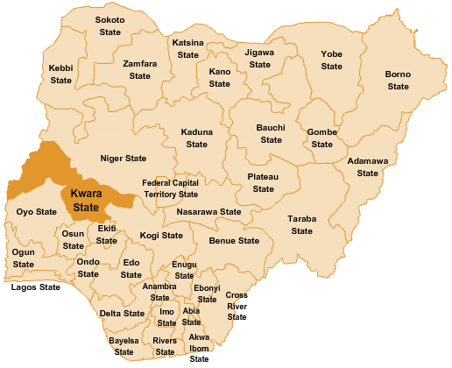

MAP OF NIGERIA SHOWING KWARA STATE
Source: ResearchGate

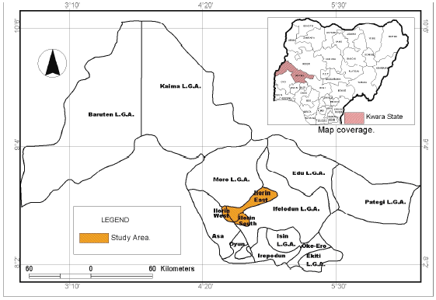

MAP OF KWARA STATE SHOWING STUDY AREA
Source: ResearchGate

4.3 SITE LOCATION/ DESCRIPTION/ CRITERIA
The selected site for the proposed Condominium Development is Square-shaped parcel of land, spanning approximately 9,312 square meters (2.3 Acres). It is strategically located within Ilorin South Local Government Area of Kwara State, specifically within the Agba Dam axis, a fast-developing residential and infrastructural zone.
Ilorin South is one of the sixteen (16) Local Government Areas in Kwara State and forms a major part of the Ilorin metropolitan area. It is a Yoruba-speaking region with a blend of diverse cultures, and it hosts many public institutions, commercial centers, and residential estates. The LGA has seen rapid urban expansion, making it a prime location for modern housing solutions.

The proposed site is well connected by major access routes, including:
- A local un-tarred road that provides internal pedestrian and community access to the estate and its services.
- The Agba Dam Road, which links to major roads like Fate Road and Asa Dam Road, facilitating easy mobility to and from the city center.
- Nearby arterial roads such as the Old Jebba Road and University Road, which serve as important routes for intercity and intracity travelers.
The size and strategic location of the site make it ideal for a comprehensive, multi-unit residential development that will serve civil servants, middle-income earners, and professionals seeking modern, secure, and accessible housing within Ilorin metropolis.

4.6 GENERAL CLIMATIC CONDITION
SITE SELECTION CRITERIA
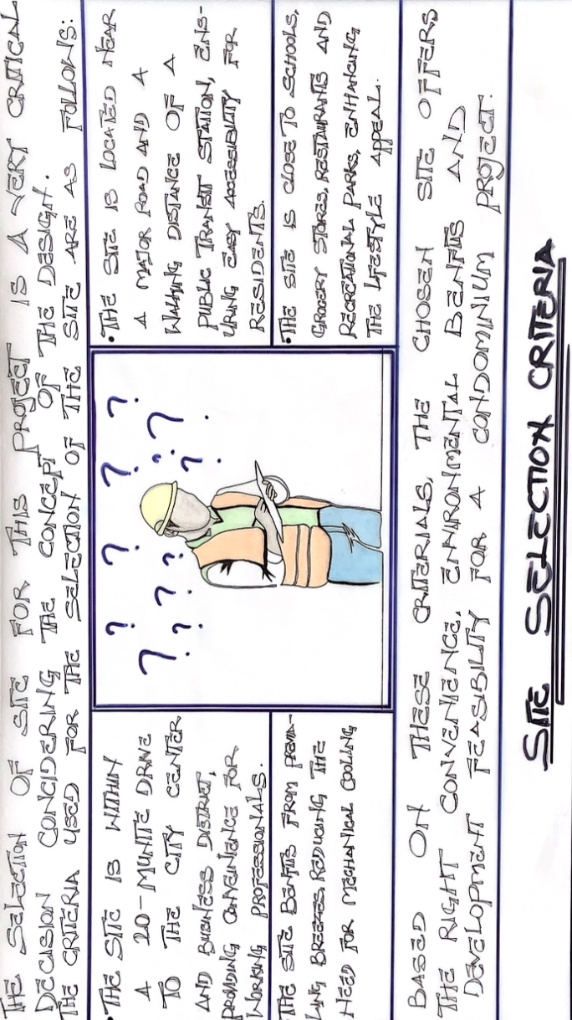
Based on the principles of effective residential planning, the following criteria—adapted from Appleton (2008)—were considered in selecting the proposed site for the Condominium Development in Ilorin South Local Government Area, Kwara State:
1. Accessibility
The site offers excellent access via a major dual-carriageway road with manageable traffic volume. This supports both residents’ convenience and emergency response efficiency. There is also potential for the development of a dedicated service road that can ease peak-hour congestion and serve as a maintenance access route for estate operations.
2. Site Relationship to the Building
The land, with a total area of approximately 9,312 square meters (2.3 Acres) is well-suited for a medium- to high-density residential development. Its shape and size allow for optimal layout of apartment blocks, adequate vehicular parking, internal road networks, green spaces, and shared community amenities such as recreation areas, a clubhouse, and retail zones.
3. Vegetation
The site is primarily covered with short grasses and scattered shrubs. Its proximity to a lowland and water body (Agba Dam) contributes to year-round greenery, making it suitable for a well-landscaped residential environment. Landscaping with trees and native vegetation will also enhance microclimate comfort, provide shade, and help prevent soil erosion.
4. Utilities
The site is located in a developed part of Ilorin South with access to existing public utilities, including electricity, water supply, telecommunications, and proximity to sanitation infrastructure. These facilities will support seamless estate servicing and connectivity.
5. Topography
The land is relatively flat with a gentle slope (~0.5% gradient) sloping northeast to southwest. This makes it cost-effective to develop, requiring minimal land grading. Depressed areas can be adapted into stormwater management features such as retention ponds or drainage easements to enhance sustainability.
6. Air Movement
The site is influenced by two major wind patterns:
• Northeast Trade Winds (Harmattan), dry and dusty, occurring between December and February.
• Southwest Trade Winds (rain-bearing), from April to October, providing moisture and ventilation.
To mitigate dust during Harmattan and enhance ventilation year-round, the use of soft landscaping—trees and shrubs—as windbreaks and filters is proposed. Buildings will be oriented to maximize airflow from the southwest for passive cooling and indoor comfort.
7. Building Orientation
The longer sides of residential blocks will face the northeast to minimize heat gain. The shorter sides will face east-west, reducing solar exposure and enhancing indoor temperature control. This orientation supports both energy efficiency and user comfort.
8. Proximity to Public Utilities
The site has easy access to vital infrastructure including good road networks, security services, water, power, and communication systems—all essential for a self-sustaining residential estate.
9. Economic Value
Located in a growing urban corridor, the site benefits from nearby commercial zones, schools, healthcare facilities, and cultural activities. This boosts the market value of the development and makes it attractive to buyers and investors.
10. Safety
The site is within a secure and low-risk area, with proximity to local law enforcement offices and security posts. Its residential surroundings make it ideal for a safe, family-friendly environment.
SITE ANALYSIS
The selected site for the condominium project is a square-shaped plot covering approximately 2.3 acres. It is accessible via Agba Dam Road and adjoining service roads that facilitate both residential traffic and estate maintenance logistics. The site is gently sloped from west to east, with minor undulations and a few low-lying areas ideal for water collection systems.
It experiences the North East Trade Winds during the dry season (harmattan), and the South West Trade Winds during the rainy season. These prevailing winds influence the building design to prioritize natural cross-ventilation and climate-responsive planning. Minor rock outcrops and natural drainage patterns at the site edges offer opportunities for creative landscaping and stormwater management.
This well-positioned site is ideal for a sustainable, comfortable, and functional condominium development, meeting the growing residential needs of Ilorin South.
WIND
Ilorin South generally experiences light to moderate wind conditions throughout the year, with average wind speeds ranging from 2 to 8 knots (approximately 3.7 to 15 km/h). The region falls within the Guinea Savannah climatic zone, and wind activity is largely influenced by seasonal transitions between the tropical maritime and tropical continental air masses. During the Harmattan season (typically from late November to February), stronger and dust-laden winds are common. These winds, carried by the northeasterly trade winds from the Sahara, often reduce visibility and create a drier atmosphere. While wind speeds during this period can occasionally exceed the yearly average, they typically remain within safe structural design limits, especially for mid- to high-rise buildings.
TEMPERATURE
Ilorin generally experiences a tropical savannah climate characterized by warm temperatures year-round with a distinct wet and dry season. Like much of inland Nigeria, Ilorin has less humidity than coastal cities but still maintains a warm atmosphere throughout the year with Average daily highs: 29°C to 36°C (84°F to 97°F) and average daily lows of 18°C to 24°C (64°F to 75°F). Coolest temperatures typically occur in December and January during the Harmattan, when nights can feel much cooler.
4.6.4 VEGETATION
The proposed site is partially covered with grasses, few trees and shrubs. Some will be removed before the construction while some will be retained for ornamentation.

4.7 SITE ANALYSIS
4.7.1 SITE SELECTION/JUSTIFICATION
In the site selection, provision is made for interesting facilities worth emulating, since the overall success and efficiency of any project depend not only on the functionality of the design but also on the careful choice of site. The site for this project has been carefully selected and is located in Ilorin South, close to Agba Dam, Kwara State. It is a residential building site, as reflected in the layout plan of the area.
The following factors affect the site selection
- Accessibility
- Location
- Infrastructural facilities
- Topography
- Soil structure
ACCESSIBILITY
The major road connecting the Ilorin city center to the Agba Dam area is the closest highway to the site, providing easy and direct access. The site can be conveniently reached through the Agba Dam Road, which links to surrounding residential neighborhoods. Two major entrances are proposed for the site to ensure smooth access into and out of the building.
LOCATION
Site location: The site is located at Off Agba Dam Road, Near Agba Dam, Ilorin South L.G.A, Kwara State, Nigeria.
INFRASTRUCTURAL FACILITIES
Facilities such as water, electricity, telephone network and road network etc. Hence it can easily be tapped to the proposed site.
TOPOGRAPHY
The topography of the land is gentle slope towards cast which can assist for the construction of drainage on site.
SOIL STRUCTURE
The soil has a very high load bearing capacity; thus, the structure will be on hard crust and firm land.

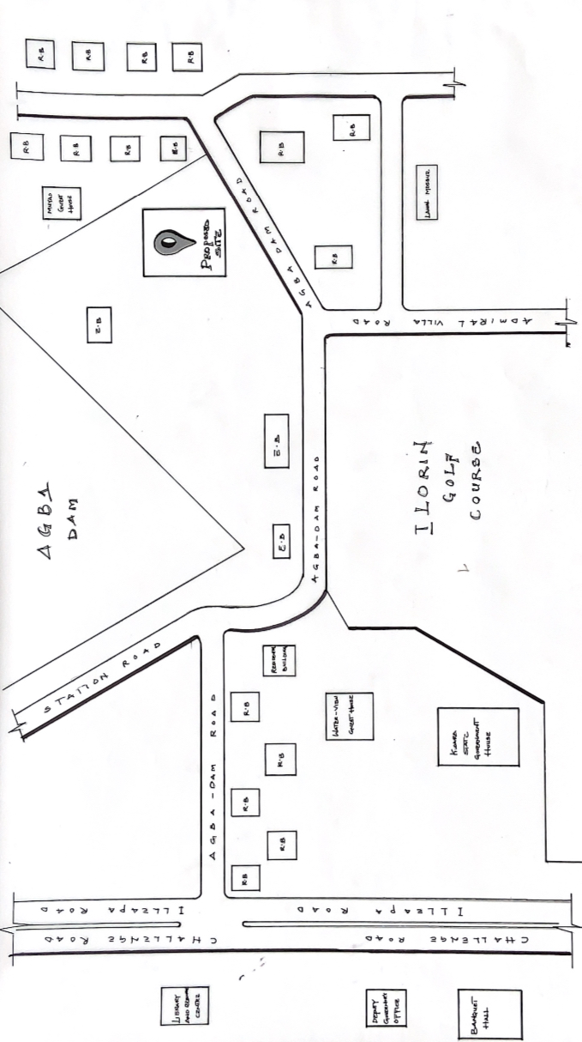
FIG 4.1:- LOCATION PLAN
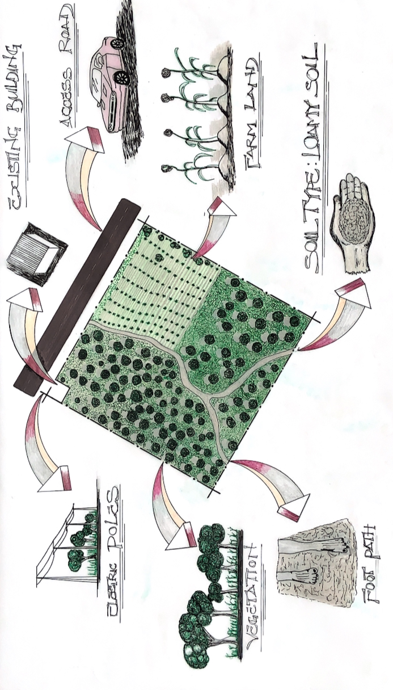
FIG 4.2:- SITE INVENTORY

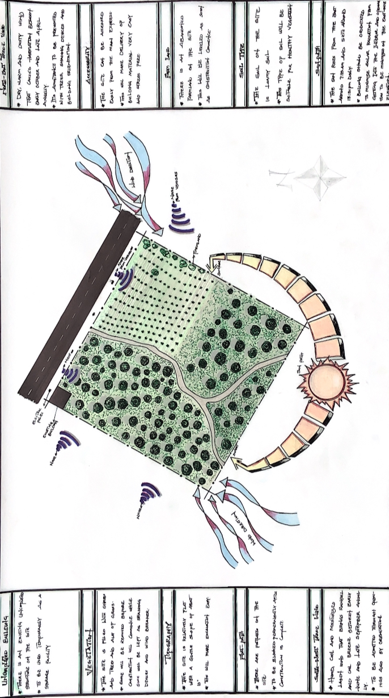
FIG 4.3:- SITE ANALYSIS

DESIGN CONCEPT/PLANNING PRINCIPLE
DESIGN PLANNING
Firstly, the process of analysis in the design into the necessary units required for the design is based on the data collected through research methodologies.
Secondly, the grouping of the various unit together according to their relationship with one another also based on the data and information gathered.
The concept of the design was arrived at from the functional relationship and bubble diagrams prepared out of the design brief which is based on the activities performed within the building. The relationship of these various activities with one another within different units that makes up the design and also based on the zoning in accordance with the level and relationship between each unit.
PLANNING PRINCIPLE
The planning principle is one of the most important aspect of any design. The planning of various units taking into consideration the activities performed in each unit, how they are related to one another and the users of the various units in the design.
In respect to the design above factors, the planning principle remains one of the most critical aspects of any architectural design. Effective planning involves organizing various functional units within the building, taking into account the activities performed in each unit, their interrelationships, and the needs of the users occupying those spaces.
In the context of this 20-storey condominium, the building is carefully zoned and vertically stratified to optimize function, comfort, privacy, and efficiency. The lower floors are primarily dedicated to communal and administrative functions, including the lobby, reception, management offices, lounge areas, and shared amenities such as a gym, meeting rooms, and possibly retail or co-working spaces.
The upper residential levels are strategically organized to provide privacy and noise control, with consideration for views, ventilation, and natural lighting. Special attention is paid to the placement of service cores (elevators, stairs, mechanical shafts), ensuring minimal disturbance to the residential units while maintaining ease of access and circulation.

CHAPTER FIVE
5.0 DESIGN REPORT
5.1 DESIGN BRIEF
After research and planning, the next step in the series of the project program is design itself. To achieve functional and well aesthetic design there must be a brief to work on. This brief depends generally on the scope of individual design. The brief of this project is therefore based on the various activities that take place in the condominium residence.
To have enough brief for the proposed condominium, case studies were carried out on the existing residential complexes both in the Nigeria urban areas and in other modern housing developments. The studies also give me the opportunity to know the nature of the residential spaces offered in such developments and how they relate to each other.
The condominium development comprises six different functional units, they are living units (apartments), recreational center, parking area, administrative/management office, security post, and communal green space.
5.2 DESIGN ANALYSIS
This is the process of itemizing units within the components of the entire design with a view to establish a solid understanding and appreciation of the space relationships.
SN | CONDOMINIUM UNITS |  |  | DIME. | M²
1 | MAIN ENTRANCE |  |  | 4.2 X 3.6 | 15.12 m²
2 | ELEVATOR LOBBY |  |  | 5.7 X 3.6 | 20.52 m²
3 | HALLWAY |  |  | 8.0 X 1.5 | 12.0 m²
4 | STAIRWELL |  |  | 2.5 X 4.5 | 11.25 m²
5 | LIVING ROOM & DINING |  |  | 8.0 X 6.5 | 52.0 m²
6 | MASTER BEDROOMS |  |  | 5.0 X3.4 | 17.0 m²
7 | BEDROOM (Type 1)  BEDROOM (Type 2) |  |  | 4.4 X 3.2  3.6 X 3.4 | 14.08 m²  12.24 m²
8 | KITCHEN |  |  | 4.0 X 2.5 | 10.0 m²
9 | TOILET (Type 1)  TOILET (Type 2) |  |  | 2.3 X 1.8  2.4 X 1.8 | 4.4 m²  4.32 m²
10 | LOBBIES |  |  | 1.5 X 2.0 | 3.0 m²
11 | ELEVATOR |  |  | 2.0 X 1.5 | 3.0 m²
12 | GYMNASIUM |  |  | X | m²
13 | LOUNGE |  |  | 7.5 X 7.7 | 57.75 m²
14 | DAYCARE |  |  | 6.2 X 3.8 | 23.56 m²
15 | RESTAURANT |  |  | 6.2 X 3.8 | 23.56 m²
16 | BAR |  |  | 4.2 X 5.2 | 21.84 m²
17 | BARBER’S SHOP |  |  | 3.0 X 3.0 | 9.0 m²
18 | SPAR |  |  | 3.2 X 3.2 | 10.24 m²
19 | LAUNDRY MART |  |  | 2.6 X 3.0 | 7.8 m²
20 | SAUNA |  |  | 3.6 X 2.2 | 7.92 m²
 | TOTAL |  |  |  | 382.6m²
S/N | OTHER UNITS ON SITE |  |  | DIMENSION | M2²
1 | CLINIC |  |  | 16.4 X 15.0 | 246.0. m²
2 | SECURITY HOUSE |  |  | 3.6 X 4.2 | 15.12 m²
3 | GEN HOUSE |  |  | 3.0 X 5.0 | 15.0 m²
4 | SWIMMING POOL |  |  | 20.0 X 10.0 | 200.0 m²
5 | TENNIS COURT |  |  | 24.0 X 11.0 | 264.0 m²
6 | KID’S PLAY GROUND |  |  | 21.1 X 14.2 | 299.62 m²
7 | POOL RESTROOMS |  |  | 3.0 X 3.0 | 9.0 m²
8 | CAR PARKS |  |  | 5.0 X 3.0 | 15.0 m²
 | TOTAL |  |  |  | 1,063.74m²
APARTMENT BREAKDOWN AND ESTIMATED OCCUPANCY
1 | APRTMT TYPE | QUAN. | BEDRMS | - PERSONS/UNIT | TOTAL PERSONS
2 | 2-BEDROOMS | 32 | 2 | ~4 | 128
3 | 3-BEDROOMS | 32 | 3 | ~5 | 160
4 | 4-BEDROOMS (FLAT) | 8 | 4 | ~6 | 48
5 | 4-BEDROOM (DUP) | 2 | 4 | ~7 | 14
 | TOTAL | 74 |  |  | 350 PEOPLE
5.3 DESIGN APPRAISAL
In any project design, there are two basic factors that should be taken into consideration. These factors are functionality and aesthetics, and functionality of any building are incompatible, but in the case of this project, both aesthetic and functionality of the design were taken care of to satisfy the highly demanded functional requirement and to create an aesthetically and proportionally balanced design. The functional efficiency of the condominium development depends largely on the zoning and enclosure of immediate spaces that are strongly related in function. All these are being taken up as seen on the site and floor plans respectively.
5.4 DESIGN CHARACTERISTICS
The idea of planning a good surrounding evolves from the primary function. It gives a good aesthetic view to the structure; it enhances the psychological feeling of the public, making use of the area: it makes the entire environment healthy, as an adage says "cleanliness is next to godliness". A clean and well-planned site is a healthy environment. in view of this, the following has been adopted in planning the site;
1.LANDFORM: As earlier discussed under the topography the land is gentle slope hence it will affect good planning.
2.TREES: Trees are planted within the condominium premises to enhance natural ventilation. Trees which will not be more than 2.5m high when fully grown are to be planted at reasonable spacing to provide shade for the parking area. Shrubs and trees such as Amelina, Aborea, Flamboyant, Alternanthera, etc., with good foliage are to be planted along the perimeter fence and at strategic locations within the site to provide shade and act as sun and wind breakers. The trees also help reduce atmospheric temperature, and the release of oxygen during photosynthesis contributes to creating a cooler and more comfortable environment for the residents.
3.GRASSES: Grasses give good impression of an environment and also protect. the land surface from erosion for this project, Bahama grass is recommended for all the lawn area.
4.FLOWER BEDS: A well planned flower arrangement gives aesthetic to environment. Flower is grown along the walkways around the main building generally except where it can obstruct vehicular pedestrian movement. Flower such as slender, Bryphallion roses, lady on boat, ice plant etc. are planted.
5.HEDGES: Hedges are also planted along some part of the walkway. In the courtyard while shrubs are also used along vehicular ways. The following shrubs are used for the hedge. Dodoneaviscosal (Josorevet). The vital (bush mil) casavatinalequstifolic (Whistling pic). Shrub such as spotted croton. Euphobiasplender (desert rose) are planted for their beautiful leaves and good scents also for ornamentation.
6.PARKING SPACE: Parking areas for the condominium are distributed to enhance accessibility and efficiency. A few parking lots are provided outside the site boundary for visitors, while additional on-site parking spaces are positioned near the main entrance for residents’ convenience. A basement car park is located directly beneath the condominium building to maximize land use and provide sheltered parking for residents. Loading zones and delivery areas are strategically placed to minimize interference with pedestrian circulation.
5.5 BUILDING STRUCTURE
- The entire condominium development consists of the residential building complex and supporting service structures, which together create a comfortable and well-organized environment for both residents and facility managers. The multi-storey building is supported by beams and columns positioned at appropriate intervals to ensure structural stability and spatial efficiency.
5.6 SERVICE
Electricity is supplied to the condominium from the nearest distribution pole, with proper connection to the main building’s electrical control system. The main water pipeline is conveniently located near the site, allowing for direct tapping of clean drinking water into the building. Telephone and internet service lines are readily accessible in the area, making communication and connectivity easy to install.
Rainwater is harvested from the rooftop and channeled through a dedicated piping system down to the basement, where it is collected and processed for non-potable uses such as flushing, irrigation, and general cleaning. This system reduces water demand from the main supply and promotes sustainability within the development.
A central air-conditioning system shall be installed where necessary to maintain indoor comfort. The condominium includes four elevators—three for residents and one designated as a service elevator to handle maintenance and delivery operations. A dedicated service room is provided at the rooftop level to house essential mechanical and utility systems, ensuring easy access for maintenance personnel without disrupting residents.
5.7 GENERAL REQUIREMENT
5.7.1 LIGHTING
The design incorporates a prominent glass façade, which allows for abundant natural daylight to penetrate deep into the interior spaces, especially in living areas, lobbies, and circulation zones. This not only reduces the need for artificial lighting during the day but also creates a visually appealing and naturally illuminated environment that enhances residents’ well-being. Despite the emphasis on daylighting, artificial lighting systems are thoughtfully integrated into the building’s design to ensure adequate illumination at night or during overcast weather conditions. High-efficiency LED fixtures, ambient and task lighting strategies, and motion-sensor technology are employed in key areas such as corridors, basement parking, stairwells, and service areas to maintain consistent brightness and reduce energy consumption.
5.7.2 ORIENTATION
The orientation of a building plays a crucial role in determining its thermal comfort. It involves positioning the structure in relation to the sun’s path and prevailing wind directions. Proper orientation reduces heat gain, improves ventilation, and enhances the overall energy efficiency of the building.
In this condominium project, the building is strategically oriented so that the shorter façade faces east, minimizing solar exposure during the early hours of the day. To further reduce heat gain, minimal or no openings are placed on this eastern face. The longer façades are oriented along the northeast trade winds and the southwest monsoon winds to allow natural cross-ventilation, enhancing indoor air movement and thermal comfort for the residents.
5.7.3 RAIN PROTECTION DEVICES
Rainfall patterns play a significant role in determining the environmental comfort and overall performance of a building. Therefore, appropriate design measures must be taken to manage rainfall efficiently and prevent moisture-related issues. In this condominium project, careful consideration has been given to the region’s heavy rainfall, particularly during the wet season (typically April to October).
Instead of conventional sloped roofing, a flat slab roof system has been adopted, designed as a green roof with grass covering the surface. This not only enhances insulation and reduces heat gain but also contributes to stormwater management. Beneath the grass layer, a network of concealed drainage pipes is integrated to capture and channel rainwater directly to the basement, where it is collected and processed for non-potable uses such as irrigation and cleaning.
To further protect the building, damp-proof and draught-proof materials are used at all critical joints to prevent water infiltration. External walls are rendered with a minimum thickness of 25mm, ensuring that any moisture absorbed does not penetrate to the interior surfaces. This combination of modern green roof design and advanced waterproofing ensures long-term durability, thermal comfort, and environmental sustainability for the residents of the condominium.

5.7.4 NOISE CONTROL DEVICE
Noise is generally defined as an unpleasant or unwanted sound—often loud and harsh. In residential settings such as condominiums, excessive noise and vibration can lead to discomfort, stress, and reduced quality of life for occupants. Therefore, effective noise control is a critical component of the building’s design. To mitigate external noise from surrounding roads or developments, landscape elements such as trees, shrubs, and earthen berms are strategically introduced around the site. These serve as natural sound buffers while also enhancing the visual appeal and creating privacy. Adequate building setbacks are also maintained to reduce direct sound transmission from outside the premises.
Internally, the building is zoned to separate active/noisy areas from quiet zones. For example, the recreational or service areas are spatially distanced from private residential units. Acoustic insulation is provided in walls, floors, and ceilings to minimize sound transfer between units and common areas. Special attention is given to the placement of elevators, stairwells, and service rooms to ensure they do not directly adjoin bedrooms or living spaces. In addition, acoustic ceiling tiles and sound-absorbing materials are used in lobbies, hallways, and communal lounges to reduce overall ambient noise levels. For areas where privacy and quiet are essential—such as meeting rooms, private lounges, and management offices—enhanced soundproofing measures are recommended.
These strategies together ensure a calm, comfortable, and acoustically balanced living environment within the condominium.
5.8 MATERIAL AND FINISHES
The choice of building materials for this condominium in Ilorin South is influenced by local climate, topography, and material availability. Ilorin experiences a mix of dry and wet seasons, with moderate to heavy rainfall during the wet season. To manage this, parapet walls are used to protect the flat slab roof and minimize wind impact, especially during the South-West monsoon. Sandcrete blocks of 150mm and 100mm thickness are commonly used for wall construction, offering both durability and structural stability. Material selection is guided by key factors such as:
The material choice and finishes are influence by a number of factors such as follows:
- Durability and weather resistance
- Local soil and topography
- Availability and affordability of materials
- Climate conditions specific to Ilorin South
- Performance and maintenance requirements
ROOF
In areas with tropical climate conditions such as Ilorin South, where rainfall is frequent and sometimes intense, roofing must be designed to withstand moisture, heat, and structural load. For this condominium project, a solid reinforced concrete slab roof has been adopted, overlaid with a green roof system consisting of grass and soil layers. This approach provides excellent thermal insulation, reduces heat absorption, and enhances environmental comfort. Unlike lightweight roofing systems, the green roof helps regulate indoor temperature while reducing the urban heat island effect. Below the grass layer, a network of drainage pipes is integrated to capture rainwater and channel it directly to the basement for collection and reuse. This ensures efficient stormwater management without overloading the public drainage system. Reinforced concrete is used for the roof slab and integrated guttering system, providing both structural durability and resistance to heavy rainfall. Where necessary, steel components are used for structural reinforcement, particularly around service areas and access points on the rooftop.
CEILING
Suspended ceilings are used in key areas of the condominium, supported by metal hangers at appropriate center-to-center intervals. The ceiling material is selected to be visually appealing, easy to clean, and suitable for residential use. It is also designed to be cost-effective while providing comfort and durability.
For these reasons, PVC or gypsum board ceilings are recommended for all residential units and common areas due to their neat finish, moisture resistance, and low maintenance. In areas where noise control is important, such as lounges, corridors, and the management office, acoustic ceiling panels are advised to reduce sound transmission and improve indoor comfort.
WALL
The structural walls of the condominium are recommended to be constructed using 225mm machine-molded sandcrete hollow blocks, known for their strength, thermal insulation, and cost efficiency. These walls provide stability and form the external enclosure of the building. All major columns and beams are to be properly reinforced with steel and integrated within the wall framework where applicable. These structural elements are to be finished with 25mm gauged smooth plaster, ensuring a clean surface ready for painting or cladding.
Most of the units are designed using a reinforced concrete frame structure, which carries the bulk of the building loads and allows for flexible internal layout. Load-bearing masonry walls are used in selected areas to support smaller spans and internal divisions. All rendered wall surfaces are to receive 25mm thick plastering, followed by painting according to the approved color schedule. In wet areas such as toilets and lavatories, walls are to be finished with ceramic tiles up to a height of 2100mm, providing water resistance and ease of cleaning.
DOORS
The type and size of doors used in the condominium depend on their specific location and function, but all doors maintain a uniform height of 2100mm for design consistency and ease of construction. Door types range from flush and paneled wooden doors for internal spaces such as bedrooms and kitchens, to solid-core or metal security doors for main entrances to each unit.
In wet areas such as toilets and bathrooms, PVC or aluminum doors are recommended for their moisture resistance and low maintenance. For balcony and terrace openings, sliding or folding glazed doors are used to enhance natural light and ventilation while saving interior space. Where required, fire-rated doors and sound-insulated doors are used, especially in service areas and between residential corridors and stairwells, to ensure safety, noise control, and durability in line with residential building standards.
WINDOWS
In the stairwells, aluminum-framed louvered or pivoted windows are recommended to facilitate cross-ventilation and natural lighting, promoting safety and comfort in circulation areas. All window types are fitted with durable, low-maintenance materials such as powder-coated aluminum to withstand weather conditions and reduce long-term maintenance.
This minimal but strategic window placement supports both functionality and the clean, contemporary appearance of the condominium.

5.9 SUMMARY AND CONCLUSION
5.9.1 SUMMARY
Throughout the design process (from conceptual development to final detailed drawings) careful consideration has been given to achieving a functional, modern, and sustainable condominium design that responds to both environmental and contextual factors. This project addresses key challenges commonly observed in multi-unit residential buildings, offering practical solutions for comfort, aesthetics, structural stability, and long-term usability.
Although design outcomes often vary due to factors such as financial constraints, site characteristics, material availability, and local climate conditions, the overall design approach for this condominium maintains a consistent concept rooted in practicality, environmental responsiveness, and contemporary living standards. With features such as a green roof with integrated rainwater harvesting, well-zoned spaces, efficient circulation, sound and thermal control, and strategic natural lighting, the design sets a high standard for future residential developments within Ilorin South and beyond.
5.9.2 CONCLUSION
In conclusion, the deductions and experience gained from the research and design process of this condominium project have significantly exposed me and, by extension, the reader of this report to the realities and requirements of modern residential design within the context of Nigerian urban development, particularly in Ilorin South.
Designing a residential building such as a condominium has helped me understand the importance of spatial planning, environmental responsiveness, material selection, and user comfort. It has also emphasized the need for zoning, functionality, and sustainability in multi-unit housing. Throughout the design, I have ensured that all key functional components, residential units, circulation, services, and recreational areas are strategically located and well-integrated.
Ultimately, this project represents my personal contribution toward addressing housing needs in a growing urban center. It fulfills my aspiration to create practical, comfortable, and environmentally responsible living spaces that support the broader goal of improving residential development standards in Nigeria.

REFERENCES
Golland, A., & Blake, R. (2004). Housing development: Theory, process and practice. Routledge.
Adebayo, A. A. (2010): Sustainable Housing Delivery in Nigeria: The Financial and Infrastructural Implication. Proceedings of the International Housing Conference, Abuja, Nigeria.
Ajayi, M. T. & Omirin, M. M. (2007): Urban Planning and the Challenges of Slum Development in Nigerian Cities. Journal of Sustainable Development in Africa, Vol. 9(1), pp. 109–122.
Ede, A. N. (2014): Building Collapse in Nigeria: The Trend of Casualties in the Last Decade (2000–2010). International Journal of Civil and Environmental Engineering, Vol. 10(6), pp. 32–39.
Fadamiro, J. A. (2002): Urban Housing and the Use of Indigenous Materials in Nigeria. Journal of the Nigerian Institute of Architects, Vol. 3(1), pp. 25–32.
Federal Ministry of Works and Housing (2002): National Building Code of Nigeria. Abuja: Government Press.
Garde, A. (2009): Sustainable by Design? Insights from U.S. LEED-ND Pilot Projects. Journal of the American Planning Association, Vol. 75(4), pp. 424–440.
NHP (2012): National Housing Policy. Federal Republic of Nigeria, Ministry of Lands, Housing and Urban Development, Abuja.
Olotuah, A. O. & Bobadoye, S. A. (2009): Sustainable Housing for the Urban Poor: A Review of Public Sector Intervention in Nigeria. The Built & Human Environment Review, Vol. 2, pp. 51–63.
UN-Habitat (2010): State of the World’s Cities 2010/2011 – Bridging the Urban Divide. Nairobi: United Nations Human Settlements Programme.
World Bank (2013): Nigeria: Housing Sector Assessment. Washington, DC: World Bank Publications. Available online at www.worldbank.org/housing-nigeria (accessed on 15th July, 2025).

APPENDIX
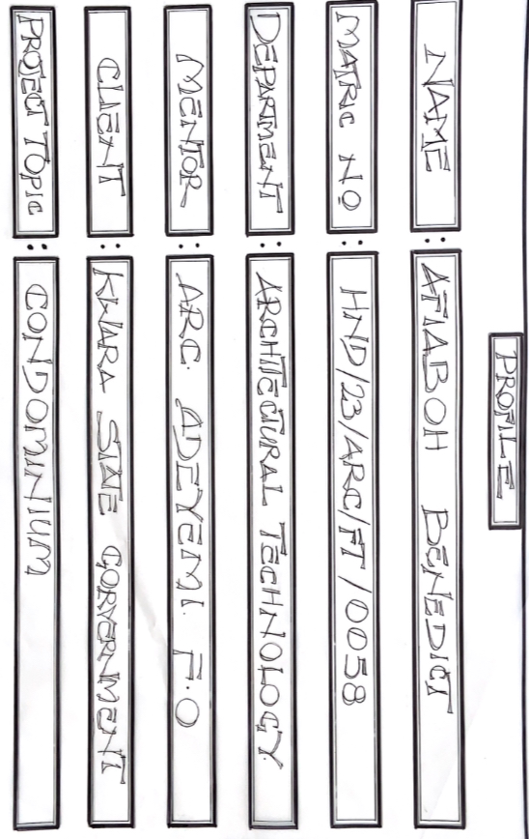
PROFILE
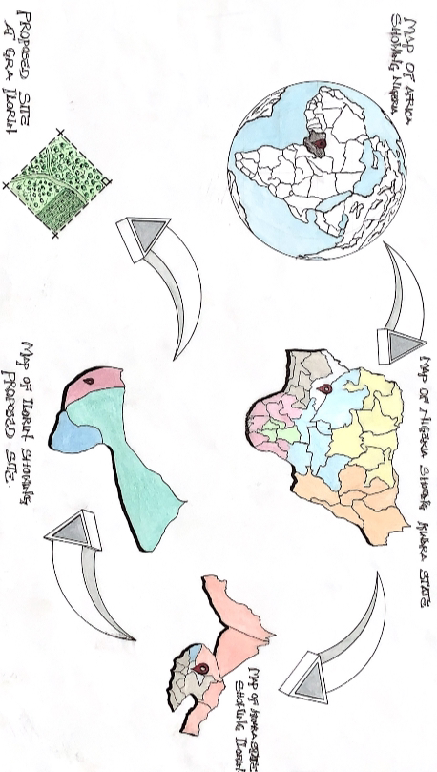
LOCATION MAP
LOCATION PLAN

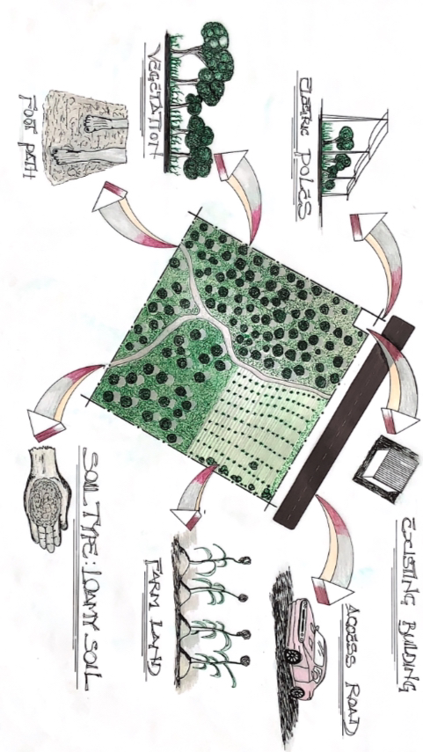SITE INVENTORY
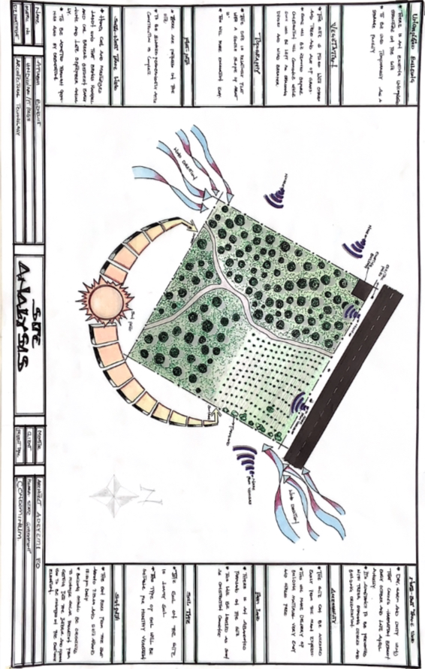SITE ANALYSIS 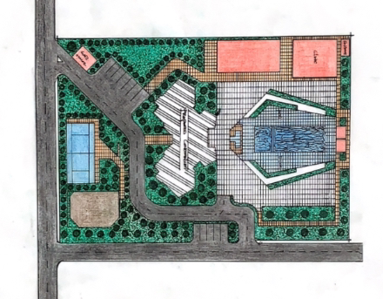
SITE PLAN

BUBBLE DIAGRAMS
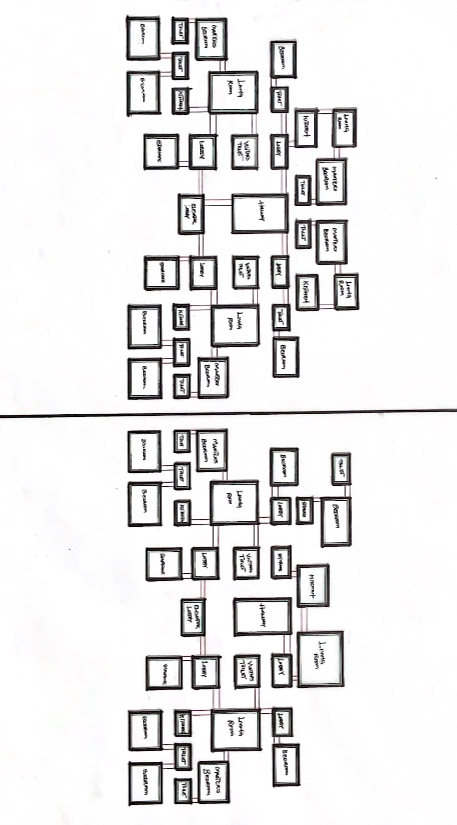
FUNCTIONAL RELATIONSHIPS

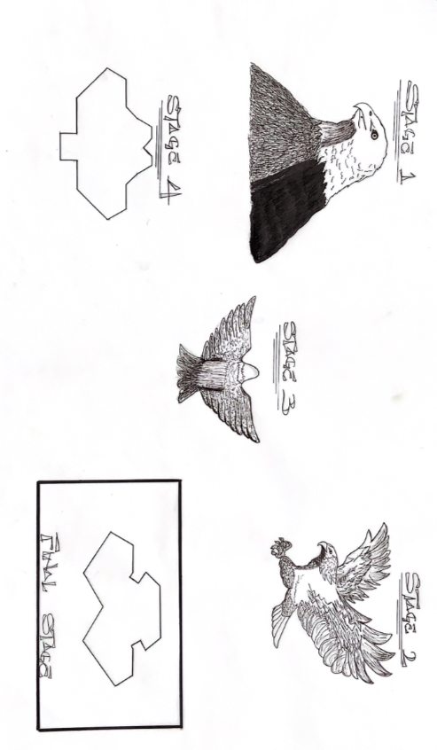
CONCEPT DERIVATION 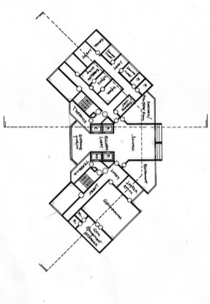
GROUND FLOOR PLAN
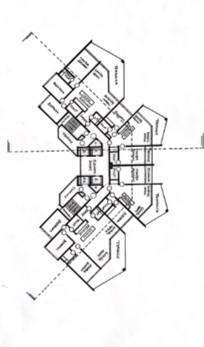
1st To 16th FLOOR PLAN

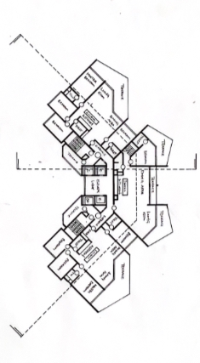
17th to 19th FLOOR PLAN
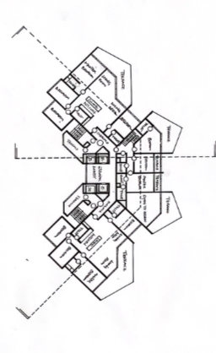
18th to 20th FLOOR PLAN
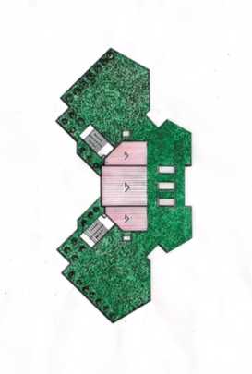
ROOF PLAN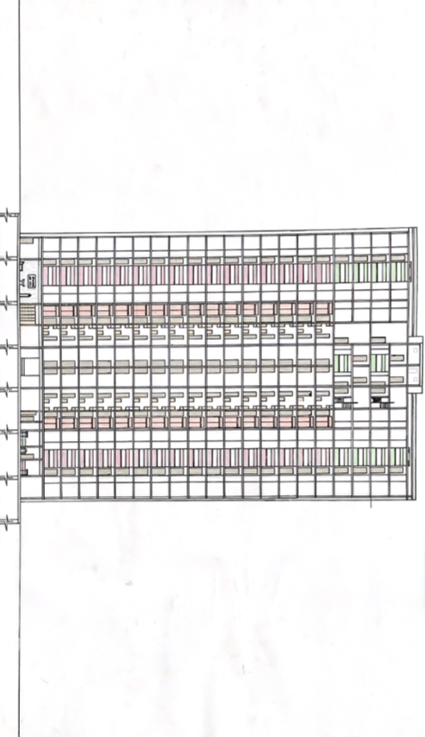
SECTION
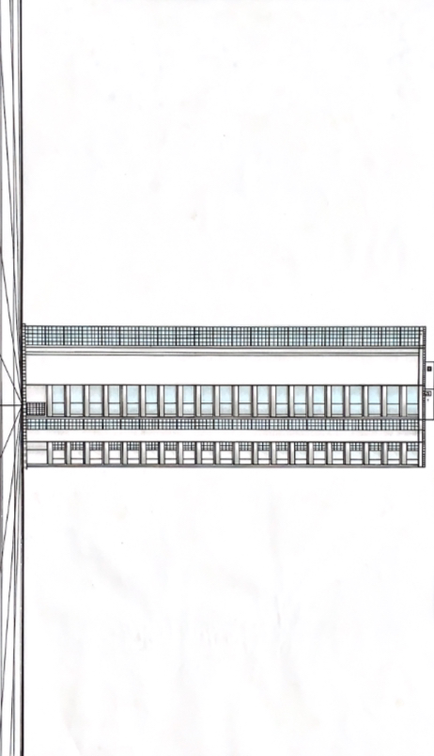
ELEVATION

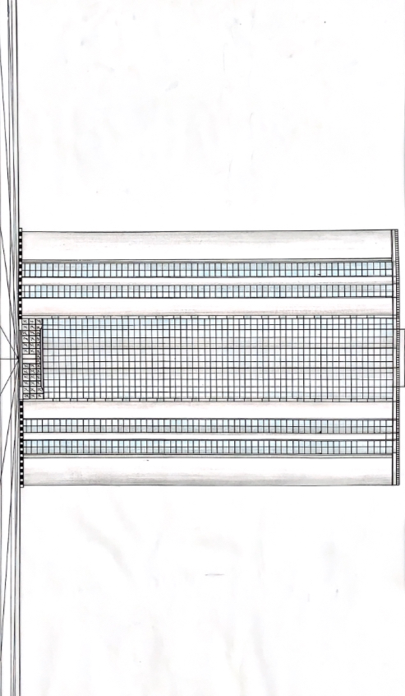
ELEVATION
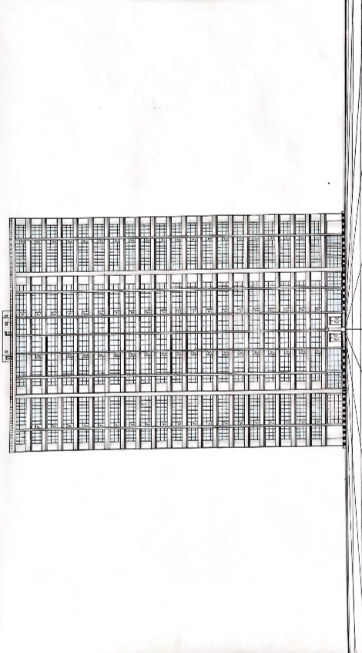
ELEVATION

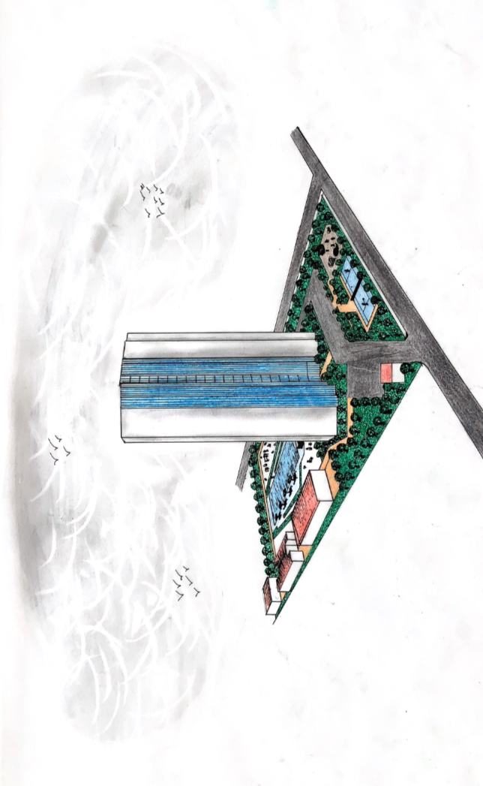
PERSPECTIVE
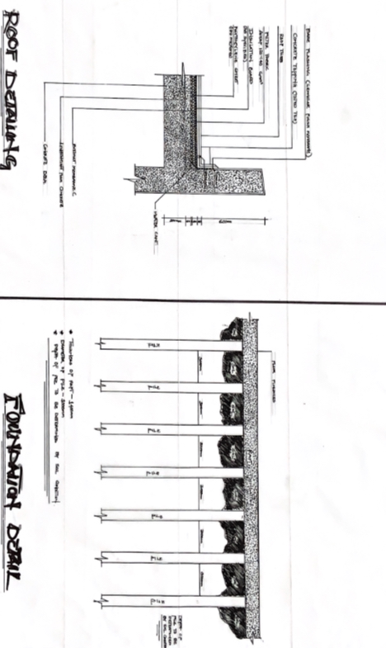
DETAIL 1
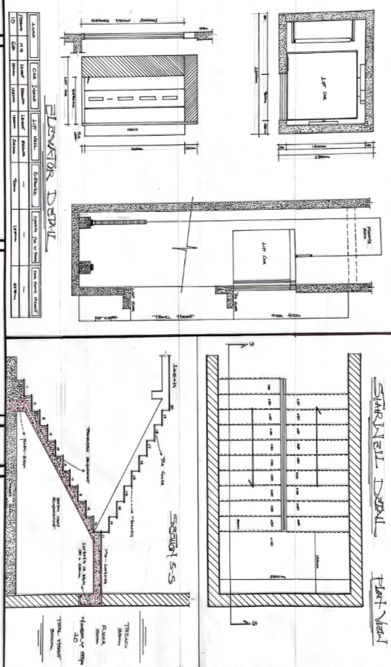
DETAIL 2 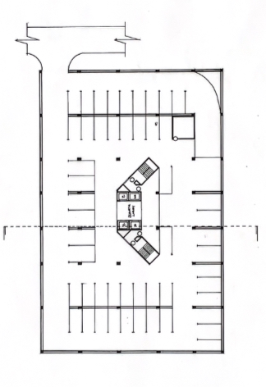
BASEMENT
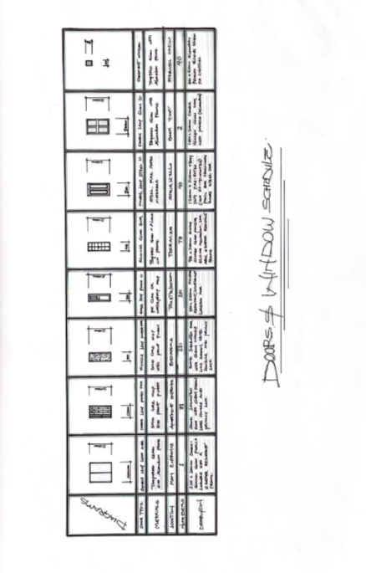
DOOR AND WINDOW SCHEDULE

