A PROJECT REPORT
ON
PROPOSED MILITARY BARRACKS
FOR
OYO STATE GOVERNMENT

BY

OGUNRONBI OPEYEMI SAMSON
HND/23/ARC/FT/041

SUBMITTED TO

THE DEPARTMENT OF ARCHITECTURAL TECHNOLOGY
INSTITUTE OF ENVIRONMENTAL STUDIES
KWARA STATE POLYTECHNIC, ILORIN

IN PARTIAL FULFILMENT AS PART OF THE REQUIREMENTS FOR THE AWARD OF HIGHER NATIONAL DIPLOMA (HND) IN ARCHITECTURAL TECHNOLOGY

JULY, 2025
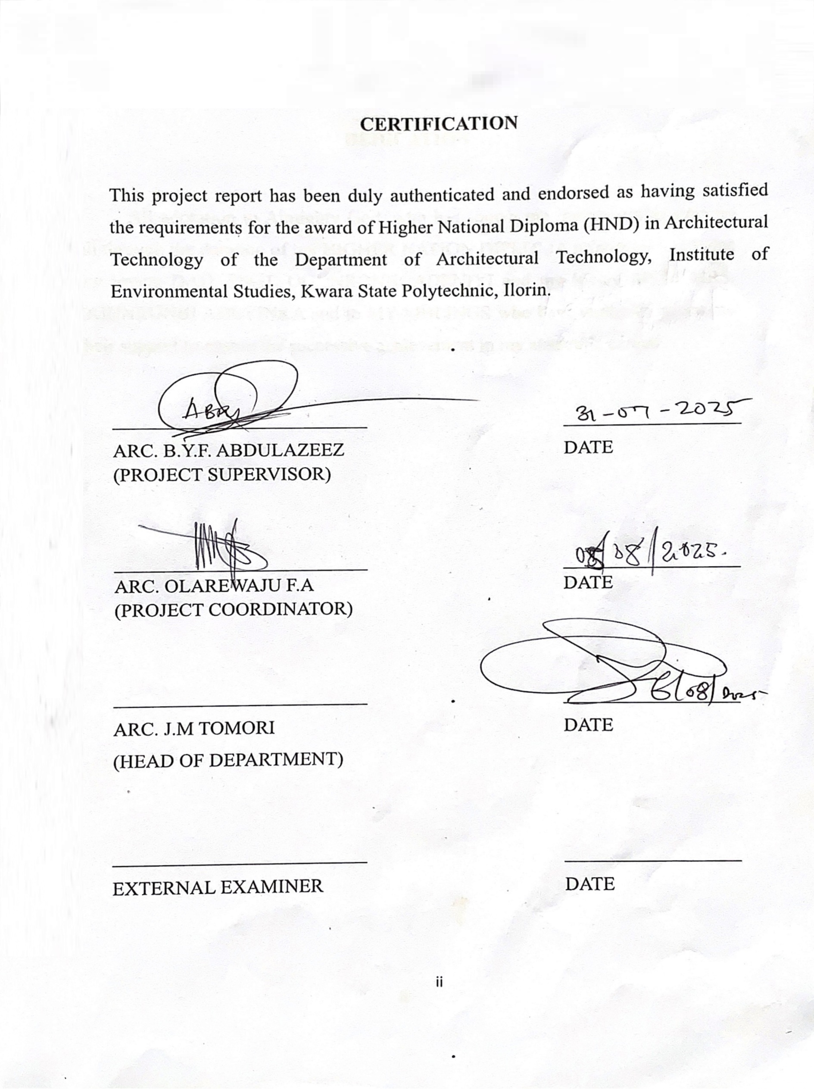

DEDICATION

All adoration to Almighty God, who has shown me immeasurable mercies all through the duration of my HIGHER NATION DIPLOMA programme and also my loving DAD, SSGT. OGUNRONBI ADENIYI and my lovely MUM MRS. OGUNRONBI ADEYINKA and to MY SIBLINGS who have endlessly given me their support to ensure the successive achievement in my academic career.

ACKNOWLEDGMENT
My gratitude goes to Almighty God who has never failed at any point in my life. I'm greatly indebted to my loving and caring parents SSGT. OGUNRONBI ADENIYI and MRS. OGUNRONBI ADEYINKA and MY BROTHER AND SISTERS for their remarkable supports financially, morally and spiritually to ensure my success academically.
My appreciation also goes to my supervisor, ARC. ABDULAZEEZ B.Y.F for the effort, patience, fatherly care, relevant instructions and guidance in the course of the project. Thank you sir.
My gratitude goes to the Head of Department ARC.TOMORI J.M and all lectures and the entire Academic Staff of the Department of Architectural Technology for their effort. Thank you
I also appreciate the support given to me by my friends and course mates

ABSTRACT
This architectural project explores the conceptualization, planning, and design of a modern military barracks, focusing on the functionality, efficiency, and well-being of military personnel. The document begins by defining military barracks from general, architectural, operational, historical, and regulatory perspectives. It then provides a detailed historical overview, tracing the evolution of barracks from ancient civilizations like Rome through to colonial and modern military infrastructures, emphasizing their role in discipline, readiness, and operational support. The aim of the project is to design a barracks that balances security, comfort, and functionality while supporting the mental and physical health of soldiers. Key objectives include space optimization, functional zoning, circulation efficiency, and provision for military discipline. Research methods employed include case studies, interviews, site observation, and literature reviews. Three Nigerian military barracks 20 Model Battalion (Taraba), Bonny Cantonment (Lagos), and Maxwell Khobe Cantonment (Jos) are analyzed to assess their strengths and deficiencies in infrastructure, spatial planning, climate adaptability, and operational support. Lessons from these case studies inform the design of a proposed barracks in Orile Igbon, Oyo State. The site is chosen for its large landmass, historical relevance, and strategic positioning. The design is guided by zoning principles, environmental considerations, and a comprehensive site analysis including soil, vegetation, climate, and accessibility. Functional areas in the barracks are organized into administrative, tactical, residential, recreational, medical, educational, and religious sectors. Construction methodologies prioritize local materials, energy efficiency, and maintainability, with considerations for insulation, landscaping, ventilation, and fire safety. Overall, the project emphasizes the importance of integrating military discipline, environmental responsiveness, and sustainable design in creating a livable and operationally effective military barracks. The research concludes with recommendations for broader adoption of such approaches to improve soldier welfare and institutional performance in Nigeria’s military housing infrastructure.

TABLE OF CONTENTS
Title page ……………………………………………………..………..………. i
Certification ………………………………………………………………….. ii
Dedication …………………………………………………………………..…. iii
Acknowledgement …………………………………………………………… iv
Abstract……………………………………………………………………….. v-vi
Table of contents………………………………………..…………………… ….vii-viii

CHAPTER ONE
- Introduction ……………………………………………………………. 1
  - Project definition……………………………………………………..…. 1
  - Historical background…………………………………………………… 2
  - Aim and Objectives …………………………………………………….. 3-4
  - Justification ……………………………………………………………… 4
  - Research Methodology …………………………………….…………….. 5
Limitation and Constraints ……………………………………………………. 6

CHAPTER TWO
- Case Studies ………………………………………………….……….. 7
Introduction……………………………………………………………….…….. 7
Literature Review ……………………………………………………………… 7-8
  - Case Study One ……………………………………………………………9-16
  - Case Study Two ……………………………………………………..……17-24
  - Case Study Three …………………………………………………………25-32

CHAPTER THREE
- Introduction to the site …………………..………………………………. 33
  - Site Location/Description……………………………………..………… 33
Site location Criteria ……………………………………………….…… 34
Site Analysis/Inventory …………………………..…………………….. 34
Site Sustainability Analysis …………………………..……… …..………. 35
  - Geographical Characteristics ………………………...………………..… 37
  - Climatic Characteristics……………………………..…..…… ……. …. 38
Conclusion…………..…………………………………..…… ………….. 38

CHAPTER FOUR
- Design Criteria/General Requirements…………………………………… 39
  - Site Planning …………………………………………………………….. 39
  - Brief Analysis…………………………………………………………….. 40
Design Scope ……………………………………………………………………. 40
  - Functional Relationship ………………………………………………… 41-42
  - Concept Development…………………………………………………… 42-43
  - Space Analysis…………………………………………………………… 43

CHAPTER FIVE
- Project Appraisal ……………………………………………………… 44
  - Construction Methodology/Materials……………………………………..44-48
  - General Design Consideration ……………………………………………49-50
  - Circulation and Zoning ……………………………………………………. 50
  - Structural Principle ………………………………………………………. 50
  - Landscape Design ………………………………………………………. 51
  - General Maintenance………………………………………………….… 51
  - General Conclusion and Recommendations …………………………… 52
Appendix…………………………………………………………………..… 53-67
References………………………………………………………………………… 68
CHAPTER ONE

1.0 INTRODUCTION

A military barracks is a socialized building or complexes designed to house and accommodate soldiers, and functional spaces such as mess, parade ground and administrative offices. The building or complex where military personnel sleep, live and conduct various non-combat activities.

Military barracks are designed to house soldiers in a disciplined and organized manner, ensuring readiness and convenience for military operations. The design focuses on efficiency, durability and organization often with a practical and simple aesthetic to support military discipline and readiness.
They may vary in size, design and amenities depending on their function and the type of military branch (Army, Navy, Air-force)
The layout and structure of barracks often reflect the specific needs and protocols of the military branch, ensuring a structured and organized environment conducive to military life

  - PROJECT DEFINITION

- General definition: A military barracks is a building a group of buildings used to house soldiers.
- Architectural definition: referred to a standardize, functional structure designed to accommodate military personnel with sleeping quarters, sanitation facilities and sometimes recreational areas
- Operational definition: military operations, a barracks serve as a centralized location for personnel to rest, regroup and receive orders, playing a vital role in maintaining readiness and discipline.
- Historical definition: historically, barracks were often large communal buildings, often built from wood or stone, intended to quarter troops near battlefields or within fortifications.
- Legal or military regulation definition: according to military regulations, barracks are officially designated living quarters for enlisted personnel, subject to rules regarding cleanliness, behavior, and occupancy limits

  - HISTORICAL BACKGROUND OF MILITARY BARRACKS

Military Barracks have played an essential role in the history of warfare and military organizations, serving as the primary living and working space for soldiers. The concept of Barracks dates back to the ancient times of civilization where armies needed centralized location for troops to rest, train and plan operations. Early examples of military housing can be traced to the Roman Empire, where soldiers were housed in large, well-constructed structures that were often built in proximity to forts or military camps.

These early barracks were crucial for maintaining discipline, organizing troops, and ensuring readiness of military companies. This was crucial for maintaining discipline organizing troops and showing readiness of military companies.
As empires expand and warfare became more structured, the need for permanent barracks increased, making the beginning of the evolution as a fundamental part of military infrastructure.

In the middle ages military forces typically camped in temporary structures when they were not engaged in combat. However, with the rise of standing armies in the 16th and 17th century, the necessity of permanent barracks became more apparent. European power, especially in France, England, and Russia, began structuring large fortified barracks to house soldiers in peace time. These structures were an often simple, utilitarian building that’s focused on efficiency, rather than comfort. The use of barracks became more increasingly wide spread with the development of professional armies and the need to house large numbers of soldiers.

The 18th century marked a significant shift in the design and purpose of military barracks. Influenced by enlightenment ideas, military forms during the period sought to improve the living condition of soldiers, Barracks were designed with more attention to hygiene, comfort, and discipline.

In France, for instance, the France Revolution, and subsequent Napoleonic wars promoted significant military innovations and barracks became an essential feature of military infrastructure. The idea was not only to house soldiers but also to create environment that could install military discipline and promote a sense of unity among troops. The architecture of this barracks began to reflect the importance of efficient troop management and military readiness.

The 20 Century, particularly doing and after World War I, saw a significant restructuring of military barracks. In response, military architects began designing barracks with more modern amenities, including better ventilation, sanitation, and comfort. During World War II, barracks became even more crucial, as global warfare demanded that vast numbers of soldiers be housed and maintained across various threats of war.

Today, military barracks remain a cornerstone of military infrastructure, although design and purpose continue to evolve with technology advancement and changing geographical realities.

  - AIM

The aim of designing a military is to create a functional, secure and efficient environment that supports the operational needs of military personnel, also to balance practicality; security and well-being, of personnel ensure the barracks effectively serves the need of the military while fostering a disciplined, organized and sustainable living environment for personnel.
OBJECTIVES

- Space efficiency and optimization: the design should minimize the use of space accommodates a large number of personnel without compromising functionality or comfort
- Security and control: Barracks must be designed to ensure the safety and security of personnel and sensitive materials.
- Functional zoning: the layout should clearly separate different functional areas, such as sleeping quarters, training/Parade ground and administrative offices.
- Support for military discipline: The design should encourage a sense of order, discipline and hierarchy.
- Health, comfort and well-being: The barracks should support the physical and mental well-being of soldiers.
- Regimented circulation and movement: The design should facilitate efficient circulation of both personnel and supplies, monitoring congestion and ensuring that soldiers can move quickly between essential areas in accordance with military routine.
- Aesthetic appropriateness: while military barracks prioritize functionality, the design should consider the aesthetics context.

  - JUSTIFICATION

The design of a barracks is a multifaceted undertaking that balance in need for practicality, security and efficiency with the welfare and well-being of soldiers.

A well designed barracks ensures that military personnel can operate effectively, remain disciplined, and stay healthy and motivated, all of which contribute to the success of military operations. It must be durable, adaptable, and cost-effective, while also providing an environment that fosters teamwork and resilience in the face of demanding circumstances.

  - RESEARCH METHODOLOGY

The project design required the collection of relevant information and data on a standard military barracks.

These were obtained through the following:

- Case studies.
- Oral interview.
- Internet research.
- Observation.

Case studies: Case studies involve the visitation of existing military barracks and acquiring information and picture photographs and sketches of existing structures.

Oral interview: Please involve interviewing officers and soldiers in the barracks to acquire information about the barracks.

Internet research: This is acquiring more information about the existing barracks on the Internet.

Observation: During case studies, observations were made on activities carried out in the barracks and way of livelihood.

LIMITATIONS AND CONSTRAINTS

CASE STUDIES

The Nigerian military has high standards in terms of security and vigilance. In the course of carrying out my case studies, I was limited to areas and facilities in the barracks in terms of access and prohibition of taking pictures of the buildings in the barracks due to security reasons.
As a student of architecture, I was given some advice and ideas by my lecturer on how to carry out case studies in areas which are prohibited.
I was able to apply this doing the case studies and was able to acquire some pictures of the buildings and facilities in the barracks.

CHAPTER TWO

2.0. CASE STUDIES

INTRODUCTION

Case studies play a crucial role in a project of this scale, as they provide valuable insights into an existing military barracks. Through such studies, students gain and understanding of established norms, spacial functionality, and shortcomings of current designs. This progress equips them with the knowledge needed to avoid repeating design flaws in their own proposals.
Ultimately, the case study helps inform critical aspects of the proposed military barracks, such as the types of space required, their interrelationships, intended functionality, and the population for which the facility is designed.

REVIEW OF RELEVANT LITERATURE

Military Barracks in Nigeria have historically served not just as accommodation for soldiers, but also a sociopolitical species that reflects broader national dynamics.

Scholars such as Ejiogu (2011) and Osaghen and Suberu (2005) examined our Nigerian barracks evolved during and after colonial rule, with British colonial administrators establishing the first structured barracks to consolidate control and discipline within the colonial military ranks. This early barracks were designed for functionality and control, often with minimal attention to soldier welfare. Post-independence, barracks expanded in number but retained similar colonial designs, lacking in modernization and proper infrastructure.

More recent case studies, including those by Adebayo (2013) and Ibrahim & Oloruntoba (2018), focuses on the tolerating living conditions in Nigerian military barracks. These studies highlight issues such as overcrowding, poor sanitation, lack of portable water, and inadequate maintenance. For instance and Ikeja Cantonment and Ojo Barracks in Lagos are frequently cited as examples where aging infrastructure and neglect have impacted the moral and health of residence. Researcher also notes how the bar environment affects the psychological well-being of soldiers and their families influencing both professional performance and civil military relations.

Effort to modernize Nigerian barracks has been inconsistent. According to Adegbamigba (2020), government programs such as Barracks Renovation Initiative under the Ministry of Defense have seen limited success due to underfunding and corruption. However, cases studies like newly developed Mohammed Buhari Contentment in Abuja, show some progress in incorporating modern amenities and improved special planning. Literature suggests that improvement in barracks condition requires policy reforms, better funding, and strategic partnership with private developers. Overall, the case studies review a critical need for a comprehensive upgrade of military living quarters to enhance the effectiveness and welfare of Nigerian Armed forces.

2.1. CASE STUDY ONE

NAME: 20 MODEL BATTALION

LOCATION: SERTI-BARUWA, TARABA STATE

THE 20 MODEL BATTALION, TARABA

HISTORICAL BACKGROUND

20 Model Battalion is located in Serti also known as Baruwa, in Gashaka local government area of Taraba state, Nigeria. The town, which grew significantly with the establishment of military and police presence in the 1950s, later became home to this strategic battalion.
Originally established as a standard Army unit, the 20 battalion was upgraded to a model battalion in June 2016 by the Chief of Army Staff (COAS), Lieutenant General Tukur Buratai. This upgrade aimed to improve regimentation, infrastructure, personnel welfare, and operational capacity, positioning the units as a benchmark for professionalism within the Nigerian Army.

Since its elevation, 20 Model Battalion has played a vital role in regional security, particularly due to its proximity to the Nigeria-Cameroon border. The unit has also contributed to civilian-military relations, through community-forced initiative, such as the introduction of banking services for soldiers and locals in partnership with first bank in 2019.

Additionally, the battalion has supported environmental security, notably assisting in training of Park Rangers for the nearby Gashaka-Gumti National Park. This efforts reflects installation but also a center of social and regional development.
DESCRIPTION

20 Model Battalion Army Barracks is located within a 963.72 km² hectare land area. The barracks first started construction in 1953 and was partially completed in 1962 by the then Head of State, but received its full commissioning in the year 2010, as part of the Nigerian Army’s efforts to enhance security in the region and address the growing challenges of insurgency and conflicts in the middle belt.

The Battalion plays a critical role in addressing security challenges in Taraba State, which has faced issues such as inter-communal conflict, insurgency, and cattle rustling.

The barracks is designed to accommodate and support Nigerian Army personnel stationed there. It provides essential infrastructure for housing soldiers, training areas and operational facilities.

MERITS

- Strategic location: The site is well positioned for security purposes, with a focus on proximity to key areas, such as transportation routes and access points, enhancing both operational efficiency and defense capabilities.
- Spacious ground: The battalion’s design incorporates expensive grounds, which are suitable for training exercises, parades and other military activities, contributing to effective military preparedness.
- Simplicity and practicality: The design emphasizes simplicity and practicality, focusing on functional species that meets the core needs of military personnel without unnecessary complexity.
- Functional layout: The design of the battalion is generally functional, with a clear division of species for barracks, administrative offices, training areas and order essential facilities, supporting efficient daily operations.
- Security features: The battalion is designed with security in mind, including perimeter fencing, controlled access points and order elements to safe guard personnel and sensitive materials.

DEMERITS

- Lack of adequate infrastructure: Some facilities within the battalion lack modern infrastructure or essential utilities like stable water supply, electricity and sanitation, impacting operational efficiency and quality of life for personnel.
- Poor maintenance: Many buildings or structures suffer from poor maintenance, leading to issues like dilapidation, water leakage, or inadequate ventilation, which could affect comfort and safety.
- Limited space planning: The design of the battalion does not allow for optimal space usage, leading to congestion or inefficient use of land, especially in terms of barracks and training facilities.
- Our updated design standards: The structure reflects outdated architectural practices, lacking contemporary design standards that focus on sustainability, energy efficiency all functionality.
- Incompatible design for tropical climate: The architectural design may not adequately account for the harsh tropical climate, leading to poor air circulation, inadequate shading and increased reliance on artificial cooling, which raises lost and reduces comfort.

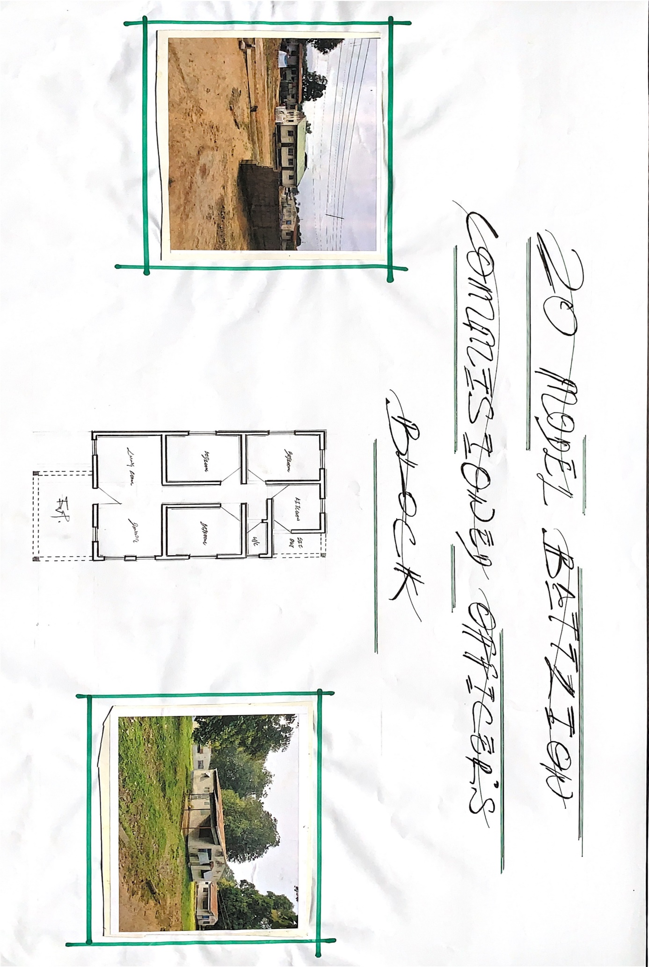
CASE STUDY ONE (1)
FIGURE 1.1
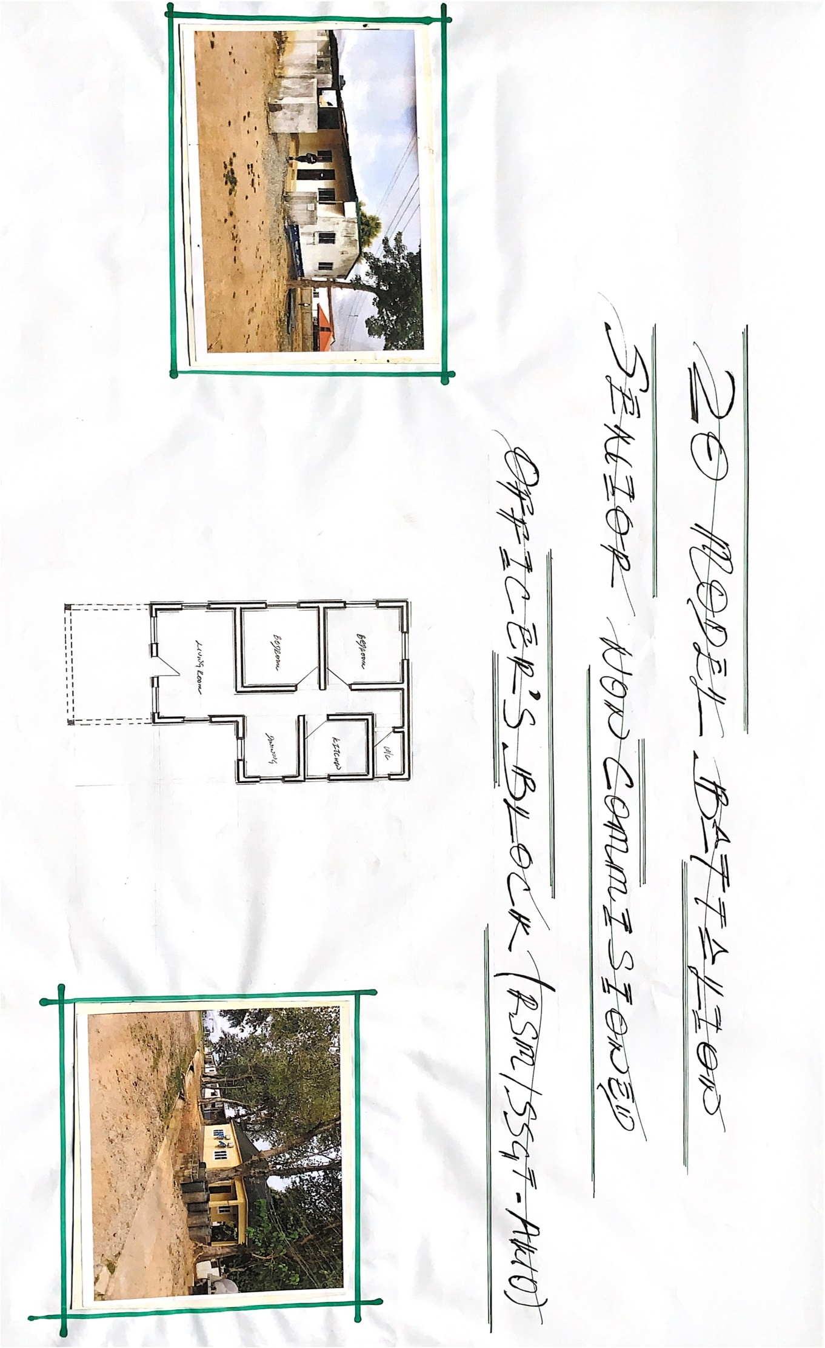
CASE STUDY ONE (1)
FIGURE 1.2
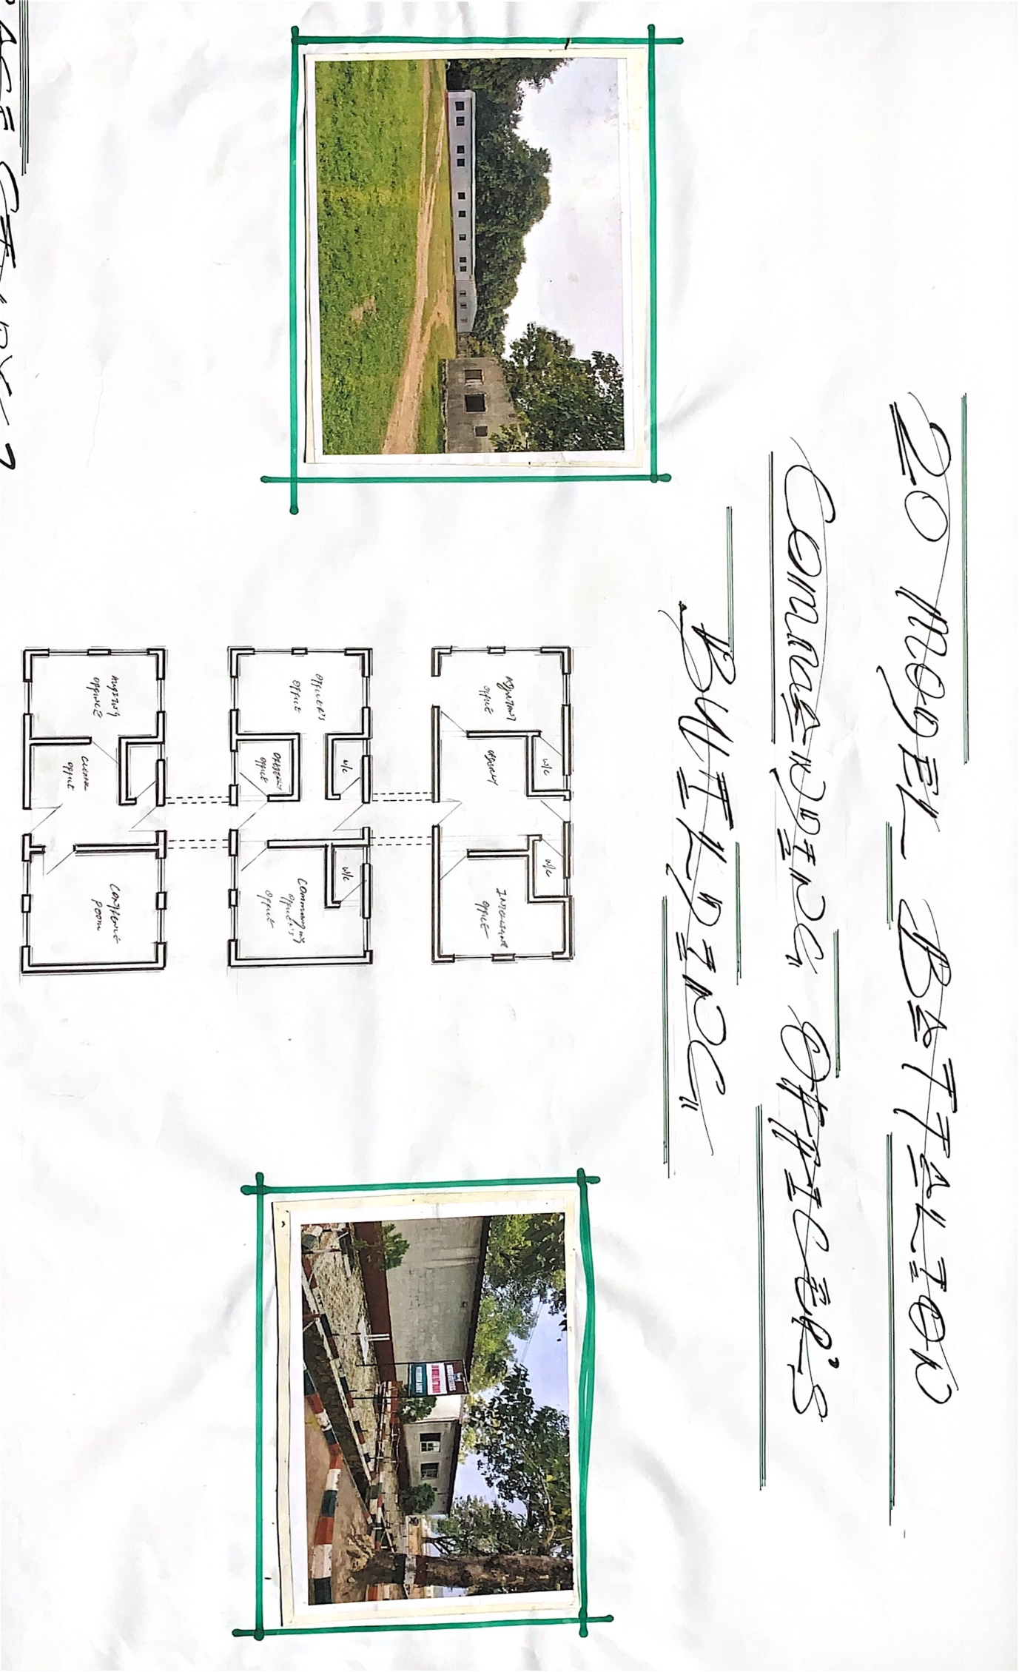
CASE STUDY ONE (1)
FIGURE 1.3

CASE STUDY ONE (1)
FIGURE 1.4
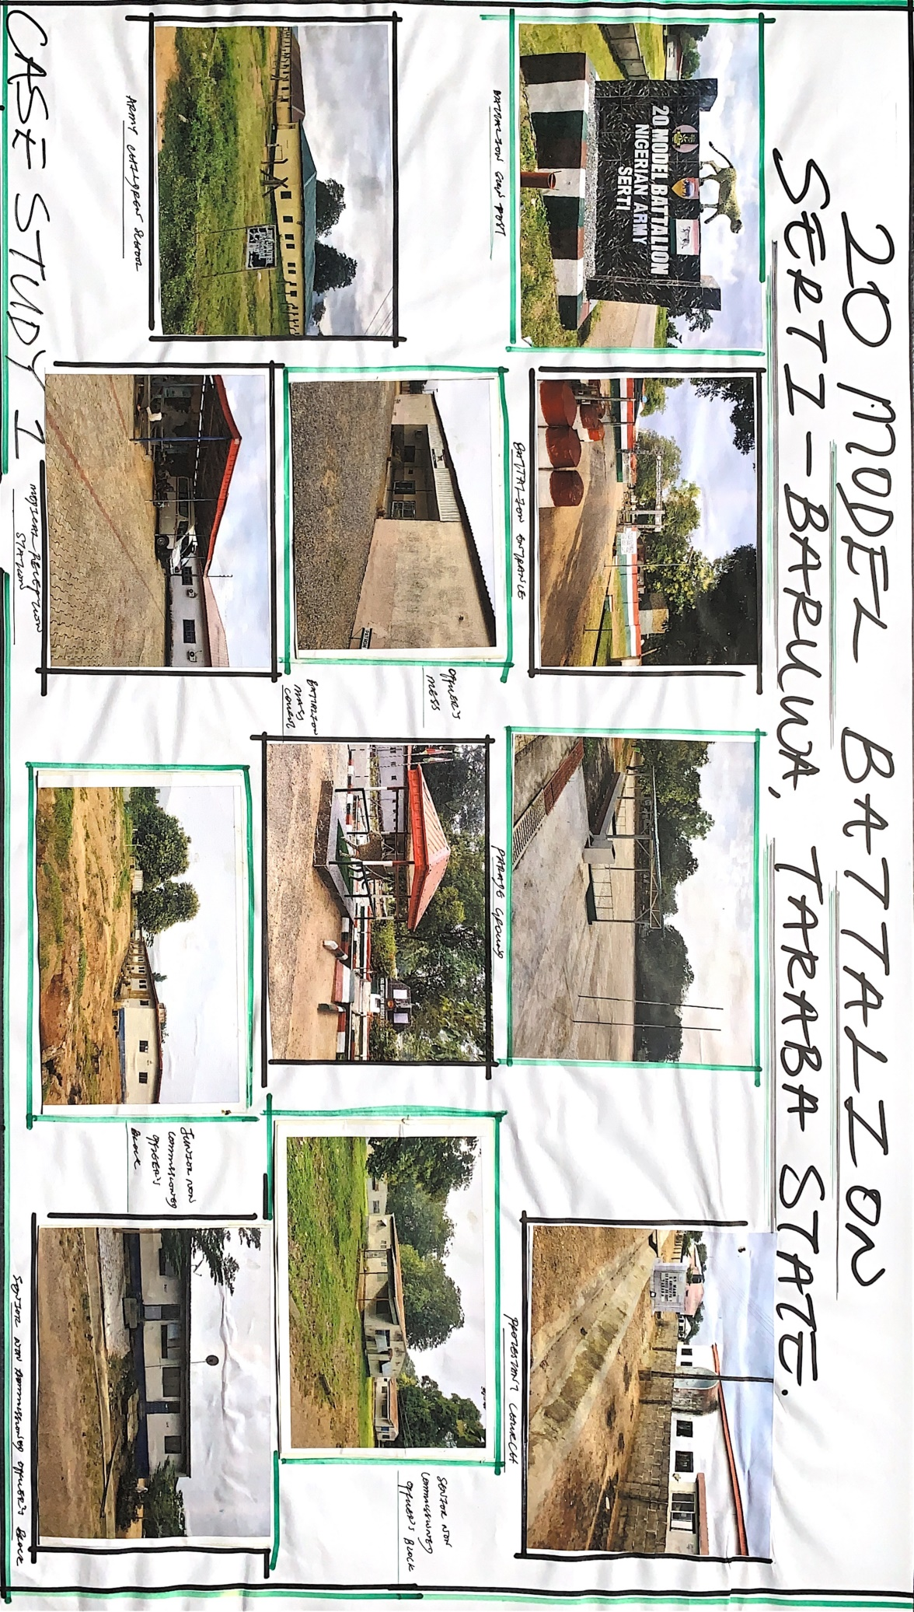
CASE STUDY ONE (1)
FIGURE 1.5

2.2. CASE STUDY TWO

NAME: BONNY CANTONMENT

LOCATION: VICTORIA ISLAND, LAGOS STATE

BONNY CANTONMENT, LAGOS STATE

HISTORICAL BACKGROUND

Bonny Cantonment, situated in Victoria Island, Lagos, is one of Nigeria's most strategically important military bases. Originally established during the colonial era, the site was developed as part of the British military infrastructure to maintain control over the Lagos colony and surrounding regions. After Nigeria’s Independence in 1960, the cantonment was integrated into the Nigerian Army’s structure and gradually evolved into a central administrative and operational hub. Its prime coastal location made it suitable for coordinating Maritime and urban security operations, especially doing periods of national unrest and civil disturbances.

Today Bonny Cantonment serves as the headquarters of the Nigerian Army’s 81 Division, which oversees military activities across Lagos and parts of the southwest region. The cantonment hosts several military units and departments, including those involved and internal security, training, and logistics. In addition to its defense rule, the cantonment has been engaged in various civil military initiatives, including medical outreach programs, disaster response, and community engagement activities in Lagos state.

DESCRIPTION

The cantonment is situated on a substantial land area of approximately 170 hectares, providing ample space for residential, administrative, and operational facilities.

Bonny Cantonment Army barracks, located in Victoria Island, Lagos, was constructed to serve as a key military installation in Nigeria. It was commissioned in 1996 and has since played a significant role in supporting military operations, training, and security in Lagos region.

Its location offers strategic advantages in terms of security and access to key urban infrastructure. Bonny Cantonment is part of the Nigerian Army’s efforts to enhance operational readiness and maintain security in Lagos and its surrounding areas.

MERITS

- Strategic location: The contentment is situated in a prime area of Lagos, providing strategic asses to key infrastructure like the airport, seaport, and major road networks, enhancing operational efficiency and security.
- Well-designed security features: The design includes robust security measures, such as perimeter fencing, controlled entry points surveillance systems and fortified buildings, which are critical for protecting military personnel and sensitive ass assets.
- Effective space planning: The cantonment is thoughtfully planned, with district areas for barracks, offices, training and recreational facilities, promoting smooth operations and a balanced environment for personnel.
- Modern infrastructure: They cantonment features modern infrastructure, including recyclable water supply, electricity and sewage system, which improve the comfort and functionality of the space for it occupants and personnel.
- Climate considerations: The buildings are designed to cope with Lagos’ tropical climate, with proper ventilation and shading, reducing the need for excessive energy use and in enhancing and answer comfort for personnel.

DEMERITS

- Traffic and accessibility issues: The surrounding area in Victoria Island can be heavily congested, especially during peak hours, which may hinder quick access to and from the cantonment for both personnel and supplies.
- Congestion: The cantonment suffer from overcrowded conditions in certain areas, practically with regard to accommodation and office species, limiting the comfort and privacy of personnel.
- Limited expansion space: Due to its urban location, there might be limited land available for future expansion or modification, restricting the ability to grow or adapt to the facility as need evolve.
- Vulnerability to coastal climate: Being located in a coastal region, the cantonment is exposed to environmental challenges like saltwater corrosion, which can impact the longevity of buildings and infrastructure if not properly maintained.
- Noise and pollution: The urban environment of Victoria Island exposes the cantonment to noise pollution and environmental degradation, which could affect the well-being of personnel and reduce the overall quality of life.

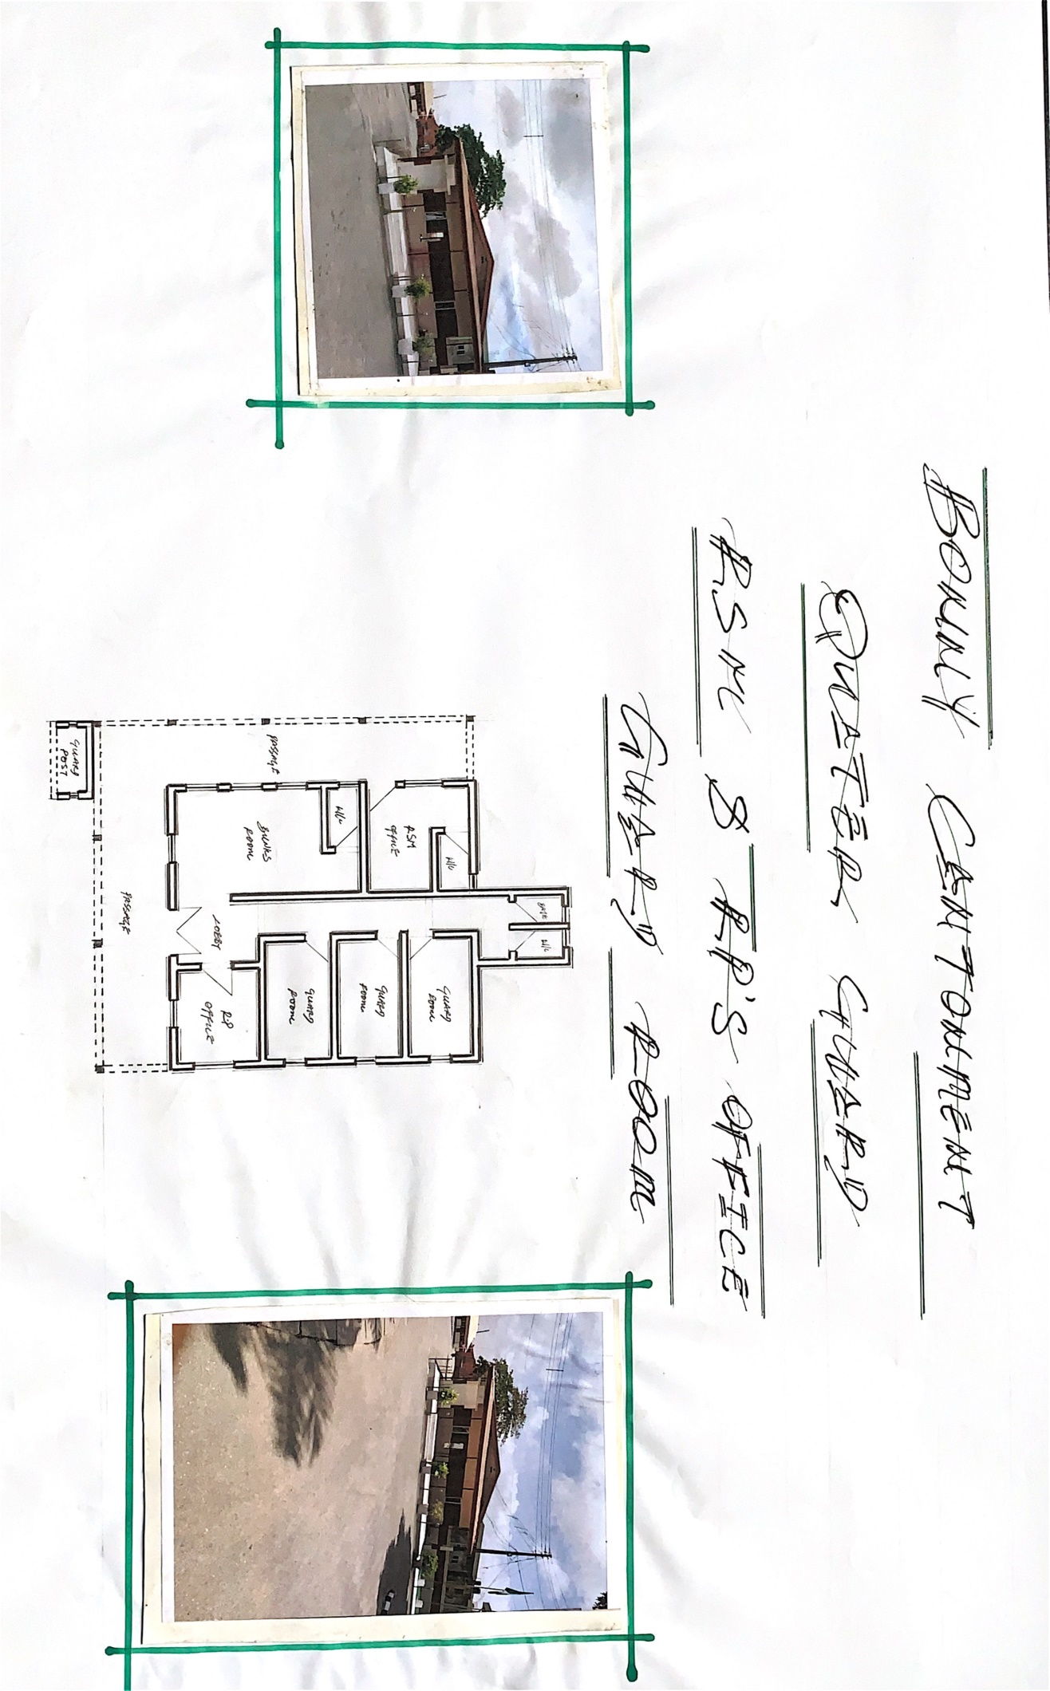
CASE STUDY TWO (2)
FIGURE 2.1
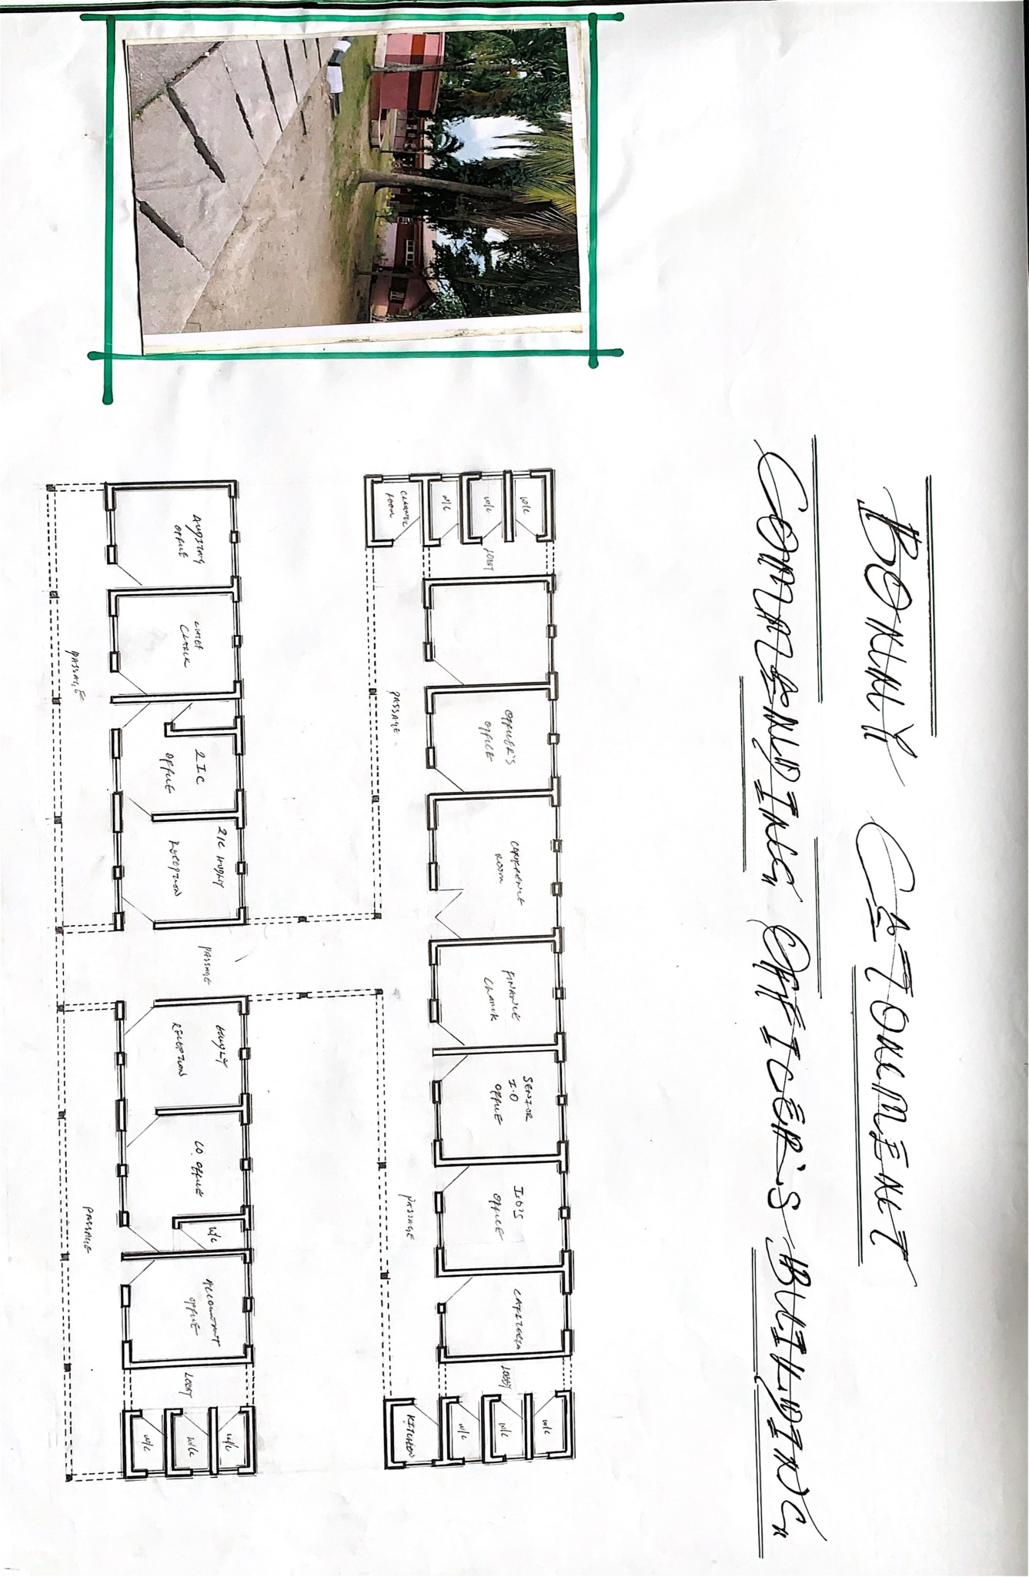
CASE STUDY TWO (2)
FIGURE 2.2

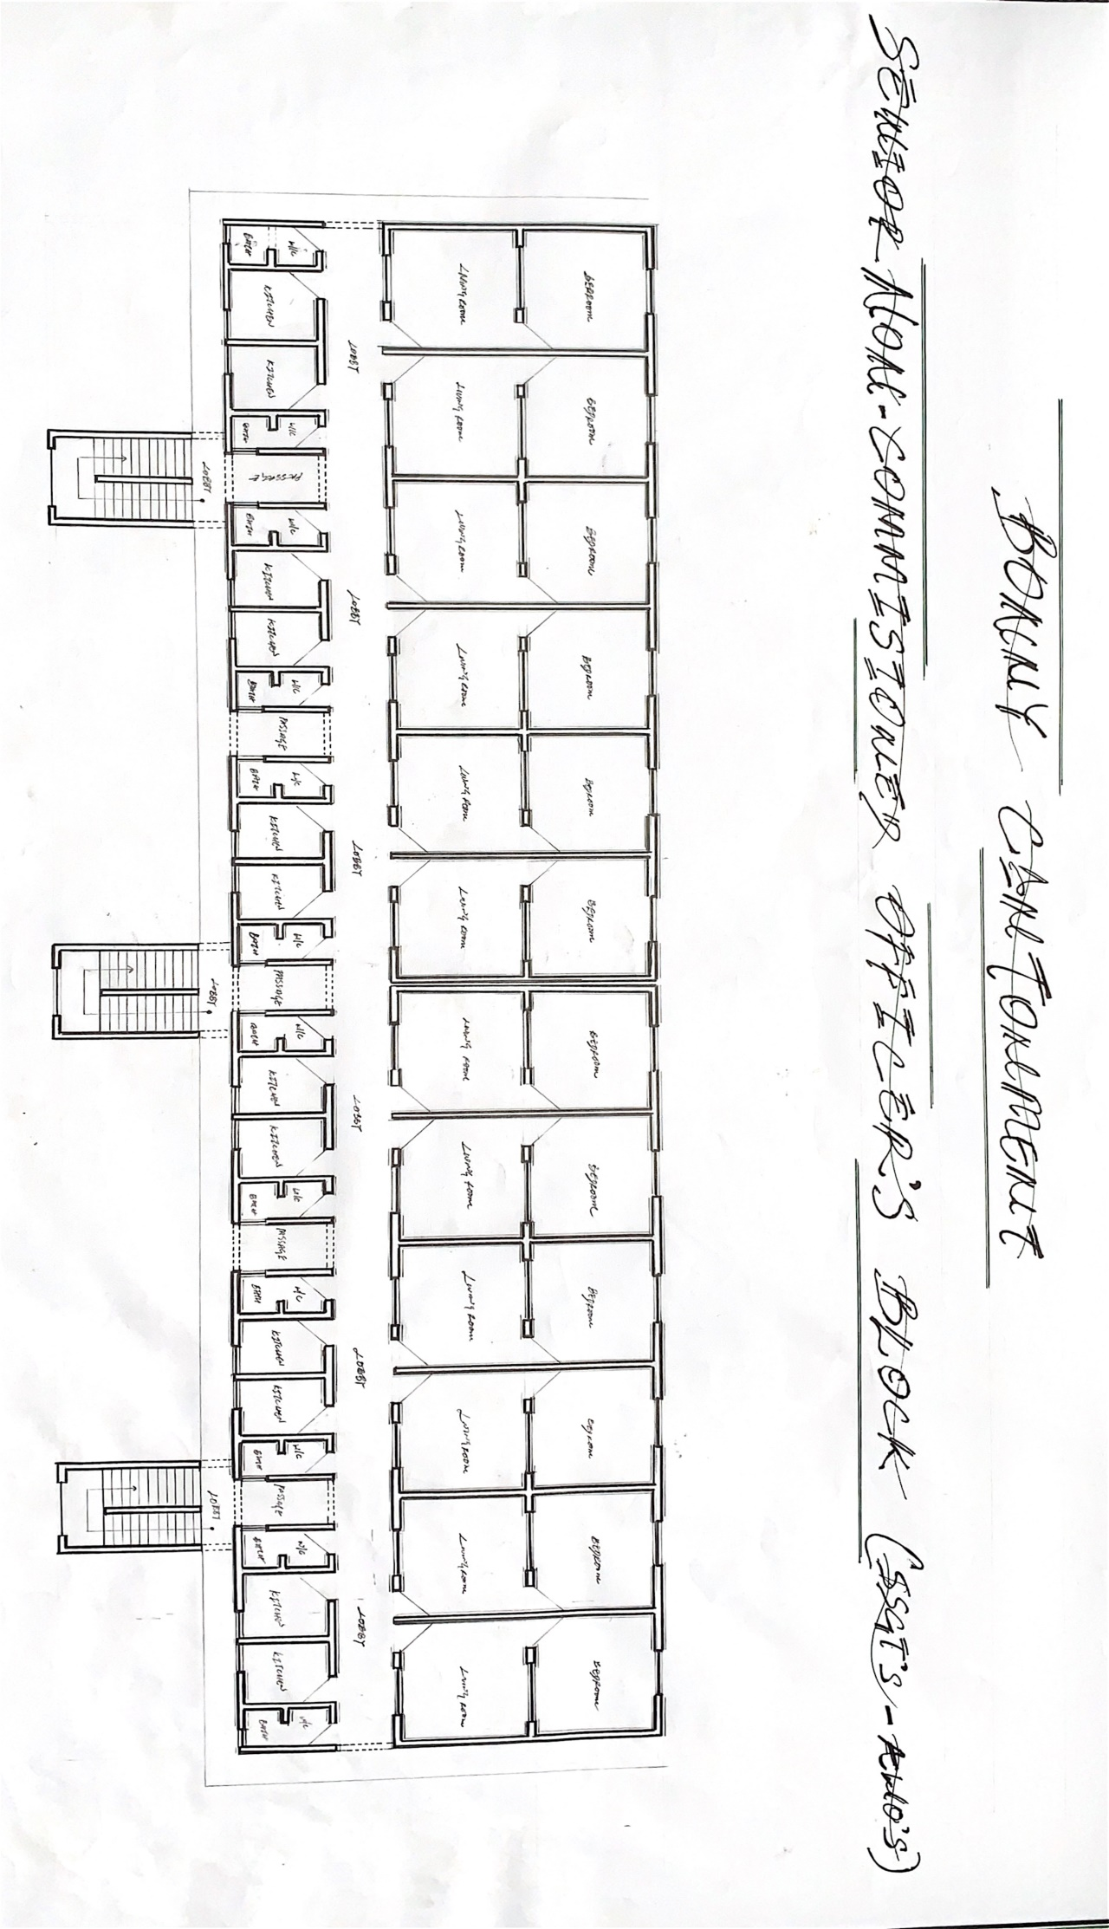
CASE STUDY TWO (2)
FIGURE 2.3

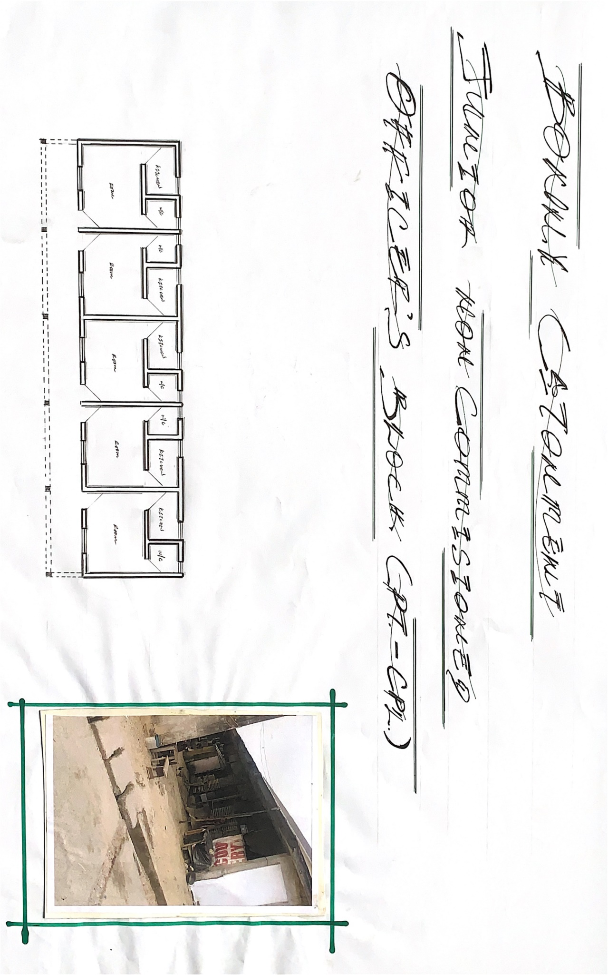
CASE STUDY TWO (2)
FIGURE 2.4

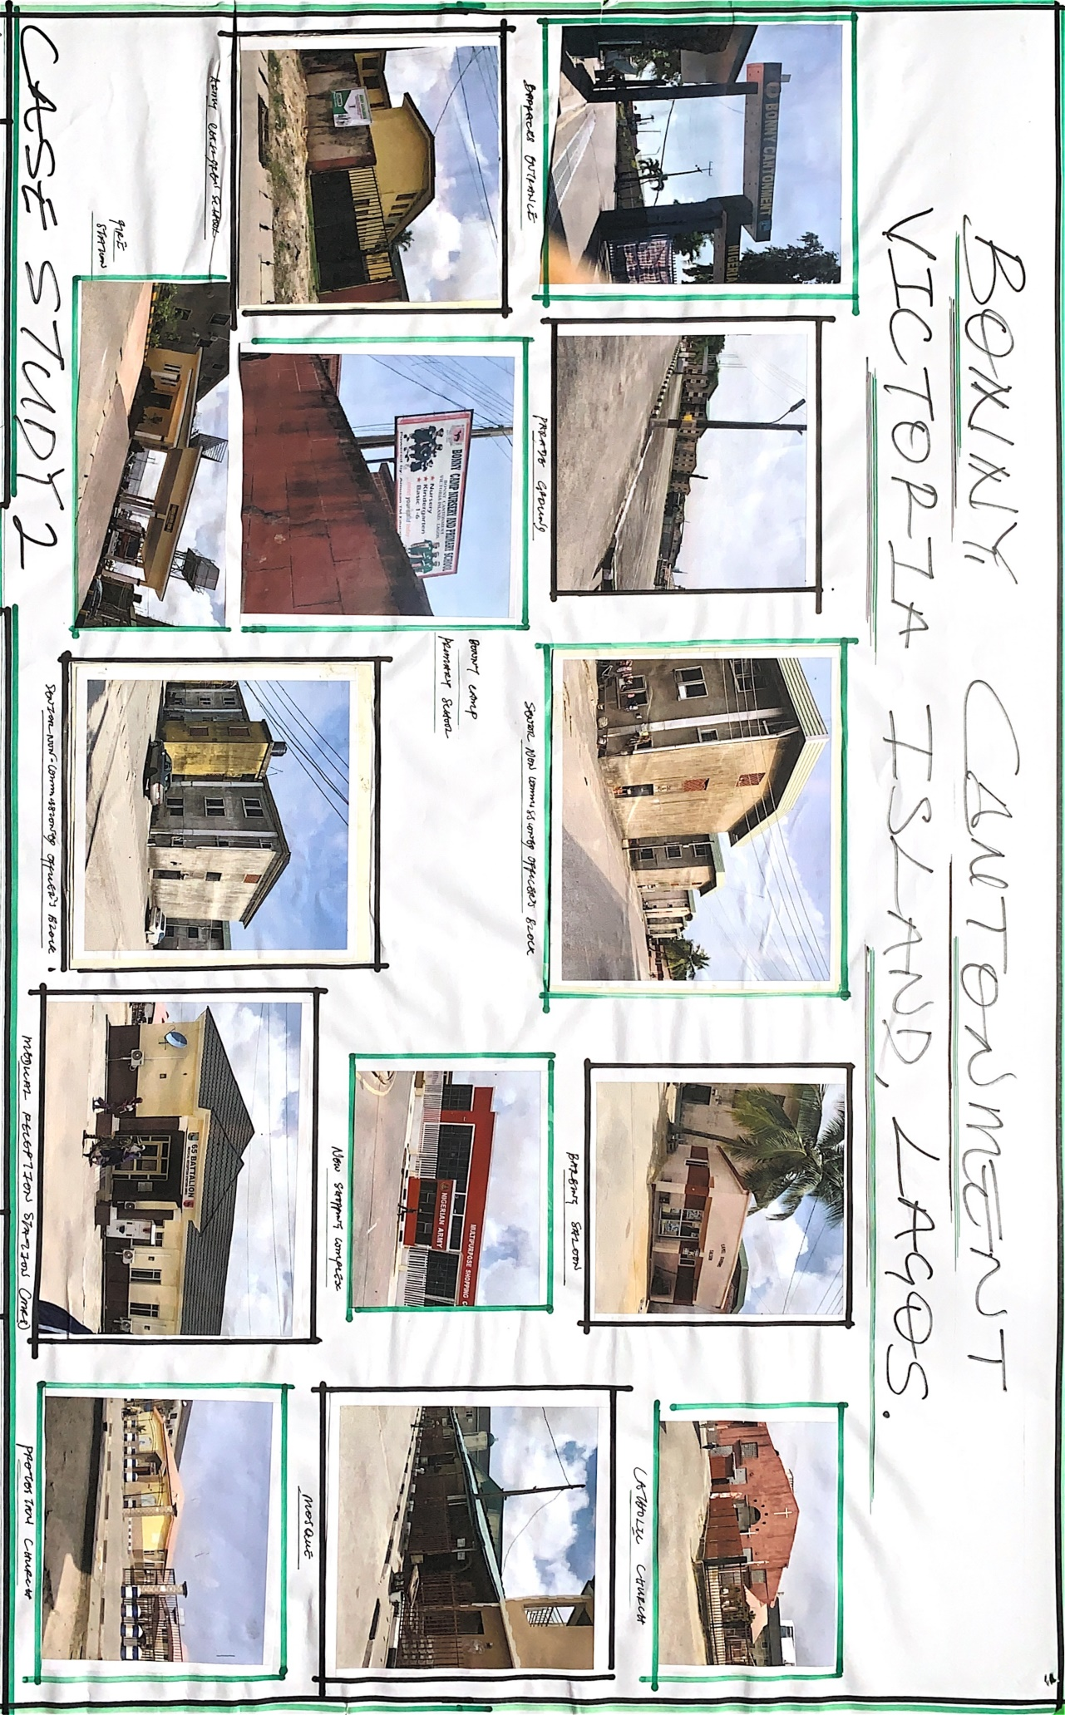
CASE STUDY TWO (2)
FIGURE 2.5

2.3. CASE STUDY THREE

NAME: MAXWELL KHOBE CANTONMENT

LOCATION: RUKUBA, JOS, PLATEAU STATE

MAXWELL KHOBE CANTONMENT, RUKUBA, JOS, PLATEAU STATE

HISTORICAL BACKGROUND

Maxwell Kobe cantonment, located in Rukuba, Jos, Plateau State, is the headquarters of Nigerian Army’s 3rd Armored division. Originally known as Rukuba cantonment, it was named in honor of the late Brigida General Maxwell Khobe, a distinguished ECOMOG commander renowned for his leadership during the Librarian and Sierra Leonean peacekeeping operations in the 1990s. Khobe's legacy was commented by his service as Chief of Defense Staff in Sierra Leone before his death in 2000, promoting the renaming of the cantonment to commemorate his contributions.

Over the years, Maxwell Khobe Cantonment has become a focal point for ongoing infrastructural development aimed at improving military preparedness and community welfare. Under successive Nigerian army leadership, project such as remodeled main entrance gate and quarter guard, upgraded networks, construction of a multipurpose dam and portable water supply. These initiatives, driven by the Nigerian Army and supported by the Chief of Army Staff, reflect a sustained commitment to enhancing troop welfare and strengthening civil military relations within the cantonment and its host communities.

DESCRIPTION

Maxwell Kobe cantonment is a significant military facility located in Rukuba, Jos in Plateau State. The cantonment was constructed as part of Nigeria’s efforts to bolster military presence and operational readiness in the region. It was commissioned in 1998.

The cantonment is situated on the land area of approximately 1000 hectares, providing ample space for barracks, training facilities and administrative buildings. Its strategic location in the media-belt of Nigeria is a key to ensuring rapid deployment of responses to security challenges in the region, including insurgency, conflicts, and order security concerns.
Max Khobe Cantonment serves as a vital hub for Nigerian Army personnel stationed in Central Nigeria.

MERITS

- Functional layout: The design of the cantonment effectively accommodates military personnel and operations, with clearly defined species for barracks, training areas and administrative buildings. The layout shows efficient movement and assess within the contentment.
- Security and safety: The cantonment is designed with robust security features, including controlled entry points, fortified structures, and a perimeter that provides a secure environment for personnel, sensitive equipment and operations.
- Environmental integration: The design takes into consideration the local climate, incorporating natural ventilation, appropriate landscaping and orientation to reduce the need for energy intensive cooling, contributing to sustainability and comfort.
- Community and well-being: The cantonment includes communal species and adequate provision for health and welfare, supporting the physical and mental well-being of soldiers stationed there.

DEMERITS

- Climate and comfort challenges: Despite effort to incorporate natural ventilation and local climate considerations, the harsh climate conditions in Plateau State, including fluctuating temperatures and occasionally harsh weather might still pose challenges for comfort and energy efficiency.
- Congestion in high-identity areas: In some part of the cantonment, high-identity housing or house communal spaces may lead to congestion impacting privacy, personal space and overall living conditions for soldiers and their families.
- Limited amenities and infrastructure: Depending on the scale and budget of the cantonment, there are lack of certain modern amenities or infrastructure development, which could affect the quality of life for personnel station there.
- Security and accessibility problems: While designed for security, certain areas face accessibility challenges for personnel or vehicles due to strict control measures, potentially hindering efficient movements within the cantonment.

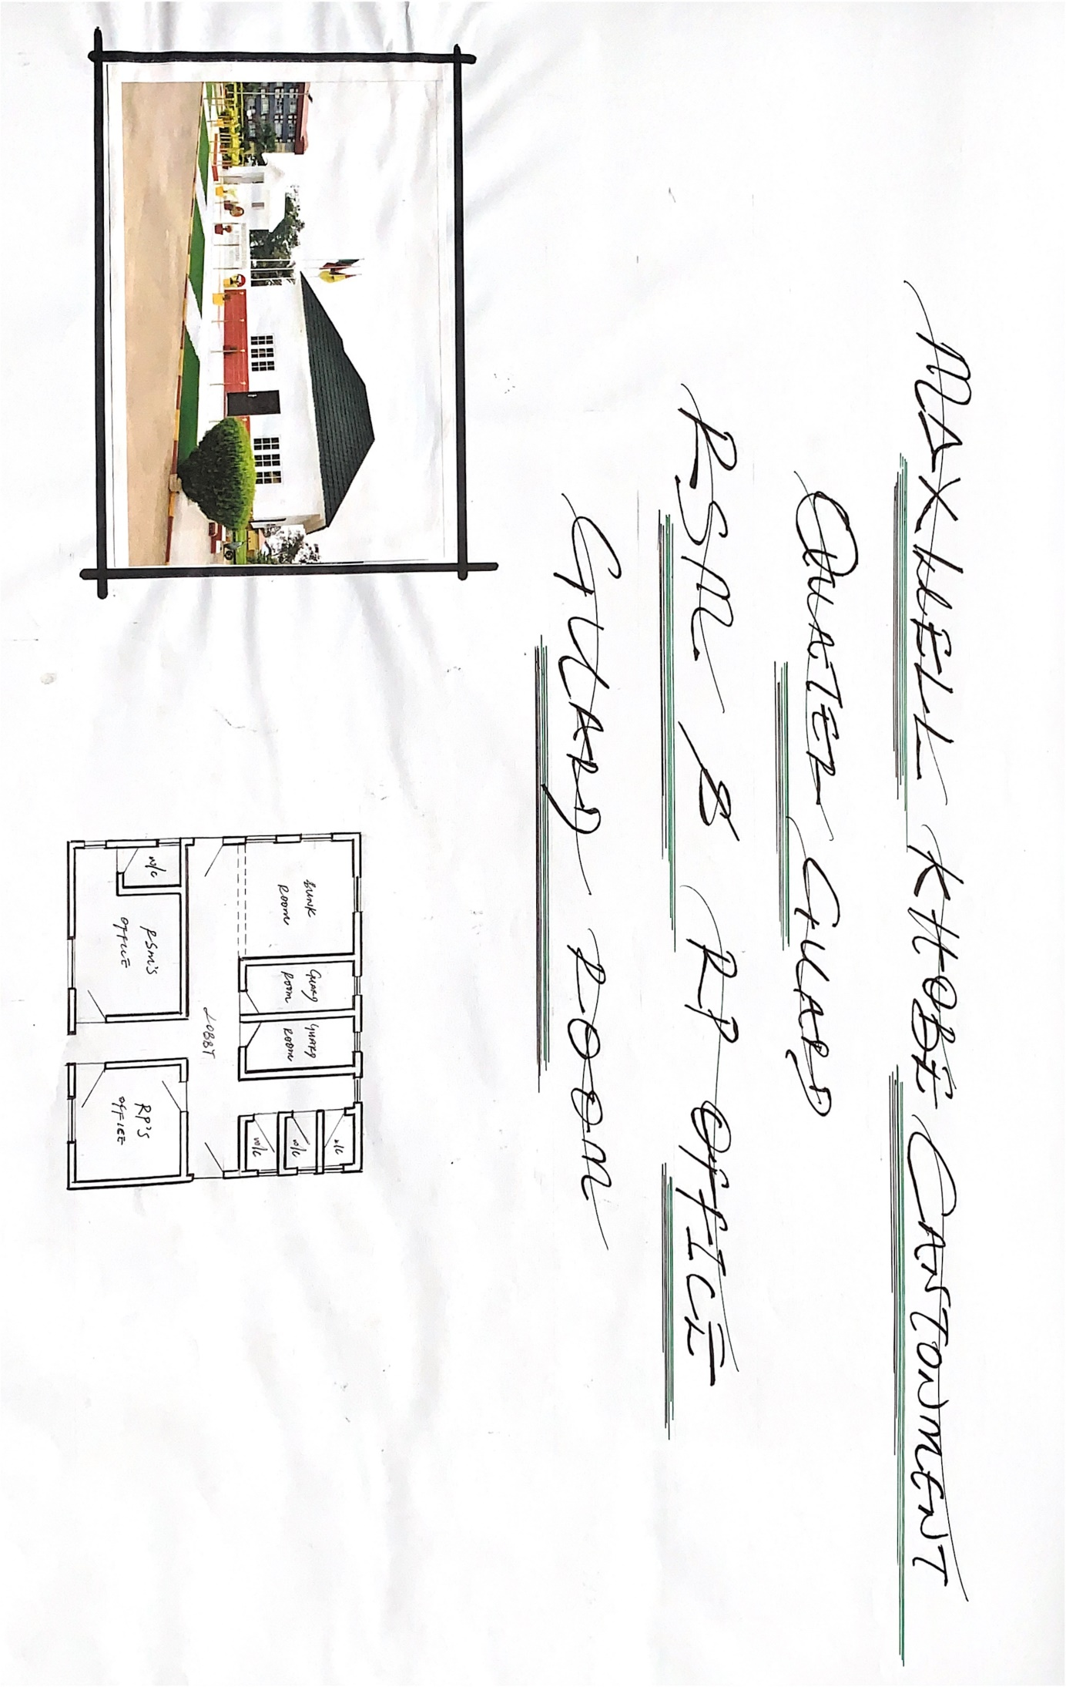
CASE STUDY THREE (3)
FIGURE 3.1
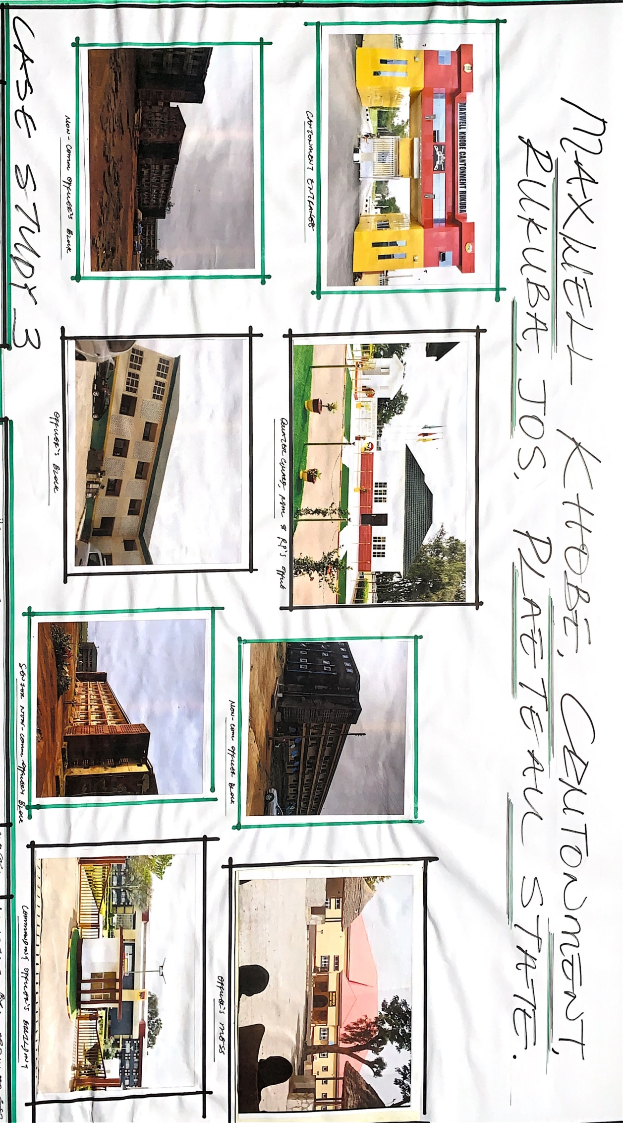
CASE STUDY THREE (3)
FIGURE 3.2

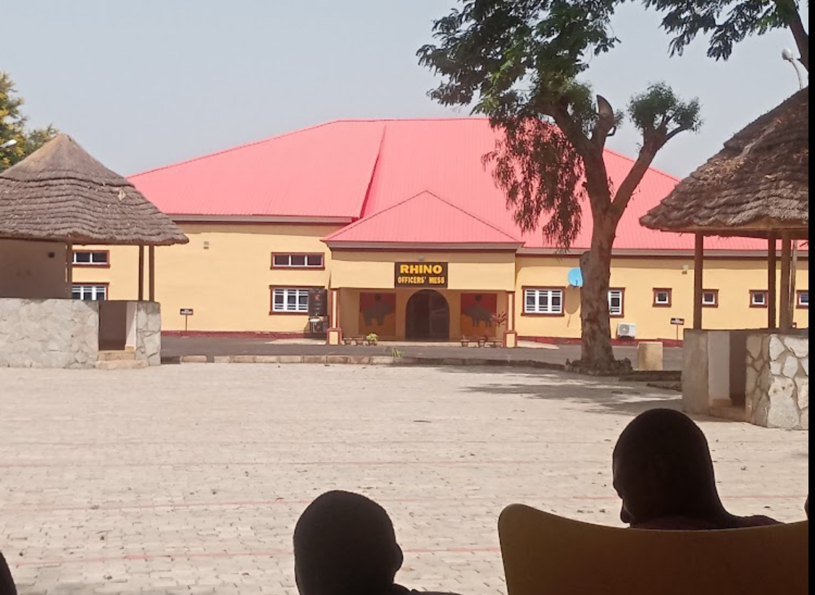
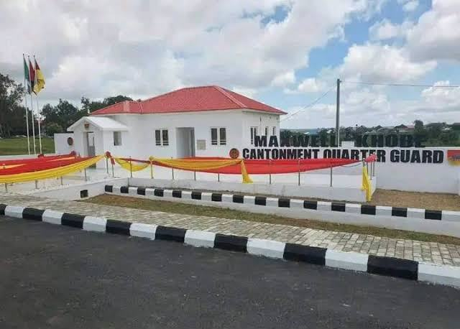
CASE STUDY THREE (3)
FIGURE 3.3

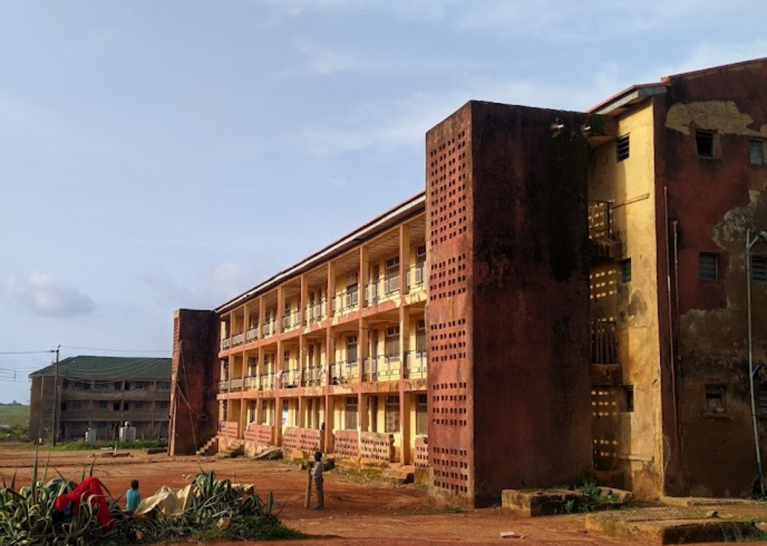
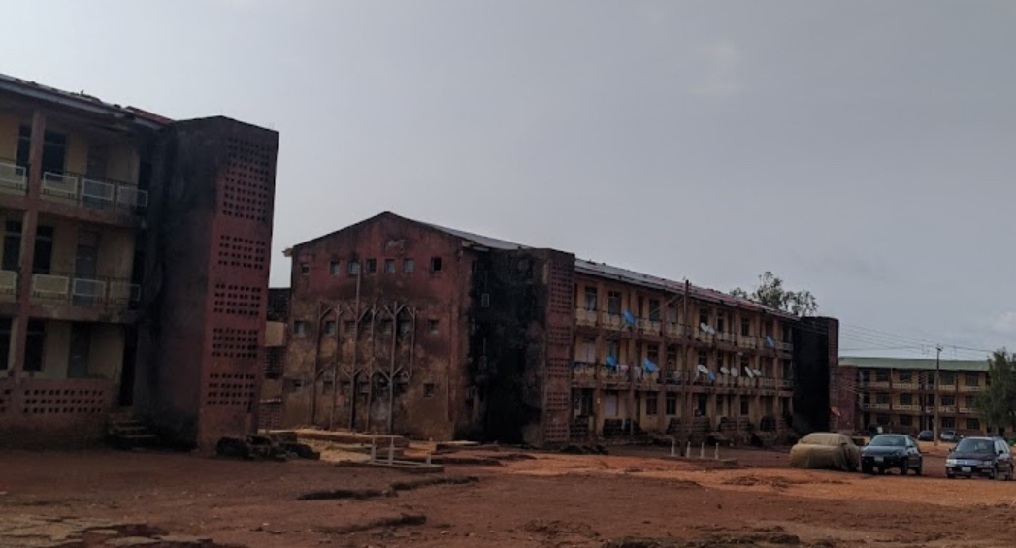
CASE STUDY THREE (3)
FIGURE 3.4

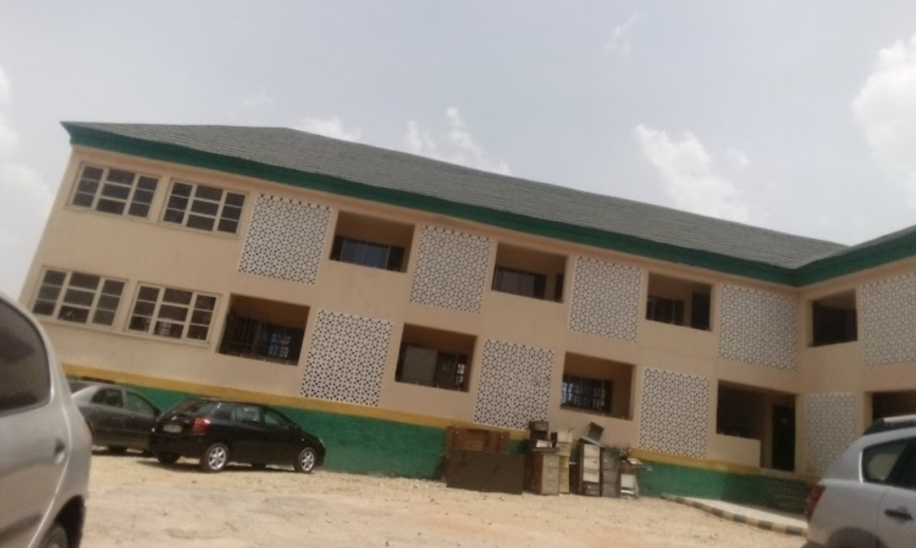
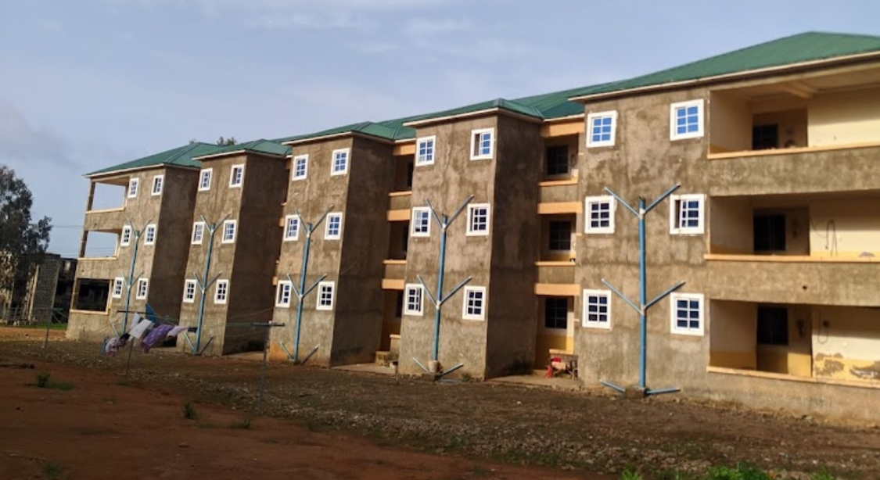
CASE STUDY THREE (3)
FIGURE 3.5

CHAPTER THREE

3.0. INTRODUCTION OF THE SITE

Orile Igbon, an ancient settlement located in Surulere Local government area of Oyo State. Orile Igbon is situated near Ogbomoso, along the Old Ogbomoso-Ilorin Road, approximately 3 kilometers after Ladoke Akintola University of Technology.

HISTORY OF ORILE IGBON

Orile Igbon, located in Surulere Local government area of Oyo State, Nigeria, is an ancient Yoruba town founded in the 11th Century by the Olugbon Ese, a direct descendant of Oduduwa, the progenitor of the Yoruba people. Historically, it was on of the four principal provinces of the old Oyo Empire, along side Oyo-Ile, Iresa, and Ikoyi, with the Olugon serving as a key political and military figure second only to the Alaafin. The town played a major role in regional governance and warfare during the height of empire. Following the collapse of the Oyo Empire and conflicts such as the Afonja Rebellion, Orile Igbon experienced decline and displacement.

3.1. SITE LOCATION AND DESCRIPTION

Orile Igbon has a latitude 08^{O}13’59’.22” to 08^{O}15’00” Eorth and longitude 004^{O}17’05.0” to 004^{O}19’01.1” East of the equator.
The local land mass of Orile Igbon is suggested that is significantly larger than Ogbomoso in terms of landmass. The town is described as "Ten times bigger than Ogbomoso land" inducting its expansive territory.
Surulere local government area, within encompasses Orile Igbon, covers an area of approximately 975 square kilometers.

  - SITE LOCATION CRITERIA

Site selection is the concentration of certain factors which influence the development of the situated site and spatial activities of the site.
Conversely, site selection criteria are based off on physical screenings.

Factors affecting choice of sites include:

- Thermal control
- Comfort.
- Ventilation
- Solar control

And also the various activities which will be taking place on the site. Based on the nature of the proposed project, the site selection should meet the requirements for the efficient functioning of the proposed project design (Military Barracks)

Additionally, the size of the land available for the development should be adequately reasonable to accommodate such functions. Furthermore, the proposed sites for the construction if proposed project design bracket (military barracks) has enough landmass existing characteristics that will facilitate the adequate functionality.
  - SITE ANALYSIS AND INVENTORY

Site analysis is conducted based on the intended propose of the project. To acquire essential information about the site, specific steps are undertaken. The process begins with a preliminary survey, which involves a visual inspection to gather data on topography, vegetation, and existing features.

Following the survey, the collected information is thoroughly analyzed to inform the design process.
Key aspects considered include soil condition, geological characteristics, topographical features, vegetation type and order relevant environmental factors. This comprehensive assessment and ensures that the site is suitable for proposed development and aids in making informed design session decisions.
Analysis to be carried out includes:

- Soil condition of the sites
- Geology
- Vegetation cover
- Landscape analysis
- Climate (sun and wind direction).

  - SITE SUITABILITY ANALYSIS

The success of a military barracks project hinges not only on the functional design but also on the strategic selection of this it’s location. Although the site for the project has already been chosen, it is imperative to evaluate it against established selection cafeteria to ensure its suitability. This evaluation should encompass factors such as terrain, accessibility, security and environmental impact, which are critical to the operational effectiveness and longevity of the facilities.

A thorough analysis of the selected site, guided by these criteria, will contribute significantly to the project overall success.

These criteria include:

- Location
- accessibility
- Size
- Scenic beauty
- Services

- LOCATION:

The strategic placement of a Military Barracks is paramount to operational effectiveness.
Beyond the internal functionality of the facility, its location relative to other essential military installations, such as training grounds, command centers, and so on, plays a critical role in ensuring seamless coordination and rapid response capabilities. Selecting a site that offers optimal proximity to these facilities enhances logistical efficiency, facilitate swift troop mobilization and strengthen overall mission readiness.
- ACCESSIBILITY:

Following site location, accessibility emerges a pivotal criterion in the selection process for a Military Barracks. The strategic value of a location is inherently linked to how easily it can be accessed. An optimally accessible site ensures seamless movements of personnel, equipment, and supplies, which is essential for operational efficiency and rapid response. Therefore, sites suitability is significantly determined by its accessibility within the operational area.

- SIZE:

The size of the site is a critical factor in the planning and development of a military barracks. An adequately sized site ensures that all necessary functions, such as accommodation, training facilities, administrative buildings, and logistics areas, can be efficient by facilitating smooth workflows, reducing vertical movements, and minimizing congestion. Moreover, ample space allows for future expansions and adaptability to evolving military needs, ensuring the barracks remain functional and relevant over time.

- SCENIC BEAUTY

The aesthetics quality of a workable surrounding plays a crucial role in enhancing personnel relaxation and productivity, while comfortable interior spaces are essential, providing personnel with pleasant external views can significantly impact their well-being. Studies have shown that exposure to natural elements, such as greenery and natural light, can reduce stress, improve focus and elevate mood. Incorporating scenic beauty into the workable environment not only creates a more enjoyable environment, but also fosters a positive psychological state, leading to increased job satisfaction and efficiency.

3.2. GEOPOLITICAL CHARACTERISTICS

VEGETATION:

Vegetation on the site is Savannah type, which is noted for predominantly tall grass and short to medium sized trees. Most of the trees are deciduous with the present artificial fig tree planted. This shall be used for landscaping purpose and shading.

Topography: the area has an average evaluation of approximately 388 meters (1273 feet) above sea level, indicating a moderately elevated terrain.
Orile Igbon is characterized by undulating plains interspersed with a gentle hills and inselbergs. The topography of Orile Igbon, with its moderate evaluation and stable geological foundation, makes it conducive for various forms of development, including residential settlements and infrastructural projects.

3.3. CLIMATIC CHARACTERISTICS

The climate of Surulere Local Government Area, like much of Southern Nigeria, experiences a tropical savanna climate under the Koppen-Geiger classification, characterized by distinct wet season and dry season.
3.4. TEMPERATURE

annual temperature hover between 24°C and 30°C (75°F - 86°F), with daily highs typically ranging from 25°C - 28°C (78°F - 38 83°F) and lows rarely dropping below 21°C (70°F) or exceeding 34°C (93°F).

3.5. RAINFALL AND HUMIDITY

Annual precipitation totals approximately 1670 mm, predominantly falling between April and October.
There are about 250 to 260 rainy days per year, making the wet season oppressively a heavily overcast.

CONCLUSION

On designing of the proposed project selecting an appropriate development site depends carefully on evaluation of all the criteria discussed, location, accessibility, size and environmental qualities, to ensure the projects long-term success and functionality.

CHAPTER FOUR

  - DESIGN CRITERIA/GENERAL REQUIREMENTS

After proper research and planning, the next step in the series of the project is designed brief. To achieve functional and well established design there must be a brief to work on. The brief depends generally on the scope of the entire design. The brief of the project is therefore for based on the various activities that take place in the Military Barracks.

To have enough brief for the proposed Military Barracks, case studies were carried out on existing Military Barracks, to know the nature of the activities carried out in the Barracks and how they are related to each other.
The Military Barracks has five major sectors which are, administrative and command, tactical, recreation and relaxation, Medical /Health and residential.

  - SITE PLANNING

The entire site is properly planned in a specific order, to give a well-defined shape and also to reflect the various activities undertaken on site.

The location of the barracks and its facilities within the site all follows these main principle.
- The zoning principle (public, semi private, private) is respected, which enhance placement of each structure and respect to the level of egress and ingress.
- Structures are placed in accordance to usage.

The entire site is properly defined with a perfect blend of both natural and artificial attraction as well as soft and hard landscaping to give a quality taste of a desire comfort to all sectors.

  - BRIEF ANALYSIS (CLIENT/USERS REQUIREMENTS)

Due to recent technological advancements, comprehensive planning for today's working environments is essential for identifying and meeting users’ needs across all areas, ultimately enhancing efficiency and productivity.

DESIGN SCOPE:

- Entrance gate
- Quarter guard
- Commanding Officer Building
- RSM and RP Block
- Armory
- Parade ground
- Sports ground
- Officers mess
- Sergeant and AWO mess
- Corporal and Private mess (soldiers club)
- Officers’ quarters
- Senior non-commission officers’ quarters
- Junior non commission officers’ quarters
- Medical reception station (MRS)
- Maintenance unit block
- Religious buildings
- Elementary school
- Secondary School
- Mammy market
- Landfill

  - FUNCTIONAL RELATIONSHIP WITHIN THE MILITARY BARRACKS

The source of the project depends greatly on the adequate understanding between and within each of the different facilities, sectors and units within the military barracks.

These relationships can be classified into the following.

- Administrative and Command
- Tactical
- Residential
- Recreation and Relaxation
- Medical/Health
- Educational
- Religious

- ADMINISTRATIVE AND COMMAND

These are structures which includes the Commanding Officer Building, Quarter Guard , RSM and RP block, Armory and Parade ground, including all administrative buildings and offices

- TACTICAL
This refers to the group set aside for tactical training and military engagement and readiness

- RESIDENTIAL
Living quarters of the personnel, Senior Officers Quarters

- RECREATIONAL AND RELAXATION

Sport grounds, Officers and Soldiers Mess, Event Hall, Open green landscaped area and gym.

- MEDICAL/HEALTH FACILITIES

Refers tot the Medical Reception Station (MRS) and other adjoining buildings

- EDUCATIONAL

Educational facilities for personnel, Elementary School, and Secondary School

- RELIGIOUS FACILITIES

Buildings for the two major religions (Church and Mosque)

  - CONCEPTUAL DEVELOPMENT AND PHILOSOPHY

The guarding principle behind a design often serves as its foundational concept. While designers may shear similar over reaching ideas, their individual interpretations and approaches can vary significantly.
In many cases, designers develop a strong personal attachment to their design philosophies, which in turn shape their unique style and identity. These philosophies are often influenced by the architect’s personal beliefs and experiences, which may stem from environmental factors or specific challenges outlined in the design brief.

In the context of Military Barracks, activities follow as sequential order, therefore it becomes essential to organize the sequence and reflects it in the design through a clear sense of hierarchy. Environmental factors also play a crucial role, as architects often leverage the characteristics of the surrounding environments to enhance their design. These factors may include locally available building materials, construction methods, prevailing building forms, spatial arrangements, types of activities, and the region’s climatic conditions.
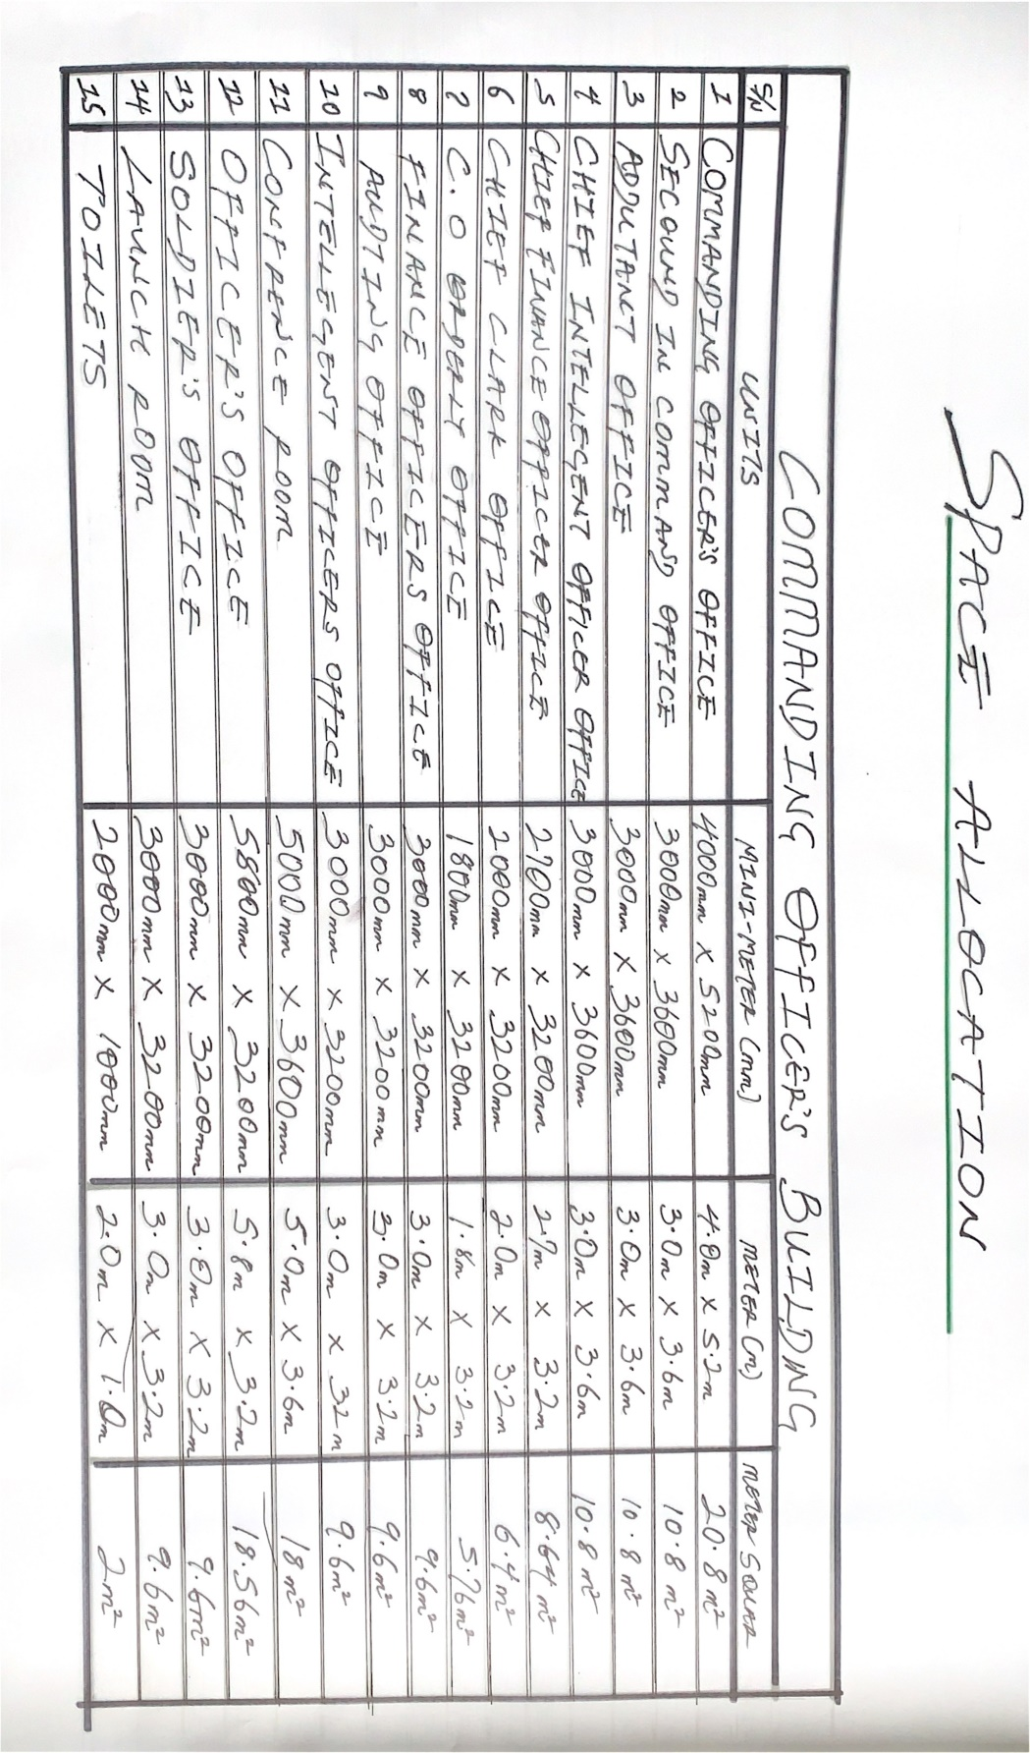
  - SPACE ANALYSIS AND CALCULATION

CHAPTER FIVE

5.0. DESIGN APPRAISAL

In any project design, there are two basic factors that should be taken into proper consideration. These factors are functionality and aesthetics of the design.

Although to some architect or designers, aesthetics and functionality of any building are incompatible, but in the case of this project, both aesthetics and functionality of design were taken into consideration, to satisfy the highly demanded functional requirements and to create aesthetically and proportionally balanced design.

The functional efficiency of a Military Barracks depends largely on the en-closeness of all the facilities of the immediate sectors that are strongly related in function. All these have been taken up into concentration as seen on the site and floor plan respectively.

5.1. CONSTRUCTION METHODOLOGY AND MATERIALS

  - IMPLEMENTATION OF DESIGN GRIDS

To facilitate planning, construction, and servicing in complex building design, a grid system is employed. This system comprises two key types of grids:

• Layout planning grids
• Grids for building elements

In better clarification, design grids are discussed under four main headings:

- The Structural Grid

This grid relates to the major zones of the building, especially the largest and most permanent parts of the building shell. Structural grids are laid out in both horizontal and vertical planes. Key factors influencing the internal structural grid include:
• The span of the structural systems adopted
• The nature of floor loading, as different building areas experience different loading conditions
• The space and dimensions required within the building

- Construction Grids

These grids take into account the standard sizes of building materials and products available in the market. By aligning design with these sizes, construction grids help minimize material wastage and optimize space usage.

- Service Grids

Service grids are designed to reduce disruption to service points within the building. They accommodate the distribution of utilities such as power points and telephone outlets throughout the facility.

- Planning Grids

Planning grids assist in organizing workgroups and their respective workspaces. They help impose a structured layout, ensuring that both individual and group space requirements are efficiently met, while maintaining overall spatial standards.

2. PLAN TYPE

This project will adopt a combination of cellular and open-plan office layouts. The cellular office setup is designated for senior executive staff, offering them the privacy and exclusivity their roles require. In contrast, the open-plan areas will be allocated for junior staff, promoting collaboration and efficient space utilization.

The cellular layout is ideal for executive functions as it ensures a quiet, private environment that matches the significance of their responsibilities.

3. BUILDING ORIENTATION

The orientation of the building will be determined by the shape and characteristics of the site, while also considering traffic flow. Traffic considerations are divided into:

• Vehicular traffic
• Pedestrian traffic

Adequate planning will ensure pedestrian routes are well separated from vehicle movement, improving both safety and accessibility. These factors, along with other site-specific conditions revealed during the design process, will influence the final building orientation.

Given the characteristics of the site, the proposed layout for the senate building is expected to follow a linear form to align with site constraints. However, alternate configurations may be explored if a linear arrangement does not achieve the intended visual prominence for the entrance.

4. INSULATION

To counteract the linear nature of the site and minimize solar heat gain, sun breakers (also known as fins) will be installed. These will help protect building occupants from direct sunlight. Additionally, the exterior walls will be finished with materials that provide both thermal insulation and good acoustic performance. The site will also include landscaping and tree planting to enhance cooling and improve the environmental quality of the surroundings.

Spaces will be zoned according to noise levels to ensure functional separation. Areas requiring quiet will be insulated from noisier zones using sound-absorbing materials. These may include carpets, PVC tiles, and terrazzo finishes, all selected to minimize indoor noises.

- CONSTRUCTION MATERIALS

Only materials available within the Nigerian construction market will be utilized for this project. This approach ensures accessibility and supports local labor, which primarily comprises indigenous workers. All building materials and techniques will be sourced locally to promote cost-efficiency and sustainability.

- FOUNDATIONS

The building will be supported by straightforward concrete foundations—either strip, pad, or pile types—depending on the site conditions and structural requirements.

- FLOOR FINISHES

Durable and low-maintenance flooring materials will be used throughout the building. Public areas will feature ceramic tiles and terrazzo flooring for their strength and ease of upkeep. For executive offices, wall-to-wall carpeting will be installed to enhance aesthetics and comfort.

- WALLS

External walls will be constructed using sandcrete hollow blocks for structural stability.

- LANDSCAPING

Landscaping plays a vital role in enhancing the visual appeal of the site while also serving functional purposes. It helps reduce solar heat gain and absorbs ambient noise. As such, the design will incorporate natural elements like trees, shrubs, and grass, which are more effective in environmental control than hard concrete surfaces.

- DOORS AND WINDOWS

For key entry points and important interior spaces such as offices and private rooms, hard wood panel doors will be installed and for sanitary spaces, costume made aluminum doors will be installed.

- ROOFING MATERIAL

The building’s roof will be constructed using long-span aluminum sheets, chosen for their durability and modern appearance.

5.2. GENERAL DESIGN CONSIDERATIONS

To ensure the building is not only functional but also visually appealing, several essential factors will be incorporated into the design:

• Services

i. Electrical Systems
High-standard electrical installations will be implemented using concealed conduit wiring for safety and neatness. A dedicated power house will provide backup electricity to guarantee uninterrupted supply, considering the unreliability of the national grid.

ii. Stormwater Drainage
An efficient drainage system will be put in place to handle rainwater and prevent flooding around the site.

iii. Sewage Disposal
Proper pipe sizing will be applied to handle both surface and waste water effectively. All drainage pipes will run through duct systems, and leaf guards will be placed over drain openings to prevent blockages from debris.

iv. Waste Management
Appropriate waste disposal strategies will be adopted to maintain hygiene and environmental sustainability throughout the site and facilities.

• Ventilation
Ventilation plays a crucial role in ensuring occupants’ comfort. It directly affects physiological well-being by regulating air purity and flow, and indirectly influences indoor temperature and humidity. To maintain optimal air quality, the building will be oriented to maximize natural airflow. Strategically sized and well-positioned windows in each zone will support passive ventilation. Additionally, mechanical systems—such as air conditioning and heat extraction units—will be included to supplement natural ventilation when needed.

• Lighting
Interior lighting serves two essential purposes: it must sufficiently illuminate both the building’s contents and the activities occurring within. To achieve this, windows will be large and thoughtfully placed both inside and out.

- Fire Protection
Contemporary buildings must integrate multiple layers of fire safety measures. These include clear escape routes, firefighter access, structural safeguards, and emergency response tools such as hydrants and extinguishers—intended to tackle early-stage fires before professional responders arrive .

5.3. CIRCULATION AND ZONING

Creating clear and intentional circulation paths within a building prevents confusion and efficiently guides both staff and visitors to their intended destinations. By establishing distinct zones and well-defined routes, the design promotes security for people and assets, and fosters a more productive and efficient environment.

5.4. STRUCTURAL PRINCIPLE

The buildings rely on a carefully designed skeleton of slabs supported by beams and columns, which channel gravity (dead, live) and lateral (wind, seismic) forces down through a load path into the foundations.

5.5. LANDSCAPE ELEMENT DESIGN

In the design, landscape elements are as follows:

- Easy Maintenance
- Durability
- Resistance to wear
- Aesthetically Pleasing

The following landscaping elements are employed in the design:
- Asphalt
- Interlocking paving
- Trees
- Shrubs and Hedges
- Grasses and lawn materials
- Decorative flowers
- Concert Kerbs

LANDSCAPE
Implementation of soft and hard landscaping where required.

5.6. GENERAL MAINTENANCE

Maintenance must be ingrained in the earliest design and planning stages of any architectural project—especially one dedicated to leisure and entertainment. Proactively servicing the structure and its amenities ensures they remain functional, comfortable, and satisfying for guests and visitors. Maintenance encompasses systematic actions aimed at preserving or restoring all building components to a designated standard. These tasks may be part of a planned strategy—complete with schedules, documentation, and controls—or undertaken reactively in response to unforeseen issues .

Given the limited maintenance culture in the region, this design allocates dedicated resources for security, sanitation, and upkeep. These provisions will maintain facilities to a high standard of hygiene and operational readiness, ensuring the venue consistently meets user expectations.

5.7. GENERAL CONCLUSION & RECOMMENDATIONS

In summary, this project has significantly expanded my perspective and analytical abilities. It underscored the importance of taking research seriously, as careful investigation enables the gathering of accurate information—providing meaningful learning and offering solutions to societal issues through academic work.

RECOMMENDATION: I warmly endorse this project to the broader public, as it promotes community development and modernization within the studied area—demonstrating the value of academic inquiry in driving real-world progress.

APPENDIX

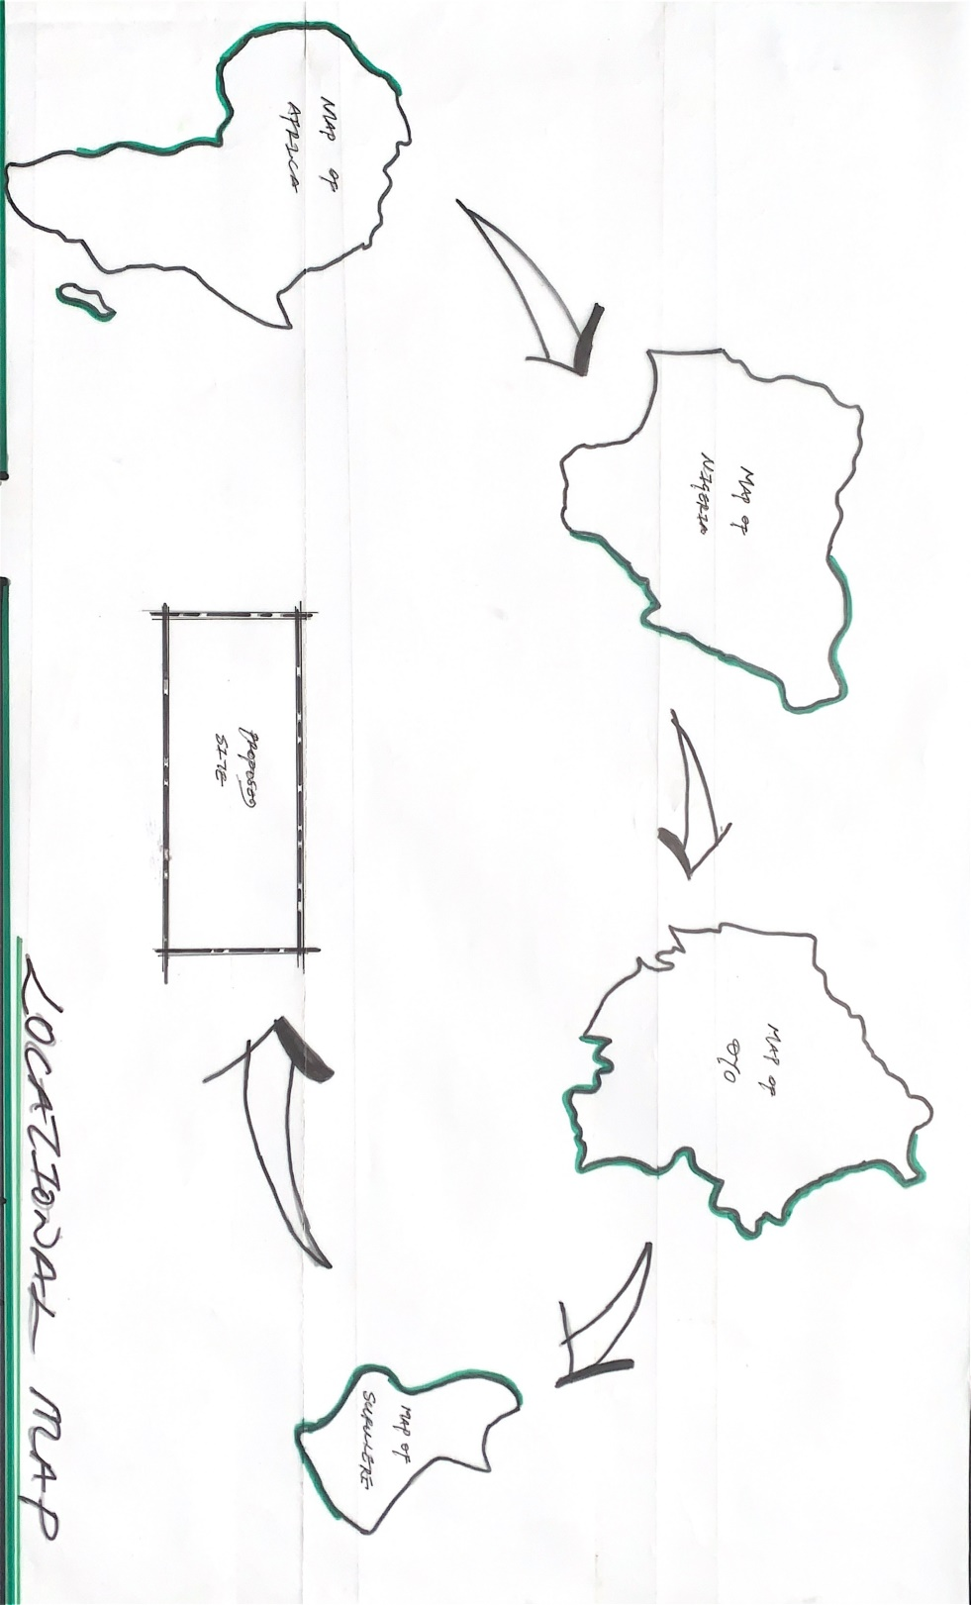

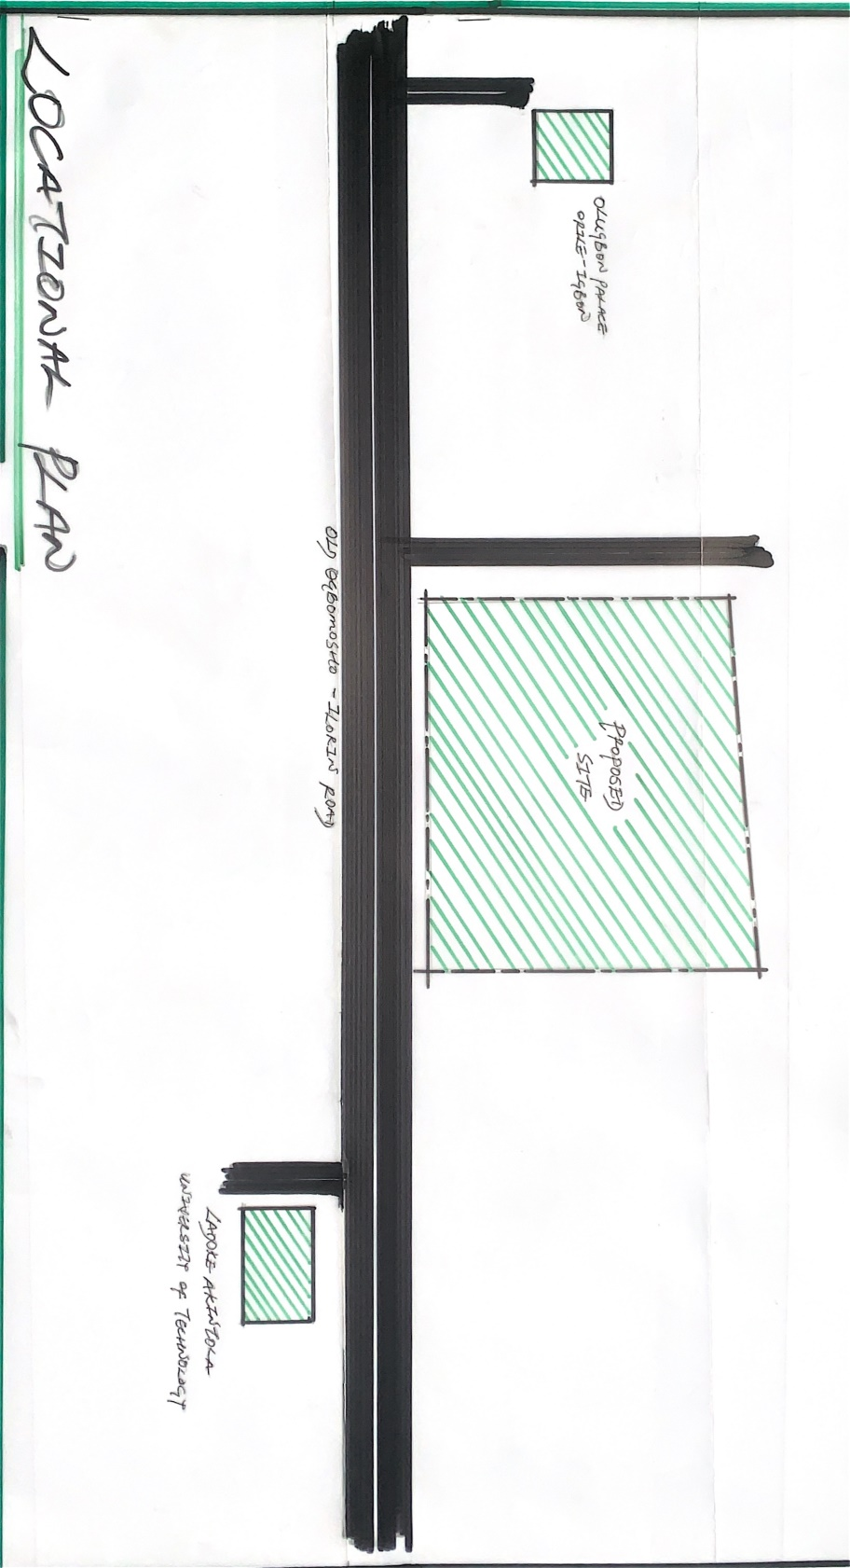

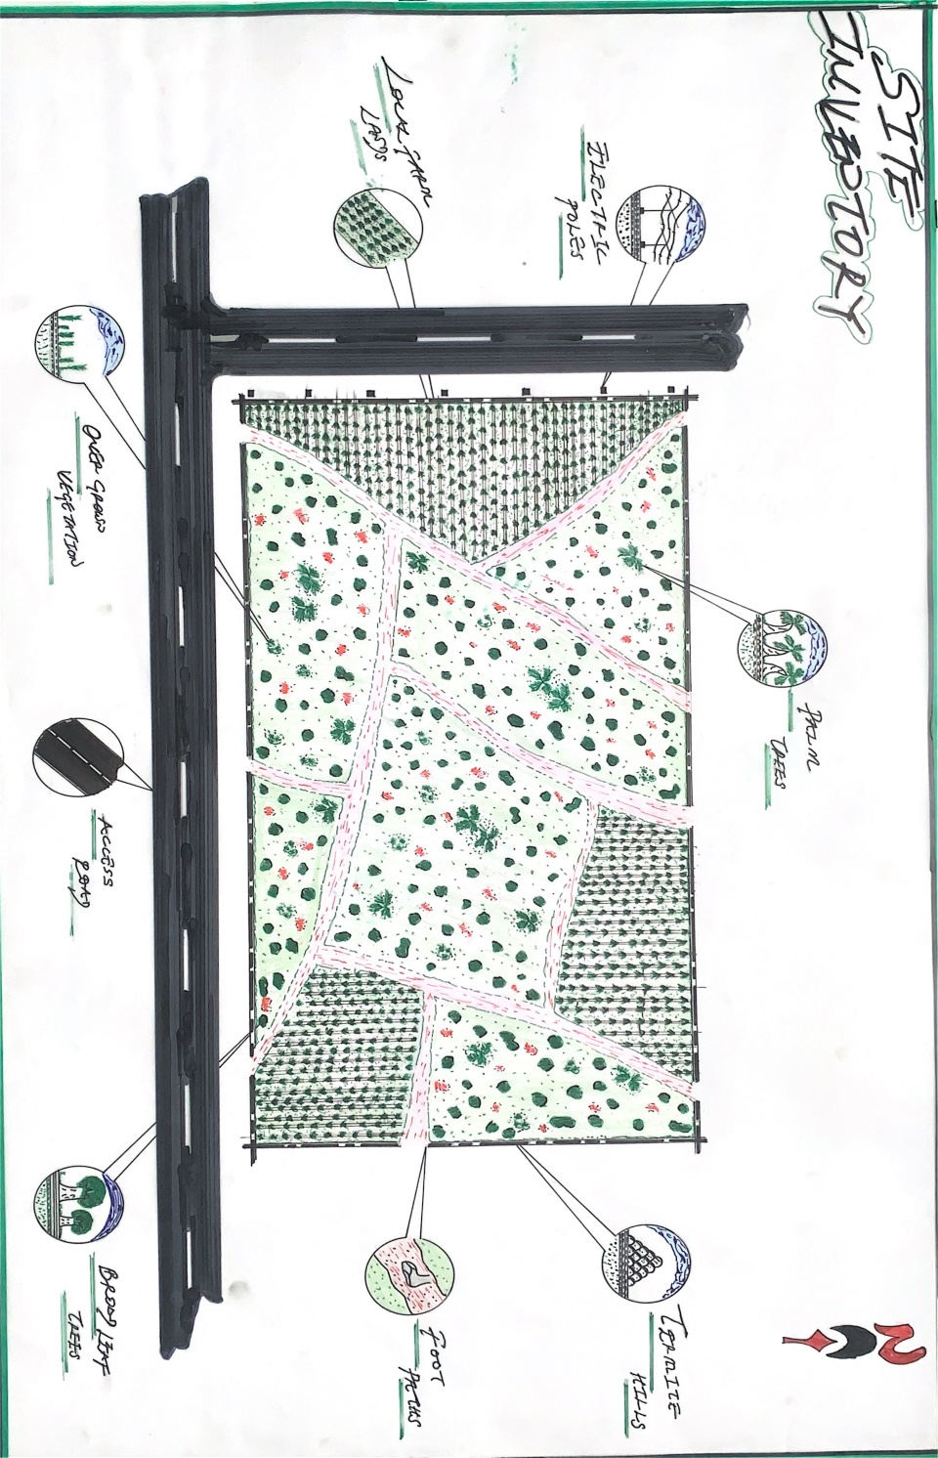

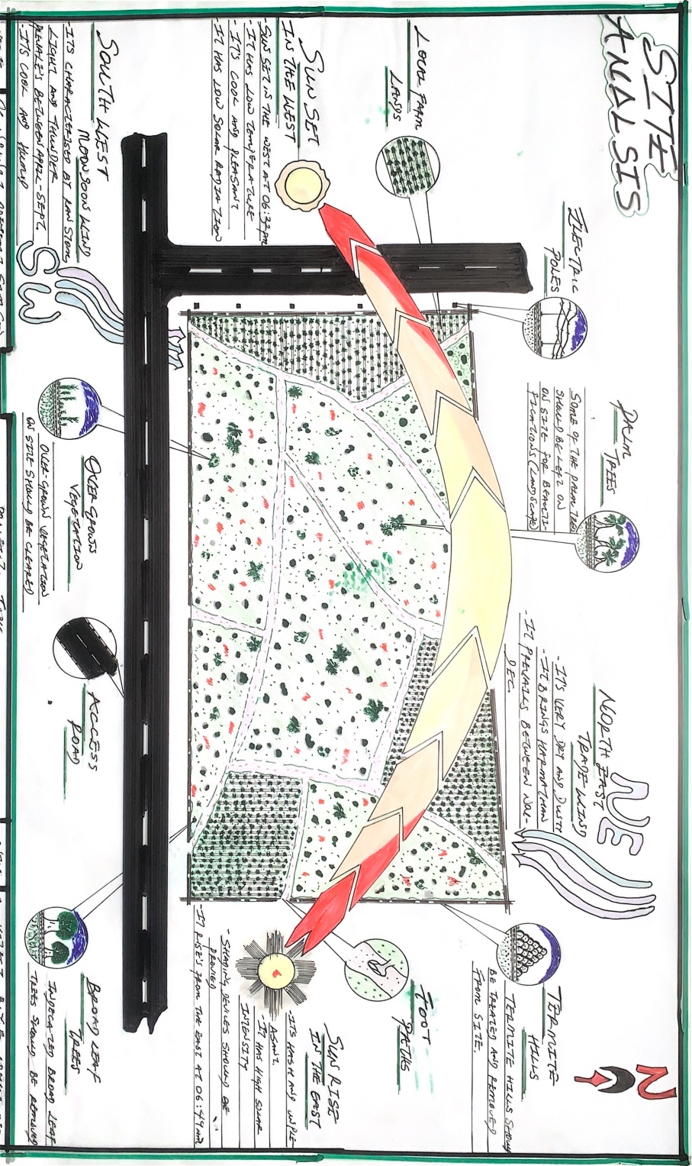

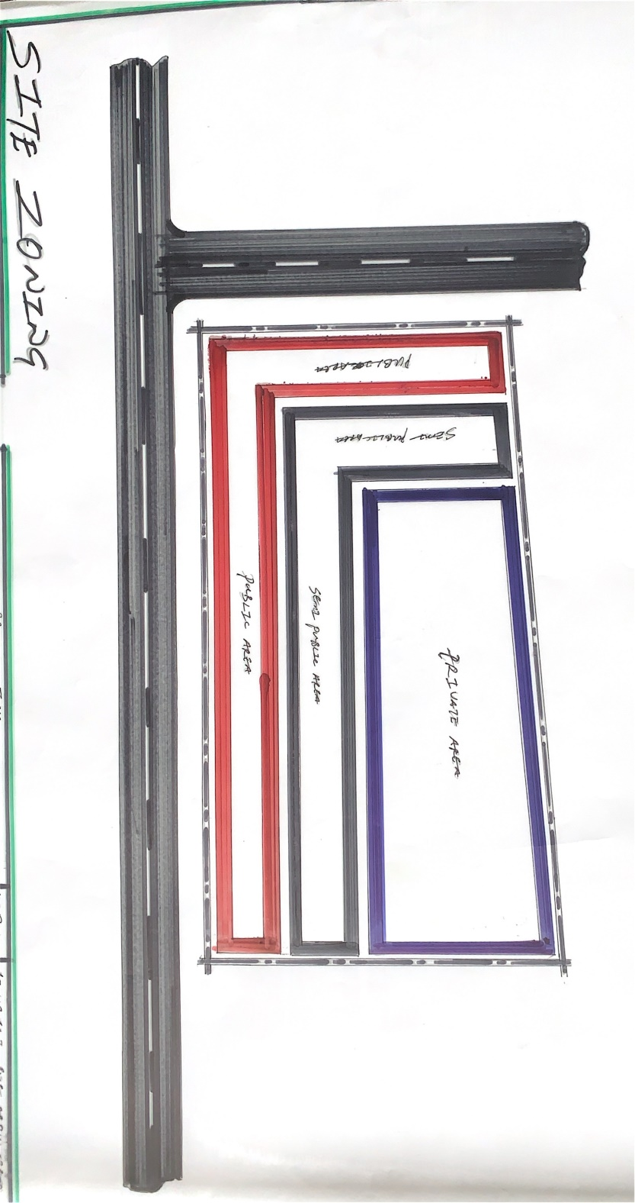


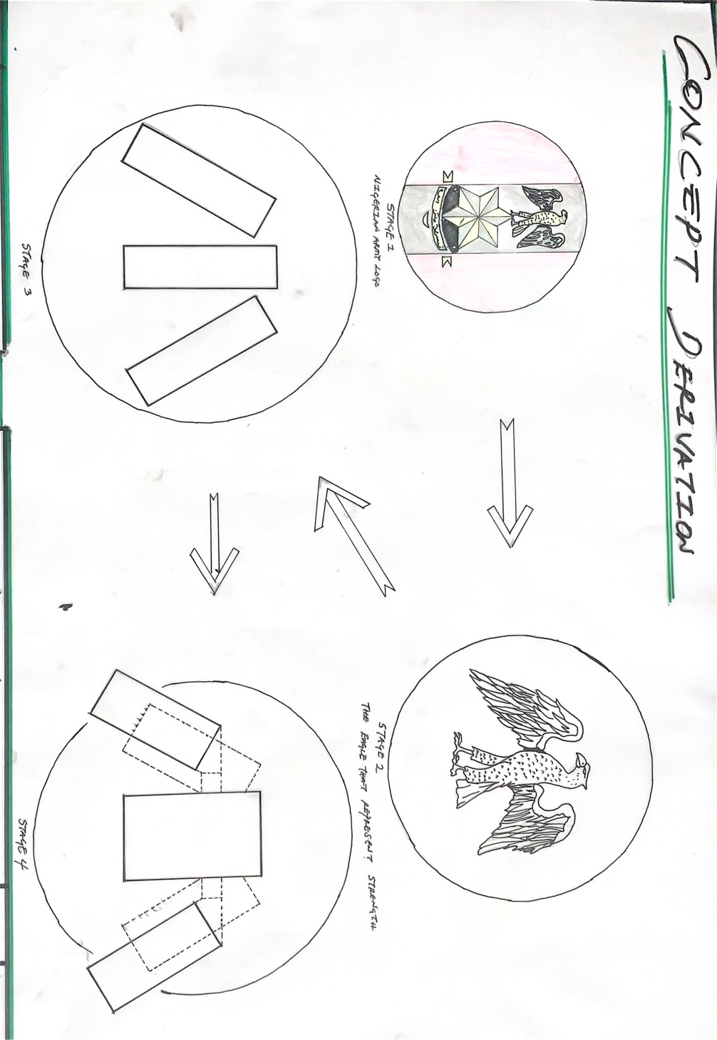
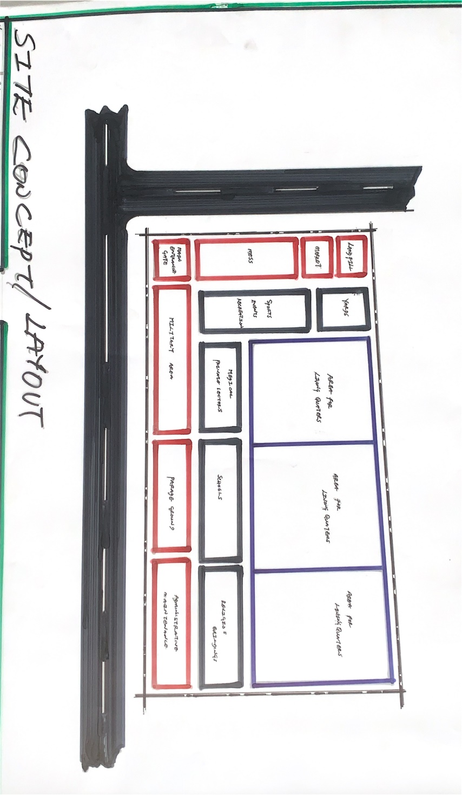

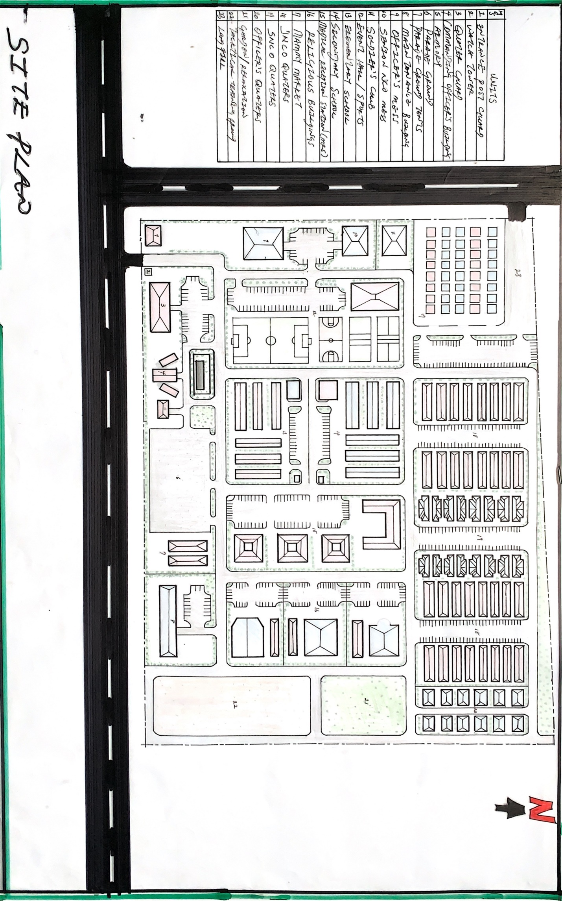

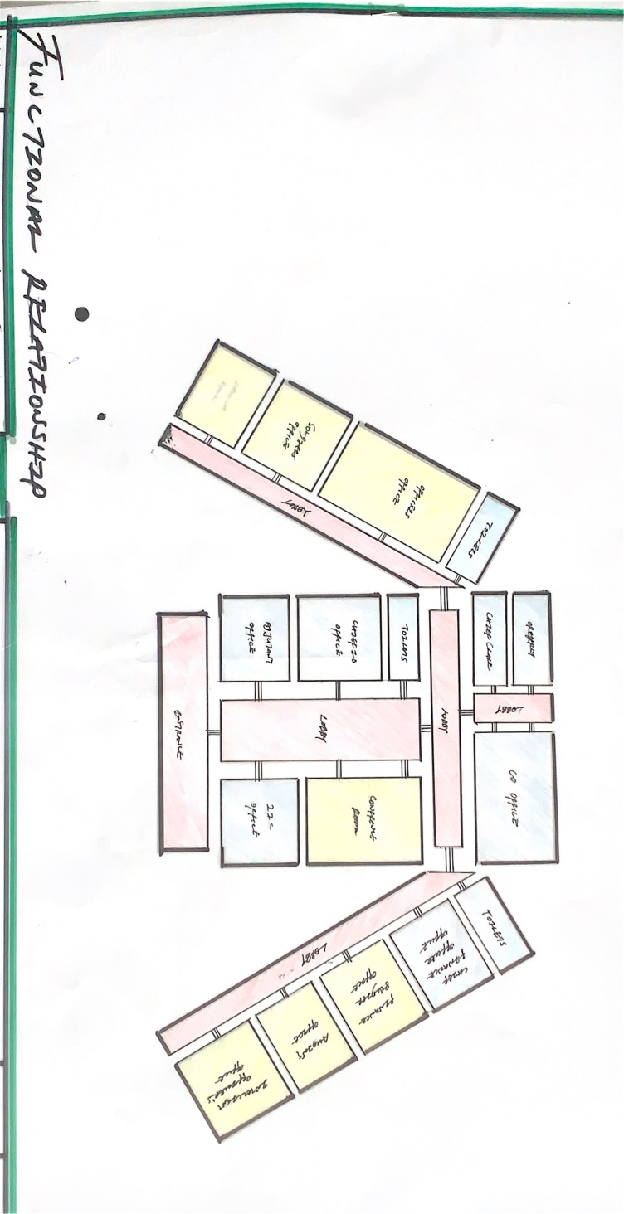



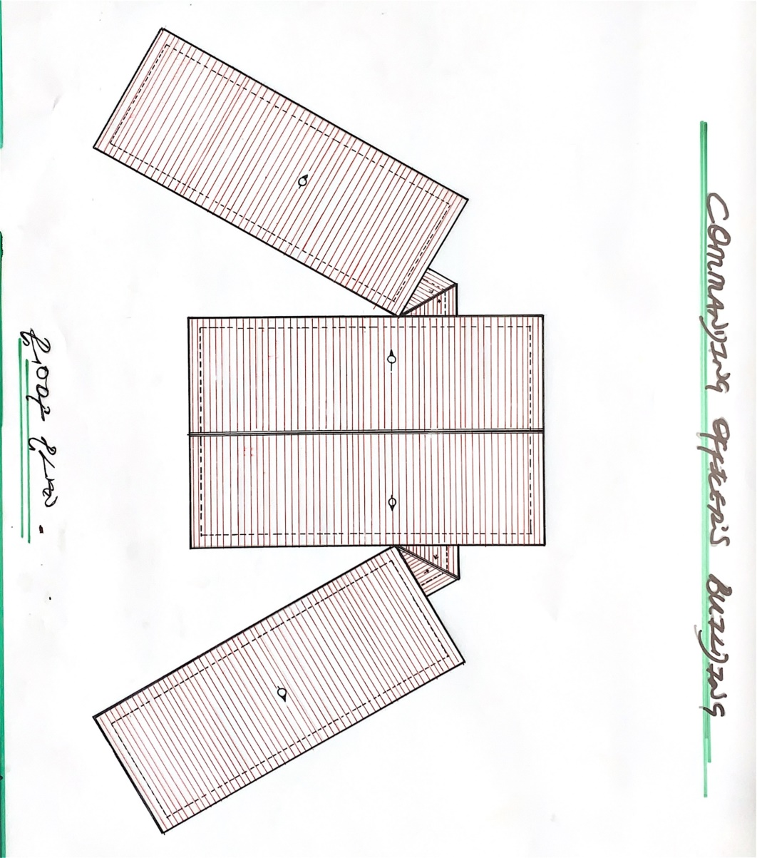
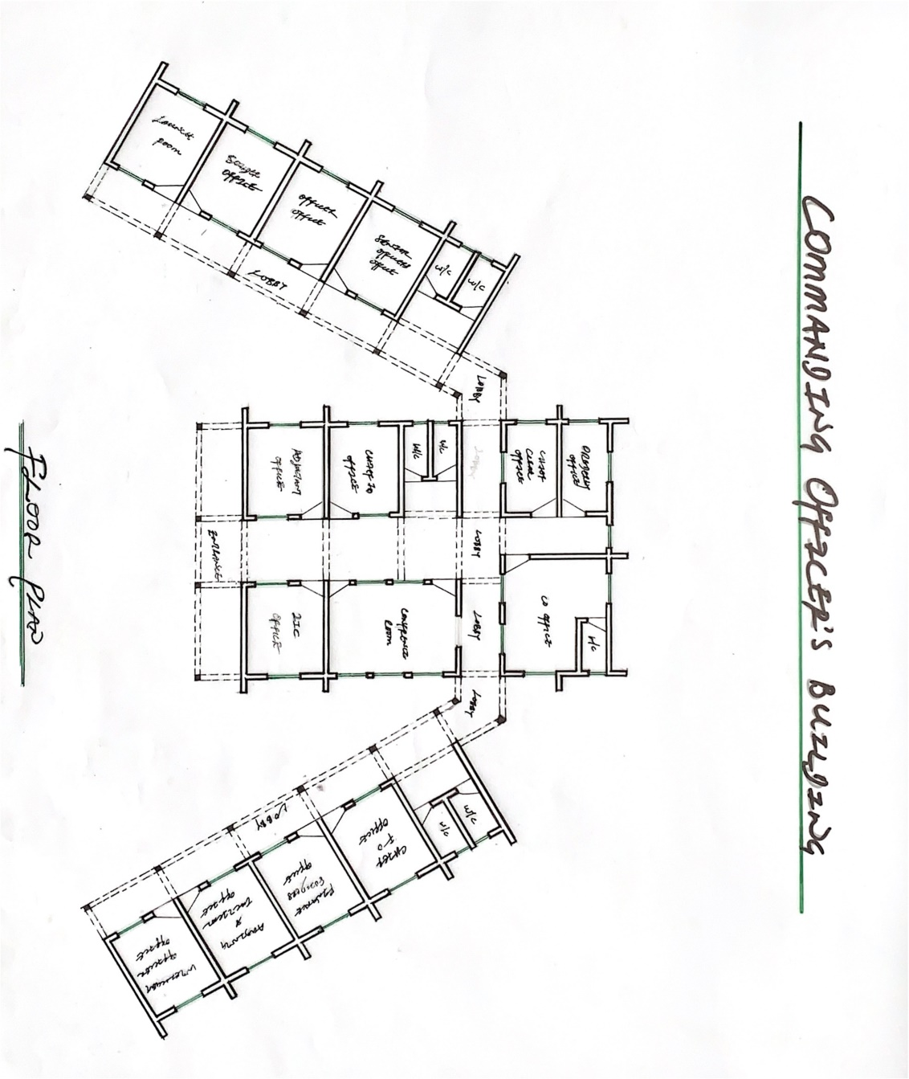

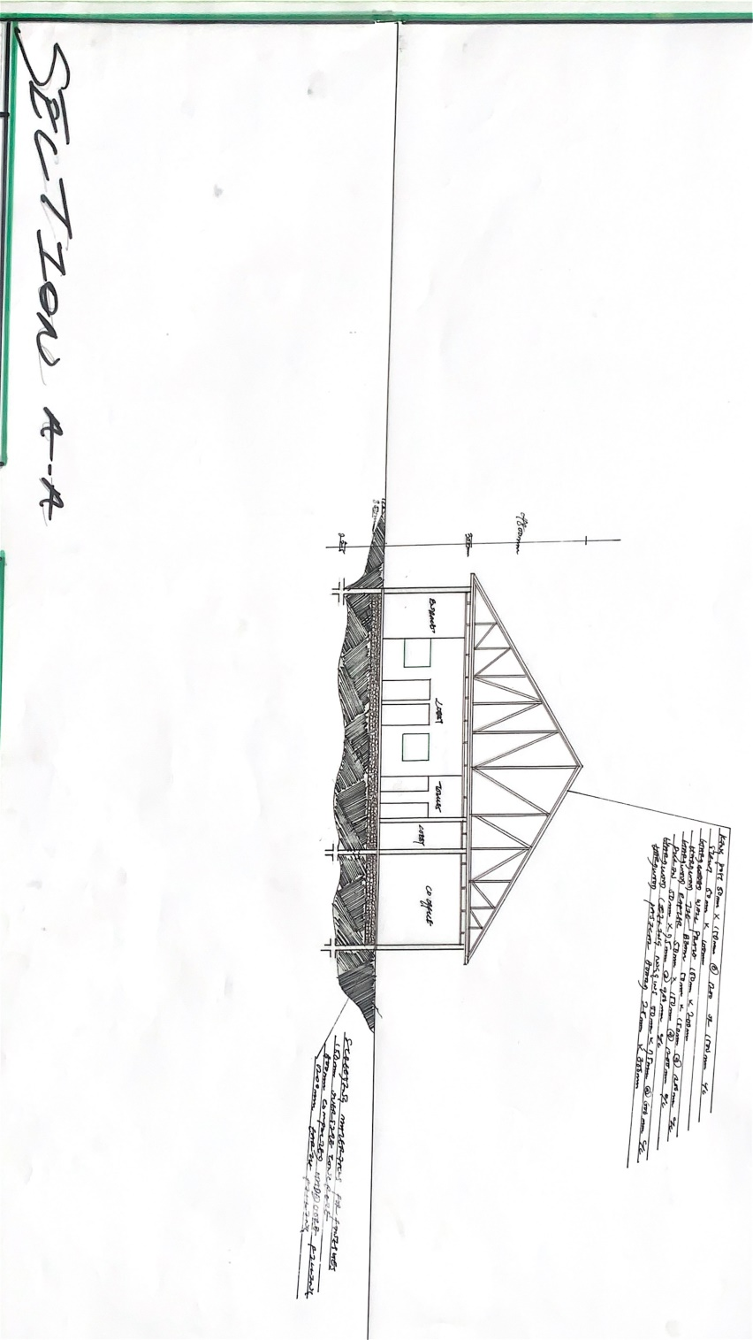

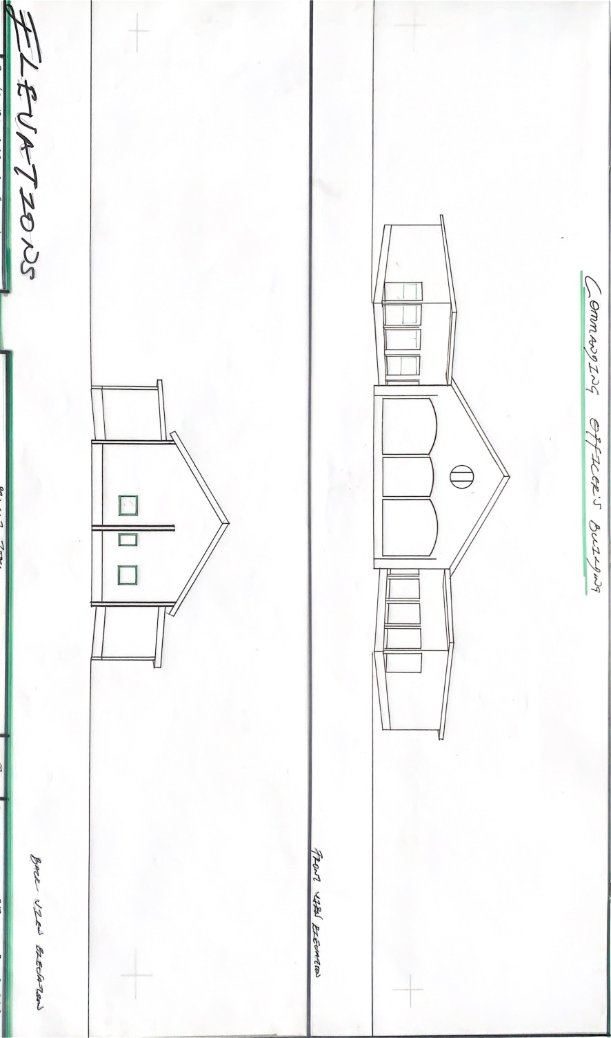

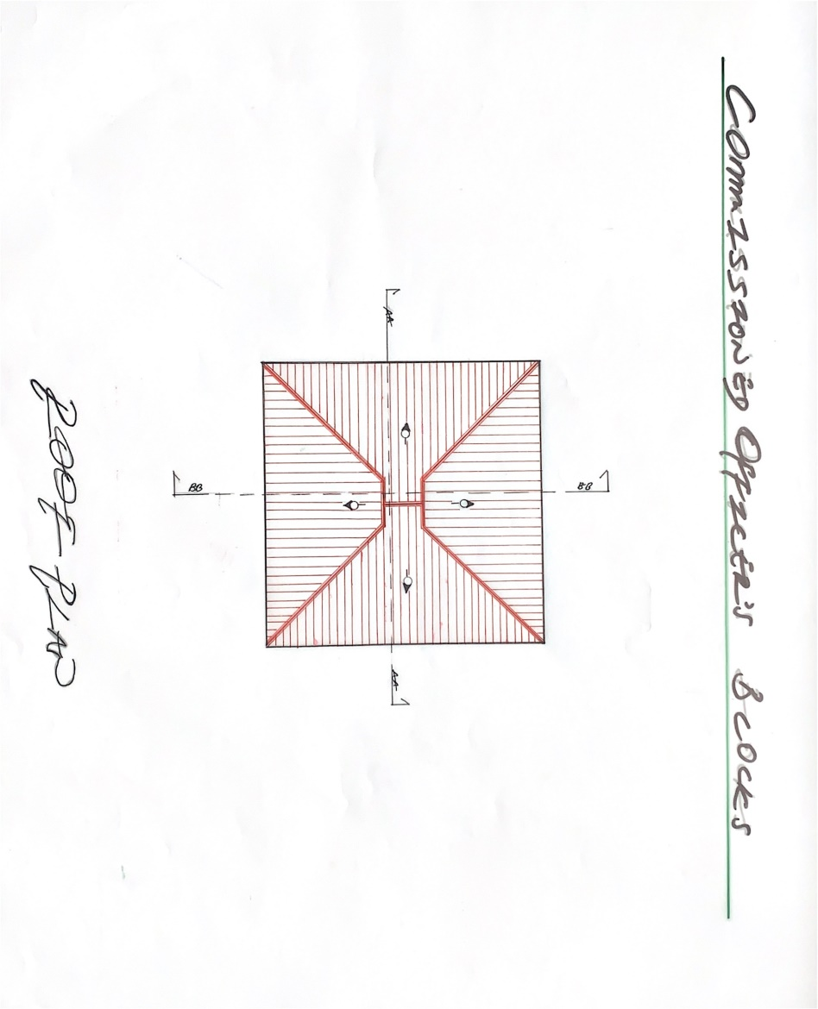
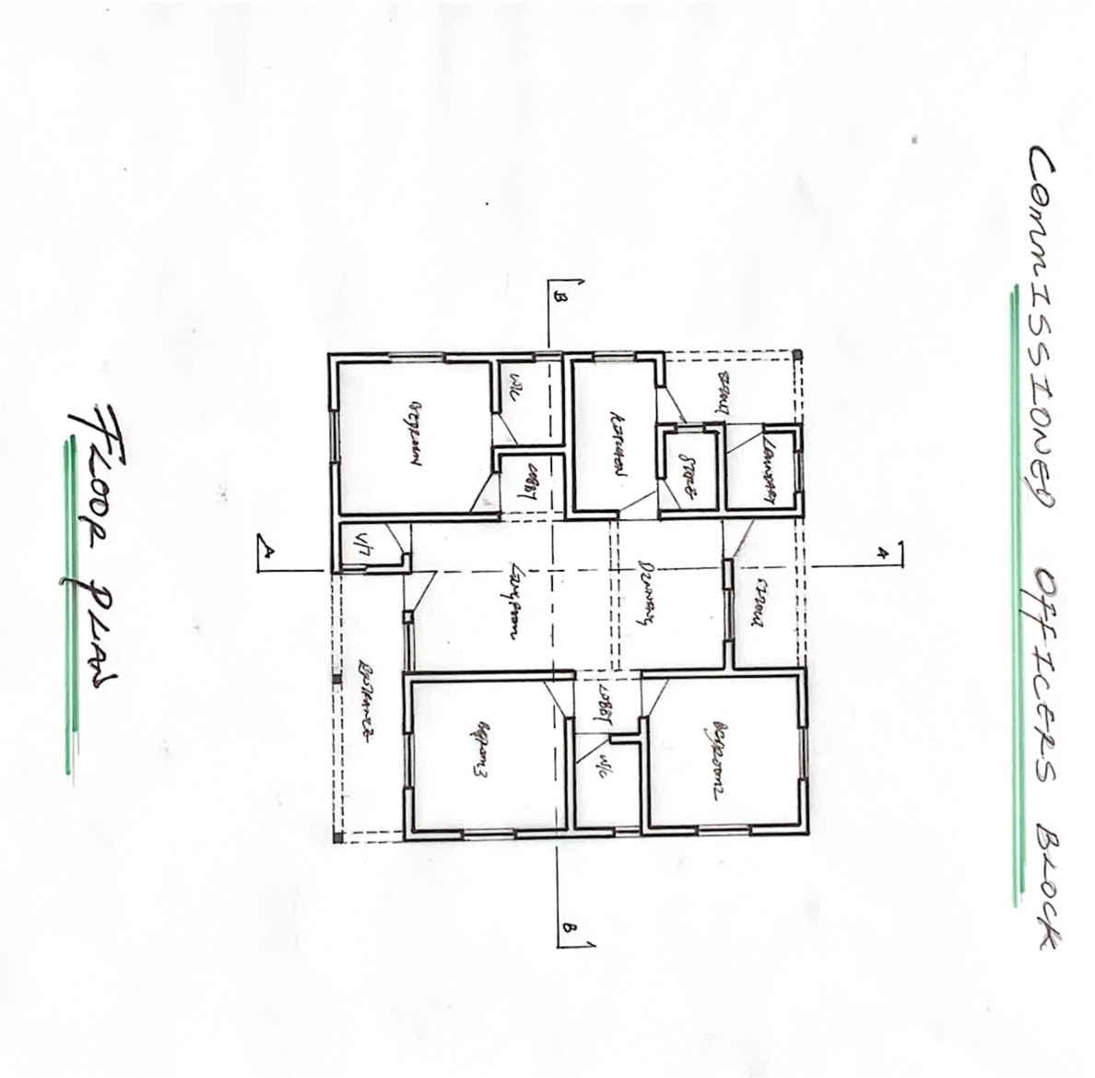

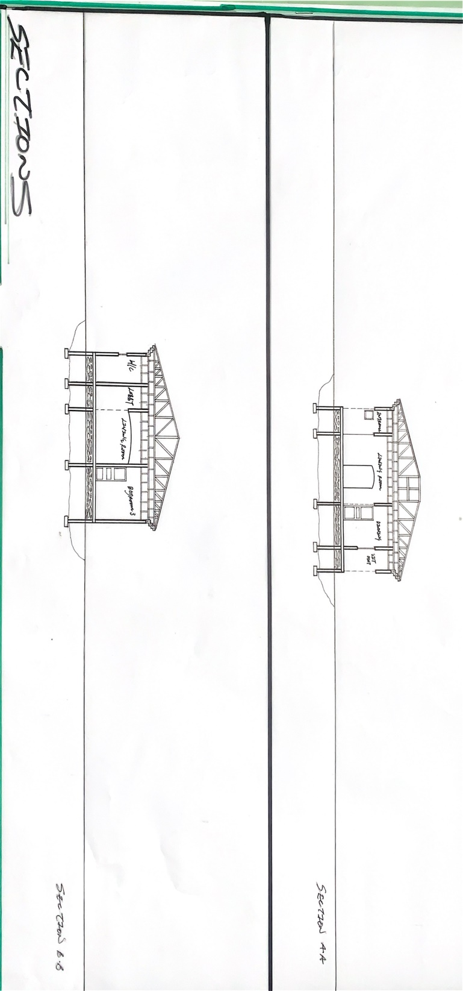
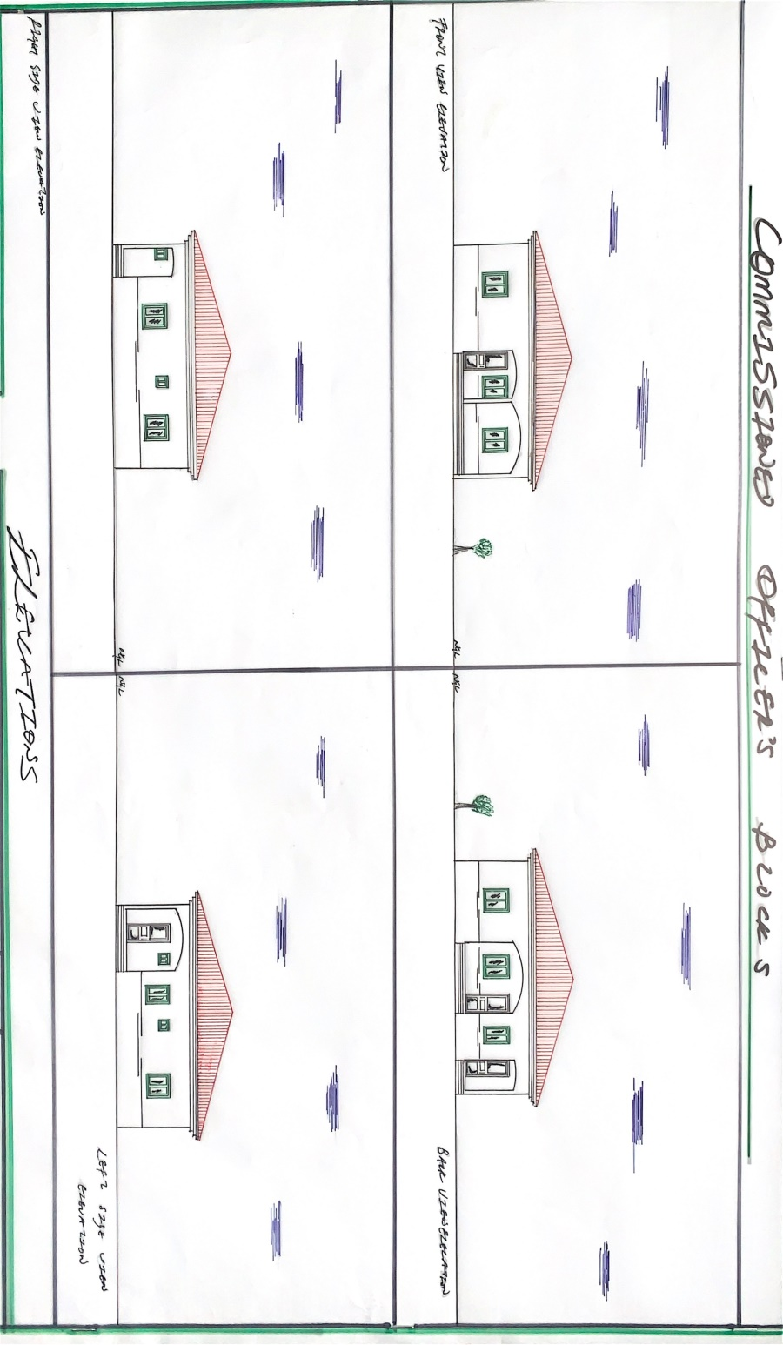

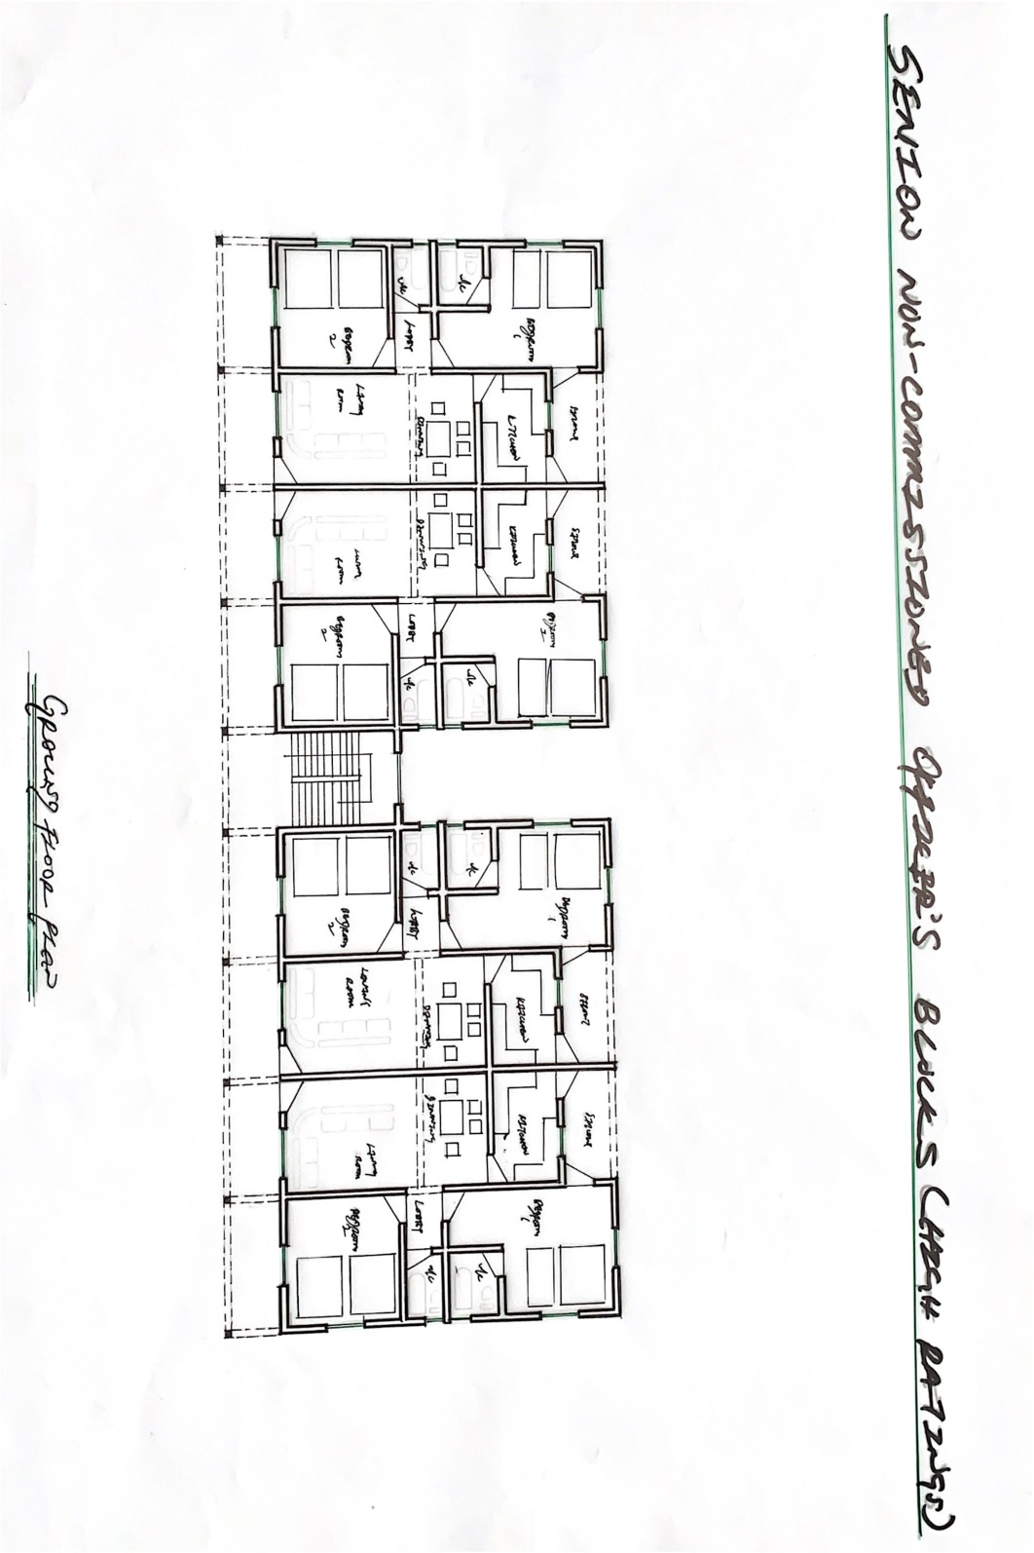

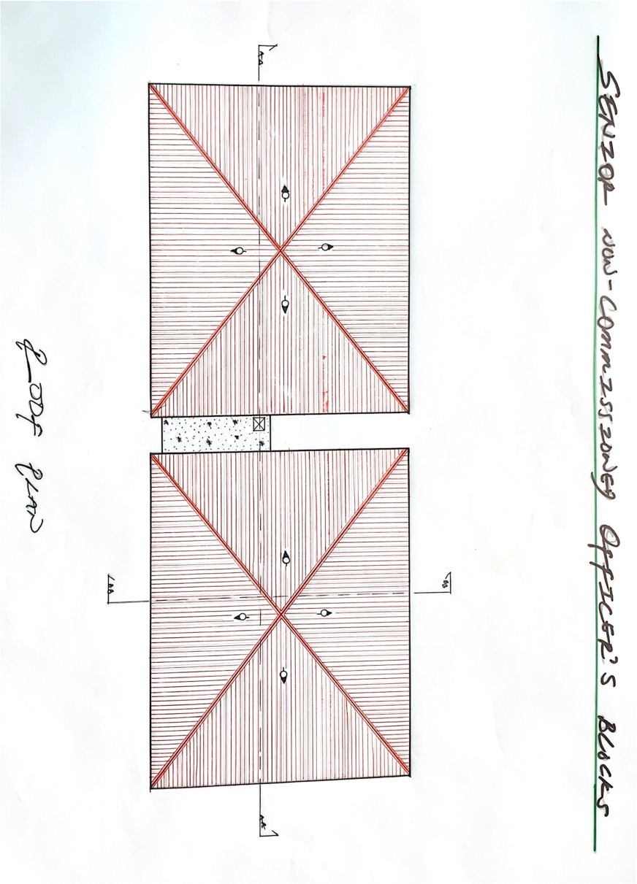
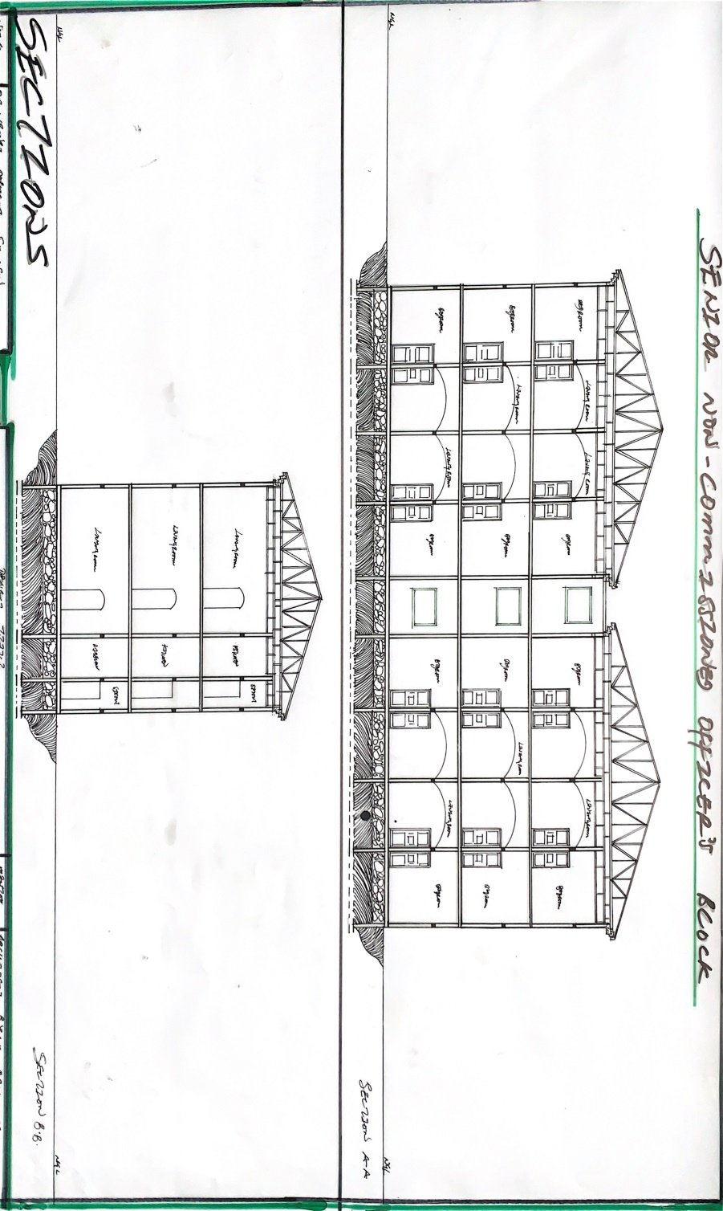
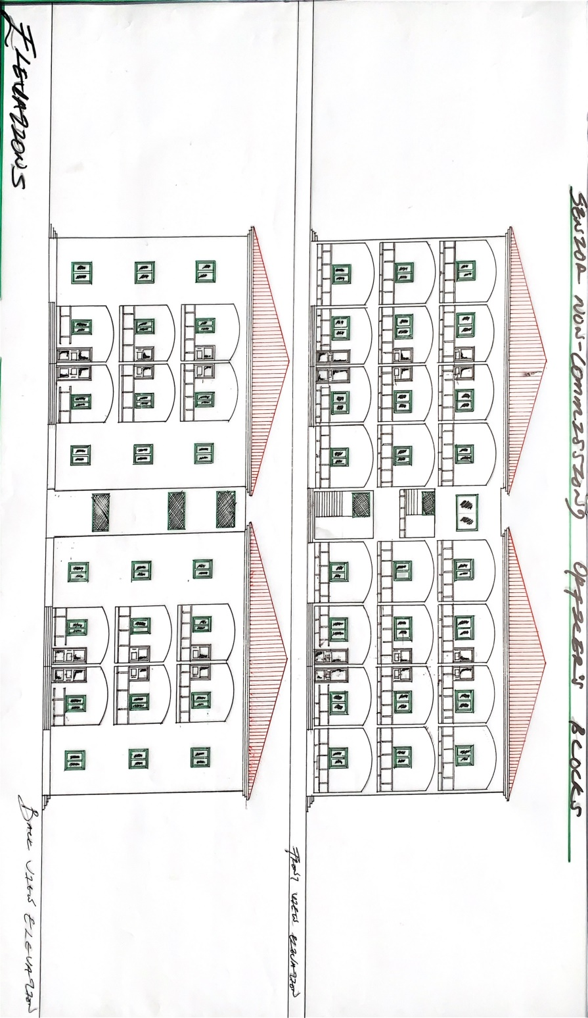
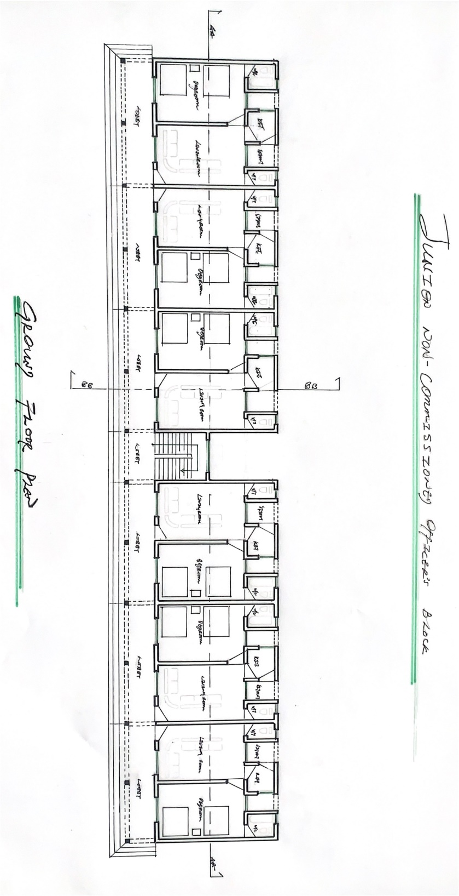

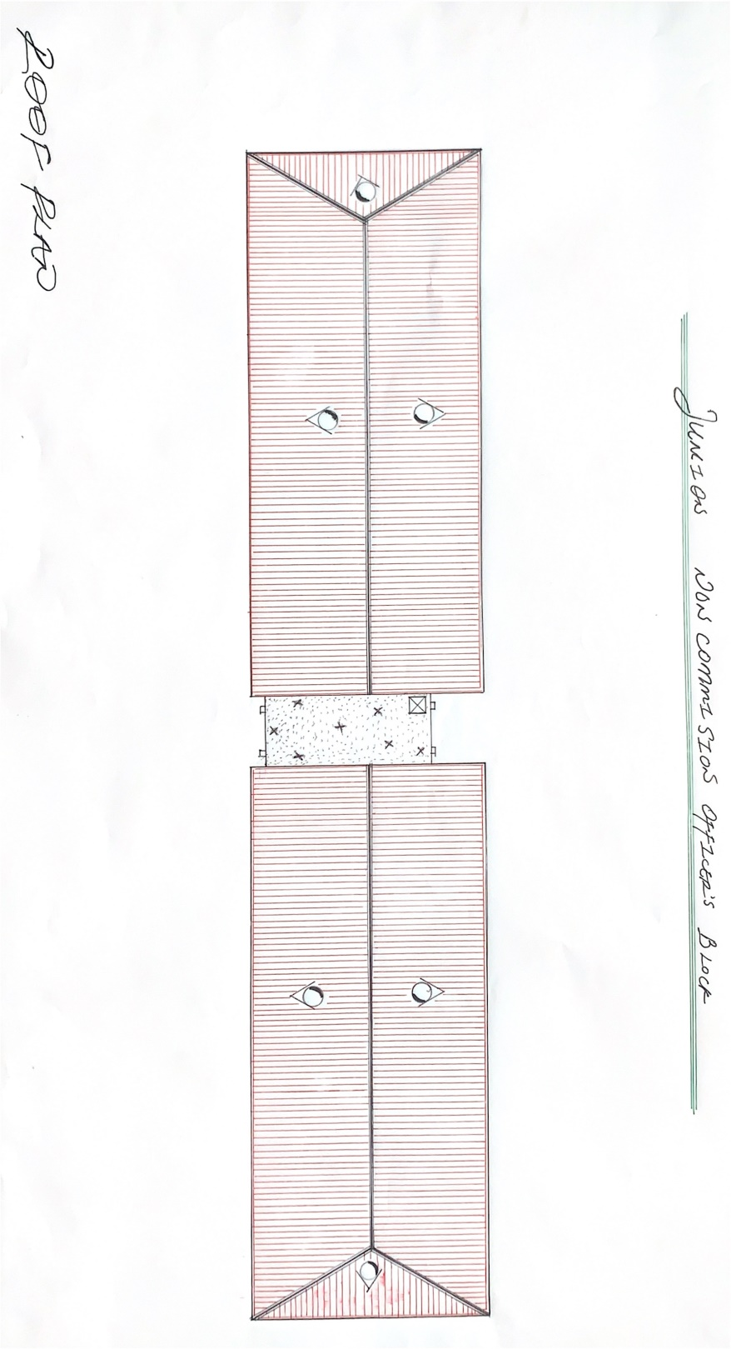

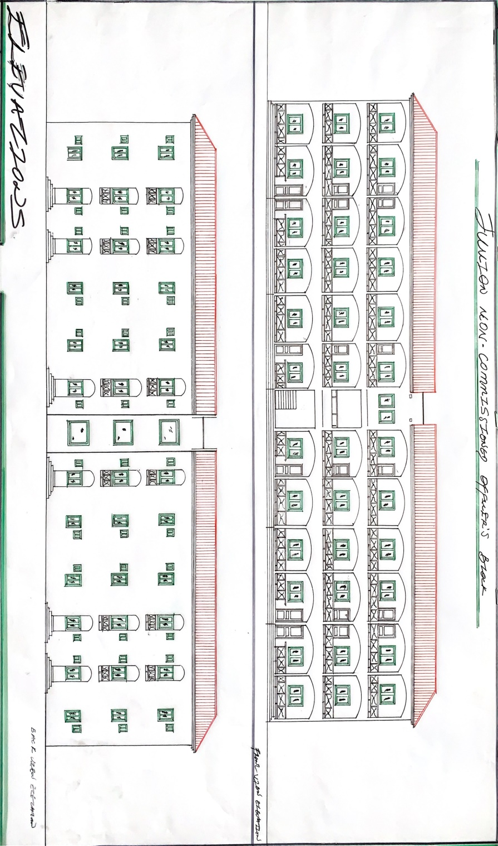

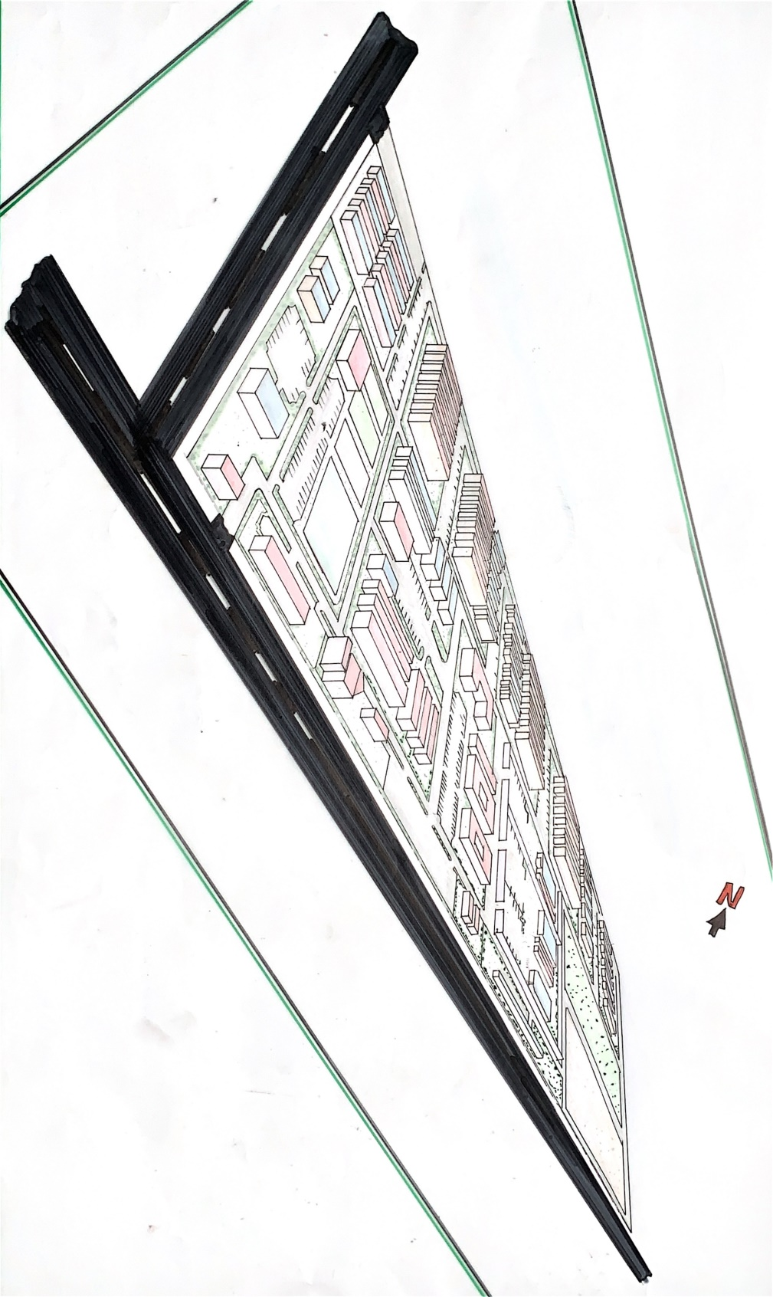

REFERENCES

- COL MD Salami, (2022) Nigerian Army College of Engineers, The influence of Barracks design on soldier’s morale.
- J.Mackenzie, (2015) Evaluation of Troops Accommodation., Royal Military College of Canada.
- James L. Pease, (2018) USA, Military Architecture: Design and Modernization of Barracks and Facilities.
- James L. Pease, (2018) USA, Post Occupancy Evaluation of Military Barrack.
- LT COL OJ Ogundepe, (2017) Nigerian Army College of Engineers. Housing the Troops: A design approach to military accommodation.
- O.Oladipo (2020), Obafemi Awolowo Unversity, Nigeria. A study of housing design for military personnel: Military Barracks in Nigeria.
- Sara M. Burnett, (2019) Texas A&M University. Design Guidelines for Military Barracks.

