A PROJECT REPORT
ON
A PROPOSED DENTAL CLINIC FOR ASA LOCAL GOVERNMENT AREA
ILORIN KWARA STATE

BY:
ABDULGANIYSU HABEEBULLAHI OLAREWAJU
ND/23/ARC/PT/0012

BEING A PROJECT REPORT SUBMITTED TO
THE DEPARTMENT OF ARCHITECTURAL TECHNOLOGY,
INSTITUTE OF ENVIRONMENTAL STUDIES,
KWARA STATE POLYTECHNIC, ILORIN.

INPARTIAL FULFILMENT OF THE REQUIREMENTS FOR THE
AWARD OF HIGHER NATIONAL DIPLOMA (ND)
IN ARCHITECTURAL TECHNOLOGY.

JULY, 2025

DECLARATION
I declare that this project/Dissertation is a project of my personal research works, It has not been presented for the award of any [ ND ] in any polytechnic. The ideas, Observations, Comments, and Suggestions here-in represent my own convictions except quotations, which have been acknowledged in accordance with conventional academic traditions.
ABDULGANIYU HABEEBULLAHI OLAREWAJU
ND/23/ARC/PT/0012

….…………………………………
SIGNATURE AND DATE

CERTIFICATION
This is to certify that this project (DENTAL CLINIC) was carried out by ABDULGANIYU HABEEBULLAHI OLAREWAJU with matriculation number ND/23/ARC/PT/0012 of the Department of Architectural Technology, Institute Of Environmental Studies (I.E.S) Kwara State Polytechnic, Ilorin. The Project Has Been Read And Approved As Meeting The Requirement For The Award Of National Diploma (ND) In Architectural Technology. Under The supervisor ARC.OLANREWAJU F.A.

ARC. OLANREWAJU F.A
Project Supervisor SIGNATURE & DATE

ARC. OLANREWAJU F.A
Project Coordinator SIGNATURE & DATE

ARC. MRS. TOMORI J.M.
Head of Department SIGNATURE & DATE

EXTERNAL EXAMINER SIGNATURE & DATE

ACKNOWLEDGEMENT
My profound gratitude goes to Almighty Allah, the creator of the universe and fountain of all wisdom whose umbrella of guard and guide. I seek refuge through thick and thin of years of study.
I will also like to appreciate my project supervisor in person of Arc. Adeyemi F.A whose contribution prepares me for the challenges in the field and for his immense contribution in all ramifications towards the completion of this research work. He encouraged me and opened the door of interaction with him. I pray Almighty Allah will shower his blessing and mercy over him, your family and may you live to reap the fruit of your labor.
I also thank and appreciate the effort of my project coordinator in person of Arc. Adeyemi F.A for is guidance and his immense contribution towards my project, I pray Almighty Allah will shower his blessing and mercy over him.
And a VERY BIG THANK to my Head of Department in person of Arc, Mrs. Tomori J.M. for her effort and encouragement, may Almighty Allah reward her abundantly.
I also thank and appreciate the effort of all the Lecturers in Architectural Technology Department, who taught and gave lasting advice's that led to the success of my programed, Almighty Allah will meet everyone at the point of their needs.
My Appreciation also goes to Arc. Muhammad Jimoh Faworaja (M.J) The CEO of Archcon Nig. Ltd, for his effort and encouragement, may Almighty Allah reward him abundantly.

DEDICATION
This project work is dedicated to Almighty Allah who has been providing all my needs for His blessing and mercy over me all through the programed. And my parents, Mr And Mrs. Abdulganiyu,my brothers, friends, love one’s and my supervisor who assist me mentally and guide me through my academic pursuit. May Almighty Allah shower his blessing and mercy over you all?

ABSTRACT
This research work was carried out on the project topic "Dental Clinic for Asa Local Government Area Kwara State". I felt caring out this project in Asa Local Government will bring out meaningful results. For easy analysis and understanding, the study is being put into five chapters. Chapter One throws light on a general introduction, definition of the project, historical background information of the project title, project justification, aim and objectives of the study, and scope of the study, Chapter two, a detailed literature review of some books, case studies and deduction from case studies. The third chapter three also mentions the historical background of the study area, site location and description, site analysis, and geographical location, climatic data, population of the area, social services, and health services. The fourth chapter deals with design criteria, design analysis, space allocation and planning principle. Chapter five deals with design appraisal, construction methodology, services, summary, conclusion and references.

TABLE OF CONTENT
Title page…………………………………………………….……………………………………………..i
Declaration……………………………………………...…………………………………………………ii
Certification………………………………………………………………………………………………iii
Acknowledgement……………………………………..…………………………………………………iv
Dedication………………………………………………...………………………………………………..v
Abstract………………………………………………………………………………………….vi
Table of contents………………………………………………………………………….……………..vii
List of tables………………………………………………………………………………………………xi
List of figures……………………………………………………………………………………………xii
List of plates…………………………………………………….………………………………….xiii-xiv
List of Appendices……………………………………………………………………………………..xv
CHAPTER ONE
- INTRODUCTION……………………………………………...……………………………13
1.1 DEFINITION………………………………………………………………………...............14
1.2 HISTORICAL BACKGROUND…………………………………..………………………..14
1.3 AIM OF THE PROJECT……………………………………...……………………………..15
1.4 OBJECTIVES OF THE PROJECT…………………………………...……………………..15
1.5 PROJECT JUSTIFICATION…………………………………………………………..……15
1.6 SCOPE OF THE PROJECT……………………………………………………………..…..15
1.7 RESEARCH METHODOLOGY………………………………………………………...…..16
CHAPTER TWO
2.0 LITERATURE REVIEW AND CASE STUDIES
2.1 HISTORICAL BACKGROUND…………………………………………...………………..17
2.2 CONCLUSION………………………………………………………………………………18
CHAPTER THREE
3.0 CASE STUDIES……………………………………………………………………………..19
3.1 SELECTED CASE STUDIES…………………………………………………………….....19
3.2 CASE STUDY ONE…………………………………………………………………………20
3.3 CASE STUDY TWO……………………………………………..………………………….22
3.4 CASE STUDY THREE……………………………………………………..……………….24
3.5 CASE STUDY FOUR……………………………………………………………………….28
3.6 DEDUCTION FROM CASE STUDIES…………….………………………………………30

CHAPTER FOUR
4.1 BRIEF HISTORICAL BACKGROUND……………………………………...…………….31
4.2 LOCATION AND SETTING OF ILORIN TOWN……………………………...………….31
4.3 POPULATION……………………………………………………………………..………..32
4.4 SITE INVENTORY…………………………………..……………………………………...33
4.5 SITE ANALYSIS………………………………………………………...………………….34
4.5.1 SITE SELECTION/JUSTIFICATION………………………………………...…………..35
4.5.2 LOCATION……………………………………………………………………..…………35
4.5.3 ACCESSIBILITY…………………………………………………………………………35
4.5.4 INFRASTRUCTURE FACILITIES………………………………………………………35
4.5.5 TOPOGRAPHY…………………………………………………………...……………….36
4.5.6 SOIL STRUCTURE…………………………………………………………….…………36
4.6 GENERAL CLIMATIC CONDITION………………………………………….…………..36
4.6.1 RELATIVE HUMIDIY………………………………………………..…………………..36
4.6.2 WIND………………………………………………………………………………..……..36
4.6.3 TEMPERATURE…………………………………………………………….……………36
4.6.4 VEGETATION………………………………………………………………….…………37
4.7.1 ROAD…………………………………………………………………..………………….37
4.7.2 WATER AND ELECTRICITY………………………………………………...………….37
4.8.0 DESIGN CRITERIA………………………………………………………………………37
4.8.1 DESIGN BRIEF………………………………………………………………….………..37
4.8.2 DESIGN ANALYSIS……………………………………………………...………………38
4.8.3 SPACIAL ALLOCATION…………………………………………...……………………39
CHAPTER FIVE
5.1 APPRAISAL OF PROPOSED SCHEME………………………………..………………….40
5.2 CONSTRUCTION METHODOLOGY……………………………………………...………40
5.3 SERVICES……………………………………………………………………………..…….40
5.3.1 VENTILATION…………………………………………………………………...……….41
5.3.2 LIGHTING……………………………………………………………………………..….41
5.3.3 PLUMBING………………………………………………………………………………..41
5.3.4 ELECTRICAL INSTALLATION…………………………………………………………41
5.3.5 WASTE DISPOSAL……………………………………………………………………….42
5.3.6 FIRE PROTECTION………………………………………………………………………42
5.3.7 RAIN PROTECTION……………………………………………………………...………42
5.3.8 EXTERNAL WORK………………………………………………………...…………….42
5.4 SUMMARY………………………………………………………………………………….42
5.4.1 CONCLUSION…………………………………………………………………………….42
5.4.2 RECOMMENDATION……………………………………………………………...…… 43
REFERANCES…………………………………………………………………………………..44

LIST OF FIGURES
PLATE 1; SHOWING LOCATION PLAN OF CASE STUDY ONE….....……………………20
PLATE 2; SHOWING GROUND FLOOR PLAN OF CASE STUDY ONE…………………..21
PLATE 3; SHOWING APPROACH VIEW OF CASE STUDY ONE……………..…………..21
PLATE 4 SHOWING LOCATION PLAN OF CASE STUDY TWO…………………..………22
PLATE 5 SHOWING GROUND FLOOR PLAN OF CASE STUDY TWO…………..……….23
PLATE 6; SHOWING APPROACH VIEW OF CASE STUDY TWO………………...…….…23
PLATE 7; SHOWING BACK VIEW OF CASE STUDY TWO…………………..……………24
PLATE 8; SHOWING LOCATION PLAN OF CASE STUDY THREE………..………..……25
PLATE 9; SHOWING FLOOR PLAN OF CASE STUDY THREE……………….………..…26
PLATE 10; SHOWING APPROACH VIEW OF CASE STUDY THREE………...………..….26
PLATE 11; SHOWING RECEPTION AREA OF CASE STUDY THREE………..…………...27
PLATE 12; SHOWING THEATRE ROOM OF CASE STUDY THREE……....……………...27
PLATE 13; SHOWING FLOOR PLAN OF CASE STUDY FOUR ……….…………………..28
PLATE 14; SHOWING RECEPTIONIST VIEW OF CASE STUDY FOUR…………….……29
PLATE 15; SHOWING PHARMACY OF CASDE STUDY FOUR …………………………..29
PLATE 16; SHOWING SITE INVENTORY OF THE PROPOSED SITE……………………..34
PLATE 17; SHOWING SITE ANALYSIS OF THE PROPOSED SITE ………..……………..35

CHAPTER ONE
- INTRODUCTION
A dental clinic isspecializedis specialized Healthcare Facility focused on providing oral Health services to individual of All Ages. These clinics are staffed by qualified dental Professionals, including dentists, Dental Hygienists and dental Assistants who work together to ensure optimal Oral Health. However, A dental clinic is a healthcare facility focused on oral health, offering a range of services from routine checkups and cleanings to more complex treatments like restorative and cosmetics procedure. It’s a place where dentists, dental hygienist and all other oral health professionals work together to diagnose, treat and prevent dental diseases ultimately contributing to the patients overall well-being.
Dentistry, the branch of medicine focused on the teeth, gums, and mouth, is often the main focus of a dental clinic. It consists of the study, diagnosis, prevention, management, and treatment of diseases, disorder, and conditions of the mouth.
Dental education refers to the university based training and clinical teaching that prepares individuals to become dentists. It encompasses a comprehensive curriculum focused on preventing, diagnosing and treating oral health. This includes developing essential skills like communication, critical thinking, and treatment planning along with understanding the biological and clinical aspects of dentistry.
A Dental Clinic is also a facility where dental professionals provide oral healthcare services. It is a spaced equipped with dental tools and equipment’s to perform various procedures from routine check-ups and cleaning to more complex treatment like root canals and dental implants. Dental Clinics also serves as educational Centre for dental students and may also be involved in dental research.
Comprehensive Care Dental Clinics offers a wide range of services including general dentistry, specialized treatments and preventive care.

  - DEFINITION OF DENTAL CLINIC
A dental clinic is specialized healthcare facility focused on providing oral health services to individual of all ages. These clinics are staffed by qualified dental professionals, including dentists dental hygienists, and dental assistants who work together to ensure optimal oral health.
Dental clinics are often associated with university or a hospital and they serve to educate dentists in training, conduct dental research or provide dental care to a community and total people in need.
  - HISTORICAL BACKGROUND
The concept of Dental care and clinics has evolved significantly over centuries shaped by advancements in medicine technology and societal needs.
In ancient Greece, Hippocrates and Aristotle wrote about dentistry, specifically about treating decaying teeth, but it wasn’t until 1530 that the first book entirely devoted to dentistry—The Little Medicinal Book for All Kinds of Diseases and Infirmities of the Teeth—was published.
By the 1700s, dentistry had become a more defined profession. In 1723, Pierre Fauchard, a French surgeon credited as the Father of Modern Dentistry, published his influential book, The Surgeon Dentist, a Treatise on Teeth, which for the first time defined a comprehensive system for caring for and treating teeth. Additionally, Fauchard first introduced the idea of dental fillings and the use of dental prosthesis, and he identified that acids from sugar led to tooth decay.
In 1840, the first dental college (Baltimore College of Dental Surgery) opened, establishing the need for more oversight. In the United States, Alabama led the way by enacting the first dental practice act in 1841, and nearly 20 years later, the American Dental Association (ADA) was formed. The first university-affiliated dental institution, the Harvard University Dental School, was founded in 1867.
By 1873, Colgate had mass produced the first toothpaste, and mass-produced toothbrushes followed a few years later.
What may come as a surprise is that the first African American to earn a dental degree dates all the way back to 1869, and the first female dental assistant was employed in New Orleans in 1885. What might be most surprising of all is that most Americans did not adopt good brushing habits until after World War II, when soldiers stationed abroad brought the concept of good oral health back to the United States.
  - AIM
The aim of designing a dental clinic is to provide high quality comprehensive dental care that ensure optimal oral health, enhances patients confidence and promotes overall well-being through preventive, restorative and cosmetic dental services.
  - OBJECTIVES
- To encourage preventive care
- To reduce the incidence of dental problems such as cavities, gum disease and tooth decay.
- To design a modern dental clinic that naturally meets up with both architectural and structural standards.
- To provide spaces that are large enough to accommodate the workers and equipments/machinery and encourage a seamless overlap between the two.
- To contribute to the architectural beauty of the area and the appreciation of the built environment.
- Provision of adequate spaces for various dental treatments.

  - JUSTIFICATION
One of it is major influencing factors is the clear circulation path, dental clinic require clear circulation paths for patients, staffs and equipments.
  - SCOPE OF THE PROJECT
- Main Building
- Generator House
- Security Post
- Parking Lot
- cafeteria
- Shops
- Access Road
  - RESEARCH METHODOLOGY
Various avenues were expressed as regards the method of research on order to arrive at a functional and appealing design concepts. The following research methods were employed.
Literature Review (Survey): References to the existing literature on dental clinic design. Search on articles, books, and online resources that discuss the best practices in the field.
Key Factors: Identifying the key factors that contribute to an effective dental clinic design. These might include patient comfort, efficient use of space, accessibility, and infection control measures.
Data Collections: Data on the factors are collected, this could involve surveys, or interviews with dental professionals and patients or observational studies of existing dental clinics.
Analysis: Analyzing the data to determine which factors are most important in dental clinic design. Using statistical methods to identify trends and corrections.
Personal Observation: Personal initiative coupled with inquisitive measure, interview and visualize the daily activities that take place within vicinity and necessary pictures were taken in order to attain the required motive.
Case Study: This involves the thorough synthesis and analysis of similar existing structure (building) Based on the data collected and better deduction was made for realization of the best.

CHAPTER TWO
- LITERATURE REVIEW
  - HISTORICAL BACKGROUND OF DENTAL CLINIC
Dentistry is one of the oldest medical professions, dating back to 7000 B.C. with the Indus Valley Civilization. However, it wasn’t until 5000 B.C. that descriptions related to dentistry and tooth decay were available. At the time, a Sumerian text described tooth worms as causing dental decay, an idea that wasn’t proven false until the 1700s!
In 1840, the first dental college (Baltimore College of Dental Surgery) opened, establishing the need for more oversight. In the United States, Alabama led the way by enacting the first dental practice act in 1841, and nearly 20 years later, the American Dental Association (ADA) was formed. The first university-affiliated dental institution, the Harvard University Dental School, was founded in 1867.
Dental health care in Nigeria faces numerous challenges, including limited access to services, inadequate workforce, and poor infrastructure. This review aims to explore the current state of dental clinics in Nigeria, focusing on accessibility, workforce, infection control, and the impact of recent global events such as the COVID-19 pandemic.
Access to dental care in Nigeria is significantly limited, especially in rural areas. A study highlighted the need for more dental clinics to improve the availability and accessibility of oral health services. The expansion of the dental workforce, including training junior cadre dental professionals and incorporating community health practitioners, is essential to address this gap.
The dental workforce in Nigeria is insufficient to meet the population’s needs. Strengthening the oral health system requires expanding the workforce through training and education. University-based initiatives have shown success in improving access to oral health care in rural and remote areas by training dental and allied health students. These programs have enhanced students’ competencies and increased their adoption of rural practices.
Cross infection control practices among Nigerian oral health care workers need significant improvement. Research has underscored the importance of implementing stringent infection control measures to ensure the safety of both patients and healthcare providers. The COVID-19 pandemic further highlighted the need for robust infection control protocols in dental settings
The COVID-19 pandemic had a profound impact on dental service utilization in Nigeria. Fear of infection significantly reduced the use of dental services, with many patients avoiding clinics due to concerns about contracting the virus. The main sources of COVID-19 information for patients were mass media and social networks, with only a small percentage receiving information from dental professionals.
Government involvement and policy implementation are crucial for improving dental care in Nigeria. Increased government spending on oral health care and better regulation of medication access are necessary steps. National policies on oral health need to be well disseminated and implemented to achieve the overall goals of the oral health system.
Community participation plays a vital role in sustaining improvements in the oral health system. Engaging and empowering communities can lead to better oral health outcomes and more effective implementation of health policies. Programs that involve community members in oral health education and basic care delivery have shown positive results.
  - CONCLUSION
Improving dental care in Nigeria requires a multifaceted approach, including expanding the workforce, enhancing infection control, increasing government support, and fostering community participation. Addressing these areas can lead to significant advancements in the accessibility and quality of dental services in Nigeria.

CHAPTER THREE
3.0 CASE STUDIES
This is research or an exercise that is carried out on existing building which is similar to the one researcher is writing on. The objective of a case study is to take a critical appraisal of existing related project with a view to identify the positive and negative aspect of such projects. It is only with time that a project can be adjusted so that it can be successful. The information obtained from the appraisal will guide the designer of new and similar project, the positive aspect of it shall be incorporated in the view proposal while attempts will be made to solve the problem of negative aspects.it is only through this that a designer can better enhance the quality and efficiency of building in the society. For a comprehensive analysis their case studies have been conducted.
  - SELECTED CASE STUDIES
Case studies are of paramount important. It is an experimental research or analysis carried out on existing building or group of building functionally similar to the one which the research is working.
For any technical design to be meaningful there is always the need for preliminary research effort to be made on this proposal as a very necessary ground work.
The following are case studies of some dental hospital:
- Glory Dental Clinic, Agric Ilorin, Kwara State.
- General Hospital Moroko Road, Ilesha, Osun State.
- Lady K Memorial Delta Clinic, Oyo, State.
- Online Case Study

  - CASE STUDY ONE (1)
Location: Glory Dental Clinic, Agric Ilorin, Kwara State.
Observation
Merits
- Easy to located
- Well ventilated
- Calm and peaceful environment
Demerits
- Noisy area
- Poor building structure
- No lab unit in the building
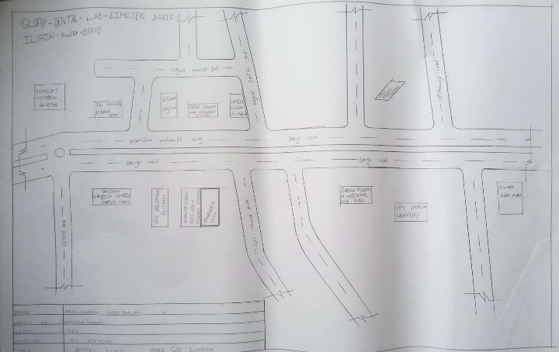

FIG 1; SHOWING LOCATION PLAN OF CASE STUDY ONE
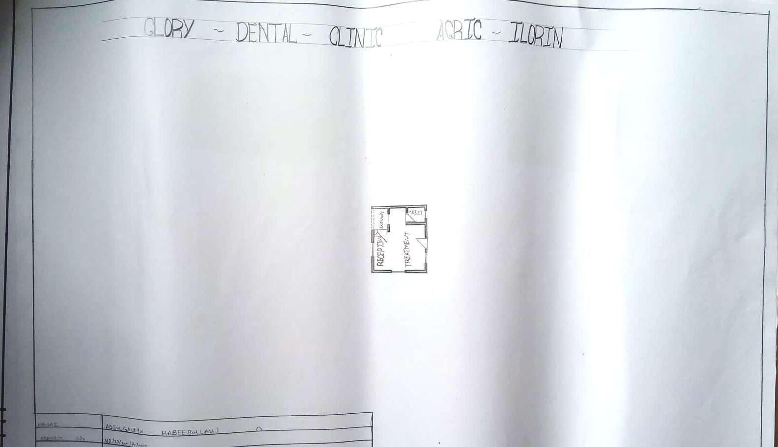

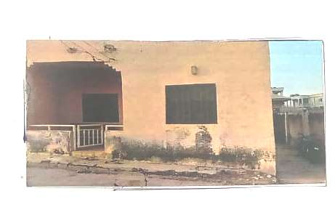
FIG 2; SHOWING GROUND FLOOR PLAN OF CASE STUDY ONE

PLATE 3; SHOWING APPROACH VIEW OF CASE STUDY ONE
  - CASE STUDY TWO (2)
- Location: General Hospital Moroko Road, Ilesha, Osun State.
Observation
Merits
- It helps people to detects their problems dentally
- It is easy for people to access
- It gives people surrounding the environment a healthy smile
- It offers peoples oral care, like brushing their tooth

Demerits
- The surgery room are not condusive
- The aesthetic is poor
- Poor structural design
- The facilities are not good
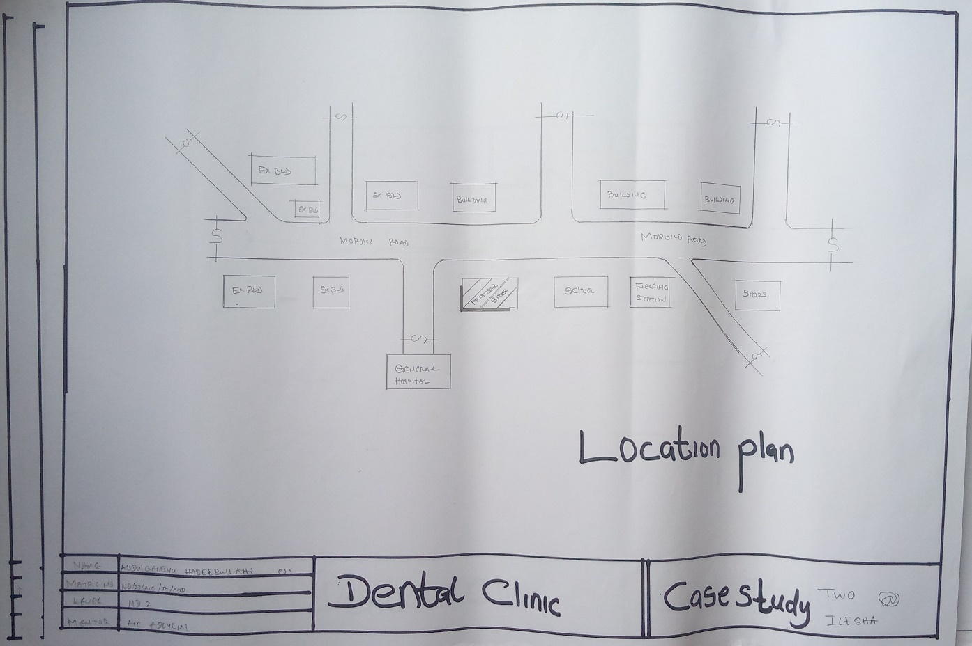

FIG 4; SHOWING LOCATION PLAN OF CASE STUDY TWO
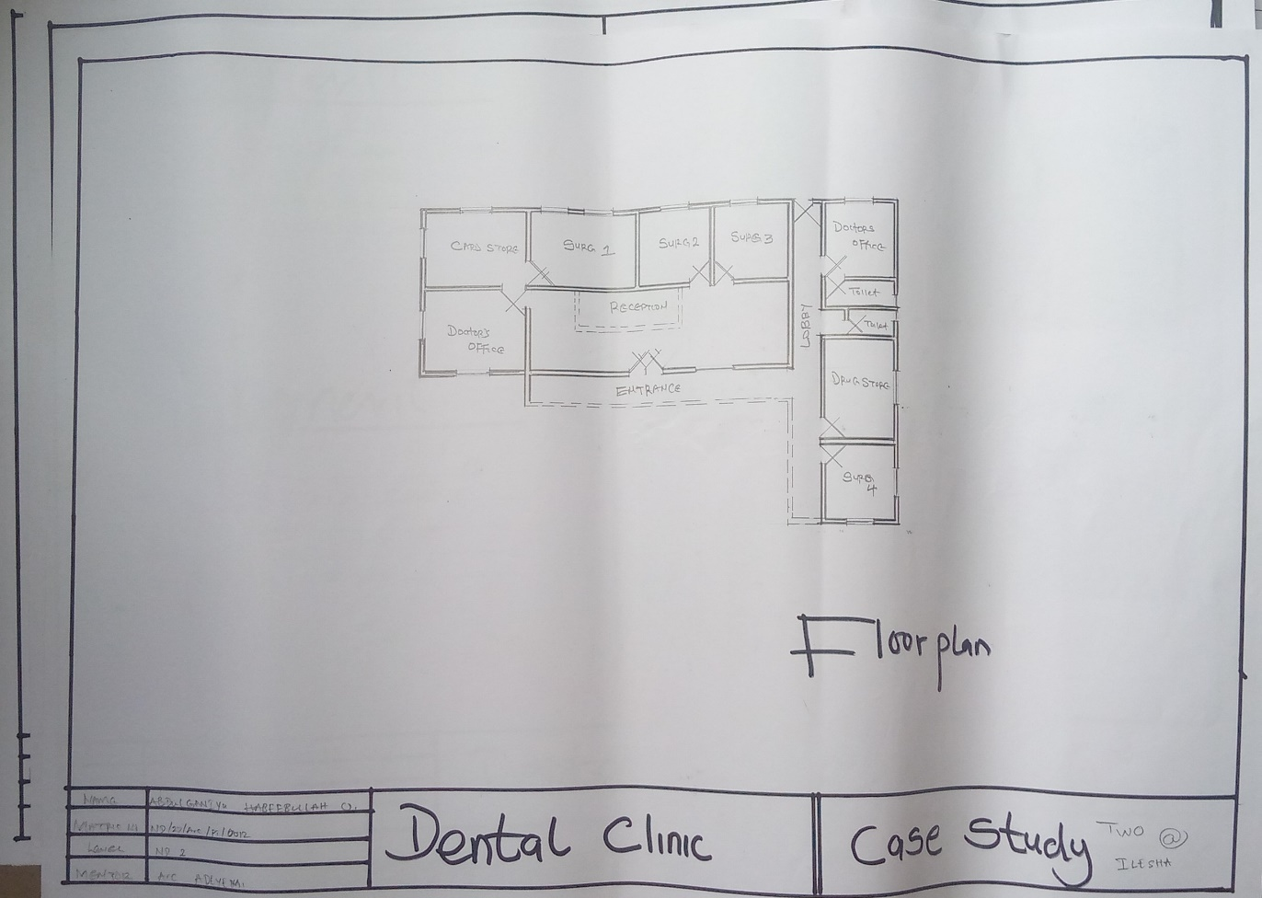

FIG 5; SHOWING GROUND FLOOR PLAN OF CASE STUDY TWO
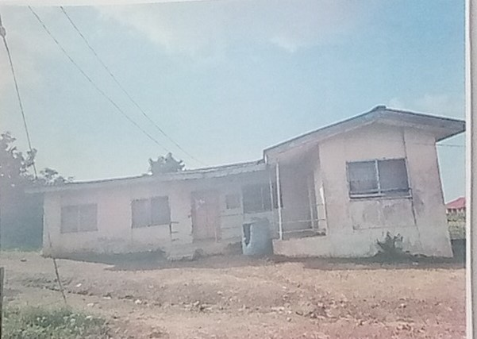

PLATE 6; SHOWING APPROACH VIEW OF CASE STUDY TWO
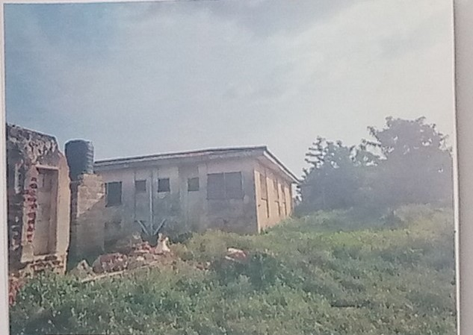

PLATE 7; SHOWING BACK VIEW OF CASE STUDY TWO

  - CASE STUDY THRE (3)
- Location: Lady K Memorial Delta Clinic, Oyo, State.
Observation
Merits
- Easy accessible
- It renders people around it healthcare
- The reception is conducive
- The surgery room is crossed ventilated

Demerits
- Not well define
- Inconducive environment
- Poor structure
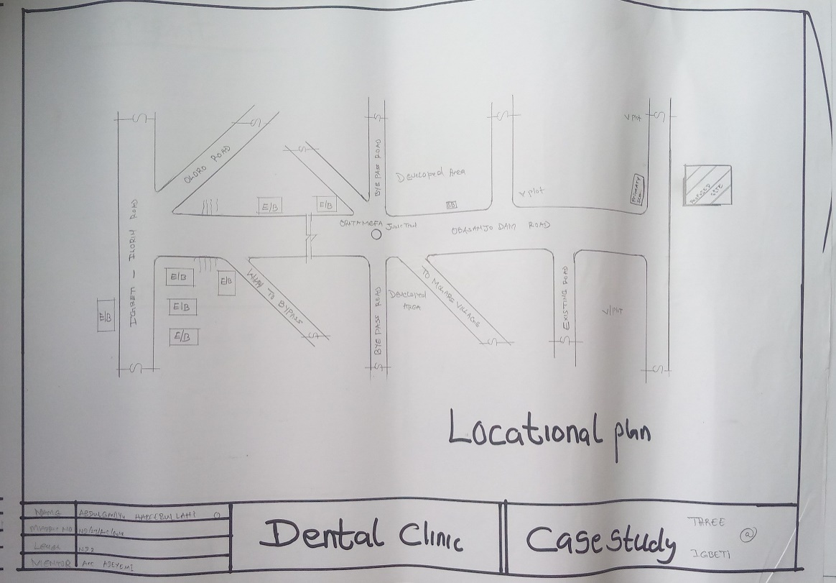

FIG 8; SHOWING LOCATION PLAN OF CASE STUDY THREE

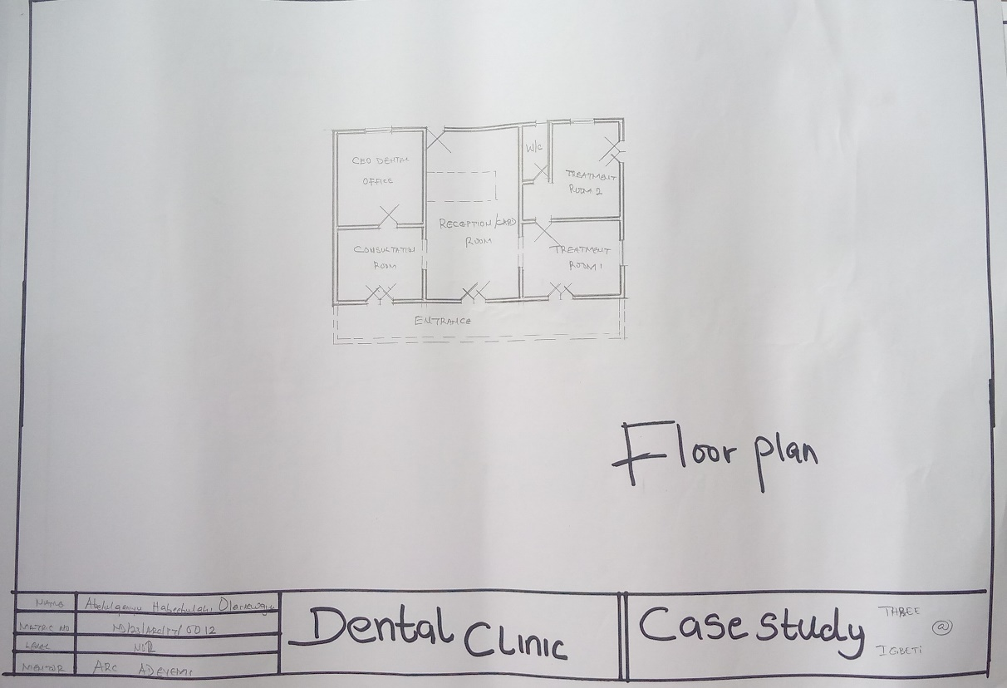

FIG 9; SHOWING FLOOR PLAN OF CASE STUDY THREE
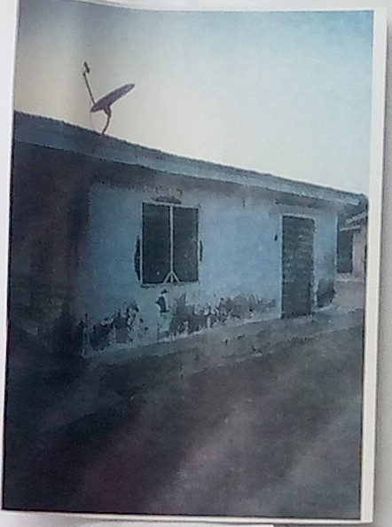

PLATE 10; SHOWING APPROACH VIEW OF CASE STUDY THREE
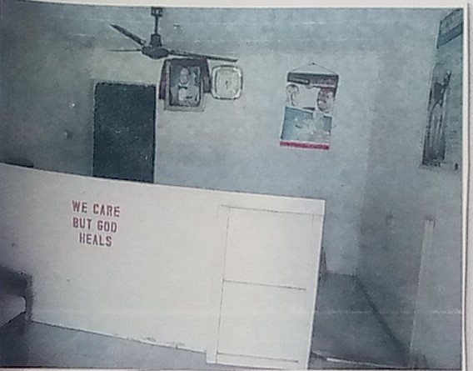

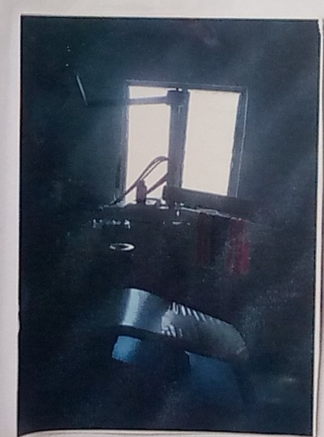
PLATE 11; SHOWING RECEPTION AREA OF CASE STUDY THREE

PLATE 12; SHOWING THEATRE ROOM OF CASE STUDY THREE
  - CASE STUDY FOUR (4)
- Location: Online Case Study
Observation
Merits
- Proper care of patients
- Well-equipped facility
- Adequate parking space
- Easily accessible from the gate
- Good security arrangement

Demerits
- No space for future expansion
- Lack of sufficient storage facilities
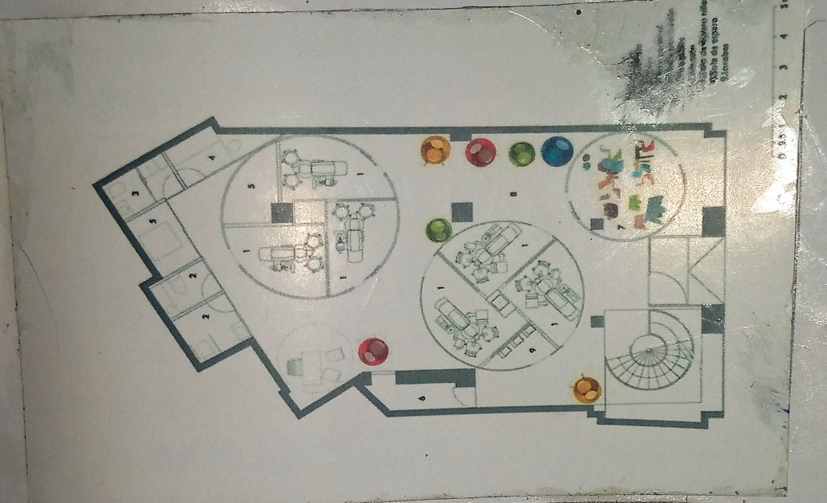

PLATE 13; SHOWING FLOOR PLAN OF CASE STUDY FOUR

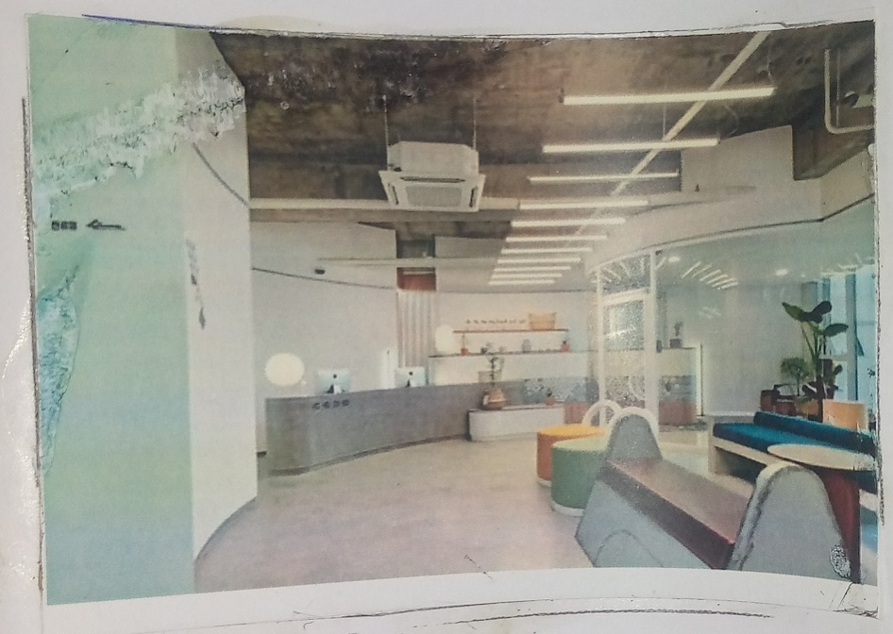

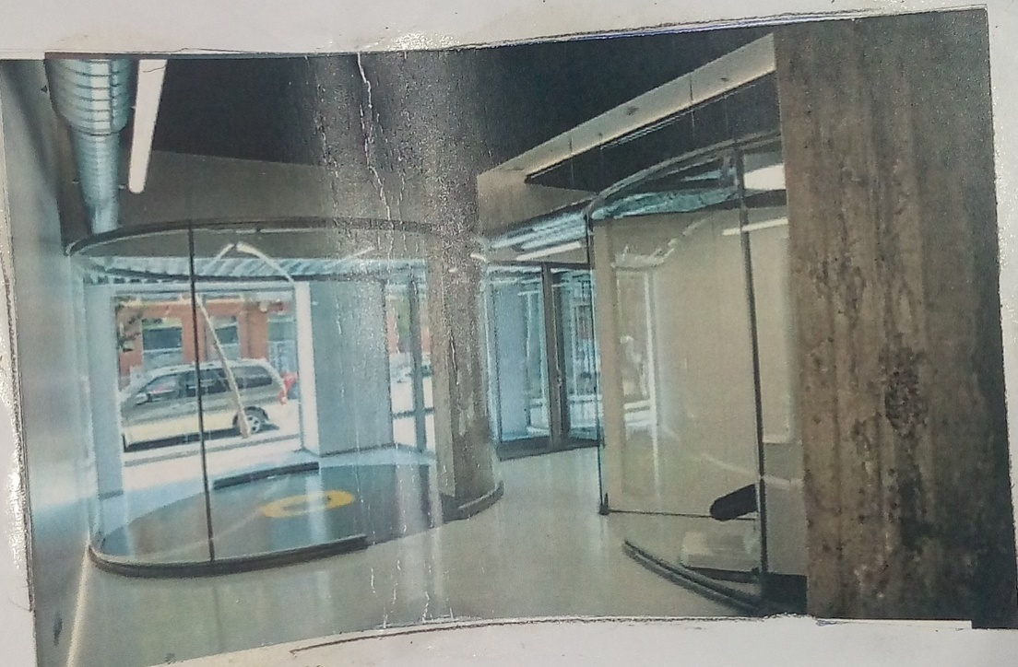
PLATE 14; SHOWING RECEPTIONIST VIEW OF CASE STUDY FOUR

PLATE 15; SHOWING PHARMACY OF CASDE STUDY FOUR
  - DEDUCTON FROM CASE STUDIES
During my visit to the dental hospitals. I was opportunities of see what is obtaining in the hospital, I made proper studies of their related function and analysis were made on their present situation with the aim of incorporation their merit in my own final proposal.
The following were deduced from case studies:
- Location and accessibility: All the clinics are conveniently located and easily accessible.
- Range of services: All the clinics offers a wide range of dental services.
- Qualified staff: The clinics employ highly qualified and trained staff to provide the best possible care to their patients.
- The units in the hospital should be properly and well linked.
- Good architectural land scraping.

CHAPTER FOUR
- PROJECT LOCATION
4.1 BRIEF HISTORICAL BACKGROUND OF ILORIN ASA L.G.A
Ilorin Asa local government area is situated in Kwara state, a North central geopolitical enclave of Nigeria. The headquarters of the LGA are in the town of Eiyenkorin with the LGA made up of towns and districts such as Orisunbare Apata Eiyekorin. The estimated population of Ilorin Asa LGA is 185,744 inhabitants with the area hosting members of diverse ethnic affiliations such as Nupe, Yoruba, and Fulani. The Yoruba language is one of the commonly spoken languages in Ilorin Asa LGA while notable landmarks in the area include the Kwara State College of Education.
GEOGRAPHY OF ILORIN ASA L.G.A
Lorin Asa LGA covers a total area of 486 square kilometers and has an average temperature of 29 degrees centigrade. The average humidity level of the area is 52 percent while the average wind speed in the LGA is 10 km/h.
ECONOMY OF ILORIN ASA L.G.A
Ilorin Asa LGA hosts a number of markets where a variety of commodities are bought and sold and these include the Ipata and the Baboko markets. Ilorin Asa LGA also hosts several publicly and privately owned institutions, industries, hotels and banks. Other important economic activities engaged in by dwellers of Ilorin Asa LGA include textile weaving, blacksmithing, and woodwork.
ORGANIZATION STRUCTURE
An organizational structure is a system that outlines how certain activities are directed in order to achieve the goals of an organization. These activities can include rules, roles, and responsibilities. The organizational structure also determines how information flows between levels within the hospital.
4.2 LOCATION AND SETTING OF ILORIN TOWN
Ilorin is the capital city of Kwara state in western Nigeria. It is situated on the Awun River, a minor tributary of the Niger. Founded in the late 18th century by Yoruba people, Ilorin became the capital of a kingdom that was a vassal state of the Oyo empire. Throughout the 19th century, Ilorin served as a major trade center between the Hausa of the north and the Yoruba of the south. It strongly resisted British rule, and only in 1897, when the army of the Royal Niger Company arrived after conquering Bida, did Ilorin recognize British supremacy. Today, modern Ilorin is mainly inhabited by MuslimYoruba people, although its traditional ruler is a Yoruba-speaking Fulani emir. The city is an industrial, commercial, and educational center, known for its local crops, cattle, and handicrafts.
4.3 POPULATION
NAME | Population Census.  1991-11-26 | Population Census.  2006-03-21 | Population Projection.  2022-03-21
ILORIN ASA | 108,715 | 207,462 | 311,500
TABLE 1: SHOWING THE POPULATION OF ILORIN ASA L.G.A
Ilorin Asa
311,500 Population [2022] – Projection
473.7 km² Area
657.6/km² Population Density [2022]
2.6% Annual Population Change [2006 → 2022]
Ilorin-East: Local Government Area in Kwara State, Nigeria
Nigeria Federal Republic 88,992,220 140,431,790 216,783,400
Source: National Population Commission of Nigeria (web), National Bureau of Statistics (web).
Explanation: The population projection assumes the same rate of growth for all LGAs within a state. The undercount of the 1991 census is estimated to be about 25 million. All population figures for Nigeria show high error rates; census results are disputed. Area figures are computed using geospatial data.
Further information about the population structure:
Gender (C 2006)
Males | 104,801 | 50.5%
Females | 102,661 | 49.5%
TABLE 2; SHOWING GENDER GROUP

Age (C 2006)
0-14 years | 85,180 | 44.4%
15-64 years | 115,064 | 51.9%
65+ years. | 7,218 | 3.7%
TABLE 3; SHOWING AGE GROUP (C 2006)

Age Distribution (C 2006)
0-9 years | 61,832
10-19 years | 44,827
20-29 years | 38,767
30-39 years | 24,426
40-49 years | 16,703
50-59 years | 9,759
60-69 years | 5,944
70-79 years | 3,039
80+ years | 2,165
TABLE 4; SHOWING AGE DISTRIBUTION

4.4 SITE INVENTORY
In the proposed site, some shrubs will be retained on site. It used to reduce sky glare and also serve as soft landscape and wind breaker.
Presence of road network which would serve as a means of accessibility to the site. Presence of electricity pole which serve as source of electricity to the site. Some trees would be retained while some will be removed if they disrupt the construction of building.
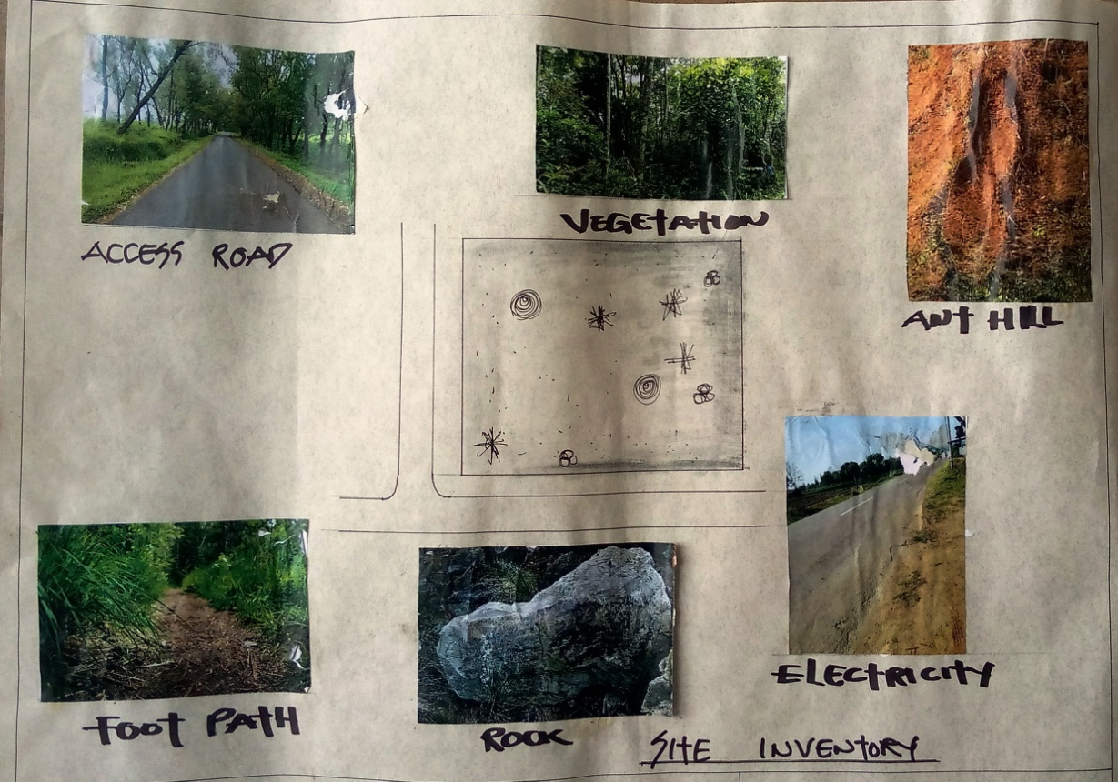
PLATE 16; SHOWING SITE INVENTORY OF THE PROPOSED SITE

4.5 SITE ANALYSIS
The site is benefitted with loamy soil which is a very good soil for grass and shrubs. It has a gentle slope towards the south east. Some of the grasses, shrubs and trees on the site are to be retained to enhance landscape patter of the site while some are to be removed and replanted where necessary. The two noticeable winds are to be directed into the building using landscape pattern to improve ventilation. Noise generated from vehicle traffic is controlled through proper planning, good landscaping and proper orientation of building. Generally, all the feature on the site are best put into different uses to aid control through proper planning, landscape and orientation.
Certainly, steps are considered to obtain vital information of the site, this information is the analyzed in details. For design purpose, the information includes soil condition, geology, topography, vegetation etc. It also involves carrying out a preliminary survey of the site.
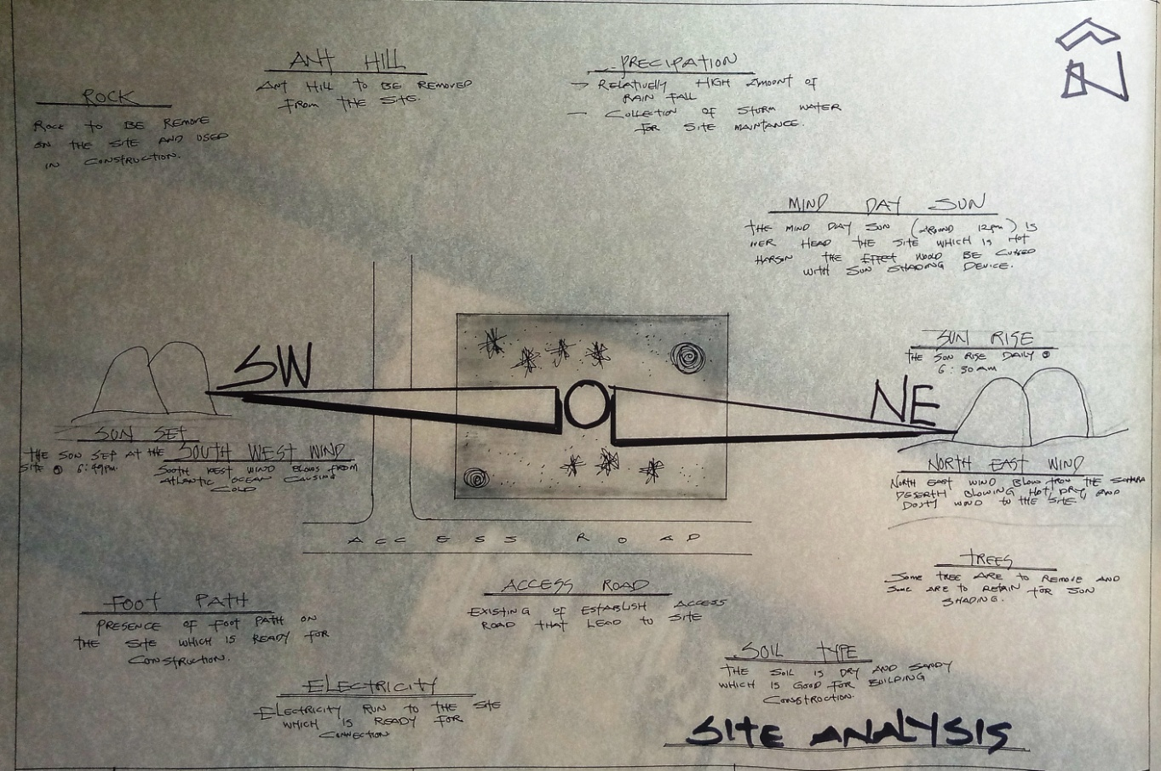
PLATE 17; SHOWING SITE ANALYSIS OF THE PROPOSED SITE

4.5.1 SITE SELECTION/JUSTIFICATION
In the site selection provision is made for interesting facilities that worth emulating since the overall success and efficiency of any project depend not on the functionality of the design but also on a careful choice of site. The site of this project has been carefully selected which is located in the premises of Ilorin, Ilorin East Local Government Kwara state, Sobi Road.
4.5.2 LOCATION
The site is located at Sobi Road, Ilorin, Kwara state.

4.5.3 ACCESSIBILITY
The site is easily accessible from the access road off from the main road that goes to sobi barrack.

4.5.4 INFRASTRUCTURAL FACILITIES
Facilities such as water electricity, telephone network and road network are all in Ilorin, hence it can easily be tapped to the proposed site.
4.5.5 TOPOGRAPHY
The topography of the land is gentle slope which can be filled and levelled up to balance round all the site levels.

4.5.6 SOIL STRUCTURE
It is made up of clayish laterite soil, which is good for building construction.

4.6 GENERAL CLIMATIC CONDITION
The city (Ilorin) has a topical climatic. The summer here have a good deal of rainfall, while the winter have very little. According to Koppen and Geiger, this climatic is classified as AW. In Ilorin, the average animal temperature is 26.50C the rainfall here average 1217mm. The least amount of rainfall occurs in January, the average in the month is 10mm. Almost of the precipitation here falls in September, averaging 232mm. The temperature are highest on average in March at around 29.00C. August is the coldest month with temperature average 24.50C.

4.6.1 RELATIVE HUMIDITY
The town is under the influence of high humidity throughout the year with a monthly relative humidity remaining above 60%. This is even higher between May and September with a relative humidity figure of about 80% average.
4.6.2 WIND
There are two prevailing winds namely: The rain bearing south-west monsoon wind which blows across the Atlantic Ocean between the month of May and October. This is called wet season. The dusty north-east trade wind which laden with dust blows through the Sahara desert during the month of November to April with very title rainfall toward April. This is called the dry season and it brings along Harmattan during its driest period.

4.6.3 TEMPERATURE
The monthly average temperature is quite uniform having February and March as the hottest months recording a higher average of about 48°C (about 85"F). July and August are the coolest (lowest monthly average of 76'F).

4.6.4 VEGETATION
The proposed site is covered with grasses few trees and shrubs. Some will be removed before the construction while some will be retained for ornamentation.

4.7.1 ROAD
There are only two access to the site
The eastern access which serve as the main entrance also main access road and southern access which serve as service road.

4.7.2 WATER AND ELECTRICITY
There are pipe born water networks and borehole water which serves the habitant of Ilorin. There is electricity supply from NEPA that serve the Ilorin east in general.

  - DESIGN CRITERIA
There are three (3) methods of designing of any project which are:
- Function before form method
- Form before function method
- Combination of Shapes
Designing projects, the function, before form method used in line with this method, the following are the design criteria for this project:
Functional: in term of functional requirement, the following design criteria must be considered. Sustainability, Site and Location, Flexibility, Circulation, Accessibility, Organization, Maintenance, Environment and Services.

4.8.1DESIGN BRIEF
After research and planning, the next step in the series of the project formation is design itself. To achieve functional and well-established design there must be a brief to work on. This brief depends generally on the scope of individual design. The brief of this project is therefore based on the various activities that take place in the hospital. To have enough brief for the proposed dental hospital, case studies were carried out on the existing dental hospital. The studies also give me the opportunity to know the nature of the various dental treatment and how they are related to each other.

4.8.2 DESIGN ANALYSIS
This is the process of itemizing units within the component of the entire design with a view to establishing a solid understanding and appreciation of the space relationships.
The units of the design are in two division,
The unit of the project division are as follows:
GROUND FLOOR:Entrance, Reception, Card room Operative Dentistry Office, Doctors Office, Pharmacy, Children zone, Gingivitis Surgery Room, Maxillofacial Surgery Room, Cosmetic Room Theatre, X – Ray Room, Wards, Cloak Room, Store, Convenience, Conference Room, Laboratory, Orthodontic Room, Mini Library, Dental Therapist Office, Accountant Office, Chief Surgeon Office, Secretary Office, Staff Lounge Room, Tooth Filling, Implant Room, Crown Tooth Room, Trauma Room, Endodontics Room, Ward, Convenience, Store, Sit Out.

4.8.3 SPACIAL ALLOCATION
Units | No. Required | Length (m) | Breadth (m) | Area (m2 )
Entrance | 1 | 2.4m | 6.2m | 12.5m²
Reception | 1 | 5.0m | 6.2m | 21.5m²
Card Room | 1 | 4.6m | 3.2m | 14.72m²
Phamacy | 1 | 5.0m | 5.2m | 24.5m²
W/C | 1 | 1.2m | 2.5m | 18.2m²
Changing room | 1 | 3.6m | 5.2m | 15.2m²
Store | 1 | 3.0m | 4.5m | 15.2m²
Office | 1 | 4,.2m | 5.0m | 15.0m²
Operating Room | 1 | 7.2m | 7.0m | 38.4m²
Male Ward | 1 | 1.0m | 6.0m | 60.0m²
Female Ward | 1 | 10.0m | 6.0m | 60.0m²
X-Ray Room | 1 | 7.0m | 5.0m | 25.0m²
Accountant Room | 1 | 5.0m | 5.0m | 25.0m²
Nurse Station | 1 | 3.1m | 7.2m | 18.6m²
Costmetic Room | 1 | 5.0m | 5.0m | 25.0m²
Mini-Liberary | 1 | 7.2m | 6.0m | 35.6m²
Conference Room | 1 | 7.0m | 5.0m | 35.0m²
Dentist Office | 1 | 4.2m | 5.0m | 20.0m²
Total | 115.315m²
TABLE 5; SHOWING SPACIAL ALLOCATION OF GROUND FLOOR

CAPTER FIVE

- GENERAL REQUIREMENTS

5.1 APPRAISAL OF PROPOSED SCHEME
The proposed scheme is to satisfy the appropriate building regulation. The project design is to confirm with the intended use of building taking into consideration with both natural factors and human that can pose a threat on the validity and stability of the project design.

5.2 CONSTRUCTION METHODOLOGY AND MATERIAL
The construction is to be carried out following the due process of construction ranging from.
- Preliminary: this involves the clearing of the site, setting out and excavation of foundation trench, foundation works down to the basement level.
- Sub-Structure: this process also entails the positioning and erection of column and beams, masonry work etc. Gypsum board: is to be used for the Acoustic purpose of the building. This material is often called dry wall, wall board or plaster board. It creates a continuous surface suitable for most types of interior decoration. It comes in different size ranging length of 2.4m, 3.0m, also in thickness of 1/ inch, 3/8 in
5.3 SERVICES
A building can be said to be good when it performs the serves required by it. In other to have a well-function building design, there calls for an installation of underground water. This is a means of providing brightness naturally by sun or moon or artificially by lamps. Good natural and artificial lighting is important in lecture rooms, and workshop. It is always easy to make mistake and time the eye in a situation of poor lighting floor. For the purpose of this project, effort is made as much as possible to light up the entire building naturally before the use of artificial lighting. In this project, to obtain maximum lighting more openings are provided for the lecture rooms, workshop and admin. Artificial source of light will still be provided for in case where there is call for the use of it at night or in a situation where the weather condition warrants it.
5.3.1 VENTILATION
As it's relates to architectural, is the intentional introduction of outside AIT into a space through openings (like window/doors and mechanical means (ACs) to provide maximum thermal comfort for human satisfaction. In this design, both means of ventilation ate introduce but majority concentration on the mechanical means of ventilation for all units in the design for the purpose of extracting the used air and introducing fresh air within all spaces for human’s consumption and satisfaction.
This is done through installation of mechanical (artificial) ventilation ducts horizontally and vertically all within the units of the design to allow easy floe of free movement of air passage through the ventilation channels and providing well, proper and adequate ventilation for each and every units in the design project.

5.3.2 LIGHTING
This is a means of providing brightness naturally by sun or moon or artificial by lamps. Good natural and artificial lighting is important in all units. It is always easy to make mistake and time the eye in a situation of poor lighting floor. For the purpose of this project, effort is made as much as possible to light up the entire building naturally before the use of artificial lighting.

5.3.3 PLUMBERING
The plumbing system in this project design is made easy for waste extraction and brain water extraction through the means of service duct channel and roof gutter drainage. All waste water and soil waste from the toilet/convenience are extracted through means of drainage pipe running through the walls down to the inspection chamber situated in the service duct, flowing down to the septic tank and soak away for final waste extractions.

5.3.4 ELECTRICAL INSTALLATION
The type of wiring system chosen should be conduct system of wiring, technical are should be wired with strong durable and light current resistance cables because of the power requirements and consumption of the equipment to be used and installed in them. Connection and distributing cable signal. Also electrical installation is to be done to allow for the use quality electrical fittings and fixtures in the whole of the hospital.

5.3.5 WASTE DISPOSAL
Waste disposal are to be put in the building and also some specific areas necessary, this waste bins should be disposed in the incinerator which will be provided within the proposed site premises. The waste should therefore, be burn in the incinerator or taken away from the site.

5.3.6 FIRE PROTECTION
Electrically, fire alarms and sensor are to be installed in the building in generally. This should be done in case of the fire occurrence. Fire extinguishers are to be placed at a certain distance in the lobbies and some other necessary areas. It is also serving as protection in case of fire outbreak.

5.3.7 RAIN PROTECTION DEVICES
The rainfall of a place generally determines the living condition and all comfort associated with that environment hence provision should be made for fast dispersal of the rain water as well as the associated condition with rainfall. This calls for the need to study the nature of rainfall of the area. To control the heavy rainfall during the wet season (April - October) the use of simple sloppy system roofing has been adopted. This is provided with roof gutter system which is linked to the ground drainage network by the use of P.V.C.

5.3.8 EXTERNAL WORKS
The external works are to be earned out generate, kerbs land and shrubs, flowers, grasses and trees planted. Concrete interlocking pavement tiles to be adopted before hard landscape for walk ways and parking spaces and car access roads must be tarred with asphalt finishes.

5.4 SUMMARY
This project, generally, has seriously widen my view and knowledge affecting my observation beyond my expectation. I have been able to deduct what it takes or entails and how to go about designing and achieving a good design of any form of this related project with total seriousness as this project has given out the facts and precise information it comprises.

5.4.1 CONCLUSION
It is obvious that majority of our patients still visit dental clinic for symptomatic treatment and pain account for the reason why majority present in the clinic. However, some factors such as low level of dental awareness and financial constraint of patient could have led to this pattern of presentation. Nevertheless, the possibility of peoples’ negligence of their health, lack of time and fear of undergoing treatment in dental clinic cannot be ruled out. This suggest that Dental surgeons and dental health workers have not been playing their role adequately in facilitating public enlightenment that people may appreciate the need for regular dental care and make adequate and proper use of the available dental care facilities.

5.4.2 RECOMMENDATION
There is need to emphasize more on the preventive aspect of dentistry. There is need to improve on the present state of dental awareness programs. The issue of cost of dental care should be better addressed than it is presently being done, e.g. through the National health insurance scheme program (NHIS).

REFERENCES
1. Brown L.J. and Lazer V. Dental care utilization: How saturated is the patient’s market? J Am Dent Assoc 1999; 130: 573-580.
2. Allukian M. Dentistry at the crossroads: The future is uncertain: The challenges are many. Am J Public Health 1982; 72: 653-654.
3. Grembowski D., Comrad D. and Milgrom P. Utilisation of dental services in the United States and an insured Population. Am J Public Health 1985; 75: 87-89.
4. Douglas C.W. and Cole K. Utilization of dental services in the US. J Dent Educ 1979 43:223- 38.
5. Savage K.O. and Arowojolu M.O. Perception of gingival bleeding by Nigerian. Afr J Med Sci; 26: 91-93.
6. Ainamo J. and Ainamo A. Prevention of Periodontal Diseases in a mixed dentition. Int Dent J 1981; 31:125-132.
7. de Lacerda J.T., Simionato E.M., Peres K.G., Peres M.A., Traebert J. and Marcenes W. Dental pain as the reason for visiting a dentist in a Brazilian adult population. Rev SaúdePública 2004; 38 (3): 1-6.
8. Kolude B. and Gbadebo S.O. Orofacial Pain: Pattern of Presentation at Dental Clinic University College Hospital Ibadan. MDS Thesis, 2007.
9. Famuyiwa O.O., Olorunsola D.A. and Derin A. Some family factors in sickle cell anemia in Lagos, Nigeria. Nig Med Practitioner 1998; 35:70-73.
10. Woosung S., Amid I., Ashley A., James L. Determinants of Dental care visits among low-income African-American children: J.Am Dent Ass 2007; 138:301-318
11. Lo G.L. The use of Dental services by adult Singaporeans. Singapore Dent J 1993; 18:22- 25.
12. Manski R.J. and Moeller J.F. Use of dental services An analysis of visits, procedures, and providers, 1996. J Am Dent Assoc 2002; 133: 167-175.
13. Sa’adu and Abdulraheem. Oral health care practice and socio-demographic findings among the physicians in Ilorin, Nigeria. Niger J Med 2003; 12: 211-216.
14. Manski R.J., Moeller J.F., and Maas W.R. Dental services: use expenditures and sources of payment, 1987. J Am Dent Assoc 1999; 130: 500-508.
15. Manski R.J., Edelstein B.L. and Moeller J.F. The impact of insurance coverage on children’s dental visits and expenditures, 1996. J Am Dent Assoc 2001; 132: 1137-1145.

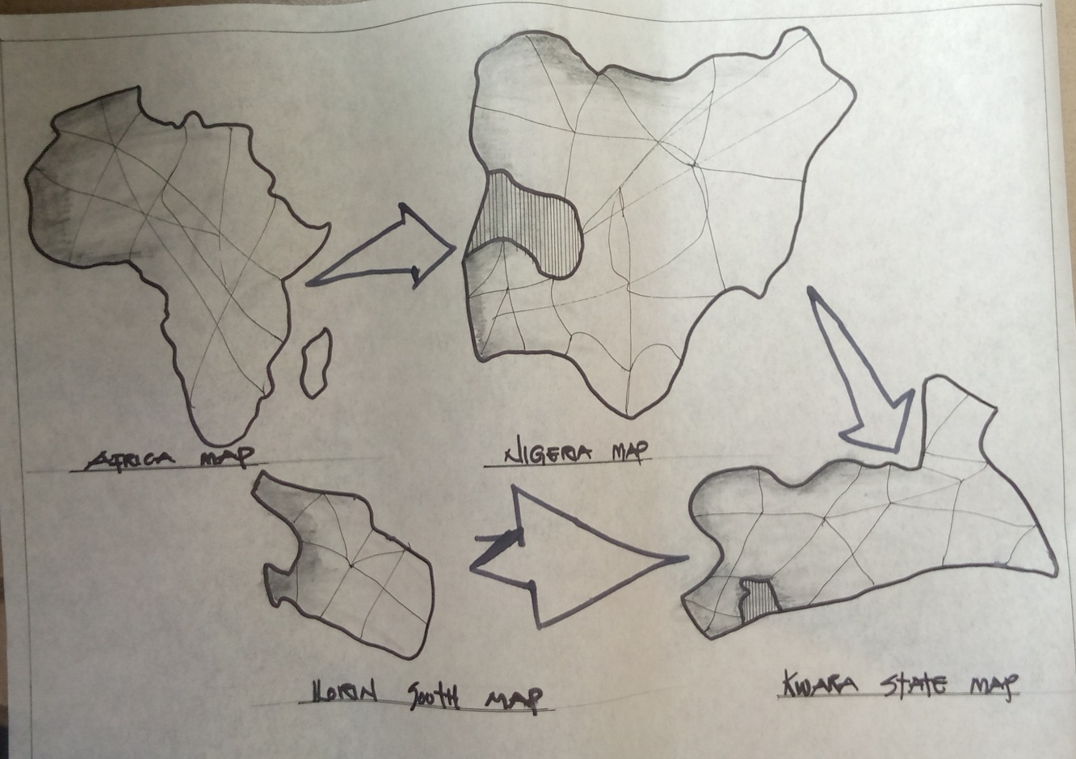
APPENDIX 1; SHOWING LOCATION MAP OF THE PROPOSED PROJECT
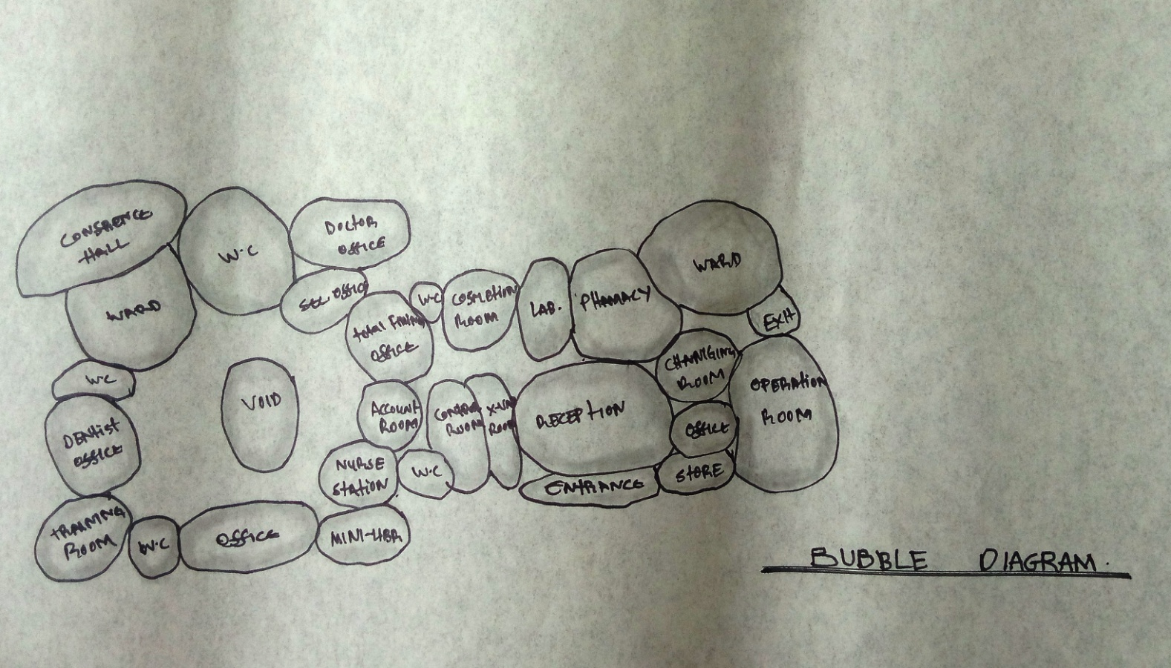
APPENDIX 2; SHOWING BUBBLE DIAGRAM OF THE PROPOSED PROJECT

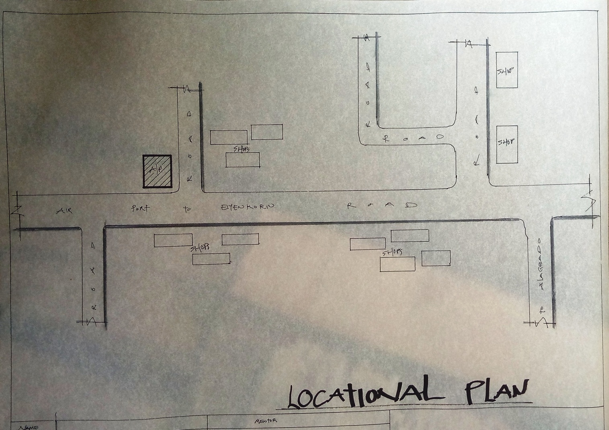
APPENDIX 3; SHOWING LOCATION PLAN OF THE PROPOSED PROJECT

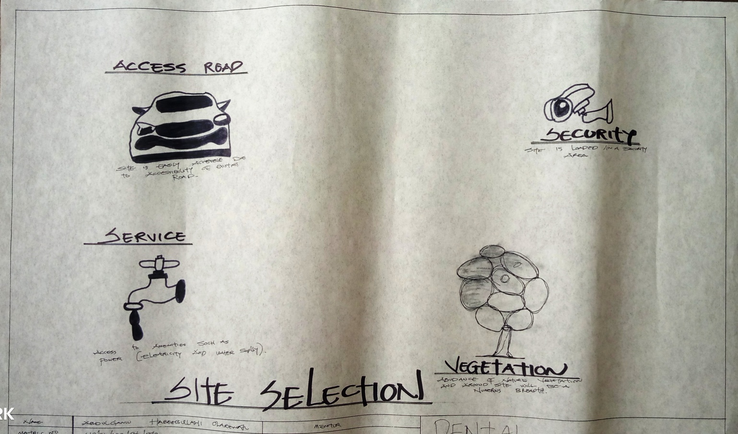
APPENDIX 4; SHOWING SITE SELECTION OF THE PROPOSED PROJECT

.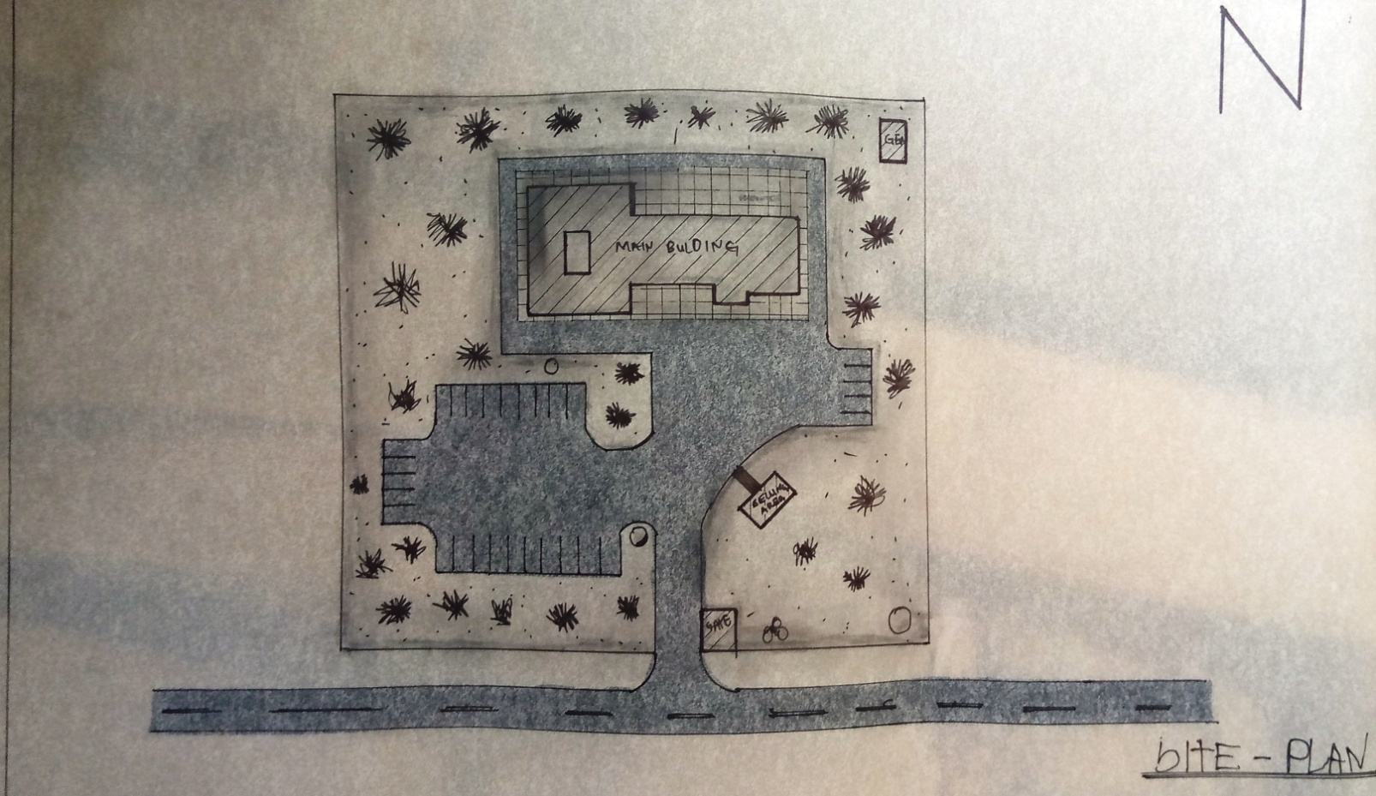
APPENDIX 5; SHOWING SITE PLAN OF THE PROPOSED PROJECT
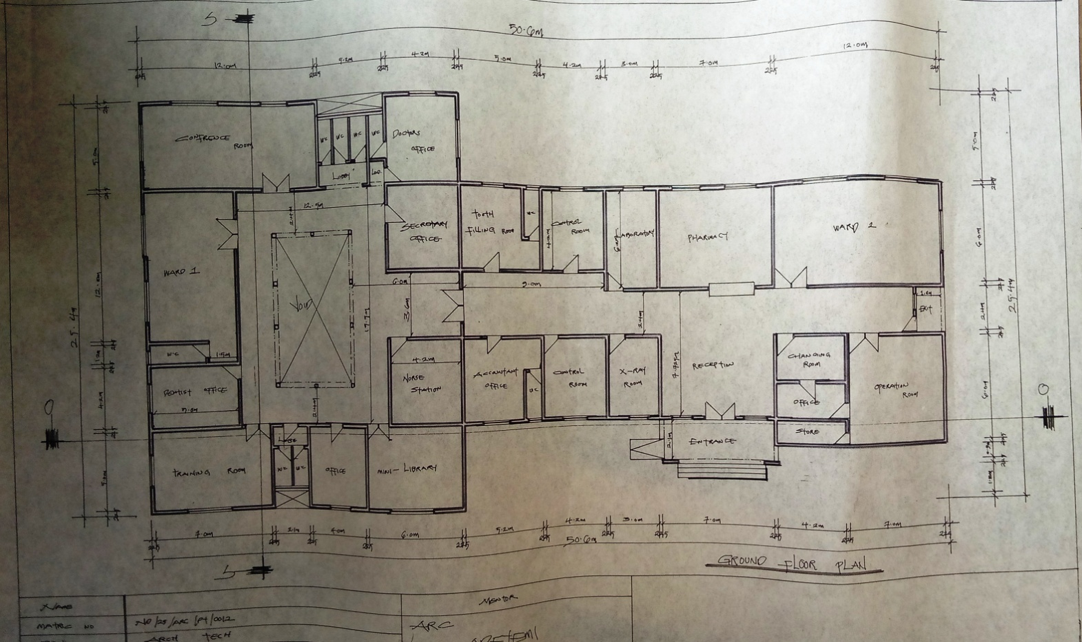
APPENDIX 6; SHOWING GROUND FLOOR PLAN OF THE PROPOSED PROJECT

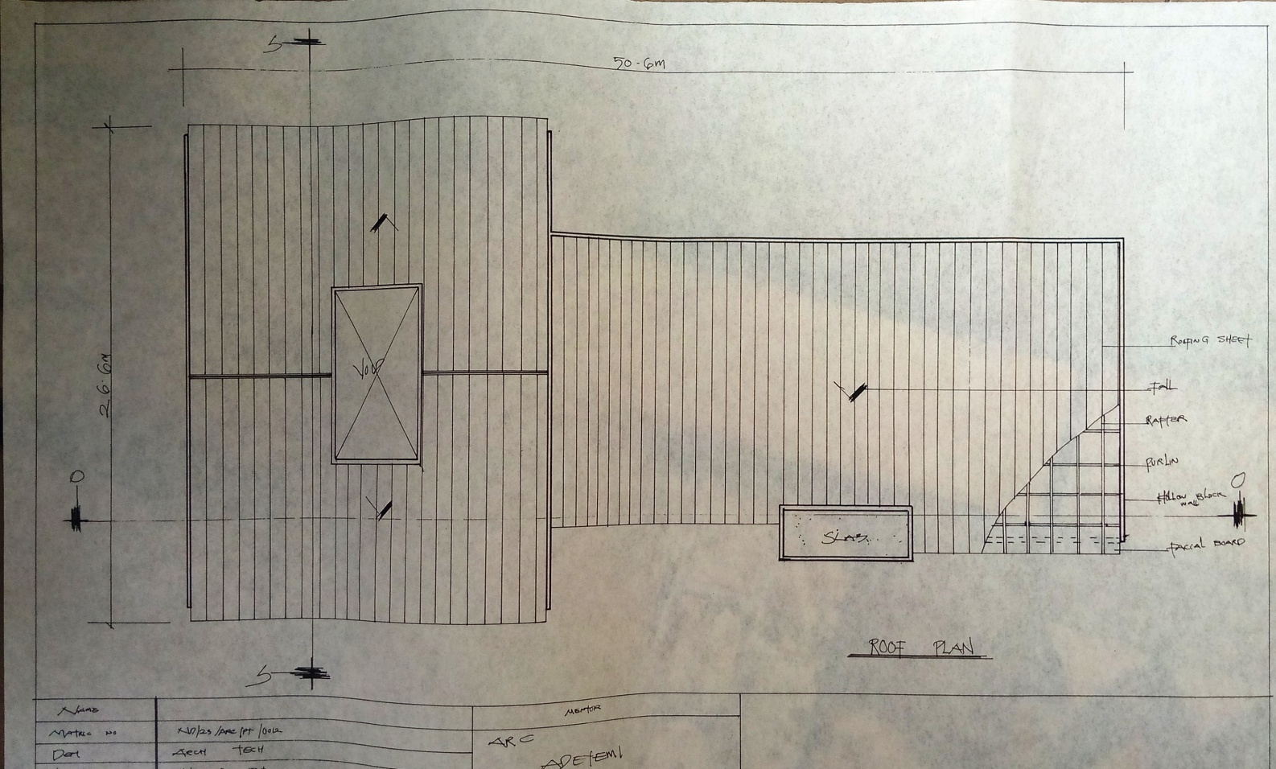
APPENDIX 7; SHOWING ROOF PLAN OF THE PROPOSED PROJECT

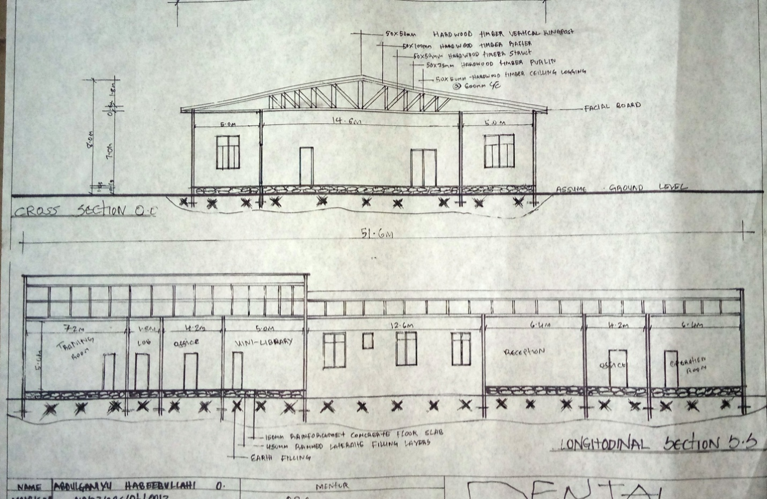
APPENDIX 8; SHOWING CROSS SECTION OF THE PROPOSED PROJECT

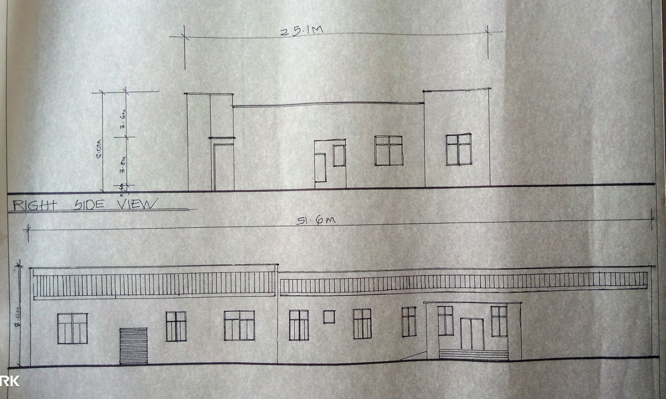
APPENDIX 10; SHOWING APPROACH VIEW AND RIGHT SIDE VIEW OF THE PROPOSED PROJECT

