A PROJECT REPORT

ON

PROPOSED RECREATIONAL CENTRE

PRESENTED BY

ABDULRAHEEM BOLAKALE ABDULRAFIU

HND/23/ARC/FT/0017

SUBMITTED TO

THE DEPARTMENT OF ARCHITECTURAL TECHNOLOGY

INSTITUTE OF ENVIRONMENTAL STUDIES

KWARA STATE POLYTECHNIC, ILORIN

IN PARTIAL FULFILLMENT OF PART OF THE REQUIREMENT FOR THE AWARD OF HIGHER NATIONAL DIPLOMA (HND) IN ARCHITECTURAL TECHNOLOGY.

AUGUST, 2025

DECLARATION

This design project work is authentic and documentation of my research work under the supervision of ARC. ABDULAZEEZ B.Y.F of the Department of Architectural Technology, Kwara State Polytechnic Ilorin, Kwara State.
I, ABDULRAHEEM BOLAKALE ABDULRAFIU with Matric No. HND/23/ARC/FT/0017 hereby solemnly declare that this project was done or handled by me. All the sources of information are specially acknowledged by means of references.

_______________________ ______________________________
DATE SIGNATURE

CERTIFICATION

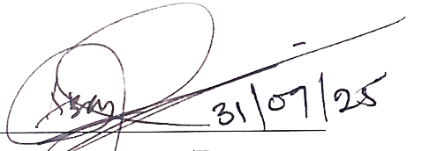
This is to certify that this project has been duly endorsed and authenticated as having satisfied part of the requirements for the award of Higher National Diploma (HND) in Department of Architectural Technology, Institute of Environmental Studies, Kwara State Polytechnic Ilorin, Kwara Sate.

ARC. ABDULAZEEZ B.Y. F Signature/Date
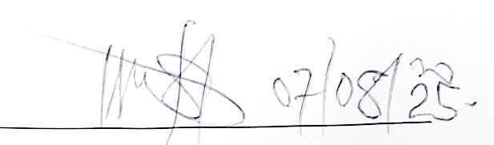
(Project Supervisor)

ARC. OLANREWAJU F. A Signature/Date

(Project Co-ordinator)

ARC. TOMORI J. M Signature/Date
(Head of Department)

External Examiner Signature/Date

DEDICATION

The project is being thought-fully dedication to Almighty Allah, the creator of all for guiding me through the duration of the course.
I also dedicate this project to my fantastic and paramount families specially my parents Mall. and Mallm. ABDULRAHEEM for their moral, love and care, provision and financial support toward this great achievement.

ABSTRACT

Recreational centre is multi-functional institution that provides access and promotes citizen well-being and offer lifelong learning opportunities. Recreation centres have their roots in ancient civilization where public spaces were used for baths, gym etc which the historical background highlights the evolution of recreation centres from ancient public spaces to modern multi-disciplinary institution.
This work is focusing on recreational activities. Apart from the fact that this project can’t be underestimated the design is also considering some structure as it is of great significance to gymnasium, swimming, and other games. Adequate car parks are considered for spectators ranging from the V.I. P’s to the popular ones. As a recreational centre which will accommodate several people, there is a need for proper security measures which was duly approached through the introduction of security post where necessary. Other facilities like, walking/jogging trail, picnic, soccer field & playground etc. has also been duly considered to the minimum level.
The research project is limited to recreational centre, other factors that restrict over of the project that most of the respond are negative to true information concerning themselves of heavy and counter or levy action against it.
The method of research in order to arrive at a functional and appealing design, different types of methods were adopted in carrying out the research work of this project are CASE STUDY, ONLINE RESEARCH, AND ORAL INTERVIEW.

ACKNOWLEDGEMENT
All glory, adoration, and honour to Almighty Allah, the creation of the universe may His names be praised forever. It is a genuine pleasure to express my deep sense of thanks and gratitude to the Almighty God for His sustenance and love throughout the course of this study.
I wish to express my profound gratitude to my mentor, guide, relentless, and untiring supervisor ARC. ABDULAZEEZ B.Y.F, his keen interest and dedication above all his overwhelming attitude to help his student had been mainly and solely responsible for completing my project. His timely advice, scholarly and scientific, and meticulous scrutiny approach have helped me to a very great extent to accomplish this great task. May God keep blessing and sustaining you. I equally commend the effort of the Head of Department ARC TOMORI J.M, the project co-ordinator ARC. ADEYEMI O.F and the entire teaching and non-teaching staffs of Architectural Technology Department for their supports during the course of study. I say a BIG THANK YOU to you all.
I owe a deep sense of Gratitude to my parent Mall. and Mallm. ABDULRAHEEM and my siblings; All the ABDULRAHEEM’s family and Mr IBRAHIM who gave their solemn support to the successful attainment of this worthy and rare degree and have to stopped at nothing to give the best of their support since I was born. I pray for you all will eat the fruit of your labour and may Allah keep sustaining and blessing you all. (AMEEN).
On the whole, I, Abdulrafiu Bolakale Abdulraheem hereby wish to acknowledge and thank all others whose names or title may not have mentioned but have in one or the other contributed to the success of my studies, I appreciate you all and I ask God’s blessing upon your endeavours. GOD BLESS YOU ALL.
TABLE OF CONTENT
TITLE PAGE
DECLARATION ………………………………………………………………………………………........... ii
CERTIFICATION …………………………………………………………………………………….......…. iii
DEDICATION ……………………………………………………………………………………………....…. iv
ABSTRACT ……………………………………………………………………………………………...…....… v
ACKNOWLEDGEMENT ………………………………………………………………………..........…. vi
TABLE OF CONTENT ……………………………………………………………………….….........…. vii
LIST OF TABLES ………………………………………...….……………………………………….......... viii
LIST OF PLATES AND FIGURES ……………………………………………………….….........…. ix
CHAPTER ONE
- Introduction ……………………………………………………………………………………………….…. 1
  - Historical Background ……………………………………………………………………………….…... 1
  - Definition ……………………………………………………………………………………………………... 1
  - Aim and Objectives …………………………………………………………………………………….…. 2
  - Scopes ……………………………………………………………………………………………………….…. 2
  - Statement of Problem ………………………………………………………………………………….…. 2
  - Methodology …………………………………………………………………………………………………. 3
  - Limits and Constraints ………………………………………………………………………….………... 3
  - Justification ……………………………………………………………………………………………………. 3
CHAPTER TWO
- Literature Review and Case Study ……………………………………………………………………. 4
  - Review of Relevant Literature …………………………………………………………………………. 4
  - Importance ……………………………………………………………………………………………………. 5
  - Selected Case Studies ……………………………………………………………………………………… 5
    - Case Study One …………………………………………………………………………………. 6 – 7
    - Case Study Two …………………………………………………………………………………. 8 – 9
    - Case Study Three …………………………………………………………………………… 10 – 11
  - Deduction …………………………………………………………………………………………………… 12
  - Conclusion ……………………………………………………………………………………………….…. 12
CHAPTER THREE
- Site and Environmental Analysis …………………………………………………………………… 13
  - Brief History and Introduction of the Study Area …………………………………………… 13
  - Site Location/Description ……………………………………………………………………………. 13
  - Site Selection/Location Criteria ……………………………………………………………………. 13
  - Site Inventory/Analysis ………………………………………………………………….…. …..…… 14
  - Climatic Data/Geographical Consideration ……………………………………. …..…..…… 14
  - Conclusion …………………………………………………………………………………….….……… 15
CHAPTER FOUR
- Design Criteria …………………………………………………………………………………………… 16
  - Site Planning ………………………………………………………………………………………………. 16
  - Brief Analysis ………………………………………………………………………………………....…. 16
  - Analysis of the Scopes …………………………………………………………………………………. 16
  - Space Allocation …………………………………………………………………………………………. 17
  - Functional Relationship …………………………………………………………………………….... 18
  - Conceptual Development ……………………………………………………………………………. 18
CHAPTER FIVE
- Design Approach …………………………………………………………………………………….…. 19
  - Appraisal of Proposed Scheme ……………………………………………………………………. 19
  - Design and Construction …………………………………………………………….…………….... 19
  - General Design Consideration …………………………………………………………….… 19 – 20
  - Construction Method and Materials ………………………………………………………. 21 – 22
  - General Maintenance ……………………………………………………………………………….…. 22
  - Summary and Recommendation ……………………………………………………………….…. 23
  - References ……………………………………………………..……………………………………….…. 32

LIST OF PLATES
Plate 1: Showing the Location and Floor Plan of Case Study One …………………....………… 6
Plate 2: Showing the Pictures of Case Study One ………………………………………….….…. 7
Plate 3: Showing the Location and Floor Plan of Case Study Two ……………………………… 8
Plate 4: Showing the Pictures of Case Study Two ………………………………………………. 9
Plate 5: Showing the Location and Floor Plan of Case Study Three …………………………… 10
Plate 6: Showing the Pictures of Case Study Three ………………………………………….…. 11
Plate 7: Showing Climatic Chart (Diagram) ……………………………………………….…… 15
Plate 8: Showing Functional Relationship Diagram ……………………………………………. 18
Plate 9: Showing Concept Derivation ………………………………………………………...… 18

LIST OF FIGURES
Figure 1: Showing Locational Map and Plan ………………………………………………...… 24
Figure 2: Showing Site Inventory and Analysis ……………………………………………...… 25
Figure 3: Showing Site Plan and Zoning ………………………………………..…………....… 26
Figure 4: Showing Floor and Roof Plan ………………………………………………....…...… 27
Figure 5: Showing Cross and Longitude Sections ………………………………………..…..… 28
Figure 6: Showing Approach and Right-Side View …………………………….……….…...… 29
Figure 7: Showing Left Side and Back Side View ………………………………………….…... 30
Figure 8: Showing Space Calculation and Detailing …………………………………….……... 31

CHAPTER ONE
- INTRODUCTION TO RECREATIONAL CENTRE
Recreation is an activity that voluntarily pursue for personal enjoyment or satisfaction, usually during their free time. Recreation takes variety of forms and occurs in places, depending on the choice of the individual.
Since the end of worl war II in 1945, recreation has become an important element in modern life. High incomes and improvement in working conditions and transportation have given many more money, time, and mobility for recreation. Today, recreation is a major industry.
Recreational Centre is a facility designed to provide pleasures for millions of people but it may also make an important contribution to an individual mental and physical health, leisure, and social engagement. It is proposed to bring out visually and verbally the most creation new idea and speculative on what potentials these may hold for the future, taking into consideration the desire of children, adults, and community at large.
  - HISTORICAL BACKGROUND OF RECREATIONAL
A recreational centre has a rich history dating back to ancient culture, where leisure and recreation played a significant role in society. The concept of recreation and leisure has evolved to overtime, influenced by various social, physical, and cultural factors. The ancient Greek’s and Roman’s built public baths, gyms, and theatres for recreational purposes.
The first documented intramural activities occurred between Freshman and Sophomore classes at Princeton in 1857. The recreation movement in the United States dates to the social programs of the late 19th Century, and city’s own bathhouses functioned as early recreation centres.
A state legislative act in 1895 mandated the construction of free public baths in cities of populations of 50,000 or more and by 1911, twelve public baths opened in Manhattan. Back to the early 20th Century, community leaders recognized the need for a dedicated space where residents could gather, socialize, and engage in various activities.
The 1970’s and 1980’s saw significant expansion and renovation of the community centre. New facilities were added including indoor games, sport facilities, and community programs.
  - PROJECT DEFINITION
A recreational Centre refers to a place where people go to participate in variety of activities, programs, and services that promote relaxation, enjoyment, social, and physical and mental well-being.
It provides spaces for recreational purposes such as Sports and Fitness, Arts and Crafts, Educational programs, and Social event aiming to elevate Health and Wellness, Family-friendly, Personal development, and Community buildings.
  - AIM AND OBJECTIVES OF THE PROJECT
AIM
To enhance the quality, trails, and recreational opportunities for the community’s well-being and make a desirable functional recreational destination to match modern civilization.
OBJECTIVES
- To design a functional recreational centre that encourage socialization, cultural exchange, and community engagement.
- To ensure that the centre is accessible to all members of the community regardless of ages, socio-economic status or ability.
- To provide a recreational centre that is safe and serve environment for all users.
  - PROJECT AND DESIGN SCOPES OF THE PROJECT
PROJECT SCOPES
- Design and Plan the Recreational Centre.
- Develop Programs and Services.
- Establish Operational Policy.
- Procure Necessary Equipment.
- Conduct Needs Assessment and Feasibility.
DESIGN SCOPES
- Indoor and Outdoor Spaces.
- Accessibility Features.
- Sustainability Features.
  - STATEMENT OF PROBLEM OF THE PROJECT
The lack of affordable well-maintained and accessible recreational centre hinders the mental, social, and physical well-being of residents, particularly low-income families and youth.

  - RESEARCH MENTHODOLOGY OF THE PROJECT
- INTERNET EXPLORING
This refers to the act of browsing, searching, and navigating the internet for information, resources. E.g. Being, Google, Wikipedia etc.
- CASE STUDY
This is the process of data collection through visitation of an existing project/work with the help of study and photograph.
- ORAL INTERVIEW
This is the process of interviewing the staffs of the visited existing recreational project/work.
- LITERATURE REVIEW
This refers to the act and process of gathering information through Textbooks, and other relevance PDF.
  - LIMITS AND CONSTRAINTS OF THE PROJECT
- Physical Limits and Constraints
- Regulatory Constraints
- Operational Limits and Constraints
- Financial Limits and Constraints
  - JUSTIFICATION OF THE PROJECT
The need for this project is to build a standard, functional, convenient, and aesthetically pleasing and ultra-modern recreational centre for the society and around the state.
CHAPTER TWO
- LITERATURE REVIEW AND CASE STUDY
  - REVIEW OF RELEVANT LITERATURE
Despite many common anachronistic assumptions about the public bath’s habits of the ancients Greek’s, a large gathering of archaeological and literary evidence suggests that the Greek’s and the Roman’s during the Republican and early Imperial periods were actually quite hygienic. The remains of dozens of Roman bathing complexes have been uncovered by archaeologists and the Roman Legionary Catalogues state that by the 4th Century AD Rome possessed 856 registered bathhouses. Even though baths were fixtures in Roman life, relatively few primary sources remain with useful details on the baths, gyms, which is possibly a testament less to their importance and more to their universality. This has made historical research nearly impossible without the help of archaeologists.
Significant archaeological research has been done in an attempt to illuminate the structure and function of the baths, gyms, through archaeological finds, as well as much historical research and speculation on the societal value of the baths, gyms, through the few primary sources that speak of them. However, this paper will finally unite the tripartite scholarship of origins, functions, and value of the gyms into a review about what is known regarding these vital structures.
The Roman gyms, bathhouses were the “single most characteristic feature of Roman Culture,” and this review will give an inclusive overview of just why this is the case. The Roman gyms, baths, are recognizable by several different names. These is some scholarly debate as to whether “Balnea” which comes from the Greek word (βαλανείον) meaning “bath” or its major opponent, Thermae, was more prevalently used in Republican Rome itself. “Thermae” comes from the Greek word (θέρμαι) meaning “hot”, two main camps arise regarding thermae: Evan’s camp, which argues that thermae was used to disambiguate large, imperial baths from private baths, Balnea, a Claridge’s camp, which maintains that both Balnea and Thermae were used to refer to all baths, regardless of size, but that Balnea was simply more common. Regardless, in modern scholarship both terms are equally as important and largely interchangeable.
In stand-alone gym houses, all patrons were required to enter through the front entrance into an initial area called the atrium. This is the initial meeting space for visitors for the gyms and also served as an entryway into the main complex just like the average public pool today, an attendant or balneator sat in the atrium in order to extract payment from the Greeks for the use of the gyms. Gym was not just a privilege reserved for the well-being, however, literary account detail the progressive fees associated with higher classes. Those who could afford to pay more were asked to and those who could not paid less, or often nothing at all. Next, the gym-goer would proceed into the apodyterium or changing room. This room served the sole purpose of allowing the patrons a place to change out of and into their clothing in relative privacy. During the gym cycle the clothing would be monitored by slaves whose job was to look after the clothing. The walls of the rooms were filled with cubbies for storing items as well as holes that held pegs for clothes to be hung upon.
  - IMPORTANCE OF THE PROJECT
- Physical and Mental Health Important
- Social and Economic Important
- Educational and Personal Development Important
- Accessibility and Inclusivity Important
  - SELECTED CASE STUDY
The objective of a case study is to appraisal of existing project/work with a view to identify positive aspect of such project. The positive aspect shall be incorporated in the view proposal while attempt made to solve the problems of negative aspects.

    - CASE STUDY ONE
HISTORICAL BACKGROUND: The Lekki Conservation Centre in Lagos, Nigeria was established in 1990 by the Nigeria Conservation Foundation. Created to protect the mangrove forests and wildlife of the Lekki Peninsula from the threat of urbanization and also serves as an education centre for the environment and a biodiversity.
LOCATION: The Lekki Conservation Centre located on Lekki Peninsula near the Lagos Lagoon and Atlantic Ocean, and accessible from Lagos-Epe expressway.
DESCRIPTION
Features: Has a 401-meter-long canopy walkway, the longest in Africa as well as nature trails, a swamp boardwalk, and a picnic area.
Wildlife: A variety of wildlife, including Monkeys, Crocodiles, Snakes, and migratory and resident birds.
Entry fees and Hours: #1,000 and 8:30 am to 5:00 p.m.
MERITS
- A severe environment with a nature trails, picnic area, and canopy walkway.
- Educational purpose and perfect for nature enthusiasts.
DEMERITS
- Maintenance concern on infrastructure like the canopy walkway etc.
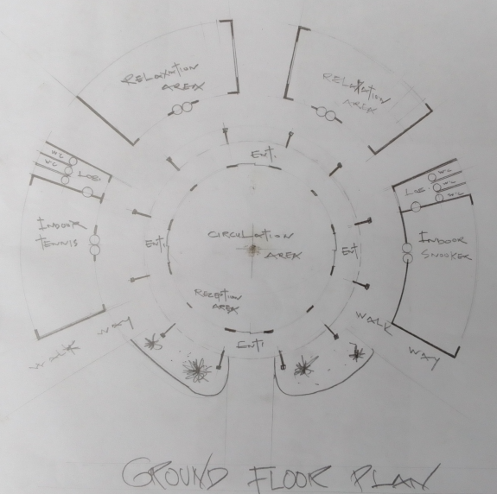
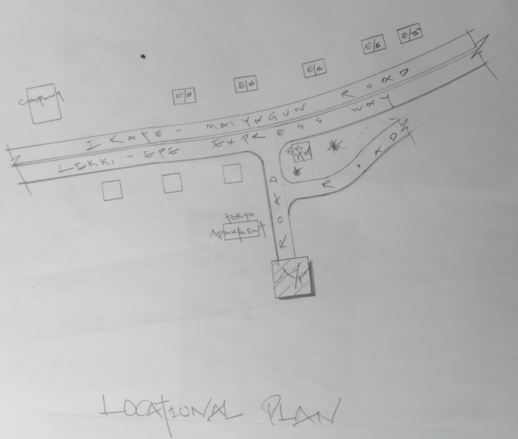
- Limited spaces can lead to overcrowding during peak periods.

Plate 1: Showing the Location and Floor Plan of Case Study One
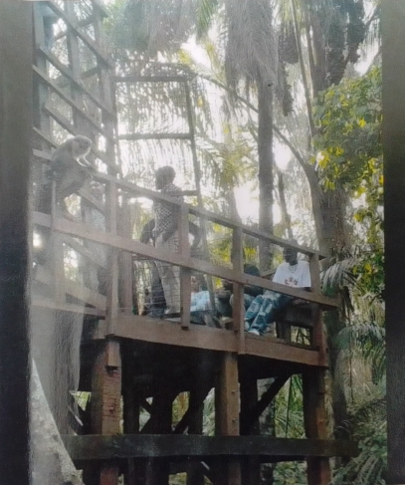
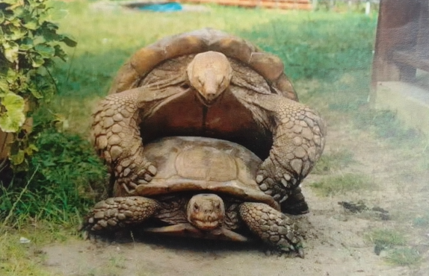
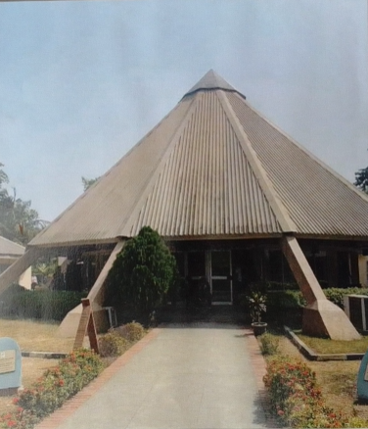
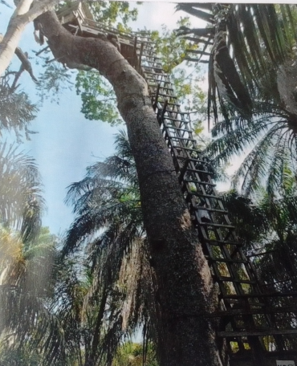

Plate 2: Showing the Pictures of Case Study One
    - CASE STUDY TWO
HISTORICAL BACKGROUND: Evelyn Event and Recreational Centre in Abuja is a popular spot for event and recreation. In-co-operated in the year 2016. Created to provide a peaceful and organized environment, perfect for relaxation and entertainment.
LOCATION: Located in Gwarinpa, along 1st Avenue Junction, by 32 Ores, Abuja.
DESCRIPTION
Features: Recreational facilities, Sport facilities, Event hall and Dining.
MERITS
- Well rich array of amenities.
- Easily accessible and simple parking space.
DEMERITS
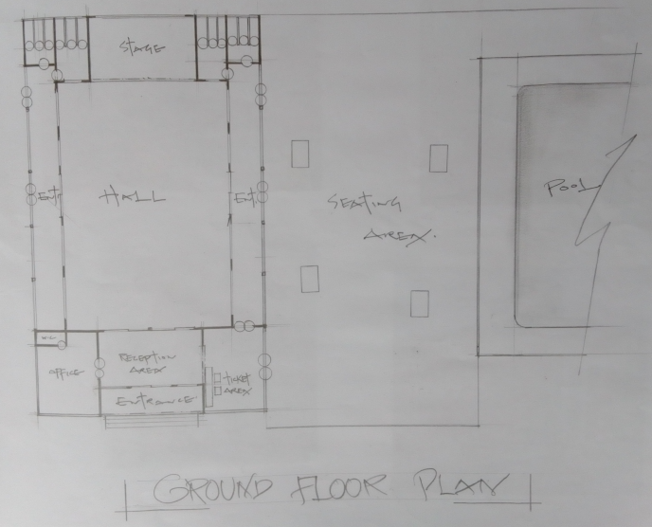
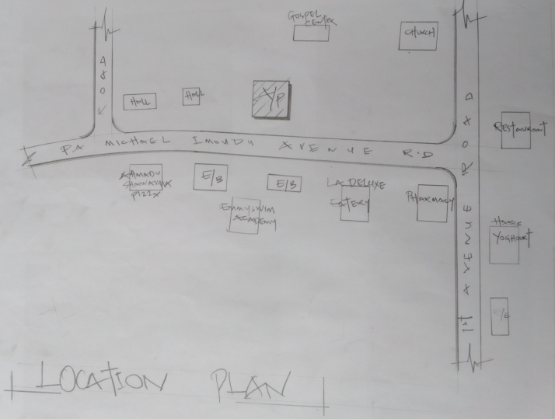
      - NO future expansion in case of another development.

Plate 3: Showing the Location and Floor Plan of Case Study Two
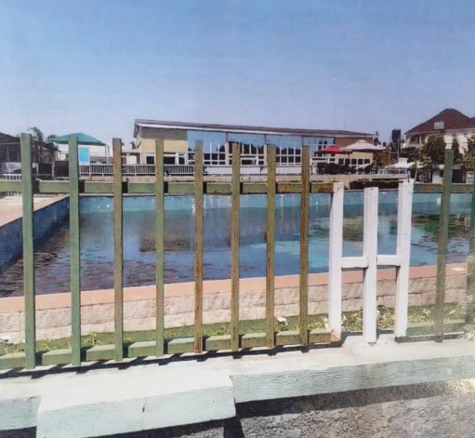
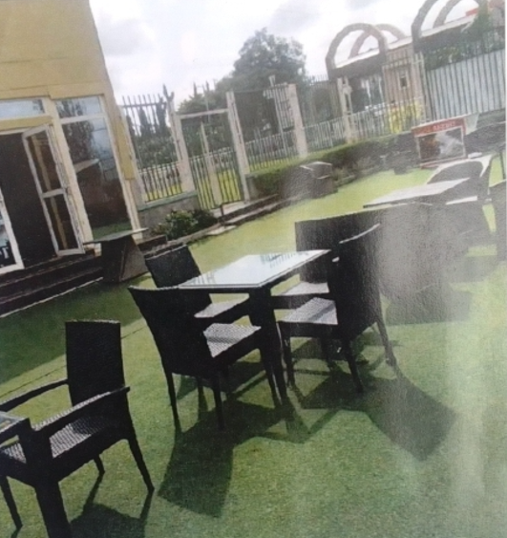
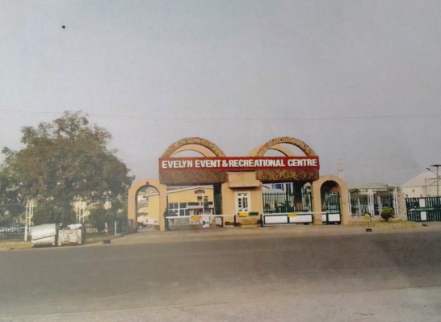
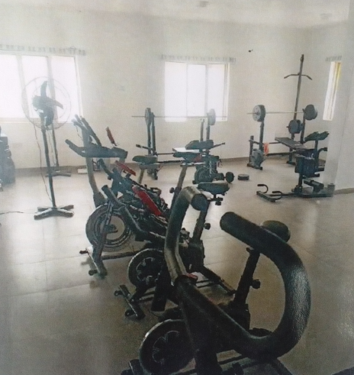
Plate 4: Showing the Pictures of Case Study Two
    - CASE STUDY THREE
HISTORICAL BACKGROUND: Bamusarg Recreational and Wellness Centre, by understanding the historical background, the stakeholders can appreciate its contribution to the community and support its continued growth and development.
LOCATION: No. 111 Itoki Rd, Ifako-Ijaiye, Ogun State.
DESCRIPTION
Features: Event spaces, Sport and Recreational facilities.
Hours: From 7:30 am to 9:00 pm.
MERITS
- Educational and Cultured for enthusiast.
- It’s well located and useful to the community.
DEMERITS
- NO space for parking lot.
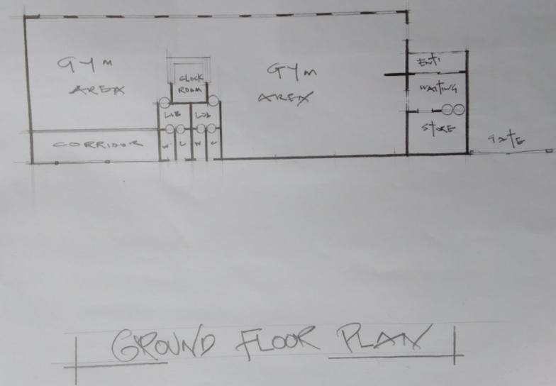
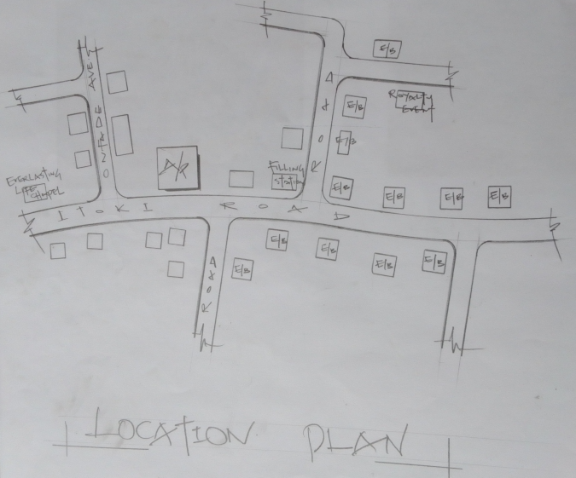
- NO future development planned.
Plate 5: Showing the Location and Floor Plan of Case Study Three

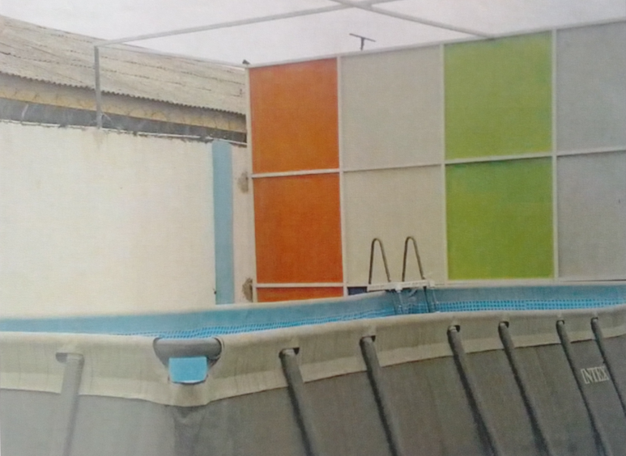
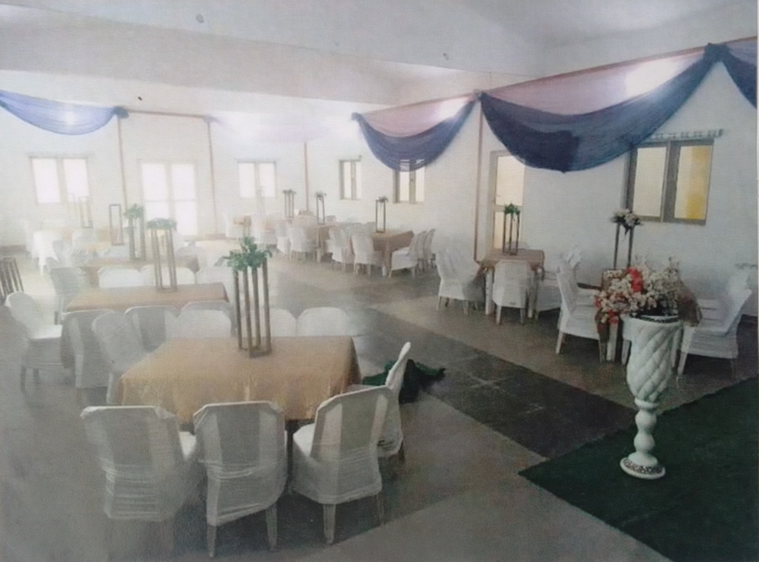
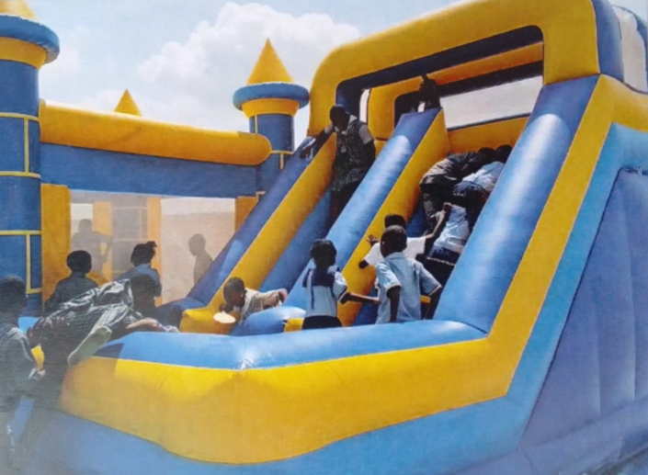
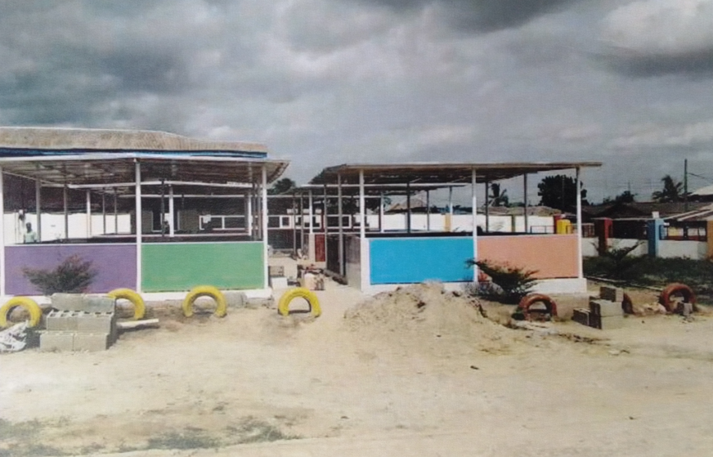
Plate 6: Showing the Pictures of Case Study Three
  - DEDUCTION
Based on the case studies of the recreational centre, I was able to deduce that;
- The centre’s unique focus on extreme sports and activities attracted a niche market of enthusiasts.
- The findings imply that the centre’s flexible scheduling and adaptive programming allowed for greater inclusivity and accessibility for participants with diverse needs.
- The findings imply that the centre’s focus on sustainability and environmental awareness resonated with the local community and contributed to its positive reputation.
- The data suggests that the centre’s innovation use of technology, such as virtual reality, enhanced the overall recreational experience and attracted new demographic.
  - CONCLUSION
Case studies are of a greater significant in a project of this magnitude and the essence is to study existing gymnasium, pool, and other recreational centre facilities/structures, in the process a student get acquainted with fact and norms, functionality and spaces, and merit and demerit of an existing structures/facilities. At the end of exercise, the study will allow students to take necessary precaution against the failure of the proposed project.
CHAPTER THREE
- SITE AND ENVIRONMENTAL ANALYSIS
  - BRIEF HISTORY/INTRODUCTION OF THE STUDY AREA
Ilorin city, traditional emirate and capital of Kwara State in Western region of Nigeria. It is located on the Awun River, a minor tribulatory of the Niger founded in the late 18th Century by Yoruba people. It became the capital of a kingdom that was a vessel state of the Oyo empire, Oyo’s commander at Ilorin, Kakanfo (field marshal). Afonja, led a rebellion in 1817 that destroyed the unity of the empire. He was aided by Shehu Alimi (a Fulani from Sokoto) by his warriors, slaves and Hausa slaves. Afonja was increasingly dominated by the Muslim Fulani and upon his assassination, Alimi and son, Abdul-Salam (Abdul-Salami) became the Emir of Ilorin and pledged allegiance to the Sokoto caliphate (C-1829). As a Muslim emirate, 110 in subjugated several towns in Yoruba land and destroyed the Oyo capital, Oyo-Ile (Old Oyo or Katun) 40 miles (641m) North-West in 1837. Abdul-Salam conducted a fired toward the seal and was only stopped by the Tradan victory over his cavalry mon at Osogbo in 1840.
LOCATION OF ILORIN: Located at Latitude 8.533° North and Longitude 4.583° East, it covers one third of South-West of Nigeria which lies on the Northern Nigeria of Yoruba plater it’s about 278 metres above guinea Savanah, a position that commonly refer to as the middle belt. (Denice Savon an)
In our opinion, recreational centre activities can take place and will boost tourism economy for Kwara State since it will be an unprecedented project in the state. Kwara State government can look into this by partnering with private sector’s in achieving this goal.
  - SITE LOCATION / DESCRIPTION
The site selected for the proposed project is located at Offa Garage Road, Ilorin, Kwara State.
  - SITE SELECTION / LOCATION CRITERIA
The selection is the consideration of certain factors which influence the development of the site and spatial activities.
Site selection criteria is based on screening, factors affecting site selection includes: ventilation and solar control, thermal control, comfort etc. and availability of services.
Moreover, due to the nature of the project, the site selection should meet the requirement for the efficiency and functionality of the proposed design. The size of the site available for development should be adequate reasonable to accommodate such functions/structure.

  - SITE INVENTORY / ANALYSIS
This is done on the basis of the purpose for which the site is to serve. Certain steps are considered to obtain vital information of or from the site. This information is then analysed after site survey in details. For design purpose, the information includes; vegetation, geology, topography, wind trade, longer and shorter sides, soil condition, and so on.
- VEGETATION: The site is covered with trees, shrubs, and ground cover most of it, would be retained for landscaping.
- GEOLOGY: This soil has a good location bearing capacity and hence raft foundation will be used for the structure to be erected on the site.
- The site longer side facing East and West while the shorter side facing North and South.
- SOIL CONDITION: The type of soil is loamy soil and hence aids goods vegetation’s of shrubs, trees, and grasses
- Sunrise and Sunset will be considered for building orientation.
Orientation of the building will give due consideration for effective ventilation and solar radiation control for total comfort of occupants.
  - CLIMATIC DATA / GEOGRAPHICAL CONSIDERATION
Ilorin has an area of 1,188square kilometres and a population of 777,667 as at the 2006 census and 908,490 estimated as at 2011.
- LATITUDE: 8°30ꞌ NORTH
- LONGITUDE: 4°33ꞌ EAST
- ATMOSPHERIC PRESSURE: 1007.1 pa
- AVERAGE RAINFALL: 250 mm/annum
- TEMPERATURE: 34.5ꞌꞌ C
- RELATIVE HUMIDITY: 31.5 %
- WIND SPREAD: 2.1 m/s N.E
- CLOUDINESS: 1.6 %

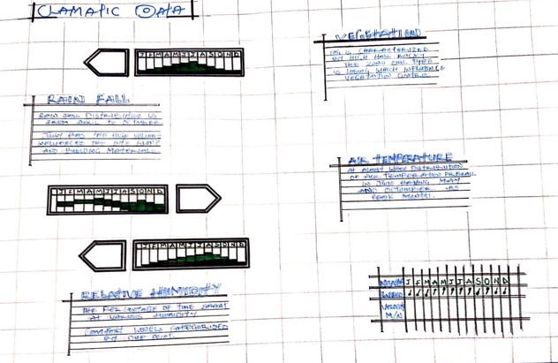
Plate 7: Showing Climatic Chart (Diagram)
  - CONCLUSION
Having duly observed the above analysis (Climatic Data/Geographical Consideration) site inventory and analysis done, the site is found suitable for the proposed project as it meets up with the site selection criteria.
CHAPTER FOUR
- DESIGN CRITERIA
  - SITE PLANNING OF THE PROJECT
The site is planned to give it a defined shape and also to reflect the activities taking place. The location of the recreational centre within the site follow these main principles;
- The zoning principle (noisy, semi-noisy, and quite zone) is observed which enhance placement of each structure.
- For easy accessibility to various units, parking spaces are planned.
The site is properly defined with a perfect blend of both natural and artificial attraction as well as soft and hard landscaping to give a quality taste of a desired comfort to all guests.
  - BRIEF ANALYSIS OF THE PROJECT
PROJECT SCOPE
- Main Building
- Outdoor Game Area
- Swimming Pool
- Sit Out
- Parking Lot
- Gate House/Security
- Generator House
- General Toilet
  - ANALYSIS OF THE SCOPES
DESIGN BRIEF
  - Reception Lounge
  - Art/Craft Room Game Room
  - Class Room Multi-Gym Area
  - Offices Kitchen
  - Play Area Indoor Game Area
  - Climbing Area Weight Room
  - Men’s Restroom Men’s Shower
  - Locker Room Racquet Area
  - Women’s Shower Women’s Restroom
  - DNCE Room Storage
  - SPACE ALLOCATION

S/N | UNITS | LENGTH | BREADTH | LENGTH X BREATH | AREA
1 | RECEPTION | 9,600mm | 3,000mm | 9,600mm x 3,000mm | 28.80m²
2 | ART/CRAFT ROOM | 8,100mm | 9,900mm | 8,100mm x 9,900mm | 80.19m²
3 | CLASS ROOM | 6,900mm | 9,900mm | 6,900mm x 9,900mm | 68.31m²
4 | LOUNGE | 6,900mm | 7,800mm | 6,900mm x 7,800mm | 53.82m²
5 | GAME ROOM | 9,300mm | 9,000mm | 9,300mm x 9,000mm | 83.70m²
6 | MULTI-GYM AREA | 24,000mm | 22,500mm | 24,000mm x 22,500mm | 540m²
7 | OFFICES | 2,100mm | 2,400mm | 2,100mm x 2,400mm | 05.04m²
8 | PLAY AREA | 3,600mm | 4,500mm | 3,600mm x 4,500mm | 16.20m²
9 | CLIMBING AREA | 3,300mm | 3,000mm | 3,300mm x 3,000mm | 09.90m²
10 | KITCHEN | 4,800mm | 2,400mm | 4,800mm x 2,400mm | 11.52m²
11 | INDOOR GAME AREA | 13,800mm | 17,700mm | 13,800mm x 17,700mm | 244.26m²
12 | WEIGHT ROOM | 15,000mm | 6,900mm | 15,000mm x 6,900mm | 103.50m²
13 | RACQUET AREA | 10,500mm | 5,700mm | 10,500mm x 5,700mm | 59.85m²
14 | DNCE ROOM | 4,500mm | 8,700mm | 4,500mm x 8,700mm | 39.15m²
15 | MEN’S RESTROOM | 4,200mm | 3,600mm | 4,200mm x 3,600mm | 15.12m²
16 | WOMEN’S RESTROOM | 4,200mm | 3,600mm | 4,200mm x 3,600mm | 15.12m²
17 | WOMEN’S SHOWER | 3,600mm | 2,400mm | 3,600mm x 2,400mm | 08.64m²
18 | MEN’S SHOWER | 3,600mm | 2,400mm | 3,600mm x 2,400mm | 08.64m²
19 | LOCKER ROOM | 3,600mm | 900mm | 3,600mm x 900mm | 03.24m²
20 | STORAGE | 3,600mm | 7,725mm | 3,600mm x 7,725mm | 27.81m²

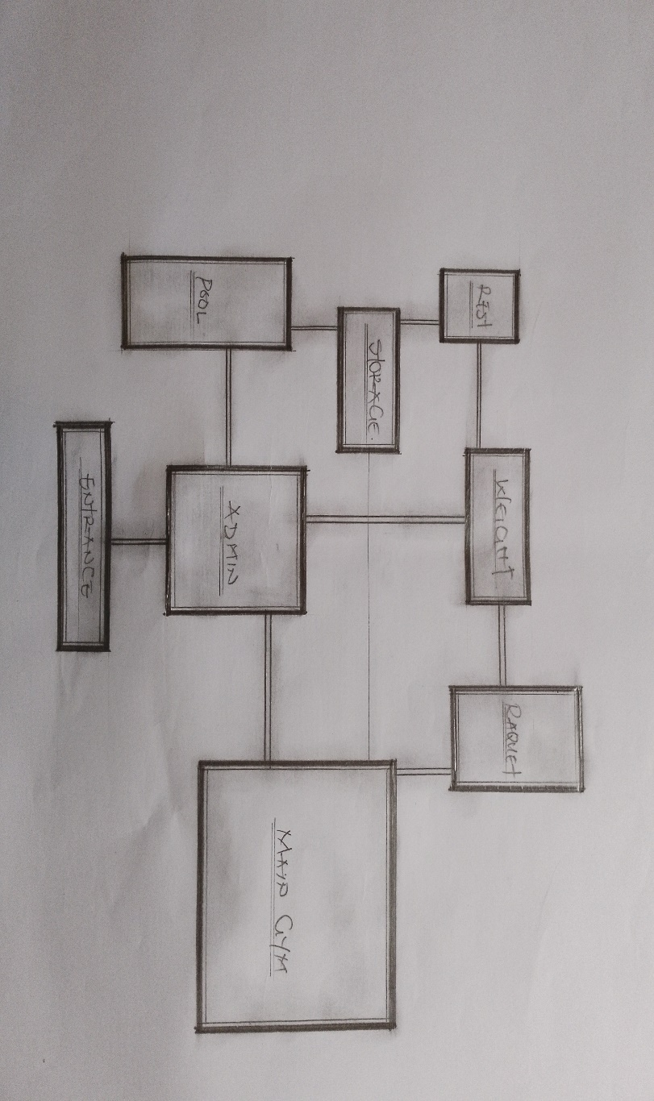
  - FUNCTIONAL RELATIONSHIP
Plate 8: Showing Functional Relationship Diagram

  - CONCEPTUAL DEVELOPMENT
The site concept was formed based on THREE values;
- VIEW: The building and facilities are located facing the road as the site is characterized with see through fence so that the road users can easily view the facility from the highway.
- ACCESSIBILITY: The parking lot provided are located in the most accessible area with good road network linking them together.
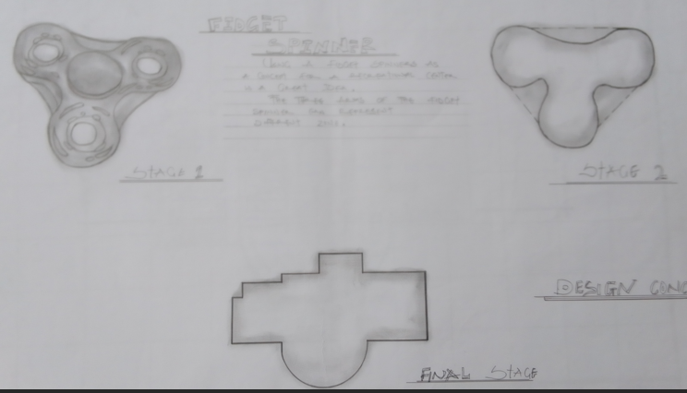
- CIRCULATION and PLANNING: The turning radius of vehicles was considered for adequate circulation and the building is located at a close proximity to aid easy access.
Plate 7: Showing Concept Derivation
CHAPTER FIVE
- DESIGN APPROACH
  - APPRAISAL OF PROPOSED SCHEME
In any project design, there are two basic factors that should be taken into consideration, these factors are; Forms, Aesthetics, and Functionality of a design of building. The above listed factors were thoroughly taken care of to satisfy the highly demanded functional requirement of the proposed project and also to create aesthetically and proportionally balanced design.
Furthermore, zoning of area with related functions, circulation pattern, security, and safety were highly considered in this project design. The design was carefully zoned into major area such as Noisy, Semi-noisy, and Quite zones.
  - DESIGN AND CONSTRUCTION
The recreations themselves would have been richly decorated with plastered and painted walls, coloured-marble cladding, and some mosaic and opus sectile floors. Supplied by a water cistern, with water drained via ditches into a main sewer, the building would have provided hot rooms, plunge pools, and other recreation area. The cistern was massive, and water would have been hand-pumped up into the tank before a network of water pipes, drains, and sewers would have ensured a continual flow of clean water. The degree of workmanship seen within the remain during the original excavations was compared with that seen at Fish Bourne Roman Palace, and the kind of sophisticated and strategic planning involved in the construction of both the Palace and the Recreations is also comparable.
  - GENERAL DESIGN CONSIDERATION
To achieve a functional design, the following factors are essentially needed to give the structure a considerable aesthetic value, some of these things are:
- SERVICES: - These include Electrical services, Filtration, Mechanical services, Sewage disposal, Drainage, Waste disposal etc. the electrical services will be of high quality and cables in concealed conduct wiring will be used. There is a power house to generate constant electricity supply in case of power failure. For effective drainage of both surface and soil waste, appropriate size of pipes is used. All pipes used are run into duct system with leaf net provided on drain pipe to prevent blockage from soil waste.
Also, incinerator will be used to burn waste on site. The element that controls the effect of solar radiation such as roof wall, sun breaker, greenies, and other materials are used.
- VENTILATION: - A primary factor in determining human comfort. They have direct effect on human body through the physiological effect on air purity and motion and indirect erect through their influence on the temperature, humidity of the indoor air and surfaces. To achieve optimum ventilation condition, the use of mechanical means of ventilation and proper orientation of building is ensured and automated windows, adequate sizes, and good positioning within sub-division of internal spaces are provided and also with the provision of dehumidifiers to maintain room humidity level of the hall so as to prevent condensation and deterioration of the building structure.
Also, a proper technique to control humidity will be adopted i.e. fresh air pool dehumidification system, air to air heat exchangers are typically used to recover energy from the pool exhaust air and transfer it to the incoming outdoor air. Because the outdoor air humidity level changes with the temperature, the colder it is the lower the humidity level is of the outside air.
- LIGHTING: - Lighting inside a building must fulfil two functions to illuminate interior and its content, and to illuminate the activities within the building appropriately so that visual mechanism can function at high level of efficiency.
All windows are of adequate sizes and height within and outside the structure. Also, the use of a transparent material “ETFE” which is glazed into the roof materials is employed to throw light into the areas of the structure so as to compliment and reduce the cost of maintaining the artificial light source in the building.
- ACOUSTICS: - Acoustics design controls intrusive noise by the choice or material dimension and shape of building. High level of noise can cause damage to the ear and so careful selection of doors, windows seals, ceiling type, and material will play an effective role in providing acoustic for the building.
- FIRE PROTECTUON: - Modern building require not only means of escape, access for fire brigade and structure protection but also first aid equipment like hydrant plant, fire extinguisher to combat any fire outbreak before the intervention of fire brigade. The proposed design, there will be provision for fire alarms and detectors.
Also, fire extinguisher such as hose reels, sprinklers, and drenches are provided at strategies position for easy access.
- EXTERNAL WORKS: - The following specifications are applicable
- The floor surface to be of interlocking materials and asphalt to allow effective drainage.
- The drainage to be conveyed away through suitable sealed gully fitted with strong grating. It should be drained into existing gutter.
- The floor to withstand expected impact and high load bearing capacity.
- The enclosure to be secured against unauthorized entry.
- Surrounding walls to be rendered and painted.
- Tarred and grasses surface should be separated with kerbs.
- Soak-way pits must be avoided with the nature of the soil generally both foul and soil waste must be properly drained.

  - CONTRUCTION METHOD AND MATERIAL
The proposed design of a recreational will be based completely on the use of quality materials and modern technology equipment. Highly qualified professional in the building industry will engage from the inception to the completion of the project work. This is done to ensure efficiency and durability of the design after which the design completed and ready for use.
Appropriate foundation type shall be used and such foundation shall be able to withstand the vibration caused by people while walking, standing, and jubilating during competitive activities as well as to be able to carry successful both live and dead load that is to be imposed on posing any threat to the comfort of the users of the complex.
    - LANDSCAPE DESIGN
Landscape design is the determination of the character of different landscaping element and their arrangement on the site to enhance the building works. Landscape design maybe two (2) types, aesthetic design and economic design. Both types are considered in the landscape design of the leisure centre.
It has been known to us that throughout the world people use mainly two (2) types of landscape namely; Soft and Hard Landscape.
    - LANDSCAPE ELEMENT USED IN THE DESIGN
In choosing an appropriate landscape element, the following are considered:
- Easy Cleaning
- Durability
- Resistance to Footwear
- Acoustic Properties
The following landscaping elements are employed;
- SOFT LANDSCAPE ELEMENTS
- TREES (VEGETATION): - To reduce solar rays in both paving and structures, reduce radiated heat, and improve comfort. Used as shading device and also used to beautify the environment.
- GRASSES AND LAWN (MATERIALS): - To reduce the reflective effect of the ground and also to control erosion and landslide in case of flooding. Used to reduce the intensity of sole radiation. It absorbs up to 45% of solar rays and disperses the rest of the environment thereby creating comfort for the occupant.
- DECORATIVE FLOWERS: - Different species of flowers are used to enhance the aesthetic appearance of the site.
- HARD LANDSCAPE ELEMENTS
- ASPHALT: - Used for drive ways and parking lots. It is economical and durable both for pedestrian and vehicular traffics.
- CONCRETE KERBS: - Uses to separate tarred surfaces from lawn covered areas.
- INTERLOCKING PAVING: - Used for walkways and outdoor paving to blend with the natural texture of the environment.
Other elements used include fountains, man-made hills, and waterfalls, flower ponds etc. to create visual interest and beautify the environment in a harmoniously blended aesthetical grandeur.
  - GENERAL MAINTENANCE
Maintenance cannot be isolated from the initial planning and design of any architectural edifice, most especially a project of this calibre which involves leisure and entertainment.
Timely maintenance of the structure and facilities to put them in proper working condition to enhance functionality and habitability of both structure and facilities for maximum satisfaction of visiting leisure and intending guest must be ensured.
Maintenance work in real technology is defined as work undertaken to keep or restore every facility of a building or site to an acceptable record i.e. planned maintenance or carried out on an emergency basis when the need arises. Due to the lack of the maintenance culture in this part of the globe, adequate provisions are made for security, sanitation, and maintenance department to centre for the facilities and endure high level of hygiene.
The maintenance of the building and facilities will be duly attended to with regular servicing of equipment’s and other facilities. The external works consist of so many factors that are of greater significant and these factors are as follow;
- Parking Space (Administrative and Staff parking, Players parking, and General parking): - This has to be technically considered by investigating the existing parking spaces in some bath house and gym. This has given me a detailed experience and I have been able to deduce to some facts that has assisted me in my own planning principle.
Effective parking space must be sectioned in order to have a proper security survey and manage space to the maximum level.
- Access Road: - This has been professionally achieved by creating or designing a ring road that has been properly linked by the minor road for easy accessibility to each basis unit with this and also case movement and transportation has been achieve affectively.

  - SUMMARY AND RECOMMENDATION
Conclusively the project has seriously broaden my view and observation beyond expectation and by this I have been able to deduce that project work of any form must not be taking lightly as it determines how far one can go to get facts and precise information towards assisting one’s self taking of experience and solving societal problems through academic works.
As a student I am recommending this project work to the entire public of Ilorin as a whole as it bring development and civilization to its locality as researched, it also creates healthy fitness, spa fitness, and general body well-being. Above it all it unites the youth and family-friendly.

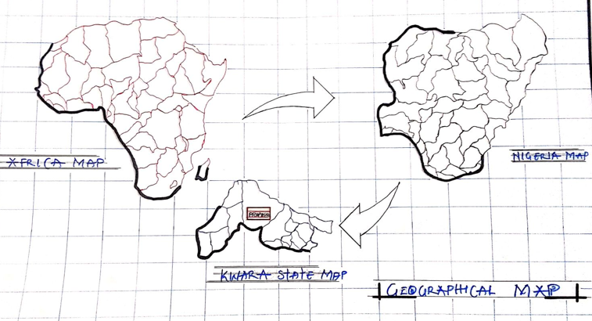

Figure 1: Showing Location Map
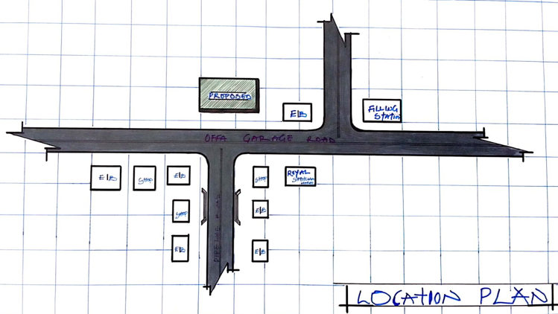

Figure 1: Showing Location Plan

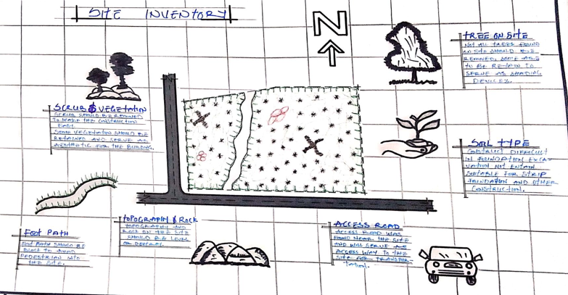

Figure 2: Showing Site Inventory

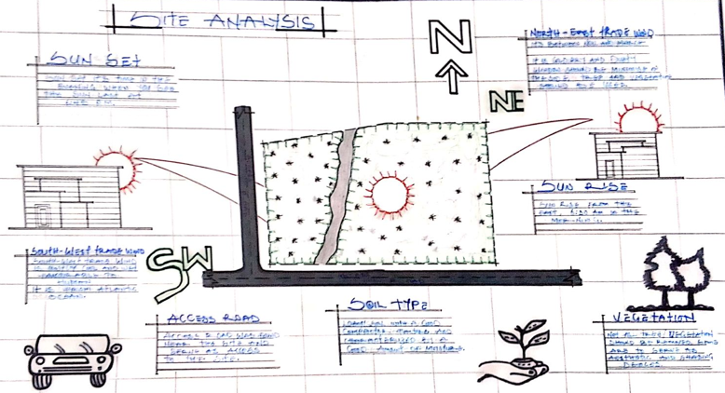
Figure 2: Showing Site Analysis

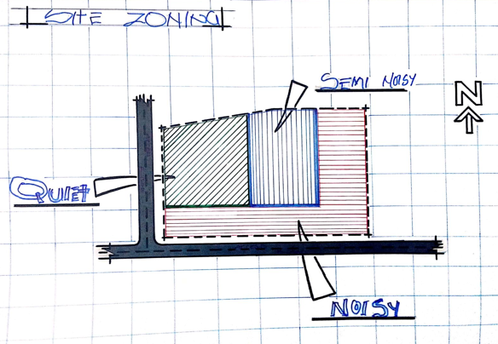
Figure 3: Showing Site Zoning
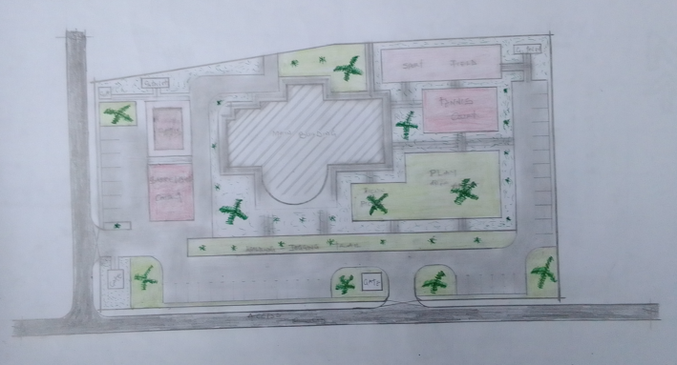

Figure 3: Showing Site Plan
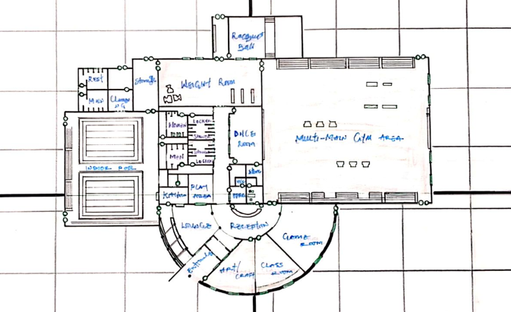
Figure 4: Showing Floor Plan

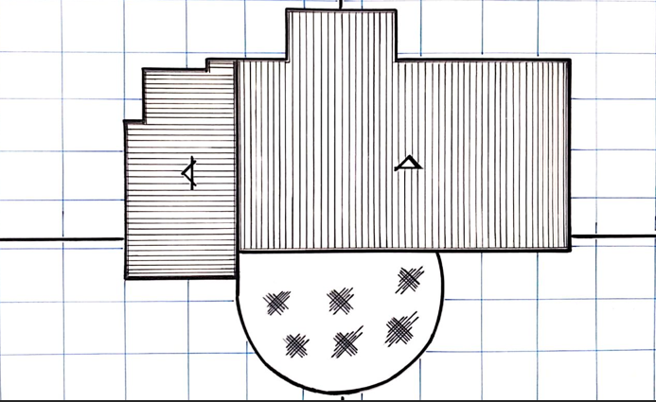

Figure 4: Showing Roof Plan

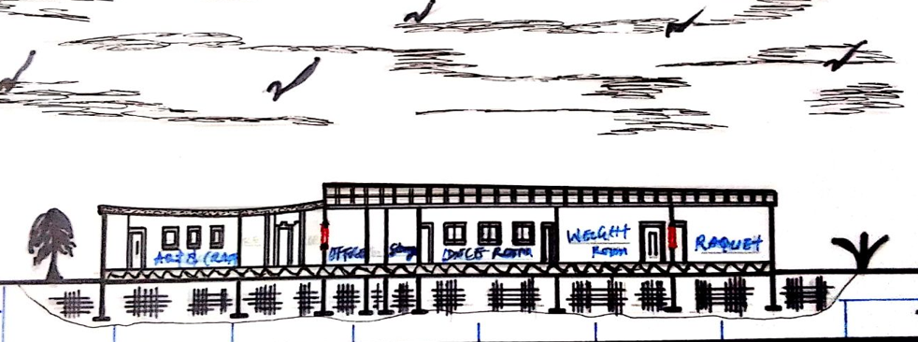

Figure 5: Showing Cross Section

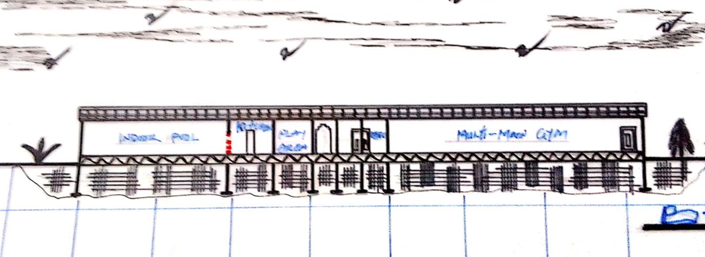

Figure 5: Showing Longitude Section

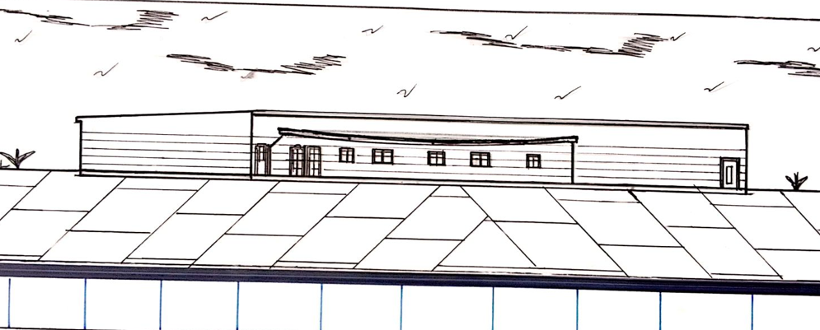
Figure 6: Showing Approach View

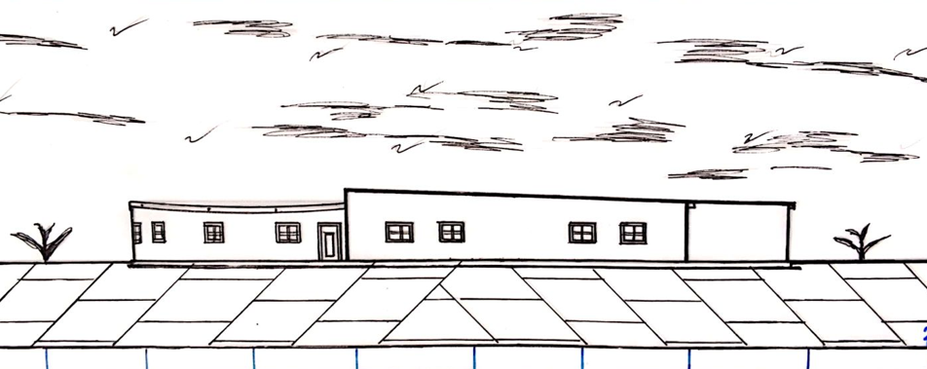

Figure 6: Showing Right Side View

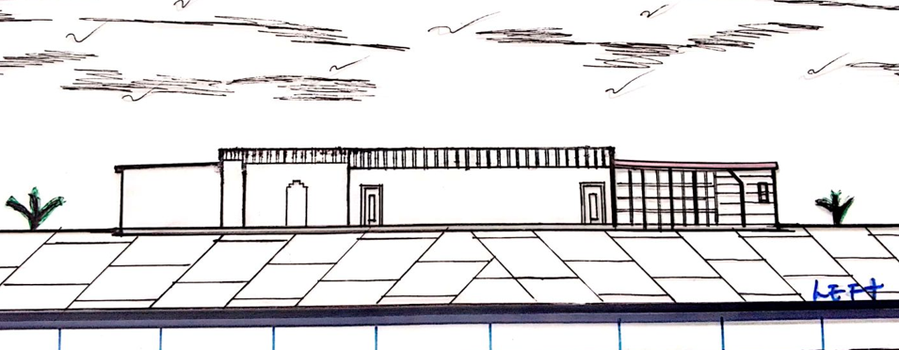

Figure 7: Showing Left Side View

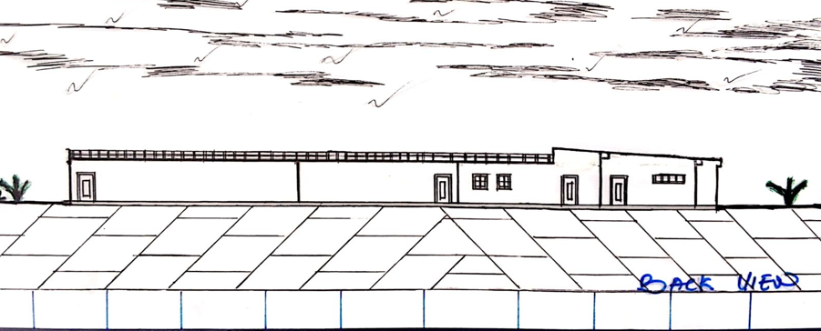

Figure 7: Showing Back Side View

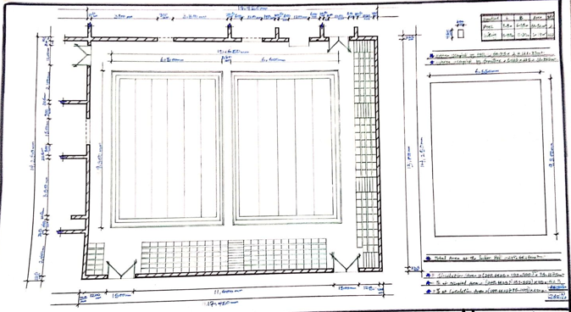
Figure 8: Showing Space Calculation

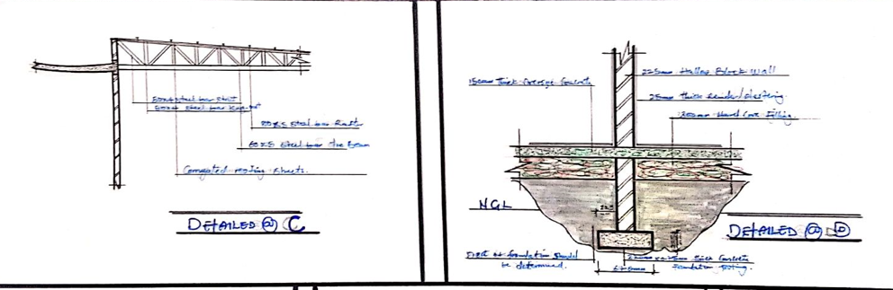

Figure 8: Showing Detailing

REFERENCES
Anita Lawrence (1989): Acoustic and Building Environmental Elsevier Science Publisher Ltd.
Barry R. (2018): Construction Building Vol. 1-5 Collins, English Language Dictionary.
David A. (1999): Metric Hand Planning and Design Data (New Edition); Architectural Press, United Kingdom.
De-Chiara (1983): Architectural Site Planning Macmillan Press Ltd.
Freezer Rekier (1979): Draughtsmanship Architectural and Building Graphics, Granada Publishers Ltd.
George K. Stedman (1996): Architectural Drafting, Functional Planning and Creative Design Granada Publishers Ltd.
Macmullan R. (1986): Environmental Service Building, The Macmillan Press Ltd.
Neufert E. (1980): Architects Data (New National Edition), Granada Ltd, Great Britain.
R. Chudley and R. Greeno (1999): Building Construction Handbook New Edition,
Smith N.A. (2000): Lighting for Health and Safety, A Division of Reed Education and Professional Publishing Ltd.
Stadia 4th Edition a Design and Development Guide. Final Guide to Quality Bathhouse Design (Fina Facility Rules and Infrastructure Regulations, Edition 2010), Natatoriums Technical Recommendations and Requirement.

