A PROJECT REPORT
ON
PROPOSED CORRECTIONAL CENTER (PRISON)
FOR
OGUN STATE GOVERNMENT

BY

ATUNDE DANIEL OLAMIDE
HND/23/ARC/FT/039

SUBMITTED TO

THE DEPARTMENT OF ARCHITECTURAL TECHNOLOGY
INSTITUTE OF ENVIRONMENTAL STUDIES
KWARA STATE POLYTECHNIC, ILORIN

IN PARTIAL FULFILMENT AS PART OF THE REQUIREMENTS FOR THE AWARD OF HIGHER NATIONAL DIPLOMA (HND) IN ARCHITECTURAL TECHNOLOGY

JULY, 2025
CERTIFICATION
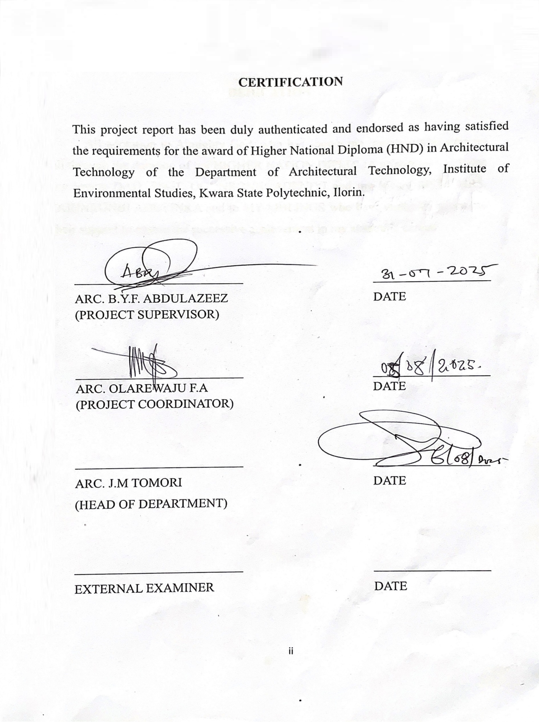
This project report has been duly authenticated and endorsed as having satisfied the requirements for the award of Higher National Diploma (HND) in Architectural Technology of the Department of Architectural Technology, Institute of Environmental Studies, Kwara State Polytechnic, Ilorin.

__________________________ __________________
ARC. B.Y.F. ABDULAZEEZ DATE
(PROJECT SUPERVISOR)

__________________________ __________________
ARC. OLAREWAJU F.A DATE
(PROJECT COORDINATOR)

__________________________ __________________
ARC. J.M TOMORI DATE
(HEAD OF DEPARTMENT)

__________________________ __________________
EXTERNAL EXAMINER DATE

DEDICATION

This project is dedicated to almighty God for His Divine mercies and protection bestowed upon me from the beginning of my life up to this present moment, all glory, praise, honor and adoration are for him forever.
To my care and lovely family for their moral, financial and spiritual support given to me throughout my staying in campus may almighty God continue to bless them. Also to my mentor, supervisor, leader ARC. ABDULAZEEZ B.Y.F for the support he gave me throughout the years in campus, I greatly appreciate your Effort on me towards the successful for my project, thank you so much sir.

ACKNOWLEDGEMENT

All praise is due to almighty God who endows wisdom to whomever he wishes may his highly name be exalted, my appreciations and gratitude goes to my family for their support both spiritually, financially, and morally I'm so grateful.
My appreciations also goes to Pastor Joel Olajubu for his support spiritually and also it teachings thank you sir.
My sincere gratitude goes to my project supervisor, ARC. ABDULAZEEZ B.Y.F [I.E.S DIRECTOR], ARC. J.M TOMORI [H.O.D], ARC. OLAREWAJU F.A and other academic staffs of the department who had taken time to contribute to every stage of my project.
And my gratitude goes to my father and mother MR ATUNDE DAVID and LATE MRS FLORENCE ATUNDE may her soul continue to rest in peace and also to my siblings for their support financially and advice thank you so much family I love you all.
I am also indebted to my friends especially the kinsmen for their support, advice, courage and love established during the course of our study and to me for the hard work, I am proud of myself.

ABSTRACT

This project report presents a comprehensive analysis of correctional centers' role in rehabilitating and reintegrating offenders into society.
Employing a mixed-methods approach, combining quantitative analysis of recidivism rates and program outcomes with qualitative insights from in-depth interviews and focus groups with inmates, staff, and administrators, this study provides a nuanced understanding of correctional rehabilitation's opportunities and challenges. Through a rigorous research methodology, this report examines the effectiveness of correctional programs and services in promoting positive behavioral change and reducing recidivism. The study's findings highlight the importance of tailored interventions, staff training, and community partnerships in supporting successful rehabilitation and reintegration. The study concludes with evidence-based recommendations for enhancing rehabilitation and reintegration efforts, ultimately contributing to safer communities and individual growth. These recommendations aim to inform policy and practice, supporting the development of more effective correctional systems that prioritize rehabilitation, restorative justice, and community safety.

TABLE OF CONTENTS
TITLE PAGE………………………………………………………………... i
CERTIFICATION…………………………………………………………… ii
DEDICATION………………………………………………………………. iii
ACKNOWLEDGMENT…………………………………………………….. iv
ABSTRACT…………………………………………………………………… v
TABLE OF CONTENT……………………………………………………… vi-vii

CHAPTER ONE

1.0 Introduction………………………………………………………………. 1
1.1 Projects Definition……………………………………………………….. 1
1.2 Purpose of the project……………………………………………………. 1
1.3. Types……………………………………………………………………. 1
1.4 Historical Background…………………………………………………… 1
1.5 AIM and Objectives……………………………………………………… 2
1.6 Project Justification……………………………………………………… 3
1.7 Project Limitation and Constraint……………………………………….. 3
1.8 Research Methodology………………………………………………….. 3
1.9 Project scope…………………………………………………………….. 4

CHAPTER TWO

2.0 Literature Review………………………………………………………. 5
2.1 Case Study……………………………………………………………… 6
2.2 Case Study One…………………………………………………………. 6-10
2.3 Case Study two………………………………………………………….. 11-14
2.4 Case Study three…………………………………………………………. 15-17

CHAPTER THREE

3.0 Fact about the Propose Location…………………………………………. 18
● Site location description……………………………………………………. 18
● Site location criteria………………………………………………………… 18
● Population………………………………………………………………….. 18
3.1 Social Service……………………………………………………………. 19
3.2 Site Analysis/Inventory………………………………………………….. 19
3.3 site suitability Analysis………………………………………………….. 19-20
3.5 Climatic Condition………………………………………………………. 20
●Rain fall…………………………………………………………………….. 20
● Temperature………………………………………………………………… 20
● Wind……………………………………………………………………….. 20
3.6 Site Topography…………………………………………………………. 20
3.7 Soil Condition and Vegetation…………………………………………… 20
3.8 Conclusion……………………………………………………………… 20

CHAPTER FOUR

4.0 Design Brief …………………………………………………………… 21
4.1 Design Analysis………………………………………………………… 21
●design scope………………………………………………………………. 21
●space allocation…………………………………………………………… 21-22
●space schedule…………………………………………………………… 22
4.1 Site Planning…………………………………………………………… 23
4.2 Project Scope…………………………………………………………… 23
4.3 Planning Principle…………………………………………………….. 23
4.4 General Requirements for Lighting…………………………………… 24
4.5 Fire Protection………………………………………………………… 24
4.6 Perimeter Fencing …………………………………………………..… 24
4.7 Foundational Relationship……………………………………………. 24-25
4.8 Conceptual Development …………………………………………… 25

CHAPTER FIVE

5.0 Design Appraisal……………………………………………………… 26
5.1 Construction Methodology…………………………………………….. 26-27
5.2 Design Characteristic [landscape]……………………………………… 27-28
5.3 Building Structure……………………………………………………… 28
5.4 Service…………………………………………………………………. 28-29
5.5 General Maintenance…………………………………………………… 29
5.6 Summary and Conclusion………………………………………………… 35

Appendix……………………………………………………………………….. 36-57
References……………………………………………………………………… 58

CHAPTER ONE
- INTRODUCTION

  - DEFINITION OF A PRISON:

A prison, also known as a jail or correctional facility, is a secure facility designed to hold individuals who have been convicted of crimes and sentence to imprisonment.

  - PURPOSE OF A PRISON

Punish: prisons aim to punish offenders for their crimes, serving as a deterrent to potential offenders.

Rehabilitate: prisons provide opportunities for inmates to reform and Rehabilitate, preparing them for reintegration into society.

Protect society: prisons protect society by confining individuals who pose as a threat to public safety.

  - TYPES OF PRISON

* MAXIMUM SECURITY PRISONS: Designed to high risk inmates, these prisons have strict security measures and limited privilege

* MEDIUM SECURITY PRISONS: Suits inmates who require less stringent security, they offer more privilege and opportunities.

* MINIMUM SECURITY PRISONS: Designed for low risk inmates, these prisons have fewer security measures and more privileges.

* JUVENILE PRISONS: Specialized facilities for young offenders, focusing on rehabilitation and education.

* WOMEN'S PRISONS: Designed to meet the unique of female inmates these prison often provide specialized programs and services.

  - HISTORICAL BACKGROUND

ANCIENT CIVILIZATION [3000BCE - 500CE]

Early prisons: the first prisons were used to hold prisoners of war, debtors and those awaiting trial.

Dungeon_like_conditions: Early prisons were often dungeon like, with poor ventilation, sanitation and living conditions, after that the middle ages [500 - 1500CE] begins, Castle and Fortresses: prisons were often located in Castle and fortresses in their era, with prisoners held in towers, dungeons or moats.

Harsh conditions: prison conditions were harsh this era, with prisoners often subjected to physical labor, torture and poor living conditions.

THE MODERN ERA [1500 - 1800CE]

Emergence of modern prisons: the modern prisons system emerged during the 16th century, with the establishment of the first modern prison in London [1518], then the reform and rehabilitation: the focus of prison shifted from punishment to reform and rehabilitation, with the introduction of education, vocational training and counseling programs.

NIGERIA PRISONS

Colonial Era: the Nigerian prison system was established during the colonial era with the first prison built in Lagos [1914]

Postcolonial era: After independence the Nigerian government continued to develop and improve the prisons system, with a focus on rehabilitation and reform .challenging and reforms the Nigeria prison system has undergone reforms, including the establishment of new prisons, improvement in living conditions and the introduction of rehabilitation
programmes till date.

  - AIM AND OBJECTIVES

AIM: To design an aesthetic appealing facility, with a well secure perimeter fencing and walls to prevent escape attempts and we'll design cells that meet the needs of inmates, including sanitation, ventilation and natural light ad well as recreational facilities such as exercise yard ,sports facilities, vocational training.

OBJECTIVES:

1) To ensure a secure and safe facility that prevents escape attempts and maintains order.
2) To employ a facility that is functional, efficient that meets the standard of a correctional facility
3) To design facility that is accessible and inclusive for all users
4) To design facility that is flexible and also environmental friendly those reflect green factors
5) Designing a facility that incorporates innovation and aesthetic to promote rehabilitation and reintegration.

  - JUSTIFICATION

The Old Nigerian prison, as being in operation for over a century while it has served it purpose, the facility has become outdated command overcrowded and inadequate for more than correctional standards due to this reason this project is Justified on making a replacement for the old prison design, putting into consideration on how to design a prison or correctional center that meet the modern correctional standard controlling overcrowding, introducing new infrastructure and adequate security.

  - PROJECT SCOPE

1) Administrative unit/block
2) Health and wellness unit/block
3) Educational block
4) Support service block
5) Security unit
6) Recreational unit
7) Staff quarters
8) Custody block/unit
9) Specialized unit

  - LIMITATION AND CONSTRAINT FOR CASE STUDIES

During the process of carrying out the case studies there are some restricted activities to be done in the correctional center [prison] because of high standard of security.

Here are the restricted activities in the facility:

- limited access to the inmate cell
- prohibition of taking picture
- using of phone or any digital object is not allowed in the facility
- limited access to some information of the prisons

  - RESEARCH METHODOLOGY

For my research methodology on a prison case study, I was able to use different method to gather data on this project.

Here are the research methodologies

- Oral interview: I was able to have the other interview with a worker at the correctional service center to get data

- Observations: during my visit to the facility I'm able to observe the prison facility, operations and inmate activities

- Internet review: I use some prison record policy and Report online

CHAPTER TWO
- LITERATURE REVIEW
These literature reviews were studied in order to know the evolvement and scope for research on the correctional center case study. Correctional center conditions, research highlights the impact of poor conditions on inmate behavior and rehabilitation for example Nigerian prisons have been identified as a significant avenue for human resource wastage.

Correctional system effectiveness, literature suggests that an effective correctional system is crucial for promoting behavioral change and social order.

Inmate Responsiveness: studies examine how inmates respond to correctional center conditions, highlighting the need for improved conditions to facilitate rehabilitation.

Research Implications

* Policy Reforms: Literature suggests that policy reforms are necessary to address issues like overcrowding and poor conditions.

* Evidence- Based Practices: Research emphasis the importance of Evidence-based practices in correctional center to improve rehabilitation outcomes.

REHABILITATION PROGRAMS IN CORRECTIONAL FACILITIES AIM TO REFORM AND REINTEGRATE INDIVIDUALS INTO SOCIETY.

These programs address various aspects, including:

• Substance Abuse Treatment: Detoxification programs, counseling, and support groups help inmates overcome addiction and reduce recidivism.
• Mental Health Interventions: Therapy and counseling address underlying mental health issues, promoting well-being and reducing criminal behavior.
• Educational Initiatives: Academic education programs and vocational training equip inmates with skills for personal development and employability.
• Cognitive-Behavioral Therapy (CBT): CBT modifies maladaptive behaviors and thought patterns, fostering pro-social conduct and reducing criminal tendencies.

IMPLEMENTATION CHALLENGES

• Limited Resources: Budgetary constraints impact program scope and quality.
• Staffing Issues: Shortage of trained staff and inadequate training hinder program effectiveness.
• Ethical Considerations: Balancing rehabilitation with punitive measures and ensuring equal access to programs.

  - CASE - STUDY

INTRODUCTION: This case study explores the effectiveness of rehabilitation programs in correctional center, focusing on promoting behavioral change and social order, The research aims to investigate the impact of these programs on inmates behavior and recidivism rates, providing insights into the challenges and opportunities for improvement in correctional center rehabilitation.

2.2. CASE STUDY ONE

HISTORICAL BACKGROUND ON KIRI KIRI MEDIUM SECURITY PRISON

Kiri kiri medium security prison was originally constructed during the colonial era. Specifically in 1955.the prison was built to house 1,056 inmates, but over the years, it has become notoriously overcrowding, with reports of holding over 5,000 inmates.
The prison has undergone some changes over the yeses in 2018 the United kingdom announced plans to spend $939,000 to build a new 112 bed wing, aimed at facilitating the transfer of Nigeria prisoners from the UK, However, it's unclear if this project was completed. It’s worth nothing that kiri kiri medium security prison has faced criticism for its poor living conditions, overcrowding and human rights concern. The prison remains an important part of Nigeria's correctional system.

MERITS

1. CELL BLOCK DESIGN: The cell blocks are designed to maximize natural light and ventilation, improving the living conditions of inmates.
2. ADMINISTRATIVE BLOCK: The administrative block is designed to provide a secure and efficient work space for prison staff.
3. LANDSCAPING: A well landscape facilities that deal with access to outdoor spaces and natural environment that can improve inmates’ mental health and we'll being.
4. SECURITY: The prison has a robust security system which includes high walls and armed guards to prevent escape attempts and maintain order.

DEMERITS

1. OVERCROWDING: The prisons design is doesn't adequately address overcrowding leading to unsanitary conditions and increased tensions among inmates.
2. OUTDATED DESIGN: The prisons design is outdated and doesn't meet the modern standards for prison design, leading to inefficiencies and safety concerns.
3. POOR VENTILATION: The design doesn't provide enough or adequate ventilation leading to poor air quality and discomfort among inmates
4. NO WATCH TOWERS: The prisons design lack watch tower for the enhancements of a clear view of the surrounding area for more security and surveillance.

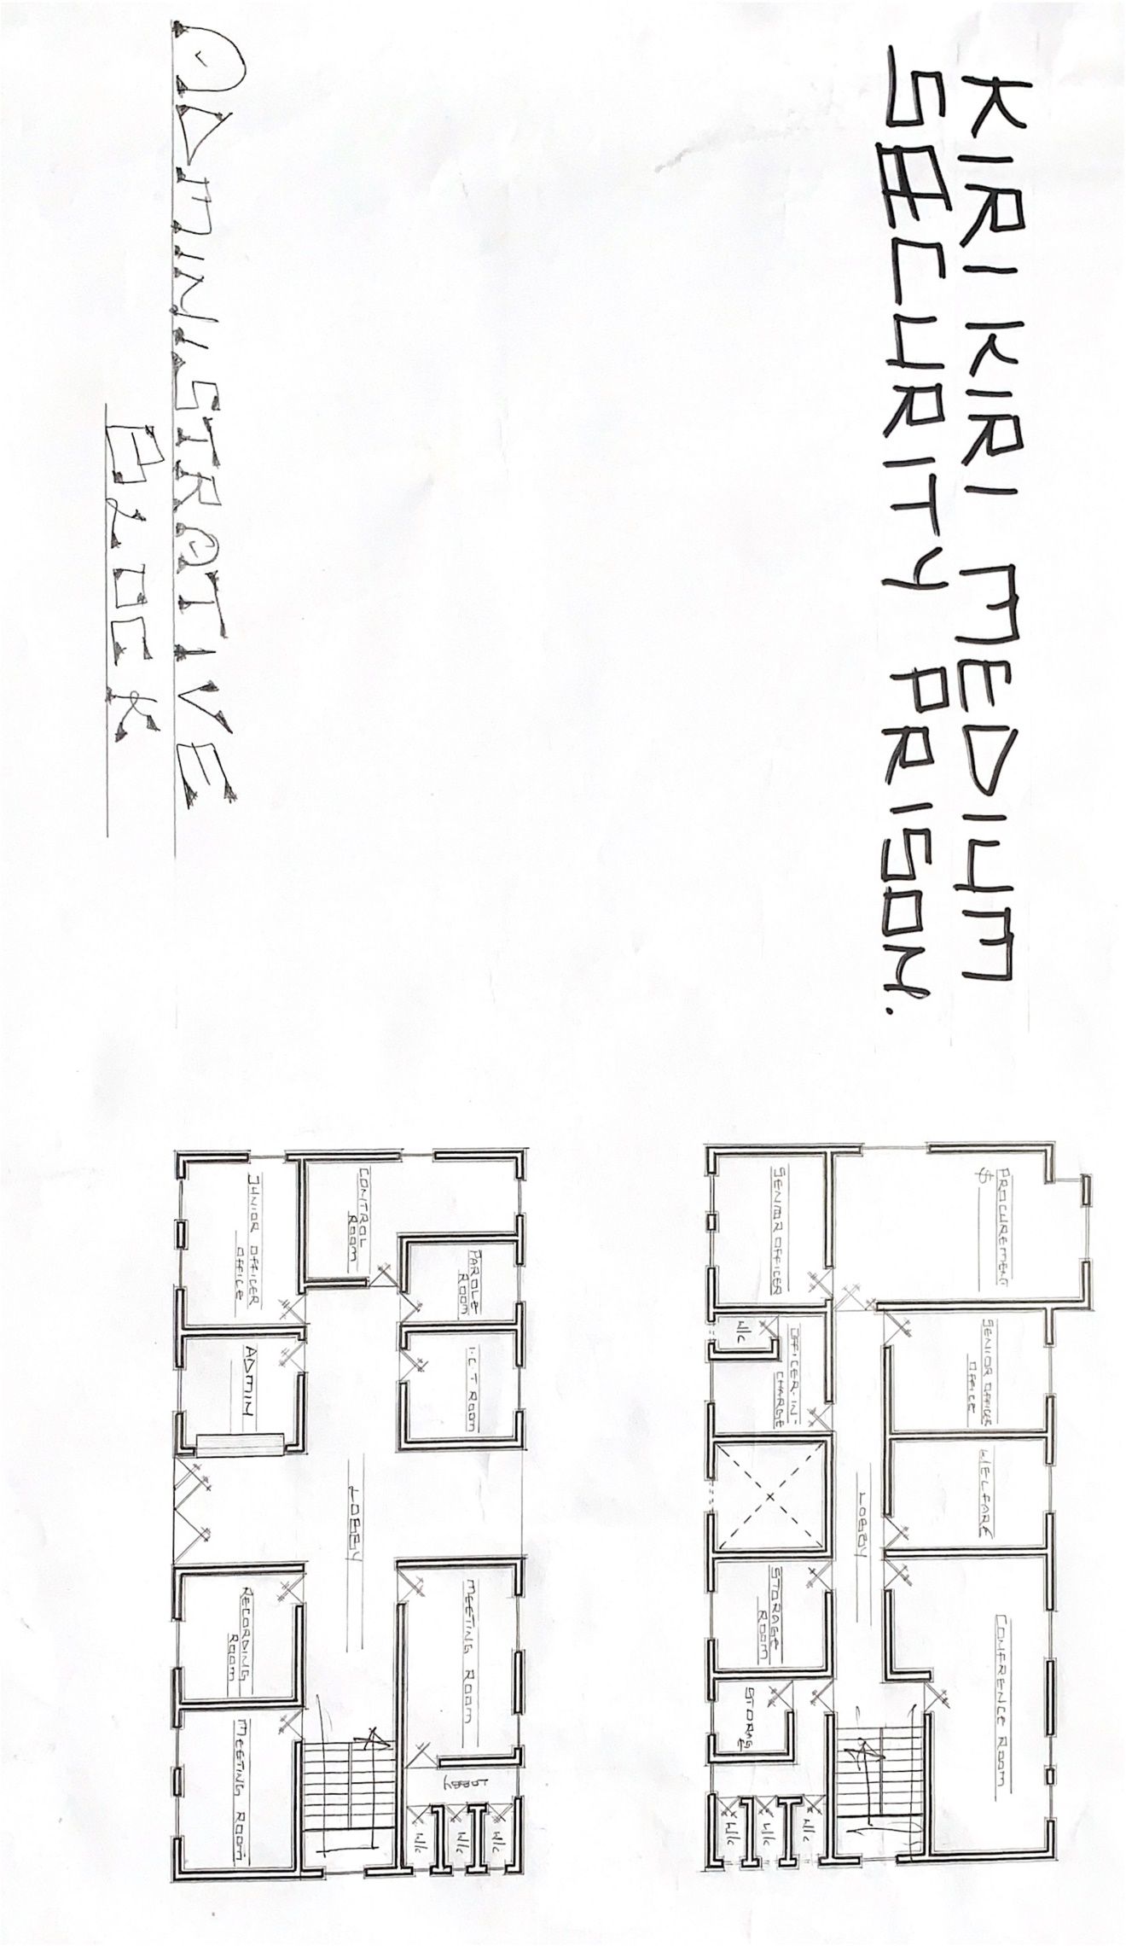

CAST STUDY ONE (1)
FIGURE 1.0

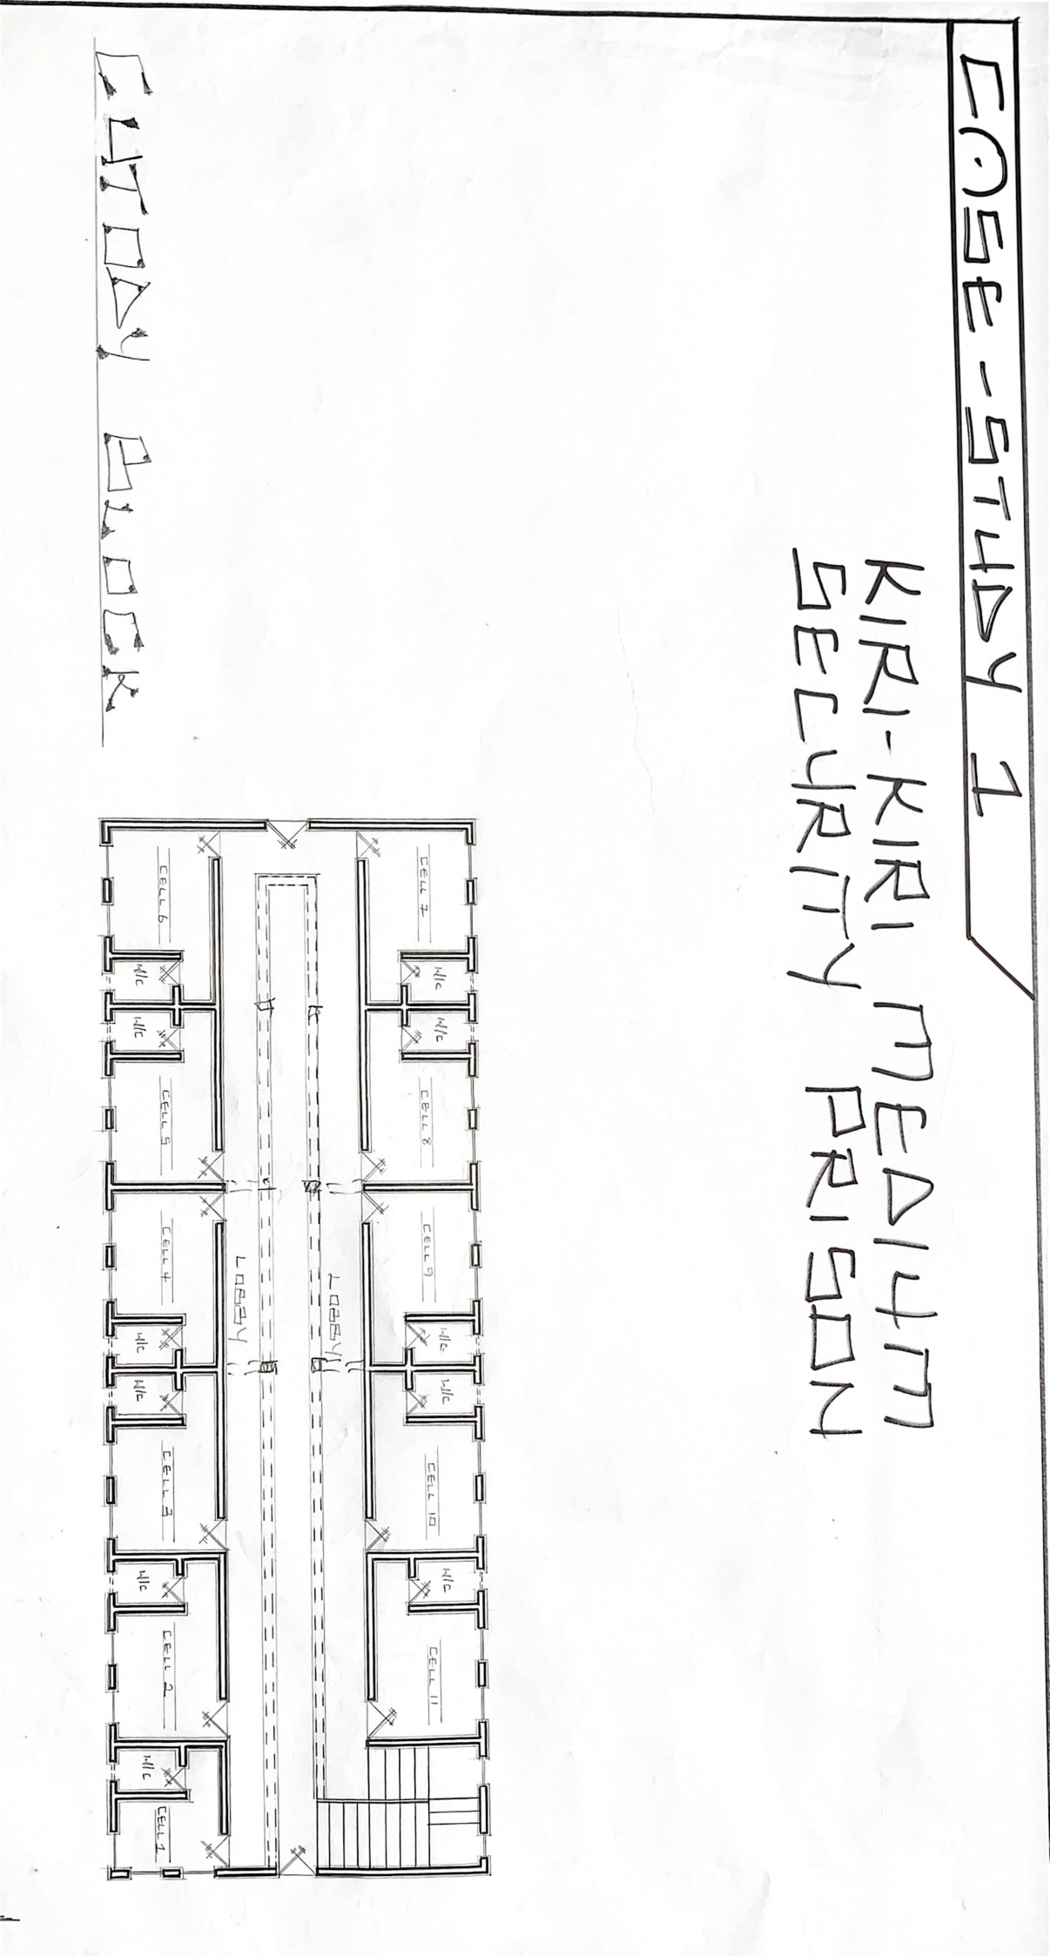

CAST STUDY ONE (1)
FIGURE 1.1

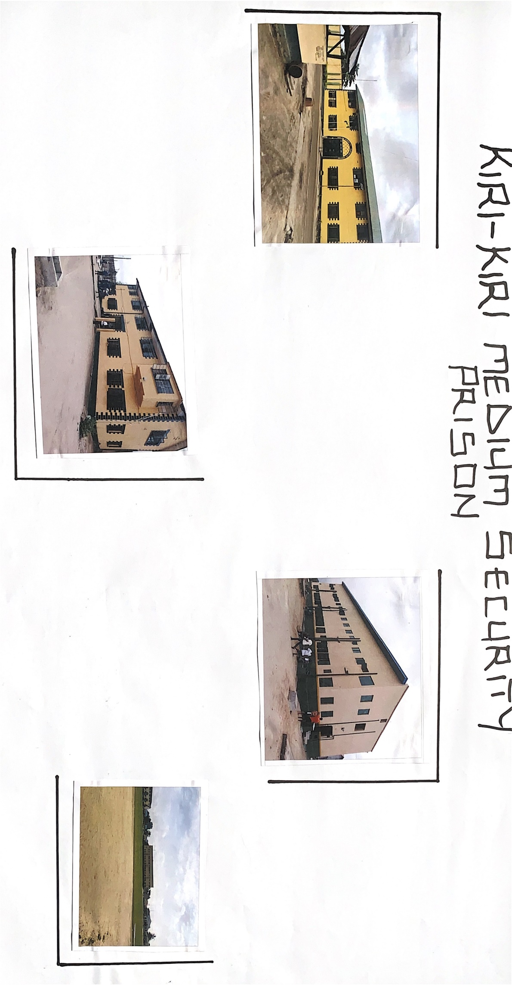

CAST STUDY ONE (1)
FIGURE 1.2

2.3 CASE STUDY TWO

HISTORICAL BACKGROUND ON IKOYI MEDIUM SECURITY PRISONS

Ikoyi prison was established in 1955 by the British colonial government as a medium security prison, the prison was designed to hold 800 inmates, primarily those serving long term sentences or awaiting execution.
After Nigeria gain independence in 1960 ikoyi prison continued to operate as a medium security facility, over the years the prison population grew, leading to overcrowding and poor living conditions

In recent years the Nigerian government has implemented reforms aimed at improving prison conditions and reducing overcrowding, despite these efforts; ikoyi prison continues to face challenges including inadequate infrastructure, poor sanitation and human rights concerns.

MERITS

1. SECURE PERIMETER: The prison has a secure perimeter fence which is also double that prevent escape attempts and unauthorized entry.
2. FUNCTIONAL LAYOUT: The prisons layout 8s functional with separate area for different activities such as housing, recreation and administration block
3. DURABILITY: The prison buildings are constructed with durable materials such as concrete and steel which can withstand harsh weather conditions.
4. HISTORICAL SIGNIFICANCE: Ikoyi prison is a historical building that dates back to the colonial ear, making her an important part of Nigeria's architectural heritage.

DEMERITS

1. LIMITED ACCESS TO NATURAL LIGHT: The prisons design doesn't provide adequate access to natural light, leading to poor living conditions and negative impacts on inmates’ mental health.
2. POOR LANDSCAPING: The prisons design is not well landscaped leading to environment dis order that doesn't enhance outdoor space for inmates to engage in recreational activities.
3. OUTDATED DESIGN: The prisons design is outdated and doesn't meet modern standards for prisons design leading to inefficiencies and safety concerns.
4. LIMITED BUILDING: The prisons design is with limited building spaces leading to overcrowding of the inmates that also leads to unsanitary conditions, tension among inmates

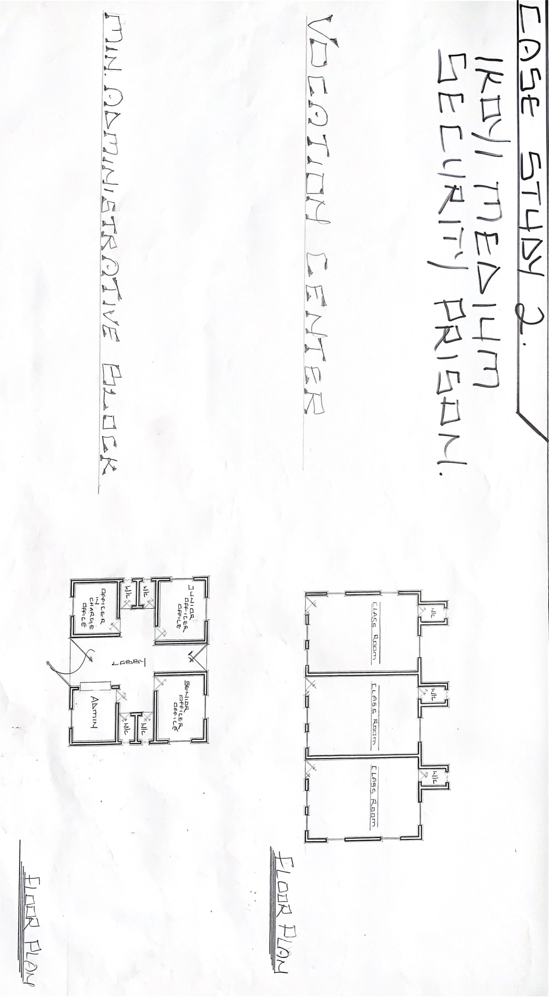

CAST STUDY TWO(2)
FIGURE 2.0

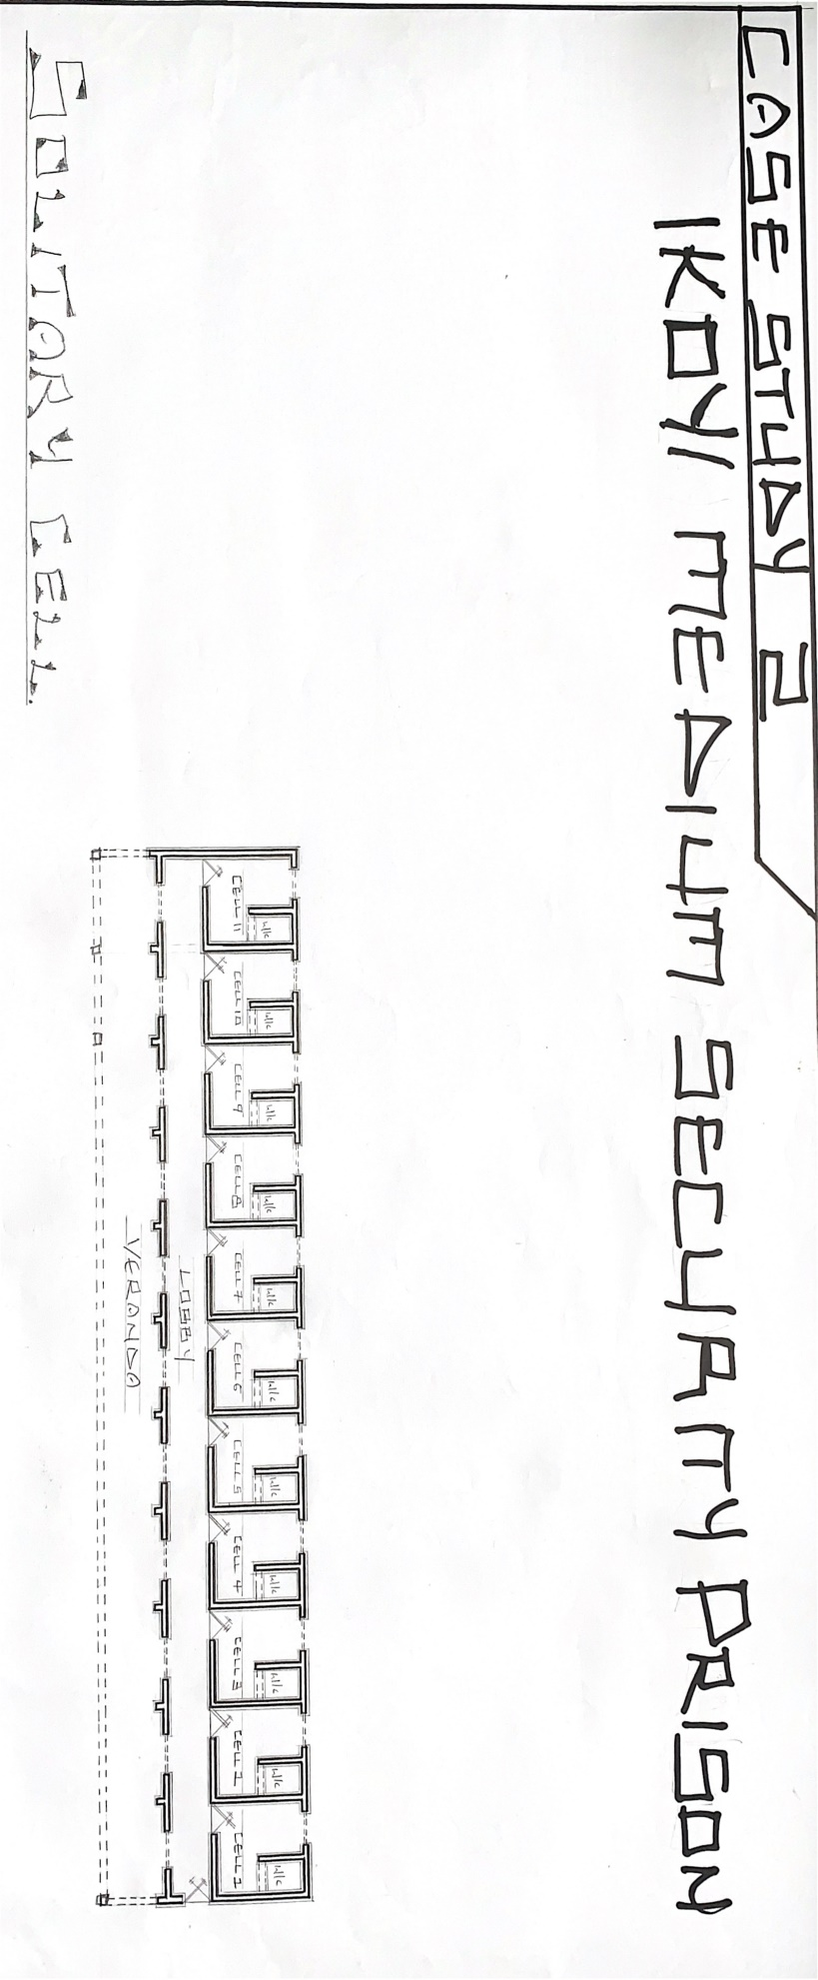

CAST STUDY TWO(2)
FIGURE 2.1

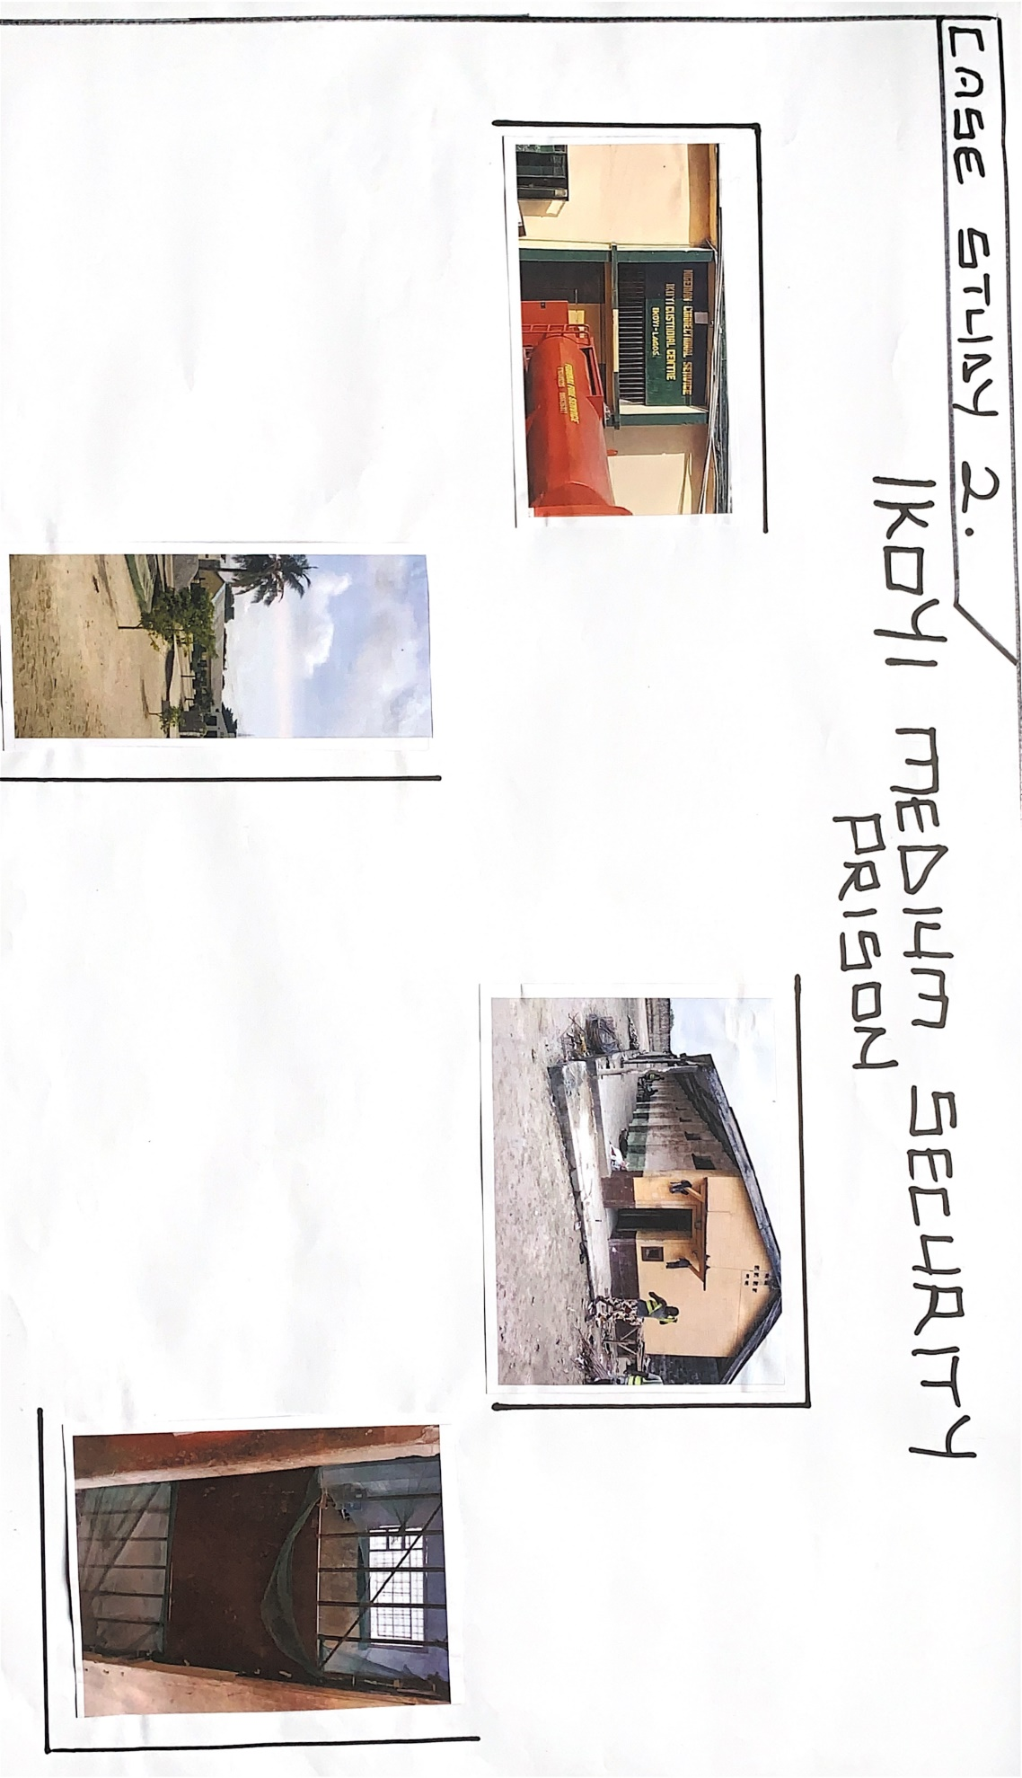

CAST STUDY TWO(2)
FIGURE 2.3

CASE STUDY THREE
HISTORICAL BACKGROUND ON OSUN STATE PRISON [ILESA]
The Ilesa prison Osun state was established in 1934 by British colonial government as a provincial prison, over the years the prison was designed to hold inmates serving short term sentences or awaiting trial.
After Nigeria gained independence in 1960, it continued to operate as a provincial prison, over the years the prison population grew, leading to overcrowding and poor living conditions.
So in recent years, the Osun state government has implemented reforms aimed at improving prison conditions and reducing overcrowding, Despite these efforts Ilesa prison continues to face challenges, including inadequate infrastructure, poor sanitation and human rights concern.

MERITS

1. ADEQUATE LIGHTING: The prisons design provides adequate lighting, improving visibility and safety.
2. DURABLE MATERIALS: The prisons building are constructed with durable materials such as concrete and steel, which can withstand harsh weather conditions.
3. FUNCTIONAL LAYOUT: The prisons layout is functional with separate areas for different activities such housing, kitchen area and administrative blocks
4. The prison has a secure perimeter fence with a good height that prevents escape attempts and unauthorized entry.

DEMERITS

1. OUT DATED DESIGN: The prison design is outdated and doesn't meet modern standards for prison design leading to inefficiencies and safety concerns.
2. POOR LANDSCAPING: The design is not well landscaped which lead to reduce in the visual appeal of the prison environment.
3. INADEQUATE STAFF -QUARTERS: The prisons staff quarters are inadequate leading to discomfort and deceased morale among prisons staff.
4. LIMITED ACCESS TO NATURAL VENTILATION: The prison design doesn't provide adequate access to natural ventilation leading to poor living conditions and negative impacts on inmates.

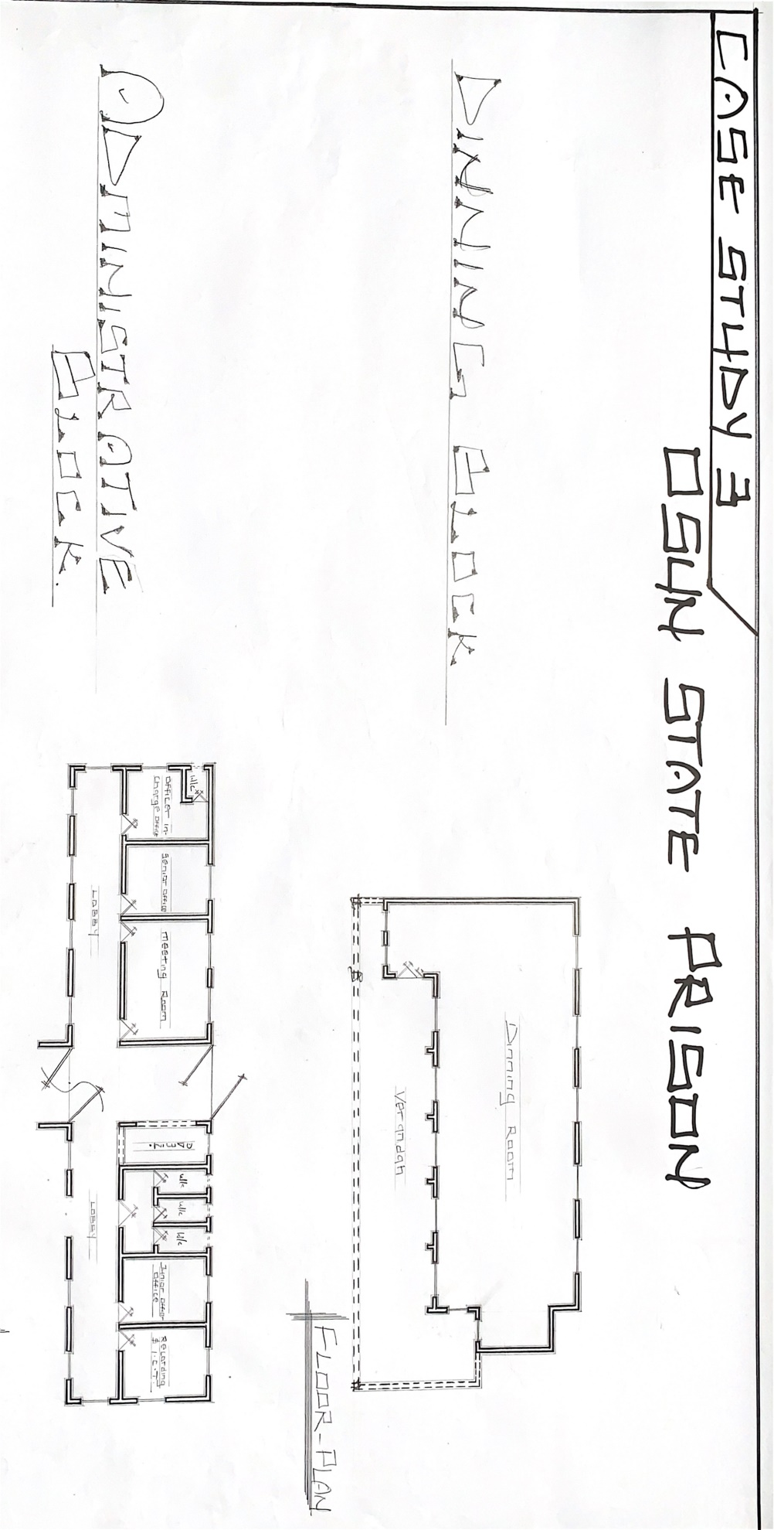

CAST STUDY THREE (3)
FIGURE 3.0

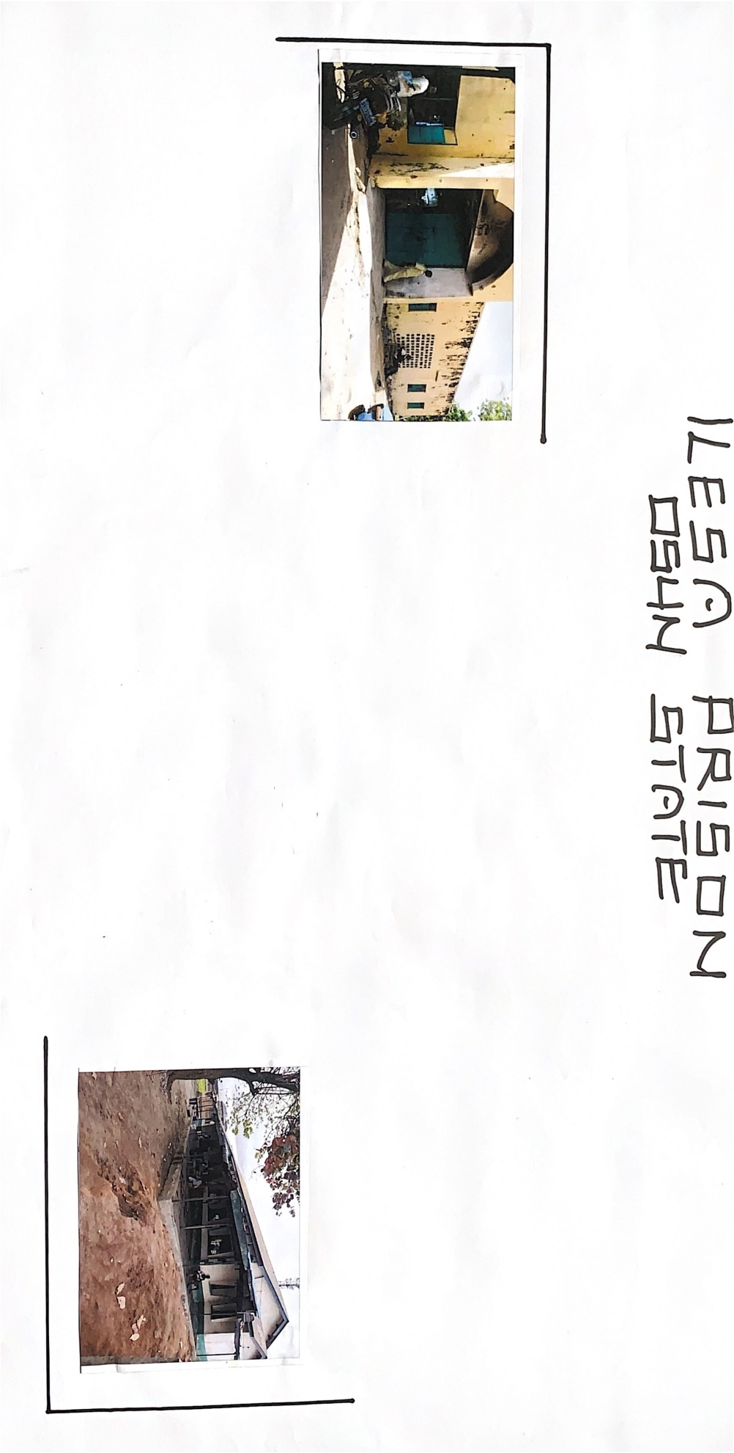

CAST STUDY THREE (3)
FIGURE 3.1

CHAPTER THREE

3.0 INTRODUCTION OF THE SITE

- FACTS ABOUT THE PROPOSED LOCATION

Eledi Atala is located at Ado Odo Ota LGA is located in the town of Songo Ota along Itele road, opposite Obansonjo farm Ogun State .Ado Odo Ota Local Government was created in 19 of May 1989 with the total of 16 wards.

- SITE LOCATION/DESCRIPTION

Eledi atata at Ado odo ota local government area, Ogun State is located on latitude 6°40' and 59.99°N and longitude 3° 40' and 59.99°E of the equator.Ado odo ota l.g.a occupies an area of 878,000,000 square meters and it's situated in Metropolitan Lagos and serves as a border local government.

- SITE LOCATION CRITERIA

Site selection is the consideration of certain factors which influence the development of the site and spatial activities.
Conversely, suite selection criteria are based on screening.

Factors affecting site selection include

1) Comfort
2) Thermal control {orientation}
3) Ventilation
4) Solar control

The activities taking place on the site due to the nature of the project, the site selection should meet the requirement for the efficient functioning of the proposed design.
Furthermore, the size of the land available for development should be adequately reasonable to accommodate such functions.
However, the proposed site for the construction of the proposed design {Correctional center prison} has enough land and facilities that will facilitate the reintegration of inmate into the society.

- POPULATION OF ELEDI-ATALA {ADO ODO OTA L.G.A}

The population of Ado Odo Ota L.G.A 526,565 people, according to 2006 census. However, a population projection for 2022 estimates the population to be around 896,700. The local government area is predominantly agrarian with a mix of other occupations.

3.1 SOCIAL SERVICES

The ministry collaborates with local government to implement project that enhance socio-economic development, such as building markets, classroom and etc.

3.2 SITE ANALYSIS/INVENTORY

This is done on the basis of the purpose for which the site is to serve certain precautions and is considered to acquire vital information of the site. This information includes soil condition, geology, topography, vegetation and so on it also involves carrying out a preliminary survey of the site.

A) Soil condition: The type of soil is sandy and hence aids the use of low cost foundation.
B) Geology: This soil is good for construction of building to be erected on the site.
C) Vegetation: This site is covered with shrubs, palm trees and ground covers most of it which would be retained for shading devices and landscaping
D) The sunrise and sunset will be considered foe building orientation, which will give effective consideration for ventilation and solar radiation control for total comfort of the staff and inmate.

3.3 SITE SUITABILITY ANALYSIS

For a complete project like the correctional center prison.it success does not only depend on the functionality and security (SAFETY) of the design but also on a careful choice of the site. For this project, the site has already been selected, although they criteria for selecting a site.

This must and shall be used to analyze the selected site.
i) Location: The most important factor is in choosing the site for a correctional center (prison) setting is the location of the site in relation to other facilities in proposed project.
ii) Accessibility: The next important criterion after site location is accessibility. This is because location is a function of accessibility, for site to be adequately accessible it must be suitably located within the area from which access it's required. Accessibility is traffic routes either vehicular or pedestrian is an important function on site.
iii) An important factors that ought to be considered is the size of the site. The site must be large enough to permit the distributions of functions on the same level. This increases efficiency of workers and inmates in continuity of the reintegration of the inmates.
iv) Service: The important of the availability of services like electricity, sewerage and water on the site cannot be over emphasized .The for and project therefore, has this service they've already laid out.
3.4 CLIMATE CONDITION
Climate condition of an area is the average weather condition of such area after a long period of time. Certain factors that affect the element of climate such as temperature, wind and humidity includes latitude, altitude, relief, proximity to seal ocean current and wind vegetation the value of soil and position of a place in relation to the direction of the sun rays.

- RAIN FALL
However, the least amount of rainfall occurs in November and December
The average in these months is 2mm; most of the precipitation here falls in July and August averaging 165mm.

- TEMPERATURE
The temperature here are highest on average in the months of march and October at around 290°c August is the coldest month with temperature averaging 25.1°c

- WIND
The wind is most often from the south from the month of march to October with a desk percentage of 63%on May. The wind is most often from the east with a peak percentage of 49% at February beginning

3.5 GEOGRAPHICAL CHARACTERISTICS

Vegetation: Vegetation on the site is savannah type which is noted for predominantly tall grass and Short large medium trees. Most of the trees are deciduous with the present artificial fig trees planted. This shall be used for landscaping purposes and shading.

Site topography: The site of the correctional center building is underlain by shale reddish Sharp sand and shale with bed of white sandstones and stripped Sandy shale. The soil structure is considered very suitable for any form of construction work. Its undulating nature ensures that it is well drained its prone neither to water logging nor erosion.

Soil condition: The type of soil is Sandy soil and hence aids the use of low cost foundation.

CONCLUSION
A proper and well care must be taken into consideration, when it comes to selecting a particular project and all these are above disused.

CHAPTER FOUR

4.0 DESIGN GENERAL REQUIREMENT

DESIGN BRIEF

After research and planning the next step in the series of the project program is design it, to achieve functional and where established design there must be a brief to work on. The brief depends generally on the scope of individual design; the brief of this project is therefore based on the various individual designs that take place in the correctional center [prison].
To have enough brief for the purpose correctional Center were carried on the existing correctional Center. The study also gives me the opportunity to know the nature of the inmate lives their life and also relationship between staff and inmates. The correctional center has different divisions which are: the custodian block, specialized blocks, administrative block etc.

DESIGN ANALYSIS

This is the process of itemizing unit within the component of the entire design with a view to establish a solid understanding and appropriate functional flow. The unit of the design is as follows:

UNITS UNDER ADMINISTRATIVE BLOCK

1. Entrance
2. Controller office
3. Seniors officer office
4. Junior's officer office
5. Parole unit
6. Admin
7. Secretary office
8. Conference room
9. I.C.T office
10. Procurement room
11. Record office
12. Welfare office
13. Convince

UNITS UNDER CUSTODY BLOCK

1. Admin
2. Interrogation room
3. Waiting room
4. Visiting room
5. Inmates cell room
6. Dinning
7. Kitchen
8. Stair case

SPACE SCHEDULE

SCHEDULE SPACE ALLOCATION STANDARDS
S/N | UNITS | LENGTH | WIDTH | TOTAL AREA
1. | Entrance | 6.2m | 3.6m | 22.32m²
2. | Controller Office | 3.8m | 4m | 15.2m²
3. | Senior Officer Office | 4.7m | 3.3m | 15.51m²
4. | Junior Officers Office | 4.7m | 3.3m | 15.51m²
5. | Parole Unit | 3m | 3.3m | 9.9m²
6. | Admin | 3m | 3.3m | 9.9m²
7. | Secretary Office | 2m | 4m | 8m²
8. | Conference Room | 5.5m | 4m | 22m²
9. | I.C.T Room | 3m | 4m | 12m²
10. | Procurement Room | 3.5m | 3.5m | 11.55m²
11. | Record Room | 3.5m | 4m | 14m²
12. | Welfare Office | 3m | 3.3m | 9.9m²
13. | Convinces | 4.7m | 4m | 18.8m²
14. | Admin Two (2) | 3.8m | 2.5m | 9.5m²
15. | Interrogation Room | 3.8m | 2.5m | 9.5m²
16. | Visiting room | 4.1m | 7.8m | 31.9m²
17. | Inmate Cell Room | 2.7m | 3.7m | 9.9m²
18. | Dinning | 6m | 9m | 54m²
19. | Kitchen | 6m | 4.2m | 25.2m²
20. | Stair Case | 3.2m | 3m | 9.6m²

4.2 SITE PLAN

The site is planned in order to give it a define shape and also to reflect the activities taking place. The location of the correctional center prison and facility, within the site follow the main principle

1). the zoning principle [private, semi- private and public zone] is the respected in which enhance placement of each structure in respect to the level of egress and ingress.
2). structures are placed in accordance to usage

4.3 BRIEF ANALYSIS

THE DESIGN SCOPE

This following are the design scope

1. The administrative block
2. Health and wellness block
3. Programming and educational unit 4.support service block
5. Recreational area
6. Security block
7. Car park
8. Custody unit/block
9. Specialized block

The above a some of the specific component that constitute the foundation and framework of the project

DESIGN CONCEPT

Firstly the process of analyzing the design into necessary unit required for the design is based on the data collection through research methodologies.
Secondly the grouping of the various units together according to their relationship with one and other is also based on the data and information gathered.
The concept of the design was derived from the functional relationship and bubble diagram prepare out of the design brief which is based on the activities performed within the correctional center prison. The relationship of this various activities with one another within different units that make up the design and also based on the zoning in accordance with the level of privacy of the units.

4.4 PLANNING PRINCIPLE

The planning principle is one of the most important aspect of any design. the planning of various unit taking into consideration to the activities performed in each unit is how they are related to one another and the use of the various units in the design

4.5 GENERAL REQUIREMENTS LIGHTING

This is a means of providing brightness naturally by sun or moon or artificially by lamps good natural and artificial lighting is important in custody block and other unit. it is also easy to make mistake or lead astray in the situation of poor lighting. For the purpose of this project effort is to made as much as possible to light up the entire facility naturally before the use of artificial lighting to improve surveillances of the inmates activities.

4.6 FIRE PROTECTION DEVICES

Building regulation and construction with insurance policy survey take care of the fire precaution need in an institution.
this will be carefully observed and periodically reviewed to ensure that the fullest use can be secure from the protection facility in an emergency fire, not only fire caused by people distractions can lead to fire accident but other reason like electrical problem .e t c
The assembly points are to be located at strategic position in case of any fire outbreak. Fire resistance material like alarm system is to be installed so that everyone could be alerted in case of Hazard. Fire retarded floor and wall finishes are to be used e.g. granolithic or terrazzo floor finishes, texcote wall e.t.c.

4.7 PERIMETER FENCING

Installation of a barrier or fence around the outer boundary of a property.

The purposes of perimeter Fencing can vary depending on the context but common reason include:

SECURITY
1) Access control: Regulating who can enter or exit the facilities
2) Protection: Preventing unauthorized access trespassing or intrusion.

SAFETY
1) Boundary definition: Clearly marking the facilities lines
2) Hazard prevention: Preventing accident or injuries by defining the perimeter.

4.8 FUNCTIONAL RELATIONSHIP WITHIN THE CORRECTIONAL CENTER

The success of the project depends greatly on the adequate understanding between and within each of the different facilities, section and units within the correctional center.

These relationships can be classified into the following:

* Administrative block
* Custody block
* Medical/Health
* Vocational block
* Educational block
* Watchtower

- Administrative Block:
This structure which include the controller general office, seniors officer and junior officer office, parole, procurement, record room and so on in. contribution to the in station of the inmates

- Custody Block:
This block/ structure accommodate the inmates including cell room, visiting room kitchen and Dining

- Medical/Health:
This structure is for emergency in the custodian which refers to the medical reception section [MRS]

- Vocational Block:
This structure is built to encourage the inmates to venture into different skills before they integration to the society

- Educational Block:
Educational facilities for inmate which include First School certificate and higher diploma degrees.

- Watch Tower:
These structures is for surveillance over the inmates as a security measures.

4.9 CONCEPTUAL DEVELOPMENT

The guiding principle behind a design often service has its Foundation concept, while designers may share similar overarching ideas, their individual interpretation and approach can vary significantly.
In many cases designer develop a strong personal attachment to the design philosophies, which in turn shape their unique style and identity. These principle or philosophies are often influenced by the Architects personal belief and experience, which may often vary from environmental Factor or specific challenges outlined in the design brief.
The context of correctional Center, activities follows a sequential order, therefore it becomes essential to recognize the sequence and reflect it in the design through a clear sense of accuracy. Environmental Factor also plays crucial role as architect often leverage the characteristic of the surrounding environment to enhance their designs. These factors may include locally available building materials, construction methods, prevailing building form, spatial arrangement, types of activities and the region climatic conditions.

CHAPTER FIVE

5.0 DESIGN AFFRAISAL OF PROPOSED SCHEME

In any project design, there are two basic factors that should be taken into consideration. These factors are Functionality and aesthetics of the design, although to some designers, aesthetic and functionality of any buildings are incompatible but in the case if this project, both aesthetic and functionality of the design been taken care of to satisfy the highly demanded functional requirements and to create aesthetically balanced design.

The functions efficiency of correctional center defends largely on the enclosure of the inmates Section that are strongly related in functions, all these are being taken up as seen on the site and Plans respectively.

5.1 CONSTRUCTION METHODOLOGY AND MATERIALS

For the advantage of Easing Planning, construction and servicing of the Administrative custody block, grid system is introduced in the design.

The grids are two kinds

• The layout Planning
• Elements with which the building is constructed

For clarity, this subject is discussed under four headings which are:

The structural grid: This relates to the male zone in the building like the biggest and most permanent parts if the buildings shell the determinant if an internal structure grid depends on

- Span of structural systems adapted
-the nature of floor loading adopted as different parts of the building experience varied leading

-Space and dimensions required in the building

CONSTRUCTION GRIDS: Consider the size of buildings products and materials available in the market, this reduce unnecessary wastage to fit the design space.

SERVICES GRID: They exist to alleviate the problem of disturbing service point throughout the building. This point includes power points and telephone outlets.

PLANNING GRID: They guide the location work group and their work places.in addition they impose the overall order and maintain individual and group space standards.

i. BUILDING ORIENTATION
Orientation of the building will be chosen according to the form of the site and at the same time give credence to traffic
This traffic is categorized into

- Vehicular
- pedestrian

Pedestrian movement will be given adequate consideration and proper separation from the correctional perimeter.

ii. LANDSCAPE: Landscape is necessary to improve the aesthetics of the environment barrier against solar radiation and absorption of noise from the environment, hence use of trees, shrubs and grasses will dominate in the design than concrete surface of landscape.

iii. CONSTRUCTION MATERIAL: The construction materials that will be used for project will be limited to Nigeria labor market having in mind that the labor market is made up of indigenous workers.

Therefore, the building materials and techniques be locally available in Nigeria.

v. FOUNDATIONS: Simple concrete strips/pads/pile foundations shall be used

vi. FLOOR FINNISHES: Hard wearing and resistant flooring materials shall be used for the design for easy maintenance and durability. Ceramic floor tiles and the administrative block and terrazzo floor Finnish shall be used for all public space and custody blocks.

vii. WALL AND INTERNAL PARTITIONS: The external wall shall be of sand-Crete hallow block material while some internal partition may be of concrete which will be treated against fires accident

viii. ROOF MATERIAL: The roof material shall be of aluminum long span.

ix. DOORS AND WINDOW: In this design, the door of the major entrance into the site will be steel made gate, while other doors and window will be four panel door and casement metal window.

5.2 DESIGN CHARACTERISTIC (Landscape)

The ideas of planning good surroundings evolve from the primary function. It gives a good aesthetic view of the structure. It enhance the psychological feelings of the public making use of the area, it makes the entire environment healthy, a clean and well planned site is a healthy environment in view of these the following had been adopted in planning site

LANDSCAPE

It has been known to us that throughout the world people use mainly two types of landscape namely:

* Soft Landscape
* Hard Landscape

SOFT LANDSCAPE ELEMENTS

a) Tree (Vegetation): Tree also has been strategically planned to be plant at turning point addition to the existing one by the road and closer to some structures to perform the fun of a shading device.

b) Grasses/Lawn: Bahamas grasses have been suggested as type of soft landscape in some area liable to be influenced negatively by erosion, it gives a good aesthetical view or look on the ground surface which makes it look more appealing to the eye

HARD LANDSCAPING ELEMENTS

a) Asphalt: Used for drive ways and parking lots, it is economical and durable both for staffs and visitors
b) Interlocking paving: Used for walk ways and outdoor paving to blend with the natural texture of the environment
c) Concrete Kerbs: Used to separate tater surface from the lawn covered areas

5.3 BUILDING STRUCTURE

The custody block is a story building with court yards supported by beams and column at appropriate intervals. Most modern buildings are usually constructed by introducing grids into the design, this make for easy and accurate consideration of frame structures used in buildings
There are two types of grids systems

1) Modular grid
2) Structured grid
For this project, structured grid system was employed in filled sand Crete block where used all retaining wall of the building. The roofing system is used for building is well seasoned timber roofing and metal roof trustees

5.4 SERVICES

These include
i. ELECTRICAL SERVICE: The electrical service will be high quality and cables in concealed and conduit wiring system will be used, there is a power house to generate constant electricity supply in case of power failure as we all know how electricity sector is not actually stable.
ii. SEWAGE DISPOSAL: For effective drainage of both surface and soil waste appropriate size of pipes are used. All pipes used are run into duct system with leaf net provided on drain pipe to prevent blockage from soil waste
iii. Drainage
iv. Waste disposal e.t.c.

5.5 GENERAL MAINTENANCE

Maintenance cannot be isolated from the initial planning and design any architectural edified most especially a proof this liber which involve reinstating and promoting human behavior as well as social aspect. Timely maintenance of structures and facilities to put them in proper working condition to enhance work ability and habit ability of both structures and facilities for maximum satisfaction the environment safety must be ensured.
Maintenance work in real technology is defined is defined work undertaken to keep or restore any facility of the building or site to an acceptable standard. The work may be carried out with fire thought, contains records planned maintenance or carried out on an emergency basic when the need arises.
Due to the lack of the maintenance Fulton this part of globe adequate providers made for the security, sanitation and maintenance department to cater for the facility and endure level of hygiene.
The maintenance of buildings and facilities will be daily attended to with regular servicing or equipment and other facilities
The internal work consists of the inmates cell block, administrative block, specialization block e.t.c.

The external work consists of so many factors that are of greater significance and these factors are as follow

1) Parking Space
2) Access Road

SUMMARY AND CONCLUSION

The complexity of correction centers focusing on rehabilitation program, challenges and opportunities for improvement. It highlights the importance of effective rehabilitation in reducing recidivism and promoting social reintegration.
I’m conclusion correctional center play a critical role in the criminal justice system and their effectiveness in well design rehabilitation programs, adequate resources and commitment to rehabilitation by prioritizing evidence based practice improving conditions and addressing the unique needs of inmates. Improving correctional center can better achieve their goals of rehabilitation and social reintegration. Further research and investment in correctional center reform and essential to creating safer, more effective and more humane correctional systems.

APPENDIX

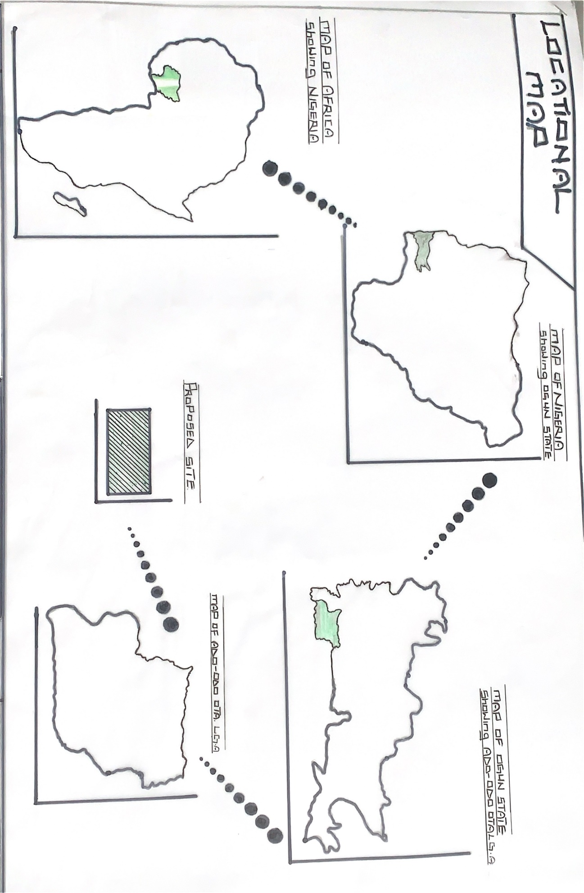

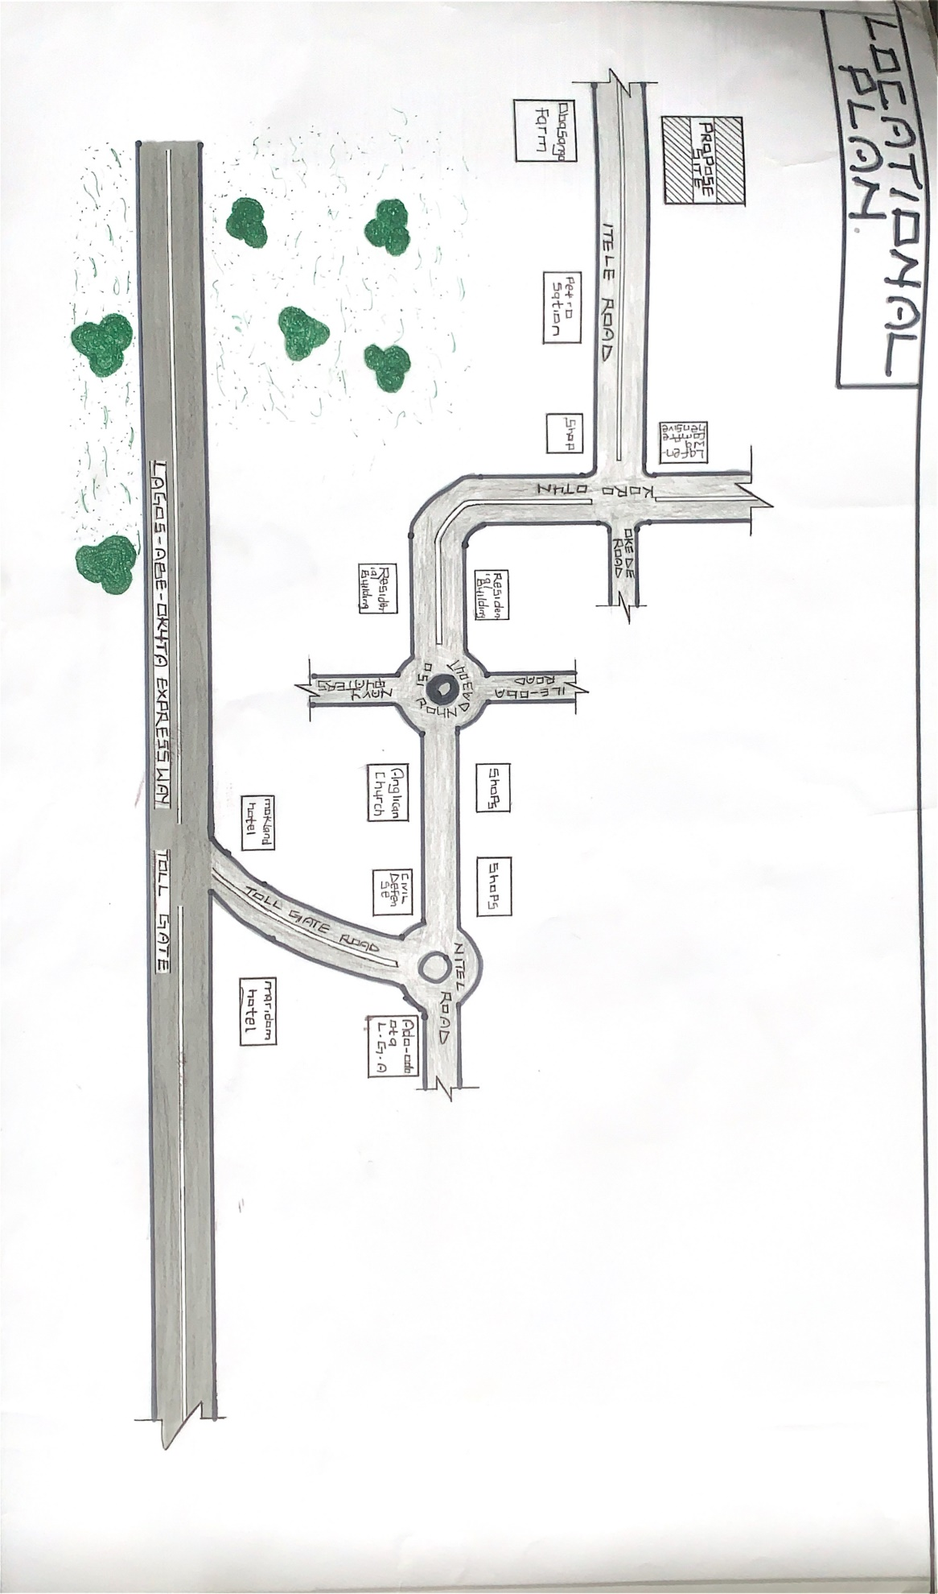

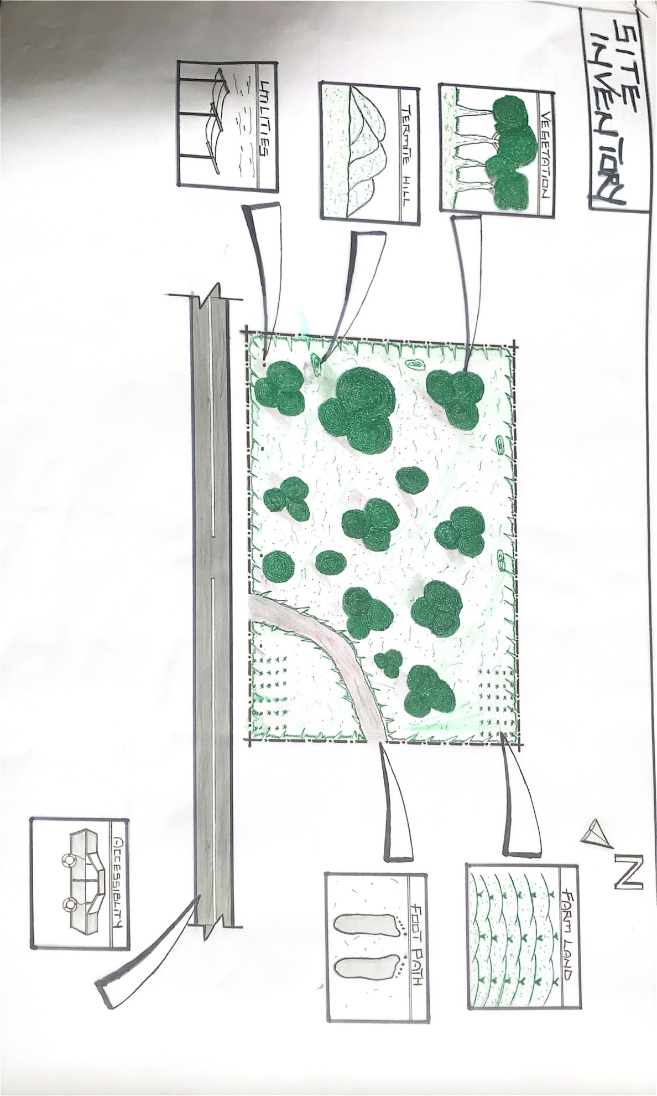

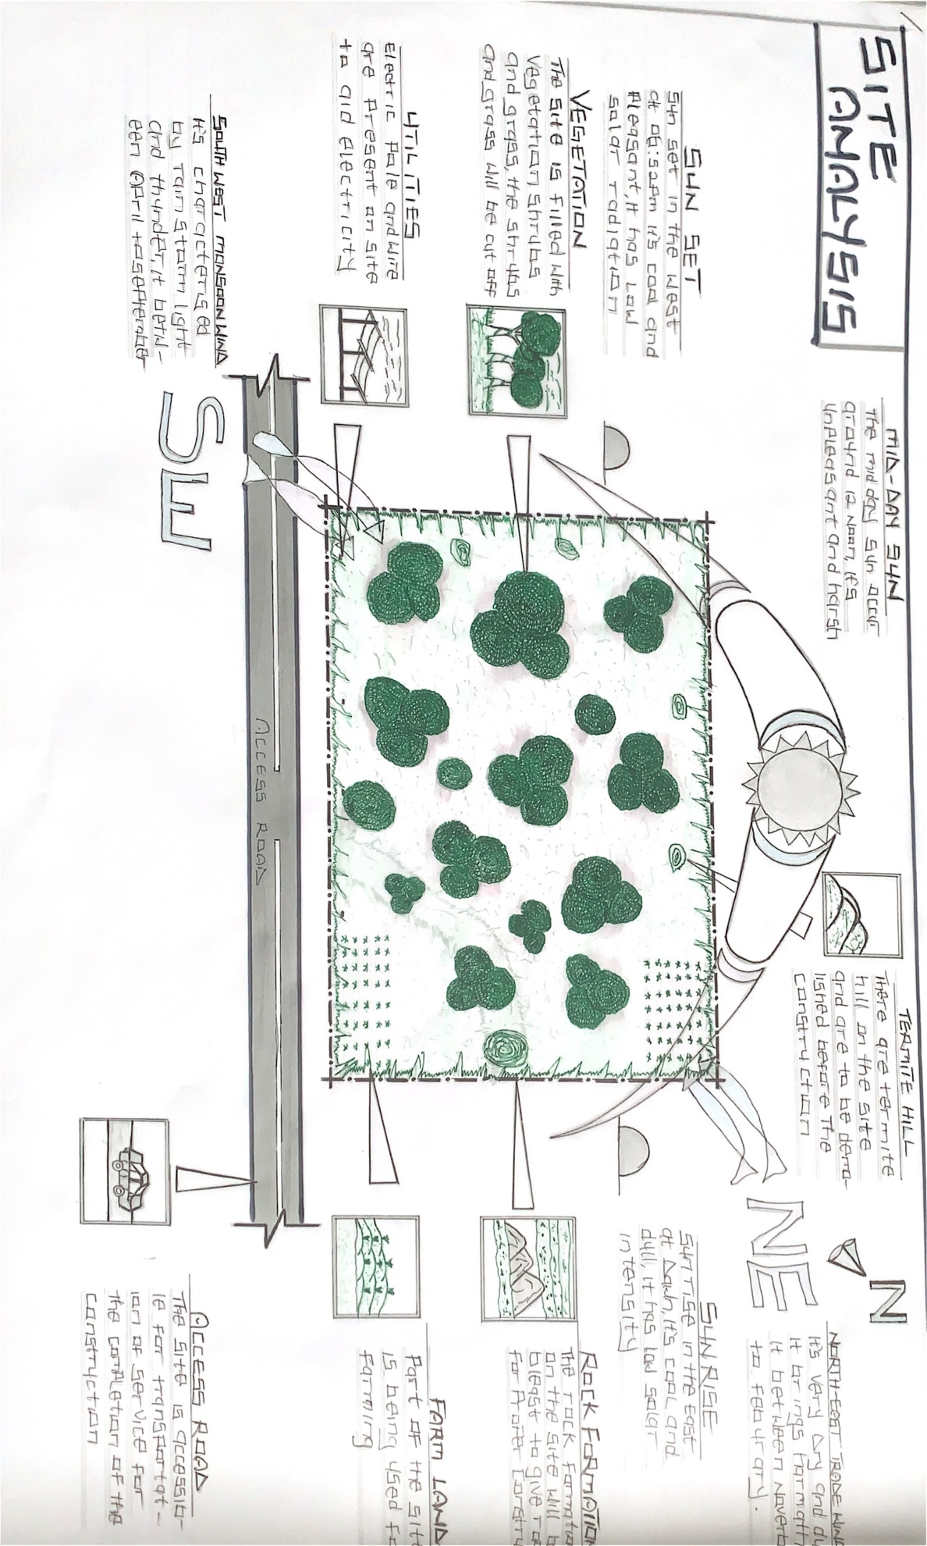

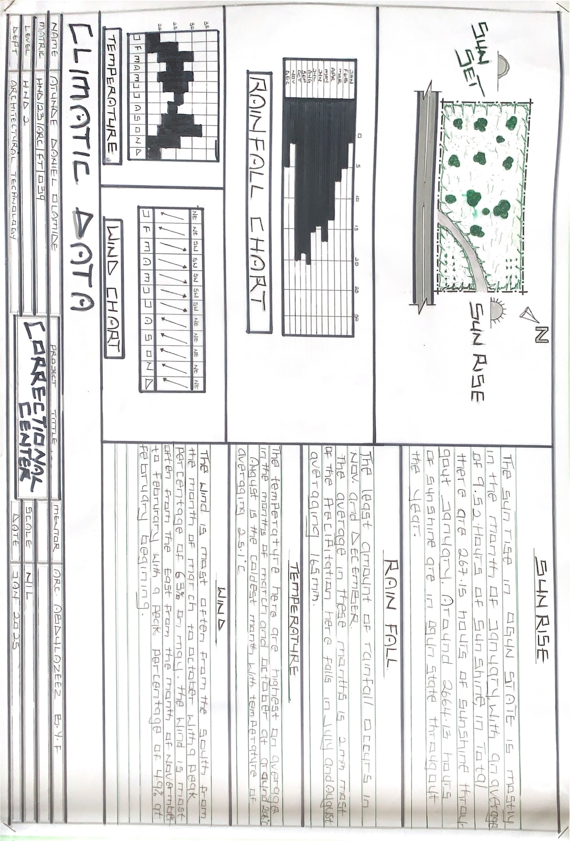

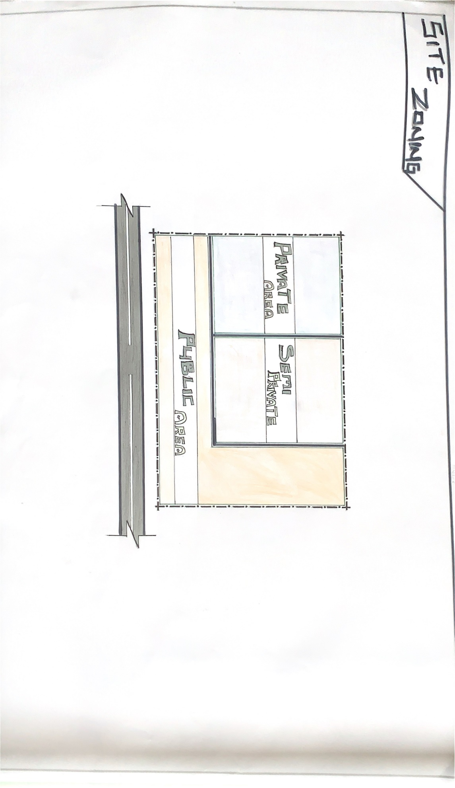

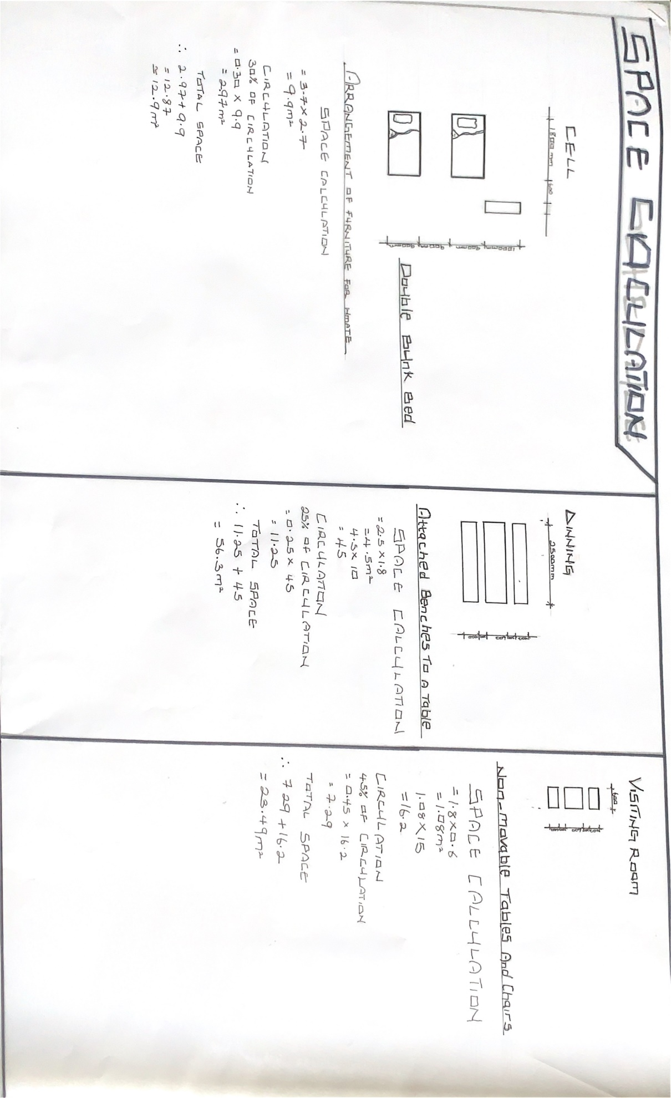

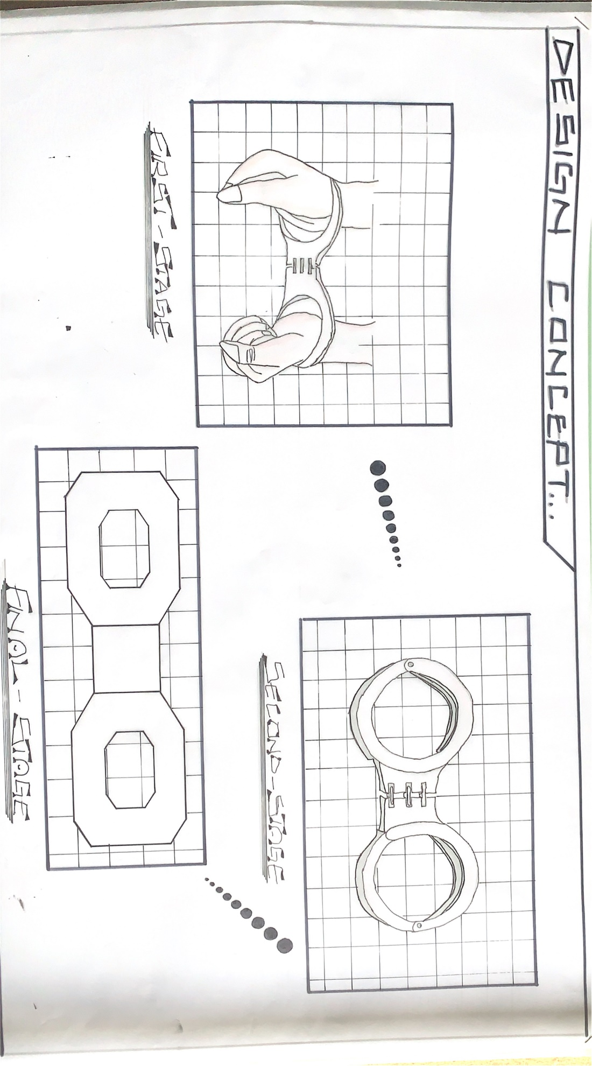

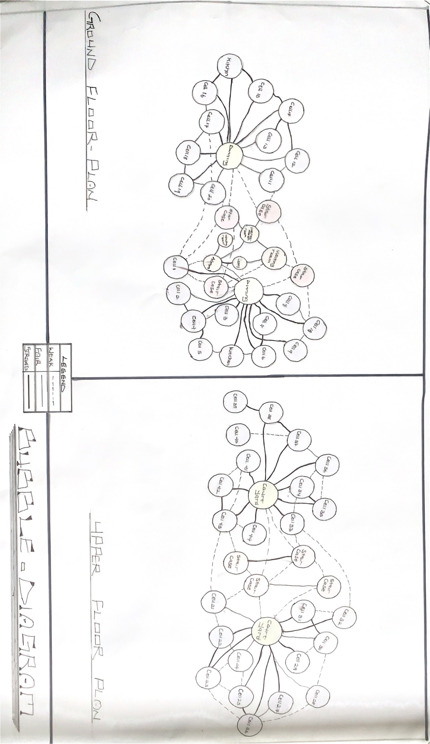

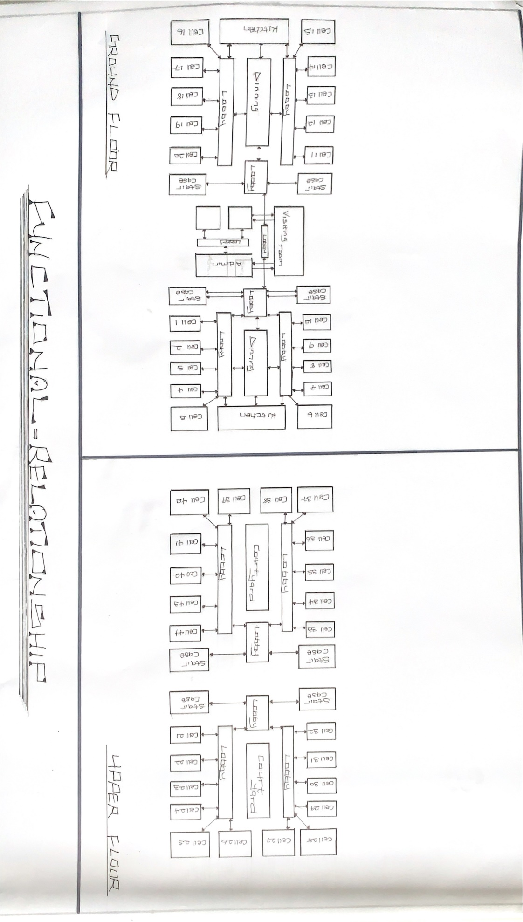

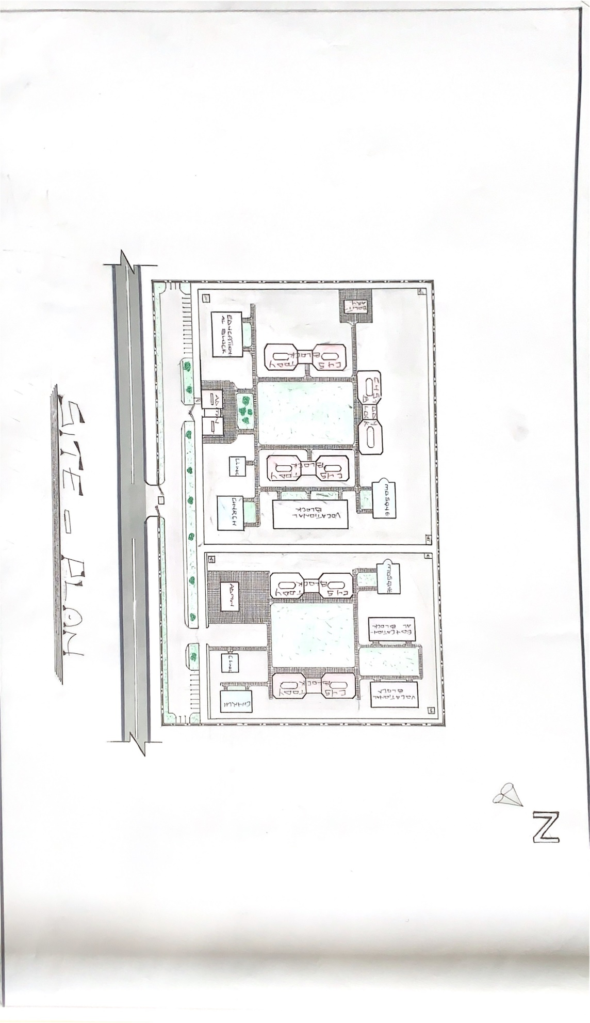

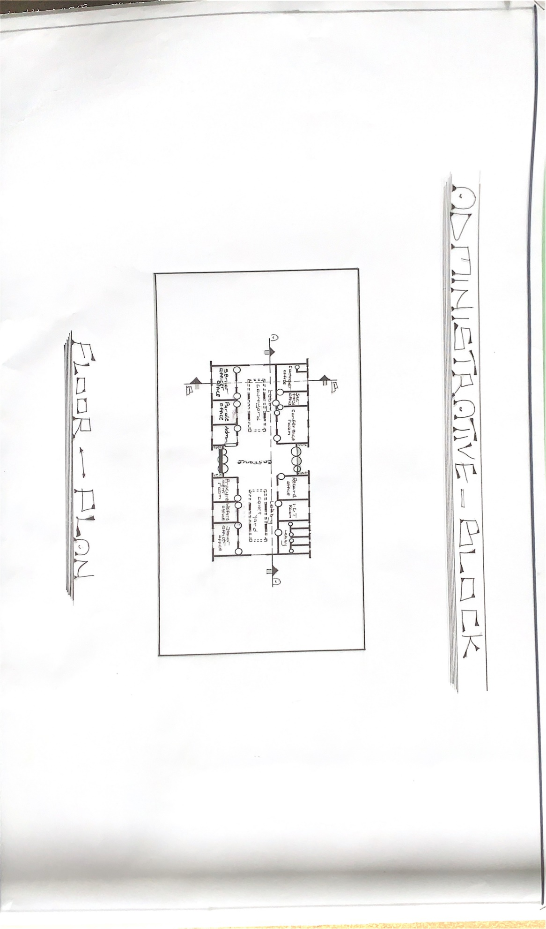

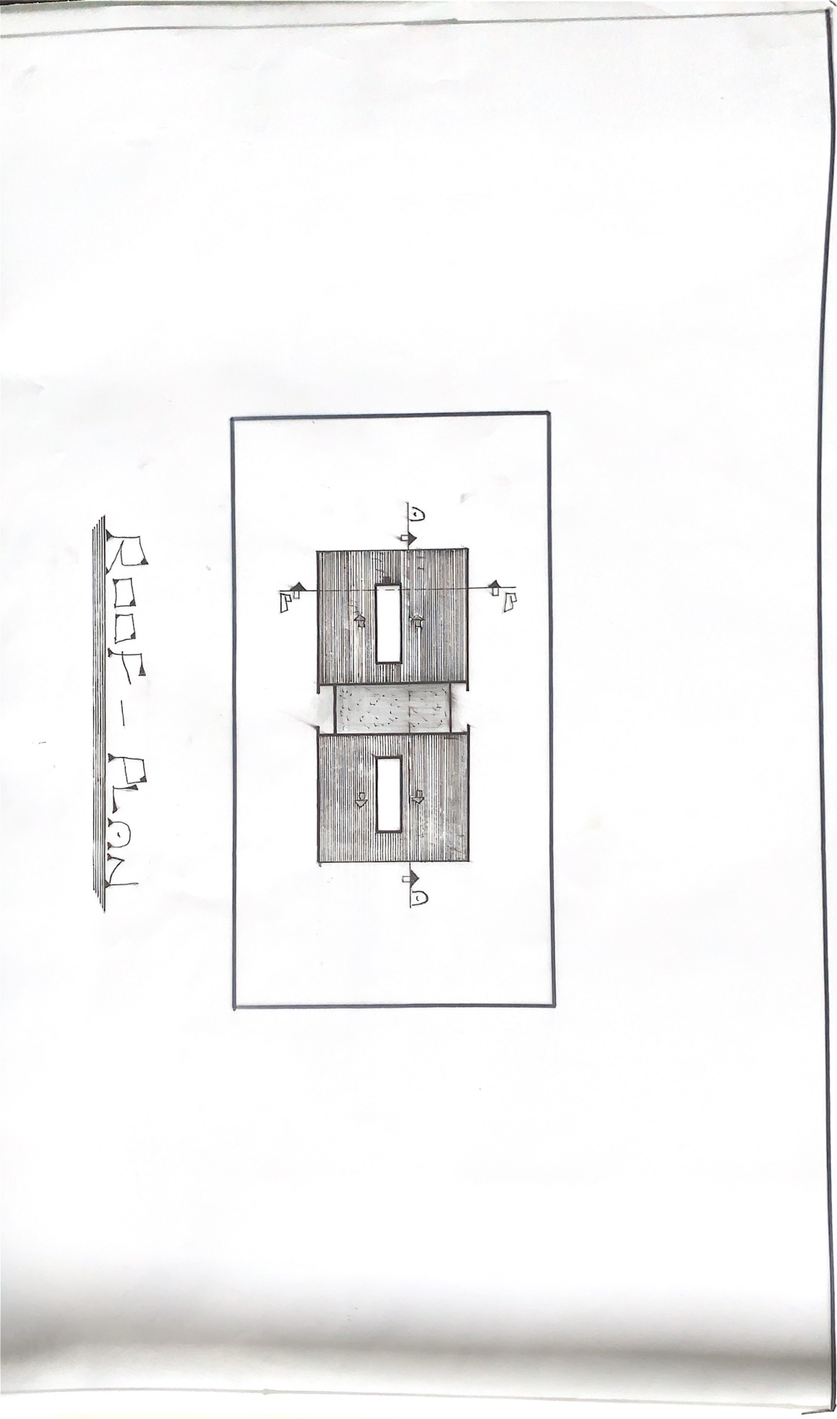

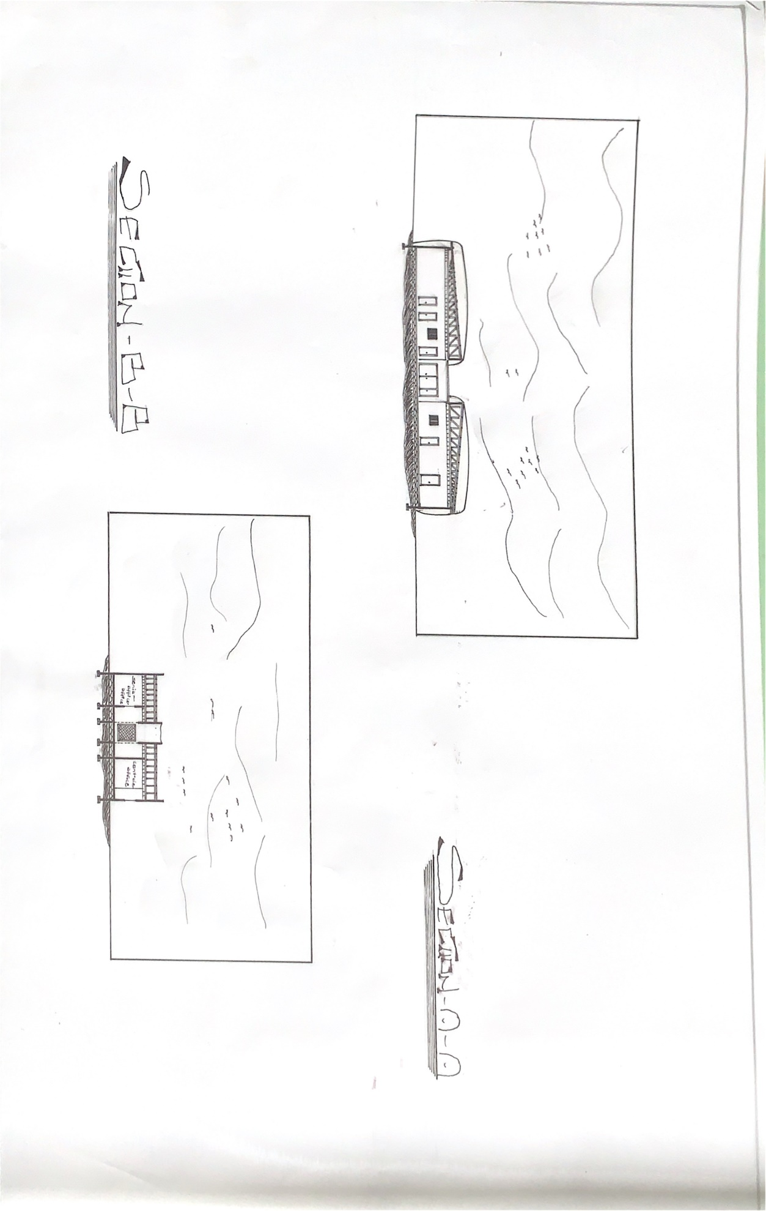

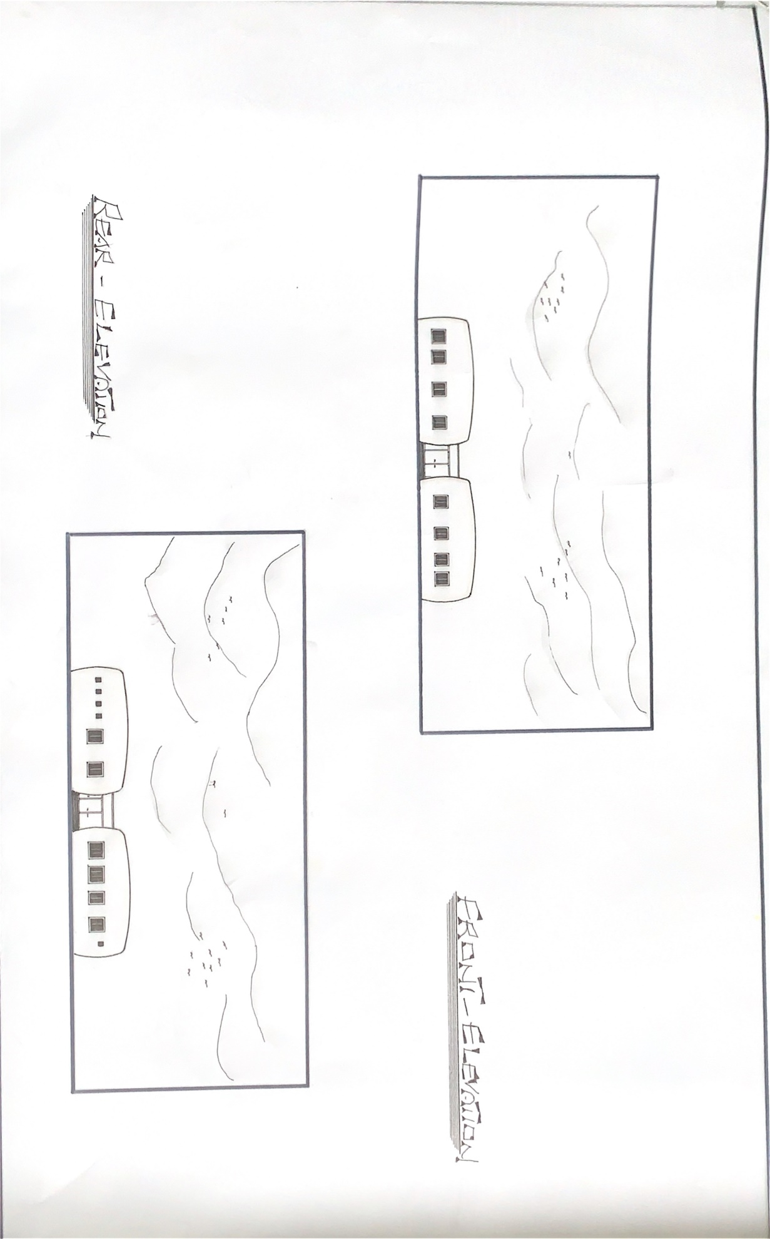

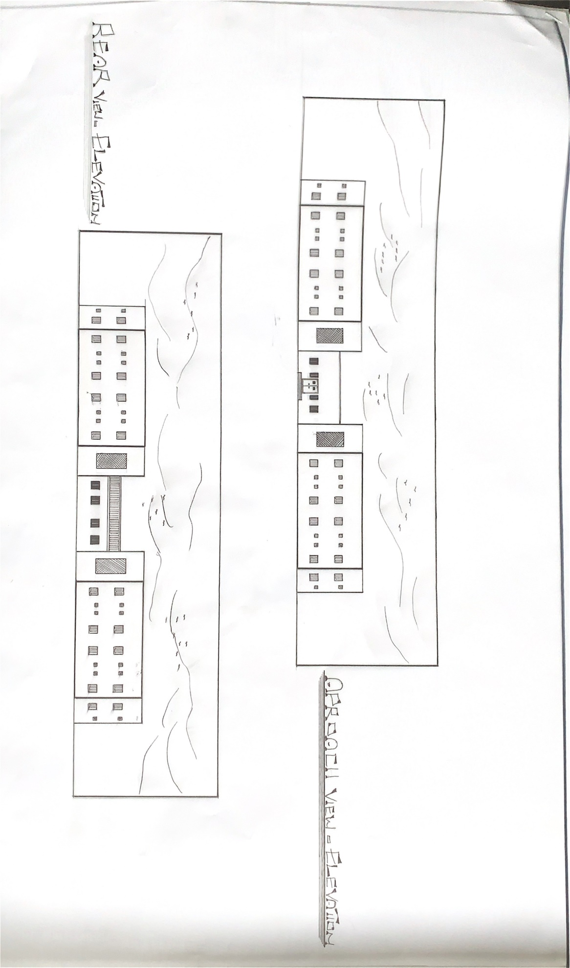

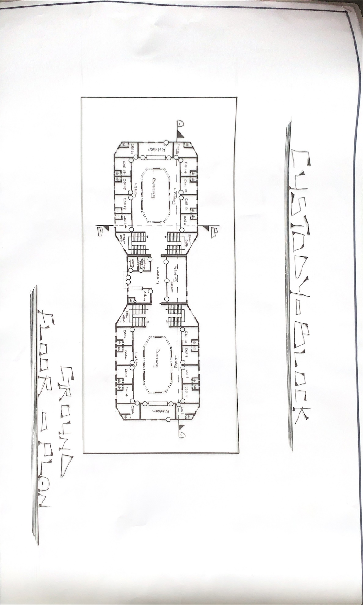

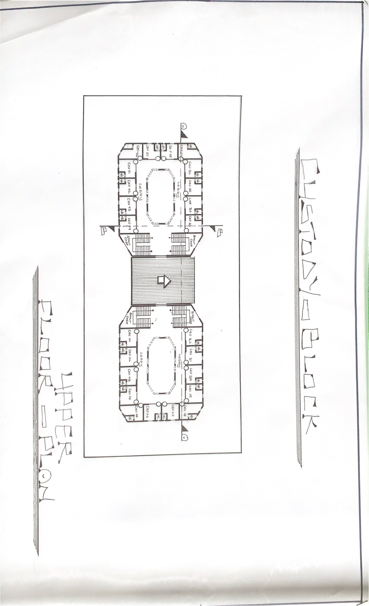

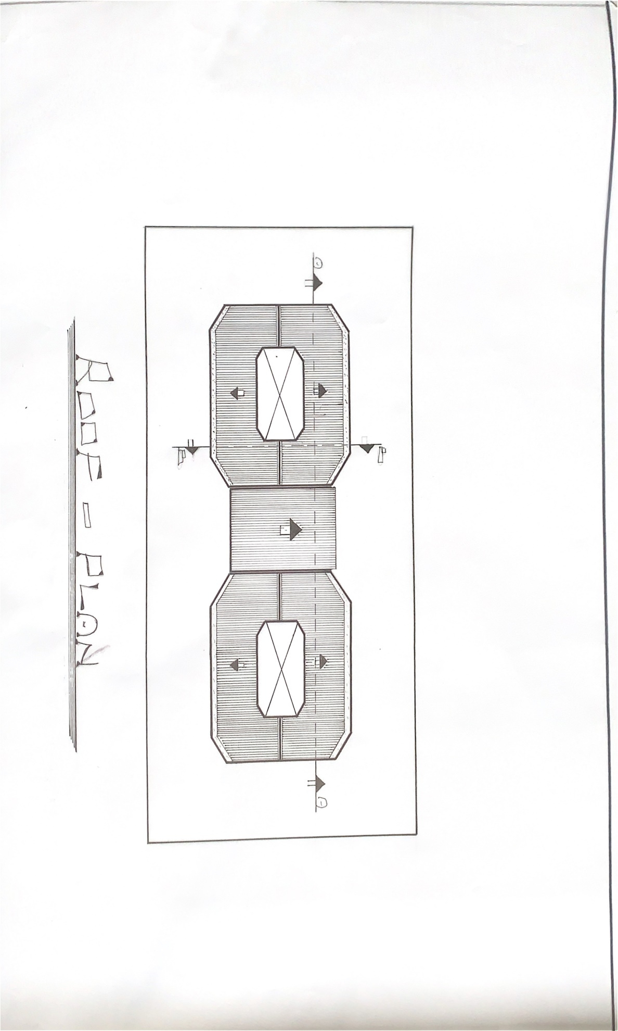

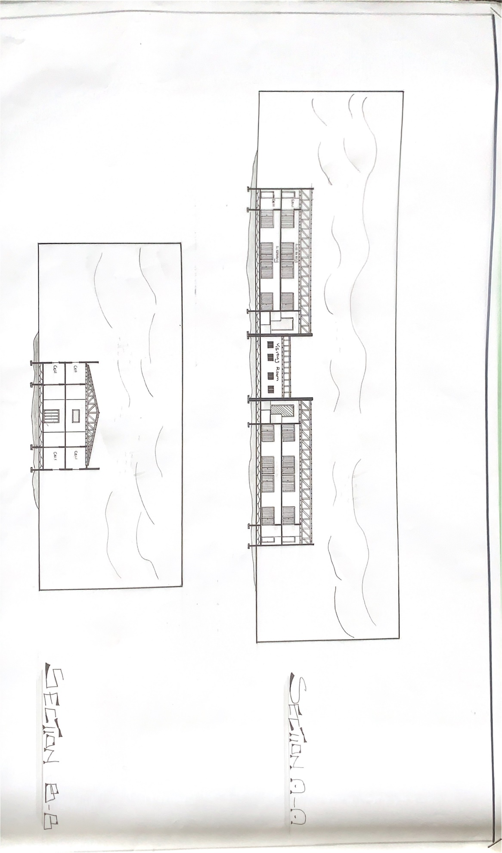

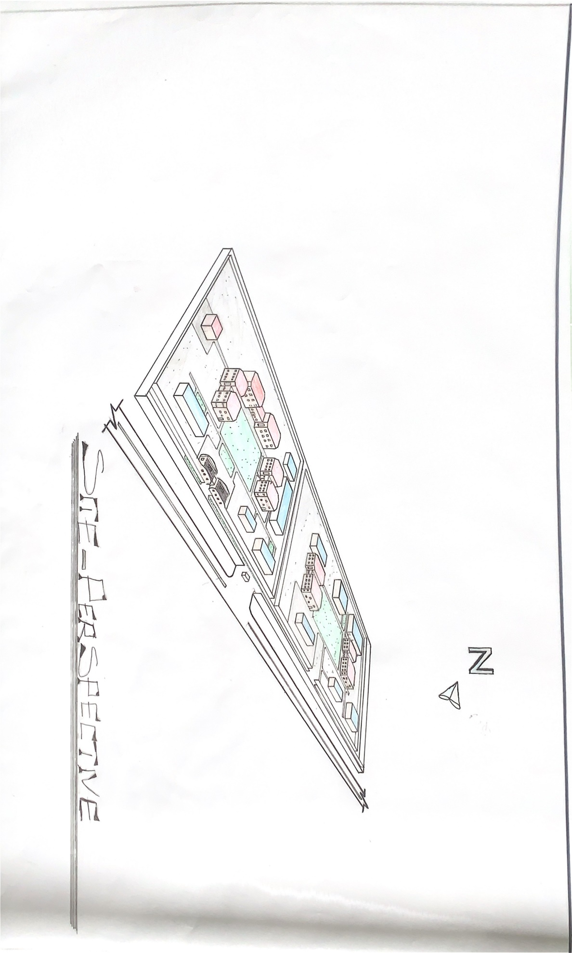

REFERENCE

- A.B Dambazau (1996) and E.U.M Igbo (2007) offer a foundational understanding of the field
- Correctional decree No.9 of (1972) and the correctional act cap 366laws of the federation of Nigeria (1990) provisions of further legal context on correctional centers
- Francis T. Cullen and cherrylero Johnson (2016) correctional theory (sage publications)
- Olubunmi Tunji’ Ojo (2018) International journal of the intellectual discourse studies of imperative and inmate’s rehabilitation programs
- Olajumoke Adenowo ( 2016) Journal of public policy and administration
- Musa A.Egu (1990) provide an insider account of the Nigeria prison system history.
- Theo Lawson (2014) National Institutes Of Correlation (NIC) website (Us department of justice)
- John Pratt (Routledge 2018) Prison and penal system
- John Wooldridge and Duala smith (2018) Oxford university press, the Oxford handbook of prisons and imprisonment
- Wole Olawale (2005) and D.I Nkidota (2009) delve into the administration of prisons and study of punishments

