A PROJECT REPORT
ON
PROPOSED DENTAL CLINIC
FOR
KWARA STATE.

By:
BABATUNDE ADEWOLE EZEKIEL
ND/23/ARC/FT/0023

Submitted to:
THE DEPARTMENT OF ARCHITECTURAL TECHNOLOGY INSTITUTE OF ENVIRONMENTAL STUDIES (IES) KWARA STATE POLYTECHNIC, ILORIN

IN PARTIAL FULFILMENT OF THE REQUIREMENTS FOR THE AWARD OF NATIONAL DIPLOMA (ND) IN ARCHITECTURAL TECHNOLOGY

JULY, 2025.
DECLARATION
I declare that this design project/Dissertation is a project of my personal work. It has been presented for the award of any National Diploma in any Polytechnic. The ideas, observation, comment, suggestions herein represent my own convictions, except quotations, which have been acknowledged in accordance with conventional academic traditions. under supervision of ARC OLANREWAJU F.A
BABATUNDE ADEWOLE EZEKIEL __________________________
ND/23/ARC/FT/0023 DATE/SIGNATURE

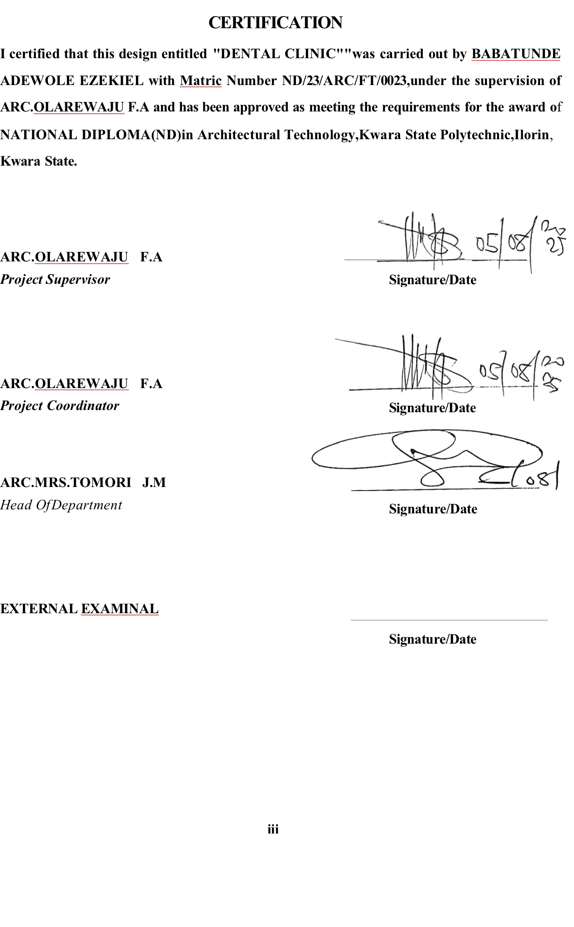
ACKNOWLEDGEMENTS
* ﻿﻿Everything that has beginning must have an end, l express my deepest gratitude to Almighty God for granting me the strength, wisdom, and perseverance to successfully complete this project. His guidance and blessings have been my greatest support throughout this journey.

* ﻿﻿I extend my heartfelt appreciation to my parents (MR.BABATUNDE PETER} and (MRS.BABATUNDE DASOLA) for their unwavering love, encouragement, and sacrifices. Their constant support and belief in me have been a source of motivation.

* ﻿﻿A very special thanks to my supervisor, ARC. MR.O.F. ADEYEMI), for their invaluable guidance, patience, and constructive feedback. Their expertise and mentorship have played a crucial role in shaping this project, and I am truly grateful for their support.

* ﻿﻿I would also like to thank my lecturers, and mentors for their invaluable guidance, constructive feedback, and knowledge that have contributed immensely to my growth in architecture.

* My sincere appreciation goes to my friends and colleagues who have provided encouragement, advice, and companionship throughout this project. Their support has made this experience more fulfilling.
DEDICATION
Dedicate this project to Almighty God, the source of my wisdom, strength, and inspiration. His grace has guided me through every challenge, and His blessings have made this achievement possible. and l also to my beloved parents, MR.BABATUNDE PETER and MRS.BABATUNDE DASOLA. Whose unwavering love, sacrifices, and support have been my greatest motivation. Their prayers, encouragement, and guidance have shaped me into the person I am today.
This project is a testament to their endless efforts and belief in my dreams.
ABSTRACT
This project report focuses on the architectural design of a modern dental clinic, developed to provide a functional and efficient healthcare facility that meets the oral health needs of the community. The aim of the project is to create a conducive environment that supports effective dental care delivery, while also ensuring comfort, safety, and hygiene for both patients and staff.

TABLE OF CONTENTS
TITLE PAGE…………………………………………………………………..........i
DECLERATION………………………………………………………………...…. ii
CERTIFICATION………………………………………………………………….. iii
ACKNOLEDGMENT……………………………………………………………… iv
DEDICATION……………………………………………………………………… v
ABSTRACT……………………………………………………………………...…. vi
TABLE OF CONTENTS…………………………………………………………… vii
LIST OF PLATES……………………………………………………………….…. x
LIST OF FIGURES………………………………………………………………… xi
LIST OF TABLES………………………………………………………………… xii
LIST OF APPENDICES…………………………………………………………….xiii
CHAPTER ONE
1.0 INTRODUCTION………………………………….………….………………………1
1.1 HISTORICAL BACKGROUND…………………………….………………..………2
1.2 DEFINITION…………………………….…………………….…...…………………3
1.3 STATEMENT O F THE RESEARCH PROBLEM. ………………………………….3
1.4 AIM AND OBJECTIVES………………………………………..………………..…..3
1.5 JUSTIFICATION………………………………………………………………….…..4
1.6 SCOPE OF STUDY………………………………………………………………..…4
1.7 LIMITATIONS OF STUDY………………………………………………………..…4
1.8 RESEARCH METHODOLOGY…………………………………………………...…5

CHAPTER TWO

2.1 LITERATURE REVIEW …………………………….…………………………………. 6
2.1.1 INTRODUCTION………………………………………………………………………...6
2.1.2 IMPORTANT ISSUES AND PROBLEMS PECULIAR TO DENTAL CLINIC TYPOLOGY………………………………………………………………………....7
2.1.3 TECHNOLOGICAL AND ENVIRONMENTAL APPROACHES FOR DESIGNING A DENTAL CLINIC……………………………...……………………………….………..8
2.2 MERIT OF STUDYING……………………………………………………….…10
2.3 CONCLUSION ………………………………………………………………….10

CHAPTER THREE
3.0 CASE STUDY……………………………………………………………….….…. 11
3.1 OUTLINES OF THE CASE STUDIES……………………………...…...…….…..11
3.1.1 CASE STUDY ONE (1): Choice Hospital Dental Clinic Lagos………….……….11
3.1.2 CASE STUDY TWO (2): Emirate Dental Clinic Ilorin …………………………...16

CHAPTER FOUR
4.1 ANALYTICAL STUDY OF THE PROJECT LOCATION…………………………24
4.1.1 INTRODUCTION…………………………………………………………………….24
4.1.2 SITE LOCATION…………………………………………………………………….24
4.1.3 SITE INVENTORY…………..…...…………………………………………………26
4.1.4 SITE ANALYSIS………………...…………………………………………………..26
4.1.5 GENERAL GEOGRAPHICAL CONDITION…………………….……………..….27
4.1.6 CLIMATE …………………………………………………………………………………...27
4.1.7 VEGETATION………………...………………………………………………..…..29
4.1.8 TOPOGRAPHY………………...……………………………………………… …..29
4.1.9 NATURAL RESOURCES………………...…………………………………….… 29
4.1.10 ENVIRONMENTAL CHALLENGES…………………………………………… ..29
4.1.11 SITE SERVICES………………………………………………………………… …30
4.1.12 SITE UNIQUENESS AND BENEFIT………………………………………………30
4.1.13 SITE SUITABILITY……………………………………………………………….30
4.2. DESIGN CRITERIA……………………………………………………………….30
4.2.1 SITE SELECTION………………………………………………………...……….30
4.2.2 BUILDING ARRANGEMENT…………………………………………………….31
4.2.3 DESIGN SCOPE…………………………………………...……………………….31
4.2.4 DESIGN BRIEF 9ANALYSIS…………………………………………………….31
4.2.5 SPACES DERIVATION ANALYSIS/SCHEDULE FOR ADMINBLOCK………32
4.2.6 FUCTIONAL ANALYSIS AND RELATIONSHIP………………………………32

CHAPTER FIVE
5.1 APPRAISAL OF PROPOSED SCHEME………………………………………….34
5.2 CONSTRUCTION METHODOLOGY AND MATERIALS. …………………….34
5.21 MATERIALS FOR CONSTRUCTION……………………………………………34
5.2.2 CONSTRUCTION METHODOLOGIES………………………………………….34
5.2.1 SERVICE……………………………………………………………………….….36
5.2.2 CIRCULATION……………………………….……………………………….….36
5.2.3 VENTILATION……………………………………….……………………….….36
5.2.4 LIGHTING……………………………………….……………………………….37
5.2.5 PLUMBING ……………………………………….……………….…………….37
5.2.6 ELECTRICAL INSTALLATION……………………………..………………….37
5.2.7 WASTE DISPOSAL……………………………………….…….……………….37
5.2.8 FIRE PROTECTION……………………………………………………………..38
5.2.9 EXTERNAL WORKS……………………………………………..……………..38
5.3 CONCLUSION AND RECOMMENDATION………………………………….38
REFERENCES………………………………………………………………………….39

LIST OF PLATES
CASE STUDY 1

PLATE 3:1.1 LOCATION MAP…..……………………………………………………….13
PLATE 3.1.2 SITE PLAN………………………………………………………………….14
PLATE 3.1.3 FLOOR PLAN……………………………………………………………….15
PLATE 3.1.4 ELEVATION …………….……………………………………...………….15

CASE STUDY 2

PLATE 3.2.1 ELEVATION………………..……………………………………………18
PLATE 3.2.2 SITE PLAN… ……………………………………………………………18
PLATE 3.2.3 FLOOR PLAN……………………………………………………………19
PLATE 3.2.4 ELEVATION …………………………………………………………….19

LIST OF FIGURES

FIGURE 3:1:1 LOCATION PLAN CASE STUDY 1…………………………..………12
FIGURE 3.1.2 FLOOR PLANS CASE STUDY 1…….……………………………..…13
FIGURE 3:1.3 SITE PLAN CASE STUDY 1 ……………………...…………….……14
FIGURE 3.2.1 LOCATION PLAN CASE STUDY 2…………………………………15
FIGURE 3.2.2 FLOOR PLANS CASE STUDY 2………………………………….…15
FIGURE 3.3.1 LOCATION PLAN CASE STUDY 3…………………………….……20
FIGURE 3.3.2 FLOOR PLAN. CASE STUDY 3…………………..……………….…21
FIGURE 4.1.11.1 MAP OF NIGERIA, 36 STATES AND FCT. ……………..………24
FIGURE 4.1.11.2 KWARA STATE MAP…………………………………..…………25
FIGURE 4.1.11.1 LOCATION PLAN …………………………………..………….…25
FIGURE 4.1.12.1 SITE INVENTORY …………………………………….……….…26
FIGURE 4.1.12.2 SITE ANALYSIS ……………………………..………..……….…27
FIGURE 4.1.3.1 AVERAGE MONTHLY RAINFALL IN ILORIN. …….….………28
FIGURE 4.1.3.2 SUNSHINE DURATION IN ILORIN. ………………………..……28
FIGURE 4.1.3.3 RELATIVE HUMIDITY IN ILORIN. ………………………..……29
FIGURE 4.2.6.1: FUNCTIONAL ANALYSIS ………………………………….…32
FIGURE 4.2.6.2: FUNCTIONAL RELATIONSHIP……………………………….…33

LIST OF TABLES

TABLE 4.2.5: SPACE ALLOCATION………………………………………………32

LIST OF APPENDICES
APPENDICES 5.1: FLOOR PLAN……………………………………..………………..40
APPENDICES 5.2: ROOF PLAN ………………………………………………………..41
APPENDICES 5.3: SITE PLAN……………………………………………………..…..42
APPENDICES 5.4: SECTIONS……………………………………………………..…..42
APPENDICES 5.5: ELEVATION……………………………………………….…..…..43
APPENDICES 5.6: EXTERNAL PERSPECTIVE. ………………………………………43

CHAPTER ONE
INTRODUCTION TO DENTAL CLINIC
Oral health is an essential component of general health and well-being. Dental diseases such as tooth decay, gum infections, and oral cancers are among the most common non-communicable diseases globally, affecting individuals across all age groups. Despite the increasing demand for dental care services in Nigeria, there remains a shortage of well-planned, accessible, and hygienic dental care facilities—especially those that adhere to modern architectural and healthcare standards.
This project presents the architectural design of a contemporary dental clinic, developed to address the need for a functional, efficient, and patient-friendly dental healthcare environment. The project aims to bridge the gap between clinical functionality and architectural aesthetics, creating a space that not only supports professional dental services but also promotes a positive experience for patients.
The proposed design considers the full range of services typically offered in a modern dental clinic. These include dental consultation, oral examinations, diagnostics (such as X-rays), preventive care, basic and advanced treatments, surgical interventions, sterilization procedures, and administrative operations. To achieve this, the spatial arrangement of the clinic is carefully zoned to separate public areas from clinical and staff-only spaces, ensuring smooth patient flow and minimizing the risk of cross-infection.

1.1 HISTORICAL BACKGROUND OF THE PROJECT
The evolution of dental care has undergone significant transformation over the centuries, from rudimentary tooth extraction practices to advanced, technology-driven oral healthcare systems. Historically, dental treatment was often carried out by barbers and general physicians, and dental facilities were rarely designed with specialized architectural requirements in mind. However, as medical knowledge expanded and awareness of oral hygiene improved, the need for dedicated dental professionals and purpose-built clinics emerged.
In Nigeria, dental health was not a major focus in the early years of healthcare development. Traditional methods of tooth extraction and herbal remedies were widely used across communities. It wasn’t until the colonial era and post-independence that dental care began to be formalized, with the establishment of dental departments in teaching hospitals and the introduction of professional dental education. Over time, dental clinics began to appear in public hospitals and urban private healthcare facilities.
Despite these advancements, the architectural design of many dental clinics in Nigeria has remained basic and often substandard. Many existing facilities lack proper zoning, hygienic sterilization areas, adequate ventilation, and patient comfort considerations. Furthermore, few clinics are designed with accessibility features or infection control layouts that align with international standards. This has led to overcrowding, poor patient experience, and inefficient service delivery.
The current project is conceptualized to address these challenges by proposing the design of a modern dental clinic that meets contemporary architectural and medical standards. It is envisioned as a facility that prioritizes patient-centered care, safety, operational efficiency, and sustainability. The project is a response to the increasing demand for specialized healthcare infrastructure in Nigeria, particularly in growing urban areas such as Ilorin, Lagos, and Abuja.
This proposed dental clinic is part of the broader effort to upgrade healthcare delivery in Nigeria through architectural innovation and thoughtful space planning. It reflects the transition from traditional and improvised healthcare settings to purpose-built, professionally designed facilities that support quality service delivery. The historical significance of this project lies in its role in shaping the future of oral healthcare through architecture—by creating a facility that not only meets today’s needs but also anticipates the future demands of dental care.

1.2 DEFINITION
A dental clinic is a healthcare facility that provides services for the prevention, diagnosis, treatment, and management of oral health issues. It is staffed by dental professionals, including dentists, hygienists, and assistants, who offer a range of services such as routine checkups, cleanings, fillings, extractions, orthodontic treatments, and more.
1.3 STATEMENT O F THE RESEARCH PROBLEM.
Many existing dental clinics in Ilorin are constrained by poor layout planning, inadequate waiting and consulting spaces, insufficient ventilation, lack of privacy and absence of modern digital systems for patient data and queue management. These issues compromise service delivery, increase patient wait times, and reduce staff efficiency.
There is a need for a new kind of dental clinic — one that is accessible, technologically equipped, and spatially optimized to deliver safe and efficient oral healthcare services in a conductive environment.
1.4 AIM AND OBJECTIVES
1.3.1 AIM OF THE STUDY
The aim of this project is to design a modern, functional and sustainable dental clinic that provide high-quality, comprehensive and enhance patient satisfaction and contributes positively to the community's well-being
1.3.2 OBJECTIVES
- To ensure that the architectural design supports a clean, calm, and welcoming healthcare environment for both patients and staff.
- To create functional spaces that meet the clinical and operational needs of a modern dental clinic.
- To prioritize the use of natural lighting and cross ventilation for energy efficiency, hygiene, and user comfort.
- To propose a flexible and accessible design that meets the needs of all users.

1.5 JUSTIFICATION.
Many communities face disparities in access to dental care, leading to untreated dental issues and poor oral health outcomes. This is to justify and identify specific barriers to access and propose solutions to improve service delivery in underserved populations, at akerebiata Ilorin.

1.6 SCOPE OF THE STUDY
The proposed dental clinic is to be designed as a modern, purpose-built facility that focuses on delivering efficient oral healthcare services within a functional and hygienic environment. The study covers the planning and architectural design of core spaces such as reception areas, consulting rooms, sterilization units, X-ray rooms, and staff areas. It also explores how healthcare standards, patient comfort, and sustainable design principles can be integrated.

1.7 LIMITATIONS OF STUDY
The limitations experienced during this course of study include:
- Time constraints limited the number of physical case studies that could be visited.
- Access to detailed health facility regulations was partially restricted.
- Budgetary concerns for full digital system implementation were assumed, not actualized.

1.8 RESEARCH METHODOLOGY
In order to archive a well-functioning and organization farmstead and to know what the farmer need; the research was done.
- Case Studies: Existing dental clinics were visited to evaluate their spatial organization, design merits, and operational challenges.
- Literature Review: Relevant architectural texts and healthcare design manuals were consulted to understand the spatial, technical, and functional requirements of dental facilities.
- Internet Research: Online platforms were used to explore modern dental clinic designs globally, with emphasis on digital integration and user-centered layouts.
- Personal Observation: Direct site visits and informal interviews were conducted to observe real-life clinic operations, document activities, and gather user feedback for informed design decisions.

CHAPTER TWO
2.1LITERATURE REVIEW
2.1.1 Introduction
The design and operation of dental clinics have been the subject of growing academic interest across fields such as public health, architecture, environmental psychology, and medical technology. Dental clinics are not merely treatment spaces—they are therapeutic environments that require careful integration of function, hygiene, comfort, and aesthetics. A well-designed dental clinic enhances patient experience, improves staff workflow, and ensures compliance with strict healthcare standards.

Several researchers have examined the correlation between spatial planning and clinical efficiency in healthcare facilities. According to Ulrich et al. (2008), the physical environment of a healthcare space significantly influences patient outcomes, including stress reduction and satisfaction. In the context of dental clinics, this is particularly relevant, as dental anxiety is a widely reported barrier to oral healthcare access. This highlights the need for clinics that prioritize patient-centered design.

2.1.2 IMPORTANT ISSUES AND PROBLEMS PECULIAR TO DENTAL CLINIC TYPOLOGY
1. Variants of the Building Type

Dental clinic designs can vary significantly depending on their scale, function, ownership, and location. These differences directly affect the design approach, spatial planning, and technological integration.

- PRIVATE VS. PUBLIC DENTAL CLINICS

Private Clinics
- Design Focus: Emphasis on patient comfort, aesthetics, and personalized services.
- Scale: Typically smaller, with 2–4 treatment rooms.
- Flexibility: Greater freedom in spatial layout, design style, and digital system integration.
- Limitations: May lack advanced surgical facilities due to space or budget constraints.

Public or Teaching Clinics
- Design Focus: Efficiency, high capacity, and compliance with government standards.
- Scale: Larger, with multiple consulting rooms, teaching spaces, and diagnostic units.
- Zoning Needs: Clear separation of clinical, academic, and administrative functions.
- Challenges: Overcrowding, complex circulation, and high maintenance demand.

- STAND-ALONE VS. HOSPITAL-BASED CLINICS

Stand-Alone Clinics
- Operate independently, typically located in residential or commercial areas.
- Require full administrative, sterilization, and emergency systems within the same facility.
- Greater emphasis on outpatient flow and street-level accessibility.

Hospital-Based Dental Clinics
- Function as a department within a general hospital.
- Share central facilities such as laboratories, records, and emergency services.
- Design must accommodate multidisciplinary interaction and compliance with hospital-wide standards.

2. Environmental and Contextual Issues

- URBAN CLINICS
- Space Limitations: Clinics located in urban centers often struggle with compact sites.
- External Noise: Proximity to busy roads affects patient comfort.
- Parking and Access: Limited space for vehicle access and drop-off.

- Rural or Semi-Urban Clinics
- Infrastructure Gaps: Poor access to electricity, water, or waste disposal services.
- Material Availability: Limited options for hygienic, durable building materials.

2.1.3 TECHNOLOGICAL AND ENVIRONMENTAL APPROACHES FOR DESIGNING A DENTAL CLINIC.
Designing a modern dental clinic requires an integrated approach that leverages both technological innovations and environmentally sustainable strategies. These approaches not only enhance the efficiency and functionality of the clinic but also improve patient experience, reduce operational costs, and promote environmental stewardship.
- TECHNOLOGICAL APPROACHES
1.1 Digital Integration and Health Management Systems
- Electronic Medical Records (EMR): A centralized, secure system for storing and retrieving patient data, improving record accuracy and minimizing paperwork.
- Automated Appointment Systems: Use of digital scheduling software to manage bookings, send reminders, and reduce patient wait times.
- Patient Self-Check-In Kiosks: Touchscreen kiosks can streamline patient registration and reduce front desk congestion.
- Dental Imaging Systems: Integration of digital X-rays, intraoral cameras, and 3D imaging (CBCT) improves diagnostic accuracy and patient communication.

1.2 IT and Communication Infrastructure
- High-Speed Internet: Essential for cloud-based record systems, real-time consultation, and digital imaging.
- Intranet Systems: For internal communication between departments (e.g., reception to lab or sterilization room).
- Secure Network and Backup Systems: Ensuring data security, confidentiality, and recovery in case of system failure.

1.3 Smart Clinic Features
- Automated Lighting and HVAC Controls: Motion or schedule-based systems to reduce energy waste.
- Voice-Activated Assistants and Touchless Controls: For improved hygiene and workflow in treatment areas.
- Central Display Monitors: Used in consulting rooms for treatment planning, patient education, and real-time imaging display.

- ENVIRONMENTAL APPROACHES
2.1 Sustainable Building Design
- Passive Cooling and Cross Ventilation: Oriented window openings, openable clerestory windows, and ventilated roofing help reduce reliance on mechanical cooling systems.
- Natural Daylighting: Maximize use of daylight through skylights and wide glazed surfaces, particularly in waiting and circulation areas.
- Thermal Insulation: Use of insulated roofing materials and cavity walls to reduce indoor temperature fluctuation and cooling load.

2.2 Renewable Energy Integration
- Solar Power Systems: Rooftop solar panels can supply energy for lighting, computers, and low-power devices, reducing utility costs and environmental impact.
- Solar Water Heaters: Used for handwashing stations and sterilization rooms.

2.3 Water Conservation Strategies
- Rainwater Harvesting: Captured rainwater can be reused for landscaping, flushing toilets, and exterior cleaning.
- Low-Flow Fixtures: Faucets, toilets, and dental unit water lines fitted with flow restrictors to reduce consumption.
- Greywater Recycling: Where feasible, wastewater from handwash sinks can be filtered and reused for toilet flushing.

2.4 Waste Management
- Segregated Waste Bins: For proper sorting of general, infectious, and sharp wastes in compliance with medical regulations.
- Sharps Disposal Units and Incinerator Access: Essential for hygienic and legal disposal of contaminated waste.
- Digital Communication: Reduces reliance on paper through electronic prescriptions, digital referrals, and online reporting.

3. Landscape And Environmental Enhancement
- Healing Gardens and Outdoor Waiting Spaces: Landscaped zones with shade trees, benches, and greenery provide a calming atmosphere for patients.
- Green Roof or Wall Options: Improve insulation and promote biodiversity in dense urban areas.
- Permeable Paving and Drainage Design: Enhances stormwater management and reduces surface runoff around the site.

4. Cultural and Community Considerations
- Accessible and Inclusive Design: Ramps, wide corridors, and signage to accommodate all users, including the elderly and physically challenged.
- Locally Sourced Materials: Use of indigenous materials for walls, ceilings, and finishes to promote local economy and reduce environmental impact.
- Community Engagement: Involving staff and community health workers during planning helps tailor design to real user needs, ensuring the clinic serves the population effectively.

CHAPTER THREE

3.0 CASE STUDY
A case study involves an up-close, in-depth, and detailed examination of a particular case or cases, within a real-world context. Case study research is to establish a firm research focus to which the research can refer over the course of a complex phenomenon or object.
Case study can be view as the study of an existing project for a reference purpose in order to determine adjustment point of that particular building. Case study research is to establish a firm research focus to which the research can refer over the course of a complex phenomenon or object.
According to researcher Robert K. Yin, defined case study method as an empirical inquiry that investigate a contemporary phenomenon within its real-life context,

3.1 OUTLINES OF THE CASE STUDIES
1. Choice Hospital Dental Clinic Lagos
2. Emirate Dental Clinic Ilorin.

3.1.1 CASE STUDY ONE (1): Choice Hospital Dental Clinic Lagos
Date of Establishment: 1966
Architect: Unknown
Location: Lagos State.

Brief Description:
Choice Hospital Dental Clinic is a dedicated dental care unit within the larger Choice Multispecialist Hospital located in Lekki, Lagos State, Nigeria. The dental clinic offers a variety of oral healthcare services, including general dentistry, pediatric dentistry, oral surgery, cosmetic dental procedures, orthodontics, and dental radiology. It serves both walk-in patients and referrals from other departments within the hospital.

Merits:
- Integration with a Multispecialist Hospital:
- Patients benefit from access to a wide range of medical services beyond dental care, allowing for holistic treatment, especially for cases that involve other health conditions.
- Trained Dental Professionals:
- The clinic is staffed by qualified and experienced dental practitioners who handle various specialties, from preventive care to advanced surgery.

- Basic Imaging and Diagnostic Equipment:
- Equipped with essential tools for dental diagnosis such as intraoral cameras, X-ray systems, and sterilization units.

Demerits:
- Limited Space:
- The dental unit is part of a general hospital, so it may not offer as much space or specialized dental infrastructure as a standalone advanced dental clinic.

- Lack of Advanced Cosmetic Technology:
- While basic services are available, advanced cosmetic dental procedures or high-end orthodontics may be limited or referred to other facilities.

- Urban-Centered Access
- The clinic’s services are limited to residents of the Lekki area or those who can afford transportation and treatment in an urban hospital.

LOCATION PLAN
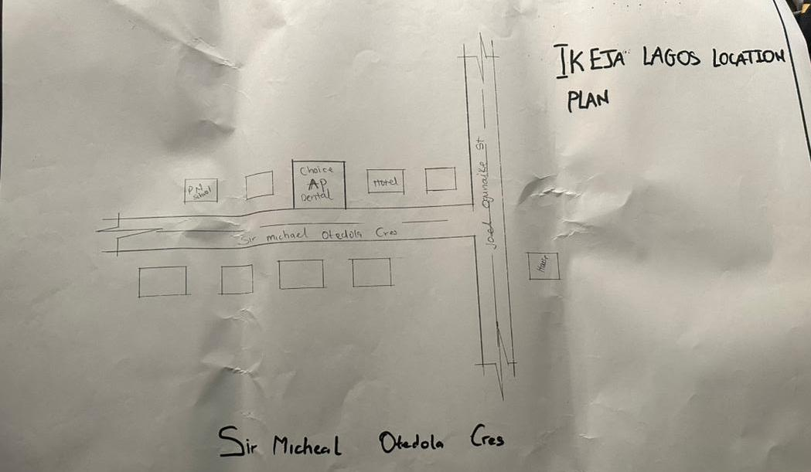Figure 3:1:1 Location Plan
SITE PLAN
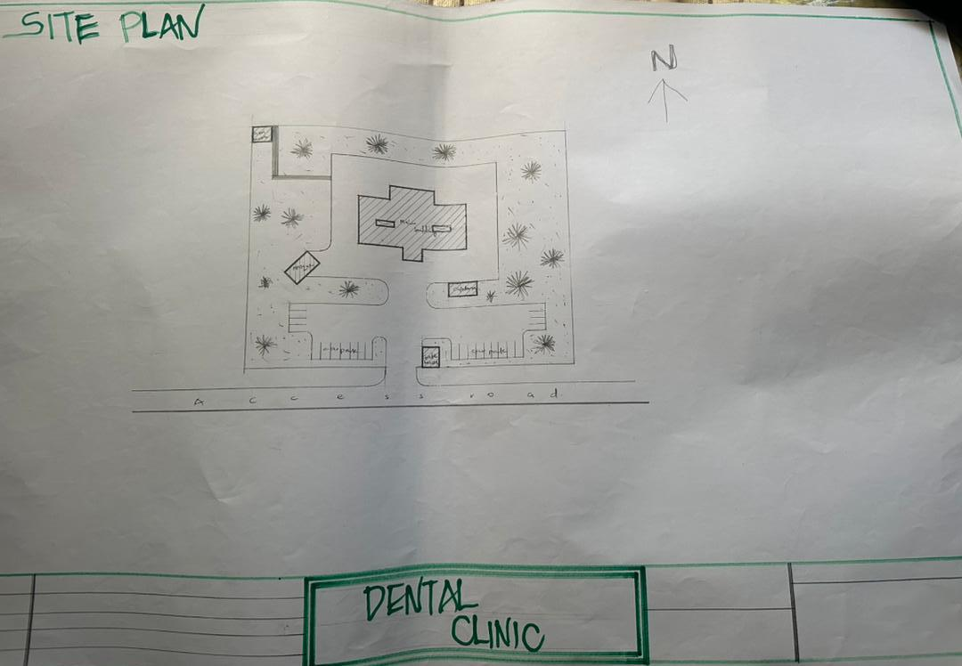
Figure 3.1.2Site Plan
FLOOR PLAN
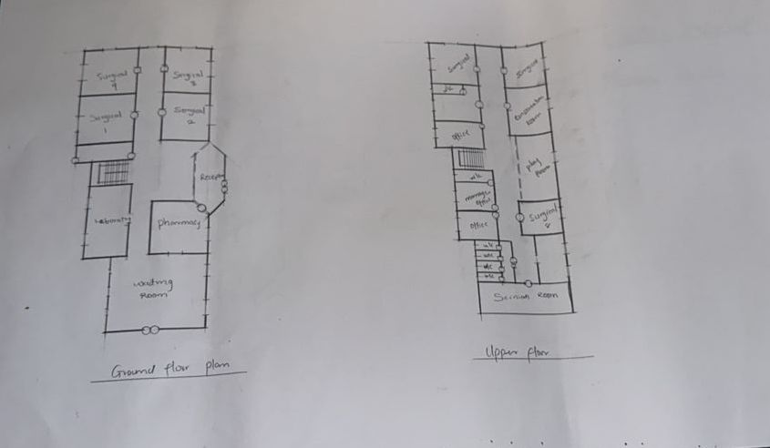
Figure 3:1.3Floor Plan
PICTURES
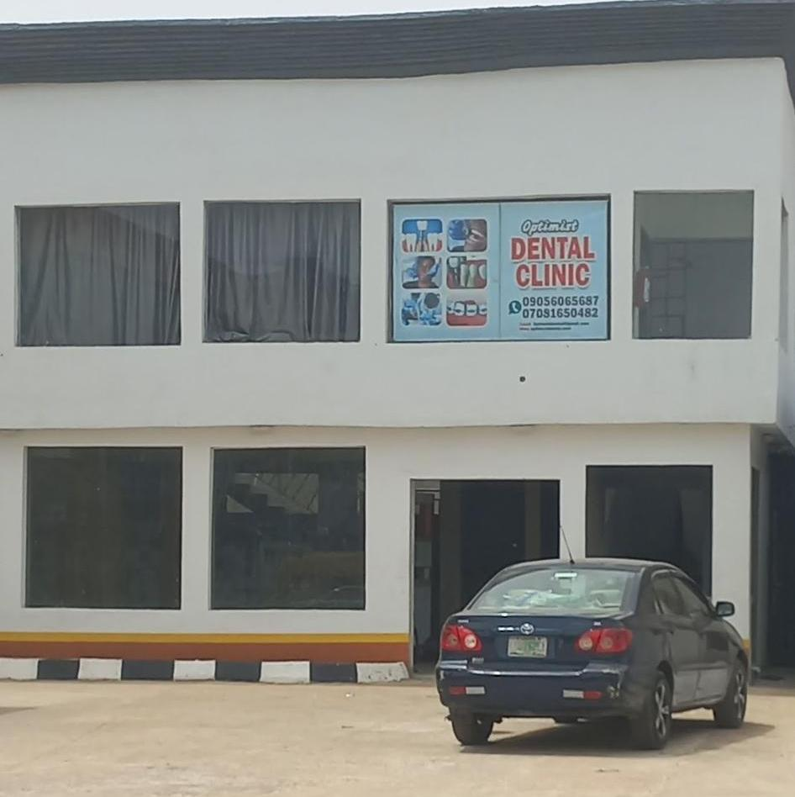
Plate 3.1.2Elevation

3.1.2 CASE STUDY TWO (2): Emirate Dental Clinic Ilorin Kwara State.
Date of Establishment:
Architect: Unknown
Location: Kwara State.

Brief Description:
Emirate Dental Clinic is a privately-owned dental care facility located in Ilorin, the capital of Kwara State, Nigeria. Positioned within a developing urban area, the clinic serves a wide range of patients from Ilorin and neighboring towns. It focuses on providing affordable and professional oral healthcare services including dental check-ups, scaling and polishing, tooth extraction, fillings, teeth whitening, and treatment of gum diseases.

Merits
- Community Accessibility:
- Easily accessible for local residents, reducing the need to travel long distances for basic dental care.

- Affordable Services:
- Offers cost-effective treatment, especially for low and middle-income earners, making it suitable for students, workers, and families.

- Personalized Attention:
- Due to its smaller scale, patients often receive one-on-one care and follow-up, enhancing trust and satisfaction.

Demerits
- Limited Equipment:
- May not have advanced diagnostic or treatment technology such as panoramic X-rays, orthodontic systems, or digital scanners.

- Space Constraints:
The clinic operates in a relatively small space, which could limit the number of patients seen per day and types of services offered.

- Few Specialists:
- The clinic may not have in-house specialists like orthodontists or oral surgeons, leading to external referrals for complex cases.

LOCATION PLAN
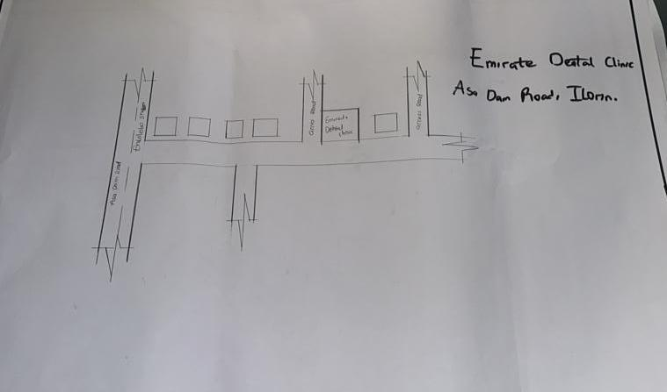Figure 3.2.1 Location Plan
SITE PLAN
FLOOR PLAN
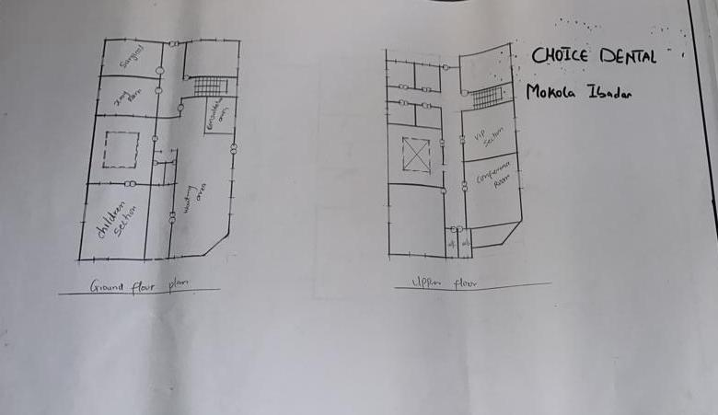
Figure 3.2.2 Floor Plans

PICTURES
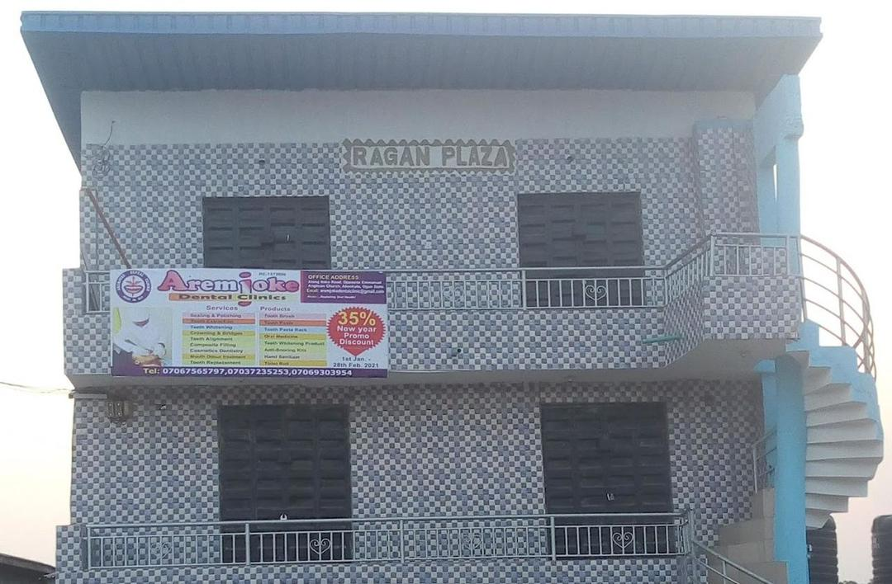
Plate 3.2.2 Elevation

CHAPTER FOUR
4.1 ANALYTICAL STUDY OF THE PROJECT LOCATION
4.1.1 INTRODUCTION
Ilorin is one of 36 states of federal of republic of Nigeria. Ilorin, the capital city of Kwara State, Nigeria, is a city with a rich historical, cultural, and economic background. Ilorin was founded in 1450 and has a significant historical legacy as a prominent center in the Yoruba and Fulani empires.
Ilorin is a city with a rich historical heritage and cultural diversity, serving as an economic and educational hub in Kwara State. Its strategic location, coupled with ongoing development efforts, positions it as a key city in Nigeria’s socio-economic landscape.

4.1.2 SITE LOCATION
This is very important point to be considered before establishing the setting of houses, should take advantage of topographical features speeds and directions should be studied to ensure the best orientation to take advantage of the prevailing wind.
Avoiding site prone to water logging and rain and draught which depends on wind direction and speed in the raining season placement of a building so that the length extends along the East and West direction.
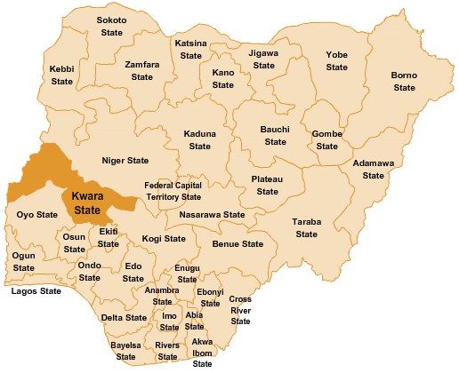
The proposed project is sited at Sobi Road Akerebiata Ilorin, Kwara State. It is surrounded with built up environment with various commercial activities being taken up in the area.

Figure 4.1.11.1 Map of Nigeria, 36 States and FCT.

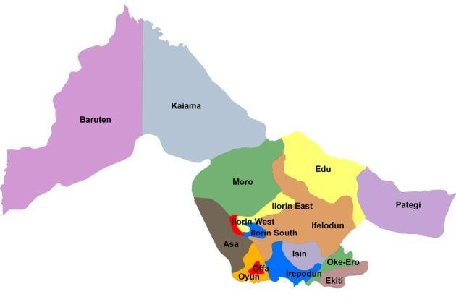

Figure 4.1.11.2 Kwara State Map

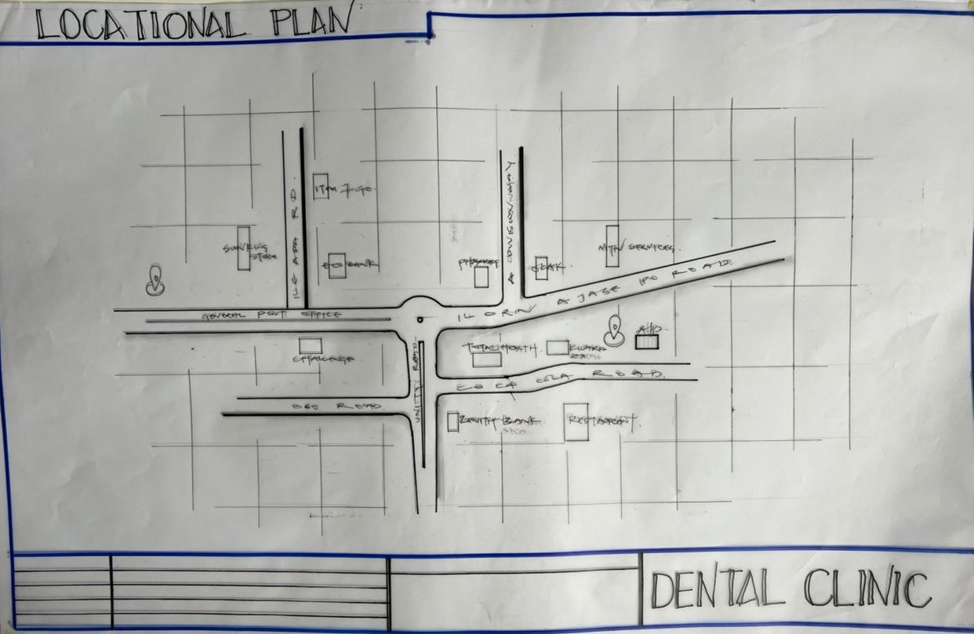
Figure 4.1.11.1 Location Plan

4.1.3 SITE INVENTORY
Site analysis is the synthesis of the physical feature and facilities that are present on the site and over the site such as trees, footpath, soil, topography, vegetation, stream and shrubs etc.

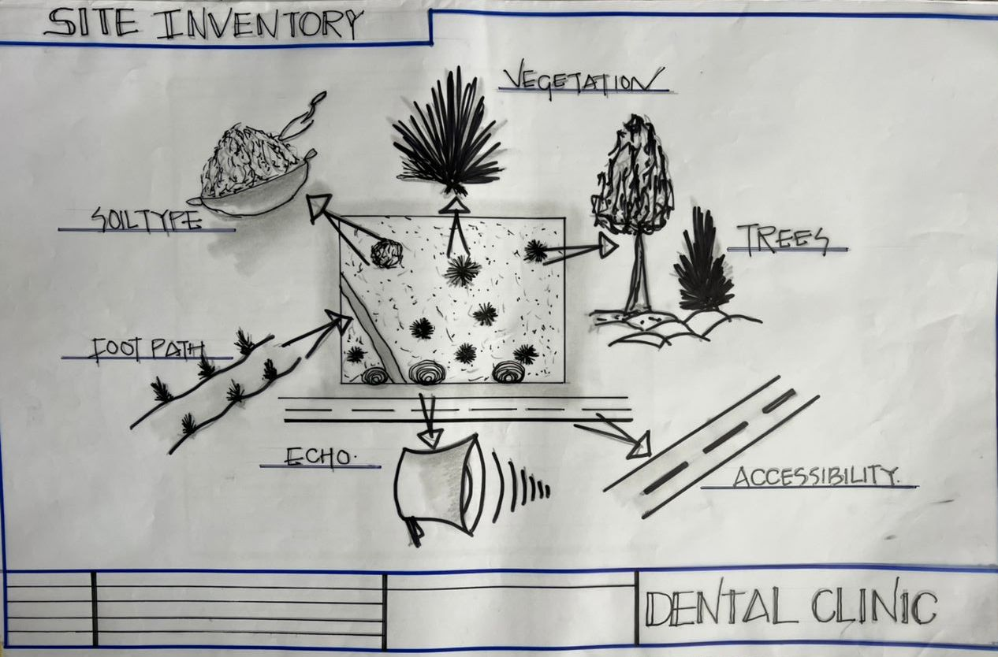
Figure 4.1.12.1 Site Inventory

4.1.4 SITE ANALYSIS
Site Analysis is the process of evaluating how a proposed site system will integrate with the existing site infrastructure by assessing physical obstructions, electrical interference, and noise to identify suitable interrogation zones for coexistence with the infrastructure.

The site selected for the project is a very gentle slope, it is a site that has never been used for any form of building construction i.e. it has not been developed in the past which make it an abode for several trees and shrubs, it is also observed during the course of inventory that some of the trees are to be removed as it could obstruct the construction process during the project, while some are to be retained to help control the adverse of the wind storm.

The soil is well compacted Soil in nature with good soil texture. The sun rises from the eastern part of the site and sets on the western part. The Construction does not need a special type of foundation due to the fact that the site is having a good bearing capacity and strength.
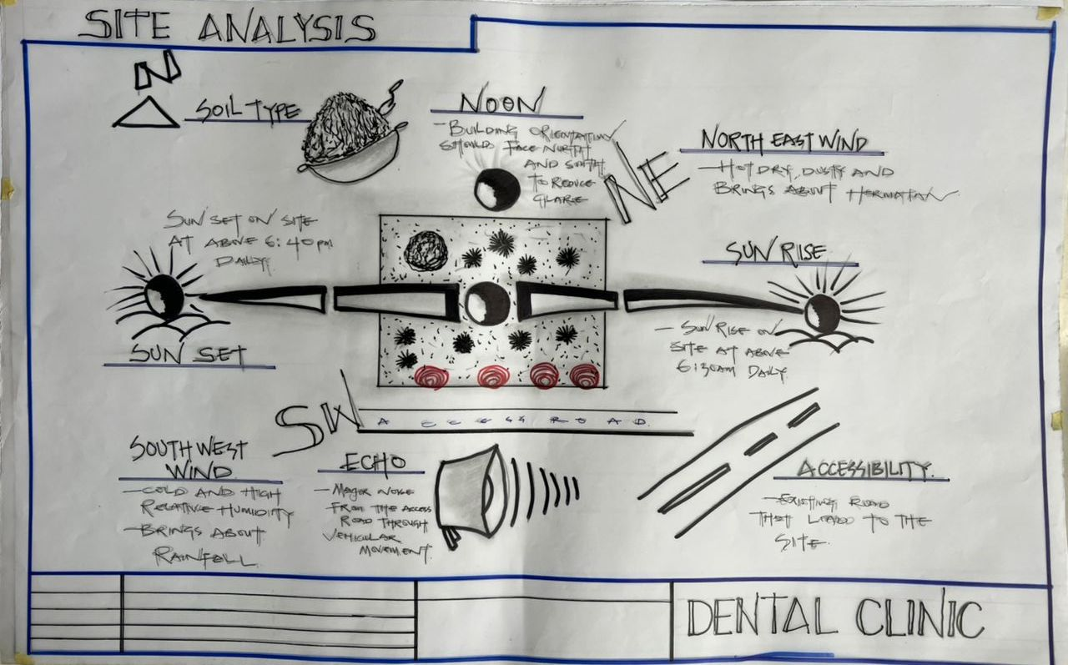
Figure 4.1.12.2 Site Analysis

4.1.5 GENERAL GEOGRAPHICAL CONDITION
Ilorin, the capital city of Kwara State, Nigeria, is characterized by specific geographical conditions that influence its climate, vegetation, and overall environmental features. Here's an overview of the general geographical conditions of Ilorin.
Ilorin is situated approximately at latitude 8.5°N and longitude 4.55°E. The city is positioned at an elevation of about 290 meters (951 feet) above sea level. Ilorin is centrally located in Nigeria, serving as a significant connection between the northern and southern parts of the country.

4.1.6 CLIMATE:
Tropical Savanna Climate: Ilorin experiences a tropical savanna climate (Aw according to the Köppen climate classification), characterized by distinct wet and dry seasons.
Temperature: Average temperatures in Ilorin range from 22°C (72°F) to 33°C (91°F). During the dry season, daytime temperatures can rise significantly, while nights are cooler, especially during Harmattan.

Rain Season: The wet season typically spans from April to October, with the heaviest rainfall occurring between June and September. Annual rainfall averages around 1,200 mm (47 inches).

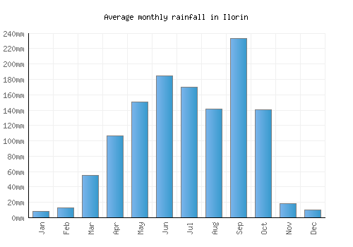

Figure 4.1.3.1 Average Monthly Rainfall in Ilorin.

Dry Season: The dry season lasts from November to March, marked by significantly lower humidity and occasional dust-laden winds from the Sahara Desert, known as Harmattan.

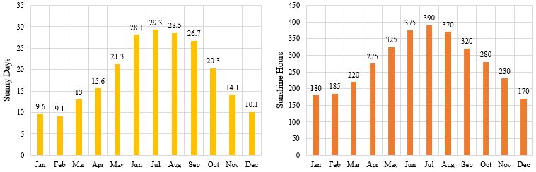

Figure 4.1.3.2 Sunshine Duration in Ilorin.

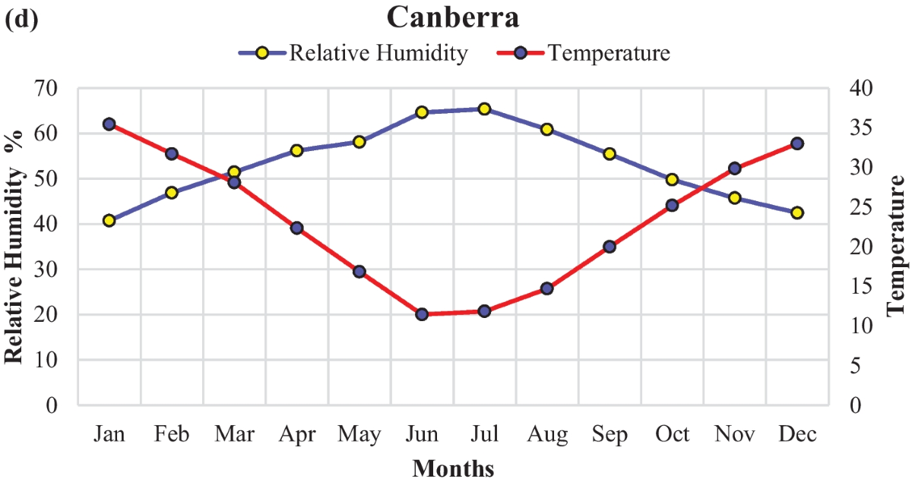

Figure 4.1.3.3 Relative Humidity in Ilorin.

4.1.7 VEGETATION
Guinea Savanna: The predominant vegetation type in Ilorin is the Guinea Savanna, characterized by a mix of grassland and scattered trees. This vegetation type is typical of the transitional zone between the forest regions in the south and the Sahel in the north.
Flora: Common plant species include acacia, baobab, shea butter trees, and various grasses and shrubs adapted to the savanna climate.

4.1.8 TOPOGRAPHY
Gently Undulating Plains: Ilorin's topography consists mainly of gently undulating plains, with occasional hills and low-lying areas.

4.1.9 NATURAL RESOURCES
Mineral Resources: Kwara State, including Ilorin, is endowed with various mineral resources such as limestone, gold, and kaolin. These resources offer potential for mining and related industries.

4.1.10 ENVIRONMENTAL CHALLENGES
Urbanization: Rapid urbanization in Ilorin has led to challenges such as deforestation, waste management issues, and pressure on infrastructure and services.
Climate Change: Like many regions, Ilorin faces the impacts of climate change, including variability in rainfall patterns and increased frequency of extreme weather even.

4.1.11 SITE SERVICES
There are good services around the site, which include good access road, for people coming to Dental Clinic, availability of electricity very close to the site which will be useful before and after construction. Also, availability of pipe born water at the chosen site.

4.1.12 SITE UNIQUENESS AND BENEFIT
- The site is accessible
- Natural factor like, is very useful
- Utility services such as water, electricity, telephone, etc. cause no problem to the inhabitants.

4.1.13 SITE SUITABILITY
The appropriateness or suitability of the site for the construction and planning of the proposed project is based on the fact that is possesses and meets the entire requirements. All the existing features were strictly considered with the intension of making advantage of them to maximum level most especially the geographical, topographical features of the site.
Types Of Forest Region
- Mangrove (Salt Quarter) Swamp Forest
- Fresh water swamp forest
- High forest

4.2. DESIGN CRITERIA
Planning is an important activity which determines the success of any endeavor. It is often said that without plans, purposes are frustrated, planning is the first and most important steps in designing a Dental Clinic, so as to achieve aims of designing and the criteria’s and should be take into consideration.

4.2.1 SITE SELECTION
A number of factors necessary for site selection for a farmstead are outlined below:
  - ﻿﻿﻿Access Road
  - ﻿﻿﻿Water
  - ﻿﻿﻿Utilizes and services (electricity, telephone, access drives etc.)
  - ﻿﻿﻿Orientation (air drainage and maximum sunshine may require orientation on a gentle Southerly slope).
  - ﻿﻿﻿Expansion.
4.2.2 BUILDING ARRANGEMENT
The arrangement of facilities for maximum efficiency of operation should be a prime concern. Proper arrangement increase efficiency by reducing walking distance to a minimum and providing adequate drive ways and turn around. It is important to note that five protections, safely and security and all influenced by the design planning.

4.2.3 DESIGN SCOPE
These are scope of designing a Dental Clinic which includes the followings;
Security House, Main Building, Mosque, Generator House, Park Lots.

4.2.4 DESIGN BRIEF9ANALYSIS
Entrance, Reception and Card Room, Waiting Area, Pharmacy, Therapy, Nurse Station, Dentist Office, Laboratory, Surgery Room, Recovery Room, Cosmetic, X-ray, Sterilization, Conference Room, Changing Room, Storage, Toilet, Exit.

4.2.5 SPACES DERIVATION ANALYSIS/SCHEDULE FOR ADMINBLOCK
S/N | SPACE | UNIT | LENGTH (M) | BREADTH (M) | AREA (M²)
 | Entrance | 1 | 6.0m | 2.0m | 12m²
 | CAO Room | 1 | 7.0m | 6.0m | 45m²
 | Reception/Waiting Room | 1 | 5.0m | 2.4m | 20m²
 | Nurse Station | 2 | 5.0m | 3.0m | 15m²
 | Injection Room | 1 | 5.0m | 3.0m | 15m²
 | Pharmacy | 2 | 5.0m | 3.0m | 15m²
 | Laboratory | 2 | 4.0m | 3.om | 12m²
 | Tooth Filling Truma | 1 | 5.0m | 5.0m | 25m²
 | X-Ray Room | 1 | 6.0m | 4.0m | 24m²
 | Ultra Room | 2 | 3.6m | 2.0m | 72m²
 | Inplawt Room | 2 | 2.7m | 1.5m | 8.1m
 | Laboratory | 1 | 4.2m | 3.0m | 12.6m
 | Toilet | 1 | 2.4m | 1.2m | 2.88m
 | Surgery | 3 | 4.2m | 4.2m | 52.92m
 | Toilet | 3 | 2.4m | 1.2m | 8.64m
 | Recovery | 2 | 4.2m | 3.6m | 30.24m
 | Toilet | 2 | 24.m | 1.2m | 5.76m
 | Cosmetic | 1 | 4.2m | 3.3m | 13.86m
 | Toilet | 1 | 2.4m | 1.2m | 2.88m
 | X-ray | 1 | 5.0m | 3.3m | 16.5m

Table 4.2.5: Space Allocation

4.2.6 FUCTIONAL ANALYSIS AND RELATIONSHIP
The Main Building plan is well function, the unit are so well related to each other,
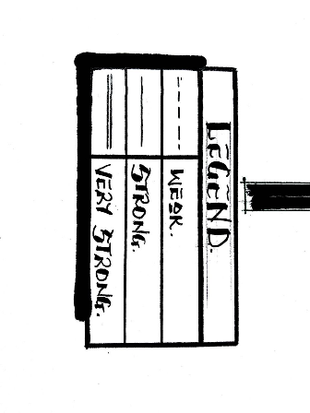
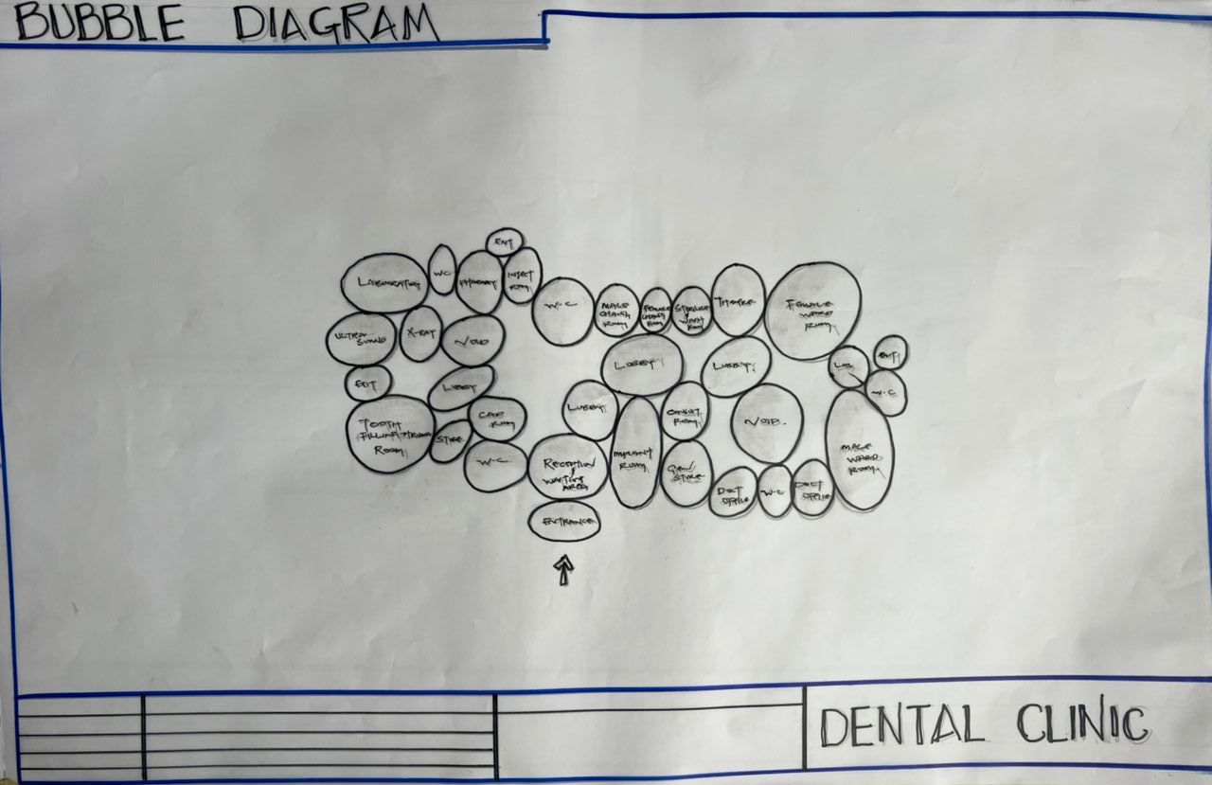
Figure 4.2.6.1: Bubble Diagram
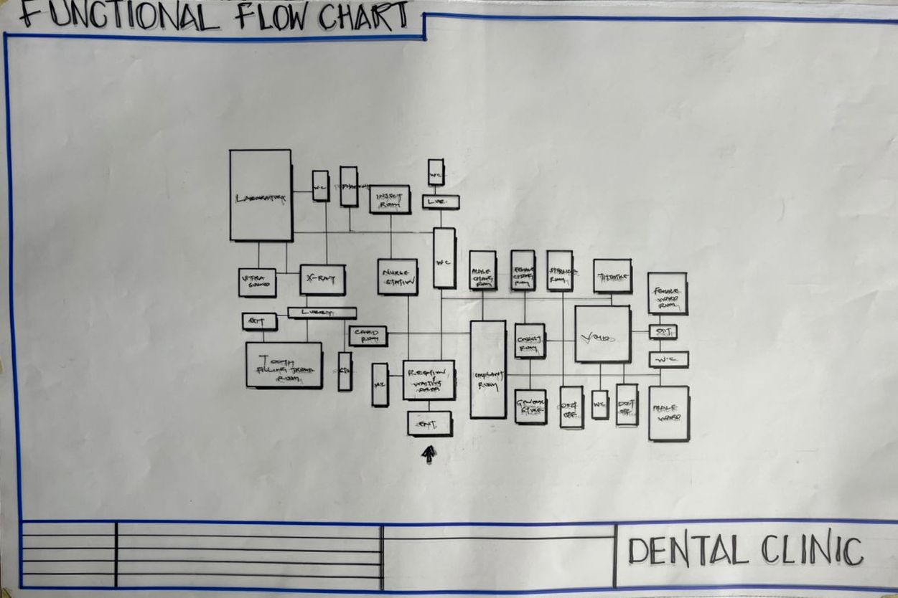

Figure 4.2.6.3: Functional Relationship

CHAPTER FIVE
5.1 APPRAISAL OF PROPOSED SCHEME
The proposed Project is to satisfy the appropriate building regulations. The design is to confirm the aid intended use of building taking into consideration with both natural factors and human factors that earn us a threat on the validity and stability of the building.

5.2 CONSTRUCTION METHODOLOGY AND MATERIALS.
The construction is to be carried out following the due process of construction ranging from:
- Preliminary: This involves the clearing of the site, setting out and excavation of foundation trench and foundation works.
- Sub-Structure: This process also entails the positioning and erection of Columns and beans, masonry works etc.
- Post Structure Stage: Is the stage which has to do with the application and installation of the paints, tiles, other finishes and construction of external works etc.

  - MATERIALS FOR CONSTRUCTION
- Sustainable and Eco-Friendly Materials
- Bamboo and Timber: Renewable and low-carbon materials, suitable for non-structural interior elements like ceiling finishes and decorative wall panels.
- Recycled Materials: Recycled steel, glass, and concrete will be considered to minimize environmental impact.
- Insulating Materials: Eco-friendly insulation such as cellulose or sheep wool may be used in walls and ceilings to enhance indoor thermal comfort.
- Traditional and Cultural Materials
- Clay and Adobe: Where applicable, these can be used in landscaping features or accent walls, reflecting cultural identity and promoting thermal comfort in hot climates.
- Stone: Locally sourced stone may be used for external cladding, boundary walls, or pathways to reflect cultural relevance and add durability.
- Tiles and Ceramics: Geometric ceramic tiles with Islamic patterns can be applied in interior decor, particularly in waiting areas, ablution spaces, and reception zones, for both aesthetic and cultural expression.
- Modern Materials
- Concrete: Reinforced concrete will be used for the main structural framework—foundations, slabs, beams, and columns—for strength and longevity.
- Steel: Steel will be used for reinforcement and roof framing, offering structural reliability and adaptability.
- Glass: Aluminum-framed windows with glazed panels will allow natural lighting while maintaining privacy and energy efficiency. Double-glazed options may be used in specific zones to enhance insulation and sound control.

    - CONSTRUCTION METHODOLOGIES
- Green Building Practices
- Passive Solar Design: The clinic is oriented to take advantage of natural sunlight and ventilation, reducing reliance on artificial lighting and cooling systems.
- Green Elements: Landscaping around the building and potential use of green wall features will enhance the environment, support insulation, and promote healing.
- Rainwater Harvesting: A system will be integrated to collect and reuse rainwater for landscaping and cleaning purposes, minimizing water waste.
2. Energy-Efficient Construction
- Thermal Insulation: High-performance insulation materials will be used in walls and roofing to reduce indoor temperature fluctuations and improve energy efficiency.
- LED Lighting: The building will utilize LED lighting for all spaces, ensuring long-term energy savings and low maintenance.
- Solar Energy: Solar panels may be installed to power essential services like lighting and ventilation, reducing dependency on grid electricity.
3. Cultural and Functional Considerations
- Building Orientation: The layout ensures proper orientation of designated prayer spaces towards Mecca, respecting religious needs.
- Islamic Architectural Features: The design may incorporate subtle Islamic elements such as arches, patterned screens, and courtyards, enhancing both identity and aesthetics.
- Community Engagement: Input from local stakeholders, healthcare workers, and community members will be considered to ensure the facility reflects cultural expectations and serves practical healthcare needs

5.2.1 SERVICE
A building can be said to be good when it performs the service required by it. In order to have well-functioning building. There calls for an installation of underground water pipes in other to provide water to all the restrooms and other necessary units in the building. A borehole system of water supply is to be adopted alongside the government supplied services and a storage facility is to be provided for effective management of water supply.

5.2.2 CIRCULATION
As a healthcare facility designed to serve a significant number of patients and staff daily, effective circulation within the proposed dental clinic is essential. The layout has been carefully planned to ensure smooth movement, reduce congestion, and maintain privacy where necessary.

The building is a single-story structure, making navigation easier and more accessible for all users, including the elderly and physically challenged. Public areas such as the reception, waiting area, and consultation rooms are positioned near the main entrance for easy access, while more private zones like treatment rooms, sterilization units, and staff offices are strategically placed to limit unnecessary traffic.

Clear separation between public, semi-public, and private spaces ensures a logical flow and enhances both functionality and hygiene control within the clinic.

5.2.3 VENTILATION
As it relates to architecture, is the intentional introduction of outside air into a space. It is mainly used to control indoor air quality by diluting and displacing indoor pollutants. It can also be used for purpose of thermal comfort of dehumidification when the introduction of outside air will help to achieve desired indoor psychometric condition.

This could be either mechanical or natural ventilation. As a regard the proposed project design, there is an introduction of a very spacious courtyard in other to make cross ventilation in most of the building units. There should also a provision of wide passage to allow free movement of air, patient and materials. Artificial ventilation is also provided through the installation of air conditioning system and fans.

5.2.4 LIGHTING
The dental clinic is designed to make use of both natural and artificial lighting. Large windows allow natural light into waiting and consultation areas, creating a calm and energy-efficient environment. Artificial lighting, using LED fixtures, is provided in all spaces—especially treatment rooms—ensuring clear visibility, safety, and compliance with healthcare standards.
5.2.5 PLUMBING
The plumbing system in this proposed building is made easy since the building has a courtyard. Water drained pipes are to be installed underground right from the courtyard to the soak away in other to discharge rainwater.

All water or sewage from the toilets are also channeled into their various inspection chambers using good and appropriate diameter PVC pipes, and taken from the inspection chamber to septic tank and soak away pit.

Rain water is also collected from gutter if the roof using 100mm diameter PVC rain water pipes and channeled into various drainage or soak away pits. There shall be no ponding; the size of any channel shall effectively discharge rain and water without causing any over lowing stagnation and mosquito breeding. All rain water channeled shall be laid to fall and shall not cause any pounding or splashing unto the committers neighboring area.

5.2.6 ELECTRICAL INSTALLATION
The type of wiring system chosen should be full conduit system of wiring. Office and other operation areas should be wired with strong, durable and light current resistance cable because of the careless operate by the students. Also, electrical installation is to be done to allow for the use of quality electrical fittings and fixtures in the whole building.

5.2.7 WASTE DISPOSAL
Waste disposal bins are to put every office of the building and also in some specific necessary area. These water bins should dispose in the incinerator which will be provided within the compound of the station. The waste should therefore be burnt in the incinerator.

5.2.8 FIRE PROTECTION
Electrically, fire alarms and sensors are to be installed in the Dental Building. This should be done in case of fire occurrence; fire extinguisher is to be placed at certain distances in the cobbles and some other necessary area. It is also serving as protector in case of fire.

5.2.9 EXTERNAL WORKS
The external works are to be carned out uncrate Krebs laid and shrubs, flowers grasses and trees planted.
Concrete interlocking tiles to be adopted of hard landscape and parking spaces both for visitors and staffs have been provided on the site.

  - CONCLUSION AND RECOMMENDATION
Conclusion
This project was undertaken to design a modern, functional, and sustainable dental clinic that meets the needs of patients and dental professionals alike. Through critical literature review, site analysis, and case study exploration, the design addressed challenges such as poor spatial organization, lack of comfort, infection control, and operational inefficiencies common in existing clinics.
The proposed clinic achieves clear spatial zoning, ease of movement, natural lighting, and integration of technology to enhance service delivery and patient experience. Environmental considerations such as passive ventilation, daylighting, and noise control were embedded in the design. In addition, attention was given to hygiene, accessibility, and regulatory compliance—core requirements for any healthcare facility.

Ultimately, this design proposal represents an academic contribution toward improving healthcare architecture in Nigeria, especially in the area of dental care delivery.
Recommendation
Based on the findings and experiences throughout this project, the following recommendations are made:
- Future dental clinics should be purpose-built with architectural input from the earliest planning stage, rather than converting residential spaces.
- Architects and health professionals should collaborate closely to ensure functional efficiency and regulatory compliance in design.
- Universal accessibility features (e.g., ramps, handrails, signage) must be included as standard in all healthcare facilities.
- Sustainable design strategies should be applied to reduce energy consumption and long-term maintenance costs.
- Further research should be done on the psychological effect of spatial design on dental patients, especially children and people with dental anxiety.
- Government and private developers should invest more in the modernization and expansion of oral healthcare infrastructure across Nigeria.

REFERENCES
- Akinyamoju, A. O., Dada, M. O., & Olanrewaju, O. A. (2018). Oral health services in Nigeria: A critical review. Nigerian Journal of Medicine, 27(1), 10–15.

- World Health Organization. (2020). Oral health: Key facts. Geneva: WHO Publications.

- Nduka, S. O., & Ezeokoli, N. B. (2015). Healthcare design in Nigeria: Bridging the gap between architecture and medicine. Journal of Environmental Design, 12(3), 45–57.

- Federal Ministry of Health (FMoH). (2019). National oral health policy. Abuja: FMoH Press.

- Oyapero, A., & Akinyamoju, A. O. (2021). The burden of dental diseases in Nigeria and the importance of clinic-based planning. Nigerian Dental Journal, 29(2), 52–60.

- Lawson, B. (2005). How designers think: The design process demystified (4th ed.). Oxford: Architectural Press.

- Neufert, E. (2012). Architects' Data (4th ed.). Oxford: Wiley-Blackwell.

- Ulrich, R. S., Zimring, C., Zhu, X., DuBose, J., Seo, H. B., & Choi, Y. S. (2008). A review of the literature on evidence-based healthcare design. HERD: Health Environments Research & Design Journal, 1(3), 61–125

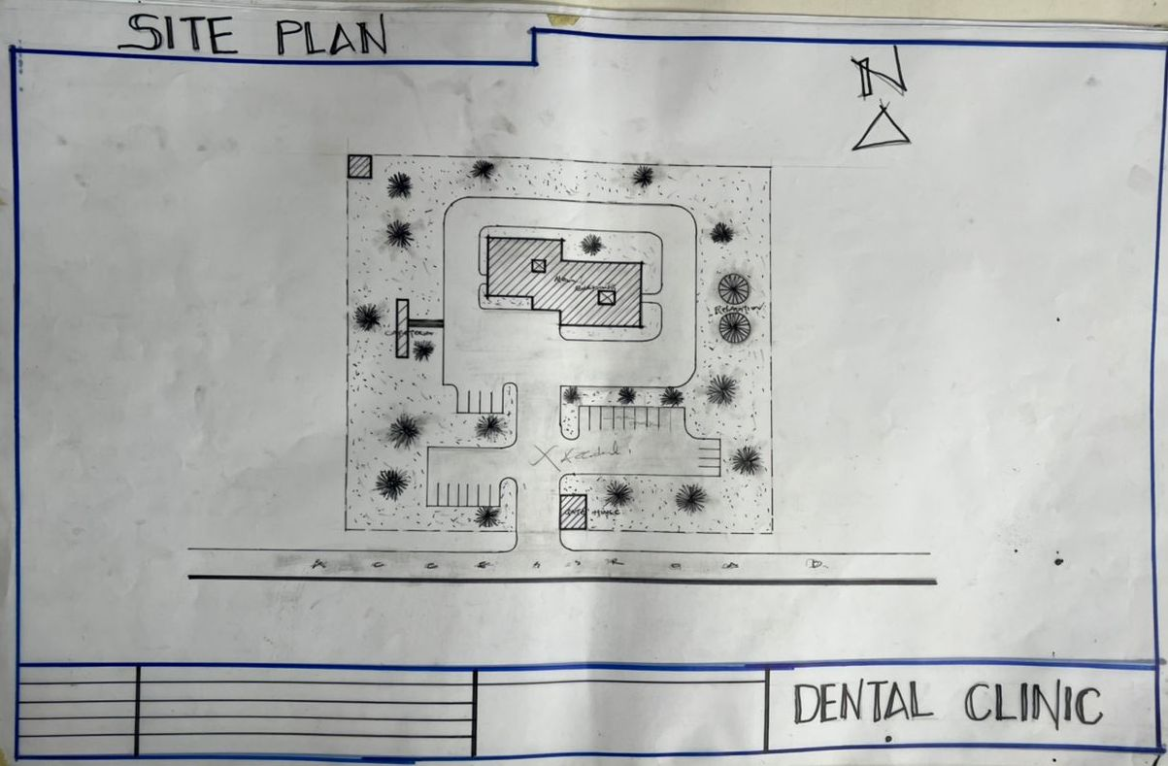
Appendix 5.1: Site Plan

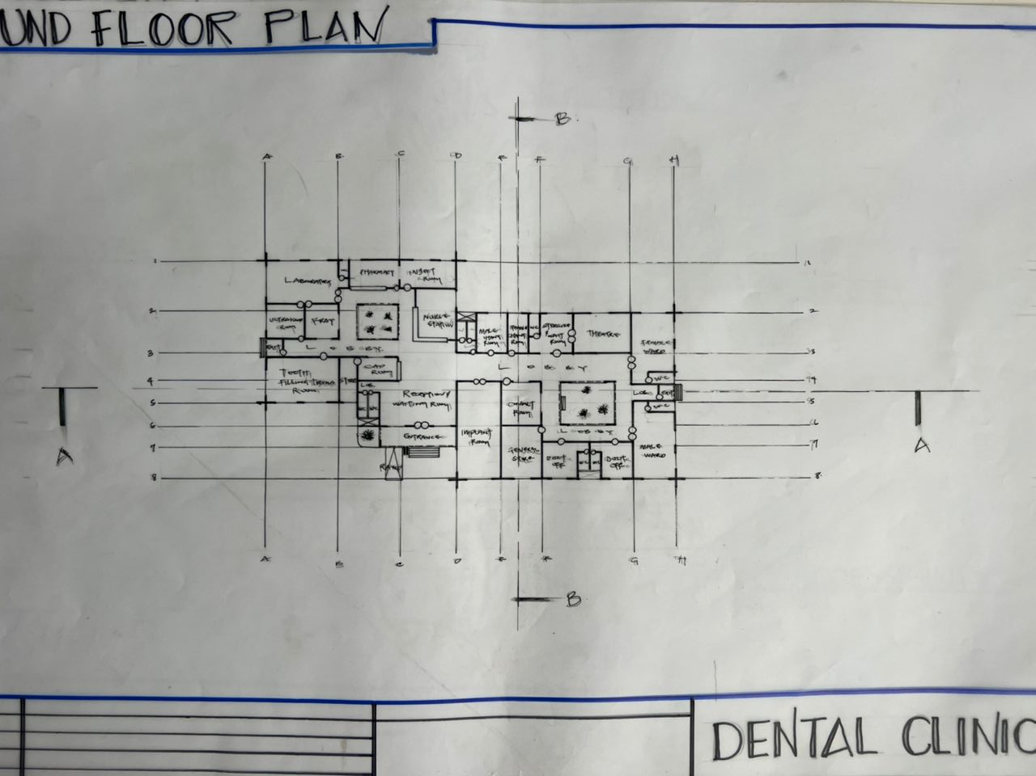
Appendix5.2: Floor Plan.
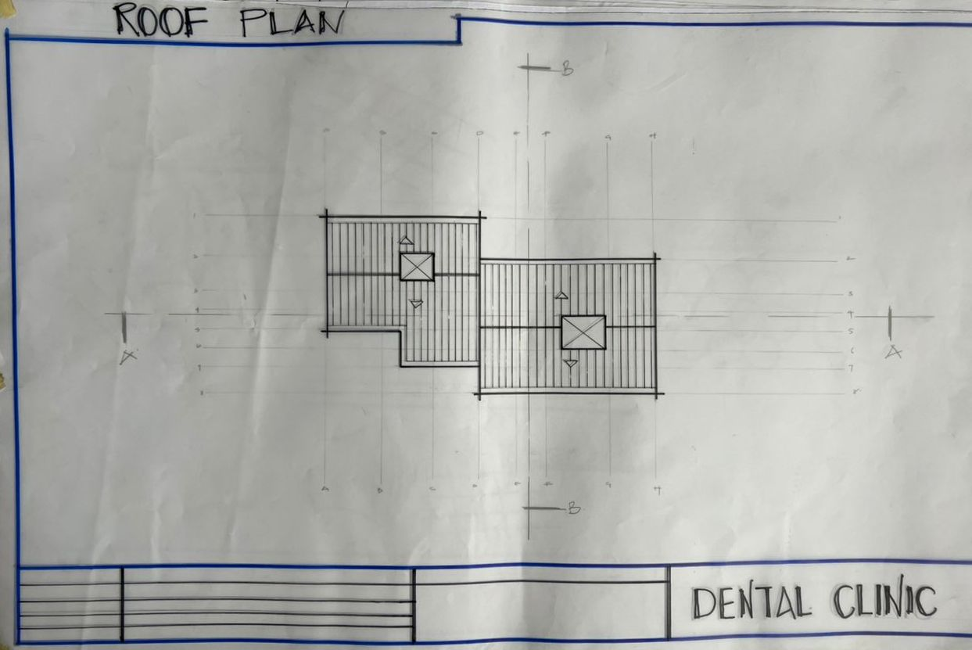
Appendix 5.5: Roof Plan

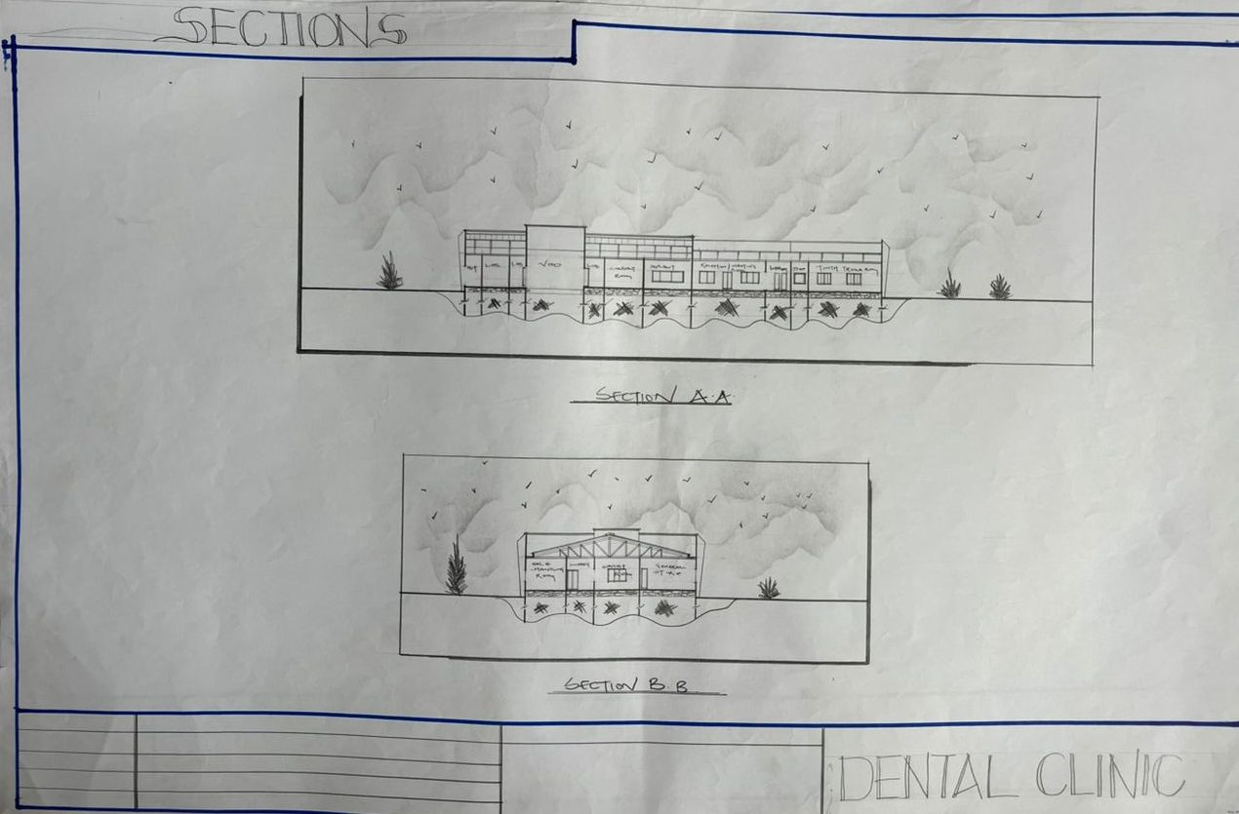
Appendix5.6: Sections

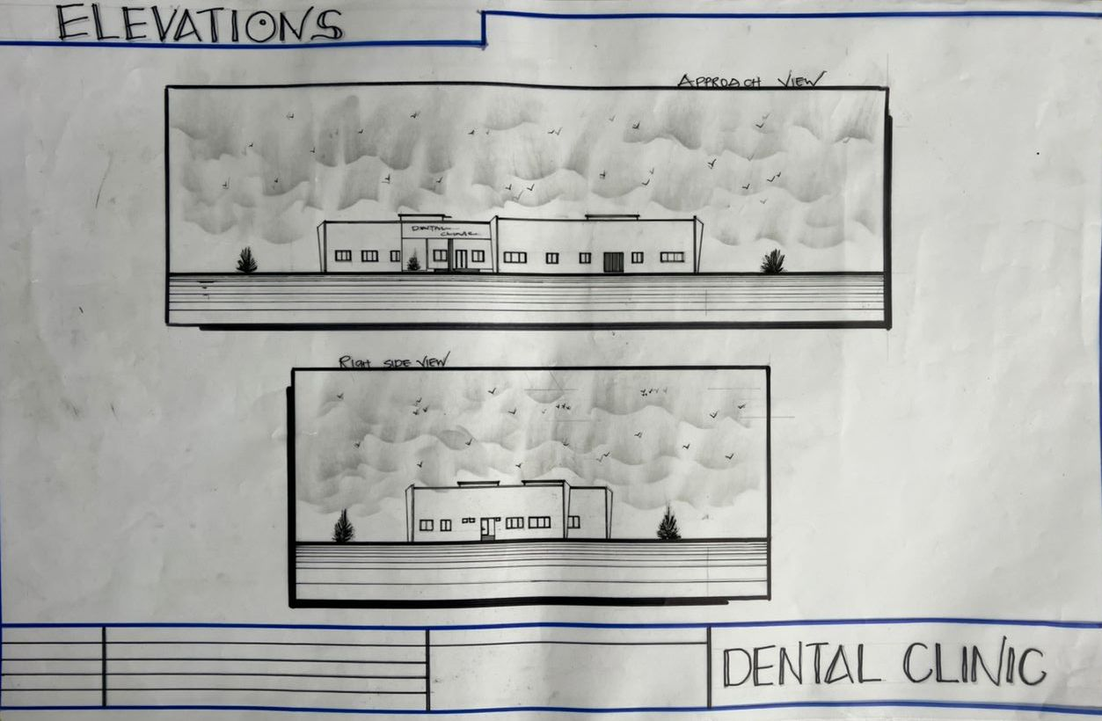
Appendix5.7: Elevation

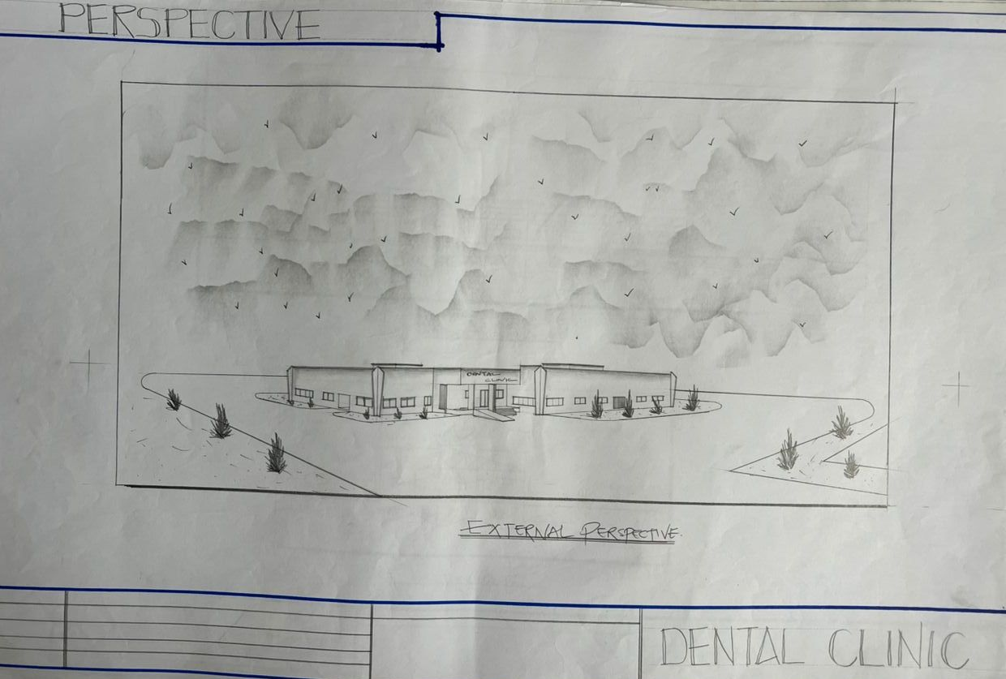
Appendix5.8: Internal Perspective.

