STUDY OF TROPOSPHERIC RADIO REFRACTIVITY OVER OSUBI, SOUTH – SOUTH NIGERIA USING METEOROLOGICAL PARAMETES

BY:

ABOLAJI OREOLUWA ESTHER HND/23/SLT/FT/0984

BEING A PROJECT REPORT SUBMITTED TO THE DEPARTMENT OF SCIENCE LABORATORY TECHNOLOGY (PHYSICS/ELECTRONIC UNIT), INSTITUTE OF APPLIED SCIENCES, KWARA STATE POLYTECHNIC ILORIN

IN PARTIAL FULFILMENT OF THE REQUIREMENTS FOR THE AWARD OF HIGHER NATIONAL DIPLOMA (HND) IN SCIENCE LABORATORY TECHNOLOGY (SLT), KWARA STATE POLYTECHNC, ILORIN, KWARA STATE

AUGUST, 2025

i
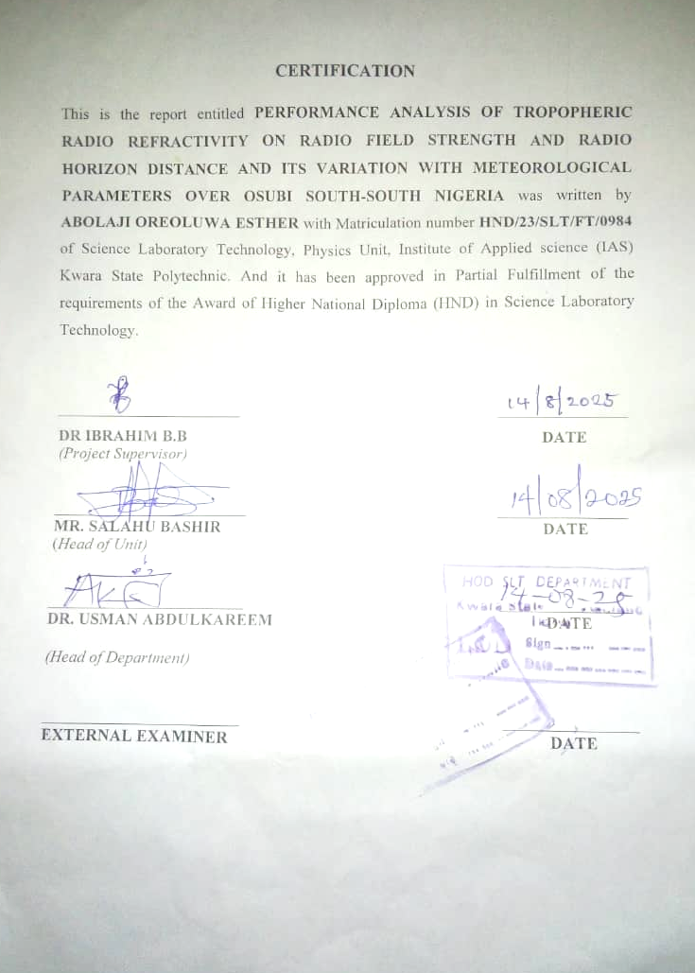

ii
DEDICATION
This work is dedicated to Almighty God, for his infinite mercy and Grace. Our utmost appreciation goes to our parents for their parental support all through the course of our academic pursuit. God bless you all

iii

ACKNOWLEDGEMENT
First and foremost, I extend my deepest gratitude to Dr. Ibrahim B. B., my project supervisor, for his unwavering guidance, insight, and patience throughout this research journey. His expertise and encouragement were instrumental in shaping my work and refining my academic skills.
I am profoundly grateful to my loving parents for their unwavering support and encouragement. To my wonderful siblings Eniola, Demilade, and Moriye your constant motivation, prayers, and belief in me, have been a source of strength throughout this experience.
I also wish to thank my dear friends: Oyin, Nofisat, Damilola, Taye, Arike, and Wale. Your companionship, uplifting conversations, and unwavering encouragement helped carry me through many challenging moments.
Special appreciation goes to my sister Jumoke Osho and all who supported me financially your generosity and practical help made this project possible when resources were limited. Your selfless support truly lifted me thank y’all.
Finally, to my project teammates and lecturers, thank you for your dedication, collaboration, and resilience during this journey.

iv

TABLE OF CONTENTS
Title page
Certification
Dedication
Acknowledgment
Table of content
Abstract
CHAPTER ONE: INTRODUCTION
1.1 Introduction
1.2 Statement of Problem
1.3 Significance of Study
1.4 Aim and Objectives
CHAPTER TWO: LITERATURE REVIEW
2.0 Literature Review
CHAPTER THREE: METHODOLOGY
3.1 Study Area
3.2 Data Acquisition
3.3 Theoretical Background
CHAPTER FOUR: RESULTS, DISCUSSION AND CONCLUSSION
4.1 Results
Conclusion
References

v
ABSTRACT
In this study, the yearly and monthly variation of tropospheric radio refractivity and field strength variability was estimated using the monthly average of daily temperature, relative humidity and atmospheric pressure meteorological parameters during the period of eleven years (2013 – 2024). The results shows that higher values of monthly tropospheric radio refractivity were recorded during the rainy and dry seasons, respectively, with highest and lowest value in the month of the months of February and September with 459.99 N-units and 451.29 N-units, respectively. The highest and lowest annual average value of tropospheric radio refractivity were found in the year 2014 and 2018 with 1286.228 N – units and 278.4276 N-units respectively. The study area under investigation yield average gradient of -42.905 N-units/km. Additionally, the average effective earth radius K was found to be 1.376. These values align with the condition of Super-refraction propagation.

vi
CHAPTER ONE
1.1 INTRODUCTION
Refractivity is the physical property of a medium as determined by its index of refraction and it is responsible for various phenomena in radio wave propagation such as ducting and scintillation, refraction and fading, range and elevation errors in radar acquisition. There are two main layers that are of interest from a radio communication perspective. The first is the troposphere (lower atmosphere) which ex- tends from the earth surface to an altitude of about 10 km at the earth poles and 17 km at the equator and tends to affect radio frequencies above 30 MHz. The second is the ionosphere which is a region that extends from around 60 km up to 700 km producing ions and free electrons which affect radio signals at certain frequencies; typically those below 30 MHz (M Idris, I Nouhou, MI Iliyasu, AO Aina, MJ Abdulsalami Ohaji, 2024). The behavior of radio waves in the tropospheric layer of the Earth’s atmosphere is very important in this modern age that is highly influenced by radio communications ranging from mobile telephoning through terrestrial digital broadcasting to the propagation of satellite radio signal through the troposphere (Akpootu & Lliyasu, 2017). The composition of the atmosphere has a significant impact on radio wave signal transmission in the lower atmosphere, or troposphere. The dynamics of climatic elements like temperature, pressure, and relative humidity are what cause it to happen. At the poles and the equator, the troposphere rises to a height of roughly 10 km and 17 km, respectively, from the earth's surface (Bello, 2024). The radio refractivity is a physical phenomenon that affects the propagation of radio signals in the Atmosphere. This process takes place in the layer of the atmosphere called the troposphere, which extends from the earth surface to a height of about 10km along the poles of the earth and 17km as we move towards the equator. The refractivity itself is being affected by the tropospheric parameters (Temperature, Relative Humidity and Atmospheric Pressure) (Oku, 2016). The relationship between surface refractivity, refractivity gradient, and radio refractivity is complex and interconnected. Surface refractivity refers to the refractive index observed at the Earth's surface, which is influenced by various atmospheric conditions such as temperature, pressure, and humidity. On the other hand, the refractivity gradient measures the vertical change in refractivity with respect to height in the atmosphere. Fluctuations in atmospheric conditions can affect the refraction of radio waves, which in turn influences radio refractivity. The combination of surface refractivity and refractivity gradient collectively determines total radio refractivity, which plays a crucial role in the propagation characteristics of radio waves in the atmosphere. Changes in surface refractivity and refractivity gradient can induce fluctuations in radio refractivity, leading to variations in signal propagation, fading, and interference in wireless communication systems (Adeyemi & Ogodo, 2024).

1
A medium's refractivity, which is determined by its index of refraction, is a physical feature that affects radio wave propagation and is accountable for a number of occurrences. Building a radio communication network requires careful consideration of the path taken by radio signals as they go from transmitter to reception (Akpootu et al., 2024).

1.2 STATEMENT OF PROBLEM
The troposphere plays a critical role in the propagation of radio waves, particularly in the Very High Frequency (VHF) and Ultra High Frequency (UHF) bands, which are widely used for communication and broadcasting. Radio refractivity, a key parameter in tropospheric radio wave propagation, is influenced by meteorological factors such as temperature, pressure and humidity. Variability in these meteorological parameters can lead to significant fluctuations in radio refractivity, which in turn affects radio field strength and signal quality. In regions like Osubi, Nigeria, where meteorological conditions exhibit seasonal and diurnal variations, understanding the behavior of tropospheric radio refractivity and its impact on radio field strength is crucial for optimizing communication systems.

1.3 SIGNIFICANCE OF STUDY

The study of tropospheric radio refractivity over Osubi, South-South Nigeria using meteorological parameters holds significant scientific, technological, and societal value. Radio refractivity, which affects the propagation of electromagnetic waves in the troposphere, plays a crucial role in the performance and reliability of terrestrial and satellite communication systems. The study will help in understanding the variations in radio refractivity will aid in optimizing the design and operation of radio communication systems such as broadcasting, mobile telephony, radar, and satellite link. This result can be use in analyzing meteorological parameters such as temperature, pressure, and relative humidity, the study provides localized insights into atmospheric behavior in the Niger Delta region. These insights are essential for regional weather prediction models and climate monitoring. The result contributes to the development of more accurate signal propagation models tailored to the climatic conditions of South-South Nigeria. Existing models are often based on temperate or generalized global data, which may not accurately reflect tropical environments like Osubi. The result findings adds to the body of knowledge in atmospheric science and radio wave propagation in tropical environments. It provides a valuable reference for further studies in similar regions across Nigeria and West Africa.

2
1.4 AIM AND OBJECTIVES

Aim:
To analyze the tropospheric radio refractivity over Osubi, South-South Nigeria, using meteorological parameters such as temperature, pressure, and relative humidity, in order to understand its impact on radio wave propagation in the region.

Objectives:
- Obtain and analyze meteorological data (temperature, pressure, and humidity) relevant to the study of radio refractivity over Osubi

- Compute the tropospheric radio refractivity values using standard atmospheric equations based on the collected meteorological parameters.

- Examine the seasonal and diurnal variations of radio refractivity in the study area.

- Investigate the relationship between meteorological parameters and refractivity gradients, particularly how they influence radio signal behavior and

- To assess the implications of refractivity variations on radio wave propagation and communication systems in Osubi and its surroundings.

3
CHAPTER 2
2.0 LITERATURE REVIEW
(Onujagbe et al., 2021) observed that surface radio refractivity over Osubi mean monthly values of the surface refractivity, Ns for the Zaria station were observed to be generally high. The implication of this is that radio wave propagating through the atmosphere will bend closer towards the earth surface.

(D. O. Akpootu, 2021) showed the Stefan-Boltzmann law has been employed to estimate the yearly and monthly average values of terrestrial solar radiation using monthly averaged meteorological parameters of temperature and relative humidity obtained from the National Aeronautics and Space Administration (NASA) during the period of nine years (2013 – 2022).

(Sa’adu et al., 2020) showed it has been observed that refractivity reveals seasonal variations with high value in rainy season and low values in dry season.

(D. Akpootu, 2021) studied that the international telecommunication union (ITU) method has been employed to estimate the yearly and monthly tropospheric radio refractivity over Osubi, Nigeria using meteorological parameters of temperature, relative humidity and atmospheric pressure during the period of fifteen years (20013 – 2022).

4
CHAPTER 3
3.1 STUDY AREA
The study area is located in Osubi, Okpe Local Government Area of Delta state, southern Nigeria. The population is approximately over 8000 people in the 2006 national census. The dumpsite studied is located along the Eku - Warri expressway. It is situated around geographic coordinates of latitude 5039.638I N and longitude 5049.000I E covering an area of 100 by 100 m. To avoid possible misleading indications related to year to year variation in weather conditions, the period under investigation was nine years (2013 - June 2022) so as to obtain a good climatological average.

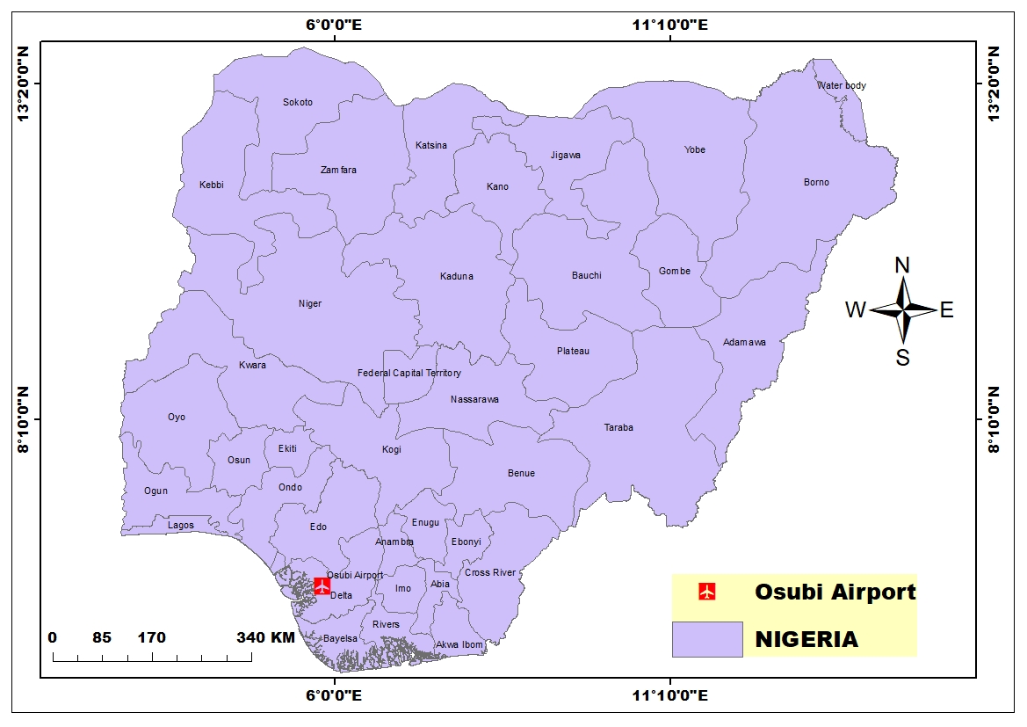

5
3.2 DATA ACQUISATION
The data used in the computations were obtained from the archives of the Department of the Meteorological Services, Federal Ministry of Aviation, at oshodi in lagos Nigeria The data used for this study were 9-year period (2013 to 2022) of daily temperature, atmospheric pressure and relative humidity and 9- years (2013-2022) of the Monthly average temperature, atmospheric pressure and relative humidity of the study area.

3.3 THEORETICAL BACKGROUND
N = Refractivity, measured in N-unit

N= $\frac{77.6}{T}\left(P+4810\frac{e}{T}\right)=N_{dry+}N_{wet}$ …………………….. (1)

Expand to get $N_{dry} and N_{wet }$

With the “dry term” of radio refractivity given by:
$N_{dry}=77.6\frac{p}{T}$ …………………………………………………… (2)
With the “wet term” of radio refractivity given by:
$N_{wet}=3.73×{10}^{5}\frac{e}{T^{2}}$ …………………………………………. (3)
Where P= Atmospheric Pressure (hPa)
T= Absolute Temperature (K)
e= Water Vapor (hPa)

6
The relationship between water vapor pressure (e) and relative humidity (RH) is given by the expression:
e= $\frac{He_{s}}{100}$ ………………………………………………… (4)
Where H = Relative Humidity
$e_{s }$= Saturated Water Vapor

$e_{s}=a exp (\frac{bt}{t+c}$) ………………………………… (5)

Where, a = 6.1121
b = 17.502
c = 24097
t = Temperature ($℃)$

Refractivity Gradient:
The radio refractivity N, also decrease exponentially in the troposphere with height:
$N_{o}$ = $N_{s}$exp ($\frac{h_{o}}{H})$ OR $N_{s}$ = 315$\exp^{-0.136h}$
Where, $N_{s}$= Refractivity at surface of the earth
$N_{o}$ = Average values of atmospheric extrapolated to sea level
$h_{o}$ = Height of the earth’s surface above sea level
$H_{o}$ = Scale height = 7.35km

$\frac{{dN}_{o}}{dh }$ = $\frac{{-N}_{s}}{H_{o}}$exp($\frac{{-h}_{o}}{H_{o}})$ refractivity gradient

7
Thus, k may be expressed in terms of refractivity gradient, dN/dh as:
K = [1+$\frac{(\frac{dN}{dh})}{157}]^{-1}$ …………………………………………. (5)

FSV – Field Strength Variation =
($N_{s(max)}$- $N_{s(max)}$) $×$ 0.2$d_{b}$
$d_{b}=$decibel……………………………………………… (6)

8
CHAPTER FOUR
4.1 RESULTS AND DISCUSIONS

Radio refractivity and its variation with other meteorological parameters
The yearly change of Osubi's radio refractivity with relative humidity is depicted in Figure above. While the radio refractivity increases until it reaches its maximum value of 8.00 N-units in 2015 and then gradually decreases until it reaches 1.00 N-units in 2018, it suddenly increases to 2020 and drops in 2021 and then increases back in 2022 the relative humidity and radio refractivity both rise from their minimum values of 1.00 N-nits in 2018.
FIG 1
FIG 1: Yearly variation of radio refractivity over Osubi, Nigeria

9
FIG 2
Fig. 2: Variation of Mean monthly surface refractivity value for Osubi

The monthly mean variation of refractivity in Osubi is shown in the figure above. The refractivity in Osubi is observed to increase sharply from its lowest value of 451.29N-units in the month of February to its maximum value of 459.99N-units in the month of May and afterwards decreases gradually till August before rising slowly to another peak value of 455.39N-units in the month of November and thereafter decreases sharply through December.

10
FIG 3
Fig. 3: Variation of Mean yearly surface refractivity value for Osubi

The yearly mean variation of refractivity in Osubi is shown in the figure above. The refractivity in Osubi is observed to increase sharply from its lowest value of 278.4276 N-units in the year 2013 to its maximum value of 1286.228 N-units in the year 2014 and afterwards decreases gradually till 2015 before rising slowly to another peak value of 373.324 N-units in the year 2016 and later decreases gradually to 2018 before rising to another peak of 276.4276 thereafter decreases sharply through 2022.

11

CONCLUSION
The international telecommunication union (ITU) method has been employed to estimate the yearly and monthly tropospheric radio refractivity over Zaria, Nigeria using meteorological parameters of temperature, relative humidity and atmospheric pressure during the period of eleven years (2013 – 2024). The yearly and monthly variations of radio refractivity was also studied. The refractivity gradient, and the field strength variability were also reported. The results in this study revealed that slightly higher values of monthly tropospheric radio refractivity were recorded in the rainy season than in the dry season with the highest and lowest values in the month of February and September with 459.99 N-units and 451.29 N-units respectively. The highest and lowest annual average values of tropospheric radio refractivity were found in the year 2014 and 2018 1286.228 N – units with 278.4276 N – units respectively. The refractivity gradient and effective earth radius found for Zaria, Nigeria during the period under investigation were -42.905 N-units/km indicating that the propagation in this region is mostly Super-refraction. This is also supported by the value of effective earth radius, which is less than 4/3 The highest and lowest values of field strength variability (FSV) was estimated in the 2013 and 2018 as 8.02 dB and 1.11 dB respectively.

12

REFERENCE
Abimbola, O. J., Bada, S. O., Falaiye, A. O., Sukam, Y. M., Otto, M. S., & Muhammad, S. (2021). Estimation of radio refractivity from satellite-derived meteorological data over a decade for West Africa. Scientific African, 14, 1–8. https://doi.org/10.1016/j.sciaf.2021.e01054
Adeyemi, B., & Ogodo, S. O. (2024). Refractivity Gradient Variations and Intertropical Discontinuities Across Nigeria. INTERNATIONAL ASTRONOMY AND ASTROPHYSICS RESEARCH, 6(1), 5–17.
Akpootu, D. ., Aminu, Z., Yusuf, A., Nouhou, I., Kola, T. ., Agidi, O. ., Salifu, S. ., Idris, M., Aliyu, M. ., & Aruna, S. (2024). INVESTIGATION OF TROPOSPHERIC RADIO REFRACTIVITY AND OTHER RELEVANT PARAMETERS USING METEOROLOGICAL VARIABLES OVER BAUCHI, NIGERIA. FUDMA Journal Of Sciences, 8(2), 306–314.
Akpootu, D. ., & Lliyasu, M. . (2017). Estimation of Tropospheric Radio Refractivity and Its Variation with Estimation of Tropospheric Radio Refractivity and Its Variation with Meteorological Parameters over Ikeja , Nigeria. Journal of Geography, Environment and Earth Science International, 10(1), 1–12. https://doi.org/10.9734/JGEESI/2017/32534
Bello, G. (2024). Assessment of Tropospheric Radio Refractivity and its Variation with Climatic Variables in the Guinea Savannah Region of Nigeria Abstract : EUROPEAN JOURNAL OF THEORETICAL AND APPLIED SCIENCES, 2(3), 89–104. https://doi.org/10.59324/ejtas.2024.2(3).10
M Idris, I Nouhou, MI Iliyasu, AO Aina, MJ Abdulsalami Ohaji, D. A. and M. (2024). Estimation and Investigation of the Variability of Tropospheric Radio Refractivity and Radio Field Strength over Accra ,. HSOA Journal Of Atmosopheric And Earth Science, 5(1), 1–9. https://doi.org/10.24966/AES-8780/100026
Oku, D. E., Joseph, A., & Obot, E. P. (2016). SEASONAL TROPOSPHERIC RADIO REFRACTIVITY VARIATION IN CALABAR , SEASONAL TROPOSPHERIC RADIO REFRACTIVITY VARIATION IN CALABAR , CROSS RIVER STATE , NIGERIA. AMERICAN INTERNATIONAL JOURNAL OF RESEARCH IN FORMAL, APPLIED AND NATURAL SCIENCES, 14–17.

13

