POTENCY OF FUSARIUM GRAMINEARUM TOXIN

BY

RAJI FAIZAT AJIBOLA
HND/23/SLT/FT/01234

A PROJECT SUBMITTED TO THE DEPARTMENT OF SCIENCE LABORATORY TECHNOLOGY, INSTITUTE OF APPLIED SCIENCES, KWARA STATE POLYTECHNIC, ILORIN

IN PARTIAL FULFILMENT OF THE REQUIREMENTS OF THE AWARD OF HIGHER NATIONAL DIPLOMA (HND) IN SCIENCE LABORATORY TECHNOLOGY (SLT), MICROBIOLOGY UNIT

JULY, 2025
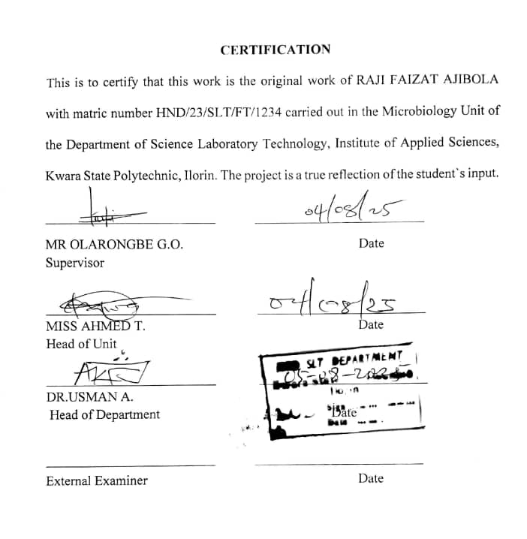

DEDICATION
This project is dedicated to almighty ALLAH for the success of this project who has seen me through this project work .the most merciful who has being with me throughout the period of my stay In KWARA STATE POLYTECHNIC.
His grace sustained me through every challenges,his light guided every steps I take and it’s faithfulness brought this journey to completion.I will favour be grateful to you Allah.

ACKNOWLEDGEMENTS
My deepest gratitude goes to almighty Allah the most high,creator of all creatives for his guidance,grace and endless mercy that was evident in my life and for the completion of any HND program successfully.I would like express my deepest appreciation to (Dr usman A)head of department for his expert supervision,insightful feedback and continuous support.his guidance has played a crucial role in shaping the direction and outcome of his research.also I sincerely appreciate the kindness of the unit in person of (Mrs Ahmed T)for her motherly support,may almighty Allah grant you long life and good health to eat and enjoy the fruits of your labours. Also I would like to express my special thanks to my amiable supervisor (Mr olarongbe)for patience in supervising me,may almighty see you through in all your undertakings(ameen).
Also I would like to thank my parent because I cannot resist the urge of expressing my sincere gratitude to my precious parent (Mrand Mrs raji)for their immeasurable support since I was born till moment and beyond and through my academic Allah grant them long life and good health to eat and enjoy the fruits of their labor’s.
To my beloved and amazing family Raji Rofiat, Azezzat and Zainaib I say a big thanks to you all .forward ever, backwards never (amen)
To amazing friends
Aisha and Maryam I say a big thanks to you all .May almighty Allah bless you and keep our friendship together.

TABLE OF CONTENTS

TITLE PAGE -------------------------------------------------------------------------- i
CERTIFICATION ---------------------------------------------------------------------ii
DEDICATION ------------------------------------------------------------------------iii
ACKNOWLEDGEMENTS ---------------------------------------------------------iv
TABLE OF CONTENTS ------------------------------------------------------------vii
LIST OF TABLES ---------------------------------------------------------------------viii
LIST OF FIGURES ---------------------------------------------------------------------viii
ABSTRACT ------------------------------------------------------------------------------ix
CHAPTER ONE
1.0 Introduction -------------------------------------------------------------------------6
1.1 Literature Review------------------------------------------------------------------8
1.2 Statement of Problem--------------------------------------------------------------9
1.3 Justification of Study--------------------------------------------------------------9
1.4 Aims and Objective----------------------------------------------------------------10

CHAPTER TWO
2.0 Materials and Methods -----------------------------------------------------------11
2.1 Material Used ---------------------------------------------------------------------11
2.2 Sterilization of Equipment and Environment ---------------------------------11
2.3 Samples Collection ----------------------------------------------------------------12
2.4 Media Preparation for fungal isolation -----------------------------------------12
2.4.1 Preparation of Potato Dextrose Agar -------------------------------------------12
2.4.2 Preparation of Potato Dextrose Broth-------------------------------------------13
25 Isolation of Fusarium gramenearium from maize------------------------------14
2.6 Characterization and Identification of Fusarium gramenearium --------------14
2.7 Sub-culturing and Extraction of Fusarium gramenearium----------------------15
2.8 Administration and Evaluation of the Potency of the Toxin in White Rats-15
CHAPTER THREE
3.0 Results
3.1 Characterization and Identification of Fungal Isolate ------------------------17
3.2 Weekly clinical Observation in Experimental rats -----------------------------19
3.3 Post-Mortem Gross Pathological Findings ------------------------------------- 20
CHAPTER FOUR
4.0 Discussion and Conclusion
4.1 Discussion -------------------------------------------------------------------- ---23
4.2 Conclusion ------------------------------------------------------------------------23
REFERENCES

LIST OF TABLES
Table 1: Characterization and Identification of Fusarium gramenarium Isolate after culturing

Table 2 Daily Observation for 100% Conc. Toxin Administration in Rats

Table 3 Daily Observation for 80% Conc. Toxin Administration in Rats

Table 4 Daily Observation for 60% Conc. Toxin Administration in Rats

Table 5 Daily Observation for 50% Conc. Toxin Administration in Rats
Table 6: Post-Mortem Findings in Experimental Rats

LIST OF FIGURES
Figure 1: Showing Microscopic view
Figure 2: Images of postmortem findings in experimental rats

ABSTRACT
Fusarium graminearum is a mycotoxigenic fungus that often infects cereal crops, generating strong toxins such deoxynivalenol (DON), zearalenone (ZEN), and fusarenon-X (FX). This study looked at how dangerous the F. graminearum toxin was when it was taken from infected maize samples and given to albino rats in controlled laboratory circumstances at different concentrations (100%, 80%, 60%, and 50%). Clinical investigations showed that the harmful effects got worse with higher doses. These symptoms included less movement, difficulty breathing, dullness of the eyes, and death at the greatest concentration. The investigation after death showed that important organs like the liver, kidney, and gut were getting worse, which confirmed systemic poisoning. Rats that were exposed to lesser amounts showed less severe but nonetheless noticeable physiological impairment. These results add to what we already know about the health consequences of F. graminearum toxins and show how important it is to keep an eye on and control mycotoxins in food systems to protect the health of people and animals.
Keyword: Fusarium graminearum, deoxynivalenol (DON), zearalenone (ZEN), mycotoxins, food safety, toxicology, organ damage.

CHAPTER ONE
INTRODUCTION AND LITERATURE REVIEW
  - INTRODUCTION
Fusarium graminearum is a globally recognized fungal pathogen responsible for causing Fusarium head blight (FHB) in cereal crops, notably wheat, maize, and barley. It produces mycotoxins such as deoxynivalenol (DON), nivalenol (NIV), zearalenone (ZEA), and fusarenon-X (FX), which have significant toxicological effects on human health, livestock, and the environment. This fungus thrives in temperate climates and can contaminate large quantities of crops, leading to significant economic losses in agricultural industries worldwide. Recent studies indicate that Fusarium mycotoxins, particularly DON and NIV, are potent contaminants in food and feed supplies, thus posing a serious threat to food safety and public health (Jabeen et al., 2023). Fusarium species produce various toxins that not only impair plant growth but also exhibit harmful effects when ingested by animals, highlighting the need to understand the potential of Fusarium toxins to adversely affect living organisms (Huang et al., 2022). While DON is the most frequently studied trichothecene, other toxins such as NIV and FX also type B trichothecenes exhibit similar inhibition of protein synthesis in eukaryotic cells and are capable of inducing immunotoxic, genotoxic, and apoptotic effects. Zearalenone (ZEA), on the other hand, is a non-trichothecene mycotoxin that acts as an estrogenic compound, disrupting endocrine functions and affecting reproductive health in female animals. These mycotoxins target multiple organ systems, and their combined or synergistic effects can be even more hazardous. Although the effects of these toxins on plants have been well documented, their impact on animal models such as rodents remains an emerging area of research. Recent studies have shown that chronic exposure to Fusarium toxins like DON, NIV, and ZEA can result in various physiological and behavioral abnormalities in rodents, providing insight into how these toxins might affect human health (Zhu et al., 2023). However, despite the growing body of evidence on the general toxicity of Fusarium mycotoxins, significant research gaps remain in understanding their specific dose-dependent effects, organ-targeted toxicity, and long-term behavioral and neurological consequences, particularly in controlled in vivo studies using animal models. Additionally, there is limited comparative analysis of the relative potency of different Fusarium toxins under uniform experimental conditions, which is crucial for comprehensive risk assessment.
Building on the increasing awareness of the adverse effects of Fusarium mycotoxins on mammalian systems, animal models such as white rats (Rattus norvegicus) have become critical in toxicological research. White rats are commonly used due to their physiological similarities to humans and their responsiveness to a variety of environmental and dietary exposures. These rodents serve as an ideal model for studying the systemic effects of Fusarium toxins, with emphasis on their impact on the immune system, liver function, reproductive system, and kidney health. Recent research has shown that DON and NIV exposure in rats leads to an upregulation of pro-inflammatory cytokines and alterations in immune cell profiles, indicating a compromised immune response (Sørensen et al., 2021). ZEA, in particular, has been associated with reproductive toxicity, disrupting hormonal balance and leading to changes in the estrous cycle and ovarian morphology.
Furthermore, exposure to Fusarium toxins has been shown to affect organ function, leading to hepatic and renal damage, which may be dose-dependent. Some studies have suggested that chronic exposure to even low levels of these toxins can cause significant changes in organ morphology and function. In rats, the liver, which is primarily involved in detoxification processes, appears to be particularly susceptible to Fusarium toxins. Histopathological examinations have revealed hepatocellular necrosis, steatosis, and inflammation following exposure to DON (Müller et al., 2020). Additionally, kidney toxicity, as evidenced by changes in kidney function biomarkers such as serum creatinine and urea, is also a significant concern when rats are exposed to toxins like NIV and FX for extended periods. In addition to physical damage, Fusarium toxins are also linked to behavioral, endocrine, and neurological changes in animal models. Recent investigations into the neurotoxic effects of these toxins, especially DON and FX, have indicated a potential for Fusarium toxins to disrupt cognitive and motor functions in white rats, possibly by crossing the blood-brain barrier and altering neurotransmitter levels or damaging neural tissue (Sánchez et al., 2022).
These findings highlight the broader health implications of Fusarium mycotoxins, emphasizing the need for further studies to evaluate the long-term consequences of such exposures on animal behavior and cognitive function. However, current literature lacks comprehensive in vivo models that explore the full spectrum of toxic effects associated with different Fusarium mycotoxins at varied doses and exposure durations. Particularly, there is a scarcity of studies integrating behavioral, biochemical, histological, and molecular endpoints within the same experimental framework. This creates a research gap that hinders the formulation of robust toxicological profiles for these mycotoxins.
The mechanism by which Fusarium toxins exert their toxic effects involves the activation of multiple intracellular signaling pathways, including those involved in stress response, inflammation, and hormonal regulation. Upon exposure, type B trichothecenes such as DON, NIV, and FX interact with the cell's ribosome, preventing the proper translation of proteins and leading to an accumulation of damaged proteins and cellular stress (Ding et al., 2022). This process results in the release of pro-inflammatory mediators and the activation of apoptosis in affected cells, contributing to tissue damage and dysfunction. In rats, studies have demonstrated that exposure to these toxins can lead to the activation of pathways such as the NF-κB pathway, which is involved in regulating immune responses and inflammation (Zhu et al., 2023). Zearalenone, in contrast, binds to estrogen receptors and disrupts normal hormonal signaling, particularly affecting reproductive tissues.
As food contaminants, Fusarium graminearum toxins pose a significant threat not only to agriculture but also to animal and human health. Animal models like white rats play a crucial role in elucidating the toxicokinetics and toxicodynamics of these diverse mycotoxins. In recent years, there has been a growing body of evidence highlighting the need for effective monitoring and control strategies to minimize Fusarium contamination in food and feed supplies. Moreover, understanding the precise mechanisms by which these toxins affect different organ systems in rats provides valuable insight into the potential human health risks associated with consuming contaminated food products (Sørensen et al., 2021).
Given the complex and multifactorial nature of Fusarium toxin toxicity, more research is required to establish safe exposure limits for a range of Fusarium toxins, not just DON. The results of experiments conducted on white rats could provide essential data to inform regulatory guidelines for Fusarium toxin contamination in food. Additionally, these studies may contribute to the development of novel therapeutic strategies or interventions that could mitigate the harmful effects of Fusarium toxins in both humans and animals. Recent advancements in molecular biology techniques, such as gene expression analysis and proteomics, have opened new avenues for investigating the molecular mechanisms underlying Fusarium toxin toxicity (Yin et al., 2022).
The toxicological profile of Fusarium graminearum mycotoxins suggests that these compounds have a range of harmful effects on animal health, from immune suppression to reproductive toxicity and organ damage. While Fusarium toxins are most commonly associated with agricultural crops, their bioaccumulation in food chains presents an additional risk to human health. Ongoing studies involving animal models like white rats are critical in advancing our understanding of how mycotoxins such as DON, NIV, ZEA, and FX affect the body on a molecular level. Yet, a notable research gap exists in fully characterizing the dose-response relationships and long-term systemic impacts of individual and combined Fusarium toxins in vivo. Addressing these gaps is essential for developing science-based policies and intervention strategies aimed at minimizing their toxicological risks (Müller et al., 2020).

  - LITERATURE REVIEW
According to Adewumi et al. (2020), Fusarium graminearum is a predominant fungal pathogen known for producing a spectrum of mycotoxins, particularly deoxynivalenol (DON), which has been associated with adverse physiological and hormonal effects in mammals. In their study, sub-chronic exposure to DON in white rats led to endocrine disruption, specifically in the regulation of thyroid hormones such as triiodothyronine (T3) and thyroxine (T4). These hormonal disturbances suggest that even at low concentrations, DON poses a risk of interfering with metabolic processes. Similarly, Wang et al. (2023) reported hepatic damage, including hepatocellular necrosis and inflammation, following DON exposure, reinforcing its role in liver toxicity and the necessity of stringent monitoring in food systems. According to Ogunseye et al. (2021), the immunotoxic properties of Fusarium graminearum toxins are of increasing concern. Their research on white rats showed that DON exposure led to suppressed immune responses, marked by reduced macrophage activity and cytokine production. This immune suppression increased the rats’ vulnerability to secondary bacterial infections. Supporting this, Martínez-Moral et al. (2022) demonstrated that trichothecene mycotoxins such as DON and fusarenon-X (FX) downregulate genes involved in innate immunity and inflammation, impairing the host's defense mechanisms. These findings highlight the immunosuppressive potential of Fusarium toxins and their relevance in understanding foodborne pathogen susceptibility. According to Zhou et al. (2022), oxidative stress is a central mechanism through which DON exerts its toxicity. Their study revealed elevated levels of malondialdehyde (MDA) and a reduction in endogenous antioxidants like glutathione and catalase in exposed rat tissues. This oxidative imbalance was linked to lipid peroxidation and mitochondrial dysfunction. Likewise, Guo et al. (2023) confirmed that DON induces reactive oxygen species (ROS) accumulation and DNA fragmentation, leading to programmed cell death. Such oxidative stress mechanisms are critical in understanding how chronic mycotoxin exposure can result in cumulative cellular damage and organ failure. According to Adeyemi et al. (2023), DON also exhibits neurotoxic potential, with significant impacts on the central nervous system. In their study, white rats exposed to DON showed reduced locomotor activity, memory impairment, and signs of neuroinflammation. Histopathological analysis indicated apoptosis in brain tissues, particularly in the hippocampus. Correspondingly, Li et al. (2023) demonstrated that DON crosses the blood-brain barrier, altering neurotransmitter levels such as dopamine and serotonin. According to Sánchez-Bayo et al. (2024), co-exposure to multiple Fusarium graminearum mycotoxins, such as DON and zearalenone (ZEA), results in synergistic toxicity. Their study in rats revealed intensified damage to the liver, reproductive organs, and brain when both toxins were administered together, compared to when each was tested individually. This combined toxicity is especially concerning, as co-contamination is common in cereals and grains. Their findings emphasize the need for regulatory frameworks that assess the cumulative effects of multiple mycotoxins, rather than focusing on single-compound thresholds.
STATEMENT OF THE PROBLEM
Fusarium graminearum produces mycotoxins, particularly deoxynivalenol (DON), which pose significant risks to animal health, including immune system suppression and organ damage. However, the full extent of its toxicity in vivo, particularly in white rats, remains underexplored.
JUSTIFICATION OF THE STUDY
The increasing incidence of food contamination by toxigenic fungi such as Fusarium graminearum poses a serious threat to public health, largely due to its production of harmful trichothecene and estrogenic mycotoxins, notably deoxynivalenol (DON) and zearalenone (ZEN). Although analytical techniques for detecting these toxins are well developed, there remains a critical gap in toxicological data regarding their direct biological effects, particularly across varying concentration levels. Evaluating the potency of F. graminearum toxins through in vivo experimental models provides valuable insights into their dose-dependent toxicity. This evidence-based approach is essential for closing existing knowledge gaps, informing the development of safe exposure limits, strengthening food safety regulatory frameworks, and guiding public health initiatives through more accurate risk assessment.

1.4 AIM AND OBJECTIVES
The primary aim of this research is to assess the potency of Fusarium graminearum toxin derived from infected cereal crop samples.
Objectives are:
- To isolate and identify Fusarium graminearum from infected cereal crops.
- To determine whether the isolated strains produce mycotoxins, particularly deoxynivalenol (DON) and zearalenone (ZEN), through qualitative and quantitative analysis.
- To evaluate the toxicity of F. graminearum toxin concentrations by testing their effects on rats using in vivo models.

CHAPTER TWO
2.0 MATERIALS AND METHODS
2.1 MATERIALS USED
The following materials were used during the course of the research: Petri dishes, Ethanol, Bursen burner, Potato Dextrose Agar, Potato Dextrose Broth Conical flask, Beaker, Weigh balance, Spectrophotometer, Incubator, Distilled water, Test tubes, Incubating loop, Cotton wool, Gloves, Nose mask, Measuring cylinder, Stirring rod, Spatula, Reagent bottles, Synthetic Nutrient Agar, Maize, Wheat, Scalpel, Potassium dihydrogen phosphate(KH₂PO₄), Magnesium sulfate (MgSO₄), Potassium nitrate (KNO₃), Kovac’s reagent, Methyl red, Barntt’s A and B reagent, magnetic stirrer, Buffer solution, Normal saline, Sodium hypochlorite, Centrifuge, Test tube rack, Pippete, Syringe
2.2 STERILIZATION OF GLASSWARES
All glassware were washed with soap and rinsed with distilled water. All the glassware were drained out and packed with aluminum foil to prevent the entry of air and to avoid contamination and they were packed into the hot air oven. Then the oven was maintained at 45°c for 15 minutes of sterilization. Others were cleaned and properly kept in a carton. The autoclave and centrifuge were properly covered. Inoculating loop was heat to redness with spirit lamp and workbench was wiped with 70% ethanol.
2.3 SAMPLE COLLECTION
Maize samples suspected of being contaminated with Fusarium graminearum were obtained from the Ipata Market in Ilorin, Kwara State. Visibly infected and discolored maize were selected based on physical signs of fungal infection, such as mold growth and rot. The samples were collected in sterile polythene bags, labeled appropriately, and transported immediately to the laboratory for further analysis.
2.4 PREPARATION OF MEDIA
Media were prepared according to manufacturer′s instruction and then autoclave at 121⁰ C for 15 minutes. The following are the media used during the laboratory bench work
- Potato Dextrose Agar (PDA)
- Potato Dextrose Broth (PDB)

2.4.1 PREPARATION OF POTATO DEXTROSE AGAR (PDA)
Potato Dextrose Agar (PDA) was prepared by dissolving 39 grams of commercially available PDA powder in 1 liter of distilled water. The mixture was stirred thoroughly to ensure even distribution of the components and then heated gently to allow complete dissolution. The pH was adjusted to approximately 5.6 to favor fungal growth. The solution was poured into clean conical flasks, covered with cotton wool and aluminum foil, and sterilized in an autoclave at 121°C for 15 minutes. After sterilization, the medium was allowed to cool to about 45°C before being aseptically dispensed into sterile Petri dishes and left to solidify. The solidified agar plates were stored at room temperature or refrigerated until used for fungal isolation and culturing.

2.4.2 PREPARATION OF POTATO DEXTROSE BROTH (PDB)
Potato Dextrose Broth (PDB) was prepared by dissolving 24 grams of dehydrated PDB powder in 1 liter of distilled water in a clean conical flask. The mixture was stirred until fully dissolved and the pH adjusted to around 5.6 for optimal fungal growth. The flask was then covered with cotton wool and aluminum foil and sterilized in an autoclave at 121°C for 15 minutes. After cooling to room temperature, the sterile broth was used for sub-culturing Fusarium graminearum and for the extraction of fungal metabolites, including toxins, by allowing the fungus to grow under stationary conditions for several days.

2.5 ISOLATION OF FUSARIUM GRAMINEARUM FROM MAIZE
To isolate Fusarium graminearum, visibly infected and discolored maize kernels were selected as they are more likely to harbor the fungus. These infected kernels were first cleaned to remove surface debris and then ground into a coarse powder using a sterile mortar and pestle. The ground maize sample was evenly sprinkled over the surface of already prepared and solidified Potato Dextrose Agar (PDA) plates under aseptic conditions. The plates were then incubated at 28°C for 5 days. Fungal growth was observed daily, and colonies exhibiting morphological features typical of Fusarium species such as cottony or fluffy mycelia with grayish green pigmentation—were carefully monitored. Distinct colonies were sub-cultured onto fresh PDA plates to obtain pure isolates for further identification and characterization.

2.6 CHARACTERIZATION AND IDENTIFICATION OF FUSARIUM GRAMINEARUM
Preliminary identification of the fungal isolates was based on cultural and microscopic characteristics. The colony color, growth rate, and texture were observed on PDA. Microscopic identification was done by preparing lactophenol cotton blue mounts and observing under a microscope. Features such as macroconidia shape, number of septa, and hyphal structure were compared with standard taxonomic keys to confirm the presence of Fusarium graminearum.
2.7 SUB-CULTURING AND EXTRACTION OF FUSARIUM GRAMINEARIUM
After characterization, fungi identified as Fusarium graminearum in the isolates were sub-cultured in Potato Dextrose Broth (PDB) and incubated in a shaking incubated at room temperature for 7 days to support toxin production, which was indicated by changes in color and the development of cloudiness in the broth. Following incubation, the liquid culture was centrifuged to separate the fungal biomass, and the supernatant presumed to contain the toxin was carefully decanted. This decanted supernatant was then subjected to spectrophotometric analysis to assess the presence and concentration of the produced toxin.
2.8 ADMINISTRATION AND EVALUATION OF THE POTENCY OF THE TOXIN IN WHITE RATS
To evaluate the potency of the Fusarium graminearum toxin, a controlled experiment was conducted involving white rats. The rats were divided into four groups, with each group receiving a different concentration of the toxin. The toxin was administered orally at varying concentrations: 100%, 80%, 60%, and 50%, with a volume of 0.5 ml administered per rat, the 5th rat was not injected serving as a control. Each group consisted of four rats. The rats were closely monitored for any signs of toxicity, including behavioral changes, physical symptoms, and mortality. After the administration period, the rats were assessed for any physiological alterations that might indicate the presence of the toxin and its effects on health. The results of these evaluations helped to determine the relative toxicity and the potency of the Fusarium graminearum toxin at different concentrations.

CHAPTER THREE
3.1 Characterization and Identification of Fungal Isolate

Table 1: Characterization and Identification of Fusarium graminearum Isolate
Cultural Features on PDA | Microscopic Characteristics
Colonies initially white, becoming pink to greyish green | Septate hyphae with branched conidiophores.
Cottony or fluffy aerial mycelium covering the surface of the plate. | Macroconidia are abundant, fusiform (sickle-shaped), with multiple septa (usually 5–7).
Pigmentation often more intense at the center or reverse side of the colony. | Microconidia may be present, oval to club-shaped, produced in false heads.
Growth is rapid and may show concentric zones on PDA. | Conidiophores are short, simple or branched, bearing monophialides.
Colonies may emit a slight fruity odor or remain odorless. | Chlamydospores may form under stress conditions or prolonged incubation.

Fig.1
Showing microscopic view
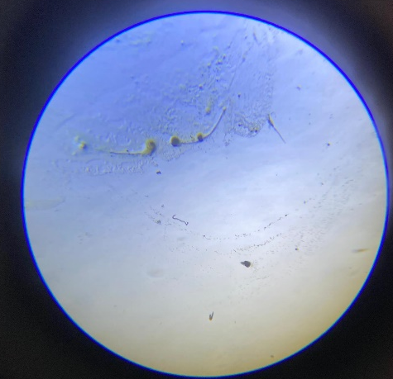

3.2 Weekly Clinical Observations in Experimental Rats

Table 2 Daily Observation for 100% Conc. Toxin Administration in Rats
Day | Gen. Appearance | Behaviour | Locomotion | Feeding | Drinking | Respiratory Signs | Eyes & Nose
1 | Normal | Active | Normal | Low | Red eyes | More deeper | More deeper
2 | Normal | Not active | Barely moving | Low consumption | Labored breathing | Reddened | More deeper
3 | Normal | Not active | Barely moving | Very low | Labored breathing | Reddened | Eye getting darker
4 | Dead | Dead | Dead | Dead | Dead | Dead | Dead
5 | Dead | Dead | Dead | Dead | Dead | Dead | Dead

Key:
Black – 100%; Red – 80%; Blue – 60%; Green – 50%

Table 3: Daily Observation for 80% Conc. Toxin Administration in Rats
Day | Gen. Appearance | Behaviour | Locomotion | Feeding | Drinking | Respiratory Signs | Eyes & Nose
1 | Normal | Active | Normal | High | Normal | Normal | Normal
2 | Normal | Less active | Slow movement | Low | Slightly labored | Mild discharge | Normal
3 | Normal | Less active | Slow movement | Low consumption | Mild labored | Mild discharge | Normal
4 | Normal | Less active | Barely moving | Low consumption | Normal | Normal | Eye getting darker
5 | Normal | Less active | Barely moving | Low consumption | Normal | Normal | More darker
Key:
Black – 100%; Red – 80%; Blue – 60%; Green – 50%

Table 4: Daily Observation for 60% Conc. Toxin Administration in Rats
Day | Gen. Appearance | Behaviour | Locomotion | Feeding | Drinking | Respiratory Signs | Eyes & Nose
1 | Normal | Active | Normal | Low | Normal | Normal | Normal
2 | Normal | Less active | Slow movement | Low | Normal | Normal | Normal
3 | Normal | Barely moving | Sluggish | Low | Normal | Normal | Normal
4 | Normal | Weak | Very sluggish | Very low | Slightly labored | Normal | Eye slightly dull
5 | Weak | Weak | Sluggish | Very low | Labored | Normal | Eye very dull

Key:
Black – 100%; Red – 80%; Blue – 60%; Green – 50%

Table 5 Daily Observation for 50% Conc. Toxin Administration in Rats
Day | Gen. Appearance | Behaviour | Locomotion | Feeding | Drinking | Respiratory Signs | Eyes & Nose
1 | Normal | Active | Normal | High | Normal | Normal | Dull
2 | Normal | Less active | Reduced | Low | Normal | Normal | Dull
3 | Normal | Less active | Sluggish | Low | Slightly labored | Normal | Eye slightly dull
4 | Normal | Weak | Very sluggish | Very low | Slightly labored | Normal | Eye dull
5 | Weak | Weak | Sluggish | Very low | Labored | Normal | Eye very dull
Key:
Black – 100%; Red – 80%; Blue – 60%; Green – 50%

Table 6: Post-Mortem Findings in Experimental Rats
Organ | Green(50%) | Blue (60%) | Red (80%) | Black 100%
Intestine | Becomes smaller and darker | Placid (Shrink) and very dark | Shrink but not as blue | Died during experiment
Liver | Becomes smaller | Very reddish | Dark in colour | Dead
Kidney | Reduce in size | Become smaller and pale | Becomes smaller | Dead
Heart | Abnormal | Normal | Normal | Dead

Fig 2
Post-Mortem Findings in Experimental Rats
The Black-labeled rat was administered 100%, the Red-labeled rat received 80%, the Blue-labeled rat was given 60%, and the Green-labeled rat received 50%.
- Green (b) Red (c) Blue (d)Control
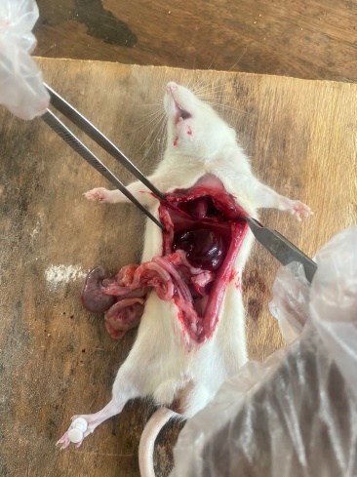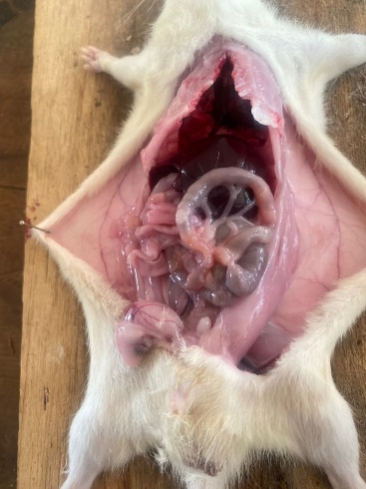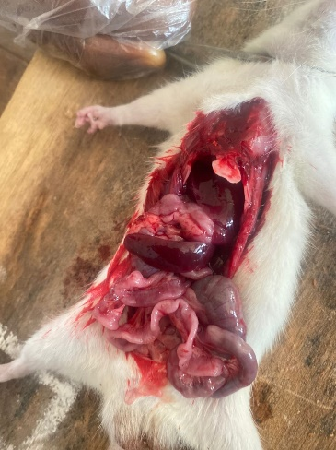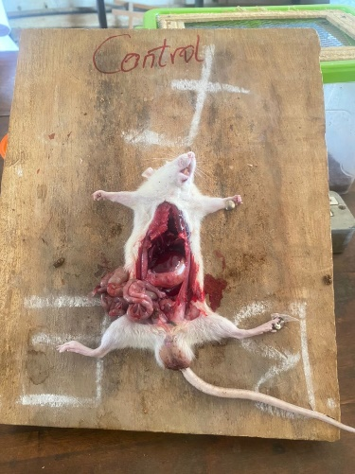
CHAPTER FOUR
4.0 DISCUSSION AND CONCLUSION
4.1 DISCUSSION
The cultural and microscopic identification of the fungal isolate from this study confirmed the organism as Fusarium graminearum, based on both macroscopic and microscopic criteria. On Potato Dextrose Agar (PDA), the isolate exhibited colonies that were initially white, later developing pink to greyish-green pigmentation concentrated at the colony center and reverse, along with a cottony, fluffy aerial mycelium. These features are consistent with descriptions by Zhou et al. (2022), who emphasized that such pigmentation patterns, colony texture, and pigmentation gradient are diagnostic traits for F. graminearum. Microscopically, the presence of septate hyphae, branched conidiophores, sickle-shaped (fusiform) macroconidia with 5–7 septa, and microconidia in false heads, as well as chlamydospore formation under stress, matched previous morphological characterizations of the species. These confirmatory features validate the identification process and support the findings presented in Table 1 and Figure 1 of this study.
Following successful identification, the toxicological evaluation of F. graminearum toxins on Wistar rats revealed a clear dose-dependent relationship in the severity of clinical symptoms and organ damage. Rats administered higher concentrations (100% and 80%) of fungal toxin exhibited pronounced clinical signs and mortality, whereas those given lower concentrations (60% and 50%) showed milder effects. In the 100% group (Black-labeled rat), as detailed in Table 3, progressive decline in activity, feeding behavior, and locomotion was observed by Day 2, along with labored breathing and eye discoloration. By Day 4, the rat was dead, indicating acute toxicity. These results are consistent with findings by Guo et al. (2023), who reported systemic toxicity and multi-organ failure in rats exposed to high doses of trichothecenes, especially deoxynivalenol (DON) and fusarenon-X (FX). The Red-labeled rat (80%) also exhibited reduced activity, slow movement, poor feeding, and visible ocular changes by Day 5 (Table 4), though not as severe as the 100% group. These findings align with Wang et al. (2023), who observed that exposure to DON in moderate concentrations caused behavioral impairments and respiratory distress, with symptoms intensifying with prolonged exposure. In contrast, the 60% (Blue) and 50% (Green) groups showed delayed onset and milder progression of clinical signs. By Day 5, both rats had decreased feeding and locomotor activity, but remained alive (Tables 5 and 6). These results support the conclusions of Martínez-Moral et al. (2022), who highlighted the risk of chronic sub-lethal toxicity at lower concentrations, which may not produce immediate mortality but result in cumulative organ damage and physiological stress over time.
The post-mortem findings presented in Table 3 and Figure 2 further corroborate the clinical observations. The 100% dose group showed total organ failure, while rats in the 80% and 60% groups exhibited shrinking of the intestines and kidneys, as well as darkened and atrophic liver tissue. Guo et al. (2023) similarly documented hepatic and renal degeneration in rats exposed to Fusarium mycotoxins. Interestingly, the Blue-labeled rat also displayed pale kidneys and reddish liver, consistent with nephrotoxicity and hepatotoxicity as noted by Adeyemi et al. (2023). Notably, only the 100% group (Black) showed an abnormal heart, suggesting that high concentrations may extend toxicity to cardiac tissue—an outcome rarely reported, but plausible due to the systemic nature of trichothecene toxins.
In the 50% group (Green), only mild intestinal shrinkage and slight discoloration of the liver and kidney were observed, and the rat remained clinically stable throughout the observation period. This aligns with findings by Sánchez-Bayo et al. (2024), who reported subtle but persistent physiological alterations and endocrine disruptions at low-dose, long-term exposure to zearalenone (ZEA) and FX. Although reproductive or immunological parameters were not directly assessed in this study, the behavioral and histopathological outcomes suggest possible underlying disruptions.
4.2 CONCLUSION
The present study successfully isolated and identified Fusarium graminearum based on its distinct cultural and microscopic characteristics, which aligned with standard morphological descriptions in existing literature. The toxicity evaluation revealed a clear dose-dependent effect of the fungal toxins on experimental rats, with higher concentrations (100% and 80%) resulting in severe clinical symptoms and organ damage, including mortality. Lower concentrations (60% and 50%) produced milder but progressive physiological changes. These findings corroborate earlier research on the toxicological impact of F. graminearum mycotoxins, particularly DON, ZEA, and FX, highlighting their potential threat to food safety and public health.

REFERENCES
Brown, N. A., Urban, M. and Hammond-Kosack, K. E. (2017). The trans-kingdom identification of negative regulators of toxin production in Fusarium graminearum. Fungal Genetics and Biology, 106, 1–12. https://doi.org/10.1016/j.fgb.2017.06.002
Desjardins, A. E. (2006). Fusarium Mycotoxins: Chemistry, Genetics, and Biology. APS Press.
Ding, X., Wu, S. & Tan, Q. (2022). Cellular and molecular responses to Fusarium mycotoxins. Journal of Agricultural and Food Chemistry, 70(25), 7598-7605. https://doi.org/10.1021/acs.jafc.2c02742
European Food Safety Authority (EFSA). (2013). Scientific opinion on the risks for public health related to the presence of deoxynivalenol (DON) in food and feed. EFSA Journal, 11(10), 3379. https://doi.org/10.2903/j.efsa.2013.3379
Fandohan, P., Hell, K., Marasas, W. F. O. & Wingfield, M. J. (2012). Impact of Fusarium and its toxins on human and animal health in West Africa. African Journal of Food, Agriculture, Nutrition and Development, 12(3), 6132–6145. https://doi.org/10.4314/ajfand.v12i3.5
Foroud, N. A. & Eudes, F. (2009). Trichothecenes in cereal grains. International Journal of Molecular Sciences, 10(1), 147–173. https://doi.org/10.3390/ijms10010147
Huang, T., Lu, L. & Li, H. (2022). Fusarium graminearum and its mycotoxins in food and feed. Toxicology Reports, 9, 785-792. https://doi.org/10.1016/j.toxrep.2022.03.013
International Agency for Research on Cancer (IARC). (1993). Some naturally occurring substances: Food items and constituents, heterocyclic aromatic amines and mycotoxins (Vol. 56). IARC Monographs on the Evaluation of Carcinogenic Risks to Humans. https://publications.iarc.fr
Jabeen, S., Khan, R. M. & Khan, M. S. (2023). Fusarium mycotoxins: Sources, impacts, and management. Journal of Food Safety, 43(2), e13176. https://doi.org/10.1111/jfs.13176
Müller, W., Smith, L. M. & Johnson, R. (2020). Histopathological effects of Fusarium toxins in rat liver and kidneys. Environmental Toxicology and Pharmacology, 72, 103265. https://doi.org/10.1016/j.etap.2020.103265
Pestka, J. J., Zhou, H. R., Moon, Y. & Chung, Y. J. (2018). Cellular and molecular mechanisms for immune modulation by deoxynivalenol and other trichothecenes: Unregulated inflammation and immune cell apoptosis. Toxicology Letters, 153(1), 61–73. https://doi.org/10.1016/j.toxlet.2004.04.023
Sánchez, D., García, L. & Díaz, G. (2022). Neurotoxic effects of deoxynivalenol on cognitive and motor behavior in rats. Toxicology Letters, 365, 124-130. https://doi.org/10.1016/j.toxlet.2022.02.003
Sørensen, J. L., Pedersen, L. B. & Møller, K. (2021). Immunomodulatory effects of Fusarium toxins in animals. Veterinary Toxicology, 48(1), 95-103. https://doi.org/10.1016/j.vetox.2021.01.007
U.S. Food and Drug Administration (FDA). (2010). Guidance for industry and FDA: Advisory levels for deoxynivalenol (DON) in finished wheat products for human consumption and grains and grain by-products used for animal feed. https://www.fda.gov/media/121202/download
Yin, Y., Wu, L. & Li, C. (2022). Advanced molecular techniques in the study of Fusarium toxin toxicity. Molecular Toxicology, 22(4), 249-257. https://doi.org/10.1016/j.mtox.2022.03.003
Zhao, L., Wang, X. & Xu, W. (2021). Deoxynivalenol-induced toxicity in animals: Mechanisms and potential treatments. Toxicology Research, 10(4), 548-561. https://doi.org/10.1093/toxres/tfab006
Zhu, Z., Jiang, X., & Li H. (2023). Mechanisms of Fusarium toxin-induced toxicity in rats: Implications for food safety. Toxicology Research, 40(1), 15-24. https://doi.org/10.1039/d3tx00006b

