PERFORMANCE ANALYSIS OF TROPOSHERIC RADIO REFRACTIVITY ON RADIO FIELD STRENGTH AND RADIO HORIZON DISTANCE AND ITS VARIATION WITH METEROLOGY PARAMETERS OVER ILORIN, NIGERIA

BY:

KAREEM VICTOR ISREAL HND/23/SLT/FT/0562

BEING A PROJECT REPORT SUBMITTED TO THE DEPARTMENT OF SCIENCE LABORATORY TECHNOLOGY (PHYSICS/ELECTRONIC UNIT), INSTITUTE OF APPLIED SCIENCES, KWARA STATE POLYTECHNIC ILORIN

IN PARTIAL FULFILMENT OF THE REQUIREMENTS FOR THE AWARD OF HIGHER NATIONAL DIPLOMA (HND) IN SCIENCE LABORATORY TECHNOLOGY (SLT), KWARA STATE POLYTECHNC, ILORIN, KWARA STATE

AUGUST, 2025

I
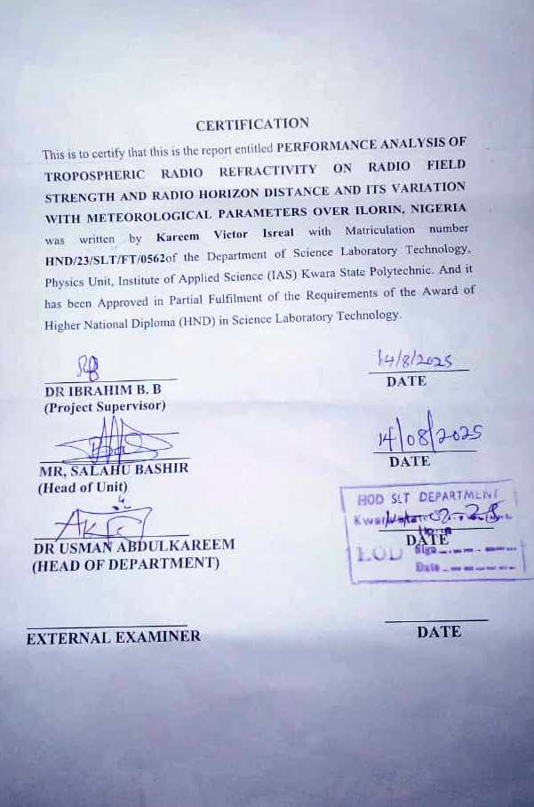ii
DEDICATION
This project is dedicated to Almighty God who made it possible for me.To everyone who believed in me, especially my family and friends, this project is dedicated to you.
I also dedicate this project to my parent for their love, support and encouragement have been my guiding light throughout this journey.
I also dedicate it to my siblings whose love, support, and encouragement have been a guide throughout this journey. Thank you, my wonderful family.
Lastly, I dedicate it to my supervisor (DR IBRAHIM. B.B)

iii

ACKNOWLEDGEMENT
First and foremost, I offer my sincerest gratitude to God for His guidance, strength, and unwavering support throughout this journey. This project would not have been possible without His blessings.

To my lovely and caring parents (Mr. and Mrs. KAREEM) my success journey is incomplete without you, thank you for always windless love and support. God bless you abundantly, may you live long to reap the fruit of your labor.

With a heart full of gratitude, I acknowledge those who have been the wind beneath my wings. To my support system(my parents)who provided unwavering belief and encouragement.Thank you for being the guiding stars that illuminated my path.

My profound gratitude goes to my project supervisor, Dr IBRAHIMB.B, who had taken his time to supervise and guide me in every stage of this project. May almighty God perfect everything that concerns you and your family (Amen)

Also not to forget my favorite person (Jimoh NofisatOdunayo) you’re real definition of a friend in need is a friend indeed. To my amazing course mate turn friends (Olawale, Jamiu) I’m indebted to you all, I really appreciate you all.

Thank you all.

iv

TABLE OF CONTENTS
Title page
Certification
Dedication
Acknowledgment
Table of content
Abstract
CHAPTER ONE: INTRODUCTION
1.1 Introduction
1.2 Statement of Problem
1.3 Significance of Study
1.4 Expected Result Applications
1.5 Aim and Objectives
CHAPTER TWO: LITERATURE REVIEW
2.0 Literature Review
2.1 Temperature
2.2 Relative Humidity
2.3 Atmospheric pressure
2.4 Water Vapor Pressure
2.5 Saturated Vapor Pressure
CHAPTER THREE: METHODOLOGY
3.1 Study Area
3.2 Data Acquisition
3.3 Theoretical Background
CHAPTER FOUR: RESULTS, DISCUSSION AND CONCLUSSION
4.1 Results
Conclusion
References

v
ABSTRACT
In this study, the yearly and monthly variation of tropospheric radio refractivity and field strength variability was estimated using the monthly average of daily temperature, relative humidity and atmospheric pressure meteorological parameters during the period of eleven years (2013 – 2024). The results shows that higher values of monthly tropospheric radio refractivity were recorded during the rainy and dry seasons, respectively, with highest and lowest value in the month of the months of September and February with 345.99 N-units and 285.29 N-units, respectively. The highest and lowest annual average value of tropospheric radio refractivity were found in the year 2013 and 2019 with 345.8986 N-units and 326.1841 N-units respectively. The study area under investigation yield average gradient of -40.8252 N-units/km. Additionally, the average effective earth radius K was found to be 1.351. These values align with the condition of Super-refraction propagation.

vi

CHAPTER 1
1.1 INTRODUCTION
The behavior of radio waves in the tropospheric layer of the Earth’s atmosphere is very important in this modern age that is highly influenced by radio communications ranging from mobile telephoning through terrestrial digital broadcasting to the propagation of satellite radio signal through the troposphere (Abimbola, 2021). Increased dependence on radio communication in Nigeria through the use of communication technologies such as laptops, smartphones and computers in our day-to-day life ease the way of doing businesses and social activities such as mobile banking, e-businesses, access to news and usage of social media (Sa’adu ‘2020). The relationship between surface refractivity, refractivity gradient, and radio refractivity is complex and interconnected(B. Adeyemi & Ogodo, 2024). The most Significant impact of the earth's atmosphere on radio wave propagation, especially at frequencies greater than 30 MHz, is refraction (Bello, 2024). The prevalence of sea and land breezes which play a major role in the development and intensification of weather events also accounts for the high concentration of water vapor in the coastal cities(Ojo, 2019). Refractivity is defined as the physical property of a medium as determined by its index of refraction and it is responsible for the different phenomena in radio wave propagation which comprises of refraction and fading, ducting and scintillation, range and elevation errors in radar acquisition( Akpootu & Rabiu, 2019). Due to the increase in the utilization of VHF/UHF and other higher frequency bands for terrestrial and earth-space radio links, developing countries usually rely on free-air wireless systems in order to be in step with the

1
world’s digital communications development(Adediji , 2014). The atmospheric water vapor molecules possess permanent dipole moments, which make water vapor a significant contributor
to the variability of the atmospheric refractive index for radio waves(B. Ã. Adeyemi, 2006). The troposphere is the part of the atmosphere most directly associated with human life( Akpootu et al., 2024). The structure of the radio refractive index, n, at the lower part of the atmosphere is a very important parameter in planning of the communication links. It is defined as a ratio of the radio wave propagation velocity in free space to its velocity in a specified medium (Valma , 2011).

1.2 STATEMENT OF PROBLEM
Reliable radio communication is critically dependent on the behavior of radio waves as they travel through the atmosphere. In the troposphere, variations in temperature, pressure, and humidity alter the refractive index of the air, impacting how radio signals propagate. Over regions like Ilorin, Nigeria characterized by tropical climate and significant seasonal meteorological variation, these changes in tropospheric radio refractivity can lead to fluctuations in radio field strength and effective radio horizon distance.
Despite the growing reliance on wireless communication systems in Nigeria, there is limited localized research quantifying how these atmospheric factors influence signal behavior in Ilorin. This gap makes it challenging for engineers and broadcasters to optimize network coverage, ensure signal reliability, and mitigate interference or signal loss.

2
The lack of detailed performance analysis in this region poses the following key challenges:
- Inconsistent signal quality due to unaccounted refractivity variations.
- Poor radio network design and coverage planning.
- Limited understanding of how seasonal weather patterns affect communication infrastructure.
Therefore, there is a need to analyze the relationship between tropospheric refractivity and radio wave performance, and to assess how meteorological parameters influence this interaction over Ilorin. Such insights will help improve the design and operation of communication systems in similar tropical environments.
1.3 SIGNIFICANCE OF STUDY
The study of performance analysis of tropospheric radio refractivity on radio field strength and radio horizon distance, and its variation with meteorological parameters over Ilorin, Nigeria, is significant for several reasons:
1.Understanding the effects of tropospheric radio refractivity on radio field strength and radio horizon distance is crucial for designing and optimizing radio communication systems, such as cellular networks, broadcasting, and navigation systems.
2. Tropospheric radio refractivity affects signal propagation, causing bending, scattering, and absorption of radio waves. Accurate modeling and prediction of refractivity are essential for reliable communication systems.

3
3. The study investigates the relationship between meteorological parameters (temperature, humidity, pressure) and radio refractivity, which is vital for understanding the impact of weather conditions on radio communication systems.
4. Focusing on Ilorin, Nigeria, provides valuable insights into the local atmospheric conditions and their effects on radio communication systems, which can inform the design and optimization of communication infrastructure in the region.
5. By understanding the variations in radio refractivity and its impact on radio field strength and horizon distance, researchers and engineers can develop strategies to mitigate signal degradation and improve the overall performance of radio communication systems.

1.4EXPECTED RESULT APPLICATIONS ARE:
1. Telecommunications: The study's findings can inform the design and optimization of cellular networks, broadcasting systems, and other telecommunication infrastructure.
2. Navigation systems: Understanding the effects of tropospheric radio refractivity on signal propagation can improve the accuracy and reliability of navigation systems, such as GPS.
3. Weather forecasting: The study's insights into the relationship between meteorological parameters and radio refractivity can contribute to improved weather forecasting and modeling

4
1.5 AIM & OBJECTIVES
The aim of this work is to analyze the impact of tropospheric radio refractivity on radio field strength and radio horizon distance, and to examine its variation with meteorological parameters over Ilorin, Nigeria while the specific objectives are to:
- Compute the tropospheric radio refractivity over Ilorin using meteorological parameters such as temperature, pressure, and relative humidity,
- Investigate the seasonal and diurnal variations of radio refractivity and their correlation with prevailing weather conditions,
- Analyze the effect of refractivity variations on radio field strength,
- Evaluate changes in radio horizon distance resulting from variations in refractivity across different atmospheric conditions and
- Provide recommendations for improving radio communication systems and network planning in Ilorin based on the observed atmospheric impacts.

5
CHAPTER TWO
2.0 LITERATURE REVIEW
(D. Akpootu & Iliyasu, 2017)estimated tropospheric radio refractivity under varying meteorological conditions in Ilorin, Nigeria. The results shows that an average value of 385.99 N-units and an average value of 382.94 N-units were observed during the rainy and dry seasons respectively.
(Daniel Effiong Oku, Amajama Joseph, 2015) showed this research work has established the fact that metrological parameters contribute significantly to the radio refractivity of Ilorinatmosphere and hence affects the radio wave propagation.
(Sa’adu et al., 2020) showed it has been observed that refractivity reveals seasonal variations with high value in rainy season and low values in dry season.
(D. Akpootu, 2021)studied that the international telecommunication union (ITU) method has been employed to estimate the yearly and monthly tropospheric radio refractivity over Ilorin, Nigeria using meteorological parameters of temperature, relative humidity and atmospheric pressure during the period of fifteen years (2002 – 2016).
(Eastern et al., 2019) showed the results of this study revealed that high values of SWVD are recorded during the raining season and low values during the dry season.

6
(D. O. Akpootu, 2021) showed the Stefan-Boltzmann law has been employed to estimate the yearly and monthly average values of terrestrial solar radiation using monthly averaged meteorological parameters of temperature and relative humidity obtained from the National
Aeronautics and Space Administration (NASA) during the period of twenty-two years (2013 - 2022).

2.1 TEMPERATURE
Temperature is a measure of the average kinetic energy within a body. It describes the potential for heat energy to move from one body to another down a gradient from an area of high temperature to an area of lower temperature. It is measured using a temperature scale which is defined against fixed physical events such as absolute zero or the triple point of water(Gardner, 2020).Fahrenheit; This is the oldest temperature scale which was developed in 1724 by Daniel Fahrenheit. This scale became popular because it was used in accurate, commercially available mercury thermometers.
MEASUREMENT OF TEMPERATURE
Thermometers are classified into those that exploit non-electrical and those that exploit electrical thermometric property change,
*Non-electrical thermometers;
Liquid expansion Gas

7
Bimetallic strip
Liquid crystal Infrared

*Electrical thermometers;
Resistance Thermistor
Thermocouple.
Thermometers measure temperature according to well-defined scales of measurement. The three most common temperature scales are Fahrenheit, Celsius, and Kelvin. Temperature scales are created by identifying two reproducible temperatures. The freezing and boiling temperatures of water at standard atmospheric pressure are commonly used. On the Celsius scale, the freezing point of water is 0 °C and the boiling point is 100 °C. The unit of temperature on this scale is the degree Celsius (°C). The Fahrenheit scale (still the most frequently used for common purposes in the United States) has the freezing point of water at 32 °F and the boiling point at 212 °F.

2.2 RELATIVE HUMIDITY
Humidity is the amount of water vapor present in the air. Humidity is measured using a hygrometer, a tool that utilizes various materials and measurements to gauge a room or space’s level of water vapor.The vapor concentration or absolute humidity of a mixture of water vapor and dry air is defined as the ratio of the mass of water vapor Mwto the volume V occupied by the mixture.

8
2.3 ATMOSPHERIC PRESSURE
The atmospheric pressure is the force exerted by the weight of the Earth's atmosphere, expressed per unit area in a given horizontal cross-section. Thus, the atmospheric pressure is equal to the weight of a vertical column of air above the Earth's surface, extending to the outer limits of the atmosphere.atmospheric pressure is reported in hectopascals (hPa). 1 hPa is equal to 100 Pa, the pascal being the basic SI (System of International Unit).It can be measured with a mercury barometer, consisting of a long glass tube full of mercury inverted over a pool of mercury.When the tube is inverted over the pool, mercury flows out of the tube, creating a vacuum in the head space, and stabilizes at an equilibrium height h over the surface of the pool.

2.4 WATER VAPOR PRESSURE
The vapor pressure (P°) is the pressure of the vapor of a compound in equilibrium with its pure condensed phase (solid or liquid).The normal boiling point of a liquid is defined as the temperature at which the vapor pressure of the liquid is 1 atmosphere (P° = 1 atm). The vapour pressure of a substance is an intrinsic physical property that plays a crucial role in determining its distribution to and from gaseous environmental phases (the atmosphere, marsh bubble gas).At ambient temperatures, the vapor pressure of a compound can vary by an order of magnitude, so the dependence on temperature is important. It is illustrative to imagine what the molecules of a substance achieve to establish an equilibrium vapor pressure by examining a kinetic-molecular description.

9
The molecules in the liquid will be thermally jostling each other and will be continuously exchanging energies.H₂O is the only matter that can be present at ambient conditions under its three phases: water vapour, liquid water and ice.
Viewing the evaporation processes on the molecular level, it occurs when the flow of individual water molecules away from the water body exceeds the return flow to the water from the air. The actual amount of evaporation that takes place is a rather complex function of five different parameters:
• Energy availability: The flow of molecules away from the water body requires a certain amount of energy. This energy can be thermal, i.e. evaporation increases with increasing temperature and the photons of the solar radiation contribute an important amount to this energy.
• Reduction in atmospheric pressure: The molecules can leave the water surface more easily if the counteracting atmospheric pressure force is smaller.
• Humidity: When the air layer above the water surface is relatively dry and far from the saturation state, the vapour gradient between water surface and atmosphere is significant. This steep gradient reduces the return flow of molecules to the water body. In calm conditions, however, vapour will rapidly build up in the air layer, saturate it and the gradient will rapidly disappear.
• Presence of wind: Strong winds will constantly remove the moist layer from the water surface and, thus, maintain a steep gradient of water vapour and high evaporation rates.

10
• Water availability: Through open surfaces, water is easily accessible and maximum evaporation rates can be achieved. If the water is present in the soil, the vegetation or animals and humans, evaporation is still taking place. However, it is regulated by pores or stomata, and is, thus, called transpiration.

2.5 SATURATED VAPOR PRESSURE
A saturated vapor is a vapor that is in contact with its own liquid within a confined space. When the enclosed space above a liquid is saturated with vapor molecules and can hold no more molecules, the pressure exerted by this saturated vapor is said to be the saturated vapor pressure (s. v. p) of the liquid.
Dew point is the temperature at which the water vapors present in the air just sufficient to saturate it. It is also defined as the temperature at which the pressure of the water is vapor is equal to the saturation vapor pressure.
Mist – mist occur in wet air with high relative humidity above 75% when water vapor in the air is cooled below its dew point. Mist limits visibility to about 1000m or less.
Fog – fog is formed when water vapor in the air is cooled down to its dew point. Fog is of more effect than the mist as it can reduce visibility to less than 200m.
The relation between the temperature and the pressure of saturated water vapor is of prime importance in establishing the thermo- dynamic behavior of steam.

11
CHAPTER 3
3.1 STUDY AREA
Ilorin as a town and capital of Kwara State, located approximately on latitude 8$°$30’Nof the equator and longitude 4$°$35’E of the Green-wich Meridian with an area of about 100km2andestimated population of 950,000 people in the North Central geopolitical zone of Nigeria. The climate is characterized by both wet and dry seasons with total annual rainfall between 990.3mm and 1,318mm and temperature of between 33$℃$ and 37$℃$(Akinyemi, 2021).
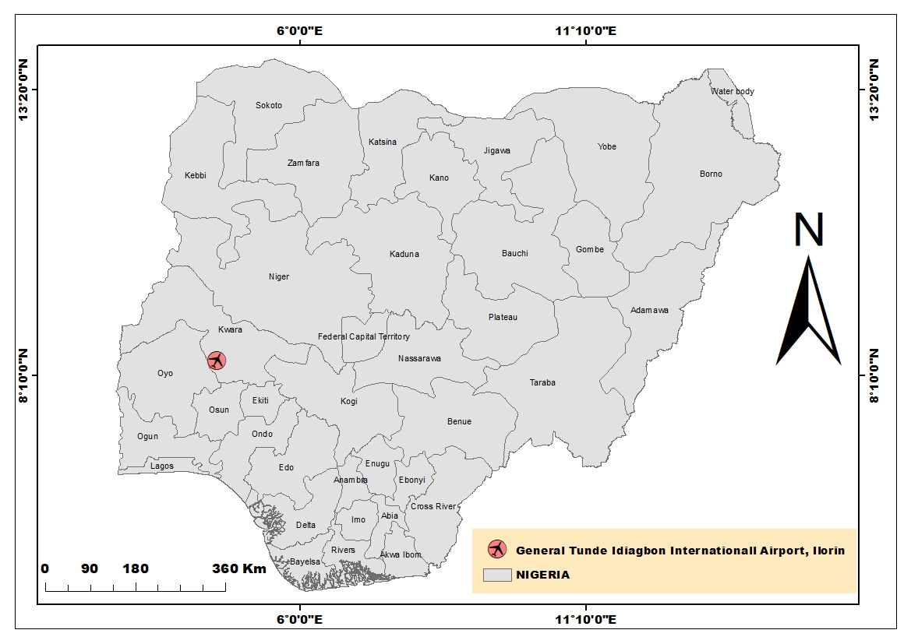

12
3.2 DATA ACQUISATION
Secondary data from the Nigeria Meteorological Agency (NIMET), Ilorin Airport office was used to study the trend and variability of rainfall and temperature between 2013 and 2024 (Akinyemi,2021).
The data used in the computations were obtained from the archives of the Department of the Meteorological Services, Federal Ministry of Aviation, at oshodi in lagos Nigeria. The data obtained for the period 2013 – 2022 were used in making the computations for those tropical stations in ilorin.

3.3 THEORETICAL BACKGROUND
N = Refractivity, measured in N-unit

N= $\frac{77.6}{T}\left(P+4810\frac{e}{T}\right)=N_{dry+}N_{wet}$ …………………….. (1)

Expand to get $N_{dry} and N_{wet }$

With the “dry term” of radio refractivity given by:
$N_{dry}=77.6\frac{p}{T}$ …………………………………………………… (2)
With the “wet term” of radio refractivity given by:
$N_{wet}=3.73×{10}^{5}\frac{e}{T^{2}}$ …………………………………………. (3)
Where P= Atmospheric Pressure (hPa)

13
T= Absolute Temperature (K)
e= Water Vapour (hPa)

The relationship between water vapor pressure (e) and relative humidity (RH) is given by the expression:
e= $\frac{He_{s}}{100}$ ………………………………………………… (4)
Where H = Relative Humidity
$e_{s }$= Saturated Water Vapor

$e_{s}=a exp (\frac{bt}{t+c}$) ………………………………… (5)

Where, a = 6.1121
b = 17.502
c = 24097
t = Temperature ($℃)$

Refractivity Gradient:
The radio refractivity N, also decrease exponentially in the troposphere with height:
$N_{o}$ = $N_{s}$exp ($\frac{h_{o}}{H})$ OR $N_{s}$ = 315$\exp^{-0.136h}$
Where, $N_{s}$= Refractivity at surface of the earth
$N_{o}$ = Average values of atmospheric extrapolated to sea level
$h_{o}$ = Height of the earth’s surface above sea level

14
$H_{o}$ = Scale height = 7.35km

$\frac{{dN}_{o}}{dh }$ = $\frac{{-N}_{s}}{H_{o}}$exp($\frac{{-h}_{o}}{H_{o}})$ refractivity gradient

Thus, k may be expressed in terms of refractivity gradient, dN/dh as:
K = [1+$\frac{(\frac{dN}{dh})}{157}]^{-1}$ …………………………………………. (5)

FSV – Field Strength Variation =
($N_{s(max)}$- $N_{s(max)}$) $×$ 0.2$d_{b}$ ……………………… (6)
$d_{b}=$decibel

15
CHAPTER FOUR
4.1 RESULTS AND DISCUSIONS
Radio refractivity and its variation with other meteorological parameters
The yearly mean variation of refractivity in Ilorin is shown in fig below. The refractivity in Ilorin is observed to increase sharply from its lowest value of 5.00N-units in the year 2013 to its maximum value 55.00N-units in the year 2019 and afterwards decreases gradually till 2020, before rising slowly to another peak value of 5.02N-units in the year 2021 and thereafter decreases sharply through 2022 (O nujagbe et al., 2021).
FIG 1
Fig 1: Variation of Mean yearly surface refractivity value for Ilorin

16
The monthly mean variation of refractivity in Ilorin is shown in the figure below. The refractivity in Ilorin is observed to increase sharply from its lowest value of 285.29N-units in the month of January to its maximum value of 345.99N-units in the month of May and afterwards decreases gradually till August before rising slowly to another peak value of 345.39N-units in the month of October and thereafter decreases sharply through December.
FIG 2
Fig 2: Variation of Mean monthly surface refractivity value for Ilorin

17
FIG 3

Fig 3: Variation of Mean monthly surface refractivity value for Ilorin
The monthly mean variation of refractivity in Ilorin is shown in the figure above. The refractivity in Ilorin is observed to increase sharply from its lowest value of326.18 N-units in the year 2019 to its maximum value of 345.99N-units in the year 2013N-units.

18
CONCLUSION
The international telecommunication union (ITU) method has been employed to estimate the yearly and monthly tropospheric radio refractivity over Ilorin, Nigeria using meteorological parameters of temperature, relative humidity and atmospheric pressure during the period of nine years (2013 – 2022). The yearly and monthly variations of radio refractivity was also studied. The refractivity gradient, and the field strength variability were also reported. The results in this study revealed that slightly higher values of monthly tropospheric radio refractivity were recorded in the rainy season than in the dry season with the highest and lowest values in the month of January and May with 345.99 N-units and 285.29 N-units respectively. The highest and lowest annual average values of tropospheric radio refractivity were found in the year 2013 and 2019 with 345.8986 N – units and 326.1841 N – respectively. The refractivity gradient and effective earth radius found for Ilorin, Nigeria during the period under investigation were -40.8252 N-units/km indicating that the propagation in this region is mostly Super-refraction. This is also supported by the value of effective earth radius, which is greater than 4/3. The highest and lowest values of field strength variability (FSV) was estimated in the year 2019 and 2013 as 54.64784 dB and 6.438766 dB respectively.

19
REFERENCES

Abimbola, O. J., Bada, S. O., Falaiye, A. O., Sukam, Y. M., Otto, M. S., & Muhammad, S. (2021). Estimation of radio refractivity from satellite-derived meteorological data over a decade for West Africa. Scientific African, 14, 1–8. https://doi.org/10.1016/j.sciaf.2021.e01054
Adediji, A. T., Ismail, M., & Mandeep, J. S. (2014). Variation of radio field strength and radio horizon distance over three stations in Nigeria. Journal of Atmospheric and Solar-Terrestrial Physics, 109, 1–6. https://doi.org/10.1016/j.jastp.2013.12.006
Adeyemi, B. Ã. (2006). Surface water vapour density and tropospheric radio refractivity linkage over three stations in Nigeria. JOURNAL OF ATMOSPHERIC AND SOLAR-TERRESTIAL PHYSICS, 68, 1105–1115. https://doi.org/10.1016/j.jastp.2006.01.012
Adeyemi, B., & Ogodo, S. O. (2024). Refractivity Gradient Variations and Intertropical Discontinuities Across Nigeria. INTERNATIONAL ASTRONOMY AND ASTROPHYSICS RESEARCH, 6(1), 5–17.
Akinyemi, O., Faweya, O., & Jide-ashaolu, E. (2021). Trend and Variability Analysis of Rainfall and Temperature Trends in Ilorin Metropolis , Kwara State , Nigeria. 74, 1–7. https://doi.org/10.31901/24566608.2021/74.1-3.3307

20
Akpootu, D. (2021). Estimation and Investigation of the Variability of Tropospheric Radio Refractivity and Radio Field Strength over Accra, Ghana. Journal of Atmospheric and Earth Science, 5(1), 1–10. https://doi.org/10.24966/aes-8780/100026
Akpootu, D. ., Aminu, Z., Nouhou, I., Yusuf, A., Idris, M., Aliyu, M. ., Salifu, S. ., Kola, T. ., & Agidi, O. . (2024). Assessment of Tropospheric Radio Refractivity and Its Variation with Climatic Variables Over Zaria , Nigeria. DUTSE JOURNAL OF PURE AND APPLIED SCIENCES, 10, 243–255.
Akpootu, D. ., & Rabiu, A. . (2019). Empirical Models for Estimating Tropospheric Radio Refractivity Over Osogbo , Abstract : THE OPEN ATMOSPHERIC SCIENCE JOURNAL, 13, 43–55. https://doi.org/10.2174/1874282301913010043
Akpootu, D., & Iliyasu, M. (2017). Estimation of Tropospheric Radio Refractivity and Its Variation with Meteorological Parameters over Ikeja, Nigeria. Journal of Geography, Environment and Earth Science International, 10(1), 1–12. https://doi.org/10.9734/jgeesi/2017/32534
Akpootu, D. O. (2021). Estimation of Terrestrial Solar Radiation and its Variation with other Meteorological Parameters over Lokoja, Nigeria. International Journal of Current Science Research and Review, 04(08). https://doi.org/10.47191/ijcsrr/v4-i8-13
Bello, G., Akpootu, D. O., & Sharafa, S. B. (2024). Assessment of Tropospheric Radio Refractivity and its Variation with Climatic Variables in the Guinea Savannah Region of Nigeria. European Journal of Theoretical and Applied Sciences, 2(3), 88–104. https://doi.org/10.59324/ejtas.2024.2(3).10
21
Daniel Effiong Oku, Amajama Joseph, E. P. O. (2015). Seasonal Tropospheric Radio Refractivity Variation in Calabar , Cross River State , Nigeria. June, 15–18.
Eastern, S., Akpootu, D. O., Mustapha, W., Rabiu, A. M., Iliyasu, M. I., Abubakar, M. B., Yusuf, S. O., & Salifu, S. I. (2019). Estimation of Surface Water Vapour Density and Its Variation with Other Meteorological Parameters Over. HYDROLOGY, 7(3), 46–55. https://doi.org/10.11648/j.hyd.20190703.12
Gardner, B. (2020). The physics of temperature. 26(6), 55–58.
O nujagbe, I. ., Ahmed Ade, F., Mopah, M., David, A. ., Unit, P., Studies, P., Polytechnic, K. S., Physics, D. of, & Department, S. L. (2021). Surface Radio Refractivity of Akure and Ondo town , South-. NIGERIA ANNALS OF PURE AND APPLIED SCIENCES, 4(1), 213–219.
Ojo, J. S., Adelakun, A. O., & Edward, O. V. (2019). Heliyon Comparative study on Radio Refractivity Gradient in the troposphere using Chaotic Quantifiers. Heliyon, 5, 1–8. https://doi.org/10.1016/j.heliyon.2019.e02083

22
Sa’adu, L., Bawa, M., & Bello, M. (2020). A Review on the Effects of Radio Refractivity and Atmospheric Parameters on Signal Quality at Ultra High Frequency (UHF). International Journal of Science for Global Sustainability, 6(2), 91–99. https://doi.org/10.57233/ijsgs.v6i2.112
Valma, E., Tamosiunaite, M., Tamosiunas, S., Tamosiuniene, M., & Zilinskas, M. (2011). Variation of radio refractivity with height above ground. Elektronika Ir Elektrotechnika, 5(111), 23–26. https://doi.org/10.5755/j01.eee.111.5.349

23

