

A PROJECT REPORT
ON
PROPOSED FASHION HOME
FOR
ILORIN EAST, KWARA STATE
BY
IDRIS ABDULRAHMAN AREMU
ND/23/ARC/FT/033
SUBMITTED TO THE:
DEPARTMENT OF ARCHITECTURAL TECHNOLOGY INSTITUTE OF ENVIROMENTAL STUDIES, KWARA STATE POLYTECHNIC, ILORIN
IN PARTIAL FULFILLMENT OF THE REQUIREMENT FOR THE AWARD OF NATIONAL DIPLOMA (ND) IN ARCHITECTURAL TECHNOLOGY.

JUNE 2025

DECLARATION
I, IDRIS ABDULKAREEM AREMU (ND/23/ARC/FT/0033), hereby declare that the information provided in this project report is accurate and true to the best of my knowledge.
I understand that this project is an original work and does not infringe on the intellectual property rights of others, under ARC. OLUWASEUN FAMILUA

Signature: __________________ Date: ____________________

Project Title:
FASHION HOME PROJECT

CERTIFICATION
I certify that this research project has been approved as meeting part of the requirement for the
award of National Diploma in Architectural Technology, Institute Of Environmental Studies,
Kwara State Polytechnic, Ilorin. Under the supervisor of ARC OLUWASEUN FAMILUA

ARC. OLUWASEUN FAMILUA -------------------------------------
Project Supervisor Signature and Date

ARC. OLAREWAJU F.A -------------------------------------
Project Coordinator Signature and Date

ARC. TOMORI -------------------------------------
Head of Department Signature and Date

External Examiner ----------------------------------------
Signature and Date

DEDICATION
To all the individuals who have inspired me throughout my journey, including my mentors, colleagues and friends. Your guidance, wisdom and encouragement have helped shape me into the person I am today.
Thank you all and Allah bless you.

ACKNOWLEDGMENT
Thank be to almighty Allah for his blessing, guidance and it protection, may his
protection and blessing continue to be with us (amen).
I would like to extend my deepest gratitude to my project supervisor that scarify his time to guide me truth my project ARC. OLUWASEUN FAMILUA. I say a big thanks.
My appreciation goes to my Amiable Head Of Department in person of ARC. J. M TOMORI and other academic staffs for their immense contribution toward the success of my program may the Lord Honor and do you all good.
I would like to thank my family and friends for their emotional support and encouragement during challenging times

ABSTRACT
Architecture is the art and science of designing buildings and structures that are aesthetically pleasing, functional and sustainable. It involves the creation of physical environments that meet the needs of users, while also reflecting the cultural, social and environmental context in which they are built.
Good architecture can enhance the human experience, promote social interaction and contribute to the well-being of individuals and communities. It can also reflect the values and aspirations of a society and provide a sense of identity and belonging. Furthermore, architecture can play a critical role in addressing some of the world's most pressing challenges, such as climate change, urbanization and social inequalit
TABLE OF CONTENTS
TITTLE PAGE ………………….………….…………..………………… i
DECLARATION ……...………………….………………..….……………. ii
CERTIFICATION ………………….………….……………….…………….iii
DEDICATION………………….………….……………….………………...iv
ACKNOWLEDGMENT ………………….………….……………….……... v
ABSTRACT………………….………….…………….…………………….vi
TABLE OF CONTENTS ………………….………….……………….……. vii
LIST OF FIGURES………………….………….……………….………….. ix

CHAPTER ONE
1.0 INTRODUCTION --------------------------------------------------------------- 1
1.1 BACKGROUND OF THE STUDY ------------------------------------------- 1
1.2 STATEMENT OF THE DESIGN PROBLEM------------------------------- 1
1.3 AIM AND OBJECTIVES ------------------------------------------------------- 1
1.4 JUSTIFICATION OF THE STUDY ------------------------------------------- 2
1.5 CLIENT’S BACKGROUND AND PHILOSOPHY------------------------- 2
1.6 SCOPE OF THE STUDY ------------------------------------------------------- 2
1.7 LIMITATIONS OF THE STUDY --------------------------------------------- 3
1.8 RESEARCH METHODOLOGY----------------------------------------------- 3

CHAPTER TWO
2.0 LITERATURE REVIEW ------------------------------------------------------- 4
2.1 EVOLUTION OF FASHION ARCHITECTURE --------------------------- 4
2.2 TYPOLOGIES OF FASHION SPACES -------------------------------------- 5
2.3 FUNCTIONAL RELATIONSHIPS IN FASHION SPACES -------------- 5
2.4 TECHNOLOGICAL AND ENVIRONMENTAL CONSIDERATION --- 6
2.5 TECHNOLOGICAL AND ENVIRONMENTAL DESIGN TRENDS --- 6
2.6 REVIEW OF SUBTOPICS RELATED TO THE FASHION HOME ----- 7

CHAPTER THREE
3.0 CASE STUDY ------------------------------------------------------------------- 8
3.1 INTRODUCTION TO SUPPORT THE DESIGN OF A FUNCTIONAL AND RELATIONSHIP MODEN FADHIN HOME ----------------------------- 8
3.2 CASE STUDY 1 (KITAN COUTURE) --------------------------------------- 9
3.3 CASE STUDY TWO (ELORAMORE) --------------------------------------- 12
3.4 CASE STUDY THREE (DANIEL FASHION HOME) -------------------- 15
3.5 ONLINE CASE STUDY ONE (USA) ---------------------------------------- 18
3.6 ONLINE CASE STUDY TWO (FRANCE) ---------------------------------- 19

CHAPTER FOUR
4.0 STUDY ARE ANALYSIS ------------------------------------------------------ 20
4.1 SITE ANALYSI ------------------------------------------------------------------ 20
4.2 SITE LOCATION AND DESCRIPTION ------------------------------------ 21
4.3 CLIMATIC AND TOPOGRAPHIC ANALYSIS --------------------------- 21
4.4 ENVIRONMENTAL IMPACT AND ZONING ANALYSIS ------------ 22
4.5 SITE INVENTORY ------------------------------------------------------------- 22
4.6 SITE SELECTION CRITERIA ----------------------------------------------- 23

CHAPTER FIVE
5.0 DESIGN PROPOSAL AND DEVELOPMENT ---------------------------- 24
5.1 PROJECT GOALS AND DESIGN BRIEF --------------------------------- 24
5.2 FUNCTIONAL AND SPATIAL CRITERIA ------------------------------- 24
5.3 CONCEPTUAL DESIGN PROCESS --------------------------------------- 25
5.4 ZONING AND SPACE RELATIONSHIP DIAGRAMS ---------------- 26
5.5 SCHEDULE OF ACCOMMODATION ------------------------------------ 26
5.6 TECHNOLOGICAL AND ENVIRONMENTAL CONSIDERATIONS ----- 27
5.7 CONSTRUCTION METHODS AND MATERIALS --------------------- 27
5.8 MECHANICAL AND ELECTRICAL SERVICES ----------------------- 27
5.9 CONCLUSION AND RECOMMENDATION ---------------------------- 28

CHAPTER ONE
  - INTRODUCTION
BACKGROUND OF THE STUDY
A fashion home refers to a physical or virtual space that serves as a hub for fashion enthusiasts to explore, learn and engage with various aspects of fashion. It is a platform that provides a comprehensive and immersive fashion experience, offering a range of services, products and resources that cater to diverse fashion needs and interests
HISTORICAL BACKGROUNG OF THE STIDY
The modern fashion industry began in the 19th century with the establishment of fashion by individual designers Charles fed rick worth is considered the first fashion designer’s as he was the first to have his libel sewn into germent.
TYPES OF FASHION HOMES:
- Physical Fashion Store: A brick-and-mortar store offering clothing, accessories and fashion-related services.
- E-commerce Website: An online platform selling fashion products, providing styling advice and showcasing fashion trends.
- Fashion Blog or Vlog: A digital space where fashion enthusiasts share their style, trends and expertise through written or video content.
- Fashion Influencer's Social Media: A social media account where fashion influencers share their personal style, fashion tips and product recommendations.

FEATURES OF A FASHION HOME:
- Product Showcase: A curated selection of fashion products, including clothing, accessories and beauty items.
- Styling Advice: Expert guidance on fashion trends, styling tips and wardrobe management.
- Fashion News and Trends: Updates on the latest fashion trends, designer collections and industry news.
- Community Engagement: Opportunities for users to interact with each other, share fashion ideas and participate in discussions.
BENEFITS OF A FASHION HOME:
- Fashion Inspiration: A constant source of fashion inspiration and ideas.
- Community Building: A space to connect with like-minded fashion enthusiasts and build relationships.
- Personalized Fashion Advice: Expert guidance tailored to individual fashion needs and preferences.
- Access to Fashion Products: A convenient platform to discover and purchase fashion products.
AIM AND OBJECTIVE OF THE STUDY
- To provide creativity and education
- To have a well oriented structure
- To ensure that all demerit of the case studies will be corrected with proposed design.

JUSTIFICATION FOR THE STUDY
Fashion are now everywhere established without taking note of their good location and proper accommodation of the user. As a private owned project this will add to new structure that will satisfy both the users and the general public.
SCOPE OF STUDY
- Entrance
- Reception
- Exhibition
- Swing room
- cutting room
- Weaving and design room
- Hairstyles
- Medical and pedicure room
- Massage room
- Measure room
- Design studio
- Finishing room
- Manager office
- Supervisor office
- First aid
- Changing room
- Store
- Work station
- Exhibition
- photo-shoot (studios)
- Officers
- Raw stores
- Class room
- Convenience
- Technology room

BRIEF OF PROJECT
- Propose building
- Warehouse
- Cafeterias
- Laundry
- Generator house
- Security house

CONSTRUCTION TECHNIQUES
The construction method will be based on the modern method of appropriate technology as may be required by the design and construction materials.
Concrete mixes of required strength are to be used for the construction of the foundation the floor slab and the column should be reinforced concrete for tensile loading squad concrete block should be used for walls in all part of the fashion home.
The cement should be port laud cement delivered in good condition site.
Material and finishes
The material choice finish are influenced by a number of factors, such factor include the following:.
1. The availability of materials
2. The cost of building materials
3. Curability and suitability of materials
4. The geology and topography of the site
5. Construction techniques
6. Cost maintenance techniques
(A) Roof:- Long span aluminum roofing sheet is recommended for all part of the fashion home building
(B) Foundation:- The foundation is according to structural engineer details the formulation footing are reinforced for stability of the building to enable it to withstand both live and death load. All the expansion joint are filled with bituminous felt right from the foundation. The hard core should be broken stone laterite with organic Matter will be avoided.
(C) Floor: In selecting a floor finishing, many factor are of great importance.
i. Quotability
ii. Resistance to wear
iii. Economical
iv. Non slip qualities
v. Resistance to chemical
vi. Loss to Clear
(D) Wall : The structural wall shall be framed structure i.e reinforced concrete structural columns and beams to be cast in situ on site, then partition wall of 225mm smooth plaster shall be used to render the internal surface of the walls internal walls in toilet and any other place subjected to water splashing shall be treated with gloss oil paint, the internal wall of the units shall be pointed with emulsion paint.
(E) Door & Windows:. The door types and size depends on the door location. But generally range from paneled door location to flush door of size 750mm for toilets to 900mm for offices and 1800mm main enferance.
All windows in this project are fixed glass, Alluminium glass, the use of alluminium windows in all the units will allow easy flow of ventilation, for circulation and central of air into the building.
Design appraisal
There are two basic factor that should be taken into consideration before any design can be done. These factors are aesthetic and functionality of the design.

Demisist
- Inadequate fenestration in building
- Unit not well defined
SITE ANALYSIS
This site for the proposed is located to Ilorin East Sango, Kwara State
The wind blow in the dry season from north-east direction while in the raining season. It blow from south-west direction south west trade wind effect on the site have cost wind which create comfort in the building. The north-east Grade wind have warn uncomfortable wind, hence, it must be prevented from the building.
(D) Flower beds:. A well planning flower arrangement gives aesthetic to the environment.
Flower are grown around the building.
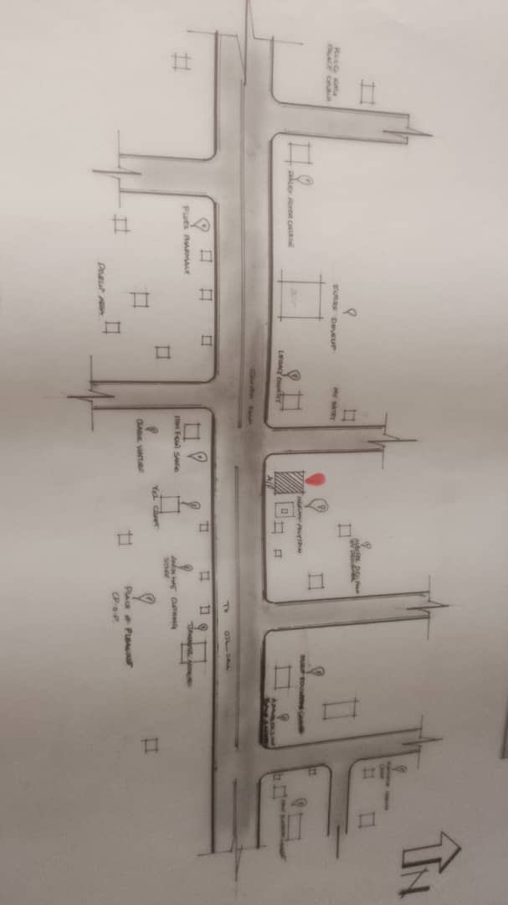

SITE PLAN
(A) Tree:- tree are planted within the fashion house to effect natural ventilation shrubs are be planted at reasonable spacing to provide shade for the car parks as shown in fig.
(B) Grass:- Grass give impression of an environment and also protect the land surface from erosion. For this reason bahama grass can be recommended for this project.
(C) Parking space:. Parking lot are located in front of the fashion house for the consumer, owner and visitor

CHAPTER TWO
2.0 LITERATURE REVIEW
2.1 INTRODUCTION
A fashion home, also known as a fashion studio or fashion house, is a creative and production environment where clothing and accessories are designed, developed, and sometimes produced. It combines aesthetics, functionality, and innovation, offering designers and stylists a space to express their creativity. This chapter reviews existing literature on fashion homes, tracing their evolution, classification, functional components, and the integration of technology and environmental design in their architecture.
2.2 EVOLUTION OF FASHION HOMES
Fashion homes have their roots in the early 19th-century fashion salons of Paris, where haute couture began to shape global fashion trends. Initially informal and modest, these spaces evolved into elaborate studios operated by iconic designers like Coco Chanel and Christian Dior. Over time, fashion homes transformed into sophisticated environments incorporating design rooms, fitting areas, showrooms, photo studios, and production units. Today, they reflect the fusion of design and business in architecture, where branding and spatial identity are paramount.
2.3 CLASSIFICATION OF FASHION HOMES
Fashion homes can be classified based on size, function, and market focus:
Haute Couture Studios: These serve elite clientele and are often luxurious in design.
Ready-to-Wear (Prêt-à-Porter) Studios: Designed for mid- to high-level market fashion brands.
Boutique Fashion Studios: Smaller in scale, focused on local or niche markets.
Educational/Training Fashion Studios: Found in institutions offering design programs.
Hybrid Studios: Combine retail, exhibition, and design production under one roof.

2.4 FUNCTIONAL COMPONENTS AND SPATIAL RELATIONSHIPS
Fashion homes typically include the following spatial components:
Reception and Waiting Area: First point of contact for visitors and clients.
Design Studio: Creative workspace with drafting tables, mannequins, and mood boards.
Pattern and Cutting Room: For garment shaping and fabric preparation.
Sewing and Finishing Room: Equipped with machines for assembling garments.
Showroom/Display Area: For exhibiting collections to clients and buyers.
Administrative Offices: Managerial and documentation zones.
Fitting Room: For customer measurement and garment trials.
Storage and Fabric Library: For textiles, tools, and finished products.
Photography/Media Room: Used for digital content creation and fashion shoots.

2.5 TECHNOLOGICAL AND ENVIRONMENTAL CONSIDERATIONS
Modern fashion homes integrate smart and sustainable technologies:
Natural Lighting: Large windows and skylights reduce energy usage.
Ventilation Systems: Both passive and mechanical ventilation for thermal comfort.
Material Selection: Use of eco-friendly and locally sourced materials.
Waste Management: Areas designated for fabric scraps and recyclable materials.
Digital Integration: CAD (Computer-Aided Design) systems, digital pattern makers, and virtual fitting rooms.
Energy Efficiency: LED lighting, solar panels, and automated systems for energy conservation.

2.6 REVIEW OF SUB-TOPIC
INTEGRATION OF MODERN TECHNOLOGY IN FASHION DESIGN STUDIOS
The fashion industry is increasingly embracing digital transformation. Fashion homes now feature:
Virtual Reality (VR) and Augmented Reality (AR): For virtual runways and remote fittings.
3D Printing: For rapid prototyping of accessories or garment components.
Smart Mirrors: For customer interaction in showrooms.
AI-Powered Tools: For style forecasting, design assistance, and customer behavior analysis.

CHAPTER THREE
3.0 INTRODUCTION
3.1 CASE STUDY
To better understand the functional and aesthetic requirements of fashion homes, it is essential to study existing examples. This chapter presents case studies of selected local and international fashion design studios. Each case is analyzed based on location, spatial layout, architectural features, material usage, functional relationships, and environmental responsiveness. The strengths and weaknesses of each project are also discussed to draw useful insights for the proposed fashion home design.

3.2 OUTLINE OF CASE STUDIES
1 PERFECT SEAMS CLOTHING, Osogbo, Osun State.
2. MUKHAD COUTURE
3. SADEZ FASHION HOUSES, Along jeseph odunlami, street, lagos state.
4. Online case study in France
5. Online case study in USA

3.3 CASE STUDY ONE
PERFECT SEAMS CLOTHING
Perfect Seams clothing is one of the most sort after clothing outfits and boutique in Osogbo. we are into sewing of various types of cloths ranging from traditional wears to official office cloth such as suits, trousers and pants. We are new in this business, we started operations in November 2016, but owing to our great level expertise we have managed to rank among one of the best clothing outfits in Osogbo and its suburb.
At Perfect Seams Clothing Outfit we cut to fit while sewing for you, in our boutique section we sell designer bags and shoes of various types. In the bid to serving you our esteemed customers better, we decided to break out the following section from Perfect seams and clothing in early 2017.
Perfect Seams Clothing’s, Osun State can be contacted at: Km 4, Beside Slot Mobile, Gbongan – Ibadan Expressway, Osogbo, Osun State.

MERIT
- Photoshoot is available
- It is good for convenience
- Class room is available

DEMERITS
- Space too shrink for work
- No changing room
- No storage for raw materials

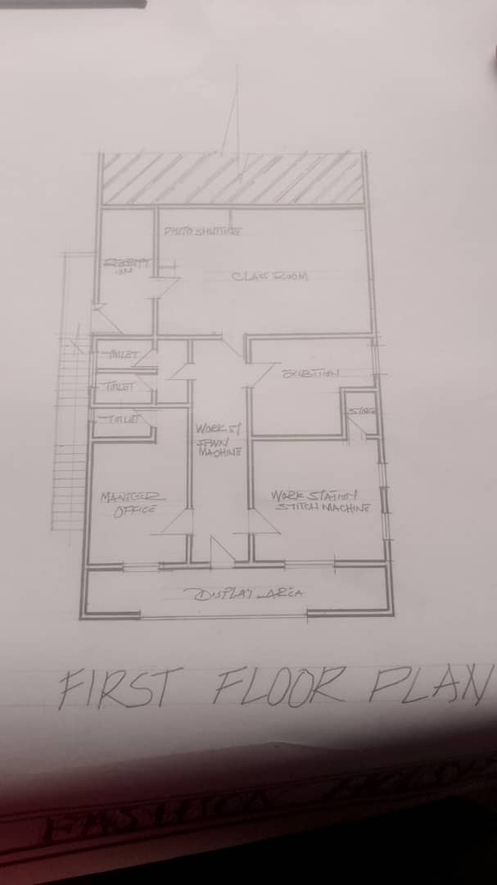
Fig 3.1.1 Floor Plan
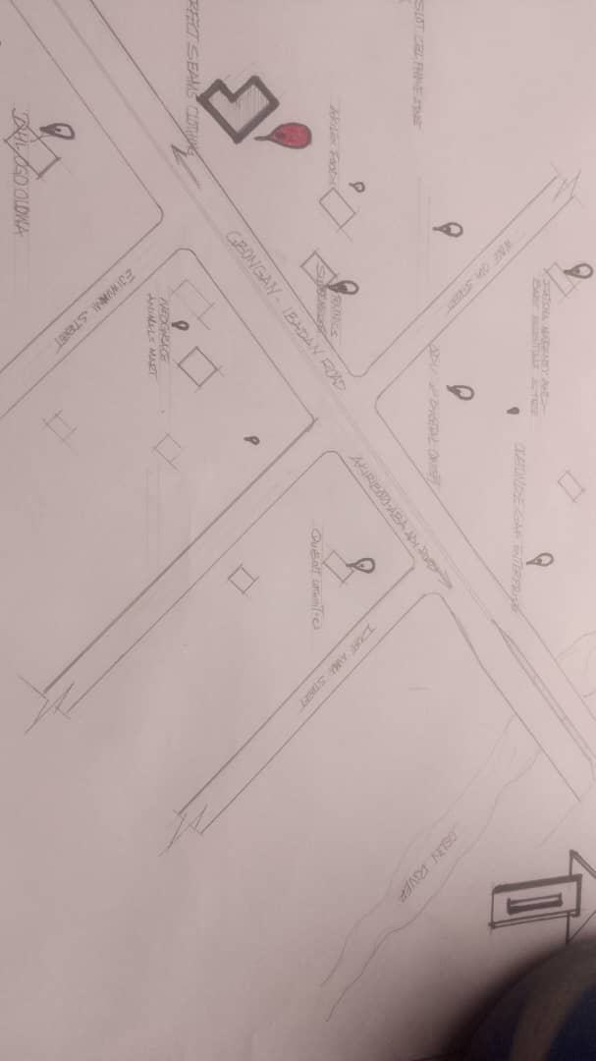
Fig 3.1.2 Floor Plan
\
Plate 3.1.1 elevation
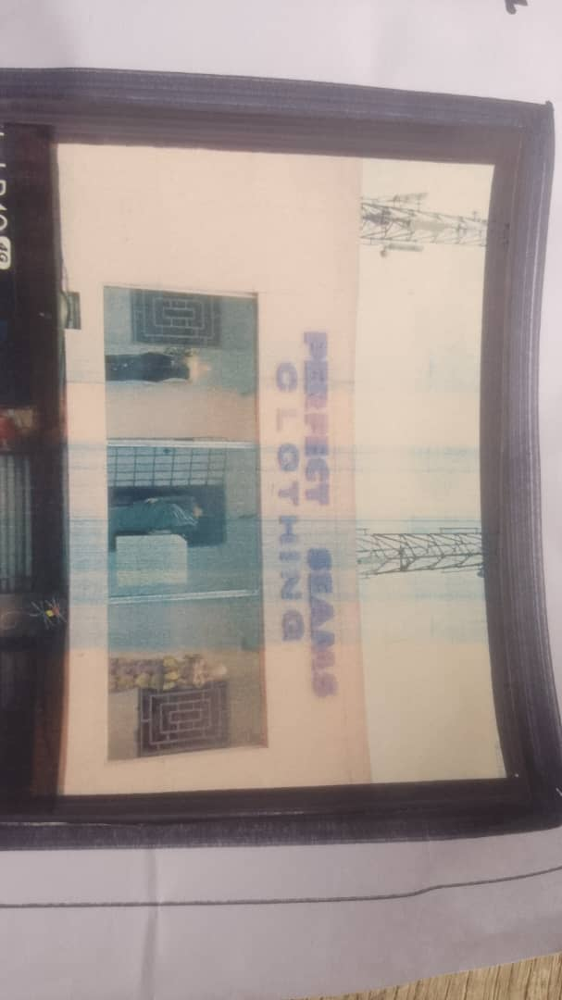
Plate 3.1.2 elevation
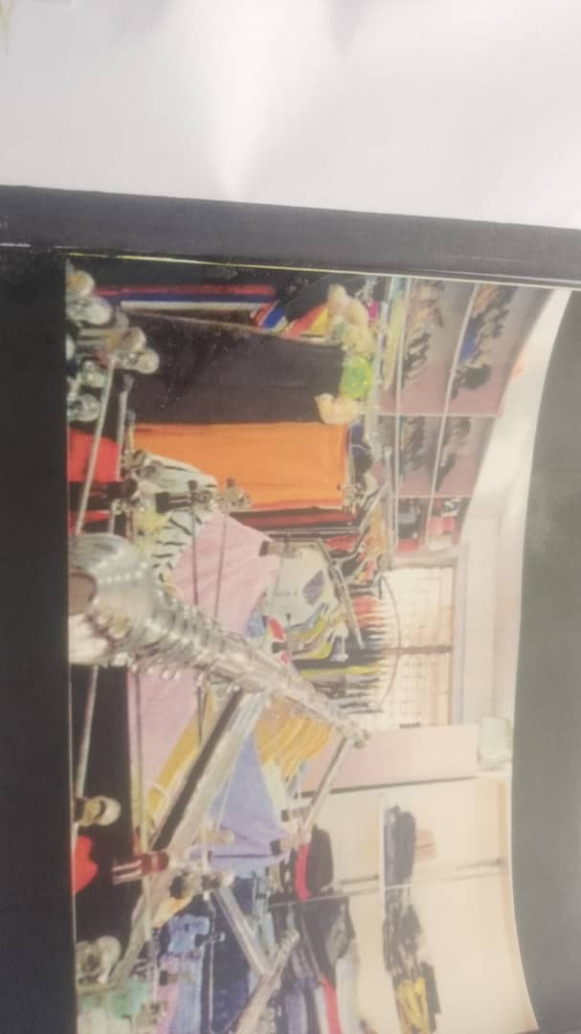
Plate 3.1.3 elevation

3.4 CASE STUDY TWO 2
MUKHAD COUTURE
Mukhad Couture, a fashion brand in Ilorin, Nigeria, is known for its streetwear and unique storytelling approach to fashion. The brand, particularly its "Street Saints Collection", uses fashion to narrate personal stories of resilience, redemption, and transformation. Mukhad Couture's designs, like the "safari blazer" and "Crop Jacket of Faith", blend functionality with style, often drawing inspiration from real-life experiences and community.
MERIT
- It is easily to accessible
- Space enough too work in working station
DEMERIT
- No Changing room
- No exhibition
- No Ventilation in every units
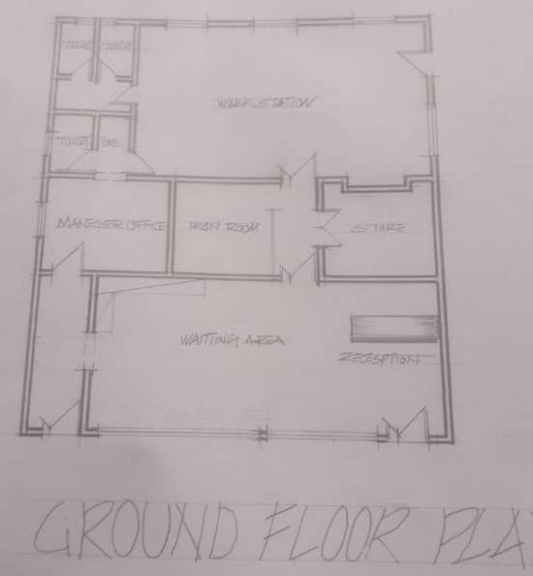

Fig 3.2.1 Floor plan
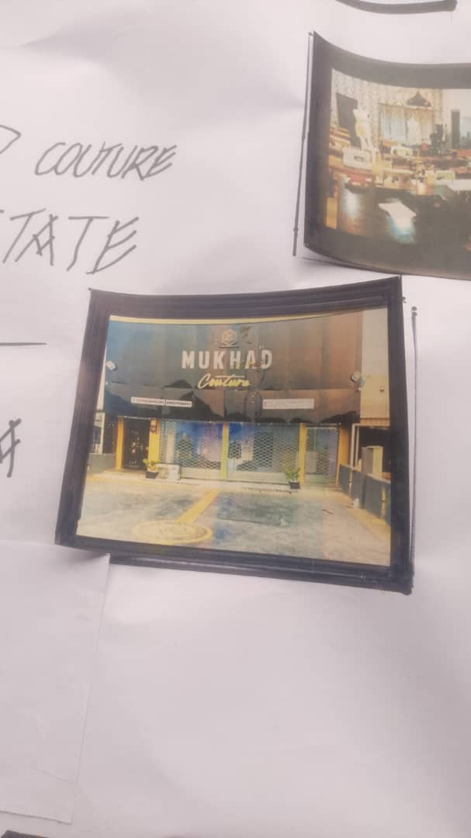
Plate 3.2.1 Elevation
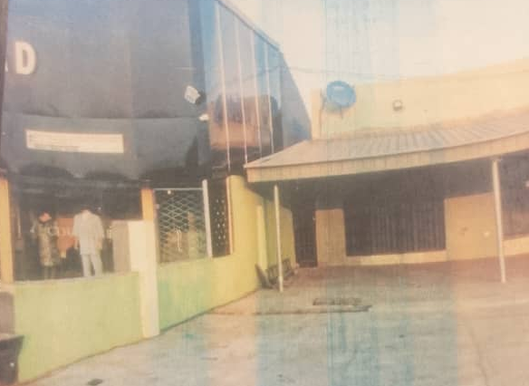
Plate 3.2.2

3.5 CASE STUDY THREE 3
SADEZ FASHION HOUSES
Along jeseph odunlami, street, lagos state.
Sade Olawoyin is a Fellow of The Institute of Chartered Accountants of Nigeria (ICAN), where she won both the 1ST Prize and Best Qualifying Lady Awards at the final level in year 2000. She has an MBA (specialized in General Management), an HND Accountancy and a Certificate in Dressmaking and Fashion Designing. She has a certificate from Women Entrepreneurship and Leadership for Africa (WELA) a program by China Europe International Business School (CEIBS). She as attended numerous trainings, workshops and seminars.
Her corporate career started in 1994 as an Audit Officer; she worked in various industries including Banking, Service and Upstream Oil & Gas; where she rose to be Financial Controller. She resigned in 2015 having worked 21years (including 12years in senior management cadre) to become a full-time entrepreneur.
Her undying love for fashion and garment business led her in 2012, to establish Sadez Fashion House Limited - a garment making company producing high quality uniforms and premium and stylish ready to wear apparels using local and western fabrics. Sadez Fashion House renders services to both corporate and private clients.
MERIT
- It is good circulation
- It is good too accessible
- Exhibition is available
DEMERIT
- It is not enough set back for main building
- No changing room
- Units not well defined

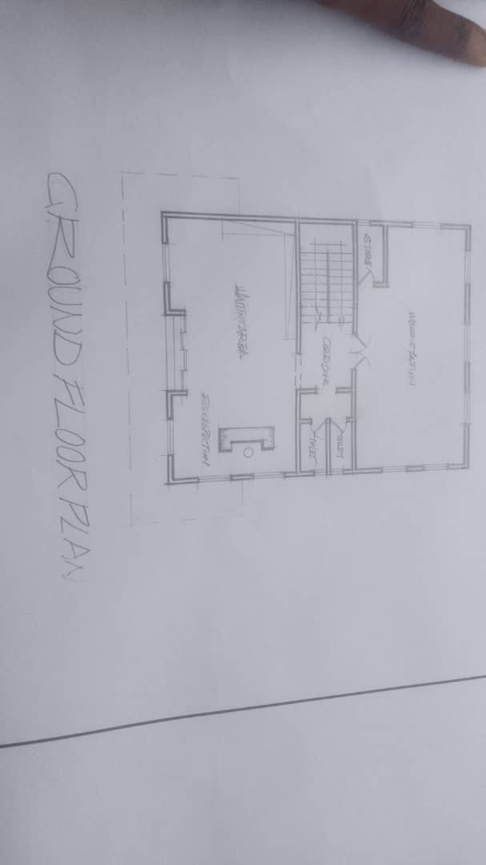
Fig 3.3.1 Ground floor Plan
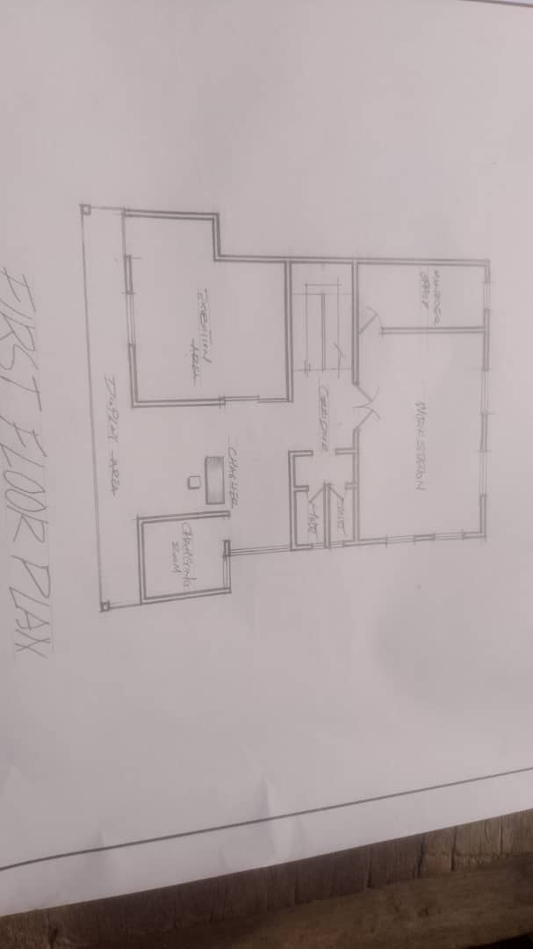
Fig 3.3.2 First floor plan
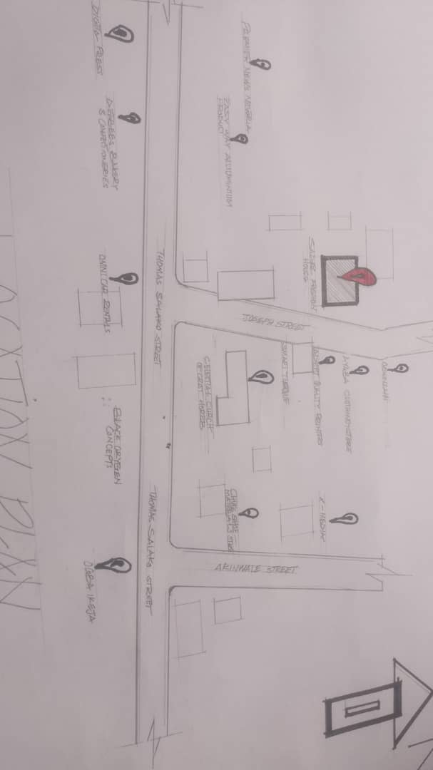
Fig 3.3.3 Locational plan

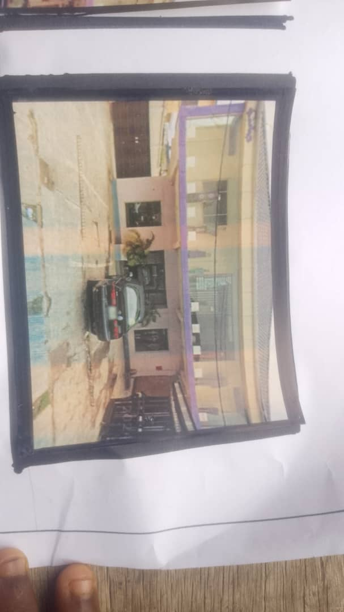
Plate 3.3.1 Elevation
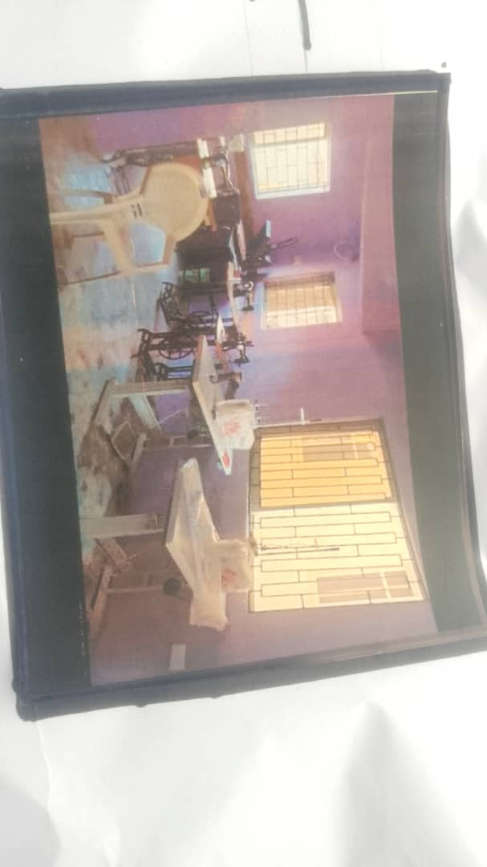
Plate 3.3.2 Inner view

CHAPTER FOUR

STUDY AREA/PROJECT SITE (ENVIRONMENTAL AND IMPACT ANALYSIS)
4.1 INTRODUCTION OF STUDY AREA / SITE SELECTION
The proposed fashion home is located in the heart of Ilorin, Kwara State, Nigeria. The site was selected for its accessibility, strategic location within a growing commercial district and proximity to potential users and clients. The area supports mixed-use development and provides a suitable environment for fashion design, production and retail activities.

4.2 SITE LOCATION / DESCRIPTION / CRITERIA
- LOCATION: Ilorin East, Sango Kwara State
- LAND USE: Commercial / Residential mix
- ACCESS: The site is accessible via a major tarred road network and is connected to adjoining streets and neighborhoods.
- UTILITIES: Availability of water supply, electricity and drainage

CRITERIA FOR SELECTION:
- Close proximity to fashion schools and institutions
- Good road network and pedestrian access
- Visibility and easy identification for potential clients
- Low slope topography for ease of construction

4.3 SITE ANALYSIS / INVENTORY
- TOPOGRAPHY: The site is relatively flat, gently sloping for natural drainage.
- VEGETATION: Sparse shrubs and grasses
- SOIL TYPE: Loamy soil, suitable for shallow foundations
- EXISTING FEATURES: No significant built structure; a few trees present
- WIND DIRECTION: Southwest to Northeast
- NOISE LEVEL: Moderate—mostly traffic-induced
4.4 GEOGRAPHICAL / CLIMATIC DATA
- CLIMATE: Tropical savannah
- AVERAGE TEMPERATURE: 26–34°C
- RAINFALL: Seasonal (May–October)
- RELATIVE HUMIDITY: 60% – 80%
- SUN PATH: East to West

4.5 ENVIRONMENTAL CONDITIONS
- DRAINAGE: Natural surface runoff present; proposed man-made channels to improve water flow
- SOIL STABILITY: Suitable for low-rise structures
- SURROUNDING STRUCTURES: Shops, residential buildings and informal kiosks

4.6 PROJECT ANALYSIS / DESIGN CRITERIA
PROJECT GOALS
- Fabric and accessories store
- Exhibition and sales outlet
- Training room and administrative offices

FUNCTIONAL / SPATIAL CRITERIA
- Clear separation of public sales and private production areas
- Adequate lighting and ventilation in the sewing and training rooms
- Smooth internal circulation flow for staff and customers

APPRAISAL OF PROPOSED SCHEMES
- Zoning of activities to reduce noise interference
- Compact but expandable spatial layout
- Emphasis on accessibility for all users

EQUIPMENT AND OPERATIONAL NEEDS
- Cutting tables, sewing machines, ironing and pressing units
- Storage for fabric and finished products
- Electrical outlets for machines
- Fire safety equipment

SPATIAL ALLOCATION / SCHEDULE OF ACCOMMODATION
- Space Size (m²) Purpose
- Reception 12 Welcoming clients
- Cutting Room 25 Fabric cutting
- Sewing Area 40 Tailoring activities
- Display Area 30 Product showcase
- Admin Office 15 Management tasks
- Store Room 10 Materials storage
- Restroom 8 Staff and clients
- Training Room 20 Fashion lessons
- Hair Styles 25 Hairdresser
- Medical and Pedicure 25 Makeup and nails
- Massage 20 Body massage

FUNCTIONAL RELATIONSHIPS
- Reception links to display area and sewing room
- Admin office adjacent to training and sewing rooms
- Storage located near the cutting and sewing sections

CHAPTER FIVE

5.0 APPROACH TO THE DESIGN / DESIGN REALIZATION
5.1 DESIGN CONCEPTS
The fashion home embodies elegance, functionality and flow. The primary design concept is "Thread in Motion", representing continuity and creativity in fashion. The plan allows for seamless movement between customer and production areas.
SITE LEVEL CONCEPT: Landscape features like patterned pavements and shaded sitting areas enhance user experience.
BUILDING LEVEL CONCEPT: Spaces designed in a loop-like flow to eliminate bottlenecks and enhance efficiency.
  - CONCEPT DEVELOPMENT SKETCHES
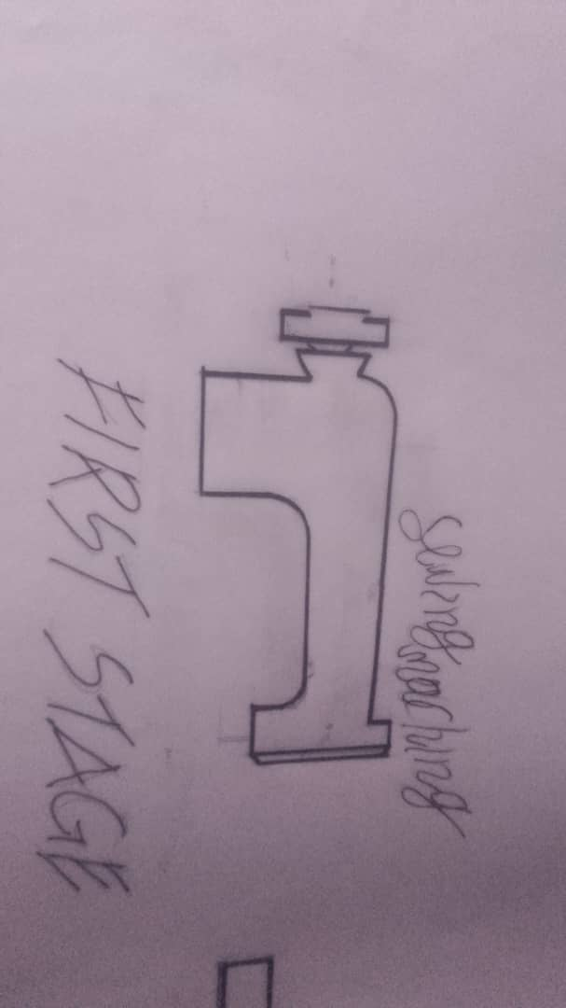

  - TECHNOLOGICAL AND ENVIRONMENTAL CRITERIA
CONSTRUCTION METHODOLOGY / MATERIALS / FINISHES
- FOUNDATION: Strip foundation
- WALLS: Sandcrete blocks
- ROOFING: Long-span aluminum roofing
- WINDOWS: Louvre and sliding windows for cross-ventilation
- FINISHES: Ceramic tiles, emulsion paint, POP ceilings
SERVICES
- CIRCULATION: Hallways and corridors with proper signage
- VENTILATION: Natural and mechanical ventilation
- LIGHTING: Combination of skylights and LED fittings
- PLUMBING: Standard PPR piping system
- ELECTRICAL: Conduit system with emergency lighting
- WASTE DISPOSAL: Central bin with rear access
- FIRE PROTECTION: Fire extinguishers and smoke detectors
- EXTERNAL WORKS: Interlocking paving, perimeter fencing and landscaping
ENVIRONMENTAL CONDITIONS TO BE ACHIEVED
- Comfortable indoor temperature with minimal mechanical cooling
- Daylighting in production spaces to reduce energy consumption
PERFORMANCE STANDARDS
- Durable finishes
- Safety and fire compliance
- Acoustic separation between training and production spaces
5.4 LEGAL AND PLANNING REGULATIONS
- Setback of 3 meters minimum on all sides
- Compliance with Kwara State building codes
- Parking space for at least 4 vehicles
- Access for physically challenged users

5.5 BEHAVIORAL PATTERNS AND CONSIDERATIONS
- Consideration for predominantly female staff and clients
- Waiting area and customer lounge
- Secure but inviting reception
- Privacy for fitting/changing areas

5.6 RECOMMENDATIONS
- Incorporate solar energy to reduce power reliance
- Future provision for a fashion studio and online order processing unit
- Adopt modular furniture for flexibility in the training and sewing spaces
- Encourage environmentally friendly practices such as fabric recycling within the facility
- Additional landscaping to enhance microclimate and aesthetic appeal

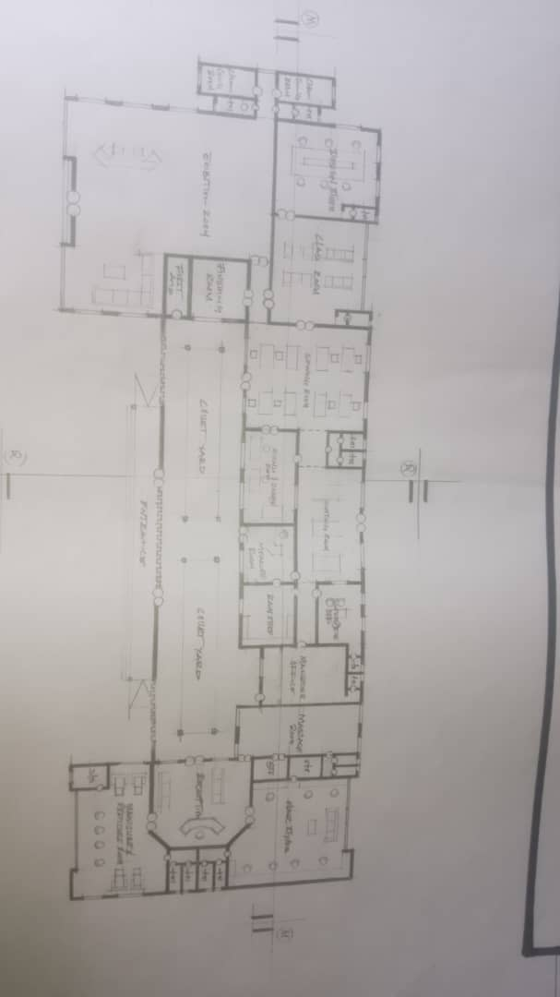

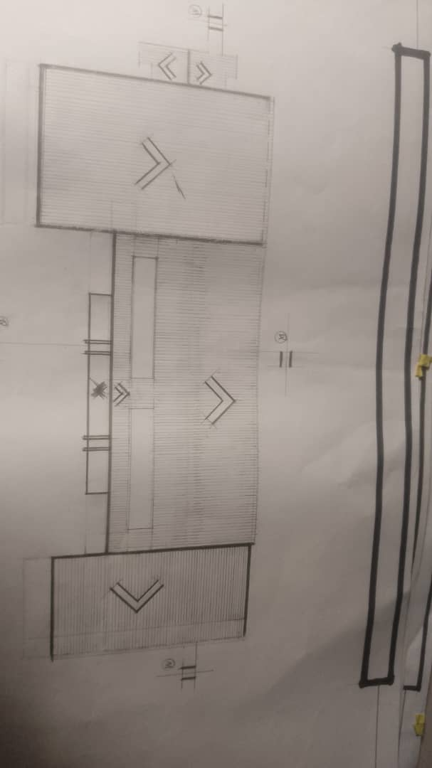
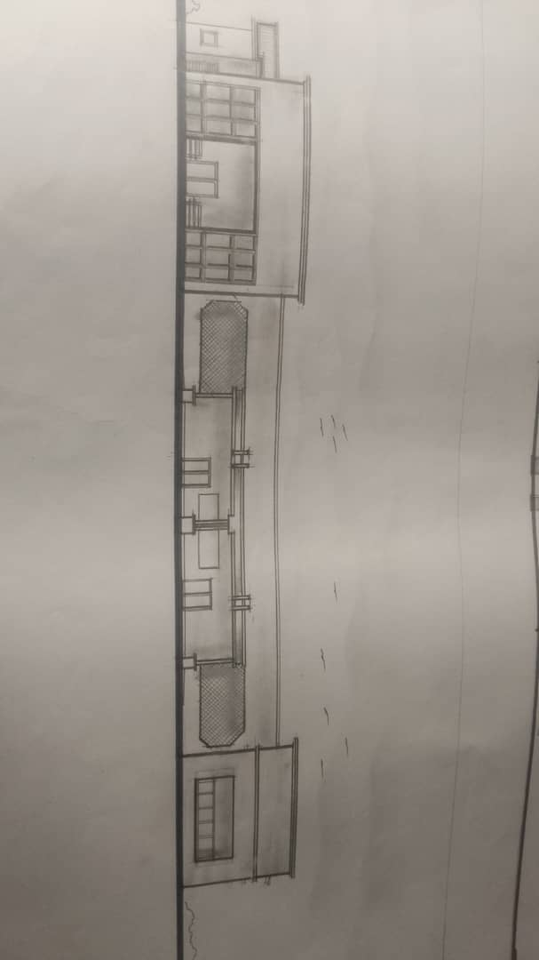

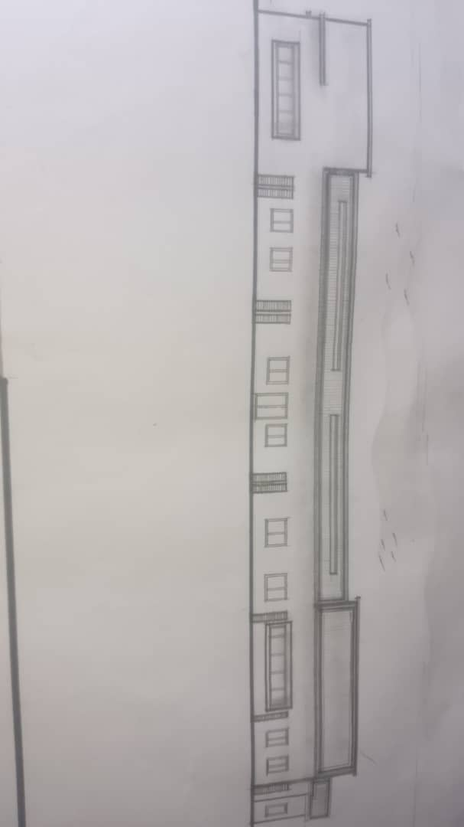

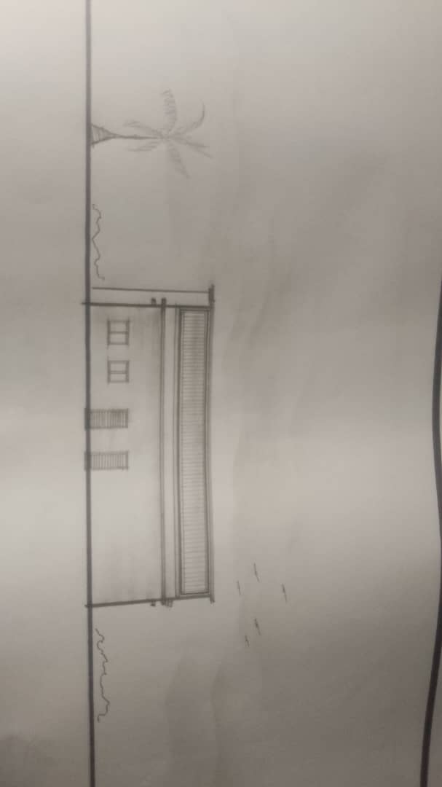

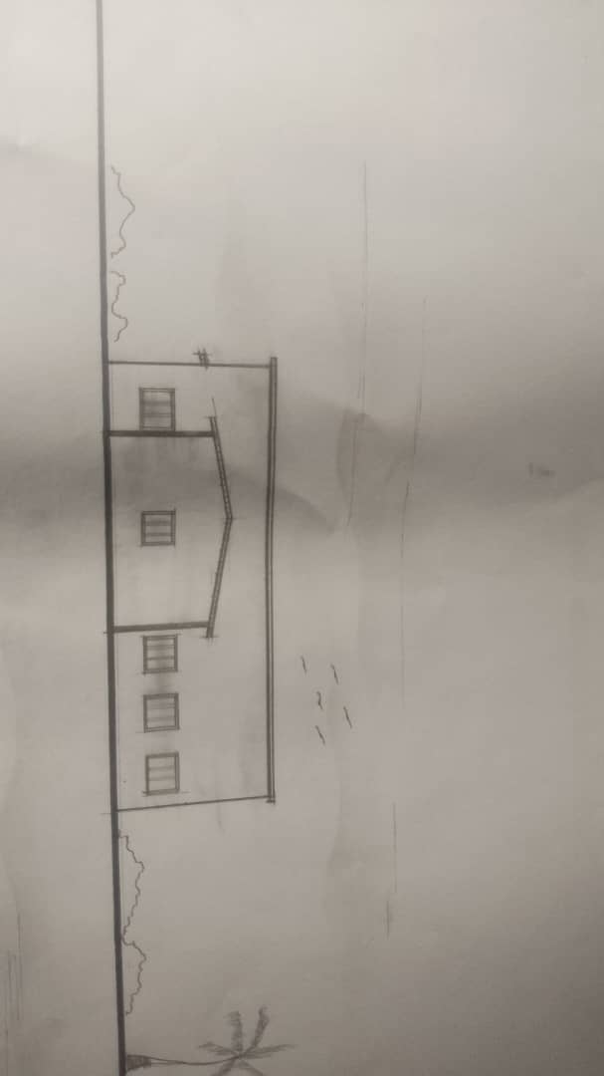

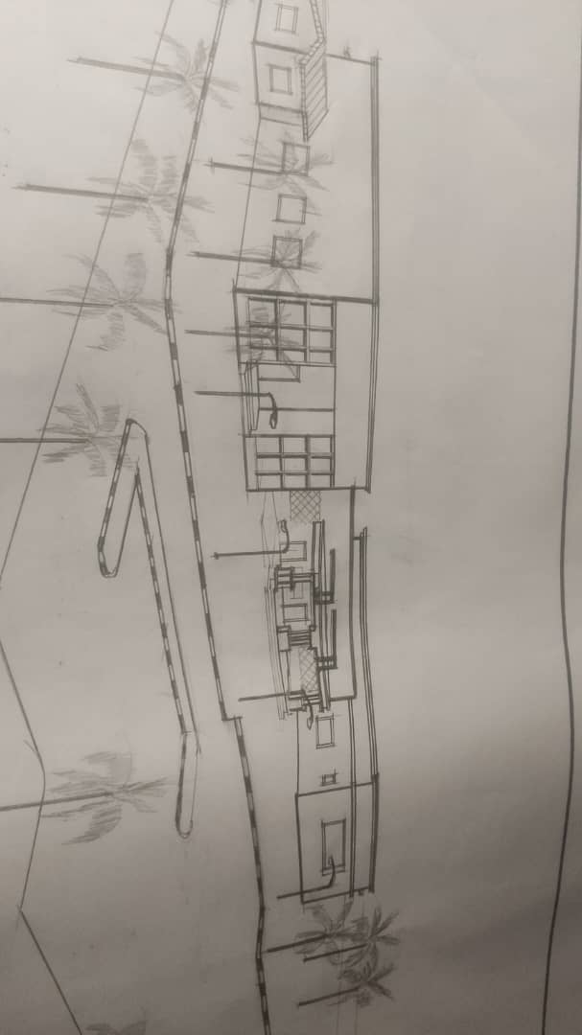

REFERENCE
Ashby, M., & Johnson, K. (2014). Materials and design: The art and science of material selection in product design. Butterworth-Heinemann.
Bayazit, N. (2004). Investigating design: A review of forty years of design research. Design Issues, 20(1), 16–29.
Brooker, G., & Stone, S. (2018). From organisation to decoration: An interiors reader. Routledge.
Ching, F. D. K. (2014). Architecture: Form, space, and order (4th ed.). Wiley.
Dempsey, A. (2010). The ultimate guide to fashion design. Chartwell Books.
Edwards, C. (2011). How to read fashion: A crash course in styles, designers and couture. Rizzoli.
Fiell, C., & Fiell, P. (2002). Design of the 20th century. Taschen.
Fletcher, K. (2008). Sustainable fashion and textiles: Design journeys. Earthscan.
Gordon, B. (2015). Textiles: The whole story – Uses, meanings, significance. Thames & Hudson.
Gregory, M. (2007). A guide to fashion design. Prentice Hall.
Heskett, J. (2005). Design: A very short introduction. Oxford University Press.
Hurley, J. (2013). Designing fashion studios: Concepts and applications. Bloomsbury.
Jirousek, C. (2010). Art, design, and visual thinking: An interactive textbook. Cornell University.
Kim, H., & DeLong, M. (2011). Fashion and cultural studies. Bloomsbury.
Lam, M. (2014). Fashion design: The complete guide. Laurence King.
Lawrence, A. (2017). Interior design for small fashion studios. Wiley.
Lloyd-Jones, T. (2010). Architecture and the fashion industry. Phaidon Press.
Madsen, F. (2005). The fashion designer survival guide. Kaplan.
McRobbie, A. (1998). British fashion design: Rag trade or image industry? Routledge.
Molotch, H. (2003). Where stuff comes from: How toasters, toilets, and cell phones came to be as they are. Routledge.
Owen, L. (2012). Sewing studio organization. Sew Today Press.
Pile, J. F. (2005). Interior design. Prentice Hall.
Quinn, B. (2012). Fashion and architecture. V&A Publishing.
Renfrew, K., & Renfrew, A. (2009). Developing a collection. AVA Publishing.
Rhodes, B. (2006). Studio space: Projects and ideas for creative interiors. Clarkson Potter.
Shoben, M., & Ward, J. (2010). Pattern cutting and making up. Routledge.
Steele, V. (2011). The Berg companion to fashion. Berg.
Teunissen, J. (2012). The future of fashion is now. Nai010 Publishers.
Zaman, A. (2021). Designing sustainable fashion studios. Springer.
Zhao, L. (2013). Fashion spaces: Design and architecture for fashion retail. Braun.

