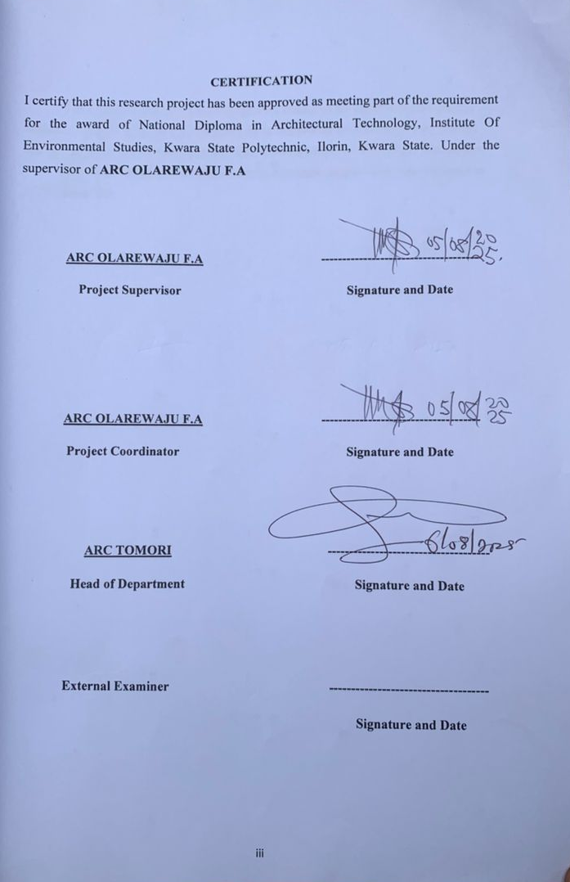

A PROJECT REPORT
ON
PROPOSED DENTAL CLINIC
FOR
ILORIN SOUTH LOCAL GOVERNMENT CHAIRMAN SANGO, ILORIN KWARA STATE, NIGERIA.
BY
ISSA ABDULRASHEED AREMU
ND/23/ARC/FT/021
SUBMITTED TO: THE DEPARTMENT OF ARCHITECTURAL TECHNOLOGY

INSTITUTE OF ENVIROMENTAL STUDIES (I.E.S), KWARA STATE POLYTECHNIC, ILORIN

IN PARTIAL FULFILLMENT OF THE REQUIREMENT FOR THE AWARD OF NATIONAL DIPLOMA (ND) IN ARCHITECTURAL TECHNOLOGY.

JUNE 2025
DECLARATION
I, ISSA ABDULRASHEED AREMU (ND/23/ARC/FT/0021), hereby declare that the information provided in this project report is accurate and true to the best of my knowledge.
I understand that this project is an original work and does not infringe on the intellectual property rights of others, under ARC. OLAREWAJU F.A

Signature: __________________ Date: ____________________

Project Title:
DENTAL CLINIC

CERTIFICATION
I certify that this research project has been approved as meeting part of the requirement for the award of National Diploma in Architectural Technology, Institute Of Environmental Studies, Kwara State Polytechnic, Ilorin, Kwara State. Under the supervisor of ARC OLAREWAJU F.A

ARC OLAREWAJU F.A -------------------------------------
Project Supervisor Signature and Date

ARC OLAREWAJU F.A -------------------------------------
Project Coordinator Signature and Date

ARC TOMORI -------------------------------------
Head of Department Signature and Date

External Examiner ------------------------------------
Signature and Date

DEDICATION
I dedicate this project to God Almighty the creator of the universe for the grace bestow upon my life, for he has strengthen me to this present time and also to my beloved and caring parent MR & MRS. DAMILARE most especially for their prayer and support.
May God Almighty bless and reward them abundantly and every other supporter to my academic life.

ACKNOWLEDGMENT
Everything that has beginning must have an end, therefore, all praises and adoration is unto Almighty Allah for the strength and courage he has accorded me in the process of this project.
Special thanks to my supervisor ARC. OLAREWAJU F.A for taking her time to go through my research work, may Almighty Allah bless you abundantly.

My appreciation goes to my Amiable Head Of Department in person of ARC. J. M TOMORI and other academic staffs for their immense contribution toward the success of my program may the Lord Honor and do you all good.

My profound gratitude goes to almighty God for the guidance and grace over my life.
My deepest appreciation goes to my parents MR & MRS DAMILARE for their moral and financial support towards my education.

ABSTRACT
The need for specialized dental healthcare facilities in Nigeria has become increasingly urgent due to population growth, increased awareness of oral health, and the demand for technologically advanced treatment environments. This project explores the architectural design and planning of a modern dental clinic aimed at enhancing patient experience, improving operational workflow, and supporting infection control standards. The proposed dental clinic seeks to respond to the inadequacies of conventional dental facilities, which often lack proper spatial zoning, ventilation, and user-centered features.
The research adopts a combination of methodologies including literature review, site analysis, and the study of precedent case studies within and outside Nigeria. Data was also obtained through interviews with healthcare professionals and visual site surveys. These methods informed the formulation of design goals, space programming, and the selection of environmentally responsive strategies.
Findings from the research revealed that the integration of central courtyards, zoning based on user access levels (public, clinical, restricted), and passive ventilation techniques significantly improve the quality and functionality of dental clinic architecture. The use of biophilic design principles, soundproof operatories, and barrier-free access were also identified as critical to user comfort and operational success.
The project concludes that dental clinics must go beyond clinical functionality to embrace comfort, environmental sustainability, and future adaptability. It is recommended that designers of healthcare facilities, particularly dental clinics in Nigeria, adopt context-sensitive, patient-centered, and flexible design approaches that align with both regulatory and social expectations.

TABLE OF CONTENTS
TITTLE PAGE - - - - - - - - - i
DECLARATION - - - - - - - - ii
CERTIFICATION - - - - - - - - iii
DEDICATION - - - - - - - - - iv

ACKNOWLEDGMENT - - - - - - - v

ABSTRACT - - - - - - - - - vi

TABLE OF CONTENTS - - - - - - - - vii
LIST OF FIGURES - - - - - - - - viii

CHAPTER ONE
1.0 INTRODUCTION - - - - - - 1
11 BACKGROUND TO THE STUDY - - - - - 1
1.2 STATEMENT OF DESIGN PROBLEM - - - - 1
1.3 AIM AND OBJECTIVES - - - - - - 2
1.4 JUSTIFICATION FOR THE PROJECT - - - - 2
1.5 CLIENT’S BACKGROUNT - - - - - - 2
1.6 SCOPE OF THE STUDY - - - - - - 3
1.7 LIMITATION OF THE STUDY - - - - - 3
1.8 RESEARCH METHODOLOGY - - - - - 4

CHAPTER TWO
2.0 LITIRATURE REVIEW - - - - - 5
2.1 REVIEW OF LITERATURE ON THE BUILDING TYPE - 5
2.1.1 HISTORICAL EVOLUSION OF DENTAL FACILITIES - 5
2.1.2 CLASIFICATION OF DENTAL CLINIC - - - - 6
2.1.3 FUNCTIONAL RELASHIONSHIP AND ZONING - - 6
2.1.4 ENVIRONMENTAL AND TECHNOLOGICAL DESIGN CONSIDERATION 7
2.2 REVIEW OF LITERATURE ON THE SUB-TOPIC - - - 7
2.2.1 HEADLINE AND USER-CENTERD DESIGN IN DENTAL CLINIC - 7
2.2.2 PEDIATRIC AND FAMILY DENTAL CLINIC - - - 8
2.2.3 SUSTAINABLE DESIGNE IN DENTAL CLINIC - - - 8
2.2.4 ACCESSIBILITY AND INCLUSIVE DESIGN - - - 8

CHAPTER THREE
3.1 CASE STUDY - - - - - - - - 9
3.2 OUTLINE OF CASE STUDY - - - - - 9
3.3 CASE STUDY ONE - - - - - - 10
3.4 CASE STUDY TWO - - - - - - 15
3.5 CASE STUDY THREE - - - - - - 20
3.6 ONLINE CASE STUDY - - - - - - 24
3.7 ONLINE CASE STUDY - - - - - - 28

CHAPTER FOUR
4.0 STUDY AREA/PROJECT SITE AND DESIGN CRITARIA - 31
4.1 SITE LOCATION AND DESCRIPTIN - - - - 31
4.1.1 SITE LOCATION - - - - - - - 31
4.1.2 SITE LOCATION CRITERIA - - - - - 31
4.2 SITE INVENTRY AND ANALYSIS - - - - 32
4.3 CLIMATIC AND ENVIRONMENTAL DATA - - - 33
4.4 PROJECT GOALS/DESIGN BRIEF - - - - 34
4.5 CONCEPTUAL DEVELOPMENT - - - - 34

CHAPTER FIVE
5.0 DESIGN APPROACH AND DESIGN REALIZATION - - 35
5.1 CONCEPTUAL DESIGN IDEA - - - - - 35
5.1.2 CONCEPTUAL DESIGN PRINCIPLE - - - - 36
5.2 DESIGN PROCESS OVERVIEW - - - - - 36
5.3 TECHNOLOGICAL ENVIRONMENTAL CRITERIAL - 37
5.3.1 CONSTRUCTION METHODE AND MATERIAL - - 37
5.3.2 BUILDING SERVICE INTEGRATION - - - - 38
5.4 ENVIRONMENTAL PERFORMANCE STRATEGY - - 38
5.5 BEHAVIOUS AND SOCIAL CONSIDERATION - - 38
5.6 CONCLUSION AND RECOMMENDATION - - - 39

CHAPTER ONE

INTRODUCTION
  - BACKGROUND TO THE STUDY
Health care facilities have evolved over the decades to meet the ever-growing demand for patient-centered, functional and hygienic environments. Dental clinics, as a specialized healthcare typology, focus on oral health delivery and require distinct design considerations that support precise clinical procedures, infection control, patient comfort and efficient staff workflow. In Nigeria, the demand for modern dental facilities has grown due to increasing awareness of oral health, a rise in population and technological advancement in dental equipment.
Architecture plays a pivotal role in designing spaces that enhance patient experience, operational efficiency and clinical safety. A dental clinic is not merely a space for treatment but a system of interrelated rooms including waiting areas, operatories, sterilization zones, imaging suites, laboratories and administrative offices. A well-designed clinic should support smooth movement, natural lighting, ventilation, privacy and infection control while complying with healthcare standards.
This project proposes a specialized dental clinic that integrates architectural functionality, aesthetics and technological adequacy to serve as a modern oral health center in Kwara State, Nigeria.
1.2 STATEMENT OF DESIGN PROBLEM
Most existing dental clinics in urban Nigerian settings, including Ilorin, are either extensions of general hospitals or compact units with limited space and outdated facilities. These spaces often lack proper ventilation, spatial organization, functional zoning and modern diagnostic tools, which negatively affect service delivery and patient satisfaction.
The key design problem is to develop a purpose-built dental clinic that accommodates various specialties (such as orthodontics, oral surgery, radiology and pediatric dentistry), ensures proper workflow, complies with building regulations and provides a healing environment for both patients and staff.

1.3 AIM AND OBJECTIVES
Aim:
To design a functional and sustainable dental clinic that enhances oral healthcare delivery through spatial efficiency, environmental comfort and advanced medical integration.
Objectives:
To study and understand the spatial requirements of a modern dental clinic.
To evaluate relevant case studies and extract applicable design principles.
To analyze the selected project site and its environmental context.
To develop a functional space program that meets both clinical and user needs.
To integrate natural lighting, ventilation and modern services systems in the design.
To ensure compliance with regulatory standards for healthcare buildings.

1.4 JUSTIFICATION FOR THE PROJECT
The rise in dental health issues, coupled with the limited availability of well-equipped dental facilities in Kwara State, justifies the need for a purpose-designed dental clinic. The proposed clinic will not only improve access to oral healthcare but will also demonstrate how architectural design can contribute to hygiene control, patient comfort and operational efficiency in a dental setting. This project also presents a valuable academic opportunity to apply architectural knowledge in solving real-life health facility challenges.

1.5 CLIENT’S BACKGROUND
The proposed project is commissioned by Ilorin south local government chairman in collaboration with Kwara State Ministry of Health and a private healthcare investor, aiming to improve dental care delivery in Sango area Ilorin. The client’s goal is to establish a modern dental facility with departments for general dentistry, pediatric care, oral surgery, imaging and education.
The client emphasizes the need for:
Hygienic design solutions
Flexibility for future expansion
Integration of green building strategies
Compliance with national health and safety codes
1.6 SCOPE OF STUDY
The scope of this study covers the architectural design and planning of a dental clinic. This includes:
Space programming for all required units
Site analysis and planning
Conceptual development and schematic design
Environmental and services integration
Compliance with healthcare architecture guidelines
It excludes the structural, mechanical and quantity surveying details unless relevant to the architectural layout.
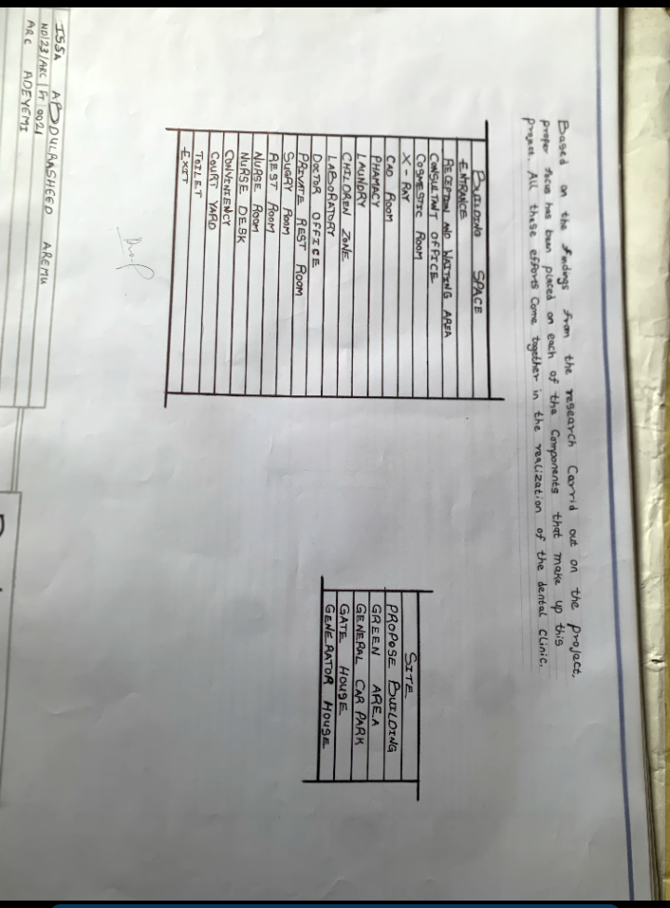

1.7 LIMITATION OF STUDY
Access to high-resolution case study drawings may be limited
Budgetary and construction detailing constraints are not covered
Time-bound limitations may restrict extensive physical site surveys
Design will focus on spatial and architectural planning rather than deep medical equipment integration
1.8 RESEARCH METHODOLOGY
The approach to solving the design problem involves:
LITERATURE REVIEW: Understanding the evolution and requirements of dental clinics
CASE STUDIES: Analyzing local and international dental facilities
SITE ANALYSIS: Physical and desktop study of the proposed site
INTERVIEWS/SURVEYS: Engaging with dental professionals (if possible)
DESIGN DEVELOPMENT: Translating findings into architectural solutions through sketches, models and CAD presentations

CHAPTER TWO
2.0 LITIRATURE REVIEW
This chapter explores the evolution of dental clinic architecture, the unique challenges involved in designing healthcare spaces and the environmental and technological requirements relevant to dental buildings. It is divided into two parts:
- REVIEW OF LITERATURE ON THE BUILDING TYPE
- REVIEW OF LITERATURE ON THE SUB-TOPIC OF THE THESIS
2.1 REVIEW OF LITERATURE ON THE BUILDING TYPE
2.1.1 HISTORICAL EVOLUTION OF DENTAL FACILITIES
Dental care, as a specialized form of healthcare, has transitioned from basic tooth extraction booths to technologically advanced oral care facilities. In the past, dental services were performed in general medical rooms or even residential settings. As medical knowledge evolved, the need for specialized clinics emerged, especially in urban centers. Today, dental clinics are highly functional spaces tailored to meet hygienic, ergonomic and psychological needs.
Architecturally, the evolution has moved from single-chair compact rooms to multi-operatory units with departments such as X-ray imaging, sterilization centers, surgical suites and consultation rooms — all requiring precise spatial relationships.

2.1.2 CLASSIFICATION OF DENTAL CLINICS
Dental clinics can be categorized based on service type and scale:
- PRIVATE CLINICS – Single practitioner or small group, compact in layout
- SPECIALIST CLINICS – Focused on a dental specialty like orthodontics or oral surgery
- TEACHING/TRAINING CLINICS – Academic dental centers with student-patient interaction
- HOSPITAL-BASED DENTAL UNITS – Integrated within general hospitals
Each category demands specific design responses, especially in spatial organization, patient flow and equipment integration.
2.1.3 FUNCTIONAL RELATIONSHIPS AND ZONING
Efficient spatial relationships are crucial in dental clinic design to ensure safety, confidentiality and smooth operation. Key functional areas include:
- Reception and Waiting Areas
- Consultation and Operatory Rooms
- X-ray/Imaging Suites
- Sterilization Rooms
- Dental Laboratories
- Pharmacy and Records Rooms
- Staff and Utility Areas

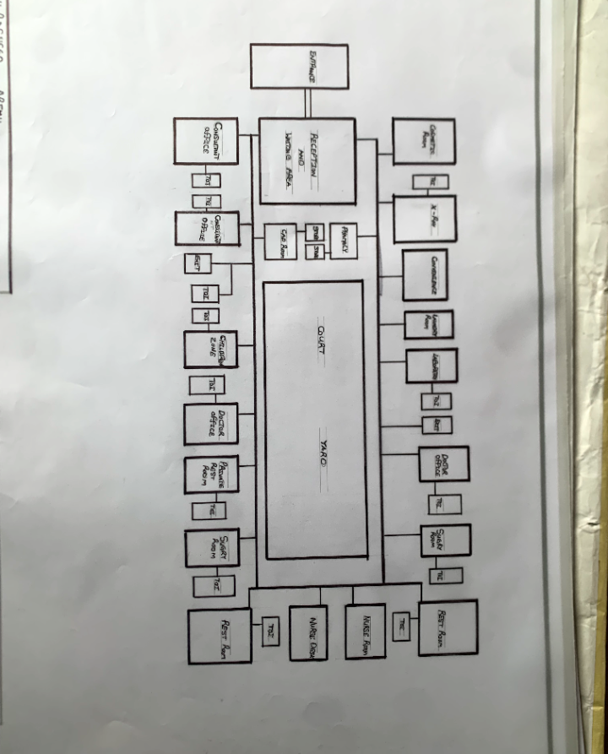

2.1.4 ENVIRONMENTAL AND TECHNOLOGICAL DESIGN CONSIDERATIONS
Dental clinics must support precise work under high hygienic standards. Thus, environmental control is essential:
- LIGHTING: Natural lighting in waiting areas; task lighting in operatories
- VENTILATION: Cross ventilation where possible, complemented with HVAC systems
- ACOUSTICS: Operatory rooms should be sound-insulated
- MATERIALS: Easy-to-clean, non-porous surfaces such as vinyl flooring, ceramic tiles, stainless steel countertops
- INFECTION CONTROL: Touchless fittings, separate sterilization zones, isolation rooms
TECHNOLOGICALLY MODERN DENTAL CLINICS INCLUDE:
- Digital X-ray machines
- Intra-oral cameras
- Electronic patient records
- Vacuum suction and compressed air systems
- Advanced dental chairs with built-in utilities

2.2 REVIEW OF LITERATURE ON THE SUB-TOPIC (e.g., Healing Architecture in Dental Spaces)
2.2.1 HEALING AND USER-CENTERED DESIGN IN DENTAL CLINICS
Recent research emphasizes the importance of "healing architecture" in healthcare facilities, especially dental spaces which often provoke anxiety. Design strategies include:
Incorporating biophilic elements such as indoor plants, nature views and calming color palettes
Providing clear circulation paths to reduce confusion and stress
Creating visual privacy without isolation
Designing welcoming reception areas that reduce the clinical “feel

2.2.2 PEDIATRIC AND FAMILY DENTAL CLINICS
WHEN DESIGNING CLINICS FOR CHILDREN, CONSIDERATIONS INCLUDE:
- Colorful, interactive waiting areas
- Child-sized furniture and fittings
- Distraction elements like wall graphics or ceiling-mounted TV screens
- Private operatory rooms for family-centered care
2.2.3 SUSTAINABLE DESIGN IN DENTAL CLINICS
SUSTAINABLE CLINIC DESIGN FOCUSES ON:
- Using low-energy appliances and efficient lighting systems
- Installing solar panels or passive cooling where possible
- Utilizing recycled and low-VOC materials
- Providing rainwater harvesting and waste segregation systems
2.2.4 ACCESSIBILITY AND INCLUSIVE DESIGN
A MODERN DENTAL CLINIC MUST BE INCLUSIVE:
- Wide corridors and doorways for wheelchair access
- Ramp access to all main entrances
- Proper signage and tactile flooring
- Accessible toilets for patients with disabilities

CHAPTER THREE
3.1 CASE STUDYS
A case study is a research methodology that involves an in-depth examination of a single case or a small number of cases. It is a qualitative research approach that aims to provide a detailed understanding of a particular phenomenon, event, or situation.
The concept of case studies has been widely applied in fields such as medicine, law, business and social sciences. However, in architecture, it serves as a tool to understand design strategies, material usage, spatial organization, environmental sustainability and cultural influences in building projects.
Renaissance Period (14th–17th Century): Architects such as Leonardo da Vinci and Andrea Palladio studied ancient Roman and Greek architecture to develop new design principles. Palladio’s book The Four Books of Architecture (1570) documented case studies of classical buildings, influencing European architecture.
3.2 OUTLINE OF CASE STUDY
- SCHUBBS DENTAL CLINIC, Lagos Ikeja
- BOZID DENTAL CLINIC, Oyo Ibadan
- EMIRATE DENTAL CLINIC, Ilorin Kwara
- TRUST DENTAL CLINIC, United State (ONLINE CASE STUDY)
- LA DENTAL CLINIC, United State (ONLINE CASE STUDY)

3.3 CASE STUDY ONE
SCHUBBS DENTAL CLINIC,
Lagos Ikeja
Schubbs Dental Clinic, a well-known dental practice in Lagos, began over three decades ago in a small office in Apapa. The clinic has since expanded to multiple locations, including Ikoyi and Ikeja, and has been providing dental care in Lagos for over two decades. A documentary highlights the clinic's history, emphasizing its commitment to quality service.
Established in 1988 by Dr. Olabode Karunwi and Dr. Olaite Karunwi, Schubbs has grown from a single chair practice in Apapa to a multiple location upscale dental chain.

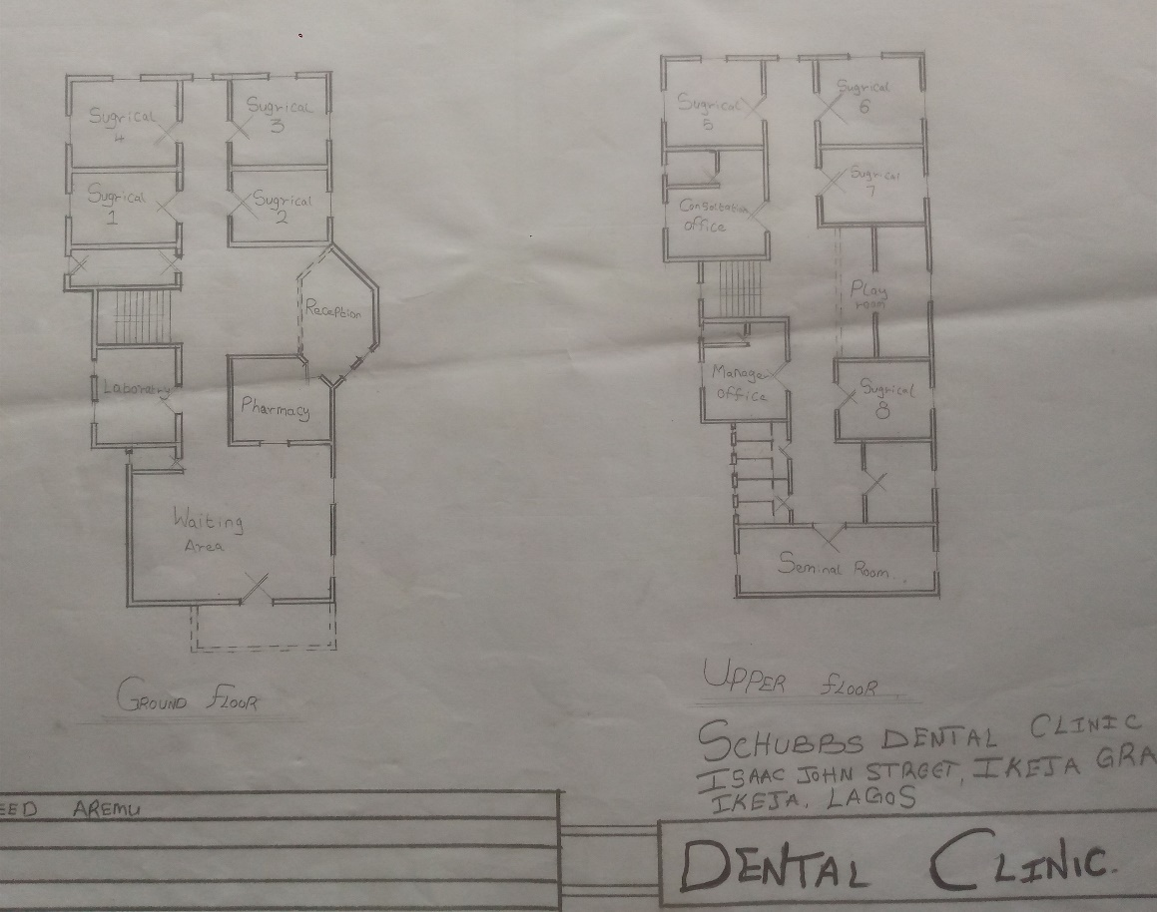
Plate 3.1.1: Floor plan of case study one Schubbs Dental Clinic
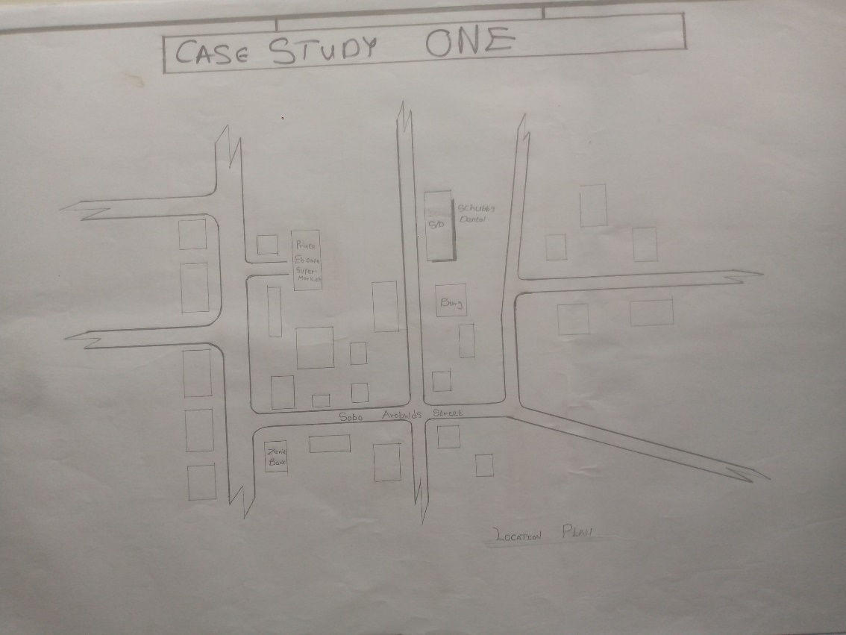
Plate 3.1.2: Locational plan of case study one Schubbs Dental Clinic
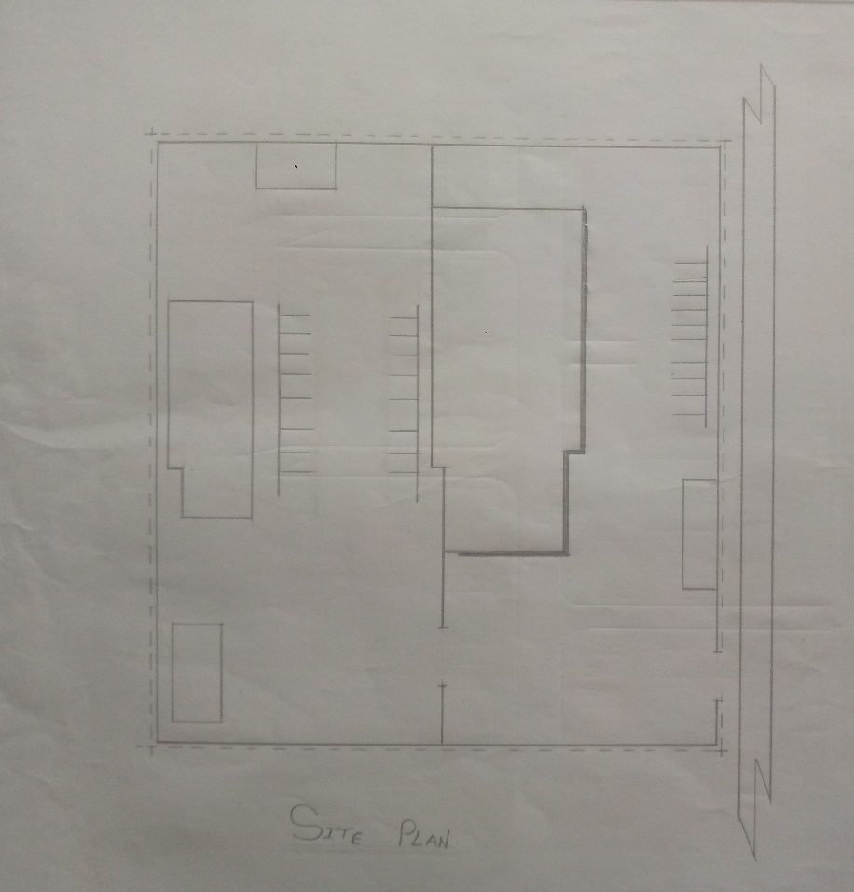
Plate 3.1.3: Site plan of case study one Schubbs Dental Clinic
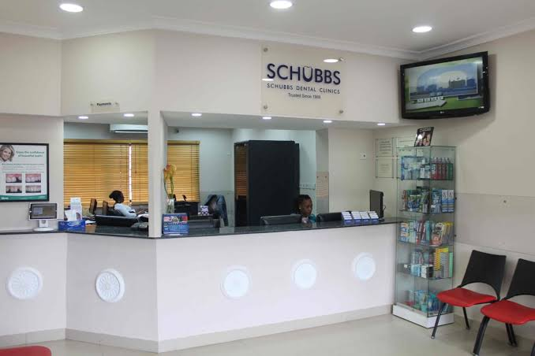
Plate 3.1.4: Inner show of case study one Schubbs Dental Clinic
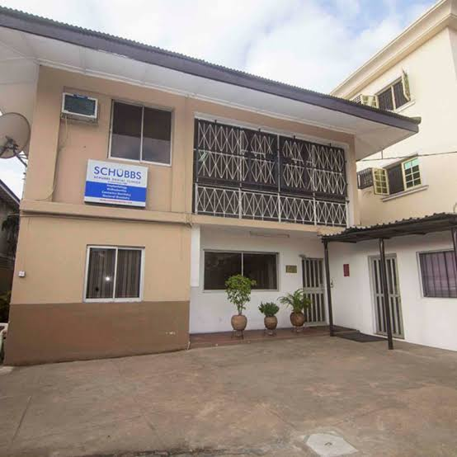
Plate 3.1.5: Outer view of case study one Schubbs Dental Clinic
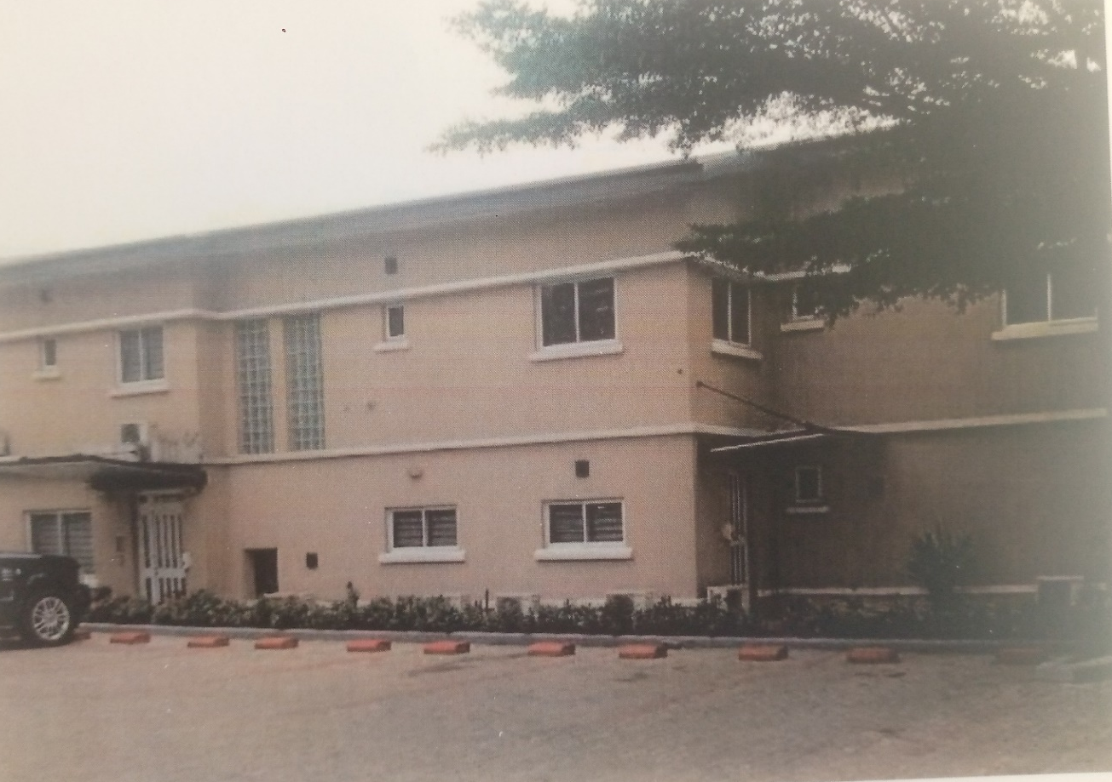
Plate 3.1.6: Outer view of case study one Schubbs Dental Clinic
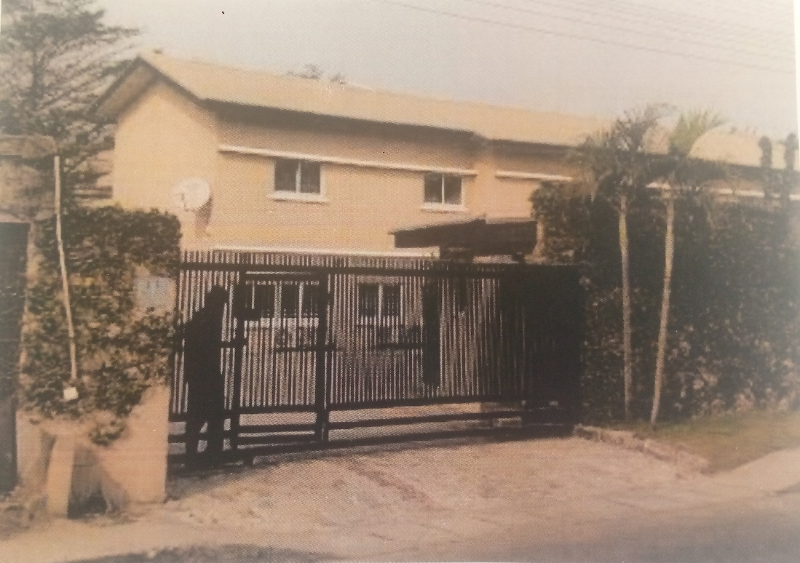
Plate 3.1.7: Outer view of case study one Schubbs Dental Clinic

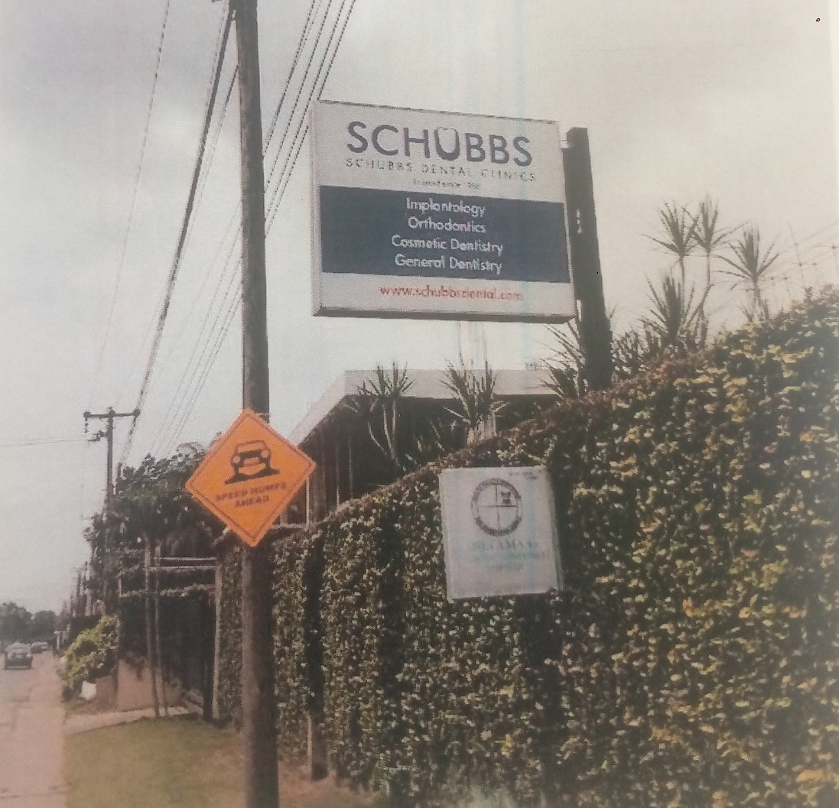
Plate 3.1.8: Signage of case study one Schubbs Dental Clinic

MERIT
- Well organized units
- Calm and peaceful environment
- Wide range of service
- High qualified team

DEMERIT

3.4 CASE STUDY TWO
BOZID DENTAL CLINIC,
Oyo Ibadan
BOZID DENTAL CLINIC's headquarters is located at SUITE 58, JOSBEED MALL ASHI-BODIJA ROAD IBADAN, IBADAN NORTH, OYO, IBADAN NORTH, OYO STATE
BOZID DENTAL CLINIC was incorporated in IBADAN NORTH, Nigeria with Registration Number OY63105. It was registered on 28 Aug 2014 and it's current status is unknown. Company's registered office address is SUITE 58, JOSBEED MALL ASHI-BODIJA ROAD IBADAN , IBADAN NORTH, OYO.
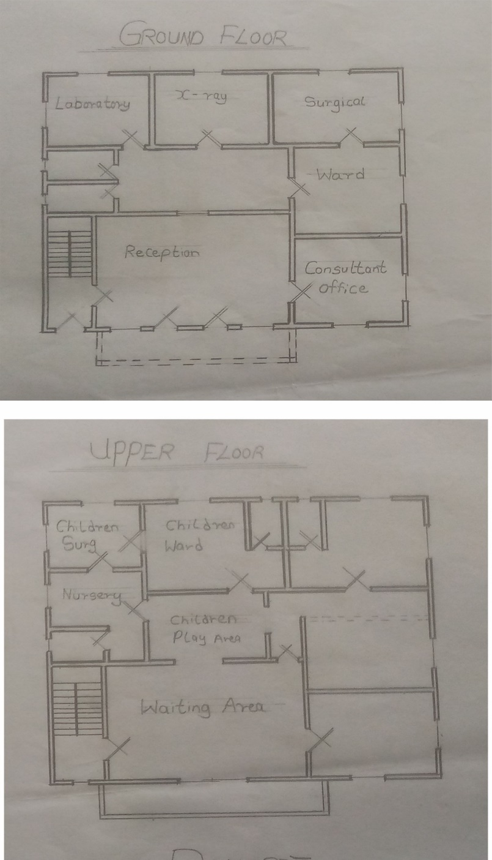
Plate 3.2.1: Floor plan of case study two Bozid Dental Clinic
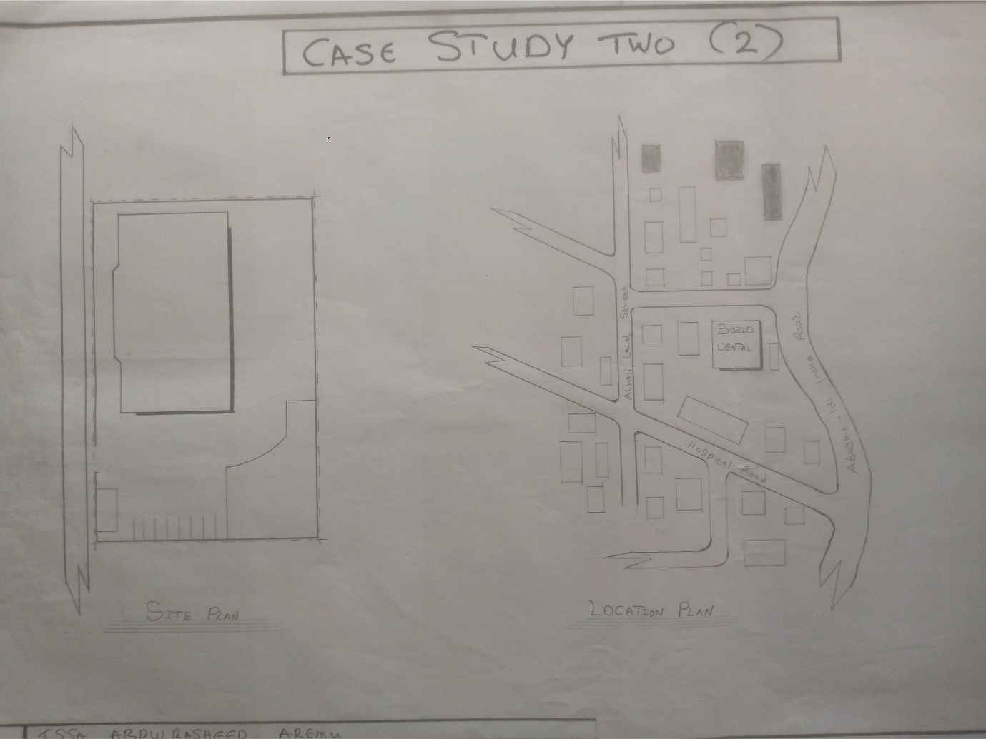
Plate 3.2.2: Site and Locational plan of case study two Bozid Dental Clinic
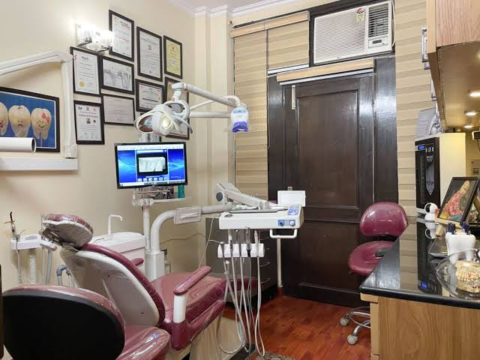

Plate 3.2.3: Inner view of case study two Bozid Dental Clinic

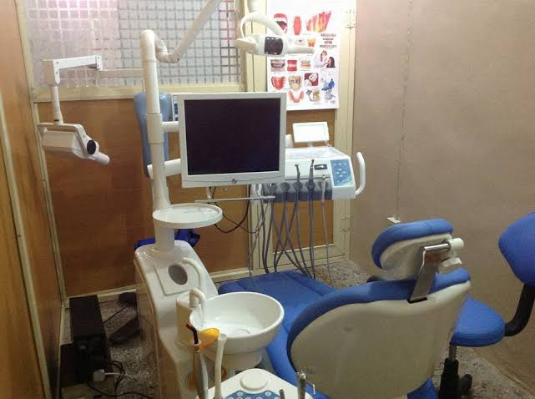

Plate 3.2.4: Inner view of case study two Bozid Dental Clinic

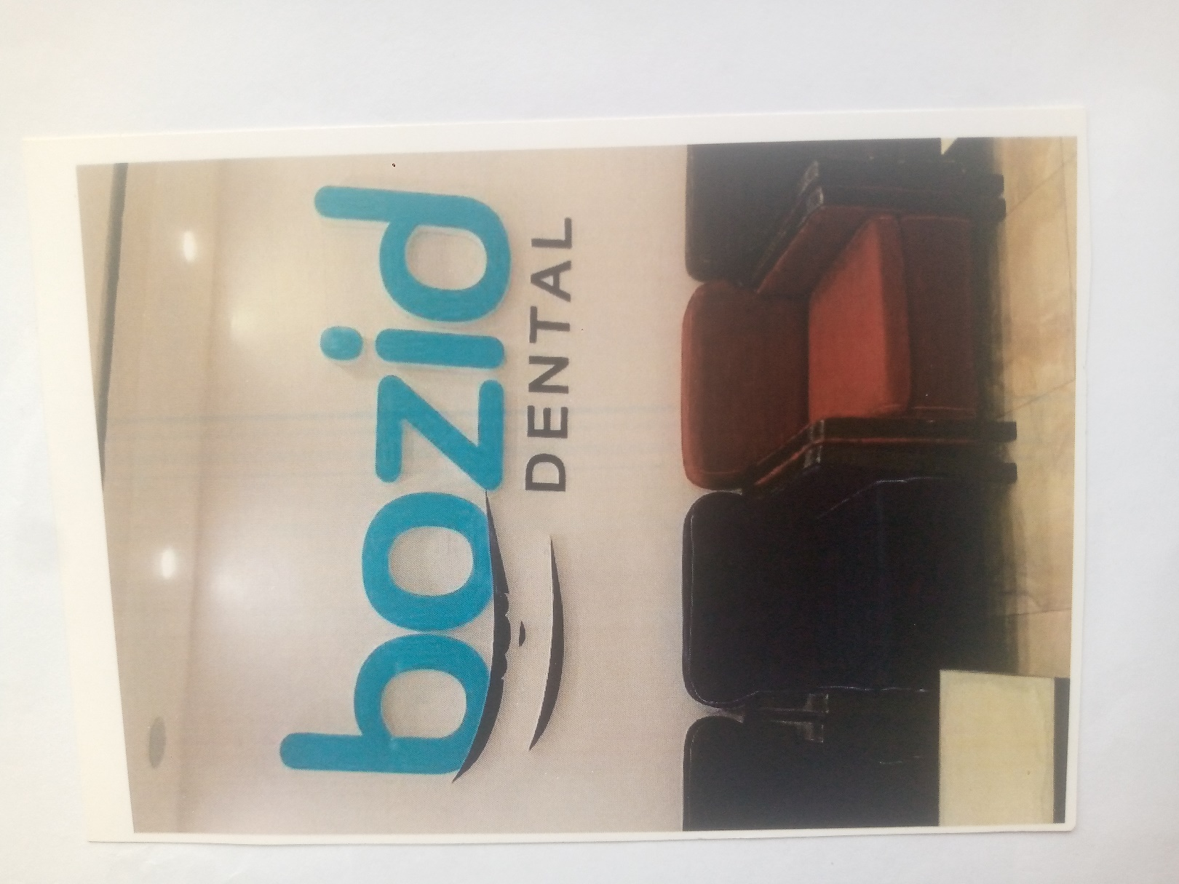

Plate 3.2.5: Reception view of case study two Bozid Dental Clinic
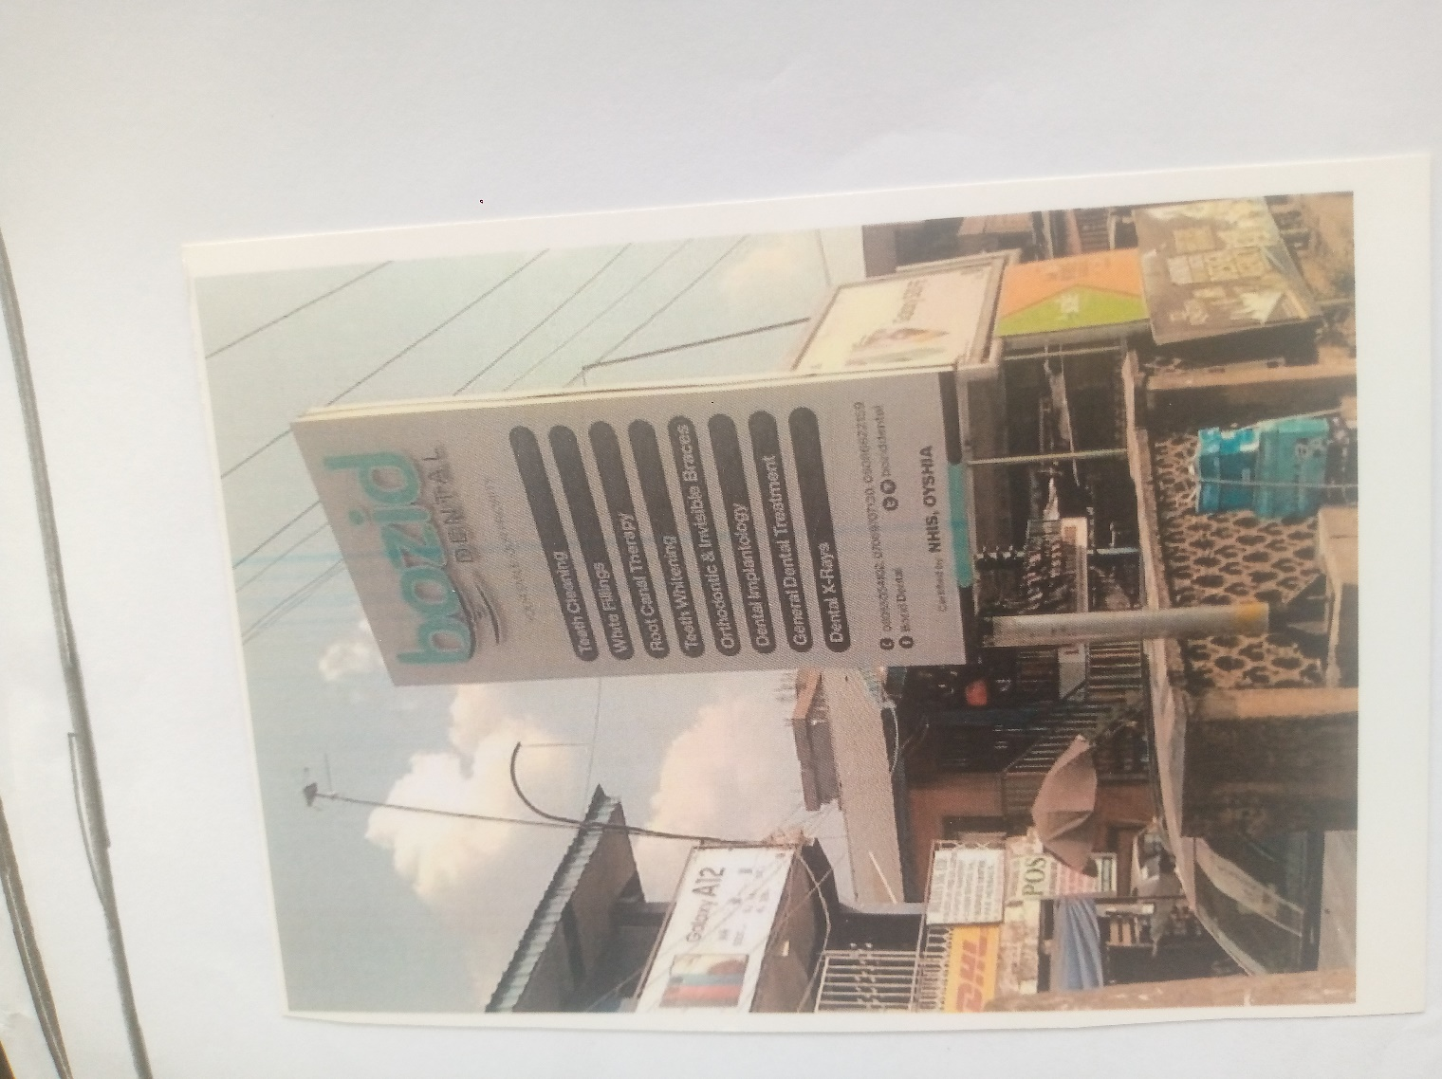

Plate 3.2.6 Signage of case study two Bozid Dental Clinic

MERIT
- Proper care of patient
- Well arrange of their facilities
- Easy access role from the gate

DEMERIT
- No space for future expansion
- Both ground and upper floor are two different apartment and they are accused differently
- Lack of sufficient storage facilities
3.5 CASE STUDY THREE
EMIRATE DENTAL CLINIC,
Ilorin Kwara
25 May 2022 — The objective of this study is to criticallyinvestigate Ilorin Emirate type of administration in Isinland 1836-1947 as typical example of Ilorin .
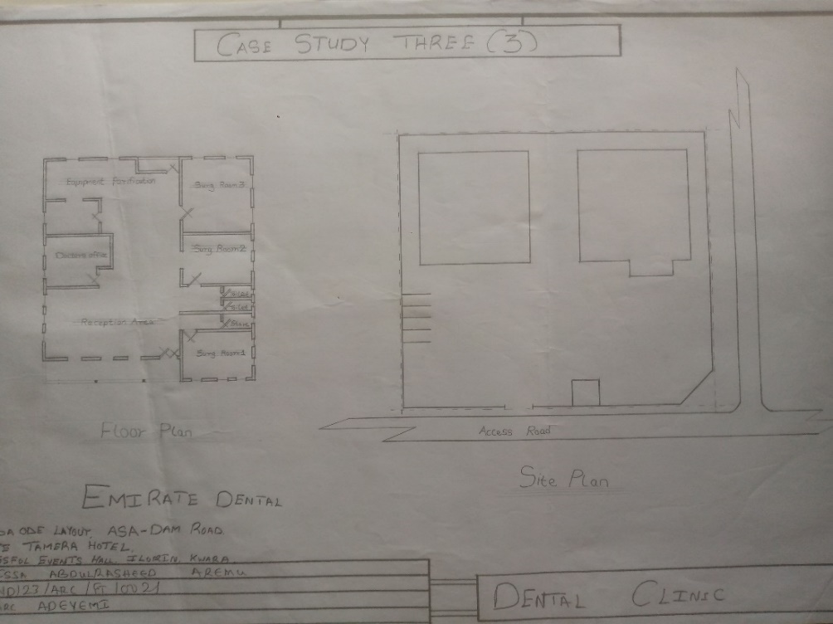
Plate 3.3.1: Floor plan and site plan of case study three Emirate Dental Clinic
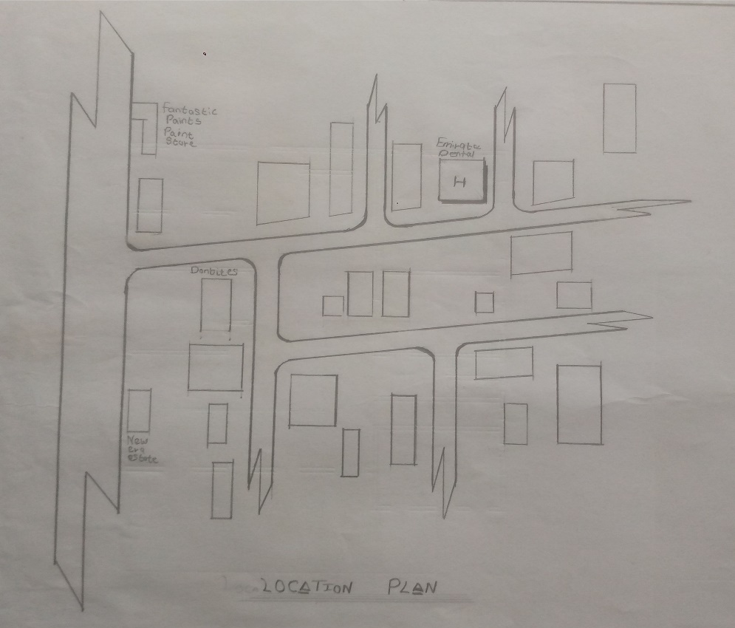
Plate 3.3.2: Locational plan of case study three Emirate Dental Clinic
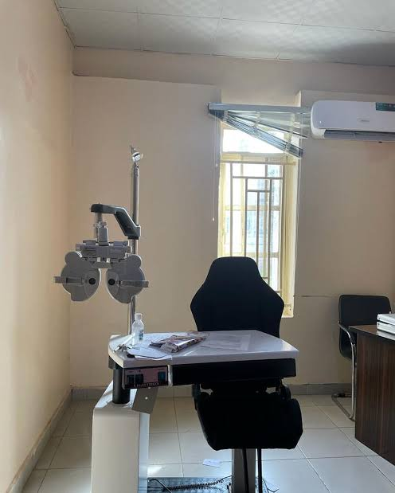
Plate 3.3.3: Inner view of case study three Emirate Dental Clinic
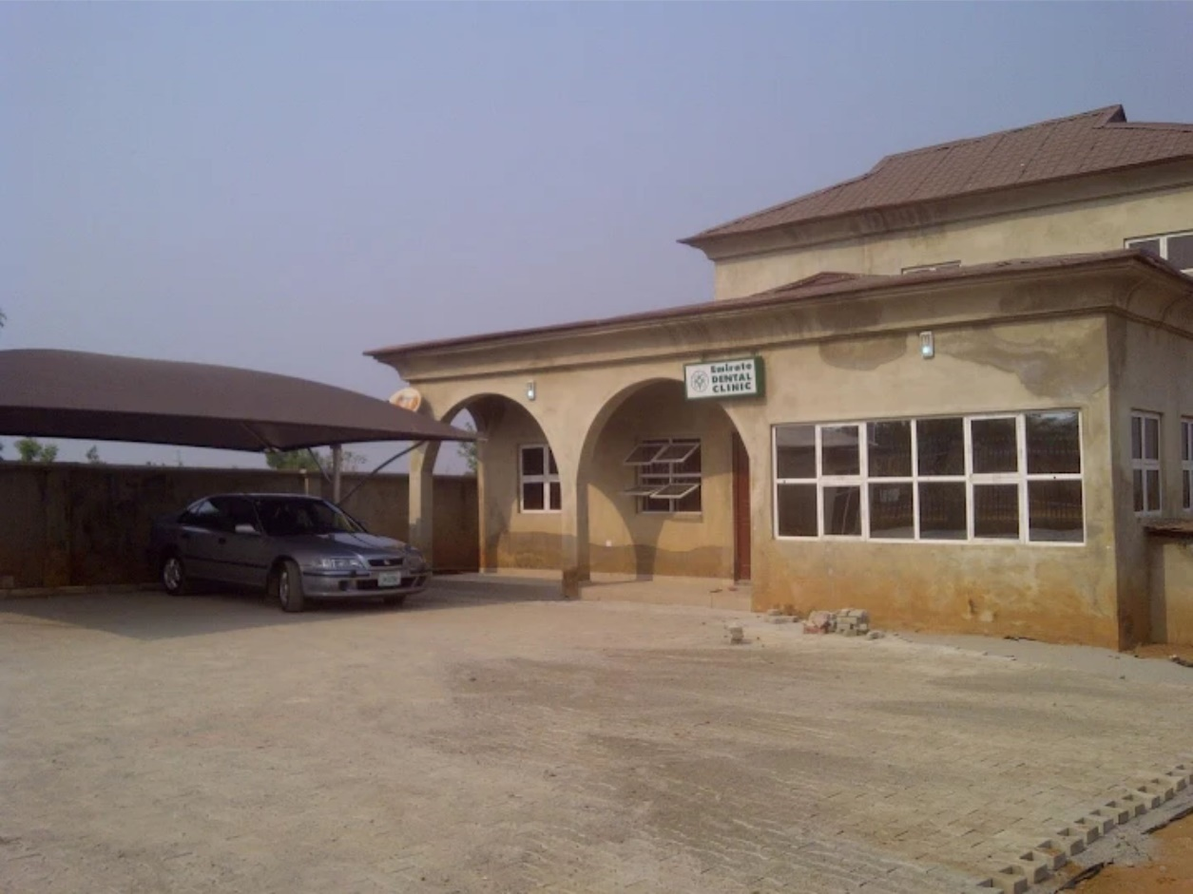
Plate 3.3.4: Outer view of case study three Emirate Dental Clinic

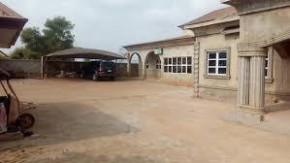
Plate 3.3.5: Outer view of case study three Emirate Dental Clinic

MERIT
- Adequate parking space
- Availability of dental services to patients
- Easy access role from the gate

DEMERIT
- It is not proposly built for a dental clinic
- Lack of training facilities
- Lack of proper sterilization equipment
3.6 CASE STUDY FOUR (ONLINE CASE STUDY)
IMPRESS DENTAL
Brushfield street, London
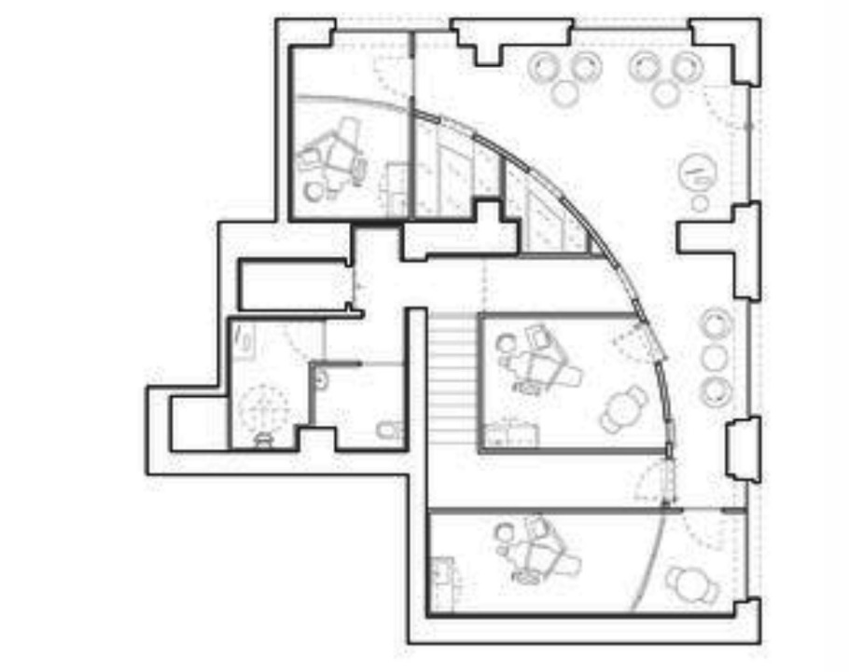

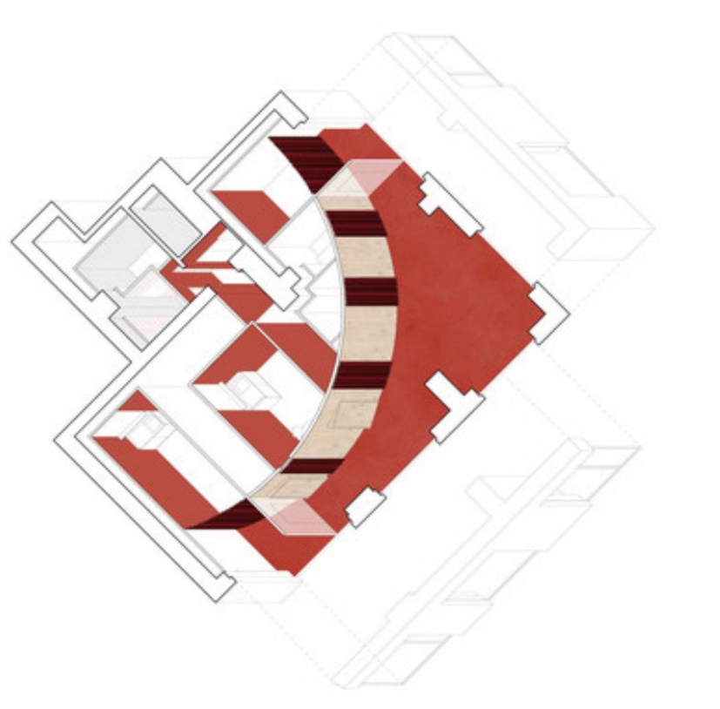
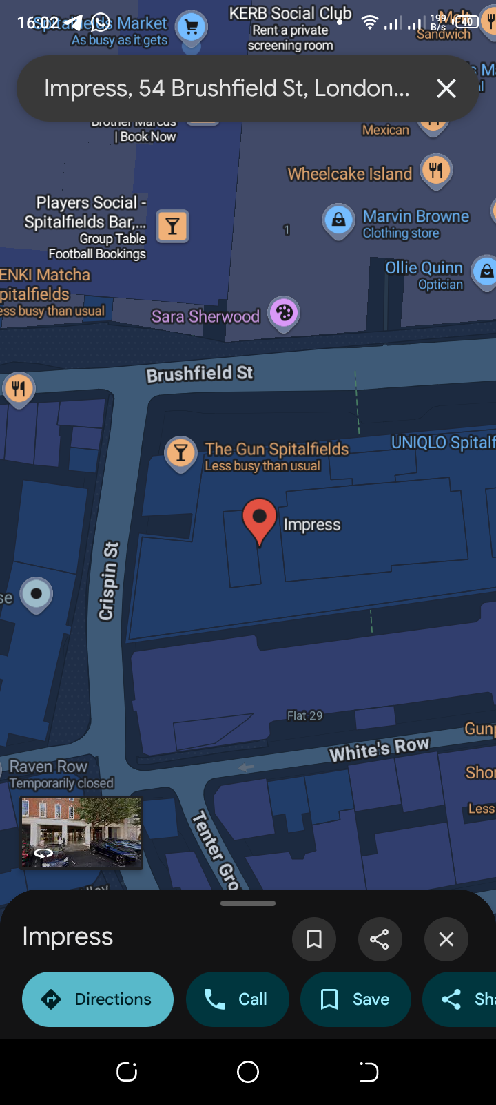
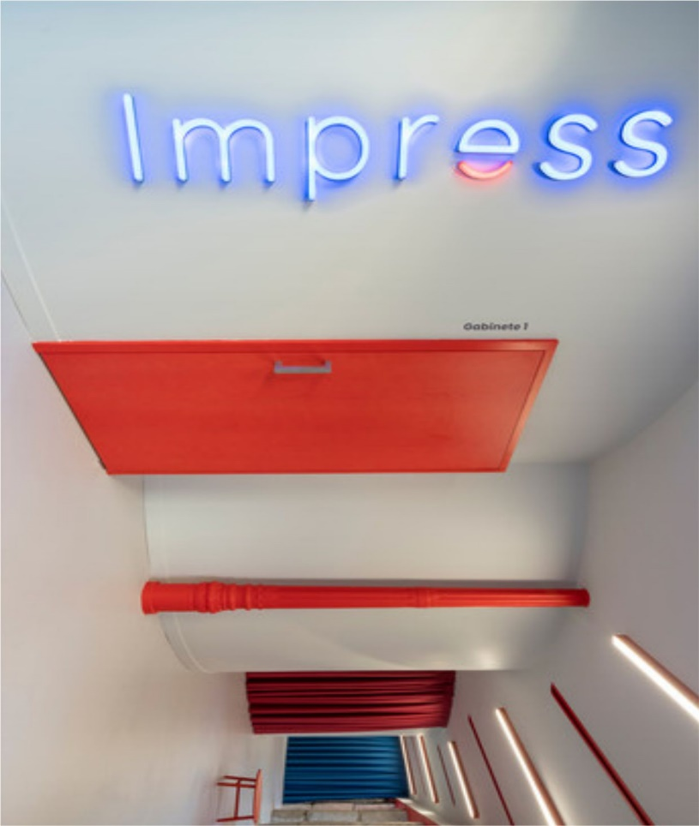

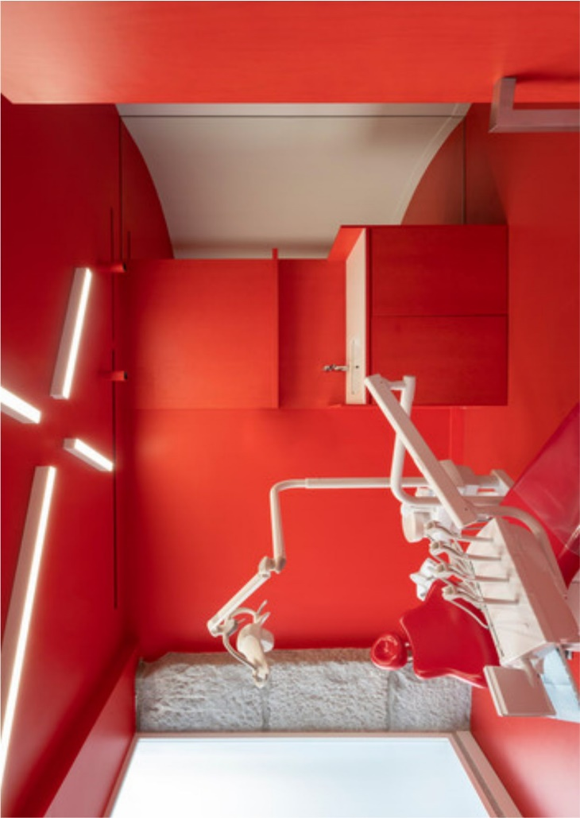

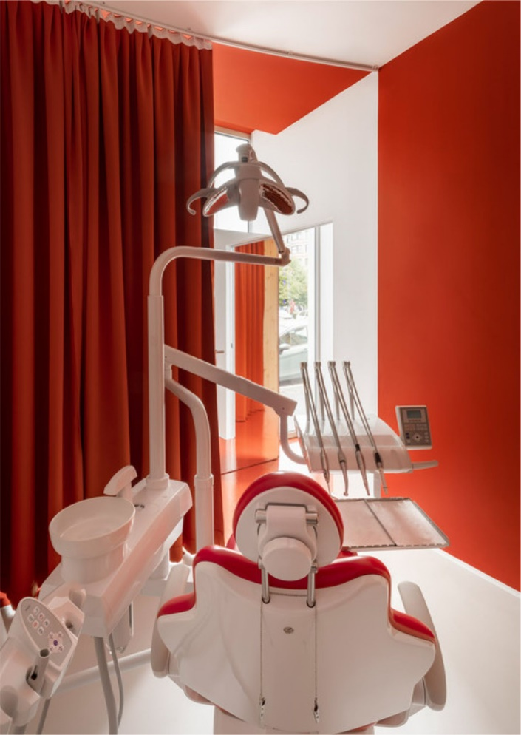

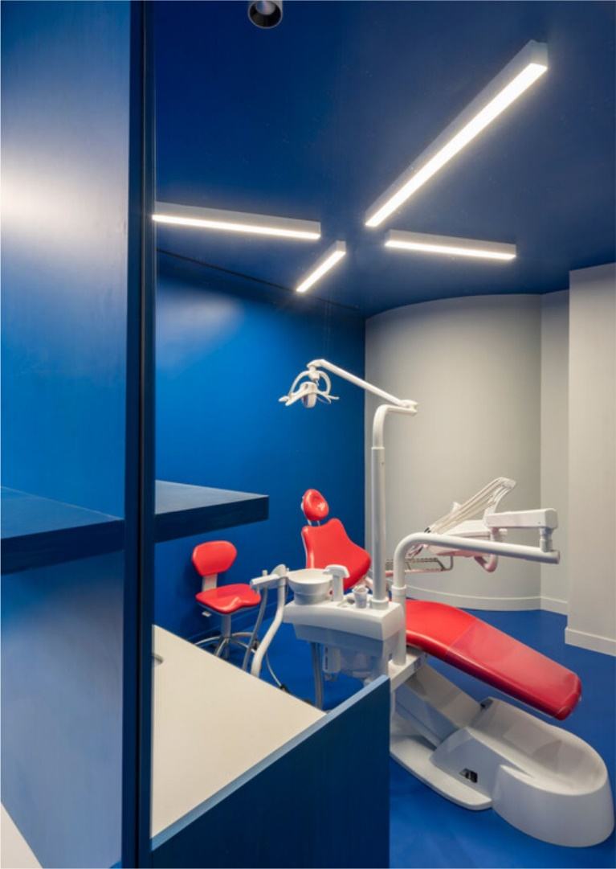

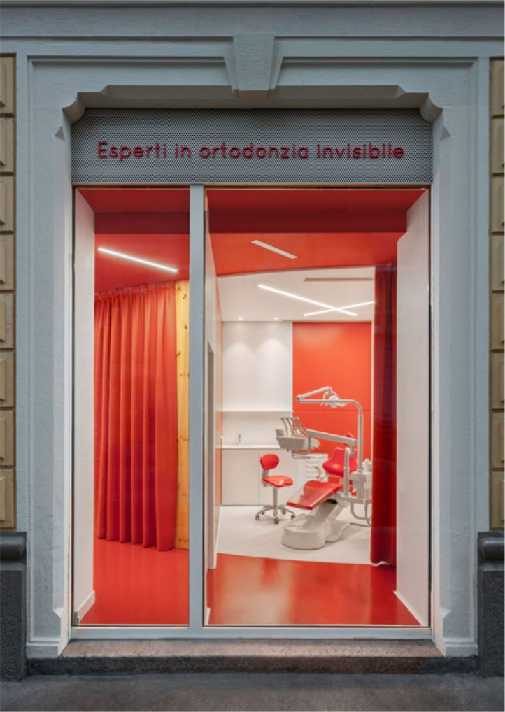
CASE STUDY FIVE (ONLINE CASE STUDY)
TRUST DENTAL CLINIC
United State
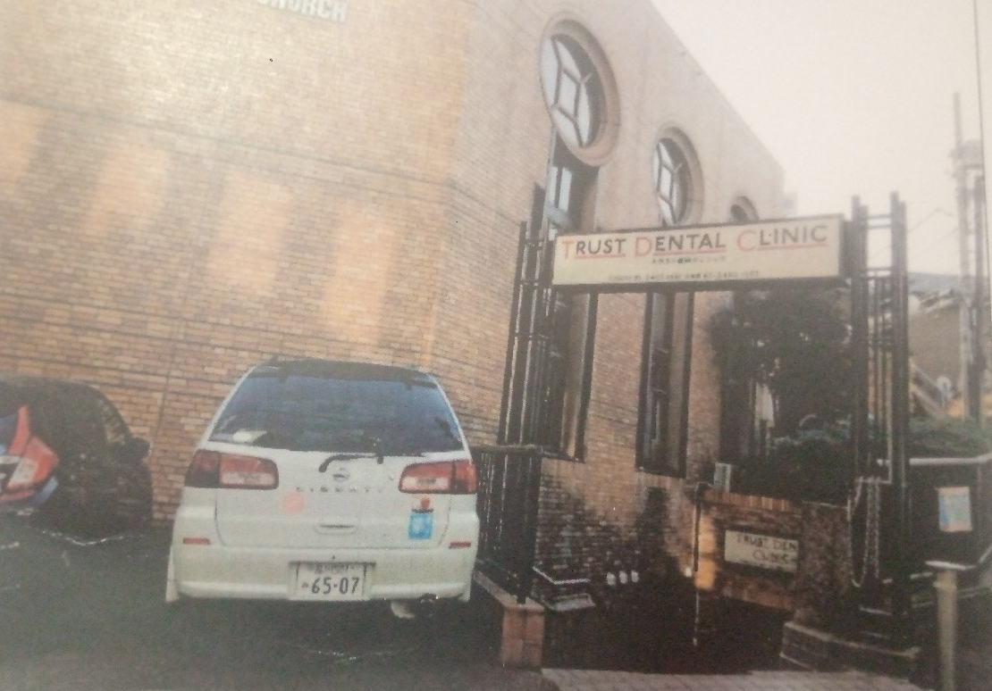
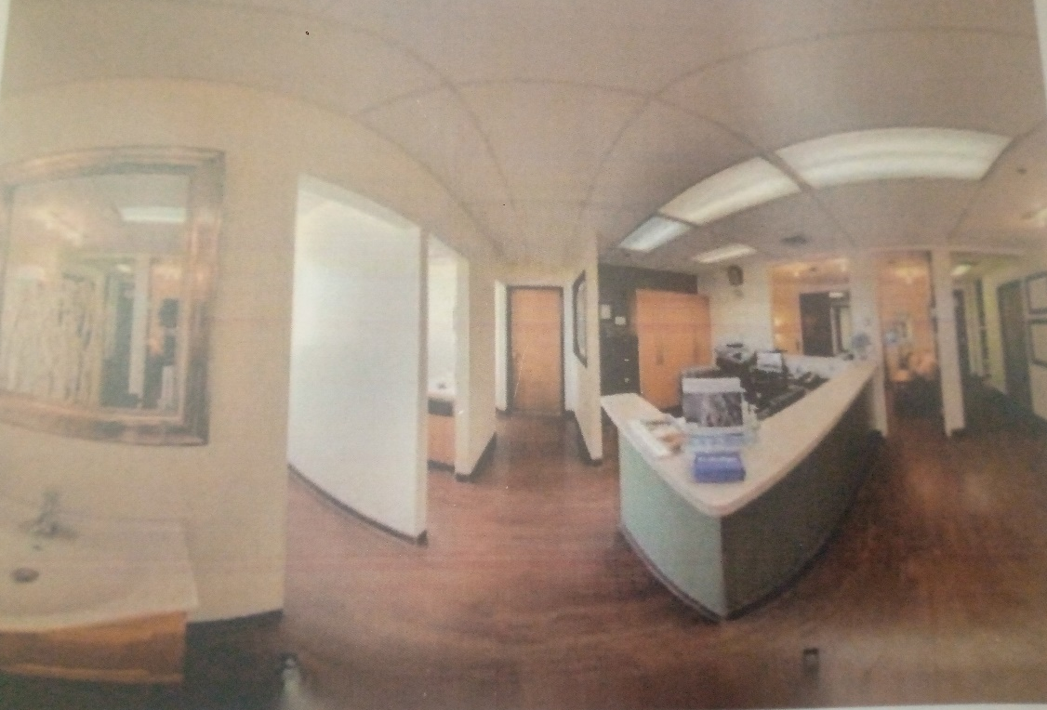
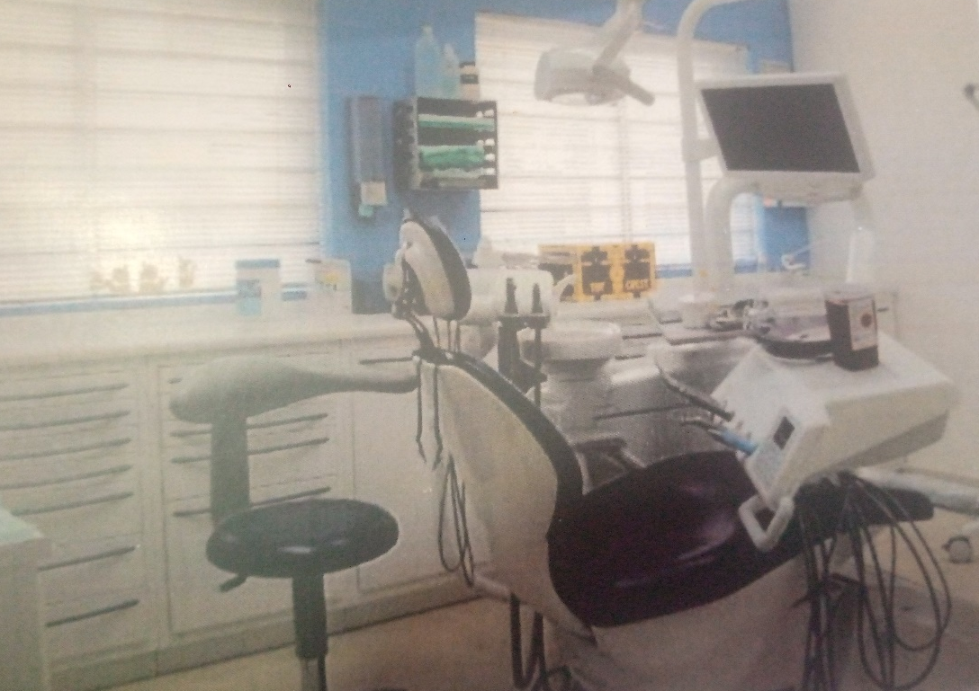
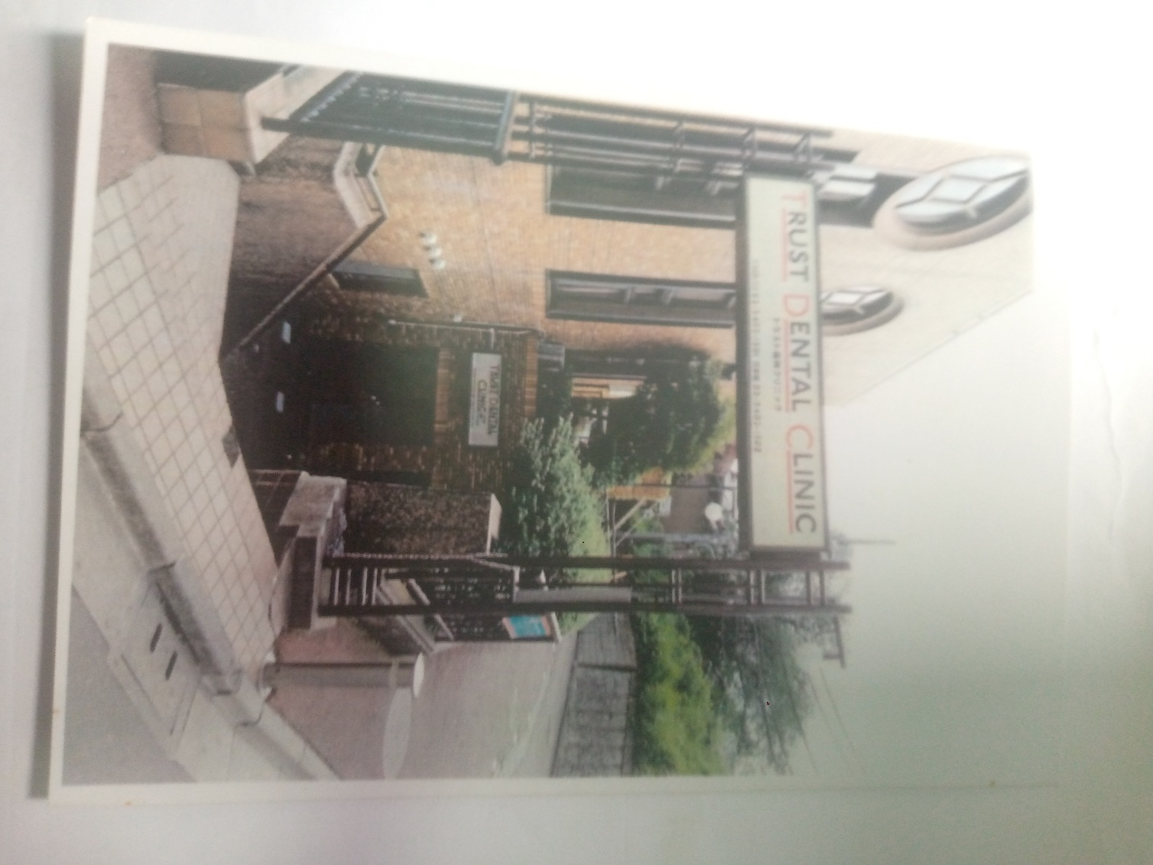
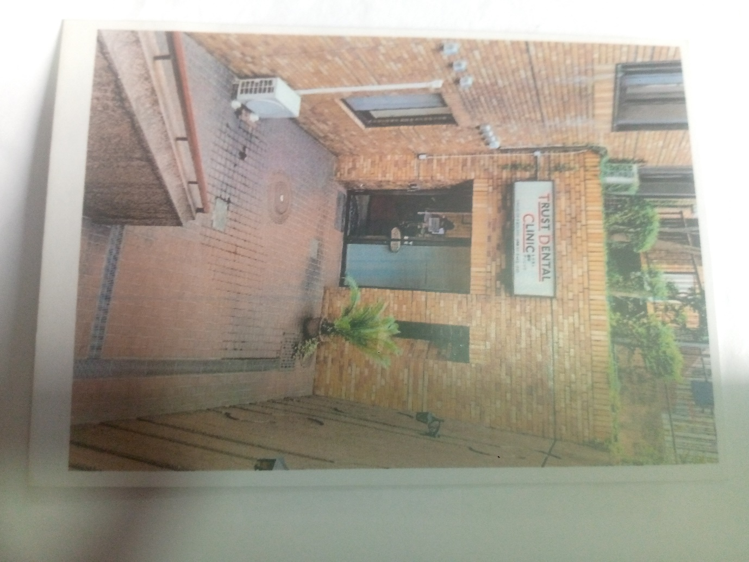
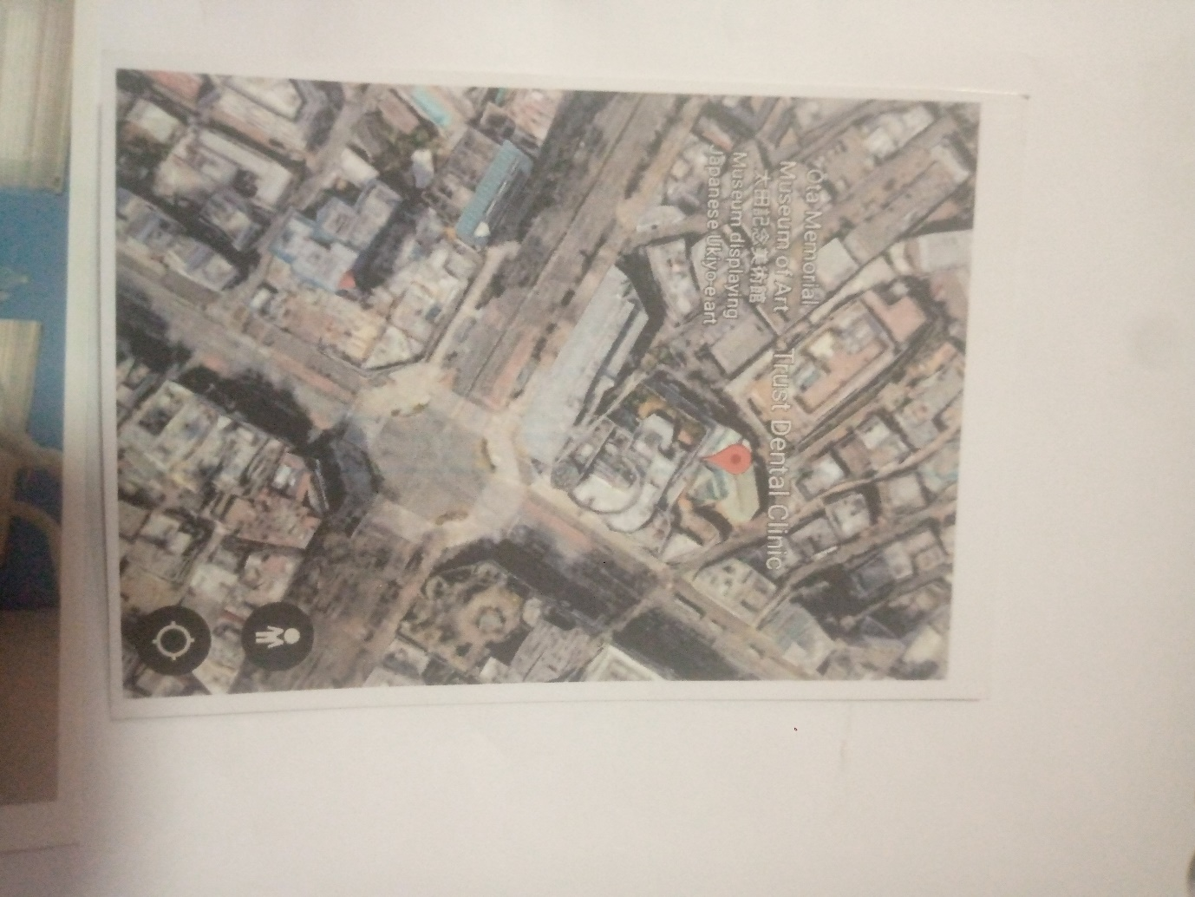

CHAPTER FOUR
4.0 STUDY AREA / PROJECT SITE AND DESIGN CRITERIA
4.1 SITE LOCATION AND DESCRIPTION
4.1.1 SITE LOCATION
The proposed site is located in Ilorin South local government, Kwara State, Nigeria. It is assumed to be situated along kulende sango area, near Item 7, easily accessible from the central business district, government hospital and academic institutions.
The surrounding developments include residential buildings, a few healthcare facilities, educational institutions and minor commercial activities. This makes it an ideal location to serve both public and private clients seeking dental care.

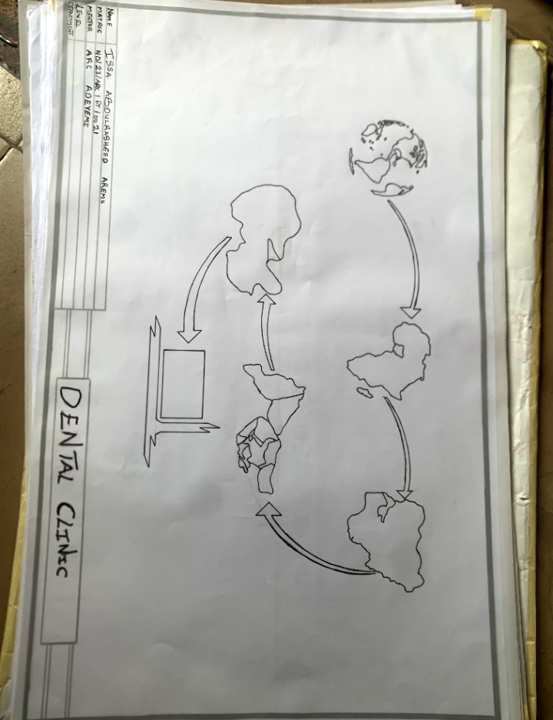

4.1.2 SITE SELECTION CRITERIA
- Accessibility by road and proximity to main public transportation routes
- Quiet and healthy environment conducive to medical operations
- Flat terrain for ease of construction
- Availability of basic infrastructure (water, electricity, drainage)
- Safety and security of surrounding neighborhood
- Potential for future expansion
4.2 SITE INVENTORY AND ANALYSIS

FEATURE | OBSERVATION
Topography | Generally flat with gentle slopes for natural drainage
Soil Condition | Assumed to be laterite soil, stable for foundation design
Climate | Tropical wet and dry climate; high solar intensity; seasonal rainfall
Wind Direction | Predominantly south-western wind — useful for natural Ventilation planning
Sun Path | East–West exposure with longer western heat gain — needs solar shading
Noise | Minimal external noise; buffer landscaping can enhance sound protection
Views | Moderate views — opportunity for landscaped gardens around waiting areas

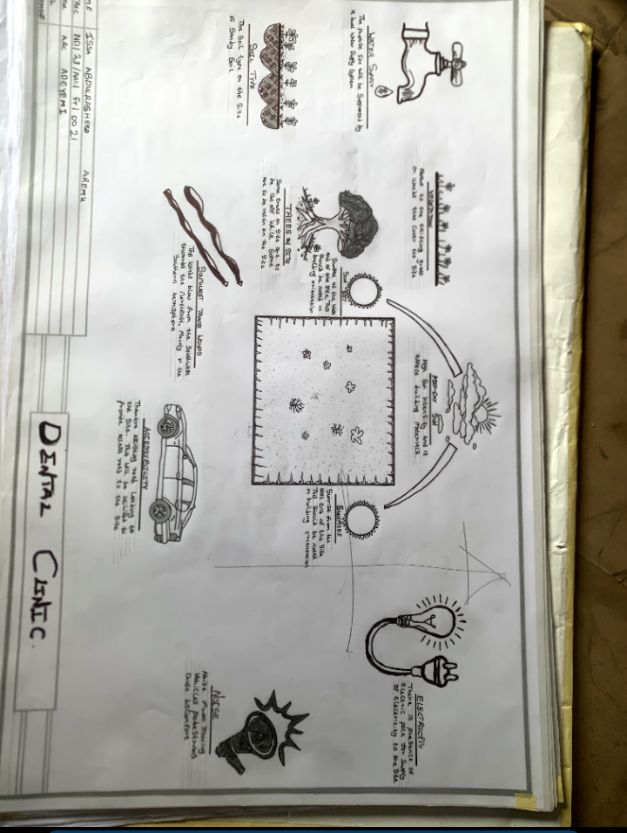
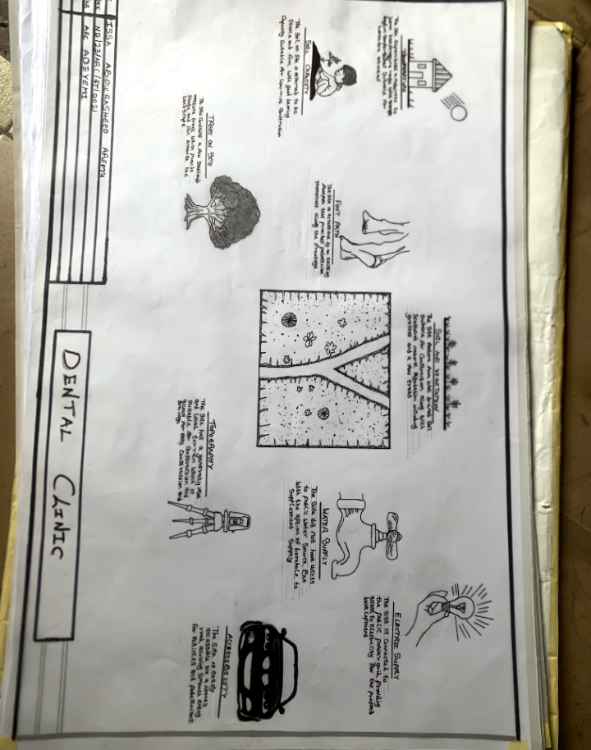

4.3 CLIMATIC AND ENVIRONMENTAL DATA (BASED ON ILORIN REGION)
- Average Temperature: 25°C – 34°C
- ANNUAL RAINFALL: 1,200 mm – 1,500 mm
- HUMIDITY: 60–80%
- SUNRISE/SUNSET: Ranges from 6:30 am to 6:45 pm throughout the year
- PREVAILING WINDS: From southwest (rainy season) and northeast (dry harmattan wind)
DESIGN IMPLICATIONS:
- Emphasis on shading devices for west-facing walls
- Use of cross ventilation and shaded courtyards
- High ceilings and operable windows for heat escape
- Covered walkways to connect functional zones

4.4 PROJECT GOALS / DESIGN BRIEF
The proposed dental clinic is expected to provide:
- A modern oral healthcare facility
- Functional zoning for different dental specialties
- A hygienic, comfortable and energy-efficient environment
- Flexible spaces adaptable to future technology and staff needs
- Facilities for patient education, diagnostics, minor surgery and recovery
CIRCULATION PATTERNS:
- One-way movement from waiting → operatory → discharge
- Dirty-to-clean sterilization loop
- Staff circulation separate from patient flow
- Courtyards used for light, airflow and privacy buffer
4.5 CONCEPTUAL DEVELOPMENT (PREVIEW)
The form will take inspiration from medical sanitizer bottle, symbolizing cleanliness, care and precision — with one central courtyards (cut yards) serving as lungs of the structure to draw in natural light and air. Zoning will radiate around these cut yards, ensuring every room has either direct or indirect access to daylight and cross ventilation.
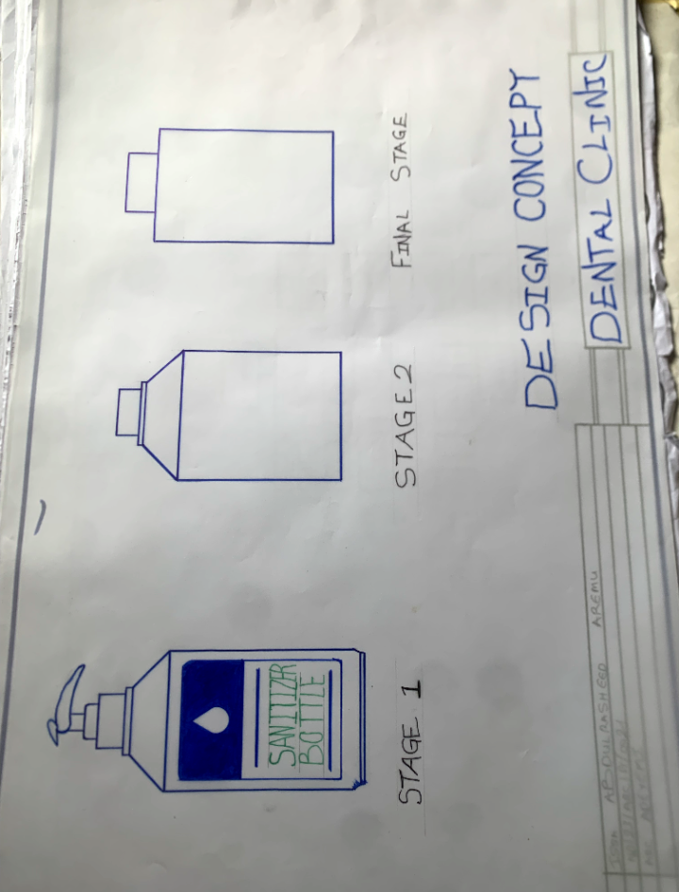
CHAPTER FIVE
DESIGN APPROACH / DESIGN REALIZATION
5.1 CONCEPTUAL DESIGN IDEA
Design Inspiration: Medical Sanitizer Bottle
The form of the building draws its symbolism from medical sanitizer bottle — the sanitizer bottle, widely associated with hygiene, safety and care, offers a strong symbolic and functional foundation for designing a dental clinic. As a concept, it inspire not only the aesthetic and spatial design but also the operational philosophy of cleanliness, precision and user centered care.
These courtyards serve as natural light wells, improve cross ventilation and visually separate clinical from administrative or public zones.
5.1.2 CORE DESIGN PRINCIPLES
- FUNCTIONALITY: Clear zoning for public, clinical and restricted areas
- FLEXIBILITY: Modular operatory rooms and convertible training/meeting spaces
- PATIENT-CENTERED DESIGN: Visual privacy, calming finishes, child-friendly spaces
- ENVIRONMENTAL SUSTAINABILITY: Use of courtyards for passive cooling and lighting
- COMPLIANCE: Conforming to NDLEA, NCDC and national healthcare facility guidelines

5.2 DESIGN PROCESS OVERVIEW
STAGE 1: SITE ZONING & MASSING
- Building mass was shaped to wrap around two central cut yards for light and air
- North–south orientation used to reduce solar heat gain on main walls
- Public-facing functions placed in the front (east), service/core areas to the back (west)
STAGE 2: SPATIAL ARRANGEMENT
- Public Area (Zone A): Entrance, reception, waiting, records
- Clinical Area (Zone B): Operatory rooms, pediatric zone, oral surgery, X-ray
- Support Area (Zone C): Pharmacy, staff lounge, training room, sterilization
- Service Area (Zone D): Generator, waste disposal, water tanks (positioned externally)
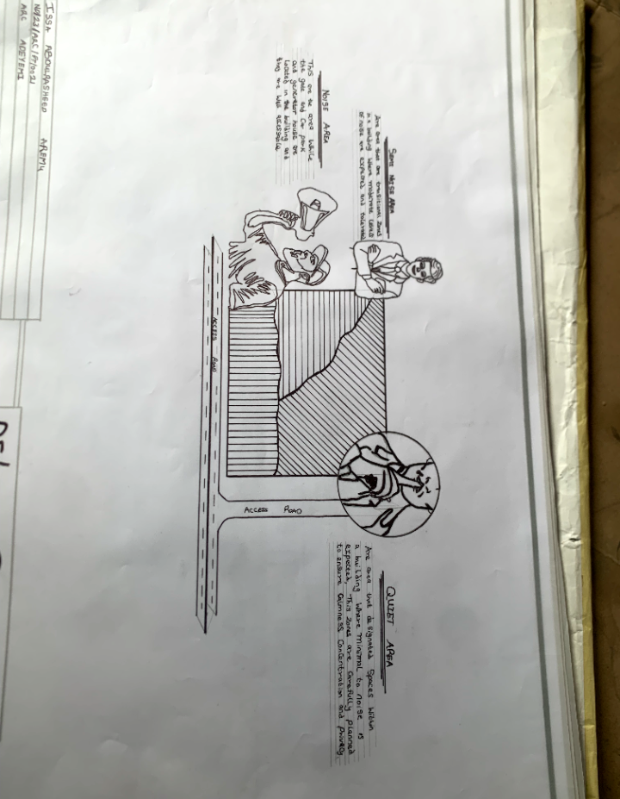

5.3 TECHNOLOGICAL AND ENVIRONMENTAL CRITERIA
5.3.1 CONSTRUCTION METHOD AND MATERIALS
- FOUNDATION: Reinforced concrete strip foundation (due to stable laterite soil)
- WALLS: Sandcrete block walls (150–225 mm thick), rendered and painted
- ROOF: Long-span aluminum roofing with roof insulation layer
- CEILINGS: Acoustic ceiling tiles in clinical rooms, PVC in toilets
- FLOORING: Non-slip ceramic tiles (for easy cleaning and infection control)
- WINDOWS/GLAZING: Aluminum casement windows with mosquito netting and frosted glass in private zones
- DOORS: Flush doors (solid core for operatory and surgery rooms)

5.3.2 BUILDING SERVICES INTEGRATION
SERVICE | DESIGN PROVISION
Circulation | Central hallway loop connecting all zones, with emergency exits at rear
Ventilation | Cross ventilation through operable windows and courtyards; ceiling fans in zones
Lighting | LED energy-saving fixtures; skylights above waiting area and courtyards
Plumbing | Dual plumbing lines with backflow preventers; rainwater harvesting tank
Electrical | Backup generator and inverter system for power stability
Waste Disposal | Segregated clinical waste room with proper drainage and soakaway system
Fire Protection | Fire extinguishers, smoke detectors and wide corridor access for emergency rescue
Acoustics | Sound insulation between treatment rooms and external walls

5.4 ENVIRONMENTAL PERFORMANCE STRATEGIES
- NATURAL LIGHTING: Every functional space is either directly lit by the courtyard or via side windows
- PASSIVE COOLING: Building orientation and courtyards reduce thermal buildup
- SHADING DEVICES: Sun breakers and external blinds on west-facing walls
- LANDSCAPE INTEGRATION: Soft landscaping around courtyards and entrances improves microclimate
- WATER MANAGEMENT: Rainwater harvesting + greywater reuse for landscaping

5.5 BEHAVIORAL AND SOCIAL CONSIDERATIONS
- ANXIETY REDUCTION DESIGN: Nature views from waiting and pediatric areas, warm color scheme
- INCLUSION: Ramp access at all entries, accessible restrooms, large signage for visibility
- PRIVACY: Separate consult rooms and visual separation from operatory to public zones
- CHILDREN’S EXPERIENCE: Playful finishes, color-coded corridors, wall art in pediatric unit

5.6 CONCLUSION AND RECOMMENDATIONS
CONCLUSION
This project has successfully examined the architectural planning and design of a functional, sustainable and patient-centered dental clinic suited to the growing healthcare needs of Kwara State. Through a detailed analysis of relevant literature, real-world case studies, site conditions and environmental factors, a holistic solution was developed — merging healthcare efficiency with spatial aesthetics and sustainability.
The use of a medical sanitizer bottle-inspired concept supported by central courtyards proved effective in organizing the functional zones, enhancing natural ventilation and delivering architectural symbolism. The proposed facility accommodates key dental departments such as general dentistry, oral surgery, orthodontics and radiology — all while ensuring user comfort, infection control and regulatory compliance.
This dissertation also contributes to academic knowledge by demonstrating how architecture can respond to health-related anxieties, space limitations and evolving technology in medical practice.
RECOMMENDATIONS
FOR FUTURE RESEARCH AND DEVELOPMENT
- Future research could explore the integration of smart health technologies in dental clinic architecture (e.g. AI-assisted diagnostics, digital scheduling, smart sterilization).
- Investigation into biophilic healing environments and their effects on patient recovery in dental settings is recommended.
- Further studies could also include post-occupancy evaluations of existing dental clinics to gather empirical feedback from patients and staff.
- For Policy and Practice
- Government and private stakeholders should invest in purpose-built dental clinics that meet modern healthcare standards.
- Design regulations for dental clinics in Nigeria should be updated and enforced by health and planning authorities.
- Local materials should be innovatively utilized in medical architecture to reduce cost and promote sustainability.
APPENDICES
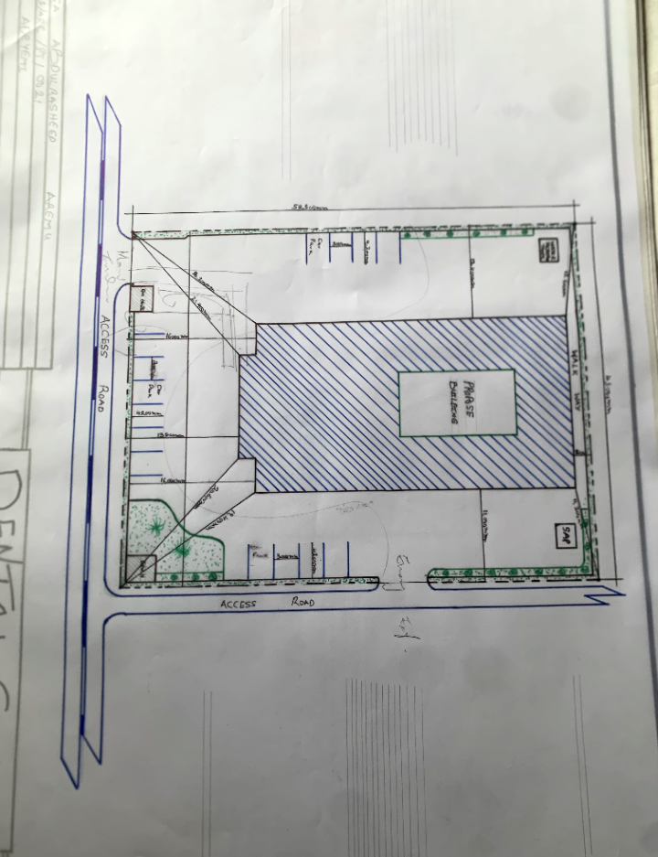

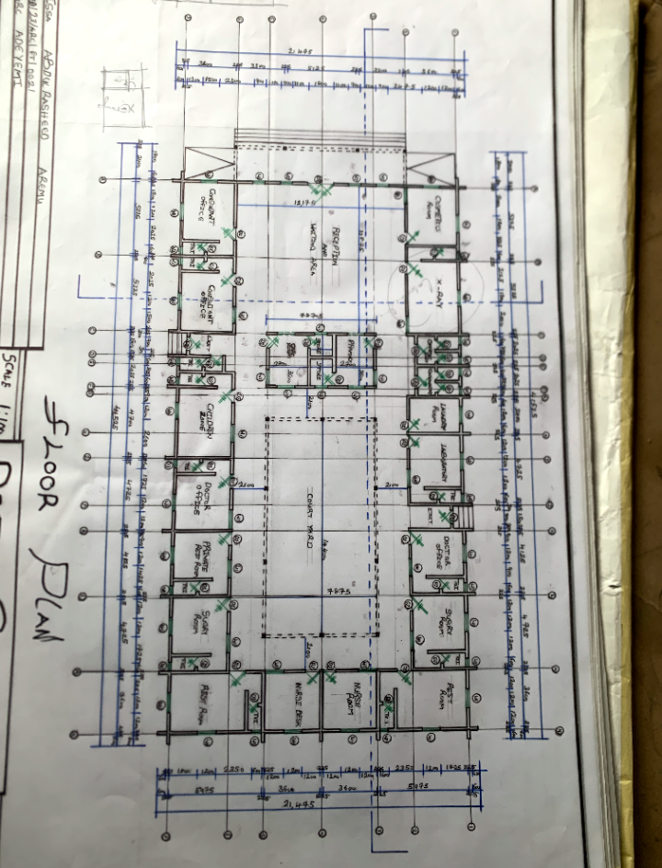

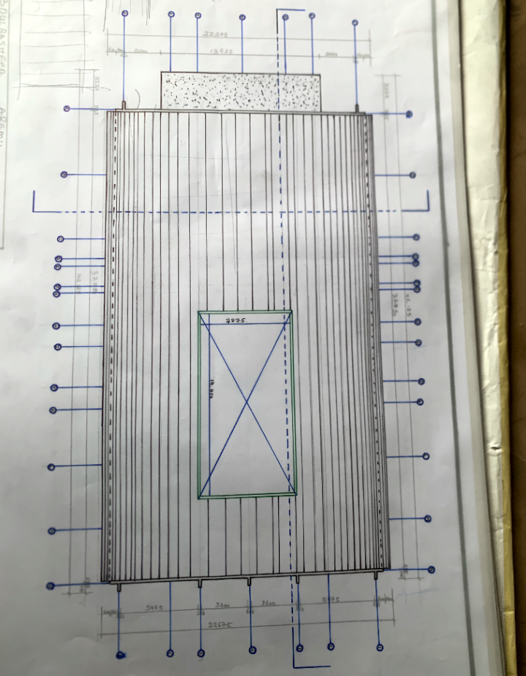

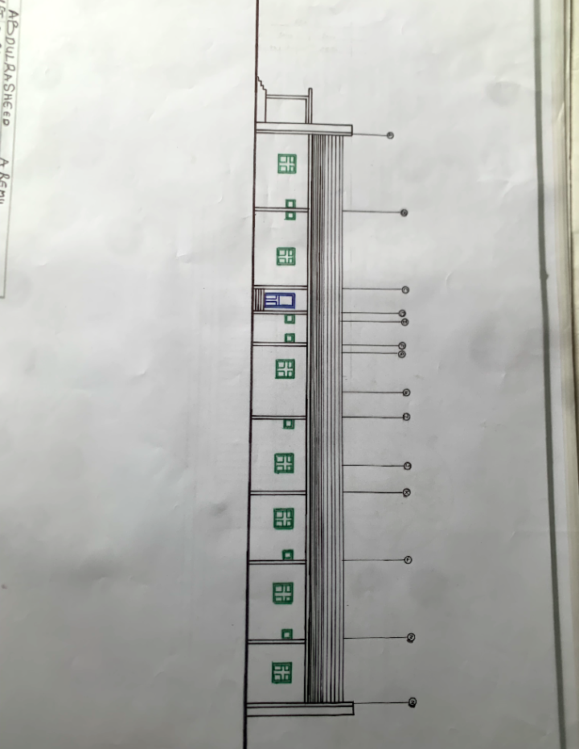

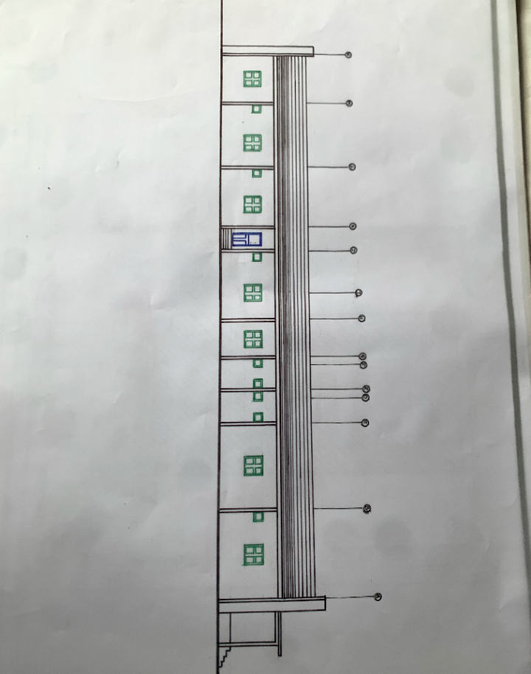
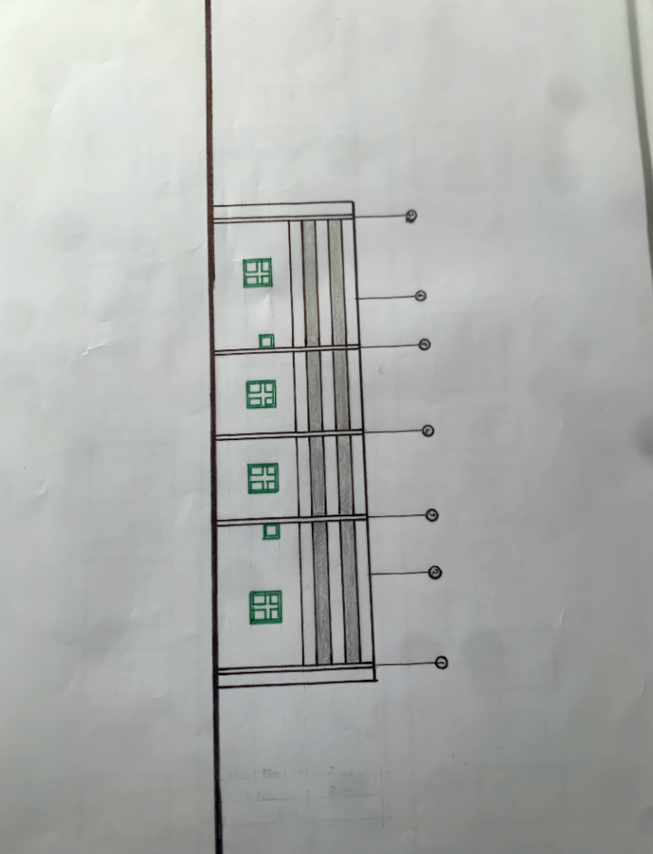

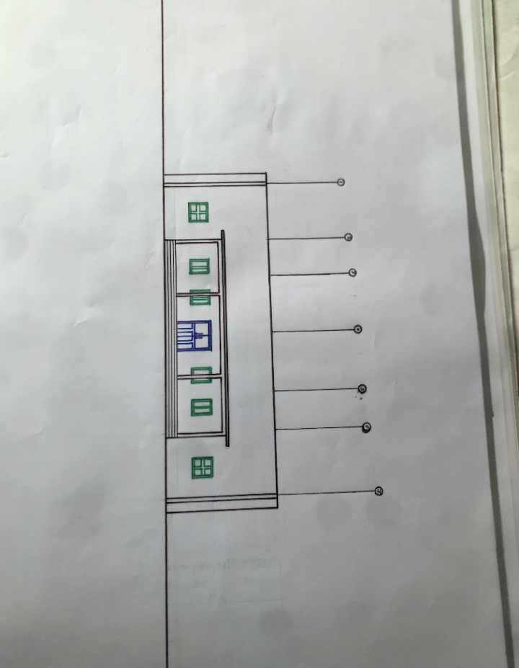

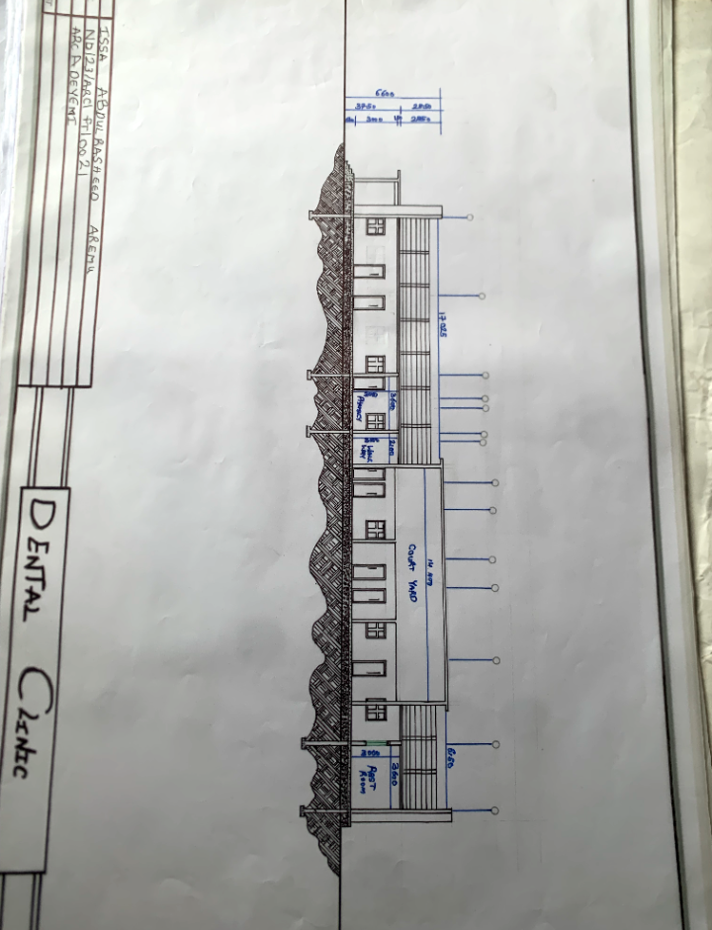
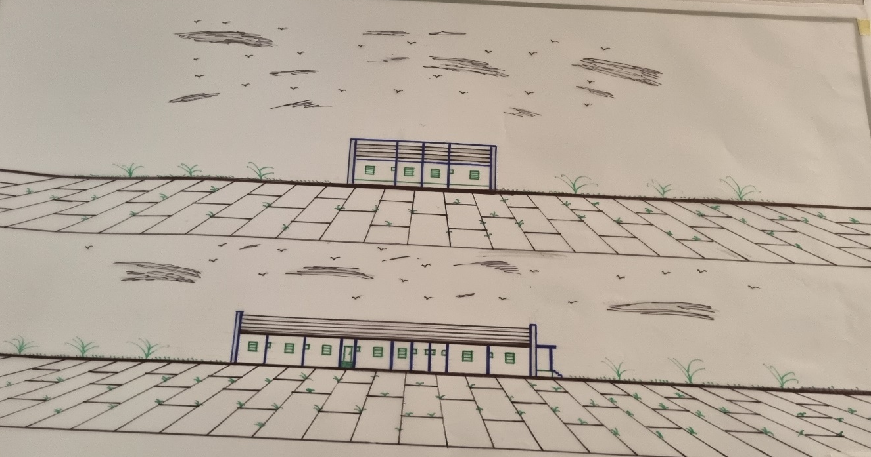

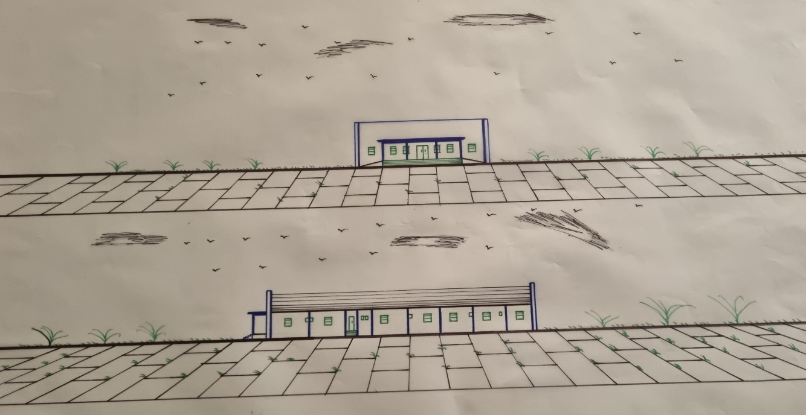

REFERENCE
Aravot, I. (2002). Back to phenomenological placemaking. Journal of Urban Design, 7(2), 201–212.
Anozie, U. C., & Okoye, T. (2019). Space planning considerations for dental clinics in Nigeria. Journal of Architecture and Built Environment in Nigeria, 9(1), 113–125.
Adewale, B. A. (2016). Sustainable energy integration in healthcare architecture: A case study in North-Central Nigeria. African Journal of Environmental Technology, 5(1), 44–53.
Aluko, B. T. (2015). Policy implications of healthcare facility locations in Nigerian urban centers. Urban and Regional Planning Review, 9(3), 34–48.28. Akande, T. M., & Yusuf, O. B. (2012). Health care planning and implementation in Nigeria: Challenges and solutions. International Journal of Health Planning and Management, 27(1), 55–66.
Adewole, A. A. (2019). Ergonomic design of operatories in Nigerian dental clinics. Journal of African Built Environment, 7(1), 66–79.
Adebayo, S. O. (2010). Design of hospitals and healthcare facilities in Nigeria. University of Lagos Press.
Akinyele, F. O. (2019). An assessment of spatial organization in Nigerian dental clinics. Nigerian Journal of Environmental Design and Management, 17(2), 88–97.
Anozie, U. C., & Okoye, T. (2019). Space planning considerations for dental clinics in Nigeria. Journal of Architecture and Built Environment in Nigeria, 9(1), 113–125.
Adebayo, S. O. (2010). Design of hospitals and healthcare facilities in Nigeria. University of Lagos Press.
Akinyele, F. O. (2019). An assessment of spatial organization in Nigerian dental clinics. Nigerian Journal of Environmental Design and Management, 17(2), 88–97.
Ching, F. D. K. (2014). Architecture: Form, space, and order (4th ed.). John Wiley & Sons.
Ching, F. D. K. (2014). Architecture: Form, space, and order (4th ed.). John Wiley & Sons.
Federal Ministry of Health, Nigeria. (2013). National Health Facility Standards: Guidelines for Primary, Secondary and Tertiary Healthcare Infrastructure.
Guenther, R., & Vittori, G. (2008). Sustainable healthcare architecture. John Wiley & Sons.
Gharipour, M., & Memarian, G. (2009). Healing environments: Architecture and design in healthcare. Architectural Research Quarterly, 13(2), 145–156.
Hutton, A. (2008). Pediatric waiting spaces in healthcare facilities: Implications for healing. Journal of Pediatric Nursing, 23(3), 180–192.
Joseph, A. (2006). The role of the physical environment in the hospital of the 21st century. The Center for Health Design.
Jolaoso, B. O. (2017). Towards patient-centered design: The role of architecture in Nigerian dental clinics. Nigerian Journal of Architecture, 11(2), 88–102.
Joseph, A. (2006). The Role of the Physical Environment in the Hospital of the 21st Century. The Center for Health Design.
Kalu, I. E., & Nwachukwu, O. I. (2020). The influence of spatial design on the efficiency of oral healthcare delivery. Journal of Architecture, Design and Urbanism in Africa, 5(2), 44–53.
Karlin, B. E., & Zeiss, R. A. (2006). Environmental and therapeutic issues in psychiatric hospital design: Toward best practices. Psychiatric Services, 57(10), 1376–1378.
Ulrich, R. S. (2000). Effects of healthcare environmental design on medical outcomes. Design and Health: The Therapeutic Benefits of Design, 49–59.
Lawson, B. (2005). Healing architecture. Arts & Health, 1(1), 1–7.
Neufert, E., & Neufert, P. (2012). Architects’ data (4th ed.). Wiley-Blackwell.
Obinna, C. J. (2021). Evaluating user satisfaction in outpatient dental clinics in urban Nigeria. African Journal of Environmental Design Research, 10(3), 112–124.
Okonkwo, P. O., & Agboola, R. A. (2020). Thermal comfort analysis in tropical healthcare buildings. Nigerian Journal of Building Sciences, 8(2), 33–45.
Nigeria Centre for Disease Control. (2020). National Guidelines for Infection Prevention and Control in Healthcare Facilities. https://ncdc.gov.ng
Olufemi, O. J. (2018). Evaluating acoustic comfort in dental operatory rooms: A case from Southwest Nigeria. Journal of Building Physics in Africa, 2(1), 59–70.
Smith, T. J., & Jones, R. M. (2018). Designing dental offices for comfort and productivity. Journal of Dental Practice Management, 32(4), 245–252.
World Health Organization. (2022). Oral health. https://www.who.int/news-room/fact-sheets/detail/oral-health
World Health Organization. (2014). Standards for improving quality of maternal and newborn care in health facilities. WHO Press.
Yilmaz, A., & Gunaydin, H. M. (2011). Sustainable healthcare facility design: A review of current literature. Procedia - Social and Behavioral Sciences, 28, 212–216.
Zimring, C., & Bosch, S. (2008). Building the evidence base for evidence-based design. Environment and Behavior, 40(2), 147–150.
Oduwaye, L. (2010). Spatial considerations in healthcare design in Nigeria. Journal of Architecture and Planning, 6(1), 15–27.
Neufert, E., & Neufert, P. (2012). Architects' data (4th ed.). Wiley-Blackwell.
Guenther, R., & Vittori, G. (2008). Sustainable healthcare architecture. John Wiley & Sons.
Lawson, B. (2005). Healing architecture. Arts & Health, 1(1), 1–7.
Hutton, A. (2008). Pediatric waiting spaces in healthcare facilities: Implications for healing. Journal of Pediatric Nursing, 23(3), 180–192.
Nigeria Centre for Disease Control. (2020). National Guidelines for Infection Prevention and Control in Healthcare Facilities. Abuja: Federal Ministry of Health. https://ncdc.gov.ng
World Health Organization. (2022). Oral health. https://www.who.int/news-room/fact-sheets/detail/oral-health
Ulrich, R. S. (2000). Effects of healthcare environmental design on medical outcomes. Design and Health: The Therapeutic Benefits of Design, 49–59.
Uduku, O. (2006). Modernist architecture and ‘the African hospital’. Social Science & Medicine, 63(5), 1165–1170.
Gharipour, M., & Memarian, G. (2009). Healing environments: Architecture and design in healthcare. Architectural Research Quarterly, 13(2), 145–156.
Yilmaz, A., & Gunaydin, H. M. (2011). Sustainable healthcare facility design: A review of current literature. Procedia - Social and Behavioral Sciences, 28, 212–216.
Smith, T. J., & Jones, R. M. (2018). Designing dental offices for comfort and productivity. Journal of Dental Practice Management, 32(4), 245–252.

