

A PROJECT REPORT
ON
PROPOSED FASHION HOUSE
FOR
MRS YEMI ALADE
BY
AFOLAYAN SULAIMON ADEBAYO
ND/23/ARC/FT/034
SUBMITTED TO: THE DEPARTMENT OF ARCHITECTURAL TECHNOLOGY
INSTITUTE OF ENVIROMENTAL STUDIES KWARA STATE POLYTECHNIC, ILORIN

IN PARTIAL FULFILLMENT OF THE REQUIREMENT FOR THE AWARD OF NATIONAL DIPLOMA (ND) IN ARCHITECTURAL TECHNOLOGY.

JUNE 2025

DECLARATION
I AFOLAYAN SULAIMON ADEBAYO (ND/23/ARC/FT/0034) declare that this Project is a product of my personal research work. It has not been presented for the award of any degree in any Polytechnic. The ideas, observations, comments, suggestions herein represent my own convictions, except quotations, which have been acknowledged in accordance with conventional academic traditions.

Signature: __________________ Date: ____________________

Project Title:
FASHION HOUSE

CERTIFICATION
I certify that this Research Project entitled 'Fashion Home' was carried out by Issa Afolayan Sulaimon Adebayo under my supervision and has been approved as meeting the requirements for the award of ND in Architectural Technology, of Kwara State Polytechnic, Ilorin, Kwara State, Nigeria. Under the supervisor of ARC OLUWASEUN FAMILUA

ARC. OLUWASEUN FAMILUA ________________________
Project Supervisor Signature and Date

ARC OLAREWAJU F.A ________________________
Project Coordinator Signature and Date

ARC TOMORI .F.A ________________________
Head of Department Signature and Date

External Examiner ________________________
Signature and Date

DEDICATION
This work is dedicated to my mentor who guided me through the ups and downs of this project. Your wisdom, expertise, and unwavering support have been invaluable to me. I am forever grateful for the opportunity to have worked with you.
To all the individuals who have inspired me throughout my project, including my colleagues, and friends. Your guidance, wisdom, and encouragement have helped shape me into the person I am today, I say a big thanks.

ACKNOWLEDGMENT
Thank be to almighty Allah for his blessing, guidance and it protection, may his
protection and blessing continue to be with us (amen).
I will like to extend my deepest gratitude to my supervisor ARC. OLUWASEUN FAMILUA whose guidance and patience were instrumental in the successful completion of this project.
My appreciation goes to my Amiable Head Of Department in person of ARC. J. M TOMORI and other academic staffs for their immense contribution toward the success of my program may the Lord Honor and do you all good.
I also thanks my Family, colleagues, and friends for their contributions and encouragement. Special thanks to every fashion professional who participated in my case studies and provided valuable insights.

ABSTRACT
The fashion industry in Nigeria has emerged as a key sector, supporting youth employment, entrepreneurship, and cultural innovation. However, most fashion businesses lack purpose-built structures to accommodate design, production, display, and training activities. This project investigates the architectural requirements of a multi-functional Fashion Home that serves as a design studio, training center, showroom, and small-scale event space.
This research uses a combination of literature review, physical case studies, interviews, and field survey methods. Three local and international case studies were analyzed to extract relevant design strategies and spatial arrangements. A site in Ilorin was selected based on accessibility and development potential.
The findings revealed that flexibility, lighting, ventilation, and workflow are essential to fashion spaces. The proposed design includes zones for administration, design, sewing, fitting, display, training, and relaxation, all integrated with passive cooling systems and sustainable materials.
The project concludes that a properly designed fashion home can empower fashion professionals by improving efficiency, presentation, and learning. It recommends that future fashion hubs embrace modern architectural principles, local context, and digital infrastructure.

TABLE OF CONTENTS
TITTLE PAGE ………………….………….…………..………………… i
DECLARATION ……...………………….………………..….……………. ii
CERTIFICATION ………………….………….……………….…………….iii
DEDICATION………………….………….……………….……...…………...iv
ACKNOWLEDGMENT ………………….………….…………….……... v
ABSTRACT………………….………….……………….……………………. vi
TABLE OF CONTENTS ………………….………….……………….……. vii
LIST OF FIGURES………………….………….……………….………….. ix

CHAPTER ONE
1.0 INTRODUCTION --------------------------------------------------------------- 1
1.1 BACKGROUND OF THE STUDY ------------------------------------------- 1
1.2 STATEMENT OF THE DESIGN PROBLEM------------------------------- 1
1.3 AIM AND OBJECTIVES ------------------------------------------------------- 1
1.4 JUSTIFICATION OF THE STUDY ------------------------------------------- 2
1.5 CLIENT’S BACKGROUND AND PHILOSOPHY------------------------- 2
1.6 SCOPE OF THE STUDY ------------------------------------------------------- 2
1.7 LIMITATIONS OF THE STUDY --------------------------------------------- 3
1.8 RESEARCH METHODOLOGY----------------------------------------------- 3

CHAPTER TWO
2.0 LITERATURE REVIEW ------------------------------------------------------- 4
2.1 EVOLUTION OF FASHION ARCHITECTURE --------------------------- 4
2.2 TYPOLOGIES OF FASHION SPACES -------------------------------------- 5
2.3 FUNCTIONAL RELATIONSHIPS IN FASHION SPACES -------------- 5
2.4 TECHNOLOGICAL AND ENVIRONMENTAL CONSIDERATION --- 6
2.5 TECHNOLOGICAL AND ENVIRONMENTAL DESIGN TRENDS --- 6
2.6 REVIEW OF SUBTOPICS RELATED TO THE FASHION HOME ----- 7

CHAPTER THREE
3.0 CASE STUDY ------------------------------------------------------------------- 8
3.1 INTRODUCTION TO SUPPORT THE DESIGN OF A FUNCTIONAL AND RELATIONSHIP MODEN FADHIN HOME ----------------------------- 8
3.2 CASE STUDY 1 (KITAN COUTURE) --------------------------------------- 9
3.3 CASE STUDY TWO (ELORAMORE) --------------------------------------- 12
3.4 CASE STUDY THREE (DANIEL FASHION HOME) -------------------- 15
3.5 ONLINE CASE STUDY ONE (USA) ---------------------------------------- 18
3.6 ONLINE CASE STUDY TWO (FRANCE) ---------------------------------- 19

CHAPTER FOUR
4.0 STUDY ARE ANALYSIS ------------------------------------------------------ 20
4.1 SITE ANALYSI ------------------------------------------------------------------ 20
4.2 SITE LOCATION AND DESCRIPTION ------------------------------------ 21
4.3 CLIMATIC AND TOPOGRAPHIC ANALYSIS --------------------------- 21
4.4 ENVIRONMENTAL IMPACT AND ZONING ANALYSIS ------------ 22
4.5 SITE INVENTORY ------------------------------------------------------------- 22
4.6 SITE SELECTION CRITERIA ----------------------------------------------- 23

CHAPTER FIVE
5.0 DESIGN PROPOSAL AND DEVELOPMENT ---------------------------- 24
5.1 PROJECT GOALS AND DESIGN BRIEF --------------------------------- 24
5.2 FUNCTIONAL AND SPATIAL CRITERIA ------------------------------- 24
5.3 CONCEPTUAL DESIGN PROCESS --------------------------------------- 25
5.4 ZONING AND SPACE RELATIONSHIP DIAGRAMS ---------------- 26
5.5 SCHEDULE OF ACCOMMODATION ------------------------------------ 26
5.6 TECHNOLOGICAL AND ENVIRONMENTAL CONSIDERATIONS ----- 27
5.7 CONSTRUCTION METHODS AND MATERIALS --------------------- 27
5.8 MECHANICAL AND ELECTRICAL SERVICES ----------------------- 27
5.9 CONCLUSION AND RECOMMENDATION ---------------------------- 28

CHAPTER ONE

INTRODUCTION
  - BACKGROUND TO THE STUDY
Fashion has become an essential element of modern identity, communication, and culture. In Nigeria, the fashion sector is rapidly evolving, driven by a growing youth population, digital platforms, and rising local and international interest in African fashion. Despite its socio-economic importance, the architectural environment supporting fashion businesses has been grossly underdeveloped. Most operators function from adapted residential spaces or open markets, leading to inefficiency, low productivity, and poor customer experience. This study seeks to bridge the gap between fashion and architecture by proposing a purpose-built Fashion Home—a multifunctional facility for fashion creativity, entrepreneurship, and expression.
  - STATEMENT OF THE DESIGN PROBLEM
There is a lack of purpose-built architectural spaces for fashion practitioners in Nigeria. The existing buildings often fail to meet the spatial, environmental, and technological needs of modern fashion businesses. A Fashion Home that integrates the entire fashion value chain (design, production, display, training, and sales) within a functional and inspiring structure is needed to improve workflow, visibility, and operational efficiency.
1.3 AIM AND OBJECTIVES
AIM:
To design a Fashion Home that provides a comprehensive architectural solution for fashion-related activities including creation, training, and exhibition.
OBJECTIVES:
To identify the spatial and environmental requirements of fashion businesses
To develop functional relationships between core fashion spaces
To incorporate sustainable and locally sourced materials
To create an environment that reflects creativity and supports entrepreneurship

1.4 JUSTIFICATION FOR THE PROJECT
The fashion industry has become one of the most promising platforms for youth engagement and economic development. Providing a purpose-built structure not only supports business operations but also enhances the aesthetics and cultural representation of the industry. A well-designed Fashion Home will serve as a beacon for creative collaboration, training, and cultural promotion.
1.5 CLIENT’S BACKGROUND AND GOALS
The client is a young, innovative fashion entrepreneur based in Ilorin. Their philosophy is centered on empowering local talent, promoting African styles, and creating a collaborative space where designers, tailors, models, and marketers can thrive. The client’s goal is to offer an inclusive and professional environment for fashion development.
1.6 SCOPE OF STUDY
The project will focus on designing a mid-size fashion facility comprising:
- Reception and admin offices
- Design and sewing studios
- Fitting and changing rooms
- Showroom and exhibition area
- Small training room
- Courtyard for informal events and photography
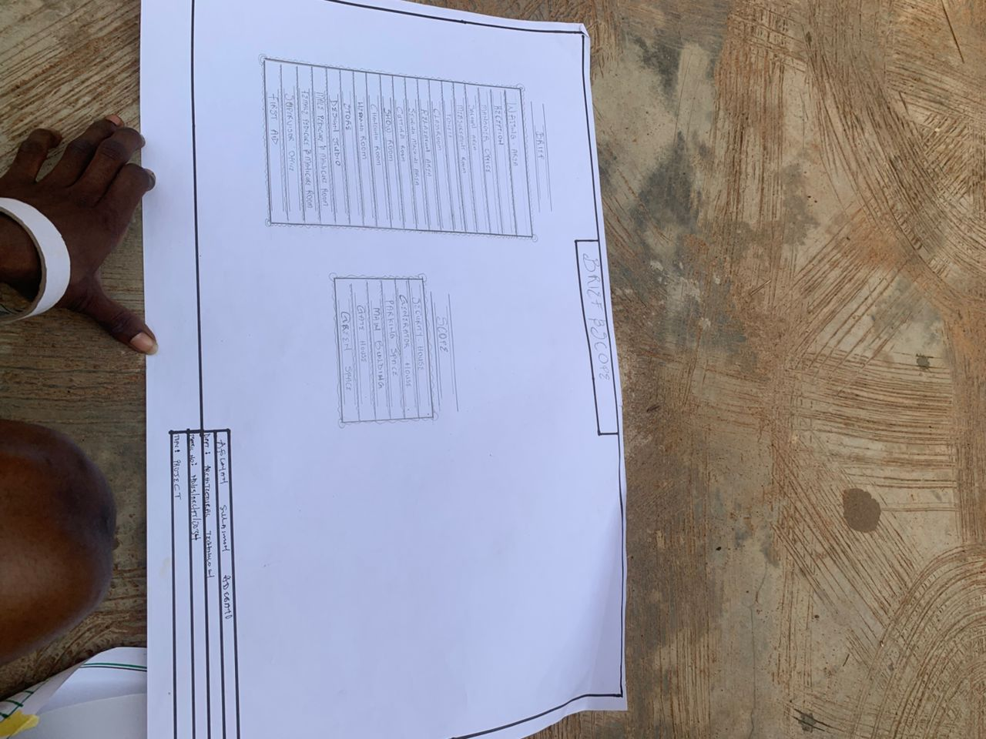

1.7 LIMITATIONS OF THE STUDY
Limited access to large-scale fashion hubs outside Ilorin
Financial and time constraints limiting physical visits to some preferred case study locations
Unavailability of some site data such as soil test and traffic impact analysis
1.8 RESEARCH METHODOLOGY
Literature review of fashion spaces and related architecture
Case studies of fashion facilities in Nigeria and abroad
Field survey and interviews with fashion professionals
Site analysis and inventory of proposed location
Concept development, sketches, and architectural design drawings

CHARPTER TWO
LITERATURE REVIEW
2.1 EVOLUTION OF FASHION HOMES
Architecture has long influenced cultural practices, and the fashion industry is no exception. Early fashion production and tailoring were often conducted in informal spaces such as homes or markets. Over time, the need for presentation, branding, and efficient production processes gave rise to structured fashion studios, boutiques, ateliers, and training schools. Today, architectural trends in fashion design spaces are influenced by minimalism, sustainability, modularity, and flexibility—principles that support the dynamic and ever-changing nature of fashion.
Modern fashion homes fuse functional production environments with engaging customer-facing spaces. Global design firms have contributed to this development by designing adaptive fashion hubs, showrooms, and workshops that are both practical and iconic. Examples include the Prada Headquarters in Milan and the Chanel Workshop in Paris. These spaces reflect both brand identity and optimal design workflow.

2.2 TYPES OF FASHION SPACES
Fashion spaces can be categorized based on function and scale:
Home Studios: Small-scale operations, often within residential buildings.
Boutiques: Focused on retail, aesthetics, and branding.
Ateliers: Professional tailoring and design studios.
Fashion Academies: Spaces for training students and interns.
Fashion Hubs: Multipurpose spaces combining design, training, events, and exhibition.
Each of these typologies demands different architectural responses in terms of lighting, space layout, privacy, accessibility, and ambiance. While small studios prioritize cost and flexibility, fashion hubs emphasize zoning and integration of multiple activities.

2.3 FUNCTIONAL RELATIONSHIPS IN FASHION SPACES
The success of a fashion building depends on seamless spatial flow between departments. The core workflow in a fashion house includes:
Design → Cutting → Sewing → Ironing → Fitting → Display → Sales. Spaces must be arranged in such a way that movement is fluid, storage is optimized, and interactions between clients and workers are well-coordinated. For example, fitting rooms should be close to the display area but separate from production sections to minimize noise and distraction.

2.4 TECHNOLOGICAL & ENVIRONMENTAL CONSIDERATIONS
Business In recent years, fashion entrepreneurs have realized the need for physical spaces that reflect brand identity and enhance productivity. From incorporating natural lighting to acoustic insulation and climate-responsive design, architecture has become essential to brand storytelling and customer experience.
The integration of architectural design in fashion enhances:
Brand aesthetics and identity
Production efficiency
Customer comfort and engagement
Training environments for interns and apprentices
Sustainable and eco-conscious operations

2.5 TECHNOLOGICAL AND ENVIRONMENTAL TRENDS IN FASHION ARCHITECTURE
Architectural responses to fashion space design must address environmental sustainability and technology integration. Some relevant trends include:
Use of glass for natural light and visibility
Bamboo and textile wall finishes for aesthetics and eco-conscious branding
Movable partitions for reconfigurable spaces
Solar panels and rainwater harvesting systems
Smart lighting and HVAC systems
Biophilic design principles for creativity and wellbeing

2.6 REVIEW OF SUBTOPICS RELATED TO THE FASHION HOME
i. Fashion Training and Empowerment Spaces Fashion homes often serve as informal schools for training apprentices. The design must include:
Flexible classrooms
Equipment rooms
Demonstration zones
Lockers and restrooms
ii.. Modeling and Exhibition Areas Fashion homes that double as mini-runway spaces need dedicated platforms, changing rooms, and lighting design suited for photography and presentation.
iii.. Collaborative Design and Business Zones Modern fashion businesses also incorporate coworking or collaborative workspaces where designers can share ideas, materials, or machinery. Lounge areas, Wi-Fi-enabled desks, and open studios are common features in such zones.
The literature confirms the growing intersection of fashion and architecture. Functional efficiency, aesthetics, sustainability, and flexibility are core to designing fashion spaces that inspire creativity and support business growth. The next chapter will analyze case studies of local and international fashion facilities to identify applicable lessons for the proposed Fashion Home

CHAPTER THREE
3.0 CASE STUDY
3.1 INTRODUCTION TO SUPPORT THE DESIGN OF A FUNCTIONAL AND MODERN FASHION HOME
Case studies of existing fashion centers and creative hubs were conducted. This chapter analyzes three relevant examples with emphasis on spatial layout, aesthetics, environmental response, circulation, and integration of various fashion activities. Each case study identifies architectural merits and demerits that informed the conceptual development of the proposed project.
3.2 OUTLINE OF CASE STUDIES
1. KITAN COUTURE, oko-afo, ogun state
2. ELORAMORE, ajao estate, lagos state
3. DANIEL FASHION HOUSE, ajah, lagos state
4. Online case study USA
5. Online case study in France

3.3 CASE STUDY ONE
KITAN COUTURE
OKO-AFO, OGUN STATE
Jitan Fashion Home was founded in 2018 by Mr Emmanuel Okonkwo a visionary designer with deep roots in Nigerian heritage and modern fashion innovation. Born in Enugu and raised in ogun state Mr Emma early fascination with colors, fabrics, and storytelling through clothing led him to pursue Fashion Design at the Nigeria College of Fashion Beyond design, Mr Emmanuel is committed to nurturing young talent. Through his Fashion & Purpose Initiative he has trained over many youths in tailoring, business skills, and creative arts.

MERIT:

- Easy accessible
- Brief precise
- Structurally balance

DEMERIT:

- The examination center is too expose d
- Poor landscaping
- Insufficient convenience

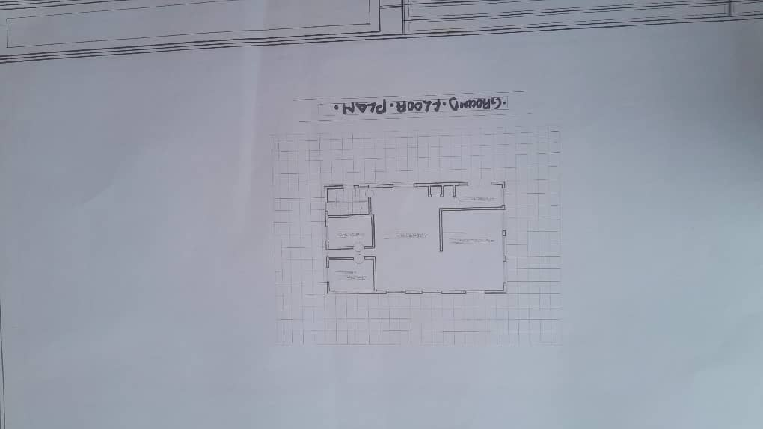

Fig 3.1.1 Floor plan

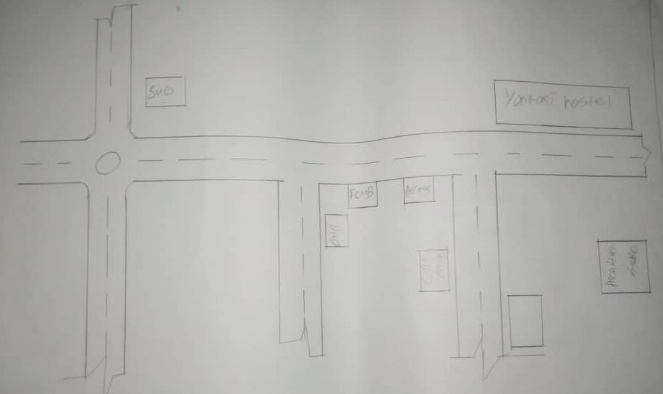

Fig 3.3.2 Locational plan



Plate 3.1.1 Elevation

3.3 CASE STUDY TWO
ELORAMORE
AJAO ESTATE, LAGOS STATE
Eloramore Fashion House was founded in 2016 by *Miss Elora Adeyemi*, a passionate Nigerian fashion designer with a vision to redefine elegance and self-expression through clothing. What began as a small tailoring workshop in Surulere, Lagos, has grown into a fully established fashion home known for its creativity, craftsmanship, and commitment to empowering African fashion.

MERIT:

- It is easily accessible
- Structurally balanced
- Aesthetically balanced

DEMERIT:

- Low packing space
- Main entrance not properly placed
- Lack of proper site zoning

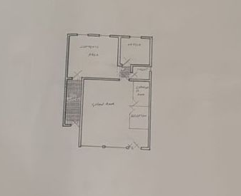

Fig 3.2.1 Floor plan
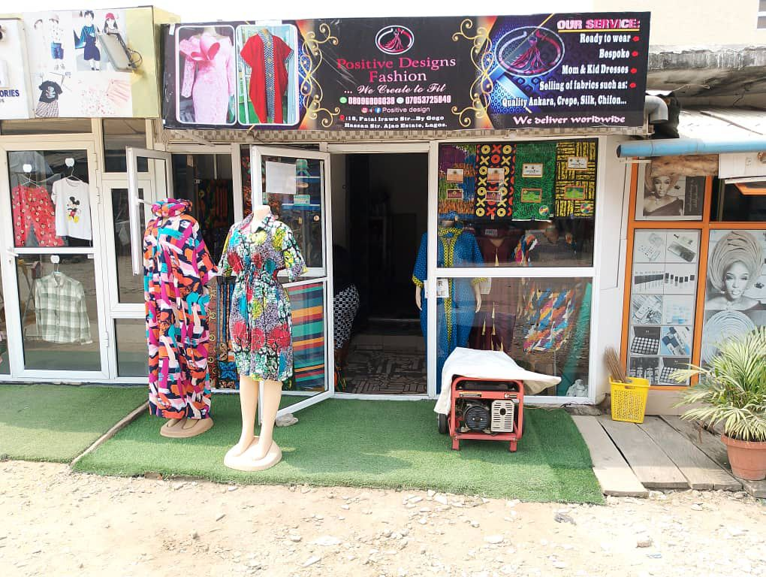

Plate 3.2.1 Front view



Plate 3.2.2 Front view

3.3 CASE STUDY THREE
LA VIVA
IKEJAH LAGOS STATE
La viva Fashion Home was established in 2017 by Ms. Amara Eze a bold and creative designer driven by a dream to build a fashion sanctuary where elegance meets identity. Raised in the vibrant heart of Lagos, Amara’s love for fashion was inspired by her mother’s traditional sewing and her own modern taste.
After studying Fashion & Textile Design at the University of Lagos she began designing custom pieces for friends and small clients, blending Ankara, silk, and organza into signature silhouettes.

MERIT
- It is easily to accessible
- Space enough too work in working station
DEMERIT
- No Changing room
- No exhibition
- No Ventilation in every units

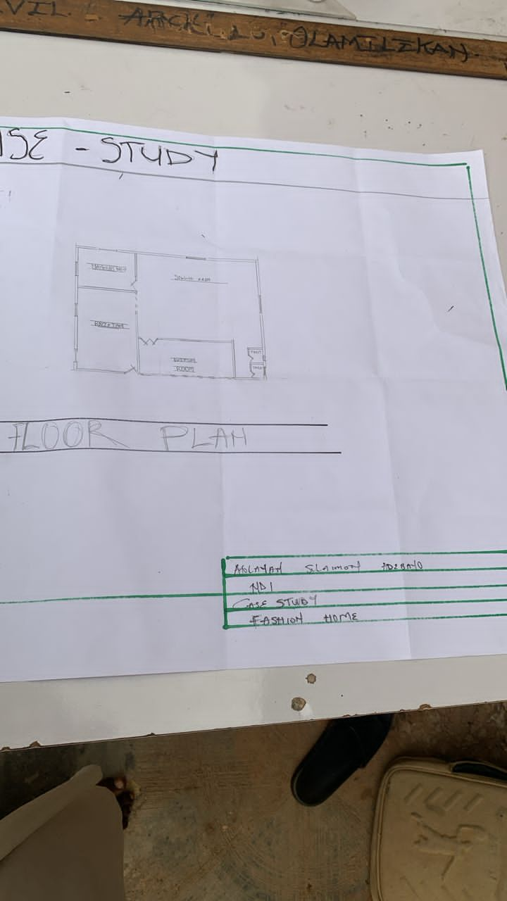
Fig 3.3.1 Floor plan

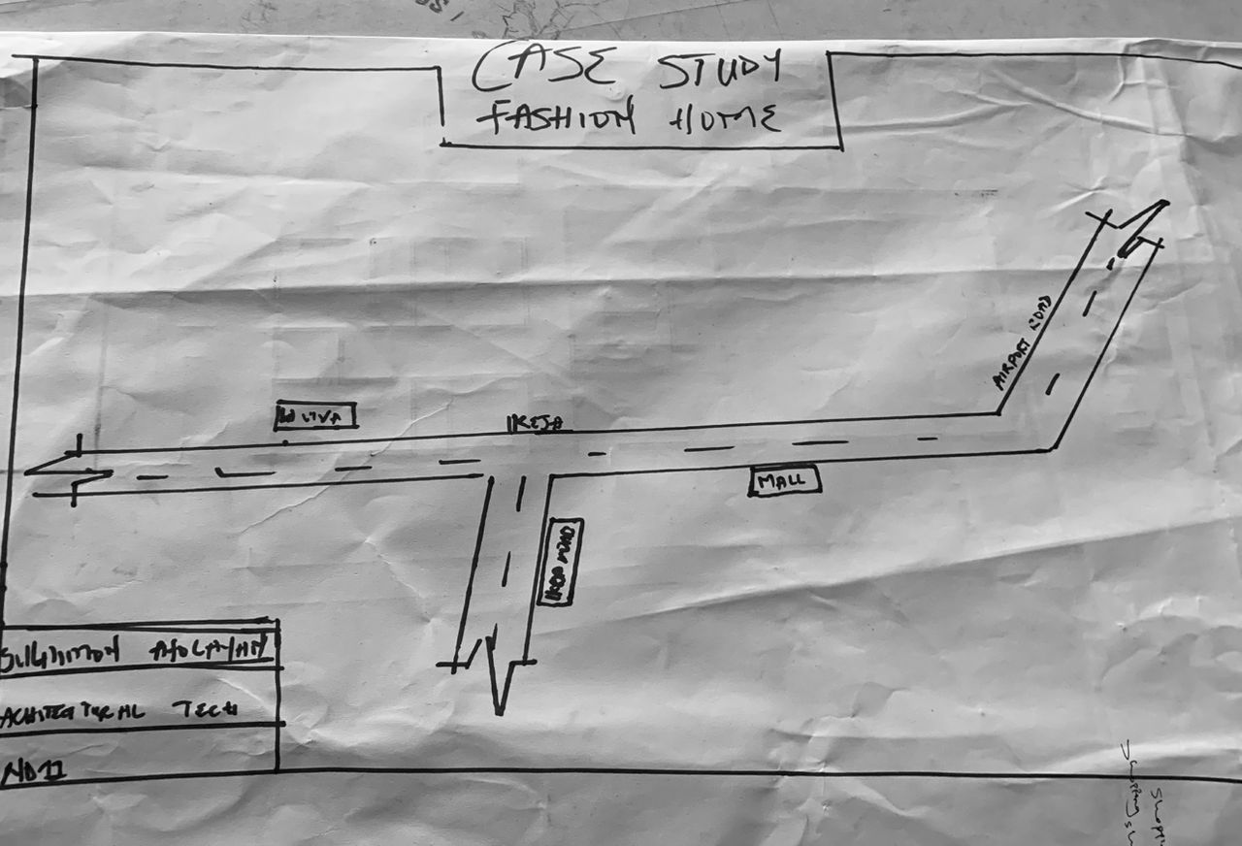
Fig 3.3.2 Locational plan
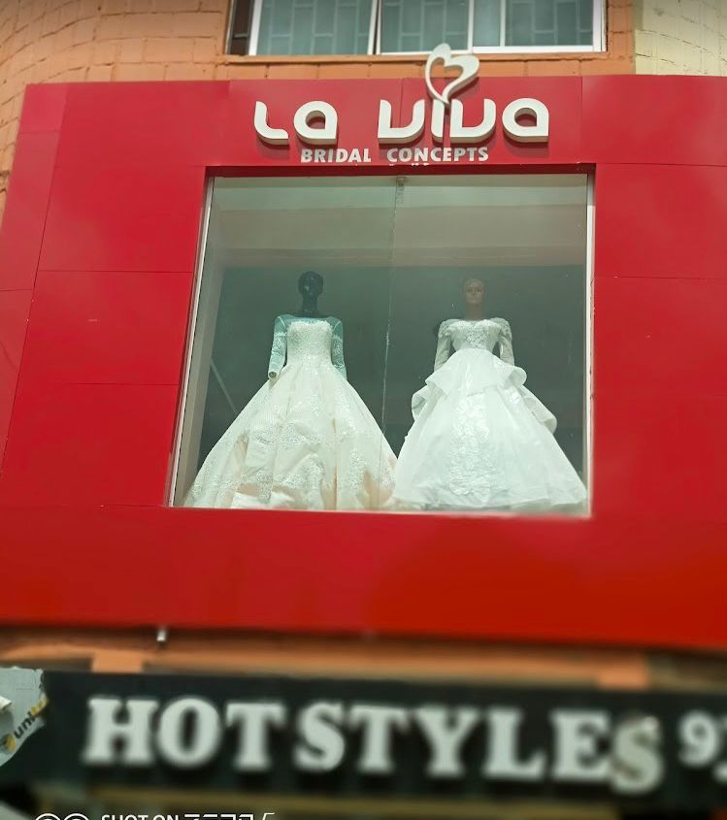

Plate 3.3.1 Front view

CASE STUDY FOUR
ONLINE CASE STUDY

CASE STUDY FIVE
ONLINE CASE STUDY

CHAPTER FOUR
STUDY AREA/SITE ANALYSIS
4.1 SITE ANALYSIS
This chapter presents an analysis of the proposed site for the Fashion Home in Ilorin. The goal is to evaluate the environmental, topographic, and contextual factors that may influence the design process. A thorough understanding of the site enables the development of architectural responses that align with climate, landscape, access, and zoning requirements.
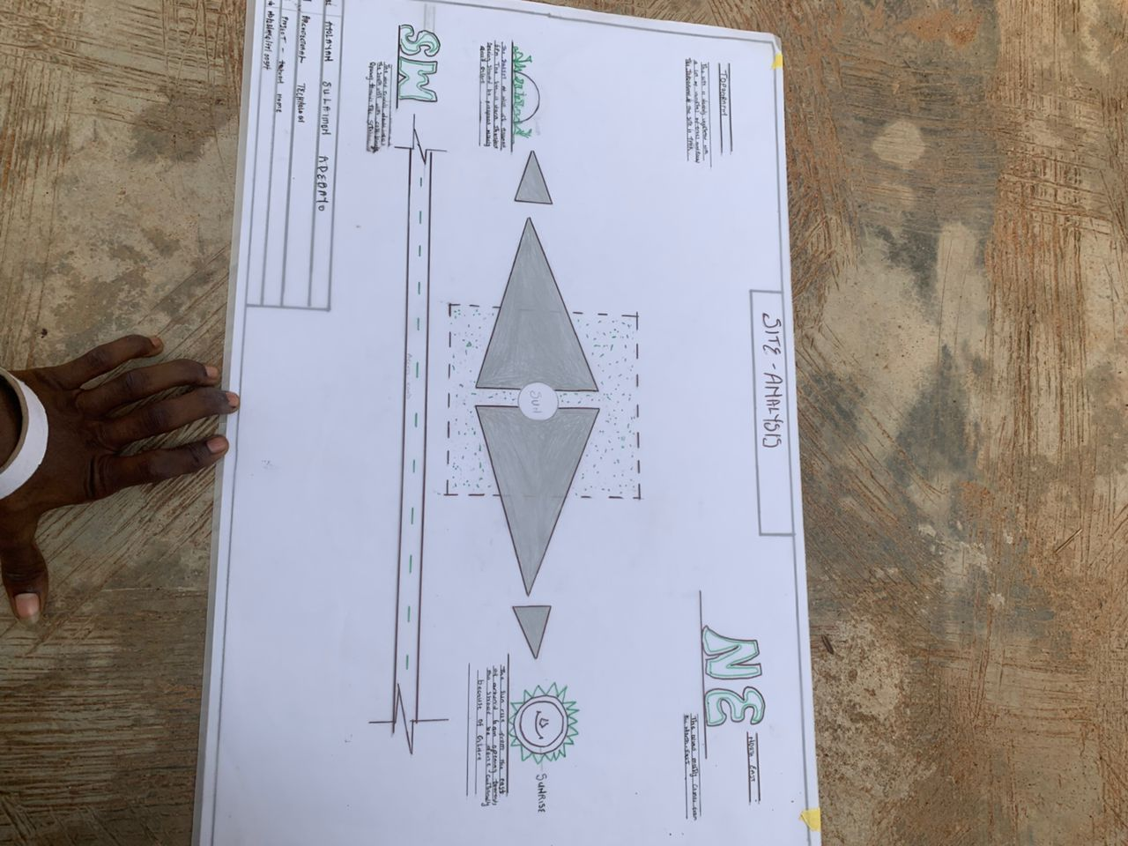

4.2 SITE LOCATION AND DESCRIPTION LOCATION:
Odogwuyan Ikorodu, Lagos State
Coordinates: Approximately 8.478° N, 4.570° E
Site Area: Approximately 800 square meters
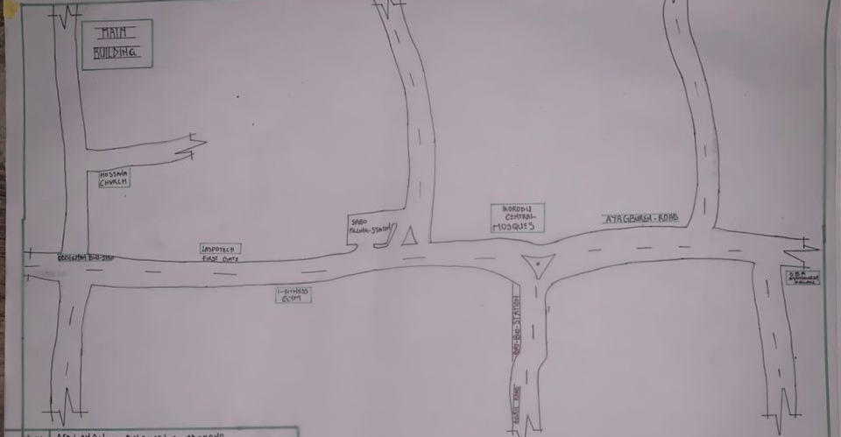
TOPOGRAPHY: Generally flat terrain with slight slope for natural drainage Land Use Zoning: Mixed-use residential/commercial area
The site is located along a secondary road that connects to University Road and major commercial corridors. Surrounding land uses include boutiques, salons, restaurants, and residential apartments, making it a vibrant location for a fashion-focused establishment.
4.3 CLIMATIC AND TOPOGRAPHIC ANALYSIS CLIMATE ZONE: TROPICAL SAVANNAH (AW)
Temperature Range: 20°C – 35°C
Rainfall: Annual average of 1,200 mm
Prevailing Wind Direction: South-west to north-east
Humidity: Moderate to high throughout the year
These climatic conditions suggest that the building design must prioritize cross ventilation, shading, and materials that perform well in hot, humid environments. The site’s relatively flat terrain supports ease of construction and accessibility.
4.4 ENVIRONMENTAL IMPACT AND ZONING ANALYSIS
The environmental quality of the site is moderately stable. There are no known flood risks or soil instability based on nearby structures and roads. However, noise pollution from nearby commercial centers and traffic must be considered, particularly in areas designated for training and client consultation.
Strengths:
Good road access
Vibrant surrounding commercial activities
Flat terrain and buildable soil
Weaknesses:
Potential for noise from traffic and adjacent activities
Limited green cover on-site

4.5 SITE INVENTORY
Access: 2.5m wide road frontage, possible vehicular and pedestrian entry
Existing Features: Sparse vegetation, minor shrubs, no major trees
Utilities: Proximity to public water supply, electrical grid, and communication lines
Drainage: Nearby surface drains run along the main road, with potential to integrate site drainage
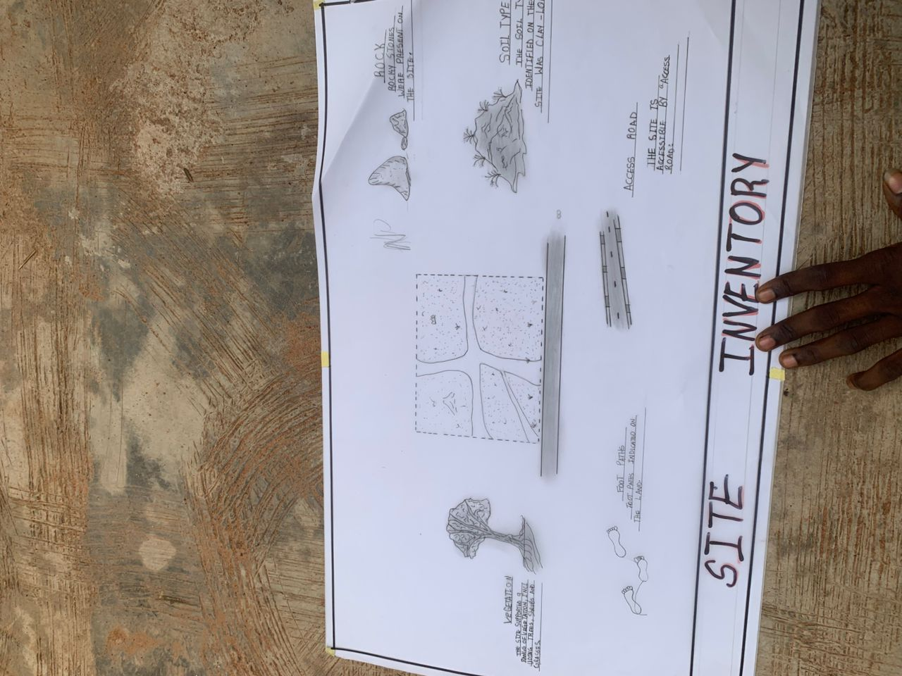

4.6 SITE SELECTION CRITERIA
The site was selected based on the following criteria:
Accessibility for clients and staff
Proximity to commercial and residential hubs
Adequate size for proposed functions
Availability of public utilities and infrastructure
Low environmental risk
The proposed site in Tanke is suitable for the development of a Fashion Home. With proper design measures—such as noise insulation, landscaping, and passive cooling—the site offers a strategic and practical foundation for the proposed facility. The next chapter will outline the design goals, spatial criteria, and conceptual development for the project.
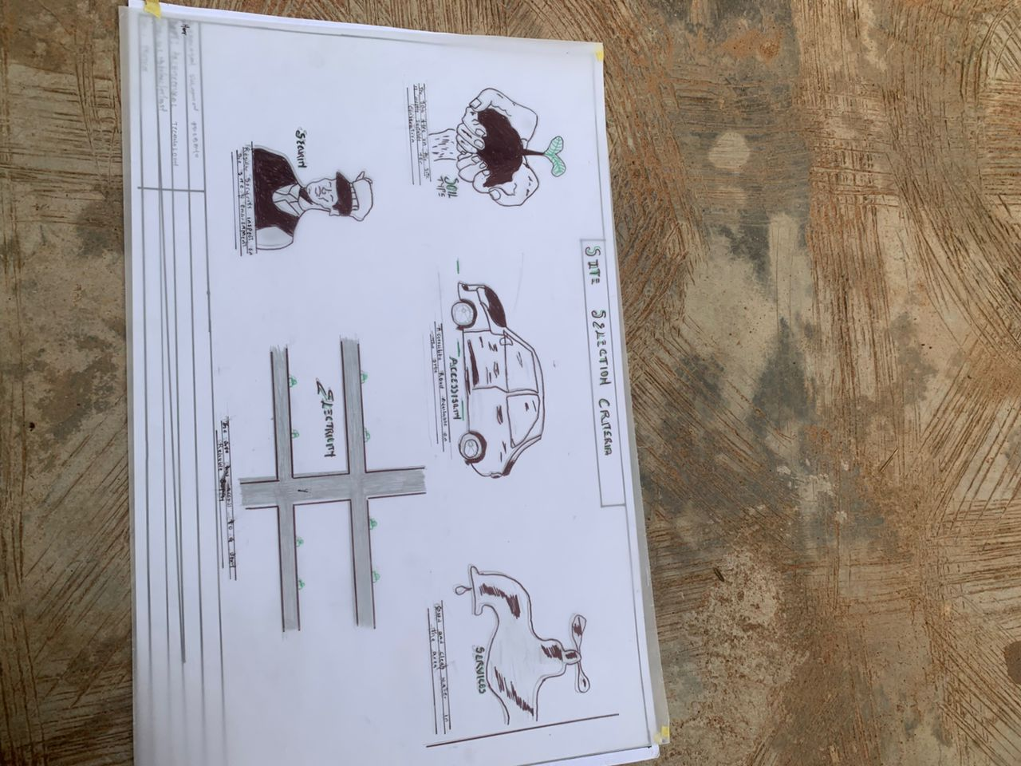

CHAPTER FIVE
5.0 DESIGN APPROACH/REALIZATION
5.1 PROJECT GOALS AND DESIGN BRIEF
PROJECT GOALS
The primary goal of this project is to create a purpose-built Fashion Home that promotes creativity, entrepreneurship, and collaboration within the fashion industry. The building will support multiple functions such as design, tailoring, fitting, training, showcasing, and administration.
DESIGN BRIEF
The client requires a facility that can:
Accommodate design and sewing studios
Provide space for client interaction and fittings
Host fashion exhibitions and mini-runway events
Include classrooms and training zones
Reflect modern, culturally inspired aesthetics
5.2 FUNCTIONAL AND SPATIAL CRITERIA
THE FOLLOWING CRITERIA GUIDE THE SPATIAL PLANNING
Clear zoning of public and private areas
Logical workflow from entry to service areas
Visual openness in showrooms
Natural ventilation and lighting in workspaces
Barrier-free access for all users

5.3 CONCEPTUAL DESIGN PROCESS
The conceptual idea is inspired by the flowing motion of fabric—graceful, layered, and interconnected. This is translated into curved circulation paths and layered zoning with central shared spaces.
The concept development progressed through:
Site sketching and spatial analysis
Bubble diagrams of activity zones
Massing models to explore form and volume
Integration of green pockets and open-air courtyards

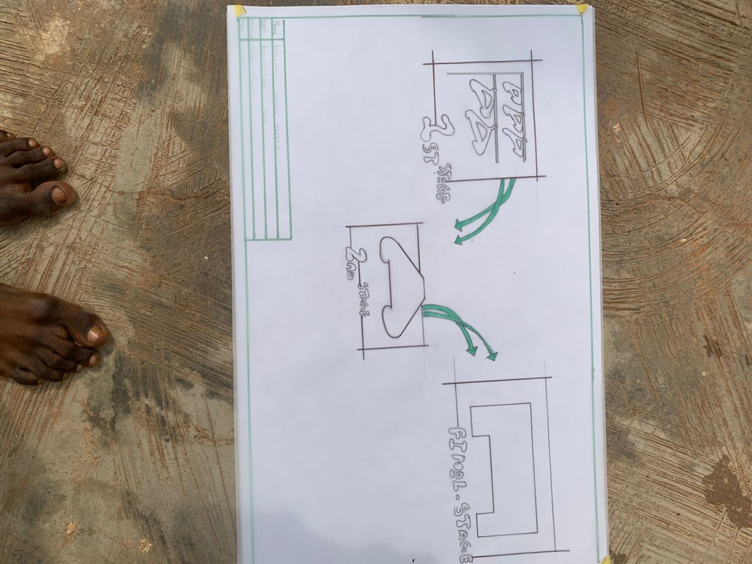

5.4 ZONING AND SPACE RELATIONSHIP
THE FACILITY IS DIVIDED INTO FIVE MAIN ZONES:
Public Zone: Reception, exhibition area, retail/showroom
Semi-Public Zone: Client waiting area, fitting rooms
Production Zone: Design studio, sewing area, equipment store
Training Zone: Classroom, presentation space
Private/Admin Zone: Offices, staff lounge, storage, restrooms
Circulation is designed to ensure minimal interference between production and client-facing areas. Visitors enter through the public zone while staff and trainees use side entrances.

5.5 SCHEDULE OF ACCOMMODATION

SPACE QUANTITY APPROX. SIZE (M²) DESCRIPTION
Reception 1 15 Entry, welcome desk
Showroom 1 40 Product display, branding area
Fitting Rooms 2 8 Each Private changing areas
Design Studio 1 35 Sketching, Concept boards
Sewing Room 1 40 Tailoring and sewing workstations
Equipment Storage 1 10 Tools, fabrics, threads
Training Room 1 30 Capacity for 12 learners
Admin Office 1 15 Manager’s office
Staff Room 1 10 Break area for staff
Toilets 2 8 each Male and female blocks
Courtyard 1 50 Outdoor fashion display space

5.6 TECHNOLOGICAL AND ENVIRONMENTAL CONSIDERATIONS ENVIRONMENTAL STRATEGIES
North-south orientation for optimal daylight
Cross ventilation through operable windows
Shaded glazing to reduce heat gain
Roof overhangs and covered walkways
Use of locally sourced materials: bamboo panels, clay bricks, terrazzo flooring
Technological Features:
Solar panels for partial power supply
Rainwater harvesting system
Energy-efficient lighting and ceiling fans
Provision for future ICT training hub
5.7 CONSTRUCTION METHODS AND MATERIALS
Structural Frame: Reinforced concrete columns and beams
Walling: Stabilized earth blocks (SEBs) with internal gypsum finishing
Roofing: Aluminum long-span sheets with insulation
Flooring: Terrazzo and polished concrete in high-traffic areas
Doors and Windows: Powder-coated aluminum frames with reflective glass
5.8 MECHANICAL AND ELECTRICAL SERVICES
Plumbing: Borehole with overhead tank, modern restrooms
Lighting: Combination of natural daylighting and LED fixtures
Ventilation: Louvers, fans, and cross ventilation
Fire Safety: Extinguishers, clear exit signage, wide escape corridors
Electrical: Underground trunking, socket points for machines and computers

5.9 CONCLUSION AND RECOMMENDATION
CONCLUSION
The design of a Fashion Home is an essential contribution to the fashion industry, providing an organized space for fashion design, production, exhibition, and training. The goal of this project was to create an architectural solution that supports both functionality and aesthetics while promoting creativity, sustainability, and innovation in fashion.
This project explored the fundamental needs of a fashion home, including design studios, cutting and sewing rooms, administrative offices, training classrooms, display areas, and a runway hall. The design process considered user needs, climate responsiveness, circulation, zoning, and integration of modern building technologies.
RECOMMENDATION
- Adequate Funding: The establishment of fashion homes should be supported with sufficient financial resources to ensure the use of quality materials and efficient construction processes.
- Sustainability Practices: Incorporate sustainable and eco-friendly materials and design strategies (like natural lighting, ventilation, and solar energy) to reduce environmental impact.
- Space Flexibility: Spaces such as workshops and showrooms should be designed to allow for flexible use and easy reconfiguration to accommodate different activities and evolving fashion trends.
- Accessibility: Ensure the facility is inclusive, with accessible routes and amenities for people with disabilities.

APPENDICES
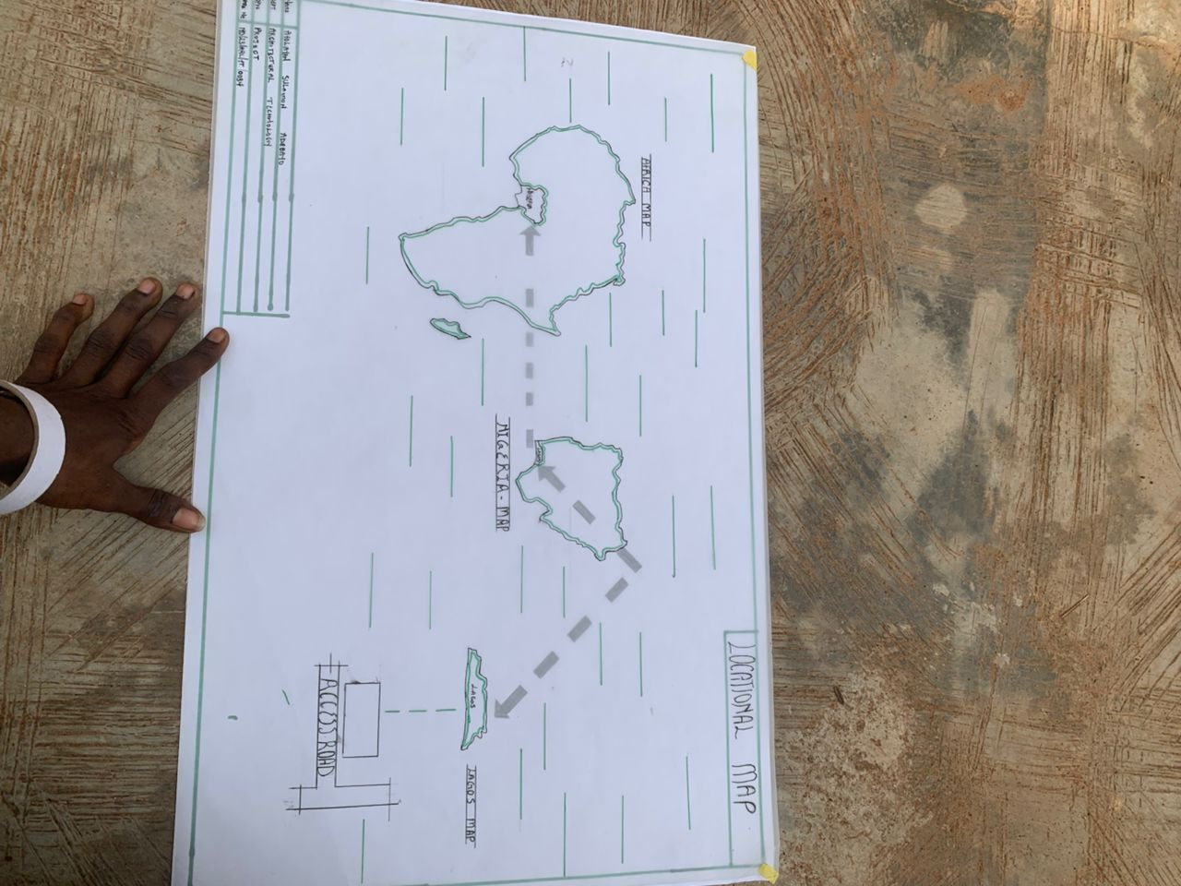

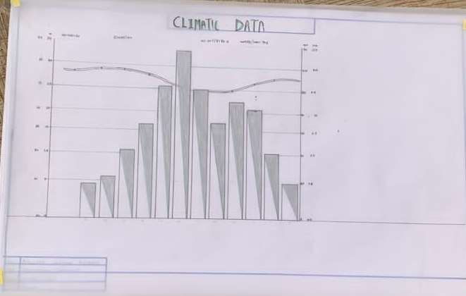

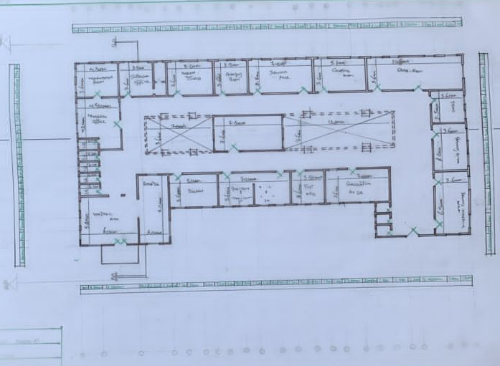

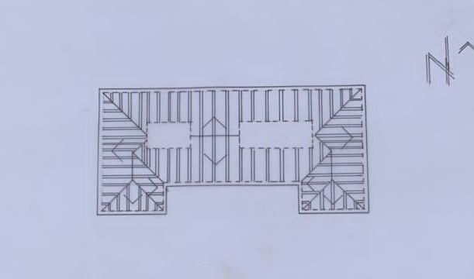
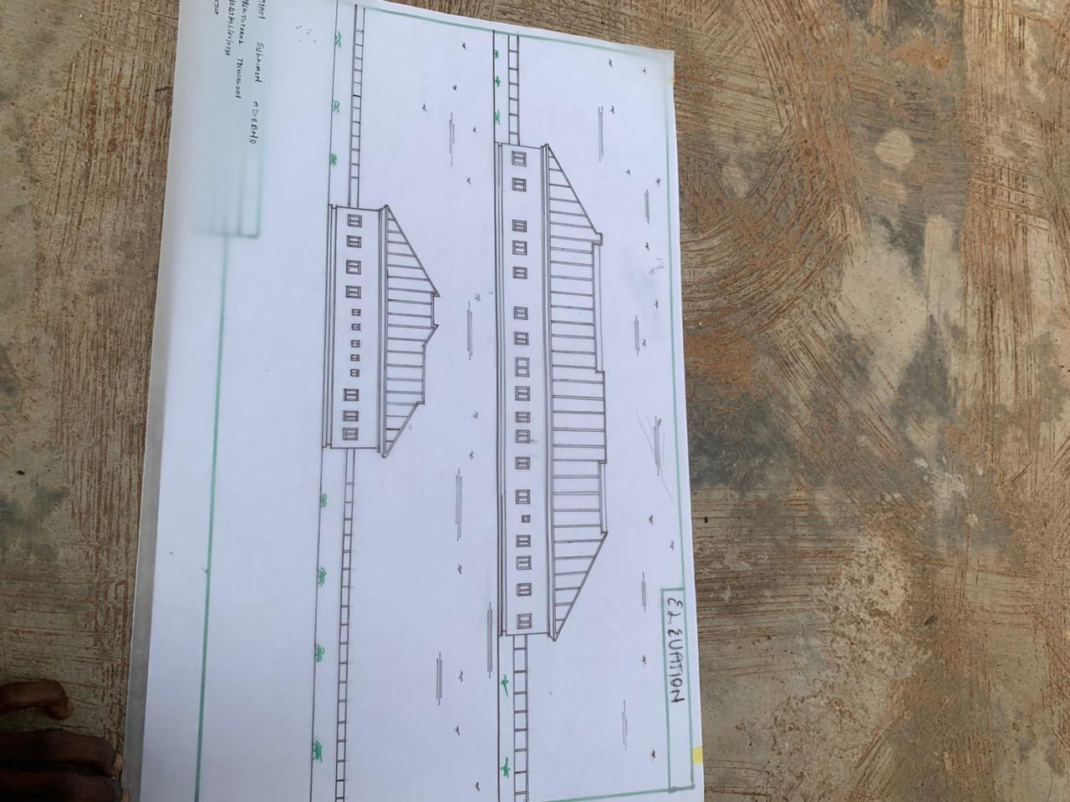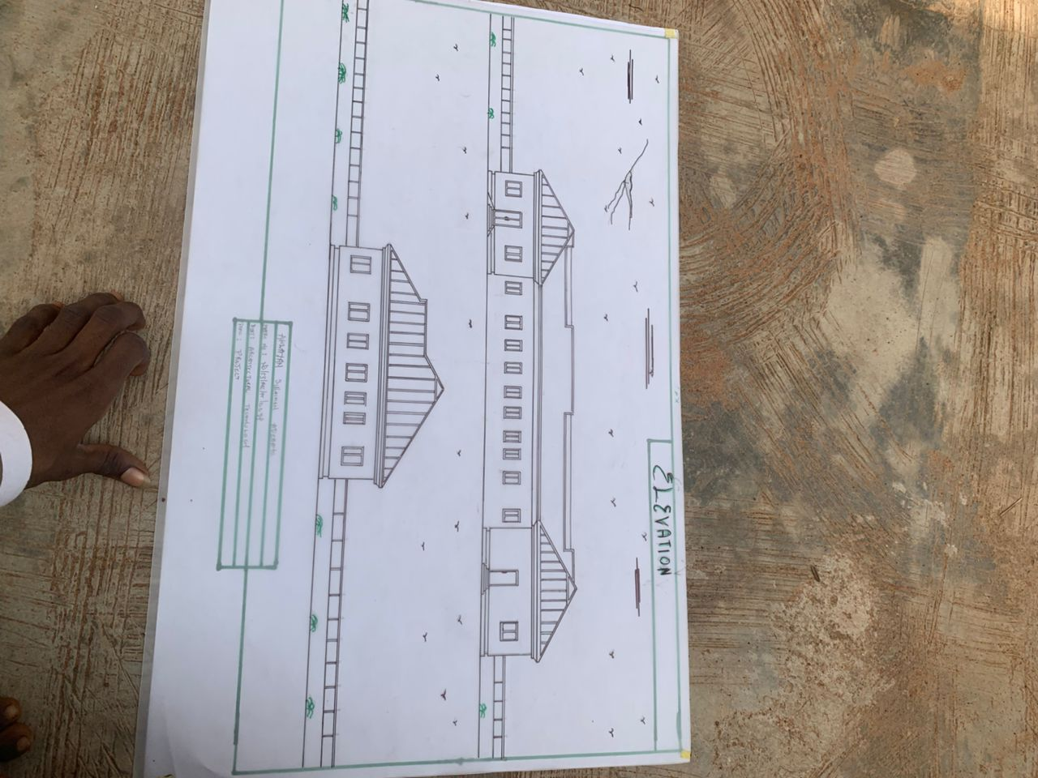
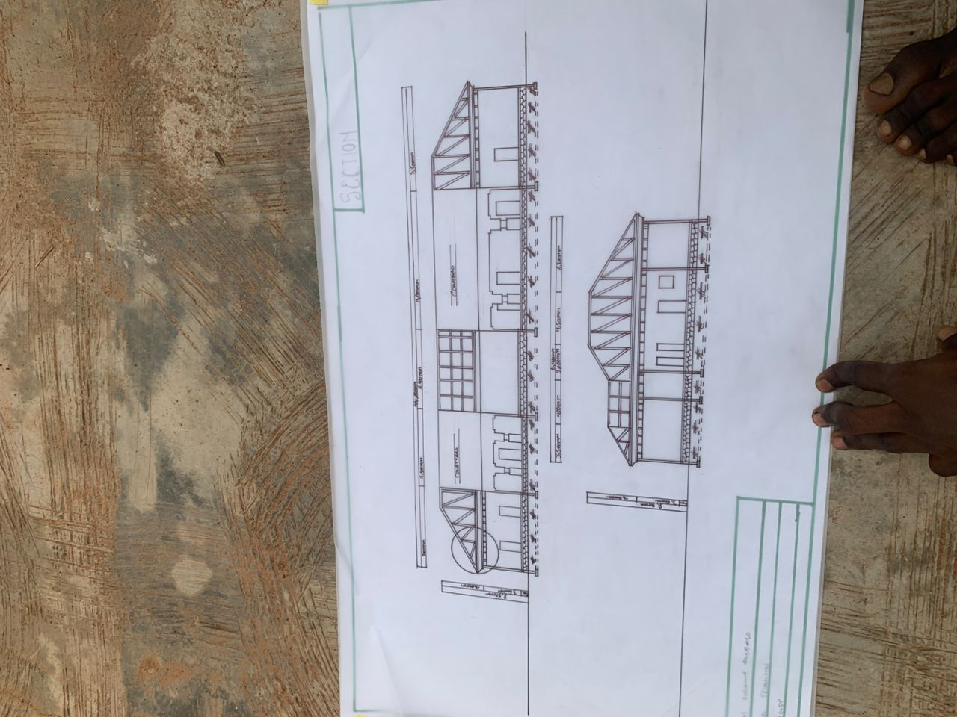
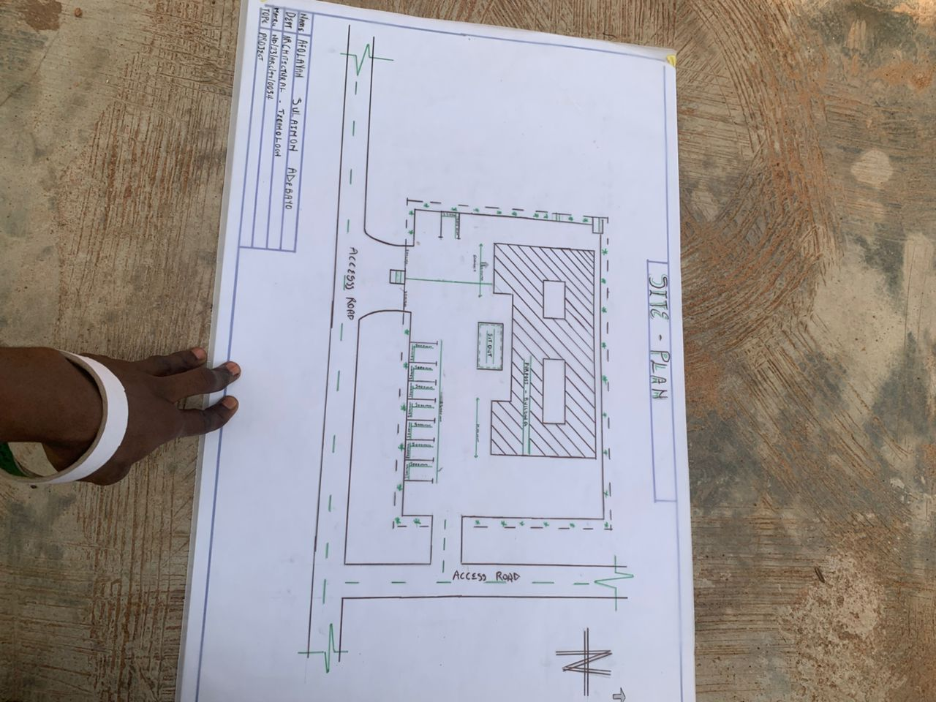
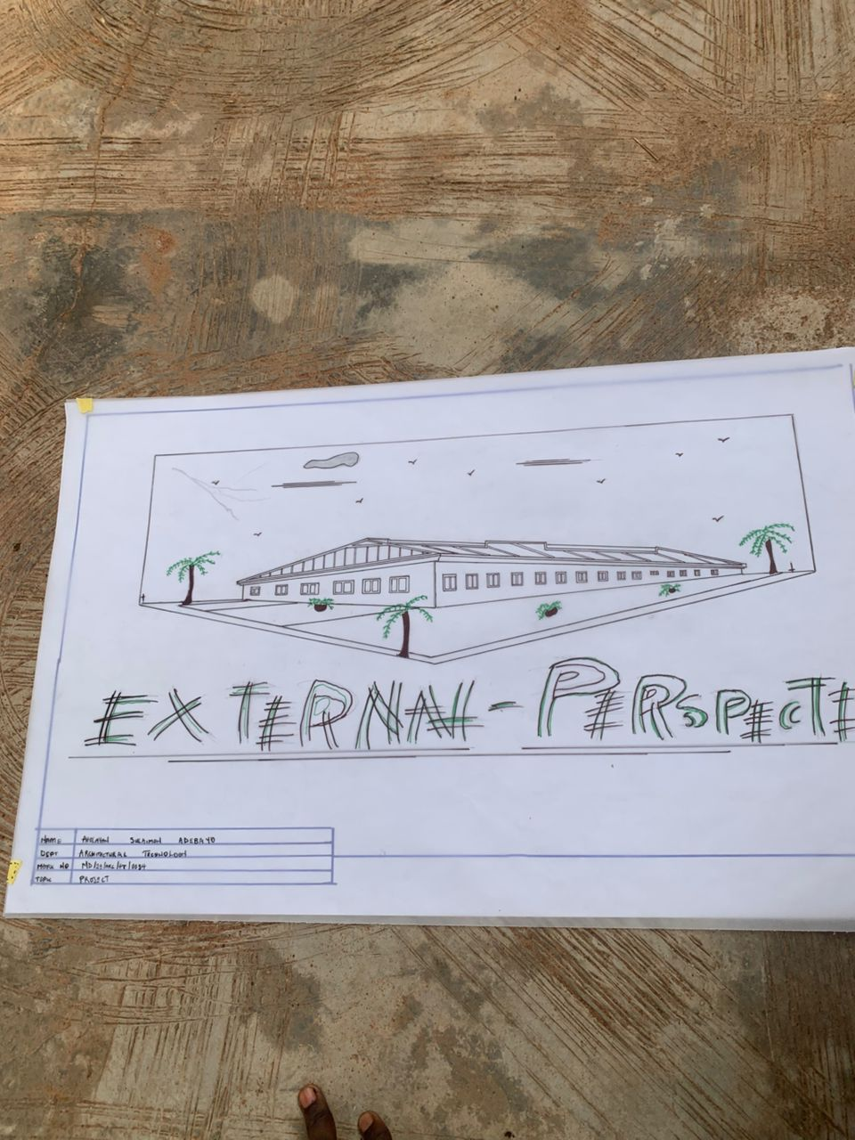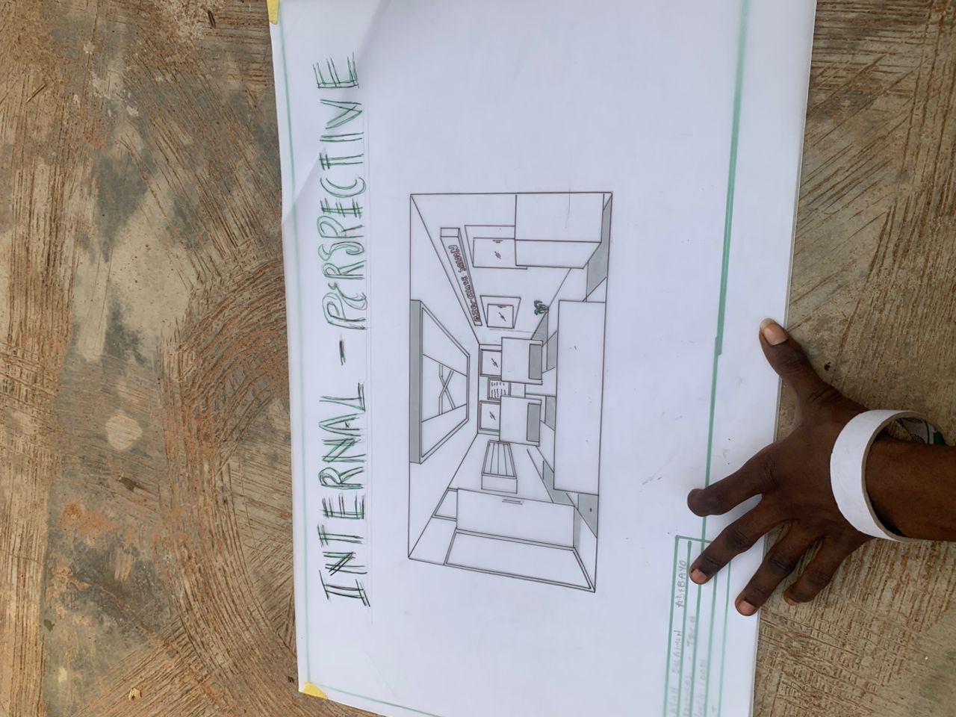

REFERENCES
Alkaff, S., & Omar, R. (2018). Spatial interaction in fashion design studios. International Journal of Built Environment, 6(2), 43–50.
Brown, S. (2012). Fashion retail interiors and brand identity. Journal of Interior Design, 37(3), 22–35.
Carlin, T. (2015). Sustainable textiles in fashion design spaces. Textile Today, 9(1), 14–18.
Cuthbert, K. (2014). Light and material choice in fashion spaces. Design Matters Journal, 12(2), 45–52.
Davies, J. (2010). User-centered design in fashion studios. Journal of Design Research, 8(4), 61–72.
Dike, E. (2017). Acoustics and lighting control in creative studios. Journal of Environmental Design, 4(1), 55–64.
Elham, S. (2019). Creating a healthy indoor environment in sewing workshops. Design & Health Journal, 13(1), 40–48.
Farid, K. (2021). Integrating AR and VR in fashion design environments. Digital Design Review, 5(2), 77–86.
Godfrey, L. (2022). Functional zoning in fashion homes. International Journal of Spatial Architecture, 7(3), 27–35.
Hassan, F. (2018). Energy conservation strategies in fashion studios. Green Building Journal, 10(4), 12–19.
Ibrahim, A. (2021). Flexibility in workspace design for fashion startups. Architectural Innovation Review, 9(1), 23–30.
James, O. (2016). Fashion design and branding through interior space. Fashion and Culture Studies, 2(1), 17–25.
Kennedy, M. (2022). Lighting in creative design spaces. Journal of Interior Lighting Design, 8(1), 50–59.
Lee, J. (2019). Space planning for small-scale fashion studios. Small Studio Architecture Review, 4(3), 33–40.
Liu, W. (2023). Integrating technology in fashion production spaces. Tech and Textile Journal, 6(2), 41–49.
Fashion Studio Guide. (2021). How to set up a modern fashion design space. Retrieved from https://www.fashionstudioguide.com/setup
ArchDaily. (2023). Fashion house architecture: 10 examples around the world. Retrieved from https://www.archdaily.com
Dezeen. (2020). 10 beautifully designed fashion studios. Retrieved from https://www.dezeen.com
Interior Design Magazine. (2022). Trends in creative design studios. Retrieved from https://www.interiordesign.net
Vogue Business. (2023). Fashion meets architecture: Studio innovations. Retrieved from https://www.voguebusiness.com
76. WGSN. (2022). 2023 design trend report: Fashion workspace evolution. Retrieved from https://www.wgsn.com
Abdulrasheed, I. (2025). Design of a modern fashion home: A proposal for Ilorin. Kwara State Polytechnic, Department of Architecture.
Mohammed, L. (2022). Creative spaces in fashion education. University of Lagos, Master's Thesis.
Adeyemi, F. (2019). Workspace ergonomics in tailoring workshops. UNILORIN.
Bello, T. (2023). The impact of layout on fashion productivity. LAUTECH Conference on Creative Design.

