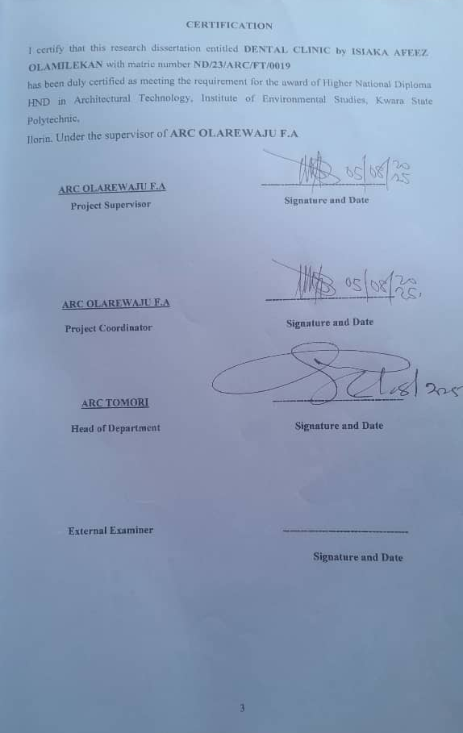

A PROJECT REPORT
ON
PROPOSED DENTAL CLINIC
FOR
CHAIRMAN OF IPOKIA LOCAL GOVERNMENT, OGUN STATE
BY

ISIAKAAFEEZOLAMILEKAN
ND/23/ARC/FT/0019
SUBMITTED TO
THE DEPARTMENT OF ARCHITECTURAL TECHNOLOGY, INSTITUTE OF ENVIRONMENTAL STUDIES (IES), KWARA STATE POLYTECHNIC, ILORIN
IN PARTIAL FULFILLMENT OF THE REQUIREMENT FOR THE AWARD OF NATIONAL DIPLOMA (ND) IN ARCHITECTURAL TECHNOLOGY,
JULY 2025

DECLARATION
I ISIAKA AFEEZ OLAMILEKAN (ND/23/ARC/FT/0019) declare that this report is a product of my personal research work. It has not been presented for the award of any degree in any Polytechnic . I understand that this project is an original work and does not infringe on the intellectual property rights of others, under ARC. OLAREWAJU F.A

Signature: __________________ Date: ____________________

Project Title:
DENTAL CLINIC
CERTIFICATION

I certify that this research dissertation entitled DENTAL CLINIC by ISIAKA AFEEZ
OLAMILEKAN with matric number ND/23/ARC/FT/0019 has been duly certified as meeting the requirement for the award of Higher National Diploma HND in Architectural Technology, Institute of Environmental Studies, Kwara State Polytechnic,
Ilorin. Under the supervisor of ARC OLAREWAJU F.A

ARC OLAREWAJU F.A -------------------------------------
Project Supervisor Signature and Date

ARC OLAREWAJU F.A -------------------------------------
Project Coordinator Signature and Date

ARC TOMORI -------------------------------------
Head of Department Signature and Date

External Examiner ------------------------------------
Signature and Date

DEDICATION
I dedicate this work to Almighty God, the giver of life, wisdom, and strength. I also dedicate it to my parents, mentors, and every individual who has supported me through this academic journey.
May God Almighty bless and reward them abundantly and every other supporter to my academic life.

ACKNOWLEDGEMENT
I return all the glory, honor, praise and adoration to the master of the universe that have given me the privilege of seeing the end of this program of him alone be the glory.
My immediate gratitude goes to my supervisor ARC. OLAREWAJU F.A who has been supportive responsive throughout this project, may God continue to reward you and your family.
My appreciation goes to my Amiable Head Of Department in person of ARC. J. M TOMORI and other academic staffs for their immense contribution toward the success of my program may the Lord Honor and do you all good.
My sincere gratitude goes to my parent, Mr & Mrs ISIAKA who brought me to this world, may you eat the fruit of your labour.
However, my gratitude also goes to all my colleague, friends, brothers, sisters and well wishers.
May your life experience joy.

ABSTRACT
The design of a dental clinic plays a crucial role in ensuring the efficiency, comfort, and safety of both patients and staff. This paper examines the key principles and best practices in dental clinic design, with a focus on spatial planning, patient experience, infection control, and sustainability. A well-organized layout enhances workflow, reduces patient anxiety, and improves overall operational efficiency. The clinic's design must incorporate specialized spaces such as treatment rooms, sterilization areas, and administrative offices, while promoting easy movement between different zones. Patient comfort is paramount, and design elements such as natural light, calming colors, ergonomic furniture, and sound control can significantly reduce stress. Infection control is critical in healthcare settings, requiring the use of durable, easy-to-clean materials and effective ventilation systems. With increasing awareness of environmental impact, sustainable design practices such as energy-efficient systems, water conservation, and the use of eco-friendly materials are becoming more prevalent in modern dental clinics. Furthermore, the integration of advanced dental technology and flexible infrastructure is necessary to meet evolving clinical needs. Ultimately, the architectural design of a dental clinic must balance functionality, aesthetics, and health standards, creating an environment that fosters both optimal patient care and professional efficiency.

TABLE OF CONTENTS

CHAPTER ONE

1.0 INTRODUCTION

1.2 HISTORICAL BACKGROUND

1.3 DEFINITION OF THE TERMS

1.4 AIMS & OBJECTIVES

1.5 OBJECTIVES

1.6 JUSTIFICATION

1.7 LIMITATION

1.8 RESEARCH METHODOLOGY
CHAPTER TWO
2.0 LITERATURE REVIEW

CHAPTERTHREE

3.0 CASE STUDIES

3.1 CASE STUDYONE

3.2 CASE STUDYTWO

3.3 CASE STUDYTHREE
CHAPTER FOUR
4.1 CONCLUSION ON DENTAL CLINIC ARCHITECTURAL DESIGN
4.2 RECOMMENDATIONS ON DENTAL CLINIC ARCHITECTURAL DESIGN
4.3 SUMMARY OF DENTAL CLINIC ARCHITECTURAL DESIGN

LIST OF TABLES
TABLE 4.1 ADMINISTRATIVE BLOCK……………………………… ………44
TABLE 4.2 SPACE SCHEDULE………………………………………… ………44
TABLE 4.3 DEMOGRAPHIC DATA OF RESPONDAN…………………………47
TABLE 4.4 RESPONDANT ON QUESTION 1……………………………………48
TABLE 4.5 RESPONDANT ON QUESTION 2……………………………………48
TABLE 4.6 RESPONDANT ON QUESTION 4……………………………………48

LIST OF FIGURES
FIGURE 1.1: CASE STUDY 1 SITE PLAN……………………...………………39
FIGURE 1.2 CASE STUDY 2 SITE PLAN VIEW………….……………………39
FIGURE 3.1 SITE LOCATION……………………………………………………42
FIGURE 3.2 SELECTION CRITERIA……………………………………………42
FIGURE 3.3 SITE ANALYSIS…………………..…………………………………43
FIGURE 4.1 FUNCTIONAL RELATIONSHIP………..…………………………45
FIGURE 4.4 CONCEPT DERIVATION……..……………………………………46

LIST OF FIGURES
PLATE 2.1: ENTRANCECE VIEW OF CASE STUDY ONE…………………. 37
PLATE 2.2: RELAXATION AREA OF CASE STUDY ONE…………………. 37
PLATE 2.3: RELAXATION VIEW OF CASE STUDY ONE…………………. 37
PLATE 2.4: CHILDREN PLAYGROUND OF CASE STUDY THREE…..…. 37
PLATE 2.5: WALK WAY VIEW OF CASE STUDY THREE…………………. 37

LIST OF FIGURES
APPENDICES 1: SITE PLAN………………………………………………………60
APPENDICES 2: FLOOR PLAN……………………………………………………60
APPENDICES 3: SECTION X-X……………………………………………………61
APPENDICES 4: SECTION Y-Y…………………………………………………....61
APPENDICES 5: SOUTH VIEW……………………………………………………62
APPENDICES 6: NORTH VIEW……………………………………………………62

APPENDICES 7: EAST VIEW……………………………………………………....64

APPENDICES 8: WESTVIEW………………………………………………...…….64
CHAPTER ONE

1.0 INTRODUCTION
Tooth decay was low in pre-agricultural societies, the growth in farming society about 10,000 years ago correlated with an increase with the rate of cavities. An infected tooth from Italy partially cleaned with flint tools, aged between 13,820 and 14,160 years old, represents the oldest known dentistry. The Indus Valley Civilization (IVC) has yielded evidence of dentistry being practised as far back as 7000 BC. An IVC site in indicates that this form of dentistry involved curing tooth related disorders with bow drills operated, perhaps, by skilled bead crafters. The reconstruction of this ancient form of dentistry showed that the methods used were reliable and effective. The earliest dental filling, made of beeswax, was discovered in Slovenia and dates from 6500 years ago.
A well-designed dental clinic enhances the overall patient experience, providing a calming atmosphere that reduces stress and promotes trust in dental care providers. The design also ensures that dental procedures are conducted with high efficiency, while making use of the latest technologies and equipment to ensure the best possible care. From the reception area to the treatment rooms, every aspect of the clinic’s design contributes to creating a space that is both functional and welcoming, Ultimately, dental clinic architectural design merges aesthetics with practicality to support the delivery of high-quality dental services in a safe and efficient environment.
1.2 HISTORICAL BACKGROUND

Historical Background on Dental Clinic Architectural Design
The architectural design of dental clinics has evolved significantly over the centuries, shaped by advancements in dentistry, changes in public health practices, and the increasing demand for specialized healthcare facilities. While dentistry as a practice dates back to ancient civilizations, the concept of dedicated spaces for dental care emerged more distinctly in the 19th and 20th centuries, aligning with the professionalization of dental practices and innovations in medical architecture.

Ancient and Medieval Times
In ancient civilizations such as Egypt, Greece, and Rome, dental care was often practiced by individuals with specialized knowledge, though they did not have dedicated clinics or specific architectural designs for dental care. Treatments were often performed in the homes or workshops of these practitioners, where basic tools, such as rudimentary drills and forceps, were used. There was no formal architectural space for dental care—medical and dental practices were typically conducted in general medical spaces or even in informal settings.

17th and 18th Centuries: Early Developments
As dentistry began to emerge as a more recognized profession in the 17th and 18th centuries, dental procedures started to move away from general medicine and were performed by specialists. However, the idea of dedicated dental clinics was still largely absent. Dental practitioners typically operated from their homes or small private offices, often sharing spaces with other healthcare professionals. These spaces were rudimentary, with little to no emphasis on design or patient comfort.

19th Century: Professionalization of Dentistry
The 19th century marked a turning point in dental care. As dental science progressed with the invention of new tools and techniques, including the first dental chair by Dr. Samuel Stockton in 1790, dentistry began to separate from general medicine. During this time, the first dedicated dental practices were established. These early dental offices were often simple, functional spaces that focused primarily on the technical aspects of dental procedures.
With the growing understanding of hygiene and sterilization in medical practice, dental clinics began to incorporate more specialized spaces, such as operating rooms and sterilization areas. The layout started to reflect the importance of maintaining a clean and organized environment to prevent the spread of infections. However, the architectural design remained relatively basic, with an emphasis on utility rather than patient experience.

Early 20th Century: Modernization of Dental Clinics
The early 20th century saw the first real attempts at designing dental clinics with a more comprehensive and patient-focused approach. With the rise of the dental profession, many dental offices started to implement modern conveniences, such as comfortable waiting areas, well-designed treatment rooms, and even decorative elements to make patients feel more at ease. During this period, there was also an increased focus on privacy, as dental practitioners sought to create individual treatment rooms for patients, which offered greater confidentiality and comfort.
Innovations in dental equipment and a growing understanding of ergonomics also influenced dental clinic design. The dental chair became a central element of the treatment room, and considerations were made to ensure that it was positioned to allow the dentist to work efficiently and comfortably. Lighting, ventilation, and acoustics were also considered for the first time as essential elements in dental clinic design.

Post-World War II: Growth and Technological Advancements
Following World War II, there was significant growth in the number of dental clinics, especially as modern technologies began to shape the field of dentistry. Dental imaging, X-ray machines, and sterilization equipment required specific spaces and infrastructure within clinics. The introduction of these advanced tools led to the redesign of treatment areas, as dental offices needed to accommodate new technologies while maintaining a focus on comfort and patient care. During this period, the design of dental clinics began to incorporate more aesthetics, combining functionality with architectural elements that aimed to reduce patient anxiety. For example, the waiting areas became more inviting, with comfortable furniture and soothing colors, reflecting the growing importance of the patient's emotional experience in addition to their physical treatment.

Late 20th Century to Present: Comprehensive Design and Patient-Centered Approach
In the late 20th century and into the 21st century, dental clinic architecture became increasingly sophisticated. The design of dental clinics evolved to meet the growing demand for specialized care, as well as the desire to create a welcoming and patientfriendly environment. The rise of cosmetic dentistry, orthodontics, and specialized treatment centers led to more diverse architectural designs, tailored to the specific needs of different types of dental care. Today, dental clinic design emphasizes patient comfort, operational efficiency, and hygiene. The integration of advanced technology—such as digital X-rays, computer-aided design (CAD), and virtual simulations—has further influenced the layout and design of treatment rooms. Modern dental clinics often feature open-concept waiting areas, ergonomic workspaces for staff, and efficient layouts that facilitate smooth patient flow. There is also a strong emphasis on sustainable design, with the use of energy-efficient materials and systems.
Architectural design now considers the holistic experience of patients, with many clinics incorporating calming aesthetics, natural light, and soundproofing elements to create an atmosphere of tranquility. The focus on creating a seamless connection between function and patient experience reflects a broader understanding of how the physical environment can positively affect mental well-being and health outcomes. The evolution of dental clinic architectural design reflects the development of the dental profession itself, from rudimentary and utilitarian spaces to modern, patient-centered environments. Advances in technology, changes in healthcare needs, and a growing understanding of patient psychology have all contributed to the design of dental clinics that not only meet the functional needs of dental practitioners but also enhance the comfort and experience of patients. The modern dental clinic has become a place where both the science of dentistry and the art of design converge to create spaces that support health, well-being, and trust.

1.3 DEFINITION OF THE TERMS

Architectural Definition
A dental clinic building is a specialized healthcare structure designed and constructed to provide a dedicated space for dental care services. It is equipped with treatment rooms, sterilization areas, waiting rooms, and administrative offices to support the operational needs of a dental practice. The design of the building considers factors such as hygiene, patient comfort, safety, and workflow efficiency for both staff and patients.

Functional Definition
A dental clinic building is a facility where dental practitioners diagnose, treat, and manage oral health conditions. It is designed to accommodate various dental treatments such as routine checkups, surgeries, orthodontics, and cosmetic dentistry. The building includes specialized spaces like dental operatories, sterilization zones, and diagnostic areas, each tailored for specific procedures and patient care needs.

Operational Definition
A dental clinic building is a healthcare facility specifically dedicated to the delivery of oral health services, including preventive, therapeutic, and corrective dental treatments. This facility supports the day-to-day operations of a dental practice, including patient intake, treatment, consultation, and post-treatment care. It includes areas for both clinical procedures and administrative tasks, ensuring the smooth functioning of a dental practice.

Patient-Centric Definition
A dental clinic building is a patient-focused environment designed to provide comfortable, safe, and accessible care. The building is constructed with the aim of reducing patient anxiety and promoting well-being through welcoming aesthetics, effective use of space, and the incorporation of modern dental technology for highquality care.

Healthcare Infrastructure Definition
A dental clinic building is an integral part of healthcare infrastructure, providing a specialized environment for the delivery of dental services to the community. It is a wellplanned facility that ensures proper infection control, accessibility for people with disabilities, and compliance with healthcare regulations while offering efficient and comprehensive dental care.
1.4 AIMS & OBJECTIVES

Aim
The aim is to design a functional and befitting modern dental clinic that will meet up with acceptable architectural and structural standards which can receive national acclaim.

1.5 OBJECTIVES
- To design a facility that will functionally and aesthetically fulfill the need for a standard modern dental clinic in Enugu State.
- To design a modern dental clinic that naturally meets up with both architectural and structural standards.
- To provide spaces that are large enough to accommodate the workers and equipment/machinery and encourage a seamless overlap between the two.
- To contribute to the architectural beauty of the area and the appreciation of the built environment.
- Provision of adequate spaces for various dental treatments.

1.6 JUSTIFICATION
Designing a dental clinic building is an essential process that requires careful consideration of various factors to ensure the facility meets the needs of both patients and healthcare providers. The justification for investing in and designing a dedicated dental clinic building lies in several key areas, each contributing to the overall success and functionality of the space.
The patient experience plays a vital role in the success of a dental practice. Many individuals experience anxiety and discomfort at dental clinics, and a well-designed building can help alleviate these feelings. A thoughtful layout with welcoming features such as soothing colors, natural lighting, and comfortable waiting areas creates a calming atmosphere. The design of individual treatment rooms, with modern equipment and aesthetic features, further reduces patient stress. The overall comfort of the patient directly influences their willingness to return for follow-up visits and can contribute to better dental health outcomes.
A dental clinic building must be designed to optimize the workflow between patients, staff, and equipment. The layout should ensure that different areas (e.g., reception, waiting area, treatment rooms, sterilization rooms) are efficiently connected to minimize unnecessary movement and time spent by both patients and dental professionals. Streamlined patient flow, from check-in to consultation and treatment, enhances operational efficiency. Efficient design ultimately leads to improved patient care, reduced waiting times, and increased productivity for the dental staff.

1.7 LIMITATION
financial resources available for the design and construction of a dental clinic often impose significant limitations. A limited budget may restrict the use of high-end materials, modern technologies, or the inclusion of desirable design features such as spacious waiting areas or advanced medical equipment. The need to balance quality with cost can sometimes lead to compromises in design, materials, or equipment that might affect the clinic's functionality or aesthetics, The available space for constructing a dental clinic may limit the design options, particularly in urban areas where property sizes are smaller or more expensive. The need to fit various functional areas (e.g., reception, waiting area, treatment rooms, sterilization areas, staff rooms, storage) into a limited footprint can be challenging.
Incorporating modern dental technologies such as digital X-rays, CAD/CAM systems, and advanced dental chairs requires specific infrastructure, including electrical systems, data management, and space requirements. The availability of space and resources to accommodate these technologies can pose a limitation, especially in smaller or older buildings.

1.8 RESEARCH METHODOLOGY
Designing a dental clinic building involves a comprehensive research methodology that takes into account the specific needs of the healthcare professionals, the patients, and the functional requirements of the clinic. The research methodology will typically include a combination of qualitative and quantitative approaches, data collection, analysis, and design application. The first step in the research methodology is to identify the specific problems or requirements of the dental clinic building design. This involves understanding the unique needs of the dental practice, its staff, and the patients.
Review existing literature on dental clinic designs, conduct interviews with dentists, architects, and other stakeholders, and examine current trends in healthcare design. Identify the challenges faced by existing dental clinics in terms of space utilization, patient comfort, workflow efficiency, and technology integration.
To arrive at a financial and standard design concept, the following research methods were carried out.
- Oral review
- Online interview
- Case study review
- Literature review

Literature Review
To gather existing knowledge on the design of healthcare facilities, particularly dental clinics, to understand best practices, guidelines, and technological advancements.
Conduct a thorough review of academic articles, books, case studies, and reports from architectural firms that specialize in healthcare buildings. Look at successful examples of dental clinic designs and architectural solutions that improve patient care and optimize operational efficiency.

CHAPTER TWO

2.0 LITERATURE REVIEW
Dental clinics, like other healthcare facilities, have unique requirements for architectural design due to their specialized nature. A well-designed dental clinic not only addresses functional needs but also creates a therapeutic environment conducive to patient comfort, staff efficiency, and safety. This literature review discusses various factors that influence the architectural design of dental clinics, including space planning, aesthetics, patient experience, infection control, and sustainability.

Space Planning and Functionality
The spatial organization of a dental clinic is crucial for ensuring smooth workflows, patient comfort, and staff efficiency. According to Simmons (2014), the layout of a dental clinic should be carefully designed to separate clinical functions from administrative areas. A typical dental clinic includes treatment rooms, a sterilization area, waiting areas, and staff rooms, all of which must be logically interconnected to ensure ease of movement for both staff and patients.
Treatment Rooms: Treatment rooms are central to the design of dental clinics, and the arrangement of dental chairs, equipment, and storage is essential for operational efficiency. Frey (2016) emphasizes that treatment rooms should have sufficient space for dental equipment, while ensuring ease of accessibility for both the dental team and patients.
Waiting Areas: Waiting areas should be comfortable and calming to help reduce patient anxiety. According to Ulrich (2006), the use of natural light, greenery, and calming colors in waiting areas can reduce stress and improve patient experience.
Administrative Spaces: The design of the administrative office and reception area must also be considered. Perry et al. (2019) suggest that clear sightlines and patient privacy in these areas are critical for ensuring both security and confidentiality.

Aesthetics and Patient Experience
The aesthetic elements of dental clinic design are pivotal in shaping the patient experience. Geisinger et al. (2017) found that the physical environment of a dental clinic significantly impacts the emotional and psychological well-being of patients. The use of colors, materials, and lighting in dental clinics can enhance the overall ambiance and alleviate patient anxiety.
Colors and Materials: Light, neutral colors are generally favored in dental clinics as they contribute to a calm and hygienic environment. Materials like natural wood or stone are sometimes incorporated into the design to introduce warmth and organic textures into otherwise sterile environments (Frey, 2016).
Lighting: Both natural and artificial lighting play important roles in creating a welcoming and functional environment. Ulrich (2006) notes that exposure to natural light can positively influence the mood and comfort of patients and staff alike. Furthermore, lighting in treatment areas should be bright enough to allow for detailed procedures without causing glare or discomfort for the patient.
Patient Comfort: Comfort measures such as ergonomic furniture, noise control, and climate control are crucial in enhancing the overall patient experience. Simmons (2014) emphasizes the importance of providing an environment that minimizes discomfort and promotes a sense of calm, which in turn can improve patient outcomes and compliance.

Infection Control and Hygiene
Given the clinical nature of dental practices, infection control is a central concern in the design of dental clinics. Frey (2016) highlights that a well-designed clinic must have dedicated spaces for sterilization and cleaning, with equipment such as autoclaves and sterilization sinks integrated into the layout. The arrangement of these areas must also minimize the risk of crosscontamination.
Materials and Finishes: The selection of materials for finishes, such as walls, floors, and countertops, is critical in maintaining hygiene standards. Non-porous, easy-to-clean materials such as ceramic tiles, stainless steel, and epoxy resins are commonly used in dental clinic designs to ensure a high level of sanitation (Perry et al., 2019).

Airflow and Ventilation: Proper ventilation systems must be in place to prevent the accumulation of harmful particles and to ensure adequate airflow. Geisinger et al. (2017) highlight the importance of incorporating high-efficiency particulate air (HEPA) filters and exhaust systems that comply with healthcare facility standards to promote a clean and safe environment.

Sustainability and Energy Efficiency
Sustainability is an increasingly important consideration in healthcare architecture, including dental clinic design. Perry et al. (2019) argue that green design strategies not only contribute to environmental protection but also result in long-term cost savings for clinic owners.
Energy Efficiency: Incorporating energy-efficient systems, such as LED lighting, energy-saving HVAC systems, and passive solar heating, can reduce energy consumption in dental clinics. Geisinger et al. (2017) recommend that dental clinic designs integrate energy-efficient technologies to improve both sustainability and operational efficiency.
Water Efficiency: Dental clinics use significant amounts of water, especially in sterilization and patient care areas. According to Frey (2016), adopting water-efficient plumbing fixtures and water recycling systems can contribute to more sustainable dental clinic operations.

Technological Integration
With advances in dental technology, modern clinics must integrate cutting-edge equipment into their design. Digital dental radiography, 3D imaging systems, and intraoral cameras require specific spatial considerations for installation and use. Simmons (2014) notes that the integration of such technologies should not only focus on equipment functionality but also consider ergonomics and patient privacy.
Data Security: As dental practices increasingly move toward digital recordkeeping and telemedicine, incorporating secure storage spaces for sensitive patient data is essential (Perry et al., 2019).

CHAPTERTHREE

3.0 CASE STUDIES
The purpose of case study in any architectural research project is to enable the designer to familiarize him/herself with terms, mode of operation, standard required any other factor that may help the designers in achieving his or her desire objectives through the study of the existing similar
structure.
3.1 CASE STUDYONE
LOCATION: OLLYTON DENTAL CLINIC AJAO ESTATE

BRIEIF HISTORY
Ollyton Dental Clinic is a distinguished private dental center located in Ajao Estate, Lagos, Nigeria. Established with the mission to provide comprehensive dental services, it has evolved into a leading institution in dental care within the region. Notably, Ollyton Dental Clinic is recognized as the first Nigerian private dental center equipped with a fully functional Oral and Maxillofacial theatre, catering to both Nigerian citizens and international patients.
The clinic is helmed by Dr. Towolawi Olorunwa, an experienced dental surgeon with a robust background in both private and public healthcare sectors in Nigeria.
Under his leadership, the clinic has expanded its services to encompass preventive dentistry, restorative procedures, implantology, cosmetic dentistry, orthodontics, oral surgery, emergency care, and general pediatric dentistry.
While specific details regarding the clinic's founding year and the inspiration behind its establishment are not readily available, Ollyton Dental Clinic's commitment to excellence and innovation in dental care has solidified its reputation as a trusted provider of comprehensive dental services in Lagos.

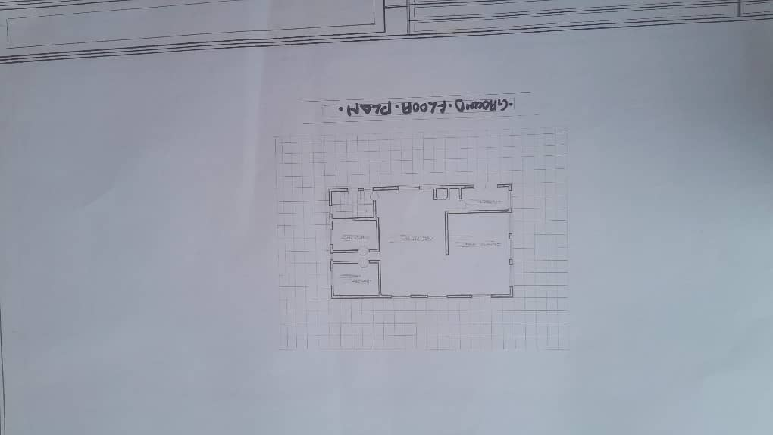
Fig 3.1.1 Ground floor plan of case study one
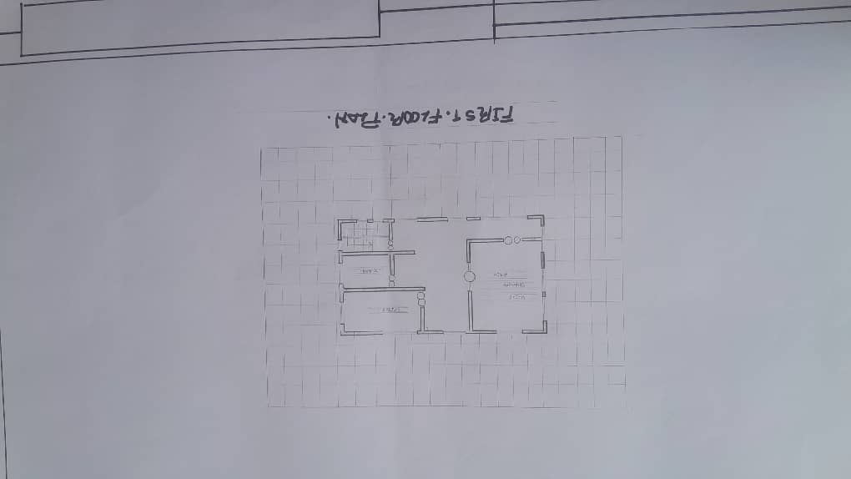
Fig 3.1..2 First floor plan of case study one
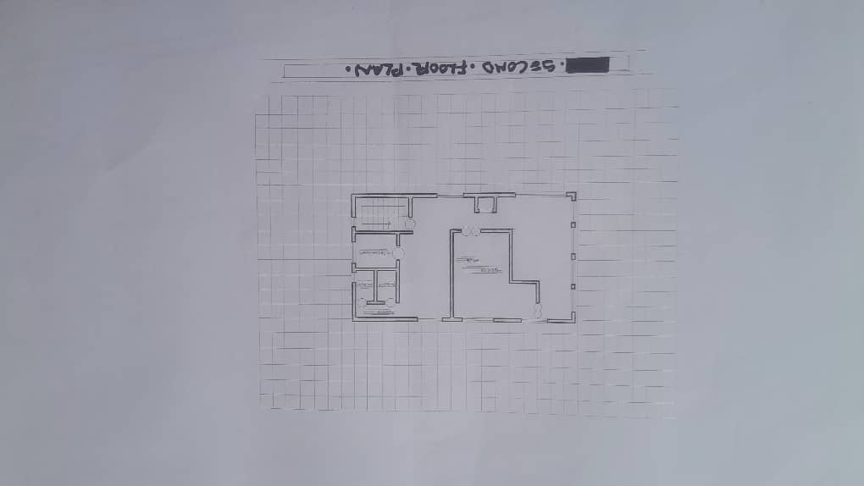
Fig 3.1.3 Second floor plan of case study one

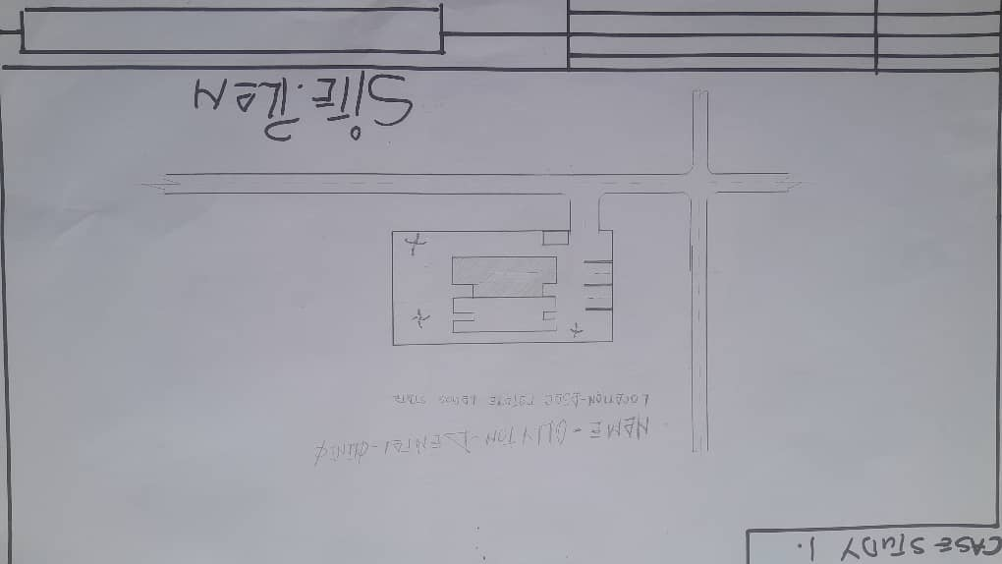
Fig 3.1.4 Site plan of case study one

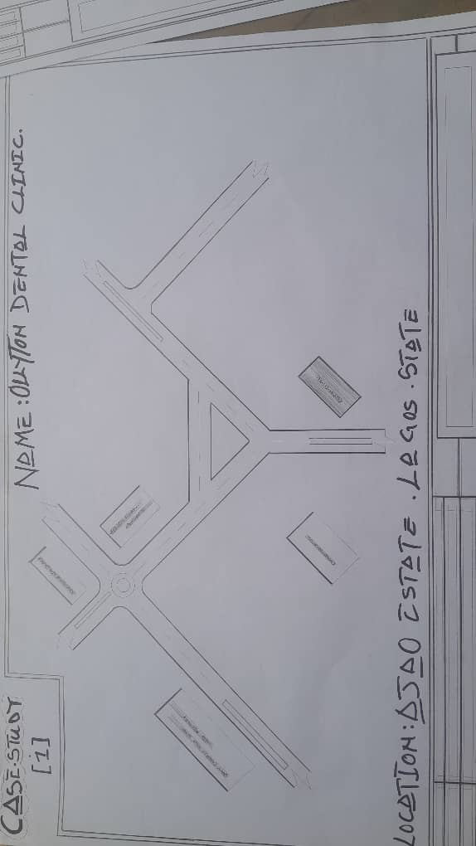
Fig 3.1.5 Locational plan of case study one
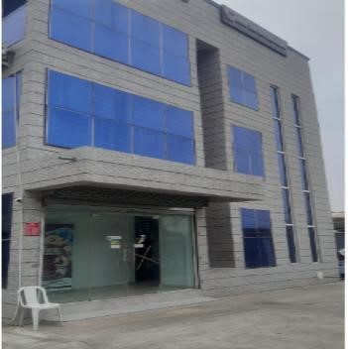
Plate 3.1.1: outerview showing of case study one Ollyton dental clinic ajao estate
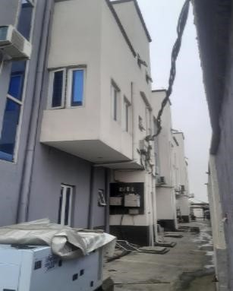

Plate 3.1.2: showingthesideviewof case study one Ollyton dental clinic ajao estate

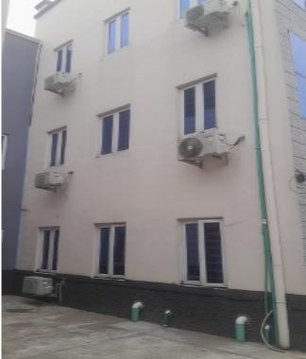
Plate 3.1.3: showing the left view of case study one Ollyton Dental Clinic Ajao Estate
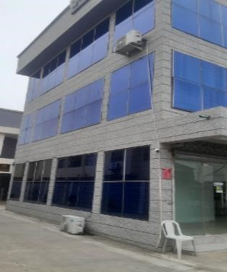
Plate 3.1.4: outerview showing of case study one Ollyton dental clinic ajao estate
MERITS
I. Their unit are well accessible

DEMERITS
- Poor landscaping
- There is no provision for disable to access the clinic such as, ramp
- Poor aesthetics
3.2 CASE STUDY TWO
LOCATION: SMILE PRIDE DENTAL CLINIC OTA OGUN STATE

BRIEIF HISTORY
Smile Pride Dental Clinic is a reputable dental healthcare facility situated in Ota, Ogun State, Nigeria. Located at 2A Solanke Street, Odo Eran Bus Stop, Iyana Iyesi, the clinic offers specialized dental treatments for both children and adults, including scaling and polishing, teeth whitening, fillings, and other general dental services.
Established in 2010, Smile Pride Dental Clinic has been committed to providing quality dental care aimed at achieving brighter, healthier smiles for its patients.
The clinic operates from Monday to Saturday, 8:00 am to 6:00 pm, and is closed on Sundays.
While specific details about the clinic's history and the inspiration behind its establishment are not readily available, Smile Pride Dental Clinic continues to serve the Ota community and surrounding areas, contributing to improved oral health through its comprehensive dental services.
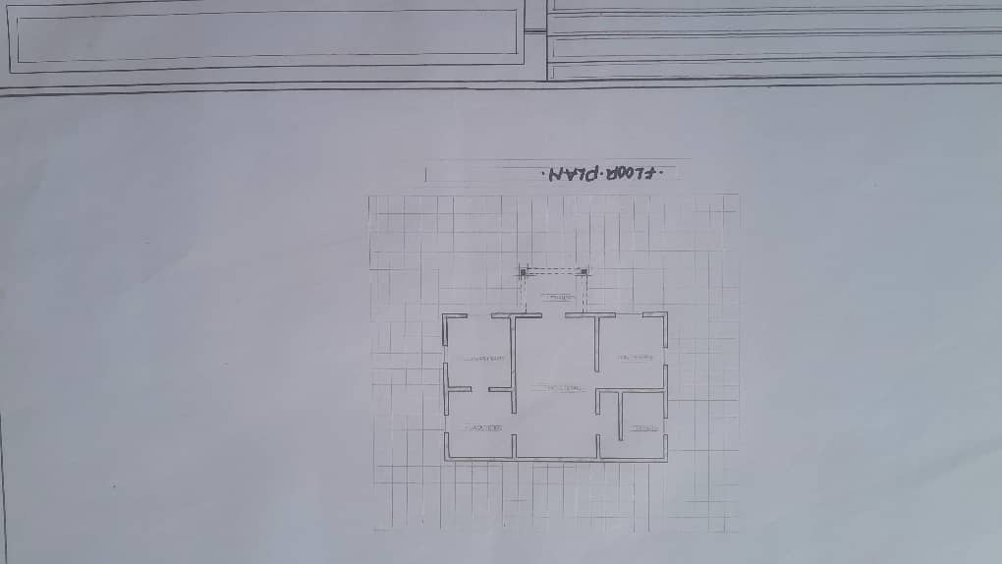
Fig 3.2.1 floor plan of case study two
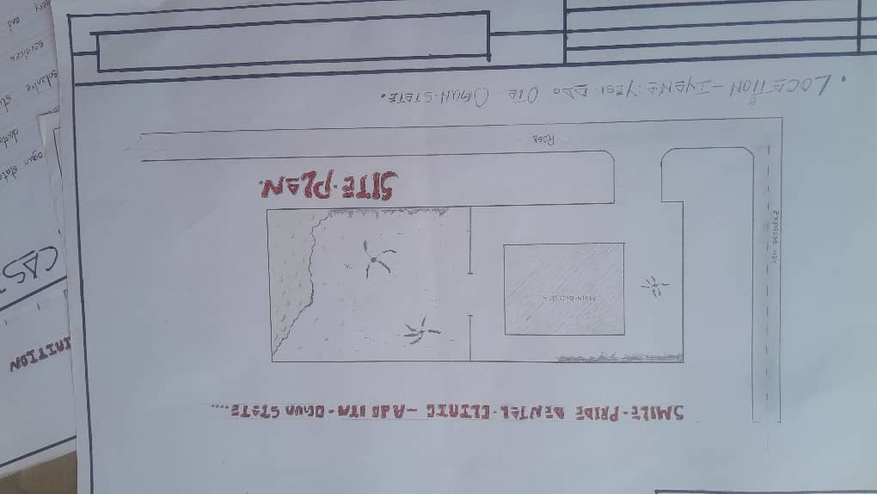
Fig 3.2.2 Site plan of case study two

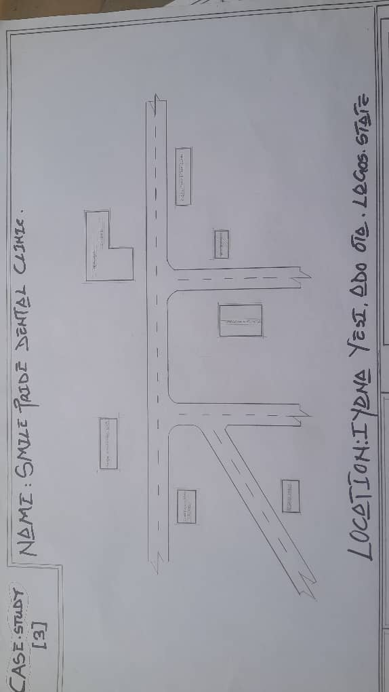
Fig 3.2.3 Locational plan of case study two

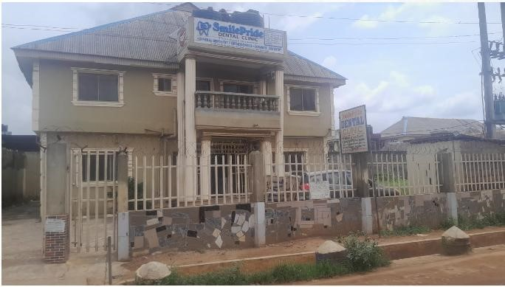
Plate 3.2.1: Outer view of case study Two Smile Pride Dental Clinic Ota Ogun State
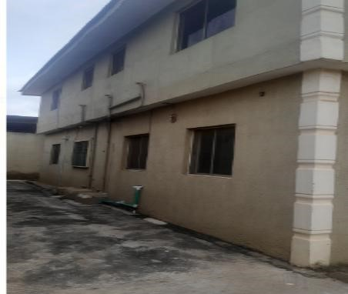
Plate 3.2.2: Showing Side view of case study Two Smile Pride Dental Clinic Ota Ogun State
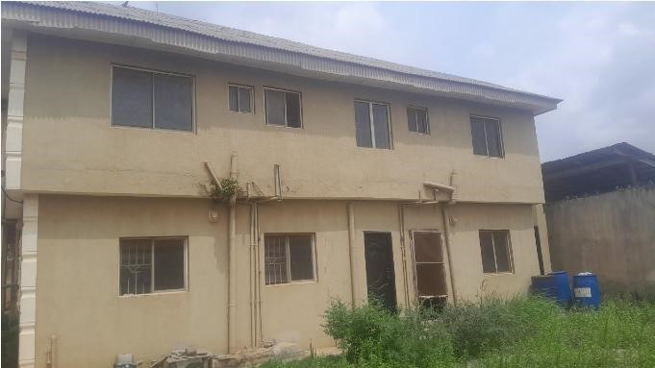
Plate 3.2.2: Showing Back view of case study Two Smile Pride Dental Clinic Ota Ogun State

MERIT
- It is well zoning and located at the centre of the community in the area
- It is well modernized structure and aesthetically build

DEMERIT
- There offices and spaces are not well defined
- There’s no provision for future expansion
- There is not enough space to carried out other activities

3.3 CASE STUDY THREE
LOCATION: THIS COLDENT DENTAL CLINIC
ADDRESS: OBAFEMI AWOLOWO WAY IKEJA
BRIEIF HISTORY

CASE STUDY THREE
Coldent Dental Clinic, located at 138 Obafemi Awolowo Way, Ikeja, Lagos, was officially registered on September 24, 2018, under the Business Name BN-2655379 as a sole proprietorship in Nigeria.
Despite its official registration in 2018, Coldent Dental Clinic has been serving patients since 2015, establishing itself as a trusted provider of comprehensive dental care in the Ikeja area. [2] The clinic's mission is to deliver international-quality dental services locally, eliminating the need for patients to seek treatments abroad.
Operating 24 hours a day, 7 days a week, Coldent Dental Clinic offers a wide range of dental services, including preventive care, cosmetic dentistry, orthodontics, and oral surgery. [2] The clinic is known for its affordability and commitment to patient satisfaction, as reflected in its slogan, "Affordable Dental Care.
Under the leadership of proprietor Dr. Collins Patrick Alegbe, Coldent Dental Clinic has become a prominent dental care provider in Lagos, recognized for its professional service and patient-centered approach.

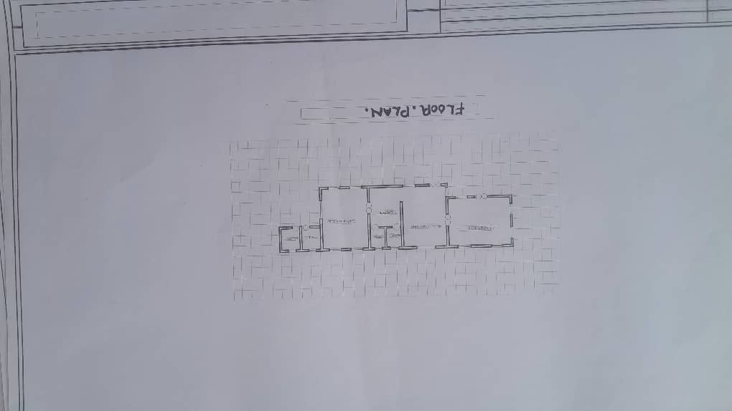
Fig 3.3.1 floor plan of case study three
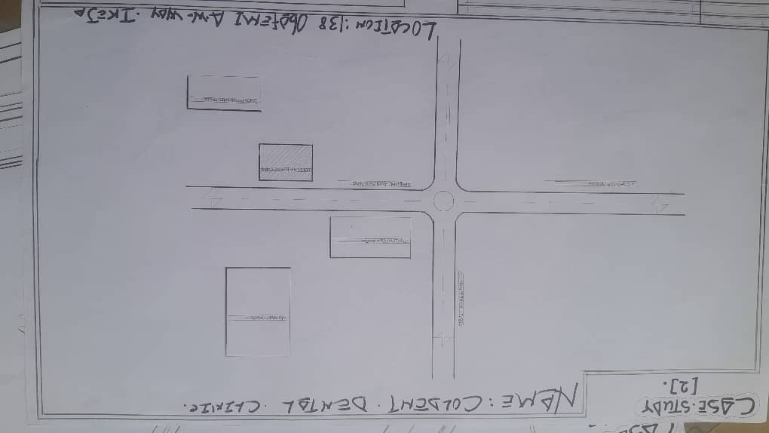
Fig 3.3.2 Locational plan of case study three

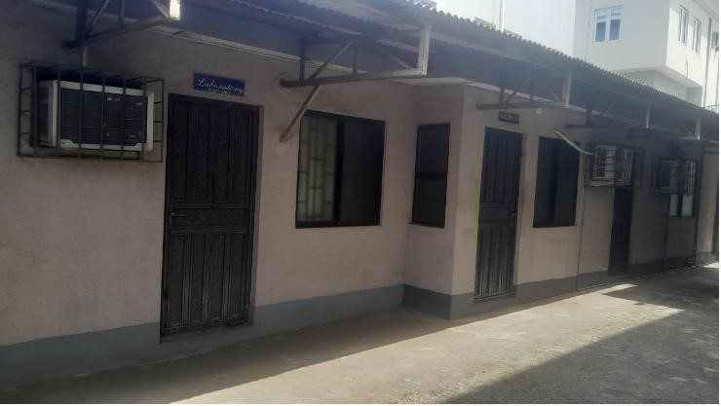
Plate 3.3.1: Showing Back view of case study three coldent dental clinic obafemi Awolowo way ikeja
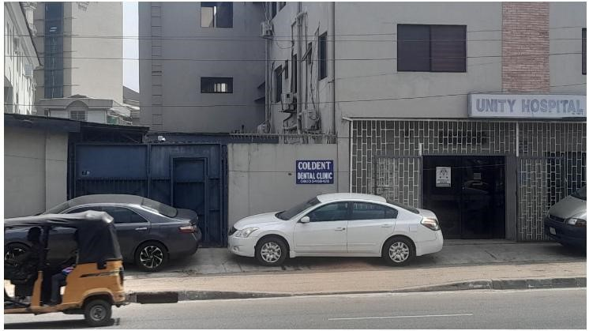
Plate 3.3.2: Showing Back view of case study three coldent dental clinic obafemi Awolowo way ikeja

MERIT
II. Easy accessibility

DEMERIT
- Poor landscaping
- The building itself is in need of renovation

3.4 CASE STUDY FOUR
ONLINE CASE STUDY
AQUA DENTAL CLINIC SWEDEN
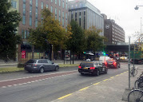
Plate 3.4.1 Elevation view

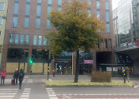
Plate 3.4.2 Elevation view

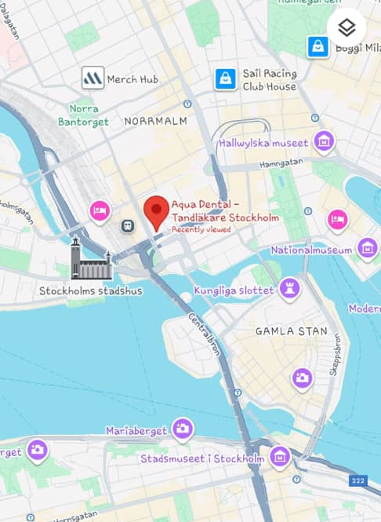
Plate 3.4.3 Locational map

3.5 CASE STUDY FIVE
ONLINE CASE STUDY
TOKYO DENTAL CLINIC


Plate 3.5.1 Elevation view

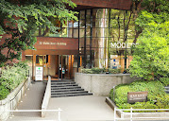
Plate 3.5.2 Elevation view

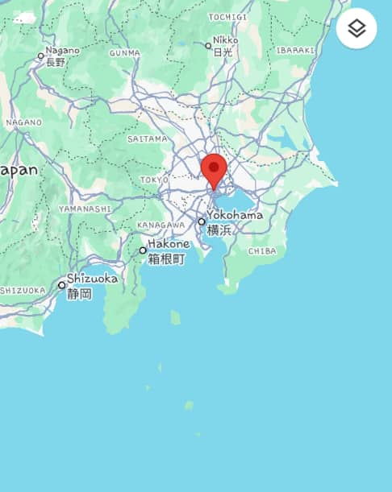
Plate 3.5.3 Locational map

CHAPTER FOUR

4.1 CONCLUSION ON DENTAL CLINIC ARCHITECTURAL DESIGN
The architectural design of a dental clinic is pivotal to ensuring a functional, efficient, and patient-friendly environment. A well-designed dental clinic must address multiple factors, including spatial organization, infection control, patient comfort, and operational efficiency. Effective layout planning ensures that treatment areas, waiting rooms, administrative spaces, and sterilization zones are well-integrated for streamlined workflow and patient experience. The incorporation of aesthetic elements, such as soothing colors, natural light, and ergonomic furniture, contributes to reducing patient anxiety, which is particularly important in dental settings where fear and discomfort are common.
Additionally, infection control is paramount in dental clinic design, necessitating the use of nonporous, easy-to-clean materials, efficient sterilization spaces, and effective ventilation systems. As dental practices increasingly adopt advanced technologies, incorporating spaces and infrastructure for modern equipment is crucial for both operational success and patient safety.
Sustainability is also a growing concern, and integrating energy-efficient and water-saving solutions can help create eco-friendly dental clinics. Ultimately, a well-thought-out dental clinic design not only enhances the patient experience but also ensures the smooth running of daily operations while adhering to health and safety regulations.

4.2 RECOMMENDATIONS ON DENTAL CLINIC ARCHITECTURAL DESIGN
Prioritize Workflow Efficiency: Clinic layouts should ensure a smooth workflow, minimizing unnecessary movement between areas. Treatment rooms, sterilization areas, and staff spaces should be strategically located for optimal efficiency.
Emphasize Patient Comfort: Incorporating calming design elements, such as soft colors, artwork, comfortable furniture, and natural light, can significantly improve patient experience.
Waiting areas should be inviting and offer privacy.
Enhance Infection Control: Use non-porous, antimicrobial materials for finishes in treatment and public areas. Separate clean and dirty zones within the clinic, and ensure that sterilization rooms are equipped with modern sterilization technology.
Incorporate Sustainable Design Features: Use energy-efficient lighting, HVAC systems, and water-saving fixtures. Solar panels and rainwater harvesting systems should be considered to reduce the environmental footprint of dental clinics.
Integrate Advanced Technology: Design spaces to accommodate advanced dental equipment, digital records management, and telemedicine. Ensure that the clinic infrastructure supports the latest technologies while maintaining ergonomic designs.
Ensure Accessibility: The clinic should comply with accessibility standards, ensuring that patients with disabilities can access treatment rooms and common areas without barriers.
Adopt Flexibility in Design: Given the evolving nature of dental care, clinic designs should be flexible enough to accommodate future changes in equipment and patient care needs.

4.3 SUMMARY OF DENTAL CLINIC ARCHITECTURAL DESIGN
The architectural design of a dental clinic is multifaceted, involving considerations for functionality, aesthetics, patient comfort, infection control, and sustainability. Key elements include well-organized spaces that facilitate smooth patient and staff movement, along with soothing environments that reduce stress for patients. Infection control is a critical factor, requiring the use of materials that are easy to clean and disinfect, while air and water quality should be carefully managed.
The integration of cutting-edge dental technologies is another essential aspect of modern clinic design, ensuring that spaces are equipped to handle advanced tools and digital systems. Sustainability has also become an important consideration, with many clinics adopting green design features that minimize energy consumption and reduce environmental impact.
Overall, the goal of dental clinic architectural design is to create a space that balances efficiency, safety, comfort, and environmental responsibility, ultimately leading to a positive experience for both patients and dental professionals.
CHAPTER FIVE
5.0 DESIGN APPROACH / DESIGN REALIZATION
5.1 CONCEPTUAL DESIGN IDEA
The conceptual framework for the proposed dental clinic is inspired by the form and symbolism of medical hand gloves, which represent cleanliness, care, and precision in healthcare. The structure of the clinic is arranged in finger-like zoning, radiating from central courtyards (cut yards) — representing the palm — which function as light wells and ventilation cores. This design ensures that natural light and air circulate throughout the facility, reducing energy consumption and promoting a healing environment.
The glove-inspired layout allows each finger (wing) to represent a specific department — such as operatories, administration, imaging, and sterilization — while the courtyards serve as the physical and visual separation between public and clinical zones.

5.2 THE DESIGN PROCESS
The design evolved through the following stages:
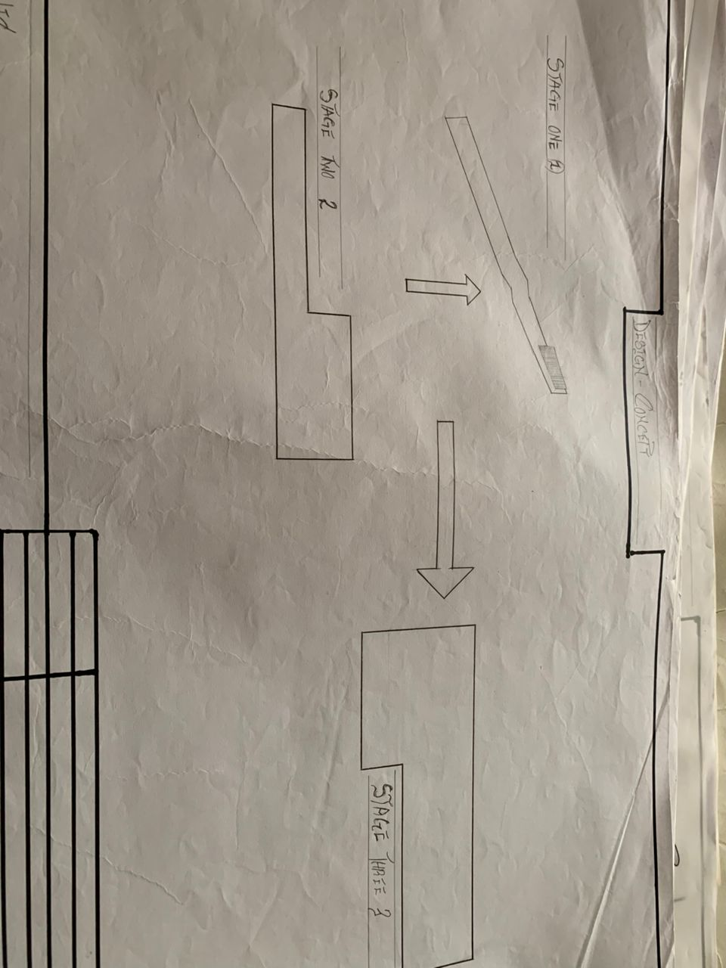
5.2.1 SITE ZONING AND MASSING
The site was zoned into public, clinical, and restricted/service areas.
The building mass was arranged to maximize natural daylight and ensure functional adjacency between departments.
Courtyards were introduced to support passive lighting and cross ventilation.

5.2.2 SPATIAL ORGANIZATION
Reception and waiting areas are located in front for easy access.
Operatory rooms, X-ray units, and oral surgery suites are positioned along quiet, private wings.
Sterilization, laboratory, and administrative offices are located in controlled-access zones.

5.3 TECHNOLOGICAL AND ENVIRONMENTAL CRITERIA
5.3.1 CONSTRUCTION METHODS AND MATERIALS
Foundation: Reinforced concrete strip foundation suitable for stable laterite soil.
Walling: 225mm sandcrete block walls finished with emulsion paint.
Roofing: Long-span aluminum roofing sheets with roof insulation.
Ceiling: Acoustic ceiling tiles in clinical zones; PVC ceiling in service areas.
Flooring: Non-slip ceramic tiles for hygiene and ease of cleaning.
Windows/Doors: Aluminum framed louvered or casement windows with insect screens; hardwood and flush panel doors for interior and exterior use.

5.3.2 ENVIRONMENTAL PERFORMANCE
Natural lighting is achieved through windows and open courtyards.
Cross ventilation via operable windows and high ceiling clearance.
Rainwater harvesting system integrated for water reuse.
Landscape buffers used for shading and noise reduction.
Solar shading devices like louvered screens protect against west-facing heat gain.

5.4 BUILDING SERVICES INTEGRATION
SERVICE DESIGN STRATEGY
Lighting Daylight-focused with LED task lighting in operatories
Ventilation Natural ventilation augmented with ceiling fans
Plumbing Dual plumbing for clean and greywater systems
Electrical Provision for backup power via generator and solar panels
Fire Safety Smoke detectors, extinguishers, and clear exit pathways
Waste Disposal Segregated medical waste room with biohazard protocols

5.5 LEGAL ISSUES AND PLANNING REGULATIONS
The proposed dental clinic conforms to:
NCDC guidelines for infection prevention and control.
Kwara State building codes regarding site setbacks, parking, and height restrictions.
Accessibility standards such as ramps, wide corridors, and accessible restrooms.
Fire and safety codes requiring fire alarms, extinguishers, and evacuation routes.

5.6 BEHAVIORAL AND PSYCHOLOGICAL CONSIDERATIONS
The facility is designed to reduce patient anxiety through:
Soothing interior finishes, light tones, and natural lighting.
Biophilic design: views to green courtyards and indoor plants.
Separate pediatric zone with playful elements for children.
Clear circulation to prevent confusion and stress.

5.7 CONCLUSION AND RECOMMENDATIONS
CONCLUSION
This project successfully explores the spatial, environmental, and functional considerations required in the design of a modern dental clinic. Through the integration of passive design strategies, thoughtful spatial zoning, and a glove-inspired architectural concept, the facility addresses the needs of patients, staff, and healthcare regulations alike.
The proposed dental clinic aims to fill the gap in quality oral healthcare delivery in Ilorin and its environs. It also demonstrates how architecture can be used to solve real-world medical infrastructure problems by focusing on hygiene, comfort, accessibility, and energy efficiency.

RECOMMENDATIONS
- Future healthcare architecture should emphasize contextual and culturally relevant design solutions.
- Government agencies should develop and enforce design guidelines specifically for dental facilities in Nigeria.
- Post-occupancy evaluations of existing clinics should be conducted regularly to guide improvements.
- The use of green technologies like solar energy and rainwater harvesting should be encouraged in public health projects.
- More research should focus on how design psychology can help reduce dental anxiety, especially in children.
APPENDICES
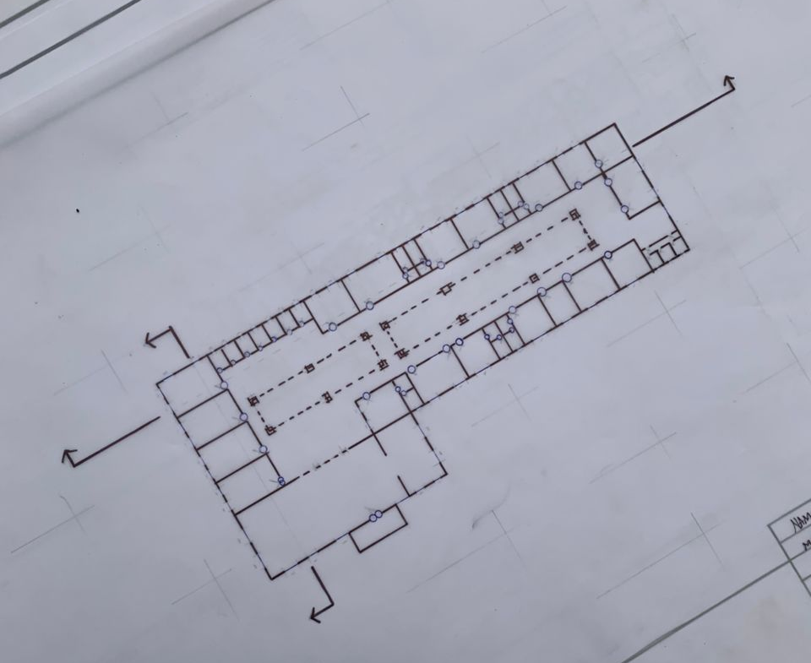
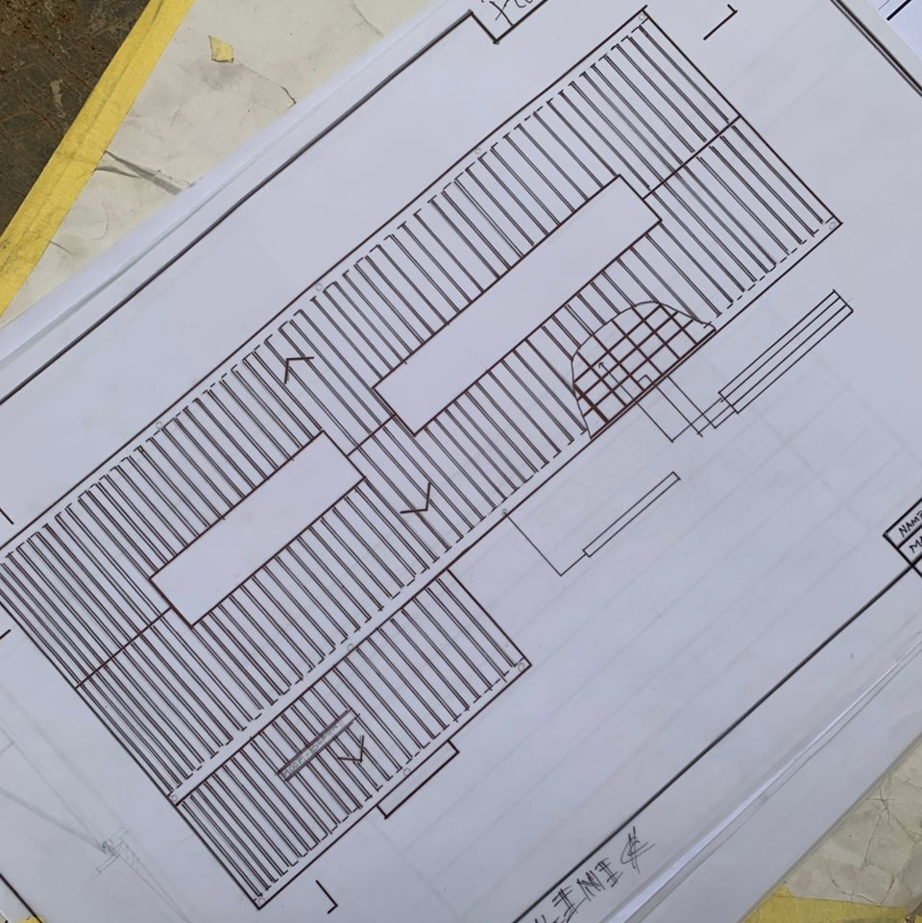
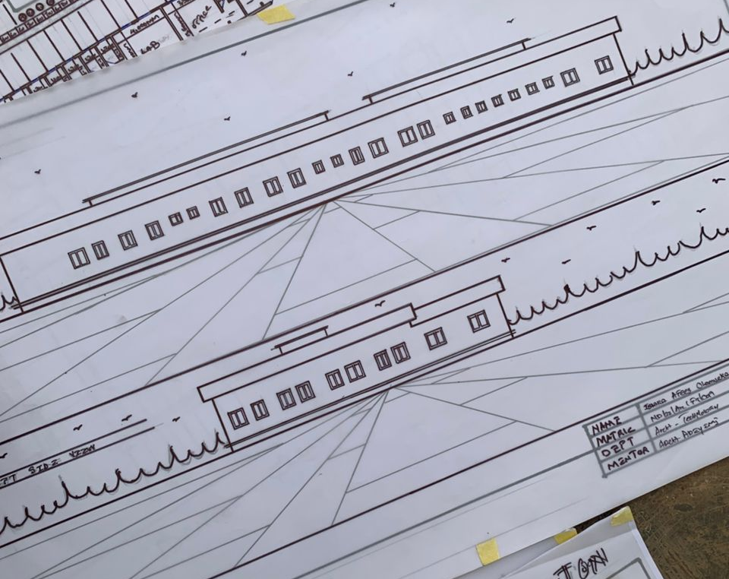
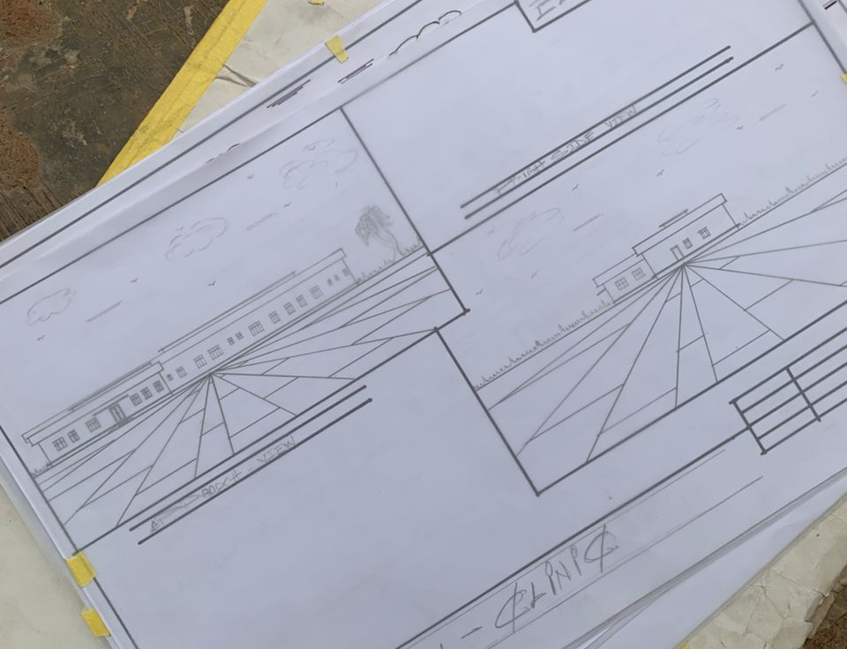
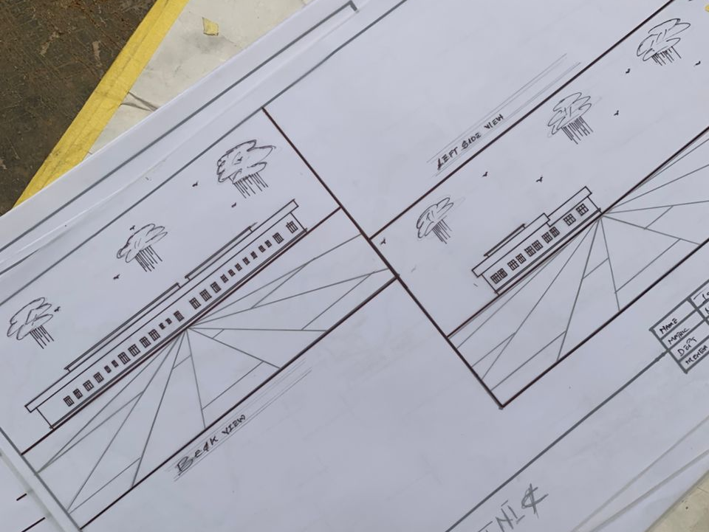

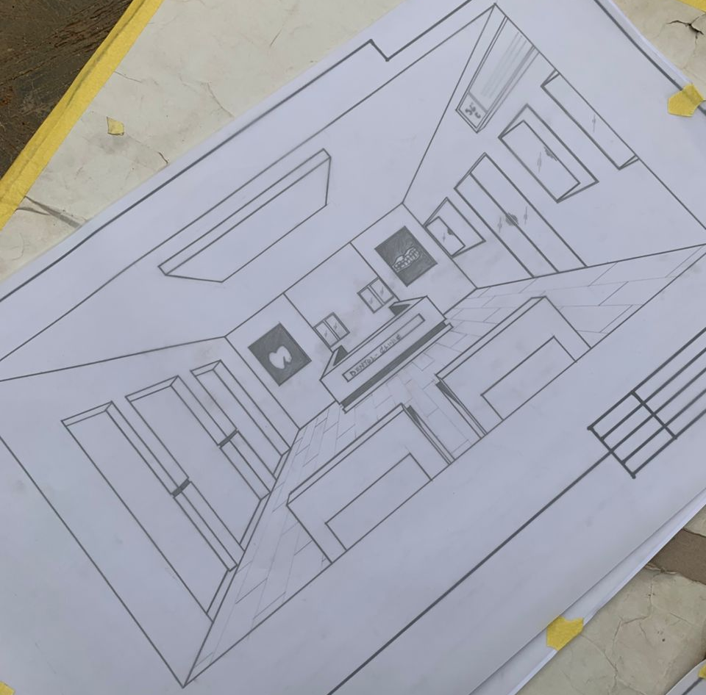
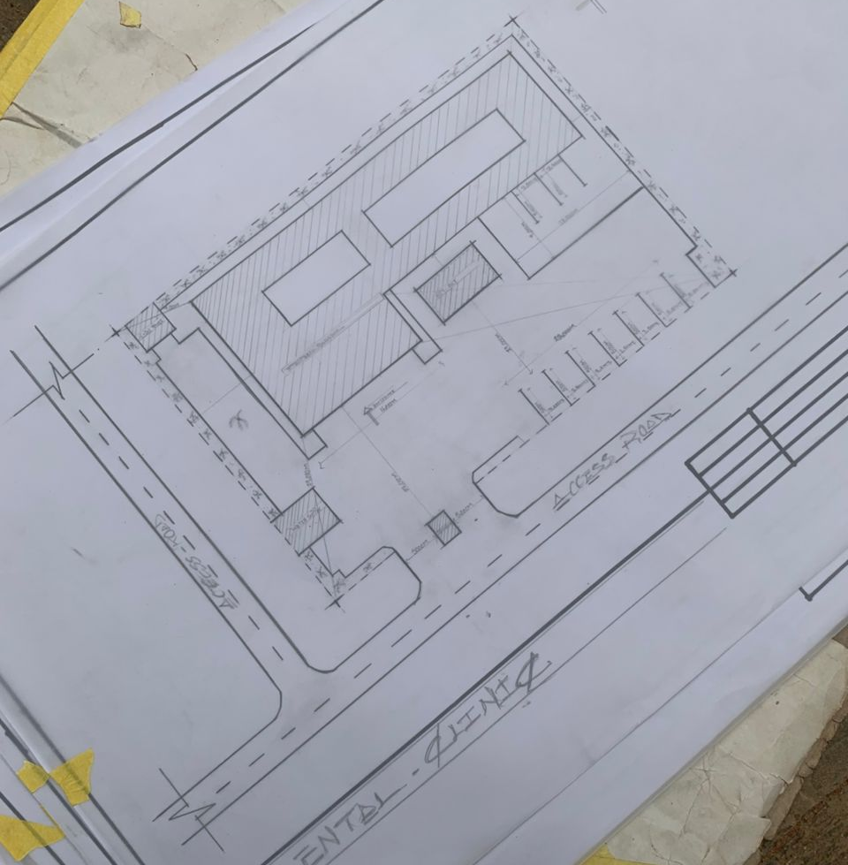
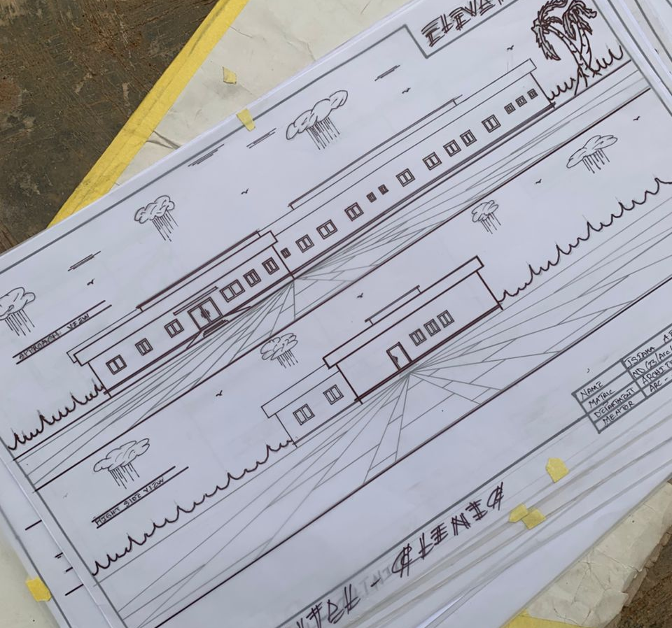
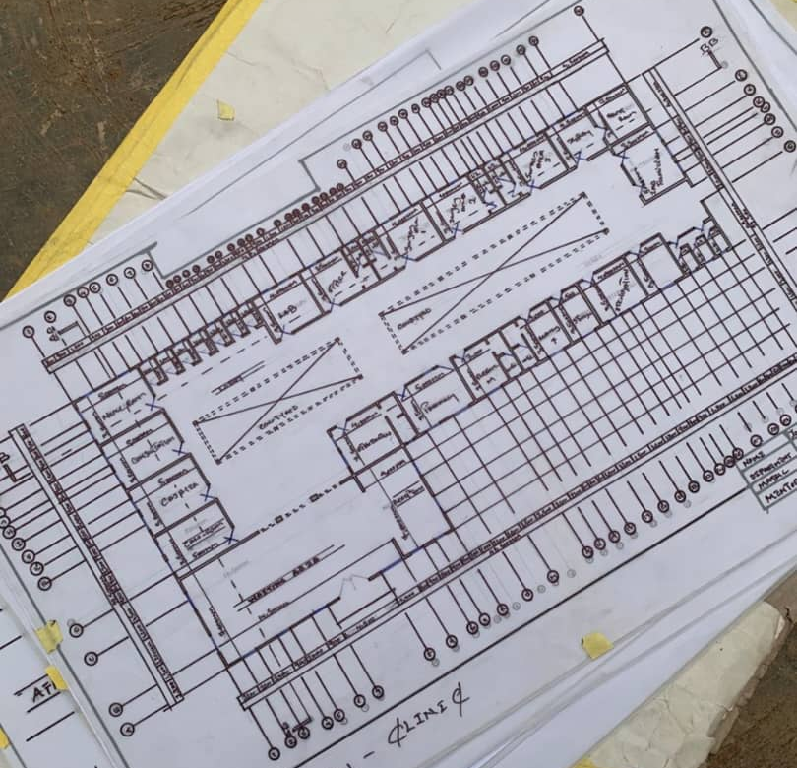

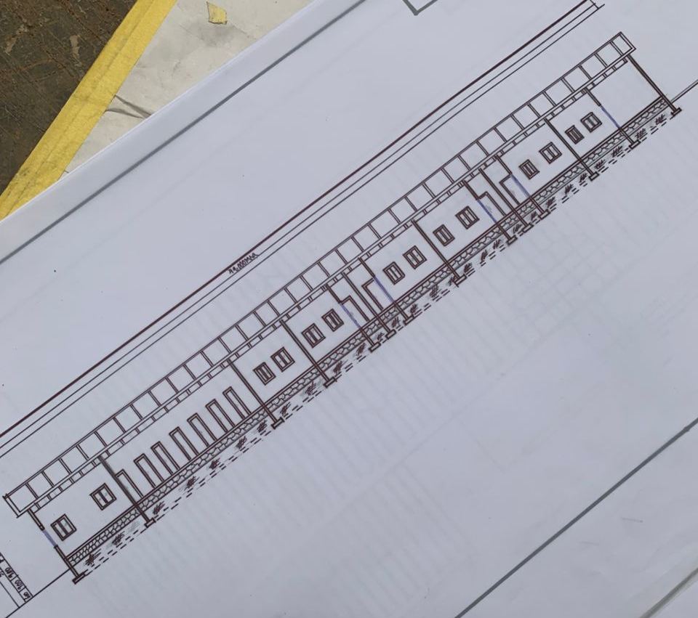

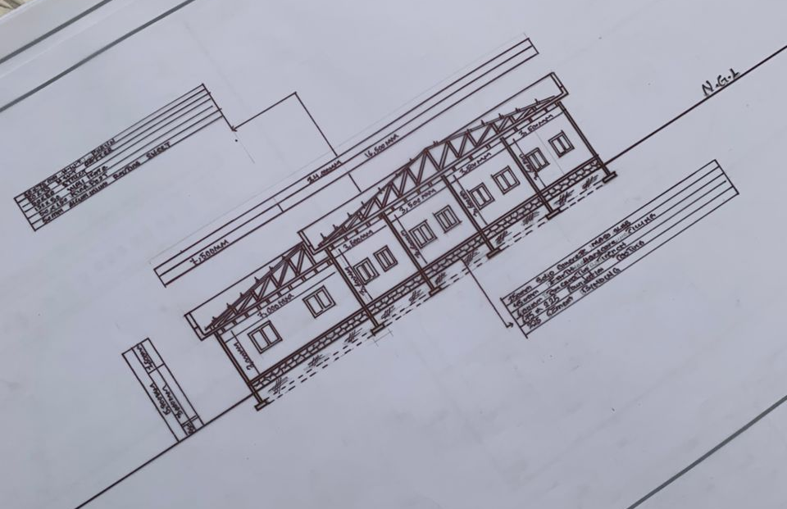
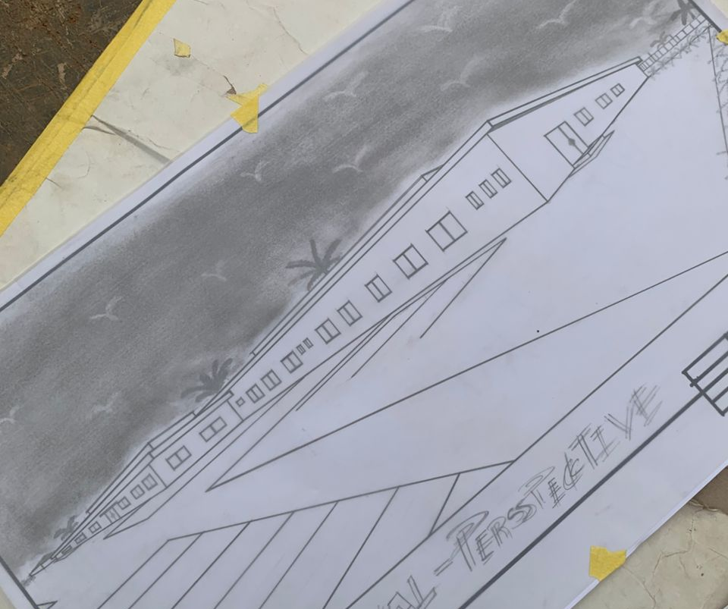

REFERENCES
Frey, A. (2016). Designing the Ideal Dental Office: Best Practices and Layout Considerations. Healthcare Design, 18(5), 34-39.
This article provides a comprehensive overview of best practices in designing dental clinics, discussing key layout considerations, ergonomics, and patient comfort.
Fisher, M., & Griffin, L. (2012). Creating the Optimal Dental Office: Space Planning for Patient Comfort and Operational Efficiency. Journal of Dental Practice Management, 23(4), 43-51.
This reference provides insight into the relationship between spatial planning and patient comfort, offering practical tips for dental office design.
Gensler, M. (2015). Designing Healthcare Spaces: A Guide to Creating Effective Healthcare Environments. Gensler Insights.
This book explores the holistic approach to healthcare design, including dental clinics, and highlights strategies for creating functional and aesthetically pleasing environments.
Geisinger, M., Braddock, A., & Larson, K. (2017). Design and Healing: Using Design to Improve Patient Experience. Journal of Health Design, 8(1), 15-30.
This paper examines the psychological impact of design elements on patients' health outcomes, including how dental clinics can incorporate healing and calming environments.
Kincaid, D. (2015). Healthcare Architecture: The Influence of Design on Patient Health and Wellbeing. The American Journal of Health Promotion, 29(4), 267-274.
This article explores how architectural design in healthcare settings, including dental clinics, can contribute to improved patient outcomes and overall wellbeing.
Perry, S., Wills, D., & Wysocki, M. (2019). Dental Office Design: A Guide to Space Planning and Workflow. Wiley.
This book serves as a guide to designing dental offices with a focus on optimizing space planning, workflow, and ensuring a positive experience for both patients and dental staff.
Patterson, J. (2013). Architectural Strategies for Effective Healthcare Design: A Guide for the Design of Dental Clinics. Architectural Review, 56(2), 67-76.
Provides specific architectural strategies tailored to dental clinics, emphasizing patient flow, infection control, and design aesthetics.

Sundararajan, V., & Gupta, N. (2018). Sustainability in Healthcare Architecture: Challenges and Opportunities in Dental Clinic Design. Journal of Sustainable Design, 4(2), 10-20.
Focuses on sustainable architectural practices and the integration of green technologies in dental clinics to reduce environmental impact while improving operational efficiency.
Simmons, R. (2014). The Impact of Architectural Design on Healthcare Outcomes: Case Studies in Dental Clinics. Journal of Healthcare Design, 10(3), 45-57.
This study examines the relationship between architectural design and healthcare outcomes in dental clinics, exploring how spatial layouts can influence both patient experience and staff efficiency.
Ulrich, R. (2006). The Role of the Physical Environment in the Hospital of the 21st Century: A Once-in-a-Lifetime Opportunity. The Center for Health Design.
Ulrich’s work focuses on how physical spaces influence healthcare outcomes, including the importance of design in reducing stress and enhancing patient satisfaction, which is also applicable to dental clinic environments.

