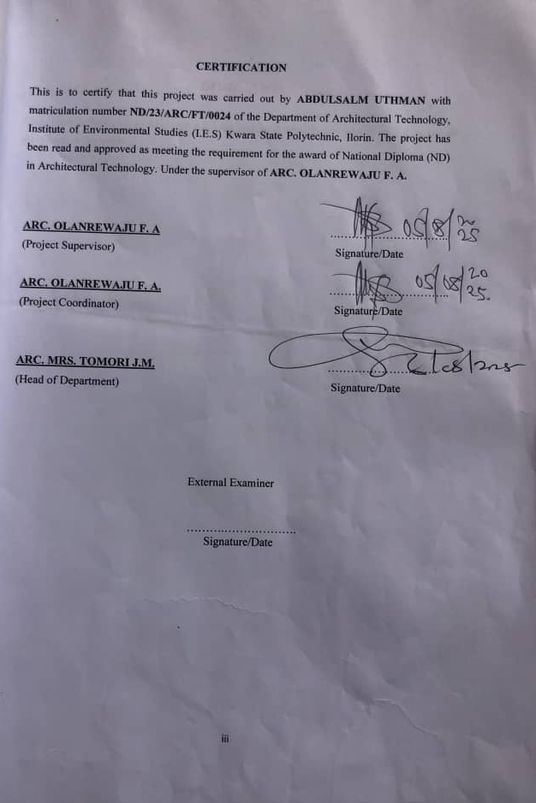

A PROJECT REPORT
ON
PROPOSED DENTAL CLINIC
FOR
GANMO ILORIN KWARA STATE
BY
ABDULSALAM UTHMAN
ND/23/ARC/FT/0024
SUBMITTED TO
THE DEPARTMENT OF ARCHITECTURAL TECHNOLOGY, INSTITUTE OF ENVIRONMENTAL STUDIES (IES), KWARA STATE POLYTECHNIC, ILORIN
IN PARTIAL FULFILLMENT OF THE REQUIREMENT FOR THE AWARD OF NATIONAL DIPLOMA (ND) IN ARCHITECTURAL TECHNOLOGY,
JULY 2025

DECLARATION

I ABDULSALAM UTHMAN (ND/23/ARC/FT/0024) declare that this report is a product of my personal research work. It has not been presented for the award of any degree in any Polytechnic . The ideas, observations, comments, suggestions herein represent my own convictions, except quotations, which have been acknowledged in accordance with conventional academic traditions. Under the supervision of ARC OLAREWAJU F.A

Signature: __________________ Date: ____________________

Project Title:
DENTAL CLINIC

CERTIFICATION
I certify that this research dissertation entitled Dental Clinic Center has been duly certified as meeting the requirement for the award of National Diploma (ND) in Architectural Technology, Institute of Environmental Studies, Kwara State Polytechnic, Ilorin. Under the supervision of ARC OLAREWAJU F.A
ARC OLAREWAJU F.A ____________________

PROJECT SUPERVISOR | SIGNATURE &DATE
ARC. OLAREWAJU F.A | _____________________

PROJECT COORDINATOR | SIGNATURE & DATE
ARC. J.M TOMORI | ____________________

HEAD OF DEPARTMENT | SIGNATURE & DATE
________________________ | ____________________
EXTERNAL EXAMINER | SIGNATURE &DATE

DEDICATION
This report is dedicated to Almighty Allah for making it possible and also to my Parent and all Architects in the world.

ACKNOWLEDGEMENT
I return all the glory, honor, praise and adoration to the master of the universe that have given me the privilege of seeing the end of this program of him alone be the glory.
My immediate gratitude goes to my supervisor ARC OLAREWAJU F.A who has been supportive responsive throughout this project, may God continue to reward you and your family.
My appreciation goes to my Amiable Head Of Department in person of ARC. J. M TOMORI and other academic staffs for their immense contribution toward the success of my program may the Lord Honor and do you all good.
My sincere gratitude goes to my parent, MR & MRS ABDULSALAM who brought me to this world, may you eat the fruit of your labour.
However, my gratitude also goes to all my colleague, friends, brothers, sisters and well wishers.
May your life experience joy.
TABLE OF CONTENTS

CHAPTER ONE

1.0 INTRODUCTION

1.2 HISTORICAL BACKGROUND

1.3 DEFINITION OF THE TERMS

1.4 AIMS & OBJECTIVES

1.5 OBJECTIVES

1.6 JUSTIFICATION

1.7 LIMITATION

1.8 RESEARCH METHODOLOGY

CHAPTER TWO

2.0 LITERATURE REVIEW

CHAPTER THREE
3.0 CASE STUDIES
3.1 CASE STUDYONE
3.2 CASE STUDYTWO
3.3 CASE STUDYTHREE

CHAPTER FOUR
4.1 CONCLUSION ON DENTAL CLINIC ARCHITECTURAL DESIGN
4.2 RECOMMENDATIONS ON DENTAL CLINIC ARCHITECTURAL DESIGN
4.3 SUMMARY OF DENTAL CLINIC ARCHITECTURAL DESIGN

LIST OF TABLES
TABLE 4.1 ADMINISTRATIVE BLOCK……………………………… ………44
TABLE 4.2 SPACE SCHEDULE………………………………………… ………44
TABLE 4.3 DEMOGRAPHIC DATA OF RESPONDAN…………………………47
TABLE 4.4 RESPONDANT ON QUESTION 1……………………………………48
TABLE 4.5 RESPONDANT ON QUESTION 2……………………………………48 TABLE 4.6 RESPONDANT ON QUESTION 4……………………………………48

LIST OF FIGURES
FIGURE 1.1: CASE STUDY 1 SITE PLAN……………………...………………39
FIGURE 1.2 CASE STUDY 2 SITE PLAN VIEW………….……………………39
FIGURE 3.1 SITE LOCATION……………………………………………………42
FIGURE 3.2 SELECTION CRITERIA……………………………………………42
FIGURE 3.3 SITE ANALYSIS…………………..…………………………………43
FIGURE 4.1 FUNCTIONAL RELATIONSHIP………..…………………………45
FIGURE 4.4 CONCEPT DERIVATION……..……………………………………46

LIST OF FIGURES
PLATE 2.1: ENTRANCECE VIEW OF CASE STUDY ONE…………………. 37
PLATE 2.2: RELAXATION AREA OF CASE STUDY ONE…………………. 37
PLATE 2.3: RELAXATION VIEW OF CASE STUDY ONE…………………. 37
PLATE 2.4: CHILDREN PLAYGROUND OF CASE STUDY THREE…..…. 37
PLATE 2.5: WALK WAY VIEW OF CASE STUDY THREE…………………. 37

LIST OF FIGURES
APPENDICES 1: SITE PLAN………………………………………………………60
APPENDICES 2: FLOOR PLAN……………………………………………………60
APPENDICES 3: SECTION X-X……………………………………………………61
APPENDICES 4: SECTION Y-Y…………………………………………………....61
APPENDICES 5: SOUTH VIEW……………………………………………………62
APPENDICES 6: NORTH VIEW……………………………………………………62 APPENDICES 7: EAST VIEW……………………………………………………....64
APPENDICES 8: WESTVIEW………………………………………………...…….64

ABSTRACT
Dental Clinic Center architectural design is a critical and complex field that focuses on creating healthcare environments that support both patient care and the well-being of medical staff. The design of a Dental Clinic Center is not only about functional spaces but also about fostering a therapeutic atmosphere. Effective Dental Clinic Center architecture considers factors such as accessibility, safety, workflow efficiency, patient comfort, and the integration of medical technologies.
Modern Dental Clinic Center designs prioritize creating spaces that minimize stress and promote healing. This involves careful consideration of natural light, air quality, sound control, and privacy. In addition, sustainable practices are increasingly being incorporated, with energyefficient systems, use of sustainable materials, and designs that reduce the environmental impact of healthcare facilities.
The layout and spatial organization of a Dental Clinic Center are essential in supporting operational efficiency and reducing the time taken for patients to move between departments. Special attention is given to clear signage, navigation, and the connection between public and private spaces. Moreover, Dental Clinic Center designs must adhere to stringent regulations concerning infection control, safety standards, and accessibility for patients with varying needs.
Ultimately, Dental Clinic Center architecture is about balancing medical functionality with the creation of environments that contribute to better health outcomes. Thoughtful, user-centered designs that prioritize comfort, privacy, and efficient care are key to improving both the physical and emotional aspects of healthcare delivery.
CHAPTER ONE

1.0 INTRODUCTION
The architectural design of a dental clinic plays a crucial role in creating a functional, comfortable, and efficient environment for both patients and healthcare professionals. Dental clinics require a specific design approach that caters not only to the clinical needs but also to the psychological well-being of patients, who may often experience anxiety during their visits. The design should facilitate smooth workflows, promote hygiene and sterilization, and provide spaces that foster effective communication between staff and patients. Key considerations in dental clinic architectural design include spatial organization, lighting, ventilation, privacy, and the incorporation of modern dental technologies. The layout must allow for easy movement of both patients and staff while ensuring the privacy and confidentiality of patient information. In addition, the clinic must comply with healthcare regulations and guidelines to ensure the safety and health of everyone in the facility.
A well-designed dental clinic enhances the overall patient experience, providing a calming atmosphere that reduces stress and promotes trust in dental care providers. The design also ensures that dental procedures are conducted with high efficiency, while making use of the latest technologies and equipment to ensure the best possible care. From the reception area to the treatment rooms, every aspect of the clinic’s design contributes to creating a space that is both functional and welcoming, Ultimately, dental clinic architectural design merges aesthetics with practicality to support the delivery of high-quality dental services in a safe and efficient environment.
1.1 HISTORICAL BACKGROUND

Historical Background on Dental Clinic Architectural Design
The architectural design of dental clinics has evolved significantly over the centuries, shaped by advancements in dentistry, changes in public health practices, and the increasing demand for specialized healthcare facilities. While dentistry as a practice dates back to ancient civilizations, the concept of dedicated spaces for dental care emerged more distinctly in the 19th and 20th centuries, aligning with the professionalization of dental practices and innovations in medical architecture.

Ancient and Medieval Times
In ancient civilizations such as Egypt, Greece, and Rome, dental care was often practiced by individuals with specialized knowledge, though they did not have dedicated clinics or specific architectural designs for dental care. Treatments were often performed in the homes or workshops of these practitioners, where basic tools, such as rudimentary drills and forceps, were used. There was no formal architectural space for dental care—medical and dental practices were typically conducted in general medical spaces or even in informal settings.

17th and 18th Centuries: Early Developments
As dentistry began to emerge as a more recognized profession in the 17th and 18th centuries, dental procedures started to move away from general medicine and were performed by specialists. However, the idea of dedicated dental clinics was still largely absent. Dental practitioners typically operated from their homes or small private offices, often sharing spaces with other healthcare professionals. These spaces were rudimentary, with little to no emphasis on design or patient comfort.

19th Century: Professionalization of Dentistry
The 19th century marked a turning point in dental care. As dental science progressed with the invention of new tools and techniques, including the first dental chair by Dr. Samuel Stockton in 1790, dentistry began to separate from general medicine. During this time, the first dedicated dental practices were established. These early dental offices were often simple, functional spaces that focused primarily on the technical aspects of dental procedures.
With the growing understanding of hygiene and sterilization in medical practice, dental clinics began to incorporate more specialized spaces, such as operating rooms and sterilization areas. The layout started to reflect the importance of maintaining a clean and organized environment to prevent the spread of infections. However, the architectural design remained relatively basic, with an emphasis on utility rather than patient experience.

Early 20th Century: Modernization of Dental Clinics
The early 20th century saw the first real attempts at designing dental clinics with a more comprehensive and patient-focused approach. With the rise of the dental profession, many dental offices started to implement modern conveniences, such as comfortable waiting areas, well-designed treatment rooms, and even decorative elements to make patients feel more at ease. During this period, there was also an increased focus on privacy, as dental practitioners sought to create individual treatment rooms for patients, which offered greater confidentiality and comfort.
Innovations in dental equipment and a growing understanding of ergonomics also influenced dental clinic design. The dental chair became a central element of the treatment room, and considerations were made to ensure that it was positioned to allow the dentist to work efficiently and comfortably. Lighting, ventilation, and acoustics were also considered for the first time as essential elements in dental clinic design.

Post-World War II: Growth and Technological Advancements
Following World War II, there was significant growth in the number of dental clinics, especially as modern technologies began to shape the field of dentistry. Dental imaging, X-ray machines, and sterilization equipment required specific spaces and infrastructure within clinics. The introduction of these advanced tools led to the redesign of treatment areas, as dental offices needed to accommodate new technologies while maintaining a focus on comfort and patient care. During this period, the design of dental clinics began to incorporate more aesthetics, combining functionality with architectural elements that aimed to reduce patient anxiety. For example, the waiting areas became more inviting, with comfortable furniture and soothing colors, reflecting the growing importance of the patient's emotional experience in addition to their physical treatment.

Late 20th Century to Present: Comprehensive Design and Patient-Centered Approach
In the late 20th century and into the 21st century, dental clinic architecture became increasingly sophisticated. The design of dental clinics evolved to meet the growing demand for specialized care, as well as the desire to create a welcoming and patientfriendly environment. The rise of cosmetic dentistry, orthodontics, and specialized treatment centers led to more diverse architectural designs, tailored to the specific needs of different types of dental care. Today, dental clinic design emphasizes patient comfort, operational efficiency, and hygiene. The integration of advanced technology—such as digital X-rays, computer-aided design (CAD), and virtual simulations—has further influenced the layout and design of treatment rooms. Modern dental clinics often feature open-concept waiting areas, ergonomic workspaces for staff, and efficient layouts that facilitate smooth patient flow. There is also a strong emphasis on sustainable design, with the use of energy-efficient materials and systems.
Architectural design now considers the holistic experience of patients, with many clinics incorporating calming aesthetics, natural light, and soundproofing elements to create an atmosphere of tranquility. The focus on creating a seamless connection between function and patient experience reflects a broader understanding of how the physical environment can positively affect mental well-being and health outcomes. The evolution of dental clinic architectural design reflects the development of the dental profession itself, from rudimentary and utilitarian spaces to modern, patient-centered environments. Advances in technology, changes in healthcare needs, and a growing understanding of patient psychology have all contributed to the design of dental clinics that not only meet the functional needs of dental practitioners but also enhance the comfort and experience of patients. The modern dental clinic has become a place where both the science of dentistry and the art of design converge to create spaces that support health, well-being, and trust.

1.2 DEFINITION OF THE TERMS

Architectural Definition
A dental clinic building is a specialized healthcare structure designed and constructed to provide a dedicated space for dental care services. It is equipped with treatment rooms, sterilization areas, waiting rooms, and administrative offices to support the operational needs of a dental practice. The design of the building considers factors such as hygiene, patient comfort, safety, and workflow efficiency for both staff and patients.

Functional Definition
A dental clinic building is a facility where dental practitioners diagnose, treat, and manage oral health conditions. It is designed to accommodate various dental treatments such as routine checkups, surgeries, orthodontics, and cosmetic dentistry. The building includes specialized spaces like dental operatories, sterilization zones, and diagnostic areas, each tailored for specific procedures and patient care needs.

Operational Definition
A dental clinic building is a healthcare facility specifically dedicated to the delivery of oral health services, including preventive, therapeutic, and corrective dental treatments. This facility supports the day-to-day operations of a dental practice, including patient intake, treatment, consultation, and post-treatment care. It includes areas for both clinical procedures and administrative tasks, ensuring the smooth functioning of a dental practice.

Patient-Centric Definition
A dental clinic building is a patient-focused environment designed to provide comfortable, safe, and accessible care. The building is constructed with the aim of reducing patient anxiety and promoting well-being through welcoming aesthetics, effective use of space, and the incorporation of modern dental technology for highquality care.

Healthcare Infrastructure Definition
A dental clinic building is an integral part of healthcare infrastructure, providing a specialized environment for the delivery of dental services to the community. It is a wellplanned facility that ensures proper infection control, accessibility for people with disabilities, and compliance with healthcare regulations while offering efficient and comprehensive dental care.
1.3 AIMS & OBJECTIVES

Aim
Provide a Safe and Hygienic Environment:
The primary aim is to create a safe and hygienic space where dental procedures can be performed with minimal risk of contamination or infection. This includes adhering to stringent healthcare standards for sterilization, ventilation, and infection control.

OBJECTIVES
- To Design the layout to maximize the use of available space, ensuring there is adequate room for treatment areas, patient waiting areas, staff offices, storage, and other necessary functions, all while maintaining patient privacy and comfort.
- The clinic should be equipped with spaces designed specifically for modern dental tools and technologies, ensuring proper placement and functionality for devices such as dental chairs, X-ray machines, and sterilization equipment.
- The design should consider patient privacy by including soundproof treatment rooms, private consultation spaces, and separate waiting areas, to ensure confidentiality during both diagnosis and treatment.
- The building must comply with all relevant health regulations and safety standards. This includes proper sterilization rooms, waste disposal systems, and compliance with infection control protocols, as well as adherence to building codes and ADA (Americans with Disabilities Act) regulations.

1.4 JUSTIFICATION
Designing a dental clinic building is an essential process that requires careful consideration of various factors to ensure the facility meets the needs of both patients and healthcare providers. The justification for investing in and designing a dedicated dental clinic building lies in several key areas, each contributing to the overall success and functionality of the space.
The patient experience plays a vital role in the success of a dental practice. Many individuals experience anxiety and discomfort at dental clinics, and a well-designed building can help alleviate these feelings. A thoughtful layout with welcoming features such as soothing colors, natural lighting, and comfortable waiting areas creates a calming atmosphere. The design of individual treatment rooms, with modern equipment and aesthetic features, further reduces patient stress. The overall comfort of the patient directly influences their willingness to return for follow-up visits and can contribute to better dental health outcomes.
A dental clinic building must be designed to optimize the workflow between patients, staff, and equipment. The layout should ensure that different areas (e.g., reception, waiting area, treatment rooms, sterilization rooms) are efficiently connected to minimize unnecessary movement and time spent by both patients and dental professionals. Streamlined patient flow, from check-in to consultation and treatment, enhances operational efficiency. Efficient design ultimately leads to improved patient care, reduced waiting times, and increased productivity for the dental staff.

1.5 LIMITATION
financial resources available for the design and construction of a dental clinic often impose significant limitations. A limited budget may restrict the use of high-end materials, modern technologies, or the inclusion of desirable design features such as spacious waiting areas or advanced medical equipment. The need to balance quality with cost can sometimes lead to compromises in design, materials, or equipment that might affect the clinic's functionality or aesthetics, The available space for constructing a dental clinic may limit the design options, particularly in urban areas where property sizes are smaller or more expensive. The need to fit various functional areas (e.g., reception, waiting area, treatment rooms, sterilization areas, staff rooms, storage) into a limited footprint can be challenging.
Incorporating modern dental technologies such as digital X-rays, CAD/CAM systems, and advanced dental chairs requires specific infrastructure, including electrical systems, data management, and space requirements. The availability of space and resources to accommodate these technologies can pose a limitation, especially in smaller or older buildings.

1.6 RESEARCH METHODOLOGY
Designing a dental clinic building involves a comprehensive research methodology that takes into account the specific needs of the healthcare professionals, the patients, and the functional requirements of the clinic. The research methodology will typically include a combination of qualitative and quantitative approaches, data collection, analysis, and design application. The first step in the research methodology is to identify the specific problems or requirements of the dental clinic building design. This involves understanding the unique needs of the dental practice, its staff, and the patients.
Review existing literature on dental clinic designs, conduct interviews with dentists, architects, and other stakeholders, and examine current trends in healthcare design. Identify the challenges faced by existing dental clinics in terms of space utilization, patient comfort, workflow efficiency, and technology integration.
To arrive at a financial and standard design concept, the following research methods were carried out.
- Oral review
- Online interview
- Case study review
- Literature review

Literature Review
To gather existing knowledge on the design of healthcare facilities, particularly dental clinics, to understand best practices, guidelines, and technological advancements.
Conduct a thorough review of academic articles, books, case studies, and reports from architectural firms that specialize in healthcare buildings. Look at successful examples of dental clinic designs and architectural solutions that improve patient care and optimize operational efficiency.

CHAPTER TWO

2.0 LITERATURE REVIEW
Dental clinics, like other healthcare facilities, have unique requirements for architectural design due to their specialized nature. A well-designed dental clinic not only addresses functional needs but also creates a therapeutic environment conducive to patient comfort, staff efficiency, and safety. This literature review discusses various factors that influence the architectural design of dental clinics, including space planning, aesthetics, patient experience, infection control, and sustainability.

Space Planning and Functionality
The spatial organization of a dental clinic is crucial for ensuring smooth workflows, patient comfort, and staff efficiency. According to Simmons (2014), the layout of a dental clinic should be carefully designed to separate clinical functions from administrative areas. A typical dental clinic includes treatment rooms, a sterilization area, waiting areas, and staff rooms, all of which must be logically interconnected to ensure ease of movement for both staff and patients.
Treatment Rooms: Treatment rooms are central to the design of dental clinics, and the arrangement of dental chairs, equipment, and storage is essential for operational efficiency. Frey (2016) emphasizes that treatment rooms should have sufficient space for dental equipment, while ensuring ease of accessibility for both the dental team and patients.
Waiting Areas: Waiting areas should be comfortable and calming to help reduce patient anxiety. According to Ulrich (2006), the use of natural light, greenery, and calming colors in waiting areas can reduce stress and improve patient experience.
Administrative Spaces: The design of the administrative office and reception area must also be considered. Perry et al. (2019) suggest that clear sightlines and patient privacy in these areas are critical for ensuring both security and confidentiality.

Aesthetics and Patient Experience
The aesthetic elements of dental clinic design are pivotal in shaping the patient experience. Geisinger et al. (2017) found that the physical environment of a dental clinic significantly impacts the emotional and psychological well-being of patients. The use of colors, materials, and lighting in dental clinics can enhance the overall ambiance and alleviate patient anxiety.
Colors and Materials: Light, neutral colors are generally favored in dental clinics as they contribute to a calm and hygienic environment. Materials like natural wood or stone are sometimes incorporated into the design to introduce warmth and organic textures into otherwise sterile environments (Frey, 2016).
Lighting: Both natural and artificial lighting play important roles in creating a welcoming and functional environment. Ulrich (2006) notes that exposure to natural light can positively influence the mood and comfort of patients and staff alike. Furthermore, lighting in treatment areas should be bright enough to allow for detailed procedures without causing glare or discomfort for the patient.
Patient Comfort: Comfort measures such as ergonomic furniture, noise control, and climate control are crucial in enhancing the overall patient experience. Simmons (2014) emphasizes the importance of providing an environment that minimizes discomfort and promotes a sense of calm, which in turn can improve patient outcomes and compliance.

Infection Control and Hygiene
Given the clinical nature of dental practices, infection control is a central concern in the design of dental clinics. Frey (2016) highlights that a well-designed clinic must have dedicated spaces for sterilization and cleaning, with equipment such as autoclaves and sterilization sinks integrated into the layout. The arrangement of these areas must also minimize the risk of crosscontamination.
Materials and Finishes: The selection of materials for finishes, such as walls, floors, and countertops, is critical in maintaining hygiene standards. Non-porous, easy-to-clean materials such as ceramic tiles, stainless steel, and epoxy resins are commonly used in dental clinic designs to ensure a high level of sanitation (Perry et al., 2019).
Airflow and Ventilation: Proper ventilation systems must be in place to prevent the accumulation of harmful particles and to ensure adequate airflow. Geisinger et al. (2017) highlight the importance of incorporating high-efficiency particulate air (HEPA) filters and exhaust systems that comply with healthcare facility standards to promote a clean and safe environment.

Sustainability and Energy Efficiency
Sustainability is an increasingly important consideration in healthcare architecture, including dental clinic design. Perry et al. (2019) argue that green design strategies not only contribute to environmental protection but also result in long-term cost savings for clinic owners.
Energy Efficiency: Incorporating energy-efficient systems, such as LED lighting, energy-saving HVAC systems, and passive solar heating, can reduce energy consumption in dental clinics. Geisinger et al. (2017) recommend that dental clinic designs integrate energy-efficient technologies to improve both sustainability and operational efficiency.
Water Efficiency: Dental clinics use significant amounts of water, especially in sterilization and patient care areas. According to Frey (2016), adopting water-efficient plumbing fixtures and water recycling systems can contribute to more sustainable dental clinic operations.

Technological Integration
With advances in dental technology, modern clinics must integrate cutting-edge equipment into their design. Digital dental radiography, 3D imaging systems, and intraoral cameras require specific spatial considerations for installation and use. Simmons (2014) notes that the integration of such technologies should not only focus on equipment functionality but also consider ergonomics and patient privacy.
Data Security: As dental practices increasingly move toward digital recordkeeping and telemedicine, incorporating secure storage spaces for sensitive patient data is essential (Perry et al., 2019).

CHAPTERTHREE

3.0 CASE STUDIES
The purpose of case study in any architectural research project is to enable the designer to familiarize him/herself with terms, mode of operation, standard required any other factor that may help the designers in achieving his or her desire objectives through the study of the existing similar
structure.
3.1 CASE STUDYONE

LOCATION: EHA CLINIC KANO LAMIDO CRESCENT

BRIEIF HISTORY
EHA Clinics, a subsidiary of eHealth Africa, is a comprehensive healthcare service provider in Nigeria. The Lamido Crescent branch in Kano State was among the first to be accredited by the Joint Commission International (JCI) for ambulatory care in SubSaharan Africa.
Since its opening, the clinic has served over 13,000 patients, providing a range of healthcare services to the local community.
MERITS
I. Their unit are well accessible

DEMERITS
- Poor landscaping
- There is no provision for disable to access the clinic such as, ramp
- Poor aesthetics
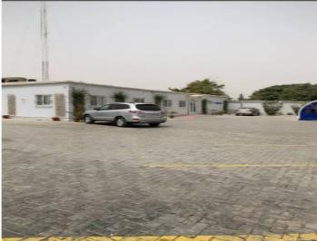
Plate 3.2.1: Showing the backView Of Case Study One EHA Clinic Kano Lamido Crescent
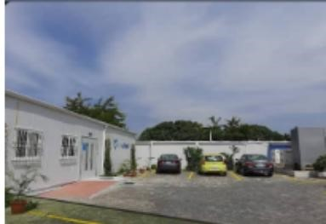
Plate 3.2.2: Showing the sideView Of Case Study One EHA Clinic Kano Lamido Crescent

3.2 CASE STUDYTWO

LOCATION: GENERAL HOSPITAL CENTER ILORIN, KWARA STATE

BRIEIF HISTORY
General Hospital Ilorin is a prominent healthcare institution located in Ilorin, the capital of Kwara State, Nigeria. Established to provide comprehensive medical services to the local community, it has played a vital role in the region's healthcare delivery. Over the years, the Hospital has undergone significant transformations to enhance its services.

MERIT
- It is well zoning and located at the centre of the community in the area
- It is well modernized structure and aesthetically build

DEMERIT
- There offices and spaces are not well defined
- There’s no provision for future expansion
- There is not enough space to carried out other activities
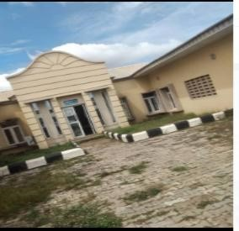
Plate 3.1.1: SideView Showing Of Case Study Two General Hospital Center Ilorin, Kwara

State
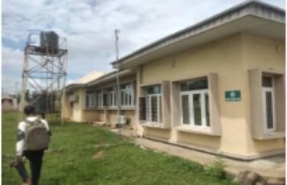

Plate 3.1.2: Showing the frontView Of Case Study Two General Hospital Center Ilorin, Kwara State
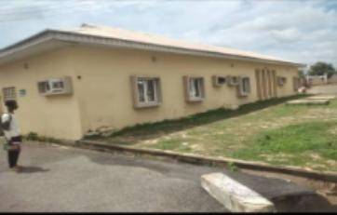
Plate 3.1.1: Showing the sideView Of Case Study Two General Hospital Center Ilorin,

Kwara State

3.3 CASE STUDYTHREE

LOCATION: ANDCHRISTIE DENTAL CLINIC LAGOS
BRIEIF HISTORY

CASE STUDY THREE
Andchristie Dental Clinic, located at 46 Raymond Njoku Street, Ikoyi, Lagos, is one of the oldest dental practices in Lagos, Nigeria. Established over 30 years ago, the clinic has consistently provided comprehensive dental care with a focus on a warm and caring approach to patients. Their team comprises professionals with extensive experience, including specialists in oral surgery, orthodontics, periodontics, pediatric dental health, implant dentistry, and restorative dentistry.
The clinic emphasizes continuous professional development to stay abreast of global dental practices..
MERIT
I. Easy accessibility

DEMERIT
- Poor landscaping
- The building itself is in need of renovation
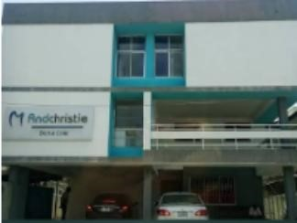
Plate 3.3.1: showing the frontview of case study Three Lautech Teaching Dental Clinic Center Osogbo Osun State

3.4 CASE STUDY FOUR
DROZDOVE & PATRNER DENTAL CLINIC
LOCATED AT UKRINE
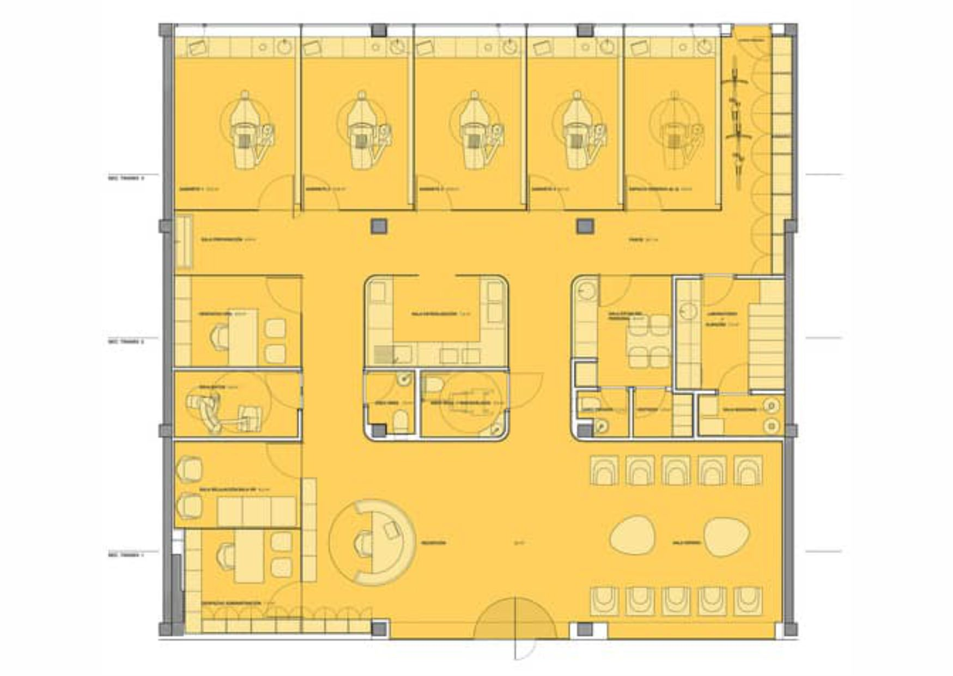
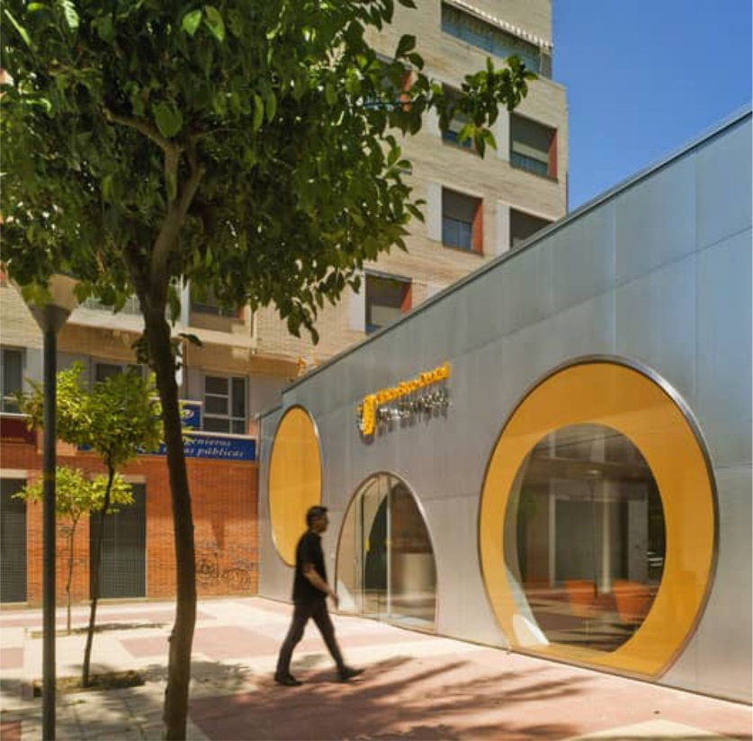
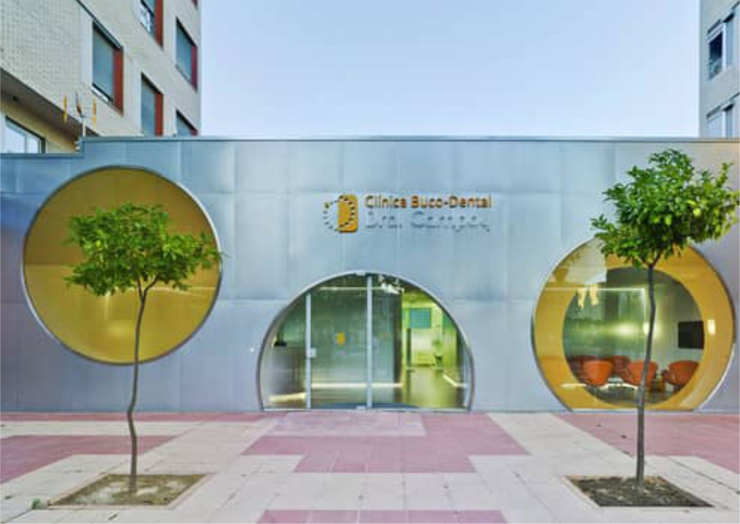

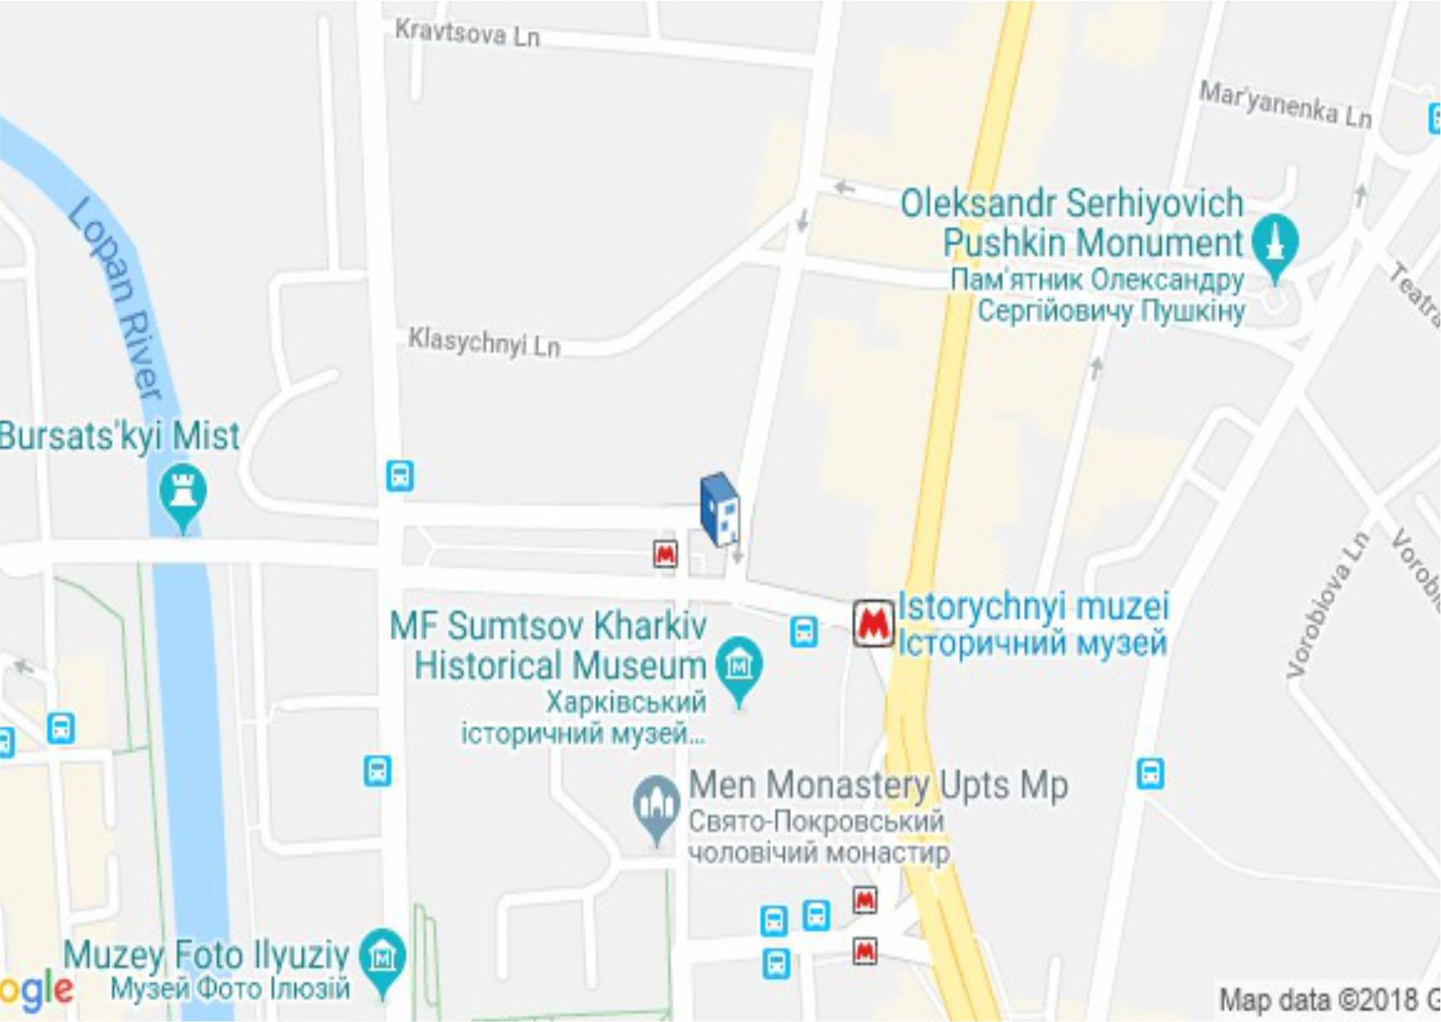

3.5 CASE STUDY FIVE
DRA. CAMPOY DENTAL CLINIC
LOCATED AT SPAIN
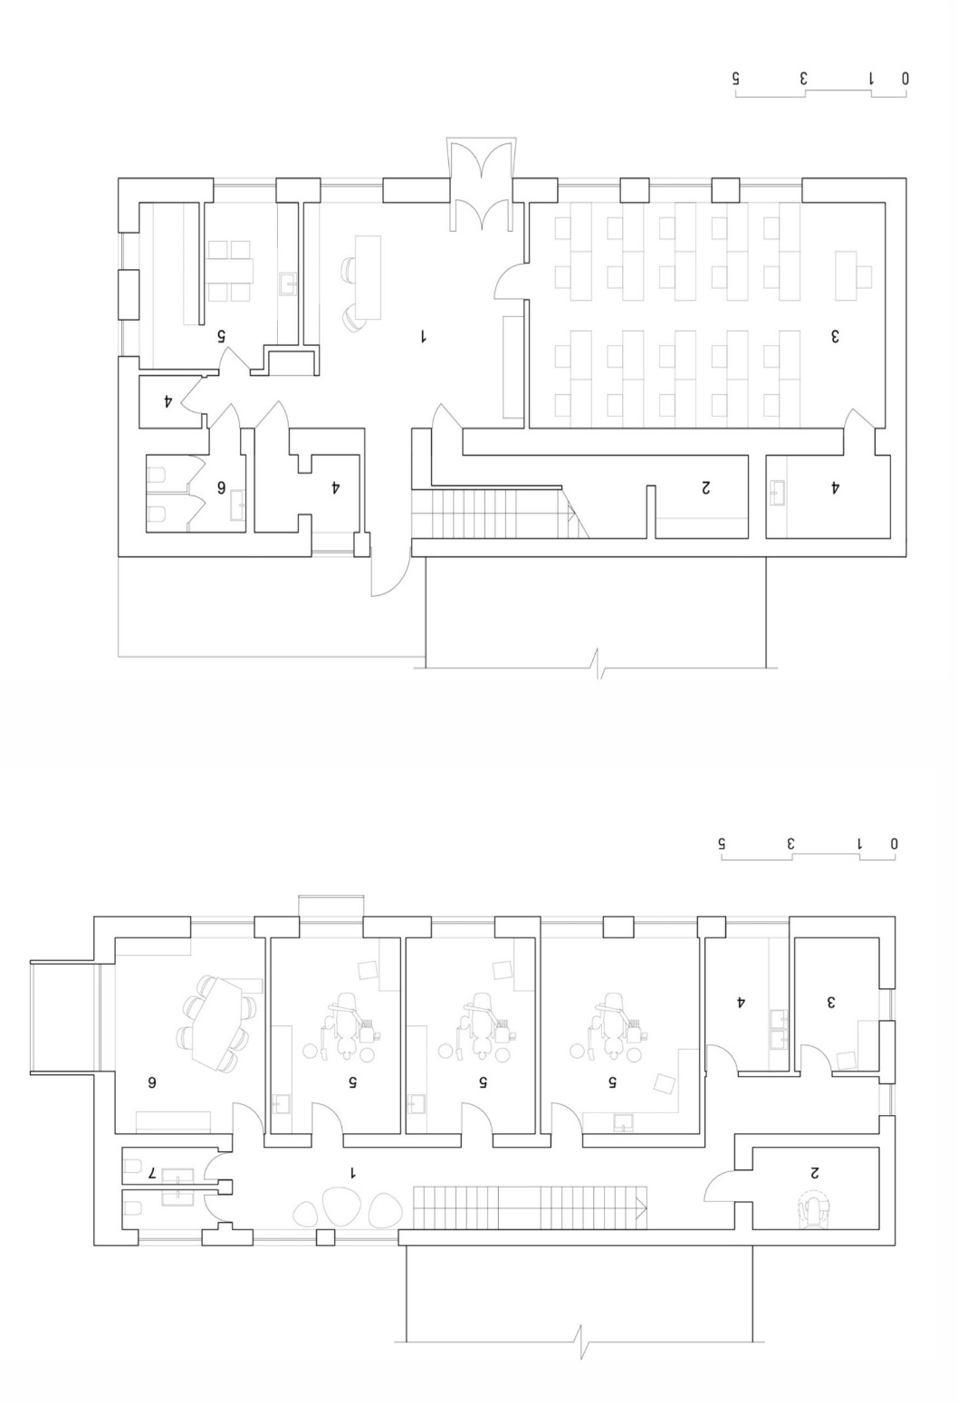
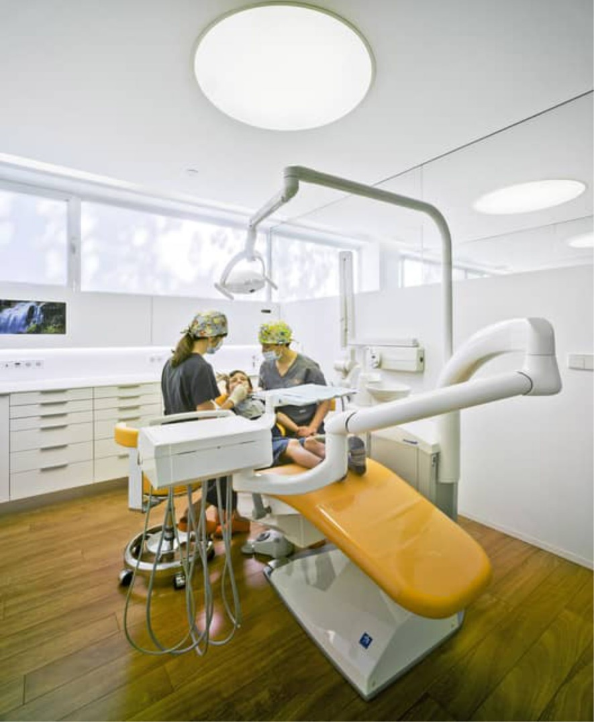



CHAPTER FOUR
SITE ANALYSIS AND INVENTORY
This involves a detailed study of the existing conditions of the site where the project will be built. It includes the size, shape, orientation, boundaries, surroundings, existing structures, access points, vegetation, utilities, and any constraints. This helps in understanding the opportunities and limitations of the site.
GEOGRAPHICAL AND CLIMATIC DATA
This refers to the physical location and climate of the site — such as rainfall, temperature, humidity, and solar exposure. This data is important for sustainable design and determining how the building will perform in that environment.
GEOGRAPHICAL DATA LOCATION
This focuses on the coordinates or address of the project site — such as the town, state, country, and proximity to landmarks. It helps in identifying the regional context of the design.
TOPOGRAPHY
This describes the natural and man-made features of the land surface — including slopes, elevation, drainage patterns, and natural formations. Topography affects how the building is positioned and how water will flow around it.
WIND PATTERN
This section explains the dominant wind directions throughout the year and how it affects ventilation, openings, shading, and building orientation. Good design takes advantage of prevailing winds to enhance comfort.
ENVIRONMENTAL CONSIDERATIONS
This involves analyzing environmental factors like noise, pollution, vegetation, wildlife, flooding, and nearby activities. The goal is to reduce negative impact on the environment and create harmony between the building and nature.
THE AREA FEATURES A MIX OF NATURAL AND DISTURBED VEGETATION
This means that the site includes both untouched vegetation (natural) and areas altered by human activity (disturbed). This informs landscaping decisions and environmental preservation.
ANALYSIS OF THE IMMEDIATE ENVIRONMENTAL CONDITIONS OF THE SITE
This refers to the micro-environment of the site — such as sun exposure, nearby buildings, trees, water bodies, roads, and how they impact the site in terms of shade, noise, traffic, or view.

SCOPE ANALYSIS
This defines the extent and limitations of the project — what will be included or excluded, the area to be covered, and the project’s purpose. It also outlines client expectations and project objectives.
DESIGN APPRAISAL
This is a review of the proposed design — evaluating if it meets the goals, functions, aesthetics, safety, and sustainability of the project. It helps to identify strengths and areas for improvement.
EQUIPMENT, OPERATIONAL AND PERFORMANCE REQUIREMENTS
This section lists tools, machines, and systems needed for the project to function — such as HVAC (cooling), lighting, plumbing, or any machinery if it's a commercial or industrial project. It also covers how the building will perform under real use.
FUNCTIONAL RELATIONSHIPS
This refers to how spaces relate and connect to each other — for example, how the living room connects to the kitchen or how patient rooms relate to the nurse station in a clinic. It ensures the building flows efficiently.
CONCEPTUAL DEVELOPMENT
This is the design idea or theme behind the project. It includes sketches, diagrams, or models showing the main concept — how the design solves the problem or expresses creativity.

CONSTRUCTION METHODOLOGY AND MATERIALS
This explains how the building will be constructed — the step-by-step process, and what materials will be used (e.g., cement, blocks, steel, timber). It also includes sustainability, cost, and availability of materials.
BUILDING SERVICES
These are the systems that make the building functional and comfortable — such as water supply, sewage, electricity, lighting, internet, air conditioning, and security.
CONCLUSION AND RECOMMENDATION
This is the final summary of the entire report. It discusses what has been achieved and makes recommendations on the best way forward — in design, construction, or improvement.
Let me know if you want me to build your full report using these sections one by one. I can help you write it step-by-step based on your project.
Here is a well-structured Site Location Description and Criteria for your project report, tailored for Ganmo, Ifelodun Local Government Area, Kwara State:

SITE LOCATION DESCRIPTION AND CRITERIA
LOCATION:
The project site is situated in Ganmo, a developing town located within Ifelodun Local Government Area of Kwara State, Nigeria. Ganmo lies along the Ilorin–Ajase-Ipo Road, making it easily accessible from the state capital, Ilorin, which is approximately 15–20 minutes away by road.
Geographical Coordinates (approximate):
Latitude: 8.4300° N
Longitude: 4.5900° E
SITE DESCRIPTION:
The proposed site is positioned within a semi-urban environment characterized by a mix of residential, commercial, and institutional developments. The area is gradually urbanizing, with increasing infrastructure such as electricity supply, road network, and access to water. The site is relatively flat with good soil conditions suitable for construction. The vegetation is sparse, consisting of patches of grass and shrubs, with some areas already cleared for development.
CRITERIA FOR SITE SELECTION
ACCESSIBILITY:
The site is easily accessible via a well-tarred major road (Ilorin–Ajase-Ipo Road) which allows for smooth transportation of materials and access for clients, staff, and emergency services.
PROXIMITY TO POPULATION:
Ganmo is a fast-growing community with increasing population density. Its proximity to Ilorin makes it ideal for attracting both urban and peri-urban clients seeking dental care.
TOPOGRAPHY AND DRAINAGE:
The land is relatively flat with slight natural drainage which makes it cost-effective for foundation work and reduces the risk of erosion or flooding.
INFRASTRUCTURE AVAILABILITY:
The area benefits from basic amenities such as electricity, access roads, borehole water, and mobile network coverage, which are essential for the daily operation of a dental clinic.
NOISE AND ENVIRONMENTAL SUITABILITY:
Located away from high-noise commercial hubs, the site provides a calm and serene environment suitable for a healthcare facility, ensuring patients’ comfort and reducing external disturbances.
SAFETY AND SECURITY:
Ganmo is generally known for being a peaceful and secure community, which is crucial for both staff and clients of the proposed clinic.
CHAPTER FIVE
CONSTRUCTION METHODOLOGY AND MATERIALS
The construction methodology for this project is based on standard building practices, tailored to suit the project scale, site conditions, and available resources. The process will follow a systematic and sequential approach to ensure safety, efficiency, and quality control throughout the construction phase.
SITE PREPARATION:
The site will be cleared of vegetation, debris, and any existing structures. This will be followed by grading and leveling to prepare for foundation works.
SETTING OUT:
Accurate setting out using surveying tools will establish the layout of the structure, including the foundations, walls, and key structural elements.

FOUNDATION WORKS:
The type of foundation (e.g., strip, pad, or raft) will be selected based on the site’s soil bearing capacity and the building’s load requirement. Excavation, soil compaction, blinding, and casting of reinforced concrete footings will follow.

SUPERSTRUCTURE CONSTRUCTION:
Reinforced concrete columns and beams will form the structural frame. Blockwork using sandcrete or hollow blocks will be used for walls. Proper alignment, plumb, and reinforcement will be ensured throughout.

ROOFING:
A timber or steel truss system will be installed, depending on the design. Roofing sheets (e.g., aluminium, zinc, or stone-coated) will be fixed, along with ridges, valleys, and rainwater drainage components.

DOORS AND WINDOWS INSTALLATION:
High-quality doors and windows will be installed after the major structure is completed:
Doors: Flush doors, panel doors, or steel security doors will be used based on function and location (e.g., main entrance vs internal).
Windows: Aluminum-framed sliding or louvered windows will be installed, fitted with glass panels and mosquito nets where necessary. All doors and windows will be properly aligned, sealed, and fixed with durable locks and handles.

FINISHING WORKS:
Wall Finishes: Plastering and smoothing of interior and exterior walls, followed by application of emulsion or textured paint.

Floor Finishes: Cement screed base, with tiles or terrazzo finishes for easy maintenance and aesthetics.
Ceiling Finishes: POP, PVC, or fibreboard ceilings will be used depending on the room type and budget.

ELECTRICAL AND PLUMBING INSTALLATIONS:
Concealed electrical wiring with PVC conduits will be laid. Plumbing works will include piping, water closet systems, basins, and shower fittings, with proper drainage connection.

EXTERNAL WORKS:
This includes the creation of access roads, walkways with interlocking tiles, soakaway pits, septic tanks, water tanks, drainage channels, and landscaping.

MATERIALS USED:
- Cement: Ordinary Portland Cement (OPC)
- Sand and Granite: For concrete and mortar mixes
- Blocks: 6" or 9" sandcrete blocks
- Steel Reinforcement: For structural concrete
- Roofing: Timber or steel trusses with aluminium/zinc sheets
- Doors: Wooden panel doors, flush doors, metal security doors
- Windows: Aluminum sliding windows with glass and net
- Paints: Emulsion (internal) and weather-proof (external)
- Flooring: Tiles or terrazzo
- Ceilings: POP, PVC, or gypsum board
- Plumbing & Electrical: Pipes, fittings, switches, sockets
- Miscellaneous: Nails, binding wire, sealants, hinges, handles

CONCLUSION ON DENTAL CLINIC ARCHITECTURAL DESIGN
The architectural design of a dental clinic is pivotal to ensuring a functional, efficient, and patient-friendly environment. A well-designed dental clinic must address multiple factors, including spatial organization, infection control, patient comfort, and operational efficiency. Effective layout planning ensures that treatment areas, waiting rooms, administrative spaces, and sterilization zones are well-integrated for streamlined workflow and patient experience. The incorporation of aesthetic elements, such as soothing colors, natural light, and ergonomic furniture, contributes to reducing patient anxiety, which is particularly important in dental settings where fear and discomfort are common.
Additionally, infection control is paramount in dental clinic design, necessitating the use of nonporous, easy-to-clean materials, efficient sterilization spaces, and effective ventilation systems. As dental practices increasingly adopt advanced technologies, incorporating spaces and infrastructure for modern equipment is crucial for both operational success and patient safety.
Sustainability is also a growing concern, and integrating energy-efficient and water-saving solutions can help create eco-friendly dental clinics. Ultimately, a well-thought-out dental clinic design not only enhances the patient experience but also ensures the smooth running of daily operations while adhering to health and safety regulations.
The research methodology for designing a dental clinic building involves a systematic and multi-faceted approach. By identifying key design requirements, gathering data from stakeholders, analyzing existing clinic designs, and incorporating modern architectural practices, designers can create spaces that are functional, patient-centered, and efficient. The ultimate goal is to create an environment that supports high-quality dental care while ensuring patient comfort, staff productivity, and operational effectiveness

RECOMMENDATIONS ON DENTAL CLINIC ARCHITECTURAL DESIGN
Prioritize Workflow Efficiency: Clinic layouts should ensure a smooth workflow, minimizing unnecessary movement between areas. Treatment rooms, sterilization areas, and staff spaces should be strategically located for optimal efficiency.
Emphasize Patient Comfort: Incorporating calming design elements, such as soft colors, artwork, comfortable furniture, and natural light, can significantly improve patient experience. Waiting areas should be inviting and offer privacy.
Enhance Infection Control: Use non-porous, antimicrobial materials for finishes in treatment and public areas. Separate clean and dirty zones within the clinic, and ensure that sterilization rooms are equipped with modern sterilization technology.
Incorporate Sustainable Design Features: Use energy-efficient lighting, HVAC systems, and water-saving fixtures. Solar panels and rainwater harvesting systems should be considered to reduce the environmental footprint of dental clinics.
Integrate Advanced Technology: Design spaces to accommodate advanced dental equipment, digital records management, and telemedicine. Ensure that the clinic infrastructure supports the latest technologies while maintaining ergonomic designs.
Ensure Accessibility: The clinic should comply with accessibility standards, ensuring that patients with disabilities can access treatment rooms and common areas without barriers.
Adopt Flexibility in Design: Given the evolving nature of dental care, clinic designs should be flexible enough to accommodate future changes in equipment and patient care needs.

4.3 SUMMARY OF DENTAL CLINIC ARCHITECTURAL DESIGN
The architectural design of a dental clinic is multifaceted, involving considerations for functionality, aesthetics, patient comfort, infection control, and sustainability. Key elements include well-organized spaces that facilitate smooth patient and staff movement, along with soothing environments that reduce stress for patients. Infection control is a critical factor, requiring the use of materials that are easy to clean and disinfect, while air and water quality should be carefully managed.
The integration of cutting-edge dental technologies is another essential aspect of modern clinic design, ensuring that spaces are equipped to handle advanced tools and digital systems. Sustainability has also become an important consideration, with many clinics adopting green design features that minimize energy consumption and reduce environmental impact.
Overall, the goal of dental clinic architectural design is to create a space that balances efficiency, safety, comfort, and environmental responsibility, ultimately leading to a positive experience for both patients and dental professionals.
APPENDICES
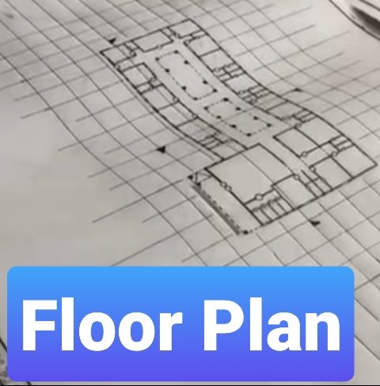

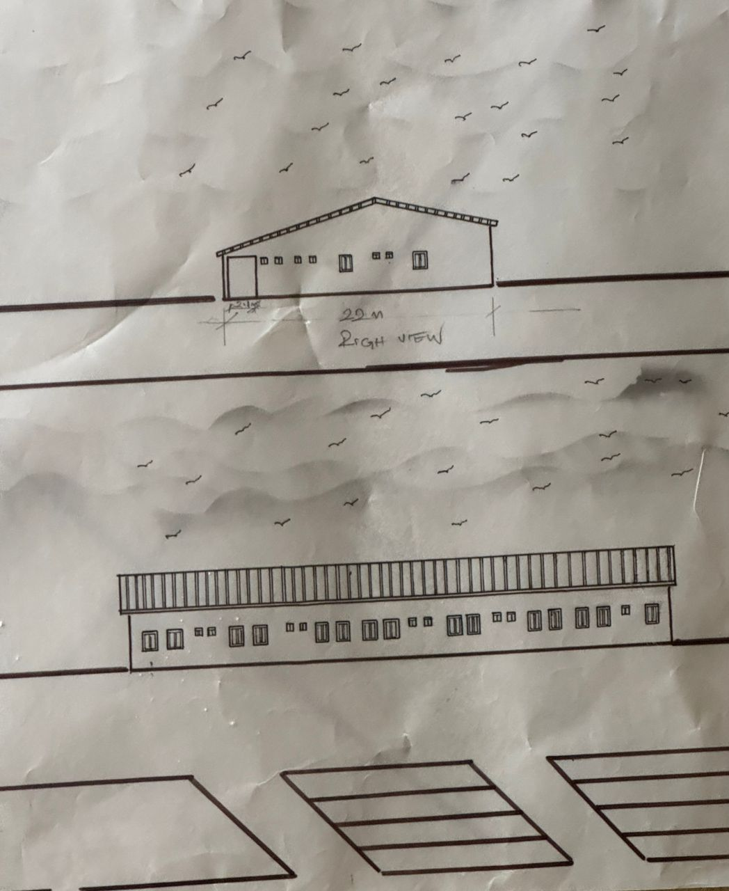

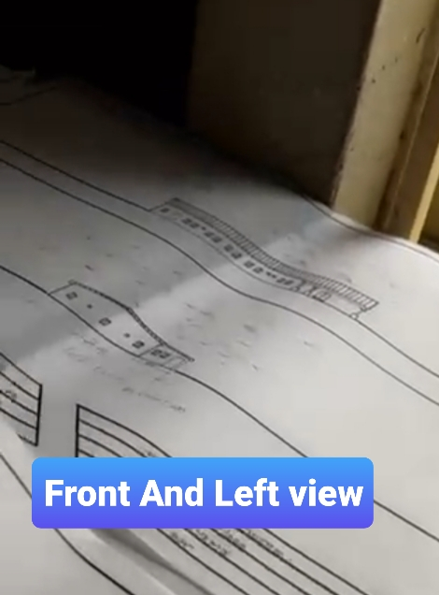

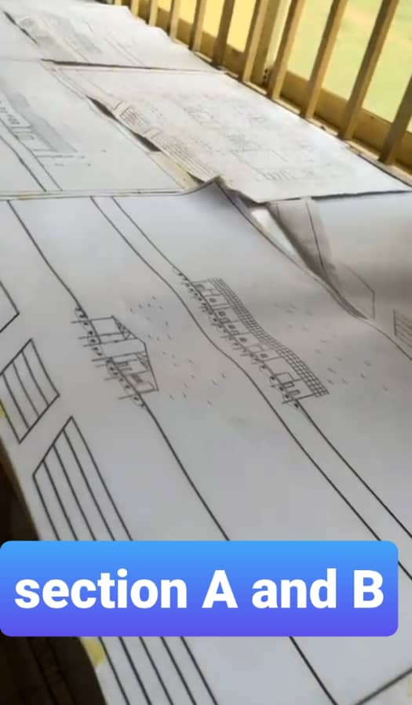
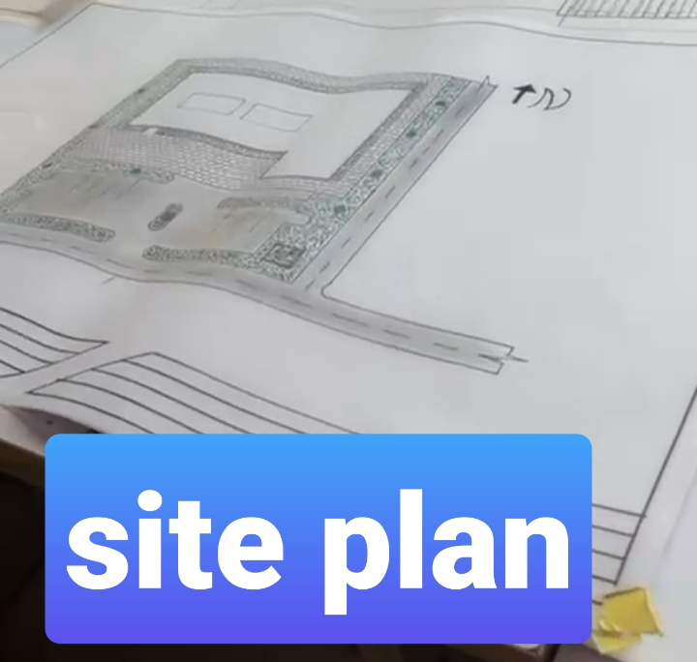

REFERENCES
Simmons, R. (2014). The Impact of Architectural Design on Healthcare Outcomes: Case Studies in Dental Clinics. Journal of Healthcare Design, 10(3), 45-57.
This study examines the relationship between architectural design and healthcare outcomes in dental clinics, exploring how spatial layouts can influence both patient experience and staff efficiency.
Frey, A. (2016). Designing the Ideal Dental Office: Best Practices and Layout Considerations. Healthcare Design, 18(5), 34-39.
This article provides a comprehensive overview of best practices in designing dental clinics, discussing key layout considerations, ergonomics, and patient comfort.
Ulrich, R. (2006). The Role of the Physical Environment in the Dental Clinic Center of the 21st Century: A Once-in-a-Lifetime Opportunity. The Center for Health Design.
Ulrich’s work focuses on how physical spaces influence healthcare outcomes, including the importance of design in reducing stress and enhancing patient satisfaction, which is also applicable to dental clinic environments.
Perry, S., Wills, D., & Wysocki, M. (2019). Dental Office Design: A Guide to Space Planning and Workflow. Wiley.
This book serves as a guide to designing dental offices with a focus on optimizing space planning, workflow, and ensuring a positive experience for both patients and dental staff.
Geisinger, M., Braddock, A., & Larson, K. (2017). Design and Healing: Using Design to Improve Patient Experience. Journal of Health Design, 8(1), 15-30.
This paper examines the psychological impact of design elements on patients' health outcomes, including how dental clinics can incorporate healing and calming environments.
Kincaid, D. (2015). Healthcare Architecture: The Influence of Design on Patient Health and Wellbeing. The American Journal of Health Promotion, 29(4), 267-274.
This article explores how architectural design in healthcare settings, including dental clinics, can contribute to improved patient outcomes and overall wellbeing.
Sundararajan, V., & Gupta, N. (2018). Sustainability in Healthcare Architecture: Challenges and Opportunities in Dental Clinic Design. Journal of Sustainable Design, 4(2), 10-20.
Focuses on sustainable architectural practices and the integration of green technologies in dental clinics to reduce environmental impact while improving operational efficiency.
Fisher, M., & Griffin, L. (2012). Creating the Optimal Dental Office: Space Planning for Patient Comfort and Operational Efficiency. Journal of Dental Practice Management, 23(4), 43-51.
This reference provides insight into the relationship between spatial planning and patient comfort, offering practical tips for dental office design.
Gensler, M. (2015). Designing Healthcare Spaces: A Guide to Creating Effective Healthcare Environments. Gensler Insights.
This book explores the holistic approach to healthcare design, including dental clinics, and highlights strategies for creating functional and aesthetically pleasing environments.
Patterson, J. (2013). Architectural Strategies for Effective Healthcare Design: A Guide for the Design of Dental Clinics. Architectural Review, 56(2), 67-76.
Provides specific architectural strategies tailored to dental clinics, emphasizing patient flow, infection control, and design aesthetics.

