
A PROJECT REPORT
ON
PROPOSED DENTAL CLINIC
FOR
YALA, CROSS RIVER STATE

BY

OGABOR HELEN OMAGU
ND/23/ARC/FT/0015

SUBMITTED TO DEPARTMENT OF ARCHITECTURAL, INSTITUTE OF ENVIRONMENTAL STUDIES (I.E.S), KWARA STATE POLYTECHNIC,
IN PARTIAL FULFILLMENT OF THE REQUIREMENTS FOR THE AWARD OF NATIONAL DIPLOMA (ND) IN ARCHITECTURAL TECHNOLOGY
JULY, 2025

DECLARATION
I, OGABOR HELEN, hereby declare that this project report titled “Design and Development of a Dental Clinic” is a record of original work carried out by me in partial fulfillment of the requirements for the award of a National diploma [ND], in department of Architecture at Kwara state polytechnic, This work has not been submitted, either in whole or in part, for any other degree or professional qualification in this or any other Institution.

OGABOR HELEN OMAGU
ND/23/ARC/FT/0015

_____________________
SIGNATURE & DATE

CERTIFICATION
I certify that this research dissertation entitled Dental Clinic by OGABOR HELEN OMAGU with Matric number ND/23/ARC/FT/0015 has been dully certified as meeting the requirement for the award of National Diploma ND in Architectural Technology, Institute of Environmental Studies (I.E.S), Kwara State Polytechnic, Ilorin, under the supervision of Arc. Olarewaju F. A

______________________ _______________
ARC. ADEYEMI F. A. Signature Date
Project Supervisor

______________________ _________________
ARC. OLAREWAJU F. Signature Date
Project coordinator

______________________ _________________
ARC. MRS. J. M TOMORI Signature Date
Head of Department

______________________ _________________

External examiner Signature Date

DEDICATION
This project is dedicated to God Almighty, the source of all wisdom and strength. To my beloved parents, whose love, support, and encouragement have been my backbone throughout this academic journey.
To all future healthcare architects and professionals, may this work inspire you to create healing environments that promote wellness and dignity for all.

ACKNOWLEDGEMENT
I would like to express my deepest gratitude to Almighty God for His grace, wisdom, and strength throughout the course of this project.
My sincere appreciation goes to my project supervisor, MR. ADEYEMI whose guidance, encouragement, and constructive criticism were invaluable to the successful completion of this work. Your support and expertise were instrumental in shaping the direction and outcome of this project.
My appreciation goes to my Amiable Head Of Department in person of ARC. J. M TOMORI and other academic staffs for their immense contribution toward the success of my program may the Lord Honor and do you all good.
Finally, I acknowledge all individuals who, in one way or another, contributed to the success of this project but whose names may not have been mentioned. Your support is truly appreciated.
Thank you all.

ABSTRACT
This project focuses on the design and development of a modern dental clinic that caters to the oral healthcare needs of the community while ensuring functionality, accessibility, and patient comfort. The study explores the essential spatial requirements, design principles, and healthcare standards necessary for creating an efficient dental facility. The project examines the role of architecture in enhancing the delivery of dental services by integrating hygienic materials, proper ventilation, natural lighting, and efficient circulation patterns. It also highlights the importance of zoning—separating public, semi-public, and private areas—to maintain privacy and promote infection control. Site analysis, case studies, and relevant literature were conducted to understand best practices and the unique challenges of dental clinic design. The proposed clinic includes functional spaces such as waiting areas, reception, consulting rooms, treatment rooms, sterilization zones, laboratories, administrative offices, and staff support areas. This project aims not only to meet technical requirements but also to create a calm and therapeutic environment that reduces patient anxiety and supports staff efficiency. Ultimately, the design seeks to bridge the gap between clinical functionality and architectural aesthetics to provide a welcoming and well-organized dental care facility.

TABLE OF CONTENTS
TITTLE PAGE ………………….………….…………..………………… i
DECLARATION ……...………………….………………..….……………. ii
CERTIFICATION ………………….………….……………….…………….iii
DEDICATION………………….………….……………….………………...iv
ACKNOWLEDGMENT ………………….………….……………….……... v
ABSTRACT………………….………….…………….…………………….vi
TABLE OF CONTENTS ………………….………….……………….……. vii
LIST OF FIGURES………………….………….……………….………….. ix

CHAPTER ONE
1.0 GENERAL OVER VIEW OF DENTAL CARE ----------------------------- 1
1.1 HISTORICAL BACKGROUND OF THE PROJECT ---------------------- 2
1.2 DESIGN PROBLEM OF THE STUDY--------------------------------------- 2
1.3 AIM AND OBJECTIVES ------------------------------------------------------- 3
1.4 JUSTIFICATION OF THE STUDY ------------------------------------------- 3
1.5 CLIENT’S BACKGROUND AND PHILOSOPHY------------------------- 3
1.6 SCOPE OF THE STUDY ------------------------------------------------------- 4
1.7 LIMITATIONS OF THE STUDY --------------------------------------------- 4
1.8 RESEARCH METHODOLOGY----------------------------------------------- 5
1.9 DEFINATION OF TERMS -----------------------------------------------------5

CHAPTER TWO
2.0 LITERATURE REVIEW ------------------------------------------------------- 4
2.1 EVOLUTION OF FASHION ARCHITECTURE --------------------------- 4
2.2 TYPOLOGIES OF FASHION SPACES -------------------------------------- 5
2.3 FUNCTIONAL RELATIONSHIPS IN FASHION SPACES -------------- 5
2.4 TECHNOLOGICAL AND ENVIRONMENTAL CONSIDERATION --- 6
2.5 TECHNOLOGICAL AND ENVIRONMENTAL DESIGN TRENDS --- 6
2.6 REVIEW OF SUBTOPICS RELATED TO THE FASHION HOME ----- 7

CHAPTER THREE
3.0 CASE STUDY ------------------------------------------------------------------- 8
3.1 OUTLINE OF CASE STUDY-------------------------------------------------- 8
3.2 CASE STUDY 1 (THE SMILE HUB DENTAL CLINIC) ----------------- 9
3.3 CASE STUDY TWO (LAGOS STATE UNIVERSITY TEACHING HOSPITAL DENTAL WING) ----------------------------------------------------- 12
3.4 CASE STUDY THREE (MEGA DENTAL CLINIC IBADAN) --------- 15
3.5 ONLINE CASE STUDY ONE (USA) ---------------------------------------- 18
3.6 ONLINE CASE STUDY TWO (LONDON) --------------------------------- 19

CHAPTER FOUR
4.0 STUDY ARE ANALYSIS ------------------------------------------------------ 20
4.1 SITE ANALYSI ------------------------------------------------------------------ 20
4.2 SITE LOCATION AND DESCRIPTION ------------------------------------ 21
4.3 CLIMATIC AND TOPOGRAPHIC ANALYSIS --------------------------- 21
4.4 ENVIRONMENTAL IMPACT AND ZONING ANALYSIS ------------ 22
4.5 SITE INVENTORY ------------------------------------------------------------- 22
4.6 SITE SELECTION CRITERIA ----------------------------------------------- 23

CHAPTER FIVE
5.0 DESIGN PROPOSAL AND DEVELOPMENT ---------------------------- 24
5.1 PROJECT GOALS AND DESIGN BRIEF --------------------------------- 24
5.2 FUNCTIONAL AND SPATIAL CRITERIA ------------------------------- 24
5.3 CONCEPTUAL DESIGN PROCESS --------------------------------------- 25
5.4 ZONING AND SPACE RELATIONSHIP DIAGRAMS ---------------- 26
5.5 SCHEDULE OF ACCOMMODATION ------------------------------------ 26
5.6 TECHNOLOGICAL AND ENVIRONMENTAL CONSIDERATIONS ----- 27
5.7 CONSTRUCTION METHODS AND MATERIALS --------------------- 27
5.8 MECHANICAL AND ELECTRICAL SERVICES ----------------------- 27
5.9 CONCLUSION AND RECOMMENDATION ---------------------------- 28

CHAPTER ONE
INTRODUCTION
1.0 GENERAL EVOLUTION OF DENTAL CARE
Dentistry is one of the oldest branches of medicine, dating back thousands of years. The earliest references to dental practice trace back to ancient Egypt, where primitive tools were used for oral care. Over the centuries, dental practices evolved significantly, driven by the understanding that oral health plays a key role in general human well-being.
The dental profession as we know it today began to take shape in the 18th century with the standardization of procedures and the establishment of dental schools. In Nigeria, oral health services have transitioned from traditional tooth-pulling practices to more formal, regulated dental institutions. With increasing population and awareness, the demand for quality dental care has grown, thus giving rise to the need for properly designed dental clinics.
Unlike general medical clinics, dental facilities require highly specialized layouts and infection control measures. The architectural design of a dental clinic must address several technical and operational factors to ensure hygienic conditions, patient comfort, and smooth workflow. Therefore, an effective dental clinic must be planned to integrate patient reception, diagnostic functions, treatment rooms, sterilization areas, administrative support, and waiting spaces within a controlled hygienic environment.
This project aims to design a Proposed Dental Clinic that not only satisfies the technical requirements of a dental health center but also addresses psychological comfort, spatial clarity, and functionality. The development of such a clinic shall serve as a vital contribution to the improvement of oral healthcare delivery in the community.

1.1 HISTORICAL BACKGROUND OF THE PROJECT
The history of dental clinic development is closely linked with advancements in medical science. From the Middle Ages, where dental extractions were done by barbers, to the modern day of digital diagnostics and laser procedures, dental care has become an integral aspect of health services globally.
In Nigeria, dental care has often been under-prioritized, with most dental units found in tertiary hospitals or as extensions within general clinics. The idea of purpose-built dental facilities is still relatively recent in many parts of the country. These limitations have led to insufficient access, long waiting times, and poor service delivery, especially in semi-urban and rural areas.
The architectural design of dental clinics must consider technological installations, patient safety, staff workflow, and infection control. The need for dedicated dental facilities has become increasingly necessary in light of rising population figures and increased public awareness of dental hygiene.
This project seeks to bridge the gap in dental infrastructure by designing a functional, hygienic, and patient-friendly clinic that reflects both modern technology and local environmental adaptability.

1.2 DESIGN PROBLEMS OF THE STUDY
The planning and architectural design of a dental clinic present several challenges that must be solved to achieve efficiency and user satisfaction. Some of the design problems identified in this project include:
• Zoning Problems: A major issue in most clinics is poor zoning which leads to cross-contamination between sterile and non-sterile areas.
• Infection Control: Many existing dental units are unable to meet basic sterilization and hygiene standards due to poor design.
• Insufficient Spatial Provision: Dental clinics often lack adequate space for waiting areas, staff support rooms, and diagnostic areas.
• Poor Lighting and Ventilation: Dental procedures require good lighting, both artificial and natural, to ensure accuracy. Poor lighting and lack of cross-ventilation create discomfort for both patients and staff.
• Patient Circulation: Confusion in circulation patterns and the lack of directional flow results in bottlenecks and affects workflow.
• Accessibility Challenges: Many buildings are not designed with provisions for people living with disabilities.
• Psychological Anxiety: The environment in many dental clinics contributes to dental anxiety, especially in children.
These design problems were carefully studied, and suitable architectural solutions were proposed to address them within this project.

1.3 AIM AND OBJECTIVES
AIM OF THE PROJECT
To design a standard and functional dental clinic that meets the needs of both patients and healthcare professionals by addressing hygienic, spatial, ergonomic, and psychological factors.
OBJECTIVES
• To provide a well-zoned layout that separates sterile and non-sterile areas.
• To integrate infection control mechanisms through design features and material selection.
• To create a workflow-efficient design that reduces movement clashes between patients and staff.
• To make the clinic accessible to all categories of patients including those with physical challenges.
• To design with aesthetics in mind so as to provide a calm and welcoming environment that reduces patient anxiety.
• To incorporate essential spaces like treatment rooms, diagnostic areas, sterilization rooms, staff areas, and reception halls in a logical manner.

1.4 JUSTIFICATION FOR THE PROJECT
A well-designed dental clinic enhances the quality of oral health services, increases patient turnout, and provides better working conditions for staff. Most of the existing dental units in the country are attached to general hospitals and lack the necessary infrastructure, comfort, and environment needed for modern-day practice.
The justification for this project is to:
• Respond to the growing demand for specialized healthcare infrastructure.
• Provide a clean and safe environment that conforms to World Health Organization (WHO) standards.
• Improve oral health outcomes through architectural innovations that encourage regular visits.
• Enhance staff performance and reduce work fatigue through efficient space usage and comfort-enhancing features.
This project will serve as a model for future dental healthcare infrastructure development.
1.5 CLIENT BACKGROUND
The client is a certified dental practitioner who has over a decade of professional experience in public and private oral healthcare delivery. The client desires a modern, fully equipped dental clinic capable of handling preventive, diagnostic, surgical, and emergency dental procedures. The site chosen is within a growing urban settlement, lacking an independent dental facility, which makes the project highly viable and relevant.

1.6 SCOPE OF THE STUDY
The scope of this architectural project includes the design of the following spaces and functions within the dental clinic:
• Reception Area
• Waiting Area
• Consulting Room
• Operatory / Treatment Rooms
• Sterilization and Clean Utility Room
• X-ray / Radiology Room
• Pharmacy / Drug Store
• Laboratory
• Record / Filing Room
• Admin Office
• Staff Lounge / Rest Area
• Toilets (Staff and Patients)
• Equipment / Utility Room
• Car Park
• Security Post

1.7 LIMITATIONS OF THE STUDY
While preparing this project, the following limitations were encountered:
• Inadequate Access to Data: Many dental clinics were not accessible for detailed case studies due to privacy and time constraints.
• Time Factor: The academic schedule did not allow for extensive fieldwork or multi-state clinic studies.
• Financial Constraints: Lack of funds limited the scope of physical model construction and site acquisition research.
• Inconsistent Standardization: In Nigeria, many dental clinics operate without standardized architectural layouts, making it hard to benchmark effectively.
Despite these limitations, adequate information was obtained from books, site visits, interviews, and online sources to develop a realistic proposal.

1.8 RESEARCH METHODOLOGY
The research methodology adopted in this study includes:
1. Literature Review: Relevant textbooks, journals, WHO standards, and Nigerian healthcare building codes were reviewed to understand the functional and spatial needs of a dental clinic.
2. Case Studies: Selected dental clinics in both government and private sectors were analyzed with regard to spatial zoning, workflow, and patient experience.
3. Site Visits: On-site observations were carried out in general clinics and standalone dental facilities to understand circulation patterns and environmental responses.
4. Expert Interviews: Interviews with practicing dentists and dental nurses were conducted to understand expectations and challenges.
5. Conceptual Sketching and Modeling: Drawings and design development techniques were used to translate data into architectural solutions.

1.9 DEFINITION OF TERMS
• Dental Clinic: A medical facility dedicated to the treatment, diagnosis, and prevention of oral and dental diseases.
• Operatory Room: A specialized space where dental treatment procedures are carried out.
• Sterilization Unit: Area designated for cleaning, disinfecting, and storing dental tools.
• X-ray Room: A room used for dental radiographs to aid diagnosis and treatment planning.
• Reception: The front-end service point for patient intake and inquiries.
• Accessibility: The ease with which persons with disabilities can enter, navigate, and use the facility.
• Zoning: Arrangement of spaces into categories such as public, semi-public, and private, for safety and functionality.
• Hygiene: Conditions or practices conducive to maintaining health and preventing disease, especially through cleanliness.

CHAPTER TWO
LITERATURE REVIEW
2.0 INTRODUCTION
The design of healthcare facilities, especially dental clinics, has evolved significantly in response to technological advancements, changing medical practices, and growing patient expectations. Dental architecture must meet strict hygiene standards, accommodate complex equipment, and simultaneously create an environment that reduces anxiety and supports efficient workflow. This chapter explores scholarly literature, design guidelines, case studies, and architectural principles relevant to dental clinics. The objective is to derive architectural knowledge that informs the design of an efficient and modern dental facility suited for the Nigerian context.

2.1 DEFINITION OF A DENTAL CLINIC
A dental clinic is a medical facility that provides dental services such as examinations, diagnoses, prevention, and treatment of diseases, disorders, and conditions of the oral cavity. It typically includes consultation spaces, treatment (operatory) rooms, sterilization zones, imaging areas, waiting zones, and staff facilities. According to the World Health Organization (WHO), a dental facility must meet minimum spatial, operational, and hygienic standards to be considered safe and functional.

2.2 DENTAL CLINIC BUILDING TYPOLOGY
A dental clinic typology refers to the classification and arrangement of spatial elements necessary for oral healthcare delivery. Clinics may vary in scale, but they share basic architectural components. These include:
• Reception and waiting area
• Operatory rooms (minimum 2)
• Consultation office
• X-ray/imaging unit
• Sterilization/utility zone
• Pharmacy/storage
• Toilets and staff rooms
Design must consider functional flow, ease of sterilization, and spatial adjacency between patient and clinical zones. Dental clinics can be stand-alone structures or integrated into general healthcare facilities.

2.3 EVOLUTION OF DENTAL CLINIC DESIGN
Historically, dental procedures were conducted in home-based spaces or shared with general physicians. However, the late 20th century witnessed a shift to purpose-built dental clinics due to infection control needs and the advancement of dental tools. The evolution follows:
• Early Period: Informal and shared spaces with limited sanitation.
• Mid-20th Century: Introduction of sterile spaces and operatory rooms.
• Modern Era: Integration of ergonomic furniture, modular planning, digital diagnostics, and patient-centric interiors.
This evolution emphasizes a shift from procedural to preventive care and from purely clinical to holistic patient experience environments.
2.4 IMPORTANT DESIGN ISSUES IN DENTAL CLINICS
Several design issues are peculiar to dental clinics:
2.4.1 Infection Control
Dental clinics must follow aseptic techniques. Architectural materials should be non-porous, easy to clean, and durable. Operatory rooms should allow physical separation from public zones, and sterilization areas must be accessible yet isolated.
2.4.2 Privacy and Noise Control
Unlike general medical clinics, dental treatment can induce anxiety. Hence, soundproofing, patient privacy, and spatial separation are critical. Operatory rooms should be enclosed or semi-enclosed with acoustic insulation.
2.4.3 Accessibility
Facilities must cater to the elderly, children, and persons with disabilities. This requires ramps, wide doorways, and accessible toilets as per global health facility guidelines (e.g., ADA).
2.4.4 Space Zoning
Zoning divides the clinic into public, semi-public, and restricted/clinical zones to control movement and contamination risk.

2.5 CLASSIFICATION OF DENTAL CLINIC TYPES
Dental clinics are classified based on:
• Ownership: Public, Private, NGO-run
• Function: General, Specialized (Orthodontics, Endodontics, Pediatric, etc.)
• Scale: Single-chair, Multi-chair, Polyclinic
Each classification influences the architectural approach and services provided. A general two-chair clinic may need less space and technology integration than a 5-chair orthodontic unit.

2.6 FUNCTIONAL SPACES AND THEIR RELATIONSHIPS
Dental clinics rely on logical spatial relationships between zones:
• Reception → Waiting → Consultation
• Consultation → Treatment → Imaging → Sterilization
• Post-treatment → Records/Pharmacy → Exit
Designing for this flow ensures operational efficiency, reduces patient stress, and enhances cleanliness.

2.7 ARCHITECTURAL SOLUTIONS TO DESIGN CHALLENGES
• Sterilization Rooms: Must be air-controlled with access to both treatment and disposal zones.
• Waiting Areas: Should include calming colors, soft furniture, and daylight access.
• Circulation: Clear separation of patient and staff movement helps maintain control.
• Ergonomics: Adjustable chairs, wall-mounted tools, and foot-controlled sinks support staff efficiency.

2.8 TECHNOLOGICAL AND ENVIRONMENTAL APPROACHES
2.8.1 Equipment Planning
Dental chairs, X-ray machines, and autoclaves must be pre-planned for in terms of spatial dimension, plumbing, electricity, and ventilation.
2.8.2 Lighting
Natural lighting reduces energy use and promotes psychological comfort. However, dental procedures require focused artificial lighting. Lighting should be 300–500 lux in reception areas and 10,000+ lux in treatment rooms.
2.8.3 Ventilation
Mechanical ventilation is critical in treatment zones to manage aerosols. Cross ventilation is ideal in waiting and support areas to improve air quality.

2.8.4 Energy and Sustainability
Use of solar panels, rainwater collection, and passive cooling designs support environmental responsibility. Low-VOC paints and LED lighting improve indoor air quality.

2.9 REGULATIONS AND STANDARDS
Regulatory compliance ensures safety and operational legitimacy. Relevant guidelines include:
- WHO Guidelines on Safe Dental Practice
• Nigerian Building Code (NBC)
• Health Facility Guidelines (Australia, UK, USA)
• Local Development Authority Zoning Laws
These standards affect layout planning, emergency exits, materials, and safety equipment placement.

2.10 AESTHETICS AND PATIENT EXPERIENCE
Studies show that spatial aesthetics greatly affect patient comfort. According to Lee and Kim (2020), the use of nature-inspired color palettes, calm music, and clean, uncluttered designs reduces dental anxiety.

2.11 CONCLUSION
The design of dental clinics must integrate clinical efficiency with psychological comfort, hygiene, and adaptability. Through proper zoning, thoughtful spatial planning, and adherence to regulatory standards, an effective and patient-friendly environment can be created. This literature review highlights how architecture, when applied with sensitivity and technical precision, contributes immensely to the improvement of oral healthcare delivery.

CHAPTER THREE
CASE STUDIES
3.0 INTRODUCTION
A case study is a detailed, in-depth analysis of a specific building, project, or system to understand its strengths, weaknesses, and overall effectiveness. In architecture, case studies allow the designer to investigate how space, form, material, technology, and functionality are applied in existing buildings. This process helps to identify and adapt best practices while avoiding known design flaws.
In this chapter, three physical case studies and two online case studies of dental and healthcare facilities were examined. Focus areas included spatial organization, circulation flow, hygienic zoning, aesthetics, ventilation, lighting, equipment planning, accessibility, and patient experience.

3.2 OUTLINE OF CASE STUDIES
- THE SMILE HUB DENTAL CLINIC, Wuse II, Abuja, Nigeria
- LAGOS STATE UNIVERSITY TEACHING HOSPITAL DENTAL WING. Ikeja, Lagos State
- MEGACARE DENTAL CLINIC, Ibadan, Oyo State
- ONLINE CASE STUDY IN USA
- CASE STUDY IN LONDON

3.1 CASE STUDY ONE
NAME: The Smile Hub Dental Clinic
LOCATION: Wuse II, Abuja, Nigeria

The Smile Hub is a private dental clinic located in the central business district of Abuja. It serves as a modern dental facility that offers a wide range of oral healthcare services including preventive dentistry, orthodontics, cosmetic procedures, and oral surgery.
Functional Areas Include:
• Reception/Waiting Area
• Three Operatory Rooms
• X-ray and Imaging Unit
• Sterilization Room
• Consultation Room
• Admin Office
• Staff Lounge and Restroom
3.1.2 Merits
• Efficient functional zoning: clear separation of public and sterile zones.
• Calming interior design with use of pastel colors and natural lighting.
• Adequate signage for patient navigation.
• Compact but functional layout.
• Centralized sterilization unit with pass-through access.
3.1.3 Demerits
• Limited parking space.
• Over-reliance on artificial ventilation.
• Small staff lounge.

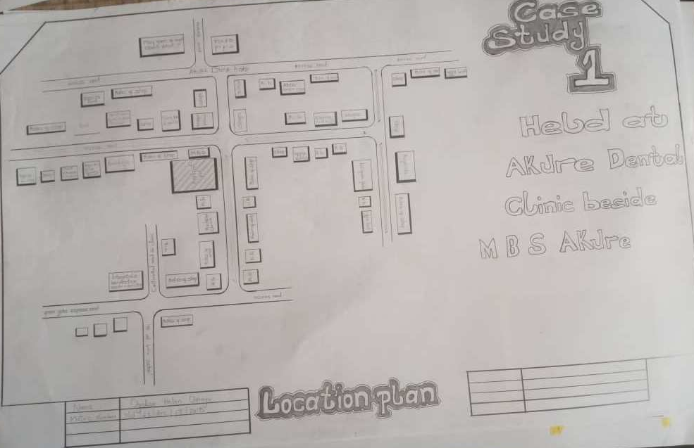
Figure 1: Location Plan, Case study 1

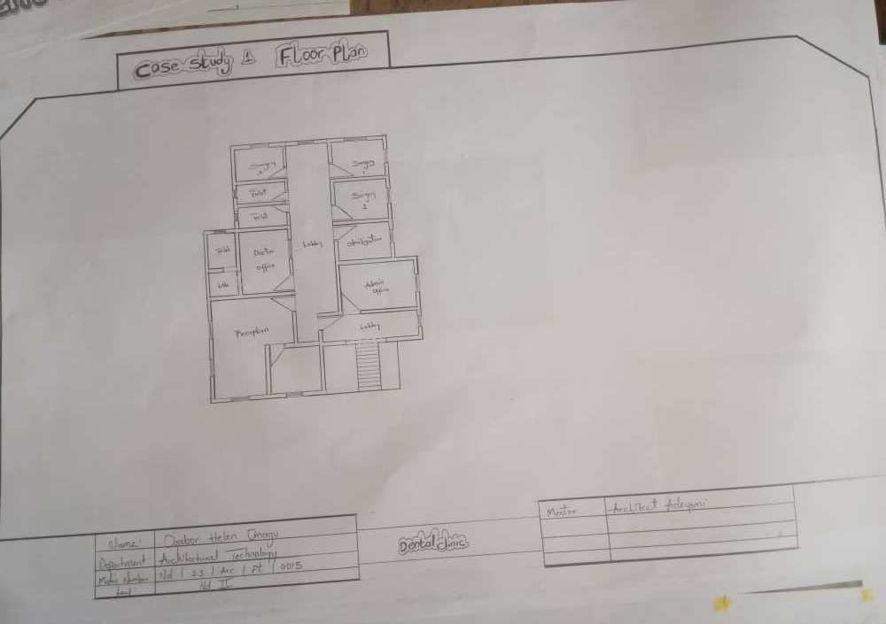
Figure 2: Floor Plan, Case Study One

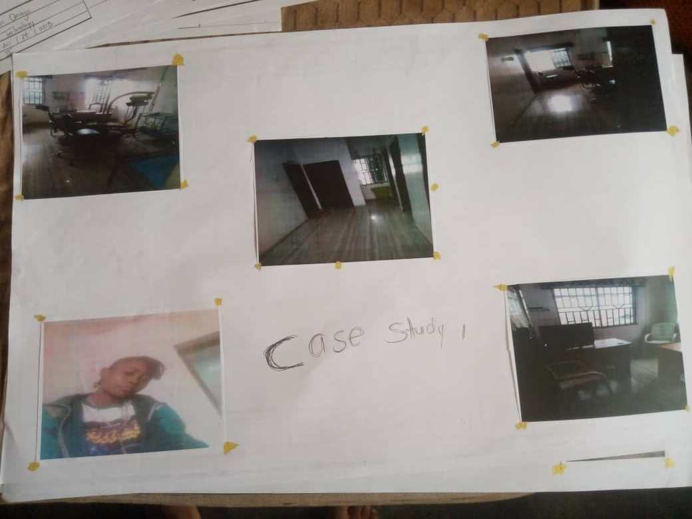
Figure 3: Case Study 1

3.2 CASE STUDY TWO
NAME: Lagos State University Teaching Hospital Dental Wing
LOCATION: Ikeja, Lagos State

The LASUTH dental facility is part of the main teaching hospital but has a semi-detached layout. It handles complex dental cases, referrals, and dental education. The clinic is operated by consultants and student interns.
Functional Areas Include:
• Patient Registration/Waiting Area
• Six Operatory Rooms
• Oral Surgery Theatre
• Radiology/X-ray Unit
• Sterilization and Cleaning Zone
• Student Observation Gallery
• Laboratory and Pharmacy
3.2.2 Merits
• Ample space for operations and teaching.
• Separate entry and exit paths reduce congestion.
• Natural ventilation in most treatment zones.
• Dedicated space for radiology and imaging.
3.2.3 Demerits
• Outdated interior fittings.
• Lack of disability access features.
• High patient traffic affects waiting time.

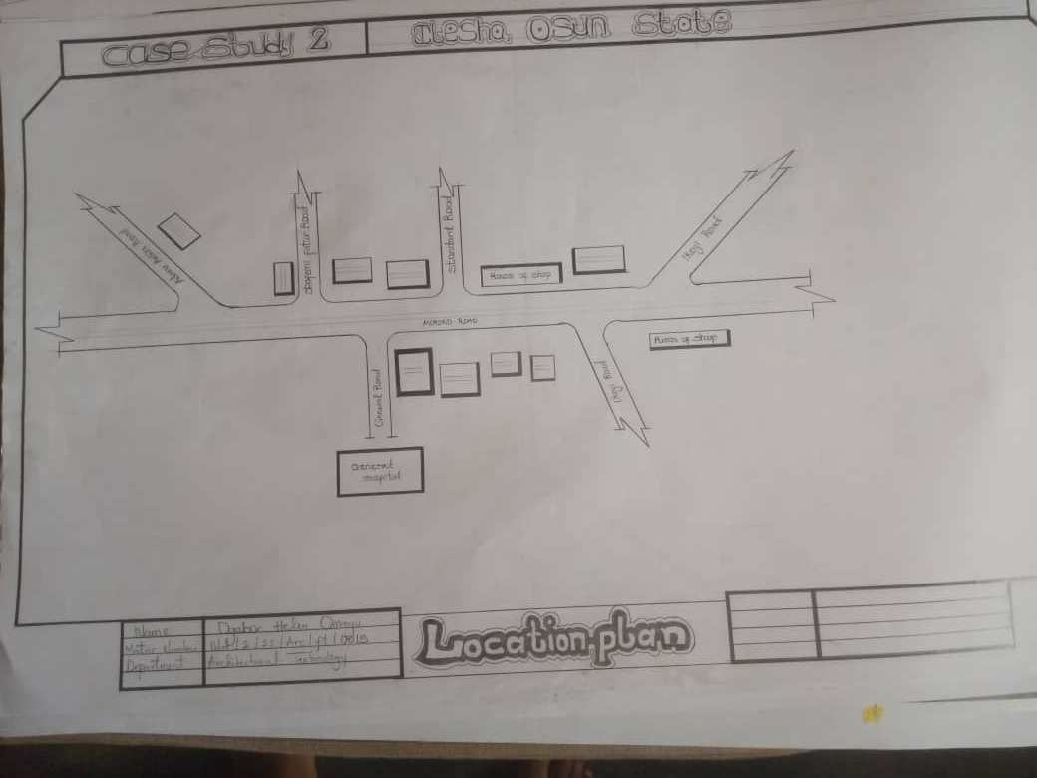
Figure 4: Location Plan for Case study 2

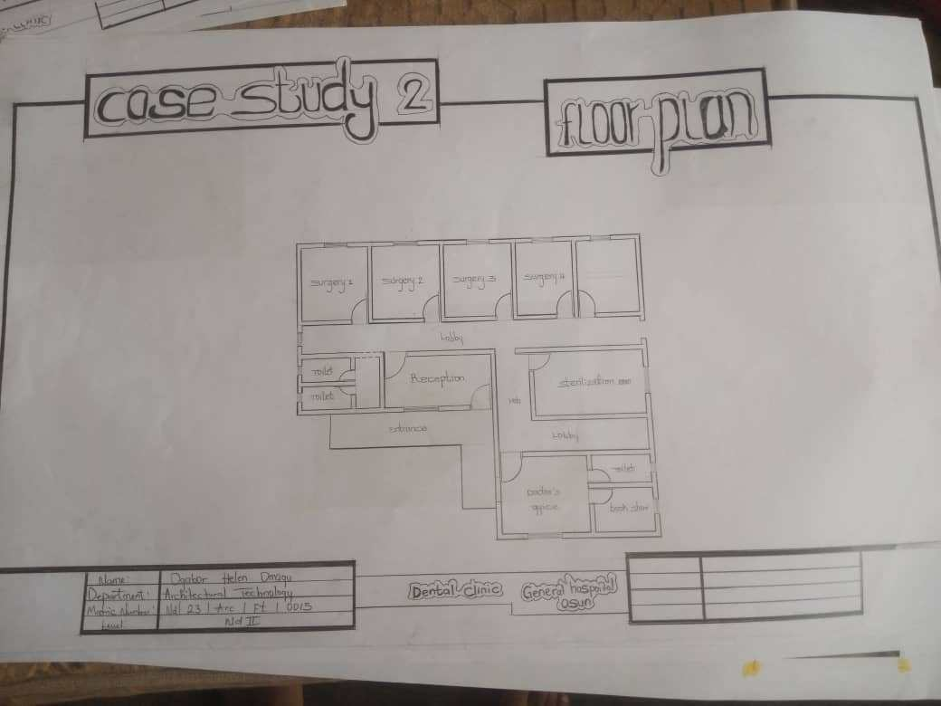
Figure 5: Floor Plan, Case Study 2

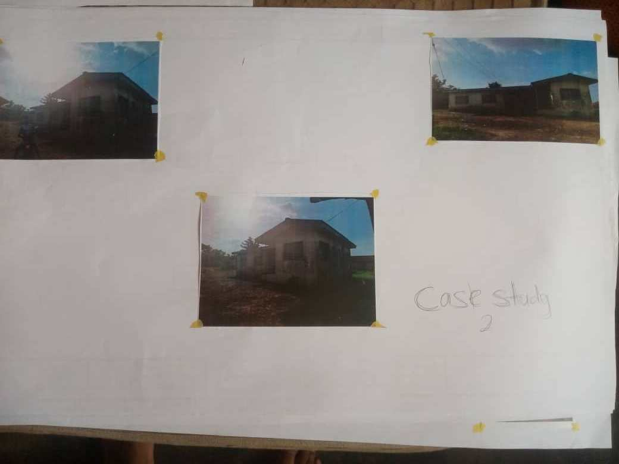
Figure 6: Case Study 2

3.3 CASE STUDY THREE
NAME: Megacare Dental Clinic
LOCATION: Ibadan, Oyo State
3.3.1 Description
Megacare is a private practice housed in a converted residential bungalow. It has a small but well-equipped dental unit providing general dental services.
Functional Areas Include:
• Reception
• Two Operatory Rooms
• X-ray Room
• Laboratory
• Pharmacy
• Toilets
• Consultation Room
3.3.2 Merits
• Home-like aesthetics reduce dental anxiety.
• Easy staff-patient interaction due to scale.
• Efficient use of small space.
3.3.3 Demerits
• Poor spatial expansion potential.
• Limited ventilation in enclosed rooms.
• No dedicated sterilization corridor.

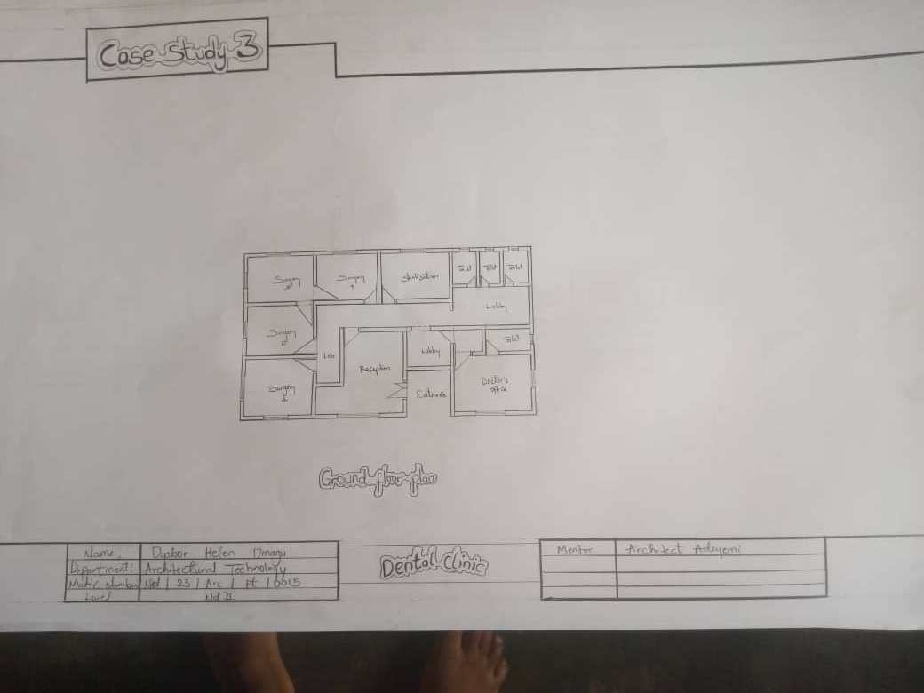
Figure 8: Floor Plan Case study 3

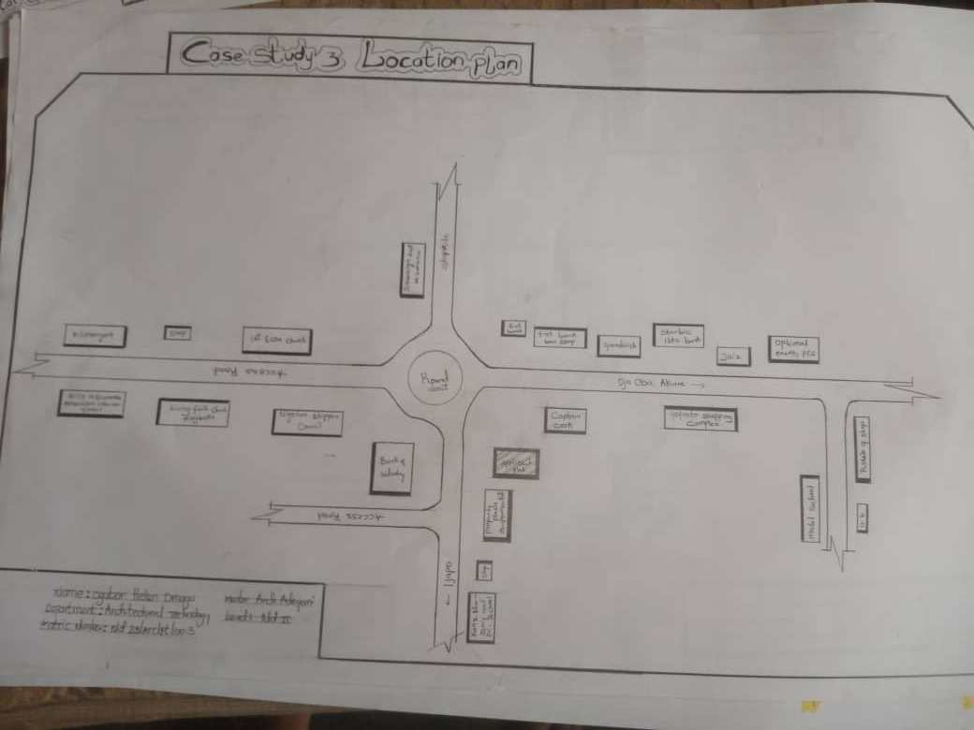
Figure 7: Location Plan, Case study 3

3.4 ONLINE CASE STUDY ONE
NAME: Henry Schein Dental Office (USA)
SOURCE: henryschein.com
This model office is designed to showcase ergonomic and workflow efficiency in private dental practice. It features modular operatory units, optimized storage, digital imaging suite, and universal design standards.
Key Learnings:
• Modular furniture improves maintenance and replacement.
• Anti-microbial flooring and wall surfaces reduce contamination.
• Curved partitions enhance patient flow and comfort.
Figure 9: Online Case Study One

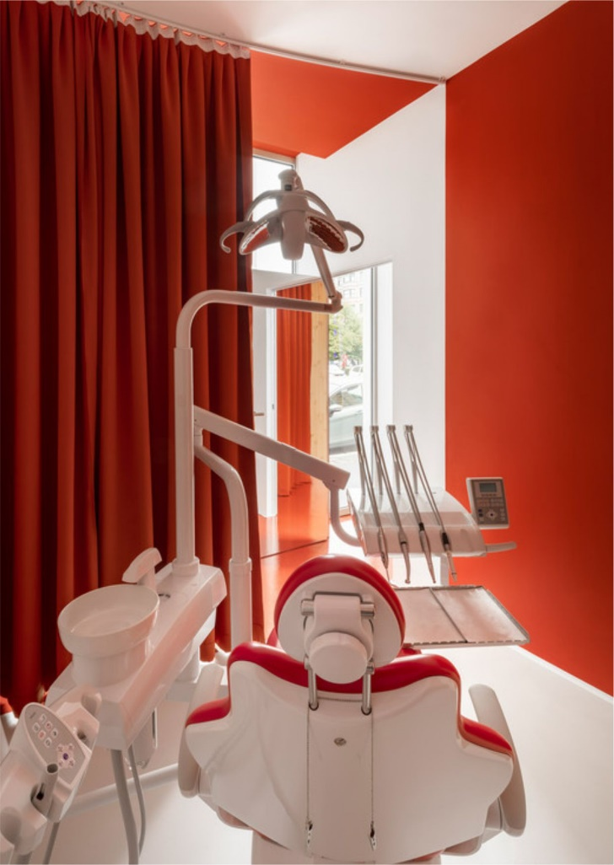
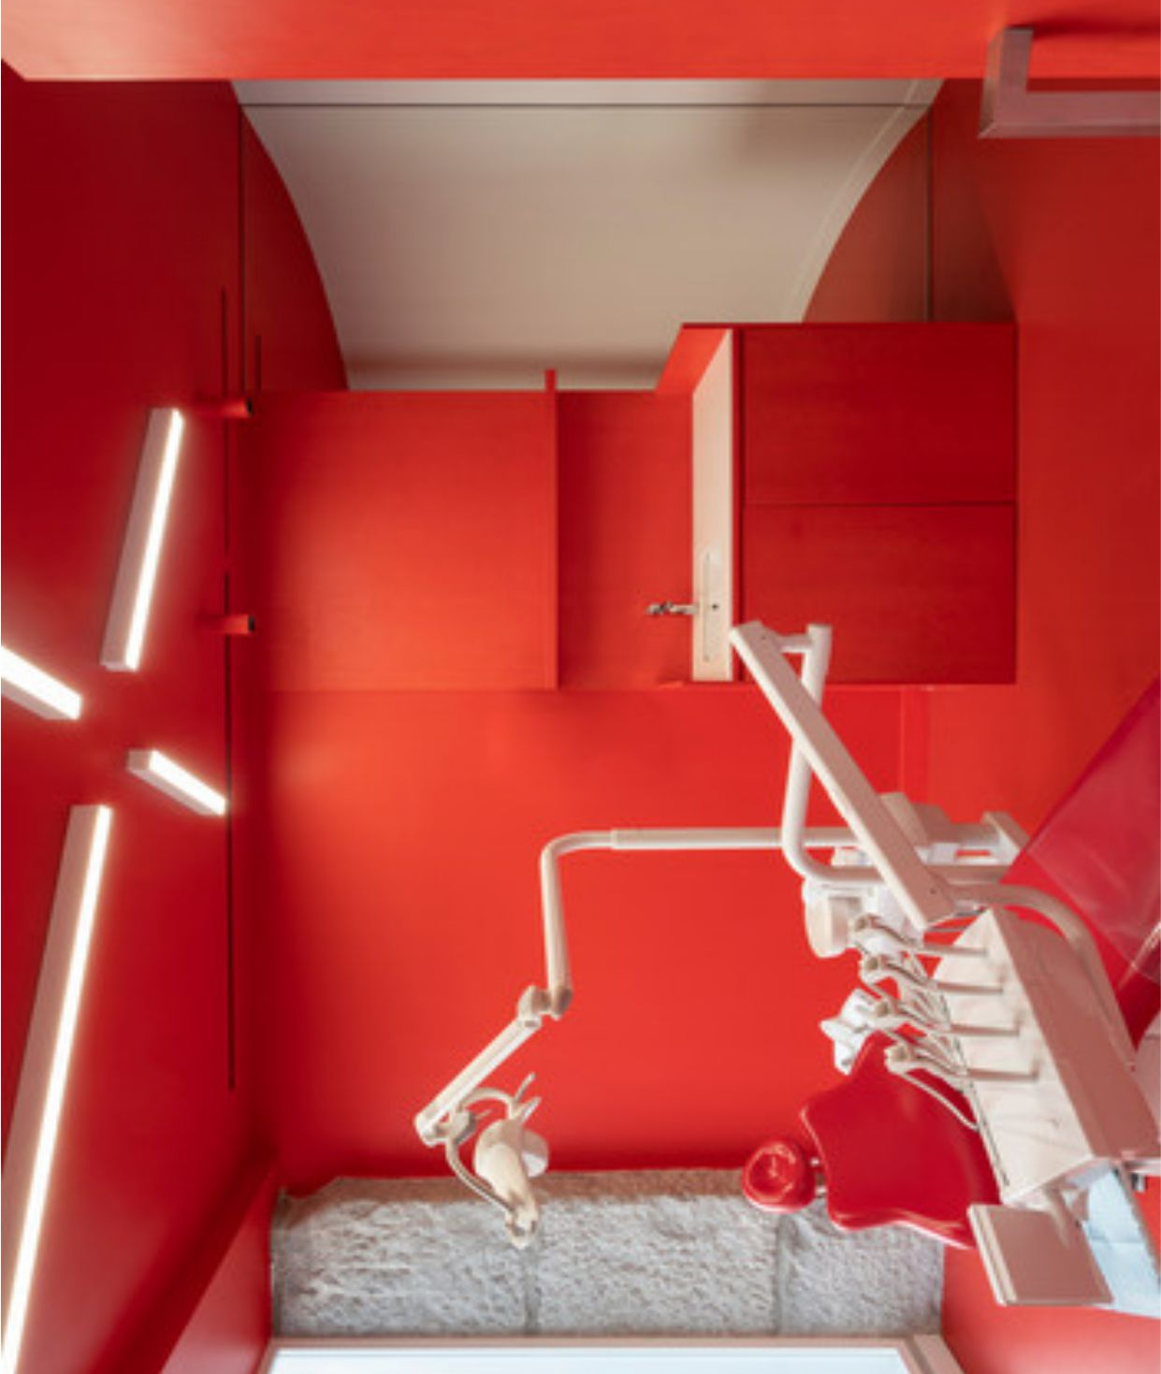

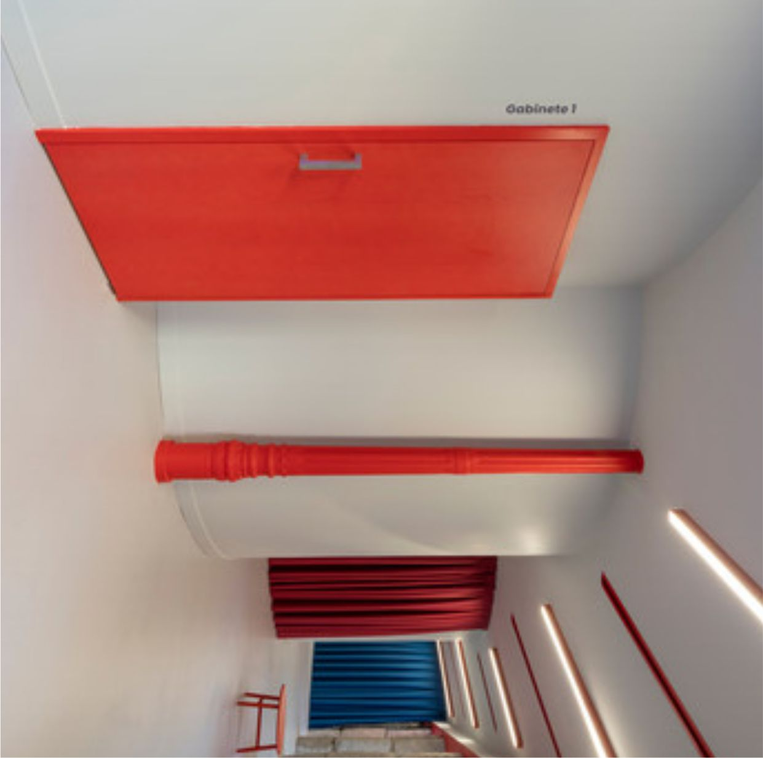

3.5 ONLINE CASE STUDY TWO
NAME: King’s College London Dental Institute
SOURCE: kcl.ac.uk
A state-of-the-art teaching and dental care center in London, UK. It combines advanced research with patient care and student training.
Key Learnings:
• Dedicated research-dental integration design.
• High-tech digital diagnostics and simulation labs.
• Color-coded zones improve movement and workflow efficiency.
Figure 10: Online Case study two
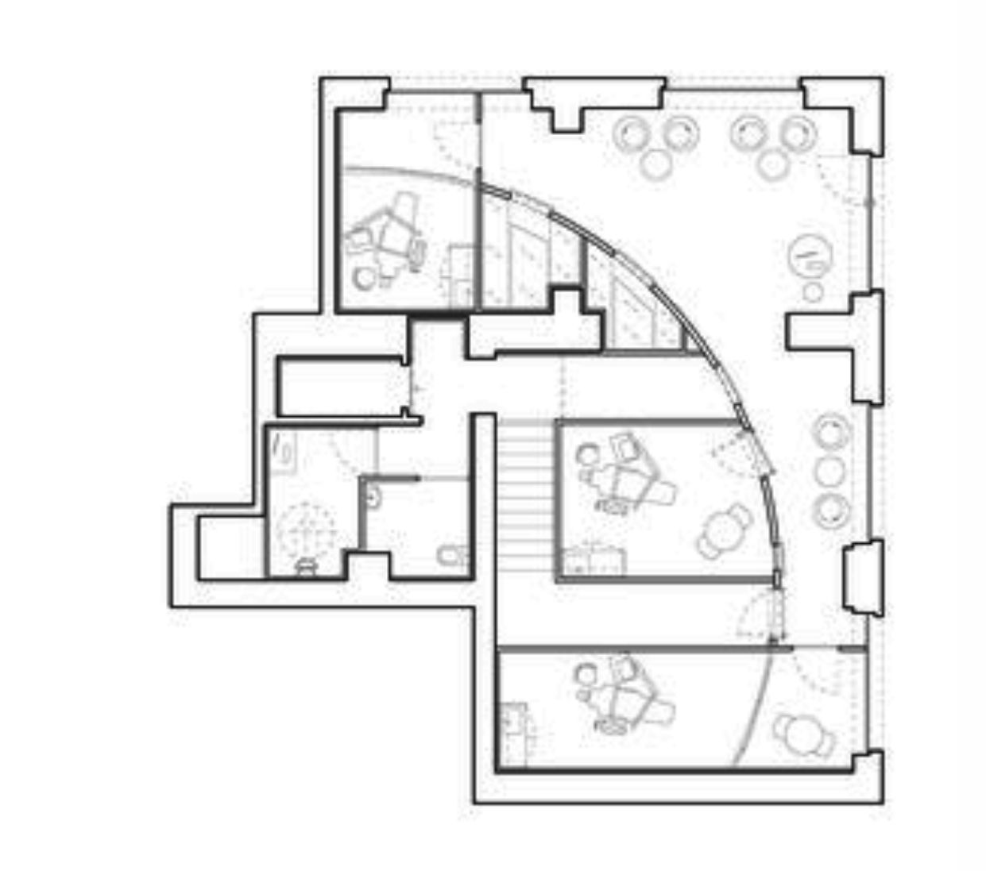
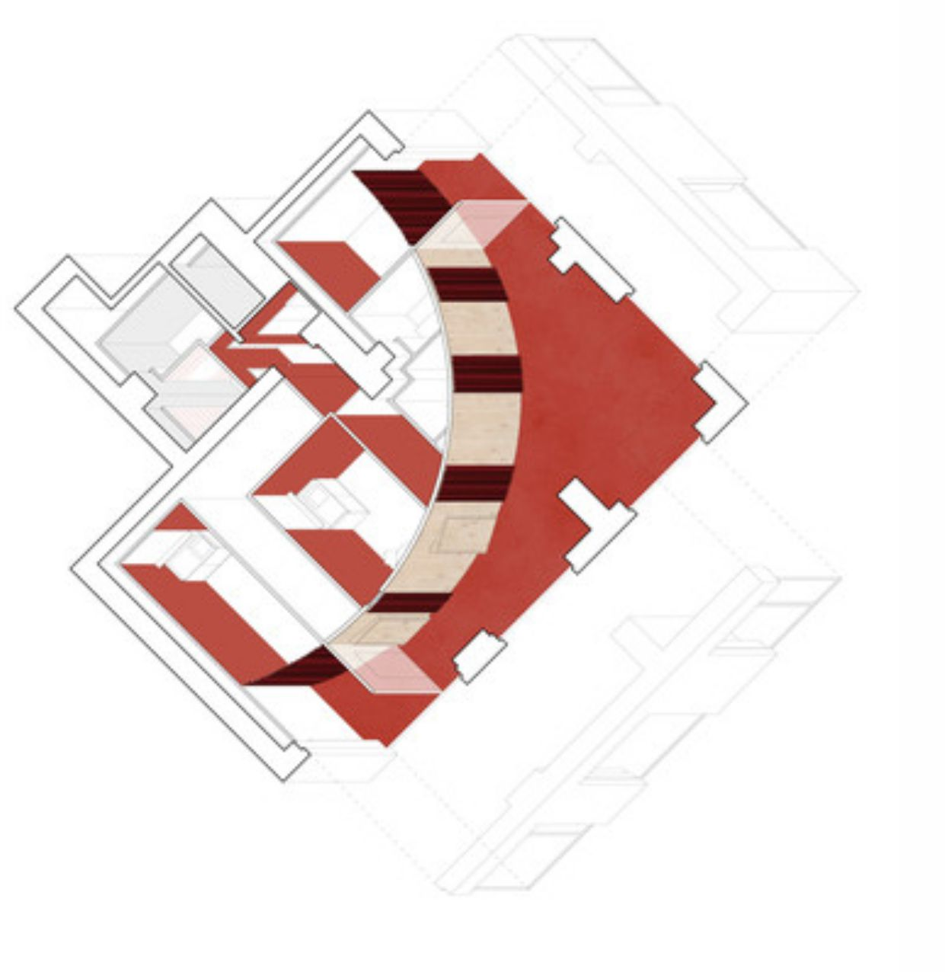

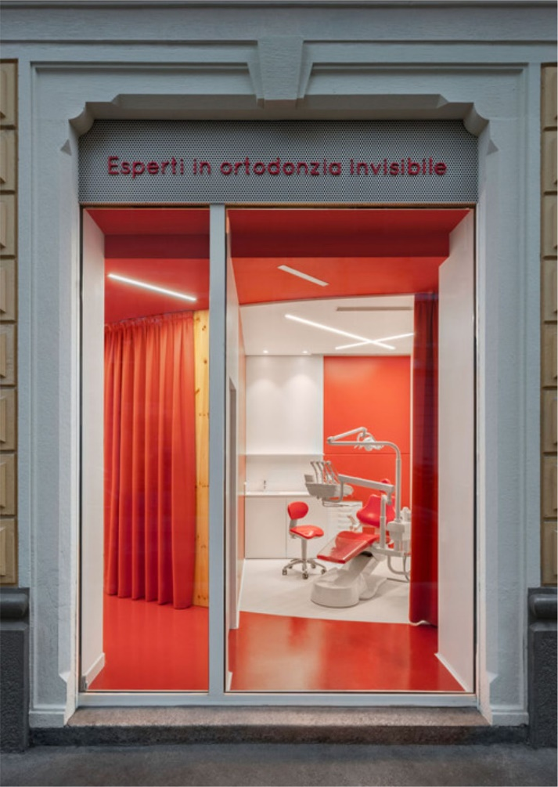
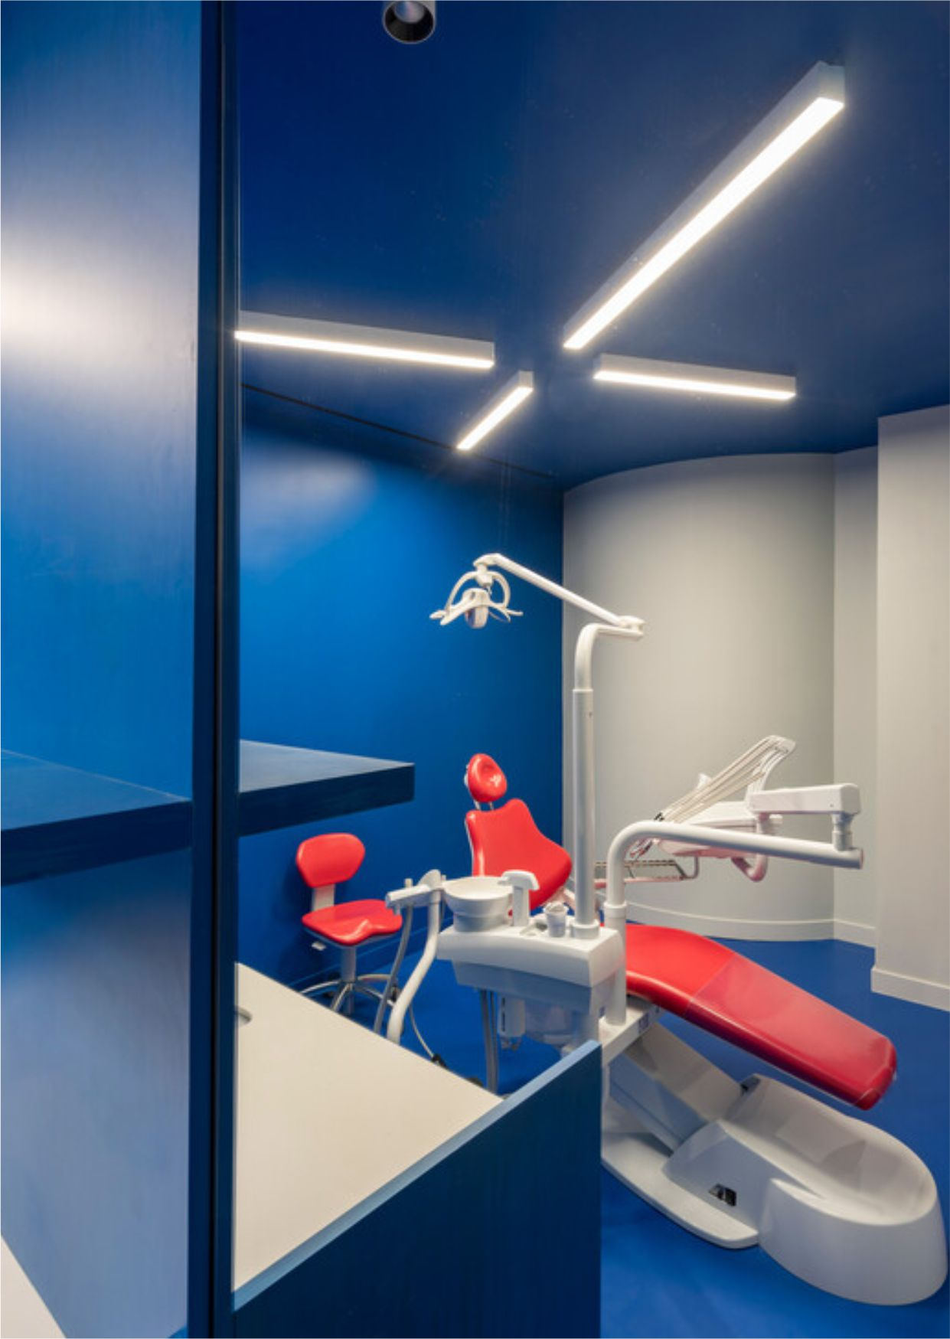

3.7 SUMMARY OF CASE STUDIES
The reviewed case studies provide insight into what makes a functional and comfortable dental clinic. Common successful elements include effective space planning, infection control mechanisms, accessibility features, and calming interior design. However, deficiencies such as poor natural lighting, outdated equipment, and limited patient comfort were observed in some local clinics.
These findings will influence the proposed dental clinic’s layout, ventilation, material selection, and spatial organization. Integrating the best aspects from each case will help produce a clinic design that is modern, patient-friendly, and efficient.

CHAPTER FOUR
STUDY AREA / PROJECT SITE (ENVIRONMENTAL AND IMPACT ANALYSIS)
4.0 INTRODUCTION
This chapter presents an analytical overview of the proposed site for the dental clinic project. The selection of a suitable site is critical to the success of any architectural design. A thorough site analysis provides insight into the natural, physical, environmental, social, and infrastructural conditions which influence the design concept, orientation, materials, and form.
Understanding the site’s strengths, limitations, and opportunities ensures that the building will integrate seamlessly into its surroundings while fulfilling both functional and aesthetic requirements. Factors considered include location, accessibility, topography, climate, existing services, neighborhood character, and environmental features.

4.1 INTRODUCTION TO THE STUDY AREA / SITE SELECTION
The proposed site for the dental clinic is located at Gwagwalada, Abuja, within the Federal Capital Territory. Gwagwalada is a rapidly developing urban district known for its educational institutions, medical centers, and growing residential communities.
The selection of this location is justified by the increasing population in the area, the demand for accessible healthcare, and the lack of sufficient standalone dental clinics. The site is accessible, located near major roads, and has proximity to both residential and institutional facilities, which supports the potential for high patient patronage.

4.2 HISTORICAL BACKGROUND OF GWAGWALADA
Gwagwalada is one of the six area councils within the Federal Capital Territory of Nigeria. Originally a quiet rural settlement, it began transforming rapidly following the creation of Abuja as Nigeria’s capital in 1991. With the expansion of educational institutions such as the University of Abuja and the School of Health Technology, the area has witnessed an influx of population, housing development, and commercial activity.
The health infrastructure of Gwagwalada includes general hospitals, private clinics, and pharmacies, but dental services remain limited and often confined to general health centers. The proposed dental clinic will therefore fill an urgent healthcare gap in the area.

4.3 SITE LOCATION AND DESCRIPTION CRITERIA
4.3.1 Site Location
• Address: Plot 5, Along Zuba Road, Gwagwalada, Abuja
• Coordinates: 8.9479° N, 7.0811° E
• Proximity: Adjacent to Gwagwalada Central Market and within 500 meters of the University Teaching Hospital.
4.3.2 Accessibility
• The site is directly accessible via a tarred main road.
• It connects easily to neighboring communities and highways leading to Abuja city center.
• Pedestrian access is possible on all sides.
4.3.3 Site Features
• Flat terrain with minimal need for grading
• Few existing trees and shrubs that can be retained for landscaping
• No visible water bodies or erosion challenges
• Quiet surroundings with good visibility from the main road

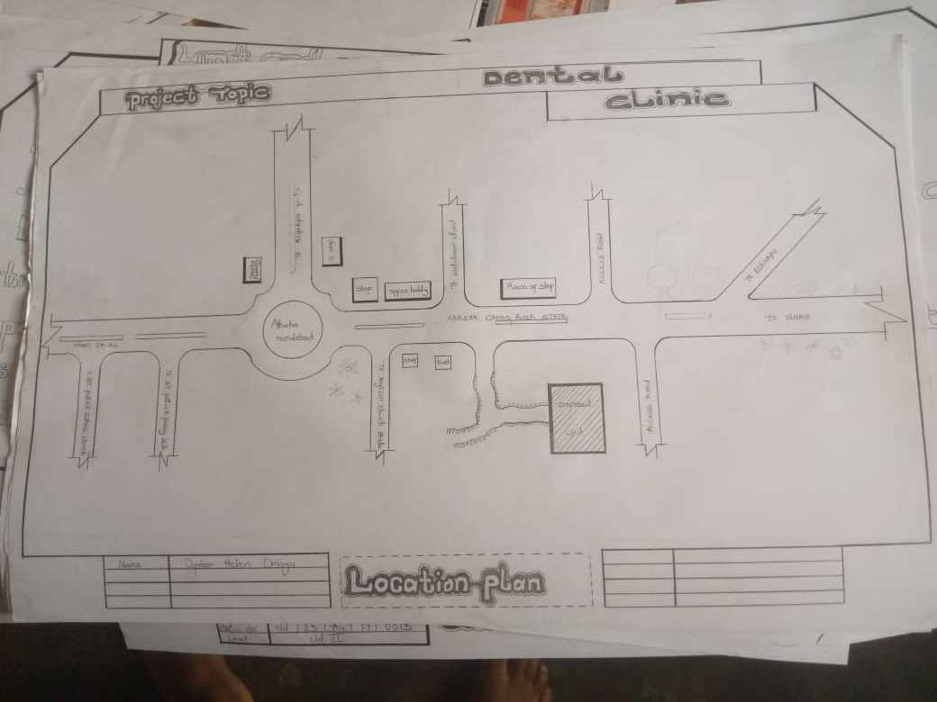
Figure 11: Location Plan

CHAPTER FIVE
CONSTRUCTION METHODOLOGY AND MATERIAL

5.0 CONSTRUCTION METHODOLOGY
The construction methodology for the proposed dental clinic project is selected based on the simplicity of the structure, ease of access to materials, labor availability, and durability. The approach adopted is more labor-intensive than capital-intensive, which ensures effective use of available resources and involvement of skilled local labor.
The project utilizes conventional modern construction techniques, involving reinforced concrete, blockwork, and aluminum window systems. The design form is horizontally oriented to maintain a close connection between all functional zones, facilitate patient circulation, and ensure accessibility.
The building entrance and layout are designed to create a calm, welcoming environment, which is vital in dental healthcare architecture due to the common anxiety associated with dental visits.

5.1 BUILDING MATERIALS AND SPECIFICATIONS
5.1.1 Cement and Concrete
• Portland cement will be used and must be delivered fresh and sealed.
• The concrete mix ratio for structural elements like foundation footings, lintels, and slabs is 1:2:4 (cement:sand:granite).
• Concrete should be well-compacted and properly cured for at least 7 days.
• Ready-mix concrete may be used in cases requiring speed and consistency.
5.1.2 Blockwork
• Hollow sandcrete blocks of 225mm thickness are used for external walls for better insulation.
• 150mm blocks will be used for partition walls internally.
• Mortar mix ratio will be 1:6 (cement:sand) for walling works.
• Control joints will be introduced to manage thermal expansion.

5.1.3 Foundation
• The building will sit on a strip foundation, suitable for the site’s soil bearing capacity.
• Depth of foundation: 600mm minimum below ground level.
• Width: 750mm with base blinding to prevent direct soil-concrete contact.

5.2 STRUCTURAL SYSTEM
The proposed structure employs load-bearing walls and reinforced concrete beams and columns. The following elements are specified:
• Columns: Reinforced concrete columns spaced as per structural calculations.
• Beams: Concrete rectangular beams of standard dimension, depending on span and loading.
• Slabs: 150mm thick concrete floor slabs with anti-termite treatment.
• Roof: Long-span steel trusses with aluminum roofing sheets.

5.3 WALL FINISHES
• External walls: Rendered with 15mm cement-sand plaster and painted with weather-resistant emulsion paint.
• Internal walls: Smooth 12mm plaster finish and painted in calming pastel colors to reduce patient stress.
• Treatment rooms: Will be finished with high-gloss washable paint for easy cleaning and infection control.

5.4 FLOOR FINISHES
Flooring is selected based on durability, hygiene, and functionality:
All floors will rest on 150mm thick reinforced oversite concrete, finished with a screed and appropriate covering.

5.5 DOORS AND WINDOWS
Doors
• Main entrance door: 1800mm-wide glass double leaf with aluminum frame.
• Interior doors: 900mm-wide flush panel solid core doors.
• Toilets: 750mm-wide flush doors with privacy locks.
• Sterile zones: Swing-type PVC-coated doors to reduce microbial contamination.
Windows
• Aluminum sliding windows with reflective safety glass.
• Louvered vents provided for passive ventilation in toilets.
• All windows will be fitted with insect screens and internal blinds for privacy.

5.6 ROOFING SYSTEM
• Roof structure will consist of steel trusses fabricated on-site.
• Aluminum long-span roofing sheets with anti-rust coating will be used.
• Soffits: White UPVC for aesthetic and maintenance ease.
• Eaves ventilation will be provided to reduce heat buildup in the ceiling void.
• Ceiling boards: 9mm PVC panels in treatment rooms and POP in other zones.
5.7 PAINTING AND DECORATION
• Walls will be treated with anti-fungal primer and low-VOC emulsion paints.
• Interior walls of public zones (reception, waiting) will have pastel-colored finishes to reduce patient anxiety.
• Operation areas will use gloss washable finishes to ensure easy maintenance.
• Staff areas and admin offices will use matte emulsion for calm work environments.

5.8 PLUMBING AND SANITARY INSTALLATIONS
• Cold water supply will be provided through PVC piping from a borehole with overhead tank system.
• Sanitary fixtures include water closets, hand basins, surgical sinks, and floor drains.
• All pipework will be concealed in walls and properly vented.
• Drainage system will connect to a soak-away and septic tank unit designed based on daily use projection.

5.9 ELECTRICAL INSTALLATION
• Electrical fittings include LED panel lights, emergency lights, wall lamps, and task lights in treatment areas.
• Power source: National grid backed by inverter system and generator.
• Wiring: Concealed copper wiring in PVC conduit.
• Dedicated sockets for dental chairs and X-ray equipment.
• Earthing system and surge protection for sensitive medical devices.

5.10 AIR CONDITIONING AND VENTILATION
• Split-unit air conditioners will be installed in treatment rooms, consultation room, and admin offices.
• Natural ventilation is enhanced through cross-ventilated windows in non-clinical zones.
• Toilet areas will use exhaust fans.
• Operatory rooms are sealed to allow air-quality control through mechanical systems.
5.11 WASTE MANAGEMENT
The design incorporates a separate waste storage zone for both biomedical waste and general refuse:
• Waste bins placed at source points (operatory rooms, X-ray room).
• Regular disposal through accredited medical waste handling services.
• Wall finishes and floor materials are selected to support frequent cleaning and disinfecting.

APPENDICES 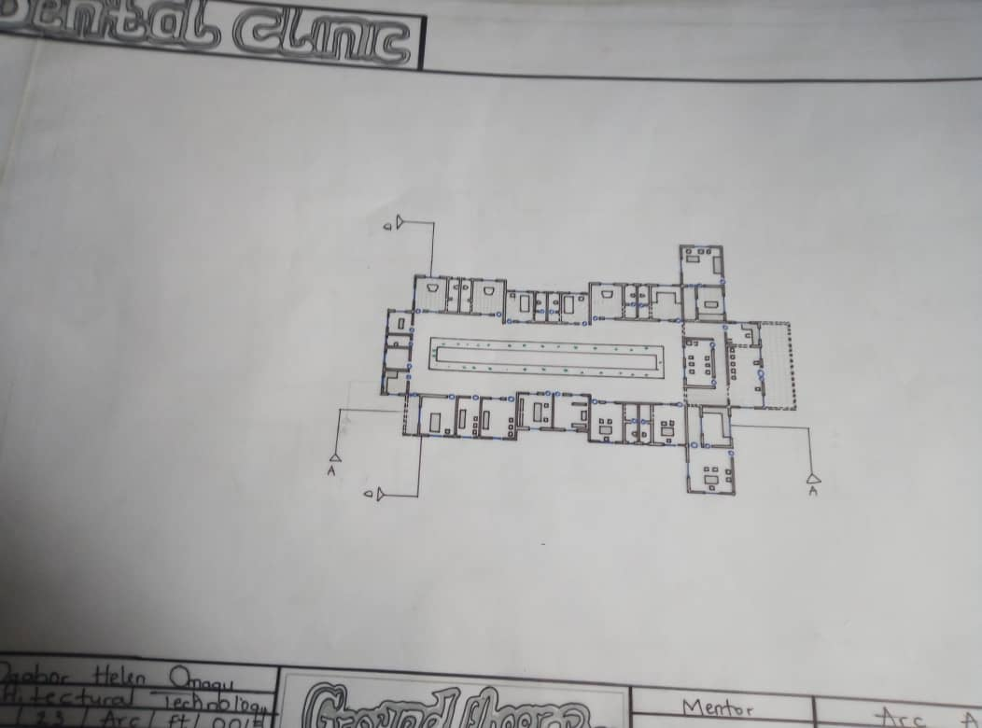

Figure 12: Ground Plan

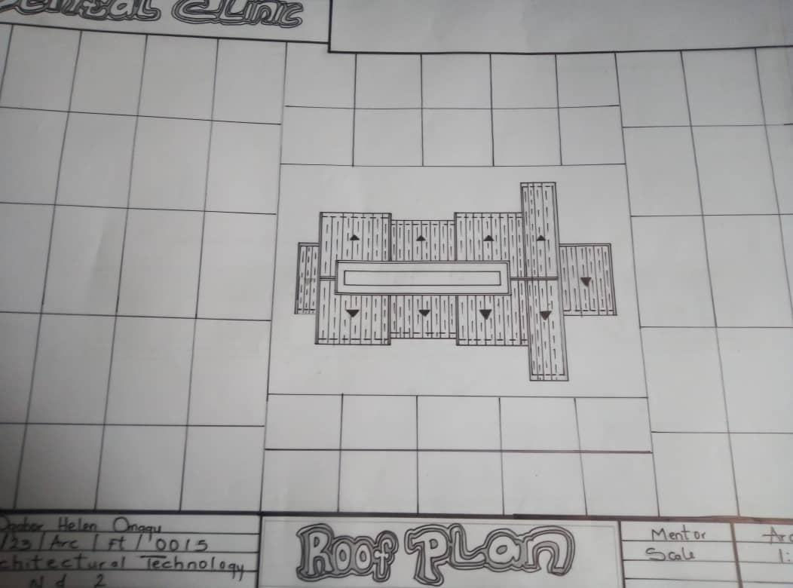
Figure 14: Roof Plan

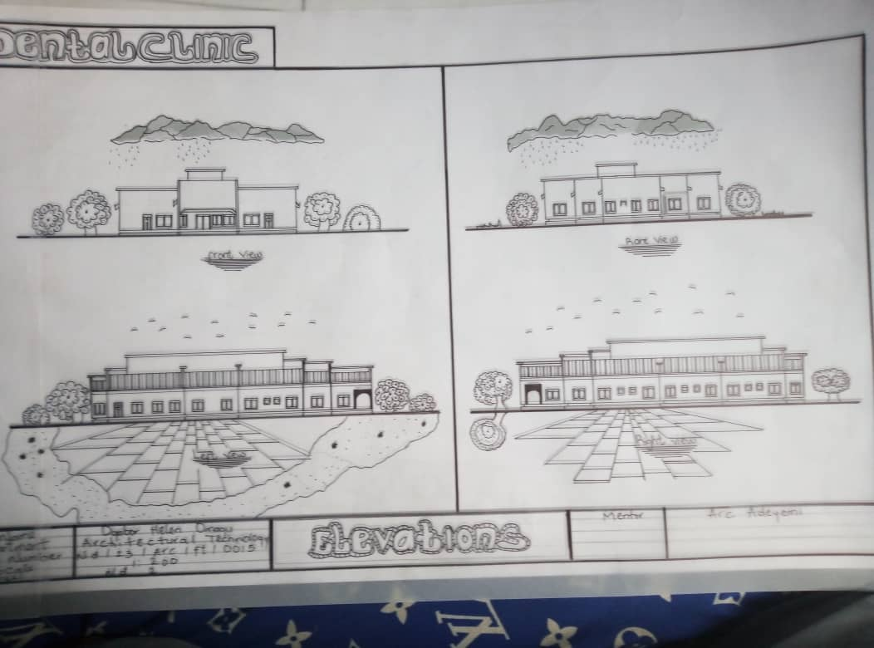
Figure 13: Elevations

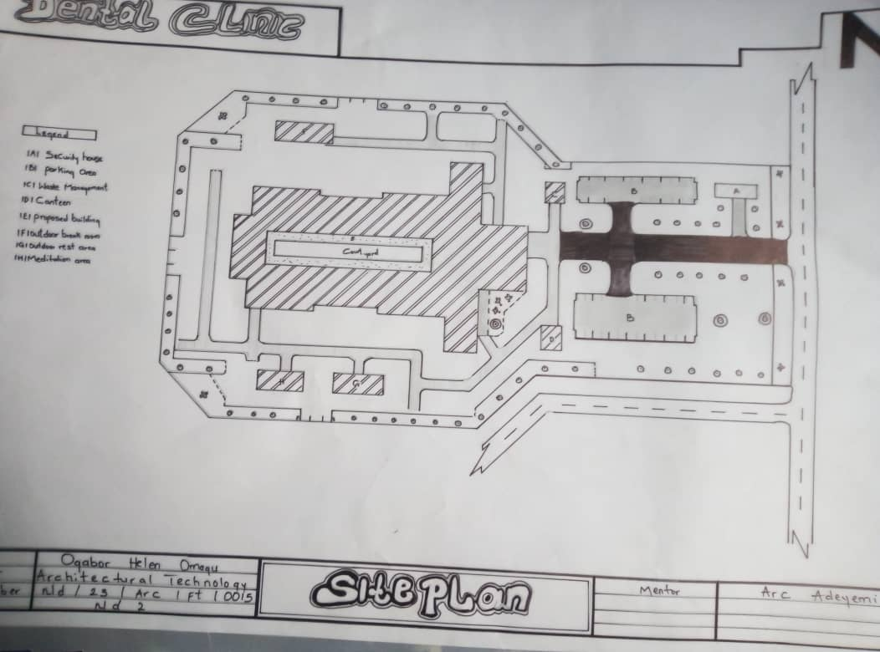
Figure 18: Site Plan

REFERENCES
- Brown L.J. and Lazer V. Dental care utilisation: How saturated is the patient’s market? J Am Dent Assoc 1999; 130: 573-580.
- Allukian M. Dentistry at the crossroads: The future is uncertain: The challenges are many. Am J Public Health 1982; 72: 653-654.
- Grembowski D., Comrad D. and Milgrom P. Utilisation of dental services in the United States and an insured Population. Am J Public Health 1985; 75: 87-89.
- Douglas C.W. and Cole K. Utilization of dental services in the US. J Dent Educ 1979 43:223- 38.
- Savage K.O. and Arowojolu M.O. Perception of gingival bleeding by Nigerian. Afr J Med Sci; 26: 91-93.
- Ainamo J. and Ainamo A. Prevention of Periodontal Diseases in a mixed dentition. Int Dent J 1981; 31:125-132.
- De Lacerda J.T., Simionato E.M., Peres K.G., Peres M.A., Traebert J. and Marcenes W. Dental pain as the reason for visiting a dentist in a Brazilian adult population. Rev Saúde Pública 2004; 38 (3): 1-6.
- Kolude B. and Gbadebo S.O. Orofacial Pain: Pattern of Presentation at Dental Clinic University College Hospital Ibadan. MDS Thesis, 2007.
- Famuyiwa O.O., Olorunsola D.A. and Derin A. Some family factors in sickle cell anaemia in Lagos, Nigeria. Nig Med Practitioner 1998; 35:70-73.
- Woosung S., Amid I., Ashley A., James L. Determinants of Dental care visits among low- income African-American children: J.Am Dent Ass 2007; 138:301-318
- Lo G.L. The use of Dental services by adult Singaporeans. Singapore Dent J 1993; 18:22- 25.
- Manski R.J. and Moeller J.F. Use of dental services An analysis of visits, procedures and providers, 1996. J Am Dent Assoc 2002; 133: 167-175.
- Sa’adu and Abdulraheem. Oral health care practice and socio-demographic findings among the physicians in Ilorin, Nigeria. Niger J Med 2003; 12: 211-216.
- Manski R.J., Moeller J.F. and Maas W.R. Dental services: use, expenditures and sources of payment, 1987. J Am Dent Assoc 1999; 130: 500-508.
- Manski R.J., Edelstein B.L. and Moeller J.F. The impact of insurance coverage on children’s dental visits and expenditures, 1996. J Am Dent Assoc 2001; 132: 1137-1145.
- Newman M.G., Takei H.H and Carranza F.A. Carranza’s clinical periodontology. 9th ed..W.B. Saunders co., pp 82.

