A PROJECT REPORT
ON
PROPOSED FIRST BANK OF NIGERIA BRANCH
IN
KWARA STATE POLYTECHNIC, ILORIN

BY

ONIPEDE FUNKE GLORIA
HND/23/ARC/FT/034

SUBMITTED TO

THE DEPARTMENT OF ARCHITECTURAL TECHNOLOGY
INSTITUTE OF ENVIRONMENTAL STUDIES
KWARA STATE POLYTECHNIC, ILORIN

IN PARTIAL FULFILMENT AS PART OF THE REQUIREMENTS FOR THE AWARD OF HIGHER NATIONAL DIPLOMA (HND) IN ARCHITECTURAL TECHNOLOGY

JULY, 2025

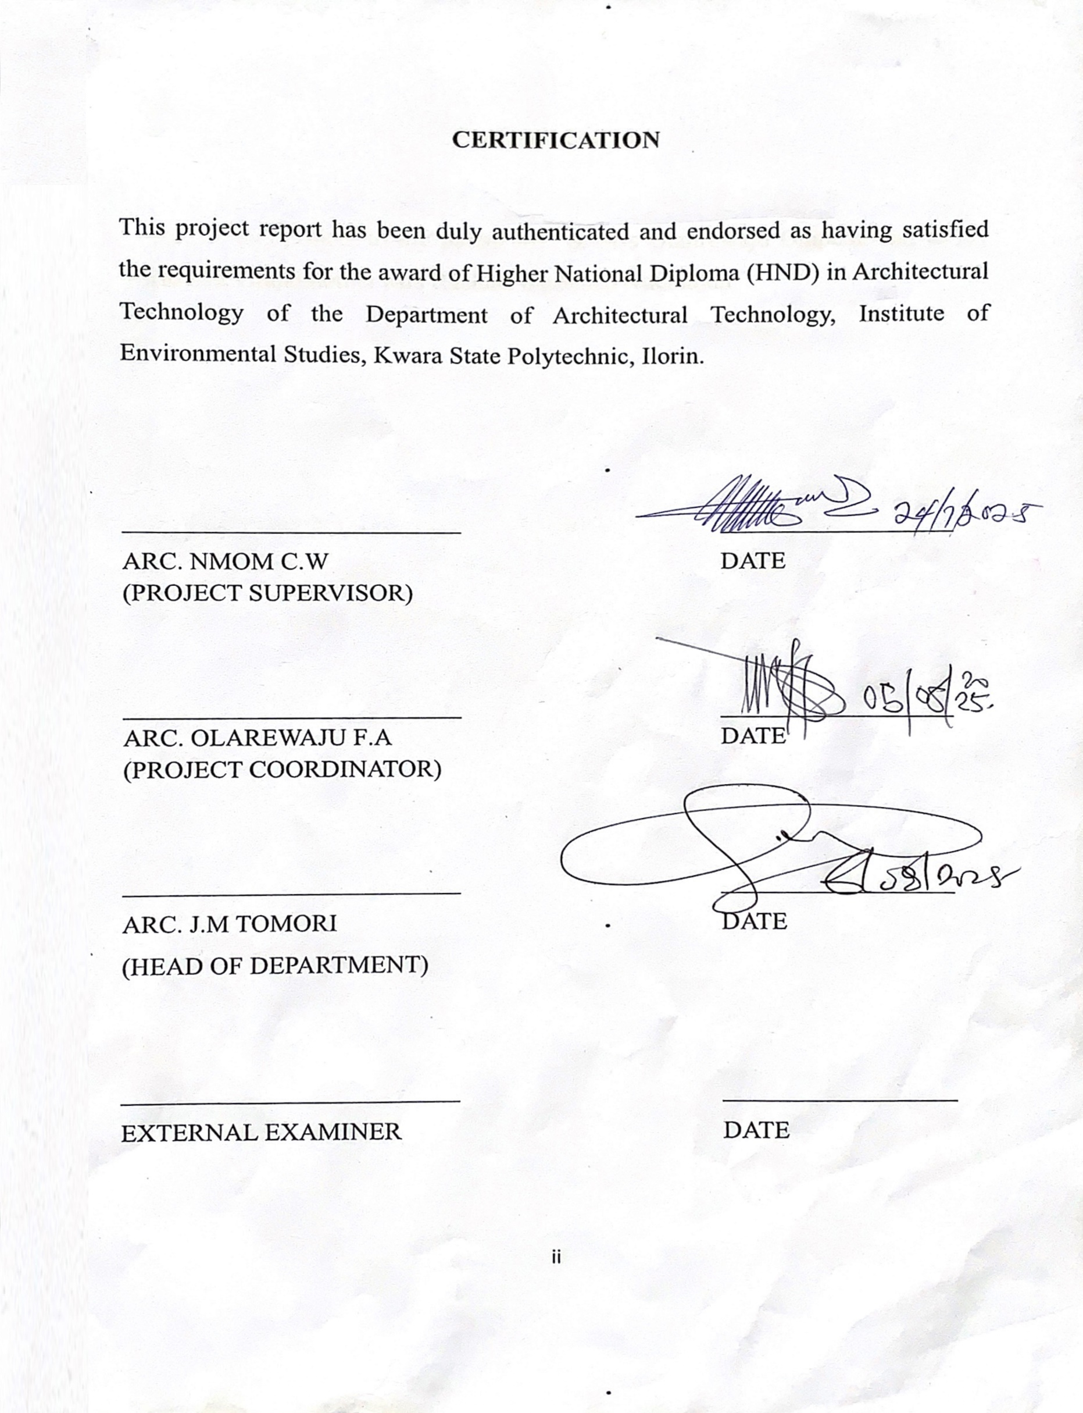
DEDICATION

I dedicate this project to my parent Mr & Mrs Olanrewaju Onipede and to my world best Grandmother Mrs Rachael oladimeji Ademidun

ACKNOWLEDGEMENT
Everything that has beginning must have an end, therefore, all praises and adoration is unto God for the strength and courage he has accorded me in the process of this project.
Special thanks to my project supervisor ARC. Nmom C.W for his guidance over this project may Almighty God bless you abundantly. (Amen)
My gratitude goes to the Head of Department ARC.TOMORI J.M and all lectures and the entire Academic Staff of the Department of Architectural Technology for their effort. Thank you
My deepest appreciation goes to my grandmother my number one support system I love you so much mama, and to my parents Mr. & Mrs. Onipede Olarewaju, I love you so much.
And to every souls that has been of help intellectually, morally and financially may the Good Lord continue to bless y’all
Lastly I wanna thank me for being a hardworking and strong lady.

ABSTRACT
This project document presents a comprehensive architectural design proposal for a modern, functional, and sustainable commercial bank tailored to the operational and branding needs of First Bank of Nigeria. The work is grounded in a rich historical and contextual background, beginning with a brief history of banking in Nigeria and the evolution of First Bank since 1894. It highlights the pressing need for integrating functionality, security, spatial efficiency, and technological innovation in commercial bank design, which existing bank structures often lack. The aim of the project is to create a standard, energy-efficient, and inclusive banking facility that not only enhances customer experience but also projects professionalism and national identity. Through in-depth research methodologies including literature review, oral interviews, site analysis, and case studies of three First Bank branches (Osogbo, Ibadan, and Lagos) the study identifies design shortcomings such as limited space utilization, lack of modern security features, poor adaptability, and inadequate customer engagement zones. The chosen site for the proposed development is within Kwara State Polytechnic, Ilorin, selected based on accessibility, security, available landmass, and favorable climatic and topographic conditions. Detailed environmental, climatic, and site analyses were carried out to inform a responsive architectural solution. Design considerations focus on maximizing security, aesthetics, functionality, and environmental integration. The spatial organization follows a zoned system that aligns related functions, facilitates user navigation, and ensures operational efficiency. The proposed facilities include a main banking hall, ATM stands, parking lots, security post, green area, and utility structures. Construction materials and methods are locally sourced and selected based on sustainability, durability, and climate responsiveness. The design also emphasizes energy efficiency, effective lighting and ventilation, acoustic control, and fire safety systems such as alarms, extinguishers, and sprinkler installations. In conclusion, the project advocates for a design-led approach to bank architecture that not only enhances operational workflow but also improves customer satisfaction, staff safety, and corporate image. It underscores the importance of architectural innovation in transforming commercial banking spaces into user-centered, secure, and future-proof environments.
TABLE OF CONTENT

TITLEPAGE…………………………………………………………..……… i
CERTIFICATION………………………………………………………………. ii
ACKNOWLEDGEMENT………………………………………………………. iii
DEDICATION………………………………………….………………………… iv
ABSTRACT………………………………………………………………………. v
TABLE OF CONTENT………………………………………………………….. vi-viii

CHAPTER ONE

1.0 INTRODUCTION………………………………….……………….………… 1
1.1 HISTORICAL BACKGROUND………...………………….………………… 1
1.2 STATEMENT OF PROBLEM OF COMMERCIAL BANK …………….…… 2
1.3 AIM AND OBJECTIVES………………………………………..………….… 2
1.4 JUSTIFICATION………………………………………………………..…… 3
1.5 CLIENT’S BACKGOUND……………………………………………….… 3
1.6 SCOPE OF PROJECT …………………………………………………….… 3
1.7 LIMITATIONS AND CONSTRAINS OF PROJECT ……………..…….… 4
1.8 RESEARCH METHODOLOGY…………………..……………………… 4

CHAPTER TWO

2.1 LITERATURE REVIEW…………………………………………………… 15
2.2 DEFINITION OF COMMERCIAL BANK …………………………………. 15
2.3 HISTORICAL DEVELOPMENT OF COMMERCIAL BANK…………… 16

CHAPTER THREE

3.0 CASE STUDY………………………………………………………………… 18
3.1 CASE STUDY 1 ONE OSOGBO ORISUNBARE BRANCH ……………... 18
3.2 CASE STUDY TWO IBADAN ELEYELE BRANCH ……………………. 21
3.3 CASE STUDY THREE LAGOS SABO YABA BRANCH … …………….. 24

CHAPTER FOUR

4.1 HISTORICAL BACKGROUND OF KWARA STATE POLYTECHNIC…….. 26
4.2 PROPOSED SITE LOCATION ……………………………………...……… 27
4.3SITE LOCATION ……………………….…………………………………… 28
4.4 SITE SELECTION CRITERIA ……………………………………………… 29
4.5 ANALYSIS OF THE IMMEDIATE ENVIRONMENTAL CONDITIONS OF THE SITE……………………………………………………..………………………… 31
4.6 PROPOSED DESIGN ……………………………………………………… 34
4.7DESIGN CONCEPT ………………………………………………………… 35
4.8APPRAISAL OF PROPOSED SCHEMES …………………………………… 37
4.9 SCHEDULE OF ACCOMMODATION ……………………………………… 38

CHAPTER FIVE

5.0DESIGN CONCEPT…………………………………………………………… 40
5.1CONSTRUCTION METHODS……………………………………………… 41
5.2SUB-STRUCTURE AND SUPER-STRUCTURE …………………………… 42
5.3 CONSTRUCTION MATERIAL S…………………………………………… 43
5.4 SERVICES AND INFRASTRUCTURE ……………………………………… 45

5.5 Conclusion…………………………………………………………………… 38-57
REFERENCES…………………………………………………………………… 58

CHAPTER 1

INTRODUCTION
1.1 HISTORICAL BACKGROUND

The history of modern and banking in Nigeria dates back to 1892 With the establishment of the African banking Corporation in Lagos. in 1894, the bank of British West African (now first bank) took over the African banking Corporation. The bank for British West Africa remained the only bank in Nigeria until Barclays Bank (Now Union Bank) was set up. Subsequently other banks come on stream until 1959, the banking Industry in Nigeria was largely unregulated. Thus ,there were no reliable and organised data on the monetary sub-sector . As the country approach independence, the central bank of Nigeria (CBN) was founded, On 1st July, 1959, according to section 4 of the 1958 CBN ordinance, one of the principal objectives of the bank is to promote Monetary stability and a sound Financial structure in Nigeria. The phenomenal growth in the number of financial institutions and financial instruments in Nigeria was as a result of the introduction of structural adjustment program (SAP) which subsequently lead to greater use of monetary policy for economic stabilization in Nigeria. However, substructure course for more timel, accurate and reliable data. This involves developments or research and the acquisition Of monetary statistics on the economy. Since its inception, the research departments of the Central bank of Nigeria has been gathering and publishing financial,monetary and banking statistics on the Nigeria economy

1.2 STATEMENT OF PROBLEM
During the case study of the commercial bank (First Bank ) it's revealed that not much has been done in the articulation of maximum security, functionality of space in the design of the Building. Physical architecture is not put into consideration, in which machinery, equipment and furnishings arrange, the size and shape of those items and spatial relationships among these elements. More so there is no functional ability of the same items to facilitate performance and accomplishments of goals, within the service context.However it is important to emphasize that physical architecture that makes people on customers to constricted may have a direct effect on customer quality perceptions ,excitement levels and indirectly on their desire to return (customer retention)This implies that service or retail facilities that are specifically designed to add some level of excitement or satisfaction to the service experience in commercial bank should provide ample space to facilitate exploration and stimulation within the physical environment. The impact of functional space allocation can be evidenced through the effective response of comfort and this is also an important aspect of the service environment that attracts profit margin and retention.

1.3 AIM AND OBJECTIVES OF THE PROJECT

AIM
The aim of project is to design functional and standard commercial bank for first bank of Nigeria using Energy-efficient system and sustainable materials.

OBJECTIVES
The objectives to achieve the aim above are
- [ ] Integrates technology and innovation into the design.
- [ ] Designing the bank to be accessible and inclusive providing facilities and services that cater to diverse customer needs.
- [ ] To provide secure and private area for customers to conduct transaction such as private banking area and secured deposit boxes.
- [ ] To design the bank to project a professional and modern image.
- [ ] Using material and design elements that convey a sense of stability and security.

1.4 JUSTIFICATION OF PROJECT
This study intense to access how functional spaces can be enhanced in the design of a commercial bank.
The design is to create innovative design that offer opportunities for innovation the bank design reflects Nigeria's national pride and identity.
The commercial bank design will be an architectural icon that represents aesthetics functionality and security and also Nigerian financial sector.

1.5 CLIENT BACKGROUND

first bank of Nigeria Limited (first bank) establish in (1894), is the premier bank in West Africa, Nigeria's number one bank brand and the leading financial services solution provider in Nigeria.
The Bank was founded by Sir Alfred Jones a shipping magnet from Liverpool. England, with its head office originally in Liverpool, the bank commercial business on a modest scale in Lagos Nigeria under the name, Bank of British West African (BBWA).
In (1912 )the bank acquire its first competitor, the bank of Nigeria (previously called Anglo- African bank) which was established in (1899) by the Royal Niger company. The bank adopted the name standard bank of West Africa Limited and in (1969 )it was incorporated locally as the standard bank of Nigeria Limited in lines with the companies decree of (1968).Change in the name of the bank also occurred in (1979 )And (1991 )to First bank of Nigeria Limited and first bank of Nigeria PLC respectively.
First bank had 1.3 million shareholders globally, was quoted on the Nigerian stock exchange (NSE) and one of most capitalized Companies.

VISION
- [ ] TO be the clear leader and Nigeria’s bank of first choice.
MISSION
- [ ] To remain true to our name by providing the best financial services possible

OBJECTIVES
- [ ] To revolutionize the bank operation in line with the dynamic of the operating environment
- [ ] To strengthen the bank ‘s brand leverage and upscale the customers experience.
- [ ] To project first bank as sophisticated and dynamic.
- [ ] Having been around for over a century we realise there was the need to refocus and Energise our brand in response to contemporary realities of the business environment.

1.6 SCOPE OF THE PROJECT
The study focuses on enhancing functionality in the design of a commercial bank for first bank of Nigeria. The design project will provide facilities and units that are necessary in the commercial bank.
The scope of the commercial bank typically include providing ATM stand for the customers and other important facilities.
Facilities to be provided In the commercial bank includes ,
- [ ] propose building
- [ ] ATM stand
- [ ] Car Lot
- [ ] Green area
- [ ] security post
- [ ] Gate house
- [ ] Toilets
- [ ] Generator house

1.7 LIMITATION AND CONSTRAINS OF THE STUDY
constrain to the research are many but some were overcome.
The following constrains are experienced during the course of the research.
- [ ] Restrictions of movements in some areas of the bank by the security and the authorities of the bank used for case study.
- [ ] Difficulties in taking pictures, photograph taken was restricted in some area which could have been used to explain some features seen during the course of carrying out the research.
- [ ] Finance funding of the project research i.e. Transportation fee , feeding and accommodation .

1.8 RESEARCH METHODOLOGY
The following method are used to carry out the research on the given project (commercial bank)
- [ ] PHYSICAL CASE STUDY- the physical case study is carried out by the physical visitation, assessing the functionality of the various units in the bank and by taking of pictures.
- [ ] ONLINE CASE STUDY - making a research es online ,assessing the bank through the help of the Internet.
- [ ] ORAL INTERVIEW- This is carried out through a verbal assessment where an individual answers question in a face-to-face /virtual setting.
- [ ] LITERATURE REVIEW- comprehensive survey of scholarly sources ( books and journal articles )

CHAPTER TWO
2.1 LITERATURE REVIEW
In this chapter, Definition of Commercial Bank, historical development and other related literature are discussed.
This literature were studied in order to know the trend and Scope for research in the chosen field.

2.2 DEFINITION OF COMMERCIAL BANK
A Commercial Bank is a financial institution that provides a wide range of banking services to both individuals and businesses. they are authorized to receive deposits, make loan, and offer other financial products like checking and saving accounts.
Essentially, they are banks that most people interact with for their everyday financial needs.
Commercial banks accept deposits from individuals and businesses in various form, including checking and saving account.
They provide loans to businesses and individuals for various purpose, such as mortgage,car loans and business investment.
Commercial Bank facilitate payment including check clearing, wire transfer and debit/credit card transaction.
Commercial banks are essential to the functioning of modern economies and they play vital role in supporting economic growth and development.

2.3 HISTORICAL DEVELOPMENT
The historical development of Commercial Bank dated back to Ancient times, with evidence of bank activities in Civilization such as :
●Ancient Mesopotamia (2,000 BC): merchant and Trader used clay tablets to record financial transactions.
● Ancient Greece and Rome (500 BC/500 AD): Temples and Palaces served as depositories for gold and other valuables. ●Medieval Europe (12th and 15th century): Merchant Banks emerged, providing financial for trade and Commerce.

MODERN COMMERCIAL BANKING
The modern commercial banking system began to take shape in the 17th and 18th Centuries with the establishment of:
1) Goldsmith banks (London, 17th century): Goldsmith stored gold and issued receipt, which became a form of currency.
2) Bank of England (1694): founded to finance the British governments wars and stabilize the currency.
3) Other European Banks: Amsterdam wissel bank (1609), banque generale (1716) and others.

19th and 20th centuries
commercial banking continued to evolve with:
1) Joint-stock banking: Banks raised capital through shares sales, expanding their lending capacity.
2) Branch banking: Banks expanded geographically, increasing accessibility.

3) Regulation and supervision: Government's established regulatory frameworks to ensure stability.

KEY DEVELOPMENT
1) Deregulation: Removal of restrictions on banking activities.

2) Globalization: Expansion of banking services across borders.

3) Technological advancement: Introduction of ATMs, online banking and mobile banking.

4) Risk management: Development of risk management tools and strategies.

IMPACT
The historical development of commercial banks has:
1) facilitated economic growth.
2) Increase financial inclusion.
3) Shaped global finance.

CHAPTER THREE

3.0 CASE STUDY
According to the JSTOR (January 2019 ) , a case study is about a person, group of situation that has been studied overtime. it can be the defined as an intensive systematic,investigation about a person, group of people, or a unit in which the researcher examine in depth data relating to several variables. case study can be produced by following a formal research method. these case studies are likely to appear in formal research Venues. as a journals and professional conference, rather than a popular works.

outline of case studied
- first Bank osogbo, orisunbare branch.
- first bank ibadan,eleyele branch.
- first bank Lagos, sabo yaba branch.
- first bank United Kingdom.

3.1 CASE STUDY ONE
Historical Background of First Bank ,Osogbo osun state ,Orisunbare branch
Estlished in 1894, is one of Nigeria's oldest and largest financial institutions. The Orisunbare branch, like all other First Bank branches, is part of this legacy, tracing its history back to the bank's initial operations in Lagos and its subsequent expansion across Nigeria. The bank, originally known as the Bank of British West Africa, played a significant role in the development of banking in Nigeria, evolving through various name changes and ownership structures.
The branch is part of the bank's extensive network, serving the local community and contributing to the bank's long-standing reputation and presence in Nigeria.

MERITS
1) it is easily accessiblee
2) contain more parking space

DEMERITS
1) no integrate technology and innovation in the design.
2)The bank design does not convey a sense of stability and security.
3)The space analysis for the customer area is small [less functionality]
4) there is no green space

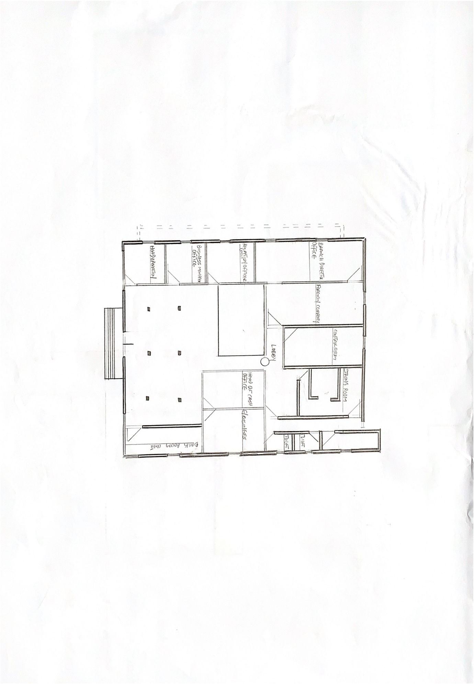

CASE STUDY 1
FIGURE 1.0

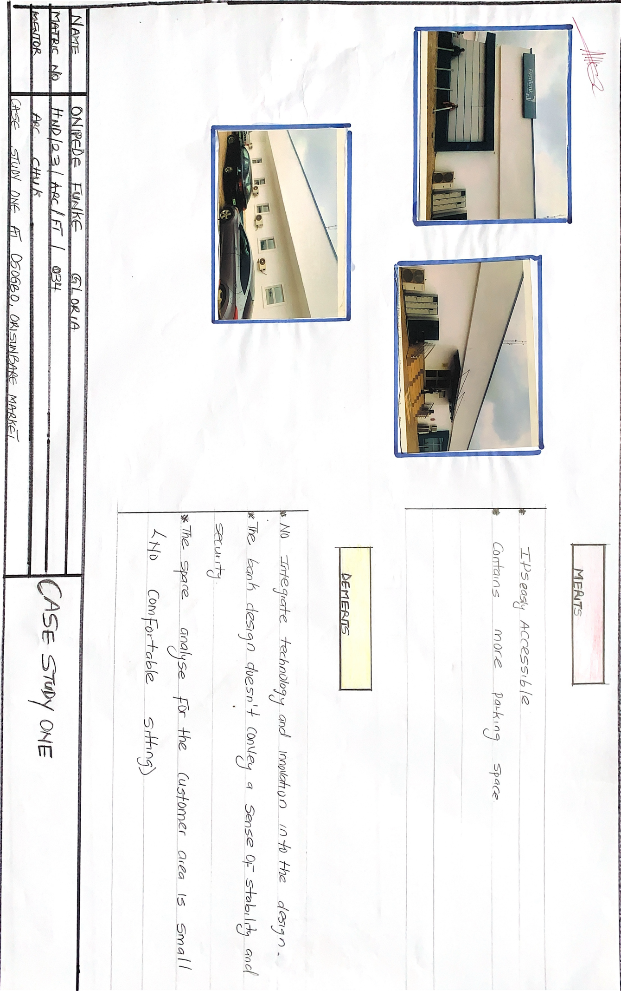

CASE STUDY 1
FIGURE 1.1

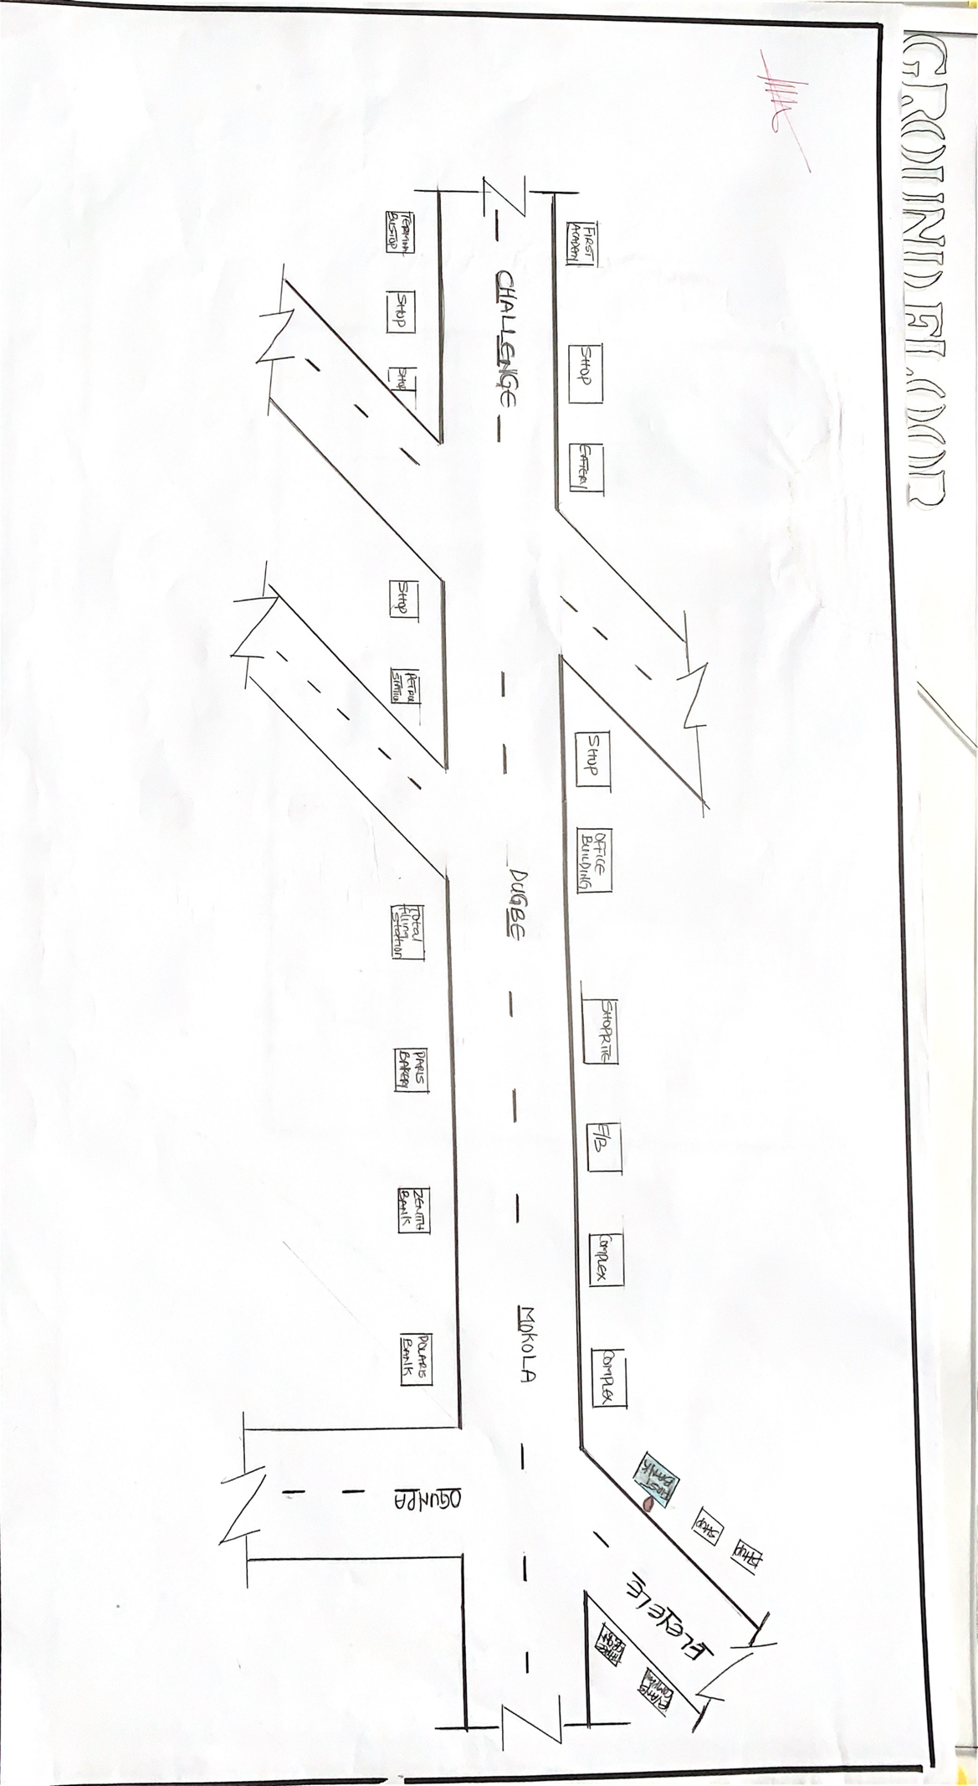

CASE STUDY 1
FIGURE 1.2

3.2 CASE STUDY TWO
Historical background,First Bank Ibadan, Eleyele branch
First Bank's Ibadan Eleyele branch, like other branches of the bank in Nigeria, has a history rooted in the bank's overall establishment and expansion. First Bank, originally known as the Bank of British West Africa, was founded in 1894. By 1914, it had already established branches in key Nigerian cities, including Ibadan. Over time, the bank underwent several name changes and expansions, becoming First Bank of Nigeria Limited in 1979. The Eleyele branch, like other First Bank branches in Nigeria, has played a role in the bank's long history of providing financial services and contributing to the development of the Nigerian economy.
The Ibadan Eleyele branch, as part of this broader history, has likely been a key part of the bank's presence and service delivery in the region.

MERITS
1) the design established strong brand identity that reflect its value and mission.
2) it conveys sustainable design principle.
3) the bank building create a welcoming and inclusive atmosphere.

DEMERITS
- Due to it addictiveness and flexibility the space are not well conducive for customers service.

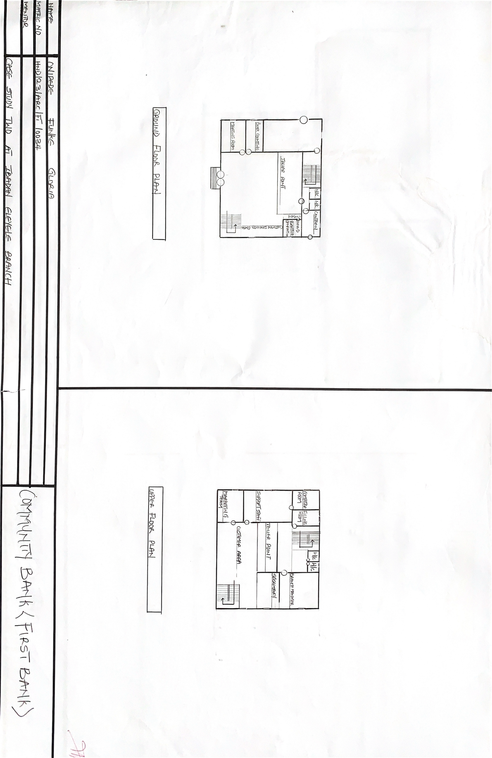

CASE STUDY 2
FIGURE 1.0
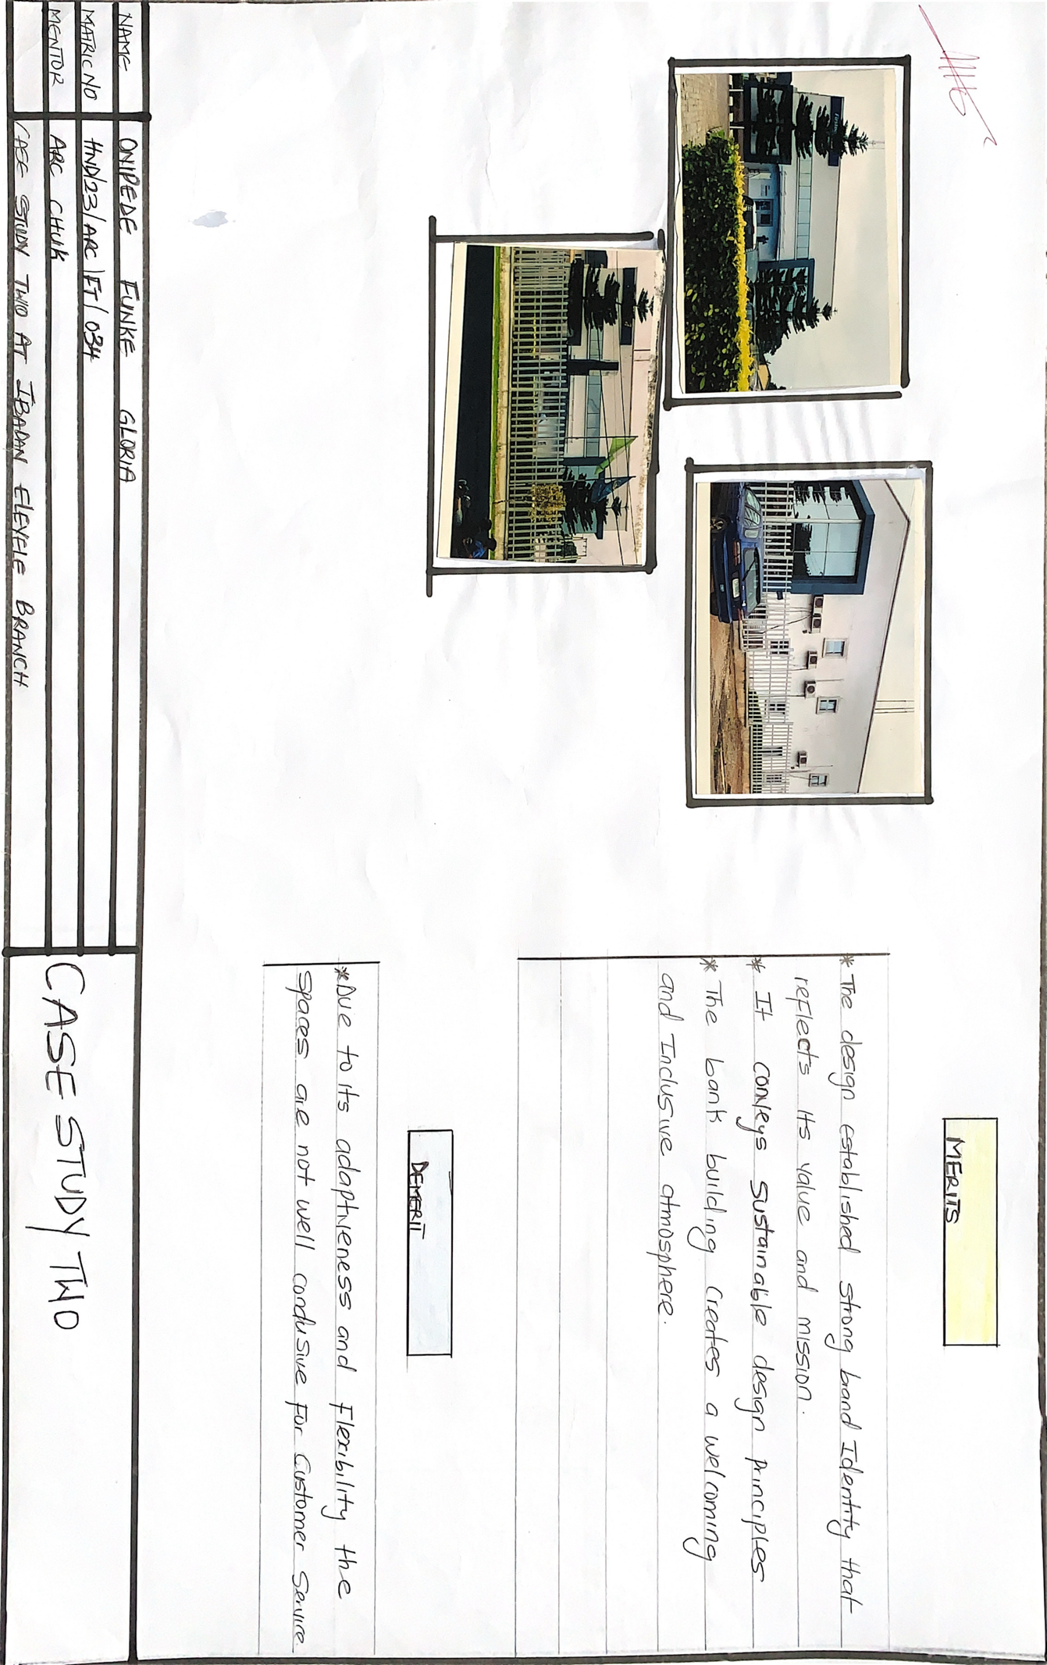

CASE STUDY 2
FIGURE 1.1
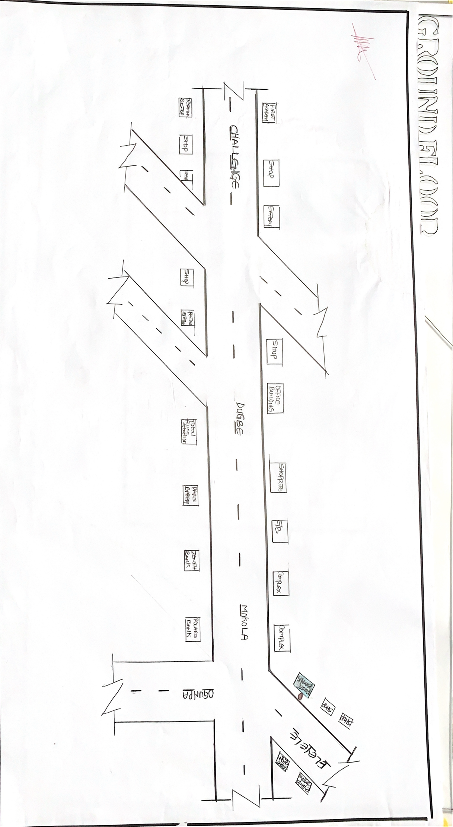

CASE STUDY 2
FIGURE 1.2

3.3 STUDY CASE THREE
Historical background of First bank ,Lagos state ,sabo yaba branch
First Bank's Sabo Yaba branch has a history rooted in the bank's broader legacy as Nigeria's oldest bank. Initially established in 1894 as the Bank of British West Africa (BBWA), First Bank has played a significant role in the country's financial development, including its expansion into various locations like Yaba. While the exact date of the Sabo Yaba branch's establishment isn't readily available, its existence is part of the bank's broader expansion and its contribution to Nigeria's financial landscape.
Founding and Early Years:
First Bank was established in 1894 by Sir Alfred Jones, a shipping magnate, as the Bank of British West Africa.
Early Expansion:
The bank quickly expanded its presence in Nigeria, including opening branches in key commercial centers.

MERITS
1) it is easily accessible
2) use of sustainable architecture ( use of shading device)

DEMERITS
1)the bank design does not provide flexibility and adaptable space that can accommodate changes, customer need and technological advancement.

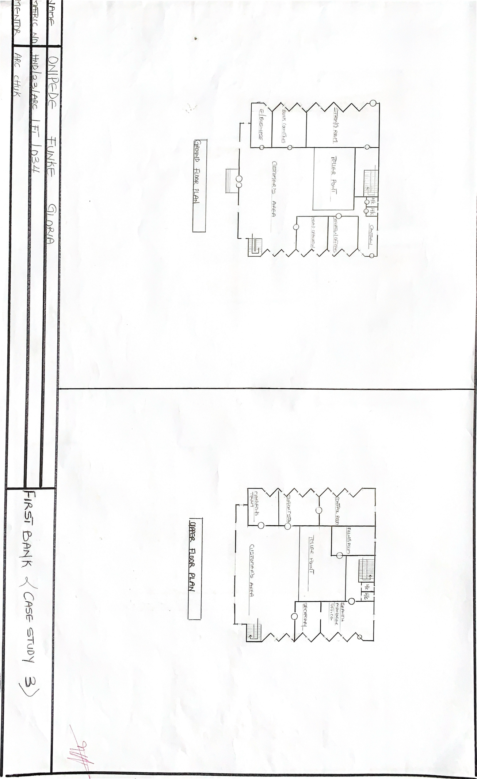

CASE STUDY 3
FIGURE 1.0
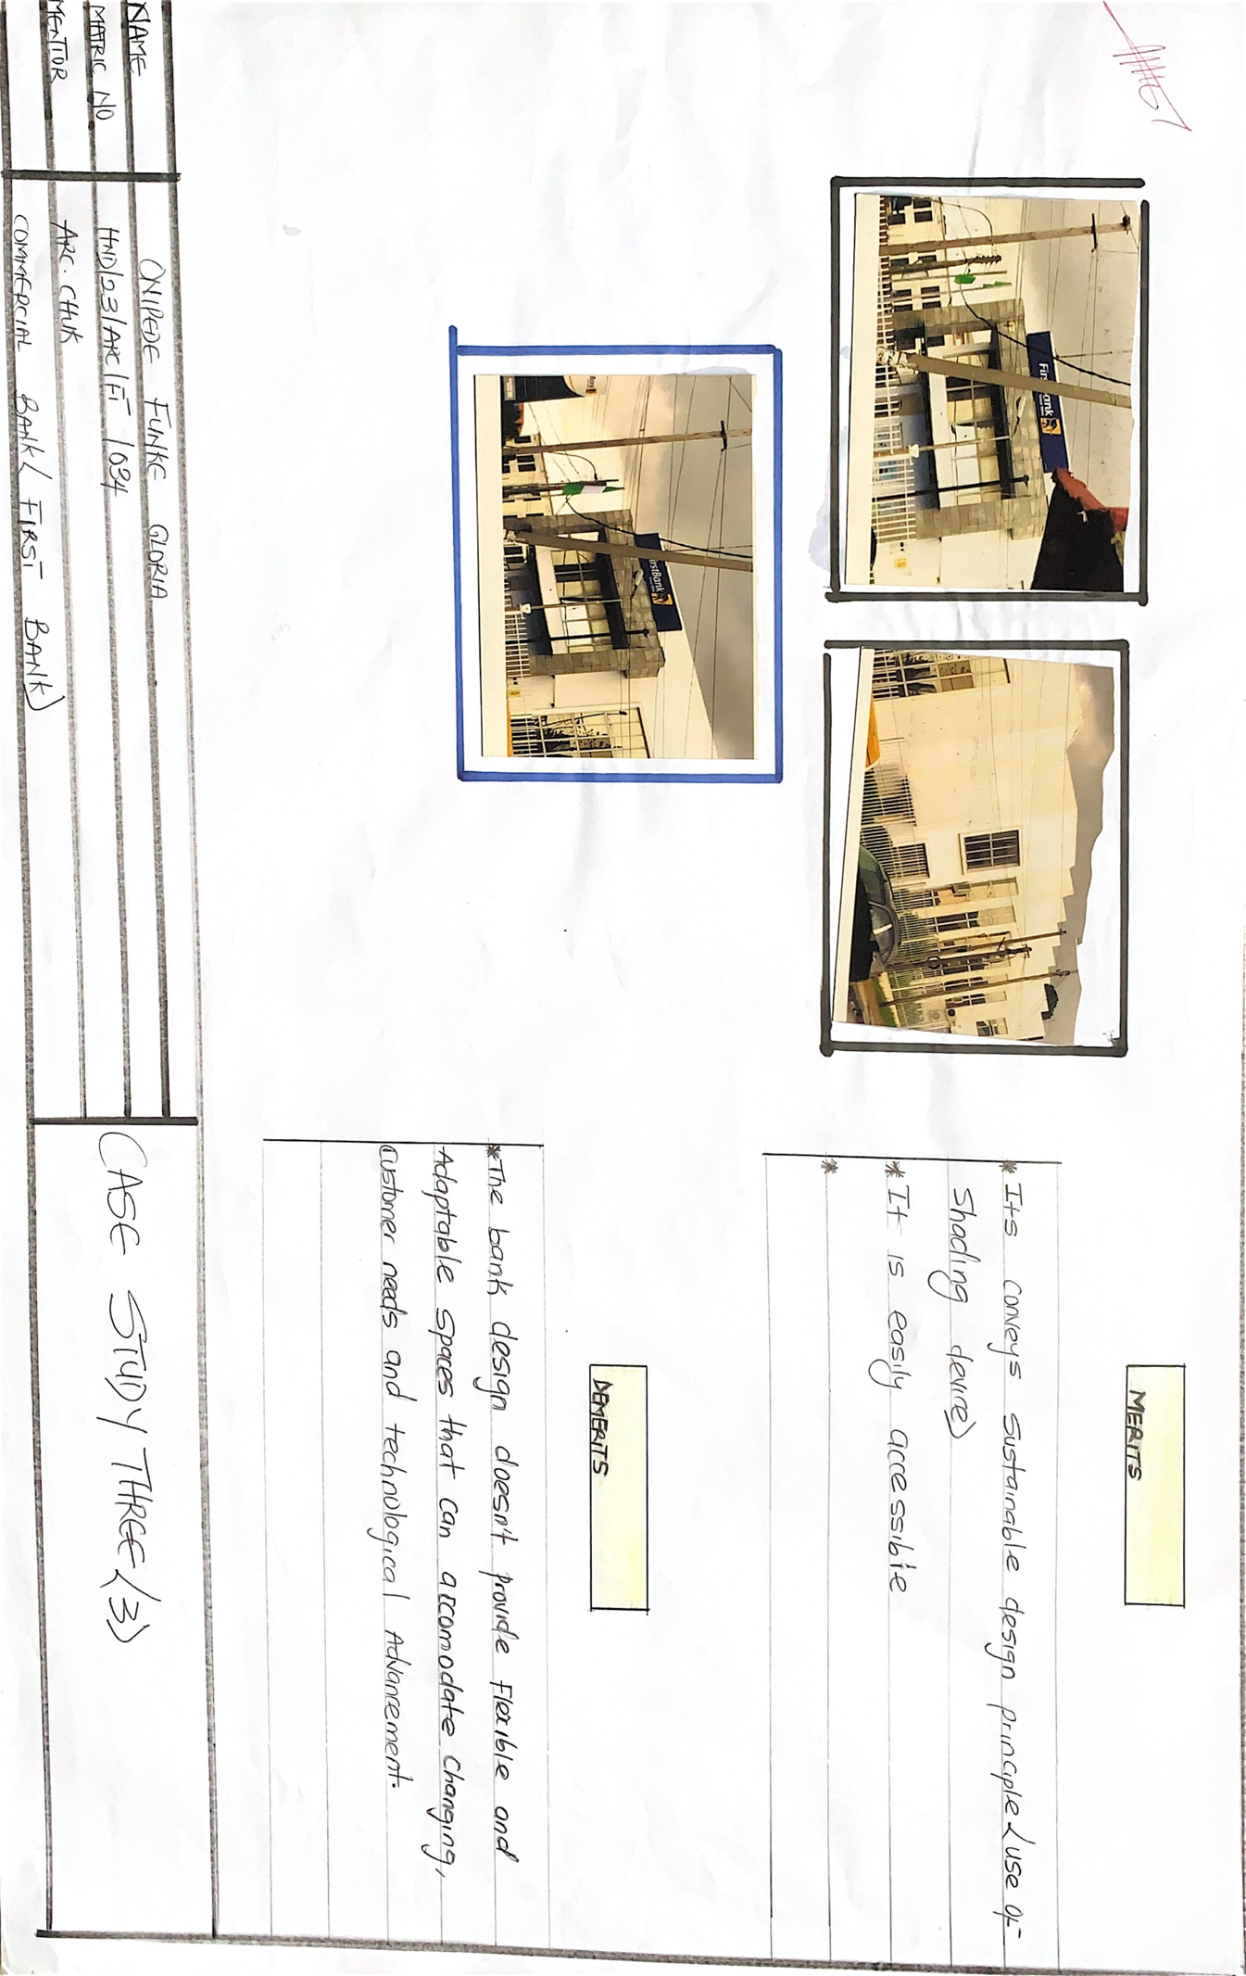

CASE STUDY 3
FIGURE 1.1
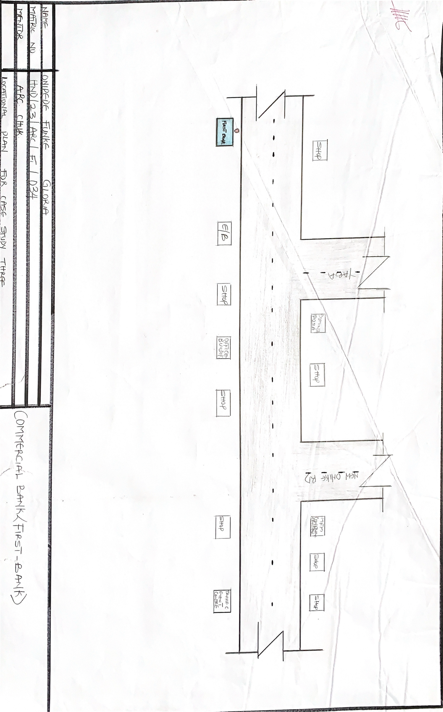

CASE STUDY 3
FIGURE 1.2

CHAPTER FOUR
INTRODUCTION TO PROPOSE SITE

4.1 HISTORICAL BACKGROUND OF KWARA STATE POLYTECHNIC

Kwara State Polytechnic, Ilorin, was established in 1973 by the then Military Governor of Kwara State, Col. David Bamigboye, following the announcement in 1971 during the launching of the four-year development plan. The decision to establish the polytechnic was in line with the Federal Military Government's policy on manpower development. The institution was initially conceived to address the need for technical and vocational training within the state.
The idea for a College of Technology in Kwara State was first suggested by General Yakubu Gowon during his visit in 1970, with the aim of upgrading the existing Government Technical Training College. The Polytechnic's establishment was also informed by the need to meet the growing national manpower requirements and the existence of similar institutions in other parts of Nigeria. The polytechnic's initial operations began with the School of Basic Studies, offering pre-university courses in pure sciences, social sciences, and arts. Over time, the institution expanded its programs to include diploma and certificate courses in various fields of science, technology, management, and vocational education. The School of Education was later separated to become the Kwara State College of Education.

4.2 SITE LOCATION
The site is located at Kwara state polytechnic, Ilorin

4.3 SITE SELECTION CRITERIA
The site is located along yankari, beside Access bank , Kwara state polytechnic.
• Accessibility
• Availability of enough land
• Security
• Nature of Site and Vegetation

• Accessibility : The site can be accessed easily as there is an existing road that leads to it.
• Availability of Enough land: To adequately provide for the various facilities required in the building and on the site, the area of land required for the project must be adequate. Therefore, the site was selected because it is wide enough to accommodate the proposed design.
• Security: The site is located within the school thereby is covered by the school security ensuring safety of the students. But also, additional security would be provided on the site.
• Nature of Site and Vegetation: The topography of the site is fairly levelled and the slightly unlevelled part can be adequately levelled. The sub soil is mainly red lateritic soil, with barches of sandy soil. The site also contains few trees and shrubs, which can help enhance the landscape of the site, and also act as wind-breakers and dust filters during the harmattan

4.4. GEOGRAPHICAL/CLIMATIC DATA

Ilorin experiences a tropical savanna climate characterized by distinct wet and dry seasons. The rainy season typically lasts from late April to October, while the dry season extend from November to April. Temperatures fluctuate between 33°C and 37°C throughout the year. Rain fall arranging from 990.3 mm to 1318 mm annually exhibiting a double maximum pattern.

CLIMATE
- Tropical Savannah climate: This is the dominant climate type in Kwara States, featuring a distinct wet and dry season pattern.
- Wet season: Generally last from late April to October. .
- Dry season: typically from November to April.
- Temperature: Ranges from 33°C to 35°C between November and January and from 34°C to 37°C between February and April.
- Rainfall: annual rainfall ranges from 990.3 mm to 1318 mm with double maximal pattern.
- Prevailing winds: The state experiences the influence of the southwest monsoon wind and the north east continental wind.

GEOGRAPHICAL FEATURES
- Geology: The area is underlain by precambrian basement complex rock.
- Soil: the soil in ilorin supports the grow of crops like cereals and vegetables.
- Vegetation: The dominant vegetation is derived savannah, characterized by grasses like spear grass and elephants grass and trees such as acacia, shea butter and locust bean trees.

4.5. ANALYSIS OF THE IMMEDIATE ENVIRONMENTAL CONDITIONS OF THE SITE

- Site features and infrastructure
The site features, electrical lines which proposes that open power supply is promptly accessible inside the site.

- Perfectly drained soil
Soil water moves through easily to allow good soil aeration and at the same time sufficient amount is retained for plant growth.
Other features includes, good drainage system and access road.

- Noise sources
There is no much noises on the side site but few noises that can be heard comes from the vehicles.

- Rainfall
Minimal rainfall is recorded in April, while June offers the most amount of rainfall.
- Vegetation and topography
The vegetation on the site consist of few trees of different species and few shrubs. The site is relatively gentle sloping and has a high load bearing capacity soil.

- Prevailing wind direction
The site experiences the influence of the southwest monsoon wind and the north east continental wind.

- Sunrise and sunset
The sunrises in the early hours of the morning at 6:28 AM to 7:30 AM and set at about 7:00 pm into the evening daily.

- Accessibility
The site is accessible by an existing road.

- Man-made features
- Electricity: Electricity is supplied to the site through overhead cables along the site boundary.
- Foot paths: There are existing foot paths on the site.
- Noise: caused by the ongoing vehicles.

4.6 PROPOSED DESIGN

The proposed design is the design of a commercial bank for First Bank of Nigeria, with emphasis on functionality, security and sustainability.

DESIGN CONSIDERATION
The following are the factors considered when designing the building.

- Security: The provision of security in the commercial bank involves the protection of the staff, customers and other valuable materials.
- Functionality: The architectural design, functionality plays a major role, design must be functional to meet the convenience of the occupants.
- Aesthetics: Aesthetics is most common factor to consider which shall be achieved by the use of attractive and radiant finishing materials.
- Landscaping: Landscaping improves environmental comfort.
- Ventilation: Natural ventilation is so much needed in architectural design.
- Lightning
- Zooming

4.7. DESIGN CONCEPT
A strong design concept response to the site, client needs and the project purpose, creating a unique and meaningful architectural outcome.
The concept address the client’s requirements, program and aspiration for the building.
The concepts also incorporate aesthetic principles, such as form, proportion and material choices to create a visually compelling design.

4.8 .APPRAISAL OF PROPOSED SCHEMES
An appraisal of a proposed scheme for the commercial bank involves evaluating the plans, feasibility, effectiveness and potential impact.
Here’s a comprehensive appeal framework

1. Location and accessibility
- Safety and security features
- Accessibility for customers
- Proximity to relevant businesses

2. Capacity and accommodation
- Number of staff and customer to be accommodated in a space at a time.

3. Infrastructure and amenities
- Electricity supply
- Internet and Wi-Fi connectivity
- Furniture and appliances

4. Management and supervision
- Banks administration and staff
- Rules and regulation
- Maintenance and repair procedures

5. Cost and Funding
- Construction and operational cost
- Funding sources (private investment)

6. Sustainability and environmental impact
- Energy efficiency
- Renewable energy sources

7. Future expansion and flexibility
- Potential for expansion or renovation
- Demographics

8. Compliance and regulation
- Adherence to local building codes and regulations
- Compliance with accessibility and safety standard.

9. Stakeholder engagement
- Involvement of the general service manager and order stakeholder involved in the project

4.9. SCHEDULE OF ACCOMMODATION

. FUNCTIONAL RELATIONSHIP
Functional relations in architectural design refer to the way in which different spaces, elements and components of a building interact and support each other to achieve the intended purpose of the structure. These relations are crucial for creating efficient, practical and aesthetically pleasing environments.

CONCEPTUAL DEVELOPMENT
Conceptual development in architectural design as the process of generating and refining ideas that form the basis of a building’s design. It involves translating abstract concepts into concrete architectural solutions.

CHAPTER FIVE
5.0 DESIGN CONCEPT

Building form and floor plan equally ,functionally related activities areas form zones consciously planned to preserve the sense of place and connectivity between species. This entails creating clear, logical hierarchies of such other architectural Way finding elements as markers edges and path to facilitate user cognitive perception and orientation in space.

DESIGN CONCEPT SYNTHESIS
Research case studies help to give direction in determine best practice in improving functionality and operation design issues in commercial bank.Thus this informs the following configuration of spaces to achieve legibility in the design.

- [ ] A hierarchical characterization of activity zones
- [ ] Simple floor layout with immediate visual and physical access to various designated spaces
- [ ] Visual perception of major articulation pathways.

5.1. CONSTRUCTION METHOD

The proposed site is a gently slope site with good draining capacity and a good safe load bearing capacity and as such the need for additional strengthening and treatment of the soil before construction may not be needed unless the geological expert request.
The building lines are taken into consideration at the inception of this design so with the building lines and the existing access road .
- [ ] A large builders square places against the building line and sideline produce to line to require using proprietary optical square which comprises two small sighting telescope set at precise site angles one another
- [ ] By using an optical instruments .

method of constructions is as follows,
- [ ] Digging of the trenches .
- [ ] Filling of hardcore .
- [ ] Block laying .
- [ ] Filling of hollow blocks with hardcore .
- [ ] Filling of Laterite in to foundation .
- [ ] casting of mass oversite slab .
- [ ] Laying of hollow blocks.
- [ ] casting of column and Lintel .
- [ ] Roof construction .
- [ ] plastering
- [ ] fixing of window frame .
- [ ] Finishing.

5.2 .CONSTRUCTION MATERIALS

The choice of materials to be used is influenced by several factors, some of these factors include;
1 The availability of materials
2 The durability and suitability of such materials
3 The climatic situation/condition
4 The cost of materials

5.3 SUBSTRUCTURE AND SUPERSTRUCTURE

- Foundations: strips /pads foundations shall be used

- Suspended Floors: Unglazed vitrified ceramic floor finish; unglazed vitrified ceramic tiles; polished granite tiles; glazed vitrified ceramic tiles.

3. Walls: Sandcrete block for all walls of load bearing capacity finished with 25mm thick wall plaster rendered and finally painted with white and blue emulsion paint on the exterior and white in the interior as may be specified. In the conveniences- toilets, etc, the walls are to be finished with glazed ceramic tiles to a height of 2.1m.
4. Doors: Sizes of doors in the design range from 750mm to 2800mm. The door schedule to be provided in the proposed design drawings shows each as applicable in the design. The surface coating of these doors especially the interior ones must be able to withstand incessant cleaning and must be able to prevent sound transmission. Single and double leaf doors shall be of approved quality, solid hardcore flush door installed with all necessary ironmongery while the main entrance door is a man trap door made up of bullet proof glass fixed to Aluminum frame .

5. Ceiling: Acoustically proofed white cellotex ceiling boards will be used. Acoustic ceiling tiles (suspended ceiling)

6. Roof :Aluminum long span

7. External Works: Grass, trees and shrubs, interlocking paving stones, plain in-situ concrete and asphalt will be incorporated in the design. The existing site is finished with coal tar and that will be retained for the driveway and parking lot.

5.6 SERVICES/ INFRASTRUCTURE
All necessary infrastructures ranging from access roads to power supply to mains water supply and drainage facilities are already existing on the proposed site. This will be needed to ensure that the centre is functional and self-sustaining. Electricity is to be tapped from the nearest electric pole at the side of the site to power activities within the centre. All roof drains runs to the underground drains which passes on to the main public drainage. Light fixtures and electrical wiring are to be concealed in the various ducts provided.

i. FIRE PROTECTION
Proper installation of cables and adequate power rating by the use of excessive current circuit breakers will help in minimizing the risk of fire outbreak especially through electrical fault. However, in the probable case of fire outbreak, the following shall help in quick quenching of the outbreak;
1. Adoption of the sprinkler system in every unit,
2. Installation of smoke/fire detecting alarms in all units,
3. Fire extinguishers are to be placed at strategic locations, and
4. Employment of the fire brigade services in the event of an outbreak.

ii. VENTILATION
As much as possible, every space provided will be ventilated naturally and Artificial ventilation

iii. LIGHTING AND GLARE
The windows provided will ensure that the centre is well lit. Glare which may result from natural lighting or the artificial one used in complementing
suitable building exterior colours that will significantly reduce or eliminate the glare. In order to reduce glare and contrast, bench tops and furniture generally will be of high reflectance i.e. light colours, likewise for the walls and ceiling.
iv. NOISE CONTROL
In achieving noise level reduction, adequate setback from the main access road is provided. Buffer zones are provided also. Catering for the noise generated within the building, an internal buffer has been introduced by separating the noisy areas from the quiet areas.

CONCLUSION
In responding to the inherent problems associated with commercial Bank, this thesis synthesized the analysis carried out during the process of the research. In trying to have a compound analysis and solution alike, case studies were critically analyzed with all the positive attributes employed to the advantage of the research.
All the features above that were analyzed in this study, if adopted, will provide an effective Functionality,Aesthetic and Safety in the sense that the problems and attitudes associated in commercial bank has been taken care of through design approach that helps prevent ignition of fire, alert staffs and customers about its outbreak, provide means of escape, limit spread of fire through proper use of material and construction methods. This enhances the safety of both staffs and customers.



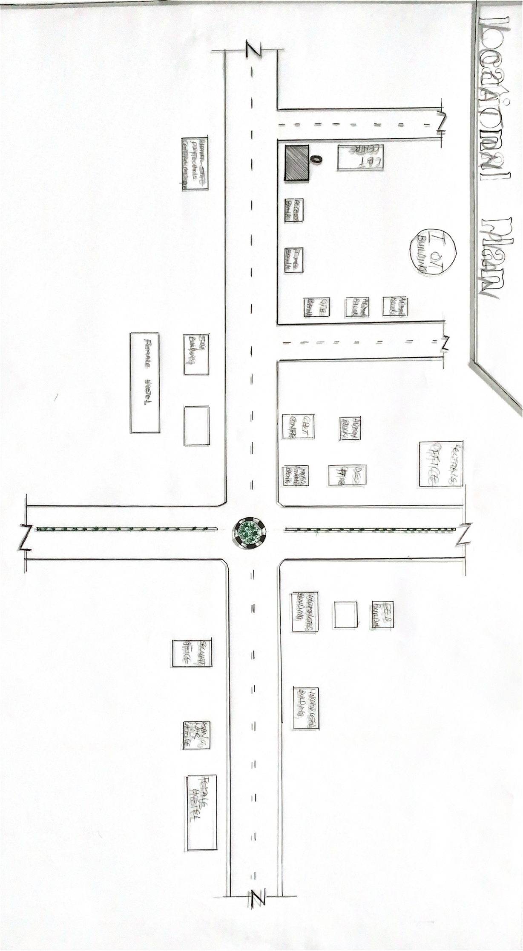

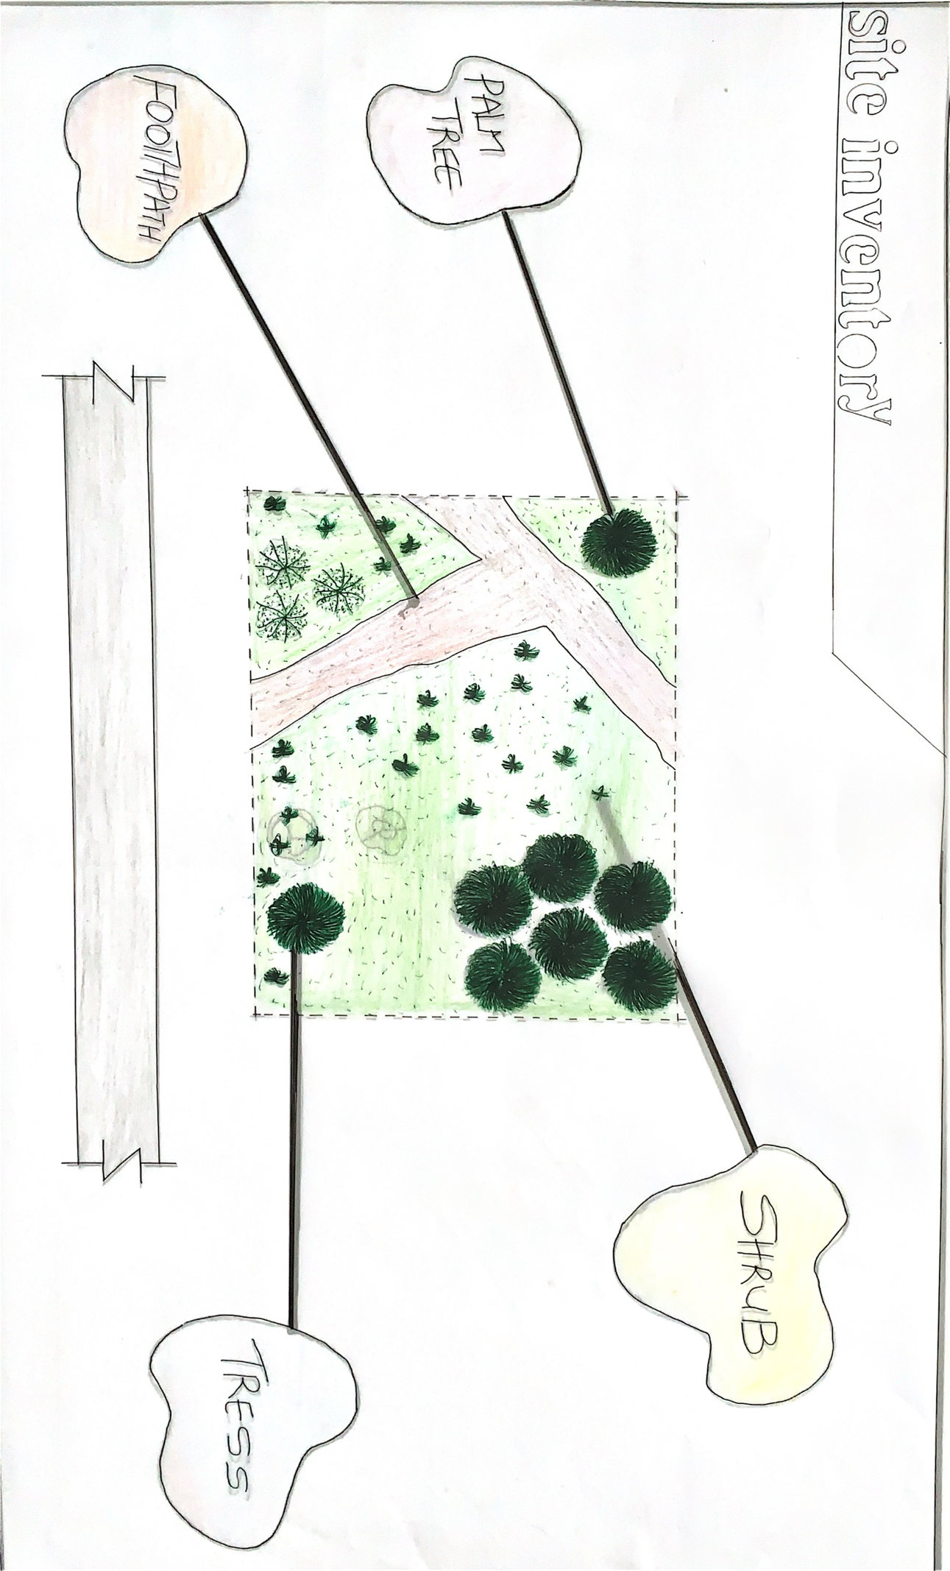

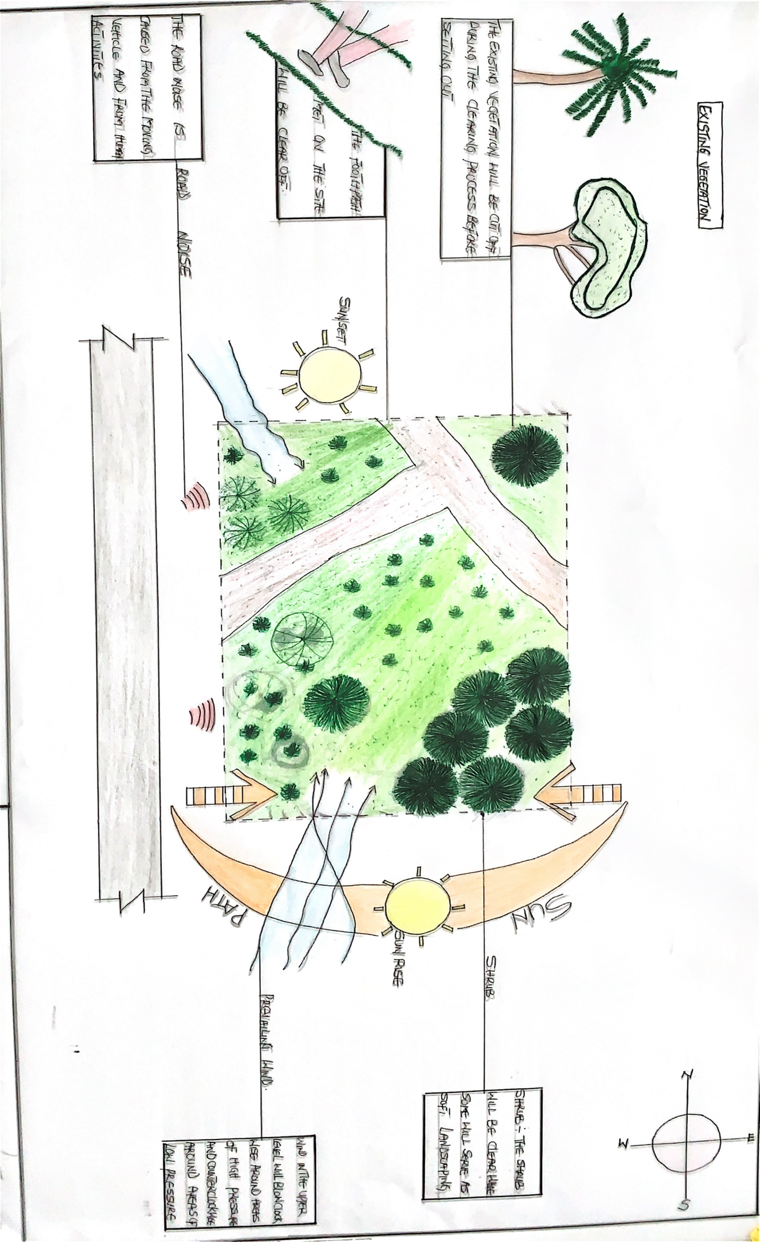

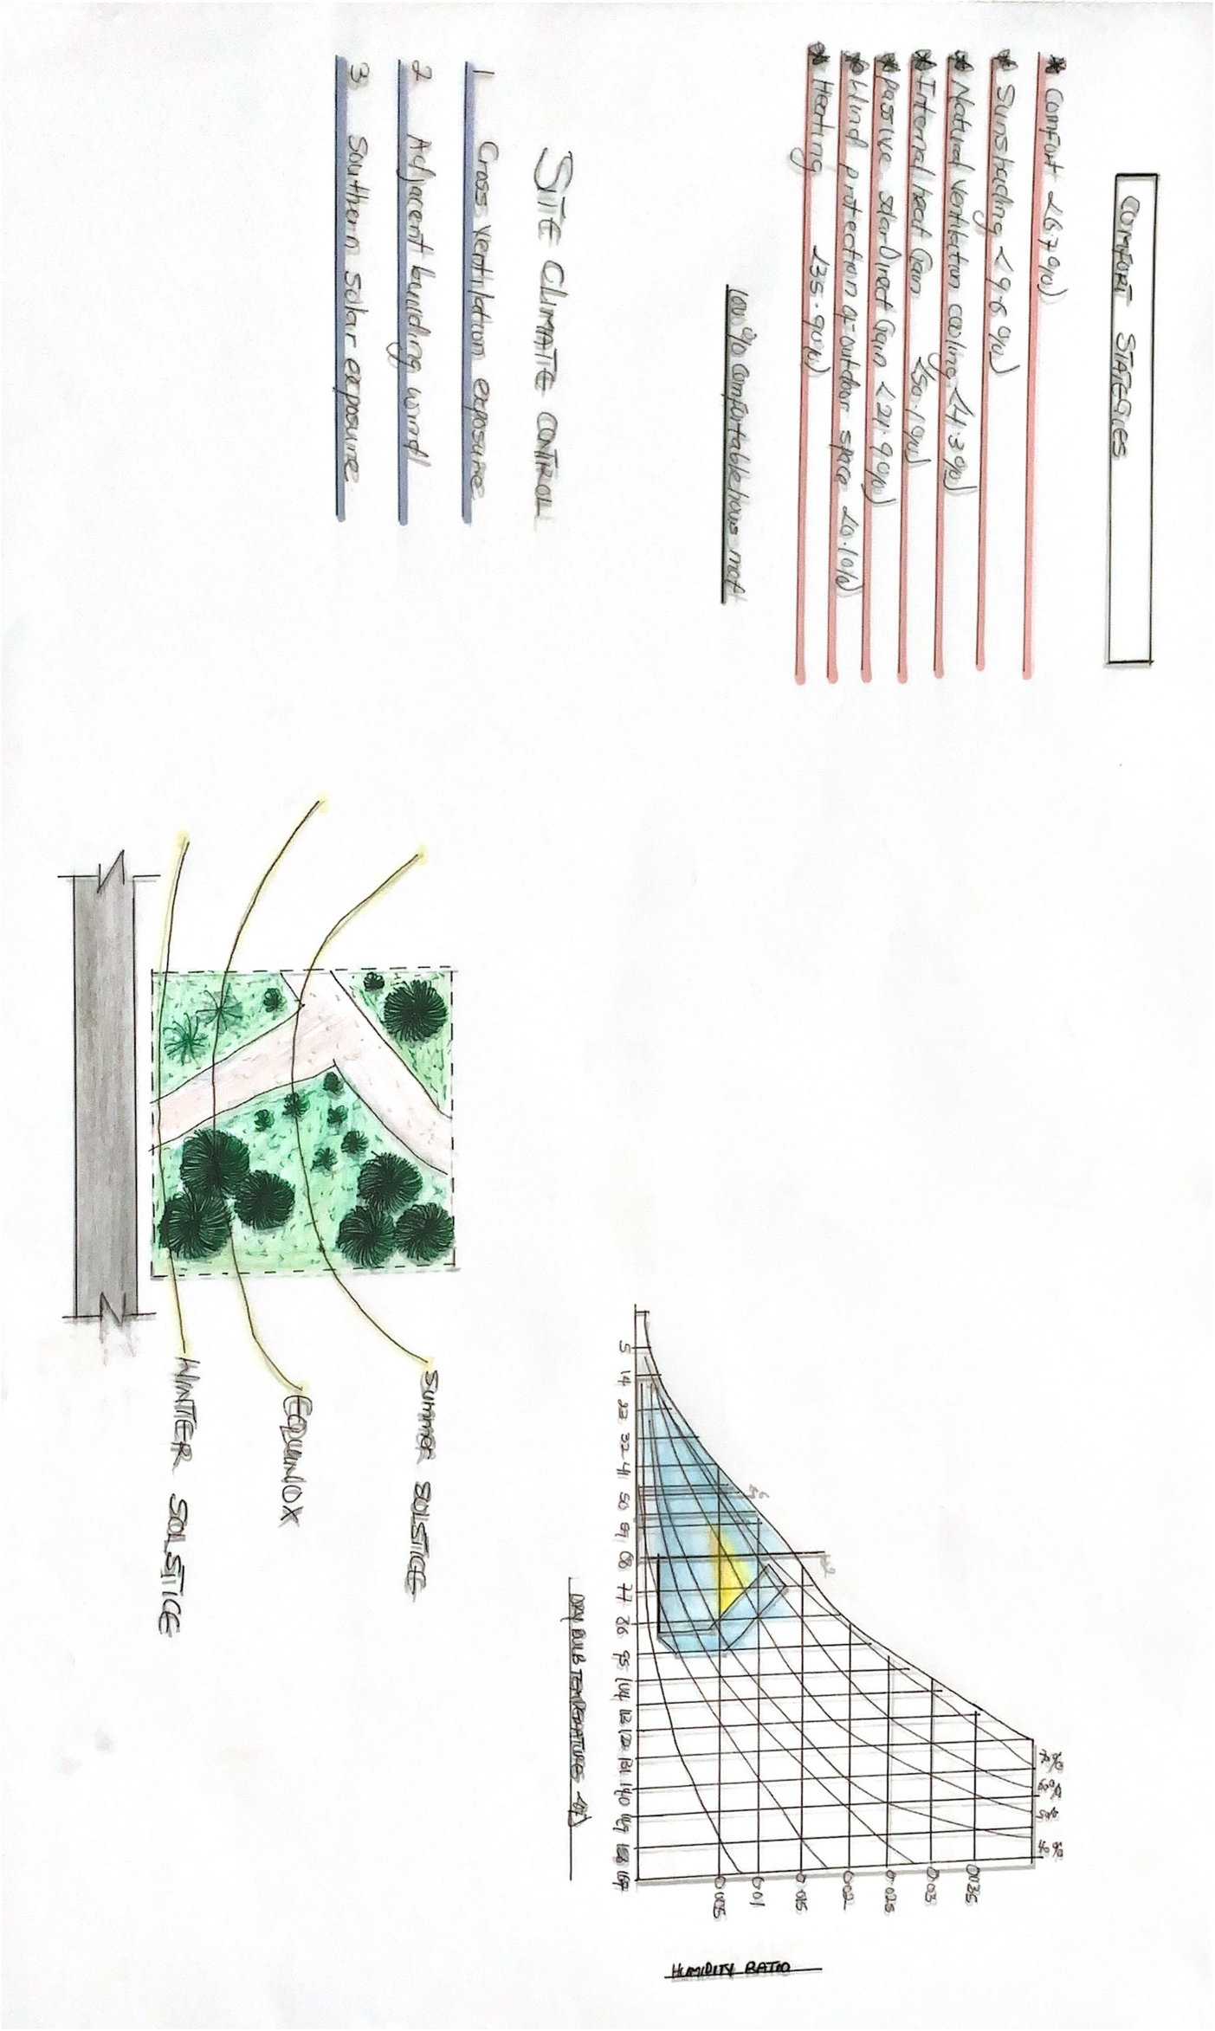

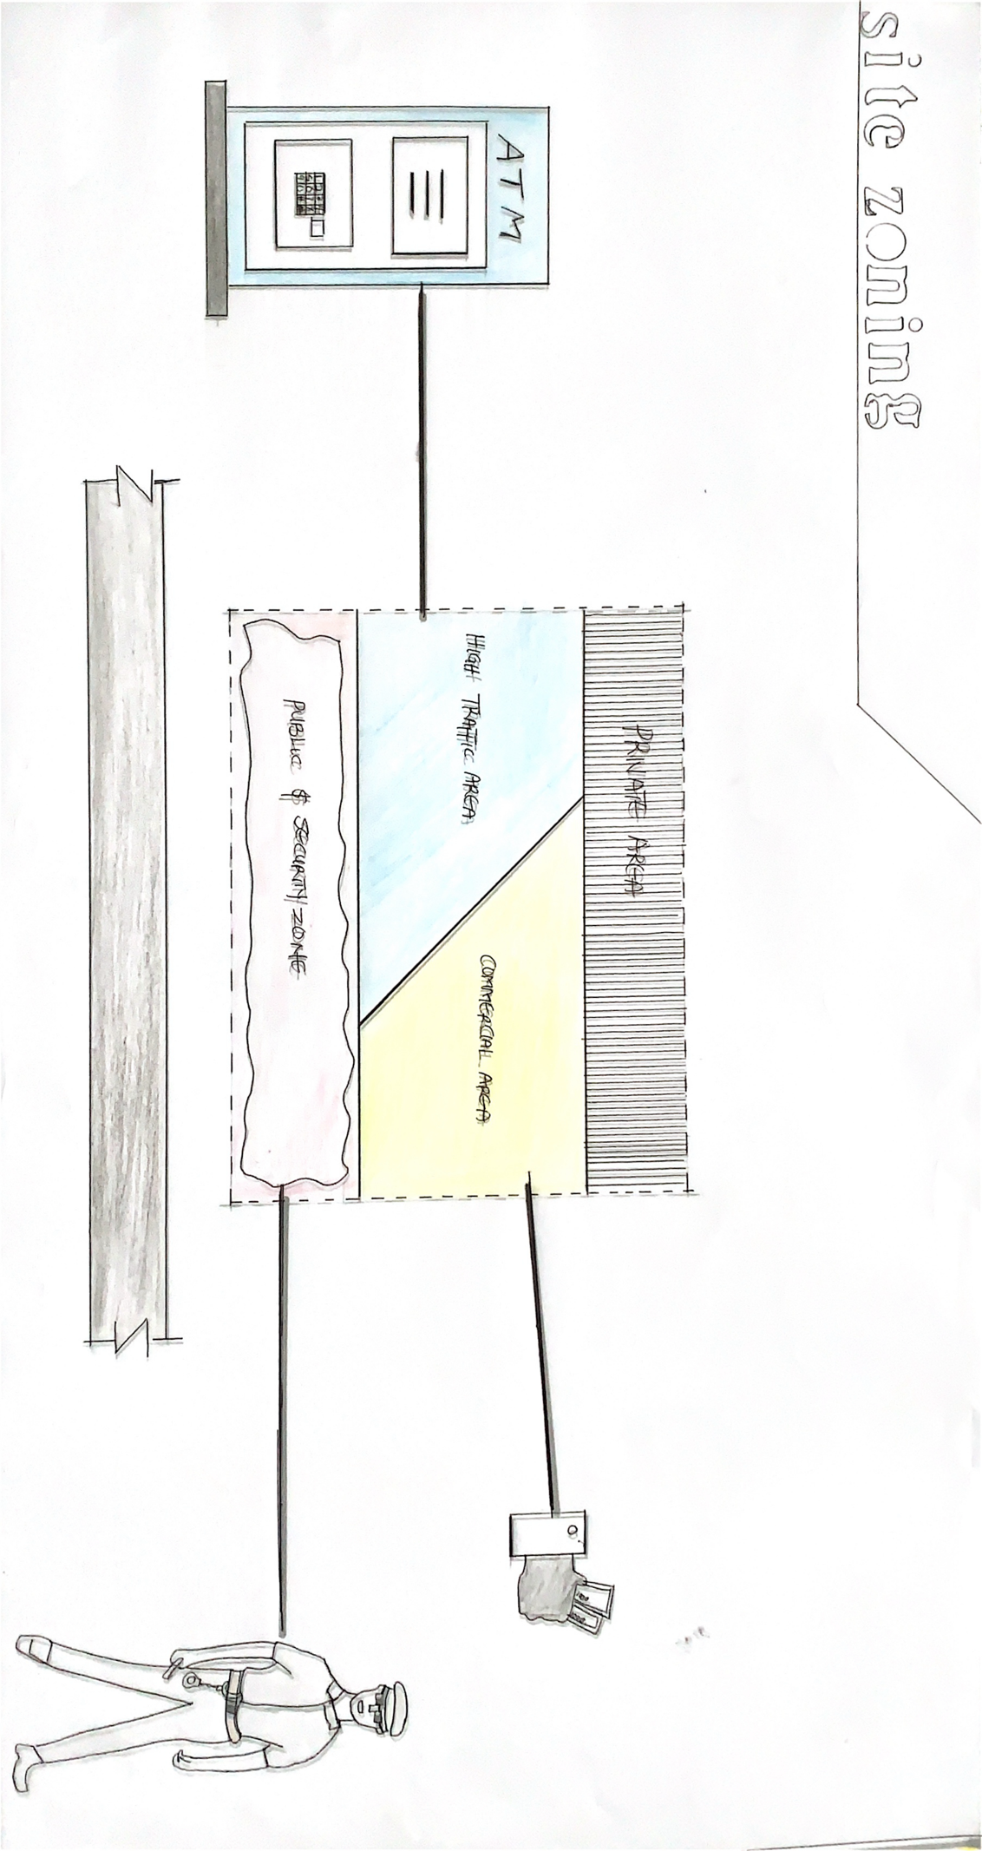

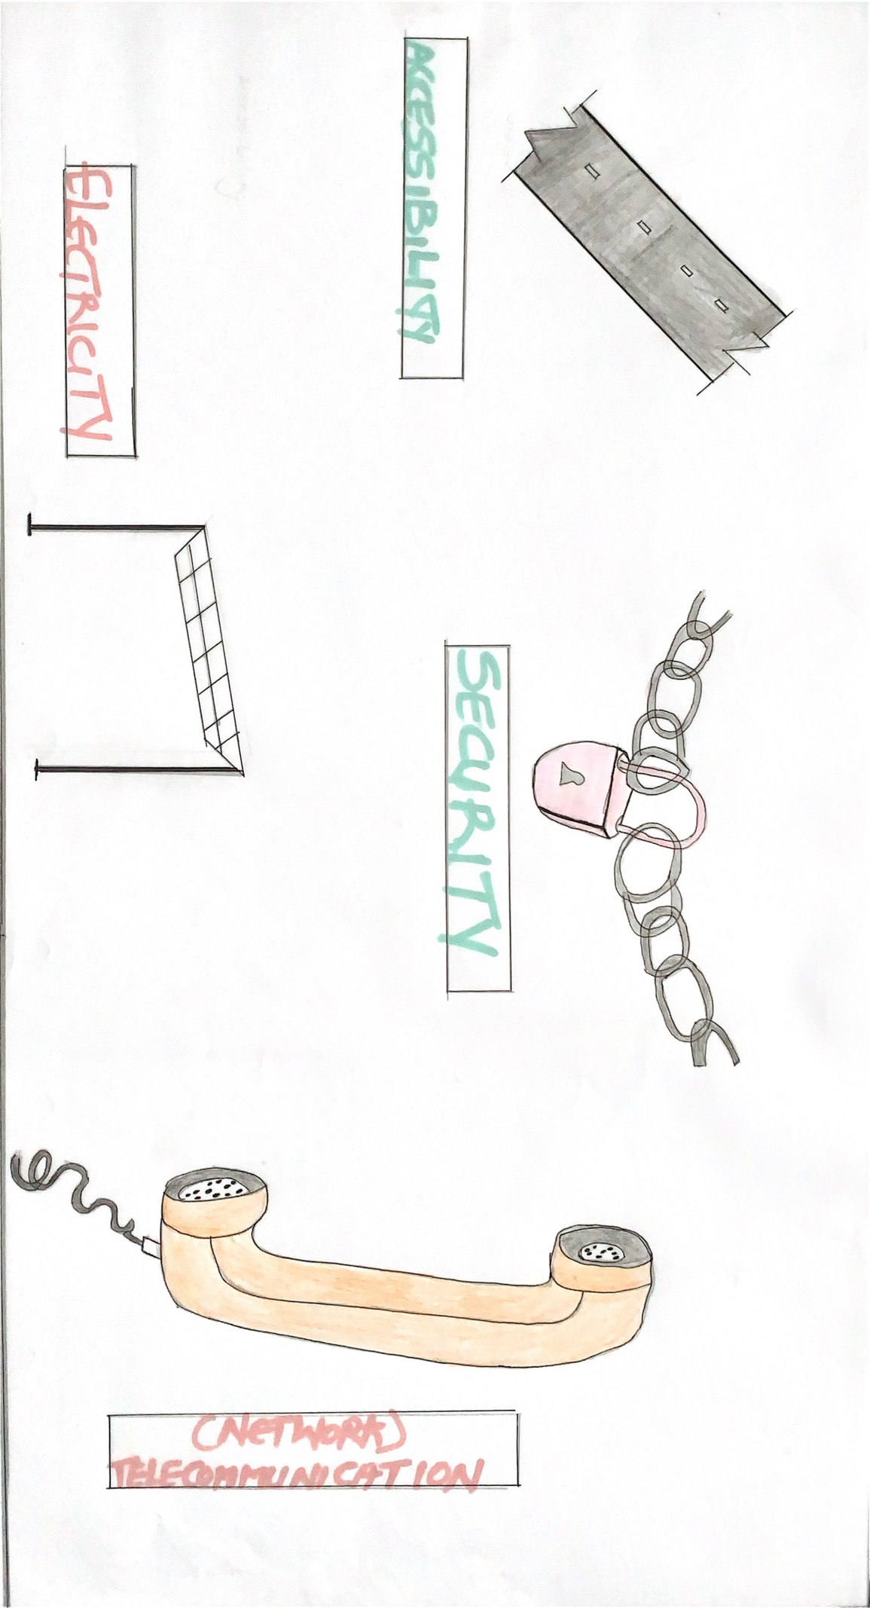



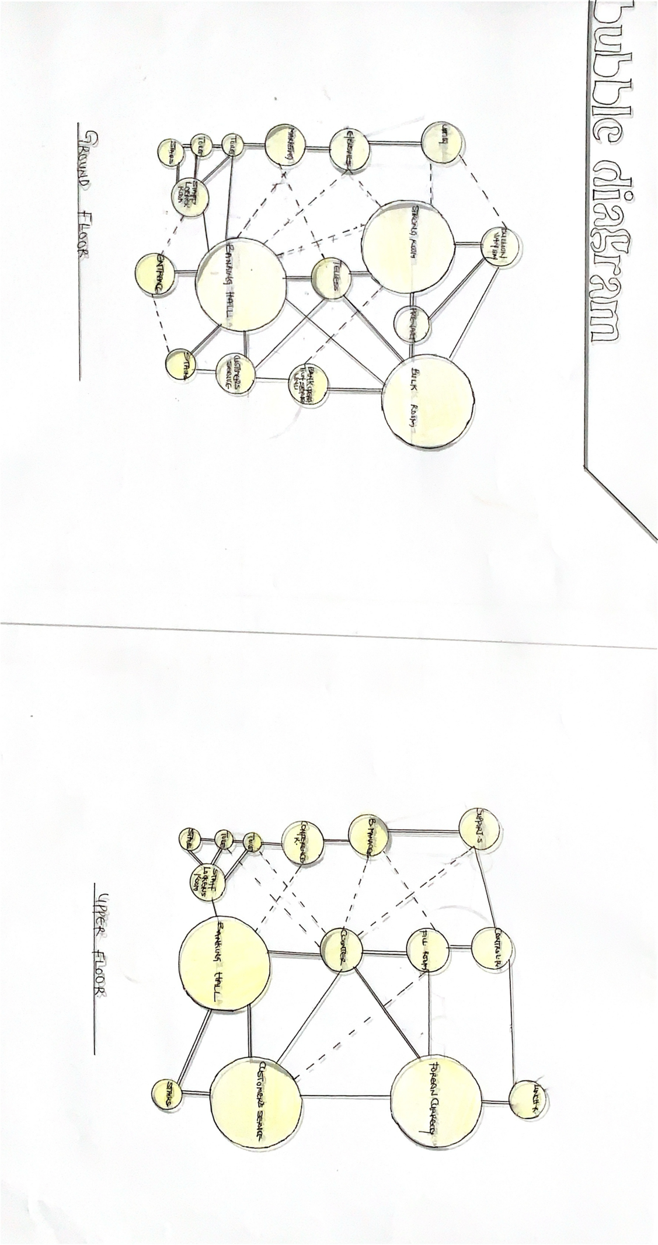

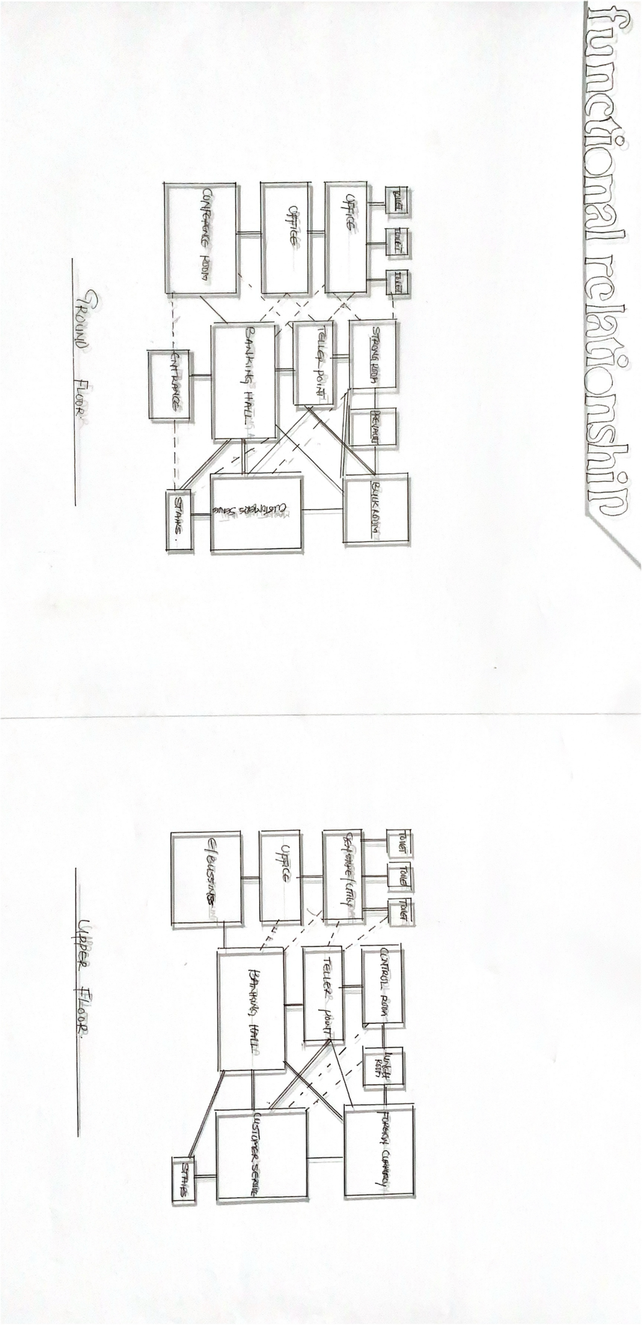

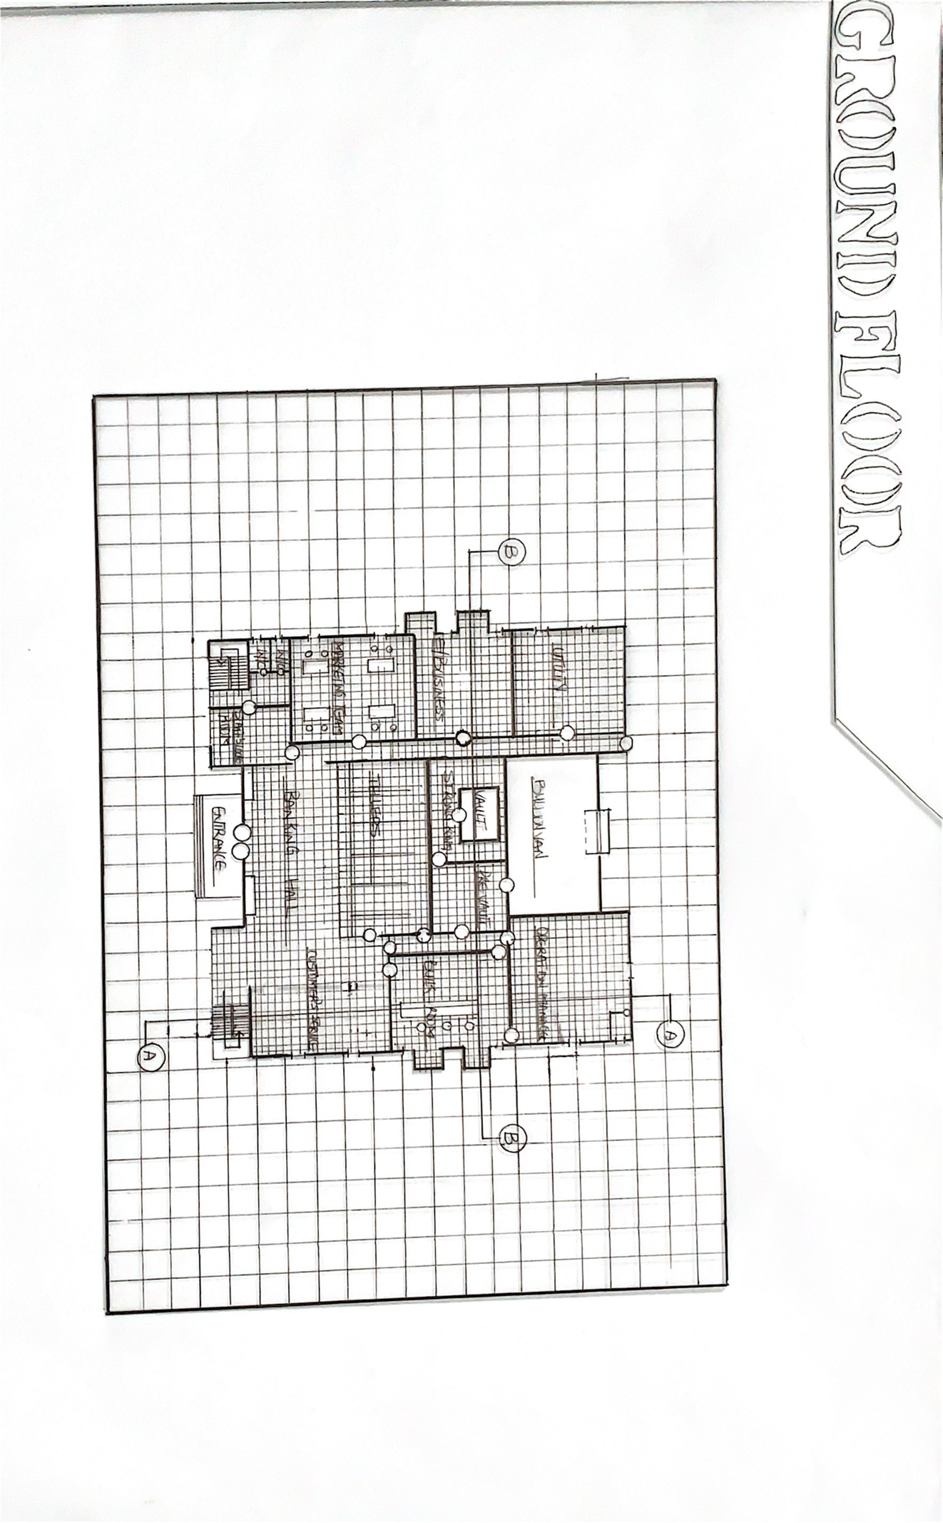

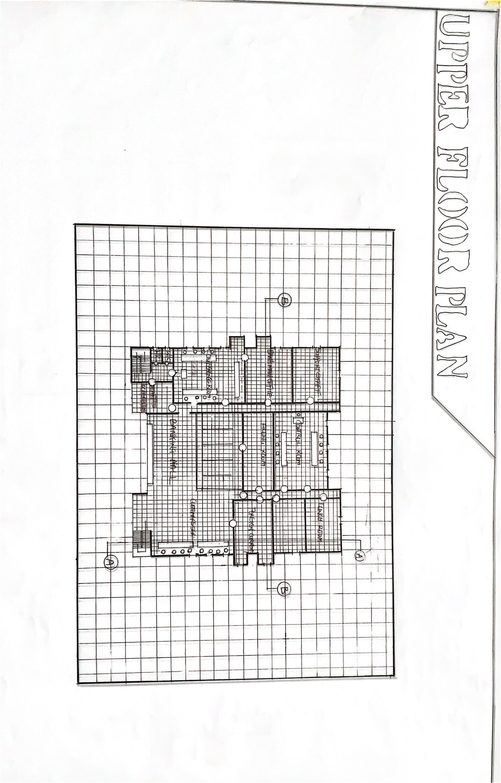

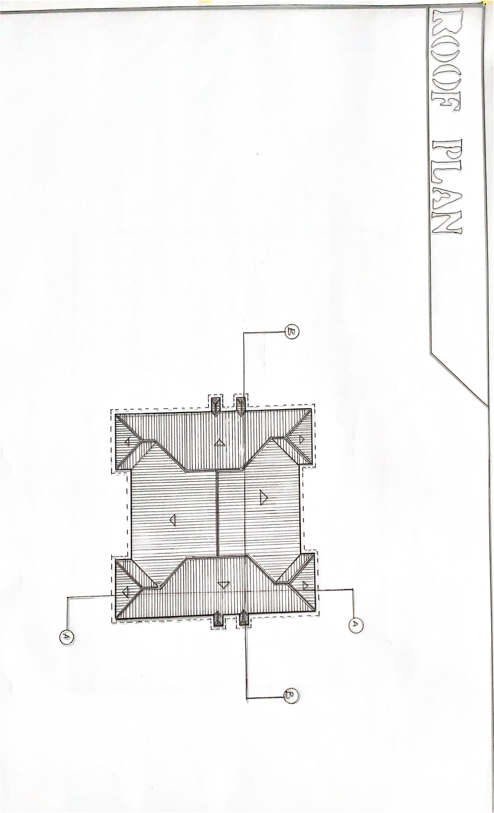

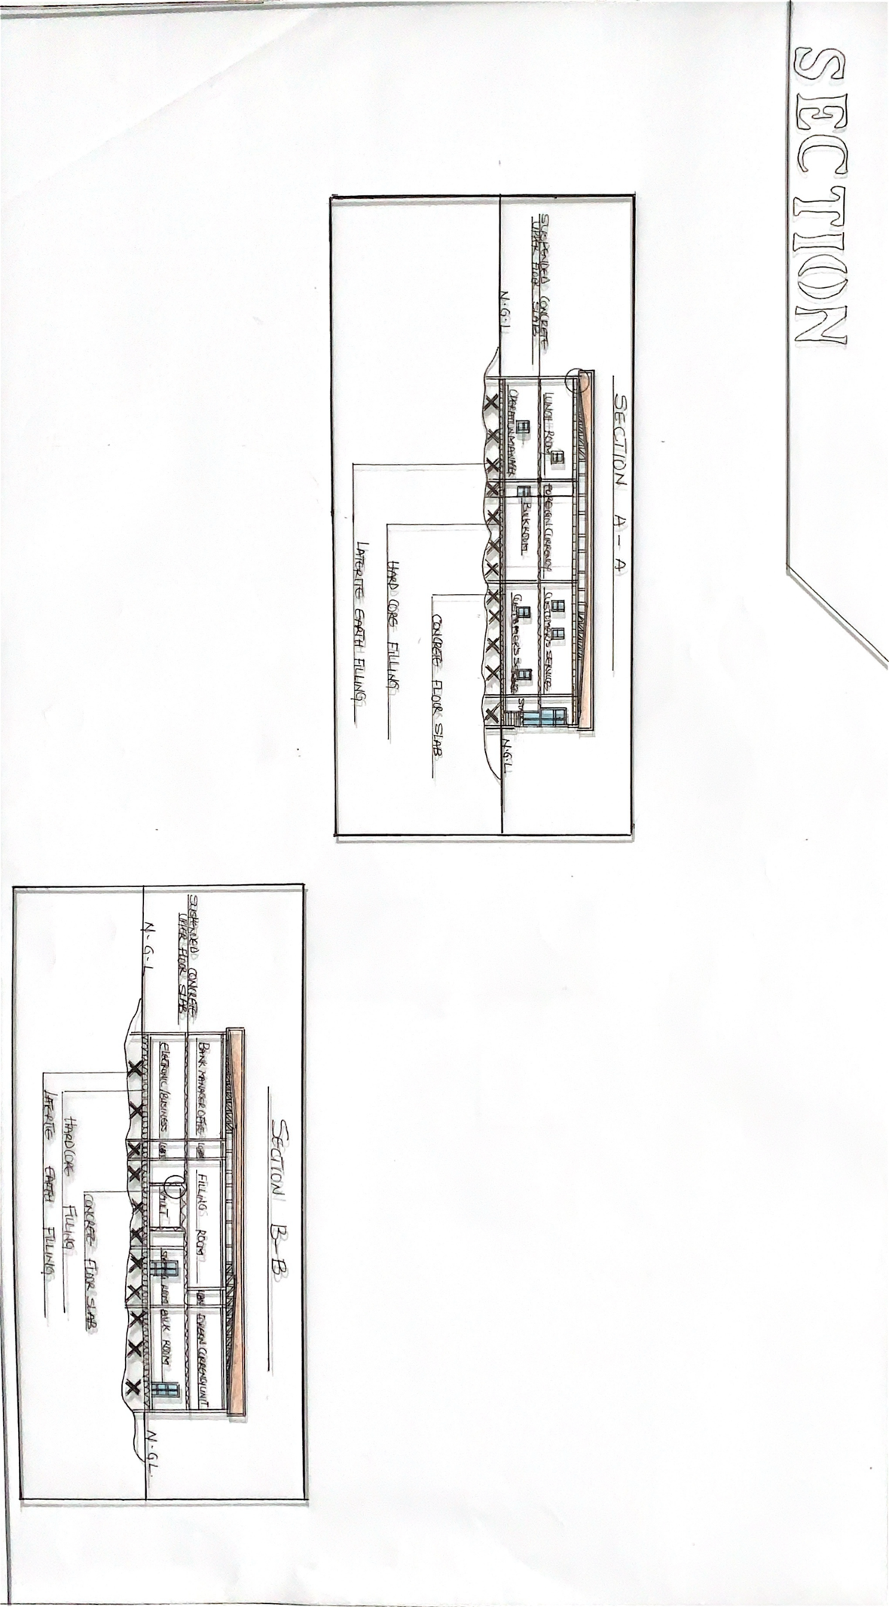

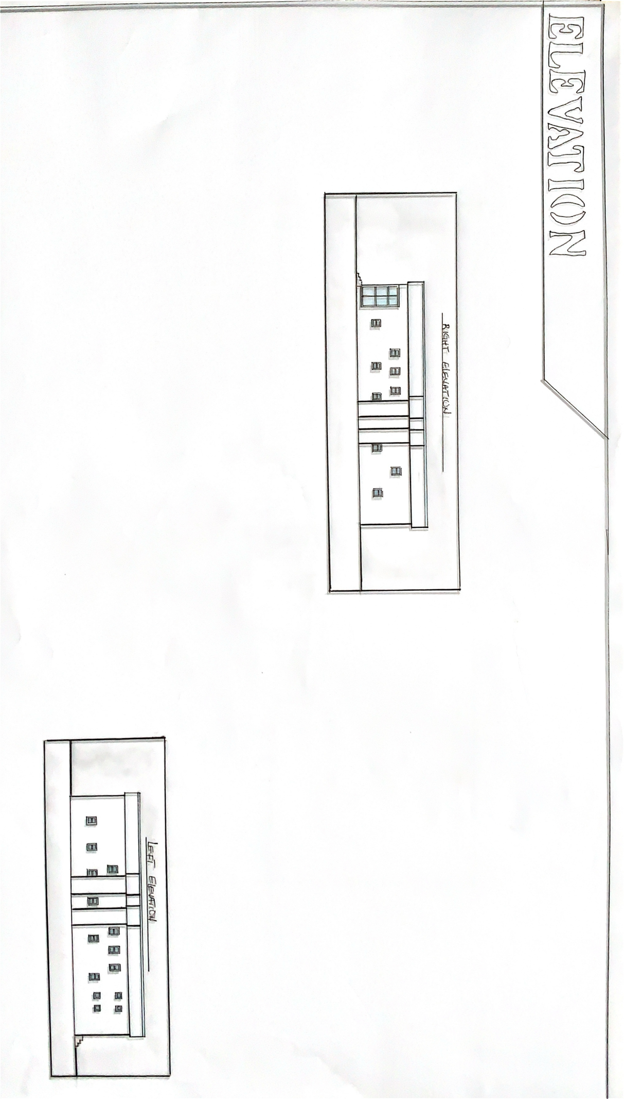

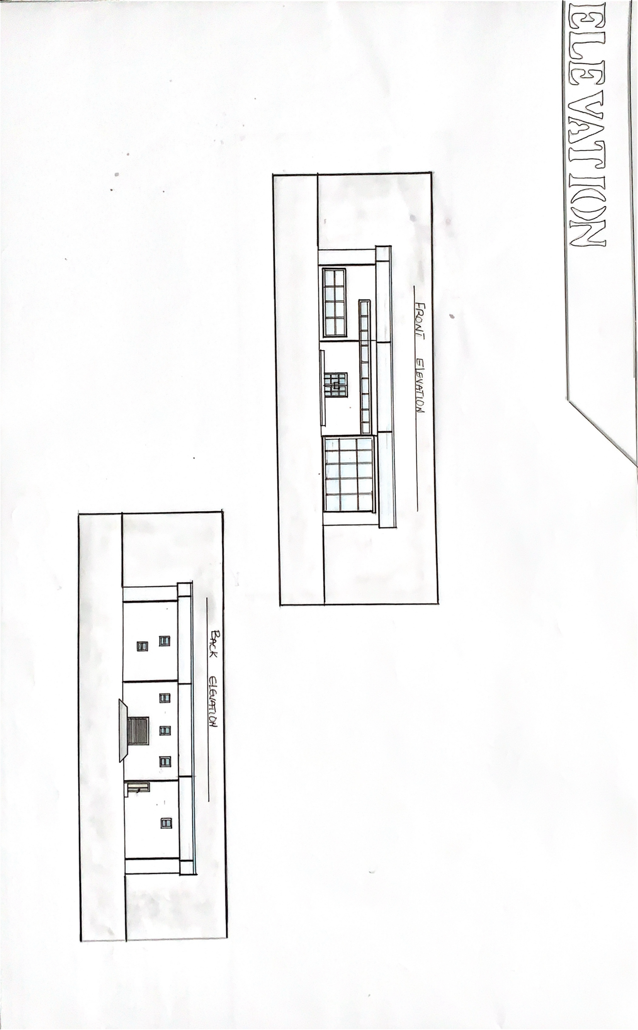

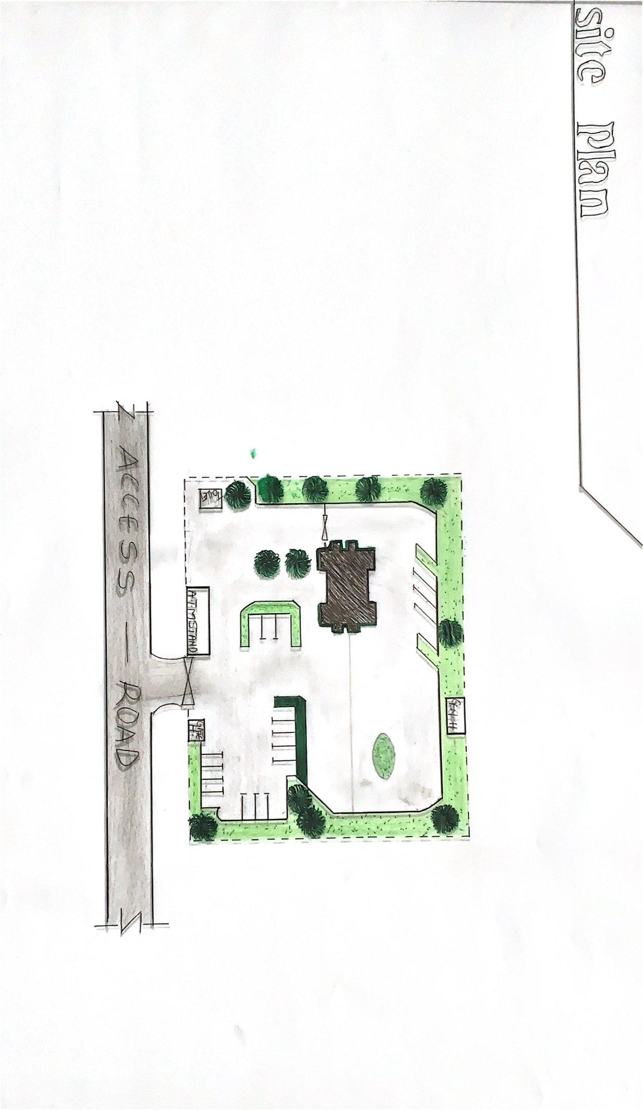

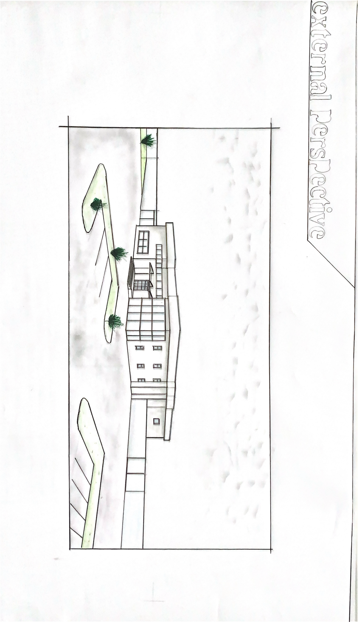

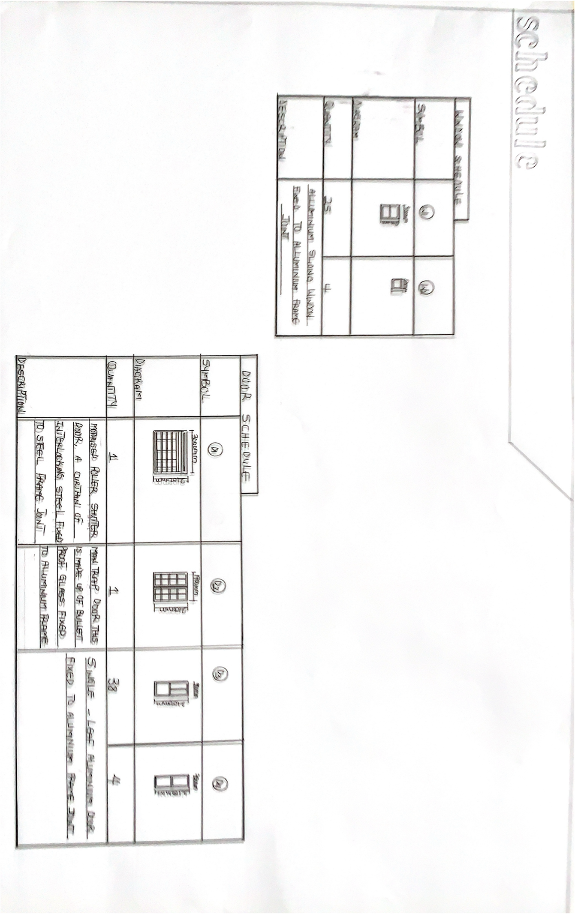

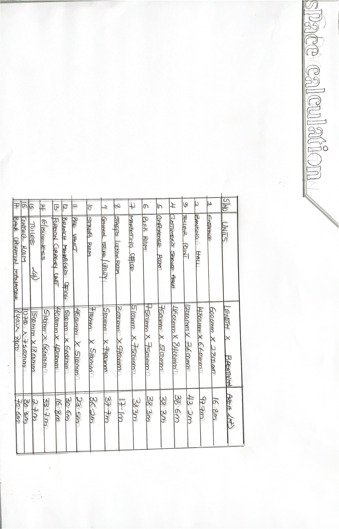

REFERENCE

Muhammad jam (2016) (satisfaction on HRM practices of commercial Banks in Bangladesh)
Abdijabbar ismail (2015): Enhancement performance through human resource management practices (a review of literature
Abubakar umar (2019): Selection of banks within kano metropolis Nigeria.
Mamoria C.B (2003): personnel management of commercial bank
George Steven (2019): case and Exercies of commercial bank
Breadwell IAN Holden Len (2013):contemporary prospective of commercial bank
Ernst and peter Neufert (1993); Architects’ data, third edition, Blackwell science publishers.
FEMA - Federal Emergency Management Agency, (1999), Fire in the United States 1987-1996, 11th Edition, US Fire Administration, Federal Emergency Management Agency, Maryland, 21727

