EFFECT OF FUNGICIDE’S APPLICATION ON SOIL MYCOBIOME

BY

FALADE ALIMAT
HND/23/SLT/FT/0625
A PROJECT SUBMITTED TO THE DEPARTMENT OF SCIENCE LABORATORY TECHNOLOGY, INSTITUTE OF APPLIED SCIENCES (IAS), KWARA STATE POLYTECHNIC, ILORIN,

IN PARTIAL FULFILMENT OF THE REQUIREMENTS FOR THE AWARD OF HIGHER NATIONAL DIPLOMA (HND) IN SCIENCE LABORATORY TECHNOLOGY, INSTITUTE OF APPLIED SCIENCES (IAS), MICROBIOLOGY UNIT
KWARA STATE POLYTECHNIC ILORIN

JULY, 2025
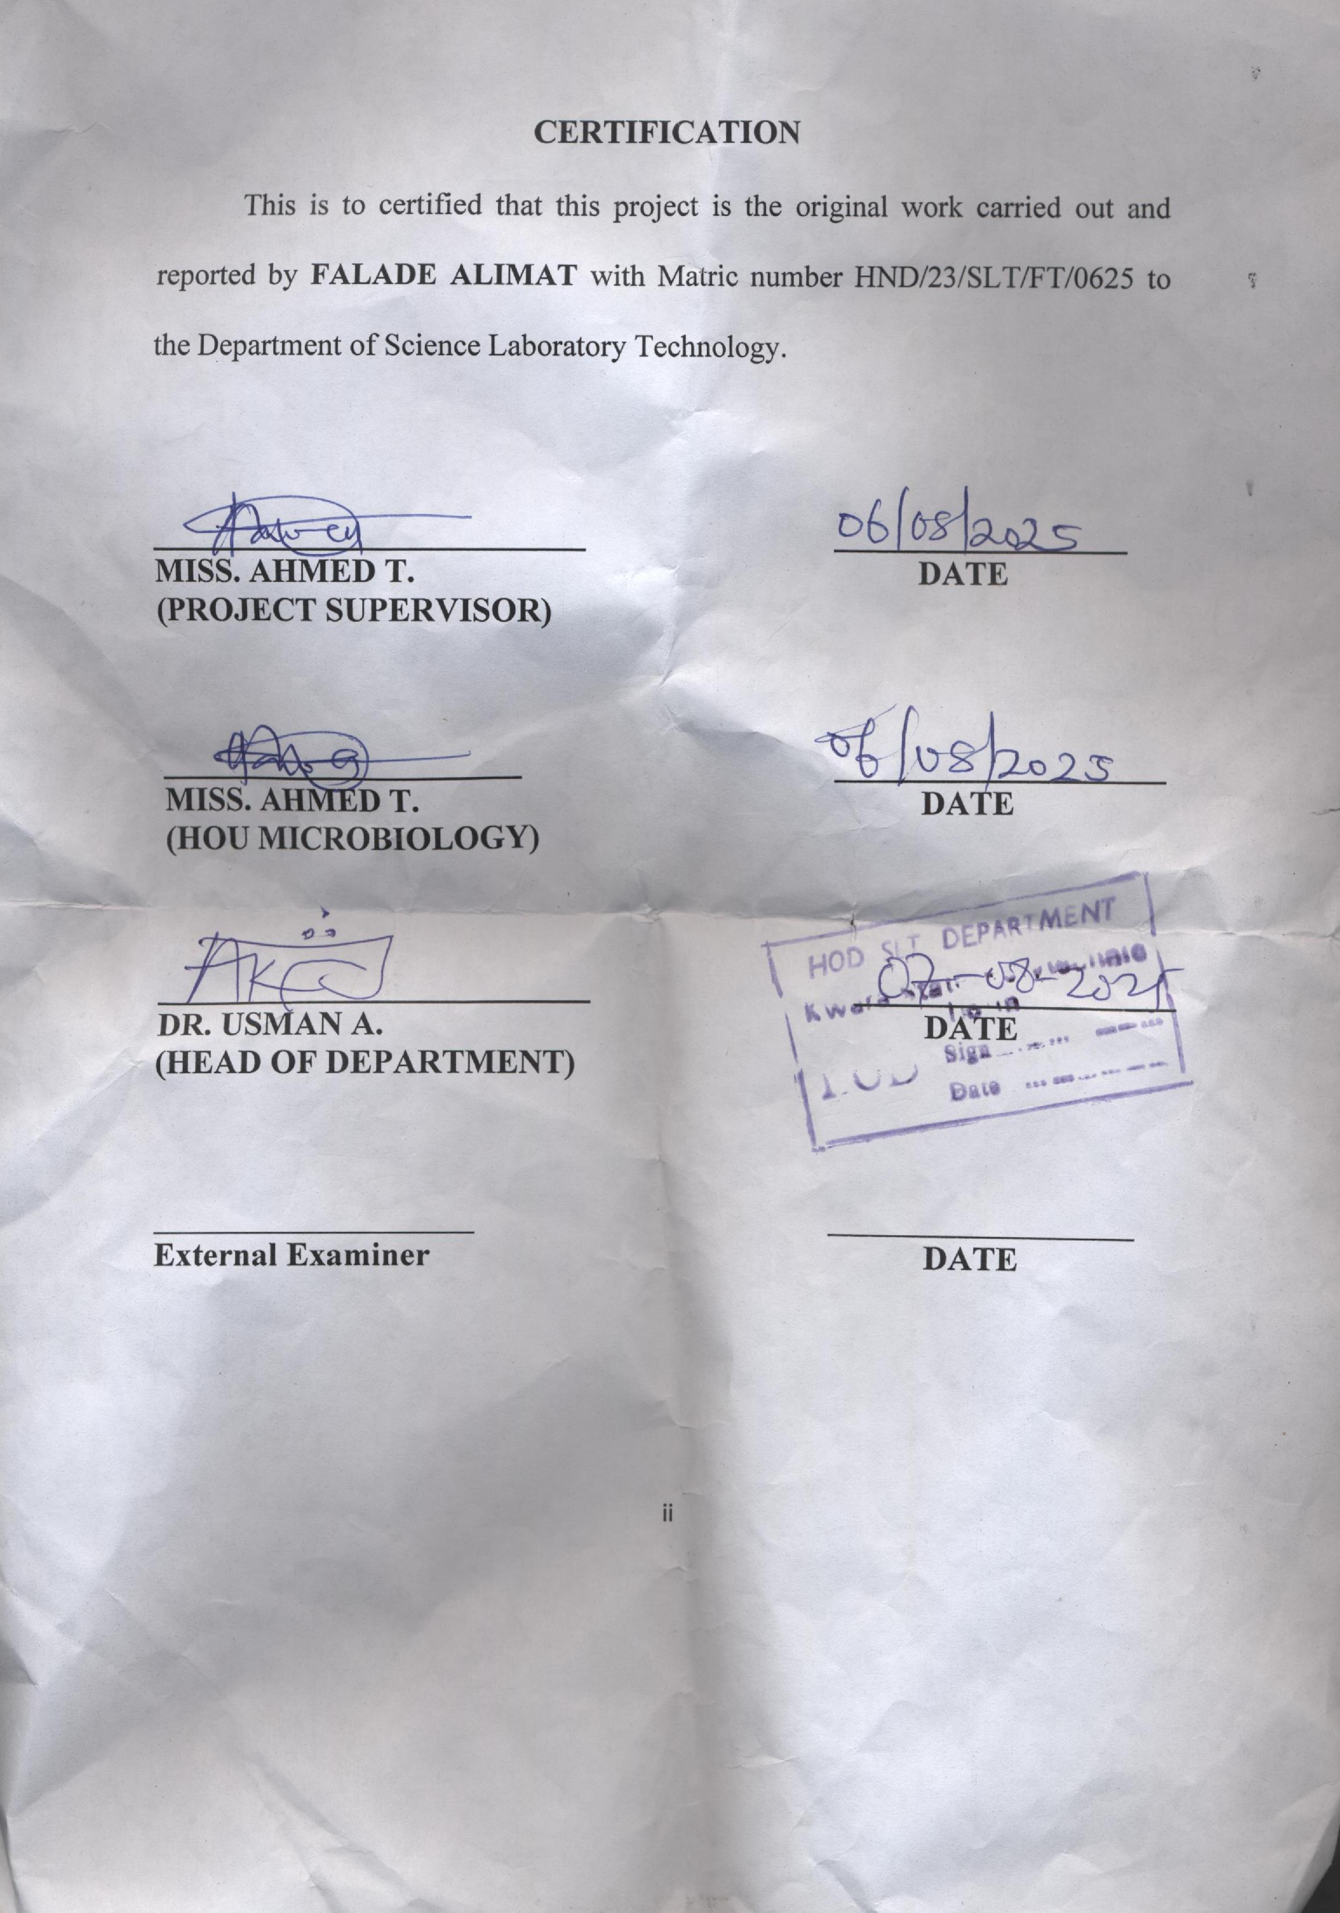
DEDICATION
This project is dedicated to Almighty Allah, the provider and Sustainer of life, whose grace has made this journey of my Higher National Diploma (HND) possible, and also to my sponsor Mr. Abdulganeey Falade (My dad) and Mrs. Abdulganeey Kafilat (My mum), my pillar of support. May Allah continue to bless and protect you.

ACKNOWLEDGEMENTS
I am indeed thankful and grateful to Almighty Allah for giving me the opportunity, courage, energy, grace and assistance needed to successfully achieve one of my desired academic height in life.
With humility and appreciation, my foremost acknowledgement goes to my amiable supervisor, Miss Ahmed Tawakalitu and my supporter Ayodele Gladys for their encouragement, guidance, who’s, despite their busy schedule, found time to guide and mentor me in my quest to achieve excellence. Hence, they have played a pivotal and potential in bringing this study to completion. I pray that Allah, in his boundless mercy, fulfill all their heart desires.
I extend my heartfelt gratitude to all my lecturers and entire staffs of the Department of Science Laboratory Technology, Kwara State Polytechnic, for their dedication to impact knowledge, which helps shaped my academic growth and learning. May Allah bless you all abundantly.
I would like to also appreciate myself, the little soul in me for not getting tired and keep pushing through this journey, and I thank God Almighty for not leaving my side, I pray Almighty Allah continue to guide me and protect me in everything I lay my hands on.
My appreciation also goes to my sisters (Falade Hafsat and Okikiola Kafayat) and my brother (Falade Abdulqudus) thank you all for your guidance and support. To make this journey successfully. I pray Almighty Allah will always be with you and reward you for all your efforts on me. And also I ‘II like to give a big thanks to my friends, the ones I always run to when everything is down, my good friends, Akano Esther, Akano Deborah, Odedele Victoria, whose love, support and encouragement have been a constant sources of inspiration to keep pushing . May Allah perfect all that concerns you all. And to everyone that see me through this journey, may Allah bless you all.
Lastly I extend my heartfelt thanks and blessings to my fellow students for their camaraderie and support, I am deeply grateful. May Allah bless us abundantly on our individual journeys.

TABLE OF CONTENTS
TITLE PAGE i
CERTIFICATION ii
DEDICATION iii
ACKNOWLEDGEMENTS iv
TABLE OF CONTENTS v-vi
LIST OF TABLES vii
ABSTRACT viii
CHAPTER ONE 1
1.0 INTRODUCTION 1
1.1 Literature Review 5
1.2 Aim 10
1.3 Statement of problem 10
1.4 Objectives 11
CHAPTER TWO 12
2.0 Materials and Methods 12
2.1 Materials 12
2.1.1 Media and Reagents 12
2.2 Preparation of Sample 13
2.2.1 Preparation and Application of Fungicide 13
2.3 Preparation of Media 14
2.4 Isolation of Fungi 15
2.5 Incubation of Soil Samples 15
2.7 Measurement of Soil pH Error! Bookmark not defined.
2.8 Identification of Fungi 16
CHAPTER THREE 16
3.0 Results 16
3.1 Soil pH of Treated and Control Samples 16
3.2 Fungal Colony Observation and Identification 18
CHAPTER FOUR 23
4.0 DISCUSSION AND CONCLUSION 23
4.1 Discussion 23
4.1 Conclusion 27
REFERENCES 28

LIST OF TABLES
Table 1: Soil pH of Treated and Control Samples……………………………………………….…………………14
Table 2: Summary of Fungal Colony Features, Suspected Species, and Counts……………………………………………………………………15

ABSTRACT
This study investigates the impact of fungicide application on soil mycobiome composition, diversity, and function in selected agricultural environments. Soil samples collected from various sites were treated with commercial fungicides, including Red Force, Black Force, Total Force, Stampede, and Ultimax Plus, and compared to untreated controls. Results revealed that fungicide application led to notable changes in soil pH ranging from 4.93-5.70, generally increasing it across all treated samples. Fungal diversity and abundance were significantly affected, with suppression of key genera such as Aspergillus, Penicillium, and Fusarium in treated soils. Conversely, an unexpected proliferation of yeast species was observed, especially in samples from Akuo and ARA, suggesting that fungicides may create ecological niches for resistant or opportunistic fungi. These findings align with previous studies that have highlighted fungicide-induced shifts in soil microbial communities and reduced ecological function. The study underscores the ecological consequences of fungicide use, suggesting the need for more sustainable practices such as integrated pest management, biocontrol agents, and reduced chemical input to preserve soil microbial balance and health.

CHAPTER ONE

1.0 INTRODUCTION
Soil ecosystems host a diverse range of microbial communities essential for nutrient cycling, organic matter decomposition, and plant health. Among these microbes, fungi play key ecological roles, forming symbiotic associations, decomposing organic residues, and suppressing pathogens. The collective fungal community in soil is referred to as the soil mycobiome. These communities can be sensitive to chemical disturbances, including the application of fungicides. The increasing use of fungicides in modern agriculture, although beneficial for controlling crop diseases, raises concerns about potential disruptions to the natural fungal balance in soil ecosystems (Guo et al., 2020).
Fungicides, particularly broad-spectrum types, may not only target harmful pathogens but also affect beneficial and neutral fungi. Mycorrhizal fungi, for example, are crucial partners for most plants, aiding in nutrient uptake and stress tolerance. Studies have shown that repeated or excessive fungicide use can reduce mycorrhizal colonization and spore production, thereby impairing plant–fungal symbiosis (Li et al., 2020). Furthermore, fungicides may alter the abundance and richness of fungal taxa, leading to a shift in community structure and potential dominance of resistant strains or opportunistic pathogens (Qi et al., 2024).
The soil mycobiome is known for its resilience, yet prolonged exposure to chemical agents may lead to functional loss and long-term degradation. For instance, fungicide residues may accumulate in soil and affect fungal enzyme activity, which in turn disrupts nutrient cycling processes like nitrogen mineralization and phosphorus solubilization. This chemical disturbance may also indirectly affect bacterial populations through fungal–bacterial interactions, potentially reducing overall soil microbial diversity and function (Zhang et al., 2022). Thus, while fungicides offer immediate protection for crops, their broader ecological consequences require careful evaluation.
Fungal diversity is a key indicator of soil health. Reduction in fungal richness due to fungicide application can limit ecosystem functions and resilience to stressors. For example, saprophytic fungi involved in breaking down complex organic matter may be suppressed, leading to slower decomposition rates and reduced soil fertility over time. Some fungicides have been found to disproportionately suppress Ascomycota and Basidiomycota phyla, which are central to decomposition and nutrient transformation processes (Whitaker et al., 2025). Such shifts in fungal community structure may also affect carbon sequestration and greenhouse gas emissions.
Environmental factors such as soil type, organic matter content, pH, and moisture influence the extent of fungicide impact on mycobiomes. For example, soils with high organic matter may bind fungicides and reduce their bioavailability, whereas sandy soils may allow for deeper fungicide penetration and wider fungal disruption. Moreover, the mode of fungicide application (e.g., foliar spray vs. soil drench) and the active ingredients used can produce different outcomes in fungal populations. Fungicides with systemic action tend to have more prolonged and far-reaching effects than contact fungicides (Liu et al., 2021).
Monitoring and assessing soil mycobiome responses to fungicide exposure require modern molecular tools. High-throughput sequencing of fungal internal transcribed spacer (ITS) regions has enabled researchers to unravel complex community shifts and detect even low-abundance taxa. Metagenomics and transcriptomics further offer insight into functional changes and gene expression patterns under chemical stress (Sun et al., 2023). These tools have revealed that fungicide exposure may reduce not only taxonomic diversity but also functional potential, impacting lignin degradation, secondary metabolite production, and stress tolerance in fungal communities.
Given the crucial roles of fungi in plant health and soil fertility, sustainable fungicide practices must be emphasized. Integrated pest management (IPM), crop rotation, use of biological control agents, and reduced reliance on chemical fungicides can help maintain a balanced soil mycobiome. Additionally, selecting fungicides with lower persistence and narrower target ranges may mitigate off-target effects on non-pathogenic fungi. A growing body of research supports the use of biofungicides and natural antifungal compounds that pose minimal risks to beneficial microbes (Gao et al., 2020). While fungicides are indispensable tools in modern agriculture, their non-target effects on the soil mycobiome warrant greater attention. Disruptions in fungal diversity and function can have cascading impacts on soil health, plant productivity, and ecosystem sustainability. Future agricultural practices must strike a balance between disease control and microbial conservation. Continuous monitoring, adoption of environmentally friendly alternatives, and awareness of fungicide–mycobiome interactions are essential steps toward resilient and ecologically sound food production systems.

1.1 Literature Review
According to Guo et al. (2020), fungicides are extensively applied in modern agriculture to combat fungal pathogens; however, their impact extends beyond target organisms to non-target soil fungal communities. The study revealed that chlorothalonil, a commonly used broad-spectrum fungicide, led to a significant reduction in fungal diversity and altered community composition in treated soils. Sensitive species were suppressed, while resistant strains became more prevalent. Additionally, key enzymatic activities involved in nutrient cycling, such as β-glucosidase and urease, were impaired, indicating a disruption in essential soil biochemical processes that support ecosystem stability.
Similarly, Li et al. (2020) highlighted the detrimental effects of fungicide application on arbuscular mycorrhizal fungi (AMF), which are integral to plant nutrient absorption and soil structural integrity. Repeated applications in agricultural fields reduced AMF colonization and spore density, thereby impairing phosphorus uptake and contributing to a decline in crop yield. The disruption of the mutualistic root-fungal relationship further underscores the indirect negative influence of chemical fungicides on plant productivity and soil health.
Wang et al. (2021) conducted a comparative study on different fungicide classes and their influence on soil fungal diversity in rice paddies. The findings showed that systemic fungicides had a more profound and long-lasting effect compared to contact fungicides. Notably, systemic fungicides suppressed the richness of Ascomycota and Basidiomycota, which play essential roles in organic matter decomposition. These effects could lead to a decline in soil organic matter breakdown, hinder carbon cycling, and negatively affect soil fertility over time.
In the context of fungicide types commonly used in agricultural practices, products such as Red Force, Black Force, and Ultimax Plus have gained popularity due to their broad-spectrum antifungal activity. Red Force typically contains difenoconazole, which interferes with fungal sterol biosynthesis, while Black Force often combines mancozeb and metalaxyl, disrupting fungal metabolism and nucleic acid synthesis. Ultimax Plus is a multi-action systemic fungicide used for preventive and curative control of a wide range of fungal diseases. Despite their effectiveness in disease control, continuous application of these fungicides has been associated with the suppression of beneficial soil fungi, emergence of resistant fungal strains, and alterations in the natural microbial equilibrium of the soil.
Chen et al. (2020) emphasized the significance of soil characteristics in modulating fungicide effects. For example, soil pH and organic matter content influence the persistence and toxicity of fungicides. Acidic soils tend to retain fungicides longer, enhancing their adverse impact on fungal populations, whereas soils rich in organic matter can adsorb fungicide residues, mitigating their toxicity. Moreover, soil texture and color are critical in determining microbial activity and fungicide interactions. Sandy soils, with larger pore spaces and low organic content, facilitate leaching of fungicides and reduce their retention time. In contrast, loamy and clay soils, which have finer particles and higher moisture retention, can accumulate more fungicide residues, increasing potential toxicity to non-target organisms. Darker-colored soils are often associated with higher organic content and microbial biomass, which could either buffer or amplify fungicide effects depending on the compound involved.
According to Sun et al. (2023), modern molecular approaches such as metagenomics and transcriptomics have unveiled detailed insights into how fungicides influence soil fungal communities. Their study showed a suppression of genes involved in lignin degradation, nitrogen cycling, and oxidative stress response after fungicide exposure, indicating a decline in the functional capacity of the soil mycobiome. This reduction may hinder plant-soil interactions and essential ecosystem services.
To mitigate these adverse effects, Gao et al. (2020) recommended environmentally sustainable alternatives such as the use of biocontrol agents(e.g., Trichoderma spp., Bacillus subtilis) and biofungicides. These options effectively control pathogens with minimal disturbance to beneficial microbes. The integration of such strategies into integrated pest management (IPM) frameworks, along with careful soil monitoring and dose reduction, is essential to preserve soil biodiversity and sustain long-term agricultural productivity.

1.2 Aim
The aim of this study is to evaluate the effect of fungicide application on the diversity, composition, and functional roles of soil mycobiome in agricultural environments.

1.3 Statement of problem
- Despite the widespread use of fungicides in agriculture to control plant diseases, there is limited understanding of their long-term impact on non-target soil fungal communities that are essential for nutrient cycling, organic matter decomposition, and plant–microbe interactions. This knowledge gap raises concerns about potential disruptions to soil health and ecosystem sustainability.
- Many conventional fungicides not only suppress pathogenic fungi but may also unintentionally alter the composition and diversity of beneficial soil fungi. The lack of sufficient data on how different fungicides affect key fungal groups, such as mycorrhizal and saprophytic fungi, hinders the development of sustainable management practices that protect soil microbial biodiversity.

1.4 Objectives
- To assess the impact of different fungicide treatments on the diversity and abundance of fungal species in agricultural soil.
- To determine the changes in community composition and functional roles of soil fungi following fungicide application.

CHAPTER TWO

2.0 Materials and Methods

2.1 Materials
The materials used for this study included sterile hand trowels for soil collection, sterile polythene bags for sample transport, 250 mL conical flasks for soil incubation, sterile pipettes and test tubes for serial dilution, and Petri dishes for fungal culture. Additional materials included a digital pH meter for measuring soil pH, laboratory incubators maintained at appropriate temperatures for fungal growth, and microscope slides and cover slips for microscopic examination (Choudhary et al., 2023).

2.1.1 Media and Reagents
The main culture medium used was Sabouraud Dextrose Agar (SDA), which was supplemented with chloramphenicol to inhibit bacterial contamination. Reagents used for fungal staining included lactophenol cotton blue, while sterile distilled water was used for serial dilution. Commercial fungicides applied to soil samples included Stampede, Total Force, Ultimax Plus, Black Force, and Red Force, all applied according to manufacturer’s dosage guidelines (González-Pérez et al., 2020).
2.2 Preparation of Sample
Soil samples were collected from five distinct locations within Kwara State Polytechnic, Ilorin: ARA, Akuo, Tourism, Village, and Yankari. Using a sterile hand trowel, samples were taken at a depth of 5–15 cm. About 200 grams of soil was collected from each site and transported to the microbiology laboratory in sterile polythene bags. Each soil sample was thoroughly mixed and divided into two equal portions of 100 grams: one labeled as "treated" and the other as "control"

2.2.1 Preparation and Application of Fungicide
One hundred grams (100 g) of soil from each location was treated with a specific fungicide as follows: Akuo with Stampede, ARA with Total Force, Tourism with Ultimax Plus, Village with Black Force, and Yankari with Red Force. Each fungicide was prepared by weighing 1 gram and dissolving it in 100 mL of distilled water in a beaker. From this solution, 10 mL was measured and added to the respective treated soil samples. Control samples received no fungicide treatment but were incubated under the same conditions to serve as a baseline for comparison (Wu et al., 2021).
2.3MeasurementofsoilpH
After the 7-day incubation period, the pH of each treated and control soil sample was measured using a calibrated digital pH meter. The readings were taken by inserting the electrode into a soil-water slurry prepared in a 1:2.5 soil-to-water ratio. These pH values were recorded to evaluate changes in soil acidity or alkalinity as a result of fungicide application (Wu et al., 2021).

2.4 Preparation of Media
Sabouraud Dextrose Agar (SDA) was prepared according to the manufacturer’s specifications by dissolving the required amount in distilled water, followed by sterilization in an autoclave at 121°C for 15 minutes. After cooling to about 45°C, chloramphenicol was added aseptically to suppress bacterial growth. The medium was then poured into sterile Petri dishes and allowed to solidify before inoculation (Zhao et al., 2022).

2.5 Isolation of Fungi
Following a 7-day incubation period at room temperature (27 ± 2°C), 1 gram of each soil sample was aseptically transferred into 9 mL of sterile distilled water to initiate serial dilution. Appropriate dilutions were made, and 0.1 mL from each was inoculated onto SDA plates. The plates were incubated at 28°C for 3–5 days, after which fungal colonies were observed, counted, and recorded as colony-forming units per gram (cfu/g) of soil (Wu et al., 2021).

2.6 Incubation of Soil Samples
All treated and control samples were placed in sterile 250 mL conical flasks and incubated at ambient room temperature (27 ± 2°C) for 7 days. To ensure even distribution of the fungicides and promote aeration, distilled water was added to the samples and they were shaken gently once daily to prevent dryness. This incubation period allowed for the fungicides to interact with the soil fungal communities (Kavamura& Esposito, 2020).

2.7 Identification of Fungi
Fungal colonies that emerged on the SDA plates were first evaluated based on their macroscopic characteristics such as colony color, texture, and growth rate. Distinct colonies were subcultured for purification. Microscopic examination was carried out using lactophenol cotton blue stain, and fungal structures such as spores and hyphae were observed under the microscope to identify the fungi to the genus level. This allowed for comparative analysis of fungal diversity and abundance between treated and control samples (Choudhary et al., 2023).

CHAPTER THREE

3.0 Results

3.1 Soil pH of Treated and Control Samples

Table 1: Soil pH of Treated and Control Samples
Sample Location | Treated Soil pH | Control Soil pH
Tourism | 5.43 | 4.93
Yankari | 5.32 | 4.96
ARA | 5.18 | 5.14
Village | 5.70 | 5.53
Akuo | 5.43 | 4.99

3.2 Fungal Colony Observation and Identification

Table 2: Summary of Fungal Colony Features, Suspected Species, and Counts
Location | Treatment | Macroscopic Features | Suspected Species | Colony Count
ARA | Treated (Total Force) | White cottony and creamy colonies | Yeast, Rhizopus spp., Aspergillus spp. | Yeast = 37  Rhizopus = 25
 | Control | White fluffy, black-centered with yellow edge, greenish-blue, powdery black spots | Rhizopus/Mucor spp., Aspergillus niger, Penicillium spp. | Rhizopus = 2  Aspergillus = 5  Penicillium = 10
Akuo | Treated (Stampede) | Large and small white colonies | Aspergillus spp., Yeast | Aspergillus = 5  Yeast = 112
 | Control | Dense white fluffy mycelium, small circular colonies | Rhizopus spp. | Rhizopus = 1
Tourism | Treated (Ultimax Plus) | Small white and dark-centered colonies | Bacteria (non-fungal), Aspergillus spp. | Bacteria = 35  Aspergillus = 4
 | Control | Woolly, cottony growth | Rhizopus spp., Mucor spp., Aspergillus spp. | Rhizopus = 1  Aspergillus = 5
Village | Treated (Black Force) | White fluffy, dark green, pale fuzzy, red/orange tint | Penicillium spp., Rhizopus spp., Aspergillus niger, Fusarium spp. | Penicillium = 4  Aspergillus = 94  Rhizopus = 2  Fusarium = 7
 | Control | White fluffy, dark green, red tint | Rhizopus, Aspergillus niger, Penicillium, Fusarium spp. | Rhizopus = 10  Aspergillus = 182  Penicillium = 20  Fusarium = 20
Yankari | Treated (Red Force) | Central white colony, black-centered, pink-orange pigment, small white | Rhizopus spp., Aspergillus niger, Yeast, bacterial contamination | Rhizopus = 4  Aspergillus = 6  Yeast = 16  Bacteria = 4
 | Control | Green, black-centered, white colonies | Penicillium, Aspergillus, Yeast | Penicillium = 1  Aspergillus = 4  Yeast = 16

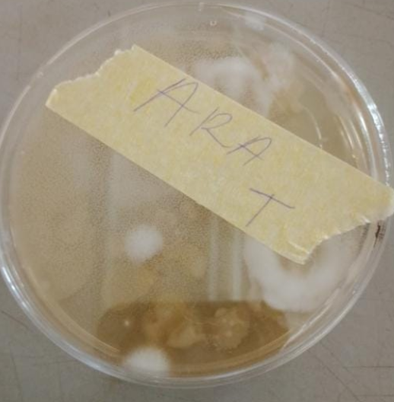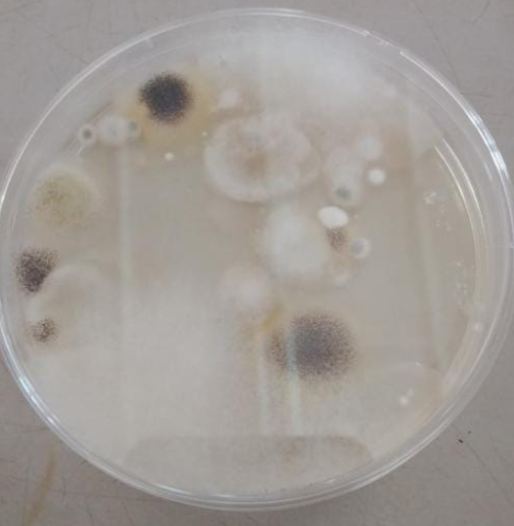
Figure 1; Culture plates showing fungal growth of treated and untreated sample for Ara.

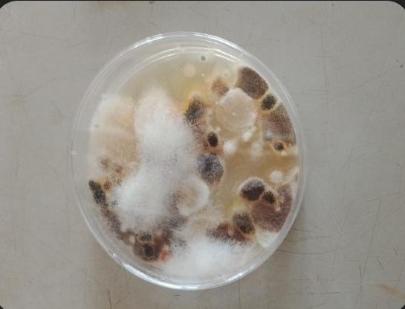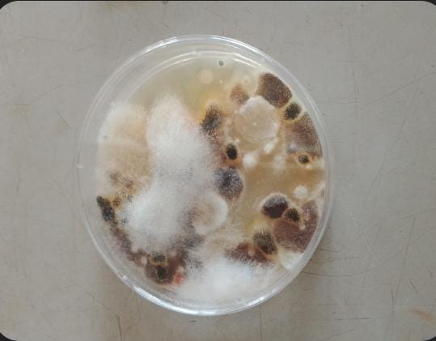
Figure 2 ; Culture plates showing fungal growth of treated and untreated sample for Village

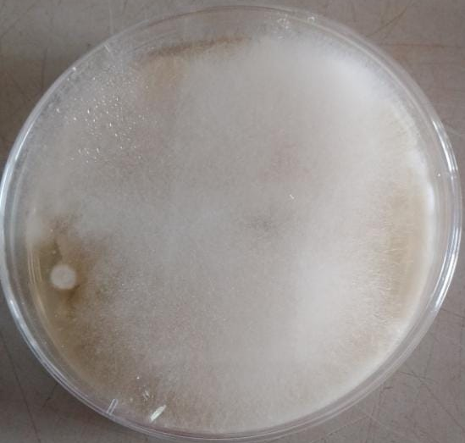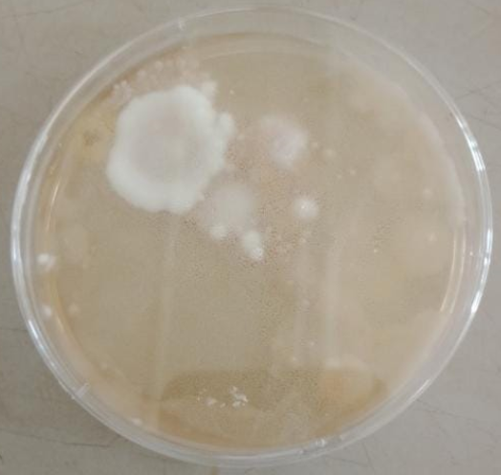
Figure 3; Culture plates showing fungal growth of treated and untreated sample for Akuo.

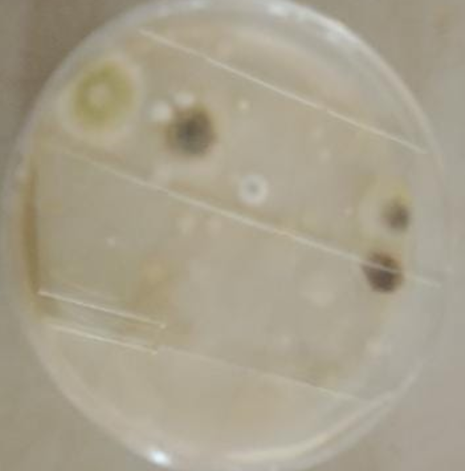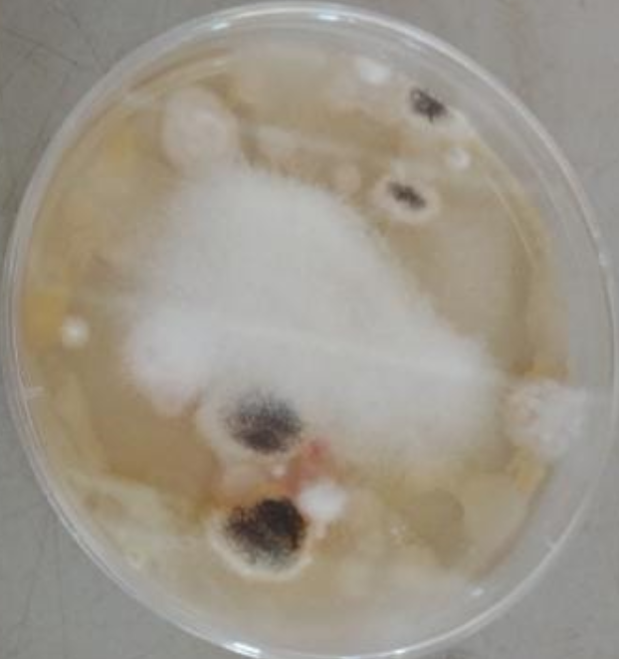
Figure 4 ; Culture plates showing fungal growth of treated and untreated sample for Yankari.

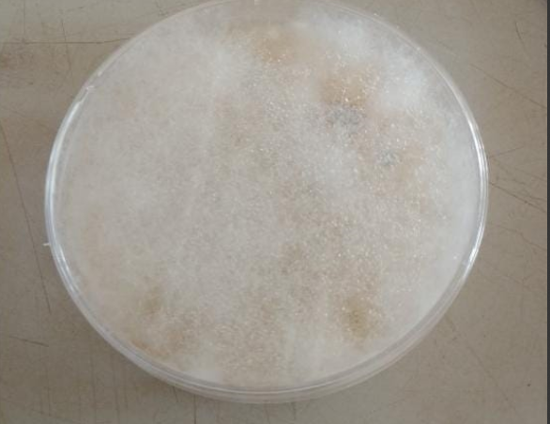
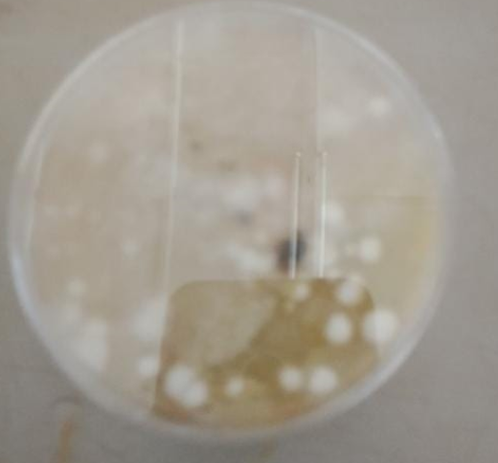
Figure 5; Culture plates showing fungal growth of treated and untreated sample for Tourism.

CHAPTER FOUR

4.0 DISCUSSION AND CONCLUSION

4.1 Discussion
The application of fungicides significantly influenced the soil pH and fungal diversity across all sampled locations. The increase in pH values in treated samples compared to their respective controls suggests that fungicides have the potential to alter soil chemistry. For example, the pH of the Tourism sample rose from 4.93 in the control to 5.43 in the treated sample, while similar increases were observed in Yankari, Village, and Akuo locations. This trend aligns with the findings ofZhang et al. (2022), who reported that chemical treatments could lead to reduced soil acidity due to fungicide buffering properties or changes in microbial metabolism.
In terms of fungal abundance and diversity, notable differences were observed between treated and control samples. Treated soils generally showed reduced fungal species diversity, with some species being suppressed and others proliferating. At the Village site, the treated soil recorded lower colony counts for Aspergillus, Penicillium, and Fusarium compared to the control. Aspergillus spp. dropped from 182 colonies in the control to 94 in the treated soil, Penicillium from 20 to 4, and Fusarium from 20 to 7. This trend is consistent with the work of Chen et al. (2020), who demonstrated that fungicides often reduce filamentous fungal diversity and favor resistant or opportunistic taxa fig.1.
Some fungicide-treated soils showed an unexpected increase in yeast populations. For instance, at the Akuo location, yeast counts in the treated sample were exceptionally high (112 colonies) compared to none in the control. This may indicate that fungicide application, while suppressing filamentous fungi, may create a niche for yeast proliferation. Yeasts tend to have simpler survival strategies and may be less sensitive to certain fungicides (Guo et al., 2020). A similar pattern was seen in the ARA sample, where yeast colonies increased significantly in the treated soil (37 colonies) compared to the control where yeasts were not dominant.
In some cases, the control soils had greater fungal complexity. For example, the ARA control sample exhibited a mix of Rhizopus, Penicillium, and Aspergillus niger, while the treated sample was dominated by Rhizopus and yeast. These findings echo the results of Wang et al. (2021), who observed that fungicides could alter soil fungal community composition, often reducing ecological complexity and skewing fungal balance toward more resistant species. The reduced fungal diversity could also lead to compromised ecological functions such as organic matter decomposition, nutrient cycling, and disease suppression.
Additionally, some treated soils showed signs of bacterial contamination, such as in the Tourism (35 bacterial colonies) and Yankari (4 bacterial colonies) samples. This might suggest that the suppression of fungal competitors by fungicides allows bacteria to exploit newly available ecological niches. According to Sun et al. (2023), fungicide-induced shifts in microbial populations can disturb the overall soil microbiome, leading to bacterial overgrowth or dominance in previously balanced ecosystems.
From a broader perspective, these findings highlight the need for caution in the use of broad-spectrum fungicides. While effective in controlling plant pathogens, these chemicals can inadvertently suppress beneficial or neutral fungal taxa, alter soil chemistry, and lead to microbial imbalances. The promotion of yeast or bacteria dominance, as seen in this study, could have implications for soil health and crop performance. Sustainable approaches, such as the use of biocontrol agents or reduced fungicide application frequency, should be encouraged to minimize ecological disruption (Lin &Mideros, 2023).

4.1 Conclusion
This study has shown that the application of commercial fungicides alters both the chemical properties and fungal biodiversity of soil. An increase in soil pH was observed across all treated samples, indicating that fungicides may slightly neutralize acidic soils or interfere with natural pH-regulating microbial processes. Furthermore, a significant reduction in fungal diversity and colony count was noted in treated samples compared to controls, with sensitive species such as Penicillium, Fusarium, and Aspergillus being suppressed in some cases. Conversely, certain fungal groups, especially yeasts, thrived under fungicide exposure, suggesting selective pressure that favors resistant or opportunistic organisms.

REFERENCES
Banerjee, S., Schlaeppi, K., & van der Heijden, M. G. A. (2020). Keystone taxa as drivers of microbiome structure and functioning. Nature Reviews Microbiology, 18(9), 567–576. https://doi.org/10.1038/s41579-020-0400-6
Chen, Y., Li, Y., Liu, J., Zhou, H., & Wang, Y. (2020). Effects of fungicide application on soil fungal community and functions in wheat fields. Applied Soil Ecology, 156, 103714. https://doi.org/10.1016/j.apsoil.2020.103714
Choudhary, D. K., Sharma, A., & Agarwal, P. (2023). Microbial ecology of fungicide-contaminated soils. Journal of Environmental Science and Health, Part B, 58(1), 12–20. https://doi.org/10.1080/03601234.2022.2129916
Gao, J., Liu, Y., Zhang, S., & Lin, L. (2020). Biological control of plant diseases: Advances and future challenges. Journal of Plant Pathology, 102, 7–15. https://doi.org/10.1007/s42161-019-00458-4
González-Pérez, J. A., Sánchez-González, M. D., & Pérez-Reynoso, C. (2020). Impact of fungicides on non-target soil fungi: Diversity and functionality. Applied Soil Ecology, 154, 103635. https://doi.org/10.1016/j.apsoil.2020.103635
Guo, Z., Wang, Y., Yu, Z., & Zhang, Y. (2020). The effect of fungicide chlorothalonil on soil microbial activity and fungal community composition. Environmental Pollution, 258, 113697. https://doi.org/10.1016/j.envpol.2019.113697
Kavamura, V. N., & Esposito, E. (2020). Biodegradation of fungicides in soil and their effect on microbial community structure. Soil Biology and Biochemistry, 144, 107762. https://doi.org/10.1016/j.soilbio.2020.107762
Li, T., Huang, X., Chen, J., & Wu, W. (2020). Negative effects of fungicides on arbuscular mycorrhizal fungi in agricultural soils. Science of the Total Environment, 705, 135862. https://doi.org/10.1016/j.scitotenv.2019.135862
Lin, H. A., &Mideros, S. X. (2023). The effect of Septoria glycines and fungicide application on the soybean phyllosphere mycobiome. Phytobiomes Journal, 7(2), 220-232.
Liu, H., Wang, X., Zhang, M., & Zhang, J. (2021). Comparative effects of contact and systemic fungicides on soil microbial communities and activities. Ecotoxicology and Environmental Safety, 208, 111484. https://doi.org/10.1016/j.ecoenv.2020.111484
Qi, Z., Tian, L., Zhang, H., Zhou, X., Lei, Y., & Tang, F. (2024). Mycobiome mediates the interaction between environmental factors and mycotoxin contamination in wheat grains. Science of The Total Environment, 928, 172494.
Sun, J., Zhang, Y., Liu, B., &Qiao, M. (2023). Metagenomic insight into the impact of fungicide residues on soil microbial functionality. Frontiers in Microbiology, 14, 1178902. https://doi.org/10.3389/fmicb.2023.1178902
Wang, P., Ma, Y., Wang, C., &Xie, Y. (2021). Influence of fungicide application on fungal diversity in paddy soils. Agriculture, Ecosystems & Environment, 319, 107576. https://doi.org/10.1016/j.agee.2021.107576
Whitaker, B. K., Opoku, J., &Kleczewski, N. M. (2025). Foliar Fungicide Application Alters the Culturable Foliar Fungal Endophyte Community in Corn. Phytobiomes Journal, (ja).
Wu, S., Liu, J., Peng, X., & Chen, W. (2021). Long-term fungicide exposure affects soil microbial community and pH.Frontiers in Microbiology, 12, 678543. https://doi.org/10.3389/fmicb.2021.678543
Zhang, D., Zhao, J., Zhou, Y., & Sun, Q. (2022). Long-term fungicide exposure affects soil microbial community composition and nutrient cycling. Soil Biology and Biochemistry, 164, 108464. https://doi.org/10.1016/j.soilbio.2021.108464
Zhao, X., Zhang, Q., Jia, Y., & Chen, Q. (2022). Effects of media components on fungal morphology and sporulation. Mycological Progress, 21(4), 389–397. https://doi.org/10.1007/s11557-022-01764-7

