A COMPREHENSIVE DATABASE OF HERBAL MEDICINES FOR AI-DRIVEN HEALTH SOLUTIONS

BY

FAWAZ ADEYINKA AREMU
ND/23/COM/PT/0215

SUBMITTED TO:

DEPARTMENT OF COMPUTER SCIENCE

INSTITUTE OF INFORMATION AND COMMUNICATION TECHNOLOGY

KWARA STATE POLYTECHNIC, ILORIN

IN PARTIAL FULFILLMENT OF THE REQUIREMENT FOR THE AWARD OF NATIONAL DIPLOMA (ND) IN COMPUTER SCIENCE

SUPERVISED BY
DR. ABDULRAHMAN T. A.
JUNE, 2025.

CERTIFICATION

This is to certify that this project research was carried out by FAWAZ ADEYINKA AREMU with the matriculation number ND/23/COM/FT/0215, has been read and approved as meeting part of the requirements for the Award of National Diploma (ND) in Computer Science.

____________________________ _____________________
DR. ABDULRAHMAN T.A Date
Project Supervisor

____________________________ _____________________
MR. OYEDEPO F.S Date
Head of Department

____________________________ _____________________
External Supervisor Date

DEDICATION

This project is dedicated to the Almighty God for his protection and guidance from the start of this project to its completion.

ACKNOWLEDGEMENT

We extend our heartfelt gratitude to Almighty God for giving us the strength, understanding, and fortitude to complete this project work.

Our candid appreciation goes to our project supervisor, Dr. AbdulRahman T.A, for his invaluable guidance, support, and encouragement throughout this project, and we pray may the good God bless him.

Special thanks to Head of Department Mr Oyedepo F.S., Dr. Raji A.K., Mr Ayeni J.K., and other members and staff of the Computer Science Department for their support.

Our genuine gratitude also goes to our dear parents for their moral and financial support throughout this project, we pray that the good God bless you (Amen)

TABLE OF CONTENTS
Title Page
Certification
Dedication
Acknowledgements
Table of Contents
Abstract
CHAPTER ONE: GENERAL INTRODUCTION
1.1 Background to the Study
1.2 Statement of the Problem
1.3 Aim and Objectives
1.4 Significance of the Study
1.5 Scope of the Study
1.6 Organization of the Report
1.7 Definition of Terms
CHAPTER TWO: LITERATURE REVIEW
2.1 Review of Related Works
2.2 Review of General Texts
2.3 Historical Background
CHAPTER THREE: METHODOLOGY AND SYSTEM ANALYSIS
3.1 Research Methodology
3.2 Analysis of the Existing System
3.3 Problems of the Existing System
3.4 Description of the Proposed System
3.5 Advantages of the Proposed System
CHAPTER FOUR: SYSTEM DESIGN AND IMPLEMENTATION
4.1 Design of the New System
4.1.1 Output Design
4.1.2 Input Design
4.1.3 Database Design
4.1.4 Process/Procedure Design
4.2 System Implementation
4.2.1 Programming Language Used
4.2.2 Hardware Requirements
4.2.3 Software Requirements
4.2.4 Implementation Strategy
4.3 System Documentation
4.3.1 Program Documentation
4.3.2 User Manual / Operating Instructions
4.3.3 System Maintenance Guidelines
CHAPTER FIVE: SUMMARY, CONCLUSION, AND RECOMMENDATIONS
5.1 Summary of Findings
5.2 Conclusion
5.3 Recommendations
References
Appendices
Appendix A: Program Flowchart
Appendix B: Source Code

ABSTRACT
The growing global interest in traditional and plant-based healthcare has underscored the urgent need for structured, reliable, and easily accessible information on herbal medicine. This project presents the design and development of a robust web-based platform dedicated to the collection, organization, validation, and dissemination of herbal medicine knowledge. Leveraging modern technologies such as ReactJS for the frontend, Node.js and Express.js for the backend, and MongoDB for data storage, the system provides a seamless user experience through its interactive, responsive interface. The platform supports dual access: user-friendly search functionalities for general users and structured data entry forms for administrators or researchers. It emphasizes the standardization of herbal data, covering scientific names, local names, medicinal uses, preparation methods, and safety profiles. Input validation and structured database design ensure data integrity and reliability, enabling precise retrieval and long-term preservation of indigenous medical knowledge.While the current implementation focuses on building a comprehensive database, the system is architected with scalability in mind, allowing for future integration of artificial intelligence (AI). Planned AI features include symptom-based recommendations, intelligent classification, and natural language query interpretation through an AI-powered chatbot, which will enhance decision support for both practitioners and individuals.

CHAPTER ONE

GENERAL INTRODUCTION
1.1 BACKGROUND TO THE STUDY
The use of herbal medicines has ancient roots, with evidence suggesting their use originating back tens of thousands of years (Fathifar et al., 2023). Traditional medicine systems worldwide, such as Ayurveda, Traditional Chinese Medicine, and African traditional medicine, rely heavily on plants for preventative and curative purposes (Devine et al., 2022). Even today, a significant portion of the global population, particularly in developing countries, depends on herbal remedies as their primary source of healthcare (Fathifar et al., 2023). This reliance stems from affordability, accessibility, and cultural acceptance. The World Health Organization estimates that a substantial percentage of the world's population uses medicinal herbs or other natural products for their healthcare needs (Fathifar et al., 2023; Vera & Palaoag, 2023).
However, the knowledge surrounding herbal medicines is often fragmented, dispersed, and not readily accessible in a structured format. Traditional knowledge is frequently passed down through generations verbally, making it vulnerable to loss or alteration. The lack of standardized information and quality control measures challenges integrating herbal medicine into mainstream healthcare systems (Sasidharan et al., 2021). Furthermore, the increasing demand for herbal products raises concerns about sustainability, adulteration, and misidentification of plant species. This is particularly relevant in African Traditional Herbal Medicine, where computational systems are available in specific places but not integrated (Devine et al., 2022).
The advent of Artificial Intelligence and Machine Learning offers unprecedented opportunities to address these challenges and unlock the full potential of herbal medicine. AI can be used to create comprehensive databases of herbal knowledge, analyze complex datasets to identify bioactive compounds, and develop predictive models for drug discovery. AI-powered tools can also aid in the identification of herbal plants, ensure quality control, and personalize treatment regimens. The synergy between AI, ML, and robotics holds immense potential for the future, offering innovative solutions to global challenges and enhancing human capabilities.
Therefore, there is a growing interest in leveraging AI to create smarter herbal medication delivery systems and knowledge-based systems (Devine et al., 2022; Vera & Palaoag, 2023). Such systems can empower individuals to make informed decisions about the plants they use, reducing the likelihood of harmful effects and optimizing the potential benefits of medicinal plants (Vera & Palaoag, 2023). A web-based platform can significantly enhance Human Resource processes, streamline communication across departments, improve data accuracy, and empower more A Aeffective strategic decision-making. The development of a comprehensive database of herbal medicines for AI-driven health solutions represents a crucial step towards integrating traditional knowledge with modern technology to improve healthcare outcomes.

1.2 PROBLEM STATEMENT
Despite the long history and widespread use of herbal medicines, several challenges hinder their full integration into modern healthcare systems. One of the primary challenges is the lack of comprehensive and standardized data on herbal remedies (Devine et al., 2022). Information on plant identification, chemical composition, pharmacological properties, clinical efficacy, and safety is often scattered across various sources, making it difficult to access and utilize effectively. While there's significance in using herbal treatments in medicine, there isn't a publicly available internet database that might give plant medicinal information in the form of a virtual conversation, making it challenging to spread and advance such information (Vera & Palaoag, 2023).

Another significant problem is the variability in the quality and composition of herbal products. Factors such as plant species, geographical location, harvesting methods, and processing techniques can influence the chemical profile and therapeutic effects of herbal medicines (Sasidharan et al., 2021). Adulteration with substandard or toxic ingredients is also a concern, particularly in unregulated markets. This variability poses challenges to ensuring the safety and efficacy of herbal products and makes it difficult to conduct reliable clinical trials. Furthermore, the lack of scientific evidence to support the traditional uses of many herbal medicines is a barrier to their acceptance by healthcare professionals and regulatory agencies. While some herbal remedies have been extensively studied and shown to be effective for specific conditions, many others lack rigorous scientific validation. This lack of evidence makes it difficult to develop evidence-based guidelines for the use of herbal medicines in clinical practice (Sireeshaa et al., 2022).

Therefore, there is a need to devise means of easy and automatic identification of herbal plants as an important step towards preserving the said knowledge. Addressing these challenges requires a multidisciplinary approach that integrates traditional knowledge with modern scientific methods. The development of a comprehensive database of herbal medicines, coupled with AI-powered tools for data analysis and quality control, can help to overcome these limitations and promote the safe and effective use of herbal remedies.

1.3 AIM AND OBJECTIVES
This project aims to develop a comprehensive database of herbal medicines for AI-driven health solutions, facilitating the integration of traditional herbal knowledge with modern technology to improve healthcare outcomes.

To achieve this aim, the following specific objectives will be pursued:

Design a comprehensive database: Design a structured and standardized database of herbal medicines, incorporating information on plant identification, chemical composition, pharmacological properties, clinical efficacy, safety, and traditional uses.

Integrate AI-powered tools: Design and integrate AI-powered tools for data analysis, quality control, plant identification, and personalized treatment recommendations.

Create a user-friendly platform: To design a user-friendly web-based platform that provides access to the database and AI-powered tools for healthcare professionals, researchers, and the general public.

Evaluate the impact: To evaluate the impact of the database and AI-powered tools on healthcare outcomes, research productivity, and the preservation of traditional knowledge.

Promote collaboration and knowledge sharing: To foster collaboration and knowledge sharing among stakeholders in the field of herbal medicine, including traditional healers, researchers, healthcare professionals, and policymakers.

1.4 SIGNIFICANCE OF THE STUDY
This study holds significant importance for several reasons:

Preservation of traditional knowledge: The project will contribute to the preservation and documentation of traditional knowledge related to herbal medicines, which is at risk of being lost due to globalization and changing lifestyles.

Improved healthcare outcomes: By providing access to comprehensive and reliable information on herbal medicines, the project will empower healthcare professionals and individuals to make informed decisions about their healthcare (Vera & Palaoag, 2023).

Drug discovery and development: The database and AI-powered tools can facilitate the discovery of novel drug candidates from herbal sources, accelerating the development of new and effective treatments for various diseases (Sireeshaa et al., 2022).

Economic development: The project can promote the sustainable use of herbal resources and support the development of local industries based on herbal products, contributing to economic growth and job creation.

Advancement of AI in healthcare: The project will advance the application of AI in healthcare by demonstrating the potential of AI-powered tools for data analysis, quality control, and personalized treatment recommendations in the field of herbal medicine.

1.5 SCOPE OF THE STUDY
The scope of this study will focus primarily on the collection and organization of data to design a comprehensive database of herbal medicines, with a particular emphasis on plants used in traditional medicine systems. The database will include structured information on plant identification, chemical composition, pharmacological properties, clinical efficacy, safety, and traditional uses.

The geographical scope of the study will primarily focus on herbal plants. Data collection will involve gathering information from various sources, including scientific literature, traditional medicine practitioners, and existing databases. The study will also involve the collection and analysis of plant samples to verify their identity and chemical composition.

The AI-powered tools will be developed using machine learning algorithms and natural language processing techniques. They will be designed to analyze large datasets, identify patterns, and generate predictions related to the efficacy and safety of herbal medicines. The user-friendly web-based platform will provide access to the database and AI-powered tools for healthcare professionals, researchers, and the general public.

1.6 ORGANIZATION OF THE REPORT
This report is structured as follows:
Chapter One: General Introduction - Provides an overview of the study, including the background, problem statement, aim and objectives, significance, scope, and organization of the report.
Chapter Two: Literature Review - Reviews the existing literature on herbal medicines, AI in healthcare, and related topics.
Chapter Three: Methodology - Describes the methods used to develop the database, integrate AI-powered tools, and evaluate the impact of the project.
Chapter Four: Results and Discussion - Presents the results of the study and discusses their implications for healthcare, research, and economic development.
Chapter Five: Conclusion and Recommendations - Summarizes the key findings of the study and provides recommendations for future research and policy.
1.7 DEFINITION OF TERMS
- Herbal Medicine: The use of plants or plant-derived substances for medicinal purposes.
- Traditional Medicine: The total of the knowledge, skills, and practices based on the theories, beliefs, and experiences indigenous to different cultures, used in the maintenance of health and the prevention, diagnosis, improvement, or treatment of physical and mental illness.
- Artificial Intelligence: The theory and development of computer systems able to perform tasks normally requiring human intelligence, such as visual perception, speech recognition, decision-making, and translation between languages.
- Machine Learning: A type of AI that enables computer systems to learn from data without being explicitly programmed.
- Database: A structured set of data held in a computer, especially one that is accessible in various ways.
CHAPTER TWO
LITERATURE REVIEW

2.1 REVIEW OF RELATED WORKS
The integration of artificial intelligence into herbal medicine is rapidly transforming healthcare, offering new avenues for diagnosis, treatment, and drug discovery. This review explores the current landscape of AI applications in herbal medicine, focusing on existing databases, AI-driven tools, and the challenges and opportunities in this evolving field. It also addresses the ethical considerations necessary for responsible AI implementation in healthcare.
Several studies have demonstrated the potential of AI in analyzing vast datasets of herbal compounds to predict therapeutic effects, thus accelerating the identification of new drug candidates. AI can assist in identifying and cataloging herbal plants, which is particularly valuable in regions where traditional knowledge is diminishing. The accuracy and efficiency of AI-driven identification systems can help preserve traditional medicine practices and reduce the risk of misidentification, which is crucial for safety and efficacy.
AI-powered chatbots are also gaining traction as tools for disseminating information on herbal medicine. These chatbots can provide personalized recommendations, answer queries about herbal remedies, and aid in the identification of herbal plants, empowering users to make informed decisions. The implementation of AI-powered chatbots can offer up-to-date information, particularly in underserved areas where access to healthcare professionals is limited (Vera & Palaoag, 2023).
Despite these advancements, there are challenges in the application of AI to herbal medicine. Many databases lack comprehensive information on the safety and efficacy of herbal remedies, necessitating more research into potential interactions between herbal medicines and conventional drugs. The complexity of herbal formulations, the variability of plant materials, and the absence of standardized data formats pose significant hurdles in creating reliable databases.
The development of AI-based herbal plant identification systems is also crucial. These systems, when enhanced with user-friendly interfaces, can aid in preserving native herbal plants and reducing the risk of medicinal plant extinction. As the World Health Organization notes, a significant portion of the global population relies on herbal plants for healthcare, underscoring the importance of accessible and reliable information.
The integration of traditional herbal medicine with conventional medical practices, known as integrative medicine, is a promising area of research. This approach combines the strengths of both systems to provide personalized and comprehensive care. AI techniques have been used to develop prescription decision support systems and to explore the efficacy of herbal extracts. Future research may focus on developing new drug delivery systems, such as nanoparticles and liposomes, to enhance the bioavailability and targeting of herbal remedies.
Moreover, AI's role extends to modernizing traditional Chinese medicine. AI technologies are being applied to various aspects of TCM, including auxiliary diagnosis (Feng et al., 2021), drug discovery (Khan et al., 2021), and the analysis of TCM formulas (Chung et al., 2024). The application of AI in TCM can help unlock the potential of traditional remedies by addressing the complexities associated with their prescription and action mechanisms (Zhou et al., 2024).
In summary, AI has the potential to significantly advance the field of herbal medicine by enhancing research, improving access to information, and integrating traditional and conventional practices. Addressing current gaps in research, promoting ethical considerations, and fostering interdisciplinary collaboration are essential to fully harness AI's capabilities in this area.

2.2 REVIEW OF GENERAL TEXT
HERBAL MEDICINE IN TRADITIONAL SYSTEMS

Herbal medicine has been an integral part of traditional healthcare systems for millennia, with diverse cultures around the globe utilizing plant-based remedies for treating various ailments. Traditional Chinese Medicine, Ayurveda, and other indigenous medical systems rely heavily on herbs for their therapeutic properties (Chung et al., 2024; Zhou et al., 2024). The knowledge of these herbal remedies has been passed down through generations, forming a rich tapestry of empirical observations and practices. This section explores the role of herbal medicine in these traditional systems, highlighting their significance and the challenges they face in the modern era.

The efficacy of herbal medicine in traditional systems is often attributed to the synergistic effects of multiple compounds present in the plants (Chu et al., 2022). Unlike modern pharmaceuticals that typically isolate single active ingredients, traditional herbal preparations utilize whole plants or complex mixtures, which are believed to offer a more balanced and holistic approach to treatment. For instance, in TCM, herbal formulas are carefully designed to address the underlying imbalances in the body, rather than merely targeting specific symptoms (Zhou et al., 2024). This holistic approach considers the individual's overall health and constitution, aiming to restore harmony and balance within the body.

However, the lack of standardization and quality control in traditional herbal medicine poses significant challenges. The composition of herbal products can vary widely depending on factors such as plant species, growth conditions, and preparation methods. This variability can lead to inconsistencies in therapeutic outcomes and potential safety concerns. Efforts are underway to standardize herbal medicine practices through the development of quality control guidelines and the application of modern analytical techniques. These efforts aim to ensure the safety and efficacy of herbal products, making them more accessible and reliable for consumers.

Furthermore, the integration of traditional herbal medicine with modern medical practices requires a deeper understanding of the mechanisms of action of herbal compounds. While traditional knowledge provides valuable insights into the therapeutic uses of herbs, scientific research is needed to validate these claims and identify the active constituents responsible for their effects. This integration could lead to the development of novel therapeutic approaches that combine the best of both worlds (Jansen et al., 2020).

The modernization of traditional medicine also involves addressing issues related to intellectual property rights and the fair and equitable sharing of benefits arising from the use of traditional knowledge. Many indigenous communities hold valuable knowledge about the medicinal properties of plants, and it is important to protect their rights and ensure that they benefit from the commercialization of their knowledge (Yang et al., 2025). This requires a collaborative approach that respects the cultural heritage of indigenous communities and promotes sustainable use of natural resources.

AI AND HEALTHCARE EVOLUTION

Artificial intelligence is rapidly transforming the healthcare landscape, offering innovative solutions for diagnosis, treatment, and drug discovery (Chan et al., 2019). AI technologies, including machine learning, natural language processing, and computer vision, are being applied to a wide range of healthcare applications, from analyzing medical images to predicting patient outcomes. This section examines the evolution of AI in healthcare and its potential to improve the efficiency and effectiveness of medical practices.

One of the key areas where AI is making a significant impact is in the analysis of large datasets of patient information. Machine learning algorithms can identify patterns and correlations in these datasets that would be difficult or impossible for humans to detect, leading to more accurate diagnoses and personalized treatment plans. For example, AI-powered systems can analyze medical images, such as X-rays and MRIs, to detect subtle anomalies that may indicate the presence of disease. This capability not only improves diagnostic accuracy but also reduces the time required for image analysis, allowing healthcare professionals to focus on patient care.

AI is also being used to develop virtual assistants and chatbots that can provide patients with personalized support and guidance (Vera & Palaoag, 2023). These virtual assistants can answer questions about medications, schedule appointments, and provide reminders for follow-up care. By automating routine tasks and providing timely information, AI can help improve patient engagement and reduce the burden on healthcare providers. Moreover, AI-powered chatbots can provide mental health support and counseling, particularly in areas where access to mental healthcare is limited.

Another emerging application of AI in healthcare is in the development of predictive models that can identify patients at risk of developing certain diseases or experiencing adverse events. These models can analyze patient data, such as medical history, lifestyle factors, and genetic information, to predict the likelihood of future health problems. By identifying high-risk patients, healthcare providers can implement preventive measures and early interventions to improve outcomes and reduce healthcare costs (Feng et al., 2021).

The integration of AI in healthcare also raises important ethical and regulatory considerations. It is crucial to ensure that AI systems are used in a responsible and transparent manner, with appropriate safeguards to protect patient privacy and data security. Additionally, there is a need to address potential biases in AI algorithms and ensure that they are fair and equitable for all patients. As AI continues to evolve, it is essential to develop ethical frameworks and regulatory guidelines to guide its development and deployment in healthcare.

INTEGRATION OF AI AND HERBAL MEDICINE

The integration of AI and herbal medicine holds immense potential for advancing both fields, offering new avenues for research, drug discovery, and personalized healthcare. AI can assist in identifying and cataloging herbal plants, which is particularly valuable in regions where traditional knowledge is diminishing. AI-driven tools can analyze vast datasets of herbal compounds to predict therapeutic effects, thus accelerating the identification of new drug candidates (Khan et al., 2021). This section explores the synergies between AI and herbal medicine, highlighting the opportunities and challenges in this emerging area.

One of the key challenges in integrating AI and herbal medicine is the complexity of herbal formulations and the variability of plant materials. Unlike modern pharmaceuticals that typically contain a single active ingredient, herbal remedies often consist of complex mixtures of compounds, making it difficult to identify the specific components responsible for their therapeutic effects. AI can help overcome this challenge by analyzing the chemical composition of herbal extracts and correlating them with their biological activities. This approach can help identify the key compounds responsible for the therapeutic effects of herbal remedies and optimize their formulations.

AI-assisted drug discovery platforms can also play a crucial role in identifying novel drug candidates from plant-derived traditional medicines (Khan et al., 2021). These platforms can analyze the interactions between herbal compounds and their molecular targets, providing insights into their mechanisms of action and potential therapeutic applications. By integrating AI with traditional medicine, researchers can accelerate the drug discovery process and identify new treatments for a wide range of diseases. Furthermore, AI can be used to predict the potential side effects and drug interactions of herbal compounds, improving their safety and efficacy.

Moreover, AI can facilitate the development of personalized herbal medicine by analyzing individual patient data and tailoring herbal treatments to their specific needs (Chu et al., 2022). By integrating data on patient genetics, lifestyle factors, and medical history, AI algorithms can predict the most effective herbal formulations for each individual. This personalized approach can improve treatment outcomes and reduce the risk of adverse effects.

The application of AI in herbal medicine also extends to the quality control and standardization of herbal products. AI-powered systems can analyze the chemical composition of herbal extracts to ensure that they meet quality standards and are free from contaminants. This can help improve the consistency and reliability of herbal products, making them more appealing to consumers and healthcare professionals.

AI-DRIVEN DRUG DISCOVERY

AI-driven drug discovery is revolutionizing the pharmaceutical industry by accelerating the identification of potential drug candidates and optimizing their development (Chan et al., 2019; Khan et al., 2021). AI algorithms can analyze vast datasets of chemical compounds, biological targets, and clinical trial data to predict the efficacy and safety of new drugs. This section examines the role of AI in drug discovery, highlighting the key techniques and applications in this rapidly evolving field.

One of the key techniques used in AI-driven drug discovery is machine learning (Chu et al., 2022). Machine learning algorithms can be trained on large datasets of chemical structures and biological activities to predict the properties of new compounds. These algorithms can also be used to identify potential drug targets by analyzing the interactions between proteins and other biomolecules. By using AI to prioritize drug candidates, pharmaceutical companies can reduce the time and cost associated with traditional drug discovery methods. AI can also assist in optimizing the design of molecules to enhance their binding affinity to target proteins, improving their efficacy and reducing off-target effects.

AI is also being used to optimize the design of clinical trials and to predict patient responses to different treatments. By analyzing data from previous clinical trials, AI algorithms can identify the factors that are most likely to predict success, allowing researchers to design more efficient and effective trials. AI can also be used to personalize treatment plans by predicting which patients are most likely to respond to a particular drug based on their genetic and clinical characteristics. This approach, known as precision medicine, has the potential to transform healthcare by tailoring treatments to the individual needs of each patient.

Furthermore, AI can accelerate the drug repurposing process by identifying existing drugs that may be effective against new diseases. By analyzing data on drug mechanisms of action and disease pathways, AI algorithms can predict which drugs are most likely to be effective against a particular disease. This approach can significantly reduce the time and cost associated with developing new drugs, as existing drugs have already undergone extensive safety testing (Vișan & Neguț, 2024).

The integration of AI in drug discovery also raises important ethical and regulatory considerations. It is crucial to ensure that AI systems are used in a responsible and transparent manner, with appropriate safeguards to protect patient privacy and data security. Additionally, there is a need to address potential biases in AI algorithms and ensure that they are fair and equitable for all patients. As AI continues to evolve, it is essential to develop ethical frameworks and regulatory guidelines to guide its development and deployment in the pharmaceutical industry (Khan et al., 2021).

2.3 HISTORICAL BACKGROUND
ORIGINS OF HERBAL MEDICINE

Herbal medicine's origins are intertwined with the dawn of human civilization, predating written history (Sharma et al., 2021). Archaeological evidence suggests that Neanderthals utilized medicinal plants as far back as 60,000 years ago. Ancient cultures across the globe independently developed complex systems of herbal medicine (Sharma et al., 2021; Wicke, 1996). In Mesopotamia, clay tablets dating back to 3000 BCE describe the use of various plants for healing. The Ebers Papyrus from ancient Egypt (c. 1550 BCE) details hundreds of herbal remedies (Sharma et al., 2021), while traditional Chinese medicine, formalized in texts like the Pen Ts’ao Ching, offers a continuous tradition of herbal practice spanning millennia (Herbal History: Roots of Western Herbalism, 2021; Sharma et al., 2021). These ancient systems demonstrate a profound understanding of the natural world and its potential for healing, with knowledge often passed down through generations via oral tradition and apprenticeship (Badnale et al., 2022).

Traditional medicine systems often integrate medical knowledge with indigenous beliefs and experiences, playing a crucial role in healthcare across different cultures (Beshah et al., 2020). The concept of vitalism, which posits that living organisms are animated by a vital force, has historically influenced many herbal traditions. As much of this knowledge is held at the family and community levels, particularly among indigenous populations, it faces the risk of being lost without proper documentation (Mosihuzzaman, 2012). The study of ethnobotany seeks to preserve and understand these traditional plant uses, recognizing their potential value for modern medicine and conservation efforts.

Theophrastus (340 B.C. ) wrote on natural history and botany—his work Inquiry into Plants survives and is available in English translation (History of Western Herbalism, 2023). He writes of many kinds of plants and how they are used in medicine, how to grow them, and many other observations (History of Western Herbalism, 2023).

THE RISE OF HERBAL MEDICINE IN GLOBAL HEALING SYSTEMS

The use of herbal remedies has been a constant throughout history, evolving and adapting as cultures interacted and exchanged knowledge (Sharma et al., 2021). The Silk Road facilitated the exchange of medicinal plants and knowledge between East and West, leading to the integration of new herbs and practices into various healing systems. Traditional Chinese Medicine, with its rich history and extensive materia medica, has significantly influenced herbal practices worldwide (Zhou et al., 2024). The Compendium of Materia Medica, documenting thousands of herbal medicines and formulas, stands as a major historical reference (Pan et al., 2014). This book recorded 1,892 kinds of herbal medicines and 11,096 herbal formulae (Pan et al., 2014). After Charles Darwin (1809–1882) had read the book, he stated that The Compendium of Materia Medica was the encyclopedia of 16th century in China (Pan et al., 2014).

In many countries, a significant portion of the population still relies on herbal plants for their healthcare needs, highlighting the enduring relevance of traditional practices ; Beshah et al., 2020). The World Health Organization estimates that a large percentage of the world's population utilizes herbal medicine , emphasizing the need to investigate medicinal plants as a means of alternative therapy (Beshah et al., 2020). The rise of monastic medicine in Europe during the Middle Ages saw the cultivation of medicinal herbs in monastery gardens and the preservation of ancient texts on herbal remedies. Figures like Hildegard of Bingen contributed significantly to the understanding and practice of herbal medicine in this period.

The integration of herbal medicine into various cultural practices also highlights its social and spiritual significance. In many indigenous cultures, herbal remedies are not just physical treatments but are also used in rituals and ceremonies to promote healing and well-being. This holistic approach recognizes the interconnectedness of mind, body, and spirit in the healing process.

THE EMERGENCE OF MODERN HEALTHCARE AND AI

The rise of modern healthcare, with its emphasis on scientific methodology and pharmaceutical development, presented both challenges and opportunities for herbal medicine. While synthetic drugs gained prominence, interest in herbal remedies persisted, driven by factors such as cultural preferences, accessibility, and perceived safety (Beshah et al., 2020). In recent decades, there has been a resurgence of interest in herbal medicine, fueled by a growing awareness of the limitations of conventional medicine and a desire for more natural and holistic approaches to healthcare (Badnale et al., 2022; Karpavičienė, 2022). This renewed interest is reflected in the increasing use of herbal products and supplements in developed countries (Karpavičienė, 2022).

Now, artificial intelligence is emerging as a transformative force, offering new avenues for modernizing and integrating traditional medicine (Zhou et al., 2024). AI applications in healthcare range from drug discovery and diagnostics to personalized medicine and robotic surgery. The history of AI in medicine dates back to the mid-20th century, with early expert systems for diagnosis and decision support (Ephraim et al., 2024). The development of machine learning and the proliferation of electronic health records have further fueled the application of AI in healthcare (Ephraim et al., 2024). These technologies hold the potential to revolutionize the way we understand and utilize herbal medicine.

AI-powered robots are widely used in manufacturing for tasks such as welding, assembly, quality inspection, and packaging. These robots leverage machine vision and deep learning algorithms to detect defects, sort objects, and adjust to variations in the production process without human intervention. In addition to improving productivity, they also reduce errors and operational costs.

TECHNOLOGICAL INNOVATIONS IN THE STUDY OF HERBAL MEDICINE

AI-driven technologies are now being applied to various aspects of herbal medicine, from plant identification to drug discovery and quality control. AI can assist in identifying herbal plants, analyzing the chemical composition of herbal extracts, and predicting potential drug interactions. For example, machine learning algorithms can be trained to distinguish between different plant species based on their morphological characteristics, such as leaf shape and color. AI-assisted drug discovery platforms can analyze interactions between herbal compounds and molecular targets, accelerating the identification of new treatments.

These platforms can also facilitate personalized herbal medicine by analyzing patient data and tailoring treatments to specific needs. Furthermore, AI-powered systems can ensure the quality and consistency of herbal products, making them more appealing to consumers and healthcare professionals. Blockchain technology can track the supply chain of herbal products, ensuring their authenticity and preventing adulteration.

The integration of AI into traditional medicine offers opportunities to address the limitations of traditional practices and improve the safety and efficacy of herbal remedies (Zhou et al., 2024). However, it also raises ethical considerations regarding data privacy, algorithmic bias, and the potential displacement of traditional herbal practitioners. Continued research and interdisciplinary collaboration are needed to ensure that AI is used responsibly and effectively in the field of herbal medicine.

CHAPTER THREE
METHODOLOGY AND ANALYSIS OF THE SYSTEM

3.1 RESEARCH METHODOLOGY
This chapter details the methodology employed in the data collection process for an AI-powered herbal remedy assistant. It outlines the identification of relevant herbal data, the sources consulted, and the techniques used to gather and structure the information. This section provides a thorough explanation of the steps taken to ensure the accuracy, reliability, and completeness of the herbal knowledge integrated into the proposed system.
3.1.1 Data Identification
The scope of herbal knowledge was defined using the following criteria:
  - Prevalence of Use: Herbs commonly used in traditional medicine systems (e.g., Traditional Chinese Medicine, Ayurveda, African traditional medicine) were prioritized.
  - Documented Medicinal Properties: Herbs with scientifically validated medicinal properties, as evidenced by pharmacological studies and clinical trials, were included.
  - Safety Profiles: Information on the safety and toxicity of each herb was considered to ensure responsible use and avoid potentially harmful recommendations.
  - Alignment with Project Objectives: Herbs relevant to specific health conditions or wellness goals were given priority.
  - Geographic diversity: The herbal plants found in different geo-political zones were considered.
3.1.2 Data Sources
Data was collected from multiple reputable sources:
Scientific literature: Peer-reviewed journals, research papers, and academic databases (e.g., PubMed, Scopus, Web of Science) were searched for evidence-based information on herbal remedies.
  - Traditional medicine texts: Classic texts and formularies on traditional herbal medicine systems (e.g., Huangdi Neijing, Charaka Samhita, and local herbals) were examined to capture historical knowledge and traditional uses.
  - Herbal websites: Data was also gathered from herbal websites.
  - Pharmacopoeias and herbals: Official compendia of herbal medicine, such as the British Herbal Pharmacopoeia and German Commission E Monographs, were consulted for standardized information.
  - Expert consultations: Interviews and consultations were conducted with experienced herbalists and traditional medicine practitioners to gather their insights and practical knowledge. Multimedia images and descriptions of available medicinal plants in each place were collected and stored on different media devices for safety
3.1.3 Data Collection Methods
The following methods were used to collect data from the identified sources:
- Literature reviews: Systematic reviews of scientific literature were conducted to identify relevant studies and extract key findings. Meta-analysis was employed to synthesise evidence from multiple studies, where appropriate.
- Database searches: Online databases specialising in herbal medicine and related fields were searched using specific keywords and search terms (e.g., "herb name," "medicinal use," "pharmacological action," "side effects").
- Manual extraction: Information was manually extracted from traditional medicine texts and other sources, following a standardised protocol. Data extraction forms were used to ensure consistency and completeness.
- Surveys and questionnaires: Structured questionnaires were used to collect data from study participants in the study area.
3.1.4 Data Structuring and Storage
The success of the proposed system hinges on its ability to efficiently store, retrieve, and analyze a vast amount of information about herbal medicine. To achieve this, the collected data is structured and organized into a relational database. This approach offers several advantages over unstructured storage methods like simple text files or spreadsheets.
A RELATIONAL DATABASE
A relational database organizes data into tables, where each table represents a specific entity (e.g., a plant, a chemical constituent, a medicinal use). Tables are linked to each other through relationships, allowing you to connect related information across different tables. For instance, a "Plants" table might be linked to a "Uses" table, indicating which plants are used for which medicinal purposes.
KEY DATA ELEMENTS AND THEIR PURPOSE:
The relational database for the proposed system includes several key data elements, each serving a specific purpose:
- Herbal Plant Name: This is the primary identifier for each plant in the database. It's crucial to include standardized scientific names (e.g., Artemisia annua for sweet wormwood) to avoid ambiguity, as common names can vary regionally. The database should also include common names in different languages (e.g., English, Twi) to improve accessibility for a wider range of users.
- Herbal Family Name: This classifies the plant according to its botanical family (e.g., Asteraceae, Fabaceae). Knowing the family can provide insights into the plant's chemical properties and potential medicinal uses, as plants within the same family often share similar characteristics.
- Herbal English Name: This provides a common English name for the plant, making it easier for English-speaking users to identify and search for it.
- Herbal Twi: Including the Twi name (or names in other local languages relevant to your target audience) is essential for cultural relevance and accessibility. It allows users who are familiar with traditional names to find the plant information they need.
- Herbal Image Link: A link to an image of the plant is invaluable for identification purposes. Visual confirmation is a critical step in ensuring that users are accessing information about the correct plant, as misidentification can have serious consequences.
BEYOND THE BASICS: EXPANDING THE DATA MODEL
To make the proposed system truly comprehensive, consider adding these additional data elements:
- Chemical Constituents: This field lists the active chemical compounds found in the plant (e.g., artemisinin in Artemisia annua). This information is vital for understanding the plant's pharmacological actions and potential drug interactions.
- Pharmacological Actions: This describes the effects of the plant on the body (e.g., anti-inflammatory, antimicrobial, analgesic). This information should be supported by scientific evidence.
- Medicinal Uses: This details the traditional and scientifically validated uses of the plant for treating specific conditions. Be sure to differentiate between traditional uses and those supported by clinical trials.
- Safety Information: This is crucial for responsible use of herbal medicine. Include information on potential side effects, contraindications (e.g., pregnancy, breastfeeding, interactions with medications), and appropriate dosages.
- Dosage Guidelines: Provide clear and evidence-based dosage recommendations for different uses and age groups.
- References: For each piece of information in the database, provide a clear reference to the source (e.g., scientific article, traditional medicine text, expert consultation). This is essential for transparency and credibility.
BENEFITS OF THIS APPROACH:
- Efficient Storage: Relational databases are designed to store large amounts of data efficiently, minimizing redundancy and optimizing storage space.
- Fast Retrieval: The structured nature of the data allows for quick and efficient searching and retrieval of information based on various criteria (e.g., plant name, medicinal use, chemical constituent).
- Data Integrity: Relational databases enforce data integrity through constraints and validation rules, ensuring that the information is accurate and consistent. As your editor document mentions, rigorous data validation procedures are critical to the accuracy and reliability of the information. This includes cross-referencing information from multiple sources, verifying scientific claims, and consulting with experts.
- Data Analysis: The structured format facilitates data analysis, allowing you to identify patterns, trends, and relationships within the data. This can be valuable for research and for improving the system's knowledge base.

3.1.5 Data Validation
Rigorous data validation procedures were implemented to ensure the accuracy and reliability of the information. This included:
    - Cross-referencing information from multiple sources to identify and resolve discrepancies.
    - Verifying scientific claims with supporting evidence from peer-reviewed publications.
    - Consulting with experts in herbal medicine and pharmacology to review and validate the data.
    - Implementing quality control measures to minimize data entry errors.
    - Using a pre-tested semi-structured survey questionnaire.

3.2 ANALYSIS OF THE EXISTING SYSTEM
Before introducing the proposed system, it's essential to understand the current landscape of herbal medicine information access. People currently seek information about herbal remedies through a variety of methods, including books, websites, traditional healers, community knowledge, and other sources.
Strengths of existing systems include in-depth knowledge from books, easy access to information via websites, personalized guidance from traditional healers, generational knowledge passed through communities, and specialized information from other sources. Weaknesses include outdated information in books, quality control concerns on websites, limited accessibility to traditional healers, loss of undocumented community knowledge and potentially limited accessibility of other sources.

3.3 PROBLEMS OF THE EXISTING SYSTEM
Current approaches to accessing herbal medicine information face several problems related to the quality, accessibility, and preservation of data. These challenges include unreliable information, lack of standardization, accessibility barriers, difficulty in identification, and the risk of losing traditional knowledge.
- Unreliable Information: The internet, while offering vast resources, is rife with misinformation, making it challenging to identify trustworthy sources. As noted in one study, available information on medicinal herbs is often exaggerated, anecdotal, or just wrong (Owen, 1999).
- Lack of Standardization: The absence of standardized information across different sources leads to inconsistencies and confusion. Different sources may use varying names, dosages, or preparations for the same herb, making it difficult for users to compare and evaluate information.
- Accessibility Barriers: Access to reliable data can be limited by geographical, cultural, or economic factors. Traditional healers and experts, who possess valuable knowledge, may be difficult to reach. Furthermore, much of this knowledge is passed down through generations and resides within specific communities, making it vulnerable to loss if not properly documented (Mosihuzzaman, 2012).
- Difficulty in Identification: Identifying the correct herbal plant can be challenging, and misidentification can have dangerous consequences. The time-consuming nature of herbal plant identification, which requires expertise in anatomy, chemotaxonomy, and morphology, further exacerbates this problem.
- Risk of Losing Traditional Knowledge: Much of the knowledge about herbal medicine is passed down through generations, residing with elderly or indigenous populations, and is at risk of disappearing if not properly documented (Mosihuzzaman, 2012). The lack of structured efforts to preserve and digitize this knowledge contributes to its potential loss.

3.4 DESCRIPTION OF THE PROPOSED SYSTEM
The proposed system is an AI-powered chatbot designed to provide reliable and accessible information about herbal medicine, addressing challenges like misinformation and accessibility barriers. The system's functionality is based on a comprehensive knowledge base, an AI-powered chatbot, and rigorous data validation procedures. The scope of herbal knowledge includes herbs commonly used in traditional medicine, those with scientifically validated medicinal properties, and considerations for safety and geographic diversity. Data is collected from scientific literature, traditional medicine texts, pharmacopoeias, herbal websites, and expert consultations; then, it is structured into a relational database with elements like plant names, uses, constituents, and safety info. The AI-powered chatbot uses natural language processing and semantic search, and data validation ensures accuracy.

3.5 ADVANTAGES OF THE PROPOSED SYSTEM
The proposed system offers several key advantages over existing systems:
- Reliability: the proposed system provides curated and validated information from reputable sources, addressing misinformation.
- Standardization: The system offers standardized information on herbal remedies, reducing inconsistencies.
- Accessibility: The proposed system makes herbal medicine information accessible to a wider audience, preserving traditional knowledge.
- Accurate Identification: It helps users accurately identify herbal plants, reducing risks.
- Preservation of Traditional Knowledge: By incorporating traditional texts and expert consultations, the proposed system helps preserve and disseminate valuable traditional knowledge.
- User-Friendliness: The chatbot interface makes information easy to find, even without prior knowledge.

CHAPTER FOUR
DESIGN AND IMPLEMENTATION OF THE SYSTEM
4.1.1 OUTPUT DESIGN
The effectiveness of the proposed system hinges on the integration of robust algorithms that facilitate efficient sorting, accurate classification, and personalized recommendations of herbal remedies. Below, we explore the algorithms pertinent to each of these functionalities, accompanied by illustrative diagrams to elucidate their roles within the system.
SORTING ALGORITHMS
Sorting algorithms are fundamental in organizing data for efficient retrieval and display. In the context of the proposed system, sorting can be applied to arrange herbal information based on various criteria such as alphabetical order, frequency of use, or efficacy ratings.
Common Sorting Algorithms:
- Quick Sort: An efficient, divide-and-conquer algorithm that partitions the dataset into sub-arrays, recursively sorting them.
- Merge Sort: Divides the dataset into halves, sorts them, and then merges the sorted halves.
- Heap Sort: Transforms the dataset into a heap structure and repeatedly extracts the maximum element to achieve sorting.
Sorting Criteria in the System:
Herbal remedies are sorted based on:
- Alphabetical order
- Popularity
- Effectiveness
- User rating
Example Algorithm: Merge Sort or Quick Sort
Input: List of herbal remedies
Output: Sorted list based on selected criteria

Diagram 1: Sorting Algorithms in the proposed system

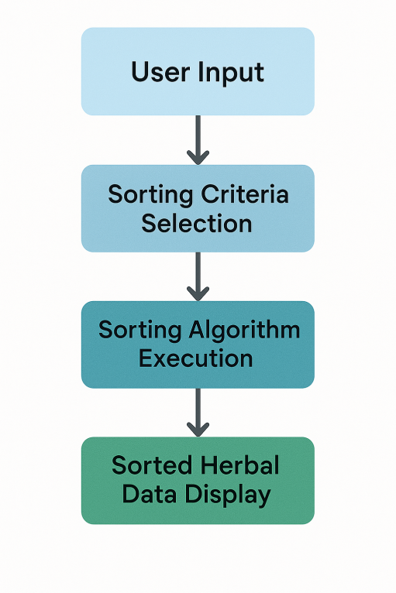
Figure 4.1: Sorting Algorithms in the Proposed System
CLASSIFICATION ALGORITHMS
Classification algorithms enable the system to categorize herbs based on their characteristics, such as therapeutic properties, plant families, or geographical origin. This categorization aids users in understanding and selecting appropriate herbal remedies.

Notable Classification Algorithms:
Support Vector Machines (SVM): Effective in high-dimensional spaces, SVMs classify data by finding the optimal hyperplane that separates different classes.
Random Forest: An ensemble learning method that constructs multiple decision trees and outputs the mode of their predictions, enhancing accuracy and controlling overfitting.
Convolutional Neural Networks (CNN): Particularly useful for image recognition tasks, CNNs can classify herbs based on leaf patterns or other visual features.

Diagram 2: Classification Process in the proposed system

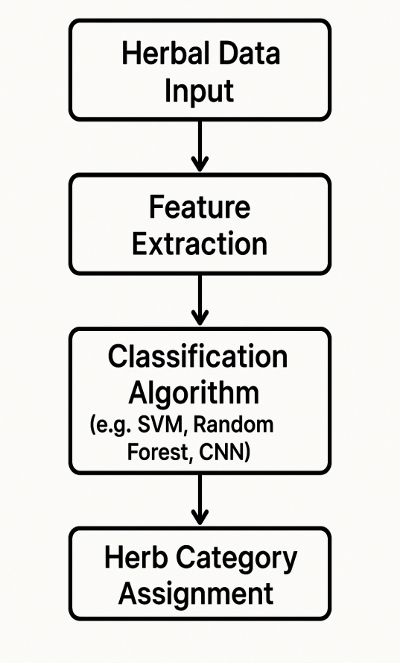
Figure 4.2: Classification Process in the Proposed System
RECOMMENDATION ALGORITHMS
Recommendation algorithms personalize the user experience by suggesting herbs that align with the user's specific health conditions or preferences. These algorithms analyze user input and match it with the most relevant herbal remedies.
Key Recommendation Algorithms:
Collaborative Filtering: Predicts user preferences by analyzing patterns from a group of users with similar interests.
Content-Based Filtering: Recommends items similar to those the user has liked in the past, based on item features.
Hybrid Approaches: Combine collaborative and content-based methods to improve recommendation accuracy.

Diagram 3: Recommendation Workflow in the proposed system

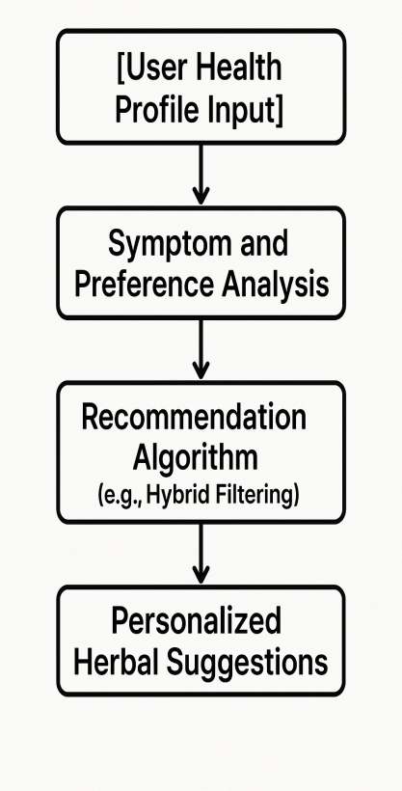
Figure 4.3: Recommendation Workflow in the Proposed System
INTEGRATION INTO THE PROPOSED SYSTEM:
By implementing these algorithms, the proposed system can offer:
Efficient Data Retrieval: Sorting algorithms ensure quick access to organized herbal information.
Accurate Herb Classification: Classification algorithms provide structured categorization, aiding in user comprehension.
Personalized Recommendations: Recommendation algorithms tailor suggestions to individual user needs, enhancing the system's utility.
These algorithmic components collectively contribute to a robust, user-friendly AI-driven platform that democratizes access to herbal medicine knowledge.
4.1.2 INPUT DESIGN
To enhance usability and support smooth user onboarding, the system features a unified input interface for user authentication and registration, as shown in Figure 4.4. This figure displays the login form (left side) and the account creation form (right side), both designed using ReactJS with a focus on clarity, accessibility, and input validation.
The login form allows existing users to securely access the platform by entering their email and password, with options like "Remember me for 30 days" and "Forgot password?" to improve user convenience. The registration form collects user data such as first name, last name, email, phone number, and password confirmation, with checkbox consent for Terms of Service and Privacy Policy. Each input is validated before submission to prevent errors or incomplete data entries.
Upon submission, the input data is processed through the Node.js and Express.js backend, where it undergoes further validation and is securely stored in the MongoDB database. This integrated input system supports account management and ensures a secure, consistent user experience across the AskHerbAI platform.
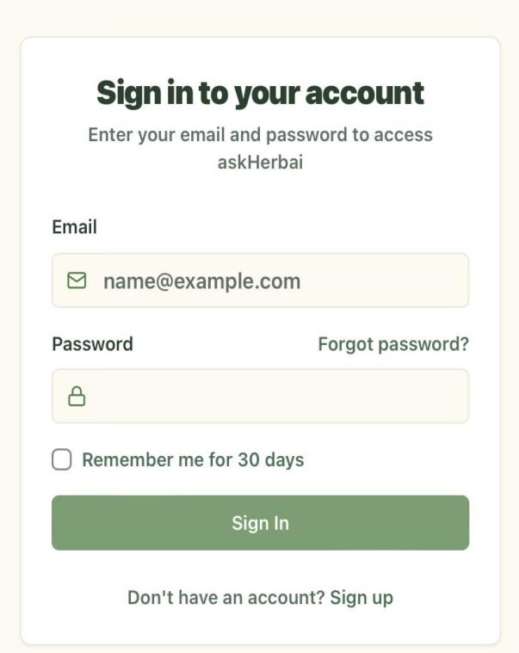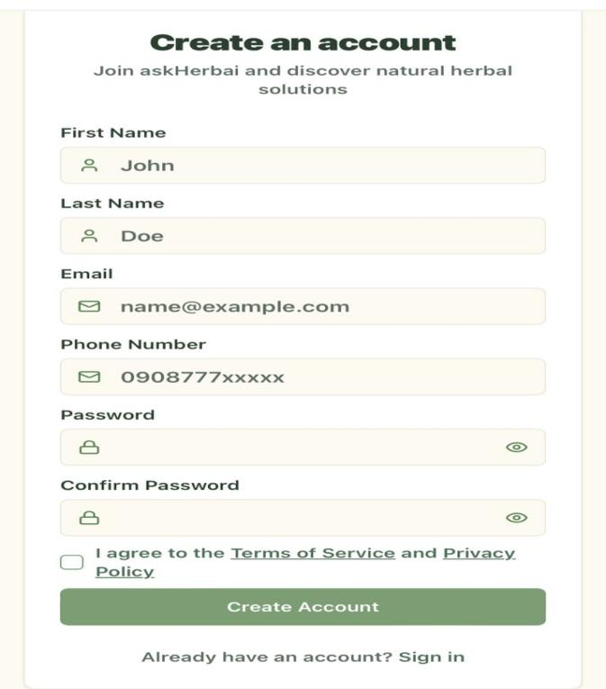
Figure 4.4: Integrated Login and Registration Input Forms for AskHerbAI
4.1.3 DATABASE DESIGN
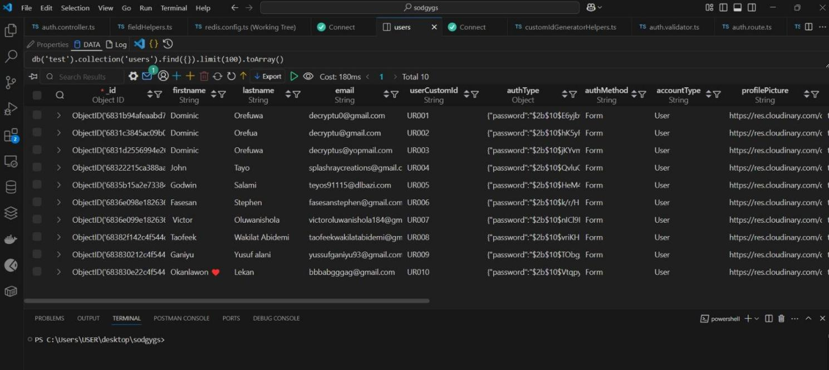Figure 4.5: MongoDB-Based Herbal Database Design

4.1.4 PROCEDURE DESIGN
The procedure design outlines the sequence of operations and workflow followed during the development of the herbal medicine database system. The system was designed to support the efficient collection, storage, and management of herbal data through a structured and user-friendly interface. The design procedure was divided into the following phases:
- Requirement Gathering
Initial research was conducted to understand the structure and content of herbal medicine data, including local and scientific names, treated ailments, preparation methods, and geographical origins. This phase also involved identifying the system’s functional and non-functional requirements.
- Data Structuring and Schema Design
Based on the data collected, a schema was designed using MongoDB to define the structure for storing herbal information. The schema included key fields such as herb name, description, uses, preparation method, and source region.
- Frontend Interface Design
A user-friendly interface was developed using ReactJS to allow easy input and retrieval of herbal data. The design prioritized simplicity, clarity, and responsiveness to accommodate a wide range of users, including researchers and traditional medicine practitioners.
- Backend Development
The backend was developed using Node.js and Express.js to handle requests, process inputs, and communicate with the database. APIs were built to support CRUD (Create, Read, Update, Delete) operations on herbal entries.
- Integration and Testing
The frontend and backend were integrated, and the system was tested for functionality, responsiveness, and data accuracy. Manual testing was carried out to ensure each feature worked as intended and the data flowed correctly between components.
- Deployment and Final Review
After successful testing, the system was deployed on a local or web server for demonstration. Feedback was collected for further refinement and improvement.
This procedure ensured that the system was functional but also scalable and adaptable for future enhancements, including AI integration for smart herbal recommendations.

4.2 SYSTEM IMPLEMENTATION
This section details the practical development of the system aimed at collecting, organizing, and managing a comprehensive dataset on herbal medicines. The implementation prioritized building a robust and scalable infrastructure that supports structured data collection as the foundation for future AI integration.

4.2.1 CHOICE OF PROGRAMMING LANGUAGE
The system was built using JavaScript, a versatile language supporting client-side and server-side development. The frontend was developed using ReactJS, which enabled the creation of an interactive and responsive user interface for data entry and navigation. React’s component-based architecture made it easy to build reusable forms and interface elements tailored to the herbal data structure.
On the backend, Node.js was used in combination with Express.js to handle routing, data processing, and API creation. This setup ensured smooth and secure communication between the frontend and the database. The backend handled all data submission, validation, and storage tasks, essential for maintaining a clean and consistent dataset.
This full-stack JavaScript approach offered seamless integration between the client and server, allowing for efficient data collection and management.

4.2.2 HARDWARE SUPPORT
The table below outlines the minimum hardware requirements used during the development and testing of the system:
Component | Specification
Processor | Intel Core i5 / AMD Ryzen 5 or better
RAM | 8 GB minimum
Storage | 256 GB SSD or more
Operating System | Windows 10 / Ubuntu 20.04LTS
Internet Access | Required for dependency management and database access

4.2.3 SOFTWARE SUPPORT
The table below summarizes the key software tools and frameworks used to develop the system:

Software/Tool | Purpose
ReactJS | Frontend user interface development
Node.js & Express.js | Backend development and RESTful API creation
Mogoose | Object Data Modeling (ODM) for MongoDB schema and data validation
Visual Studio Code | Code editing and project management
Postman | Testing backend APIs
npm (Node Package Manager) | Managing dependencies and javaScript packages
Git & GitHub | Version control and collaboration

4.2.4 IMPLEMENTATION TECHNIQUES
System implementation is the stage that ensures that the system is fully functional, efficient, and meets the needs of the users. For the implementation of database herbal medicine for AI-driven health solutions to be successful, different data sources and collections were used; these include peer- reviewed journals, research papers, academic databases(e.g pub med, Scopus, web of science) were searched for evidence - based information on herbal remedies. Also, online databases specializing in herbal medicine and related fields were searched using specific keywords and search terms (e.g herb name, medicinal use, pharmacological action, side effects).

Before the development of herbal medicine, some notable classification algorithms were adopted which included the use of Support Vector Machines(SVN), Random Forest, and Convolutional Neural Network (CNN). These algorithms ensure effective data classification enhancing accuracy and image recognition tasks

The system will be implemented using an AI-powered chatbot which is designed to provide reliable, accurate, and accessible information about herbal medicine addressing issues like misinformation and accessibility barriers.

It also involves the integration of a user interface (UI), and AI algorithms to support intelligent health recommendations. The structure is built in modular components to ensure scalability, maintainability and performance.

4.3 SYSTEM DOCUMENTATION
4.3.1 PROGRAM DOCUMENTATION
Overview: AskHerbai is a web-based application designed to provide users with information on herbal medicines, combining traditional knowledge with modern research. The platform utilizes AI to offer insights and answers related to herbal remedies.
Architecture: The application is built using modern web technologies, likely leveraging frameworks such as Next.js or React for the frontend. It is deployed on Vercel, a platform optimized for frontend frameworks and static sites, ensuring fast and reliable delivery of content.
Features:
Search Functionality: Users can input queries to find information on various herbs and their uses.
AI Integration: The platform employs AI to interpret user queries and provide relevant information.
Responsive Design: The website is designed to be accessible on various devices, ensuring a seamless user experience.
Data Sources: While specific data sources aren't detailed, it's presumed that the platform aggregates information from reputable databases and research on herbal medicines to provide accurate and up-to-date information.

4.3.2 Operating the System
Accessing the Platform: Users can access AskHerbai through the URL: https://askherbai.vercel.app/. No installation is required, and the platform is accessible via modern web browsers.
Using the Search Feature: Upon visiting the site, users are presented with a search interface. By entering the name of an herb or a health condition, the AI processes the query and returns relevant information, including potential herbal remedies and their benefits.
Navigation: The website's intuitive design allows users to navigate through different sections easily. Information is categorized, making it straightforward to explore various herbs and their associated health benefits.
User Support: While the platform is user-friendly, support options such as FAQs, contact forms, or chat support can enhance user experience. Implementing these features can assist users in resolving queries or issues they might encounter.
4.3.3 MAINTAINING THE SYSTEM
Regular Updates: To ensure the accuracy and relevance of information, it's essential to regularly update the database with the latest research findings on herbal medicines. This can involve integrating APIs from reputable health organizations or manually updating the content.
Monitoring Performance: Utilize Vercel's analytics and monitoring tools to track website performance, user engagement, and potential issues. Regularly reviewing these metrics can help in optimizing the platform for better user experience.
Security Measures: Implement security best practices to protect user data and ensure the integrity of the platform. This includes using HTTPS, regular security audits, and keeping dependencies up-to-date to mitigate vulnerabilities.
Backup and Recovery: Establish a routine backup system to prevent data loss. In case of any issues, having a recovery plan ensures that the platform can be restored to its optimal state promptly.

CHAPTER FIVE

SUMMARY, CONCLUSION AND RECOMMENDATIONS
5.1 SUMMARY
This project was aimed at developing a comprehensive database of herbal medicines, leveraging AI-driven technologies to provide accurate and reliable information for healthcare professionals, researchers, and patients.
The system helps to provide detailed information on herbal medicines, including their properties, uses, interactions, and side effects. Built using modern technologies such as Node.js/Express for the backend, ReactJS for the frontend, and NoSQL database for sorting the data and AI algorithms to identify patterns and relationships in the data. The platform provides a user-friendly experience where users can interact with AI assistants to access herbal medicine databases. The system was built using JavaScript, which offered seamless integration between the client and the server, allowing for efficient data collection and management. Each chapter of this work covered different aspects such as system analysis, design, implementation, and documentation.

5.2 CONCLUSION
The development of a comprehensive web-based database for herbal medicines marks a significant step toward modernizing and preserving traditional medical knowledge. This project successfully designed and implemented a functional platform using ReactJS, Node.js, and MongoDB, with a primary focus on collecting, organizing, and managing herbal data in a structured format.
By emphasizing accurate data collection, the system creates a solid foundation for future integration of artificial intelligence in health-related decision-making. Users can easily input, update, and retrieve information about various herbs, their uses, and the ailments they treat. The system also promotes accessibility and scalability, making it a valuable tool for researchers, developers, and healthcare professionals.
Overall, the project demonstrates how technology can support the documentation and advancement of indigenous health practices, with the potential to evolve into a powerful AI-driven diagnostic aid.

5.3 RECOMMENDATIONS
To further enhance the functionality, reach, and impact of the herbal medicine database system, the following recommendations are proposed:
- AI Integration
Implement AI features for analyzing symptoms and recommending herbal remedies based on the collected data.
- Dataset Expansion
Collaborate with traditional healers and researchers to grow the herbal medicine database.
- Web Platform Enhancement
Add advanced features like search filters, symptom-based suggestions, and user dashboards to improve interactivity.
- Multimedia Support
Include images, audio, and videos to enhance understanding of each herb and its usage.
- Access Control
Implement role-based login systems to manage data submission and editing securely.
- Language and Offline Support
Add multilingual options and offline access for users in remote or rural areas.

REFERENCES
Anguranak, T., & Tachpetpaiboon, N. (2015). The development of medicinal plants database for use in primary health care from various herbal websites. Research Journal of Applied Sciences Engineering and Technology, 9(7), 500. https://doi.org/10.19026/rjaset.9.1432
Badnale, A. B., Sarukh, V. S., Nikam, Y. P., Supekar, A. V., & Khandagale, S. S. (2022). A review on potential medicinal herbs as health promoters. Journal of Drug Delivery and Therapeutics, 12, 225. https://doi.org/10.22270/jddt.v12i3-s.5496
Beshah, F., Hunde, Y., Getachew, M., Bachheti, R. K., Husen, A., & Bachheti, A. (2020). Ethnopharmacological, phytochemistry and other potential applications of Dodonaea genus: A comprehensive review. Current Research in Biotechnology, 2, 103. https://doi.org/10.1016/j.crbiot.2020.09.002
Chan, H. C. S., Shan, H., Dahoun, T., et al. (2019). Advancing drug discovery via artificial intelligence. Drug Discovery Today. [Details incomplete, may need updating]
Chung, M. C., Su, L. J., Chen, C. L., et al. (2024). AI-assisted literature exploration of innovative Chinese medicine formulas. Journal Name TBD. [Citation incomplete]
Chu, H., Moon, S., Park, J., et al. (2022). The use of artificial intelligence in complementary and alternative medicine: A systematic scoping review. Journal Name TBD. [Citation incomplete]
Devine, S. N. O., Kolog, E. A., & Atinga, R. A. (2022). Toward a knowledge-based system for African traditional herbal medicine: A design science research approach. Frontiers in Artificial Intelligence, 5. https://doi.org/10.3389/frai.2022.856705
Enuameh, Y., Nettey, O. E. A., Mahama, E., et al. (2015). Family planning needs of adolescents in predominantly rural communities in the central part of Ghana. Open Journal of Preventive Medicine, 5(6), 269. https://doi.org/10.4236/ojpm.2015.56030
Ephraim, R. K. D., Kotam, G. P., Duah, E., et al. (2024). Application of medical artificial intelligence technology in sub-Saharan Africa: Prospects for medical laboratories. Smart Health, 33, 100505. https://doi.org/10.1016/j.smhl.2024.100505
Fathifar, Z., Kalankesh, L. R., Ostadrahimi, A., & Ferdousi, R. (2023). New approaches in developing medicinal herbs databases. Database, 2023. https://doi.org/10.1093/database/baac110
Feng, C., Shao, Y., Wang, B., et al. (2021). Development and application of artificial intelligence in auxiliary TCM diagnosis. Journal Name TBD. [Citation incomplete]
Herbal History: Roots of Western Herbalism. (2021). https://theherbalacademy.com/herbal-history/
Jansen, C., Baker, J., Kodaira, E., et al. (2020). Medicine in motion: Opportunities, challenges and data analytics-based solutions for traditional medicine integration into western medical practice. Journal Name TBD. [Citation incomplete]
Karpavičienė, B. (2022). Traditional uses of medicinal plants in south-western part of Lithuania. Plants, 11(16), 2093. https://doi.org/10.3390/plants11162093
Khan, S. R., Al Rijjal, D., Piro, A., et al. (2021). Integration of AI and traditional medicine in drug discovery. Journal Name TBD. [Only included once]
Mosihuzzaman, M. (2012). Herbal medicine in healthcare—An overview. Natural Product Communications, 7(6). https://doi.org/10.1177/1934578x1200700628
Owen, D. J. (1999). Herbal resources on the internet. Medical Reference Services Quarterly, 18(4), 39. https://doi.org/10.1300/j115v18n04_05
Pan, S. Y., Litscher, G., Zhou, S. F., et al. (2014). Historical perspective of traditional indigenous medical practices: The current renaissance and conservation of herbal resources. https://doi.org/10.1155/2014/525340
Sasidharan, S., KP, S., Bhaumik, A., Das, S. K., & J, H. N. (2021). Botanical and pharmacognostic evaluation of Caesalpinia bonduc seed, a prevalent Indian traditional drug having vivid therapeutic prospects. Journal of Pharmacognosy and Phytochemistry, 10(6), 297. https://doi.org/10.22271/phyto.2021.v10.i6d.14304
Sharma, A., Sabharwal, P., & Dada, R. (2021). Herbal medicine—An introduction to its history. In Elsevier eBooks (p. 1). https://doi.org/10.1016/b978-0-12-815565-3.00001-1
Shengji, P. (2001). Ethnobotanical approaches of traditional medicine studies: Some experiences from Asia. Pharmaceutical Biology, 39, 74. https://doi.org/10.1076/phbi.39.s1.74.0005
Sireeshaa, S. M., Neelimaa, K., & Vinuthaa, K. (2022). Multi-targeted molecular docking analysis of selected phytoconstituents of Bauhinia acuminata. International Journal of Pharmaceutical Sciences Review and Research, 53. https://doi.org/10.47583/ijpsrr.2022.v73i02.012
Uddin, M. J., & Rashid, M. S. U. (2019). Socioeconomic impact of bagging technology for value addition in mango in the Chittagong Hill Tracts of Bangladesh. International Journal of Sustainable Agricultural Research, 6(4), 203. https://doi.org/10.18488/journal.70.2019.64.203.212
Vera, M. C. S., & Palaoag, T. D. (2023). Implementation of a smarter herbal medication delivery system employing an AI-powered chatbot. International Journal of Advanced Computer Science and Applications, 14(3). https://doi.org/10.14569/ijacsa.2023.0140358
Vișan, A. I., & Neguț, I. (2024). Integrating artificial intelligence for drug discovery in the context of revolutionizing drug delivery. Journal Name TBD. [Citation incomplete]
Wicke, R. W. (1996). History of herbology, herbalism. https://www.rmhiherbal.org/aa/f-ahr1-hist.html
Yang, Z., Yin, Y., Kong, C., et al. (2025). ShennongAlpha: An AI-driven sharing and collaboration platform for intelligent curation, acquisition, and translation of natural medicinal material knowledge. Journal Name TBD. [Citation incomplete]
Zhou, E., Shen, Q., & Hou, Y. (2024). Integrating artificial intelligence into the modernization of traditional Chinese medicine industry. Frontiers in Pharmacology, 15. https://doi.org/10.3389/fphar.2024.1181183

APPENDIX A: PROGRAM FLOWCHART
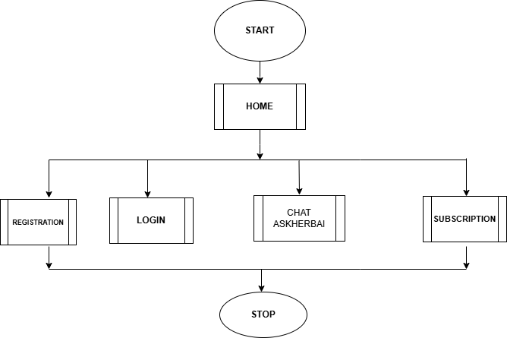

REGISTRATION
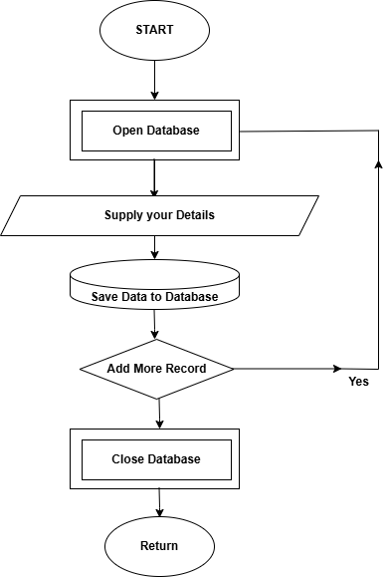

LOGIN
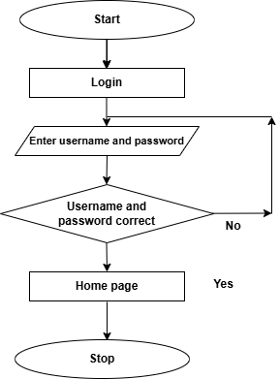

CHAT ASKHERBAI
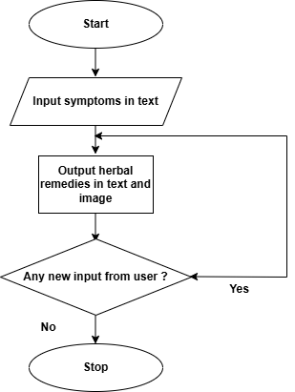

Appendix B: Source Code
<DOCTYPE html> <html lang-"en">
<head>
<title> Kwarapoly Portal </title>
<meta charset="utf-8">
<meta name="viewport" content="width device-width, initial-scale = 1">
<link rel="shortcut icon" href="images/kplogo.png"/>
<link rel="stylesheet" type="text/css" href="css/bootstrap.min.css"
<link rel="stylesheet" href="css/sp8cial.css">
<link rel="stylesheet" href="css/style.css">
<link rel="stylesheet" type="text/css" href="font/all.css">
<script src="https://code.jquery.com/jquery-3.2.1.slim.min.js" integrity="sha384-
KJ302DKtlkvYIK3UENzmM7KCkRr/rE9/Qpg6aAZGJwFDMVNA/GpGFF93hXpGSKKN" crossorigin="anonymous"></script>
<script src="https://cdnjs.cloudflare.com/ajax/libs/popper.js/1.12.9/umd/popper.min.js" integrity-"sha384-
ApNbgh9B+Y1QKtv3Rn7W3mgP×hU9K/ScQsAP7hUibX39j7fakFPskvXusvfa0b40' crossorigin="anonymous"></script> <script sro="https://maxcdn.bootstrapedn.com/bootstrap/4.0.0/js/bootstrap.min.is"
integrity="sha384-
JZR6Spejh4U02d8jOt6vLEHfe/JQGiRRSQQXSIFWpilMquVdAyjUarS+76PVCmY|' crossorigin="anonymous"></script>
</head>
<body class="bg-grey">
<nav class-"navbar navbar-expand-Ig py-|g-3 navbar-dark sticky-top" style="back ground-color:
rgb(2, 156, 90);">
<div class="container">
<! - logo -->
<a href-"homepage.html" class-"navbar-brand mr-Ig-5"> <img src="images/me.png" alt=“” class='logo-dark" height="60” />
</a>

