A PROJECT REPORT ON RESTUARANT FOR LUKMAN MUSTAPHA OLAYIWOLA

AT
KWARA STATE POST OFFICE ILORIN, KWARA STATE.
BY
TEMIM IBRAHIM ALABI
ND/23/ARC/PT/0020
BEING A PROJECT SUBMITTED TO:
THE DEPARTMENT OF ARCHITECTURAL TECHNOLOGY INSTITUTE OF ENVIRONMENTAL STUDIES KWARA STATE POLYTECHNIC, ILORIN
IN PARTIAL FULFILMENTS OF THE REQUIREMENTS FOR AWARD OF NATIONAL DIPLOMA (ND) IN ARCHITECTURAL TECHNOLOGY
JULY, 2025

DECLARATION
I declare that this design project is a project of my personal efforts. It has not been presented for the award of any ND in any Ilorin post office. The ideas, observations, comments, suggestions here in represent my own convictions, except quotations, which have been acknowledged in accordance with conventional academic traditions.
TEMIM IBRAHIM ALABI.  ----- | ----------------------------
ND/23/ARC/PT/0020 | SIGNATURE/DATE

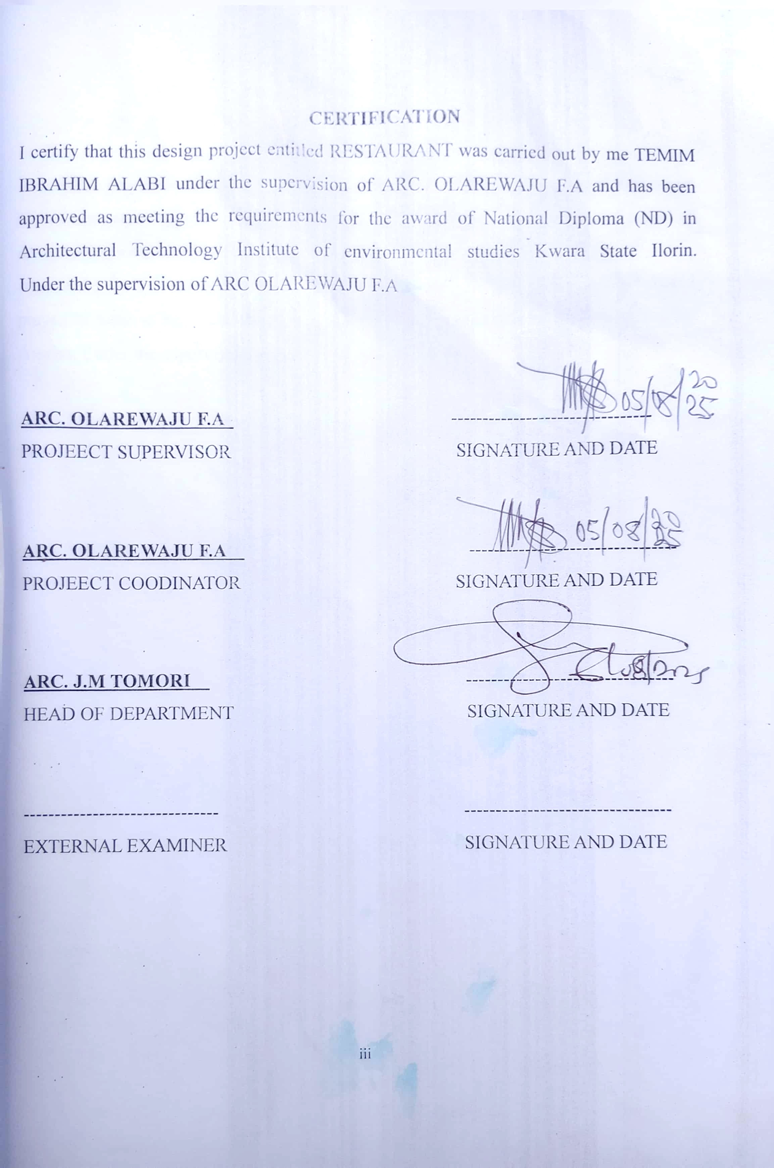
CERTIFICATION
IcertifythatthisdesignprojectentitledRESTAURANTwascarriedoutbyme
TEMIMIBRAHIMALABIunderthesupervisionofARC.OLAREWAJUF.Aandhas
beenapprovedasmeetingtherequirementsfortheawardofNationalDiploma(ND)in
ArchitecturalTechnologyInstituteofenvironmentalstudiesKwaraStateIlorin.
ARC.OLAREWAJUF.A
--------------------------------
PROJEECTSUPERVISOR
SIGNATUREANDDATE
ARC.OLAREWAJUF.A
---------------------------------
PROJEECTCOODINATOR
SIGNATUREANDDATE
ARC.J.MTOMORI
---------------------------------
HEADOFDEPARTMENT
SIGNATUREANDDATE
-------------------------------
---------------------------------
EXTERNALEXAMINER
SIGNATUREANDDATE

DEDICATION
This project is dedicated to Almighty Allah, the master of the universe who out of his infinity mercy that prevailed over judgment has guided me throughout the period of my academic career to him all honors. Glory Adoration
Also to my loving caring parents for their love and support right from birth, till date, I prayed to Allah in his sufficient mercy grant all them their heart desired Ameenthuma- Ameen

ACKNOWLEDGEMENT
Firstly, my gratitude goes to Almighty Allah for granting me good health throughout the duration of my course and the grace to complete another phase of my academic pursuit. My appreciation also goes to my mentor in person of ARC. OLAREWAJU F.A for the
patience and assistance of fared during the writing of this project. And also to all the
entire lecture and the management of Architectural department.
I also acknowledged to my loving mother and also to the most supporting person have ever seen my lovely father for their financially and sponsored on me throughout
my programme.
My indebted gratitude goes to my brother and sister for their financial and moral
support during the course and my loving one may Allah reward you richly.
Finally, my appreciation also goes to my friend and my course mate in mention like, olamilekan, sulaiman, Ibrahim for their support from the beginning of this program
till end.

TABLE OF CONTENT
Declaration ...ii
Certification .....iii Dedication .iv
Acknowledgement . v
Table of content vi
List of tables .. .viii List of figures .. ix
List of plates .x
List of appendices xi
Abstract xii

CHAPTER ONE
1.0 introduction of the study 1
1.1 project definition 3
1.2 historical background .. . .3
1.3 Aim and Objectives of the project ....4
1.4 Justification for the Project ...4
1.5 Scope of the Study 4
1.6 Limitation of the Study .5
1.7 Research Methodology .5

CHAPTER TWO
2.0 Review of Literature of the project... .. . .6
2.1 Review of relevant literature on building .. ...6
2.2 Review of literature on sub-topic of the thesis . 7

CHAPTER THREE
3.0 Case Studies .. 9
3.1 Case Study one .. . ...9
3.2 Case Study two ........12
3.3 Case Study three . .. ..….15
3.4 Case study four online case study .........18
3.3 Case Study five online case study .. .19
3.5 Findings and Discussions ... ...19
3.6 Deductions for studies .…..19

CHAPTER FOUR
4.0 Analysis of Topographical and Environmental Conditions of the site .…20
4.1 Introduction of the Study area ... 20
4.2 Site Location and description ...22
4.3 Site Analysis/Inventory .. ..23
4.4 Geographical / climatic data . 25
4.5 Design Criteria .26
4.6 Brief Analysis/Project goals . . . ..26
4.7 Spatial Allocation .....27
4.8 Functional relationship . . . ..28
4.9 Conceptual Development . .…...28

CHAPTER FIVE
5.0 Approach to the Design …. .. .29
5.1 Technological and Environmental Criteria .…......29
5.2 Essential Service Required …. ....30
5.3 Environmental Conditions to Be Achieved …. .. .32
5.4 Performance Standard ..…...32
5.5 Legal Issue & Planning Regulation .. ..33
5.6 behavioral pattern and Considerations....................................................... ...33
5.7 Summery .. .34
5.8 Conclusions and Recommendations … .34
Reference … ..36
Appendices ..... ..38

LIST OF TABLES
Table 4.5.1: Showing the Geographical and Climate Data of Ilorin .25
Table 4.5. 2: Showing the Average Temperature of Ilorin 26
Table 4.10.1: Space Allocation for the design .. 27

LIST OF FIGURES
Fig3.1.1: showing the location plan of case study one . 9 fig3.1.2: showing the floor plan of case study one . . .9 fig3.2.1: showing the location plan of case study two ... ..12 fig3.2.2: showing the floor plan of case study two . ..…. ..12 fig3.3.1: showing the location plan of case study three .. .. ...15 fig3.3.2: showing the floor plan of case study three ............................15 Fig5.1: showing The site inventory .. …...............23
Fig5.2: showing The site analysis .. ... ..….. .........24

LIST OF PLATES
Plate3.1.1: showing approach view of case study one----------------------------------------11
Plate3.1.2: showing side view of case study one ---------------------------------------------11
Plate3.1.3: showing the inner view of case study one ---------------------------------------12
Plate3.2.1: showing approach view of case study two --------------------------------------14 Plate3.2.2: showing left view of case study two ---------------------------------------------14
Plate3.2.3: showing inner view of case study two -------------------------------------------15
Plate3.3.1: showing approach view of case study three-------------------------------------17
Plate3.3.2: showing side view of case study three-------------------------------------------17
Plate3.3.2: showing inner view of case study three------------------------------------------18
Plate3.4.1: showing internal view of case study four (online case study) --------------18
Plate3.5.1: showing internal view of case study five (online case study) -------------------19

LIST OF APPENDICES
Appendix 5.3; showing the site plan . .. 38
Appendix 5.4; showing the floor plan ..........................................................39
Appendix 5.5; showing the roof plan ..40
Appendix 5.6; showing the sections ..41
Appendix 5 8; showing the elevations . 42
Appendix 5.12; showing the external perspective.….....43
Appendix 5.13; showing the internal perspective .… . .. ..43
ABSTRACT
Restaurants play a significant role in our lifestyles, and dining out is a favorite social activity. Everyone needs to eatso, to enjoy good food and perhaps wine in the company of friends and in pleasant surroundings is one of lifes pleasures. Eating out has become a way of life for families. Today, more meals than ever are being eaten away from home. The methodology used for this project was based on the survey of existing similar project undertaken as case studies and review of literature on the subject matter via internet.
Deduction from the findings indicate that the restaurant should be well equipped with adequate spaces, ray of sunlight, material to be used and maintenance of plant, the project include the proposal power house, Gate House, Relaxation Area and Car Park.

CHAPTER ONE 1.0 INTRODUCTION

1.1 BACKGROUND OF THE STUDY
Restaurant is a place where the diners could buy food and drink with a high-service. There are lots of restaurants around Bali, either they belong to hotels or stand alone. According to White M (2019), restaurant is a place that could be visited by everyone which provides and sells food and beverage commercially to personal, couple or group. Restaurants offer service of Food and Beverage desires to satisfy the guest. The food and beverage service department is the department that has a contribution for the positive feed-back given by the guests in the restaurant. The waiter/waitresses are the sections in food and beverage service who are responsible to give best service to the guest. By giving the best service, guests would feel satisfied and mostly they would give good reviews to the restaurant. As waiters, they have to know the job description before assisting the guests in every section and know the conversation or the language used for assisting guests. Jejaton restaurant is a restaurant in Fairfield by Marriot Kuta Sunset Road. Jejaton restaurant provides Indonesian traditional food. It makes this restaurant different than others. Not only is the food, the equipment used for food are also made from traditional things, such as: plate from wood, straw from bamboo and etc. The guests who are coming to have meal in this restaurant are not only the in-house guest (guest who are staying in the hotel). There are lots of guests come from outside. Many of them said that this restaurant is like a beauty in simplicity.
Based on the review, this
Eating out has a long history. Taverns existed as early as 1700 b.c.e. The record of a public dining place in Ancient Egypt in 512 b.c.e. shows a limited menu only one dish was served, consisting of cereal, wild fowl, and onion. Be that as it may, the ancient Egyptians had a fair selection of foods to choose from: peas, lentils, watermelons, artichokes, lettuce, endive, radishes, onions, garlic, leeks, fats (both vegetable and animal), beef, honey, dates, and dairy products, including milk, cheese, and butter.
The ancient Romans were great eaters out. Evidence can be seen even today in Herculaneum, a Roman town near Naples that in 70 a.d. was buried under some 65 feet of mud and lava by the eruption of Mt. Vesuvius. Along its streets were a number of snack bars vending bread, cheese, wine, nuts, dates, figs, and hot foods. The counters were faced with marble fragments. Wine jugs were imbedded in them, kept fresh by the cold stone. Mulled and spiced wines were served, often sweetened with honey. A number of snack bars were identical or nearly so giving the impression that they were part of a group under single ownership.
Bakeries were nearby, where grain was milled in the courtyard, the mill turned by blindFolded asses. Some bakeries specialized in cakes. One of them had 25 bronze baking pans of various sizes, from about 4 inches to about 1.5 feet in diameter.
After the fall of Rome, eating out usually took place in an inn or tavern, but by 12:00 a.m. There were cooking houses in London, Paris, and elsewhere in Europe, where cooked food could be purchased but seating wasn t available. Medieval travelers dined at inns, taverns, hostelries, and monasteries.

1.2 PROJECT DEFINITION RESTAURANT
According to White M (2019), restaurant is a place that could be visited by everyone which provides and sells food and beverage commercially to personal, couple or group.
Restaurant is a place where the diners could buy food and drink with a high-service.

1.3 JUSTIFICATION
To design a well functional and spacious restaurant located at Department of Agriculture Ilorin Kwara State and to design, fabricate and install a well functioned new restaurant suitable for use as a place of income and also to develop a project demonstrate excellent practice in suitable environmental design at Department of Agriculture Ilorin Kwara State.
The structure will demonstrate the best of aesthetic contemporary and environmental design practice.

1.4 AIM AND OBJECTIVEs AIM
The aim of the design project is to design a functional, aesthetically balanced restaurant that aid the economic situation and reconnect people with their food and high light the value of locally grown produce and healthy eating and lifestyles for kwara state ilorin post officeIlorin

OBJECTIVES
- Identify various causes of fire incidences in the restaurant
- Identify and evaluate construction techniques that would help in functionality
- To create a restaurant that relate to and complement each other through site design, for example, through shared use of public spaces and landscape connections.
- To create a restaurant that respond to their context and complement each other in their building design and street orientation.
- To facilitate linkages among uses on and off site through use of pedestrian, bicycle and circulation connections, shared access and parking.
- Design a spacious restaurant that can accommodate people and their circulations.

1.5 SCOPE OF PROJECT
The design project will provide facilities that are necessary in the restaurant with more emphasis on passive means of fire safety. The outdoor spaces as much as the indoor spaces will receive attention. It will accommodate only female students. Facilities to be provided in the hostel would include;
Main building.

1.6 LIMITATION OF DESIGN
The project is limited on main restaurant in Kwara State post office Ilorin. And also limited to planting eight different crops in it due to sufficient area of land provided.

1.7 RESEARCH METHODOLOGY
Various method of research has been regards the architectural design of restaurant.
This involves series of research in order to achieve a balance structure in design of RESTAURANCE.
- Case studies
- Oral interview
- Literature review
- Site visitation
CASE STUDY: As the name implies involves a study of an existing structure that are similar to the proposed project.
ORAL INTERVIEW: Individual interview was carried out randomly with member of the housing.
LITERATURE REVIEW: Relevant textbooks, lecture notes, magazines, journals and pdf notes.
SITE VISITATION: In the research all the mentioned above would not have meaning if the site were not visited so the site visitation confirmed all that is necessary to be adopted in the design.

CHAPTER TWO 2.0 REVIEW OF RELEVANT LITERATURE
Restaurant is an establishment that prepares and serves food and drinks to customers. Meals are generally served and eaten on the premises, but many restaurants also offer take-out and food delivery services. Restaurants vary greatly in appearance and offerings, including a wide variety of cuisines and service models ranging from inexpensive fastfood restaurants and cafeterias to mid-priced family restaurants, to high-priced luxury establishments.
In the United States, it was not until the late 18th century that establishments that provided meals without also providing lodging began to appear in major metropolitan areas in the form of coffee and oyster houses. The actual term "restaurant" did not enter into the common parlance until the following century. Prior to being referred to as "restaurants" these eating establishments assumed regional names such as "eating house" in New York City, "restorator" in Boston, or "victualling house" in other areas. Restaurants were typically located in populous urban areas during the 19th century and grew both in number and sophistication in the mid-century due to a more affluent middle class and to urbanization. The highest concentration of these restaurants were in the West, followed by industrial cities on the Eastern Seaboard.
When Prohibition went into effect in 1920, restaurants offering fine dining had a hard time making ends meet because they had depended on profits from selling wine and alcoholic beverages. Replacing them were establishments offering simpler, more casual experiences such as cafeterias, roadside restaurants, and diners. When Prohibition ended in the 1930s, luxury restaurants slowly started to appear again as the economy recovered from the Great Depression.
The Civil Rights Act of 1964 outlawed segregation based on race, color, religion, or national origin in all public accommodations engaged in interstate commerce, including restaurants. Katzenbach v. McClung, 379 U.S. 294 (1964), was a decision of the US Supreme Court which held that Congress acted within its power under the Commerce Clause of the United States Constitution in forbidding racial discrimination in restaurants as this was a burden to interstate commerce.
In the 1970s, there was one restaurant for every 7,500 persons. In 2016, there were 1,000,000 restaurants; one for every 310 people. The average person eats out five to six times weekly. 3.3% of the nation's workforce is composed of restaurant workers. According to a Gallup Poll in 2016, nearly 61% of Americans across the country eat out at a restaurant once a week or more, and this percent is only predicted to increase in future years. Before the COVID-19 pandemic, The National Restaurant Association estimated restaurant sales of $899 billion in 2020. The association now projects that the pandemic will decrease that to $675 billion, a decline of $274 billion over their previous estimate.
2.1 REVIEW OF RELEVANT LITERATURE ON BUILDING.

FRENCH CULINARY HISTORY
The first restaurant ever was called a public dining room and established in France. Through-out history, France has played a key role in the development of restaurants. The first restaurant that actually consisted of patrons sitting at a table and being served individual portions, which they selected from menus, was founded in 1782 by a vendor named Beau Villiers. It was called the Grand Tavern de Londres. However, this was not the beginning of the restaurant concept. The first restaurant proprietor is believed to have been A. Boulanger, a soup vendor, who opened his business in Paris in 1765.7 He sold soups at his all-night tavern on the Rue Bailee. He called these soups restaurants (restoratives), which is the origin of the word restaurant. Boulanger believed that soup was the cure to all sorts of illnesses. However, he was not content to let his culinary repertoire rest with only a soup kitchen. By law at the time, only hotels could serve food (soup did not fit into this category). In 1767, he challenged the traitors (hotel restauranteurs ) monopoly and prepared a soup that consisted of sheep s feet with a white sauce. The traitors guild filed a lawsuit against Boulanger, and the case went to the French Parliament. Boulanger won the suit and soon opened his restaurant, Le Champ d Oiseau.
In 1782, the Grand Tavern de Londres, a true restaurant, opened on the Rue de Richelieu; three years later, Aux Trois Frères Provençaux opened near the Palais-Royal. The French Revolution in 1794 literally caused heads to roll so much so that the chefs to the former nobility suddenly had no work. Some stayed in France to open restaurants and some went to other parts of Europe; many crossed the Atlantic to America, especially to New
Orleans.

AMERICA RESTAURANT REVIEW
The beginning of the American restaurant industry dates back to 1634, when Samuel Coles opened an establishment named Coles Ordinary in Boston. It was a tavern the first tavern of record in the American colonies. It was quite successful, lasting well over 125 years. Prior to the American Revolution, establishments selling food, beverages, and a place to sleep were called ordinaries, taverns, or inns. Rum and beer flowed freely. A favorite drink, called flip, was made from rum, beer, beaten eggs, and spices. The bartender plunged a hot iron with a ball on the end into the drink. Flips were considered both food and a drink. If customers had one too many flips, the ordinaries provided a place to sleep.
In America, the innkeeper, unlike in Europe, was often the most respected member of the community and was certainly one of its substantial citizens. The innkeeper usually held some local elected office and sometimes rose much higher than that. John Adams, the second president of the United States, owned and managed his own tavern between 1783 and 1789.9 the oldest continually operating tavern in America is the Frances Tavern in New York City, dating from about 1762. It served as the Revolutionary headquarters of General George Washington and was the place where he made his farewell address. It is still operating today.
The restaurant, as we know it today, is said to have been a byproduct of the French Revolution. The term restaurant came to the United States in 1794 through a French refugee from the guillotine, Jean-Baptiste Gilbert Paypalt. Paypalt set up what was likely the first French restaurant in this country, Julien s Restauranteur, in Boston. There he served truffles, cheese fondues, and soups. The French influence on American cooking began early; both Washington and Jefferson were fond of French cuisine, and several French eating establishments were opened in Boston by Huguenots who fled France in the eighteenth century to escape religious persecution.

2.2 REVIEW OF LITERATURE ON SUB-TOPIC OF THE THESIS
2.2.1 COMMON TYPES OF STRUCTURES

THE COFFEEHOUSE
The coffeehouse which appeared in Oxford in1650 and seven years later in London, was a forerunner of the restaurant today. Coffee at the time was considered a cure-all. As one advertisement in 1657 had it: ... Coffee closes the orifices of the stomach, fortifies the heat within, and helped digesting ... is good against eyesores, coughs, or colds... Lloyd s of London, the international insurance company, was founded in Lloyd s Coffee House. By the eighteenth century, there were about 3,000 coffeehouses in London.
Coffeehouses were also popular in Colonial America. Boston had many of them, as did Virginia and New York. Both the words cafe, meaning a small restaurant and bar, and cafeteria come from the single word cafe, French for coffee.
In the eighteenth century, with the exception of inns which were primarily for travelers, food away from home could be purchased in places where alcoholic beverages were sold. Such places were equipped to serve simple, inexpensive dishes either cooked on the premises or ordered from a nearby inn or food shop. Tavern-restaurants existed in much of Europe including France and Germany with

CHAPTER THREE 3.0CASDE STUDY SELECTED
- CASE STUDY ONE; LOCATION: AT ADO EKITI STATE
- CASE STUDY TWO; LOCATION: AT, CHICKEN REPUBLIC TAIWO ROADILORIN, KWARA STATE.
- CASE STUDY THREE; LOCATION: AT, CAPTAIN COOK, OFFA, KWARA
STATE
- CASE STUDY FOUR (ONLINE CASE STUDY) AT CHINEASE
- CASE STUDY FIVE (ONLINE CASE STUDY) AT SPAIN
3.1 CASE STUDY ONE
LOCATION: AT, ADO EKITI, EKITI STATE

MERIT
- Well and simple structure
- Easy to locate and accessible
- Provision of hard landscaping

DEMERIT
 Lack of natural ventilation
 Deficiency in soft landscaping
 Insufficient dining space / eating area
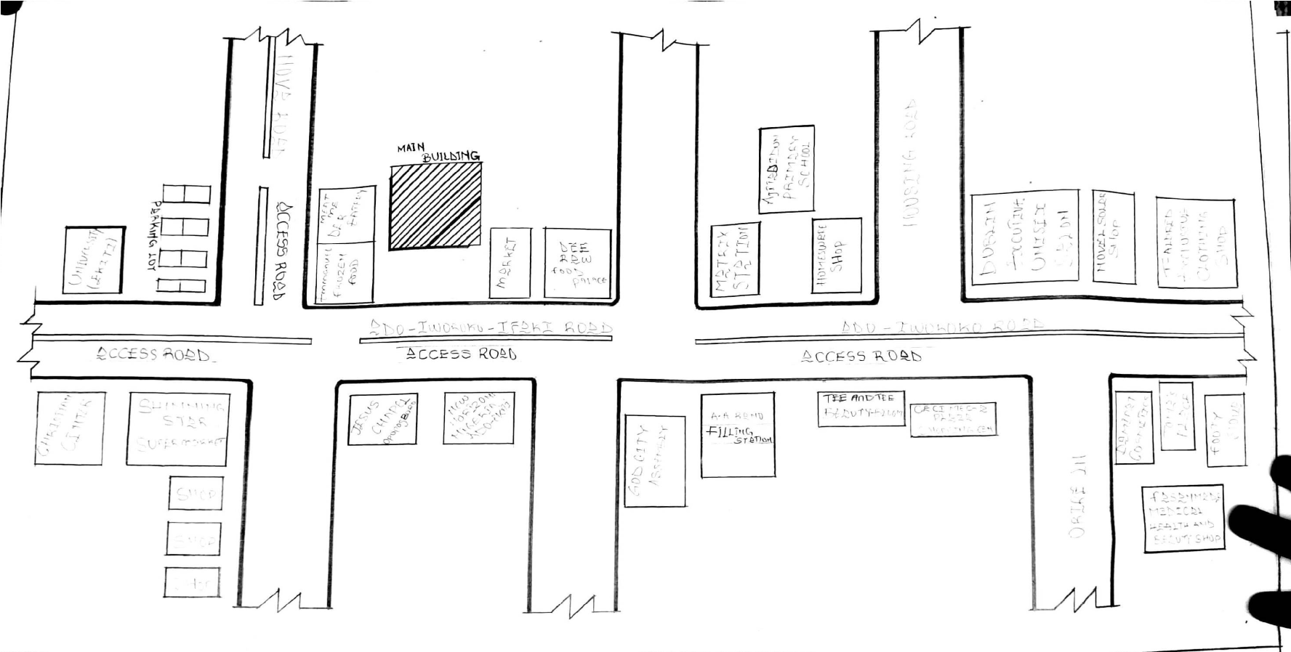

FIGURE 3.1.1: Showing the location plan of case study one
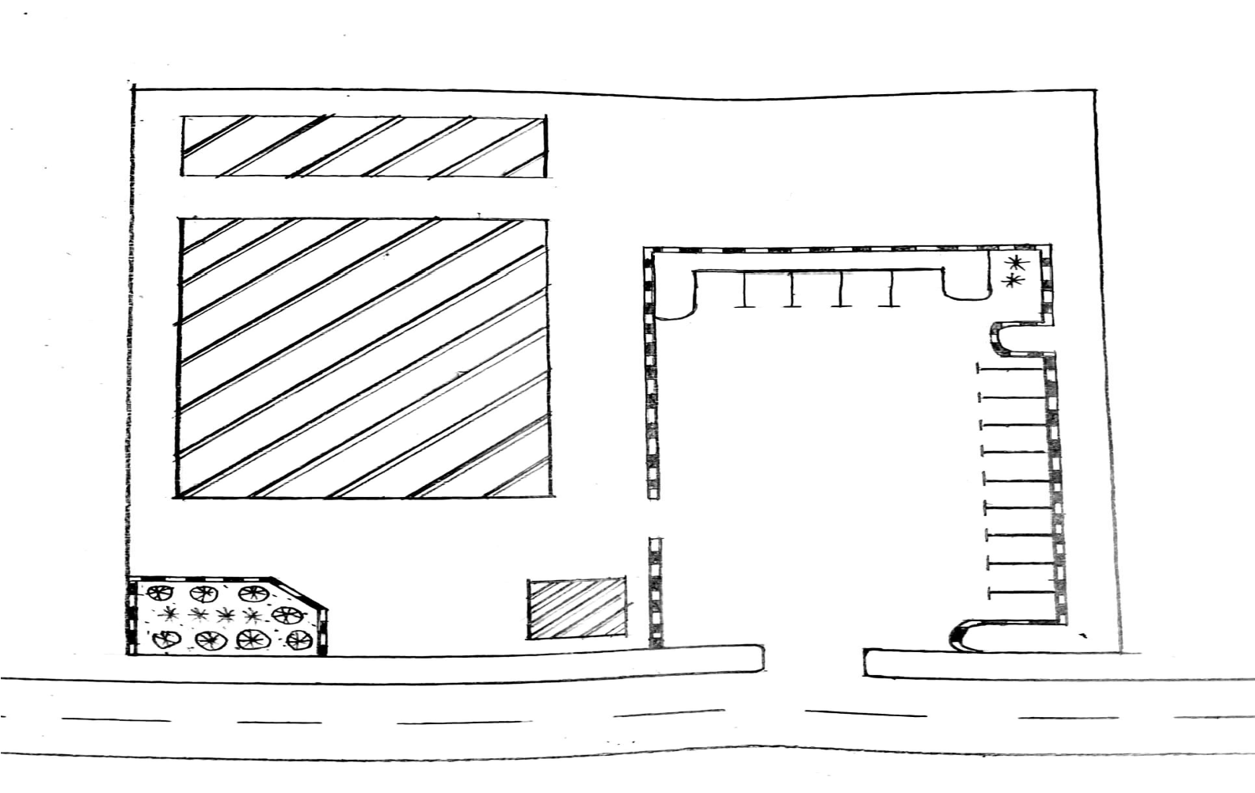

Plate 3.1.2: Picture Showing the Site Plan of case study one
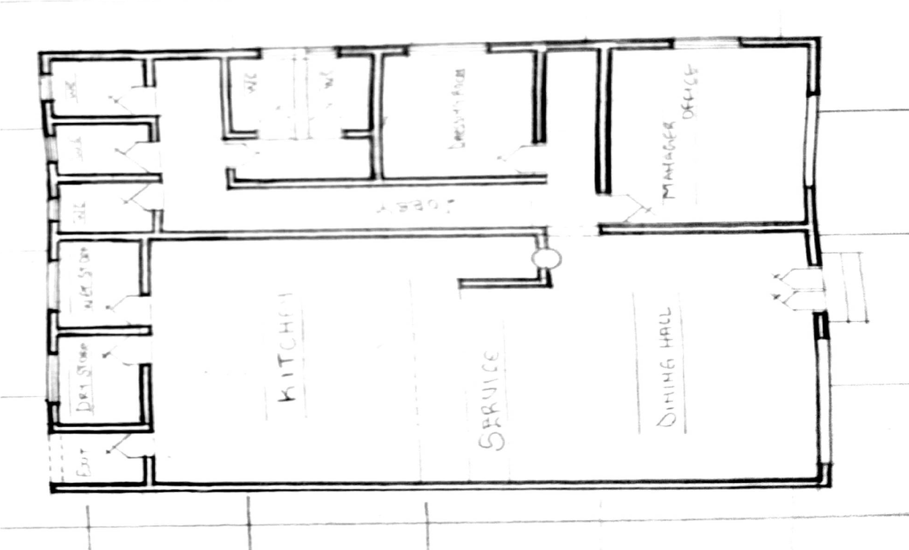

Plate 3.1.3: Picture Showing the Floor Plan of case study one
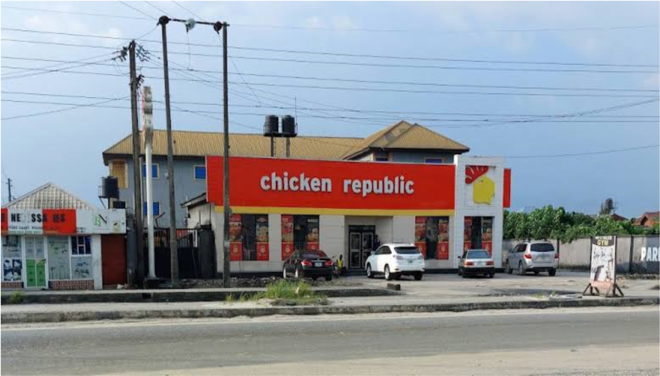

Plate 3.1.1: Showing the approach view of case study one
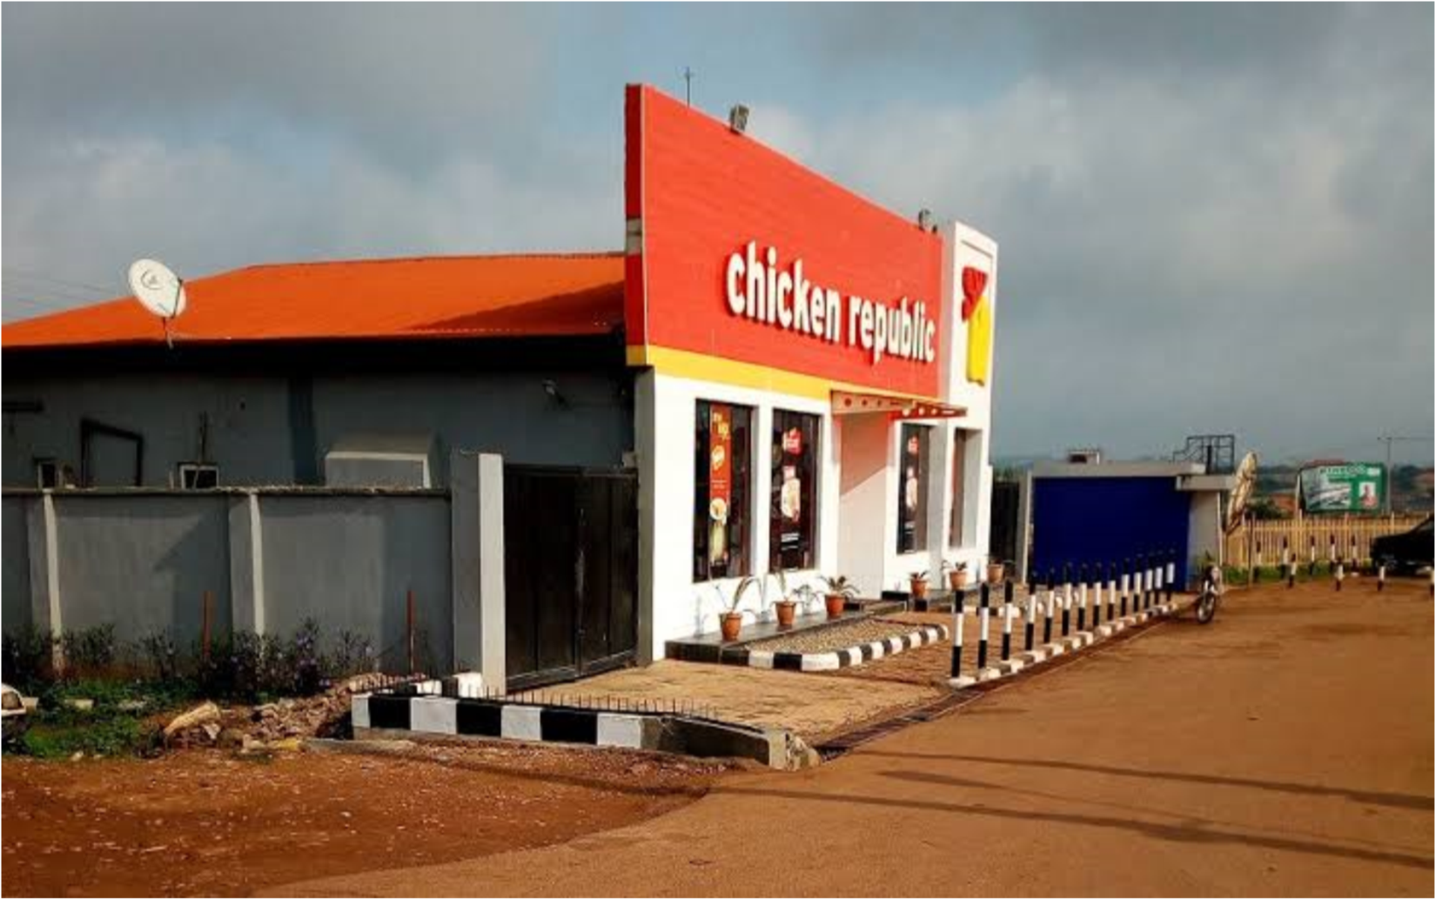
Plate 3.1.2: Showing the left view of case study one
3.2.1 CASE STUDY TWO
LOCATION: AT, CHICKEN REPUBLIC TAIWO ROAD ILORIN, KWARA
STATE.

MERIT
Structural balance and design
It's well ventilated
Provision of hard soft and hard landscaping

DEMERIT
Limited seating space Insufficient dining area limited availability of parking space
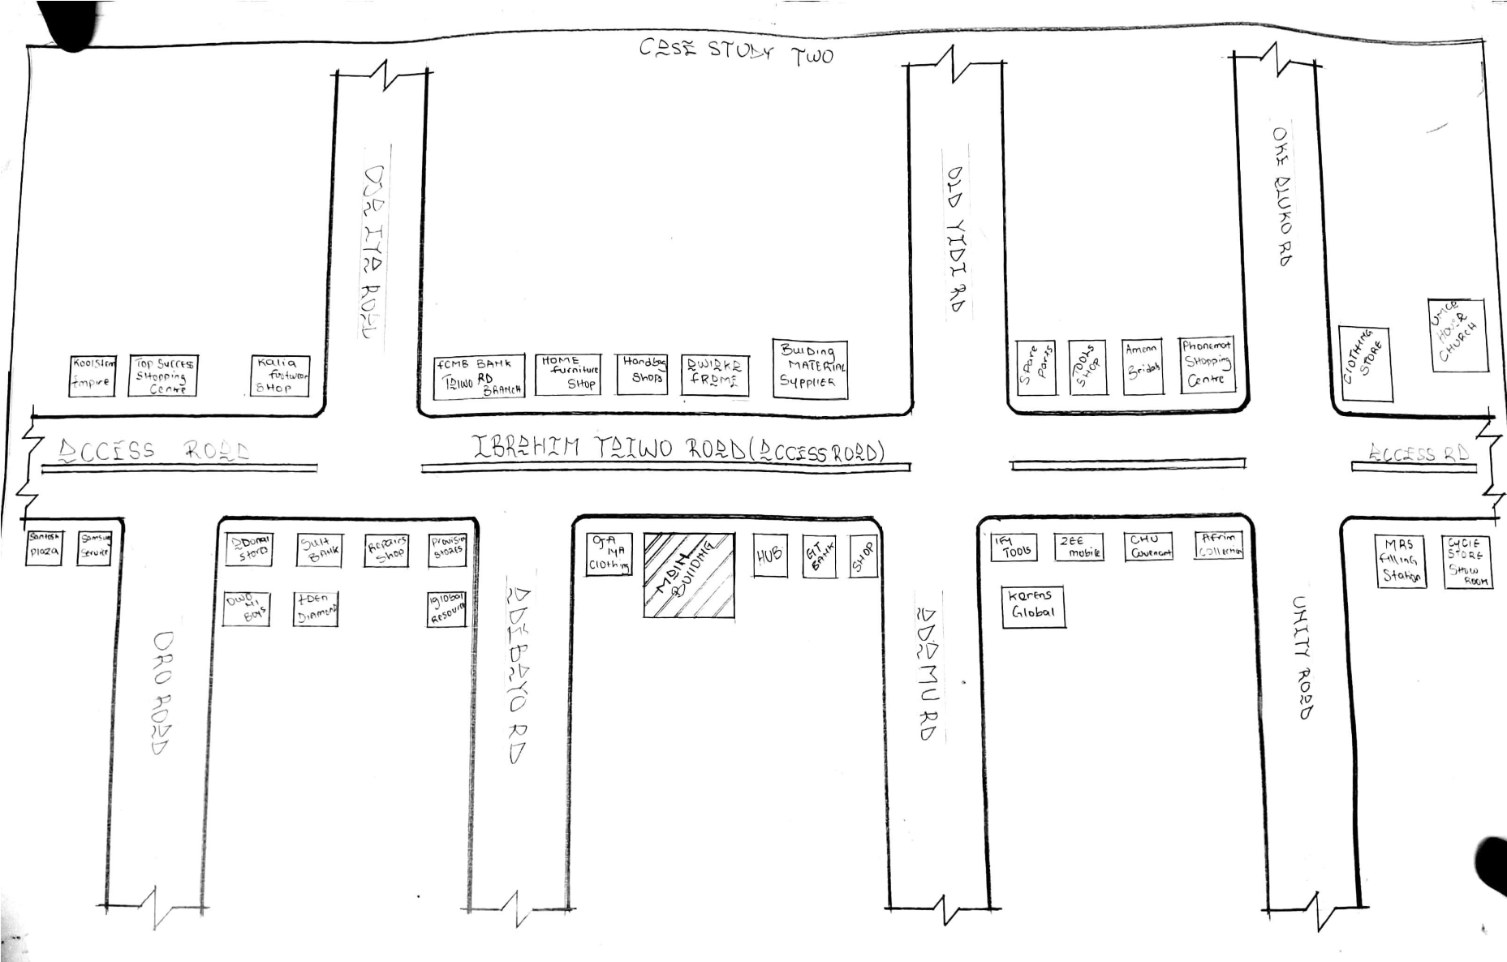

Figure 3.2.1: Picture Showing the Location Plan of case study two
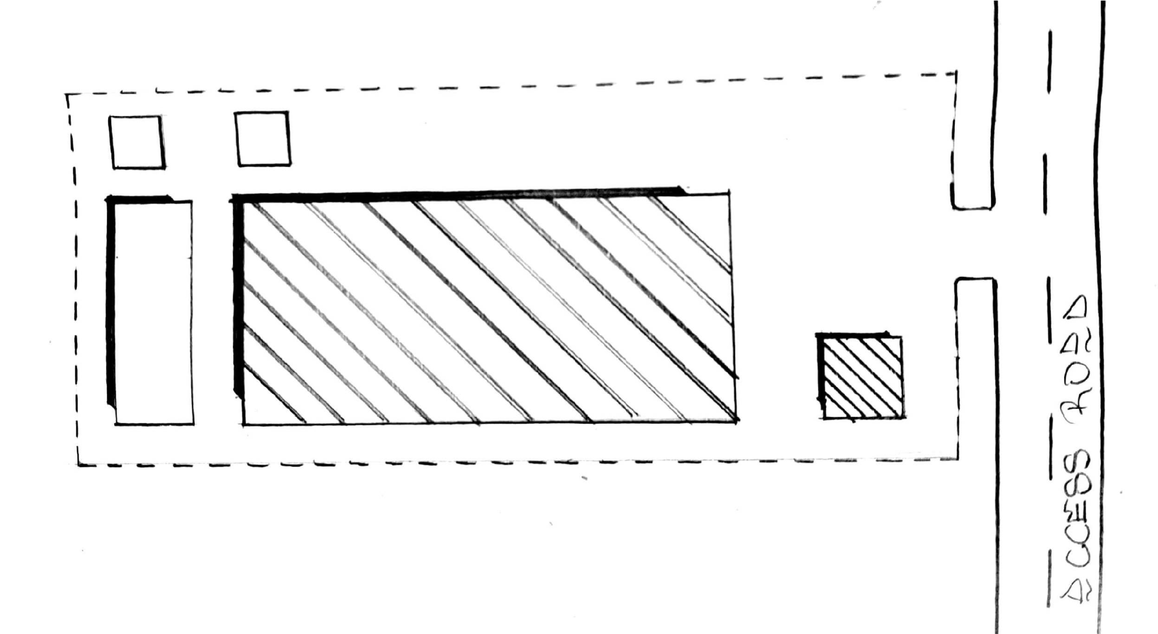

Figure 3.2.2: Showing the Site Plan of case study two
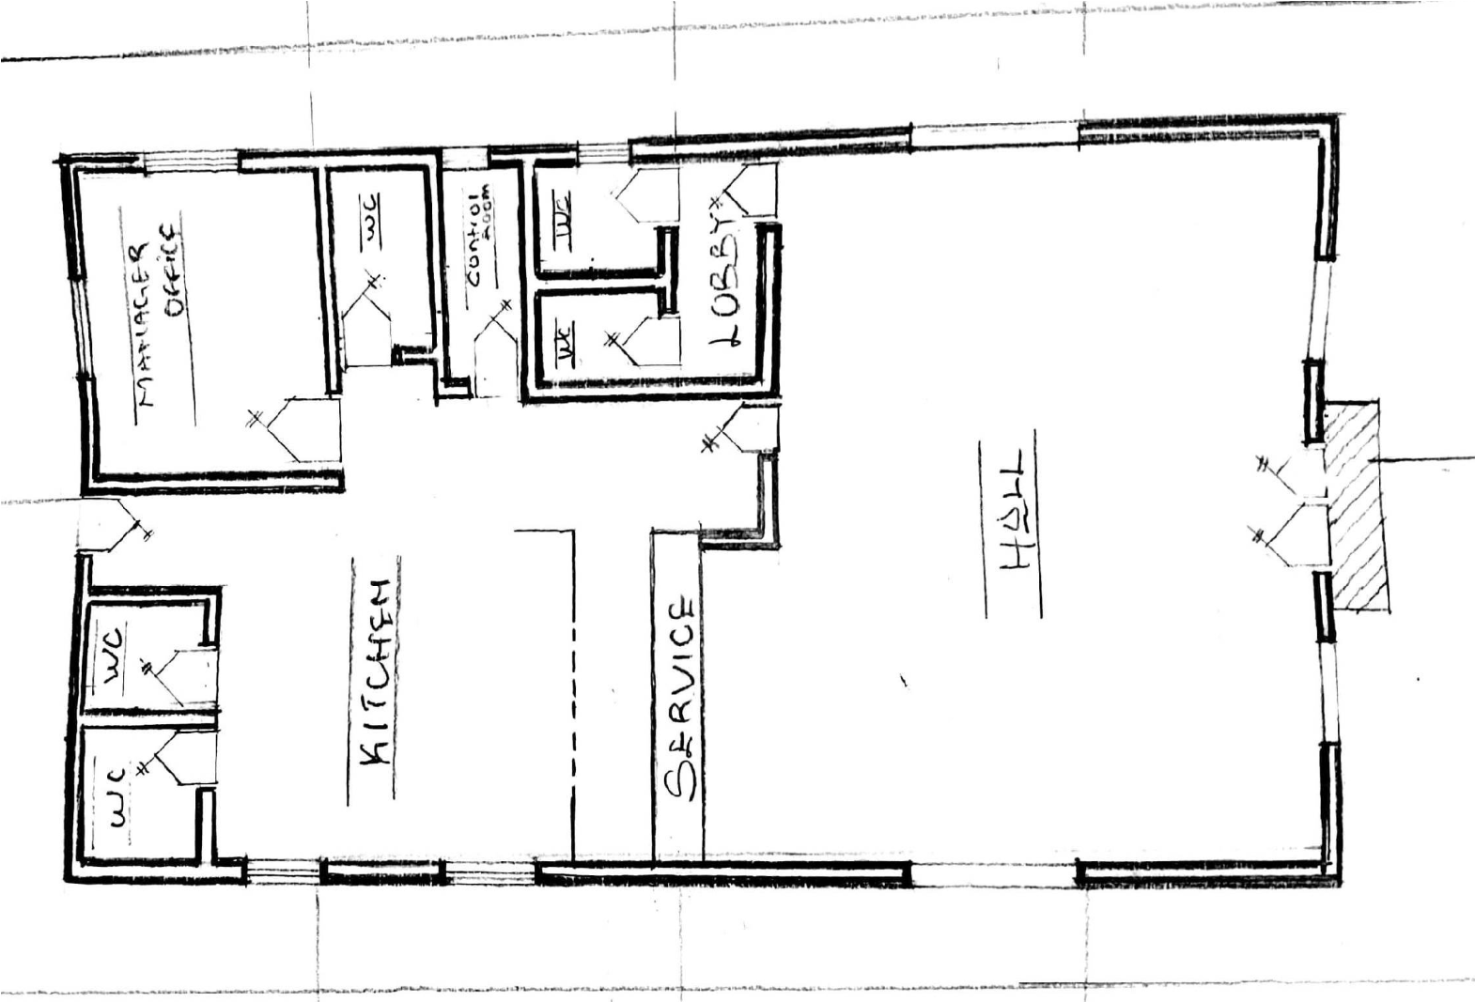

Figure 3.2.3: Showing the Floor Plan of case study two
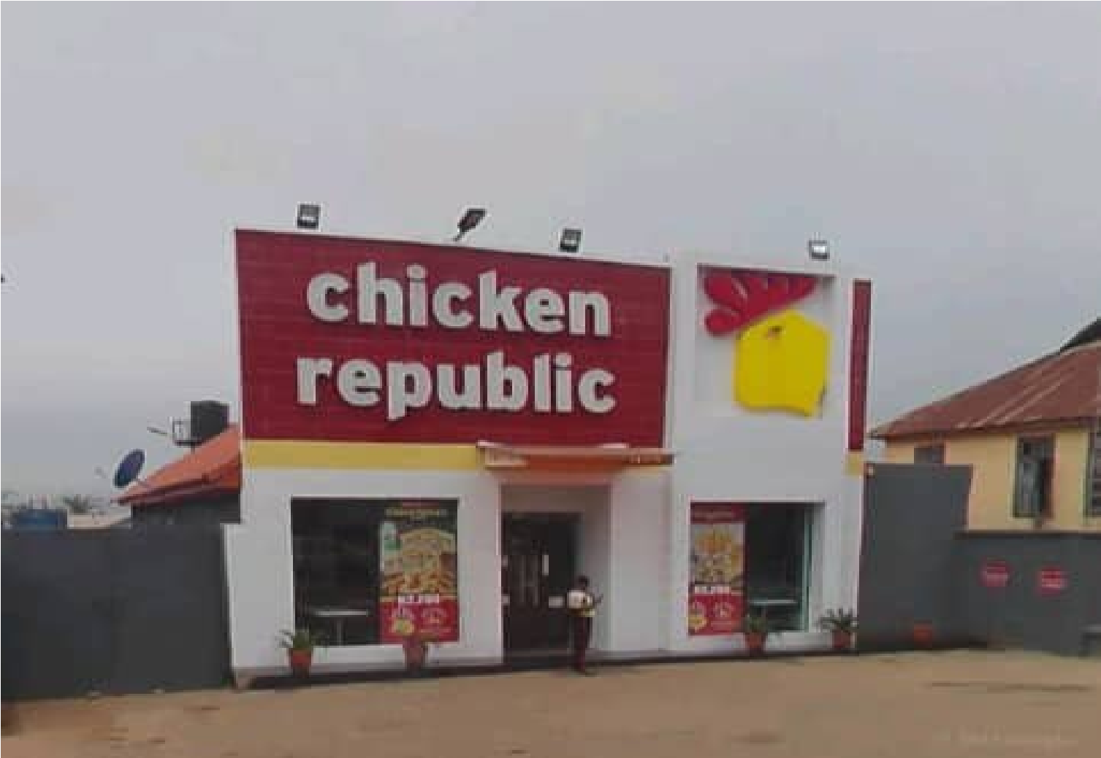

Plate 3.2.1: Showing the approach view of case study two
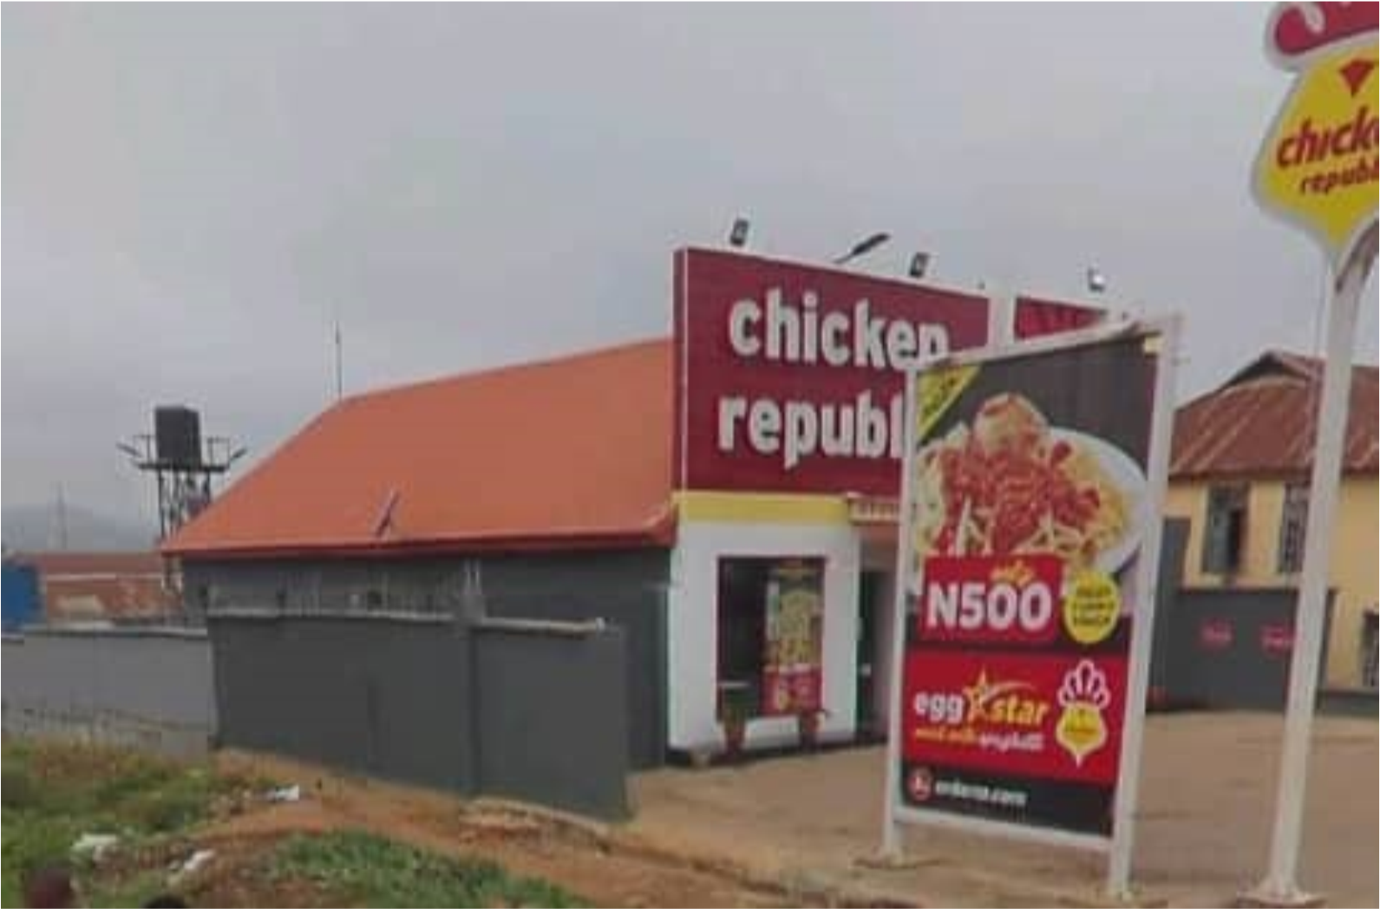

Plate 3.2.2: Showing the left view of case study two
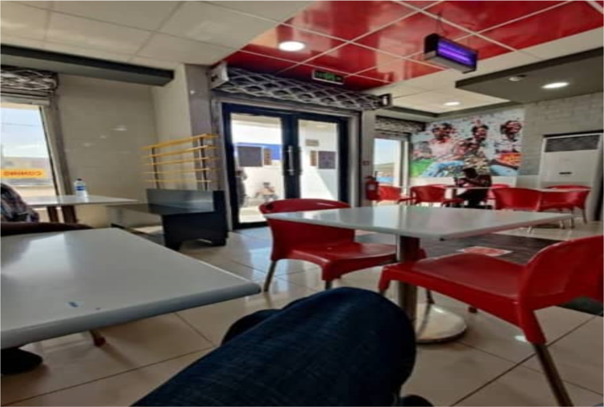
Plate 3.2.3: Showing the interior view of case study two
3.3 CASE STUDY THREE LOCATION: AT, CAPTAIN COOK OFFA, KWARA STATE

MERIT
Availability of artificial ventilation
Simplicity design
Easy to locate and accessible

DEMERIT
shortage of parking space
Inadequate natural ventilation
Insufficient seating capacity
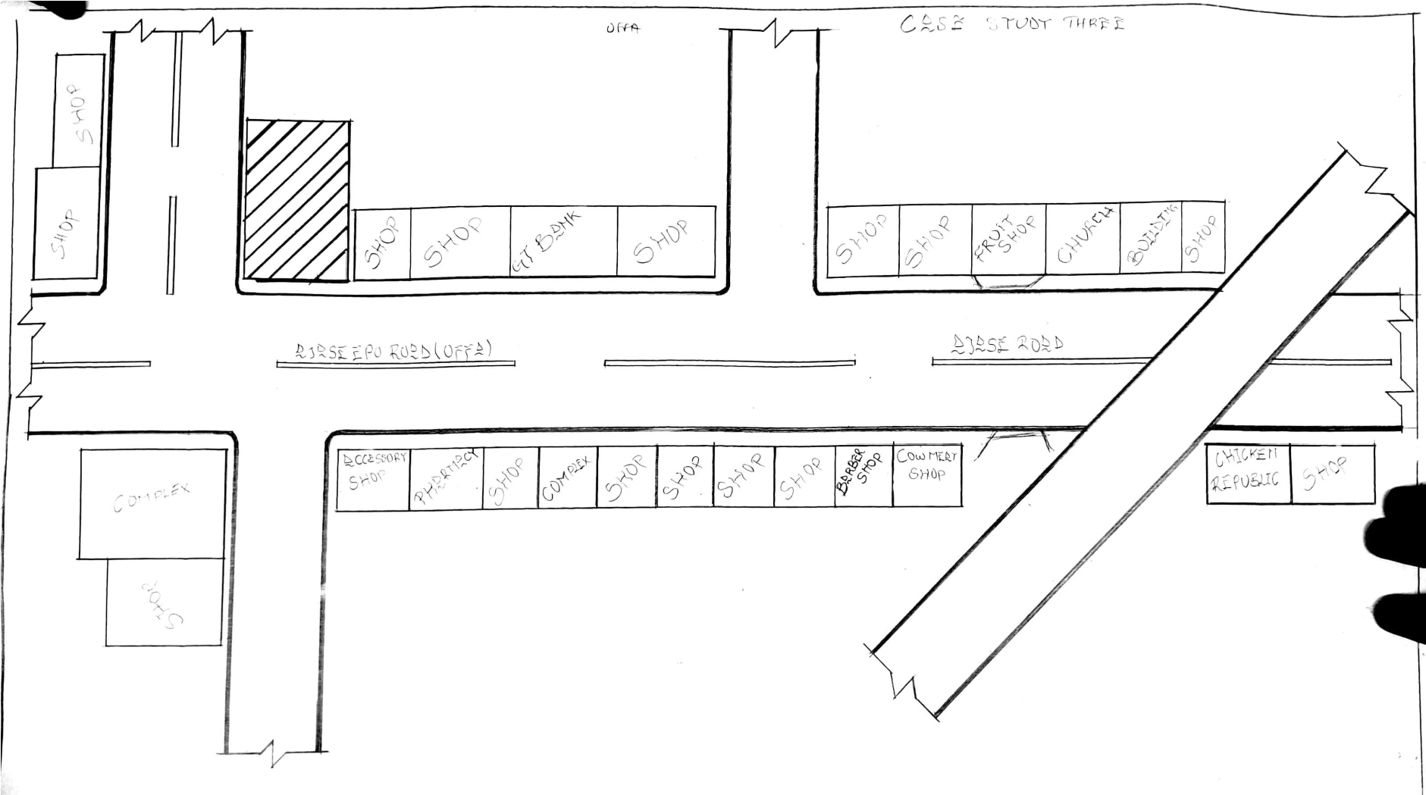
Figure 3.3.1: Showing the location plan of case study three
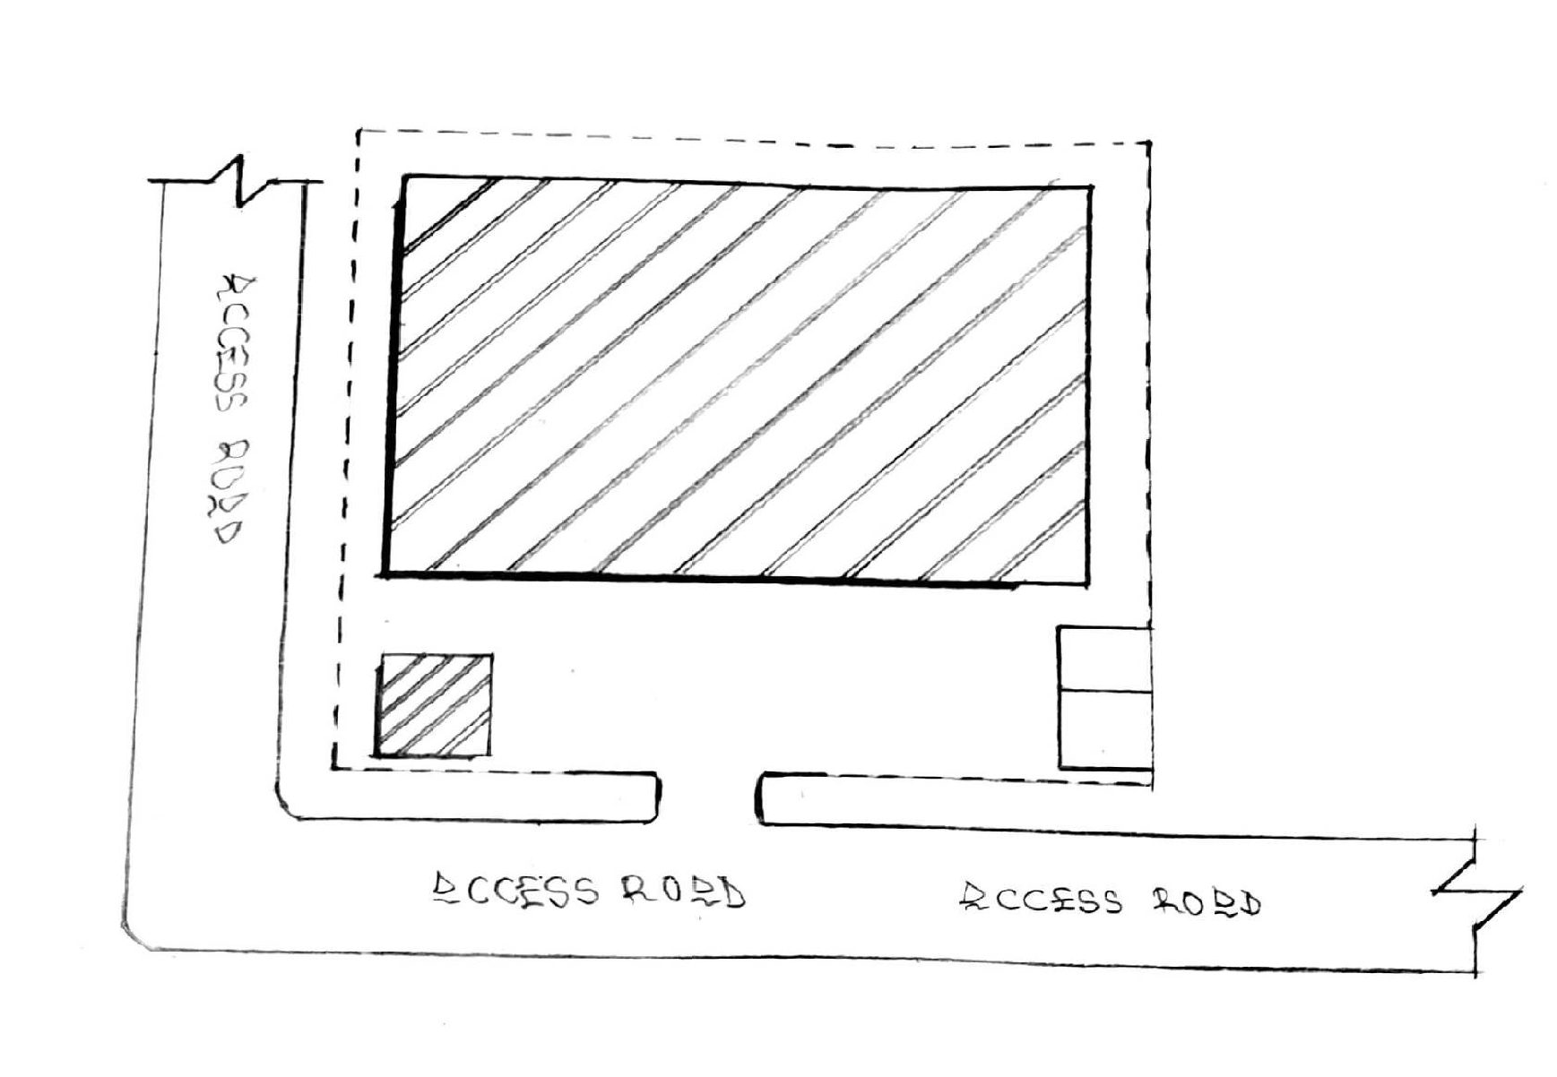

Figure 3.3.2: Showing the Site plan of case study three
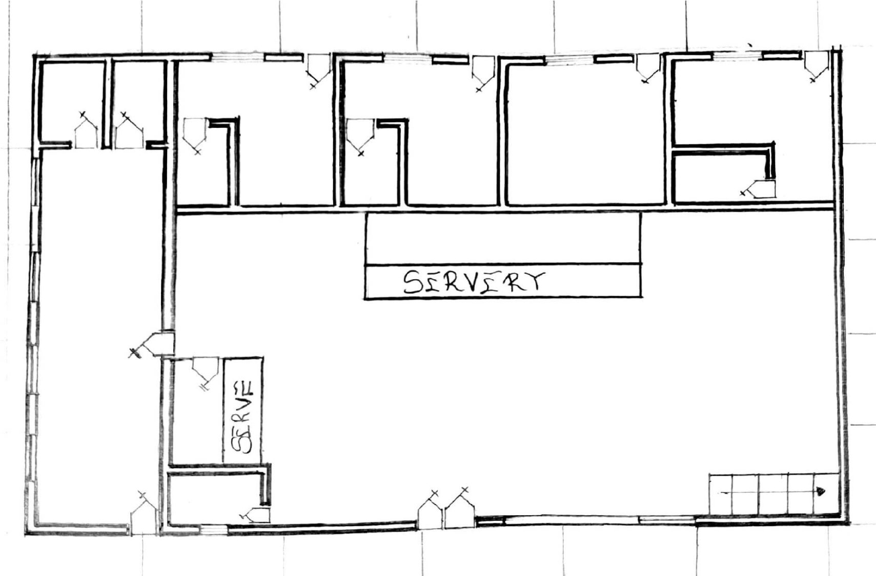

Figure 3.3.3: Showing the floor plan of case study three
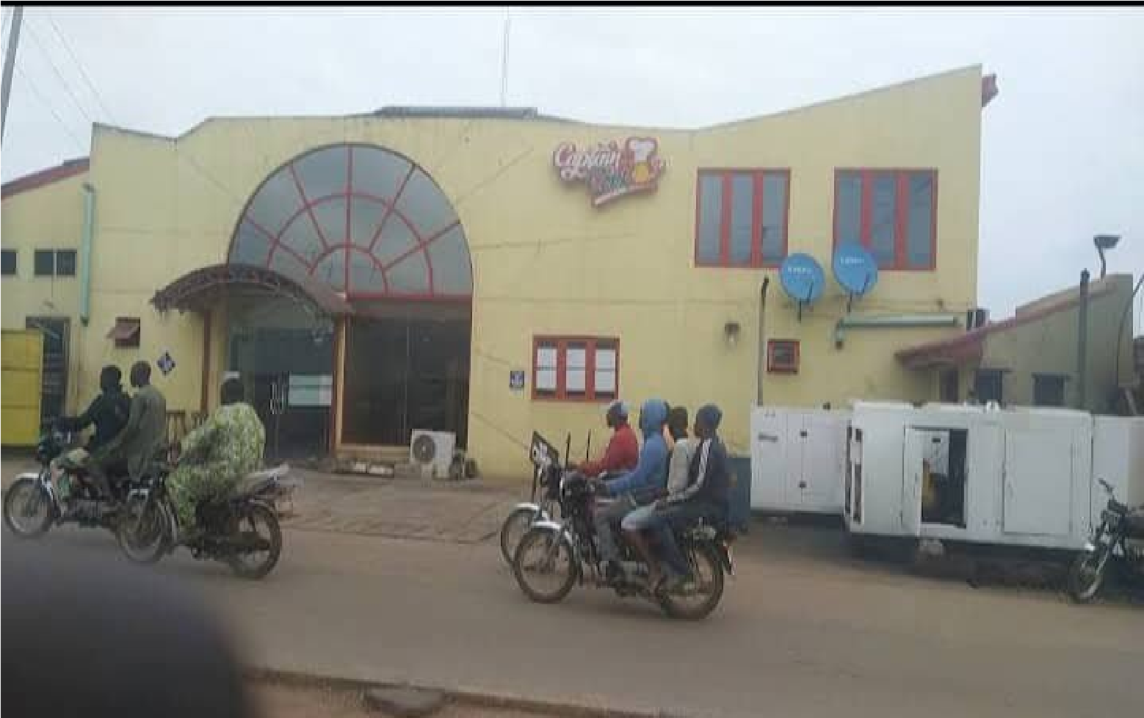

Plate 3.3.1: Showing the approach view of case study three
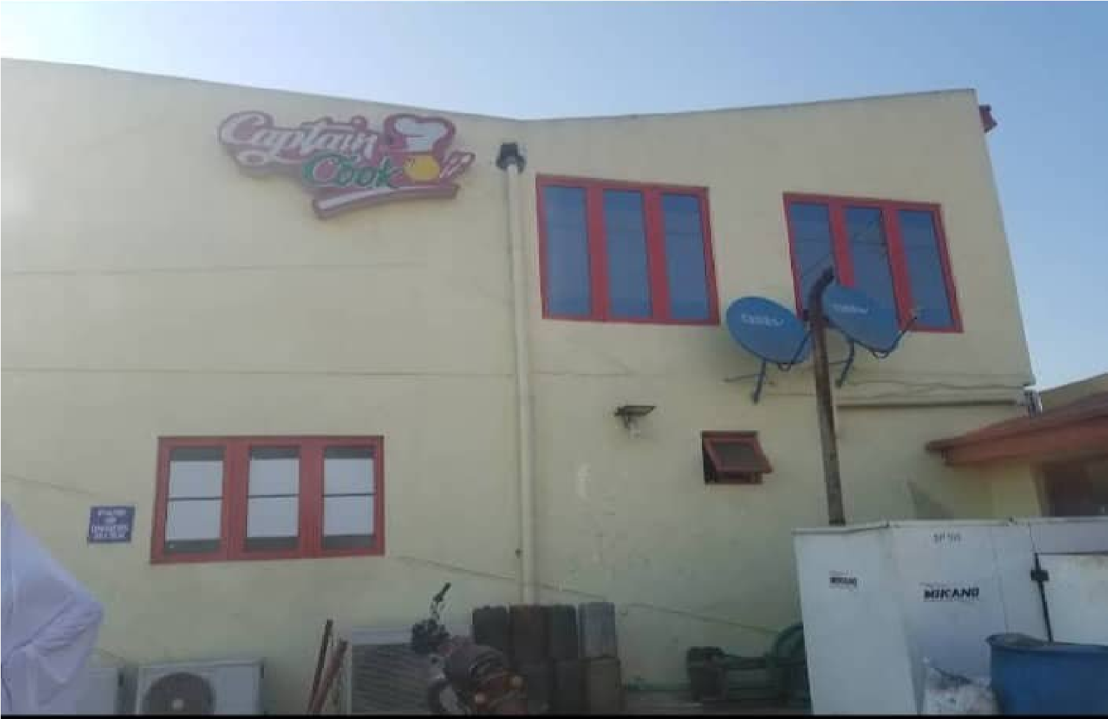

Plate 3.3.2: Showing the side view of case study three
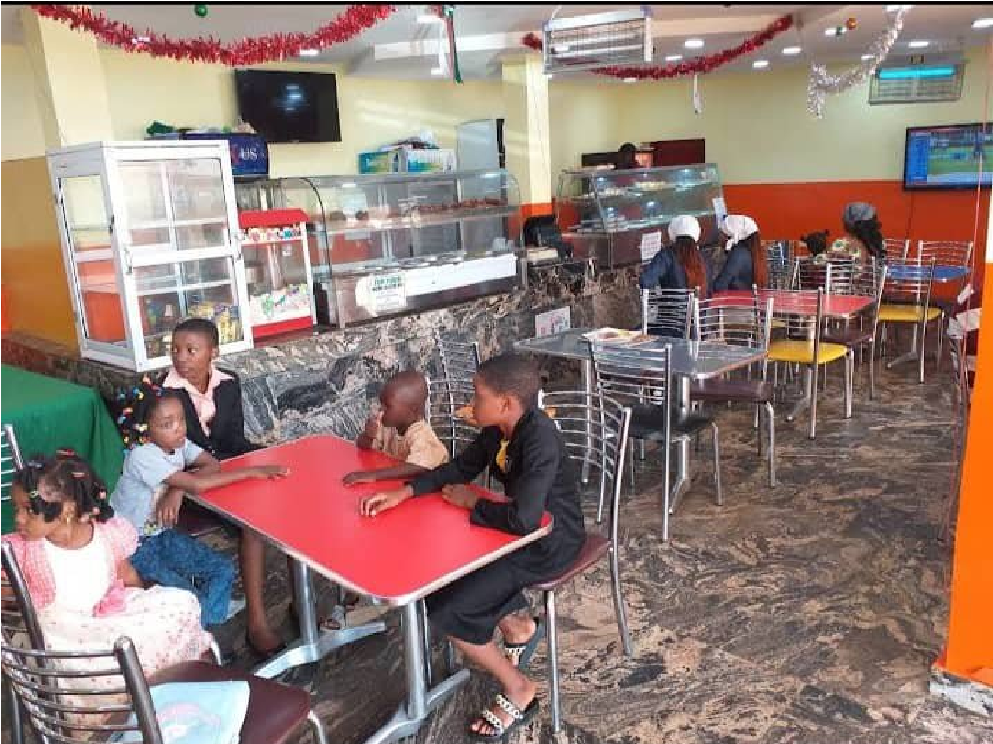
Plate 3.3.3: Showing the interior of case study three

3.4 CASE STUDY FOUR (ONLINE CASE STUDY) LOCATION; CHINESE RESTAURANCE
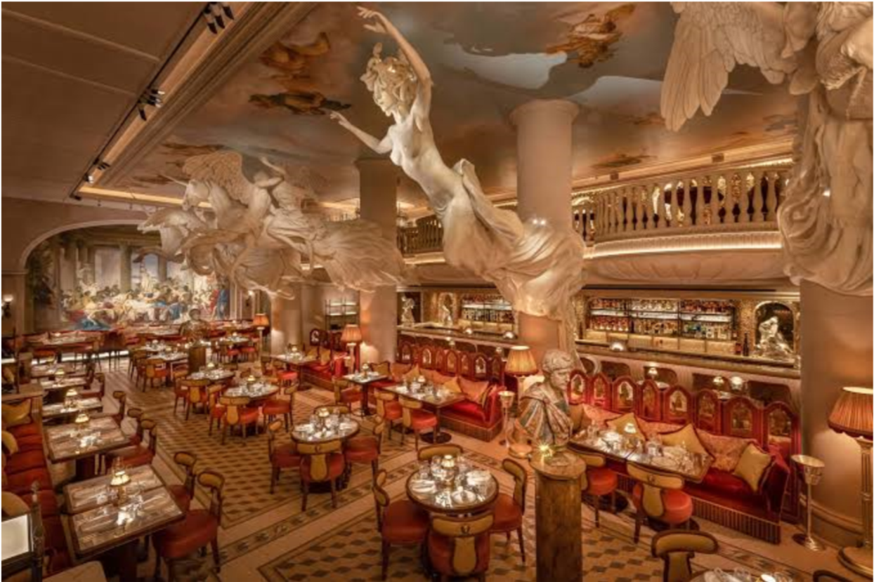
Plate 3.4.1: Showing the Internal view of case study

3.5 CASE STUDY FIVE (ONLINE CASE STUDY) LOCATION; SPAIN
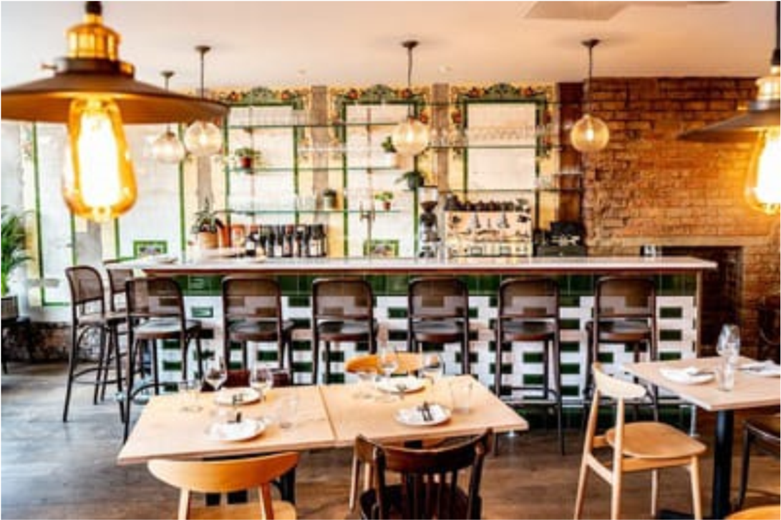
Plate 3.5.1: Showing the internal view of case study

3.5 FINDINGS AND DISCUSSIONS
From the research carried out I have found out that expansion area on the site should be provided and there should be provisions of social amenities to help the people achieve optimum comport as well as a suitable drainage system.

3.6 DEDUCTION FOR STUDY
From the case studies carried out, I observe that;
The restaurant were not properly designed and also the provision for the customer are not taking care of.
CHAPTER FOUR
4.0 ANALYSIS OF TOPOGRAPHICAL AND ENVIRONMENTAL

CONDITIONS OF THE SITE VEGETATION, TOPOGRAPHY VEGETATION
The site is covered with shrubs, thick grass and vegetable leaves and trees. All the vegetables and shrubs are to be removed. At the time of conducting of site investigated on the proposed project site, the site displays a relatively thick vegetation cover that is; there are grasses, shrubs as well as big trees. There are portions with simple vegetation cover due to human activities (Clearing and farming) that is taking place on the site.

TOPOGRAPHY
It has a gentle slope. It does not undulate. The topography of the proposed development site is relatively low that the top soil and the sub-soil is firm and buildable.
The site is therefore free from any natural or physical constraints and rock outcrops.

4.1INTRODUCTION OF STUDY AREA

4.1.1 HISTORY OF KWARA STATE
Kwara State was created on 27th May 1967, when the Federal Military Government of General Yakubu Gowon broke the four regions that then constituted the Federation of
Nigeria into 12 States. At its creation, the State was made up of the former Ilorin and Kabba Provinces of the Northern region and was initially named the West Central State but later changed to Kwara a local name for the River Niger
Kwara State has since 1976 reduce considerably in size as a result of further State creation exercises in Nigeria. On 13th February 1976, the Idah/Dekina part of the state was called out and merged with a part of the Benue/Plateau State to form Benue State. On 27th August 1991, five Local Government Area namely Oyi, Yagba, Okene, Okechi, and Kogi State were also exercised to form part of the new Kogi State, while a sixth, Borgu local Government area was merged with Niger state.
There are sixteen local government areas in the state they includes;
Asa ,Baruten,Edu, Ekiti, felodun, Ilorin East, Ilorin West, Ilorin South, Offa, Moro,
Kiama, Oke-Ero, Irepodun, Edu

HISTORY OF PROJECT TOWN (ILORIN)
The Ilorin of the 1930s and 1940s was a society that was struggling to preserve its cultural and evolve cultural commonality in its encounter with the British Colonial enterprise, which despite its comfort with the Emirate system, was posing new modern challenges. This culture of Ilorin which the peoples of the city had come to cherish, was itself a mesh of cultures: Yoruba, fulanis, Hausa, Nupe, Kemberi and others. The historical encounters between the Fulani Jihadists led by Alimi and the Yoruba worriers led by Afonja, had about a century earlier led the defeat of the latter.
However, what emerged in Ilorin was a traditional leadership system which meshed the Hausa-Fulani emirate system with Yoruba title holding.

ILORIN LOCATION
Ilorin is a city with a large population in Kwara state, Nigeria, which is located in the continent of African.
Cities, Towns and places near Ilorin include Yemoja, Akamo and Ogidi, the closest major cities include Oshogbo, Ede, Oyo and Ijebu-Ode.

ILORIN DATA
Latitude | 8.4965/829 29.9616
Longitude | 4.544642/432 40.7106
State/region | Kwara
Country | Nigeria
Continent | Africa
Population size | Large

4.2SITE LOCATION AND DESCRIPTION
The proposed site for RESTAURANCE is located at kwara state ilorin post office, Ilorin, Kwara State.

SITE LOCATION CRITERIA
The guiding rules which determine the choice of site depends on the following factors.
Topography and soil type on the soil
Accessibility of site to users
Nearness to users and surrounding environment Wind direction
All these factors listed above have been considered and found to be satisfactory which determine the choice of site.

CONSIDERATION FOR SITE SELECTION
- Therapeutic Possibilities: The site provide therapy in the form of social interaction and physical activities
- Accessibility: The site can be directly accessed and has no problem being located. It is located at Ilorin post Kwara State.
- Infrastructural Facilities: Infrastructural facilities such as electricity, water, drainage and good road network are all present advantages on site for utilization.
- Vegetation: The vegetation is characterized by trees and shrubs. The topography is relatively flat with gentle slope.
- Soil Textures: The soil is a sandy soil, the soil is a virgin in the sense that there is no existing building on it.
- Land Scape: Trees and shrubs are to be scattered over the site which are to be incorporated has landscaped features on site among other landscaped element.
4.3 SITE INVENTORY/SITE ANALYSIS

4.3.1 SITE INVENTORY
The presence features on the site are well analyzed and some measures are put in place to control and at the same time aid the design. It is the preliminary survey of the site.

4.3.2 SITE ANALYSIS
This is done on the basic purpose for which the site is to serve. Certain steps are considered to obtain vital information of the site. This information is then analyzed after site survey in details. For design purpose, the information includes soil condition, geology, topography, vegetation etc. it also involves carrying out a preliminaries survey of the site.
- soil condition: the type of soil on the site is loamy and hence aids good vegetation of flowers and grasses. Etc.
- Geology: this soil has a poor load bearing capacity and hence the type of foundation to be use is to be based on geo-physics result of the site soil nature.
- Vegetation: the site is covered with shrubs, palms, trees. Most of the shrubs should be retain in the site for landscaping.
- Topography: this is the layout of the site. The site is relatively flat at the east while the west part is a little sloppy towards the northern part. This will aids effective landscape planning.
The sunrise and sunset will be considered for building orientation and lightening. Also the northeast trade wind and the southwest trade wind will give due consideration for effective ventilation and solar radiation control for total comfort of occupant.
4.4 GEOGRAPHICAL / CLIMATE DATA OF ILORIN.
This city has a tropical climate. The summers here have good deal of rainfall, while the winters have very little. According to Koppen and Geiger, this climate is classified as AW. In Ilorin, the average annual temperature is 26.5⁰c. The rainfall here averages 1217mm.
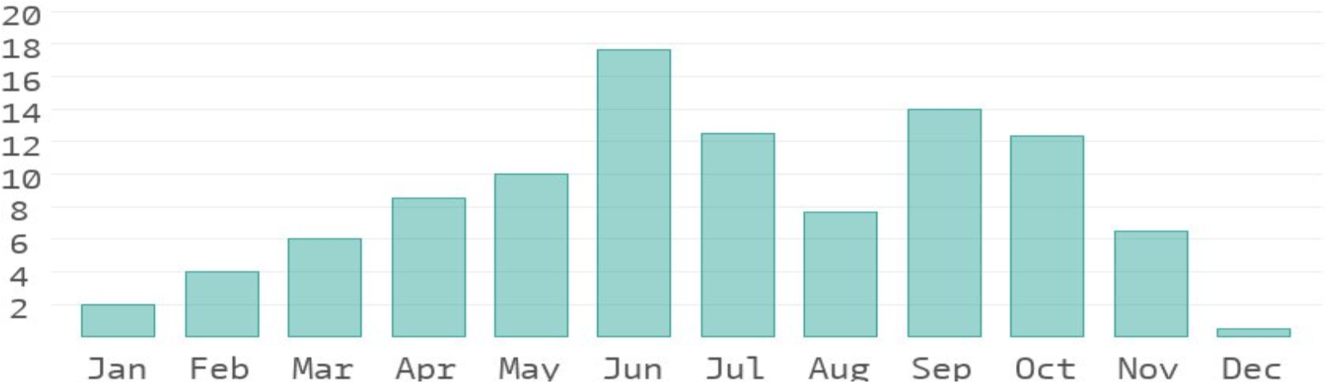

Table 4.5.1: Showing the Geographical and Climate Data of Ilorin
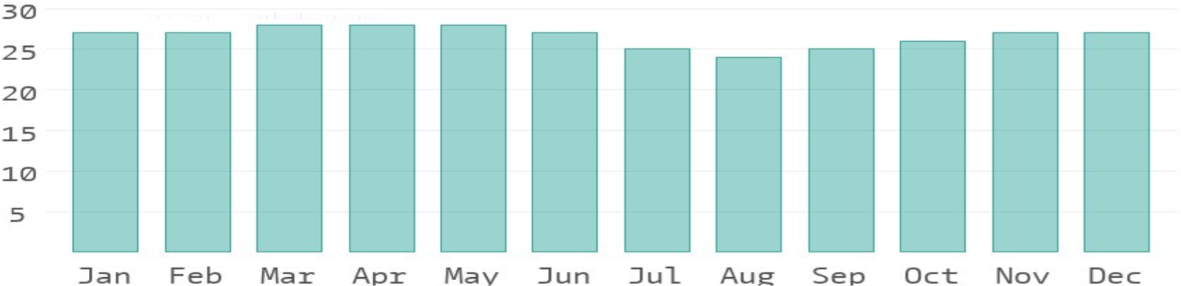

Table 4.5. 2: Showing the Average Temperature of Ilorin
The temperatures are highest on average in March, at around 29.0⁰c. August is the coldest month, with temperatures averaging 24.5⁰c.

4.5 DESIGN CRITERIA
There are three methods of designing of any project which are:
Function before form method
Form before function method
Combination of shapes
Designing projects, the function, before form methods used in line with this method, the following are the design criteria for this project:
Functional: In term of functional requirement the following design criteria must be considered.
Sustainability, Site and location, Flexibility, Circulation, Accessibility, Organization,
Maintenance, Environment and services

4.5.1 SITE PLANNING
The site is planned in order to give it a defined shape and also to reflect the activities taking place. The location of building and facilities within the site follows this main principle.
- The zoning principle (noisy, semi-noisy, quiet zone) is respected which enhance placement of each structure in respect to the level of egress and ingress.
- Structures are placed in accordance to usage.
- For easy accessibility to restaurants, parking space for cart cars are planned within and around each structure.

4.6DESIGN BRIEF
4.6.1 SCOPES AND BRIEFS

SCOPES
- Main restaurant
- Power house
- Mosque
- Security post
- pedestrians
- Parking space

BRIEFS
- Entrance
- Eating Area
- Chef Offices
- kitchen
- Cold store
- Dry store
- Changing room
- servery
- exit
- Rest room
4.7 SCHEDULE OF SPATIAL ALLOCATION ADMIN. BLOCK.
Units | Qty | Length(m) | Breath(m) | LxBxQty | Area (sqm)
Entrance | 1 | 5.0M | 4.2M | 5.0X4.2X1 | 21.0
Eating area | 1 | 6.6m | 5.2m | 6.6x5.2x1 | 34.32
Chef Offices | 4 | 7.2m | 4.2m | 7.2x4.2x4 | 30.24
Kitchen | 1 | 8.6m | 5.6m | 8.6x5.6x1 | 44.72
Cold store | 1 | 4.9m | 4.0m | 4.9x4.0x1 | 19.6
Dry store | 1 | 4.9m | 4.0m | 4.9x4.0x1 | 19.6
Server | 1 | 10.0m | 16.0m | 10.0x16.0 | 480.0
Exit | 1 | 10.0m | 9.7m | 10.0x9.7x1 | 97.0
Changing rooms | 2 | 2.8m | 16.0m | 2.8x16.0x2 | 44.0
Toilet ( rest room) | 7 | 1.2m | 2.1m | 1.2x2.1x7 | 176.4

Table 4.7.1: Showing the Space Allocation of the Admin Block

4.8 FUNCTIONAL RELATIONSHIPS
The functional relationship chart represents graphically the connections existing between the various spaces provided. It also emphasizes and educates on the strength and weakness of these connections. For instance, in this study it is important for the main Auditorium to have close proximity to the back stage and simultaneously to the changing room. Achieving these connections entails the functional relationships.

4.9 CONCEPTUAL DEVELOPMENT
The design concept of restaurant should reflect the identity and should articulate the attributes of restaurant activities, the natural landscape is an increasingly scarce and valuable resources and the proposed restaurant is helping to protect it.
The design is flexible and the elements used are bold massive and of flowing expression in order to attract new market in agricultural system.
A design solution based on reliability, stability, strength, safety and aesthetic is aimed at giving the restaurant an identity and expression.

CHAPTER FIVE 5.0 APPROACHES TO THE DESIGN
In approaching this design project, many factors, strategies and research works were taken into consideration. Some of the factors which include functionality, durability, cost of materials. The research work put into consideration are study of neighborhood Value, statistic, household value, patient and social lives of the workers and the patient in the center. The proposed restaurant design consists of battered design which consists of farm stead and huts which does not have the capacity to withstand heavy rainfall and high rate temperature. Hence the climatic data and neighborhood activities were vehemently considered. These factors and deductions were highly adhered to in this project to achieve a functional, aesthetically balanced, durable and proportional balanced design.

5.1 TECHNOLOGY AND ENVIRONMENTAL CRITERIAL CONSTRUCTION METHODOLOGY
The method of construction involved in the erecting the building structure is in accordance to the Architectural detail required in executing the buildings and process of construction that is critical to structural component as affected by the site conditions and type of materials to be used.
After the preparation of the site plan, many design details are developed to show the specific methods of construction. It is to serve two important purpose; firstly they stipulate the aesthetics and structural element of the plan and secondly they provide the basis for costing the project.
The section is not intended to present aesthetic or design solution alone but also indicate how similar technological difficulties are handled. In the method of construction, the factors are considered:
Climatic condition
Fire protection
Durability and easy maintenance
Easy accessibility
Economy/Aesthetics
Available of materials
Cost of material
Construction techniques
Condition of the sub-soil present on the sit
The various building component taken into consideration are:

5.1.1 CONSTRUCTION METHOD AND MATERIAL
Wooden domes have a hole drilled in the width of a strut. A stainless steel band locks the strut's hole to a steel pipe. With this method, the struts may be cut to the exact length needed. Triangles of exterior plywood are then nailed to the struts. The dome is wrapped from the bottom to the top with several stapled layers of tar paper, in order to shed water, and finished with shingles. This type of dome is often called a hub-and-strut dome because of the use of steel hubs to tie the struts together.
Panelized domes are constructed of separately framed timbers covered in plywood. The three members comprising the triangular frame are often cut at compound angles in order to provide for a flat fitting of the various triangles. Holes are drilled through the members at precise locations and steel bolts then connect the triangles to form the dome. These members are often 2x4's or 2x6's, which allow for more insulation to fit within the triangle. The panelized technique allows the builder to attach the plywood skin to the triangles while safely working on the ground or in a comfortable shop out of the weather.
This method does not require expensive steel hubs.

5.2 ESSENTIAL SERVICE REQUIRED
SERVICES AND CIRCULATION
The highest point of view part put into consideration in this project is strictly circulated. The design will encourage flexibility of space for free and easy circulation interpretation of space within and outside the building and the use of level change to accentuate the characters of individual spaces within the building.

VENTILATION
Ventilation is one of the most important components in a successful restaurant, especially in hot and humid tropical climate condition. If there is no proper ventilation, restaurants and their growing plants can become prone to problems. The main purposes of ventilation are to regulate the temperature, humidity and vapor pressure deficit to the optimal level, and to ensure movement of air and thus prevent build-up of plant pathogens (such as Botrytis cinerea) that prefer still air conditions. Ventilation also ensures a supply of fresh air for photosynthesis and plant respiration, and may enable important pollinators to access the restaurant crop.
Ventilation can be achieved via use of vents often controlled automatically via a computer - and recirculation fans.

iii. LIGHTNING
Adequate natural lightning with the use of openings is expected within the units of the building in the day and artificial lightning is needed in the building in other to provides light to some spaces where natural lightning are not provided. iv. PLUMBING
Complex of water supply is obtained from the main water supply system, all the restaurants are connected to the main water supply system.

v. ELETRICAL INSTALLATION
Electrical connection is from close services (IBDC) with three phases connections to avoid power failure in case the automatic generator has been provided with switches on. vi. ACOUSTICS
Acoustics design controls intrusive noise by the choice of materials, dimension and shape of building. High level of noise can cause damage to the ear and so careful selection of doors, windows seals and on mongering will play and effective role in providing acoustic for the building. Also suspended ceiling and parquet will be extensively used.
In the proposed design there will be provision for fire alarms and detectors. Also fire extinguisher such as hose reels, sprinklers and drenches are provided at strategic position for easy access.

vii. WASTE DISPOSAL
All waste water appliances should be easily drained into soak away and soil appliance should be drained separately.
Large refuse container is to be placed along one side of the building and be easily accessed by the collection vehicle to lift and dump out the refuse in the container.

viii. FIRE PROTECTION AND CONTROL
Modern building require not only means of escape, access for fire brigade and structure protection but also first aid equipment i.e hydrant plant, fire extinguisher to combat any fire outbreak before the intervention of fire brigade.
In the proposed design there will be provision for fire alarms and detectors. Also fires extinguish such as hose reels, sprinklers and drenches are provided at strategic position for easy access.

ix. EXTERNAL WORK
For external works, the following specifications are applicable:
The floor surface to be of interlocking materials and asphalt to allow effective drainage.
The drainage to be conveyed away through suitable sealed gully fitted with strong grating. It should be drained into existing gutter.
The enclosure to be secured against unauthorized entry.
Tarred and grasses surface should be separated with kerbs.

5.3 ENVIROMENTAL CONIDITIONS TO BE ACHIEVED
. The plantation of trees to regulate the temperature
. The orientation of the building structure to achieve maximum comfort thereby controlling solar radiation.

5.4 PERFORMANCE STANDARDS
The performance standard of the building construction is to be a highly luxurious because of the targeted users and the occupants of the town which have a high taste of social lives.

5.5 LEGAL ISSUES AND PLANNING REGULATIONS
The proposed building must pass through various processes in order to be approved of the planning regulations of the local government authorities and the board of chiefs because of it being a public building. The process for approval in the local planning authority is to provide the following
The c of o of the land
The original land purchase documents
The survey plan
The structural drawings
The architectural drawings
The mechanical and electrical drawings

5.6 BEHAVIORAL PATTERNS AND CONSIDERATIONS
The considerations is the designing the RESTAURANCE to bring comfort to the targeted users by providing adequate security, creating open spaces to be used for learning Arabic recitation of the Muslim residents and provision of recreational facilities.

5.6.1 GENERAL MAINTENANCE
Maintenance cannot be isolated from the initial planning and design of any architecturally edified most especially a project of this caliber which involves accommodation.
Timely maintenance of the structure and facilities to put them in proper condition to enhance balanced living and to avoid building deterioration. It is the work done to restore a building to an acceptable standard. The maintenance will be dully attended to with regular cleaning, repainting, and constant checking of access roads, planting of trees

5.7 SUMMARY
This proposed project is designed to produce an adequate, functional balanced structure with good orientation for the proposed restaurant structure.
The research methodology employed was a case studies carried in the following area.
1. restaurant at Ado ekiti, Chicken Republic Ilorin, kwara state, captain cook ilorin kwara State and the Online case studies.

5.8 CONCLUSIONS AND RECOMMENDATIONS

5.8.1 CONCLUSION
This study has shown that there is a high level of awareness and utilization of the restaurant services at post office Ilorin kwara state. The level of utilization was however very much higher among the people in the vicinity.
The level of utilization of the restaurant among the residents is not affected by their levels of service. The results also show that many respondents are not satisfied with the services obtained at the area due to the poorly-maintained facilities, inadequacies in restaurant equipment.

5.8.2 RECOMMENDATIONS
From the findings of this study, the following recommendations were made:
- Policy makers' and all stakeholders' attention ought to be drawn to improving the statusand performance of the restaurant of the location at ilorin post office by properly maintaining these facilities and providing basic utilities such as water supply and electricity.
- The image of restaurant should be improved by educating members of the area on thepurpose for establishing restaurant within the location as the first point of call in providing skill growth.
- Adequate prevention and regulation should be made available at the restaurant.
- Incentives should be made available for restaurant personnel to encourage them towork in urban areas.
- Adequate facilities and equipment should be made available at the restaurant in tomake the jobs of the workers easier and more effective.
The experience gained and deduction gathered from the research has exposed my knowledge to civic designs. These research were used to develop the design of the proposed of restaurant
Conclusively, this particular project enable me to know what is adequate needed and requirement for restaurants design with reference to architectural design protocols, it also fulfill my ambition to contribute and encourage my quota to the enhancement of architectural technology study in Kwara state Ilorin.

REFERENCE/BIBLIOGRAPHY
Afzali, S (2021) Development and implementation of optimal supplemental lighting control strategies in restaurants (Doctoral dissertation, University of Georgia).Google Scholar
Afzali, S, Mosharafian, S, van Iersel, MW and Mohammadpour Velni, J (2021a) Development and implementation of an IoT-Enabled optimal and predictive lighting control strategy in restaurants. Plants 10(12), 2652.CrossRefGoogle ScholarPubMed
Ahamed, MS, Guo, H and Tanino, K (2020) Modeling heating demands in a Chinesestyle solar restaurant using the transient building energy simulation model TRNSYS. Journal of Building Engineering 29, 101114.CrossRefGoogle Scholar
Aissa, M and Boutelhig, A (2021) CFD comparative study between different forms of solar restaurants and orientation effect. Journal Homepage 39(2), 433 440.
http://iieta.org/journals/ijht Google Scholar
Al-Helal, I, Picuno, P, Alsadon, AA, Ibrahim, A, Shady, M and Abdel-Ghany, AM (2022) Effect of shape, orientation and aging of a plastic restaurant cover on the degradation rate of the optical properties in arid climates. Applied Sciences 12(5), 2709.CrossRefGoogle Scholar
Alharbi, A, Campen, J, Sharaf, M, de Zwart, F, Voogt, W, Scheffers, K, Tsafaras, I, Abdelaziz, ME, Babiker, O, Gruda, N and Qaryouti, M (2021) Effect of clear and defuse glass covering materials on fruit yield and energy efficiency of restaurant cucumber grown in hot climate. Acta Scientiarum Polonorum, Hortorum Cultus 20(3), 37 44.CrossRefGoogle Scholar
Aroca-Delgado, R, Pérez-Alonso, J, Callejón-Ferre, ÁJ and Díaz-Pérez, M (2019) Morphology, yield and quality of restaurant tomato cultivation with flexible photovoltaic rooftop panels (Almería-Spain). Scientia Horticulturae 257, 108768.CrossRefGoogle Scholar
Azaizia, Z, Koolz, S, Hamdi, I, Elkhal, W and Guizani, AA (2020) Experimental study of a new mixed mode solar restaurant drying system with and without thermal energy storage for pepper. Renewable Energy 145, 1972 1984.CrossRefGoogle Scholar
Bazgaou, A, Fatnassi, H, Bouharroud, R, Elame, F, Ezzaeri, K, Gourdo, L, Wifaya, A, Demrati, H, Tiskatine, R, Bekkaoui, A and Aharoune, A (2020) Performance assessment of combining rock-bed thermal energy storage and water filled passive solar sleeves for heating Canarian restaurant. Solar Energy 198, 8 24.CrossRefGoogle Scholar
Benavides, PT, Lee, U and Zare-Mehrjerdi, O (2020) Life cycle restaurant gas emissions and energy use of polylactic acid, bio-derived polyethylene, and fossil-derived polyethylene. Journal of Cleaner Production 277, 124010.CrossRefGoogle Scholar Briga-Sá, A, Paiva, A, Lanzinha, JC, Boaventura-Cunha, J and Fernandes, L (2021) Influence of air vents management on trombe wall temperature fluctuations: an experimental analysis under real climate conditions. Energies 14(16), 5043.CrossRefGoogle Scholar
Evans, D, Parkes, D, Dooner, M, Williamson, P, Williams, J, Busby, J, He, W, Wang, J and Garvey, S (2021) Salt cavern exergy storage capacity potential of UK massively bedded halites, using Compressed Air Energy Storage (CAES). Applied Sciences 11(11),
4728.CrossRefGoogle Scholar
Fernández, EF, Villar-Fernández, A, Montes-Romero, J, Ruiz-Torres, L, Rodrigo, PM, Manzaneda, AJ and Almonacid, F (2022) Global energy assessment of the potential of photovoltaics for restaurant farming. Applied Energy 309, 118474.CrossRefGoogle Scholar
Anita Lawrence(1989)acoustics and built environment Elsevier publisher ltd.
De-chira (1983) architecture site planning, Macmillan press ltd.
Frezer rekeir (1979) draughtmanship architectural building graphics. Granada publisher
George k. steman (1996) architectural drafting function planning and creative design, Granada publisher.
Microsoft Encarta 2008. 1993-2997 microsoft corporations.
Neufert E. (1980) architectural data. (third national English edition).
Granada.
Peter A. (1999) metric handbook planning and design data new edition, architectural press. United kingdom.
Smith N.A (2002) lighting for health and safety . A division of reed educational and professional publishing ltd.

