A TECHNICAL PROJECT REPORT
ON
A PROPOSED DENTAL CLINIC
FOR
ILORIN SOUTH LOCAL GOVERNMENT [FUFU]
KWARA STATE
BY
ONOVO CHIKWUDI KINGSLEY
ND/23/ARC/PT/0014

SUBMITED TO:
DEPARTMENT OF ARCHITECTURAL TECNOLOGY,
INSTITUTE OF ENVIRONMENTAL STUDIES,
KWARA STATE POLYTECHNIC ILORIN.

IN PARTIAL FULFILMENTS OF THE REQUIREMENTS,
FOR AWARD OF NATIONAL DIPLOMA
(ND) IN ARCHITECTURAL TECHNOLOGY

SUPERVISOR: ARC. OLAREWAJU. F. A

JULY, 2025

DECLARATION
I ONOVO CHIKWUDI KINGSLEY of matric number ND/23/ARC/PT/0014 I hearby declare that this project research DENTAL CLINIC is my own unaided technical report works. It has not been presented for the award of any ND in any Polytechnic.The ideas, observations, comments, suggestions of this report represent my own convictions, except quotations, which have been acknowledged in accordance with conventional academic traditions

ONOVO CHIKWUDI KINGSLEY ………………………….
ND/23/ARC/PT/0014 SIGNATURE

CERTIFICATION
I certify that this Research Project/Dissertation entitle VOCATIONAL CENTRE” as carried out by ONOVO CHIKWUDI KINGSLEY, under my supervision and has been approved as meeting the requirements for the award of ND in Architectural Technology, Kwara State Polytechnic, Ilorin Kwara State.

ARC. OLAREWAJU F.A
(Project Supervisor SIGNATURE/DATR

ARC. OLAREWAJU F.A
(Project coordinator ) SIGNATURE/DATE


ARC. J.M TOMORI.
(Head of Department) SIGNATURE/DATE

EXTERNAL SUPERVISOR SIGNATURE/DATE

ACKNOWLEDGEMENT

I utmost gratitude goes to almighty God for his grace, guidance protection and infinite mercy that gave me courage, wisdom and endurance needed to start and finish the research in spite of all difficulties. I cannot but appreciate the effort to my supervisor in person of ARC.OLAREWAJU F.A for her support and assistant. I also grateful to my head of department (H O D) ARC. J. M , and my course mate for their readiness to help, to all my guidance and suggestions. Finally, my gratitude and adoration goes to almighty GOD for his protection, enduring mercy over me throughout the period of my study. I also wish to express our profound gratitude to my parents (Mr and Mrs ONOVO ), for their love, care, assistance, financial moral support and most importantly for always been there for us, and to my love ones.
In appreciation to my HOD ARC J.M Tomori and Director IES ARC BYF Abdulazeez, I appreciate your support for our HND studies. Your guidance and resources have been invaluable. Thank you for creating an enabling environment for us to thrive. Your leadership and vision inspire us to excel. We're grateful for your mentorship and backing."

DEDICATION
This research is dedicated to almighty GOD whose guidance and protection has been more than enough for me since the beginning of this research to the end. I also to my parents MR AND MRS ONOVO for been there for me at all time.

TABLE OF CONTENTS
TITTLE PAGE………………………………………………………………………... i
DECLARATION……………………………………………………………………...ii
CERTIFICATION………………………………………………………………….….iv
ACKNOWLEDGEMENT……………………………………………………………..v
TABLE OF CONTENT…………………………………………………………….... vi
LIST OF FIGURE………………………………………………………………….....vii
LIST OF PLATES……………………………………………………………………viii
LIST OF APPENDIX……………………………………………………………….... ix
ABSTRACT…………………………………………………………………………...x
CHAPTER ONE
1.0 INTRODUCTION…………………………………………………………………1
1.1 PROJECT DEFINITION……………………………………………………….….1
1.2 HISTORICAL BACK GROUND………………………………………………….2
1.3 JUSTIFICATION ………………………………………………………………….2
1.4 AIM…………………………………………………………………………………3
1.5 OBJECTIVES………………………………………………………………………3
1.6 CLIENT BACKGROUND, PHILOSOPHY………………………………………..3
1.7 SCOPE OF STUDY………………………………………………………………...3
1.8 LIMITATION OF DESIGN………………………………………………………..4
1.9 RESEARCH METHODOLOGY…………………………………………………..5
CHAPTER TWO
2.1 LITERATURE REVIEW…………………………………………………………...6
2.2 REVIEW OF ALL LITERATURE ON THE SUB-TOPIC………………………..8

CHAPTER THREE

3.1 CASE STUDY ONE…………………………………………………………………9
3.2 CASE STUDY TWO…………..…………………………………………………….12
3.3 CASE STUDY THREE………………………………………………………….….15
CHAPTER FOUR
4.1 INTRODUCTION OF STUDY AREA………………………………………….…18
4.2 SITE LOCATION/DESCRIPTION………………………………………………...19
4.3 SITE ANALYSIS/INVENTORY…………………………………………………...19
4.4 GEOGRAPHICAL/CLIMATIC CONDITIONS……………………………….…..20
4.5 DESIGN CRITERIA…………………………………………………………….….20
4.6 BRIEF ANALYSIS………………………………………………….……………....20
4.7 SPATIAL PROGRAMMING (REAQUIREMENT AND ANALYSIS)……..……21
4.8 CONCEPTUAL DEVELOPMENT…………………………………………...……21
4.9 SITE CONCEPT………………………………………………………………...….22
4.10 BUILDING CONCEPT……………………………………………………...……23

CHAPTER FIVE
5.1 PROJECT APPRAISAL…………………………………………………………..24
5.2 CONSTRUCTION METHODOLOGY AND MATERIALS……………………26
5.3 BUILDING SERVICE……………………………………………………………28
5.4 CONCLUSION AND RECOMMENDATION…………………………………...30
5.5 REFERENCES…………………………………………………………………….31

LIST OF FIGURES
FIGURE 2.1: LOCATIONAL PLAN CASE STUDY ONE………………….9
FIGURE 2.2: FLOOR PLAN OF CASE STUDY ONE ……………………..9
FIGURE2. 3: LOCATIONAL PLAN OF CASE STUDY TWO……...……..12
FIGURE2. 4: FLOOR PLAN OKELERIN CASE STUDY TWO …………..13
FIGURE2. 5: LOCATIONAL PLAN OF CASE STUDY THREE.…..……..15
FIGURE2. 6: FLOOR PLAN OF CASE STUDYTHREE… …………….....15
FIGURE3.1. GEOGRAPHICAL/ CLIMATIC DATA ……………………...18
FIGURE3.2. AVERAGE MONTHLY TEMPERATURE …………………..23

FIGURE3.3. AVERAGE MONTHLY RAINFALL IN ILORIN ……………24
FIGURE 4.1 BUILDING CONCEPT ………………………………………..27
LIST OF PLATE

PLATE 2.1 .FRONT VIEW OF CASE STUDY ONE…………………….….10

PLATE 2.2 .INTERNAL VIEWS OF CASE STUDY ONE …….……….…..10

PLATE 2.2 .INTERNAL VIEWS OF CASE STUDY TWO …….……….…..11

PLATE 2.3 .FRONT VIEW OF CASE STUDY TWO ……………………….13

PLATE 2.4 .PICTURES OF CASE STUDY THREE…….…………..…........16

PLATE 2.4 .PICTURES OF CASE STUDY THREE…….…….......................16

LIST OF APPENDIX

APPENDIX 5 .1; SHOWING LOCATIONAL MAP………..…………..……….32

APP ENDIX 5 .2; SHOWING LOCATIONAL PLAN………….……………......32

APPENDIX.5;3 SHOWINGINTERNAL PERSPECTIVE…………….………..33
APPENDIX 5. 4; SHOWING SITE ANALYSIS…………..…………….….…....33

APPENDIX 5. 5; SHOWING ROOF……...…………………………….….….….34

APPENDIX 5 .6; SHOWING FLOOR PLAN…….………………………….…...34

ABSTRACT
This study investigates the critical need for establishing a dental clinic in the ilorin south community, located in the Ilorin south Local Government Area of Kwara State, Nigeria. The community currently faces significant challenges in accessing dental care services, leading to a range of oral health issues that impact the overall well-being and quality of life of its residents. The proposed dental clinic aims to address these challenges by providing comprehensive dental care services, including preventive, diagnostic, and restorative treatments. The establishment of a dental clinic in ilorin south community would not only improve the oral health outcomes of the residents but also contribute to the overall development of the community. The clinic would provide a much-needed resource for the community, reducing the need for residents to travel long distances to access dental care services. This would lead to improved health outcomes, increased productivity, and enhanced economic development in the community. The study highlights the importance of accessible dental care services in promoting the health and well-being of communities, particularly in underserved areas. By establishing a dental clinic in ilorin south community, this study aims to contribute to the development of a healthier and more prosperous community. The findings of this study will have implications for policymakers, healthcare providers, and community leaders, informing strategies for improving access to dental care services in similar communities.

CHAPTER ONE
1.0 INTRODUCTION
A dental clinic is a healthcare facility that specializes in the diagnosis, treatment, and prevention of oral health issues, providing a wide range of services to patients of all ages. These clinics are equipped with modern technology and staffed by trained dental professionals, including dentists, hygienists, and assistants, who work together to deliver high-quality care. Dental clinics offer various services, including routine check-ups, cleanings, fillings, crowns, bridges, dentures, and extractions, as well as more specialized treatments like orthodontics, oral surgery, and dental implants. Many clinics also provide preventative care, such as fluoride treatments and oral cancer screenings, to help patients maintain good oral health. The primary goal of a dental clinic is to provide patients with comprehensive and compassionate care, addressing their unique needs and concerns. Dental professionals strive to create a welcoming and relaxing environment, ensuring that patients feel comfortable and informed throughout their treatment. Modern dental clinics prioritize patient safety and infection control, adhering to strict protocols and guidelines to prevent the spread of diseases. Many clinics also incorporate advanced technology, such as digital X-rays and intraoral cameras, to enhance diagnosis and treatment. By providing accessible and affordable care, dental clinics play a vital role in promoting oral health and overall well-being within communities. Regular visits to a dental clinic can help prevent dental problems, detect issues early, and ensure a lifetime of healthy smiles.
1.1 HISTORICAL BACKGROUND
The history of dental clinics is a rich and fascinating narrative that spans thousands of years, with ancient civilizations making significant contributions to the development of modern dentistry, including the use of chew sticks, beeswax for fillings, and early forms of toothbrushes, with the Egyptians, Chinese, and Etruscans all playing important roles in the evolution of dental care. As civilizations rose and fell, dentistry continued to evolve, with the ancient Greeks and Romans making notable contributions to the field, including the use of gold wire to secure teeth and the development of dental instruments, and in the Middle Ages, barber-surgeons performed tooth extractions and basic dental care, often with limited understanding of the underlying anatomy and techniques. The formalization of dentistry as a distinct profession began to take shape in the 18th century, with the publication of Pierre Fauchard's seminal work, "The Surgeon Dentist," which detailed dental anatomy, techniques, and instruments, and marked a significant turning point in the development of modern dentistry, and since then, dentistry has continued to advance at a rapid pace, with significant developments in technology, including high-speed dental drills, X-rays, fluoride treatments, digital impressions, and laser dentistry. Today, modern dental clinics prioritize infection control, incorporating features like negative pressure treatment rooms, HEPA filters, and UV light disinfection systems, and design considerations that minimize touchpoints, promote social distancing, and enhance patient comfort, all of which have become especially important in the post-pandemic era, and as dentistry continues to evolve, dental clinics will likely remain at the forefront of oral health care, providing essential services to patients of all ages and backgrounds. The history of dental clinics is a testament to human ingenuity and the ongoing quest for better health and well-being, and as we look to the future, it is clear that dental clinics will continue to play a vital role in shaping the oral health of communities around the world, and with ongoing advances in technology, materials, and techniques, dental clinics will remain a cornerstone of modern healthcare, providing essential services and promoting healthy smiles for generations to come.
1.2 DEFINITION.
A dental clinic is a healthcare facility that provides comprehensive oral care services to patients, including diagnosis, treatment, and prevention of dental problems. It is staffed by trained dental professionals, including dentists, hygienists, and assistants, who work together to deliver high-quality care. Dental clinics offer a wide range of services, from routine check-ups and cleanings to complex procedures like oral surgery and dental implants. The primary goal of a dental clinic is to promote oral health and overall well-being by providing personalized, compassionate, and evidence-based care to patients of all ages and backgrounds. Regular visits can help prevent dental issues.
1.3 JUSTIFICATION
The need for a medical and dental facility in Ilorin south community is justified by the significant gap in healthcare access and services. Residents currently face substantial barriers, including long travel distances and limited access to essential healthcare services, leading to poor health outcomes and increased morbidity rates. Establishing a facility would address these challenges, providing timely and quality care, improving health outcomes, and enhancing the overall well-being of the community. This investment would also contribute to reducing healthcare disparities and promoting health equity, ultimately benefiting the community's social and economic development. It's a vital necessity.
1.4 AIM AND OBJECTIVES
My aim for this project is to design a medical and dental facility for Ilorin south is to provide accessible and comprehensive healthcare services, addressing the significant lack of medical and dental care in the area.
1.5 OBJECTIVE
1 To design and Provide regular check-ups, treatments, and preventive care to reduce morbidity and mortality rates.
2 To Offering health education programs to empower the community with knowledge on healthy practices, disease prevention, and management
3 To design and Encouraging community participation in healthcare decision-making and promoting partnerships with local organizations to ensure sustainability.

1.6 CLIENTS BACKGROUNG, PHYLOSHOPHY
Ilorin South is a Local Government Area in Kwara State, Nigeria. Established in 1996, its administrative headquarters is in the town of Fufu. Ilorin South comprises several communities and is part of the larger Ilorin metropolis. The area has a population of 208,691 as of the 2006 census and covers an area of 174 km². Ilorin, the capital of Kwara State, has a rich history dating back to its establishment as a military outpost by the Alaafin of the old Oyo Empire. Over time, Ilorin became a significant part of the kingdom with influences from the Fulani and Yoruba cultures. The city's strategic location contributed to its growth and cultural diversity. Today, Ilorin South, like other parts of Kwara State, plays a role in the state's economic and social development.
1.7 SCOPE AND BRIFE OF PROJECT
* Gate house
*Proposed building
*Parking lot
*water storage
*Power house
1.8 LIMITATION
Limitations in research refer to the constraints or weaknesses that may impact the validity, reliability, or generalizability of the findings. These limitations can arise from various sources, including:
Types of Limitations
1. Methodological Limitations: Limitations related to the research design, sampling strategy, or data collection methods.
2. Sampling Limitations: Limitations related to the sample size, population, or sampling frame.
3. Data Limitations: Limitations related to the quality, accuracy, or completeness of the data.
Examples of Limitations
1. Small sample size: Limited statistical power and reduced generalizability.
2. Biased sampling: Non-representative sample, which may lead to inaccurate conclusions.
3. Limited access to data: Incomplete or inaccurate data, which may impact the validity of the findings.
Importance of Acknowledging Limitations
1. Transparency: Acknowledging limitations demonstrates transparency and honesty in research.
2. Contextualizing findings: Recognizing limitations helps to contextualize the findings and interpret them accurately.
3. Future research directions: Identifying limitations can inform future research directions and improve the quality of subsequent studies.
1.9 RESEARCH METHODOLOGY
Research methodology refers to the systematic and scientific approach used to conduct research, including the methods, techniques, and procedures employed to collect and analyze data. It provides a framework for investigating a research question or hypothesis and ensures the validity, reliability, and accuracy of the findings.

Types of Research Methodologies
1. Quantitative Research: Uses numerical data and statistical methods to investigate research questions or hypotheses.
2. Qualitative Research: Employs non-numerical data, such as text, images, or observations, to gain insights into research phenomena.
3. Mixed-Methods Research: Combines quantitative and qualitative approaches to provide a more comprehensive understanding of the research topic.
Research Methodology Steps
1. Literature Review: Conducting a thorough review of existing research on the topic to identify gaps and inform the research question.
2. Research Design: Selecting an appropriate research design, such as experimental, quasi-experimental, or descriptive, to investigate the research question.
3. Data Collection: Collecting data using various methods, such as surveys, interviews, observations, or experiments.
Importance of Research Methodology
1. Ensures Validity and Reliability: A well-designed research methodology ensures that the findings are valid, reliable, and generalizable.
2. Provides a Framework: Research methodology provides a systematic approach to conducting research, guiding the researcher through the entire process.
3. Enhances Credibility: A rigorous research methodology enhances the credibility of the research findings and contributes to the advancement of knowledge in the field.

CHAPTER TWO

2.1 LITERATURE REVIEW
A lecture review is a critical evaluation of a lecture or presentation, providing feedback on its content, delivery, and overall effectiveness. Here's a comprehensive review:
STRENGTHS
- Clear objectives: The lecture had well-defined objectives, providing a clear direction for the audience.
- Engaging content: The lecturer presented complex information in an engaging and accessible manner.
- Effective use of visual aids: The use of visual aids, such as slides or videos, enhanced the lecture and facilitated understanding.
AREAS FOR IMPROVEMENT
- Pace: The lecture could benefit from a more consistent pace, allowing the audience to absorb the information more effectively.
- Interaction: Incorporating more interactive elements, such as discussions or Q&A sessions, could increase audience engagement and participation.
- Real-world examples: Including more real-world examples or case studies could help illustrate key concepts and make the lecture more relatable.
SUGGESTIONS FOR FUTURE LECTURES
- Incorporate more multimedia elements: Utilizing multimedia elements, such as videos or podcasts, could enhance the lecture and cater to different learning styles.
- Encourage audience participation: Encouraging audience participation through discussions, polls, or Q&A sessions could increase engagement and foster a more interactive learning environment.
- Provide additional resources: Providing additional resources, such as readings or online materials, could support further learning and exploration of the topic.
Due to having a more knowledgeable and networked contemporary society, designers are being required to deal with building occupiers of different cultures and various professional backgrounds. As a result, the traditional design knowledge is no longer enough in solving complex client demands (Manzini, 2009). Therefore, the continued utilisation of design knowledge based on traditional processes will result in unsatisfied client demands as the complexity increases. This increase in complexity also affects facilities management (FM) operations which are directly linked to the facility type and purpose of use. but it is only the analysis of best practices in facilities management that can provide an innovative input to the supportive function of building design” (Bröchner, 2003, p. 23). The above statement illustrates the idea behind the need to enhance the supportive role of a building’s design through integrating FM requirements when designing. Qualitative non-financial factors on top of the conventional cost, profit, and output concerns (Pitt & Tucker, 2008) will have to be considered. In order to discuss facilities management and design integration, the two facility-related disciplines and their role should be introduced first, followed by a discussion on the nature of integration and content of FM input into design. In other words, this literature review starts with discussing facilities management, its components and relation to an organisation’s core business. Facility design is handled next, elaborating on the various design stages and revealing the correlation between facility users’ needs and design processes. Facilities management requirements, their identification and communication to designers are then presented to conclude the description of the research topic. Based on the literature review, a research problem is identified leading to the identification of a gap in the knowledge presented.

FACILITIES MANAGEMENT
Once an organization occupies any facility for the purpose of implementing its core business services and processes, facilities management is then required to support the core business and ensure continuity. Combining both resources and activities, effective facilities management is fundamental to the success of any organisation. FM contributes to the delivery of corporate strategic and operational needs, as well as provides an efficient and safe environment through carrying out the day-to-day operations. The role of FM is strategically important as it translates the requirements of senior decision makers into a day-to-day situation affecting people at work or where they live (BIFM, 2012).

2.1 REVIEW OF ALL LITERATURE ON THE SUB-TOPIC
A lecture review on the sub-topic of dental clinics would cover various aspects of dental care and clinic operations. Here's an overview:
KEY TOPICS COVERED
- Dental Clinic Operations: Understanding the fundamentals of running a dental clinic, including patient management, record-keeping, and infection control.
- Restorative Dentistry: Learning about materials and techniques used for direct and indirect restorations, such as composite resins, ceramics, and dental implants.
- Caries Management: Diagnosis, prevention, and treatment of dental caries, including the use of bioactive materials and minimally invasive techniques.
- Esthetic Dentistry: Principles and techniques for achieving aesthetically pleasing results in dentistry, including smile design, tooth whitening, and ceramic restorations.

LECTURE OBJECTIVES
- Understand Dental Clinic Operations: Familiarity with the day-to-day management of a dental clinic.
- Master Restorative Techniques: Proficiency in various restorative materials and techniques.
- Manage Dental Caries: Effective diagnosis, prevention, and treatment of dental caries.
- Apply Esthetic Principles: Knowledge of esthetic dentistry principles and techniques.
POTENTIAL LECTURE FORMAT
- Lectures: Didactic sessions covering key topics in dental clinics.
- Hands-on Sessions: Practical training in restorative techniques, caries management, and esthetic dentistry.
- Case Studies: Real-life case studies to illustrate key concepts and treatment approaches.
BENEFITS OF ATTENDING
- Enhanced Knowledge: Deeper understanding of dental clinic operations and restorative dentis

CHAPTER THREE

3.0 CASE STUDY
This can be defined as the gathering of information through various means o: was Case Study 2.2 This is a research or an exercise that is carried out on existing building which 1s Similar to the one researcher is writing on. The objective of a case study is to take a critical appraisal of existing related project with a view to identity the positive and negative aspect of such project. It is only with time that a project can be adjusted so that it can be successful. The information obtained from the appraisal will guide the designer of new and similar project, the project position aspect of it shall be incorporated in the View proposal while attempts will be made to solve the problem of negative aspect. lt is only through this that a design can better enhance the quality and efficiency of building in the society, tor a comprehensive analysis their case studies have been conducted.
3.1 CASE STUDY
CASE STUDY ONE
NAME: IRE AYO DENTAL CLINIC
LOCATION: ALEYELE AREAS, IBADAN OYO STATE
MERIT
1 It has a large and mass area of land
2. It is easily accessible through existing road
DEMERIT
1 The roof needs renovation
2. It has no toilets to use

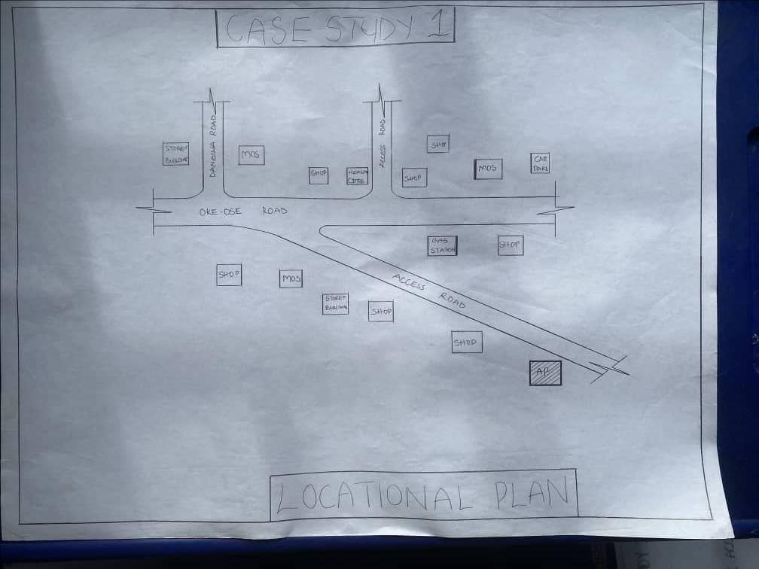

FIGURE3.1: LOCATIONAL PLAN OF CASE STUDY ONE

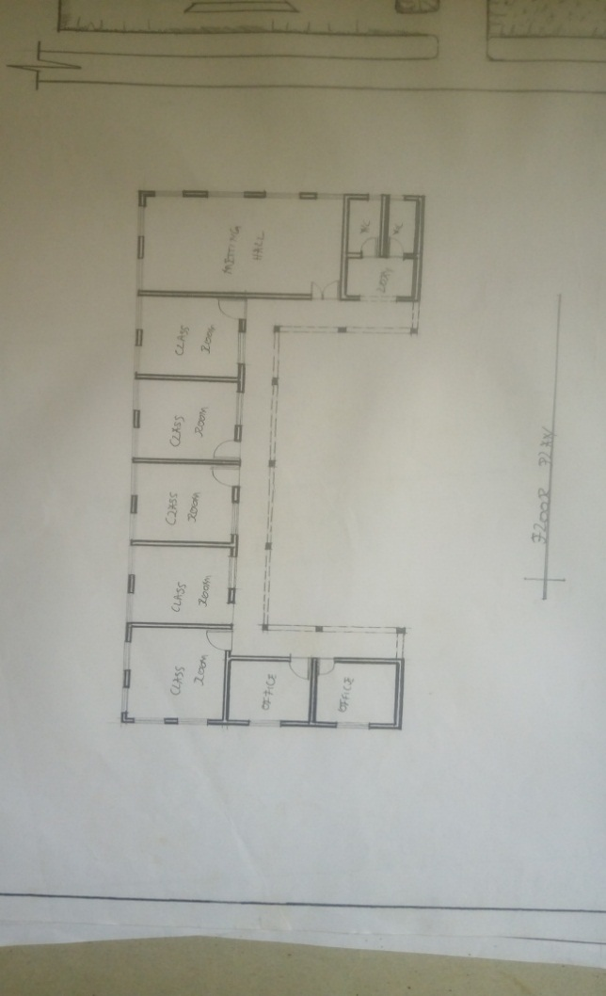
FIGURE3.2: FLOOR PLAN OF CASE STUDY ONE

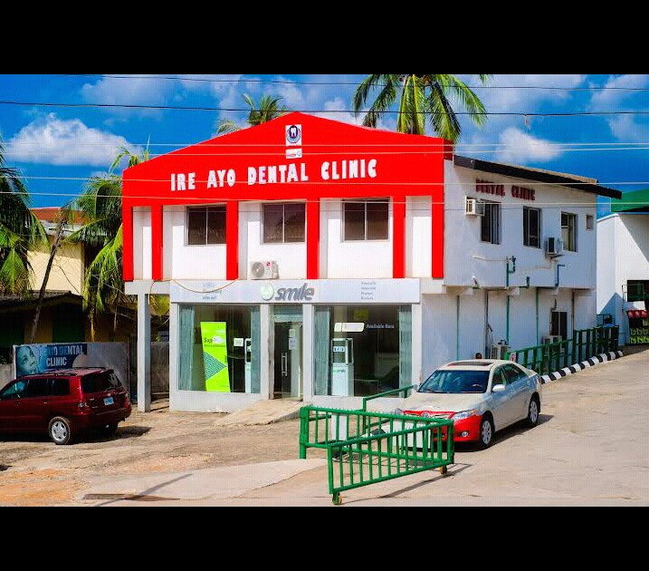

PLATE3.1: FRONT VIEW CASE STUDY ONE
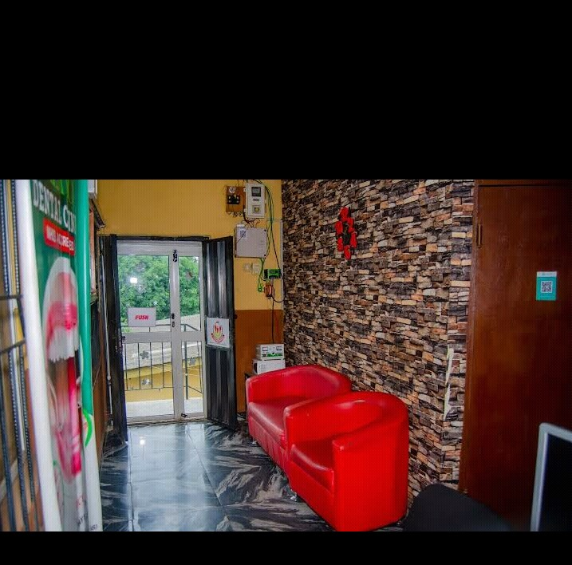

PLATE3.2: INTERNAL VIEW CASE STUDY ONE
CASE STUDY TWO
NAME: KOMO DENTAL CLINIC
LOCATION: OGBOMOSHO, OYO STATE.
MERIT
1 It is well ventilated
2 The approach is well aesthetic
DEMERIT
1 It has no landscape
It has no playing ground/ field for students

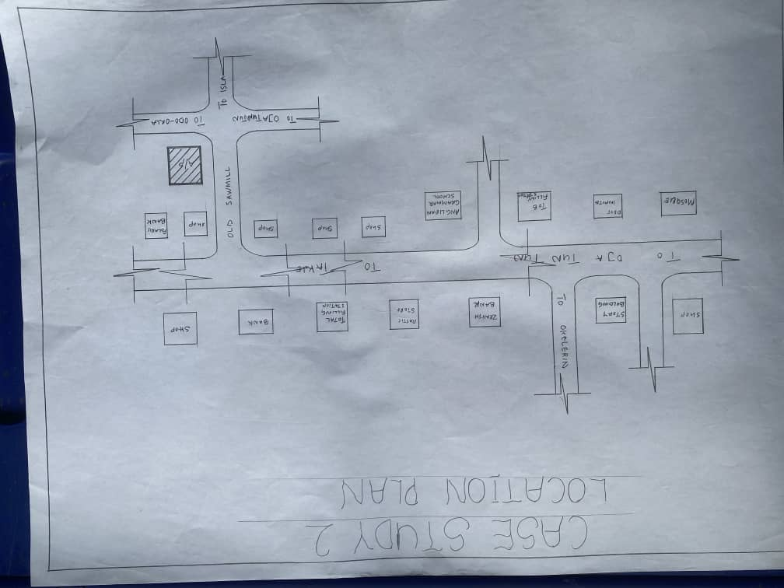

Figure3.3: locational plan of OKELERIN VOCATIONAL CENTRE IBADAN

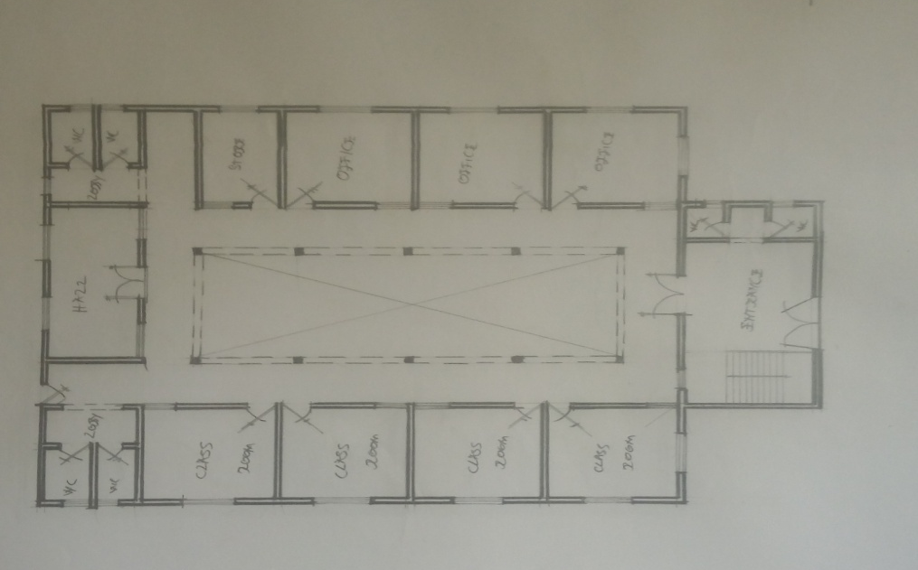
Figure3.4: floor plan OKELERIN VOCATIONAL CENTRE IBADAN

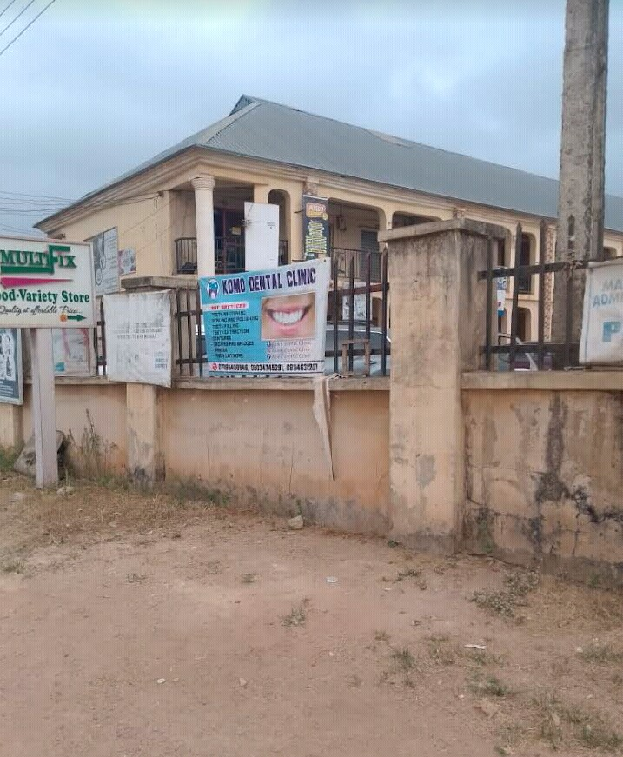

Plate 3.3 .front view of OKELERIN VOCATIONAL CENTRE IBADAN

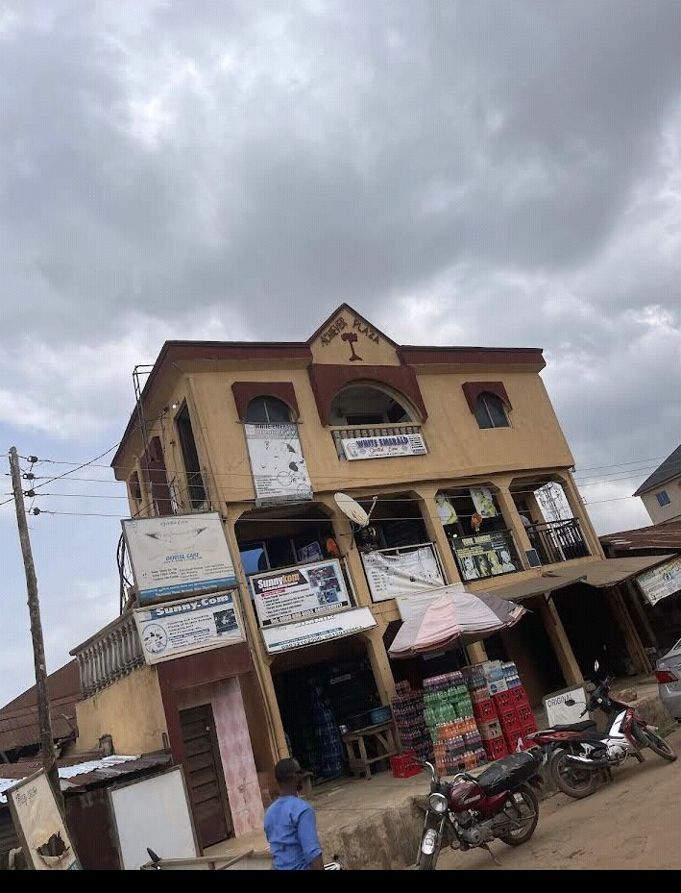

PLATE 3.4 .SIDE VIEW OF CASE STUDY TWO

STUDY THREE
NAME: COOL SMILE DENTAL
LOCATION: OGBOMOSHO, OYO STATE
MERIT
1. It is easily accessible through existing road
DEMERIT
1. It is not well ventilated
2. The approach is aesthetically poor

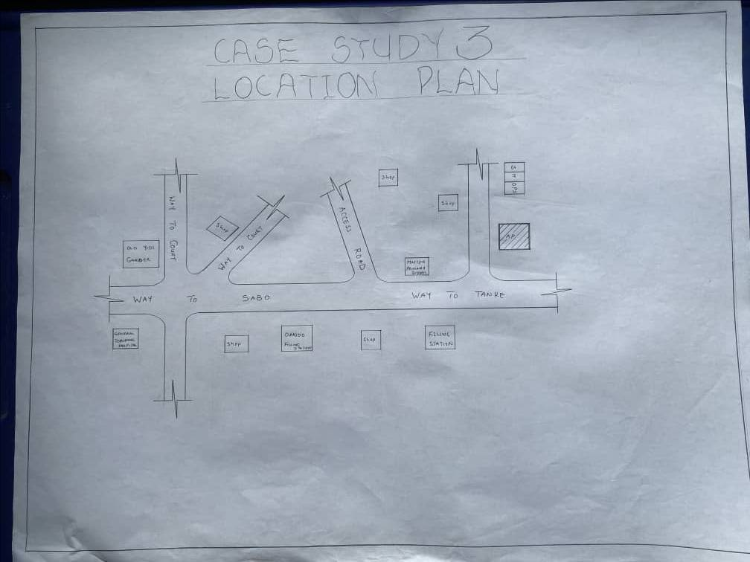

FIGURE3. 5: LOCATIONAL PLAN OF CASE STUDY THREE

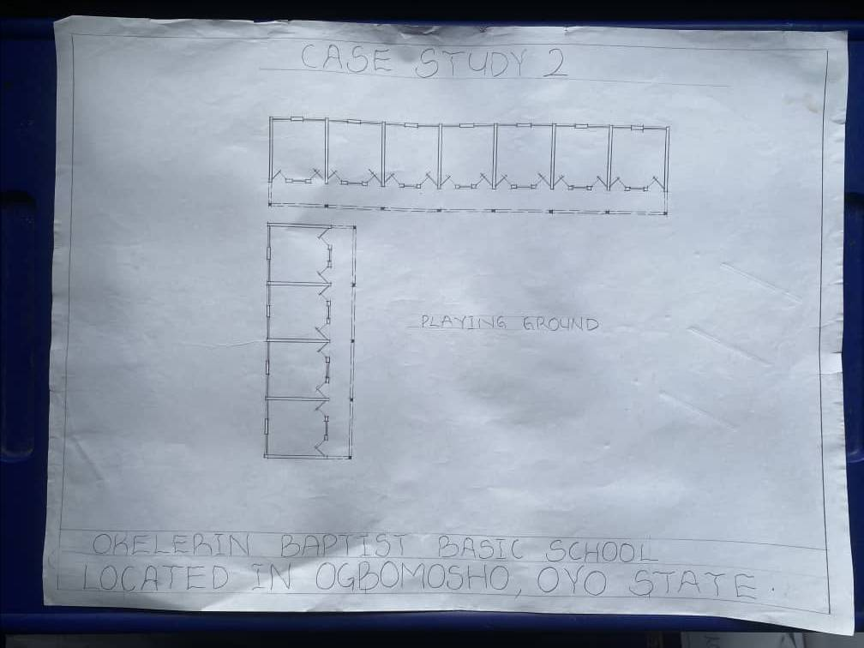

FIGURE3. 6: FLOOR PLAN OF CASE STUDY THREE

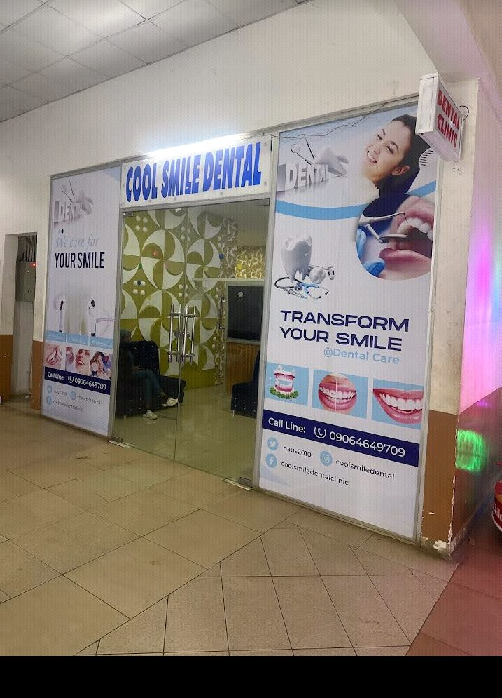
PLATES 3. 5: Showing view of CASE STUDY THREE
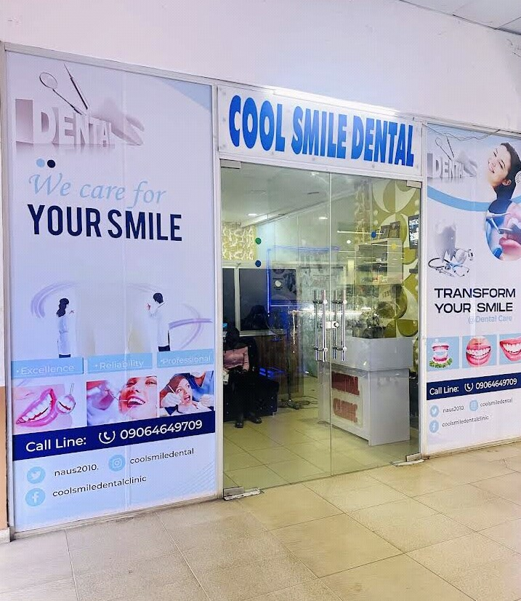
PLATES 3. 6: Showing view of CASE STUDY THREE

CASE STUDY FOUR (ONLINE CASE STUDY)
NAME: CENTRE EYES
LOCATION: TEXAXZ U.S.A

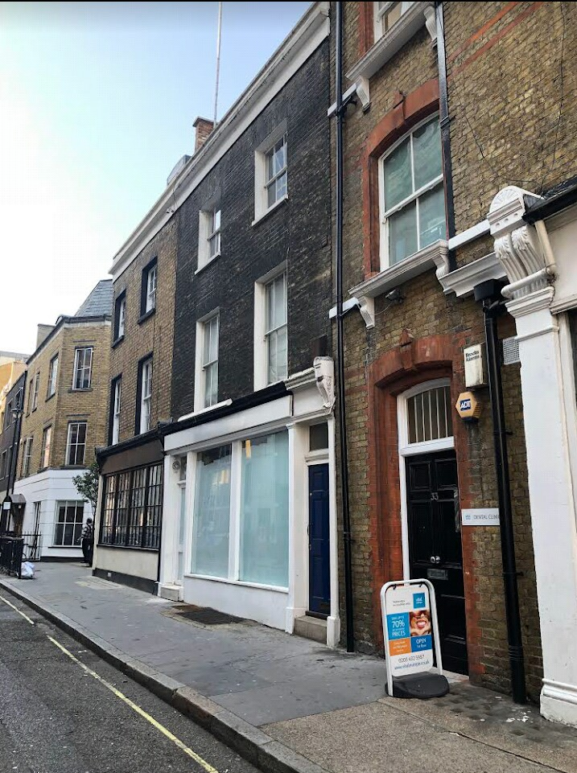
PLATES 3.7: SHOWING VIEW OF ONLINE CASE STUDY
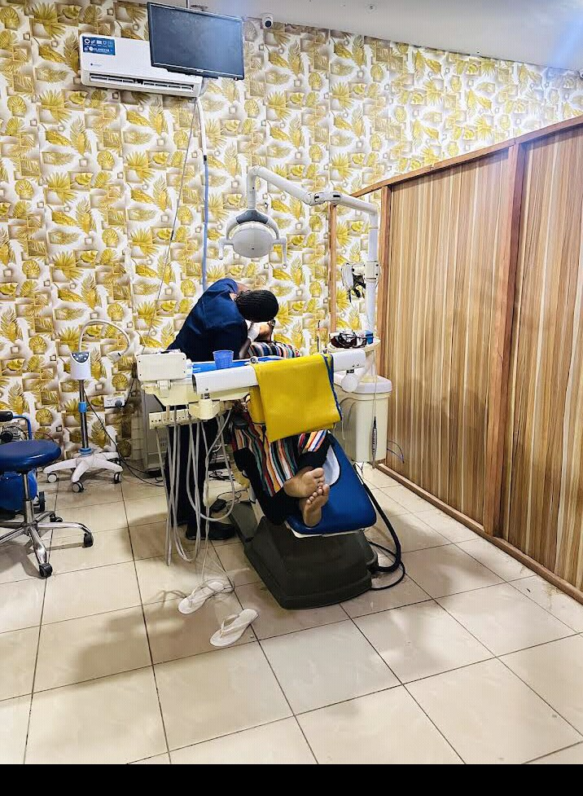
PLATES 3.8: INTERNAL VIEW ONLINE CASE STUDY
CHAPTER FOUR
4.0 PROJECT LOCATIONAL AREA
4.1 BRIEF HISTORY OF KWARA STATE
Kwara state come into existence in 1967 when the country was divided into twelve states by the federal military government of Nigeria (Decree 14), it was then called west central state and later changed to kwara state. It shares common boundaries with niger, oyo, osun, ondo, kogi, and benin republic. Kwara state ranks among five largest with total area about 75,000smm that is eight percent area of Nigeria. The area is generally sparsely populated with population of about 1.7milllion in 1983 but presently to be 2.5million. the state is blessed with some natural features, which serve as tourist attraction in the state and nationwide, which including the owu falls, sobi hills, esie museum etc. The eastern of the state is hill and valley, scenery, vegetation is largely the typical guinea savannah consistency of full-interspersed grasses with trees. The state also comprises of it local government areas with their respective local government headquarters .Avoid pollution by harmful smokes, fumes, and boots. Ease of access: there should be ease of access to and from site to allow for smooth traffic flow. There should be adequate space for future expansion. Sufficient and adequate space for parking Compatible with current and probable future zoning regulations Close to parks museum, museums, and other community services Favorable orientation to wind and natural light Size of site, possibility for expansion, suitability and availability. Commercial potential of surrounding area Land-use compliance Visual and aesthetical potential Proximity to national landmark.
UTILITY SERVICE
Availability of electricity, drainage, sewer feasibility of bringing utilities to site at reasonable cost restrictions on right of way.
4.1.1 HISTORY OF PROJECT TOWN (ILORIN)
Ilorin is the capital city of kwara state and it is believed to be the sixth of the first ten largest cities in Nigeria, Ilorin is located in the southern part of kwara state in latitude 8.26N and longitude 4E and 2E of Nigeria. It is about 300km away from Abuja (the federal capital city by road) it has a north-south rail line linking it to various part of the country apart from the numerous road networks. Ilorin is also provided with airstrip, which has facilities for standard international airport and a standard 5star hotel.
4.2 SITE LOCATION / DESCRIPTION
The site for the proposed primary School pepele community in ilorin east l.g.a kwara state.
4.3 SITE SELECTION CRITERIA
Site selection is the consideration of certain factors which influence the development of the state. Before the execution of any project, the following factor are to be considered for selection of site.
Accessibility
Zoning
Availability of infrastructure etc.
The site selection was based on the following, these include;
Location: the choice of location should be in relation to the following.
Zoning: the site should be within an area reserved for institutional facilities and public utilities. It should be free from industrial zones.
4.4 SITE ANALYSIS/ INVENTORY
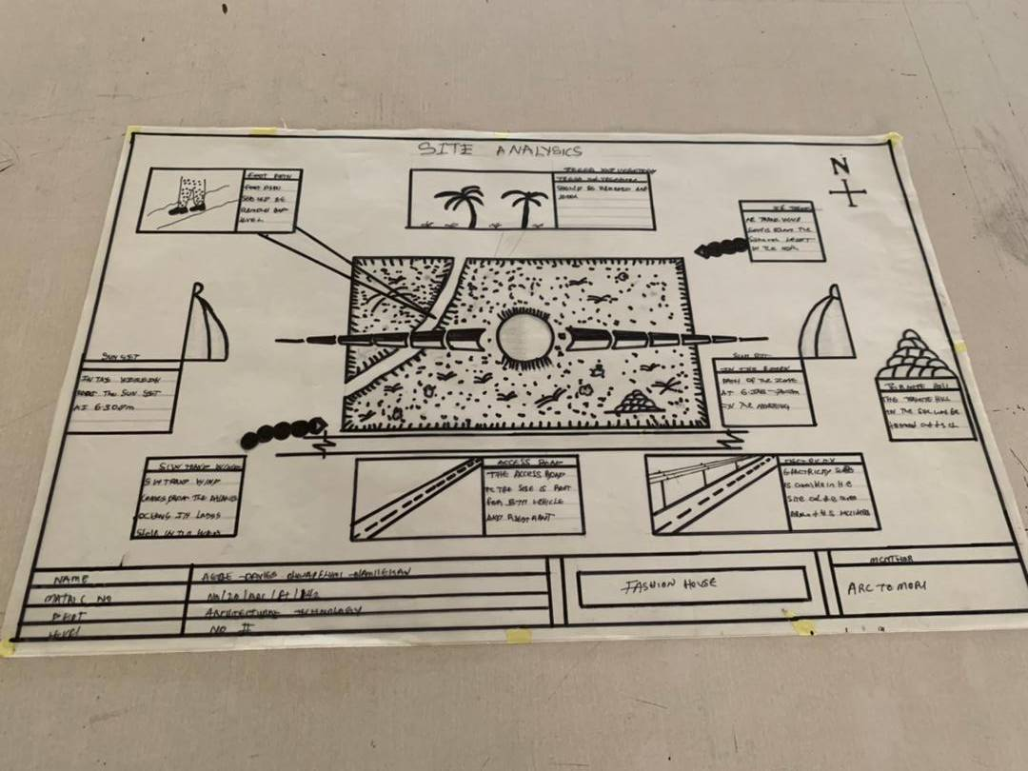
This is done on the basic of the purpose for which the site is to serve.Certain steps are considered to obtain vital information of the site; this information is then analyzed after in details for design purpose, the information includes soil condition, geology, topography, vegetation etc. It also involves carrying out a preliminary survey of the site. Soil condition: the type of soil on the site is loamy and hence aids good vegetation of trees, shrubs and grasses etc. Geology: the soil has a very sound load bearing capacity and hence strip foundation will be used for the structure to be erected on the site. Vegetation cover: the site is covered with shrubs, trees and grass which covers the ground. Which most of it will be retained for landscape. Topography: this is the layout of the site; the site gently slopes toward west

4.5.1 Climatic Data
The environmental and climatic conditions of the project site are analyzed to further understand the factors that will guide the achievement of a functional design.
Such factors are;
CLIMATIC DATA OF ILORIN
Ilorin falls under the climatic region referred to as guinea savannah and in the middle belt of the country. The monthly average temperature is quite uniform, having February and march as the hottest months, recording a higher average of about 45⁰c (about 85⁰f) July and august are the coolest (lowest monthly average temperature of 76⁰f) the town is under relative humidity figure of about 80% average.

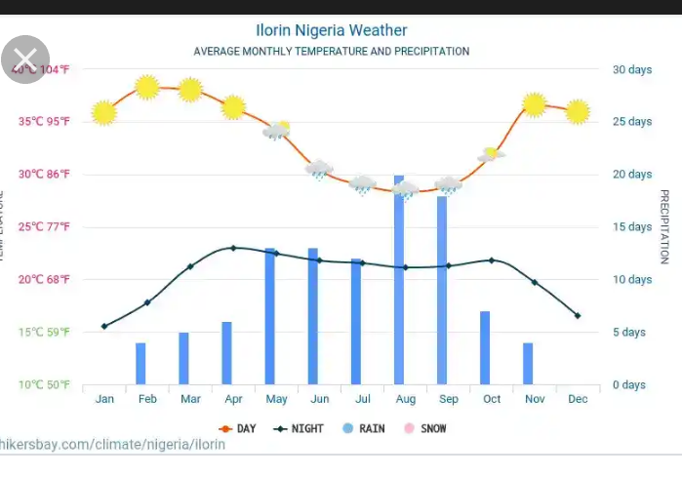

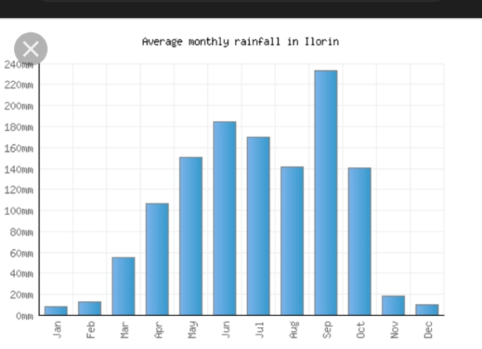

Figure3.2. Average monthly temperature

4.5.2 TEMPERATURE
The monthly temperature in Ilorin ranges between 12⁰c to 24⁰c, the annual range of temperature of the city is 18⁰c meanwhile the city experience it’s highest temperature between april and October every year. The southwest trade wind which carries moisture blows within april and October every year while the northeast trade wind which is dry and carries harmatan blows within February and march and April every year. The south west trade wind which carries moisture blows within October, November and January.
4.5.3 DAYLIGHT
The light is adequately and moderate in Ilorin throughout the year. The daylight is between the hours of 7.0 and 18.0GMT.
4.5.4 RELATIVE HUMIDITY
The importance of temperature influences that actual amount of water vapor present in air and this decide the moisture and carrying capacity of the air. It decides the rate of evaporation and condensation and also affect the nature and type of cloud formation and precipitation as relative humidity is directly related to the temperature of the air, the highest humidity in the state is therefore experienced in the month of April.
WIND DIRECTION: the north-east trade wind blows undesirable cold wind, it is dry, dusty and bring harmattan which is prevalent between the month of march and November.
VEGETATION: Ilorin is in the guinea region of the country. The amount of rainfall that is normally experienced between February and November result into this type of vegetation cover over the area of the site. The thick forest characterized by hard and soft timber with layers of vegetation covers or the low grass covers. The medium highest trees and trees at the highest level of the ground. The vegetation cover is identified with two shapes, the umbrella shapes and conical shape sharing both properties of the vegetation in forest and the region.
SOLAR PATH DIRECTIO: The sunrise from the east and set in the west, the high intensity of the sun normally experienced at this period the shading devices through the conservation and presentations of the existing natural featuring will surely reduce and combat the effect of this heat emission and transmission at the centre.
4.6 DESIGN CRITERIA In this type of design there is need for proper research using both the local (existing similar structure in the same country) and international structure as a case studies to inculcate the new ideas into the design in order to have a well functional conforming and unique structure that suit the international tastes. Some of the criteria are: Accommodation Analysis: I make provision for at least average number of people to be accommodated from two of my cases studies. Source of supply: in this project design the structure is largely make use of artificial source of lightening and ventilations therefore there should be a provision for a standby source of electricity. Landscaping: the environment must be warmth landscaped for both the visitors and the occupant to feel amused within the environment. Shrubs used for landscape include. Functionality of the units; all the units should be well functional so as to make every activities to be ease i.e provision of internet facilities within the structure and a control office within the building also.
4.7 BRIEF ANALYSIS
In this type of project, it can be seen that some building are accompany by sub-units which are required in this project and these units form the design scope of this project which are listed below:
ENTRANCE
RECEPTION HALL
CAD ROOM
Director office
LABORATORY OFFFICE
CONSULTANT
PHAMACY
PHAMACY STORE
SURGRY ROOM
RECOVERY ROOM
CHIFE DENTAL OFFICE
STRERILAZATION ROOM
KITCHEN
DENTAL OFFICE
NURSE STATION
METROL OFFICE
EXIT
ACHIVE/ STORE
4.8 BUBBLE DIAGRAM
This is to show the problem that is on ground to solve by mentioning all the design brief that present in the proposed design are low all these can be related.
4.9 CONCEPTUAL DEVELOPMENT (SITE AND BUILDING)
The design concept of this project is based on the principle of FORM follows FUNCTION where the basic design is gotten through the use of bubble and functional relation diagram.

4.10 SITE CONCEPT
The site design was achieved by taking into considerations some environmental and physical features. They are orientation, circulation and zoning.
Orientation: the building is oriented in such a way that as much as possible direct sunlight is prevented from entering the building.
Circulation: the site is distinguished in such a way that allows for easy accessibility and circulation of pedestrian and vehicles.
zoning: zoning of required functional spaces is done with respect to their various

CHAPTER FIVE
5.0 PROJECT APPRAISAL
The smooth operation of the proposed DENTAL CLINIC would depend largely on the availability of services such as lightning (mostly artificial), ventilation (mostly natural), electricity services plumbing and water services, fire services and drainage etc.
5.1 CONSTRUCTION METHODOLOGY AND MATERIAL
In construction of building, the skill and workmanship dose not only brings out the beauty but until the when specification detail of materials and construction method which had been adopted in this project are skillfully built are as followed.
5.2 SITE CLEARANCE
Trees in all the area where building is to cover would be cut down and carried away from the site in order to get the organic matter, and the top soil is also removed to a depth of 150mmm the clearing of the site can either be done manually or with the use of machine i.e bulldozer or grader.
5.3 FOUNDATION
In these project two type of foundation will be use which are strip and pad foundation. the strip which is the continue spread of concrete shall be use for the load bearing wall and the thickness shall be the same size as the block wall, and the spread will be three times side of the wall, the pad will be use and footing for all the base and also retaining wall of 30mm thick are adopted in some case like rakings in the main conference and will be reinforced.
5.4 STRUCTURAL SYSTEM
This is a horizontal surface design and constructed to accommodate and serve the purpose of supporting people furniture and equipment in the building
5.5 FLOOR
The thickness for the floor slab will be 150mm in the floor, except the generator house which has 300mm thick for generator stand. the following finishing will be use for the project. P.V.C Floor tiles- these are floor tiles made from thermal-plastic binder (vily 1), it is to be use in all available offices, reception, maintenance, V.VI.P, room, restaurant etc. ceramic floor tiles: patterned glazed ceramic floor tiles of brown color will be use for the entire toilet and bath. acoustic carpet underlay: sundown acoustic carpet underlay is a composite material using sundown tuff-mass as a barrier in weight of 1 to 2b and acoustic foam decouple. there is an option for a soft or firm acoustic foam layer that provide a comfortable feel. sundown carpet reduces noise radiating from carpet surface. It may be used alone or to supplement installation applied in spaces sundown carpet underlay is manufactured in 54’ with ¼ and ½ thickness.
5.6 WALLS
These are vertical continuous solid structure which is usually made by brick, stone. concretes, metals etc to serve the purpose of which it is desired. the walls would be a load bearing or non-load bearing walls. all the walls in the building are 225mm wall and it has been supported by columns a beams running vertically and horizontally for structural rigidity. The walls of the main conference hall are slanted 10⁰ to the floor slab, they are made up of columns at 5.5m interval with a precast reinforced concrete blind of 5500x450x50mm thick arranged in a louver pattern, overlapped by 50mm to each other. all other meeting hall wall is cladded with marble tiles because of its sound absorbent characteristics and of its aesthetics value, except the toilet which shall be tiled white and patterned grazed ceramic tile to door height. The wall finishes for the building interior is marble honeycomb panels wall material as sound insulator within the various unit in the building.
5.7 ROOF
Roofs in building construction are constructed in order to protect the building from all the weather condition and the materials varies according to the materials available e.g steel roof or timber roof. steel roof used in this project as a result of large span and is been covered with asbestos roofing sheet with a pitched roof and hipped roof are adopted.

5.8 STEEL
This is metal which is made of alloy of carbon and iron having a very strength in both tension and compression but it is a very stiff material. steel possess the capacity undergoing a consideration strain after the elastic limit before it fall. steel has the ability to carry dead/imposed load with its limit. it is used in the building construction industry for reinforcement of concrete, windows, and door frame, floor slab etc. it is a very versatile construction material.
5.9 CEILING
The material use for the project is an acoustic ceiling tile to reduce noise from the roof. the vacuum between the roof and the ceiling should be filled with rock wool material.
5.10 DOOR
These are solid barrier fixed at opening to serve the purpose of gaining and denying access into building and it can be used as security as well as fire barriers which had been adopted for use in the project.
5.11 STANDARD DOUBLE LEAVE SINGLE SWING GLAZED ALUMINIUM DOOR- This are door, which will serve the main entrance into the building this is composed of aluminum frame and glasses glazed.
PURPOSE NADE METAL DOOR -These types of door are provided in three-bed type for proper ventilation and lightening. necessary place that is required.
FIRE CHECKED PURPOSE MADE DOOR – These type of door will be use in all the door ways in the building like the kitchen, conveniences these is necessary because there is the need to control the spreads of fire in the building.
ALUMINIUM
This is another material that is used in building construction industry and it is made up of alloyed mixed with other element to made a suitable structural material. they are usually corrosion resistance and very light compared to the weight of the steel and highly resistance to corrosion and it is used in the building construction for roofing sheet, partitioning frames, windows frames etc.
TIMBER
Timber is one of the earliest forms of concrete and other material and it is light in weight . it is sometimes used for structural aspect of the building having weight one sixteenth that of steel. timber is a very versatile material and can be used in conjunction with other materials such as steel without any issue arising. it can also be use for constructing room carcass, roof trusses, floor finishes, ceiling finishes, skirting and other building materials.
GLASS
These is another material used in the heating of soda line and sand to a temperature of which they melt and fuse to the stage it can be draw cast rolled on bed of molten tin to be flat glass. Glass can either be transparent or translucent and they come in different ways and types. Clear Sheet Glass: This type of glass is usually transparent and has varying thickness and may cause optical distortion. Wired Glass: This type of glass wire is usually embedded into it, it is glazing because the wire holds the glass together so as to reduce the danger of its breakage. Double Gazing Units: This type of glass can either be transparent or translucent but usually very thick and comprises of float glass spaced apart and sealed around a dehydrated method which had been adopted in the project and are skillfully built. Toughened Glass: This type of glass can either be transparent or translucent but usually very thick it can be broken into fragments and comparatively harmless pieces, it is usually used for doors and softly screens. Pattern Glass: This type of glass is translucent because of the pattern or the texture of the glass. it could also be timed or plane.
WINDOW
These are openings found on walls and also on roofs so that day light can pass through, some transparent materials can also be used to allow passage of light and ventilation into the building. The following are the types of windows to be used in the projects. Aluminum pivoted windows(tinted): this type of window will be used in the guest house and restaurant. Aluminum pivoted window(plane): this type of window will be used in all other units.
5.12 SERVICES
5.13 VENTILATION
The major source of ventilation is a system of natural ventilation, which is centrally controlled. Efforts were made to ensure cross ventilation principle in the design, while the other source of ventilation is the artificial ventilation provided in the form of CENTRAL AIR CONDITIONING SYSTEM (AC) The various components are ventilated by ducts that are linked to the source of the ventilation.
5.14 PLUMBERING SERVICES
All the water is to be supplied and distributed to other areas through 50mm diameter 100mm and 150mm diameter. All the bath and showers tray and towel trays, while all the toilets will be provided with tissue rolls holder, man holes, septic tanks and soak away pits shall be placed in suitable location for easy maintenance.

LIGHTNING
Lightning is very important for accuracy, safety and productivity, for this proposal the use of natural lightning provided for by the use of windows on the surrounding walls, the natural light is complemented with artificial lights provided by means of varieties of light fittings.
FIRE SERVICES
In the electrical panel room, a fire control unit box is provided to serve each building on site and each building has its own electrical panel room which has/smoke detector which alert the people if there is outbreak of fire in any part of the building before damage is done to other part of the building. carbon oxide gas are positioned and strategic locations in the building.
DRAINAGE
The surface water are channeled into 600mm wide and 600mm deep covered drains with inspection chamber at strategic points and emptied into the main municipal city drain. separate drain system has been employed to drain of foul water from the water closets, surface water and pave areas.
5.15 SECURITY SERVICE
The entry and exits into the site have been fitted with cctv cameras, this is to monitor the movement of vehicles in and out of the site. The entrances will also be maintained with security men checking incoming and outgoing vehicles.
ELECTRICAL SERVICES
The power holding company of Nigeria (PHCN) mean which pass across the site shall be the major source of power supply into the building but an alternative source will however be provided which s generator and effective 3 phase line will be used and the connection will be armored cables while the internal distributions/connections would be conduit conduct piping.
RESFUSE DISPOSAL SYSTEM
An effluent point is positioned at a corner on the site where the recyclable materials are taken off the site and a chute system is channeled into it which brings solid refuse to the point and refuse bins are placed at strategic places on the site and are later emptied off into the system.
5.16 SUMMARY
A dental clinic is a facility where dental care is provided by professionals to patients for prevention, diagnosis, and treatment of dental issues. Dental clinics offer services like routine check-ups, cleanings, fillings, extractions, and more complex procedures like root canals or dental implants. The goal of a dental clinic is to maintain and improve patients' oral health, contributing to overall health and well-being. Modern dental clinics often use advanced technology for diagnostics and treatments, aiming for efficient and comfortable care. Staff typically include dentists, dental hygienists, and assistants working together for patient care. Accessibility and patient education are key aspects of dental clinic operations
5.17 CONCLUSIONS
Recommendations for a dental clinic include emphasizing preventive care through patient education on oral hygiene and regular check-ups. Clinics should invest in modern dental technology for accurate diagnostics and effective treatments. Ensuring a comfortable and safe environment for patients is crucial. Staff training and development are important for providing high-quality care. Building patient trust through clear communication about treatments and costs is essential. Clinics should also consider accessibility for patients with different needs and promote community oral health initiatives. Regular updates on dental best practices and adherence to health standards are necessary for optimal clinic
5.18 RECCOMMENDATIONS
Recommendations for a dental clinic include emphasizing preventive care through patient education on oral hygiene and regular check-ups. Clinics should invest in modern dental technology for accurate diagnostics and effective treatments. Ensuring a comfortable and safe environment for patients is crucial. Staff training and development are important for providing high-quality care. Building patient trust through clear communication about treatments and costs is essential. Clinics should also consider accessibility for patients with different needs and promote community oral health initiatives. Regular updates on dental best practices and adherence to health standards are necessary for optimal clinic operation.

REFERENCES
1. American Dental Association (ADA) Guidelines: Guidelines for dental practices and oral health.
2. Dental Clinic Management: Strategies for effective management of dental clinics.
3. Oral Health and Systemic Health: Links between oral health and overall health.
4. Preventive Dentistry: Importance of preventive care in dental clinics.
5. Dental Technology Advances: Use of technology in modern dental clinics.
6. Patient Communication in Dentistry: Importance of communication in dental care.
7. Dental Anxiety Management: Managing anxiety in dental patients.
8. Pediatric Dentistry: Dental care considerations for children.
9. Geriatric Dentistry: Dental care for elderly patients.
10. Dental Hygiene Practices: Role of dental hygienists in clinics.
11. Infection Control in Dentistry: Importance of infection control in dental settings.
12. Dental Implants and Restorations: Advanced dental treatments like implants.
13. Oral Health Education: Role of education in preventive dental care.
14. Dental Clinic Accreditation Standards: Standards for accreditation of dental clinics.

LIST OF APPENDIX

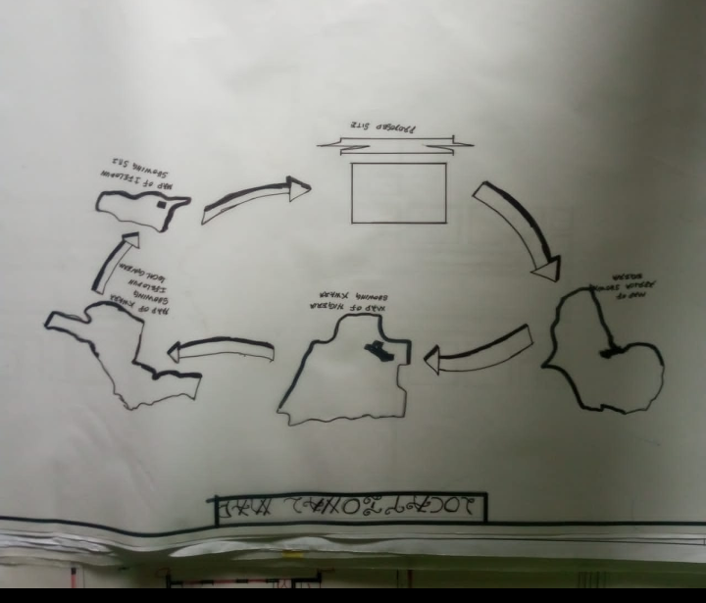
APPENDIX 1. SHOWING LOCATIONAL MAP
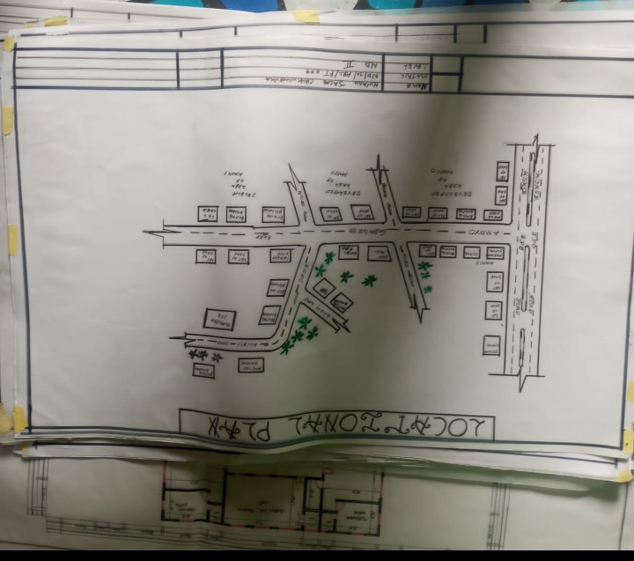
APPENDIX 2. SHOWING LOCATIONAL PLAN

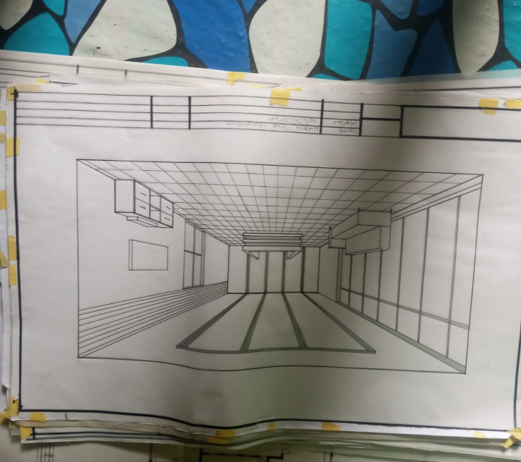
APPENDIX 3. SHOWING INTERNAL PASPECTIVE

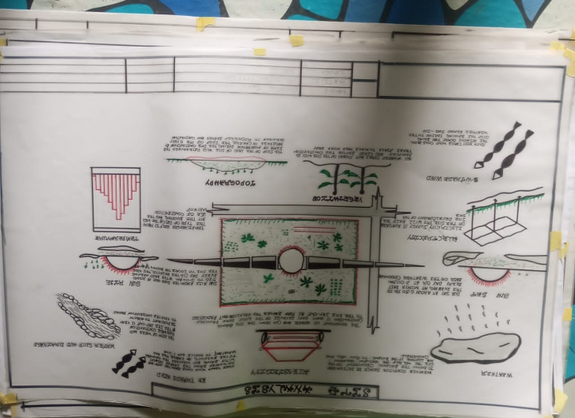
APPENDIX 4. SHOWING SITE ANALYSIS

