A PROPOSED PROJECT REPORT
ON
SENATE BUILDING
FOR
KWARA STATE UNIVERSITY OF EDUCATION.
BY
FARUQ MUJAHEED MUHAMMED
HND/23/ARC/FT/0020
SUBMITTED TO:

THE DEPARTMENT OF ARCHITECTURAL TECHNOLOGY
INSTITUTE OF ENVIRONMENTAL STUDIES (I.E.S)
KWARA STATE POLYTECHNIC, ILORIN.

IN PARTIAL FULFILMENT OF THE REQUIREMENTS FOR THE AWARD OF HIGHER NATIONAL DEPLOMA (HND) IN ARCHITECTURAL TECHNOLOGY

JULY, 2025.



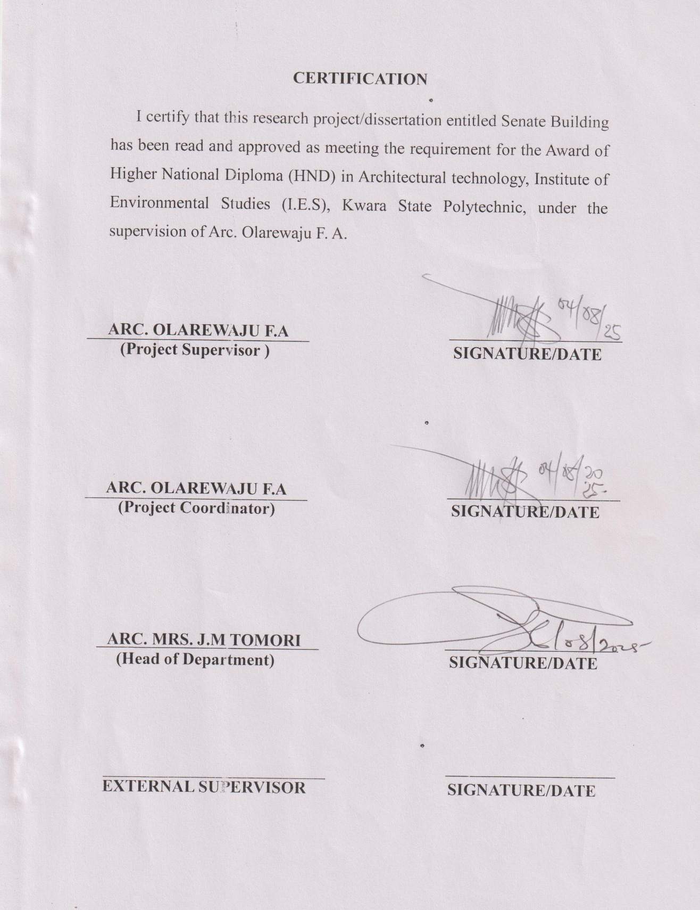

DEDICATION
I dedicate this project to Almighty ALLAH for his faithfulness and favour given to me throughout this project and also to my sponsor KOBIOWU FOUNDATION.

ACKNOWLEDGEMENT
I am grateful to Almighty Allah for His grace, protection, guidance and mercy that saw me through the ups and downs to start and complete the programme Higher National Diploma (HND) in Architectural Technology in a great institution, Kwara State polytechnic, Ilorin.
I would like to say a big thank you to my supervisor, Arc. Olarewaju. F.O. for the encouragement he gave me throughout the course of this project work. My lovely HOD Arc (Mrs) Tomori J.M. and to all lecturers of the Department of Architectural Technology, Arc. Nwom Chuckwuma, Arc. Solomon Familua and others (lecturers), GOD bless you all.
To my sponsor, big thanks to Kobiowu Foundation for giving me an opportunity to complete my education. To the founder of Kobiowu Foundation (Alhaji Ahmed Raheem Babatunde a.k.a Baba Akhara), may Almighty Allah continue to bless you more and increase your wealth and offspring. Ameen.
I am also grateful to my parents, Mr. And Mrs. FARUQ and my sisters ROSHIDAT and my brother BABATUNDE for giving me all the support I need to complete this project.
To my friends that supported me, I thank you for your kind-hearted manner, thank you for always been there.

TABLE OF CONTENT
Title Page
Declaration…………………………………………………………………..…. ii
Certification …………………………………………………………………....iii
Dedication ……………………………………………………………………...iv
Acknowledgment …………………………………………………………….…v
Table of content ………………………………………………………...…...vi-vii
List of plates………………………………………………………………...…viii
List of Figures ……………………………………………………………..…....ix
List of Appendix…………………………………………………………………x
Abstract …………………………………………………………………….…. xi
CHAPTER ONE:
1.0 General Introduction ……………………………..…………….…..….1-2
1.1. Historical background of the project…………………….……...……2-3
1.2 Definition…………………………………….…………………….....3-4
1.3 Statement of design problem ………………………………….……….4-5
1.4 Aim and Objectives of the study……………………………………...….6
1.5 Project justification …………………………………….………..………6
1.6 Clients background……………………………………………...……...7-8
1.7 Scope of the study…………………………………………….…..…....8-9
1.8 Limitation of design………………………………………….………...…9
1.9 Research Methodology …………………………………………………10
Deduction………………………………………………………………..11
CHAPTER TWO:
2.0 Review of relevant Literature……………………….….……….…...12-18
CHAPTER THREE
3.0 Case studies………………………………………………….………….19
3.1 Case study one………………………………….…………………....19-23
3.2 Case study two………………………………………………………24-25
3.3 Case study three……………………………………………...……...26-27
3.4 Case study four(online case study)………………………………..…28-29
3.5 Deduction from Case study ………..…………………...……………...30

CHAPTER FOUR
4.0 Introduction to study area ………………….……………….…………..31
4.1 Historical background of selected location state……………...………...31
4.2 Physical feature of the location ……………………………...………....32
4.3 Population ………………………………………………...………….…32
4.4 Social service …………………………………………….….…….……32
4.4.1 Road ………………………………….………………….……………...33
4.4.2 Health service ………………………….……………………….………33
4.4.3 Water and electricity …………………………………………………....34
4.4.4 General climatic condition ………………………………….…………..34
4.5 Site selection/justification/site analysis…….………………………..35-37
4.6 Design concept/planning principle…………………………………..….38
4.7 Planning principle ………………………………………………………39
CHAPTER FIVE
5.0 Design report……………………………………………………………40
5.1 Design brief ……………………………………….…………………..40
5.2 Design appraisal ………………………………….………………...…40
5.3 Design characteristics ………………………………………...………...41
5.4 Building structure …………………………………………………...41-42
5.5 Service ………………………………………..………………………...42
5.6 General requirement ………………………………………………...42-44

5.7 Summary and conclusion …………………………………………….…44
5.7.1 Summary ………………………………………………………………..44
5.7.2 Conclusion ………………………….…………………………………..44
Recommendation……………………………………………………………....45
References …………………………………………………………………..…46
Appendix …………………………………………………………………..47-55

LIST OF PLATES
Plate 1.1-1.3: Elevations Of Case Study One……………………….…………20
Plate 1.4-1.6: Elevations Of Case Study Two………………….……..….……24
Plate 1.7-1.9: Elevations Of Case Three……………..…………………...…....26
Plate 2.0-2.2: Elevations Of Case Study Four ( online )……………………….29

LIST OF FIGURES
Figure 1.1-1.7: Showing Floor Plan of Case Study One……………..……..…22
Figure 1.8-.2.1: Showing Floor Plan Of Case Study Two………….…….……25
Figure 2.2-2.5: Showing Floor Plan Of Case Study Three……………..….…..27
Figure 3.4: Showing Floor Plan Of Case Study four…………………..…..…..28

LIST OF APPENDIX
Appendix 1: location map and Location plan………………………………….. 47
Appendix 2: Site inventory and Site analysis……………………………….... 48
Appendix 3: Site plan and Flowchart…..…………………………………….. 49
Appendix 4: Floor plan and Roof plan………………..…………….…..… 50-51
Appendix 5: Sections…………………...…………………….…………….… 52
Appendix 6: Elevations…………………………………………………… 53-54
Appendix 7: Space analysis and details….………………………...……….… 55

ABSTRACT

The Senate Building, as a central hub for legislative and administrative activities, often faces functional and spatial inadequacies due to aging infrastructure and evolving institutional demands. This study aims to assess the current state of the Senate Building in terms of structural integrity, space utilization, and functionality, with the objective of proposing viable design and planning interventions that align with modern standards and institutional needs.

A mixed-method approach was adopted, combining architectural surveys, structural assessments, and user interviews. Quantitative data were gathered through structural analysis tools, while qualitative insights were obtained from stakeholders through semi-structured interviews to understand space efficiency and user satisfaction.

Findings revealed several structural weaknesses, including foundation settlement and deterioration of key load-bearing components. Spatial analysis indicated suboptimal utilization of office and conference areas, contributing to congestion and inefficiency. Users highlighted issues related to inadequate ventilation, lighting, and accessibility, all of which impact daily operations.

The study concludes that comprehensive renovation and modernization of the Senate Building are urgently needed. Recommendations include structural retrofitting, reconfiguration of internal spaces for better flow and utility, and the incorporation of sustainable building systems to enhance energy efficiency and user comfort. These interventions are expected to significantly improve functionality and extend the building’s lifespan.

CHAPTER ONE
1.0 INTRODUCTION
A Senate Building can be described as a purpose-built government facility that serves as the central space for legislative deliberation, governance, and civic representation. According to Britannica (2016), such civic institutions often forming part of the broader civic or governmental center are designed to be focal points within the urban fabric, housing dominant public functions. Traditionally, these buildings reflect institutional authority, but more recently, the concept of civic design has evolved to encompass not only architectural symbolism but also the strategic organization, grouping, and landscaping of public facilities for functional and experiential effectiveness (Moseley, 2013). In the context of a Senate Building, special attention must be paid to the internal organization of legislative and public spaces, alongside critical design aspects such as acoustics and environmental control.
Acoustics is a branch of physics that deals with sound, including its origin, propagation, and perception. In architecture, it is concerned with the planning, design, and construction of buildings to achieve desirable sound conditions within and around the built environment. Proper acoustic design plays a vital role in correcting sound-related deficiencies in building components, improving speech intelligibility, controlling reverberation, and minimizing unwanted noise. Specifically, in a Senate Building where dialogue, debate, and public address are central to its function, acoustic performance becomes an essential design priority. This includes both the absorption and insulation of internal sounds as well as dissipation of external noise from the surrounding environment.
The application of acoustics in architectural design ensures optimal auditory conditions in spaces such as Senate chambers, committee rooms, auditoriums, press briefing halls, and galleries. As buildings become increasingly mechanized with the use of air-conditioning systems, office equipment, and other electronic devices the need for noise control intensifies. Without proper acoustic treatment, these technologies can contribute to a sound environment that impairs communication and reduces the quality of deliberation.
While all buildings require a degree of acoustic consideration, this requirement is particularly crucial in governmental and civic structures like the Senate Building. Here, the production, projection, and reception of sound are fundamental to the building’score function. Although the science of acoustics spans across various media solids, liquids, and gases it is most commonly studied and applied in architectural contexts, particularly those that serve the public interest. The careful integration of acoustic principles into the design of the Senate Building ensures not only functional performance but also the comfort, dignity, and transparency expected of a national legislative institution.
1.1 HISTORICAL BACKROUND
The journey of Senate buildings began with modest, often colonial-era structures that provided only basic facilities for legislative functions. These early buildings typically featured large halls for deliberation, limited office spaces, and minimal public access or security provisions. Legislative sessions were held with little consideration for acoustics, environmental comfort, or technological support.
By the late 20th century, architectural and technological advancements began reshaping the nature of parliamentary and senate buildings globally. Countries such as Nigeria, South Africa, the United States, and India led the change by adopting modern architectural solutions, integrated security systems, and digital infrastructure. This period marked the beginning of contemporary Senate buildings larger, more efficient, and purpose-built facilities designed to support complex legislative operations, improve communication, and enhance democratic transparency.
In the early 21st century, a significant shift occurred toward sustainability, automation, and civic engagement in government architecture. Senate buildings evolved to include smart systems for energy management, acoustic optimization, and security automation. Designs began to prioritize not only operational functionality but also environmental performance and public access. These changes contributed to more secure, efficient, and citizen-friendly legislative environments.
Modern Senate buildings now embrace digital transformation, with integrated ICT systems enabling real-time legislative tracking, e-governance platforms, automated voting systems, and media broadcasting facilities. These innovations have reduced manual administrative tasks, improved decision-making speed, and increased public involvement through transparent communication channels.
As environmental concerns continue to shape architectural priorities, Senate buildings are increasingly being designed with green materials, energy-efficient systems, and sustainable construction practices. Efforts such as passive cooling, solar integration, and intelligent lighting systems are now commonly employed. Additionally, the integration of acoustic engineering ensures optimal sound quality in chambers and committee rooms, facilitating clearer dialogue and better deliberation.
This evolution reflects not only a change in architectural form and function but also a deeper commitment to democratic values, public participation, and institutional sustainability.
1.2 DEFINITION OF TERMS
- Modern: Refers to something contemporary, up-to-date, and designed to meet current functional, technological, and aesthetic standards.
- Senate: The upper chamber of a legislative body, often tasked with reviewing, debating, and passing laws. In the context of Nigeria, the Senate is a part of the National Assembly and plays a vital role in national governance.
- Senate Building: A purpose-designed structure that houses the offices, chambers, and support facilities necessary for the legislative functions of the Senate. It symbolizes democratic authority and governance, and is often the focal point for political decision-making and civic interaction.
- Chamber: The principal hall or room within the Senate Building where formal legislative sessions and debates are conducted.
- Acoustics: The science of sound as it applies to building design, particularly concerning the control of sound reflections, transmission, and absorption to enhance clarity and comfort in speech-sensitive spaces like legislative chambers and auditoriums.
- Public Gallery: A designated seating area within the Senate chamber or other legislative space that allows members of the public to observe proceedings, promoting transparency and civic engagement.
- Legislative Function: The formal role of drafting, debating, amending, and passing laws within a parliamentary or senatorial system.
- Administrative Wing : The section of the Senate Building that houses support services and offices such as those of clerks, legal advisors, record keepers, and administrative staff.
- Civic Architecture: A category of public architecture intended to serve government, justice, or community functions, characterized by monumentality, accessibility, and symbolic value.
- Noise Control: Architectural and engineering strategies used to reduce unwanted sound within or around a building, particularly crucial in institutional buildings where clarity of speech and privacy are essential.
- Committee Room: A smaller, acoustically sensitive space used for meetings, hearings, and legislative sub-group activities outside of the main chamber.
1.3 STATEMENT OF DESIGN PROBLEM
The absence of a modern, purpose-built Senate Building in Kwara State that effectively supports legislative activities, public engagement, and administrative functions has created a pressing need for a facility that combines architectural excellence with functional efficiency. The proposed Senate Building is intended to serve as a civic symbol a contemporary space for deliberation, communication, and democratic interaction. It aims to provide a controlled, acoustically optimized environment that enhances legislative discourse and administrative operations, while also accommodating public participation in governance.
However, many existing governmental structures suffer from poor acoustic design due to inadequate architectural planning and construction limitations. These issues often result in user discomfort and hinder effective communication within key spaces such as chambers, hearing rooms, and auditoriums. Acoustic challenges, such as echo, flutter, and external noise infiltration, compromise the audibility and clarity of proceedings. Reflective surfaces like domes or curved walls can cause focusing of sound waves, producing disruptive echoes, while parallel walls can create flutter echoes and destructive sound interference. Additionally, external noise from urban traffic or nearby airports can further diminish the acoustic performance of such buildings.
In light of these issues, the proposed Senate Building will incorporate acoustic design as a critical aspect of its architectural planning. Materials, geometry, and spatial arrangements will be carefully selected to absorb or diffuse sound as necessary, ensuring clear communication during debates, committee meetings, and public engagements. The integration of sound-insulating construction methods will protect interior spaces from external noise pollution, allowing proceedings to occur without disruption.
Ultimately, the intention is to create a civic landmark that not only fulfills its primary role as the seat of legislative power but also promotes accessibility, public transparency, and engagement. By providing well-designed spaces that foster both formal communication and informal interaction, the Senate Building will support the growing population’s need for representation, participation, and institutional reliability enhancing the relationship between government and citizens in a functional and symbolic architectural setting.

1.4 AIM AND OBJECTIVES
1.4.1 AIM
To design a modern Senate Building that meets contemporary legislative requirements while embodying national identity, sustainability, and architectural excellence for Kwara State University of Education.
1.4.2 OBJECTIVES
- To develop a functional spatial layout that accommodates Senate chambers, committee rooms, administrative offices, and public galleries with efficient circulation.
- To integrate sustainable architectural solutions for energy efficiency, natural lighting, and ventilation.
- To enhance accessibility and security through thoughtful planning and appropriate technologies.
- To reflect the cultural and institutional identity of the nation through architectural expression and material selection.
To create a technologically equipped environment that supports modern legislative operations and media integration.
1.5 JUSTIFICATION
A Senate Building is important for the smooth running of any university. At Kwara State University of Education, Ilorin, there is currently no central building where top-level decisions are made or where key administrative offices are located. This has made communication and coordination between departments difficult and less effective.
So this compelled me to design. A Senate Building that will provide a central location for offices like the Vice-Chancellor, Registrar, Bursar, and other important university leaders. It will also include meeting rooms and halls where academic decisions, staff matters, and policy discussions can take place.
1.6 CLIENTS BACKGROUND
Kwara State University of Education, Ilorin, is a leading institution committed to the training of highly skilled educators, administrators, and professionals in Nigeria’s education sector. Located in Ilorin, the capital city of Kwara State, the university plays a vital role in supporting the intellectual and socio-economic development of the state and the nation at large. Its mission centers on advancing knowledge through quality teaching, research, and service delivery, particularly in the field of education.
As one of the specialized universities in the region, the institution has experienced significant growth in student population, academic programs, and administrative responsibilities. However, this expansion has also brought with it an urgent need for enhanced institutional coordination and centralized administrative infrastructure. Currently, most of the university’s administrative operations are scattered across temporary or repurposed spaces that lack the capacity and design efficiency needed to support the institution’s long-term vision.
The proposal to construct a modern Senate Building emerges as a strategic intervention to address these operational and structural limitations. The building is envisioned as a central administrative hub that will house the offices of principal officers, support university governance, and provide dignified, functional spaces for decision-making, meetings, and institutional coordination.
Architecturally, the project is expected to reflect the cultural identity of the institution while embracing modern design principles such as energy efficiency, flexibility, accessibility, and sustainability. The facility will serve not only as the administrative nucleus of the university but also as a physical symbol of its aspirations for excellence, innovation, and growth.
The philosophy behind the proposal is rooted in the belief that a well-designed Senate Building is critical to the university’s ability to deliver on its academic mission, foster collaboration, and respond to emerging challenges in the education sector. It will play a crucial role in policy formulation, academic planning, and resource management, all of which are essential to the smooth functioning of the university.
The proposed Senate Building will include executive offices (Vice Chancellor, Registrar, Bursar, etc.), Senate Chambers, board and meeting rooms, staff offices, ICT support areas, and auxiliary spaces for security, archives, and maintenance. The design will emphasize modularity to allow for future expansion and will integrate smart building systems and environmentally friendly practices.
The primary goal of the project is to validate the need for a purpose-built Senate Building at Kwara State University of Education, Ilorin, and to articulate the design, spatial, and functional elements required for its successful realization. In doing so, the project will contribute to improved administrative effectiveness, institutional identity, and the university’s long-term sustainability
1.7 SCOPE OF THE STUDY
- The Senate Building will be designed as a multi-functional civic structure that accommodates the diverse activities and responsibilities of a legislative institution. The building will be divided into three primary sections: Legislative Section, Administrative Section, and Public Engagement Section, each tailored to fulfill specific roles and serve distinct user groups efficiently.
- Legislative Section: This core area will include the main Senate chamber, committee rooms, caucus rooms, and offices for senators. It will be equipped with state-of-the-art audio-visual systems, acoustic treatments, and secure access points to ensure the smooth and confidential conduct of legislative proceedings. The spatial arrangement will prioritize functionality, hierarchy, and accessibility for lawmakers and staff.
- Administrative Section: This section will house the support departments responsible for documentation, legal drafting, research, ICT, protocol, and record-keeping. Offices for clerks, administrative officers, and technical staff will be strategically located to support legislative operations seamlessly. The design will emphasize efficient circulation, workspace ergonomics, and digital infrastructure integration.
- Public Engagement Section: Reflecting the Senate’s commitment to transparency and civic interaction, this section will include facilities for the general public such as an exhibition gallery, media briefing room, auditorium, public cafeteria, and a courtyard for civic gatherings. It may also incorporate a library for policy research, visitor orientation centers, and designated observation areas for live Senate sessions. These spaces will promote education, inclusivity, and community engagement.
Through this tripartite division, the Senate Building will not only support the functional demands of modern governance but also act as a civic symbol providing a dignified, secure, and welcoming environment for legislation, administration, and public participation. The architectural layout will reflect democratic ideals while meeting the spatial, acoustic, and technological standards necessary for an efficient legislative process.
1.8 LIMITATION TO DESIGN
This study will be limited to the evaluation and integration of acoustic and noise control strategies within the Senate Building, particularly in spaces designated for public interaction and legislative functions such as the Senate chamber, committee rooms, auditorium, and media briefing areas. Due to constraints in time, budget, and access to detailed technical data, the scope will not extend to the full engineering detailing of acoustic systems or post-occupancy performance analysis. Additionally, the design proposal will focus primarily on delivering functionally appropriate spaces that enhance communication, collaboration, and user comfort, without delving into the extensive structural or mechanical engineering solutions that may be implemented during the execution phase of the project

1.9 RESEARCH METHODOLOGY
The methodology adopted for this study combines both qualitative and observational research approaches. These methods were chosen to provide a comprehensive understanding of the functional, spatial, and architectural requirements of Senate Buildings within the Nigerian context. The following methodologies were employed:
- Internet Research: Online resources were explored to gather current information on architectural trends, functional planning, and technological innovations in Senate Buildings. This included accessing academic articles, governmental publications, and architectural design references to ensure alignment with global best practices.
- Case Studies: Existing Senate Buildings across various Nigerian universities and governmental institutions were studied to examine their spatial organization, circulation patterns, and integration of administrative and ceremonial functions. These case studies provided valuable insights into practical challenges and successful design strategies.
- Oral Interviews: Structured interviews were conducted with key stakeholders, including university administrators, staff, architects, and maintenance personnel. This helped to capture firsthand experiences regarding operational needs, user comfort, security considerations, and functional requirements specific to Senate Buildings.
- Photography: Photographic documentation was undertaken during site visits to record architectural features, structural details, and environmental context. These visual materials supported detailed analysis and informed design decisions.
- Literature Review: Relevant books, academic journals, and technical manuals on public institutional buildings were reviewed. This provided a strong theoretical foundation and highlighted key design principles, sustainability considerations, and innovations applicable to Senate Buildings.
DEDUCTION
Based on the analysis of the proposed design and operations of the Senate Building, the following deductions were made:
      - Efficient Administrative Workflow:
The layout of the Senate Building promotes seamless movement and interaction between offices, committee rooms, and legislative chambers. This spatial organization enhances coordination among departments and supports timely decision-making and legislative processes.
      - Institutional Integrity and Security:
The design incorporates secure access control points, surveillance systems, and designated zones for public, staff, and senators. These measures ensure operational security and uphold the dignity and integrity of the legislative institution.
      - Comfort and Functionality:
Adequate ventilation, natural lighting, and ergonomic furniture have been integrated to ensure comfort for both visitors and personnel. The use of sound insulation in chambers and conference rooms enhances communication and productivity.
      - Environmental Responsibility:
The design includes features such as solar panels, rainwater harvesting systems, and landscaping with native vegetation. These strategies promote environmental sustainability and reduce the building’s ecological footprint.
      - Cost-effectiveness and Scalability:
Through modular construction techniques and locally sourced materials, the building remains economically viable. The layout also allows for future expansions or modifications in response to administrative growth or evolving legislative needs.
CHAPTER TWO
2.0 LITERATURE REVIEW
Review of Literature on Senate Building Type
The Senate Building serves as the administrative nerve center of tertiary institutions, often housing key offices such as those of the Vice Chancellor, Registrar, and Senate Committee rooms. Literature on institutional architecture emphasizes the importance of such administrative buildings in shaping organizational efficiency and academic governance. According to Akintoye and Adedeji (2013), institutional buildings must reflect a blend of prestige, functionality, and representational value, as they often serve both symbolic and practical roles within the university setting.
Senate buildings are also studied in the context of architectural expression and institutional identity. As noted by Ogunleye (2015), the architectural design of a Senate Building can reinforce the authority and academic values of an institution. This necessitates careful planning in terms of spatial hierarchy, circulation flow, and integration of security and ICT infrastructure. In line with global trends, modern Senate buildings are expected to be sustainable, flexible, and technologically integrated to support digital administration and evolving governance needs.
Studies have also underscored the need for accessibility and transparency in the design of such administrative complexes. Buildings that encourage inclusivity and open communication through their spatial arrangement foster better institutional.
Building typology is a foundational concept in architectural theory and practice. It refers to the systematic classification of buildings based on their form, function, spatial configuration, materiality, and cultural or historical relevance. Typologies help architects understand precedents and inform design decisions that balance user needs with aesthetic, administrative, and environmental performance.
In the context of institutional and administrative development, typologies like Senate Buildings are especially important as they represent the administrative heart of universities, symbolizing governance, leadership, and institutional identity. These buildings serve not only as office complexes but also as emblematic structures that reflect institutional values, academic tradition, and public authority.
Senate buildings support decision-making, academic coordination, and ceremonial functions, hence their dual role in administration and representation. Their design must consider operational efficiency, spatial hierarchy, user accessibility, and environmental integration.
2.1 EVOLUTION OF SENATE BUILDING ARCHITECTURE
Over the past century, Senate buildings in Nigeria and globally have transitioned from modest office blocks to architecturally significant landmarks. Early models typically adopted colonial administrative templates: rigid, hierarchical, and introverted structures. These prioritized function over form but often lacked spatial flexibility, environmental responsiveness, or symbolic gravitas.
With the expansion of university education and a deeper understanding of the relationship between space and productivity, contemporary Senate buildings now integrate advanced spatial planning, information technology systems, passive design strategies, and ceremonial architecture. This evolution aligns with global trends in educational governance that emphasize transparency, inclusiveness, and environmental consciousness.
In Kwara State, this transition is visible in institutions like the University of Ilorin and Kwara State University, which feature purpose-built administrative structures that reflect both functionality and regional identity.
2.2 CLASSIFICATION OF SENATE BUILDING TYPOLOGIES
Senate buildings may be classified by several criteria, including:
Function-Based Typologies:
Central Administrative Complex
Senate Chambers and Council Meeting Suites
Vice-Chancellor’s Office and Principal Officers’ Suites
Registry, Bursary, and Academic Planning Units
Scale-Based Typologies:
Compact models (colleges or polytechnics)
Medium-complex institutions (state universities)
Large-scale federal university complexes
Ownership and Funding Typologies:
Publicly funded Senate complexes (Federal or State)
PPP-funded or donor-supported institutional headquarter
Architectural Typologies:
Linear corridor office layouts
Central atrium with radial offices
Courtyard-based or cluster-block models
Monumental façade with civic symbolism
The typology adopted influences decisions about access control, vertical circulation, space allocation, facade articulation, and overall campus orientation.
2.3 FUNCTIONAL SPACE RELATIONSHIPS IN SENATE BUILDINGS
Efficient Senate buildings require clear, hierarchical, and secure spatial relationships. Poor layout planning can disrupt workflow, reduce security, and compromise privacy in sensitive administrative operations.
A typical space relationship model includes:
- Public Reception and Information Halls
- Vice Chancellor's
- Deputies’ vice Chancellor Offices
- Council Chambers / Board Rooms
- Academic planning units (Archives or Record Repositories)
- Bursary and deputy Bursary
- Registry, and deputy Registry
- Human resources (Administrative Offices)
- Utility & IT Rooms
Access zoning should allow controlled public movement while enabling discreet internal operations. Clear wayfinding, vertical connectivity (elevators and stairwells), and provision for digital infrastructure are vital.
2.4 INNOVATIVE AND CONTEXTUAL DESIGN STRATEGIES
Designing Senate buildings in Ilorin and its surrounding areas requires sensitivity to climate (hot, humid tropical savannah), social dynamics, and institutional growth.
Contextual strategies include:
Deep overhangs and brise-soleils to reduce solar gain
Courtyards and shaded atria for natural cooling and daylight
Natural cross-ventilation to minimize energy demand
Use of compressed earth blocks, laterite stone, or adobe for regional identity
Rainwater harvesting for landscaping and sanitation reuse
Cultural integration of Yoruba motifs and colors for identity
These strategies promote sustainability, affordability, and cultural relevance in institutional architecture across Ilorin.
2.5 TECHNOLOGICAL AND ENVIRONMENTAL DESIGN TRENDS
Modern Senate buildings are expected to integrate technology for better governance and sustainability:
ICT-integrated boardrooms for remote meetings and digital documentation
Smart card access for staff and data security
CCTV and building management systems
LED lighting and energy zoning
Passive cooling and daylighting strategies
Green roofs or shaded terraces for executive areas
2.6 CASE STUDIES OF SENATE BUILDINGS
FACILITY LOCATION KEY FEATURES
University of Ilorin Ilorin, Kwara Monumental entrance, internal courtyards, zoned offices
Kwara State University Malete, Kwara Split-level structure, passive cooling, local materials
Ahmadu Bello University Zaria Symbolic civic design, monumental architecture
Obafemi Awolowo University Ile-Ife Open courtyard system, modernist interpretation
These case studies reflect regional adaptation, symbolic design, and the integration of administrative efficiency with representational form.
2.7 CHALLENGES IN IMPLEMENTATION OF SENATE BUILDINGS
Budget limitations affecting design quality
Lack of climate-responsive building practices
Poor maintenance culture in public universities
Inadequate accessibility features for persons with disabilities
Congestion due to centralized planning Bureaucratic delays in funding and project execution
2.8 DESIGN PRIORITIES FOR ILORIN CONTEXT
Considering the climate, topography, and educational landscape of Ilorin:
Elevated plinths or platforms to address flooding in the rainy season
Accessible roads and parking bays for visitors and staff
Sun-shading and cross-ventilation to reduce heat buildup
Landscape buffers and shaded walkways
Use of affordable local building materials and regional skills
Modular planning to allow for institutional growth
2.9 GENDER, ACCESSIBILITY, AND INCLUSION IN DESIGN
Senate buildings must reflect inclusive values of academic institutions:
Wheelchair-accessible ramps and lifts
Gender-neutral restrooms and lactation bays
Prayer and reflection rooms
Ergonomic furniture for all users
Flexible training rooms for administrative staff development
2.9.1 ENVIRONMENTAL MANAGEMENT IN CAMPUS ADMINISTRATION
Environmental sustainability should be part of the architectural solution:
Paper waste management and digital archiving
Solar lighting and inverter backups
Use of trees and green courtyards to regulate microclimate
Drainage systems to prevent flooding during Ilorin’s heavy rains
2.9.2 FUTURE DESIGN TRENDS
AI-enabled visitor management and access systems
Digital building twins for maintenance planning
Sensor-based lighting and HVAC controls
Smart records and meeting room automation
Expandable layouts for growing institutions

SUMMARY OF LITERATURE GAPS
Inadequate architectural evaluation of existing Senate buildings in Ilorin
Lack of climate-specific design manuals for university administrative blocks
Poor integration of inclusive and gender-sensitive spaces
Weak implementation of digital infrastructure in planning and use
CONCLUSION
This literature review emphasizes the urgent need for climate-appropriate, inclusive, and technologically responsive Senate buildings in Ilorin. As centers of academic governance, these buildings must embody transparency, sustainability, and institutional identity. A hybrid approach merging regional materials, modern construction techniques, and inclusive spatial planning will enable the development of robust and symbolic administrative headquarters fit for 21st-century education in Kwara State.

CHAPTER THREE
3.0 CASE STUDIES
INTRODUCTION
This chapter is aimed at highlighting the various elements that could make up a Senate Building. It focuses on identifying the basic concepts employed in the design, such as functional layout, workflow optimization, and building topology. Various examples were studied from within and outside the country to understand best practices in modern cassava processing and how these influence the architectural and operational planning of such facilities.
3.1 CASE STUDY ONE
UNIVERSITY OR ILORIN SENATE BUILDING
LOCATION: ILORIN, KWARA STATE, NIGERIA.
DESCRIPTION
The Senate Building is a seven-story administrative complex that serves as the nerve center of the University of Ilorin, housing key offices such as the Vice-Chancellor’s Office, the Governing Council Chamber, and major administrative units including the registry and bursary.
It forms part of the city's major academic build-out following the development of the Main Campus from the early 1980s onward. Floor Count 7 Floor, Floor Area 10,806.25 SQM.

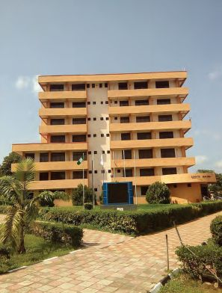
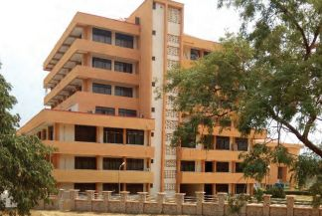

PLATE 1.1:-ELEVATIONS PLATE 1.2:-ELEVATIONS

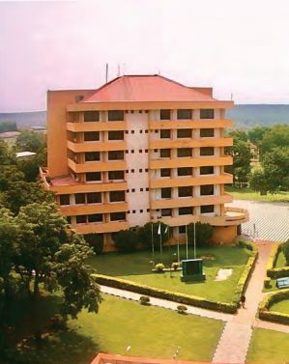

PLATE 1.3:-ELEVATIONS
SOURCE:- Researcher Field Work, 2025

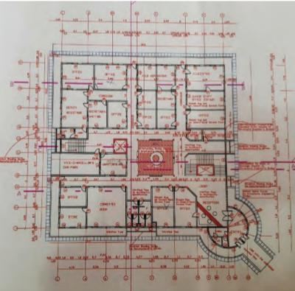
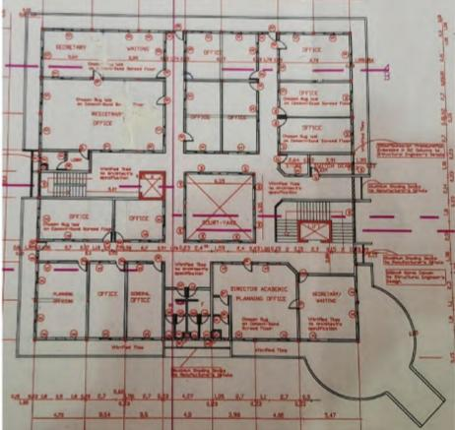

FIG 1.1:-FLOOR PLANS FIG 1.2:-FLOOR PLANS

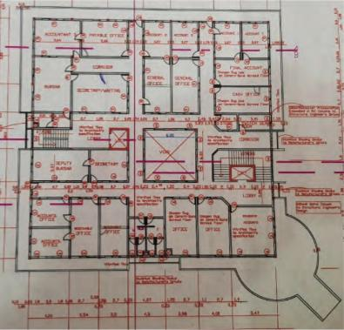
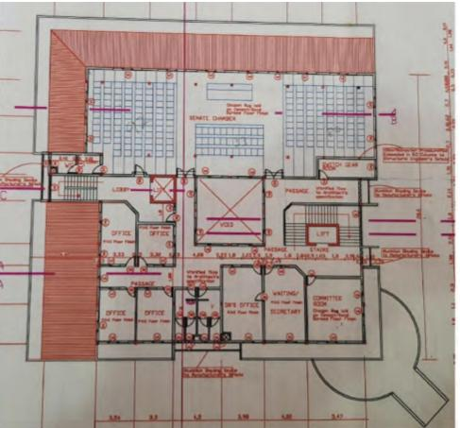

FIG 1.3:-FLOOR PLANS FIG 1.4:-FLOOR PLANS

SOURCE:- Researcher Field Work, 2025
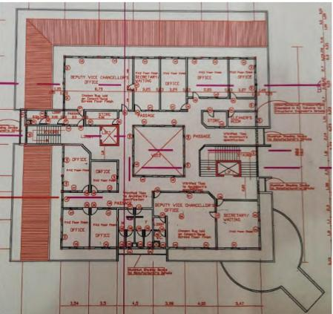
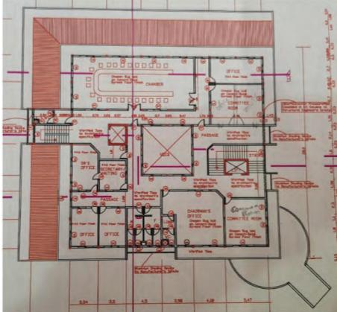

FIG 1.5:-FLOOR PLANS FIG 1.6:-FLOOR PLANS

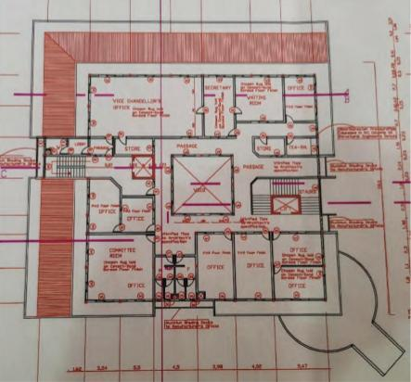

FIG 1.7:-FLOOR PLANS
SOURCE:- Researcher Field Work, 2025

3.1.2 MERITS
- It has high security system.
- The theory of hierarchy obeyed.
- Adequate cross ventilation was achieved especially in the Senate chamber.
- It has functional accessibility.
3.1.3 DEMERITS
- It has limited scalability.
- It has maintenance challenges
- It has limited flexibility
- The building consumed high rate of energy.
3.2 CASE STUDY TWO
AHMADU BELLO UNIVERSITY SENATE BUILDING.

LOCATION: ZARIA, KADUNA STATE, NIGERIA.

DESCRIPTION
The Senate Building of Ahmadu Bello University (ABU), Zaria was constructed as part of the institution's post-independence expansion during the 1960s and 1970s, following Nigeria’s push for educational and infrastructural development in the northern region. Floor Count 9 FLOORS, Date of Completion (Early 1980s).

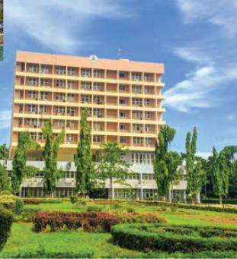
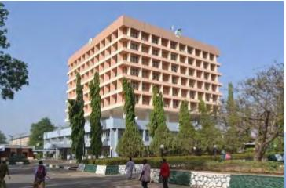

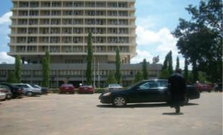
PLATE 1.4:-ELEVATIONS PLATE 1.5:-ELEVATIONS

PLATE 1.6:-ELEVATIONS
SOURCE:- Researcher Field Work, 2025

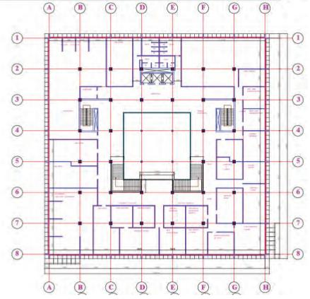
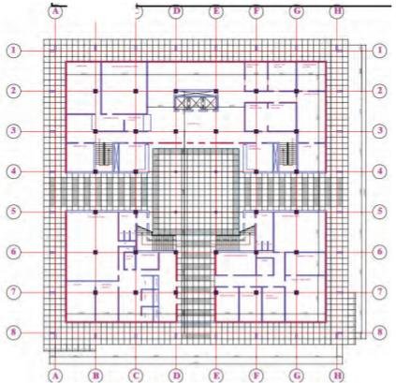

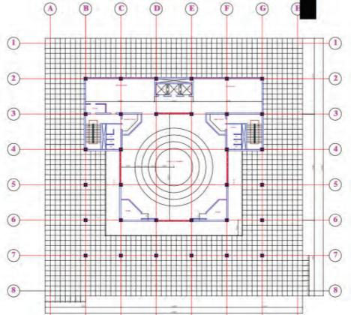
FIG 1.8:-FLOOR PLANS FIG 1.9:-FLOOR PLANS
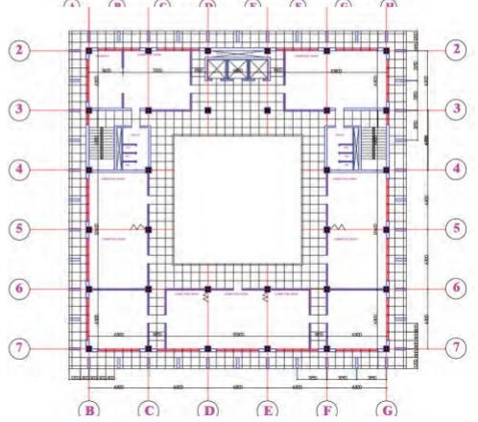

FIG 2.0:-FLOOR PLANS FIG 2.1:-FLOOR PLANS

SOURCE:- Researcher Field Work, 2025
3.2.1 MERITS
  - Functional Zoning.
  - Security and Controlled Access.
  - Architectural Prominence.
  - Symbolic Design Features.
3.2.2 DEMERITS
  - Limited Parking Space.
  - Accessibility Issues.
  - Overcrowding and Space Constraints.
  - Aging Infrastructure.
  - Poor Ventilation in Some Sections.
3.3 CASE STUDY THREE
LADOKE AKINTOLA UNIVERSITY OF TECHNOLOGY SENATE BUILDING
LOCATION: OGBOMOSHO, OYO STATE, NIGERIA.
DESCRIPTION
The Senate Building serves as LAUTECH’s central administrative hub, housing key offices such as the Vice-Chancellor, Registrar, Bursar, and the Governing Council Chamber.
Built in 2004, it unified previously scattered administration units into a single iconic structure. Floor Count (4 Floors), Date of completion (May, 2006),
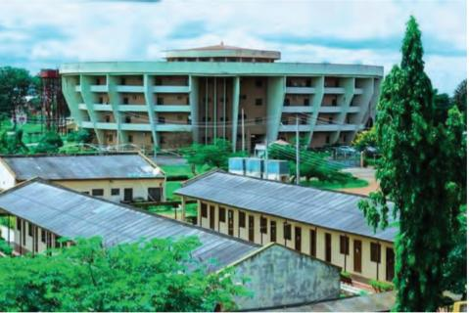
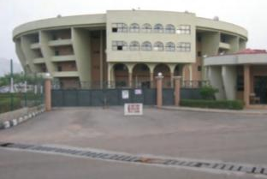

PLATE 1.7:-ELEVATIONS PLATE 1.8:-ELEVATIONS
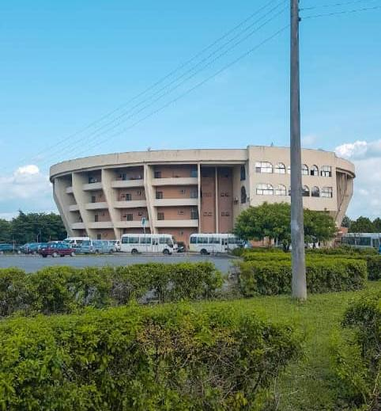

PLATE 1.9:-ELEVATIONS
SOURCE:- Researcher Field Work, 2025

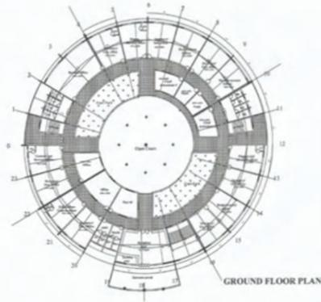
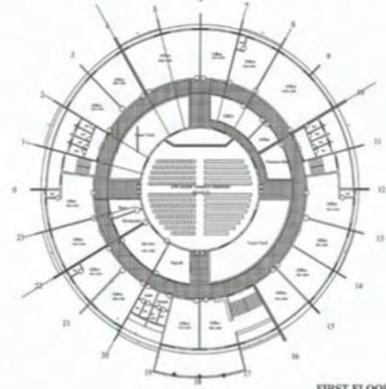

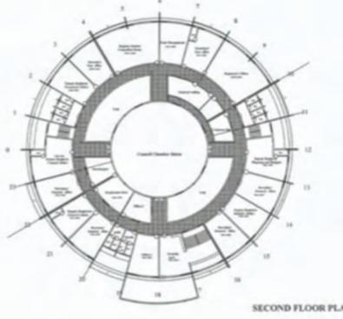
FIG 2.2:-FLOOR PLANS FIG 2.3:-FLOOR PLANS
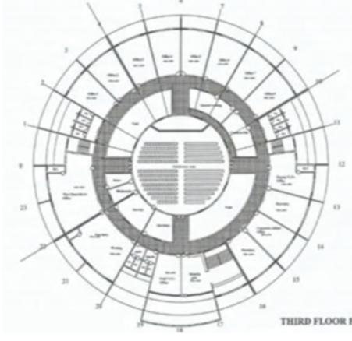

FIG 2.4:-FLOOR PLANS FIG 2.5:-FLOOR PLANS
SOURCE:- Researcher Field Work, 2025

3.1 MERITS
  - Presence of courtyard system that enhances the building.
  - The building layout efficiently accommodate various administrative offices.
  - The building as central location.
  - It as good natural lightning and ventilation.
3.3.2 DEMERITS
  - Absence of escape route, due to emergency.
  - The lobbies are not lightened passively.
  - The stair cases are isolated, making the stair uneasy to access by new users.
  - The entrance into the building is not well defined.
3.4 CASE STUDY FOUR [ONLINE CASE STUDY
UNIVERSITY OF LONDON.

LOCATION: BLOOMSBURY, LONDON, WC1 UNITED KINGDOM.

DESCRIPTION

Name: University of London

Type: Public, federal research university

Established: 1836

Location: London, England, United Kingdom

Motto: “University of London – Learn, Discover, Achieve”

Chancellor: HRH The Princess Royal (Princess Anne)

Main administrative building: Senate House, Malet Street, Bloomsbury

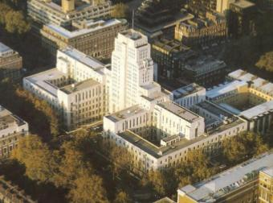
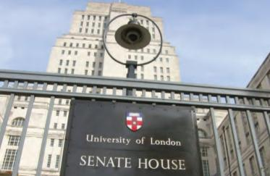

PLATE 2.0:-ELEVATIONS PLATE 2.1:-ELEVATIONS

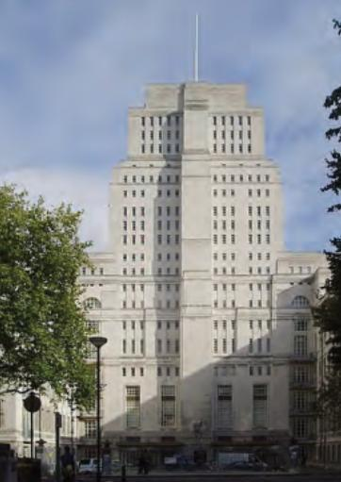

PLATE 2.2:-ELEVATIONS
SOURCE:- Researcher Online (Google), 2025

3.6 DEDUCTION FROM CASE STUDIES:
These are the common similar knowledge or information derived from the aforementioned case studies. Some of which are:

- Choice of location should be in a developing or already developed area for easy access to the trainings offered.
- Segregation of each department form one another
- Well designed and well positioned landscapes
- Separation of noisy departments from departments with less noise
- Provision of required ventilation and fenestration into each units to serve the spaces well

CHAPTER FOUR
ANALYSIS OF THE ENVIRONMENTAL AND TOPOGRAPHICAL CONDITIONS OF THE SITE
4.0 INTRODUCTION TO STUDY AREA
This chapter provides a comprehensive analysis of the environmental, topographical, and climatic characteristics of the selected site within Ilorin, the capital of Kwara State, Nigeria. Understanding these characteristics is crucial to ensuring that the proposed kwara state university of education is both sustainable and well-integrated into its local context.
4.1 HISTORICAL BACKGROUND OF ILORIN
Ilorin is the capital city of Kwara State, located in the North Central geopolitical zone of Nigeria. It is historically significant as a meeting point between the northern and southern parts of Nigeria and serves as a hub of Yoruba, Hausa-Fulani, and Nupe cultural influences.
Pre-Colonial Era:
Founded around the 15th century by Yoruba settlers, Ilorin later became an emirate under the Sokoto Caliphate in the early 19th century. It grew as a center of Islamic scholarship and trade.
Colonial Era (1900–1960):
Under British colonial rule, Ilorin became a provincial capital and administrative center. The city experienced the introduction of Western education, health facilities, and railway links, enhancing its commercial importance.
Post-Colonial Era (1960–Present):
Since Nigeria’s independence, Ilorin has grown into a major urban and administrative center. It hosts several government institutions, universities, and industries, while still maintaining strong ties to agriculture and rural economies in surrounding areas.
Key Features and Landmarks in Ilorin:
Government House and state secretariat
University of Ilorin and Kwara State Polytechnic
Emir’s Palace and Central Mosque
International Aviation College and Kwara State Stadium
Major markets: Ipata, Oja Tuntun, and Mandate markets
4.2 PHYSICAL FEATURES OF THE LOCATION
Ilorin lies on a relatively flat plateau interspersed with gentle rolling hills. This topography is favorable for construction and site planning. The surrounding soil type, primarily red laterite, offers good drainage and bearing capacity, making it suitable for industrial development such as cassava processing.
4.3 POPULATION OF KWARA STATE AND ILORIN
As of 2022, Kwara State had a population of approximately 3.6 million people. Ilorin, being the capital city, is the most populated area in the state, with an estimated population of over 900,000 to 1 million, depending on the area covered (Ilorin East, West, and South LGAs).
The workforce in Ilorin is diverse, comprising civil servants, students, artisans, traders, farmers, and professionals, providing a strong human resource base for agro-industrial operations.
4.4 SOCIAL SERVICES IN ILORIN
- Healthcare:
Presence of major facilities like University of Ilorin Teaching Hospital (UITH), General Hospital, and private clinics.
- Education:
Numerous public and private primary and secondary schools.
- Tertiary institutions: University of Ilorin, Kwara State University, Kwara Polytechnic, etc.
- Transportation:
Well-connected via federal highways and urban roads.
Presence of Ilorin International Airport for logistics.
- Utilities:
Electricity provided by IBEDC.
Water supply from Asa Dam and private boreholes.
4.4.1 ROAD NETWORK
Ilorin is accessible through a well-established road network that connects to other parts of Nigeria. Major roads include:
Ilorin–Jebba–Kaduna Road
Ilorin–Ibadan–Lagos Highway
Ilorin–Lokoja–Abuja Road
These roads support movement of agricultural inputs and finished products. Internal roads within the city are paved, though some rural outskirts may have untarred sections.

4.4.2 HEALTH SERVICES
Healthcare in Ilorin is well-developed:
- Tertiary care: University of Ilorin Teaching Hospital
- Secondary care: General Hospitals, private hospitals, and specialty clinics
- Primary care: Numerous community health centers and mobile health units

4.4.3 WATER AND ELECTRICITY
Water: Supply comes from the Asa River Dam, supplemented by boreholes and public water boards.
Electricity: Distributed by the Ibadan Electricity Distribution Company (IBEDC) with relatively stable supply in major areas.
4.4.4 CLIMATIC CONDITIONS
Ilorin experiences a tropical wet-and-dry (savannah) climate.
Wet Season (April–October):
Rainfall: 1,200 – 1,500 mm annually
Temperature: 23°C – 31°C
Humidity: 70–85%
Dry Season (November–March):
Temperature: 24°C – 35°C
Humidity: 30–55%
Harmattan: Cold, dusty winds from December to February
Other Climatic Data:
Average Annual Temperature: ~27°C
Sunshine Hours: ~2,400 per year
Elevation: ~290–340 meters above sea level
Relative Humidity: Peaks in September (~85%), lowest in February (~60%)
Wind: Mild throughout the year, with higher speeds during the harmattan season

4.4.5 VEGETATION
Ilorin lies within the Guinea Savannah zone, characterized by:
- Tall grasses and scattered trees
- Deciduous shrubs and farmlands
- Soil suitable for cassava, maize, yam, and vegetable cultivation
Vegetation will be selectively cleared for development, while green belts and buffers will be preserved for environmental sustainability.

4.5 SITE ANALYSIS AND JUSTIFICATION
The selected site for the cassava processing plant is located within Ilorin's peri-urban fringe, offering several advantages:
- Accessibility: Connected to major roads and urban infrastructure
- Labor Pool: Availability of skilled and semi-skilled labor
- Topography: Flat to gently sloping terrain, ideal for factory construction
- Utilities: Access to water, electricity, and communication networks
- Soil Conditions: Red laterite with good bearing capacity
- Market Proximity: Easy access to local and regional markets in Ilorin and beyond

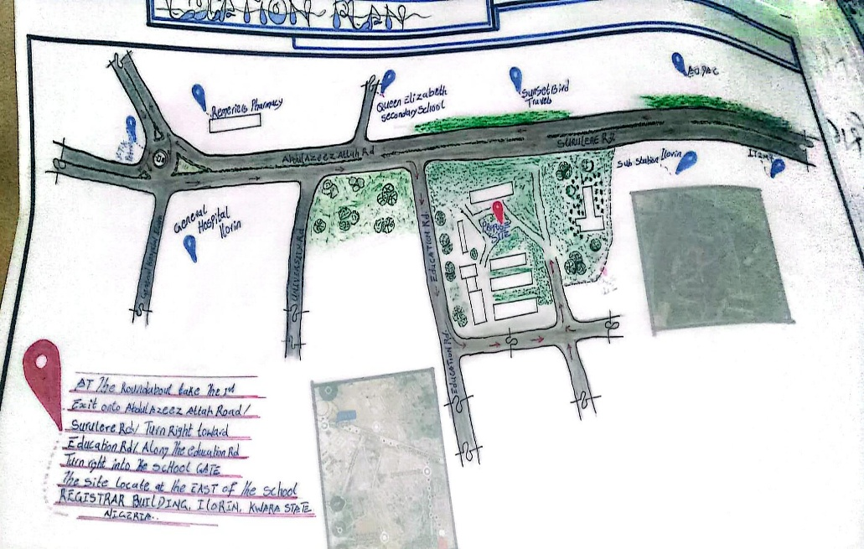

FIG 4.1:- LOCATION PLAN

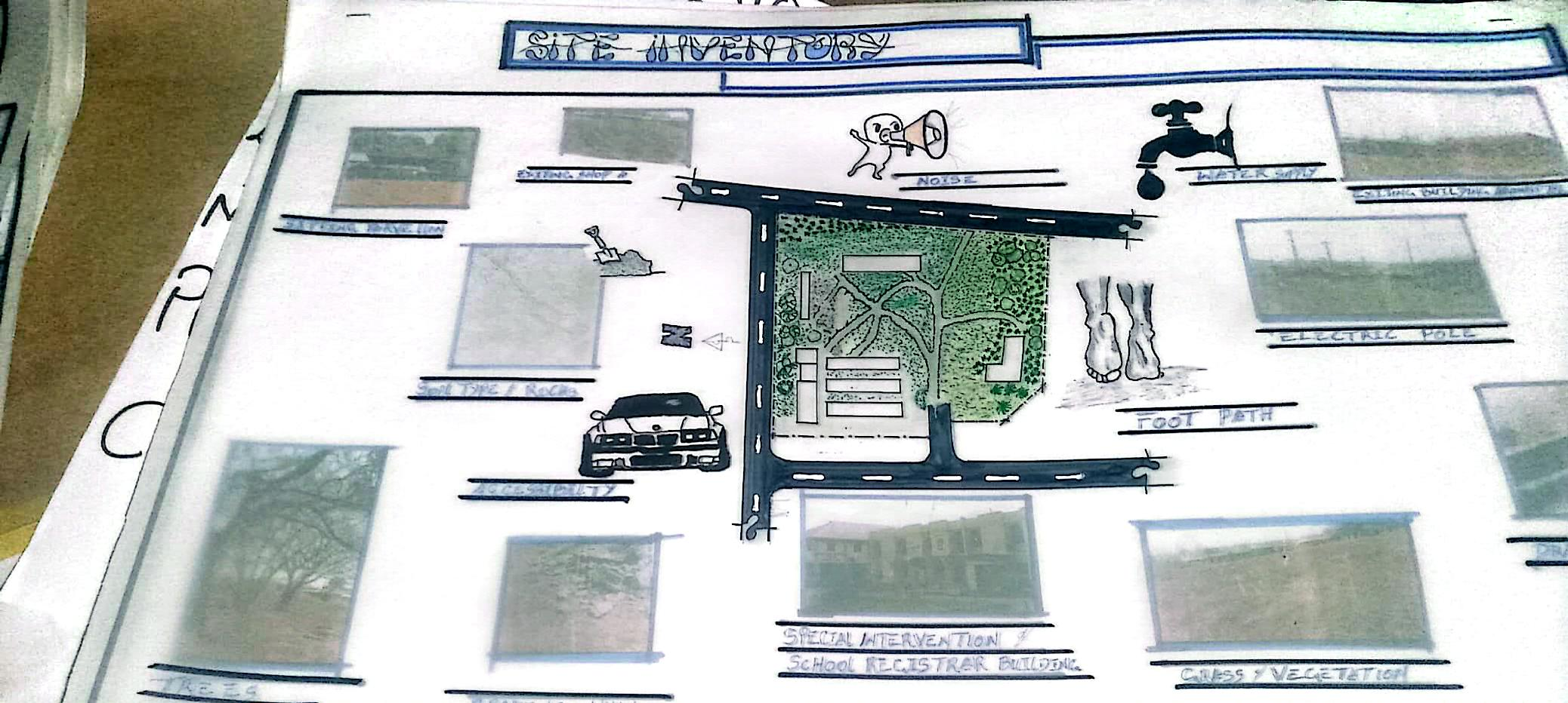

FIG 4.2:- SITE INVENTORY

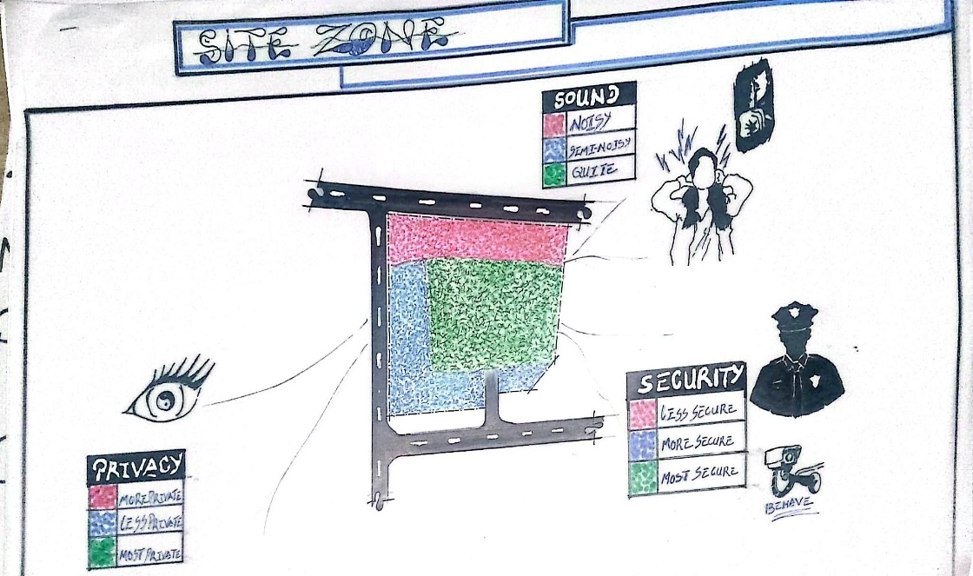
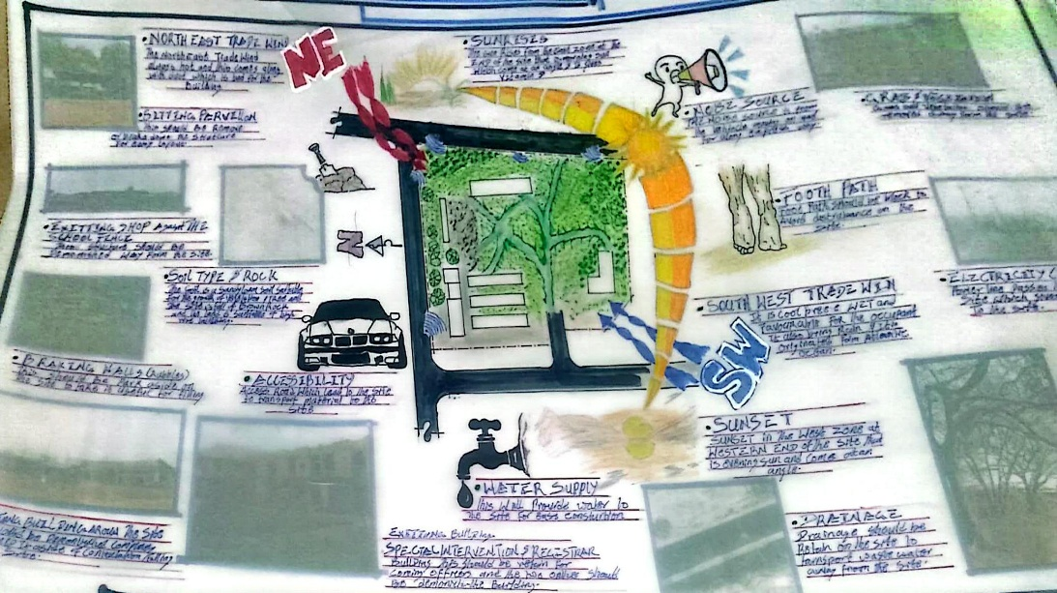

FIG. 4.3:- SITE ANALYSIS

FIG. 4.4:- SITE ZONING

4.6 DESIGN CONCEPT/PLANNING PRINCIPLE
DESIGN PLANNING
The design planning process for the Senate Building commenced with a detailed analysis of its functional requirements, user expectations, and administrative workflow. This analysis was informed by research into existing Senate buildings across academic and institutional settings, consultations with stakeholders including administrative staff and facility managers and best practices in public institutional architecture.
Central to the design is the integration of core administrative and decision-making functions within a structure that facilitates transparency, accessibility, and operational efficiency. The functional spaces including the Senate chambers, offices of principal officers, committee rooms, conference halls, and support services were grouped based on hierarchical importance and frequency of interaction.
The concept development relied heavily on spatial flow diagrams and adjacency matrices to ensure that related functions were located in close proximity, thus minimizing travel time within the building and improving collaboration. Careful attention was given to circulation patterns for staff, visitors, and executives to avoid congestion and enhance security where necessary. Hierarchical zoning was adopted to differentiate between public, semi-private, and restricted areas, promoting ease of navigation and organizational structure.
4.7 PLANNING PRINCIPLE
The planning principle focuses on creating a civic environment that supports administrative productivity, formal interactions, and dignified representation. The Senate Building is structured around two main zones:
The Administrative Wing, which houses offices for the Vice Chancellor/Rector, Registrar, Deans, and administrative units, along with meeting rooms, archives, and IT support services.
The Legislative/Deliberative Wing, which accommodates the Senate chambers, committee rooms, voting areas, observation galleries, and lounges for high-level deliberation and stakeholder engagement.
To support efficient operation and accessibility, the site is divided into the following three major zones:
- Zone A: Quiet/Public Zone Includes the reception foyer, waiting areas, public inquiry desks, and gallery spaces for official visits or public interactions.
- Zone B: Semi-Private Zone This transitional zone consists of staff offices, service corridors, and departmental clusters that require occasional public access but are primarily staff-operated.
- Zone C: Restricted/Executive Zone Encompasses the Senate chamber, executive suites, confidential meeting rooms, and high-security areas reserved for top-level deliberations and records management.

CHAPTER FIVE
5.0 DESIGN REPORT
5.1 DESIGN BRIEF
Following extensive research and conceptual development, the next critical phase in the project is the architectural design process. A Senate Building, as the administrative nerve center of a university, must reflect authority, institutional identity, and operational efficiency. The design brief for this project was informed by a detailed study of Senate Buildings across leading Nigerian and international universities.
These studies provided insight into spatial requirements, circulation patterns, hierarchical functions, and symbolic expressions in institutional design. The proposed Senate Building is intended to house the Vice Chancellor's office, principal officers’ suites, Senate chambers, conference rooms, registry departments, and support spaces such as lounges, waiting areas, and public service zones.
The key objectives of the brief are:
To create an iconic structure that reflects the dignity and identity of the institution.
To ensure optimal spatial functionality for administrative operations.
To integrate sustainable design principles, comfort, and accessibility for staff and visitors.
The structure is also designed to serve as a ceremonial and representational space for academic and governmental engagements.
5.2 DESIGN APPRAISAL
Designing a Senate Building requires a balance between functionality and aesthetic presence. In this project, both elements are harmonized to reflect the university's status while ensuring practical efficiency.
The internal layout prioritizes hierarchical zoning, security, and accessibility. The architectural language of the building adopts modern, clean lines and symbolic form, representing institutional permanence and intellectual leadership. Natural ventilation, lighting, and landscape integration enhance user comfort and sustainability.
5.3 DESIGN CHARACTERISTICS
- LANDFORM
The Senate Building is sited on elevated ground to emphasize prominence. The gentle slope enhances drainage and allows for an impressive frontal view.
- LANDSCAPING AND TREE BUFFERING
Shade trees such as flamboyant and neem line the access drive and courtyards, providing natural cooling and creating a serene campus environment.
- GREEN SPACES AND LAWNS
Bahama and Kikuyu grasses cover open lawns used for outdoor gatherings and formal events. These green zones promote environmental quality and university aesthetics.
- FLOWER BEDS AND HEDGES
Ornamental hedges demarcate pedestrian paths, with flowering plants strategically located near main entrances to soften the building’s formal tone.
- PARKING SPACES
Parking provisions are made for principal officers, staff, and visitors. A separate zone is allocated for protocol vehicles and security patrols.
5.5 BUILDING STRUCTURE
The Senate Building comprises multiple levels arranged to reflect administrative hierarchy:
Ground Floor: Registry departments, service counters, general administrative offices.
Middle Floor: Conference rooms, directorate offices, and waiting areas.
Upper Floor: Vice Chancellor's suite, principal officers’ offices, and Senate Chambers.
The structure uses reinforced concrete frames with flat slab floors, ensuring strength and spatial flexibility. Façade treatments include curtain walls and stone cladding for visual impact and thermal control.
5.6 SERVICES
- Power Supply
Connected to the national grid with standby diesel generators and provisions for future solar backup.
- Water Supply
A borehole and overhead tank system ensure reliable supply for restrooms and general use.
- Waste Management
Office waste is managed via centralized collection points with separate bins for recyclables. Plumbing and sanitary systems are routed to a septic tank and soak-away system.
- Ventilation and Air Conditioning
A hybrid system of cross-ventilation and split-unit air conditioning is used in offices and meeting rooms. Senate chambers and executive offices feature centralized cooling systems.
5.6 GENERAL REQUIREMENTS
- LIGHTING
Daylighting is maximized through clerestory windows, glass blocks, and light wells. Energy-efficient LED fixtures ensure full illumination during meetings and events.
- ORIENTATION
The building faces prevailing winds and avoids direct sun exposure on critical spaces to enhance thermal comfort.
- RAIN PROTECTION
Sloped roofing with concealed gutters and downpipes ensures quick drainage. Perimeter drainage channels protect the foundations from water damage.
- NOISE CONTROL
Sound insulation materials are applied in ceilings and partitions of executive offices and conference rooms. Quiet zones are separated from public activity areas.
- MATERIALS AND FINISHES
Material Selection Considerations:
Institutional aesthetics and longevity
Resistance to weather and wear
Local availability and ease of maintenance
- ROOFING
Aluminum standing seam sheets with insulated layers for thermal efficiency.
- CEILING
Acoustic tiles and suspended gypsum boards in offices and meeting rooms.
- WALLS
Sandcrete blocks finished with cement render and durable paints. Feature walls use stone cladding and composite panels.
- DOORS AND WINDOWS
Solid wooden doors for executive spaces; aluminum-framed glass doors in public zones. Pivot windows with anti-insect screens allow controlled ventilation.
- WALKWAYS
All paths are paved and partially shaded with pergolas and covered corridors connecting to adjacent buildings.
5.7 SUMMARY AND CONCLUSION
5.7.1 SUMMARY
From preliminary concept to construction drawings, this Senate Building design adheres to administrative functionality, symbolic architecture, environmental sustainability, and spatial clarity. The layout encourages logical workflow and dignified representation.
5.7.2 CONCLUSION
This design embodies a modern vision of institutional administration—bridging functionality and identity. Inspired by notable case studies and tailored to the local context, it creates a lasting architectural expression of leadership and learning.

RECOMMENDATIONS
- Institutional Branding and Symbolism: Incorporate architectural elements that reflect the university’s heritage and identity, such as insignias, art installations, and culturally significant motifs.
- Digital Infrastructure Integration: Ensure the building is equipped with smart technologies including automated lighting, access control systems, high-speed internet, and digital meeting aids to support hybrid administration.
- Zoning and Functional Efficiency: Clearly separate zones for public visitors, staff, and top-level management to improve workflow, reduce disruptions, and enhance security.
- Environmental Sustainability: Adopt green building principles such as solar panels, rainwater harvesting, energy-efficient HVAC systems, and natural lighting to reduce operational costs and promote sustainability.
- Accessibility Compliance: Ensure universal design by providing ramps, elevators, accessible restrooms, and clear signage to accommodate all users, including people with disabilities.
- Security and Surveillance: Install integrated security systems including CCTV, perimeter fencing, controlled entry points, and fire safety measures to protect assets and personnel.
- Flexible and Scalable Design: Use modular planning that allows for future expansion and internal reconfiguration as administrative needs evolve.
- Staff Wellness and Comfort: Provide ergonomic office furniture, lounges, prayer rooms, and a staff canteen to support well-being and productivity.
- Landscaping and External Works: Develop green spaces, pedestrian paths, shaded courtyards, and recreational areas to enhance the outdoor environment and encourage informal interaction.
- Stakeholder Engagement: Involve administrative staff, academic leaders, and facility managers in the planning and design process to ensure the building meets user needs and institutional priorities.
With these recommendations, a modern Senate Building can significantly enhance institutional governance, reinforce academic leadership, and project a strong and enduring image of the university.
REFERENCES
Aluko, O.E. (2011). The Institutional Context of Urban Planning and Management in Nigeria. African Research Review, 5(1), 195–213.
Adegbile, M.B. (2015). The Role of Architecture in University Administration: A Study of Senate Buildings in Nigerian Universities. Journal of Environmental Design and Management, 7(2), 112–121.
Federal Ministry of Education (2007). Guidelines for University Physical Planning and Development in Nigeria. Abuja: FME Publications.
Obabori, A.O., Obayemi, A.T., & Aluko, B.O. (2010). Space Planning in Nigerian Public Institutions: A Focus on Senate Buildings. Journal of Architecture and Built Environment, 6(3), 45–59.
Smith, P.F. (2003). Architecture in a Climate of Change: A Guide to Sustainable Design. Oxford: Architectural Press.
National Universities Commission (NUC) (2020). Benchmark Minimum Academic Standards and Administrative Guidelines. Abuja: NUC.
Britannica (2016), civic institutions often forming part of the broader civic or governmental center are designed to be focal a
architectural symbolism
Moseley, (2013) organization, grouping, and landscaping of public facilities for functional and experiential effectiveness
Akintoye and Adedeji (2013), institutional buildings must reflect a blend of prestige, functionality, and representational value, as they often serve both symbolic and practical roles within the university.
Ogunleye (2015), the architectural design of a Senate Building can reinforce the authority and academic values of an institution.

APPENDICES
