A PROJECT REPORT
ON
PROPOSED CONDOMINIUM
FOR
ANAMBRA STATE GOVERNMENT
AWKA, ANAMBRA STATE

BY
OKEKE CHRISTIAN SUNDAY
HND/23/ARC/FT/0009

SUBMITTED TO
THE DEPARTMENT OF ARCHITECTURAL TECHNOLOGY
INSTITUTE OF ENVIRONMENTAL STUDIES, (IES)
KWARA STATE

IN PARTIAL FULFILLMENT FOR THE REQUIREMENTS FOR THE AWARD OF HIGHER NATIONAL DIPLOMA (HND)
IN ARCHITECTURAL TECHNOLOGY

JULY, 2025
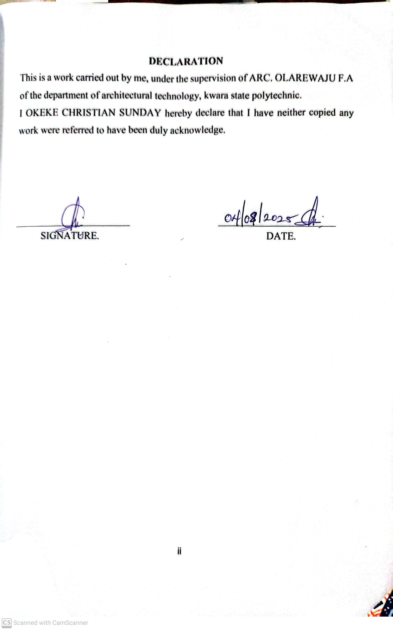
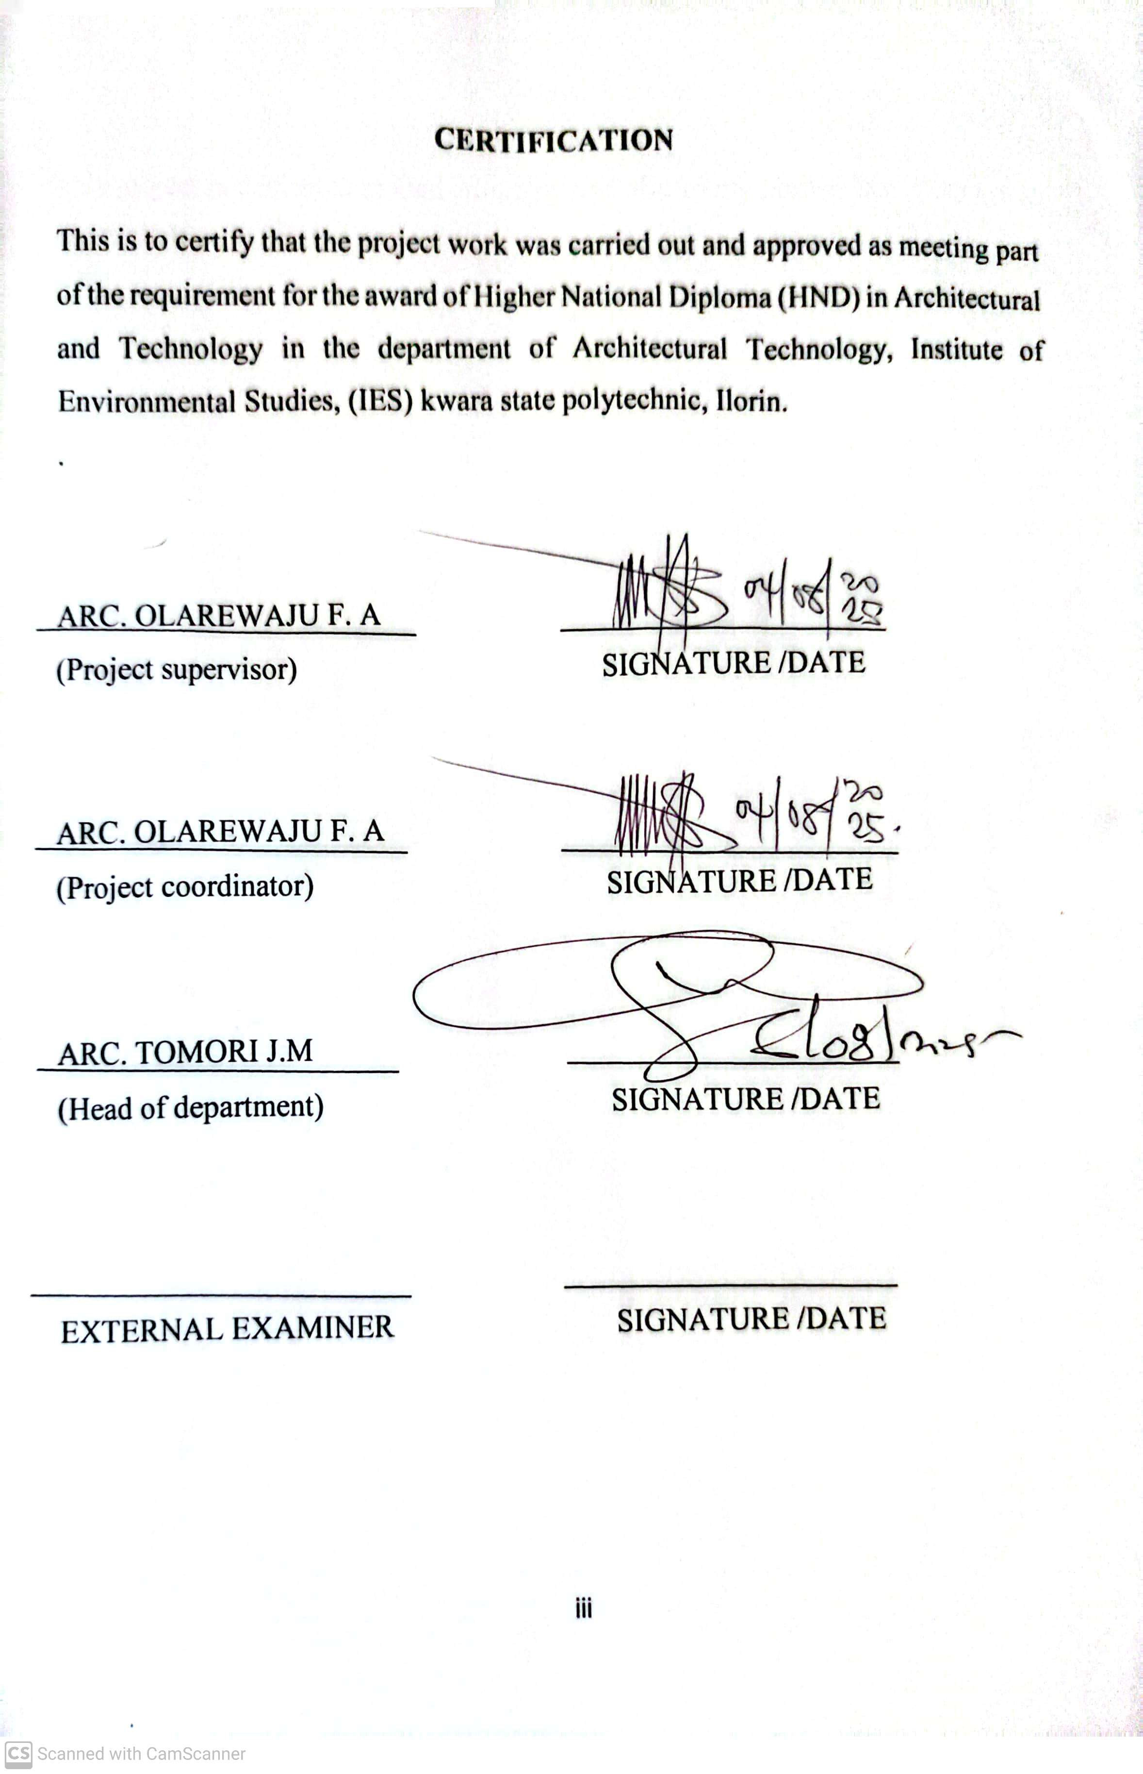
DEDICATION
This project is dedicated to God Almighty and also to my brother MR AND MRS OKWUDILI OKEKE.

ACKNOWLEDGEMENT
I give all adoration and thanks to God Almighty, the giver of life and Joy for giving me this great opportunity, strength and wisdom to start and conclude the program of Higher National Diploma and to study Architecture in the great institute of environmental studies.

I must appreciate and gratify the devoted assistance of my supervisor ARC. Olarewaju F. A, for the commencement to this work to the very end. To all academics and non-academics staff members of the department of Architectural Technology, ARC. Tomori J.M, ARC. Abdulazeez B.Y.F, ARC. Solomon Familua, ARC Chucks. God bless you all.

I would like to place my sincere appreciation and thanks for the overwhelming support and love I received from my cousin MR AND MRS GODFRY OKEKE.

Special appreciation goes to my siblings Mr. Okwudili Okeke, Emmanuel Okeke,
Also to my colleagues and friends, Mmobuchi Emma, Mmaduako elochukwu, Orabuisi Uju, Aisha Ayobami, Abraham Joseph, Fatimah, and May God bless us all and crown our effort with success. Amen.

TABLE OF CONTENTS
TITLE PAGE
DECLARATION…...................................................................................................................ii
CERTIFICATION……………………………..…………………...……………………....... iii
ACKNOWLEDGEMENT……………………...……………………………………….…....iv
TABLE OF CONTENTS……………………..……………………..…………….…………...v
LIST OF TABLE…………………………………………….…………………….…….……vi
LIST OF FIGURE………………………………………..…….…..………….…….….……vii
LIST OF PLATE……………………………………………….……..………….……….....viii
LIST OF APPENDICES…………………………………...…..………………….…….....…vx
ABSTRACT………………………………………..………..….…………………….…….....x
CHAPTER ONE
1.0 INTRODUCTION……………………………...………………………………....…...1
1.2 BACKGROUND INFORMATION……….………...........…………….……...….….2
1.3 DEFINITION………………….………….…..………….………………….…….......3
1.4 STATEMENT OF PROBLEM…………….………………….…………………....... .3
1.5 AIM AND OBJECTIVES…………….……….…………..……………….…..….…..4
1.6 JUSTIFICATION…….………………...…….……………..…..........................….….5
1.7 DESIGN SCOPE…………………………………………………....................….......5
1.8 LIMITATION OF STUDY…………………………….…….……...…………..….....6
1.9 RESEARCH METHODOLOGY………………………………………..………….....7
CHAPTER TWO
2.0 LITERATURE REVIEW………….…………….……….……………..………...….10
2.1 CONDOMINIUM……………………………………..…………………………......10
2.2 EVOLUTION OF CONDOMINIUM……………….…………………….…….......10
2.2.1 MODERN CONDOMINIUM (INDIVIDUAL OWNERSHIP……………….…...…11
2.3 PROBLEM PECULIAR AND ISSUES IN CONDOMINIUM………………...…..11
2.4 TOWARDS THE DEFINITION OF A CONDOMINIUM…………………...……..14
2.5 PROBLEMS ASSOCIATED WITH CONDOMINIUM PROJECTS IN NIGERIA...15
2.6 ACOUSTICS IN CONDOMINIUM DESIGN……………..…….…………..…...…17
2.7 PRINCIPLES OF NOISE CONTROL IN CONDOMINIUM DESIGN……………….....18
2.5 TECHNOLOGICALLY AND ENVIRONMENTAL APPROACH…………………20
CHAPTER THREE
3.0 INTRODUCTION………………………...……………………………………....….22
3.1 CASE STUDY ONE……………………………………………………...……..........22
3.2 CASE STUDY TWO……………………………………………………......…..…....26
3.3 CASE STUDY THREE…............................................................................................30
3.4 CASE STUDY FOUR…..............................................................................................32
3.5 CASE STUDY FIVE…................................................................................................33
CHAPTION FOUR
4.0 HISTORICAL BACKGROUND OF THE SITE…………....…………….……….....34
4.1 THE HISTORY OF AWKA………………………………………………………….34
4.1.2 SITE LOCATION / DESCRIPTION…………………………...….…………...…….34
4.1.2.1SITE CRITERIA…………………………..……………………………....…….……35
4.1.3 SITE ANALYSIS………………….…………………………………...……….……36
4.1.3.1SITE INVENTORY………………………………………….......................…...……37
4.2 PROJECT ANALYSIS………………………………………………………….……40
4.2.1 DESIGN BRIEF……………….,……….……………………….....................….…..40
4.3 PROPOSED FACILITIES IN CONDOMINIUM DEVELOPMENT………………..41
CHAPTER FIVE
APPROACH TO THE DESIGN/DESIGN REALIZATION…………….…………………43
5.0 INTRODUCTION………………………………………..………………………...….…43
5.1 DESIGN IDEA / CONCEPT……………………………………….…………..….……..43
5.2 TECHNOLOGY AND ENVIRONMENTAL CRITERIA…………….……………….42
5.2.1 CONSTRUCTION METHODOLOGY…………………………...………………..….44
5.2.2 BUILDING SERVICES………………………………………………...…………...…45
5.2.3 ENVIRONMENTAL FOCUS……………………………………………………...…..47
5.4 ACOUSTICS………………………………………………………..……………...…….47
6.0 CONCLUSION…………………………………………………..…………………...….48
6.1 RECOMMENDATIONS…………………………………………,,……………….…….49

LIST OF FIGURE
SHOWING THE LOCATIONAL PLAN OF THE CASE STUDY……………………..…..23
SHOWING THE SITE PLAN CASE STUDY ONE……,………………..…………….…..23
SHOWING THE FLOOR PLAN OF CASE STUDY ONE……………..………………….23
SHOWING THE LOCATIONAL PLAN OF CASE STUDY TWO.………………….…….26
SHOWING THE SITE PLAN CASE STUDY TWO…………..…………………...…..……27
SHOWING THE FLOOR PLAN OF THE CAS STUDY TWO…………………….….….....27
SHOWING THE LOCATIONAL PLAN OF CASE STUDY THREE………………………30
LIST OF PLATE
SHOWING THE INTERIOR VIEW OF CASE STUDY ONE…………….…………..….…23
SHOWING THE EXTERIOR VIEW OF CASE STUDY ONE ……….…………………….24
SHOWING THE FRONT VIEW OF CASE STUDY ONE………………………………...24
SHOWING THE SITE INTERIOR VIEW OF CASE STUDY TWO………………………28
SHOWING THE INTERIOR VIEW OF CASE STUDY TWO ………………………....…28
SHOWING THE FRONT VIEW CASE STUDY TWO …………………..………….…….28
SHOWING THE SITE INTERIOR VIEW OF CASE STUDY THREE…………….…...…31
SHOWING THE INTERIOR VIEW OF CASE STUDY THREE……………….……….…31
SHOWING THE FRONT VIEW AND SIDE VIEW CASE THREE…………………….…..31

ABSTRACT

This project report presents a comprehensive design proposal for a modern urban housing development located in Awka, Anambra State. The motivation for the proposal stems from the increasing demand for well-planned residential units complemented by essential amenities to serve a diverse population, driven by urban growth, population increase, and the need for secure, comfortable, and affordable housing.

The architectural design of the project emphasizes environmental sustainability, functional efficiency, and user inclusiveness. Site planning adopts layout principles to clearly define residential blocks, recreational zones, and support structures such as green buffers, footpaths, and vehicular circulation. The layout includes multiple apartment units, a management office, communal green areas, children’s play zones, health post, and a security post. Materials are selected based on their availability, capacity, and energy efficiency to ensure a cost-effective and context-sensitive design.

A key feature of the proposed development is its inclusive and sustainable approach. The design incorporates accessible units for people of all ages and gender-sensitive communal spaces that can serve residential and recreational functions. Emphasis is also placed on safety, thermal ventilation, water conservation, and solar energy integration. Ornamental trees are used as green buffer, shading and regulating air quality and livability of the environment, ensuring a serene and welcoming atmosphere for residents.

CHAPTER ONE

1.0 INTRODUCTION
According to mark B. Weiss (2019) in the condominium concept, condominium (or condo for short) is an ownership regime in which a building (or group of buildings) is divided into multiple units that are either each separately owned, or owned in common with exclusive rights of occupation by individual owners. These individual units are surrounded by common areas that are jointly owned and managed by the owners of the units. The term can be applied to the building or complex itself, and is sometimes applied to individual units. The term "condominium" is mostly used in the US and Canada, but similar arrangements are used in many other countries under different names.
Residential condominiums are frequently constructed as apartment buildings, referred as well as Horizontal Property. There are also row house style condominiums, in which the units open directly to the outside and are not stacked. Alternatively, detached condominiums look like single-family homes, but the yards (gardens), building exteriors, and streets, as well as any recreational facilities (such as a pool, bowling alley, tennis courts, and golf course), are jointly owned and maintained by a community association.
Many shopping malls are commercial condominiums in which the individual retail and office spaces are owned by the businesses that occupy them, while the common areas of the mall are collectively owned by all the business entities that own the individual spaces.
Unlike apartments, which are leased by their tenants, in most systems condominium units are owned outright, and the owners of the individual units also collectively own the common areas of the property, such as the exterior of the building, roof, corridors/hallways, walkways, and laundry rooms, as well as common utilities and amenities, such as the HVAC system and elevators. In other property regimes, such as those in Hong Kong and Finland, the entire buildings are owned in common with exclusive rights to occupy units assigned to the individual owners. The common areas, amenities, and utilities are managed collectively by the owners through their association, such as a homeowner association or its equivalent.
Some condominium complexes consist of single-family dwellings. There are also "detached condominiums" where homeowners do not maintain the exteriors of the dwellings or yards, and "site condominiums", where the owner has more control and possibly ownership (as in a "whole lot" or "lot line" condominium) over the exterior appearance. These structures are preferred by some planned neighborhoods and gated communities.
Technically, a condominium is a collection of individual units and common areas along with the land upon which they sit. Individual home ownership within a condominium is construed as ownership of only the air space confining the boundaries of the home. The boundaries of that space are specified by a legal document known in the United States as a Declaration, filed on record with the local governing authority. These boundaries may extend to the interior side of the walls surrounding a condo, allowing the homeowner to make some interior modifications without impacting the common area. Anything outside this boundary is held in an undivided ownership interest by a corporation established at the time of the condominium's creation. The corporation holds this property in trust on behalf of the homeowners as a group—it may not have ownership itself

1.2 BACKGROUND INFORMATION

The history of condominium can be traced back to ancient time, with the concept of individual ownership of a dwelling in a milt unit building dating back to the romans.
1.2.1 ANICIENT ROMA
Citizen were permitted to own a individual units in multifamily structure ancient Roma cities called insula which contained multiple separate dwelling
The first recorded condominium project was the shoe estate in London England built in 1840, however, the project was not a true condominium in the modern sense as it was more cooperative own ship arrangement
The first modern condominium project is often credited to the Montreal apartment building in Montreal, Quebec, Canada was designed by architect Ross and Macdonald structure and it feature a unique ownership structure where each units was separately, but share common areas were jointly owned by all residents.
The first condominium project in United States was the Huntington apartment in New York City, built in 1913. The project was developed by the Harriman family and feature a condominium ownership structure.
The modern condominium concept gain popularity in the unite state in the 1950s and 1960s particularly in the city like Miami and New York. Today condominium are a common form of residential ownership around the world.

1.3 DEFINITION
A condominium, often shortened to "condo," is a type of housing where a resident owns their individual unit within a larger building or complex, but also shares ownership of the common areas with other resident

1.4 STATEMENT OF PROBLEM
Awka, the capital of Anambra State, is experiencing rapid urbanization and population growth due to its status as a government, educational, and commercial center. However, this growth has not been matched by a proportional development in modern, organized, and affordable residential housing, especially for middle-income earners, young professionals, civil servants, and small families.
The current housing landscape in Awka is dominated by informally planned apartments, poor infrastructure, and limited access to modern amenities, leading to a decline in residential quality, safety, and environmental comfort. In many cases, essential services such as waste management, water supply, security, and recreational spaces are inadequate or entirely absent.
Moreover, the lack of integrated residential communities that combine housing with social, commercial, and leisure facilities has led to increased traffic congestion, poor work-life balance, and reduced quality of life for residents.

Therefore, there is a critical need for a well-designed, climate-responsive, and service-oriented condominium development in Awka that will:
- Provide functional, secure, and comfortable living spaces;
- Integrate essential services and lifestyle amenities;
- Respond to climatic and environmental conditions;
- Promote community living and social interaction and align with sustainable urban development goals.

1.5 AIM AND OBJECTIVES

1.5.1 AIM
The aim of this project is to design functional and aesthetically pleasing living spaces that improve residents’ quality of life.

1.5.2 OBJECTIVES
- To design a functional layout that ensures efficient circulation, privacy, and spatial organization for residents.
- To incorporate modern amenities and services such as recreational facilities, retail spaces, green areas, parking, and security systems within the development.
- To respond to the local climate and environment through passive design strategies such as optimal building orientation, natural ventilation, solar shading, and landscaping.
- To promote community interaction and social cohesion through the inclusion of shared spaces like a clubhouse, multipurpose hall, playgrounds, and courtyards.
- Implementing smart building system to enhance energy efficiency and security and resident experience
- To ensure accessibility and safety, including provision for emergency access, disabled-friendly paths, and a secure, gated environment.

1.6 JUSTIFICATION
The need for this condominium project arises from the increasing housing demand in Awka, driven by urban migration, growing population, and the city's emergence as a government, academic, and commercial hub. The current housing stock is largely inadequate in terms of quality, safety, infrastructure, and aesthetics, especially for middle-class and upwardly mobile residents.

1.7 DESIGN SCOPE
This study focus on enhancing the safety and comfortably in the design of condominium in Anambra state. The design project will provide facility that are necessary in the condominium which more emphasis on passive mean of safety and comfortably. The outdoor space as much as the indoor space will receive attention.
1.7.1 Facilities to be provide in condominium would includes
GATE HOUSE
GENERATOR HOUSE
MAIN CONDOMINIUM (PROSOSED DESIGN)
PARKING LOTS
TENNIS COURT
BASKET BALL COURT
ADMINISTRATIVE UNITS
SWIMMING POOL
1.7.2 DESIGN BRIEF
RECEPTION
LOUNGE
KITCHEN
DINING
BEDROOM
TOILET AND BATH
GAME ROOM
MASSAGE ROOM
MINI POOL
YOGA ROOM
EXIT
LIFT
STAIRCASE
BAR
COMMUNITY LOUNGE
MINI MART/ RESTAURANT
GYM

1.8 LIMITATION OF STUDY
The limitation experienced during the course of study includes.
Time constraint.
Financial constraint: the project design was quite overwhelming as it was not expected.
Less Information: certain units was restricted during the research which could have help my proposed design and equally improve my knowledge of the design project.
1.9 RESEARCH METHODOLOGY

Information needed to design a standard condominium are obtained through the following;
- Case study
- Oral interview
- Literature review
- Internet browsing
In carrying out this work, data were collected from diverse source which can be classified into primary and secondary source.
PRIMARY SOURCE: Some of the data for this project were gathered by carrying out series of case studies and making direct observation of the data as they occur. Questions were asked when needed, with a view to have a better understanding. Some of the data were accompanied by photographs since certain level of details is required.
CASE STUDY: This involves visiting the existing building or structures of related project (CONDOMINIUM) to know needed information.
ORAL INTERVIEW: Oral interview is adopted to seek opinion of available officials and managers, and were considered as a major respondent who provide a very useful information in deciding the concept and scope of the project.
SECONDARY SOURCE: past literatures were reviewed to get some data for this work. Some were collected from internet, encyclopedia and previous related projects.

DEFINITION OF TERMS
i. Condominium (Condo)
A condominium is a type of residential property where individual units are owned separately, while common areas such as hallways, recreational spaces, parking lots, and external infrastructure are jointly owned and maintained by all residents through a management body or homeowners’ association. Condominiums are popular in urban centers due to their space efficiency, shared amenities, and community living structure.

ii. Condominium Complex
A condominium complex refers to a cluster of individual condo units within a single or multi-building development. It may include residential towers, parking structures, landscaping, and shared facilities such as gyms, lounges, swimming pools, security posts, and maintenance areas. The design of the complex integrates privacy with community engagement, often regulated by shared ownership agreements.

iii. Reverberation
In a residential context, reverberation refers to the prolonged reflection of sound within a room or enclosed space. Excessive reverberation in common areas such as lobbies or recreation halls can hinder speech clarity and acoustic comfort, hence it is controlled using sound-absorbing materials in the architectural finishes.

iv. Vibration
Vibration refers to the oscillatory motion of building elements, often caused by mechanical systems, footfall, or structural interaction. In condominiums, vibration control is essential for comfort, especially in multi-story buildings where impact noise and mechanical vibrations can transfer between units.

v. Noise
Noise is defined as any undesirable or disruptive sound. In condominium environments, noise management is critical for maintaining privacy and comfort between adjacent units and public spaces. Acoustic insulation, zoning, and building orientation help reduce noise transmission.

vi. Sound
Sound is the movement of air particles through pressure fluctuations within the audible range. In architecture, sound is considered in both functional and comfort terms—enhancing positive acoustic experiences in communal spaces while minimizing intrusive noise in private living areas.

vii. Echo
Echoes are distinct sound reflections that return to the listener with a delay after the original sound. In large condominium lobbies, corridors, or atriums, untreated surfaces can cause echo effects, which are mitigated through the use of acoustic ceiling panels, soft furnishings, and strategic space planning.

CHAPTER TWO
2.0 LITERATURE REVIEW
2.1 CONDOMINIUM
According to mark B. Weiss (2019) in the condominium concept, A Condominium, often shortened to condo in the Nigeria and in most developed country, is a type of living space which is similar to an apartment but which is indendently sellable and therefore regarded as real estate. It is where the condominium building structure is divided into several units that are each separately owned, surrounded by common area that are jointly owned. Similar concepts in other English speaking countries include strata title in Australia, Malaysia, New Zealand and the Canadian province of British Columbia, common hold in United Kingdom.
Residential condominium are frequently construction as apartment building, but there has been an increase in the number of detached condominium which look like single family home but in which the yard , building exterior and street are jointly owned and jointly maintained by a community association

2.2 EVOLUTION OF CONDOMINIUM
The concept of condominium has evolved significant, starting from it early interpretation as a joint rule of a territory by multiple entitle, often to avoid conflict to its modern meaning of individual owned residential units within a complex.
This evolution can be traced through the different stage:
Early interpretation (joint rule / territorial control)
In Europe, particularly in the middle ages and early modern period, condominium was used to describe situation where two or more state jointly exercise control over a territory, often to prevent disputes or prolong military conflict.
The purpose was often to secure border area or port, or to have ensure that no single power would have exclusive control over a territory.

2.2.1 MODERN CONDOMINIUM (INDIVIDUAL OWNERSHIP)
The modern understanding of condominium refer to a building or complex where individual units are individually owned, but shared amenities and common area are maintained by a homeowner association. This concepts emerge later, particularly in the 20th century, with the growth of apartment building and the desire responsibility of owning a house.
2.3 PROBLEM PECULIAR AND ISSUES IN CONDOMINIUM
While offering convenience living, have unique challenges streaming from sharing ownership and commercial living
Common issue include:
- maintenance and up keeping of common area
- conflict resolution among residents
- management of shard amenities

Furthermore issues like noise pollution, security concern and enforcing bylaws can also arise in condominium living.
- Maintenance and up keeping of common area: Sharing spaces like hallways elevator landscape and pool require cooperation and financial contribution from all residents
- Conflict resolution among resident’s noise and disturbance: Enforcing quiet hour and addressing noise complaint can be also challenging particularly in decent polluted area.
- Management shared amenities: Ensuring that shared amenities like gym swimming pool recreation area etc. are well maintained used fairly required carefully management.
2.3.1 Functions and relationship between common
In condominium building common spaces serve a critical social and functional role they facilitated in interaction between residents provide opportunity for recreation and offer share amenities like lobbies, hallways, elevation, and outdoor areas.
2.3.2 Functions of sharing a common space
- Social interaction
- Access and circulation.
- Shared amenities
- Properties management
- Community building
- Relationship between common space and private units
- Interconnectedness
- Shared resources
- Virtual and social connection
- Maintenance and responsibilities
2.3.3 Examples of common area
- Parking lots
- Elevator
- Gym
- Hallway
- Pool
- Garden
- Lobbies
- Fire escape
- Stairways
- Laundry
- Lounges
2.3.4 Variants of building types condominium
Condominium often referred to as apartment building can be classified based on factors like occupancy construction types and units configuration
2.3.5 Bases of type classification.
Occupants: building a broadly categorized by their intended use with residential building being the most relevant to condominium
Construction type: building can be classified based on the material used in their construction and their fire resistance
Unit configuration: condominium units are often distinguished by their size and layout such as studies bedroom and multi bedroom units
Special features: condominium may also be classified by special features like penthouse, lofts, or but level units
Location and grade: condominium properties may be further classified by their location building quality and amenities such as the CBRE introduction to condo grade classification.
2.3.6 Types of condominium building
- Residential building apartments this is the primary classification encompassing multi-unit residential complex where individual units are owned
- Studio units these are open plan apartments where the living space, dining area, kitchen and bedroom are combined into one
- Bedroom units (1bedroom 2 bedroom etc.) these units are characterized by the number of bedroom with variation and size and layout
- Loft units: these units often features open plan design with high ceiling and exposed structure element
- Penthouse units these are tropical located on the top floor of a building often with large size of panoramic view
- Townhouse / terrace building those houses are single family home these are attached to other house sharing a common one
- Duplex / These are multifamily buildings that can have two or three separated units

2.4 TOWARDS THE DEFINITION OF A CONDOMINIUM
A condominium is a residential development consisting of individually owned housing units within a multi-unit building or complex, which may also include shared common spaces and amenities. It represents not just a modern housing solution, but also a reflection of contemporary urban living, catering to the needs of diverse residents within a defined locality. According to CRES (2014), condominiums are an integral part of evolving housing systems that support social interaction, economic efficiency, and spatial sustainability. The condominium, though a relatively modern residential concept, combines multiple functions—residential, recreational, administrative, and commercial—into a unified built environment that adapts to both the location and the needs of its users.
A condominium can thus be defined as a multi-use residential development that integrates private ownership of individual units with collective ownership and management of common facilities such as corridors, elevators, recreation areas, gyms, and parking spaces. The architectural flexibility of condominiums allows for a multifunctional use of space, enhancing efficiency in land use and minimizing construction and maintenance costs while ensuring convenience for residents.
According to the Macmillan Free Dictionary (2016), a condominium is a building or complex of buildings containing a number of individually owned apartments or houses. It becomes particularly compelling when the architectural design incorporates local character and environmental responsiveness, blending modern living with cultural identity. Therefore, the condominium is not just a housing solution, but also a setting for community life, providing facilities for recreation, interaction, and sometimes commercial or institutional functions.
In modern urban planning, the design of a condominium should focus more on harmonizing with the environment and promoting resident comfort, rather than dominating the landscape with imposing structures. This shift reflects a deeper understanding of ecological balance and the necessity of preserving the natural and social environment in any residential development.
The New Encyclopedia Britannica (2015) gives insight into the condominium as an efficient urban housing typology that organizes residential units and shared amenities in a way that maximizes land use and enhances communal living. In many cities, condominiums are strategically located within or near business districts or transit hubs, making them a practical choice for both individuals and families seeking accessibility and urban convenience.
Mermoud (2016) traces the philosophical roots of collective housing to ancient models such as the Roman insulate and the Greek polis, where dense yet organized communal living was a practical and cultural norm. Similarly, the site selection for a condominium is critical—it should ideally be located near economic centers, transportation routes, and essential services. The management offices, security posts, recreational lounges, and maintenance departments are often centralized within the development for efficiency.
The size and scale of the condominium project are determined by the target population, the range of services to be provided, and the economic strength of the developer. A small condominium might include a few residential blocks with shared parking and green spaces, while a larger development may feature a clubhouse, retail outlets, healthcare services, and even co-working spaces. It is also desirable to include open spaces, gardens, or roof terraces to enhance the quality of life within the development (Kancevica, 2016). One common challenge in condominium planning is balancing land availability with cost—prime urban locations offer the highest value but often the least space, while outlying areas may have more land but less economic incentive.

2.5 PROBLEMS ASSOCIATED WITH CONDOMINIUM PROJECTS IN NIGERIA
Condominium development, like any large-scale residential project, is often accompanied by a range of challenges and constraints, which can be either man-made or natural. These issues vary in scope, complexity, and impact, depending on the specific location, design approach, target demographic, and management strategy of the project. In Nigeria, these problems are particularly significant due to urban pressures, socio-economic disparities, and weak regulatory enforcement.

The most prevalent problems associated with condominium projects in Nigeria include the following
- Inadequate Design Concepts. Many condominium developments suffer from poorly conceived architectural designs that fail to consider local climate conditions, user behavior, accessibility, and future expansion needs. This often leads to inefficient use of space, lack of ventilation, inadequate parking, and congestion within shared areas. In some cases, designs are copied from foreign models with little adaptation to local realities.
- Poor Functional Allocation of Spaces. A common issue in Nigerian condominiums is the improper distribution of functional spaces. Residential units are sometimes cramped, while communal spaces such as lobbies, corridors, and recreational areas are undersized or neglected altogether. Inadequate separation between private and public zones within the development can also affect residents’ privacy and comfort.
- Inefficient Siting and Location. The siting of condominiums often fails to consider accessibility, infrastructure availability, proximity to basic services, or the environmental impact of construction. In some cases, condominiums are located in flood-prone areas, on unregulated plots, or in zones without adequate road networks, drainage, or utility connections.
- Financial Constraints. The cost of developing and maintaining condominium projects in Nigeria is high, and limited access to funding can delay or compromise project execution. Developers may cut corners due to funding gaps, resulting in substandard construction quality. Additionally, potential buyers or residents may be unable to afford the fees required for shared services or facility management.
- Poor Maintenance Culture. A significant challenge is Nigeria’s generally weak maintenance culture, especially in multi-occupancy buildings. Over time, shared facilities such as elevators, water systems, power supply, and waste disposal units deteriorate due to lack of regular servicing and insufficient contributions from residents toward maintenance costs. This leads to rapid degradation of the living environment and reduces property value.
- Sound and Environmental Control Issues. Condominium buildings often struggle with acoustic control and noise pollution, especially in densely populated urban areas. Poor sound insulation between units leads to disturbances, while lack of proper waste and water management systems can result in health and environmental hazards.

2.6 ACOUSTICS IN CONDOMINIUM DESIGN

Acoustics, as defined by Jacobsen (2011), is the science of sound—encompassing the behavior of wave motion in gases, liquids, and solids, as well as the effects of these waves in various environments. In the context of architectural design, acoustics plays a crucial role in environmental control within buildings, especially in multi-occupancy residential developments like condominiums. The study of acoustics is inherently architectural; sound behaves in response to the spatial configuration, material selection, and surface treatments of a building. Therefore, effective acoustic design is essential in enhancing both the functionality and comfort of residential spaces.
Contemporary architectural practice now recognizes that buildings are more than passive shelters—they are active systems of environmental control that regulate thermal comfort, lighting, spatial organization, and acoustics. Well-designed acoustic systems in condominiums—such as sound-insulating walls and floors, acoustic ceiling panels, noise-dampening windows, and strategic zoning of noisy vs. quiet areas—can significantly improve residential experience.

2.7 PRINCIPLES OF NOISE CONTROL IN CONDOMINIUM DESIGN
In the context of condominium living, noise control is an essential aspect of ensuring comfort, privacy, and health for residents in a high-density environment. Effective noise control requires a strategic understanding of the three fundamental elements in any noise transmission scenario:
- The Source of the Sound
- The Path through Which the Sound Travels
- The Receiver of the Sound
Although in real-life residential settings, there may be multiple noise sources, various transmission paths, and numerous receivers, the basic principles of noise control remain consistent.
In condominiums, the primary objective of a noise control strategy is to reduce the level of sound that reaches the receiver—usually the resident inside a unit. This can be achieved by making modifications at any of the three points: the source, the path, or the receiver, or ideally, a combination of all three
Controlling the Source of Noise

- The source of noise in a condominium could be internal or external. Common sources include:
- Mechanical systems (e.g., HVAC units, water pumps, elevators)
- Appliances (e.g., washing machines, generators, loudspeakers)
- Human activity (e.g., loud talking, footsteps, children playing)
- External elements (e.g., road traffic, construction, nightlife)
- To mitigate noise at the source, developers and property managers can:
- Install low-noise equipment
- Isolate mechanical systems from living areas
- Use vibration-dampening mounts
- Enforce community regulations on noise-generating activities
- Interrupting the Sound Path
- The path is the medium through which sound travels from the source to the receiver. In a condominium, this path can include:
- Airborne transmission (e.g., voices or music through walls)
- Structure-borne transmission (e.g., footsteps or plumbing vibrations through floors or walls)
- Reflective paths (e.g., sound bouncing off hard surfaces like tiles or glass)
To control the path:
- Use sound-insulating materials in walls, ceilings, and floors (e.g., dense gypsum board, acoustic underlays)
- Install double-glazed or laminated windows to reduce external noise
- Apply carpets, acoustic panels, and soft furnishings to absorb interior sound reflections
- Ensure proper acoustic sealing around doors, windows, and utility openings
Protecting the Receiver
- The receiver is the person or space affected by the noise. Though often the most passive element, protective measures can still be implemented, such as:
- Zoning quieter rooms (like bedrooms) away from noise-prone areas (like roads or elevators)
- Creating buffer zones (e.g., corridors or storage areas) between units
- Designing unit layouts to minimize the exposure of sensitive rooms to shared walls or mechanical shafts
2.8 TECHNOLOGICALLY AND ENVIRONMENTAL APPROACH
A sustainable condominium design integrated technological and environmental approach in building structures, material, lightening, ventilation, and mechanical service
This include using ecofriendly materials implementing national ventilation system.
2.8.1Structural design and material
- Eco friendly material: Utilize sustainable material like reclaimed wood, bamboo and recycled concrete. This material have lower environmental impacts than traditional option
- Structural design consider: Lightweight and efficiency structure system potentially incorporating prefabrication technique to reduce construction waste and time.
- Building orientation: Orient the building to maximize natural lighting and ventilation, reducing reliance and artificial system.
- Lighting LED lights: Switched to LED lighting which uses significantly less energy than traditional incandescent or fluorescence blub.
- Daylights: Designed for Optimal national lights penetration reducing the need for artificial lighting during daylight hours.
- Mechanical and service: Smart home technology integrates smart thermostat, Water heater and other appearances for energy management and efficiency.
- Water Conservation: Install low flow features and rainwater the businesses tend to reduce water consumption
- Renewable energy: Consider incorporating solar panel and other renewable energy sources to power the building.
- Ventilation Natural ventilation Embrace natural ventilation system like cross ventilation when diving ventilation and stick ventilation this system utilizes natural airflow for cooling and ventilation
- Energy efficiency HVAC system: If artificial ventilation is required use high efficiency HVAC system that minimize energy consumption.

CHAPTER THREE

CASE STUDIES
3.0 INTRODUCTION
Case study can be defined as the process of investigation or researching and analyzing an existing project in order to allow creating an improvement in a proposed project.

3.1 CASE STUDY ONE

APARTMENT 1004
    - Location: Victoria Island, Lagos state.
3.1.2 Historical Background:
The estate was constructed in the 1970s during Nigeria’s oil boom era. It was completed in 1979 as part of the Nigerian government’s plan to provide modern, high-density housing for federal civil servants and expatriates.

Architectural Design: Designed by the architectural firm Nickson and Borys, the estate showcases a modernist design, featuring high-rise apartment blocks and a compact, organized layout that was advanced for its time.
Initially built as official quarters for federal legislators and top government officials, especially members of the National Assembly.
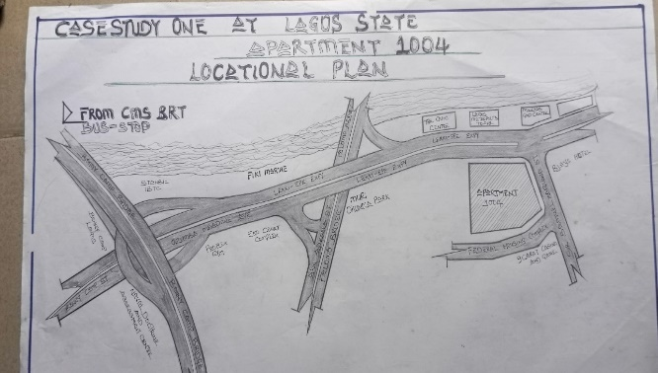

LOCATIONAL PLAN
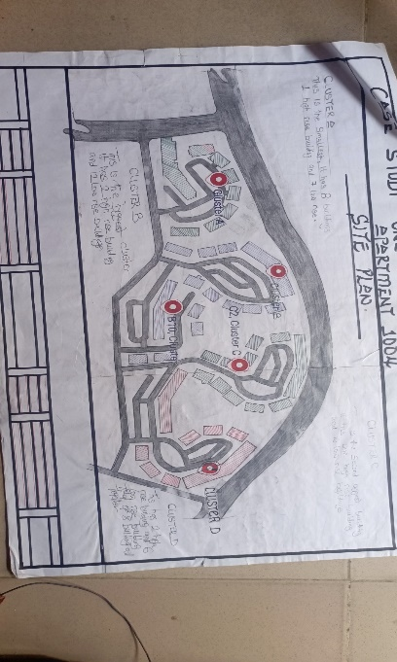

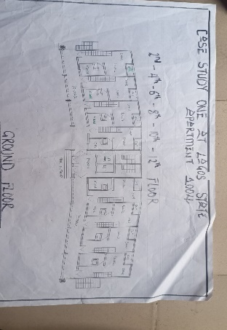

SITE PLAN

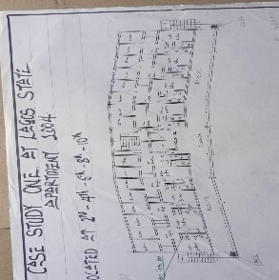

GROUND FLOOR, 2ND, 4TH, 6TH, 8TH, 10TH, 12TH, 14TH

1ST FLOOR, 3ND, 5TH, 7TH, 9TH, 11TH, 13TH, 14TH
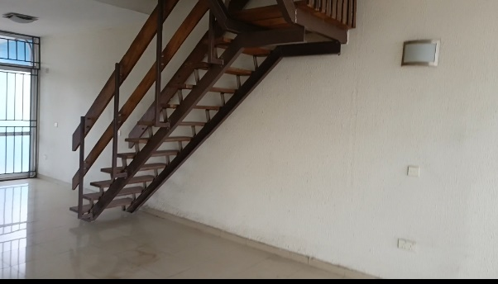

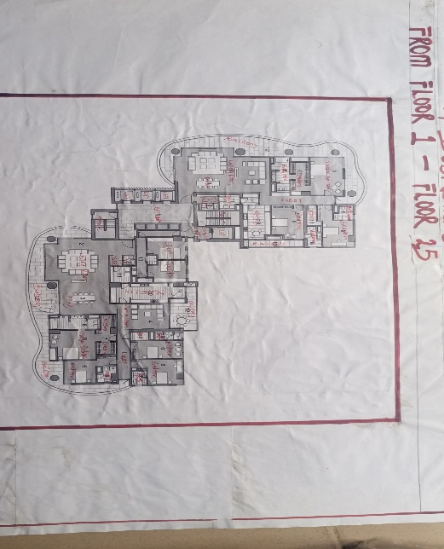
INTERIOR VIEW
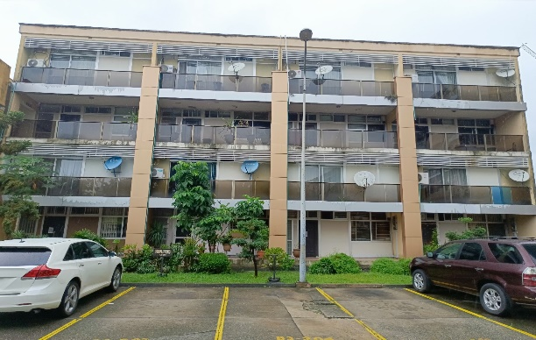

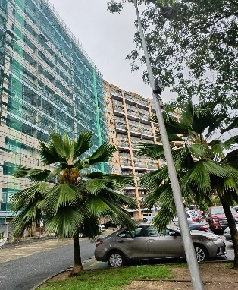
LOW RISE BUILDING

HIGH RISE BUILDING
3.1.3 MERITS
- High ceiling and generous layout especial in 2-4 bedroom units and penthouse.
- Smart use of land over 1000 apartment on approx. 11 hectares, with sufficient space for courtyard, green area and common facilities
- It is easy to locate.
- The location is easily accessible.

3.1.4DEMERITS
- Inadequate smart system amenities.
- Poor landscaping
- Outdated infrastructure
- Renovation is difficult due to the rigid structural design and shared utilities.
- Limited privacy, balconies and windows face other apartment closely in some blocks which reduce privacy.

3.2 CASE STUDY TWO

4 BOURDILION APARTMENT
3.2.1 Location: No4 Bourdillon Rd, Ikoyi, Lagos 106104, Lagos.

3.2.2 Historical Background:
Development & Timeline:
The project was conceived and developed in the early 2010s as part of the wave of luxury high-rise developments reshaping the Lagos skyline.
It was completed and launched around 2019–2020.

Developed by Kaizen Properties, a Nigerian real estate firm focused on delivering high-end residential and commercial developments.
Architecture and design services were provided by top international consultants.

The vision behind 4 Bourdillon was to create world-class luxury living in the heart of Ikoyi, combining elegant architecture, modern amenities, and exclusivity. It was targeted at high-net-worth individuals, including business executives, expatriates, and influential Nigerians.

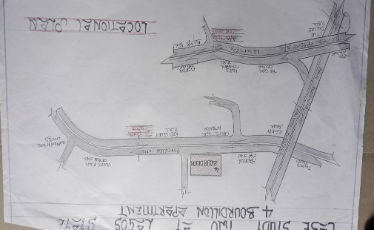

LOCATIONAL PLAN
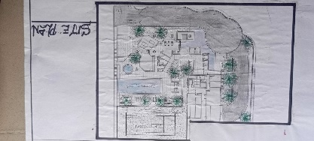

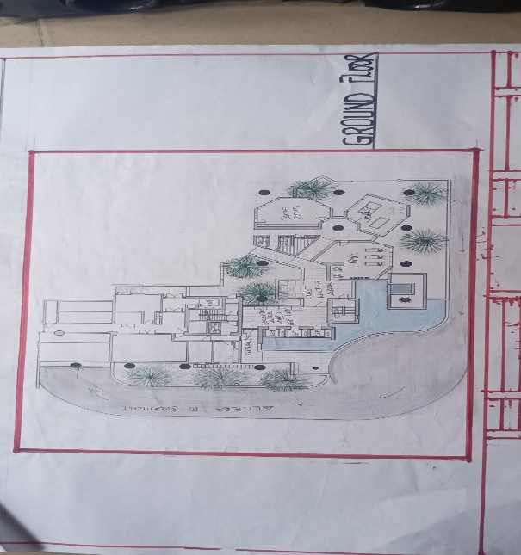

SITE PLAN

GROUND FLOOR

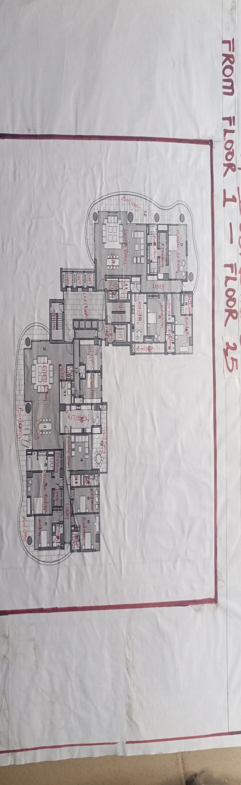

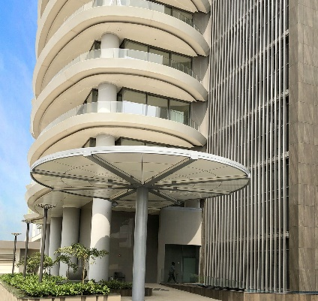
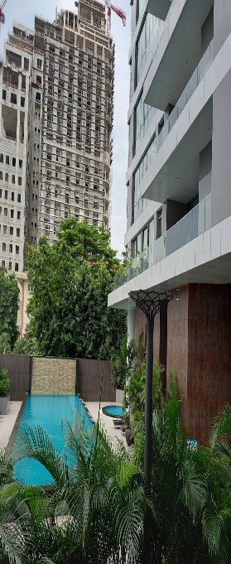
1ST FLOOR TO 25TH FLOOR

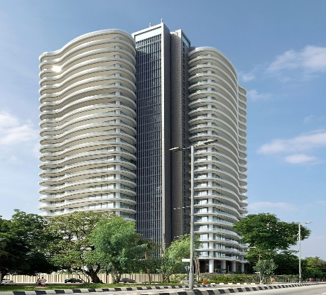
ENTRANCE BACK

EXTERIOR VIEW
3.2.3 MERITS
- Sustainability elements: large windows allow natural day lighting reducing the need for artificial lighting during the day
- Landscaping includes green buffer and water features creating a serene and passive coiling environment
- Visitor screening and identity verification protocol at the main gate and reception
- CCTV cameras installed throughout common area, lobbies, parking lots, elevator and perimeter zone

3.2.4 DEMERITS
- No restaurant, cafe or mini mart for the resident or occupants.
- Residents must rely on external restaurant or arrange for private chef.
- Limited community space apart from the club house.

3.3 CASE STUDY THREE
25 TANGO TOWER
3.3.1 Location: 25 Bourdillon Road, Ikoyi, Lagos.
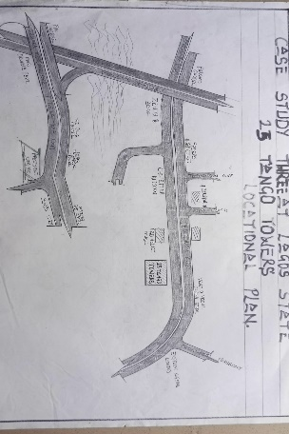
3.3.2 Historical Background:
The most famous residential tower in Lagos, Tango Towers is one of the most desirable places to live and is always used as an example of luxury living in Lagos. This full floor penthouse apartment has had extensive upgrades, including the floor, kitchen, lighting and wardrobes. This 4 bedroom apartment is spread across the entire 11th floor, with a large private balcony, private lobby.

LOCATIONAL PLAN
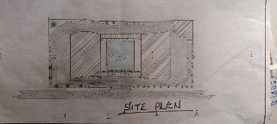

SITE PLAN

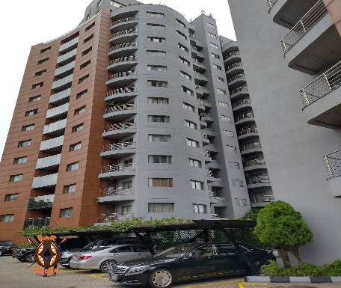

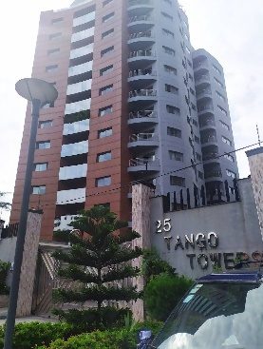

3.3.3 MERITS
- Natural Lighting Good daylight through large windows and balconies.
- Controlled Access Design, Single gated vehicular and pedestrian entry provides a choke point that is easier to monitor and defend.

3.3.4 DEMERITS
- No Smart Building Features. Lacks visible integration of smart home systems.
- Heat Gain & Limited Shading. Heavy use of glass without deep overhangs or louver systems cause excessive solar heat gain, increasing reliance on AC.
- Outdoor Communal Space. The building footprint and layout limit green/open spaces for residents to interact.
- Single Entry Point per Tower which can lead to increases risk during emergencies or high visitor traffic.

3.4 CASE STUDY FOUR (ONLINE)

THE GRAND CONDOMINIUM
3.4.1 Location: 1717 N Bay shore Dr. Miami, FL 33132, USA
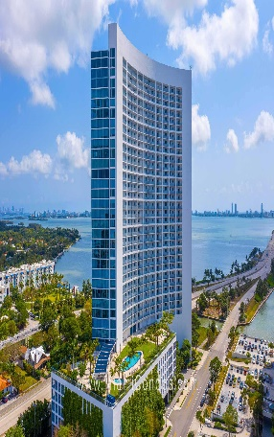
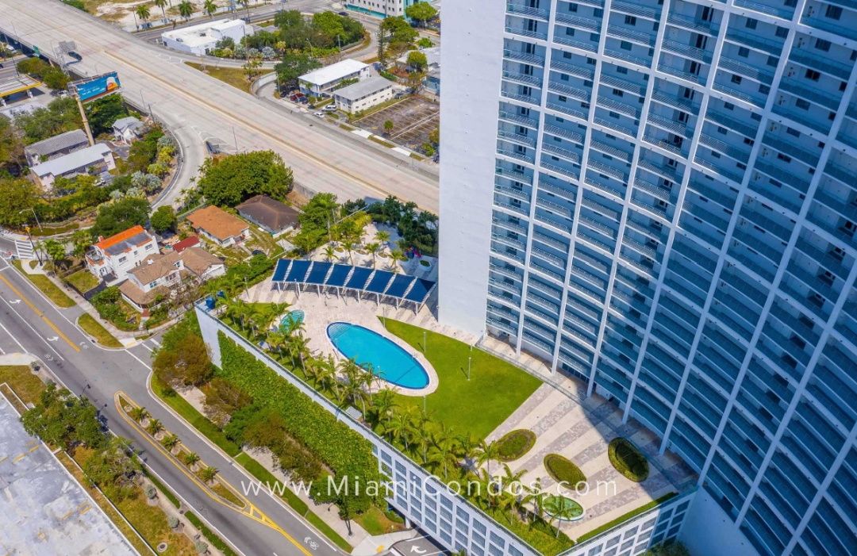

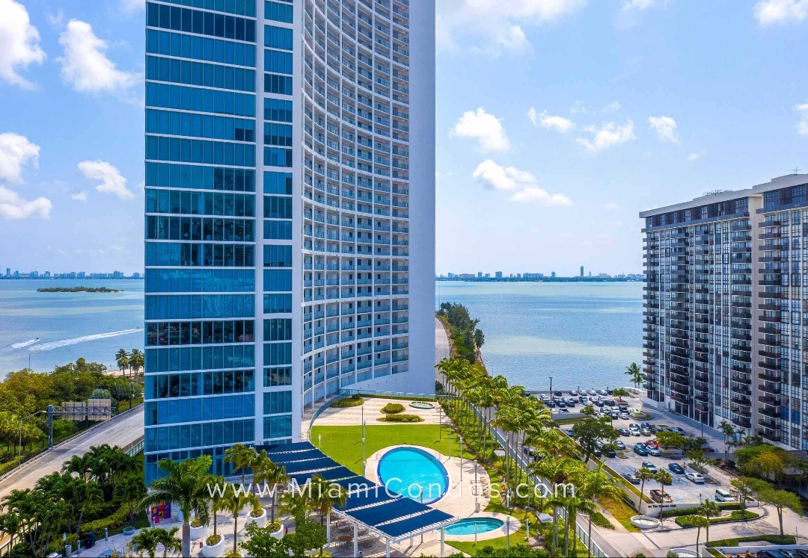

3.5 CASE STUDY FIVE (ONLINE)

THE MET CONDOMINIUM
3.5.1 Location: 123 South Sathorn Road, Thung Maha Mek sub-district, Sathorn, Bangkok 10120
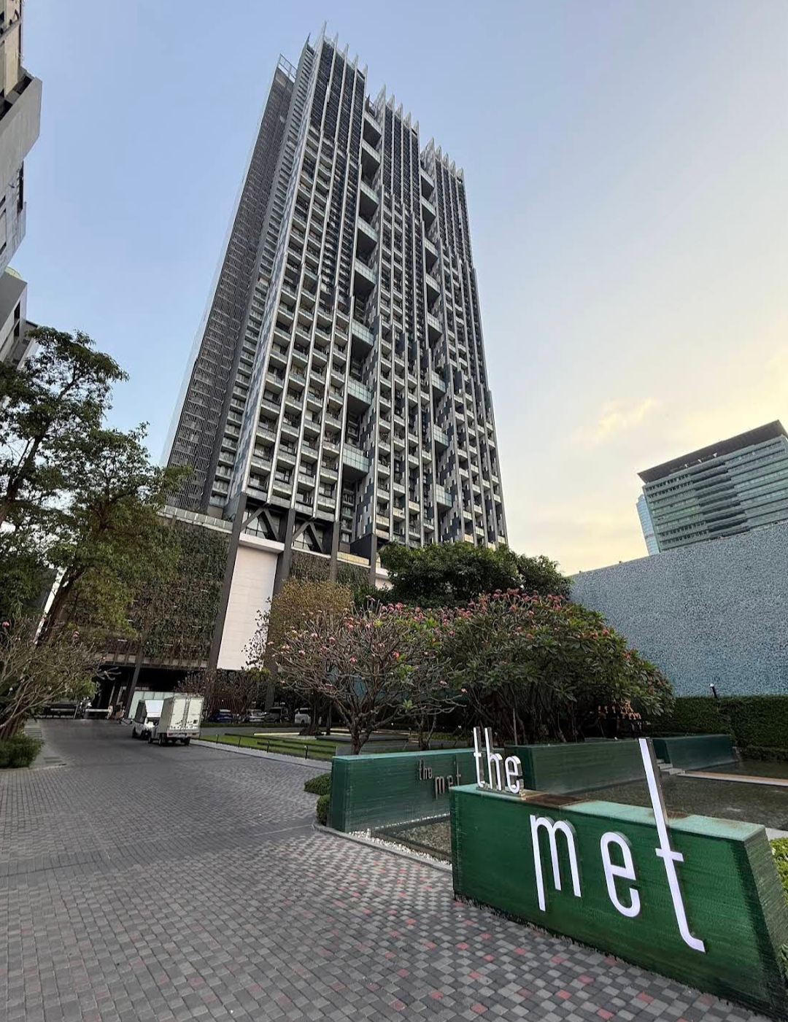

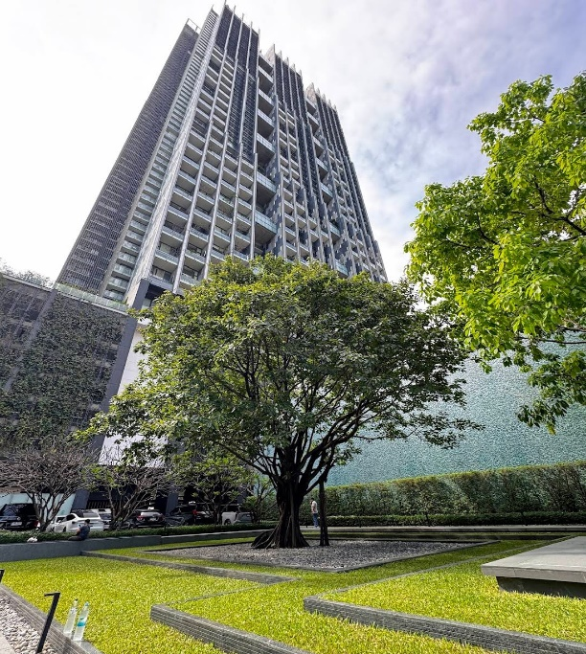
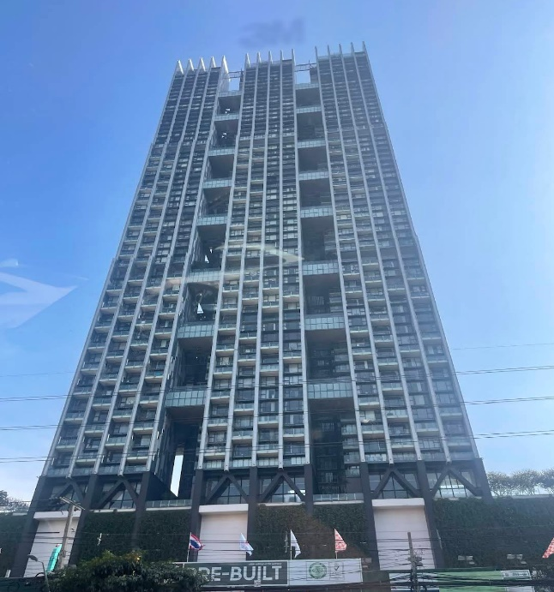

CHAPTER FOUR
4.0 HISTORY/ INTRODUCTION OF STUDY AREA

4.1 The History of Awka
Awka is the capital city of Anambra State, located in southeastern Nigeria. Historically, it is one of the oldest and most prominent towns in the Igbo heartland. Awka has long been recognized as a center of blacksmithing, with its skilled ironworkers producing tools, weapons, and ritual objects used throughout Igbo land. This craftsmanship earned Awka a place of importance in pre-colonial times.
Before British colonization, Awka was governed through a system of traditional leadership and council of elders, with decision-making power vested in titled men and lineage heads. The town was made up of several villages and kindred’s, united by shared ancestry, customs, and religious practices.
During the colonial era, Awka played a vital role in the administration of the Eastern Region due to its strategic location and educated population. It later gained prominence as the capital of Anambra State when the state was restructured.
Today, Awka is a growing urban center, home to government institutions, businesses, and educational establishments. It hosts the Nnamdi Azikiwe University (UNIZIK), one of the major federal universities in Nigeria. Despite its urbanization, Awka retains many aspects of its traditional identity and continues to serve as a link between Anambra rich cultural heritage and modern development.

4.1.2 SITE LOCATION / DESCRIPTION
The proposed site is located in Awka, the capital city of Anambra State, and can be easily identified due to its notable surrounding landmarks. It is situated along Villa Garden Hotel awka, and is located not far from the central bank of Nigeria awka, a major connecting point in the city. The site lies approximately a 5-minute drive from the express road Awka, making it easily accessible by road.
Its closeness to key infrastructure and transportation routes enhances its visibility and strategic importance, making it a prime location for development.

4.1.2.1 SITE CRITERIA
The selection of the proposed site for the condominium development in Awka is based on established urban planning principles, referencing Appleton (2008). The site meets the following critical criteria for residential development:
- Accessibility: The site is well-positioned along a major road in Awka, providing easy access for residents and service vehicles. The road network supports smooth traffic flow, with provisions for an internal service road to manage peak hour traffic and ensure emergency access.
- Relationship to the Building and Surroundings: The site’s expansive land area allows for optimal placement of residential blocks, recreational areas, green zones, and ample vehicular parking. Its configuration supports natural zoning, privacy, and phased development if needed, while maintaining functional linkages throughout the property.
- Vegetation and Landscaping Potential: The site is covered with green grasses and low shrubs, typical of Awka’s tropical vegetation. Due to its proximity to a water body and lowland areas, the environment remains lush for most of the year. Landscaping with trees and ground cover will enhance microclimate control, minimize erosion, and improve the visual appeal of the estate.
- Utilities and Infrastructure: The area enjoys access to essential public services, including electricity, water supply, telecommunications, and paved road infrastructure. These utilities reduce startup costs and support sustainable urban living.
- Topography: The site lies on lowland terrain with a gentle 0.5% gradient, sloping from the northeast towards the southwest. The land is relatively flat but mildly undulating in places. It will be appropriately leveled and compacted during construction to avoid future structural settlement.
- Air Movement: The site experiences both dominant North-East Trade Winds (dry, dusty, from December to February) and South-West Trade Winds (moist, from April to October). Landscaping with trees and shrubs will serve as a windbreak and dust filter.
- Orientation of Buildings: For optimal solar control and thermal comfort, buildings should be oriented with their longer sides facing northeast-southwest, reducing exposure to intense east-west solar radiation. This layout also encourages cross-ventilation and energy efficiency.
- Proximity to Public Utilities: The site is well-serviced, with proximity to key amenities such as tarred roads, electricity grid, borehole/water systems, internet connectivity, schools, healthcare facilities, and security services, ensuring convenience and comfort for future residents.
- Economic Value: The area is situated within a growing urban district of Awka, characterized by a mix of commercial and cultural activity. This makes it ideal for condominium development, offering both residential value and investment potential.
- Safety: The location is within a relatively secure neighborhood with a low incidence of crime. Security infrastructure, including neighborhood watch and law enforcement presence, contributes to the overall safety of the area.

4.1.3 SITE ANALYSIS
The proposed site for the condominium housing project in Awka occupies approximately 26.49 hectares of land. The site benefits from multiple points of access, with the primary access road located along the Amawbia–Nibo axis, a dual-carriageway with each flange accommodating up to four lanes. In addition, two service roads run along either side of the property, offering convenient routes for deliveries, utilities, and secondary access.
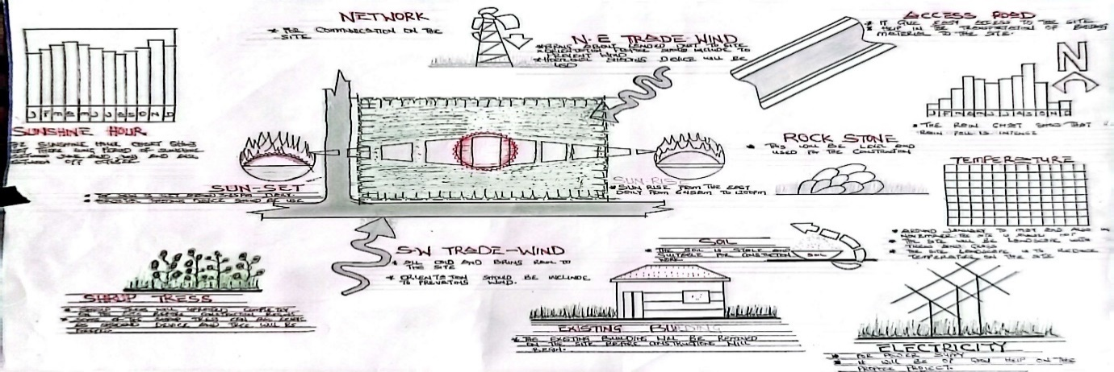

4.1.3.1 Site Inventory
This site inventory contains climatic and environmental conditions of the site and it was discovered that the Site is still a virgin land which gives an advantage to its proper use. Proper research has been carried out in View of acquiring relevant data that will be further analyzed to inform the design process of the building to Achieve functionality, stability and create a unique building experience.
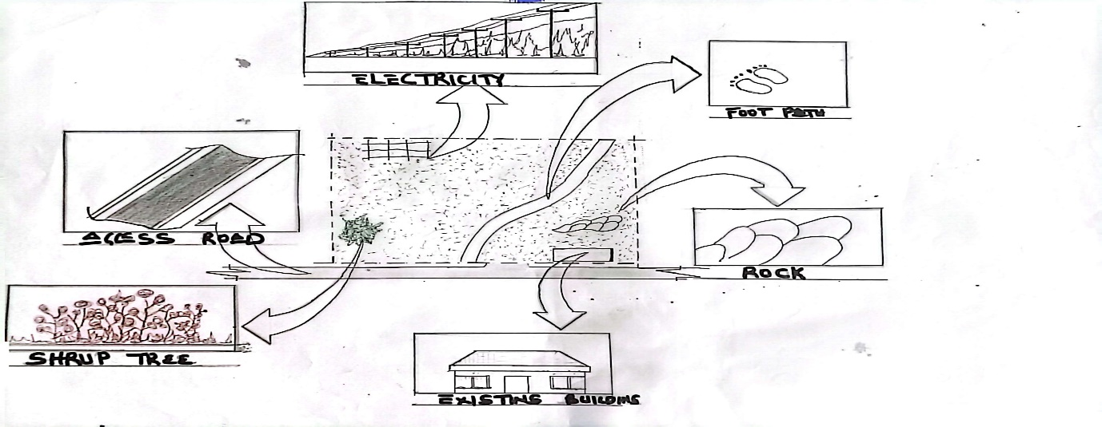

4.1.4 Topography and Slope of the Site
The topography of the site selected for the proposed design is even but characterized with mild gradients.

4.1.4.1 Climate Data.
Climatic conditions characteristically are measured over wider areas and lengthier time frames. In considering the climatic condition of the site the rainfall, temperature and prevalent wind speed were carefully considered using available climatic data from various sources.

Rainfall
Awka experiences a tropical rainforest climate characterized by distinct wet and dry seasons. The driest month is typically January, with an average rainfall of approximately 18 mm, while the wettest month is usually September, recording an average rainfall of around 1217 mm annually? The rainy season generally extends from April to October, with frequent and sustained rainfall during peak months.
This prolonged wet season often leads to elevated humidity levels and reduced solar exposure, whereas the dry season—marked by increased sunshine—results in higher daytime temperatures and discomfort, especially in the afternoon hours. These climate dynamics necessitate climate-responsive design strategies in the planning and construction of the condominium.
To mitigate direct solar impact and regulate indoor temperatures, the following architectural measures should be incorporated:
Shading devices (louvers, brise-soleil, pergolas)
Deep overhangs and terraces
Verandas and recessed balconies
Use of light-colored finishes and reflective materials
Landscaping with trees and vegetation to reduce heat gain and provide natural cooling
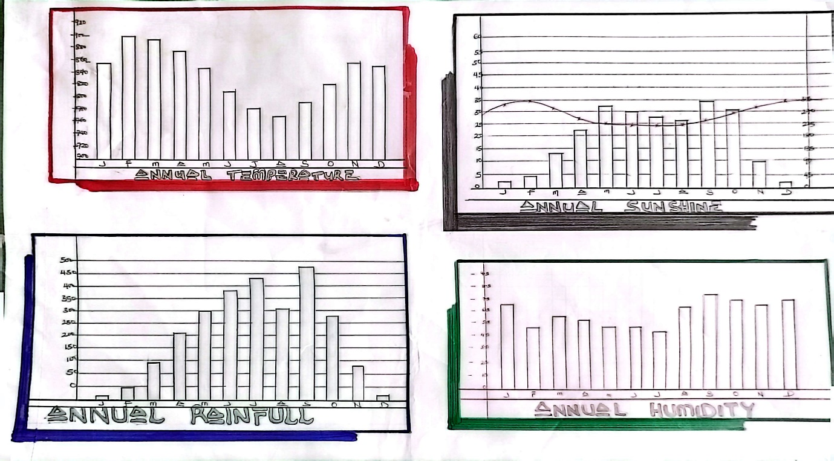

Temperature
The hottest period of the year in Awka occurs in March, with average daily temperatures reaching approximately 29.0 °C, while the coolest month is typically August, with average temperatures around 24.5 °C. Although temperature fluctuations are moderate due to the tropical setting, the high humidity can intensify perceived heat levels (heat index), causing significant discomfort if not properly addressed in the design.
It is essential that temperature and humidity challenges are considered from the conceptual stage through to construction. Integrating passive cooling techniques, natural ventilation, and thermally efficient materials will ensure that the condominium units remain comfortable year-round, thus enhancing the habitability and environmental performance of the development.

4.2 PROJECT ANALYSIS
4.2.1 Design Brief
The proposed condominium housing development in Awka, the capital of Anambra State, is conceived to serve the growing housing needs of residents within the city and its surrounding environs. Awka, being a fast-developing urban center with increasing population and economic activity, presents a strategic location for a well-planned, modern, and secure residential estate.
The condominium Is designed to cater to a diverse user group including civil servants, professionals, families, students, and investors seeking high-quality living in a serene and accessible environment. The development aims to provide a blend of privacy, comfort, security, and communal interaction, while responding to the climatic, cultural, and urban realities of the region.
The project also seeks to reflect modern architectural aesthetics, while incorporating sustainable design principles, such as natural ventilation, passive solar control, and green landscaping, to promote environmental efficiency and residential well-being.

4.3 PROPOSED FACILITIES IN THE CONDOMINIUM DEVELOPMENT
The condominium estate is designed as a self-sustaining residential community with a wide range of shared and support facilities aimed at enhancing the quality of life, convenience, and leisure of its residents. The following facilities are proposed:

- Reception / Estate Management Office
For guest check-in, inquiries, facility supervision, and administrative tasks.
- Meeting / Conference Rooms:
Available for resident meetings, estate association gatherings, or private business use.
- Community Lounge / Gallery Space
A relaxed common area that may also feature rotating art displays or local cultural pieces.
- Cinema Room / Viewing Lounge
Small in-house theater or multimedia space for entertainment.
- Beauty Salon / Barbershop
For grooming and personal care within the estate.
- Neighborhood Mall (Mini)
A small cluster of convenience shops and services (pharmacy, dry cleaner.
- Courtyards & Landscaped Gardens
Open-air spaces for relaxation, gatherings, and improving microclimate.
- Secure Storage Rooms
For maintenance equipment, backup utilities, or tenant storage needs.
- Fitness Room / Gymnasium
Equipped for exercise, yoga, and wellness programs.
- Recreational Room (Games/Rehearsal Area)
For leisure activities, possibly including music or creative hobbies.
- Restaurant / Café
On-site casual dining for residents and visitors.
- Green Areas / Tree-Lined Walkways
Designed to improve air quality and provide shaded walking/jogging paths.
CHAPTER FIVE

APPROACH TO THE DESIGN/DESIGN REALIZATION

5.0 INTRODUCTION
This chapter highlights the design process right from the conceptualization of the design, method of Construction through services that are necessary for the building to be in proper use.

5.1 DESIGN IDEA / CONCEPT
The design of the condominium was approached from a pragmatic standpoint, where functionality served as the primary driver of decision-making. In residential buildings—especially those intended for multifamily living—practical considerations such as spatial efficiency, ventilation, circulation, and privacy are critical for long-term success and occupant satisfaction.
While architectural aesthetics often compete with functional requirements, this design aims to strike a careful balance between the essential pillars of architecture: function, form, and experience. The building is designed not just to shelter but to enhance the everyday life of its residents—offering comfort, security, and a sense of place.
The condominium’s layout is carefully structured to maximize natural light, encourage cross-ventilation, and ensure efficient spatial flow—without compromising on visual appeal. The aesthetic expression is clean and contemporary, yet sensitive to local materials, climate conditions, and cultural identity, allowing it to blend harmoniously with the urban fabric of Awka.

5.2 TECHNOLOGY AND ENVIRONMENTAL CRITERIA
In designing the condominium, careful consideration was given to the varied environmental needs of different spaces within the building. A modern residential facility comprises not only living units, but also communal lounges, circulation corridors, recreational areas, vertical transport systems, and utility spaces—each demanding a unique set of performance requirements to ensure user comfort, safety, and efficiency.

5.2.1 CONSTRUCTION METHODOLOGY
Given the modern nature of the residential lifestyle envisioned in this condominium development, it is essential that the building’s construction method and material palette project both durability and contemporary appeal. Aesthetic coherence with functional modernism is vital to attract potential occupants and ensure the building remains relevant and desirable for years to come.

To that effect, modern construction materials and techniques have been selected, including but not limited to:
- Reinforced concrete slabs, columns, and beams, offering structural integrity and fire resistance.
- Aluminum-framed glass windows to maximize natural lighting and facilitate cross-ventilation.
- Curtain wall systems and composite panel cladding to enhance thermal performance and façade aesthetics.
Specialized Space Considerations
Certain components of the building demand specialized attention due to their functional intensity or sensitivity to environmental variables. These include:

1. Recreational and Multipurpose Areas
Spaces such as the resident lounge, gym, and multipurpose hall require adequate acoustic treatment to control noise levels and prevent sound spillover into residential areas. Finishes in these spaces are chosen for:
- Sound absorption (e.g., acoustic wall panels, vinyl flooring, acoustic ceiling tiles).
- Durability under high usage (e.g., anti-slip floor tiles, impact-resistant wall surfaces).
- Ease of maintenance.

2. Utility and Service Areas
These include refuse collection points, generator rooms, pump rooms, and underground water tanks. Such spaces are constructed using reinforced block work, non-slip industrial flooring, and corrosion-resistant fixtures to withstand heavy usage and moisture exposure.

5.2.2 BUILDING SERVICES
Building services comprising electrical, mechanical, and plumbing systems are a critical component of the condominium's infrastructure, ensuring comfort, safety, and long-term operational efficiency.

Mechanical Systems
Mechanical systems are broken down into the following major subsystems:

- Ventilation Systems
- Electrical Systems

Ventilation Systems
A hybrid approach combining natural and artificial ventilation is adopted across the development:

Natural Ventilation: Achieved through proper building orientation and strategically placed operable windows, ventilated corridors, and open stairwells. Encouraged in residential units, lobbies, and circulation spaces for energy efficiency.

Artificial Ventilation: Split-unit air conditioners are standard in living rooms and bedrooms. Mechanical exhaust systems in bathrooms and kitchens to eliminate stale air. Fresh air intake and ducted supply provided in enclosed spaces like elevators, gyms, and ground-floor lobbies.

HVAC (Heating, Ventilation & Air Conditioning)
While heating is not a major concern in the tropical Awka climate, cooling and humidity control are essential. Selected communal zones (e.g., the multipurpose hall, indoor recreation rooms) are fitted with central or VRV air-conditioning systems capable of maintaining controlled thermal and humidity levels.

2. Electrical Systems
LED lighting used throughout for energy efficiency.
Smart metering, backup power infrastructure (generators and/or inverters), and solar-powered common area lighting for sustainability.
Wired provisions for internet, satellite TV, and intercom systems in each unit.

3. Firefighting and Life Safety
Fire hydrants and hose reels, dry risers, fire alarms, and smoke detectors are placed in accordance with Nigerian building codes.
Dedicated fire escape staircases, fire-rated doors, and emergency signage are incorporated throughout the structure.

4. Plumbing & Water Supply
A pressurized plumbing system ensures consistent water delivery to all floors.
Grey water recycling and rainwater harvesting features may be considered for landscape irrigation and utility functions.
Water treatment systems and borehole/municipal supply integration provide resilient water infrastructure.

5.2.3 ENVIRONMENTAL FOCUS
Emphasis on low-energy systems, eco-friendly materials, and climate-adaptive architecture supports both user well-being and long-term sustainability.
Where necessary, artificial systems (particularly air conditioning and mechanical ventilation) serve as support systems—only activated when natural systems cannot meet occupant comfort thresholds.

5.4 ACOUSTICS
In the context of residential buildings such as condominiums, acoustic design plays a vital role in ensuring the comfort, privacy, and well-being of occupants. Unlike auditoriums or performance halls where sound amplification is a central concern, the primary acoustic objective in a condominium is to control noise transmission between units, minimize external noise intrusion, and enhance the quality of sound in communal spaces.

Acoustics, as defined by Encyclopedia Britannica (2013), is the relationship between sound produced in a space and its listeners. Applying this principle to a multi-unit residential setting involves careful attention to:

CHAPTER SIX
CONCLUSION AND RECOMMENDATIONS
6.0 CONCLUSION

In conclusion, a condominium development with multipurpose and communal facilities should be designed to cater to a wide range of user functions—social, recreational, and residential. These spaces must integrate efficient lighting systems, acoustically treated walls and ceilings, and must be safe, technologically responsive, and easy to maintain.
For spaces such as residents’ halls, gyms, lounges, or event auditoriums within the condominium, acoustic considerations are paramount for occupant comfort and safety. Acoustic issues should be addressed at the design stage—as was done in this design—to minimize hazards and enhance sound quality. Proper acoustic planning ensures minimal noise disturbance between units and within shared spaces, improving overall resident experience.

A critical parameter in acoustic design is the reverberation time, which depends on the volume and total sound absorption of a space. The shape and materials of the room, as well as furnishings and occupant load, significantly impact this acoustic property. Therefore, for condominium buildings—especially high-rise and mixed-use types—materials should be selected to optimize speech clarity and sound insulation, both in shared areas and between individual residential units.

Additionally, a balanced use of sound-absorptive and sound-reflective materials is essential to avoid excessive reverberation while ensuring privacy and noise control. Safety concerns such as fire resistance, durability, and non-toxicity of materials must also be considered in tandem with acoustic performance.

6.1 RECOMMENDATIONS

To enhance acoustic performance and safety in future condominium projects, the following recommendations are proposed:

1. Adopt acoustic modeling and simulation tools during the design phase. Techniques such as Auralisation, using modern software, can visualize and optimize the sound behavior within large or shared spaces before construction.

2. Investigate new, durable sound-absorbing materials that are also cost-effective, fire-resistant, and environmentally friendly. This would ensure long-term safety and acoustic comfort without inflating building costs.

3. Study both occupied and unoccupied reverberation times in multipurpose condominium spaces (e.g., lounges, gyms, auditoriums). These insights can help developers set appropriate standards for acceptable acoustic comfort levels during peak and off-peak usage.

4. Implement zoning and buffer strategies such as sound-insulated walls between units and shared amenities, use of acoustic ceilings, and installation of vibration-absorbing floor systems, especially in high-traffic areas.

- Integrate acoustic safety standards into building codes and operational policies of the condominium to ensure continued compliance and comfort for future occupants.

REFERENCES

1. Akintoye, A., & MacLeod, M. J. (1997). Risk analysis and management in construction. International Journal of Project Management, 15(1), 31–38.
2. Cullingworth, J. B., & Caves, R. W. (2013). Planning in the USA: Policies, Issues and Processes (3rd ed.). Routledge.
3. Emoh, F. I., & Egolum, C. C. (2019). Housing Demand and Condominium Development in Urban Nigeria: An Empirical Study of Awka and Environs. Journal of Environmental Design and Management, 11(2), 45–58.
4. Federal Republic of Nigeria. (1992). National Housing Policy. Abuja: Federal Ministry of Works and Housing.
5. Giddings, B., Hopwood, B., & O'Brien, G. (2002). Environment, economy and society: Fitting them together into sustainable development. Sustainable Development, 10, 187–196.
6. Moseley, M. J. (2013). An Introduction to Rural Settlement Planning (2nd ed.). Routledge.
7. Olotuah, A. O., & Bobadoye, S. A. (2009). Sustainable Housing Provision for the Urban Poor: A Review of Public Sector Intervention in Nigeria. The Built & Human Environment Review, 2, 51–63.
8. Onibokun, A. G. (1985). Urban Housing in Nigeria: Past Approaches, Future Policy. Nigerian Institute of Social and Economic Research (NISER).
9. United Nations-HABITAT. (2011). Affordable Land and Housing in Africa. UN-Habitat, Nairobi.
10. Ukoje, J. E., & Kanu, K. C. (2014). Implementation and the Challenges of the Mass Housing Scheme in Abuja, Nigeria. American International Journal of Contemporary Research, 4(4), 209–218.
11. Weiss M.B. (2019).The Condominium Concept: Practical Guide for Office, Owner, Realtors, Attorney, and director of Florida Condominium (15th Ed.). Ocean view Publishing

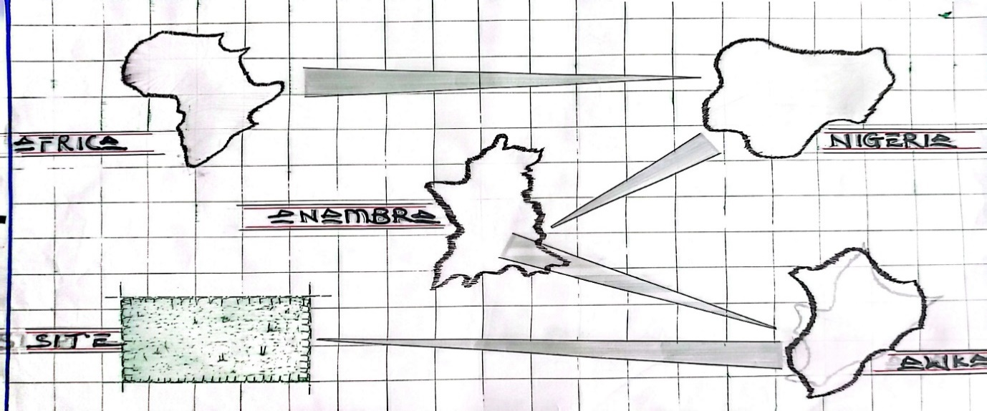

LOCATIONAL MAP
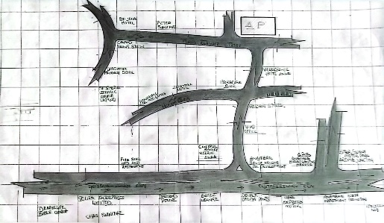

LOCATIONAL MAP

SITE INVERTOY
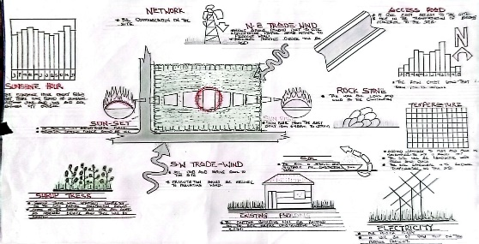

SITE ANALYSIS
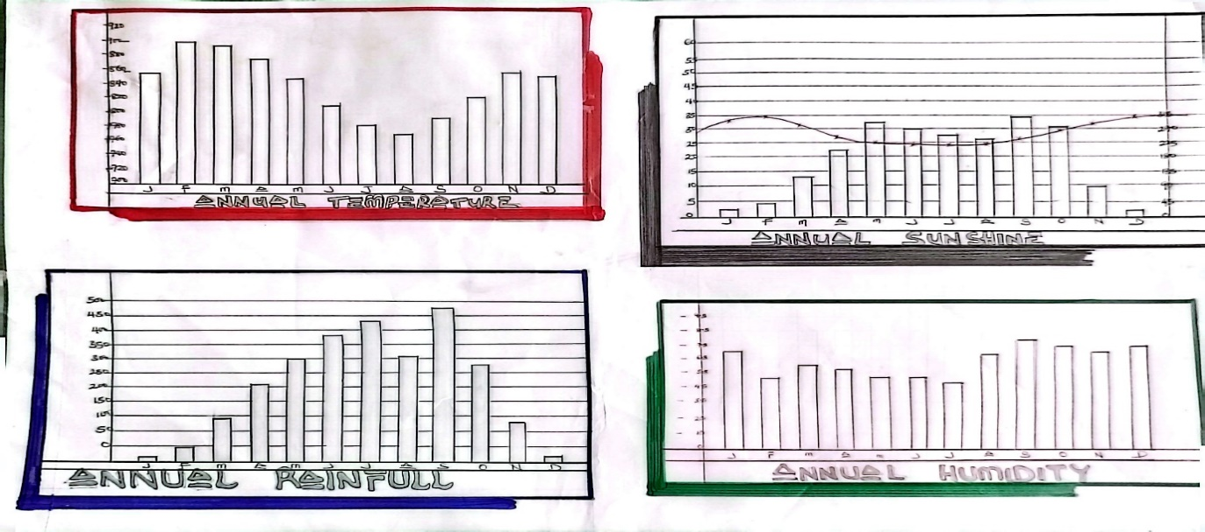

CLIMATE DATA
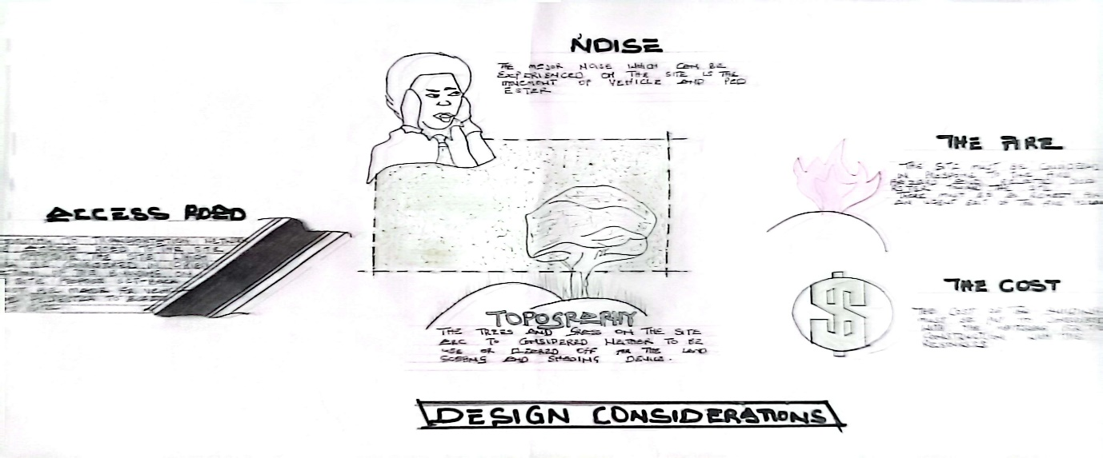

DESIGN CONSIDERATION
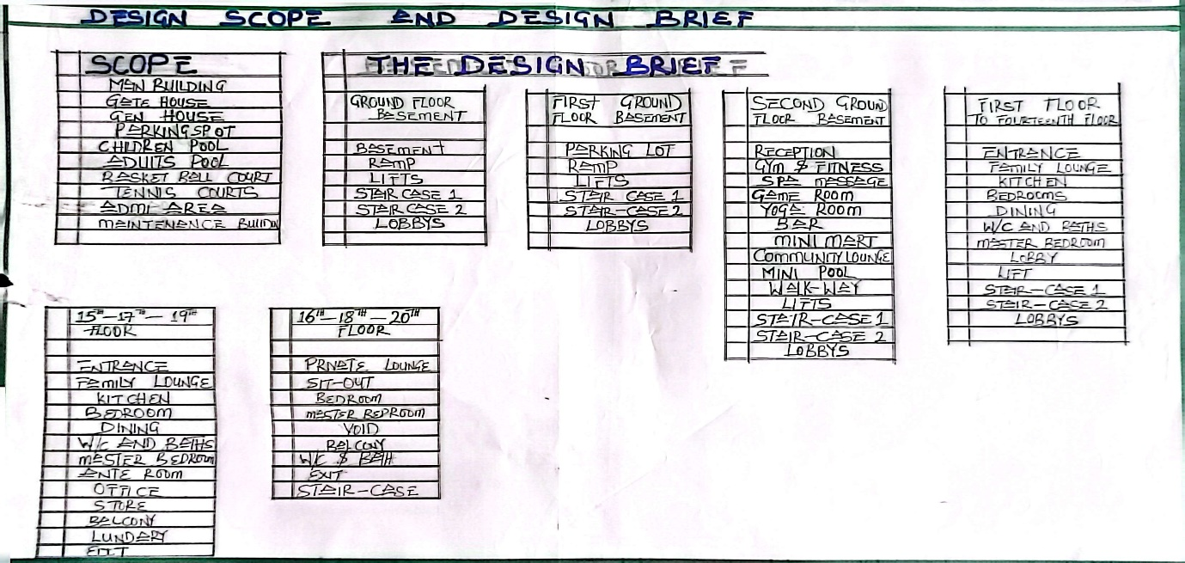

DESIGN BRIEF AND SCOPE
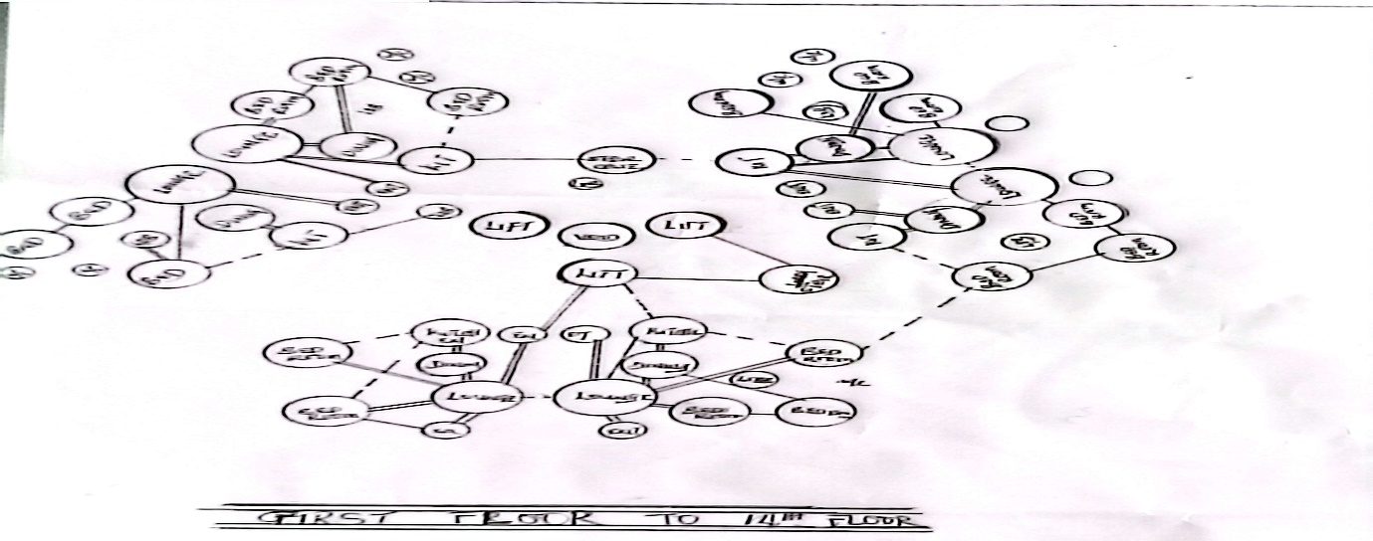

BUBBLE DIAGRAM 3RD FLOOR TO 16TH FLOOR
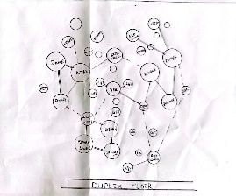

BUBBLE DIAGRAM 17TH FLOOR DUPLEX

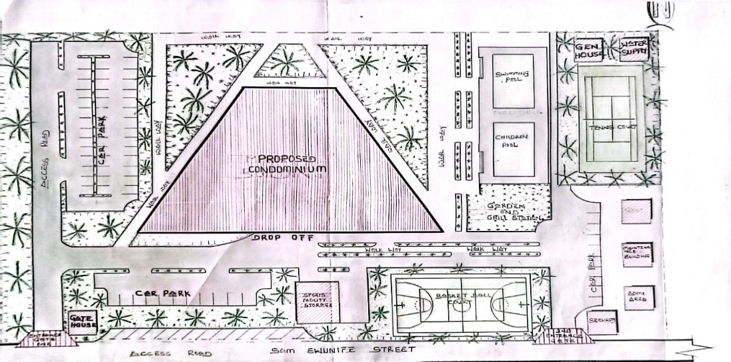

SITE PLAN
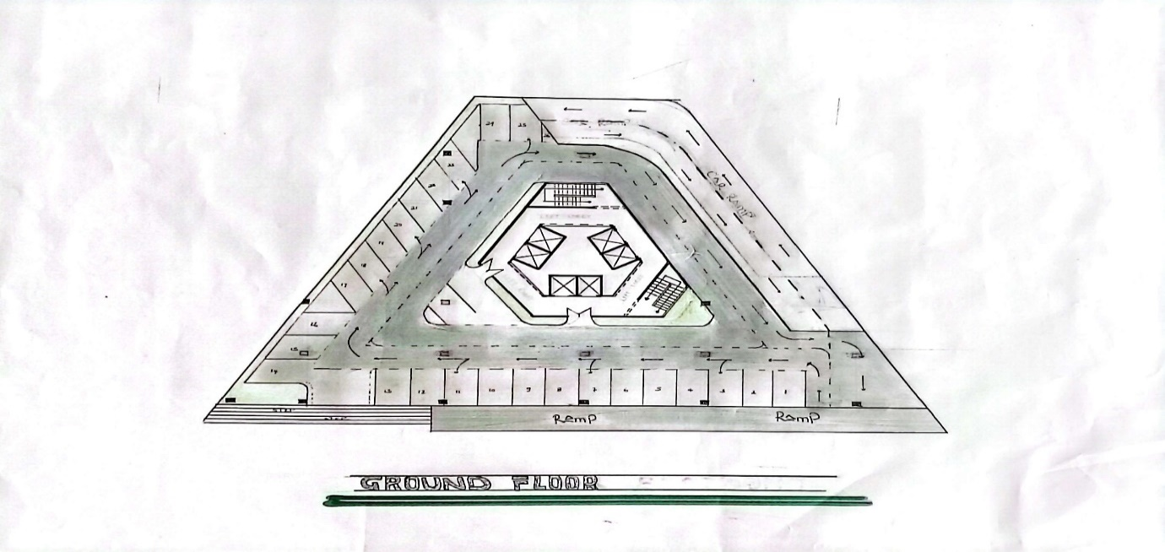

GROUND FLOOR
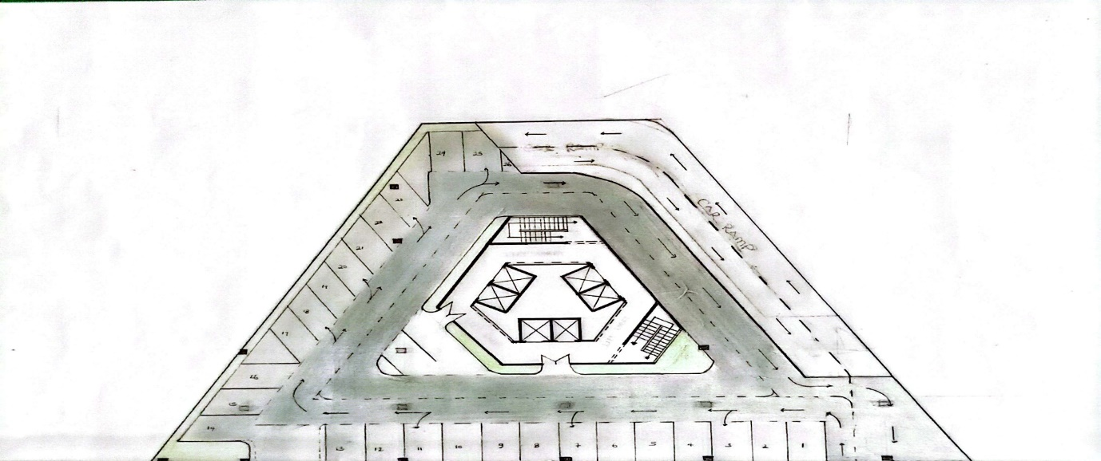

FIRST FLOOR
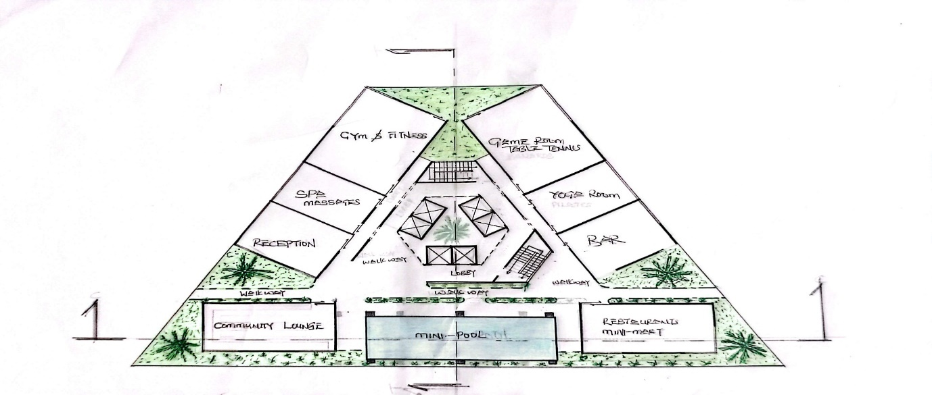

2ND FLOOR
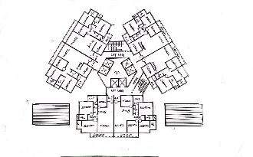

3RD FLOOR TO 16TH FLOOR
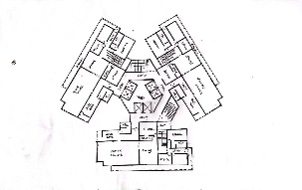

17TH -19TH -21ST FLOOR
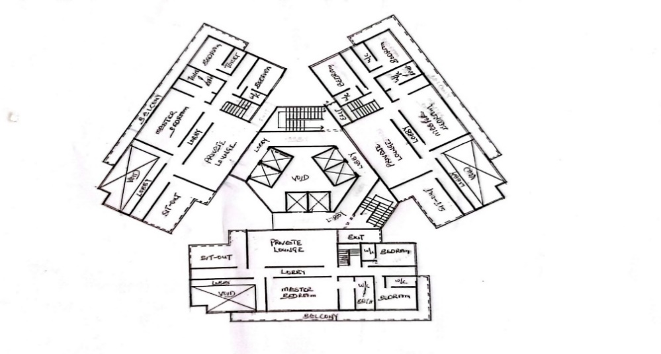

18TH -20TH -22 RD FLOOR
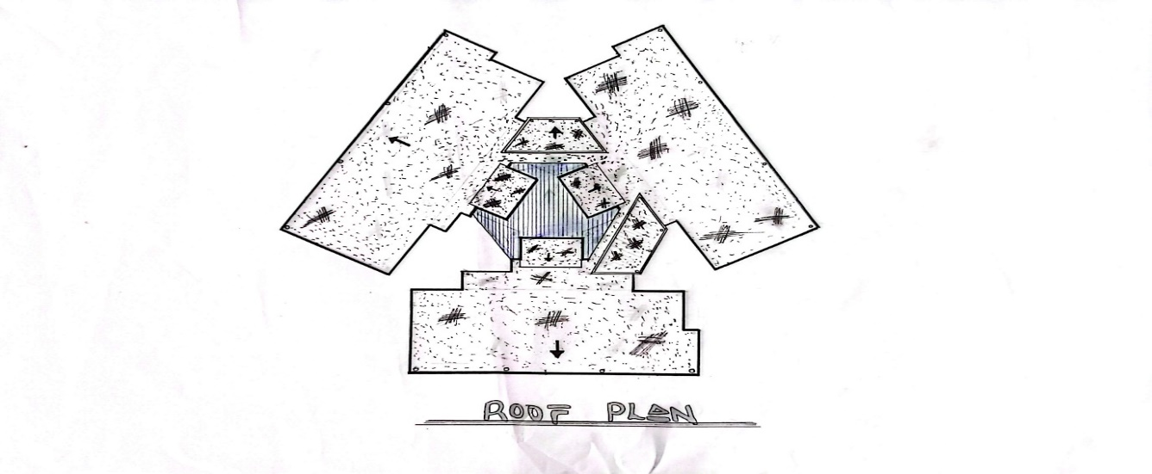

ROOF PLAN
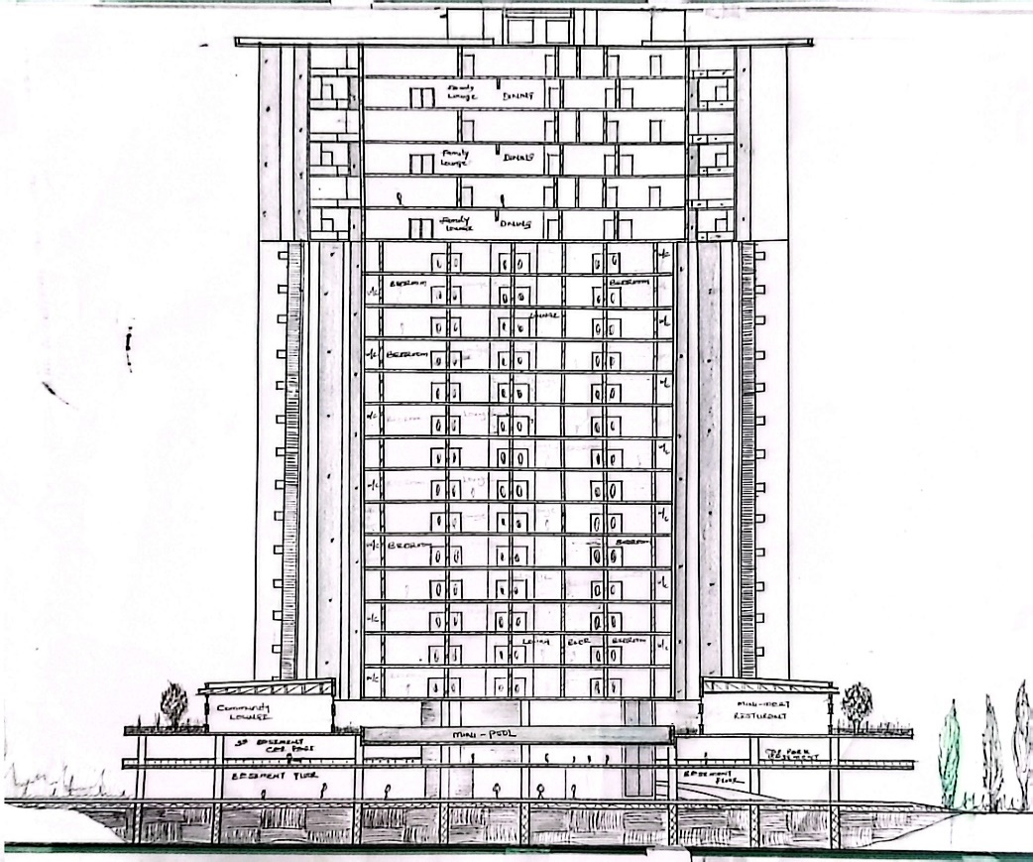

SECTION A - A
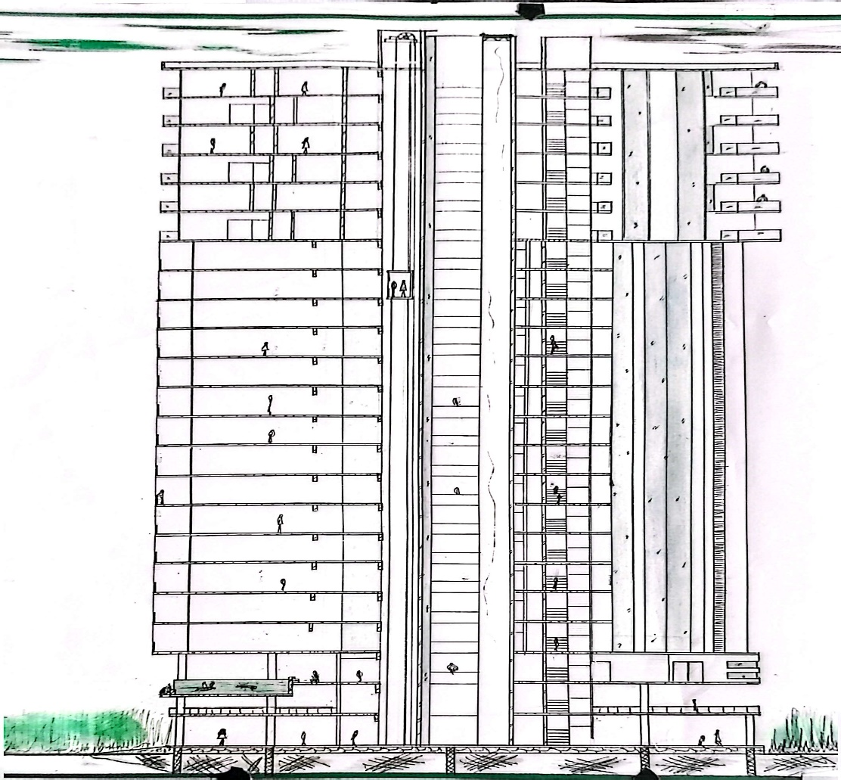

SECTION B - B
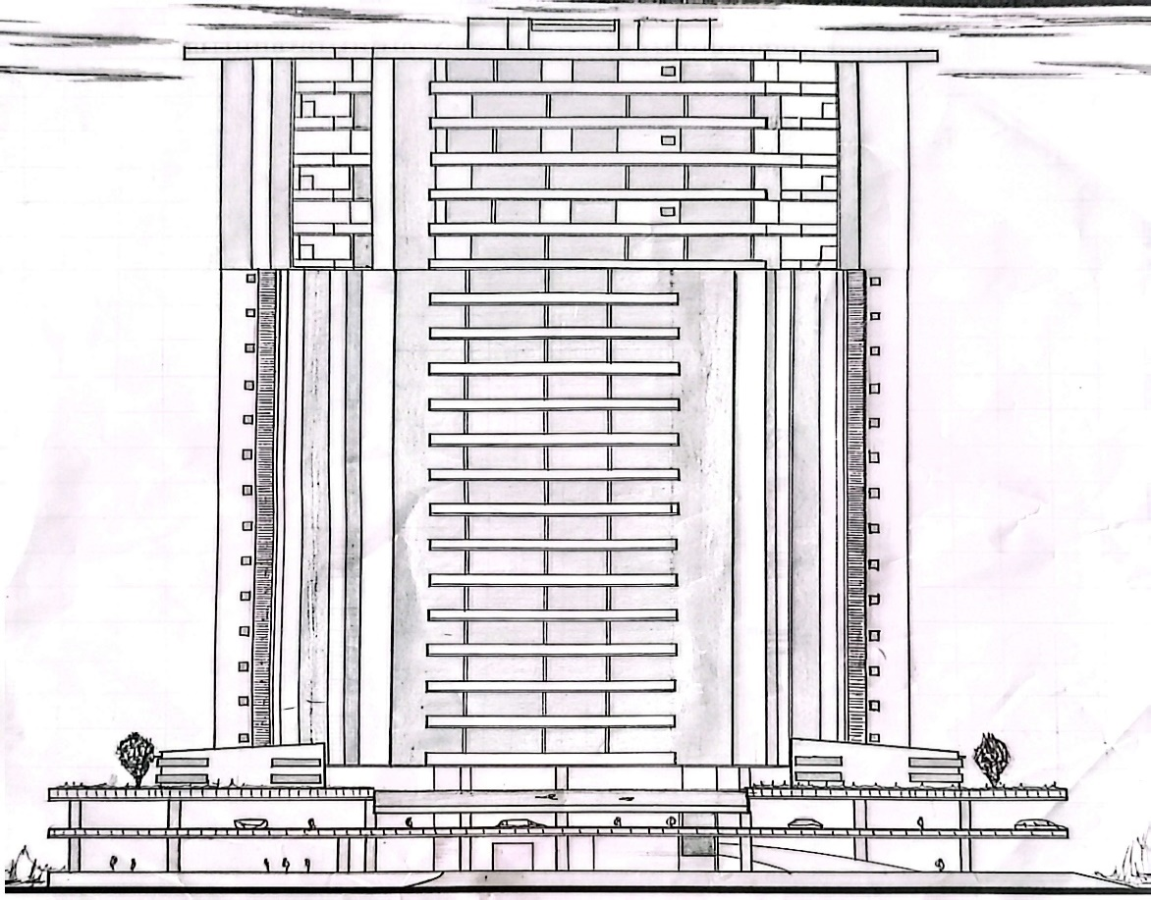

FRONT ELEVATION
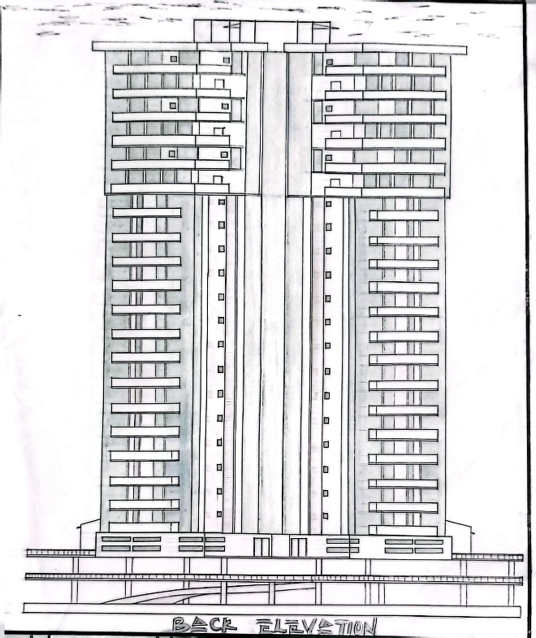
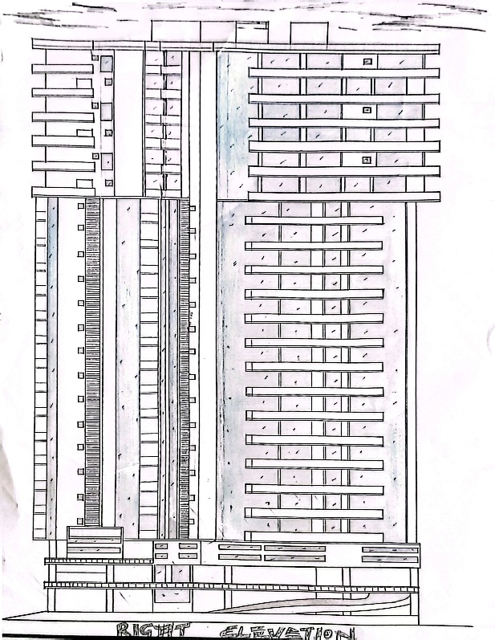

RIGHT ELEVATION BACK ELEVATION
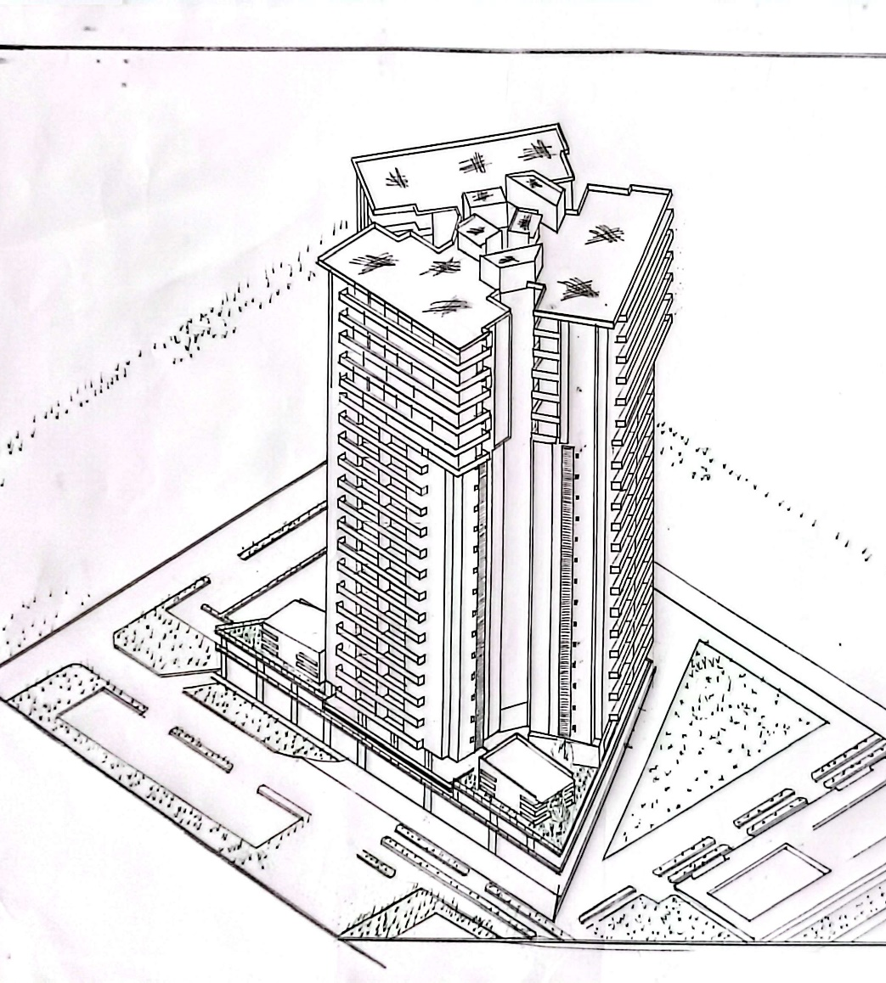

3D PERSPECTIVE
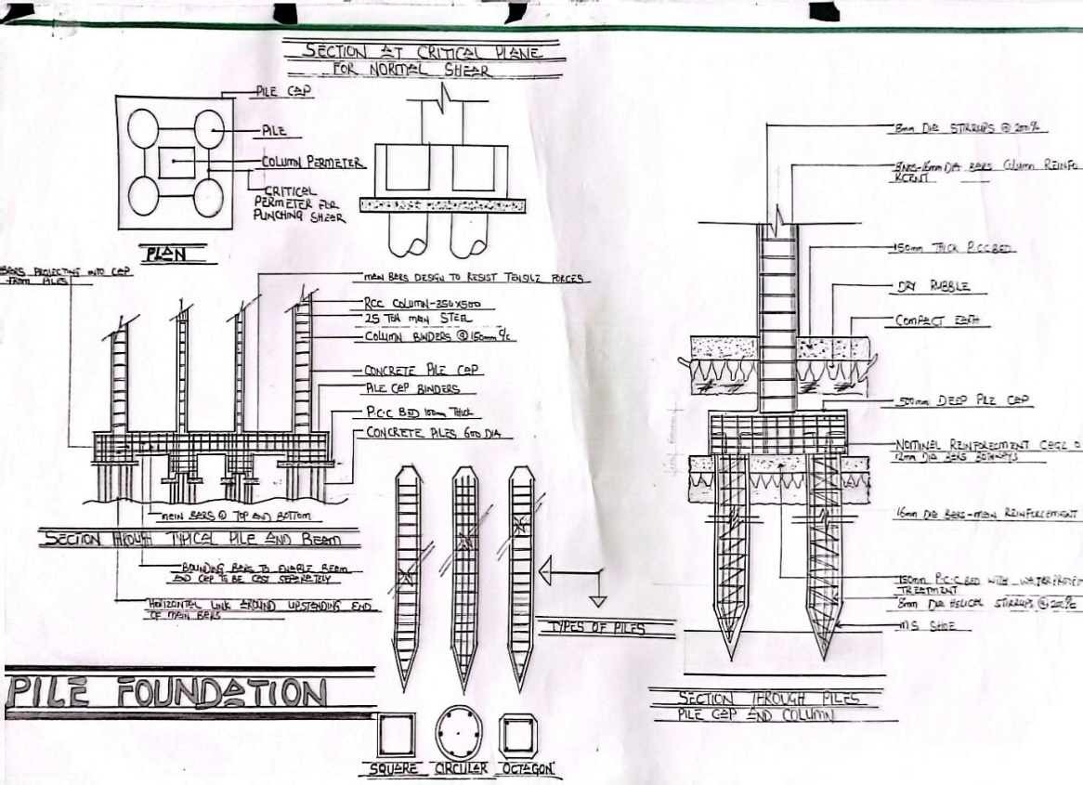

PILE FOUNDATION DETAIL
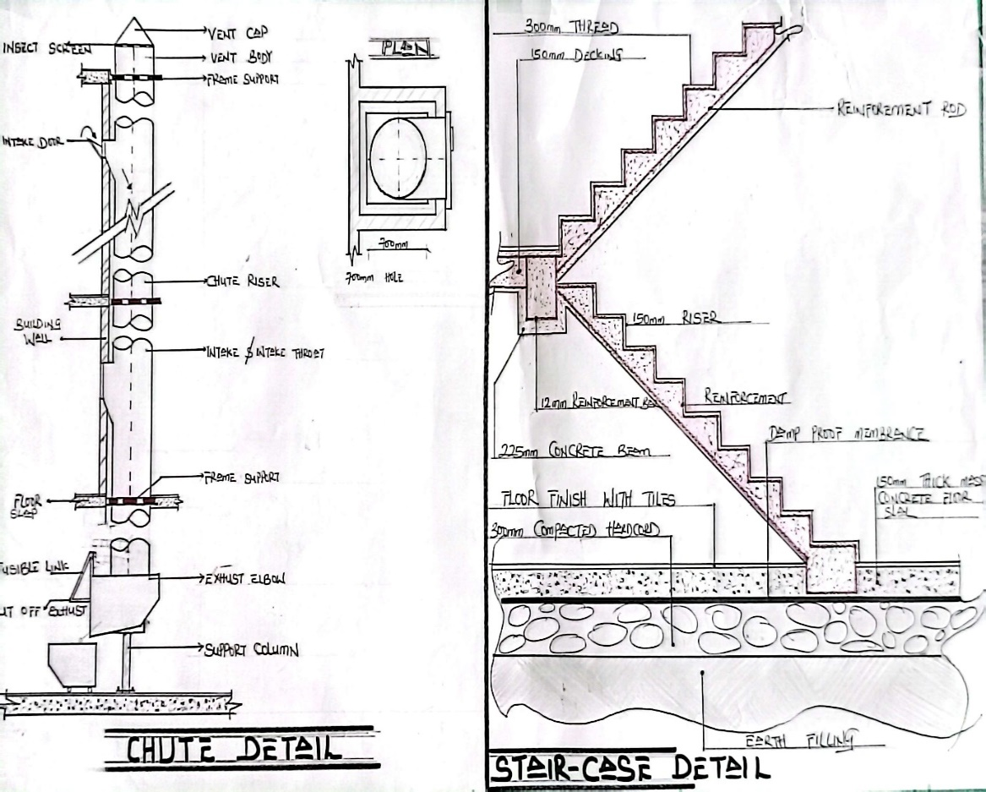

CHUTR DETAIL STAIRCASE DETAIL

