A PROJECT REPORT

ON

PROPOSED RADIO AND TELEVISION STATION LOCATED AT IJARA ISIN, ISIN LOCAL GOVERNMENT, KWARA STATE

BY

OGUNNIYI CHRISTIANAH SEYI

HND/23/ARC/FT/0079

SUBMITTED TO DEPARTMEN OF ARCHITECTURAL TECHNOLOGY, INSTITUTE OF ENVIRONMENT STUDIES, KWARA STATE POLYTECHNIC, ILORIN

BEING A DISSERTARION SUBMITTED TO DEPARTMEN OF ARCHITECTURAL TECHNOLOGY IN PARTIAL FULFILLMRNT OF THE REQUIREMENTS FOR THE AWARD OF HIGHER NATIONAL DIPLOMA IN DEPARTMEN OF ARCHITECTURAL KWARA STATE POLYTECHNIC, ILORN KWARA STATE

JULY 2025

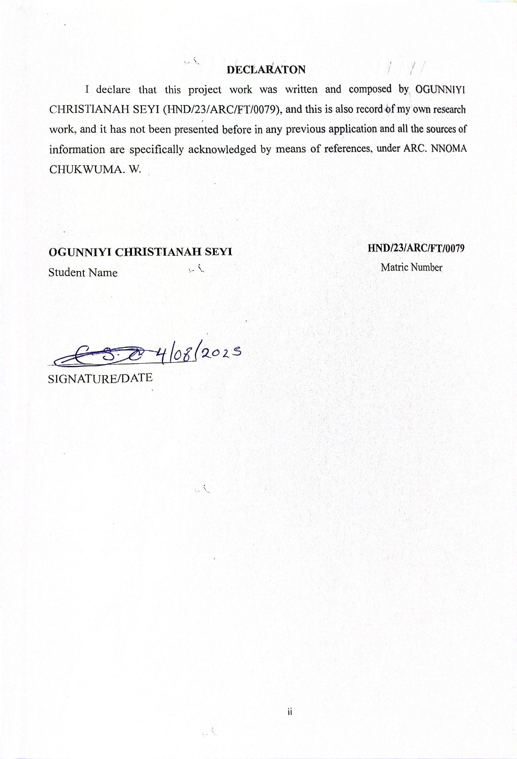

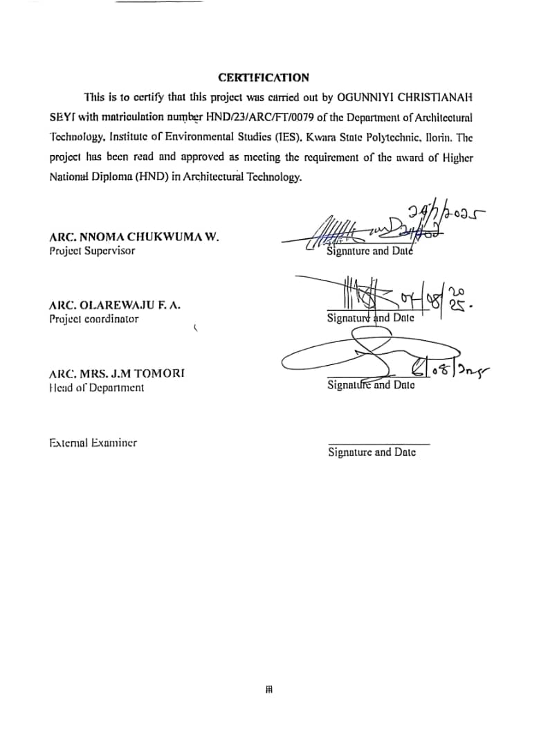

DEDICATION

This project is dedicated to Almighty God, the most beneficent and merciful, whom out of His infinite mercy, endless and limitless grace and love spared my life for the completion of this course, and to my loving mum Mrs. Ogunniyi Olanike, Mr. Degbe Oluwasefunmi, Mr. Ojomu Adeyinka, Bro Opeyemi Olamilekan and Mr. Iboyi, Thank God for the support throughout the project.

ACKNOWLEDGEMENT

I give all praises and adoration to God for the strength and courage bestowed upon me throughout this project.

My deepest appreciation goes to my wonderful mum Mrs. Ogunniyi Olanike, Bro Degbe Oluwasefunmi, Mr. Ojomu Adeyinka, Bro Opeyemi Olamilekan, Mr. Iboyi. Thank God for the unwavering moral and financial support toward my education .Special thanks to my supervisor Arc. Nnoma Chukwuma W for dedicating his time to reviewing my research despite his busy schedule. May Almighty God bless you abundantly.

I extend my gratitude to the project coordinator in person of Arc. Olarewaju F. A. and management, teaching and non-teaching staff of the Architectural Technology Department for their valuable impact on my life during my studies.

I also appreciate my friends. No words can fully express my gratitude for all your support. I am truly overwhelmed and pray that the good Lord blesses and prospers you all. Thanks

TABLE OF CONTENT

COVERPAGE………………………………………………………………………………. i

DECLARATION……………………………………………………….……………………ii

CERTIFICATION……………………………………………………….………………….iii

ACKNOWLEDGEMENT…………………………………………………………………..iv

DEDICATION……………………………………………………….………………………v

LIST OF FIGURES……………………..……………………….…………………………viii

LIST OF PLATES………………………………………………………………….……......ix

ABSTRACT………………………………………………………………………..…………i

CHAPTER ONE

1.1 HISTORICAL BACKGROUND……………………….……………………………1

1.2 INTRODUCTION……………………………………………………………………2

1.3 DEFINTION OF RADIO AND TELEVISION STATION…………………………..2

1.4 STATEMENT OF PROBLEM…………………….…...………….…………………3

1.5 AIM AND OBJECTIVES OF THE STUDY……………………..………………….3

1.6 JUSTIFICATION OF THE STUDY………………………………………..…..……4

1.7 SCOPE OF THE PROJECT………………………………………………………….4

1.8 LIMITATIONS OF STUDY……………………………………………………..…..5

1.9 RESEARCH METHODOLOGY……………………………………………………5

CHAPTER TWO

2.1 LITERATURE REVIEW …………………………………………………………...6

2.2 SPATIAL PLANNING………………………………………………………………6

2.3 ACOUSTIC TREATMENT…………………………………………………………6

2.4 TECHNOLOGICAL INTEGRATION………………………………………………6

2.7 SUSTAINABILITY………………………………………………………………….7

2.6 CONCLUSION………………………………………………………………………7

CHAPTER THREE

3.0 CASE STUDIES……………………………………………………………………..8

3.1 CASE STUDY ONE: AT IBADAN………………………………………………….8

3.2 CASE STUDY TWO: AT OYO STATE (NTA)……………………………………...10

3.3 CASE STUDY THREE: AT IBADAN (Yemetu N.T.A)…………………………….11

3.4 CASE STUDY FOUR: AT ILORIN (Kwara State TV)……………………………13

3.5 CASE STUDY FIVE (AT ILORIN DIAMOND F.M)……………………………..15

3.6 CASE STUDY SIX (AT ILORIN, Alubarika F.M)………………………………...17

CHAPTER FOUR

4.0 INTRODUCTION OF THE STUDY………………………………………………19

4.1 HISTORY OF THE STUDY AREA……………………………………...………...19

4.2 SITE LOCATION…………………………………………………………………..19

4.3 SITE ANALYSIS.…………………………………………………………………..21

4.4 SITE PLANNING…………………………………………………………………..25
4.5 DESIGN CRITERIA………………………………………………………………..26
4.6 BRIEF ANALYSIS OF PROJECT………………………………………………….26
4.7 SPACE ALLOCATION/SCHEDULE OF ACCOMMODATION………………….28
4.8 CONCEPTUAL DEVELOPMENT…………………………………………………30

CHAPTER FIVE

5.0 PROJECT APPRAISAL……………………………………………………………31

5.1 CONSTRUCTION METHOD……………………………………………………..31

5.2 MATERIALS AND STANDARD FORMS………………………………………..32

5.3 CONCLUSION…………………………………………………………………….34

REFERENCES……………………………………………………………………..35

APPENDICES……………………………………………………………………...36

LIST OF FIGURES
Figure 3.1: Location Plan for Case Study 1………………………………………..8
Figure 3.2: Floor Plan for Case Study 1…………………………………………...9
Figure 3.3: Location Plan for Case Study 2………………………………………..10
Figure 3.4: Floor Plan for Case Study 2…………………………………………...10
Figure 3.5: Location Plan for Case Study 3………………………………………..11
Figure 3.6: Floor Plan for Case Study 3…………………………………………...12
Figure 3.7: Location Plan for Case Study 4………………………………………..13
Figure 3.8: Floor Plan for Case Study 4…………………………………………...13
Figure 3.9: Location Plan for Case Study 5………………………………………..15
Figure 3.10: Floor Plan for Case Study 5…………………………………………..16
Figure 3.11: Location Plan for Case Study 6……………………………………….17
Figure 3.12: Floor Plan for Case Study 6…………………………………………..17

LIST OF PLATE
Plate 3.1: Elevations of Case Study 1………………………………………………9
Plate 3.2: Elevations of Case Study 2………………………………………………11
Plate 3.3: Elevations of Case Study 3………………………………………………12
Plate 3.4: Elevations of Case Study 4………………………………………………14
Plate 3.5: Elevations of Case Study 4………………………………………………14
Plate 3.6: Elevations of Case Study 4………………………………………………15
Plate 3.7: Elevations of Case Study 5………………………………………………16
Plate 3.8: Elevations of Case Study 6………………………………………………18
Plate 4.1: Locational Plan…………………………………………………………..19
Plate 4.2: Locational Map…………………………………………………………..20
Plate 4.3: Site Inventory…………………………………………………………….20
Plate 4.4: Site Analysis……………………………………………………………...21
Plate 4.5: Site Zoining………………………………………………………………21
Plate 4.6: Climatic Data……………………………………………………………..24
Plate 4.7: Space Analysis……………………………………………………………28
Plate 4.8: Functional Analysis………………………………………………………29
Plate 4.9: Functional Relationship…………………………………………………..29
Plate 4.10: Concept Derivation……………………………………………………...30

ABSTRACT

This design report examines the architecture, design principles, and consideration necessary for creating a modern radio and television station. It addresses the unique requirements of radio and television broadcasting facilities, emphasizing functionality, acoustic and technological integration the design process involves a detailed analysis of spatial organization, incorporating studio, control room, administration office, and public area to facilitate seamless operations and a conductive working environment

Key aspect covered include sound proof techniques ergonomic workspace design and the integration of advanced broadcasting technology. Sustainability is a critical focus, with discussions on energy-efficient building practices and the use of eco-friendly materials. The report also explores the aesthetic elements that contribute to an inviting and professional atmosphere, reflecting the station's brand identity.

Case studies of contemporary radio and television station provide practical insights and innovative design solutions. Through this comprehensive exploration, the report aims to offer architect and broadcasters a robust framework for developing radio and television station that are both technically proficient and aesthetically pleasing, ensuring an optimal environment for high-quality broadcasting and effective audience engagement.

CHAPTER ONE

INTRODUCTION

1.1 HISTORICAL BACKGROUND OF THE STUDY

The history of broadcasting with early radio transmission which only coned the dot-dash of wireless telegraph. The radio broadcasting was first exercise experimentally around 1905-1906, the inception of commercial broadcasting around 1920-1921.This starts with audio (phone) sound) broadcasting services which were transmitted through the auras radio wave from a transmitter to antenna which later to receiving device. The two types of methods that that were also imbibe in broadcasting common programmed are either in syndication or simulcast or both.

The first ever signals of significant power that carried voice or music was said to have been accomplished in 1906 by Reginald Fessenden when he made a Christmas eve broadcast to ship at sea from Massachusetts. WRGB was the first television station in existence and it was founded in the year 1928.it broadcast from the general electric facility in Schenectady New York, USA. It is owned by a freedom communication. In the year 1950s American television networks introduced broadcasts in color. This was approved by the world's first monochrome compatible color television standard indecent 1953 how and when radio and television started in Nigeria.

Radio and television broadcasting in Nigeria began under colonial rule with radio coming in 1933. First radio broadcasting in Nigeria was used to relay foreign broadcasts in Lagos.

Lagos had the first radio station in Nigeria.

The Nigerian Broadcasting System was established in 1951.

Television broadcasting began much later with the Western Nigeria Television (WNTV) launching on October 31, 1959 in Ibadan, making it the first in tropical Africa.

1.2 INTROUDCUTION

In the contemporary media landscape, radio and television remains a vital medium for communication, information dissemination, and entertainment. Despite the advent of digital and social media platforms, radio and television continues to have a significant impact due to its accessibility, real-time delivery and ability to reach diverse audiences. The architectural design of radio and television station plays a crucial role in its operational efficiency, aesthetic appeal and overall functionality. This proposed focuses on the architectural design of a new radio and television station that aims to blend modern technological requirements with sustainable and innovative architectural solutions.

The proposed radio and television station is envisioned to serve as a hub for local and regional broadcasting, fostering community engagement and providing a platform for diverse voices. It will be equipped with studios, production and recording room, news editing room and recreational space to ensure a conducive working environment for staff and guests. The design will prioritize acoustics, soundproofing and ergonomic consideration to enhance productivity and ensure high-quality broadcasts.

1.3 DEFINITION OF RADIO AND TELEVISION STATION

Radio station: A radio station is a facility that broadcasts audio signals to the public over electromagnetic radio frequency. It transmits news, talks, shows, and advertisements through AM, FM, or digital platforms. Radio stations typically consist of a studio for content production and a transmitter to send signals to receivers.

Television station: A television station is a facility that broadcasts audio-visual signals to the public over electromagnetic channels. It transmits programs including news, entertainment, documentaries, and advertisements using broadcasting technology. Television stations generally include production studios, transmission facilities, and distribution systems to deliver content to viewers' screens.

1.4 STATEMENT OF PROBLEM

The increasing demand for high-quality broadcasting services has highlighted several issues in existing radio and television station infrastructures. These problems include inadequate soundproofing, poor acoustics, inefficient use of space, and lack of modern technological integration. Many radio and television stations are housed in buildings that were not originally designed for broadcasting purposes leading to compromised audio visual quality and operational inefficiencies. Additionally, there is often a lack of attention to sustainable design practices, resulting in high energy consumption and environmental impact.

The proposed radio and television station aims to address these issues by providing a purpose-built facility that meets the contemporary needs of broadcasters and listeners alike. The design will focus on creating a functional and aesthetically pleasing environment that enhances the broadcasting experience while promoting sustainability and efficiency.

1.5 AIM AND OBJECTIVES OF THE STUDY

Aim of the project

Aim:

The aim of the project is to design a well-functioning aesthetic and structurally balanced station that would be able to compete with the modern-day radio and television station.

Objectives

To have a befitting radio and television station structure that would compete with the modern radio and television station structurally.

ii. To achieve an aesthetic and structurally balanced design.

Incorporation of effective and proper landscape as it may be required for a modern-day radio and television station.

Application of acoustic materials to the major acoustical room so as to have a noise-free and functioning broadcasting radio and television station

1.6 JUSTIFICATION OF STUDY

The proposed architectural design for the new radio and television station is justified on several grounds:

A purpose built facility with advanced acoustic treatments and soundproofing will significantly improve the audio quality of broadcasts, leading to a better listener experience.

A well-designed layout will streamline operations, reduce workflow bottlenecks, and create a more productive working environment for staff.

Incorporating sustainable design practices will reduce the station's energy consumption and environmental impact, aligning with global efforts to combat climate change and promoting corporate social responsibility.

Integrating modern broadcasting technology will enable the station to stay competitive in the rapidly evolving media landscape and offer innovative services to its audience. An aesthetically appealing and culturally relevant design will foster a strong connection with the local community, enhancing the station's role as a hub for regional broadcasting and community engagement

1.7 SCOPE OF THE PROJECT

Gate house

Main building

Canteen

Transmission building

Generator house

Utility bay

ATM gallery

1.8 LIMITATION OF STUDY

Limitations to the research are very many but some of them were overcome in the course of the study.

The economic situation of the country is really biting hard on a lot of things such as transportation fare, accommodation expenses which are part of the setbacks experienced during the course of carrying out this research work. The following to an extent limited the study:

1. Lack of access to relevant drawings, due to the security code by developer.

2. It was difficult to access useful books from the library, and to get officials from various existing housing estate to cooperate in getting information from them, some of the respondents could not give very specific answers to interviews conducted.

1.9 RESEARCH METHODOLOGY

The achievement of the research’s aim and objective was made possible with the literature of the highlighted phenomenon and the spatial requirement of the Post graduate hall of residence. Other information were collected from case studies and interviews carried out on relevant respondent. Through this, the expected function, space, size and form needed for the building were inferred. However, the secondary data were sourced from textbooks, journals and internet.

CHAPTER TWO

INTRODUCTION

2.1 LITERATURE REVIEW

The architectural design of radio and television stations is a specialized field that blends technical requirements with aesthetic and functional considerations. This literature review explores the critical aspects of designing radio and television stations including planning, acoustic treatment, technological integration, and sustainability.

2.2 SPATIAL PLANNING

Effective spatial planning is crucial in the architectural design of radio and television stations. According to Wheeler (2007), the layout must facilitate efficient workflow and communication among different departments. The primary spaces in a radio and television station include studios, control rooms, editing suites, offices, technical rooms, and common areas. Each area must be designed to meet specific functional needs while ensuring accessibility and comfort.

2.3 ACOUSTIC TREATMENT

Acoustic treatment is a fundamental aspect of radio and television station design. The quality of sound in a radio and television station directly impacts the broadcast's clarity and listener experience. Gervais (2018) emphasizes the importance of controlling sound reflections, reverberations, and external noise. This can be achieved through the use of sound-absorbing materials, isolation techniques, and strategic placement of sound barriers. Additionally, acoustic consultants often play a critical role in designing studios to achieve optimal sound quality (Everest & Pohlmann, 2015).

2.4 TECHNOLOGICAL INTEGRATION

The integration of advanced technology is paramount in modern radio and television station design. Turner (2016) notes that technological advancements have revolutionized the way radio and television stations operate, necessitating designs that accommodate sophisticated broadcasting equipment, digital upgrades, ensuring that the infrastructure can adapt to evolving needs.

2.5 SUSTAINABILITY

Sustainability in architectural design has become increasingly important and radio and television stations are no exception. Incorporating sustainable practices can reduce operational costs and environmental impact. According to Kibert (2016) sustainable design involves using energy-efficient systems, renewable materials, and incorporating natural lighting and ventilation. Green roofs and solar panels are examples of sustainable features that can be integrated into radio and television station designs to enhance energy efficiency and reduce the carbon footprint (Smith, 2017).

2.6 CONCLUSION

The architectural design of radio and television stations is a complex process that requires careful consideration of spatial planning, acoustic treatment, technological integration, and sustainability. By examining the principles and case studies discussed, it is evident that successful radio and television design are those that balance functionality with aesthetic appeal, technological needs with sustainability, and innovation with tradition. Future research and developments in this field will continue to enhance the way radio and television stations are designed and operated, ensuring they meet the demands of modern broadcasting while contributing positively to the environment.

CHAPTER THREE

3.0 CASE STUDY

Case studies can be defined as the process of critically investigating and analyzing existing projects to foster innovation, creativity, and improvements in proposed project, for research purposes, it is essential to study existing examples of buildings with similar functions.

The chosen case studies were evaluated based on site layout, facilities provided, and design form. Specifically, case studies of radio and television stations in Ilorin and other locations were conducted to gather technical details and necessary data to improve current and future requirements of the radio and television station.

Outline of Cases Studied For this research, six case studies were carried out

3.1 CASE STUDY 1: AT Ibadan (Bcos)

Location: Ibadan town Oyo state.

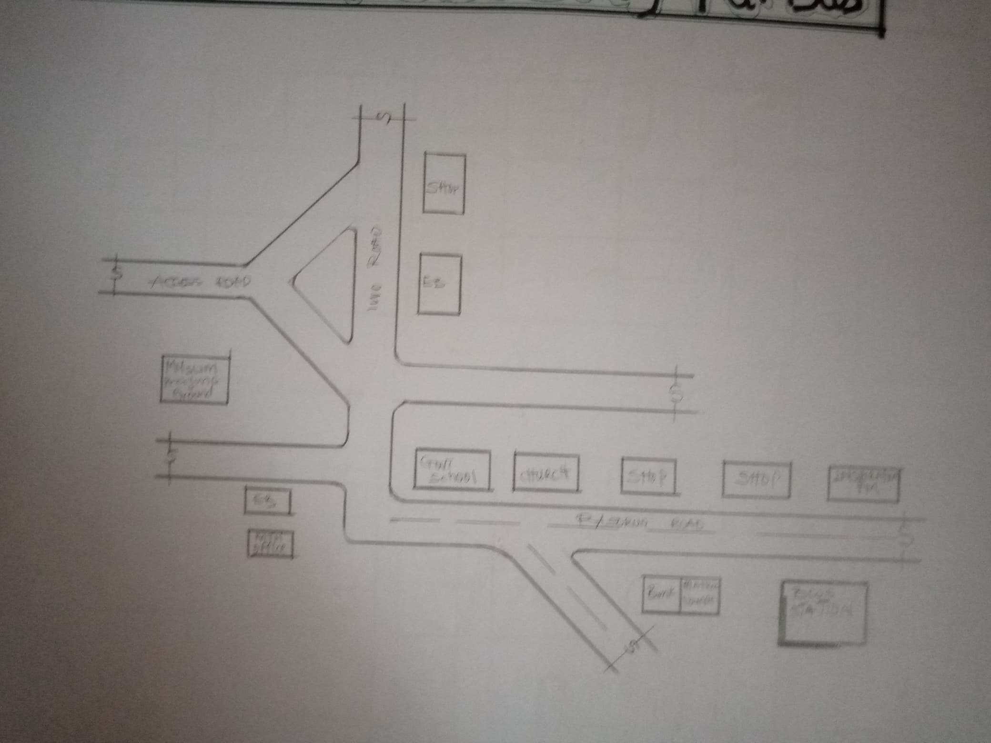

Figure 3.1: Showing Locational Plan’

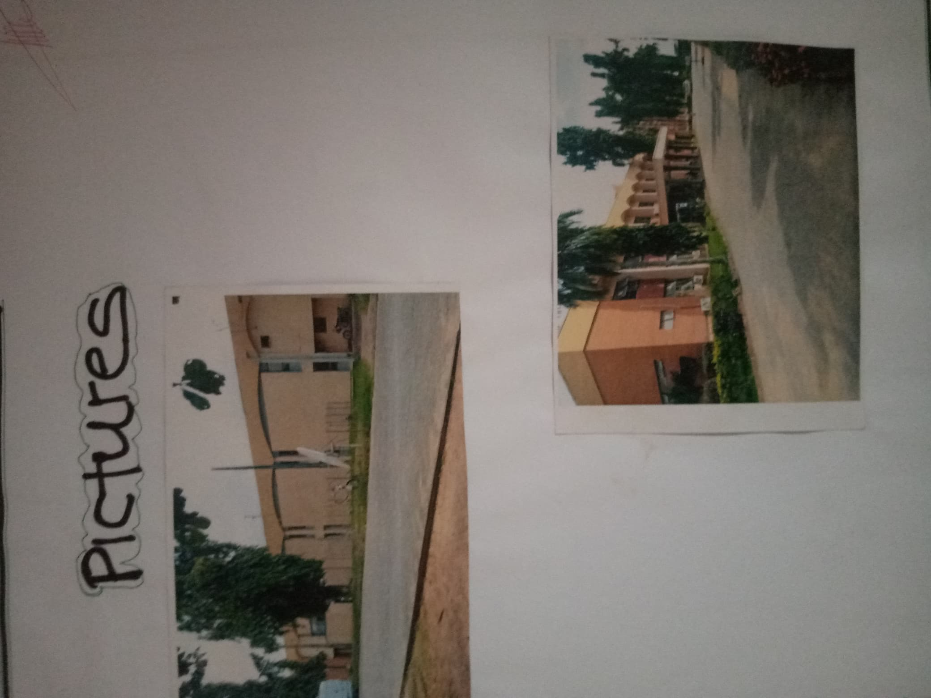
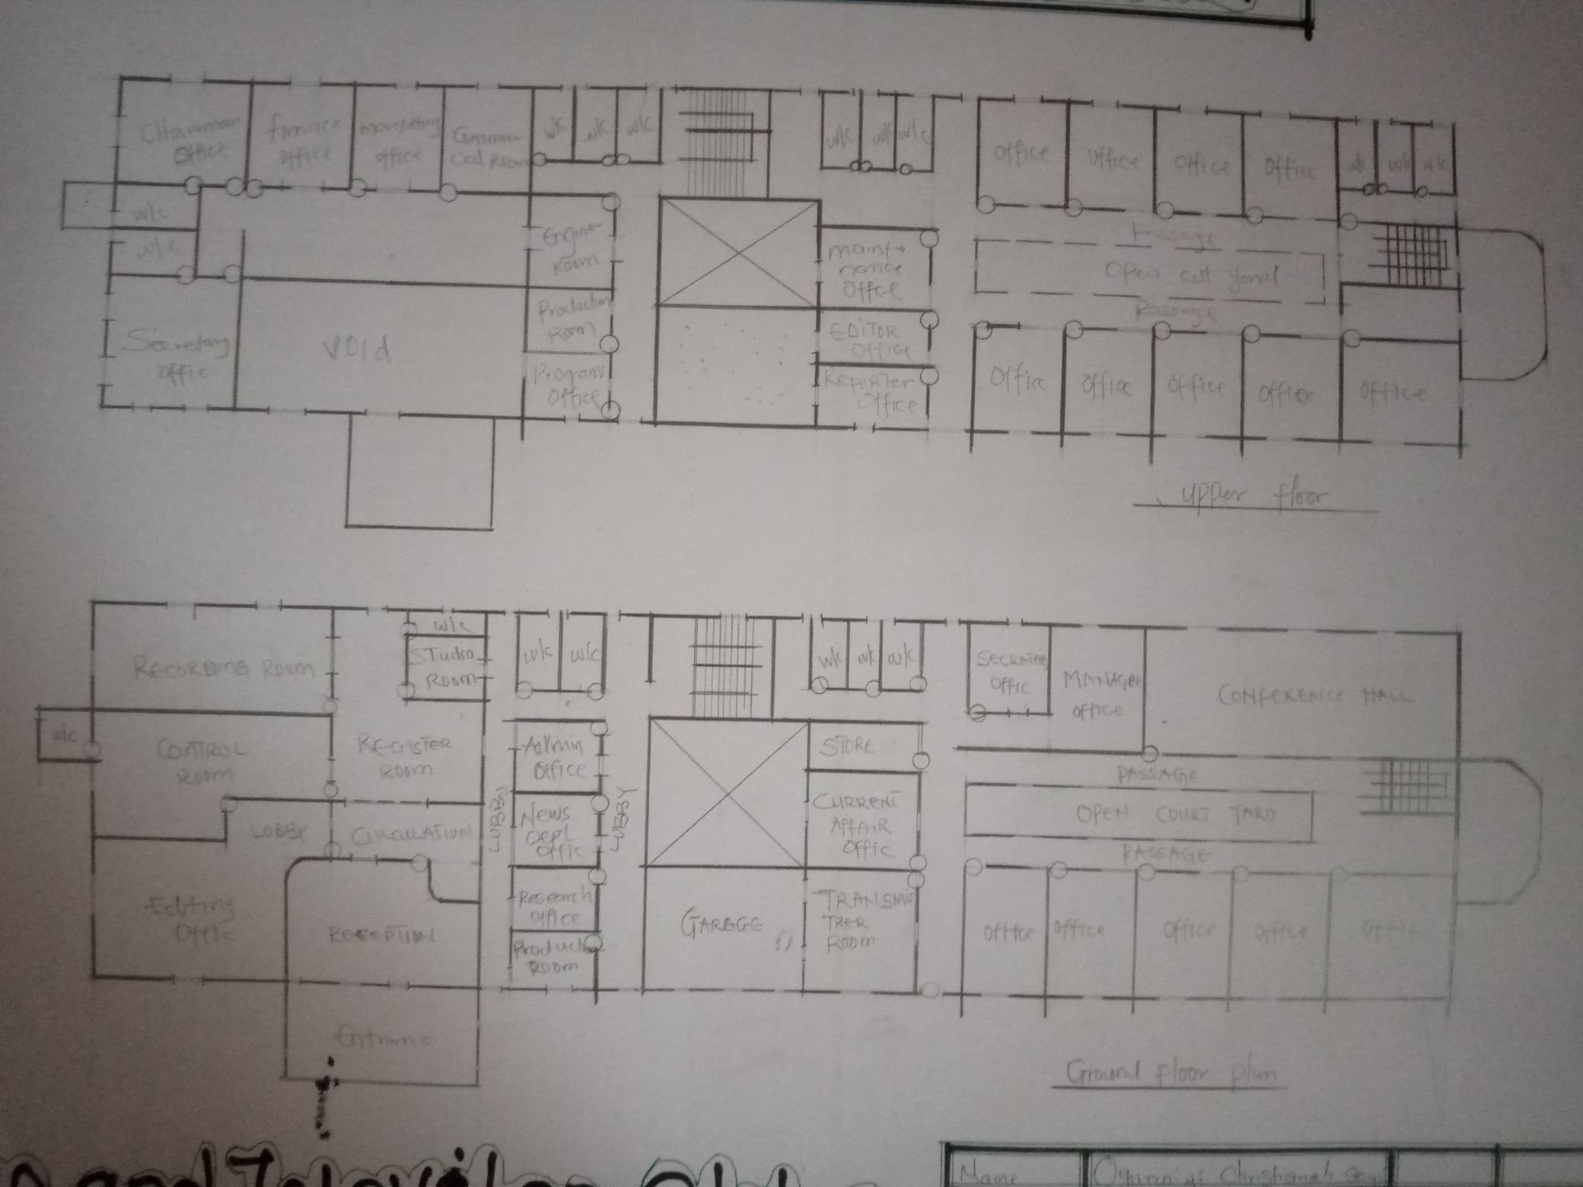
Figure 3.2: Showing Floor Plan

Plate 3.1: Elevations of Case Study 1

Merits

It is well oriented

The office are spacious

It is well landscaped and aesthetically balance

Demerits

The unit is not well linked up

It not easy to locate

CASE STUDY TWO (2): At Oyo State (NTA)

Location: oyo town, Oyo state
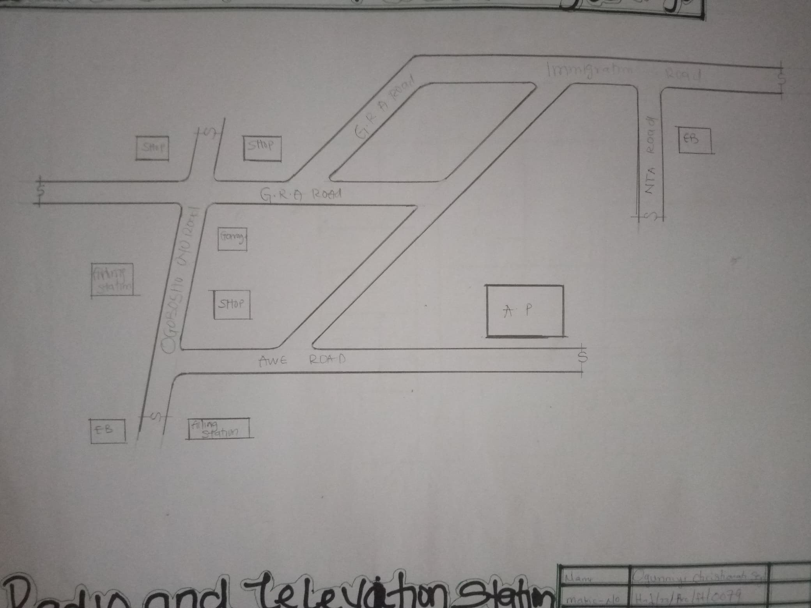

Figure 3.3: Showing Locational Plan
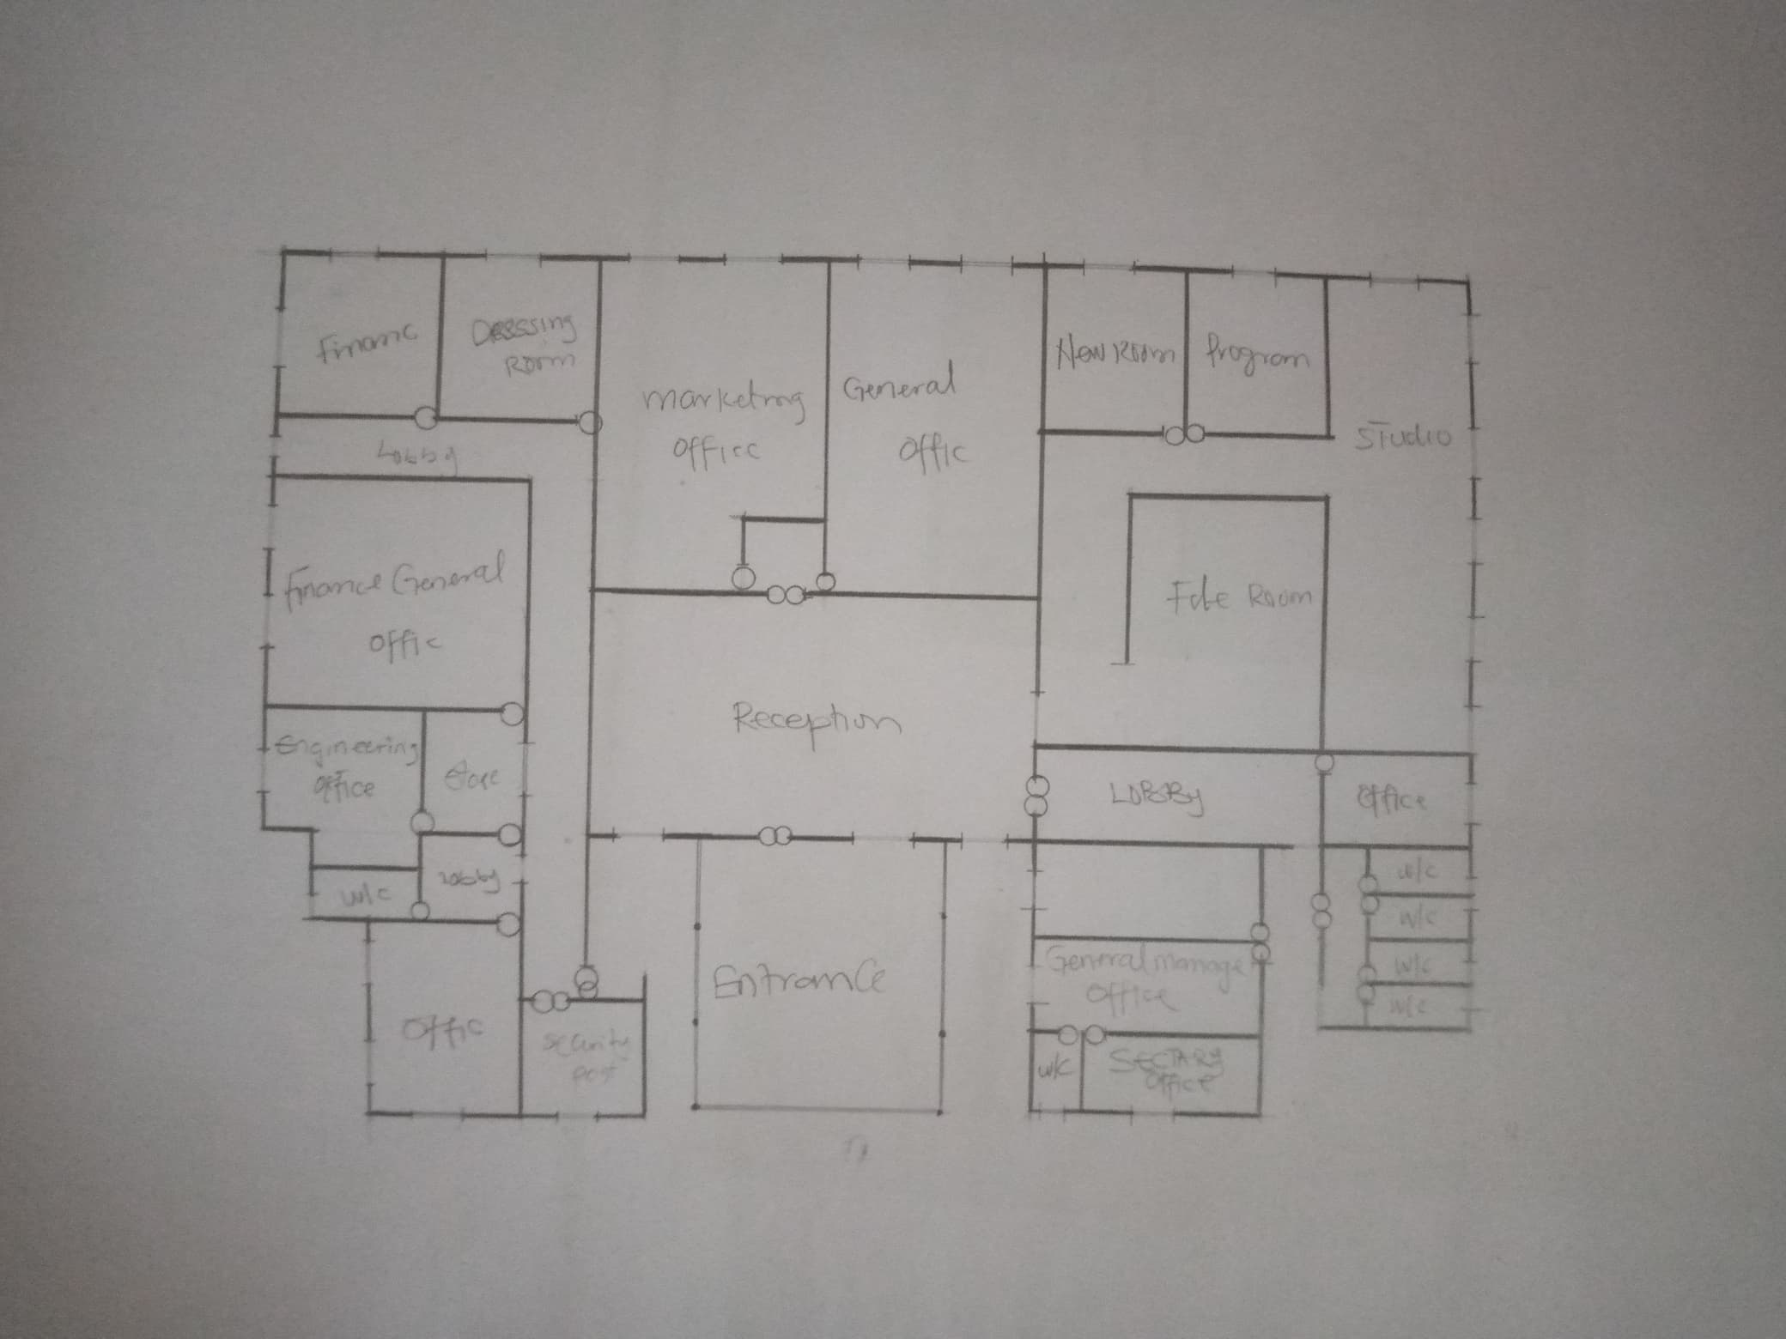

Figure 3.4: Showing Floor Plan
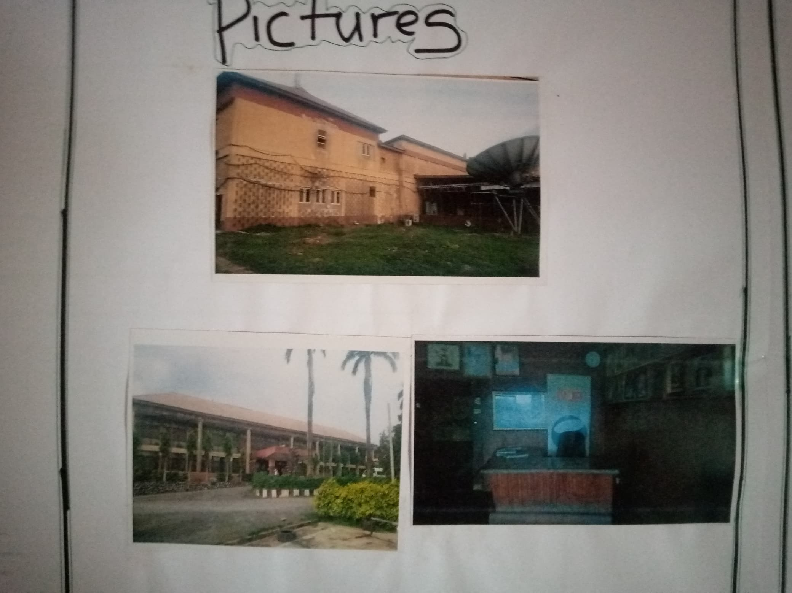

Plate 3.2: Elevations of Case Study 2

Merits

It is well landscaped and aesthetically balance

It has enough parking space for both the staff and visitors

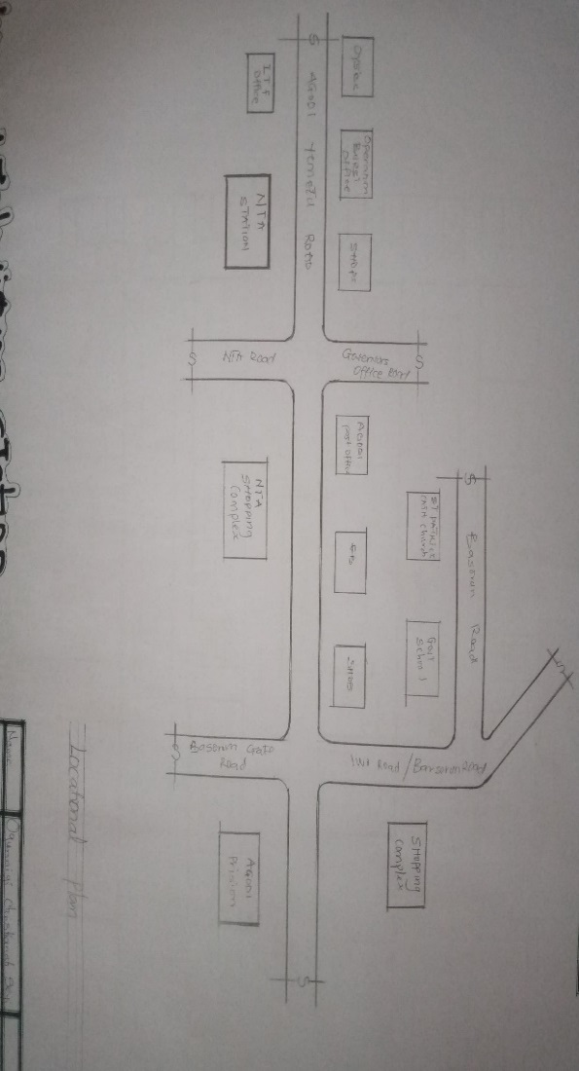
It is well oriented

Demerit

The station is not easily accessible from the main town

The unit are not well linked

CASE STUDY THREE (3): At Ibadan (Yemetu N.T.A)

Figure 3.5: Showing Locational Plan
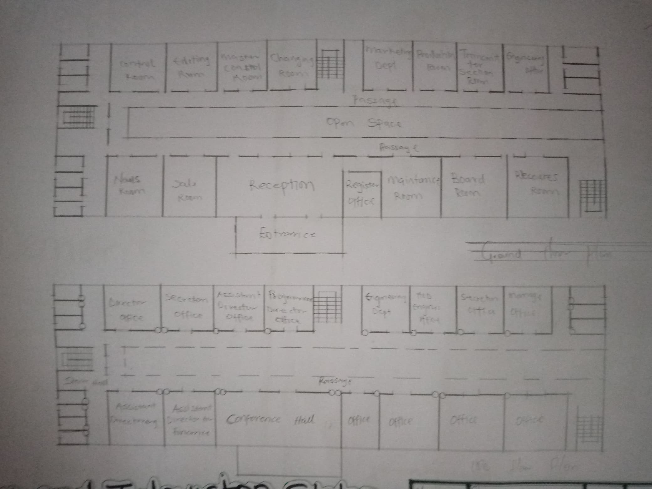

Figure 3.6: Showing Floor Plan
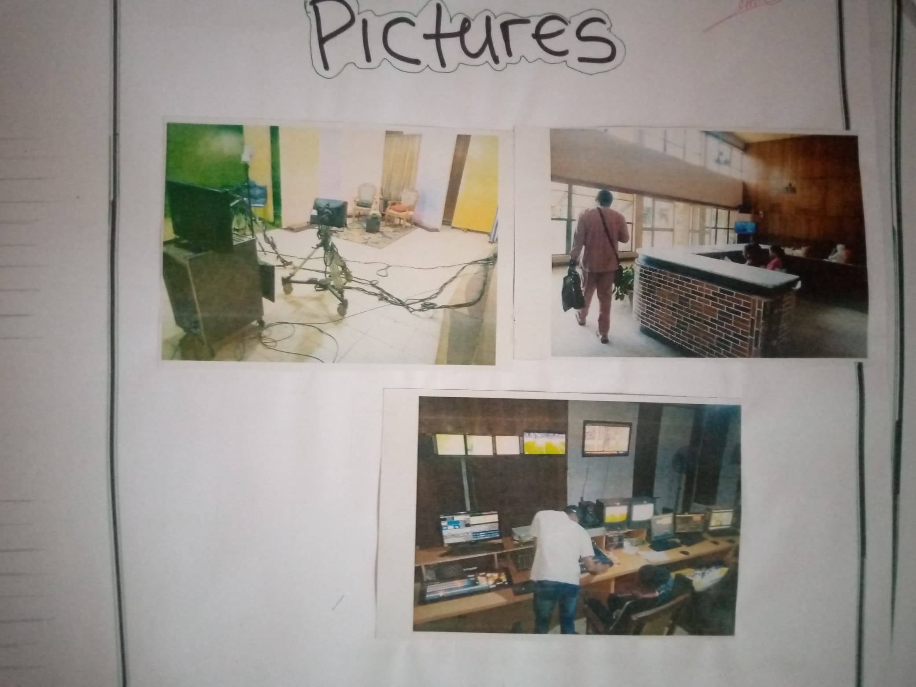

Plate 3.3: Elevations of Case Study 3

Merits

The building are well ventilated

It is well oriented and structurally balanced

It is easy to locate

Demerit

It is not well landscaped

Some unit are congested due to the number of the staff occupying the office

The unit are not linked up

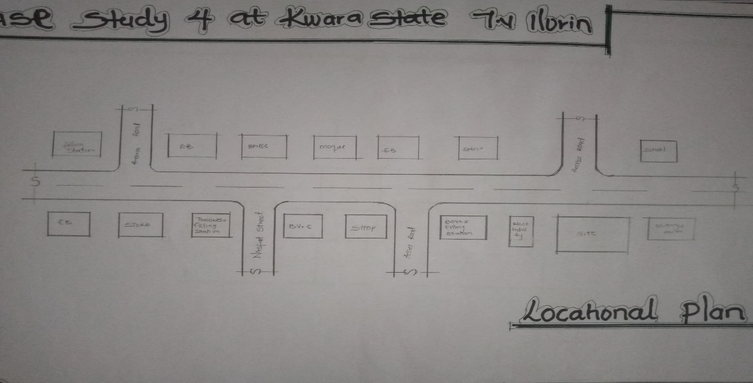
CASE STUDY TWO (4 At Ilorin (Kwara State TV)

Figure 3.7: Showing Locational Plan
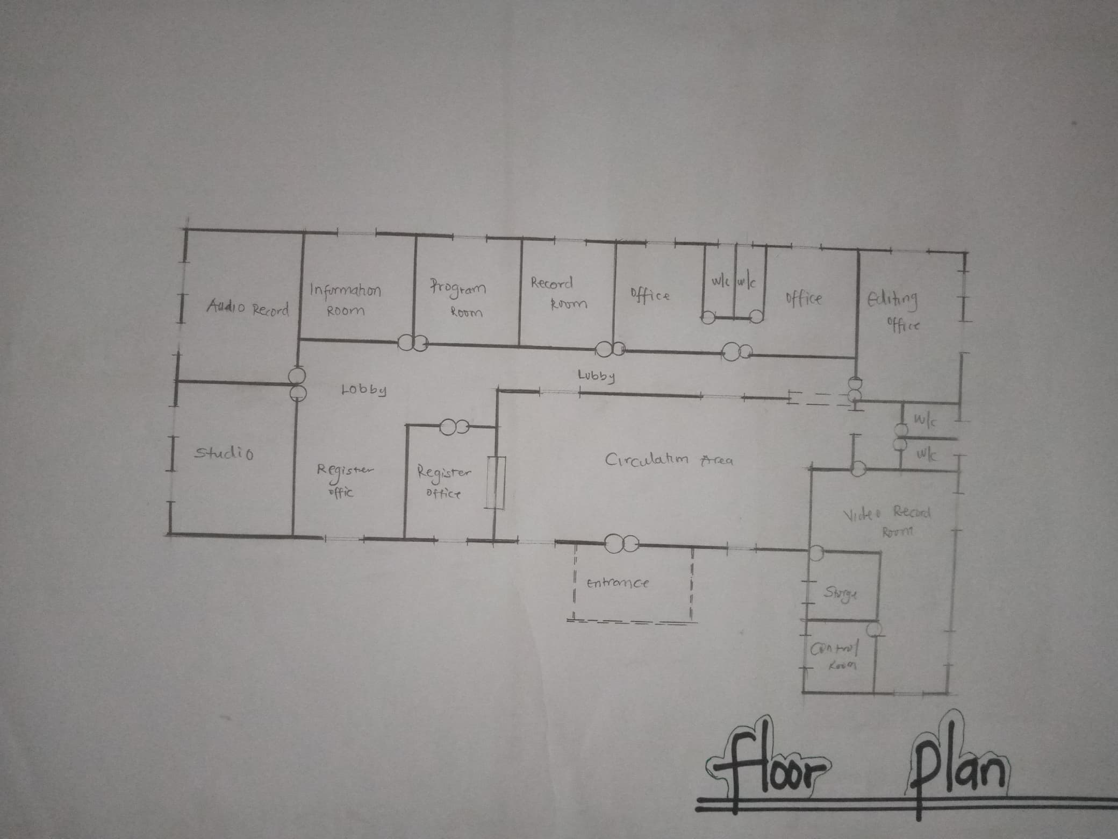

Figure 3.8: Showing Floor Plan

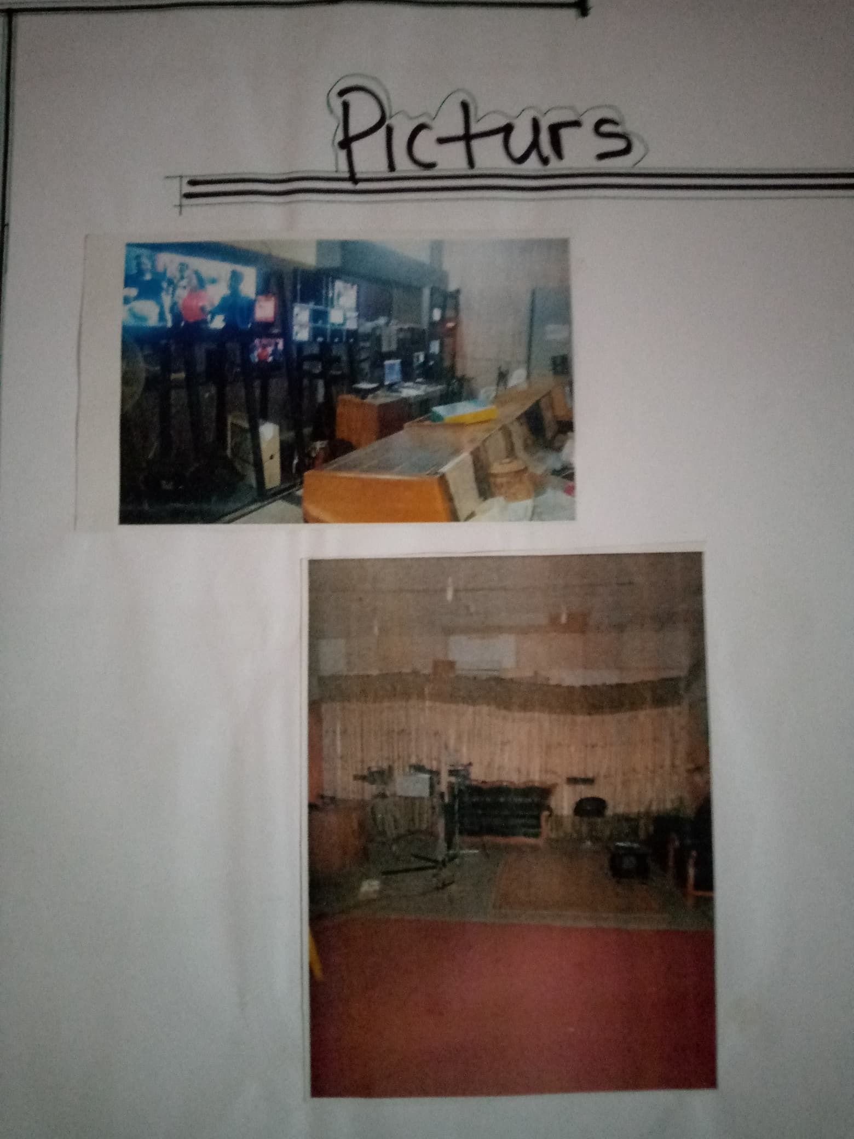

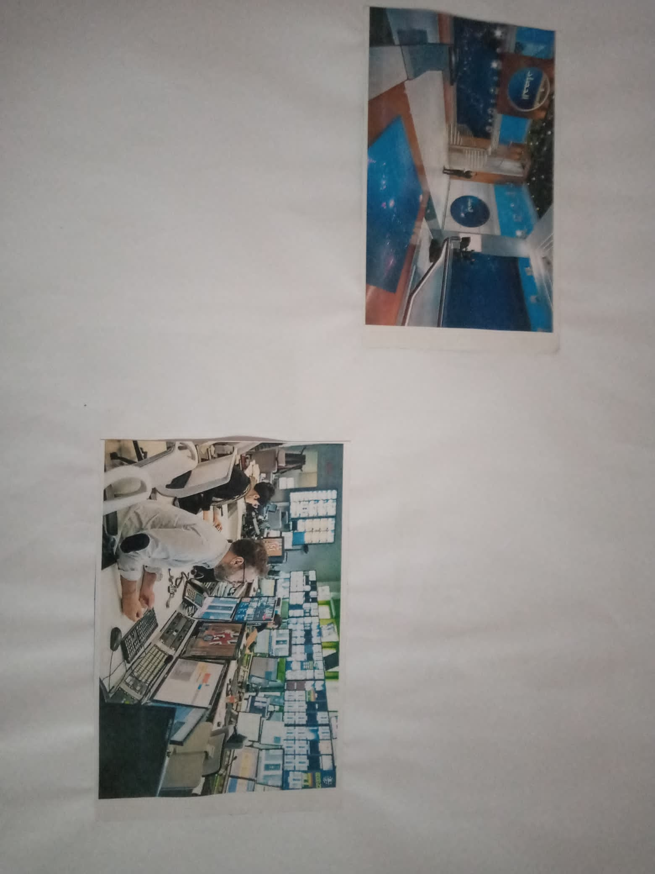

Plate 3.4: Elevations of Case Study 4

ONLINE CASE STUDY ONE (At Canada radio and television station)

Plate 3.5: Elevations Case Study 4

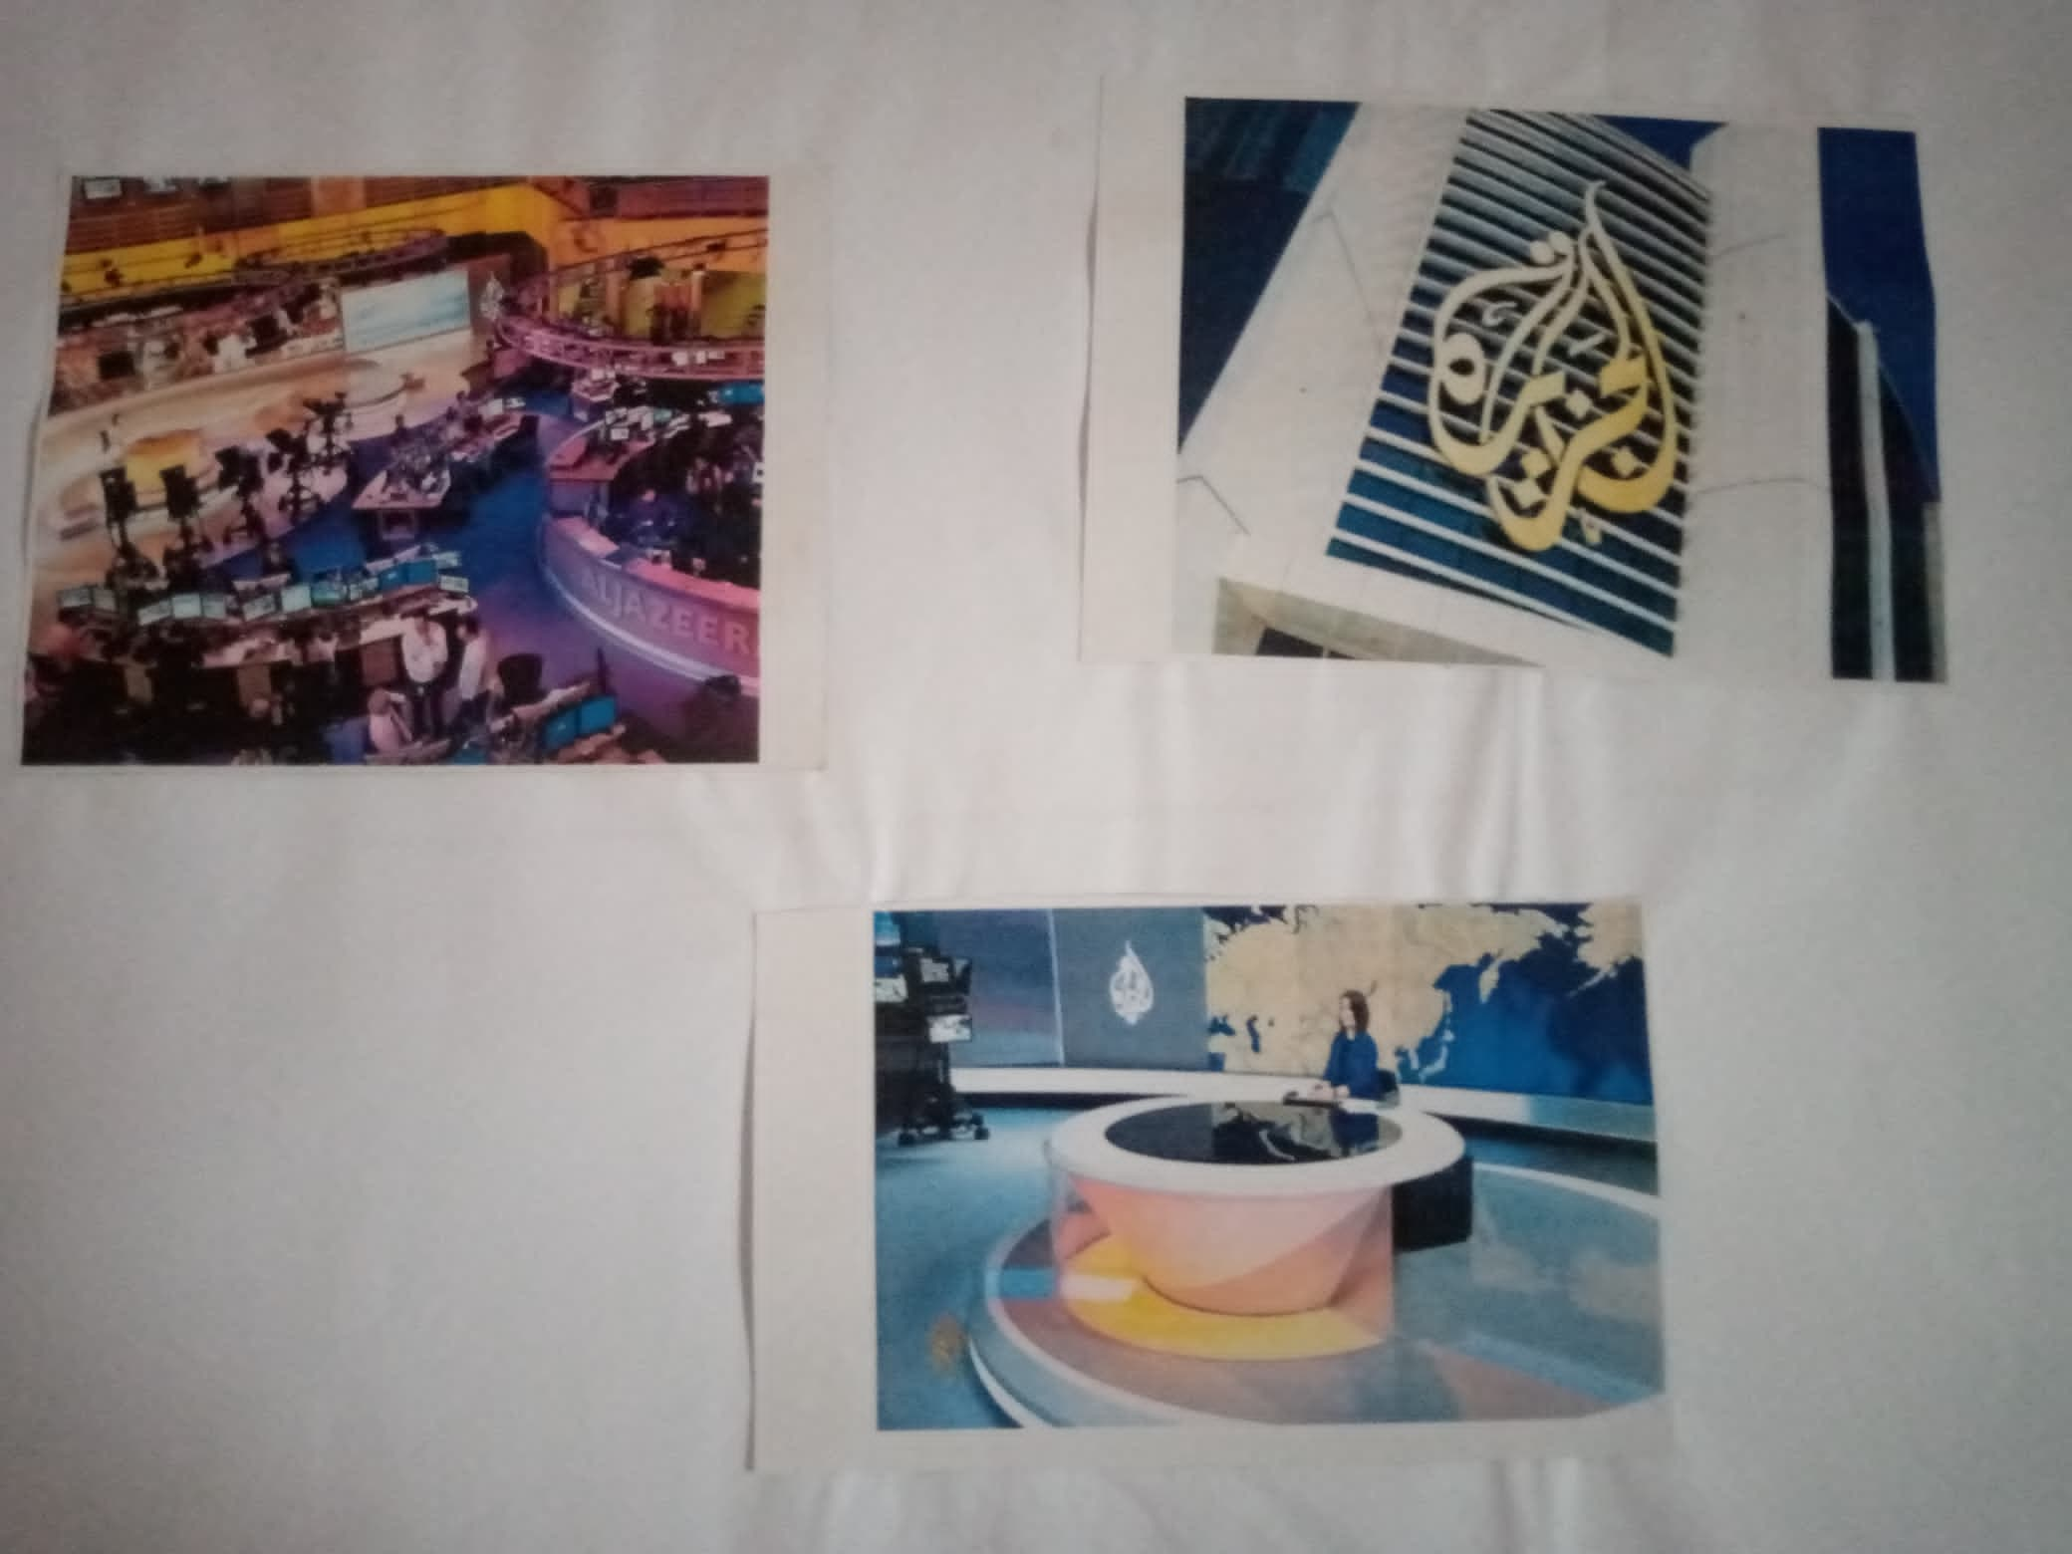
ONLINE CASE STUDY TWO (At ALJAZEER)

Plate 3.6: Elevations of Case Study 4

Merits

It is well landscaped and aesthetically balance

It is well oriented

The office are spacious

Demerit

The unit is not well linked u

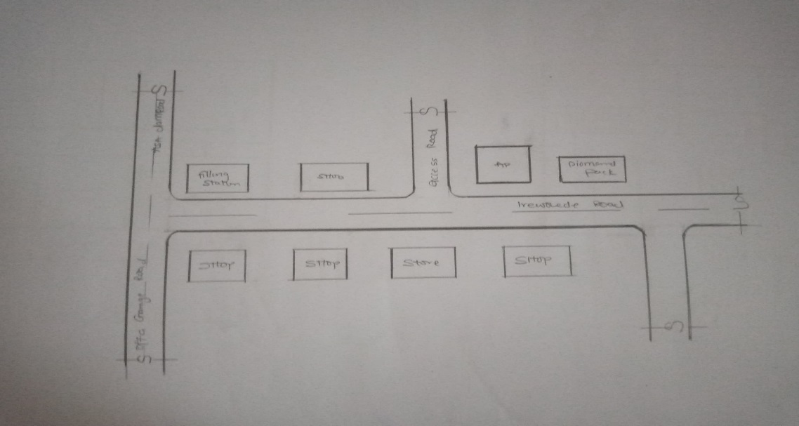
CASE STUDY FIVE (5 at Ilorin (Diamond FM)

Figure 3.9: Showing Locational Plan
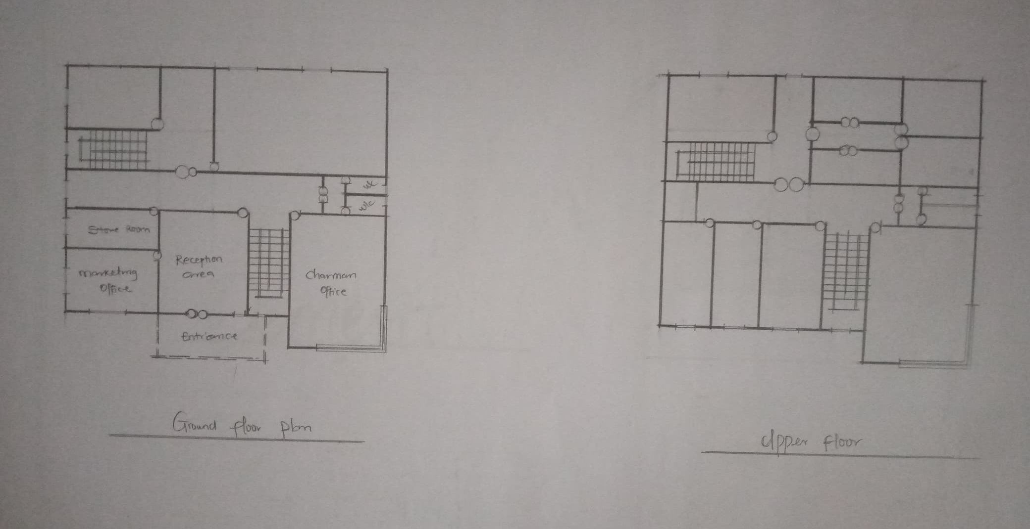

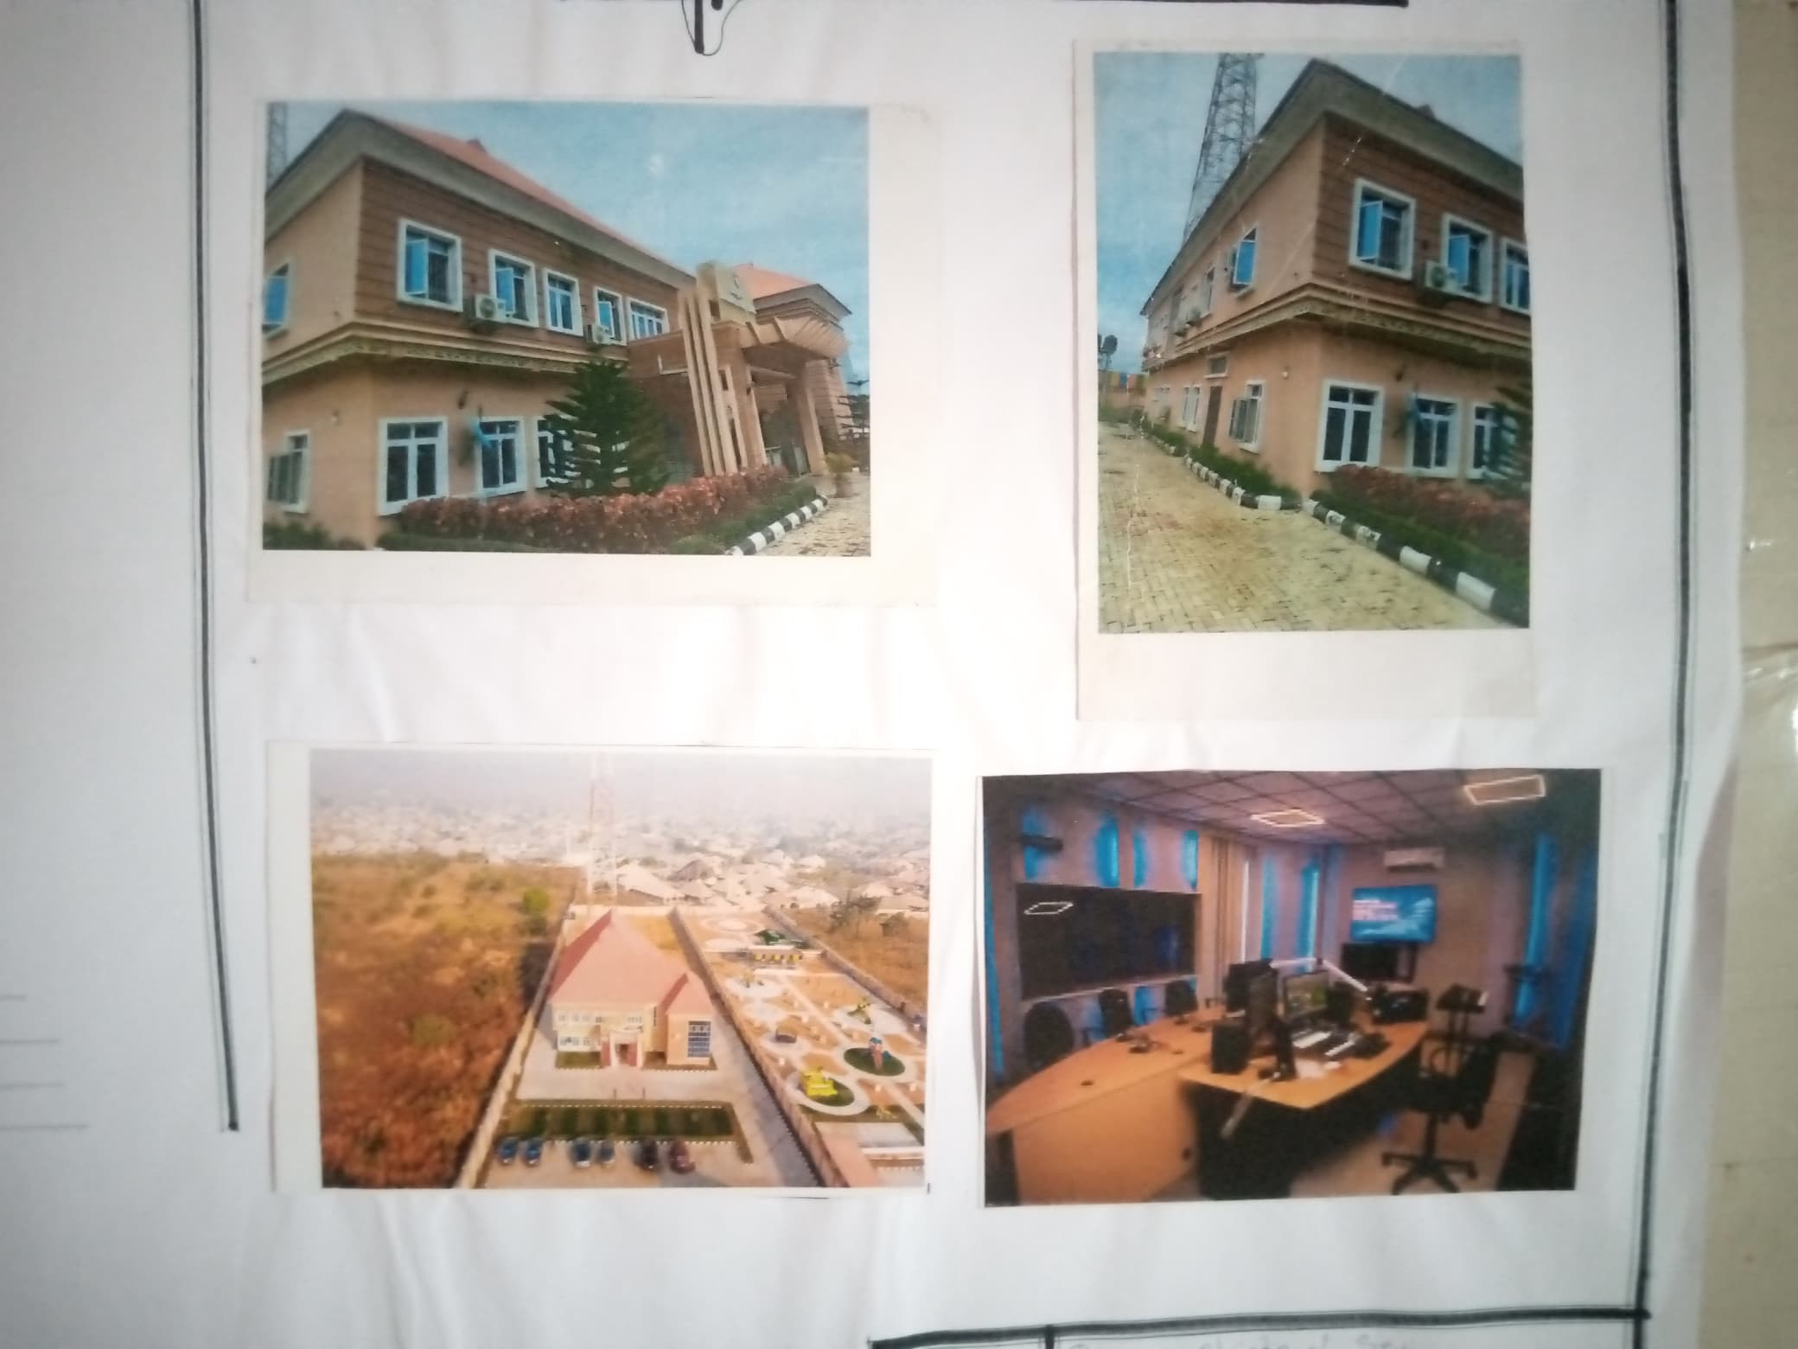
Figure 3.10: Showing Floor Plan

Plate 3.7: Elevation of Case Study 5

Merits

It is easily accessible

There is provision for security post

Adequate provision of ventilation and lighting in the offices

Demerit

It lack drainage facility

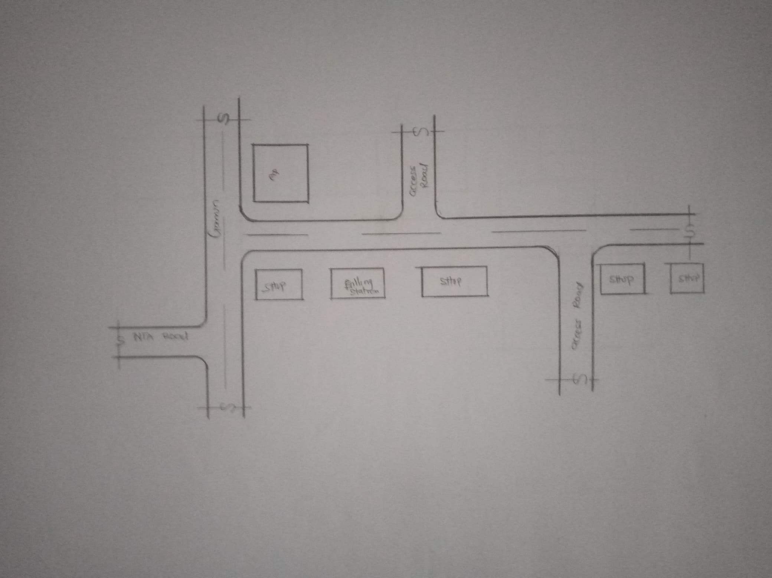
CASE STUDY SIX 6 at Ilorin (Alubarika FM)

Figure 3.11: Showing Locational Plan
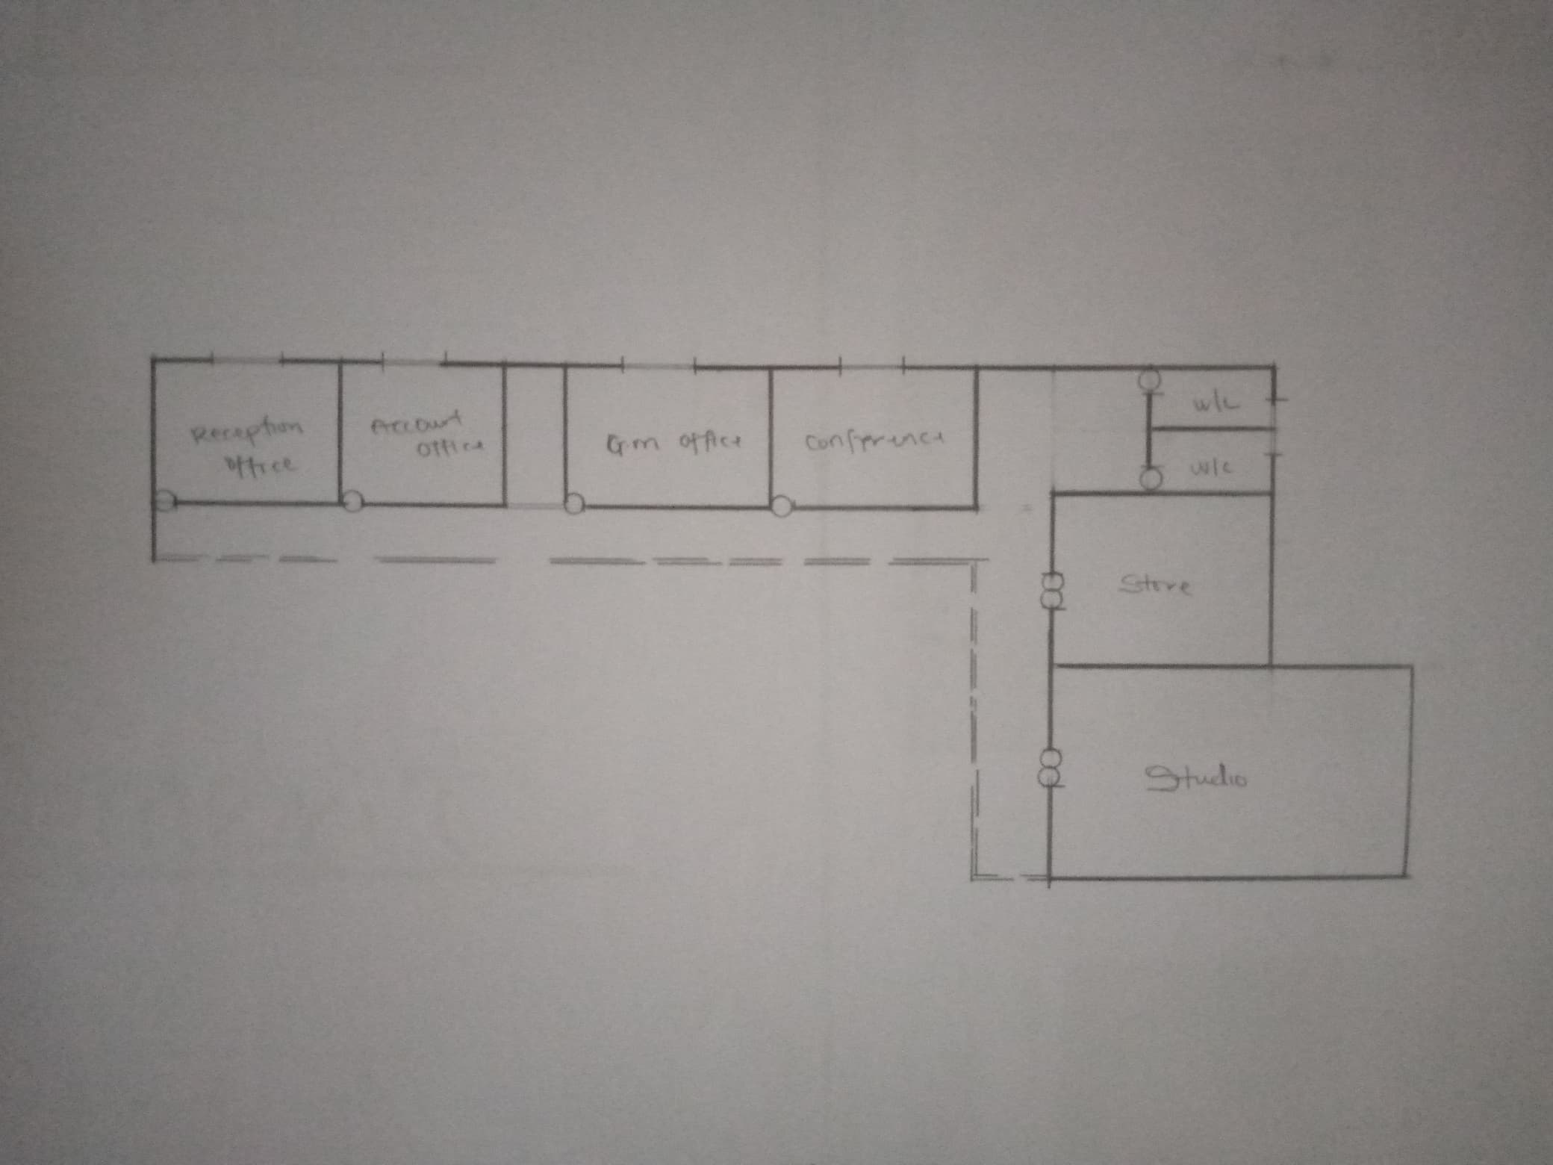

Figure 3.12: Showing Floor Plan

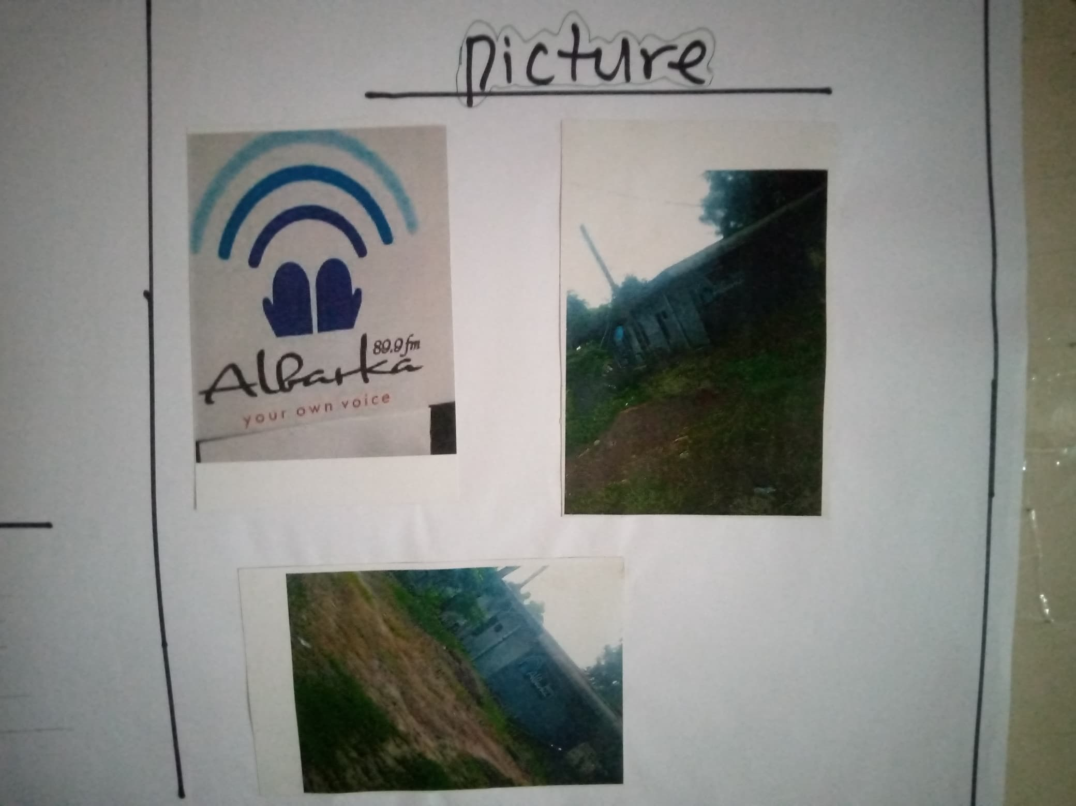

Plate 3.8: Elevations of Case Study 6

Merits

Well defined entrance

There is provision for security post

Studio are well equipped

Demerit

No enough parking space

Live studio not big enough

Poor landscape

CHAPTER FOUR

4.0 INTRODUCTION OF STUDY AREA/SITE SELECTION

4.1 HISTORY OF THE STUDY AREA

Ijara-Isin is a town in Isin Local Government Area in Kwara State. A Yoruba town. Local Government Area of Kwara state was created from the old Irepodun Local Government Area in 1996 with the headquarters at Owu-Isin.

The Ijara-Isin people are stock of the Igbomina. Yoruba language is spoken in however the local dialect concurs as igbomina. Ijara-Isin is a very peaceful community. The people of Ijara-Isin are known for their communal living and being social.

4.2 LOCATION OF THE SITE

The site is located at Ijara-Isin, Isin local government, Kwara State.

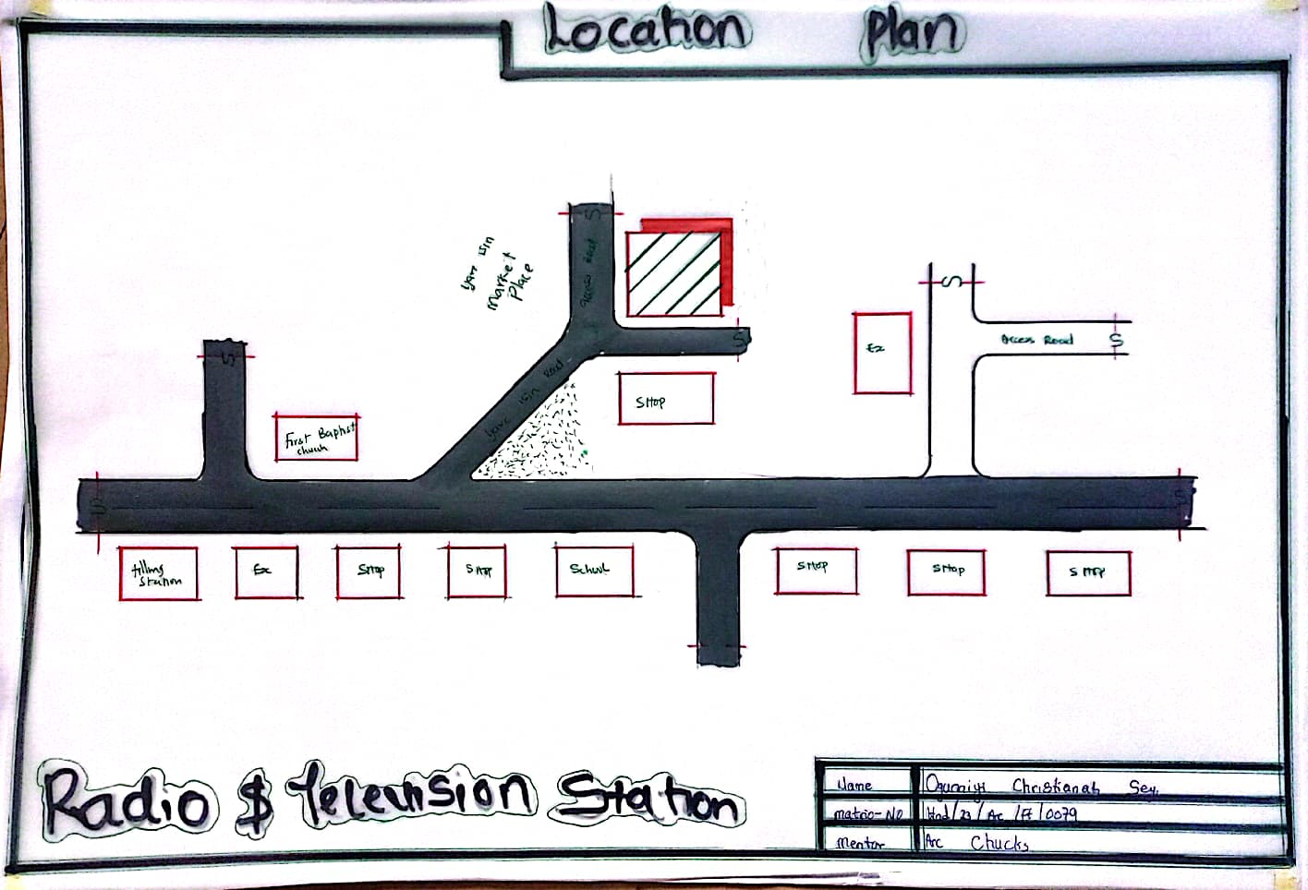
Figure:

Plate 4.1: Locational Plan
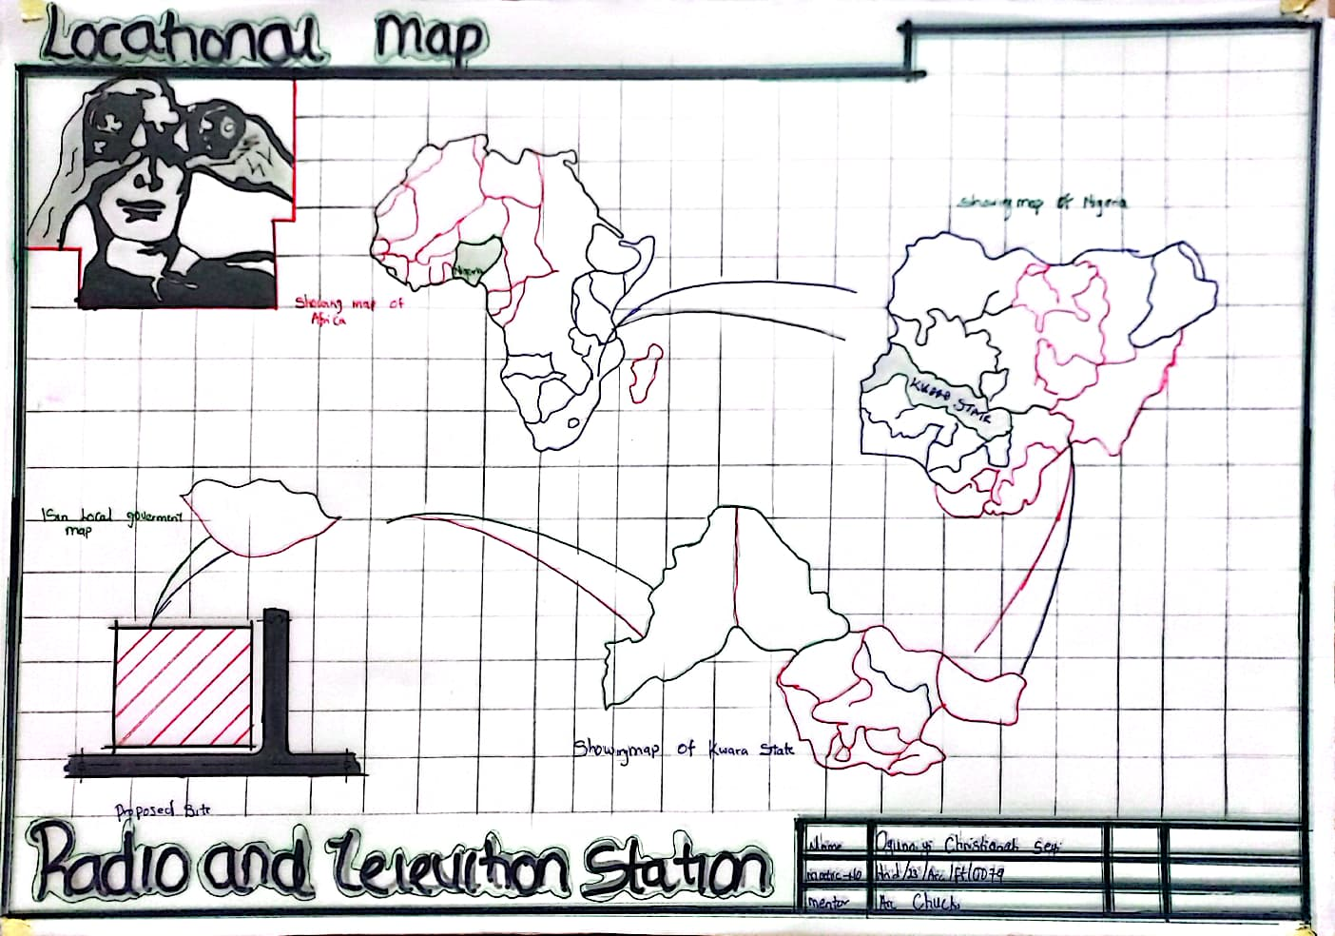

Plate 4.2: Locational Map
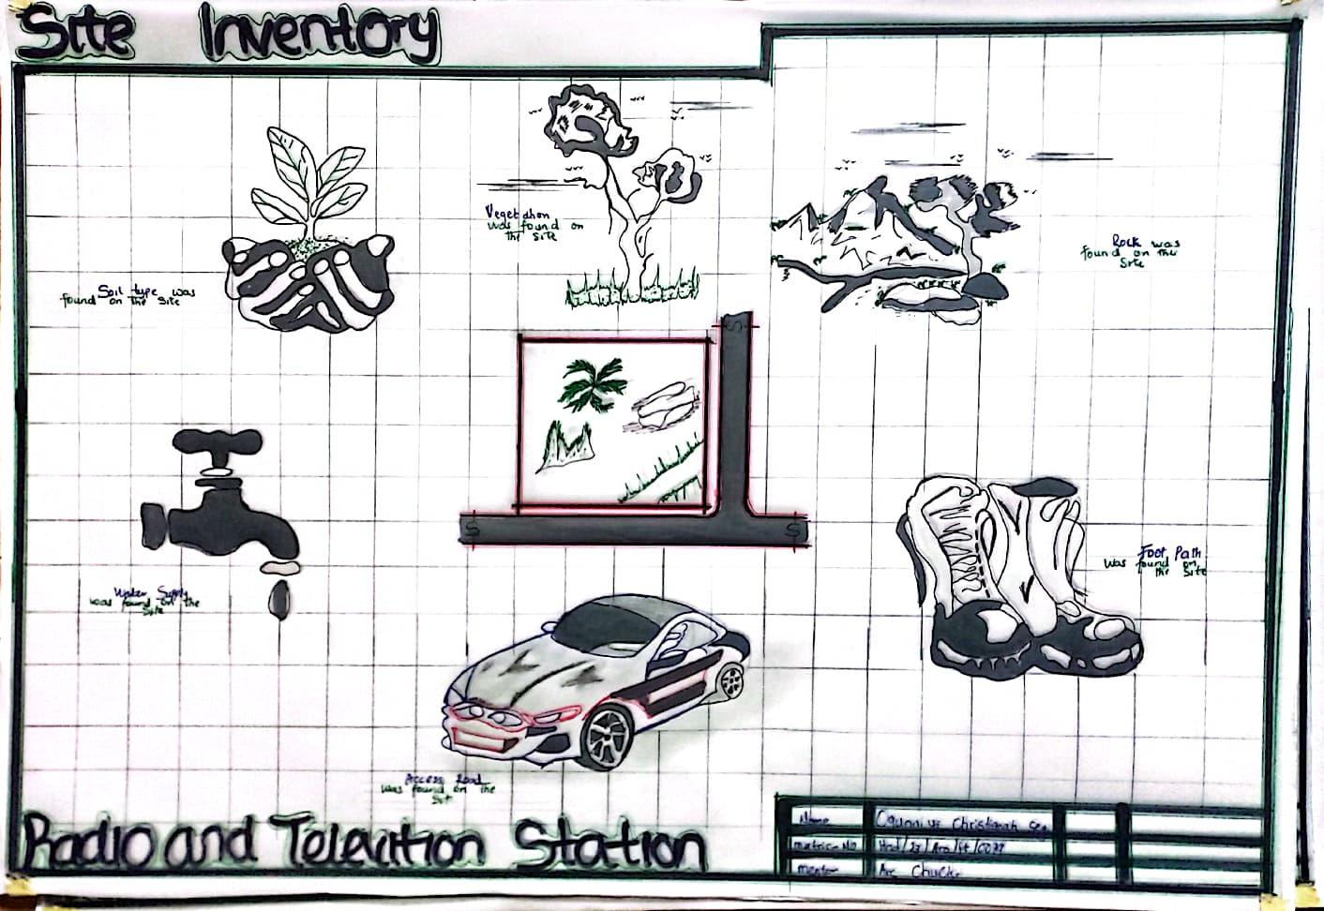

Plate 4.3: Site Inventory

4.3 SITE ANALYSIS
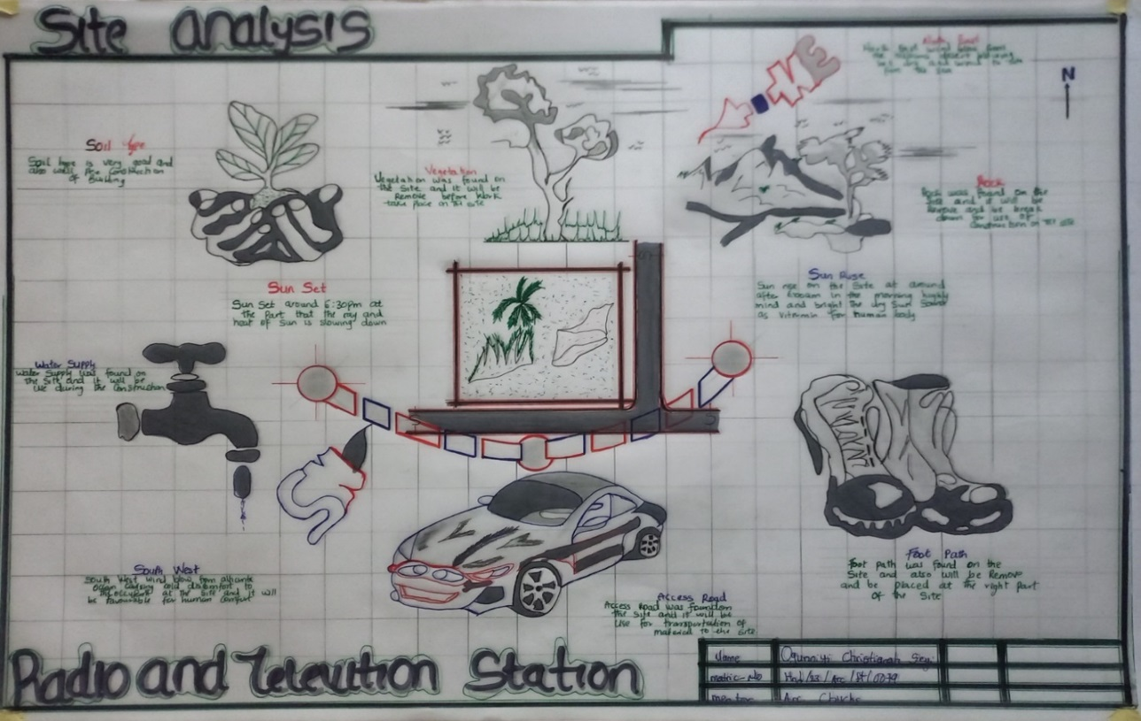

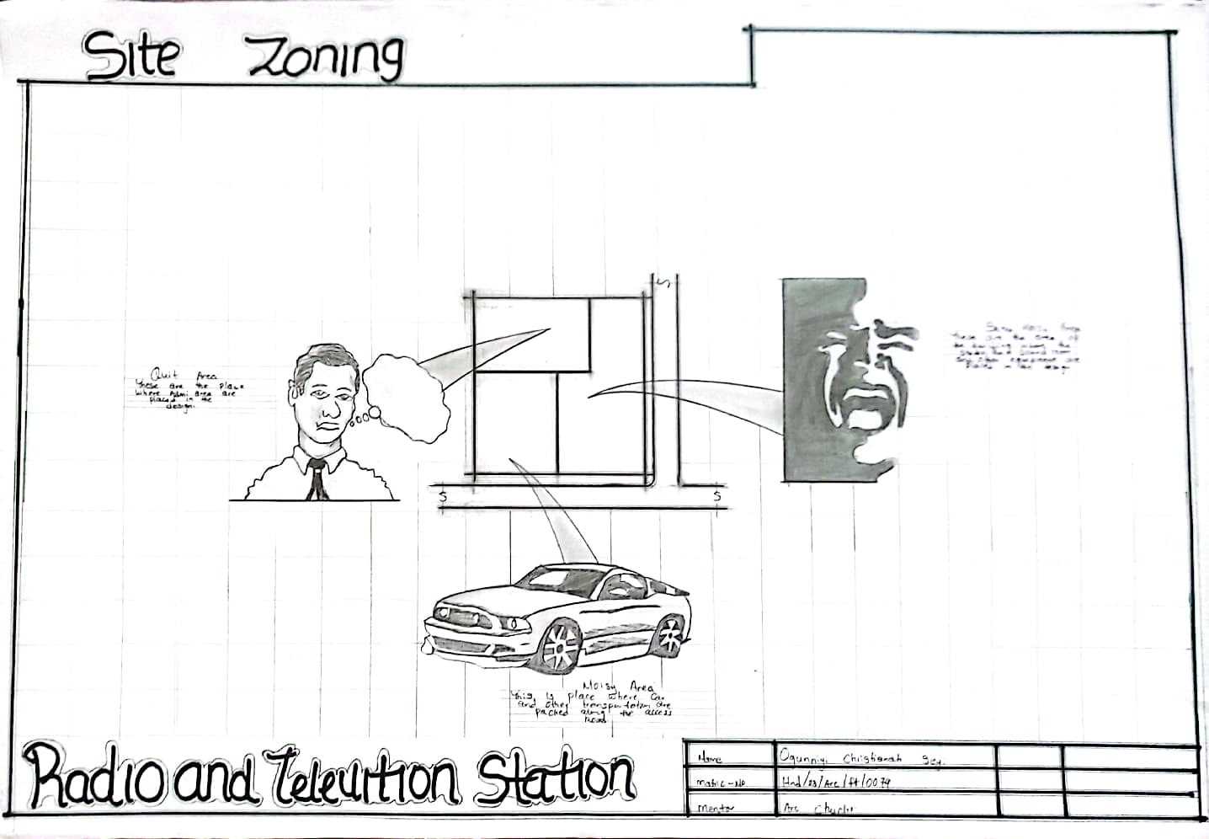
Plate 4.4: Site Analysis

Plate 4.5: Site Zoning

The site is a very important aspect of a design proposal, being the point at which the tangible percentage of a development concept or state is making an impact. The site chosen for any project hence, is of importance in determining the final result and composition of the solution. Thus in all aspects the site and its environment determine the solutions in terms of contextual appropriateness measured by the geographical location and Geometric The specific aspect of the site, its micro-climate are thus a complex interaction of any factors: orientation, scope, topography, temperature patterns, humidity, precipitation, vegetation, Present or absence of water, seasonal availability of sunlight especially in urban areas, the influence of other buildings. The success of any design, in this case radio and television station, to a large extent depends on a wise site selection.

The layout of the building on site will greatly be determined by the topography and physical features (such as water bodies, access, trees, local climate, utility lines) seen on site.

The existing in close proximity to the site has greatly influenced the character of the building to be built in terms of forms, beauty and economy of the design.

Vegetation

The site is covered with shrubs, thick grass, and vegetable leaves and trees. All the vegetables and shrubs are to be removed at the time of conducting the site investigation of the proposed project. i.e. the site displays a relatively thick vegetation cover that is: there are tall grasses, shrubs as well as big trees. There are portions with simple vegetation cover due to human activities (clearing and farming).

Soil Condition: It has a firm laterite soil with good sub-surface condition for construction and landscaping.

Topography: The topography of the proposed development site is relatively low that the topsoil and subsoil is firm and buildable.

Wind Direction: The north-east trade wind brings cold, dust, harmattan and these cause discomfort. The south-west trade wind brings cold humidity which gives comforting effect to the people. Proper ventilation is considered as part of the building effective arrangement.

Geographic/Climatic Data

Climate: The two major influences on the Ijara-Isin climate are the two major wind currents. The south west trade wind is warm and moisture laden and the north east trade wind is cold and dry. The two wind currents bring about the two different seasons called the rainy season and the dry season. The rainy season is between April and October. The dry season is between November and March. It is accompanied by cold, dust and harmattan.



Figure 4.3 Hours of Sunshine per day

Source; Worlddata.info

Rainfall

The type in Isan-Isin is the convectional type caused by the intense heating by the sun during the day. Rainfall is heavy, between 1542mm and 2699mm and is distributed throughout the year.



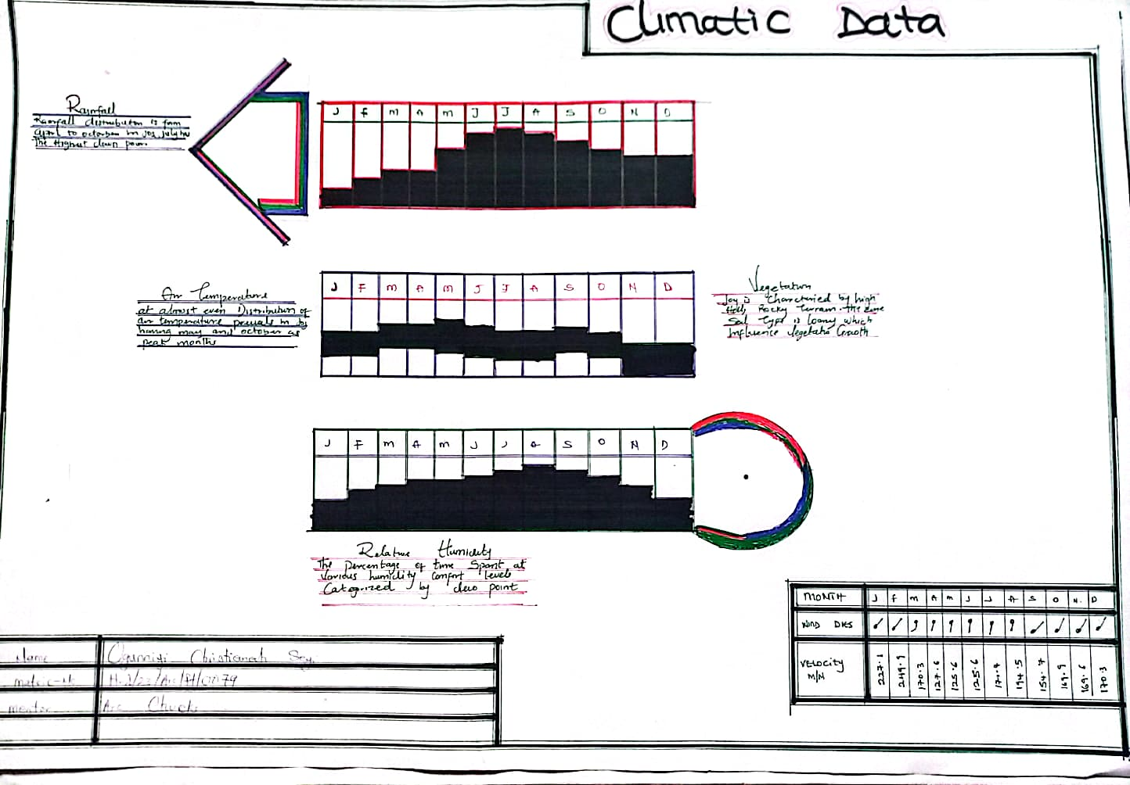

Plate 4.6: Climatic Data

Wind

Both tropical continental and tropical maritime air masses affect Isan-Isin. The town experiences thunderstorm during the beginning and end of the raining season. The prevailing wind direction is south-west trade wind which is rain bearing since it takes origin from the sea. In the raining season period ends from north.

Temperature

The mean monthly temperature of Ijara-Isin is around 27°C with very little variation. Cloudiness and heavy precipitation help to moderate the daily temperature so that the climate is not unbearable. The regular land and sea breeze assist in maintaining equatorial climate.

Humidity

Due to the high annual rainfall, Ijara-Isin’s humidity is high ranging from between 64 percentages and 87 percentages. Over 80 percentage humidity was observed to be common in the morning time during the raining season when the temperature is high. Coupled with the high relative humidity, the atmosphere could be uncomfortable creating heat trap.

Vegetation

Ijara-Isin has dense vegetation. This is as a result of heavy rainfall and uniformly high temperature (solar radiation). Plant growth is very rapid.

Position of the Window

Owing to the high rate of humidity in the tropical environment, air movement must be directed at the body level if it is to be very effective for main or primary source of ventilation is the high located window while the low secondary ventilation...

4.4 SITE PLANNING

The site is planned in order to give it a defined shape and also to reflect the activities taking place. The location of a building and facilities within the site follow these main principles:

1 The priority of individual structure within the term of zoning (noisy, semi-noisy, and quiet zones)

2 Parking space located within and around the various units for convenience

3 The police post and fire station is located not too far from the main gate for security purpose

4 The site is properly defined with a perfect blend of both natural and artificial attractions as well as soft and hard landscaping.

4.5 DESIGN CRITERIA

Building is a factor that is needed to be critically considered in designing a radio and television station. There occur a lot of vibration in the radio and television station and this is due to the noise produced by some equipment used in transmission. Having considered these factors, there would also be a need to take into cognizance the walls and floors of some certain part/units of the television station (such as studio area) how they are to be designed in order to meet the requirement and standard of operation.

4.6 BRIEF ANALYSIS OF PROJECT

In order to have a good and functioning space which serve the purpose that it has been proposed for, the following units is to be followed by the client as a brief that have been provided.

The proposed project has a ground floor with one floor for upper floor use.

Ground Floor we have the following units:

Entrance porch

A reception stand and a security corner for checking in and out

Waiting area

Conveniences for visitors

CCTV room

Chairman’s Office

News room

Engineer Office

Studio 1 & 2

Production room

General Manager’s office

Programming room

Marketing room

I.T. room

News editing room

At the upper floor we have:

Cafeteria hall

Secretary’s office

Manager’s office

News room

Lobby

Main control room

Production and recording room

Sales room

Strategy room

Master control room

Resource room

Finance department

Make-up room

Studio

Marketing department

Office

Outdoor:

Gate house

Main building

A.T.M. Gallery

Canteen

Satellite

Transmission area

Generator house

4.7 SPACE ALLOCATION / SCHEDULE OF ACCOMMODATION
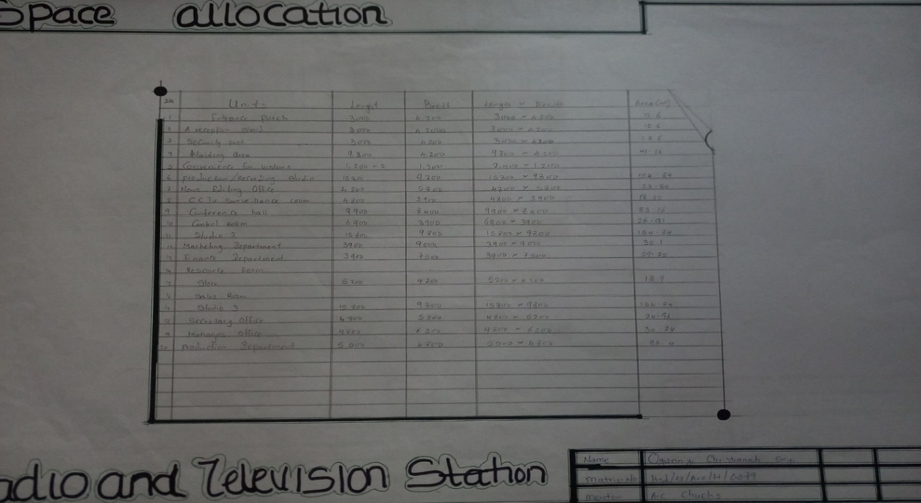

Plate 4.7: Space Allocation

FUNCTIONAL ANALYSIS

The functional analysis tries to arrange different units of the radio and television station in such a way that the overall layout of the site is functionally and aesthetically satisfactory and pleasant to the users

BUBBLE DIAGRAM

Bubble diagram is a graphics representation that translates function or activities into spatial arrangement showing the connection with the space and their orientation on the site.

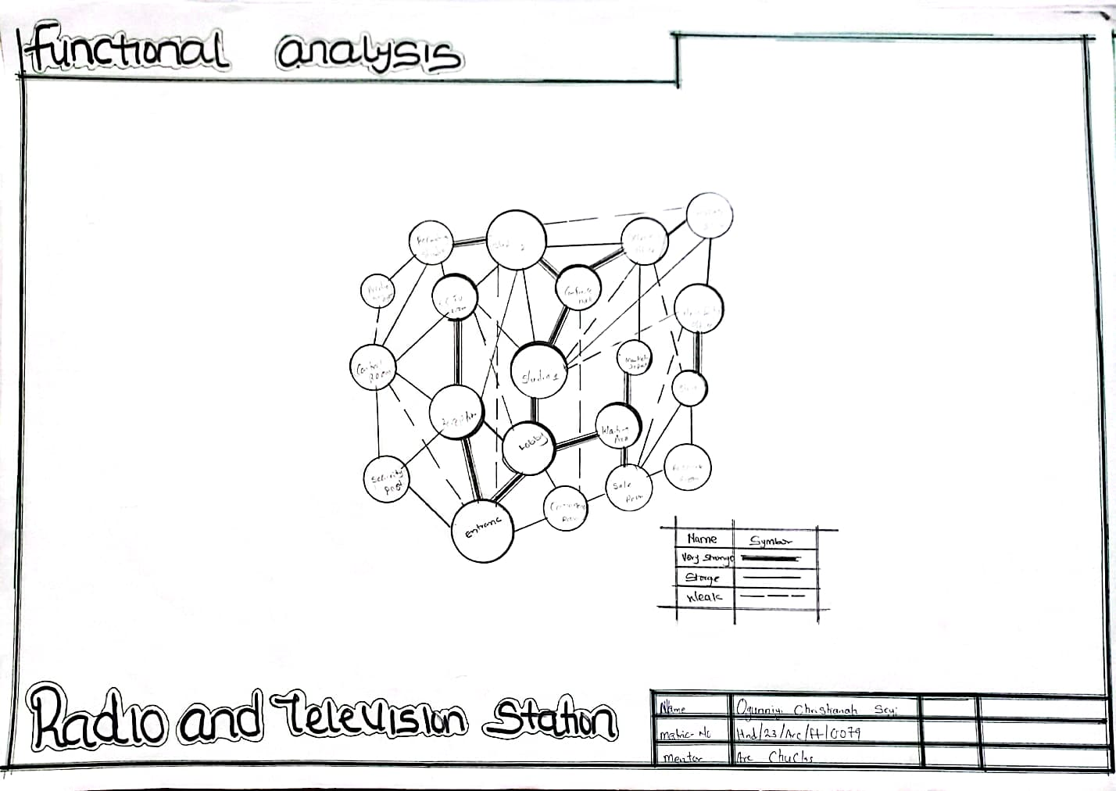
Plate 4.8: Functional Analysis
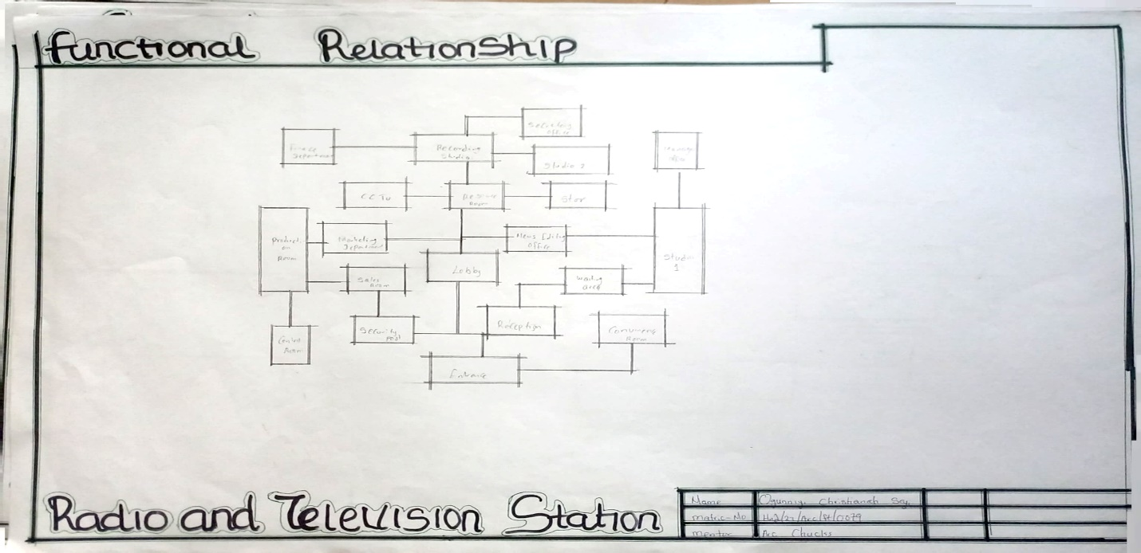

Plate 4.9: Functional Relationship

4.8 CONCEPTUAL DEVELOPMENT

The proposed project duly considered functionality which is the paramount factor when embarking on a housing estate project. In the concept development functionality was seriously considered in order to achieve the linear relationship between the units in the radio and television station and the occupants
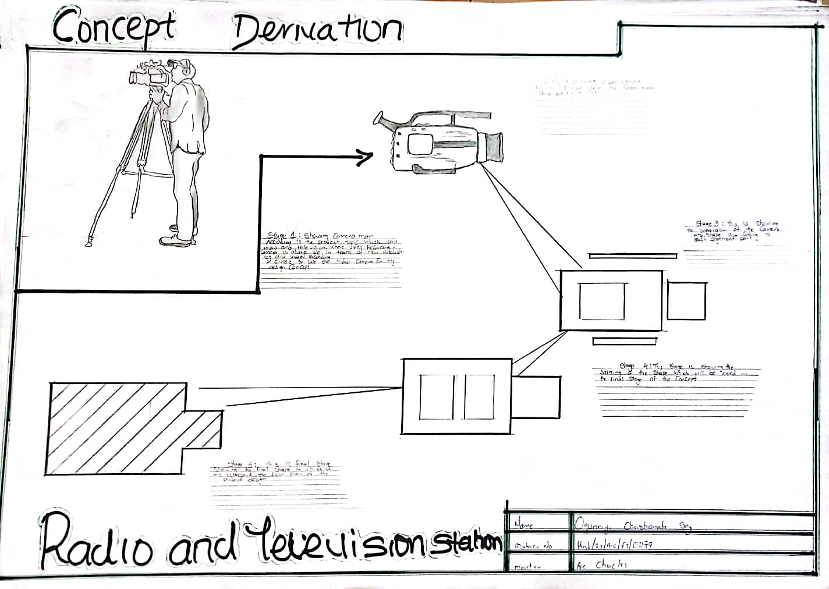

Plate 4.10: Concept Derivation

CHAPTER FIVE

5.0 PROJECT APPRAISAL

5.1 CONSTRUCTION METHOD

The method of construction involves in the erection of the building structure is in accordance with the architectural detail required in executing the building and the process of construction that is critical to structural components as affected by the site conditions and types of materials to be used.

After the preparation of the overall site plan, many design detail is developed to show the specific methods of construction. These details, are an integral part of the design process and serve two important purposes. Firstly, they stipulate the aesthetic and structural elements of the plan and secondly they provide the basis for costing the project.

This section offers a wide range of representative details of the various aspect of site development and assumed that the details will act as guide to assist site designers in solving their particular problems. The section is not intended to present aesthetic or design solutions alone but also indicate how similar technological difficulties are handled. It is clear that the method of construction of any structure such as housing estate is determined from the functional requirement of the facilities provided and its exposure to weather and climate condition. For any used, the following factors are considered

➢ Climatic conditions of the site

➢ Condition of the sub-soil present on the site

➢ Fire protection requirement

➢ Appearance of materials

➢ Durability and easy maintenance

➢ Economy

➢ Availability of materials

➢ Aesthetics

➢ Construction technique

➢ Cost of materials

The various building components take into consideration are:

i. SUB-STRUCTURE:

This is the part of the building below the natural ground level. The foundation footing are reinforce for stability of the building to enable it to withstand the load (Live, Super-imposed and wind load). The foundation of the building shall be determined by the structural engineer according to the bearing capacity of the soil.

ii. SUPER-STRUCTURE:

This is the building part that is above the ground level. The entire structure is designed with reinforced concrete columns, beams and hollow sand screed block.

5.2 MATERIALS AND STANDARD FORMS

The following materials are applied in the construction of the structure such as:

➤ FLOORS

The ground floor will be of solid concrete slab of 150mm with asphalt coating as damp proof course laid on well compacted hardcore. The upper floors are reinforced concrete suspended floors are reinforced concrete suspended floors of 150mm thick.

Floor finishes are to be specified for each unit depending on the function it meant to serve. Floor finishes are ceramic floor tiles and terrazzo floor tiles because they are durable, easy to maintain and do not wear easily.

DOORS

The size and types of door used depend on location, but generally the size ranges from 750mm, 900mm, and 1200mm and the type of material specified for the construction in the door schedule which should be strictly followed.

WINDOWS

A window in a building is designed primarily to allow natural light, natural air, the building and used allow free flow of carbon dioxide out of the building as well as to allow for outside view. The choice of window to be used is specified in the window schedules

ROOFS

Roof members of all buildings will be made up of steel and long span of aluminums roofing sheet. This is for the easy maintenance of self-support and long life span.

CEILING

The kind of ceiling system specified for the building in the housing estate is the asbestos ceiling sheet. The functional requirement of the ceiling is considered under the following:

1 Durability

2 Easy to maintain

3 Heat resistance

4 Cost

ESSENTIAL SERVICES

Services are essential for comfort, ability, security and safety to create a conducive atmosphere for the user of the housing estate. To achieve this, the following services must be provide

1. ELECTRICITY

The main source of electricity is from national electric power authority and this should be connected to the site from the power line in front of the site way

2. VENTILATION

Ventilation needed at the inflating part of building. Varies from pal…

Design studio with adaptation layout to accommodate various types of shows, including live broadcasts, pre-recorded segment, and talk shows with live audiences.

3. Integrate Sustainable Design Elements:

Incorporate sustainable practices such as energy-efficient lighting, HVAC systems, and the use of eco-friendly materials to reduce the studio’s environmental footprint.

4. Prioritize Ergonomics and Comfort:

Design office and studio environments with ergonomic furniture and climate control to enhance the comfort and productivity at work.

5. Ensure Redundancy and Backup Systems:

Implement redundant systems for critical technical operations, including backup power supplies, to ensure uninterrupted broadcasting in case of equipment failure or power outage.

6. Plan for Future Expansion:

Design the facility with potential future expansion in mind, allowing for easy modifications and additions as the station grows.

7. Provide Adequate Training Facilities:

Include dedicated space for staff training and development to keep the team updated with the latest industry practices and technologies.

8. Optimize Space Utilization:

Efficiently plan the layout to maximize the use of space, ensuring that all functional areas are easily accessible while maintaining clear separation between public and restricted are

9. Enhance Technological Infrastructure:

Equip the technical team with the latest broadcast control and I.T. equipment, ensuring robust and reliable operation. Consider future-proofing by incorporating scalable and upgradable systems.

10. Facilitate Accessibility and Inclusivity:

Design all areas, including restrooms and outdoor spaces, to be accessible to individuals with disabilities, ensuring compliance with relevant accessibility standards.

5.3 CONCLUSION

The architectural design of a radio and television station requires a meticulous approach to balance functionality, technology, and comfort. By adopting advanced soundproofing techniques and flexible studio design, the station can ensure high-quality audio and visual production and accommodate diverse broadcasting needs. Enhancing technological infrastructure and optimizing space utilization will support efficient operations and future growth.

Prioritizing ergonomics, comfort, and sustainable design elements will foster a productive and environmentally responsible workplace. Ensuring redundancy and backup systems will safeguard against interruptions while facilitating accessibility and inclusivity will make the station welcoming to all individuals.

REFERENCES

1 Bartony N. & Chevron l. (2008). Architectural Engineering Moscow: Mr. Publishers.

2 Chusday. L. (2004). NAB’s Guide to Careers in Television (Second Edition Ed) Baltimore: National Association of Broadcasters Education Foundation.

3. Everest, F.A. & Pohlmann, K.C. (2015). Master Handbook of Acoustics. McGraw-Hill Education.

4. Gervais, J. (2018). Acoustic Design for the Home Studio. Cengage Learning.

5. Gniedzik. J. (2008). Structural System in Architecture. Zaria.

6. Kibert, C.J. (2016). Sustainable Construction: Green Building Design and Delivery. Wiley.

