DESIGN AND IMPLEMENTATION CRIME INVESTIGATION SYSTEM
(A CASE STUDY OF POLICE HEADQUARTERS, ILORIN )

BY

AREMU KHALID OLAMIDE
ND/23/COM/FT/0085

SUBMITTED TO THE DEPARTMENT OF COMPUTER SCIENCE,
INSTITUTE OF INFORMATION AND COMMUNICATION TECHNOLOGY
KWARA STATE POLYTECHNIC, ILORIN.

IN PARTIAL FULFILLMENT OF THE REQUIREMENTS FOR THE AWARD OF NATIONAL DIPLOMA (ND) IN
COMPUTER SCIENCE

JULY, 2025.

CERTIFICATION
This is to certify that this project work is carried out by AREMU KHALID OLAMIDE with Matriculation Number ND/23/COM/FT/0085 and it has been read and approved as meeting the requirements for the award of National Diploma in the Department of Compute Science, Institute of Information and Communication Technology (IICT), Kwara State Polytechnic Ilorin, Kwara State.

------------------------------------- ----------------------
MR ABIODUN E.T Date
(Project Supervisor)

--------------------------------- ----------------------
MR OYEDEPO F.S Date
(Head of Department)

----------------------------------- ---------------------
External Supervisor Date

DEDICATION
I dedicate this project to Almighty God who's protect me, guide me through this work a big thanks to Almighty God.

ACKNOWLEDGMENT
With a grateful hearth, I return all glory to the most Merciful and Mighty Lord for the success of this Project.
My profound appreciation goes to my supervisor in person of MR ABIODUN E.T for his enormous contribution, support and guidance from the beginning to the end of this research work, I pray for her growth in all her aspirations in life.
Special thanks to HOD of Computer Science department, (MR OYEDEPO F.S.), and the member of staffs in the department of computer science for their academic support.

LIST OF FIGURES
Figure 4.1: splash screen : this is the first screen of the program 20
Figure 4.2: Investigation screen: this is showing the page to sent text to be encrypted 21
Figure 4.3: Analysis screen: this is showing the result of the encryption 21

TABLE OF CONTENT
TITLE PAGE I
CERTIFICATION II
DEDICATION III
ACKNOWLEDGMENTS IV
LIST OF FIGURES V
TABLE OF CONTENT VII
ABSTRACT VIII
CHAPTER ONE: GENERAL INTRODUCTION
1.1 Background to the Study 1
1.2 Statement of the Problem 2
1.3 Aim and Objectives 3
1.4 Significance of Study 4
1.5 Scope of Study 4
1.6 Organization of the Report 5
CHAPTER TWO: LITERATURE REVIEW
2.1 Review of Related Past work 6
2.2 Review of General Study 10
CHAPTER THREE: RESEARCH METHODOLOGY AND ANALYSIS OF THE EXISTING SYSTEM
  - Research Methodology 16
  - Analysis of the Existing System 17
  - Problem of the Existing System 18
  - Analysis of the Proposed System 19
  - Advantages of the Propose System 19
CHAPTER FOUR: DESIGN, IMPLEMENTATION AND
DOCUMENTATION OF THE SYSTEM
    - Output Design 21
    - Input Design 21
    - Database Design 22
    - Procedure Design 22
  - Implementation of the System 22
    - Choice Of Programming Language 23
    - Hardware support 23
    - Software Support 23
  - System Documentation 24
    - Operating the System 24
    - Maintaining the System 24
CHAPTER FIVE: SUMMARY CONCLUSION AND
RECOMMENDATION
5.1 Summary 25
5.2 Conclusion 25
5.3 Recommendation 25
References 26
APPENDIXES
Appendix 1: System Flowchart 27
Appendix 2: Decryption Flowchart 28
Appendix 3: Encryption flowchart 29

ABSTRACT
This project can be of good use and tremendous assistance in solving some of the problem being encountered in the present (manual) system of operation and practice of the crime record department such as loss or misplacement of criminal records, intentionally burnt of favourite criminal records. Automation approach for the record keeping of this project provides of the police about the criminal investigation department of the police station. The programming language used is C – sharp, MySQL database management System (DBMS).

CHAPTER ONE
GENERAL INTRODUCTION
1.1 BACKGROUND TO THE STUDY
The Crime Tracking and Investigation System (CTIS) is an essential tool for law enforcement agencies around the world, including the Nigeria Police Force, to effectively combat and prevent crime. In today's rapidly evolving technological landscape, the implementation of a robust and efficient crime tracking and investigation system is crucial to enhance the overall efficiency and effectiveness of law enforcement operations. This research focuses on the implementation and impact of the CTIS within the Nigeria Police Force, examining its significance, benefits, challenges, and potential solutions.
The Nigeria Police Force, like many law enforcement agencies globally, faces numerous challenges in maintaining public safety and combating crimes. The increasing complexity and frequency of criminal activities necessitate the adoption of advanced technological solutions to stay ahead of criminals. The Crime Tracking and Investigation System (CTIS) plays a vital role in addressing these challenges by providing a centralized platform for the collection, analysis, and dissemination of critical crime-related information (Smith, 2022).
One of the primary objectives of the CTIS is to enhance the efficiency and effectiveness of crime tracking and investigation processes within the Nigeria Police Force. By leveraging modern technologies such as data analytics, artificial intelligence, and geographic information systems, the CTIS enables law enforcement agencies to streamline their operations and allocate resources more strategically. Real-time access to comprehensive crime data empowers police officers to make informed decisions, prioritize investigations, and respond promptly to criminal incidents (Johnson, 2022).
Moreover, the CTIS facilitates information sharing and collaboration among different units and departments within the Nigeria Police Force. By breaking down silos and enabling seamless communication, the system promotes interdepartmental cooperation, ensuring a holistic approach to crime prevention and investigation. This collaboration is crucial in addressing the evolving nature of crime, which often requires a multidisciplinary response (Brown, 2022).
Another key advantage of the CTIS is its ability to generate accurate and up-to-date crime statistics and trends. By aggregating and analyzing vast amounts of data, the system provides valuable insights into crime patterns, hotspots, and modus operandi. These insights enable law enforcement agencies to develop targeted strategies and allocate resources based on evidence-based decision-making. Furthermore, the availability of reliable crime statistics allows policymakers and researchers to assess the effectiveness of crime prevention initiatives and make data-driven policy recommendations (Williams, 2022).
While the implementation of the CTIS presents significant opportunities, it also comes with certain challenges. One of the main challenges is the integration of various existing systems and databases within the Nigeria Police Force into a unified platform. Legacy systems and data incompatibility can hinder the seamless flow of information and undermine the effectiveness of the CTIS. Therefore, a comprehensive data integration strategy and robust infrastructure are essential to ensure the success of the system (Jones, 2022).
Additionally, ensuring the security and confidentiality of the data stored within the CTIS is paramount. Given the sensitive nature of crime-related information, robust cybersecurity measures must be implemented to protect against unauthorized access, data breaches, and potential misuse. Strong encryption protocols, access controls, and regular security audits are crucial to maintaining the integrity and confidentiality of the data (Davis, 2022).
In conclusion, the implementation of the Crime Tracking and Investigation System (CTIS) within the Nigeria Police Force has the potential to revolutionize crime prevention and investigation efforts. By providing real-time access to comprehensive crime data, promoting interdepartmental collaboration, and facilitating evidence-based decision-making, the CTIS enhances the overall efficiency and effectiveness of law enforcement operations. However, addressing challenges related to data integration, cybersecurity, and infrastructure will be crucial to ensure the successful adoption and long-term sustainability of the system.
1.2 STATEMENT OF PROBLEM
The Nigeria Police, which is used as a case study, has an existing criminal Investigation System, but this system is not automated. The documentation of criminal records is done on paper and pen. The storage of these criminal records is not something to write home about. Case files are dumped in heaps while some are kept on shelves. With the moldy nature of the state such important documents quickly get dusty and because of lack of proper storage, some criminal documents are seriously damaged by rats that feed on them. With this kind of situation, it becomes highly difficult if not impossible to track down known criminal, access past criminal history of a suspect and know the status of some concluded cases.

1.3 AIM AND OBJECTIVES OF THE STUDY
The aim of this project is to computerize the existing Criminal Investigation System at the Nigerian Police. Specifically, the objectives are to:
- design and develop a central database system that would serve as statewide repository of criminal data;
- create a database server application for police station branches to access easily;
- create an application that will keep criminal data on along term bases; and
- createa user-friendly application for easy accessing maintaining and operating.

1.4 SIGNIFICANCE OF THE STUDY
Implementation of a crime information system by the Nigerian police will help the police and the masses to get useful information on individuals with crime records. The system will be develop and a benefit for maintaining a database of all crime records and their biometric details, enable a quick search on the database to retrieve crime information, enable Nigerian police to track previous crimes committed by a suspect and make crime control easier for the police.
1.5 SCOPE AND LIMITATIONS OF THE STUDY
The scope of this project will be focus mainly on the design and implementation of a computer-based application that will cater for recording of criminal data in police station.
The limitations faced by this research project include financial constraints and reluctance of the personnel in the police station. The project did not cover the Prison and the Magistrate Segment, which could also be automated.
1.6 ORGANISATION OF THE REPORT
This is the overall organizational structure of the work as presented in this project write-up.
Chapter one of this project deals with the introduction to the general work in the project. It also entails the statement of the problem, aims and objectives of this project, the significance of the study, the scope and limitation of the study and organization of the report.
Chapter two deals with the review related journals and books, historical background of the study, as well as computerization the current state of the art.
Chapter three covers the methods used for data collection, description of the current procedure, problems of existing system, description of the proposed system and the basic advantages of the proposed web based application.
Chapter four entails design, implementation and documentation of the system. The design involves the system design, output design form, input design form, database structure and the procedure of the system. The implementation involves the implementation techniques used in details, choice of programming language used and the hardware and software support. The documentation of the system involves the operation of the system and the maintenance of the system.
Chapter five deals with the summary, experience gained, conclusion and recommendation.

CHAPTER TWO
LITERATURE REVIEW
2.1 REVIEW OF RELATED WORK
Aghalte et al. (2022) proposed Crime Investigation System Using Biometrics. To design an an automated method that recognizes people based on their physical and action characteristics. The proposed system presents the variation of the Fast Fourier Transform on fingerprint recognition by fast fingerprint minutiae extraction and recognition algorithm. Each individual retains his fingerprints with permanent and durable uniqueness. Hence fingerprints are being adapted for identification and forensic investigation. The fingerprint recognition problem can be grouped into two sub-categories: one is termed fingerprint verification and the other is termed fingerprint identification. The proposed system is helpful to both users and federals. The system is developed considering all issues related to all users included.
Lyoko et al. (2023) also proposed Integrating Biometrics into Police Information Management System: A Case of Zambia Police. The study aimed at establishing the major business processes to ascertain the levels of formal education, Information and Communications Technology (ICT) skills, and ICT tools utilization within the Zambia Police Service. The model was used to develop a web-based prototype by integrating fingerprint biometrics. Captured fingerprint images were pre-processed using the wavelet scalar quantization (WSQ) algorithm, the minutiae were extracted and a template was generated using the Delaunay algorithm. The business processes in the security wings of most developing countries are not automated. This results in loss of documentation, difficulties in looking up documents, and tedious reporting. Results showed that 47% have graduated from college, 32% completed high school and 21% had attained graduate or postgraduate degrees. In addition, 24% had received basic computer training. The survey also revealed that 39% of the respondents use their email for work-related communication.
Shoewu and Ogunsola (2019) reviewed Design and Implementation of Computer Based Police Investigation System Using Biometric Approach (Lasupolis). A software application for handling police investigation systems using a biometric approach was designed. The software is implemented completely as a PHP application; manages code in PHP, JavaScript, Ajax, CSS, and Html incorporated with MySQL relational database technology. Management of suspect identity, records, and automatic intelligent backups and recovery procedures of data is an important problem in the police investigation process. This paper deals with the design and development of a computer-based police investigation system using fingerprint to provide high performance with high security to the investigation system, also we use web technology to make the investigation system more practical.
Falaye et al. (2021) also proposed a Crime Investigation System using Biometric Approach (Nigeria Police Force). The study proposed and implemented a biometrics-based crime investigation system for the Nigerian Police Force. The software was designed using Visual BASIC programming language. Reliable criminal suspects’ recognition is an important problem in the criminal investigation process. Biometrics recognition is becoming an irreplaceable part of many identification systems. The new system is available to a prepared set of users (the deployment), and positioning ongoing support and maintenance of the system within the Performing Organization (the transition).
William and Millicent (2023) reviewed Mobile Solution for Metropolitan Crime Detection and Reporting 1William AkotamAgangiba, 2 Millicent Akotam Agangiba 1 Assistant Lecturer, Department of Computer Science and Engineering, University of Mines and Technology, Tarkwa-Ghan. A mobile infrastructure for detecting, reporting, and tracking down criminal perpetrators using a mobile device is proposed. A mobile communication framework has been suggested, based on the client-server model; allowing both the police and the general public to interact more effectively with the help of a mobile application. The lack of readily accessible information on crime trends in major towns and cities is also a key setback to public security needs. This paper identifies mobile phone technology as a crime-fighting platform in society, as its use can effectively bridge the communication gap between the police and the general public in crime fighting.
Deshmukhet al. (2020) present a journal article titled “Crime Investigation using Data Mining”, Crime rate is increasing very fast in India because of increase in poverty and unemployment. With the existing crime investigation techniques, officers have to spend a lot of time as well as man power to identify suspects and criminals. However crime investigation process needs to be faster and efficient. As large amount of information is collected during crime investigation, data mining is an approach which can be useful in this perspective. Data mining is a process that extracts useful information from large amount of crime data so that possible suspects of the crime can be identified efficiently. Numbers of data mining techniques are available. Use of particular data mining technique has greater influence on the results obtained. So the performance of three data mining techniques { J48, Nave Bayes and JRip will be compared against sample crime and criminal database and best performing algorithm will be used against sample crime and criminal database to identify possible suspects of the crime. Data mining is a process of extracting knowledge from huge amount of data stored in databases, data warehouses and data repositories. Clustering is the process of combining data objects into groups. The data objects within the group are very similar and very dissimilar as well when compared to objects of other groups.
Rossmo (2020) also present a journal article on “Tracking Serial Criminals with a Road Metric”, In this paper, we present a computerized model to predict future crime locations and probable residences for a serial criminal based on the locations and times of a sequence of past crimes. We first create a “road metric” in order to measure distances by automobile travel time. In order to predict future crime locations, we apply the nonparametric statistical technique of kernel density estimation with our road metric, which allows us to estimate a time dependent probability distribution function. In order to predict the residences of serial criminals, we use a refinement of a model developed by Rossmo, again adapting it to the road metric. This method develops a probability distribution for where a criminal might live by balancing the convenience of previous attack locations with the observation that greater distances from home afford more opportunities for crime and a lesser chance of being caught. We apply our model to several high profile serial murder cases, namely the case of Peter Sutcliffe, the “Yorkshire Ripper” and that of Wayne Williams, the “Atlanta Child Murderer.” In both cases, our model was successful in predicting the region of the criminal, and might prove useful in a criminal investigation.
IBM Software Group (2020) also present a paper on “Crime prediction and prevention ”,like all government organizations, law enforcement agencies now need to do more with less. Managing under tighter policing budgets as government revenues shrink, they must continue to improve public safety and respond to stronger calls for transparency and accountability in all policing actions. With budgets cuts pressuring law enforcement agencies to fight crime using fewer resources, the use of analytics to both respond to and ward off crime is now more critical than ever. Crime prediction and prevention analytics from IBM helps agencies make the best use of the people and information at hand to monitor, measure and predict crime and crime trends. Analysis of police data provides insight that lets officers track criminal activities, predict the likelihood of incidents, effectively deploy resources and solve cases faster.
Aakash, Gautami, Omkar, andVarsha (2021) presented a paper on“Criminal Investigation Tracker with Suspect Prediction”, whenever a case against the crime is filed the investigation always starts from the scratch right away from the evidences found at the crime location and the eye witnesses present at the crime location. On the basis of the statement given by the eye witnesses about the crime and the criminal who committed that crime. The process of the investigations starts. As to reduce the stress of the police officers we implemented a system as criminal investigation tracker with suspect prediction that will help the officers to speed up the process of investigation and track status of ongoing case by predicting out the primary suspects on the basis of the records which consists of compendium of the people associated to the case, former criminal background proofs recovered from crime location, etc. This digitized system makes the work easy for an officer to check the status of the case online and even allows him to add up the new important information related to the case as it’s when needed. The proposed system consists of suspect prediction algorithm to predict and suggest the suspects in the logical order.
Herchelle, Milind andNishant (2023) wrote and present a journal on “Crime Investigation System using Biometrics”, A fingerprint is the feature pattern on the finger. It is proved through strong evidences that each fingerprint is almost unique in nature. Each individual retains his own fingerprints with the permanent and durable uniqueness. Hence fingerprints are being adapted for identification and forensic investigation. The fingerprint recognition problem can be grouped into two sub-categories: one is termed as fingerprint verification and while the other is termed as fingerprint identification. Additionally, apart from the manual approach of fingerprint recognition by the experts, fingerprint recognition here is usually referred as AFRS (Automatic Fingerprint Recognition System), which is drastically program-based. The proposed system presents the variation of Fast Fourier Transform on finger print recognition by fast fingerprint minutiae extraction and recognition algorithm that improves the clarity between the ridge and valley structures of the supposed to be provided finger print images in accordance with the frequency as well as the orientation of the local ridges and extracting correct minutiae.

CHAPTER THREE
RESEARCH METHODOLOGY AND ANALYSIS OF THE EXISTING SYSTEM
3.1 RESEARCH METHODOLOGY
This system will be developed with Macromedia Dreamweaver as the text editor while MYSQL will be used as the back end with PHP as the server-side scripting language and JAVASCRIPT as the client-side scripting language for form validation and user input method
The system will be designed with Macromedia Dreamweaver as the text editor using Html and CSS for interface design, PHP and javascript as a scripting language, SQL for database provision for querying the database, and phpMyAdmin as the database management system.

3.2 ANALYSIS OF THE EXISTING SYSTEM
Before the introduction and the application of computers in criminal records, crime investigation, and detection, most criminal records or other criminal-related activities were carried out using the manual or traditional approach in the process of data processing, which involves the use of paper files, manual skills, and human brain work.
The traditional approach to crime investigation is usually time-consuming, resulting in a lot of delays and often generally inefficient leading to high costs.
3.3 PROBLEMS OF THE EXISTING SYSTEM
Due to the manual means being used by the Nigerian police force, in keeping information about crime and entering records of it into record books instead of it being in the form of data input into the computer storage system, problems arise and there problems have plagued the Nigerian police force and affected the policing system in the country. Some of these problems are enumerated below.
- Insufficient Equipment
Almost all police units in the country lack equipment such as computer system. If these systems are provided, there will be good reports generated, communication links among different police units (when networked) and this in-turn will enhance decision Making and ultimately facilitate the fighting crime because good and valuable information yield‘s good results.
(b) Keeping Of Record Books For Different Cases That Come In Daily.
This presents a lot of problems to the policing system because the record books are always voluminous and in trying to keep all these, some vital information might be lot. This also makes the office look very clumsy and untidy since most files are covered with dust.
(c) Loss Of Important Information
Due to damages that occur to record books and files, when pages are lost, some vital information is also lost
(d) Inaccuracy -Due to the manual method of handling information a lot
of human error are noticed in processed information.
(e) Time lapses
Due to the manual method, there is always a slow response- a time when the law court requires information about particular cases.
(f) Insecurity
There can be no proper security of information.

3.4 ANALYSIS OF THE PROPOSED SYSTEM
On the other hand, the use of computers in the management of criminal records and crime investigation tends to be very efficient because less time is spent on the investigation of crimes since it is automated; giving accurate and reliable criminal investigation results. With the introduction of biometrics technology which is an advanced computer technique now widely adopted as a front-line security measure for both identity verification and crime detection and also offers an effective crime deterrent. Biometrics embraces a range of techniques such as fingerprinting and handwriting recognition for identity verification using physical data and behavioral patterns. In the recent past, fingerprint images were obtained by "ink-technique" which is also referred to as off- line fingerprint acquisition. It is essentially based on the development of pattern recognition systems, today electronic or optical sensors such as cameras and scanning devices are used to capture images, recordings, or measurements of a person’s unique characteristics. This digital data is then encoded and can be stored and searched on demand, via a computer. Such biometric search is not only very rapid (often taking place in real-time), but it is also a process that is accepted globally in establishing forensic evidence in a law court. It cannot be over emphasized that there is a need to provide adequate, efficient, and effective technological knowhow, especially in the area of crime investigation which will make their job simpler and faster, as well as prompt and effective in their service delivery.

3.5 ADVANTAGES OF THE NEW SYSTEM
Successful implementation of the Biometrics-Based Crime Records Investigation System will greatly increase the efficiency of the Nigerian Police Force officers and will help to ensure that criminal records are managed properly monitoring criminal suspects in the country. It will as well ensure the following:
i. Reduction of redundancies and inconsistencies.
ii. Ensure user-defined rules to ensure the integrity of data.
iii. Enables data sharing across all applications.
iv. Ensures data access authorization.
v. Has an automatic intelligent backup and recovery procedure of data.
vi. Integrity can be improved.
Thus, the problem of delay in retrieving criminal suspects' records for reference purposes and for appropriate court action or prosecution to be taken can be reduced drastically and the efficiency in the management of criminal records and investigation of a criminal cases being rendered by the Nigerian Police Force will greatly be improved upon.

CHAPTER FOUR
DESIGN, IMPLEMENTATION AND DOCUMENTATION OF THE SYSTEM
  - Design of the System
The proposed system is designed in modules with the modules working together to perform the goal of crime tracking record System in order to enhance the performance of the existing system as earlier discussed in chapter three.
The ability to analyze and give focus to the system is explained in the following formats which are output design, input design, database design and procedure design.
    - Output Design
The output to be extracted from the proposed system are
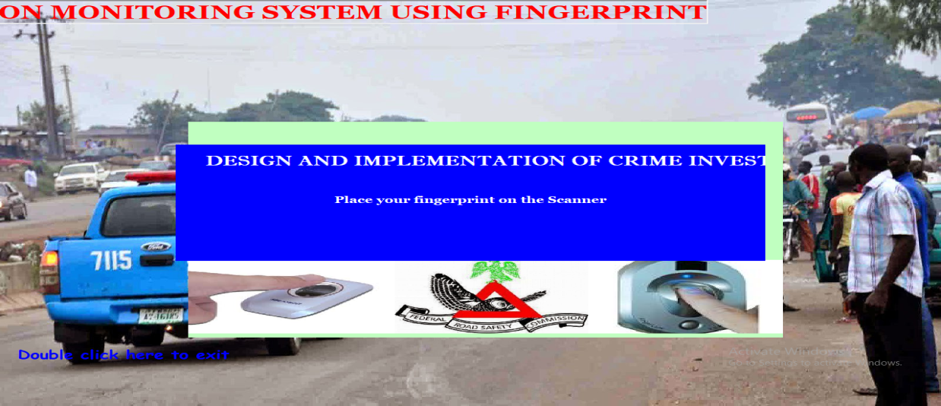
Figure 4.2Finger Authenticate. This is where all criminal records are authentication.
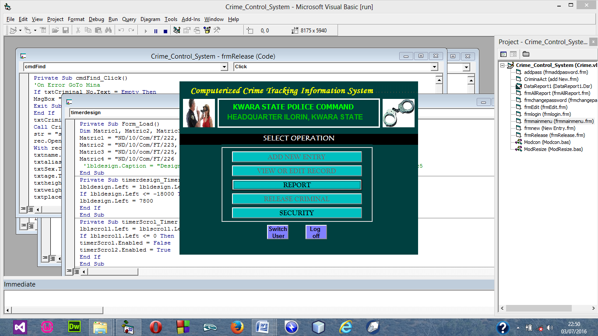Figure 4.3 Security Menu. These allow the admin to change the password of any account.
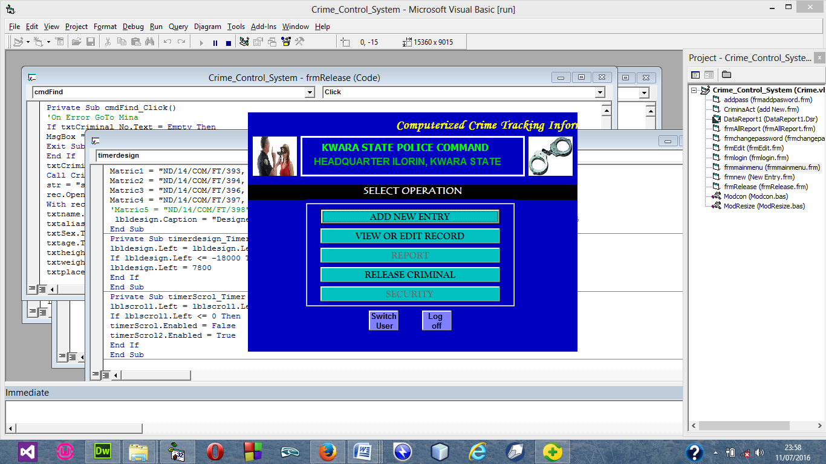
Figure 4.4 User Main Menu. These Allow user to make use of the system.
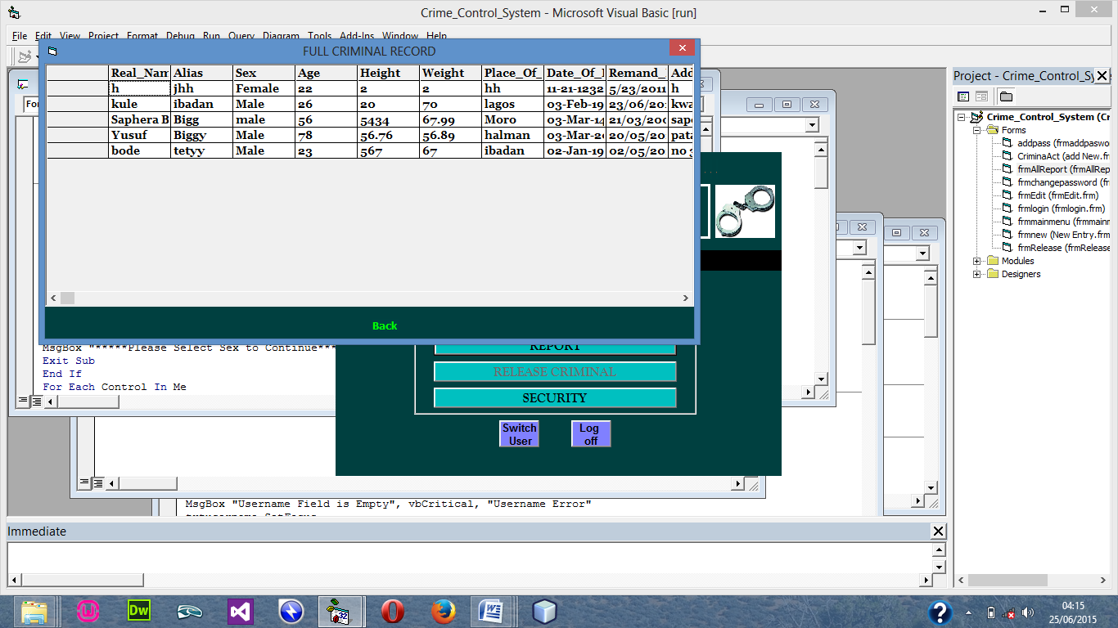
Figure 4.5 Full Report. This module show the full report of criminal details
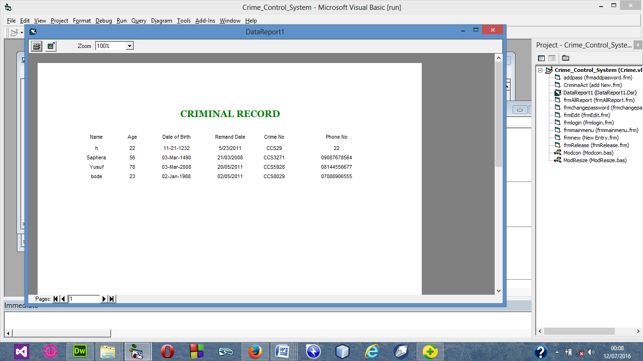
Figure 4.6 Release CrSiminal Report. This module shows the Released criminal report
    - Input Design
The input to be extracted from the proposed system are
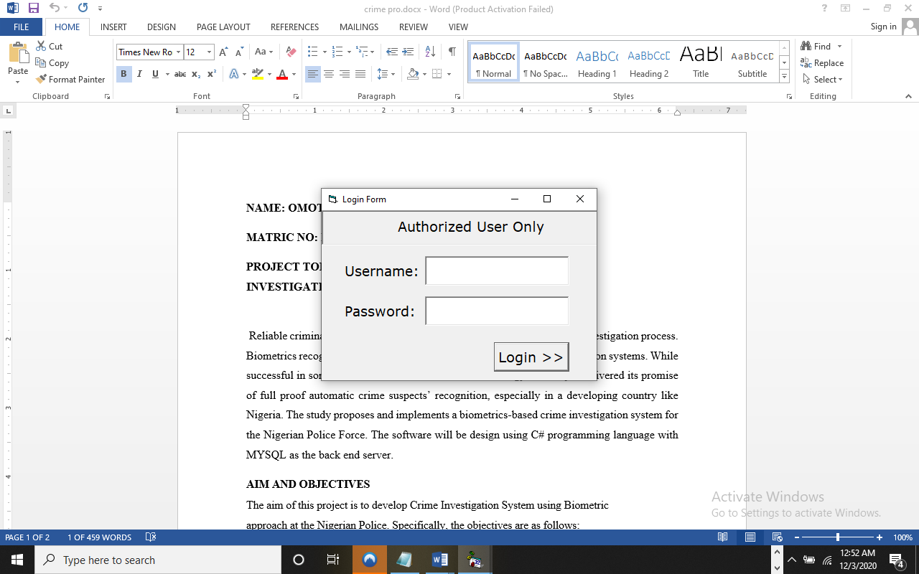
Figure 4.7 Login Menu this module authorized user to login in into the system

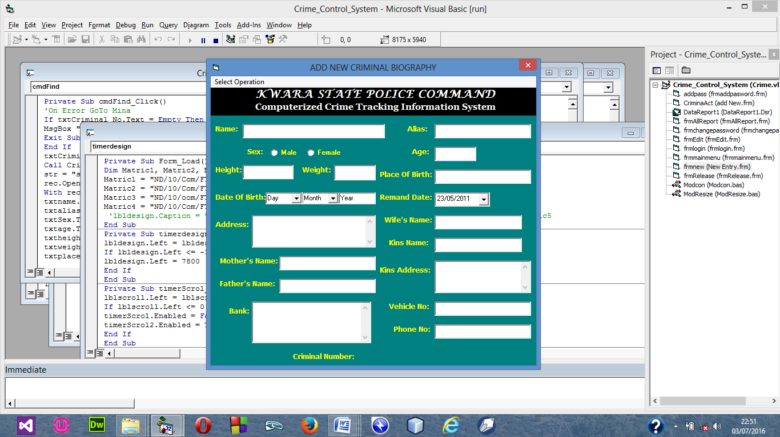

Figure 4.8 Add New Case Menu this module allow user to add new criminal record
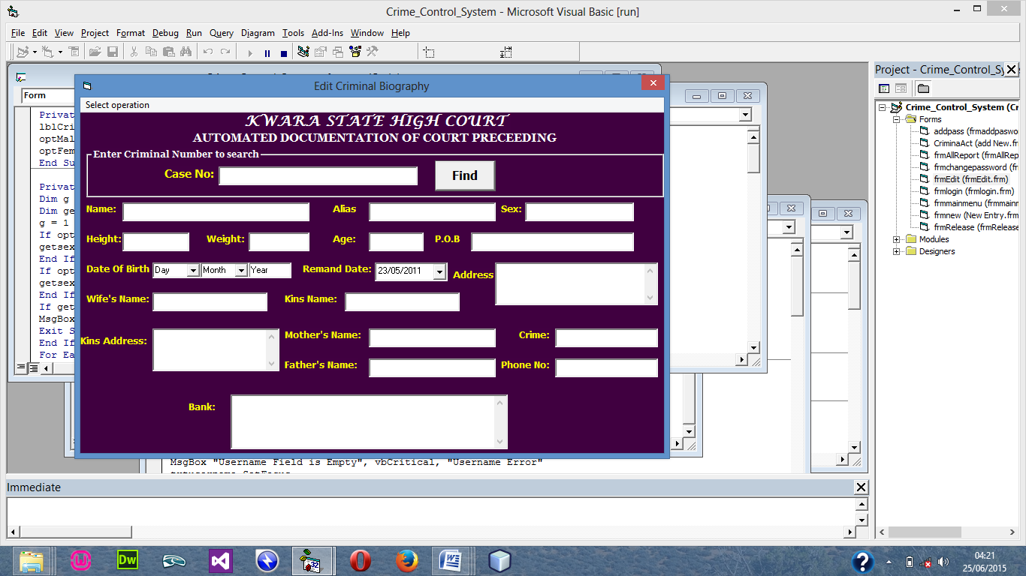
Figure 4.9 Modify Criminal Record Menu this module allow user to modify criminal record
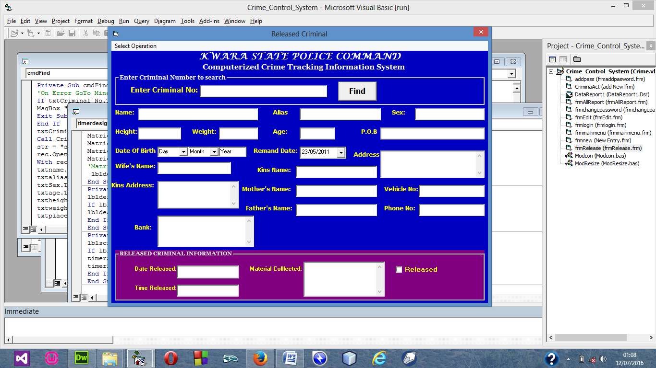
Figure 4.10 Release Criminal Menu this allow admin to release criminal that is settled
    - Database Design
This refers to the tables used in the proposed system. The database design for the proposed system is as shown below
A Staff Table
FIELD NAME | FIELD TYPE | FIELD WIDTH
DATE | DATE/TIME | 8
SEX | TEXT | 6
DOB | DATE/TIME | 8
MARITALSTATUS | TEXT | 10
DISCIPLINE | TEXT | 15
STATE | TEXT | 15
NATIONALITY | TEXT | 15
ADDRESS | TEXT | 30
POSTHELD | TEXT | 10
TELEPHONE | NUMBER | 11
KINNAME | TEXT | 30
KINADDRESS | TEXT | 30
KINREL | TEXT | 15
KINPHONE | NUMBER | 11
EMAIL | TEXT | 30
QUALIFICATION | TEXT | 20
DATEEMPLOYED | DATE/TIME | 8
SCHOOLATTENDED | TEXT | 30

B Criminal Table
FIELD NAME | FIELD TYPE | FIELD WIDTH
NAME | TEXT | 30
SEX | TEXT | 6
AGE | NUMBER | 3
MARITALSTATUS | TEXT | 8
OCCUPATION | TEXT | 15
STATE | TEXT | 10
NATIONALITY | TEXT | 10
ADDRESS | TEXT | 30
OFFENCE | TEXT | 20
VICTIMNAME | TEXT | 30
DATEARRESTED | DATE/TIME | 8
POLICE | TEXT | 30
DPO | TEXT | 30
CELLNO | NUMBER | 6
JUDGEMENT | TEXT | 20

C Court Table
FIELD NAME | FIELD TYPE | FIELD WIDTH
COURTNAME | TEXT | 30
COURTCASE | TEXT | 20
JUDGISTNAME | TEXT | 30
CRIMINALNAME | TEXT | 30
COURTOUTCOME | TEXT | 20
STATE | TEXT | 10
LAWYERRESULT | TEXT | 30
DATE | DATE/TIME | 8
TYPE | TEXT | 20

D Client Table
FIELD NAME | FIELD TYPE | FIELD WIDTH
CLIENTNAME | TEXT | 30
SEX | TEXT | 6
AGE | NUMBER | 3
MARITALSTATUS | TEXT | 8
OCCUPATION | TEXT | 30
TELEPHONE | NUMBER | 11
EMAILADDRESS | TEXT | 30
ADDRESS | TEXT | 30
CASEPROBLEM | TEXT | 20
VICTIMNAME | TEXT | 30
DATEARRESTED | DATE/TIME | 8
RELATIONSHIP | TEXT | 15
AMOUNTCHARGE | NUMBER | 7
DATE | DATE/TIME | 8
MODEOFPAYMENT | TEXT | 10

    - Procedure Design
The proposed system is developed in modules each of the modules working together to accomplish the goal of automated chamber record system. It has four modules namely Staff Profile, Court Profile Record, Report and About.
- STAFF PROFILE: The module allows the staffs of a chamber adopting the system to be able to fill in their biography which will be added to the database and as well created a room for modification when the need arise.
- COURT PROFILE RECORD: This module allows records client, criminal and court cases to be recorded in the database.
- REPORT: This module allows the display of information which has been saved to the database to be viewed in a form with the help of the data report and as well provide the facility for it to be viewed on a hard copy (printed).
- ABOUT: This module displays the records of the developers of the proposed system and about the system information in which you are running the proposed system.

  - Implementation of the System
Programming Language used
The programming language which was found to be accurately suitable for the design and implementation of the design of the proposed software program is “Microsoft Visual Basic 6.0 Enterprise Edition” with “Microsoft Access 2003” used as database application to support the programming language used to design the software program.
The programming language is used with some reasons listed below:
- It has rich integrated development environment (IDE).
- It has a rich graphic user interface, which makes it easy to use.
- It makes connection to a database to be easy.
- It aids modular programming
- It has capability of handling large database.
- It is flexible to use as it allows the use of mouse that enhance easier and faster program development.
- It compiles and interprets program easily in terms of speed and efficiency.
    - Hardware Support
In this project work, the hardware components used for the implementation of the proposed software system design for Stock Exchange Market our case study has the following configurations
- At least Pentium III PC (Personal Computer)
- At least 10 GB of hard-disk
- At least 128 MB of RAM (Random Access Memory)
- Enhanced Keyboard
- P/S2 Mouse
- Monitor
- UPS (Un-interrupted Power Supply)
- Stabilizer
- Storage Devices (e.g. Flash Drive 20 GB, CD-ROM (i.e. Compact Disc Read Only Memory)

    - Software Support
The software support used in this project work is basically programs, which give efficiency to the hardware making, the following software requirement used in this project work are:
- Windows 95/98/XP/Vista
- Microsoft Access (MS-Access) 2003
- Microsoft Word (Ms-Word)
- Microsoft Visual Basic 6.0 Enterprise Edition
- Microsoft PowerPoint

  - Documentation of the System
  - 1 Operating the System

Click on the start button

Select All Programs

Click on the software program name to run the proposed software program.

The Software Designed Program will display the Splash Screen / Welcome Screen

Enter the Password code and click on OK.

If the password is valid, it will display the Main Menu.
    - Maintaining the System
A good program that is already operational should be easy to change, modify or maintain, especially by other programmers, so as to satisfy the frequent changing user needs. Maintenance is different from debugging. Debugging refers to an act of locating and correcting errors (bugs) found in a program that is still being developed.
The program is design in such a way that could be easily maintained. It is divided in modules and each module is clearly documented to enables ease maintenance at latter time.

CHAPTER FIVE
SUMMARY, CONCLUSION AND RECOMMENDATIONS
5.1 Summary
It is very important that Nigeria Police should know the level of crime in the country. This will help the police to know whether toput in more effort in their fight against crime or not. The reliability and efficiency of this project correct those weaknesses that are found in the existing method of investigation criminals.
The achievements recorded by this design can be summarized as follows.
- The design provides prompt and accurate criminal records to the police and as at when due. This with the police can evaluate the true nature of criminal cases. Handled in the court.
- With the design record keeping within the police station by means of an online access, it becomes very easier for the police to investigation down hardened criminals, habitualcriminal, suspects sinder police supervision and copy of finger print of all persons convicted of all offence. This will be made possible by the method of data storage, which support DBMS (Data Base Management System) and eliminates redundancy) that dominates the manual and other existing method.
- It provides users with an organized approach and access to database which supports some data encryption.
5.2 Conclusion
Most people guilty of embezzlement do not have criminal histories. Embezzlers tend to have a gripe against their employer, have financial problems, or simply an inability to resist the temptation of a loophole they have found. Screening and background checks on perspective employees can help in prevention; however, many laws make some types of screening difficult or even illegal. Fired or disgruntled employees sometimes sabotage their company's computer system as a form of "payback". This sabotage may take the form of a logic bomb, a computer virus, or creating general havoc. Some police stations have developed measures in an attempt to combat and prevent crime. Police sometimes implement security measures such as cameras, fingerprint records of crimes, and background checks. Not only do these methods help prevent crime, but they help police to keep track of crimes and maintain a database of crime records.
5.3Recommendations
Efforts have been made to design and develop software that support network. But there are still areas that may be considered as a further and important area to improve on, and my suggestion go thus.
i. There is the need for the magistrate segments and prison record to be automated.
ii. The development of DNA database stores criminal fingerprint.

References
Attenborough, F. L. (ed. and trans.) (2013). The Laws of the Earliest English Kings. Cambridge: Cambridge University Press. Reprint March 2006. The Lawbook Exchange, Ltd.
Blackstone, W. (2012).Commentaries on the Law of England: A Facsimile of the First Edition of 2011-2012, Vol. 1. (2013). Chicago: The University of Chicago Press.
Blythe, James M. (2014). Ideal Government and the Mixed Constitution in the Middle Ages. Princeton: Princeton University Press.
Brown, A. (2022). Enhancing collaboration in law enforcement: The role of information sharing systems. Journal of Law Enforcement Technology, 34(2), 45
Cohen, Stanley (2013). Visions of Social Control: Crime, Punishment, and Classification. Polity Press.
Daube, D. (2011). Roman Law: Linguistic, Social and Philosophical Aspects. Edinburgh: Edinburgh University Press.
Davis, B. (2022). Ensuring data security in crime tracking and investigation systems: Challenges and solutions. International Journal of Cybersecurity and Crime Investigation, 8(1), 78-92.
Driver, G. R. & Mills, J., C. (2016).The Babylonian Laws. 2 Vols. Oxford: Oxford University Press.
Dworkin, Ronald. (2015). Taking Rights Seriously.Harvard University Press.
Foucault, Michel (2013). Discipline and Punish: the Birth of the Prison, New York: Random House.
Gagarin, Michael (2012) Early Greek Law (Reprint ed.) Berkeley: University of California Press
Garner, Richard.(2011). Law and Society in Classical Athens. London: Palgrave Macmillan.
Garoupa, Nuno&Klerman, Daniel. (2013). "Optimal Law Enforcement with a Rent Seeking Government". American Law and Economics Review.

Guterman, Simeon L. (2014). The Principle of the Personality of Law in the Germanic Kingdoms of Western Europe from the Fifth to the Eleventh Century. New York: P. Lang.
Hart, H.L.A. (2014). Law, Liberty and Morality. Stanford: Stanford University Press.
Hart, H.L.A. (2014). The Concept of Law. 2nd revised edition (2015). Oxford: Oxford University Press.
Johnson, C. (2022). Leveraging technology for effective crime tracking and investigation: A case study of the CTIS implementation. Journal of Police Science and Technology, 16(3), 210-225.
Jones, M. (2022). Overcoming data integration challenges in implementing the CTIS: Lessons from international experiences. Law Enforcement Information Management Journal, 42(4), 56-70.
Kern, Fritz. (2016). Kingship and Law in the Middle Ages. Reprint edition (2017), Westport, Conn.: Greenwood Press.
Kramer, Samuel Noah. (2017). The Sumerians: Their History, Culture, and Character. Chicago: University of Chicago
Maine, Henry Sumner. (2013). Ancient Law: Its Connection with the Early History of Society, and Its Relation to Modern Ideas. Reprint edition (2014). Tucson: University of Arizona Press.
Oppenheim, A. Leo (and Reiner, Erica as editor). (2010). Ancient Mesopotamia: Portrait of a Dead Civilization. Revised edition (September 15, 2012). Chicago: University of Chicago Press.
Pennington, Kenneth. (2013). The Prince and the Law, 1200-1600: Sovereignty and Rights in the Western Legal Tradition. Berkeley: University of California Press.
Polinsky, A. Mitchell. (2011). "Private versus Public Enforcement of Fines". The Journal of Legal Studies. p

