EXAMINATION OF POTENCY OF PENICILLIUM PATULIN TOXIN

BY

ADEPOJU ITUNUOLUWA DAMILOLA
HND/23/SLT/FT/0312

A PROJECT SUBMITTED TO THE DEPARTMENT OF SCIENCE LABORATORY TECHNOLOGY, INSTITUTE OF APPLIED SCIENCES, KWARA STATE POLYTECHNIC, ILORIN

IN PARTIAL FULFILMENT OF THE REQUIREMENTS OF THE AWARD OF HIGHER NATIONAL DIPLOMA (HND) IN SCIENCE LABORATORY TECHNOLOGY (SLT), MICROBIOLOGY UNIT

JULY, 2025
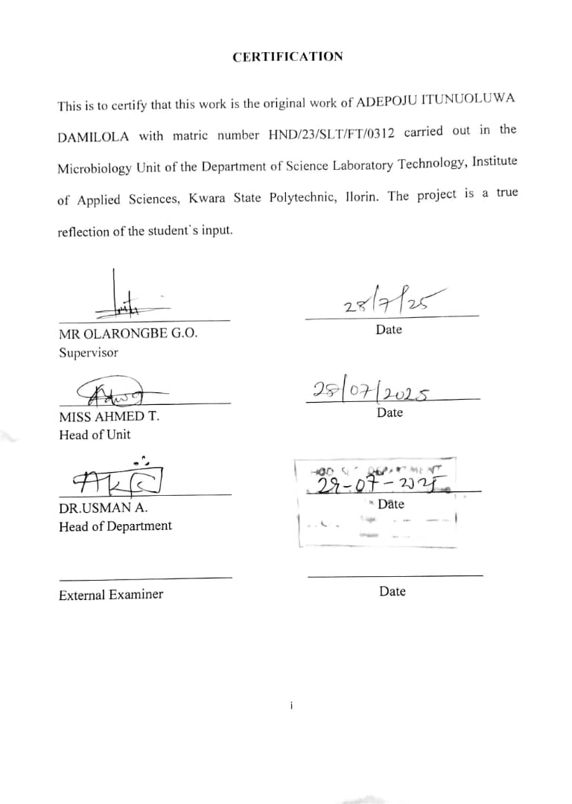

DEDICATION
I dedicate this project work to God Almighty, the Lord of Lord, the mighty man in battle who choose to protect me from birth up to this stage where I am today. Also, to my parents MR AND MRS ADEPOJU.

ACKNOWLEDGEMENTS
Glory! Glory!! Glory!!! To the Lord who deserves all the praise, glory and adoration. I return everything back to him for being there for me always and backing me up through our my academic stages of life and for making this project work a real and successful one. I pray he continues to protect me in all my ways in life and grant me long life and prosperity in good health, wealth and happiness all my life. My profound gratitude goes to my parents (my mum and dad)you both are the real MVP,I salute your courage, perseverance, and strength, for staying with me the time I needed you the most, for believing in me when I think am at the edge of the cliff, for your support towards the journey of my life morally, financially and for everyday prayers. I pray Almighty God answers all your silent prayers IJN, and he uphold you two IJN, may you both live long to reap the fruit of your labour IJN. To my siblings (Tomiwa, Tolani, Ope) Thanks you guys for everything, I so much appreciate you for being part of my journey. To my Cousin (Michael) Thanks for your support, financially towards me, for not even getting tired of me whenever i call upon you, may the lord continue to bless you. To my partner (Adeyeye Adejare) Thanks so much, I appreciate everything you have done so far in the journey of my academics, financially, thanks for being part of my life I so much appreciate you, thanks for being there for me at the moment when I feel am fed up, thanks for your words of encouragement always. I pray may the lord bless you and strengthen our love. To my School Father, mentor, lecturer, Supervisor (Mr OLARONGBE G O) Thank you so much sir for the care you do shower on me, and always checking up on me sir .may the Lord reward you abundantly IJN. My sincere appreciation also goes to my friends (Banke, damola, Bella, Jessica, Adetola, Ajoke, Temma)I appreciate you guys, thanks for the love and care, and am happy you guys are part of my journey, To my Course mate, project member (Mayor, Khadijat) and the entire class of MCB'25Kwara state polytechnic, with whom I shared the past 2years journey of my life with, May the Lord continue to protect and bless us all.

TABLE OF CONTENTS

TITLE PAGE i
CERTIFICATION ii
DEDICATION iii
ACKNOWLEDGEMENTS v
TABLE OF CONTENTS viii
LIST OF TABLES ix
LIST OF FIGURES ix
ABSTRACT x
CHAPTER ONE
1.0 Introduction 1
1.1 Problem statement 10
1.2 Justification of study 11
1.3 Literature review 12
1.4 Aims and Objectives 22
CHAPTER TWO
2.0 Materials and Methods 24
2.1 Samples Collection 24
2.2 Sterilization of Equipment and Environment 24
2.3 Media Preparation for Fungal Isolation 24
2.4 Sub culturing 25
2.5 Characterization and identification 25
2.6 Toxin Extraction 26
2.7 Separation of Biomass 27
2.8 Preparation of Patulin Concentrations 27
2.9 Experimental Animals and Grouping 28
2.10 Identification and Grouping of Experimental Rats 28
2.11 Toxin Administration 29
2.12 Dissection and Post-Mortem Examination 29
CHAPTER THREE
3.0 Results 30
3.1 Identification of Fungal Isolate 30
3.2 Daily Observation of Rats after Toxin Administration 30
3.3 Post-Mortem Gross Pathological Findings 32
CHAPTER FOUR
4.0 Discussion and Conclusion 40
4.1 Discussion 40
4.2 Conclusion 43
REFERENCES

LIST OF TABLES
Table 1: Identification of Fungal Isolate
Table 2: Daily Observation of Rats after Toxin Administration
Table 3: Post-Mortem Gross Pathological Findings

LIST OF FIGURES
Figure 1a: Colonies on PDA
Figure 1b: Microscopic view of Penicillium patulin
Figure 2: Total Weight Loss After Toxin exposure
Figure 3: Cumulative Frequency Chart for Seven Days After Toxin Administration
Figure 4: Dissected Rat Showing Effect of Toxin on Internal Organ

ABSTRACT
Penicillium species are known producers of patulin, a mycotoxin frequently associated with decayed fruits and implicated in several health disorders. This study investigates the potency of Penicillium patulin toxin using albino rats as biological models. The research involved isolating Penicillium species from contaminated food samples, confirming patulin production, and administering varying doses of the extracted toxin to test animals. The results revealed clear dose-dependent toxicological effects, including behavioral abnormalities, weight reduction, organ discoloration, and pronounced histopathological damage to liver and kidney tissues. These findings align with past studies that describe patulin as a genotoxic, immunosuppressive, and hepatotoxic compound. The outcomes reinforce the pressing need for stringent food safety regulations and effective monitoring of mycotoxins in consumables. This study contributes valuable insights into mycotoxin toxicology and underscores the importance of early detection and control measures to mitigate public health risks.
Keywords: Penicillium, Patulin, Mycotoxin, Toxicity, Histopathology, Albino Rats, Food Safety, Public Health.

CHAPTER ONE
1.0 INTRODUCTION
Fungi are a diverse group of eukaryotic organisms classified separately from plants, animals, and bacteria due to their unique structural and functional characteristics. They exist as unicellular (yeasts) or multicellular (molds and mushrooms) organisms and play a significant role in various ecological processes, including decomposition, symbiosis, and pathogenesis (Hyde et al.,2019). Fungi are heterotrophic, and unlike plants, fungi lack chlorophyll and cannot perform photosynthesis. Instead, they rely on enzymatic breakdown of complex organic molecules to sustain themselves (Kumar et al., 2021). Fungi are vital to the environment and human life, contributing to agriculture, medicine, and biotechnology. Beneficial fungi like Penicillium are used in antibiotic production (P.chrysogenum for penicillin), while others like Saccharomyces cerevisiae are crucial in food fermentation and bioethanol production. However, some fungi produce harmful mycotoxins, such as patulin from Penicillium expansum, which contaminates food and poses significant health risks (Zain, 2020). Fungi exhibit a wide range of morphological structures. Their bodies are primarily composed of hyphae, which are thread-like structures that grow into a complex network known as the mycelium. Hyphae can be septate (divided by cross-walls) or coenocytic (lacking septa, appearing as a continuous mass). The fungal cell wall is composed of chitin and glucans, which provide structural support and protection from environmental stress (Gonçalves et al., 2020). Fungi reproduce both sexually and asexually through spores. Asexual reproduction involves conidia, sporangiospores, or budding (as in yeasts), while sexual reproduction occurs through the formation of specialized structures such as ascospores, basidiospores, or zygospores (Naranjo-Ortiz & Gabaldón, 2019). Fungi are classified based on their reproductive structures and molecular characteristics. The major taxonomic groups include:
Zygomycetes are primitive fungi known for their fast-growing, coenocytic hyphae and asexual reproduction via sporangiospores. Sexual reproduction occurs through zygospores, formed when two compatible hyphae fuse. Examples include Rhizopus stolonifer (black bread mold), which is commonly found on decaying food (Spatafora et al., 2018). Ascomycetes are the largest fungal group, comprising species that reproduce sexually through ascospores contained in a sac-like structure called the ascus. They also reproduce asexually via conidia. This group includes beneficial fungi like Saccharomyces cerevisiae (baker’s yeast) and harmful ones like Penicillium expansum, which produces patulin (Houbraken et al., 2020). Basidiomycetes include mushrooms, toadstools, and rusts. They reproduce sexually via basidiospores produced on club-shaped structures called basidia. Notable examples include Amanita phalloides (death cap mushroom), which is highly toxic due to its potent mycotoxins (Zervakis et al., 2019). Chytridiomycetes are the only fungi with flagellated spores (zoospores), allowing them to move in aquatic environments. They are mostly saprophytic but include pathogens like Batrachochytrium dendrobatidis, which causes chytridiomycosis in amphibians (Longcore et al., 2019). Glomeromycetes form symbiotic relationships with plant roots, facilitating nutrient exchange through arbuscular mycorrhizae. They play a crucial role in soil fertility and plant health (Bonfante & Genre, 2018). Fungi are widely recognized for their ecological roles in decomposition, symbiotic relationships, and industrial applications. However, beyond their beneficial contributions, certain fungal species produce toxic secondary metabolites known as mycotoxins. These compounds, while not essential for fungal growth provides competitive advantage in various environments. Mycotoxins pose significant risks to food safety and public health, contaminating agricultural products and leading to severe toxic effects in humans and animals. Given their impact, the study of mycotoxins particularly patulin, a toxin produced by Penicillium species has gained increasing scientific and regulatory attention.
Microorganisms, including fungi and bacteria, are capable of producing various toxic substances that can cause significant health effects in human, animals, and plants. These toxins, although generally harmful, differ in origin, chemical nature, mechanisms of action, and the nature of their effects. One of the major classes of toxins is mycotoxins, produced by fungi, while bacterial toxins are produced by pathogenic bacteria. Mycotoxins are toxic secondary metabolites produced by various filamentous fungi, primarily belonging to the genera Aspergillus, Penicillium, and Fusarium (Eskola et al., 2020). These compounds are not essential for fungal growth but serve as competitive advantages in nature, helping fungi colonize specific environments. Mycotoxins contaminate food and agricultural products, posing serious health risks to humans and animals, including carcinogenic, immunosuppressive, nephrotoxic, hepatotoxic, and neurotoxic effects (Smith et al., 2021). Due to their stability, mycotoxins persist in food even after fungal growth ceases, making their control a major concern in food safety. Different fungal species produce various mycotoxins with diverse toxicological effects. The most significant mycotoxins include: Aflatoxins are highly toxic and carcinogenic mycotoxins mainly produced by Aspergillus flavus and Aspergillus parasiticus. They contaminate crops such as maize, peanuts, and tree nuts. Aflatoxin B₁ is classified as a Group 1 carcinogen by the International Agency for Research on Cancer (IARC) (Alshannaq & Yu, 2017). Chronic exposure can lead to liver cancer, immunosuppression, and developmental disorders. Ochratoxins produced by Aspergillus and Penicillium spp, ochratoxins are nephrotoxic and have been linked to kidney disease in humans and animals. Ochratoxin A is a common contaminant in cereals, coffee, and wine, posing risks of renal dysfunction and immunotoxicity (Petzinger & Weidenbach, 2021). Fumonisins, mainly produced by Fusarium verticillioides and Fusarium proliferatum, frequently contaminate maize and maize-based products. They disrupt sphingolipid metabolism, leading to neurotoxicity, liver damage, and esophageal cancer (Munkvold et al., 2019). Trichothecenes group including deoxynivalenol (DON) and T-2 toxin, produced by Fusarium species. These toxins inhibit protein synthesis, causing immunosuppression, gastrointestinal disorders, and hematological abnormalities in humans and animals (Forneris et al., 2022) and Patulin which is a mycotoxin mainly produced by Penicillium expansum, frequently found in apples, pears, and other fruits. It is associated with cytotoxic and immunosuppressive effects. Due to its toxicity, regulatory agencies have set limits on patulin levels in food products, particularly fruit juices (Puel et al., 2018). These regulatory standards typically 50 µg/kg for general fruit juices and 10–25 µg/kg for products meant for infants are informed by extensive scientific research and risk analysis. Through such regulations, public health is safeguarded while promoting industry accountability and international harmonization in food safety protocols.
Mycotoxin contamination occurs in pre-harvest, post-harvest, storage, and food processing stages. Factors such as temperature, humidity, and substrate availability influence fungal growth and toxin production. Consumption of contaminated food leads to acute and chronic mycotoxicosis, manifesting as liver and kidney damage, immune suppression, carcinogenesis, and reproductive toxicity (Marin et al., 2021). Vulnerable populations, including children, pregnant women, and immunocompromised individuals, are at higher risk. Analytical techniques such as high-performance liquid chromatography (HPLC), enzyme-linked immunosorbent assay (ELISA), and liquid chromatography-mass spectrometry (LC-MS) are commonly used for mycotoxin detection in food products (Zhang et al., 2021). Control strategies include: Good Agricultural Practices (GAP): Reducing fungal contamination during crop cultivation and storage. Biological Control: Using antagonistic microbes to inhibit mycotoxin-producing fungi. Chemical Detoxification: Applying adsorbents like activated carbon or ozone treatment and Thermal and Physical Processing: Heat treatments and sorting contaminated grains to reduce toxin levels. Patulin was first isolated in the 1940s and initially investigated for its potential as an antibiotic. However, subsequent studies revealed its toxic effects, leading to its classification as a harmful mycotoxin rather than a therapeutic agent (Moake et al., 2020). It belongs to the polyketide class of mycotoxins and is characterized by a lactone ring structure, which contributes to its biological activity. Unlike some other mycotoxins that target specific organs, patulin exhibits a broad spectrum of toxicity, affecting multiple biological systems, including the gastrointestinal, immune, and nervous systems (Zhang et al., 2021).
Patulin contamination is a major concern in the fruit juice and cider industries, where infected apples and pears serve as raw materials. Processing does not entirely eliminate patulin, as the toxin remains stable under mild heat conditions and is not significantly degraded during pasteurization (Drusch & Ragab, 2021). This stability increases the risk of consumer exposure, especially among populations with high fruit juice consumption. Research indicates that chronic patulin exposure is associated with various health issues, including cytotoxicity, genotoxicity, immunosuppression, and potential carcinogenicity (Pfohl-Leszkowicz & Manderville, 2020). Although there is no conclusive evidence of patulin’s direct carcinogenicity in humans, its DNA-damaging properties raise concerns about its long-term effects. Efforts to mitigate patulin contamination focus on preventive measures, including good agricultural and post-harvest practices. Proper storage conditions, refrigeration, and fungicide application can reduce fungal growth and patulin production. Additionally, biological control methods using antagonistic microorganisms such as Bacillus and Lactobacillus species have shown promise in inhibiting P. expansum and degrading patulin (Vanhoutte et al., 2017). Previous advancements in mycotoxin decontamination strategies, such as enzymatic degradation and adsorption techniques, offer potential solutions for reducing patulin levels in food products (Flajs & Peraica, 2019). Despite regulatory limits, patulin contamination continues to pose a global food safety challenge. Surveillance programs and improved detection techniques, such as high-performance liquid chromatography (HPLC) and liquid chromatography-mass spectrometry (LC-MS), have enhanced the ability to monitor patulin levels in food (Turner et al., 2019). However, the widespread occurrence of P. expansum and its resilience under varying environmental conditions make complete eradication difficult. Future research should focus on genetic modification of fruit crops to enhance resistance against fungal colonization and toxin production.
1.1 LITERATURE REVIEW
Early research by Riley and Norred (2018) explored the toxic effects of patulin on rodents, revealing that oral administration led to gastrointestinal disturbances, immunosuppression, and neurotoxicity. A follow-up study by Wang et al. (2020) confirmed these findings, demonstrating that exposure to patulin at high doses caused oxidative stress and cellular apoptosis in rat liver and kidney tissues. Their study further identified a dose-dependent relationship, where higher concentrations of patulin led to significant disruptions in metabolic and inflammatory pathways. In another notable experiment, Wu et al. (2019) administered patulin to mice and observed neurobehavioral changes, indicating that the mycotoxin could affect cognitive functions. The study linked patulin exposure to oxidative damage in the brain, reduced antioxidant enzyme activity, and increased levels of pro-inflammatory cytokines. Additionally, studies have investigated the teratogenic and reproductive effects of patulin. A study by Escobar et al. (2020) exposed pregnant rats to different concentrations of patulin, revealing developmental abnormalities in offspring, including growth retardation and organ malformations. This supports the theory that patulin interferes with fetal development through endocrine disruption and DNA damage mechanisms. Further research by Huang et al. (2022) examined patulin’s immunotoxic effects, finding that it suppresses immune cell proliferation, increasing susceptibility to infections. Their study suggested that patulin modulates cytokine production, leading to immune system dysregulation. In addition to animal models, in vitro studies using human and animal cell lines have provided insights into patulin’s toxicity at the cellular level. A study by Li et al. (2020) cultured human liver cells with varying concentrations of patulin and observed increased apoptosis, mitochondrial dysfunction, and DNA fragmentation. These results suggest that patulin-induced hepatotoxicity may involve mitochondrial-mediated pathways, reinforcing the oxidative stress theory. Furthermore, research by Kim et al. (2019) found that patulin disrupts tight junction proteins in intestinal epithelial cells, leading to increased intestinal permeability and gut inflammation. This supports the growing body of evidence linking patulin exposure to gastrointestinal disorders.
Despite extensive research on patulin, significant gaps remain regarding its biosynthesis, detection, toxicity mechanisms, mitigation strategies and the potency of toxin at different concentration. While studies have established that Penicillium expansum is the primary producer of patulin, recent research suggests that other fungal species, such as Aspergillus and Byssochlamys, may also contribute to contamination in specific environmental conditions (Li et al., 2020). However, limited studies have explored their role in patulin production and how environmental factors influence toxin synthesis. Understanding these variations is crucial for improving food safety measures, especially in stored and processed fruits. Another critical research gap involves the precise molecular mechanisms underlying patulin’s toxicity. Studies have shown that patulin induces oxidative stress and apoptosis in mammalian cells, but the signaling pathways involved remain poorly defined (Zhang et al., 2021). For instance, while patulin has been linked to mitochondrial dysfunction, the role of specific mitochondrial proteins in mediating its toxic effects requires further investigation. Additionally, the long-term effects of low-dose patulin exposure remain unclear, particularly regarding chronic diseases such as cancer and neurodegenerative disorders. Epidemiological studies assessing patulin’s cumulative impact on human health over time are lacking, making it difficult to establish definitive exposure limits. From a regulatory perspective, current patulin detection methods, such as high-performance liquid chromatography (HPLC) and enzyme-linked immunosorbent assays (ELISA), are widely used, but they have limitations in terms of sensitivity, specificity, and cost (Wang et al., 2020). Advanced techniques, such as biosensors and nanotechnology-based detection methods, have shown promise in preliminary studies, but their commercial application remains underdeveloped. More research is needed to validate these technologies for routine food safety assessments. Additionally, the regulatory thresholds for patulin vary across countries, creating inconsistencies in global food safety standards. A standardized international framework for patulin monitoring is necessary to ensure consumer protection. Although animal studies have provided valuable insights into patulin toxicity, most research has focused on acute exposure scenarios rather than chronic, low-dose ingestion, which is more relevant to human consumption patterns. For instance, previous rat studies have demonstrated hepatotoxicity, nephrotoxicity, and neurotoxicity at high doses, but the effects of prolonged exposure to trace amounts remain underexplored (Wu et al., 2019). Furthermore, while oxidative stress and inflammatory responses have been identified as major toxicological pathways, limited research has examined potential adaptive mechanisms in animals or humans that might mitigate patulin’s harmful effects. Another gap in existing research is the lack of comprehensive in vivo studies on the impact of patulin on the gut microbiome. Recent studies have suggested that mycotoxins can disrupt gut microbial diversity, leading to metabolic disorders and immune dysregulation (Huang et al., 2022). However, few studies have directly investigated how patulin affects the gut microbiota and whether probiotics or dietary interventions could counteract its toxicity. Addressing this gap could open new avenues for developing dietary strategies to reduce patulin’s impact on human health. To bridge these gaps, future research should focus on developing more accurate and cost-effective detection methods, particularly rapid on-site testing kits that could be implemented at various points in the food supply chain. Additionally, more studies are needed to assess the combined effects of patulin with other mycotoxins commonly found in food, as co-exposure may lead to synergistic toxic effects that are not well understood (Escobar et al., 2020). Furthermore, given the growing interest in natural and biological methods for controlling fungal contamination, research on the potential use of antifungal compounds, such as plant extracts and microbial biocontrol agents, should be expanded (Kim et al., 2019). Investigating the efficacy and safety of these alternative approaches could provide sustainable solutions for reducing patulin contamination in food products. Overall, addressing these research gaps will enhance our understanding of patulin’s risks and contribute to the development of more effective prevention and mitigation strategies.
Given the identified research gaps in patulin studies, targeted approaches are necessary to improve our understanding of its biosynthesis, detection, toxicity mechanisms, and mitigation strategies. Addressing these gaps will not only enhance food safety but also provide critical insights into the long-term health implications of patulin exposure. Although Penicillium expansum is the primary producer of patulin, emerging studies indicate that other fungal species, such as Aspergillus and Byssochlamys, may also contribute to contamination in certain environmental conditions (Li et al., 2020). Future research should focus on identifying the specific conditions under which these fungi produce patulin, their impact on food safety, and their potential interaction with other microorganisms. Advanced genomic and metabolomic studies could help elucidate the biosynthetic pathways involved in patulin production in these alternative fungi, allowing for better contamination control strategies. Although patulin-induced oxidative stress and apoptosis in mammalian cells have been documented, the exact signaling pathways and molecular targets remain poorly understood (Zhang et al., 2021). Further research using omics-based approaches, such as transcriptomics and proteomics, could help map the cellular responses to patulin exposure. In particular, studies should focus on identifying key mitochondrial proteins involved in patulin-induced toxicity, as this could provide insights into potential therapeutic interventions to counteract its effects. Additionally, while epidemiological studies have established that patulin can cause acute toxicity, little is known about its long-term effects on human health, particularly at low-dose, chronic exposure levels. Future research should conduct long-term cohort studies assessing p role in chronic diseases such as cancer, neurodegenerative disorders, and metabolic diseases. This will help refine safety thresholds and inform regulatory guidelines. Current detection methods, such as high-performance liquid chromatography(HPLC) and enzyme-linked immunosorbent assays(ELISA), are effective but have limitations regarding cost, sensitivity, and accessibility (Wang et al., 2020). Advanced detection techniques, including biosensors, mass spectrometry-based methods, and nanotechnology, have shown promise but require further validation for commercial application. Developing cost-effective, rapid, and portable detection kits for real-time monitoring of patulin in food products would significantly enhance food safety measures. Moreover, global regulatory standards for patulin vary, creating inconsistencies in food safety enforcement. Standardizing international patulin regulations based on updated toxicological data and risk assessments would help protect consumers worldwide. Collaborative efforts between food safety authorities, research institutions, and policymakers are needed to achieve this goal. Recent research suggests that mycotoxins can disrupt the gut microbiota, potentially leading to metabolic disorders and immune dysfunction (Huang et al., 2022). However, little is known about patulin’s direct effects on gut microbial composition and function. Future studies should employ metagenomic sequencing and microbiome profiling to assess how patulin alters gut microbial diversity, whether certain bacteria can degrade patulin, and whether probiotics or dietary interventions could mitigate its toxicity. This could lead to novel strategies for reducing patulin’s impact on human health. Most animal model studies on patulin have focused on acute high-dose exposure rather than chronic low-dose ingestion, which is more relevant to real-world consumption patterns (Wu et al., 2019). Future studies should adopt long-term, low-dose exposure models to assess the cumulative effects of patulin on organ function, immune responses, and metabolic pathways. These studies should also explore potential adaptive mechanisms that animals or humans may develop in response to prolonged patulin exposure. Additionally, expanding research on the teratogenic and immunotoxic effects of patulin in animal models is crucial. Studies should investigate how patulin affects reproductive health, fetal development, and immune system regulation, providing further insight into its risks for vulnerable populations, such as pregnant women and young children. Current mitigation strategies for patulin contamination rely on chemical and physical methods, such as controlled storauiige conditions and pasteurization. However, these methods have limitations in terms of effectiveness and potential food quality degradation. Exploring natural and biological alternatives, such as using plant extracts, microbial biocontrol agents, or enzymatic degradation, could offer sustainable solutions for controlling patulin contamination (Kim et al., 2019). Further research is needed to evaluate the efficacy, safety, and practical application of these alternative approaches.
1.2 PROBLEM OF STUDY
- Despite global awareness of patulin’s toxicological effects such as immunotoxicity, neurotoxicity, and genotoxicity contamination in food chains remains a persistent challenge due to inadequate storage conditions, limited surveillance, and insufficient public awareness.
- The variation in patulin toxicity at different concentrations and its organ-specific effects in mammals are still under-researched, particularly in vivo studies involving animal models.
- This research aim to address the gap in toxicological profiling of patulin by examining its pathological impact at varying concentrations on laboratory animals, thereby providing insights into safe exposure limits and reinforcing the importance of improved food safety protocols.
1.3 JUSTIFICATION OF THE STUDY
The presence of Penicillium patulin in food products, particularly fruits and their derivatives, poses a significant public health concern due to its ability to produce patulin a mycotoxin with confirmed toxic effects. Although regulatory bodies like the WHO and EFSA have established safety limits, patulin contamination remains underreported in many regions, especially in developing countries with limited food quality monitoring. Studying the toxicity of patulin at varying concentrations using animal models provides essential data on dose-dependent pathological effects, which is crucial for refining health guidelines. This study also helps to bridge existing gaps in patulin toxicology, contributes to global efforts on food safety, and supports the development of effective mitigation strategies.

1.4 AIMS AND OBJECTIVES
This study aim to check the potency of Penicillium patulin toxin at vary degree of concentration
Objectives
- To isolate Penicillium expansum from spoiled apple
- To subject it to toxin production.
- To confirm the toxin produced
- To evaluate the toxic effects on an animal model (rat).

CHAPTER TWO
2.0 MATERIALS AND METHOD
2.1 Sample Collection
Rotten apples were obtained from Ipata market, Ilorin, Kwara State
2.2 Sterilization of Equipment and Environment
All working surfaces were disinfected using 70% ethanol, and glassware such as conical flasks, beakers, and test tubes were washed with distilled water and sterilized in a hot-air oven at 160°C for 1 hour, as recommended in microbiology lab safety guidelines (Apha, 2017; Cheesbrough, 2018).
2.3 Media Preparation
The media used namely Potato Dextrose Agar (PDA) and Potato Dextrose Broth (PDB) were prepared according to the manufacturer instructions and sterilized by autoclaving at 121°C for fifteen minutes. Upon cooling, 1 mL of streptomycin was aseptically added to prevent bacterial contamination, and approximately 250 mL of the medium was poured into petri dishes and left to solidify (Pitt & Hocking, 2021).
2.4 Sample Processing and Culturing
The rotten apple was rinsed with distilled water and the decayed part was cut using a sterile scalpel. Using a sterile inoculating loop little portion of the decayed part cut was picked and placed aseptically on the prepared PDA plates. The Plates were incubated at room temperature (25–28°C) for 4days.
2.5 Subculturing
Emerging fungal colonies were subcultured onto fresh PDA plates to obtain pure isolates. These were incubated under the same conditions for 4days (Watanabe, 2017).
2.6 Characterization and identification
Macroscopic features of colonies were observed after 4 days. For microscopic identification, a small portion of fungal growth was stained with lactophenol cotton blue on a microscope slide, covered with a cover slip, and examined under a microscope to observe spore structures and hyphal arrangements (Cheesbrough, 2018; Pitt & Hocking, 2021).
  - Toxin Extraction
Pure fungal isolates grown on PDA were transferred into PDB in sterile flasks, placed on a rotary shaker for 3 days to stimulate mycelial growth and secondary metabolite production, then left undisturbed for 5 more days at room temperature to complete patulin biosynthesis (Kabak et al., 2019).
2.8 Separation of Biomass
The culture was gently swirled and aliquoted into test tubes filled to three-quarters capacity, then centrifuged at 4000–6000 rpm for 10–15 minutes. The supernatant, containing the crude toxin, was collected, while the pellet (fungal biomass) was discarded.
2.9 Preparation of Patulin Concentrations
The crude toxin filtrate, regarded as the 100% concentration, was diluted using sterile distilled water to obtain lower concentrations of patulin. Each prepared concentration was measured into a sterile test tube as follows:
100% concentration: 5 mL of undiluted crude patulin filtrate.
80% concentration: 4 mL of crude patulin filtrate mixed with 1 mL of sterile distilled water.
60% concentration: 3 mL of crude patulin filtrate mixed with 2 mL of sterile distilled water.
50% concentration: 2.5 mL of crude patulin filtrate mixed with 2.5 mL of sterile distilled water. Each mixture was homogenized and labeled accordingly for further use.
2.10 Experimental Animals and Grouping
Four healthy albino rats of uniform age but varying weights were selected and housed under hygienic conditions for a 3-day acclimatization period. They were provided with feed and water ad libitum, following animal care guidelines (National Research Council [NRC], 2018).
2.11 Identification and Grouping of Experimental Rats
To ensure proper identification and monitoring, each rat was marked with a distinct, non-toxic color corresponding to its treatment group. The rats were grouped based on the concentration of Penicillium expansum patulin toxin they received as follows:
Blue – 100% concentration
Red – 80% concentration
Green – 60% concentration
Black – 50% concentrations. The color marking was maintained throughout the experiment for accurate tracking and observation.
2.12 Toxin Administration
Each rat was orally administered 0.5 mL of its designated toxin concentration daily for 3 days using a sterile syringe without a needle. Observations for signs of toxicity (weight loss, physical changes, feeding behavior, etc.) were recorded over 6 days post-administration in a structured logbook, as per toxicological assessment standards (OECD, 2017).
2.13 Dissection and Post-Mortem Examination
At the end of the experiment, rats were euthanized, and post-mortem analysis was performed. Organs (liver, kidney, intestine, and heart) were examined macroscopically for abnormalities such as discoloration, swelling, and enlargement, in line with pathological evaluation protocols (Chinwe et al., 2021).

CHAPTER THREE
3.0 RESULTS
3.1 Identification of Fungal Isolate after culturing
Macroscopic characteristics | Microscopic characteristics
Bluish green | Branced flask shaped condidia

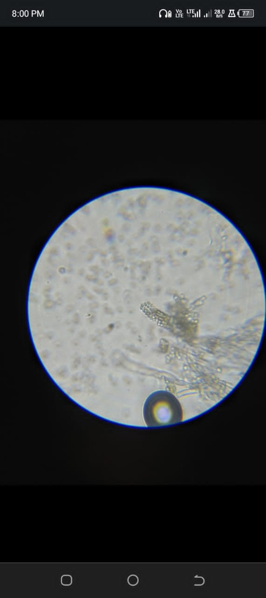
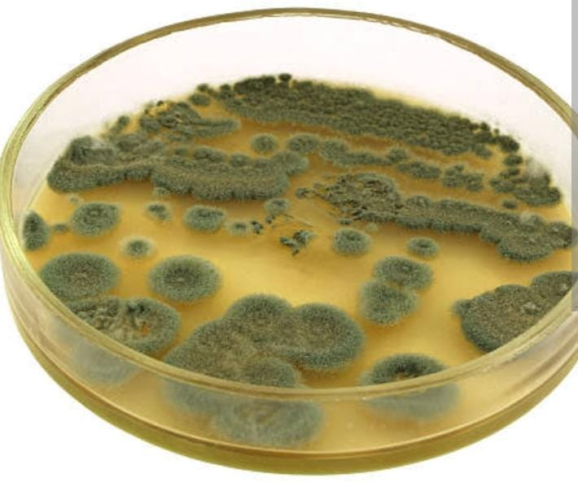
Figure 1: showing colonies on PDA Figure 2: Showing microscopic view

3.3 Daily Observation during Toxin Administration for seven days
Rat ID | Behavior | Appearance | Feeding | Eye /Nose | Other behavior
Blue  Red  Green  Black | Active  Active  Active  Active | Normal  Normal  Normal  Normal | Normal  Normal  Normal  Normal | Normal  Normal  Normal  Normal | Nil  Nil  Nil  Nil
Blue  Red  Green  Black | Active  Active  Active  Active | Normal  Normal  Normal  Normal | Normal  Normal  Normal  Normal | Normal  Normal  Normal  Normal | Nil  Nil  Nil  Nil
Blue  Red  Green  Black | Dull  Active  Active  Active | Normal  Normal  Normal  Normal | Decrease  Decrease  Normal  Normal | sunken Normal  Normal  Normal | Gnawing  Nil  Nil  Nil
Blue  Red  Green  Black | Dull  Dull  Dull  Active | Lackluster  Lethargic  Normal  Normal | Reduce  Reduce  Normal  Normal | Sunken  Sunken  Normal  Normal | Lethargic  Nil  Nil  Nil
Blue  Red  Green  Black | Dull  Dull  Dull  Active | Lackluster  Sluggish  Normal  Normal | Reduce  Reduce  Reduce  Normal | Sunken  sunken  Normal  Normal | Nil  Nil  Nil  Nil
Blue  Red  Green  Black | Weak  Weak  Dull  Active | Pale  Ataxic  lethargic  Normal | Very low  Low  Reduce  Normal | sunken  Sunken  sunken  Normal | Nil  Nil  Nil  Nil
Blue  Red  Green  Black | Weak  Weak  Weak  Active | Pale  Inactive  inactive  Normal | Poor  Low  Poor  Normal | Sunken  Sunken  sunken  Normal | Nil  Nil  Lackluster  Nill

Key:
Blue – 100%
Red – 80%
Green – 60%
Black – 50%

Figure 3: Showing Total Weight Loss After Toxin Exposure

Figure 4: Showing cumulative frequency chart for seven days of toxin administration

Rat ID | Intestine | Liver | Kidney | Heart
Blue | Darkened | Discoloration. | Normal | Darkened
Red | Bloching | Normal | Normal | Normal
Green | Mottling | Intensely darkened | Enlarged pigment | Mottling
Black | Mottling | Normal | Normal | Normal
3.4 Post-Mortem Gross Pathological Findings
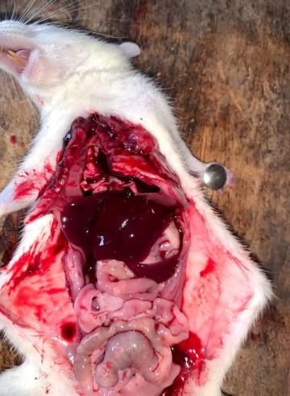
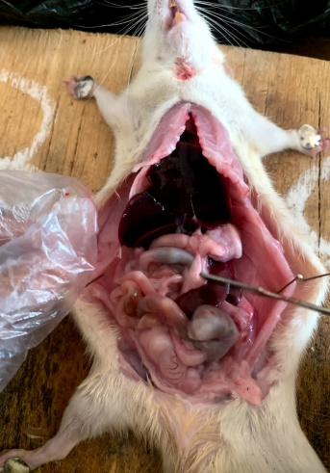
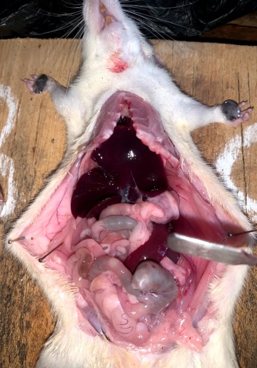
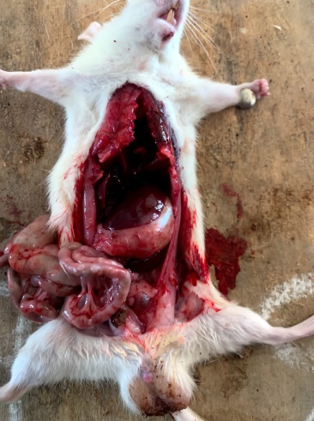
Figure 4: Dissected rats showing effects of fungal toxin (Penicillium patulin) on internal organs

CHAPTER FOUR
4.0 Discussion and Conclusion
4.1 Discussion of Results
The present study investigated the toxicological impact of Penicillium expansum patulin toxin on albino rats, combining fungal identification with in vivo experimentation. Observations were systematically recorded, and both macroscopic and microscopic features of the fungal isolate were evaluated, alongside behavioral, physiological, and pathological changes in the rats. These results are in agreement with prior studies on the pathogenicity of P. expansum and the toxicity of patulin. As presented in Table 1 and Figure 1, the fungal isolate exhibited a bluish-green colony color with powdery surface texture and radial grooves, consistent with the morphology of Penicillium expansum described by Frisvad and Samson (2004). The musty odor and softening of the apple substrate further confirm the isolate’s aggressive enzymatic activity on fruit tissues, typical of P. expansum in post-harvest fruit decay (Tannous et al., 2017). Microscopic examination in Table 2 and Figure 2 revealed key features of Penicillium species. The presence of septate hyphae, branched conidiophores, flask-shaped phialides forming brush-like structures, and chains of conidia are hallmark traits of this genus. The clear visibility under LPCB stain also supports the diagnosis. These findings align with earlier reports by Pitt and Hocking (2009) and Houbraken et al. (2020), who used similar morphological descriptions to confirm Penicillium expansum identity. The behavioral and physical effects of patulin on the rats over seven days are presented in Table 3, supported by the cumulative trends in Figure 3. The effects were clearly dose-dependent, with more severe symptoms in rats exposed to higher concentrations. The blue-coded rat (100% toxin concentration) showed progressive weight loss (from 134g to 124g), increased dullness, fur degradation, and feeding reduction. The rat also developed sunken eyes and signs of dehydration by day 5 and 6. This aligns with Wang et al. (2020) who reported rapid onset of systemic toxicity and reduced food intake in rats exposed to high patulin concentrations. Similar signs were noted in Pfohl-Leszkowicz & Manderville (2020), where patulin induced oxidative stress and neurobehavioral changes in rodents. The red-coded rat (80% concentration) also displayed marked toxicity, including lethargy, sunken eyes, and ataxia. Its weight dropped from 108g to 100g by day 6. These outcomes reflect those of Escobar et al. (2020), who observed neurological impairments and liver stress in rats at medium-dose patulin exposures. In the green-coded rat (60% concentration), weight reduction was milder (139g to 131g), with dullness and fur less shiny observed toward the end of the study. The symptoms were relatively delayed compared to higher doses. Kim et al. (2019) had reported similar subtle yet significant signs of gastrointestinal and hepatic dysfunction at intermediate patulin exposure levels. The black-coded rat (50% concentration) maintained a stable condition throughout. No significant behavioral, ocular, or weight changes were observed, consistent with findings by Moake et al. (2005), who noted that patulin concentrations below regulatory limits often result in negligible short-term toxicity, though chronic effects remain a concern. The post-mortem examination, detailed in Table 4 and illustrated in Figure 4, revealed clear organ-level damage correlating with toxin concentration. The 100% patulin rat (Blue) exhibited darkened intestines and heart, and discolored liver, indicating severe systemic toxicity. These findings echo the work of Puel et al. (2018) and Riley & Norred (2018), who found that patulin induces vascular and hepatic degeneration at high doses. The 80% group (Red) presented with intestinal blotching, consistent with mild hemorrhagic enteritis, while major organs like liver, kidney, and heart appeared normal. Such localized damage supports earlier observations by Huang et al. (2022), who emphasized patulin’s direct impact on the intestinal barrier and its pro-inflammatory effects. The 60% group (Green) had mottled intestines, a deeply pigmented and enlarged kidney, and darkened liver, showing significant internal stress. These findings suggest multi-organ involvement even at submaximal concentrations, in line with the hepatotoxic and nephrotoxic findings of Li et al. (2020). In contrast, the 50% group (Black) had only mild intestinal mottling and no significant abnormalities in liver, kidney, or heart. This suggests that lower doses fall below the acute toxicity threshold, aligning with EFSA (2017) regulatory standards that define 50µg/kg as the safe limit for patulin in food
4.2 CONCLUSION
This study confirms patulin’s toxic effects in albino rats, revealing dose-dependent weight loss, behavioral changes, and organ damage. The results align with previous studies, emphasizing the need for strict monitoring of patulin in food products to safeguard public health and prevent mycotoxin-related complications in humans and animals.

REFERENCES
Alshannaq, A., & Yu, J. H. (2017). Occurrence, toxicity, and analysis of major mycotoxins in food. International Journal of Environmental Research and Public Health, 14(6), 632.
Anderson, N. M., Lin, K., & Zhang, B. (2017). Fungal contamination of fruits and its impact on food safety: A review. Food Microbiology, 68, 1-10
Bonfante, P., & Genre, A. (2018). The arbuscular mycorrhizal symbiosis: Origin and evolution of a beneficial plant-fungal interaction. Fungal Biology Reviews, 32(4), 193–205.
Drusch, S., & Ragab, W. (2021). Stability of patulin in fruit juice processing and storage. Journal of Food Science and Technology, 58(4), 1550-1563.
Escobar, I. E., Lopes, J. M., Muthukrishnan, G., Smith, H., Hernandez, C., & Dandekar, A. A. (2020). The role of enterotoxins in Staphylococcus aureus pathogenesis and host immune response. Infection and Immunity, 88(10), e00354-20. https://doi.org/10.1128/IAI.00354-20
Eskola, M., Kos, G., Elliott, C. T., Hajšlová, J., Mayar, S., & Krska, R. (2020). Worldwide contamination of food-crops with mycotoxins: Validity of the widely cited ‘FAO estimate’ of 25%. Critical Reviews in Food Science and Nutrition, 60(16), 2773-2789.
Flajs, D., & Peraica, M. (2019). Mycotoxins in food: Detection, monitoring, and detoxification. Toxins, 11(6), 328.
Forneris, L., Ruiz, M. J., & Juan-García, A. (2022). Trichothecenes mycotoxins: Biomonitoring and human exposure. Toxins, 14(5), 337.
Gonçalves, M., Wisecaver, J. H., Kominek, J., & Shen, X. X. (2020). Evolution of chitin metabolism pathways in fungi. Genome Biology and Evolution, 12(5), 1017–1035
Hayes, A. W., Phillips, T. D., Williams, W. L., & Ciegler, A. (1979). Acute toxicity of patulin in mice and rats. Toxicology, 13(1), 91–100.
Houbraken, J., Kocsubé, S., Visagie, C. M., Yilmaz, N., & Frisvad, J. C. (2020). Classification of Penicillium and Aspergillus: Historical overview and current status. Studies in Mycology, 95, 5–10
Huang, Q., Zhao, H., Liu, Y., Wang, X., Chen, Q., & Li, F. (2022). Detection of classical and novel enterotoxins in Staphylococcus aureus from dairy products and molecular typing. Frontiers in Microbiology, 13, 842612.
Hyde, K. D., Xu, J., Rapior, S., Jeewon, R., & Lumyong, S. (2019). The amazing potential of fungi: 50 ways we can exploit fungi industrially. Fungal Diversity, 97(1), 1–136
Kim, H. J., Kim, J. Y., Lee, Y. J., Park, J. H., Choi, S. Y., & Oh, D. H. (2019). Occurrence of enterotoxin-producing Staphylococcus aureus in ready-to-eat foods and dairy products in Korea. Food Science and Biotechnology, 28(1), 179–186.
Kumar, S., Kaushik, N., Proffitt, E., & Mehrotra, R. (2021). Fungal ecology and diversity in changing environments. Environmental Microbiology Reports, 13(1), 19–35.
Li, S., Wang, X., Liu, J., Yang, Y., Zhang, H., & Xu, Y. (2020). Molecular characterization and toxin gene profiling of Staphylococcus aureus isolated from food and clinical samples. Microbial Pathogenesis, 149, 104522
Longcore, J. E., Pessier, A. P., & Nichols, D. K. (2019). Batrachochytrium dendrobatidis: A fungus linked to global amphibian declines. Journal of Wildlife Diseases, 55(3), 454–469.
Marin, S., Ramos, A. J., Cano-Sancho, G., & Sanchis, V. (2021). Mycotoxins: Occurrence, toxicology, and exposure assessment. Food and Chemical Toxicology, 157, 112603.
McKinley, E. R., Carlton, W. W., & Boon, G. D. (1982). Patulin mycotoxicosis in the rat: Toxicology, pathology and clinical pathology. Food and Chemical Toxicology, 20(3), 289–300.
Moake, M. M., Padilla-Zakour, O. I., & Worobo, R. W. (2020). Food safety implications of patulin in apple juice. Comprehensive Reviews in Food Science and Food Safety, 19(3), 1532-1547.
Munkvold, G. P., Ariño, A., & Mahuku, G. (2019). Fumonisins and their implications in plant disease and food safety. Toxins, 11(6), 328.
Naranjo-Ortiz, M. A., & Gabaldón, T. (2019). Fungal evolution: Diversity, taxonomy, and phylogeny of the Fungi. Biological Reviews, 94(6), 2101–2137.
Petzinger, E., & Weidenbach, A. (2021). Ochratoxin A: Its impact on the human kidney and approaches to reduce its contamination in food. Journal of Toxicology, 2021, 8850476.
Pfohl-Leszkowicz, A., & Manderville, R. A. (2020). Molecular mechanisms of patulin toxicity and its impact on DNA integrity. Toxicology Reports, 7, 798-810.
Puel, O., Galtier, P., & Oswald, I. P. (2010). Biosynthesis and toxicological effects of patulin. Toxins, 2(4), 613–631.
Puel, O., Galtier, P., & Oswald, I. P. (2018). Biosynthesis and toxicological effects of patulin. Toxins, 10(10), 406.
Riley, L. W., & Norreed, A. T. (2018). Staphylococcus aureus: Pathogenesis, epidemiology, and clinical manifestations. Journal of Clinical Microbiology, 56(4), e00215-18. https://doi.org/10.1128/JCM.00215-18
Smith, M. C., Madec, S., Coton, E., & Hymery, N. (2021). Natural co-occurrence of mycotoxins in foods and feeds and their in vitro combined toxicological effects. Toxins, 13(1), 30
Spatafora, J. W., Chang, Y., Benny, G. L., Lazarus, K., & Smith, M. E. (2018). A phylum-level phylogenetic classification of fungi. Mycologia, 110(1), 1–12.
Speijers, G. J. A., Franken, M. A. M., Van Leeuwen, F. X. R., & Van Egmond, H. P. (1986). Subchronic oral toxicity study of patulin in the rat. Rijksinstituut voor Volksgezondheid en Milieuhygiëne, Report no. 618314 001.
Tannous, J., El Khoury, R., & Atoui, A. (2017). Patulin biosynthesis and regulation in Penicillium expansum: A review. Microorganisms, 5(4), 49.
Turner, N. W., Subrahmanyam, S., & Piletsky, S. A. (2019). Analytical methods for detection of patulin in food. Analytical and Bioanalytical Chemistry, 411(12), 2531-2545.
Vanhoutte, I., Audenaert, K., & De Gelder, L. (2017). Biocontrol of patulin-producing Penicillium expansum with antagonistic microorganisms in post-harvest apples. International Journal of Food Microbiology, 246, 31-39.
Wang, Y., Zhang, X., Chen, L., Liu, Y., Zhao, X., Xu, M., & Li, J. (2020). Prevalence and characterization of enterotoxin genes in Staphylococcus aureus isolates from food samples. Food Control, 113, 107164. https://doi.org/10.1016/j.foodcont.2020.107164
Wu, S., Duan, N., Gu, H., Hao, L., Ye, H., & Wang, Z. (2019). A comprehensive review on Staphylococcus aureus enterotoxins: Production, detection, and regulatory mechanisms. Critical Reviews in Food Science and Nutrition, 59(3), 373–386. https://doi.org/10.1080/10408398.2017.1372412
Zain, M. E. (2020). Impact of mycotoxins on humans and animals. Toxicology Research, 9(1), 1–16
Zervakis, G. I., Venturella, G., & Papazi, A. (2019). Edible and medicinal mushrooms: Importance, taxonomy, and production. International Journal of Medicinal Mushrooms, 21(1), 1–16.
Zhang, K., Zhang, L., Pan, L., & Zhang, W. (2021). A review of mycotoxin detection techniques in food. Food Chemistry, 353, 12944.

