A PROJECT REPORT
ON
PROPOSED RESTAURANT
FOR
ALHAJA RISIKAT AT MARABA AREA, ILORIN KWARA STATE
BY
AYOADE IBRAHIM REMILEKUN
ND/23/ARC/PT/019

SUBMITTED TO THE DEPARTMENT OF ARCHITECTURAL TECHNOLOGY, INSTITUTE OF ENVIRONMENTAL STUDIES, KWARA STATE POLYTECHNIC, ILORIN

IN PARTIAL FULFILMENT OF THE REQUIREMENTS FOR THE AWARD OF NATIONAL DIPLOMA IN ARCHITECTURAL TECHNOLOGY

JULY 2025

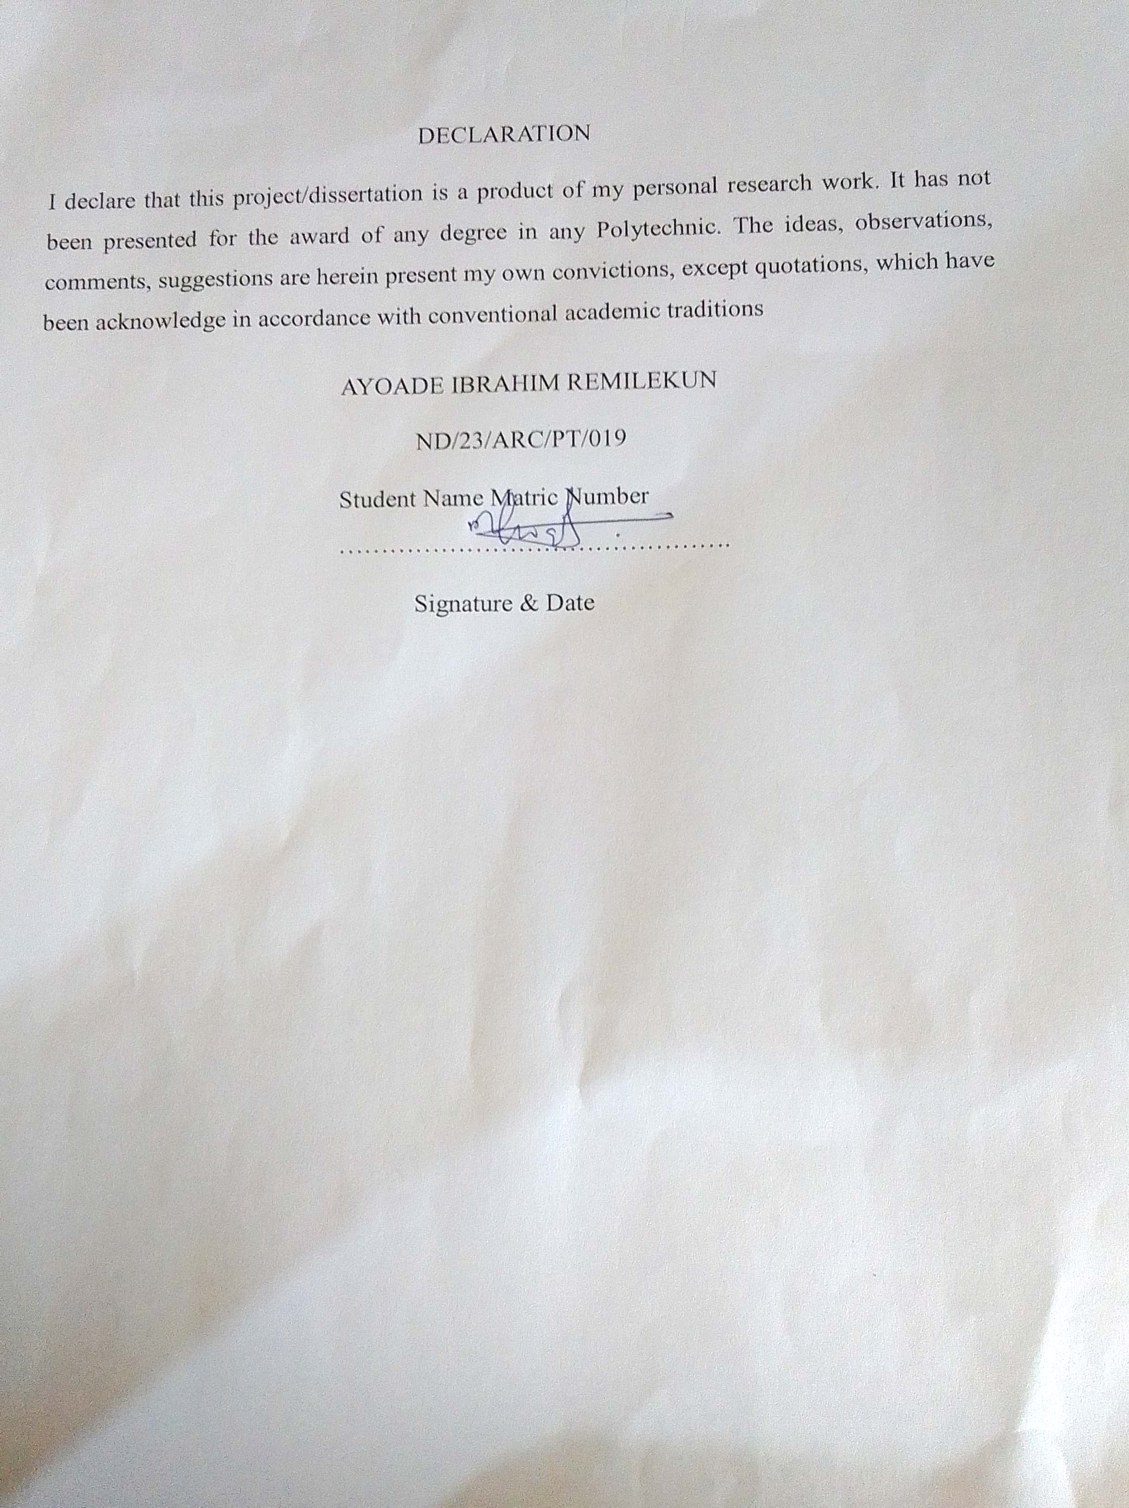

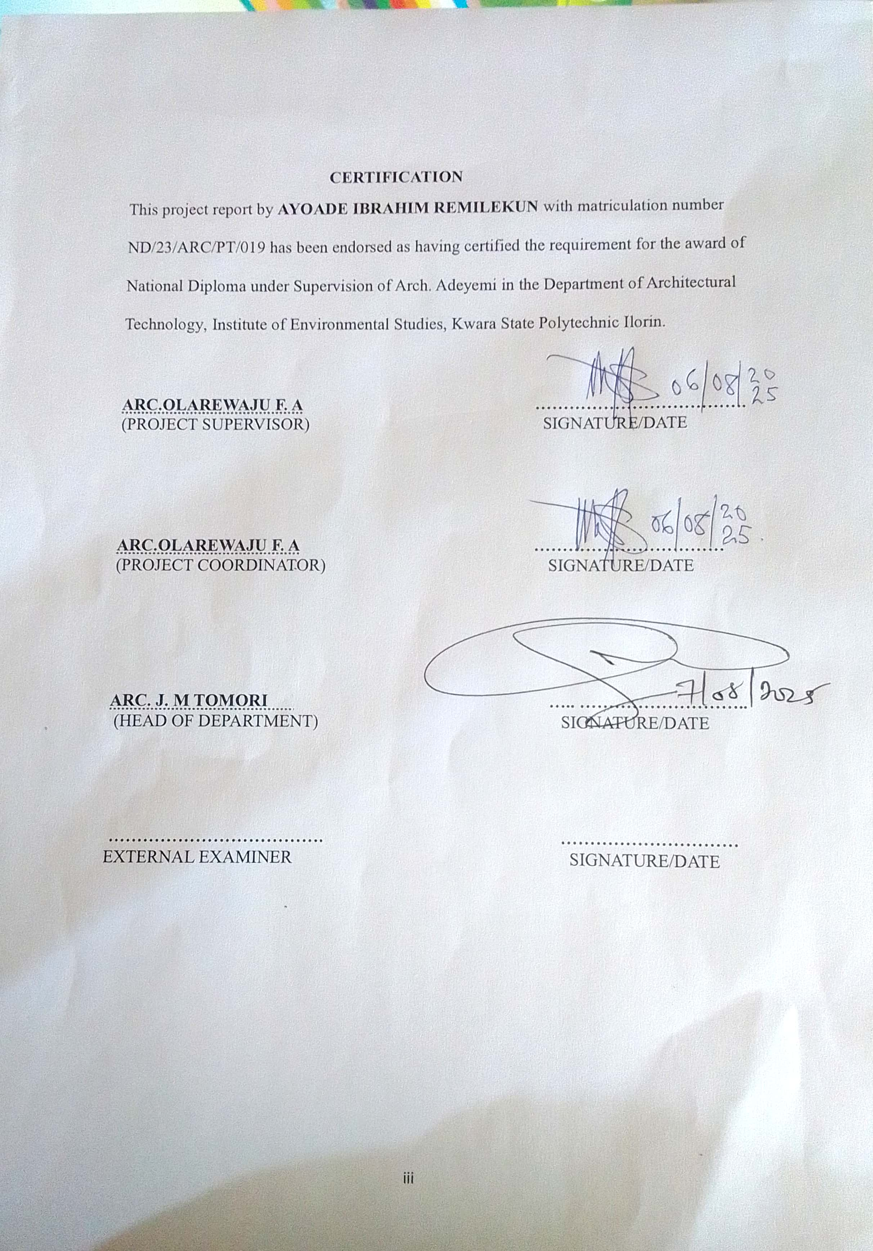
DEDICATION
This project is dedicated to Almighty God, the author and finisher of our faith for his guidance and grace towards me to complete this programme successfully and also to my lovely mother Mrs. M.T. AYOADE for her moral and financial support.

ACKNOWLEDGEMENT
Like every journey with a beginning and an end, this project marks the closing of a meaningful chapter one shaped by grace, resilience, and countless lessons. I bow in gratitude to the Almighty, the Master Architect of all things, for the strength, clarity, and inspiration that guided me through every sketch, note, and sleepless night.
To my supervisor, Arc. Olarewaju F. A., thank you for being the lighthouse in this academic voyage. Despite the tides of your tight schedule, you found time to steer me with wisdom and insight. May your generosity be repaid in full by Heaven’s abundance.
To my ever-supportive parents, Mr. and Mrs. Ayoade thank you for being the pillars upon which this dream stands. Your unwavering encouragement and sacrifices are the foundation of every milestone I’ve achieved.
My heartfelt appreciation also extends to the management, faculty, and non-academic staff of the Department of Architectural Technology. You shaped my perspective, inspired my designs, and instilled in me the discipline to build more than structures but purpose.
To my siblings, my dear brother and sister, and the tribe of friends and classmates who made this journey less lonely and more colourful thank you for cheering me on, pushing me forward, and reminding me that I was never alone.
To everyone who walked this path with me in ways big and small your contributions are etched into the blueprint of my success.
May your kindness return to you tenfold.
With profound gratitude,
Thank you all

TABLE OF CONTENTS
TITLE PAGE- i
DECLARATION ................................................................................................................ ii
CERTIFICATION................................................................................................................ iii
DEDICATION..................................................................................................................... iv
ACKNOWLEDGEMENTS.................................................................................................. v
TABLE OF CONTENTS..................................................................................................... vi
LIST OF TABLES............................................................................................................... vii
LIST OF FIGURES............................................................................................................. viii
LIST OF PLATES............................................................................................................... ix
LIST OF APPENDICES...................................................................................................... x
ABSTRACT........................................................................................................................ xi
CHAPTER ONE
- INTRODUCTION........................................................................................................ 2
1.1 BACKGROUND INFORMATION............................................................................... 2
1.2 PROJECT DEFINITION................................................................................................ 2
1.3 AIM AND OBJECTIVES................................................................................................2
1.4 STATEMENT OF PROBLEM........................................................................................ 2
1.5 RESEARCH METHODOLOGY.................................................................................... 3
1.6 LIMITATION AND CONSTRAINT.............................................................................. 3
CHAPTER TWO
2.0 LITERATURE REVIEW................................................................................................ 4
2.1 INTRODUCTION........................................................................................................... 4
2.2 FUNCTIONAL DESIGN................................................................................................ 4
2.3 INCLUSIVITY AND ACCESSIBILITY........................................................................ 5
2.4 FLEXIBILITY AND ADAPTABILITY......................................................................... 5
2.5 COMMUNITY BUILDING............................................................................................ 6
2.6 MODERN AMENITIES AND TECHNOLOGY ........................................................... 6
2.7 CONCLUSION............................................................................................................... 7
CHAPTER THREE
3.0 CASE STUDIES............................................................................................................. 8
3.1 INTRODUCTION......................................................................................................... 8
3.1.1 RELEVANCE OF CASE STUDIES TO ARCHITECTURAL DESIGN.................... 8
3.2 CASE STUDY ONE....................................................................................................... 9
3.3 CASE STUDY TWO...................................................................................................... 14
3.4 CASE STUDY THREE.................................................................................................. 16
CHAPTER FOUR
4.0 STUDY AREA/PROJECT SITE AND PROPOSED PROJECT................................... 18
4.1 INTRODUCTION..................................................................................................... 18
4.2 SITE LOCATION...................................................................................................... 18
4.2.2 SITE SELECTION CRITERIA.................................................................................... 20
4.3.2 VEGETATION.......................................................................................................... 20
4.3.3 TOPOGRAPHY......................................................................................................... 21
4.3.4 DRAINAGE............................................................................................................... 22
4.3.5 ACCESSIBILITY...................................................................................................... 22
4.3.6 CLIMATE
4.3.7 SITE FEATURES AND INFRASTRUCTURE........................................................... 24
4.3.8 NOISE SOURCES........................................................................................................ 24
4.4 SITE ANALYSIS............................................................................................................ 24
  - PROPOSED DESIGN.................................................................................................... 26
4.5.1 DESIGN CONSIDERATIONS:................................................................................................. 26
4.5.2 DESIGN CONCEPT................................................................................................... 27
4.5.3 BRIEF ANALYSIS....................................................................................................... 27
4.6 FUNCTIONAL RELATIONSHIP.................................................................................. 28
4.7 CONCEPTUAL DEVELOPMENT................................................................................ 28
4.8 BUBBLE DIAGRAM.................................................................................................... 28
CHAPTER FIVE
APPROACH TO THE DESIGN/DESIGN REALIZATION............................................... 29
5.0 SPECIFICATIONS AND CONSTRUCTION.............................................................. 29
5.1 MATERIAL AND FINISHES ............................................................................... 29
5.1.1 WALLS.................................................................................................................... 29
5.1.2 FLOORS................................................................................................................... 29
5.1.3 CEILING.................................................................................................................. 29
    - ROOF....................................................................................................................... 30
    - WINDOWS AND DOORS....................................................................................... 30
5.2 STRUCTURAL SYSTEM.......................................................................................... 30
  - BUILDING SERVICE.................................................................................................. 32
5.4 LANDSCAPING AND EXTERNAL WORKS.............................................................. 34
REFERENCES.......................................................................................................................35

LIST OF PLATES
PLATE 3.1: Picture the back view of case study 1………………………………………......14
PLATE 3.2: Picture showing the front view of case study 1 ………………………………...14
PLATE 3.3: Picture showing the rear view of case study 2………… …………………..…..18
PLATE 3.4: Picture showing the left view of case study 2 ………………………………….18
PLATE 3.5: Picture showing the rear view of case study 3………… …………………..…..22
PLATE 3.6: Picture showing the left view of case study 3 ………………………………….22

LIST OF FIGURES
FIGURE 2.1: Location Plan for case study one 10
FIGURE 2.2: Floor Plan for case study one 11

ABSTRACT
This study explores the architectural design of modern restaurants, with a focus on enhancing customer experience, operational efficiency, environmental sustainability, and overall functionality. Restaurants play a vital role in food service, tourism, and economic growth, especially in developing regions where the demand for quality dining experiences is rapidly increasing. Therefore, a well-designed restaurant facility is essential not only for attracting and satisfying customers but also for ensuring smooth operations and long-term business sustainability.
The research examines existing restaurant structures, identifying prevalent challenges such as poor ventilation, inadequate lighting, inefficient space utilization, insufficient sanitation measures, and lack of accessibility for all users. Surveys and interviews were conducted with local restaurant owners, chefs, hospitality managers, and design experts to understand the practical needs of both customers and staff. Based on this analysis, the study proposes a set of architectural design guidelines that prioritize ambiance, airflow, temperature regulation, sanitation, accessibility, and ease of maintenance.
A conceptual restaurant design is presented, integrating functional zoning, hygienic food preparation areas, customer comfort, sustainable material selection, and efficient spatial planning. The design also incorporates renewable energy options and water recycling systems, ensuring long-term operational viability. By addressing current structural inadequacies, this study aims to provide a comprehensive architectural framework that enhances dining experiences, improves operational flow, and promotes sustainable restaurant development in Ilorin, Kwara State, and similar urban centers.
CHAPTER ONE
1.0 INTRODUCTION
1.1 BACKGROUND INFORMATION
Restaurants have evolved from mere food outlets into sophisticated spaces that shape cultural experiences, enhance social interaction, and contribute significantly to the urban economy. The architectural design of a restaurant transcends the physical structure; it encapsulates ambience, identity, spatial organization, customer satisfaction, and operational efficiency. A well-conceived restaurant design can increase customer retention, streamline service delivery, and strengthen brand image (Bitner, 1992; Waxman, 2006).
In recent decades, the hospitality industry has undergone a transformation that places increasing importance on aesthetics, customer experience, and sustainability. These trends are pushing the boundaries of architectural design, demanding innovative layouts, technologically enhanced service features, and flexible spatial configurations (Jones & Lockwood, 2004). The modern restaurant is no longer a static space but a dynamic environment that must cater to diverse dining formats—ranging from casual dining and quick service to fine dining and outdoor experiences.
According to Edwards and Gustafsson (2008), the dining environment significantly impacts customers' perception of food quality and their willingness to return. Consequently, the role of architects and designers in crafting memorable dining experiences has become central to restaurant success. Interior lighting, material finishes, acoustics, seating arrangement, spatial zoning, and ventilation all play pivotal roles in determining the restaurant’s functionality and appeal (Kimes & Robson, 2004).
With the increase in competition and customer awareness, restaurants now prioritize functionality alongside aesthetics. The integration of kitchens, storage, service zones, and customer seating must be efficient and seamless, ensuring that operations run smoothly during peak periods. In particular, the open-kitchen concept, popularized in recent years, demands architectural creativity to maintain hygiene, safety, and customer engagement simultaneously (Horng et al., 2013).
Furthermore, restaurants are increasingly viewed as social spaces that support cultural identity and communal bonding. In urban centers, restaurants often serve as informal meeting places for families, friends, and business associates. As such, the design must reflect not only functionality but also the sociocultural values of its users (Davis, 2010). An effective architectural design must therefore blend operational requirements with psychological and emotional elements that shape user behaviour.
The design process also needs to consider accessibility and inclusivity, ensuring that customers with physical disabilities can enjoy the space without limitations. In accordance with universal design principles, elements such as ramps, accessible restrooms, and wide passageways should be standard features in any modern restaurant (Preiser & Ostroff, 2001).
In essence, the architectural design of a restaurant is a multidimensional endeavour. It integrates design theories, behavioural psychology, service logistics, brand strategy, and sustainability principles into a unified built environment that appeals to both the senses and logic of its patrons.
1.2 PROJECT DEFINITION
This project centers on the architectural design of a modern restaurant that embodies comfort, efficiency, aesthetics, and sustainability. The design will cater to various dining preferences and incorporate flexible spatial arrangements to serve different user groups, including walk-in customers, families, groups, and persons with special needs. It will integrate front-of-house and back-of-house operations, ensuring optimal service flow and environmental harmony. The restaurant will also reflect contemporary design trends and branding strategies, positioning it as a social and commercial landmark within its locality.
1.3.1 AIM
The aim of this project is to develop an architectural design for a restaurant that balances operational functionality with customer-centric aesthetics, resulting in a space that enhances dining experiences, promotes inclusivity, and reflects sustainability.
1.3.2 OBJECTIVES
- To develop a spatial layout that promotes efficiency between service areas (kitchen, storage, staff circulation) and customer zones (entrance, dining, waiting, restrooms).
- To ensure inclusivity through the application of universal design principles, including ramps, elevators, accessible restrooms, and flexible seating.
- To explore innovative lighting, acoustic treatment, and furniture arrangement that enrich the dining atmosphere and align with the restaurant’s brand identity.
- To incorporate sustainable materials and eco-friendly systems such as natural ventilation, energy-efficient lighting, and water-saving devices.
- To provide adaptable spaces for different dining arrangements (e.g., open dining, private booths, family tables, and outdoor patios).
- To integrate modern technology in the restaurant’s design, including digital ordering systems, reservation kiosks, and ambient control systems.

1.4 STATEMENT OF PROBLEM
The hospitality industry in many regions continues to suffer from suboptimal restaurant designs that hinder customer satisfaction and reduce operational efficiency. Common issues include cramped kitchens, poor circulation paths, noise pollution, lack of accessibility for persons with disabilities, and inadequate lighting or ventilation (Lockwood & Medlik, 2001). These problems not only impair staff productivity but also compromise the customer experience, leading to reduced patronage and financial losses.
Furthermore, many restaurant designs fail to incorporate sustainable materials or energy-efficient systems, thereby increasing operational costs and contributing to environmental degradation. Inadequate attention is also paid to inclusive design, alienating customers with mobility challenges and limiting market reach.
This project seeks to address these shortcomings by proposing a restaurant design that integrates aesthetics, functionality, sustainability, and inclusivity. By doing so, it aims to contribute to a new generation of restaurant environments that are both commercially viable and socially responsible.
1.5 CLIENT BACKGROUND
The client, Alhaja Risikat, is a seasoned and passionate culinary professional with over two decades of hands-on experience in the food and hospitality industry. Her journey into the world of gastronomy began more than 20 years ago, driven by a deep-rooted love for cooking and a desire to share her culinary gifts with the wider public.
Over the years, she has successfully built a strong reputation as a highly skilled restaurant operator, known for her unmatched expertise in preparing a wide variety of local Nigerian delicacies as well as continental and international dishes. Her food not only satisfies taste buds but also reflects her cultural identity, creativity, and commitment to excellence in every meal served.
Through consistency, innovation, and an uncompromising focus on quality and hygiene, Alhaja Risikat has built a loyal and expanding customer base within and beyond the Maraba–Tanke community in Ilorin. Her ability to blend traditional cooking techniques with modern culinary practices has made her stand out among her peers.
Now, with growing customer demand and a clear vision for the future, she seeks to take her food business to a higher level by embarking on the development of a modern, fully-equipped restaurant facility. This new establishment is envisioned to provide a more comfortable, efficient, and aesthetically pleasing environment where customers can enjoy freshly prepared meals in a hygienic and welcoming atmosphere.
The proposed restaurant project is not just a commercial venture but a passion-driven initiative aimed at elevating the dining experience for her patrons. It will serve as a platform to expand her culinary services, improve service delivery, and reflect her years of experience and dedication to the hospitality industry.
Ultimately, the new restaurant will stand as a landmark of excellence, where local traditions meet global culinary standards — a place where good food, great service, and lasting memories are served daily.
1.6 RESEARCH METHODOLOGY
To formulate a well-informed and contextually appropriate design proposal, the following research methods were adopted:
- Case Studies: Examination of existing successful restaurant architectures both locally and internationally to identify best practices, functional layouts, and design strategies.
- Internet Review: Exploration of global trends in restaurant architecture, sustainable building technologies, and customer experience design through digital platforms.
- Oral Interviews: Interaction with restaurant owners, chefs, architects, and patrons to gather qualitative insights on operational needs and user expectations.
- Literature Review: Analysis of scholarly publications, architectural journals, and industry reports to provide theoretical grounding and empirical support for design decisions.
1.6 LIMITATIONS AND CONSTRAINTS
- Access Restrictions: Difficulty in accessing certain restaurants for detailed case studies due to operational confidentiality or security policies.
- Limited Literature: A scarcity of region-specific academic resources and design guidelines on restaurant architecture, especially in the Nigerian context.

- Financial Constraints: Budget limitations affected the scope of physical site visits, professional consultations, and procurement of design resources.
- Time Limitations: The time-bound nature of academic research restricted the duration available for comprehensive stakeholder engagement and extended observation.

CHAPTER TWO
LITERATURE REVIEW
2.0 INTRODUCTION
The architectural design of restaurants plays a fundamental role in shaping customer experiences, operational workflows, and overall brand identity. As dining out has evolved from a purely functional activity to a social and emotional experience, the physical environment has become a key determinant of a restaurant’s success. A well-designed restaurant not only provides an efficient space for food preparation and service but also enhances mood, satisfaction, and customer loyalty through atmosphere, comfort, and aesthetics (Bitner, 1992; Waxman, 2006).
The emergence of experiential dining, increased consumer expectations, and growing emphasis on inclusivity and sustainability have collectively redefined the criteria for effective restaurant design. As noted by Edwards and Gustafsson (2008), the physical setting of a meal influences customers’ perception of food quality and value. Therefore, understanding the interdisciplinary nature of restaurant design encompassing architecture, psychology, branding, and service management is critical for both architects and restaurateurs.
This chapter explores key themes in contemporary restaurant architecture, focusing on functional design, spatial organization, inclusivity, adaptability, community engagement, technology, and sustainability. It draws upon scholarly research, design principles, and real-world examples to provide a robust foundation for designing innovative, efficient, and customer-centric restaurant spaces.
2.1 FUNCTIONAL DESIGN
2.1.1 Purpose and Utilization
The primary function of a restaurant is to facilitate the preparation and consumption of food in an environment that is both functional and aesthetically pleasing. Successful restaurant architecture ensures that all core components including the kitchen, storage areas, service stations, and dining zones operate in a harmonious and efficient sequence (Jones & Lockwood, 2004). Johnson and Smith (2020) emphasize that the design should support smooth transitions between front-of-house and back-of-house operations, ensuring minimal disruptions and optimal service delivery.
A critical aspect of this functionality is the kitchen layout. A poorly planned kitchen can lead to workflow congestion, staff fatigue, and increased service times. Lee (2019) advocates for the use of the "kitchen triangle" principle, where the refrigerator, stove, and sink are strategically placed to minimize movement and maximize productivity. In open-kitchen formats, where food preparation is visible to diners, the design must also account for aesthetics, acoustics, and hygiene.
In addition, the front-of-house must be equally optimized for customer comfort and service flow. The entry experience, waiting areas, and proximity to restrooms all influence how guests perceive the space (Kimes & Robson, 2004). These details are critical in encouraging repeat visits and building customer trust.
2.1.2 Spatial Organization
Effective spatial organization is vital for maximizing restaurant functionality. According to Carter and Brooks (2021), clear spatial zoning segregating dining areas, kitchen operations, service corridors, and utility zones can significantly enhance staff efficiency and customer satisfaction. Adams (2018) highlights the importance of path optimization, where movement patterns are analysed to reduce crowding and waiting time.
Restaurant spaces should also be intuitive to navigate. Wayfinding design, including floor finishes, lighting cues, and signage, can guide patrons naturally through the space without confusion (Lawson, 2001). Proper zoning also allows for acoustical control, ensuring that kitchen noise or crowded sections do not negatively impact the dining experience.
2.2 INCLUSIVITY AND ACCESSIBILITY
2.2.1 Design for All Users
An inclusive restaurant design is one that accommodates users of all physical abilities, ages, and backgrounds. Nelson and White (2022) assert that inclusive architecture is not just a legal obligation but a moral and business imperative. Restaurants that lack ramps, elevators, or accessible restrooms risk alienating a significant segment of potential customers.
Designing for inclusivity also involves creating spaces that feel welcoming to diverse cultural groups, families with children, and elderly patrons. This can be achieved through thoughtful seating arrangements, varying table heights, and clear circulation paths. The Americans with Disabilities Act (ADA, 2010) and similar guidelines globally mandate features like slip-resistant flooring, sufficient turning radius for wheelchairs, and barrier-free entries requirements that are becoming standard practice in the restaurant industry.
2.2.2 Universal Design Principles
Universal design goes beyond mere accessibility. It strives to create spaces that are inherently usable by all people, regardless of ability, without the need for adaptation. Miller and Lopez (2020) emphasize principles such as flexibility in use, low physical effort, and perceptible information, which can be applied to seating, entrances, menus, and bathroom facilities.
Peters (2021) further notes that restaurants incorporating universal design tend to attract wider patronage, enhance customer comfort, and reduce liability risks. Examples include braille menus, acoustic-friendly interiors for the hearing-impaired, and gender-neutral restrooms.
2.3 FLEXIBILITY AND ADAPTABILITY
2.3.1 Multi-Functional Spaces
In today’s competitive foodservice landscape, restaurants must be able to adapt their spaces for various events, functions, and peak-hour dynamics. Green and Morris (2022) suggest that restaurants benefit greatly from modular design using movable partitions, retractable walls, and sliding doors to reconfigure spaces as needed. This adaptability allows a restaurant to transition from a lunch service to an evening event or accommodate private dining groups without altering the overall spatial integrity.
Multi-functional design also accommodates seasonal changes. For example, convertible indoor-outdoor seating areas can expand service capacity during warmer months while preserving interior intimacy during colder seasons.
2.3.2 Furniture and Layout
Furniture selection plays a key role in space adaptability. Taylor and Benson (2019) advocate for lightweight, stackable, and modular furniture that can be rearranged quickly to meet changing customer needs. O’Neil (2020) adds that flexible seating plans enhance revenue generation by allowing the same space to serve couples, families, or large parties depending on the demand.
Layouts should also consider movement dynamics, ensuring that service staff can navigate efficiently and customers feel neither cramped nor isolated. The design must strike a balance between maximizing seat count and maintaining comfort.
2.4 COMMUNITY BUILDING
2.4.1 Social Interaction Spaces
Restaurants often serve as social anchors in their communities. Walters et al. (2021) suggest that architectural features such as communal tables, lounge areas, and patios promote socialization and repeat patronage. These spaces encourage interaction among guests and contribute to a restaurant’s identity as a community hub.
The spatial placement of social areas should be strategic visible enough to draw in patrons but designed to maintain a sense of privacy for those seeking quieter dining. The trend toward "third places" public spaces that are neither home nor work has made restaurants an important element in urban community life (Oldenburg, 1991).
2.4.2 Identity and Branding
Architectural design can be a powerful branding tool. Nguyen and Harper (2020) assert that elements such as lighting, colour schemes, wall graphics, and furniture style are not merely decorative but convey the restaurant’s concept and values. For instance, a rustic Italian trattoria may use reclaimed wood and warm tones, while a minimalist sushi bar might employ clean lines and monochrome materials.
Sanders (2022) emphasizes that a consistent brand language across spatial design enhances recognition and loyalty. The design must reflect authenticity and align with the cuisine, target demographic, and service style.
2.5 MODERN AMENITIES AND TECHNOLOGY
2.5.1 Integration of Technology
Technology is revolutionizing restaurant design and operation. Brown and Clarke (2023) identify digital menus, ordering kiosks, and automated reservation systems as essential features for enhancing service efficiency and reducing wait times. Martin (2022) further suggests that integrated point-of-sale (POS) systems, smart lighting, and climate control contribute to smoother operations and customer comfort.
Technology also affects spatial requirements. For example, digital ordering reduces the need for large reception areas, while self-service beverage stations require strategic placement near high-traffic zones.
2.5.2 Sustainable Design
Sustainability in architecture is no longer optional. Smith and Baker (2021) highlight the environmental and economic benefits of incorporating energy-efficient appliances, low-flow plumbing, natural lighting, and recycled materials into restaurant design. Green certifications, such as LEED (Leadership in Energy and Environmental Design), not only lower operational costs but also appeal to eco-conscious consumers.
Logan (2023) adds that biophilic design incorporating natural elements like plants, wood, and daylight enhances psychological well-being and dining satisfaction, contributing to a healthier and more appealing environment.
2.6 CONCLUSION
This literature review demonstrates that restaurant architecture is an interdisciplinary endeavour that requires a balance between function, aesthetics, inclusivity, technology, and sustainability. Each design decision from layout and materials to lighting and furniture shapes not only how the restaurant operates but also how customers perceive and engage with the space.
By synthesizing insights from diverse academic and industry sources, this chapter provides a comprehensive foundation for the development of a restaurant that is efficient, inclusive, visually compelling, and socially impactful.

CHAPTER THREE
3.0 CASE STUDIES
3.1 INTRODUCTION
A case study in architectural research involves a detailed investigation of specific real-world projects to uncover insights into their design, construction, and functionality. In the context of restaurant design, case studies provide a platform for analysing how spatial planning, aesthetics, materials, and services influence the dining experience. These in-depth examinations enable architects and designers to learn from existing establishments, assess design outcomes, and adapt best practices in their own projects. Data is typically gathered through site visits, interviews, architectural drawings, and user feedback.
3.1.1 RELEVANCE OF CASE STUDIES TO RESTAURANT ARCHITECTURAL DESIGN
- Learning from Existing Projects: Case studies of restaurants reveal practical solutions to challenges in design and operation. Studying successful dining establishments offers a blueprint for space efficiency, ambiance creation, and customer flow management.
- Understanding Design Solutions: Designers can evaluate various layout concepts, such as open kitchens, bar-centric plans, or modular seating arrangements, and analyse their impact on customer satisfaction and service delivery.
- Contextual Analysis: Restaurants are deeply influenced by their location be it urban, coastal, or rural as well as cultural expectations. Case studies help understand how regional influences shape architectural decisions.
- Innovation and Trends: New trends like green kitchens, digital menu integration, or thematic interiors emerge constantly. Through case studies, architects can keep pace with innovations and modern practices.
- Problem-Solving: Restaurant case studies often highlight how architects and operators resolved issues like acoustics, ventilation, circulation, or kitchen-dining interface conflicts, which serve as learning points.
- Regulatory and Compliance Insights: Understanding how restaurants comply with fire codes, accessibility standards, and food safety regulations is vital. Case studies offer insight into how these are integrated into architectural planning.
- Client and User Perspectives: User feedback on layout, ambiance, accessibility, and convenience offers direct insight into the strengths and weaknesses of a design, informing user-centric design approaches.
3.2 CASE STUDY ONE
RESTAURANT: THE ULTIMA EXECUTIVE RESTAURANT AND BAR
LOCATION: IBADAN, OYO STATE
Brief History:
The ULTIMA EXECUTIVE RESTAURANT AND BAR is a modern African fusion restaurant located in the Ibadan. Established in 2019, it quickly gained popularity for its mix of contemporary architecture and traditional culinary offerings. The design of the restaurant reflects a blend of natural materials, airy spaces, and cultural motifs, positioning it as a landmark dining spot in the city.
Facilities and Design Features:
- Dining Hall: Main area with flexible seating for individuals, couples, and groups.
- Outdoor Lounge: Landscaped exterior space with shaded pergolas and water features.
- Open Kitchen: Customers can view meal preparation, enhancing transparency and engagement.
- Bar Section: Integrated bar counter with high stools and ambient lighting.
- Private Dining Rooms: Enclosed rooms for meetings, small parties, or VIP guests.
- Restrooms: Separate male/female facilities with accessibility features.
- Parking: Dedicated parking space for up to 30 vehicles.
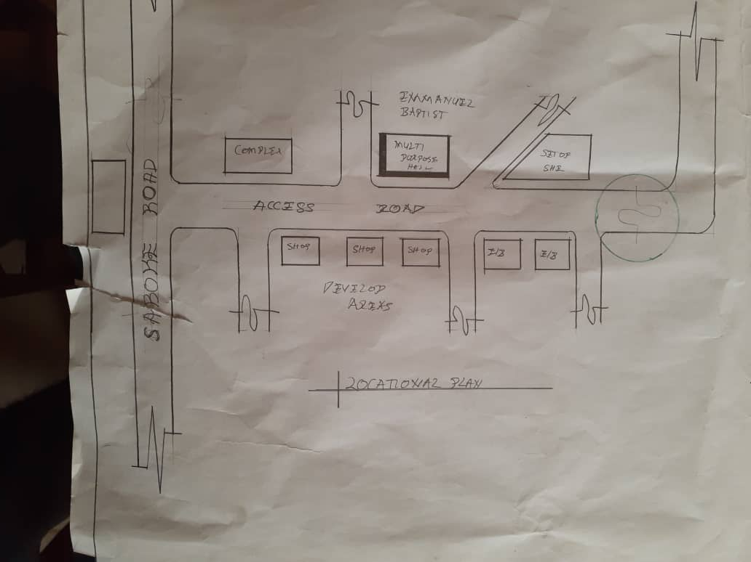
FIGURE 3.1: LOCATION PLAN OF THE CASE STUDY ONE
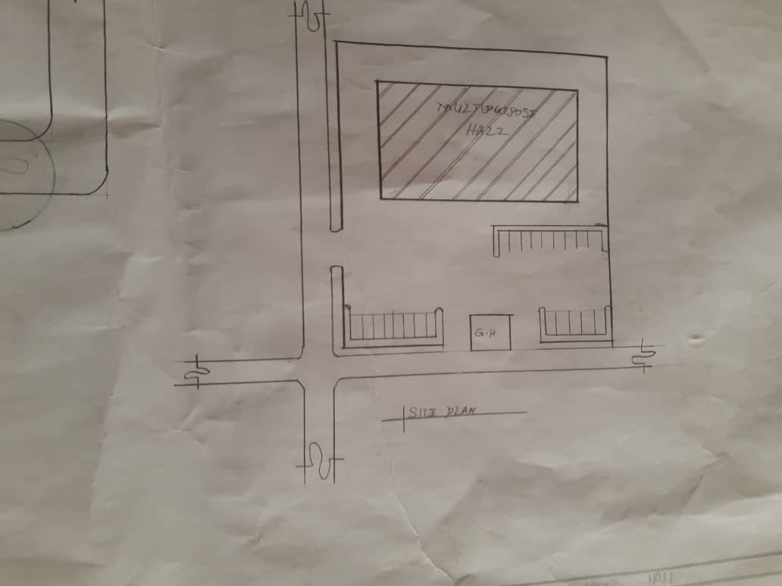
FIGURE 3.2: SITE PLAN OF CASE STUDY ONE
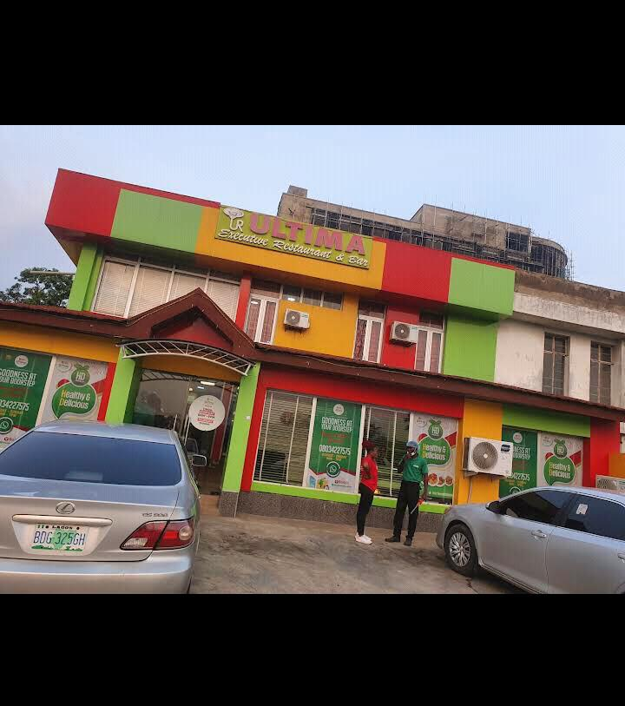
PLATE 3.1: FRONT ELEVATION SHOWING THE BISTRO'S FACADE
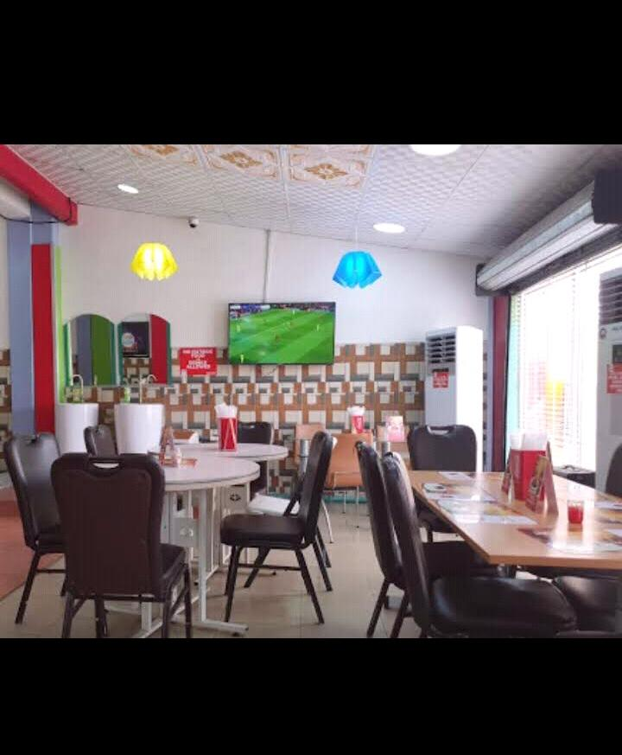
MERITS:
- Well-ventilated and with ample natural lighting
- Excellent landscaping and outdoor ambience
- Sufficient parking for staff and guests
- Contemporary design reflecting local identity
DEMERITS:
- Noise from nearby traffic interferes with the outdoor lounge
- No play area or entertainment zone for children

3.3 CASE STUDY TWO
RESTAURANT: URBAN CRAVINGS
LOCATION: BODIJA, IBADAN, OYO STATE
Brief History: Urban Cravings is an upscale restaurant situated in the commercial district of Bodija. Built in 2021, its concept revolves around urban industrial aesthetics combined with local flair. The restaurant is known for its glass façade, minimalist interiors, and eco-conscious material use.
Design and Facilities:
- Main Dining Area: Features exposed ceilings, metallic finishes, and pendant lighting.
- Rooftop Terrace: Offers panoramic views of the city with open-air seating.
- Kitchen Area: Closed kitchen design with strong ventilation systems.
- Takeaway Section: Express service counter for online and walk-in orders.
- Toilets: Compact but modern, with water-saving fixtures.
- Parking: Limited on-site parking; valet service provided.
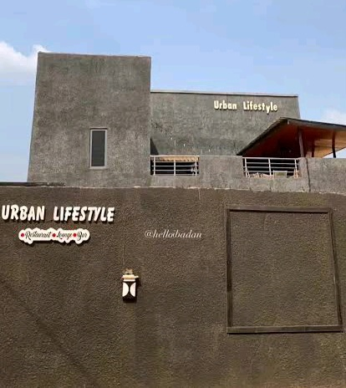
PLATE 3.2: ENTRANCE VIEW OF URBAN CRAVINGS

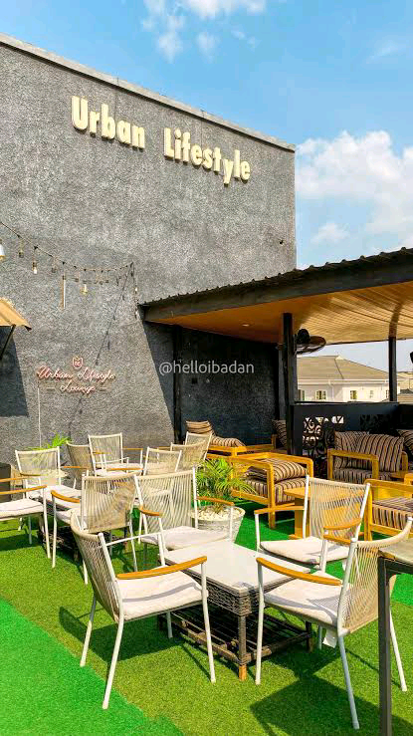
PLATE 3.3: SIDE ELEVATION SHOWING ROOFTOP AREA
OBSERVATIONS
MERITS:
- Innovative design that blends modernism with comfort
- Energy-efficient lighting and ventilation
- Elevated dining experience through rooftop seating
DEMERITS:
- Limited parking space, heavily reliant on valet service
- Small kitchen space impacts efficiency during peak hours
3.4 CASE STUDY THREE
RESTAURANT: THE PALM GROVE DINER
LOCATION: ADO-EKITI, EKITI STATE
Brief History:
The Palm Grove Diner is a mid-sized family-style restaurant known for its lush garden setting and warm ambiance. Established in 2017, it aims to provide an eco-friendly environment using sustainable architecture, including rammed earth walls and solar-powered systems.
Design Features and Facilities:
- Central Dining Space: Surrounded by glass walls overlooking gardens.
- Kids' Corner: A small playground with child-friendly amenities.
- Kitchen Area: Separated from the dining hall but accessible via a corridor.
- Patio Dining: Semi-covered seating for outdoor lovers.
- Mini Library: A unique addition offering reading material for waiting customers.
- Restrooms: Simple, eco-friendly with natural ventilation.
- Parking: Adjacent gravel parking lot accommodating 20 vehicles.

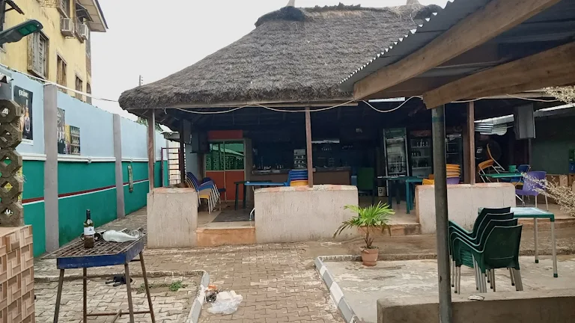
PLATE 3.4: IMAGE SHOWING THE ENTRANCE OF THE PALM GROVE DINER
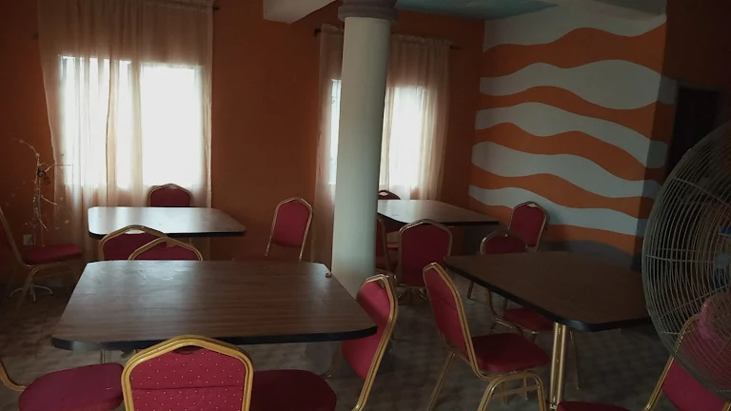
PLATE 3.5: PERSPECTIVE ELEVATION SHOWING THE DINING SPACE FROM THE GARDEN

OBSERVATIONS
MERITS:
- Eco-friendly materials and design
- Family-friendly layout with inclusive spaces
- Calm and natural ambiance enhancing dining experience
DEMERITS:
- Less visibility from the main road reduces walk-in customers
- Limited indoor space during rainy season

CHAPTER FOUR
4.0 STUDY AREA/PROJECT SITE AND PROPOSED PROJECT
4.1 Introduction
Ilorin, the capital city of Kwara State in Nigeria, boasts a rich history that intertwines various cultural influences. Established in 1450, it began as a settlement of the Yoruba people. Its strategic location at the crossroads of northern and southern Nigeria facilitated its growth into a significant trading hub.
In the early 19th century, Ilorin's history took a pivotal turn during the Fulani Jihad, led by Usman dan Fodio. In 1823, Ilorin was conquered by the Fulani leader Shehu Alimi, transforming it into an emirate under the Sokoto Caliphate's influence. This conquest brought about a blend of Yoruba and Fulani cultures, which remains evident today.
Under British colonial rule in the late 19th and early 20th centuries, Ilorin continued to develop as an administrative and commercial center. Post-independence, it became the capital of Kwara State when the state was created in 1967.
Today, Ilorin is a vibrant city known for its educational institutions, including the University of Ilorin, and its rich cultural heritage, which reflects its diverse historical influences.
4.2 Site Location
Maraba, located within the Ilorin metropolis of Kwara State, Nigeria, serves as a vibrant urban junction connecting the Ilorin East and South local government areas. Known for its commercial vitality and residential mix, Maraba is a transitional zone linking key communities such as Tanke, Fate, Gaa-Akanbi, and Post Office. The area’s proximity to educational institutions, administrative facilities, and transportation nodes makes it a strategic location for development projects.
Ilorin, the capital of Kwara State, was established around 1450 as a Yoruba settlement and later came under the influence of the Fulani Jihad in the 19th century. It evolved into a significant emirate under Shehu Alimi, blending Yoruba and Fulani traditions. Today, Ilorin reflects a multifaceted cultural identity, serving as an educational and administrative hub with institutions like the University of Ilorin and Al-Hikmah University enhancing its regional importance.
4.2 Site Location
The proposed project site is situated in Maraba, Ilorin South LGA, Kwara State, Nigeria. The site lies between the Tanke Junction and Challenge axis, a high-traffic zone characterized by a blend of commercial, institutional, and residential land uses. It is accessible via multiple adjoining roads including University Road and Offa Garage Road, with nearby neighborhoods such as Basin, GRA, and Pipeline.
- Coordinates: Approx. Latitude 8.4790°N, Longitude 4.5410°E
- Nearby Landmarks: Unity Road, Kwara Hotel, Royal Shekinah Restaurant, Harmony Hospital
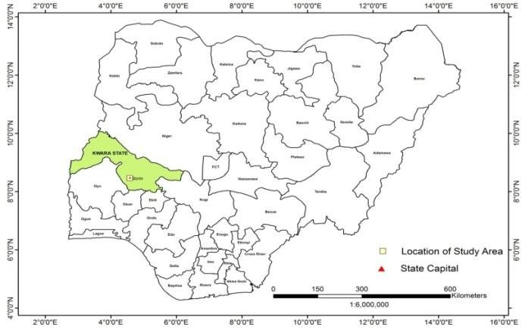
Figure 4.1 Map of Nigeria showing location of Kwara State
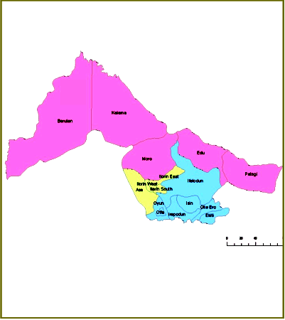
Figure 4.2 Map of Kwara State showing location of Ilorin
4.2.2 Site Selection Criteria
The site was selected based on the following category;
- Location
- Ease of access
- Availability of enough land
- Security
- Nature of Site and Vegetation

- Location:
The site is located along existing female hostels within the school.
- Ease of Access:
The site can be accessed easily as there is an existing road that leads to it.
- Availability of Enough land:
To adequately provide for the various facilities required in the building and on the site, the area of land required for the project must be adequate. Therefore, the site was selected because it is wide enough to accommodate the proposed design.
- Security:
The site is located within the school thereby is covered by the school security ensuring safety of the students. But also, additional security would be provided on the site.
- Nature of Site and Vegetation:
The topography of the site is fairly levelled and the slightly unlevelled part can be adequately levelled. The sub soil is mainly red lateritic soil, with batches of sandy soil. The site also contains few trees and shrubs, which can help enhance the landscape of the site, and also act as wind-breakers and dust filters during the harmattan.
4.3.2 Vegetation
The vegetation on the site consists of few trees of different species and shrubs. Some trees and shrubs will be retained to enhance the landscape of the site, and also act as wind-breakers and dust filters during the harmattan.
4.3.3 Topography
The topography of the site is fairly levelled and the slightly unlevelled part can be adequately levelled.
4.3.4 Drainage
There is no existing drainage on the site, so drainage would be constructed.
4.3.5 Accessibility
The site is accessible by an existing road along the adjoining buildings which leads to the site.
4.3.6 Climate
Ilorin is a city in Nigeria with a warm climate, experiencing an average daily high temperature of around 33 degrees Celsius. The weather is generally tropical and humid, with high temperatures and humidity making it feel quite warm throughout the year. Ilorin's climate is characterized by a mix of wet and dry seasons, inviting residents and visitors to enjoy its natural beauty and outdoor activities.
The best time to travel to Ilorin is from November to March, when the weather is relatively drier and more comfortable for outdoor activities. During these months, the rainfall is minimal, making it ideal for exploring the city and its surroundings. The wet season, with most precipitation, occurs from April to October, with rainfall peaking between June and September
Hours of sunshine per day

Figure 4.3 Rainy days per month
The number of hours of sunshine refers to the time when the sun is actually visible, without any obstruction by clouds, fog, or other obstacles. In Ilorin, February is the sunniest month, with an average of 7 hours of sunshine per day. In contrast, August has the shortest duration of sunshine throughout the year.
Rainy days per month
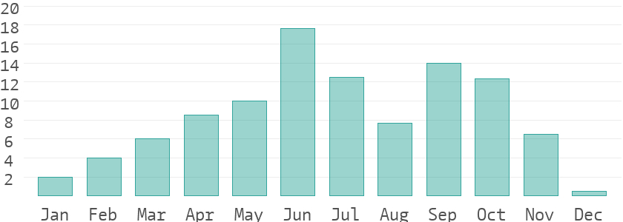
Figure 4.4 Rainy days per month
A rainy day in Ilorin is defined as a day with at least 0.1 mm of precipitation per square meter, which can include rain, snow, hail, or even dew. It doesn't have to rain the entire day to qualify. June has the highest number of rainy days, averaging 18, while December has the fewest rainy days.
Relative humidity in %
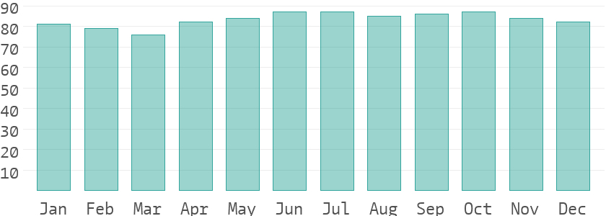
Figure 4.5 Water temperature
Warm air can absorb more moisture than cold air. The relative humidity indicates the amount of moisture in the air as a percentage of the maximum amount it can hold. High humidity levels can make people feel uncomfortable and oppressed. Generally, a relative humidity of 40-60% is considered pleasant. In Ilorin, June is the most uncomfortable month, with an average humidity of 87%. In contrast, March has lower humidity levels, making it more comfortable to endure
4.3.7 Site Features and Infrastructure
The site is equipped with electrical lines, indicating that readily available power supply is accessible on-site.
The soil is well-drained, allowing water to permeate easily for good soil aeration while retaining sufficient moisture for plant growth.
Additional features include water supply and an access road
4.3.8 Noise Sources
There are no much noises on the site but the few noises that can be heard comes from the adjacent structures which are the existing hostels.
4.4 Site Analysis.
A site analysis involving a study of the site is carried out, it takes into consideration natural and man-made components present in and around the site, as well as climatic conditions of Kwara State. The plate below shows a schematic summary of the analysis of the proposed site.
- Rainfall:
Minimum rainfalls are recorded in December, while June offers the most amount of rainfall.
- Vegetation and Topography:
The vegetation on the site consists of few trees of different species and few shrubs. The site is relatively gentle sloping and has a high load bearing capacity soil.
- Prevailing Wind Direction & Sun-Path Angles
The two predominant winds blowing across this area are the South West Trade wind and the North East Trade wind. The former, which blows across the Atlantic Ocean, is characteristically cold and results in the wet season. Being a cold wind, it is capable of holding much moisture contents across the ocean, and hence an increase in relative humidity of the area affected. However, the North East Trade wind, which blows across the Sahara Desert, is dusty and dry wind. Consequently, the two predominant seasons experienced in this area are characteristically marked by the two wind types. The summer (the season between spring autumn when the sun is hot and there are many flowers) is experienced between April and September, when the south west Trade wind is more predominant, while the winter season is shortly marked between November and March, when the north east trade wind is more predominant. This later season {winter} is however characterized by cool and hazy mornings, couple with dusty afternoons, because of the dust particles it brings forth from the desert. To reduce the effects of wind driven, trees were planted.
- Sunrise and sunset:
The sun rises from the east in the early hours of the morning at about 6:30am - 7:00 am and sets in the west at about 6:45 pm in the evening daily.
- Accessibility:
The site is accessible by an existing road along the adjoining buildings which leads to the site.
- Man-made features
- Electricity: Electricity is supply to the site through overhead cables along the site boundary.
- Footpath: There are no existing footpaths on the site, few would be channeled.
- Noises: Caused by adjacent structures
4.5 Proposed Design
The proposed project is the design of a modern restaurant with architectural emphasis on safety, functional efficiency, and aesthetic appeal. The restaurant is intended to serve the growing population of residents, students, and professionals in the Maraba–Tanke corridor of Ilorin, offering both dine-in and takeaway services in a well-structured and welcoming environment.
4.5.1 Design Considerations
The following key factors were considered in developing the architectural design of the restaurant:
- Passive and Active Fire Safety Measures: Fire-resistant materials, proper kitchen ventilation, accessible fire exits, fire extinguishers, smoke detectors, and sprinkler systems are integrated to ensure safety.
- Aesthetics: Use of contemporary, vibrant finishing materials such as polished wood, textured walls, decorative lighting, and natural elements to create an appealing atmosphere.
- Functionality: The spatial layout is designed for ease of movement between kitchen, dining, storage, and service areas to enhance staff efficiency and customer experience.
- Ventilation: Adequate natural ventilation through large operable windows, open-plan dining, and mechanical systems to maintain indoor air quality.
- Circulation and Zoning: Clear zoning separates the public (dining, waiting areas) from the private (kitchen, staff areas), with a defined circulation path to reduce congestion and confusion.
- Landscaping: Incorporation of soft landscaping at the restaurant entrance and around the perimeter to create a serene environment and reduce heat.
- Security: Fenced perimeter with gated access, external lighting, CCTV surveillance, and controlled access to service areas to ensure the safety of staff and patrons.
4.5.2 Design Concept
The design is based on functionalism, a principle that emphasizes that every component of a building should serve a defined purpose. The restaurant is envisioned as a space where comfort, efficiency, and sensory experience come together seamlessly. The spatial configuration supports fast service, customer satisfaction, and staff productivity, while also allowing for ambient dining experiences.
4.5.3 Brief Analysis of Building Spaces
The building is divided into functional zones to support both front-of-house and back-of-house operations:
1. Administrative and Service Areas
- Manager’s Office: Overseeing day-to-day operations and staff coordination.
- Cashier’s Booth: Located near the entrance for payment and order processing.
- Staff Room: A rest area with lockers and restroom facilities for employees.
- Control/Surveillance Room: Monitors CCTV and building systems.
2. Customer Areas
- Reception/Waiting Area: Welcomes guests and manages seating flow.
- Main Dining Hall: Spacious area with flexible seating arrangements for groups, couples, and individuals.
- VIP Dining Rooms: Enclosed, soundproof spaces for private functions or special guests.
- Outdoor Terrace Dining: Covered seating with natural breeze and views.
- Café/Beverage Counter: A casual counter for quick coffee, pastries, and refreshments.
- Restrooms (Male/Female/Accessible): Well-designed and ventilated for customer convenience.
3. Kitchen and Back-of-House Areas
- Preparation Area: For cold and hot prep activities.
- Cooking Area: Equipped with modern stoves, ovens, fryers, and hoods.
- Storage Rooms: Separate dry storage, refrigerated storage, and utility rooms.
- Dishwashing Section: Isolated from food prep zones to prevent contamination.
- Delivery Entrance: Rear access for goods delivery without interfering with customer flow.
4.6 Functional Relationship
A bubble diagram is used to define spatial interactions and relationships between zones within the restaurant. The goal is to ensure optimal workflow, customer comfort, and safety. Key adjacencies include:
- Dining areas close to restrooms and café counter
- Kitchen directly linked to both dining and storage
- Reception easily accessible from the entrance
- Private dining near the main hall but acoustically separated
- Clear service routes without intersecting customer paths
4.7 Conceptual Development
The conceptual framework for the restaurant focuses on:
- Streamlining customer flow from entry to seating, ordering, dining, and exit
- Separating service routes to enhance efficiency and hygiene
- Creating open, well-ventilated and well-lit interiors using glass walls and skylights
- Using vertical landscaping and green buffers for passive cooling
- Designing flexible dining arrangements that can be adapted for various events
- Prioritizing emergency exits and fire escape routes in all zones
4.8 Bubble Diagram
The bubble diagram represents the foundational spatial relationships that inform the architectural layout. It illustrates:
- Core zones: Kitchen, Dining, Admin, Storage
- Service flow: Storage → Kitchen → Dining
- Customer journey: Entry → Reception → Dining → Exit
- Ancillary spaces: Restrooms, Café, Outdoor seating
This schematic helps balance the public and private functions of the building while maximizing land use efficiency and user experience.

CHAPTER FIVE
APPROACH TO THE DESIGN / DESIGN REALIZATION
5.0 SPECIFICATIONS AND CONSTRUCTION
5.1 Materials and Finishes
Material and finish selection plays a crucial role in determining the functionality, fire safety, durability, and visual appeal of the proposed restaurant. Every element, from walls to flooring and ceilings, is selected not only for its aesthetic value but also for its fire resistance, hygiene compliance, and sustainability.
5.1.1 Walls
The restaurant’s internal and external walls will be constructed with hollow sandcrete blocks reinforced with concrete columns at intervals to ensure structural stability. To enhance fire resistance, interior partition walls around cooking areas will be concrete-filled blockwork. Finishes will include graphitex trowel paint or stone-effect paint, which offer aesthetic depth and natural resistance to fire and heat. Hygienic, easily cleanable wall tiles will be used in food preparation areas.
5.1.2 Floors
The floors will comprise 150mm-thick mass concrete slabs on hardcore sub-base. Non-slip ceramic tiles will be used as the primary floor finish in dining, kitchen, and restroom areas, ensuring durability, safety, and ease of maintenance. The tiles are flame-resistant and do not emit toxic fumes under high heat, making them ideal for a restaurant environment.
5.1.3 Ceiling
Ceilings in the dining and reception areas will consist of plasterboard with acoustic paneling, supported by metal furring channels. In kitchen and service zones, fire-rated gypsum boards with aluminum composite lining will be used to meet fire and hygiene codes. Ceiling finishes are selected for sound control, flame resistance, and cleanability.
5.1.4 Roof
A steel truss system will form the main roofing structure, finished with long-span aluminum roofing sheets for durability, lightness, and heat reflection. The roof will incorporate ventilation ridges to allow hot air escape, improving internal comfort, especially in cooking areas.
5.1.5 Windows and Doors
Windows will be aluminum casement types with double-glazed safety glass to provide thermal insulation and reduce noise. Doors will include metal-framed flush doors for public access and fire-rated metal doors for kitchen and emergency exits. All exit doors will swing outward and comply with escape route standards to facilitate safe egress during emergencies.
5.2 Structural System
i. Substructure (Foundation)
The site’s soil analysis confirms high load-bearing capacity, enabling the use of deep strip foundations. Reinforced concrete footings will support the load of the restaurant building and its superstructure, with proper damp proofing to avoid rising moisture.
ii. Superstructure
The superstructure will include reinforced concrete columns and beams, load-bearing blockwork, and slab systems. All structural elements will conform to Nigerian Building Code standards and will integrate fireproofing and thermal insulation where necessary.
5.3 Building Services
i. Power Supply
The restaurant will be powered primarily through PHCN mains, with a backup generator and solar inverter system installed to ensure uninterrupted service, especially during peak hours.
ii. Lighting
Natural lighting is maximized through wide windows and clerestory glazing in dining areas. Artificial lighting will include a mix of LED recessed downlights, pendant lights, and accent fixtures, selected for ambience, energy efficiency, and visual clarity in both front- and back-of-house areas.
iii. Ventilation
A combination of cross ventilation and mechanical ventilation will be employed. Kitchen areas will be equipped with industrial extractor hoods, while dining and lounge areas will rely on natural airflows enhanced by ceiling fans and operable windows. Air conditioning units will be used in enclosed VIP sections.
iv. Staircase
In case of a two-storey section (e.g., rooftop dining or mezzanine), reinforced concrete staircases with non-slip nosing and metal handrails will be provided. A dedicated fire escape staircase will be positioned at the rear.
v. Fire Protection
Fire protection systems include:
- Smoke and heat detectors in all zones
- Fire extinguishers and hose reels at strategic locations
- Fire alarm panels with manual call points
- Clearly marked exit signage and lighting
All fire-rated zones will follow passive design strategies such as compartmentalization, fire-resistant materials, and protected exit routes.
vi. Plumbing and Electrical Installations
All plumbing and electrical systems will be routed through concealed conduit systems to maintain hygiene and aesthetic integrity. Kitchens will have separate plumbing systems for potable and wastewater. All fittings will be stainless steel, corrosion-resistant, and food-grade compliant.
vii. Water Supply
Water will be supplied via a borehole system, with a dedicated overhead storage tank to ensure constant flow. Filtration units will be installed for water used in food preparation and beverage services.
viii. Drainage and Sewage Disposal
Drainage will utilize graded surface water channels leading to culverts, while wastewater and sewage will be directed to septic tanks and soak-away pits via 300mm PVC pipes, complete with inspection chambers and vents.
ix. Waste Disposal
A structured waste management system will include segregated bins for biodegradable, recyclable, and hazardous waste. External waste collection points will be located away from dining areas and emptied by municipal services.
5.4 Landscaping and External Works
The site’s landscape design integrates both hard and soft landscaping to enhance the customer experience and environmental quality.
- Soft Landscaping: Native trees, shrubs, ornamental grasses, and flower beds will be used to soften the building’s appearance and provide shaded sitting areas for outdoor diners.
- Hard Landscaping: This includes interlocking stone-paved walkways, outdoor dining patios, driveways, and clearly marked parking spaces. Water features or sculptures may be incorporated at the entrance for visual interest.
- Access Points: The site has two vehicular gates—one main access for guests and a rear service access for deliveries and staff entry. Pedestrian walkways are also clearly defined for safety.
- Parking: Adequate on-site parking is provided for diners and staff, including designated spaces for disabled users, delivery trucks, and motorcycles.
This comprehensive approach to design and specification ensures that the proposed restaurant at Maraba Tanke, Ilorin, is not only aesthetic and functional but also safe, sustainable, and user-friendly, setting a high standard for contemporary dining facilities in the region.

References
Bitner, M.J. (1992). Servicescapes: The impact of physical surroundings on customers and
employees. Journal of Marketing, 56(2), 57–71.
Davis, M. (2010). Architecture of Community. Island Press.
Edwards, J.S.A., & Gustafsson, I.B. (2008). The room and atmosphere as aspects of the
meal: A review. Journal of Foodservice, 19(2), 22–34.
Horng, J.S., Chou, S.F., Liu, C.H., & Tsai, C.Y. (2013). Creativity and sustainable
development: Trends and successful practices in architecture and design. Sustainability, 5(3), 1239–1255.
Jones, P., & Lockwood, A. (2004). The Management of Hotel Operations. Cengage Learning.
Kimes, S.E., & Robson, S.K.A. (2004). The impact of restaurant table characteristics on
meal duration and spending. Cornell Hotel and Restaurant Administration Quarterly, 45(4), 333–346.
Lockwood, A., & Medlik, S. (2001). Tourism and Hospitality in the 21st Century.
Butterworth-Heinemann.
Preiser, W.F.E., & Ostroff, E. (2001). Universal Design Handbook. McGraw-Hill.
Waxman, L. (2006). The coffee shop: Social and physical factors influencing place
attachment. Journal of Interior Design, 31(3), 35–53.
Adams, T. (2018). Zoning for Functionality in Restaurant Design. Architectural Digest, 56(4),
44–53.
Bitner, M.J. (1992). Servicescapes: The Impact of Physical Surroundings on Customers and
Employees. Journal of Marketing, 56(2), 57–71.
Brown, L., & Clarke, J. (2023). Tech-Driven Restaurant Design. Hospitality Technology
Review, 35(1), 21–33.
Carter, E., & Brooks, H. (2021). Planning for Flow: Spatial Arrangement in Hospitality
Spaces. Design Quarterly, 49(2), 88–101.
Edwards, J.S.A., & Gustafsson, I.B. (2008). The Room and Atmosphere as Aspects of the Meal:
A Review. Journal of Foodservice, 19(2), 22–34.
Green, K., & Morris, L. (2022). Modular Thinking in Restaurant Design. International Journal
of Hospitality Architecture, 18(2), 60–72.
Jones, P., & Lockwood, A. (2004). The Management of Hotel Operations. Cengage Learning.
Lawson, B. (2001). The Language of Space. Architectural Press.
Lee, R. (2019). Efficient Kitchen Layouts for the Modern Restaurant. Culinary Engineering
Journal, 11(1), 11–20.
Logan, M. (2023). Biophilic Design in Restaurants: A Green Revolution. Sustainable Design
Journal, 29(4), 39–49.
Martin, D. (2022). Smart Service Systems in Restaurants. Service Innovation Quarterly, 14(3),
75–88.
Miller, D., & Lopez, F. (2020). Designing for All: Principles of Universal Accessibility. Journal
of Inclusive Architecture, 15(1), 33–47.
Nelson, P., & White, G. (2022). Access for All: Hospitality Design for Inclusivity. Access and
Inclusion Review, 8(2), 19–31.
Nguyen, K., & Harper, S. (2020). Brand Identity Through Space. Restaurant Design Studies,
13(3), 102–116.
O’Neil, R. (2020). Furniture Flexibility in Modern Dining Spaces. Furniture Design Today,
22(4), 51–63.
Peters, J. (2021). Practical Universal Design for Restaurants. Design for All Quarterly, 19(1),
66–78.
Sanders, L. (2022). Visual Branding in Restaurant Interiors. Commercial Interiors Journal,
10(2), 84–95.
Smith, H., & Baker, R. (2021). Sustainable Practices in Restaurant Design. Journal of
Environmental Architecture, 7(2), 99–110.
Taylor, M., & Benson, A. (2019). Adaptive Dining Layouts in Hospitality Design. Hospitality
Interiors, 6(3), 29–41.
Walters, D., Jones, F., & Harris, A. (2021). Restaurants as Social Spaces: Design
Considerations. Urban Social Design Journal, 16(2), 59–73.
Waxman, L. (2006). The Coffee Shop: Social and Physical Factors Influencing Place
Attachment. Journal of Interior Design, 31(3), 35–53.

