PROJECTREPORT

ON

PROPOSEPRIMARYSCHOOL,ILORINKWARASTATE BY
ADELODUNABDULRASAQTEMILAYO ND/22/ARC/FT/0025

BEING A DESIGN PROJECT SUBMITTED TO THE DEPARTMENT OF ARCHITECTURAL TECHNOLOGY, INSTITUTEOFENVIRONMENTALSTUDIES,(I.E.S)KWARA STATE POLYTECHNIC ILORIN KWARA STATE.

INPARTIALFULFLMENTOFTHE REQUIREMENTFORTHE AWARDOFNATIONALDIPLOMA(ND)INARCHITECTURAL TECHNOLOGY, KWARA STATE POLYTECHNIC.

JULY,2025

DECLARATION

I declare that this design project is a project of my personal research works. It has not been presented for the award of any ND in any polytechnic. This ideas observation, comments suggestion herein represents my own conviction, except quotations, which have been acknowledged in accordance with conventional academic traditions.

ADELODUNABDULRASAQTEMILAYO ND/22/ARC/FT/0025

Signature/Date

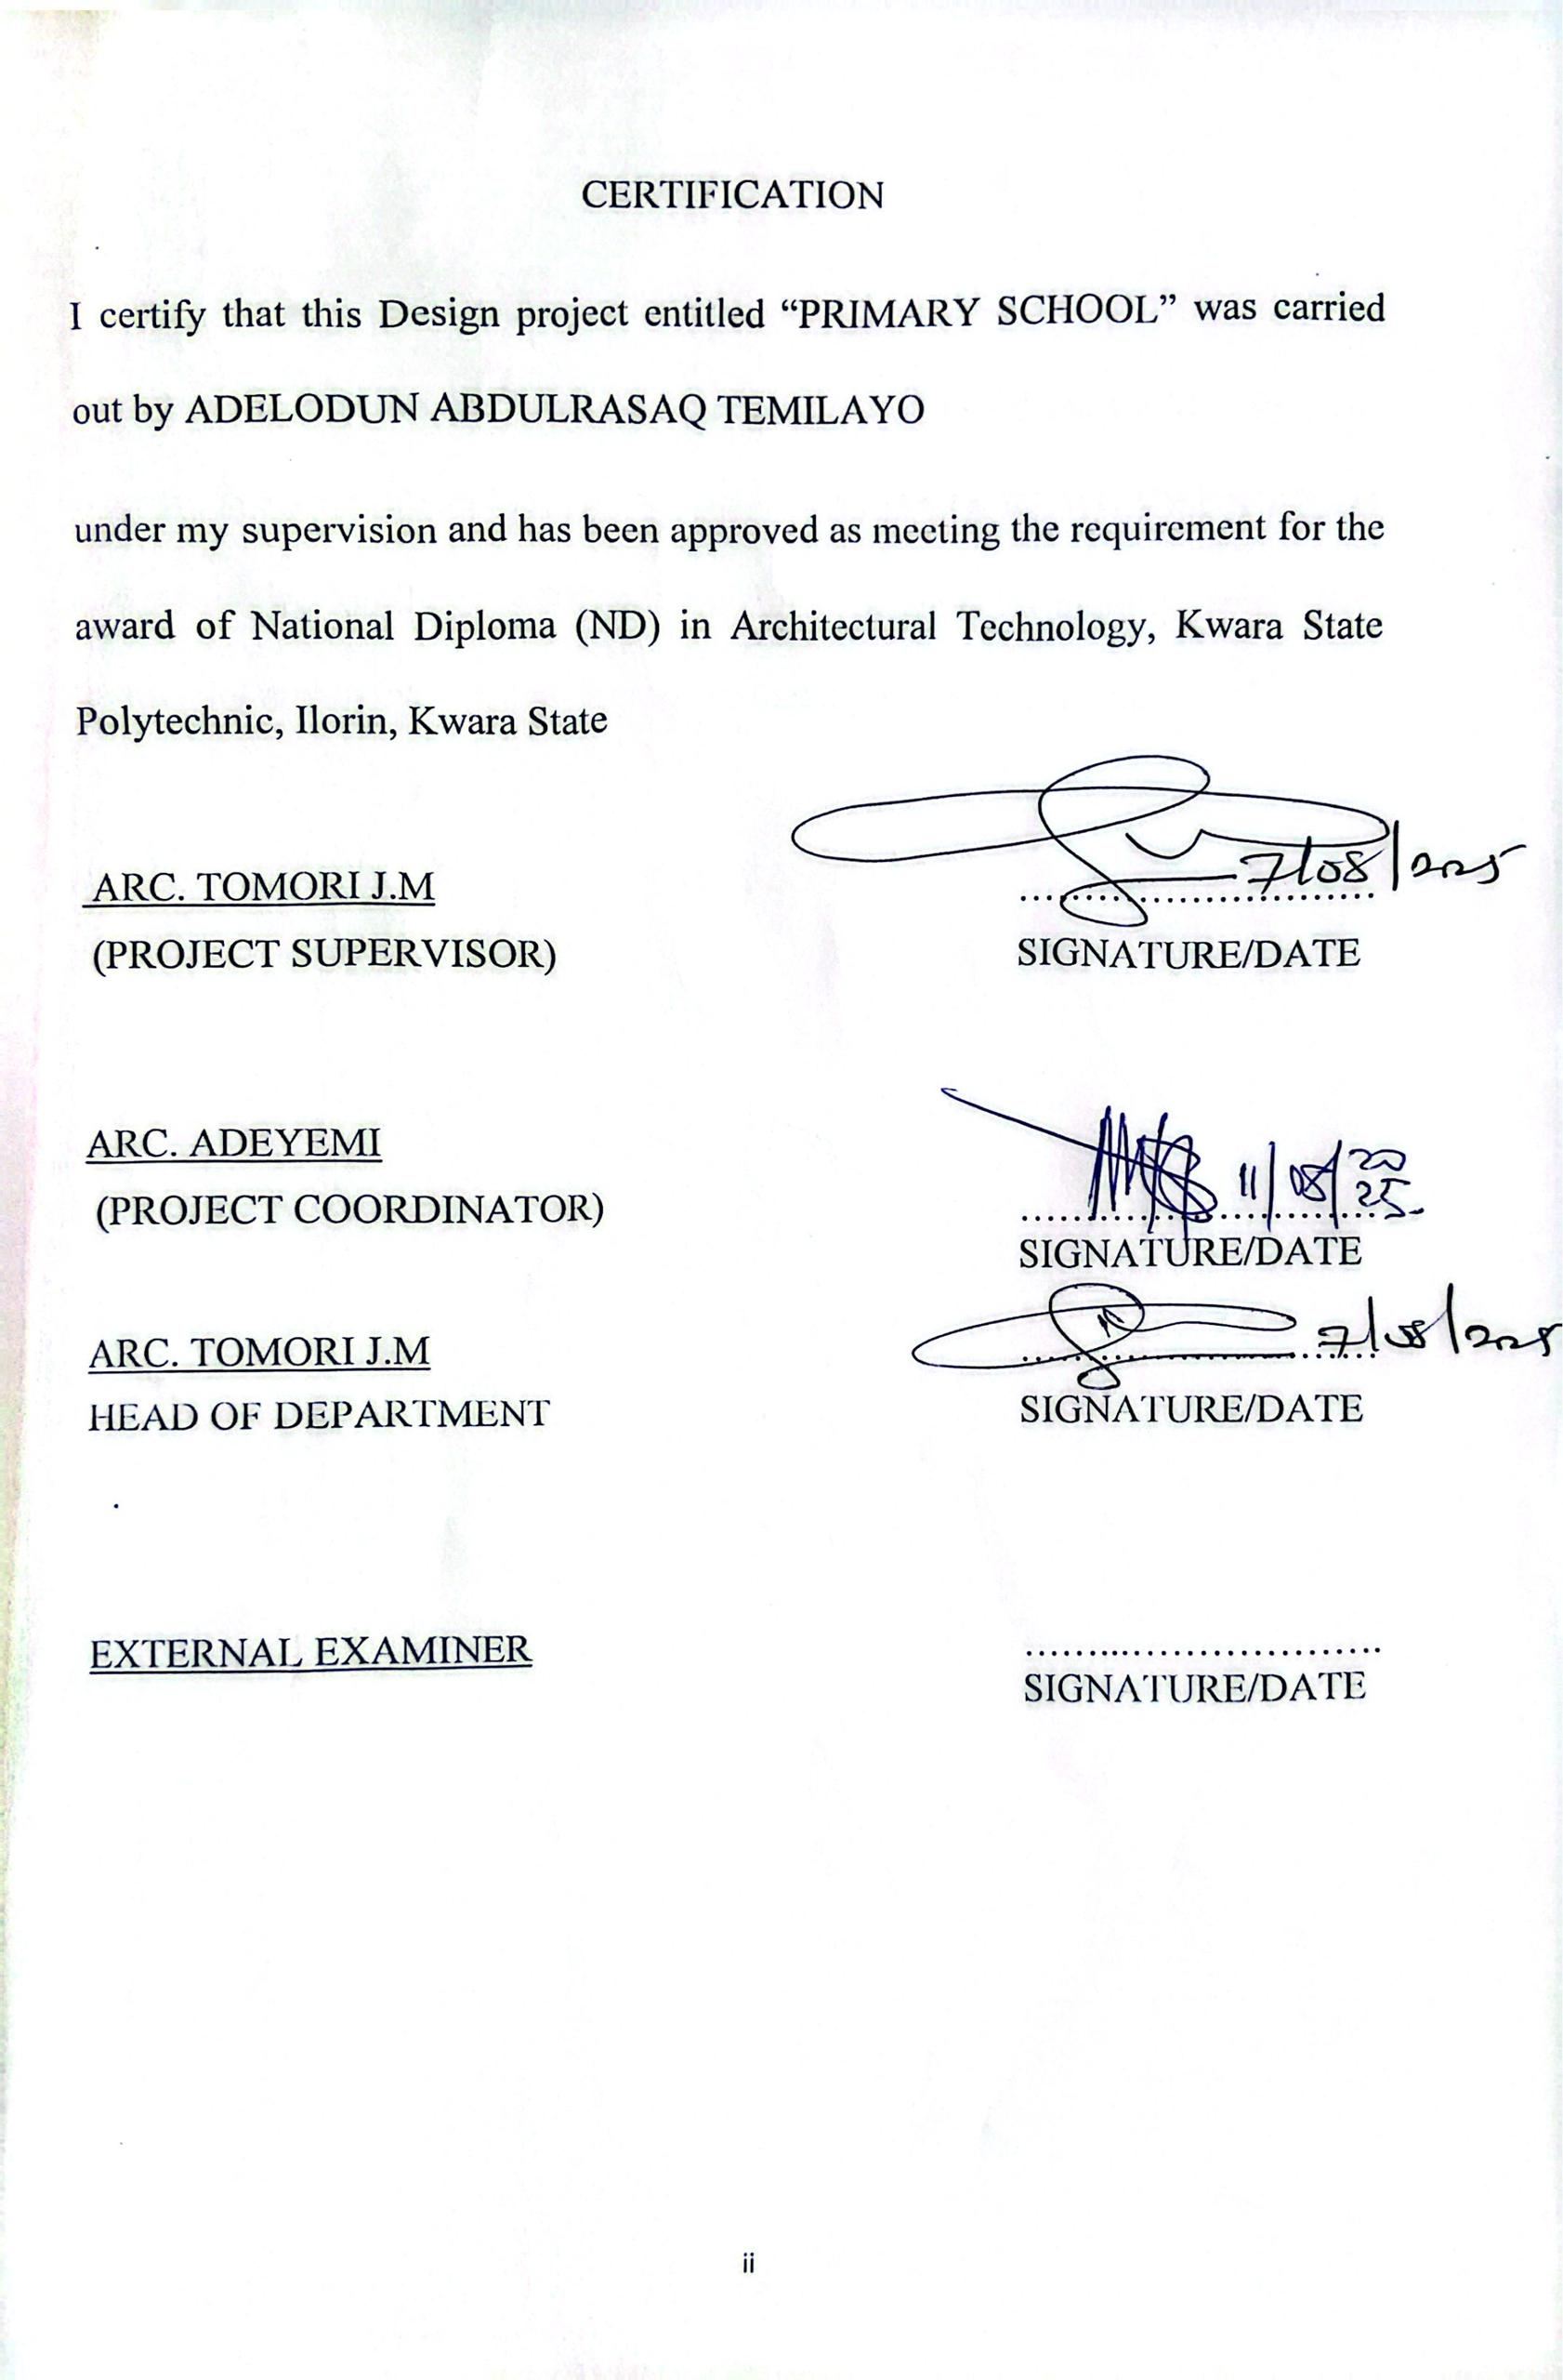
ACKNOWLEDGEMENT
Everything that has beginning must surely have an end therefore, all praise and adoration is unto Almighty ALLAH for the strength and courage he hasrecorded me into the process of this project.
Especially thanks to my supervisor ARC. (MRS). TOMORI J.M for the commitment to this work to the very To all lecturers of the department of architectural technology ARC CHUCKUMA NMON, ARC.OLAREWAJU F.A,ABDULAZEEZB.Y.F,ARCSOLOMONFAMILUA.Godblessyou
all.
My deepest appreciation goes to my parent MR. and MRS. ADELODUN and also to my Sponsor ALHAJA REMILEKUN ALAO and the entire member of ADELODUN FAMILY for the supports towards my education.
I also appreciate my friends in person of ABDULRAHEEM MUSA BABATUNDE and my loving sisters, brothers and course mates as they have contributing immensely to my success of the project.
There is no number of words that I can best describe you all, I am indeed overwhelmed of your supports and I pray Almighty Allah will bless you all.
Thanksyouall.

DEDICATION

This design project is dedicated to almighty Allah, the all sufficient and themost beneficent God for his guidance and Grace toward me to complete this program successfully and also to my sponsor ALHAJA REMILEKUN ALAO and the entire family of ADELODUN for their supports morally, spiritually, financially and in every other way to see that my program was successful.

TABLEOFCONTENTS
TitlePage | Page
Declaration |  | i
Certification |  | ii
Acknowledgement |  | iii
Dedication |  | iv
TableofContent
CHAPTERONE
1.0 BACKGROUNDOFTHESTUDY |  | 1
1.1 INTRODUCTION |  | 1
1.2 STATEMENTOFTHEDESIGNPROBLEM |  | 1
1.3 AIMSANDOBJECTIVES |  | 3
1.3.1 MAINAIMS |  | 3
1.3.2 SPECIFICOBJECTIVES |  | 3
1.4 SIGNIFICANCEOFTHESTUDY |  | 4
1.5 JUSTIFICATIONOFTHEPROJECT |  | 4
1.6 BENEFITOFTHEPROJECT |  | 5
1.6.1 TARGETBENEFICIARIES |  | 5
1.6.2 POTENTIALIMPACT |  | 6
1.7 SCOPEOFTHEPROJECT |  | 6
1.7.1 GEOGRAHICSCOPE |  | 6
1.7.2 CONTENTSCOPE |  | 6
1.8 METHODOLOGICALSCOPE |  | 7
1.9 LIMITATIONOFTHEPROJECT |  | 7
1.9.1 GEOGRAPHICLIMITATION |  | 7
1.9.2 SAMPLESIZELIMITATION |  | 7
1.9.3 TIMECONSTRAINTLIMITATION |  | 7
1.9.4 RESOURCESLIMITATION |  | 7
1.9.5 METHODOLOGICALLIMITATION |  | 7

DATALIMITATION 8
CONTEXTUALLIMITATION 8
RESEARCHMETHODOLOGY 8
RESEARCHDESIGN 8
DATACOLLECTIONMETHODS 8
DATAANALYSISMETHODS 9
SAMPLINGSTRATEGY 9
REASEARCHINSTRUMENTS 9
DATAQUALITYASSURANCE 9
CHAPTERTWO
LITERATUREREVIEW 11
INTRODUCTION 11
THEORETICALFRAMEWORK 11
KEYTHEMES 11
EMPIRICALSTUDIES 12
GAPSINTHELITERATURE 12
CONCEPTOFTHEPROJECT 13
PROJECTOVERVIEW 13
KEYCONCEPTS 13
DESIGNPRINCIPLES 13
PROJECTGOALS 13
HISTORYANDDEVELOPMENTOFTHEPROJECT 14
BACKGROUND 14
PROJECTCONCEPTION 14
DEVELOPMENTPROCESS 14
MILESTONES 15
CHALLENGES 15
LESSONSLEARNED 15
IMPORTANCEOFTHEPROJECTINTHESOCIETY 16

2.5.1 | EDUCATIONALMPACT | 16
2.5.2 | SOCIALIMPACT | 16
2.5.3 | ECONOMICIMPACT | 16
2.5.4 | ENVIRONMENTALIMPACT | 17
2.5.5 | LONGTERMBENEFIT | 17
2.6 | DESGINCONSIDERATIONSFOR | MODERNPRIMARY
SCHOOLS |  | 17
2.6.1 | SUSTAINABLEDESIGN | 17
2.6.2 | CHILDCENTEREDDESIGN | 18
2.6.3 | TECHNOLOGYINTEGRATION | 18
2.6.4 | COMMUNITY ENGAGEMENT | 18
2.6.5 | HEALTHANDWELL–BEING | 18
2.6.6 | FLEXIBILITYANDADAPTABILITY | 19
2.7 | CHALLENGES OF DESIGNING | SUSTAINABLE AND
CHILDFRIENDLYPRIMARYSCHOOLS 19
FINANCIALCHALLENGES 19
INFRASTRUCTURECHALLENGES 19
2.8 SUMMARYOFLITERATUREREVIEW 21
CHAPTERTHREE
CASESTUDYOFTHEPROJECT 22
INTRODUCTION 22
CASESTUDYBACKGROUND 22
DESIGNFEATURES 22
CHAPTERFOUR
PROJECTANALYSISANDDESIGNCRITERIAOFTHE PROJECT 26
INTRODUCTION 26
ANALYSIS 26
DESIGNCRITERIA 26

DESIGNPRICIPLES 27
APPROACHTOTHEDESIGNOFTHEPROJECT 27
USERCENTEREDDESIGNAPPROACH 27
SUSTAINABLEDESIGNAPPROACH 27
CHILDFRIENDLYDESIGNAPPROACH 28
COMMUNITYENGAGEMENTAPPROACH 28
CONTEXUALDESIGNAPPROACH 28
INTEGRATEDDESIGNAPPROACH 28
DESIGNREALIZATIONOFTHEPROJECT 29
FINALDESIGN 29
CHAPTERFIVE

5.0 RECOMMENDATIONS | AND | CONCLUSION | OF | THE
PROJECT |  |  |  | 31
5.1 RECOMMENDATIONS |  |  |  | 31
5.2 CONCLUSION |  |  |  | 32
REFERENCES APPENDIXS
APPENDIX A: DESIGN DIAGRAMS APPENDIX B: SUSTAINABILITY FEATURES
APPENDIXC:CHILDFRIENDLYDESIGNFEATURES APPENDIX D: PROJECT TIMELINE
APPENDIXE:BUDGETBREAKDOWN

ABSTRACT
This project explores the design of primary schools in Ilorin, Kwara State, Nigeria, with a focus on creating sustainable and child-friendly learning environments. The study investigates the impact of school design on student learning outcomes and well-being, highlighting the importance of natural light, flexible learning spaces, and sustainable materials. A case study approach is adopted, combining site analysis, stakeholder engagement, and design development. The proposed design model incorporates sustainable design principles and child-friendly features, providing a blueprint for future primary school design in Ilorin and beyond.
This abstract provides a concise overview of the project's objectives, methodology, and findings, highlighting the significance of effective primary school design in promoting student learning outcomes and well-being.

CHAPTERONE
BACKGROUNDOFTHESTUDY
INTRODUCTION
The design of primary schools plays a critical role in shaping the learning experiences of young children. Effective school design can enhance student engagement, motivation, and academic achievement, while also promoting social, emotional, and physical well-being.
In Nigeria, primary education is a crucial phase of a child's educational journey, laying the foundation for future academic success. However, many primary schools in Nigeria face challenges related to infrastructure, resources, and design, which can negatively impact student learning outcomes.
There is a need for primary schools in Nigeria to be designed in a way that supports the unique needs of young children, promotes sustainability, andfosters a love of learning. This study aims to explore the design of primary schools in Ilorin, Kwara State, with a focus on creating sustainable and child- friendly learning environments.

STATEMENTOFTHEDESIGNPROBLEM
The design problem addressed in this study is the lack of effective and sustainable primary school design in Ilorin, Kwara State, Nigeria, which can negatively impact student learning outcomes and well-being.

SPECIFICDESIGNCHALLENGES
- Inadequate Infrastructure: Many primary schools in Ilorin lack adequate infrastructure, including classrooms, furniture, and facilities, which can hinder effective learning.

- Poor Design: Existing primary school designs often neglect the unique needs of young children, failing to provide comfortable, safe, and engaging learning environments.
- Sustainability: Primary schoolsin Ilorinoftenlack sustainable design features, such as natural lighting, ventilation, and energy-efficient systems, which can increase energy costs and environmental impact.
- LimitedFlexibility: Traditional primaryschooldesignsoftenfeature rigidand inflexible learning spaces, which can limit the effectiveness of teaching and learning.

DESIGNOBJECTIVES
- Create Comfortable and Engaging Learning Environments: Design primary schools that provide comfortable, safe, and engaging learning environments that support the cognitive, social, and emotional development of children.
- Promote Sustainability: Incorporate sustainable design principles and features that reduce energy consumption, conserve resources, and minimize environmental impact.
- Support Flexible Learning: Design flexiblelearning spaces that accommodate differentteaching methods and learningstyles, promoting effectiveteaching and learning.
- Enhance Student Well-being: Create primary schools that prioritize student well-being, including physical and mental health, safety, and happiness.

DESIGNCONSTRAINTS
- Budgetary Limitations: Primary school design must be cost-effective and budget-friendly, considering the limited resources available.

- Cultural and Social Context: Designs must be sensitive to the cultural and social context of Ilorin, Kwara State, Nigeria, reflecting local values, traditions, and needs.
- Environmental Factors: Designs must consider environmental factors, such as climate, topography, and natural resources, to ensure sustainability and resilience.

This comprehensive statement of the design problem highlights the key challenges and objectives of primary school design in Ilorin, Kwara State, Nigeria, providing a clear direction for the design solution.

AIMSANDOBJECTIVES
MAINAIMS
The main aim of this project is to design and develop a comprehensive plan for primary schools in Ilorin, Kwara State, Nigeria, that incorporates sustainableand child-friendly features, promoting effective learning environments and supporting the cognitive, social, and emotional development of children.

SPECIFICOBJECTIVES
- Conduct a Needs Assessment: Conduct a thorough needs assessment to identify the requirements and challenges of primary schools in Ilorin, Kwara State, Nigeria.
- Develop a Design Concept: Develop a design concept for primary schools that incorporates sustainable and child-friendly features, promoting effective learning environments.
- Design Sustainable and Child-Friendly Facilities: Design facilities that are sustainable, safe, and accessible, and that support the cognitive, social, and emotional development of children.

- Promote Flexible Learning: Design flexible learning spaces that accommodate different teaching methods and learning styles.
- Evaluate and Refine the Design: Evaluate the effectiveness of the design and refine it based on feedback from stakeholders.

EXPECTEDOUTCOMES
- Improved Learning Environments: Primary schools that provide effective learning environments, promoting student engagement and achievement.
- Sustainable and Child-Friendly Design: Primary schools that incorporate sustainable and child-friendly design features, reducing environmental impact and promoting student well-being.
- Increased Community Engagement: Primary schools that engage with the local community, promoting social cohesion and supporting the development of the community.

SIGNIFICANCEOFTHESTUDY
This project has the potential to contribute to the development of effective primary school design principles and practices in Nigeria, promoting improved student learning outcomes and well-being. The findings of this study can inform policy decisions, guide architectural design, and support the creation of sustainable and child-friendly learning environments.

JUSTIFICATIONOFTHEPROJECT

SignificanceofPrimaryEducation
Primary education is a critical phase of a child's educational journey, laying the foundation for future academic success and personal development. Effective primary education can have a lasting impact on a child's cognitive, social, and emotional development.

NeedforSustainableandChild-FriendlyDesign
Traditional primary school designs often neglect the unique needs of young children, failing to provide comfortable, safe, and engaging learning environments. There is a need for primary schools that incorporate sustainable and child-friendly design features, promoting effective learning and supporting the well-being of children.

BENEFITSOFTHEPROJECT
- Improved Learning Outcomes: The project can contribute to improved learning outcomes for children by providing effective learning environmentsthat support academic achievement.
- Increased Sustainability: The project can promote sustainability by incorporating environmentally friendly design features and reducing energy consumption.
- Enhanced Child Well-being: The project can support the well-being of children by providing safe, accessible, and engaging learning environments.

TARGETBENEFICIARIES
- Children: The primary beneficiaries of the project are children who attend primary schools in Ilorin, Kwara State, Nigeria.
- Teachers and Educators: The project can also benefit teachers and educators by providing them with effective learning environments that support their teaching practices.
- Communities: The project can have a positive impact on local communitiesbypromotingsocialcohesionandsupportingthedevelopmentofthecommunity.

POTENTIALIMPACT
- Improved Educational Outcomes: The project can contribute to improved educational outcomes for children in Ilorin, Kwara State, Nigeria.

- Increased Community Engagement: The project can promote community engagementandsocialcohesionbyinvolvingstakeholdersinthedesignprocess.
- Sustainable Development: The project can promote sustainable development by incorporating environmentally friendly design features and reducing energy consumption.

This comprehensive justification highlights the significance of the project, its potential benefits, and its target beneficiaries. The project has the potential to contribute to improved learning outcomes, increased sustainability, and enhanced child well-being in Ilorin, Kwara State, Nigeria.

SCOPEOFTHEPROJECT
GEOGRAPHICSCOPE
TheprojectfocusesonprimaryschoolsinIlorin,KwaraState,Nigeria.

CONTENTSCOPE
Theprojectwillcoverthefollowingtopics:
- PrimarySchoolDesign:Thedesignofprimary schools,includingarchitecture, layout, and facilities.
- Sustainability: The incorporation of sustainable design principles and features in primary schools.
- Child-FriendlyDesign:Thedesignofprimaryschoolsthatsupportthe cognitive, social, and emotional development of children.
- Learning Environments: The creation of effective learning environments that promote student engagement and achievement.

METHODOLOGICALSCOPE
Theprojectwillemploythefollowingmethodologies:

- Literature Review: A review of existing literature on primary school design, sustainability, and child-friendly design.
- CaseStudy:AcasestudyofprimaryschoolsinIlorin,KwaraState,Nigeria.
- DesignDevelopment:Thedevelopmentofadesignconceptforprimaryschools that incorporates sustainable and child-friendly features.

LIMITATIONOFTHEPROJECT
GeographicLimitation
The project is limited to primary schools in Ilorin, Kwara State, Nigeria, which may not be representative of other regions or countries.
SampleSizeLimitation
Theprojectmay havealimitedsamplesize,which couldimpactthe generalizability of the findings.
TimeConstraintLimitation
Theprojectmaybeconstrainedbytimelimitations,whichcouldimpactthe depth and breadth of the research.
ResourceLimitation
Theprojectmaybelimitedbyresourceconstraints,includingfunding, personnel, and equipment.
MethodologicalLimitation
The project may be limited by the chosen researchmethodology, which may not capture all the complexities of primary school design and sustainability.
DataLimitation

The project may be limited by the availability and quality of data, which could impact the accuracy and reliability of the findings.

ContextualLimitation
TheprojectmaybelimitedbythespecificcontextofIlorin,KwaraState, Nigeria, which may not be applicable to other contexts.
Theselimitationshighlightthepotentialconstraintsandchallengesofthe project, and can inform the interpretation and application of the findings.

RESEARCHMETHODOLOGY

RESEARCHDESIGN
Theresearchdesignforthisprojectisamixed-methodsapproach,combining qualitative and quantitative methods to gather and analyze data.

DATACOLLECTIONMETHODS
- Surveys: Surveys will be administered to teachers, students, and parents to gather data on their perceptions of primary school design and sustainability.
- Interviews: Interviews will be conducted with stakeholders, including policymakers, architects, and educators, to gather in-depth insights on primary school design and sustainability.
- Case Study: A case study of primary schools in Ilorin, Kwara State, Nigeria, will be conducted to gather data on existing design and sustainability practices.
- Observations: Observations will be made of primary school facilities to gather data on the physical environment and its impact on learning.

DATAANALYSISMETHODS
- Descriptive Statistics: Descriptive statistics will be used to analyze quantitative data, including frequencies, means, and standard deviations.
- Thematic Analysis: Thematic analysis will be used to analyze qualitative data, including interview transcripts and observational notes.

- Content Analysis: Content analysis will be used to analyze documents and policies related to primary school design and sustainability.

SAMPLINGSTRATEGY
- Purposive Sampling: Purposive sampling will be used to select participants for interviews and surveys, including stakeholders with expertise in primary school design and sustainability.
- Random Sampling: Random sampling will be used to select primary schools for the case study.

RESEARCHINSTRUMENTS
- SurveyQuestionnaire:Asurveyquestionnairewillbedevelopedtogather data on perceptions of primary school design and sustainability.
- InterviewProtocol:Aninterviewprotocolwillbedevelopedtoguide interviews with stakeholders.
- Observation Checklist: An observation checklist will be developed to guideobservations of primary school facilities.

DATAQUALITYASSURANCE
- Validity: The validity of the research instruments will be ensured through pilot testing and expert review.
- Reliability: The reliabilityof the researchinstrumentswillbe ensuredthrough consistency checks and data validation.
This comprehensive research methodology provides a clear outline of the research design, data collection and analysis methods, and sampling strategy, ensuring that the research is conducted in a rigorous and systematic manner.

CHAPTERTWO

LITERATUREREVIEW

INTRODUCTION
The literature review provides an overview of existing research on primary school design and sustainability, highlighting key themes, findings, and gaps in the literature.

THEORETICALFRAMEWORK
- Learning Environment Theory: The learning environment theory emphasizes the importance of the physical environment in supporting student learning and well-being.
- Sustainable Development Theory: The sustainable development theory highlights the need for environmentally friendly and socially responsible design practices.

KEYTHEMES
- DesignElements:Researchhighlightstheimportanceofdesignelementssuch as natural light, ventilation, and flexible learning spaces in supporting student learning and well-being.
- Sustainability: Studies emphasize the need for sustainable design practices, including energy-efficient systems, renewable energy sources, and waste reduction.
- Child-Centered Design: Research emphasizes the importance of child- centereddesignapproachesthatprioritizetheneedsandperspectivesofchildren.
EmpiricalStudies

- Impact of Design on Learning: Studies have shown that well-designed learning environments can improve student learning outcomes and engagement.

- Sustainable Design Practices: Research has highlighted the benefits of sustainable design practices, including reduced energy consumption and improved indoor air quality.
- Child-Friendly Design: Studies have emphasized the importance of child- friendly design approaches that prioritize theneeds and perspectives of children.
GapsintheLiterature
- Context-Specific Research: There is a need for context-specific research on primary school design and sustainability in Nigeria.
- Longitudinal Studies: There is a need for longitudinal studies to examine the long-term impact of primary school design and sustainability on studentlearning outcomes and well-being.
The literature review highlights the importance of primary school design and sustainability in supporting student learning outcomes and well-being. The review identifies key themes, findings, and gaps in the literature, informing the development of a comprehensive design solution for primary schools in Ilorin, Kwara State, Nigeria.

This literature review provides a comprehensive overview of existing research on primary school design and sustainability, highlighting key themes, findings, and gaps in the literature. The review informs the development of a context- specific design solution that prioritizes the needs and perspectives of children and promotes sustainable design practices.

CONCEPTOFTHEPROJECT
ProjectOverview
The project aims to design and develop sustainable and child-friendly primary schools in Ilorin, Kwara State, Nigeria, that support the cognitive, social, and emotional development of children.

KeyConcepts
- Sustainability:Theprojectincorporatessustainabledesignprinciplesand practices that reduce environmental impact and promote energy efficiency.
- Child-Friendly Design: The project prioritizes child-friendly design approaches that support the needs and perspectives of children.
- LearningEnvironments:Theprojectfocusesoncreatingeffectivelearning environments that promote student engagement and achievement.

DesignPrinciples
- NaturalLightandVentilation:Thedesignincorporatesnaturallightandventilation to promote a healthy and comfortable learning environment.
- Flexible Learning Spaces: The design includes flexible learning spaces thataccommodate different teaching methods and learning styles.
- SustainableMaterials:Thedesignincorporatessustainablematerialsandpractices that reduce environmental impact.

ProjectGoals
- Improve Learning Outcomes: The project aims to improve learning outcomes for children by providing effective learning environments.
- PromoteSustainability: Theprojectpromotessustainabledesignpracticesand reduces environmental impact.
- Support Child Development: The project supports the cognitive, social, andemotional development of children.

This concept provides a clear overview of the project's objectives, key concepts, and design principles, ensuring that the project stays focused and achieves its goals.

HistoryandDevelopmentoftheProject
Background
The project was conceived out of a need to improve the quality of primary education in Ilorin, Kwara State, Nigeria. The existing primary school infrastructure was found to be inadequate, with many schools lacking basic facilities and amenities.

ProjectConception
The project was conceived in [Year] by a team of educators, architects, and policymakers who recognized the importance of creating sustainable and child- friendly learning environments.

DevelopmentProcess
- Needs Assessment: A needs assessment was conducted to identify the requirements and challenges of primary schools in Ilorin, Kwara State, Nigeria.
- Literature Review: A literature review was conducted to identify best practices in primary school design and sustainability.
- Stakeholder Engagement: Stakeholders, including teachers, students, and parents, were engaged to gather feedback and insights on primary school design and sustainability.
- Design Development: A design concept was developed that incorporates sustainable and child-friendly features.

Milestones
- Project Proposal: A project proposal was developed and submitted to stakeholders for review and approval.

- Design Refinement: The design concept was refined based on feedback from stakeholders.
- Final Design: A final design was developed that meets the needs and requirements of primary schools in Ilorin, Kwara State, Nigeria.

Challenges
- Limited Resources: The project faced challenges related to limited resources, including funding and personnel.
- Infrastructure Constraints: The project had to contend with existing infrastructure constraints, including limited land availability.

LessonsLearned
- Importance of Stakeholder Engagement: The project highlighted the importance of stakeholder engagement in the design process.
- Need for Context-Specific Design: The project emphasized the need for context-specific design that takes into account the unique needs and requirements of primary schools in Ilorin, Kwara State, Nigeria.

This history and development section provides an overview of the project's conception, development process, milestones, challenges, andlessons learned.It highlights the importance of stakeholder engagement, context-specific design, and sustainability in primary school design.

ImportanceoftheProjectinthe Society
EducationalImpact
- Improved Learning Outcomes: The project can improve learning outcomes for children by providing effective learning environments.

- Increased Access to Quality Education: The project can increase access to quality education for children in Ilorin, Kwara State, Nigeria.
SocialImpact
- Promoting Sustainable Development: The project promotes sustainable development by incorporating environmentally friendly design principles and practices.
- Enhancing Community Engagement: The project can enhance community engagementandsocialcohesionbyinvolvingstakeholdersinthedesignprocess.
EconomicImpact
- Reducing Energy Consumption: The project can reduce energy consumption and costs by incorporating energy-efficient design principles and practices.
- Creating Jobs: The project can create jobs and stimulate economic growth in the construction and education sectors.
EnvironmentalImpact
- ReducingEnvironmentalImpact:Theprojectcanreduceenvironmentalimpact by incorporating sustainable design principles and practices.
- Promoting Environmental Awareness: The project can promote environmental awareness and education among children and the community.

Long-TermBenefits
- Improved Quality of Life: The project can improve the quality of life for children and the community by providing effective learning environments and promoting sustainable development.
- Sustainable Future: The project can contribute to a sustainable future by promoting environmentally friendly design principles and practices.

This importance section highlights the potential impact of the project on the society, including educational, social, economic, and environmental benefits. It emphasizes the importance of sustainable development and community engagement in creating effective learning environments.
DesignConsiderationsforModernPrimarySchools
SustainableDesign
- EnergyEfficiency:Incorporateenergy-efficientsystemsandrenewable energy sources to reduce energy consumption.
- WaterConservation:Implementwater-savingmeasures,suchaslow-flow fixtures and rainwater harvesting systems.
- WasteReduction:Designforwastereductionandrecycling,including composting and recycling facilities.
Child-CenteredDesign
- Flexible Learning Spaces: Design flexible learning spaces that accommodate different teaching methods and learning styles.
- NaturalLightandVentilation:Incorporatenaturallightandventilationto promote a healthy and comfortable learning environment.
- SafetyandSecurity: Ensurethe safetyandsecurity of childrenthrough design features such as secure entry points and surveillance systems.

TechnologyIntegration
- Digital Infrastructure: Design digital infrastructure, including Wi-Fi and charging stations, to support technology integration in the classroom.
- Interactive Learning Tools: Incorporate interactive learning tools, such as smartboards and educational software, to enhance student engagement and learning.

CommunityEngagement
- CommunitySpaces:Designcommunityspaces,suchaslibrariesandplaygrounds, that promote community engagement and socialization.
- Parent-Teacher Interaction: Create spaces for parent-teacher interaction, such as parent-teacher conference rooms.

HealthandWell-being
- HealthyEnvironments:Designhealthyenvironments,includingairquality monitoring and natural ventilation, to promote student health and well-being.
- Physical Activity: Incorporate physical activity spaces, such as playgrounds and sports facilities, to promote student physical activity.
FlexibilityandAdaptability
- Flexible Classrooms: Design flexible classrooms that can adapt to differentteaching methods and learning styles.
- Future-Proofing:Designschoolsthatcanadapttofuturechangesin technology, pedagogy, and community needs.

These design considerations prioritize sustainability, child-centered design, technology integration, community engagement, health and well-being, and flexibility and adaptability, ensuring that modern primary schools meet theneeds of students, teachers, and the community.
Challenges of Designing Sustainable and Child-Friendly Primary Schools
FinancialChallenges
- Limited Budget: Designing and building sustainable and child-friendly primary schools can be expensive, and limited budgets can make it difficult to incorporate all the desired features.

- Cost of Sustainable Materials: Sustainable materials and technologies can be more expensive than traditional materials, making it challenging to stay within budget.

InfrastructureChallenges
- Existing Infrastructure: Existing infrastructure, such as old buildings, can be difficult to renovate or retrofit to meet modern sustainability and child- friendliness standards.
- Limited Land Availability: Limited land availability can make it challenging to design schools that meet the needs of students and the community.
SocialChallenges
- Changing Community Needs: Changing community needs and demographics canmakeit challengingtodesignschoolsthatmeet the needs of thecommunity.
- Stakeholder Engagement: Engaging stakeholders, including parents, teachers, and community members, can be time-consuming and challenging.
EnvironmentalChallenges
- Climate Change: Designing schools that can withstand the impacts of climate change, such as extreme weather events, can be challenging.
- Environmental Sustainability: Designing schools that minimize environmental impact and promote sustainability can be challenging, especially in areas with limited resources.

TechnicalChallenges
- IntegratingTechnology:Integratingtechnologyintoschooldesigncanbe challenging, especially in areas with limited infrastructure.
- SustainableTechnologies:Incorporatingsustainabletechnologies,suchas renewable energy systems, can be technically challenging.

RegulatoryChallenges

- Building Codes and Regulations: Meeting building codes and regulations can bechallenging,especiallywhendesigningsustainableandchild-friendlyschools.
- Zoning Regulations: Zoning regulations can limit the location and design of schools, making it challenging to find suitable sites.
These challenges highlight the complexities of designing sustainable and child- friendly primary schools, and the need for careful planning, stakeholder engagement, and creative problem-solving.
SummaryofLiteratureReview
The literature review highlights the importance of sustainable and child-friendly design in primary schools. Key findings include:
- Sustainable design: Sustainable design principles and practices can reduce environmental impact, promote energy efficiency, and create healthy learning environments.
- Child-friendly design: Child-friendly design approaches prioritize the needs and perspectives of children, promoting engagement, motivation, and learning.
- Learning environments: Effective learning environments can improve student outcomes, including academic achievement and social-emotional development.
Theliteraturereviewalsoidentifiesgapsinexistingresearch,including:
- Context-specific research: Limited research exists on sustainable and child- friendly.
The literature review informs the development of a comprehensive design solution for primary schools in Ilorin, Kwara State, Nigeria, that prioritizes sustainability, child-friendliness, and effective learning environments.

CHAPTERTHREE

CASESTUDYOFTHEPROJECT

INTRODUCTION
The case study provides an in-depth examination of the designand development ofsustainableandchild-friendlyprimaryschoolsinIlorin,KwaraState,Nigeria.

CASESTUDYBACKGROUND

The case study focuses on a specific primary school in Ilorin, Kwara State, Nigeria, that has been designed and developed using sustainable and child- friendly design principles.

DesignFeatures The school features:
- Sustainable materials: The school building is constructed using sustainable materials, such as locally sourced wood and low-carbon concrete.
- Energy-efficient systems: The school is equipped with energy-efficient systems, including solar panels and energy-efficient lighting.
- Natural ventilation: The school design incorporates natural ventilation, reducing the need for air conditioning and promoting a healthy indoor environment.
- Child-friendly spaces: The school features child-friendly spaces, including flexible learning areas and play-based learning environments.

BENEFITS
The case study highlights the benefits of sustainable and child-friendly design, including:

- Improved student outcomes: Students at the school have reported improved academic performance and engagement.
- Reduced environmental impact: The school's sustainable design features have reduced its environmental impact, including energy consumption and waste generation.
- Increased community engagement: The school's design has promoted community engagement and socialization, including parent-teacher interaction and community events.

CHALLENGES
Thecasestudyalsohighlightschallenges,including:

- Limited resources: The school faced limited resources, including funding and infrastructure constraints.
- Cultural and social barriers: The school encountered cultural and social barriers, including resistance to new design approaches.
The case study demonstrates the effectiveness of sustainable and child-friendly design in primary schools, highlighting benefits for students, the community, and the environment. The study provides valuable insights for educators, policymakers, and designers seeking to create effective learning environments.

CASESTUDY1
NAME:OsupaPrimarySchool
LOCATION:OsupaRoad,OsogboOyoState. MERITS
  - Ithasalmostacompleteunit
  - Adequateofsecurityandcleaning
  - ItisAestheticallybalance

DEMERIT
  - Lackofmaintenance
  - Thebuildingisnotwelloriented
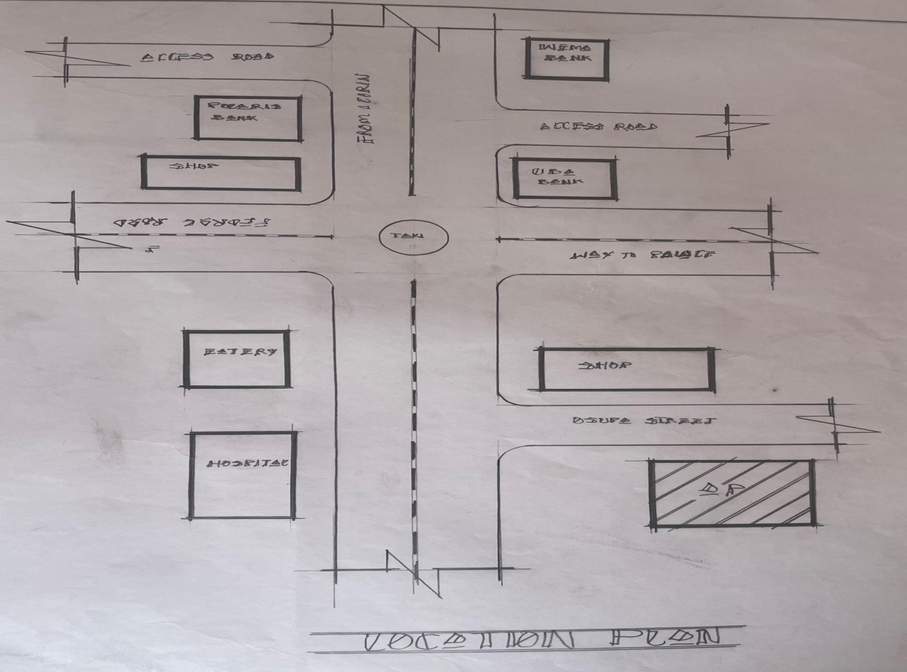
FIGURE3.1.1LOCATIONPLAN

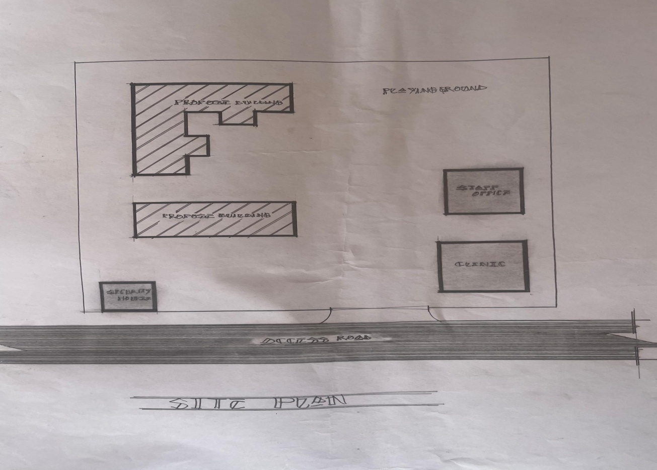
FIGURE3.1.2SITE PLAN
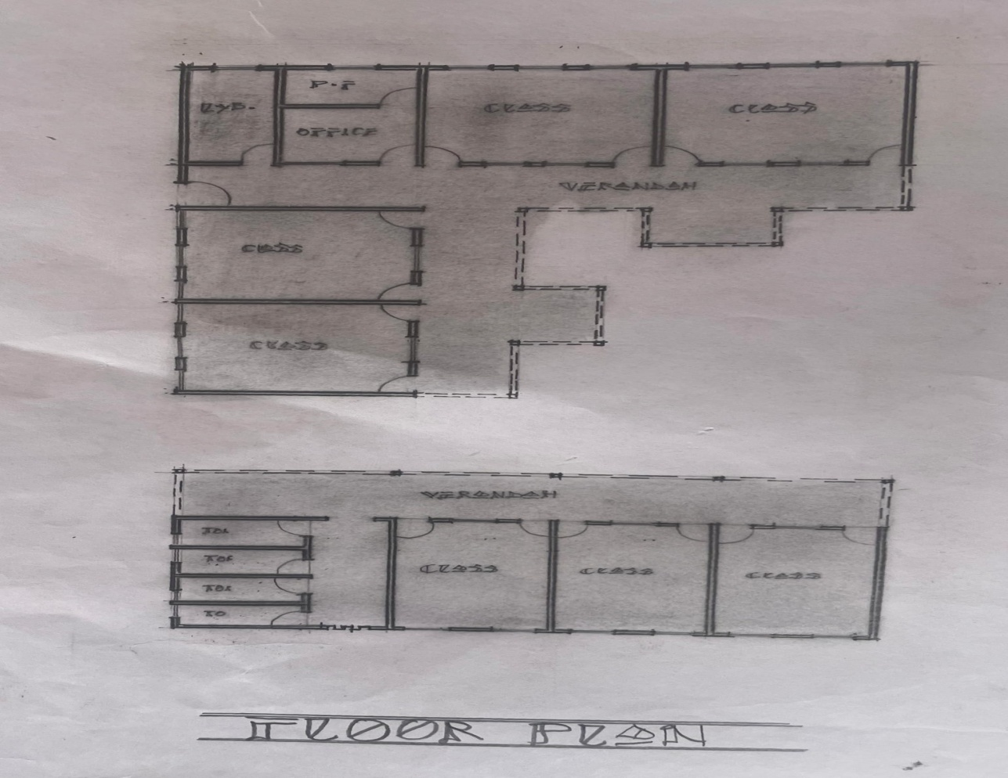
FIGURE3.1.3FLOORPLAN

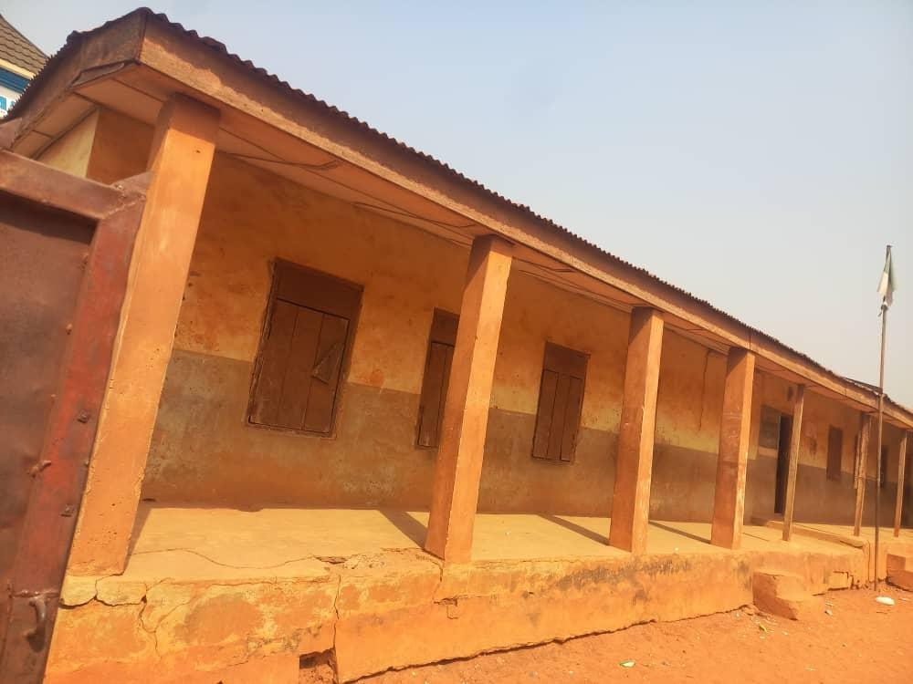
PLATE:3.1.1OSUPAPRIMARYSCHOOLVIEW
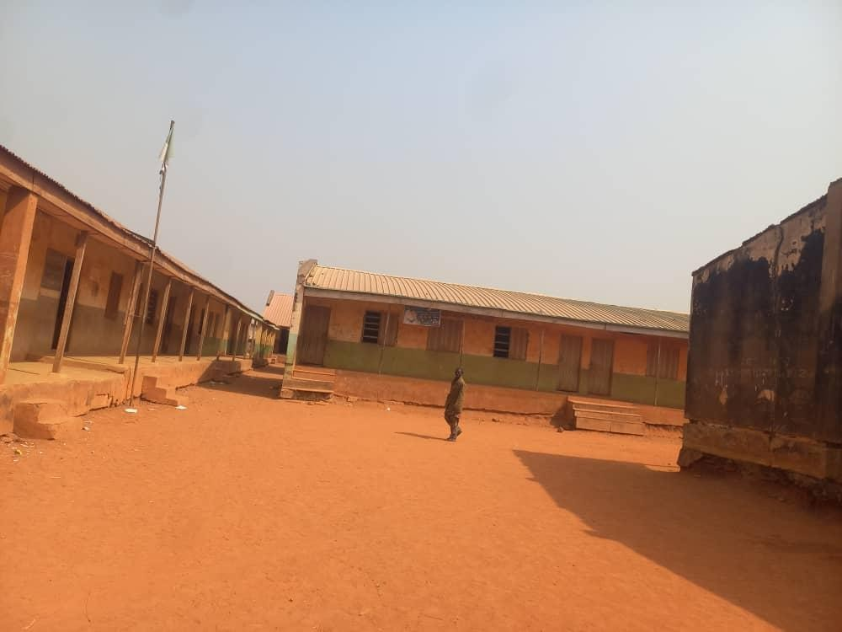

PLATE:3.1.2OSUPAPRIMARYSCHOOLCOMPOUND

CASESTUDY2
NAME:C.A.CPrimarySchool
LOCATION:AraromiStreet,OsogboOsunState. MERITS
- It’swellorganised
- Thereisenoughclass room
- Locationatverycoolandsilentarea DEMERITS
- Lackofmaintenance
- Nospecificplaceforclinicandauditorium
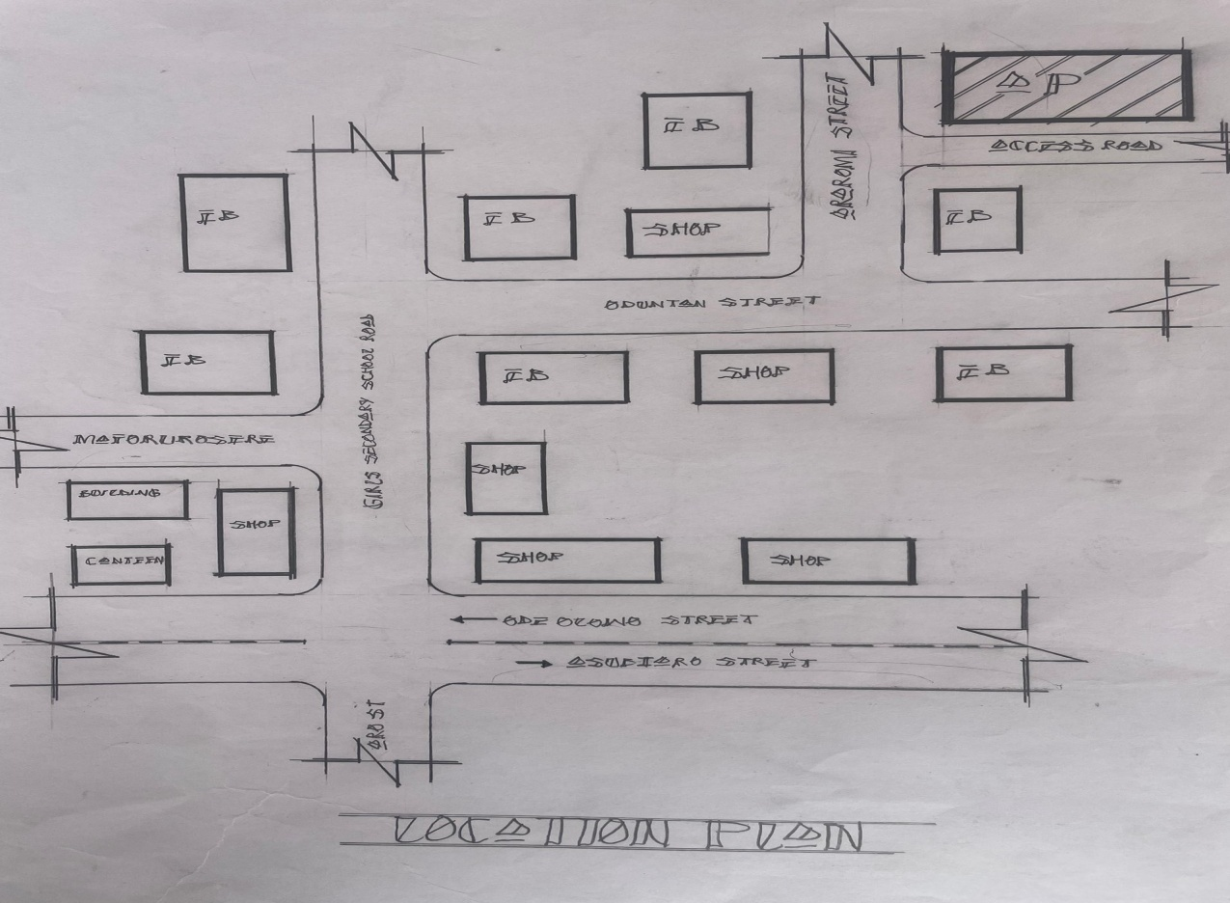

FIGURE3.2.1LOCATIONPLAN

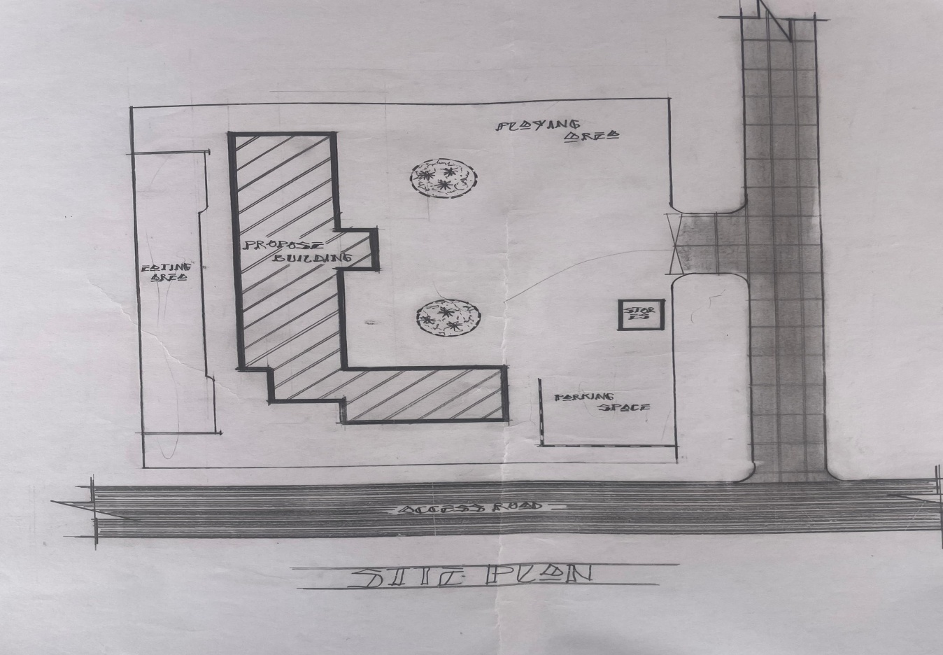

FIGURE3.2.2SITE PLAN
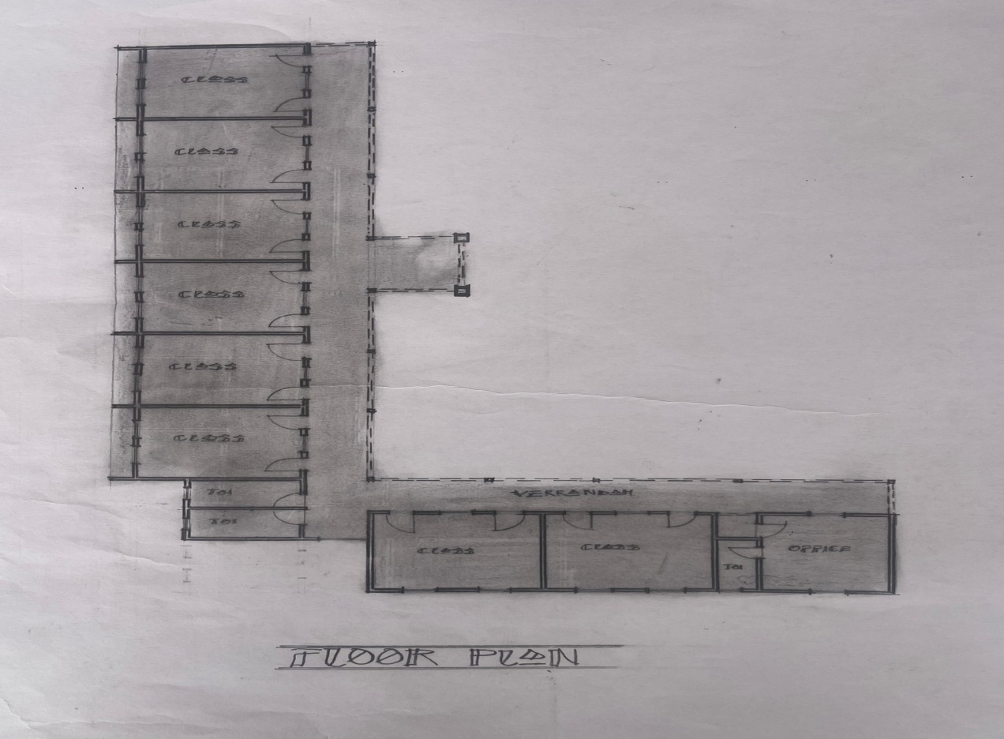

FIGURE3.2.3FLOORPLAN

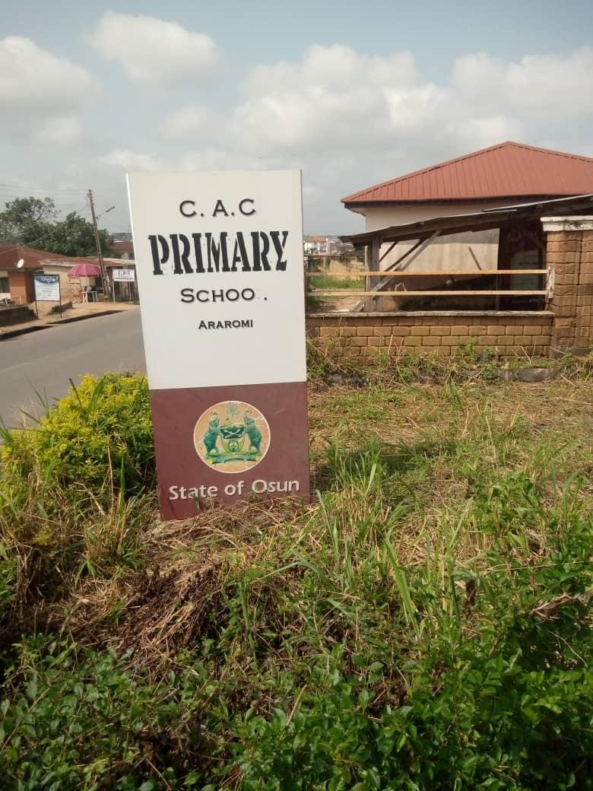

PLATE3.2.1C.A.CPRIMARYSCHOOLSIGNPOSTANDFRONTAGE
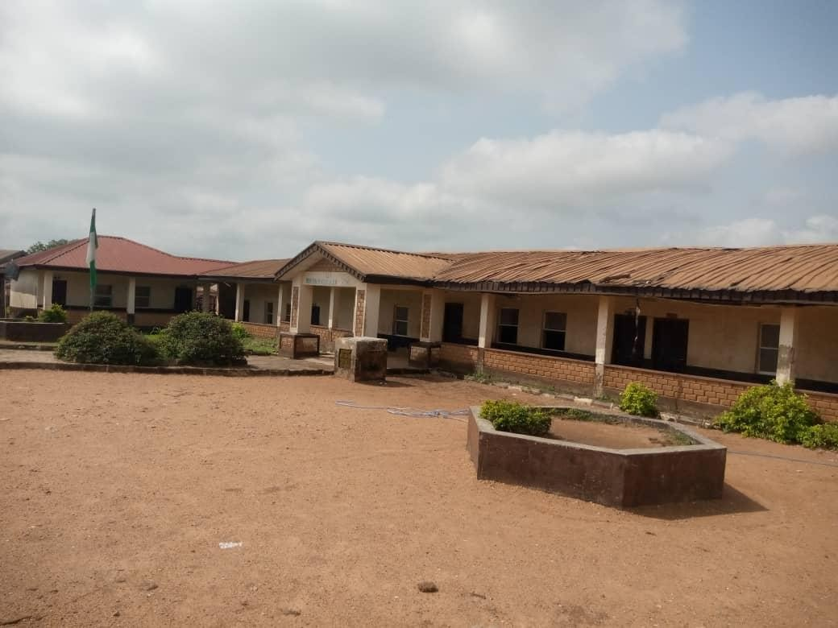
PLATE3.2.3C.A.CPRIMARYSCHOOLCOMPOUND

CASESTUDY3
NAME: Al-Hillal Primary School LOCATION:OffaRoadIlorinKwaraState MERITS
- It DEMERITS

CHAPTERFOUR

PROJECTANALYSISANDDESIGNCRITERIAOFTHEPROJECT

INTRODUCTION
Thischapterpresentstheanalysisanddesigncriteriaforthesustainableand child-friendly primary school project in Ilorin, Kwara State, Nigeria.

ANALYSIS
Theanalysisincludes:
- Site analysis: The site analysis examines the school's location, climate, andenvironmental conditions.
- Useranalysis:Theuseranalysisidentifiestheneedsandrequirementsof students, teachers, and the community.
- Functional analysis: The functional analysis examines the school's functional requirements, including classrooms, administration, and recreational spaces.

DESIGNCRITERIA
Thedesigncriteriainclude:

- Sustainability: The design prioritizes sustainability, including energy efficiency, water conservation, and waste reduction.
- Child-friendliness: The design incorporates child-friendly features, including flexible learning spaces and play-based learning environments.
- Safety and security: The design ensures safety and security, including secure entry points and surveillance systems.
- Flexibility and adaptability: The design allows forflexibility and adaptability, including modular classrooms and multi-purpose spaces.

DESIGNPRINCIPLES
Thedesignprinciplesinclude:

- Naturallightandventilation:Thedesignmaximizesnaturallightand ventilation to promote a healthy indoor environment.
- Sustainable materials: The design incorporates sustainable materials, including locally sourced wood and low-carbon concrete.
- Energy efficiency: Thedesign prioritizes energy efficiency, including energy- efficient lighting and HVAC systems.
The project analysis and design criteria provide a comprehensive framework for designing sustainable and child-friendly primary schools in Ilorin, Kwara State, Nigeria. The design prioritizes sustainability, child-friendliness, safety, and flexibility, ensuring a effective learning environment for students.

APPROACHTOTHEDESIGNOFTHEPROJECT
User-CenteredDesignApproach
The design approach prioritizes the needs and requirements of users, including students, teachers, and the community.

SustainableDesignApproach
Thedesignapproachincorporatessustainabledesignprinciples,including:

- Energyefficiency:Energy-efficientsystemsandrenewableenergysources.
- Waterconservation:Water-savingmeasuresandrainwaterharvesting.
- Wastereduction:Wastereductionandrecyclingstrategies.

Child-FriendlyDesignApproach
Thedesignapproachincorporateschild-friendlyfeatures,including:

- Flexiblelearningspaces:Adaptableclassroomsandlearningareas.
- Play-basedlearning:Incorporatingplay-basedlearningenvironments.
- Safetyandsecurity:Secureentrypointsandsurveillancesystems.

CommunityEngagementApproach
Thedesignapproachinvolvescommunityengagementandparticipation,including:

- Stakeholderconsultation: Consultationwith students, teachers, parents, and community members.
- Communityinvolvement:Involvingthecommunityinthedesignprocess.

ContextualDesignApproach
Thedesignapproachconsidersthelocalcontext,including:

- Climate and environment: Designing for the local climate and environmental conditions.
- Culturalandsocialcontext:Incorporatinglocalculturalandsocialnorms.

IntegratedDesignApproach

Thedesignapproachintegratesmultipledisciplines,including:

- Architecture:Buildingdesignandlayout.
- Engineering:Mechanical,electrical,andplumbingsystems.
- Landscapedesign:Outdoorspacesandlandscaping.

This approach ensures a comprehensive and effective design that meets the needs of users, promotes sustainability, and supports learning and community engagement.

DESIGNREALIZATIONOFTHEPROJECT
FinalDesign
Thefinaldesignincorporatessustainableandchild-friendlyfeatures,including:
- Energy-efficient building envelope: Designed to minimize energy consumption.
- Renewableenergysystems:Solarpanelsandwindturbinestogenerate electricity.
- Rainwaterharvesting:Collectingandstoringrainwaterfornon-potableuses.
- Flexiblelearningspaces:Adaptableclassroomsandlearningareas.
- Play-basedlearningenvironments:Designedtopromoteplay-basedlearning.

MATERIALSELECTION
Thedesignincorporatessustainablematerials,including:
- Locallysourcedmaterials:Materialssourcedfromlocalsuppliers.

- Recycledmaterials:Recycledmaterialsusedinconstruction.
- Low-VOCmaterials:Materialswithlowvolatileorganiccompounds.

LANDSCAPEDESIGN
Thelandscapedesignincorporates:
- Nativeplantspecies:Plantspeciesnativetotheregion.
- Outdoorlearningspaces:Designedtopromoteoutdoorlearning.
- Playareas:Safeandaccessibleplayareasforchildren.

IMPLEMENTATIONPLAN
Theimplementationplanincludes:
- Phasedconstruction:Constructionphasedtominimizedisruption.
- Community engagement: Community engaged throughout the construction process.
- Monitoring and evaluation: Ongoing monitoring and evaluation to ensure design intent is met.
The design realization of the project incorporates sustainable and child-friendly features, promoting a healthy and effective learning environment. The final design meets the needs of users, supports learning and community engagement, and minimizes environmental impact.

CHAPTERFIVE
RECOMMENDATIONSANDCONCLUSIONOFTHEPROJECT
RECOMMENDATIONS
DesignRecommendations
- Incorporate sustainable design principles: Incorporate energy-efficient systems, renewable energy sources, and sustainable materials into primary school design.
- Prioritize natural light and ventilation: Design schools to maximize natural lightandventilation,reducingtheneedforartificiallightingandHVACsystems.
- Create flexible learning spaces: Design flexible learning spaces that accommodate different teaching methods and learning styles.

PolicyRecommendations
- Develop sustainable school design guidelines: Develop guidelines for sustainable school design that prioritize energy efficiency, water conservation, and waste reduction.
- Provide incentives for sustainable design: Provide incentives for schools that incorporate sustainable design principles and practices.

- Supportteachertraining:Supportteacher trainingonsustainablepracticesand environmental education.

ImplementationRecommendations
- Engagestakeholders:Engagestakeholders,includingstudents,teachers,parents, and community members, in the design and implementation process.
- Monitor and evaluate: Monitor and evaluate the effectiveness of sustainable design principles and practices in primary schools.
- Provideongoing support: Provideongoing supportand maintenanceto ensure the long-term sustainability of school design and operations.

ResearchRecommendations
- Conductfurtherresearch:Conductfurtherresearchontheimpactofsustainable design on student learning outcomes and well-being.
- Develop case studies: Develop case studies of successful sustainable schooldesign projects.
- Share bestpractices: Share best practicesand lessons learned from sustainable school design projects.

These recommendations aimto promote sustainable and child-friendly design in primary schools, supporting the well-being of students, teachers, and the community.

CONCLUSION
The project has successfully designed a sustainable and child-friendly primary school in Ilorin, Kwara State, Nigeria, incorporating energy-efficient systems, renewable energy sources, and sustainable materials.

KeyAchievements

- Sustainabledesign:Theprojecthasdemonstratedthefeasibilityofsustainable design principles in primary school design.
- Child-friendlydesign:Theprojecthasprioritizedchild-friendlydesign approaches, creating a safe and supportive learning environment.
- Communityengagement:Theprojecthasengagedstakeholders,including students, teachers, parents, and community members, in the design process.

IMPACT
Theprojectisexpectedtohaveapositiveimpacton:

- Student learning outcomes: By providing a safe, supportive, and sustainable learning environment.
- Environmentalsustainability:Byreducingenergyconsumption,promoting renewable energy sources, and minimizing waste.
- Communitydevelopment:Byfosteringcommunityengagementandsocial cohesion.

FutureDirections
The project provides a model for future sustainable and child-friendly design projects, highlighting the importance of prioritizing student needs, environmental sustainability, and community engagement.

The project concludes that sustainable and child-friendly design can have a positive impact on primary school education, promoting student well-being, environmental sustainability, and community development.

REFERENCES
Aksam, A. (2020). Sustainable Design for Architecture: A Guide to Sustainable Building Design and Construction. Routledge.
Baldock, P. (2018). Child-Friendly Design: Designing Spaces for Children and Young People. Bloomsbury Publishing.
Kibert,C.J.(2016).SustainableConstruction:GreenBuildingDesignandDelivery. John Wiley & Sons.
UnitedNationsEnvironmentProgramme.(2020).Sustainability,12(10),1-15.
JournalofSustainableArchitecture.(2020).Vol.10,Issue2.
Children,YouthandEnvironments.(2015).Vol.25,Issue1.
UnitedNationsEnvironmentProgramme(UNEP).SustainableBuildingsand Climate Initiative. Retrieved from
National ClearinghouseforEducationalFacilities(NCEF).Designing Schools for Sustainability. Retrieved from
USGreenBuildingCouncil(USGBC).LEED forSchools.Retrievedfrom The Benefits of Sustainable Schools: A Review of the Literature. (2018). Designing Schools for the Future: A Guide to Sustainable Design. (2020).
- InternationalConferenceonSustainableArchitecture.(2019).Proceedings.

- WorldConferenceonEducationalSciences.(2018).Proceedings.
TheImpactofSustainableDesignonStudentLearningOutcomes.(2020). Child-Friendly Design in Schools: A Case Study. (2019).
Sustainable School Design Project Report. (2020). Child-FriendlySchoolDesignProjectReport.(2019).

APPENDIXSAPPENDIX A: DESIGN DIAGRAMS
- Site Plan: A detailed diagram of the school site, including building locations and outdoor spaces.
- Floor Plan: A detailed diagram of the school building, including classroomlayouts and common areas.

APPENDIXB:SUSTAINABILITYFEATURES

- Energy Efficiency Measures: A list of energy-efficient features incorporated into the school design, including lighting and HVAC systems.
- WaterConservation Measures:Alistofwater-saving featuresincorporated into the school design, including glow-flow fixtures and rainwater harvesting.

APPENDIXC:CHILD-FRIENDLYDESIGNFEATURES
- FlexibleLearningSpaces:Adescriptionoftheflexiblelearningspaces designed to accommodate different teaching methods and learning styles.
- Play-Based Learning Environments: A description of the play-based learning environments designed to promote student engagement and exploration.

APPENDIXD:PROJECTTIMELINE

- Project Schedule: A detailed timeline of the project, including key milestones and deadlines.

APPENDIXE:BUDGETBREAKDOWN
- Cost Estimate: A detailed breakdown of the project costs, including construction, materials, and labor.
These appendices provide additional information and details about the project, supporting the main report and providing a comprehensive overview of the design and implementation process.
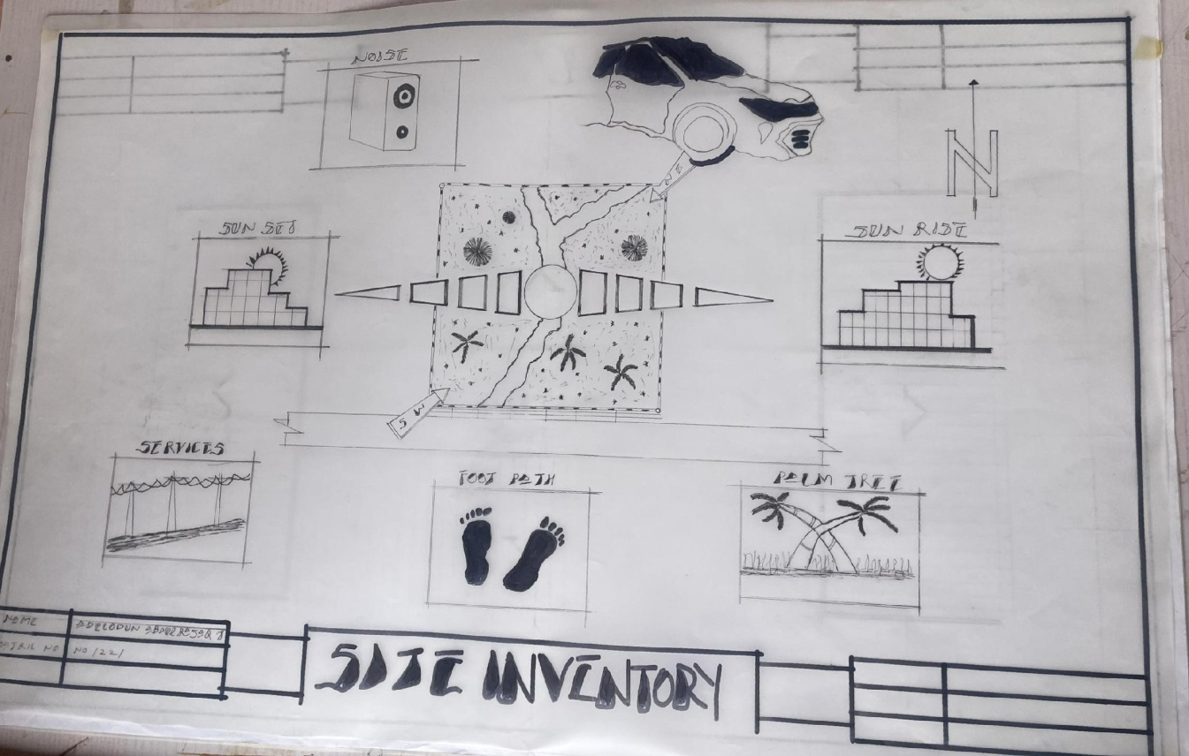

SITEINVENTORY

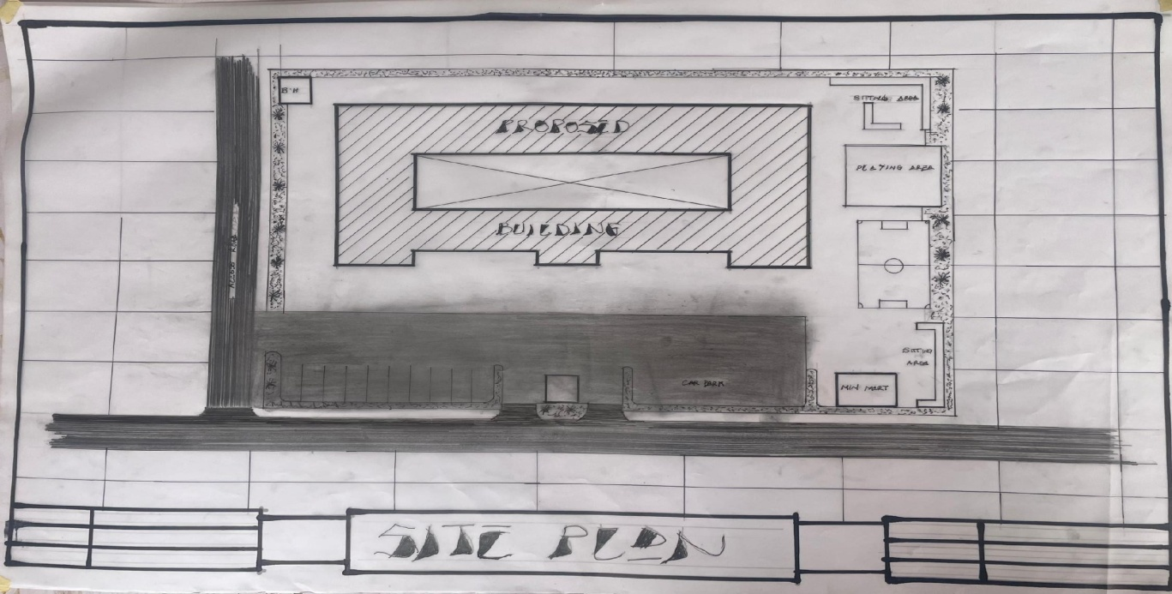
SITEPLAN
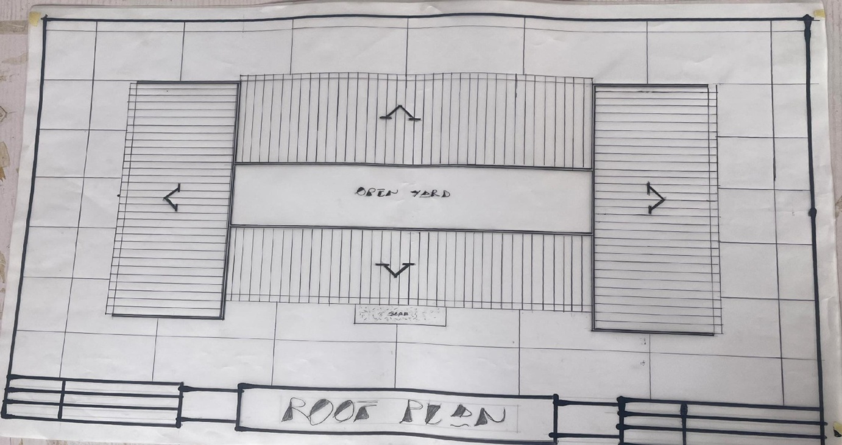
ROOF PLAN

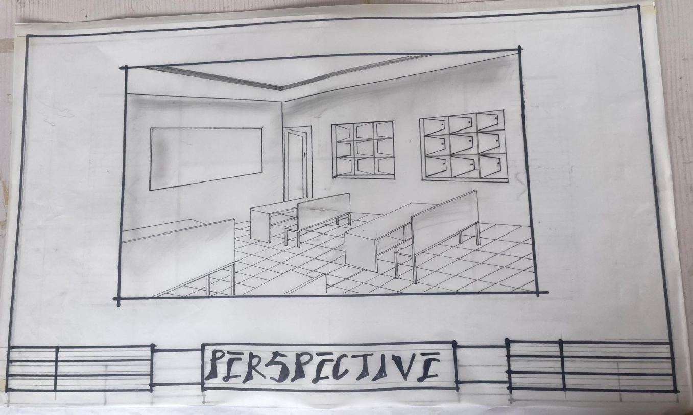

PERSPECTIVE

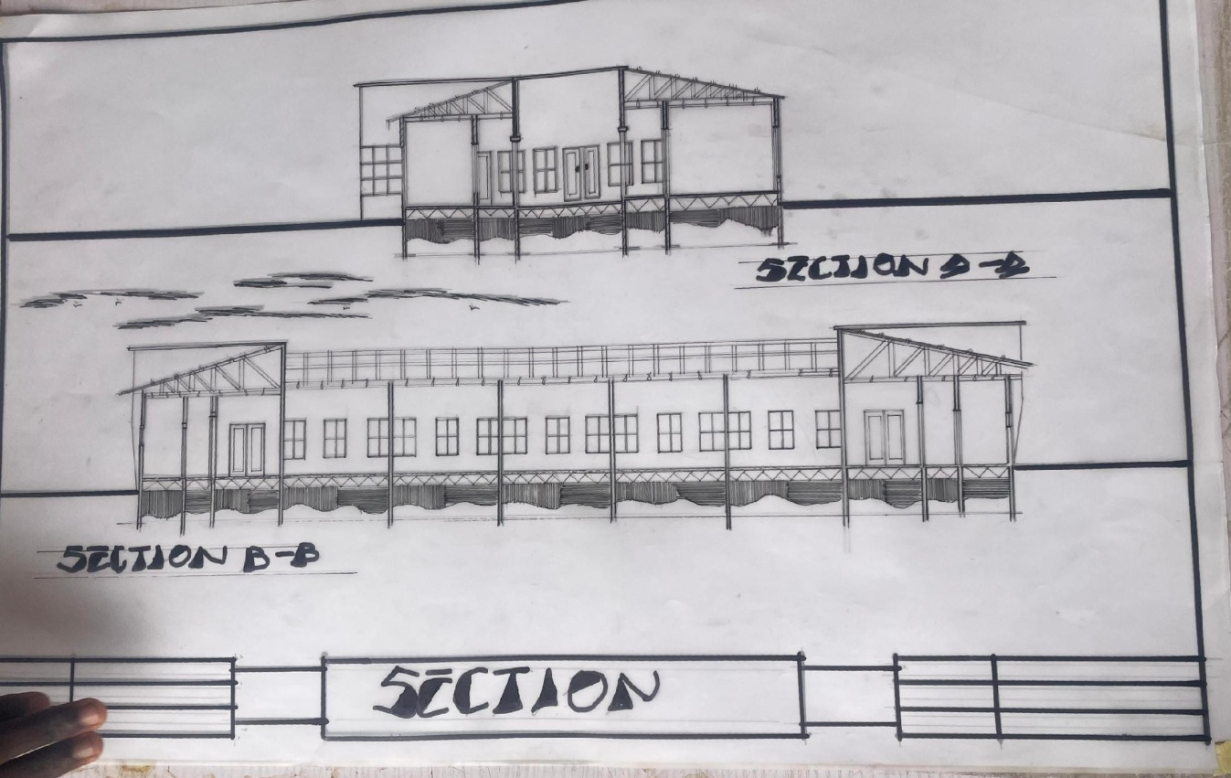

SECTION

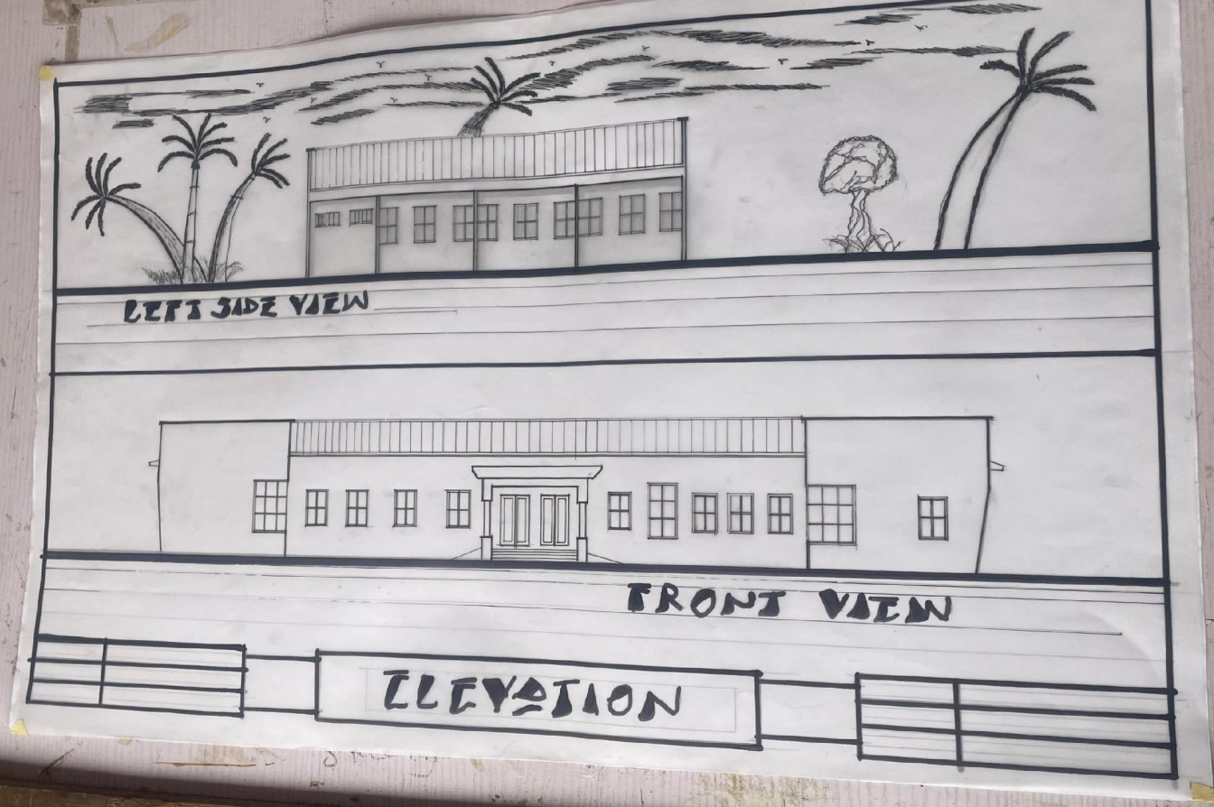

FRONTVIEWELEVATION

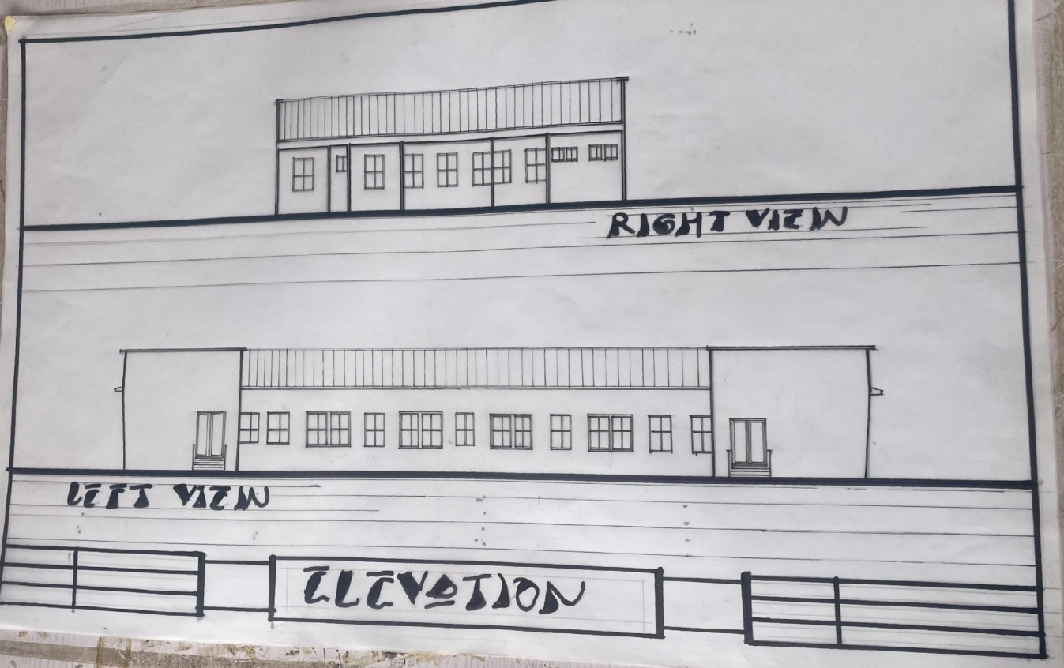

RIGHTVIEWELEVATION

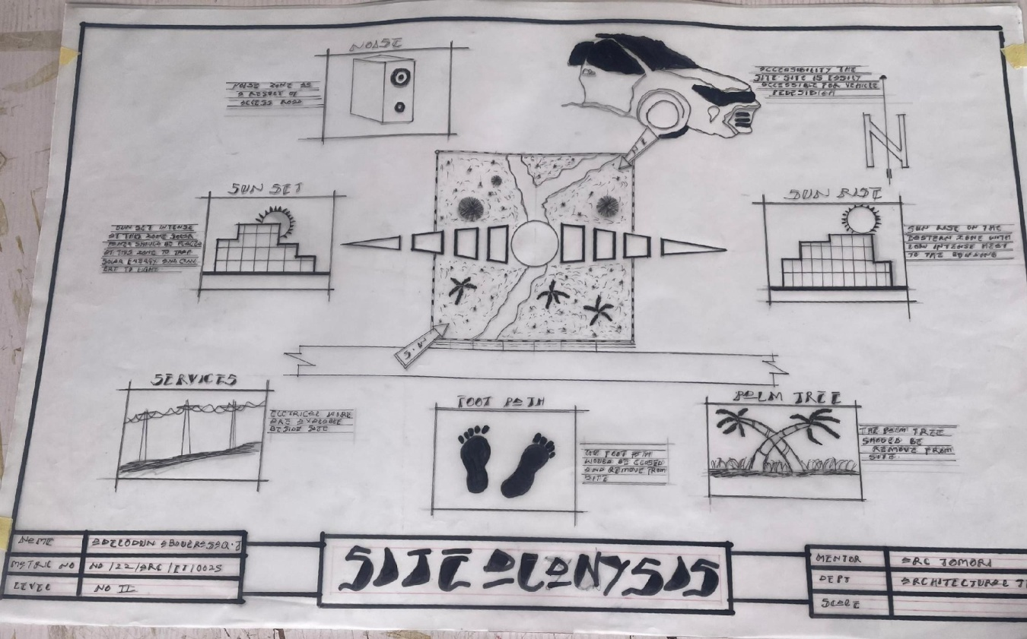

SITEANALYSIS
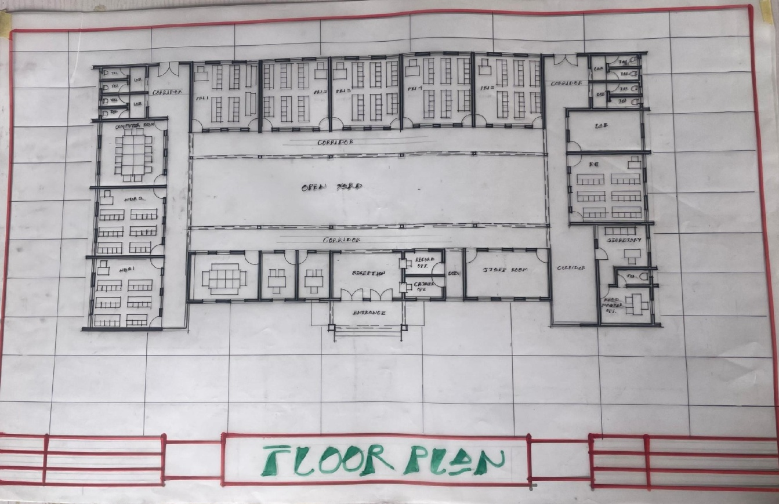

FLOORPLAN

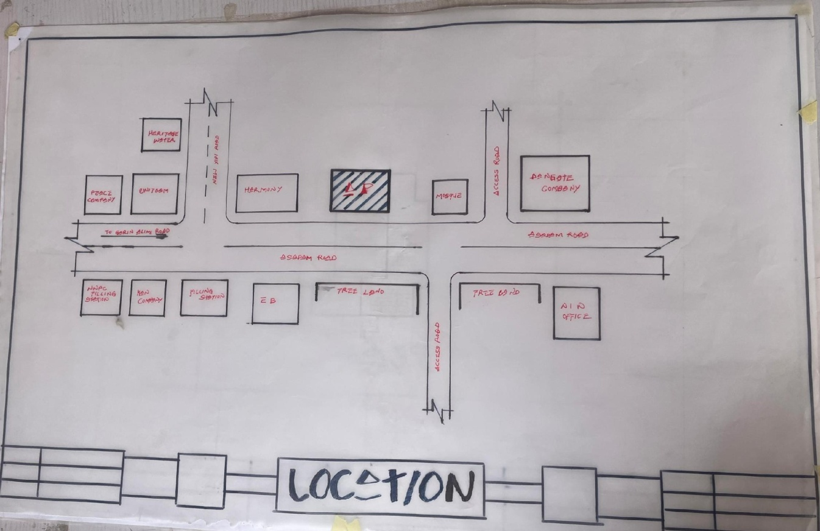

LOCATIONPLAN

