A PROJECT REPORT

ON
COMMERCIAL BANK (FIRST BANK)

FOR
OVIA SOUTH-WEST L.G.A, EDO STATE
BY
ABIODUN IYANU
HND/23/ARC/FT/0025

SUBMITTED TO:
THE DEPARTMENT OF ARCHITECTURAL TECHNOLOGY
INSTITUTE OF ENVIRONMENTAL STUDIES (I.E.S)
KWARA STATE POLYTECHNIC, ILORIN.

IN PARTIAL FULFILMENT OF THE REQUIREMENTS FOR THE AWARD OF HIGHER NATIONAL DIPLOMA (HND) IN ARCHITECTURAL TECHNOLOGY

JULY, 2025.

DECLARATION
I, ABIODUN IYANU, with Matric Number HND/23/ARC/FT/0025, hereby declare that this project / dissertation is the result of my personal research work under the supervision of ARC. CHUCKWUMA NMOM. It has not been presented for the award of any degree in any polytechnic. The ideas, observations, comments, suggestions herein represent my own convictions, except quotations, which have been acknowledged in accordance with conventional academic traditions.



________________ 24th of July, 2025
Signature Date

CERTIFICATION
I certify that this research project/dissertation entitled COMMERCIAL BANK (FIRST BANK) has been read and approved as meeting the requirement for the Award of Higher National Diploma (HND) in Architectural technology, Institute of Environmental Studies (I.E.S), Kwara State Polytechnic, under the supervision of ARC. CHUCKWUMA NMON



ARC. CHUKWUMA NMON ____________________
(Project Supervisor) SIGNATURE/DATE



ARC. OLAREWAJU F.A ____________________
(Project Coordinator) SIGNATURE/DATE



ARC. J.M TOMORI ____________________
(Head of Department) SIGNATURE/DATE

______________________ ____________________
EXTERNAL EXAMINER SIGNATURE/DATE

DEDICATION
Firstly, this report is dedicated to Almighty GOD, the Creator of heaven and earth, who has always been my strength throughout this project. I am deeply grateful for His unconditional love and infinite mercy, showered upon me throughout my studies.
I also dedicate this project to my parents, Mr. and Mrs. Abiodun Olawale, whose unwavering love, sacrifices, and guidance have shaped me into who I am today.
Finally, to my brothers and sisters, my colleagues, and others for their support, laughter, and encouragement along the way—I pray our Father in heaven, Jesus, rewards everyone abundantly.

ACKNOWLEDGEMENTS
All praise and glorification be to the Almighty, Creator of the universe, for granting me the privilege to undertake this journey.
I extend my deepest gratitude to my hardworking and dedicated supervisor, Arc. Mr. Chukwuma Nmom; project coordinator, Arc. Mr. Olarewaju F.A.; and Head of Department, Arc. Mrs. J.M. Tomori. My heartfelt thanks also go to the entire staff of the Department of Architecture at the State Polytechnic, Ilorin, for their unstinting support.
I am forever indebted to my loving parents, Mr. and Mrs. Abiodun Olawale, and my uncles, Mr. Obayelu Victor and Mr. Adeoti Emmanuel, for their moral and financial support. May they reap abundant blessings.
To my siblings and friends—your love, prayers, encouragement, and laughter carried me through the most trying times.
Finally, I sincerely appreciate Aleah, William, my brother Segun, and Arc. Dayo Babalola. Your unwavering support meant the world to me. I could not have done this without you. Amen.

LIST OF FIGURES
Fig. 1.1: Location Plan……………………………………………………………………...10
Fig. 1.2: Ground Floor Plan (Case Study One)……………………………………………..11
Fig 1.3: Location Plan……………………………………………………………………...13
Fig 1.4 Floor Plan…………………………………………………………………….……………………………………..14
Fig 3.3: Location Plan………………………………………………………………………16
Fig 3.3.2 First Floor Plan…………………………………………………………………….……………………………17
Fig 4.0 Location Plan……………………………………………………………………...29
Fig 4.1 Site Inventory……………………………………………………………………....30
Fig 4.2 Site Analysis…………………………………………………………………….…30

LIST OF PLATES
Plate 1.1 Approach View……………………………………………………………………11
Plate 1.2 Approach View……………………………………………………………………12
Plate 1.3 Internal View……………………………………………………………………...12
Plate 1.4 Approach View……………………………………………………………………14
Plate 1.5: Internal View……………………………………………………………………...15
Plate 1.6: Internal View……………………………………………………………………...15
Plate 3.1 Approach View……………………………………………………………………18
Plate 3.2 Approach View……………………………………………………………………18
Plate 3.3: Internal View……………………………………………………………………...19
Plate 3.4 Internal View……………………………………………………………………...19
Plate 3.5: Location Plan……………………………………………………………………...20
Plate 3.6 Approach View…………………………………………………………………….21
Plate 3.7: Approach View……………………………………………………………………21
Plate 3.8: Location Plan……………………………………………………………………...22
Plate 3.9: Approach View……………………………………………………………………22
Plate 4.0: Approach View………………………………………………………………… ..23

LIST OF TABLE
Table 1: Space Allocation/ Schedule of Accommodation …………………………………..28

ABSTRACT
This project explores the architectural design of a next-generation banking facility for First Bank of Nigeria, with a focus on enhancing user experience, optimizing operational performance, and a strong commitment to sustainability. By fusing tradition with innovation, this project aims to redefine the future of banking spaces, providing a model for 21st century financial institutions that seamlessly integrate functionality, aesthetics and environmental responsibility.

TABLE OF CONTENTS
Title Page…………………………………………………………………………………….i
Declaration Page…………………………………………………………………………… ii
Certification…………………………………………………………………………………iii
Dedication…………………………………………………………………………………...iv
Acknowledgments…………………………………………………………………………...v
List of Figures……………………………………………………………………………….vi
List of Plates…………………………………………………………………………………vii
List of Table………………………………………………………………………………….iix
Abstract………………………………………………………………………………………ix
Table Of Contents…………………………………………………………………………x-xii
CHAPTER ONE
1.0 Introduction……………………………………………………………………………1
1.1 Historical Background………………………………………………………………1-2
1.2 Definition of the Study………………………………………………………………2-3
1.3 Justification………………………………………………………………………….3-4
1.4 Aim and Objectives…………………………………………………………………4
1.4.1 Aim…………………………………………………………………………………4
1.4.2 Objective……………………………………………………………………………4
1.5 Scope of Design…………………………………………………………………….4
1.6 Statement of Design Problem………………………..……..……………………….4-5
1.7 Deduction …………………………………………………………………………..5-6
1.8 Limitation to Design………………………………………………………………..6
1.9 Research Methodology……………………………………………………………………………….6
CHAPTER TWO
2.0 Introduction…………………………………………………………………………7
2.1 Historical Development of Bank Architecture……………………………………...7
2.2 Functional Zoning and Space Programming…………………………………………………………..7
2.3 Security Integration in Bank Architecture………………………………………………………………8
2.4 User-Centered Design in Banking Spaces………………………………………………………………8
2.5 Environmental Performance and Sustainable Practices……………………………..8
2.6 Global Case Studies on Modern Bank Design………………………………………9
2.7 Conclusion……………………………………………………………………………………………………..9
CHAPTER THREE
3.0 Case Studies…………………………………………………………………….10
3.1 Case Study One…………………………………………………………………10-12
3.1.2 Merits …………………………………………………………………………………………………………….10
3.1.3 Demerits…………………………………………………………………………………………………………10
3.2 Case Study Two…………………………………………………………………13-15
3.2.1 Merits……………………………………………………………………………13
3.2.2 Demerits…………………………………………………………………………13
3.3 Case Study Three………………………………………………………………..16-19
3.3.2 Demerits…………………………………………………………………………16
3.4 Case Study Four (Online Case Study)……………………………………………20-21
3.5 Case Study Five (Online Case Study 2)…………………………………………..22-23
3.6 Deduction from Case Studies ………………………….…………………………23
CHAPTER FOUR
4.0 Analysis of the Environmental and Topographical Conditions of the Site………24
4.1.1 Introduction to Study Area……………………………………………………….24
4.1.2 Historical Background Of Ovia South-West LGA………………………………24-25
4.2 Site Location/Description………………………………………………………………………………….25
4.3 Site Location Criteria…………………………………………………………….25-26
4.4 Site Analysis……………………………………………………………………..26
4.5 Geographical / Climatic Data……………………………………………………26-27
4.6 Space Allocation Schedule Of Accommodation………………………………..28
4.7 Design Concept (Conceptual Development) …………………………………...29
CHAPTER FIVE
5.1 Appraisal of Proposed Scheme………………………………………………….31
5.1.1 Construction Methodology & Material…………………………………………31
5.1.2 Construction Methodology……………………………………………………..31-34
5.1.3 Materials Used in Construction…………………………………………………34
5.2 Conclusion ………………………………………………………………………34
5.3 Recommendations……………………………………………………………….34
References……………………………………………………………………..35
Appendices……………………………………………………………………36 Appendix I: Map Location and Location Plan……………………………….36
Appendix II: Site Inventory and Site Analysis………………………………..37
Appendix III: Design Brief and Scope and Site Plan …………………………38 Appendix IV: Bubble Diagram and Functional Flow Chart…………………..39
Appendix V: Design Concept Derivation and Right View Elevation…………40
Appendix VI: Front View Elevation and Roof Plan…………………………...41
Appendix VII: Ground Floor Plan and First Floor Plan………………………..42
Appendix IIX: Internal Perspective and Details………………………………..43
Appendix IX: Cross Section……………………………………………………44

CHAPTER ONE
1.0 INTRODUCTION
The design of a modern commercial bank facility goes beyond creating a space for financial transactions it embodies the values, vision, and operational efficiency of the banking institution. In today’s rapidly evolving financial landscape, banks are increasingly expected to deliver secure, inclusive, and customer-centric services within a technologically advanced and sustainable built environment.
This project focuses on the architectural design of a new commercial bank facility that meets the functional demands of contemporary banking while reflecting the brand identity and long-standing heritage of the institution. As digital transformation continues to redefine banking operations, there is a pressing need for physical bank branches to adapt offering not only secure and efficient service delivery but also a welcoming, accessible, and flexible environment for diverse users.
In many parts of Nigeria, especially in urban and semi-urban areas, existing bank structures are outdated in both form and function. Many lack adequate spatial planning, advanced security systems, and energy-efficient technologies. The proposed design responds to these challenges by incorporating smart building systems, climate-responsive architecture, and spatial arrangements that enhance both staff productivity and customer experience.
Furthermore, the bank facility will serve as a symbol of trust, stability, and modernity core values essential to sustaining customer loyalty and institutional reputation. The integration of sustainability, digital infrastructure, and user-friendly spaces ensures that the design aligns with future-forward banking strategies and regulatory standards.
Through thoughtful planning and innovative architectural solutions, this project aims to deliver a modern commercial bank facility that balances aesthetics, functionality, and technological advancement paving the way for a resilient and responsive banking environment.
1.1 HISTORICAL BACKROUND
First Bank of Nigeria is a multinational bank and financial services company headquartered in Lagos, Nigeria. It was founded in 1894 by Sir Alfred Jones, and is currently owned by FBN Holdings PLC, which has a diversified ownership base with over 1.3 million shareholders.
The bank, Nigeria’s oldest, became a public company in 1970 and was listed on the Nigerian Stock Exchange (NSE) in 1971. However, as part of the implementation of a non-operating holding company structure, it was delisted from the NSE and re-registered under FBN Holdings PLC in 2012.
Before the restructuring in 2012, First Bank was organized as an operating holding company. The transition to a non-operating holding company structure under FBN Holdings was completed in 2012.
Originally established as the Bank of British West Africa, the bank served British-controlled regions, focusing mainly on shipping and trading activities in Nigeria. The founder, Alfred Lewis Jones, was a British shipping magnate who held a monopoly on importing silver currency into West Africa. Initially, the bank’s services catered primarily to foreign trade and not to the needs of indigenous Nigerians, who had limited access to credit.
Following Nigeria’s independence in 1960, the bank expanded its services to include more credit offerings to indigenous Nigerians. As a result, Standard Bank of Nigeria reduced its stake to 38%, signaling that it was no longer the primary operator of the bank. Consequently, the bank's name was changed to First Bank of Nigeria Limited in 1979. In 1991, it was renamed First Bank of Nigeria PLC, and in 2012, it reverted once again to First Bank of Nigeria Limited, in accordance with the Central Bank of Nigeria’s regulatory requirements.
1.2DEFINITION OF THE STUDY
DEFINITION
1. Definition of Bank and Banking
- Bank:
A bank is a financial institution that is licensed to receive deposits, offer loans, and provide other financial services such as wealth management, currency exchange, and safe deposit boxes. Banks serve as intermediaries between depositors who provide capital and borrowers who need capital for personal, commercial, or governmental purposes.
- Banking:
Banking refers to the activities carried out by banks, including the acceptance of deposits, granting of loans, payment processing, money transfer services, and financial advisory. It encompasses a wide range of financial services aimed at managing money, credit, and financial transactions.
2. Definition of Units in a Bank
The term "units in banking" typically refers to the various departments or functional divisions within a bank that handle different aspects of its operations. Below are some key units:
1. Retail Banking Unit: Handles services for individual customers, such as savings accounts, personal loans, debit/credit cards, and online banking.
2.Treasury Unit: Manages the bank’s liquidity, investments and foreign exchange operations.
3. Corporate/Commercial Banking Unit: Provides services to businesses and corporations, including business loans, trade financing, and treasury services.
4. Operations Unit: Manages the internal processes of the bank, including transaction processing, clearing, settlements, and branch support.
5. Credit and Risk Management Unit: Evaluates loan applications, monitors credit risk, and implements strategies to minimize financial losses.
6. IT and Digital Banking Unit: Oversees digital platforms, cybersecurity, core banking systems, and the integration of technology into banking services.
7. Customer Service Unit: Addresses customer inquiries, complaints, and general support to ensure customer satisfaction.
8. Compliance and Internal Audit Unit: Ensures the bank adheres to laws, regulations, and internal policies through monitoring and auditing processes.
1.3. JUSTIFICATION
In view of the fact that Ovia South West L.G.A in Edo state does not have a commercial bank. I have decided to design a-state-of-the-art commercial bank that will bring about easy access in the banking system in the area as well as environmental development.
1.4 AIM AND OBJECTIVES
1.4.1 AIM
The aim of this project is to design aesthetic, structurally balanced and functional First Bank branch building that promotes operational efficiency and exceptional customer service delivery.
1.4.2 OBJECTIVE
- To create a maximum space for the activities needed in the building.
- To design modern mature building structures.
- To reflect First Bank identity through architectural expression.
- To provide maximum security to the bank and I.C.T requirements of a modern bank.
1.5 SCOPE OF DESIGN
The project will include:
- Banking hall
- ATM gallery
- Manager and staff offices
- Customer waiting area
- Vaults and secure zones
- Restrooms and kitchenette
- IT/server room
- Parking area and landscape
- Security systems and access control
- Mechanical and electrical services
1.6 STATEMENT OF DESIGN PROBLEM
Many existing First Bank buildings across Nigeria are outdated in both layout and infrastructure. These facilities often lack adaptable spatial configurations, modern mechanical and security systems, as well as energy-efficient features. There is a pressing need for contemporary architectural solutions that respond to the evolving demands of digital banking, address the challenges of climate change, and ensure inclusive access for all users.
1.7 DEDUCTION
Based on the analysis of the proposed design and operations of the commercial bank, the following deductions were made:
1. Functionality and Efficiency
The spatial layout of the bank has been organized to enhance smooth workflow and customer navigation. Departments are clearly zoned, ensuring minimal congestion and efficient service delivery.
2. Security Integration
Advanced physical and electronic security measures—including surveillance systems, secure cash handling zones, reinforced vaults, and controlled access points have been incorporated to address growing security concerns, especially in high-risk areas.
3. Accessibility and Inclusivity
The design provides for barrier-free access, including ramps, accessible toilets, clear signage, and wide circulation paths, ensuring that all categories of users, including persons with disabilities, can use the facility comfortably.
4. Digital and Technological Integration
The facility supports digital banking operations with provisions for self-service kiosks, ATM galleries, customer support zones, and IT infrastructure to enable seamless online and offline services.
5. Energy Efficiency and Sustainability
Passive cooling strategies, natural lighting, energy-efficient systems, and sustainable material selections were employed to reduce energy consumption and minimize environmental impact.
6. Aesthetic and Corporate Branding
The architectural form and interior finishes reflect the bank’s brand identity projecting an image of trust, professionalism, and modernity that aligns with customer expectations and corporate values.
7. Flexibility and Adaptability
Spaces are designed to be adaptable for future expansion or reconfiguration, allowing the bank to respond to evolving operational needs and technological advancements without major structural alterations.
8. Customer-Centered Experience
The design emphasizes customer comfort and convenience with waiting areas, consultation rooms, and user-friendly service counters that reduce service time and enhance customer satisfaction.
1.8 LIMITATION TO DESIGN
The design of this project shall be based on a First Bank building pattern in which the units and supporting facilities would be designed.
1.9 RESEARCH METHODOLOGY
The research methodology for this study encompasses a comprehensive approach to understanding bank architecture and customer behavior, as well as addressing the specific requirements of First Bank. The key components include:
Literature Review: An extensive review of existing literature on bank architecture, design principles, and customer behavior to establish a theoretical foundation.
Corporate Requirements Analysis: Examination of First Bank’s corporate guidelines and branding standards to ensure alignment with the bank’s identity and operational needs.
Case Studies: In-depth analysis of existing commercial bank buildings to identify best practices, innovative design solutions, and functional layouts.
Site Analysis and User Interviews: On-site evaluations and structured interviews with bank staff and customers to gather practical insights and user experience data.

CHAPTER TWO
2.0 INTRODUCTION
The architecture of banking institutions has evolved significantly in response to technological innovation, user expectations, and evolving financial services. This chapter explores scholarly and professional perspectives on the spatial organization, aesthetics, safety, and sustainability considerations influencing contemporary bank architecture. The aim is to frame a design approach that addresses modern operational needs while enhancing user experience and promoting environmental responsibility.
2.1 HISTORICAL DEVELOPMENT OF BANK ARCHITECTURE
Bank buildings have traditionally symbolized authority, wealth, and security. Architectural styles from the 19th and early 20th centuries often borrowed from neoclassical motifs—grand columns, high ceilings, and solid materials—to convey institutional reliability. However, the late 20th century saw a departure from monumentalism toward designs emphasizing transparency and accessibility. The introduction of digital banking and automation tools further accelerated the need for adaptable, multifunctional layouts that could accommodate both traditional and self-service banking functions.
2.2 FUNCTIONAL ZONING AND SPACE PROGRAMMING
Effective space planning is crucial in banking architecture, with a need to delineate between customer-facing and secure operational areas. Modern bank layouts are typically organized into four major zones:
- Customer Interaction Zone: Includes reception, queuing area, and consultation booths.
- Automated Service Area: Incorporates ATMs, deposit machines, and digital kiosks.
- Administrative Zone: Encompasses offices, meeting rooms, and operational support spaces.
- Security and Utility Core: Houses the vault, surveillance center, control room, and emergency exits. Clear spatial hierarchies and circulation paths not only streamline operations but also improve wayfinding and user comfort.
2.3SECURITY INTEGRATION IN BANK ARCHITECTURE
Security in bank design transcends physical fortification and extends into technological and procedural layers. According to Al-Azzawi (2019), architectural measures such as limited entry points, reinforced concrete vaults, and secure teller enclosures are essential. Integration of access control systems, intrusion alarms, and round-the-clock surveillance systems strengthens operational safety. Additionally, security design must consider crowd control, emergency evacuation routes, and crime deterrence without compromising customer friendliness.
2.4 USER-CENTERED DESIGN in BANKING SPACES
Customer-centric design has become a priority in bank architecture, aligning with service-oriented business models. Interior design strategies focus on reducing anxiety and enhancing user engagement. According to recent findings by the Retail Banking Research Institute (2021), banks with intuitive layouts, natural lighting, acoustic control, and calming color palettes see higher customer satisfaction rates. Furthermore, inclusive design featuring wheelchair ramps, tactile signage, and adjustable service counters ensures accessibility for all user groups.
2.5 ENVIRONMENTAL PERFORMANCE AND SUSTAINABLE PRACTICES
Green architecture principles are being adopted by financial institutions aiming to reduce operational costs and fulfill corporate social responsibility goals. Sustainable strategies include:
- Installation of photovoltaic systems to generate renewable energy
- Use of low-emission materials and recycled construction components
- Deployment of bioclimatic design features such as shading devices and ventilated façades
- Implementation of smart lighting and HVAC systems to optimize energy use
- Certification frameworks such as BREEAM and LEED guide the planning of eco-friendly bank branches, particularly in urban areas where energy demands and carbon footprints are high.

2.6 GLOBALCASESTUDIESONMODERNBANKDESIGN
ING House (Amsterdam, Netherlands): A landmark in biophilic and energy-efficient bank design, featuring a raised structure with natural ventilation and a glazed façade.
Bank of America Tower (New York, USA): Known for its high environmental performance, the tower incorporates recycled materials, greywater recycling, and on-site cogeneration systems.
UBA Head Office (Lagos, Nigeria): Emphasizes a corporate identity through its futuristic exterior while integrating smart security features and a digitized customer service model. These examples underscore a global shift toward adaptable, energy-conscious, and brand-aligned architecture in the banking sector.
2.7 CONCLUSION
Thereviewed literature reveals that successful bank design must harmonize security, technological innovation, customer interaction, and sustainability.
Modern bank architecture must not only support efficient service delivery but also reflect the evolving values and identity of the financial institution.
This foundational understanding will guide the conceptual and technical decisions in designing a contemporary bank branch.

CHAPTER THREE
3.0 CASE STUDIES
3.1 CASE STUDY ONE
LOCATION: ALIMOSHO, KUFFO STREET / AYOBO ROAD, LAGOS STATE.
3.1.2 MERITS
- Reinforced concrete framework: Provide strength, durability, and resistance to structural failure presented at the proposed building.
- Provision of ATM canopies: structural extension and canopy protects users from weather at ATM zones.
- Staircases and Ramps are constructed to standard dimensions, ensuring stability and user safety.
3.1.3 DEMERITS
- Building maintenance and challenges.
- The Bank uses block walls inside which makes it difficult to reconfigure spaces for modern use.

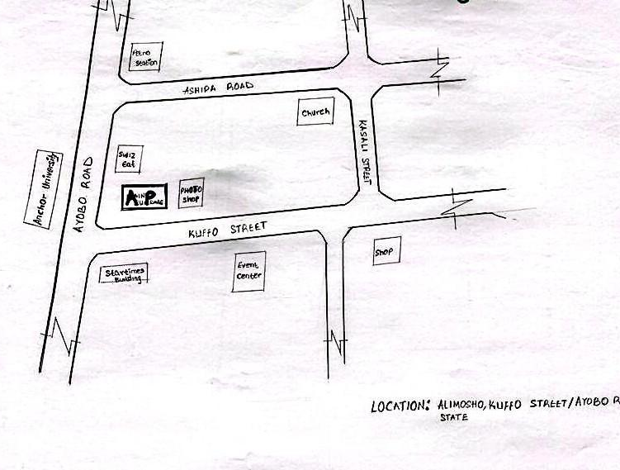

FIG. 1.1 LOCATION PLAN

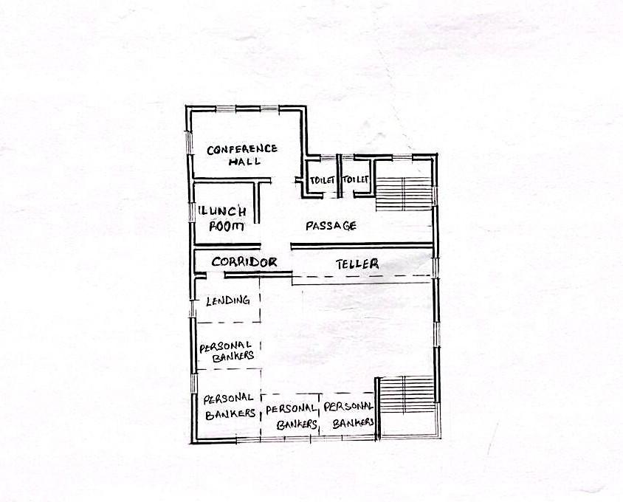
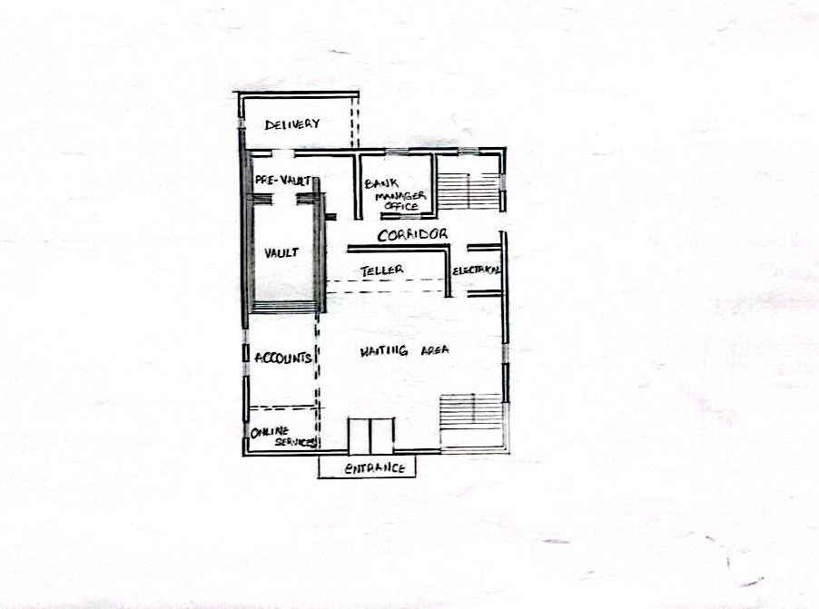

FIG. 1.2 GROUND FLOOR PLAN (CASE STUDY ONE)

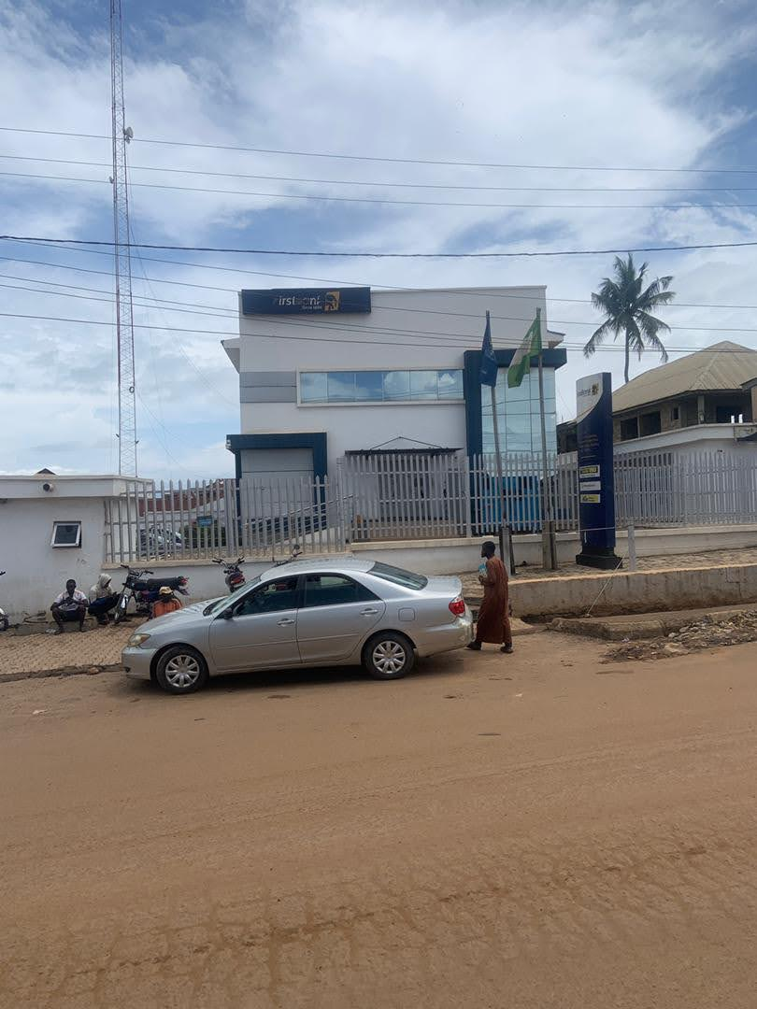

PLATE 1.1 APPROACH VIEW
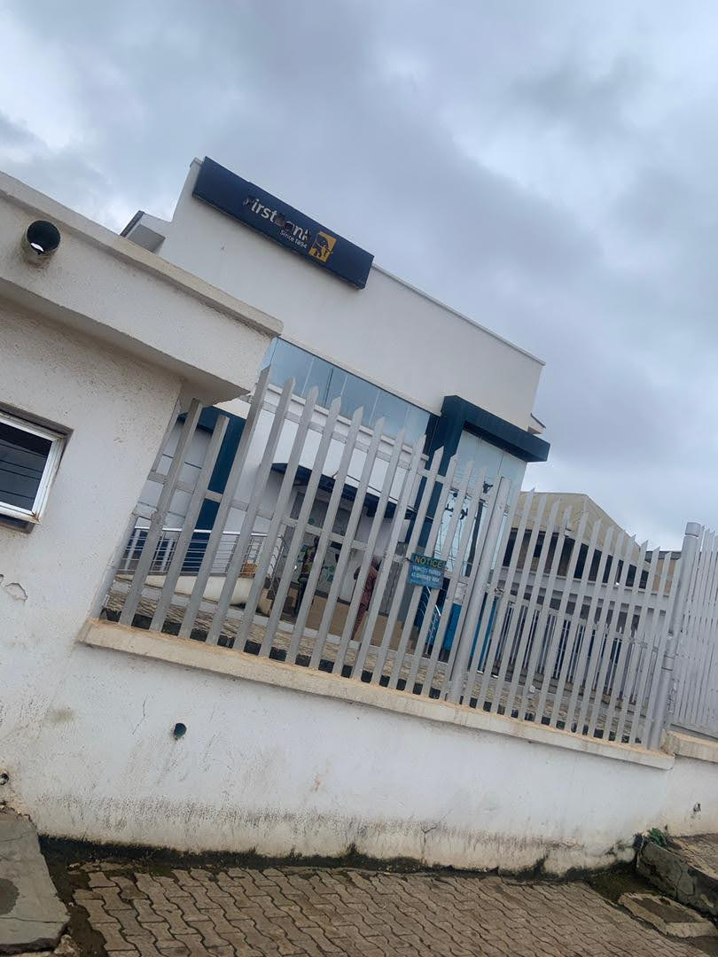

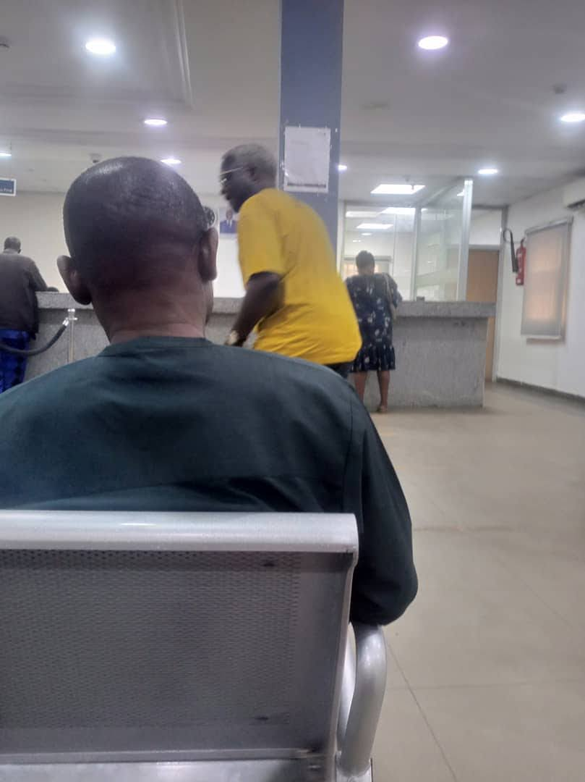
PLATE 1.2 APPROACH VIEW

PLATE 1.3 INTERNAL VIEW
3.2 CASE STUDY TWO
LOCATION: OPP-CAPTAIN COOK, ALAGBAKA JUNCTION, AKURE, ONDO STATE.
3.2.1 MERITS
- It is easily located
- It has good structure
- It's well function
- It has provision of ATM canopies
3.2.2 DEMERITS
- Small window sizes make it limits daylight and natural ventilation, increasing dependence on electricity
- It is not well landscaped
- Poor acoustic control
- The bank's aging structural finishes are peeling plaster and low-quality past construction.

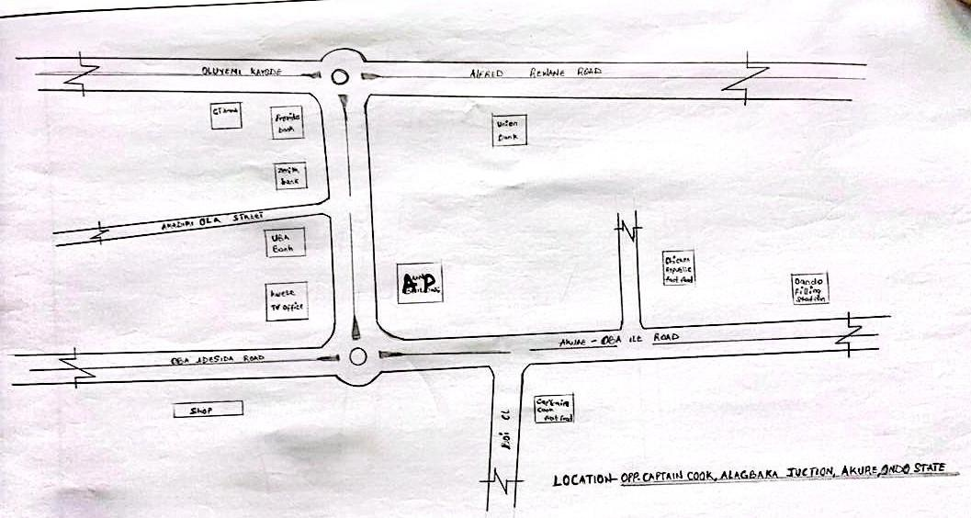
FIG 1.3 LOCATION PLAN

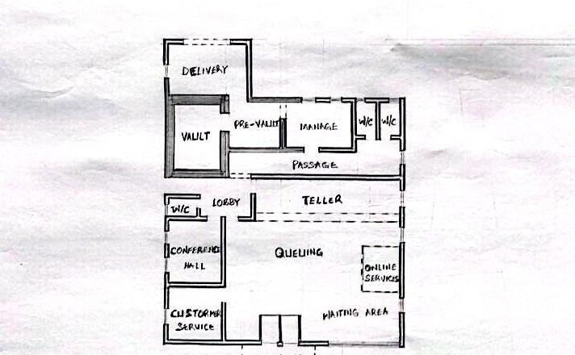
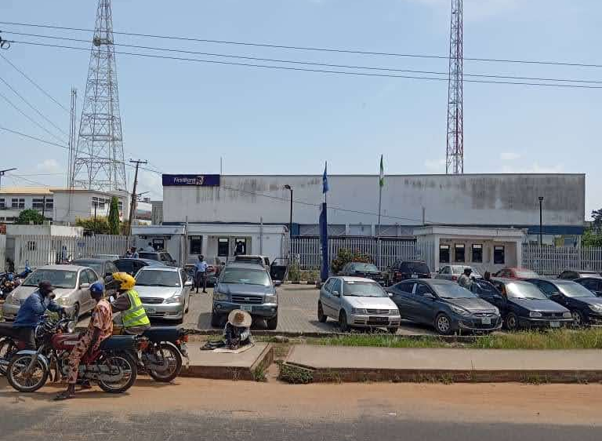
FIG 1.4 FLOOR PLAN

PLATE 1.4 APPROACH VIEW

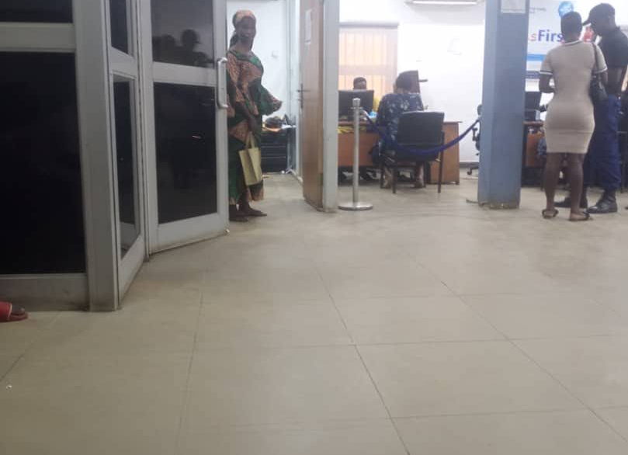

PLATE 1.5: INTERNAL VIEW

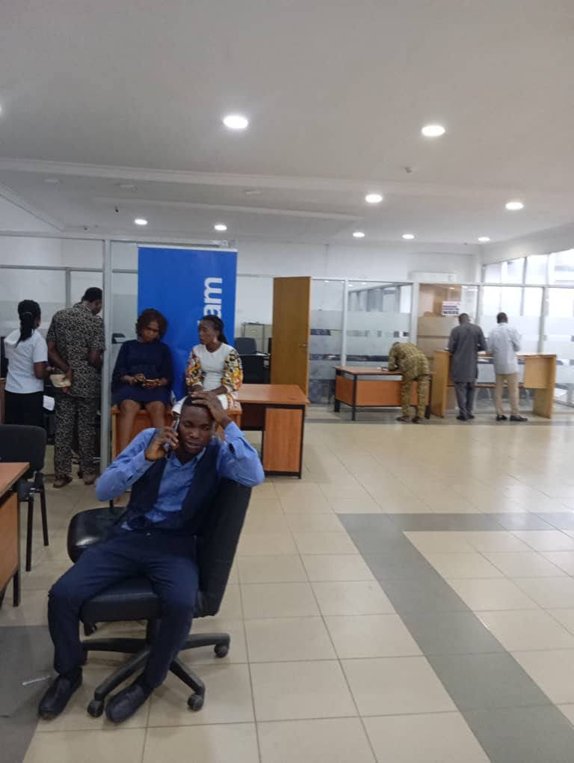

PLATE 1.6: INTERNAL VIEW

3.3 CASE STUDY THREE
LOCATION: FIRST BANK, GANAJA JUNCTION, LOKOJA, KOGI STATE
3.3.1 MERITS
- It easily accessible
- It is well oriented
- Perimeter fencing and gates for safety and controlled access
- Steel truss solid roofing structure
3.3.2 DEMERITS
- It is not well landscaped.
- No provision for expansion.
- It is structurally small and narrow staff rooms lead to discomfort and poor working condition.

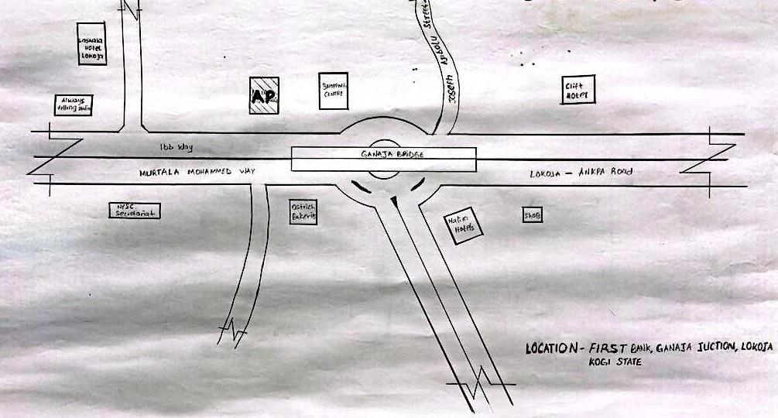

FIG 3.3 LOCATION PLAN

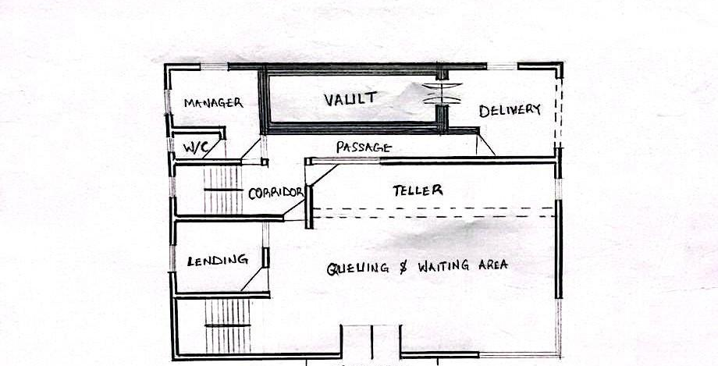

FIG 3.3.1 GROUD FLOOR PLAN

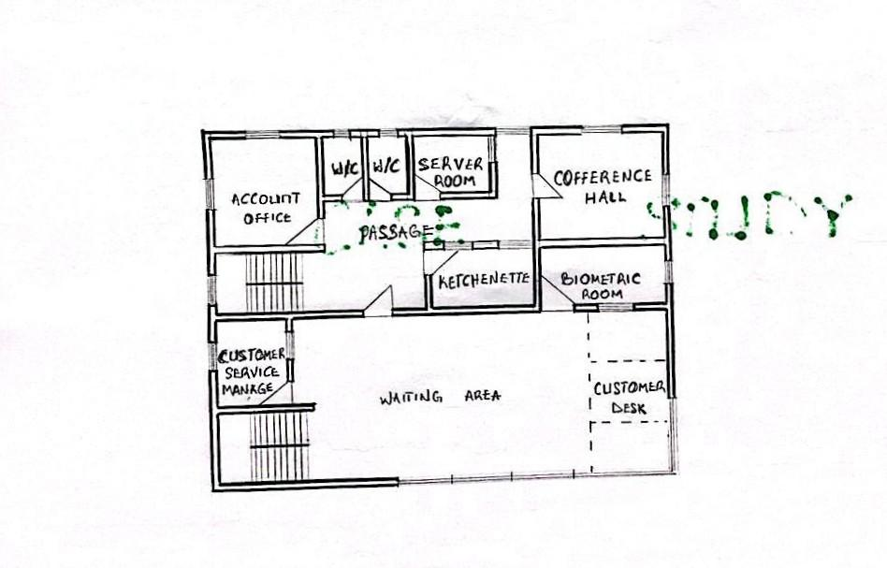
FIG 3.3.2 FIRST FLOOR PLAN
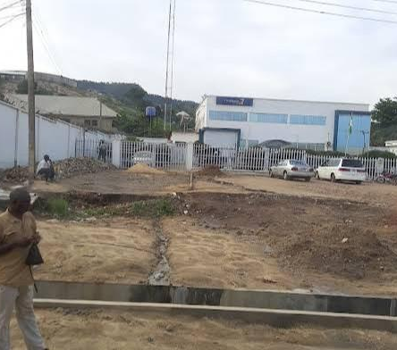

PLATE 3.1 APPROACH VIEW
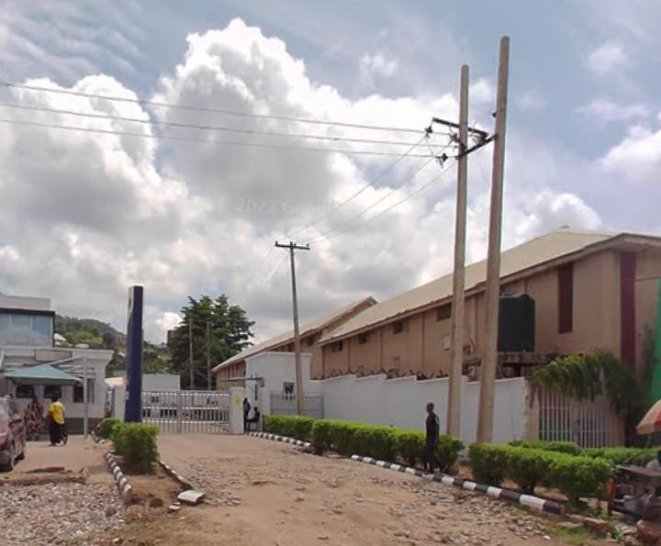

PLATE 3.2 APPROACH VIEW
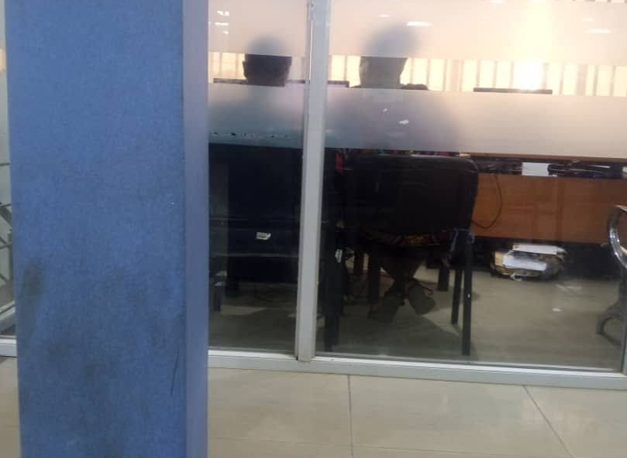

PLATE 3.3: INTERNAL VIEW

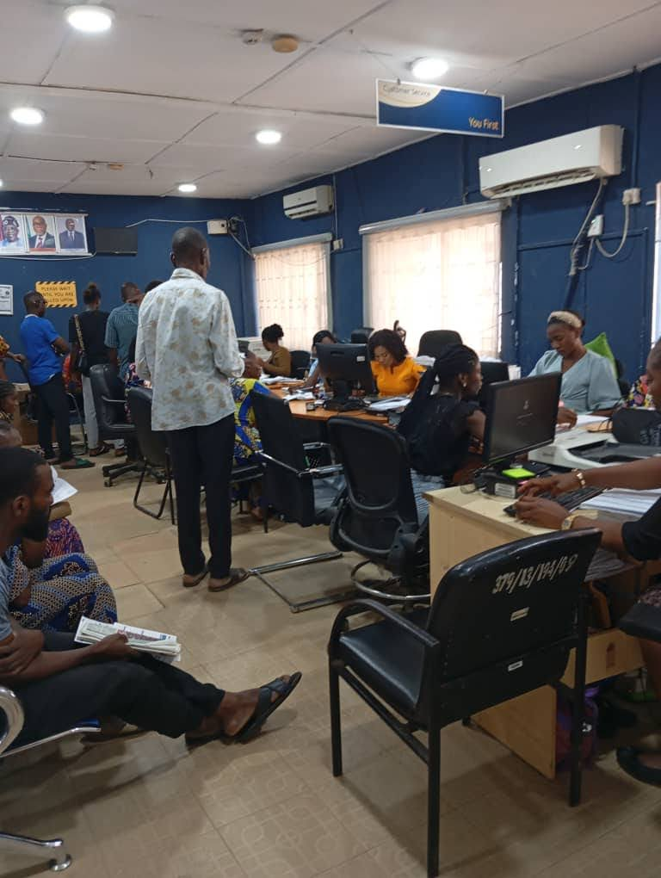
PLATE 3.4 INTERNAL VIEW

3.4 CASE STUDY FOUR (ONLINE CASE STUDY)
NAME: FBN BANK SENEGAL
LOCATION: PG7G+FFM, LES.VOIES DE I’ALTER NANCE, DAKAR, SENEGAL

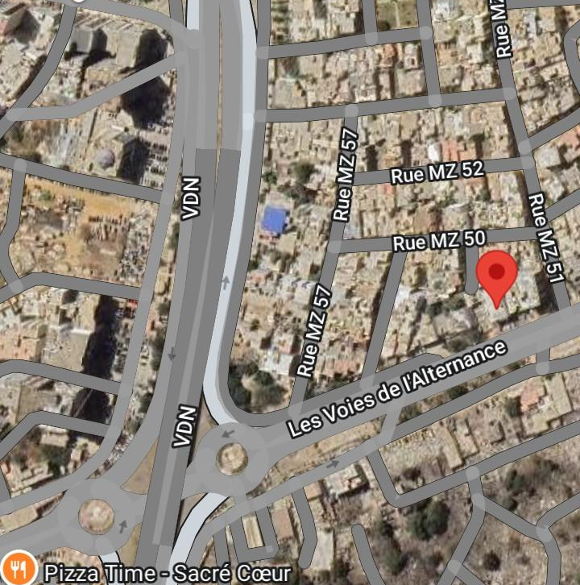

PLATE 3.5: LOCATION PLAN

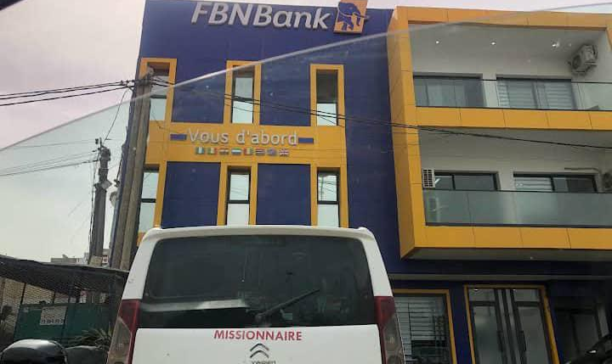

PLATE 3.6 APPROACH VIEW

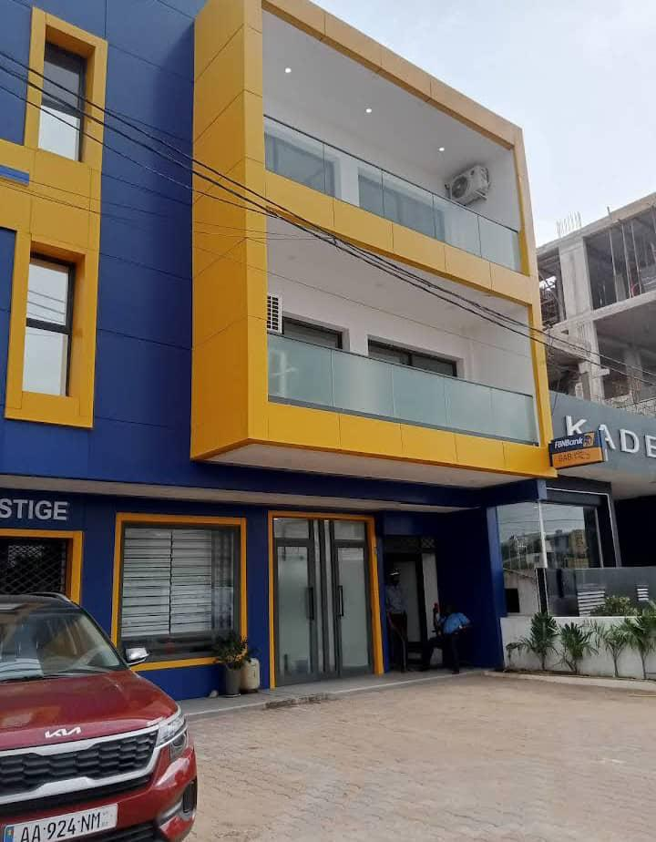

PLATE 3.7: APPROACH VIEW

3.5 CASE STUDY FIVE (ONLINE CASE STUDY 2)
NAME: FBN BANK GHANA LIMITED
LOCATION: HRW9+2R9,111 LIBERATION ROAD ACCRA GHANA
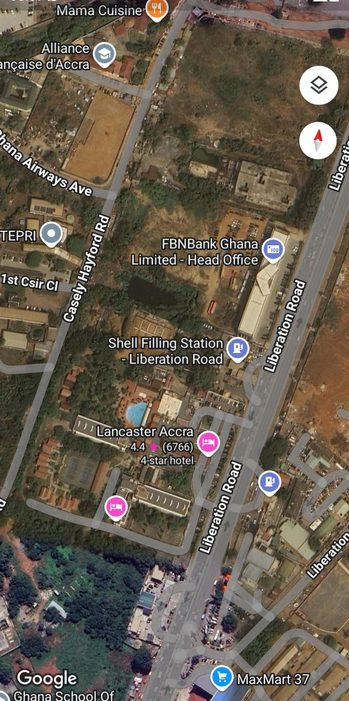

PLATE 3.8: LOCATION PLAN
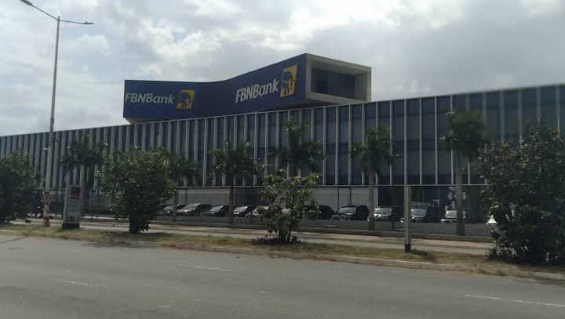

PLATE 3.9: APPRAOCH VIEW

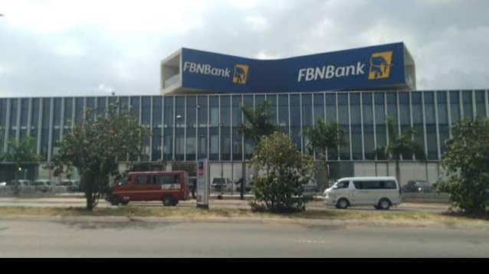

PLATE 4.0: APPROACH VIEW

3.6 DEDUCTION FROM CASE STUDIES:
The merits and demerits observed in the selection studies of the existing structure will be taken in the design of the proposed commercial Bank.

CHAPTER FOUR
4.0 ANALYSIS OF THE ENVIRONMENTAL AND TOPOGRAPHICAL CONDITIONS OF THE SITE
4.1.1 INTRODUCTION TO STUDY AREA
Ovia South-West Local Government Area (LGA) is one of the administrative regions in Edo State, Nigeria. Its historical background is closely tied to the larger history of the Benin Kingdom and the broader Edo cultural heritage.
4.1.2 HISTORICAL BACKGROUND OF OVIA SOUTH-WEST LGA:
- Origin within the Benin Kingdom:
Ovia South-West is part of the greater Benin Kingdom, which has a rich history dating back several centuries. The Benin Kingdom, renowned for its sophisticated governance system, art, and culture, influenced the social and political structures within the region.
- Ethnic Composition:
The people of Ovia South-West LGA are predominantly of the Edo ethnic group. They share cultural, linguistic, and traditional ties with the Benin people. The area consists of various towns and villages that were historically governed by local chiefs under the broader authority of the Oba of Benin.
- Colonial Era and Administrative Evolution:
During the British colonial period, the administrative structure of the region was reorganized to align with colonial governance models. Ovia South-West, like many other areas, was integrated into the colonial local government system, which eventually evolved into the current local government framework.
- Modern Creation of Ovia South-West LGA:
Ovia South-West LGA was officially created as part of the administrative divisions within Edo State to decentralize governance and bring government closer to the people. It was carved out from the larger Ovia North-East Local Government Area. This administrative restructuring aimed to enhance local development and political representation.

- Economic and Cultural Significance:
The area has traditionally been agrarian, with farming as the mainstay of its economy. The LGA is also known for cultural festivals and practices that preserve Edo traditions, reflecting the historical continuity of its people’s heritage.
4.2. SITE LOCATION / DESCRIPTION
- The site is accessible by road, with the Benin - Lagos express way running through or nearby. Internal roads connect the various communities / electricity poles pissed through it.
- The site topography show that it is relatively flat thereby enhance the construction of project
- The site is predominantly flat with patches of undulating terrain.
4.3 SITE LOCATION CRITERIA
Site Location Criteria for Ovia South-West Local Government Area (LGA), Edo State, Nigeria
When evaluating site location criteria for an area like Ovia South-West LGA, it's important to consider factors that influenced the establishment and development of the LGA in its current location. These criteria are based on physical, socio-economic, and political factors that make the area viable for settlement, governance, agriculture, and connectivity.
1. PROXIMITY:
This proximity allows for administrative convenience, access to larger markets, and easier transportation of goods and services.
It facilitates integration with state-level infrastructure and government services.
2. LANDAVAILABILITYAND TOPOGRAPHY:
- The region has vast expanses of arable land suitable for agriculture, which is the dominant economic activity.
- Flat to gently undulating terrain makes the land ideal for building infrastructure such as roads, housing, and public utilities.
- Availability of undeveloped land also made it easier to plan community layouts and local government facilities.
3. ACCESSIBILITY AND TRANSPORTATION
- Located near the Benin–Lagos Expressway, which enhances road connectivity to other parts of Edo State and the South-West region of Nigeria.
- Internal roads link major towns and villages, making it easier for people and goods to move within the LGA.
- Accessibility influences where local government headquarters (e.g., Iguobazuwa) and service centers are situated.
5. SECURITY AND SOCIAL COHESION
- Relatively peaceful and socially cohesive communities.
- Ethnically homogeneous populations (predominantly Bini/Edo) reduce conflict and ease administrative governance.
4.4 SITE ANALYSIS
Analysis of site is the physical synthesis within the site, site analysis gives full details of the future present on the site in helping with the property planning, it expresses the relationship between buildings, sunrise and sunset.
4.5. GEOGRAPHICAL / CLIMATIC DATA
The proposed site has a very smooth road towards the SOUTH-WEST region part of the site and is considered useful for climatic conditions and construction of the proposed building.
CLIMATE
OVIA SOUTH-WEST experiences a tropical savanna climate
- Temperature: Average yearly temperature is approximately 28.78° C (83.8°F)
- Humidity: Average relative humidity is around 53%
- Rainfall: Annual precipitation is about 183.49mm, with approximately 266 rainy days per year.
- Season:
- Wet season: Typically from April to October.
- Dry season: Generally from November to March.

RAINFALL
- Annual precipitation: Approximately 189.49 mm.
- Rainy days: Around 266 days annually, indicating frequent rainfall events.

WIND
- Wind pattern: predominantly influenced by the intertropical convergence zone (ITCZ), leading to variable wind directions.
- Speed: Average wind speeds are moderate, with occasional gusts during thunderstorms.
- Direction: Winds generally shift with the seasons, influenced by the movement of the ITCZ.
TEMPERATURE
- Average yearly temperature: Approximately 28.78°C (83.8°F)
- Daily variations: Temperatures can vary between 24°C (75°F) during cooler periods and up to 31°C (88°F) during hotter periods.

4.6: SPACE ALLOCATION / SCHEDULE OF ACCOMMODATION
Table 1: SPACE ALLOCATION / SCHEDULE OF ACCOMMODATION
SNO | WORKSHOP BLOCKS UNIT | DIMENSIONS | M²
1 | ENTRANCE | 8.0 X 4.0 | 32m²
2 | BANKING HALL | 22.925 X 10.375 | 237.84m²
3 | BUlK ROOM | 8.025 X 6.0 | 48.15m²
4 | VAULT ROOM | 8.0 X 5.0 | 40m²
5 | PRE-VAULT | 5.0 X 5.0 | 25m²
6 | ACCOUNTANT OFFICE | 5.55 X 5.2 | 28.86m²
7 | DELIVERY BAY | 10.0 X 10.0 | 100m²
8 | STORE | 3.0 X 2.0 | 6m²
9 | UTILITY ROOM | 5.0 X 8.0 | 40m²
10 | CONFERENCE HALL | 11.475 X 8.0 | 91.8m²
11 | BREAK ROOM | 5.8 X 4.0 | 23.2m²
12 | CUSTOMER CARE SERVICE HALL | 22.924 X 11.225 | 257.32m²
13 | ICT AREA | 10.0 X 10.0 | 100m²
14 | AUDITOR OFFICE | 5.0 X 8.0 | 40m²
15 | BRANCH EXECUTIVE OFFICE | 7.25 X 8.0 | 58m²
16 | SECRETARIES OFFICE | 5.225 X 6.875 | 35.92m²
17 | OPERATION MANAGER | 7.0 X 8.0 | 56m²
18 | LOAN OFFICE | 8.025 X 6.0 | 48.15m²
19 | MARKETING OFFICE | 8.025 X 6.0 | 48.15m²
20 | TRAINING HALL | 8.225 X 10.225 | 84.10m²
21 | HUMAN RESOURCES OFFICE | 8.0 X 4.65 | 37.2m²
 | TOTAL |  | 1437.69m²

4.7 DESIGN CONCEPT (CONCEPTUAL DEVELOPMENT)
This is basically the principle governing the production of a principle idea that gives design. This makes it possible for designers to have the same concept for a work, but with a different approach in its interpretation. Most times, some designers have a religious obsession for their design philosophy that eventually gives them a peculiar character, thereby giving them an identity.
Personal beliefs and experience of the architect may determine the design concept. These beliefs and experiences may be a product of the environmental factors that exist within that area or problems deduced from the design brief.
In terms of design brief, the commercial bank (First Bank) activities are sequential, hence the need arises to identify this sequence and stem the design to suit the sequential movement with the use of hierarchy. For environmental factors, the architect tries to exploit the building environment to the advantage of the design. These factors include the building materials available and construction techniques, building forms in use, the spaces and activities, and the characteristics of the space.

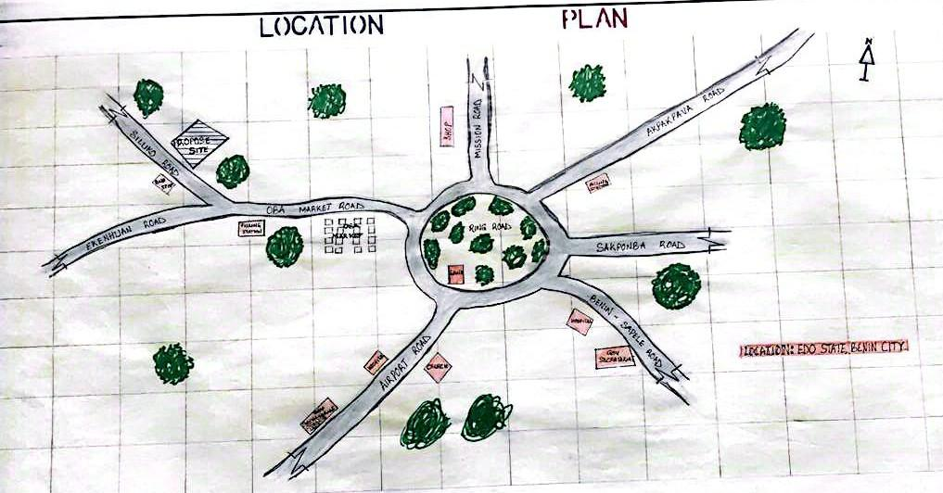

FIG 4.0 LOCATION PLAN

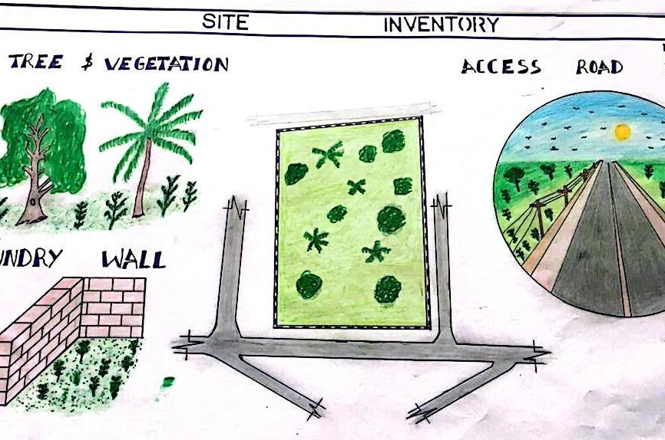

FIG 4.1 SITE INVENTORY
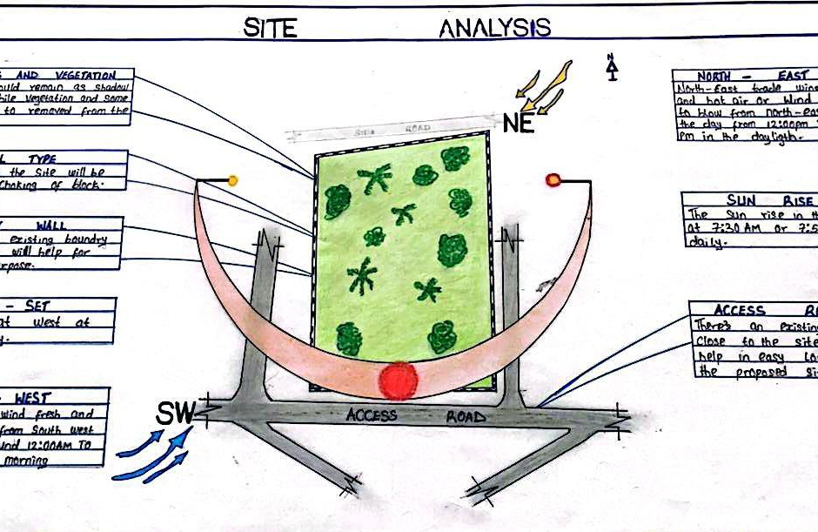

FIG 4.2 SITE ANALYSIS

CHAPTER FIVE
5.1 APPRAISAL OF PROPOSED SCHEME
The proposed scheme for designing a commercial bank presents a forward-thinking approach to banking that aligns with current market trends and customer expectations. By focusing on technology, customer service, and regulatory compliance, the bank has the potential to carve out a significant market share. However, the proposed scheme for designing a commercial bank aims to create a modern financial institution that meets the evolving needs of customers while adhering to regulatory requirements and leveraging technology for efficiency. This appraisal evaluates the key components of the proposed scheme, including objectives, design features, operational frameworks, risk management strategies, and potential challenges.
5.1.1 CONSTRUCTION METHODOLOGY & MATERIAL
The construction of a commercial bank requires a well-planned methodology and the use of high-quality materials to ensure safety, functionality, and aesthetic appeal. By following a structured approach and selecting appropriate materials, the project can meet the needs of the bank and its customers while adhering to regulatory standards and sustainability goals. Careful attention to detail throughout the construction process will contribute to the long-term success and durability of the bank
5.1.2 CONSTRUCTION METHODOLOGY
PRE-CONSTRUCTION PHASE
- Site Analysis and Survey: Conduct a thorough site analysis to assess soil conditions, topography, and environmental impact. This includes geotechnical surveys and environmental assessments.
- Design Development: Collaborate with architects and engineers to finalize the design, ensuring it meets functional requirements, aesthetic goals, and regulatory compliance.
- Permitting and Approvals: Obtain necessary permits and approvals from local authorities, including zoning, environmental, and building permits.
SITE PREPARATION
- Clearing and Grading: Clear the site of vegetation, debris, and existing structures. Grade the land to create a level foundation.
- Excavation: Excavate for foundations, and utility trenches as required. Ensure proper shoring and safety measures are in place.
SUPERSTRUCTURE CONSTRUCTION
- Framing: Construct the superstructure using steel or reinforced concrete framing, depending on the design. Steel frames offer flexibility and strength, while concrete provides durability.
- Floor Systems: Install floor systems (e.g., concrete slabs, composite steel decking) that meet load-bearing requirements and provide sound insulation.
ENCLOSURE AND ROOFING
- Exterior Walls: Construct exterior walls using materials such as brick, glass, or precast concrete panels.
- Windows and Doors: Install energy-efficient windows and secure doors that meet safety and aesthetic standards.
- Roofing: Install a roofing system (e.g., flat, sloped, green roofs) that provides weather resistance and complements the building design.
INTERIOR CONSTRUCTION
- Partitions and Finishes: Construct interior partitions using drywall or modular systems. Apply finishes such as paint, flooring, and ceiling tiles.
- Mechanical, Electrical, and Plumbing (MEP): Install MEP systems, including HVAC, lighting, electrical wiring, and plumbing fixtures, ensuring compliance with building codes.
SECURITY FEATURES
- Access Control Systems: Integrate security features such as access control systems, surveillance cameras, and alarm systems into the design.
- Safe Rooms and Vaults: Construct secure areas for cash handling and sensitive documents, using reinforced materials and secure locking mechanisms.
LANDSCAPING AND SITE DEVELOPMENT
- Landscaping: Develop the surrounding landscape with trees, shrubs, and hardscaping to enhance aesthetics and create a welcoming environment.
- Parking and Access Roads: Construct parking lots and access roads, ensuring compliance with local regulations and providing adequate space for customers and employees.
FINAL INSPECTION AND HANDOVER
- Quality Control: Conduct thorough inspections at each stage of construction to ensure quality and compliance with specifications.
- Handover: Prepare for the final handover by addressing any punch list items and ensuring that all systems are operational.
5.1.3 MATERIALS USED IN CONSTRUCTION
STRUCTURAL MATERIALS
- Concrete: Used for foundations, floors, and walls due to its strength and durability.
- Steel: Utilized for framing and reinforcement, providing flexibility and structural integrity.
EXTERIOR FINISHING MATERIALS
- Brick : Used for aesthetic appeal and durability in exterior walls.
- Glass: High-performance glazing for windows and facades, enhancing natural light and energy efficiency.
- Precast Concrete Panels: Used for quick installation and uniformity in exterior finishes.
INTERIOR FINISHING MATERIALS
- Drywall: Commonly used for interior partitions and ceilings.
- Flooring: Options include tile, carpet, and polished concrete, chosen for durability and aesthetics.
- Paint and Wall Coverings: Selected for visual appeal and to create a professional atmosphere.
MECHANICAL, ELECTRICAL, AND PLUMBING (MEP) MATERIALS
- HVAC Systems: Energy-efficient heating and cooling systems to maintain comfort.
- Electrical Wiring and Fixtures: High-quality wiring and fixtures to ensure safety and efficiency.
- Plumbing Pipes and Fixtures: Durable materials such as PVC, copper, or PEX for plumbing systems.
5.2 CONCLUSION
This design approach for the commercial Bank (First Bank) project is rooted in a balance between customers, centric spaces and robust operational security. The integration of environmental sustainability, efficient service systems, and compliance with legal frameworks ensures a high-performance banking environment.
5.3 RECOMMENDATIONS
- Future studies should explore modular banking units for rural outreach.
- Further research into AI-driven bank service environments and IOT integration in security systems.
- Sustainability performance can be enhanced with solar energy adoption.

REFERENCES
First Bank of Nigeria Ltd. (2019). 125 years of trust: A legacy of excellence. Lagos: First Bank of Nigeria Ltd.
Central Bank of Nigeria. (2020). Banking sector reforms and financial stability in Nigeria. Abuja: Central Bank of Nigeria.
Afolabi, B., & Oladejo, M. O. (2019). Modern banking hall design and customer satisfaction: A case study of selected Nigerian banks.
First Bank of Nigeria. (2023, June 10). Our history.
FBN Holdings Plc. (2022). Annual report and financial statements 2021.

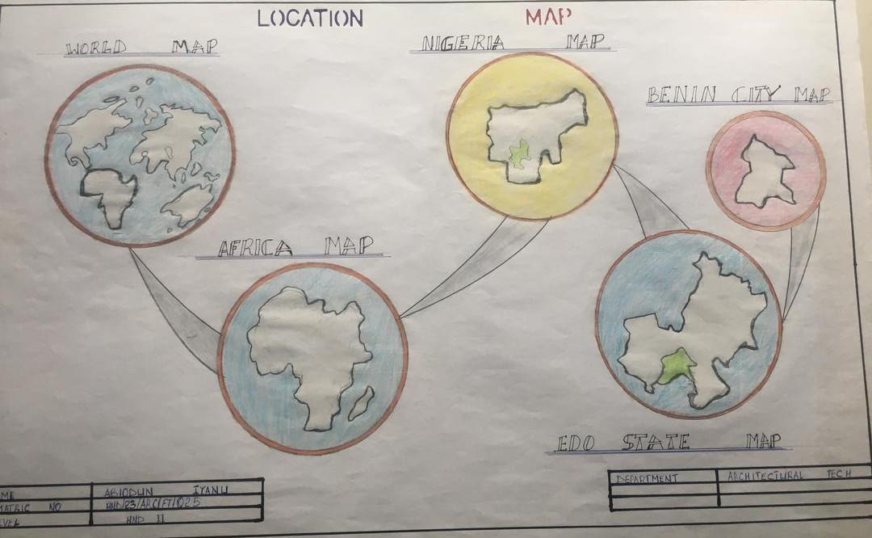
APPENDICES

LOCATION MAP

LOCATION PLAN

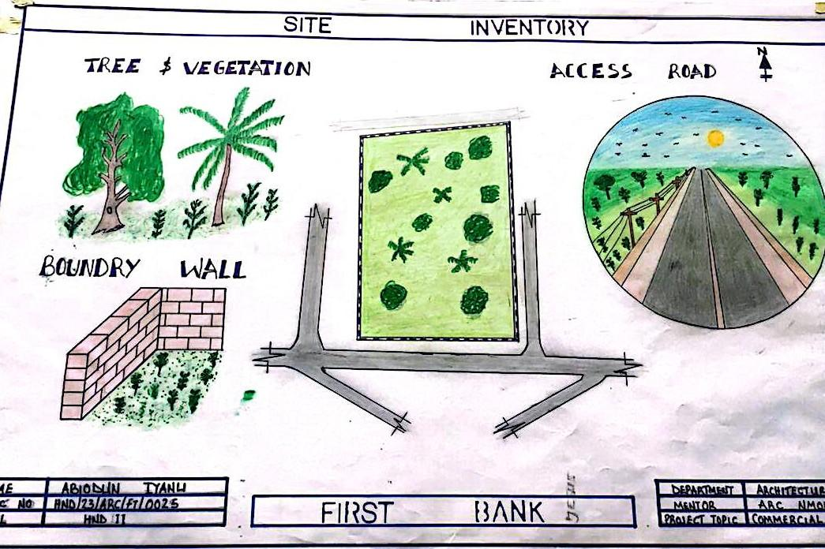

SITE INVENTORY

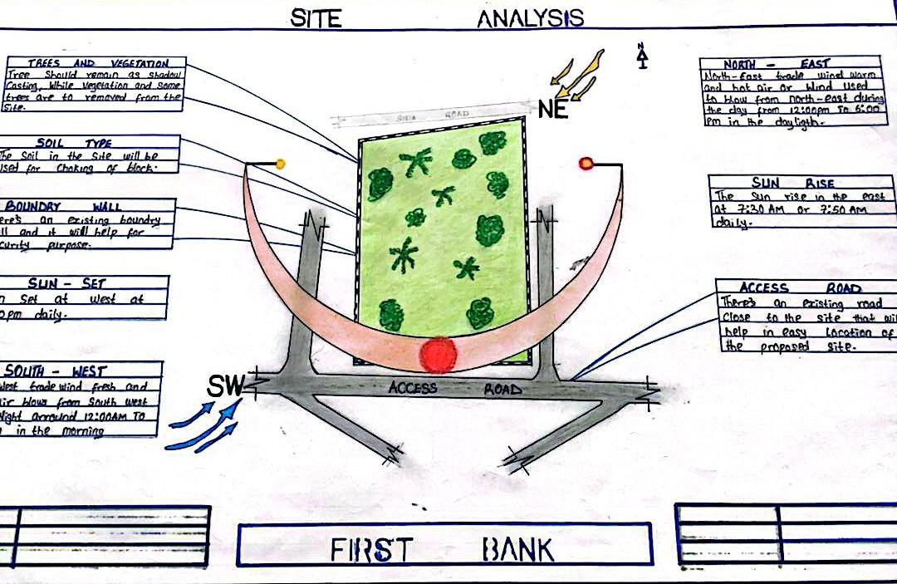

SITE ANALYSIS

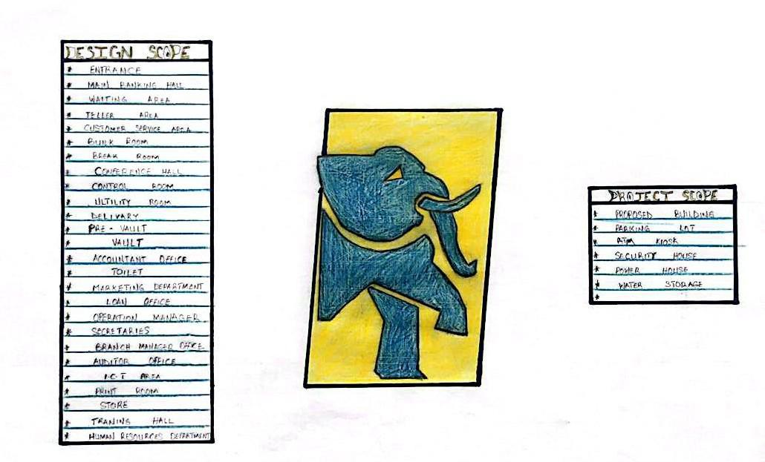

DESIGN BRIEF AND SCOPE

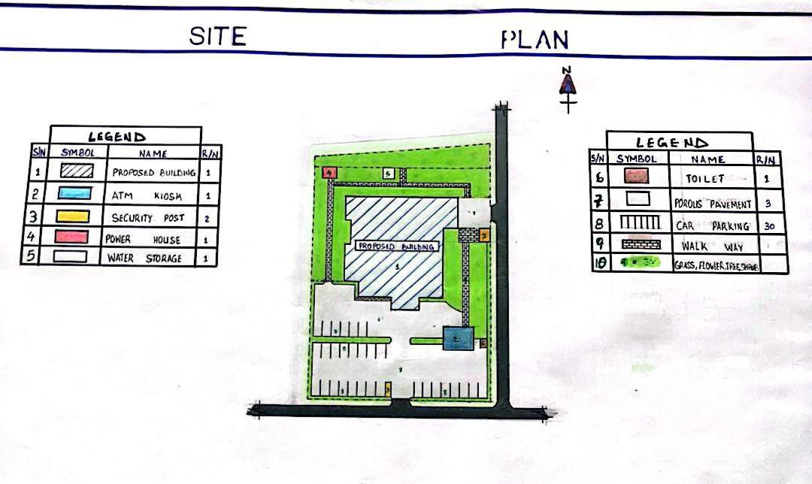

SITE PLAN

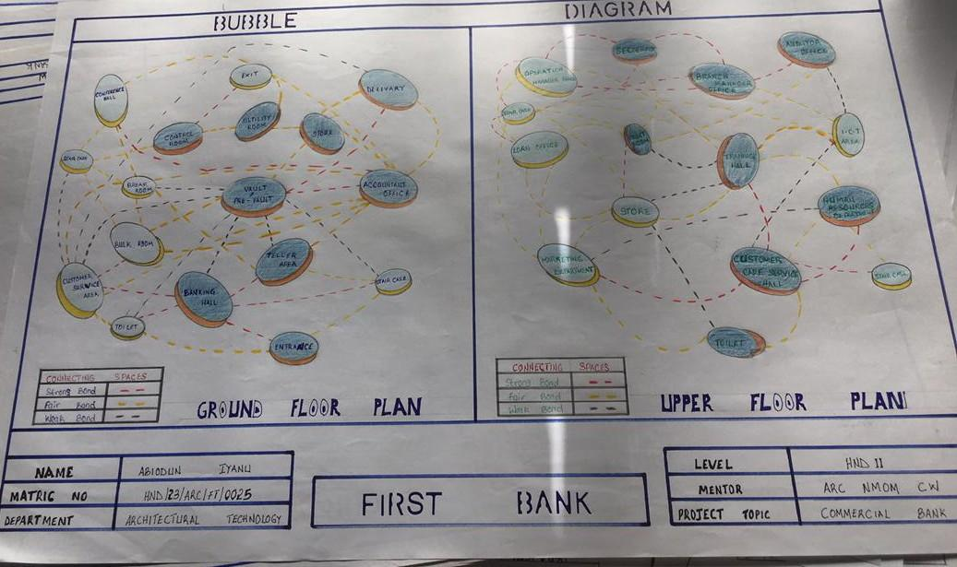

BUBBLE DIAGRAM

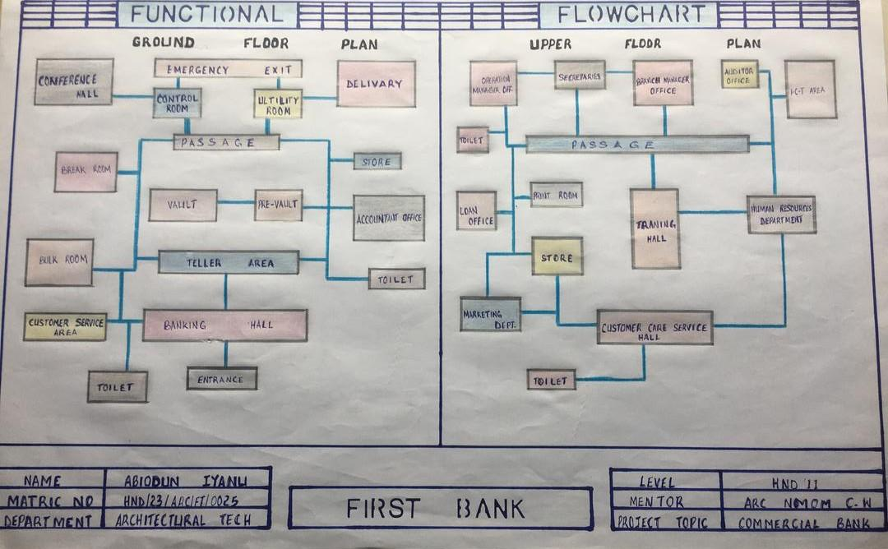

FUNCTIONAL FLOW CHART

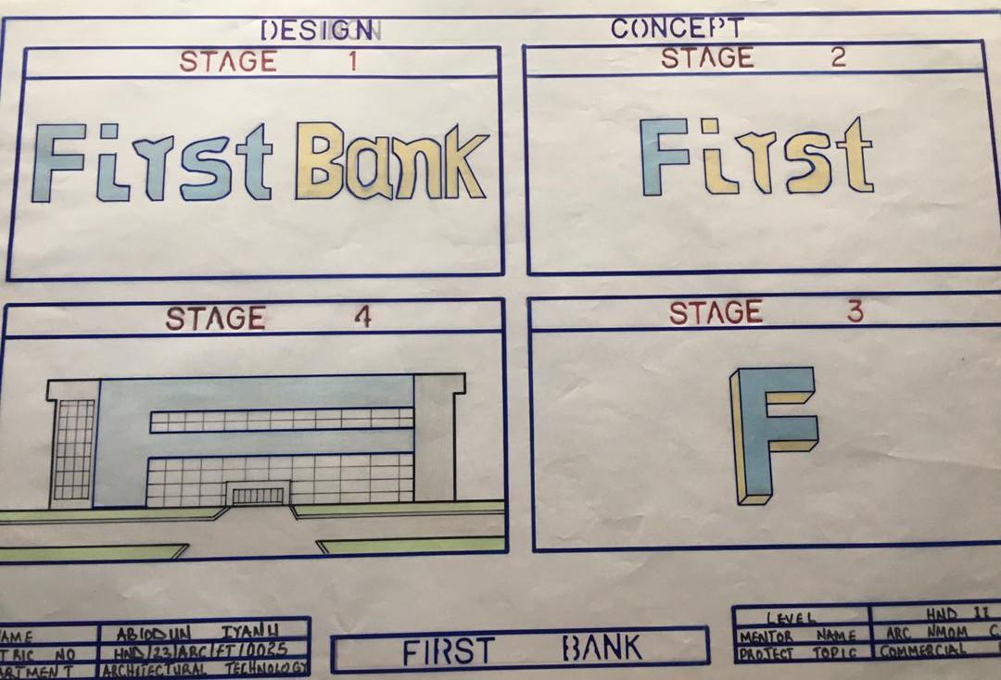

DESIGN CONCEPT DERIVATION
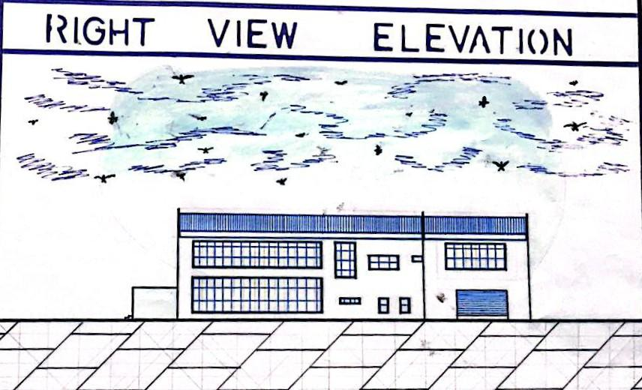

RIGTH VIEW ELEVATION

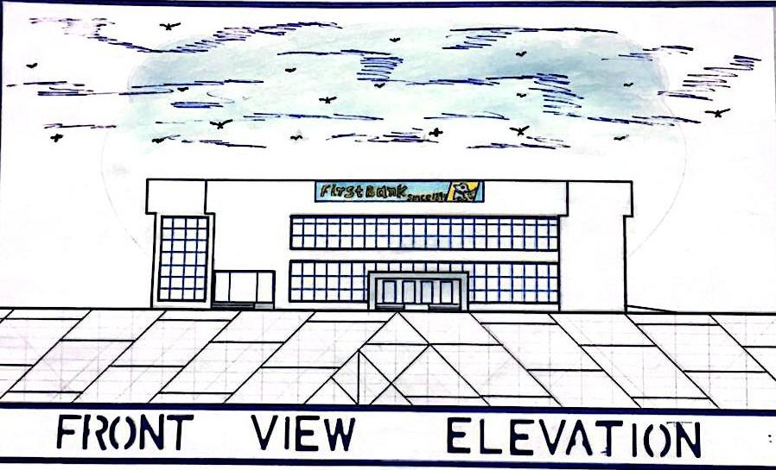

FRONT VIEW ELEVATION
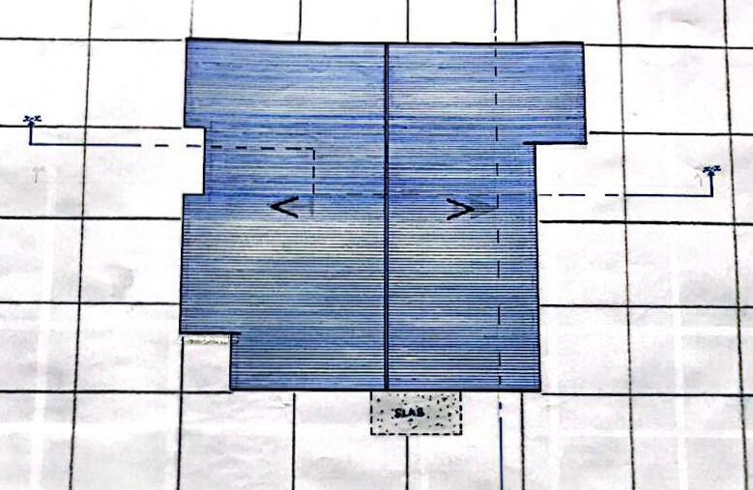

ROOF PLAN

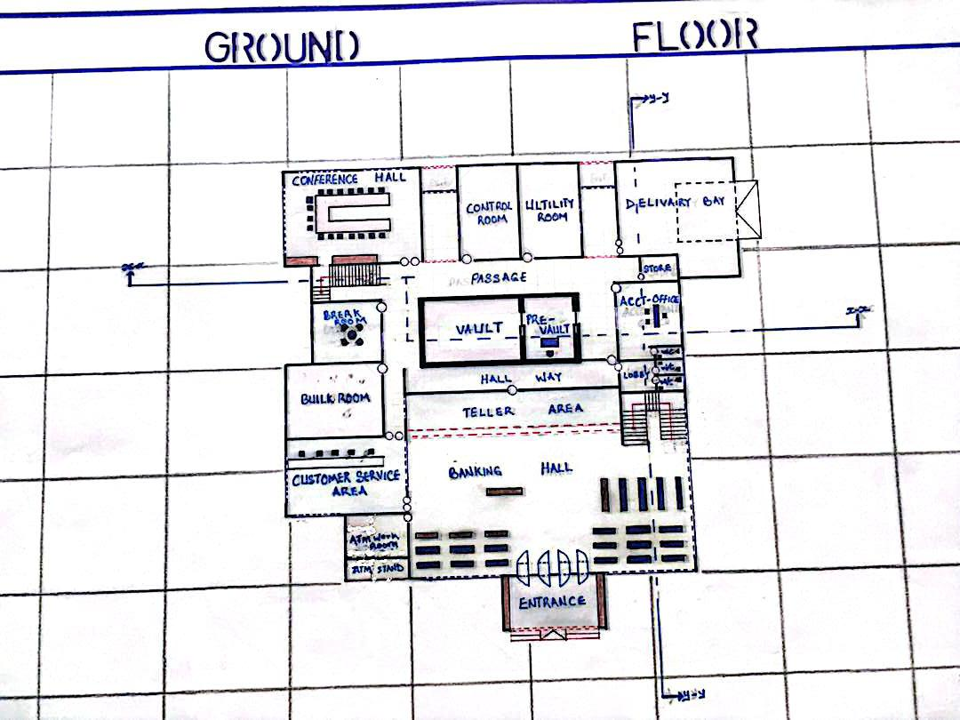

GROUND FLOOR PLAN
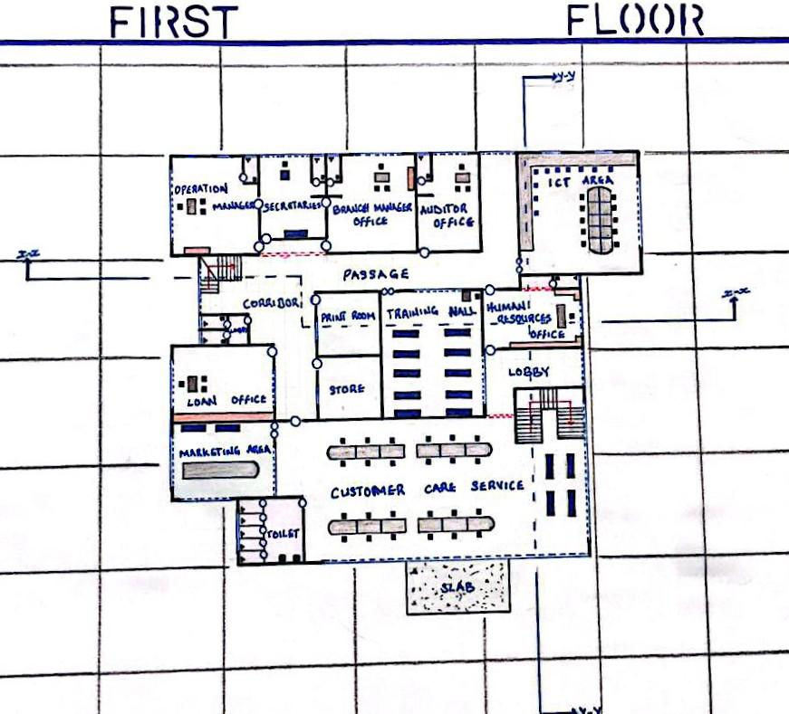

FRIST FLOOR PLAN

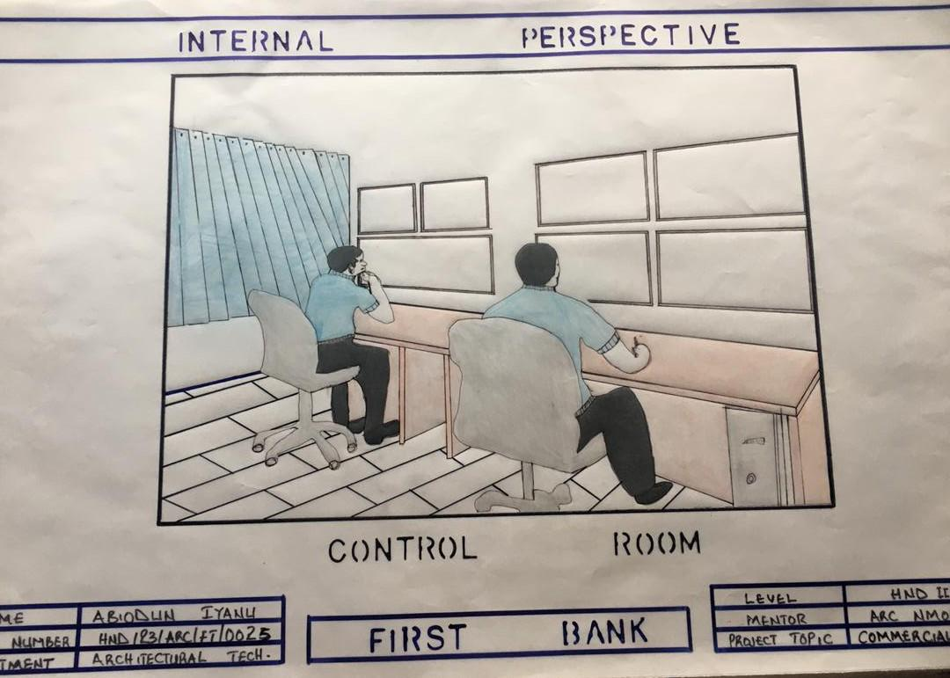

INTERNAL PERSPECTIVE

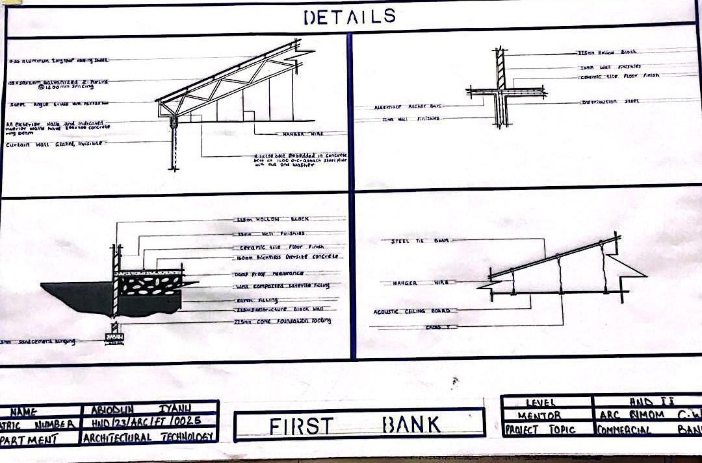

DETAILS

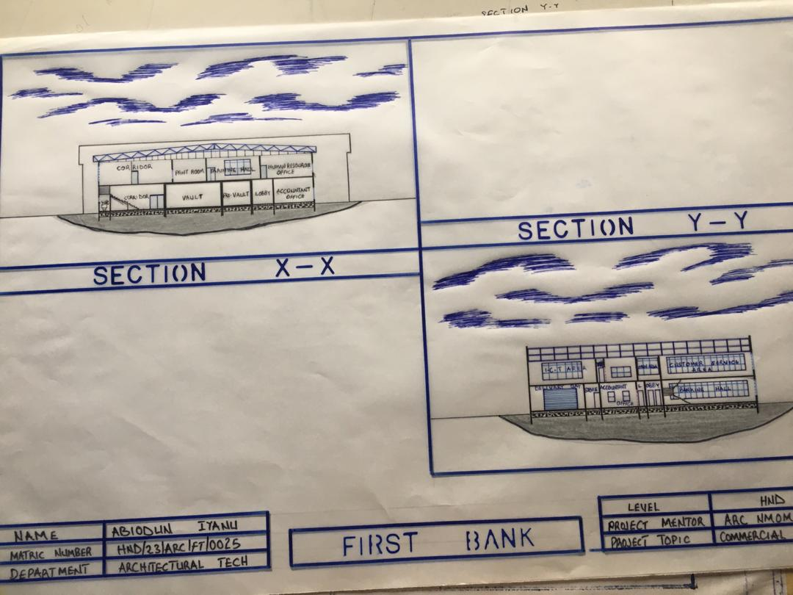

CROSS SECTION

