A PROJECT REPORT
ON
PROPOSED CLUBHOUSE
FOR
BROWN ORGANIZATION.LOCATED AT APATA COMMUNITY,ASA LOCAL GOVERNMENT, KWARA STATE.
BY

AKINREMI AFOLABI ISAAC
HND/23/ARC/FT/069

SUBMITTED TO :

THE DEPARTMENT OF ARCHITECTURAL TECHNOLOGY, INSTITUTE OF ENVIRONMENTAL STUDIES
KWARA STATE POLYTECHNIC, ILORIN

IN PARTIAL FULFILLMENT AS PART OF THE REQUIREMENTS FOR THE AWARD OF THE HIGHER NATIONAL DIPLOMA (HND) IN ARCHITECTURAL TECHNOLOGY

JULY, 2025

DECLARATION
I Akinremi Afolabi Isaac, declare that this project/ dissertation is a project of my personal research work. It has not been presented for the award of any HND in any Polytechnic.
The ideas, observations, comments, suggestions. Here in present my own with conventional academic tradition.

______________________ ____________________
SIGNATURE DATE

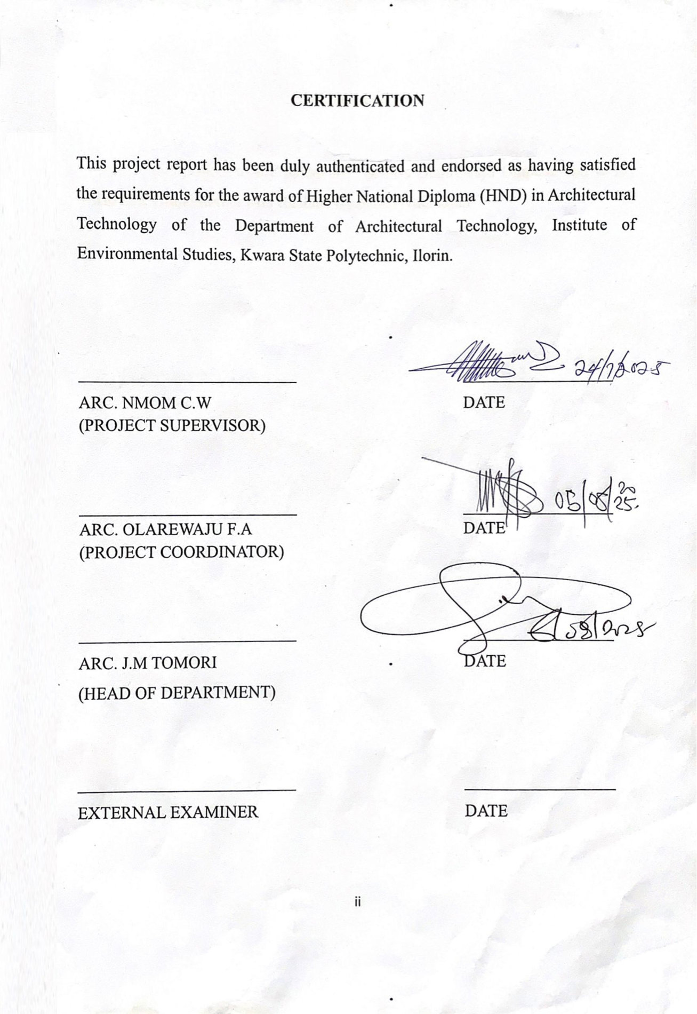

DEDICATION
This design report is dedicated to Almighty GOD who preserved me to reach this level in my education career; this report is also dedicated to appreciate my parents Mr. OLAPOSI AKINREMI and Mrs CHRISTIANAH AKINREMI

ACKNOWLEDGEMENTS
This design report write up is dedicated to Almighty GOD the creator of Heaven and Earth, from Him, we all comes from and to him we all return, to all prayer and adoration be to Him.
I must not forget the effort made by my Supervisor ARC. C.W NMOM, ARC. ABDULAZEEZ B.Y.F [I.E.S DIRECTOR], ARC J.M TOMORI [H.O.D], ARC OLAREWAJU F.A [PROJECT COORDINATOR] for devoting their time to read and edit this research project work, I must say without his effort and contribution this project would not deliver to this standard.
Besides, my appreciation goes to all architectural department lecturers for their immense contribution over my educational career, I pray may Almighty GOD continue to accumulate you all in knowledge In Jesus Name.
My parent Mr Olaposi Akinremi and Mrs Christianah Akinremi deserve endless thanks for their financial and faithful prayer throughout my educational career.
My sincere gratitude goes to my lovely Brother’s, daddy Daniel, daddy darasimi, daddy David, and brother wale for their immense contribution. And also my sincere gratitude goes to my amiable course mate friends, I can’t mention all due to space, and to all my urgent 2k I appreciate may our love keeps existing forever[ I love you all].
Last but not least, I want to thank me for believing in me, I want to thank me for doing all this hard work, I want to thank me for having no days off, I want to thank me for never quitting, I want to thank me for trying to do more right than wrong, I want to thank me for just being me all the times.

TABLES OF CONTENTS
TITLE PAGE i
DECLARATION ii
CERTIFICATION iii
DEDICATION iv
ACKNOWLEDGEMENTS v
TABLE OF CONTENTS vi-ix
LIST OF PLATES x
LISTOF FIGURES xi
CHAPTER ONE
1.1 INTRODUCTION 1-2
1.2 BACKGROUND OF STUDY/HISTORICAL BACKGROUND 2-3
1.3 DEFINITION 3
1.4 JUSTIFICATION 3
1.5 AIM AND OBJECTIVES 3-4
1.6 SCOPE OF THE STUDY 4
1.7 LIMITATION 4
I.8 METHODOLOGY 4-5
1.9 CONCLUSION 5

CHAPTER TWO
LITERATURE REVIEW 6
2.1 EVOLUTION OF THE CLUBHOUSE. 6
2.2 VARIANTS AND TYPOGRAPHICAL CLASSIFICATION 6
2.2.1 CLASSIFICATION BASED ON FUNCTION AND CLIENTELE 6-7
2.2.2 HYBRID TYPOLOGIES 7
2.3 FUNCTIONS AND SPATIAL RELATIONSHIP 7
2.3.1 CORE FUNCTIONS 7-8
2.3.2 SPATIAL RELATIONSHIP. 8
2.3.3 UNIQUE ARCHITECTURAL RESPONSES 8
2.4 TECHNOLOGICAL AND ENVIRONMENTAL APPROACH 9
2.4.1 STRUCTURAL SYSTEMS 9
2.4.2 MATERIALS 9
2.4.3 LIGHTNING 10
2.3.4 VENTILATION 10
2.3.5 MECHANICAL AND SERVICE SYSTEMS 10
CHAPTER THREEE CASE STUDIES
3.1 CASE STUDY ONE ILORIN CLUB 11
3.1.1 HISTORICAL BACKGROUND 11
3.1.2 MERITS AND DEMERITS 11
3.2 CASE STUDY TWO IKOYI CLUB 1938 14
3.2.1 HISTORICAL BACKGROUND 14
3.2.2 MERITS AND DEMERITS 14
3.3 CASE STUDY THREE ILORIN GOLF CLUB 17
3.3.1 HISTORICAL BACKGROUND 17
3.3..2 MERITS AND DEMERITS 17
3.4 CASE STUDY FOUR GLEN COUNTRY CLUB 20
3.4.1 HISTORICAL BACKGROUND. 20
3.5 CASE STUDY FIVE THE LOS ANGELES COUNTRY 22
3.5.1 HISTORICAL BACKGROUND 22
CHAPTER FOUR
4.1 DESIGN CRITERIA 24
4.2 BRIEF ANALYSIS 25-26
4.3 THE SPACE ALLOCATION IN CLUBHOUSE 26-27
4.4 FUNCTIONAL RELATIONS 28
4.5 FIRE PROTECTION DEVICES 28
4.6 SITE PLANNING 28
4.7 THE PROJECT SCOPE 29
4.8 DESIGN CONCEPT 29
CHAPTER FIVE
5.1 PROJECT APPRAISAL 30
5.2 CONTRIBUTION METHODOLOGY AND MATERIAL 30-31
5.3 DESIGN SERVICE 32
5.3.1 VENTILATION AND LIGHTING 32
5.3.2 PLUMBING AND WASTE DISPOSAL 32-33
5.3.3 ELECTRICAL INSTALLATION AND FIRE PROTECTION 33
5.4 SUMMARY 34
5.5 RECOMMENDATION 34-35
BIBLOGRAPHY 36

LIST OF PLATES OF CASE STUDY ONE
PLATE 2.1: Pictures Showing the outdoor sport
PLATE 2.2: Pictures Showing the lounge area

LIST OF PLATES OF CASE STUDY TWO
PLATE 2.1: Pictures Showing the approach view
PLATE 2.2: Pictures Showing the outdoor sports view

LIST OF PLATES OF CASE STUDY THREE
PLATE 2.1: picture showing the lounge view
PLATE 2.2: Picture showing the outdoor sit out

LIST OF PLATES OF CASE STUDY FOUR
PLATE 2.1: Picture showing site layout
PLATES 2.2: Picture showing lounge view
PLATES 2.3: Picture showing Bar view

LIST OF PLATES OF CASE STUDY FIVE
PLATES 2.1: Picture showing exterior view
PLATES 2.2: Pictures showing sit out
PLATES 2.3: picture showing indoor sport space

LIST OF FIGURES OF CASE STUDY 1 AT ILORIN, KWARA STATE.
FIG. 2.1 Picture showing lcocation plan
FIG. 2.2 picture showing site layout

LIST OF FIGURES OF CASE STUDY 2 AT LAGOS, OSUN STATE.
FIG. 2.1 Picture showing location plan
FIG. 2.2 picture showing site plan

LIST OF FIGURES OF CASE STUDY 3 AT ILORIN
FIG. 2.1 Picture showing location plan
FIG. 2.2 Picture showing floor plan

CHAPTER ONE
1.1 INTRODUCTION
A Clubhouse refers to a building or facility that serves as the central gathering place for members of a club , organization or community. It provides a space for socializing, meeting, events and recreational activities.
TYPES OF CLUBHOUSES
- Social clubs :- In social clubs, a clubhouse is a place for members to relax, socialize, And participate in various activities such as game cards, dining, special events.
- Sports clubs :- Many sports organizations [E. G golf club, tennis clubs or yacht club]Offer amenities like Changing rooms, lounges, and dining facilities. The clubhouse may also host events like tournaments, awards ceremonies, and social gatherings for members and their guests.
- Residential communities :- In residential areas like gated communities or retirement villages. A Clubhouse may serve as a shared facility offering amenities such as a pool, fitness center, meeting rooms or communal kitchens. It is often used for community-building events and social activities.
FEATURES OF A CLUBHOUSE.
- Social areas :- These often include lounges, bars, or game rooms where members can relate or socialize.
- Meeting and events spaces :- Rooms or halls designed to accommodate meetings. Seminars or larger events like banquet and parties.
- Dining facilities :- Mini clubhouses I have on-site restaurants or cafés serving meals and drinks, Often exclusive to members or their guests.
- Regression facilities :- Depending on the club clubhouses might include fitness centers, swimming pool, sport courts, All spa services.
- Administration offices :- These spaces may house the administration functions of the club, such as membership management and event coordination

1.2. BACKGROUND OF STUDY/HISTORICAL BACKGROUND
The concept of a clubhouse has evolved over time often serving as a social hub members of a community organizations. Historically, clubhouses I've been associated with various groups, including social clubs, Fraternal organizations, and recreational associations.
In the late 19th and early 20th Centuries, many cities began to establish private clubs where individuals gather for leisure activities, networking and socializing. These Spaces often featured amenities Like dining rooms, lounges, and event space. The idea was to create a sense of belonging among members who shared common interest.
During the 20th century, the concept expanded to include community centers and youth clubs, which aimed to provide a safe space for social interaction and engagement, particularly For younger generations.
- Gentlemen’s clubs [ 1700s] :- Exclusive social clubs for men in London] offered space for gaming, dining, and intellectual discussions.
- social clubs [1800s].
- Country clubs [1800s].
- Night clubs [1920s prohibition era].
- Modern clubhouse [mid-20th Century].
- Contemporary clubhouse [late 20th century to present].
1.3 DEFINITION
Clubhouse is a private social club traditionally for men, that offer a place for members to gather, socialize, and some times conduct business. They often have exclusive facilities like dining rooms, bars, library, and sometimes accommodation.
1.4 JUSTIFICATION
This project serves as a space for residence of ASA local governments area and communities around it To connect with each other reducing feelings of isolation and loneliness.
This involvement helps strengthen the community bonds and fosters a sense, of belonging among residents also play vita role in promoting cohesion, Community development and well being.

1.5 AIM AND OBJECTIVES
AIM
To design a functional and inviting clubhouse that serves as a central hub for social Regression and leisure activities catering to the diverse needs of its users while reflecting the community’s identity and promoting sustainability.
OBJECTIVES
- To provide space that's encourage interaction among members such as lounges, multipurpose halls.
- To create spaces that cater to relaxation such as gardens, spa facilities or outdoor activity areas.
- Ensure the clubhouse has an appealing architectural design that aligns with the surrounding environment.

1.6 SCOPE OF DESIGN
- Car park
- Security post
- Main building
- Private meeting room
- Outdoor sport
- Guest house

1.7 LIMITATION
During the process of carrying out each of my case study at Clubhouse. A lot of restriction protocol were faced because of members privacy.
- Prohibition from taking pictures.
- Limited access to some part of the facilities.
- The interpret has few knowledge about the clubhouse

1.8 METHODOLOGY
Project research involves the use of the following means and sources of Obtaining information and data.
- Literature review :- This step involves examining existing literature related to my proposed project topic [Clubhouse], allowing me to understand the current state of my research.
Case study :- This involves physical case study, whereby I was able to analyze, and gain insights Into the design principles, materials and construction techniques. An online case study was also carried out.
- Oral :- This Involves spoken communication used to collect and analyze data during case study.
By employing this methodologies, I gain a comprehensive understanding of architectural issues and contributing to the designing of clubhouse.
1.9 CONCLUSION
I have understood the inherent problem synparthasized the analysis carried out during the process of this research. In trying to have a compound analysis and solution alike, case studies were critically analyzed and all their positive attributes employed to the advantage of this project without mixing word. This project will provide an effective way of use a useful life of disable in a society.
CHAPTER TWO
2.0 LITERATURE REVIEW
2.1 EVOLUTION OF THE CLUBHOUSE.
The gentlemen’s clubhouse as its roots in the 18th-century British social tradition. Initially, these spaces served as exclusive meeting places for the upper-class make elite, offering venues for networking, leisure, and informal political discussion. Notable early examples include white club [1693] and Brooks club [1746] in London, which set a precedent for such buildings globally.
During the 19th and early 20th centuries, the typology evolved in boots form and function adapting to social, political, and technological shifts. In colonial contexts [e.g British colonies in Africa, India], clubhouses took on roles as colonial power symbols. In post-colonial and modern settings , gentlemen’s clubs have diversified to accommodate professional associations, recreation groups, and cultural communities.
State of the art expressions No integrates advanced materials, sustainable practice, and flexible species, reflecting changing social values and modern lifestyle white retaining core characteristics such as exclusivity, privacy and Multifunctionality.

2.2 VARIANTS AND TYPOLOGICAL CLASSIFICATION
2.2.1 CLASSIFICATION BASED ON FUNCTION AND CLIENTELE
Gentlemen’s clubhouses can be classified into several categories, based on their purpose and the community they serve :-
- Social clubs :- Primarily for socialization and recreation.
- Professional clubs :- Linked to professions like law, medicine, or business.
- Cultural clubs :- Focused on art, literature, or heritage.
- Sports clubs :- Centered around specific sports and activities like golf or polo.
- Country clubs :- Typically located in suburban areas, combining leisure, dining and sports.
Each type influences spatial organization, facilities required, and the degree of public versus private accessibility.

2.2.2 HYBRID TYPOLOGIES
Contemporary clubhouses often blend functions, integrating wellness centers, co-working Spaces, boutique hotels, or fine dining, thus requiring more sophisticated spatial planning and service systems.

2.3 FUNCTIONS AND SPATIAL RELATIONSHIPS.
2.3.1 CORE FUNCTIONS.
Despite variations, most gentlemen's clubhouse include :-
- Main lounge and bar area :- Central for informal interaction.
- Game and recreation rooms :- billiards, cards or board games.
- Library and reading rooms :- Quiet, contemplative spaces.
- Guest rooms :- For overnight accommodation.
- Administrative offices :- Full staff and management.
- Support spaces :- Kitchens, toilets, changing rooms, and storage.
2.3.2 SPATIAL RELATIONSHIPS
Effective planning ensures privacy while allowing social interaction. For example:-
- The main lounge is often a transition space linking to other activity areas.
- Noise sensitive zones [library, guest rooms] are separated from lively areas [ bars, games room].
- Staff areas typically concealed accessible for efficient service delivery.
Circulation design reinforce hierarchy, exclusivity, and comfort, often using separate entrance or corridors for guests and service staff
2.3.3 UNIQUE ARCHITECTURAL RESPONSES
Architects have tackled challenges like :-
- Balancing openness with exclusivity using screening devices or landscape buffers.
- Maintaining tradition while incoperating modern design cues.
- Addressing multifunctionality through modular space planning or flexible partitions.

2.4 TECHNOLOGICAL AND ENVIRONMENTAL APPROACH
2.4.1 STRUCTURAL SYSTEMS
Structures vary depending on location and scale
- Traditional masonry was common in early clubs.
- Modern steel or reinforced concrete frames allow longer spans for open lounges and halls.
- Prefabricated or modular construction Is emerging in cost sensitive or remote contexts.

2.4.2 MATERIALS
Material choices reflect desired ambiance :-
- Natural wood and stone for warmth Prestige
- Leather and brass are often used In furnishings and detailing.
- Glass and steel In contemporary designs convey transparency and sophistication.
Durability and maintenance a key factors, especially in high-use areas like lounges and bars.

2.4.3 LIGHTING
- Ambient Lighting in common areas sets the tone.
- Task lighting is used in reading or gaming areas.
- Use of skylights and clerestory windows introduces natural light in private zones.
- Lighting controls enhance flexibility and energy efficiency.

2.4.4 VENTILATION
- Cross ventilation is ideal in tropical climates.
- Mechanical ventilation [HVAC Systems] ensures Indoor comfort and quality in sealed or urban settings.
- Ventilated double skin facades and solar chimneys are employed in sustainable designs.

2.4.5 MECHANICAL AND SERVICE SYSTEMS
- Efficient plumbing systems unnecessary for bars, Kitchens and restrooms
- Smart building management systems [BMS] Optimize energy and security.
- ICT Infrastructure supports WI-FI, AV Systems and booking services.
- Fire safety systems, including alarms, sprinklers and exits, are essential due to the social nature of the building.

CHAPTER THREE CASE STUDIES
CASE STUDY 1
3.1 ILORIN CLUB
3.1.1 HISTORICAL BACKGROUND
Ilorin club is located in GRA road, KWARA state. It was established in 1925, making it one of the oldest social clubs in Nigeria. It was founded by a group of prominent Individuals in ilorin. Aimed at providing a space for social interaction and the promoting of cultural activities.
Over the years, Ilorin Club has evolved, adapting to changes in society while maintaining its core values of fellowship and community service. It has become a hub for videos events, fostering unity Among members and contributing to the cultural richness of ilorin.
3.1.2 MERITS AND DEMERITS
MERITS
- Good circulation pattern
- Good arrangement of facility.
- Centrally located and provides easy access.
- Adequate space for future development.
DEMERITS
- Lacks adequate green landscape.
- Dilapidated structures present.

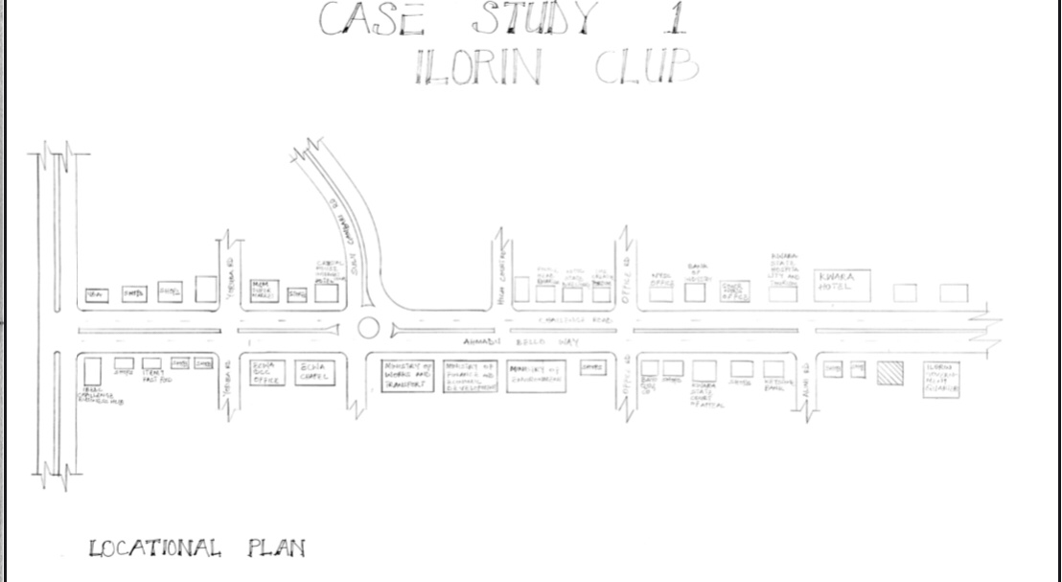
FIG: 2.1. Picture showing locational plan of case study one at Ilorin club

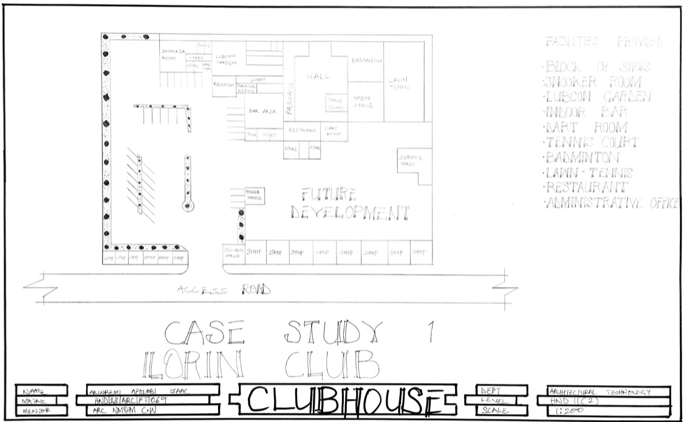
FIG: 2.2. Picture showing site layout of case study one at Ilorin club

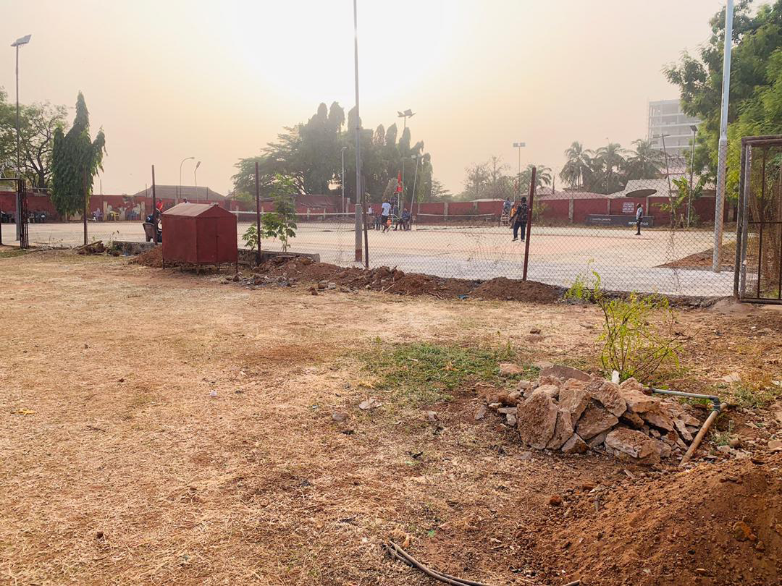
PLATE: 2.1.. Picture showing the outside sport of case study one at ilorin club.

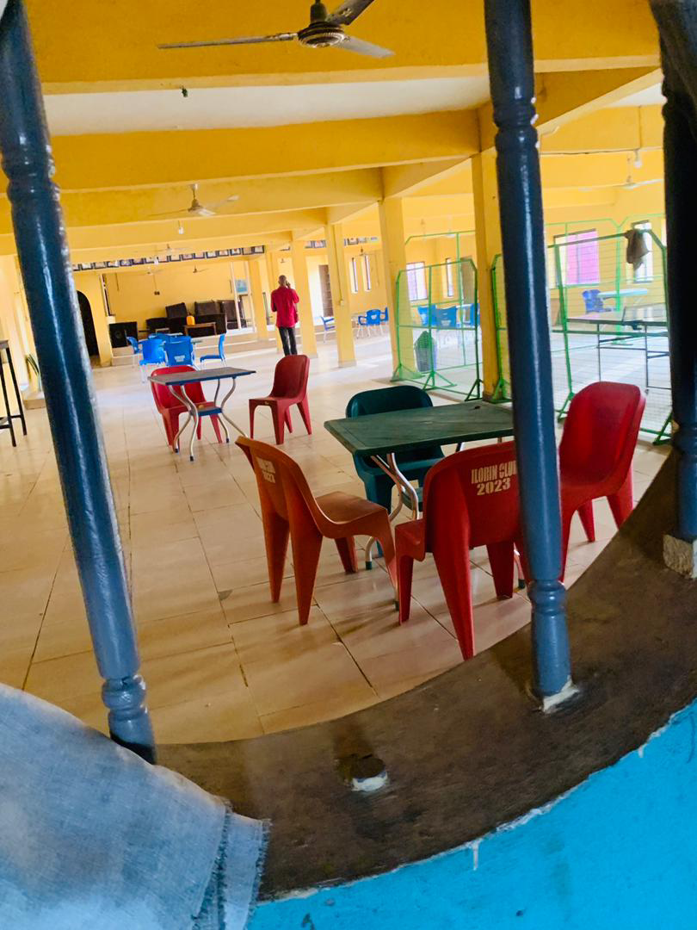
PLATE: 2.2. Picture showing the lounge area of case study one at ilorin club.
3.2 CASE STUDY 2 IKOYI CLUB 1938
3.2.1 HISTORICAL BACKGROUND
Ikoyi Club 1938 Is located at ikoyi lagos state. It was established in 1938 as european club. The club’s design reflects colonial architecture characterized by open spaces, verandas and europeans styles. This design was intentional, Promoting a relaxed atmosphere conducive to social interactions.
It was initially founded as a golf club for expatriates And has since Evolved into a multifaceted social and recreational hub. It’s facilities include lawn tennis, swimming, squash table tennis, badminton, billiards, snooker pool and other sports, bars and kitchen, gymnasium.
3.2.2. MERITS AND DEMERITS
MERITS
- The layout caters for a range of activities
- Good circulation pattern
- Uses of open space and large Verandas promotes natural lighting and ventilation to the building.
- The architectural elements enhances the visual appealing, making it an attractive venue
DEMERITS
- inadequate space for future development
- Dilapidated structures present.
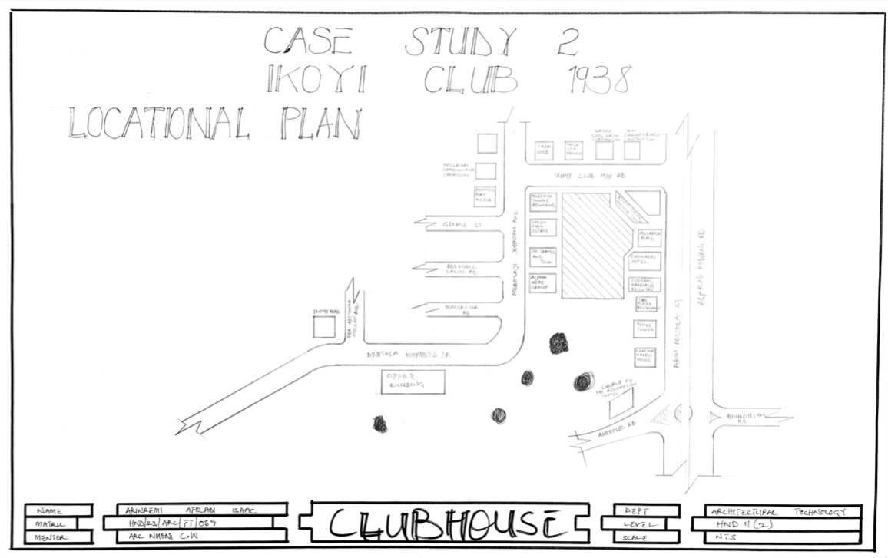
FIG: 2.1. Picture showing location plan of case study two at Ikoyi club 1938.

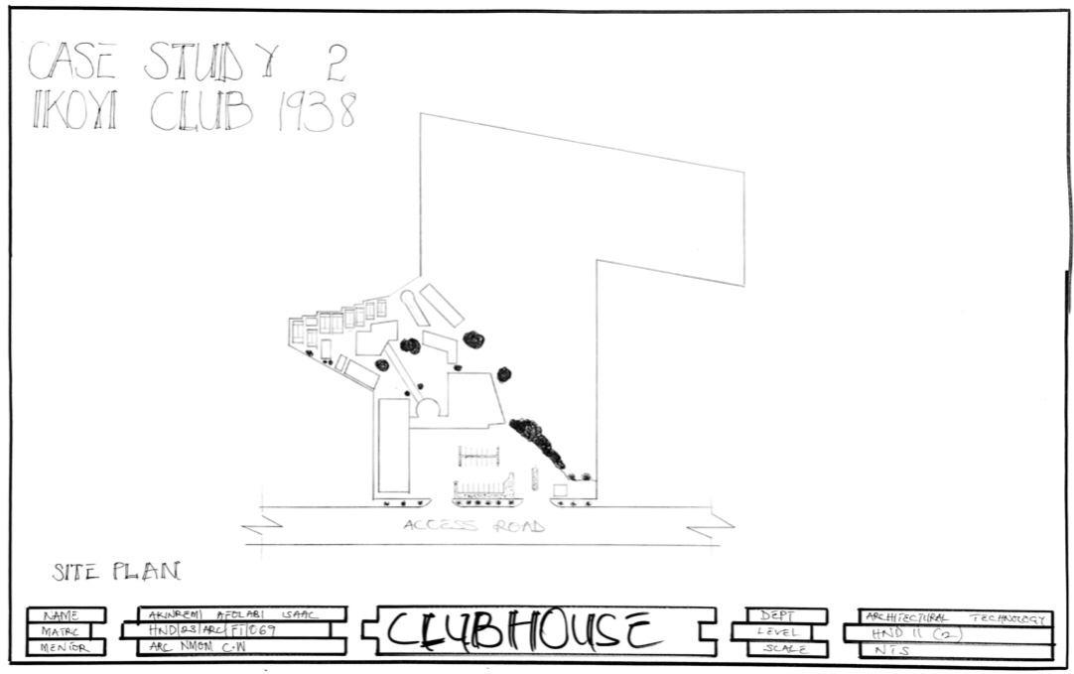
FIG: 2.2. Picture showing site layout of case study two at Ikoyi club 1938.

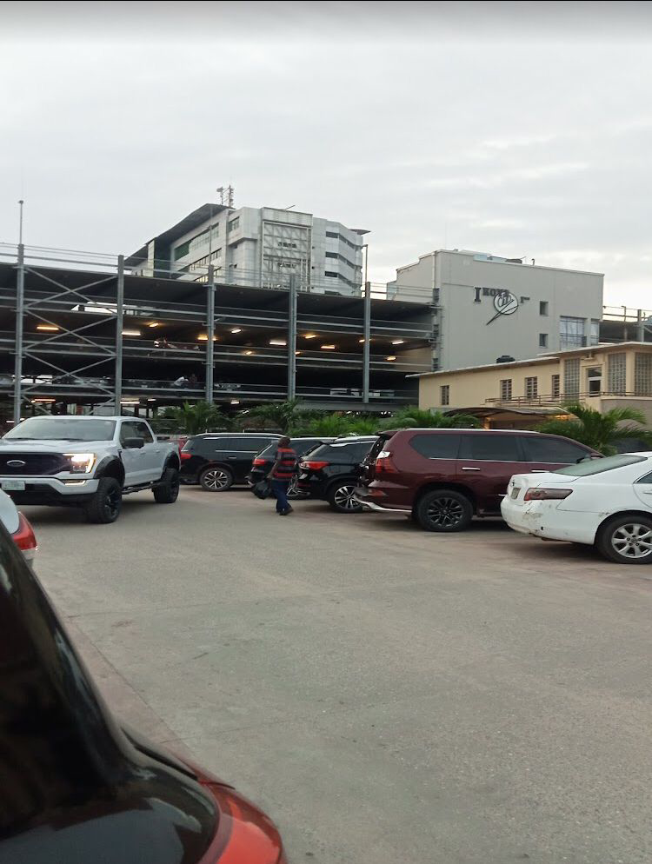
PLATE:2.1. Picture showing entrance view of Ikoyi club 1938 layout.

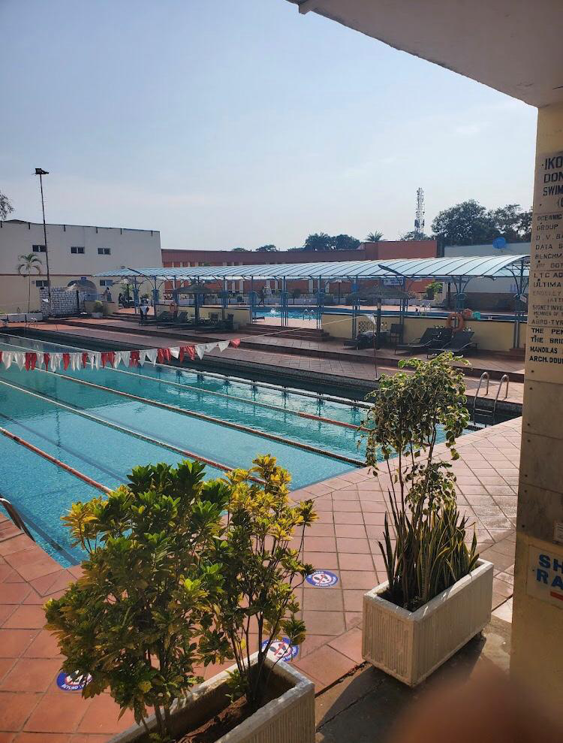
PLATE: 2.2. Picture showing outdoor sport view of Ikoyi club 1938
3.3 CAASE STUDY 3
ILORIN GOLF CLUB
3.3.1 HISTORICAL BACKGROUND
Ilorin Golf club, located off GRA road, KWARA State. It was established in 1978, club was formed to promote the sport of Golf among residents and visitors. It features an 18- hole Golf course that is known for its beautiful landscape and challenging layout.
Over the years, it has hosted various local and national tournaments, Contributing to the growth of golf in Nigeria. It also serves as a social hub. Breaking together golf enthusiasts From different backgrounds to enjoy the sport and build friendships.

3.3.2 MERITS AND DEMERITS
MERITS
- The design often integrates well with the natural landscape, enhancing the aesthetic appeal.
- Safety for visitors.
- Simple arrangement for activity space.
DEMERITS
- Inadequate number of facilities
- Insufficient natural light
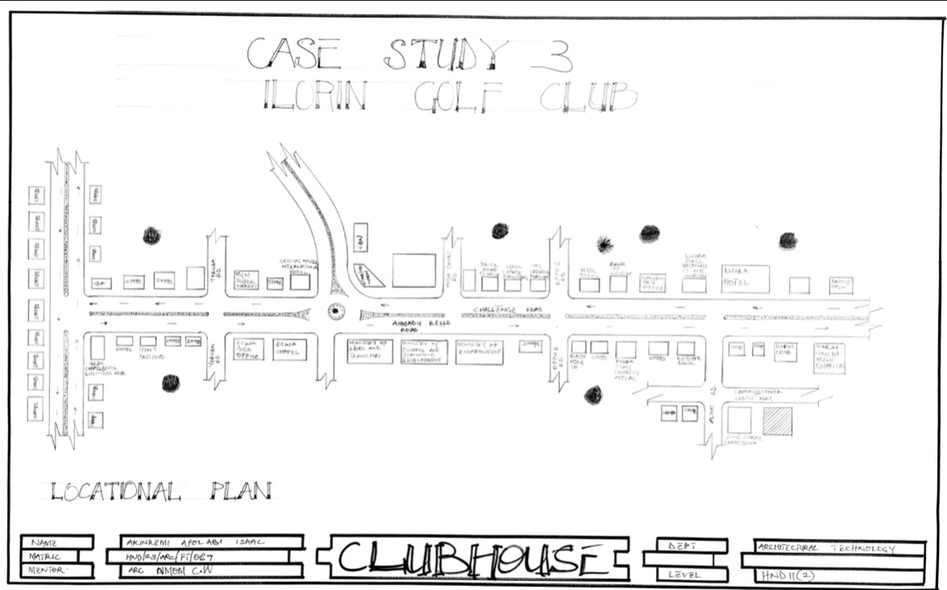
FIG: 2.1. Picture showing location plan of case study three at Ilorin golf club.

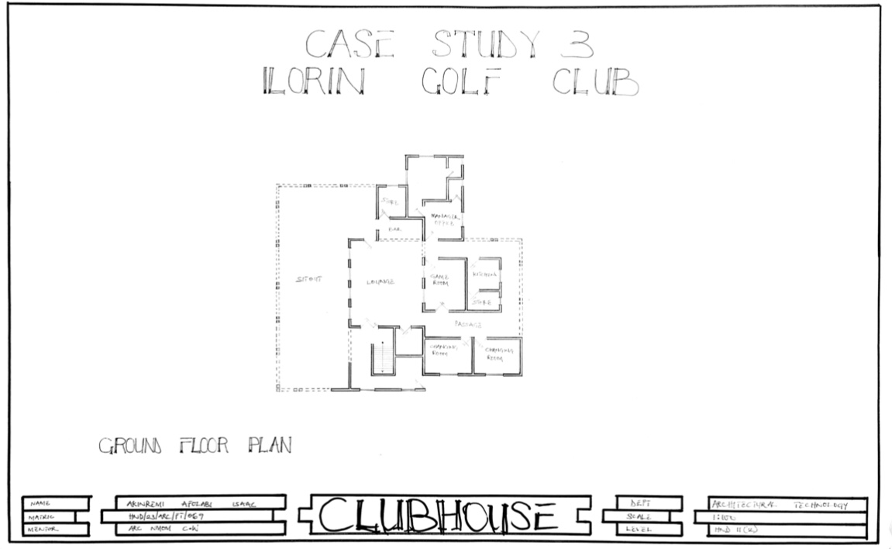
FIG: 2.2. Picture showing floor plan of case study three at Ilorin golf club.
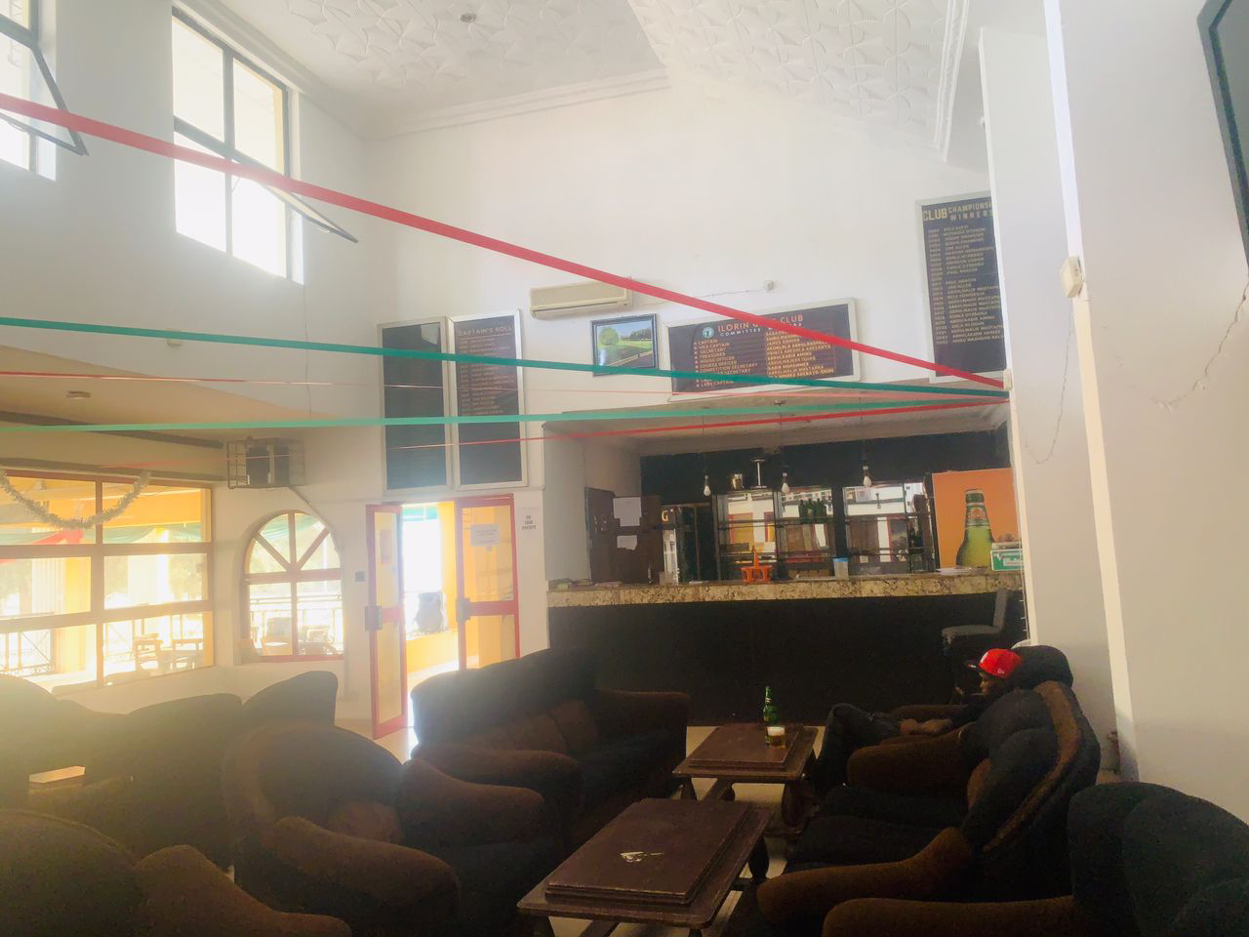
PLATE: 2.1 Picture showing lounge view of case study three at Ilorin golf club.

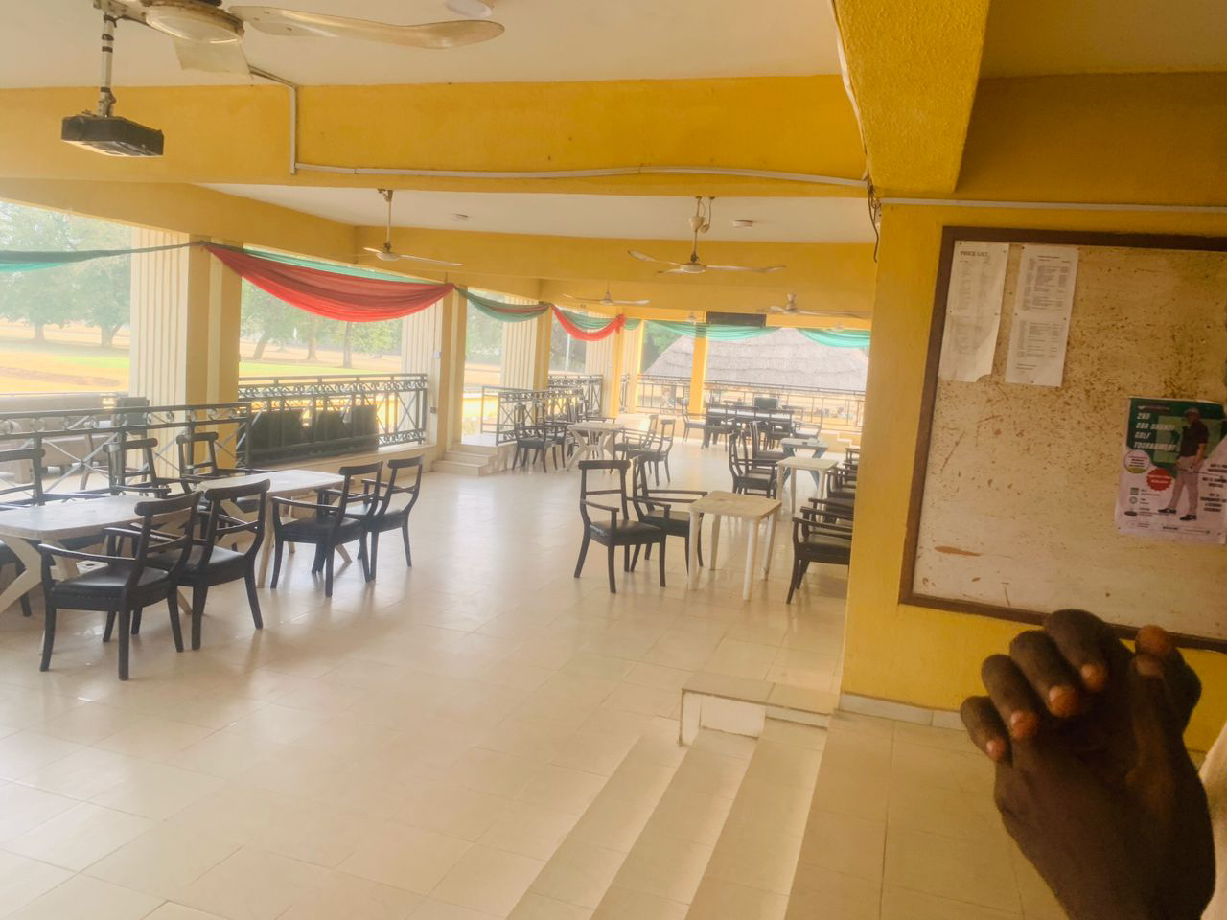
PLATE:2.2 Picture showing the outdoor sit out of case study three at Ilorin golf club.
3.4 CASE STUDY 4
GLEN COUNTRY CLUB [ONLINE]
HISTORICAL BACKGROUND
Located in the picturesque city of Cape Town, South Africa. It was established in 1955.
Glen country clubIs is a hub of excitement and leisure. This exclusive club Offer a wide range of invigorating , activities that cater to individuals of all ages and interests.
The Glen country club is more than just a sports facilities, it is also a sought-after venue for private and corporate functions with it's elegant and versatile spaces. The club provides the backdrop from memorable events, whether it’s a wedding reception, a milestone celebration, or a professional gathering.
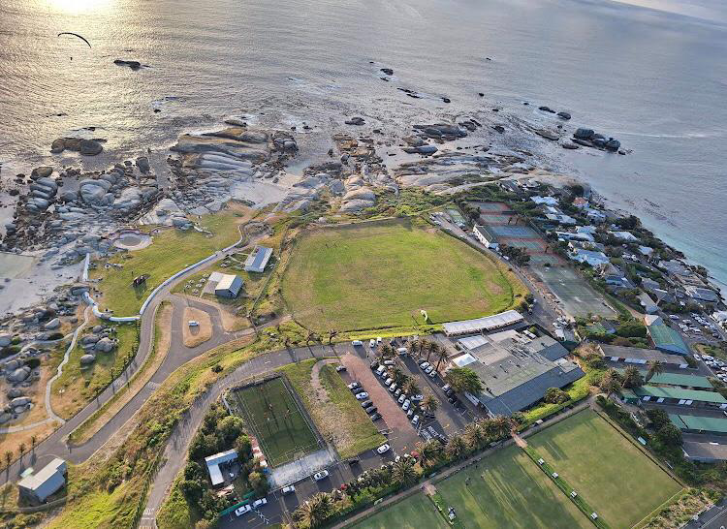
PLATE: 2.1. Picture showing site layout view of case study four at Glen club.
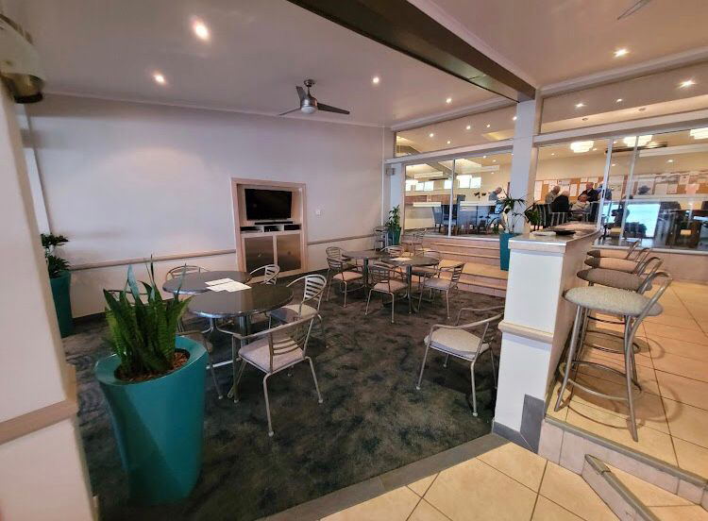
PLATE: 2.2. Picture showing lounge view of case study four at Glen club.
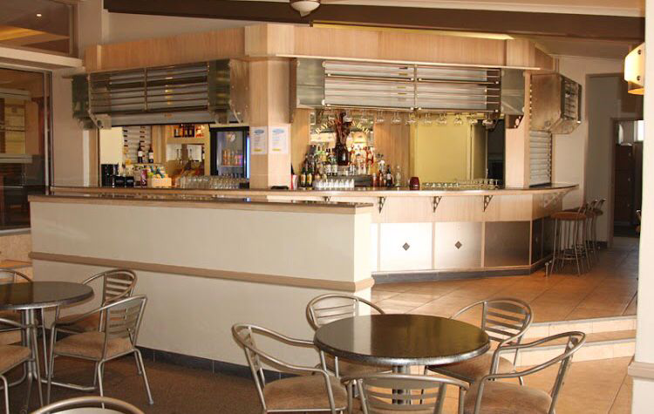
PLATE: 2.3. Picture showing Bar view of case study four at Glen club.

3.5 CASE STUDY 5
THE LOS ANGELES COUNTRY [ONLINE]
3.5.1 HISTORICAL BACKGROUND
Located in Beverly Hills, Los Angeles, California, USA. It was established in 1911.
LACC Has a reputation for exclusivity and as being a gathering place and social hub for many prominent figures in entertainment, politics and business over the years.
It’s facilities have evolved to include dining areas, tennis courts, and other recreational amenities making it a premier destination for its members.

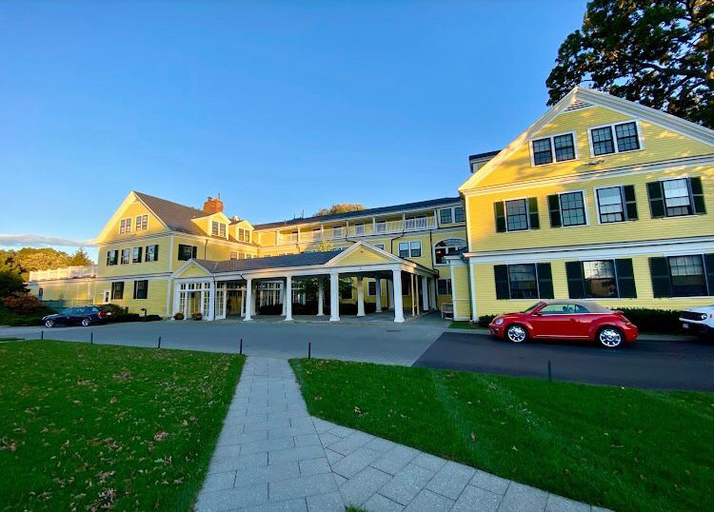
PLATE: 2.1. Picture showing the exterior view of case study five at The Los Angeles club.

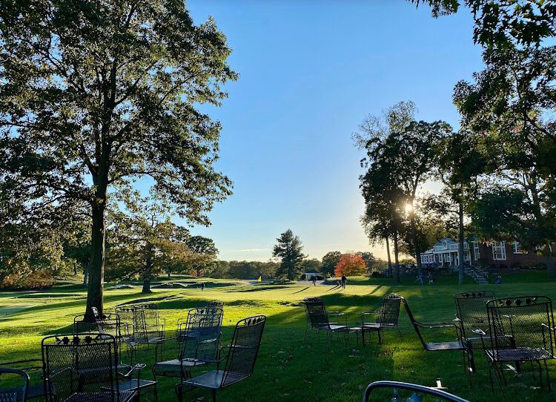
PLATE: 2.2. Picture showing the sit out of case study five at The Los Angeles club.

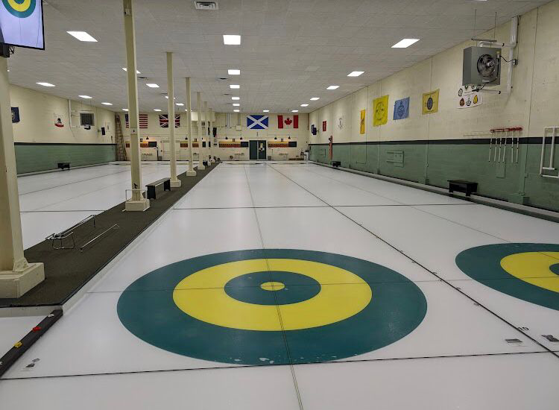
PLATE: 2.3. Picture showing the indoor sport space of case study five at The Los Angeles club.

CHAPTER FOUR
4.1 DESIGN CRITERIA
THE DESIGN CONSIDERATIONS OF CLUBHOUSE:- which are
- Function before form method
- Form before function method
In designing project the function before form methods used a consonance with his method, the following are the design criteria for this project
1. FUNCTIONAL
In term of functional requirement the following are the design criteria
- To meet the functional standard of clubhouse and to allow easy flow of movement
- To Whom It May Concern achieve enough conducive for members and the staff.
- To allow for easy coordination of the various unit.
- To disallow the penetration of sun ray, insect and crawlers into the building
- To protect the user of walk way corridor and veranda from some ray and rain.
2. FORM
Under this following are the design criteria:
- For familiarity and harmony the lounge hall conform with pattern
- Achieve natural lighting and natural ventilation where necessary.
- To avoid direct penetration of sun rays and driving rain into the class room especially building class room and hostel.

4.2 BRIEF ANALYSIS
There are usually major aim of clubhouse and aim of administrative block in Nigeria.
There are usually different unit in a clubhouse depending on the design type and function to this project has the following suitable use.
- Administrative block
- Guest house
- Changing room
- Private meeting room
a. Administrative structure
This is paramount determining the functional relationship expected between and within the different facilities . The hierarchical structure and possible directions of work flow are the two basic factors that are involved in the administrative structure. Administrative hierarchy basically pertains the different steps and levels that exist in the highest officer in the unit and subsequently to the office of the chief executive which in this case is the House governor. This provides the required horizontal and vertical separation in the building .
Direction of work flow explains the path taken by the core administrative.
- Entrance
- Reception
- Offices
- Cafe
- Security control room
- Indoor game room
- Fitness
- Bar/ Lounge
- Restaurant
- Kitchen
- Female changing room
- Male changing room
- Store
- Conveniences
- Pool
- Pool maintenance
- Bar Attendant
- Janitor
- Exist

4.3 THE SPACE ALLOCATION IN CLUBHOUSE BUILDING DESIGN
S/N | UNITS | DIMENSION (M) length x breath | NUMBER REQUIRED | TOTAL AREA ( M²)
1 | Entrance | 4.75 x 1.8 | 1 | 8.55
2 | Reception | 4.75 x 5.4 | 1 | 25.65
3 | Offices | 3.6 x 3.6 | 2 | 12.96
4 | Cafe | 5.6 x 5.4 | 1 | 30.24
5 | Security control room | 5.6 x 4.5 | 1 | 25.2
6 | Fitness | 7.2 x 14.33 | 1 | 103.14
7 | Store | 3.6 x 5.4 | 1 | 19.44
8 | Indoor game room | 6.6 x 10.45 | 1 | 68.97
9 | Store | 3.6 x 2 | 1 | 10.8
10 | Convenience | 5.63 x 3.6 | 2 | 20.25
11 | Changing room | 6.53 x 3.6 | 2 | 31.32
12 | Bar | 14.55 x 14.33 | 1 | 208.43
13 | Bar attendant | 3.6 x 3.6 | 1 | 12.96
14 | Store | 3 x 3.6 | 1 | 10.8
15 | Void | 5.4 x 2.1 | 1 | 11.34
16 | Restaurant | 12.2 x 14.85 | 1 | 181.17
17 | Store | 3.6 x 5.63 | 1 | 20.25
18 | Kitchen | 4.05 x 3.9 | 1 | 15.8
19 | Exit | 4.05 x 1.5 | 1 | 6.07
20 | Janitor store | 2.4 x 3.3 | 2 | 7.92
21 | Pool maintenance | 2.2 x 2.1 | 2 | 4.62
22 | Pool | 3.9 x 9 | 1 | 35.10
 |  | TOTAL

4.4 FUNCTIONAL RELATIONS
Functional relation is also known as bubble diagram and it express how each unit in a design is relatively functioning with each other. It shows closeness of one unit to another.
In this project, the functional relationship was done before any sketch and this is what aids, this project to function better

4.5 FIRE PROTECTION DEVICES
Building regulation and construction With insurance policy survey take care of the fire precaution needed in a clubhouse. This should be carefully observe and periodically reviewed to ensure that the fullest use can be secured from the protection facilities In an emergency fire, not only fire caused by people distraction can lead to fire accident but all the reason electric problem e.t.c
The assembly point are to be located at strategic position in case of any fire outbreak. Fire resistant material like alarm system is to be installed so that everyone could be alerted in case of hazard. Fire retarded floor and wall finishes and to be used e.g granolithic or terrazzo floor finishes, textcote wall render e.t.c

4.6 SITE PLANNING
The site is planned in order to give it a define ship and also to reflect the activities taking place. The location of the administrative block and other facilities, within the site follows this main principal.
- The Zoning principal [noisy, semi noise, quiet zone] is reflected which enhance placement of structure in respect to the level of egress and ingress.
- Structures are place in accordance to usage.

4.7. THE PROJECT SCOPE
This following are the project scope:-
- Administrative block
- Guest house
- Changing room
- Private meeting room
- Outdoor sports
- Car parks
- Security post

4.8 DESIGN CONCEPT
Firstly the process of analyzing the design into necessary units required for the design is based on the data collected to research methodologies
Secondly the grouping of the various units together according to the relationship with one another is also based on the data and information gathered.
The concept of the design was derived from the functional relationship and bubble diagram prepared out of the design brief within the clubhouse. The relationship of these various activities with one and other within different units that make up the design And also based on the zoning in accordance with the level of privacy of the units.

CHAPTER FIVE
5.1 PROJECT APPRAISAL
There are people that feel that, imagination and reason cannot be intermingle. The utility are irreconcilable, a useful building should be a design for utility and be recognized for what it is, and a beautiful building should not be required to be useful. I totally disagree with this. I believe and repeatedly demonstrate throughout this project and any other project whatever, that a useful building can also be beautiful, that has therapeutic value, and beauty is worth paying for. This belief, embracing the broadest concept as well as the smallest details and transcending functionalism, poses a challenge for any architect engaged in Clubhouse design to satisfy the highly demanding functional requirements and still to create a beautifying building.
5.2 CONSTRUCTION METHODOLOGY AND MATERIAL
(a) Doors
Doors types and sizes depend on door location but generally range from 750mm for toilets, 900mm for offices and administrative rooms, 1200mm for main entrance , 1500mm for entrance, 1800mm for indoor game room and open space for exist. All the doors leaves shall be purpose made solid cored flush door everlasting fire resistance and noise reduction. The doors are also located in the plan so as to allow for easy reach (especially during emergency) self directional and to shorten the distance, the patient are to undergo.

(b) Windows
Windows to toilets, bathrooms, laboratories office and other rooms are of reflective glasses. The words are screened with mosquito wire gauge. This enhances free circulation and control of the air into the buildings.
(c) Ceiling
The ceiling height is 3,400mm. this is to allow ceiling fan where necessary and hanging of fluorescent lamps. This ceiling are made of P.O.P [Plaster of Paris]. This arrangement will reduce the cost of timbers and enhance aesthetic appearance. Well painted and smooth finished are to be used on the ceiling.
(d) Roof
Roof members are of hardwood that are well seasoned and are treated against pests and another wood defects. Tie being, rafter and the post are of 150mmx75mm type while the purling are 50x75mm each. Ceiling noggins and joist are of 50x50mm softwoods, well seasoned and are places 1800mm center to center while purling are 600mmx 1200mm center are arranged alternatively. This arrangement will reduce sagging and collapsing of the rood members due to the rain and the wind load on the roof. The roof system is the gutter roof.
Colored long Span aluminum rooting sheets shall be use as roof covering this will reduce heat, withstand fogs, heavy am, wind load ant above all enhance aesthetic appearance of the building

5.3 DESIGN SERVICES
The design services are the building member that makes a building functional for human comfort, that is, thing that are not building worth but are found in the building. The design service discuses those domestic system which affect human health, safety and comfort as well as circulations, ventilation, lighting. plumbing, electrical installation, acoustics, waste disposal, fir protection and external works.
5.3.1. VENTILATION
Ventilation is required for the comfort of the building users, therefore effort have been made to provide natural ventilation with the aid f paper orientation of the building.
LIGHTING
To enhance clear illumination and cool rooms in any health institution health centre fluorescent lamp in twins shall be used in all the rooms. However, operating lamps may be added in the theater. The site is supplied with NEPA and U-KV transformer is located not too far from the proposed main gate to health centre.
Solar energy and two stand-by generators are provided on the site to serve as an alternative power supply.
5.3.2. PLUMBING
The plumbing works for these projects are made to meet the standard requirement of the local building coded which specify materials that are acceptable for use tor water supply and drainage system.
Water service pipe and water distribution pipes are made of red-brass while the drains above and underground building are made copper.
WASTE DISPOSAL
Sink is provided for the kitchenette wash-hand basins are provided in kitchen. Principal office, toilets, class rooms etc as device for collecting soil water which eventually disposed to the septic tanks and soak away
5.3.3 ELECTRICAL INSTALLATION
The wiring system for this project is carried out, taking safety as the primary consideration. Conduit wiring system is the type of wiring system that is employed in this project which reduce the risk of electrical shock and improve the aesthetics quality of the building surfaces.

FIRE PROTECTION
Fire safety has not been left out; this becomes an important consideration in the kitchen where most disaster is caused by fire. Generally, fire extinguisher are recommended to be provided at appropriate points, fire resisting materials such as doors, windows and ceiling arc also recommended.
Fire alarm system is to be installed, so that everyone could be alerted in case of any hazard.
EXTERNAL WORKS
All the external woks such as wall and roof should be of high quality which make the building to be strong enough and structurally okay.

5.4 SUMMARY
I believe that I have done enough through research into the planning and designing CLUBHOUSE in this part of the state, In fact, at the end of this project I almost become an educational sector, This is also applied to the reader of this write up by the time he/she covers the whole pages.
The project has enabled me and the readers to know what exactly the special need education is all about, This enabled me to evaluate and analyze sufficiently and efficiently the needs of this project. Aesthetic value and functional needs of project of this type are very difficult to combine, This has been successfully done in this project.
Environment problems will always associated with special needs education.
Finally, this project fulfills my ambition to contribute my little quote to the development of ASA Local Government Area Kwara state and Nigeria whole.

5.5 RECOMMENDATIONS
I recommended that at least one Clubhouse should be built in every state to encourage people to communicate and interact with eachother.
STATEMENT OF PROBLEM
In designs, problems are bound to be solved. These includes: creating adequate natural/ cross ventilation, circulation / traffic control, achieving aesthetically appealing structure.
The architectural problems arise due to the nature of the design either as its functions, environmental religion, cultural background, etc.
The character of the building also poses a problem
Case studies are historical documents used for this purpose. Historical information is gotten by first looking at the issue as a whole before considering them in isolation. Through this process, we obtain a clear comprehensive knowledge of the subject matter we are tacking and the circumstances that lead to the concept.

BIBLIOGRAPHY
Conrad- Garrisi, D.L. [2011] inter/intrapersonal variables in Clubhouse
Coniglio FD, Hancock N, Ellis LA. Peer support within clubhouse
Berbeni; T, Hamilton, E.C. and Lam M. Sutherland .M. (ed) (2008), Learning, Yale University Press.
British Council; (2001), Information on Special in ELT Ernest Neurfert; Architect Data Third Edition.
Mckeown, S. (1999) le profession technology; clubhouse 120, Pp 30-33
Wilson, D.R; (1997), Accessible Authentically Using Internet Resource with clubhouseForeign Language Learners in Difficulty;
Wing, B.H. (ed.) (1996) Northeast Conference Reports.
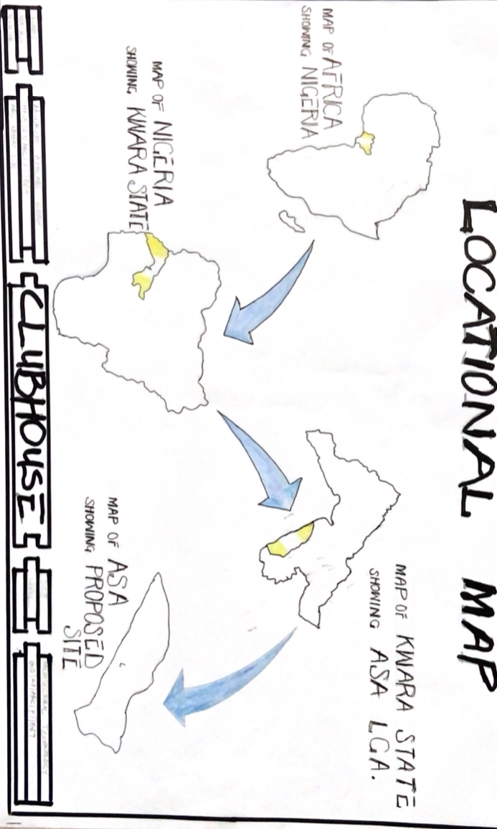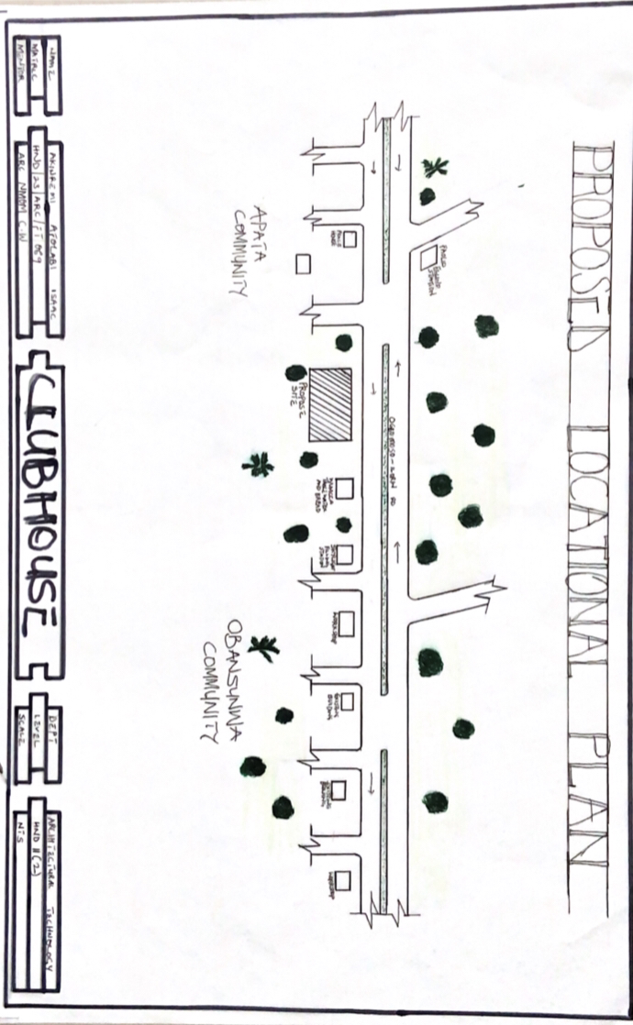
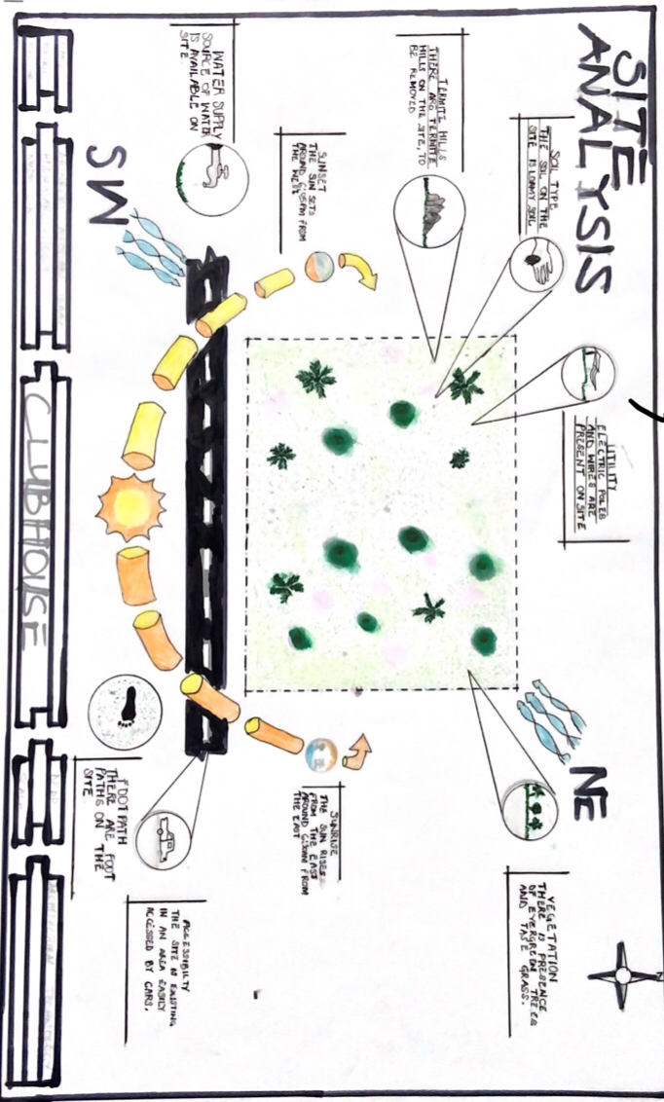
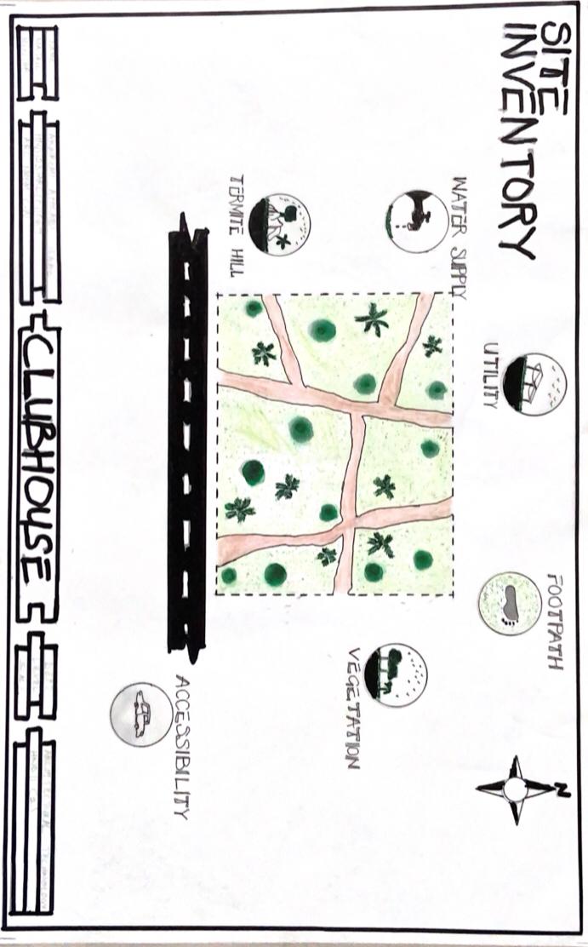
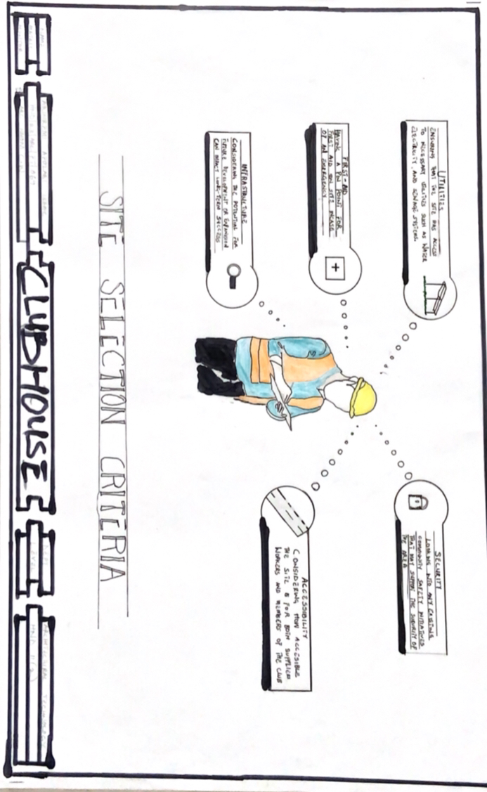
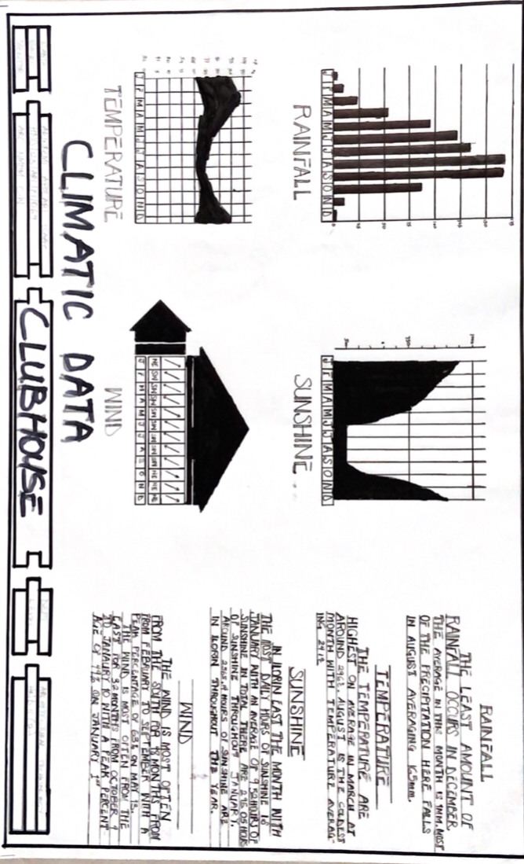
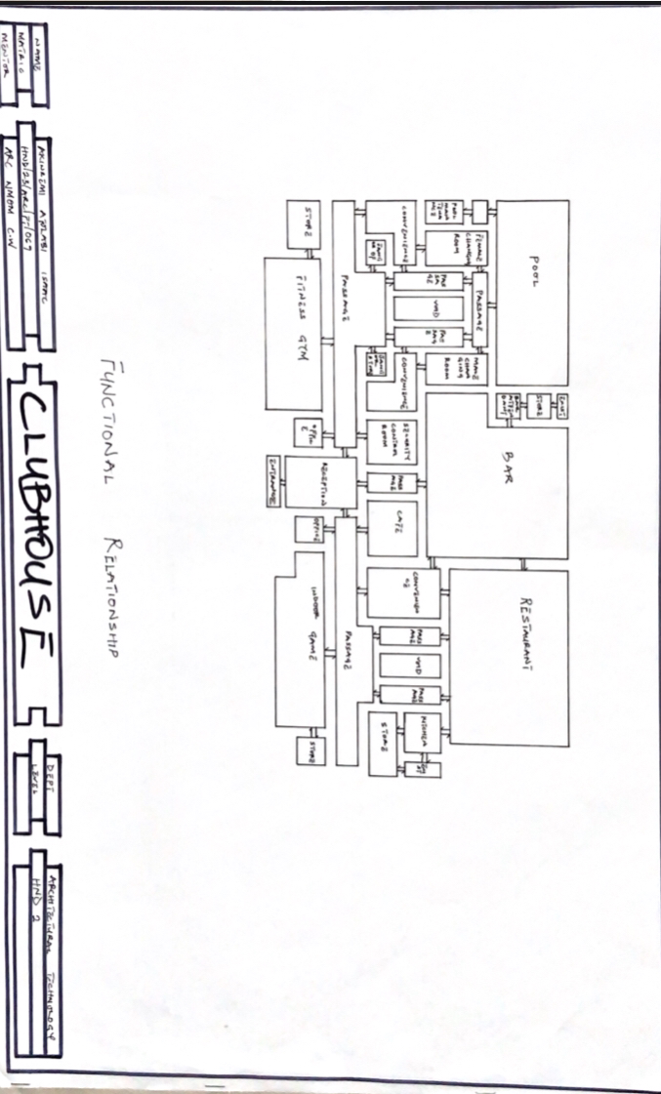
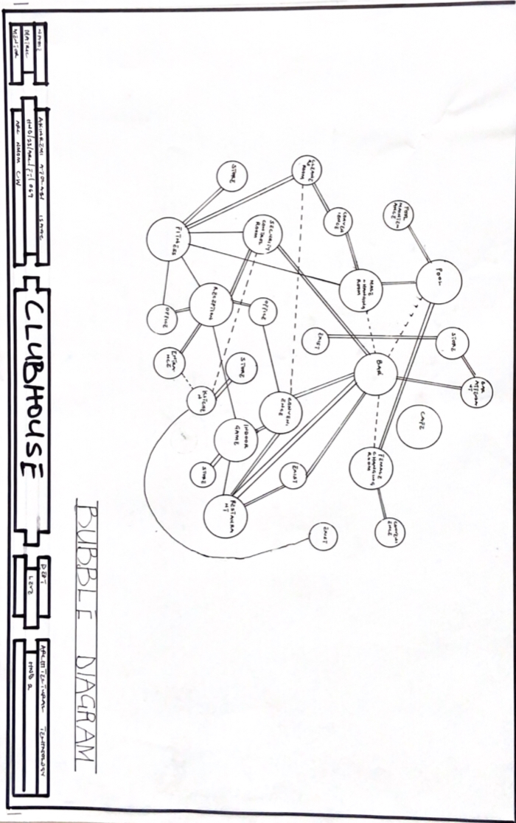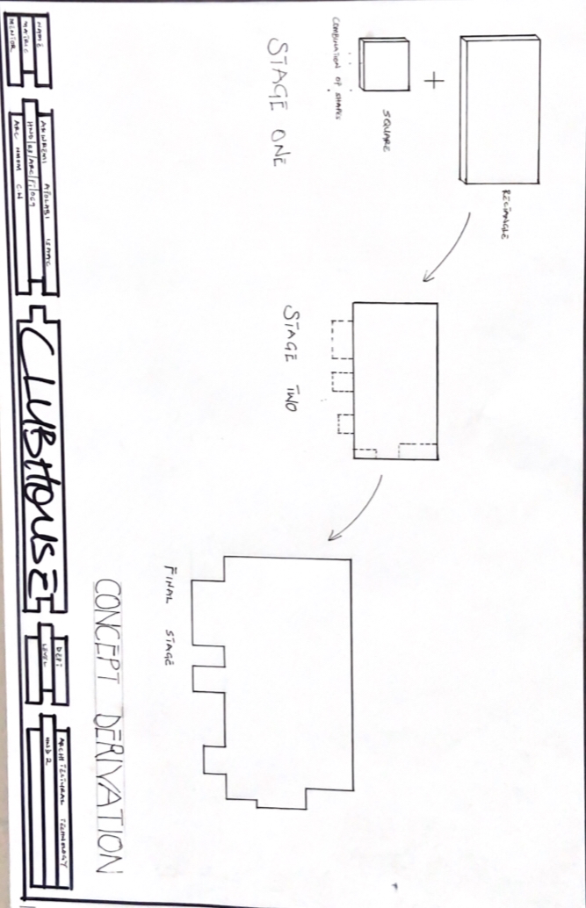ko
