A PROJECT REPORT
ON
PROPORSED MATERNITY HOMEFOR (KWARA
STATE GOVERNMENT)
ILORIN SOUTH, KWARA STATE
BY
OBAYOMI OLATOMOLA OLALEYE
ND/23/ARC/PT/0040

A PROJECT REPORT SUBMITTED TOTHE DEPARTMENT OF
ARCHITECTURAL TECHOLOGY, INSTITUTE OF
ENVIRONMENTAL STUDIES, KWARA STATE POLYTECHIC, ILORIN

INPARTIAL FULFILMENT OF THE REQUIREMENT FOR THE
AWARD OF NATIONAL DIPLOMA (ND) IN ARCHITECTURAL
TECHNOLOGY.

JULY, 2025

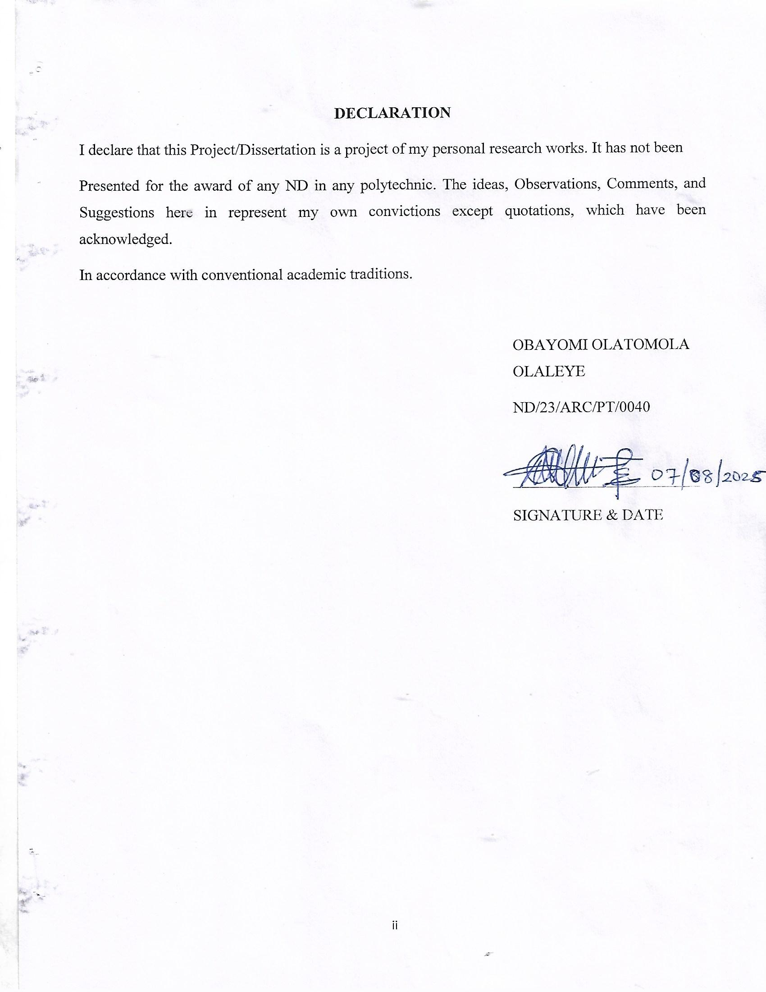
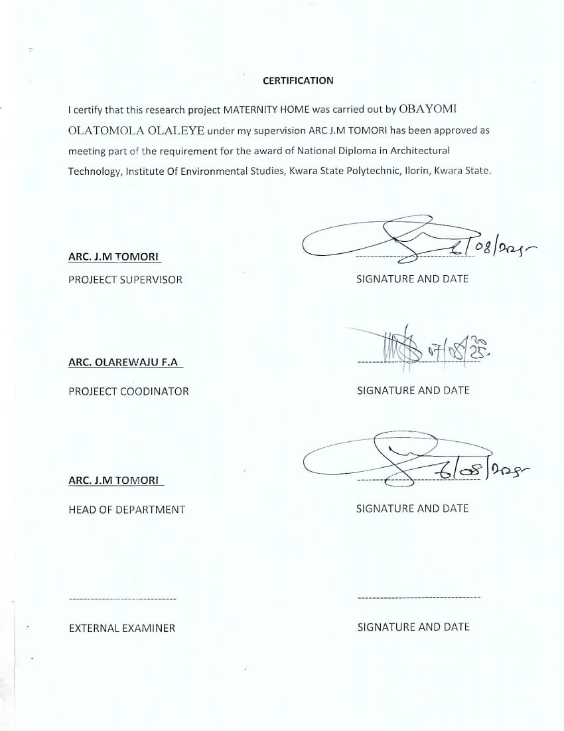
ACKNOWLEDGEMENT
My profound gratitude goes to Almighty God, the creator of universe and fountain of all wisdom whose umbrella of guard and guide. I seek refuge through thick and thin of years of study.
I will also like to appreciate my project supervisor in person of ARC J.M TOMORI whose contribution Prepare me for the challenges in the field and for his immense contribution is all ramification towards the completion of this research work. He encourage me and open the door of interaction with him. I pray Almighty God will shower his blessing and mercy over him, your family and may you live to reap the fruit of your labour.
I also want thank and appreciate the effort of all the Lectures in Architectural Technology Department, ARC FAMILUA O.S, ARC MOH SHERO, ARC OLARIWAJU F.A, ARC CHUCWUMA NMOM, who taught and give lasting advice’s that led to the success of my program, Almighty Allah will meet everyone at the point of needs.
I would also show my profound gratitude to my parents MR and MRS O OBAYOMI, Engr S A OBAYOMI, ARC DARAMOLA for their Immeasurable motivation, advices, efforts, and prayers on me for the completion of this program.
My Lovely sisters and brothers. Almighty God shower his endless blessing, mercy, unlimited grace, joy, happiness without sorrow, sound health overall and may Almighty God meet everyone at the point of your needs.
Precious friends: My lovely friends Tunde, Ayo, Lateef, Tohib, Sodiq. Almighty God shower his blessing, grace, and happiness with sound health over you all and our prayer (AMEEN)
I would also show my appreciation for the effort of an unforgettable of MR O OBAYOMI, who advise me to carry on my journey. Almighty God bless you and grant your heart desires, good health over you.
Lastly ,I would like to appreciate the effort of my colleagues in department, school, and hostel, I whole heartedly say a VERY BIG THANK YOU, I appreciate you all, May Almighty God bless you all.
Above all, my utmost thanks go to the all sufficient God, the fountain of my wisdom, for his great and protection over my life, for his undying love, support and guidance throughout my period of learning and also for in sighting writing this project without him am nothing.

DEDICATION
This project work is dedicated to Almighty God who has been providing all my need for his blessing and mercy over me all through the program.
And to my parent, my sisters, my brothers, friends, love one’s and supervisor who assist me financially, spiritually, mentally and guide me through my academic pursuit. May Almighty Allah shower his blessing and mercy over you all.

TABLE OF CONTENT
TITLE PAGE…………………………………………………………………………....i
DECLARATION………………………………………………………………………..ii
CERTIFICATION……………………………………………………………...…..…...iii
ACKNOWLEDGEMENT……………………………………………………………....iv
DEDICATION…………………………………………………………………………..v
TABLE OF CONTENTS…………………………………………………………..…....vi
LIST OF TABLES……………………………………………………………………….x
LIST OF FIGURES……………………………………………………………………...xi
LIST OF PLATES……………………………………………………………………....xii
LIST OF APPENDICES……………………………………………………………...…xiii
ABSTRACT………………………………………………………………………….….xiv
CHAPTER ONE
  - INTRODUCTION…………………………………………………………………...1
1.2 DEFINATION…………………………………………………………………….....3
1.3 HISTORICAL BACKGROUND……………………………………………………3
1.4 AIMS AND OBJECTIVES ………………………………………………………... 4
1.5 PROJECT JUSTIFICATION …………………………………………………….... 4
1.6 CLIENT BACKGROUND………………………………………..………………….4
1.7 SCOPE OF THE PROJECT………………………………………………...………. 5
1.8 RESEARCH METHODOLOGY…………………………………………………… 5
CHAPTER TWO
2.1 LITERATURE REVIEW…………………………………………………………...6
2.2 HISTORICAL BACKGROUND…………………………………………………...6
CHAPTER THREE
3.1 CASE STUDIES…………………....………………………...........................………6
3.2 SELECTED CASE STUDIES………………………………………………………..6
3.3 CASE STUDY ONE………………………………………………………….……....7
3.3 CASE STUDY TWO…………………………………………………………….…...11
3.4 CASE STUDY THREE………………………………..............................……...…...13
3.5 ONLINE CASE STUDY……….…………………………............................…….....15
3.6 DEDUCTION…... ……………………………………….....................................…..17
CHAPTERFOUR
BRIEF HISTORICAL BACKGROUND………………………………..…………........18
LOCATION AND SETTING OUT…………….………….....................……….….......19
POPULATION…………………………………………………………………..............19
SITE INVENTORY……..…………………………………………………....................21
SITE ANALYSIS…….………………………………………………………….............21
SITE SELECTION AND JUSTIFICATION……….………………………………........22
LOCATION ….. …………………………………………………...……………........22
ACCESSIBILITY………….……………………………………..………………...........22
INFRASTRUCTURE FACILITIES…………..................................................................23
TOPOGRAPHY……………………………………………...………………..........................23
SOIL STRUCTURE…………………………………………….…………......................23
GENERAL CLIMATE CONDITION……………………………………………............23
RELATIVE HUMIDITY………………………………………………............................23
WIND…..............................................................................................................................23
TEMPERATURE………………………………………………...…………….................24
VEGETATION…………………………………………………..………….......................24
ROAD …………………………..........................................................................……………24
WATER AND ELECTRICITY……………………………………………………………..…............…...24
DESIGN CRITERIA…………………………………………..............................…..…….25
DESIGN BRIEF 25
DESIGN ANALYSIS 25
SPECIAL ALLOCATION 26
PLANNING PRINCIPLE… 28
CHAPTERFIVE

5.0 APPROACH TO THE DESIGN………………………………………………….…………….…………………………..36
5.1 TECHNOLOGICAL AND ENVIRONMENTAL CRITERIA……………………………..............................36
5.2 ESSENTIAL SERVICE REQUIRED.............................................................................................38
5.3 ENVIRONMENTAL CONDITIONS TO BE ACHIEVED……………………...……………….…………………..39
5.4 PERFORMANCE STANDARD…………………………………………………………………….……………………….40
5.5 LEGAL ISSUE & PLANNING REGULATION………………………………………………..………………………..40
5.6 BEHAVIORAL PATTERN AND CONSIDERATIONS...................................................................40
5.7 CONCLUSIONS AND RECOMMENDATIONS…………………………………………..............................41
REFERENCE………………………………………………………………………………........................................42
APPENDICES…………………………………………………………………………………………………..……………………..45

LIST OF TABLES

TABLE 4.3.1; SHOWING THE POPULATION OF THE GENDER 25

TABLE 4.11.2; SHOWING SPACIAL ALLOCATION OF FLOOR PLAN… 30

LIST OF FIGURES
FIG 3.3.1; SHOWING LOCATION PLAN OF CASE STUDY ONE… 9
FIG 3.3.2; SHOWING FLOOR PLAN OF CASE STUDY ONE… 9
FIG 3.4.4.3; SHOWING LOCATION PLAN OF CASE STUDY TWO… 12
FIG 3.4.4; SHOWING FLOOR PLAN OF CASE STUDY TWO… 13
FIG 3.5.5; SHOWING LOCATION PLAN OF CASE STUDY THRE… 15
FIG 3.5.6; SHOWING FLOOR PLAN OF CASE STUDY THREE… 16
FIG 4.2.7; SHOWING LOCATIONAL PLAN OF THE PROPOSED SITE… 24
FIG 4.4.8; SHOWING SITE INVENTORY OF THE PROPOSED SITE… 26
FIG 4.5.9; SHOWING SITE ANALYSIS OF THE PROPOSED SITE… 27

LIST OF PLATES

PLATE 3.3.1; SHOWING FRONT VIEW OF CASE STUDY ONE…………………………………………….10
PLATE 3.3.2; SHOWING LEFT VIEW OF CASE STUDY ONE………………………………………………..10
PLATE 3.3.3; SHOWING BACK VIEW OF CASE STUDY ONE……………………………………………….11
PLATE 3.3.4; SHOWING RIGHT VIEW OF CASE STUDY ONE………………………......................…11
PLATE 3.4.5; SHOWING FRONT VIEW OF CASE STUDY TWO…………………………………………….13
PLATE 3.4.6; SHOWING BACK VIEW OF CASE STUDY TWO……………………………………………….14
PLATE 3.4.7; SHOWING RIGHT VIEW OF CASE STUDY TWO………………………..……………………14
PLATE 3.5.8; SHOWING FRONT VIEW OF CASE STUDY THREE.............................................16
PLATE 3.5.9; SHOWING LEFT VIEW OF CASE STUDY THREE …………………….……………………...17
PLATE 3.6.10; SHOWING FLOOR PLAN OF ONLINE CASE STUDY…………………………………....18
PLATE 3.6.11; SHOWING FRONT VIEW OF ONLINE CASE STUDY……………….....................….18
PLATE 3.6.12; SHOWING RIGHT VIEW OF ONLINE CASE STUDY……………………………………....19
PLATE 3.6.13; SHOWING FLOOR PLAN OF ONLINE CASE STUDY……………………………………….20
PLATE 3.6.14; SHOWING FRONT VIEW OF ONLINE CASE STUDY……………………………………...20
PLATE 3.6.15; SHOWING BACK VIEW OF ONLINE CASE STUDY…………………………………………21

LIST OF APPENDICES
APP 5.1; SHOWING SITE PLAN OF THE PROPOSED PROJECT 37
APP 5.2; SHOWING FLOOR PLAN OF THE PROPOSED PROJECT 37
APP 5.3; SHOWING ROOF PLAN OF THE PROPOSED PROJECT 38
APP 5.4; SHOWING FRONT VIEW OF THE PROPOSED PROJECT 38
APP 5.5; SHOWING SIDE VIEW OF THE PROPOSED PROJECT 39
APP 5.6; SHOWING WINDOW SCHEDULE ………………….………………...…...................................39

ABSTRACT
This researcher work was carried out on the project topic "Maternity home for Ilorin South Kwara state". I felt caring out this project in local government will bring out meaningful result. For easy analysis and understanding, the study is being put into five chapters. Chapter one throws light on general introduction, definition of the project, historical background information of the project title, project justification, aim and objectives of the study, scope of the study, Chapter two, a detailed literature review of some books, case studies and deduction from case studies. The third chapter three also mention about the historical background of the study area, site location and description, site analysis, and geographical location, climatic data, population of the area, social services, and health services. The fourth chapter deals with design criteria, design analysis, space allocation and planning principle. Chapter five deals with design appraisal, construction methodology, services, summary, conclusion and references.

CHAPTER ONE
1.1 INTRODUCTION
A maternity home, or maternity housing program, is a form of supportive housing provided to pregnant women. Maternity housing programs support a woman in need of a stable home environment to reach her goals in a variety of areas including education, employment, financial stability, prenatal care, and more. There are over 400 maternity homes in the United States ranging in size and criteria for admittance. Staffing model is a primary way that maternity homes differ. The three major staffing models are houseparent’s (e.g. a married couple), live-in staff, and shift staff. Additionally, there are a limited number of maternity housing program who operate as a "shepherding" or "host" home. In the "host home" model, women are connected to screened households that offer to provide housing. In other countries, the term "maternity home" may refer to the above described or may describe a temporary residence for pregnant women awaiting birth, which might include women who must travel long distances for medical care or high-risk pregnancies who are receiving frequent care. Maternity homes are not to be confused with maternity hospitals, or other facilities in which women give birth. Another sort of temporary housing for pregnant women are the maternity hostels that have become widespread in countries such as India where commercial surrogacy is big business.
1.2 DEFINITION OF MATERNITY HOME
Here is a clear and concise definition of a maternity home for your project:
Definition of Maternity Home
A maternity home is a specialized healthcare facility designed to provide comprehensive care and support to women during the stages of pregnancy, childbirth, and the postnatal period. It typically offers services such as antenatal check-ups, labor and delivery, postnatal care, neonatal care, family planning, and maternal education.
Maternity homes are established to ensure safe delivery conditions, reduce maternal and infant mortality, and promote the well-being of mothers and their newborns. These facilities may operate independently or as part of a larger hospital, and they can vary in size and scope depending on the community’s needs.

1.3 HISTORICAL BACKGROUND
Historical Background of Maternity Homes

The salvation Army opened its first one in 1886.Other examples include Bethany Home in Minneapolis, later renamed Harriet Walker Hospital.
Prior to the 1980s, housing for pregnant women was offered in larger, institution-like settings that were strongly adoption-oriented. In these homes, confidentiality was a priority due to the social stigma around unwed births and the policies reflected the adoption laws and practices of the time. From these settings grew many of the narratives around maternity homes that continue to this day (e.g. women forced into adoption; preventing birth mothers from seeing their new borns; concealing placement details).
In the early 1970s, Anne and Jim Pierson were pioneers in the host home model and publicly recognized by President Reagan for their family-style method of welcoming pregnant women. Shepherding or host homes grew in popularity in the 1980s and 1990s as a new type of housing resource. In this model, pregnant women in crisis pregnancies were housed within the spare bedrooms in the homes of passionate volunteers during their pregnancy. Several longstanding maternity homes used some version of a host home living environment as the launching point for developing a housing program. Additionally, many founders of longstanding maternity homes (and other pregnancy help organizations) began by welcoming women into their own home.
In the 1970s and 1980s, the adoption process began to grow in flexibility (e.g. changes to father notification, no longer making short-term placements of adopted babies into foster care, making use of probate court adoptions rather than solely via adoption agencies, increased inter-state adoptions.) Offering a more flexible housing option via a new model paralleled the more flexible adoption process. The large, institutional maternity homes began to close during this time.

1.4 AIM AND OBJECTIVES OF THE PROJECT
AIM OF THE PROJECT
To create a functional, safe and aesthetically building environment that supports the physical and emotional needs of expectant mothers, medical staff, and visitors. It focuses on optimizing space planning, ensuring privacy, accessibility and safety, while incorporating natural light, ventilation, and a calming atmosphere to promote healing and comfort
OBJECTIVES OF THE PROJECT
- To design efficient spaces for mutenatal care, delivery postnatal recovery, and antenatal care ensuring smeeth workflows for medical staff.
- To ensure adequate privacy for patients through well planned room layout and sound proofing.
- To create a welcoming and calming environment with ample natural light ventilation and aesthetic elements that reduce stress.
- To incorporate universal design principles to make the facility accessibility to all including pregnant women and individual with disabilities

1.5 PROJECT JUSTIFICATION OF THE PROJECT
This project justify, a well-planned maternity home in Ilorin South which will enhance patient care, optimize operational patient efficiency and support. Architectural consideration will ensure a functional, aesthetically pleasing, and sustainable healthcare facility that meets modern medical standards.

1.6 CLIENT BACKGROUND
The name of my client is BUKOLA SARAKI
Former senator of Kwara state.
Bukola saraki is a Nigerian politician and a businessman who is the former Senetor of Kwara State. He was first elected Senetor under the platform of the People Democratic Party in the year 2011

1.7 SCOPE OF THE STUDY
- Proposed Building
- Emergency Building
- Canteen
- Gate House
- Power House
- Parking Lot
- Apartment
- Access Road
1.8 RESEACH METHODOLOGY
Various avenues were expressed as regards the method of research on order to arrive at a functional and appealing design concepts. The following research methods were employed.
CASE STUDY: This is the method that carried out in which to gain more detailed experience and an my project topic maternity home .
ORAL INTERVIEW: An oral interview in the method I carried out to collect more information by directly engaging with individuals e.g manager the workers, the citizens and other to gain more experience on my project
LITERATURE REVIEW: This is the process by which I carried out in the process of reach, articles, niddles and others materials on my project.
CHAPTER TWO
2.0 LITERATURE REVIEW
2.1 HISTORICAL BACKGROUND OF A MATERNITY HOME
MATERNITY HOME
Maternity homes are specialized healthcare facilities designed to support childbirth and maternal care, where architectural design plays a crucial role in ensuring safety, comfort, and efficient medical operations. Historically, these buildings evolved from simple residential adaptations to purpose-built institutions reflecting advances in medical knowledge and public health. [World Health Organization 2016].
Early maternity homes emphasized natural ventilation, light, and separation of patients to reduce infection risks, often featuring neoclassical or Victorian architectural styles. The 20th century introduced functionalist and modernist designs, focusing on hygiene, streamlined workflows, and clinical efficiency through the use of new materials like steel and glass. [United Nations Population Fund (UNFPA) 2022].
In recent years, maternity homes have embraced patient-centered design principles, incorporating private rooms, calming environments, natural light, and accessibility to create spaces that promote emotional well-being alongside medical care. Sustainable and culturally sensitive architecture also characterizes modern maternity facilities, aiming to provide holistic support for mothers and families.
Maternity homes in the UK are specialized healthcare facilities dedicated to the care of pregnant women, childbirth, and postpartum support. Historically, childbirth took place at home, but with advances in medical knowledge and public health, purpose-built maternity hospitals began to emerge in the 18th and 19th centuries. Maternity homes in the UK reflected Georgian and Victorian styles, with features such as large windows and high ceilings designed to promote hygiene and ventilation. As medical science progressed, these facilities evolved to include dedicated labor wards, operating theaters, and neonatal units, often adopting modernist and functionalist architectural styles in the 20th century.
Today, UK maternity homes emphasize patient-centered care, with private birthing suites, natural lighting, family-friendly spaces, and sustainable design. They provide a wide range of services, including prenatal care, labor and delivery, neonatal intensive care, and postnatal support, playing a vital role in maternal and infant health. [Salihu, H. M. et al. 2015].
Maternity homes in the United Kingdom have a rich history shaped by evolving medical practices, social changes, and architectural advancements. Originally, childbirth was predominantly a home-based event, attended by midwives or family members. However, rising concerns over maternal and infant mortality in the 18th and 19th centuries prompted the development of specialized maternity hospitals. Hospitals designed with functionalist and modernist principles emerged, focusing on efficient layouts, sterile environments, and patient safety. Dedicated labor wards, operating theaters, and neonatal intensive care units (NICUs) became standard. The establishment of the National Health Service (NHS) in 1948 further accelerated the modernization and expansion of maternity services across the UK.
Until the 1750s all births took place at home – except of course where birth occurred unexpectedly! A labour and the recovery afterwards were known as ‘lying-in’. The lying-in period was typically a month, during which the new mother at first recuperated bed-bound, then remained in the house, gradually returning to her household duties. Lying-in ended with the public cleansing and thanksgiving ritual of ‘churching’ performed in the local Church of England.
Lying-in did not take place just anywhere in the home but involved carefully remaking the master bedroom into a dark and airless lying-in chamber. At the first signs of labour, extra linen was draped onto and around the bed and over the windows and doors. The fire was stoked up, and all openings in the room closed – sometimes even gaps and the keyhole were stuffed with fabric. It was thought air and light were harmful, and may lead to the dreaded puerperal fever, a tremendously dangerous illness (essentially an infection) experienced after childbirth. Men were removed from the room, and replaced by a gathering including the midwife and at least five women to aid the birth, called the ‘gossip’. The room was darkened further after birth, as it was thought light could damage the new mother’s eyesight, already weakened by the effort of childbirth.[ Olanrewaju, A. 2018].
From the 1750s the domestic spaces of home birth were made complex by the emergence of lying-in hospitals. These were the first specialist hospitals, and began an era of institutions in general – from spaces of welfare such as asylums and hospitals to those of intellectual gathering like the Literary and Philosophical Society in Newcastle and the Royal Society in London. The lying-in hospitals were philanthropic charities aimed at poor (albeit married) women who lacked the funds to afford decent homes let alone good midwifery care. Although they undoubtedly helped many women, the lying-in hospitals were devised and controlled by the new men-midwives to develop their skills and establish their status. At first occupying large houses, as the century progressed they acquired purpose made buildings. In contrast to the dark and airless domestic lying-in chamber, these were lofty and neo-classical designs, with roomy wards of 6-8 beds and large windows. Their advantages – including light and airy spaces, access to new forms of care and spaces of rest – contrasted with their disadvantages – lack of privacy, a shift in control over one’s own body as it was passed to the institution, the medicalisation of birth and an increased death rate from puerperal fever. [UN-Habitat 2021].
Across the nineteenth-century, birth witnessed various experimental practices in these purpose made spaces. Men-midwives were gradually renamed accoucheurs and then obstetricians. Although the vast majority of women continued to give birth at home – indeed it was not until the 1940s that more than 50% women gave birth in hospital – midwifery care had shifted, and the practices and ideas tested in the hospitals affected home delivery. Light and fresh air were seen as important. Instruments such as midwifery forceps became more common, and men began to be called into the birth chamber in favour of the traditional female midwives, particularly by the middle- and upper-classes. [Osei, C. B. 2017].

CHAPTER THREE
3.1 CASE STUDIES
This is are search or an exercise that is carried out on existing building which is similar to the one researcher is writing on. The objective of a case study is to take a critical appraisal of existing related project with a view to identify the positive and negative aspect of such projects. It is only with time that a project can be adjusted so that it can be successful. The information obtained from the appraisal will guide the designer of new and similar project, the positive aspect of it shall be incorporated in the view proposal while attempts will be made to solve the problem of negative aspects. It is only through this that a designer can better enhance the quality and efficiency of building in the society. For a comprehensive analysis their case studies have been conducted.

3.2 SELETED CASE STUDIES
Case studies are of paramount important. It is an experimental research or analysis carried out on existing building or group of building functionally similar to the one which there search is working.
For any technical design to be meaningful there is always the need for preliminary research effort to be made on this proposal as a very necessary ground work.
The following are case studies of some maternity clinic.
    - Katangua off Ogbomosho, oyo state.
    - Sabo road behind jimoh adelabu petroleum ltd, osogbo osun state.
    - Kwara state polytechnic, Apata yakuba Ilorin Kwara state.

3.3 CASE STUDY ONE
Location; KATANGUA OFF OGBOMOSHO, OYO STATE.

OBSEVERATION
MERITS
- Adequate parking space
- It is well landscape
- Easily accessible from the gate
- Provision of drainage facilities
- Good security arrangement

DEMERIT
- Noisy area
- There is no lab unit in the building

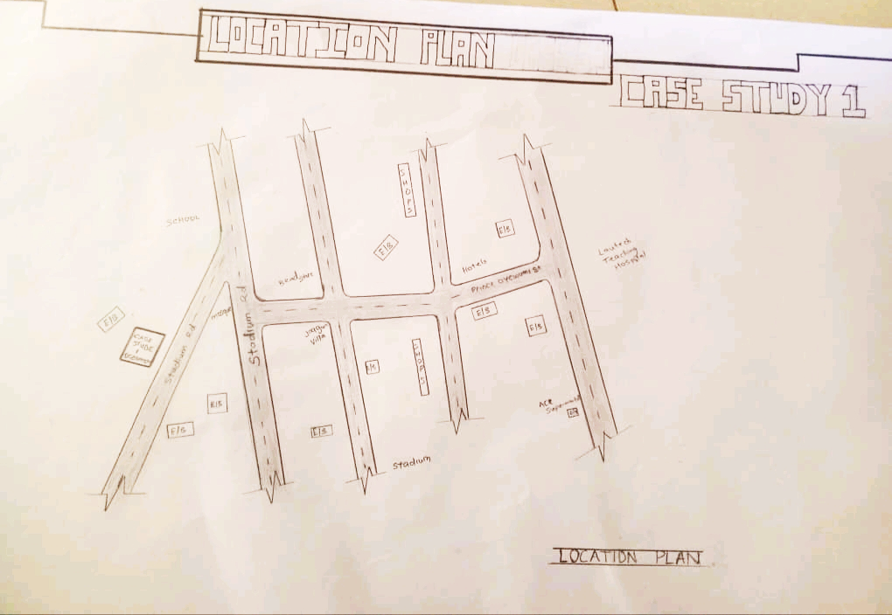

FIG 3.3.1; SHOWING LOCATION PLAN OFCASE STUDY ONE

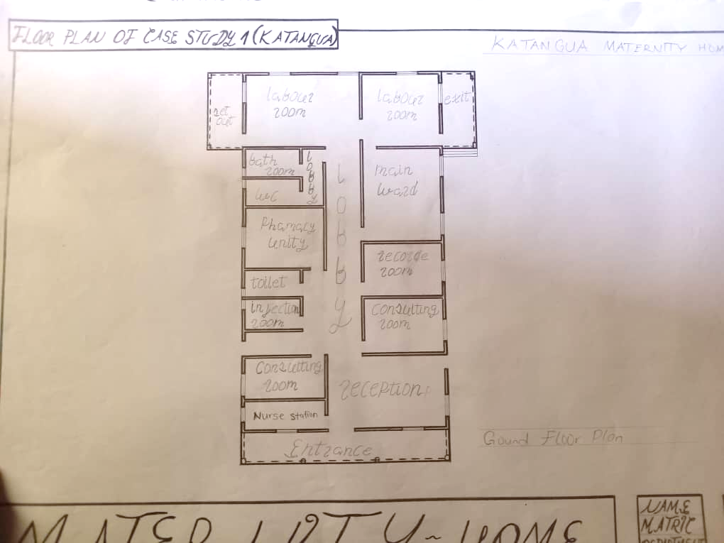

FIG 3.3.2; SHOWING FLOOR PLAN OF CASE STUDY ONE
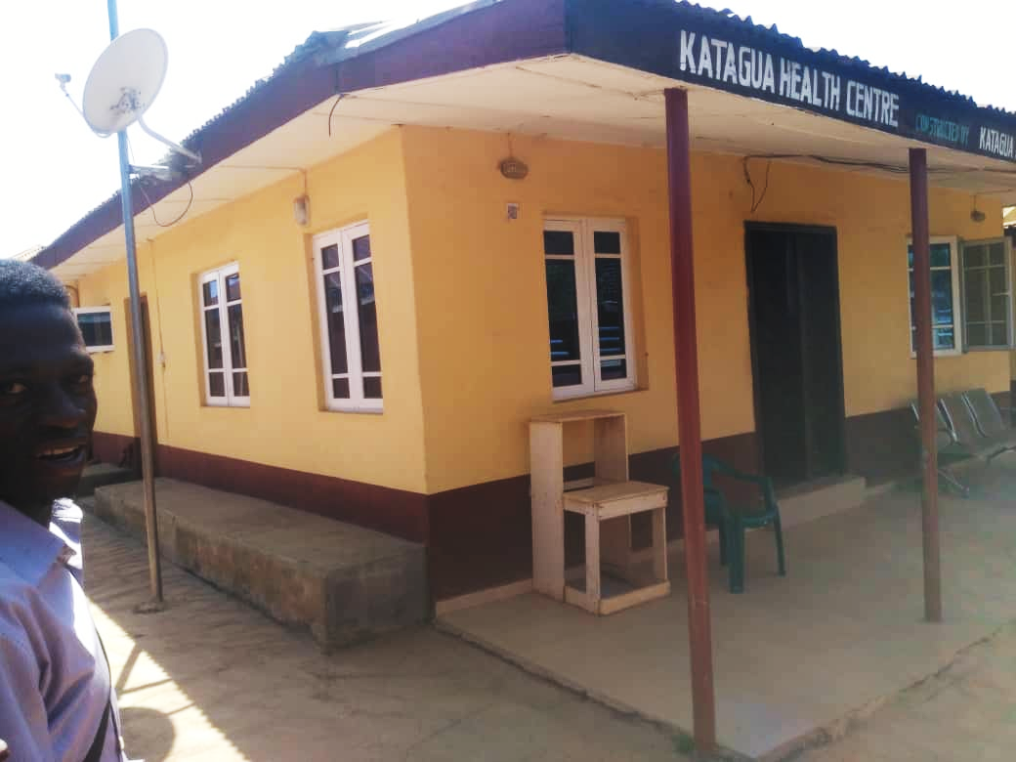

PLATE 3.3.1; SHOWING FRONT VIEW OF CASE STUDY ONE

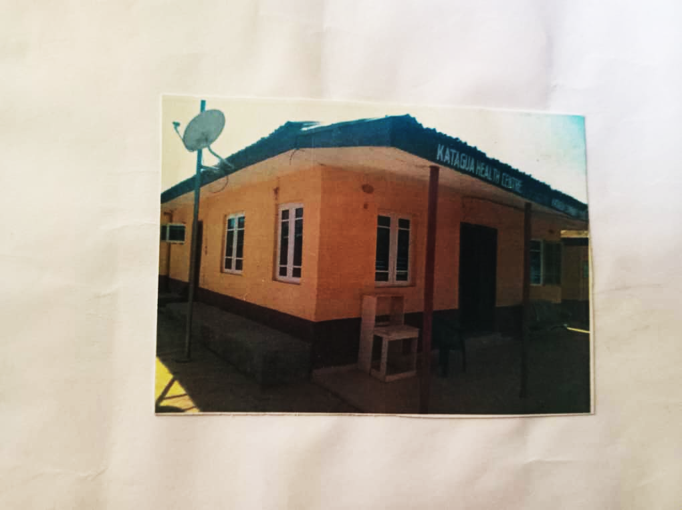

PLATE 3.3.2; SHOWING LEFT VIEW OF CASE STUDY ONE
3.4 CASE STUDY TWO (2)
LOCATION: SABO ROAD BEHIND JIMOH ADELABU PETROLEUM LTD, OSOGBO OSUN STATE.

MERITS
- Eazy to locate
- Provision of drainage facilities
- There is a room provide secured storage for medical records

DEMERITS
- Noisy area
- It is not well landscape
- Not in a conducive environment

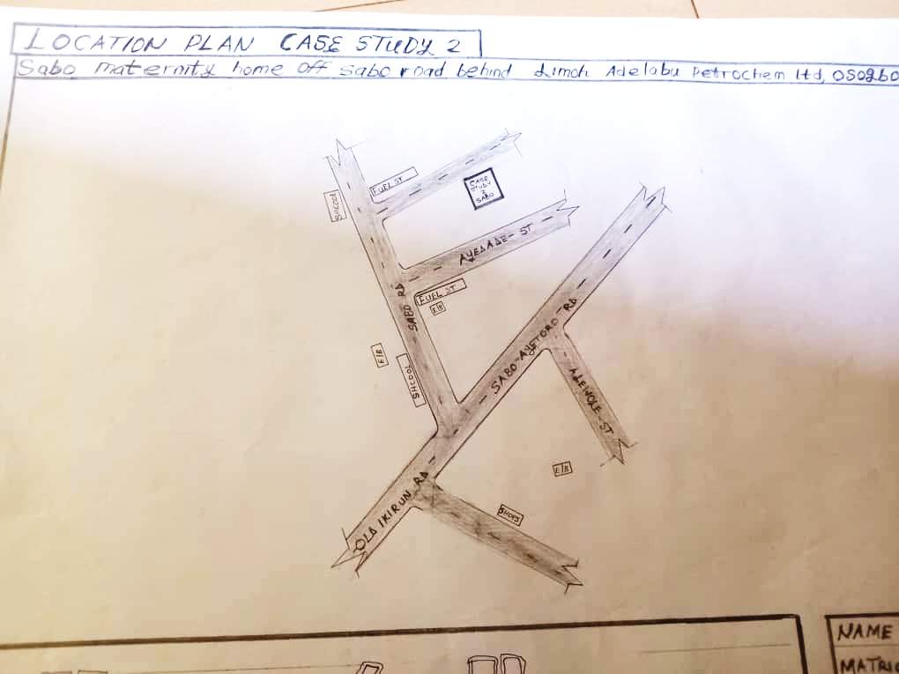

FIG 3.4.3; SHOWING LOCATION PLAN OF CASE STURDY TWO
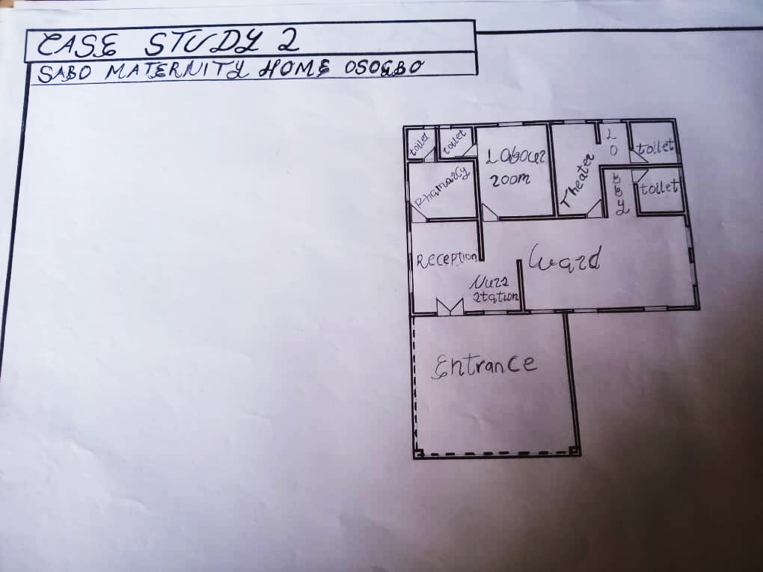
FIG 3.4.4; SHOWING THE FLOOR PLAN OF CASE STUDY TWO



PLATE 3.4.5; SHOWING THE FRONT VIEW OF CASE STUDY TWO
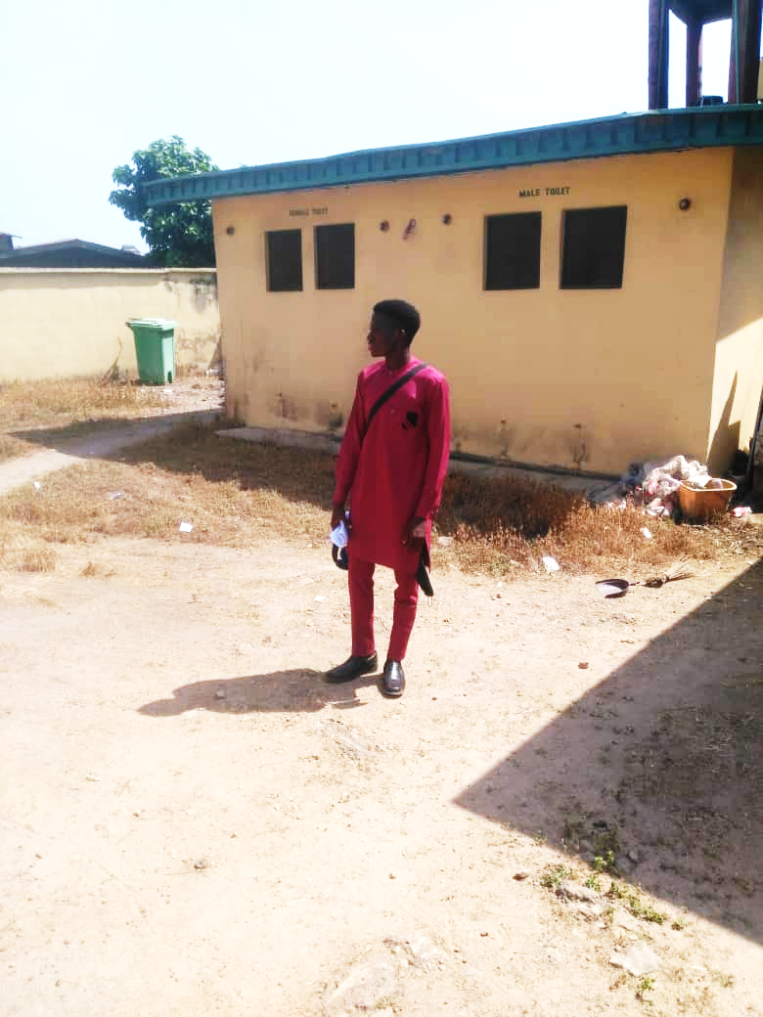

PLATE 3.4.6; SHOWING BACK VIEW OF CASE STUDY

3.5 CASE STUDY THREE (3)
LOCATION: KWARA STATE POLYTECHNIC, APATA YAKUBA ILORIN KWARA STATE

MERITS
- Easy to locate
- Good security
- Well landscaping

DEMERIT
- In adequate parking space
- Noisy area
- Poor building structure

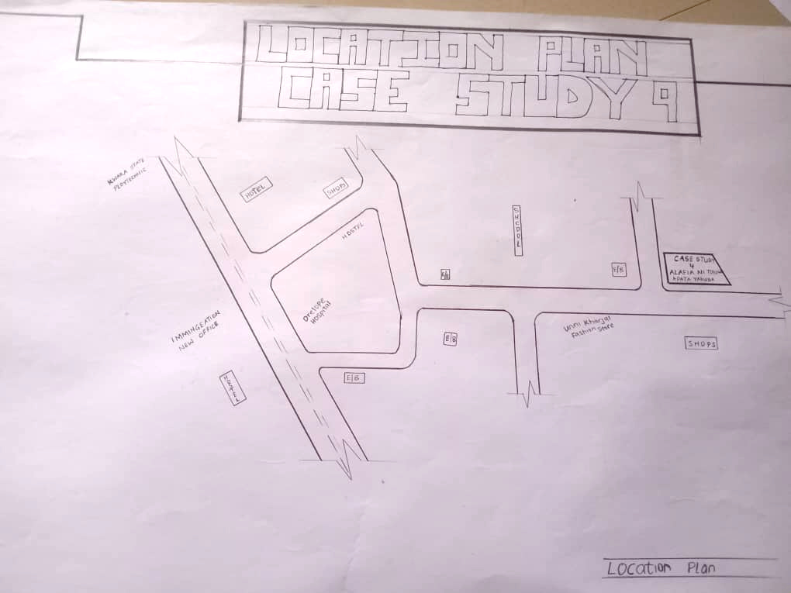

FIG 3.5.5; SHOWING LOCATION PLAN OF CASE STUDY THREE

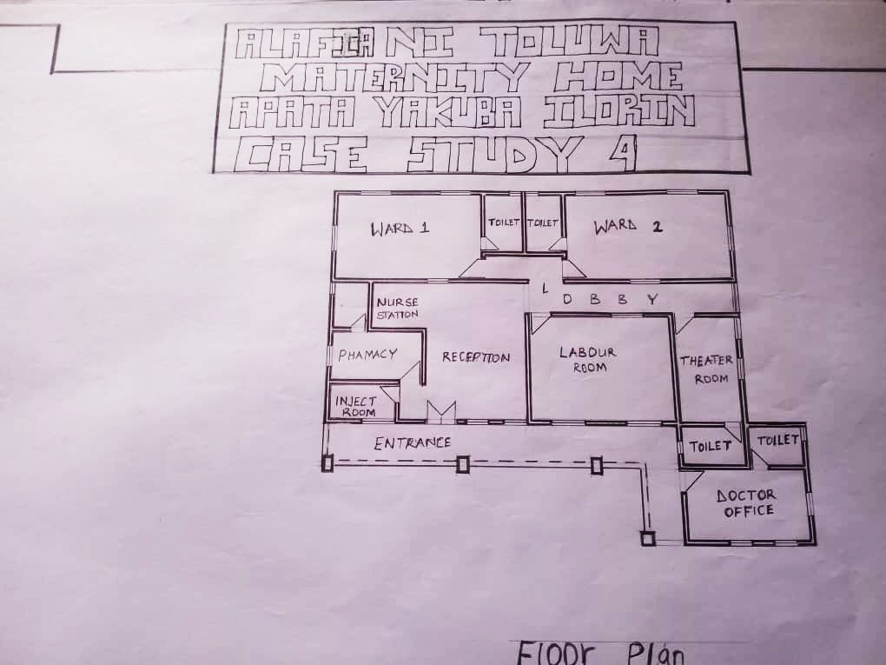
FIG 3.5.6; SHOWING FLOOR PLAN OF CASE STUDY THREE

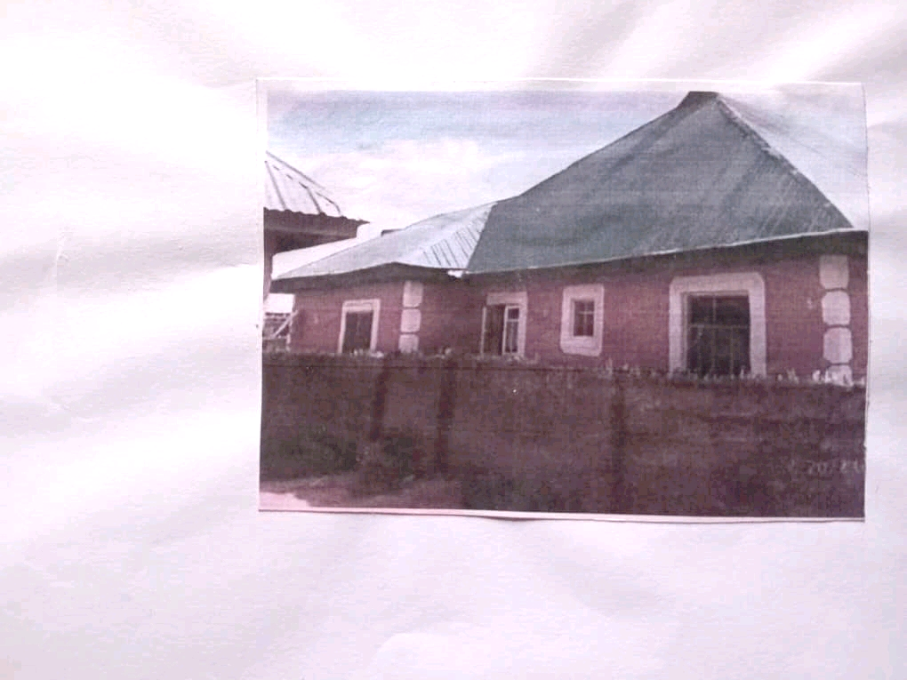

PLATE 3.5.8; SHOWING FRONT VIEW OF CASE STUDY THREE

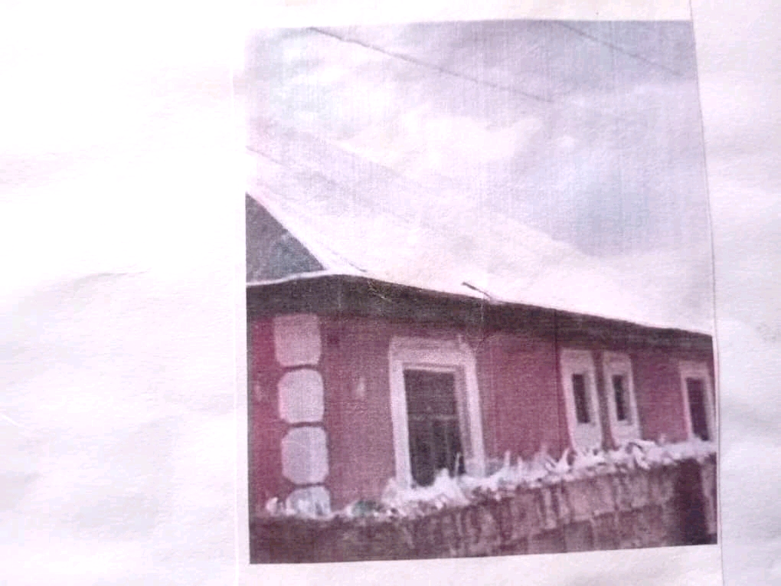

PLATE 3.5.9; SHOWING LEFT VIEW OF CASE STUDY THREE

3.6 ONLINE CASE STUDY
ONLINE CASE STUDY ONE
PROJECT NAME: MATERNITY CLINIC
LOCATION: KILIMANJARO IN TANZANIA
ARCHITECT: MAHARAJ
YEAR: 2012
AREA: 485m

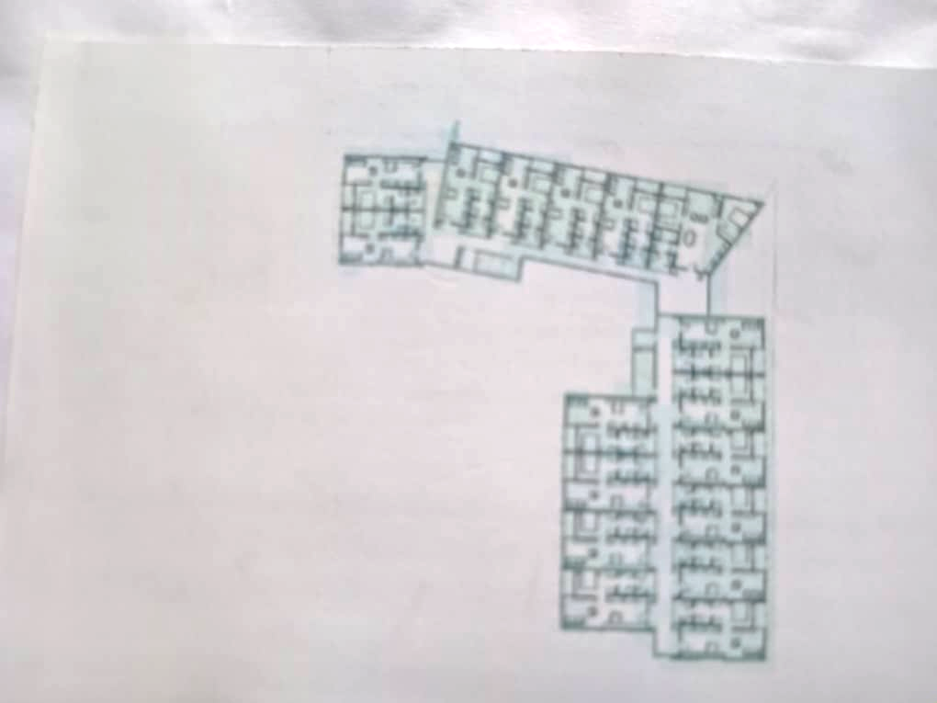
PLATE 3.6.11; SHOWING PLAN OF ONLINE CASE STUDY
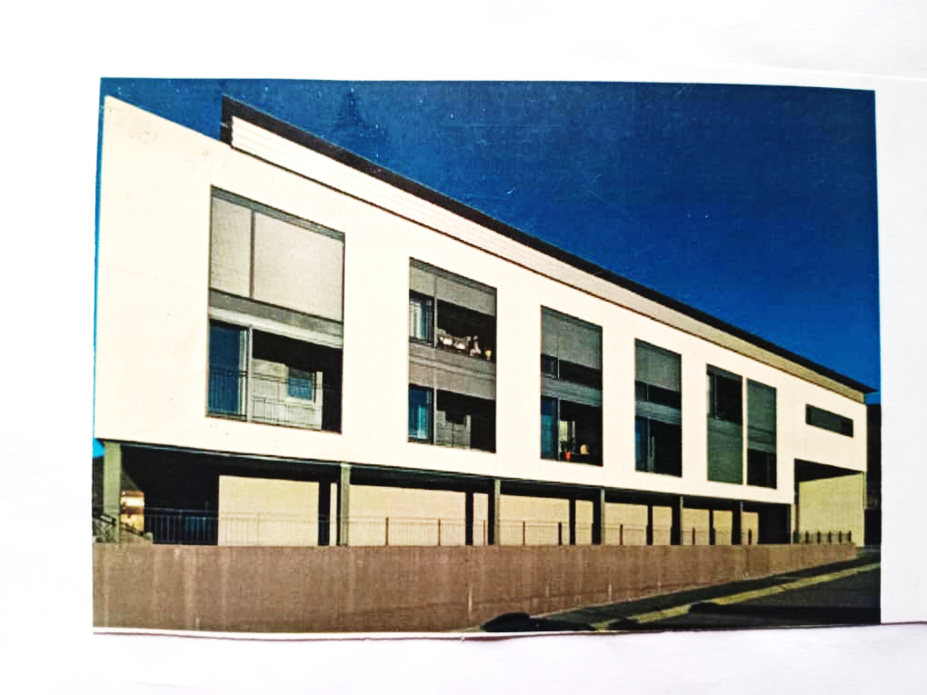
PLATE 3.6.11; SHOWING FRONT VIEW OF ONLINE CASE STUDY
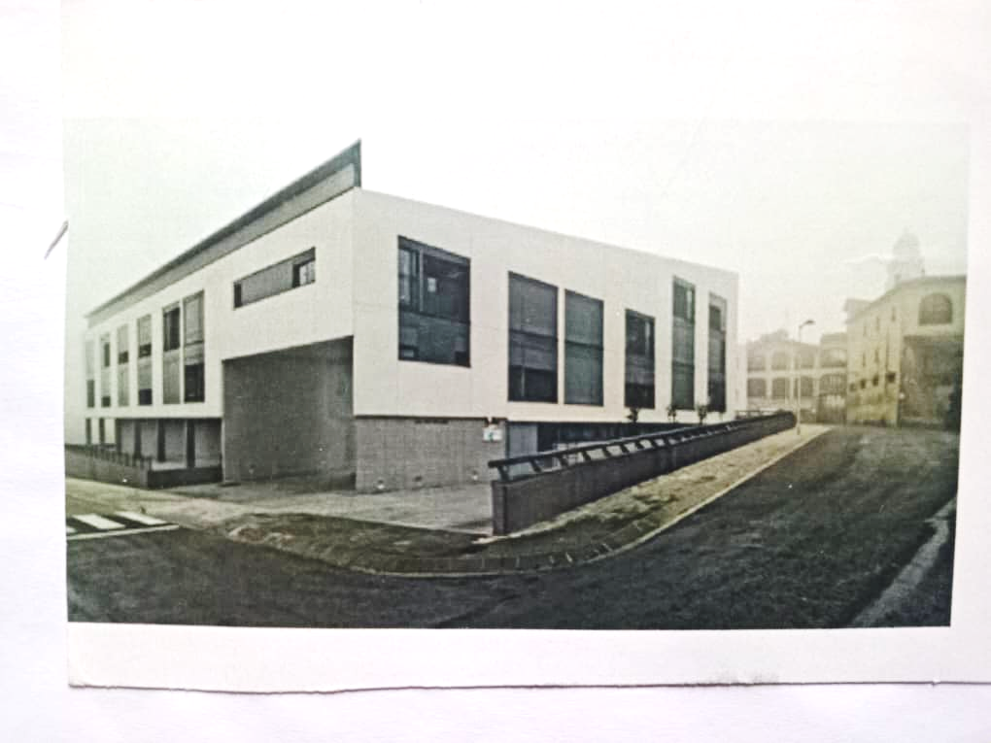
PLATE 3.6.12; SHOWING RIGHT VIEW OF ONLINE CASE STUDY

ONLINE CASE STUDY TWO
PROJECT NAME: COMMUNITY HEALTH
LOCATION: ASHATIN REGION, Togo
ARCHITECT: STEVEN
YEAR: 2011
AREA: 355m
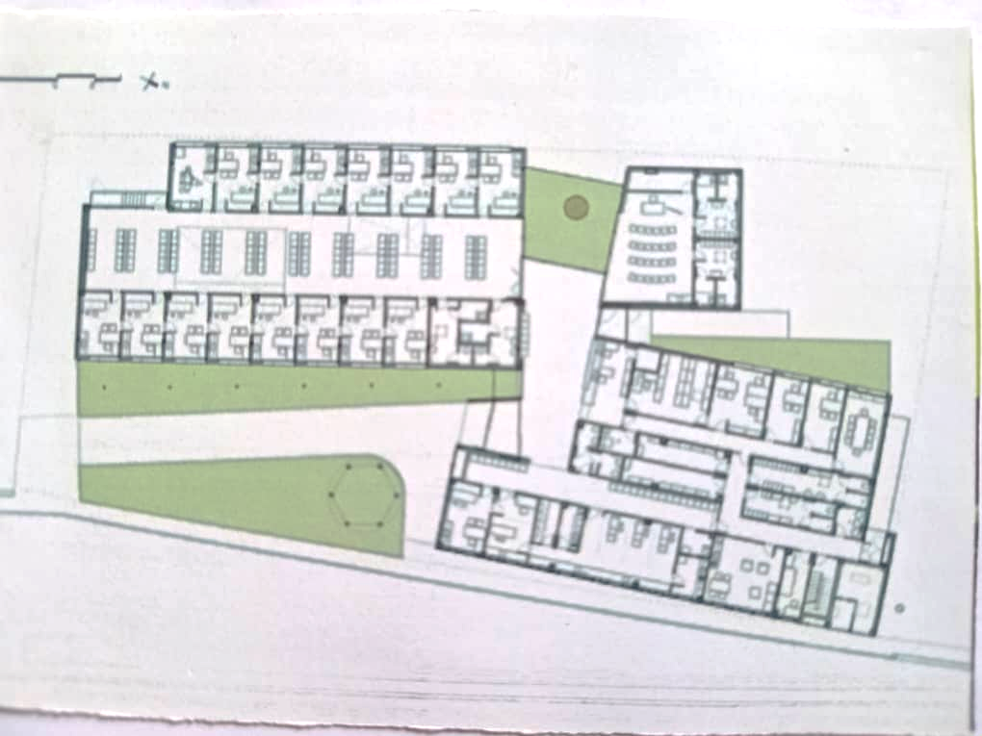
PLATE 3.6.13; SHOWING FLOOR PLAN OF ONLINE CASE STUDY

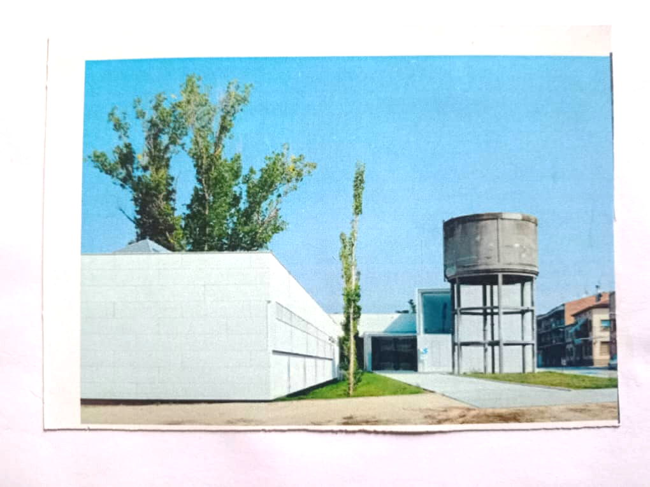

PLATE 3.6.14; SHOWING LEFT VIEW OF ONLINE CASE STUDY
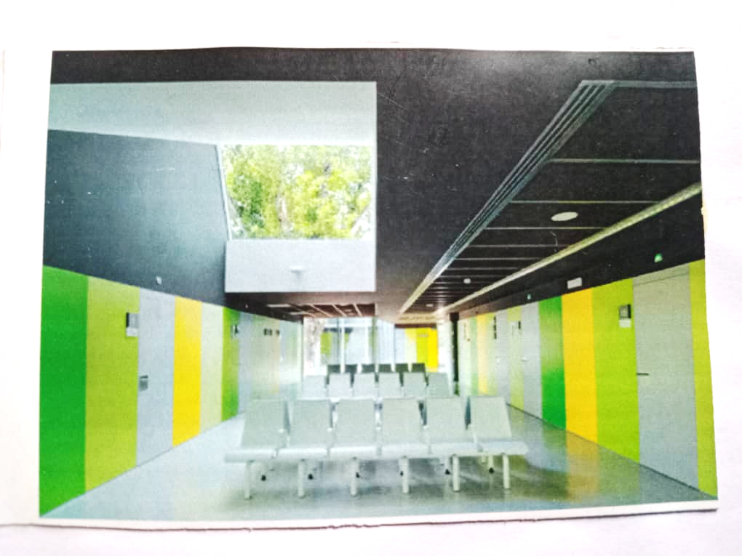
PLATE 3.6.15; SHOWING INTERIOR OF ONLINE CASE STUDY
DEDUCTION FROM CASE STUDIES
During my visit to the maternity home. I was opportunities to see what was obtain in the health care, I made a proper studies of their related function and analysis were made to their present situation with the aim of incorporation with their merit in my own final proposal.
The following were deduce from my case study
- Adequate natural ventilation and lighting.
- Good architectural landscaping.
- The units in the hospital should be properly and well linked.
- There is need for consultation rooms.
- Parking spaces should be well defined.
- Good drainage system.
CHAPTER FOUR
4.0 PROJECT LOCATION
4.1 BRIEF HISTORICAL BACKGROUND OF ILORIN

Ilorin was founded by the Yoruba, one of the three largest ethnic groups in Nigeria, in the late 18th century. It became a provincial military headquarters within the Oyo Empire until 1817, when the local Kakanfo (field marshal) named Afonja rebelled, supported by the Hausa Shehu Alimi, an itinerant Islamic preacher and teacher. Their alliance eventually broke down over the Muslims' increasing power and Afonja's refusal to convert, and he was eventually assassinated. Alimi's son Abd al-Salam pledged allegiance to the Sokoto Caliphate in 1823.The Oyo Empire and its Borgawa allies marched against Ilorin circa 1835, trying to reclaim its former glory, but were decisively defeated; this marked the end of Oyo.Abd al-Salam led the jihad toward the sea but was ultimately stopped at Oshogbo in 1840 by the army of Ibadan. Throughout the 19th century, Ilorin served as a major trade node between the Hausa and the Yoruba.[8] It strongly resisted British rule, but was occupied by the Royal Niger Company in 1897 and its lands were incorporated into the British Northern Nigeria Protectorate in 1900.[5] With the subdivision of the country’s administrative regions in 1967, Ilorin became part of West Central (later Kwara) state.
The city retains a strong Islamic influence, although Christianity is now widely practiced in the cosmopolitan part of the city due to the significant immigration of people from other parts of Kwara State and the rest of Nigeria.
GEOGRAPHY OF ILORIN

Ilorin is the capital city of Kwara State, located in the North Central region of Nigeria. It lies between latitudes 8°24′N and 8°36′N, and longitudes 4°30′E and 4°36′E. It serves as a gateway between the northern and southern parts of the country, making it a strategic administrative and commercial center.
Bordering States: Oyo State to the south, Kogi State to the east, and Niger State to the north.
Proximity: Approximately 306 km northeast of Lagos and 500 km southwest of Abuja.

ECONOMY OF ILORIN
Ilorin is the capital city of Kwara State located in the Western region of Nigeria. Although Ilorin is classified under the North-Central geopolitical zone, the city is considered a Yoruba city by all historical and sociological standards. As of the 2006 census, it had a population of 777,667, making it the 7th largest city by population in Nigeria.

ORGANIZATION STRUCTRE
Ilorin, the capital city of Kwara State, operates under a dual system of governance that includes both traditional leadership (Emirate system) and modern democratic structures under the Nigerian government.

4.2 LOCATION AND SETTING OF ILORIN
Kwara (Yoruba: Ìpínlẹ̀ Kwárà) is a state in Western Nigeria, bordered to the east by Kogi State, to the north by Niger State, and to the south by Ekiti, Osun, and Oyo states, while its western border makes up part of the international border with Benin. Its capital is the city of Ilorin and the state has 16 local government areas. Of the 36 states of Nigeria, Kwara is the ninth largest in area but the sixth least populous with an estimated population of about 3.2 million as of 2016.Geographically, Kwara is split between the West Sudanian savanna in the east and the Guinean forest–savanna mosaic ecoregion in the rest of the state. Important geographic features include rivers with the Niger flowing along the northern border into Lake Jeba before continuing as the border while the Awun, Asa, Aluko, and Oyun rivers flow through the interior. In the far northwest of the state is the Borgu section of the Kainji National Park, a large national park that contains populations of grey heron, kob, hippopotamus, African bush elephant, olive baboon, and roan antelope, along with some of the last remaining West African lions on earth. In the far southwest, a small part of the Old Oyo National Park contains crowned eagle, martial eagle, African buffalo, oribi, and patas monkey populations
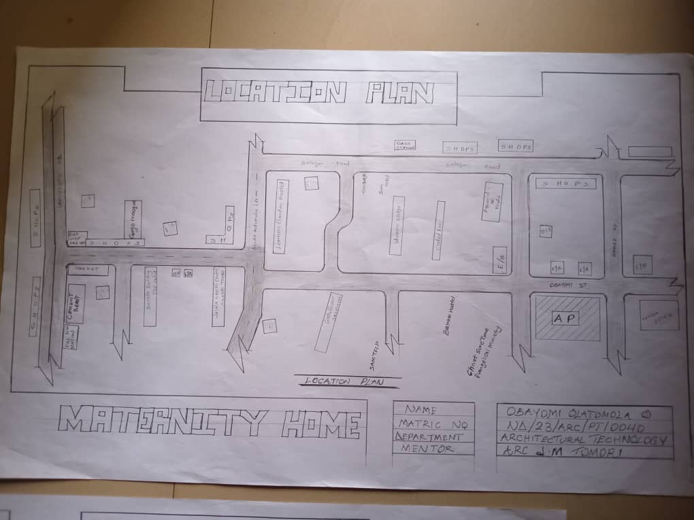
FIG 4.2.7; SHOWING LOCATION OF THE PROPOSE SITE
4.3 POPULATION
The population development of Ilorin as well as related information and services.
The metro area population of Ilorin in 2024 was 1,064,000, a 3.3% increase from 2023.
The metro area population of Ilorin in 2023 was 1,030,000, a 3% increase from 2022.
The metro area population of Ilorin in 2022 was 1,000,000, a 2.67% increase from 2021.

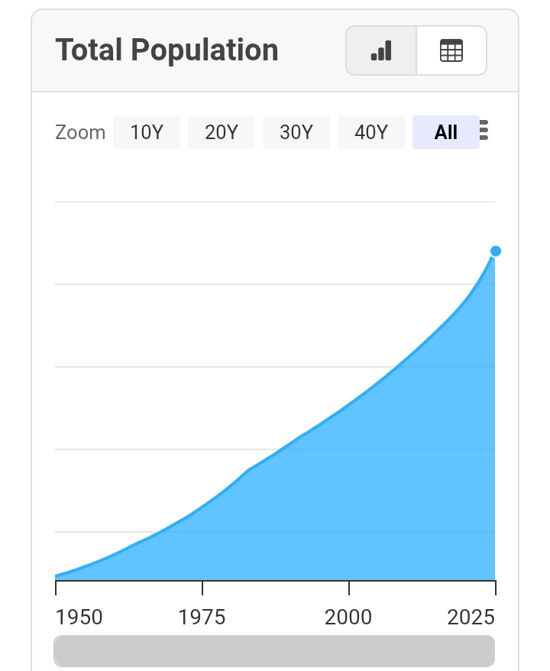
TABLE 4.3.1; SHOWING GENDER GROUP

4.4 SITE INVENTORY
In the proposed site, some shrubs will be retained on site. It used to reduce sky glare and also serve as soft landscape and wind breaker.
Presence of road network which would serve as a means of accessibility to the site. Presence of electricity pole which serve as source of electricity to the site. Some trees would be retained while some will be removed if they disrupt the construction of building.
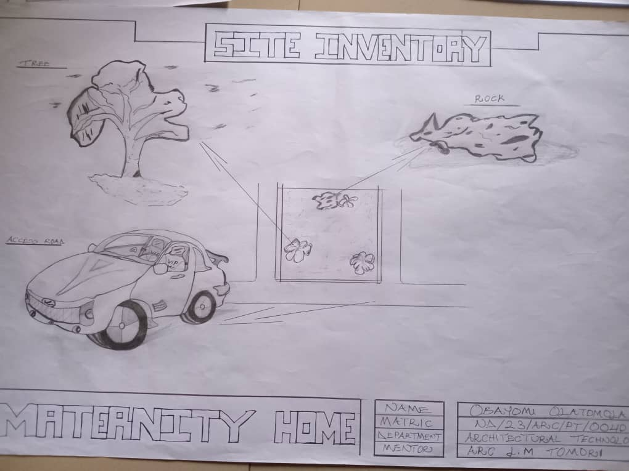
FIG 4.4.8; SHOWING SITE INVENTORY OF THE PROPOSED SITE

4.5 SITE ANALYSIS
The site is benefitted with loamy soil which is a very good soil for grass and shrubs. It has a gentle slope towards the south east. Some of the grasses, shrubs and trees on the site are to be retained to enhance landscape patter of the site while some are to be removed and replanted where necessary. The two noticeable winds are to be directed into the building using landscape pattern to improve ventilation. Noise generated from vehicle traffic is controlled through proper planning, good landscaping and proper orientation of building. Generally, all the feature on the site are best put into different uses to aid control through proper planning, landscape and orientation.

Certainly, steps are considered to obtain vital information of the site, this information is the analyzed in details. For design purpose, the information include soil condition, geology, topography, vegetation etc. It also involves carrying out a preliminary survey of the site.

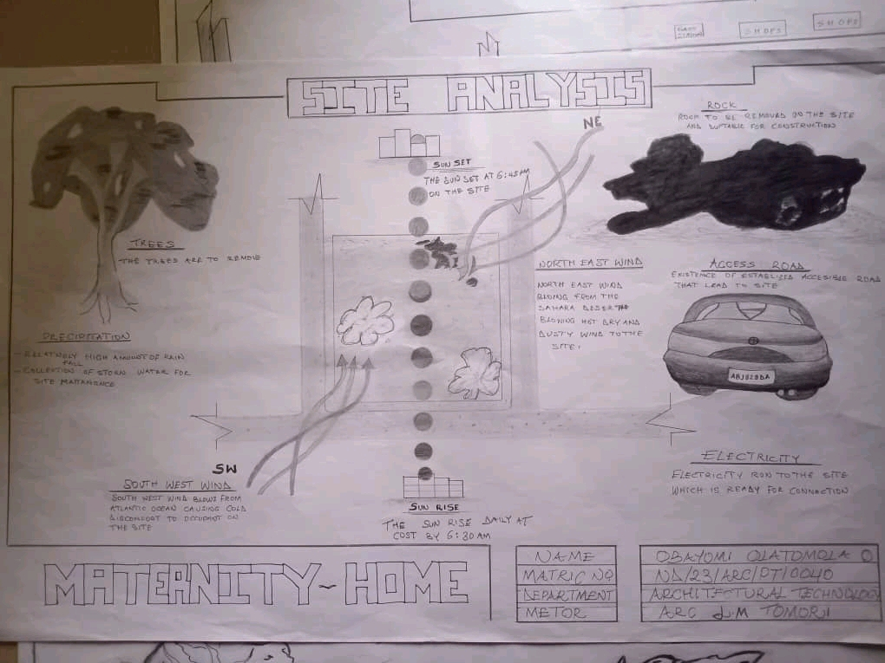
FIG 4.5.9; SHOWING SITE ANALYSIS OF THE PROPOSED SITE

4.5.1 SITE SELECTION/JUSTIFICATION
In the site selection provision is made for interesting facilities that worth emulating since the overall success and efficiency of any project depend not on the functionality of the design but also on a careful choice of site. The site of this project has been carefully selected which is located in the premises of Kwara state, Ilorin kwara state. The proposed site is located at Tanke road at Ilorin, Kwara state.
4.5.2 LOCATION
The site is located
Ilorin South 240001, Kwara state Nigeria:
Tanke is located at Ilorin South. It is a residential area of University Road, in the city of Ilorin. The community is a settlement that is mostly occupied by students of the University of Ilorin. The area houses places such as the Tanke Market, Tanke Reservoir, Royal FM.Kaynet street in Tanke Ilorin after visiting Avenue.
4.5.3 ACCESSIBILITY
The site is easily accessible from the access road off from the main road that goes to Alagede Road. The site can also be reached through the access road that lead to university of ilorin.
4.5.4 INFRASTRUCTURAL FACILITIES
Facilities such as water electricity, telephone network and road network are all in Ilorin, hence it can easily be tapped to the proposed site.
4.5.5 TOPOGRAPHY
The topography of the land is gentle slope which can be filled and levelled up to balance round all the site levels.
4.5.6 SOIL STRUCTURE
It is made up of clayish laterite soil, which is good for building construction.

4.6 GENERAL CLIMATIC CONDITION
In Ilorin, the wet season is oppressive and overcast, the dry season is humid and partly cloudy, and it is hot year round. Over the course of the year, the temperature typically varies from 64°F to 95°F and is rarely below 57°F or above 100°F.The hot season lasts for 2.6 months, from January 23 to April 10, with an average daily high temperature above 92°F. The hottest month of the year in Ilorin is March, with an average high of 94°F and low of 73°F.The cool season lasts for 3.6 months, from June 22 to October 10, with an average daily high temperature below 85°F. The coldest month of the year in Ilorin is August, with an average low of 70°F and high of 83°F.In Ilorin, the average percentage of the sky covered by clouds experiences significant seasonal variation over the course of the year.
4.6.1 RELATIVE HUMIDITY
The muggier period of the year lasts for 10 months, from February 6 to December 6, during which time the comfort level is muggy, oppressive, or miserable at least 34% of the time. The month with the most muggy days in Ilorin is August, with 31.0 days that are muggy or worse.
4.6.2 WIND
The wind experienced at any given location is highly dependent on local topography and other factors, and instantaneous wind speed and direction vary more widely than hourly averages. The average hourly wind speed in Ilorin experiences significant seasonal variation over the course of the year. The windier part of the year lasts for 6.5 months, from February 17 to September 2, with average wind speeds of more than 6.7 miles per hour. The windiest month of the year in Ilorin is April, with an average hourly wind speed of 8.4 miles per hour. The calmer time of year lasts for 5.5 months, from September 2 to February 17. The calmest month of the year in Ilorin is November, with an average hourly wind speed of 4.8 miles per hour.
4.6.3 TEMPERATURE
The hot season lasts for 2.6 months, from January 23 to April 10, with an average daily high temperature above 92°F. The hottest month of the year in Ilorin is March, with an average high of 94°F and low of 73°F.The cool season lasts for 3.6 months, from June 22 to October 10, with an average daily high temperature below 85°F. The coldest month of the year in Ilorin is August, with an average low of 70°F and high of 83°F.
4.6.4 VEGETATION
The proposed site is covered with grasses few trees and shrubs. Some will be removed before the construction while some will be retain for ornamentation.

4.7 SOCIAL SERVICES
4.7.1 ROAD
There are only two access to the site
The southern access which serve as the main entrance and also main access road
4.7.2 WATER AND ELECTRICITY
There are pipe born water networks and borehole water which serves the habitant of Ilorn south. There is electricity supply from NEPA that serve the Kwara state in general

4.8 DESIGN CRITERIA
There are three (3) methods of designing of any project which are: Function before form method
Form before function method Combination of Shapes
Designing projects, the function, before form method used in line with this method, the following are the design criteria for this project:
Functional: in term of functional requirement, the following design criteria must be considered.
Sustainability, Site and Location, Flexibility, Circulation, Accessibility, Organization, Maintenance, Environment and Services

4.9 DESIGN BRIEF
After research and planning, the next step in the series of the project programed is design itself. To achieve functional and well established design there must be a brief to work on. This brief depends generally on the scope of individual design. The brief of this project is therefore based on the various activities that take place in the maternity. To have enough brief for the proposed Maternity home, case studies were carried out on the existing maternity home. The studies also give me the opportunity to know the nature of the various maternity treatment and how they are related to each other.

4.10 DESIGN ANALYSIS
This is the process of itemizing units within the component of the entire design with a view to establishing a solid understanding and appreciation of the space relationships.
The units of the design are in three division, the unit of the project division are as follows:
GROUND FLOOR PLAN; Ward 1, Ward 2, Antenatal, Reception, Lobby, Nurse station 2, Kitchen, Delivery room, Resting room, Card room, Theater room, Doctor office, Private ward, Toilet, Toilet, Entrance, Laboratory, Pharmacy store, pharmacy, Laundry, Exit, Lobby.
4.11 SPACE REQUIREMENT
SPACE | HIGHT | LENGTH | AREA
Ward 1 | 3.5mm | 8.7mm | 12.2mm
Ward 2 | 3.9mm | 8.1mm | 12.0mm
Antenatal | 3.0mm | 4.3mm | 7.3mm
Reception | 6.0mm | 5.4mm | 11.4mm
Lobby | 2.6mm | 2.8mm | 5.4mm
Nurse station 2 | 2.4mm | 2.7mm | 5.1mm
Kitchen | 3.7mm | 5.2mm | 8.9mm
Delivery room | 6.0mm | 3.9mm | 9.9mm
Resting room | 1.5mm | 1.2mm | 2.7mm
Card room | 1.8mm | 2.5mm | 4.3mm
Theater room | 3.8mm | 4.9mm | 8.7mm
Doctor office | 4.7mm | 1.8mm | 6.5mm
Private ward | 2.6mm | 1.5mm | 7.1mm
Toilet | 1.2mm | 1.2mm | 2.4mm
Toilet | 1.2mm | 1.7mm | 2.9mm
Entrance | 3.3mm | 5.4mm | 8.7mm
Laboratory | 5.7mm | 3.7mm | 9.4mm
Pharmacy store | 1.9mm | 1.2mm | 3.1mm
pharmacy | 3.0mm | 4.6mm | 7.6mm
Laundry | 2.7mm | 2.5mm | 5.2mm
Exit | 1.8mm | 1.8mm | 3.6mm
Lobby | 2.4mm | 650mm | 3.50mm
Waiting area | 3.9mm | 2.6mm | 6.5mm
Total |  |  | 154.250mm

TABLE 4.11.2; SHOWING SPACIAL ALLOCATION OF FLOOR PLAN
Necessary units in the building. A borehole system of water supply is to be adopted alongside the government supplied services and a storage facility is to be provided for effective management of water supply.

4.12 PLANNING PRINCIPLE
The planning principle is one of the most important aspects of any design. The planning of various units taking into consideration the activities performed in each unit, how they are related to one another and the users of the various units in the design. In respect to the above factors.

CHAPTER FIVE
5.0 APPROACHES TO THE DESIGN
In approaching this design project, many factors, strategies and research works were taken into consideration. Some of the factors which include functionality, durability, cost of materials. The research work put into consideration are study of neighborhood
Designing a maternity facility involves a deep understanding of both medical functionality and the emotional needs of patients. The architectural approach must balance efficiency, comfort, hygiene, and aesthetics to support childbirth and postnatal care. Below are the key design approaches applied in maternity.
5.1 TECHNOLOGY AND ENVIRONMENTAL CRITERIAL
CONSTRUCTION METHODOLOGY
The method of construction involved in the erecting the building structure is in accordance to the Architectural detail required in executing the buildings and process of construction that is critical to structural component as affected by the site conditions and type of materials to be used.
After the preparation of the site plan, many design details are developed to show the specific methods of construction. It is to serve two important purpose; firstly they stipulate the aesthetics and structural element of the plan and secondly they provide the basis for costing the project.
The section is not intended to present aesthetic or design solution alone but also indicate how similar technological difficulties are handled. In the method of construction, the factors are considered:
- Climatic condition
- Fire protection
- Durability and easy maintenance
- Easy accessibility
- Economy/Aesthetics
- Available of materials
- Cost of material
- Construction techniques
- Condition of the sub-soil present on the sit
The various building component taken into consideration are:
- SUB-STRUCTURE
This is the part of the building below natural ground level. The foundation footing are reinforced for stability of the building to enable it to withstand the load (live and super-imposed and wind load). The foundation of the structure shall be determined by the structural engineer according to bearing capacity of the soil.
- SUPER STRUCTURE
This is the part of building that is above the natural ground level. The entire structure is design with reinforced concrete columns, beams and hollow sand screed blocks.
MATERIAL AND STANDARD FORM
The following materials are applied in the construction of the structure such as:
FLOORS
The ground floor will be solid concrete slab of 150mm with asphalt coating as damp proof course laid well compacted hardcore. Floor finishes are ceramic floor tiles and terrazzo floor tiles because they are durable, easy to maintain and do not wear easily.
DOORS
The size and types of doors depend on its location but generally the size ranges from 750mm, 900mm and 1200mm respectively.
WINDOWS
The windows in the building is designed primarily to allow natural light, natural air/ventilation into the building and used to allow easy free flow of carbon dioxide out of the building as well as to allow for outside view.
ROOFS
Roof member of all buildings will be made up of timber and long span aluminum roofing sheets. This is for the easy maintenance of self-support and a longer life span.
CEILING
The kind of ceiling system adopted for the building in the poultry farm is the asbestos ceiling sheet. The factors considered for choosing this type is
- Durability
- Easy to maintain
- Cost
5.2 ESSENTIAL SERVICE REQUIRED
Service are essential for comfort ability security and safety to create a conducive atmosphere for the users of the poultry farm the following service must be provided:
    - PLUMBING SERVICES
All water supplies and other distribution to all the required areas would be through 50mm diameter galvanized steel pipe while selvage will be PVC service pipe, which will be provided with shower tray, towel trays, wash hand basin and tissue roll holders. Septic tanks and soak away pit shall be placed in suitable location for easy maintenance.
ACOUSTICS
The major noise comes from the major road and this could be reduced by maintaining a reasonable setback from the major road and the proper landscaping which include the planting of trees and flowers to serve as noise and sound absorb ant.
WASTE DISPOSAL
Waste disposal should be provided where unwanted materials such as dirt should be dumped in order to make the environment clean.
FIRE PROTECTION
Structural protection is achieved by using fire resisting elements and limiting the use of combustible materials and finishes. Fire detectors and firefighting equipment should be provided.
EXTERNAL WORKS
These are works carried out outside and around the building. It is otherwise known as landscaping building.
These are the elements used to provide aesthetics and general human comfort in and around the building.
There are two types of landscaping:
- Soft landscaping
- Hard landscaping
The following specifications are applicable for the external works.
- Surrounding walls to be rendered and painted
- The floor surface to be of interlocking materials and asphalt on the road to allow effective drainage
- The floors to withstand expected impact and high load bearing capacity.
The landscape elements are:
- Asphalts: used for drive ways and parking lots. It is economical and durable both for pedestrian and vehicular traffics.
- Interlocking paving: used for walkways and outdoor paving to blend with the natural texture of the environment.
- Trees: used as shading device and also to reduce rays in both paving and structure.
- Decorative flowers: different species of flowers are used to enhance the aesthetic appearance of the site.
5.3 ENVIROMENTAL CONIDITIONS TO BE ACHIEVED
- The plantation of trees to regulate the temperature
- The orientation of the building structure to achieve maximum comfort thereby controlling solar radiation.

5.4 PERFORMANCE STANDARDS
The performance standard of the building construction is to be a highly luxurious because of the targeted users and the occupants of the town which have a high taste of social lives.
5.5 LEGAL ISSUES AND PLANNING REGULATIONS
The proposed building must pass through various processes in order to be approved of the planning regulations of the local government authorities and the board of chiefs because of it being a public building. The process for approval in the local planning authority is to provide the following
The c of o of the land
The original land purchase documents
The survey plan
The structural drawings
The architectural drawings
The mechanical and electrical drawings
5.6 BEHAVIORAL PATTERNS AND CONSIDERATIONS
The considerations is the designing the poultry farm to bring comfort to the targeted users by providing adequate security, creating open spaces to be used for learning Arabic recitation of the Muslim residents and provision of recreational facilities.
GENERAL MAINTENANCE
Maintenance cannot be isolated from the initial planning and design of any architecturally edified most especially a project of this caliber which involves accommodation.
Timely maintenance of the structure and facilities to put them in proper condition to enhance balanced living and to avoid building deterioration. It is the work done to restore a building to an acceptable standard. The maintenance will be dully attended to with regular cleaning, repainting, and constant checking of access roads, planting of trees.

5.7CONCLUSION
A well-designed maternity home is essential for improving maternal and infant health outcomes, especially in regions with high maternal mortality rates like Nigeria. Architecture plays a critical role in not just sheltering medical services but enhancing healing, dignity, and safety.
This project demonstrates that it is possible to design a cost-effective, sustainable, and user-friendly facility that meets both international healthcare standards and local socio-environmental conditions. When maternity homes are properly planned, they can drastically reduce maternal and neonatal complications, increase healthcare access, and foster community trust in medical institutions.
5.8 RECOMMENDATIONS
1. Adopt Evidence-Based Design:
Incorporate patient-centered and evidence-based design principles that improve healing environments and reduce stress for patients and staff.
2. Prioritize Sustainability:
Integrate eco-friendly technologies such as solar panels, passive cooling systems, and local building materials to reduce operational costs and environmental impact.
3. Enhance Accessibility:
Design for universal access — include ramps, wide doorways, tactile guides, and signage in local languages to accommodate people with disabilities and low literacy levels.
4. Ensure Flexibility:
Spaces should be adaptable to future expansions, changes in medical technologies, or sudden increases in patient load (e.g., during health crises).
5. Involve Stakeholders Early:
Collaborate with healthcare workers, pregnant women, local authorities, and community leaders during the design phase to ensure culturally appropriate and functional solutions.
6. Integrate Green and Healing Spaces:
Incorporate landscaping, gardens, and rest areas for patients and families, which have been shown to aid mental well-being and recovery.
7. Government and NGO Investment:
Governments and health-focused organizations should invest in constructing and upgrading maternity homes in underserved areas.

REFERENCE
1. Neufert, E. (2012). Architects' Data. Wiley-Blackwell.
2. Ching, F. D. K. (2014). Architecture: Form, Space, and Order. Wiley.
3. Tzortzopoulos, P., & Kagioglou, M. (2011). Delivering Value in Healthcare Construction Projects. Routledge.
4. Lawson, B. (2005). How Designers Think: The Design Process Demystified. Architectural Press.
5. Gupta, R. (2010). Hospital Administration and Human Resource Management. Jaypee Brothers.
6. Verderber, S., & Fine, D. J. (2000). Healthcare Architecture in an Era of Radical Transformation. Yale University Press.
7. Karlen, M. (2011). Space Planning for Commercial and Residential Interiors. Wiley.
8. Kumar, R. (2005). Planning and Designing of Specialty Healthcare Facilities. AIIMS Press.
9. Marberry, S. O. (2006). Improving Healthcare with Better Building Design. Health Administration Press.
10. Malkin, J. (2008). A Visual Reference for Evidence-Based Design. Center for Health Design.
11. World Health Organization (2016). Standards for Improving Quality of Maternal and Newborn Care in Health Facilities.
12. WHO (2020). Global Strategy for Women’s, Children’s and Adolescents’ Health (2016–2030).
13. United Nations Population Fund (UNFPA) (2022). Maternal Health Thematic Fund Annual Report.
14. WHO (2018). Delivering Quality Health Services: A Global Imperative for Universal Health Coverage.
15. UNICEF (2019). Every Child Alive: The Urgent Need to End Newborn Deaths.
16. UNFPA (2017). Midwifery Services Framework.
17. WHO (2021). Health Facility Design Guidelines: A Guide to Infrastructure Planning.
18. WHO Regional Office for Africa (2020). Maternal and Child Health Reports in Nigeria.
19. UN-Habitat (2021). Sustainable Design for African Cities.
20. WHO (2022). Infection Prevention and Control Guidelines in Health Facilities.
21. Lawson, B. (2002). The Language of Space.
22. Joseph, A. (2006). The Role of the Physical Environment in the Hospital of the 21st Century.
23. Salihu, H. M. et al. (2015). Maternal Mortality in Nigeria: Addressing the Elephant in the Room.
24. Agyepong, I. A. (2014). Health Systems Strengthening in West Africa.
25. Dilani, A. (2008). Psychosocially Supportive Design: A Salutogenic Approach in Healthcare Architecture.
26. Oluwatosin, O. A. (2010). Maternal and Newborn Healthcare in Nigeria: Design Challenges and Prospects.
27. Ulrich, R. S. (1991). Effects of Health Facility Design on Patient Outcomes: A Review.
28. Olanrewaju, A. (2018). Public Health Facilities in Nigeria: Gaps in Maternal Healthcare.
29. Olajide, A. (2020). Architecture and Maternal Health: A Nigerian Case Study.
30. Osei, C. B. (2017). Sustainable Design for Healthcare Facilities in West Africa.

APPPENDICES

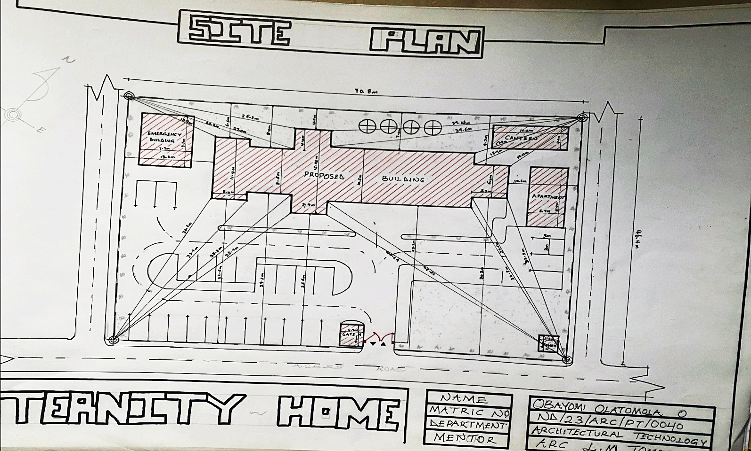
APP 5.1; SHOWING SITE PLAN OF THE PROPOSED PROJECT
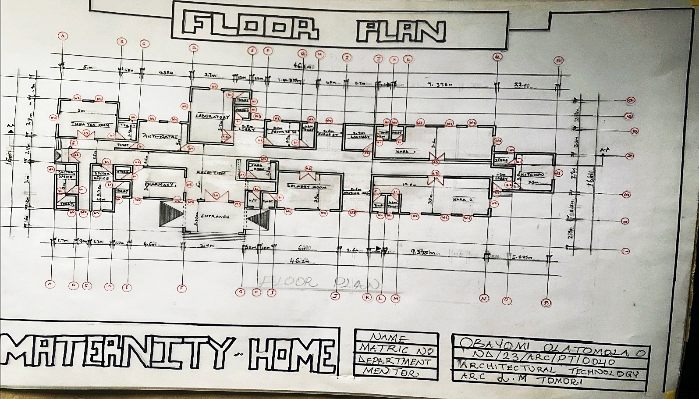
APP 5.2; SHOWING PLAN OF THE PROPOSED PROJECT
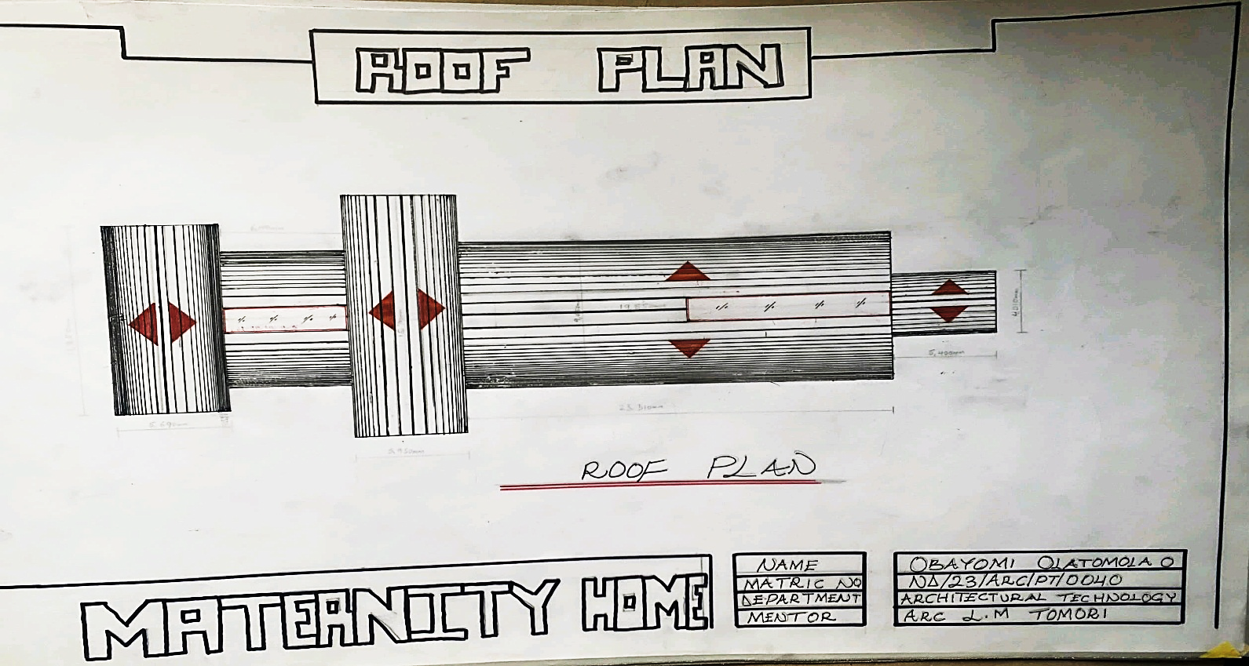
APP 5.3; SHOWING ROOF PLAN OF THE PROPOSED PROJECT
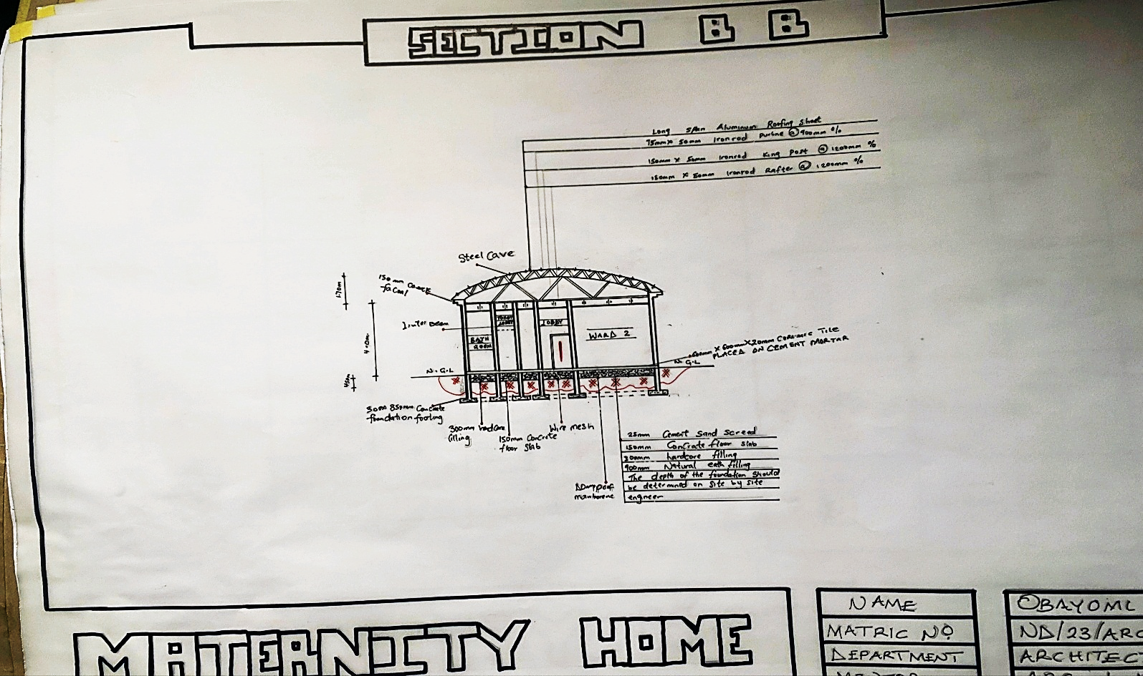
APP 5.4; SHOWING CROSS SECTION OF THE PROPOSED PROJECT
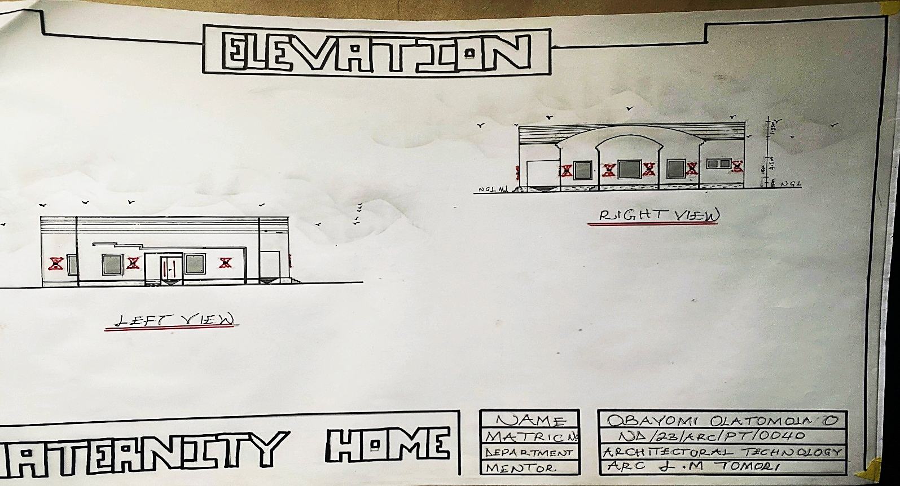
APP 5.5; SHOWING LEFT AND RIGHT VIEW OF PROPOSED PROJECT

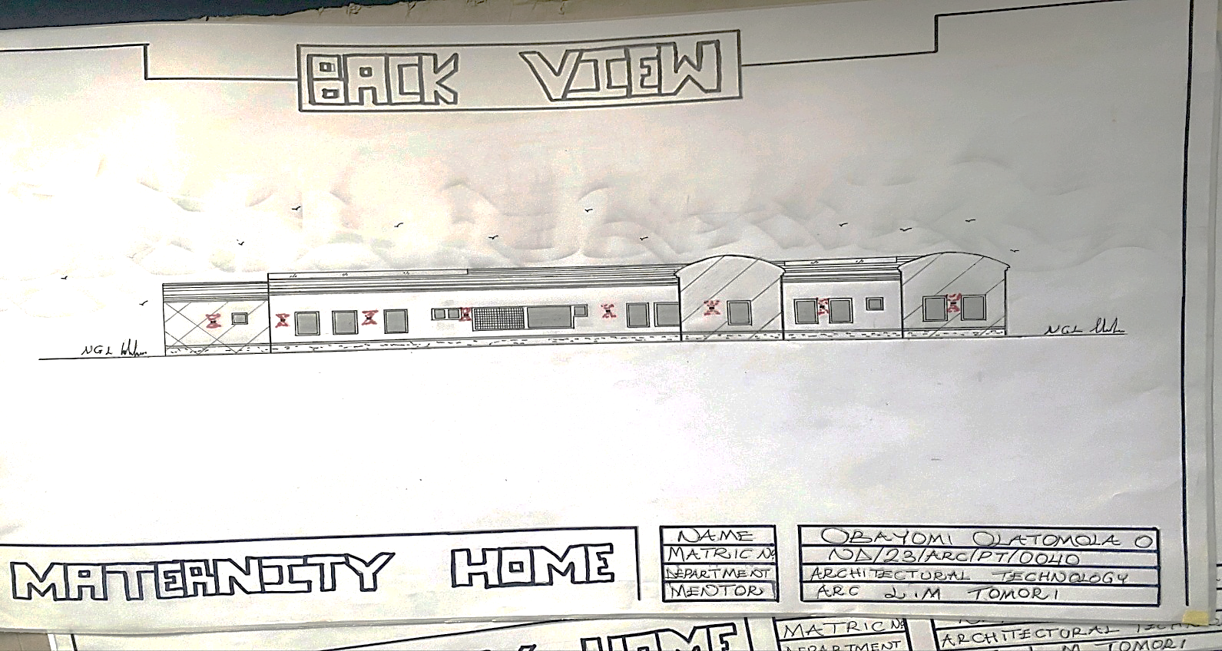
APP 5.6; SHOWING BACK VIEW OF THE PROPOSED PROJECT

