INTERPRETATION OF AEROMAGNETIC DATA OF ILORIN, NORTHCENTRAL NIGERIA

BY:

IDRIS, MEDINAT ADEBOLA
ND/23/SLT/PT/0755

BEING A PROJECT REPORT SUBMITTED TO THE DEPARTMENT OF SCIENCE LABORATORY TECHNOLOGY (PHYSICS/ELECTRONIC UNIT), INSTITUTE OF APPLIED SCIENCES, KWARA STATE POLYTECHNIC ILORIN

IN PARTIAL FULFILMENT OF THE REQUIREMENTS FOR THE AWARD OF NATIONAL DIPLOMA (ND) IN SCIENCE LABORATORY TECHNOLOGY (SLT), KWARA STATE POLYTECHNC, ILORIN, KWARA STATE

JUNE, 2025

CERTIFICATION
This is to certify that this project was carried out by above name and matriculation numbers, submitted to the Department of Science Laboratory Technology, Physics/Electronics unit, Institute of Applied Science (IAS), Kwara State Polytechnic, Ilorin, in partial fulfilment for the requirement of the award of National Diploma (ND) in Science Laboratory Technology (SLT).

___________________ _______________
Mr. Surajudeen Shittu Date
Project Supervisor

___________________ _______________
Mr. Lukman I. A. Date
SLT PT Coordinator

___________________ _______________
Dr. Abdulkareem Usman Date
Head of Department

___________________ _______________
External Examiner Date

DEDICATION
This project is dedicated to Almighty God, the provider and sustainer of life, whose grace has made this journey of my National Diploma (ND) possible. It is also dedicated to my parents, my pillar of support. May God continue to bless and protect you.

ACKNOWLEDGEMENT
I'm grateful for the opportunity to learn and grown
providing me with the resources and support I needed to succeed. Thank god for your guidance and support blessings and favor. I'm thankful for Your presence in my academic journey.”
I would like to extend my sincere gratitude to my project supervisor. Mr. Surajudeen Shittu for their invaluable guidance, support, and expertise throughout.
I'm grateful to my lecturers for their guidance, expertise, and support throughout my academic journey. Their passion for teaching and commitment to my growth have been invaluable. Thank you for sharing your knowledge and shaping me into a better learner."e Kwara State Polytechnic, Ilorin, may Allah bless you all abundantly.
I would like to express my deepest gratitude to my parents, for their unwavering love support and guidance throughout my journey. Their sacrifices, encouragement and wisdom have been instrumental in shaping me into the person thank you for your unconditional love support and guidance.

TABLE OF CONTENTS
TITLE PAGE
CERTIFICATION
DEDICATION
ACKNOWLEDGMENT
TABLE OF CONTENT
CHAPTER ONE: INTRODUCTION
- PREAMBLE
1.1 FUNDAMENTALS OF AEROMAGNETIC SURVEY
1.2 THE GEOMAGNETIC FIELD
1.3 STATEMENT OF THE PROBLEM
1.4 AIM AND OBJECTIVES
1.5 SIGNIFICANCE OF THE STUDY
1.6 GEOGRAPHY OF THE STUDY AREA
1.7 GEOLOGY OF THE STUDY AREA
CHAPTER TWO: LITERATURE REVIEW
2.0 INTRODUCTION
2.1 OVERVIEW OF GEOPHYSICAL METHODS
2.1.1 GRAVITY METHOD
2.1.2 ELECTRICAL METHODS
2.1.3 RADIOMETRIC METHOD
2.1.4 SEISMIC METHOD
2.2 MAGNETIC METHOD
2.2.1 THE EARTH’S MAIN FIELD
2.2.2 MAGNETIC PROPERTIES OF ROCKS
2.2.2.1 SUSCEPTIBILITIES OF ROCKS AND MINERALS
2.2.3 MAGNETIC SURVEY METHODS
2.2.3.1 GROUND MAGNETIC SURVEY
2.2.3.2 MARINE (SEA-BORNE) MAGNETIC SURVEY
2.2.3.3 AEROMAGNETIC SURVEY
2.2.4 REDUCTION/CORRECTION OF MAGNETIC OBSERVATIONS
2.2.4.1 THE INTERNATIONAL GEOMAGNETIC REFERENCE FIELD (IGRF)
2.2.4.2 CORRECTION OF DIURNAL VARIATION
2.2.4.3 REDUCTION TO THE POLE
2.2.4.4 UPWARD AND DOWNWARD CONTINUATION
2.2.4.5 ELEVATION AND TERRAIN CORRECTIONS
2.2.5 METHODS OF INTERPRETING MAGNETIC DATA
2.2.5.1 QUALITATIVE ANALYSIS
2.2.5.2 QUANTITATIVE ANALYSIS
2.2.6 MAGNETIC SURVEYING INSTRUMENTS
2.2.6.1 THE FLUXGATE MAGNETOMETER
2.2.6.2 PROTON MAGNETOMETER
2.2.6.3 MAGNETIC GRADIOMETERS
2.2.7 ADVANTAGES OF AEROMAGNETIC METHOD
2.3 PREVIOUS WORKS ON INTERPRETATION OF AEROMAGNETIC DATA
CHAPTER THREE: METHODOLOGY
3.0 DATA ACQUISITION
3.0.1 MAGNETIC SURVEY SPECIFICATIONS
3.1 DATA ANALYSIS
3.4 DATA PROCESSING AND INTERPRETATION METHOD
3.4.1 STATISTICAL SPECTRAL INTERPRETATION
CHAPTER FOUR: RESULTS AND DISCUSSION
4.0 INTRODUCTION
4.1 DEPTH ESTIMATION FROM STATISTICAL SPECTRAL ANALYSIS
CHAPTER FIVE: CONCLUSION AND RECOMMENDATION
5.0 INTRODUCTION
5.1 CONCLUSION
5.2 RECOMMENDATION
BIBLIOGRAPHY

CHAPTER ONE
INTRODUCTION
- Preamble
Geophysics is the application of physics to study the Earth, oceans, atmosphere and near-Earth space. It is a broad subject that encompasses many of the major sciences – physics, astronomy, planetary science, geology, environmental science, oceanography, and meteorology.
The science of geophysics applies the principles of physics to the study of the Earth. Geophysical investigations of the interior of the Earth involve taking measurements at or near the Earth’s surface that are influenced by the internal distribution of physical properties. Analysis of these measurements can reveal how the physical properties of the Earth’s interior vary vertically and laterally.
By working at different scales, geophysical methods may be applied to a wide range of investigations from studies of the entire Earth to exploration of a localized region of the upper crust for engineering or other purposes. In the geophysical exploration methods (also referred to as geophysical surveying)discussed in this book, measurements within geographically restricted areas are used to determine the distributions of physical properties at depths that reflect the local subsurface geology. (Kearey, et al., 2002).
An alternative method of investigating subsurface geology is, of course, by drilling boreholes, but these are expensive and provide information only at discretelocations. Geophysical surveying, although sometime sprone to major ambiguities or uncertainties of interpretation, provides a relatively rapid and cost-effectivemeans of deriving areally distributed information on subsurface geology. In the exploration for subsurface resources the methods are capable of detecting anddelineating local features of potential interest that could not be discovered by any realistic drilling programme.
Geophysical surveying does not dispense with the needfor drilling but, properly applied, it can optimize explorationprogrammes by maximizing the rate of groundcoverage and minimizing the drilling requirement. The importance of geophysical exploration as a means ofderiving subsurface geological information is so greatthat the basic principles and scope of the methods andtheir main fields of application should be appreciated by any practising Earth scientist.This book provides a generalintroduction to the main geophysical methods inwidespread use. (Kearey, et al., 2002).
A geophysicist is someone who studies the Earth using gravity, magnetic, electrical, and seismic methods. Some geophysicists spend most of their time outdoors studying various features of the Earth, and others spend most of their time indoors using computers for modeling and calculations. Some geophysicists use these methods to find oil, iron, copper, and many other minerals. Some evaluate earth properties for environmental hazards and evaluate areas for dams or construction sites. Research geophysicists study the internal structure and evolution of the earth, earthquakes, the ocean and other physical features using these methods.
1.1 Fundamentals of aeromagnetic survey
From the point of view of geomagnetism, the earth may be considered as made up of three parts: core, mantle and crust (Figure 1.1). Convection processes in the liquid part of the iron core give rise to a dipolar geomagnetic field that resembles that of a large bar-magnet aligned approximately along the earth's axis of rotation (Reeves, 2005). The mantle plays little part in the earth's magnetism, while interaction of the (past and present) geomagnetic field with the rocks of the Earth's crust produces the magnetic anomalies recorded in detailed (e.g. aeromagnetic) surveys carried out close to the earth's surface.
Figure 1: The main divisions of the Earth’s volume (after Reeves, 2005)
Magnetic field in SI units is defined in terms of the flow of electric current needed in a coil to generate that field. As a consequence, units of measurement are volt-seconds per square metre or Weber/m² or Teslas (T). Since the magnitude of the earth's magnetic field is only about 5 x 10⁻⁵ T, a more convenient SI unit of measurement in geophysics is the nanoTesla (nT = 10⁻⁹ T). The geomagnetic field then has a value of about 50 000 nT.
Magnetic anomalies as small as about 0.1 nT can be measured in conventional aeromagnetic surveys and may be of geological significance. Commonly recorded magnetic anomalies have amplitudes of tens, hundreds and (less often) thousands of nT. One nT is numerically equivalent to the gamma (γ) which is an old (cgs) unit of magnetic field. The gamma still has some common currency but should, strictly speaking, now be replaced by the nT.
1.2 The geomagnetic field
The dipolar nature of the geomagnetic field necessitates taking some care in specifying the field's direction. The field is oriented vertically downward at the north magnetic pole, is horizontal (and pointing north) at the magnetic equator and points vertically upwards at the south magnetic pole (Figure 1.2). The magnetic poles have been observed to have moved considerably over historical times and detectable movement occurs even from year to year (Reeves, 2005). However, it is thought that, on average over geological time, the dipole field which best fits the observed geomagnetic field has been coaxial with the geographic poles of rotation. Instantaneously, however - at times such as the present - the virtual magnetic poles may differ from the geographic poles by as much as 10 to 20 degrees.

Figure 1.2: The Earth’s dipolar magnetic field and the inclination of the field at varying latitudes.
The definition of the main geomagnetic field at any point on the earth's surface as a vector quantity requires three scalar values (Figure 1.3), normally expressed either as three orthogonal components (vertical, horizontal-north and horizontal-east components) or the scalar magnitude of the total field vector and its orientation in dip and azimuth. With the exception of a few specialised surveys (see later), aeromagnetic surveys have always measured only the scalar magnitude of F, making the latter system more convenient for present purposes. The angle the total field vector makes above or below the horizontal plane is known as the magnetic inclination, I, which is conventionally positive north of the magnetic equator and negative to the south of it. ( -90°≤ I ≤ +90°). The angle between the vertical plane containing F and true (geographic) north is known as the magnetic declination, D, which is reckoned positive to the east and negative to the west. The value of D is commonly displayed on topographic maps to alert the user to the difference between magnetic north, as registered by a compass, and true north. D is less than 15° in most places on the Earth, though it reaches values as large as 180° along lines joining the magnetic and geographic poles.

Figure 1.3: The vector total magnetic field may be defined either as (a) three orthogonal components (horizontal north, horizontal east and vertical) or (b) as the scalar magnitude of the total field, F and two angles, the inclination from the horizontal, I and the declination from true (geographic) north, D.
1.3 STATEMENT OF THE PROBLEM
Many geophysical works have been done in the study area, mostly employing the electrical methods, this study therefore attempts to make use of the magnetic method in order to aid the understanding of the subsurface of the area and also compliment results from other methods.

1.4 AIM AND OBJECTIVES
The aim of this study is to estimate the depths to the basement rock in the study area by interpreting the aeromagnetic data over the area.
The objectives of the study are:
• To determine depth to basement (magnetic source).
• Categorize the magnetic sources (deeper and shallower).
• Ascertain thickness of overburden layer.
• Lithology delineation of the subsurface.
• Determine depth of shallow magnetic sources resulting from outcrops of lateritic bodies and intrusion of magnetic rocks in the sedimentary formation within the study area
1.5 SIGNIFICANCE OF THE STUDY
Airborne geophysics contributes to tectonic reconstruction, groundwater resource management, petroleum and mineral exploration, mining and environmental protection application. Considering the fact that modern high-resolution magnetometers are able to collect data with an accuracy of 0.001nT according to (Rajaramet al., 2009), aeromagnetic method is unequivocally suitable to determine the basement depth and map out the fractured zone in the study area.
1.6 GEOGRAPHY OF THE STUDY AREA
1.6.1 Topography and Drainage
The topography and drainage pattern is highly associated with the geology of Kwara State. The hard rocks come out as high relief features with hills and ridges. In areas of granitic gneisses, schist and migmatite, the relief is rolling /undulating landscapes and almost flat in some places, this is as a result of variation in rock structure, texture and mineralogy. Figure 1.4 is the Elevation map of Ilorin and environs (part of the study), which displays range of elevation with different colors. The map also provides idea of topography of the study area.
1.6.2 Climate
There are two types of seasons of Nigerian climate; wet and dry seasons.
Wet season: This occur between March and October, the humidity in the state is moderately distributed with average annual rainfall of 1145mm.
Dry season: These spans from November to late February/March. The precipitation is very low during this period and crop production is crippled except where irrigation facilities are being used.
December and January are usually cold dry months and heaviest rainfall occurs between June and early August with a short drought between August and September (august break).
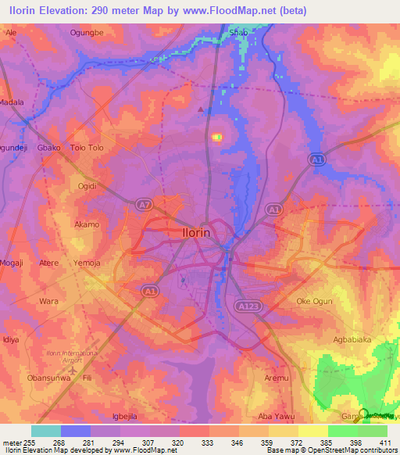
Figure 1.4: Topography of Part of Kwara State

1.6.3 Vegetation
The soils of Ilorin are easy to farm. These are loamy soil with sodium and low fertility, because of the high seasonal rainfall coupled with the high temperature, there is tendency for lateritic soil to constitute the major soil types due to the leaching of minerals and nutrients of the soil (Ajibadeet al., 2004).
The derived Savannah dominates the vegetation of the area. The vegetation type comprises tall grass which is interspersed with scattered trees. Among the grasses in the area include spear grass, elephant grass, and goat weed of height of 3:5meters. Trees in the area include shear butter, acacia and locust beans trees. Agricultural activities in Ilorin are limited to small garden plots of groundnut, maize, beans and vegetables cultivated mainly for domestic consumption, cultivation of yam, cassava, and guinea-corn. Vegetables are increasingly done at the outskirts of the city. Both climate and soil of Ilorin support the growth of cereal crops (Atlas, 1982).
1.7 GEOLOGY OF THE STUDY AREA
Geologically, the study area longitude 4º30’ – 5º30’ E and latitude 8º00’ – 8º30’ N (part of Kwara State) lies in the Precambrian Basement complex of southwestern Nigeria and is underlain by rock of metamorphic and igneous type. However, migmatite predominantly underlies the area and characterized by weathered regolith which vary in thickness from place to place. The hydrologic setting of the area studied is typical of what is obtained in other Basement complex area where the availability of water is a function of the presence of thick-little clay overburden material and presence of water filled joints, fracture or faults within the fresh Basement rocks. The humid tropical climate of Ilorin has particularly encourage relatively deep weathering of the near surface rocks to produce porous and permeable material that allows groundwater accumulation as shallow aquifer which is recharged principally through infiltration of rainwater (Ajibade, 2008).
The city is situated in the transitional zone between the forest and savannah region of Nigeria. The geology of Ilorin consists of Pre-Cambrian basement complex with an elevation that varies from 273m to 333m in the West having an isolated hill (Sobi hills) of about 394m above sea level and 200m to 364m in the East. (Oyegun, 1985) further asserted that a large part of Ilorin town is laid by sedimentary rock, which contains both primary and secondary laterites and alluvial deposits. The major river in Ilorin is Asa, which flows North-South direction dividing the plain into two, Western and Eastern parts. The eastern part is generally steeper than the western part with height ranging from 900 – 1200 feet in some part and peaking at isolated landforms (Ajibade, 2008).
Five major groups of rocks had been recognized in the basement complex of southern Nigeria (Rahman, 1973).
These include,
1. Migmatite- Gneiss complex which comprises gneisses, quartzite, calcium silicates rocks, biotite hornblende, schist and amphiboles
2. Slightly migmatised to unmigmatised para-schists and meta-igneous rocks
3. Charnockitic rocks
4. Older granites
5. Unmetamorphosed dolerite dykes, which comprises pegmatite, quartz veins and doleritic dykes
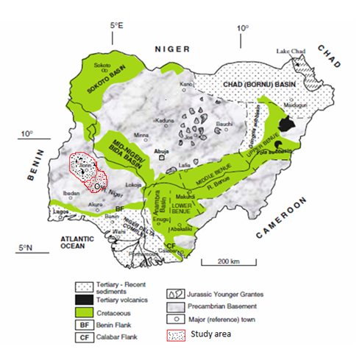
Figure 1.5: Geological map of Nigeria showing the study area, after (modified after Obaje, 2007).

CHAPTER TWO
LITERATURE REVIEW
2.0 INTRODUCTION
In this chapter, the overview of geophysical methods to geo-environmental studies, and use of aeromagnetic method are reviewed. This chapter also entails summary of the results of reconnaissance to improve the understanding of the lithology of the study area using magnetic method. In the following discussion, the applicability of geophysical methods to geo-environmental studies is reviewed. Only magnetic method is detailed in this chapter while other geophysical methods are briefly discussed.
Some geophysical methods, such as gamma-ray spectrometry and remote sensing, measure surface attributes; others, such as thermal and some electrical methods are limited to detecting relatively shallow feature. Geophysical modeling provides generalized and non-unique solutions to questions concerning the geometry of subsurface geologic relations. The non-uniqueness of these solutions is both a mathematical problem and one related to the multiplicity of sources that can cause geophysical anomalies. This feature is an implicit uncertainty in the discussion that follows. Environmental geophysics, like exploration geophysics, requires complimentary geophysical surveys integrated with geochemical and geologic insight (Gadallah, et al., 2009).
2.1 OVERVIEW OF GEOPHYSICAL METHODS
Various geophysical survey methods have been and are being used on land and offshore. Each of these methods measures something that is related to subsurface rocks and their geologic configurations. Rocks and minerals in the earth vary in several ways. According to (Gadallah, et al., 2009) these include:
• Density – mass per unit volume. The gravity method detects lateral variations in density. Both lateral and vertical density variations are important in the gravity method.
• Magnetic susceptibility – the amount of magnetization in a substance exposed to a magnetic field. The magnetic method detects horizontal variations in susceptibility.
• Propagation velocity – the rate at which sound or seismic waves are transmitted in the earth. It is these variations, horizontal and vertical, that make the seismic method applicable to petroleum exploration.
• Resistivity and Induced Polarization – Resistivity is a measure of the ability to conduct electricity and induced polarization is frequency-dependent variation in resistivity. Electrical methods detect variations of these over a surface area
• Self-Potential - ability to generate an electrical voltage. Electrical methods also measure this over a surface area.
• Electromagnetic wave reflectivity and transmissivity: reflection and transmission of electromagnetic radiation, such as radar, radio waves and infrared radiation, is the basis of electromagnetic methods etc.
2.1.1 Gravity Method
In gravity surveying, subsurface geology is investigated on the basis of variations in the Earth’s gravitational field arising from differences of density between subsurface rocks. An underlying concept is the idea of a causative body, which is a rock unit of different density from its surroundings. A causative body represents a subsurface zone of anomalous mass and causes a localized perturbation in the gravitational field known as a gravity anomaly. On a small scale, buried relief on a bedrock surface, such as a buried valley, can give rise to measurable anomalies. On a larger scale, small negative anomalies are associated with salt domes. Modern instruments capable of rapid gravity measurements are known as gravity meters or gravimeters (Al-Chalabi, 1972).
2.1.2 Electrical Methods
There are many methods of electrical surveying. Some makes use of fields within the Earth while others require the introduction of artificially-generated currents into the ground. These methods include;
• Direct current resistivity
• Electromagnetic
• Mise-a-la-masse
• Induced polarization
• Self-potential
The resistivity method is used in the study of horizontal and vertical discontinuities in the electrical properties of the ground, and also in the detection of three-dimensional bodies of anomalous electrical conductivity. It is routinely used in engineering and hydro geological investigations to investigate the shallow subsurface geology (Aspinall, et al., 1975).
The Induced Polarization method makes use of the capacitive action of the subsurface to locate zones where conductive minerals are disseminated within their host rocks. When using a standard four-electrode resistivity spread in a DC mode, if the current is abruptly switched off, the voltage between the potential electrodes does not drop to zero immediately. After a large initial decrease the voltage suffers a gradual decay and can take many seconds to reach a zero value (Aspinall, et al., 1975).
The capacitive property of the ground causes both the transient decay of a residual voltage and the variation of apparent resistivity as a function of frequency. The two effects are representations of the same phenomenon in the time and frequency domains, and are linked by Fourier transformation.
The self-potential method makes use of natural currents flowing in the ground that are generated by electrochemical processes to locate shallow bodies of anomalous conductivity. The self-potential (or spontaneous polarization) method is based on the surface measurement of natural potential differences resulting from electrochemical reactions in the subsurface. Typical SP anomalies may have amplitude of several hundred millivolts with respect to barren ground. They invariably exhibit a central negative anomaly and are stable over long periods of time. They are usually associated with deposits of metallic sulphides, magnetite or graphite (Corry, 1985).
Electromagnetic (EM) surveying methods make use of the response of the ground to the propagation of electromagnetic fields, which are composed of an alternating electric intensity and magnetizing force. Primary electromagnetic fields may be generated by passing alternating current through a small coil made up of many turns of wire or through a large loop of wire. The response of the ground is the generation of secondary electromagnetic fields and the resultant fields may be detected by the alternating currents that they induce to flow in a receiver coil by the process of electromagnetic induction (Raab, et al., 1984).
2.1.3 Radiometric Method
Radiometric surveying is employed in the search for deposits necessary for this application, and also for non-radioactive deposits associated with radioactive elements such as titanium and zirconium. Radiometric surveys are of use in geological mapping as different rock types can be recognized from their distinctive radioactive signature. The elements of principal interest in radiometric exploration are uranium (238U), thorium (232Th) and potassium (40K). Probably the most common application of radiometric techniques is in geophysical borehole logging (Gadallahet al., 2009).
2.1.4 Seismic Method
Reflection seismology (or seismic reflection) is a method of exploration geophysics that uses the principles of seismology to estimate the properties of the Earth's subsurface from reflected seismic waves (https://en.wikipedia.org/wiki/waste_management).
At its most basic, the seismic reflection technique consists of generating seismic waves and measuring the time taken for the waves to travel from the source, reflect off an interface and be detected by an array of receivers (or geophones) at the surface. By Knowing the travel time from the source to various receivers, and the velocity of the seismic waves, a geophysicist then attempts to reconstruct the pathways of the waves in order to build up an image of the subsurface (Sheriffet al., 1995).
2.2 MAGNETIC METHOD
The aim of a magnetic survey is to investigate subsurface geology on the basis of anomalies in the Earth’s magnetic field resulting from the magnetic properties of the underlying rocks. Although most rock-forming minerals are effectively non-magnetic, certain rock types contain sufficient magnetic minerals to produce significant magnetic anomalies (Horsfall, 1997).
2.2.1 The Earth’s Main Field
The Earth’s main magnetic field originates in electric currents circulating in the liquid outer core (geo-dynamo), but can be largely modeled by a dipole source at the Earth’s center. Distortions in the dipole field extending over regions thousands of kilometers across can be thought of as caused by a relatively small number of subsidiary dipoles at the core-mantle boundary (Milsom et al., 2011).
2.2.2 Magnetic Properties of Rocks
A rock may be regarded as a heterogeneous assemblage of minerals. The matrix minerals are mainly silicates or carbonates, which are diamagnetic in character. Interspersed in this matrix is a lesser quantity of secondary minerals (such as the clay minerals) that have paramagnetic properties. The bulk of the constituent minerals in a rock contribute to the magnetic susceptibility but are incapable of any contribution to the remanent magnetic properties, which are due to a dilute dispersion of ferrimagnetic minerals (e.g., commonly less than 0.01% in a limestone). The variable concentrations of ferrimagnetic and matrix minerals result in a wide range of susceptibilities in rocks (Lowrie, 2007).
2.2.2.1 Susceptibilities of Rocks and Minerals
The susceptibility of a rock usually depends on its magnetite content. Sediments and acid igneous rocks have small susceptibilities whereas basalts, dolerites, gabbros and serpentines are usually strongly magnetic. Weathering generally reduces susceptibility because magnetite is oxidized to hematite, but some laterites are magnetic because of the presence of maghemite and remanently magnetized hematite (Milsom et al., 2011).
The susceptibility, k, is small for most natural materials, and may be either negative (diamagnetism) or positive (paramagnetism). The fields produced by such materials are usually considered too small to affect survey magnetometers.
Modern high-sensitivity magnetometers are creating exceptions to this rule, but most useful magnetic anomalies are still due to the small number of ferro- or ferri-magnetic substances in which the molecular magnets are held parallel by intermolecular exchange forces. Below the Curie temperature, these forces are strong enough to overcome the effects of thermal agitation. Magnetite, pyrrhotite and maghemite, all of which have Curie temperatures of about 6000C, are the only important naturally occurring strongly magnetic minerals and, of the three, magnetite is by far the most common. Hematite, the most abundant iron mineral, normally has a very small susceptibility, and many iron ore deposits do not produce significant magnetic anomalies (Lowrie, 2007).
2.2.3 Magnetic Survey Methods
It is the induced and remanent fields that are of particular interest in a magnetics survey because the magnitudes of these fields are directly related to the magnetic susceptibility, spatial distribution and concentration of the local crustal materials. Furthermore only a few minerals occur abundantly enough in nature to make a significant contribution to the induced and remanent fields, the most important of these is magnetite and to a lesser extent ilmenite and pyrrhotite (Clarke, 1997). The three methods of acquiring magnetics data are discussed as follows.
2.2.3.1 Ground Magnetic Survey
Ground magnetic surveys are usually performed over relatively small areas on a previously defined target. Data is acquired close to ground level either via a person carrying a magnetometer or with a magnetometer mounted on a motor vehicle such as a quad motorcycle or four-wheel drive. Consequently, station spacing is commonly of the order of 10–100m, although smaller spacing may be employed where magnetic gradients are high. Readings should not be taken in the vicinity of metallic objects such as railway lines, cars, roads, fencing, houses, etc., which might perturb the local magnetic field. For similar reasons, operators of magnetometers should not carry metallic objects. Base station readings are not necessary for monitoring instrumental drift as fluxgate and proton magnetometers do not drift, but are important in monitoring diurnal variations (Ross, 2002).
2.2.3.2 Marine (sea-borne) Magnetic survey
Marine magnetic surveying techniques are similar to those of airborne surveying. The sensor is towed in a ‘fish’ at least two ships’ lengths behind the vessel to remove its magnetic effects. Marine surveying is obviously slower than aeromagnetic surveying, but is frequently carried out in conjunction with several other geophysical methods, such as gravity surveying and continuous seismic profiling, which cannot be employed in the air (Ross, 2002).
2.2.3.3 Aeromagnetic survey
Aeromagnetic surveying is rapid and cost-effective, typically costing some 40% less per line kilometer than a ground survey. Vast areas can be surveyed rapidly without the cost of sending a field party into the survey area and data can be obtained from areas inaccessible to ground survey. The vast majority of magnetic surveys are carried out in the air, with the sensor towed in a housing known as a ‘bird’ to remove the instrument from the magnetic effects of the aircraft or fixed in a ‘stinger’ in the tail of the aircraft, in which case inboard coil installations compensate for the aircraft’s magnetic field. The magnetic field is usually measured with a total field magnetometer. The most common instrument in use today is the caesium-vapour magnetometer.
Observations are made at regular intervals along a series of flight lines of constant azimuth and spacing. Observations are similarly made along tie lines oriented perpendicular to the traverse lines. Tie lines are necessary to assist in the removal of temporal variations in the main field. Tie lines are usually spaced about ten times further apart than traverse lines (Brodie C. Ross, 2002).
Various corrections are necessary to be done on the acquired data for accurate geophysical extrapolations to be made, these corrections are discussed below.

2.2.4 Reduction/Correction of Magnetic Observations
The reduction of magnetic data is necessary to remove all causes of magnetic variation from the observations other than those arising from the magnetic effects of the subsurface.
2.2.4.1 The International Geomagnetic Reference Field (IGRF)
The Earth’s main field varies not only with latitude and longitude but also with time. Between 1980 and 2002 the field strength in the central Atlantic decreased by about 6%. These secular changes are described by the empirical International Geomagnetic Reference Field (IGRF) equations, which are defined to order N =10 by 120 spherical harmonic coefficients, supplemented to order N =8 by a predictive secular variation model. The shortest wavelength present is about 3000 km. IGRFs provide reasonable representations of the actual fields in well-surveyed areas, where they can be used to calculate regional corrections, but discrepancies of as much as 250 nT can occur in areas from which little information was available at the time of formulation. Since 2000, the accuracies of the IGRFs have been greatly improved by incorporating data from the Danish Oersted and German CHAMP satellites (Milsom, et al., 2011).
Secular changes are adequately predicted by extrapolation from past observations for only a few years into the future, and IGRFs are updated every five years and are also revised retrospectively to give definitive models (DGRFs). These time-dependent corrections are vital for comparing airborne or marine surveys carried out years or even months apart but are less important in ground surveys, where base stations can be reoccupied (Milsom et al., 2011).
2.2.4.2 Correction of Diurnal Variation
The effects of diurnal variation may be removed in several ways. On land a method similar to gravimeter drift monitoring may be employed in which the magnetometer is read at a fixed base station periodically throughout the day. The differences observed in base readings are then distributed among the readings at stations occupied during the day according to the time of observation. It should be remembered that base readings taken during a gravity survey are made to correct for both the drift of the gravimeter and tidal effects; magnetometers do not drift and base readings are taken solely to correct for temporal variation in the measured field. Such a procedure is inefficient as the instrument has to be returned periodically to a base location and is not practical in marine or airborne surveys. These problems may be overcome by use of a base magnetometer continuous-reading instrument which records magnetic variations at a fixed location within or close to the survey area. This method is preferable on land as the survey proceeds faster and the diurnal variations are fully charted. Where the survey is of regional extent the records of a magnetic observatory may be used. Such observatories continuously record changes in all the geomagnetic elements. However, diurnal variations differ quite markedly from place to place and so the observatory used should not be more than about 100 km from the survey area (Milsom et al., 2011).
Diurnal variation during an aeromagnetic survey may alternatively be assessed by arranging numerous crossover points in the survey plan. Analysis of the differences in readings at each crossover, representing the field change over a series of different time periods, allows the whole survey to be corrected for diurnal variation by a process of network adjustment, without the necessity of a base instrument. An alternative method of removing the regional gradient over a relatively small survey area is by use of trend analysis. A trend line (for profile data) or trend surface (for a real data) is fitted to the observations using the least squares criterion, and subsequently subtracted from the observed data to leave the local anomalies as positive and negative residuals (Lowrie, 2007).
2.2.4.3 Reduction to the Pole
This simplifies the interpretation of anomalies by removing the asymmetry introduced due to its induction by the inclined main field. The main field is only vertical (and induced anomalies symmetric) at the north and south magnetic poles. As the name suggests reduction to the pole transforms the data to that which would have been measured at the magnetic poles. This simplifies the anomalies by centering anomalies over the causative magnetic body rather than being skewed and offset to one side (Ross, 2002).
2.2.4.4 Upward and Downward Continuation
Upward and downward continuation of magnetic data transforms the data to that which would be measured on different surfaces either above or below the actual observation surface. Upward continuation thus tends to attenuate the effect of near surface sources relative to deeper sources, while downward continuation has the opposite effect (Brodie C. Ross, 2002).
2.2.4.5 Elevation and Terrain Corrections
The vertical gradient of the geomagnetic field is only some 0.03nTm-1 at the poles and -0.015nTm-1 at the equator, so an elevation correction is not usually applied.The influence of topography can be significant in ground magnetic surveys but is not completely predictable as it depends upon the magnetic properties of the topographic features. Therefore, in magnetic surveying terrain corrections are rarely applied (Brodie C. Ross, 2002).
Having applied diurnal and geomagnetic corrections, all remaining magnetic field variations should be caused solely by spatial variations in the magnetic properties of the subsurface and are referred to as magnetic anomalies.
2.2.5 Methods of Interpreting Magnetic Data
There are basically two main methods of data interpretation in magnetic survey;
• Qualitative Interpretation
• Quantitative Interpretation
2.2.5.1 Qualitative Analysis
Much qualitative information may be derived from a magnetic contour map. This applies especially to aeromagnetic maps which often provide major clues as to the geology and structure of a broad region from an assessment of the shapes and trends of anomalies. Sediment covered areas with relatively deep basement are typically represented by smooth magnetic contours reflecting basement structures and magnetization contrasts. Igneous and metamorphic terrains generate far more complex magnetic anomalies, and the effects of deep geological features may be obscured by short wavelength anomalies of near-surface origin (Keary, et al., 2002).
Qualitative interpretation could be done by visual inspection of the anomaly map to locate points of high or low intensity which may be interpreted as dyke or infiltration of material with different magnetic properties. Map of magnetic intensity in nanotesla (nT) could also be plot against distance (m) along selected profiles to visualize some structural trend.
2.2.5.2 Quantitative Analysis
There are various methods of interpreting magnetic data quantitatively amongst these methods are;
1. Euler deconvolution method
2. Wavelet method
3. Spectral method
4. Pal’s method
5. Centroid method and so on.
Spectral Analysis Method of Interpretation
Magnetic anomalies caused by shallow structures are more dominated by high wave number components than those resulting from deeper source. This effect may be quantified by computing the power spectrum of the anomaly since the long power spectrum has a linear gradient whose magnitude is dependent upon the depth of the source (Spector, et al., 1970).
The major advantage of Spectral analysis method is its ability to filter almost all the noise from the data whilst still making sure no information is lost in the process of interpretation by overlapping data. Such techniques of spectral analysis provide rapid depth estimates from regularly-spaced digital field data; no geomagnetic or diurnal corrections are necessary as these remove only low-wavenumber components and do not affect the depth estimates which are controlled by the high-wavenumber components of the observed field (Spector, et al., 1970).
Limiting depth is the most important parameter derived by direct interpretation, and this may be deduced from magnetic anomalies by making use of their property of decaying rapidly with distance from source. Magnetic anomalies caused by shallow structures are more dominated by short-wavelength components than those resulting from deeper sources. This effect may be quantified by computing the power spectrum of the anomaly as it can be shown, for certain types of source body, that the log-power spectrum has a linear gradient whose magnitude is dependent upon the depth of the source (Spector, et al., 1970).

2.2.6 Magnetic Surveying Instruments
In early magnetic surveys the geomagnetic elements were measured using magnetic variometers. There were several types, including the torsion head magnetometer and the Schmidt vertical balance, but all consisted essentially of bar magnets suspended in the Earth’s field. Such devices required accurate levelling and a stable platform for measurement so that readings were time consuming and limited to sites on land (Keary, et al., 2002).
2.2.6.1 The Fluxgate Magnetometer
The first such device to be developed was the fluxgate magnetometer, which found early application during the Second World War in the detection of submarines from the air. The instrument employs two identical ferromagnetic cores of such high permeability that the geomagnetic field can induce a magnetization that is a substantial proportion of their saturation value.
Identical primary and secondary coils are wound in opposite directions around the cores. An alternating current of 50–1000Hz is passed through the primary coils, generating an alternating magnetic field. In the absence of any external magnetic field, the cores are driven to saturation near the peak of each half-cycle of the current. The alternating magnetic field in the cores induces an alternating voltage in the secondary coils which is at a maximum when the field is changing most rapidly. Since the coils are wound in opposite directions, the instrument can be used to measure Z or H by aligning the cores in these directions, but the required accuracy of orientation is some eleven seconds of arc to achieve a reading accuracy of 0.1nT. Such accuracy is difficult to obtain on the ground and impossible when the instrument is mobile (Lowrie W, 2007).
2.2.6.2 Proton Magnetometer
The most commonly used magnetometer for both survey work and observatory monitoring is currently the nuclear precession or proton magnetometer. The sensing device of the proton magnetometer is a container filled with a liquid rich in hydrogen atoms, such as kerosene or water, surrounded by a coil. The hydrogen nuclei (protons) act as small dipoles and normally align parallel to the ambient geomagnetic field. A current is passed through the coil to generate a magnetic field 50–100 times larger than the geomagnetic field, and in a different direction, causing the protons to realign in this new direction. The current to the coil is then switched off so that the polarizing field is rapidly removed. The protons return to their original alignment by spiraling, or precessing, in phase around this direction with a period of about 0.5 ms, taking some 1–3 s to achieve their original orientation.
Field instruments provide absolute readings of the total magnetic field accurate to 0.1 nT although much greater precision can be attained if necessary. The sensor does not have to be accurately oriented, although it should ideally lie at an appreciable angle to the total field vector. Consequently, readings may be taken by sensors towed behind ships or aircraft without the necessity of orienting mechanisms. Aeromagnetic surveying with proton magnetometers may suffer from the slight disadvantage that readings are not continuous due to the finite cycle period. Small anomalies may be missed since an aircraft travels a significant distance between the discrete measurements, which may be spaced at intervals of a few seconds. Many modern proton magnetometers make use of the Overhauser Effect (Lowrie, 2007).
The protons are then polarized indirectly using radiofrequency energy near 60MHz. The power consumption of such instruments is only some 25% of classical proton magnetometers, so that the instruments are lighter and more compact. The signal generated by the fluid is about 100 times stronger, so there is much lower noise; gradient tolerance is some three times better; sampling rates are faster.
2.2.6.3 Magnetic Gradiometers
The sensing elements of fluxgate, proton and optically pumped magnetometers can be used in pairs to measure either horizontal or vertical magnetic field gradients. Magnetic gradiometers are differential magnetometers in which the spacing between the sensors is fixed and small with respect to the distance of the causative body whose magnetic field gradient is to be measured. Magnetic gradients can be measured, albeit less conveniently, with a magnetometer by taking two successive measurements at close vertical or horizontal spacing. Magnetic gradiometers are employed in surveys of shallow magnetic features as the gradient anomalies tend to resolve complex anomalies into their individual components, which can be used in the determination of the location, shape and depth of the causative bodies. The method has the further advantages that regional and temporal variations in the geomagnetic field are automatically removed. Marine and airborne versions of magnetometers and gradiometers are discussed by Woldand Cooper (1989) and Hood and Teskey (1989), respectively (Keary, et al., 2002).
2.2.7 Advantages of Aeromagnetic Method
Aeromagnetic method is becoming more popular among geophysicists due to its high versatility, cost effectiveness and various other advantages over other geophysical techniques. The magnetic fields change when the physical properties like susceptibility and thickness of subterranean rocks change. The magnetic data finds wide applications and is able to provide very valuable subsurface information (Churchill, et al., 2012).
Some of its other advantages are highlighted below;
• It covers large region in little time compared to land and sea borne surveys
• Airborne geophysics also contribute to tectonic reconstruction, groundwater resource management, petroleum and mineral exploration, mining and environmental protection application (Churchill, et al., 2012)
• It covers areas of barrier that would not have been possible in land and sea borne
• Modern high-resolution magnetometers are able to collect data with an accuracy of 0.001nT (Rajaram, et al., 2009)
• Data obtained could be interpreted in diverse ways like hydrocarbon prospecting, determination of curie depth, depth of magnetic basement, fractures amongst others.
2.3 PREVIOUS WORKS ON INTERPRETATION OF AEROMAGNETIC DATA
Numerous geophysical work have been and are being done around the globe using the various geophysical methods, some of the previous work that employed magnetic methods are reviewed here. (Olawuyi, 2015) Evaluated the fault and lineament structures within the Lafiagi Study area using geological, aeromagnetic and gravity data.(Anakwuba, et al., 2011) Interpreted the aeromagnetic data over Maiduguri-Dikwa Depression using Fourier transform to deduce the magnetic source depth (both shallower and deeper) and also to delineate the fracture condition of the study area.
David and Mauritus concluded from the spectral analysis result obtained from aeromagnetic data of some part of Lower Benue Trough, that the area holds enough thickness for the accumulation of hydrocarbon. The magnetic basement surface plot of the area reveals that the basement surface presents a successive pattern of crests and troughs. It also indicates that the shape of the basement is irregular and associated with deep faults resulting from fractures (Davidet al., 2013).

CHAPTER THREE
METHODOLOGY
3.0 Data Acquisition
High Resolution Aeromagnetic data covering the study area (Parts of Kwara State bounded by longitude 4º30’ -5º30’ and latitude 8º-8º30’) collected within 07/12/06 - 31/05/07 by Fugro Airborne Surveys on behalf of the Nigeria Geological Survey Agency (NGSA) was procured from the Geological Survey Agency of Nigeria. Some of the specification of the aeromagnetic survey are listed below:
3.0.1 Magnetic Survey Specifications
Magnetic Data Recording Interval 0.1 seconds or less (~7m)
Sensor Mean Terrain Clearance 80 meters
Flight Line Spacing 500 meters
Tie Line Spacing 5000 meters
Flight Line Trend 135 degrees
Tie Line Trend 45 degrees
EQUIPMENT SPECIFICATIONS
Magnetometers 3 x Scintrex CS3 Caesium Vapour
Data Acquisition System FASDAS
Magnetic Counter FASDAS
Radar Altimeter KING KR405/KING KR405B
Barometric Altimeter ENVIRO BARO/DIGIQUARTZ
Most of the data was collected between 2005 and 2009; hence an IGRF 2005 model was used for the calculation of declination and inclination. The Total Magnetic field Intensity value Z was stripped of 33,000nT for ease of processing. A simple arithmetic addition of 33,000nT to each value of Z therefore gives you the Z-Total (NGSA).
3.1 Data Analysis
High Resolution Aeromagnetic data covering the study area (Part of Kwara State bounded by longitude 4º30’ – 5º30’ and latitude 8º-8º30’) Collected by Fugro Airborne Surveys was acquired, the component of the field measured was the total magnetic field. The study area is covered by two aeromagnetic map of total-field intensity in sheet 223 and 224 on a scale of 1:100,000. The data used were gridded into 21 overlapping windows using Oasis montaj. In this study, Fast Fourier Transform (FFT) filter was used to calculate the depth. The data was transformed from time domain to space domain using FFT. A Matlab program was developed to separate the high and low frequency signal zones and to calculate their slopes.
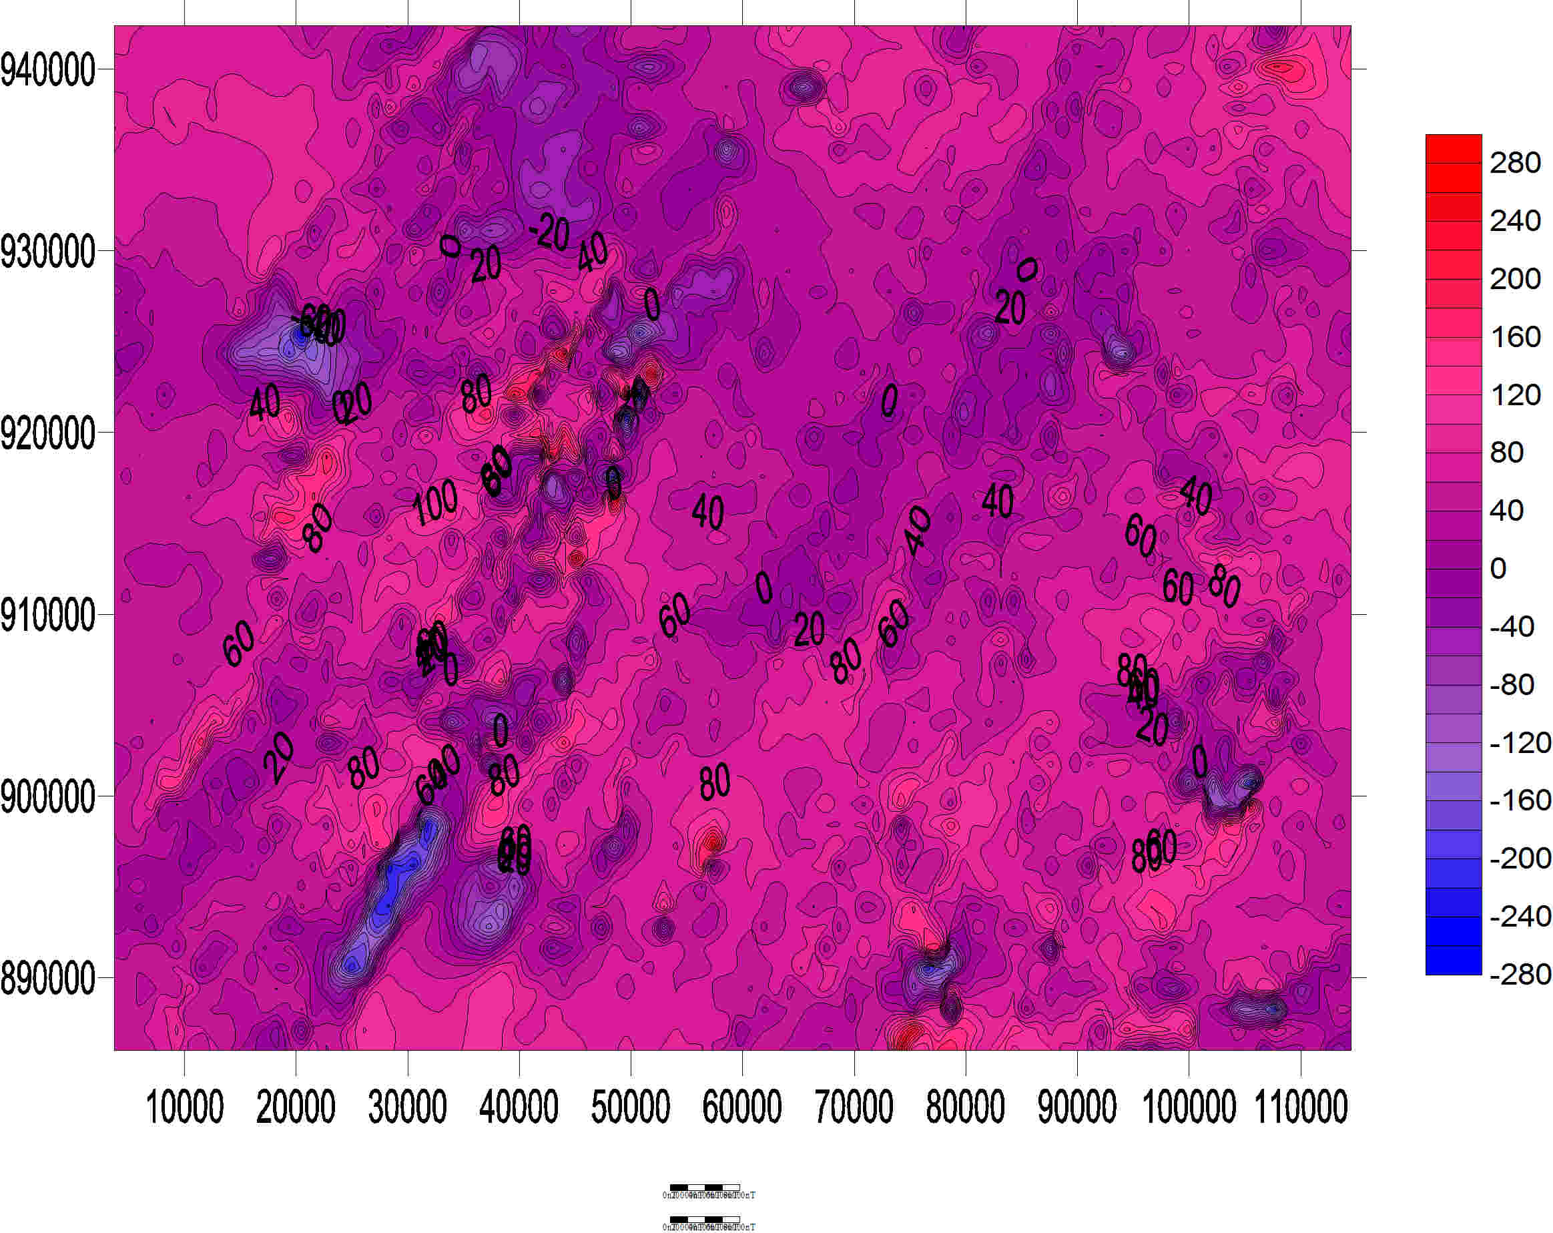
Fig 3.1: Contour map of total intensity of the study area

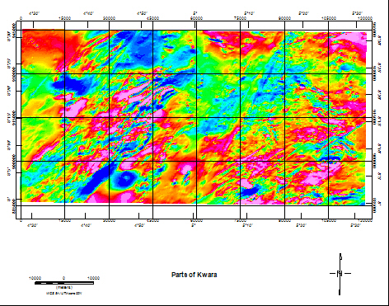
Fig 3.2: Gridded total intensity map of the area
3.4 DATA PROCESSING AND INTERPRETATION METHOD
3.4.1 Statistical Spectral Interpretation
The Energy Spectral Analysis method applied to magnetic grid data allows calculation of an average depth to ensembles of the causative bodies. From the slope of the linear segment of the spectrum graph, the depth is calculated. Depth is a function of the decay of the spectrum function within a corresponding frequency interval. A plot of the logarithm of the radially averaged energy spectrum vs. the radial frequency from gridded magnetic data shows the decay of this function which indicates depth to the modelled prism (Salako et al., 2013).
The Fourier transform of the potential field due to a prismatic body has a broad spectrum whose peak location is a function of the depth to the top and bottom surfaces and whose amplitude is determined by its density or magnetization. The peak wave number (ω^{i}) can be related to the geometry of the body according to the following expression
$$ω^{i}=\frac{Hn({h_{b}}/{h_{t}})}{h_{b}-h_{t}}$$
ω^{i} is the peak wave number in radian /ground – unit, h_{t} is the depth to the top and h_{b} is the depth to the bottom (K. A. Salako & Udensi, 2013).
$$f\left(ω\right)=e^{hω}$$
Where ω is the angular wave number in radians/ground –unit and h is the depth to the top of the prism. For a prism with top and bottom surface, the spectrum is:
$$f\left(ω\right)=e^{-h_{t}w}-e^{-h_{b}w}$$
Where h_{t} and h_{b} are the depths to the top and bottom surface respectively. As the prism bottom moves closer to the observation point at surface, the peak moves to a higher wave number. When looking at the spectrum, it is important to note that the amplitude of a deep prism does not exceed the amplitude of the same prism at shallow depth at any wavenumber. The effect of increasing the depth is to shift the peak to lower wavenumbers.
The sources can only be distinguished if the deep sources have greater amplitude or if the shallow sources have less depth extent. When considering a line that is long enough to include many sources, the log spectrum of this data can be used to determine the depth to the top of a statistical ensemble of sources using the relationship.
$$LogE\left(k\right)=4πhk$$
Where, h is the depth in ground – units and k is the wavenumber in cycles / ground – unit. The depth of an ‘ensemble’ of source can be determined by measuring the slope of the energy (power) spectrum and dividing by 4π. A typical energy spectrum for magnetic data may exhibit three parts – a deep source component, a shallow source component and a noise component (K. A. Salako & Udensi, 2013).
Multiple linear segments (slopes) on the spectrum correspond to separate depth ensembles. The spectrum consists of three parts; the highest wavenumber signal (corresponding to noise signal), the low frequency and the high frequency signals. The spectrum graph depicts the 1st slope, the steepest, which corresponds to deeper bodies dominating the low frequency zone. The 2nd slope indicates the average depth to the shallower sources.

CHAPTER FOUR
RESULTS AND DISCUSSION
4.0 INTRODUCTION
The result of spectral analysis of high resolution aeromagnetic data over part of Kwara State bounded by is discussed in this chapter. The result of the 2D spectral depth estimate were presented in tabular form depicting the shallower and deeper source, the energy spectra plot are also presented.
4.1 DEPTH ESTIMATION FROM STATISTICAL SPECTRAL ANALYSIS
The total magnetic field data was used to determine the depth to magnetic sources within Ilorin using statistical spectral analysis. Some of the power spectrum blocks of the plot of logarithm of spectral power (energies) against wavenumbers (frequencies) obtained for the area are shown in Fig 3.3 below.

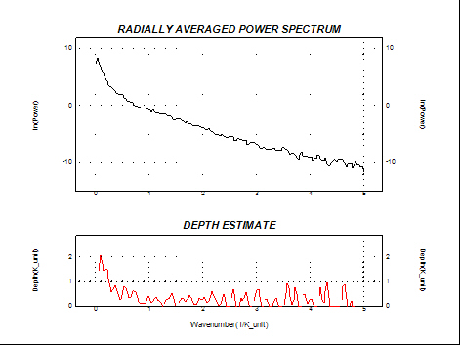
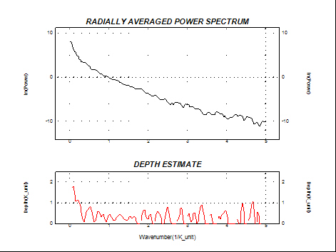
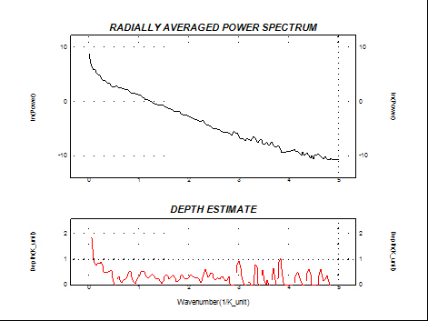
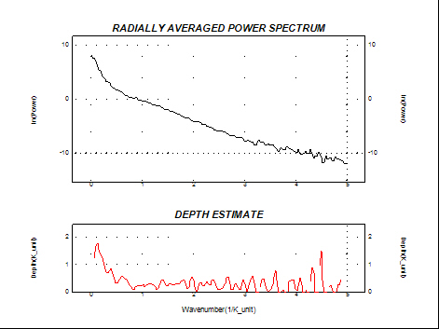

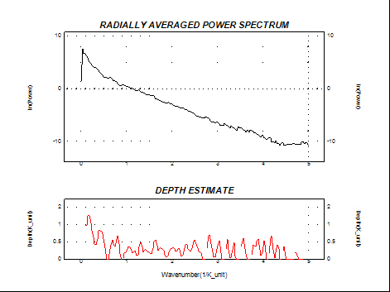
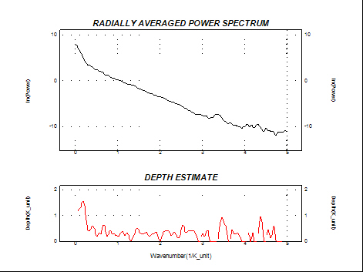
Fig 3.3 Power Spectrum Plot of some of the Blocks
Two linear segments were drawn from the graph, the spectral data of each window was exported to excel. The data was later imported into Matlab and used to plot the logarithm of the radially averaged power spectrum against the wavenumber for each of the twenty one window (some of the blocks are shown below, Fig 3.4) from which the slope of the two linear segment (deeper and shallow) was obtained.
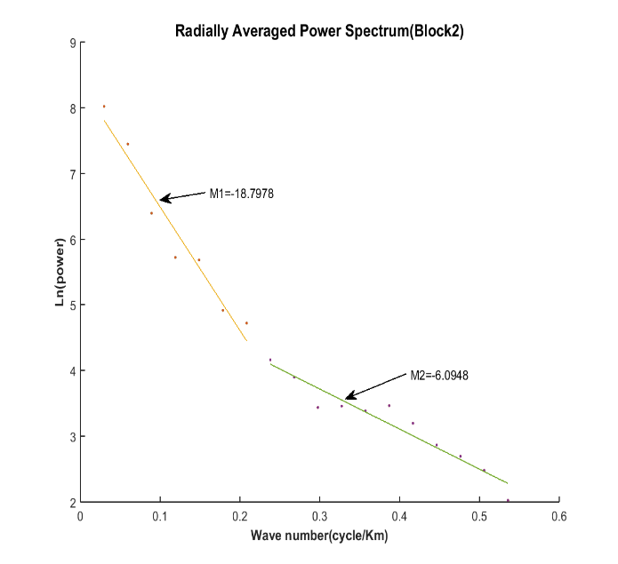
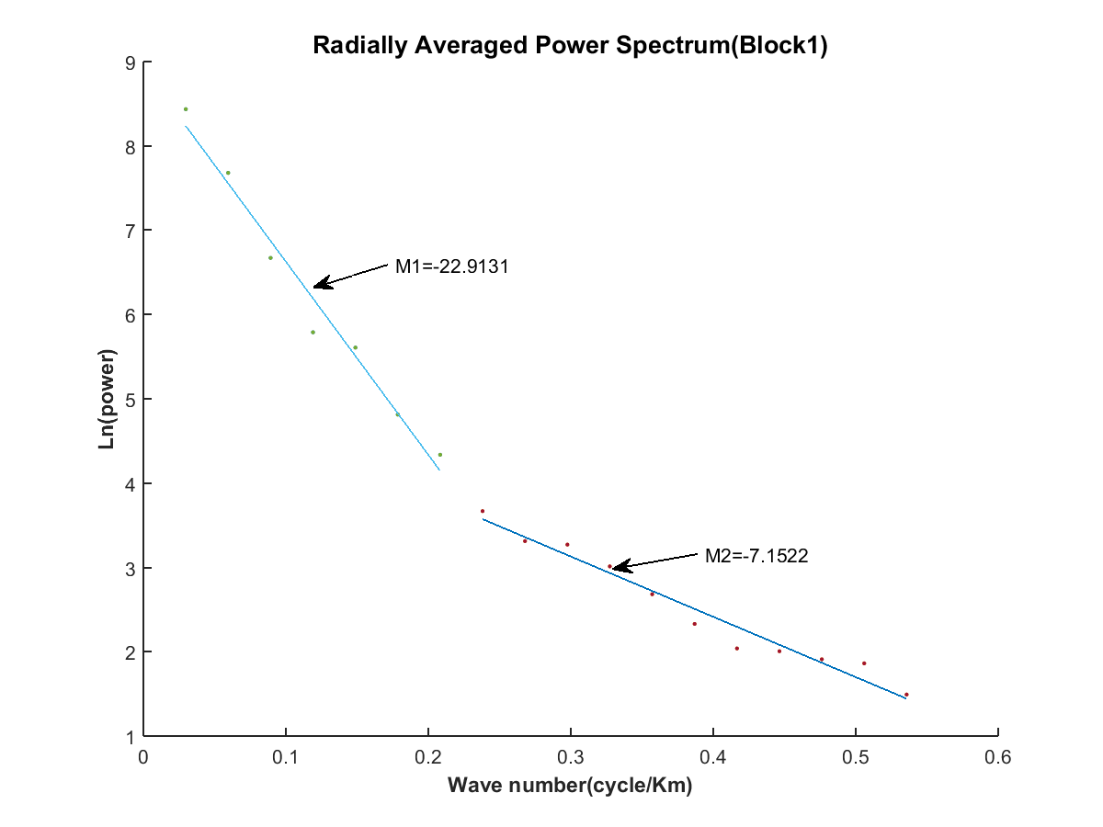

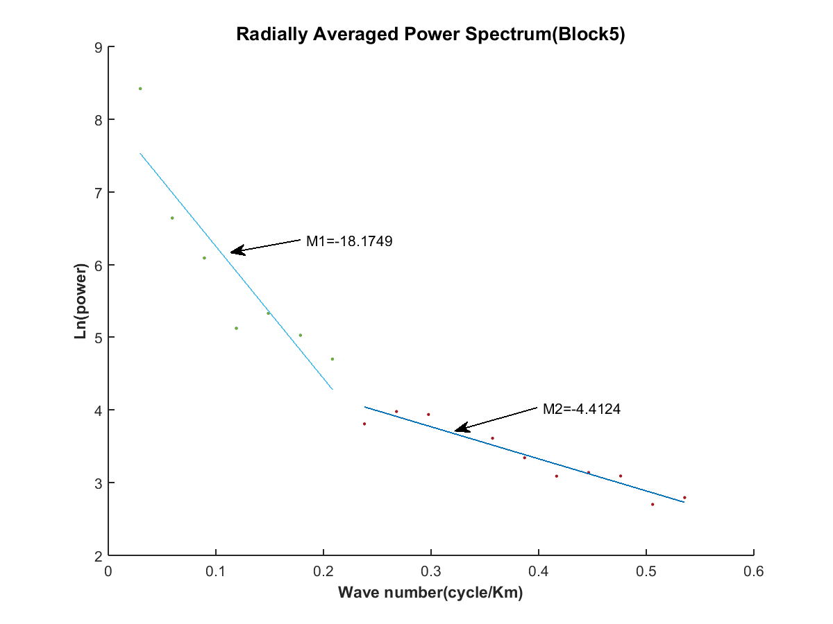
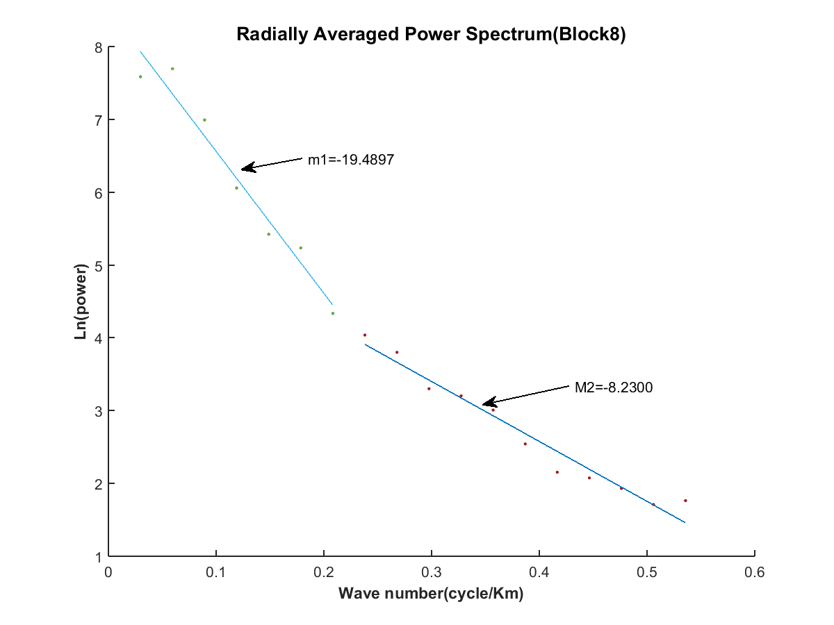
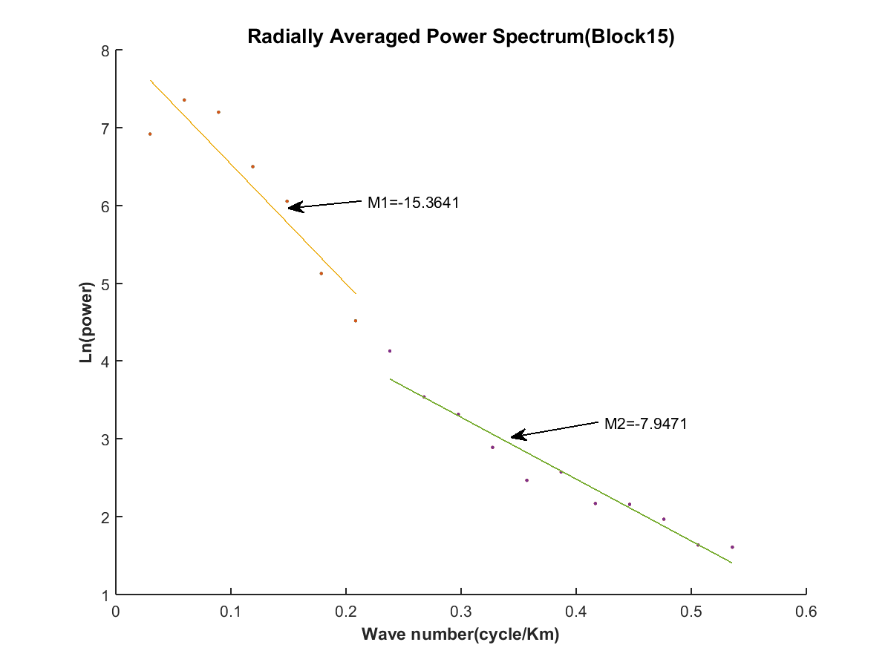
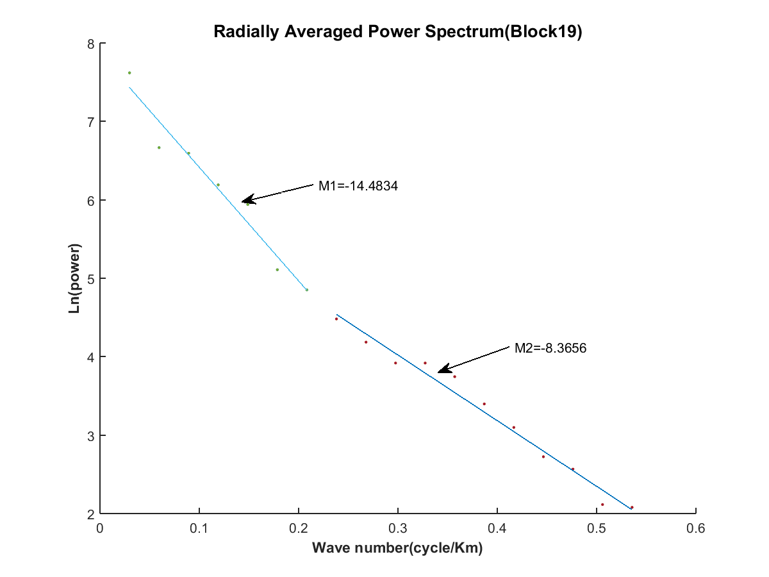
Fig 3.4 Plot of Ln(power) against Wavenumber of selected Windows
The slope obtained was used to calculate the depth to causative body as
$D1=-\frac{m1}{4π}$ $D2=-\frac{m2}{4π}$
Where m₁= slope of the deeper source, m₂= slope of shallow source
D₁= depth to deeper source, D₂= depth to shallow source
The maximum depth that can be probed in this research work is about 2.39k given by
$$D=\frac{L}{2π}$$according to (R.T. Shuey, et al., 1977), where L is window length (15km in this case).
4.3 RESULTS
The relationship between the depth (D) to the basement and the decay slopes (m) of the energy spectrum as proved in previous section is
$$D=-\frac{m}{4π}$$Table 4.1 below shows the estimated magnetic sources for both the shallow source (D2) and deeper sources (D1).
Table 4.1 Result of Depth Estimate from Spectral Analysis
The primary sources that account for the first layer depth derived from the statistical spectral analysis are the magnetic rocks that intrude the sedimentary formation.
The first layer magnetic source’s depth as estimated using FFT ranges from 0.1826km to 0.6656km, while the range of the second (deeper) magnetic source depth is from 0.8772km to 1.8231km. The maximum depth (1.8231km) could be found at the south-western part while the minimum depth of about 0.8772km could be found roughly at the central part of the total intensity map. Contour and surface maps of the shallow sources in the study area are given in Fig 4.2 and 4.3.

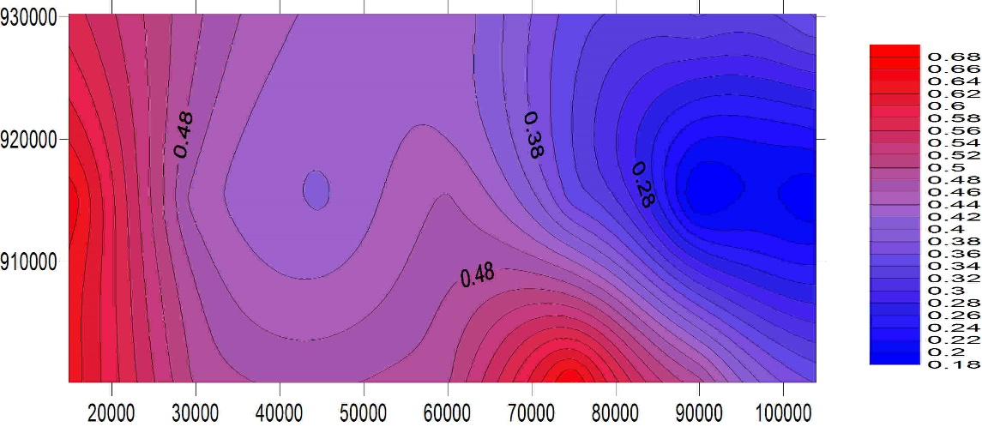
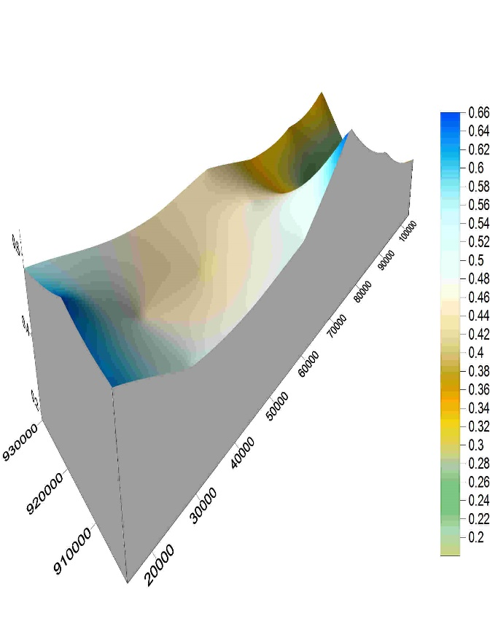
Fig 4.2 Contour Map of Shallow Source

Fig4.3 Surface Map of the Shallow Surface

The second layer depth may be attributed to magnetic rocks that are emplaced or intruded into the basement underlying the sedimentary cover. Also, intra-basement features such as fractures could equally contribute to sources that accounted for the second layer depth.
This depth to top of the underlying magnetic basement estimated from the statistical analysis using FFT ranges as discussed above.
The second layer depth invariably represents the average sedimentary thickness (1.3049km) of the study area, that is, the depth to the underlying basement complex rocks.
The contour map and 3D surface map below (Fig 4.4 and 4.5) are that of the second layer depth representing the depth to magnetic basement rock. This depth approximation correlates previous works and geology of the study area (Part of Kwara State bounded by longitude 4⁰30’- 5⁰30’ E and latitude 8⁰ - 8⁰30’ N) which is a basement complex, the depth to magnetic source is expected to be small and shallow in the study area.

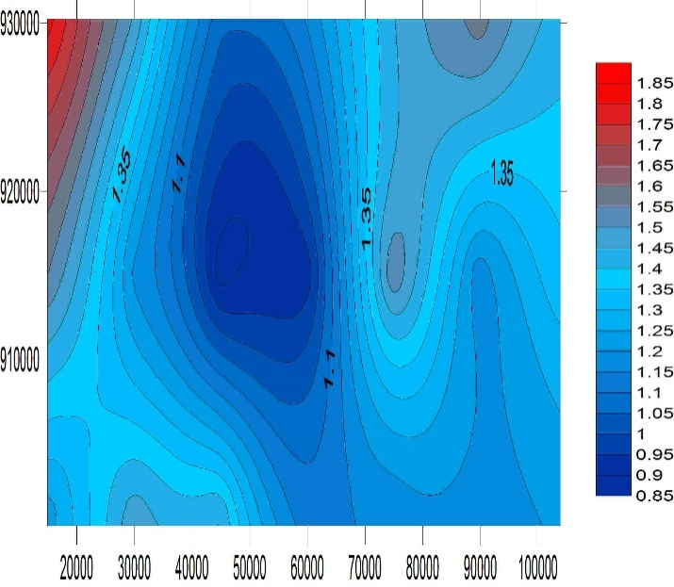
Fig 4.4 Contour Map of Deeper Source

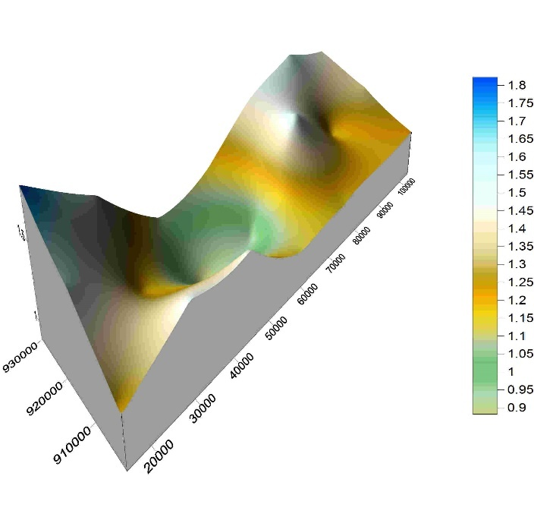

Fig 4.4 Surface Map of Deeper Source
CHAPTER FIVE
CONCLUSION AND RECOMMENDATION
5.0 INTRODUCTION
This chapter is concerned with the summary, conclusion and recommendation drawn from this research project.
5.1 CONCLUSION
The high resolution aeromagnetic data over part of Kwara State was subjected to quantitative analysis using Fast Fourier Transform method. The procedure involved in this study includes gridding of the magnetic data, production of the frequency domain map, and estimation of depths to magnetic sources. The results reveal two depth source models in the study area. The deeper sources range from 0.8772 to 1.8231km, while the shallower sources range from 0.1755 to 0.6323km. The deeper magnetic sources identified with the crystalline basement, while the shallower magnetic sources could be associated to near surface magnetic sources, which may be magnetic rocks that intruded into the sedimentary formations or magnetic bodies (e.g. laterite) within the sedimentary cover.
5.2 RECOMMENDATION
The result obtained from the spectral analysis of high resolution aeromagnetic data to determine depth to magnetic basement is shallow and this correlates to previous geological work which pointed out that the area is a basement complex.
It is highly recommended that other geophysical techniques such as seismic method should be applied in order to checkmate the result obtained from this research. Also, recent magnetic survey is also recommended, considering the time that this data was acquired.

Bibliography
Ajibade, L. (2008). Waste Ergonomics Optimization in Ilorin, Nigeria. Ethiopian Journal of Environmental Studies and Management Vol.1 No.2.
Ajibade, L., & A. O. (2004). Effects of automobile mechanics activities of soils in ilorin nigeria. Geo-Studies Forum an International Journal of Environmental and Policy Issues, 18-27.
Al-Chalabi, M. (1972). Interpretation of gravity anomalies by non-linear optimisation. Geophys. Prosp., 20, 1–16.
Anakwuba, E., A. O., & N. L. (2011). The interpretation of aeromagnetic anomalies over Maiduguri-Dikwa depression, Chad basin Nigeria: A structural view. Scolars Research Library, Archieves of Applied Science Research, 499-508.
Aspinall, A., & A. W. (1975). The earth resistivity instrument and its application to shallow earth surveys. . Underground Services, 3, 12–15.
Atlas. (1982). Ilorin, Nigeria: Geography department university press.
Brodie, R. C. (2002). Airborne and Ground Magnetics (Vol. ACT 2601). Geoscience Australia. PO Box 378, Camberra.
Churchill, O., A. O., & E. A. (2012). Aeromagnetic Interpretation over Maiduguri and Environs of Southern Chad Basin,Nigeria (Vols. Vol 2, no. 3, 77-93). Journal of Earth Sciences and Geotechnical Engineering.
Clarke, D. (1997). Magnetic petrophysics and magnetic petrology: aids to geological interpretation of magnetic surveys. AGSO Journal of Geology and Geophysics 17: 83-103.
Corry, C. (1985). Spontaneous polarization associated with porphyry sulfide mineralization. . Geophysics, 50, 1020–34.
David, I. I., & M. N. (2013). Interpretation of Aeromagnetic anomalies over some parts of lower Benue trough using spectral analysis technique (Vols. vol. 2, issue 8). International journal of Scientific & technology research.
Gadallah, M., & R. F. (2009). Exploration Geophysics. ,XXII,266p. 110 illus. in color., Hardcover .
Gunn, P. (1998 ). Aeromagnetics locates prospective areas and prospects. (Vols. 17, 67–9.). The Leading Edge,.
Horsfall, K. (1997). Airborne magnetic and gamma-ray data acquisition. AGSO journal of Geology and Geophysics 17:23-30.
K. A. Salako, & Udensi, E. E. (2013). Spectral Depth Analysis of Parts of Upper Benue Trough and Borno Basin, North-East Nigeria, Using Aeromagnetic Data. International Journal of Science and Research (IJSR), India , Online ISSN: 2319-7064 .
Keary, P., M. B., & I. H. ( 2002). An Introduction to Geophysical Exploration. Blackwell Science. Third Edition.
Lowrie, W. (2007). Fundamentals of Geophysics (Vol. 2nd edition). Zurich: Swiss Federal University.
Luqman, T. O., L. S., L. N., & S. A. (2012). Interpretation of aeromagnetic data over the younger granite complex of Northern Nigeria. Blackwell educational books.
Mariitia, N. (2007). The Magnetic Method. 2(17).
Milsom, J., & A. E. (2011). Field Geophysics (Vol. 4). Wiley and Sons Ltd., Publication.
Muhibbu-Din, O., & Ajibade. (2011). Study of physiochemical parameter of E_uent Impacted Stream. Obafemi Awolowo University, Ile-Ife Nigeria (unpublished).
NGSA. (n.d.). http://www.ngsa-nig.org/content/airborne-geophysical-data. (Nigeria Geological Survey Agency) Retrieved November 3, 2016, from http://www.ngsa-nig.org: www.ngsa-nig.org
Obaje, N. G. (2007). Geology and Mineral Resources of Nigeria. Springer Dordrecht Heidelberg London New York.
Olawuyi, A. (2015). Lineaments mapping for Hydrogeological study using Aeromagnetic and pseudogravity Data: A case study of Lafiagi, Southwestern nigeria (Vol. vol. 10). Zimbabwe journal of Science and Technology.
R., O. (1985). The use and waste of water in third world city. .
R.T. Shuey, D.K. Schellinger, A.C. Tripp, & Alley, L. (1977). Curie depth determination from aeromagnetic spectra. (50, 75-101.).
Raab, P., & F.C. Frischnecht. (1984). Time-domain electromagnetic soundings at the Nevada Test Site,. Nevada.: Geophysics, 49, 981–92.
Rahman, M. (1973). Review of the basement geology of south western Nigeria . Geology of Nigeria. 2ed. Rockview publishers, Jos. pp 39-56.
Rajaram, M., S. A., K. H., & M. P. (2009). Curie Isotherm map of India subcontinent from satelite and aeromagnetic data (Vols. Vol. 281, pp 147-158). Earth planet. Sci. Letts.
Sheriff, & E. R. (1991). Geophysics Encyclopedic dictionary of Exploration Geophysics (Vol. 3rd edition). Society of Exploration Geophysics.
Sheriff, R. E., & L. P. (1995). Exploration Seismology. (Vol. 2nd Edition. ). Cambridge University Press.
Spector, A., & F. G. (1970). Statistical models for interpreting aeromagnetic data. Geophysics, 35, 293–302.
Telford, W., L. G., R. S., & D. K. (1976). Applied Geophysics. Cambridge University Press, Cambridge, 860 pp.
Wikipedia. (n.d.). Retrieved 11 12, 2015, from Wikipedia: https://en.wikipedia.org/wiki/Waste_management

