A PROJECT REPORT ON PROPOSED DENTAL CLINIC
FOR ( KWARA STATE GOVERNMENT)
AT
SHARE,KWARA STATE
BY
KAZEEM FARUQ OLAMILEKAN
ND/23/ARC/PT/0055

BEING A PROJECT REPORT SUBMITTED TO
THE DEPARTMENT OF ARCHITECTURAL TECHOLOGY, INSTITUTE OF
ENVIRONMENTAL STUDIES,
KWARA STATE POLYTECHIC, ILORIN.

INPARTIAL FULFILMENT OF THE REQUIREMENT FOR
THE AWARD OF NATIONAL DIPLOMA (ND)
IN ARCHITECTURAL TECHNOLOGY.

MARCH, 2025

DECLARATION

I declare that this Project/Dissertation is a project of my personal research works. It has not been Presented for the award of any ND in any polytechnic. The ideas, Observations, Comments, and Suggestions here in represent my own convictions except quotations, which have been acknowledged. In accordance with conventional academic traditions.



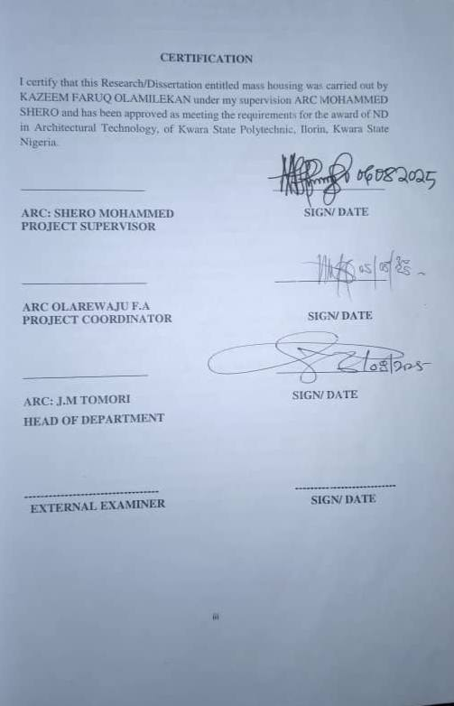
ACKNOWLEDGEMENT

My profound gratitude goes to Almighty Allah, the creator of universe and fountain of all wisdom whose umbrella of guard and guide. I seek refuge through thick and thin of years of study.
I will also like to appreciate my project supervisor in person of ARC MOHAMMED SHERO whose contribution Prepare me for the challenges in the field and for his immense contribution is all ramification towards the completion of this research work. He encourage me and open the door of interaction with him. I pray Almighty Allah will shower his blessing and mercy over him, your family and may you live to reap the fruit of your labour.
I also want thank and appreciate the effort of all the Lectures in Architectural Technology Department, who taught and give lasting advice’s that led to the success of my program, Almighty Allah will meet everyone at the point of needs.
I would also show my profound gratitude to my parents MR and MRS KAZEEM for their Immeasurable motivation, advices, efforts, and prayers on me for the completion of this program.
My Beloved Brother: Warris, Hammed and My Beloved sister Lateefat Almighty Allah shower his endless blessing, mercy, unlimited grace, joy, happiness without sorrow, sound health over you and may Almighty Allah meet everyone at the point of your needs.
Precious friends: My lovely friends Peter, Damilola, Habeeb, Joshua, Muhammed, BTC. Almighty Allah shower his blessing, grace, and happiness with sound health over you all and our prayer (AMEEN)
I would also show my appreciation for the effort of an unforgettable of MR AND MRS MUHAMMED, who advise me to carry on my journey. Almighty Allah bless you and grant your heart desires, good health over you.
Lastly,I would like to appreciate the effort of my colleagues in department, school, and hostel, I whole heartedly say a VERY BIG THANK YOU, I appreciate you all, May Almighty Allah bless you all.
Above all, my utmost thanks go to the all sufficient God, the fountain of my wisdom, for his great and protection over my life, for his undying love, support and guidance throughout my period of learning and also for in sighting writing this project without him am nothing.

DEDICATION
This project work is dedicated to Almighty Allah who has been providing all my need for his blessing and mercy over me all through the program.And to my parent, my sisters, my brothers, friends, love one’s and supervisor who assist me financially, spiritually, mentally and guide me through my academic pursuit. May Almighty Allah shower his blessing and mercy over you all.

TABLE OF CONTENT
Title page…………………………………………………………… i
Declaration…………………………………………………………… ii
Certification………………………………………………………….. iii
Acknowledgement……………………………………………………...iv
Dedication……………………………………………………………. v
Table of contents……………………………………………………... vi
List of tables…………………………………………………………..x
List of figures………………………………………………………… xi
List of plates…………………………………………………………..xii
List of Appendices…………………………………………………… xiii
Abstract………………………………………………………………. xiv
CHAPTER ONE
1.1 INTRODUCTION………………………………………………...1
1.2 DEFINITION…………………………………………………….. 2
1.3 HISTORICAL BACKGROUND…………………………………3
1.4 AIM AND OBJECTIVES ………………………………………..4
1.5 PROJECT JUSTIFICATION …………………………………….4
1.6 CLIENT BACKGROUND………………………………………. 4
1.7 SCOPE OF THE PROJECT………………………………………5
1.8 RESEARCH METHODOLOGY…………………………………5
CHAPTER TWO
2.1 LITERATURE REVIEW…………………………………………6
2.2 HISTORICAL BACKGROUND………………………………...6
CHAPTER THREE
3.1 CASE STUDIES……………………………………….…...........6
3.2 SELECTED CASE STUDIES………………………………….. 6
3.3 CASE STUDY ONE………………………………………….. 7
3.4 CASE STUDY TWO……………………………………………. 11
3.5 ONLINE CASE STUDY…………………………………… 15
3.6 DEDUCTION……………………………………………………16
CHAPTERFOUR
BRIEF HISTORICAL BACKGROUND………………………..…...18
LOCATION AND SETTING OUT……………………………...…....19
POPULATION……………………………………………….…….....19
SITE INVENTORY………………………...…………………..……...21
SITE ANALYSIS………………………………………………..….....21
SITE SELECTION AND JUSTIFICATION… ……… ……. ..….......22
LOCATION ………………………………..…………….…………..22
ACCESSIBILITY………….……………………..………………… .22
INFRASTRUCTURE FACILITES….………………………………..23
TOPOGRAPHY……………………………………............................23
SOIL STRUCTURE…………………………………………………..23
GENERAL CLIMATE CONDITION.………………….…………. 23
RELATIVE HUMIDITY…………………………………………... 23
WIND…............................................................................................... 23
TEMPERATURE…………….…………………………………….. 24
VEGETATION…………………………………………………….. 24
ROAD……………………………………………………………… 24
WATER AND ELECTRICITY……………………………………… 24
DESIGN CRITERIA…………………………………………………..25
DESIGN BRIEF …………………………………………….…….25
DESIGN ANALYSIS… ………………………………………..…..25
SPACIAL ALLOCATION …………………………………………....26
PLANNING PRINCIPLE………………………………………….. 28
CHAPTERFIVE
APPRAISAL OF PROPOSED SCHEME…………………………. 29
CONSTRUCTION METHODOLOGY………………………………29
SERVICES…………………………………………………………. 29
VENTILATION……………………………………………………. 30
LIGHTING………………………………………………………… 30
PLUMBING……………………………………………………….. 30
ELECTRICAL INSTALLATION………………………………… 30
WASTE DISPOSAL……………………………………………….. 31
FIRE PROTECTION………………………………………………. 31
RAIN PROTECTION……………………………………………… 31
EXTERNALWORK…………………………………………………..31
SUMMARY………………………………………………………... 31
CONCLUSION…………………………………………………….. 32
RECOMMENDATION……………………………………………. 32
REFERENCES………………………………………………….. 33
APPENDICES………………………………………………………...34

Chapter 1 LISTOFTABLES
TABLE1;SHOWING THE POPULATION OF THE GENDER…….......25
TABLE2;SHOWING SPACIAL ALLOCATION OF FLOOR PLAN…..30

Chapter 2 LIST OF FIGURES
FIG1;SHOWING LOCATION PLAN OF CASE STUDY ONE…….10
FIG2;SHOWING FLOOR PLAN OF CASE STUDY ONE………... 10
FIG3;SHOWING LOCATION PLAN OF CASE STUDY TWO……13
FIG4;SHOWING FLOOR PLAN OF CASE STUDY TWO……….. 14
FIG5;SHOWING LOCATION PLAN OF CASE STUDY THRE… 16
FIG6;SHOWING FLOOR PLAN OF CASE STUDY THREE………17
FIG7;SHOWING LOCATIONAL PLAN OF THE PROPOSED SITE,24
FIG8;SHOWING SITE INVENTORY OF THE PROPOSED SITE…26
FIG9;SHOWING SITE ANALYSIS OF THE PROPOSED SITE……27

Chapter 3 LIST OF PLATES
PLATE1;SHOWING FRONT VIEW OF CASE STUDY ONE……………..11
PLATE2;SHOWING RIGHT VIEW OF CASE STUDY ONE……………...11
PLATE3;SHOWING BACK VIEW OF CASE STUDY ONE………………12
PLATE4;SHOWING EATING AREA OF CASE STUDY ONE……………12
PLATE5;SHOWING FRONT VIEW OF CASE STUDY TWO……………..14
PLATE6;SHOWING WAITING AREA OF CASE STUDY TWO… ……….15
PLATE7;SHOWING SURGERY ROOM OF CASE STUDY TWO………..15
PLATE8;SHOWING FRONT VIEW OF CASE STUDY THREE………….16
PLATE9;SHOWING RIGHT VIEW OF CASE STUDY THREE…………..18
PLAE10;SHOWING SURGERY ROOM OF CASE STUDY THREE……..18
PLATE11;SHOWING FRONT VIEW OF ONLINE CASE STUDY…….. 19
PLATE12;SHOWING RECEPTION ROOM OF ONLINE CASE STUDY. 19
PLATE13;SHOWING RELAXATION ROOM OF ONLINE CASE STUDY20
PLATE14;SHOWING SURGERY ROOM OF ONLINE CASE STUDY…. 20
PLATE15;SHOWING FRONT VIEW OF ONLINE CASE STUDY……… 21
PLATE16;SHOWING SURGERY ROOM OF ONLINE CASE STUDY…...21

Chapter 4 LISTOFAPPENDICES
APP1;SHOWING SITE PLAN OF THE PROPOSED PROJECT………………..38 APP2;SHOWING GROUND FLOOR PLAN OF THE PROPOSED PROJECT….38
APP3;SHOWING ROOF PLAN OF THE PROPOSED PROJECT……………….41
APP4;SHOWINGCROSS SECTION OF THE PROPOSED PROJECT…………42
APP5; SHOWING ELEVATIONS OF THE PROPOSED PROJECT……………..44
APP6: SHOWING SIDE VIEW OF THE PROPOSED PROJECT………………..44

ABSTRACT
This researcher work was carried out on the project topic "Eatery for Share, Ilorin Kwara state". I felt caring out this project in ifelodun local government will bring out meaningful result. For easy analysis and understanding, the study is being put into five chapters. Chapter one throws light on general introduction, definition of the project, historical background information of the project title, project justification, aim and objectives of the study, scope of the study, Chapter two, a detailed literature review of some books, case studies and deduction from case studies. The third chapter three also mention about the historical background of the study area, site location and description, site analysis, and geographical location, climatic data, population of the area, social services, and health services. The fourth chapter deals with design criteria, design analysis, space allocation and planning principle. Chapter five deals with design appraisal, construction methodology, services, summary, conclusion and references.

CHAPTER ONE
  - INTRODUCTION
An eatery is a casual or informal place that offers prepared food for purchase and consumption.
An eatery, also commonly referred to as a restaurant, café, or food outlet, is a commercial establishment where food and drinks are prepared, served, and consumed, often in a social environment. Beyond the provision of meals, eateries today have evolved into important architectural spaces that influence human interaction, promote cultural identity, and contribute to the urban aesthetic of any environment. As an architectural student, the design of an eatery project offers a unique opportunity to explore how built spaces can enhance user experience, functionality, and environmental integration.
The growing demand for well-designed eateries in both urban and suburban areas reflects society's increasing emphasis on leisure, convenience, and social connection. In Nigeria, particularly within university communities, residential districts, and commercial zones, eateries serve as more than just places for nourishment; they act as social spaces, meeting points, and, in many cases, landmarks within the built environment. The challenge for the architect, therefore, lies not only in creating a functional space that meets health and safety standards but also in designing an environment that evokes comfort, visual appeal, and cultural relevance.
Architectural design in eateries goes beyond the aesthetic appeal of walls, roofs, and furniture. It involves careful space planning, accessibility considerations, ventilation strategies, lighting solutions, acoustics, and efficient circulation for both customers and staff. A successful eatery design must accommodate the operational requirements of food preparation areas, storage, restrooms, dining spaces, and administrative offices, while also prioritizing customer comfort and satisfaction.
In contemporary architectural practice, eateries reflect modern trends such as sustainability, energy efficiency, and biophilic design. The integration of natural lighting, proper ventilation, green spaces, and the use of eco-friendly materials are now key factors that contribute to the overall success of eatery projects. Furthermore, accessibility for people with disabilities, fire safety measures, waste management, and hygiene are essential components that influence the architectural design process.
  - DEFINITION OF EATERY
An eatery is a commercial establishment designed for the preparation, sale, and consumption of food and beverages. It serves as a space where individuals or groups can purchase and enjoy meals in a comfortable, organized, and often socially interactive environment. Eateries range in scale and type, including restaurants, fast-food outlets, cafés, canteens, bistros, and food courts.
From an architectural perspective, an eatery is not just a functional space for eating but a carefully designed environment that enhances the dining experience through thoughtful spatial arrangement, aesthetics, ventilation, lighting, accessibility, and cultural expression. It incorporates areas for food preparation, service counters, dining spaces, restrooms, storage, and administrative sections, all working together to ensure operational efficiency and user satisfaction.
  - HISTORICAL BACKGROUND
The earliest forms of eateries can be traced to ancient civilizations, where the need for public food provision arose, particularly in urban centers and along trade routes. In Ancient Rome, establishments known as thermopolia were popular. These were small shops or stalls that sold ready-to-eat food and drinks to the public, often catering to the working class and travelers who did not have cooking facilities at home. Archaeological remains of thermopolia have been discovered in the ruins of Pompeii, providing evidence of the architectural layout, including serving counters, food storage areas, and simple seating arrangements.
Similarly, in ancient China, tea houses and street food stalls served as early forms of eateries, where travelers, merchants, and locals could enjoy food and beverages. The famous Silk Road trade routes further encouraged the growth of roadside eateries, providing food and shelter for travelers.
Medieval Period
During the medieval period in Europe, inns, taverns, and alehouses served as the primary public eating establishments. These spaces not only provided food and drink but also played vital roles as social and communal gathering points. The architectural style of these eateries reflected the materials and construction techniques of the time, with timber framing, stone walls, and large hearths for food preparation.
In Middle Eastern and Islamic cultures, caravanserais and roadside eateries developed to serve merchants and travelers along trade routes. These establishments often included courtyards, kitchens, and shaded eating spaces, demonstrating early considerations for comfort and climate-responsive architecture.
Development of Modern Restaurants
The modern concept of the eatery as a formal, purpose-built restaurant emerged in the 18th century in France, particularly in Paris. The term "restaurant" comes from the French word "restaurer," meaning "to restore." The earliest restaurants were places where people could purchase specially prepared meals, often in a more refined and comfortable setting compared to street stalls or taverns. These establishments placed emphasis on both food quality and the dining environment, marking the beginning of architectural design being a key element of eateries.
By the 19th and 20th centuries, the growth of cities, advancements in building technology, and the rise of middle-class culture contributed to the proliferation of eateries worldwide. The development of cafés, fast-food outlets, food courts, and fine-dining restaurants provided diverse options for different social classes and tastes.
1.4 AIM AND OBJECTIVES OF THE PROJECT
AIM OF THE PROJECT
The aim of designing this (EATERY) create a well design and a comfortable spaces in the building. And also to operate the eatery as a profitable business, managing costs of optimizing menu pricing and maintaining sales values.
OBJECTIVES OF THE PROJECT
- To provide easily and comfortable accessibility for the customers and the workers
- To ensure efficient work flows circulation for staff and customer
- To incorporate proper ventilation, heating and cooling system.
- To create a unique dining experience
JUSTIFICATION OF STUDY
Hereby justify to design a proposed planned in Share. is that the people of Share need a place to eat and promote their environment and to support their economic growth by generating income for the community and to create well function, aesthetic and convenience in the design.
1.6 CLIENT BACKGROUND

1.7 SCOPE OF THE STUDY
- Entrance
- Dining
- Customer Serving Area
- Toilet
- Kitchen
- Manager Office
- Changing Room
- Store
- Bakery
- Exit
1.8 RESEACH METHOLODY
Various avenues were expressed as regards the method of research on order to arrive at a functional and appealing design concepts. The following research methods were employed.
LITERATURE REVIEW: Reference to tolerate for ideas of various writer were consulted in order to attain useful and important past work on similar project.
INTERNET: This is are search that was done and gained from the internet in other to get further information.
PERSONAL OBSERVATION: personal initiative coupled within quisitive measure, interview and visualize the daily activities that take place within vicinity and necessary pictures were taken in order to attain there quired motive
CASE STUDIES: This involves the thorough synthesis and analysis of similar existing structure (building) Based on the data collected and better deduction was made for realization of the best.
ORAL INTERVIEW:This is an interview conducted and gathered by professional body so as to know the efficiency and deficiency of the project which the researcher worked on.

CHAPTER TWO
2.0 LITERATURE REVIEW
2.1 HISTORICAL BACKGROUND OF EATERY
EATERY
The design and development of eateries have been widely studied across architectural, urban, and environmental disciplines. An eatery is not merely a functional space for food preparation and consumption; it is a social, cultural, and economic space that reflects societal trends, architectural innovation, and environmental considerations. This chapter reviews relevant literature on eatery design, focusing on the evolution, space planning principles, structural considerations, environmental impact, and user experience. The literature review provides a theoretical foundation for the design of a modern eatery that meets both functional requirements and architectural excellence.
An eatery, as defined by Ching (2014), is a public or semi-public space designed to facilitate the preparation, sale, and consumption of food and drinks, often incorporating elements of leisure, social interaction, and aesthetics. Eateries include various establishments such as restaurants, cafés, fast-food outlets, canteens, and food courts, each with distinct spatial and structural requirements. According to Jones (2016), the architectural design of an eatery plays a significant role in influencing user comfort, circulation patterns, food hygiene, and overall operational efficiency.
Oldenburg (1999) introduced the concept of eateries as "third places" — spaces outside the home (first place) and workplace (second place) where people gather, interact, and build community ties. This highlights the eatery's role not just as a service-oriented space but as an essential component of urban and social life.
Efficient space planning is critical to the success of any eatery design. According to Neufert (2012), the functional zoning of an eatery must ensure clear separation between service areas (kitchen, storage, waste disposal) and customer areas (dining, lounge, restrooms) to enhance hygiene and user experience. Lawson (2001) emphasizes that the layout must consider accessibility, circulation, and flexibility to accommodate varying customer needs and operational efficiency.
Recent studies by Petrie et al. (2018) suggest that open-plan layouts, strategic furniture arrangement, and integration of natural light improve spatial comfort and customer satisfaction. Furthermore, the incorporation of outdoor seating areas has been found to enhance the spatial experience, particularly in tropical climates like Nigeria.
The structural design of eateries is influenced by factors such as building materials, climatic conditions, building codes, and functional requirements. According to Allen and Iano (2013), modern eateries utilize reinforced concrete, steel frames, glass facades, and eco-friendly materials to achieve structural stability, durability, and visual appeal.
Akande (2020), in a study of food outlets in Nigeria, emphasized the importance of selecting materials that are cost-effective, durable, and responsive to the local climate. In regions with high temperatures and rainfall, like Ogun State, structural features such as wide overhangs, effective drainage systems, and proper ventilation are critical design considerations.
The integration of sustainability into structural design is increasingly prioritized. Kwok and Grondzik (2018) advocate for energy-efficient building envelopes, rainwater harvesting systems, and the use of recycled materials to reduce the environmental footprint of eateries.
Environmental sustainability has become a core consideration in eatery design. According to Edwards (2010), eateries have significant environmental impacts, particularly in energy consumption, water use, and waste generation. Architectural interventions such as passive ventilation, natural lighting, solar shading, and waste recycling can significantly mitigate these impacts.
Umar and Oladapo (2019) highlighted that in tropical regions, incorporating natural ventilation and shading reduces the need for mechanical cooling, enhancing both energy efficiency and user comfort. Additionally, the use of renewable energy sources such as solar panels is increasingly integrated into eatery designs to promote sustainability.
The success of an eatery is closely tied to the user experience, which is significantly influenced by the architectural design. According to Bitner (1992), factors such as interior design, acoustics, lighting, and spatial organization play critical roles in shaping customer perception and behavior.
Contemporary research by Kaya and Erkip (2020) shows that the aesthetic appeal of eateries — including color schemes, materials, and furniture design — contributes to customer retention and brand identity. Furthermore, eateries that incorporate cultural elements and contextual design often create a sense of belonging and identity for users.

CHAPTER THREE
3.1 CASE STUDIES
This is are search or an exercise that is carried out on existing building which is similar to the one researcher is writing on. The objective of a case study is to take a critical appraisal of existing related project with a view to identify the positive and negative aspect of such projects. It is only with time that a project can be adjusted so that it can be successful. The information obtained from the appraisal will guide the designer of new and similar project, the positive aspect of it shall be incorporated in the view proposal while attempts will be made to solve the problem of negative aspects. It is only through this that a designer can better enhance the quality and efficiency of building in the society. For a comprehensive analysis their case studies have been conducted.
3.2 SELETED CASE STUDIES
Case studies are of paramount important. It is an experimental research or analysis carried out on existing building or group of building functionally similar to the one which there search is working.
For any technical design to be meaningful there is always the need for preliminary research effort to be made on this proposal as a very necessary ground work.
The following are case studies of some eatery.
- OSOGBO OSUN STATE
- IBADAN OYO STATE
- ORE ONDO STATE
3.3 CASE STUDY ONE
LOCATION:SE LEVER EATERY AT 1, SE LEVER COMPLEX BOROLOGO COMPOUND ORITA ELELEDE JUNCTION OWO OPE, OSOGBO OSUN STATE
OBSEVERATION
MERITS
- It is aesthetically design
- It is easily accessible
- It has cross ventilation
DEMERITS
- There is not enough space for eating area
- There is not enough park spaces
- Lack of ramps
- Lack of toilet
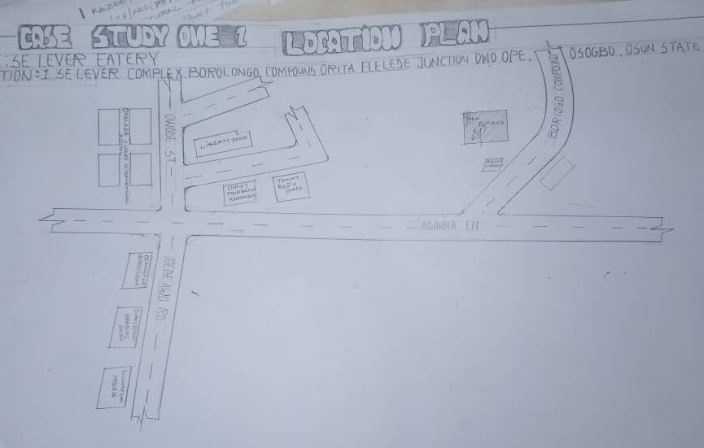
FIG1;SHOWING LOCATION PLAN OFCASE STUDY ONE
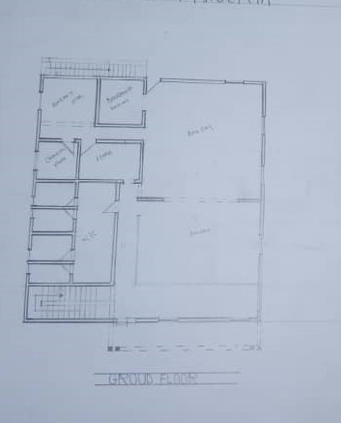
FIG2; SHOWING FLOOR PLAN OF CASE STUDY ONE
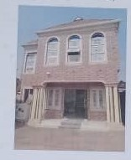
PLATE1; SHOWING RIGHT VIEW OF CASE STUDY ONE
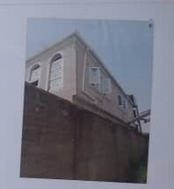
PLATE2; SHOWING BACK VIEW OF CASE STUDY ONE
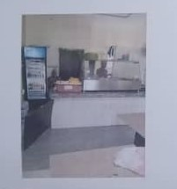
PLATE4; SHOWING WAITING ROOM OF CASE STUDY ONE
3.4 CASE STUDY TWO (2)
LOCATION:AROMA PLACE AT AWOLOWO WAY BODIJA IBADAN OYO STATE
OBSEVERATION
MERITS
- It is easily accessible for able and disable body.
- It is well design.
- It has enough space for services.
DEMERITS
- Lacks of toilet of the customers
- Lack of cross ventilation and natural light
- Lack of security house.
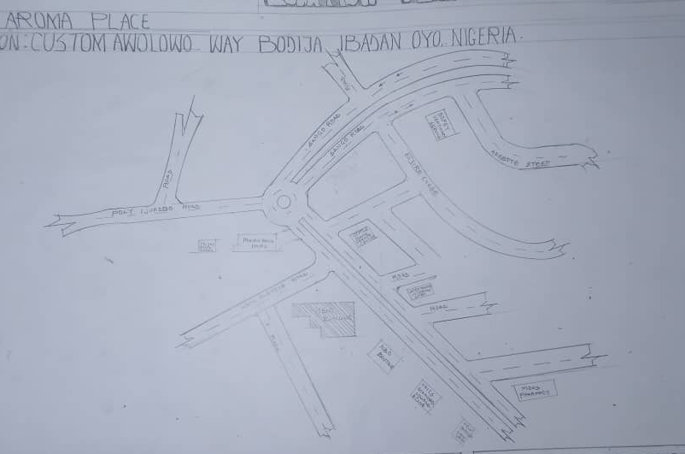
FIG3; SHOWING LOCATION PLAN OF CASE STUDY TWO
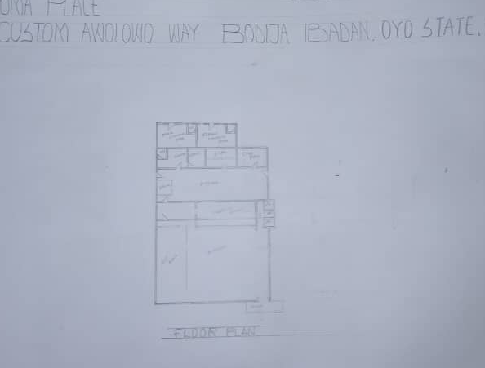
FIG 4;SHOWING THE FLOOR PLAN OF CASE STUDY TWO
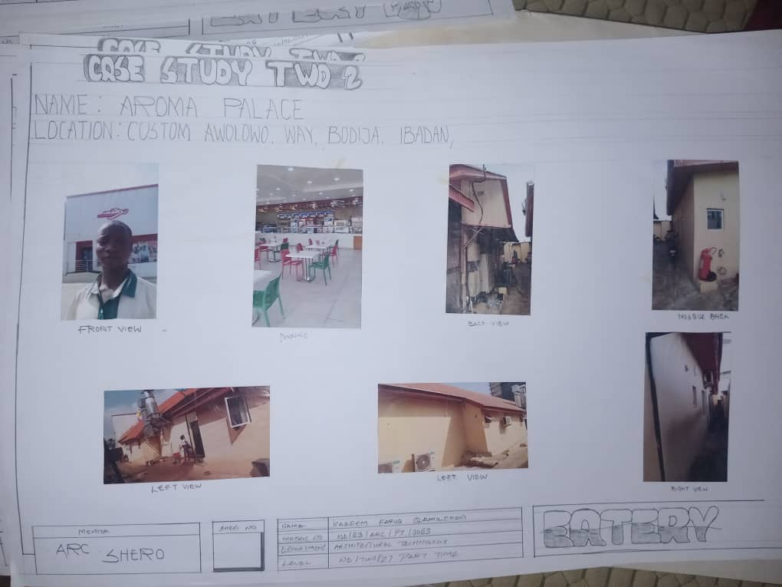
PLATE 5; SHOWING FRONT VIEW OF CASE STUDY TWO
PLATE 6;SHOWING EATING AREA OF CASE STUDY TWO
PLATE 7;SHOWING LEFT VIEW OF CASE STUDY TWO
3.5 CASE STUDY THREE (3)
LOCATION:CROWN BAY FOOD AT BENIN SHAGAMU EXP, OTU, ONDO STATE
OBSEVERATION
MERITS
- There is enough space for service area
- It is easily accessible for people on a journey
- It has comfortable seating area
- It has natural lighting and cross ventilation
DEMERITS
- Their kitchen is not easily accessible from the dining
- Limited accessibility for the people
- The building is not well designed
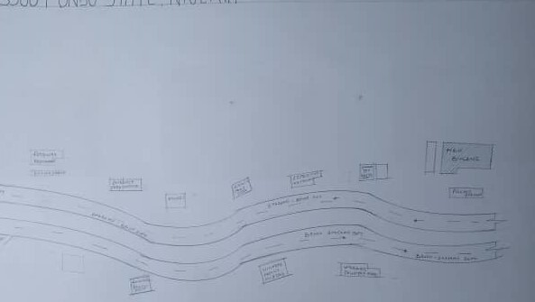
FIG 5; SHOWING LOCATION PLAN OF CASE STUDY THREE

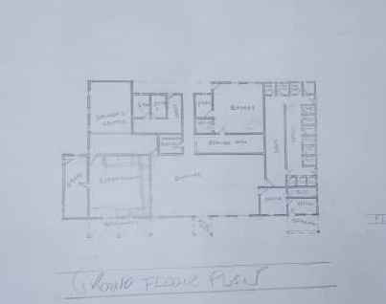
FIG 6; SHOWING FLOOR PLAN OF CASE STUDY THREE
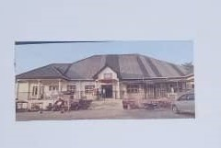PLATE8;SHOWING FRONT VIEW OF CASE STUDY THREE
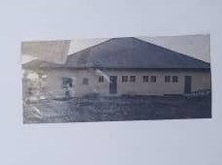
PLATE 9; SHOWING RIGHT OF CASE STUDY THREE
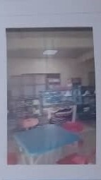 PLATE 10; SHOWING DINING AREA OF CASE STUDY THREE

3.6 ONLINE CASE STUDY
ONLINE CASE STUDY ONE
PROJECT NAME:KITCHEN ALIMENTARI ITALIAN FOOD
LOCATION:VIA DEGLI EQUI 58,00185 ROMA RM, ITALY
ARCHITECT: PADILLA NICAS ARQUITECTAS
YEAR: 2013
AREA: 485m
ONLINE CASE STUDY TWO
PROJECT NAME:BASE CAMP EATERY
LOCATION: 9006 YOSEMITE LODGE DR TUOLUMNE MEADOWS CA 95389, UNITED STATE.
ARCHITECT: DROZDOV&PARTNERS
YEAR: 2018
AREA: 359m
DEDUCTION FROM CASE STUDIES
During my visit to the Eatery. I was opportunities to see what was obtain in the eatery, I made a proper studies of their related function and analysis were made to their present situation with the aim of incorporation with their merit in my own final proposal.
The following were deduce from my case study
- The location of the eatery plays a vital role in its accessibility and visibility.
- Proximity to busy roads, offices, schools, or markets enhances patronage.
- Managing peak-hour crowding without compromising comfort.
- Ventilation and extraction systems properly installed to manage cooking fumes.
- Anti-slip flooring and accessible design for people with disabilities.

CHAPTER FOUR
4.0 PROJECT LOCATION
4.1 BRIEF HISTORICAL BACKGROUND OF KWARA STATE
Kwara (Yoruba: Ìpínlẹ̀ Kwárà) is a state in Western Nigeria, bordered to the east by Kogi State, to the north by Niger State, and to the south by Ekiti, Osun, and Oyo states, while its western border makes up part of the international border with Benin. Its capital is the city of Ilorin and the state has 16 local government areas.
Of the 36 states of Nigeria, Kwara is the ninth largest in area but the sixth least populous with an estimated population of about 3.2 million as of 2016.Geographically, Kwara is split between the West Sudanian savanna in the east and the Guinean forest–savanna mosaic ecoregion in the rest of the state. Important geographic features include rivers with the Niger flowing along the northern border into Lake Jeba before continuing as the border while the Awun, Asa, Aluko, and Oyun rivers flow through the interior. In the far northwest of the state is the Borgu section of the Kainji National Park, a large national park that contains populations of grey heron, kob, hippopotamus, African bush elephant, olive baboon, and roan antelope, along with some of the last remaining West African lions on earth. In the far southwest, a small part of the Old Oyo National Park contains crowned eagle, martial eagle, African buffalo, oribi, and patas monkey populations.
ECONOMY OF KWARA STATE
Agriculture is the main source of the state's economy and the principal cash crops are: cotton, cocoa, coffee, kola nut, tobacco, sesame and palm produce. Kwara state is home to Shonga Farms, a product of the Back-to-Farm project of one of the past administrators of the state, Dr. Abubakar Bukola Saraki. Shonga Farms is made up of 13 commercial farmers. Mineral resources in the state are Petroleum, Gold, limestone, marble, feldspar, clay, kaolin, quartz and granite rocks, and laterite found majorly in omuaran.
ORGANIZATION STRUCTRE
An organizational structure is a system that outline shows certain activities that are direct in order to achieve the goals of an organization. These activities can includes rules, roles and responsibilities. The organizational structure also determine show information flows between levels within the clinic.
4.2 LOCATION AND SETTING OF KWARA STATE
Kwara State was created on 27 May 1967, when the Federal Military Government of General Yakubu Gowon broke the four regions that then constituted the Federation of Nigeria into 12 states. At its creation, the state was made up of the former Ilorin and Kabba provinces of the then Northern Region and was initially named the West Central State but later changed to "Kwara", a local name for the River Niger, in the Hausa language.
Kwara state has since 1976 reduced considerably in size due to further state creation exercises in Nigeria. On 13 February 1976, the Idah/Dekina part of the state was carved out and merged with a part of the then Benue/Plateau state, to form Benue state.
On 27 August 1991, five Local Government areas, namely Oyi, Yagba, Okene, Okehi and Kogi were also excised to form part of the new Kogi state, while a sixth, Borgu Local Government Area, was merged with Niger state. The major populated local governments are Ilorin and Offa.
Kwara state has numerous mineral resources such as tourmaline, tantalite, and many mineral deposits in the northern part. Cocoa and Kolanut in the Southern parts Oke - Ero, Ekiti and Isin LGA.
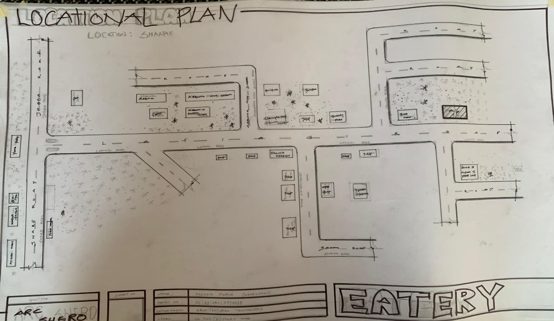
FIG 7; SHOWING LOCATION OF THE PROPOSE SITE
4.3 POPULATION
The population development of kwara state as well as related information and services.
The current metro area population of Ilorin in 2025 is 1,100,000, a 3.38% increase from 2024.
The metro area population of Ilorin in 2024 was 1,064,000, a 3.3% increase from 2023.
The metro area population of Ilorin in 2023 was 1,030,000, a 3% increase from 2022.
The metro area population of Ilorin in 2022 was 1,000,000, a 2.67% increase from 2021.
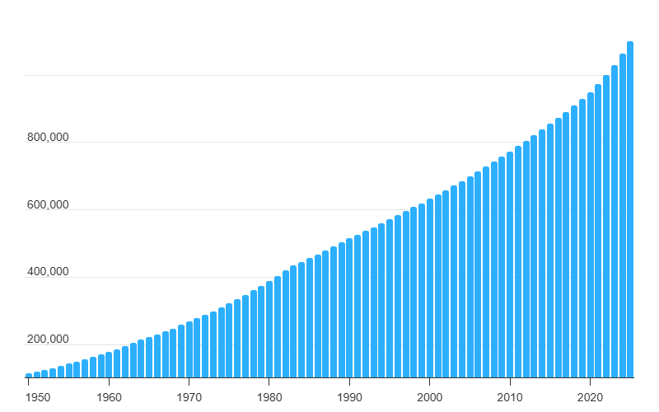
TABLE 1; SHOWING GENDER GROUP
4.4 SITE INVENTORY
In the proposed site, some shrubs will be retained on site. It used to reduce sky glare and also serve as soft landscape and wind breaker.
Presence of road network which would serve as a means of accessibility to the site. Presence of electricity pole which serve as source of electricity to the site. Some trees would be retained while some will be removed if they disrupt the construction of building.
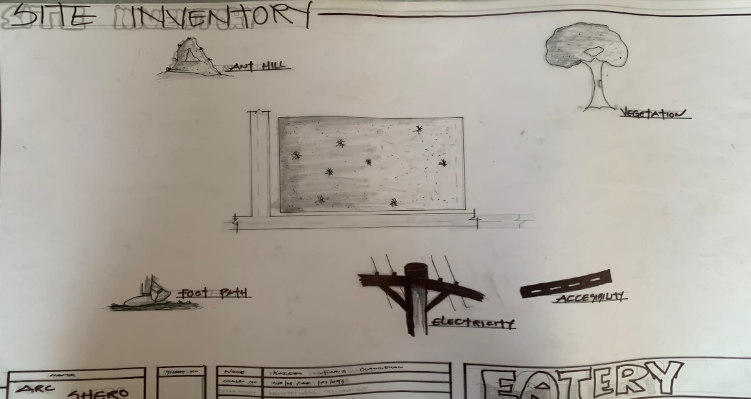
FIG 8; SHOWING SITE INVENTORY OF THE PROPOSED SITE
4.5 SITE ANALYSIS
The site is benefitted with loamy soil which is a very good soil for grass and shrubs. It has a gentle slope towards the south east. Some of the grasses, shrubs and trees on the site are to be retained to enhance landscape patter of the site while some are to be removed and replanted where necessary. The two noticeable winds are to be directed into the building using landscape pattern to improve ventilation. Noise generated from vehicle traffic is controlled through proper planning, good landscaping and proper orientation of building. Generally, all the feature on the site are best put into different uses to aid control through proper planning, landscape and orientation.
Certainly, steps are considered to obtain vital information of the site, this information is the analysed in details. For design purpose, the information include soil condition, geology, topography, vegetation etc. It also involves carrying out a preliminary survey
of the site.
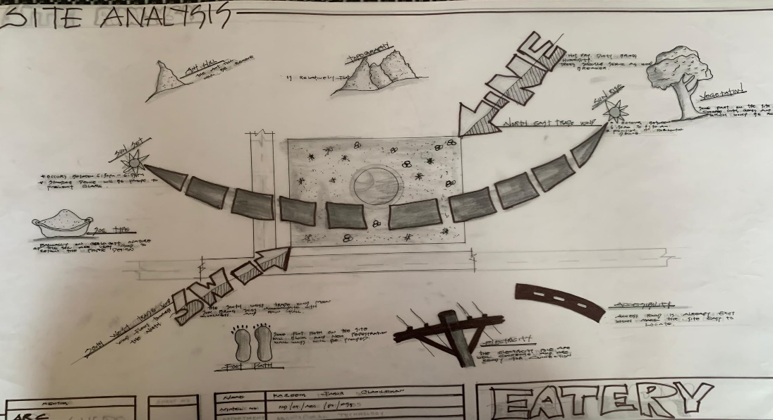
FIG 9; SHOWING SITE ANALYSIS OF THE PROPOSED SITE
4.5.1 SITE SELECTION/JUSTIFICATION
In the site selection provision is made for interesting facilities that worth emulating since the overall success and efficiency of any project depend not on the functionality of the design but also on a careful choice of site. The site of this project has been carefully selected which is located in the premises of Share, Ilorin local government Kwara state. The proposed site is located at Share at Ilorin, Kwara state.
4.5.2 LOCATION
The site is located
SHARE, ILORIN LOCAL GOVERNMENT, KWARA STATE.
4.5.3 ACCESSIBILITY
The site is easily accessible from the access road off from the main road that goes to share. The site can also be reached through the access road that lead to General.
4.5.4 INFRASTRUCTURAL FACILITIES
Facilities such as water electricity, telephone network and road network are all in Ilorin, hence it can easily be tapped to the proposed site.
4.5.5 TOPOGRAPHY
The topography of the land is gentle slope which can be filled and levelled up to balance round all the site levels.
4.5.6 SOIL STRUCTURE
It is made up of clayish laterite soil, which is good for building construction.
4.6 GENERAL CLIMATIC CONDITION
Kwara State generally experiences a tropical savanna climate (Aw) with distinct wet and dry seasons. The temperature is warm throughout the year, with an average around 29.54°C (85.17°F). Rainfall varies, with an annual average of about 101.45 millimeters (3.99 inches), and the state has around 148.38 rainy days annually.
4.6.1 RELATIVE HUMIDITY
Relative humidity is higher during the rainy season, ranging from 75% to 88%, and lower during the dry season, ranging from 35% to 80%.
4.6.2 WIND
The prevailing winds are the south-west monsoon wind and the north-east continental wind.
4.6.3 TEMPERATURE
Kwara State is characterized by warm temperatures year-round, with January being the coolest month and April being the hottest. Temperatures can range from a minimum of 14°C (58°F) in January to an average of 27°C (81°F) throughout the year, with April experiencing intense heat that can reach 43°C (109°F).
4.6.4 VEGETATION
The proposed site is covered with grasses few trees and shrubs. Some will be removed before the construction while some will be retain for ornamentation.
4.7 SOCIAL SERVICES
4.7.1 ROAD
There are only two access to the site
The southern access which serve as the main entrance and also main access road
4.7.2 WATER AND ELECTRICITY
There are pipe born water networks and borehole water which serves the habitant of Ibadan. There is electricity supply from NEPA that serve the Kwara state in general
4.8 DESIGN CRITERIA
There are three (3) methods of designing of any project which are: Function before form method
Form before function method Combination of Shapes
Designing projects, the function, before form method used in line with this method, the following are the design criteria for this project:
Functional: in term of functional requirement, the following design criteria must be considered.
Sustainability, Site and Location, Flexibility, Circulation, Accessibility, Organization, Maintenance, Environment and Services
4.9 DESIGN BRIEF
After research and planning, the next step in the series of the project programed is design itself. To achieve functional and well established design there must be a brief to work on. This brief depends generally on the scope of individual design. The brief of this project is therefore based on the various activities that take place in the Eatery. To have enough brief for the proposed Eatery, case studies were carried out on the existing Eatery. The studies also give me the opportunity to know the nature of the various unit in building and how they are related to each other.
4.10 DESIGN ANALYSIS
This is the process of itemizing units within the component of the entire design with a view to establishing a solid understanding and appreciation of the space relationships.
The units of the design are in three division, the unit of the project division are as follows:
GROUND FLOOR PLAN; Entrance, VIP entrance, Eating Area, Serving Area, Snacks, Kitchen, Dry room, Cold Room, Cold Store, Delivery Bay, Manager Office, Account Office, Chief Office, Changing Office, Rest Room, Exit.
NAME | S/N | LENGTH[m] | BREATH[m] | AREA[m]
ENTRANCE | 1 | 4.2m | 1.8m | 7.56m2
VIP ENTRANCE | 1 | 3.6m | 1.8m | 6.46m2
EATING AREA | 1 | 15.0m | 14.0m | 27.0m2
VIP EATING AREA | 1 | 8.0m | 14.0m | 112.0m2
SERVING AREA | 1 | 13.6m | 3.6m | 48.9m2
SNACKS | 1 | 3.6m | 12.0m | 12.9m2
KITCHEN | 1 | 13.6m | 12.0m | 105.2m2
DRY ROOM | 1 | 4.0m | 3..0m | 12.0m2
COLD ROOM | 1 | 4.0m | 3.0m | 12.0m2
COLD STORE | 1 | 3.6m | 3.6m | 12.9m2
DELIVERY BAY | 1 | 7.2m | 3.6m | 24.48m2
MANAGER OFFICE | 1 | 3.6m | 3.6m | 12.9m2
ACCOUNT OFFICE | 1 | 5.6m | 3.6m | 12.96m2
CHEF OFFICE | 1 | 7.0m | 4.2m | 16.8m2
CHANGING ROOM | 2 | 4.2m | 3.6m | 15.4m2
REST ROOM | 2 | 3.6m | 3.8m | 12.6m2
EXIT | 2 | 2.4m | 1.2m | 4.32m2

TABLE 2; SHOWING SPACIAL ALLOCATION OF FLOOR PLAN
Necessary units in the building. A borehole system of water supply is to be adopted alongside the government supplied services and a storage facility is to be provided for effective management of water supply.
4.12 PLANNING PRINCIPLE
The planning principle is one of the most important aspects of any design. The planning of various units taking into consideration the activities performed in each unit, how they are related to one another and the users of the various units in the design. In respect to the above factors.

CHAPTER FIVE
4.13 GENERAL REQUIREMENTS
4.14 APPRAISAL OF PROPOSED SCHEME
The proposed scheme is to satisfy the appropriate building regulation. The project design is to confirm with the intended use of building taking into consideration with both natural factors and human that can pose a throat on the validity and stability of the project design.
4.15 CONSTRUCTION METHODOLOGY AND MATERIAL
The construction is to be carried out following the due process of construction ranging from.
Preliminary: this involves the clearing of the site, setting out and excavation of foundation trench, foundation works down to the basement level.
Sub-Structure: this process also entails the positioning and erection of column and beams, mansonry work etc.
Gypsumboard: is to be used for the Acoustic purpose of the building. This material is often called dry wall, wall board or plaster board. It creates a continuous surface suitable for most types of interior decoration. It comes in different size ranging length of 2.4m, 3.0m, also in thickness of 1/ inch, 3/8 inch.
4.16 SERVICE
A building can be said to be good when it performs the serves required by it. In other to have a well-function building design, there calls for an installation of underground water. This is a means of providing brightness naturally by sun or moon or artificially by lamps. Good natural and artificial lighting is important in lecture rooms, and workshop. It is always easy to make mistake and time the eye in a situation of poor lighting floor. For the purpose of this project, effort is made as much as possible to light up the entire building naturally before the use of artificial lighting. In this project, to obtain maximum lighting more openings are provided for the lecture rooms, workshop and admin. Artificial source of light will still be provided for in case where there is call for the use of it at night or in a situation where the weather condition warrants it.
4.16.1 VENTILATION
As it's relates to architectural, is the intentional introduction of outside AIT into a space through openings (like window/doors and mechanical means (ACs) to provide maximum thermal comfort for human satisfaction. In this design, both means of ventilation ate introduce but majority concentration on the mechanical means of ventilation for all units in the design for the purpose of extracting the used air and introducing fresh air within all spaces for humans consumption and satisfaction.
This is done through installation of mechanical (artificial) ventilation ducts horizontally and vertically all within the units of the design to allow easy floe of free movement of air passage through the ventilation channels and providing well, proper and adequate ventilation for each and every units in the design project.
4.16.2 LIGHTING
This is a means of providing brightness naturally by sun or moon or artificial by lamps. Good natural and artificial lighting is important in all units. It is always easy to make mistake and time the eye in a situation of poor lighting floor. For the purpose of this project, effort is made as much as possible to light up the entire building naturally before the use of artificial lighting.
4.16.3 PLUMBING
The plumbing system in this project design is made easy for waste extraction and brain water extraction through the means of service duct channel and roof gutter drainage.
All waste water and soil waste from the toilet/convenience are extracted through means of drainage pipe running through the walls down to the inspection chamber situated in the service duct, flowing down to the septic tank and soak away for final waste extractions.
4.16.4 ELECTRICAL INSTALLATION
The type of wiring system chosen should be conduct system of wiring, technical are should be wired with strong durable and light current resistance cables because of the power requirements and consumption of the equipment to be used and installed in them. Connection and distributing cable signal. Also electrical installation is to be done to allow for the use quality electrical fittings and fixtures in the whole of the hospital.
4.16.5 WASTE DISPOSAL
Waste disposal are to be put in the building and also some specific areas necessary, this waste bins should be disposed in the incinerator which will be provided within the proposed site premises. The waste should therefore, be burn in the incinerator or taken away from the site.
4.16.6 FIRE PROTECTION
Electrically, fire alarms and sensor are to be installed in the building in generally. This should be done in case of the fire occurrence. Fire extinguishers are to be placed at a certain distance in the lobbies and some other necessary areas. It is also serving as protection in case of fire outbreak.
4.16.7 RAIN PROTECTION DEVICES
The rainfall of a place generally determines the living condition and all comfort associated with that environment hence provision should be made for fast dispersal of the rain water as well as the associated condition with rainfall. This calls for the need to study the nature of rainfall of the area. To control the heavy rainfall during the wet season (April - October) the use of simple sloppy system roofing has been adopted. This is provided with roof gutter system which is linked to the ground drainage network by the use of P.V.C.
4.16.8 EXTERNAL WORKS
The external works are to be earned out generate, kerbs land and shrubs, flowers, grasses and trees planted. Concrete interlocking pavement tiles to be adopted before hard landscape for walk ways and parking spaces and car access roads must be tarred with asphalt finishes.
4.17 SUMMARY
This project, generally, has seriously widen my view and knowledge affecting my observation beyond my expectation. I have been able to deduct what it takes or entails and how to go about designing and achieving a good design of any form of this related project with total seriousness as this project has given out the facts and precise information it comprises.
4.17.1 CONCLUSION
The architectural design of an eatery plays a critical role in defining customer experience, enhancing functionality, and contributing to the overall success of the business. This project has emphasized that beyond providing shelter and seating, an eatery must be designed to attract customers, promote comfort, and support efficient operations.
Through the case study analysis and design process, it was established that proper space planning, functional zoning, aesthetics, and environmental considerations are fundamental to an eatery's success. The seamless integration of these elements ensures smooth service delivery, customer satisfaction, and a unique dining atmosphere that reflects the eatery’s identity.
Moreover, considerations such as ventilation, acoustics, material durability, and sustainability are crucial for maintaining hygiene standards, reducing operational costs, and promoting environmental responsibility. The project also revealed that urban constraints such as limited space and high construction costs require innovative design approaches to optimize space usage without compromising functionality or comfort.
4.17.2 RECOMMENDATION
This project has demonstrated that well-considered architectural design is central to creating a successful, functional, and aesthetically pleasing eatery. By integrating efficient space planning, customer comfort, operational flow, and sustainability, the eatery can serve not only as a food outlet but also as a vibrant social space that enhances community interaction and contributes positively to the urban fabric.

REFERENCES
ASHRAE. (2019). Standard 62.1: Ventilation for acceptable indoor air quality.
Ball, R. (2002). The fundamentals of interior architecture. AVA Publishing.
Bitner, M. J. (1992). Servicescapes: The impact of physical surroundings on customers and employees. Journal of Marketing, 56(2), 57–71.
Chicken Republic, Ilorin – Fast-food design with efficient kitchen-to-customer flow.
Karlen, M., & Fleming, J. (2003). Space planning basics (2nd ed.). Wiley.
Lawson, B. (2001). The language of space. Architectural Press.
Lin, I. Y. (2004). Evaluating a servicescape: The effect of cognition and emotion. International Journal of Hospitality Management, 23(2), 163–178.
Lu, Y., & Wang, C. (2008). Designing dining environments: Effects of restaurant interior design on dining satisfaction. Journal of Foodservice Business Research, 11(3), 361–382.
National Building Code of Nigeria. (2006). Regulations for commercial and public buildings. Federal Ministry of Works and Housing. for structural, fire, sanitary, and accessibility codes for eateries.
Neufert, E. (2012). Architects' data (4th ed.). Wiley-Blackwell.
Ogunyemi, B. T., & Olatunde, K. (2014). Climate-sensitive architectural design for small food businesses in Nigeria. Nigerian Journal of Architecture, 10(1), 72–81.
Pile, J. F. (2005). Interior design. Prentice Hall.
Sweet Sensation, Ibadan – Urban fast food with bright lighting andcompact space planning.
Tantalizers Restaurant, Lagos – Known for blend of Nigerian design and modern eatery planning.
The Place Restaurant, Ilorin – Casual dining eatery with modern finishing and customer comfort.
WHO. (2021). Food safety and hygiene guidelines for food establishments.


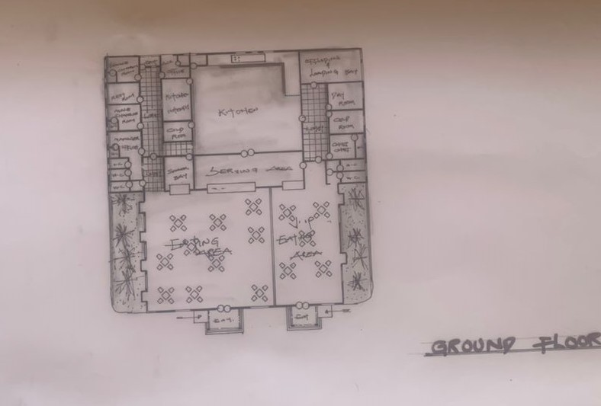
PROPOSED PROJECT FLOOR PLAN
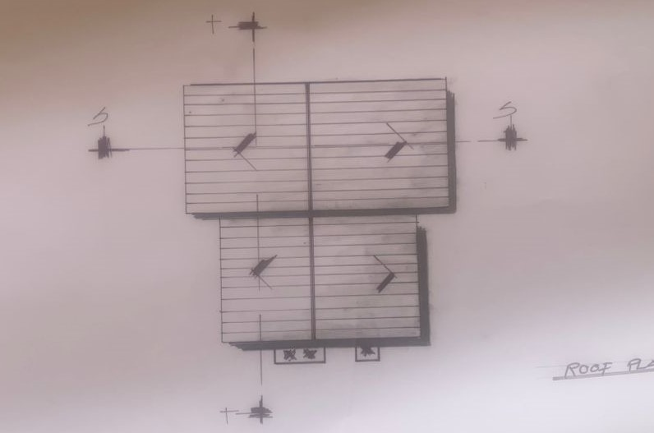
PROPOSED PROJECT SITE PLAN

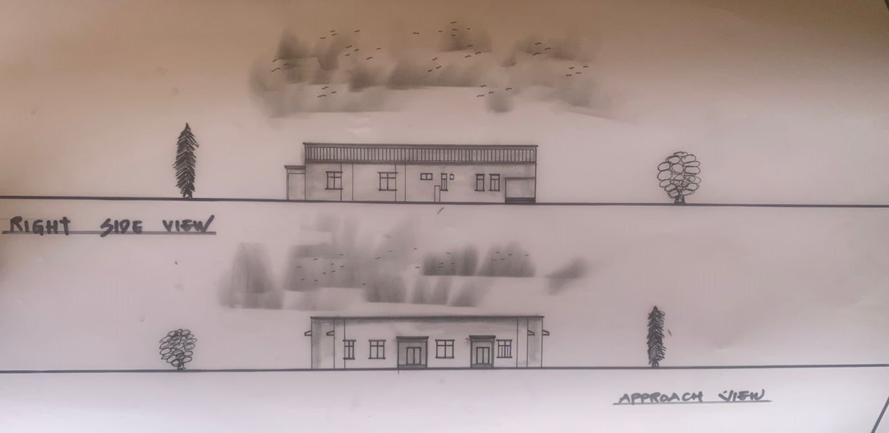
PROPOSED PROJECT ELEVATIONS
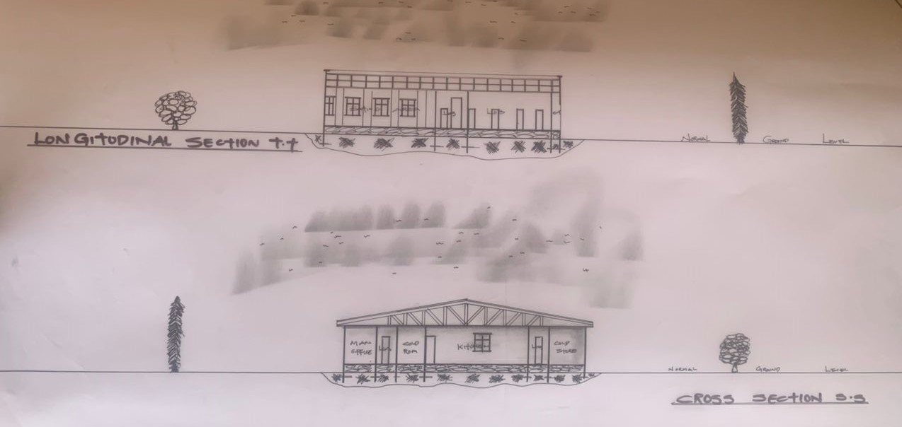
PROPOSED PROJECT SEECTION

