ISOLATION AND CHARACTERIZATION OF MYCOBIOME IN AGRICULTURAL FIELDS
BY
OLALERE ZAINAB ADETOLA
HND/23/SLT/FT/0462

A PROJECT SUBMITTED TO THE DEPARTMENT OF SCIENCE LABORATORY TECHNOLOGY, INSTITUTE OF APPLIED SCIENCES (IAS), KWARA STATE POLYTECHNIC, ILORIN,
IN PARTIAL FULFILMENT OF THE REQUIREMENTS FOR THE AWARD OF HIGHER NATIONAL DIPLOMA (HND) IN SCIENCE LABORATORY TECHNOLOGY, INSTITUTE OF APPLIED SCIENCES (IAS), MICROBIOLOGY UNIT
KWARA STATE POLYTECHNIC ILORIN
JULY, 2025

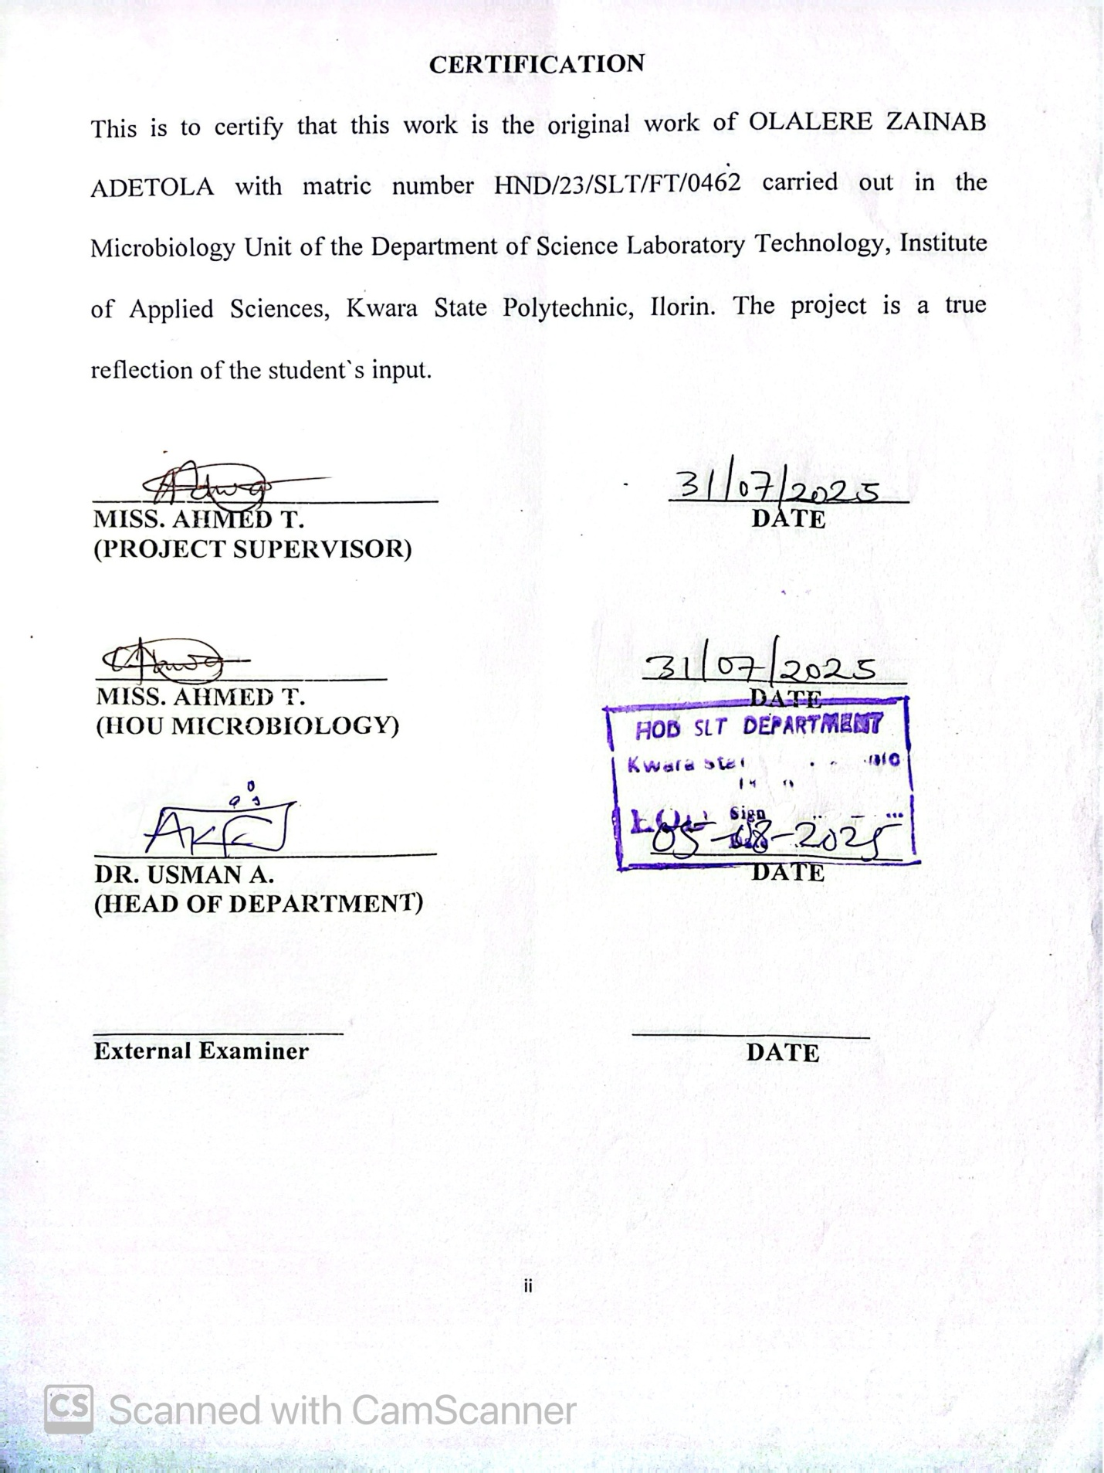
DEDICATION
I dedicated this work to Almighty Allah, the creator of heaven and earth, the one who gives knowledge and understanding for his mercy and blessings showered upon me throughout this program and making this work a successful one

ACKNOWLEDGEMENTS
My gratitude goes to Almighty God for the privilege given to me to complete this project work
To my ever kind supervisor MRS AHMED T whose also my Head of unit (HOU) I say a big thank you for your moral support, words of encouragement, effort that lead to the successful completion of this project. May God Almighty continue to preserve, guide and shower his blessings over you Ma.
My special appreciation goes to the Head of the Department HOD and all lecturers for all gestures and the knowledge they all impacts in me,may Almighty God continue to bless you all
To my beloved parents and family, I appreciate y’all for being my backbone and my biggest supporter, without y’all I have no power to be here today.
I thank y’all for being there for me in time of needs,encouragement,moral, support, spiritually and most of all financially. May Almighty God continue to enrich your pockets and grant y’all long life and prosperity to reap the fruits of labour
To my beloved friends and course mates that have been my supporting system since the beginning of the program, thank y’all for making the experience an amazing one. May the lord Almighty reward each and everyone of you in point of your needs (Amen)
TABLE OF CONTENTS
TITLE PAGE i
CERTIFICATION ii
DEDICATION iii
ACKNOWLEDGEMENTS iv
TABLE OF CONTENTS v-vi
LIST OF TABLES vii
ABSTRACT viii
CHAPTER ONE 1
1.0 INTRODUCTION 1
1.1 Literature Review 4
1.2 Statement of Problem 9
1.3 Aim 10
1.4 Objectives 10
CHAPTER TWO 11
2.0 MATERIALS AND METHODS 11
2.1 Materials 11
2.1.1 Media and Reagents 11
2.2 Collection and Preparation of Soil Samples 12
2.3 Soil pH Measurement 12
2.4 Preparation of Media 13
2.5 Inoculation and Incubation 13
2.6 Identification of Fungi 13
2.7 Macroscopic Observation of Fungal Colonies 14
2.8 Microscopic Examination 14
CHAPTER THREE 15
3.0 RESULT 15
3.1 Soil pH Measurements across Different Agricultural Locations 15
3.2 Preliminary Identification of Fungi 15
3.3 Macroscopic Observation of Fungal Colonies 16
3.4 Colony Count (CFU/g of Soil) 17
3.5 Frequency of Occurrence of Fungal Isolates 17
CHAPTER FOUR 21
4.0 DISCUSSION AND CONCLUSION 21
4.1 DISCUSSION 21
4.2 Conclusion 24
REFERENCES 25

LIST OF TABLES
Table 1: Soil pH Measurements across Different Agricultural Locations...…25
Table 2: Preliminary Identification of Fungi………………………………....25
Table 3: Macroscopic Observation of Fungal Colonies……………………..26
Table 4: Colony Count (CFU/g of Soil)……………………………………..27
Table 5: Frequency of Occurrence of Fungal Isolates……………………….27

ABSTRACT
The mycobiome, comprising the fungal component of soil microbial communities, plays a vital role in agricultural ecosystems by influencing nutrient cycling, organic matter decomposition, and plant health. This study aimed to isolate and characterize the mycobiome present in agricultural fields to better understand its diversity, abundance, and functional significance. Soil samples were collected from selected farmlands in Kwara State Polytechnic and subjected to serial dilution, inoculation on Potato Dextrose Agar (PDA), and incubation under standard conditions. Fungal isolates were identified using both macroscopic and microscopic techniques, including colony morphology and structural staining with lactophenol cotton blue. The results revealed the presence of five major fungal genera: Aspergillus spp., Rhizopus spp., Penicillium spp., Fusarium spp., and Aspergillus niger, with Aspergillus spp. being the most frequently occurring (40%). Colony counts ranged from 4.5 × 10⁴ CFU/g to 8.0 × 10³ of soil, indicating a high fungal load in the sampled agricultural soils. The diversity observed underscores the ecological importance of these fungi, which may act as beneficial mutualists or as pathogenic threats depending on environmental conditions and soil management practices. This study highlights the significance of regular mycobiome monitoring in agricultural soils as a means to inform sustainable farming strategies, enhance soil health, and mitigate crop disease risks. The findings contribute valuable data to the broader understanding of fungal biodiversity and its implications for agroecological productivity and resilience.
CHAPTER ONE

1.0 INTRODUCTION
The soil microbiome, encompassing bacteria, archaea, fungi, and other microorganisms, plays a pivotal role in maintaining soil health and fertility. Within this complex community, the mycobiome the fungal component has garnered increasing attention due to its significant influence on plant growth, nutrient cycling, and disease suppression. Fungi in the soil engage in various interactions with plants, ranging from mutualistic associations, such as mycorrhizal relationships, to pathogenic interactions that can lead to crop diseases. Understanding the composition and function of the soil mycobiome is essential for developing sustainable agricultural practices that enhance crop productivity while preserving environmental integrity.
Recent advancements in high-throughput sequencing technologies have revolutionized our ability to study the soil mycobiome. Metagenomic and metabarcoding approaches allow for comprehensive profiling of fungal communities, revealing their diversity, structure, and functional potential. These techniques have uncovered a vast array of previously uncharacterized fungal taxa and have provided insights into the ecological roles of fungi in various soil environments (Ważny et al., 2023). Such knowledge is crucial for identifying beneficial fungi that can be harnessed to improve soil health and crop resilience.
Agricultural practices significantly influence the composition and functionality of the soil mycobiome. Intensive farming, monoculture, and excessive use of chemical fertilizers and pesticides can disrupt fungal communities, leading to reduced biodiversity and impaired ecosystem services. Conversely, sustainable practices like crop rotation, intercropping, and organic farming have been shown to promote a more diverse and stable mycobiome, which in turn supports plant health and productivity (Khan, 2021). Therefore, characterizing the mycobiome under different agricultural management regimes is vital for informing best practices.
The role of arbuscular mycorrhizal fungi (AMF) in agriculture is particularly noteworthy. AMF form symbiotic relationships with the roots of most terrestrial plants, facilitating the uptake of nutrients such as phosphorus and nitrogen. Studies have demonstrated that the diversity and abundance of AMF are influenced by both current and historical land use, with proximity to natural habitats enhancing AMF diversity in agricultural fields (Yarzábal et al., 2024). This highlights the importance of landscape-level considerations in managing soil fungal communities.
Soil fungi also contribute to the decomposition of organic matter, thereby playing a critical role in carbon cycling and sequestration. Saprotrophic fungi, which decompose dead organic material, are essential for maintaining soil structure and fertility. Their activities influence the availability of nutrients for plants and other soil organisms. Understanding the dynamics of these fungal populations can inform strategies to enhance soil carbon storage, a key component in mitigating climate change (Kinge, 2024).
The application of beneficial fungi as biofertilizers and biocontrol agents offers promising avenues for sustainable agriculture. Fungal inoculants can improve plant nutrient uptake, enhance resistance to pathogens, and reduce the need for chemical inputs. For instance, certain strains of Trichoderma and Glomus have been effectively used to suppress soil-borne diseases and promote plant growth (Jumbam et al., 2024). However, the success of such applications depends on a thorough understanding of the native mycobiome and its interactions with introduced species.
Environmental stressors, including climate change, pollution, and land degradation, pose significant challenges to soil fungal communities. Extremophilic fungi, capable of surviving under harsh conditions, have been identified as potential allies in developing resilient agricultural systems. These fungi can contribute to plant stress tolerance and soil remediation efforts (Jumbam et al., 2024). Research into the functional traits of extremophilic fungi is expanding our toolkit for addressing the impacts of environmental change on agriculture
The integration of mycobiome studies into agricultural research necessitates a multidisciplinary approach, combining molecular biology, ecology, soil science, and agronomy. Collaborative efforts are essential to translate fundamental research into practical applications that benefit farmers and ecosystems alike. Moreover, engaging stakeholders in the co-development of mycobiome-based solutions can facilitate the adoption of sustainable practices and technologies.
The characterization of the soil mycobiome is a critical step toward achieving sustainable agriculture. By elucidating the diversity, functions, and interactions of soil fungi, we can develop strategies to enhance soil health, increase crop yields, and reduce environmental impacts. Continued research and innovation in this field hold the promise of transforming agricultural systems to meet the challenges of the 21st century.

1.1 Literature Review
The mycobiome refers specifically to the community of fungal organisms present in a particular environment, such as agricultural soil. These fungi are not random inhabitants; they play critical ecological roles that influence the health and productivity of soil and crops. In agricultural ecosystems, fungal communities contribute significantly to nutrient cycling by breaking down organic matter into usable forms, thereby facilitating the availability of essential nutrients like nitrogen, phosphorus, and potassium to crops. Moreover, some fungi help in aggregating soil particles, improving soil structure, aeration, and water retention, which are crucial for root development. Their influence extends to plant health as well, as some fungi form symbiotic associations with plant roots, enhancing their ability to absorb nutrients, while others may act as natural antagonists to harmful pathogens. Recent research has shown that these fungal populations are highly diverse and are shaped by multiple interacting factors, including soil type, plant species, agronomic practices (e.g., fertilization, irrigation, pesticide use), and climatic conditions (Peay et al., 2016). Within the mycobiome, fungal species can be broadly categorized as mutualists (e.g., mycorrhizal fungi that benefit plant roots), saprotrophs (decomposers that break down organic residues), and pathogens (which cause plant diseases). The interplay among these groups determines the overall soil health and productivity. Thus, gaining insight into the composition and functionality of the mycobiome is not just of academic interest but is vital for achieving sustainable agricultural practices and long-term soil fertility management.
A dominant and well-studied group within the soil mycobiome is the Arbuscular Mycorrhizal Fungi (AMF). These fungi form mutualistic associations with the roots of approximately 80% of terrestrial plants, including most major crops. AMF colonize plant roots and extend their hyphae into the surrounding soil, thereby increasing the absorptive surface area of roots. This enables more efficient uptake of relatively immobile nutrients, especially phosphorus, as well as zinc, copper, and water. In return, the fungi receive carbohydrates produced by the plant through photosynthesis (Smith & Read, 2008). Beyond improving nutrient acquisition, AMF are known to enhance plant resistance to a range of biotic stresses (such as pathogens and pests) and abiotic stresses (such as drought, salinity, and heavy metal toxicity). However, their presence and effectiveness in agricultural fields are highly sensitive to soil management practices. Practices like deep tillage, inorganic fertilizer application, and fungicide use can disrupt AMF networks, reduce their colonization, and thus diminish their benefits. In contrast, conservation practices such as reduced tillage, compost application, and reduced chemical input can promote the abundance and activity of AMF. Therefore, preserving and fostering AMF diversity is key to improving soil biological health, reducing input costs, and ensuring ecosystem resilience in agricultural systems.
Not all fungi in the mycobiome are beneficial; some are pathogenic, causing serious plant diseases that negatively affect crop yield and quality. These include fungi responsible for root rots (e.g., Fusarium, Pythium), wilt diseases (Verticillium, Fusarium oxysporum), and damping-off in seedlings. The presence and proliferation of these harmful fungi often result from imbalances in the soil microbiome, particularly when beneficial microbial populations are diminished due to poor soil management. Studies have shown that monoculture farming systems, which involve growing the same crop repeatedly in the same field, significantly reduce soil microbial diversity and encourage the dominance of soil-borne pathogens (Penton et al., 2014). This increases the vulnerability of crops to diseases and leads to higher reliance on chemical pesticides. However, integrated soil health management strategies such as crop rotation, organic amendments (e.g., compost, manure), cover cropping, and biofumigation have been shown to reduce pathogen load in soil and improve overall fungal diversity. These practices encourage a more balanced mycobiome, which can lead to natural suppression of pathogens through microbial competition and antagonism. Hence, managing the pathogenic and beneficial components of the mycobiome is essential for sustainable plant protection.
Modern intensive agricultural practices have had a profound impact on soil fungal biodiversity and function. The excessive use of synthetic fertilizers, frequent tillage, and heavy reliance on agrochemicals disrupt the natural fungal communities in soil. These practices often favor fast-growing, opportunistic fungi that are less beneficial and even detrimental to crop health. Hartmann et al. (2015) reported that organic farming systems, which limit synthetic inputs and emphasize soil conservation, support a higher diversity and richness of soil fungi, including those that contribute to natural disease suppression and organic matter breakdown. The rich fungal diversity in organically managed soils promotes biological interactions that enhance soil fertility, reduce the need for chemical inputs, and maintain ecosystem functions. Therefore, evaluating and characterizing the mycobiome under different agricultural regimes such as conventional vs. organic, or monoculture vs. polyculture provides valuable insight into the ecological impacts of farming practices. This knowledge is essential for designing sustainable land management strategies that are both productive and environmentally friendly.
Historically, the study of fungal communities in soil was limited by traditional culture-based methods, which often fail to detect non-culturable or slow-growing fungi. The emergence of molecular biology techniques, particularly high-throughput sequencing (HTS) methods, has revolutionized our understanding of soil fungal diversity. Techniques such as Internal Transcribed Spacer (ITS) rRNA gene sequencing allow researchers to identify a wide range of fungi in soil samples with high precision and sensitivity (Nilsson et al., 2019). These methods also facilitate functional predictions, enabling researchers to determine not just the identity, but also the potential ecological roles of different fungal taxa. Coupled with bioinformatics and metagenomic tools, scientists can now analyze vast amounts of sequencing data to assess fungal abundance, richness, diversity indices, and community structure. This has opened new frontiers in studying fungal interactions with other soil microbes (e.g., bacteria, archaea) and with plant hosts. Importantly, such insights can inform microbiome engineering, whereby microbial communities are manipulated to enhance crop performance and soil health.
Research has established that the structure and composition of the soil mycobiome are not uniform but vary greatly depending on geographic location, climatic conditions, soil physicochemical properties, and type of crops grown. For example, Frąc et al., (2018) demonstrated that maize and wheat fields in different eco-regions harbor distinct fungal communities that influence nutrient dynamics and plant health in diverse ways. Such regional and crop-specific differences have important implications for agricultural productivity, pest and disease pressure, and nutrient cycling. Understanding these local variations in fungal populations enables the design of site-specific management practices. For instance, a fungal strain that is beneficial in one environment may not thrive or may even be harmful in another. Therefore, comprehensive characterization of the mycobiome across different agricultural fields and agro-ecological zones is vital to optimize microbial inputs, select crop varieties that align with local soil biology, and design customized soil management protocols. This localized approach enhances the effectiveness of microbial-based interventions and ensures sustainable agricultural intensification.

1.2 Statement of Problem
Despite the importance of soil fungi, their diversity and function in many agricultural soils remain poorly understood, especially in developing regions. The disruption of native fungal communities by pesticides, tillage, and monoculture farming raises concerns about long-term soil health and productivity.

1.3 Aim
To characterize the composition, diversity, and functional roles of the mycobiome (fungal community) in agricultural fields, in order to understand their influence on soil health, plant growth, and crop productivity.

1.4 Objectives
- To isolate and identify fungal species present in agricultural soil
- To determine the diversity and abundance of fungal populations across different zones of the agricultural field

CHAPTER TWO

2.0 MATERIALS AND METHODS

2.1 Materials
The materials employed in this study included basic microbiological tools and equipment such as glassware, aluminum foil, inoculating loops, measuring cylinders, sterile slides, cover slips, micropipettes, and a compound microscope. A pressure cooker served as the sterilization device for the media. Additionally, essential items for aseptic techniques like ethanol and distilled water were utilized throughout the experiment. All instruments were sterilized before and after use to avoid contamination and ensure the accuracy of the results.

2.1.1 Media and Reagents
The chemical reagents used in this study included Potato Dextrose Agar (PDA), normal saline (0.85% NaCl), lactophenol cotton blue stain, and immersion oil. PDA was selected as the primary fungal growth medium due to its ability to support the growth of a wide range of fungal species. Lactophenol stain was employed for the microscopic identification of fungal structures, and ethanol was used as a surface disinfectant.

2.2 Collection and Preparation of Soil Samples
Soil samples were collected from five different agricultural locations within Kwara State Polytechnic using sterile techniques to prevent external contamination. These included the IBAS region, Village region, Tourism region, Marketing, and Banking and Finance field. Approximately 1g of soil from each site was aseptically introduced into a sterile test tube containing 9 ml of normal saline to serve as the stock solution. This was followed by a serial dilution process up to 10⁻⁵ to reduce microbial load and enable isolation of distinct fungal colonies. This dilution technique ensured the effective separation and growth of individual mycobiome colonies during incubation.

2.3 Soil pH Measurement
The pH of each soil sample was determined to assess the influence of soil acidity or alkalinity on fungal diversity. To achieve this, 10 g of each soil sample was mixed with 25 ml of distilled water in a sterile beaker, stirred thoroughly, and allowed to settle for 30 minutes. The pH of the supernatant was then measured using a calibrated digital pH meter. The pH values were recorded for each location and later correlated with fungal load and diversity during data analysis.

2.4 Preparation of Media
A total of 16.25 g of Potato Dextrose Agar (PDA) was weighed into a sterile 500 ml conical flask. Then, 250 ml of distilled water was added, and the mixture was thoroughly stirred using a sterile glass rod. The PDA solution was heated until boiling and then autoclaved in a pressure cooker for 20 minutes to ensure complete sterilization. After cooling to about 45–50°C, the PDA was poured aseptically into ten sterile Petri dishes, which were subsequently labeled according to the dilution levels (10⁻² and 10⁻⁴).

2.5 Inoculation and Incubation
Using a micropipette, 1 ml of the 10⁻² and 10⁻⁴ serial dilutions were aseptically inoculated onto the labeled PDA plates in duplicate. Each Petri dish was gently swirled to evenly distribute the inoculum. All inoculated plates were incubated at ambient temperature (approximately 25–30°C) for 140 hours (5 days) to allow sufficient fungal growth. After the incubation period, visible fungal colonies were observed and recorded.

2.6 Identification of Fungi
Sub-culturing was conducted on visibly distinct fungal colonies to obtain pure isolates. A sterile inoculating loop was used to transfer fungal colonies onto freshly prepared PDA plates. These sub-culture plates were incubated for an additional 72 hours. After incubation, identification of the fungal isolates was carried out by observing the colony morphology and microscopic characteristics. A sterile loop was used to make a smear of each fungal colony on a sterile slide. A drop of lactophenol cotton blue stain was added, and a cover slip was gently placed over the smear. After five minutes, immersion oil was applied to the cover slip, and the slide was examined under the microscope for structural identification of fungal spores, hyphae, and conidiophores.

2.7 Macroscopic Observation of Fungal Colonies
The colony morphology including size, color, texture, and pigmentation—was recorded. These features provided preliminary classification clues, such as whether the fungi belonged to genera like Aspergillus, Penicillium, or Rhizopus. Colonies with similar morphologies were grouped and analyzed together for further confirmation.

2.8 Microscopic Examination
Microscopic examination focused on identifying key structures such as septate or non-septate hyphae, sporangia, conidiophores, and spores. These observations were matched against standard fungal identification manuals and atlases to confirm the genera or species of the isolated fungi.

CHAPTER THREE

3.0 RESULT

3.1 Soil pH Measurements across Different Agricultural Locations
Table 1: Soil pH Measurements across Different Agricultural Locations
Soil location | pH
IBAS region | 7.8
Village region | 8.0
Tourism region | 7.7
Marketing | 7.7
Banking and finance | 8.0

3.2 Preliminary Identification of Fungi

Table 2: Preliminary Identification of Fungi
Identification was done using both macroscopic and microscopic features, referenced with fungal identification keys.
Isolate Code | Macroscopic Features | Microscopic Features | Probable Genus
F1 | White, woolly, rapidly spreading | Round with threadlike non-septate hyphae | Rhizopus spp.
F2 | Greenish powdery colony | Round spores with septate hyphae | Aspergillus spp.
F3 | Blue-green, velvety colonies | Chains of conidia with brush-like head | Penicillium spp.
F4 | Black, raised colonies | Rough conidiophores and dark conidia | Aspergillus niger
F5 | Yellowish-white, lobate growth | Canoe-shaped macroconidia | Fusarium spp.

3.3 Macroscopic Observation of Fungal Colonies
Fungal colonies were examined based on characteristics such as texture, color, margin, and growth pattern on PDA.

Table 3: Macroscopic Observation of Fungal Colonies
Isolate Code | Colony Color | Texture | Margin | Growth Pattern | Presumptive Genus
F1 | White | Woolly/Cottony | Irregular | Spreading | Rhizopus spp.
F2 | Greenish | Powdery | Circular | Dense and radial | Aspergillus spp.
F3 | Blue-Green | Velvety | Circular | Compact | Penicillium spp.
F4 | Black | Smooth | Circular | Raised | Aspergillus niger
F5 | Yellowish-White | Fluffy | Lobate | Spreading slowly | Fusarium spp.

3.4 Colony Count (CFU/g of Soil)
Fungal load was estimated from serially diluted soil samples using spread plate technique.

Table 4: Colony Count (CFU/g of Soil)
Dilution Factor | Number of Colonies | CFU/g of Soil
10⁻² | 45 | 4.5 × 10⁴
10⁻⁴ | 8 | 8.0 × 10³

3.5 Frequency of Occurrence of Fungal Isolates
This table shows the frequency at which each fungal genus was isolated across the plates.

Table 5: Frequency of Occurrence of Fungal Isolates
Fungal Genus | Number of Occurrences | Percentage Frequency (%)
Rhizopus spp. | 3 | 30%
Aspergillus spp. | 4 | 40%
Penicillium spp. | 2 | 20%
Fusarium spp. | 1 | 10%

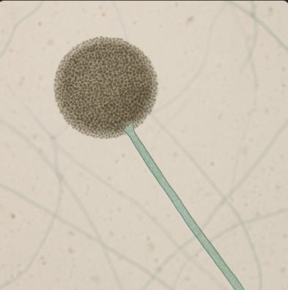
Fig. 1:
Powdery structure and rounded

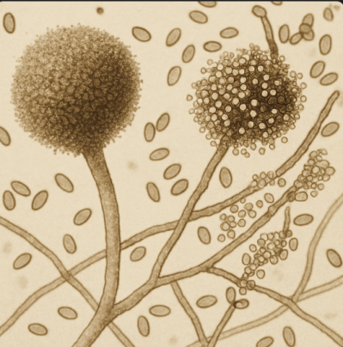
Fig.2 :
Round structure and Threadlike structure

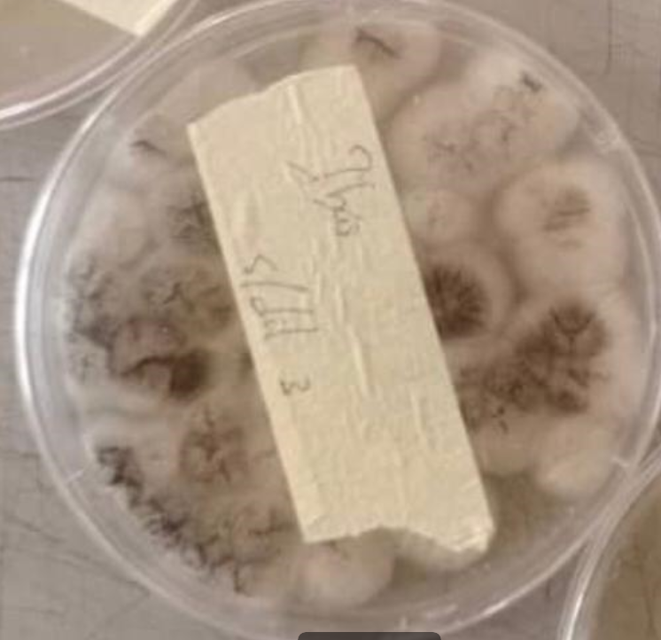
Fig. 3: Rhizopus spp

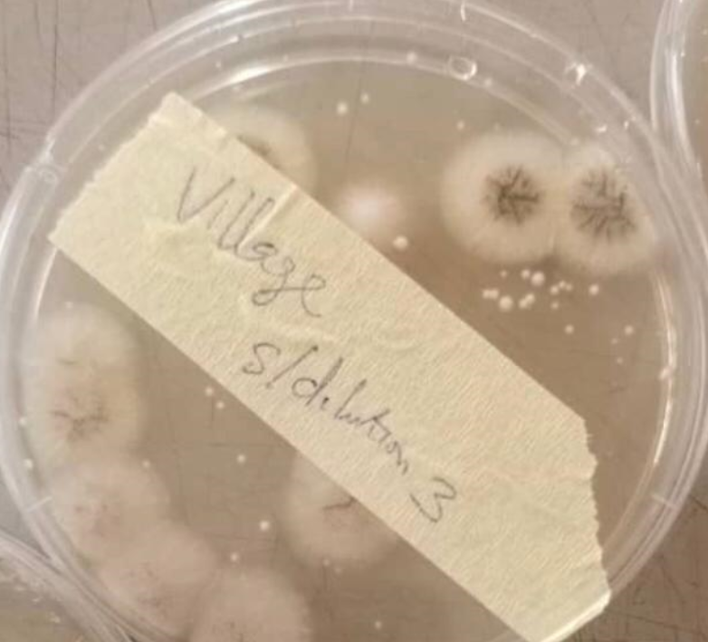
Fig.4: Fusarium spp

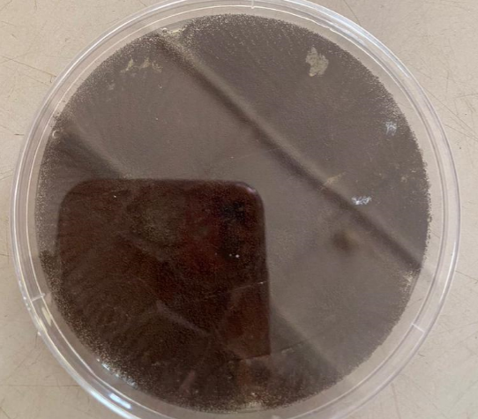
Fig. 4: Aspergillus spp

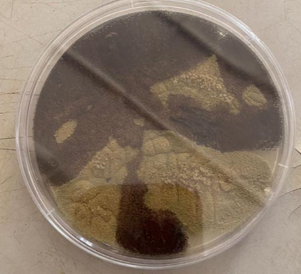
Fig.5: Penicillium spp

CHAPTER FOUR

4.0 DISCUSSION AND CONCLUSION

4.1 DISCUSSION
The soil pH measurements across the five agricultural locations (Table 1) revealed a generally alkaline to slightly neutral range, with pH values spanning from 7.7 to 8.0. The highest pH values were observed in the Village and the Tourism region (both 8.0), while the IBAS region recorded a pH of 7.8. Such pH conditions are known to favor the growth of many filamentous fungi, particularly those like Aspergillus and Penicillium spp., which thrive in mildly alkaline soils (Hassani et al., 2020). These pH levels support microbial activity by increasing nutrient availability, a factor that may explain the diversity observed in fungal isolates.
Preliminary fungal identification (Table 2), based on both macroscopic and microscopic features, indicated the presence of five dominant genera: Rhizopus, Aspergillus, Penicillium, Aspergillus niger, and Fusarium. The microscopic examination (Figure 1) confirmed key structural features. Rhizopus spp. (F1) showed characteristic round sporangia and long, non-septate hyphae, typical of zygomycetes. This observation aligns with Qadri et al., (2021), who described similar features in Rhizopus isolated from rhizosphere soils in maize and sorghum farms.
Aspergillus spp. (F2) were identified by their septate hyphae and spherical conidia, while Aspergillus niger (F4) showed darker pigmentation and rough conidiophores under microscopic view. These are consistent with observations made by Nguyen et al., (2020), who noted such morphological traits as indicative of Aspergillus genus during soil biodiversity studies. Penicillium spp. (F3) displayed brush-like conidiophores and chains of conidia—hallmark identifiers supported by Sharma et al., (2020). Fusarium spp. (F5) were noted for their canoe-shaped macroconidia, a defining feature found in soil fungi often associated with plant disease (Oyebanji et al., 2021).
Macroscopic observations on PDA (Table 3) supported the initial identifications. Rhizopus spp. appeared as rapidly spreading, white, woolly colonies, characteristic of its rapid colonization behavior in nutrient-rich substrates. Aspergillus species formed compact, dense, green to black powdery colonies, a trait previously reported by Chowdhary et al., (2020). Penicillium spp. had velvety, blue-green colonies, while Fusarium spp. produced yellowish-white colonies with lobate margins and slower growth. These features matched those observed by Sharma et al., (2020) during their work on soil-borne fungi.
The fungal load, as indicated by colony-forming units per gram (Table 4), showed that the 10⁻² dilution had a significantly higher count (4.5 × 10⁴ CFU/g) compared to 8.0 × 10³ CFU/g in the 10⁻⁴ dilution. This suggests that the soil samples harbored a high density of viable fungal propagules. Such fungal abundance is likely due to the organic content and moisture-holding capacity of the agricultural soils, which enhance microbial colonization and survival. Yusuf et al., (2022) similarly reported high CFU values in irrigated farm soils in tropical regions.
The frequency of occurrence data (Table 5) further demonstrated the dominance of Aspergillus spp. (40%), followed by Rhizopus spp. (30%), Penicillium spp. (20%), and Fusarium spp. (10%). The predominance of Aspergillus can be attributed to its resilient spores, metabolic versatility, and tolerance to diverse environmental conditions (Chowdhary et al., 2020). Rhizopus also appeared frequently, likely due to its saprophytic role in breaking down organic debris. The relatively lower frequency of Fusarium spp. may indicate niche competition or lower adaptability in alkaline soils, a trend also noted by Oyebanji et al., (2021) in their studies of fungal communities in Nigerian farmland.
Overall, the morphological observations (Figures 1 and 2) and colony characteristics on PDA (Table 3) validated the preliminary genus identification, reinforcing the presence of typical soil fungi. These fungi are known not only for their ecological roles in decomposition and nutrient cycling but also for their potential pathogenic interactions with crops (Hassani et al., 2020). The data gathered from this study offer foundational insight into the mycobiome composition of local agricultural fields and underline the need for continuous monitoring to understand the balance between beneficial and harmful fungi in soil ecosystems.

4.2 Conclusion
The characterization of mycobiome in agricultural fields offers essential insights into soil health and fertility. This study reveals that agricultural soils harbor diverse fungal species that can either enhance or hinder crop production, depending on their ecological roles. Therefore, routine soil mycobiome analysis should be encouraged as a tool for sustainable land management, early disease detection, and improvement of crop yield through better-informed agricultural practices.

REFERENCES
Chowdhary, A., Sharma, C., & Meis, J. F. (2020). Environmental prevalence of pathogenic fungi and the role of agriculture. Current Fungal Infection Reports, 14, 1–9. https://doi.org/10.1007/s12281-020-00375-5
Frąc, M., Hannula, S. E., Bełka, M., & Jędryczka, M. (2018). Fungal biodiversity and their role in soil health. Frontiers in Microbiology, 9, 707. https://doi.org/10.3389/fmicb.2018.00707
Hartmann, M., Frey, B., Mayer, J., Mäder, P., & Widmer, F. (2015). Distinct soil microbial diversity under long-term organic and conventional farming. The ISME Journal, 9(5), 1177–1194. https://doi.org/10.1038/ismej.2014.210
Hassani, M. A., Durán, P., & Hacquard, S. (2020). Microbial interactions within the plant holobiont. Microbiome, 8, 45. https://doi.org/10.1186/s40168-020-00810-w
Jumbam, B., Amiri, Z. B., Dandurand, L. M., Zasada, I. A., & Aime, M. C. (2024). Analyses of fungal communities from culture-dependent and-independent studies reveal novel mycobiomes associated with Globodera and Heterodera species. Phytobiomes Journal, 8(4), 621-642.
Khan, A. A. H. (2021). Role of the Mycobiome in Agroecosystems. In Microbiome-Host Interactions (pp. 275-293). CRC Press.
Kinge, T. R., Ghosh, S., Cason, E. D., & Gryzenhout, M. (2022). Characterization of the endophytic mycobiome in cowpea (Vigna unguiculata) from a single location using illumina sequencing. Agriculture, 12(3), 333.
Nguyen, D., Nguyen, N. H., & Tedersoo, L. (2020). Soil fungal diversity and composition across different agricultural land-use types. Frontiers in Microbiology, 11, 593. https://doi.org/10.3389/fmicb.2020.00593
Nilsson, R. H., Larsson, K. H., Taylor, A. F. S., Bengtsson‐Palme, J., Jeppesen, T. S., Schigel, D., ... & Abarenkov, K. (2019). The UNITE database for molecular identification of fungi: handling dark taxa and parallel taxonomic classifications. Nucleic Acids Research, 47(D1), D259–D264. https://doi.org/10.1093/nar/gky1022
Oyebanji, F. O., Ojo, O. F., & Ajani, R. O. (2021). Diversity of soil fungi in cultivated agricultural soils in southwestern Nigeria. Nigerian Journal of Mycology, 13(2), 78–87.
Peay, K. G., Kennedy, P. G., & Talbot, J. M. (2016). Dimensions of biodiversity in the Earth mycobiome. Nature Reviews Microbiology, 14, 434–447. https://doi.org/10.1038/nrmicro.2016.59
Penton, C. R., Johnson, T. A., Quensen, J. F., Iwai, S., Cole, J. R., & Tiedje, J. M. (2014). Functional genes to assess nitrogen cycling and aromatic hydrocarbon degradation: primers and processing matter. Frontiers in Microbiology, 5, 279. https://doi.org/10.3389/fmicb.2014.00279
Qadri, M., Fatima, A., & Rehman, R. (2021). Isolation and identification of beneficial soil fungi from agricultural fields. Asian Journal of Mycology, 4(1), 14–20.
Sharma, R., Choudhary, D. K., & Johri, B. N. (2020). Assessing the diversity of soil fungi in crop rhizosphere. Journal of Environmental Biology, 41(3), 515–523.
Smith, S. E., & Read, D. J. (2008). Mycorrhizal Symbiosis (3rd ed.). Academic Press.
Ważny, J., Rozpądek, P. and Domka, A. (2023). How does metal soil pollution change the plant mycobiome? Environmental Microbiology, 25(1), 123–135. https://enviromicro-journals.onlinelibrary.wiley.com/doi/full/10.1111/1462-2920.16392
Yarzábal Rodríguez, L. A., Álvarez Gutiérrez, P. E., Gunde-Cimerman, N., Ciancas Jiménez, J. C., Gutiérrez-Cepeda, A., Ocaña, A. M. F., & Batista-García, R. A. (2024). Exploring extremophilic fungi in soil mycobiome for sustainable agriculture amid global change. Nature Communications, 15(1), 6951.
Yusuf, R. O., Adediran, G. O., & Bello, M. O. (2022). Characterization of fungi in irrigated farm soils in Ilorin, Nigeria. African Journal of Microbiology Research, 16(1), 34–41.

