A PROJECT REPORT ON
PROPOSED DENTAL CLINIC FOR KWARA
STATE GOVERNMENT

BY:
OLABAMIJI FAWAS OLAYEMI
ND/23/ARC/PT/0016

BEING A PROJECT REPORT SUBMITTED TO
THE DEPARTMENT OF ARCHITECTURAL TECHNOLOGY,
INSTITUTE OF ENVIRONMENTAL STUDIES,
KWARA STATE POLYTECHNIC, ILORIN.

INPARTIAL FULFILMENT OF THE REQUIREMENTS FOR THE
AWARD OF HIGHER NATIONAL DIPLOMA (ND)
IN ARCHITECTURAL TECHNOLOGY.

JULY 2025

DECLARATION
I declare that this project/Dissertation is a project of my personal research works, It has not been presented for the award of any ND in any polytechnic. The ideas, Observations, Comments, and Suggestions here-in represent my own convictions except quotations, which have been acknowledged in accordance with conventional academic traditions.
OLABAMIJI FAWAS OLAYEMI
ND/23/ARC/PT/0016
….…………………………………
SIGNATURE AND DATE

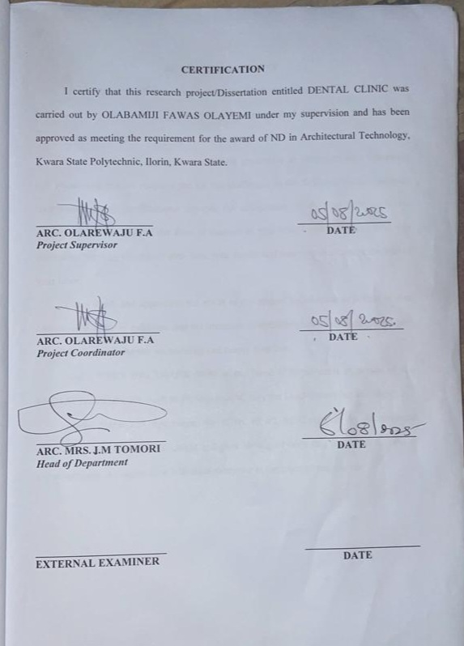
ACKNOWLEDGEMENT
My profound gratitude goes to Almighty God, the creator of the universe and fountain of all wisdom whose umbrella of guard and guide. I seek refuge through thick and thin of years of study.
I will also like to appreciate my project supervisor in person of Arc. Olarewaju F.A whose contribution prepares me for the challenges in the field and for his immense contribution in all ramifications towards the completion of this research work. He encouraged me and opened the door of interaction with him. I pray Almighty God will shower his blessing and mercy over him, your family and may you live to reap the fruit of your labor.
I also thank and appreciate the effort of my project coordinator in person of Arc. Olarewaju F.A for is guidance and his immense contribution towards my project, I pray Almighty God will shower his blessing and mercy over him.
And a VERY BIG THANK YOU to my Head of Department in person of Arc J.M Tomori for her work in the department, may the Lord reward her abundantly.
I also thank and appreciate the effort of all the Lecturers in Architectural Technology Department, who taught and gave lasting advice's that led to the success of my programed, Almighty God will meet everyone at the point of their needs.

DEDICATION
This project work is dedicated to Almighty God who has been providing all my needs for His blessing and mercy over me all through the programed. And my parents, Mr Olabamiji
And Mrs. Olabimiji my brothers, friends, love one’s and my supervisor who assist me financially, spiritually, mentally and guide me through my academic pursuit. May Almighty God shower his blessing and mercy over you all?

ABSTRACT
This research work was carried out on the project topic "Dental Clinic for Amoyo Ilorin East Local Government Kwara State". I felt caring out this project in Amoyo Ilorin East Local Government Kwara State will bring out meaningful results. For easy analysis and understanding, the study is being put into five chapters. Chapter One throws light on a general introduction, definition of the project, historical background information of the project title, project justification, aim and objectives of the study, and scope of the study, Chapter two, a detailed literature review of some books, case studies and deduction from case studies. The third chapter three also mentions the historical background of the study area, site location and description, site analysis, and geographical location, climatic data, population of the area, social services, and health services. The fourth chapter deals with design criteria, design analysis, space allocation and planning principle. Chapter five deals with design appraisal, construction methodology, services, summary, conclusion and references.

TABLE OF CONTENT
Title page……………………………………………………………………………………………..i
Declaration……………………………………………………………………………………………ii
Certification……………………………………………………………………………………………iii
Acknowledgement………………………………………………………………………………………iv
Dedication………………………………………………………………………………………………..v
Abstract………………………………………………………………………………………….vi
Table of contents……………………………………………………………………………………..vii-x
List of tables………………………………………………………………………………………………xi
List of figures……………………………………………………………………………………………xii
List of plates…………………………………………………….………………………………….xiii-xiv
List of Appendices……………………………………………………………………………………..xv
CHAPTER ONE
- INTRODUCTION……………………………………………………………………………1
1.1 DEFINITION………………………………………………………………………...............2
1.2 HISTORICAL BACKGROUND……………………………………………………………..2
1.3 AIM OF THE PROJECT……………………………………………………………………..3
1.4 OBJECTIVES OF THE PROJECT…………………………………………………………..3
1.5 PROJECT JUSTIFICATION…………………………………………………………………3
1.6 SCOPE OF THE PROJECT…………………………………………………………………..3
1.7 RESEARCH METHODOLOGY……………………………………………………………..4
CHAPTER TWO
2.0 LITERATURE REVIEW AND CASE STUDIES
2.1 HISTORICAL BACKGROUND……………………………………………………………..5
2.2 CONCLUSION………………………………………………………………………………6
CHAPTER THREE
3.0 CASE STUDIES……………………………………………………………………………..7
3.1 SELECTED CASE STUDIES…………………………………………………………….....7
3.2 CASE STUDY ONE…………………………………………………………………………7
3.3 CASE STUDY TWO……………………………………………………………………….12
3.4 CASE STUDY THREE…………………………………………………………………….16
3.5 CASE STUDY FOUR……………………………………………………………………….19
3.6 ONLINE CASE STUDY ONE………………………………………………………………22
3.6.1 ONLINE CASE STUDY TWO……………………………………………………………25

LIST OF FIGURES
FIG 1; SHOWING LOCATION PLAN OF CASE STUDY ONE………………………………8
FIG 2; SHOWING GROUND FLOOR PLAN OF CASE STUDY ONE………………………..8
FIG 3; SHOWING UPPER FLOOR PLAN OF CASE STUDY ONE…………………………..9
FIG 4 SHOWING LOCATION PLAN OF CASE STUDY TWO………………………………13
FIG 5 SHOWING GROUND FLOOR PLAN OF CASE STUDY TWO……………………….13
FIG 6; SHOWING UPPER FLOOR PLAN OF CASE STUDY TWO…………………….…14
FIG 7; SHOWING LOCATION PLAN OF CASE STUDY THREE…………………………17
FIG 8; SHOWING FLOOR PLAN OF CASE STUDY THREE………………………………17
FIG 9; SHOWING LOCATION PLAN OF CASE STUDY FOUR……………………………20
FIG 10; SHOWING FLOOR PLAN OF CASE STUDY FOUR…………………….………….20
FIG 11; SHOWING SITE INVENTORY OF THE PROPOSED SITE…………………………31
FIG 12; SHOWING SITE ANALYSIS OF THE PROPOSED SITE…………………………...32

LIST OF PLATES
PLATE 1; SHOWING FRONT VIEW OF CASE STUDY ONE……………………………...10
PLATE 2; RECEPTION AREA OF CASE STUDY ONE…………………………………….11
PLATE 3; SHOWING TREATMENT ROOM OF CASE STUDY ONE…………………….11
PLATE 4; SHOWING CONFERENCE ROOM OF CASE STUDY ONE……………………12
PLATE 5; SHOWING FRONT VIEW OF CASE STUDY TWO…………………………….14
PLATE 6; SHOWING BACK VIEW OF CASE STUDY TWO……………………….……..15
PLATE 7; SHOWING RECEPTION AREA OF CASE STUDY TWO……………………….15
PLATE 8; SHOWING TREATMENT ROOM OF CASE STUDY TWO……………………16
PLATE 9; SHOWING FRONT VIEW OF CASE STUDY THREE……………………………18
PLATE 10; SHOWING RECEPTION AREA OF CASE STUDY THREE…………………..18
PLATE 11; SHOWING TREATMENT ROOM OF CASE STUDY THREE………………..19
PLATE 12; SHOWING FRONT VIEW OF CASE STUDY FOUR………………………….21
PLATE 13; SHOWING RIGHT VIEW OF CASE STUDY FOUR………………………….…21
PLATE 14; SHOWING BACK VIEW OF CASE STUDY FOUR……………………………..22
PLATE 15; SHOWING TREATMENT ROOM OF CASE STUDY FOUR…………………..22
PLATE 16; SHOWING GOOLGE MAP OF ONLINE CASE STUDY ONE………………...23
PLATE 17; SHOWING FRONT VIEW OF ONLINE CASE STUDY ONE………………….23
PLATE 18; SHOWING RIGHT VIEW OF ONLINE CASE STUDY ONE…………………..24
PLATE 19; SHOWING TREATMENT ROOM OF ONLINE CASE STUDY ONE…………..24
PLATE 20; SHOWING GOOGLE MAP OF ONLINE CASE STUDY TWO………….……25
PLATE 21; SHOWING FRONT VIEW OF ONLINE CASE STUDY TWO…………………25
PLATE 22; SHOWING RECEPTION AREA OF ONLINE CASE STUDY TWO………….…26
PLATE 23; SHOWING TREATMENT ROOM OF ONLINE CASE STUDY TWO…………26

CHAPTER ONE
1.0 INTRODUCTION
The architectural design of a dental clinic plays a vital role in shaping the overall experience of both patients and healthcare professionals. A dental clinic is more than just a space for medical procedures it is a highly functional, health-sensitive environment that must adhere to strict standards of hygiene, accessibility, spatial organization, and comfort. With advancements in medical technology and increasing awareness of patient-centered care, the need for thoughtfully designed dental facilities has become imperative.
In recent years, the focus on designing healthcare facilities has shifted toward creating spaces that promote healing, minimize stress, and ensure operational efficiency. Dental clinics are no exception. These facilities require careful planning of clinical zones, waiting areas, administrative offices, sterilization units, and patient consultation rooms all designed to function in an integrated and efficient manner. The architecture must support infection control, privacy, smooth circulation, and the accommodation of modern dental equipment while remaining aesthetically pleasing and welcoming.
Additionally, a well-designed dental clinic should reflect modern architectural principles such as sustainability, energy efficiency, and adaptability. In urban and semi-urban settings, where population growth and healthcare needs are rising, dental clinics serve as crucial hubs for oral healthcare delivery. Therefore, the architectural response to this demand must integrate contextually appropriate design strategies that address the social, environmental, and medical dynamics of the community it serves.
This project aims to explore and develop an architectural solution for a modern dental clinic that balances functionality with human-centric design principles, providing a safe, efficient, and therapeutic environment for both patients and practitioners.
1.1 DEFINITION OF A DENTAL CLINIC
A dental clinic refers to a facility dedicated to oral healthcare, where patients receive treatments ranging from basic cleaning to surgical interventions. Historically, evidence of dental procedures such as cleaning with primitive tools dates back to ancient civilizations, suggesting long-standing efforts to manage oral conditions (Petersen et al., 2005). Modern dental clinics often function as training centers for students, research hubs for dental innovations, and service points for underprivileged populations.
1.2 HISTORICAL BACKGROUND
Dentistry is among the earliest medical practices, with origins tracing back to around 7000 B.C. during the Indus Valley Civilization. By 5000 B.C., Sumerian texts were already proposing theories about dental decay. The ancient Greeks, including Hippocrates and Aristotle, contributed early insights into dental treatments (Ring, 2009).
Significant progress occurred in the 18th century when Pierre Fauchard—recognized as the father of modern dentistry—introduced comprehensive methods for treating oral ailments and pioneered dental fillings and prosthetics (Ring, 2009). The formalization of dental practice began in the United States with the establishment of the first dental college in 1840 and the creation of licensing laws in the following decades.
Throughout the 19th and 20th centuries, dentistry saw innovations like mass-produced toothpaste, professional associations, and expanded educational opportunities for women and African Americans. However, widespread adoption of dental hygiene practices, such as regular tooth brushing, did not become common until after World War II (American Dental Association, 2022).
1.3 AIM
The primary goal of designing a dental clinic is to provide a functional, hygienic, and comfortable environment that meets the needs of both patients and staff, while also being aesthetically appealing and structurally sound.
1.4 OBJECTIVES
- To design a modern dental facility that fulfills the operational and aesthetic needs of a dental clinic in Enugu State.
- To integrate architectural and structural principles for optimal functionality.
- To allocate sufficient spatial arrangements for staff movement, patient flow, and equipment setup.
- To enhance the visual and architectural appeal of the surrounding built environment.
- To provide designated spaces for the range of dental treatments offered.
1.5 PROJECT JUSTIFICATION
The rationale behind proposing this project in Sobi stems from the increasing demand for modern dental healthcare. Establishing a new dental hospital necessitates the creation of a conducive and well-equipped environment for efficient service delivery.
1.6 SCOPE OF THE PROJECT
- Main Clinic Building
- Residential Quarters
- Cafeteria
- Security Post
- Power House
- Parking Area
- Landscape (Green Park)
- Access Roads
1.7 CLIENT BACKGROUND
The proposed clinic is located in Amoyo, a community within the Ilorin South Local Government Area. The town has experienced population growth and increasing demand for quality healthcare services, especially dental care.
1.8 RESEARCH METHODOLOGY
To develop an effective and functional design for the dental clinic, a multi-method research approach was adopted:
- Literature Review: Scholarly books, journals, and articles on dental architecture and oral healthcare standards were reviewed.
- Key Factor Identification: Factors like infection control, spatial efficiency, accessibility, and patient comfort were prioritized (WHO, 2023).
- Data Collection: Interviews with dental professionals, patients, and stakeholders provided valuable insights.
- Data Analysis: Trends were analyzed to determine critical components of effective dental clinic design.
- Personal Observation: Field visits, photographic documentation, and interviews within the project’s vicinity were conducted.
- Case Study: Comparable dental clinics were studied to understand their successes and shortcomings, guiding better design decisions.
CHAPTER TWO
- LITERATURE REVIEW
Designing a dental clinic goes beyond the aesthetic arrangement of physical structures; it involves integrating medical functionality, patient psychology, spatial efficiency, and hygienic best practices within a healing environment. The architectural design of a dental clinic must support efficient workflow, infection control, patient comfort, and the technological needs of modern dentistry. This literature review explores existing academic and professional insights on the architectural design of dental clinics, covering core themes such as spatial planning, ergonomics, sustainability, and user experience.
2.1. Functionality and Spatial Planning
A critical component of dental clinic architecture is the functional layout of the facility. According to Neufert (2012), efficient spatial planning ensures a smooth workflow for staff, reduces patient wait times, and minimizes the risk of cross-contamination. Dental clinics are typically divided into functional zones: reception and waiting areas, consultation rooms, treatment rooms, sterilization rooms, storage areas, and staff zones. Each space must be planned to support clear circulation pathways for both staff and patients, ideally separating clean and contaminated zones to maintain infection control standards (Jung et al., 2016).
For instance, treatment rooms should be located in quieter areas of the clinic, away from the entrance, to reduce noise and enhance patient privacy. Sterilization rooms, as recommended by the Centers for Disease Control and Prevention (CDC), should be centrally located to serve multiple operatory rooms efficiently and prevent contamination spread (CDC, 2003).
2.2. Patient-Centered Design and User Experience
Modern dental clinic design increasingly emphasizes patient-centered architecture. Research by Ulrich et al. (2008) highlights how architectural environments significantly impact patient anxiety and satisfaction. Dental procedures often evoke fear and anxiety; therefore, the architectural environment must aim to reduce stress through design elements such as natural lighting, warm colors, acoustic insulation, and the use of nature-inspired décor (Becker & Parsons, 2007).
Waiting areas should be comfortable, well-ventilated, and psychologically calming, with access to visual distractions such as artwork, greenery, or digital screens. Transparency in design—such as glass partitions between waiting and treatment areas can also help reduce the fear of the unknown, a common source of dental anxiety (Evans, 2003).
3. Ergonomics and Efficiency
Ergonomics is a foundational principle in the architectural design of dental clinics. As practitioners often spend long hours in static positions, operatories must be designed to support ergonomic practices and minimize the risk of musculoskeletal disorders (Finsen et al., 1998). The design should facilitate seamless coordination between the dentist, assistant, and patient. This involves positioning of dental chairs, cabinetry, light sources, and instruments within easy reach and optimal sight lines.
According to Horská et al. (2020), dental operatory layout directly influences the productivity and well-being of dental practitioners. Workspaces should be flexible and adaptable to accommodate right- or left-handed dentists and a variety of dental specialties such as orthodontics or pediatric dentistry.
4. Infection Control and Hygiene
Hygiene is paramount in dental clinic architecture. The World Health Organization (WHO) emphasizes that spatial layouts must reduce opportunities for contamination. This includes having non-porous, easy-to-clean surfaces; separate clean and dirty workflows; and hands-free door mechanisms (WHO, 2009). Flooring materials, wall coatings, and ceiling finishes must comply with medical hygiene standards.
Moreover, mechanical ventilation and air filtration systems must meet health regulations, particularly in treatment rooms where aerosols are frequently generated. The COVID-19 pandemic further intensified the focus on infection control in healthcare design, prompting many practices to reconfigure air flow systems and waiting room layouts (Mujumdar et al., 2021).
5. Integration of Technology
Dental clinics must accommodate a variety of modern dental technologies, including digital radiography, intraoral scanners, 3D imaging, and computer-aided design/computer-aided manufacturing (CAD/CAM) systems. The architectural design must integrate wiring, plumbing, and data systems to support these technologies without compromising aesthetics or accessibility (Alibhai, 2001).
The inclusion of built-in equipment cabinetry, concealed service ducts, and accessible maintenance corridors are becoming standard in advanced dental clinic architecture. These ensure ease of upgrade, reduce visible clutter, and support long-term adaptability.
6. Sustainability and Environmental Considerations
Sustainability in dental clinic design is gaining traction. Energy-efficient lighting, natural ventilation, water-saving devices, and the use of environmentally friendly materials can reduce operational costs and environmental impact (Kats, 2010). Incorporating daylight and passive cooling techniques not only saves energy but also improves patient and staff well-being.
Green architecture can also enhance the image of a dental clinic. According to Heerwagen (2000), sustainable buildings convey a message of care and responsibility, traits that align with healthcare values and positively influence patients’ perception of care.
7. Cultural and Contextual Relevance
In locations like Nigeria and other developing regions, local cultural values, climatic conditions, and economic realities must guide architectural design. For instance, designs must factor in natural ventilation, solar orientation, power reliability, and water access while using locally available materials to cut costs (Olotuah, 2006).
Additionally, the size and function of the dental clinic whether public, private, urban, or rural—will influence design priorities. Smaller clinics may prioritize multipurpose spaces and modular furniture, while larger urban clinics may focus on patient flow management and digital integration.

Conclusion
The architectural design of a dental clinic is a multidisciplinary effort that fuses function, comfort, hygiene, and innovation. A well-designed clinic improves not only operational efficiency and infection control but also enhances patient experience and staff satisfaction. As dentistry continues to evolve with technological and environmental changes, the design of dental clinics must remain responsive, resilient, and human-focused. Future research should continue to explore how architecture can support holistic oral healthcare in diverse settings.

CHAPTER THREE
3.0 CASE STUDIES
Case studies involve a thorough examination and analysis of existing buildings that are similar in function and form to the proposed project. The main objective is to critically evaluate such buildings in order to identify their strengths and weaknesses. Through this appraisal, insights are gained that can significantly influence the design of new projects. Positive features can be adopted and integrated into the new proposal, while identified shortcomings will be addressed and corrected in the design solution.
Only over time can built structures be adequately assessed for effectiveness, and it is through such studies that architects can enhance the quality, functionality, and sustainability of the built environment. In line with this, several relevant case studies have been conducted to provide a comprehensive understanding of existing dental clinic designs.
3.1 SELECTED CASE STUDIES
Case studies are an essential part of architectural research. They serve as experimental evaluations or analyses of existing buildings or groups of buildings that serve similar functions to the project in focus. For any architectural design to be relevant and effective, it is crucial to carry out preliminary research to establish a strong foundation for the proposed design.
Outlined below are the selected case studies of dental clinics analyzed for this research:
- Schubbs Dental Clinic, Ikeja, Lagos State
- Choice Dental Clinic, Ikeja, Lagos State
- Emirate Dental Clinic, Asa-Dam Road, Ilorin, Kwara State
- Bozid Dental Clinic, 52 Oyo Road, Ibadan, Oyo State

3.2 CASE STUDY ONE
Location: Schubbs Dental Clinic, Ikeja, Lagos State
Key Observations:
Merits:
- Staffed with highly qualified professionals
- Offers a wide range of dental services
- Features a well-planned and executed architectural design
- Situated in a serene and peaceful environment
- The landscape is aesthetically pleasing and well maintained
Demerits:
- Lacks provision for future expansion

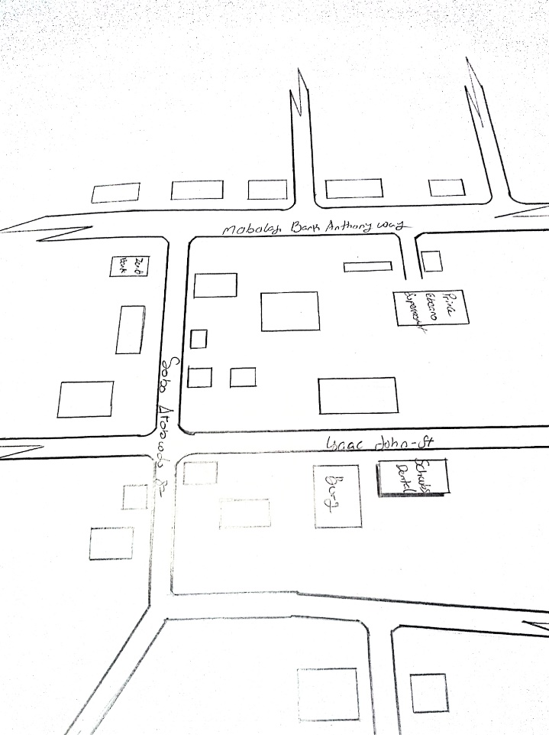
FIG 3.1: SHOWING LOCATION PLAN OF CASE STUDY ONE
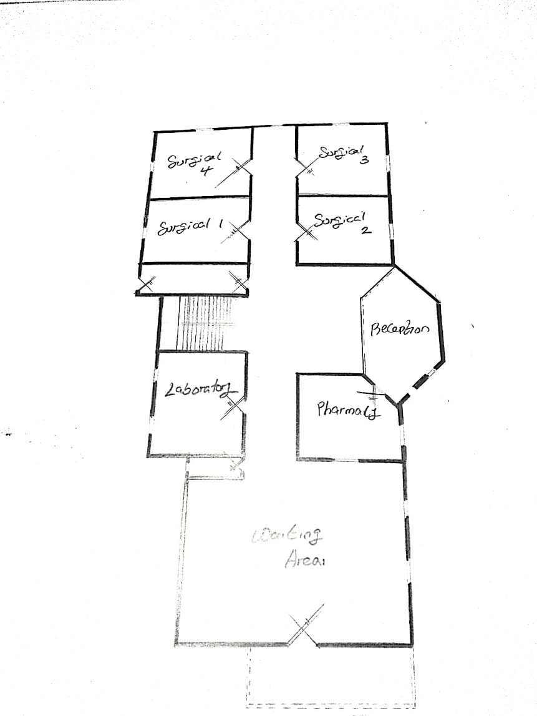
FIG 3.2: SHOWING GROUND FLOOR PLAN OF CASE STUDY ONE
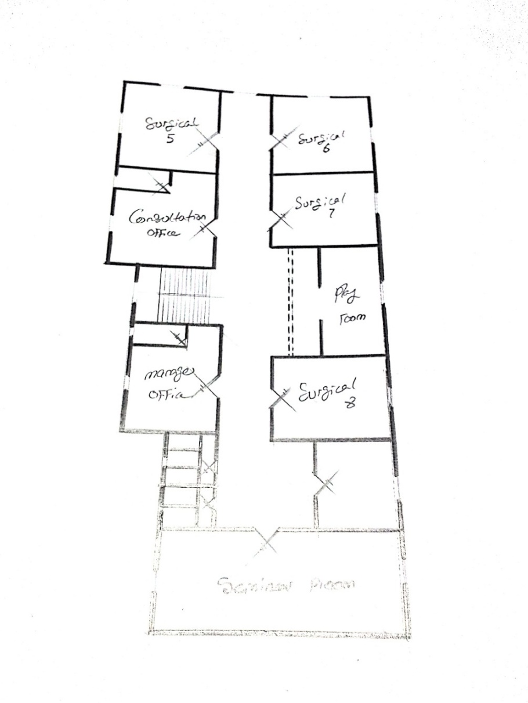
FIG 3.3: SHOWING UPPER FLOOR PLAN OF CASE STUDY ONE
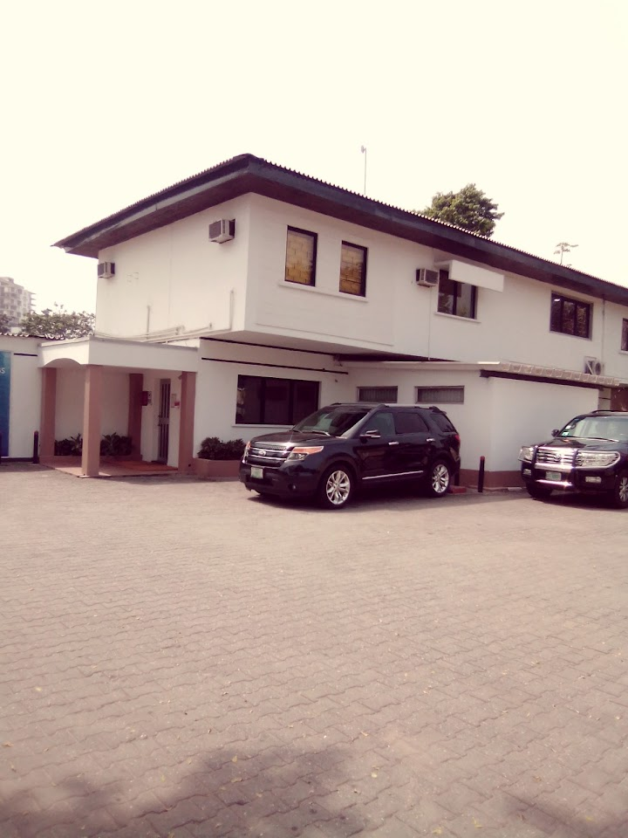
PLATE 3.1: SHOWING FRONT VIEW OF CASE STUDY ONE
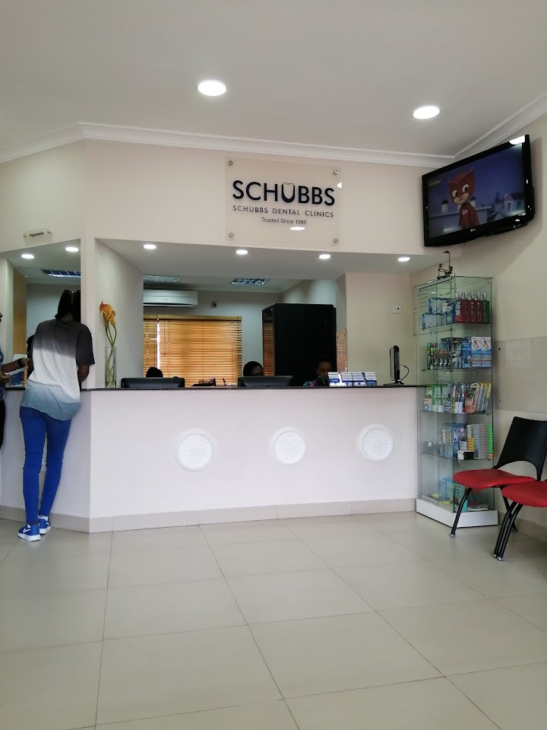
PLATE 3.2: SHOWING RECEPTION AREA OF CASE STUDY ONE
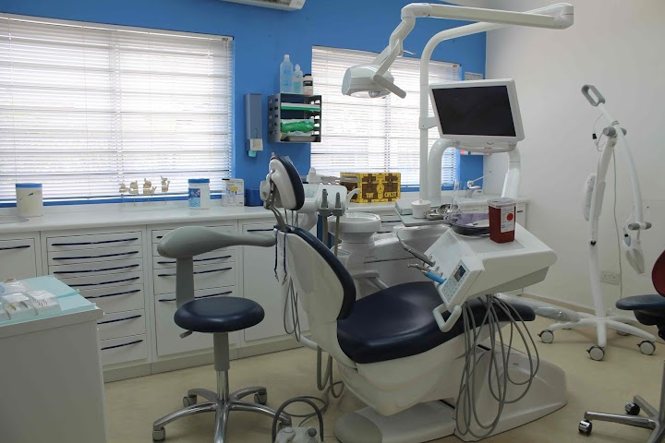
PLATE 3.3: SHOWING TREATMENT ROOM OF CASE STUDY ONE
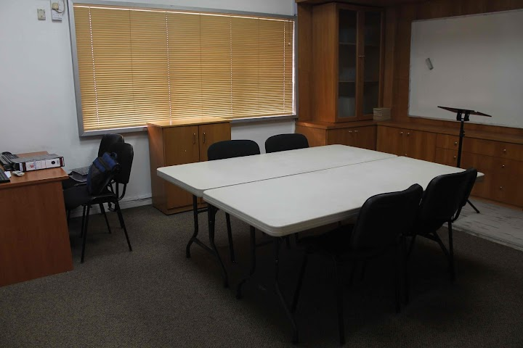
PLATE 3.4: SHOWING CONFERENCE ROOM OF CASE STUDY ONE
CASE STUDY TWO
Location: Choice Dental Clinic, Ikeja, Lagos State
Observations:
Merits:
i. Equipped with modern, high-tech dental equipment
ii. Offers a comprehensive variety of dental services
iii. Operates with an efficient and standardized system
iv. Provides sufficient parking facilities for patients and staff
Demerit:
i. The drainage infrastructure is insufficient and poorly managed
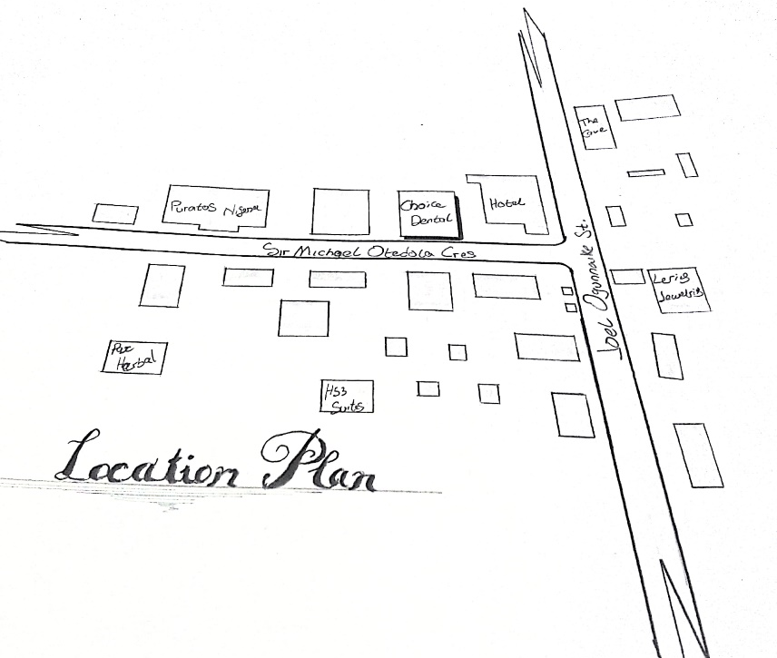
FIG 4; SHOWING LOCATION PLAN OF CASE STUDY TWO
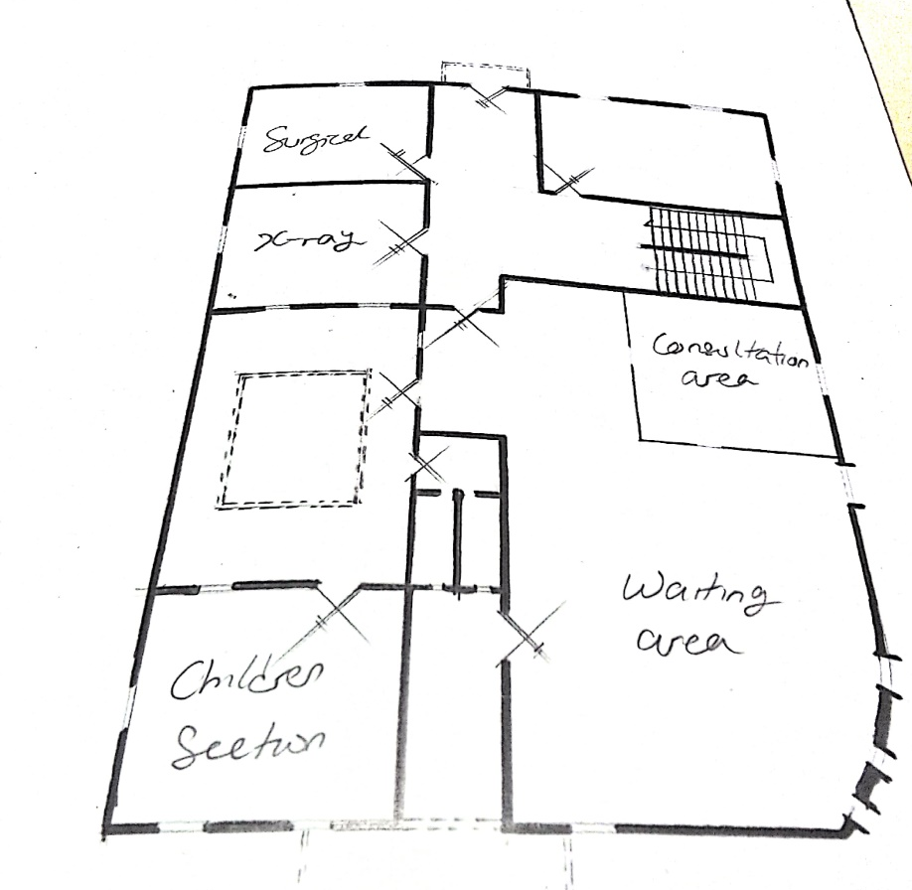
FIG 5; SHOWING GROUND FLOOR PLAN OF CASE STUDY TWO
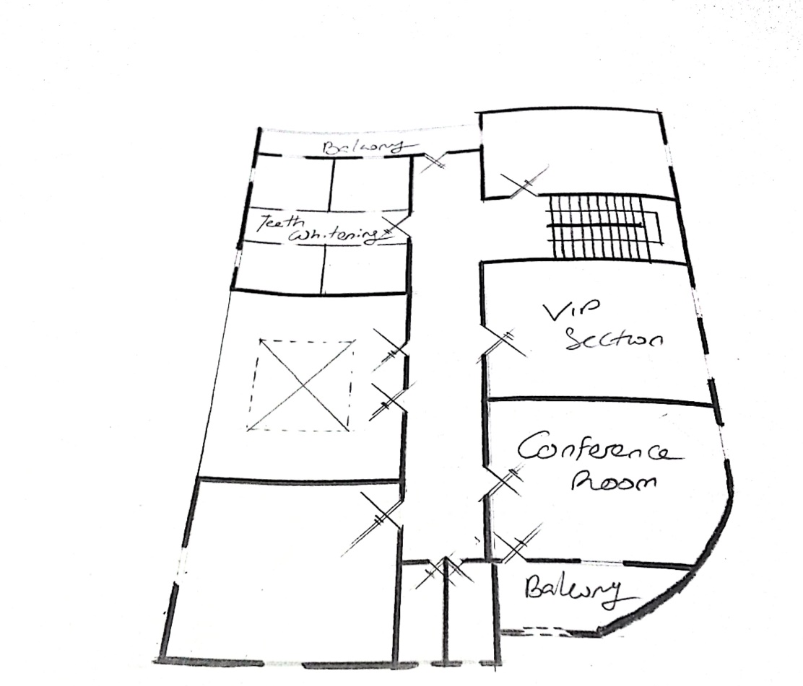
FIG 6; SHOWING UPPER FLOOR PLAN OF CASE STUDY TWO

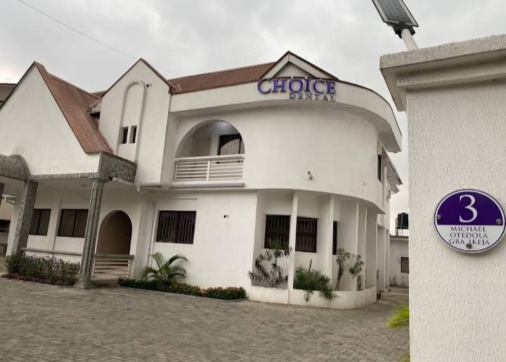
PLATE 5; SHOWING FRONT VIEW OF CASE STUDY TWO
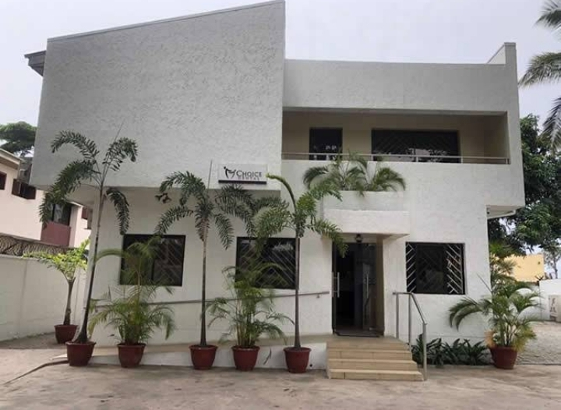
PLATE 6; SHOWING BACK VIEW OF CASE STUDY TWO

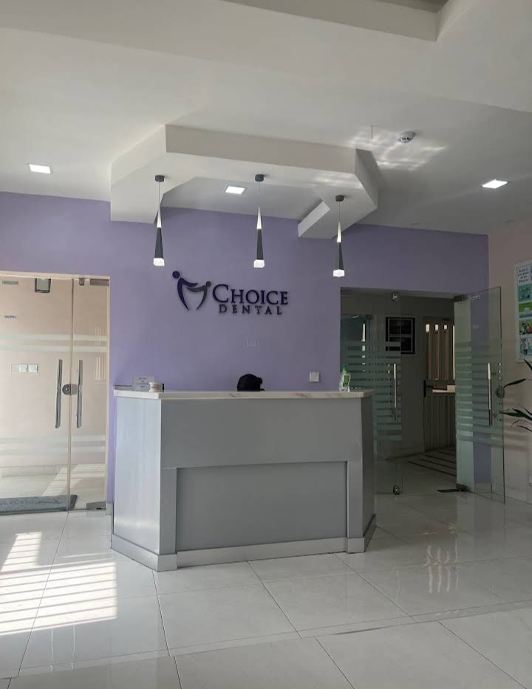
PLATE 7; SHOWING RECEPTION AREA OF CASE STUDY TWO
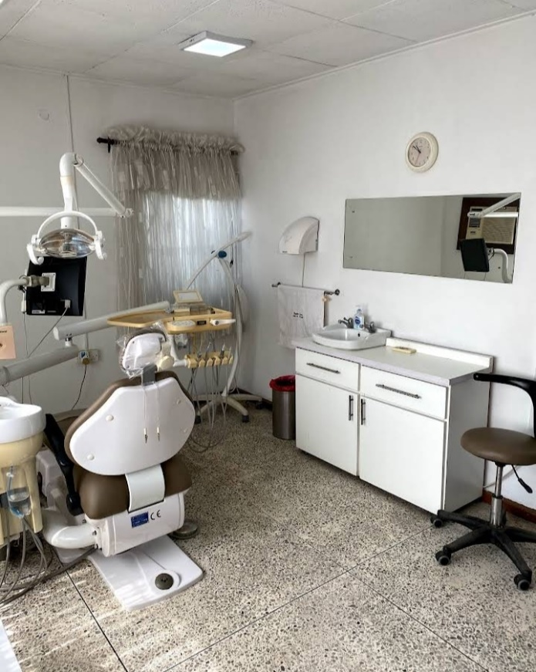
PLATE 8; SHOWING TREATMENT ROOM OF CASE STUDY TWO
3.1 CASE STUDY THREE
Location: Emirate Dental Clinic, Asa-Dam Road, Ilorin, Kwara State
Key Observations:
Merits:
i. Adequate parking space is provided
ii. Offers essential dental care services
Demerit:
i. Absence of proper sterilization facilities
ii. Poor maintenance of dental instruments
iii. Inadequate landscaping around the facility
iv. Located in an environment that is not conducive for healthcare delivery
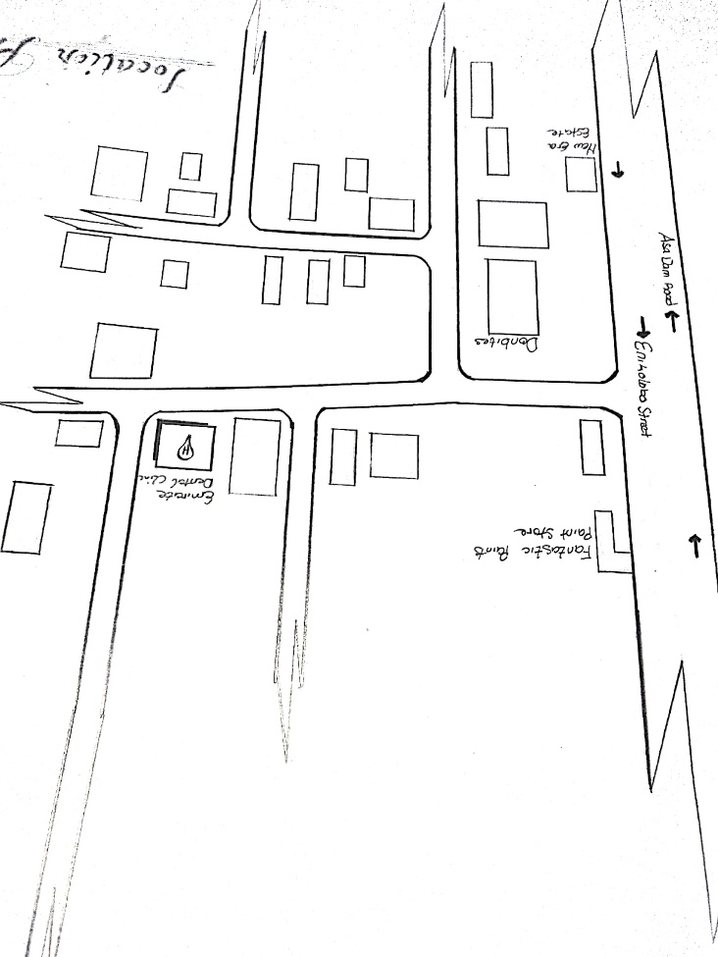
FIG 7; SHOWING LOCATION PLAN OF CASE STUDY THREE
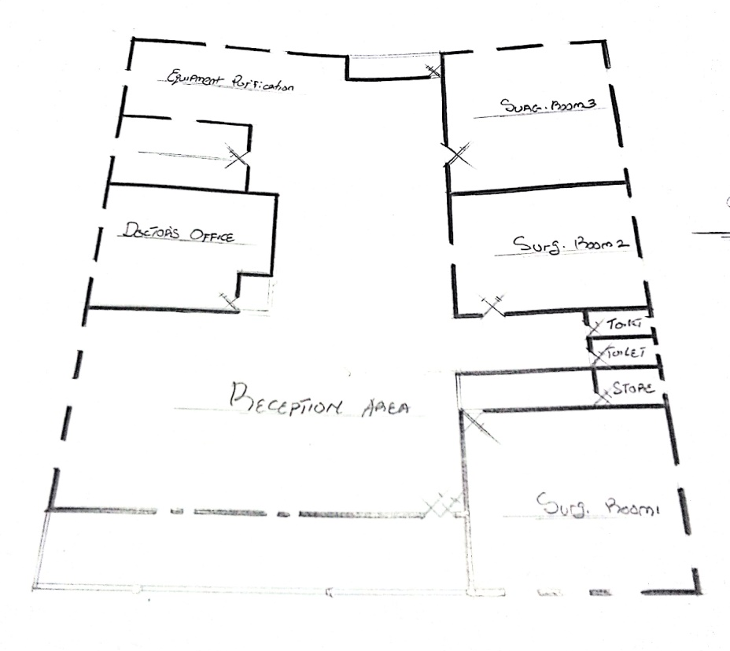
FIG 8; SHOWING FLOOR PLAN OF CASE STUDY THREE
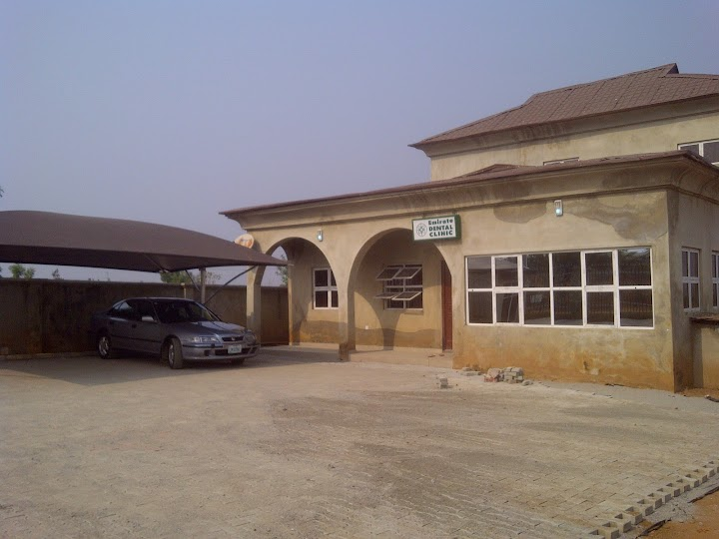
PLATE 9; SHOWING FRONT VIEW OF CASE STUDY THREE
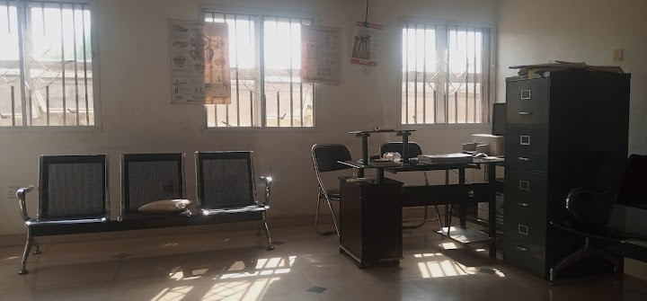
PLATE 10; SHOWING RECEPTION AREA OF CASE STUDY THREE
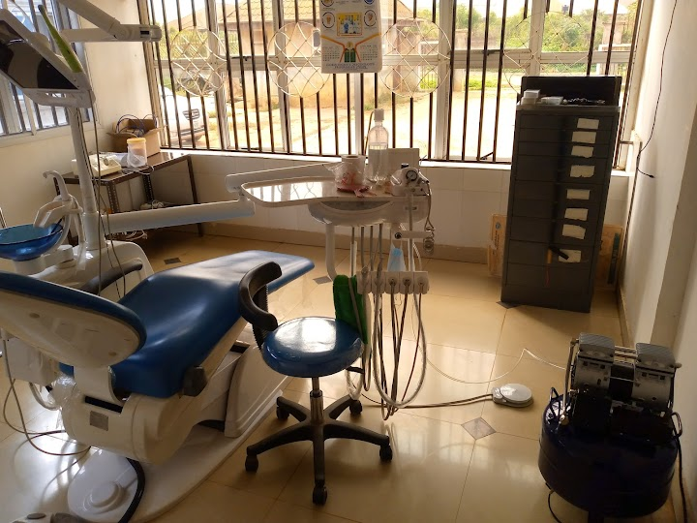
PLATE 11; SHOWING TREATMENT ROOM OF CASE STUDY THREE
3.1 CASE STUDY FOUR
Location: Bozid Dental Clinic, 52 Oyo Road, Ibadan, Oyo State
Observations:
Merits:
i. Patients receive quality and attentive care
ii. The facility is well equipped with modern dental tools
iii. Sufficient parking space is available
iv. The clinic is easily accessible from the main entrance
v. Security measures are effectively in place
Demerit:
i. There is no provision for future expansion
ii. The clinic lacks adequate storage facilities

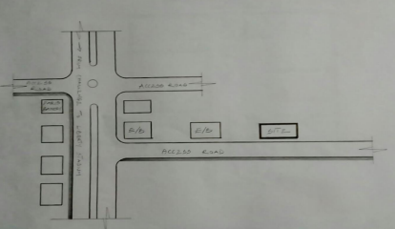
FIG 9; SHOWING LOCATION PLAN OF CASE STUDY FOUR

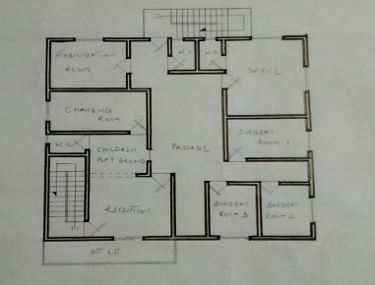
FIG 10; SHOWING FLOOR PLAN OF CASE STUDY FOUR
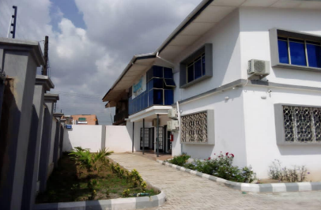
PLATE 12; SHOWING FRONT VIEW OF CASE STUDY FOUR

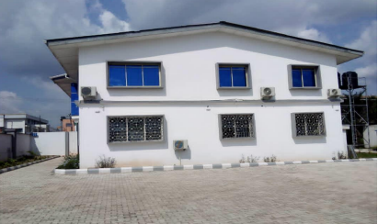
PLATE 13; SHOWING RIGHT VIEW OF CASDE STUDY FOUR
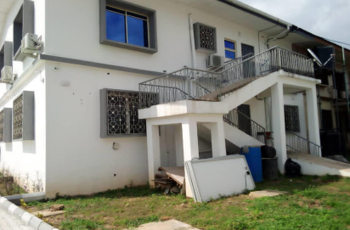
PLATE 14; SHOWING BACK VIEW OF CASE STUDY FOUR

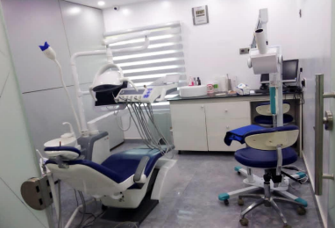
PLATE 15; SHOWING TREAMENT ROOM OF CASE STUDY FOUR

  - ONLINE CASE STUDY (1)
Location: UR Medicine Eastman Dental at Elmwood Ave, Rochester, New York.
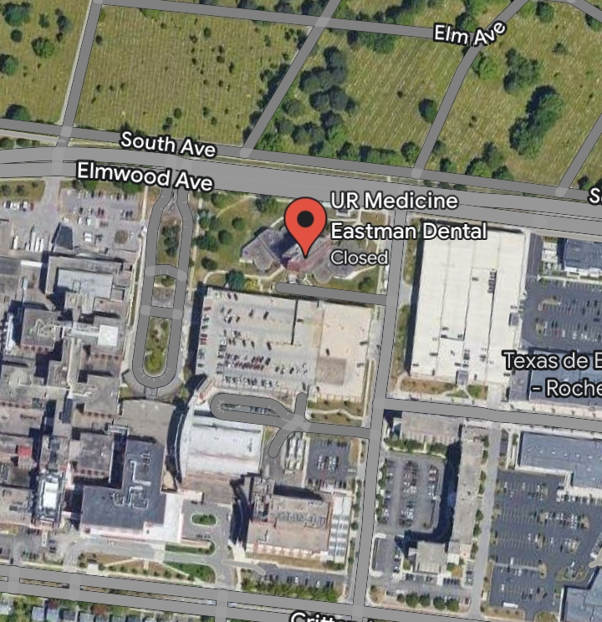
PLATE 16; SHOWING GOOGLE MAP OF ONLINE CASE STUDY ONE
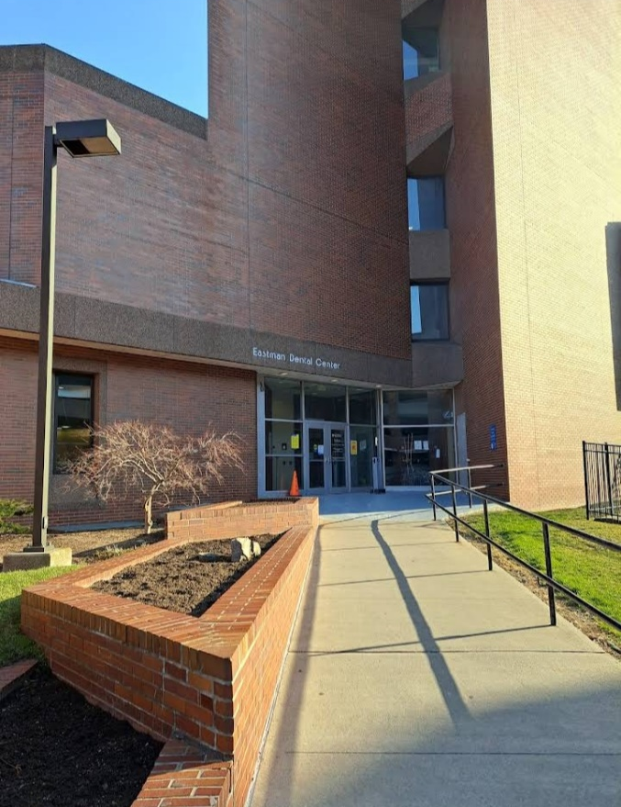
PLATE 17 SHOWING FRONT VIEW OF ONLINE CASE STUDY ONE
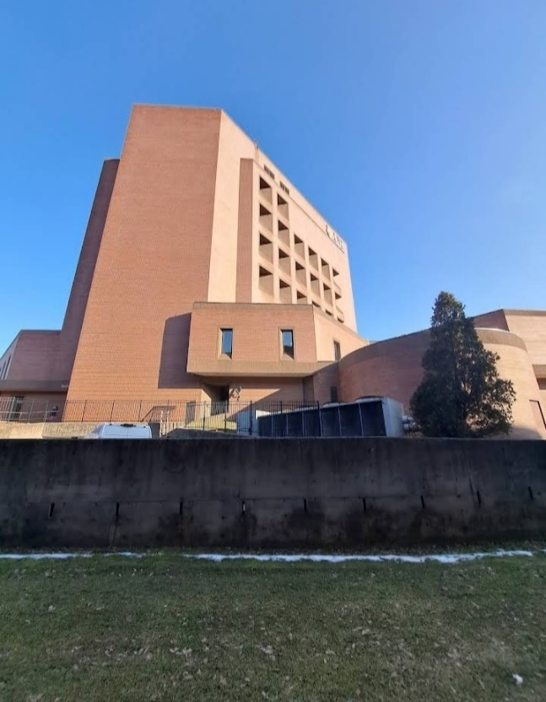
PLATE 18; SHOWING RIGHT VIEW OF ONLINE CASE STUDY ONE
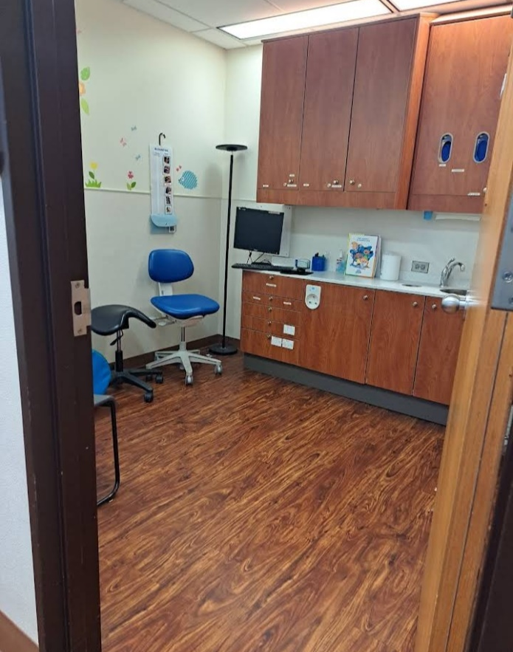
PLATE 19; SHOWING TREATMENT ROOM OF ONLINE CASE STUDY ONE
3.6.1 ONLINE CASE STUDY TWO (2)
Location: All Dent Dental Center Zahnzentrum at Zahnzentrum, Germany.
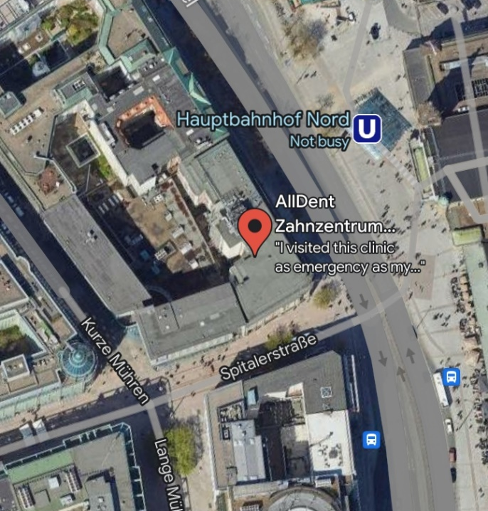
PLATE 20; SHOWING GOOGLE MAP OF ONLINE CASE STUDY TWO
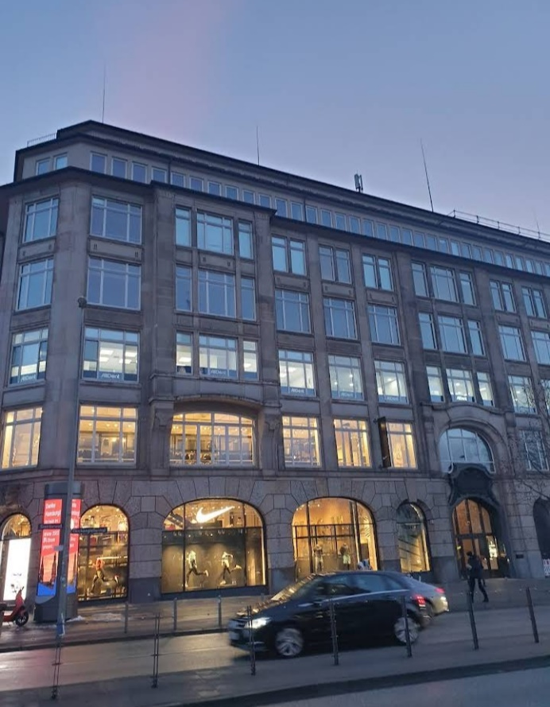
PLATE 21; SHOWING FRONT VIEW OF ONLINE CASE STUDY TWO
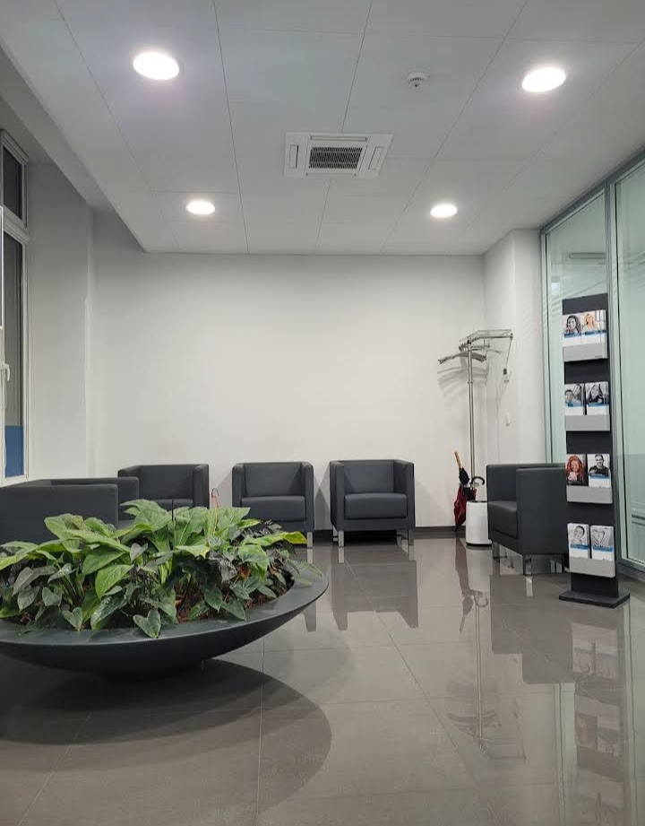
PLATE 22; SHOWING RECEPTION AREA OF ONLINE CASE STUDY TWO
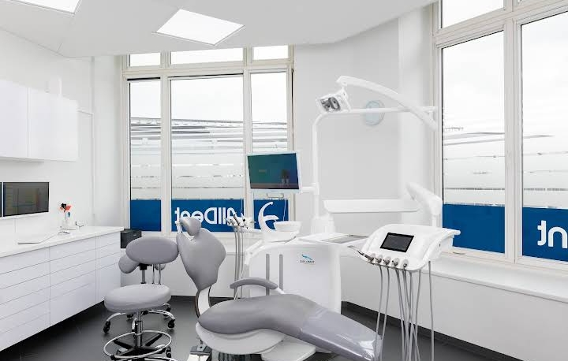
PLATE 23; SHOWING TREATMENT ROOM OF ONLINE CASE STDY TWO

  - DEDUCTIONS FROM CASE STUDIES
During my visits to the selected dental clinics, I had the opportunity to observe and analyze their operational structures and functional layouts. Detailed studies were conducted on their spatial organization and service delivery, with the goal of integrating their strengths into my proposed design.
From the case studies, the following key deductions were made:
Location and Accessibility: All the clinics are strategically situated in easily accessible locations, enhancing patient convenience.
Range of Services: Each facility provides a comprehensive variety of dental treatments and services.
Qualified Personnel: The clinics employ well-trained and experienced professionals to ensure high-quality patient care.
Functional Connectivity: Internal units and departments within the clinics are efficiently connected, ensuring smooth workflow.
Architectural Landscaping: The clinics exhibit commendable landscape design, which enhances aesthetics and provides a serene environment.

CHAPTER FOUR
4.0 STUDY AREA AND DESIGN CRITERIA
4.1 INTRODUCTION TO KWARA STATE
Kwara State is located in the North-Central region of Nigeria. It was created in 1967 and has its capital in Ilorin, which is both the largest city and a major administrative, cultural, and commercial center. Kwara shares borders with Niger, Kogi, Osun, Oyo, and Ekiti States, as well as an international boundary with the Republic of Benin to the west.
The state comprises sixteen Local Government Areas (LGAs) and is ethnically diverse, with Yoruba, Nupe, Baruba, and Fulani groups forming the major population clusters. Kwara is known for its stable climate, moderate population density, and developing urban infrastructure—making it suitable for healthcare infrastructure like dental clinics. The state government has placed increasing emphasis on healthcare delivery, particularly in semi-urban and peri-urban areas like Amoyo.
4.1.1 ABOUT AMOYO, ILORIN SOUTH LOCAL GOVERNMENT
Amoyo is a growing town located in Ilorin South LGA of Kwara State. It lies along the Ilorin Ajase-Ipo Road, providing strategic access to Ilorin metropolis and neighboring communities. The town has witnessed gradual urbanization, with rising demand for improved social amenities, including healthcare facilities.
Currently, access to specialized healthcare particularly dental care is limited, forcing many residents to travel into central Ilorin. The proposed dental clinic aims to bridge this healthcare gap by providing modern, accessible, and affordable dental services to residents of Amoyo and its environs.
4.2 SITE ANALYSIS
4.2.1 LOCATION AND ACCESSIBILITY
The proposed clinic site is situated within a residential commercial corridor, approximately 3 km from the Amoyo Central Bus Stop. It is directly accessible via a tarred road connected to the Ilorin–Ajase-Ipo highway, ensuring ease of access for patients and emergency vehicles. The site location also allows for adequate visibility and wayfinding for first-time visitors.
4.2.2 EXISTING SERVICES
The proposed location benefits from access to essential utilities:
- Electricity: Power supply is available from the Ibadan Electricity Distribution Company (IBEDC), with provisions for inverter and generator backup.
- Water Supply: The area supports both borehole and municipal water supply systems.
- Telecommunications: Strong mobile network coverage allows for internet-enabled services like e-records, tele-dentistry, and security monitoring.
4.3 CLIMATIC CONDITIONS OF THE SITE
RAINFALL
Amoyo experiences a tropical climate with an annual rainfall range of approximately 1,200–1,400 mm, concentrated between April and October. Proper drainage design is necessary to avoid flooding and moisture-related deterioration of materials.
TEMPERATURE
Average daily temperatures range from 23°C to 34°C. Natural ventilation and solar-shading techniques will be integrated into the building design to enhance comfort for both patients and staff.
WIND DIRECTION
The prevailing winds in the region come from the southwest during the rainy season and the northeast (harmattan) during the dry season. The building orientation will leverage prevailing winds for passive cooling and ventilation.
4.4 SITE SELECTION CRITERIA
The following factors informed the choice of site:
- Proximity to residential neighborhoods and schools.
- Easy accessibility via public and private transportation.
- Availability of space for parking and future expansion.
- Stable soil condition and moderate topography.
- Compliance with zoning and public health regulations.
4.5 DESIGN CRITERIA
4.5.1 FUNCTIONALITY OF THE SITE
The proposed dental clinic is planned to ensure a seamless experience for patients, staff, and visitors. The layout encourages functional zoning with distinct areas for:
- Public access and reception
- Clinical treatment and procedure rooms
- Staff and administrative operations
- Utility and service areas
- Parking and circulation zones
Barrier-free access, natural daylighting, and controlled ventilation will enhance patient comfort and operational efficiency.
4.6 DESIGN BRIEF
The proposed dental clinic is a medium-capacity healthcare facility with general and specialized dental units. It will include consultation rooms, procedure areas, sterilization zones, a pharmacy, and support spaces.
Primary objectives include:
- Providing comprehensive dental care services in a hygienic and professional environment.
- Integrating passive environmental control systems to minimize energy costs.
- Ensuring accessibility for physically challenged individuals.
- Allowing for phased future expansion.
4.7 ANALYSIS OF THE BRIEF
4.7.1 CLINICAL UNITS
- Reception and Waiting Area: With comfortable seating, natural ventilation, and visual access to the front desk.
- Consultation Rooms (2 Nos.): For diagnosis, patient interviews, and treatment planning.
- Dental Surgery Rooms (3 Nos.): Fully equipped with dental chairs, lighting, and sterilization trolleys.
- Sterilization Room: Located between surgery rooms for quick access to autoclaves and disinfection tools.
- X-ray Room: Shielded and compliant with radiation safety guidelines.
- Pharmacy and Dispensing Unit
4.7.2 SUPPORT FACILITIES
- Administrative Office: Includes the clinic manager’s office, records room, and meeting area.
- Staff Room: With changing area, lockers, and kitchenette.
- Toilets: Separate for patients and staff; wheelchair-accessible.
- Water Storage and Generator House
- Security Post and Perimeter Fencing
4.7.3 EXTERNAL AREAS
- Parking Area: Marked spaces for staff, patients, and emergency vehicles.
- Landscaping: Green buffers for aesthetics and environmental comfort.
- Access Driveway and Walkways: For pedestrian and vehicular circulation.
4.8 SPACE ALLOCATION / SCHEDULE OF ACCOMMODATION
Space/Facility | Percentage of Site
Clinical Areas | 35%
Support Facilities | 25%
Parking and Circulation | 20%
Landscaping and Green Zone | 15%
Utility Spaces | 5%

4.9 FUNCTIONAL RELATIONSHIP
A bubble diagram illustrates the interrelation between key areas:
- Reception is centrally located, connecting to all treatment zones.
- Sterilization and X-ray rooms are adjacent to treatment areas for operational efficiency.
- Administrative unit is positioned for privacy but with access to public zones.
- Waste disposal and generator units are located away from the main building.
4.10 CONCEPTUAL DEVELOPMENT
The design concept embraces:
- Zoning: Clear segregation of public, semi-private, and private zones.
- Orientation: East–West building orientation for passive solar control.
- Ventilation: Operable windows, ceiling heights, and cross-ventilation to manage indoor air quality.
- Modular Layout: Allows for future expansion or functional adjustments.
4.11 DESIGN ANALYSIS
4.11.1 GENERAL SERVICES
- Water Supply: Borehole with overhead storage tank.
- Electricity: Connected to national grid with solar and generator backup.
- Drainage: Surface drains and soakaways to prevent flooding.
- Waste Disposal: Medical and general waste separated; sharps and biological waste incinerated.
4.11.2 BUILDING SERVICES
- Lighting: Combination of natural daylighting and energy-efficient LED fittings.
- Ventilation: Natural and mechanical systems for cooling and air filtration.
- ICT Infrastructure: LAN and internet setup for digital record-keeping and appointments.
- Security: CCTV surveillance, fencing, and controlled entry.
This design proposal for a dental clinic in Amoyo, Ilorin South LGA, Kwara State, provides a sustainable, patient-friendly, and professionally efficient healthcare environment, tailored to the specific needs of the community and in alignment with modern healthcare architecture standards.

CHAPTER FIVE
PROJECT APPRAISAL
5.0 INTRODUCTION
This chapter presents a comprehensive appraisal of the proposed dental clinic development in Amoyo, Ilorin South Local Government Area, Kwara State. It highlights the selected construction techniques, building materials, service systems, fire safety strategies, and landscape integration. The project is envisioned to support high-quality dental care delivery with emphasis on functionality, patient comfort, infection control, sustainability, and ease of maintenance.
5.1 CONSTRUCTION METHODS AND MATERIALS
The construction of a dental clinic requires precision and adherence to health and safety regulations. Emphasis is placed on durability, hygiene, accessibility, and flexibility for future upgrades. The involvement of architects, structural engineers, mechanical and electrical consultants is crucial to achieving clinical efficiency and compliance with medical facility standards.
5.1.1 Substructure
The foundation system will be designed based on the site's geotechnical conditions. For the clay-loamy soils typical of Amoyo, a reinforced strip foundation is recommended to support load-bearing walls and columns.
- Concrete mix ratio: 1:2:4 (cement:sand:gravel), with waterproofing membranes beneath the slab to prevent rising damp.
- Anti-termite treatment and blinding layer will be applied for durability.
5.1.2 Superstructure
The superstructure will be composed of reinforced concrete frames infilled with sandcrete blocks (225mm). The framing ensures flexibility in internal partitions and accommodates utilities such as plumbing and electrical systems.
5.1.3 Floors
- Clinical zones (e.g., treatment rooms, sterilization areas): Epoxy-coated concrete or non-slip vinyl flooring for infection control.
- Reception and admin: Terrazzo or polished tiles for aesthetics and easy cleaning.
- Restrooms and wet areas: Ceramic tiles with coved skirting.
5.1.4 Walls
- Internal partitions: Hollow sandcrete blocks, plastered and finished with anti-bacterial washable paints.
- Wet areas: Full-height ceramic tiles to ensure hygiene.
- External walls: Painted with weatherproof emulsion paint for durability.
5.1.5 Roof
- Roof structure: Timber or mild steel trusses with aluminum long-span roofing sheets.
- Ceiling: Suspended acoustic ceilings (POP or gypsum board) in clinical and reception areas to enhance aesthetics and noise control.
- Insulation: Thermal insulation installed beneath the roof to regulate indoor temperature.
5.1.6 Doors and Windows
- Doors: Steel security doors at entrances; flush panel wooden doors for internal spaces; lead-lined doors for X-ray rooms (if applicable).
- Windows: Aluminum sliding windows with frosted or tinted glass for privacy and daylighting.
5.1.7 Finishes
- Internal walls: Anti-microbial emulsion paint in clinical areas.
- Floors: Non-slip, easy-to-clean materials across all zones.
- External finishes: Textured weatherproof paints.
5.2 BUILDING SERVICES
5.2.1 Acoustic and Lighting Design
Dental clinics require a calm atmosphere with appropriate acoustic control and lighting.
- Noise reduction: Acoustic ceiling tiles and wall insulation to dampen sound.
- Natural lighting: Maximized through large glazed openings.
- Artificial lighting: Recessed LED panels and task lighting for examination and surgical precision.
5.3 MECHANICAL SERVICES
- Air-conditioning (HVAC): Split-unit ACs for thermal comfort in each consulting and waiting room.
- Ventilation: Mechanical extractors in toilets and sterilization zones.
- Dental equipment: Suction units, air compressors, and dental chairs will be integrated with corresponding mechanical fixtures.
5.4 ELECTRICAL SERVICES
- Main power: Connection to the public electricity grid (IBEDC).
- Backup system: 20–30KVA standby generator and inverter system with solar panels for uninterrupted power.
- Electrical wiring: Concealed PVC conduit system with properly labeled distribution boards.
- Outlets: Sufficient electrical and data points in treatment areas, reception, and admin zones.
5.5 PLUMBING SERVICES
- Water supply: Borehole with elevated tank and distribution piping.
- Sanitary fittings: Modern fixtures with hands-free taps in clinical areas.
- Waste disposal: Dedicated PVC drainage systems and bio-waste channels leading to septic and soak-away systems.
- Medical waste: Segregated collection points for sharps and biohazards.
5.6 FIRE SAFETY SYSTEMS
- Fire extinguishers: Dry chemical types in corridors, treatment rooms, and electrical rooms.
- Smoke detectors and alarms: Installed in key areas for early warning.
- Emergency exits: Clearly marked and fitted with panic bars.
- Fire drills: Regular training for clinic staff on fire safety protocols.
5.7 LANDSCAPING AND EXTERNAL WORKS
5.7.1 Soft Landscaping
- Ornamental trees and shrubs to provide shade and enhance aesthetics.
- Green buffer zones to create a serene healing environment.
5.7.2 Hard Landscaping
- Driveways and walkways: Interlocking paving blocks for ease of movement and durability.
- Parking lot: Marked spaces for staff, patients, and emergency vehicles.
- Drainage: Open concrete drains to manage surface runoff.
- Perimeter fencing: Block wall with security gates and CCTV.
5.8 BUILDING STANDARDS AND REGULATIONS
The clinic design complies with:
- Nigerian Building Code (NBC)
- World Health Organization (WHO) guidelines on healthcare infrastructure
- Medical and Dental Council of Nigeria (MDCN) facility regulations
- Fire Service Regulations and Public Health Codes
5.9 STRUCTURAL STABILITY
- Structural grid system used to evenly distribute loads.
- Reinforced concrete beams and columns for strength and resistance to seismic or wind stresses.
- Tie beams and lintels to enhance wall integrity.
- Roof bracing to minimize wind uplift.
5.10 MAINTENANCE CONSIDERATIONS
To ensure long-term functionality and reduce operational downtime:
- Use of durable, easy-to-clean materials in all zones.
- Accessible service ducts for electrical and plumbing maintenance.
- Standardized fittings for easier replacements.
- Training of staff on basic upkeep and sterilization routines.
Conclusion
The proposed dental clinic in Amoyo, Ilorin South LGA, is designed to meet modern healthcare standards while remaining contextually appropriate for the community. It emphasizes infection control, user comfort, sustainability, and adaptability. Through carefully selected construction methods, high-quality materials, and appropriate building services, the facility aims to serve as a reliable and welcoming center for oral health care in the region.

References
Alibhai, A. (2001). Designing dental clinics: The art of balancing efficiency and aesthetics. Dental
Economics.
Becker, F., & Parsons, K. (2007). Hospital facilities and the role of evidence-based design. Journal
of Facilities Management, 5(4), 263–274.
Centers for Disease Control and Prevention (CDC). (2003). Guidelines for Infection Control in
Dental Health-Care Settings. MMWR.
Evans, G. W. (2003). The built environment and mental health. Journal of Urban Health, 80(4),
536–555.
Finsen, L., Christensen, H., & Bakke, M. (1998). Musculoskeletal disorders among dentists: A
review. Journal of Occupational Medicine.
Heerwagen, J. H. (2000). Green buildings, organizational success, and occupant productivity.
Building Research & Information, 28(5/6), 353–367.
Horská, E., et al. (2020). The ergonomics of dental practice: Evaluation and recommendations.
Journal of Dental Research and Review, 7(2), 95–101.
Jung, J. H., et al. (2016). Healthcare facility planning: Efficient zoning and infection control.
Healthcare Design Magazine.
Kats, G. (2010). Greening our built world: Costs, benefits, and strategies. Island Press.
Mujumdar, P., et al. (2021). Post-COVID dental clinic design: Towards safer practice
environments. International Journal of Dental Hygiene.
Neufert, E. (2012). Architects' Data (4th ed.). Wiley-Blackwell.
Olotuah, A. O. (2006). Housing design for effective climate control in Nigeria. Journal of
Environmental Design and Management, 2(1), 67–76.
Ulrich, R. S., Zimring, C., Zhu, X., et al. (2008). A review of the literature on evidence-based
healthcare design. HERD: Health Environments Research & Design Journal, 1(3), 61–125.
World Health Organization (WHO). (2009). Infection prevention and control in health care: WHO
guidelines.

