A PROJECT REPORT ON PROPOSED RESTAURANT FOR MAMA SAHEED RESTAURANT AT OGBOMOSHO, OYO STATE
BY
ALIMI SAHEED OLAYEMI
ND/23/ARC/PT/021

SUBMITTED TO THE DEPARTMENT OF ARCHITECTURAL TECHNOLOGY, INSTITUTE OF ENVIRONMENTAL STUDIES KWARA STATE POLYTECHNIC, ILORIN

IN PARTIAL FULFILMENT OF THE REQUIREMENTS FOR THE AWARD OF NATIONAL DIPLOMA IN ARCHITECTURAL TECHNOLOGY
JULY 2025

DECLARATION
I, Alimi Saheed Olayemi, hereby declare that this project/dissertation is the result of my independent research work. It has not been previously submitted for the award of any diploma or degree in any polytechnic or institution of higher learning. All ideas, observations, comments, and suggestions expressed herein are my own, except where due acknowledgment has been given in line with standard academic conventions.
ALIMI SAHEED OLAYEMI
ND/23/ARC/PT/021
Student Name Matric Number
……………………………………….
Signature & Date

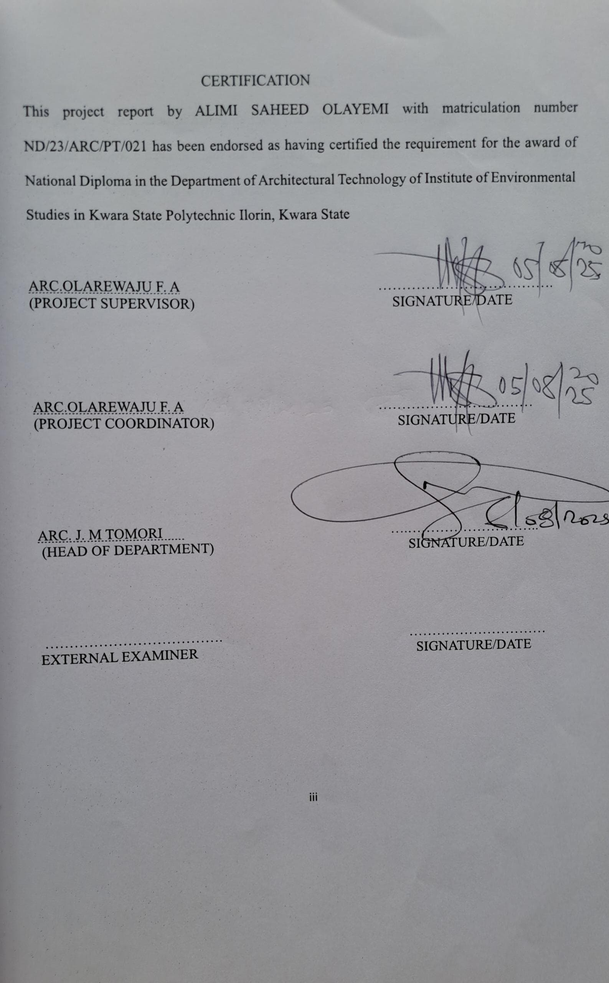

DEDICATION
This project is dedicated to Almighty God, the author and finisher of my faith, whose divine guidance and grace have brought me to the successful completion of this programme. I also dedicate this work to my loving parents for their unwavering moral and financial support throughout this academic journey.

ACKNOWLEDGEMENT
Every journey has a beginning and an end, and this project marks the closing of a meaningful chapter one shaped by grace, determination, and continuous learning.
First and foremost, my deepest gratitude goes to the Almighty God, the Master Architect of all creation, for granting me strength, insight, and endurance throughout this academic pursuit.
To my supervisor, Arc. Olarewaju F. A., I sincerely thank you for your invaluable guidance, encouragement, and constructive criticisms. Despite your tight schedule, you always found time to direct and support me I remain truly grateful.
My heartfelt appreciation goes to my parents, Mr. and Mrs. Alimi, for being the strong foundation of my success. Your love, prayers, and sacrifices have been my constant source of strength and motivation.
To the departmental part time coordinator Arc Familua O. S., the management, lecturers, and non-teaching staff of the Department of Architectural Technology, thank you for shaping my professional knowledge and character. Your dedication to excellence has left an indelible mark on my academic growth.
Special thanks to my siblings, my dear brother and sister, and to my classmates and friends, who made this journey lively, collaborative, and enriching. Your support and companionship added colour to every step I took.
To everyone who contributed, directly or indirectly, to the success of this project your impact is truly appreciated and forever cherished.
With profound gratitude,
Thank you all.
ABSTRACT
This restaurant aims to provide a unique dining experience that blends high quality culinary techniques with a warm, inviting atmosphere. The menu features a diverse selection of locally sourced ingredients, offering a fusion of traditional flavours and modern innovations. With a focus on sustainability, the restaurant strives to minimize its environmental impact by utilizing eco-friendly practices, such as waste reduction, energy efficiency, and supporting local farmers and suppliers. The design of the space is contemporary yet comfortable, offering both intimate dining experiences and spaces for larger gatherings. Whether for casual meals, special occasions, or corporate events, this restaurant caters to a variety of tastes and preferences while delivering exceptional service and an unforgettable dining experience.

TABLE OF CONTENTS
TITLE PAGE i
DECLARATION ii
CERTIFICATION iii
DEDICATION iv
ACKNOWLEDGEMENTS v
TABLE OF CONTENTS vi
LIST OF TABLES vii
LIST OF FIGURES viii
LIST OF PLATES ix
LIST OF APPENDICES x
ABSTRACT xi
CHAPTER ONE
- INTRODUCTION 2
1.1 BACKGROUND INFORMATION 2
1.2 PROJECT DEFINITION 2
1.3 AIM AND OBJECTIVES 21.3.1 AIM 2
1.3.2 OBJECTIVES 2
1.4 STATEMENT OF PROBLEM 2

1.6 RESEARCH METHODOLOGY 3
1.7 LIMITATION AND CONSTRAINT 3
CHAPTER TWO
2.0 LITERATURE REVIEW 4
2.1 INTRODUCTION 4
2.2 FUNCTIONAL DESIGN 4
2.3 INCLUSIVITY AND ACCESSIBILITY 5
2.4 FLEXIBILITY AND ADAPTABILITY 5
2.5 COMMUNITY BUILDING 6
2.6 MODERN AMENITIES AND TECHNOLOGY 6
2.7 CONCLUSION 7
CHAPTER THREE
3.0 CASE STUDIES 8
3.1 INTRODUCTION 8
3.1.1 RELEVANCE OF CASE STUDIES TO ARCHITECTURAL DESIGN 8
3.2 CASE STUDY ONE 9
3.3 CASE STUDY TWO 14
3.4 CASE STUDY THREE 16
CHAPTER FOUR
4.0 STUDY AREA/PROJECT SITE AND PROPOSED PROJECT 18
4.1 INTRODUCTION 18
4.2 SITE LOCATION 18
4.2.2 SITE SELECTION CRITERIA 20
4.3.2 VEGETATION 20
4.3.3 TOPOGRAPHY 21
4.3.4 DRAINAGE 22
4.3.5 ACCESSIBILITY 22
4.3.6 CLIMATE
4.3.7 SITE FEATURES AND INFRASTRUCTURE 24
4.3.8 NOISE SOURCES 24
4.4 SITE ANALYSIS. 24
  - PROPOSED DESIGN 26
4.5.1 DESIGN CONSIDERATIONS: 26
4.5.2 DESIGN CONCEPT 27
4.5.3 BRIEF ANALYSIS 27
4.6 FUNCTIONAL RELATIONSHIP 28
4.7 CONCEPTUAL DEVELOPMENT 28
4.8 BUBBLE DIAGRAM 28
CHAPTER FIVE
APPROACH TO THE DESIGN/DESIGN REALIZATION 29
5.0 SPECIFICATIONS AND CONSTRUCTION 29
5.1 MATERIAL AND FINISHES 29
5.1.1 WALLS 29
5.1.2 FLOORS 29
5.1.3 CEILING 29
    - ROOF 30
    - WINDOWS AND DOORS 30
5.2 STRUCTURAL SYSTEM 30
  - BUILDING SERVICE 32
5.4 LANDSCAPING AND EXTERNAL WORKS 34
REFERENCES 35

LIST OF PLATES
PLATE 3.1: Picture the back view of case study 1………………………………………......14
PLATE 3.2: Picture showing the front view of case study 1 ………………………………...14
PLATE 3.3: Picture showing the rear view of case study 2………… …………………..…..18
PLATE 3.4: Picture showing the left view of case study 2 ………………………………….18
PLATE 3.5: Picture showing the rear view of case study 3………… …………………..…..22
PLATE 3.6: Picture showing the left view of case study 3 ………………………………….22

LIST OF FIGURES
FIGURE 2.1: Location Plan for case study one 10
FIGURE 2.2: Floor Plan for case study one 11

CHAPTER ONE
1.0 INTRODUCTION
1.1 Background Information
The concept of the restaurant has evolved significantly over time from basic venues offering food and drink to complex architectural spaces that influence cultural identity, foster social interaction, and drive economic activity in urban settings. Modern restaurants serve as more than dining establishments; they function as experiential environments where atmosphere, branding, and operational fluidity intersect to influence customer perception and satisfaction (Bitner, 1992; Waxman, 2006).
In the contemporary hospitality industry, architectural design has taken on a strategic role. Increasingly, the focus has shifted from purely functional arrangements to spaces that prioritize aesthetics, user comfort, and sustainability (Jones & Lockwood, 2004). Restaurants now cater to a wide variety of dining preferences from casual take-out to fine dining and alfresco experiences—necessitating adaptable layouts, efficient circulation, and advanced technological integration to ensure competitiveness and customer retention.
Studies have shown that the physical environment significantly influences customer behaviour and perceived quality of food. For instance, Edwards and Gustafsson (2008) assert that ambience, layout, and spatial comfort directly affect customer satisfaction and the likelihood of repeat visits. As a result, designers are tasked with addressing a broad range of sensory and functional concerns, such as lighting quality, acoustic control, material selection, furniture configuration, ventilation, and the spatial zoning of public and private areas (Kimes & Robson, 2004).
Moreover, as consumer expectations evolve, there is an increased demand for restaurants that merge operational efficiency with visual and experiential appeal. One example is the open-kitchen concept, which enhances transparency and guest engagement but also requires precise architectural planning to ensure hygiene, safety, and spatial harmony (Horng, Chou, & Liu, 2013).
Restaurants also play a pivotal role as informal community centers and cultural symbols, particularly in urban contexts. They often serve as gathering spaces for social and business engagements, thereby necessitating architectural responses that reflect local identity and sociocultural values (Davis, 2010). In this context, effective design extends beyond function to include emotional and psychological dimensions that shape user experience and promote behavioural satisfaction.
Inclusivity and accessibility have become essential design considerations in modern restaurant architecture. Adherence to universal design principles such as the incorporation of ramps, tactile flooring, accessible restrooms, and wide aisles ensures that the built environment accommodates individuals with diverse physical abilities, in line with best practices in inclusive architecture (Preiser & Ostroff, 2001).
Ultimately, restaurant architecture is an interdisciplinary endeavour. It integrates spatial design, environmental psychology, branding, sustainability, and service logistics into a cohesive and responsive framework. A well-designed restaurant not only enhances operational performance but also creates an engaging and memorable dining experience for its patrons.

1.2 Project Definition
This project focuses on the architectural design of a modern restaurant that seamlessly blends comfort, functionality, aesthetic appeal, and environmental sustainability. The proposed design will accommodate diverse user needs including individual diners, families, groups, and persons with disabilities through flexible and inclusive spatial arrangements. The facility will integrate back-end operations with customer-facing areas to enhance service flow, embody current design trends, and serve as a social and commercial landmark in its locale.
1.3 Aim and Objectives
1.3.1 Aim
The aim of this project is to design a restaurant that harmonizes operational efficiency with customer-centered aesthetics, while promoting inclusivity and environmental sustainability.
1.3.2 Objectives
- To create a spatial layout that ensures smooth interaction between service areas (kitchen, storage, staff circulation) and customer zones (entrance, dining, restrooms).
- To promote inclusivity by implementing universal design features such as ramps, elevators, accessible restrooms, and flexible seating.
- To enhance the dining atmosphere through innovative lighting, acoustic treatments, and furniture design that align with the restaurant’s branding.
- To incorporate sustainable building materials and systems, including natural ventilation, energy-efficient lighting, and water-saving fixtures.
- To design adaptable dining spaces suitable for various arrangements such as private booths, family tables, open seating, and outdoor patios.
- To integrate modern technologies, including digital menus, automated ordering systems, and smart environmental controls.
1.4 Statement of Problem
Despite the growth of the hospitality industry, many restaurants suffer from poorly conceived architectural designs that negatively affect customer satisfaction and operational efficiency. Common challenges include inefficient kitchen layouts, restricted circulation, poor acoustics, inadequate lighting and ventilation, and lack of accessible features for individuals with disabilities (Lockwood & Medlik, 2001). These issues not only hinder staff performance but also degrade the customer experience, leading to reduced patronage and economic losses.
Additionally, many restaurant projects overlook the importance of sustainability, failing to incorporate eco-friendly systems and materials. This oversight increases operational costs and environmental impact. There is also a notable gap in inclusive design practices, which alienates potential customers with special mobility needs and limits the restaurant’s reach.
This project aims to address these deficiencies by proposing a restaurant design that integrates aesthetics, functionality, sustainability, and inclusivity ultimately fostering a new generation of customer-centric and socially responsible dining environments.
1.5 Client Background
The client, popularly known as Mama Saheed, is a seasoned culinary entrepreneur based in Ogbomoso, Oyo State, with over two decades of practical experience in the food and hospitality industry. Her journey into professional cooking began with a deep-rooted passion for preparing traditional meals, which she gradually transformed into a successful food business widely recognized across the region.
Mama Saheed is well known for her expertise in preparing authentic Nigerian dishes particularly Yoruba cuisine served with exceptional taste, hygiene, and consistency. Her restaurant, Mama Saheed Restaurant, has grown into a trusted name in Ogbomoso, attracting a loyal customer base that includes students, families, workers, and travelers alike.
Driven by a commitment to excellence and community service, she now aims to expand her operations by establishing a modern, purpose-built restaurant facility that reflects her values of hospitality, cleanliness, and cultural authenticity. This new restaurant will offer a more comfortable and aesthetically pleasing environment, with improved service delivery and a broader menu to meet the evolving needs of her growing clientele.
For Mama Saheed, this project goes beyond profit it is a legacy initiative that seeks to elevate the local dining culture, create employment opportunities, and serve as a landmark where tradition meets modernity. The proposed restaurant is envisioned as a space where customers can enjoy freshly prepared meals in a warm, inviting atmosphere that celebrates both culinary heritage and contemporary hospitality standards.
1.6 Research Methodology
To develop an informed and context-sensitive architectural design, the following research methods were employed:
- Case Studies: Analysis of successful restaurant designs, both locally and internationally, to identify best practices and functional innovations.
- Photography: Visual documentation of existing restaurant settings and site conditions to inform layout and material choices.
- Internet Review: Exploration of global trends in restaurant architecture, sustainability, and customer experience through digital research.
- Oral Interviews: Direct engagement with restaurant owners, chefs, architects, and patrons to gain practical insights and understand user expectations.
- Literature Review: Review of academic articles, professional journals, and industry reports to establish a solid theoretical foundation for the design.
1.7 Limitations and Constraints
- Access Restrictions: Some restaurants were not accessible for case study analysis due to operational confidentiality or security protocols.
- Limited Literature: There is a scarcity of region-specific academic resources on restaurant architecture, especially within the Nigerian context.
- Financial Constraints: Budget limitations affected the extent of physical site visits, expert consultations, and procurement of design tools.
- Time Constraints: The limited timeframe of the academic project reduced the opportunity for prolonged engagement with stakeholders and extensive observation.

CHAPTER TWO
LITERATURE REVIEW
2.0 Literature Review: Architectural Design of a Restaurant
2.1. Introduction
Restaurant architecture plays a vital role in shaping customer experience, operational efficiency, and brand identity. As dining has evolved into a sensory and cultural activity, architectural design is no longer limited to physical construction—it encompasses ambiance, spatial flow, environmental comfort, and emotional engagement. Scholars and practitioners have increasingly focused on how architectural elements influence customer satisfaction and business success in hospitality settings.
2.2. Role of Architecture in Restaurant Identity
Architectural design is integral to establishing a restaurant's identity. The physical environment communicates the brand message, cultural values, and target audience (Waxman, 2006). For instance, fine dining restaurants tend to adopt elegant and minimalist designs, while casual eateries often feature playful, colourful, or thematic interiors. According to Bitner (1992), the "services cape" a framework describing how the physical environment affects customer behaviour highlights the psychological impact of spatial layout, lighting, colour, and acoustics on dining experiences.

2.3. Spatial Planning and Functional Layout
Efficient spatial planning is central to restaurant operations. The architectural layout must seamlessly integrate the front-of-house (FOH) areas dining, waiting, reception with the back-of-house (BOH) spaces like kitchen, storage, and staff areas (Jones & Lockwood, 2004). An ideal layout ensures minimal interference between customers and staff while maintaining smooth circulation for service delivery. Research by Kimes and Robson (2004) emphasizes the importance of zoning and ergonomic workflows in reducing congestion, especially during peak hours.
The open-kitchen concept, which exposes culinary processes to diners, has gained popularity for promoting transparency and customer engagement. However, it requires careful attention to noise control, air circulation, hygiene visibility, and thermal comfort (Horng et al., 2013).
2.4. Atmosphere and Interior Design
Ambiance is a critical component of restaurant design. Elements such as lighting, music, materials, furniture, and scent contribute to a multisensory experience that shapes customer perceptions. According to Ryu and Han (2010), customers’ satisfaction and behavioural intentions are directly influenced by ambient conditions and interior décor. Lighting, in particular, has been found to affect appetite, mood, and perceived food quality (Baraban & Durocher, 2010). Warm, soft lighting creates a cozy environment, while bright, cool lights are often used in fast-food settings to encourage quick turnover.
Material selection is another key factor. Natural materials such as wood, stone, and brick often convey warmth and authenticity, aligning well with rustic or organic restaurant themes (Baker, 1987). Contemporary restaurants may use metal, glass, and polished concrete for a modern, industrial look.
2.5. Sustainability and Eco-Friendly Design
Modern architectural approaches increasingly prioritize sustainability in restaurant design. Strategies such as passive ventilation, energy-efficient lighting, locally sourced materials, and water-saving plumbing align with global efforts to reduce environmental impact (Edwards, 2010). In addition, green certifications such as LEED (Leadership in Energy and Environmental Design) encourage the adoption of sustainable building practices in hospitality architecture.
Studies by Al-Saadi and Abdulsatar (2017) argue that sustainable design not only lowers operational costs but also appeals to environmentally conscious customers. The incorporation of natural lighting, rooftop gardens, and green walls contributes to the aesthetic appeal while improving indoor air quality.
2.6. Cultural and Social Considerations
Restaurants often serve as cultural landmarks, reflecting the traditions and social practices of the communities they operate in. Cultural sensitivity in design may involve the use of local motifs, indigenous construction methods, or spatial arrangements suited to communal dining (Davis, 2010). In Nigeria, for example, open-air and semi-outdoor settings are popular due to the climate and social preferences for informal gatherings.
Designers must also consider inclusive and accessible design. According to Preiser and Ostroff (2001), universal design principles ensure that facilities accommodate individuals with disabilities through features like ramps, wide aisles, accessible restrooms, and tactile indicators.
2.7. Technology Integration
The integration of technology in restaurant architecture has become prominent in recent years. Touchless entry systems, smart lighting, interactive menus, and automated kitchens are examples of how technology enhances both user experience and operational efficiency (Chow, 2013). Architecture must support digital infrastructure and equipment while maintaining aesthetic balance and usability.
2.8. Conclusion
The architectural design of a restaurant is a multifaceted discipline that blends aesthetics, functionality, culture, sustainability, and technology. From the layout of spaces to the choice of materials and lighting, every design decision influences customer satisfaction, brand identity, and business success. As the hospitality industry evolves, architects and designers must adopt a holistic, user-centered approach that aligns with environmental goals, cultural relevance, and technological innovation.
By synthesizing insights from diverse academic and industry sources, this chapter provides a comprehensive foundation for the development of a restaurant that is efficient, inclusive, visually compelling, and socially impactful.

CHAPTER THREE
CASE STUDIES
3.0 Introduction
Case studies in architectural research serve as essential tools for examining real-world projects in detail, offering critical insights into the functional, aesthetic, and spatial elements of design. In the realm of restaurant architecture, these studies allow for a nuanced understanding of how layout, materials, lighting, ventilation, cultural context, and operational flow shape the overall dining experience. Through direct observation, interviews, architectural analysis, and user feedback, valuable lessons can be extracted and adapted for future projects.
3.1 Relevance of Case Studies in Restaurant Architectural Design
The importance of case studies in understanding restaurant design cannot be overstated. Their relevance includes:
- Learning from Precedents: Reviewing built restaurant projects helps architects understand how various design concepts perform in real-life scenarios, particularly in terms of space utilization, user flow, and atmosphere.
- Evaluating Design Strategies: Case studies enable the comparison of diverse spatial arrangements—such as open kitchens, tiered seating, or flexible dining zones—and their impact on user satisfaction and staff efficiency.
- Contextual Integration: Every restaurant operates within a unique environmental, cultural, and urban context. Case studies provide insight into how design adapts to regional climates, cultural aesthetics, or urban constraints.
- Tracking Innovation: As trends evolve—ranging from sustainable kitchens to immersive dining environments—case studies provide a window into emerging innovations in restaurant architecture.
- Addressing Challenges: Real-world projects often present challenges, such as acoustic control, ventilation, or kitchen-dining integration. Analyzing how designers addressed these challenges provides actionable insights.
- Understanding Compliance: Effective restaurant design also entails meeting regulations—fire safety, accessibility, zoning laws, and health standards. Case studies demonstrate how these are practically implemented.
- Human-Centric Feedback: User feedback on comfort, ambiance, accessibility, and efficiency enriches the understanding of how space performs beyond visual appeal.

3.2 Case Study One: The Heritage Bistro
- Location: GRA, Ilorin, Kwara State
- Year Established: 2019
Brief History
The Heritage Bistro is a contemporary African fusion restaurant situated in the GRA district of Ilorin. Since its establishment, it has distinguished itself through an architectural style that marries modern materials with traditional African motifs. The design focuses on openness, cultural references, and natural integration.
Design Features and Facilities
- Main Dining Area: Flexible seating for individuals, couples, and groups.
- Outdoor Lounge: Landscaped with pergolas, greenery, and water features for a relaxed ambiance.
- Open Kitchen: Visually connects diners with the cooking process, enhancing transparency.
- Bar Section: Sleek integration with mood lighting and high stools.
- Private Rooms: Enclosed spaces for private functions or VIP guests.
- Restrooms: Accessible, gender-specific facilities.
- Parking: Space for approximately 30 vehicles.
Figure 3.1: Location Plan

Figure 3.2: Site Plan
Figure 3.3: Floor Plan

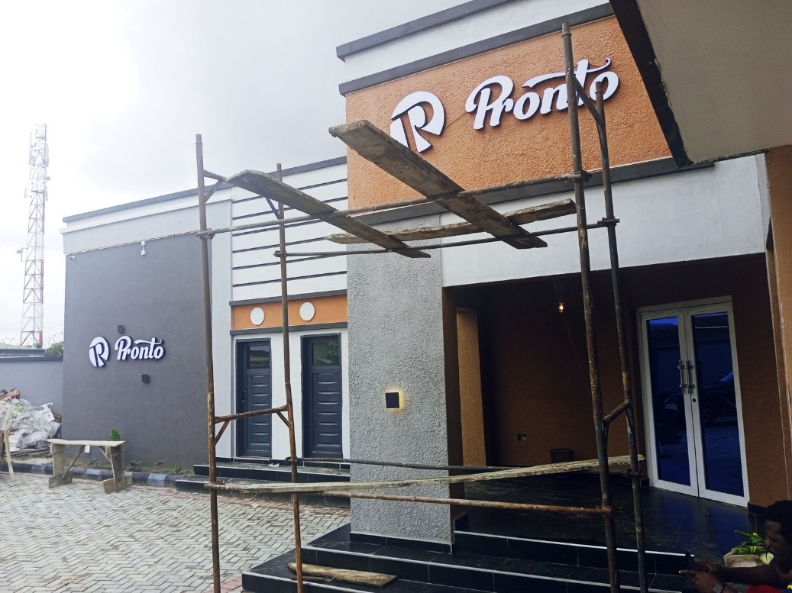
Plate 3.1: Front Elevation of the Bistro
Observations
- Merits:
  - Ample natural light and ventilation
  - Well-landscaped exterior promotes relaxation
  - Sufficient on-site parking
  - Design reflects cultural identity
- Demerits:
  - Proximity to traffic causes noise interference outdoors
  - Lack of children's entertainment area

3.3 Case Study Two: Tantalizers Ogbomoso
• Location: Ogbomoso, Oyo State
• Year Built: 2019
Brief History
Tantalizers Ogbomoso is a well-known quick-service restaurant located in the heart of Ogbomoso, Oyo State. Established in 2019, it is part of the broader Tantalizers fast-food chain, which is renowned across Nigeria for offering quality local and continental meals in a clean and welcoming environment. The architectural style of the Ogbomoso outlet blends functional modern design with subtle cultural motifs, ensuring both efficiency and aesthetic appeal. With a focus on family-friendly service, affordability, and consistency, Tantalizers has become a go-to dining destination for students, families, and travelers seeking dependable meals in a comfortable setting.
Design Features and Facilities
- Main Dining Hall: Defined by industrial finishes such as exposed beams and pendant lighting.
- Rooftop Terrace: Offers panoramic city views with open-air seating.
- Kitchen: Enclosed, highly ventilated workspace.
- Takeaway Counter: Fast-track section for quick service.
- Restrooms: Compact yet modern with water-saving fixtures.
- Parking: Limited space; relies on valet service.
Figure 3.4: Site Plan

Figure 3.5: Floor Plan
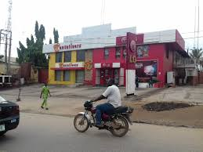
Plate 3.3: Side Elevation Highlighting Rooftop Space

Observations
- Merits:
  - Modern, visually striking design
  - Efficient energy and lighting systems
  - Elevated dining through rooftop experience
- Demerits:
  - Limited self-parking; heavy dependency on valet
  - Kitchen size constraints during high traffic
3.4 Case Study Three: Latitude Café and Lounge
• Location: Oyo Town, Oyo Stat
Brief History
Latitude Café and Lounge is a stylish and contemporary dining destination situated in the vibrant city of Oyo Town, Oyo State. Known for its relaxed atmosphere and eclectic menu, the café has become a favorite spot for locals and visitors alike. It offers a fusion of traditional Nigerian flavors and modern continental cuisine, served in a chic, lounge-style setting. The interior design incorporates modern elements with cultural accents such as locally crafted décor, warm lighting, and open-air seating areas that encourage relaxation and social interaction. Latitude Café and Lounge is especially popular among young professionals, creatives, and travelers looking to enjoy quality food, refreshing drinks, and a taste of modern Oyo hospitality.
Design Features and Facilities
- Central Dining Hall: Encased with glass panels offering lush views.
- Kids' Corner: Equipped with child-friendly amenities.
- Kitchen: Detached but accessible via a connecting hallway.
- Outdoor Patio: Semi-covered with garden seating.
- Mini Library: Features reading material for guests.
- Restrooms: Naturally ventilated and eco-conscious.
- Parking: Gravel lot for about 20 vehicles.
Figure 3.6: Floor Plan
Figure 3.7: Floor Plan

Figure 3.7: Floor Plan

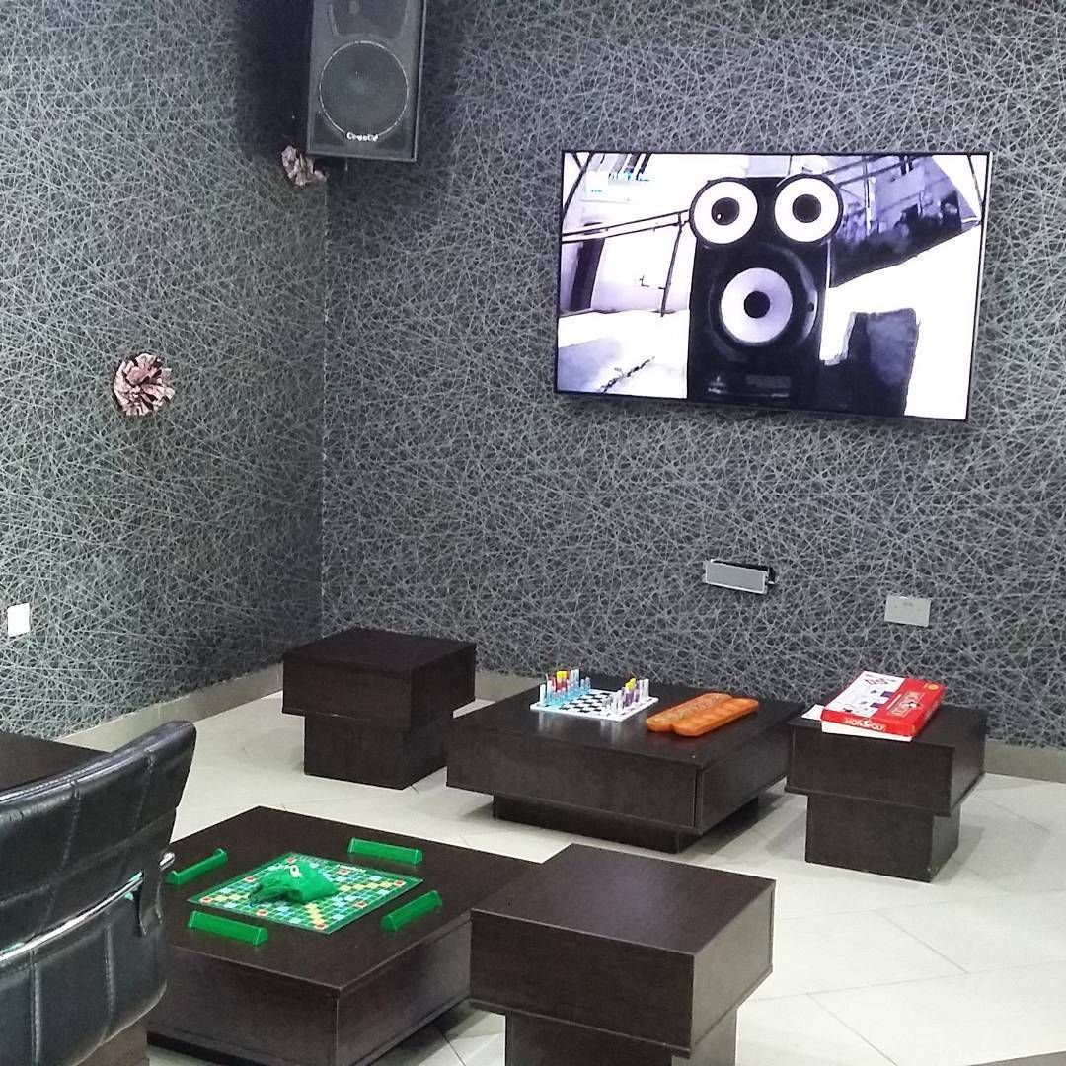
Plate 3.5: Interior
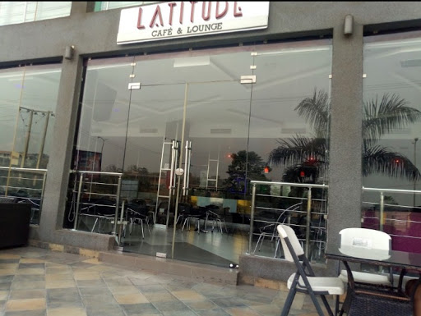
Plate 3.4: Entrance View

Observations
- Merits:
  - Sustainable and natural building techniques
  - Family-friendly and inclusive design
  - Serene garden ambiance improves dining comfort
- Demerits:
  - Low roadside visibility affects walk-in traffic
  - Outdoor spaces less usable in rainy conditions

CHAPTER FOUR
STUDY AREA / PROJECT SITE AND PROPOSED DEVELOPMENT
4.0 Study Area / Project Site
4.1 Introduction
Ogbomosho, located in Oyo State, Nigeria, is a city steeped in Yoruba heritage and history. Founded in the 17th century, it has evolved into a prominent regional center known for its educational institutions, artisanal economy, and vibrant cultural life. It has earned a reputation as a hub for trade, academia, and hospitality, making it an ideal location for a contemporary restaurant project.
4.2 Site Location
The proposed project site is situated within the heart of Oke-Ado neighbourhood in Ogbomosho North Local Government Area, Oyo State. Positioned along a busy commercial and residential corridor, the location connects key landmarks such as major schools, markets, and transport hubs. Its excellent visibility and easy accessibility make it strategically favorable for a new restaurant development.
Site Coordinates: Approx. Latitude 8.1216° N, Longitude 4.2346° E
Nearby Landmarks: Oke-Ado Market, Ladoke Akintola University Clinic, First Bank Branch, and several churches and mosques.
4.2.2 Site Selection Criteria
The selection of this site was informed by several key criteria:
- Strategic Location: Located adjacent to high-footfall zones including markets, schools, and commercial streets in Oke-Ado.
- Ease of Access: Accessible via multiple connecting roads and public transport stops.
- Land Availability: Sufficient plot size to accommodate dining areas, kitchen, parking, landscaping, and amenities.
- Security: Located in a well-populated residential enclave with existing community security structures.
- Site Characteristics: Gently sloping terrain with red lateritic soil, scattered vegetation ideal for landscaping.
4.3 Site Features
4.3.1 Vegetation
Sparse existing trees and shrubs dot the site. Selected mature trees will be preserved to enhance greenery, provide shade, and serve as natural windbreakers and dust filters.
4.3.2 Topography
The site is predominantly level. Minor grading will be performed to ensure uniform surface and drainage flow.
4.3.3 Drainage
No formal drainage infrastructure exists; a properly designed drainage network will be implemented to manage stormwater and prevent surface runoff.
4.3.4 Accessibility
Well-connected by a network of surrounding roads. A central access point will allow both pedestrian and vehicle entry.
4.3.5 Climate
Ogbomosho experiences a tropical climate similar to much of southwestern Nigeria, with average daytime highs around 32–34 °C. The rainy season runs from April to October, peaking between June and September, while November to March is typically dry with Harmattan-dust conditions. High RH and seasonal winds (South West during rains; North East during dry season) influence ventilation and orientation design.
4.3.6 Infrastructure & Utilities
Electric power is available via overhead lines; water supply and access roads are in place. Soil conditions are ideal for landscaping and building foundations.
4.3.7 Noise Sources
Low ambient noise levels. Minor traffic noise from adjacent streets, which will be addressed through design placement and materiality.
4.4 Site Analysis Summary
- Rainfall: Heaviest during June–September; lightest in December–January.
- Vegetation & Topography: Minimal vegetation; gently sloping surface.
- Wind & Sun Path: Prevailing South West and North East trade winds; sunrises at ~6:30–7:00 am and sunsets around 6:45 pm.
- Accessibility: Multiple road access points with pedestrian and vehicular entry.
- Utilities: Electricity, water supply, and good soil drainage present.
- Noise: Low-level from local residential and street activity.
4.5 Proposed Design
A modern restaurant design is proposed, focusing on safety, operational efficiency, and aesthetic appeal. The facility will cater to students, staff, families, and professionals in the Oke-Ado area, offering both sit-down and takeaway services in a welcoming, well-planned space.
4.5.1 Design Considerations
Key architectural criteria include:
- Fire & Safety: Integration of fire-resistant materials, smoke detectors, fire exits, sprinklers, and ventilation systems.
- Aesthetic Quality: Contemporary finishes polished timber, textured wall panels, decorative lighting, greenery.
- Functionality: Logical spatial arrangement to support efficient kitchen-dining operations, storage, and circulation.
- Ventilation & Indoor Comfort: Natural airflow through operable windows and strategic openings; mechanical ventilation in kitchen zones.
- Circulation & Zoning: Distinct public (dining, waiting, terrace) and service zones (kitchen, storage, staff) with formal circulation routes.
- Landscaping: Soft landscape perimeter planting and courtyard gardens for thermal comfort and visual quality.
- Security: Fencing, controlled entry, external lighting, and CCTV coverage.
4.5.2 Design Concept
Guided by functionalism, the design seeks to unite form and purpose. The layout supports rapid service, operational efficiency, and sensory engagement, while preserving opportunities for relaxed, ambient dining.
4.5.3 Functional Layout
The building comprises the following distinct zones:
- Administrative / Service Areas
  - Manager’s Office
  - Cashier / Reception Booth
  - Staff Break Room & Lockers
  - Security Monitoring Room
- Guest Areas
  - Reception & Waiting Lounge
  - Main Dining Hall with flexible seating
  - VIP/Private Dining Rooms
  - Outdoor Terrace Seating
  - Café / Beverage Counter
  - Accessible Male / Female Restrooms
- Kitchen & Back-of-House
  - Preparation Stations (hot and cold)
  - Cooking Area with ventilation canopy
  - Dry and Cold Storage Rooms
  - Dishwashing & Cleaning Zone
  - Service Delivery / Goods Entrance (separate from customer entry)
4.6 Functional Relationships
A bubble diagram illustrates core adjacencies and circulation paths:
- Dining areas located near restrooms and café counter
- Kitchen directly connected to storage and dining
- Reception adjacent to building entrance and waiting area
- VIP rooms near main hall but acoustically isolated
- Staff/service paths segregated from customer routes
4.7 Conceptual Development
Design strategies include:
- A clear customer journey: entry → greeting → seating → dining → exit
- Segregated service routes for hygiene and efficiency
- Bright, well-ventilated interiors using glass panels and skylights
- Vertical greenery and perimeter planting for shade and temperature moderation
- Configurable dining layouts for events or peak service times
- Safety-first circulation with designated fire escape routes
4.8 Bubble Diagram
A conceptual bubble diagram visually outlines:
- Core zones: Kitchen, Dining, Admin, Storage
- Service workflow: Storage → Kitchen → Dining → Delivery
- Customer flow: Entrance → Reception → Dining → Exit
- Supporting zones: Restrooms, Café, Outdoor seating
This diagram ensures a balance between functional zoning, efficient land use, and positive customer experience.

CHAPTER FIVE
APPROACH TO DESIGN / DESIGN REALIZATION
5.0 Specifications and Construction Approach
This chapter outlines the construction methodology, materials, finishes, and services required for realizing the design of the proposed restaurant. Each component has been thoughtfully selected to optimize performance in terms of functionality, durability, safety, sustainability, and aesthetics.
5.1 Materials and Finishes
Material selection plays a crucial role in achieving the design intent, particularly in ensuring structural integrity, fire safety, hygiene, and environmental friendliness.
5.1.1 Wall Construction and Finishes
The internal and external walls will be constructed using hollow sandcrete blocks, reinforced with concrete columns at regular intervals for structural stability. In kitchen and high-risk zones, concrete-filled blockwork will be employed for enhanced fire resistance. Interior walls in food preparation areas will be lined with glazed ceramic tiles for ease of cleaning and hygiene compliance. Aesthetic finishes such as Graphitex or stone-effect paints will be used in public-facing areas to create visual depth and improve thermal performance.
5.1.2 Floor Finishes
The floors will comprise 150mm-thick mass concrete laid over a compacted hardcore base. High-grade non-slip ceramic tiles will be used throughout the restaurant including dining, kitchen, and sanitary areas ensuring safety, durability, and easy maintenance. These tiles are flame-resistant and emit no toxic fumes under heat, making them suitable for a restaurant environment.
5.1.3 Ceiling Systems
Ceilings in public zones (e.g., dining and reception) will feature plasterboard combined with acoustic panels to enhance sound absorption. In kitchen and utility areas, fire-rated gypsum boards with aluminum lining will be installed for heat resistance and hygiene. All ceiling systems are designed for ease of cleaning and to meet relevant fire codes.
5.1.4 Roofing System
The roof will be structured with steel trusses and covered with long-span aluminum roofing sheets, chosen for their durability, lightweight nature, and heat-reflective properties. Ventilation ridges will be integrated to expel hot air and maintain internal comfort, particularly in cooking areas.
5.1.5 Windows and Doors
Windows will be aluminum-framed casement types with double-glazed safety glass for noise reduction and thermal insulation. Doors in public zones will be flush metal types, while fire-rated steel doors will be installed in kitchen and exit routes. All emergency doors will swing outward in compliance with escape route regulations.
5.2 Structural System
i. Substructure (Foundation)
The foundation system will be deep strip footing, designed in accordance with the soil's proven high load-bearing capacity. Reinforced concrete footings with damp-proof membranes will prevent moisture ingress and support the weight of the superstructure effectively.
ii. Superstructure
The superstructure will include reinforced concrete columns and beams, along with load-bearing blockwork. All structural elements will adhere to Nigerian Building Code specifications, with integrated fireproofing and thermal insulation where required.
5.3 Building Services
i. Electrical Power Supply
Power will be sourced from the national grid (PHCN) with a diesel-powered backup generator and solar inverter system to ensure uninterrupted operations during peak periods or outages.
ii. Lighting Design
Ample natural light will be harnessed using wide windows and clerestory glazing. Artificial lighting will include a combination of LED recessed lights, pendants, and wall sconces chosen for their energy efficiency, mood setting, and visual clarity.
iii. Ventilation Strategy
Ventilation will be hybrid: natural cross-ventilation in dining and lounge zones, supported by ceiling fans and operable windows; while kitchen areas will employ mechanical extraction systems, including industrial hoods and exhaust fans. Enclosed VIP spaces will be air-conditioned for comfort.
iv. Staircases
Where a second level is introduced (e.g., rooftop dining), access will be via reinforced concrete staircases featuring non-slip treads and metal balustrades. An external fire escape stairwell will be incorporated for safety.
v. Fire Protection Systems
An integrated fire safety system will include:
- Smoke and heat detectors in all key areas
- Fire extinguishers and hose reels placed strategically
- Fire alarm systems with manual call points
- Illuminated and clearly marked emergency exits Passive fire protection measures such as compartmentalization and fire-rated materials will also be employed.
vi. Plumbing and Electrical Installations
All installations will follow concealed conduit routing for aesthetic and hygienic integrity. Kitchens will have dedicated water lines for potable and wastewater. Stainless steel, food-grade fittings will be used throughout.
vii. Water Supply
Water will be sourced via a borehole, supported by an overhead storage tank for continuous supply. Filtration units will treat water used for cooking and beverage services.
viii. Drainage and Waste Disposal
Surface water drainage will be achieved through graded channels and culverts. Sewage and greywater will flow into septic tanks and soak-away pits using 300mm PVC pipes, with inspection chambers for maintenance.
Waste segregation (biodegradable, recyclable, hazardous) will be facilitated via designated bins, with external collection points situated away from dining areas.
5.4 Landscaping and External Works
Soft Landscaping
The site will be softened using native trees, ornamental shrubs, and grass to create a serene environment and shaded outdoor seating areas.
Hard Landscaping
Paved walkways, driveways, and an open-air patio will be provided. Sculptural elements or a small water feature may be introduced near the entrance to enhance the restaurant's identity.
Access and Circulation
The facility will have two vehicular gates a main entrance for patrons and a secondary gate for staff and deliveries. Pedestrian walkways will be clearly marked and safely separated from vehicular zones.
Parking Provision
Adequate parking will be provided for guests and staff, including designated spaces for disabled users, delivery vehicles, and motorcycles.
Conclusion
The proposed restaurant's design demonstrates a holistic approach to construction, functionality, sustainability, and user experience. From structural components to service integration and landscape design, the project adheres to best practices in modern hospitality architecture, ensuring a safe, inviting, and efficient facility suitable for the vibrant setting of Ogbomosho

References
Bitner, M. J. (1992). Servicescapes: The Impact of Physical Surroundings on Customers and
Employees. Journal of Marketing, 56(2), 57–71.
Davis, D. (2010). The Role of Architecture in Shaping Social Interaction in Hospitality
Settings. International Journal of Contemporary Hospitality Management, 22(1), 1–14.
Edwards, J. S. A., & Gustafsson, I.-B. (2008). The Room and Atmosphere as Aspects of the
Meal: A Review. Journal of Foodservice, 19(1), 22–34.
Horng, J.-S., Chou, S.-F., & Liu, C.-H. (2013). Creativity and Sustainable Development of
Culinary Professionals: A Case Study of Open-Kitchen Restaurants in Taiwan. Sustainability, 5(7), 2956–2971.
Jones, P., & Lockwood, A. (2004). The Management of Hotel Operations. London: Thomson
Learning.
Kimes, S. E., & Robson, S. K. A. (2004). The Impact of Restaurant Table Characteristics on
Meal Duration and Spending. Cornell Hotel and Restaurant Administration Quarterly, 45(4), 333–346.
Preiser, W. F. E., & Ostroff, E. (2001). Universal Design Handbook. New York: McGraw-
Hill.
Waxman, L. (2006). The Coffee Shop: Social and Physical Factors Influencing Place
Attachment. Journal of Interior Design, 31(3), 35–53.
Bitner, M.J. (1992). Servicescapes: The impact of physical surroundings on customers and
employees. Journal of Marketing, 56(2), 57–71.
Davis, M. (2010). Architecture of Community. Island Press.
Edwards, J.S.A., & Gustafsson, I.B. (2008). The room and atmosphere as aspects of the
meal: A review. Journal of Foodservice, 19(2), 22–34.
Horng, J.S., Chou, S.F., Liu, C.H., & Tsai, C.Y. (2013). Creativity and sustainable
development: Trends and successful practices in architecture and design. Sustainability, 5(3), 1239–1255.
Jones, P., & Lockwood, A. (2004). The Management of Hotel Operations. Cengage Learning.
Kimes, S.E., & Robson, S.K.A. (2004). The impact of restaurant table characteristics on
meal duration and spending. Cornell Hotel and Restaurant Administration Quarterly, 45(4), 333–346.
Lockwood, A., & Medlik, S. (2001). Tourism and Hospitality in the 21st Century.
Butterworth-Heinemann.
Preiser, W.F.E., & Ostroff, E. (2001). Universal Design Handbook. McGraw-Hill.
Waxman, L. (2006). The coffee shop: Social and physical factors influencing place
attachment. Journal of Interior Design, 31(3), 35–53.
Adams, T. (2018). Zoning for Functionality in Restaurant Design. Architectural Digest, 56(4),
44–53.
Bitner, M.J. (1992). Servicescapes: The Impact of Physical Surroundings on Customers and
Employees. Journal of Marketing, 56(2), 57–71.
Brown, L., & Clarke, J. (2023). Tech-Driven Restaurant Design. Hospitality Technology
Review, 35(1), 21–33.
Carter, E., & Brooks, H. (2021). Planning for Flow: Spatial Arrangement in Hospitality
Spaces. Design Quarterly, 49(2), 88–101.
Edwards, J.S.A., & Gustafsson, I.B. (2008). The Room and Atmosphere as Aspects of the Meal:
A Review. Journal of Foodservice, 19(2), 22–34.
Green, K., & Morris, L. (2022). Modular Thinking in Restaurant Design. International Journal
of Hospitality Architecture, 18(2), 60–72.
Jones, P., & Lockwood, A. (2004). The Management of Hotel Operations. Cengage Learning.
Lawson, B. (2001). The Language of Space. Architectural Press.
Lee, R. (2019). Efficient Kitchen Layouts for the Modern Restaurant. Culinary Engineering
Journal, 11(1), 11–20.
Logan, M. (2023). Biophilic Design in Restaurants: A Green Revolution. Sustainable Design
Journal, 29(4), 39–49.
Martin, D. (2022). Smart Service Systems in Restaurants. Service Innovation Quarterly, 14(3),
75–88.
Miller, D., & Lopez, F. (2020). Designing for All: Principles of Universal Accessibility. Journal
of Inclusive Architecture, 15(1), 33–47.
Nelson, P., & White, G. (2022). Access for All: Hospitality Design for Inclusivity. Access and
Inclusion Review, 8(2), 19–31.
Nguyen, K., & Harper, S. (2020). Brand Identity Through Space. Restaurant Design Studies,
13(3), 102–116.
O’Neil, R. (2020). Furniture Flexibility in Modern Dining Spaces. Furniture Design Today,
22(4), 51–63.
Peters, J. (2021). Practical Universal Design for Restaurants. Design for All Quarterly, 19(1),
66–78.
Sanders, L. (2022). Visual Branding in Restaurant Interiors. Commercial Interiors Journal,
10(2), 84–95.
Smith, H., & Baker, R. (2021). Sustainable Practices in Restaurant Design. Journal of
Environmental Architecture, 7(2), 99–110.
Taylor, M., & Benson, A. (2019). Adaptive Dining Layouts in Hospitality Design. Hospitality
Interiors, 6(3), 29–41.
Walters, D., Jones, F., & Harris, A. (2021). Restaurants as Social Spaces: Design
Considerations. Urban Social Design Journal, 16(2), 59–73.
Waxman, L. (2006). The Coffee Shop: Social and Physical Factors Influencing Place
Attachment. Journal of Interior Design, 31(3), 35–53.

