A PROJECT REPORT
ON
PROPOSED DAY CARE CENTER FOR ASA DAM, ILORIN KWARA STATE
BY
AWOLOLA OLUWASIJIBOMI JOSHUA
ND/23/ARC/PT/030

SUBMITTED TO THE DEPARTMENT OF ARCHITECTURAL TECHNOLOGY, INSTITUTE OF ENVIRONMENTAL STUDIES KWARA STATE POLYTECHNIC, ILORIN

IN PARTIAL FULFILMENT OF THE REQUIREMENTS FOR THE AWARD OF NATIONAL DIPLOMA IN ARCHITECTURAL TECHNOLOGY

JULY 2025

DECLARATION
I, Awolola Oluwasijibomi Joshua, hereby declare that this project/dissertation is the result of my independent research work. It has not been previously submitted for the award of any diploma or degree in any polytechnic or institution of higher learning. All ideas, observations, comments, and suggestions expressed herein are my own, except where due acknowledgment has been given in line with standard academic conventions.
AWOLOLA OLUWASIJIBOMI JOSHUA
ND/23/ARC/PT/030
Student Name Matric Number
……………………………………….
Signature & Date

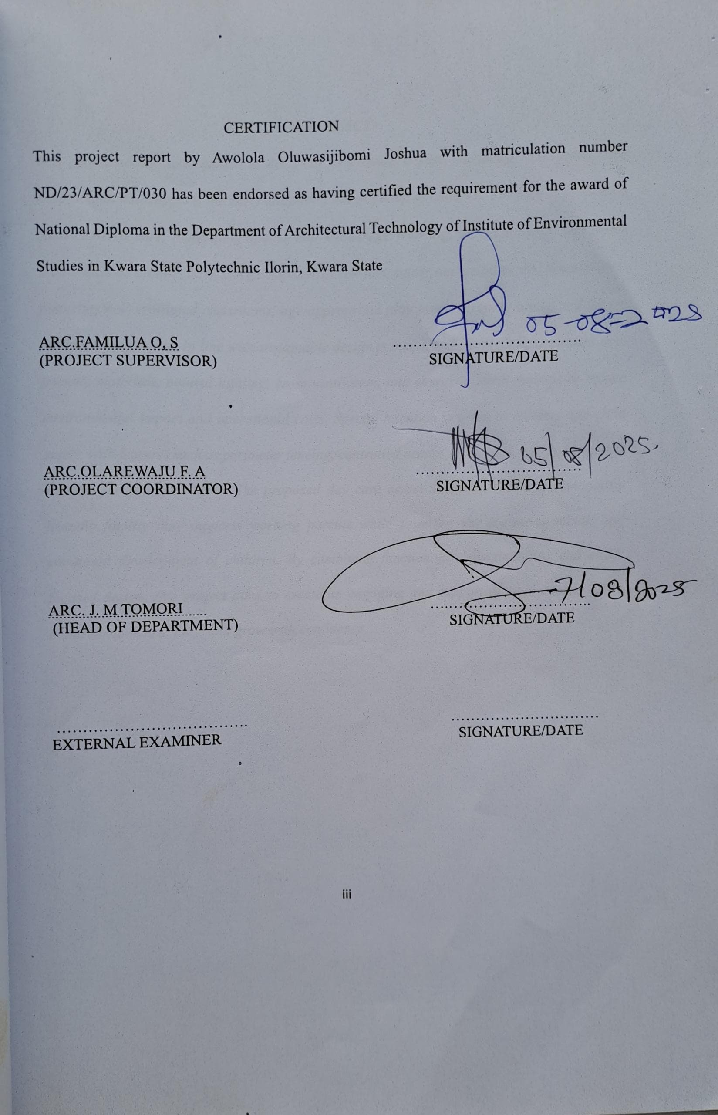
DEDICATION
This project is dedicated to Almighty God, the author and finisher of my faith, whose divine guidance and grace have brought me to the successful completion of this programme. I also dedicate this work to my loving parents for their unwavering moral and financial support throughout this academic journey.

ACKNOWLEDGEMENT
Every academic journey has its milestones, and this project represents the culmination of a chapter defined by grace, perseverance, and continuous growth.
First and foremost, I return all glory and honour to the Almighty God, the Master Architect of creation, for His divine guidance, strength, and wisdom throughout the course of this work.
My sincere appreciation goes to my supervisor, Arc. Familua O S., whose invaluable guidance, constructive criticism, and encouragement have been instrumental to the successful completion of this project. Despite a demanding schedule, you always made time to mentor and support me I remain deeply grateful. A very big thank you to the entire management and staff of the Architectural Department at Kwara State Polytechnic, Ilorin, for their continuous support.
To my beloved parents, Mr. and Mrs. Awolola, your love, prayers, and unwavering sacrifices have been my pillar of strength. Every step of this journey is a reflection of your steadfast support and inspiration.
I also extend my heartfelt gratitude to the management, lecturers, and non-teaching staff of the Department of Architectural Technology, whose dedication to excellence and mentorship have shaped both my professional knowledge and personal character.
Special thanks to my siblings for their constant encouragement, and to my classmates and friends for making this journey memorable, collaborative, and fulfilling. Your companionship brought light and colour to every stage of this academic pursuit.
Finally, to everyone who contributed in one way or another to the success of this project, whether through advice, assistance, or moral support, your impact is sincerely appreciated and forever treasured.
With a heart full of gratitude,
Thank you all.

ABSTRACT
This proposed day care center is designed to provide a safe, nurturing, and stimulating environment that supports the early childhood development of children. The facility prioritizes child-centered care, integrating spaces that encourage learning, play, creativity, and social interaction. Its architectural design emphasizes comfort, safety, accessibility, and functionality, featuring well-ventilated classrooms, age-appropriate play zones, sleeping areas, and secure outdoor playgrounds. In line with sustainable design principles, the project incorporates eco-friendly materials, natural lighting, cross ventilation, and energy-efficient systems to reduce environmental impact and operational costs. Special attention is given to security and child safety, with features such as perimeter fencing, controlled access points, and non-toxic finishes suitable for young children. The proposed day care center is envisioned as a community-friendly facility that supports working parents while fostering the cognitive, social, and emotional development of children. By combining functionality, sustainability, and child-focused design, this project aims to create an engaging and supportive environment where children can learn, play, and grow with confidence.

TABLE OF CONTENTS
TITLE PAGE i
DECLARATION ii
CERTIFICATION iii
DEDICATION iv
ACKNOWLEDGEMENTS v
TABLE OF CONTENTS vi
LIST OF TABLES vii
LIST OF FIGURES viii
LIST OF PLATES ix
LIST OF APPENDICES x
ABSTRACT xi
CHAPTER ONE
- INTRODUCTION 1
1.1 BACKGROUND INFORMATION 2
1.2 PROJECT DEFINITION 2
1.3 AIM AND OBJECTIVES 21.3.1 AIM 2
1.3.2 OBJECTIVES 2
1.4 STATEMENT OF PROBLEM 2

1.6 RESEARCH METHODOLOGY 3
1.7 LIMITATION AND CONSTRAINT 3
CHAPTER TWO
2.0 LITERATURE REVIEW 4
2.1 INTRODUCTION 4
2.2 FUNCTIONAL DESIGN 4
2.3 INCLUSIVITY AND ACCESSIBILITY 5
2.4 FLEXIBILITY AND ADAPTABILITY 5
2.5 COMMUNITY BUILDING 6
2.6 MODERN AMENITIES AND TECHNOLOGY 6
2.7 CONCLUSION 7
CHAPTER THREE
3.0 CASE STUDIES 8
3.1 INTRODUCTION 8
3.1.1 RELEVANCE OF CASE STUDIES TO ARCHITECTURAL DESIGN 8
3.2 CASE STUDY ONE 9
3.3 CASE STUDY TWO 14
3.4 CASE STUDY THREE 16
CHAPTER FOUR
4.0 STUDY AREA/PROJECT SITE AND PROPOSED PROJECT 18
4.1 INTRODUCTION 18
4.2 SITE LOCATION 18
4.2.2 SITE SELECTION CRITERIA 20
4.3.2 VEGETATION 20
4.3.3 TOPOGRAPHY 21
4.3.4 DRAINAGE 22
4.3.5 ACCESSIBILITY 22
4.3.6 CLIMATE
4.3.7 SITE FEATURES AND INFRASTRUCTURE 24
4.3.8 NOISE SOURCES 24
4.4 SITE ANALYSIS. 24
  - PROPOSED DESIGN 26
4.5.1 DESIGN CONSIDERATIONS: 26
4.5.2 DESIGN CONCEPT 27
4.5.3 BRIEF ANALYSIS 27
4.6 FUNCTIONAL RELATIONSHIP 28
4.7 CONCEPTUAL DEVELOPMENT 28
4.8 BUBBLE DIAGRAM 28
CHAPTER FIVE
APPROACH TO THE DESIGN/DESIGN REALIZATION 29
5.0 SPECIFICATIONS AND CONSTRUCTION 29
5.1 MATERIAL AND FINISHES 29
5.1.1 WALLS 29
5.1.2 FLOORS 29
5.1.3 CEILING 29
    - ROOF 30
    - WINDOWS AND DOORS 30
5.2 STRUCTURAL SYSTEM 30
  - BUILDING SERVICE 32
5.4 LANDSCAPING AND EXTERNAL WORKS 34
REFERENCES 35

LIST OF PLATES
PLATE 3.1: PICTURE THE BACK VIEW OF CASE STUDY 1………………………......14
PLATE 3.2: PICTURE SHOWING THE FRONT VIEW OF CASE STUDY 1 ……....…...14
PLATE 3.3: PICTURE SHOWING THE REAR VIEW OF CASE STUDY 2………… …18
PLATE 3.4: PICTURE SHOWING THE LEFT VIEW OF CASE STUDY 2 ………….….18
PLATE 3.5: PICTURE SHOWING THE REAR VIEW OF CASE STUDY 3………… ….22
PLATE 3.6: PICTURE SHOWING THE LEFT VIEW OF CASE STUDY 3 ………….….22

LIST OF FIGURES
FIGURE 3.1 : FLOOR PLAN OF CASE STUDY ONE ........................................................15
FIGURE 3.2: SHOWING THE SITE PLAN OF CASE STUDY TWO..................................15
FIGURE 3.3: SHOWING THE FLOOR PLANS OF CASE STUDY TWO..........................18
FIGURE 3.4: SHOWING THE SITE PLAN OF CASE STUDY THREE..............................22
FIGURE 3.5: SHOWING THE FLOOR PLAN OF CASE STUDY THREE.........................22

CHAPTER ONE
1.0 INTRODUCTION
1.1 Background Information
The concept of the Day Care Center has evolved significantly over time, from simple child-minding spaces to sophisticated, purpose-built facilities designed to foster early childhood development, safety, and comfort. Modern day care centers serve as more than just temporary child care venues; they act as developmental environments where safety, education, recreation, and socialization intersect to support the holistic growth of children (Bredekamp & Copple, 1997; Essa, 2013).
In contemporary early childhood care, architectural design has become a critical factor in enhancing learning and caregiving outcomes. The focus has shifted from basic shelter provisions to child-friendly spaces that prioritize safety, accessibility, sensory engagement, and environmental sustainability (Olds, 2001). Day care centers now provide multiple functional areas, including playrooms, rest zones, outdoor playgrounds, feeding areas, and administrative offices—requiring layouts that ensure efficient supervision and circulation while promoting a stimulating learning atmosphere.
Research indicates that the physical environment plays a key role in shaping children’s behavior, safety, and cognitive development. According to Moore (2008), factors such as natural lighting, ventilation, spatial zoning, color schemes, and acoustic comfort influence children’s mood and engagement levels. Therefore, designers are tasked with addressing a wide range of functional and psychological considerations, including safety provisions, childproofing, secure access points, and the arrangement of indoor and outdoor activity spaces.
Additionally, there is a growing emphasis on inclusive and sustainable design. Day care centers must accommodate children of diverse physical abilities through universal design elements such as ramps, accessible restrooms, wide circulation paths, and tactile floor surfaces (Preiser & Ostroff, 2001). Furthermore, integrating sustainable features like natural ventilation, energy-efficient lighting, and eco-friendly materials reduces operational costs and promotes environmental responsibility.
Ultimately, the architectural design of a day care center is an interdisciplinary endeavor, integrating early childhood education principles, environmental psychology, safety engineering, and spatial planning. A well-designed day care center not only facilitates smooth operations for caregivers but also nurtures children’s development, builds parental trust, and strengthens the social fabric of the community.
1.2 Project Definition
This project focuses on the architectural design of a modern day care center that harmonizes safety, functionality, child-friendly aesthetics, and environmental sustainability. The proposed facility will cater to infants and toddlers by providing secure indoor and outdoor environments for learning, play, and rest. The design will incorporate flexible spaces for various activities, operational areas for staff efficiency, and inclusive features that accommodate children with special needs, thereby creating a safe and stimulating hub for early childhood development.
1.3 Aim and Objectives
1.3.1 Aim
The aim of this project is to design a day care center that provides a safe, functional, and development-oriented environment for children, while ensuring operational efficiency, inclusivity, and sustainability.
1.3.2 Objectives
- To develop a child-centered spatial layout that includes classrooms, playrooms, rest areas, feeding zones, and outdoor recreational spaces.
- To enhance safety and accessibility through universal design features such as ramps, childproof fittings, and accessible sanitary facilities.
- To create a stimulating learning and play environment through the use of natural lighting, ventilation, vibrant color schemes, and age-appropriate furniture.
- To integrate sustainable design principles by incorporating eco-friendly materials, energy-efficient systems, and effective natural ventilation.
- To ensure operational efficiency by providing clearly defined zones for staff activities, storage, and administration without compromising child supervision.
- To foster community trust by creating a warm, secure, and inviting environment that meets parental expectations.
1.4 Statement of Problem
Despite the increasing demand for early childhood education facilities, many existing day care centers are constrained by poor architectural design, which poses safety risks and limits developmental opportunities for children. Common issues include inadequate play space, poor ventilation, lack of natural lighting, insufficient childproofing, and non-compliance with accessibility standards (Olds, 2001).
Additionally, a significant number of day care centers lack sustainable and inclusive features, leading to increased operational costs and the exclusion of children with special needs. These deficiencies compromise child safety, caregiver efficiency, and parental confidence in the facility.
This project seeks to address these challenges by proposing a day care center design that integrates safety, functionality, child-friendly aesthetics, environmental sustainability, and inclusivity, thereby ensuring a facility that supports holistic child development and community trust.
1.5 Client Background
The client, Mrs. Mary Adebayo, is an experienced early childhood caregiver and educator with over fifteen years of professional practice in Ogbomoso, Oyo State. She began her career as a nursery school teacher and gradually established a small home-based child care service, which quickly gained recognition for its nurturing environment and reliable caregiving practices.
Driven by a passion for child development and community service, Mrs. Adebayo now seeks to expand her operations by developing a purpose-built day care center. Her vision is to provide a secure, educational, and stimulating environment where children can learn, play, and grow under professional supervision.
The proposed facility is intended to set a new standard for early childhood care in Ogbomoso by integrating modern architectural design, safety, and operational efficiency. Beyond child care, the project is envisioned as a legacy initiative that supports working parents, creates local employment opportunities, and strengthens the foundation for lifelong learning.
1.6 Research Methodology
To achieve a functional and context-appropriate architectural design, the following research methods were employed:
- Case Studies: Analysis of successful local and international day care centers to identify best practices in safety, space planning, and child engagement.
- Photography: Visual documentation of existing facilities and potential site conditions to inform spatial and material decisions.
- Internet Review: Investigation of global trends in early childhood care design, sustainable architecture, and child-friendly facilities.
- Oral Interviews: Engagement with caregivers, parents, and early childhood education experts to gather practical insights.
- Literature Review: Examination of academic journals, design guidelines, and child development publications to establish a strong theoretical foundation.
1.7 Limitations and Constraints
- Access Restrictions: Limited access to some existing day care centers for physical case study due to operational and privacy concerns.
- Limited Literature: Scarcity of Nigerian-focused architectural resources on day care design.
- Financial Constraints: Budget limitations affected the number of site visits and extent of expert consultation.
- Time Constraints: The academic project timeline limited the opportunity for extended observation and detailed engagement with multiple stakeholders.
CHAPTER TWO
LITERATURE REVIEW
2.0 Literature Review: Architectural Design of a Day Care Center
2.1 Introduction
The architectural design of a Day Care Center plays a crucial role in ensuring child safety, supporting early learning, and facilitating operational efficiency for caregivers. Unlike conventional facilities, a day care center must integrate functional, aesthetic, and psychological considerations to create an environment that promotes the holistic development of children.
Modern approaches to day care architecture recognize that the physical environment influences children’s cognitive, emotional, and social behavior (Olds, 2001). A well-designed day care facility must therefore prioritize spatial organization, indoor environmental quality, play and learning zones, child safety measures, inclusivity, and sustainability. Architectural elements such as lighting, ventilation, materials, and circulation paths are not merely functional—they actively shape children’s experiences and their parents’ confidence in the facility.
2.2 Role of Architecture in Child Development
Architecture in day care design is more than the construction of physical spaces; it directly impacts early childhood development. Research highlights that young children are highly responsive to their environments, and the design of learning spaces can influence attention span, creativity, and social interaction (Moore, 2008).
The physical environment of a day care communicates the values and philosophy of the facility. Bright, stimulating spaces with vibrant color schemes can encourage play and imagination, while calm, neutral areas may promote rest and concentration. Well-zoned spaces also support structured routines critical for emotional stability and learning in young children.
According to Olds (2001), child-friendly architecture should integrate elements that are scaled to children’s sizes, ensure visual accessibility for caregivers, and foster a sense of security. Rounded corners, low storage units, non-slip flooring, and clear sightlines are some features that support a safe and developmentally appropriate environment.
2.3 Spatial Planning and Functional Layout
Effective spatial planning is central to the functionality of day care centers. The architectural layout must ensure seamless interaction between children, caregivers, and support spaces. Functional areas typically include:
- Indoor Activity Rooms: For learning and play activities, often subdivided into zones for storytelling, art, and free play.
- Sleeping/Rest Areas: Designed to be quiet, comfortable, and thermally regulated.
- Feeding Zones and Kitchenettes: Located strategically to ensure hygienic meal preparation and easy supervision during feeding times.
- Outdoor Play Areas: Equipped with age-appropriate play equipment, secured perimeters, and soft surfacing to prevent injuries.
- Administrative and Staff Areas: Including offices, storage, and staff rest zones to support operational efficiency.
Efficient circulation design ensures that caregivers can supervise multiple areas while minimizing unnecessary movement. Research emphasizes the importance of zoning and child-adult circulation separation to enhance safety and reduce disruption during activities (Sanoff, 1995).
2.4 Indoor Environment and Sensory Design
The interior environment of a day care center significantly affects children’s comfort and behaviour. Key factors include:
- Lighting: Natural lighting is ideal for improving mood and attention, while soft artificial lighting supports restful activities (Baraban & Durocher, 2010).
- Colour Schemes: Warm, vibrant colours stimulate engagement in play areas, whereas softer hues are preferred in nap zones to encourage calmness.
- Acoustics: Sound control is critical, as high noise levels can disturb learning and rest. Use of acoustic panels, curtains, and soft finishes can minimize noise.
- Materials and Finishes: Non-toxic, easy-to-clean, and durable materials like rubber flooring or laminated surfaces ensure hygiene and safety.
Indoor design should stimulate the senses without overstimulation, striking a balance between playful and calming environments.
2.5 Sustainability and Eco-Friendly Design
Sustainable design is increasingly vital in day care architecture, given the need for healthy environments for children. Eco-friendly strategies include:
- Natural Ventilation and Daylighting: Reduces energy use and enhances indoor air quality.
- Energy-Efficient Lighting and Appliances: Minimizes operational costs and environmental footprint.
- Use of Local and Non-Toxic Materials: Protects children’s health and supports sustainable construction practices.
- Green Outdoor Spaces: Gardens and vegetated play areas promote environmental awareness and sensory development (Edwards, 2010).
Studies by Al-Saadi & Abdulsatar (2017) note that sustainable design not only reduces operational costs but also enhances long-term health outcomes for occupants, which is critical for children’s development.
2.6 Cultural and Social Considerations
Day care centers also serve as social and community hubs, reflecting the cultural values of their environment. In many Nigerian communities, incorporating local materials, motifs, and spatial layouts enhances the sense of familiarity and cultural identity. Outdoor courtyards or semi-open spaces accommodate communal activities and parent-child interactions.
Inclusivity is equally vital. According to Preiser & Ostroff (2001), universal design ensures that children with disabilities or mobility challenges are accommodated. Key features include ramps, wide doorways, accessible restrooms, tactile surfaces, and barrier-free circulation paths. By ensuring inclusivity, the day care fosters equity and social integration from early childhood.
2.7 Technology Integration in Day Care Centers
Modern day care centers increasingly incorporate technology to enhance both security and educational delivery. Examples include:
- CCTV Surveillance: To monitor safety and provide parents with peace of mind.
- Smart Access Control: Ensures that only authorized persons can enter the facility.
- Digital Learning Tools: Interactive boards, tablets, and projection systems for age-appropriate learning.
- Environmental Controls: Smart lighting, fans, and air conditioning to maintain thermal comfort efficiently (Chow, 2013).
Technology integration must be balanced with child safety, ensuring that all devices are securely installed and that the environment remains child-centered rather than technology-dominated.
2.8 Conclusion
The architectural design of a day care center is a multidisciplinary effort that combines safety, functionality, child development principles, cultural sensitivity, sustainability, and technological innovation. Each design decision—from spatial zoning to color selection—affects how children learn, play, and socialize.
By integrating insights from literature and best practices, architects can create day care centers that are safe, inclusive, stimulating, and environmentally responsible, ultimately supporting both early childhood development and community well-being.

CHAPTER THREE
CASE STUDIES
3.0 Introduction
Case studies are an essential part of architectural research, as they provide insight into real-life applications of design principles and allow designers to evaluate how theoretical concepts perform in practical scenarios. In the context of Day Care Center architecture, case studies help to identify effective strategies for space planning, safety integration, environmental quality, inclusivity, and child-focused design.
Through direct observation, architectural analysis, user feedback, and interviews with caregivers, valuable lessons can be drawn from existing facilities. These insights inform the design of new day care centers that are functional, safe, and developmentally appropriate.
3.1 Relevance of Case Studies in Day Care Center Architectural Design
The significance of case studies in day care center design can be summarized as follows:
- Learning from Precedents: By analysing existing day care centers, architects can observe how functional spaces such as play areas, rest zones, and administrative sections perform in real-life operations.
- Evaluating Design Strategies: Case studies highlight effective approaches to safety, child circulation, indoor-outdoor connectivity, and supervision of children.
- Contextual Integration: They show how day care centers respond to local climate, urban constraints, and cultural expectations.
- Tracking Innovation: Innovative child-friendly features, such as interactive play installations or sustainable outdoor spaces, are often discovered through precedent studies.
- Addressing Real-World Challenges: Case studies reveal how designers overcome challenges like noise control, sanitation, security, and emergency access.
- Understanding Compliance: Observing built projects demonstrates how safety regulations, fire exits, and accessibility standards are practically implemented.
- Human-Centric Feedback: Engaging with caregivers, parents, and staff provides first-hand insights into how architectural spaces affect daily operations and child development outcomes.
3.2 Case Study One: Little Angels Day Care Center
- Location: GRA, Ilorin, Kwara State
- Year Established: 2018
Brief History
Little Angels Day Care Center is a purpose-built early childhood facility located in the serene Government Reserved Area (GRA) of Ilorin. Established in 2018, the center was designed to provide a safe and stimulating environment for children aged 6 months to 5 years. Its architecture integrates child-friendly design principles with functional spaces for caregivers, reflecting a modern approach to early childhood care.
Design Features and Facilities
- Main Activity Hall: Open-plan play and learning space divided into cognitive, sensory, and creative activity zones.
- Sleeping Rooms: Quiet rooms with controlled lighting and acoustic treatments for naptime.
- Outdoor Play Area: Secured with soft flooring, swings, slides, and shaded resting zones.
- Kitchen and Feeding Area: Hygienically separated from activity zones, with an adjacent child feeding section.
- Administrative Office and Reception: Provides supervision and parental interaction spaces.
- Restrooms: Gender-specific and child-scaled, with an accessible restroom for children with special needs.
- Parking: Small lot accommodating staff and parents during drop-off and pick-up.
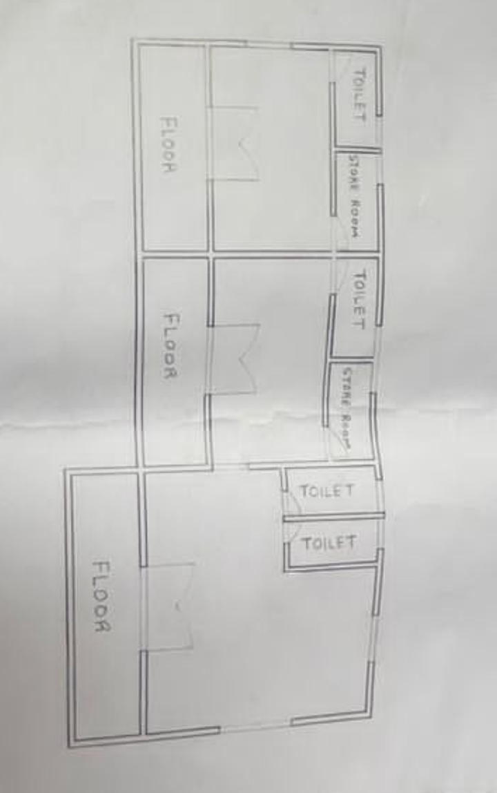
FIGURE 3.1 : FLOOR PLAN OF CASE STUDY ONE


PLATE 3.1 : ELEVATION OF CASE STUDY ONE

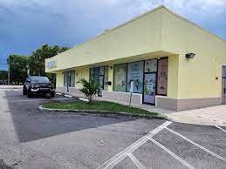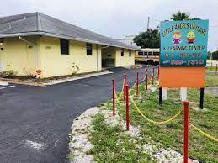
PLATE 3.2 : PERSPECTIVE VIEW OF CASE STUDY ONE
Observations
- Merits:
  - Well-zoned spaces allow for easy supervision.
  - Ample natural ventilation and lighting.
  - Child-scaled facilities ensure safety and usability.
- Demerits:
  - Limited outdoor play space restricts large group activities.
  - Proximity to a residential street creates occasional noise disturbance.
3.4 Case Study Two: Abyem Academy
• Location: Ilorin, Kwara State
• Year Built: 2018
Brief History
Abyem Academy is a private educational institution in Ilorin that provides nursery, primary, and day care services for young children. Established in 2018, the academy was created to offer a secure and engaging learning environment for children of working-class parents in the city. Its architectural design emphasizes safety, accessibility, and functional learning spaces that cater to early childhood development.
Design Features and Facilities
- Indoor Play Area: Spacious hall with soft floor coverings, colorful wall art, and age-appropriate play equipment to encourage creative and motor skill development.
- Nap Zone: Well-ventilated sleeping area designed with low-height partitions to ensure easy supervision by caregivers.
- Outdoor Playground: Fully fenced compound with swings, slides, and climbing structures, providing a safe and fun environment for physical activities.
- Learning Classrooms: Bright and airy classrooms with child-friendly furniture, large windows for natural lighting, and display boards for interactive learning.
- Kitchenette and Feeding Area: Small kitchen for meal preparation, directly connected to the feeding section to ensure hygiene and ease of service.
- Staff Office and Storage: Dedicated office space for administrative tasks and secure storage for teaching materials and children’s belongings.
- Child-Friendly Restrooms: Low-level fixtures, step stools, and water-efficient taps designed for safety and ease of use by toddlers.
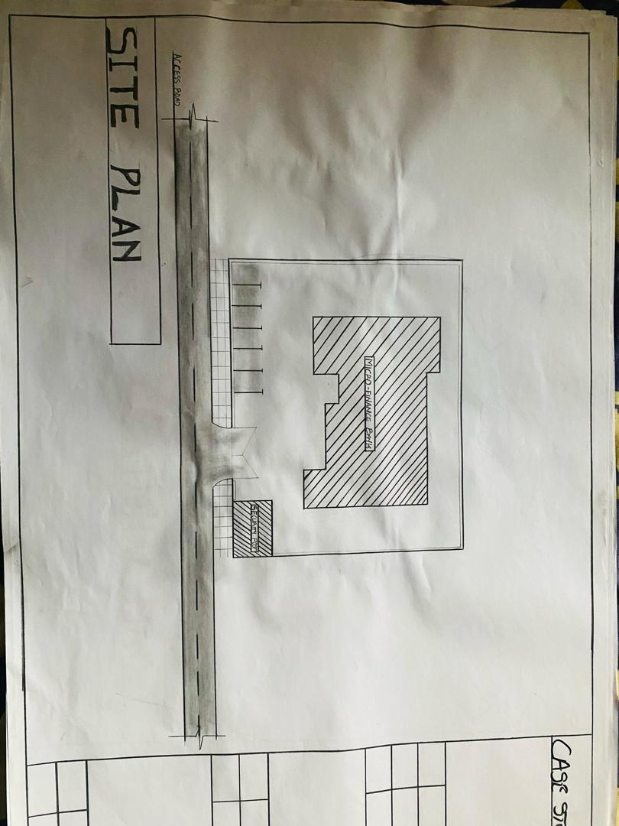
FIGURE 3.2: SHOWING THE SITE PLAN OF CASE STUDY TWO
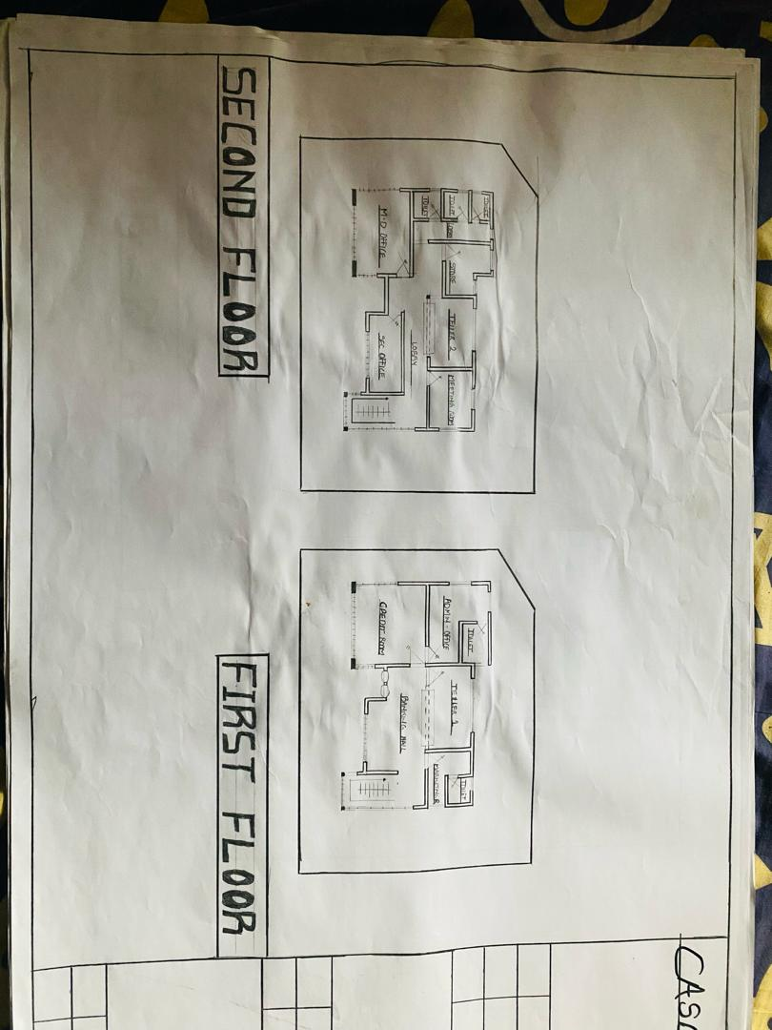
FIGURE 3.3: SHOWING THE FLOOR PLANS OF CASE STUDY TWO

PLATE 3.3 : ELEVATION OF CASE STUDY TWO
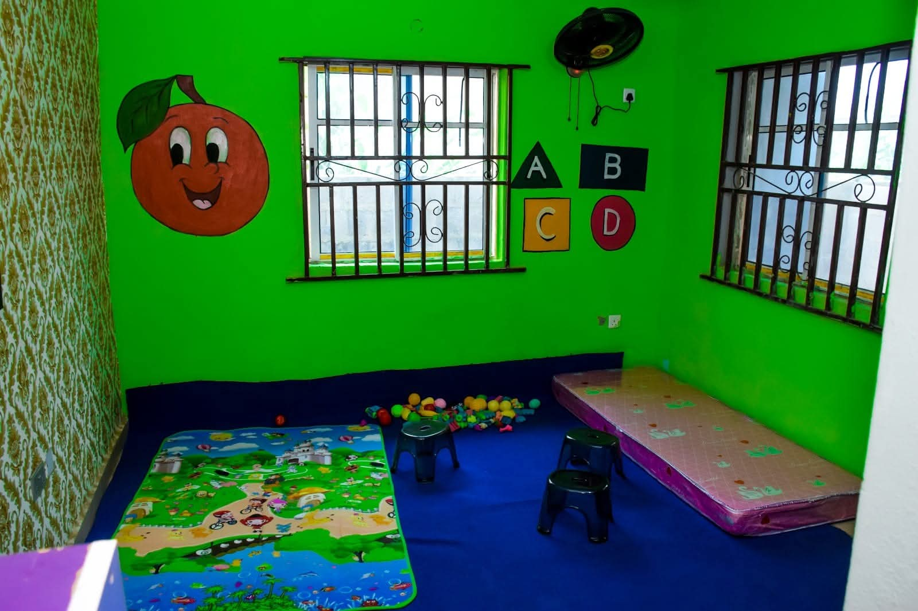
PLATE 3. 4: INTERIOR OF CASE STUDY TWO

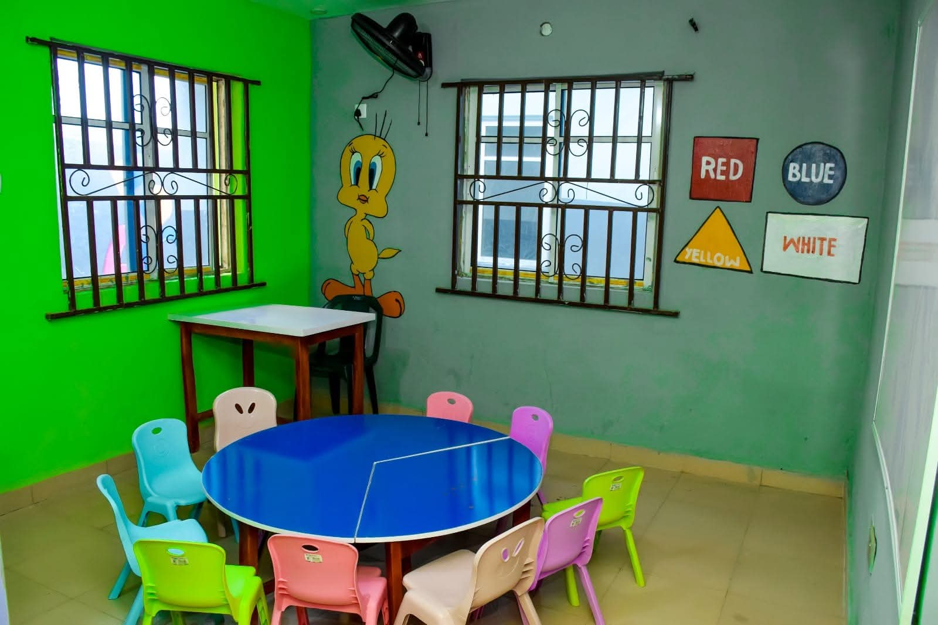
PLATE 3. 5: INTERIOR OF CASE STUDY TWO
Observations
- Merits:
  - Efficient indoor layout enhances caregiver supervision.
  - Outdoor and indoor play areas stimulate cognitive and physical development.
  - Energy-efficient design with natural lighting reduces operational costs.
- Demerits:
  - Limited indoor space during peak enrolment.
  - Outdoor play area is unusable during heavy rains due to lack of covered zones.

3.4 Case Study Three: Happy Tots Day Care Center
- Location: Oyo Town, Oyo State
- Year Established: 2017
Brief History
Happy Tots Day Care Center is a community-focused facility providing affordable early childhood care services. Known for its vibrant and interactive spaces, it integrates cultural motifs and local building materials to create a warm, familiar environment for children. The center emphasizes inclusive education and accommodates children with mild physical disabilities.
Design Features and Facilities
- Central Activity Room: Spacious hall with colourful décor, child-sized tables, and flexible play zones.
- Mini Library and Reading Corner: Encourages early literacy and quiet time.
- Outdoor Recreation Area: Grassy courtyard with shaded seating and safe play equipment.
- Kitchen and Dining Area: Strategically placed near the activity room for easy supervision during meals.
- Administrative Block: Houses the head caregiver’s office and a small first aid room.
- Restrooms: Well-ventilated, child-friendly, and accessible for children with special needs.
- Parking: Gravel lot accommodating 15 vehicles for staff and visitors.
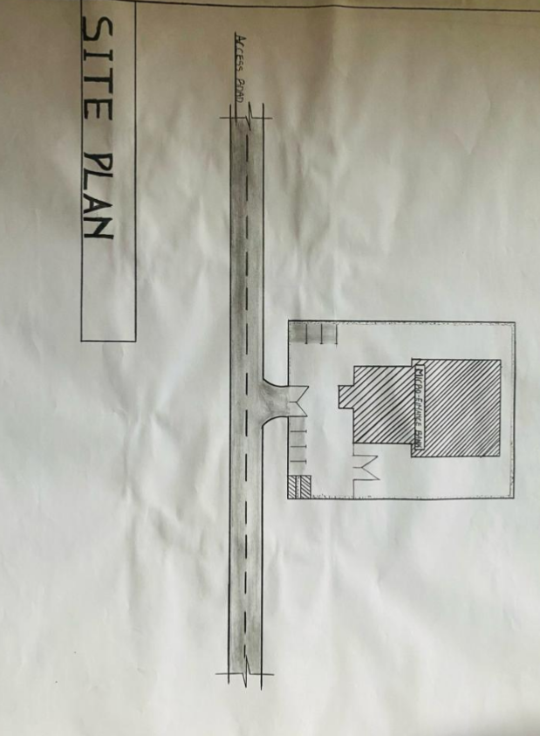
FIGURE 3.4: SHOWING THE SITE PLAN OF CASE STUDY THREE
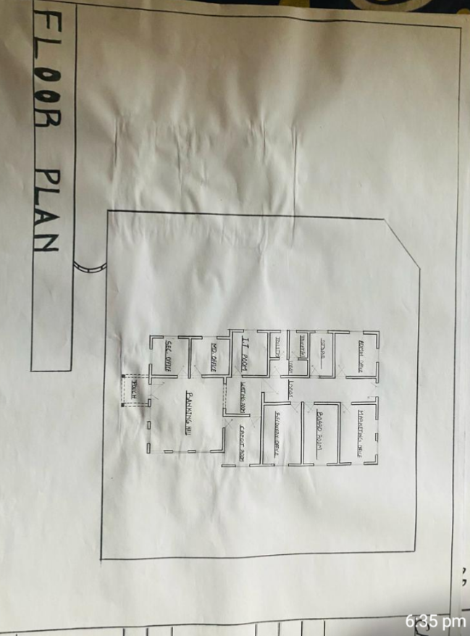
FIGURE 3.5: SHOWING THE FLOOR PLAN OF CASE STUDY THREE

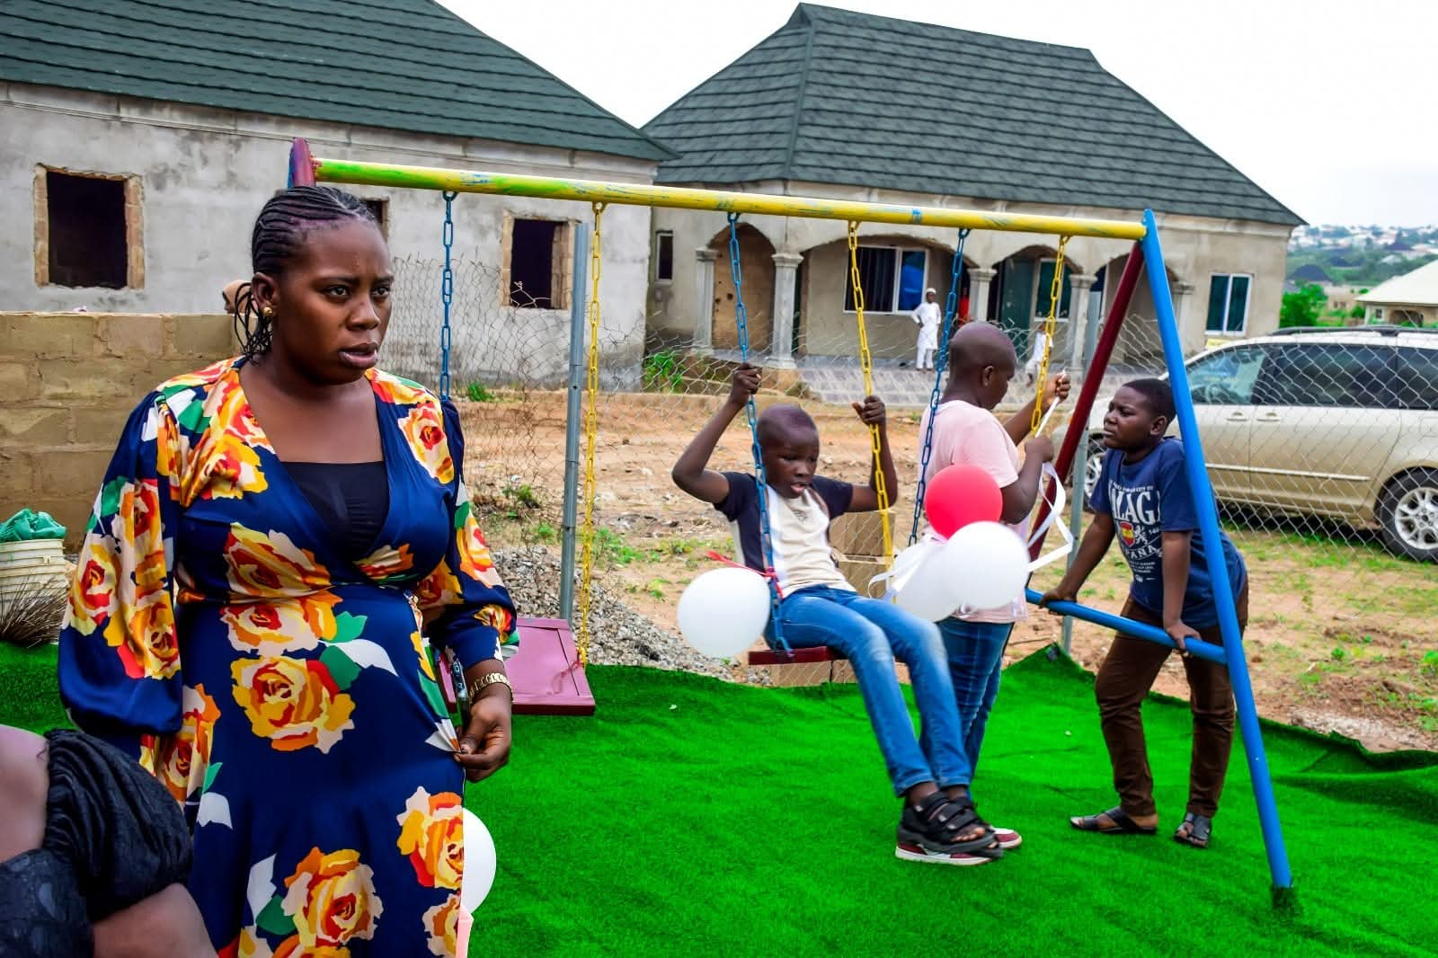
PLATE 3.3 : ELEVATION OF CASE STUDY THREE
Observations
- Merits:
  - Inclusive and community-oriented design.
  - Harmonious integration of indoor and outdoor spaces.
  - Promotes social interaction and early learning.
- Demerits:
  - Limited security features; perimeter fencing needs reinforcement.
  - Outdoor spaces are weather-dependent.
3.5 Summary of Case Studies
The three case studies highlight the importance of safety, functionality, and child-focused design in day care center architecture. Common successful features include:
- Flexible indoor play and learning spaces.
- Natural lighting and ventilation for comfort and energy efficiency.
- Outdoor play areas to support physical and social development.
Identified challenges included limited outdoor coverage during rainy conditions, spatial constraints, and occasional noise disturbances. Lessons from these studies will inform the proposed design by emphasizing inclusive layouts, weather-adaptable outdoor spaces, and integrated security measures.

CHAPTER FOUR
STUDY AREA / PROJECT SITE AND PROPOSED DEVELOPMENT
4.0 Study Area / Project Site
4.1 Introduction
Ilorin, the capital city of Kwara State, Nigeria, is a historic urban center renowned for its rich Yoruba, Fulani, and Islamic heritage. Founded in the 18th century, Ilorin has grown into a major administrative and educational hub in North-Central Nigeria. The city features a blend of traditional and modern architecture, and it continues to expand due to its roles in commerce, education, and governance.
The city’s population includes a significant number of working-class parents, civil servants, and students, making it a strategic location for a modern day care center. The increasing number of dual-income households and the growth of educational and administrative institutions have created a rising demand for safe, functional, and developmentally appropriate child care facilities in the city.
4.2 Site Location
The proposed project site is located within the Tanke area of Ilorin South Local Government Area, Kwara State. The site sits along a mixed residential and institutional corridor, which is in proximity to schools, health centers, and residential estates, ensuring convenience for parents dropping off and picking up their children.
- Site Coordinates: Approx. Latitude 8.4799° N, Longitude 4.5418° E
- Nearby Landmarks: University of Ilorin Secondary School, Tanke Junction Market, various mosques and churches, and small residential estates.
4.2.1 Site Selection Criteria
The selection of this site was based on the following considerations:
- Proximity to Residential Areas: Located near family residences to facilitate easy drop-off and pick-up.
- Accessibility: Connected by multiple local roads and public transport routes, ensuring ease of access.
- Land Size and Suitability: Sufficient plot area to accommodate classrooms, playgrounds, parking, and green spaces.
- Safety and Security: Situated within a low-crime, well-populated area with community watch and nearby police presence.
- Environmental Conditions: Well-drained, gently sloping terrain with sparse vegetation suitable for landscaping and outdoor play.
4.3 Site Features
4.3.1 Vegetation
The site has minimal natural vegetation, primarily small shrubs and a few medium-sized trees. Selected trees will be preserved to provide natural shading and enhance the outdoor play environment.
4.3.2 Topography
The terrain is gently sloping, which is advantageous for surface water drainage. Minimal grading will be required for construction.
4.3.3 Drainage
There is no formal drainage system on-site; therefore, the design will incorporate stormwater drains and soakaways to prevent flooding and ensure safety for children.
4.3.4 Accessibility
The site is easily accessible by local roads, with provisions for a dedicated drop-off/pick-up lane and separate pedestrian access to enhance child safety.
4.3.5 Climate
Ilorin experiences a tropical wet and dry climate:
- Rainy Season: April to October (peak June–September)
- Dry Season: November to March (Harmattan influence)
- Average Temperature: 27–34 °C
The building design will maximize cross-ventilation, sun-shading devices, and weather-resistant finishes for optimal comfort and durability.
4.3.6 Infrastructure and Utilities
- Electricity: Supplied via overhead power lines.
- Water: Accessible from local boreholes and municipal supply.
- Soil: Lateritic soil suitable for shallow foundation construction.
4.3.7 Noise Sources
Noise levels are generally low, with occasional vehicular activity from nearby residential streets. Outdoor play areas will be positioned away from any potential noise sources for child safety and comfort.

4.4 Site Analysis Summary
- Vegetation & Topography: Sparse vegetation; gently sloping land suitable for construction.
- Wind & Sun Path: Prevailing South-West wind (wet season) and North-East wind (dry season); allows for natural cross-ventilation.
- Accessibility: Well-connected to residential streets with room for vehicle circulation and pedestrian safety.
- Utilities: Electricity and water available; soil suitable for structural foundation.
- Noise Level: Low to moderate; manageable with landscaping buffers.
4.5 Proposed Design
The proposed development is a modern day care center designed to prioritize child safety, comfort, functionality, and aesthetic appeal. The facility will accommodate infants and toddlers, with spaces for learning, recreation, rest, feeding, and administration.
4.5.1 Design Considerations
Key architectural criteria for the day care center include:
- Child Safety: Secured fencing, controlled access points, non-slip flooring, and soft-fall surfaces for playgrounds.
- Aesthetic & Child-Friendly Environment: Use of bright colours, child-scaled furniture, wall murals, and natural lighting.
- Functionality: Efficient circulation between activity rooms, nap areas, playgrounds, and feeding spaces.
- Ventilation & Indoor Comfort: Large operable windows, shading devices, and cross-ventilation to maintain healthy air quality.
- Accessibility & Inclusivity: Ramps, low-level fixtures, and accessible restrooms for children with special needs.
- Landscaping: Shaded outdoor play zones with grass and rubberized flooring for safety and comfort.
- Security: Perimeter fencing, CCTV monitoring, and a dedicated reception to control access.
4.5.2 Design Concept
The design adopts a child-centered, functional layout where spaces are zoned into learning, resting, and play areas, while administrative and service zones remain separated to enhance operational efficiency. Open floor plans and visual transparency will allow caregivers to supervise children easily.
4.5.3 Functional Layout
The proposed day care center will include:
- Administrative / Service Areas
  - Reception and Waiting Area
  - Caregivers’ Office
  - First Aid and Sick Bay
  - Staff Lounge and Lockers
- Children Activity Areas
  - Indoor Play and Learning Hall
  - Sleeping/Nap Room
  - Feeding Area with Adjacent Kitchenette
  - Reading/Quiet Corner
- Outdoor Facilities
  - Secured Playground with Soft Flooring
  - Shaded Sitting Area for Outdoor Learning
- Support Facilities
  - Child-Friendly Toilets and Wash Areas
  - Storage for Toys, Learning Aids, and Cleaning Equipment
  - Designated Drop-off/Pick-up Zone
4.6 Functional Relationships
The building layout is based on safe and efficient circulation:
- Children move between activity rooms, nap rooms, and feeding areas without crossing service zones.
- Caregiver supervision is central, with visual connectivity to indoor and outdoor play spaces.
- Outdoor play areas are directly connected to the activity hall for easy monitoring.
- Administrative and staff areas are positioned near the entrance for security and operational control.
4.7 Conceptual Development
Key strategies guiding the design include:
- Safety-first circulation: Separation of child movement from service and vehicular areas.
- Daylight optimization: Use of large windows and skylights to reduce energy demand and create a lively atmosphere.
- Flexible space planning: Indoor areas can accommodate varied learning and recreational activities.
- Environmental sustainability: Inclusion of shaded landscaping, natural ventilation, and water-efficient features.
- Community integration: Outdoor areas that encourage social interaction during pick-up and drop-off hours.
4.8 Bubble Diagram
The conceptual bubble diagram illustrates the relationship between core functional zones:
- Child Activity Zone centrally located for supervision.
- Nap and Feeding Zones adjacent to the activity hall.
- Outdoor Playground directly linked to the main hall.
- Administrative/Reception Zone near the entrance for access control.
- Service Zone (storage, kitchen) separated from child circulation.
This arrangement ensures safety, efficiency, and developmental suitability, creating an environment where children can learn, play, and grow in comfort.

CHAPTER FIVE
APPROACH TO DESIGN / DESIGN REALIZATION
5.0 Specifications and Construction Approach
This chapter presents the construction methodology, materials, finishes, and building services required to realize the proposed day care center in Ilorin, Kwara State. Each component has been selected to prioritize child safety, functionality, durability, aesthetics, and sustainability, ensuring a nurturing environment that supports early childhood development.
5.1 Materials and Finishes
Material selection is crucial for the functionality and safety of children, as well as the long-term sustainability of the facility.
5.1.1 Wall Construction and Finishes
- Walls: Constructed with hollow sandcrete blocks, reinforced with concrete columns at intervals for stability.
- Internal Finishes: Smooth plastered and painted with washable, non-toxic, and child-safe emulsion paints.
- Activity & Play Areas: Lower wall portions finished with durable laminated panels or ceramic tiles for easy cleaning and to resist wear from child contact.
- External Finishes: Weather-resistant textured coatings (Graphitex or stone-effect) to enhance durability and aesthetics.
5.1.2 Floor Finishes
- Floors will consist of 150 mm mass concrete on a compacted hardcore base with damp-proof membranes.
- Non-slip, impact-resistant ceramic tiles or vinyl flooring will be used in classrooms, nap rooms, and corridors to ensure child safety.
- Soft flooring (rubber tiles or padded grass) will be used in indoor play zones to reduce injury risk.
5.1.3 Ceiling Systems
- Classrooms & Activity Areas: Acoustic suspended ceilings to reduce noise and create a comfortable learning environment.
- Service Areas (toilets, kitchen): Moisture-resistant PVC or gypsum board ceilings for hygiene and easy maintenance.
5.1.4 Roofing System
- A lightweight steel truss system will support long-span aluminum roofing sheets.
- Roof vents and ridge ventilation will be incorporated to expel hot air and maintain indoor comfort.
- Wide overhangs will protect windows from rain and reduce direct sunlight penetration.
5.1.5 Windows and Doors
- Windows: Aluminum casement windows with laminated safety glass to reduce injury risk and maximize natural light.
- Doors: Main entrances will have flush steel doors for security, while interior doors will be lightweight wooden doors with anti-pinch hinges.
- Emergency Exits: Outward-swinging doors with panic bars for rapid evacuation.
5.2 Structural System
i. Substructure (Foundation)
- Shallow strip foundations are proposed due to the firm lateritic soil conditions.
- Foundations will include reinforced concrete footings and damp-proof membranes to protect against moisture ingress.
ii. Superstructure
- Reinforced concrete columns and beams with sandcrete block infill walls.
- Load-bearing elements designed per Nigerian Building Code and to meet child safety standards, ensuring structural stability.
5.3 Building Services
i. Electrical Power Supply
- Power will be sourced from the national grid (PHCN).
- Solar backup system and inverter will support critical areas like the administrative office, lighting, and security systems.
ii. Lighting Design
- Natural lighting: Maximized with large windows and clerestory openings to create cheerful, child-friendly spaces.
- Artificial lighting: Energy-efficient LED fixtures with protective covers to prevent accidental damage.
iii. Ventilation Strategy
- Natural cross-ventilation: Achieved with opposite window placements and vent blocks.
- Mechanical ventilation: Ceiling fans and low-noise extractors in enclosed areas.
- Children’s comfort: Avoidance of harsh drafts or sharp temperature fluctuations.
iv. Fire Safety Systems
- Smoke detectors in key rooms (classrooms, kitchen, and storage areas).
- Fire extinguishers and hose reels placed in accessible points.
- Clearly marked illuminated emergency exits and fire assembly points.
- Non-combustible finishes in the kitchen and storage areas for passive fire protection.
v. Plumbing and Water Supply
- Concealed piping system for hygiene and aesthetic appeal.
- Child-height hand wash basins and toilets in dedicated sanitary areas.
- Water sourced from borehole with overhead storage tank to guarantee continuous supply.
vi. Drainage and Waste Disposal
- Properly graded channels to manage stormwater runoff.
- Septic tank and soakaway system for sewage disposal.
- Child-safe waste segregation system with covered bins in indoor and outdoor spaces.
5.4 Landscaping and External Works
Soft Landscaping
- Grassy lawns, shaded trees, and ornamental plants to create a calm and stimulating environment for children.
- Rubber-padded outdoor play areas to enhance safety.
Hard Landscaping
- Paved pedestrian paths and child-friendly outdoor activity zones.
- Secure perimeter fencing with controlled gates for drop-off and pick-up.
Access and Circulation
- Dedicated one-way vehicular route for drop-off and pick-up.
- Separate pedestrian walkway to prevent accidents.
Parking Provision
- Provision for staff and visitor parking, including short-term parking bays for parents.
5.5 Conclusion
The proposed day care center in Ilorin, Kwara State adopts a child-focused, safe, and sustainable design approach. By integrating durable materials, proper ventilation, fire safety systems, and outdoor learning spaces, the facility will provide a conducive environment for early childhood care and education.
The design realization reflects a balance between safety, functionality, and aesthetics, ensuring that the facility meets both developmental needs of children and operational efficiency for caregivers.

References
Bitner, M. J. (1992). Servicescapes: The Impact of Physical Surroundings on Customers and
Employees. Journal of Marketing, 56(2), 57–71.
Davis, D. (2010). The Role of Architecture in Shaping Social Interaction in Hospitality
Settings. International Journal of Contemporary Hospitality Management, 22(1), 1–14.
Edwards, J. S. A., & Gustafsson, I.-B. (2008). The Room and Atmosphere as Aspects of the
Meal: A Review. Journal of Foodservice, 19(1), 22–34.
Horng, J.-S., Chou, S.-F., & Liu, C.-H. (2013). Creativity and Sustainable Development of
Culinary Professionals: A Case Study of Open-Kitchen Restaurants in Taiwan. Sustainability, 5(7), 2956–2971.
Jones, P., & Lockwood, A. (2004). The Management of Hotel Operations. London: Thomson
Learning.
Kimes, S. E., & Robson, S. K. A. (2004). The Impact of Restaurant Table Characteristics on
Meal Duration and Spending. Cornell Hotel and Restaurant Administration Quarterly, 45(4), 333–346.
Preiser, W. F. E., & Ostroff, E. (2001). Universal Design Handbook. New York: McGraw-
Hill.
Waxman, L. (2006). The Coffee Shop: Social and Physical Factors Influencing Place
Attachment. Journal of Interior Design, 31(3), 35–53.
Bitner, M.J. (1992). Servicescapes: The impact of physical surroundings on customers and
employees. Journal of Marketing, 56(2), 57–71.
Davis, M. (2010). Architecture of Community. Island Press.
Edwards, J.S.A., & Gustafsson, I.B. (2008). The room and atmosphere as aspects of the
meal: A review. Journal of Foodservice, 19(2), 22–34.
Horng, J.S., Chou, S.F., Liu, C.H., & Tsai, C.Y. (2013). Creativity and sustainable
development: Trends and successful practices in architecture and design. Sustainability, 5(3), 1239–1255.
Jones, P., & Lockwood, A. (2004). The Management of Hotel Operations. Cengage Learning.
Kimes, S.E., & Robson, S.K.A. (2004). The impact of restaurant table characteristics on
meal duration and spending. Cornell Hotel and Restaurant Administration Quarterly, 45(4), 333–346.
Lockwood, A., & Medlik, S. (2001). Tourism and Hospitality in the 21st Century.
Butterworth-Heinemann.
Preiser, W.F.E., & Ostroff, E. (2001). Universal Design Handbook. McGraw-Hill.
Waxman, L. (2006). The coffee shop: Social and physical factors influencing place
attachment. Journal of Interior Design, 31(3), 35–53.
Adams, T. (2018). Zoning for Functionality in Restaurant Design. Architectural Digest, 56(4),
44–53.
Bitner, M.J. (1992). Servicescapes: The Impact of Physical Surroundings on Customers and
Employees. Journal of Marketing, 56(2), 57–71.
Brown, L., & Clarke, J. (2023). Tech-Driven Restaurant Design. Hospitality Technology
Review, 35(1), 21–33.
Carter, E., & Brooks, H. (2021). Planning for Flow: Spatial Arrangement in Hospitality
Spaces. Design Quarterly, 49(2), 88–101.
Edwards, J.S.A., & Gustafsson, I.B. (2008). The Room and Atmosphere as Aspects of the Meal:
A Review. Journal of Foodservice, 19(2), 22–34.
Green, K., & Morris, L. (2022). Modular Thinking in Restaurant Design. International Journal
of Hospitality Architecture, 18(2), 60–72.
Jones, P., & Lockwood, A. (2004). The Management of Hotel Operations. Cengage Learning.
Lawson, B. (2001). The Language of Space. Architectural Press.
Lee, R. (2019). Efficient Kitchen Layouts for the Modern Restaurant. Culinary Engineering
Journal, 11(1), 11–20.
Logan, M. (2023). Biophilic Design in Restaurants: A Green Revolution. Sustainable Design
Journal, 29(4), 39–49.
Martin, D. (2022). Smart Service Systems in Restaurants. Service Innovation Quarterly, 14(3),
75–88.
Miller, D., & Lopez, F. (2020). Designing for All: Principles of Universal Accessibility. Journal
of Inclusive Architecture, 15(1), 33–47.
Nelson, P., & White, G. (2022). Access for All: Hospitality Design for Inclusivity. Access and
Inclusion Review, 8(2), 19–31.
Nguyen, K., & Harper, S. (2020). Brand Identity Through Space. Restaurant Design Studies,
13(3), 102–116.
O’Neil, R. (2020). Furniture Flexibility in Modern Dining Spaces. Furniture Design Today,
22(4), 51–63.
Peters, J. (2021). Practical Universal Design for Restaurants. Design for All Quarterly, 19(1),
66–78.
Sanders, L. (2022). Visual Branding in Restaurant Interiors. Commercial Interiors Journal,
10(2), 84–95.
Smith, H., & Baker, R. (2021). Sustainable Practices in Restaurant Design. Journal of
Environmental Architecture, 7(2), 99–110.
Taylor, M., & Benson, A. (2019). Adaptive Dining Layouts in Hospitality Design. Hospitality
Interiors, 6(3), 29–41.
Walters, D., Jones, F., & Harris, A. (2021). Restaurants as Social Spaces: Design
Considerations. Urban Social Design Journal, 16(2), 59–73.
Waxman, L. (2006). The Coffee Shop: Social and Physical Factors Influencing Place
Attachment. Journal of Interior Design, 31(3), 35–53.

APENDICES
