
DEPARTMENT OF SCIENCE LABORATORY TECHNOLOGY
PHYTOCHEMICAL PROFILLING OF THE CRUDE EXTRACTS OF EUPHORBIA NUTANS (NODDING SPURGE) LEAVES

By

YAHYA RIDWAN ASUKUTI
HND/23/SLT/FT/1032

BEING A THESIS SUBMITTED TO
THE DEPARTMENT OF SCIENCE LABORATORY TECHNOLOGY (CHEMISTRY UNIT),
INSTITUTE OF APPLIED SCIENCES, KWARA STATE POLYTECHNIC ILORIN, KWARA STATE.
IN PARTIAL FULFILLMENT OF THE REQUIREMENT FOR THE AWARD OF HIGHER NATIONAL DIPLOMA (HND) IN SCIENCE LABORATORY TECHNOLOGY, KWARA STATE POLYTECHNIC ILORIN,
KWARA STATE

SUPERVISED BY: MR. O. E. ADEYEMO

2024/2025 SESSION

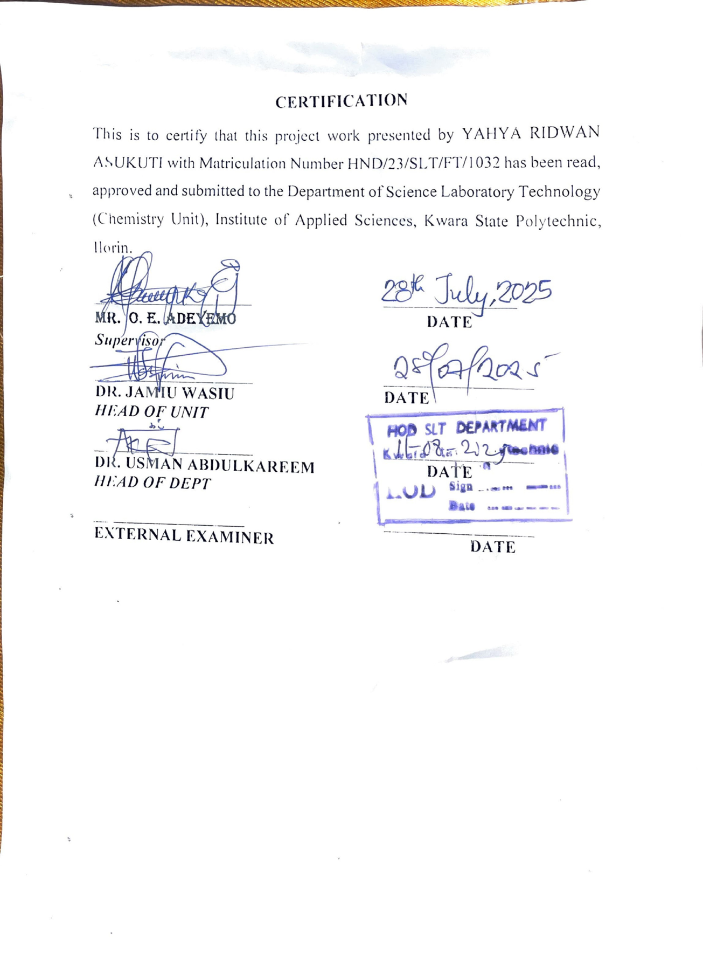
DEDICATION
We dedicated this project to Almighty God, the One who makes impossibility possible, for the opportunity given to us during this project work.
Also to our noble and loving parents for their cares, supports and prayers for us, may Almighty God bless them (AMEN).

ACKNOWLEDGEMENT
All praises, thanks and adoration are due to Almighty God, the Creator of heavens and the earth, who spared our lives.
More so, we acknowledge our Supervisor in person of Mr. Adeyemo O. E for his patience and word of advice to us, may Almighty God bless him and his home greatly (AMEN).
Also to our adored and loving parents, who have been there for us from birth until date, may Almighty God let them reap the fruit of their labours (AMEN).
Then, to our amiable and caring lecturers in SLT Department for their cares during our program in this institution, may Almighty God reward him Abundantly (AMEN).
Finally, we are grateful to our families for their efforts and to all our friends both at home and in the school, God will always be with you all (AMEN).

Contents
Title page
Certification
Dedication
Acknowledgements
Table of Content
Abstract
CHAPTER ONE
1.0 Introduction
1.1 Problem statement
1.2 Aims and Objectives of the Study
1.3 Justification of the Study
1.4 Relevance of the Study
1.5 Scope of the Study
CHAPTER TWO
2.0 Literature review
2.1 Background of nodding spurge
2.2 Taxonomic classification of nodding spurge
2.3 Distribution map
2.4 Detailed description
2.4.2 Leaves and stems
2.4.3 Fruit
2.5 Favorable climate
2.6 Nodding spurge in pastures and hay fields
2.7 Managing nodding spurge in pastures and hay
2.8 Insects, diseases and other plant problems
2.9 Management guidelines for spurges
2.10 Nodding spurge weed control
2.11 Toxicity of nodding spurge
2.12 Traditional uses of euphorbia species
2.13 Phytochemicals
2.13.1 Phytochemicals types and functions
2.13.1.1 Classes of phytochemicals
2.13.1.1.1 Flavonoids
2.13.1.2 General functions of phytochemicals
2.14 Pharmacological and biological activities of euphorbia species
2.14,1 Antimicrobial activity
2.14.2 Antioxidant and antiviral activity
2.14.3 Anti-inflammatory activity
2.14.4 Anthelmintic activity
2.14.5 Immunomodulatory activity
2.14.6 Other activities
2.14.7 Neuroprotective activity2.14. 8 other biological activities
2.15 Toxicity and side effect
CHAPTER THREE
3.0 Materials and methods
3.1 Reagents and apparatus
3.1.1 Reagents
3.1.2 Apparatus and equipment
3.2 Collection of samples
3.3 Preparation of samples
3.4.1 Qualitative phytochemical analysis
CHAPTER FOUR
4.0 Results and discussion
4.1 Results
4.2 Discussion
4.3 Conclusion
References as footnotes

Abstract
The dried leaves of euphorbia nutans were extracted with five (5) different solvents of varying polarity (n-hexane, chloroform, ethyl acetate, acetone and ethanol) to assess their extractive power for the component phytochemicals and to profile the phytochemicals present in the leaves sample. The results of the study showed that aqueous ethanol had the greatest extractive power by showing the highest number of phytochemicals in its crude extract, compared to those of others. The ethanol showed the presence of eight (8) phytochemicals, acetone showed five (5) phytochemicals, chloroform extracts showed three (3) while ethyl acetate and n-hexane each showed the presence of one phytochemical. Those phytochemicals present in the leaves sample of e. nutans are; steroids, triterpene, alkaloids, tannins, flavonoids, lactones, diterpenes, and glycosides. Only saponins was found to be absent. These secondary metabolites present make the plant a potential medicinal plant rather than just a weed.

Keywords: euphobiaceae, euphorbia nutans, phytochemicals, extracting solvents

CHAPTER ONE
1.0 INTRODUCTION
Euphorbia is the third largest genus in the flowering plants after Fabaceae and Rubiaceae with about 2000 species distributed worldwide¹. The family includes approximately 6200 species in 200 genera which are mostly trees, shrubs, herbs, climbers and succulents recorded throughout the world except the cold alpine and arctic regions^{2,3}.
The Euphorbiaceae family, commonly referred to as the spurge family is well-known in terms of its species used as sources of traditional medicines. Moreover, the Fabaceae, Lamiaceae, Euphorbiaceae, Apocynaceae, Malvaceae, Apiaceae and Ranunculaceae families are listed as being the medicinally most important plant families on a worldwide scale⁴.
1. Pascal A. Olounladé, et al. “A review of the ethnomedical uses, phytochemistry and pharmacology of the Euphorbia genus”. The Pharma Innovation Journal. 2017, 6(1), 34-39
2. M. Koekemoer, H. M. Steyn, and S. P. Bester. “Guide to plant families of southern Africa. Strelitzia 31”. South African National Biodiversity Institute, Pretoria, South Africa. 2014.
3. M. J. Christenhusz and J. W. Byng.” The number of known plants species in the world and its annual increase”. Phytotaxa. 2016, 261, 201-217.
4. M. Phumthum, H. Balslev, and A. S. Barfod. “Important medicinal plant families in Thailand”. Front Pharmacol. 2019, 10, 1125.
Euphorbiaceae plant family is notably one of the most prominent flowering plant families with 227 accepted genera and over 8000 species⁵. Euphorbiaceae species are widely distributed, from Neotropical to Afrotropical, Indo-malayan, Australasian, and Oceanian regions⁶. Species from this family exhibit a wide range of morphologies, including climbers, shrubs, and woody trees that often have latex in a variety of colors⁷.
It has been widely reported for its ethno-medicinal uses for the treatment of diseases ranging from respiratory infections, body and skin irritations, digestion complaints, inflammatory infections, body pains microbial illness, snake/scorpion bite, endocrine and sensory disorders⁸. Studies showed the purgative and emetic effects of Euphorbia species⁹.
5. Euphorbiaceae Juss, In Plants of the World Online, Kew Science. https://powo.scie nce. kew.org/taxon/urn:lsid:ipni.org:names:30375178-2.
6. D.S. Seigler. “Phytochemistry and systematics of the Euphorbiaceae”. Ann. Missouri Bot. Gard. 81. 1994, 380–401. https://doi.org/10.2307/2992104.
7. M.G. Simpson, Diversity and classification of flowering plants: eudicots, Plant Syst. 2010, 275–448.
8. M. Ernest, et al. “Uses of Euphorbia L. (Euphorbiacene)”. Journal of Ethnaphamacology, 2015, 176.
9. O. C. Chika, et al. “Antibacterial activities and toxicological potentials of crude ethanolic extracts of Euphorbia hirta”. Journal of American Science. 2007. 3(3), 11-160
They are also implicated in the treatment of skin diseases such as warts, sores, carbuncles, boils, hair loss, dermatitis, sunburn and eczema¹⁰.
The family Euphorbiaceae, also called the spurge family, named in honors of Greek Physician Euphorbia, is a diverse angiosperm family. The genus Euphorbia belonging to this family is the third-largest genus of Angiosperms¹, consisting of approximately 2000 species, distributed throughout the world. In India, the species of Euphorbia have been part of traditional medicinal knowledge among several communities for treating various skin disorders, renal infections, snakebites, leprosy, infertility, etc. There are approximately 195 species of Euphorbia reported in India¹¹.
Medicinal plants are vital to life of every form, especially human lives. They have been used in the traditional medicinal system since
10. S. Amtaghri, et al. “Traditional uses, pharmacological and phyotochemical studies of Euphorbia: A review”. Current Topics in Medicinal Chemistry. 2022, 22(19), 1553- 1570.
11. S. Sonakshi, et al. “Phytochemical analysis of euphorbia species of Gujarat, India: a review”. International Association of Biologicals and Computational Digest. 2024, 3(1), 22-33.
ancient times to treat a wide range of diseases and to promote health¹². Recording the medicinal relevance of species from high biodiversity areas is crucial because some of these plants' natural habitats are rapidly disappearing as a result of anthropogenic activities¹³. It is generally estimated that there are approximately between 250,000 and 500,000 species of higher plants. Approximately 10,000 of different plants around the world have recorded medicinal use, and >90% of present therapeutic classes derive from natural product prototype¹⁴.
Medicinal plants have been playing a crucial role on the health care and well-being of man since the dawn of human civilization. According to World Health Organization (WHO), medicinal plants were the best source to obtain variety of drugs. About 80 per cent of individuals from developed countries use medicines, which has compounds derived from different medicinal plants. However, such

12. S. M. K. Rates. “Plants as source of drugs”. Toxicon. 2001, 39, 603–613.
13. O. Olaoluwa, et al. “Ethnopharmacology, phytochemistry and biological activities of selected African species of the genus Ficus” Trends Phytochem. Res. 2022, 6, 46–69.
14. V. Butterweck, and A. Nahrstedt. “What is the best strategy for preclinical testing of botanicals? A critical perspective” Planta Med. 2012, 78, 747–754.
plants should be further investigated to better understand their properties, safety, and efficiency¹⁵.
Plants are naturally gifted at the synthesis of medicinal compounds, whose characterization has led to discovery of new, cheap drugs with high therapeutic potential^{16,17}. Their exploitation in medicine is very old, for example, in 28 A.D the Greek physician Dioscorides wrote De Materia Medica which included 600 medical plants and was the leading text on pharmacology until the renaissance. Hippocrates may have prescribed willow tree leaves to abate fever. Salicin having anti-inflammatory and pain-relieving properties was originally extracted from the white willow tree and later synthetically produced to become the staple over-the-counter drug^{18, 16}. Medicinal plants contribute significantly to rural livelihoods. Apart from the traditional healers practicing herbal medicine, many people are
15. S. Arunkumar, M. Muthuselva. “Analysis of phytochemical constituents and antimicrobial activities of aloevera L. against clinical pathogens. World J. Agril. Sc. 2009, 5(5), 572-576.
16. Huie C.W., 2002. Review: Modern sample preparation techniques for the extraction and analysis of medicinal plants. Journal of Analytical and Bioanalytical Chemistry, 373, 23-30.
17. Ukwuani A.N., Abubakar M.G., Hassan S.W., Agaie B.M., 2013. Antinociceptive Activity of Hydromethanolic Extract of Some Medicinal Plants in Mice. International Journal of Pharmacy. Photon 104, 120-125.
18. Houghton P.J., Raman A., 1998. Laboratory Hand book for the Fractionation of Natural Extracts. London: Chapman and Hall, 1st edition, pp. 1-153.
involved in collecting and trading medicinal plants. The result is an increased demand in both local and international markets as well as bio-prospecting activities searching for sources of new drugs. The World Health Organization (WHO) has estimated that about 80% of the world’s population depends on medicinal plants for their primary health-care¹⁹⁻²². Drugs derived from unmodified natural products or semi-synthetic drugs obtained from natural sources accounted for 78% of the new drugs approved by the United States Food and Drug Administration (FDA) between 1983 and 1994^{21,23}.

19. Mothana R.A., Abdo S.A., Hasson S., Althawab F.M., 2008. Antimicrobial, Antioxidant and Cytotoxic Activities and Phytochemical Screening of Some Yemeni Medicinal Plants. Journal of Evidence-based Complimentary and alternative medicine, doi:10.1093/ecam/nen004.
20. Gupta V.K., Shukla C., Bisht G.R.S., Kumar S., Thakur R.L., 2010. Detection of anti-tuberculosis activity in some folklore plants by radiometric BACTEC assay. Letters in Applied Microbiology., 52, 33-40.
21. Ngoci S.N., Mwendia C.M., Mwaniki C.G., 2011. Phytochemical and cytotoxicity testing of Indigofera lupatana Baker F. Journal of Animal & Plant Sciences, 11(1), 1364-1373.
22. Prakash V, Sandhu P., 2012. In vitro antimycobiotic and antibacterial action of seed extract of Celastrus paniculatus Willd. (Jyotismati). Journal of Antimicrobials. Photon 127 (2012) 123-132.
23. Suffredini B.I., Paciencia M.L.B., Nepomuceno D.C., Younes R.N., Varella A.D., 2006. Anti-bacterial and cytotoxic activity of Brazilian plant extracts- Clusiaceae. Memórias do Instituto Oswaldo Cruz, 101, 1590-1598.
1.1 PROBLEM STATEMENT
Herbal remedies are cheap alternative to conventional medicine. They have contributed significantly to rural livelihoods and apart from the traditional healers practicing herbal medicine, many people are involved in collecting and trading in medicinal plants. Despite the fact that medicinal plant use has been an old habit in most communities, the emergence of drug and multidrug-resistant strains of microorganisms have opened a morewider window for continued research and discoveries on medical plant. Also most communities in developing nations are deep into medicinal plant use due to the alarming rates of poverty and therefore this need scientific backing especially in deducing their efficacies to treatment of such ailments. They provide unlimited opportunities for new drug leads because of the unmatched availability of chemical diversity.
Presently there are very few reported works in the literature about the phytochemical profile of Euphorbia nutans, although many other plants in the euphorbiaceae family. This indicates that there has ben little scientific attention on this very specie and definitely has contributed to its unpopular nature in this part of the world, hence its majorly regarded as weed. Its medicinal potential and value has not been well explored as well. This study is intended to look into this area of the plant by exploring its chemical and medicinal nature. This may consequently bring to fore the medicinal importance of the plant and subsequently promote its usage.
1.2 AIM AND OBJECTIVES OF THE STUDY
The aim of this study is to qualitatively profile the ethanolic extract of nodding spurge for the secondary metabolites present.
Specific objectives
i. To collect samples of fresh leaves of euphorbia nutans (nodding spurge) from areas with Ilorin town in Kwara State, Nigeria.
ii. To dry the washed leaf samples and ensure its dried under shade away from direct sunlight.
iii. To extract the pulverized dried leaf with ethanol
iv. To qualitatively test for the presence of a number of phytochemicals in the crude ethanolic extract.
v. To assess the possible medicinal potential of the crude ethanolic extract based on its phytochemical load.
vi. To compare the extractive powers of these solvents to determine the best solvent for extracting bioactive components of e. nutans
1.3 JUSTIFICATION OF THE STUDY
Eyebane has potential medicinal properties and a place in traditional medicine. It's important to exercise caution due to its toxicity. Nodding spurge lies in its potential therapeutic benefits and its role in the ecosystem, but its use should be approached with care and awareness of its potential dangers. This study will tend to further pronounce its potential and medicinal value. In addition it will serve as eye opener to investigating other plants regarded as weeds in this environment, thereby promoting local herbs medicinal significance.
1.4 RELEVANCE OF THE STUDY
This work is relevant in the area of “alternative medicine” and in the use of medicinal plants/natural product for drug discovery. Euphorbia Nutans is relevant due to its medicinal properties, ecological role and potential toxicity. It's used traditionally for various ailments and can be nectar source for pollinators. It also contains a milky sap that can cause irritation to humans and animals.
1.5 SCOPE OF THE STUDY
This project work is designed to assess the type of naturally occurring chemical compounds in the crude extracts of Euphorbia Nutans from several solvents. It will not include the quantification of these compounds, but solely their detection to establish how rich the plant is in phytochemicals.

CHAPTER TWO
2.0 LITERATURE REVIEW
Euphorbia nutans is a part of medicinal herbs that are viewed as the local heritage with global importance. They are used to treat several diseases of humans and animals. Among these herbs, we have the species of Euphorbia (Spurges). He is a very large and diverse genus of flowering plants in the spurge family (Euphorbiaceae)¹. All spurges produce mostly white latex which they exude when cut, and this sap is often toxic. The rich morphological variability and near-cosmopolitan distribution of Euphorbia^{24,25} have attracted human interest around the world since ancient and even prehistoric times^{26,27}.

24. J. W. Horn, et al. “Phylogeneties and the evolution of major structure and character in the giant genur Euphorbia L. Euphorbiacene”. Molecular phylo-genetics and Evolution, 2012, 63(2), 305-326.
25. A. Karimi, et al. “Determination of antioxidant activity, phenolic contents and antiviral potential of methanol extract of Euphorbia spinidens Bornm (Euphorbiaceae)”. Tropical. Journal of Pharmaceutical Research. 2016, 15(4), 759-764.
26. R. E. Schultes. “Members of Euphorbiaceae in primitive and advanced societies”. Botanical. Journal of the Linnean Society. 1987, 94, 79-95.
27. M. Ernst, et al. “Global medicinal uses of Euphorbia L. (Euphorbiaceae)”. Journal of Ethnopharmacology. 2015; 52:1-43.
In Nigeria for example extracts or exudes of the plant are used as ear drops and in the treatment of boils sore and promoting wound healing^{28,29}. Spurge are known for their uses as ornamental and household plants and their latex contributed to the economic importance of some species such as Euphorbia antisyphilitica, Zucc. (Candelilla wax)^{26,27,30}.
Numerous studies were done on many species of Euphorbia to provide phytochemistry and biological activity of the compounds¹.
Studies have shown the purgative and emetic effects of Euphorbia species²⁸.
2.1 BACKGROUND OF NODDING SPURGE
Euphorbia nutans is a summer annual herb and a native of North American occurs throughout Tennessee. It is a troublesome weed in
28. C. Ogueke Chika, N. Jude, I. C. Okoli, B. N. Anyanwu. Antibacterial activities and toxicological potentials of crude ethanolic extracts of Euphorbia hirta”. Journal of American Science. 2007, 3(3), 11-16.
29. B. P. Sandeep, S. N. Nilofar, and S. M. Chandrakant. “Review on phytochemistry and pharmacological aspects of Euphorbia hirta Linn. Journal of Pharmaceutical Research and health Care. 2009, 1(1), 113-133.
30. A. F. M. Rizk. “The chemical constituents and economic plants of the Euphorbiaceae”. Botanical Journal of the Linnean Society. 1987, 94, 293-326.
row and vegetable crops, ornamentals, right-of-way, pastures and hay fields, and many other situations³¹. It was found in disturbed areas like roadsides, riverbanks, and garden, and lawns. It has been recognized for its milky sap that can cause skin irritation³². It grows small clusters of cup-shaped white flowers. Like all other species of euphorbia, this plant has a sap that is toxic³³.

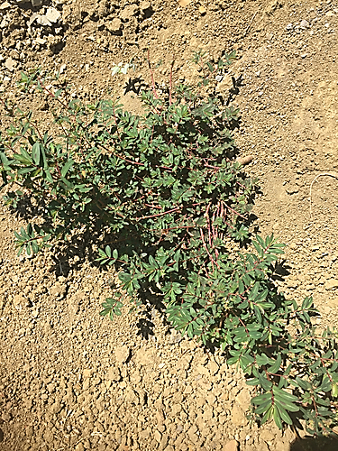
Figure 2.1: Nodding spurge grown on roadside
31. G. Neil Rhodes, Jr. “Nodding spurge”. Department of Plant Sciences, Institute of Agriculture, University of Tennessee. 2017, D52, 1-3
32. North Carolina Extension Gardener Plant Toolbox. www.plants.ces.ncsu.edu.
Retrieved July, 202533.
33. www.picturethisai.com/wiki/Euphorbia_nutans.html. Retrieved July, 2025
2.2 TAXONOMIC CLASSIFICATION OF NODDING SPURGE
Nodding spurge is a weedy annual or short-lived perennial herb in the spurge family Euphorbiaceae, native to much of the United States, Eastern Canada, Mexico, Central America, the Caribbean, and Venezuela. The specific epithet, nutans, means “nodding” and references the nodding nature of stems³⁴.
Table 2.1: Taxonomic classification³⁴
Kingdom | Plantae – Plants
Subkingdom | Tracheobionta - Vascular plants
Superdivision | Spermatophyta - Seed plants
Division | Magnoliophyta - Flowering plants
Class | Magnoliopsida – Dicotyledons
Subclass | Rosidae
Order | Euphorbiales
Family | Euphorbiaceae Juss. - Spurge family
Genus | Chamaesyce Gray – sandmat
Species | Chamaesyce nutans (Lag.) Small - eyebane
34. North Carolina Extension Gardener Plant Toolbox. www.plants.ces.ncsu.edu. Retrieved July, 2025
2.3 DISTRIBUTION MAP
Eyebane is native to parts of Central and South America. It has since spread to assorted regions across Europe, Asia, North Africa, and Oceania.
2.4 DETAILED DESCRIPTION
The cotyledons or seed leaves of seedlings are glabrous (lack trichomes or hairs) and the stem are red and glabrous. The first true leaves are opposite with irregularly toothed margins. As the plant grow Figure 2.2 below, it continues to form opposite, simple oblong or oblong-elliptically shaped leaves that are approximately 0.1 to 0.6 inches wide and 0.2 to 1.6 inches long. The leaves and stems produce a milky irritant sap when cut or crushed. The plant has a fibrous root system, and it can grow to a height of approximately 30 inches.
Nodding spurge produces separate, small, white male and female flowers (Figure 2.3). The fruit of nodding spurge is a capsule,
35. Plant Encyclopedia>Eyebane www.picturethisai.com/wiki/Euphorbia_nutans.html
approximately 0.1 inches wide and long that contains ovoid, irregularly wrinkled seeds (Figure 2.4)³¹.
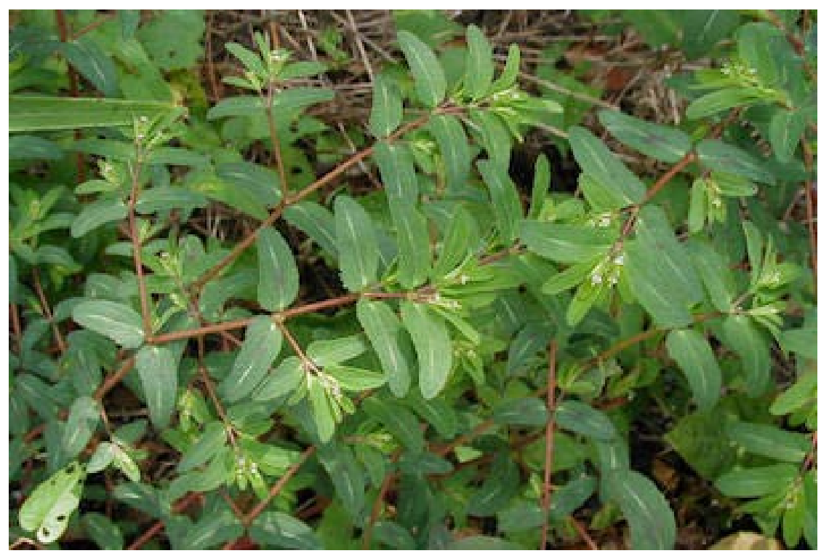
Figure 2.2: Opposite leaf arrangement of Nodding Spurge³⁶.
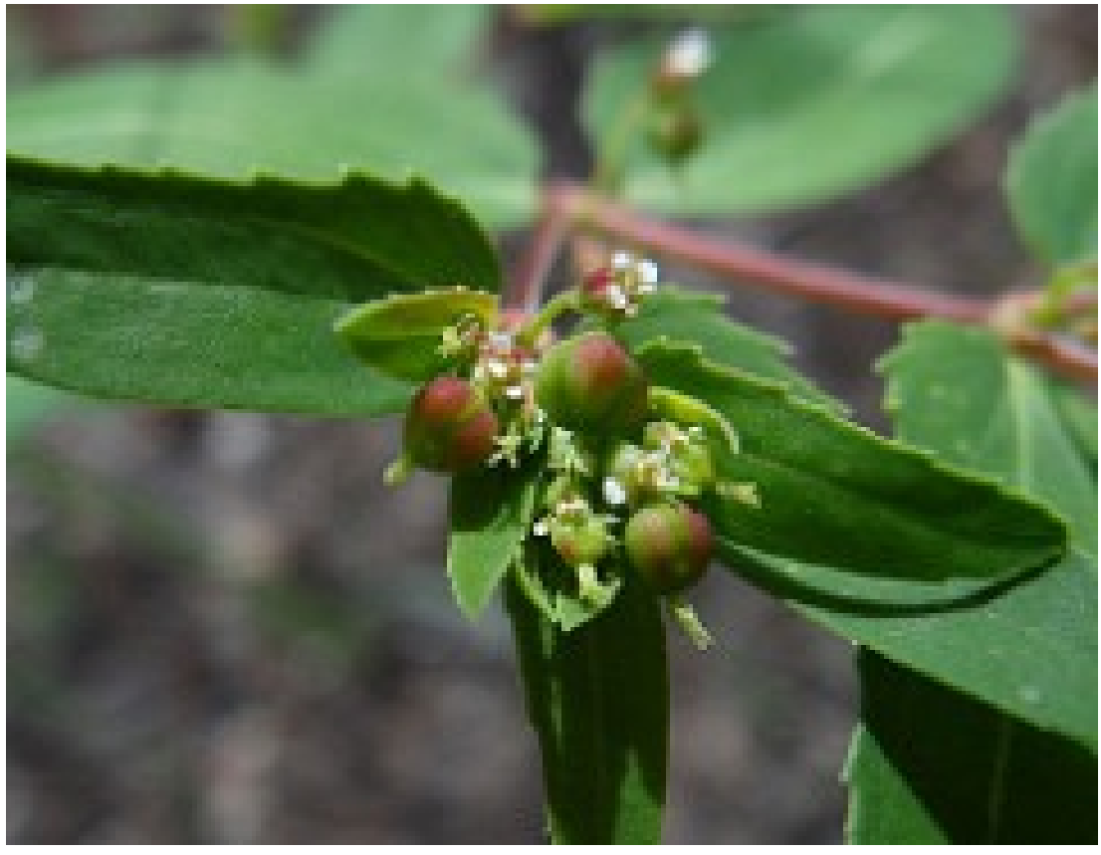
Figure 2.3: Nodding spurge flower and seed capsule³⁷.
36. https://missouristate.edu/pbtrewatha/nodding_spurge.htm
37. https://www.flickr.com/photos/coreyaimond/6136509840
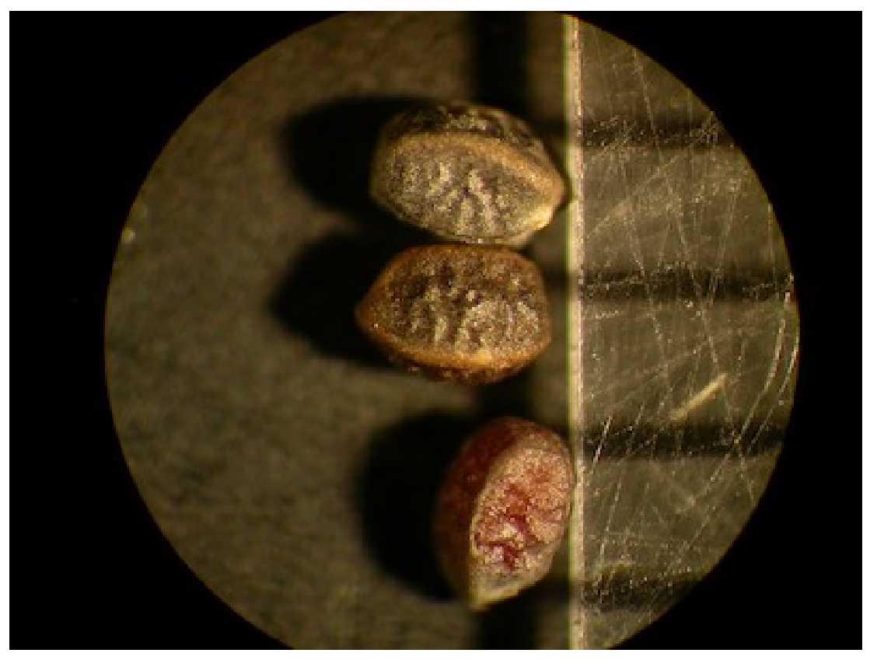
Figure 2.4: Nodding spurge seed³⁸
2.4.1 Flower
Flower shape: 4-petals Cluster type: flat
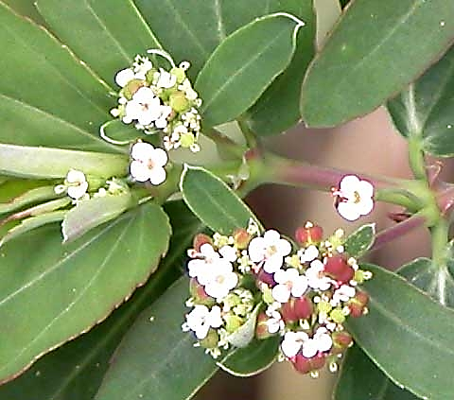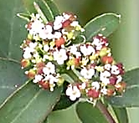
Figure 2.4: Nodding spurge flowers sowing the petals³⁴
38. http://soilcropandmore.info/crops/weeds/nodding_spurge.htm
The flowers are small clusters of cup-shaped, greenish-pink and white blooms at the ends of the branches³⁴. Flowers are small but distinct, mostly in clusters at the tips of branches, few in the lower leaf axils. A small cup, 1/8 inch across, holds the male and female flowers in the center. The rim of the cup has 4 white to pink, rounded petal-like appendages, each a thickened gland at the base that is green to red. The male flower anthers are yellow and nearly indistinct. The clump of styles of the single female flower in the center sit atop a round, 3-parted ovary on a short stalk that extends out from the flower center. Both the floral cup and the developing ovary are often blushed with red. The structure of this flower is called a “cyathium” and is common to all the Euphorbias³⁹.
2.4.2 Leaves and stems
Leaf attachment: opposite Leaf type: simple
Leaves are opposite, oblong to oval oblong, 1/3 to 1¹/₃ inch long and a third as wide, blunt or rounded at the tip, mostly stalkless or very

39. www.minnesotawildflowers.info Retrieved July 2025
short stalked, conspicuously asymmetrical sometimes with a shallow but distinct lobe on one side at the base. Leaf edges are variably toothed, mostly coarsely serrated all around the edge but sometimes only at the tip or on one side, or occasionally completely toothless. Surfaces on young leaves are covered with fine curled hairs, often in a single row, becoming hairless with age. The lower surface is typically light green and infrequently there is a splotch of red mid-leaf on the upper surface. Stems are often red colored, hairy on new growth, becoming smooth with age. The lower stem is erect though more spreading in the upper plant, and often drooping at the branch tips. Leaves and stems exude a milky sap when broken³⁹.
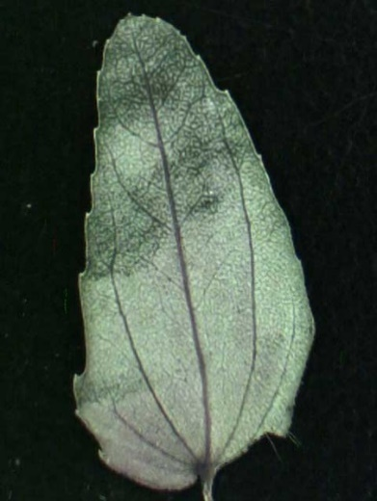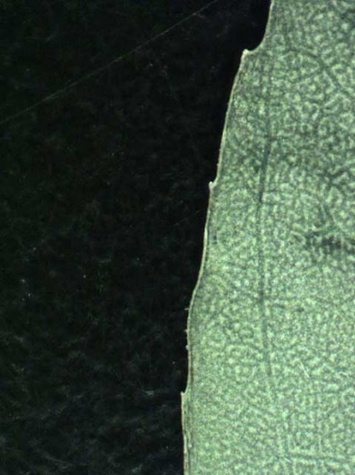
Figure 2.6: Nodding spurge (a) Abaxial leaf surface (b) Leaf margin³⁴
The leaves are green with a red blotch in the center on the upper surface and is a lighter green on the undersides. They are oval to oblong with either serrated or entire margins, and the surface of young leaves have finely curled hairs³⁴.
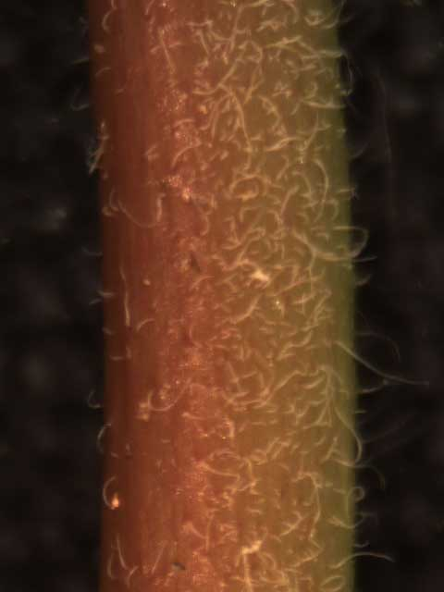
Figure 2.7: Nodding spurge stem³⁴
The stems are pinkish-red, round, and hairy when young. The lower part of the stem is erect, but it tends to droop at the end of the branches.
2.4.3 Fruit
Fruit type: capsule/pod
Fruit is a 3-sectioned capsule, strongly 3-sided, stalked, ¹/₁₀ inch wide, that develops rapidly from the center of the cyathium, the clump of styles persisting at the tip.
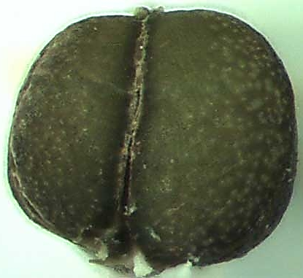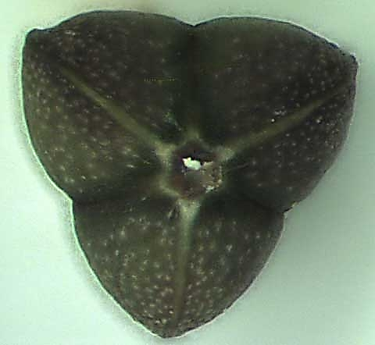
- (b)
Figure 2.8: Nodding spurge seed pod (a) side view (b) top view³⁴
The capsule initially hangs down, becoming erect at maturity, and is typically tinged red. Each section contains a single seed. The fruit appears as a tiny, 3-lobed capsule containing one seed in each lobe³⁴. Seeds are oval-oblong, angular with rounded angles in cross-section, 1 to 1.6 mm long, slightly wavy on the surfaces, dark brown sometimes with a paler coating that may persist only along the angles³⁹.
2.5 FAVORABLE CLIMATE
Nodding Spurge, formerly known as Chamaesyce nutans, is relatively common, though often overlooked. While it can become locally weedy in gardens and lawns in both dry and moist locations, historically it appears to have a strong affinity for sandy soils along lake shores and river banks. It is fairly easily distinguished from the other spurges by its open, upright to spreading branches with nodding tips. While in some areas it can grow to heights of over 2 feet, it more commonly stays under a foot tall³⁹. Nodding spurge prefers full sun and well-draining soil but adapts to various soil conditions. It tolerates drought and humidity; however, wet soil conditions often cause root rot. It can be propagated by stem cuttings, and it can also readily reseed itself³⁴. This plant is best found in native gardens or meadows and lawns. Preliminary research suggests that nodding spurge is generally well-controlled by most herbicides that list "spurge" as a susceptible species³⁴. The plant thrives in various climates and has been introduced to the Mediterranean area, along with temperate and tropical locales on multiple continents³⁵.
Water: Originating from moist environments, eyebane thrives with consistent hydration, requiring weekly watering to avoid oversaturation. It flourishes best outdoors, where natural rainfall supports its growth cycles in line with its native climate's seasonal changes³⁵.
Fertilize: Eyebane requires minimal fertilizer for growth, thriving in well-drained poor soils. Fertilizer is only needed upon lower leaf yellowing, indicating nutrient deficiency. At this stage, applying half-strength liquid fertilizer will sustain the plant for several months.
Propagation: Eyebane is mainly propagated through cuttings, as seeds are hard to germinate. Wear gloves when handling cuttings, and allow them to dry for 2-3 days before planting in a soilless medium. Misting and occasional air exposure are crucial to prevent mold and rot during rooting.
2.6 NODDING SPURGE IN PASTURES AND HAY FIELDS
As is the case with most other weeds, nodding spurge competes with grasses for light, water and nutrients, and it reduces the forage quality of pastures and hay. In hay fields, nodding spurge (as is the case with other summer annual and many perennial weeds) flourishes following the first hay cutting. Commonly used synthetic auxin herbicides such as 2,4-D, dicamba and GrazonNext HL (aminopyralid + 2,4-D) applied for control of other weeds present at that time, such as common cocklebur, common ragweed and horsenettle, do not control nodding spurge. This is particularly frustrating to producers seeking to produce clean hay or high-quality grazing³¹.
2.7 MANAGING NODDING SPURGE IN PASTURES AND HAY FIELDS
Management in Pastures and Hay Fields Maintaining a dense stand of grass, avoiding over-grazing, and maintaining proper soil pH and fertility will provide much-needed competition with spotted spurge. However, this alone is not sufficient in heavily infested fields. Research has shown that although the synthetic auxin herbicides are notoriously weak on this species, the sulfonylurea herbicide metsulfuron is very active on it. Currently, metsulfuron is available in a pre-mixture with chlorsulfuron called Cimarron Plus. Also, a number of generic versions of metsulfuron alone are available. Cimarron Plus and generic metsulfuron can be tank-mixed with synthetic auxin herbicides labeled for use in pastures and hay fields. While established bermudagrass and established orchardgrass are very tolerant of metsulfuron, tall fescue is sensitive. Metsulfuron should not be applied to tall fescue stands less than 2 years old. In established tall fescue, producers will notice seed head suppression, stunting, yellowing, and in some cases, yield reduction. However, established tall fescue will recover fully³¹.
2.8 INSECTS, DISEASES AND OTHER PLANT PROBLEMS
Nodding spurge has no serious insect or disease problems. Overwatering can cause root rot. Some people experience skin rashes from contact with the toxic sticky plant sap of euphorbias. Wears protective gloves when handling this plant. Keep this plant out of reach of small children and pets.

2.9 MANAGEMENT GUIDELINES FOR SPURGES
Because spurges flower when young and have little or no seed dormancy, weed populations can increase rapidly. Remove plants when young to reduce seed production. They are time-consuming to hand weed due to the number of seedlings that form. Some species may forcefully discharge seeds. Spurges are well-controlled by most pre-emergence herbicides labeled for use.
2.10 NODDING SPURGE WEED CONTROL
Eyebane originates from North America. Known as a weed, it is infamous for its invasive nature, particularly in agronomic crops and gardens. This weed possesses the capacity to reproduce rapidly and grow abundantly, making it a threat to other plants. It can produce up to 3,000 seeds per plant, which significantly contributes to its invasive trait. Eyebane can cause harm by depleting soil nutrients that are necessary for other plants, hampering their growth and threatening biodiversity. This plant predominantly spreads through its prolific seed production, where the seeds are dispersed by wind, water, or through human activities such as gardening and farming. Eyebane can also resprout from broken taproots, making it difficult to control and eradicate. The plant's aggressive growth and adaptability to various conditions underscore its weedy nature³⁵.
How to Control It: The best season for the removal of eyebane is during the early summer or late spring. The weed should ideally be removed before it has fully flowered, as this is when it tends to spread seeds. Here are a few methods for controlling or removing this weed:
- Hand-pulling: The most organic and straightforward method. Dampen the soil around eyebane to make the roots easier to pull out. Ensure to wear gloves to prevent any skin irritation from the plant's sap.
- Smothering: Place layers of cardboard, newspaper, or landscape fabric over the area where eyebane is growing. This method will block sunlight and prevent the weed from growing.
- Vinegar spray: Mix a solution of 10% vinegar and 90% water. Spray the mixture directly onto eyebane, ensuring the entire plant is covered. Be careful not to overspray onto non-target plants as it can potentially harm them³⁵.
2.11 TOXICITY OF NODDING SPURGE
Eyebane poses a moderate toxicity risk to humans, cats, and dogs due to diterpene esters in its sap. Contact with or ingestion of the sap can cause skin irritation, gastrointestinal issues, and more severe symptoms. Immediate medical or veterinary care is advised if exposure occurs³⁵. As with all euphorbias, nodding spurge exudes a milky sap from the stems and leaves that can be toxic³⁴.
2.12 TRADITIONAL USES OF EUPHORBIA SPECIES
Some species of Euphorbia have been used in traditional medicine since many decades in the worldwide to treat a variety of human and animal diseases. Recent studies show that more than 5% of Euphorbia species are used in medicine⁴⁰. They are most often used to treat digestive disorders, skin
40. M. Ernst, et al. “Global medicinal uses of Euphorbia L. (Euphorbiaceae). Journal of Ethnopharmacolog”y. 2015, 52,1-43.
diseases. Numerous studies referred to the purgative and emetic effect of Euphorbia species⁴¹. Uses of Euphorbia was recorded from all continents except Australasia. For example in India Euphorbia is used to treat worm infestations in children and for dysentery, gonorrhea, jaundice, pimples, digestive problems and tumors^{29,42}. China, Nigeria and Philippines⁴³used this for the same purpose.
Euphorbia is also used to treat skin or subcutaneous cellular tissue disorders. The most frequently treated disorders in the category of skin diseases are warts, sores, boils, carbuncles, dermatitis, calluses, hair loss, irritation, sunburn, eczema, psoriasis, pustules, and the use of Euphorbia spp. as astringents. The milky sap or latex of spurge is used to have a protective and defensive role in helping heal wounds⁴⁴.
Numerous scientific records bring up to the use of Euphorbia to treat wounds and hemorrhages. The treatment of abscesses, blisters,
41. S. V. Hoang, P. Baas, and P. J. A. Kessler. “Traditional medicinal plants in Ben En National Park”, Vietnam Blumea. 2008, 53, 569-601.
42. K. R. Kirtikar, B. D. Basu. “Indian Medicinal Plants”, Periodical Experts Books Agency, 2nd edition, Vol. 3, New Delhi, 1991, 210-293.
43. D. T. Gaioni. “Medical choices in a Philippine highland community. Ethnomedical and Biomedical dimensions of Bauko clinical reality”. Anthropos. 2002, 97, 505-518.
44. www.euphorbiaceae.org. Retrieved on 11 September, 2016.
burns and injuries were also recorded. In China, both E. thymifolia and E. maculata are used for the treatment of hemoptysis, hematuria, hemafecia, hematemesis, epistaxis and vaginal bleeding and for the treatment of wounds and carbuncles^{41,43}.
In the category of respiratory system disorders, Euphorbia is used to treat asthma and coughs, but also included descriptions of treatments for bronchial complaints, breathlessness, pneumonia and use as an expectorant and originating. The most cited species was E. hirta⁴⁰.
2.13 PHYTOCHEMICALS
Phytochemicals are variety of nonnutritive chemical substances produced during the growth and metabolism of plants, contribute significantly to the flavor and color of foods and widely found in fruits, vegetable, cereals, nuts, cocoa etc⁴⁵.
The majority of these compounds does not directly participate in the growth, development, and reproduction of plants and were hence named “secondary metabolites” in 1891⁴⁶.
45. Yan Yang, Wenhua Ling. “Health Bene fi ts and Future Research of Phytochemicals: A Literature Review”. The Journal of Nutrition. 2025, 155, 87 –101.
46. E. Ahmed, et al, “Secondary metabolites and their multidimensional prospective in plant life”, J. Pharmacogn. Phytochem. 2017, 6(2), 205 –214.
Phytochemical can have complementary and/or overlapping mechanism of action in the body, including antioxidant effects, modulation of enzyme actions, stimulation the immune system, modulation of hormone metabolism, anti-bacterial and antiviral effect, interference with DNA replication and physical action whereby some may bind physically to cell walls by preventing the adhesion of pathogens to human cell walls²¹.
2.13.1 Phytochemicals types and functions
2.13.1.1 Classes of Phytochemicals
2.13.1.1.1 Flavonoids
Flavonoids (or bioflavonoids) (Figure 2.9 below) are a class of plant secondary metabolites. Its name came from the Latin word flavus meaning yellow; their colour in nature. Flavonoids (specifically flavanoids such as the catechins) are “the most common group of polyphenolic compounds in the human diet and are found ubiquitously
in plants”⁴⁷. Flavonoids have protective effects including anti-inflammatory, anti-oxidant, anti-viral, and anti-carcinogenic properties. The widespread distribution of flavonoids, their variety and their relatively low toxicity compared to other active plant compounds (for instance alkaloids) mean that many animals, including humans, ingest significant quantities in their diet. In vitro studies show that flavonoids also have anti-allergic, anti-inflammatory, anti-microbial⁴⁸, anti-cancer and anti-diarrheal activities⁴⁹.
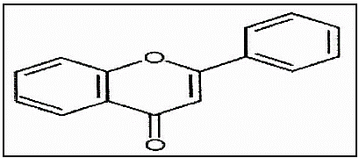
Figure 2.9: Molecular Structure of the Flavone backbone.
47. Spencer, J.P.E. (2008). Flavonoids: modulations of brian fucntions. British Journal of Nutrition, 99, 60-77.
48. Cushnie T.P.T & Lamb A.J. (2011): Recent advances in understanding the antibacterial properties of flabouroids. International journal of artimicrobial agents 38 (2):99-107.
49. Schuier M., Sies, H., Illek, B & Fischer, H. (2005) Cocoa-realted flabonoids inhibit (FTR-mediated chloride transport across T84 human colon epithelia J. Nutri 135 (10), 2320-2325.
- Cardiac Glycosides: Cardiac glycosides (e.g. Figure 2.10 below) are found as secondary metabolites in several plants, They are drugs used in the treatment of congestive heart failure and cardiac dosage must be controlled carefully, since the therapeutic dose is close to the toxic dose⁵⁰.
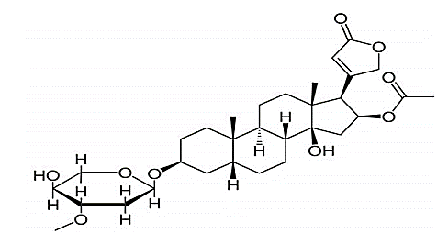
Figure 2.10: The chemical structure of oleandrin, toxic cardiac glycosides.
Cardiac glycosides (also called cardanoids) occurs as a complex mixture together in the same plant and most of them are toxic, however many have pharmacological activity especially to the heart. They are used in treatment of congestive heart failure, whereby they inhibit

50. Denwick P.M. (2002). Natural products: A biosynthetic approach, 2nd ed. (John wiley and sons Ltd, England).
Na⁺/K⁺ ATPase pump that causes positive inotropic effects and electrophysiological changes. This strengthens heart muscle and the power of systolic concentrations against congestive heart failure.
They are also used in treatment of atrial fibrillation, flatter and they acts as emetics and as diuretics.
- Alkaloids: (Figure 2.11 below) are a group of naturally occurring chemical compounds that contain mostly basic nitrogen atoms. There are other related groups of compounds with neutral and even weakly acidic properties⁵¹. Alkaloids are readily available in leaves, bark, roots or seeds of plants with diverse biological functions. Some alkaloids stimulate the nervous systems; others can cause paralysis, elevate blood pressure or lower it. Certain alkaloids act as pain relievers, tranquilizers etc. Although alkaloids act on a diversity of metabolic systems in humans and other animals, they almost uniformly invoke a bitter taste⁵².
51. Raj, K & Bansal, A. (2004). Textbook of Organic chemistry. 4th ed. New Age International.
52. Rhoades, D.F (1979). Evolution of plant chemical defense against merbionas. In G.A. Resenthal, D.H. Janzen, Herbal varies; their interaction with secondary plant metabolites Academic press: new york, p41..
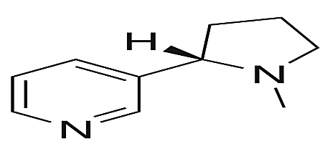
Figure 2.11: The nicotine molecule contains both pyridine (left) and pyrrolidine rings (right).
An alkaloid is a plant-derived compound that is toxic or physiologically active. Some alkaloids such as Isopteropoline, phenopyline have anti-microbial activity whereby, they act by promoting white blood cells to dispose harmful micro-organisms and cell debris. Highly aromatic planar polyketary alkaloids like berberine, piperine and harmane work by interacting the DNA and cell wall of others by simulating neurotransmitters such as acetylcholine, dopamine and serotonine. They affect central nervous system (CNS) at the synapses. They also act as narcotics as antimalaria, as topical anaesthetic for opthalmology, in treating hypertension, neuralgia, rheumatism, motion sickness and also in extending the life of hormones. Some types of alkaloids are hallucinative, addictive, and toxic and hence used as arrow poison for hunting wild game.
- Phytate: Phytic acid or phytate (known as inositol hexakis-phosphate) (Figure 2.12 below) is the principal storage form of phosphorus in many plant tissues, especially bran and seeds. Phytate is not digestible to humans, this is because the lack the digestive enzyme phytase required to remove phosphate from the inositol in the phytate molecule. So it is not a source of either inositol or phosphate if eaten directly by human. Moreover, phytic acid chelates and thus makes un-absorbable certain important minor minerals such as zinc and iron, and to a lesser extent.
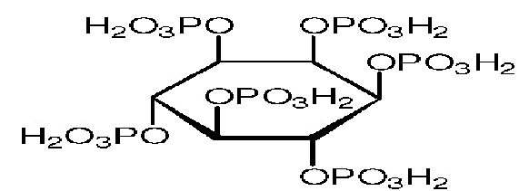
Figure 2.12: Molecular Structure of Phytic acid, (C₆H₁₈O₂₄P₆).
Liu, et al.⁵³ reported the anti-cancer property of phytic acid and show a protective action in carcinogenesis. Phytic acid acts as anti-cancer agent against colon, soft tissues, metastatic lung cancer and
believed as a potential antioxidant⁵⁴.
53. J. Liu, et al. “Manganese Acoumulation and tolerance in cetosia argentea linn: A new Mn-hyper accumulating plant species” Journal of Hazonetous Materials, 2014, 267:136-141.
54. Makkor, H.P.S., Siddhuraju S & Becker, K. (2007). Plant secondary metaboliles; Methods in Molecular Biology (Springer New York).
mammary cancer. The presence of phytic acid in dietary sources is
- Saponins: Saponins are terpene glycosides. They are one of many secondary metabolites found in natural sources, with saponins found in particular abundance in various plant species. More specifically, they are amphipathic glycosides (Figure 2.13) grouped in terms of phenomenology, by the soap-like foaming they produce when shaken in aqueous solutions, and, in terms of structure, by their composition of one or more hydrophilic glycoside moieties combined with a lipophilic triterpene derivative⁵⁵. Saponins exert various biological benefits, such as anti-inflammatory, anti-diabetic, anti-HIV, anti-atherosclerotic and serve as protective functions like gastro-protective, hepatoprotective and hypolipidemic^{56,57}. Besides, saponins are effective in maintaining liver function, lowering blood cholesterol, preventing peptic ulcer, osteoporosis as well as platelet agglutination⁵⁸.
55. Hostettmann K&Marston A, (1995). Chemistry and pahrmacelogy of Naturla products (Cambridge: Cambridge university press).
56. Kashiwada Y, wang H.K, Nagzo S, kitanaka S, Yasuda I, Fujioka et al (1998). Anti Aids agents 30 Anti-Hiv activity of cleandic acid, pomolic acid and structurally related tritepenoids journal of natural products 1090.IMS.
57. Banno T, Akilisa K, Yasukawa H, Higashihara M, Ukiya K. & Watanabe (2004). Triterpene acids from the leaves of perilla fructescenes and thesis anti-inflammatory and anti-tumour. Promoting effects. Bioscience biotechnology and biochemistry. 68;85-90.
58. L. Lu, et al. “Tannin inhibits Hiv-1 entry by targeting gp41”, Acta Pharmacol. Sin 2004, 25(2), 213-218.

These are surface active agents with soap-like properties and can be detected by their ability to cause foaming and to haemolyse blood cells⁵⁹. They have a host of biological roles including boosting respiratory system as expectorant and hence activity against cough. They also have anti-protozoa activity whereby they act by reacting with cholesterol in the protozoal cell membranes causing cell lysis e.g. Yucca saponins are effective against protozoan Giardia lamblia. They serve as vaccine boosters by acting as adjuvant. They have anti-inflammatory, emetic, antiviral, antifungal, insecticidal, molluscicidal, piscicidal and anti-bacterial activity²¹. They also bind to primary bile acids, which are metabolized by colonic bacteria into secondary bile acids. Some of the secondary bile acids are promoters of colon cancer. They have economic values as source of cheap, environment friendly detergents and cosmetics²¹.

59. J. B. Harborne. “Phytochemical methods”. London: Chapman and Hall. 1973. pp. 52-114.
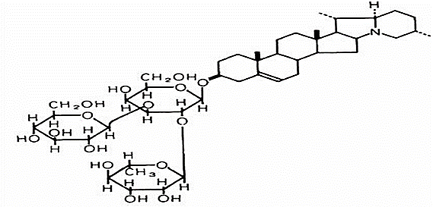
Figure 2.5: Chemical structure of the saponin solanine.
- Tannin (Figure 2.14) (also known as vegetable tannin, natural organic tannins or sometimes tannoid, i.e. a type of biomolecule, as opposed to modern synthetic tannin) is an astringent, bitter plant polyphenolic compound that binds to and precipitates proteins and various other organic compounds including amino acids and alkaloids. Tannins are usually subdivided into two groups: hydrolyzable tannins (HT) and proanthocyanidins (PA). Hydrolyzable tannins are gallic acid and ellagic acid esters of core molecules that consist of polyols such as sugars and phenolics. Hydrolyzable tannins are more susceptible to enzymatic and non-enzymatic hydrolysis than PA, and usually are more soluble in water. Proanthocyanidins are polymers of flavan-3-ols linked through an interflavan carbon bond that is not susceptible to hydrolysis. Proanthocyanidins are more commonly referred to as condensed tannins. Hydrolyzable tannins also undergo condensation reactions. Tannins have shown potential antiviral⁵⁸, antibacterial⁶⁰ and antiparasitic effects⁶¹. It was also reported that certain tannins are able to inhibit HIV replication selectivity and is also used as diuretic⁶².
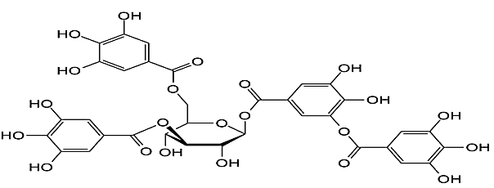
Figure 2.14: Tannic acid, a type of tannin.
Tannins are astringent, bitter plant polyphenols that either bind and precipitate or shrink proteins. They have physiological role by acting as antioxidants through free radical scavenging activity, chelation of transition metals, inhibition of pro-oxidative enzymes and lipid peroxidation.
60. H. Akiyama, et al. “Antibacterial action of several tannins aginst staphy lococcus aureus. J. Antimicrob. Chemother 48 (4), 2001, 487-491.
61. Kohodziej, H. & Kiderlen, A.F (2005). Antileishmanual actively and immune modulatory effects of tannis and realted compounds on leishmanra parasitued RAW 264-7 cells photochemistry, 766 (17), 2056-71.
62. Haslem E. Plant Polychenol: vegetal tamin relisted – Chemistry and Pharmacology of natural products (Cambridge university press, 1989).
They also inhibit tumor growth by inducing apoptosis, mutagenicity of carcinogens, and inhibiting.
They have economic role of tanning leathers in leather industry.
They affect intake and digestibility of feeds among livestock and excess can be carcinogenic on normal tissues.
They also inhibit viral reverse transcriptase.
They accumulate metal ions e.g cobalt, manganese, iron, copper etc necessary for growth microbial growth as cofactors and activators of enzymes.
(f) Oxalate: Oxalate (IUPAC: ethanedioate) is the dianion with the formula C₂O₄²⁻, also written (COO)₂²⁻ (Figure 2.15). Many metal ions form insoluble precipitates with oxalate, a prominent example being calcium oxalate, the primary constituent of the most common kind of kidney stones. Oxalate occurs in many plants, where it is synthesized via the incomplete oxidation of carbohydrates. Oxalate function as chelating agents and may chelate many toxic metals such as mercury and lead. But one major concern or difference between oxalate and other chelating agents is that oxalates could trap heavy metals in the tissues of living organism thereby making elimination of them very difficult.
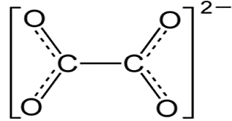
Figure 2.15: The structure of the oxalate anion.
- Phenols: Phenols, sometimes called phenolics (Figure 2.16), are a class of chemical compounds consisting of a hydroxyl group (-OH) bonded directly to an aromatic hydrocarbon group. Phenolic compounds are classified as simple phenols or polyphenols based on the number of phenol units in the molecule⁶³⁻⁶⁵. Dilute solutions of phenol are useful antiseptics, but strong solutions of phenols are caustic and scarring to tissues. In plants, the phenolic units are esterified or methylated and are submitted to conjugation, which means that the natural phenols are mostly found in the glycoside
63. Robbins, R.J. Phenolic Acids in foods: An overview of Analytical methodology. J. Agric, Food chems. 2003, 51,2866-2887.
64. Amorati R & Valgimigli L. Modulation of the antioxidant activity of phenols by non-covalent interactions, Org Biol. Chem 2012, 4147-4158.
65. Khoddami, A. et al/2015). Technique for analysis of plant phenolic compounds molecules, 18(2),2328-75.
form instead of the aglycone form. This property of undergoing
conjugation with other molecules enables it to scavenge free radicals and thus inhibit the oxidative mechanisms that can lead to degenerative diseases such as cancer. Phenols are reported antitumour agents and exhibit antiviral and antimicrobial activities, hypotensive effects⁶⁶ and antioxidant properties⁶⁷.
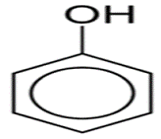
Figure 2.16: Phenols. Other names: Carbolic acid, benzenol, phenylic acid
(g) Flavonoids: They are structural derivatives of flavones, containing conjugated aromatic systems, often bound to sugars as glycosides, and they are phenolic and water soluble in nature⁶⁷. They exert their roles as anti-oxidants and hence protecting against degenerative diseases.
Flavonoids such as quercetin act as chain breaking anti-oxidants, preventing oxidation of low-density lipoprotein by macrophages and

66. Matsubara, Y., Kumamoto, H & Uzuka, Y (1985). Structure and and hypotensive effect of flavonoid glycesides in citrus unshui peelings. J. Agri. Boil. Chem, 49(909-914).
67. Robak, J. & Gry glewski, Flavonoids are scavengers of superoxide onions. Biochem. Pharmacol. 37, 837-41.
metal ions like copper. This reduces the oxidative stress²¹. They also act as nature's biological modifiers as anti-allergens, anti-inflammatory, and induces phase two enzymes that eliminate mutagens and carcinogens. Flavonoids are also known to increase coronary flow, to
reduce the myocardial oxygen consumption and to lower the arterial pressure⁶⁸. They are also known to reduce capillary fragility⁶⁷ to be anti-allergic and also to be anti-spasmodic and hence applied to relief asthma and nose bleeding²¹.
(h) Terpenoids: These are derivatives of isoprene molecules having a carbon skeleton built from one or more of CIS units. They exert their roles as anti-bacterial, anti-fungal, anti-viral, anti-protozoan, antiallergens, as immune boosters and as antineoplastic.
The mechanism of action is speculated to involve membrane disruption by these lipophilic compounds. They are used to relieve cold, influenza, cough and acute bronchial diseases.

68.T. T. X. Dong, et al. “Orthogonal array design in optimizing the extraction efficiency of active constituents from roots of Panax notoginseng. Journal of Phytotherapy Research, 2005, 19, 684-688.
2.13.1.2 General functions of phytochemicals
Most phytochemcials are known to possess many properties which makes them vital to both plants and animals. Some of these properties are;
(a) Anti-oxidant property: some phytochemicals are known to protect
cells against oxidative damage and help lower the risk of developing cancer.
(b) Anti-microbial properties: many phytochemical protect the body from microbial activities.
(c) Physiological activities: some phytochemicals bind physiologically to cell walls interfering with the ability to pathogens to bind to cell receptors.
(d) In addition to its anti-oxidant activity, phytochemicals help stimulate the immune system, modulate the detoxification of enzymes and steroid hormone concentration. They also help decrease platelet aggregation, modulate hormone metabolism, cholesterol mechanisms, blood pressure reduction, as well potent against some viruses and bacteria.
2.14 PHARMACOLOGICAL AND BIOLOGICAL ACTIVITIES OF EUPHORBIA SPECIES
Euphorbia exhibits several pharmacological activities.
2.14,1 Antimicrobial Activity
Sudhakar et al.⁶⁹ evaluated the ethanolic extract of aerial parts on some pathogens bacteria. Euphorbia neriifera has demonstrated antimicrobial activity by fighting off bacterial and fungal infections - e.g pseudomonas aeruginosa, proteus vulgaris and staphylococcus aureus.
    - Antioxidant and antiviral activity
Euphorbia spinidens contain compounds that act as antioxidants, helping to protect the body against damage from free radicals. This show that the methanolic extract of E. spinidens has high content of phenolic and flavonoid compounds with good antioxidant activity¹.

69. M. Sudhakar, et al. “Antimicrobial activity of caesalpinia pulcherrima, Euphorbia hirta and Asystasia gangeticum”. Fitoterapia. 2006; 77(5):378-380.
2.14.3 Anti-inflammatory activity
The aqueous and ethanolic extracts of E. hirta displayed a high percentage of anti-inflammatory properties⁷⁰ (Ghosh et al., 2019). The triterpenes found in the n-hexane extract of E. hirta exerted anti-inflammatory activity in mice, applying to the model of phorbol acetate induced ear inflammation in mice⁷¹ (Patil et al., 2009). Similarly, aqueous and alcoholic extracts of E. antiquorum when evaluated against acute inflammation employing carrageenan-induced rat paw oedema and chronic inflammation employing cotton pellet-induced granuloma in rats, both extracts showed a significant decrease or inhibition in chronic inflammation. It was concluded that triterpenoids present in both of the extracts may have been responsible for the anti-inflammatory property⁷² (Kumar &Saikia, 2016).

70. P. Ghosh, et al. “Botanical description, phytochemical constituents and pharmacological properties of Euphorbia hirta Linn: a review”. International Journal of Health Sciences and Research. 2019, 9(3). 273-286.
71. S. B. Patil,et al. “ Review on phytochemistry and pharmacological aspects of Euphorbia hirta Linn. Journal of Pharmaceutical Research and Health Care1(1) 113–133.
72.A. Kumar, & D. Saikia. Euphorbia Antiquorum Linn: A Comprehensive Review of Ethnobotany, Phytochemistry and Pharmacology. Journal of Analytical & Pharmaceutical Research, 2016, 2(4), 1–6.
2.14.4 Anthelmintic Activity
Anthelmintic refers to the ability of a substance to kill or expel parasitic worms. It shows a remarkable and significant reduction in the levels of the identified helminthes^{29, 73}.
2.14.5 Immunomodulatory Activity
It refers to the ability of a substance to alter the immune system's response, either by stimulating or suppressing it. Immunomodulation is a promising strategy for treating a range of conditions, including cancer, infectious diseases and autoimmune disorders, by either boosting the immune response or reducing harmful inflammation. According to Ghannadian et al.,⁷⁴ the dried acetone-chloroform extract of aerial parts of E. spinidens showed two new triterpenoids: lup-20(29)-ene-33,28-diol commonly known as betulin and (3β, 23E)-Cycloarta-23-ene-3,25-diol. The pharmacological activity of the two triterpenoids, in particular, betulin showed that they have the immunomodulatory activity. Betulin has shown encouraging
74. Ghannadian M, Akhavan A, Abdalla OM, Ayatollahi AM, Mohammadi-kamalabadi M, Ghazanfari H. Triterpenes from Euphorbia spinidens with immunomodulatory activity. Journal of Pharmacy Research and Science. 2013; 8(3): 205-210.
stimulatory effect on the proliferation of human peripheral blood lymphocytes activated by PHA.
2.14.6 Other Activities
Prostratin (a tigliane), which is produced by E. fischeriana and E. cornigera, has shown potential as an adjuvant therapy for the treatment of latent HIV infection⁷⁵⁻⁷⁸. They may be useful for the treatment of multidrug resistant cancers^{21, 79-80}.
73. A. A. Adeolu. “Anthelmintic efficacy of the aqueous crude extract of Euphorbia hirta Linn in Nigerian dogs”. Veterinarski Arhiv. 2005; 75(1):39-47.
74. King AJ, Brown GD, Gilday AD, Larson TR, Graham IA. Production of bioactive diterpenoids in the Euphorbiaceae depends on evolutionarily conserved gene clusters. The Plant Cell. 2014; 26:3286-3298.
75. Miana GA, Bashir M, Evans FJ. Isolation of prostratin from Euphorbia cornigera. Planta Medica. 1985; 51:353-354.
76. Qing-Gao M, Wen-Zi L, Xiao-Yun W, Tian-Xi Z, Guo-Wei Q. Diterpenoids from Euphorbia fischeriana. Phytochemistry. 1997; 44:663-666.
77. Kulkosky J, Culnan DM, Roman J, Dornadula G, Schnell M, Boyd MR et al. Prostratin: activation of latent HIV-1 expression suggests a potential inductive adjuvant therapy for HAART. Blood. 2001; 98:3006-3015.
78. Johnson HE, Banack SA, Cox PA. Variability in content of the anti-AIDS drug candidate prostratin in Samoan populations of Homalanthus nutans. Journal of Natural Products. 2008; 71:2041-2044.
79. Dueber MT, Adolf W, West CA. Biosynthesis of the diterpene phytoalexin casbene: partial purification and characterization of casbene synthetase from Ricinis communis. Plant Physiology. 1978; 62:598-603.
80. Lai XZ, Yang YB, Shan XL. The investigation of Euphorbiaceous medicinal plants in Southern China. Economic Botany. 2004; 58:S307-S320. 80.
81. Reis M, Ferreira RJ, Serly J, Duarte N, Madureira AM, Santos DJ et al. Colon adenocarcinoma multidrug resistance reverted by Euphorbia diterpenes: structure-activity relationships and pharmacophore modeling. Anti-cancer agents in medicinal chemistry. 2012; 12:1015-1024.
2.14.7 Neuroprotective activity
It shows that myrsinil diterpenes with strong neuroprotective activities may possibly be useful for the treatment of nervous system diseases, such as Parkinson's disease^{82, 83}.
2.14. 8 Other biological activities
As part of a study, the wound-healing properties of plants used in traditional Samoan medicine, including H. nutans (mentioned as Oma-lanthus), was investigated in vitro by Frankova et al. on the proliferation and migration of human dermal fibroblasts. It was demonstrated that H. nutans extract significantly stimulates cell migration to the wound area⁸⁴. The wound-healing mechanism is closely related to the acti-vation of NF-κB. The activation of NF-κB will trigger the release of pro-inflammatory cytokines, including IL-10 and IL-13, that stimulate tissue repair⁸⁵. Prostratin has been reported to
82. J. Xu, et al. “Three new myrsinol diterpenes from Euphorbia prolifera and their neuroprotective activities. Molecules. 2012; 17:9520-9528
83. Dawson TM, Dawson VL. “Molecular pathways of neurodegeneration in Parkinson’s disease. Science. 2003; 302: 819-822.
84. A. Frankova, L. Vistejnova, T. Merinas-Amo, Z. Leheckova, I. Doskocil, J. Wong Soon, T. Kudera, F. Laupua, A. Alonso-Moraga, L. Kokoska, In vitro antibacterial activity of extracts from Samoan medicinal plants and their effect on proliferation and migration of human fibroblasts, J. Ethnopharmacol. 264 (2021)
stimulate IKK-dependent phosphorylation leading to the activation of NF-κB⁸⁶.
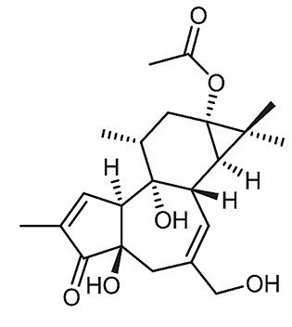
Prostratin
2.15 TOXICITY AND SIDE EFFECT
The spurges share the feature of having a poisonous, milky, white, latex-like sap. The skin irritating and caustic effects are largely caused by varying amounts of diterpenes. Tripenes such as betulin and corresponding esters are other major components of the latex. In contact with mucous membranes (eyes, nose, mouth), the latex can produce extremely painful inflammation. When large succulent spurges in a greenhouse are cut, vapours can cause irritation to the eyes and throat several meters away¹.
85. T. Liu, L. Zhang, D. Joo, S.C. Sun, NF-κB signaling in inflammation, Signal Transduct. Target. Ther. 21 (2017) 1–9,
86. S.A. Williams, L.F. Chen, H. Kwon, D. Fenard, D. Bisgrove, E. Verdin, W.C. Greene, Prostratin antagonizes HIV latency by activating NF-κB, J. Biol. Chem. 279 (2004) 42008–42017,
CHAPTER THREE
3.0 MATERIALS AND METHOD
3.1 REAGENTS AND APPARATUS
3.1.1 Reagents
Methanol, Ethanol, Lead acetate, Cupric copper, Potassium hydroxide (KOH) solution, ferric chloride, sodium hydroxide (NaoH), distilled water, Mayer’s reagent, Hagner’s reagent, Wagner’s reagent Dragendoff’s reagent, acetic anhydride, hydrochloride, hydrochloric acid solution, ethanolic KOH, chloroform, pyridine, indicator solution (for Kjedahl titration), boric acid, sodium nitropruside, Kjedhal tablet, potassium hydroxide (KOH), pellet, concentrated tetraoxosulfate (vi) acid (H₂SO₄), acetone, hexane.
3.1.2 Apparatus and Equipment
Beaker, glass funnel, separating funnel, filter paper, stirring rod, test tubes, test tube rack, burrett, Kjedahl digestion flask, filter paper, droppler, round bottom flask, petri dish, porcelain crucible and lid, pipette, retort stand, clamps, stop cork, measuring clinder, volumetric flask, conical flask, thermometer, bursen burner, wire guaze, reflux apparatus, spatula, dessictor, distillation flask, digestion flask, flat bottom flask.
Equipment: Hot air even, visible spectrophotometer, magnetic stirrer, blender, heating mantle, weighing balance, water bath, muffle furnace, aluminium foil paper.
3.2 COLLECTION OF SAMPLES
The fresh euphorbia nutans leaves sample were collected from a private residence garden at Gaa-Akanbi area, lorin, Kwara State, Nigeria. The fresh leaves sample was transported to the Laboratry in black clean polyethene bag and kept away from direct sunlight.
3.3 PREPARATION OF SAMPLES
The e.nutans leaves sample was destalked manually and healthy ones rinsed severally with distilled water. These were allowed to drain. The drained leaves sample was left to dry under shade and were employed for phytochemical analysis after each has been pulverized.

3.4.1 Qualitative phytochemical analysis
Test for steroids:
- Salkowski Test: chloroform solution was mixed with the extract of the sample and concentrated sulphuric acid and on standing yield rod colour.
- Lieberman Burchadt test: chloroform solution of the extract was mixed with few drops of acetic anhydride and 1ml of concentrated sulphuric acid from the sides gives reddish ring at the junction of 2 layers.
Test of Triterpenes:
- Salkowski Test: chloroform solution of the extract when shaken with conc, sulphuric acid, lower layer turns to yellow on standing.
- Lieberman test: chloroform solution of the extract with few drops of acetic acid and 1ml concentrated sulphuric acid gives deep red at the junction of the 2 layers.
Test of alkaloids:
The extracts were mixed with ammonia and the extracted with chloroform solution. To this dilute hydrochloride acid was added. The acid layer was used for alkaloids.
- Mayer’s test (potassium mesuric iodide): the acid layer with few drops of mayer’s reagent gives a creamy while precipitate.
- Wagners test (solution of lodine in potassium iodide): the acid layer with few drops of Wagner’s reagent gives reddish brown coloured precipitate.
- Hager’s test (saturated solution of picric acid): the acid layer with Hager’s reagent gives yellow precipitate.
- Dragerdroff’s test (solution of potassium bismuth iodide): acid layer with few drops of dragendroff’s reagent gives reddish brown precipitate.
Test of Tannins
- Ferric chloride test: extracts mixed with 1% ferric chloride solution gives blue, green or brownish green colour
Test for flavonords:
- Ferric chloride test: Alcoholic solution of the extracts mixed with few drops of neutral ferric chloride solution gives green colour.
- Lead acetate test: alcoholic solution of the extracts mixed with few drops of 10% lead acetate gives yellow precipitate.

Test of lactones:
- Legals test: the extracts mixed with mixture of sodium nitroprusside and pyrtaine and treatment with methanol alkali gives deep red colour.
Test for Diterpenes:
- Copper acetate test: the extracts, mixed with solution of copper acetate gives green colour.
Test of glycosides:
- Sodium hydroxide reagent: dissolve a small amount of alcoholic extract in 1ml water and sodium hydroxide solution was added. A yellow colour indicates the presence of glycosides.
Test of Saponins
- Foam test: a small amount of extract is shaken with little quantity of water. The foam produces persists for 10mins. It confirms the presence of saponins.

CHAPTER FOUR
4.0 RESULTS AND DISCUSSION
4.1 RESULTS
The results of the phytochemical analysis of the crude extracts of euphorbia nutans leaves sample in five (5) different solvents are presented in Table 4.1 below.
Table 4.1: Results of phytochemical screening of crude extracts of e. nutans leaves sample.
Phytochemicals | n-Hexane | Chloroform | Ethyl acetate | Acetone | Ethanol
Steroids | + | + | - | - | +
Triterpenoid | - | - | - | - | +
Alkaloid | - | - | - | + | +
Tannins | - | + | - | - | +
Flavonoids | - | - | - | + | +
Lactones | - | - | - | + | +
Diterpenes | - | + | + | + | +
Glycosides | - | - | - | + | +
Saponnins | - | - | - | - | -
4.2 DISCUSSION
From the Table 4.1 above, the different solvents used have different capacity to extract phytochemicals from the e. nutans sample considering the different number of phytochemicals detected in each crude extract.
This variation is readily attributable to the different polarities of this solvents as the major factor. The least number of phytochemical present is found in both n-hexane (dipole moment = 0) and ethyl acetate (dipole moment=1.88 Debye) solvents. Although the latter is of moderate polarity while the former is absolutely non-polar. It is therefore clear why both have different phytochemical detected in each; steroid only detected in n-hexane extract and diterpene only was found in the ethyl acetate extract. However, chloroform with weaker polarity (dipole moment = 1.15 Debye) than ethyl acetate had the presence of three (3) phytochemicals in its extract namely; steroids, tannins and diterpenes. The observed presence of more phytochemicals in chloroform is indicative of more chloroform-soluble compounds in e.nutans than the ethyl acetate-soluble ones. Acetone which is more strongly polar (dipole moment 2.91 Debye) had the presence of five (5) different phytochemicals in its crude extracts which are; alkaloids, flavonoids, lactones, diterpenes and glycosides. The crude ethanolic extract surprising confirmed the presence of almost all the phytochemicals tested for with the exception of only saponnins. This may be linked to ethanol having higher polarity in aqueous environment (dipole moment =3.1 Debye) than in anhydrous form (dipole moment =1.7 Debye)⁸⁷. In this extraction study, 90% aqueous ethanol solution was employed, this must have enhanced the extractive power of the solvent (ethanol).
Considering the number of phytochemicals extracted by each solvent, the aqueous ethanol solvent extract contained eight (8) of the nine phytochemicals analyzed for. This reveals that euphorbia nutans leaves sample is rich in secondary metabolites which may impart medicinal values on it like many other plant species of euphorbiaceae.
4.3 CONCLUSION
The leaves of euphorbia nutans is a rich source of phytochemicals and has the potential of displaying medicinal properties due to the presences of these bioactive components. Aqueous ethanol has been shown in this study to have the highest extractive ability for this plant material and hence the best of the five (5) solvents used.
87. Titus S. van Erp and Evert Jan Meijer. Ab Initio Molecular Dynamics Study of Aqueous Solvation of Ethanol and Ethylene. The Journal of Chemic al Physics. 2002, 1-15

