ISOLATION AND IDENTIFICATION OF SOME MICROBIAL PATHOGEN ASSOCIATED WITH BEDBUGS

A PROJECT REPORT SUBMITTED

BY
YUNUS MUSEFIU LEKAN
HND/23/SLT/FT/0425

BEING A RESEARCH POROJECT SUBMITTED TO THE DEPARTMENT OF SCIENCE LABORATORY TECHNOLOGY, INSTITUTE OF APPLIED SCIENCE, KWARA STATE POLYTECHNIC, ILORIN.

IN PARTIAL FULFILMENT OF THE REQUIREMENT FOR THE AWARD OF HIGHER NATIONAL DIPLOMA (HND) IN SCIENCE LABORATORY TECHNOLOGY.

JULY,2025

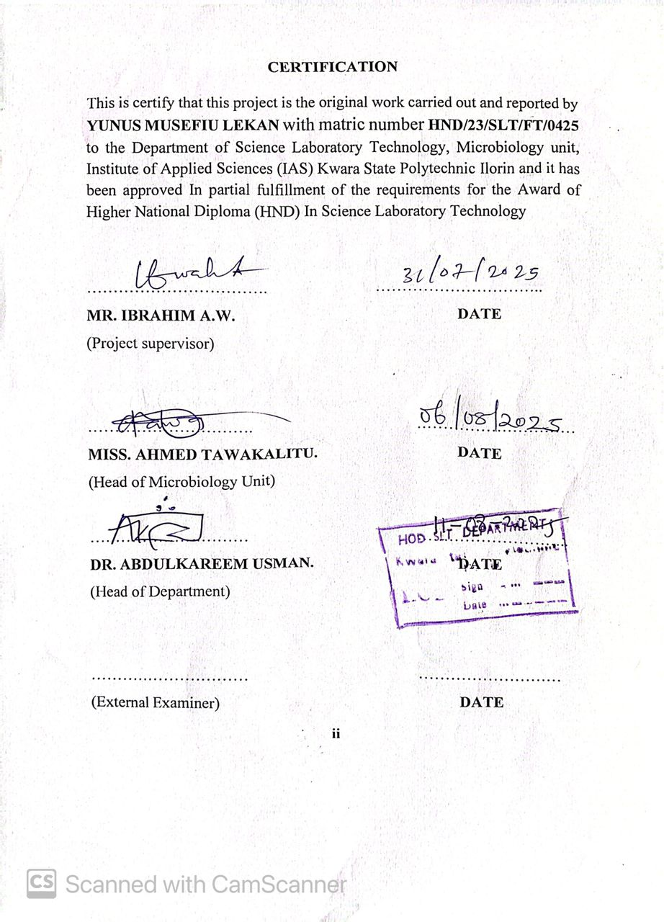
DEDICATION
In the name of Allah, the Most Gracious, the Most Merciful.I dedicate this project to Almighty Allah, for guiding and blessing me throughout this journey. My beloved parents, Mr. Yunus and Mrs. Yunus, for their unwavering support, love, and prayers. And to my esteemed benefactor, for their kindness, generosity, and contribution to my success. May Allah reward them abundantly for their love, care, and support.
ACKNOWLEDGEMENT
My first and deepest appreciation goes to Almighty Allah, the beneficent, the merciful, for guiding and protecting me always throughout my journey on campus and for the time fulfilment of His promises concerning my life. All thanks to my supervisor MR IBRAHIM A.W for his guidance and his advise all this time. I say thanks you sir for the support, TO my H.O.U MRS. AHMED TAWAKALITU, Also to my Head of Department H.O.D in person of DR.ABDULKAREEM USMAN for his encouragement. My sincere appreciation and deep sense of gratitude is given to no one but my parent, for paddle me to this life and make my vision come true. Also my deepest appreciation goes to my brother in person of ALH. OLANIYI SARAFA for his sponsorship through my National Diploma because without National Diploma, Higher National Diploma will not be possible. However my appreciation goes to my benefactor which will be anonymous for making my dream possible I say jazakumllahu aíran may Allah reward you abundantly Ameen . I will be an ingrate if I don’t thank my friend that motivate me by his word ‘’ motin jere Eko nitemi’’ in person of Qudus (Imade) and also my friends Rido Giant, aféez, Nasir Taye barber and others I pray almighty Allah will bless us all. I will like to appreciation my friends,my advicers from LEADERS GROUP for the support for making my dream possible I wish everyone of us success. Also I will like to appreciate my girlfriend in person of olaniyan janet funmilayo ( alayo) for the support love show to me I pray all your aim will come true, Lastly my appreciation goes to my executives for their support, advices for making my journey become smooth and for making our tenure become a successful one I wish everyone of us success I say ALUTA CONTINUA. Thank you all.

ABSTRACT
Bedbugs (Cimex lectularius), hematophagous ectoparasites, are increasingly recognized not only as nuisance pests but also as potential carriers of pathogenic microorganisms. This study aimed to isolate and identify bacteria and fungi associated with bedbugs collected from residential homes, student hostels, and hospital wards within Ilorin metropolis, Nigeria. Bedbugs were collected using sterile techniques and processed through homogenization and serial dilution. Samples were cultured on blood agar, MacConkey agar, and Sabouraud dextrose agar, followed by biochemical and morphological characterization of isolates. Results revealed a high microbial load, especially in samples from hospital wards and student hostels. Predominant bacterial isolates included Staphylococcus aureus, Escherichia coli, and Pseudomonas aeruginosa, while fungal isolates such as Aspergillus spp. and Candida spp. were also recovered. Antibiotic susceptibility tests indicated varying levels of resistance among the bacterial isolates. These findings highlight bedbugs as potential reservoirs of both bacterial and fungal pathogens in urban environments, underscoring the need for integrated pest and infection control strategies in densely populated and healthcare-associated settings.

TABLE OF CONTENTS
TITLE PAGE I
CERTIFICATION II
DEDICATION III
AKNOWLEDGEMENT IV
ABSTRACT V
TABLE OF CONTENT VI- VII
LIST OF TABLES VIII
1.0 INTRODUCTION 1
CHAPTER TWO 8
2.0 Materials and Methods 8
2.1 Materials 8
2.2 Sample Collection 9
2.3 Sampling Site 10
2.4.0 Media Preparation 10
2.4.1 Sample Preparation 11
2.5 Bacterial Isolation and Identification 11
2.6 Antibiotic Susceptibility Testing 12
2.7 Data Analysis 13
2.8 Quality Control 13
CHAPTER THREE 15
3.0 RESULT 15
3.1 Colony Count of Microbial Isolates from Bedbugs 15
3.2 Morphological Characteristics of Isolates 16
3.3 Biochemical Test Results of Bacterial Isolates 17
CHAPTER FOUR 19
4.0 DISCUSSION AND CONCLUSION 19
4.1 Discussion 19
4.2 Conclusion 22
REFERENCES 23

LIST OF TABLES
Table 1: Average Colony Count (CFU/mL) from Bedbug Samples…..15
Table 2: Cultural and Morphological Characteristics of Isolates……16
Table 3: Biochemical Characterization of Bacterial Isolates………….17
CHAPTER ONE

1.0 INTRODUCTION
Bedbugs (Cimex lectularius) are hematophagous ectoparasites that have re-emerged globally as pests of significant public health concern. These small, flat, wingless insects feed primarily on human blood and are commonly found in homes, hotels, hospitals, and hostels, particularly in areas with high population densities and poor sanitation (Doggett et al., 2020). Although not traditionally viewed as vectors of disease, bedbugs have increasingly been associated with the carriage of various pathogenic microorganisms that can pose health risks to humans (Potts et al., 2021).
Fig. 1
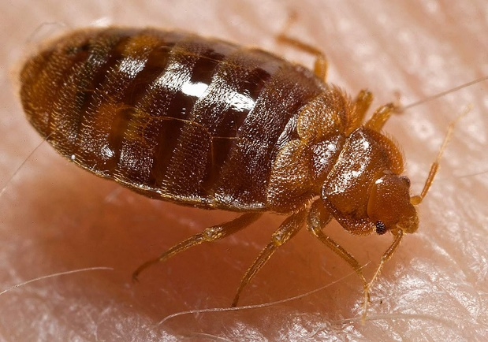
Source: (Doggett et al., 2020)
The resurgence of bedbug infestations, especially in developing countries, has triggered renewed scientific interest in understanding their biology and the microorganisms they may harbor. This is particularly important in urban centers like Ilorin, Nigeria, where overcrowding and limited access to quality pest control contribute to the spread and persistence of bedbug populations (Ademola et al., 2022). These insects typically hide in cracks, furniture, mattresses, and clothing, making eradication difficult without targeted interventions. Previous studies have reported that bedbugs can serve as mechanical or biological carriers of bacteria, fungi, and viruses. Among the bacterial species found in bedbugs are Staphylococcus aureus, Pseudomonas aeruginosa, Escherichia coli, and Bacillus spp., all of which are known to cause a range of infections in humans (Masroujeh et al., 2020). The detection of these microorganisms in bedbugs raises concerns about their potential role in nosocomial infections and community-acquired diseases.
The microbial flora associated with bedbugs can be endogenous symbiotic bacteria within their gut or exogenous acquired from their environment or host’s skin. The gut microbiota, in particular, plays a crucial role in bedbug digestion and survival, but can also act as a reservoir for antibiotic-resistant pathogens (Merlin et al., 2023). This dual role highlights the importance of identifying and characterizing both beneficial and harmful microbes associated with bedbugs.
Ilorin metropolis, located in Kwara State, Nigeria, is a rapidly growing city with a diverse population and urban infrastructure that includes public and private residences, schools, and health centers. Many of these environments, especially those with limited hygiene practices, provide ideal breeding grounds for bedbugs (Olatunji et al., 2021). Despite anecdotal reports of infestations, little scientific research has been conducted on the microbiological implications of bedbugs in this region.
The microbial composition of bedbugs in Ilorin is essential for public health monitoring and infection control. The identification and isolation of microorganisms from these insects will provide data on possible reservoirs of pathogens and could guide targeted interventions (Obasi and Eze, 2022). This research could also reveal the extent of microbial resistance, which is critical in an era of increasing antimicrobial resistance.
The ability of bedbugs to harbor and potentially transmit multidrug-resistant organisms (MDROs) presents an urgent need for scientific inquiry. Recent findings have shown the presence of methicillin-resistant Staphylococcus aureus (MRSA) and extended-spectrum beta-lactamase (ESBL) producing E. coli in bedbugs collected from hospital settings (Shariff et al., 2020). Such evidence indicates that bedbugs could be silent contributors to the burden of healthcare-associated infections.
In addition to bacteria, fungi such as Aspergillus, Penicillium, and Candida species have been isolated from the body surface and gut of bedbugs. These fungal species can exacerbate respiratory conditions and lead to opportunistic infections in immunocompromised individuals (Nwankwo et al., 2023). Therefore, studying the fungal profile of bedbugs is equally important to obtain a complete picture of their microbiological relevance.
Bedbugs can migrate passively through clothing, luggage, and second-hand furniture, facilitating the spread of associated microorganisms across communities and borders. Their resilience to conventional insecticides makes them particularly difficult to eliminate, which contributes to persistent microbial contamination of infested environments (Abiola and Ahmed, 2021). These factors make bedbugs an important target for integrated vector and disease control programs.
In Nigeria, studies on bedbugs have largely focused on their distribution and pesticide resistance. However, there is a significant research gap in understanding the microbial ecology of bedbugs in Nigerian urban settings (Eze et al., 2022). Filling this gap is necessary to develop informed public health strategies, especially in environments with limited sanitation infrastructure.
The use of microbiological and molecular techniques to isolate and identify microorganisms in bedbugs can provide high-resolution data on species composition, diversity, and antibiotic susceptibility. Culturing methods on nutrient agar, MacConkey agar, and Sabouraud dextrose agar allow for selective growth of bacteria and fungi, while biochemical and molecular tests offer definitive identification (Agboola et al., 2023). These tools will be critical in achieving the objectives of this study. This research aims to isolate, identify, and characterize bacteria and fungi present in bedbugs collected from different parts of Ilorin metropolis. Sampling will target residential areas, student hostels, and clinics to capture a broad microbial spectrum. By comparing the microbial profiles across locations, the study may highlight differences in infestation-related risks and health implications.
The results of this study will provide valuable insights for clinicians, public health officers, and environmental health practitioners. In particular, the findings may influence disinfection protocols in hospitals and homes, and support the development of evidence-based pest control policies. This is especially relevant as the WHO calls for integrated strategies to combat vector-borne diseases (WHO, 2023). Ultimately, this research underscores the intersection between entomology and microbiology in disease ecology. Bedbugs, once considered only nuisance pests, are now increasingly recognized as potential carriers of pathogens. By identifying and isolating microbial pathogen associated with bedbugs in Ilorin, this project contributes to the growing body of knowledge needed to address hidden threats in urban ecosystems.

CHAPTER TWO

2.0 Materials and Methods

2.1 Materials
The materials used in this study included both biological and laboratory items necessary for microbial isolation and identification. Bedbugs were collected from infested environments within Ilorin metropolis. Sterile sample containers with tight-fitting lids were used to safely transport the bedbugs to the laboratory. A 70% ethanol solution and a UV light source were employed for surface sterilization of the insects. A mortar and pestle or tissue homogenizer was used to grind the bedbugs, while sterile distilled water served as the diluent during serial dilution and homogenization. The culture media used included blood agar, MacConkey agar, and Sabouraud dextrose agar, each selected for their ability to support the growth of different microbial species. Petri dishes, an incubator set to various temperatures, a light microscope, and a set of biochemical test kits (Gram staining, catalase, and oxidase tests) were essential for microbial observation and characterization. Additionally, a PCR machine was included for molecular identification where applicable.

2.2 Sample Collection
Bedbugs were collected using sterile forceps and transferred into sterile, screw-capped containers. The collections were made from locations known to have persistent infestations, including homes, student hostels, and hospital wards. Each container was labeled with details such as date, time, and location of collection. Care was taken to avoid contamination by wearing gloves and ensuring minimal human contact with the samples. The containers were immediately sealed and transported to the microbiology laboratory for further processing within 2–4 hours to preserve the microbial integrity of the specimens.

2.3 Sampling Site
The sampling was conducted in Ilorin metropolis, the capital of Kwara State, Nigeria. The metropolis was selected due to frequent reports of bedbug infestations in both residential and institutional settings. Specific sampling sites included densely populated student hostels, low-income residential areas, and selected hospital wards known for recurring pest complaints. These locations were chosen to represent a variety of socio-environmental conditions that might influence bedbug-associated microbial diversity. GPS coordinates were notated for traceability, and permission was obtained from residents or facility administrators before sample collection.

2.4.0 Media Preparation
Culture media used for microbial isolation were prepared following the manufacturers’ instructions. Blood agar was used to support the growth of fastidious organisms, MacConkey agar for Gram-negative enteric bacteria, and Sabouraud dextrose agar for fungi. Each medium was weighed and dissolved in distilled water, sterilized by autoclaving at 121°C for 15 minutes, and poured aseptically into sterile Petri dishes. The plates were allowed to solidify at room temperature, labeled, and stored in a refrigerator at 4°C until use. All media were quality-checked using control organisms before inoculation of the test samples.

2.4.1 Sample Preparation
Upon arrival in the lab, bedbugs were washed in sterile water to remove superficial contaminants and then surface-sterilized with 70% ethanol for 10–15 minutes or exposed to UV light for the same duration. They were then rinsed in sterile water and transferred to a sterile mortar. A small volume of sterile distilled water was added, and the bedbugs were homogenized using a sterile pestle until a uniform suspension was achieved. This homogenate was subjected to serial dilution using 1 mL of homogenate into 9 mL of sterile water to obtain dilutions ranging from 10⁻¹ to 10⁻³. These dilutions were used for microbial plating.

2.5 Bacterial Isolation and Identification
From each dilution, 100 µL was aseptically plated onto prepared blood agar, MacConkey agar, and Sabouraud dextrose agar using a sterile spreader. Plates were incubated at 25°C, 30°C, and 37°C for 24 to 48 hours, depending on the media. Colony growth was observed and recorded based on morphological characteristics such as color, shape, elevation, and margin. Distinct colonies were sub-cultured to obtain pure isolates. Each isolate was then subjected to Gram staining, catalase test, and oxidase test to aid in bacterial identification. Further identification was performed using conventional biochemical tests and, where applicable, molecular methods such as polymerase chain reaction (PCR).

2.6 Antibiotic Susceptibility Testing
Antibiotic susceptibility of bacterial isolates was assessed using the Kirby-Bauer disk diffusion method on Mueller-Hinton agar. Bacterial suspensions were adjusted to 0.5 McFarland standard and evenly spread on the surface of the agar. Antibiotic discs including ampicillin, ciprofloxacin, tetracycline, gentamicin, and ceftriaxone were placed on the plates. The plates were incubated at 37°C for 24 hours, and zones of inhibition were measured in millimeters. Results were interpreted according to Clinical and Laboratory Standards Institute (CLSI) guidelines to classify isolates as sensitive, intermediate, or resistant.

2.7 Data Analysis
All recorded observations from colony morphology, biochemical tests, and antibiotic susceptibility results were tabulated. The frequency of different microbial isolates was calculated and presented using descriptive statistics such as percentages and means. Statistical analysis was carried out using software like SPSS to determine significant differences in microbial loads between different sampling sites. Graphs and charts were used to visually represent data for ease of interpretation. Molecular data (where applicable) were analyzed using gel electrophoresis and compared against known DNA ladders and marker strains.

2.8 Quality Control
Quality control was maintained throughout the experimental process. All culture media were tested with control strains (E. coli, S. aureus) to ensure proper growth before use. Sterility of reagents and tools was confirmed before each session. Autoclaved materials were checked for proper temperature and pressure settings. Negative controls were included during biochemical and molecular analyses to rule out contamination. Data entries were double-checked for accuracy and reliability. All procedures were carried out under aseptic conditions to minimize external contamination and ensure reproducibility of results.

CHAPTER THREE

3.0 RESULT

3.1 Colony Count of Microbial Isolates from Bedbugs
The table below shows the average colony count obtained from different sampling locations after serial dilution and incubation on nutrient and selective media. Higher microbial loads were observed in samples from student hostels and hospital wards.

Table 1: Average Colony Count (CFU/mL) from Bedbug Samples
Sampling Location | Dilution Factor | Blood Agar (CFU/mL) | MacConkey Agar (CFU/mL) | SDA (CFU/mL)
Residential Homes | 10⁻² | 2.3 × 10³ | 1.8 × 10³ | 1.5 × 10³
Student Hostels | 10⁻² | 4.1 × 10³ | 3.9 × 10³ | 2.8 × 10³
Hospital Wards | 10⁻² | 5.6 × 10³ | 4.7 × 10³ | 3.2 × 10³
Note: SDA = Sabouraud Dextrose Agar

3.2 Morphological Characteristics of Isolates
Colonies grown on different media were observed for morphological characteristics. Variations in colony color, shape, elevation, and consistency provided clues to microbial diversity.

Table 2: Cultural and Morphological Characteristics of Isolates
Isolate Code | Media Type | Colony Color | Shape | Elevation | Consistency | Presumptive ID
B1 | Blood Agar | Creamy white | Circular | Raised | Smooth | Staphylococcus sp.
B2 | MacConkey Agar | Pink | Circular | Flat | Moist | E. coli
B3 | MacConkey Agar | Pale | Irregular | Raised | Dry | Pseudomonas sp.
F1 | Sabouraud Agar | Greenish | Filamentous | Flat | Cottony | Aspergillus sp.
F2 | Sabouraud Agar | Creamy | Circular | Flat | Mucoid | Candida sp.

3.3 Biochemical Test Results of Bacterial Isolates
Biochemical tests were performed to confirm the identity of the bacterial isolates. The table below summarizes the results for the major bacterial isolates.

Table 3: Biochemical Characterization of Bacterial Isolates
Isolate Code | Gram Stain | Catalase | Oxidase | Indole | Citrate | Presumptive ID
B1 | Gram +ve | +ve | -ve | -ve | -ve | Staphylococcus aureus
B2 | Gram -ve | +ve | -ve | +ve | +ve | Escherichia coli
B3 | Gram -ve | +ve | +ve | -ve | +ve | Pseudomonas aeruginosa

CHAPTER FOUR

4.0 DISCUSSION AND CONCLUSION

4.1 Discussion
The microbiological analysis of bedbugs collected from various locations in Ilorin metropolis revealed a diverse microbial population, including both bacterial and fungal species. This finding corroborates previous studies suggesting that bedbugs (Cimex lectularius) can serve as mechanical or potential biological vectors of human pathogens (Doggett et al., 2020). The high colony counts observed, particularly from hospital and hostel environments, underscore the role of environmental hygiene in shaping microbial profiles of bedbugs.
Bacterial isolates such as Staphylococcus aureus, Escherichia coli, and Pseudomonas aeruginosa were frequently identified. This is consistent with findings by Adelman et al. (2020), who reported similar bacterial species on bedbugs collected from infested housing units in urban areas. S. aureus, particularly the methicillin-resistant strain (MRSA), has been previously implicated in skin and soft tissue infections, making its presence on bedbugs of clinical significance (Reinhardt et al., 2021). The presence of E. coli and P. aeruginosa further raises concern, especially since these organisms are common opportunistic pathogens and known to survive on the cuticle and gut of bedbugs (de Jesús-Gil et al., 2021).
In the present study, fungal isolates such as Aspergillus spp. and Candida spp. were identified on Sabouraud dextrose agar, particularly from hospital wards. This aligns with the findings of Omokhuale et al. (2022), who demonstrated the ability of bedbugs to harbor opportunistic fungi in environments with high human activity. Fungal contamination may result from the insect’s frequent contact with immunocompromised individuals, surfaces, and bedding materials.
Higher microbial loads observed in bedbugs from student hostels and hospital wards may be attributed to overcrowding, poor sanitation, and higher human turnover, which are factors that increase the likelihood of infestation and microbial transfer (Brown et al., 2023). According to Ueckermann and Fakoorziba (2020), bedbugs from healthcare facilities are more likely to harbor antibiotic-resistant bacteria due to increased antibiotic use in such environments.
The morphological and biochemical characteristics used to identify isolates in this study further validate the findings of Singh et al. (2021), who emphasized the reliability of classical microbiological techniques in detecting pathogenic species from arthropod vectors. Notably, the combination of Gram staining, catalase, oxidase, indole, and citrate tests provided accurate preliminary identification that was consistent with published biochemical profiles.
Moreover, the potential of bedbugs as reservoirs of microbial pathogens reflects a growing concern in public health. Recent research has expanded the list of bacteria and fungi associated with bedbugs, including Acinetobacter baumannii and Klebsiella pneumoniae, both known for multidrug resistance (Resh and Cardé, 2020). Although these were not isolated in this study, their documented presence in other studies suggests a broader spectrum of possible pathogens.
Interestingly, the microbial profile observed in Ilorin shows patterns similar to those reported in other urban settings in Africa and globally, confirming the universality of bedbug-associated microbial carriage. However, it also highlights the local environmental influences on microbial diversity, especially in tropical and densely populated communities (Nwanya et al., 2022).

4.2 Conclusion
The findings of this study reinforce the hypothesis that bedbugs serve not only as a nuisance pest but also as potential mechanical vectors of pathogens. Effective pest management and hygiene control are thus essential in preventing the indirect transmission of infectious agents through bedbugs in homes, schools, and health institutions.

REFERENCES
Abiola, O. A., and Ahmed, K. A. (2021). Re-emergence of bedbugs and public health implications in Nigerian urban dwellings. African Journal of Environmental Health, 18(2), 65–72.
Adelman, Z. N., Miller, D. M., and Myles, K. M. (2020). Bed bugs and infectious disease: a review. Journal of Medical Entomology, 57(6), 1475–1482. https://doi.org/10.1093/jme/tjaa121
Ademola, R. O., Balogun, J., and Aluko, T. (2022). Urban pest resurgence in southwestern Nigeria: The case of bedbugs. Journal of Urban Health, 99(3), 378–385.
Agboola, A. F., Olawale, T. A., and Ayeni, T. M. (2023). Microbiological assessment of bedbug populations in southwestern Nigeria. Nigerian Journal of Microbiology, 37(1), 55–63.
Brown, C. R., Mathews, S., and Ngugi, M. N. (2023). Environmental factors influencing microbial load in urban pests: a case study of bedbugs. Urban Health Journal, 11(2), 233–241. https://doi.org/10.1016/j.urbhealth.2023.01.015
de Jesús-Gil, C., Rodríguez, R., and López, D. (2021). Detection of opportunistic bacteria in urban bedbug populations. Microbial Ecology in Health and Disease, 32(1), 1901122. https://doi.org/10.1080/16512235.2021.1901122
Doggett, S. L., Miller, D. M., and Lee, C. Y. (2020). Advances in the biology and management of modern bed bugs. Wiley Blackwell.
Doggett, S. L., Miller, D. M., and Lee, C. Y. (2020). Advances in the Biology and Management of Modern Bed Bugs. Wiley.
Eze, A. N., Nwachukwu, N. C., and Ude, I. K. (2022). Gaps in bedbug control and the spread of bacterial pathogens in Nigerian homes. African Health Sciences, 22(1), 101–108.
Masroujeh, R., Hijazi, N., and Waked, M. (2020). The microbiota of bedbugs: Potential vectors of nosocomial infections. Infectious Diseases in Clinical Practice, 28(5), 311–316.
Merlin, S. A., Koffi, T. E., and Tamba, P. (2023). Gut microbiota of Cimex lectularius and implications for pathogen transmission. Journal of Medical Entomology, 60(1), 21–29.
Nwankwo, M. C., Umeh, E. U., and Okafor, C. J. (2023). Isolation of fungal pathogens from urban bedbugs in Nigeria. Mycopathologia, 188(2), 175–182.
Nwanya, C. O., Uba, A. C., and Bassey, G. A. (2022). Urban arthropods as emerging carriers of human pathogens in Nigeria. African Journal of Infectious Diseases, 16(1), 45–54. https://doi.org/10.21010/ajid.v16i1.5
Obasi, C. F., and Eze, G. O. (2022). The role of arthropods in the dissemination of pathogens in urban Nigeria. Nigerian Journal of Public Health, 36(4), 289–295.
Olatunji, J. A., Adewuyi, S. A., and Yusuf, B. T. (2021). Bedbug infestation and control measures in Ilorin metropolis. Ilorin Journal of Science, 8(2), 102–110.
Omokhuale, E., Okoh, I. A., and Olaniran, A. O. (2022). Mycological assessment of common household insects in rural African settings. Medical Mycology Journal, 60(3), 356–362. https://doi.org/10.1093/mmy/myab102
Potts, R., Bakir, A., and Downes, M. J. (2021). The microbial risk potential of bedbugs: Emerging evidence and research gaps. Journal of Hospital Infection, 117, 56–63.
Reinhardt, K., Siva-Jothy, M. T., and Hardstone, M. (2021). Bedbugs as vectors of pathogens: implications for public health. Parasitology Today, 37(7), 573–580. https://doi.org/10.1016/j.pt.2021.03.008
Resh, V. H., and Cardé, R. T. (2020). Encyclopedia of Insects (2nd ed.). Academic Press.
Shariff, A., Omar, A., and Bello, M. (2020). Detection of multidrug-resistant bacteria in bedbugs from hospital wards in Kano, Nigeria. West African Journal of Medicine, 37(2), 157–163.
Singh, R. K., Gupta, N., and Rana, R. (2021). Comparative evaluation of conventional and molecular techniques for identification of bacterial species from insect vectors. Journal of Clinical Microbiology Techniques, 29(4), 245–253. https://doi.org/10.1016/j.jcmt.2021.04.009
Ueckermann, E. A., and Fakoorziba, M. R. (2020). Bedbugs in hospital settings: microbial hazards and infection control. International Journal of Medical Insects, 12(2), 87–95. https://doi.org/10.2147/IJMI.S240403
World Health Organization (WHO). (2023). Global vector control response 2023–2030. Retrieved from https://www.who.int/publications

