A PROPOSED PROJECT REPORT
ON

PUBLIC LIBRARY

FOR
ADEKUNLE BANJO AVE IKOSI - KETU LAGOS STATE NIGERIA

BY
SANNI AHMED SAMUEL
HND/23/ARC/FT/0076

SUBMITTED TO:
THE DEPARTMENT OF ARCHITECTURAL TECHNOLOGY
INSTITUTE OF ENVIRONMENTAL STUDIES (I.E.S)
KWARA STATE POLYTECHNIC, ILORIN.

IN PARTIAL FULFILLMENT OF THE REQUIREMENTS FOR THE AWARD OF HIGHER NATIONAL DIPLOMA (HND) IN ARCHITECTURAL TECHNOLOGY

JULY, 2025.

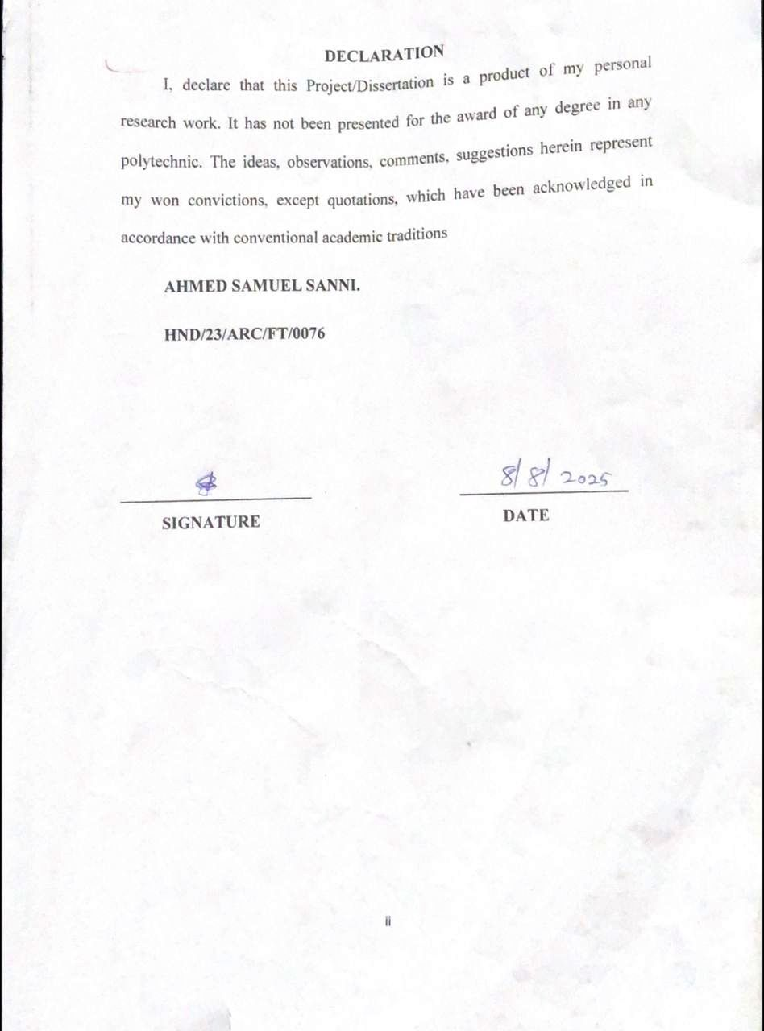
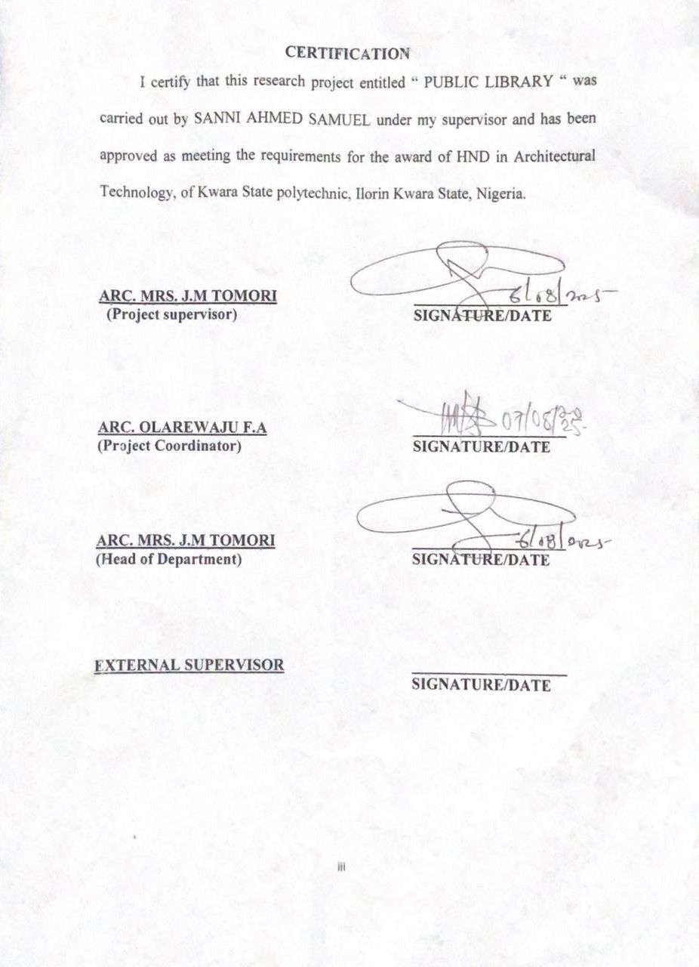
DEDICATION

This project is dedicated to my beloved parents, whose their unwavering support,encouragement, and sacrifice have been my greatest sources of strength.I also dedicate this work to my supervisor and friends, whose guidance and motivation has helped me throughout the journey.
Above all, I dedicated this project to Almighty God, for granting me the wisdom, health, and perseverance to successfully complete this work.

ACKNOWLEDGEMENT
First and foremost, I would like to express my sincere gratitude to God Almighty for granting me the knowledge, his infinite mercy, perseverance and strength to complete this project successfully.
I am deeply grateful to the Department of Architectural Technology also my heartfelt thanks go to all the lecturers and staff and also to my supervisor, ARC. J.M. TOMORI, who is also the HOD of this great department and has been supportive throughout this project, may Almighty God continue to bless you and reward you.
My sincere appreciation goes to my dearest, loving, and caring parent Mr. and Mrs. SANNI for their parental, moral, and financial support and for making my dream a reality. I also appreciate my colleagues and friends for their cooperation and helpful suggestions. This project would not have been possible without the contribution and support of all these individuals.

ABSTRACT
This project explores the design of a contemporary public library that integrates functionality, sustainability, and cultural relevance within an urban context. The increasing demand for inclusive, multifunctional public spaces in city like Lagos. Has led to the development of generic facilities that often lack identity and meaningful connection to their environment.
This design seeks to address this issue by creating a library that not only meets modern informational and community needs but also reflects the cultural and climatic characteristics of its region. The research examines spatial planning, material selection, and facade treatment as tools for achieving environmental efficiency and cultural expression. Case studies of successful public library developments were analyzed, and interviews with architects, librarians, and local users were conducted to understand user preferences and regional design values.
The resulting design proposal features flexible reading and learning spaces, shared green areas, efficient natural lighting and ventilation strategies, and locally inspired facade treatments. The project concludes that incorporating cultural identity and sustainable design principles in public libraries enhances both user experience and the architectural character of urban civic spaces. The proposed design incorporates features such as:
Modular and reconfigurable interior layouts
Shared green courtyard
Passive design strategies, including cross ventilation, and day lighting to reduce energy use.
By embedding these elements into the architectural language of the library, the project aims to promote a sense of place, foster community ownership, and create a sustainable, future ready public infrastructure. Ultimately, the research concludes that integrating local cultural identity with sustainable, human centered design significantly enhance not only the user experience but also the architectural character of urban civic spaces, positioning public libraries as vital nodes in the social and environmental fabrics of modern cities.
TABLE OF CONTENT
Title Page
Declaration…………………………………………………………...….……. ii
Certification ……………………………………………………………...…...iii
Dedication ………………………………………………………………...…...iv
Acknowledgment ………………………………………………………………v
Table of content ……………………………………………………………….vi
List of plates……………………..…………………………………………... vii
List of Tables…………………………………………………………..…..…viii
Abstract ……………………………………………………………..……….. ix
CHAPTER ONE:
1.0 General Introduction …………………………..………..…….……...1
1.1 Definition……………………………………………….….…………...3
1.2 Historical background of the project ………………..………………..3
1.3 Statement of design problem …………………………….…………….3
1.4 Aim and Objectives of the study……………………………………….7
1.5 Project justification …………………………………..…………….…7
1.6 Clients background………….………………………………………....8
1.7 Scope of the study ………………………….…………………......9
1.8 Limitation of design…………...……………..……………………...…10
1.9 Research Methodology …………………………..……………….….11
CHAPTER TWO:
2.0 Review of relevant Literature………………………………..……….13
CHAPTER THREE
3.0 Case studies…………………………………………………………….23
3.1 Selected Case Studies …………………………………..…………….23
3.2 Case study one……………………………………….……....……….23
3.3 Case study two………………………………………….….…………26
3.4 Case study three……………………………………..……………….30
3.5 Case study four……………………………………….………………32
3.6 Case study five (online case study) ………………….......…………33
3.7 Deduction from Case study ………………………….......…………34
CHAPTER FOUR
4.0 Project location……………………………………………….………35
4.1 Historical background of selected location state ……………..…….36
4.2 Historical background of Selected location LGA………….……….36
4.3 Physical feature of the location ………………………………..……38
4.4 Population ………………………………………………………….…38
4.5 Social service ………………………………………………….…...…38
4.5.1 Road …………………………………………………….…..………….39
4.5.2 Health service …………………………………………….…...….……39
4.5.3 Water and electricity ………………………………………………….40
4.6 General climatic condition ……………………………….………….40
4.7 Site analysis ………………………………………………...…………42
4.7.1 Site selection/justification ………………………………….….…….42
CHAPTER FIVE
5.0 Design report…………………………………………………..………47
5.1 Design brief ……………………………………………………..…….47
5.2 Design analysis ………………………………………………..……47
5.3 Design appraisal ………………………………………………….……49
5.4 Design characteristics ……………………………………………..….49
5.5 Building structure …………………………………………………….51
5.6 Service ……………………………………………………………….....51
5.7 General requirement ………………………………………………….52
5.7.1 Lighting ………………………………………..………………..…….52
5.7.2 Orientation …………………………………………………………….52
5.7.3 Rain protection devices ………………………………………….…..53
5.7.4 Noise control device ……………………………………………….….53
5.8 Material and finishes ……………………………………………….…53
CHAPTER SIX
6.0 Summary and conclusion ………………………………..……………56
6.1 Summary …………………………………………………………..….56
6.2 Conclusion ………………………………………………………….…56
References ……………………………………………………………………58

LIST OF FIGURES
Fig. 3.0: Location Plan of Case Study One………………………………...24
Fig 3.1: Ground Floor Plan of Case Study One ………………………..…25
Fig 3.2: First Floor Plan of Case One ……………………………………...25
Fig 3.3: Location Plan of Case Study Two …..……………………………27
Fig 3.4: Ground Floor of Case Study Two……..…….……………………28
Fig 3.5: First Floor Plan of Case Study Two………………………………28
Fig 3.6:Second floor plan of case study two ………………………………30
Fig 3.7:Location plan of case study three …………………………………31
Fig 3.8:Floor plan of case study three …………………………………….31
Fig 3.9:Second floor plan of case study three …………………………….59
Fig 4.0: Location map……………………………………………………....44
Fig 4.1 Site inventory……………………………………………………….45
Fig 4.2 Site analysis………………………………………………………….45

LIST OF PLATES
Side view of case study one ….…………………………………………….25
Side view of case study two ………………………………………………..29
Side view of case study three …………………………………………….…32
Location map of case study four ……………………………..……………33
Side view of case study four.………………………………………………..33
Location map of case study five ……………………………………………..33
Side view of case study five …………………………………………………33

LIST OF APPENDICIES
APPENDIX 1 Geographical Map ……………………………………………59
APPENDIX 2 Climatic Data …………………………………………………59
APPENDIX 3 Site Zoning ……………………………………………………60
APPENDIX 4 Concept Derivation …………………………………………..60
APPENDIX 5 Bubble Diagram ……………………………………………...61
APPENDIX 6 Site Plan ……………………………………………………….61
APPENDIX 7 Ground Floor Plan …………………………………………..62
APPENDIX 8 First Floor Plan ….…………………………………………..62
APPENDIX 9 Roof Plan …………….………………………………………63
APPENDIX 10 Section B.B …………………………………………………63
APPENDIX 11 Front Elevation ……..……………………………………...64
APPENDIX 12 Back Elevation …….……………………………………….64
APPENDIX 13 Right and Left Elevation ………………………………….65
APPENDIX 14 Internal Perspective ………………………………………65
CHAPTER ONE
1.0 GENERAL INTRODUCTION
Public library is a library that is accessible be the general public and is usually funded from public sources such as taxes. It Is designed to support Literacy, Learning personal development and recreation for people of all ages.
Public libraries are typically funded by the government, Local authorities or Charitable organization, making their services accessible to everyone. In essence public libraries is vital for Creation Informed, empowered and Connected Communities• Public Libraries exist in many countries across the world and often connected an essential part of having an educated and literate population. Public libraries are distant from research, school Libraries and academic libraries. A Public library is a community-Centered Institution that provides free access to books, Information, and a wide range of educational and cultural resources. Unlike private academic libraries, public libraries are open to everyone, regardless of age, background, or Income. Their primary mission is to promote literacy, Support lifelong learning and foster an informed and educated society. Public libraries offer much more than just books. They provide media, internet services, and educational programs such as workshops, lectures, and reading clubs.

Many libraries also serve as safe and Inclusive spaces for Children, students, job seekers, and the elderly. The Concept of the public library dates back Centuries, but it became more structured and Widespread in the 19th Century, particularly in Europe and North America. Today, public libraries continue to evolve by integrating modern technology, offering digital lending services, and supporting community development through outreach initiatives.
In essence, public Libraries play a Crucial role in democratizing knowledge and ensuring that every Individual has the opportunity to learn, grow, and Contribute meaningfully to society. Public libraries also play an important role in preserving cultural heritage. They often maintain archive, local history collections, and rare manuscripts that are valuable for historical research and community identity. The development of public libraries is closely linked to the growth of democratic societies, where access to information is considered a basic right. The idea is that knowledge should not be limited to a few, but shared openly to empower individual and uplift communities. In the digital, public library have embarked technology to remain relevant. Many now offer e-books, online databases, virtual Classes, and multimedia resources. This transformation has allowed libraries to reach wider audience and Stay Connected with Users even beyond their physical premises.
In Conclusion, the public library is, much more than a place to borrow books .It is a Cornerstone of education, equality, and Community life. It serves as a lifelong Companion for learning, Curiosity, and growth, making it an indispensable part of any society.
  - DEFINITION OF PUBLIC LIBRARY
  - A public library is an organization established, supported and funded by the community, either through local, regional or national government, to provide access to knowledge, information and works if the imagination through a range of resources and services, regardless of race, age, or states. It serves as an informal educational institution that support lifelong learning, research and self development for individuals of all ages and backgrounds and promotes literacy, creativity and cultural development while serving as a safe inclusive space for learning and collaboration.
1.2 HISTORICAL BACKGROUND OF THE PROJECT
The history of public libraries can be traced to ancient times when libraries were to store records and resources. The earliest records of a library institution as it is presently understand Can be dated back to around 500 years age in the Southwest Asian region of the world. One of the oldest libraries found is that at the ancient library as Elba (ciach 2500 bc)in present-day stria. The term Library is based on the latin word "libra" for "books" or "document" Contained in latin libraries "Collection of books" and librarium "Container for books".
Bentamin frankin established the first lending Library in America in 1731, Which was founded Sometime in the 7th Century bc for the "ROYAL CONTEMPLATION" of the Assyrian ruler Ashurbanipal in Nineveh (7th Century BE).
In Ancient Egypt, Libraries were Closely linked with religious and administrative centers. The library of Alexandria, founded in the 3rd Century BCE in Egypt, became a beacon of Scholarship and an early attempt at universal knowledge collection .Similarly, ancient Greek and Roman societies valued libraries though they were often reserved for scholars and the elite. Libraries such as those of Aristotle and Cicero played key roles in preserving philosophical and literary works.
During the middle Ages in Europe, Literacy was largely Confined to monasteries • Monastic libraries preserved religious texts and manu-script, often copied by hand. Those libraries were not opened to the general public. The invention of the printing press by Johannes Gutenberg in the 15th century revolutionized access to books. Printing reduced the cost of book production, enabling more people to afford and read books. This development laid the foundation for the modern public library system by increasing the demand for shared reading spaces and organized book collections.

Among the history of public library is the birth of the modern public library which is free and accessible to all. It emerged in the 19th century, particularly in the United kingdom and United States. United Kingdom public libraries Act of 1850 in England was a landmark moment. It authorized boroughs to establish free public libraries funded by local taxes. The act was driven by industrialization, urbanization, and a growing recognition of the need for educated workers and informed citizens. While United States public libraries the Boston Public Library, founded in 1852, is considered the first large free municipal library. Philanthropists like Andrew Carnegie significantly advanced the public library movement, funding the construction of over 2,500 library buildings worldwide in the late 19th and early 20th centuries. Public libraries have increasingly become “third places” — communal spaces that are neither home nor work, where people can learn, socialize, and collaborate.
In conclusion The public library has evolved from exclusive archives of ancient rulers to dynamic community hubs serving the general public. Its history reflects humanity’s enduring pursuit of knowledge, education, and shared culture. As society continues to change, the public library remains a resilient institution, adapting to new needs while holding true to its foundational values: free access to information, lifelong learning, and community empowerment.

1.3 STATEMENT OF DESIGN PROBLEM
This project explores the design of a contemporary public library that integrates functionality, sustainability, and cultural relevance within an urban context. The increasing demand for inclusive, multifunctional public spaces in growing cities like Ilorin has led to the development of generic facilities that often lack identity and meaningful connection to their environment. This design seeks to address this issue by creating a library that not only meets modern informational and community needs but also reflects the cultural and climatic characteristics of its region. The research examines spatial planning, material selection, and facade treatment as tools for achieving environmental efficiency and cultural expression.
Case studies of successful public library developments were analyzed, and interviews with architects, librarians, and local users were conducted to understand user preferences and regional design values.
The resulting design proposal features flexible reading and learning spaces, shared green areas, efficient natural lighting and ventilation strategies, and locally inspired facade treatments. The project concludes that incorporating cultural identity and sustainable design principles in public libraries enhances both user experience and the architectural character of urban civic spaces.

1.4 AIM AND OBJECTIVES
AIM
To design a library that is functional, sustainable, accessible and also provide a welcoming environment for individuals to study, work, and relax, with consideration for maintenance and operate efficiency.
OBJECTIVES
- To create spaces that accommodate various activities such as reading, studying, working, socializing and hosting events.
- To design a space that's is quiet to study, a resource rooms and spaces for knowledge sharing.
- To design a library that includes ramps, elevators, and wide aisles for the use of everyone including the special needs.
- Design for long-term adaptability.
- To create an appealing landscaping that enhance comfortable and welcoming environment..
1.5 PROJECT JUSTIFICATION
The public library serves as a vital resources hub for children, teenagers, youths, and adults offering a wide range of materials, services and programs to different learning, styles and research interest. The project is justifying to design a PUBLIC LIBRARY for the settlement of IKOSI KETU LAGOS STATE to support academic endeavors of the community by providing access to current and relevant resources, ensuring that users have the necessary tools for their research and studies. I am designing for that area to cultivate learning culture.

1.6 CLIENTS BACKGROUND
In terms of infrastructure, Ikosi-Ketu Local Council Development Area has made notable progress in recent years. The local authorities have undertaken the construction and rehabilitation of roads and drainage systems, improved electricity access in several neighborhoods, and facilitated the development of schools and primary health care centers to enhance the standard of living for residents.
Overall, Ikosi-Ketu is a vibrant and evolving urban area with a rich cultural heritage and historical significance. Its strategic location along key transport routes and its proximity to major commercial districts make it a vital part of Lagos State’s economic and social landscape.
1.7 SCOPE OF THE STUDY
Numerous educational, informational, recreational, and communal activities take place within a public library. The scope of this project is limited to a comprehensive study on the adequate provision of functional reading areas, resource centers, and supporting facilities that make up a standard modern public library. The design will emphasize space efficiency, comfort, accessibility, privacy for focused study, and opportunities for social interaction, catering to a diverse range of users such as students, researchers, families, and the general public.

The development will reflect a contemporary urban lifestyle with considerations of sustainability, smart technology integration, and community engagement. Facilities provided within the library will support daily learning, intellectual growth, relaxation, cultural enrichment, and essential services that enhance the overall quality of life for users.
The facilities to be provided in the public library development will include;
- Residential Apartments
- Reception
- Internet cafe
- Spacious reading room
- Separate section spaces [ Children, Teenagers, Adults, Vip citizens ]
- Stack Rooms
- Reference Sections
- Multipurpose Hall
- Digital Library Access
- Self-service kiosks
- Surveillance and security systems
- Study Rooms
- Marker space/innovation Labs
- Language Labs
- Library Office
- Technical Processing Sections
- Elevators and emergency stairwells
- Control and server unit
- Cafeteria
- Parking Area
- Waste Management
1.8 LIMITATION TO DESIGN
While conducting research for the design and planning of a public library, several challenges were encountered that significantly impacted the depth, scope, and efficiency of the research process.
1. Limited Access to Information: Gaining access to detailed architectural floor plans, construction documents, and prior user evaluations of existing public libraries was often restricted due to privacy policies, data confidentiality, and institutional regulations. This limited the ability to conduct comparative analysis and draw insights from existing models.
2. Limited Technical Knowledge Among Stakeholders: Many key stakeholders—especially local community members, general users, and some staff—lacked the technical vocabulary or design awareness necessary to express architectural and spatial needs in detail. This made it challenging to accurately interpret their feedback for design planning purposes.
3. Environmental and Physical Barriers: Site visits were occasionally disrupted by adverse weather conditions, especially in urban centers with dense populations and limited open space. In some cases, restricted access to public library buildings—due to ongoing operations, security protocols, or renovation activities—also limited opportunities for thorough on-site observation, user interaction, and environmental assessment.
1.9 RESEARCH METHODOLOGY
There are various methods used during the research of this project in order to arrive at a functional and appealing design concept. The following research methods were employed.
Literature Review: reference to tolerance for ideas of various writer were gathered also analys published information and research studies were used in order to attain useful and important past thesis work on similar project.
Oral Interview: A face to face interaction was conducted with practicing architects, engineers, Librarians of various public library were and better deduction from their information sources also influence the end design.
Internet Exploring: Different webs pages was navigated and also use of search engines and exploring online content to satisfy curiosity and gather more information.
Case study: This involves the thorough synthesis and analysis of similar existing structure building based on the data collected and better seduction was made for realization of the design best.

CHAPTER TWO
2.0 LITERATURE REVIEW
Based on the research synthesized by Lesley Farmer for the IFLA guidelines "Using Research to Promote Literacy and Reading in Libraries "Written by Ellie Cheun and Annika Waldekt under the supervision of Lisa Krolak (Head of Documentation, UIL Hamburg), April 2016
INTRODUCTION
A literature review is a vital step in conducting research. It involves the systematic examination of previous studies and publications—books, journals, conference proceedings, reports, dissertations—on a specific topic. The purpose is to gather and synthesize all relevant and essential work to gain a comprehensive understanding. A literature review outlines the methodologies and findings of earlier studies, enabling researchers to identify trends, draw comparisons, avoid duplication, and refine research questions.
When it comes to public libraries, the literature review explores their evolving roles, services, architectural development, community engagement strategies, and the challenges they face. Public libraries are central to fostering literacy, democratic access to information, lifelong learning, and community development.

Evolution of the Building Typology of Public Libraries
The typology of public library buildings has undergone a profound transformation over centuries, mirroring shifts in societal needs, technological advancements, and cultural values. From sacred repositories of knowledge to vibrant community hubs, library architecture reflects evolving concepts of public access, education, and civic engagement.
A public library was established in Rome by the first century BC, in Atrium Libertatis. However, the first major public library was said to been established in Athens Pisistratus in the sixth century BC , and by the end of the Hellenistic period, public libraries are said to have been widespread in the Eastern Mediterranean.
In Cesena, Italy, the first community-run public library, the Melanesian Library, was established in 1447, provided both secular and religious texts in Latin, Greek, and Hebrew, and was fully open to all members of the public, At the start of the 18th century, libraries were becoming increasingly public and were more frequently lending libraries. The 18th century saw the switch from closed parochial librarion to lending libraries.

However, up until the mid-19th century, there were virtually no public libraries in the sense in which we now understand the term, i.e., libraries provided with public funds and freely accessible to all.*” Only one important library in Britain, namely Chethan’s Library in Manchester, was fully and freely accessible to the public.
CHALLENGES PECULIAR TO PUBLIC LIBRARY
-Inadequate Funding: Public libraries often depend on government budgets, which can be inconsistent or insufficient. The impact of inadequate funding in public library includes; Affects staffing, acquisition of new materials, maintenance, and introduction of modern services (e.g., digital access).
-Outdated Infrastructure: Many public libraries operate in old buildings with limited space, poor internet access, or insufficient facilities and the impacts of outdated structures is that it hinders modern service delivery and user comfort.
-Digital Divide and Technological Obsolescence: While libraries try to provide digital services (Wi-Fi, e-books, computers), keeping up with fast-changing technology is a challenge.
-Low Public Awareness and Perception: Some communities undervalue libraries or are unaware of available services and it includes Underutilization, leading to reduced relevance and funding.
-Staffing Challenges: Shortage of qualified librarians, limited training opportunities, or burnout due to understaffing can leads to Limits service quality and innovation.
SOLUTIONS PECULIAR TO THIS BUILDING TYPOLOGY
- Flexible and Adaptive Interior Design: To accommodate changing user needs and multifunctional use by using movable partitions and modular furniture.
- Integration of Technology Infrastructure: To support digital literacy, e-learning, and modern library functions by installing robust WI-FI networks and charging stations.
- Sustainable and Green Building Practices: To reduce operational costs and promote environmental.
Responsibility by using solar panels, natural lightning, and ventilation systems.
- Zoning For Diverse User Groups: To meet the needs of varied demographics ( children, teens, adults, seniors ) by separating quiet study area from children’s and teens sections.
- Community – Centric Spaces: To reinforce the library’s role as a civic and cultural hub by including meeting rooms, auditoriums, and gallery spaces.
-Security and Surveillance Systems: To protect users, staff, and resources without compromising openness by Installing discreet CCTV, RFID for books, and secure entry/exit points.
- Universal Design and Accessibility: To serve users of all abilities and ages by Installing ramps, elevators, tactile paths, accessible restrooms.
REVIEW OF THE LITERATURE
Public libraries are undergoing a profound transformation, evolving from traditional knowledge repositories into dynamic centers for community engagement, innovation, and social inclusion. This literature review synthesizes key perspectives across architecture, public space theory, digital infrastructure, and sustainability to explore how public libraries are redefining their role in the 21st century.
Barton and Quinn (2022) argue that equitable design is foundational to the modern library, advocating for inclusive architecture that supports accessibility for all users. Their work suggests that the physical structure of libraries must reflect the principles of social justice and participatory access. This aligns with Nussbaum’s (2019) capabilities approach, which emphasizes the role of public infrastructure in enabling human development and democratic participation.

Libraries are increasingly becoming multi-use, reconfigurable environments. Cohen (2019) introduces the concept of the “flexible library,” where spaces are adapted to different user needs—from study areas to collaborative hubs. Davies and Kent (2020) explore the implementation of maker spaces in public libraries, viewing them as democratizing tools for creativity and innovation. These changes reflect a shift from static to dynamic public environments.
Koolhaas (2015) famously describes libraries as “the last bastion of public space,” emphasizing their role in offering free, open, and non-commercial environments. This perspective is grounded in Fraser’s (2016) rethinking of the public sphere, which views institutions like libraries as arenas for discourse and civic participation. Harvey (2016) deepens this discourse by situating libraries within the right-to-the-city framework, arguing that they are key actors in resisting privatization and maintaining inclusive urban life.Environmental and technological innovation are increasingly central to library development. The International Federation of Library Associations and Institutions (IFLA, 2021) provides guidelines for sustainable architecture, emphasizing green materials, energy efficiency, and environmental responsibility. Thompson (2017) presents a case study of the Salt Lake City Public Library, showcasing biophilic design strategies that connect people with nature. Lee and Matthews (2020) extend this discussion by focusing on smart infrastructure and its potential to enhance operational efficiency and user experience. Schmidt (2016)
examines Dokk1 in Aarhus, Denmark, as a case of civic-centered design where public participation informed both programming and space utilization. Similarly, Miller (2018) analyzes the Idea Stores in East London, highlighting their impact on community transformation through accessible design, education, and cultural programming. Bryant, Matthews, and Walton (2009) support this view, presenting public libraries as crucial social and learning environments.
Types of Public Libraries
Public libraries vary in size, service model, and target populations. Key types include:
---Central Libraries : Serve as flagship libraries in urban areas with extensive collections, services, and event programming.
Branch Libraries : Smaller neighborhood libraries offering localized services often focusing on children, youth, and families.
---Rural Libraries : Serve sparsely populated areas, often limited in resources but crucial for access to Information and services.
---Mobile Libraries : Bookmobiles and digital vans bring library services to remote or underserved communities.

---Digital/Virtual Libraries : Offer e-books, online databases, and digital reference services accessible 24/7.
--Hybrid Libraries : Combine physical and digital services with community spaces, innovation labs, and co-working areas.
Challenges in the Digital Era :The digital age brings both possibilities and risks. Conway (2010) highlights dilemmas in digital preservation, arguing that digitization alone is not sufficient without robust preservation strategies. Posner (2013) identifies the institutional and resource-based barriers that hinder digital humanities integration in libraries. In parallel, Hernon and Altman (2010) focus on assessing service quality, underscoring the importance of user-centered service delivery in digital and physical contexts.
Theoretical Frameworks and Spatial Understanding : Soja’s (2018) concept of Third space offers a spatial framework that views libraries as complex combinations of physical structures, symbolic meanings, and lived experiences. This understanding positions libraries not merely as buildings but as cultural and political sites of negotiation and identity.
---Functions of Public Libraries
Provide access to educational, informational, and recreational materials
Promote reading and information literacy across age groups
Support digital inclusion through free access to devices and Wi-Fi
Preserve community heritage through local archives
Facilitate civic dialogue and community cohesion.
---Challenges Facing Public Libraries
Despite their vital role, public libraries confront several modern challenges:
Budget Constraints: Limited funding affects staffing, programming, and collection development.
Digital Divide: Meeting increasing demand for technology and internet access among underserved populations.
Evolving User Needs: Adapting spaces and services for multilingual, multigenerational, and neuro diverse users.
Sustainability: Upgrading infrastructure to meet green building standards with limited funds.
Security and Safety: Managing public access while ensuring staff and user safety.
Measuring Impact: Demonstrating the library’s value to funders and policymakers with quantifiable data.
----Addressing These Challenges Requires:
- Strategic Planning
- Community Partnerships
- Innovative Programming
- User-Centered Design
- Ongoing Staff Training
Conclusion
The transformation of public libraries is multifaceted, encompassing design innovation, digital infrastructure, environmental sustainability, and a commitment to equity. The literature illustrates that libraries are no longer passive spaces for book storage but active institutions shaping inclusive, democratic, and resilient urban futures.

CHAPTER THREE

3.0 CASE STUDIES
- OSUN STATE LIBRARY BOARD AT PMB 4367 OKE - FIA, OSOGBO.
- KWARA STATE LIBRARY BOARD AT 3 SULU GAMBARI ROAD, GRA, ILORIN KWARA STATE NIGERIA.
- AMERICAN CORNER IBADAN LIBRARY AT 54, MAGAZINE ROAD (JERICHO) IBADAN, OYO STATE, NIGERIA.
- KESHEN GOODMAN LIBRARY AT 330 LACEWOOD DR, HALIFAX, NOVA SCOTIA, B3S OA3, CANADA.
- SOUTH AFRICAN KEPI MADUMO LIBRARY AT CAPE TOWN, RAMOKHOASE STREET PRETORIA 001
3.1. CASE STUDY ONE
OSUN STATE LIBRARY BOARD PMB 4367 OKE - FIA, OSOGBO.
BRIEF INTRODUCTION
It was established on April 29, 1994, and commissioned by Lt. Gen. Oladipo Diya, the Osun State Library is situated in the Oke Fia district along Ilobu Road in Osogbo, the state capital.
Facilities & Operations
The library operates as the primary public library overseen by the state government, offering general reference and lending services. It is reportedly located near the state government house and features a formal, imposing exterior typical of government institutions .

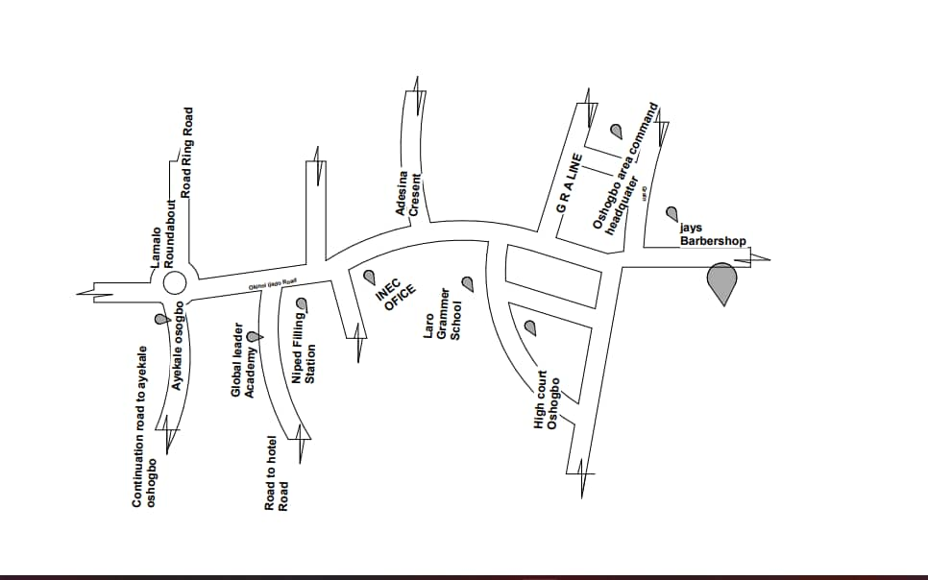

FIG 3.1:- LOCATION PLAN OF CASE STUDY ONE
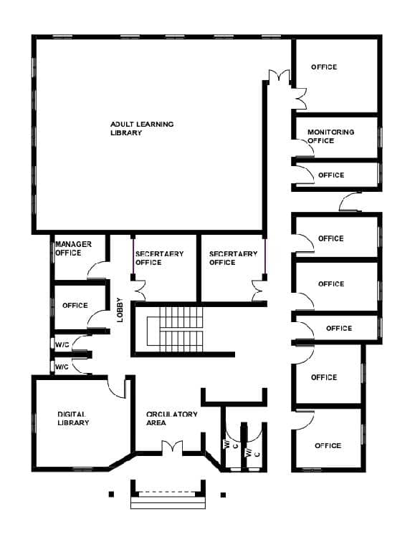

FIG 3.2:- GROUND FLOOR PLAN OF CASE STUDY ONE

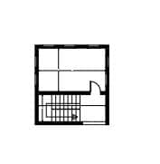

FIG 3.3:- FIRST FLOOR PLAN OF CASE STUDY ONE
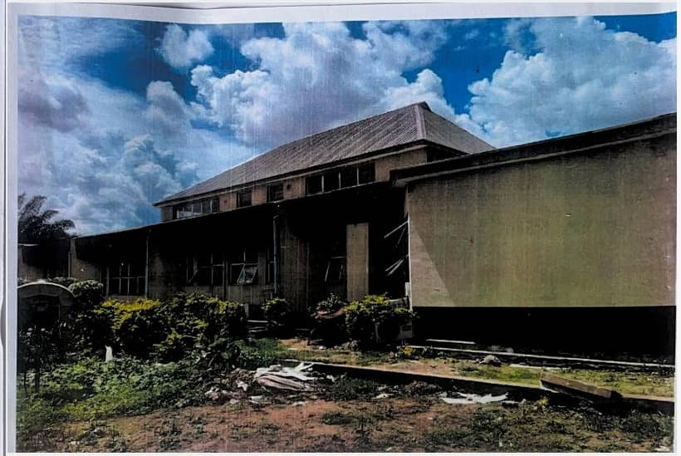

PLATE 3.1:- SIDE VIEW OF CASE STUDY ONE

3.1.1 MERITS
The Library is located in a quiet and serene area.
Building is well oriented.
The Library has a good landscaping.
It's easily accessible.
3.1.2 DEMERITS
There are minimum provision for conveniences
The Library are only allocated and limited to specific and privilege people
Site scopes is not well segmented
3.2 CASE STUDY TWO
KWARA STATE LIBRARY BOARD AT 3 SULU GAMBARI ROAD, GRA, ILORIN KWARA STATE NIGERIA.
Kwara State Library Board, situated at 3 (or 16) Sulu Gambari Road (also referred to as Zulu Gambari or Sulu Gambari Way) in GRA, Ilorin, serves as the primary public library in the state . Established shortly after Kwara State was created in 1967—initially operating from temporary buildings—it was relocated to its permanent facility in the early 1990s and formally commissioned in November 1990 by General Ibrahim Babangida . A significant renovation in 2005, led by then‑governor BukolaSaraki, modernized the administrative, technical, and acquisition divisions .

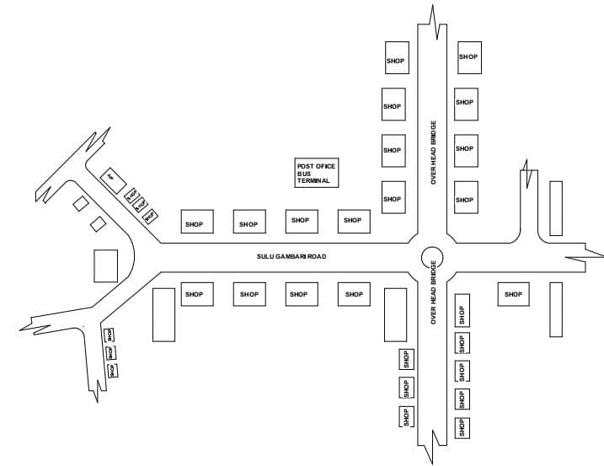

FIG 3.4:- LOCATION PLAN OF CASE STUDY TWO
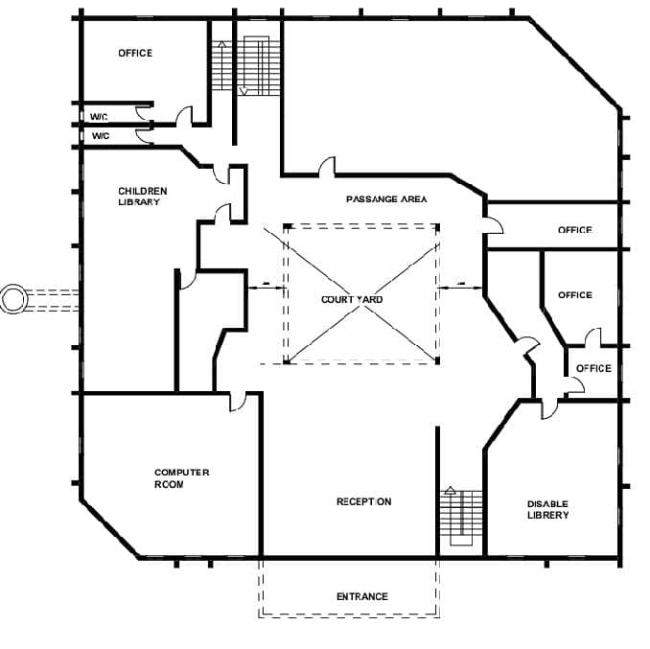

FFFIFHHHHH
FIG 3.5 :- GROUND FLOOR PLAN OF CASE STUDY TWO

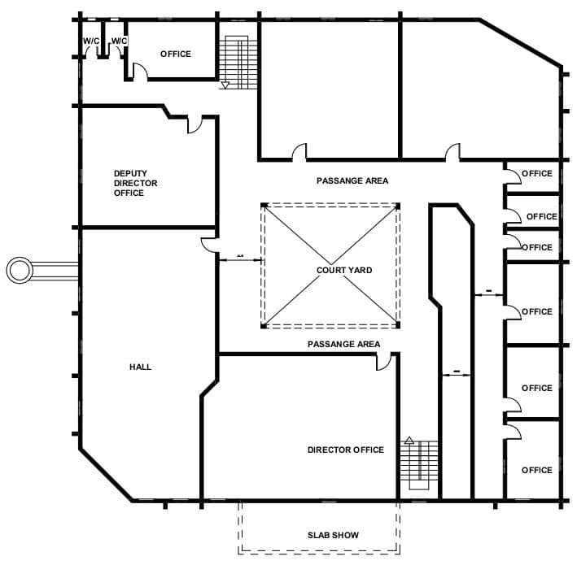
FIG 3.6:-FIRST FLOOR PLAN OF CASE STUDY TWO

FIG 3.7:- SECOND FLOOR PLAN OF CASE STUDY TWO

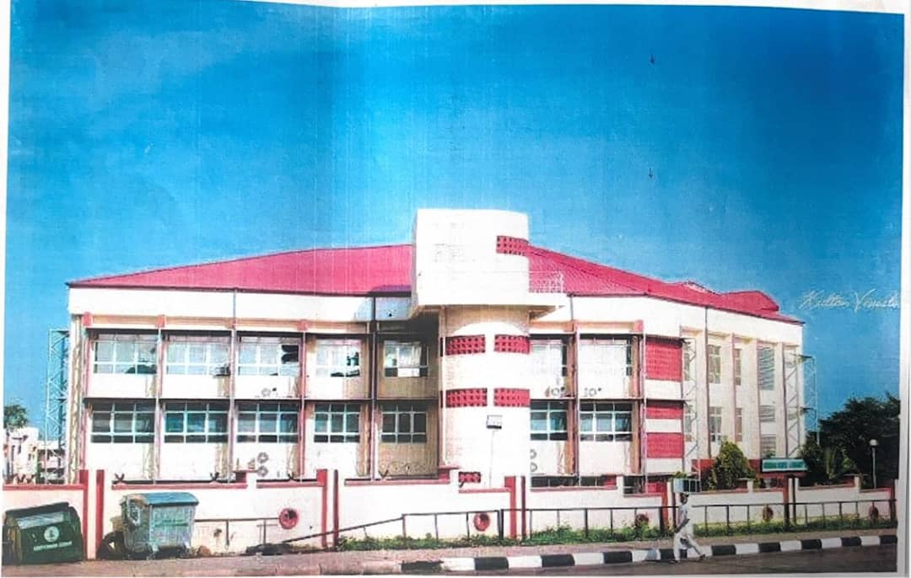

SOURCE:- Researcher Field Work, 2025

PLATE 3.2:- SIDE VIEW OF CASE STUDY TWO
3.2.1 MERITS
The multipurpose room is placed on a separate floor from the reading space to reduce noise impact.
Atrium is provided to enhance acoustic privacy.
3.2.2 DEMERITS
Floor to ceiling distance is not sufficient
Floor finishes are not sound abordant.
Poor landscaping

3.3 CASE STUDY THREE
AMERICAN CORNER IBADAN LIBRARY AT 54, MAGAZINE ROAD (JERICHO) IBADAN, OYO STATE, NIGERIA.
BRIEF INTRODUCTION
The American Corner Ibadan, part of the U.S. government’s network of American Spaces across Nigeria, is hosted by the Initiative for Information, Arts and Culture Development (IACD)—situated at 54 Magazine Road, Jericho, Ibadan, directly beside The Booksellers Ltd., near Sabo Road in the city center .
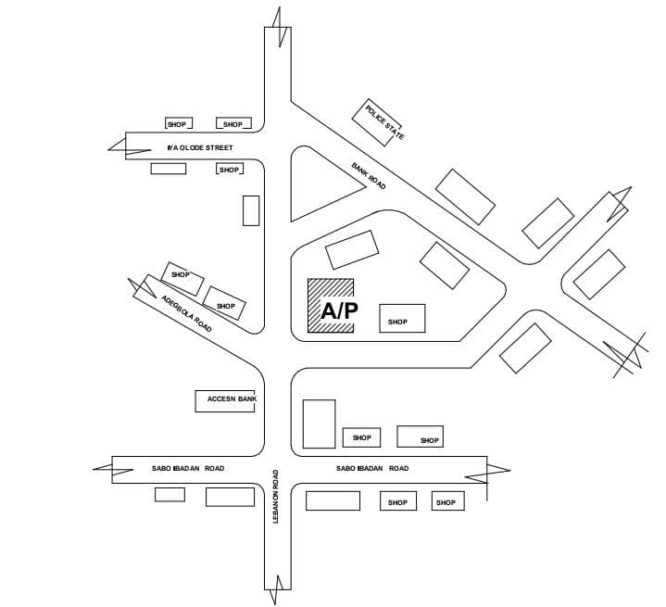

FIG 3.8:- LOCATION PLAN OF CASE STUDY THREE

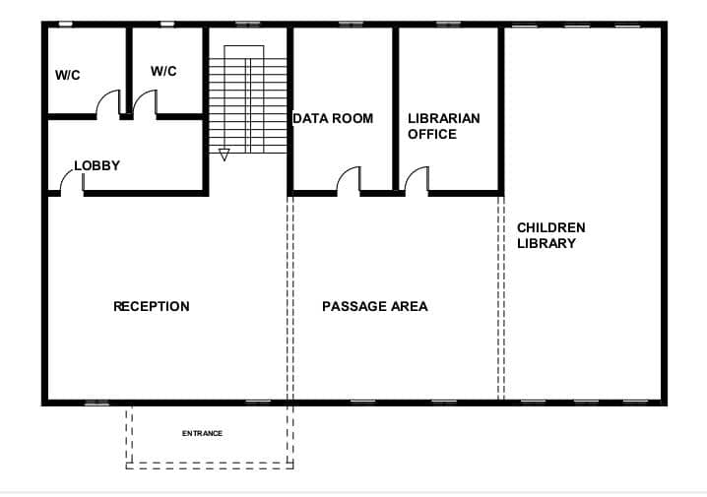
FIG 3.9:- GROUND FLOOR PLAN OF CASE THREE
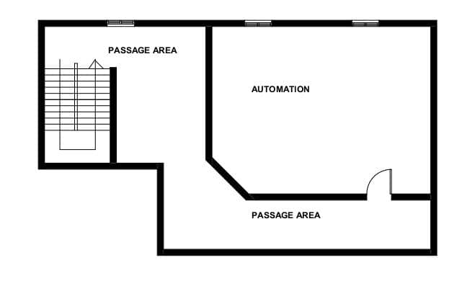
FIG 3.10:- UPPER FLOOR PLAN OF CASE STUDY THREE

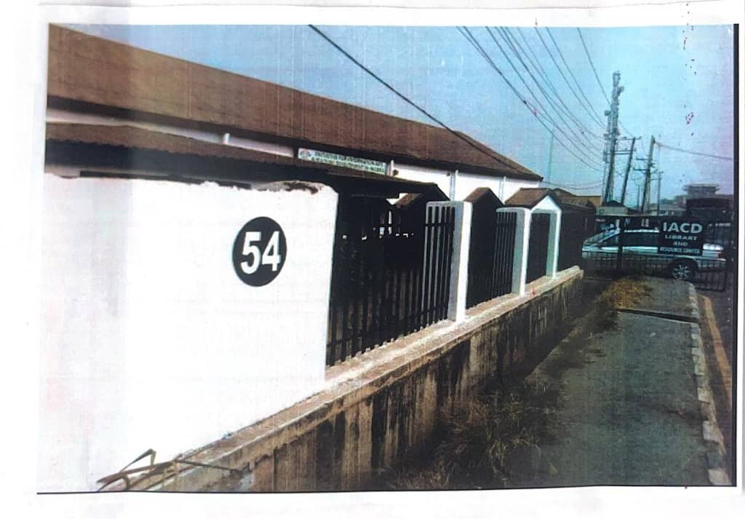

PLATE 3.3:- SIDE VIEW OF CASE STUDY THREE
3.3.1 MERITS
There is adaptive reuse of existing structures
There is natural lightning and ventilation
It's easily accessible
3.3.2 DEMERITs
There are limited floor area
Acoustic challenges
Lack of dedicated outdoor spaces.
3.4 CASE STUDY FOUR [ONLINE CASE STUDY]
KESHEN GOODMAN LIBRARY AT 330 LACEWOOD DR, HALIFAX, NOVA SCOTIA, B3S OA3, CANADA.
BRIEF INTRODUCTION
The KESHEN GOODMAN LIBRARY, located in Halifax, Nova Scotia, is a prominent branch of Halifax public libraries, opened in 2001, it's named after two key benefactor, the KESHEN family and the Goodman family, who contributed to it's development. The library was established to serve the growing community of Clayton Park, Rockingham, and surrounding areas. It quickly became a hub for learning, community engagement, and cultural activities.
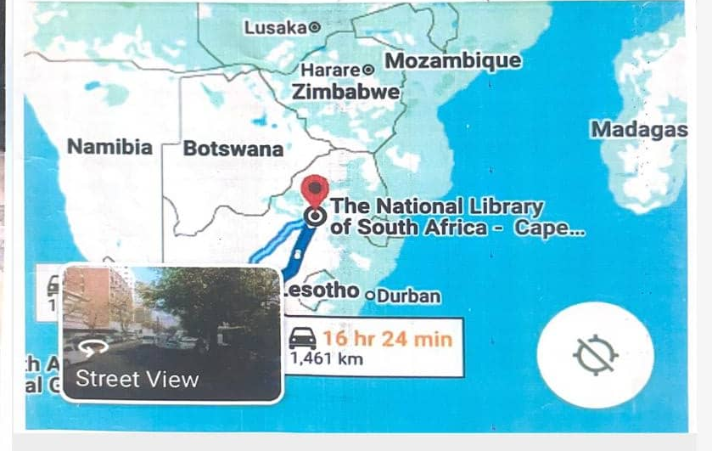
PLATE 3.5: LOCATION MAP OF CASE STUDY FOUR
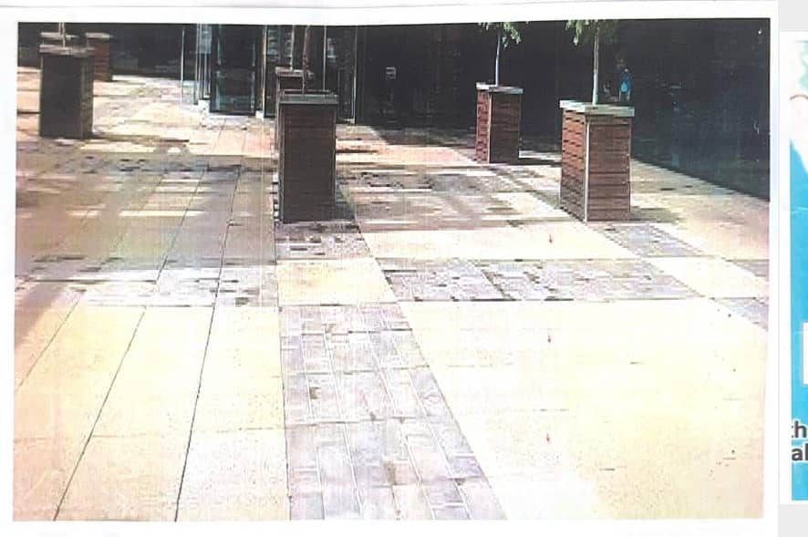
PLATE 3.7: SIDE VIEW OF CASE STUDY FOUR
3.4.1 MERITS
The library has good lightning and a good ventilation The library contains and serve for everybody from the kids to the adults and special needs.
3.4.2 DEMERIT
Spaces in the building are not well segmented and allocated, I.E VIP space, general reading rooms, children rooms, are not in segments.
3.5 CASE STUDY FIVE [ONLINE CASE STUDY 2]
SOUTH AFRICAN KEPI MADUMO LIBRARY AT CAPE TOWN, RAMOKHOASE STREET PRETORIA 001
BRIEF INTRODUCTION:
The Kepi MADUMO South Africa Library [KMSA] are build up to complete collection of published documenting from or relating to south Africa; maintain and extend any other collections or published and unpublished documents. The library is a one storey building with segmented comfort to library users. The library also provide recreational activities and facility for it's users that aids learning and provide other knowledge experience.

SIDE VIEW OF CASE STUDY FOUR
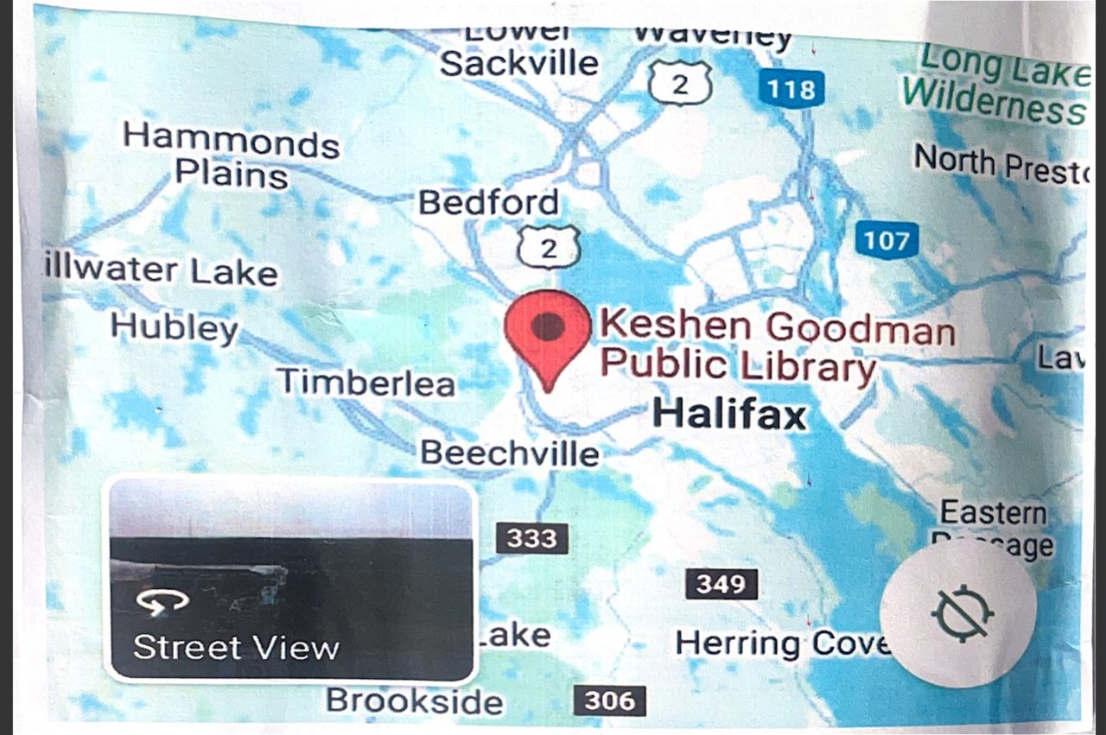

PLATE 3.7 : LOCATION MAP OF CASE STUDY FIVE
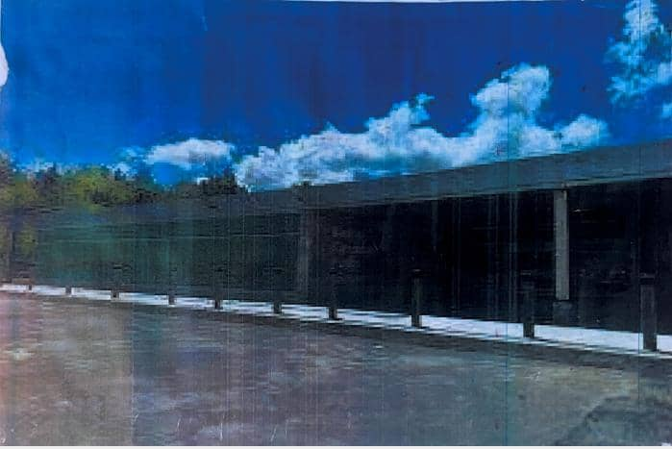PLATE 3.8 : SIDE VIEW OF CASE STUDY FIVE
3.5.1 MERITS
It has a very good landscaping
The site is well organized, i.e consisting of well allocated parking space and drop of point.
3.5.2 DEMERIT
It has a poor lightning system
It has limited flexibility

3.6 DEDUCTION FROM CASE STUDIES:
These are the common similar knowledge or information derived from the aforementioned case studies. Some of which are:
Choice of location should be in a developing or already developed area for easy access to the trainings offered.
Segregation of each department form one another
Well designed and well positioned landscapes
Separation of noisy departments from departments with less noise
Provision of required ventilation and fenestration into each units to serve the spaces well

CHAPTER FOUR
ANALYSIS OF THE ENVIRONMENTAL AND TOPOGRAPHICAL CONDITIONS OF THE SITE
4.1 INTRODUCTION TO STUDY AREA
4.1.1 HISTORICAL BACKGROUND OF LAGOS STATE
Lagos State, Nigeria’s most populous and economically dynamic region, boasts a multifaceted history that spans over a millennium. Strategically situated along the southwestern coast of Nigeria, bordering the Atlantic Ocean, Lagos has evolved from a modest fishing and farming settlement into one of Africa's most significant urban agglomerations. Its historical trajectory is marked by indigenous development, imperial entanglements, and post-independence transformation.
Pre-Colonial Era (c. 1000 AD – 1861) : The origins of Lagos trace back to the early 11th century, when the Awori people, a sub-group of the Yoruba ethnic nationality, established a settlement in the area now known as Isheri and Ikeja. Originally called Oko, meaning “farm,” and later known as Eko, the settlement served as a hub for fishing, agriculture, and local trade. Oral traditions attribute the name “Eko” to Oba Ado, a Benin prince, reflecting the political and cultural influence of the Benin Empire between the 14th and 16th centuries. During this period, Lagos operated as a vassal state under Benin suzerainty, governed by appointed Akarigbos and later Obas of Lagos, who maintained allegiance to the Oba of Benin.
British Colonial Era (1861 – 1960 ) : Lagos became a British protectorate in 1861 and developed into a major commercial center, with infrastructure like roads, railways, and ports.
Post – Colonial Era (1960 –Present ) : Lagos became the capital of Nigeria after independence in 1960 which makes rapid growth and urbanization led to it’s current status as a megacity.
Some notable historical events and landmarks in Lagos include:
- The Benin Empire's influence (14th - 16th centuries)

- The Portuguese arrival (15th century)
- The slave trade (16th - 19th centuries)
- The construction of the Lagos Lagoon bridges (19th century)
- The development of Tinubu Square, National Museum, and other historical sites
4.2 HISTORICAL BACKGROUND OF IKOSI-KETU, LAGOS STATE
Ikosi-Ketu, located within the Kosofe Local Government Area of Lagos State, has a vibrant historical and cultural heritage shaped by its indigenous communities and evolving urban landscape.
Pre-Colonial Era
The area was originally settled by the Awori people, one of the earliest
Yoruba-speaking groups in the Lagos region.
Ikosi and its environs thrived as agrarian communities, with farming, fishing, and trade forming the backbone of the local economy.
Its strategic position between Lagos Island and northern Yoruba territories made it a transit point for goods and cultural exchange.
Colonial Era (1861–1960)
Following the British annexation of Lagos in 1861, Ikosi-Ketu gradually became integrated into the expanding colonial economy.
The community remained semi-rural during this period, but saw increased missionary activity and early educational and religious institutions.
Post-Colonial Era (1960–1990s)
After Nigeria’s independence, Ikosi-Ketu began experiencing population growth and suburban development, especially in the 1970s and 1980s.
The development of road networks like Ikorodu Road accelerated residential expansion and connected the community to the Lagos metropolis.
Modern Ikosi-Ketu (1990s–Present)
Today, Ikosi-Ketu is a densely populated and highly commercialized area, knownfor its markets (notably Ketu Market), transport hubs, and residential estates.
It is part of the Kosofe Local Government, which was created to decentralize governance and better manage the region’s rapid urbanization.
The area is home to diverse ethnic groups, reflecting Lagos State’s cosmopolitan character.
Development in education, commerce, and infrastructure has increased, with growing investments in schools, healthcare centers, and public services.
Notable Landmarks and Sites
The Ikosi Traditional Palace, seat of the Oba of Ikosi.
Ketu Market, a bustling commercial hub.
Agboyi River, part of the area’s natural boundary and a historical water route.
Various old missionary churches and community halls that reflect its colonial-era legacy

4.3 PHYSICAL FEATURES OF THE LOCATION
Ikosi-Ketu is a well-urbanized, mixed-use community suitable for both residential living and commercial activities. Its strategic location along major transportation routes like Ikorodu Road and Oworonshoki Expressway makes it easily accessible from other parts of Lagos.
This accessibility and centrality make it a prime location for setting up Vocational and Educational Training (VET) facilities. Students from surrounding areas like Mile 12, Ojota, and Alapere can easily commute to training centers in Ikosi-Ketu without traveling long distances. The presence of schools, youth populations, and transport connectivity makes it ideal for skill acquisition programs, educational outreach, and community development initiatives.
4.4 POPULATION OF LAGOS STATE
Lagos state is by estimate and population the largest city in the country with the growth of some 3,000 people or around 1.1 million annually, so the true population figure of the greater Lagos area in 2022 is roughly 28million(up from some 23.5million initial population in 2018).
4.5 SOCIAL SERVICES
Ikosi-Ketu, under the jurisdiction of Kosofe Local Council Development Area (L.C.D.A), offers a wide range of social services aimed at improving the quality of life for its residents. These include:
Healthcare services
Educational infrastructure and schools
Social welfare and support programs

Affordable housing initiatives
Public transportation systems
Environmental sanitation and waste management
Food security programs and agricultural extension
Youth empowerment and vocational training
Women’s development programs
Disaster preparedness and emergency response services
4.5.1 ROAD
Ikosi-Ketu enjoys strong road connectivity through major routes such as Ikorodu Road, Ketu–Mile 12 Expressway, and several interconnecting streets within the community. The proposed site for any institutional or training facility would be accessible via these well-established roads, which link the area to nearby neighborhoods like Ojota, Agboyi, and Alapere. Paved access roads further ease transportation within the community.
4.5.2 HEALTH SERVICES
Health services in Ikosi-Ketu are provided through a combination of government-owned and private health facilities. These include:
Primary Health Care Centers (PHCs) under the Kosofe L.C.D.A.
General Hospitals and Maternity Centers located nearby in Ketu and Ojota.
A number of private clinics, pharmacies, and specialist hospitals, ensuring residents and institutions have convenient access to medical care.
Institutions located within Ikosi-Ketu can also include in-house health services to support students and staff, consistent with the broader community health infrastructure.
4.5.3 WATER AND ELECTRICITY
Water Supply:
Ikosi-Ketu benefits from Lagos State Water Corporation’s pipe-borne water supply, supplemented by numerous boreholes and private water sources that serve both households and institutions.
Electricity Supply:
The community receives power from Ikeja Electric, one of the primary distribution companies in Lagos. Most areas in Ikosi-Ketu are connected to the national grid, with steady (though sometimes irregular) power supply. Many facilities also operate generators or solar backups to ensure consistent energy availability.
4.6 GENERAL CLIMATIC CONDITION
Lagos State has a tropical climate of two seasons which is expatiated below
1. Wet Season (April to October):
- High temperatures (22-30°C/72-86°F)
- High humidity (60-90%)
- Heavy rainfall (1,500-2,000 mm/60-79 in)
- Flooding common during peak rainfall months (June to September)
2. Dry Season (November to March):

- Warm temperatures (20-28°C/68-82°F)
- Low humidity (40-60%)
- Low rainfall (less than 50 mm/2 in)
- Harmattan winds bring dry, dusty air from December to February
Additional climatic features:
- Temperature: Average annual temperature is around 26°C (79°F)
- Rainfall: Annual rainfall is around 1,800 mm (71 in)
- Sunshine: Lagos receives an average of 2,000 hours of sunshine per year
- Sea Level: Lagos is a coastal city, with an average elevation of 10-20 meters (33-66 feet) above sea level
RELATIVE HUMIDITY
Due to its tropical climate, Lagos state relative humidity is as follows:
-Average annual percentage of humidity: 83%
- Most humid month: October, at 87.0%
- Least humid month: March, at 76.0%
- Current humidity: 73% to 74% (as of July 28, 2024)
- Indoor humidity: 73% (extremely humid, as of July 28, 2024)
Forecasted humidity:
- 84% (morning, July 28, 2024)
- 72% (afternoon, July 28, 2024)

- 86% (evening, July 28, 2024)
- 90% (night, July 28, 2024)
WIND
Lagos state generally experiences light to moderate winds throughout the year, with average wind speeds ranging from 3-10knots (5.5-18.5km/h). During the harmattan season (November to February), the city may experience stronger winds due to the dry and dusty weather conditions.
TEMPERATURE
Temperatures in Abeokuta are usually warm and humid throughout the year, with average high ranging from 28-32°C (82-90°F) and lows ranging from 20-24°C (68-76°F).
4.6.4 VEGETATION
The proposed site is partially covered with grasses, few trees and shrubs. Some will be removed before the construction while some will be retained for ornamentation.
4.7 SITE ANALYSIS
4.7.1 SITE SELECTION/JUSTIFICATION
In the site selection provision is made for interesting facilities that Worth emulating since the overall success and efficiency of any project depend not only on the functionality of the design but also careful choice of Site. The site of this project has been carefully selected which is located at ADEKUNLE BANJO Ave IKOSI KETU LAGOS STATE, resident building as appears on the layout plan of Lagos state.

The following factors affect the site selection
Accessibility
Location
Infrastructural facilities
Topography
Soil structure
ACCESSIBILITY
The major road connecting Lagos-Ibadan express Rd to CMS road is the closest highway to the site and the site can be easily be accessed through CMD road to ADEKUNLE BANJO Street. 3 major entrances are been proposed for easy access in to and out of the building.
LOCATION
Site Location: The site is located in ADEKUNLE BANJO Ave IKOSI KETU off Lagos -Ibadan express road Lagos State Nigeria.
It is a well-located site for the proposed project as the location is well developed and good of educational facilities. The site is conducive and effective for learning, it is a very wide land suitable for the proposed project and giving numerous advantages to the community around the site.
INFRASTRUCTURAL FACILITIES
Facilities such as water, electricity, telephone network and road network etc. Hence it can easily be tapped to the proposed site.
TOPOGRAPHY
The topography of the land is gentle slope towards cast which can assist for the construction of drainage on site.
SOIL STRUCTURE
The soil has a very high load bearing capacity; thus, the structure will be on hard crust and firm land.
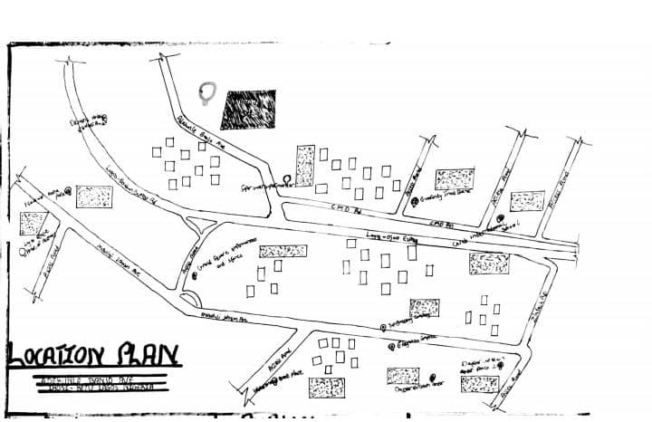
FIG 4.1 :- LOCATION PLAN
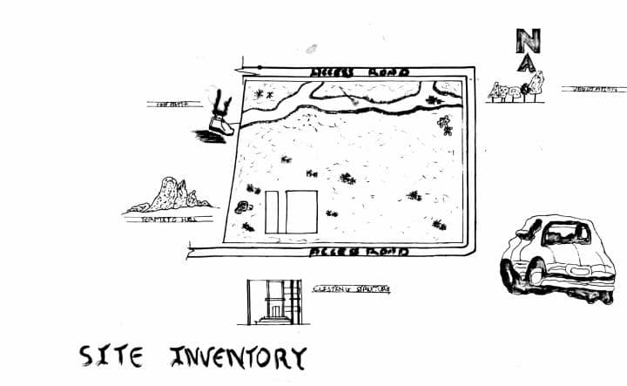
FIG 4.2:- SITE INVENTORY
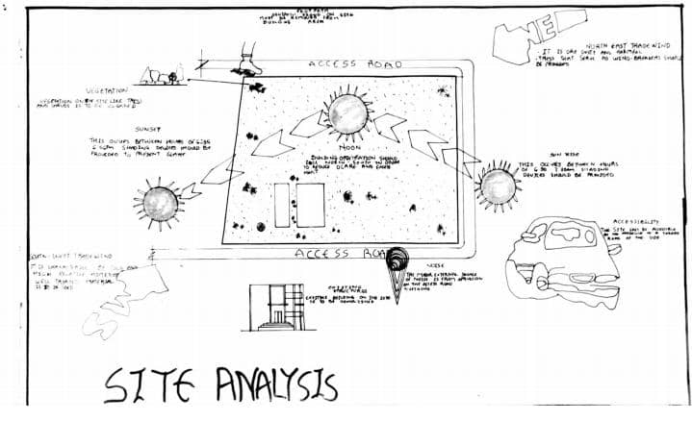
FIG 4.3:- SITE ANALYSIS
DESIGN CONCEPT/PLANNING PRINCIPLE
DESIGN PLANNING
Firstly, the process of analysis in the design into the necessary units required for the design is based on the data collected through research methodologies.
Secondly, the grouping of the various unit together according to their relationship with one another also based on the data and information gathered.
The concept of the design was arrived at from the functional relationship and bubble diagram so prepared out of the design brief which is based on the activities performed within the public library. The relationship of these various activities with one another within different units that makes up the design and also based on the zoning in accordance with the level of noise produce by each unit.
PLANNING PRINCIPLE
The planning principle is one of the most important aspect of any design. The planning of various units taking into consideration the activities performed in each unit, how they are related to one another and the users of the various units in the design.
In respect to the design above factors, the building is divided into two floor. The first floor contain the Service Unit ; while the second Floor is the Admin which is well positioned on the site taking cognizance and into consideration the activities going on in the surroundings and possible noises that might be produce.
In respect to the sit zoning, the safe zoning is divided into three parts. The first division as semi quite area while third division C is quite and noisy area.

CHAPTER FIVE
5.0 DESIGN REPORT
5.1 DESIGN BRIEF
After research and planning, the next step in the series of the project program is design itself. To achieve functional and well aesthetic design the1¢ must be a brief to work on. This brief depends generally on the scope of individual design. The brief of this project is therefore based on the various activities that take place in a public library.
To have enough brief for the proposed public library.Case studies were carried out ‘on the existing Public Libraries both in the Nigeria and Other countries. The studies also give me the opportunity to get to know different Libraries in Nigeria and important books that needs to be ready.
5.2 DESIGN ANALYSIS
This is the process of itemizing units within the components of the entire design with a view to establish a solid understanding and appreciation of the space relationships.
SNO | DESIGN SCOPE UNIT | DIMENSIONS | M2
1 | ENTRANCE | 10.5 X 9.3 | 97.65m2
2 | CLOAK AREA & SECURITY DESK | 10.5 X 5.7 | 59.85m2
3 | RECEPTION | 3.7 X 3.2 | 11.84m2
4 | INTERNET CAFÉ | 9.1 X 0.7 | 6.37m2
5 | LIBRARY MESEUM | 10.6 X 9.1 | 96.46m2
6 | SPECIAL NEEDS | 9.1 X 5.6 | 50.96m2
7 | CHILDREN LIBRARY | 10.5 X 9.1 | 95.55m2
8 | SEMINAR HALL | 10.7 X 10.4 | 111.28m2
9 | SERIAL | 9.5 X 4.7 | 44.65m2
10 | SORTING | 9.5 X 4.7 | 44.65m2
11 | DELIVERY BAY | 7.2 X 6.2 | 44.64m2
12 | NEWSPAPER AREA | 9.7 X 5.0 | 48.5m2
13 | ART & CRAFT | 11.5 X 7.7 | 88.55m2
14 | VIP UNIT | 15.8 X 9.7 | 153.26m2
15 | PREPARING & CATALOGUEING | 4.6 X 4.3 | 19.78m2
16 | CONTROL UNIT | 4.6 X 2.5 | 11.5m2
17 | SERVER UNIT | 4.6 X 2.2 | 10.12m2
18 | E-LIBRARY | 11.2 X7.5 | 84m2
19 | LIBRARY UNIT | 25.8 X 14.0 | 361.2m2
20 | DIRECTOR UNIT | 5.9 X 5.5 | 32.45m2
21 | SECRETARY OFFICE | 4.8 X 3.5 | 16.8m2
22 | REFERENCE CIRCULATION | 7.5 X 5.0 | 37.5m2
23 | STAIR HALL | 5.5 X 2.3 | 12.65M22
24 | Conveniences | 2.0 X 1.4(X5) | 28m2
25 | EXIT | 3.6 X 3.2 | 11.52m2
 | TOTAL |  | 1540.17

Table 4.1 Space Allocation Of The Design Analysis

5.3 DESIGN APPRAISAL
In any project design, there are two basic factors that should be taken into consideration. These factors are functionality and aesthetics and functionality of any building are incompatible but in the case of this project, both aesthetic and functionality of the design were taken care of to satisfy the highly demanded functional requirement and to create aesthetically and proportionally balanced design.
The functional efficiency of institute of Vocational studies depends largely on the enclosures of the immediate section that are strongly related in function all these are being taken up as seen on the site and floor plans respectively.
5.4 DESIGN CHARACTERISTICS
The idea of planning a good surrounding involves from the primary function. It gives a good aesthetic view to the structure; it enhances the psychological feeling of the public, making use of the area: it makes the entire environment healthy, as an adage says "cleanliness is next to godliness". A clean and well-planned site is a healthy environment in view of these following had been adopted in planning the site.
1.LANDFORM: As earlier discussed under the topography the land is gentle slope hence it will affect good planning.
2.TREES: Trees are planted within the institute building to effect natural Ventilation. Trees which will not be more than 2.5m high when grown are to be planted at reasonable spacing to provide shade for the car park. Shrubs and trees such as Amelina, Aborea, Flamboyant, Alternance etc. with good foliage are to be planted along with the fence and some strategic places within the site to provide shade and serve as sun's and wig breakers. ‘The trees also reduce the atmospheric temperature and release of oxygen during photosynthesis makes the atmosphere cold.
3.GRASSES: Grasses give good impression of an environment and also protect. the land surface from erosion for this project, Bahama grass is recommended for all the lawn area. Some courtyard that are busy are covered with lawns, fines grasses like Kikuyu grass planted in the courtyard and some parts are paved for relaxation purpose.
4.FLOWER BEDS: A well planned flower arrangement gives aesthetic to environment. Flower is grown along the walkways around the main building generally except where it can obstruct vehicular pedestrian movement. Flower such as slender, Bryphallion roses, lady on boat, ice plant etc. are planted.
5.HEDGES: Hedges are also planted along some part of the walkway. In the courtyard while shrubs are also used along vehicular ways. The following shrubs are used for the hedge. Dodoneaviscosal (Josorevet). The vital (bush mil) casavatinalequstifolic (Whistling pic). Shrub such as spotted croton. Euphobiasplender (desert rose) are planted for their beautiful leaves and good scents also for ornamentation.
6.PARKING SPACE: Parking lots are located in front of administrative offices to service the administrative. Loading send concrete block should be Portland cement delivered in good condition to the construction site all the instruction given in civil engineering drawing will be thoroughly and strictly adhered to in order to avoid failure. The walkways should be constructed of concrete roof laid to fall with 2 layer of bitumen fact. The roof member should be firmly secured. The mortar bed should at least 25mm thick bond of block should be stretcher bond.
5.5 BUILDING STRUCTURE
The whole institute building has administrative building complex which makes the environment more comfortable for both the library users and the staff in that environment. The story building supported by beans and column at appropriate intervals. Most modern school buildings are usually constructed by introducing grid into the design. This make for easy and accurate consideration of frame structure used in school buildings. ‘There are two types of grid system:
Modular grid
Structure grid
For this project, structure grid system was employed in filled sand Crete blocks were used for all the retaining walls of the institute. The roofing system used for the lecture theatre is steel truss roofing.
Some part concrete roof where also used along with timber the prevalent damage usually caused by termites is prevented by the application termitarium treatment like Gamalin 20 solignum etc.
5.6 SERVICE
Electricity is tapped from the nearest pole of the institute building. The main water pipeline is closely located to the site where drinking water can be tapped telephone line is within the polytechnic which makes connection easy.
The entire roof drains runs to the surrounding gutter which finally drains to the main gutter along the public drainage all the solid and liquid wastes are effectively disposed of by the soak away pits and septic tanks, a central AC system shall be fixed where appropriate.

5.7 GENERAL REQUIREMENT
5.7.1 LIGHTING
This is a means of providing brightness naturally by sun or moon or artificially by lamps. Good natural and artificial lighting is important in the reading rooms. It is always easy to make mistake and the eye in a situation poor lightning floor. For the purpose of this project, effort is made as much as possible to light up the entire building naturally before the use of artificial lighting.
In this project, to obtain maximum lighting more openings are provided for the reading rooms, E-LIBRARY, seminar hall and reference circulation. Artificial source of light will still be provided for in case where there is call for the use of it at night or in a situation where the weather condition warrants it.
5.7.2 ORIENTATION
The orientation of a building involves the arrangement of the building forward or away from the sunrays, across or along the trade winds normally determines the thermal comfort in the building. In view of these, the building is oriented in the safe plan in such a way that be short facts is facing the east with no opening at all and the fact away from the sunrays and forward the north east trade wind and south west monsoon wind to produce thermal comfort since the facet towards the sun always tap temperature the sun and the long facet away from the sun but long the trade winds will always tap the advantage of other winds while the harsh effect of the north east trade wind will be reduced by planting trees along the side facing it. This will enhance Permeable screening order words serving as wind breaker.
5.7.3 RAIN PROTECTION DEVICES
The rainfall of a place generally determines the living condition and all comfort associated with that environment hence provision should be made for fast dispersal of the rain as well as associated condition with rainfall. This calls for the need to study the nature of rainfall of the area. To control the heavy rainfall during the wet season (April-October). The use of simply sloppy system roofing has been adapted.
Damp proof draught proof materials are used by various joint of the roof to withstand the passage of rain water.
25mm thickness is used for rendering so that water absorbed from the external wall will not reflect on the internal side of the wall.
5.7.4 NOISE CONTROL DEVICE
This is an unpleasant sound of ten lauded harsh. Excessive noise and vibration can cause fatigue, leading to errors and general dissatisfaction in the Library unit, studio, seminar hall. External noise could be easily controlled with the aid of landscape materials and rough setbacks. .
Acoustic ceiling tiles offer much help reducing overall noise level thus it is recommended for the school offices, lecture rooms, departmental studios, library and other units where conversation are confidential in nature e.g. the board room.
5.8 MATERIAL AND FINISHES
The influence of building material on construction works in Lagos and its environs is similar to what prevail in the middle belt of the country. In the south the rainfall encourages the use of parapet wall to reduce falling out of the roof by heavy wind (either North-East or South-West trade wind). Concrete/Sand Crete blocks in regular molds are often used for wall construction with a standard of 100mm, 150mm and thickness.
The material choice and finishes are influence by a number of factors such as follows:
The durability and suitability of materials
Geology and topography of the site
Availability of material
The climate conditions
Properties of materials
The coast of the materials
ROOF
In areas experiencing tropical climate condition such as Lagos where there is rainfall, roof should preferably not be of light weight construction. A corrugated iron sheet with parapet covering it and the external surface should absorb as little solar energy as possible. For these reasons, long span galvanized aluminum roofing sheets is recommended for all parts of the complex in addition to the reinforced concrete roof gutter and concrete roof slab. Steel is recommended as roofing strimhire of the lecture theater and other unit's timber are to be used.

CEILING
Suspended ceiling is used in some lecture roof with metal hangers with fanny ceiling at suitable center to center. The ceiling material is prepared to be attractive and easily cleaned. It should be of moderate cost for the above reasons the

recommendation furnishing of all the offices is Celotex expect the lecture theatre that acoustic material is used to reduce the effect of the noise.
WALL
The structural walls of the building are to be constructed with 225mm engine molded sand/cement hollow blocks. The column and beans are properly reinforcing with wall the wall whole applicable column and beans are furnished with 25mm gauged smooth. Also, most if the unit are of framed structured which carried most of the loads. Load bearing masonry wall are also used and furnished with 25mm thick wall rendering and finally painted according to color specification schedule in the toilet,, the wall is to be furnished with ceramic tile to height of about 2100mm.
DOORS
The door type and size depend on the door location, but generally range from paneled door to panel folding doors of sizes from 750mm for toilets to 2700mm for the lecture theatre, library and main entrances to departments. Some doors are purposely made swinging doors for durability, fire resistance and noise control.
WINDOWS
The windows that are to be used range from pivoted windows, projected and Naco louvers blade with metal and aluminum frame.
COVERED WALKWAYS
The roofing to all covered walkways with the Library should be made of reinforced concrete slab finish laid to fall two layers of bitumen felt, the walking paying should be made of present concrete slab finished roughly to prevent slippery when wet.

6.0 SUMMARY AND CONCLUSION
6.1 SUMMARY
Throughout the design process (from inception to the final detailed drawing). Consideration has been given to a simple but functional design, which take care of all problem in the existing Libraries. However, this project forms part of the efforts toward establishing a conventional public library within a higher institution of learning, aimed at supporting both academic and community-based educational needs."
Since design generally are affected by various factors ranging from finance, nature of site, material choice and availability as well as various other factors, the design could vary but the approach and concept are basically within a range everywhere.
6.2 CONCLUSION
In conclusion, the deduction and experience learnt and gained from the essential research which was carried out on the school of business and vocational studies in some Nigerian Polytechnic and Universities have extremely exposed me and of course the reader of the project report to what is obtainable in school of business and vocational studies in Nigeria.
Institution design, especially as I have realized from the research has follow functions that follow one another. It also enables me to know what is needed in school design, with particular reference of business discipline. In my design, I have made sure that all the functional aspect of the project was located at a particular point.

Finally, this project fulfills my ambition to contribute my own quota to the enhancement of educational development of the school generally in Nigeria.

REFERENCES
Barton, L., & Quinn, M. (2022). Designing foe Equity: Public Libraries and
Inclusive Architecture. Journal of Library Architecture.
Cohen, B. (2019). The Flexible Library: Reconfiguring Public Space. Library
Trends
Davies, S., & Kent, H. (2020). Makerspaces in Public Libraries : Democratizing
Innovation and creativity. Library Technology Reports.
Fraser, D. (2016). Rebel cities: From the Right to the city to the urban
Revolution Verso.
IFLA. (2021). Green libraries: Guidelines for Sustainable architecture and Practices.
International Federation of Library Association and Institutions.
Koolhaas, R. (2015). Libraries: The last Bastion of Public Spaces. Architectural
Review.
Lee, S., & Matthews, D. (2020). Smart Infrastructure in Next-generation Libraries.
Digital Library Perspectives.
Miller, P. (2018). Idea Stories and community Transformation in East London.
Urban Library Journal.
Nussbaum, M. (2019). The Capabilities Approach and public Infrastructure.
Philosophy & Public Affairs.
Schmidt, K. (2016). Reimagining the Public Library: The case of Dokk1, Aarhus.
Scandinavian Library Journal.
Soja, E. (2018). Thirdspace: Journeys to Los Angeles and other real-and-imagined places. Wiley-Blackwell.
APPENDIX1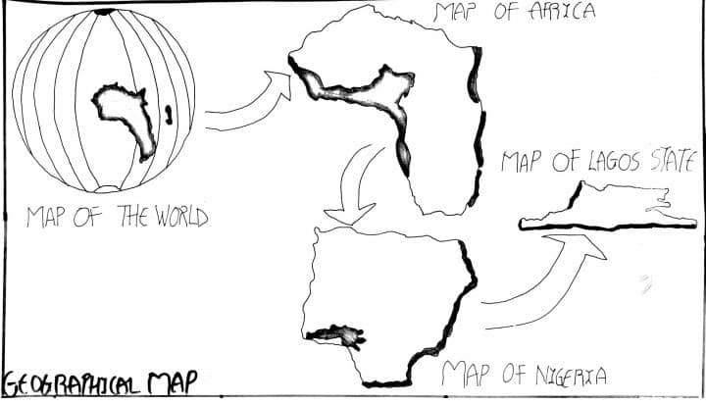
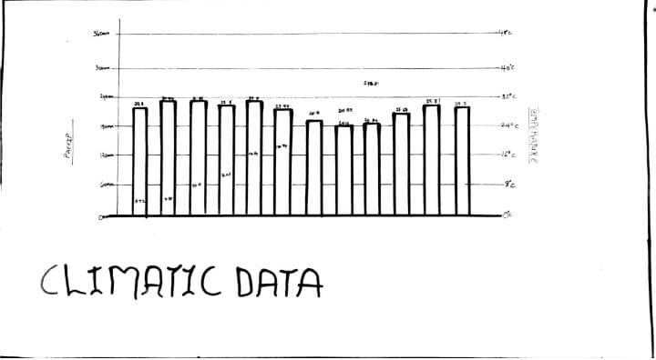
APPENDIX 2
APPENDIX 3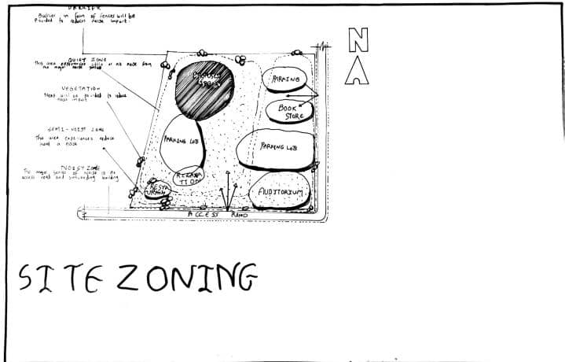
APPENDIX 4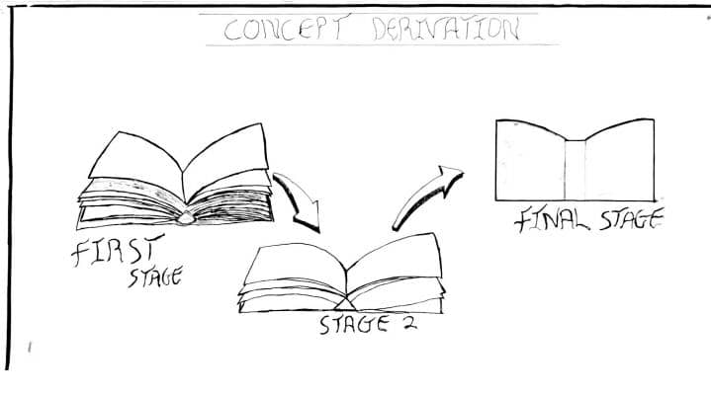
APPENDIX 5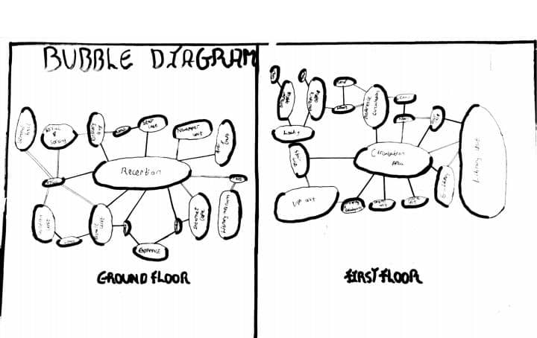
APPNDIX 6
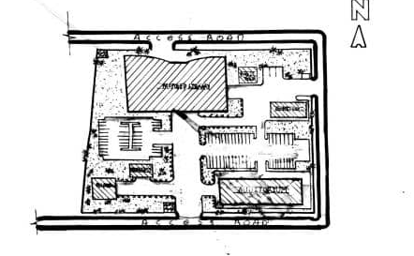
APPENDIX 7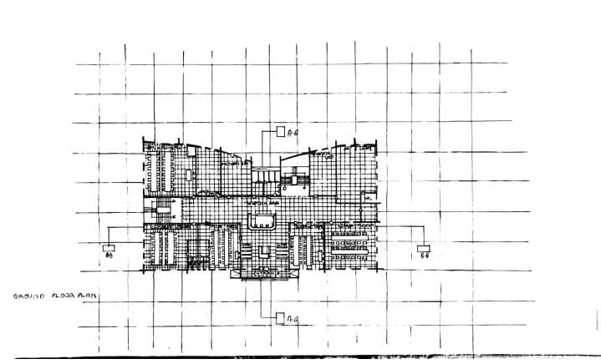
APPENDIX 8
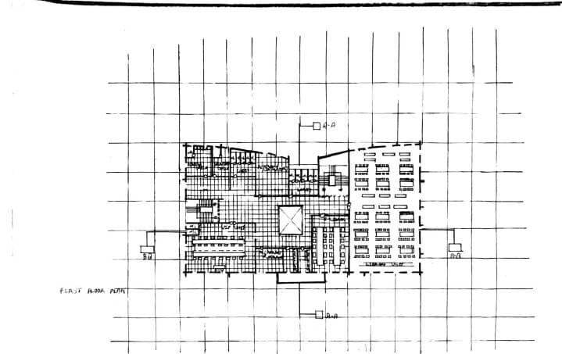
APPENDIX 9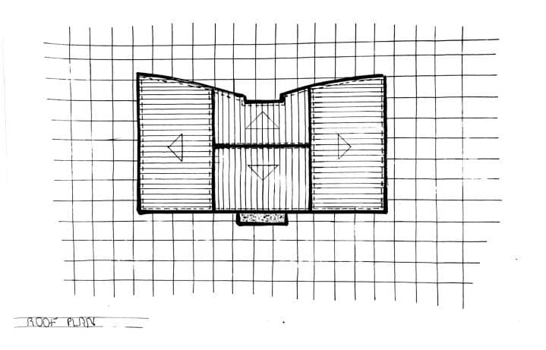
APPENDIX 10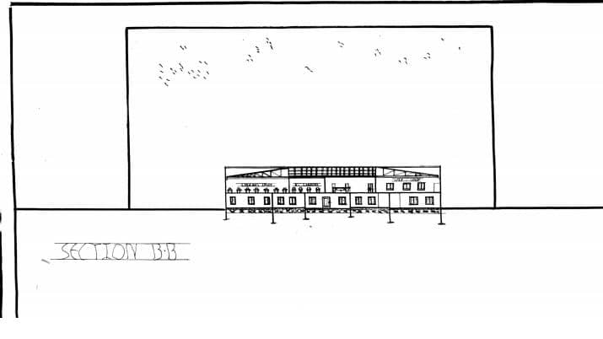
APPENDIX 11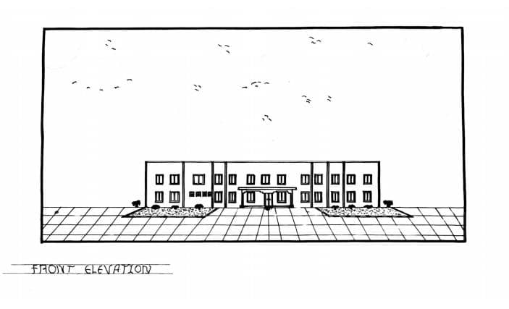
Appendix 12
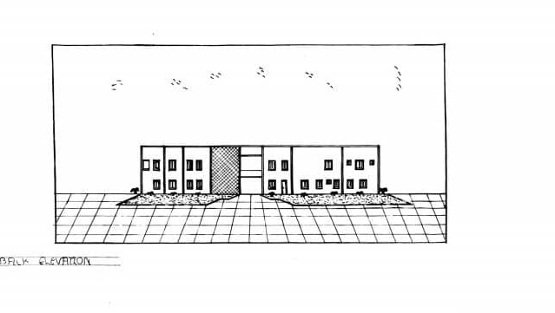

APPENDIX12
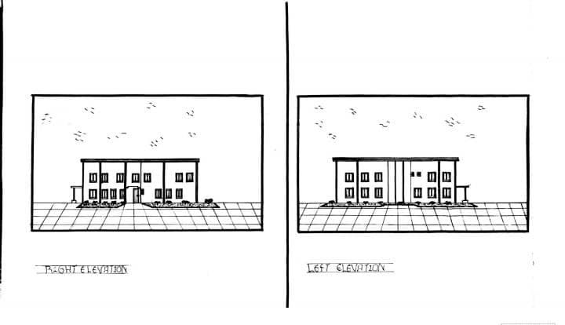
APPENDIX13
