EFFECT OF DIFFERENT ANNEALING PROCESSES ON THE MECHANICAL PROPERTIES OF ARC-WELDED MILD STEEL JOINT

BY

FALAYE AYOMIDE ISRAEL
HND/23/MET/FT/0003

SUBMITTED TO:
DEPARTMENT OF METALLURGICAL ENGINEERING TECHNOLOGY, INSTITUTION OF TECHNOLOGY, KWARA STATE POLYTECHIC, ILORIN, KWARA STATE

IN PARTIAL FULFILMENT FOR THE AWARD OF HIGHER NATIONAL DIPLOMA (HND)
IN THE DEPARTMENT OF METALLURGICAL ENGINEERING TECHNOLOGY

SUPERVISED BY:
ENGR. S.A. BABALOLA

AUGUST, 2025
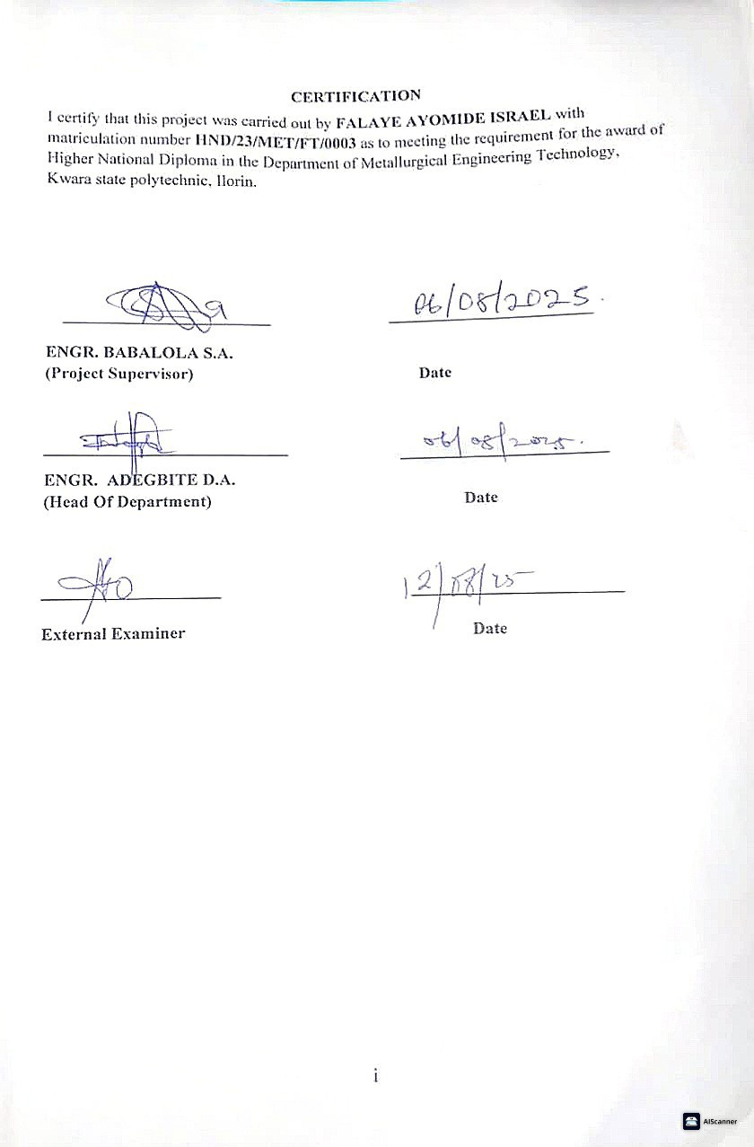

DEDICATION
I dedicate to Almighty God, the creator of heaven and earth, who in his infinite mercy has sustained me from the beginning of this Higher National Diploma Program to the very end and also for the success of this work. I also dedicate this work to my loving parents MR. & MRS. FALAYE and my beloved SISTERS for her gracious support in my life. I really appreciate all.

ACKNOWLDGEMENTS
I sincerely appreciate our project supervisor, Engr. Babalola S. A., for his invaluable support, guidance, and constructive criticism throughout the project work. I are also grateful to the lecturers and staff of the Department of Metallurgical Engineering, Kwara State Polytechnic, for the knowledge and assistance provided during our academic journey.
Special thanks go to our families Mr and Mrs Falaye for their moral and financial support, as well to my special person Rachel for your encouragement. I also give thanks to all my friends and siblings for their courage and support throughout this programme. May God bless you all.

ABSTRACT
This study investigates the impact of different annealing processes on the mechanical properties of arc-welded mild steel joints. Mild steel, known for its favorable weldability, is widely used in structural and industrial applications. However, the welding process introduces thermal stresses and alters the microstructure of the heat-affected zone (HAZ), which can compromise the integrity of welded components. To address this, post-weld heat treatments such as annealing are employed to restore and enhance material properties. Despite the availability of various annealing techniques, there remains limited clarity on which method offers the best balance between strength, toughness, and ductility in welded joints.
.

TABLE OF CONTENTS

Title Page

Certification i

Dedication ii

Acknowledgement iii

Abstract iv

Table of Contents v

CHAPTER ONE

1.0 Introduction 1

1.1 Background of the Study 1

1.2 Statement of the Problem 2

1.3 Aim and Objectives 2
1.3.1 Aim 2
1.3.2 Specific Objectives 3

1.4 Justification for the Study 3

1.5 Significance of the Study 4

CHAPTER TWO

2.0 Literature Review 5

2.1 Carbon 5

2.1.1 Properties Of Carbon 6

2.2 Carbon Steel 6

2.2.1 Types Of Carbon Steel 7

2.2.2 Low Carbon Steel 7

2.3 Mild Steel 7

2.4 Metallurgical Processes Occuring In A Welded Joint 8

2.4.1 Weld Zone 8

2.4.2 Adjacent and Heat Affected Zone (HAZ) 9

2.4.3 Typical Weld/Heat Affected Zone Structures 9

2.4.4 Weld Defect Identification 10

2.4.5 The Inspection and Test Of Welds 12

2.5 Structure And Heat Treatment Of Steels Welded Joints 14

2.6 Annealing 16

2.7 Related Journals 17

CHAPTER THREE: METHODOLOGY

3.0 Materials And Methods 19

3.1 Material 19

3.2 Methods 20

3.2.1 Annealing 20

3.2.2 Tensile Testing 21

3.2.3 Hardness Testing 22

CHAPTER FOUR

4.0 Results And Discussion 24

4.1 Results 24

4.2 Discussion Of Results 26

4.2.1 Tensile Testing Observation And Analysis 27

CHAPTER FIVE

5.0 Conclusion And Recommendation 28

Reference 30

List of Figures

Fig 3.1: Welded Mild Steel Rod 23

Fig 3.2: Welded Spot 23

Fig 3.3: Hardness Test Specimen 23

Fig 4.1: Bar chart Of Hardness Test 25

Fig 4.2; Microstructures Of Samples With Different Annealing 26

List of Tables
Table 4.1: Vickes Hardness Values Of The Annealed Samples 24

CHAPTER ONE
1.0 INTRODUCTION
1.1 Background of the Study
Mild steel is a versatile material commonly used in construction, automotive, and manufacturing industries due to its affordability, good strength, and ease of fabrication. One of the primary methods of joining mild steel components is arc welding a fusion welding technique that utilizes an electric arc to melt and fuse metal parts. Despite its effectiveness, arc welding introduces thermal stresses and causes changes in the steel’s microstructure, which can negatively impact its mechanical properties such as hardness, tensile strength, and toughness.
To address these issues and restore or improve the welded joints’ properties, post-weld heat treatments like annealing are often employed. Annealing involves heating and slowly cooling the welded metal to relieve internal stresses, refine grain structure, and improve ductility. Various annealing method such as full annealing, process annealing, and stress-relief annealing affect welded steel differently, influencing its mechanical performance based on factors like temperature, duration, and cooling rate.
Although many studies have explored the effects of annealing on welded steel, inconsistent results have emerged due to differences in welding techniques, material composition, and heat treatment conditions. Therefore, it is important to evaluate and compare how different annealing processes affect the mechanical behavior of arc-welded mild steel, to identify the most suitable treatment for enhancing structural reliability.

This research aims to provide useful insights for industries that rely on arc welding by examining how specific annealing techniques influence the strength, hardness, and toughness of welded mild steel joints. Ultimately, the study seeks to recommend the best post-weld heat treatment for improving durability and service life.

1.2 Statement of the Problem

Arc welding, though effective for joining mild steel, but often introduces residual stresses, hardness variations, and microstructural distortions that compromise the mechanical integrity of welded joints. Without appropriate post-weld heat treatment, these defects can lead to reduced toughness, brittleness, and even premature failure under service conditions. While annealing is widely used to mitigate these effects, there is a lack of clear guidance on which annealing method offers the best improvement in mechanical properties for arc-welded mild steel. The absence of a standardized approach makes it difficult for engineers and manufacturers to optimize welding processes for strength and durability. This study, therefore, addresses the problem by experimentally comparing different annealing processes and their effects on mechanical performance, with the goal of identifying the most effective technique for enhancing weld quality.

1.3 Aim and Objectives
1.3.1 Aim:
To investigate the effects of different annealing processes on the mechanical properties of arc-welded mild steel joints.

1.3.2 Specific Objectives:
- To examine the microstructural changes in arc-welded mild steel after different annealing treatments.
- To determine how annealing affects the hardness of welded mild steel.
- To assess the toughness of the treated joints using impact testing.
- To recommend the most suitable annealing process for improving mechanical performance.

1.4 Justification for the Study
The widespread use of mild steel in structural and mechanical applications makes it vital to ensure the reliability of its welded joints. Since arc welding introduces undesirable thermal effects, applying the correct heat treatment is essential to enhance material properties and extend the lifespan of welded components. This study is justified by the need to:
- Enhance structural integrity and reduce welding-induced defects.
- Improve the performance and service life of mild steel joints through effective heat treatment.
- Provide practical recommendations for industries reliant on welded components.
- Contribute to research by filling knowledge gaps in the comparative effectiveness of annealing techniques.
- Reduce maintenance costs and improve safety through optimized post-weld treatments.

1.5 Significance of the Study
This research will benefit several fields, including:
- Material Science and Welding Technology: by contributing data on how different annealing processes affect mechanical properties.
- Industrial Applications: helping engineers select appropriate treatments for welded structures.
- Economic Efficiency: through reduced repair and maintenance costs.
- Academic Research: offering a foundation for further studies on post-weld treatments.
- Safety and Sustainability: by improving reliability and reducing material waste in welded components.

CHAPTER TWO

2.0 LITERATURE REVIEW

2.1 CARBON
Carbon is a non-metallic element having chemical symbol C, the atomic
number of 6, an atomic weight of 12.01115, periodic table group 4 member,
melting point of 3,550 approximate boiling point of 4,825°C approximate, density of 3.52g/cm³ and the atomic radius of 0.77A⁰. Carbon can exist in three forms, two of these forms are crystalline namely diamond and graphite.
Diamond (at 20⁰C) is the hardest of natural substances, consists of a lattice of carbon atoms arranged in a tetrahedral structure at equal distance apart (1.5544A⁰), and bonded by election pairs in localized moleculer orbital formed by overlapping of 5p³ hybrides .
In graphite (at 20⁰C) one of the softest substances, the carbon atoms are
arranged in laminar sheets, 3.40⁰A apart with each atoms bonded to three
others in its sheet by electron pairs in localized molecular orbital's formed by
formed by overlapping of the Sp² hybrid.
The remaining P-electron form a mobile System of non-localized π bonds that permits of electrical conductivity within the lamina. Ordinary carbon is a third form which is non-crystalline or amorphous.
Diamond and graphite are allotrope of carbon. Allotropy is the existence
of an element in two or more form; differ in physical properties but chemical
properties are the same.

2.1.1 PROPERTIES OF CARBON
- Solubility: Carbon is insoluble in common solvent but soluble in iron
both the liquid and solid states.
- Chemical Reactivity: Carbon is increasive with normal chemical
reagents. Its one chemical reaction is combustion which all allotropes undergo at a sufficiently high temperature.
- Adsorption: Amorphous carbon can really adsorb gases.
- Reducing Properties: Oxides of metal on a charcoal block are reduced
to metals. Carbon has a strong affinity for oxygen and hence a powerful reducing agent.
- Electrical Properties: Graphite conducts electricity, and it is used in electrolysis which takes on chemical part in electrolysis.
2.2 Carbon Steel
Iron comes from ore such as heamatite (Fe₂O₃) a rock like substance found in the earth's crust and consisting of iron oxides and other elements. Pure iron is a relatively soft, ductile material with a low melting point and is of little commercial value. Iron is alloyed with carbon to produce carbon steel. Small amounts of other metals or element may be added to carbon steels to produce specific properties, but the main alloying ingredient is carbon.
Carbon steels have higher melting point than iron. They are also harder
and have several other properties that make them more useful than iron.

2.2.1 Types of Carbon Steel
Carbon steel can be classified into three groups based on the amount of carbon they contain. They are referred to as low, medium and high carbon steel.
2.2.2 Low Carbon Steels
Steels with a carbon range 0.2% to 0.3% are called low carbon steels. Steels in the class are tough, ductile and easily machine low carbon steel when subjected to the spark test will throw off long white-colored streamer with very little or no sparkles . Low carbon steels are cheap and possess good formability and excellent weldability. These steels are extensively used as sheet and strip steel, structural steel cold heading steel, free cutting steel and case hardening steels. Low carbon steels exhibit poor response to heat treatment as a means for improving mechanical properties, particularly tensile and yield strength. In fact, many heat treatment processes are an integral part of the manufacturing and fabrication processes of low carbon steels.

2.3 Mild Steel
Mild steel, often referred to as low carbon steel, is extensively used across various industries due to its affordability, ease of fabrication, good ductility and weldability. With a carbon content typically ranging between 0.05% and 0.25%, it provides a balance between strength and flexibility, making it suitable for structural applications. The presence of other alloying elements like manganese, silicon, sulfur, and phosphorus contributes to its mechanical characteristics. Its versatility allows for wide application in sectors like construction, automotive manufacturing, and machinery production.

2.4 METALLURGICAL PROCESSES OCCURRING IN A WELDED JOINT
According to temperature distribution during welding and cooling rate after welding, a welded joint will comprise of the weld metal zone, the fusion zone, the adjacent and heat affected zone (HAZ) and the base metal.
2.4.1 Weld Zone
This is the weld melt itself after it solidifies although the fusion zone is
represented by a fairly narrow area (almost a sharp line), a certain amount of
diffusion or base metal pick up is to be found in the weld area near the line of
fusion. When the base metal contains considerable carbon, for instance, some of the carbon will diffuse into the weld zone. Welds, like ingots, tend to form a coarse columnar structure when they solidify.
These columnar grains structure of welds are almost evident in those having a large weld zone, high heat input and a slow cooling rate. A single pass weld generally produces a coarse columnar structure that is some what undesirable. Since it is not so strong as a finer, less oriented grains structure. A two pass weld will often recrystallize the ferrite grains to some extent, thus stress relieving the pass weld zones. Nevertheless, the weld zone is usually stronger than the base metal in welded structure (Clive Cookson, 1975).

2.4.2 Adjacent and Heat Affected Zone (HAZ)
These zones as previously shown are those zones heat the weld. In those zones, the grains also begin to grow and coarsen when held at higher temperature for longer period, usually having little or no hard structures. In the arc welding, however, relatively small quantities of metal are consequently often tend to cool very rapidly since the base metal act, as a heat sink cheat absorber) that quickly cool the weld zone (Clive Cookson,1975).
2.4.3 Typical Weld/ Heat Affected Zone Structures
The presence of martensite in unalloyed low carbon steel is generally associated with carbide particles. A random distribution of coarse carbide lead to the formation of isolated area of high carbon mantensite in the matix.
Recent work by Rivera and Traylor (1979) confirmed that the structure of the heat affected zone adjacent to the weld nugget varied for steels of similar composition but having different carbide lead to the formation of isolated areas of high morphology. In the parent steel for example, in steel approximately 0.066%C with fine carbide of up to 4μm in diameter, the carbide adjacent to the weld nugget were observed to have dissolved completely during welding to give an austenite which, on subsequent cooling, produced martensite in a zone consisting of partially dissolved fine carbides in a ferrite matrix. The martensite tended to occur as a continuous bandof hardness 300 VPN around the weld nugget.
It was concluding that the presence of martensite is only detrimental if the carbon content of the martensite is sufficient to cause excessive hardening or if the martensite is present at a continuous work. Also that chemical composition is important in that it affects the relative strength of the weld nugget/heat affected zone and base steel.

2.4.4 Weld Defects Identification
Ideally, the mechanical properties of weld metals are at least equal to those of the base metal, but the presence of metallurgical changes greatly lead to deviation. The quality of welded joints depends in many respects on the technological methods of welding as a result of which a continuous joint must be obtained. The continuity of welded joints is one of the main features of qualitative welding. There continually shows up usually cracks and pores. As the metal is fused, it gives off gases, which, while remaining in the solidified metal, render it porous and pores conduce to the failure of a welded joint. They serve as stress concentrators. Common weld defects include:
(a) Cracks
(b) Cavities
(c) Slag inclusions
(d) Lack of fusion and penetration
(e) Imperfect shape, i.e. distortion
(f) Miscellaneous faults
(a) Cracks
Exists as surface and internal cracks. It occurs due to large depth/width weld bead, high arc energy and one or preheat pick-up sulphur phosphorus or niobium from the parent metal. Also occurs when there is poor ductility in the through-thickness direction of the plate as a result of non-metallic inclusion. The defects are controlled or at least minimized by pre-heating or post-heating of weld, proper joint design, optimum heat input and hence welding temperature velocity etc.
(b) Cavities
It results as a result of the entrapment of gas in solidified welds metal. The gas may originate from dampness or grease on the workpiece or consumable or nitrogen pick-up from the atmosphere.
(c) Slag Inclusions
Slag inclusion are due to incomplete removal of slag in multi-pass welds, the presence of scale/rust on prepared surface, or the use of electrode with damaged coatings.
(d) Lack of Fusion and Penetration
It results as a result of incorrect welding conditions (e.g. insufficient heat input) or
incorrect weld preparation (e.g. root face too large).
(e) Imperfect Shape
Imperfect shapes are due to linear misalignment, excessive reinforcement, overlap,
undercut and excessive penetration.
(f) Miscellaneous Faults
Such faults include accidental arc strikes and spatter of globules of molten metal which adhere to the parent metal remote from the weld. Again problems of distortion may occur if the heating or cooling is uneven.

2.4.5 The Inspection and Test of Welds
There are two basic ways of determining the quality of a weld viz:
- Destructive Testing: This includes standard mechanical tests and laboratory test of macrographs and micrographic (metallographic) structure of the metal, as well as cracks, blow holes, poor fusion, burning or overheating or the presence of intruders (other defects of the welds. This method reveals the micro and macro properties of access quality.

- Non-Destructive Testing: Non-destructive testing is a range of methods of testing welds for surface and internal imperfections and determines properties or access quality. An essential feature of all such tests is that the material being examined must not be damaged and its future performance in service must not be impaired .
The methods used for non-destructive testing (NDT) include:
(a) Visual Inspection (VI)
(b) Radiographic Inspection (RI)
(c) Magnetic Particle Inspection (MI)
(d) Ultrasonic Inspection (UI)
(e) Liquid Penetrate Inspection (LI)
(f) Air Pressure Inspection (AI)
(g) Fluorescent Penetrate Inspection (FI)

(a) Visual Inspection (VI)
Visual inspection is the first level of weld inspection. It involves using of the eyes, either unaided or with a low-power magnifier to look for imperfection and flaws visual inspection detects blowhole, cracks, porosity, uneven weld, and dimensional errors.
(b) Radiographic Inspection (RI)
Radiographic inspection or radiographic examination is a non-destructive test method that uses x-rays or gamma rays to detect flaws in solid materials. This is based on the different absorption of x-rays passing through the work by the metal and various non
metallic substances. This method reveals porosity, blowholes, cracks, poor fusion and slag inclusions.
(c) Magnetic Particle Inspection (MI)
This method is used for detecting surface discontinuities or cracks in magnetic material. This method utilized the dispersion of magnetic fluxes at the defect in the work. The magnetic flux is distorted so that lines of forces are concentrated in the surface of the magnetized part at the edges of a discontinuity or other flaw. This cine of force attracts finely divided magnetic particles which were previously applied uniformly to the whole surface of the work; the readily visible accumulation of these parties out cine the defect. This method reveals fine cracks and pores in the weld.
(d) Ultrasonic Inspection (UI)
This is based on the capacity of different media to reflect ultrasonic wave (with frequencies over 20,000cps) in a different manner. Flaw in weld, such as non-metallic inclusion, can be detected by this method in part up to 5m thick.
(e) Air (Pressure) Inspection (AI)
This method checks the air tightness of the work.
(f) Fluorescent Penetrate Inspection
The part being tested by this method is immersed for 20 - 30 minutes in a mixture of kerosene and oil. Then it is wiped dry and immersed in magnesium powder which adhere at the place where the oil appears cover the cracks. This method is applied to reveal fine cracks.
2.5 STRUCTURE AND HEAT TREATMENT OF STEELS WELDED JOINTS
Pure iron exists in the three main allotropic forms α-ferrite and δ-ferrite which are body-centered cubic (bcc) and gamma-austenite, which is face-central cubic (fcc). The temperatures ranges over which these phases are stable are indicated on the ordinate of the iron-carbon equilibrium diagram.
The properties and structure of steel can be varied through different cooling rate because the various allotropic forms are capable of taking into-solid-solution different amount of carbon. While the \alpha-phase can dissolves about 0.02\% carbon, the austenite can hold up to between 1.4 - 2.0\% carbons in solid solution. On cooling very slowly i.e equilibrium cooling, austenite decomposes into a structure consisting of ferrite and a mixture of ferrite and cementite, known as pearlite which has a lamellar structure; these phases are found on the equilibrium diagram. As the cooling rate becomes very high some non equilibrium phase such as bainite and martensite may be formed.
These different phases which can be obtained by cooling at different rates possess different properties as a result of different amount of carbon in solid solution. Fast cooling rate allow a lot of carbon to be retained in the lattice and the non-equilibrium phases resulting from such cooling are very hard brittle.
The mechanical properties of such could however be improved by subjecting them to different heat-treatments.
Heat treatment of steel can be defined uniformly as the process of heating the steel uniformly to some predetermined temperature and cooling it at a rate which will produce in it the desired type of structure. Heat treatment may serve one or more of the following purpose:
(a) Relieve stresses after either hot or cold working
(b) Improved machineability
(c) Increase tensile strength and hardness
(d) Harden cutting tools
(e) Improve ductility and shock-resistance
(f) Change the grain size
(g) Change the chemical composition.
In all the heat-treatment processes for steel, it is the rate of cooling that determines the ultimate structure that is obtained. The final structures obtained are closely related to the temperature at which transformation occurs.
During heat treatment, heating should be slow and uniform to allow for homogenous structure. Excessive heating above the solidus should be avoided and proper soaking time should be allow and this will depends on the thickness of the materials.
2.6 Annealing
Like normalizing, annealing is carried out by austenitizing the steel to about 30⁰C above the critical temperature, holding for a sufficiently long time to homogenize the steel and then cool slowly in the furnace to room temperature.
A number of process heat-treating operations are classified under the general term of annealing. These may be employed to reduce strength or hardness, remove residual stresses, improve toughness, restore ductility, refine grain size, reduce segregation or alter the electrical or magnetic- properties of the material.
(a) Full Annealing: In the process of full annealing, hypereutectoid steels (less than 0.77% carbon) are heated to held for sufficient time to convert the structure to homogenous single-phase austenite of uniform composition and temperature and then slowly cooled at a controlled rate to below the A₁ temperature. Cooling usually done in the furnace by decreasing the temperature by (10 to 30⁰C per hour to at least (30⁰C) below the A₁ temperature. At this point the metal can be removed from the furnace and air cooled to room temperature the resulting structure is one of coarse pearlite (widely spaced lamellae) with excess ferrite in amounts predicted by the phase diagram. In this condition, the steel is quite soft and ductile.
(b) Sub-Critical Annealing: Sub- critical annealing, as the name suggests, is a process in which the maximum temperature to which steel is heated is always less than the lower critical temperature (A₁). These processes have been represented in the figure below.
In sub-critical annealing, no phase transformation takes place. Only thermally activated phenomena, such as recovery, recrystallization, grain growth, agglomeration of carbides and softening occur in this process.
(c) Stress Relieving Annealing: A stress-relief anneal may be employed to reduce the residual stresses in large steel castings.
Welded assemblies and cold- formed products parts are heated to temperature below the A₁ (1000 to 12000⁰F or 550 to 650⁰C ), held for a period of the time ad ten slow cooled. Times and temperatures vary with the condition of the component.

2.7 Related Journals

- Farayibi et al (2023), worked on the topic 'Effect of Post: Weld Heat Treatment on the Mechanical Properties of Mild Steel Weldments. They studied the influence of post weld heat treatment (PWHT), particularly annealing, on the mechanical properties of arc welded mild steel joints, and examines changes in hardness and tensile strength following different heat treatment procedures. Results obtained reveal that proper annealing significantly enhances ductility and reduces residual stresses while modifying the hardness profile of the weld and surrounding zones. The findings support the use of PWHT to improve the reliability and performance of welded mild steel components in structural applications.

- International Journal of Scientific & Engineering Research (IJSER)(2019), worked on the topic “Comparative Study of Mechanical Properties of Mild Steel Under Different Heat Treatments.” They analyzed how different heat treatment methods affect the mechanical behavior of mild steel. By subjecting steel specimens to various treatments such as annealing, normalizing, quenching, and tempering, the study evaluates the resulting changes in hardness, tensile strength, and ductility. The results indicate that each heat treatment uniquely influences the microstructure and mechanical performance, highlighting the importance of selecting suitable heat treatment methods based on the desired application.

- International Journal of Advanced Manufacturing Technology (2019) worked on the topic “Microstructural and Mechanical Characterization of Arc Welded Mild Steel Joints Subjected to Heat Treatment.” They investigates the microstructural evolution and mechanical properties of arc welded mild steel joints following heat treatment. Detailed characterization is conducted to evaluate grain size, phase distribution (ferrite and pearlite), and their correlation with hardness and strength.

- Journal of Materials Engineering and Performance(2018), worked on the topic “Effect of Heat Treatment on Mechanical Properties of Welded Low Carbon Steel.” They studied how heat treatment, especially annealing, affects the mechanical behavior of welded low carbon steel. Through microstructural analysis and mechanical testing, the study demonstrates that annealing promotes grain refinement, relieves internal stresses, and improves ductility and toughness. The research emphasizes the role of controlled heat treatment in enhancing the structural integrity and service performance of welded steel.

- Engineering Science and Technology International Journal(2017), worked on the topic “Influence of Welding Parameters and Post Weld Heat Treatment on the Microstructure and Hardness of Mild Steel.” They analyzed how welding parameters (such as heat input and cooling rate) and post weld heat treatment impact the microstructure and hardness of mild steel weldments. The results show that variations in thermal input significantly affect the HAZ and weld bead hardness. Post weld annealing contributes to improved microstructural uniformity and mechanical stability. The findings offer valuable insights into optimizing welding procedures for better material performance

CHAPTER THREE

3.0 MATERIALS AND METHODS

3.1 Materials
The materials, tools, and equipment used in this research were carefully selected to ensure consistent results throughout the welding, heat treatment, and testing stages.
Materials Includes:
- Mild Steel Rods – 12 mm diameter, known chemical composition, suitable for welding and mechanical testing.
- Welding Electrodes – E6013 type, 3.2 mm diameter, ideal for shielded metal arc welding (SMAW).
- Annealing Furnace – Used to apply controlled heating and cooling during heat treatment.
- Cooling Media – Air and furnace environment for varying cooling conditions after annealing.
- Grinding and Polishing Tools – To prepare samples for mechanical and microstructural testing.
Equipment:
- SMAW Machine – Provides a stable arc for consistent welding across samples.
- Muffle Furnace – For heating specimens to precise temperatures during annealing.
- Universal Testing Machine (UTM) – Measures tensile strength and elongation.
- Rockwell Hardness Tester – Evaluates surface hardness of specimens.
- Cutting and Finishing Tools – Power hacksaw, bench grinder, emery paper.
- Digital Thermocouple – Monitors annealing temperatures accurately.
- Vernier Caliper – Ensures accurate dimensional measurements of specimens.
- Personal Protective Equipment (PPE) – Ensures safety during all procedures.

3.2 Methods
The study followed a structured procedure to evaluate how different annealing methods influence the properties of welded mild steel joints. The process is outlined as follows:
- Sample Preparation – Steel rods were cleaned and cut into standard sizes. Edges were beveled to improve fusion.
- Each of the specimen was cut into equal length (150mm) each.
- Welding Process – SMAW was used to join samples using E6013 electrodes at 80V and 100A, with a gap of 3 mm between pieces.
- Sample Classification – Welded samples were grouped: Control (no treatment), and Groups A to C for different annealing treatments.
- Annealing Treatments – Each group was heat-treated using the following techniques:
    - Annealing
- Full Annealing (Group A):
- Heated to approximately 850°C and held for 1 hour.
- Cooled slowly inside the furnace to ambient temperature.
- Stress-Relief Annealing (Group B):
- Heated to 650°C and held for 45 minutes.
- Furnace-cooled gradually back to room temperature.
- Subcritical annealing (Group C)
- Heated to 550°C and held for 45 minutes.
- Allowed to cool in open air.
After treatment, samples were machined to ASTM standards for mechanical testing.

3.2.2 Tensile Testing:
- Specimen Preparation: Mild steel rods were welded and cut into 150 mm lengths. Each sample was machined to standard tensile test shape, ensuring the weld zone was at the center of the gauge length. Samples were grouped based on annealing method: Full Annealing, Subcritical, Stress-Relieving, and Untreated.
- Test Setup: A Universal Testing Machine (UTM) was used. Specimens were clamped securely and aligned properly to ensure accurate loading without bending.
- Test Execution: The UTM applied increasing tensile force until each sample fractured. Load and elongation were recorded automatically during the process.
- Tensile Strength Calculation: Tensile strength was calculated by dividing the maximum load by the original cross-sectional area of the sample.
- Observation and Analysis:
- Full annealing: Improved ductility and elongation but slightly reduced tensile strength.
- Stress-relieving annealing: Offered a balanced performance with moderate strength and good toughness.
- Subcritical annealing: Had minimal impact on tensile properties due to the low treatment temperature.
- Untreated sample: Although harder, showed less ductility and a higher tendency toward brittle fracture.

3.2.3 Hardness Testing:
  - The hardness test was carried out at E.M.D.I Akure on LECO micro-hardness tester which uses a diamond indenter
  - The sample was ground and polished to a mirror-like surface such that its microstructure can be observed
  - The sample was then placed on the table of the micro-hardness tester
  - The micro-hardness tester was calibrated and the testing commenced.
  - The test load used was 98.07mN (10gf) and dwell time of the diamond indenter on the sample was 10 seconds.
  - After the test has been completed, the tester automatically calculated the resulting hardness values (taking the diagonal diameters into consideration) in both HV (Vicker) and HRC (Rockwell C) modes.
  - The hardness test were carried out at various points along the tests specimen.
  - Multiple readings were taken around the welded region, and average values were recorded.
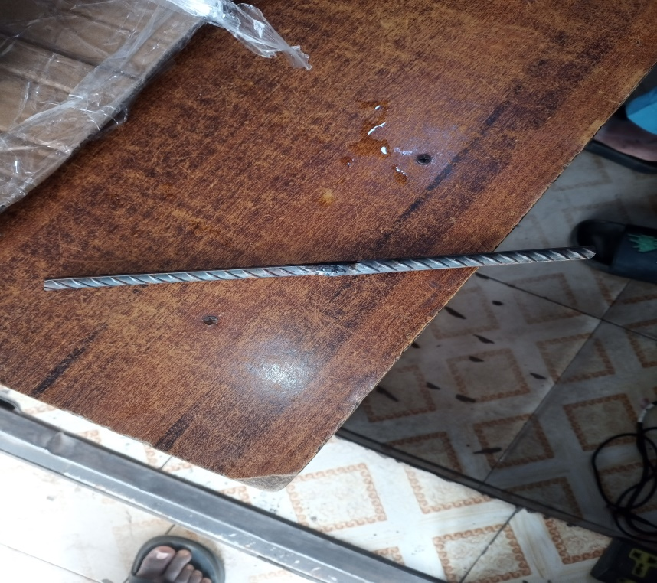
Fig 3.1: Welded Mild Steel Rod
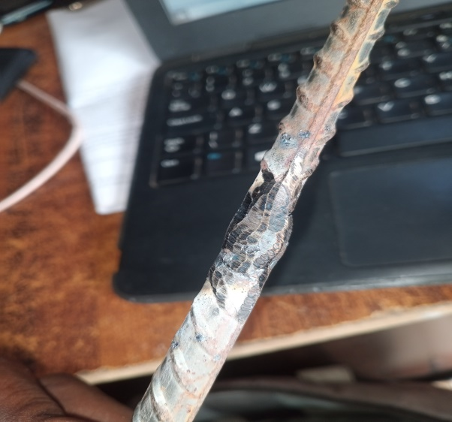
Fig 3.2: Welded Spot

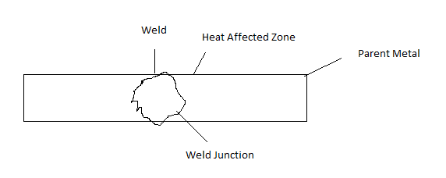 Fig 3.3: Hardness Test Specimen

CHAPTER FOUR

4.0 RESULTS AND DISCUSSION

4.1 Results
The results obtained from the mechanical testing of welded mild steel samples subjected to different annealing processes are presented in this section. These results include Vickers hardness values measured at three points: the weld, the junction, and the heat-affected zone (HAZ). The data shows the effect of each annealing method on the microstructural and mechanical behavior of the welded joints.
Table 4.1: Vicker hardness values for the annealed samples
 | Vicker Hardness Value
Samples | Point 1  (Weld) VHN | Point 2  (Junction) VHN | Point 3 (HAZ)  VHN
Full Annealing | 204 | 493 | 770
Subcritical  Annealing | 213 | 521 | 796
Stress Relieving  Annealing | 235 | 553 | 859
Untreated | 230 | 543 | 892

In all cases, the HAZ consistently showed the highest hardness values, indicating that it experienced the most significant microstructural changes due to welding and heat treatment. Homogenizing annealing resulted in the highest overall hardness among the treated samples, while full annealing showed the lowest hardness values at the weld and junction.

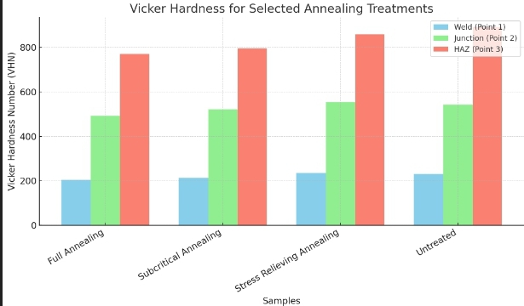
Fig 4.1: Bar chart of Hardness Test



Untreated Magnification (x 200) Full Annealing

(Magnification(x 200)


Stress Relieving Annealing Subcritical Annealing Magnification (x 200) Magnification (x200)
Fig 4.2: Microstructures Of The Sample With Different Annealing

4.2 Discussion of Results
The mechanical testing results highlight the varying effects of different annealing treatments on arc-welded mild steel joints. Each treatment altered the hardness profile and microstructure of the weldments, especially in the HAZ.
- Full Annealing: The weld region showed reduced hardness, suggesting that ferrite was transformed or redistributed, leading to improved ductility and lower internal stress. This method is suitable for applications requiring enhanced toughness.
- Subcritical Annealing: Little change was observed in the microstructure, as the temperature was not high enough for phase transformation. This treatment mainly relieved stress without significantly improving hardness.
- Stress-Relieving Annealing: Partial dispersion of ferrite resulted in reduced internal stress and moderate mechanical performance.
- Untreated Sample: Although the untreated joints had high hardness in the HAZ, they are more prone to brittleness and cracking.
4.2.1 Tensile Testing Observation and Analysis:
- Full annealing: Improved ductility and elongation but slightly reduced tensile strength.
- Stress-relieving annealing: Offered a balanced performance with moderate strength and good toughness.
- Subcritical annealing: Had minimal impact on tensile properties due to the low treatment temperature.
- Untreated sample: Although harder, showed less ductility and a higher tendency toward brittle fracture.

CHAPTER FIVE

5.0 CONCLUSION AND RECOMMENDATION

Conclusion
This research successfully evaluated the effects of different annealing processes on the mechanical properties of arc-welded mild steel joints. Through experimental analysis, it was observed that each annealing technique influenced the hardness, toughness, and microstructure of the welded samples differently.
Among the treatments,. Full annealing improved ductility and reduced residual stress, making it suitable for applications that prioritize toughness. Stress-relieving annealing offered moderate improvements by minimizing internal stresses without significant structural change. In contrast, subcritical annealing showed minimal mechanical enhancement due to the lower temperature applied.
The untreated samples exhibited the highest hardness in the heat-affected zone but are at greater risk of brittleness and cracking under load. Overall, the findings demonstrate that post-weld heat treatment, especially Stress-relieving annealing, significantly improves the mechanical behavior of welded mild steel, making it safer and more reliable for industrial use.

Recommendations
- Full annealing is recommended for components that demand improved ductility and stress relief.
- Careful control of annealing parameters temperature, holding time, and cooling rate is essential for achieving the desired results.
- Fabrication workshops should incorporate standardized post-weld heat treatment practices to improve weld quality and component lifespan.
- Future research could explore the combined effects of annealing with other heat treatments like normalizing or tempering, and also investigate fatigue behavior under cyclic loading conditions.
- Training programs should be developed for engineers and technicians on the importance of post-weld treatments to ensure better fabrication outcomes.

REFERENCES
Adedayo, A.V. (2008): Metal Joining Processes, Department of Metallurgical Engineering Kwara State Polytechnic, Ilorin.
Adepoju, 0.T., Olatunbosun O.A., (1984): The Effect of Heat Treatment and Microstructure on the Machinability of Carbon Steels. Format of Nigerian Society of Engineers Vol. 19 No 4. Pp. 112 - 116.
Alagbe, M. (2008): Heat Treatment Processes. Department of Metallurgical Engineering, Kwara State Polytechnic, Ilorin.
Cancaster, J.F. (1985): The Metallurgy of Welding, Fourth Edition, pp. 182 -
189.
Davies, A.C. (1984): The Science and Practice of Welding vol. 1 Welding Science and Technology London New York, Pp. 186.
George, L. (1973): The Theory and Practice of Metalwork (2nd Edition Metric)
UK: Longman Pub. Ltd. Pp.316.
Graham, J. (1978): The Science and Practice of Welding, New York.
Maslor, A. Davies, M.L., John, B.D. (1984): Engineering Manufacturing
Processes and Materials, in Publishers, Moscow Pp. 135.
MIT, (2008): Open Course ware on Metal Joining Processes.
Omotoyinbo, J.A. (1985): MME 513 Production Metallurgy. Pp. 188- 191.
Rybarkov, V. (1979): (Arc and gas welding) Mir Publisher Mosco Pp. 220.
International Journal of Advanced Manufacturing Technology (2019) worked on the topic “Microstructural and Mechanical Characterization of Arc Welded Mild Steel Joints Subjected to Heat treatment.”
Journal of Materials Engineering and Performance (2018), worked on the topic “Effect of Heat Treatment on Mechanical Properties of Welded Low Carbon Steel.”
Engineering Science and Technology International Journal (2017), worked on the topic “Influence of Welding Parameters and Post-Weld Heat Treatment on the Microstructure and Hardness of Mild Steel.”

