PETROGRAPHICSTUDIESOFROCKINKWARASTATE POLYTECHNIC, ILORIN.

By

Emmanuel Seyi ABIODUN
ND/23/MPE/FT/0074
SUBMITTEDTO:

BEING A RESEARCH PROJECT SUMMITED TO THE DEPARTMENT OF MINERALS AND PETROLEUM RESOURCES ENGINEERING TECHNOLOGY INSTITUTE OF TECHNOLOGY, KWARA STATE POLYTECHNIC, ILORIN

IN PARTIAL FULFILLMENT OF THE REQUIREMENT FOR THE AWARD OF NATIONAL DIPLOMA (ND)INMINERALS AND PETROLEUM RESOURCES ENGINEERING TECHNOLOGY

AUGUST, 2025.

i

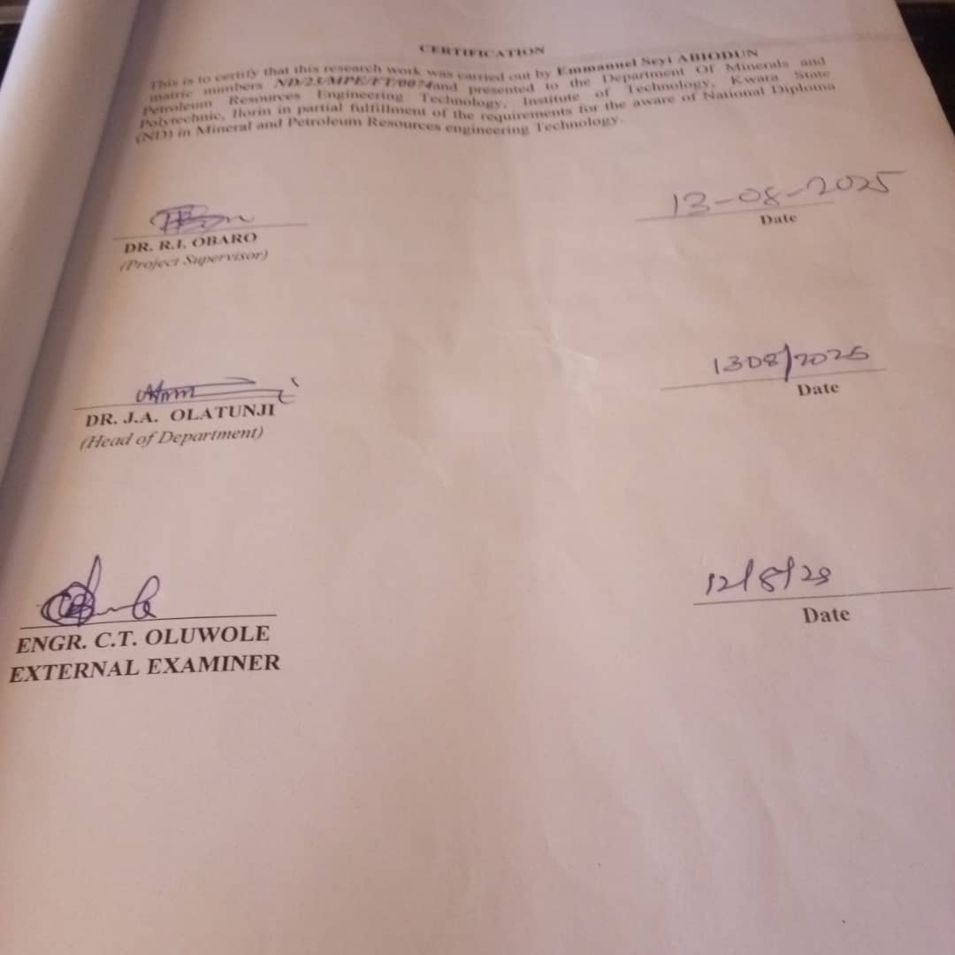

ii

DEDICATION

With profound gratitude, I dedicate this work to the Almighty God, whose infinite mercy, sustenance, and protection have guided me throughout the course of this project. His grace, loving-kindness, wisdom, and strength have been my constant support —to Him alone be all the glory.
I also dedicate this work to my beloved family for their unwavering support and immense sacrifices toward my education. May the Almighty God bless them abundantly.
Special appreciation goes to my parents, Mr. Abiodun Oluwashola and Mrs. Abiodun Mary, as well as and my dear siblings, for their financial support, encouragement, and prayers. I am deeply grateful, and I pray that God continues to prosper their ways.
Lastly, I extend my heartfelt dedication to the lecturers of Kwara State Polytechnic for their dedication, guidance, and contributions to my academic journey. I sincerely appreciate your efforts.

iii

ACKNOWLEDGEMENT

I give all the glory and adoration to Almighty GOD, the beginning and the End, for his greatest protection and love given to me as a privilege to start and complete this research work.
I wholeheartedly extend my special thanks to my amiable supervisor Dr. Reuben Obaro for his professional guidance and support towards the success of this project. To my Head of department Dr. Olatunji and other lecturer in minerals and petroleum resources engineering technology department, and Kwara state polytechnic for availing me with their wealth of experience, may you all be reward abundantly.
My sincere appreciation also goes to my course mates who directly or indirectly affected my life in the progress of this work.

Iv

ABSTRACT

The project titled the petrographic study of rock in Nigeria aims to conduct a comprehensive analysis of rocks within the Kwara State Polytechnic, Ilorin, In order to identify their mineralogical composition of rock. Petrographic study plays a crucial role in unraveling the mineralogical texture, characteristics of rocks which in turn provide insights Into their formation history, mechanical behavior, and potential application.
The methodology employed involved fresh representative sample of magmite gneiss tagged sample A porphritic granite sampled B and Biotite granite sampled C were collected on the open cast mine site on out crops. During the cause of the project the laboratory analysis were carried out on three different types of rocks lablled sample A (Magmite Gneiss), Sample B (porphritic granite) and Sample C (Biotite Granite). The Petrographic analysis carried outinclude thin section analysis and optical observations.
The results based on petrographic studies of the thin sectionsthe various mineral distributions such as quartz, biotite, hornblende and felsper (orthoclase, plagioclase, and microcline). The quartz and felsper constitute almost 88% of the thin section with otheraccessory minerals in both plain polarized and crossed polarized light.
In conclusion Petrographic and geochemical analysis reveal the granitic rocks are rich in quartz, feldspars, and biotite, with high silica and aluminosilicate content, indicating a calc- alkaline origin. Trace elements are minimal. These rocks possess good potential for engineering applications and economic minerals like quartz, feldspar, and mica. It's recommended that the government equip laboratories for detailed petrographic analysis and promote the exploration of solid mineral resources for industrialization.
v

 | TABLEOFCONTENTS
Titlepage |  | I
Certification |  | Ii
Dedication |  | Iii
Acknowledgement |  | Iv
Abstract |  | V
Tableof content |  | vi-viii
Listof Figures |  | Ix
Listof Tables |  | X

CHAPTERONE
INTRODUCTION 1
Background ofthestudy 1
Aimofthestudy 2
Objectivesof the study 2
Problem Statement 3
Justificationofthe study 3
Scopeofthestudy 3
Limitationsofthe Study 4
CHAPTERTWO
LITERATUREREVIEW 5
Reviewof Previouswork 5
CompositionofRock 6
Physicalcompositionof Rocks 7
ChemicalPropertiesofRock 8
MineralogicalCompositionof Rock 8
EconomicImportanceofRock 9

Vi

CHAPTERTHREE

MATERIALSAND METHODS 11
Geologyof Nigeria 11
Geologyofthe StudyArea 13
Sample Collection 15
Sample Preparation 15
CHAPTERFOUR
RESULTSANDDISCUSSION 16
ResultsofPetrographic studiesof theThinSections 16
DiscussiononPetrographicStudiesofMigmatiteGneiss 16
PetrographicDescriptionofsome oftheProminentMineralsinthe Migmatite 17
Quartz (SiO2) 17
PlagioclaseFeldspar (Na2AlSi3O8.Ca2Al2Si2O8) 17
OrthoclaseFeldspar 17
MicroclineFeldspar 18
Muscovite (KF)2(Al2O3)3(SiO2)6 18
Biotite(Mg,Fe)3AlSi3O10(OH,F)2 18
Hornblende (Ca2(Mg,Fe)5(AI,Si)8O22(OH)2 19
DiscussiononPetrographicStudiesofPorphyriticGranite(SampleB) 20
DiscussiononPetrographicStudiesofBiotiteGranite(SampleC) 22
EconomicPotentialoftheRocks 24
CHAPTERFIVE
ConclusionandRecommendation 26
Conclusion 26
Recommendation 27
References 28

LISTOFFIGURES
Figure3.1:GeologicalMap ofNigeria(ModifiedfromAfricaAtlases, 2007) 11
Figure3.2:LocationMapof theStudyArea(modifiedafterOlasehinde etal.,1998) 13

 | LISTOFPLATES
Plate4.1. | PhotomicrographofmigmatitegneissunderCrossed PolarizedLight | 19
Plate4.2. | PhotomicrographofmigmatitegneissunderPlanePolarizedLight | 19
Plate4.3. | PhotomicrographofporphyriticgraniteunderCrossedPolarized Light | 21
Plate4.4. | PhotomicrographofporphyriticgraniteunderPlanePolarized Light | 21
Plate4.5. | PhotomicrographofBiotitegraniteunderCrossedPolarized Light | 23
Plate4.6. | PhotomicrographofporphyriticgraniteunderPlanePolarized Light | 23

CHAPTERONE

INTRODUCTION

Backgroundofthe study
Petrography is a branch of geology that focuses on the detailed description and classificationofrocks, primarilythroughmicroscopic analysisof thinsections.It isa critical tool for understanding the origin, composition, and history of rocks, as well as the processes that shaped them.Nigeria, located withinthe WestAfrican Craton,isendowed with awidevariety of rock types including igneous, metamorphic, and sedimentary rocks that reflect a complex geological history.
This study focuses on the petrographic analysis of rocks from various regions of Nigeria in order to reveal their mineralogical composition, texture, and structural characteristics. Nigeria’s geology is dominated by three major lithological units: the Precambrian Basement Complex,the Younger Granites oftheJosPlateau,and thesedimentary basins(Christopher etal. 2022).
The Precambrian Basement Complex, which underlies much of western and northern Nigeria, consists of migmatites, gneisses, schists, and granitoids. The Younger Granites, emplaced during the Jurassic period, are known for their ring complexesand mineralization.The sedimentary basins such as the Niger Delta, Benue Trough, and Chad Basin contain varioustypes of sedimentary rocks and are of great economic importance due to their hydrocarbon potential. Despite these resources, there is a need for a more detailed petrographic characterization of rocks across the country to better understand their properties, origins, and implications for natural resource development (Oyediran and Fohgi; 2019).

Petrography,thebranchofgeologydedicatedtothedetaileddescriptionand classification of rocks, is fundamental in understanding the Earth's crustal composition and thegeological processes that have shaped it over time. By meticulously examining thin sections ofrocks under polarizing microscopes,geologists can identify mineral constituents, textures, andstructures, thereby gaining profound insights into the history and conditions of rock formation. theextensivegeologicalstudiesconductedinNigeria,thereremainsasignificantgapin comprehensivepetrographicanalysesofmanyrockunits.Detailedpetrographicstudiesare essential for accurate geologicalmapping,mineral exploration, andunderstanding the tectonic evolutionoftheregion.Adeagboetal.(2017)analyzedstructuralelementsandmineralogical compositionsofrocksinpartsofOkeOgun,contributingtotheunderstandingoftheregion's geological history.

​Aimofthestudy

Theaimofthisstudyistoconductacomprehensivepetrographicanalysisofrockswithinthe Kwara State Polytechnic, Ilorin, in order to identify their mineralogical compositions of rocks.

​Objectiveofthestudy

Thespecificobjectivesofthe studyare to:

- collect representative rock samplesfrom different locations within the Kwara StatePolytechnic campus.
- preparethinsectionsofthecollectedrocksamplesforpetrographicexamination under a polarizing microscope.
- identify and classify the mineral constituents and textures of the rocks using standard petrographic techniques.

​ProblemStatement
The abundance and diversity of rock types in Nigeria, many areas remain underexplored in terms of their petrographic characteristics. This lack of detailed microscopic analysis can lead to inaccurate geological mapping, misinterpretation of rock origins, and poor understanding of subsurface structures. Such gaps in knowledge can affect exploration, engineering, and construction activities.
A systematic petrographic study is therefore essential to fill these knowledge gaps and provide a scientific basis for further geotechnical and resource assessments.

​Justification ofthe Study

Petrographic studies are crucial for various applications in geology, including mineral exploration, geotechnical engineering, and academic research. By examining rocks in thin section, geologists can obtain detailed information about their mineralogy, texture, and history that cannot be observed macroscopically.
This study will contribute to a better understanding of the geological framework of Nigeria, which is vital for national development, especially in the mining, oil, gas, and construction industries. Additionally, the findings will aid academic institutions and researchers in expanding the existing geological knowledge base of the country.

​Scopeofthestudy

It will include fieldwork for sample collection, laboratory preparation of thin sections,and microscopic analysis for mineralogical and textural identification. The study will cover petrographic analysis of selected rock samples from representative geological zones in the study area.

​Limitationsofthestudy
This study aimed to carry out comprehensive petrographic analysis involving fieldwork, laboratory preparation, and microscopic examination of rock samples from the study area.

CHAPTER TWO LITERATUREREVIEW

ReviewofPrevious Works

Petrographic studies play a crucial role in unraveling the mineralogical and textural characteristics of rocks, which in turn provide insights into their formation history, mechanical behavior, and potentialapplications. Several researchers haveexaminedthepetrography of rocks within Nigeria’s Basement Complex, revealing a rich diversity of rock types such as granite gneisses, migmatites, schists, and quartzites (Rahaman, 2019).
These studies have emphasized the importance of petrographic analysis for determining rock quality, especially in geotechnical and civil engineering applications. For instance, Olorunfemi and Jimoh (2020) investigated rocks from the Akure area and identified their geotechnical relevance for road construction based on petrographic characteristics. Their work showed that rocks with high quartz content and equigranular textures are more suitable for aggregateproductionduetotheirdurabilityandresistance toweathering.Suchfindingshave laid a foundational understanding that underscores the value of petrographic assessments in local infrastructural planning.
Research carried out in Kwara and surrounding states has also highlighted the significance of localized geological studies. Olarewaju and Akinola (2021) conducted a petrographic and structural study of rocks in Jebba, Kwara State, and concluded that most of the rocks belong to the Pan-African orogenic belt and have undergone multiple episodes of metamorphism. Their thin-section analysis revealed the presence of biotite, feldspar, quartz, and minor accessory minerals, which allowed them to infer the tectonic history of the area. In a relatedstudy,Yusufetal. (2022)examined granite outcrops inIgbeti, OyoState, and linkedtheir

mineralogytothe region’s potentialfor quarrying anddimensionstoneproduction. These studies serve as models for the present research, as they demonstrate how petrography can be used to evaluate rock quality, economic potential, and tectonic implications. However, few studies have targeted institutional environments like polytechnics, where ongoing infrastructure development makes geological insights particularly relevant.

​CompositionofRocks

The study area is in Kwara State Polytechnic, Ilorin, is predominantly characterized byrocks from Nigeria's Precambrian Basement Complex, which is the result of billions of years of geologicalprocesses.Thiscomplexismadeupofvarioustypesofrocks,includinggranites, migmatite-gneisscomplexes,andschists,eachcontributingtotheregion’sgeologicdiversity. Theserocktypesareintegralinunderstandingthestructuralintegrityofthearea, especiallyforconstruction,geologicalstudies,andresourceexploration.Thegranites,in particular,arewidespreadintheareaandformasignificantpartofthebedrock.Theyare primarily composed of quartz, feldspar, and mica, with quartz making up a significant portion of the rock, contributing toits hardness and resistance toweathering (Rahaman, 2020). Granites are oftenlight-colored,rangingfromgraytopink,andtheirmassiveformmakesthemessentialfor
understandingthelocaltopography.

Granites in thisregion are primarily of the sodic type, where albite feldspar predominates, although orthoclase feldspar is also present. These minerals are chemically stable and provide the granite with its remarkable resilience against weathering and erosion. The quartz component in granites contributes to their high silicon dioxide (SiO2) content, which in turn affects their durability and strength. The mica content, especially biotite, adds a degree of flexibility and can influencetherock'sweatheringpatternsovertime.GranitesintheIlorinareaaretypically

coarse-grained and display a crystalline structure, which is essential for geological studies as it indicates the conditions under which the rock crystallized. Their widespread distribution in the study area means they significantly impact the region’s soil properties and ground stability.

​Physicalcomposition ofRocks

Thephysicalcompositionof therocksintheKwara StatePolytechnic area,Ilorin,plays a crucial role in understanding their behavior under various environmental and engineering conditions. The main rock types in this area, including granites, migmatites, and schists, have distinct physical properties due to their mineral content and the geological processes that formed them. Granite, for example, is a coarse-grained, igneous rock composed primarily of quartz, feldspar, and mica. These minerals are well crystallized and visible to the naked eye, which contributes to the rock's characteristic grainy texture. The quartz content, in particular, provides granite with high hardness, making it resistant to weathering and erosion, which is one of the reasons it is commonly used in construction (Rahaman, 2020).
Granites in the Ilorin area often exhibit a variety of colors, ranging from light gray to pink, depending on the proportion of feldspar and mica present. The feldspar minerals in granite are responsible for its lighter tones, while the mica imparts a darker hue. The presence of biotite mica in some granites adds a slight metallic sheen, contributing to the aesthetic appeal of the rock. The texture of granite is also impacted by its grain size, with larger crystals indicating slower cooling of the molten rock. This coarse-grained structure not only adds to its strength but also allows for easier identification of the mineral components in the field. As a result, granite is widely used in architectural and engineering projects in Ilorin and beyond, due to its robustness and durability.

​Chemical CompositionofRocks
ThechemicalcompositionoftherocksintheKwaraStatePolytechnicarea,Ilorin,is crucialforunderstandingtheirproperties,behaviorunderstress,andweatheringpatterns.The primary rock types in the region—granite, migmatites, and schists—each have distinct chemical signaturesthatarearesultofthemineralsthatformthem.Granite,forexample,iscomposed mostly of quartz, feldspar, and mica, with quartz being the most abundant mineral, contributingto its high silicon dioxide (SiO2) content. Quartz accounts for approximately 30-40% of granite's overallcomposition,providingitwithremarkabledurabilityandresistancetochemical weathering (Rahaman, 2020). The feldsparcontent, primarilycomposed of orthoclase(KAlSi2O3) andalbite(NaAlSi2O3),addspotassium,sodium,andcalciumtotherock’schemicalprofile, which influences its crystallization and overall stability.
The presence of mica minerals like biotite and muscovitealso contributes tothe chemical composition of granite. Biotite (K(Mg,Fe)2AlSi2O3(OH)2) contains iron (Fe) and magnesium (Mg), which impart a darker color to the rock and affect its chemical weathering characteristics while muscovite (KAl2(AlSiO2)(OH)2) is less abundant, its aluminum (Al) and potassium (K) content can affect the rock's structural integrity and resistance to breakdown under acidic conditions. Together, these minerals give granite its stable chemical profile and contribute to its long-lasting physical properties in environments prone to weathering and erosion.

​MineralogicalCompositionofRocks
The mineralogical composition of the rocks in the Kwara State Polytechnic area, Ilorin, is fundamental in understanding their formation, stability, and behavior under different environmental conditions. The primary rock types in this region—granite, migmatites, and schists—eachhavedistinctmineralogicalcompositionsthatresultfromspecificgeological

processes. Granite, being an igneous rock, is predominantly composed of quartz, feldspar, and micaminerals.Themostabundantmineral,quartz(SiO₂),constitutesaround 30-40%ofgranite’s overallmineralcontent, providingitwithexceptionalhardnessand resistance toboth mechanical weathering and chemical alteration (Rahaman, 2020). Feldspar, consisting of both orthoclase (KAlSi2O3) and albite (NaAlSi2O3), contributes significantly to the rock's mineralogical profile, providing potassium, sodium, and calcium, which are essential in the formation and crystallization of granite.
In addition to quartz and feldspar, mica minerals, such as biotite and muscovite, are essential components of granite. Biotite (K(Mg,Fe)2AlSi2O3(OH)) is rich in iron and magnesium andgivestherockadarker colorandaslightlyflexibletexture.Muscovite(KAlSi2O3)(OH)2), on the other hand, is lighter in color and more abundant in potassium and aluminum.

​EconomicImportanceofRocks
Rocks in the Kwara State Polytechnic area, Ilorin, have significant economic importance duetotheirvariousapplicationsinconstruction,industry,andagriculture.Oneofthemost notableusesofrocksinthisregionisintheconstructionindustry.Granite,withitshigh durability,isapreferredmaterialforbuildingfoundations,roadconstruction,andpavement works. The hardness of granite makes it highly resistant to weathering and erosion, ensuring that structuresbuiltwiththismateriallastlonger,especiallyinareassubjecttoenvironmentalstress.
The availability of granite quarries in and around Ilorin makes it a key resource for the local and national economy, providing both raw materials for construction and employment opportunities in mining and processing industries (Rahaman, 2020).
In addition to granite, the region's migmatites and schists are valuable for certain industrialprocesses.Migmatites,withtheirmineral-richcompositionofquartz,feldspar,and

mica, have applications in the production of ceramics and glass. The feldspar component, in particular, is essential in the glass-making industry as a fluxing agent, lowering the melting temperature of silica. This makes the local migmatites a resource for industries involved in glass production, as well as the manufacturing of tiles, pottery, and porcelain. Similarly, mica, found abundantly in schists and migmatites, is used in the electrical industry due to its insulating properties, further contributing to the economic value of these rocks (Akinyemi and Adepoju, 2021).
The agricultural sector also benefits from the mineral content of the region’s rocks, particularly the weathering products of granite and schist. When rocks such as granite weather, they release important nutrients likepotassium, calcium, and magnesium, which are essential for soil fertility.The resulting soil formation from weathered rocks provides fertile land for agricultural activities in the region. Additionally, the clay minerals derived from weathered feldspar contributeto soilstructure, improvingwater retentionand nutrient availabilityfor crops. This makes the region's rocks indirectly beneficial to local farmers, ensuring sustainable agricultural practices in Ilorin (Ogunleye et al., 2022).

CHAPTERTHREE

MATERIALSANDMETHOD

GeologyofNigeria
Nigeria's geology is characterized by a diverse and complex structure that spans several geologicaltimeperiods,makingthecountryrichinbothgeologicalhistoryandmineralresources (Fig.3.1).Broadly,thegeologyofNigeriacanbedividedintothreemajorcomponents:the PrecambrianBasementComplex,theYoungerGranites,andtheSedimentaryBasins(Obaje, 2019). The Precambrian Basement Complex, which dominates the southwestern, northern, andcentral parts of the country,is composed mainly of migmatites, gneisses, granites, schists, andquartzites. This basement terrain is believed to haveundergone several tectonothermal events,includingtheLiberian,Eburnean,Kibaran,andPan-Africanorogenies,withthePan-African event being themostsignificant inshaping thecurrent structural configuration(Rahaman, 2020). TheYoungerGranites,mostlyfoundontheJosPlateau,areaseriesofringcomplexes formed during the Jurassic period and are associated with tin and columbite mineralization. The third major component, the Sedimentary Basins, including the Niger Delta, Benue Trough, and ChadBasin,occupythesouthernandnortheasternpartsofthecountryandcontainvast petroleum,gas,andothermineralresources(Nwajide,2021).Understandingthegeologyof Nigeriaisvitalnotonlyformineralexplorationandhydrocarbondevelopmentbutalsofor engineeringgeology,groundwaterstudies,andenvironmentalplanning—especiallyinregions suchasIlorinthatlienearthetransitionzonebetweentheBasementComplexandyounger
sedimentaryunits.

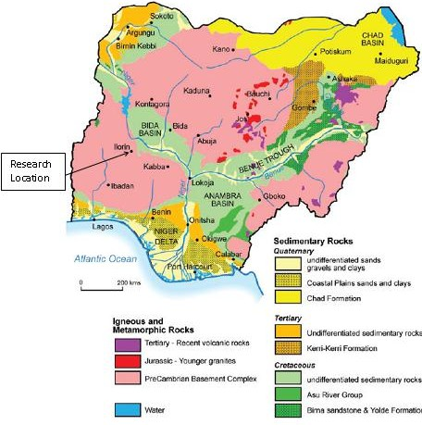

Figure3.1:GeologicalMapofNigeria(ModifiedAfterRahaman,1988)

​Geologyof theStudyArea
Kwara State Polytechnic is located in Ilorin, the capital of Kwara State, which fallswithin the southwestern region of Nigeria’s Basement Complex (Fig. 3.2). This area is well known for its ancient rock formations that have been around for hundreds of millions of years. Most of the rocks in and around the polytechnic are part of the Precambrian Basement Complex, which is made up of rocks like granite, migmatite-gneiss, quartzite, and schist. These rocks were formed under intense heat and pressure deep within the Earth’s crust and later exposed at the surface over time due to erosion and tectonic activity. Their presence plays a big role in shaping the physical landscape of the area, including the type of soil, vegetation, and even the drainage system.
A closer look at the geology of the campus reveals widespread exposures of granite and gneissic rocks, often seen in the form of rock outcrops scattered across parts of the school environment. These rocks usually display features like foliation and jointing, which tell stories about how they were formed and the natural forces that acted upon them. For instance, the foliation seen in gneiss is a result of minerals aligning due to pressure during metamorphism. Meanwhile, joints and fractures in the rocks suggest that the area has experienced some tectonic stress in the past, which could also influence how groundwater moves through the subsurface today. These structural features are important to consider, especially for engineering purposes like construction or borehole drilling within the school.

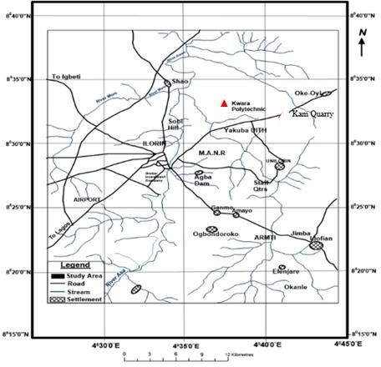

Figure3.2.LocationMapoftheStudyArea(modifiedafterOlasehindeetal., 1998)

​Sample Collection
Fresh representative samples of Migmatite Gneiss tagged Sample A, Porphyritic Granite tagged Sample B and Biotite Granite (Sample C) were collected on the open-cast mine site on outcrops. Structural features were observed based on tectonic activities and visual studies were also carried out to identify the different types of rocks.
The Global Positioning System was used to take the coordinate of the different locations where the samples are taken. Other equipment used includes hammer, chisel, sampling bags, paper tapeand marker.The three samplewere separated indifferentsample bagsand transported to University of Ilorin, Geology and Mineral Sciences Laboratory for detailed analysis.

​Sample Preparation

The laboratory analysis was carried out on three different types of rocks labeled SampleA(MigmatiteGneiss),SampleB(PorphyriticGranite)andSampleC(BiotiteGranite).The petrographical analysis carried out include thin section analysis and optical observations. During thepreparationofthinsectionsanalysisforallthesamples,athicknessof1.0cmofasquare shapeof eachof therocksample wascutwith thecutting machine.Applyingemerycloth and caborundumpowder,thespecimenisfurtherflatteningtoathicknessofabout0.04mm.This flattenedspecimenisoverlaidbythe boiledCanadabasalmanditiscoveredwithacoverslip and left forabout aday, thenitis washed, rinsedwith spirit and later withwater. Atotal ofsix(6) thinsections(2slidesfromeachrocksample)werepreparedfromthesamplesforeffective analysisandcontrol.Theanalysesweresubjectedtomicroscopicexaminations.Petrographic studies of the selected samples were made with the aid of a polarizing microscope. Some of the major minerals were observed under the microscopic examinations.

CHAPTERFOUR

RESULTSANDDISCUSSION

ResultsofPetrographicstudiesoftheThinSections
Theresultsbasedonpetrographicstudiesofthethinsectionsrevealedthevariousmineral distributions such as quartz, biotite, hornblende and feldspar (orthoclase, plagioclase and microcline). The quartz and feldspar constitute almost 88% of the thin section with other accessory minerals in both plane polarized and cross polarized light.

​DiscussiononPetrographicStudiesofMigmatite Gneiss

The migmatite gneiss is the oldest type of rock in the study area. According to Abba (1983) gneiss occurs as the most widespread lithological unit in basement terrains and the imprints of the Pan – African deformation were evident by regional metamorphism, migmatization, extensive granitization and gneissification which produce syntectonic granites and homogeneous gneisses. It is common and appears to demonstrate undifferientiated pattern within the area. They are depicted generally by alternating light and dark coloured bands. The felsic bands of the rock consist of quartz, plagioclase and orthoclase feldspar with large percentage composition while the hornblende, muscovite or biotite constitutes smallerpercentage of minerals in mafic bands.
Based on mineral assemblages, quartz is however a dominant minerals while others such as feldspar and biotite are also making up a vital part. It has textural classification of fine to medium grained. In addition, the rock has undergo numerous orogenic cycles which has essentially lead to large scale deformation (Obaje, 2009). The imprints has been widely reported inthePrecambrianrocksofNigeria(Rahaman,1989).Themacroandmicrostructuresisasa

resultoffracturing(Olayinka,1992) suchasfolding,jointing,veins,intrusions, foliationsand mineral lineations which were found in the study area.

​PetrographicDescriptionof someoftheProminentMineralsinthe Migmatite Gneiss

The studied thin section with the aid of petrological microscope and slides were analyzed under plane polarized light and crossed nicol. The studied minerals include quartz, feldspar, biotite and hornblende.

​Quartz (SiO2)

The quartz is colourless in plane polarized light and shaped in euhedal. In coss polarized light, the quartz is colourless, reddish and conchoidal fracture with anhedral shape (Plate 4.1 and 4.2). It also display pleinchoism crystal of quartz that exhibit low relief and sometimes exhibit undulose extinction indicative of deformation or straining (Obini and Omietimi, 2020).

PlagioclaseFeldspar(Na2AlSi3O8.Ca2Al2Si2O8)

The feldspar mineral observed are plagioclase feldspar which is clearly from Albite twining characteristics (Ojelokun and Fawole, 2019) which is as a result of angle parallel to the large crystals in plane polarized light is colourless (Plate 4.1) but it demonstrate first order grey colour when the polar is crossed. It can be characterized from other types of feldspar because of its polysynthetic twining visible in the crystal. Some of the plagioclase in the slides occur as phenocryst (Plate 4.2).

​OrthoclaseFeldspar

The orthoclase feldspar under plane polarized light and crossed polarized light (XPL) appears cloudy and colourless (Plate 4.1 and 4.2). The crystals have low relief and are anhedralin shape. It is often colourless crystals with grey and reddish. The darker portion in the thin section suggest weathered feldspar with no definite cleavage.

​MicroclineFeldspar
The microcline feldspar exhibit a cystal system known as triclinic. This mineral is colourless under plane polarized light (PPL) and appears milky white under cross polarized light (XPL) with higher relief to quartz and orthoclase plate (Plate 4.1 and 4.2). The physical and chemicalcomposition of microcline feldspar can be compare with the orthoclase feldspar. A thin section study implies large anhedral to subhedralmicroperthitic microcline with good polysynthetic crosshatched crystals with elongated crystals that exhibit subhedral habit.

​Muscovite (KF)2(Al2O3)3(SiO2)6

The muscovite appears colourless under plane polarized light (PPL) (Plate 4.1) and has a palegreenappearanceundercross polarizedlight(XPL) (Plate4.2)which makesitpleochroic. It exhibit parallel extinction with high relief and perfect cleavage in all direction. However, many of the crystals has twining and those near to the extinction shows position display appearance which is characteristics of mica family.

​Biotite(Mg,Fe)3AlSi3O10(OH,F)2

The colour of the biotiteisbetween grey to brown colouration with subhedral to anhedral shape and has no twining. It has a directional cleavage. The mineral plate does not have extinction angles but form interstitial lamellae which may occur as linear aggregates with alteration to chlorite. It exhibits different pleonchoic orientation. The biotite has some inclusion of accessory minerals like zicon, rutile and apatite (Plate 4.1 and 4.2). It has strong birefringence under crossed polarised light, interference colour of dark green with symmetrical extinction and polysynthetic twinning.

​Hornblende (Ca2(Mg,Fe)5(AI,Si)8O22(OH)2

The colour of hornblende under plane polarized light is greenish black and it alsodisplays pleochroism from green to brown.Under plane polarized light, a few of the hornblende crystals showed the characteristics shape and two cleavages. Under crossed nicol, twinning was seen in a few hornblende crystals and the highest interference colour seen isa second-order blue.

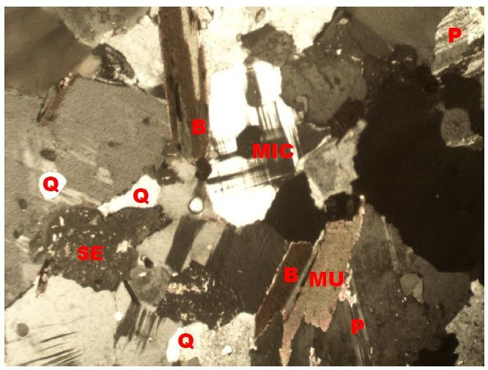

Plate4.1:PhotomicrographofmigmatitegneissunderCrossedPolarizedLight(XPL), showing quartz (Q), biotite (B), plagioclase feldspar (P).

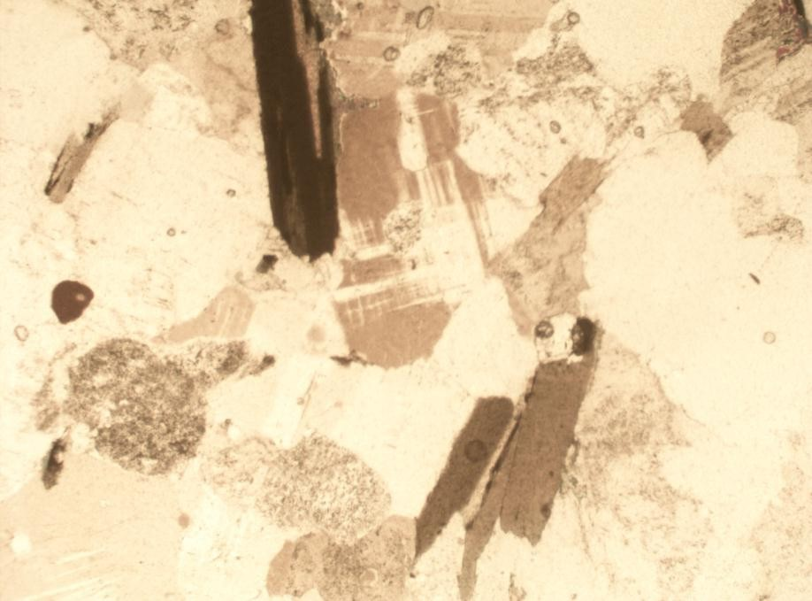

Plate 4.2: Photomicrograph of migmatite gneiss under Plane Polarized Light (PPL) showing the various shades of colours of mineral grains, Quartz (Q), Biotite (B), Plagioclase feldspar.

​DiscussiononPetrographicStudiesofPorphyritic Granite(SampleB)

Porphyritic granite is the second most abundant rock type in the study area and it exhibits the characteristics of both slow and rapid rates of cooling magma. This has resulted to large orgiant crystals of minerals (Phenocrysts) due to slow cooling, nevertheless, it has been subjectedto furtherrapid cooling asthe magma eventually move to the surfaceto formfiner groundmassin which the phenocryst are embedded to form porphyritic texture (Saad and Baba, 2017). Themajor mineral constituents that occur include quartz, biotite, hornblende and plagioclase feldspar. Thequartzintheporphyriticgraniteiseuhedralinshapeanditdisplaysunduloseextinction. The biotite exhibitsdifferent pleonchoic orientation. The biotite has some inclusionof

accessory minerals like zircon, rutile and apatite. The plagioclase feldspar occurs as phenocrysts with lamellar twinning within the groundmass. Accessory minerals in the rock include zircon, apathite, magnetite and titanite (Plate 4.3 and 4.4)

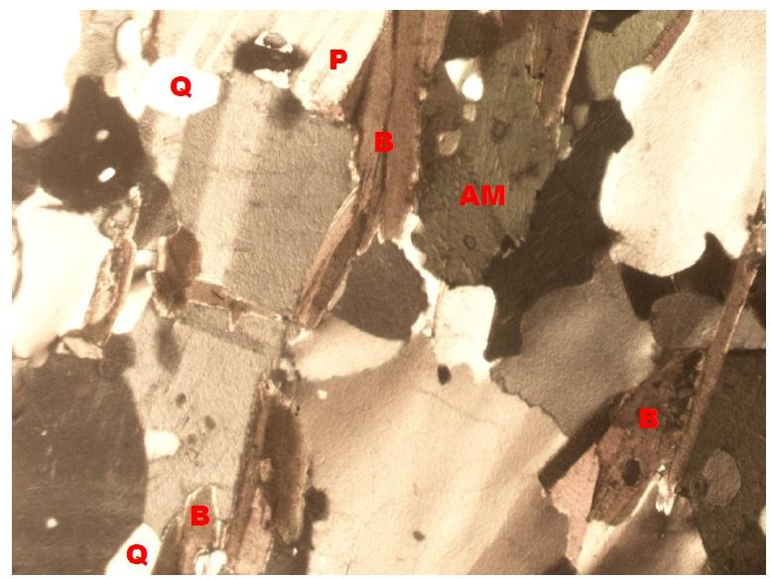

Plate4.3:PhotomicrographofporphyriticgraniteunderCrossedPolarizedLight(XPL), showing quartz (Q), biotite (B), plagioclase feldspar (P).

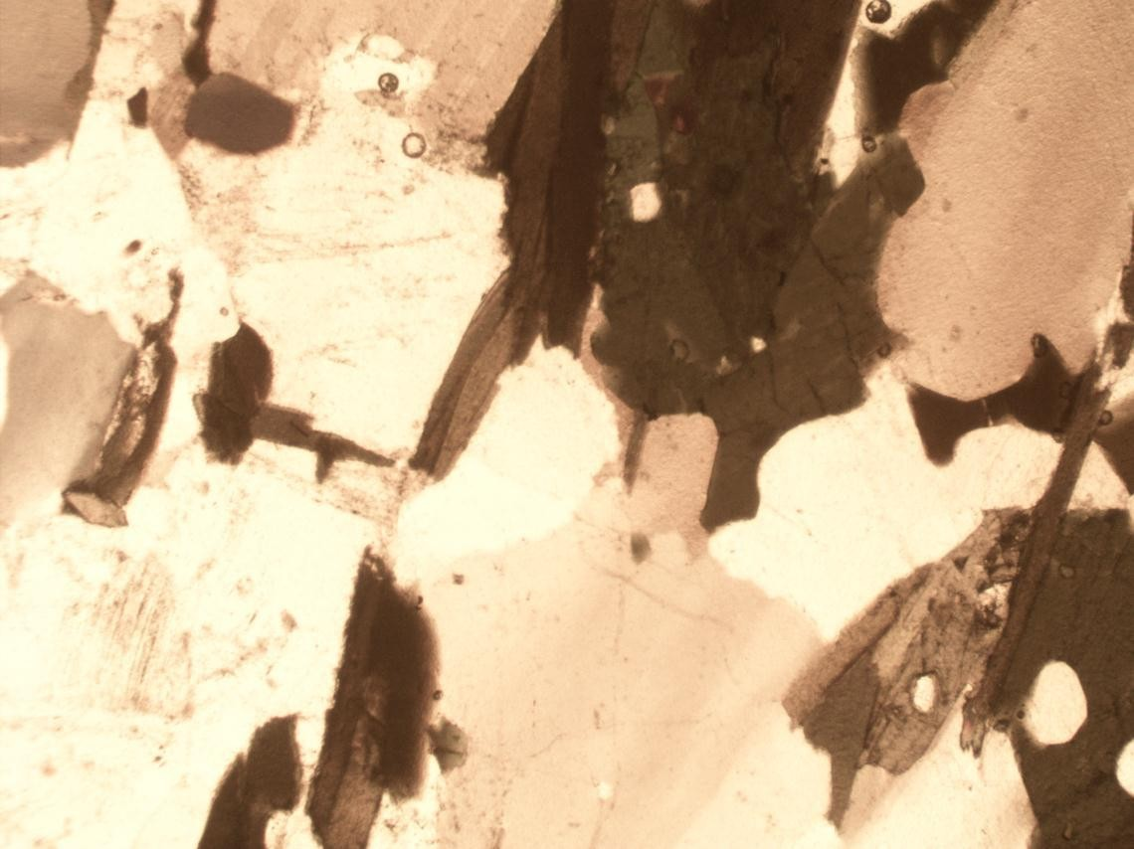

Plate4.4:PhotomicrographofporphyriticgraniteunderPlanePolarizedLight(PPL)showing the various shades of colours of mineral grains, Quartz (Q), Biotite (B), Plagioclase feldspar.

​DiscussiononPetrographicStudiesofBiotiteGranite (SampleC)

The biotite granite is a medium to coarse grained rock. The colour has resulted from the disintegration of biotite to fom chlorite (Aga and Haruna, 2019). Biotite is pleochroic form green to brown and are subhedral in shape (Plate 4.5 and Plate 4.6). The chlorite that occurs within the fractures has lightgreen colouration and occurs mainly incracks present within mineral matrixes. Thecrystalformofthechloriteisanhedralandoccursasadifferentproduct.However,
the quartz in the biotite granite is euhedral to crystal in shape with crypto crystalline inclusions.It displays undulose extinction. This essentially proves that the rocks were highly deformed. The huge tectonicactivitiesthattookplaceoroccur mighthave ledtotheexposureoftherockstothe surfaceofthestudyarea.Theoccurrenceoffeldsparinthebiotitegraniteisknownas

plagioclasefeldsparanditisan irregularformed perthitewithpatches ofitformedat the surface.
Theironoxideoccursas tinyblackpatches insomebiotitecrystals anditislessabundant in the sample.

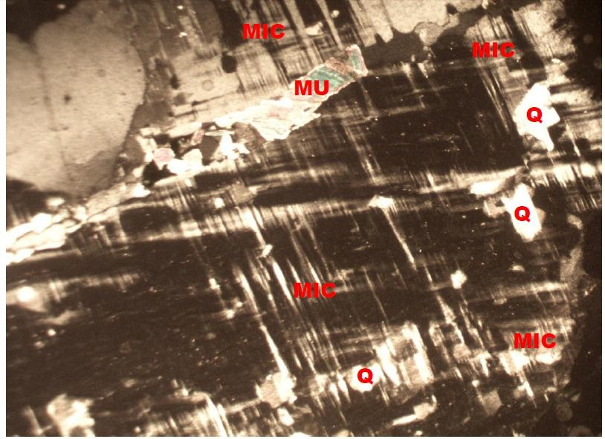
Plate4.5:PhotomicrographofBiotitegraniteunderCrossedPolarizedLight(XPL),showing quartz (Q), biotite (B), plagioclase feldspar (P)

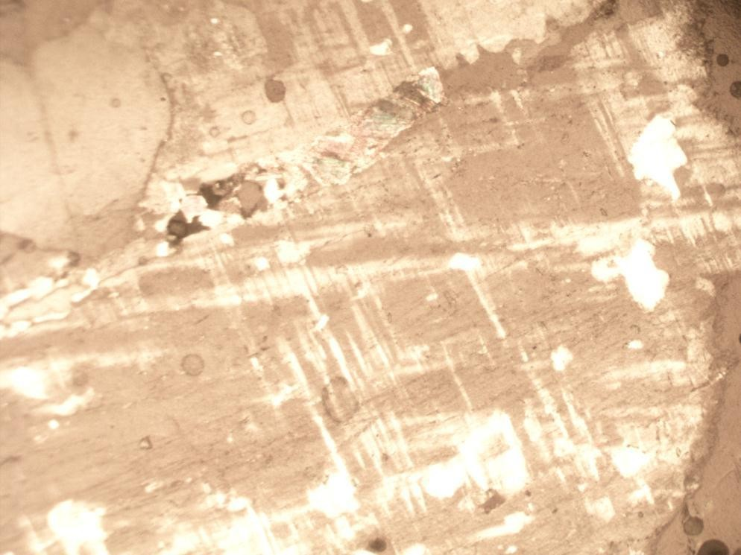
Plate4.6:PhotomicrographofporphyriticgraniteunderPlanePolarizedLight(PPL)showing the various shades of colours of mineral grains, Quartz (Q), Biotite (B), Plagioclase feldspar.

​EconomicPotentialoftheRocks

Economically, the sampled rocks (Migmatite Gneiss, Porphyritic Granite and Biotite Granite) in the studied area have good potentials for engineering purposes. Industrially, the quartzite can be used as industrial silica sand, silicon and silicon carbide. It can also be used as decorativestone used tocover walls. It is alsouseful inflooring, star stepsand as roofingtiles. It is sometimes used as railway ballast and also in road construction purposes such as bridges, building houses, road pavement etc.
The petrographic analysis examined indicate that mineral distribution quality are essentially made up economic minerals quartz, feldspar, biotite, muscovite and other accessory minerals. It is important to reiterates that these minerals are conspicuously present in both rocks anditisevidencedthatthemineralspresentsarerandomlydistributedinaccordancetotheir

lithological variations (Ajali, 1997). Feldspar can be mined as profit by ceramics and glass industries for making product. The feldspar (plagioclase and orthoclase) can also be mined for fertilizers and cements.

CHAPTER FIVE CONCLUSIONANDRECOMMENDATION

Conclusion

Petrographicstudiesand geochemical analysisof twodifferent rock samples werecarried outinthestudyarea.Petrographically, thegraniticrocks inthestudyareaare composedofmajor rock forming silicate minerals such as quartz, biotite mica, and feldspars.
The geochemical analysis on the rocks in the study area shows that the rocks are mineralogically composed of quartz, orthoclase and plagioclase feldspar, albite, microcline and other minor constituents such as hornblende and biotite. The rocks in the study area are chemically characterized by high percentage of silica (SiO2), alumino-silicate minerals and the ferromagnesian compounds (Fe2O3and MgO) whichhave varying low amount in both rock samples with calcium oxide which could be attributed to the calc-alkaline nature of the magma which serves as the precursor of the rocks.
The chromium oxide (Cr2O3), phosphorus oxide (P2O5), sulphide (SO3), manganeseoxide (MnO), titanium oxide (TiO2), zinc oxide (ZnO) and copper oxide (CuO) are the least abundant mineral with very low percentage weight composition of less than 1% in both samples. Economically, the various rocks in the area have good potentials for engineering purposes. The petrographic analysis examined indicate that mineral distribution quality are essentially made up economic minerals quartz, feldspar, biotite, muscovite and other accessory minerals.

​Recommendation
The federal government should establish and equip the existing laboratories to carry out detailed analysis particularly on petrographic analysis of rocks for engineering construction purposes. Measures should also be put in place to exploit and explore solid mineral resources in order to enhance industrialization and boost the economy of the country.

REFERENCES

Adeagbo, C. A., Osokpor, J., & Aladejana, J. A. (2017). Petrographic and structural analysis ofbasement complex rocks in parts of Oke Ogun area, southwestern Nigeria. Journal of African Earth Sciences.
Anyiam, A. O., Akintola, A. I., & Ntekim, E. E. (2017). Petrography and reservoirquality evaluation of sandstones around Abuul, Ushongo area, southern Benue Trough, Nigeria. Nigerian Journal of Basic and Applied Sciences.
Chukwu, A., & Obiora, D. (2012). Whole-rock geochemistry and petrogenesis of basic and intermediate intrusive rocks in the Ishiagu area, southeastern Nigeria. Journal of Geology and Mining Research.
Christopher, B. C., Musa, H., & Akinyemi, O. (2022). Geological and mineralogical overview of lithological units in Nigeria. African Journal of Geosciences and Environmental Studies.
Iliya, A., & Ma’aji, I. (2021). Petrography of crystalline basement rocks around Arumand environs, central Nigeria: Implications for mineral potential and environmental assessment. Journal of Mining and Geology.
Jimoh, M. A., Abdulkadir, M. A., & Audu, Y. (2020). Organic petrography and geochemical characteristics oftheMaastrichtianGombe Formation,GongolaBasin,northeastern Nigeria. Petroleum & Coal.
Nule, D. A., Effiong, G. J., & Akpan, A. E. (2024). Mineralogical and geochemical investigation of basement rocks in parts of Ikom and Iso–Bendeghia, southeastern Nigeria. Nigerian Journal of Mining and Geology,
Oyediran, I. A., & Fohgi, S. A. (2019). An overview of Nigeria’s lithostratigraphic units and implications for resource exploration. Earth and Environmental Research Journal, 5(1)
Suleiman, M. A., Oladeji, S. O., & Gambo, J. S. (2020). Geochemical and petrographicevaluation of weathered rocks in central Nigeria: Implications for environmental hazard and land use. International Journal of Geosciences.
Usman, S., & Ibrahim, A. A. (2017). Petrographic and geochemical characteristics of rocks inthe Wonaka SchistBelt, northern Nigeria. Journalof EarthSciences andGeotechnical Engineering.

