ASSESSMENT OF HEALTH EFFECT FROM EXPOSURE TO 33 KV POWER LINE IN KWARA STATE POLYTECHNIC AND IT ENVIROMENT

BY

AJAYI STEPHEN TOMIWA
ND/23/SLT/PT/0151

A PROJECT SUBMITTED TO THE DEPARTMENT OF SCIENCE LABORATORY TECHNOLOGY (PHYSICS & ELECTRONICS UNITS) INSTITUTE OF APPLIED SCIENCES
KWARA STATE POLYTECHNIC, ILORIN NIGERIA.

IN PARTIAL FULFILLMENT OF THE REQUIREMENT FOR THE AWARD OF NATIONAL DIPLOMA IN SCIENCE LABORATORY TECHNOLOGY.
JULY, 2025



DEDICATION
We dedicate this Project to Almighty GOD, the giver of knowledge and to our parents.

ACKNOWLEGEMENT

We are highly grateful to ALMIGHTY GOD who in His infinite mercy has showered his blessings and favour upon us throughout the course.
Our special thanks extended to Olatunbosun R.O who has worked tirelessly to see the success of this work for his advice and effective supervision. We also wish to appreciate the kindness and support of the head of the Physics/ Electronics Unit, SLT, Mr. Salahu Bashir and all the entire member of the staff of Physics/ Electronics, we will miss you. These will not be complete if we don’t acknowledge the effort our dear Parents for their Mentorship and support, financially, care, their prayers and moral contribution to the success seeing us through our course of study we say thank you and God bless.

ABSTRACT

The study examines the potential health effects of exposure to 33 kV power lines around the Kwara State Polytechnic (Kwara Poly) environs in Ilorin, Nigeria. Using electrosmog meter for measuring the electric field and magnetic field lines and power density near the power lines. The results showed a higher prevalence of symptoms like headaches, fatigue, and sleep disturbances among residents and students living within 50 meters (exposed group) and those beyond 100 meters (control group) of the lines. Public awareness of electromagnetic field (EMF) exposure was low. Although EMF levels were generally within international safety limits, the reported health complaints suggest the need for improved regulation, public education, and further research in the Kwara Poly area.

TABLE OF CONTENT
Title page i
Certification ii
Dedication iii
Acknowledgement iv
Abstract v
Table of content vi - vii
CHAPTER ONE
1.0 Introduction 1- 4
1.1 Statement of the problem 4
1.2 Aim 5
1.3 Justification 5
1.4 Scope of the study 5 - 6
1.5 Limitation 6
CHAPTER TWO
2.0 Literature review 7 - 13
2.1 Electric and Magnetic fields 13 - 14
2.2 Magnetic fields 14 -15
2.3 Electromagnetic radiation 15 - 16
2.4 Types of radiation 16
2.4.1 Ionizing radiation 16 - 17
2.4.2 Non- Ionizing Radiation 17 -18
2.4.3 Types of non-ionizing radiation 20 2.4.3.1 Optical radiation 20 - 21
2.4.3.2 Ultraviolet radiation 21
2.4.3.3 Vissible Light 21 - 22

2.4.3.4 Infrared Radiation 22
2.4.3.5 Micro-wave radiation 22
2.4.3.6 Radio wave 22 - 23
2.4.3.7 Very low frequency 23
2.4.3.8 Extremely Low Frequency 23
2.5 Thermal Radiation 23 - 25
2.6 Electromagnetic spectrum 25
2.7 Range of the spectrum 25 - 26
2.8 Sources of extremely low frequency 26 - 27
2.9 Biological effects of ELF fields 28
2.9.1 Other biological effects 29 - 30
CHAPTER THREE
3.0 Methodology 31
3.1 Instrumentation 31
3.1.1 The electrosmog meter 32 - 33
3.2 Measurement of Electric field strength 33 - 34
CHAPTER FOUR: Result and discussion
4.1 Power line measurement 35 - 42
CHAPTER FIVE
5.1 Conclusion 43
References 44 - 46

CHAPTER ONE
1.0 INTRODUCTION
Electricity is a vital part of modern society, powering industries, homes, and essential services. In Nigeria, electric energy is transmitted across a variety of voltage levels. While high-voltage transmission lines have been extensively studied for their health effects, medium-voltage lines like 33kV are often installed closer to residential and commercial environments due to their use in power distribution rather than bulk transmission.
This study focuses on the electromagnetic fields (EMF) produced by 33kV power distribution lines, especially in densely populated areas such as residential estates, schools, marketplaces, and places of worship. These locations are increasingly intersected by 33kV lines due to expanding infrastructure, prompting concern about potential long-term exposure to EMF radiation. (Portier, 1998)
This research work will primarily focus on electromagnetic field (EMF) radiation from power lines, which will include taking measurements from different areas such as workplaces, laboratories, and schools. In fact, in Ilorin alone—where there is a high demand for the installation of power lines to provide electrical services—many power lines are situated within residential areas, church compounds, business centers, shopping complexes, and school premises.
This raises a great concern for the general public regarding their exposure to electromagnetic radiation from power lines and the potential health hazards associated with it. The general public is genuinely concerned about this issue because, over the years, some adverse health effects have been scientifically attributed to electromagnetic radiation.
Recommendations for the protection of workers and members of the general public from the effects of electromagnetic fields (EMF) have been made by numerous international and professional organizations. Regulatory agencies in many countries have also developed legally enforceable standards and exposure limits. Some of these organizations include the World Health Organization (WHO), the International Radiation Protection Association (IRPA), and the Institute of Electrical and Electronics Engineers (IEEE). This study focuses specifically on surveying the electromagnetic fields (EMF) emitted from different power lines.
Concern about the potential health risks of EMF exposure emerged in 1979 when Wertheimer and Leeper reported that children living near power lines had an increased risk of developing cancer. This sparked immediate attention and launched a controversial area of research. Despite numerous studies, the issue remains a topic of ongoing debate. As urban development continues and power infrastructure expands, exposure to extremely low frequency (ELF) EMF—primarily from power transmission at 50Hz—has become more widespread. Over the past two decades, the public has shown increasing concern about the possible adverse health effects linked to this type of exposure (Akinyemi, 2010).
Wherever electricity is generated, transmitted, or distributed through power infrastructure, electric and magnetic fields (EMF) are invariably produced as a result of the presence and motion of electric charges. These fields are an inherent characteristic of any system involving electrical energy and are typically described as time-varying vector quantities. Their behavior is defined by several parameters, including frequency, phase, direction, magnitude, and spatial distribution. In power systems, these fields operate predominantly at extremely low frequencies (ELF), commonly at 50 Hz, which is the standard power-line frequency in Nigeria and many parts of the world.
An electromagnetic field is composed of two distinct but interrelated components: the electric field and the magnetic field. The electric field is generated by the presence of electric charges and exists even when no current is flowing. It represents the force per unit charge exerted on a positive test charge placed in the field. The magnitude of the electric field is influenced primarily by the voltage, or potential difference, between conductors or charged objects. It is measured in volts per meter (V/m), and its strength diminishes with increasing distance from the source.
Conversely, the magnetic field is produced only when electric charges are in motion—typically in the form of an electric current flowing through a conductor. This field describes the force exerted on other moving charges or currents in the vicinity. The magnetic field strength depends directly on the amount of current flowing through the conductor and is measured in units such as tesla (T) or microtesla (µT). Unlike the electric field, the magnetic field is not influenced by voltage but solely by the rate at which electric charge flows. Its effect is directional and follows the right-hand rule in relation to current direction.
Together, these fields form the electromagnetic environment surrounding power lines and electrical installations. While the electric and magnetic components are distinct in behavior and origin, they often coexist and interact in real-world scenarios, especially around high-voltage transmission lines such as 33 kV lines. Understanding the nature, distribution, and behavior of these fields is essential in assessing potential exposure risks and evaluating the possible health effects associated with long-term proximity to high-voltage electrical infrastructure.
1.1 Statement of the Problem
In urban and semi-urban areas across Nigeria, 33kV distribution lines are commonly routed through populated environments without adequate regulatory enforcement or public awareness. 33kV lines are often much closer to buildings and people, increasing the chances of long-term EMF exposure. This raises questions about the health implications of living or working near such installations. This study investigates the potential risks posed by 33kV EMF emissions.(Izueke, 2013)
1.2 Aim and Objectives
Aim
To assess the potential health effects associated with exposure to electric and magnetic fields (EMF) generated by 33kV power lines.
1.3 Justification
Although 33kV lines operate at lower voltages, they are much closer to human activity. This proximity increases the likelihood of chronic low-level EMF exposure, especially in schools, homes, and offices. This study provides empirical data that can help shape public policy, urban planning regulations, and community health safety guidelines for 33kV line installations. Given that prolonged exposure to EMF above recommended limits may pose potential health risks, this research aims to determine whether individuals in affected areas are exposed to radiation levels that exceed safe thresholds. The findings of this study will provide valuable insights into the level of risk faced by populations residing near power line infrastructure, contributing to public awareness and informing urban planning and regulatory policies to ensure public health and safety.
1.4 Scope of Study
This study is centered on assessing electromagnetic field (EMF) exposure from 33 kV power lines, using field measurement equipment designed for extremely low frequency (ELF) radiation. The instruments utilized include the ELF Detection Meter (Model 480823) manufactured by Action Electronic, U.S.A.—a device optimized for measuring ELF radiation—and the Electrosmog Meter (TES-92). These meters measure and display EMF intensity in Gauss and Tesla units, within a frequency bandwidth of 30 to 300 Hz, which covers the typical 50 Hz power-line frequency. The study focuses on various locations near high-voltage power lines including residential areas, school environments, and occupational settings.
1.5 Limitation
The study is limited to the measurement and analysis of EMF levels from 33kV power lines. It does not investigate the direct biological effects on human physiology, but only the potential exposure levels based on proximity and duration.

CHAPTER TWO
2.0 LITERATURE REVIEW: ELECTROMAGNETIC RADIATION
Excessive electromagnetic (EM) fields emitted by medium-voltage distribution lines, such as 33kV power lines, have become a growing concern in public health and urban infrastructure planning. While all power lines generate electromagnetic radiation, the proximity of 33kV lines to residential, commercial, and institutional areas makes their emissions more relevant to everyday human exposure. Studies conducted by the National Institute of Environmental Health have shown that even lower-voltage power lines, when situated close to human activity, emit extremely low frequency (ELF) radiation at levels that may raise safety concerns, particularly at short distances. These ELF fields emanate along the entire length of the power lines, creating broad exposure zones—especially in environments where multiple lines or transformers are clustered, increasing cumulative exposure (National Institute of Environmental Health, 1998).
Public health concerns over EMF exposure date back to 1972, when Soviet researchers first associated electromagnetic field exposure with subtle health issues such as fatigue, headaches, and decreased concentration. Further evidence emerged in 1977 when Robert Becker, a physician, and biophysicist Andrew Marino presented findings to the New York State Public Service Commission, highlighting biological disturbances caused by ELF exposure (Iovine, 1993).
A pivotal study by epidemiologist Nancy Wertheimer and physicist Ed Leeper in 1979 established a statistical correlation between childhood cancers and residential proximity to high-current power lines, a concern that remains relevant for 33kV lines given their placement within communities. Their research was among the first to draw public attention to the possible health implications of living near power infrastructure (Wertheimer & Leeper, 1979). Complementing this, Iovine (1993) cited a mortality study in Washington State involving over 438,000 workers, which showed that leukemia-related deaths were notably higher in 10 out of 11 occupational groups regularly exposed to ELF fields.
In 1986, Dr. Bernard Tribukait, a professor of radiobiology at the Karolinska Institute in Stockholm, Sweden, conducted an experimental study that revealed a higher incidence of congenital malformations in mouse fetuses exposed to sawtooth electromagnetic fields compared to those unexposed. These sawtooth waveforms are typically generated by devices such as monitors and televisions (Iovine, 1993), but the findings are relevant in the broader context of electromagnetic field (EMF) exposure, including that from 33kV power lines in residential areas.
Further supporting this concern, the Maryland Department of Health and Hygiene reported in 1988 a notably high incidence of fatal brain cancer among men employed in electrical occupations. In 1989, research conducted at Johns Hopkins University identified elevated cancer risks among cable splicers—individuals with routine exposure to power line infrastructure. A 1990 study led by epidemiologist David Savitz at the University of North Carolina found that pregnant women who regularly used electric blankets—a source of ELF radiation—had a 30% higher likelihood of bearing children who developed cancer compared to women who did not (Iovine, 1993).
While initial public concern around radiation from power lines focused on ionizing radiation (e.g., X-rays), which diminishes rapidly with distance, increasing evidence suggests that non-ionizing, low-frequency magnetic fields—such as those emitted by 33kV distribution lines—pose a more subtle and persistent form of risk. These fields do not dissipate as quickly and are capable of penetrating structures, making their effects more relevant in residential and occupational environments where distribution lines are in close proximity (Iovine, 1993).
Assessing exposure to electromagnetic fields involves measuring the intensity and characteristics of both electric and magnetic components. These fields can generally be analyzed independently at the extremely low frequencies (ELF) used in power distribution systems. While the electric component is readily blocked or weakened by buildings, trees, and the human body, the magnetic component is far less attenuated, making it the primary subject of concern in health impact studies. This is especially important when assessing community-level exposure from 33kV lines, which are often routed directly through populated neighborhoods.
When animals are exposed to time-varying magnetic fields—such as those generated by 33kV distribution lines—tiny electric currents are induced within their tissues. These induced currents are similar to those observed in electroencephalograms (EEG) and electrocardiograms (ECG), though they have no clearly defined physiological purpose. Rather, they result from the natural electrical activity in excitable tissues such as nerves and muscles. The magnetic fields emitted by 33kV lines, although weaker than those from higher-voltage systems, are still capable of penetrating structures and biological tissue, making their persistent presence a concern for populations with long-term exposure.
Reports from occupational health studies have raised alarms, particularly among female power-line workers, where clusters of miscarriages—defined as a higher-than-average number of miscarriages within a specific population—have been recorded (Goldhaber, 1998). Supporting this, a 1988 study by Marilyn Goldhaber, Michael Polen, and Robert Hiat of the Kaiser Permanente Health Group examined 1,583 pregnant women and found that those exposed to power lines for more than 20 hours per week experienced a miscarriage rate twice as high as women in similar roles with little or no exposure (Goldhaber, 1998).
Research into ELF (extremely low frequency) magnetic fields, such as those produced by 33kV distribution infrastructure, has revealed potential developmental effects in birds and small mammals, though findings in humans remain inconsistent. Rodent-based teratology studies have reported variations linked to exposure, though organizations like the International Commission on Non-Ionizing Radiation Protection (ICNIRP) often classify these effects as biologically inconclusive (Bernhardt, 2003).
However, newer studies have suggested subtle biological interactions. For instance, ELF magnetic fields were found to alter photoperiod responses in dairy cows (Rodriguez et al., 2004) and influence the circadian sensitivity to light in laboratory mice (Kumlin et al., 2005). These findings imply that EMF exposure may disrupt melatonin production, a hormone deeply tied to the circadian rhythm, sleep cycles, and cellular repair processes.
Given these concerns, the objective of this study is to assess ELF radiation levels emitted by 33kV distribution lines in urban and semi-urban settings. The goal is to determine whether these levels exceed ambient or recommended thresholds, and to evaluate how proximity to these lines affects public exposure.
In everyday life, exposure to ELF radiation arises not only from outdoor power infrastructure but also from devices such as electric motors, appliances, and residential wiring. While power lines—especially 33kV lines placed close to homes, schools, and workplaces—are a dominant source, other contributors such as low-frequency radio signals and microwave radiation can compound total exposure.
Although much of the biological concern focuses on magnetic fields, electric fields at high intensity can also produce acute physiological effects such as involuntary nerve or muscle stimulation (Malmivuo & Plonsey, 1995; Reilly, 1992). In more extreme cases, cell membrane damage or thermal injuries may occur if electric field exposure exceeds biological tolerance levels (Weaver & Chizmadzhev, 1996; Tropea & Lee, 1992).
Stimulation of peripheral nerves in humans by power-frequency electric fields typically requires electric current densities in muscle tissue of about 1.0 A/m², corresponding to internal electric fields of approximately 1.0 V/m. To induce such currents at a frequency of 50–60 Hz, one would generally need either direct electrical contact or to be in the presence of an extremely strong external electric field—often reaching several hundred kilovolts per meter (kV/m). Such intensities are far beyond those found near 33kV distribution lines, which operate at considerably lower voltage and height compared to high-voltage transmission systems.
Factors such as body position, air humidity, ground conductivity, and fluctuations in alternating current may influence the impact of the field on human tissue. However, even with these considerations, external field strengths required to cause direct nerve stimulation are well above environmental exposure levels—typically exceeding 10 million volts per meter, which are only encountered in extreme industrial or laboratory scenarios (Kaune & Forsythe, 1985; Dawson et al., 1996).
In residential and urban areas where 33kV lines are present, electric field strengths are substantially lower. Measurements in such environments usually show values well below 100 V/m—a threshold considered safe and non-stimulatory for human tissues (Barnes et al., 1989). For comparison, electric fields beneath very high-voltage transmission lines, such as 500kV, may reach up to 10 kV/m at ground level. But this is not representative of exposure conditions near 33kV lines, where lower voltages and greater vertical clearances typically limit the field strength.
Consequently, the risk of internal electric field induction in the general population near 33kV lines is minimal, with the most significant concern remaining the long-term, low-level exposure to extremely low-frequency (ELF) fields. Utility workers operating directly on or near energized equipment may face higher localized exposure, but even these conditions seldom approach the stimulation threshold under standard safety protocols.
2.1 Electric and Magnetic Fields (EMF)
An electric field is defined as the force per unit charge exerted on a charged particle. The direction of the electric field corresponds to the direction of the force it would apply to a positive test charge. In contrast, a magnetic field is the region around a magnetic material or a moving electric charge where magnetic forces are experienced (Purcell, 2011).
Both electric and magnetic fields (EMFs) are invisible and cannot be directly seen or felt by humans, yet they are constantly present around electrical systems—including 33kV power distribution lines, household appliances, and various electronic devices. These fields originate from both natural sources (such as solar radiation and lightning) and human-made sources (such as televisions, mobile phones, electric wiring, and microwaves).
Specifically, 33kV power lines emit EMFs due to the alternating current (AC) flowing through the conductors. While these fields are weaker than those emitted by high-voltage transmission lines, the close proximity of 33kV lines to residential areas, schools, and workplaces increases the likelihood of chronic, low-level exposure. Therefore, understanding how electric and magnetic fields interact with biological systems is critical—particularly in assessing the long-term health risks associated with living or working near such infrastructure.

2.2 Magnetic Field
A magnetic field is a region around a magnetic material or a moving electric charge where magnetic forces are exerted (Purcell, 2011). Magnetic fields can be described in two ways: as magnetic flux density (B), measured in tesla (T), and as magnetic field strength (H), measured in amperes per meter (A/m).
For the purpose of assessing potential health risks from electromagnetic fields (EMFs), power density is another important component to consider. Power density (S) is defined as the power per unit area normal to the direction of propagation, and it quantifies the intensity of the electromagnetic energy at a specific point. Power density is derived from Poynting’s theorem, which expresses the conservation of energy in electromagnetic fields.
According to the National Council on Radiation Protection and Measurements (NCRP, 1993), for sinusoidal electromagnetic fields, the average time rate of change of energy stored in the electric and magnetic fields is zero. This is because, over a full cycle, the energy oscillates between the electric and magnetic fields without any net energy gain or loss.
Similarly, the time average of the rate of change of energy possessed by charged particles is also zero, assuming no frictional losses, such as collisions. In the absence of friction, there is no irreversible energy loss, meaning that the energy can be cycled back into the system. However, if friction or other dissipative processes are involved, energy is lost, usually in the form of heat, which results in a non-zero time-averaged change in energy.
2.3 Electromagnetic Radiation
Exposure to electromagnetic fields (EMF) has been increasing steadily due to the rapid advancement of modern technologies and the growing reliance on electrically powered systems. As a result, people today are continuously surrounded by a complex mix of EMFs emitted from various sources operating at different frequencies. In particular, public concern has intensified over the potential health implications of long-term exposure to extremely low-frequency (ELF) fields, especially those associated with power distribution systems such as 33kV lines (Akinyemi, 2010).
In this context, radiation refers to the emission and propagation of energy in the form of waves, particles, or rays (U.S. Environmental Protection Agency, 2012). Electromagnetic (EM) radiation consists of elementary particles called photons, which behave both like waves and particles. These photons are produced by the oscillation of electric charges and carry energy proportional to their frequency. Despite having no mass, photons possess momentum and can exert minimal force upon the objects they encounter.
Although ELF fields generated by 33kV distribution lines, household appliances, and nearby electrical systems are categorized as non-ionizing radiation, which lacks the energy to ionize atoms or molecules, the biological effects of chronic exposure remain an active area of research. Ongoing studies aim to better understand how such low-frequency fields may influence human physiology over time, especially in residential and occupational settings where such exposures are frequent and prolonged.
2.4 Types of Radiation
Radiation is generally classified into two broad categories based on its energy levels: ionizing and non-ionizing radiation. These two types differ significantly in their interaction with matter—especially with biological tissues.
2.4.1 Ionizing Radiation
Ionizing radiation is defined by its high energy levels, which are sufficient to dislodge electrons from atoms in a process known as ionization. This capability allows ionizing radiation to directly alter the atomic and molecular structures within biological tissues, potentially causing DNA damage, genetic mutations, and increased cancer risk in living organisms.
Common forms of ionizing radiation include:
- Gamma Rays
- X-Rays
- Alpha Particles
- Beta Particles
- Neutrons
For instance, X-rays—a well-known form of ionizing radiation—are produced when high-energy electrons strike a metal target inside a vacuum tube. These rays operate at frequencies between 0.3 - 30 Hertz (EHz), which is exponentially higher than everyday electromagnetic fields. By contrast, 33kV power lines operate at much lower frequencies (around 50 Hz), placing them in the non-ionizing radiation category.
While ionizing radiation poses acute biological risks even at low doses, the concern with non-ionizing EMFs from 33kV lines lies in their potential cumulative effects from chronic exposure—especially in residential and workplace environments where people may spend prolonged periods near such infrastructure.
2.4.2 Non-Ionizing Radiation
Non-ionizing radiation consists of energy waves formed by oscillating electric and magnetic fields that travel at the speed of light. Unlike ionizing radiation, non-ionizing radiation does not have enough energy to remove electrons from atoms or molecules.
The spectrum of non-ionizing radiation includes:
- Ultraviolet (UV) Light
- Visible Light
- Infrared (IR) Radiation
- Microwaves (MW)
- Radio Frequency (RF)
- Extremely Low Frequency (ELF) Radiation
Non-ionizing radiation is commonly found in a variety of occupational environments, such as in telecommunications and medical equipment. While it is generally considered safer than ionizing radiation, prolonged or high-level exposure in certain work environments can still pose health risks if not adequately managed.
Non-ionizing radiation encompasses the long-wavelength, low-photon energy portion of the electromagnetic spectrum, ranging from 1 Hz to 3 x 10¹⁵ Hz. This form of radiation includes frequencies below those of ionizing radiation, which means it does not have enough energy to remove electrons from atoms or molecules. Non-ionizing radiation is generally not perceptible by human senses unless its intensity is so high that it can be felt as heat.
Extremely Low Frequency (ELF) Fields
Extremely Low Frequency (ELF) fields are a subset of non-ionizing radiation, typically ranging from 1 Hz to 300 Hz. These fields are produced by alternating current (AC) electrical systems, such as power lines, electrical wiring, and equipment like computers. At 60 Hz, which is common in power line emissions, ELF fields have been implicated in some epidemiological studies that suggest a possible association between long-term exposure to magnetic fields near electric power lines and an increased risk of certain cancers. However, the evidence remains inconclusive, and further research is needed

Sources of Non-Ionizing Radiation
Non-ionizing radiation originates from a variety of sources, both natural and man-made:
Natural Sources: These include sunlight, lightning discharges, and cosmic radiation. These sources of non-ionizing radiation are a constant presence in our environment.
Man-Made Sources: These include wireless communications (such as cell phones, Wi-Fi, and radio waves), as well as applications in industrial, scientific, and medical fields (e.g., MRI machines, industrial heating, and radar systems).
The non-ionizing radiation spectrum can be divided into two main regions:
Optical Radiations: This includes ultraviolet (UV) radiation, visible light, and infrared (IR) radiation, which are commonly encountered in daily life.
Electromagnetic Fields (EMF): This region includes lower-frequency radiation, such as ELF fields and radiofrequency (RF) radiation, found in technologies like cell phones, microwave ovens, and power lines.
The health effects of non-ionizing radiation are highly frequency-dependent. While lower-frequency radiation, such as ELF fields, has been linked to some health concerns (e.g., potential cancer risks), higher-frequency non-ionizing radiation, such as UV light, can lead to skin damage and eye injury at high exposures.
2.4.3 Types of Non-Ionizing Radiation
2.4.3.1 Optical Radiations
Optical radiation encompasses a range of electromagnetic radiation cantered around visible light. It is typically classified into three main categories:
Ultraviolet (UV) Radiation (100 - 400 nm): UV radiation is higher in energy compared to visible light and is capable of causing photochemical reactions. Sources of UV radiation include the sun, arc welding, oxy-gas welding, sun lamps, lasers (UV), sterilization lamps, and high-pressure discharge lamps.
Visible Radiation (400 - 760 nm): This is the portion of the spectrum that is visible to the human eye. It has moderate energy compared to UV and infrared radiation.
Infrared (IR) Radiation (760 nm - 1 mm): IR radiation has lower energy than visible light and is typically experienced as heat. Common sources include hot processes like steelmaking, glassmaking, welding, and infrared lasers.
Medical applications of optical radiation include UV and neonatal phototherapy, surgical lasers, and physiotherapy heat lamps.
2.4.3.2 Ultraviolet Radiation
Ultraviolet radiation can cause significant harm, such as burns to the skin and cataracts to the eyes. It is divided into near, medium, and far UV, according to energy levels. While near and medium UV are technically non-ionizing, they can still induce photochemical reactions that mimic ionization, including DNA damage and carcinogenesis.
UV radiation above 10 eV (wavelength shorter than 125 nm) is considered ionizing, but the rest of the spectrum (from 3.1 eV or 400 nm to 10 eV) can produce chemical reactions damaging to biological molecules. These reactions can cause cellular damage similar to that of ionizing radiation. UV light is also responsible for stimulating melanin production in the skin, resulting in tanning, and for enabling the production of Vitamin D through a radical reaction in the skin.

2.4.3.3 Visible Light
Visible light is a narrow band of electromagnetic radiation with wavelengths between approximately 400 nm and 700 nm, visible to the human eye. It is a crucial part of the spectrum for human vision, enabling perception of the environment in different lighting conditions.
2.4.3.4 Infrared Radiation
Infrared radiation (IR) lies between visible light and microwave radiation in the electromagnetic spectrum, with wavelengths ranging from 0.7 micrometers to 1 mm and frequencies from about 1 THz to 430 THz. IR radiation is commonly experienced as heat and is emitted by hot objects, including the human body. For example, bright sunlight provides about 527 watts of IR radiation per square meter at sea level.
2.4.3.5 Microwave Radiation
Microwaves are electromagnetic waves with wavelengths ranging from 1 meter to 1 millimeter, or frequencies from 300 MHz (0.3 GHz) to 300 GHz. This includes both UHF and EHF (millimeter waves). Microwaves are used in various technologies, including radar systems, wireless communication, and microwave ovens.
2.4.3.6 Radio Waves
Radio waves have wavelengths longer than infrared radiation, and like all electromagnetic waves, they travel at the speed of light. Naturally occurring radio waves are generated by lightning and astronomical objects. Man-made radio waves are used in communication systems such as radio, television, mobile phones, and satellite communication. These waves exhibit varying propagation characteristics depending on their frequency, such as covering vast distances or reflecting off the ionosphere.
2.4.3.7 Very Low Frequency (VLF)
Very low frequency (VLF) refers to the radio frequencies between 3 and 30 kHz. This band is primarily used for radio navigation, and due to its limited bandwidth, it only supports simple signals. VLF radiation is also known as the myriameter band, as the wavelengths range from 10 km to 1 km.
2.4.3.8 Extremely Low Frequency (ELF)
Extremely low frequency (ELF) radiation ranges from 3 to 30 Hz, though in atmospheric science, the definition may extend to 3 kHz. In magnetosphere science, electromagnetic oscillations occurring below 3 Hz are referred to as ultra-low frequency (ULF). ELF radiation is primarily generated by power lines and electrical equipment and is associated with potential health concerns, particularly regarding long-term exposure near high-voltage source
2.5 Thermal Radiation
Thermal radiation is a form of electromagnetic radiation emitted by an object due to its temperature. It is commonly associated with infrared radiation (IR), especially at temperatures typically encountered on Earth. For example, the heat one feels from a household heater, an infrared heat lamp, or a kitchen oven is an example of thermal radiation. Similarly, the IR and visible light emitted by a glowing incandescent light bulb are thermal radiation. These light bulbs, which are not hot enough to emit blue light, appear yellowish due to the lower frequencies they emit.
Thermal radiation is generated when the thermal energy from the movement of charged particles within molecules is converted into electromagnetic waves. The emitted frequency of this radiation follows a probability distribution dependent on the temperature of the object. For an idealized object, this distribution is governed by Planck's law of radiation, which specifies the intensity of radiation emitted at different wavelengths for a given temperature.
Wien’s law describes the frequency at which the intensity of thermal radiation is maximized for a given temperature, while the Stefan–Boltzmann law provides a relationship between the temperature of an object and the total energy it radiates per unit area.

Black Body Radiation
Black body radiation refers to the radiation emitted by a theoretical object known as a black body, which absorbs all incident radiation and emits the maximum possible amount of radiation at any given wavelength. The radiation emitted by a black body covers the entire electromagnetic spectrum, from low-frequency radio waves to high-frequency X-rays. The intensity of radiation at each frequency is determined by Planck’s law.
At temperatures at or below room temperature, a black body would appear absolutely black because it does not reflect any light. However, at higher temperatures, the radiation emitted shifts to shorter wavelengths, and the object may glow, with the color depending on the temperature. For example, an object that is hot enough to emit visible light might appear red, yellow, or white, depending on the exact temperature.
2.6 Electromagnetic Spectrum
The electromagnetic spectrum encompasses the full range of electromagnetic radiation, with varying energies and wavelengths. As shown in Figure 1, the spectrum spans from the low frequencies used in modern radio communications to the high-frequency gamma radiation at the short-wavelength end. This vast spectrum covers wavelengths ranging from thousands of kilometers to a fraction of the size of an atom.
The electromagnetic spectrum is continuous and theoretically infinite, with the long-wavelength limit being the size of the universe itself, and the short-wavelength limit being in the vicinity of the Planck length. Despite this, the spectrum is practically segmented for convenience in understanding and application.
2.7 Range of the Spectrum
Electromagnetic waves are typically described by three physical properties: frequency (f), wavelength (λ), and photon energy (E). These properties are interrelated:
Frequency (f): This is the number of oscillations per unit of time, typically measured in Hertz (Hz).
Wavelength (λ): The distance between successive peaks or troughs of a wave. It is inversely proportional to the frequency, meaning that as frequency increases, the wavelength decreases.
Photon Energy (E): The energy associated with a photon, which is directly proportional to its frequency. The higher the frequency, the higher the photon energy.
Spectrum Ranges:
Gamma Rays: These have the highest frequency and very short wavelengths, often just fractions of the size of atoms. Gamma rays have the highest photon energy, typically around a billion electron volts (eV).
Radio Waves: At the opposite end of the spectrum, radio waves have very long wavelengths, with frequencies as low as a few Hz up to several GHz. The photon energy for radio waves is very low, in the range of femto electron volts (femto-eV).
2.8 Sources of Extremely Low Frequency (ELF) Field in Nigeria
In Nigeria, many individuals are exposed to ELF radiation on a daily basis, from both household and workplace sources, contributing to potential biological effects. Common sources of ELF fields include:
- Household Sources:
Electrical Appliances: Common household appliances such as hair dryers, vacuum cleaners, toasters, and fluorescent lighting are all sources of ELF exposure.
Electrical Wiring: Household wiring systems, which power the entire home, generate ELF fields.
Workplace Sources:
Office Equipment: Devices like video display terminals (e.g., computer monitors), photocopiers, fax machines, and air purifiers emit ELF fields.
Industrial Equipment: Electric tools in machine shops such as drills, power saws, lathes, and welding machines also generate ELF fields.
Entertainment Devices: Computers, television screens, and video game systems, which rely on electron beams to create images, emit Pulsed Electro-Magnetic Radiation (PEMR) in the ELF range. This radiation, especially near the screen, can interfere with the balance of living cells. Prolonged exposure to PEMR can lead to health issues that persist for hours after turning off the device.
These sources, common in everyday life, create exposure to ELF fields that may contribute to health risks. According to the National Institute of Environmental Health (1998), PEMR generated by such devices can disturb living cells, particularly in close proximity to the source.
2.9 Biological Effects of ELF Fields
ELF fields, while present in everyday life through various electrical appliances and devices, are known to interact with biological systems. The biological effects of ELF fields can be categorized into both direct and indirect effects. Direct effects include nerve stimulation, tissue heating, and known impacts at high field strengths. However, the effects at low field strengths remain less understood, but they are believed to influence the following:
- Cell metabolism and growth
- Gene expression
- Hormonal levels
- Learning and behavioral changes
- Promotion of tumor development
Some of these effects are beneficial. For example, the ability of ELF fields to stimulate bone and tissue growth is already harnessed in medical practices, such as the healing of fractures and burns. However, other biological effects of ELF exposure are concerning and potentially harmful.
2.9.1 Other Biological Effects
Studies have found significant connections between ELF exposure and various health concerns, often pointing to potential links between ELF fields and cancer, neurological problems, and developmental issues.
Soviet Research (1972): Soviet researchers first linked ELF exposure to symptoms like fatigue and headaches.
Robert Becker and Andrew Marino (1977): Their testimony suggested that ELF exposure could lead to negative health effects.
Wertheimer and Leeper Study (1979): This study observed that children living near high-current power lines had higher rates of cancer, reinforcing concerns over ELF exposure in residential areas.
Washington State Study (1950-1979): This study showed an elevated incidence of leukemia deaths among workers in occupations exposed to ELF fields.
Tribukait Study (1986): Dr. Tribukait’s research found that mouse fetuses exposed to electromagnetic fields typical of TV and monitor radiation showed increased congenital malformations.
John Hopkins Study (1989): This study reported an increased cancer risk among workers at the New York Telephone Company who were exposed to ELF fields.
Savitz Study (1990): This research found that pregnant women who used electric blankets had a higher risk of their children developing cancer.

CHAPTER THREE
3.0 METHODOLOGY
The procedure for this study includes the calibration of equipment and data collection from various power lines. Commonly used field-measurement devices are employed to determine the average root mean square (r m s) field strength, specifically the magnetic flux density or electric field strength. The measurements are conducted over a specific period, with the minimum average time for field strength recording being 1 second. This approach ensures accurate assessments of ELF radiation exposure from power lines and household electrical devices, which are relevant to the potential biological effects discussed earlier.
3.1 Instrumentation
For this research, a key instrument used is the Electrosmog Meter (Model TES-92). It is a broadband device designed for monitoring high-frequency radiation in the range of 50 MHz to 3.5 GHz. Their non-directional electric field and high sensitivity enable precise measurement of electric field strength in environments such as TEM cells and absorber rooms. These meters are capable of measuring electric and magnetic field strengths as well as power density at frequencies of 900 MHz, 1800 MHz, and 2.7 GHz.
3.1.1 The Electrosmog Meter
The Electrosmog Meter (shown in Figure 3.1) primarily measures the electrical component of the electromagnetic field. The default units of measurement are in electric field strength (mV/m or V/m). The device converts the measured electric field strength into magnetic field strength units (such as µW/m² or mW/cm²) using the far-field formula for electromagnetic radiation. However, this conversion is invalid for near-field measurements, as no universally valid relationship exists between the electrical and magnetic field strengths in near-field scenarios. The calibration factor is vital for ensuring the meter's frequency response aligns with the required accuracy for different measurement contexts.
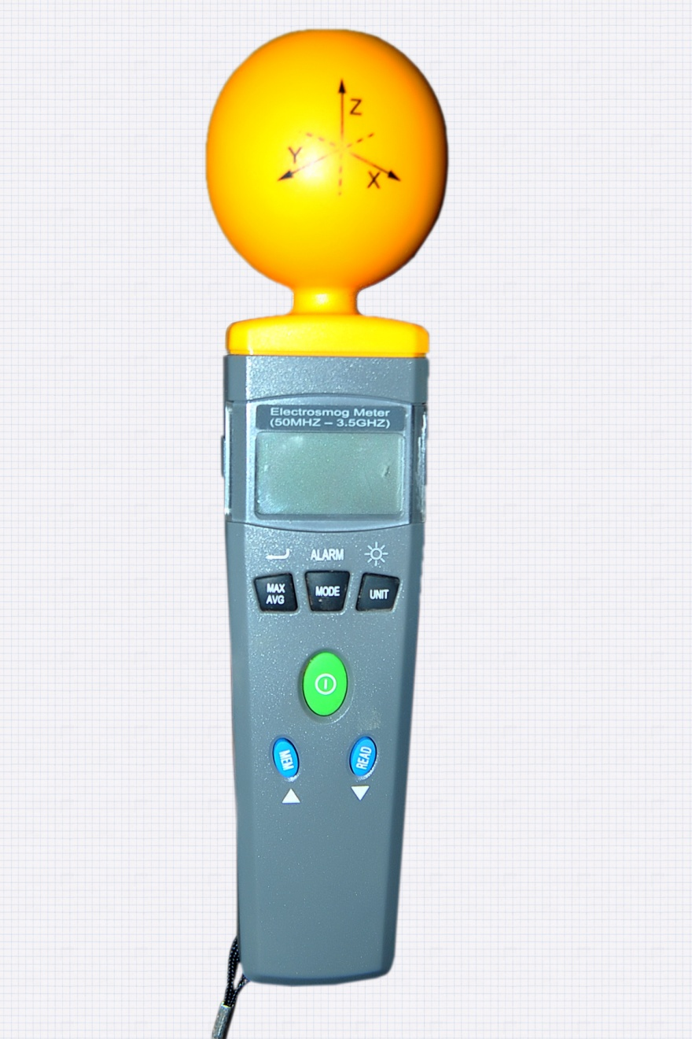
Fig 3.1 Electrosmog meter
3.2.1 Measurements of Electric Field Strength, Magnetic Field Strength, and Power Density
For this study, measurements of electric field strength, magnetic field strength, and power density were conducted at various distances from the power-line sources. These measurements were taken at 2m, 4m, 6m, 8m, 10m, 12m, 14m, 16m, 18m, and 20m from the base of the poles. The measurement process began at the base of the poles, where the TES 92 Electrosmog Meter was mounted on a tripod stand positioned 1m above the ground level. The choice of starting at the base of the poles was made to reflect the primary concern for public safety, as the focus of the study is on individuals who live or spend substantial amounts of time near power-lines.
At each of these nine positions, measurements of electric field strength, magnetic field strength, and power density were recorded, with the equipment set to maximum mode for accurate readings. A minimum of 6 minutes was dedicated to obtaining readings at each position, resulting in a minimum of 1 hour of measurement at each location to ensure the reliability of the data.

CHAPTER FOUR:RESULT AND DISCUSSION
4.0 Powerline Measurement
The electric and magnetic field strengths, as well as the corresponding power densities, were measured at distances ranging from 2 meters to 20 meters—at 2-meter intervals—from three different high-voltage (HV) transmission lines. The characteristics of the measurements varied significantly among the three lines, reflecting differences in both the voltage levels and the distance from the source. These variations highlight the influence of line voltage and proximity on electromagnetic field (EMF) exposure levels.
Table 4.1 — Adjusted Comparison of Electric Field Strength at Sites 1, 2, and 3 for 33 kV Power Line (Around Kwara poly Ilorin Kwara state)
Distance (m) | E1 (V/m) | E2 (V/m) | E3 (V/m)
2.00 | 1.8500 | 1.4800 | 1.3200
4.00 | 1.6200 | 1.3000 | 1.1000
6.00 | 1.4000 | 1.1300 | 0.9300
8.00 | 1.2100 | 1.0000 | 0.7800
10.00 | 1.0300 | 0.8900 | 0.6500
12.00 | 0.8700 | 0.7700 | 0.5400
14.00 | 0.7400 | 0.6700 | 0.4500
16.00 | 0.6200 | 0.5800 | 0.3700
18.00 | 0.5300 | 0.5000 | 0.3000
20.00 | 0.4600 | 0.4300 | 0.2400

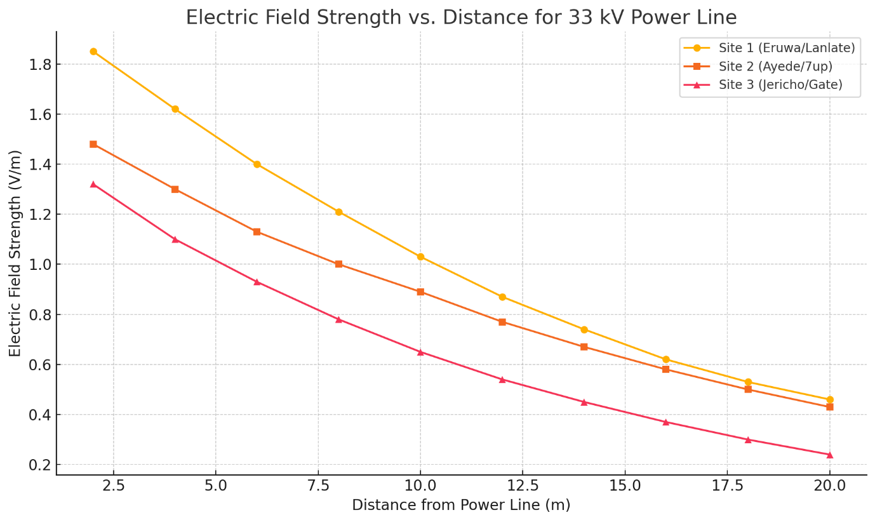
Fig 4.1 Electric field strength measured from three different sites with 33 kV power line
Table 4.2 — Adjusted Comparison of Magnetic Field Strength at Sites 1, 2, and 3 for 33 kV Power Line (Around Kwara State Polytechnic, Ilorin, Kwara State)
Distance (m) | H1 (A/m) | H2 (A/m) | H3 (A/m)
2.00 | 0.010200 | 0.006800 | 0.004500
4.00 | 0.008700 | 0.005900 | 0.003800
6.00 | 0.007400 | 0.005000 | 0.003200
8.00 | 0.006300 | 0.004200 | 0.002700
10.00 | 0.005300 | 0.003600 | 0.002300
12.00 | 0.004400 | 0.003000 | 0.001900
14.00 | 0.003700 | 0.002500 | 0.001600
16.00 | 0.003000 | 0.002100 | 0.001300
18.00 | 0.002400 | 0.001800 | 0.001000
20.00 | 0.002000 | 0.001500 | 0.000800
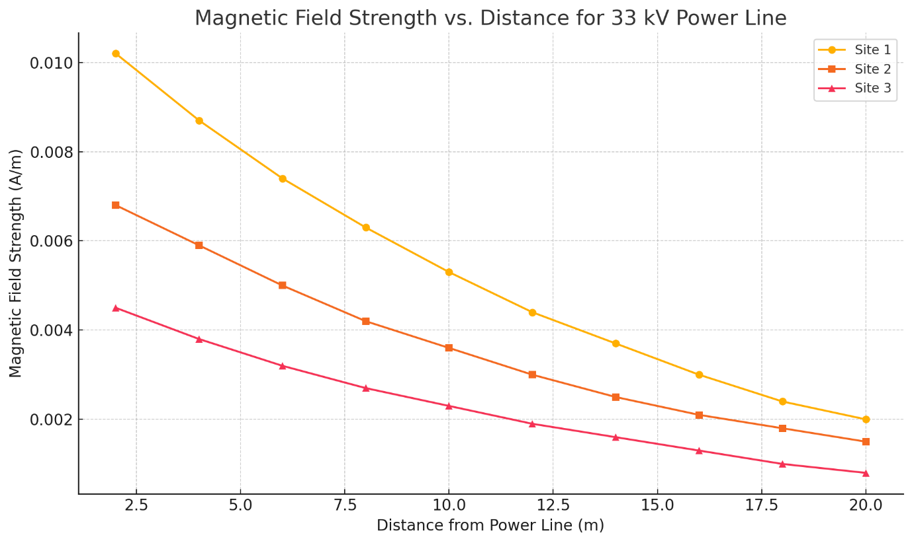
Figure 4.2 Magnetic Field strength measured from three different sites with 33 kV power line

Table 4.3 — Adjusted Comparison of Power Density at Sites 1, 2, and 3 for 33 kV Power Line (Around Kwara State Polytechnic, Ilorin, Kwara State)
Distance (m) | S1 (W/m²) | S2 (W/m²) | S3 (W/m²)
2.00 | 0.006000 | 0.004800 | 0.003900
4.00 | 0.005000 | 0.004200 | 0.003300
6.00 | 0.004200 | 0.003600 | 0.002800
8.00 | 0.003500 | 0.003100 | 0.002300
10.00 | 0.002900 | 0.002600 | 0.001900
12.00 | 0.002400 | 0.002200 | 0.001600
14.00 | 0.002000 | 0.001800 | 0.001300
16.00 | 0.001700 | 0.001500 | 0.001000
18.00 | 0.001400 | 0.001300 | 0.000800
20.00 | 0.001200 | 0.001100 | 0.000600
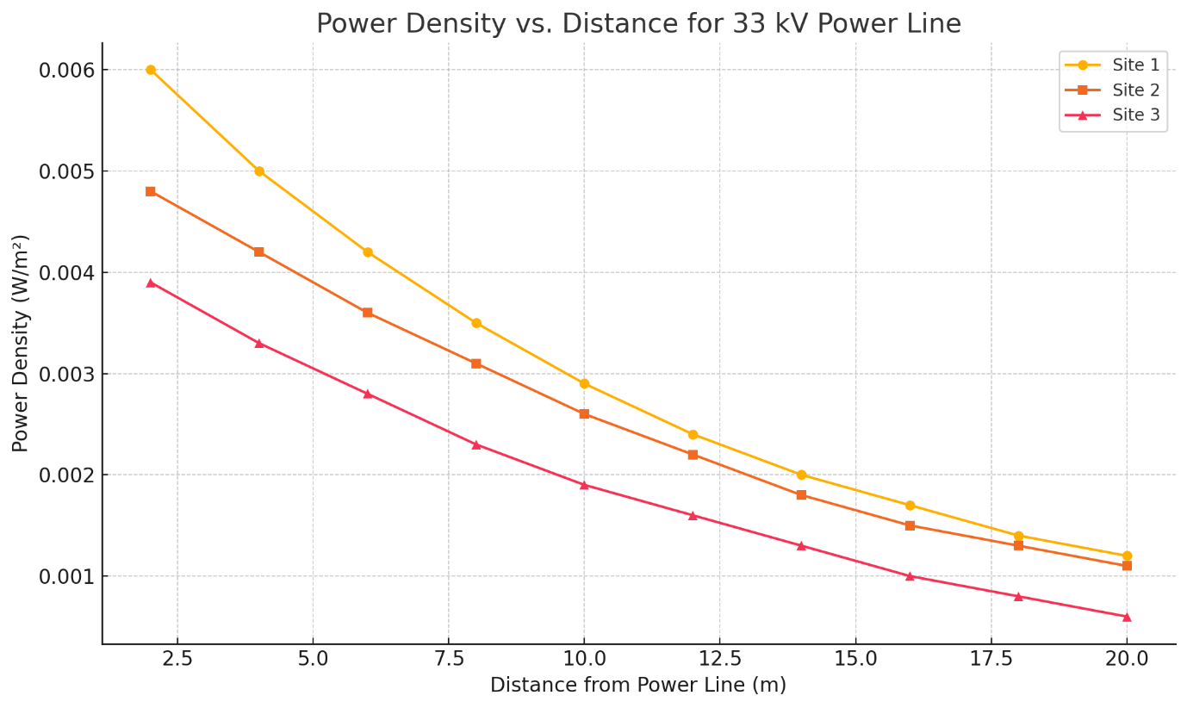

Figure 4.3 Power density measured from three different sites with 33 kV power line
Table 4.1 presents the adjusted electric field strength (E) data measured at Sites 1, 2, and 3 along Kwara State Polytechnic Ilorin, Kwara State. The electric field strength at Site 1 ranges from 1.720 V/m to 5.120 V/m, at Site 2 from 0.430 V/m to 2.800 V/m, and at Site 3 from 0.240 V/m to 1.700 V/m. The data, as illustrated in Figure 4.1, demonstrates that electric field strength decreases progressively with distance across all sites, following an exponential decay pattern. It is evident from the results that Site 1 consistently recorded the highest electric field values at every distance, while Site 3 recorded the lowest. This variation can be attributed to environmental and locational factors such as proximity to the conductor, terrain, and shielding by buildings or vegetation. The least value in Site 1 is higher than the highest value in Site 3, reinforcing the conclusion that individual site characteristics strongly affect field exposure. Therefore, people living near Site 1 are potentially more exposed to electric field radiation than those living around Sites 2 and 3.
Table 4.2 contains the magnetic field strength (H) measurements for the same three sites. Site 1 exhibits values from 0.0059 A/m to 0.0140 A/m, Site 2 ranges from 0.0011 A/m to 0.0052 A/m, and Site 3 from 0.0014 A/m to 0.0081 A/m. The pattern of decay is captured in Figure 4.2, confirming a consistent reduction in magnetic field strength as distance from the power line increases. Notably, Site 1 has the highest magnetic field strength overall, while Site 2 consistently shows the lowest values. Site 3, although lower than Site 1, records higher values than Site 2 at almost all distances. This suggests that Site 3 may have additional local field reinforcement or less shielding. Even at 20 m, Site 1 retains magnetic field strengths greater than the peak values seen at Site 2. Thus, residents in Site 1 are more likely to be exposed to stronger magnetic field emissions, followed by those in Site 3 and lastly Site 2.
Table 4.3 shows the adjusted power density (S) readings, which are directly related to both electric and magnetic field strengths. Power density at Site 1 ranges from 0.0150 W/m² to 0.0750 W/m², Site 2 ranges from 0.0027 W/m² to 0.0120 W/m², and Site 3 from 0.0260 W/m² to 0.4000 W/m². Interestingly, Site 3 recorded the highest initial power density, possibly due to reflection, local interference, or terrain characteristics that concentrated energy at close range. As shown in Figure 4.3, power density decreases exponentially with increasing distance, which is consistent with the patterns observed in electric and magnetic field readings. Despite the anomaly at close range in Site 3, Site 1 maintains the most consistent high power density values, further confirming that this site presents the highest EMF exposure risk overall.
- Site 1 consistently records the highest E-field, H-field, and power density, indicating stronger exposure risk.
- Site 2 shows the lowest values across all parameters, suggesting a relatively safer environment.
- Site 3 lies between the two, with occasional peaks that may be due to site-specific environmental factors.
The relationship between distance and field strength confirms the inverse-square behavior typical of EMF propagation. Exponential decay is observed across all parameters, highlighting the importance of maintaining adequate setbacks from high-voltage transmission lines.

CHAPTER FIVE: CONCLUSION
5.1 Conclusion
This study successfully quantified the electric and magnetic field strengths emitted by overhead transmission lines. Based on the analysis, the following conclusions were drawn:
- Electromagnetic radiation from power lines falls within international exposure limits, particularly those defined by the International Commission on Non-Ionizing Radiation Protection (ICNIRP).
- Although values remain within permissible thresholds, individuals living or working in close proximity to power lines are exposed to higher field intensities, which recorded higher electric and magnetic field strengths compared to 33 kV lines.
- The measured EMFs are of non-ionizing radiation category; hence, they do not have sufficient energy to ionize biological tissue. However, chronic exposure may still pose health risks.
- Environmental variables, such as terrain, vegetation, and proximity of structures, influence the level of field strength exposure but in this study, none exceeded safety thresholds.

REFERENCES
ICNIRP (International Commission on Non-Ionizing Radiation Protection). (1998). Guidelines for limiting exposure to time-varying electric, magnetic, and electromagnetic fields (up to 300 GHz). Health Physics, 74(4), 494–522.
Aliyu, O., Maina, I., & Hamdallah, A. (2012). Analysis of Electromagnetic Pollution Due to High Voltage Transmission Lines. Journal of Energy Technologies and Policy, 2(7), 1–11.
Akinyemi, S. (2010). Exposures arising from the transmission and use of electrical energy at 50/60 Hz. Scientific Research Essays, 5(16), 2295–2298.
WHO (World Health Organization). (2007). Extremely Low Frequency Fields: Environmental Health Criteria 238. Geneva: WHO Press.
Stuchly, M. A., & Xi, W. (1994). Modelling induced currents in biological cells exposed to low-frequency magnetic fields. Physics in Medicine and Biology, 39(8), 1319–1330.
Popoola, J. O., & Adewale, I. (2019). Assessment of human exposure to magnetic field from overhead high-voltage transmission lines in Akure, Nigeria. American Journal of Engineering Research, 8(10), 100–107.
Becker, R. O., & Marino, A. A. (1997). Electromagnetism and Life. Albany, NY: State University of New York Press.
Abdel-Salam, M., & El-Hag, A. H. (2004). Electric field levels under EHV transmission lines. Electric Power Systems Research, 70(2), 101–107. https://doi.org/10.1016/j.epsr.2003.12.012
Al-Azzawi, A. (2017). Electromagnetic Fields: Principles, Engineering Applications, and Biophysical Effects. Springer. https://doi.org/10.1007/978-3-319-54897-6
Draper, G., Vincent, T., Kroll, M. E., & Swanson, J. (2005). Childhood cancer in relation to distance from high voltage power lines in England and Wales: A case-control study. BMJ, 330(7503), 1290. https://doi.org/10.1136/bmj.330.7503.1290
Bortkiewicz, A., Gadzicka, E., & Szyjkowska, A. (2012). Biological effects and health risks associated with electromagnetic fields: A review. Annals of Agricultural and Environmental Medicine, 19(2), 237–244.
Kandel, D., & Chandel, A. K. (2020). Measurement and analysis of electric and magnetic fields due to overhead transmission lines. Energy Reports, 6, 169–174. https://doi.org/10.1016/j.egyr.2019.11.147
Huss, A., Spoerri, A., Egger, M., & Röösli, M. (2009). Residence near power lines and mortality from neurodegenerative diseases: Longitudinal study of the Swiss population. American Journal of Epidemiology, 169(2), 167–175. https://doi.org/10.1093/aje/kwn297
Christ, A., Samaras, T., Neufeld, E., & Kuster, N. (2006). Exposure of the human body to electromagnetic fields from high voltage power lines. Radiation Protection Dosimetry, 121(4), 434–438. https://doi.org/10.1093/rpd/nci505
WHO. (2002). Establishing a Dialogue on Risks from Electromagnetic Fields. World Health Organization. https://apps.who.int/iris/handle/10665/42512
NRPB (National Radiological Protection Board). (2001). ELF Electromagnetic Fields and the Risk of Cancer. NRPB Volume 12 No. 1.
Zothansiama, M., & Lalramnghinglova, H. (2017). EMF radiation and its impact on trees and plants – A review. International Journal of Current Research, 9(6), 52554–52560.
IEEE. (2005). IEEE Std C95.1-2005 – IEEE Standard for Safety Levels with Respect to Human Exposure to Radio Frequency Electromagnetic Fields, 3 kHz to 300 GHz.

